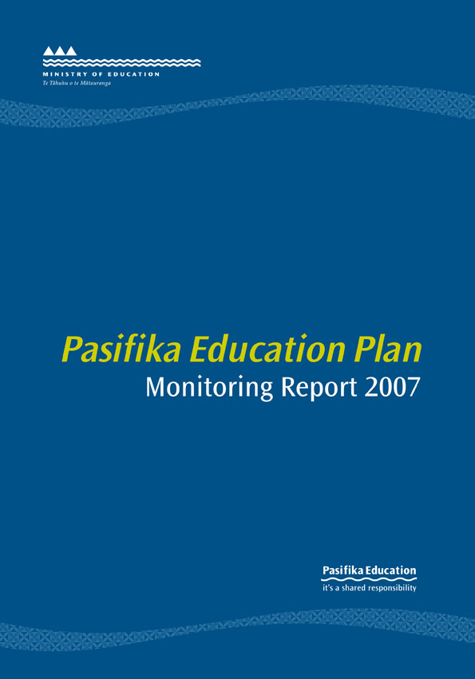

Contents
Foreword from the Minister of Education
Message from the Secretary for Education
Executive Summary
Early Childhood Education
Participation in Early Childhood Education
Quality in Early Childhood Education
Compulsory Education
Achievement at School
Effective Teaching
Student Engagement in Schooling
Pasifika Representation on School Boards of Trustees
Family and Community Engagement
Tertiary Education
Participation in Tertiary Education
Achievement in Tertiary Education
Engagement with Pasifika Communities
Education Sector-wide
Monitoring the Pasifika Education Plan
Information Availability
Networking
Special Education
Auckland Strategic Action Plan
Pasifika Language Curriculum
Whole-of-government Approach and the Pacific Region
Regional Data
Technical Notes
Foreword from the
Minister of Education
Education has a critical role in changing people’s lives and providing them with opportunities.
In a world of constant change, dwindling geographic and social barriers, and increasing access to knowledge and information technology, our children and their families have more to learn, with more opportunities than ever before.
A one-size-fits-all model is no longer appropriate for a 21st century education system. The government and the Ministry of Education are committed to realising the full potential of all New Zealand students and providing the best learning opportunities for everyone.
Education is a key factor in achieving economic and social outcomes for Pasifika students, their families and communities, and in turn improving Pasifika peoples’ contribution to the New Zealand economy. It is not only the Pasifika community that benefits but New Zealand society as a whole.
The first Pasifika Education Plan: Monitoring Report was released in July 2007 and provided a snapshot of the progress towards achieving the goals and targets of the Pasifika Education Plan 2006-2010. This is the last that will report on the Pasifika Education Plan 2006-2010.
Both the 2006 and 2007 monitoring reports show that we are on track in achieving the Plan’s targets. Of great significance is the reduction in suspension rates at secondary school during 2007.
However, while progress is evident, there are still high numbers of Pasifika students who have not realised their full potential and do not enjoy success in education.
This Pasifika Education Plan: Monitoring Report 2007 gives a snapshot of progress towards achieving the goals and targets of the Plan. It gives a clear indication of where to prioritise work over the next year and where a more concerted, sharpened focus needs to occur across the education sector.
I am pleased to present the Pasifika Education Plan: Monitoring Report 2007.

Hon Chris Carter
Minister of Education
Message from the
Secretary for Education
Welcome to the Pasifika Education Plan: Monitoring Report 2007.
Pasifika students have celebrated many successes but it is no secret that our education system could and should do more to accelerate improved outcomes for Pasifika students and their families.
The overarching outcome for the Ministry of Education is building a world-leading education system that provides all New Zealanders with the knowledge, skills and values to be successful citizens in the 21st century. To reach this outcome, we need to focus on stepping up students’ participation, engagement and achievement across early childhood education and schooling, with more quality and relevance in tertiary education.
The Pasifika Education Plan: Monitoring Report 2006 was released last year. It provided an opportunity to share what we had found out about the achievement of Pasifika students, to let you know what we are trying to achieve, why this is important, and what progress we have made in achieving our goals.
This report, the Pasifika Education Plan: Monitoring Report 2007, builds on last year’s report and includes brief case studies in early childhood education and schooling that show where we are on track. You will see that, on the whole, we are heading in the right direction but that we still need to keep a sharp focus on:
- participation and quality in early childhood education;
- strong literacy and numeracy foundations in schooling, and making sure students are engaged in learning; and
- transitioning students into higher levels of learning and achievement in tertiary education.
The ministry will continue to increase its evidence base on what works for Pasifika students to step up policy and practice at all levels of education.
It is my hope that you read this report, share its findings with your colleagues, and join in strengthening a shared understanding of what we are working towards in raising Pasifika achievement.

Karen Sewell
Secretary for Education

Executive Summary
The Pasifika Education Plan 2006-2010 (the Plan) provides a strategic direction for improving education outcomes for Pasifika peoples in Aotearoa/New Zealand. The Plan was released in June 2006.
This is the second in the series of monitoring and evaluation reports on the 2006-2010 Plan. It provides a national and regional picture of progress towards achieving the Plan’s goals and targets and forecasts progress to 2010.
The report shows that many of the activities that contribute to sector-wide goals are tracking well and will be achieved by 2010. These include work on Pasifika languages, building capability and capacity, international work across the Pacific region, and the Auckland Strategic Action Plan amongst others. The report also shows particularly pleasing progress in reducing suspension rates.
This report also identifies areas requiring accelerated effort. These identified areas have been focused on in the latest Pasifika Education Plan.
The 2007 findings include:
- in early childhood education
– participation has continued to improve. The forecast position for 2010 is that Pasifika participation will improve considerably to 88.5 percent. This is short of its target of 95 percent. However, the FREE ECE programme is expected to improve this forecast;
- in compulsory education
– half of all 2006 Pasifika school leavers achieved NCEA Level 2 or above. The forecast position for 2010 is that the target will be exceeded at 56.9 percent;
– the rate of Pasifika students leaving school with little or no formal attainment has improved and is forecasted to match that of non-Pasifika school leavers by 2010; and
– the age-standardised suspension rates for Pasifika students decreased sharply by 17 percent between 2006 and 2007 after three years of steady increase and may well meet the 2008 target. The forecast is for a Pasifika age-standardised suspension rate of 7.9 per 1,000 students by 2008, close to the target of 7.5 per 1,000 students;
- in tertiary education
– Pasifika participation shows the greatest rate of increase of all ethnic groups at 22 percent since 2001. The forecast position is for 4.3 percent participation at degree level or above, slightly below the target of 5 percent;
– the five-year retention rate is increasing at all qualification levels from 42 percent to 45 percent and is likely to be exceeded with a forecast position of 48 percent by 2010;
– the forecast position on the five-year completion rate for students who begin bachelors degree-level study in 2006 is at 32 percent; however, with more effort and the recent changes in the tertiary sector, it is expected that shifts will be made towards achieving the target currently set at 38 percent; and
– the proportion of Pasifika undertaking Modern Apprenticeships has increased, while the proportions of Māori and European/Pākehā have decreased; and
- in education sector-wide
– a monitoring framework has resulted in two monitoring reports driven by robust evidence and linked to education sector and theme strategies;
– close and effective working relationships with education agencies and a protocol agreement between the Ministry of Education and the Ministry of Pacific Island Affairs have been strengthened, consolidating strategic approaches supporting the Plan;
– the ministry has developed strong links with Pacific countries through the Treaty of Friendship with Samoa, a Memorandum of Understanding with Tokelau, and a Memorandum of Understanding with Niue. The ministry has supported all Forum Education Ministers’ Meetings (FEdMM) since 2001 and in 2007 New Zealand hosted the FEdMM annual meeting in Auckland;
– the Auckland Strategic Action Plan is how the Pasifika Education Plan is realised in Auckland. A strong Pasifika team has been built in Auckland with a focus on connecting educational activity across the region; and
– the Vagahau Niue in the New Zealand Curriculum and the Tongan in the New Zealand Curriculum guidelines were launched in 2007. The Tokelau language curriculum will be launched late in 2008.
The table below summarises progress to date.
Table 1.0: Pasifika Education Plan
TARGETS |  | CURRENT STATUS
Early Childhood Education | Lift Pasifika participation in early childhood education (ECE) reported on entry to school from 85 percent in 2005 to 95 percent by 2010. | Participation has continued to improve and is currently forecast to be 88.5 percent by 2010.  The impact of FREE ECE and other initiatives will continue to raise participation towards the 95 percent target.
Early Childhood Education | Increase the number of registered Pasifika ECE teachers (37 percent in 2005). | The target has been met. The number of qualified and registered Pasifika teachers has increased, but more are needed in the system to be able to meet the 2010 teacher registration targets for the ECE Strategic Plan.
Early Childhood Education | Improve reported quality in Pasifika ECE services. | A 2006 ERO report confirms that having registered ECE teachers leads to improved quality in ECE services. There is emerging qualitative evidence to show the positive benefits of professional development for ECE teachers in improving quality learning in ECE centres.

TARGETS |  | CURRENT STATUS
Compulsory Education | Positive shifts in performance as measured by national and international assessments (PISA, PIRLS, TIMSS and NEMP) by 2010. | The 2006 international data indicates that there has been no significant shift in reading, mathematical and scientific literacy proficiency levels for Pasifika students. New Zealand is currently participating in several international assessments. Results of these will be available in late 2008.
Compulsory Education | By 2010 the proportion of Pasifika students leaving school with little or no formal qualifications will match that of all school leavers. | More Pasifika students are leaving with qualifications. The gap between Pasifika and non-Pasifika has narrowed considerably. Current trends have led to a forecast of 8.9 percent of Pasifika school leavers and 9.4 percent of non-Pasifika students leaving school with little or no formal attainment by 2010.
Compulsory Education | Increase the proportion of Pasifika students leaving school with at least NCEA Level 2 or equivalent from 44 percent (2004) to at least 51 percent by 2010. | The gap between Pasifika and non-Pasifika students has decreased over the last year. In 2006, half of all Pasifika school leavers achieved NCEA Level 2 or above (49.6 percent). The forecast is that the target of 51 percent will not only be met by 2010 but is expected to be exceeded at 56.9 percent.

TARGETS CURRENT STATUS
Compulsory Education | Increase the number of registered teachers that are effective for Pasifika students. | An ERO review in 2006 identified only 14 percent of schools as being consistently effective for Pasifika students. There has, however, been recent improvement in Pasifika student achievement as a result of national literacy and numeracy professional development programmes.
Compulsory Education | Increase the number of Pasifika teachers. | The number of Pasifika teachers has increased since 2002, but the Pasifika student:teacher proportion is still at 9.6 percent for Pasifika students compared with 2.8 percent for Pasifika teachers.
Compulsory Education | Improve responsiveness through planning and reporting. | In 2006, 3.5 percent of schools had a strategic planning target that specifically mentioned Pasifika students. The most common focus of these targets is in the areas of literacy and numeracy.
Compulsory Education | Reduce the age-standardised rate of Pasifika suspensions in the compulsory education sector, currently at 9.3 per 1,000, by 20 percent over the next three years (by 2008). | The age-standardised suspension rates for Pasifika students have decreased by 17 percent between 2006 and 2007. Assuming Pasifika rates continue to show improvement, the forecast position is a Pasifika age-standardised suspension rate of 7.9 per 1,000 by the end of 2008.  The student engagement initiatives in schools identified with high Pasifika student populations are beginning to show signs of making a significant difference.
Compulsory Education | Increase Pasifika board representation from 3.1 percent to 4.2 percent of all trustees by the end of 2007. | The 2007 representation of 3.5 percent is short of this target; however, in 2007 there were 487 elected, appointed or co-opted Pasifika board of trustee members compared with 394 in 2000. This increase since 2000 is the largest increase of the ethnic groups.
Compulsory Education | Establish five school community liaison clusters that are focused on student achievement by 2008. | The target has been exceeded. There are currently six clusters under the Pasifika School Community Parent Liaison (PSCPL) initiative. They are located in Wellington (1), Auckland (3) and Christchurch (2).

TARGETS CURRENT STATUS
Tertiary Education | Increase the Pasifika participation rate at degree level and above from 3.4 percent in 2004 towards a total of 5.0 percent by 2010. | The forecast for Pasifika participation in 2010 is 4.0 percent. This is below the target of 5.0 percent. Pasifika have had a 23 percent increase since 2001 and this is the largest increase of the ethnic groups.
Tertiary Education | Increase the Pasifika five-year retention rate at all qualification levels from 45 percent (2000 to 2004) towards 48 percent by 2010. | The forecast is 44 percent by 2010. The target is not expected to be met.  The ministry is working collaboratively with the Tertiary Education Commission and other agencies to ensure all system levers are used to meet the Plan’s targets to 2010.
Tertiary Education | Increase the proportion of Pasifika in industry training studying at level 4 or higher from 23 percent in 2004 towards 30 percent by 2010. | The proportion of the Pasifika labour force participating in industry training has been steadily rising since 2000 as government has progressively increased funding for this programme.  The forecast, however, is 19 percent, which is still below the 2004 level.
Tertiary Education | Increase the participation of Pasifika people in Modern Apprenticeships closer to a rate that is in proportion to the Pasifika share of the national working-age population by 2010. | Based on current efforts the forecast is 4 percent. This represents an increase towards the Pasifika share of the working-age population, but there is room for further increases.  The ministry is in partnership with the Tertiary Education Commission and other agencies to ensure all system levers are used to meet the Plan’s targets to 2010.

TARGETS CURRENT STATUS
Tertiary Education | Increase Pasifika five-year degree-level completion rates from 30 percent (2000 to 2004) towards 38 percent by 2010. | Based on current efforts, the forecast is 32 percent, slightly under the target.  In recent years the five-year completion rate of all students in bachelors degree-level qualifications has decreased.  This is possibly a reflection of a positive labour market and a preference for shorter, more vocationally orientated certificates and diplomas.
Tertiary Education | Maintain the five-year higher-level progression rate at 34 percent or higher. | The forecast position is 44 percent. The target is expected to be exceeded. Pasifika students who complete a tertiary education qualification are more likely than European/Pākehā students and Asian students to progress on to further study in a higher-level qualification.
Tertiary Education | Tertiary education organisations to be able to demonstrate evidence of actions they have taken to consult with the Pasifika community and to address Pasifika aspirations. | The ministry is working with the Tertiary Education Commission in providing strategic oversight across the tertiary sector and in enhancing relationships with Pasifika communities.
Education Sector-wide | Finalise the monitoring and evaluation framework. | The first Pasifika Education Plan: Monitoring Report was released in July 2007. This second and final monitoring report on the Pasifika Education Plan 2006-2010 will be released during 2008. In the future, the ministry will release annual reports on Pasifika education, and these will continue to be driven by robust evidence and education sector-wide theme strategies.
Education Sector-wide | Implement the Pasifika Communications Strategy, in a timely and effective way – through publication of Talanoa Ako: Pacific Education Talk, web maintenance, radio programmes and strategic fono series. | The Pasifika Communications Strategy has enabled the ministry to achieve a level of success in providing quality information to Pasifika communities. The challenge for the ministry is to ensure it uses media that is easily accessed by communities.  Strong links have been made with other ministry communication strategies such as Team-Up. This has made the ministry’s key messages and evidence more available to Pasifika families and communities.

TARGETS CURRENT STATUS
Education Sector-wide | Increase the availability of Pasifika research evidence. | More Pasifika research and evidence are now available and have been published.
Education Sector-wide | Finalise Pasifika capacity/capability development plans. | The Ministry of Education’s Pasifika Caucus has provided internal support for staff. The Caucus assists the ministry’s organisational success in being better informed about Pasifika issues, customs, cultures and networks.  The Pasifika cultural training package has been provided across Special Education to help improve capability.
Education Sector-wide | Finalise Pasifika capacity/capability development plans. | In May 2007, work began on the development of Pasifika practice guidelines to provide culturally responsive services to Pasifika children and their families.  This has been rolled out to other parts of the ministry.
Education Sector-wide | Further develop and strengthen Pasifika Advisory Group and regional reference groups. | The National Pasifika Advisory Group continues to meet twice a year and to act as a champion of Pasifika education and the implementation of the Pasifika Education Plan.  At the regional level the ministry’s Pasifika Education Coordinators and Pasifika reference groups have adopted a more collaborative approach to localising plans and engaging Pasifika communities and families, including the hard-to-reach families.
Education Sector-wide | Include appropriate measurements of special education support interventions for Pasifika students in the Student Support Outcomes Monitoring Scheme. | In 2007, increasing Pasifika access to early intervention services has been a focus for the Northern and Central South regions of the North Island. Pasifika early intervention referrals increased from 4 percent to 5 percent. This positive shift will be accelerated in the future through increased collaboration across the sector and stronger links with key Pasifika providers.

TARGETS CURRENT STATUS
Education Sector-wide | Establish systems for analysing and reporting indicator measures for a range of special education interventions for Pasifika students. | More focus on gathering quality information and data on the numbers of Pasifika students accessing special education has been occurring over the last year. This has assisted in assessing and reporting on the effectiveness of special education support for Pasifika.
Education Sector-wide | Develop a screening resource to assist educators to identify, clarify and respond to the special education needs of Pasifika learners. | In 2007, the Better Information to Address Barriers to Learning (BITABL) screening tool provided better information to address barriers to learning for early childhood and primary school students in Pasifika communities. Future work will address the development of a new Pasifika screening tool that builds on the successes of the Pasifika BITABL tool.
Education Sector-wide | Finalise the Auckland Strategic Action Plan. | Positive educational outcomes for Pasifika must be raised in Auckland, where 72 percent of the New Zealand Pasifika student population attend education services.  Priority has been given to increasing internal ministry capacity in the regional offices to effect the stepped-up changes required across the region. An Auckland team is in place working across Early Childhood, Regional Education and Special Education.
Education Sector-wide | Finalise the development of Niuean, Tongan and Tokelauan curriculum guidelines for release during 2006. | The Vagahau Niue in the New Zealand Curriculum and Tongan in the New Zealand Curriculum guidelines were released during 2007. Tokelau in the New Zealand Curriculum will be launched in late 2008. Future work consists of a review of Samoan in the New Zealand Curriculum and the development of support material for  all Pasifika language curriculum guidelines.

TARGETS CURRENT STATUS
Education Sector-wide | Increase links between the Plan and other government strategies. | Strong links have been built between the Plan and other government strategies such as the Pacific Economic Action Plan (Ministry of Pacific Island Affairs); Family Violence (Taskforce for Action on Violence within Families); the Disability Strategy (Office for Disability Issues); and the Pacific Health Strategy (Ministry of Health).
Education Sector-wide | Finalise a strategic framework for responding across the Pacific region. | The ministry has been responsive to requests for support from across the Pacific region through the Treaty of Friendship with Samoa, and Memorandum of Understanding with Niue. Work with these countries focuses on curriculum support and resource development. Tokelau was provided with technical support to enhance educational capacity and capability.  The Pacific Forum Education Ministers’ Meeting was held in Auckland in late 2007. It provided an opportunity for New Zealand and the 14 Pacific Forum nations attending to strengthen relationships and contributions to the Ministers’ Forum Basic Education Plan.

Participation in Early Childhood Education
What we have found
The percentage of Pasifika new school entrants who have participated in early childhood education (ECE) services has increased over the last six years. While Pasifika rates have increased more than those of all other ethnic groups since 2000, Pasifika continue to have the lowest participation rate of the ethnic groups.
Based on the improved participation rate for Pasifika new school entrants since 2000, the forecast position for 2010 is that Pasifika participation will improve considerably to 88.5 percent. This is short of its target of 95 percent. The FREE ECE programme is expected to improve this forecast.

What we are trying to achieve
Significantly increase Pasifika children’s participation in early childhood education services.
Target
Lift Pasifika participation in early childhood education reported on entry to school from
85 percent (in 2005) to 95 percent by 2010.

Why this is important
Time spent in early childhood education enhances future learning. New Zealand studies¹ have shown that time spent in early childhood education has a significant positive relationship to academic achievement well into secondary schooling years. This is important because it confirms a range of international research that demonstrates the ongoing influence of early childhood education on children’s learning.

How we are going
As can be seen in Figure 1.1, the gap between the proportion of Pasifika new school entrants who have participated in early childhood education services and the proportion of new school entrants from all ethnic groups who have participated in ECE services has narrowed over the past six years. Since 2000, the proportion of Pasifika new school entrants who have participated in early childhood education services has increased by 11 percent. During this same period the proportion of new school entrants from all ethnic groups who have participated in early childhood education services has increased by 4 percent.

1 See the Competent Children, Competent Learners publication series on the Education Counts website.

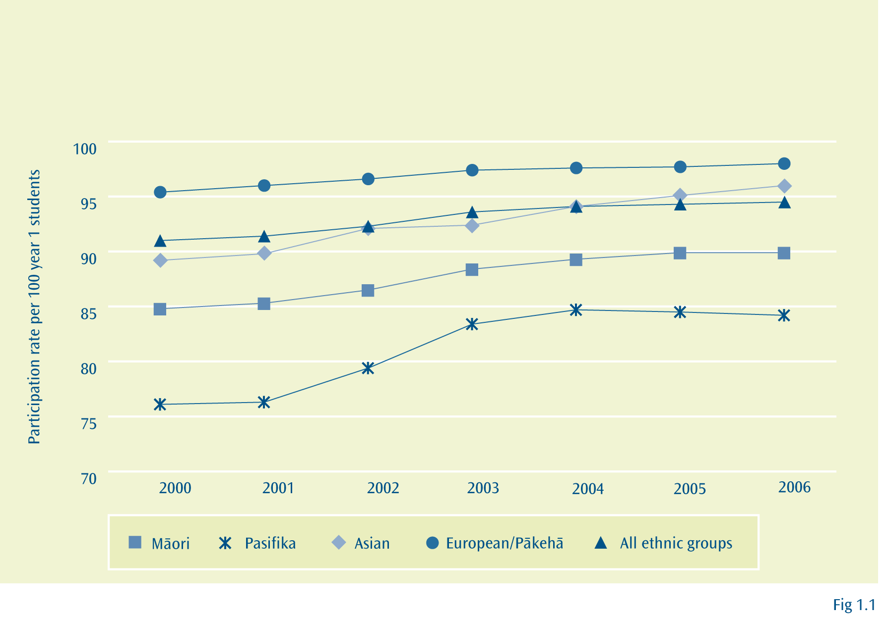
Figure 1.1:Early childhood participation rate of year 1 students, by ethnic group
(2000 to 2006)

Notes: 1. Excludes children aged five years.
2. Children can enrol at more than one service, so double counting of enrolments will occur, causing the apparent participation rate to be greater than 100 percent for some age groups.
3. ‘All ethnic groups’ includes the ethnic category ‘Other’.

In 2006, the percentage of Pasifika new school entrants who had participated in early childhood education services was 84.2 percent. European/Pākehā (98.0 percent), Asian (96.0 percent) and Māori (89.9 percent) all had greater participation rates than Pasifika.
The targeted participation rate for Pasifika new school entrants for 2010 is 95 percent. At this stage the forecast for 2010 for Pasifika is 88.5 percent, while for non-Pasifika it is 97.1 percent. This forecast does not take into consideration the expected positive impact from FREE ECE, which provides 20 free hours for all 3 and 4 year-olds.
The participation rate is forecast to increase by 2010 for Māori (to 92.6 percent), European/Pākehā (to 98.9 percent) and Asian (to 98.1 percent) groups.

Where to find out more
www.educationcounts.govt.nz

indicators

Participation in early childhood education

Hours of participation in early childhood education

Prior participation in early childhood education: new entrants
PUBLICATIONS
Pasifika Early Childhood Education

Quality in Early Childhood Education
What we have found
Registered Pasifika teachers
The percentage of Pasifika early childhood teachers that are registered with the New Zealand Teachers Council is increasing at a faster rate than that of non-Pasifika early childhood teachers. However, Pasifika teachers are still less likely to be registered than other ECE teachers. In 2006, 43.9 percent of Pasifika early childhood teachers were registered compared with 57.5 percent of non-Pasifika early childhood teachers.
Quality in Pasifika ECE services
From 2008, at least half of all regulated teachers² in teacher-led ECE services will be required to hold a recognised ECE teaching qualification. In 2006, only one-third of Pasifika ECE services (31 out of the 93) were meeting this requirement. These services will need to increase their number of registered teachers, or manage their rolls so that existing qualified staffing levels are sufficient to meet licensing requirements.
What we are trying to achieve
Improve the quality of early childhood education services attended by Pasifika.
Target
Increase the number of registered Pasifika early childhood education teachers.
Target
Improve reported quality in Pasifika early childhood education services.
Why this is important
Children benefit from participation in quality ECE services. Early childhood education teachers are registered to help ensure the quality of services. Teacher registration shows new teachers have successfully completed a recognised teacher education programme, and then receive supervision and support. Gaining full registration and maintaining a practising certificate assure currency of professional knowledge and practice.
How we are going
Registered Pasifika teachers
As can be seen in Figure 2.1, the percentage of Pasifika early childhood teachers that are registered is growing at a faster rate than that of non-Pasifika early childhood teachers. In 2006, 43.9 percent of Pasifika early childhood teachers were registered. This is almost 2.5 times higher than the figure for 2004 (18.4 percent). During the same period, the percentage of non-Pasifika early childhood teachers who were registered increased by less than 50 percent. However, Pasifika early childhood teachers are still less likely to be registered than non-Pasifika ECE teachers, of whom 57.5 percent are registered.
2 Teachers required for an early childhood education service to meet the minimum regulatory requirements for staff:child ratios.

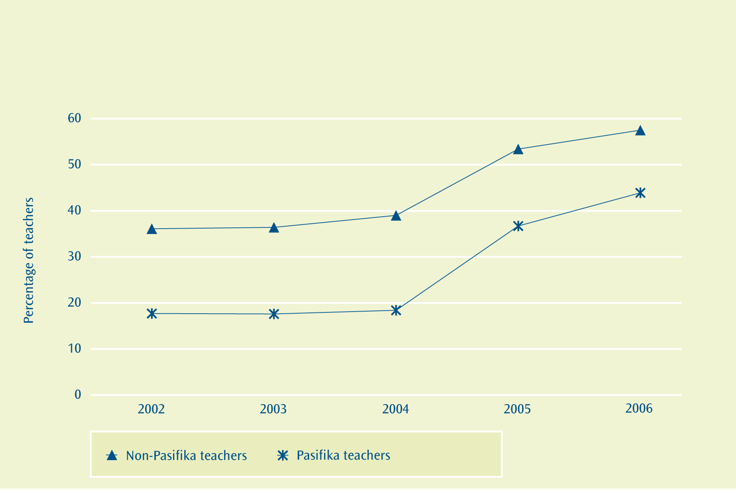
Figure 2.1:Percentage of early childhood teachers that are registered with the New Zealand Teachers Council, by ethnic group (2002 to 2006)

Notes: 1. Excludes caregivers in home-based networks.
2. Excludes adults on duty in parent/whänau-led services including playcentres and te köhanga reo.

Quality in Pasifika ECE services
A 2006 Education Review Office (ERO) report confirms that having registered ECE teachers leads to improved quality in ECE services³. The Education Review Office evaluates and reports on the quality of education in ECE services as part of its regular cycle of reviews.
Many Pasifika services provided programmes that were culturally enriching, and some of these were high quality. Most services met current requirements for staff qualifications. However, there was wide variation between Pasifika services in the type and quality of education provided, and some services needed to improve.
From the end of 2007, 50 percent of regulated teachers⁴ in teacher-led ECE services will be required to hold a recognised ECE teaching qualification. In 2006, as can be seen in Figure 2.2, 62 of the 93 Pasifika character services were not meeting this requirement. However, the number of services with Pasifika character that have less than 50 percent of their staff qualified has been decreasing steadily since 2004. This is good news as these services may face loss of licence, and closure, if they do not increase the number of registered ECE teachers. Almost two-thirds of Pasifika services are located in Auckland, where there is currently high demand for registered ECE teachers.

3 ERO (2006). Early Childhood Services: Readiness for 2007 Qualification Requirements. Wellington: Education Review Office.
4 Teachers required for an early childhood education service to meet the minimum regulatory requirements for staff:child ratios.

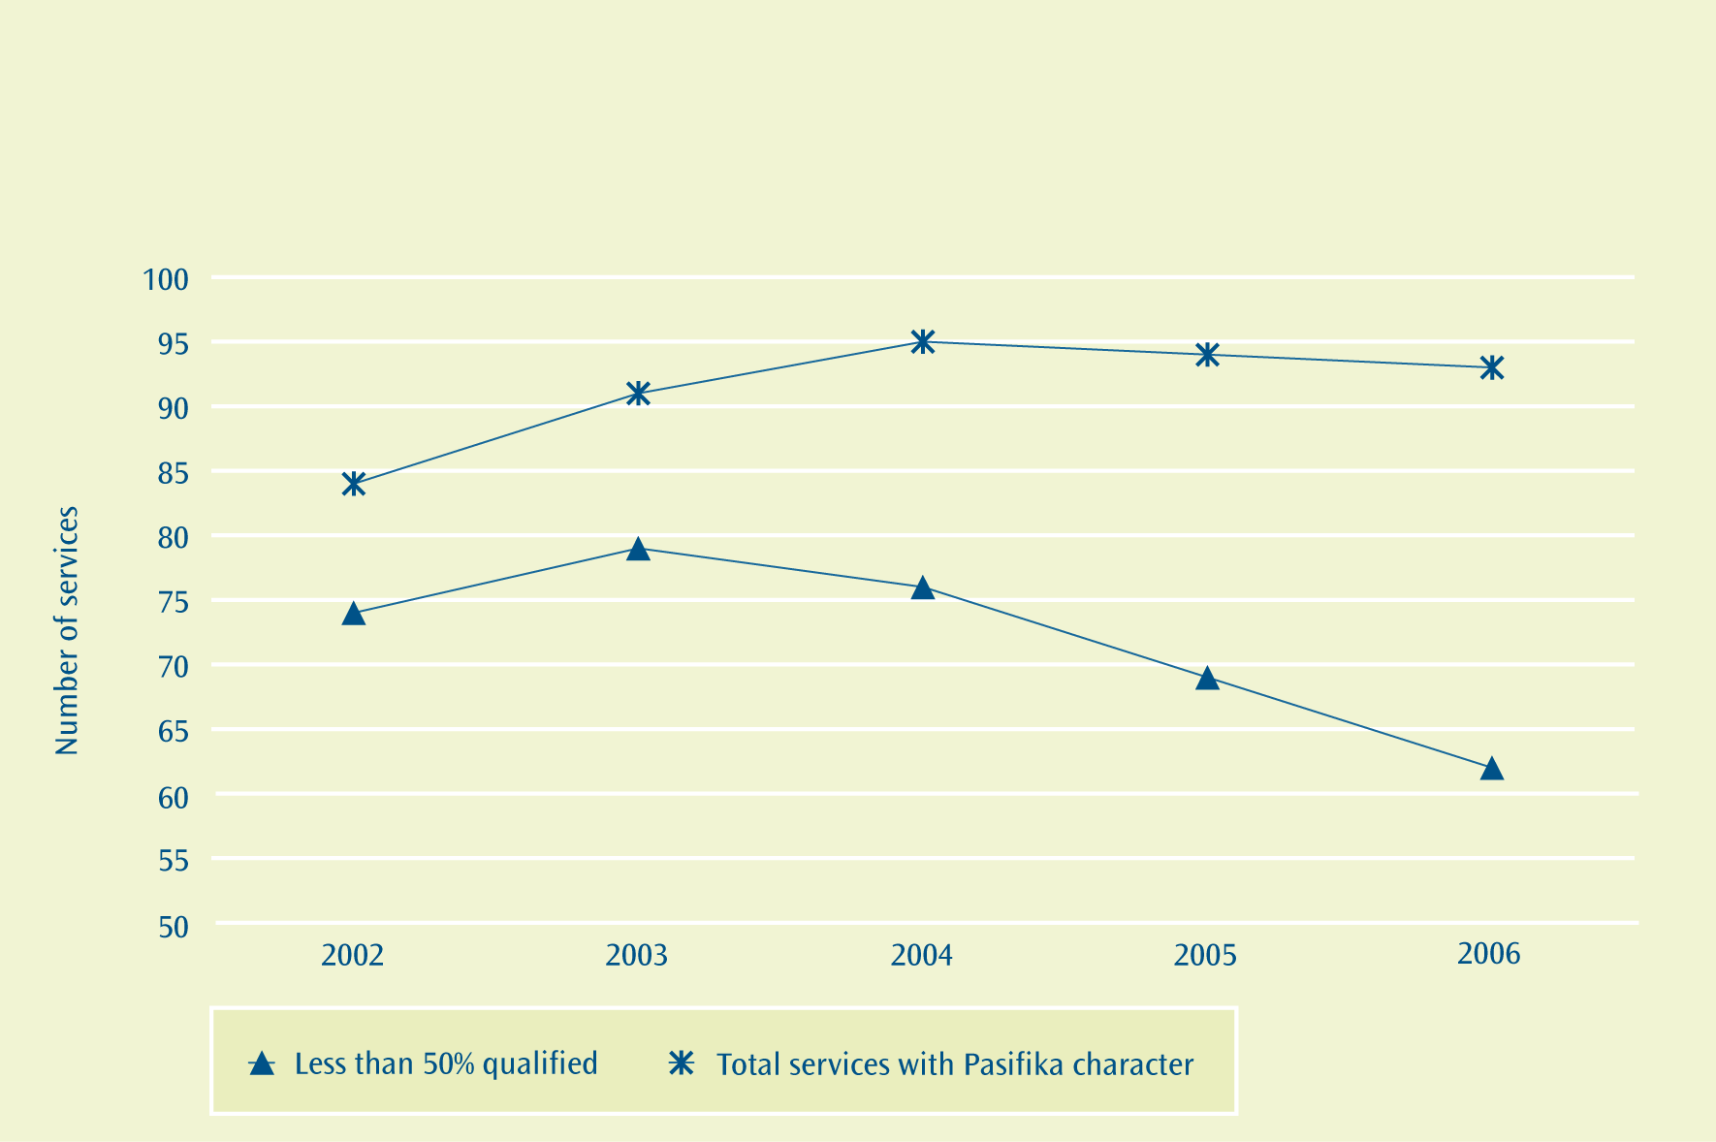
Figure 2.2:Number of services with Pasifika character, and with less than 50 percent of their teachers qualified (2002 to 2006)

Notes: 1. Excludes home-based networks.
2. Excludes parent/whänau-led services including playcentres and te köhanga reo.

In July 2007, the first intake of students into the Diploma of Teaching (Early Childhood Education) Pasifika Specialisation programme graduated from Auckland University of Technology. Also in 2007 there were the first graduates with the same qualification from Te Tari Puna o Aotearoa, the New Zealand Childcare Association. These current and prospective graduates are expected to increase the number of Pasifika registered and qualified teachers in early childhood education.
Comments from Pasifika teachers participating in early childhood professional development programmes are beginning to capture the nature of changes they are making to their practice. This is improving the quality of learning experiences for children in their services. Following are snippets from a provisionally registered Pasifika teacher and a fully registered teacher.
Case Study 1
Reflections from a provisionally registered Pasifika teacher following her engagement in
Te Whäriki professional development
Participating in Te Whäriki professional development programmes has enabled me to learn so much and develop a deeper understanding in many aspects of the job, particularly working with children and in relation to teamwork. I also feel my attitude has changed. Now I am happy and always look forward to coming to work with the children. Meetings were facilitated in my mother tongue, which enabled me to gain a basket of knowledge and understanding.
At first I didn’t want to be part of the professional development because I knew that there would be lots of meetings. But soon I began to use my initiative to take responsibility for gathering data and I was happy to make changes in our environment for children’s learning and teachers. Since we have implemented changes to the environment, I noticed that children are not running around in the centre. Now the children are engaged in different areas of the curriculum and they are playing really well with their peers. The impact of these changes is reflected in the learning stories, where stories are richer and more colourful.

Case Study 2
Reflections from a fully registered Pasifika teacher following her engagement in Te Whäriki professional development
Understanding the intent of learning stories in the early childhood curriculum and learning made it easy and interesting for me to understand the importance of interacting with children.
Earlier when using checklists, there was no interaction with children. Now, unlike before, when you write about children’s learning you can extend not only their learning but also the teachers’ knowledge in working with children.
I feel more professional now in meeting with parents and sharing their children’s stories. It is like a communication tool that helps form our relationships with parents and families. I now lead the staff in meetings, and this has given me the confidence to share and discuss with staff in an open and respectful way. Before, I was doing things on my own most of the time.
Where to find out more
www.educationcounts.govt.nz

indicators

Teacher qualifications: schooling

PUBLICATIONS
Picking up the Pace

An Evaluation of Initial Uses and Impact of Equity Funding
Pasifika Early Childhood Education

Achievement at School
What we have found
International assessments
The 2006 Programme for International Student Assessment (PISA) results show an increasing gap between Pasifika 15 year-old students and their European/Pākehā and Asian counterparts as proficiency level increases for reading, mathematical and scientific literacy. Pasifika are greatly under-represented in the higher proficiency levels (level 3 to level 5 or 6) of these subjects, as are Māori.
Little or no formal attainment
Since 2000, all ethnic groups have seen a reduction in the percentage of school leavers with little or no formal attainment. The gap between the proportion of Pasifika students leaving school with little or no formal attainment and that of non-Pasifika students has been closing over the past four years. The proportion of Pasifika school leavers with little or no formal attainment is much lower than that of Māori; however, it is still higher than that of European/Pākehā and Asian students.
It is forecast that the target will be bettered with a predicted 8.9 percent of Pasifika students and 9.4 percent of non-Pasifika students leaving with little or no formal attainment by 2010.
NCEA Level 2 or above
Since 2003, all ethnic groups have seen an increase in the percentage of school leavers who achieve NCEA Level 2 or above. The gap between the proportion of Pasifika students leaving school with NCEA Level 2 or above and non-Pasifika students has decreased over the past year. The proportion of Pasifika school leavers with NCEA Level 2 or above is higher than that of Māori; however, it is still much lower than that of European/Pākehā and Asian students.
The forecast position is that the target will be met. It is predicted that, by 2010, 56.9 percent of Pasifika school leavers will have NCEA Level 2, 5.9 percent above the target.
What we are trying to achieve
Increase Pasifika students’ achievement in education.
Target
Achieve positive shifts in performance as measured by national and international assessments (PISA, PIRLS, TIMSS and NEMP⁵) by 2010.
Target
By 2010, increase the proportion of Pasifika students leaving with little or no formal attainment to match that of all school leavers.

5 PISA: Programme for International Student Assessment; PIRLS: Programme in International Reading Literacy Study; TIMSS: Trends in International Mathematics and Science Study; NEMP: National Education Monitoring Project.
Old Target
Increase the proportion of Pasifika students leaving school with at least NCEA Level 2 or
equivalent from 52 percent (2004) to at least 60 percent by 2010.
In 2004, there were methodological changes in the allocation of some attainment levels to school leavers. This had no impact on school leavers with little or no formal attainment; however, for NCEA Level 2 the 2004 data is not comparable with earlier or later data. Because 2004 is the base year for the NCEA Level 2 target, and the basis of the desired position for 2010, the target had to be recalculated. The corrected target is:
Revised Target
Increase the proportion of Pasifika students leaving school with at least NCEA Level 2 or equivalent from 44 percent (2004) to at least 51 percent by 2010.
Why this is important
The success of an education system is manifested in, among other things, the success of individuals in finding sustainable employment, as well as the level of wages that employers are willing to pay for their skills and knowledge. A formal school qualification is a measure of the extent to which young adults have completed a basic prerequisite for higher education and training, or for many entry-level jobs.
People with no qualifications have unemployment rates far exceeding those with qualifications. In New Zealand, people with no qualifications have an unemployment rate over 60 percent higher than those whose highest qualification was a year 12 (sixth form) school qualification or above.
Educational qualifications are also linked to incomes. For example, wage and salary earners with a bachelors degree or higher currently earn around 80 percent more per hour on average than those with no qualification across developed countries.
How we are going
International assessments
New Zealand is currently participating in a number of international assessments. Information from these assessments will be available towards the end of 2008. Results from the 2006 Programme for International Student Assessment (PISA) are available for ethnic comparisons. PISA shows that there has not been a major shift in achievement for Pasifika students in reading, mathematical and scientific literacy.

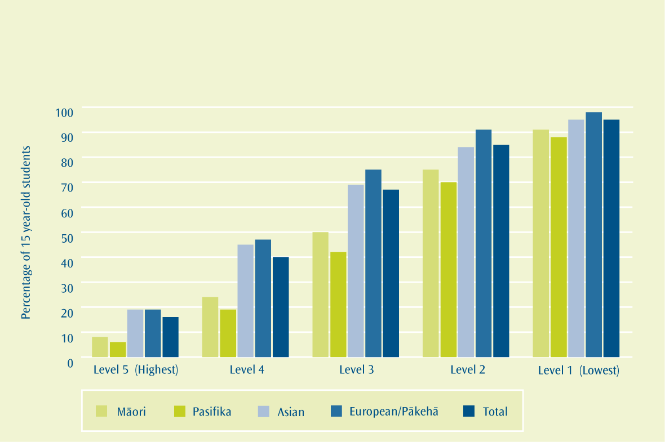
Figure 3.1:Percentage of New Zealand 15 year-old students reaching the PISA reading literacy proficiency levels (2006)

Note: 1. ‘Total’ includes ethnic category ‘Other’.
As can be seen in Figure 3.1, as the reading literacy proficiency level increases, the gap between Pasifika 15 year-old students and their European/Pākehā and Asian counterparts increases. Pasifika as well as Māori are greatly under-represented with respect to the proportion of 15 year-old students reaching the higher reading literacy proficiency levels (levels 3 to 5).
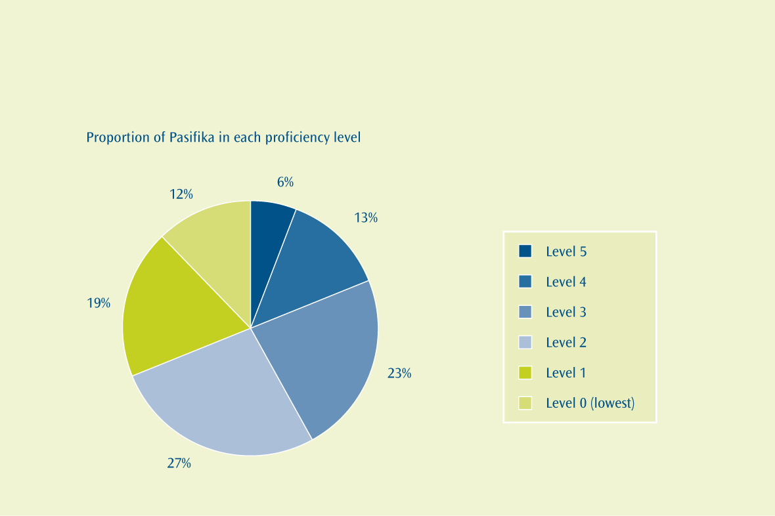
Figure 3.1a: Proportion of Pasifika 15 year-old students, by highest PISA reading literacy proficiency level (2006)

As shown in Figure 3.1a above, one in every two Pasifika 15 year-old students reached either level 2 or 3 as their highest PISA reading literacy proficiency level in 2006, while almost one in every five reached level 4 or higher.

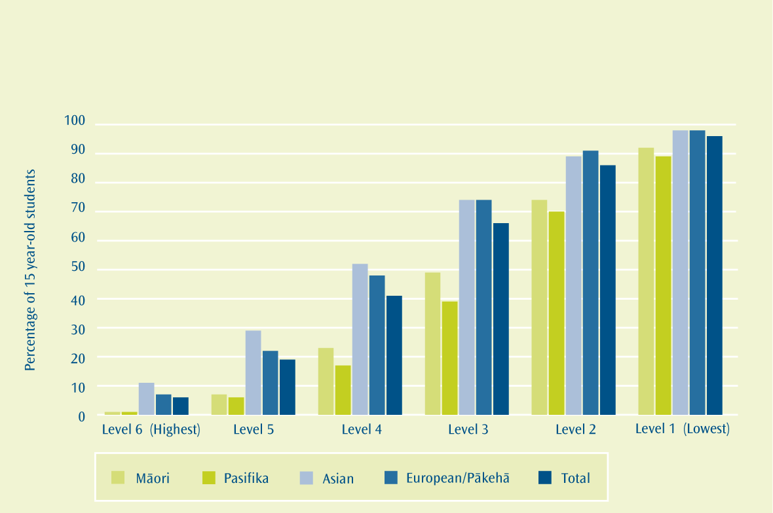
Figure 3.2:Percentage of New Zealand 15 year-old students reaching the PISA mathematical literacy proficiency levels (2006)

Note: 1. ‘Total’ includes ethnic category ‘Other’.
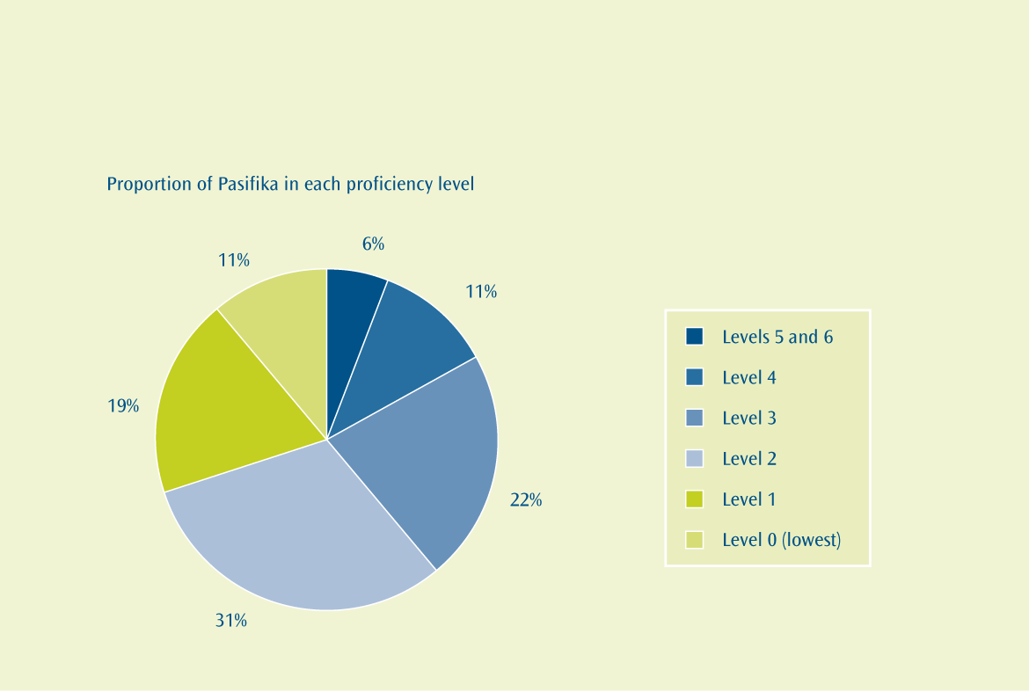
Figure 3.2a: Proportion of Pasifika 15 year-old students, by highest PISA mathematical literacy proficiency level (2006)

As shown in Figure 3.2a above, 53 percent of Pasifika 15 year-old students reached either level 2 or 3 as their highest PISA mathematical literacy proficiency level in 2006, while one in every six reached level 4 or higher.
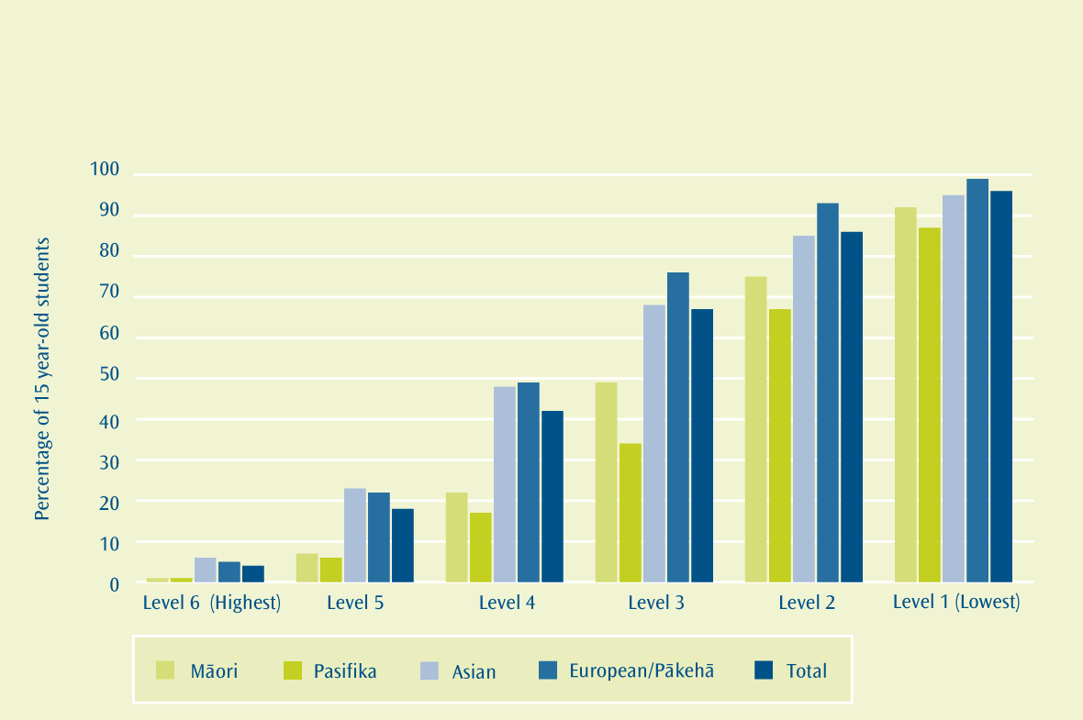
Figure 3.3:Percentage of New Zealand 15 year-old students reaching the PISA scientific literacy proficiency levels (2006)

Note: 1. ‘Total’ includes ethnic category ‘Other’.
A very similar trend to that shown in the previous two figures can be seen in Figure 3.3. Once again, as the scientific literacy proficiency level increases, the gap between Pasifika 15 year-old students and their European/Pākehā and Asian counterparts increases. As with reading and mathematical literacy, Pasifika as well as Māori are greatly under-represented with respect to the proportion of 15 year-old students reaching the higher scientific literacy proficiency levels (levels 3 to 6).

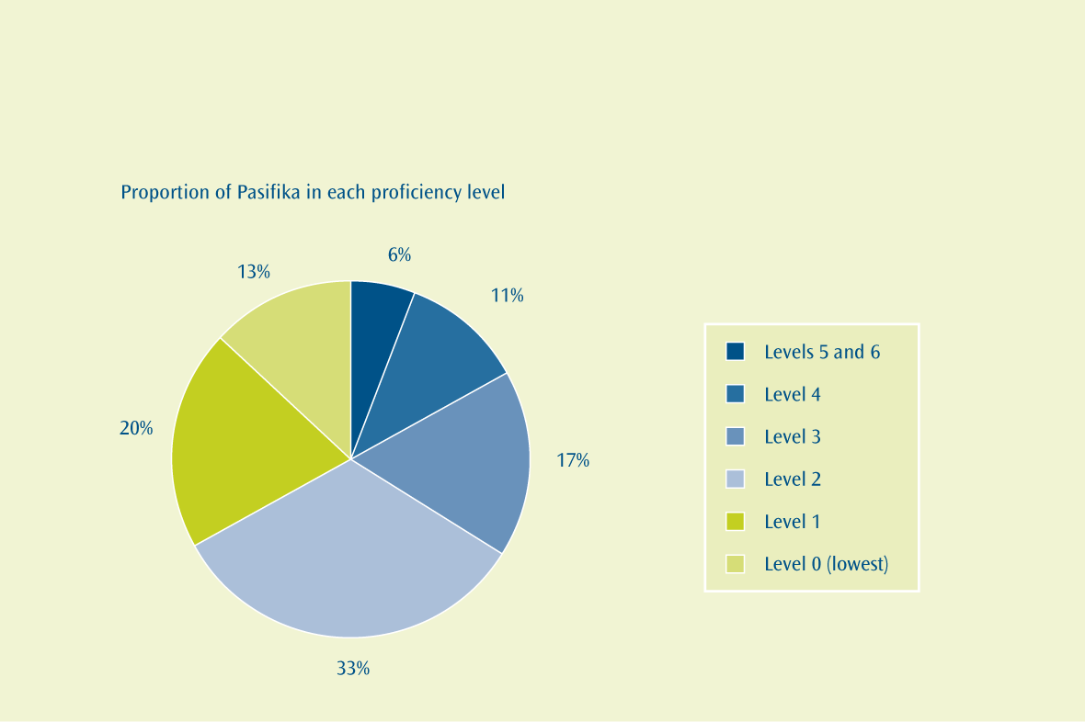
Figure 3.3a: Proportion of Pasifika 15 year-old students, by highest PISA scientific literacy proficiency level (2006)

As shown in Figure 3.3a above, one in every two Pasifika 15 year-old students reached either level 2 or 3 as their highest PISA scientific literacy proficiency level in 2006, while one in every six reached level 4 or higher.
Little or no formal attainment
The wording of the target requires Pasifika to match the performance of all school leavers. The convention in this situation is to compare a group with the sum of the other groups, and not the total, which includes its own data. There is little difference between the non-Pasifika and ‘All Ethnic Groups’ data here anyway.

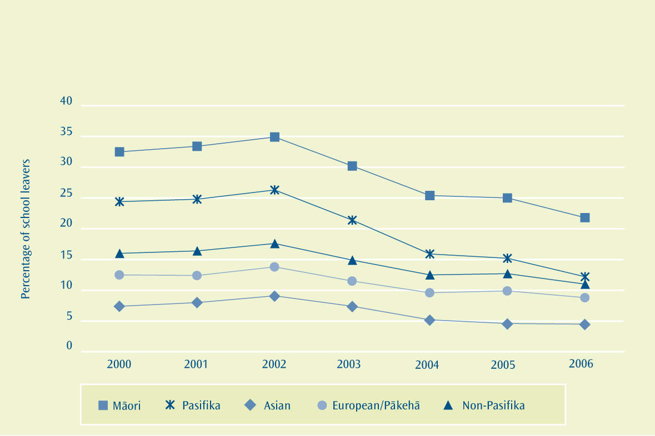
Figure 3.4:Percentage of school leavers with little or no formal attainment, by ethnic group (2000 to 2006)

Note: 1. 2000-2001: No formal attainment or fewer than 12 credits at National Certificate level.
2002-2004: No formal attainment or 1-13 credits at NCEA Level 1.
2005-2006: No formal attainment or 1-13 credits at any NCEA level.
As can be seen in Figure 3.4, the gap between the proportion of Pasifika and the proportion of non-Pasifika students leaving school with little or no formal attainment has been closing over the last four years. Since 2000, the proportion of Pasifika school leavers with little or no attainment has halved. During this same period the proportion of non-Pasifika school leavers with little or no attainment has decreased by almost one-third.
In 2006, the percentage of Pasifika school leavers with little or no formal attainment was 12.2 percent. This was 39 percent more than the rate for European/Pākehā (8.8 percent) and 2.7 times more than the rate for Asian school leavers (4.5 percent). Conversely, this was almost half the rate for Māori (21.8 percent).
Current trends have led to a forecast of 8.9 percent of Pasifika students and 9.4 percent of non-Pasifika students leaving school with little or no formal attainment by 2010. The proportion of students leaving school with little or no formal attainment by 2010 is forecast to decrease for Māori (17.6 percent), European/Pākehā (7.7 percent) and Asian (3.7 percent).
NCEA Level 2 or above
As can be seen in Figure 3.5, the gap between the proportion of Pasifika and the proportion of non-Pasifika students leaving school with NCEA Level 2 or above has decreased over the last year. Since the introduction of NCEA Level 2 in 2003, the proportion of Pasifika school leavers with NCEA Level 2 or above has increased by 17 percent. During this same period the proportion of non-Pasifika school leavers with NCEA Level 2 or above has increased by 14 percent.

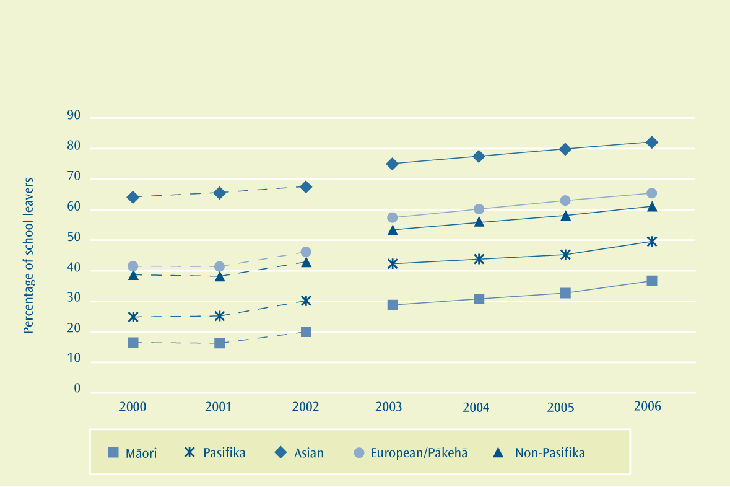
Figure 3.5:Percentage of school leavers with an NCEA Level 2 qualification or above, by ethnic group (2000 to 2006)

Notes: 1. Due to methodological changes in the allocation of attainment levels in 2004, for leavers achieving a qualification between little or no formal attainment and UE standard, the percentages of leavers with at least NCEA Level 2 in 2004 is not comparable with other years, and has been omitted.
2. A direct comparison cannot be made between rates up to and including 2002 and rates for 2003 on, due to the change in qualification structure.
In 2006, half of all Pasifika school leavers achieved NCEA Level 2 or above (49.6 percent). Over 82 percent of Asian school leavers and over 65 percent of European/Pākehā school leavers achieved NCEA Level 2 or above, while the Māori rate was almost 37 percent.
It is forecast that the target of 51 percent of Pasifika school leavers attaining at least NCEA Level 2 by 2010 will be met. The forecast is that 56.9 percent of Pasifika school leavers will have NCEA Level 2 or above by 2010. The proportion of students leaving school with NCEA Level 2 or above by 2010 is forecast to increase for Māori (43.3 percent), European/Pākehā (70.6 percent) and Asian (85.2 percent).
Where to find out more
www.educationcounts.govt.nz

indicators

School leavers with no qualifications

School leavers with NCEA Level 2 or above

School leavers with a university entrance standard

PUBLICATIONS
Focus on Pasifika Students’ Achievement in Reading Literacy: Results from PISA 2000
Pasifika Achievement: High Level Analysis

Effective Teaching
What we have found
Registered teachers that are effective for Pasifika students
In 2007, the Education Review Office (ERO) identified only 14 percent of schools as being consistently effective for Pasifika students. However, there has been recent improvement in Pasifika student achievement, as a result of national professional development programmes in both literacy and numeracy.
Pasifika teachers
Pasifika teachers were under-represented in the teaching sector in 2007, with Pasifika making up 9.6 percent of state school rolls, while making up only 2.8 percent of the teaching workforce. This proportion of Pasifika teachers has increased by 24 percent since 2002. In 2006, Pasifika students made up 5.3 percent of teacher graduates. This is relatively low, however it is greater than the current proportion of Pasifika teachers and should lead to an increase in the proportion of Pasifika teachers in the short term.
Responsiveness through planning and reporting
In 2006, 3.5 percent of schools had a strategic planning target that specifically mentioned Pasifika students.
The most common focus of these targets was in the areas of literacy and numeracy.
What we are trying to achieve
Increase the effectiveness of teaching for Pasifika students.
Target
Increase the number of registered teachers that are effective for Pasifika students.
Target
Increase the number of Pasifika teachers.
Target
Improve responsiveness through planning and reporting.
Why this is important
There is compelling evidence that effective teaching makes the greatest ‘in-school’ difference to students’ learning and achievement outcomes⁶. Like all students, Pasifika students’ achievement is closely linked to quality teaching, high teacher expectations and the involvement of parents.

6 Education Review Office (2006). The Achievement of Pacific Students. Wellington: Education Review Office.
How we are going
Changes in effectiveness of teachers for particular cohorts of students are difficult to measure. The ERO uses a range of indicators to measure teacher effectiveness. A recent ERO⁷ report on Pasifika student achievement found that only 14 percent of schools are consistently effective for Pasifika students. However, three-quarters of schools were effective in some areas and needed to improve in others. Improvement is needed in collecting and analysing student achievement information, analysing information on the attendance and suspension rates of Pasifika students, and engaging with Pasifika communities.
National professional development programmes have resulted in more effective teaching of literacy⁸ and numeracy⁹. Pasifika students have benefited from their teachers’ involvement with these programmes, with increased achievement in reading, writing and numeracy by these students.
Pasifika teachers
Pasifika teachers are under-represented in state schools compared with the proportion of Pasifika students. In 2007, Pasifika students made up 9.6 percent of the school roll, while only 2.8 percent of teachers were of Pasifika ethnicity. However, this teacher proportion was a 24 percent increase since 2002 and, as can be seen in Figure 4.1, the gaps are closing. Since 2002, the proportions of classroom teachers, teachers in management and principals who are Pasifika have all increased at a greater rate than the proportion of Pasifika students. However, the proportion of principals who are Pasifika has remained relatively static since 2003.
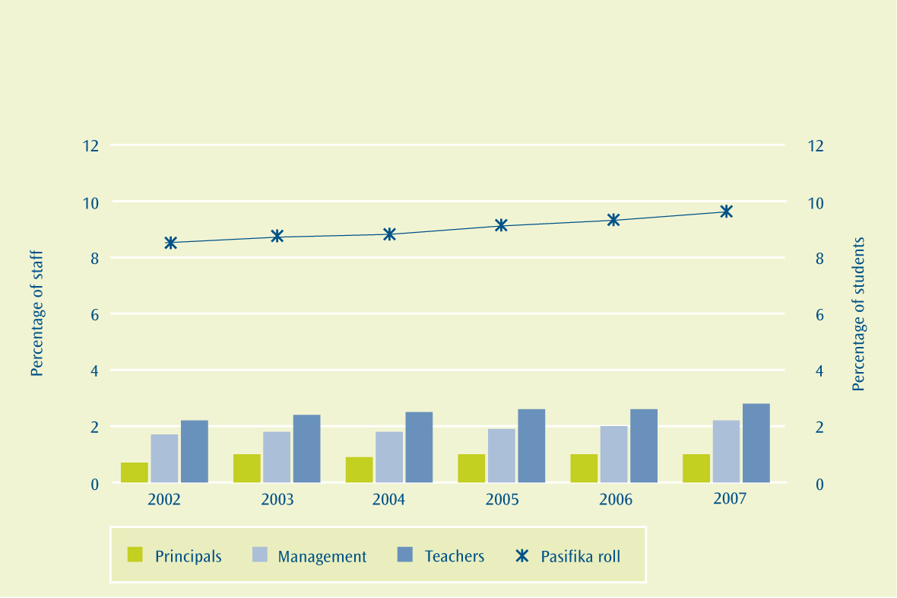
Figure 4.1:Percentage of Pasifika staff and students in state schools (2002 to 2007)

7 ibid.
8 Ministry of Education (2006). Literacy Professional Development Project. Wellington: Ministry of Education.
9 Holton, D. (2005). ‘Findings from the New Zealand Numeracy Development Project 2004’ in Findings from the New Zealand Numeracy Development Project 2004 by Higgins, J., Irwin, K.C., Thomas, G., Trinick, T. and Young-Loveridge, J. Wellington: Ministry of Education.
Teacher education data suggests that this disparity between the proportions of Pasifika teachers and students is unlikely to change in the near future. As can be seen in Figure 4.2, in 2006 Pasifika made up 7.8 percent of teacher education enrolments and 5.3 percent of teacher education graduates. This teacher graduate proportion is greater than the proportion of teachers who are Pasifika (2.8 percent), and this should lead to an increase in the proportion of Pasifika teachers in the short term. Although there was an increase in the proportion of teacher education enrolments who are Pasifika between 2002 and 2003 there has been no change since 2003. There was an increase in the proportion of teacher graduates who are Pasifika between 2002 and 2003; however, this proportion has decreased since 2003.
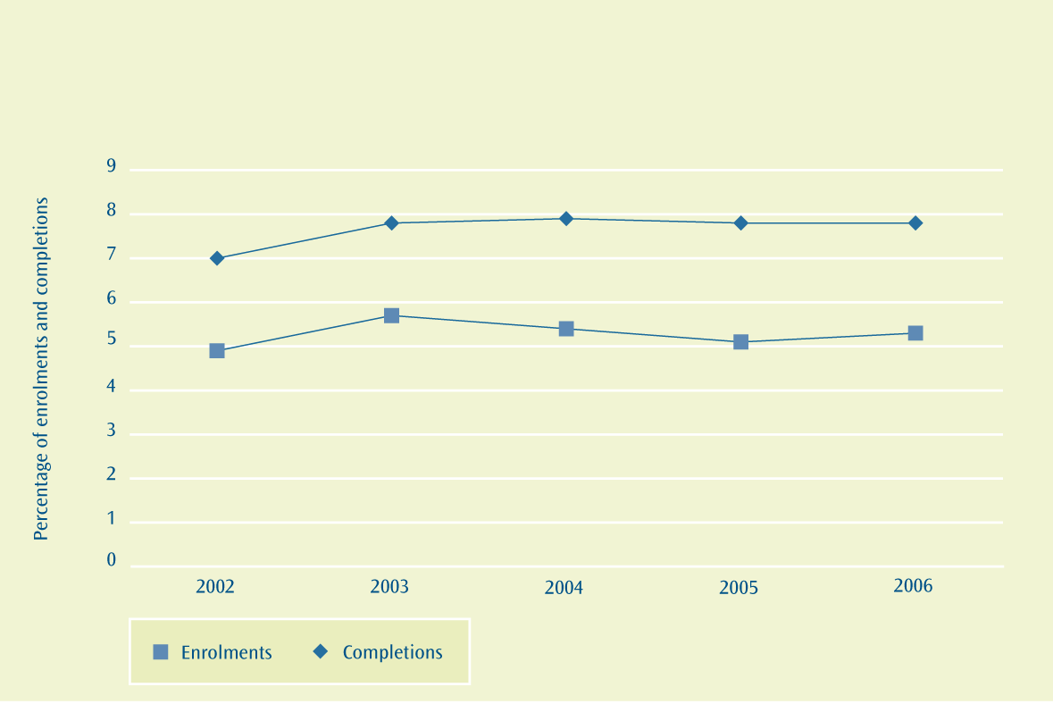
Figure 4.2:Percentage of enrolments and completions from teacher education
programmes who are Pasifika (2002 to 2006)

Responsiveness through planning and reporting
All schools are required to document their strategic planning in their annually updated school charters. Targets are set by boards of trustees based on, amongst other things, analysis of achievement data. In 2006, 3.5 percent of schools had set targets that specifically mentioned Pasifika students, which represents no change on the 2005 figure. The most common targets were with reference to literacy and numeracy skills, and this applied to both Pasifika and non-Pasifika students.
Case Study 3
Pasifika Schooling Improvement Project
Schooling Improvement is a Ministry of Education-funded project that aims to raise student achievement in clusters of schools where there has traditionally been a significant underachievement problem. There are 25 previous, current and emerging schooling improvement clusters around the country. Schools in the clusters work with the ministry and external experts, using evidence and classroom-focused interventions to raise student achievement, mainly in literacy and numeracy.
In these schooling improvement clusters, Pasifika students are often making achievement gains of several months in addition to expected annual progress, but the gap between the average achievement of Pasifika students and of others in the same schools is not closing; in some cases, it is widening. For this reason, the Pasifika Schooling Improvement Project was established to work across existing and emerging initiatives with high numbers of Pasifika students, to help them accelerate the gains for their Pasifika students.
The project is Schooling Improvement’s response to the Pasifika Education Plan, and was developed by a design team that includes representatives from the Pasifika community, practitioners, researchers and the ministry. The project has three main parts, as shown in the diagram on page 34 – research, supporting existing and emerging initiatives, and linking with other programmes.
The research began in early 2008 and is expected to finish in mid-2009. It will provide valuable information to help the existing clusters improve their effectiveness for Pasifika students, and to inform planning for new schooling improvement clusters in areas with high numbers of Pasifika students.
Meanwhile, existing and emerging schooling improvement clusters are being supported to focus on their Pasifika students through a professional learning fono, planned for 2008, and opportunities for individual schools to expand or deepen existing practices they have found to be effective for their Pasifika students.

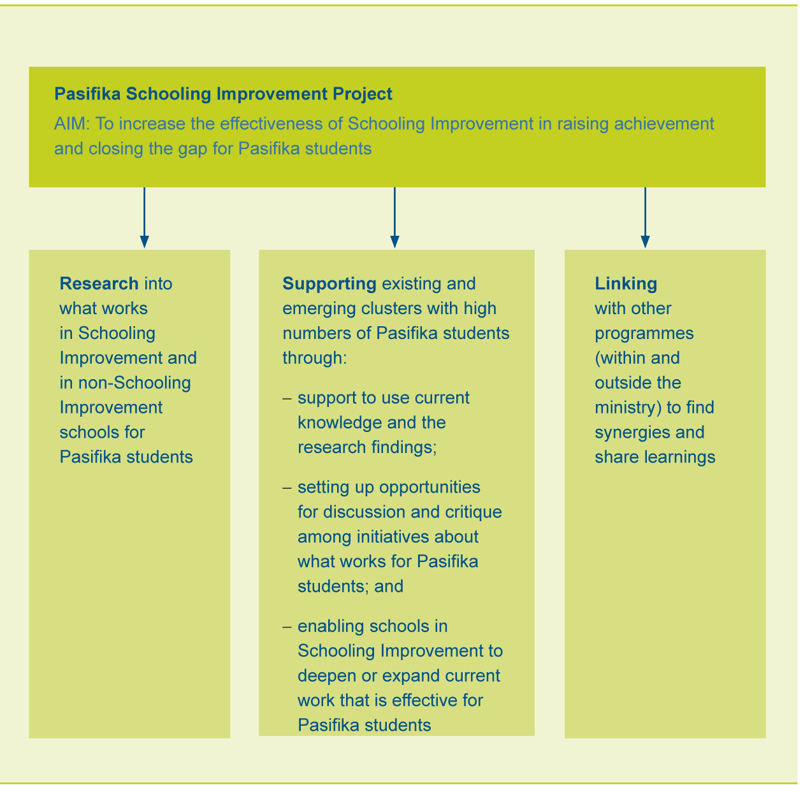

Where to find out more
www.educationcounts.govt.nz

indicators

School leavers with no qualifications

School leavers with NCEA Level 2 or above

School leavers with a university entrance standard

PUBLICATIONS
Focus on Pasifika Students’ Achievement in Reading Literacy: Results from PISA 2000
Pasifika Achievement: High Level Analysis

Case Study 4
Mangere AUSAD reading comprehension project
Since 2003, seven Mangere schools have been working together to raise achievement in reading comprehension at years 4 to 9, with support from University of Auckland researchers. Pasifika students represent over 70 percent of the total student population in these schools. The work came out of the Schooling Improvement work in Mangere and was partly funded through the Teaching and Learning Research Initiative (TLRI) and later by the Extending High Standards Across Schools (EHSAS) programme.
In the first year, the project involved teachers, school leaders and researchers analysing student achievement data and classroom observations in detail, to examine students’ specific strengths and weaknesses in reading comprehension and to identify what teachers needed to know and do differently to address these needs. During the second year, teachers received extensive professional development targeted at the needs identified. Since then, the analysis of data and reflection on practice have continued. Teachers also inquire into their own practice and report back at an annual teachers’ conference.
Over the three years of the initial intervention (March 2003 to November 2005), STAR reading comprehension results at years 4 to 9 for students present across all three years (254 students) improved from a mean of stanine 3.26 to stanine 4.21 (in the average band of 4-6). This increase represents an acceleration of approximately one year in addition to normal development. Gains were similar for Pasifika students and others (mainly Māori) and for both genders. For all year 4 to 9 students (4,400 students – including those who left and arrived during the three years) gains were from a mean of stanine 3.10 to stanine 3.82.
Even after the intensive programme had finished, achievement continued to rise in 2006 and 2007, with achievement for all students rising to a mean of stanine 3.98 in 2006 and 4.04 in 2007. The University of Auckland is currently researching how the schools have managed to sustain continuing gains after the end of the intensive intervention, as continued gains after the end of professional development are rarely recorded internationally.
Student Engagement in Schooling
What we have found
In 2007, age-standardised suspension rates for Pasifika students were lower than Māori suspension rates. However, they were still higher than European/Pākehā and Asian suspension rates respectively. Age-standardised suspension rates for Pasifika had been steadily increasing since 2003, but 2007 saw a substantial decrease of 17 percent from the previous year.
The forecast is for a Pasifika age-standardised suspension rate of 7.9 per 1,000 students by 2008, close to the target of 7.5 per 1,000 students. This forecast takes into account the recent significant improvements in Pasifika suspensions and the increasing proportion of Pasifika students in schools involved in student engagement initiatives. As such it may be potentially more susceptible to variation.
The Ministry of Education is working with schools to strengthen student engagement through working relationships that are focused on raising achievement. Due to the overall trend during 2001 to 2005, which showed an increase in Pasifika suspension rates, it was determined that there was a need to focus on reducing Pasifika suspensions.
Old Target
Reduce the rate of Pasifika suspensions in the compulsory education sector, currently at nine per 1,000, by 20 percent over the next three years.
The majority of suspensions occur for students aged 13 to 15, accounting for 70 percent of total suspensions in 2006. The peak age was 14 years, which had a suspension rate of 24.9 per 1,000 students in 2006. This strong relationship with age is why an age-standardised rate should be used for monitoring and target setting. The new target that takes this into account is stated below.
Revised Target
Reduce the age-standardised rate of Pasifika suspensions in the compulsory education sector currently at 9.3 per 1,000, by 20 percent over the next three years (by 2008).
Why this is important
Student engagement, that is the ‘opportunity to learn’, is an essential part of helping students to reach their educational potential, and obtain the prerequisites for higher education and training, or for many entry-level jobs.
Student disengagement leads to higher risks of negative youth behaviours such as drug and alcohol abuse, and violence. It also causes disruptive behaviour that affects others in the schooling community.
There are clear signals when a student is disengaging from school. These can include a decline in academic performance, as well as behavioural problems and non-attendance. If underlying reasons are not identified and tackled, disengagement could lead to chronic truancy, stand-downs and suspensions, or in the more serious cases exclusion or expulsion of the student. Strategies employed by schools must focus both on regular school attendance by students (student presence) and on student achievement.
How we are going
As can be seen in Figure 5.1, the gap between the age-standardised suspension rate for Pasifika students and non-Pasifika students has varied over the past seven years and, due to a substantial decrease (17 percent) in Pasifika suspensions between 2006 and 2007, has narrowed again after three years of widening. The age-standardised suspension rate for Pasifika students in 2007 was at a very similar level to what it was in 2000; it has increased by 1 percent. During this same period the age-standardised suspension rate for non-Pasifika students has decreased by 19 percent.

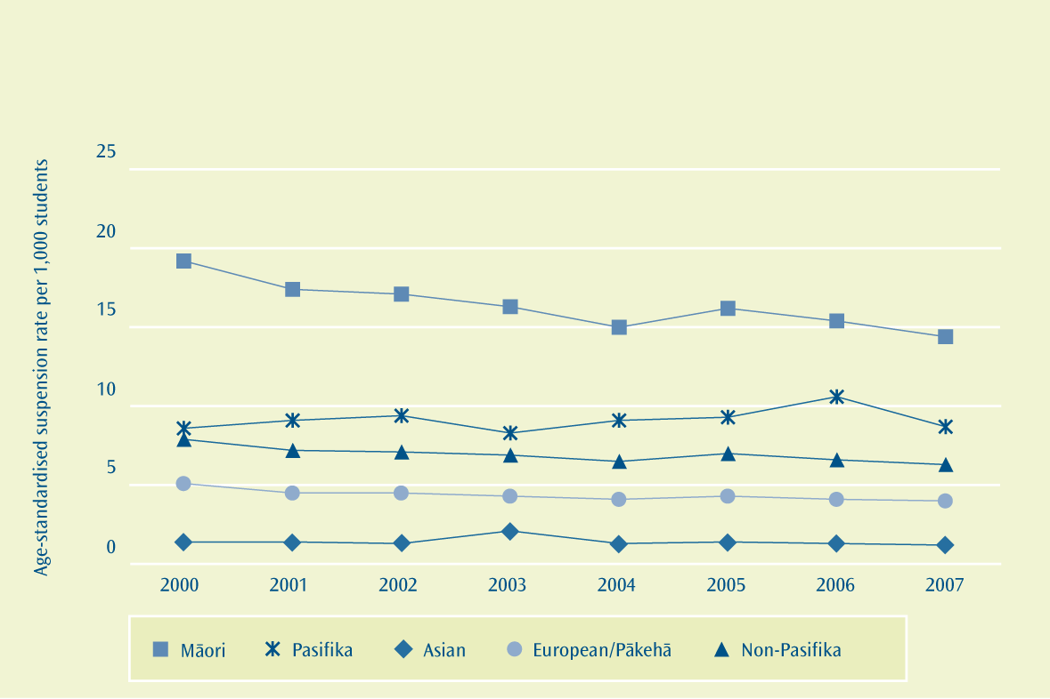
Figure 5.1:Age-standardised suspension rates, by ethnic group (2000 to 2007)

Note: 1. NZAID students, foreign fee-paying students, Correspondence School students, adult students (age > 19) and private students are excluded.
In 2007, the age-standardised suspension rate for Pasifika was 8.7 per 1,000 students; this was over two times and over seven times greater than the rates for European/Pākehā (4.0 per 1,000 students) and Asian (1.2 per 1,000 students) respectively. Conversely, in 2007, the age-standardised suspension rate for Māori (14.4 per 1,000 students) was 65 percent greater than for Pasifika.
In an effort to counter the disproportionately high number of Māori suspensions, the Suspension Reduction Initiative (SRI) was established in 2001. The SRI, part of the Student Engagement Initiative (SEI) since 2003, initially involved working with 65 secondary schools with historically high suspension rates for Māori. During the period 2000 to 2007, the Māori suspension rate within the original group of schools, which were part of the SEI in 2001, reduced from 73.1 per 1,000 to 30.3 per 1,000 students.
As a result of rising suspension rates since 2000, Pasifika students became a focus of the SEI in July 2006. The same approach that was used to reduce Māori suspensions has been used to reduce Pasifika suspensions, with schools with high Pasifika suspension rates being able to work with the Ministry of Education to implement strategies to reduce their suspension rates. This work has helped contribute to the 17 percent reduction in Pasifika suspensions between 2006 and 2007.
There has been an increase in the proportion of Pasifika students in SEI schools where decreases in suspensions are more pronounced. Assuming Pasifika rates continue to show improvements similar to those achieved by non-Pasifika during the first years of the SEI, the forecast position is a Pasifika age-standardised suspension rate of 7.9 per 1,000 students by the end of 2008.

What we are doing
The ministry focuses on student engagement through Schooling Improvement initiatives. An example of this is the Manurewa Enhancement Initiative (MEI).
The MEI includes just over 16,000 students, 31 percent of whom are Pasifika, and includes a student engagement and attendance strand to its focus on raising student achievement. This work includes student mentoring targeted to identified students at risk of disengagement; and a student engagement contract with the Manurewa District Truancy Services. The service provides individualised support for identified students to transition them back into being engaged with school.
Pasifika students in the Northern Region Student Engagement Initiative (SEI) have been a focus since July 2006 as a result of an increasing Pasifika suspension rate. A number of Northern Region SEI schools have a high Pasifika population.
Senior management in schools have worked with ministry staff to develop strategies for better engagement with families through newsletters, school information evenings and personal interviews.
Early intervention in relation to attendance and behaviour issues has been a focus, along with a restorative approach to behaviour management. Personal goal setting with students and an increase in support services for students are helping.
Evidence to date from the SEI work suggests that it takes two to three years to implement changes that are self sustaining. The data for 2007 Pasifika suspension rates is looking promising as Figure 5.1 shows.
In 2008, work will revolve around collecting, using and analysing good attendance data, engagement in the classroom with an emphasis on positive student/staff relationships, and continued development of good transition practices for students starting high school.
Case Study 5
Tangaroa College has reduced its Pasifika suspension rate from 16 per 1,000 students in 2006
to 2 per 1,000 students in 2007. The school considers its focus on engagement with families and caregivers has contributed to this reduction.
Senior management staff have meaningful conversations with students, families and caregivers about achievement and attendance.
The focus on positive NCEA results in the first instance is encouraging parents and caregivers to come to school, and to move forward positively when there are attendance or behaviour issues. Specific goals are then made for these students and support systems are put in place.

Where to find out more
www.educationcounts.govt.nz

indicators

Truancy from school

Stand-downs and suspensions from school
Exclusions and expulsions from school
Early leaving exemptions
Retention of students in senior secondary schools

PUBLICATIONS
Strengthening Education in Mangere and Otara (SEMO)

Attendance and Absence in New Zealand Schools

Pasifika Representation on School Boards of Trustees
What we have found
Pasifika representation on school boards of trustees is still low. Currently 3.5 percent of all boards of trustees’ members are Pasifika, while 3.9 percent of all elected, appointed or co-opted boards of trustees’ members are Pasifika. These are both relatively large increases since 2000.
The 2007 figure of 3.5 percent of all boards of trustees’ members being Pasifika is short of the target of 4.2 percent.
Schools that have a relatively high number and proportion of Pasifika students have shown considerably higher Pasifika representation. In 2006, 19.3 percent of all elected, appointed or co-opted boards of trustees’ members were Pasifika in these schools.
If only schools that have a relatively high number and proportion of Pasifika students are analysed then a revised target would be: “Increase Pasifika board representation from 18.6 percent to 25.2 percent of trustees by the end of 2007”. The 2007 figure of 19.3 is short of this proposed target.
What we are trying to achieve
Increase Pasifika representation, strengthen their retention on school boards of trustees and increase boards’ understanding and management of Pasifika issues in education.
Target
Increase Pasifika board representation from 3.1 percent to 4.2 percent of all trustees by the end
of 2007.
Why this is important
Active participation by Pasifika parents, families and communities in planning, development and delivery of education services will help to ensure that those services are appropriate and effective for Pasifika students. Pasifika representation on boards of trustees is one key mechanism for participation.
How we are going
Pasifika representation in all schools
In 2007, the total number of all Pasifika boards of trustees’ members was 654. As can be seen in Figure 6.1, this accounts for 3.5 percent of all boards of trustees’ members. This is a 47 percent increase on the 2.4 percent of board membership that was Pasifika in 2000 (492 Pasifika members).
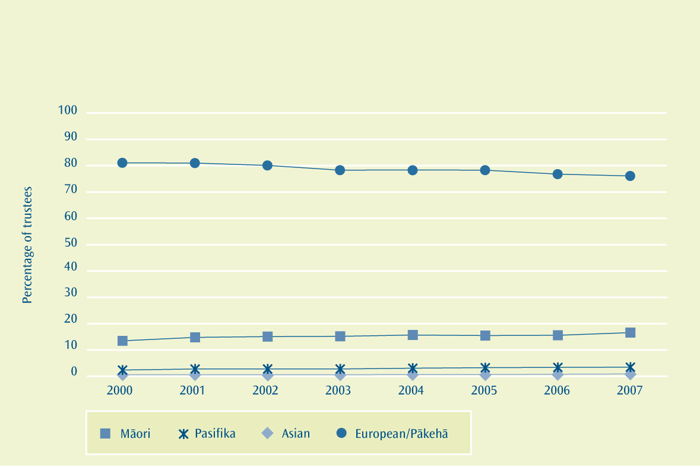
Figure 6.1:Proportion of all boards of trustees’ members, by ethnic group (2000 to 2007)

In 2007, 487 of the 654 Pasifika board members were either elected, appointed or co-opted Pasifika boards of trustees’ members. As shown in Figure 6.2, this accounts for 3.9 percent of all elected, appointed or co-opted boards of trustees’ members. This is a 42 percent increase on the 2.8 percent of board membership accounted for by Pasifika in 2000 (394 Pasifika members). This increase since 2000 is the largest increase of the ethnic groups.

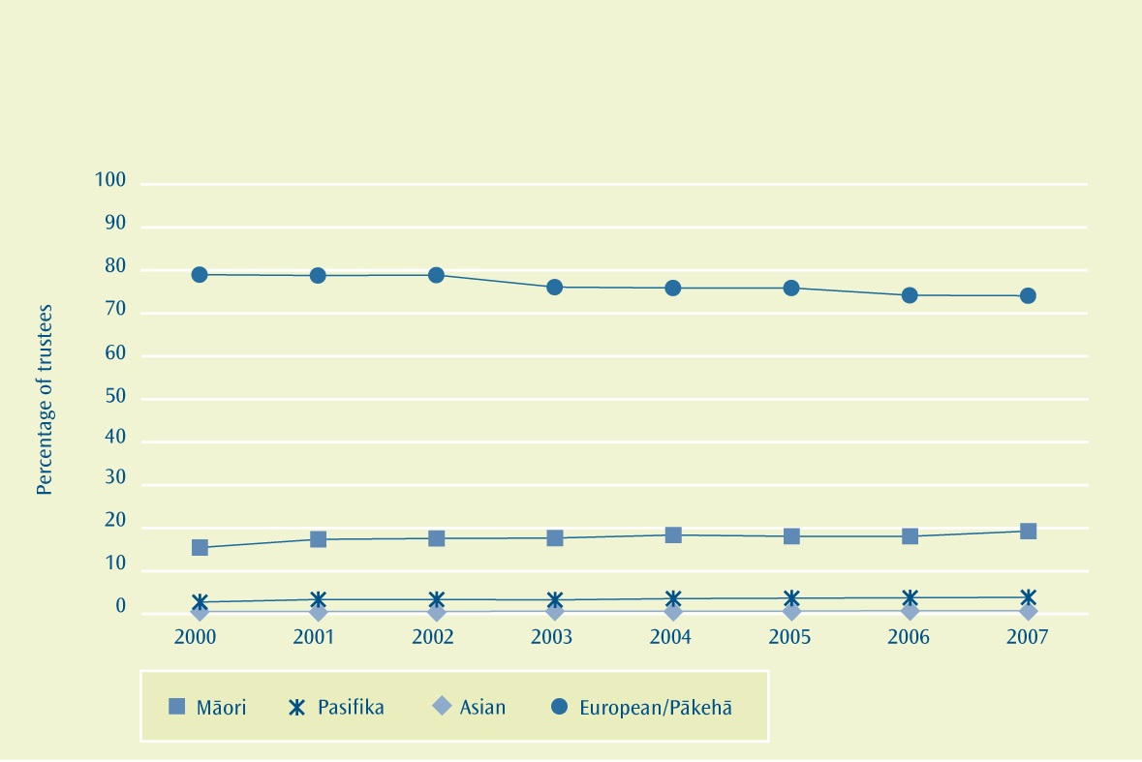
Figure 6.2:Proportion of elected, appointed or co-opted boards of trustees’ members, by ethnic group (2000 to 2007)

Note: 1. Members that are elected, appointed or co-opted.
The target was to have Pasifika board representation of 4.2 percent of all trustees by the end of 2007. Unfortunately the 2007 representation of 3.5 percent is short of this target.
Pasifika representation in schools that have large Pasifika student roll numbers
To get a better understanding of representation on boards of trustees by Pasifika parents, families and communities, this section restricts schools to those that have five or more Pasifika students and Pasifika students make up at least 10 percent of the roll.

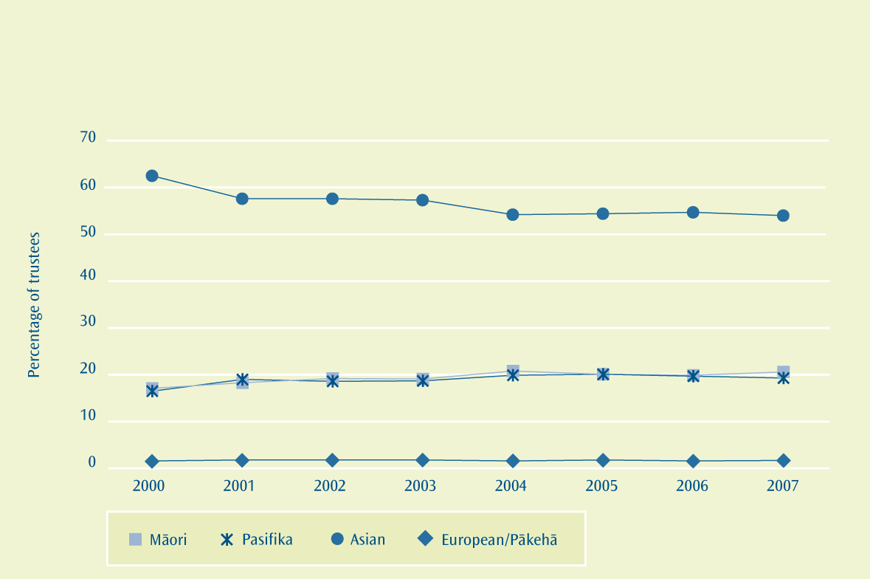
Figure 6.3:Proportion of elected, appointed or co-opted boards of trustees’ members, by ethnic group in Pasifika schools (2000 to 2007)

Notes: 1. Schools included in this analysis have five or more Pasifika students who make up at least 10 percent of the roll.
2. Members that are elected, appointed or co-opted.
In 2007, there were 403 elected, appointed or co-opted Pasifika boards of trustees’ members in the schools included in this analysis. As can be seen in Figure 6.3, this accounts for 19.3 percent of all elected, appointed or co-opted boards of trustees’ members of these schools. This is a 17 percent increase on the 16.5 percent of board membership accounted for by Pasifika in these schools in 2000 (341 Pasifika members). This increase since 2000 is the second largest increase of the ethnic groups, with Māori having a slightly larger increase. However, most of this increase occurred between 2000 and 2001.
If this more tightly focused method for measuring Pasifika representation is converted to the target it would be: “Increase Pasifika board representation from 18.6 percent to 25.2 percent of trustees by the end of 2007”. Unfortunately the 2007 figure of 19.3 percent is short of this proposed target.
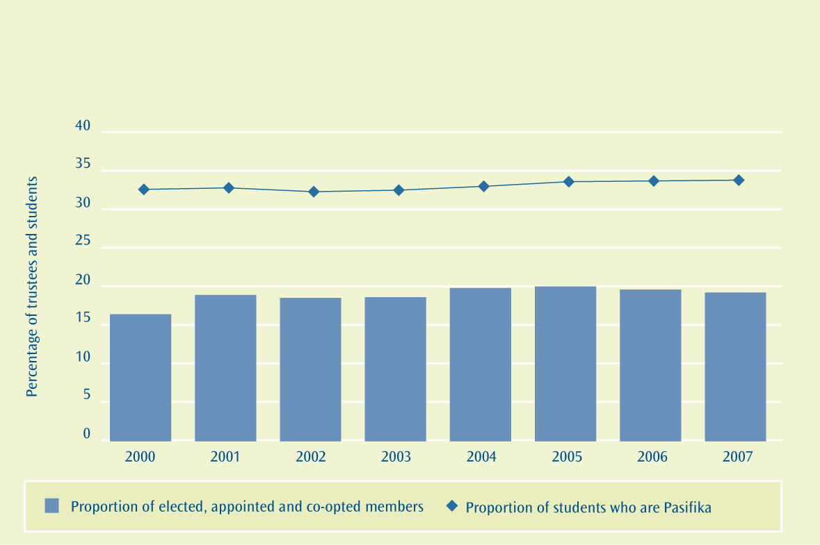
Figure 6.4:Proportion of elected, appointed or co-opted boards of trustees’ members, by ethnic group and proportion of students who are Pasifika (2000 to 2007)

Notes: 1. Schools included in this analysis have five or more Pasifika students who make up at least 10 percent of the roll.
2. Members that are elected, appointed or co-opted.

As shown in Figure 6.4, the proportion of Pasifika on boards of trustees is lower than the proportion of Pasifika students in these schools. This is largely due to demographics; the proportion of the school-age population who are Pasifika is considerably higher than the proportion of the population aged 25 to 50 who are Pasifika. This gap has narrowed between 2000 and 2007; however, most of the gap was narrowed between 2000 and 2001.
Where to find out more
www.educationcounts.govt.nz

indicators

School trustees who are Pasifika

School trustees who are Māori
PUBLICATIONS
Strengthening Education in Mangere and Otara (SEMO)
Pacific Islands School Community Parent Liaison Project Case Study
Results of the Schools Boards of Trustees Elections

Family and Community Engagement
What we are trying to achieve
Increase parent, family and community engagement in education.
Target
Establish up to five school community liaison clusters that are focused on student achievement
by 2008.
Why this is important
Research shows that families and communities play a significant role in determining student outcomes.
Active participation by Pasifika parents, families and communities in planning, development and delivery of education services will help to ensure that those services are appropriate and effective for Pasifika students. School community clusters are one key mechanism for active participation where this is tightly focused on student achievement.
How we are going
There are currently six clusters under the Pasifika School Community Parent Liaison (PSCPL) initiative. Clusters are located in Wellington (1), Auckland (3) and Christchurch (2) and involve a range of school staff, parents and families. Each cluster employs a Pasifika Liaison Adviser, who provides the cluster with support and professional development over three years.
The work in 2007 has included extending the roll-out of the PSCPL resource Connections and Conversations to schools through School Support Services. Those clusters that were due to finish their PSCPL term of three years in 2007 have been renewed.
The ministry also works through its national and regional Pasifika Advisory Groups to engage with Pasifika families and communities on education issues.
Where to find out more
www.educationcounts.govt.nz

PUBLICATIONS
Pacific Islands School Community Parent Liaison Project Case Study
Literature Review on the Effective Engagement of Pasifika Parents and Communities in Education

Participation in Tertiary Education
What we have found
In provider-based learning, where learning is mainly undertaken within a tertiary education organisation, via lectures, there has been an increase in the participation of Pasifika over recent years.
The age-standardised participation rate of Pasifika in bachelors degree-level study is the lowest of all major ethnic groups. Even though this rate has increased faster than for any other ethnic group, the Pasifika participation rate in tertiary education in 2010 is forecast to be below the target.
Pasifika tertiary students are also less likely to stay enrolled and/or complete their tertiary qualifications than all other ethnic groups. It is also forecast that the 2010 Pasifika retention rate for the 2006 cohort will not meet the target.
In workplace learning, there are has been a steady rise in participation of Pasifika. Pasifika who are in industry training are less likely to be studying a qualification above level 3 of the National Qualifications Framework than Māori, non-Māori and non-Pasifika. It is forecast that the proportion of Pasifika industry trainees studying at level 4 or above will decrease. This trend is the same for all industry trainees studying at level 4 or above. In Modern Apprenticeships, Pasifika are under-represented compared with their share of the national population aged 15 to 24 years. Pasifika make up 9 percent of the population aged 15 to 24 years. However, they make up only 3 percent of all Modern Apprenticeships. This is forecast to increase to 4 percent in 2010.
What we are trying to achieve
Increase Pasifika students’ participation and improve retention in tertiary education.
Target
Increase the Pasifika participation rate at degree level and above from 3.4 percent in 2004 towards a total of 5.0 percent by 2010.
Old Target
Increase the Pasifika five-year retention rate at all qualification levels from 42 percent (2000 to 2004) towards 45 percent by 2010.
Due to methodological changes, the Pasifika five-year retention rate for students starting in 2000 has changed. The target has been revised accordingly. See technical note 1 (page 79) for more information.
Revised Target
Increase the Pasifika five-year retention rate at all qualification levels from 45 percent (2000 to 2004) towards 48 percent by 2010.
Target
Increase the proportion of Pasifika in industry training studying at level 4 or higher from 23 percent in 2004 towards 30 percent by 2010.
Target
Increase the participation of Pasifika people in Modern Apprenticeships closer to the rate that is in proportion to the Pasifika share of the national working-age population by 2010.
Why this is important
Participation helps understanding of how well the population is accessing learning opportunities after compulsory schooling. Success in tertiary education provides benefits to the individual and to society, not only in terms of increased employment opportunities and income but also in terms of wellbeing and social capital.
Continued participation in learning and education over a lifetime is a feature of the knowledge society. With rapid changes in society, economy and technology, skills can quickly become outdated. It is important that people continue to access education after they have completed their initial education.
How we are going
Participation at degree level and above
As can be seen in Figure 8.1, the age-standardised participation rate for Pasifika students studying at degree level or above is 3.4 percent. This rate is lower than for both European/Pākehā (4.7 percent) and Māori (3.6 percent).
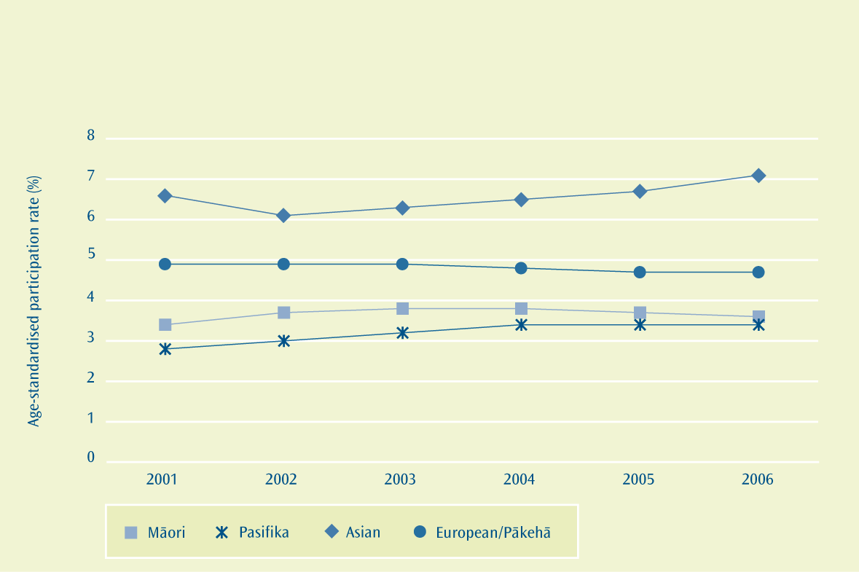
Figure 8.1:Age-standardised participation rates for degree level and above, by ethnic group (2001 to 2006)

Pasifika have had a 23 percent increase since 2001 and this is the largest increase of the ethnic groups. This compares with a national decrease of 2.5 percent and an increase of 6.8 percent for Māori.
The forecast for Pasifika participation in 2010 is 4.0 percent. This is below the target of 5.0 percent.
Five-year retention rate
As shown in Figure 8.2, Pasifika students are more likely than students of other major ethnic groups to withdraw from, and/or not complete, their tertiary qualification within five years of starting. Of all Pasifika students who started a qualification at a public tertiary institution in 2002, 43 percent had either completed it or were still enrolled in the qualification five years later. This compares with 54 percent for Māori students, 51 percent for European/Pākehā students and 65 percent for Asian students.

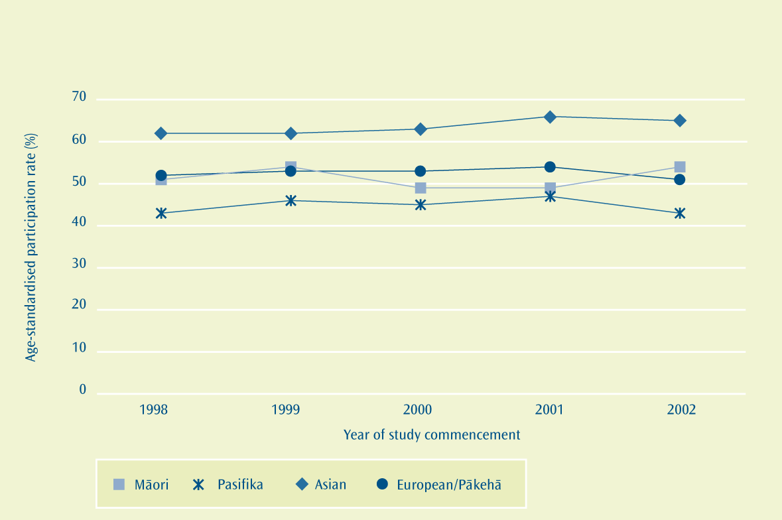
Figure 8.2:Five-year retention rates (percentage) of tertiary education students in public tertiary education institutions, by ethnic group and year of study commencement between 1998 and 2002

Based on recent trends, the forecasted retention rate of Pasifika students who enrolled in a tertiary education qualification in 2006 was 44 percent. This includes students who are either still enrolled in or are completing their qualification by 2010. This is below the target of 48 percent of Pasifika.
Participation in industry training
As can be seen in Figure 8.3, the proportion of the Pasifika labour force participating in industry training has, along with that of other ethnic groups, been steadily rising since 2000 as government has progressively increased funding for this programme. In 2006, 11.9 percent of the Pasifika labour force participated in industry training, while in comparison 16.6 percent of the Māori labour force was engaged in industry training. This was more than twice the rate for non-Māori (7.5 percent of the non-Māori labour force).

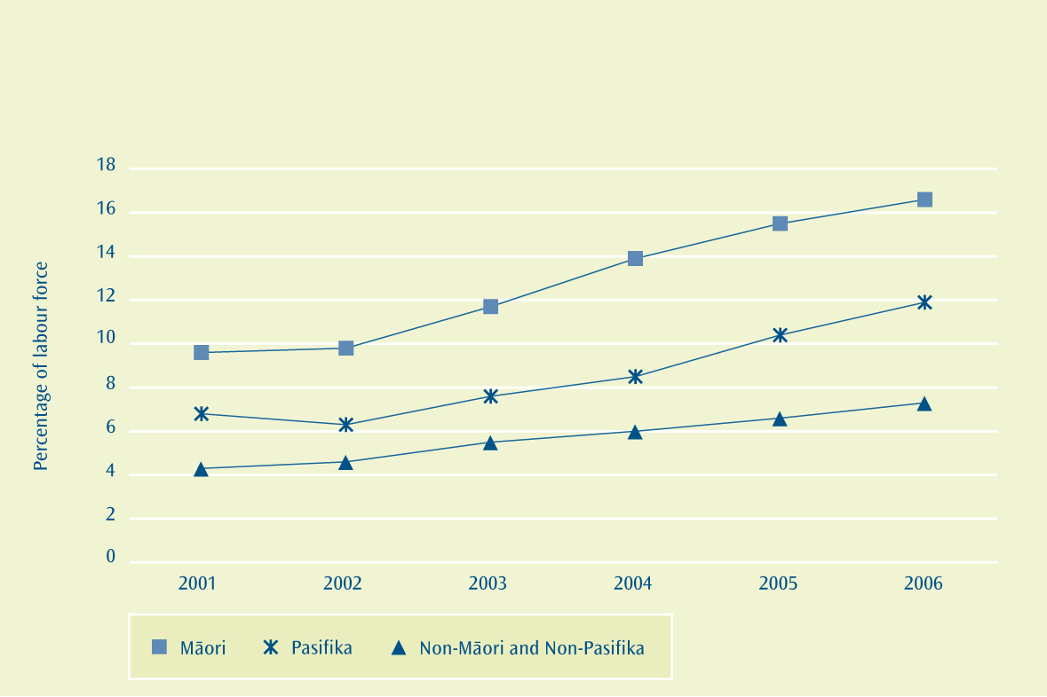
Figure 8.3:Percentage of labour force in industry training, by ethnic group (2001 to 2006)

While Pasifika peoples have comparable participation in industry training, the target is to improve industry trainees’ participation at level 4 and above. In other words, it is looking to increase the proportion of Pasifika industry trainees studying at higher levels (levels 1 to 3 equate to school-level study, while levels 4 and above are tertiary-level study).

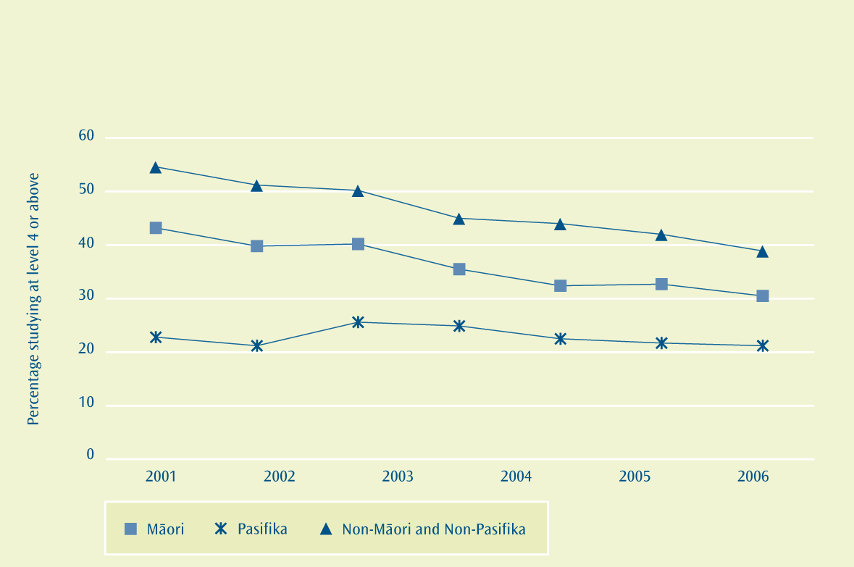
Figure 8.4:Proportion of learners in industry training, of each ethnic group, who are studying at level 4 or above (2001 to 2006)

As can be seen in Figure 8.4, of the Pasifika learners participating in industry training in 2006, 21.2 percent were studying at level 4 or above. This was the lowest proportion of the ethnic groups. Māori had a participation rate at level 4 or above of 30.5 percent, while non-Pasifika and non-Māori had the highest participation rate at 38.9 percent.
Since 2000, the proportion of all industry trainees studying at level 4 or above has fallen as industry training has broadened. The proportion of Pasifika students studying at level 4 has decreased by 7 percent. This is good in comparison with other ethnic groups, where the rates have decreased by more than four times this rate. The forecast is that 19 percent of Pasifika learners will be participating in industry training at level 4 or above by 2010. This is well below the target of 30 percent.
Participation in Modern Apprenticeships
As is shown in Table 8.1, the number of Pasifika undertaking Modern Apprenticeships has increased more than that of all the other major ethnic groups over the period 2001 to 2006.
Table 8.1: Number of Modern Apprenticeships, by ethnic group (2001 to 2006)
Ethnic group | 2001 | 2002 | 2003 | 2004 | 2005 | 2006 | Percentage change 2001 to 2006
Māori | 380 | 667 | 928 | 1,025 | 1,198 | 1,430 | 276%
Pasifika | 47 | 91 | 120 | 161 | 213 | 290 | 517%
European/Pākehā | 1,570 | 3,457 | 5,051 | 5,746 | 6,621 | 7,284 | 364%
Total | 2,049 | 4,344 | 6,259 | 7,175 | 8,390 | 9,466 | 362%

However, while the proportion of Māori and European/Pākehā in Modern Apprenticeships reflects their shares of the national population, Pasifika are significantly under-represented in Modern Apprenticeships. As can be seen in Figure 8.5, in 2006 Pasifika made up only 3 percent of all Modern Apprenticeships while they made up 9 percent of the population that Modern Apprenticeships are aimed at (15 to 24 year-olds).
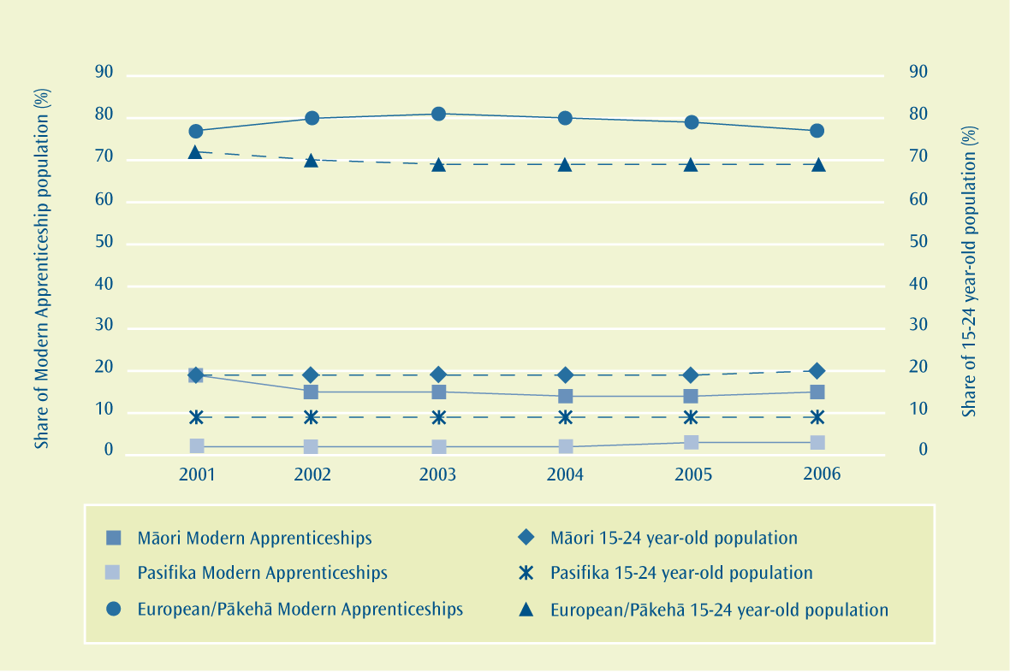
Figure 8.5:Share of Modern Apprenticeship learners by ethnic grouping versus share of population aged 15 to 24 years by ethnic grouping (2001 to 2006)

The forecast is that 4 percent of all Modern Apprenticeships will be Pasifika in 2010. This is an increase towards the Pasifika share of the population aged 15 to 24 years.

What we are doing
The Tertiary Education Strategy 2007/12 sets out the contributions government expects from the tertiary system over the next five years. It is expected that if tertiary education organisations shift to respond to the priorities outlined in the Strategy, this will support the realisation of the Pasifika Education Plan targets. One area of focus for the Strategy is “ensuring maximum educational opportunity for all New Zealanders”. For Pasifika, this means a focus on building on the recent successes to lift achievement at all levels of tertiary education. The Tertiary Education Commission will look for evidence in tertiary education organisations’ Plans, and through the quality assurance system, that tertiary education organisations are taking steps to ensure the education they offer supports Pasifika students to achieve their aspirations. The following are the priority outcomes sought through the Strategy:
- Increasing the educational success for young New Zealanders to achieve qualifications at level 4 and above by age 25
For Pasifika, this means tertiary education organisations (TEOs) should ensure they have in place the necessary systems and structures to support Pasifika success, and strong links with schools and Career Services to ensure Pasifika can make informed study choices.

- Increasing literacy, numeracy and language levels for the workforce
Literacy, numeracy and language form a necessary foundation to support the achievement of Pasifika Education Plan targets at the higher levels of tertiary education. This means providing effective literacy, numeracy and language teaching in contexts that make sense to the student (such as workplaces). The high number of second language learners among Pasifika means that language will need to be a specific focus for tertiary education organisations working with Pasifika.
- Increasing the achievement of advanced trade, technical and professional qualifications to meet regional and national industry needs
For Pasifika, this means increasing Pasifika achievement across a range of qualifications, including those accessed through Modern Apprenticeships, to support Pasifika economic development and to meet regional and national industry needs. This means ensuring Pasifika can choose from, and move into, a range of careers and make a key contribution to New Zealand’s economic transformation.
The Ministry of Education, alongside the Tertiary Education Commission (TEC) and other government agencies, works to increase Pasifika participation through:
- student support – all New Zealanders are supported through the student loans and allowances schemes to address the financial barriers to participating in tertiary education. Student allowances are designed to provide assistance to those who are unable to support themselves financially while undertaking full-time study;
- Step Up Scholarships – these also provide support for students from low-income backgrounds who are studying in approved degree courses. From 1 January 2008, the number of Step Up Scholarships was to increase by 50 percent and the scheme has been redesigned to increase access opportunities for students from low-income backgrounds;
- Special Supplementary Grants – the purpose of these grants is to provide additional funding for tertiary education institutions to improve participation, retention and achievement of Māori and Pasifika learners at higher levels of tertiary education through the provision of services and initiatives that are developed to meet the specific learning needs of these groups. This funding will continue to be made available within the new funding system operating from 1 January 2008;
- Modern Apprenticeships and industry training – the Tertiary Education Commission has an ongoing role in these programmes, working with a wide range of stakeholders, to support the participation and achievement of under-represented groups, including Pasifika peoples. The Commission has held regional workshops with key stakeholders that have been successful in strengthening stakeholder networks to promote industry-driven strategies to enhance participation of under-represented groups;
- Tupulaga Le Lumana’i (Skill Enhancement) – this is provided specifically to support young Pasifika people to undertake training to meet the skills required for an identified industry, which might lead to a Modern Apprenticeship or industry training agreement, or further tertiary study;
- improving the participation, retention and success of Pasifika in tertiary education – this requires a partnership between learners, their families and communities, TEOs, and government agencies;
- requiring that TEOs and the funder, the TEC, deeply understand the tertiary education needs and aspirations of Pasifika peoples – it also implies that Pasifika communities will take an active ownership interest in the quality, relevance and responsiveness of the tertiary education system;
- establishing in 2007 a stakeholder engagement function to better understand the tertiary education needs of stakeholders across industries, sectors and regions;
- the Stakeholder Engagement Manager Pasifika, who works with Pasifika communities throughout the country to help explain the tertiary education structure and recent reforms; and
- the regional facilitation process that results in the production of a regional statement of tertiary education needs – this is one vehicle for bringing about closer and more productive relationships between TEOs and Pasifika communities.
Where to find out more
www.educationcounts.govt.nz

indicators

Participation rates in tertiary education

Tertiary student retention
Participation in industry training

International students enrolled in formal tertiary education

Enrolments in foundation education courses

PUBLICATIONS
Pacific Peoples and Tertiary Education: Issues of Participation

Profile and Trends: New Zealand’s Tertiary Education Sector

Tertiary Education Strategy – Monitoring and Education

Achievement in Tertiary Education
What we have found
The five-year higher-level progression rate for Pasifika students that complete a qualification, at any level, has increased over the past four years. Pasifika students are more likely than European/Pākehā and Asian students to progress on to a higher qualification within five years of graduation.
There has been a slight increase in the five-year completion rate of bachelors degree-level qualifications for Pasifika students over the past five years; however, Pasifika students are less likely to complete their bachelors degree-level qualifications within five years than their Māori, European/Pākehā and Asian counterparts.
The Pasifika five-year higher progression rate is expected to be above the target. The forecast Pasifika five-year bachelors degree-level completion rate is, however, expected to be below the target.
What we are trying to achieve
Increase Pasifika student achievement and progression in tertiary education at all levels, particularly at the bachelors degree level and above.
Old Target
Maintain the five-year higher-level progression rate at 31 percent or higher.
Due to methodological changes the Pasifika five-year higher-level progression rate for students starting in 2000 has changed. The target has been revised accordingly. See technical note 1 for more information page 79.
Revised Target
Maintain the five-year higher-level progression rate at 34 percent or higher.
Old Target
Increase Pasifika five-year bachelors degree-level completion rates from 32 percent (2000 to 2004) towards 40 percent by 2010.
Due to methodological changes the Pasifika five-year bachelors degree-level completion rate for students starting in 2000 has changed. The target has been revised accordingly. See technical note 1 for more information.
Revised Target
Increase Pasifika five-year bachelors degree-level completion rates from 30 percent (2000 to 2004) towards 38 percent by 2010.
Why this is important
Successfully completing a tertiary education qualification provides, on average, better economic outcomes. A tertiary education qualification also provides a sound foundation for lifelong learning, and contributes to developing a workforce and society with the ability to meet the challenges of today and the future.
How we are going
Higher-level progression rates
As can be seen in Figure 9.1, Pasifika students who complete a tertiary education qualification are more likely to progress on to further study in a higher-level qualification than European/Pākehā students and Asian students. This rate of progression has increased more for Pasifika students over the past four years than for European/Pākehā, Māori and Asian students.
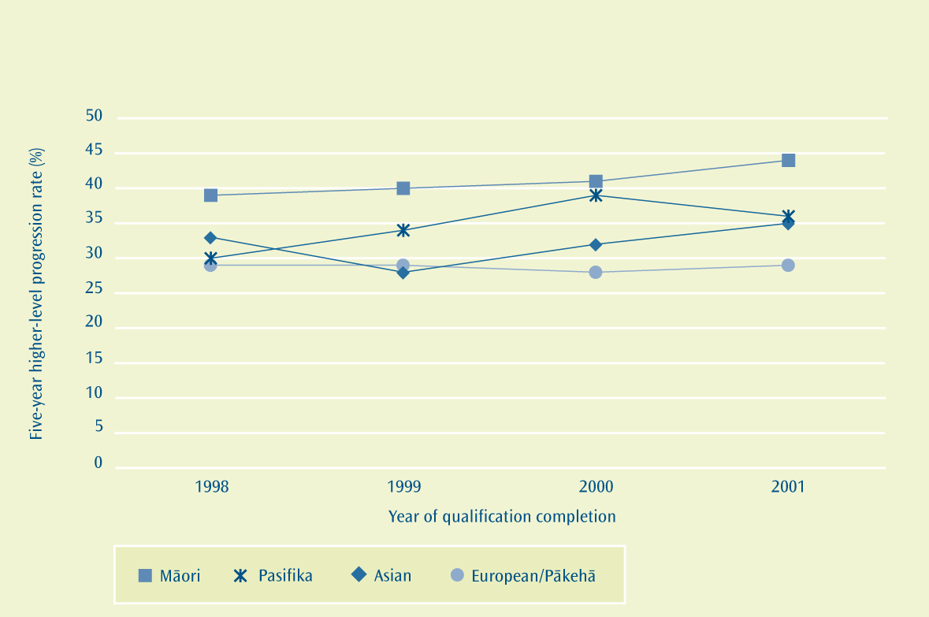
Figure 9.1:Five-year higher-level progression rates for students at public tertiary education institutions, by ethnic group for those who completed qualifications between 1998 and 2001

While 36 percent of Pasifika students who completed a tertiary education qualification in 2001 had enrolled in a higher qualification between 2002 and 2006, 35 percent of Asian students and 29 percent of European/Pākehā students did the same. The rate for Māori was 44 percent.
Given current trends, it is likely that the proportion of Pasifika progressing on to higher qualifications upon graduation will be maintained at 34 percent or higher. The forecast for 2010 (for those graduates of 2005) is 44 percent.
Bachelors degree-level completion rates
As can be seen in Figure 9.2, the five-year completion rate of students in bachelors degree-level qualifications showed a slight increase for students who started their degrees in 2002 compared with those who started their studies in 1998. The completion rate for Pasifika students in bachelors degree-level study has been more stable than that of their European/Pākehā and Asian counterparts.

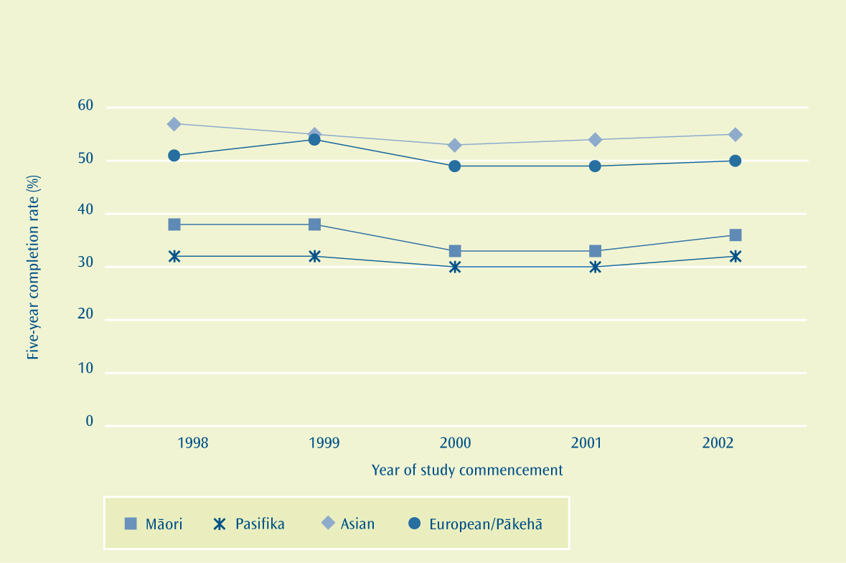
Figure 9.2:Five-year completion rates of bachelors degree-level qualifications at public institutions, by ethnic group and year of study commencement between 1998 and 2002

Pasifika students are less likely to complete their bachelors degree-level qualifications within five years of starting. Of all the Pasifika students who started a bachelors degree-level qualification at a public tertiary education institution in 2002, 32 percent completed this qualification by 2006. This compares with 36 percent for Māori students, 50 percent for European/Pākehā students and 55 percent for Asian students.
The forecast is that 32 percent of the 2006 cohort will complete their bachelors degree-level qualification by the end of 2010. This is below the target of 38 percent.
What we are doing
The ministry is working with the Tertiary Education Commission to ensure that all system levers are used to meet the Plan’s completion target. Work towards this includes:
- Special Supplementary Grants – the purpose of these grants is to provide additional funding for tertiary education institutions to improve participation, retention and achievement of Māori and Pasifika learners at higher levels of tertiary education through the provision of services and initiatives that are developed to meet the specific learning needs of these groups. This funding will continue to be made available within the new funding system operating from 1 January 2008; and
- appointment of a stakeholder engagement manager with a Pasifika focus. This position provides strategic oversight across the tertiary sector. This work also supports better engagement and responsiveness from the sector to Pasifika students and their communities.

Where to find out more
www.educationcounts.govt.nz

indicators

Completion of tertiary education

Tertiary student progression

Educational attainment in the adult population

PUBLICATIONS
Profile and Trends: New Zealand’s Tertiary Education Sector

Tertiary Education Strategy – Monitoring and Education

Engagement with Pasifika Communities
What we have found
There has been an increased focus on Pasifika students in tertiary institutions between 2000 and 2006.
What we are trying to achieve
Ensure that the needs and aspirations of Pasifika communities are identified and addressed.
Target
Tertiary education organisations (TEOs) to be able to demonstrate evidence of actions they have taken to consult with the Pasifika community and to address Pasifika aspirations.
Why this is important
Pasifika are becoming a larger proportion of the population. Attracting and retaining Pasifika students and developing a culture of lifelong learning will depend on the tertiary system being responsive to Pasifika students and communities.
How we are going
According to University Objectives: An analysis of university annual reports 2002-2006, the number of universities that included objectives relating to Pasifika was four times greater in 2006 than 2002. These objectives were focused on the New Zealand Pasifika community and wider Pasifika region, and aimed to improve teaching and research relevance in the Pasifika community.
The Tertiary Education Strategy 2002/07 Monitoring Report 2005, A System in Change, reports that a third of all tertiary education organisations had started to focus on engagement with Pasifika communities. However, this engagement has been focused more on the needs of Pasifika students as part of recruitment and less on Pasifika development and Pasifika social goals.
Where to find out more
www.educationcounts.govt.nz

PUBLICATIONS
Getting Started – Report on Stage 1 of the Evaluation of the Tertiary Education Strategy 2002/07

Making Use? Views on the use and usefulness of the Tertiary Education Strategy 2002/07

Lining Up? The influence of the Tertiary Education Strategy 2002/07 on tertiary education organisation profile objectives

Tertiary Education Strategy 2002-2007 Monitoring Report 2005
University Objectives: An analysis of university annual reports 2002-2006

Monitoring the Pasifika Education Plan
What we are trying to achieve
Continue ongoing development and monitoring of the Pasifika Education Plan that is driven by robust evidence and linked to education sector and theme strategies.
Target
Finalise a monitoring and evaluation framework.
Why this is important
Monitoring, evaluation and reporting tools are important for knowing whether the education system is delivering on the Plan’s goals and targets and to assist in early risk identification and developing mitigation strategies. In other words, a monitoring and evaluation framework is a critical tool for knowing what we are doing, and whether we are achieving the outcomes we want, and allowing us to reflect on outcomes and update or change them if necessary.
How we are going
The Pasifika Education Plan 2006-2010 monitoring framework was completed during 2007. As the Plan is a population strategy that includes all sectors of education and has many different stakeholders, this first year has concentrated on developing a collaborative approach which includes engaging stakeholders, establishing roles and responsibilities, and collating data nationally and regionally on Pasifika student achievement and participation.
The first monitoring report was released in July 2007. This second and final report on the Pasifika Education Plan 2006-2010 was released during 2008. Future annual reports will be based on the stepped-up Pasifika Education Plan 2008-2012.
Information Availability
What we have found
Improve the quality of information available to Pasifika parents, families and communities through a variety of media, with strong linkages across a number of communications strategies.
Target
Implement the Pasifika Communications Strategy in a timely and effective way – through publication of Talanoa Ako: Pacific Education Talk, web maintenance, radio programmes and strategic fono series.
Target
Increase the availability of Pasifika research evidence.
Why this is important
Parents and families need to make education decisions based on good information provided through media that is easy to access and understand. Similarly, decisions on teaching and learning by teachers and educators, education providers, and education agencies need to be informed by the most up-to-date evidence available.
For parents and families specifically, engaging in their children’s learning, and knowledge and ability to access resources to support learning, amongst other things, contributes to student achievement.
How we are going
The Pasifika Communications Strategy focuses on providing quality information to Pasifika communities to enable better understanding of the ministry’s work and better engagement in education.
Media includes:
- Talanoa Ako: Pacific Education Talk published three times each year;
- web work on the ministry’s websites;
- Pasifika radio programmes; and
- the strategic fono series held across the country.
The ministry has achieved some level of success in implementing the Pasifika Communications Strategy since its inception in 2002. In particular, the annual strategic fono series led by the Secretary for Education has become a fixture on many Pasifika community and education calendars. Likewise, the distribution of Talanoa Ako: Pacific Education Talk has steadily grown since its first issue in 1999. Where possible, radio programmes communicating key education messages have been broadcast across the country both in English and in Pasifika languages.
The challenge over the coming year will be to ensure this work accurately reflects and reaches a hugely diverse population grouping. This will include an evaluation of the effectiveness of work contributing to the Pasifika Communications Strategy.
Part of that evaluation will include:
- a survey of Talanoa Ako: Pacific Education Talk;
- annual strategic fono series report-back; and
- radio programme milestone reporting.
While communications issues such as the advance of new technologies impact broadly across New Zealand and globally, the Pasifika Communications Strategy will continue to cater to issues more specific to Pasifika communities. These include Pasifika languages education, adult literacy levels in English, and lower levels of internet access in the home compared with other households.
This year sees the ministry reflecting on six years of annual strategic fono across the country and evaluating the extent to which outcomes were achieved. This will help the ministry prepare for the next series of strategic fono in 2008.
The Pasifika Communications Strategy has made strong links across other ministry communications strategies such as Team-Up and Mission-On and will continue to be a vehicle to disseminate research and evidence on Pasifika student outcomes.
Where to find out more
www.educationcounts.govt.nz

PUBLICATIONS
Pasifika Education Research Toolkit
Pasifika Education Research Guidelines
Talanoa Ako: Pacific Education Talk
Pasifika Education Plan 2006-2010

Networking
What we are trying to achieve
Build and sustain the ministry’s capacity, capability and networks to effectively deliver on the Pasifika Education Plan.
Target
Finalise Pasifika capacity/capability development plans.
Target
Further develop and strengthen Pasifika Advisory Group and regional reference groups.
Why this is important
Everyone in the ministry is responsible for Pasifika education and therefore needs an understanding of the issues, processes, methodologies and Pasifika peoples’ education aspirations to be able to plan and implement strategies that effectively deliver on the Pasifika Education Plan.
Strong and effective networks add value to the ministry’s work, help to build strong and effective bridges with Pasifika communities and keep everyone focused on achieving the goals and targets of the Pasifika Education Plan.
How we are going
Pasifika capacity and capability development plans
Pasifika Caucus – the Caucus is one of the Equal Employment Opportunity (EEO) networks within the ministry with membership open to all Pasifika staff. Caucus work includes assisting the ministry in achieving its business goals, strategic priorities, and the Pasifika Education Plan, and promoting and raising the profile of Pasifika education within staff members’ work areas.
The Caucus played an important role in initiating ‘Pasifika Day’ held in June each year. Pasifika Day in both 2006 and 2007 was a huge success and there was an increased Pasifika visibility across the ministry.
Developing capacity – work during 2007 continued to focus on increasing the ministry’s capacity and leadership to raise Pasifika achievement in the Northern region through the Auckland Strategic Action Plan. The work of the Pasifika Project Manager and Schooling Improvement team has contributed to achieving the goals of the Plan in the Auckland region. Further joint developments are being finalised within regional offices.
Pasifika Advisory Group and regional reference groups
The ministry facilitates the National Pasifika Advisory Group, which has ethnic, sector, and professional association representatives and meets twice a year nationally and once regionally. The group’s role is to assist the ministry in:
- developing strategies to address education issues for Pasifika communities;
- further developing and implementing the Pasifika Education Plan; and
- providing effective connections and feedback loops to Pasifika communities.
The Pasifika Advisory Group continues to play a key role in the ongoing development of the annual strategic fono series.
Alongside the Pasifika Advisory Group are Pasifika reference groups that advise their respective local offices across all four ministry regions. Looking ahead this year, the ministry will work with reference groups to strategise how to provide more effective communication channels with Pasifika parents and families.
Where to find out more
www.educationcounts.govt.nz

PUBLICATIONS
The Ministry of Education’s Pasifika Advisory Group

Special Education
What we have found
Increase access to and understanding of special education services and identify and develop effective practices that reflect Pasifika perspectives on special education.
Target
Include appropriate measurements of special education support interventions for Pasifika students in the Student Support Outcomes Monitoring Scheme.
Target
Establish systems for analysing and reporting indicator measures for a range of special education interventions for Pasifika students.
Target
Develop a screening resource to assist educators to identify, clarify and respond to the special education needs of Pasifika learners.
Why this is important
Assessing the effectiveness of special education support for Pasifika students and their families continues to assist in identifying the impact of current interventions and increase the understanding of services within the ministry and Pasifika communities.
How we are going
Early intervention and quality information
Increasing Pasifika access to early intervention services has been a focus for the Northern and Central South regions since August 2007 and continuing into 2008; Pasifika early intervention referrals have increased from 4 percent to 5 percent in 2007. This will be stepped up in 2008 to 2009 with a greater focus in Auckland, increased collaboration with the ECE teams and the Ministry’s Pasifika Advisory Group, and strengthening relationships with key Pasifika providers. Gathering quality information and data on the numbers of Pasifika students accessing special education will also be a focus.
Focus on Auckland
The new Northern region Pasifika team, based in Auckland and managed by the Group Special Education national Pasifika manager, will play a critical role in achieving the Plan and developing the Auckland Strategy. A dedicated team of Pasifika Education Coordinators for the Northern region will provide excellent opportunities to engage with the various Pasifika communities in the Auckland area and grow their understanding of special education and the importance of early intervention.
Screening Tool – Better Information to Address Barriers to Learning (BITABL)
In 2007, the BITABL initiative provided better information and responses to address barriers to learning for children aged 0 to 8 years in early childhood education services and primary school. The Pasifika BITABL has been particularly successful in developing the Do You Know Me? resource.
A shift in focus will occur with the BITABL screening tool in 2008, with less of a focus on Pasifika. Future work will address the development of a new Pasifika screening tool that builds on the successes of the Pasifika BITABL tool.
Where to find out more
www.educationcounts.govt.nz

PUBLICATIONS
You and Your Child. An introduction to Special Education services for Pasifika families

Auckland Strategic Action Plan
What we are trying to achieve
Build and strengthen a significant strategic Pasifika focus on Auckland.
Target
Finalise the Auckland Strategic Action Plan.
Why this is important
Positive educational outcomes for Pasifika must be raised sharply, particularly in Auckland, where 72 percent of New Zealand’s Pasifika student population attend education services.
How we are going
The Auckland Strategic Action Plan is how the Pasifika Education Plan is realised in Auckland, working across all functional areas and with communities. This includes building a strong Pasifika team in Auckland with a focus on connecting educational activity across early childhood services, schools and tertiary providers, local communities and regional initiatives. This is about making sure that strategic priorities work really well on the ground. Features of an Auckland Pasifika Strategy include:
- a cohesive, whole-of-ministry approach;
- increased interagency collaboration and joint projects;
- a robust reporting and monitoring framework to report on progress;
- effective utilisation of data and research to inform; and
- focused community engagement initiatives.
The Auckland Pasifika Strategy will be made available late in 2008.
Priority has been given to increasing internal ministry capacity in the regional office to effect the stepped-up changes required across the region. The Auckland team is in place working across Early Childhood, Regional Education and Special Education. This is a significant first step, with the team currently making sure the actions around Pasifika are realised in the region.
Pasifika Language Curriculum
What we are trying to achieve
Increase opportunities for building strong Pasifika language foundations through Pasifika language curriculum and resource development.
Target
Finalise the development of Niuean, Tongan and Tokelauan curriculum guidelines for release during 2006.
Why this is important
Investing in Pasifika languages offers a way to strengthen productive partnerships between education providers and the multiple worlds Pasifika children and young people move in. International research shows there are benefits for learners who achieve competency in two languages. Where one of these languages is an ancestral language, learners benefit from a stronger sense of self and cultural identity with an enhanced capacity to operate in multiple cultural contexts.
Pasifika communities have also expressed, in many forums, their desire to retain and foster their languages in New Zealand. Although this is not the sole domain of education, there are various ways that education can contribute.
How we are going
The Vagahau Niue in the New Zealand Curriculum and the Tongan in the New Zealand Curriculum guidelines were launched in 2007. A review of the Samoan language curriculum is currently underway with a completion date late in 2008. Tokelau in the New Zealand Curriculum is expected to be finalised for release in 2008.
The Cook Islands Māori Learning Language Series (LLS) materials have been developed with an expected launch date during 2008. Development of LLS materials for Samoan is underway with an expected completion date in 2008.
The ministry also publishes the following resources to support Pasifika languages:
- the Tupu Series – books in Samoan, Tongan, Niuean, Cook Islands Māori, Tokelauan and English;
- Folauga – a Samoan journal for years 1 to 8 students that supports the achievement objectives of Samoan in the New Zealand Curriculum for all levels;
- Folauga Ua Loa – a magazine for years 9 to 13 students that will engage students with high-interest reading material to support literacy in Samoan; and
- Pacific Song Series – five song books and CDs in Samoan, Tongan, Niuean, Cook Islands Māori and Tokelauan.
Other initiatives supporting Pasifika languages:
- Language Enhancing Achievement for Pasifika (LEAP) project
– LEAP aims to help teachers at all school levels to enhance the academic achievement of their bilingual Pasifika students and improve their educational experiences. The resource brings together all the factors that research has shown can support bilingual Pasifika students’ learning, especially those that relate to Pasifika languages and English; and
- Achievement Through Pasifika Languages (ATPL) initiative
– The aim of ATPL is to support strong Pasifika language foundations outside of formal schooling. Three centres are operating in Auckland (Samoan and Niuean) and Christchurch (Tongan) and focus on students in years 1 to 4. Running after school, these centres offer language activities supported by communities and schools.
Where to find out more
www.educationcounts.govt.nz

PUBLICATIONS
Tai’ala mo le Gagana Samoa: Samoan in the New Zealand Curriculum

Cook Islands Māori in the New Zealand Curriculum

Vagahau Niue in the New Zealand Curriculum

Tongan in the New Zealand Curriculum

Programmes for Teaching Pacific Islands Languages

Tupu Series, Folauga and Folauga Ua Loa (Learning Media)

Whole-of-government Approach and the Pacific Region
What we are trying to achieve
Strengthen relationships with external agencies for closer, whole-of-government collaboration on education within New Zealand and across the Pacific region.
Target
Increase links between the Plan and other government strategies.
Target
Finalise a strategic framework for responding across the Pacific region.
Why this is important
To date, there are nine Pasifika strategies across government. Approaches that are linked across different education sectors and across wider government improve efficiency and effectiveness and minimise duplication. For Pasifika families and communities this means being able to benefit from services that are more streamlined and that have been developed from a client perspective.
New Zealand has historical relationships across the Pacific region that guide the way the ministry works with its counterparts in Pacific countries. In recent years there has been an increase in requests for joint projects from Pacific countries for educational services and/or resources from New Zealand. Working more strategically to respond to these requests means that Pasifika students in both New Zealand and Pacific countries benefit from the best quality education provision.
How we are going
Links between the Plan and other government strategies
The ministry continues to work closely and proactively with agencies that serve Pasifika communities.
The ministry has a protocol agreement with the Ministry of Pacific Island Affairs to support close and effective working relationships between the two agencies. The protocol articulates a ‘no surprises’ approach which allows each agency to be involved in the early design phases of each other’s work. The following are mechanisms the ministry uses to align with other education and Pasifika strategies across government:
- membership and attendance at the Ministry of Pacific Island Affairs Chief Executives’ and Senior Officials’ groups;
- education agency membership on the Pasifika Advisory Group; and
- information sharing and dissemination through the Pasifika Communications Strategy.
The focus continued in 2007 to be on re-establishing regular policy discussion groups across agencies focused on education issues.
The Plan has strong links to education agencies and sector strategies across early childhood, compulsory and tertiary education and other agency-driven strategies including the Pacific Economic Action Plan and the Pacific Women’s Action Plan (Ministry of Pacific Island Affairs); Family Violence (Taskforce for Action on Violence within Families); the Disability Strategy (Office for Disability Issues); and the Pacific Health Strategy (Ministry of Health).
Strategic framework for responding across the Pacific region
The ministry is currently working on joint projects with Pacific countries through the Treaty of Friendship with Samoa, a Memorandum of Understanding with Tokelau, and a Memorandum of Understanding with Niue. Work across the region also includes the development of Pasifika languages curricula.
The ministry was part of consultations by the Pacific Forum Secretariat in developing the Pacific Plan for the region. The ministry has supported all Forum Education Ministers’ Meetings (FEdMM) since the inaugural meeting in Auckland in 2001. At this meeting Ministers approved a Forum Basic Education Action Plan (FBEAP) for the region and its progress is reported on at their annual meeting. The ministry hosted the 2007 meeting in Auckland.
The ministry’s work programme for the year will continue to develop a strategic framework for responding across the Pacific region. An initial scoping paper was done during 2006 and this will be further progressed before the end of 2008.
Table 18.1 Percentage of year 1 students who attended early childhood education services,
by Regional Council and ethnic group (2006)
Table 18.1a Percentage of year 1 students who attended early childhood education services,
by Pacific Island group (2006)a
Table 18.2 Percentage of ECE teachers that are registered with the New Zealand Teachers Council, by Regional Council and ethnic group (2006)
Table 18.2a Percentage of ECE teachers that are registered with the New Zealand Teachers Council, by Pacific Island group (2006)
Table 18.3 Percentage of school leavers with little or no formal attainment, by Regional Council and ethnic group (2006)
Table 18.4 Percentage of school leavers with NCEA Level 2 or above, by Regional Council and ethnic group (2006)
Table 18.5 Percentage of teachers in state schools, by Regional Council and ethnic group (2006)
Table 18.6 Age-standardised suspension rates per 1,000 students, by Pacific Island group (2007)
Table 18.6.a Age-standardised suspension rates per 1,000 students, by Pacific Island group (2007)
Table 18.7 Proportion of all boards of trustees’ members, by Regional Council and ethnic group (2006)
Table 18.8 Proportion of elected, appointed or co-opted boards of trustees’ members of ‘Pasifika schools’, by Regional Council and ethnic group (2006)
Table 18.1: Percentage of year 1 students who attended early childhood education services, by Regional Council and ethnic group (2006)
Region¹ | Ethnic group
Region¹ | Māori | Pasifika | Asian | Other | European/ Pākehā | Total
Northland Region | 85.4 | 75.6 | 93.1 | 100.0 | 94.0 | 89.4
Auckland Region | 84.3 | 81.5 | 95.6 | 91.2 | 98.3 | 91.7
Waikato Region | 91.5 | 86.2 | 96.2 | 95.6 | 97.3 | 95.0
Bay of Plenty Region | 87.0 | 87.8 | 93.9 | 93.3 | 98.5 | 93.3
Gisborne Region | 88.2 | 94.4 | 100.0 | x | 97.7 | 91.7
Hawke’s Bay Region | 93.5 | 98.0 | 97.6 | 72 .7 | 98.8 | 96.3
Taranaki Region | 94.2 | 91.3 | 96.2 | 100.0 | 97.1 | 96.3
Manawatu-Wanganui Region | 94.8 | 94.1 | 95.8 | 100.0 | 97.0 | 96.2
Wellington Region | 95.1 | 92.0 | 97.6 | 91.6 | 99.0 | 97.2
Tasman Region | 96.8 | x | 100.0 | x | 95.2 | 95.4
Nelson Region | 96.4 | 66.7 | 94.1 | 88.9 | 98.3 | 97.1
Marlborough Region | 89.2 | 66.7 | 100.0 | 100.0 | 99.3 | 97.5
West Coast Region | 93.9 | x | 100.0 | x | 94.9 | 94.9
Canterbury Region | 97.5 | 94.2 | 98.0 | 91.0 | 98.7 | 98.3
Otago Region | 94.2 | 96.5 | 98.5 | 87.9 | 98.5 | 97.8
Southland Region | 95.6 | 100.0 | 88.9 | 100.0 | 97.6 | 97.3
Chatham Islands County² | 88.9 | x | x | x | x | 92.3
New Zealand Total | 89.9 | 84.2 | 96.0 | 91.7 | 98.0 | 94.5

Table 18.1a: Percentage of year 1 students who attended early childhood education services, by Pacific Island group (2006)
Pacific Island Group | Tokelauan | Fijian | Niuean | Tongan | Cook Islands Māori | Samoan | Other Pasifika peoples | Total Pasifika
National Rate | 90.6 | 91.9 | 82.5 | 80.3 | 84.6 | 85.1 | 85.4 | 84.2

Notes:
1. The Regional Council area of the school each Year 1 student was located in.
2. The Chatham Islands County is a separate county outside the standard Regional Council boundaries.
3. NZAID students (foreign students sponsored by the New Zealand Agency for International Development - a branch of MFAT), foreign fee paying students and students at health camps are excluded.
4. The number of students with unknown attendance has been excluded (from both the numerator and denominator) when calculating participation rates.
5. x = for this category there were less than 5 Year 1 students.
6. The total for each region includes students from all ethnic groups including those with less than 5 Year 1 students.
7. The New Zealand total includes students from all Regional Council areas including those with less than 5 Year 1 students.
Table 18.2: Percentage of ECE teachers that are registered with the New Zealand Teachers’ Council, by Regional Council and ethnic group (2006)
Region¹ | Ethnic group
Region¹ | Māori | Pasifika | Asian | Other | European/ Pākehā | Total
Northland Region | 29.7 | x | 27.3 | 83.3 | 56.1 | 49.9
Auckland Region | 40.5 | 40.4 | 38.6 | 29.8 | 53.8 | 47.9
Waikato Region | 43.4 | 39.0 | 27.3 | 50.0 | 54.8 | 52.2
Bay of Plenty Region | 38.8 | 58.6 | 46.4 | 21.4 | 56.3 | 52.6
Gisborne Region | 63.6 | 60.0 | x | x | 61.6 | 62.6
Hawke’s Bay Region | 39.3 | 21.4 | x | x | 62.4 | 57.8
Taranaki Region | 66.7 | x | 55.6 | x | 59.9 | 60.3
Manawatu-Wanganui Region | 45.8 | 45.5 | 38.1 | x | 59.8 | 57.1
Wellington Region | 54.3 | 55.3 | 60.2 | 45.5 | 67.8 | 64.7
Tasman Region | 100.0 | x | x | x | 71.4 | 73.7
Nelson Region | x | x | x | x | 70.2 | 71.0
Marlborough Region | 42.9 | x | x | x | 64.2 | 61.9
West Coast Region | 14.3 | x | x | x | 39.5 | 37.2
Canterbury Region | 64.9 | 52.8 | 72.2 | 38.1 | 68.2 | 67.4
Otago Region | 76.5 | 58.8 | 36.4 | 42.9 | 75.5 | 74.0
Southland Region | 61.5 | 22.2 | x | x | 66.8 | 65.3
Chatham Islands County² | n | n | n | n | n | n
New Zealand Total | 45.0 | 43.9 | 42.6 | 35.1 | 60.8 | 56.4

Table 18.2a: Percentage of ECE teachers that are registered with the New Zealand Teachers’ Council, by Pacific Island group (2006)
Pacific Island Group | Tokelauan | Fijian | Niuean | Tongan | Cook Islands Māori | Samoan | Other Pasifika peoples | Total Pasifika
National Rate | 50.0 | 38.6 | 47.2 | 37.4 | 37.9 | 46.4 | 54.3 | 43.9

Notes:
1. The Regional Council area of the teacher-led ECE service in which each teacher was located.
2. The Chatham Islands County is a separate county outside the standard Regional Council boundaries.
3. x = for this category there were fewer than five teachers of this ethnic group in this region.
4. n = there is no teacher-led service in the Regional Council area.
5. The regional total includes teachers from all ethnic groups including those with fewer than five members.
6. The New Zealand total includes teachers from all Regional Council areas including those with fewer than five members.
7. The Correspondence School is included in the New Zealand total.
Table 18.3: Percentage of school leavers with little or no formal attainment, by Regional Council and ethnic group (2006)

Region¹ | Ethnic group
Region¹ | Māori | Pasifika | Asian | Other | European/ Pākehā | Total
Northland Region | 20.8 | x | x | x | 6.6 | 12.4
Auckland Region | 20.6 | 11.6 | 3.8 | 6.9 | 6.8 | 8.7
Waikato Region | 22.3 | 18.0 | 8.1 | 9.8 | 9.4 | 13.1
Bay of Plenty Region | 23.2 | 10.9 | 9.1 | x | 7.3 | 12.8
Gisborne Region | 16.2 | x | x | x | 5.1 | 11.6
Hawke’s Bay Region | 13.8 | 13.2 | x | x | 8.6 | 10.2
Taranaki Region | 25.8 | x | x | x | 9.0 | 12.3
Manawatu-Wanganui Region | 16.2 | 7.1 | x | x | 7.4 | 9.4
Wellington Region | 21.2 | 11.7 | 4.7 | 12.7 | 7.0 | 10.0
Tasman Region | 28.6 | x | x | x | 16.7 | 18.3
Nelson Region | 24.7 | x | x | x | 6.1 | 8.4
Marlborough Region | 17.4 | x | x | x | 9.9 | 11.3
West Coast Region | 16.0 | x | x | x | 20.4 | 19.0
Canterbury Region | 22.9 | 13.9 | 6.2 | 15.5 | 10.3 | 11.5
Otago Region | 11.7 | 13.6 | x | x | 6.3 | 6.9
Southland Region | 15.1 | x | x | x | 6.8 | 8.2
Chatham Islands County² | n | n | n | n | n | n
Not Applicable | 80.1 | 87.5 | x | 50.0 | 60.0 | 67.2
New Zealand Total | 21.8 | 12.2 | 4.5 | 9.0 | 8.8 | 11.1

Notes:
1. The Regional Council area of the school each student was located in.
2. The Chatham Islands County is a separate county outside the standard Regional Council boundaries.
3. NZAID students (foreign students sponsored by the New Zealand Agency for International Development - a branch of MFAT), foreign fee paying students and students at health camps are excluded.
4. n = there is no school with students in Year 9 and above in the Regional Council area.
5. x = for this category there were less than 5 school leavers with little or no formal attainment.
6. Not Applicable includes the correspondence school and a small number of students (<30) whose school campus covers more than one Regional Council area.
7. The total for each region includes students from all ethnic groups including those with less than 5 school leavers with little or no formal attainment.
8. The New Zealand total includes students from all Regional Council areas including those with less than 5 school leavers with little or no formal attainment.
Table 18.4: Percentage of school leavers with NCEA Level 2 or above, by Regional Council and ethnic group (2006)

Region¹ | Ethnic group
Region¹ | Māori | Pasifika | Asian | Other | European/ Pākehā | Total
Northland Region | 37.2 | 54.2 | 69.4 | 61.1 | 62.4 | 52.2
Auckland Region | 39.2 | 51.6 | 83.6 | 67.1 | 70.3 | 65.7
Waikato Region | 36.6 | 41.3 | 73.8 | 51.0 | 60.7 | 54.0
Bay of Plenty Region | 33.4 | 47.3 | 74.7 | 75.0 | 63.1 | 53.2
Gisborne Region | 34.8 | 72.7 | 100.0 | x | 65.4 | 48.1
Hawke’s Bay Region | 41.9 | 39.6 | 74.4 | 62.5 | 65.0 | 57.4
Taranaki Region | 32.9 | 41.2 | 84.6 | 71.4 | 62.4 | 56.6
Manawatu-Wanganui Region | 40.6 | 54.8 | 81.1 | 85.0 | 64.5 | 58.9
Wellington Region | 38.4 | 48.0 | 82.3 | 49.7 | 70.4 | 62.7
Tasman Region | 34.9 | x | x | x | 53.9 | 51.3
Nelson Region | 47.3 | 46.2 | 61.1 | 100.0 | 73.6 | 70.4
Marlborough Region | 37.7 | 55.6 | x | 100.0 | 63.8 | 60.3
West Coast Region | 10.0 | x | x | x | 38.0 | 34.8
Canterbury Region | 35.3 | 38.1 | 81.9 | 61.9 | 65.4 | 62.5
Otago Region | 46.4 | 43.2 | 79.1 | 78.6 | 69.2 | 67.0
Southland Region | 37.1 | 53.8 | 83.3 | 100.0 | 63.2 | 58.8
Chatham Islands County² | n | n | n | n | n | n
Not Applicable | 3.3 | x | x | x | 9.2 | 7.3
New Zealand Total | 36.7 | 49.6 | 82.2 | 63.5 | 65.4 | 60.2

Notes:
1. The Regional Council area of the school each student was located in.
2. The Chatham Islands County is a separate county outside the standard Regional Council boundaries.
3. NZAID students (foreign students sponsored by the New Zealand Agency for International Development - a branch of MFAT), foreign fee paying students and students at health camps are excluded.
4. n = there is no school with students in Year 9 and above in the Regional Council area.
5. x = for this category there were less than 5 school leavers with NCEA Level 2 or above.
6. Not Applicable includes the correspondence school and a small number of students (<30) whose school campus covers more than one Regional Council area.
7. The total for each region includes students from all ethnic groups including those with less than 5 school leavers with NCEA Level 2 or above.
8. The New Zealand total includes students from all Regional Council areas including those with less than 5 school leavers with NCEA Level 2 or above.
Table 18.5: Percentage of teachers in state schools, by Regional Council and ethnic group (2006)

Region¹ | Ethnic group
Region¹ | Māori | Pasifika | Asian | Other | European/ Pākehā
Northland Region | 21.3 | 1.5 | 1.3 | 1.9 | 74.0
Auckland Region | 6.9 | 5.6 | 7.7 | 3.7 | 76.1
Waikato Region | 12.9 | 1.2 | 2.4 | 1.6 | 82.0
Bay of Plenty Region | 22.0 | 0.8 | 1.2 | 1.6 | 74.4
Gisborne Region | 35.7 | 0.7 | 0.9 | 1.6 | 61.2
Hawke’s Bay Region | 15.2 | 0.6 | 0.8 | 2.2 | 81.2
Taranaki Region | 8.6 | 0.6 | 1.3 | 1.6 | 88.0
Manawatu-Wanganui Region | 12.8 | 1.1 | 1.6 | 1.5 | 83.0
Wellington Region | 8.0 | 2.9 | 2.4 | 2.8 | 83.9
Tasman Region | 4.8 | x | x | 1.8 | 93.2
Nelson Region | 5.6 | x | x | 1.6 | 91.7
Marlborough Region | 5.2 | x | x | 2.1 | 90.8
West Coast Region | 4.2 | x | x | 2.2 | 91.9
Canterbury Region | 4.5 | 0.6 | 1.0 | 1.6 | 92.3
Otago Region | 3.9 | 0.8 | 0.6 | 1.4 | 93.3
Southland Region | 6.9 | 1.2 | 0.5 | 1.0 | 90.4
Chatham Islands County² | x | x | x | x | x
New Zealand Total | 9.9 | 2.5 | 3.4 | 2.4 | 81.8

Notes:
1. The Regional Council area in which each teacher was located.
2. The Chatham Islands County is a separate county outside the standard Regional Council boundaries.
3. x = for this category there were fewer than five teachers of this ethnic group in this region.
4. The New Zealand total includes teachers from all Regional Council areas including those with fewer than five members.
5. The Correspondence School is included in the New Zealand total.
Table 18.6: Age-standardised suspension rates per 1,000 students, by Regional Council and ethnic group (2007)

Region¹ | Ethnic group
Region¹ | Māori | Pasifika | Asian | Other | European/ Pākehā | Total
Northland Region | 13.7 | 10.8 | x | x | 3.5 | 8.5
Auckland Region | 13.0 | 8.8 | 1.0 | 9.3 | 3.6 | 5.9
Waikato Region | 14.4 | 9.1 | x | 5.8 | 4.3 | 7.4
Bay of Plenty Region | 14.4 | 6.0 | x | 15.1 | 2.1 | 7.0
Gisborne Region | 15.3 | x | x | x | 2.6 | 10.7
Hawke’s Bay Region | 13.2 | 6.0 | x | x | 3.4 | 6.8
Taranaki Region | 16.9 | x | x | x | 2.5 | 6.1
Manawatu-Wanganui Region | 21.3 | 13.2 | x | 11.6 | 6.0 | 10.8
Wellington Region | 11.4 | 9.1 | 1.1 | 3.1 | 3.5 | 5.4
Tasman Region | 9.4 | x | x | x | 5.9 | 6.4
Nelson Region | 12.7 | x | x | x | 2.7 | 4.2
Marlborough Region | 12.3 | x | x | x | 7.7 | 8.3
West Coast Region | 11.0 | x | x | x | 5.7 | 6.4
Canterbury Region | 15.1 | 6.8 | 2.9 | x | 4.8 | 6.0
Otago Region | 7.6 | x | 5.6 | x | 3.5 | 4.0
Southland Region | 26.3 | x | x | x | 5.2 | 8.9
Chatham Islands County² | x | x | x | x | x | x
Not Applicable | x | x | x | x | x | x
New Zealand Total | 14.4 | 8.7 | 1.2 | 7.5 | 4.0 | 6.6

Table 18.6a: Age-standardised suspension rates per 1,000 students, by Pacific Island group (2007)
Pacific Island Group | Tokelauan | Fijian | Niuean | Tongan | Cook Islands Māori | Samoan | Other Pasifika peoples | Total Pasifika
National Rate | 4.0 | 4.0 | 13.1 | 9.4 | 11.0 | 8.1 | 7.7 | 8.7

Notes:
1. The Regional Council area of the school each student was located in.
2. The Chatham Islands County is a separate county outside the standard Regional Council boundaries.
3. NZAID students (foreign students sponsored by the New Zealand Agency for International Development - a branch of MFAT), foreign fee paying students and students at health camps are excluded.
4. x = for this category there were less than 5 suspensions and/or students.
5. Not Applicable includes the correspondence school and a small number of students (<30) whose school campus covers more than one Regional Council area.
6. The total for each region includes students from all ethnic groups including those with less than 5 suspensions and/or students.
7. The New Zealand total includes students from all Regional Council areas including those with less than 5 suspensions and/or students.
Table 18.7: Proportion of all boards of trustees’ members, by Regional Council and ethnic group (2006)

Region¹ | Ethnic group
Region¹ | Māori | Pasifika | Asian | Other³ | European/ Pākehā
Northland Region | 35.8 | 0.6 | x | 3.9 | 59.4
Auckland Region | 11.7 | 10.2 | 2.0 | 4.5 | 71.7
Waikato Region | 19.1 | 1.1 | 0.7 | 3.5 | 75.6
Bay of Plenty Region | 34.5 | 1.0 | 0.4 | 3.4 | 60.8
Gisborne Region | 51.7 | x | x | 4.5 | 42.4
Hawke’s Bay Region | 23.0 | 1.6 | x | 3.0 | 72.1
Taranaki Region | 11.8 | x | 0.7 | 6.1 | 80.8
Manawatu-Wanganui Region | 16.8 | 1.4 | x | 4.9 | 76.6
Wellington Region | 12.0 | 6.3 | 1.3 | 3.8 | 76.6
Tasman Region | 6.3 | x | x | 5.9 | 87.5
Nelson Region | 4.9 | x | x | x | 92.0
Marlborough Region | 7.9 | x | x | 3.1 | 89.1
West Coast Region | 7.6 | x | x | 6.1 | 86.3
Canterbury Region | 5.6 | 1.1 | 0.6 | 4.5 | 88.2
Otago Region | 5.6 | 0.5 | 0.5 | 4.0 | 89.4
Southland Region | 5.6 | x | x | 5.3 | 88.8
Chatham Islands County² | 29.4 | x | x | x | 47.1
New Zealand Total | 15.6 | 3.4 | 0.8 | 4.2 | 76.0

Notes:
1. The Regional Council area in which each trustee was located.
2. The Chatham Islands County is a separate county outside the standard Regional Council boundaries.
3. The ‘Other’ ethnic group includes the category ‘Not Stated’.
Table 18.8: Proportion of elected, appointed or co-opted boards of trustees’ members of ‘Pasifika schools’, by Regional Council and ethnic group (2006)

Region¹ | Ethnic group
Region¹ | Māori | Pasifika | Asian | Other³ | European/ Pākehā
Northland Region | 80.0 | 0.0 | 0.0 | 0.0 | 20.0
Auckland Region | 19.0 | 22.5 | 1.6 | 4.3 | 52.7
Waikato Region | 36.4 | 13.6 | 1.5 | 0.0 | 48.5
Bay of Plenty Region | 22.2 | 0.0 | 11.1 | 11.1 | 55.6
Gisborne Region | x | x | x | x | x
Hawke’s Bay Region | 42.3 | 5.8 | 0.0 | 1.9 | 50.0
Taranaki Region | x | x | x | x | x
Manawatu-Wanganui Region | 27.1 | 8.3 | 2.1 | 0.0 | 62.5
Wellington Region | 19.0 | 21.4 | 1.8 | 4.7 | 53.1
Tasman Region | x | x | x | x | x
Nelson Region | x | x | x | x | x
Marlborough Region | 20.0 | 0.0 | 0.0 | 0.0 | 80.0
West Coast Region | x | x | x | x | x
Canterbury Region | 14.1 | 5.9 | 0.7 | 2.2 | 77.0
Otago Region | 8.3 | 11.1 | 0.0 | 16.7 | 63.9
Southland Region | 7.1 | 0.0 | 0.0 | 35.7 | 57.1
Chatham Islands County² | x | x | x | x | x
New Zealand Total | 19.9 | 19.7 | 1.5 | 4.4 | 54.6

Notes:
1. The Regional Council area in which each trustee was located.
2. The Chatham Islands County is a separate county outside the standard Regional Council boundaries.
3. The ‘Other’ ethnic group includes the category ‘Not Stated’.
4. Only includes schools where there are at least five Pasifika students and 10 percent or more of the roll are Pasifika.
1 Changes in tertiary numbers from Pasifika Education Plan
Monitoring Report 2006
A number of revisions of tertiary data were made during 2007. This has resulted in differences in numbers (and rates) for some tertiary measures between what was shown in the 2006 Pasifika Education Plan Monitoring Report and what appears in this report. The two principal reasons for these differences are provided below.
A major review was undertaken of the quality of qualification award category codes (a classification of level of study) and New Zealand Standard Classification of Education (NZSCED) field of study assigned to qualifications. As a result, a number of qualifications had their level and field of study revised. The effect of this was that between 1,000 and 2,000 enrolments a year were reclassified from type ‘D’ to type ‘C’. Currently only records known as type ‘D’ are included in enrolments. These relate to students enrolled in formal qualifications of more than one week’s equivalent full-time study (EFTS). Non-formal enrolments and formal enrolments of a week or less equivalent full-time study are excluded. Hence, those recoded to type ‘C’ are now out of scope and not included in this year’s supply. Many students previously coded to level 1 to 3 certificates have now been reclassified as level 4 certificates, or level 5 to 7 diplomas. The change does not affect completions but impacts on higher-level progression rates.
A major review of individual student identifiers, and the data matching process to assign these, was also undertaken during the year. As part of the tertiary reforms introduced by the government in 2006, there was a need to have better information on the attrition, completion and progression rates for each individual institution. As well, there was an apparent discontinuity in system completion and attrition rates using individual student identifiers before 2003 (based on National Student Number (NSN)) with rates from 2003 onwards (based on NSN). Both these factors made it essential that the Ministry of Education review the data matching methodology. The availability of four years of NSN data was able to provide a powerful independent means to measure the accuracy of the matching, and to revise the processes used. The methodology was extensively reviewed in 2007 and NSNs were regenerated for all existing enrolments and completions data from 1994 to 2006.
2 Ethnicity
Ethnicity is the ethnic group or groups to which an individual belongs. The concept of ethnicity adopted by the Ministry of Education is a social construct of group affiliation and identity. The Ministry of Education uses the definition of ethnicity used by Statistics New Zealand, namely:
A social group whose members have one or more of the following characteristics:
- They share a sense of common origins.
- They claim a common and distinctive history and destiny.
- They possess one or more dimensions of collective cultural individuality.
- They feel a sense of unique collective solidarity.
Prioritisation of ethnicity is when people are allocated to one of the ethnicities they have recorded that they affiliate with. This usually occurs when data is collected manually and/or aggregate data returns are collected centrally. This allocation is performed using a predetermined order of ethnic groups. The purpose of this prioritisation is to ensure that ethnic groups of policy importance are not swamped by the European/Pākehā ethnic group.
In the Early Childhood Education and Schooling sections of this publication ethnicity is prioritised in the order of Māori, Pasifika, Asian, other groups except European, and European/Pākehā.
Multiple ethnicities are used in the Tertiary part of this publication. Multiple ethnicity works by considering each ethnicity a person affiliates with as one data entry. For example, the data relating to an individual who affiliates as both Māori and Pasifika will be included in both categories. This approach can be undertaken in tertiary analysis as most data is collected in a disaggregated fashion.
In this publication European/Pākehā refers to people who affiliate as New Zealand European, Other European or European (not further defined). For example, this includes but is not limited to people who consider themselves Australian (not including Australian Aborigines), British and Irish, American, Spanish, Ukrainian and Czech.
3 Notes for Early Childhood Education section
Quality in Early Childhood Education
- Registered teachers include: holders of a New Zealand Teachers Council (NZTC) practising certificate that is NZTC full registration, holders of an NZTC practising certificate that is subject to NZTC confirmation, and holders of an NZTC practising certificate that is NZTC provisional.
4 Notes for Tertiary section
Participation at degree level and above, and Five-year retention rate
(Figures 8.1 and 8.2)
- Participation rate is the percentage of the population aged 15 and over who were enrolled at any time during the year.
- Participation rates are not available for ‘Other’ ethnic group; these are included in the total.
- Separate participation rates are not available for ‘Pasifika’, ‘Asian’ and ‘European/Pākehā’ ethnic groups prior to 2000.
- Retention rate is defined as the percentage of domestic students starting a qualification at a public provider in 2002 who are still enrolled or have completed by the end of 2006.
- Retention rates for any group with fewer than 30 students have been excluded.
- The retention rate total includes those students who have changed qualification level, whereas rates for individual levels do not.
- Retention rate does not include private training establishments (PTEs) (i.e. only public tertiary providers
are included).
- These rates are age-standardised to the 2006 national age distribution (i.e. they represent the rate a group would have if they had the same age distribution as the 2006 national age distribution).
- Data relates to domestic students enrolled at any time during the year with a tertiary education provider in formal qualifications of greater than 0.03 EFTS.
- Data excludes those PTEs and Other Tertiary Education Providers (OTEPs) that neither received tuition subsidies nor were approved for student loans or allowances.
- Data excludes all non-formal learning and on-job industry training.
- Students who identify with more than one ethnic group have been counted in each group, but only once in the total. Consequently, the sum of the students in each group may not add to the total number of students.
- Students who were enrolled at more than one qualification level have been counted in each level, but only once in the total. Consequently, the sum of the students in each qualification level may not add to the total number of students.
- Totals also include those students whose qualification level or ethnic group is unknown.
Participation in industry training, and Participation in Modern Apprenticeships (Figures 8.3, 8.4, 8.5 and Table 8.1)
- Data relates to total number of trainees during the year.
- Totals also include Modern Apprenticeship numbers.
- Ethnic group is based on the single prioritised method of reporting.
Bachelors degree-level completion rates, and Higher-level progression rates
(Figures 9.1 and 9.2)
- This completion rate is defined as the percentage of domestic students starting a qualification in 2002 who have completed a qualification at the same level by the end of 2006.
- Completion and progression rates for any group with fewer than 30 students have been excluded.
- A five-year higher-level progression rate is defined as the percentage of students completing a qualification who have enrolled at a higher qualification level at any time in the next five years.
- Data excludes all non-formal learning and on-job industry training.
- Data relates to domestic students enrolled at any time during the year with a tertiary education provider in formal qualifications of greater than 0.03 EFTS.
- Data excludes those PTEs and OTEPs that neither received tuition subsidies nor were approved for student loans or allowances.
- For this indicator European/Pākehā refers to people who affiliate as New Zealand European, Other European or European (not further defined). For example, this includes but is not limited to people who consider themselves Australian (excluding Australian Aborigines), British and Irish, American, Spanish and Ukrainian.
- Students who identify with more than one ethnic group have been counted in each group. Consequently, the sum of the students in each ethnic group may not add to the total number of students.
- Students who were enrolled at more than one qualification level have been counted in each level. Consequently, the sum of the students in each qualification level may not add to the total number of students.
- Totals also include those students whose qualification level or ethnic group is unknown.
- The total includes those students who have changed qualification level, whereas rates for individual levels do not.
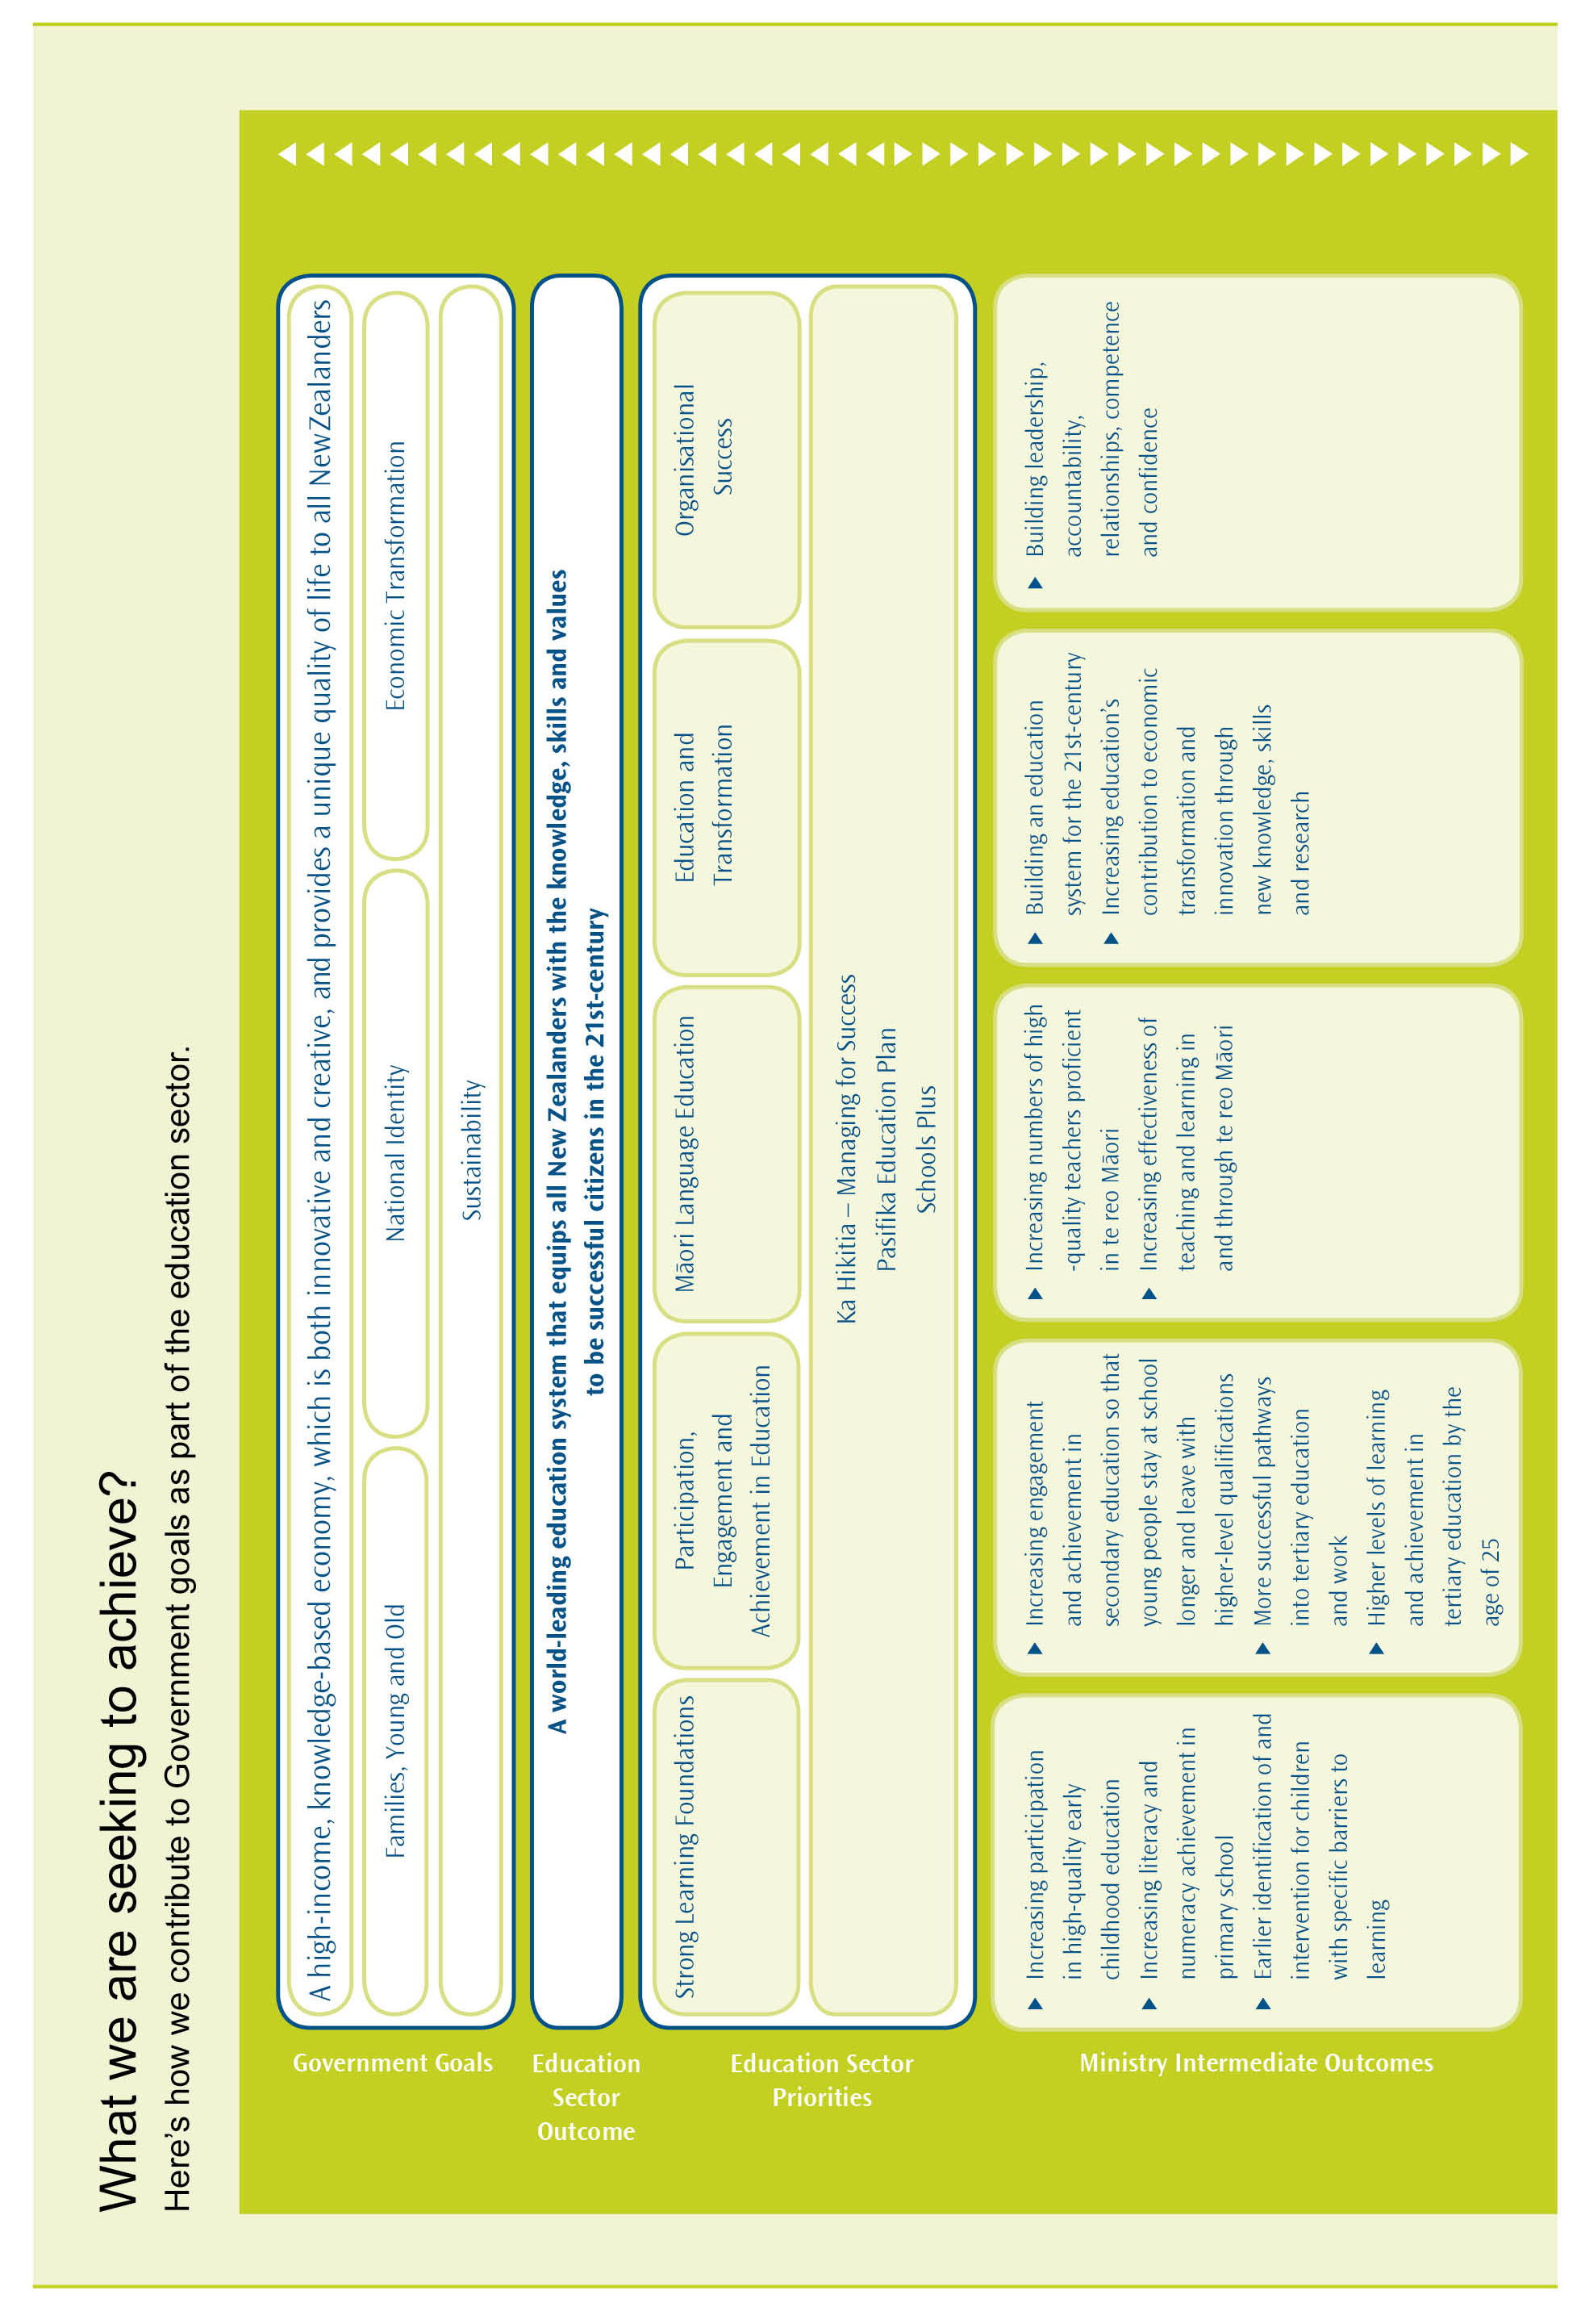
Priorities into Action
We have a task: to build a world-leading education system for the 21st-century. We have a set of priorities so we know where to focus our efforts. Now we need the knowledge, skills and determination of every person in the ministry to turn these priorities into action.
In all that we do, we must ensure equity, targeting our resources on building an education system that is successful for Māori and to lift achievement for Pasifika students.
We need to use the evidence, to know what works in lifting achievement for learners and to use this knowledge to target resources for the greatest impact.
We need to prioritise. That means focusing on critical points in the system to increase participation, engagement and achievement and to take action to address disparities.
We need to focus on results and build our capability and confidence to manage resources as effectively and efficiently as possible.
We need to connect, to work collaboratively within the ministry and across the sector. As we build leadership, accountability, relationships, competence and confidence to ensure our own ‘organisational success’, we need to attend to these factors to ensure the success of the whole education sector.
Finally, we need to be accountable, to be transparent and responsible in the way we work, continually monitoring our progress to ensure we are working in the right way.
