Making Disability Rights Real
Whakatūturu ngā Tika Hauātanga

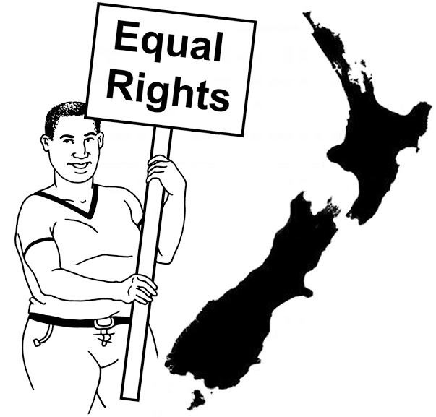
Disability Rights



2012 – 2013
Easy Read Summary
The United Nations Convention on the Rights of Persons with Disabilities
In 2008 New Zealand signed an international agreement called The United Nations Convention on the Rights of Persons with Disabilities.

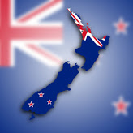
This is also known as the Disability Convention.

New Zealand has to report to the United Nations to tell them if disabled people are getting their human rights in New Zealand.
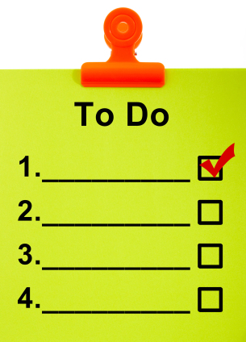

A group of people make sure that
the Government follows the human rights that are in the Disability Convention.

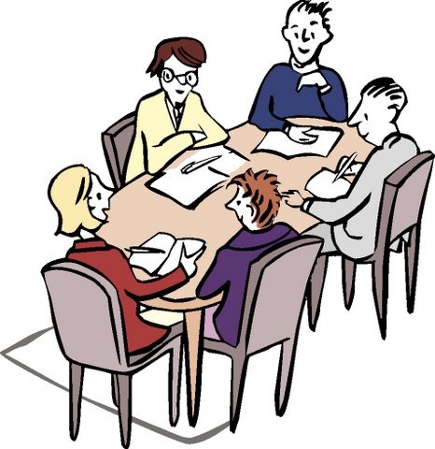
These people are called Disability Convention Independent Monitors.

The Monitors are people from the:

- Human Rights Commission

- Office of the Ombudsman

- Convention Coalition Monitoring Group.

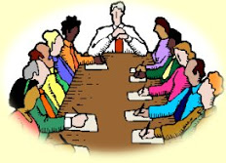
The Convention Coalition Monitoring Group is a group of people from New Zealand Disabled People’s Organisations (DPOs).

The Disabled People’s Organisations are:
- Disabled Person’s Assembly (New Zealand) Inc.

- Deaf Blind (New Zealand) Inc.

- Blind Citizens New Zealand

- Deaf Aotearoa New Zealand

- Ngā Hau e Whā

- Ngāti Kāpo o Aotearoa Inc.

- Balance New Zealand

- People First New Zealand Inc. Ngā Tāngata Tuatahi.

What are human rights?

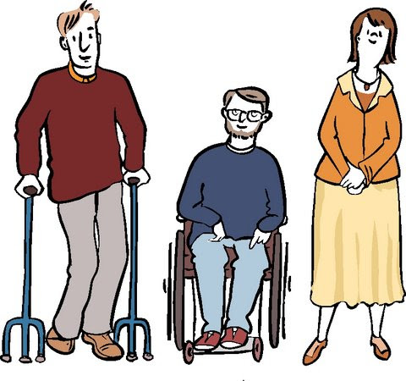
Everyone has human rights.

Human rights mean you must be treated:
- fairly
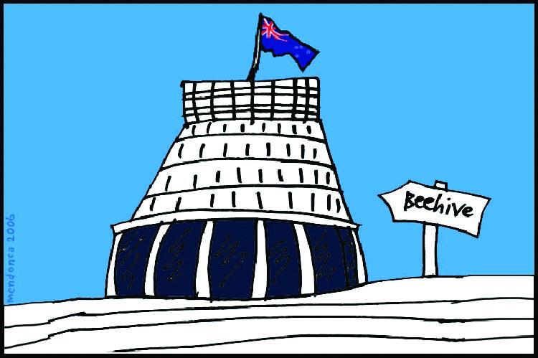
- equally
- with respect.

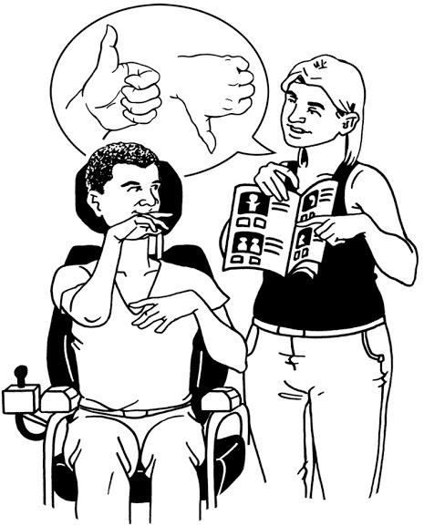
The Government must make sure that all people can:
- be safe
- make their own decisions
- have a good life
- be part of community and society.

Making Disability Rights Real

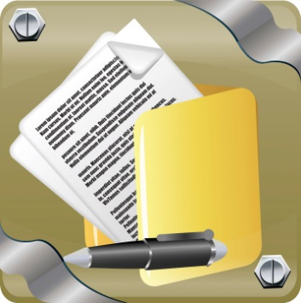
1
In 2012 the Independent Monitors wrote a report about if New Zealand had followed the rights of the Disability Convention between 2007 and June 2012.
1

2
This is the 2nd Making Disability Rights Real report.

Introduction

This report is about:
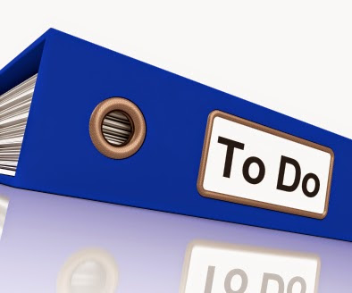
- 5 main issues for disabled people around getting their human rights in New Zealand


- 4 things that worry the Independent Monitors about disabled people getting their human rights in New Zealand
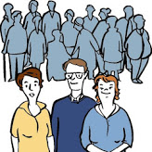
- some of the things that get in the way of disabled people getting their human rights
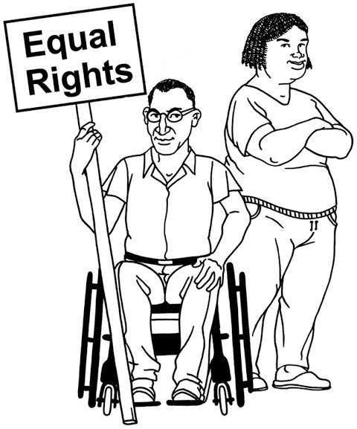
- what needs to happen to make sure that disabled people have human rights in New Zealand.

5 main issues

The Independent Monitors have found 5 main issues that are important to look at to make sure disabled people get their human rights in the Disability Convention.
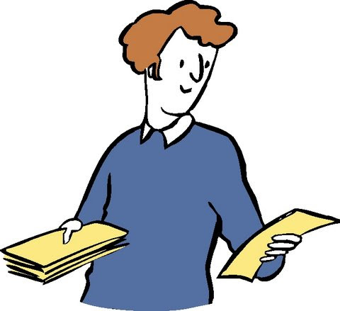
- Information

There is still not enough information about disabled people.

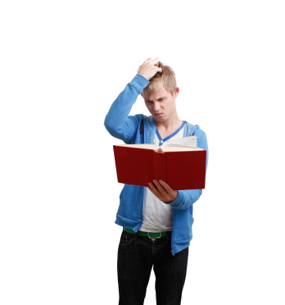
This makes it hard to know what the problems really are for disabled people.

Statistics New Zealand has written a report called the 2013 Household Disability Survey.

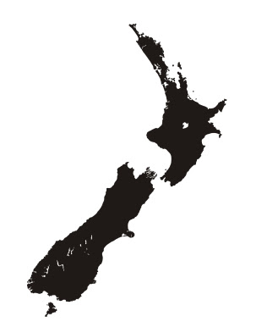
The report has information in it from people around New Zealand.

The information is about:
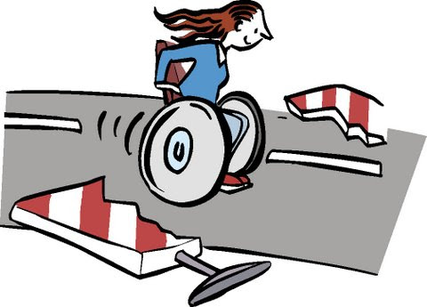
- what disabled people need to live a good life in New Zealand

- what gets in the way of disabled people living a good life.

2. Having Access

The Disability Convention says that disabled people should have what they need to live a good life.
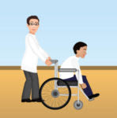

It must be easier to:

- use public buildings like hospitals and schools
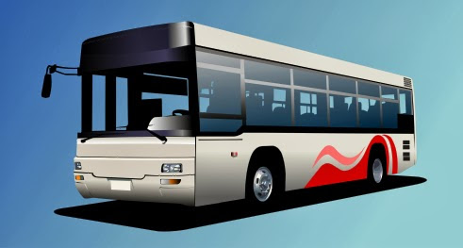
- use public transport

- have support services that meet people’s needs

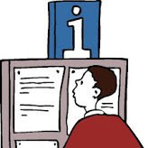
- have information in different ways

- use New Zealand Sign Language and other ways to communicate.

All these things need to happen to make sure that disabled people live a full life.


3. Putting people first

Putting people first means that disabled people can make choices and decisions for themselves.

This is one of the most important things for the Government to work on.

There have been some changes but more change needs to happen. It needs to happen more quickly.

Disabled People’s Organisations must be involved in this work and disabled people and their family need to be in leadership roles.

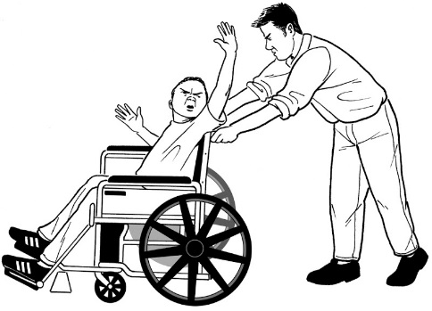
4. Violence and Abuse

Disabled people are often treated badly or differently by other groups of people just because of their disability.

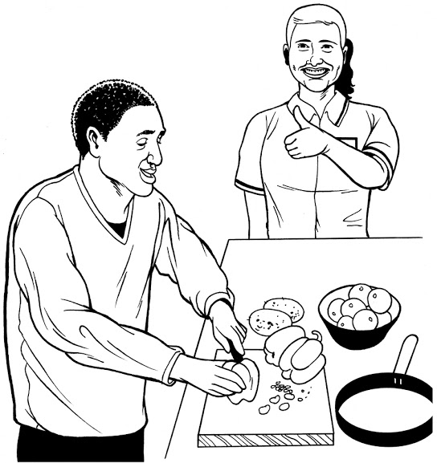
Violence, neglect and abuse of disabled people can happen anywhere - like at home, work and in residential services.

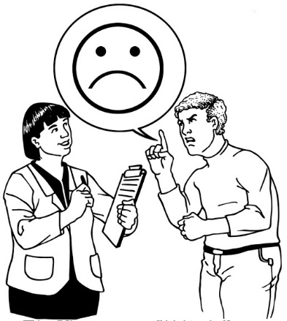
It can be very hard for disabled people to be:
- listened to
- believed
- helped.

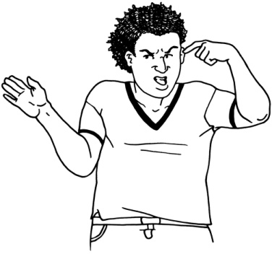
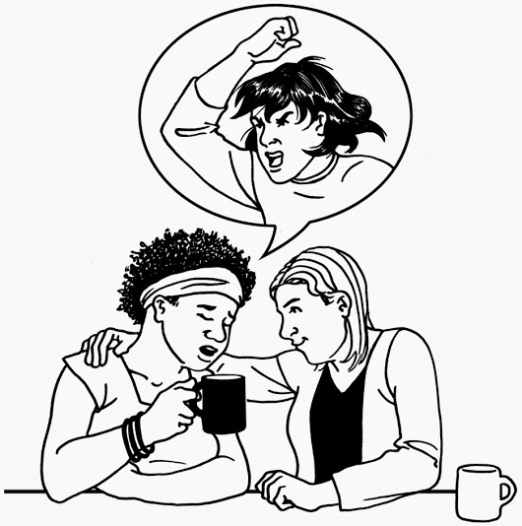
Abuse can be:
- punching
- slapping
- pushing
- pulling hair.

Abuse can also be:
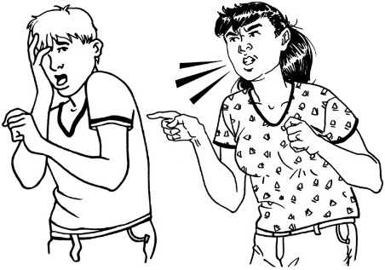
- mental
- emotional
- sexual
- about using your money
- about religion or beliefs.
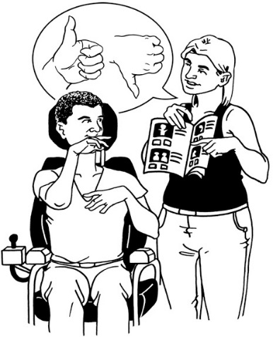
Disabled people most at risk of abuse are:
- people who cannot speak
- people who have to rely on the abuser for support and help.

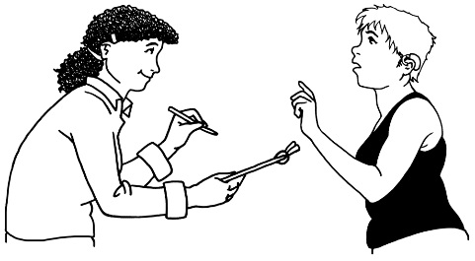
Work needs to be done to:
- keep disabled people safe from abuse
- make sure that disabled people have the right support after making a complaint.

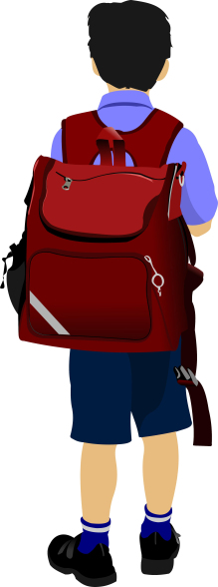
5. Education

Some good work has been done to make sure that disabled children have the chance to go to mainstream schools.

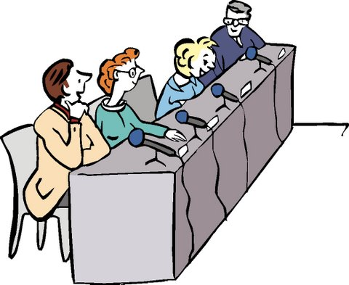
The Education Review Office (ERO) is a group of people who make sure that schools are safe and are following the rules set by the Government.

ERO did a review to find out if schools and early childhood centres were including disabled children.


The review found out that some schools were working well to make sure disabled children were included.

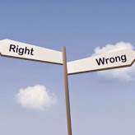
Some schools need to look at:

- how to make things better for disabled children

- how they are working to include disabled children in school.
Bullying, being left out and feeling lonely are big issues for disabled children and young people.

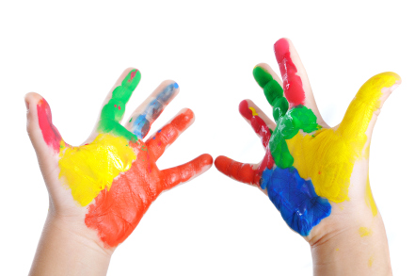
It is important that disabled children feel safe to learn so that they can be the best that they can be.

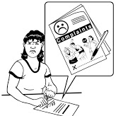
The Human Rights Commission has received lots of complaints about what education is like for many disabled people.

The Independent Monitors are worried that there is not enough being done to make sure disabled children are getting their right to education.

More work needs to be done to make sure that this happens.

The work should be done with Disabled People’s Organisations.

In New Zealand there is no law that says you have a right to inclusive education.

The 4 other things that the Independent Monitors are worried about

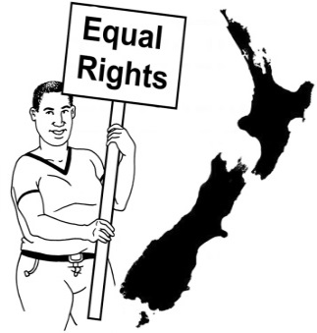
When the Independent Monitors were making this report they found 4 things that worried them about disabled people not getting their human rights in New Zealand.

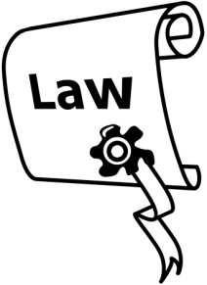
These 4 things are:

- The new law called the New Zealand Public Health and Disability Amendment Act 2013.

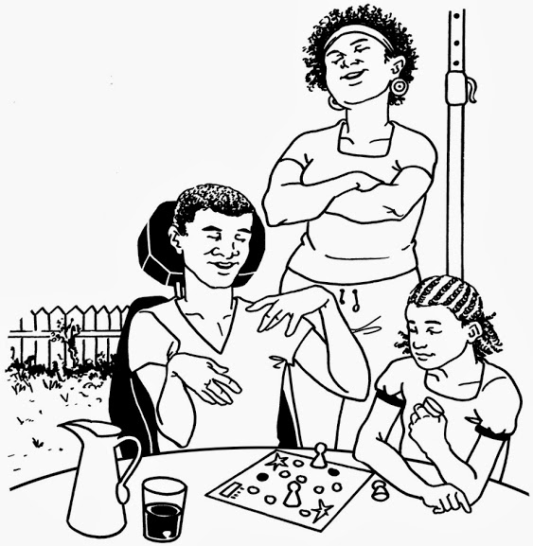
The New Zealand Public Health and Disability Amendment Act 2013 talks about the Government’s family care policy.
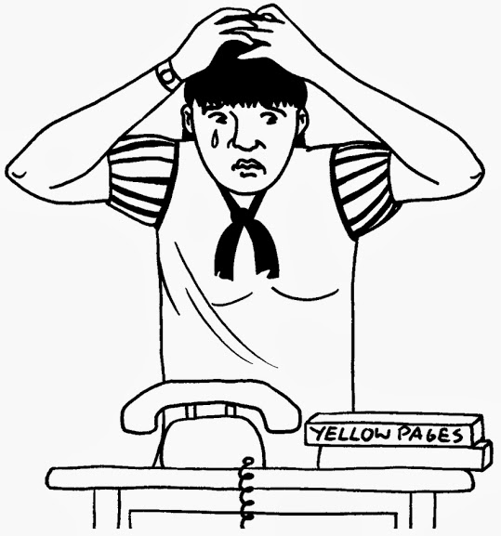
This law makes it hard for people to get any legal help if they feel they are not being treated fairly under the family care policy.

The Independent Monitors want the Government to say that they recognise the right of disabled people to choose a family member to be their caregiver.


The Government also needs to pay family members who are caregivers the same as they pay people who are not family members.

2. Supported decision-making

Article 12 of the Disability Convention says disabled people have the right to make decisions about what they want to do.

If it is hard for a disabled person to say what they want they can have support to make decisions.

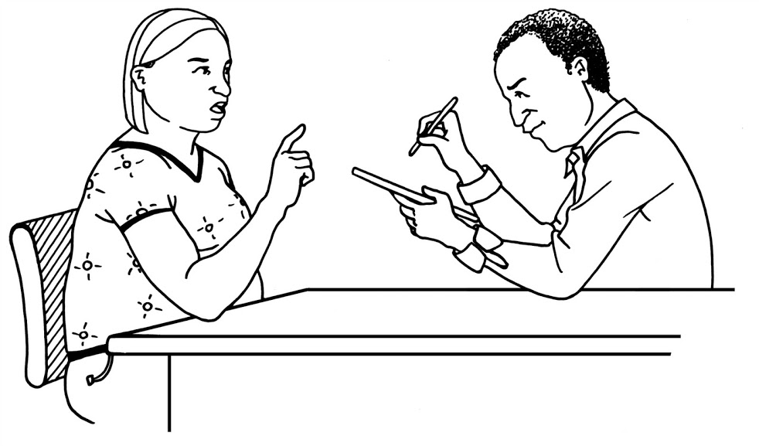
A process called supported decision-making needs to be set up.
This will make sure that disabled people get the right to make their own decisions.

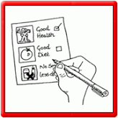
3. The poor health of disabled people

Disabled people have poorer health and don’t live as long as non-disabled people.
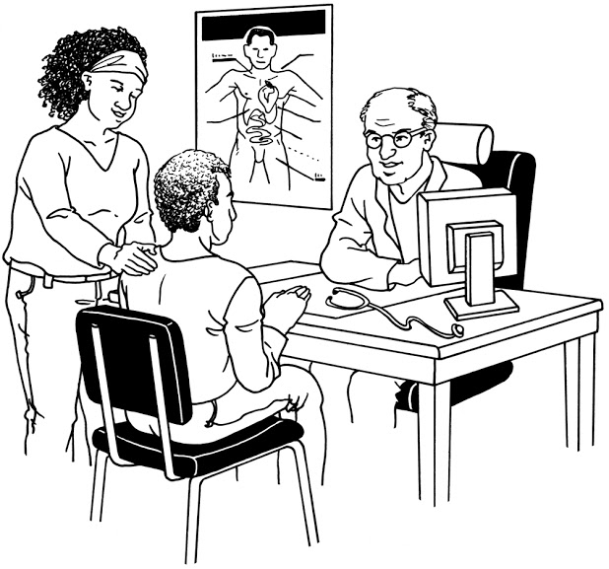

It is even worse for people with learning disability.

4. Parts of a law called the Children, Young Persons and their Families Act 1989

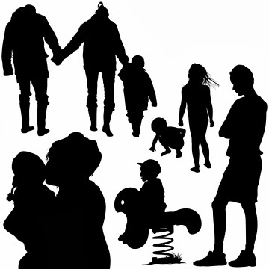
The Children, Young Persons and Their Families Act 1989 is a law that does not support disabled children’s right to a family life.

It does not treat disabled children fairly because of their disability.

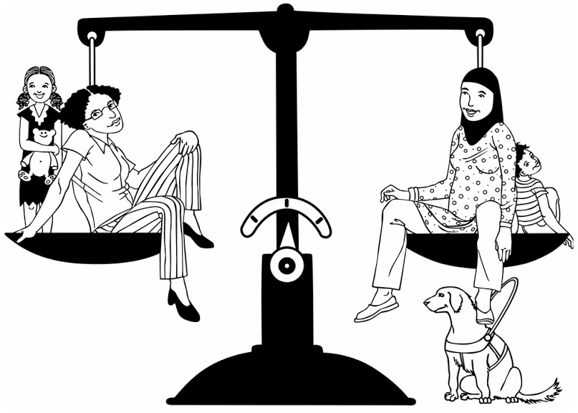
The Independent Monitors say that this law needs to be changed so that disabled children have the same rights as other children when a decision has to be made about where they have to live.

Recommendations - what needs to happen now

This report says that there are 38 things that need to happen:

Recommendation 1
The Government needs to keep working with Disabled People’s Organisations, disabled people, children and families to develop the Disability Action Plan.

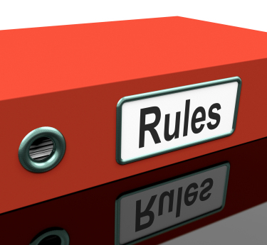
Recommendation 2
The Ministry of Justice and the Office for Disability Issues need to work together to make a set of rules.

The rules will say what extra support can be needed so that disabled people have the same rights as others under the Human Rights Act and the New Zealand Bill of Rights Act.

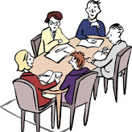
The Disabled People’s Organisations and the Independent Monitors need help to make this happen.



Recommendation 3
Statistics New Zealand needs to make a report about the Disability Survey 2013.
It should look to see if disabled women and men are getting equal rights in New Zealand.

Recommendation 4
The Families Commission and Disabled People’s Organisations need to develop a set of rules.

These rules need to make sure that people who do studies also have stories about disabled women’s and men’s lives.

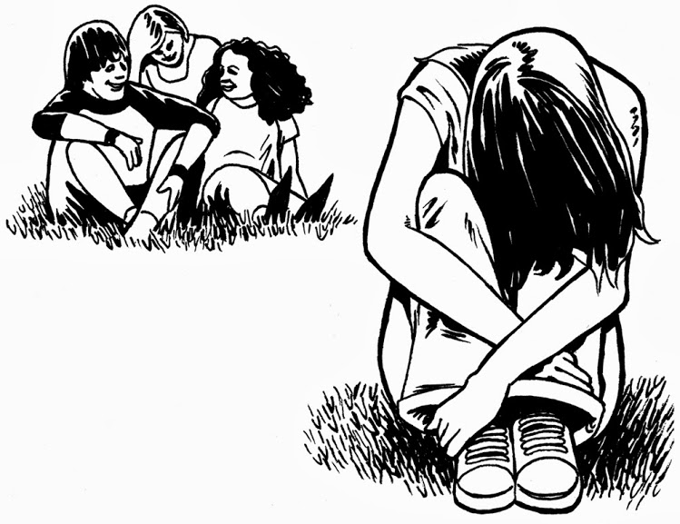
Recommendation 5
Better information must be collected about the lives of disabled children.

Disabled People’s Organisations will support this work.


Recommendation 6
Look at the review of the building safety standard NZS 4121:2001 and see if it should cover people’s houses.

Recommendation 7
The Ministry of Transport must make a set of rules that will make sure it is easy for everyone in New Zealand to use public transport.

Recommendation 8
Disabled People’s Organisations, disabled people and their families need to have their say on policies that are about:
- the right to life
- new medical practices.
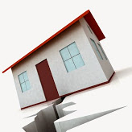
Recommendation 9
The Government needs to work quickly to carry out a review of the 3 month time limit for putting in a claim with the Earthquake Commission.

Recommendation 10
The Law Commission needs a review of the law called the Mental Health (Compulsory Assessment and Treatment) Act 1992.
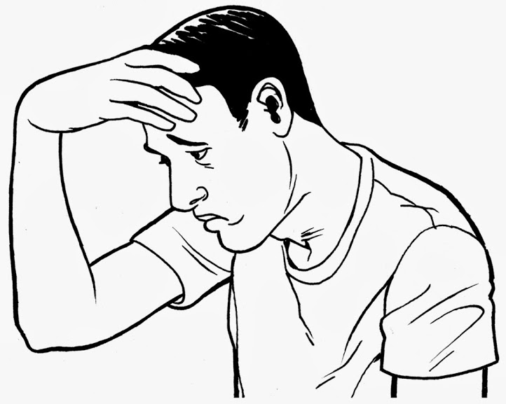
This needs to be done to see if it fits with Articles 12 and 13 of the Disability Convention.

Recommendation 11
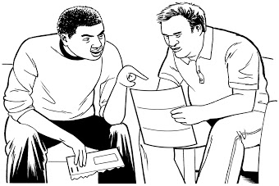
The Office for Disability Issues must find out if:
- people understand the law called the Protection of Personal and Property Rights Act

- the rules of this law are being followed by welfare guardians and property managers.

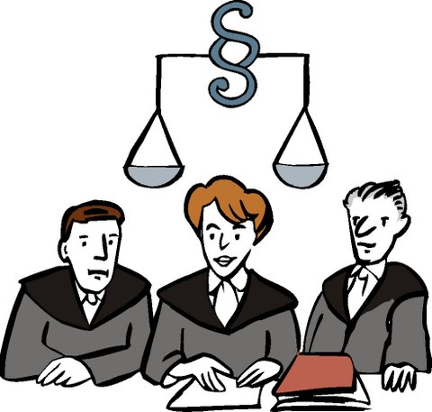
Recommendation 12
The Department of Corrections needs to look at what they are doing to make sure that disabled prisoners are treated fairly.

Recommendation 13
The Government must have many different ways to make sure that:
- disabled people have the same protection from domestic abuse and other abuse as everyone else
- the police and other agencies take disabled people’s reports of abuse seriously
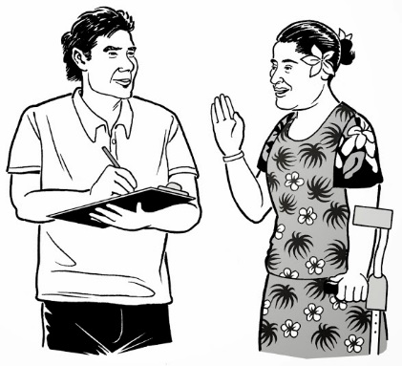
- the abuse of disabled people is talked about in other anti-violence programmes

- the laws of New Zealand keep disabled people safe

- more people are aware of the abuse of disabled people

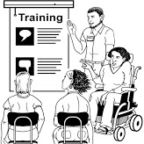
- Disabled People’s Organisations, the police, staff working in courts and people who provide services are trained about how to keep disabled people safe.


Recommendation 14
The Government needs to look at disability support systems to make sure that disabled people have choices and control about support and services.


The Government should look at what has worked well from the Enabling Good Lives work.

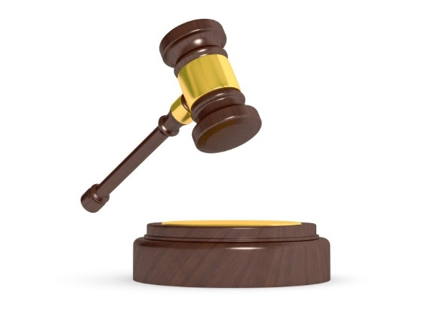
Recommendation 15
That the Government change the New Zealand Public Health and Disability Amendment Act 2013 so disabled people can complain if they are not being treated fairly under the family care policy.

The law makes it too hard for a disabled person to choose a family member to be their paid caregiver.

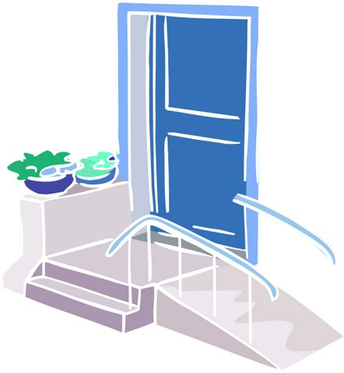
Recommendation 16
Anyone who applies for the Social Housing Fund grant must follow a set of rules like the Lifemark Design Standards.

These rules will make sure that they provide accessible housing.

Recommendation 17
All government agencies need to follow the government web standards for accessibility.

This must be a rule for government agencies and other projects that are paid for by the Government

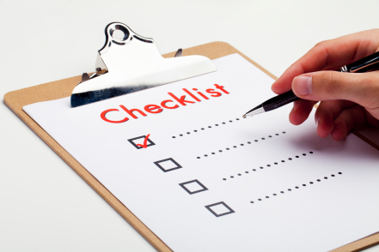
Recommendation 18
Government web standards must be used by:
- councils
- district health boards
- other organisations that get government money to run their service.

Recommendation 19
All government agencies need to make rules about how they talk with disabled people, like making information in Easy Read.

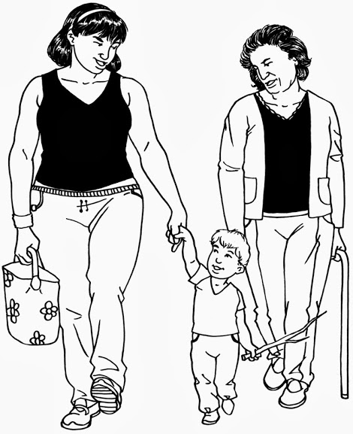
Recommendation 20
The Ministry of Justice must look at a law called the Adoption Act to see if section 8 follows the rules of the Disability Convention.

Recommendation 21
The Government needs to take away sections 141, 142 and 144 (2) of the law called The Children and Young Persons and Their Families Act 1989.


This is so that disabled children have the same rights as other children about where they live.


Recommendation 22
The Government must give non-government organisations (NGOs) more support to deliver programs for disabled children.

Recommendation 23
The Government must make it the law for disabled children to have the right to have inclusive education.

Recommendation 24
The Ministry of Education needs to put together programmes that stop bullying in schools.

Schools need to think how they can make sure disabled children are safe and feel safe.

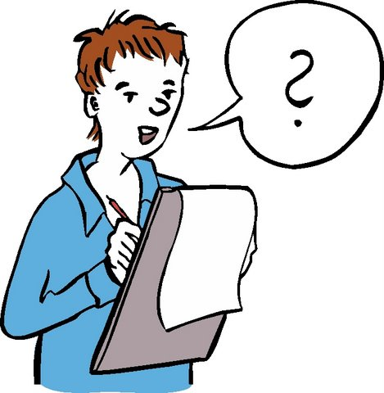
Recommendation 25
The Ministry of Education needs to make projects that talk about difference so that everyone in school learns about different disabilities.

Recommendation 26
The Ministry of Health must work with people with learning disability and their organisations to set up a programme to:
- make better health services for disabled people
- look at what work has been done
- look at what work can be done better.

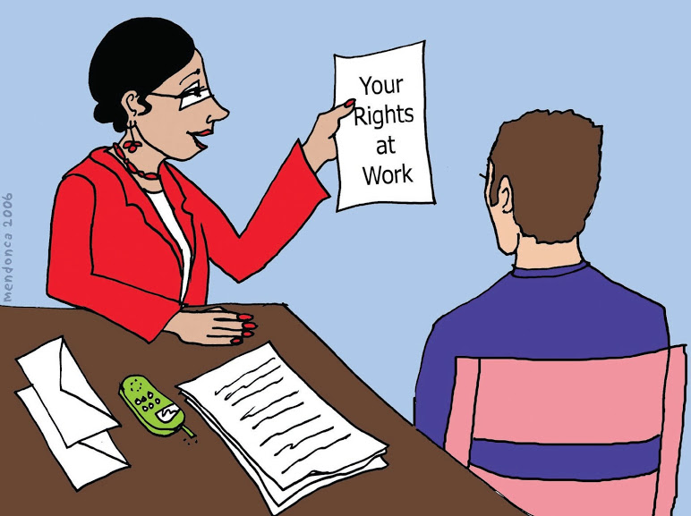
Recommendation 27
The Chief Executives’ Group on Disability Issues must work with Disabled People’s Organisations on employment issues.
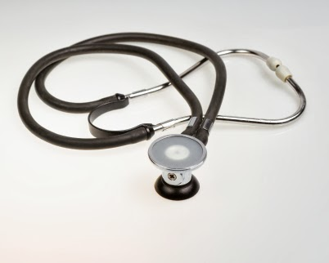
They need to make it easier for more disabled people to have jobs in the public sector – like in government departments and health agencies.

This includes what extra support is needed so disabled people have the same rights as others under the Human Rights Act and the New Zealand Bill of Rights Act.

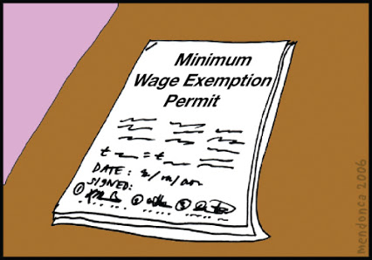
Recommendation 28
The Ministry of Business, Innovation and Employment must work with the Disability Employment Forum to find better ways to pay disabled people for their work.

They must look at the minimum wage exemption to see if has to be changed so disabled people have rights at work.

They need to do this by 31 December 2014.

Recommendation 29
The Ministry of Social Development must:
- make sure that the disability allowance can be used for more things that disabled people want and need - like money for housing

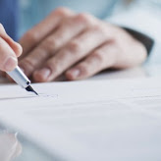
- look at and report on if they can give people in Christchurch more money for their accommodation supplement, so it is the same as what people get in Auckland or Wellington.

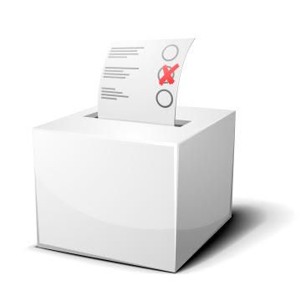
Recommendation 30
The Electoral Commission needs to make sure that everyone who has a right to vote at the next general election can do so in a way that works best for them -like in secret and on their own.
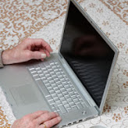
Recommendation 31
The Department of Internal Affairs needs to set up a new way for people to vote online for the 2016 local elections.

The people working for the Department of Internal Affairs should check to see if this works and is easy for everyone to use, including disabled people.

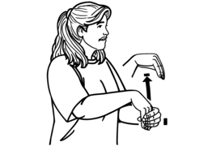
Recommendation 32

Money should be given to make sure that New Zealand Sign Language will be used on the TV when people talk about the elections.

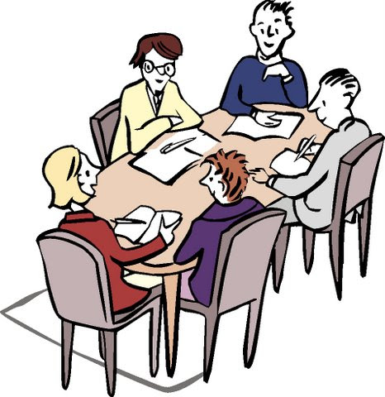
Recommendation 33
Disabled people who have been elected to government boards and public authorities should have any extra support they need to do their work.

Recommendation 34
The Ministry of Culture and Heritage needs to make some rules about how to make TV and radio programmes and newspapers and magazines easier for everyone to understand.

They should look at what works well in other countries.

Recommendation 35
NZ On Air needs to make a rule about programmes that it gives money to or supports so they are easy for everyone to understand.

Recommendation 36
Statistics New Zealand needs to work with Disabled People’s Organisations to get information about disabled people.

The information should look at what issues are the same or different for disabled people and non-disabled people.

Recommendation 37
The Government must start work on the list of things that United Nations Treaty Bodies have said need to be better for disabled people.

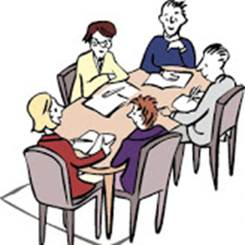
Treaty Bodies are groups of people who check to make sure governments are following the rules of human rights agreements like the Disability Convention.

Recommendation 38
The Government must ratify the Optional Protocol of the Disability Convention.

Ratify means to make something official by signing or voting for it.

Optional means the Government does not have to agree to it.

They can choose whether they will agree to it or not.

If New Zealand ratifies the Optional Protocol people will be able to complain to the Committee on the Rights of Persons with Disabilities when they are not getting their human rights.
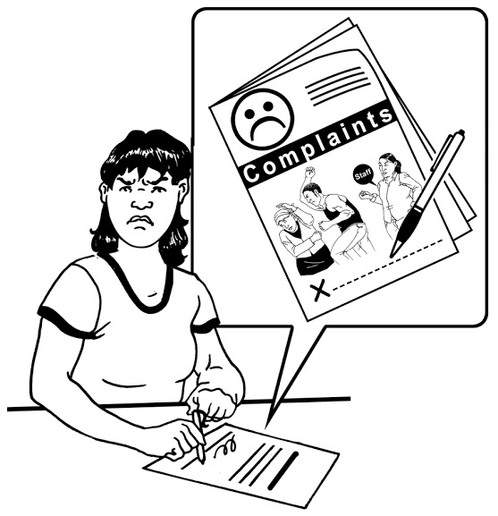
This will mean the Government will have to act when there are complaints about services not giving people their rights.

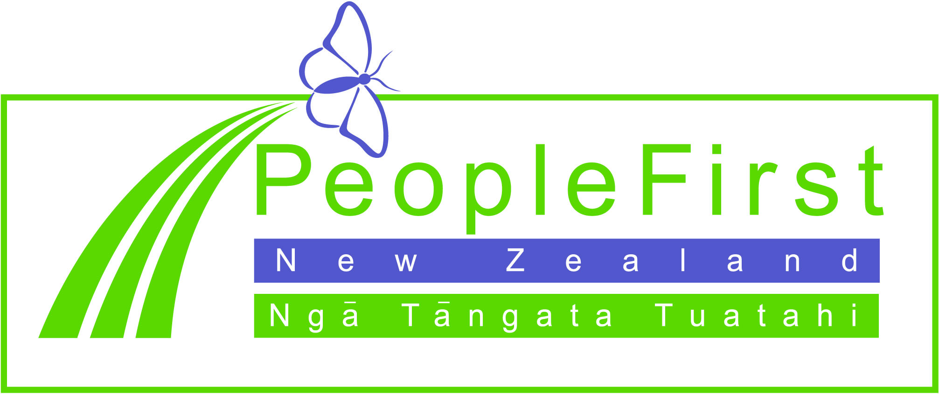

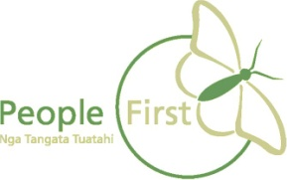
This information has been translated into Easy Read
by People First New Zealand Inc.



