The material wellbeing of NZ households:

Overview and Key Findings

from

- the 2019 Household Incomes Report
- and the companion report using non-income measures (the 2019 NIMs Report)

Prepared by Bryan Perry

Ministry of Social Development
Wellington

November 2019

The Overview brings together in one place the key definitions and concepts, and the key findings and overall story from both reports – all the figures, tables and charts used in the Overview are in the two fuller reports.

What the reports are about

The Household Incomes Report and its companion report using non-income measures (the NIMs Report) provide information on the material wellbeing of New Zealand households from two perspectives:
- household incomes: the reports use disposable household income (total after-tax income from all sources for all members of the household), adjusted for household size and composition
- non-income measures (NIMs): this approach more directly measures the material wellbeing of households in terms of having:
- the basics such as adequate food, clothes, accommodation, electricity, transport, keeping warm, maintaining household appliances in working order, and so on
- freedoms to purchase and consume non-essentials that people commonly aspire to.

In addition to reporting low-income and material hardship trends for the whole population and various groups within the population, there is also detailed information on:
- the distribution of household income more generally, including trends in income inequality using several measures, and trends in very high incomes
- the impact of income taxes and transfers on household incomes
- the degree of overlap between those households reporting low incomes and those reporting various levels of material hardship
- housing affordability and housing quality, for the whole population and for selected groups
- trends in reported life satisfaction, for the whole population and for selected groups
- international comparisons, including trends in household incomes, low income and material hardship rates, income and wealth inequality, and children in jobless households
- selected themes such as inclusive growth, the squeezed middle, the working poor and changing sources of income for older New Zealanders.

All of this is set within an income-wealth-consumption-material-wellbeing framework, an emphasis on the importance of being explicit about definitions and assumptions and the differences these can make, and on being aware of both the richness and limitations of the survey data used.

The reports are published as part of the Ministry of Social Development’s (MSD’s) work on monitoring social and economic wellbeing. They are a resource for use by a wide range of individuals and groups – policy advisors, researchers, students, academics, community groups, commentators and citizens more generally – to inform policy development and public debate around material living standards, poverty alleviation and redistribution policies.

Data sources

The main data source is Stats NZ’s Household Economic Survey (HES). The survey is conducted face-to-face and in recent years the response rate has been close to 80%, with an achieved sample typically around 3000 to 3500 households. In 2014-15 and 2017-18 (‘HES 2015’ and ‘HES 2018’) larger samples of 5500 were planned for and achieved. The recently-completed 2018-19 survey has much larger sample of 20,000 households and will be used for MSD’s 2020 reports.

Analysis of the HES data is supplemented by analysis of MSD administrative data, data from Stats NZ’s longitudinal Survey of Family, Income and Employment (SoFIE) which ran from 2002 to 2009, MSD’s 2008 Living Standards Survey, the OECD’s Income Distribution Database, and Eurostat’s EU-SILC surveys.

The interviews for the latest available HES (HES 2018) took place from July 2017 to June 2018. The incomes question asked about incomes “in the last 12 months”. The latest income figures (2018 HES) therefore reflect on average what household incomes were in late 2017, rather than “today”.

Though most of the survey data is from Stats NZ, the analysis and findings are the work and responsibility of the MSD, except where noted otherwise.

The 2019 reports

Each new set of reports builds on the analysis and findings of previous reports.

Unless there is a major shock to the economy such as the Global Financial Crisis (GFC), a change in the housing market that impacts on rental costs, or a policy change that directly impacts in a significant way on the labour market, incomes or subsidies, findings using the latest available survey data can be expected to be broadly in line with previously identified levels, and trends in all the main areas monitored by the reports. They can also be expected to reveal very similar relativities between different groups.

The 2019 reports update information based on the 2018 HES and for the most part the numbers are as expected and previous findings are confirmed.

In addition to the updates themselves, there is new material in the 2019 reports, including:
- using information on liquid financial assets from the Net Worth module in the 2018 HES to enhance and better explain findings about the relatively limited overlap between low-income households and households reporting material hardship
- a strengthening of the section on housing affordability and housing quality
- more detailed findings on in-work poverty
- international comparisons of the proportion of children in workless households, in-work poverty rates, and economic vulnerability for the ‘near poor’.

The Appendices and other technical sections also have new material, including:
- analysis showing the difference that different methodological assumptions can make for reporting on low-income levels and trends
- new analysis to assist with discussion and debate around the setting of suitable thresholds for monitoring low-income trends, drawing on research carried out for the Welfare Expert Advisory Group.

Reporting low-income and material hardship trends in the 2019 reports

The 2019 reports resume the publication of low-income and material hardship rates for children and their households (using 2017-18 survey data), after not doing so in the 2018 reports for the 2015-16 and 2016-17 survey years.

The rationale for the decision regarding the 2018 reports had two aspects: (a) the sudden and relatively large reported drops in rates when there were no known factors in the economy, the housing market or policy change to explain the observation; and (b) the evidence of sample bias in the two surveys, though less for 2017 than 2016.

MSD is satisfied that the 2017-18 survey data is sufficiently robust for the uses to which it is put in its reports. Low-income rates in 2017-18 are back to where they are expected to be, and there is no evidence of the level of sample bias previously noted. When the 2015-16 and 2016-17 rates are set aside, the trends to 2017-18 for children are the same as for those reported by Stats NZ in April 2019 using different data sources. Reported material hardship rates are still low in HES 2018 compared with 2013 to 2015 rates, but the 2018 rates are plausible given the continued economic growth in the period and the independent evidence of declining hardship rates based on data from the General Social Survey. See Appendix One for a fuller account of the rationale for MSD’s decisions.
The Introduction: ………………………………………………………………………………………. 5
- identifies some of the challenges involved in analysing sample surveys such as the HES, and in interpreting findings, especially when there is volatility in year-on-year figures
- discusses the income-wealth-consumption-material-wellbeing framework used in the reports, including how the framework helps both the high-level measurement story and a high-level narrative for approaches to address material disadvantage
- outlines the way the reports define and measure material wellbeing, and illustrates the differences that different measures can make to the overall picture

The Key Findings section covers:
- Household incomes: …………………………………………………………………………………………… 12
  - trends from 1982 to 2018 for both BHC and AHC incomes
  - trends in very high incomes
- Income inequality: ………………………………………………………………………………………………. 16
  - trends from 1982 to 2018 using percentile ratios and the Gini
  - income redistribution
  - Inclusive Growth? and the ‘Squeezed middle (class)’?
- Housing costs relative to income, especially for low-income households ……………………………… 23
- Housing quality: ……………………………………………………………………………………………... 27
  - dampness and mould, and difficulty keeping it warm in winter
  - crowding
- Low income (income poverty) and material hardship trends, including relativities between
different groups by family type, work status, age, ethnicity, and tenure:
  - concepts, definitions and the multi-measure multi-level approach used in the reports …….. 29
  - the whole population ………………………………………………………………………………… 33
  - children (0-17yrs) ..………………………………………………………………………………….. 37
  - older New Zealanders (65+ yrs) ..………………………………………………………………… 44
  - the working poor ……………………………………………………………………………………… 47
- Income mobility and low-income persistence ………………………………………………………………. 51
- International comparisons: …….……………………………………………………………………………….. 52
  - household income trends
  - income inequality and very high incomes
  - wealth inequality
  - poverty and material hardship
  - children in workless households
  - UN Sustainable Development Goals.

Appendices

Appendix One discusses the value and limitations of the HES for the purposes of the reports ……. …………. 54

Appendix Two enables the reader to work out where their household is ranked on the income spectrum …….. 62

Appendix Three gives the dollar value of various income poverty lines for different household types ………… 64

Appendix Four lists the items used for DEP-17 and MWI and enables the reader to calculate their
household’s material hardship rate …………………………………………………………………….. 65

Appendix Five gives profiles of living standards at different MWI levels, using MWI and non-MWI items . ……. 67

Appendix Six outlines the method used for creating a material hardship time series from 2007 to 2018 .. ……. 68

Appendix Seven notes and discusses four commonly-expressed misunderstandings or misrepresentations
of the findings on low-income and material hardship for children ………….………………………… 69

Appendix Eight provides a high-level schema that outlines the range of causes of material hardship
for children, to assist with discussions on policy options ……………………….……………………………. 71
Glossary and Abbreviations

HES Household Economic Survey
HES 2010, etc HES 2009-10 – the income data mainly reflects incomes in calendar 2009
SoFIE Survey of Family, Income and Employment
IS Income Survey
BHC Before (deducting) housing costs
AHC After (deducting) housing costs (housing costs = rent, rates, dwelling insurance and mortgage payments)
NIMs Non-income measures (sometimes called non-monetary indicators (NMIs))
ELSI Economic Living Standards Index
MWI Material Wellbeing Index (MSD’s 24-item full spectrum index = ELSI, mark 2)
DEP-17 17-item material deprivation index (MSD)
EU-13 13-item material and social deprivation index (Eurostat)
NAOTWE net (after tax) average ordinary time weekly earnings
median income the middle income, with the same number of people above as below
mean income arithmetic average of all incomes
quintile when individuals are ranked by some characteristic and divided into 5 equal groups, each group is called a quintile (each group is 20% of the whole)
Q1 a shorthand for the bottom quintile
decile when individuals are ranked by some characteristic and divided into 10 equal groups, each group is called a decile (each group is 10% of the whole)
D2 a shorthand for the second decile (ie second up from the bottom)
percentile when individuals are ranked by some characteristic and divided into 100 equal groups, each group is called a percentile (each group is 1% of the whole)
P10 10th percentile – this is at the top of the bottom decile, 10% up from the bottom
P50 50th percentile (ie the median)
90:10 ratio the ratio of the income at P90 to that at P10
Gini a common measure of inequality – it reflects the average distance between every possible pair in a distribution
OTI (Housing) outgoings to income ratio
AS Accommodation Supplement
NZS New Zealand Superannuation
WFF Working for Families
GFC Global Financial Crisis
‘anchored line’ low income (poverty) measure:
- this is the line set at a chosen level in a reference year (currently 2007, but changing to 2018 in the next report), and held fixed in real terms (CPI adjusted)
- sometimes referred to as the constant value line (CV-07 and CV-18 for short)
- the concept of ‘poverty’ here is – have the incomes of low-income households gone up or down in real terms (ie inflation-adjusted) compared with what they were previously?

‘moving line’ low income (poverty) measure:
- this is the fully relative line that moves when the median moves (eg if median rises, the poverty line rises and reported poverty rates increase even if low incomes stay the same)
- sometimes referred to as the REL line for short
- the concept of ‘poverty’ here is – have the incomes of low-income households moved closer or further away from the incomes of middle-income households (ie those at the median)?
Introduction

Using and interpreting the findings in the two main reports and in this Overview

There are several factors to consider when interpreting the numbers, trends and other findings in the reports.

The surveys on which the bulk of the analysis and information in the reports is based are snapshots of different samples each survey, not a movie following the same people

- Most of the findings in the reports are based on Stats NZ’s Household Economic Survey (HES) which surveys a different group each time (ie repeat cross-sectional surveys). To gain a fuller picture of the material wellbeing of individuals we need information on the same group of people over many years (longitudinal surveys). These can tell us about: total income received over several years which is a better indicator of material wellbeing than income over just one year; persistence of low-income and material hardship; income mobility; and changing household circumstances.

- Up-to-date New Zealand longitudinal data with household income information for the whole population is not available at present (2002-2009 only), though what we have is very useful in that it shows: (a) the relationship between repeat cross-sectional low-income rates and low-income rates from the longitudinal data; and (b) that we are similar to other countries which have longer-running surveys. In addition, the material hardship measures from the HES go some way to capture the impacts of income history beyond the current year.

The surveys gather information on the usually resident population living in private dwellings

- The survey therefore includes those living in retirement villages, but not those in non-private dwellings such as rest homes, hotels, motels, boarding houses and hostels.

- Low-income (poverty) and material hardship rates based on the HES and surveys like it are about trends and relativities for the population in private dwellings. Other sorts of surveys are needed to obtain a picture of what life is like for those “living rough” or in boarding houses, hostels and so on.

- This does not mean that the survey does not reach households with very limited financial resources or those in more severe hardship. For example, in 2018, 215 of the households interviewed reported receiving help from a food bank or other community organisation more than once in the previous 12 months, and 427 reported putting up with feeling cold ‘a lot’ in the previous 12 months because of needing to spend on other basics.

Findings based on sample surveys have statistical uncertainties

- As the findings in the reports are based on data from sample surveys there are always statistical uncertainties.
  - Some of the uncertainties arise by chance from the fact that the information is from a sample rather than the whole population. This is often referred to as “sampling error”. This means, for example, that most numbers are expected to bounce around either side of a trend line, especially for population sub-groups and more so for smaller than for larger ones. Sampling error exists even if a 100% response rate is achieved. Sampling error is not a mistake. It is an inevitable feature of using a sample rather than counting everyone in the population of interest.
  - Other uncertainties and ‘noise’ arise from the fact that the response rate to the survey is always less than 100% (typically around 75-80% in recent years for the HES). If those who do not respond are on average quite different from those who do, and if this difference changes from year to year, then further fluctuations can occur that do not represent real-world fluctuations (an example of ‘non-sampling error’). Non-response bias is a challenge for all sample surveys. It can to some degree be addressed by applying carefully-designed weights to the achieved sample and, in the case of those from more socio-economically disadvantaged areas, through extra efforts at the stage of seeking households to interview.

- The reports use a range of strategies to address the statistical uncertainties and other challenges. For example:
- rolling two or three year averages for some time series
- reporting actual estimates, but overlaid with a trend-line to summarise
- using the average over several years when reporting on the composition of low-income groups or those experiencing material hardship, thus allowing reasonable estimates for smaller population groups
- reporting sensitivity analysis when applying different modifications to the original dataset to address anomalies (such as the issue of reported incomes being implausibly low)
- not reporting results when uncertainties are too great.

- More detail on how the reports deal with these issues, and more generally on the value and limitations of the HES for the purposes of the reports, is found in Appendix One.

The latest information is for the 2017-18 year, and on average reflects household circumstances for late 2017, not ‘today’
- The interviews for the latest available HES (HES 2018) took place from July 2017 to June 2018. The incomes question asked about incomes “in the last 12 months”. The latest income figures (HES 2018) therefore reflect on average what household incomes were in late 2017, rather than ‘today’.
- The impact of the first three months of the 1 April 2018 changes to the Accommodation Supplement are captured for some households, but the impact of the Budget 2018 Families Package is not reflected, as it was implemented from 1 July 2019. The 2020 report will reflect the early impact of the package, but the full impact will not be visible until the 2021 reports.

Looking ahead

- It was recognised in officials’ advice on what is now the Child Poverty Reduction Act (2018) that the current HES is not able to provide the precision and certainty needed to support the requirements of the Act, as the Act requires the setting and monitoring of progress towards specific targets.

- Stats NZ sought and received extra funding (announced in Budget 2018) to increase the sample size of the HES to around 20,000, and to make other improvements to increase the response rate and improve data quality, starting with the 2019 HES. The data collection for this began in July 2018 and was completed in June 2019.

- The larger sample for the 2019 HES will also improve the accuracy of the findings reported on in the MSD reports, and opens up possibilities for more detailed breakdowns.

- Stats NZ is scheduled to report on child poverty statistics in February 2020 using the 2018-19 data. MSD is planning to have its 2020 reports published in July next year, returning to the earlier practice.

The reports are living documents, updated each year based on the latest available data, and expanded with new topics and themes. They look back to where we have come from since the 1980s and where we have got to a year or so before publication.

The income-wealth-consumption-material-wellbeing framework

The income-wealth-consumption-material-wellbeing framework used in the reports is described below:
- Household income and financial and physical assets together largely determine the economic resources available to most households to support their consumption of goods and services and therefore their material standard of living.
- To measure material wellbeing more directly, the NIMs report uses both MSD’s material wellbeing index (MWI) which covers the whole spectrum from low to high material living standards, and its deprivation index (DEP-17) which focuses on the low living standards end of the spectrum. The MWI and DEP-17 rank households in almost exactly the same order for the lower 20% of the population.
- Households with resources that are not adequate for supporting consumption that meets basic needs (those experiencing poverty or material hardship) are of special public policy interest.
- The framework recognises that factors other than incomes and assets can also impact on material wellbeing. These factors are especially relevant for low-income / low-asset households, and can make the difference between ‘poverty/hardship’ and ‘just getting by’.

Basic needs / essentials
Discretionary spend / desirable non-essentials
Resources available for consumption
Household income
DEP-17

MWI
Financial and physical assets

Other factors
eg assistance from outside the household (family, community, state), housing costs, high or unexpected health or debt servicing costs, lifestyle choices and ability to convert given resources into valuable consumption, ability to access available resources

Material wellbeing or living standards

- The framework provides a high-level explanation for the observation that not all households with low incomes are in hardship, and not all in hardship have low incomes. The overlap between similar-sized groups of those identified as in material hardship and those with low incomes is typically only 40 to 50%, not anywhere near 100%, as there are many factors in addition to income that determine a household’s level of material wellbeing (living standards).
- The level of liquid financial assets held by a household is one such factor, as shown in the chart and table below for HES 2017-18. For households with similar incomes, lower levels of liquid financial assets mean higher levels of material hardship.

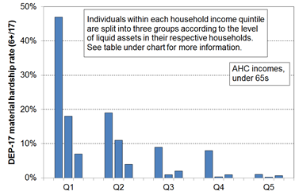

HES 2017-18 | Q1 |  |  | Q2 |  |  | Q3
median liquid assets ($) | 0 | 400 | 8,000 | 100 | 1,200 | 12,000 | 500 | 3,600 | 19,300
can pay an unexpected + essential $500 bill within a month without borrowing | 24% | 43% | 67% | 51% | 71% | 79% | 69% | 84% | 85%
material hardship rate (6+/17, DEP-17) | 47% | 18% | 7% | 19% | 11% | 4% | 9% | 1% | 2%

- For low-income households that have very limited or no financial assets, income is the main in-house resource available to generate their standard of living. Such households struggle in varying degrees to meet basic needs, and are also very vulnerable to the negative impacts of “shocks”, such as even a small drop in income or an unexpected expense.

The framework and government policy to address poverty and material hardship

The income-wealth-consumption-material-wellbeing framework, together with its elaboration in Appendix Eight in relation to child poverty and material hardship, provide a high-level check-list for discussion, debate and policy development for addressing poverty and hardship.

For example, thinking about poverty alleviation from the perspective of a household, and how that intersects with government policy, the framework points to the following as pathways for addressing or alleviating poverty:
- increasing household income (whether it be from higher total earnings or increased government cash assistance or reduced tax)
- having the demands on the core household budget reduced (for example, through government services and government subsidies such as those for free doctor’s visits for under 14s, reduced fees for Community Services Card holders, child care subsidies, the SuperGold Card for older New Zealanders, KickStart Breakfast in schools programme; and through the work of various NGOs (including food banks)
- assisting with addressing toxic debt through services such as those offered by the Community Finance Initiative and the Microfinance Network more generally
- having some financial savings to help deal with shocks to the budget (for example, loss or reduction in paid employment, unexpected health issues that incur costs or reduce earning capacity, unexpected large bill for the car)
- getting better at using a given income to meet basic needs (for example, through improved budgeting, healthy family functioning (tension and chaos reduce efficiency), improving life skills, better access to government and community services, and so on)
- having a streamlined user-friendly interface with government agencies and others for clients to access available assistance
- having improved neighbourhood amenities, including public transport services.

The framework makes it clear that improving the day-to-day living standards of households is about more than income, though income remains a very important factor.

When the focus is on raising incomes for households with children the framework points to three factors that impact on child poverty rates and on the proportion of poor children who come from various subgroups (that is, on the composition of the poor):
- the economy and the labour market (impacting for example on employment and unemployment rates, wage rates, benefit numbers (including numbers of sole-parent families), and interest rates)
- demographic shifts and changing cultural norms (for example, the number of sole-parent families, whether sole-parent families live in households on their own or with other adults, the proportion of dual-earner two-parent households)
- policy changes that have a direct impact on income (for example policy changes around benefit rates, income-related rent subsidies, the Accommodation Supplement and Working for Families settings all have clear impacts on the child poverty rates for children from both working and workless households, and on the relativities between the two groups).
Three ways of measuring material wellbeing and ranking households

The reports use three different measures of material wellbeing to rank households from high to low. Both income measures adjust for household size and composition to enable more realistic comparisons between different household types.
- BHC income (income before deducting housing costs):
Household income from all household members, from all sources after paying income tax, gives an indication of the different levels of financial resources available to different households, all else being equal.
But all else is not equal, as the framework and chart on page 8 make clear. There are many factors other than current income that make a difference to the actual day-to-day living standards of households. For example, the largest item on the household budget for many households is accommodation costs, and yet for others in mortgage-free homes these costs are much lower. Accommodation costs cannot usually be changed in the short-term. To better compare the material wellbeing of households when using incomes, the Incomes Report also uses household income after deducting housing costs (AHC incomes).
- AHC income (income after deducting housing costs):
AHC income (ie BHC income after deducting housing costs) is a very useful measure for understanding the real-life differences in consumption possibilities for households when looking at income alone. AHC income is sometimes called “residual income”.
There are other factors (in addition to income and housing costs) that also contribute to a household’s material wellbeing. The combined impact of all these factors on a household’s material wellbeing can be captured by examining more directly the actual living conditions and consumption possibilities that households experience. The MWI does this.
- MWI (Material Wellbeing Index)
The MWI is made up of 24 items that give direct information on the day-to-day actual living conditions that households experience. They are about the basics such as food, clothes, accommodation, electricity, transport, keeping warm, maintaining appliances in working order, and so on, and also about the freedoms households have to purchase and consume non-essentials that people commonly aspire to. Appendix Four has a list of the MWI items.
Differences in MWI scores reflect the differing impact on living standards of the income, assets and other factors in the framework on page 8. The MWI rankings reflect the different levels of consumption for different households in a way that gets around the need to carry out the very demanding analysis required to estimate a dollar value for each household’s consumption. The tables in Appendix Five give a picture of the different living standards profiles at different MWI levels, using both MWI items and several items not in the MWI. MSD also uses two deprivation or material hardship indices which focus only on the low end of the spectrum:
- DEP-17: this gives the same results as the MWI when looking at the bottom quintile (20%), but the scoring is more intuitive (eg a score of 7+/17 simply means “missing 7 or more basics from the list of 17”)
- EU-13: this 13-item index is used in Europe and we use it to monitor how New Zealand ranks internationally – it ranks households in much the same order as DEP-17 does.

Where do you and your household rank?

- Appendix Two has tables to enable the reader to find out which BHC income decile their household fits in.

- Appendix Four shows how to calculate your household’s MWI score and then how that score translates to a ranking relative to the whole population.
The different measures can show different pictures of who is in the higher and lower material wellbeing levels

Different pictures can emerge depending on which measure of material wellbeing is used. This is most clearly illustrated when looking at how different age groups rate relative to each other on the three measures.
- The charts below show how the bottom quintile (bottom 20%) becomes “younger” when the ranking measure changes from BHC to AHC to the MWI – that is, the proportion of older New Zealanders in the bottom quintile decreases (25% to 9% to 5%) and the proportion of children increases (28% to 34% to 38%).
- The differences arise in part because mortgage-free home ownership is very high among older New Zealanders (ie housing costs are very low for most), so when moving from BHC to AHC incomes a large re-ranking happens with many older New Zealanders moving up and many families with children moving down relative to each other. The two circled figures at the left of the table further below show how the re-ranking leads to many older New Zealanders moving from Q1 (BHC) to Q2 (AHC).

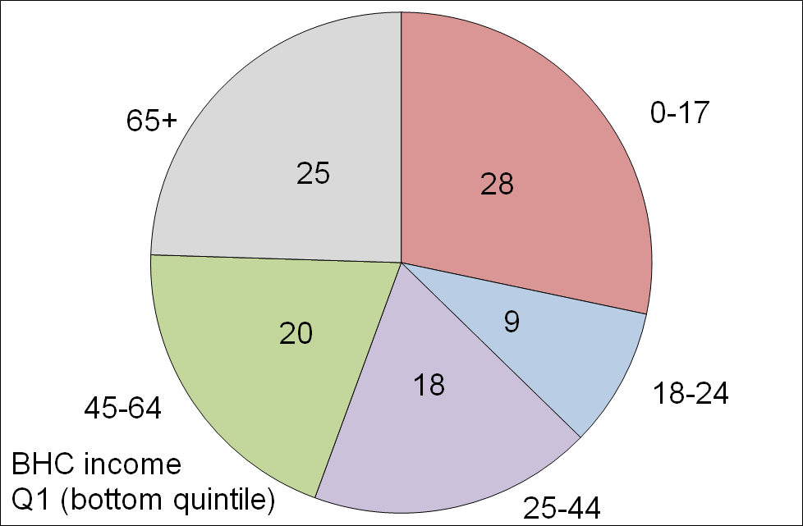
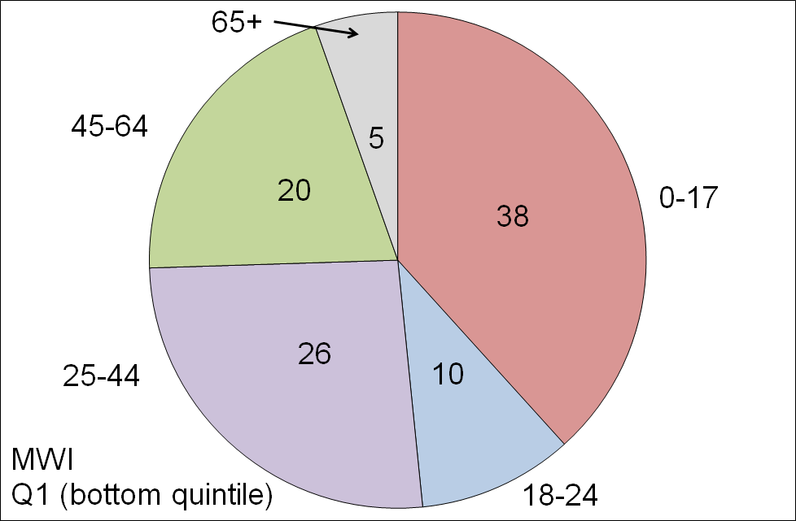
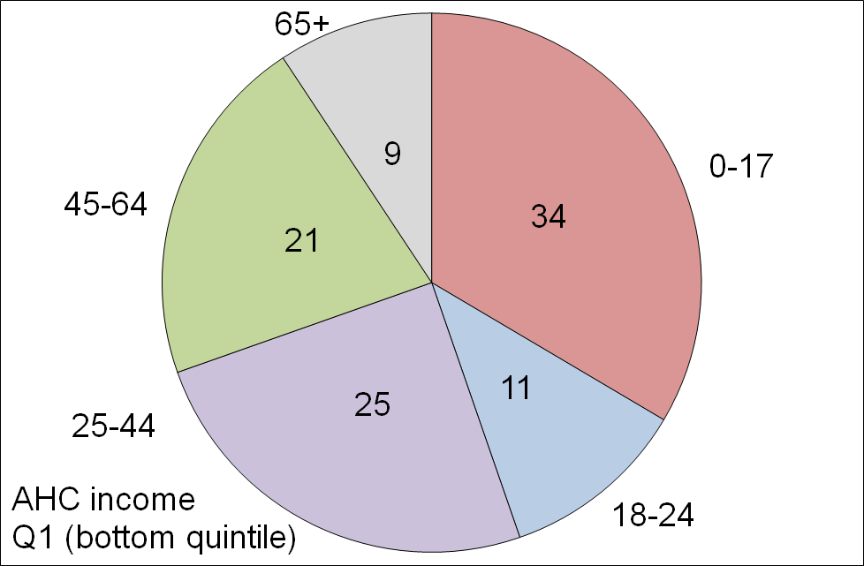
The make-up of the bottom quintile (20%) for the three measures, by age groups (HES 2015)

- The differences in the make-up of the bottom quintile on the three measures are also a reflection of the life-cycle fact that, in addition to a mortgage-free home, many aged 65+ have all the household appliances and furniture they need, and many have other financial reserves they can call on. This explains the large difference for older New Zealanders when comparing their numbers in Q5 (see table below): using the MWI, 44% of older New Zealanders are in this higher living standards group, whereas for AHC only 20% are.
- The table also shows that around one in three older New Zealanders (35%) have BHC incomes that place them in the bottom BHC income quintile, but only one in fourteen (7%) are in the lowest MWI quintile.

Where older New Zealanders are found across all quintiles (%), three measures (HES 2015)
 | Q1 | Q2 | Q3 | Q4 | Q5 | TOTAL
BHC | 35 | 18 | 16 | 14 | 16 | 100
AHC | 13 | 32 | 18 | 16 | 20 | 100
MWI | 7 | 10 | 15 | 24 | 44 | 100

Even when the income and MWI pictures look similar, as they often do for AHC low income (poverty) and MWI material hardship numbers, the actual overlap between the households in the two groups is usually fairly modest (45-50% for the bottom quintiles)

- Analysis using AHC incomes identifies the same groups as more likely to be at the lower end as analysis using the MWI (sole parent households; older New Zealanders renting and with only NZ Superannuation (NZS) as income; and so on).

- However, the overlap between those in households with low AHC incomes and those in households with low MWI scores is only modest. For example, the overlap between the lower 20% of each ranking is typically around 45% to 50%, reflecting the impact of the factors other than income on the actual living standards of the households.

- This does not mean that household income is not an important driver of living standards. For low-income households an income increase will almost always raise their material wellbeing. What the finding means is that for comparing the material wellbeing of households, income alone is often not a reliable indicator as the “other factors” vary greatly from household to household (see framework on page 9).

When people are asked if their household’s income is adequate to cover the basics of food, clothing, accommodation and other necessities, there is good evidence that their responses take account not only of their income but also of all the other factors that make demands on or contribute to the household budget

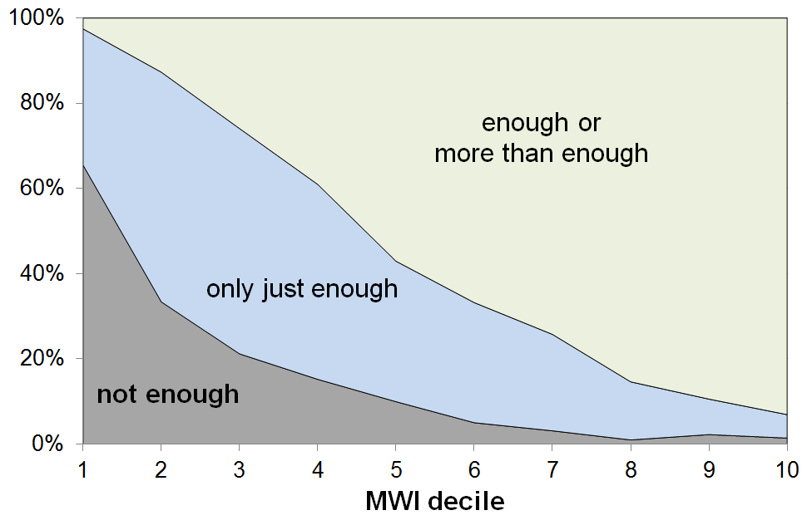
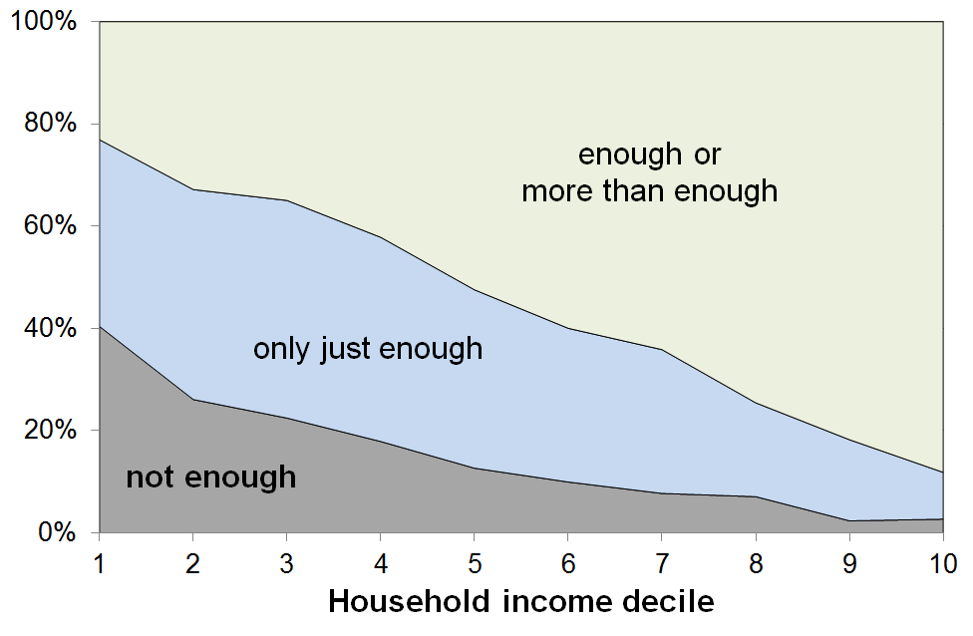
- The graphs below show the responses to the income adequacy question asked in the HES, by household BHC income decile and by decile of MWI score (HES 2013 and 2014 combined). The graphs use a three-way split for grouping the responses: not enough; only just enough; and enough or more than enough.

- The expected gradients from lower to higher material wellbeing are clear on both measures. The “not enough” distribution is however much more tightly bunched at the lower end when the MWI is used for ranking households rather than when household income is used.

- In line with the framework outlined on page 9, this stronger bunching at the low end when using MWI rankings is highly likely to reflect the fact that respondents are taking as a given both their stock of household goods and appliances, and also the “other” factors that assist or place extra demand on the household budget. In other words, the responses are thoughtful contextualised ones about the adequacy of household income given their particular circumstances. MWI scores reflect the impact on living standards of these other factors as well as that of the household income, whereas household income is a more indirect measure of material wellbeing, a proxy that cannot take account of other key factors.

- Looking at the data from the other perspective (how many say “enough” or “more than enough”), 23% of those in the lowest income decile report having “enough” or “more than enough” income to meet basic needs, but only 3% of those in the lowest MWI decile report that their income is “enough” or “more than enough”.

- These findings:
- illustrate the value and importance of the income-wealth-consumption-material-wellbeing framework used in the reports
- give some encouraging evidence of the robustness of the responses given to this more subjective self-assessment question
- warn against using the responses to this common question as if they give reliable information on income adequacy per se, leaving other factors aside.
Key Findings

Incomes and income inequality

Household incomes

- Household income is not the same as household or individual earnings as, in addition to wages and salaries, it includes interest and government transfers such as NZS, income-tested benefits, housing subsidies, tax credits and so on, as well as wages and salaries.

- The table below gives an idea of the distribution of household incomes from low to high. It uses incomes from all sources after all income taxes have been paid (disposable household income). It shows the disposable household income levels at the top of each of deciles 1-9 and in the middle of the top decile, from the 2018 HES. The income at the top of decile 5 is the median income ($82,600). The incomes in the table are not adjusted for household size and composition.
Decile | Disposable HH income at the top of each decile ($)
1 | 32,000
2 | 46,500
3 | 58,700
4 | 69,800
5 | 82,600
6 | 96,400
7 | 110,700
8 | 132,500
9 | 168,800
9.5 | 218,800

- Household income in the rest of this section is adjusted for household size and composition. This is sometimes called equivalised disposable household income. It enables more realistic comparisons of income resources between households of different types.

- The trends and findings for incomes before deducting housing costs (BHC incomes) and those for incomes after deducting housing costs (AHC incomes) can be quite different for two reasons: households with similar BHC incomes can have quite different housing costs and therefore different AHC incomes; and housing costs have increased over the years as a proportion of the budgets for most households, especially for low-income (BHC) households.

BHC incomes

- In the five years from HES 2013 to HES 2018 median household income (BHC) rose close to17% in real terms, an average of just over 3% pa above the CPI inflation rate.

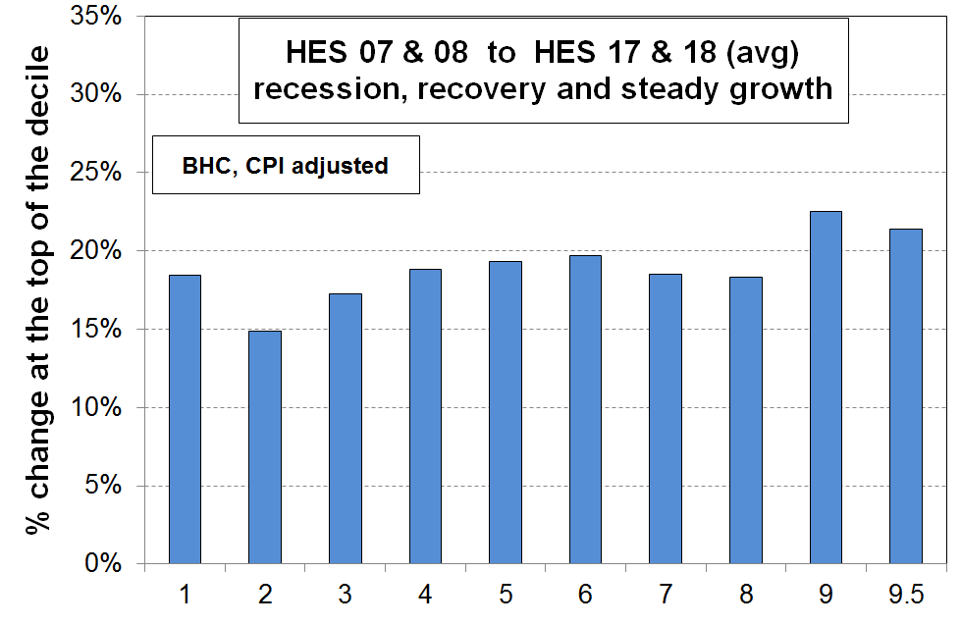
- The graph shows the net improvement at the top of each income decile from just before the impact of the GFC began (avg of HES 2007 and 2008, which covers calendar 2006 and 2007) through to 2017-18. The increases were reasonably even across the bulk of the spectrum at around 17-20% in real terms (17-20% above inflation), with a larger gain for higher income households (~22%). (P95 is in the middle of the top (10th) decile.) The negative impact of the GFC and the associated recession was generally a little greater for lower income households, but the slightly greater gains since then for lower income households have mostly offset that.
- The rise in BHC incomes at P10 (the top of the bottom decile) in the chart above mainly reflects rises in real terms for NZS. Those whose incomes are almost entirely from NZS are located towards the top of the bottom decile and in the bottom of the second decile.
- Incomes for beneficiary households were generally flat or declining in real terms in the period (even when the impact of the 2016 Child Material Hardship package is taken into account), so did not contribute to the rise at P10.
- The minimum wage rose by 15% in real terms in the period from 1 April 2007 to 1 April 2017. This rise would have had some impact on the level of incomes around P10, though the great majority of very-low-wage workers live in households with incomes above P10 (eg around 80-90% of those with wages less than 105% of the minimum wage).

- New Zealand’s net gains from before the GFC and recession to HES 2017 are better overall than for many OECD countries – the negative impact was more muted here and the recovery has been stronger than for many:
  - the UK median fell through the GFC and has only just returned to its pre-GFC level (4% above pre-GFC level in latest 2017-18 survey)
  - Italy, France and Germany were flat through the GFC but have seen small gains in recent years; Spain and Portugal were also fairly flat through the GFC but median incomes have fallen since
  - the US median in 2014 was much the same as in 2008 before the GFC, but had lifted around 13% by 2017
  - in Australia, household incomes across all parts of the distribution have been relatively flat since 2007-08, just as the GFC began to have an impact
  - New Zealand’s post-GFC gain at the median of around 20% in real terms through to 2017-18 is more like that of the top performers such as Finland and Canada (~15-20%), though those countries did not have the fall in median during the GFC that New Zealand did (-3%).
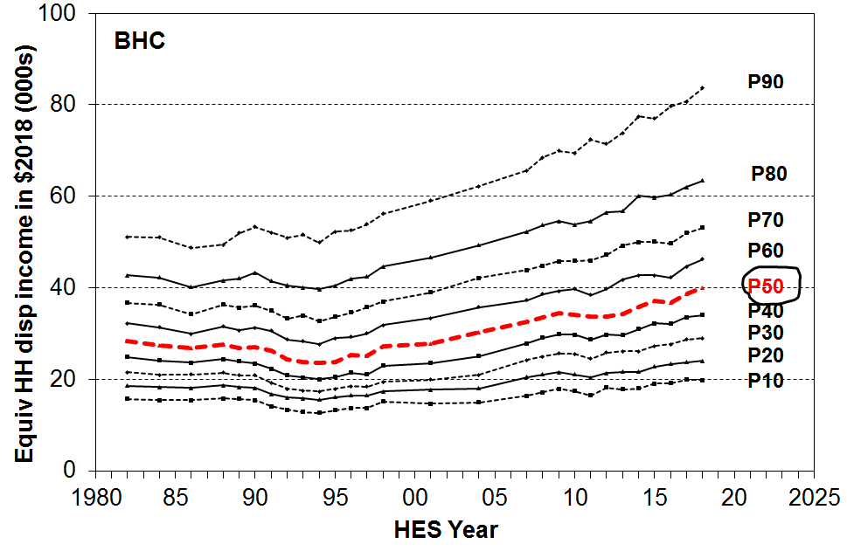
- The graph shows the trends for different parts of the BHC income distribution for the last three decades. It shows the fall in the median from 1982 to 1994, the steady rise to 2008-09, the fall in the GFC recession and the subsequent rise through to the 2018 HES.

- Incomes at the top of the bottom decile (P10) only returned to their 1980s level in 2007.

- Increasing gaps between the different lines on the graph can be caused by two quite different factors. When interpreting the graph, both need to be kept in mind:
- First, the widening gaps can reflect increasing inequality. For example, from 1982 to 1994, the gap between the P90 and P50 (median) lines widened and the P90:P50 ratio increased.
- Second, the gaps can widen even when there is no increase in the ratio of higher to lower incomes, and it is an increase in the latter that is usually meant by “increasing inequality”. This apparent visual paradox occurs because the eye notes the gaps (ie the absolute differences) between the lines, whereas the ratio of the level of one line to that of another further down is not something the eye easily picks up. From 1994 to 2018, the percentage increase of CPI-adjusted incomes at the median and at P90 were the same (68%). This means that P90 incomes remained at around double the P50 level, even though the actual gap between them increased in dollar terms. In this period, it is the increase in the dollar gap that increases the visual dispersion between the lines, not any increase in the ratio.
- This difference between ratio and absolute difference taps into a conceptual and philosophical debate on the meaning of changes in inequality that is beyond the scope of this report.

Very high incomes
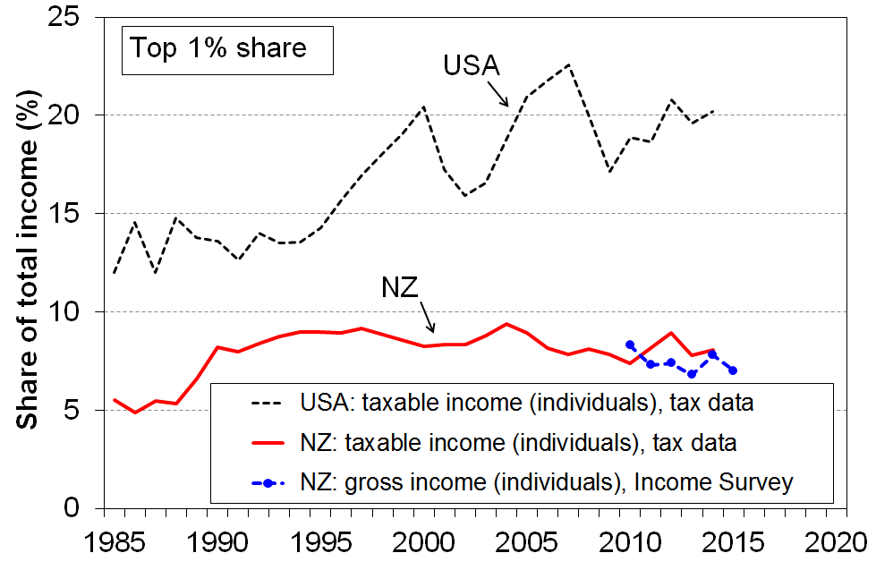
- There is considerable media and public interest in the very high incomes that some individuals receive, and in the perceptions that the gap between these and the rest is increasing, and that this group is receiving an increasing share of total income.

- One way of looking at the issue is to examine the trends in the income share received by the top 1%. The most reliable information on these very high incomes is from tax records.

- The graph shows that, for New Zealand, the share received by the top 1% increased from 5% in the mid 1980s to around 9% in the mid 1990s, and was steady or slightly falling through to 2014, in the 7-9% range. Information from the NZ Income Survey (using a sample of around 30,000 individuals) shows that there is no evidence of any rise over the years from 2010 to 2015.
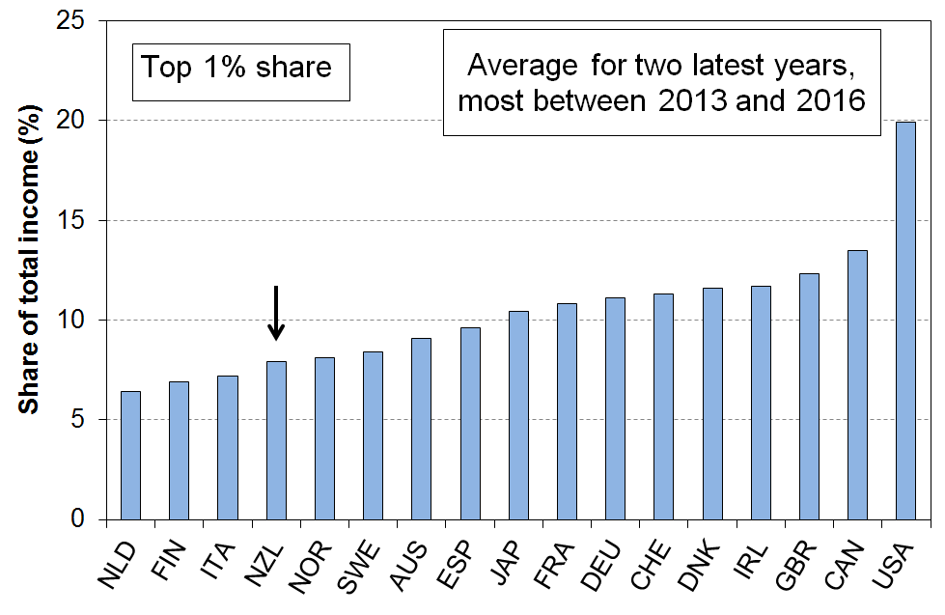
- New Zealand’s top 1% share is in the lower range for OECD countries with whom New Zealand traditionally compares itself.

- Narrowing the focus even further to look at just the top 0.5% of individuals, the same picture emerges for New Zealand: from 2000 to 2013, the share of income received by the top 0.5% was steady at 5-6%.
- One of the reasons for the interest in what is happening with very high incomes is the fact that in the USA there has been considerable growth in the share of total income received by high income earners (see graph above), while at the same time there has been little or no income rise for the bulk of the “middle class” until recently. Neither of these factors apply in New Zealand: the trends for the top 1% and 0.5% shares are flat for New Zealand, and “middle class” household income growth has been solid over the two decades to 2018 (in real CPI adjusted terms, 3% pa on average).

AHC incomes
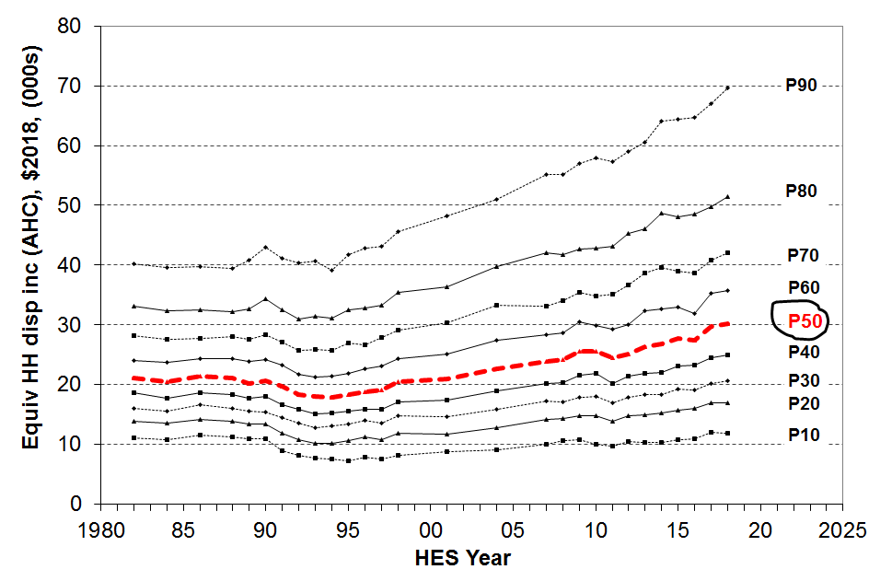
- Trends in household incomes after deducting housing costs (AHC incomes) tell a somewhat different story than do BHC incomes, especially for low-income households:
- incomes at P10 (top of the bottom decile) have only just returned to their level in the late 1980s in real terms
- P20 incomes returned to their 1980s level just before GFC
- the median (P50) returned to 1980s level in the early 2000s, and is now around 34% higher than in 2004.
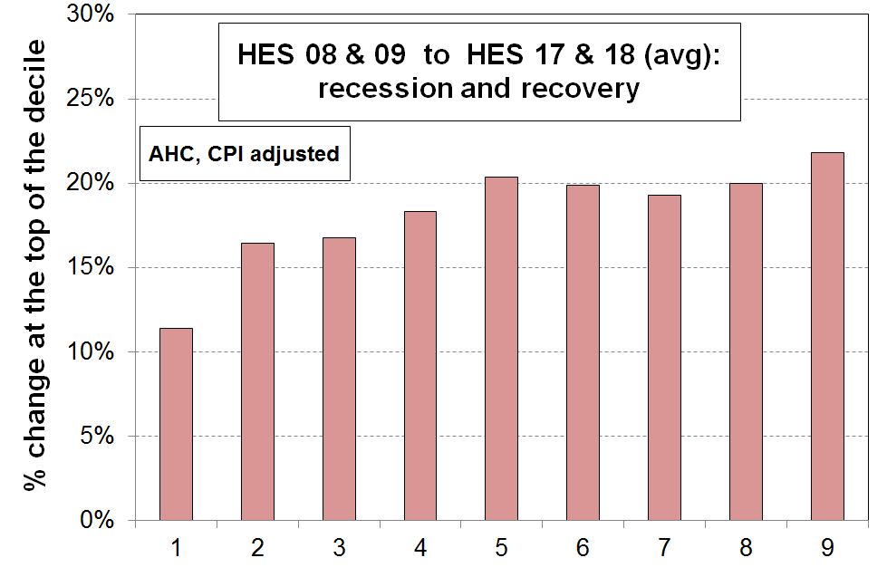
- The second chart shows that, over the decade to 2017/18, AHC incomes at the top of the bottom decile increased much less than for all other deciles (11% compared with 17 to 20% elsewhere). This contrasts with the same analysis for BHC incomes on page 14, which showed more even gains across income deciles. Within the bottom AHC decile there are those who have gained even less than is reported for P10.

- The differences between BHC and AHC trends arises mainly because housing costs now take a greater proportion of the household income especially for low-income households. For under 65s, the share is:
- up from 14% in the late 1980s to 22% on average for 2017 and 2018
- up from 23% to 47% for the bottom quintile
- up from 20% to 33% for Q2 (second from bottom quintile).
More detailed information on trends in housing outgoings to income ratios (OTIs) is given in the housing section below (see p25).

- AHC income inequality rates are higher than BHC rates at all times. AHC low-income rates (poverty rates) are higher now than in the 1980s on every measure used in the Incomes Report. Information on these trends is given below in the Inequality and Poverty and Hardship sections (pp18 and 31 respectively).

Income inequality

- There are many types of inequality that are of relevance to public policy formulation and debate, including inequalities in educational outcomes and access to health care and the justice system, wage inequality, wealth inequality and inequality in community outcomes, and so on. The focus in this section is solely on inequality of household incomes.

- Household income inequality is about the gap between the better off and those not so well off: it is about having “less than” or “more than” others, and about how much incomes are spread out or dispersed. This is different from (income) poverty which is about household resources being too low to meet basic needs – about “not having enough” when assessed against a benchmark of “minimum acceptable standards”.

- Several approaches are used to summarise in a single number the amount of income dispersion or inequality. No one statistic has emerged as the preferred or “best” one, mainly because each one captures a different aspect of the way the dispersion of incomes changes over time, and each one has its own value and limitations. It is now common internationally to report on more than one indicator and to compare and discuss the trends produced by each.

- The most straightforward approach is the percentile ratio, usually either the 80:20 or 90:10.

- The 90:10 ratio covers a greater portion of the population than does the 80:20 (80% compared with 60%). The graph shows the 90:10 trend from 1982 to 2018.

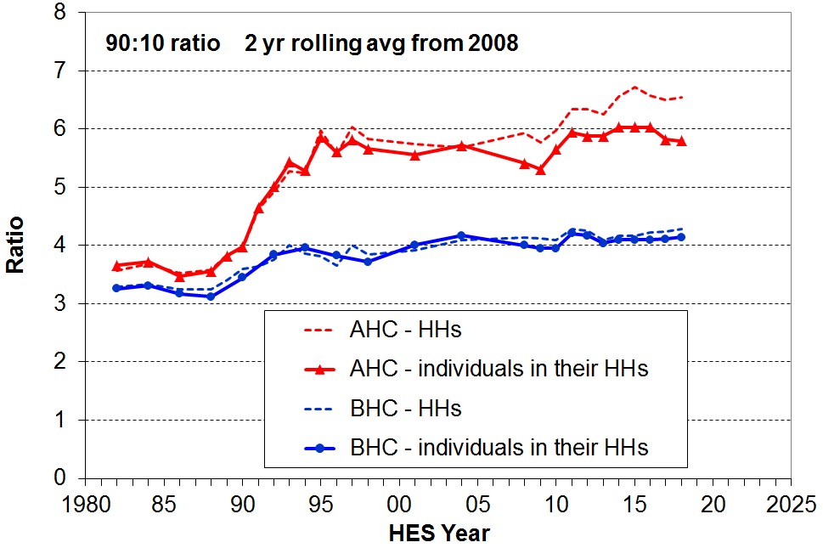
- BHC household incomes at the 90th percentile are around 4 times the level of incomes of households at the 10th percentile. This is very close to the ratios for Australia and the UK. The trend has been fairly flat from the mid-1990s to 2018. There is no evidence of any sustained medium-term or post-GFC rise in inequality on this measure for BHC incomes.

- The main rise in the BHC 90:10 ratio occurred from the late 1980s to the early 1990s.

- AHC incomes are more dispersed than BHC incomes. This occurs because housing costs make up a higher proportion of the household budget for lower income households than they do for higher income households, thus spreading out AHC incomes more so than BHC incomes.

- The steeper rise for the AHC ratio from around 2005 when counting households (rather than all individuals in their households) reflects the fact that, in that period, low-income single-person households on average experienced much greater housing cost pressures than low-income mid-size to larger households. When all individuals in their households are counted, the impact on the 90:10 ratio of this pressure is diluted, as the experiences of the mid-size to larger households carry more weight (as they contain more individuals).

- The rise in AHC inequality from the late 1980s to the mid 1990s was much larger than the BHC rise. In contrast to the fairly flat BHC trend in the last twenty years, the AHC trend was consistently a little higher from 2011 to 2016 than it was in the mid 2000s, especially when counting households (dashed line). The reported recent fall should not be treated as definitive – it is driven by a particularly low number for 2017 HES, and another survey or two is needed to assess whether it is ‘real’ or just a statistical ‘blip’.

- The Gini coefficient is a commonly used measure of inequality. In contrast to percentile ratios which look at the ratio between two points on the income spectrum, the Gini takes into account the incomes of all households, giving a summary of the income differences between each household in the sample and every other household in the sample.

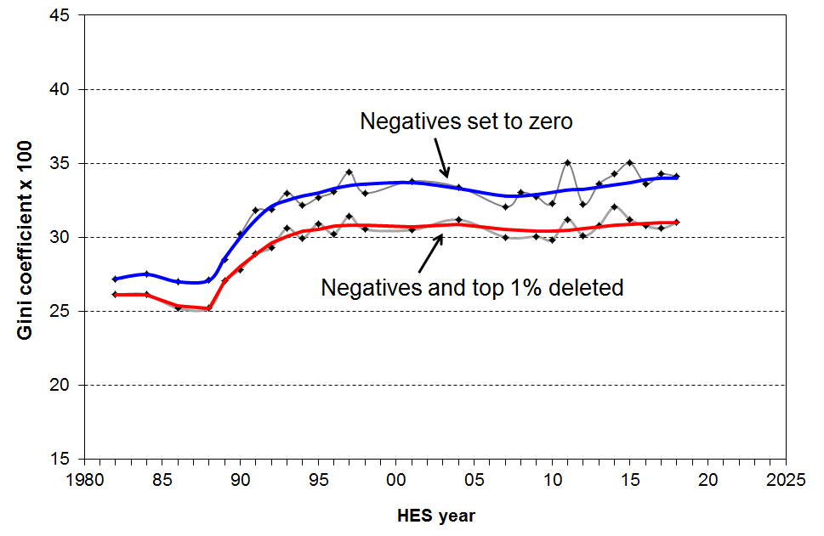
- Taking all incomes into account looks at first sight to be an advantage, but it comes at a price. As outlined at the end of Appendix One, there are challenges with the reliability of income data at the very top and bottom. Sampling fluctuations at both ends can have a significant impact on the Gini value. For example, for both 2011 and 2015 there was a sharp rise in the numbers of households with very high incomes. These are also the two years with historically high Gini numbers, as shown in the fluctuating survey-by-survey upper line in the graph on the right. The number and size of the negative incomes reported can have an impact on the Gini, but in practice this is a much smaller impact. Neither of these issues impact on the 90:10 figures as the issues occur either above P90 or below P10.

- The upper line in the graph shows the Gini with the negatives set to zero as is standard practice. The lower line shows the Gini with both the top 1% and negatives deleted. The fluctuations for this ‘bottom 99%’ line are more muted and the trend is flatter.

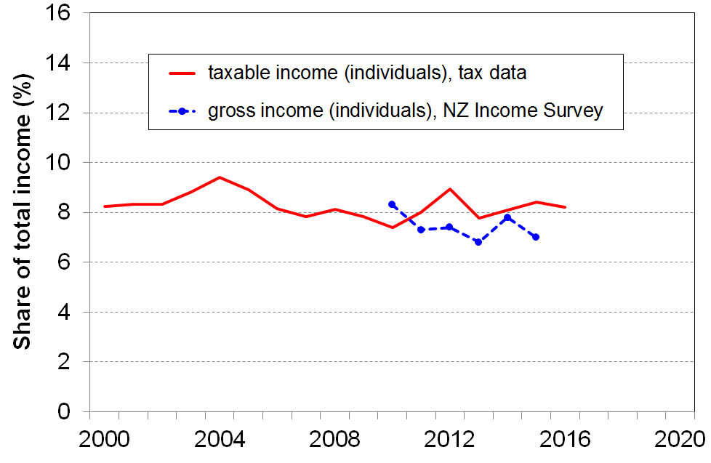
- The second graph provides an independent monitoring of what is happening to the top 1% share. The trend using tax data is reasonably flat from 2000 to 2016 (latest available), and the trend from 2009 to 2015 using the Income Survey is also flat.

- To give a summary of the income inequality trend using the Gini, this report uses the ‘bottom 99%’ line in the upper graph (red line) together with the top 1% share trend.

- For AHC incomes, the Gini (with both the top 1% and negatives deleted) shows a modest rising trend from 2007 to 2018, with the 2018 level being higher than it was in the early 2000s, in contrast to the flat trend for the Gini for BHC incomes in the period.

- The Palma measure or ratio is a relatively new addition to the suite of inequality measures used for international comparisons: it compares the top decile share with the share for the bottom four deciles. Country rankings using the Gini and the Palma measures are very highly correlated, and the Palma has the advantage of being easier to understand. The OECD now reports the Palma in its Income Distribution database.

- As with the Gini, the Palma BHC income inequality trend for the bottom 99% has been flat for at least two decades.

- In the 2017 and 2018 HES, the Palma ratio for New Zealand was just under 1.4. This is a little higher than Australia (1.3), lower than the UK (1.5) and the US (1.8), but much higher than Denmark, Norway and Finland (all close to 0.9), and above the OECD-35 median (1.1).

Summing up

- There are several approaches available for reporting on income inequality, and it is commonplace for more than one to be used.
- There is no evidence of any sustained rise or fall in BHC household income inequality in the last 10-15 years using the 90:10 ratio, or the last 20 years using the Gini for the bottom 99%, or the last 25 years looking at the top 1% share from tax records.
- The level of BHC income inequality in New Zealand is a little higher than the OECD average.
- AHC incomes are much more dispersed than BHC incomes and there is evidence of higher AHC income inequality in the last few years as compared with the mid 2000s and earlier.

How the income inequality picture changes depending on the income concept used

The reported level of inequality or dispersion in the distribution of incomes depends on which income concept is used. The graph below shows the different levels of inequality that different income concepts produce, using the 80:20 percentile ratio as the measure.

Inequality is lower when the focus moves from individuals to households (HHs). The 80:20 ratio falls from 5.8 for individual taxable income to 3.6 for HH gross taxable income. HH gross taxable income excludes all non-taxable components such as WFF tax credits, AS, and so on. When these are included, inequality drops further (HH gross). Taking personal income tax deductions into account further reduces the 80:20 ratio, as does the adjustment for household size and composition. The 80:20 ratio is more than halved in going from individual taxable income to equivalised disposable HH income. The latter is the most useful of these income concepts to use when using income to assess the material wellbeing of the population, and of subgroups within it.

80:20 percentile ratio for different income concepts, 2012-13
(HLFS for individuals, HES for households)
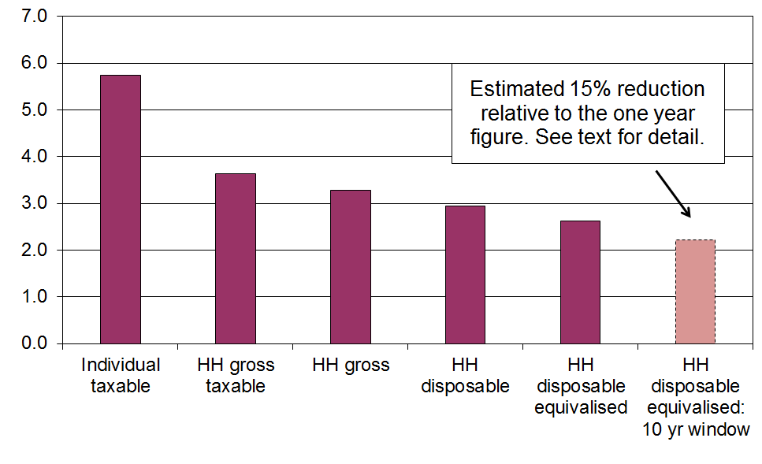
When the same group of individuals is followed over time (longitudinal data), and the income concept is the average household disposable income of the individual over, say, ten years rather than one, then measured inequality falls even further as a result of income mobility. For Australia the fall was around 15% for both the 90:10 ratio and the Gini from 2001 to 2010 and for the UK it was around 15% for the Gini for five year periods starting at various years in the 1990s. The right-hand bar above assumes a 15% reduction for illustrative purposes.

Income redistribution

- New Zealand, like all OECD countries, has a tax and transfer system that redistributes market income (wages, salaries, investments, self-employment) and reduces the inequality and hardship that would otherwise exist. In interpreting the findings in this section it is important to note that market income is not the counterfactual or ‘natural state’ that would exist if there was no government intervention. The existence of taxes, government expenditure and the apparatus of the welfare state (in some form) is a given, and influences citizens’ behaviour in relation to labour market participation, living arrangements, and so on. The analysis can be taken as an indication of the extent of redistribution given that we live in a redistributive welfare state.

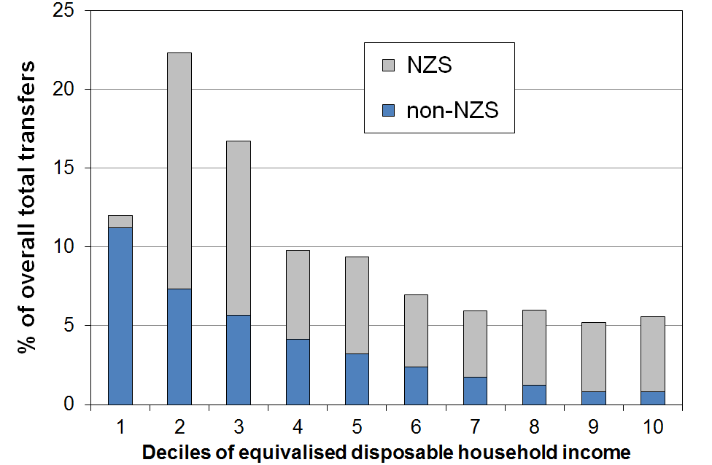
- ‘Government transfers’ include working-age welfare benefits, NZS, the Accommodation Supplement, Working for Families tax credits, special needs grants, and so on. The chart shows the distribution of these transfers across household income deciles, with NZS separated out. For example, decile 2 households receive 22% of all transfers and two thirds of that is NZS (HES 2015).

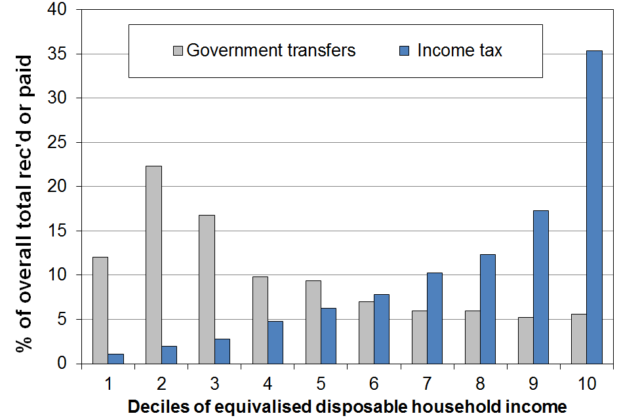
- The second chart shows how the proportion of total income tax paid and transfers received varies across the different deciles. For example, in 2015 households in the top decile paid one third (35%) of all income tax collected, and received 5% of all transfers. The transfers received by the top decile are almost entirely from NZS. The rest is from low-income ‘independent’ adults living in high-income households while (legitimately) receiving a core income-tested benefit such as Sole Parent Support.

- Another useful way of looking at the extent of redistribution is to look at the difference between income taxes paid and transfers received for households in different income deciles. For many households, the amount they receive in transfers is greater than what they pay in income tax. They have a negative net tax liability.

- One group with negative net tax liability is low- to middle-income households with dependent children. For example, single-earner families with two children can earn up to around $60,000 pa before they pay any net tax (2016 settings). Around half of all households with children receive more in welfare benefits and tax credits than they pay in income tax. The vast majority of older New Zealanders (aged 65+) live in households where there is a negative net tax liability – the income tax they pay is less than the value of the NZS they receive. “Working-age” working households without dependent children have a positive income tax liability whatever their income.

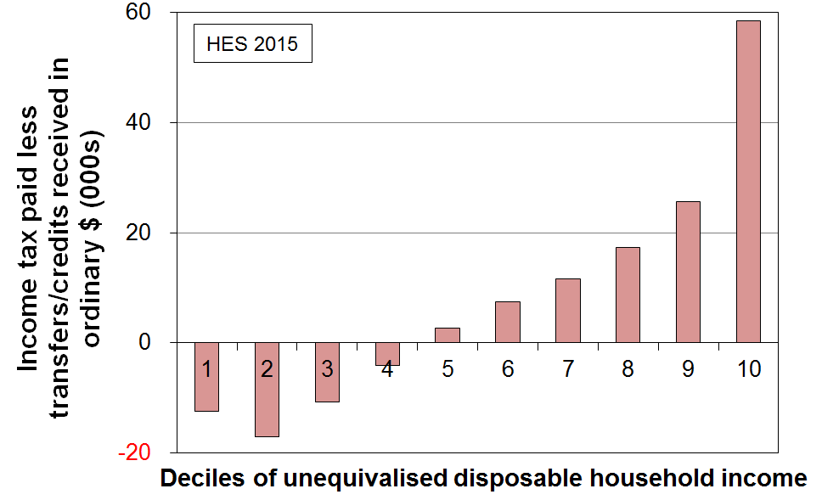
- The bottom chart shows that when all households are counted (working age with children, working age without children, and 65+ households), and looking at households grouped in deciles rather than looking at individual households, the total income tax paid by each of the bottom four deciles is less than the total transfers received (tax credits, welfare benefits, NZS and so on). For the fifth decile, payments and receipts are on average equal. It is only for each of the top five deciles that total income tax paid is greater than transfers received.

- For a more comprehensive analysis, the impact of GST payments and the receipt of government services (especially health and education) need to be considered. The above is limited to income tax and transfers only.

International comparisons

- The OECD publishes information on the impact on income inequality of income taxes and transfers by comparing the Gini figures for household incomes for before and for after taxes and transfers.
- The latest available OECD comparisons are for 2014 or 2015.
  - For ‘working-age’ New Zealanders (aged 18 to 65 years), the reduction in the Gini was 18% on average over OECD years 2013 to 2016 (HES 2014 to 2017). The NZ reduction is similar to that for Japan, Canada and the USA, but less than for Australia and the UK (~25%), and much less than for many European countries such as Denmark, France and Austria (33-36% reductions). The median OECD reduction was 27%.
  - For the full population, New Zealand’s reduction in inequality was 28% compared with the OECD median of 37%.

Inclusive Growth

- The idea of “Inclusive Growth” (IG) has gained traction in recent years, especially post GFC. At the heart of the IG notion is the goal of simultaneously promoting economic growth and reducing (or at least not increasing) various inequalities.

- For example, the OECD launched its IG initiative in 2012 in association with the Ford Foundation, and defines IG as “economic growth that creates opportunity for all segments of the population and distributes the dividends of increased prosperity, both in monetary and non-monetary terms, fairly across society”.

- By definition, the notion of inclusiveness requires a focus on individuals and households, not just on the system as a whole and ‘averages’. IG is also multi-dimensional, covering not only income and wealth, but also jobs, education, health and access to healthcare. Some include other dimensions too in a broader notion of ‘living standards’.

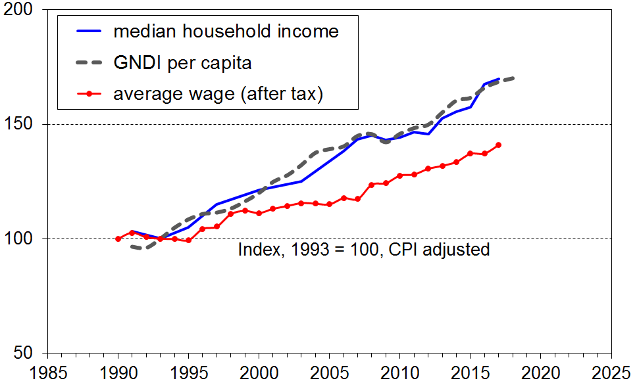
- One of the motivations for the IG approach is the observation that, for many countries in the years leading up to the GFC, the dividends of economic growth were not fairly shared across the whole income distribution. In particular, in the US and the UK a small group of very high income earners vacuumed up the bulk of the new income coming from economic growth, leaving little or none for the rest to share.

- The graphs show one aspect of New Zealand’s IG experience from the mid 1990s to 2018 – the growth in real terms of household incomes (not equivalised) and Gross National Disposable Income per capita (GNDI pc). They show that:
- median disposable household income tracked very closely with GNDI pc, showing ‘inclusive growth’ (top graph)
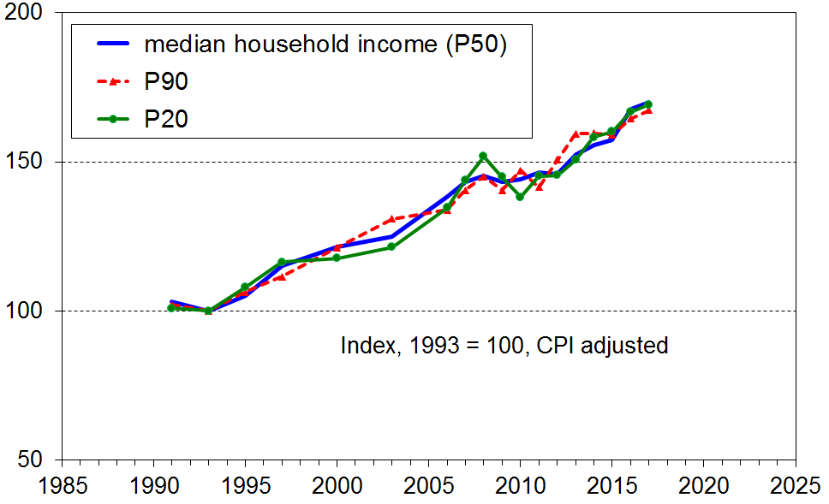
- the P20 and P90 incomes tracked close to the median (P50), thus showing that the ‘inclusive growth’ extended to higher and lower incomes (bottom graph)
- average wages (after tax) fell behind GNDI pc growth, consistent with lowish productivity growth or higher returns to capital than to labour, or both (and see the point made at the top of the next page).
- in the post GFC years, average wage growth (after tax) has been a little less than the growth in median household incomes and GNDI per capita.

- One of the reasons for the higher growth rate for household incomes compared with wages is the increase in total hours in paid employment per household for many multi-adult households. This to a large degree reflects the increased female labour force participation in the period.
  - For example, out of all two parent families that had at least one parent in FT employment, the proportion with two earners increased from 58% in 1994 to just over 70% on average in 2017 and 2018 HES.
  - One consequence of this is that the ratio of median two parent income to median sole parent income increased from 1.68 in the mid 1990s to 1.78 in 2007 to 2010 and 1.95 on average in the 2017 to 2018 HES.

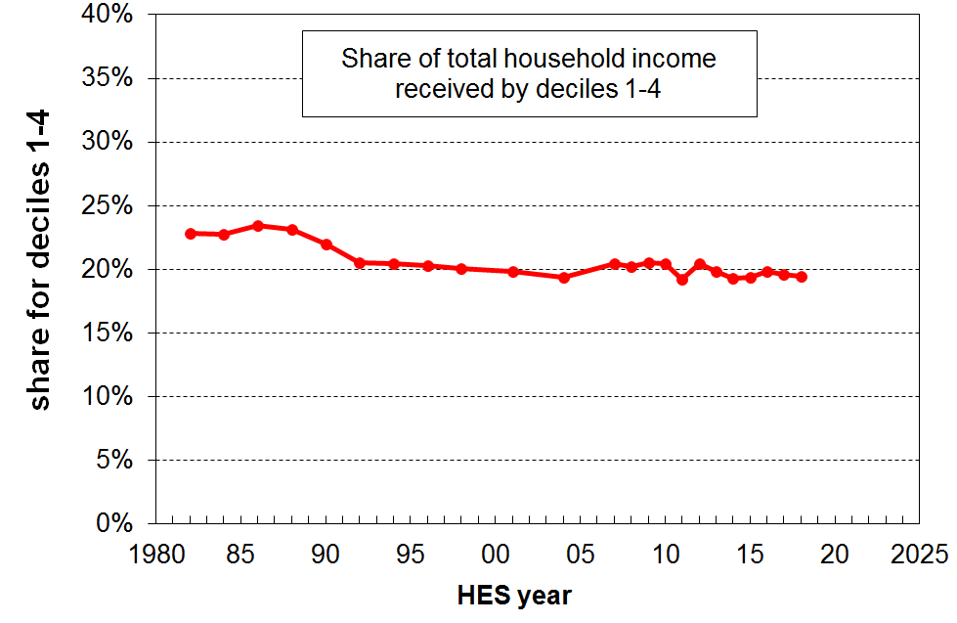
- Another way of investigating how inclusive the economic growth of a country is is to look at the proportion of total income that goes to the lower four deciles (bottom 40%). The graph shows a generally flat trend from the early 1990s through to 2018, which means that the income growth of the bottom 40% has been much the same as that for the national average in that period. If the growth for the bottom 40% is greater than that for average incomes, the trend line will slope up, showing that the bottom 40% is taking a larger slice of the pie (ie is growing faster than the national average).

- There are two qualifications to the otherwise positive household incomes story for New Zealand for the last 25 years (positive from an Inclusive Growth perspective).

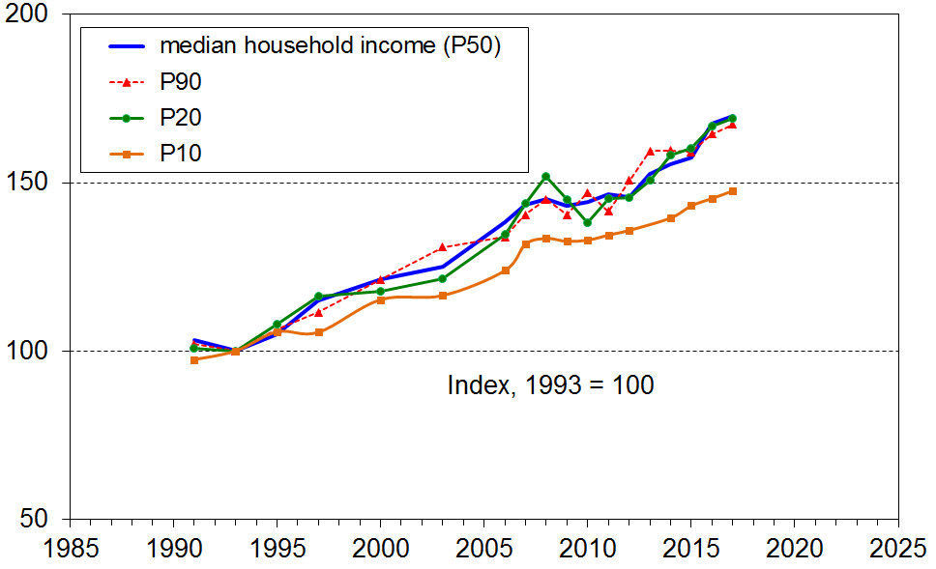
- First, household incomes at P10 (ie at the top of the bottom decile) have not kept up with the growth in the rest of the income distribution. Conclusions from such analysis can be very dependent on the start year chosen. The finding that P10 has lagged behind the rest is robust to choice of start year for any time after the early 1990s.

- The net gain over the whole period at P10 is less than for the median or P20. The fact that there was any real income growth at all at P10 mainly reflects rises in real terms for NZS. Those whose incomes are almost entirely from NZS are at or near the top of the lower decile and the bottom of the second decile. In addition, the minimum wage grew by close to 50% in real terms from 2000 to 2018, and this would have assisted with a rise at P10, though many receiving the minimum wage live in households above P10. Income from welfare benefits remained steady in real terms in the period but for those with children the Working for Families assistance declined in value in real terms.

- The second qualification is that when housing costs are taken into account, incomes for low-income households have fallen even further behind the rest. More detail is provided in the Housing Costs section below.

- For assessing the degree of Inclusive Growth in New Zealand’s experience, the above is just a small contribution. For example, the largely positive analysis of IG for household incomes does not address the question as to whether the current range of incomes is ‘optimal’ or considered ‘fair and reasonable’ by the population, nor whether those households with low incomes have enough to live on at an acceptable minimum standard.
The squeezed middle (class)?

- The idea of ‘the squeezed middle’ is related to the Inclusive Growth (IG) theme. One of the starting points for the IG discourse is the observation that in some countries the dividends of economic growth have not in recent years been fairly shared across the whole income distribution.
- The experience of a ‘squeezed middle’ comes in different degrees of severity. Perhaps the most severe has been for the US where median household incomes in real terms are lower now than in 2000, where wage growth has fallen behind productivity growth, and where employee wage and salary compensation made up only 43% of GDP in 2013 compared with 47% in 2000. This all indicates a shift in income from labour to capital, and shows up in for example the rapid rise in the share of all income received by the top 1% (currently 23%, up from 15% in 2000, and 10% in the 1960s).
- A less severe version occurs when middle incomes grow in real terms but not fast enough for middle class households to be as well-off as they had anticipated, and with parents coming to realise that unlike previous generations there is little chance of their children doing better than they did. This is more the UK experience.

- Does New Zealand have a squeezed middle? Clearly not in the US sense as middle incomes are still growing strongly in real terms, and the proportion of income received by the top 1% is steady and much lower at 7-8%. But is there evidence of a less severe version?

- How to define middle incomes for quantifying changing patterns is challenging, defining the middle class more so. As a part of its Inclusive Growth work programme the OECD has investigated the number of people in households with incomes between 75% of the median and double the median (their call on a notion of ‘middle income’), finding that:
  - On average over all OECD member countries (OECD-35), around 61% of people are in middle income households on that definition (latest available data is for ~ 2015).
  - Norway, Denmark, Netherlands, the Czech Republic and Iceland top the list at around 70%, and Chile (48%) and Mexico (45%) have the smallest group. The estimate for India is 40% and for China 48%.
  - New Zealand (56%) is similar to the UK, Italy, Canada and Australia (58%), but below the OECD median (61%).
  - The USA is lower at 51% which is down from 60% in the early 1980s and 53% in the early 2000s.
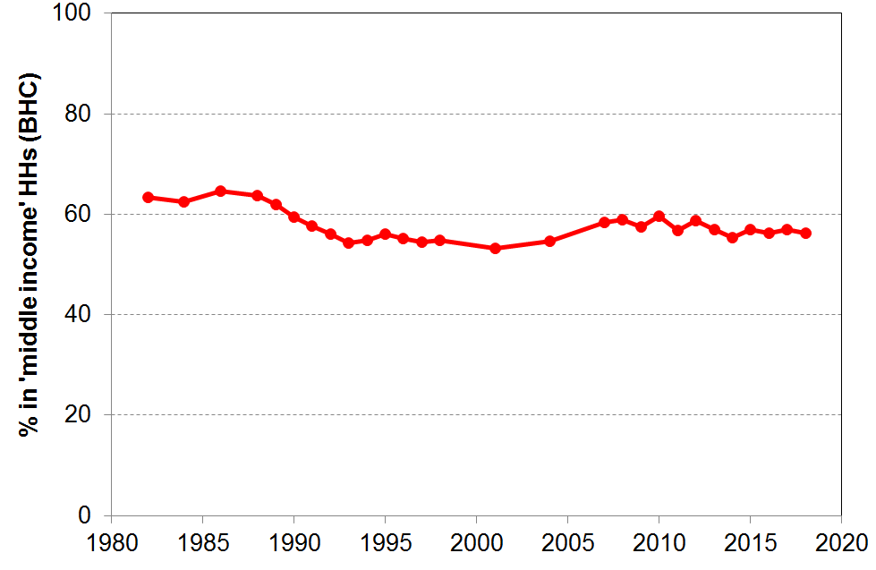
  - The graph shows some evidence of a ‘hollowing out of the middle’ starting in the late-1980s and steadying in the mid-1990s to the mid-2000s, but with some recovery since 2004 (65% to 53% to 56%). This aspect is similar to the UK experience but, in New Zealand, middle incomes have grown strongly since the GFC / recession whereas in the UK they have not. This latter aspect is part of what has driven the middle-income angst in the UK.

  - Defining ‘middle income’ is challenging and ‘middle class’ is an even more fluid concept, with no commonly agreed definition – income is a part of it, so are aspirations, education level and type of employment. The question of whether the ‘middle class’ is squeezed or not is beyond the scope of these reports.

Housing costs and housing quality

The housing costs part of this section focuses on those already in their own homes or renting. It does not look at affordability from the perspective of those in the market seeking to purchase a property.

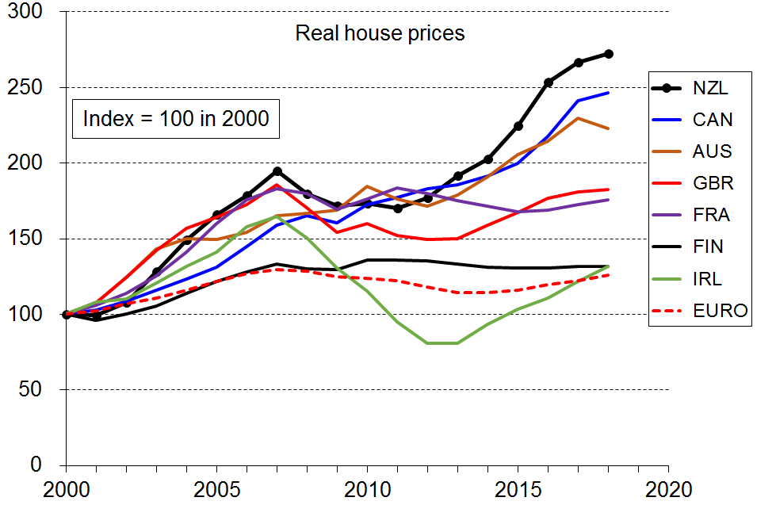
Nevertheless, the trend in house prices provides an important context as house prices impact on the size of mortgage repayments and on rents charged. The chart shows the two periods of rapid rise for New Zealand, 2000-2007 before the GFC, then again from 2012 on. In the period from 2000, New Zealand experienced the largest increase in real house prices in the OECD. Canada and Australia (and Sweden, not shown) had similar increases. New Zealand also has the highest rise when using 1980 as the start date, a five-fold increase, compared with only a 50% rise for the Euro area, and 60% for OECD countries. (Source: OECD House Prices and Related Indicators.)

Ongoing housing costs relative to income

- High outgoings for housing costs relative to income are often associated with financial stress for low- to middle-income households. Low-income households especially can be left with insufficient income to meet other basic needs such as food, clothing, basic household operations, transport, medical care and education for household members.

- Housing affordability can be measured in a number of ways. From the perspective of potential homeowners, the simplest measure is the ratio of average house price to annual household disposable income, which in effect gives the number of years needed to cover the purchase price of a house (on average). Other more sophisticated measures incorporate the cost of financing as well (eg Massey University’s Home Affordability Index). The Housing Affordability Measure from the Ministry of Business, Innovation and Employment uses a mix of administrative and survey data and covers both renters and aspiring first-home buyers. It is based on the notion of ‘residual income’ for households, very similar to this report’s income after deducting housing costs (AHC) measures. It is currently a work-in-progress and designated as experimental.

- This section on housing affordability takes the perspective of households already in their own homes or renting, and uses a measure which is relevant to both homeowners and renters. The ratio used is that of gross housing costs to household disposable income, in much the same way that home-loan lenders do for assessing risk. Housing costs are taken as rates, dwelling insurance, mortgage and rent. The ratio is called OTI for short (outgoings-to-income ratio).

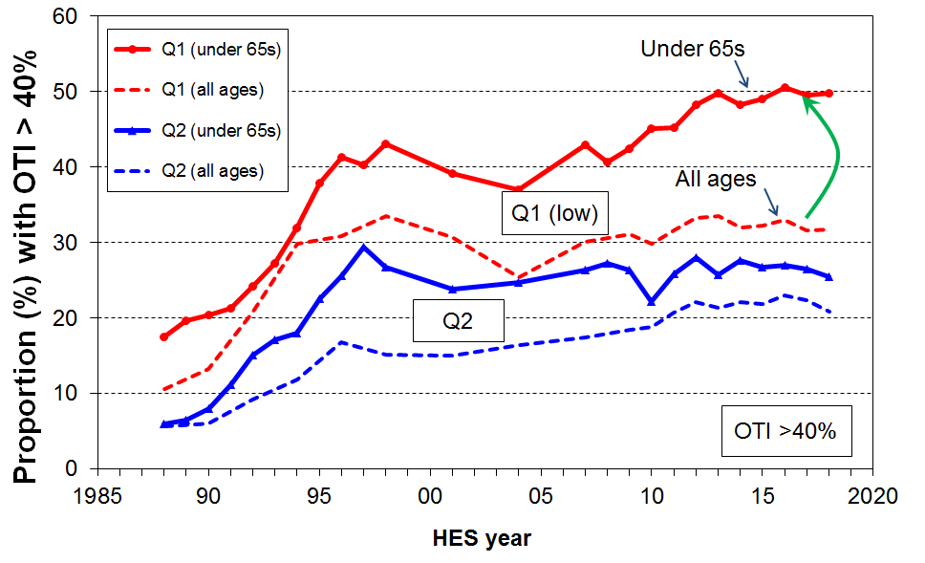
- OTI levels and trends for the over 65s are strongly influenced by the high mortgage-free tenure of this group. Their mortgage-free rate is currently around 72% overall, and 70% in the lower two BHC income quintiles. The very low housing costs for this (increasingly sizeable) group lowers the overall OTI figures, masking what is happening for the under 65s, as shown in the chart on the right for those with OTIs greater than 40%. Half of all under 65 low-income (Q1) households spend at least 40% of their income on housing costs, compared with around one third for all in Q1. The difference arises because only 8% of 65+ low-income (Q1) households have these high OTIs.

- This section therefore focuses on the OTI levels and trends for the under 65s which, on average, are much higher than those for the population overall.

Proportion of households with high OTIs (under 65s)

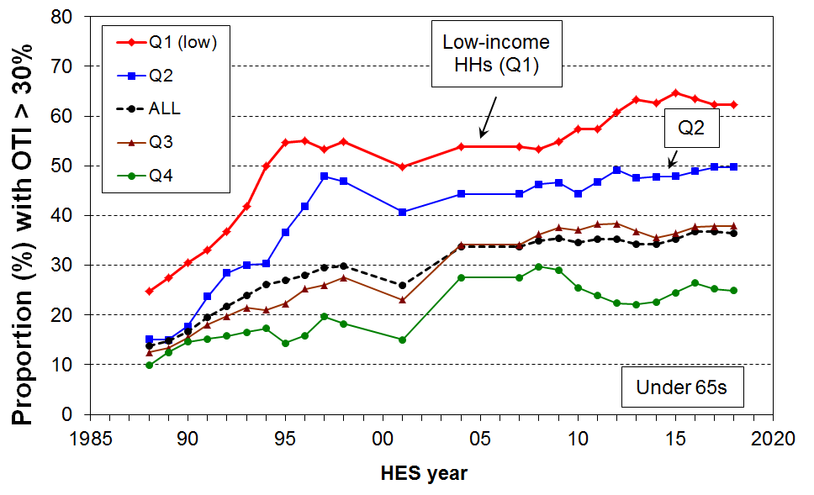
- The chart on the right shows the trends in the proportion of households spending more than 30% of their after-tax income on housing costs (OTIs>30%). On average over the HES years 2016 to 2018, 38% of households had OTIs greater than 30%. This is up from 30% in the mid-1990s and 15% in the late 1980s.

- For the bottom two income quintiles (Q1 and Q2), the proportions were 62% and 50% respectively on average over HES 2017 and 2018. While these are higher than a decade earlier (53% and 47% respectively), the rates for both seem to have levelled out in recent years.
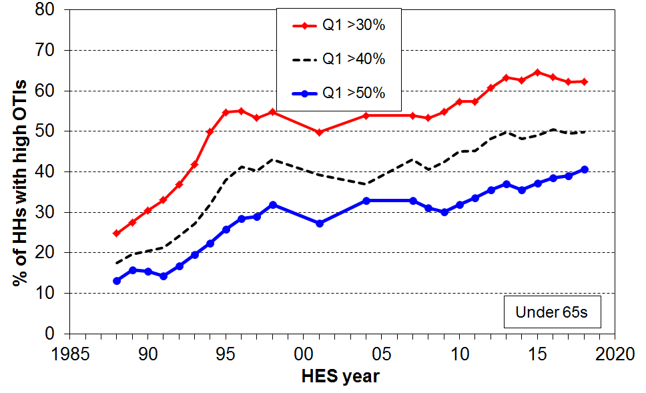
- Within the group of low-income (Q1) households spending more than 30% of their income on housing, there are many spending considerably more than 30%. For example, two in five (40%) of Q1 households spend more than half of their income on housing. This group now makes up two thirds (65%) of all those Q1 households with OTIs greater than 30% (under 65s). The trend-line for this group has been steadily rising over the last decade.

- From 2007 to 2018, around 20% of all under-65 households had an OTI of more than 40%, up from 6-7% in the late 1980s.

- The figures above are national averages. There are regional differences that a relatively small sample survey like the HES cannot reliably report on when breaking down by both region and income quintile.

OTI trends for under 65s, by tenure

- Renters make up around two thirds of the low-income (Q1) households experiencing high housing costs (the proportion is similar for OTIs greater than 30%, 40% or 50%).

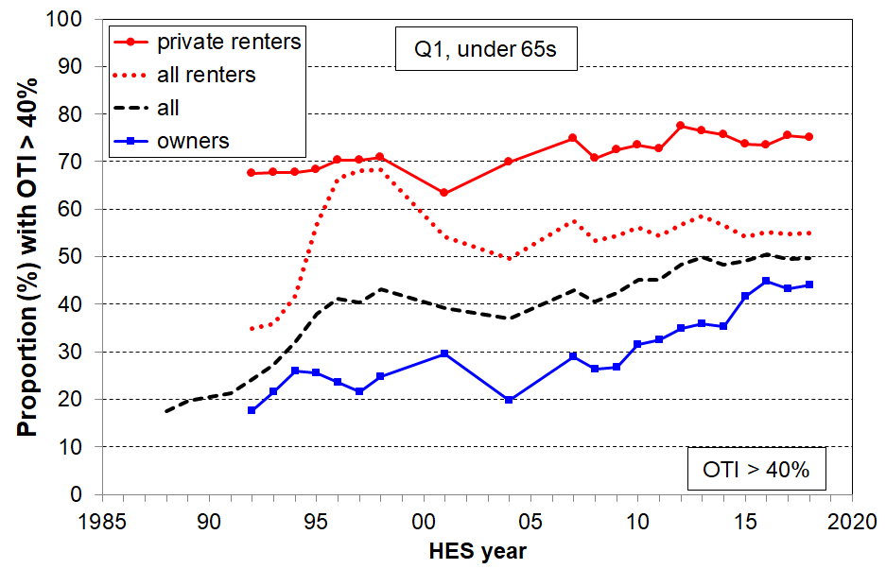
- The chart shows the trends for low-income (Q1) renters and home-owners who spend more than 40% of their income on housing costs:
  - The line for private renters has plateaued at around 75% – this means that three out of four low-income (Q1) renters are spending more than 40% of their income on rent.
  - The line for ‘all renters’ has settled at around 55%. It is lower than the ‘private rent’ line as it includes those in social housing whose housing costs have been capped at 25% of income since 2001. From 1992, state house tenants had their rents gradually increased to market rent levels – hence the large rise in the ‘all renters’ line.
  - The rate for owners has steadily risen in the last decade from around 30% to 45%.

- Around 40% of low-income households spend more than half their income on housing costs. This represents very high housing stress. On average over 2016 to 2018, 60% of households renting privately and 35% of owner households had these very high OTIs.
Household types with high OTIs and low incomes (Q1)

- The table below reports the proportion of selected household types with high OTIs (>40% and >50%) and low income (Q1). The figures are averages for 2007 and 2008, then for 2017 and 2018.

- Housing stress has risen in the last decade for most under 65 household types, and is especially high for single-person households.

 | OTI > 40% |  | OTI > 50%
 | 2007 + 2008 | 2017 + 2018 | 2007 + 2008 | 2017 + 2018
Single 65+ | 6 | 9 | 4 | 4
Couple only maxage 65+ | 4 | 9 | 3 | 5
Single <65 | 47 | 65 | 38 | 56
Couple only maxage<65 | 33 | 45 | 31 | 39
SP HH with any dependent children | 42 | 53 | 26 | 37
2P HH with any dependent children | 34 | 40 | 28 | 32
Other family HHs with any deps | 28 | 18 | 11 | 11
All households with dep children | 37 | 42 | 25 | 31
ALL under 65 households | 41 | 50 | 31 | 41

Using MSD administrative data for those receiving the Accommodation Supplement

- In June 2018, half of all renters receiving the Accommodation Supplement (AS) spent more than half their income on housing costs, three in four spent more than 40%, and almost all renters spent more than 30% (see Table below).

- These figures (and those for other groups listed) are all similar to what they were in 2016. This means that the AS changes from 1 April 2018 roughly kept pace with rising accommodation costs for AS recipients in the 2016 to 2018 period.

- The 2016 and 2018 figures were all up on what they were in June 2007, especially for those spending more than 40% or 50% of their income on housing costs. The AS and other support did not keep pace with rent rises in that period.

Housing stress for AS recipients using three OTI thresholds (30%, 40% and 50%): for month of June
Group | This group as a proportion of all who receive AS |  |  | housing costs as a proportion of income
Group |  |  |  | >30% |  |  | >40% |  |  | >50%
Group | 2007 | 2016 | 2018 | 2007 | 2016 | 2018 | 2007 | 2016 | 2018 | 2007 | 2016 | 2018
All | 100 | 100 | 100 | 87 | 91 | 93 | 59 | 69 | 71 | 34 | 43 | 44
Renters | 63 | 66 | 65 | 90 | 94 | 95 | 67 | 76 | 77 | 40 | 51 | 52
Single adults, no dep children | 45 | 55 | 56 | 90 | 94 | 94 | 65 | 73 | 74 | 40 | 49 | 51
One parent with 1 dep child | 19 | 14 | 13 | 86 | 89 | 91 | 60 | 65 | 67 | 33 | 42 | 40
One parent with 2+ children | 17 | 14 | 13 | 84 | 88 | 88 | 55 | 62 | 63 | 23 | 32 | 34
2 parent with dep children | 11 | 9 | 10 | 74 | 89 | 92 | 40 | 56 | 58 | 21 | 27 | 27
Beneficiaries | - | 67 | 66 | - | 93 | 94 | - | 74 | 77 | - | 48 | 52
NZS/VP | 9 | 13 | 14 | 81 | 86 | 88 | 48 | 52 | 56 | 23 | 26 | 26
Source: MSD Information Analysis Platform, iMSD

- The proportion of Accommodation Supplement (AS) recipients receiving the maximum payment reached 47% in December 2017, up from 25% in February 2007. By December 2018 it had fallen back to 25%, reflecting the impact of the 2018 AS changes and the other Families Package (FP) changes from 1 July 2018.

- These findings based on administrative data are consistent with the findings above based on survey data from the HES.
Average housing costs as a proportion of average income for different income quintiles (under 65s)
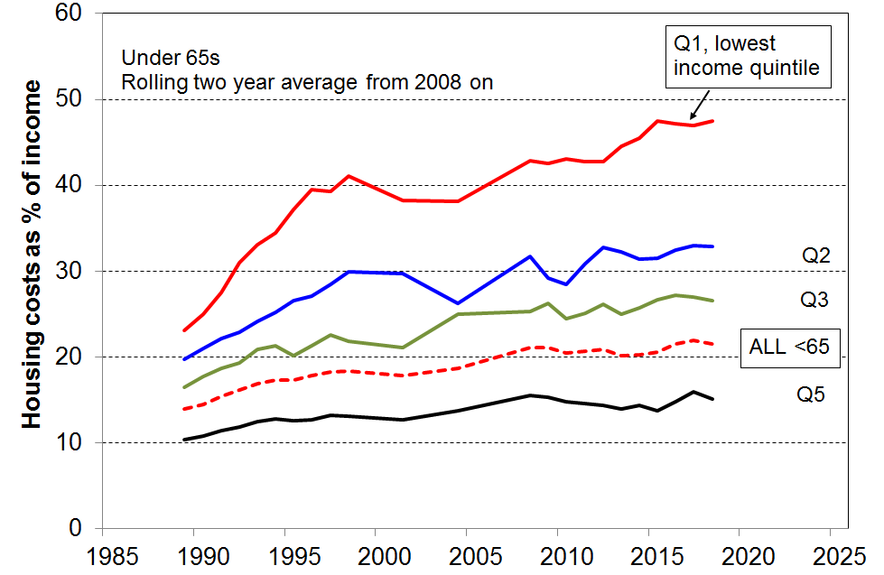
- As is clear from the information above, housing costs now take a greater proportion of household income, especially for low-income households. For under 65s:
  - up from 14% in the late 1980s to 22% in HES 2017 and 2018 for all under 65s
  - up from 23% to 47% on average for the bottom quintile (Q1), and 20% to 33% for Q2.

- Housing costs relative to income for those paying private rent are higher still. For under 65 private renters (on average for 2017 and 2018), the proportions are:
  - 25% for all (21% for all under 65s, irrespective of tenure)
  - 54% in Q1 (47% for all under 65s in Q1, irrespective of tenure).

Housing quality

- Major problems with dampness and mould, difficulty with keeping the house warm, and overcrowding are all issues with housing quality that have impacts on health and wellbeing, especially for children.
- Lack of contents insurance significantly reduces the ability for people to bounce back after a fire, flood, earthquake or other misfortune, and increases economic vulnerability.

Dampness and heating issues for private dwellings

- In the HES surveys, starting with HES 2013, respondents are asked whether their accommodation had no problem, a minor problem or a major problem with (i) dampness or mould, and (ii) keeping it warm / heating it in winter.
- On average over the three surveys from HES 2013 to HES 2015:
- 7% reported a major problem with dampness or mould
- 9% reported a major problem with heating it / keeping it warm in winter
- for children (aged 0-17 yrs), the figures for their households were:
    - 10% for a major problem with dampness and mould (~110,000 children)
    - 13% for a major problem with heating / keeping it warm in winter (~140,000)
    - 7% reporting both issues (~75,000).

- The issues are more prevalent in lower-income households than in middle- and higher-income households, and are especially concentrated in households with low MWI scores (bottom quintile) – the latter are households experiencing multiple deprivation across a range of basics:
- a quarter to a third of the bottom MWI quintile households report ‘a major problem’
- around 70% of those reporting ‘major problems’ are in the lowest MWI quintile.

- The issues are much more prevalent in rental accommodation than in owner-occupied dwellings:
  - one in three ‘social housing’ homes (33%) were reported to be hard to heat or keep warm in winter, 19% for private rentals with AS, 11% for private rentals with no AS, and 4-5% for those in their own homes.
- for both issues, around 65% of those reporting a major problem were in rental accommodation – 45% in private rental and 20% in HNZC homes

- In a related question, respondents were asked to what degree they had put up with feeling cold in the last 12 months as a result of being forced to keep costs down to pay for other basics. The options were ‘not at all’, ‘a little’, or ‘a lot’.
- Overall, 8% reported a serious problem on this issue (response = ‘a lot’).
- The rates were particularly high for sole parent and beneficiary-with-children households (21% and 27% respectively), 10% for children in all households, and 4% those aged 65+.
- The rate for those in working families with children overall was only 6%. However, as there are more low-income working families than there are beneficiary families the numbers reporting having to put up with the cold ‘a lot’ are not vastly different for each group (~40,000), even though the rates are different (as above). This touches on a finding that comes up several times in the reports: there is good evidence of a group of ‘working poor’ that is (currently) about the same size as the ‘beneficiary poor’ group.
- The rate for those in working families with children overall was only 6%, but for the bottom AHC income quintile it was 13%. For beneficiary households in the bottom quintile the rate was 27%. Looking at the bottom income quintile controls to some degree for income, making the 13% and 27% figures a more realistic comparison between the two groups.
Crowding

- Living in a crowded house greatly increases the risk of transmission and experience of communicable diseases and respiratory infection. It can also mean severely reduced personal space and privacy, inadequate space for children to do homework or study, and increased chances of relational stress.

- There is no internationally agreed measure of household crowding, but the Canadian National Occupancy Standard is used widely in New Zealand. This index uses a set of rules for determining who should and should not share a bedroom, with a crowded household being one that requires one or more extra bedrooms. A severe crowding measure uses a threshold of a need for two or more extra bedrooms.

- The Census data shows a decline in household crowding from 13% in 1986 to 10% in 2001 (using the 1+ measure). The rate has plateaued at this level in the Censuses for 2006 and 2013.

- Those of Pacific ethnicity report the highest crowding rate in 2013 (39%) though this was down from 50% in 1986. The rate for Māori declined from 35% to 19% in the same period.

- Crowding is an issue for a good number of children:
  - the rate in the 2013 Census was 16% (~130,000) for the less severe measure (1 or more extra bedrooms needed), and 5% (~40,000) using the more severe 2+ measure
- 80% of those in crowded households are in households with children
- 38% of children in HNZC homes live in crowded accommodation (1+ needed).

- Crowding often goes hand-in-hand with other material hardships. Around half of those reporting crowding are in the bottom MWI quintile – this figure applies to children and the population overall.

- The 2016 HES reports that around 4% of children aged 6-17 years (~30,000) did not have separate beds – the bulk of these children (80%) live in households with MWI scores in the bottom quintile (20%). This should be taken as a conservative estimate as the 2016 HES had some sample bias, including under-counting poorer households with children. The figure will be updated in the next report, based on data from the larger 2018-19 HES.

Contents insurance

- Lack of contents insurance significantly reduces the ability for people to bounce back after a fire, flood, earthquake or other misfortune. It increases economic vulnerability.
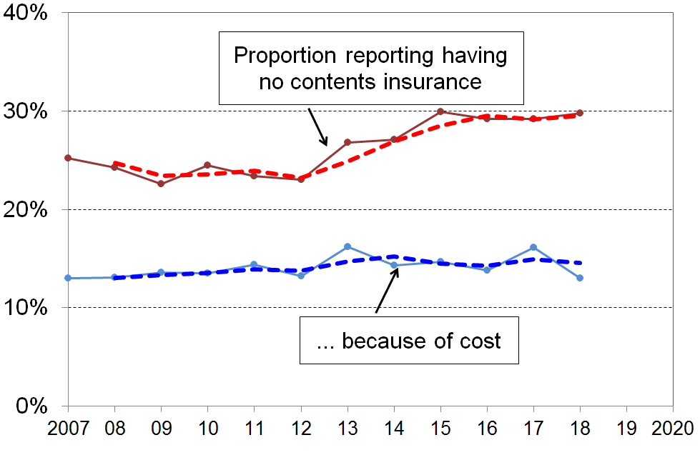
- The top line on the chart shows that the proportion of people in households without contents insurance rose from ~24% in 2007 to 2011 … to a new plateau of close to 30% in 2015 to 2018 (two-year rolling average dashed trend-line).

- In low-income households (the bottom AHC quintile (20%)), 51% of those aged under 65 lived in households that had no contents insurance in 2007 & 2008 – this had risen to 56% in 2015 to 2018.

- If the rise in the numbers without contents insurance were simply a temporary response to tighter household budgets for some in the GFC and associated downturn, the next few surveys could be expected to show a decline. However, as the lower line shows, there is an almost flat trend for those who say that they have no contents insurance “because of the cost” and the need to have money for other basics. It is not clear what is behind the rise in the upper line.

- For older New Zealanders (aged 65+), the straight “no-insurance” rate (as in the upper line) has been steady at 14-16% through the period. The change is occurring among those under 65.
Poverty and material hardship

‘Poverty’ is an awkward word, in part because of conceptual and definitional issues, in part because whatever else poverty is understood to be it is in its essence an unacceptable state-of-affairs. Using the term therefore carries with it an implication and moral imperative that something should be done about it. Despite the awkwardness, its widespread use means that there is little chance of any other word gaining acceptance. The approach in the reports is to use the word, but to be very clear what is meant by it and what is not meant by it, and what measure is being used.

What the reports mean by poverty and material hardship

- Poverty is essentially about household resources being insufficient to meet basic needs. In richer countries poverty is commonly defined as exclusion from a minimum acceptable standard of living in one’s own society because of inadequate household financial and material resources.

- In practice, household incomes have traditionally been used to measure resources, with low incomes used as a measure of income poverty. The limitations of this approach are well-known and have been briefly discussed in the opening section of this Overview (p7). For example, financial and physical assets are an important part of a household’s resources for generating consumption and are usually not counted, the impact of high health, disability or housing costs are not captured in the usual BHC income measures. The report makes extensive use of AHC measures and, in so doing, addresses to a reasonable degree one aspect of the limitations of BHC incomes. Monitoring trends in low incomes (BHC and AHC) is nevertheless an important exercise as many low-income households have very limited or no financial or other assets, and their income is therefore the main in-house resource available for meeting basic needs.

- Over the last two decades growing use has been made of non-income measures (NIMs) to more directly measure material standard of living, and material hardship. The EU has formally adopted a 13-item material and social deprivation index (‘EU-13’ in this report) as one of its suite of social inclusion indicators. Some use a combination of both low income and material hardship as a poverty measure (eg Ireland for their main poverty measure, New Zealand for one of the specified measures in the Child Poverty Reduction Act 2018 (CPRA), or as a measure of deeper poverty).

- MSD’s reports use the low income, material hardship and the combined approaches.

Poverty – narrow or wide?

- The focus of poverty measurement in the MSD reports is on the core material and financial hardship aspects. In this regard it is line with the CPRA.

- In contrast, some use ‘poverty’ as a virtual catch-all term to refer to any serious disadvantage or cluster of disadvantages experienced by individuals, households or geographical areas (for example, low educational achievement, poor health, poor quality housing and local amenities, high unemployment).

- In other contexts, the causes, correlates and consequences of income poverty and material hardship are bundled together with the core notion and turned into an undifferentiated loose construct. This is understandable given the intertwining of so many threads, but it is not a helpful approach when it comes to measurement and coherent evidence-informed discussion. Apart from a high-level reference to causes in the discussion on page 9 and in the more elaborated version in Appendix Eight, these matters lie beyond the scope of the reports. Consequences for wider wellbeing are not considered except insofar as self-assessed life satisfaction scores are reported. Some closely-related correlates of poverty are reported on, notably housing affordability and quality, and food insecurity.
Setting thresholds

- Value judgments are needed to decide on what is ‘minimum acceptable’ or ‘adequate’ (ie where to draw the lines). This is an inescapable aspect of poverty measurement and debate, but does not mean that any measure will do nor that all measures are equally suspect. Some are clearly more reasonable and defensible than others.

- In general, there are two main ways to set thresholds that are likely to have wide support:
  - Use thresholds commonly used internationally.
  - Use thresholds that are arrived at either by a direct consensual process (for low incomes), or one that uses items that have wide support as essentials (for hardship indices).

- The reports use both approaches. In particular, in relation to the latter option:
    - The Incomes Report notes and uses the evidence provided in the New Zealand Poverty Measurement Project focus groups from the 1990s and in the Example Families and Budgets paper prepared for the 2019 Welfare Expert Advisory Group.
    - The NIMs report has a section using essential child-specific items to assist in setting a hardship threshold for all households.

- The dollar value of the low-income thresholds used in the Household Incomes Report are provided in Appendix Three for a range of household types.

Updating the low-income thresholds (‘poverty lines’) from survey to survey

- There are two common approaches to updating the low-income thresholds (‘poverty lines’) from survey to survey:
- select a threshold in a reference year and update it each survey using the CPI (an anchored or constant-value approach)
- use thresholds that are a fixed percentage of the median (a fully relative approach).

- The two approaches correspond to two different conceptualisations of what an ‘improvement’ means for low-income households:
  - on the first approach (anchored line), the situation of a low-income household is said to have improved if its income rises in real terms, irrespective of whether its rising income makes it any closer or further away from middle-income households
  - on the second approach (moving line or fully relative approach), the situation of a low-income household is said to have improved if its income gets closer to that of the median household, irrespective of whether it is better or worse off in real terms.

- The Incomes Report uses both approaches but takes the view that the anchored line is the more fundamental in the short to medium term, in the sense that it reveals whether the incomes of low-income households are rising or falling in real terms. Whatever is happening to the incomes of the ‘non-poor’, if more and more people end up falling below an anchored-line threshold, as happened in New Zealand from the late 1980s through to the mid 1990s, then in the population at large there is likely to be wide concern about increasing poverty.

- The anchor or reference year needs to re-set from time to time if household incomes continue to rise in real terms. The report initially used 1998 as the reference year, then in 2008 changed to 2007. The report also reports a time series starting in 20017 using 2018 as the reference year which aligns with the reporting requirements in the Child Poverty Reduction Act (2018).

A multi-measure multi-level approach

- The reports use a multi-level multi-measure tiered approach, with a supporting narrative to integrate the information into a coherent story. There are several elements to the rationale for adopting this approach.

- Income poverty (low income) and material hardship each exist on a continuum from less to more severe.
  - As noted above, the notion of poverty is a contestable one and different views can reasonably be held on the matter of where to draw the line on the spectrum from more to less severe material disadvantage, whatever measure is used.
  - Beyond these matters of judgement, it is important to use more than one threshold as trends in poverty rates and in the composition of those identified as ‘poor’ can be quite different at different depths.

- Poverty and material disadvantage are multi-dimensional, so different measures are needed to better capture the full picture and to understand which groups are experiencing (which sorts of) material disadvantage.

Illustrations from Spain and Ireland

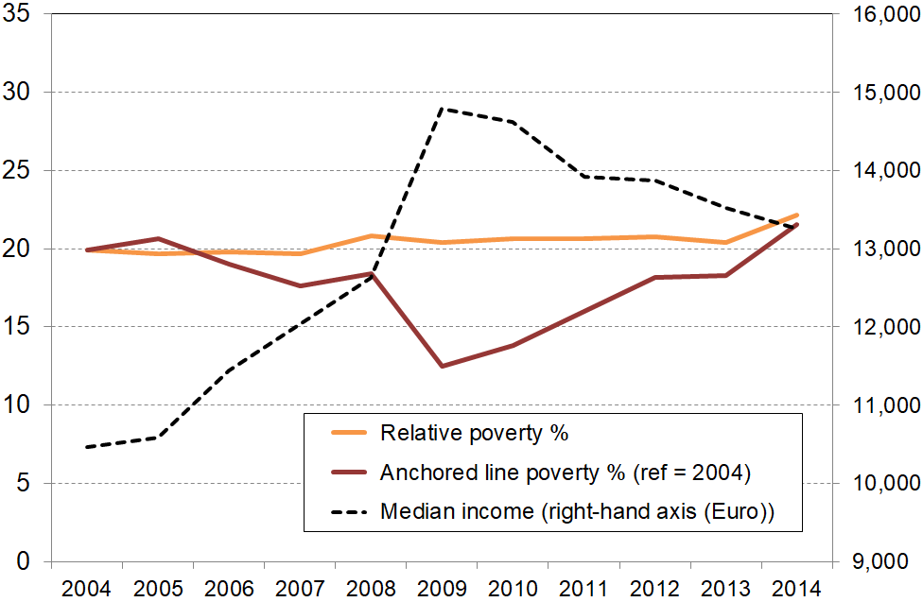
- The value of a tiered multi-measure approach is illustrated here for Spain. The chart shows the differing low-income trends using fully relative and anchored line BHC measures. The anchored line measure clearly picks up the impact of rising real incomes before the GFC and of the downturn during and after the GFC. Reported anchored line ‘poverty’ rates first fell as incomes improved, then rose as many households saw their incomes fall (darker solid line). On the other hand, the fully relative measure remained steady, giving no indication of the increasing financial difficulties experienced by many households in Spain. The flat trend reflects the fact that, on the fully relative measure, a declining median means a declining poverty line. This decline masks the fact that the incomes of low-income households were falling in real terms. Material hardship rates (not shown) broadly followed the anchored line trajectory.
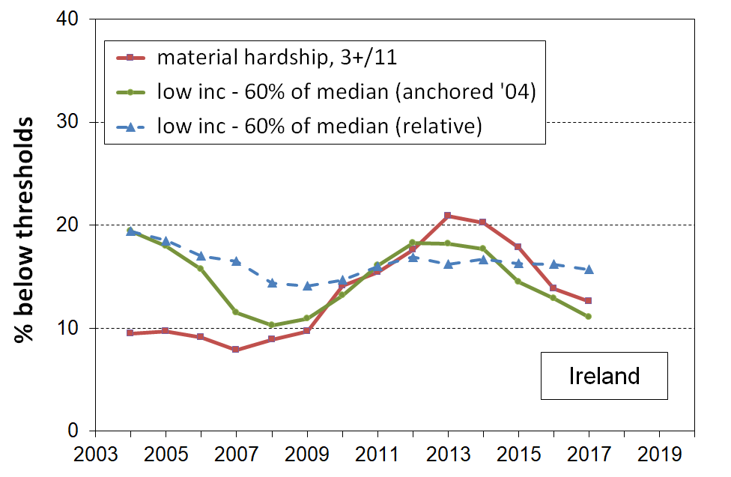
- The evidence from Ireland shows a similar pattern. As the impact of the GFC bit in, both the low-income anchored line and material hardship measures showed strong increases, then fell away in the recovery after the GFC.

- On the other hand, the fully relative low-income measure (broken line) showed only a minor fall and rise, and has remained flat in the last few years while the anchored line and material hardship trends fell away.

Poverty experienced

The understanding of poverty and the associated measurement approach used in the MSD reports is narrowly focused. It is about ‘unacceptable financial or material hardship’ and the insights about this that can be gleaned from a national survey.

This is a legitimate focus, but in pursuing it it is important to be aware that there is much more to “poverty” than what can be measured (albeit imperfectly) through analysis of data from income or deprivation surveys. These can tell us about the material core (“unacceptable material or financial hardship”), but a different type of research is needed to give insight into how this unacceptable hardship is experienced and understood.

What is at issue here is the non-material as well as the material manifestations of poverty. Poverty has to be understood not just as a disadvantaged and insecure economic condition but also as a shameful and corrosive social relation … [The non-material aspects include] … lack of voice; disrespect, humiliation and assault on dignity and self-esteem; shame and stigma; powerlessness; denial of rights and diminished citizenship … They stem from people in poverty’s everyday interactions with the wider society and from the way they are talked about and treated by politicians, officials, the media and other influential bodies.

What people on low incomes report is a situation of great complexity in which the pressures they face are cumulative. Basics become luxuries that have to be prioritised and saved for. Solutions to one problem create problems of their own, as when saving on heating exacerbates illness and borrowing from the rent money generates arrears and threats of eviction. Poverty feels like entrapment when options are always lacking, the future is looming and unpredictable, and guilt seems ever present, arising from an inability to meet one’s children’s needs, one’s own expectations and society’s demands.

It has become popular in discussions of human wellbeing to use Amartya Sen’s dictum that the basic concern of human development or of ‘the good life’ is ‘our capability to lead the kind of lives we have reason to value’. The same language is sometimes used in relation to discussions around strategies to address poverty, with the goal of poverty alleviation intervention being characterised as helping people ‘lead the kind of lives they have reason to value’.

In using only this aspect of Sen’s thinking, it misses two key elements that Sen himself identifies in his writing on the conceptualisation of poverty. The first is the matter of the “irreducible absolutist core”– poverty alleviation is about having households attain a minimum acceptable standard, which may nevertheless be (well) below ‘leading the kind of lives they have reason to value’. The second is that Sen identifies ‘shame’ as being at the core of poverty experienced. There is a good case that the bumper-sticker type of use of the notion of ‘leading the kind of lives we have reason to value’ in the context of poverty discourse both misrepresents Sen on poverty and understates the stress of life at the hard end.

Population as a whole

Low income (income poverty)

- As discussed above, the report uses both the anchored line and fully relative approaches, and household incomes both before and after deducting housing costs (BHC and AHC, for short).

- Two reference years are used for the anchored line trends: 2007 for the longer-run series starting from 1982, and 2018 for a second series starting from 2007. In each case the threshold is set at 50% of the AHC median for the reference year, and adjusted by the CPI for inflation for other years. These thresholds are therefore held at a constant value (CV) in real terms from survey to survey. For short, the anchored line measures are sometimes referred to as AHC 50% CV-07 and so on. Other reports (eg from the UK) refer to these as ‘absolute’ measures. This is an unhelpful and potentially misleading label as it is likely to be incorrectly taken to refer to a subsistence level of living or the like.

- The report takes a multi-measure multi-level tiered approach to reporting low-income trends. While both anchored and fully relative low-income measures have their place, the report takes the view that the anchored line is the more fundamental, at least in the short to medium term, in the sense that it reveals whether the incomes of low-income households are rising or falling in real terms. Whatever is happening to the incomes of the ‘non-poor’, if more and more people end up falling below an anchored-line threshold, as happened in New Zealand from the late 1980s through to the mid 1990s and again in the GFC-induced recession, then there is likely to be wide concern about increasing poverty in the population at large.

- AHC measures are given prominence as they give more robust comparisons between groups, and over time as the relative importance of housing costs changes. In previous editions, AHC CV measures were referred to as ‘primary’, but now that we have the CPRA in which ‘primary’ is used quite differently (for those measures for whom targets are required), this description is dropped.

Anchored line trends

- For the period from just before the Global Financial Crisis (GFC) to 2018, for both BHC and AHC incomes, the anchored line low-income rates first rose during the GFC then fell in the recovery and have been steadily falling since.

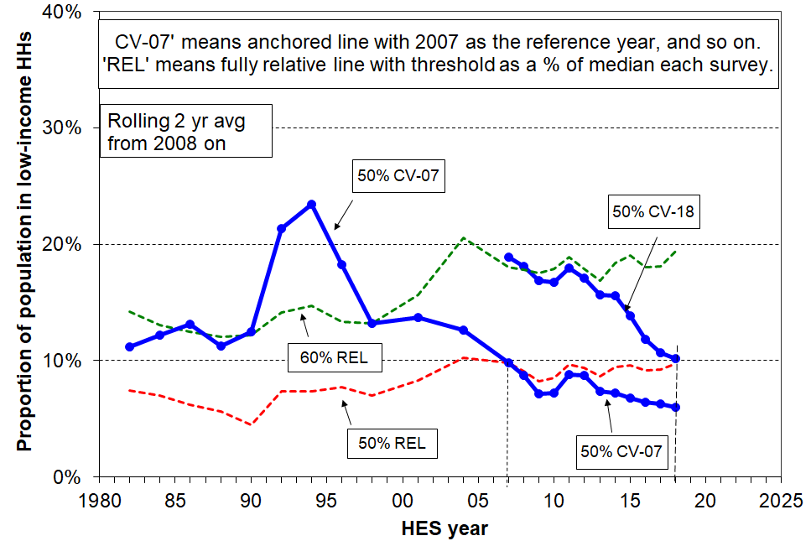
- Since the GFC, low-income anchored line BHC rates have fallen more so for the 50% CV-18 measure than for the 50% CV-07 measure.

- The falls reflect the improvement in household incomes in real terms for many low-income households post-GFC, and falling numbers receiving a main working-age benefit. The lesser fall using the CV-07 measure (lower threshold than CV-18) reflects the fact that the bulk of households below this line are beneficiary households, whose incomes remained fairly steady in real terms in the period. On the other hand the greater decline using the (higher) CV-18 threshold is driven by rising real incomes for low-wage and superannuitant households. In real CPI-adjusted terms, the minimum wage rose 12% and NZS rose 9% from the 2011 to the 2018 survey years.

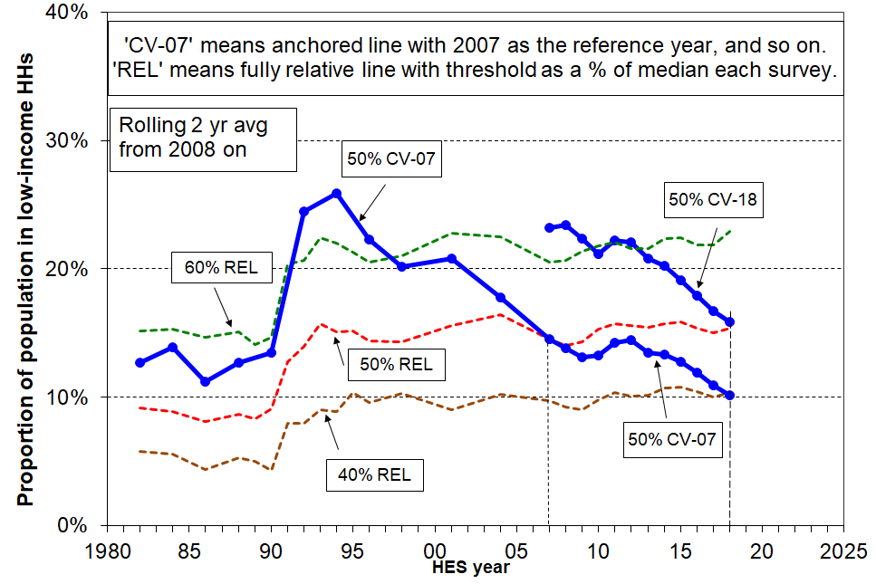
- Low-income anchored line AHC rates show the same general rise in the GFC and steady fall in the recovery and later. In contrast to the BHC measure, the CV-18 fall is only a little steeper than the CV-07 fall as the inclusion of housing costs significantly changes the ranking of low-income households, especially as there are a good number of superannuitants whose housing costs are in the main relatively low.

- Looking at the longer-term picture from 1982, the AHC 50% CV-07 poverty rate more than doubled in a very short period from the late 1980s to early 1990s, reflecting rising unemployment, a falling average wage, demographic changes (more sole parent families), the 1991 benefit cuts and the introduction of market rents in (what we now refer to as) social housing. It then steadily fell through to 2007 with improving employment, a rising average wage, rising female employment, the introduction of income-related rents and Working for Families. This fall in the anchored line rate indicates that the AHC incomes of many low-income households were higher then (2007) than in the mid 1990s.

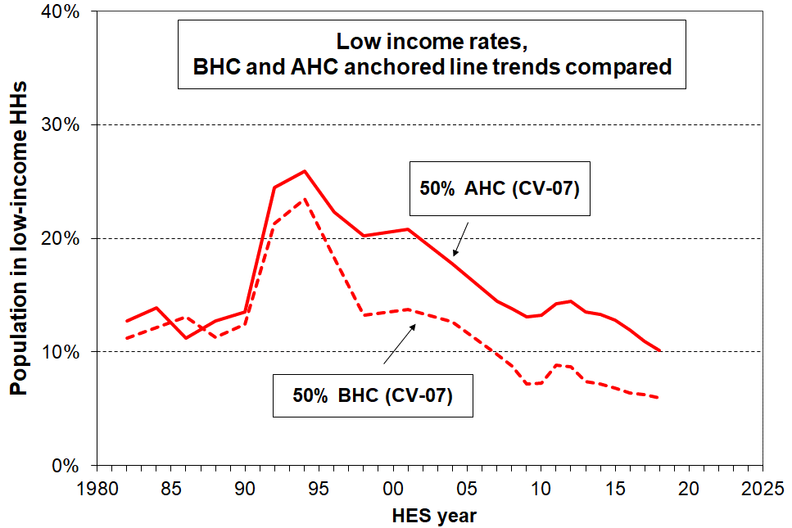
- Over the last three decades housing costs have continued to take a much larger proportion of household income, especially for low-income households (see p28 above). The different trajectories for BHC and AHC incomes show up as different trends for BHC and AHC low-income rates using anchored line measures, as shown in the chart on the right. BHC household incomes for low-income households were higher in real terms from 2004 to 2018 than in the mid 1980s. This shows up in the dashed line in the graph in which BHC anchored line poverty rates from 2004 on are lower than in the 1980s. In recent years the rate has been ~7% compared with 11-12% in the 1980s. On the other hand, AHC low-income anchored line rates have only recently returned to the rates reported for the 1980s (~11-12%), and in 2018 were 10%. AHC incomes for low-income households were around the same in 2015 in real (inflation-adjusted) terms as in the 1980s, despite the real increase in BHC incomes. This is mainly because housing costs are now much higher relative to BHC incomes, especially for low-income households (see pp25ff above).

- The AHC anchored line trend reflects the combined impact of demographics, policy initiatives, the state of the New Zealand and international economies, and decisions that impact on housing supply and the cost of housing development.

Trends for the relative measures

- The three fully relative AHC trend lines in the chart at the top of this page show that whatever threshold is chosen, low-income rates at the different depths have tracked in reasonably similar ways over the last twenty years. These trend lines inform us about the degree of income inequality in the bottom half of the income distribution. This is valuable information, but it tells us very little about trends in the number of New Zealanders with day-to-day real-life challenges to making ends meet. For that we need information from the anchored line income graphs and from the material hardship graph below.

- There is no evidence of any increasing depth of relative income poverty over the last two decades. Increasing depth means that for a given threshold, a greater proportion are further below the threshold than before. For example, increasing depth could show up as the 40% AHC relative line moving closer to the 50% relative line, showing an increasing number in very low income households (under 40%) compared with the numbers between the 40% and 50% lines.

Material hardship

- The chart below shows the trends in material hardship for the population as a whole from 2007 to 2018 (HES years). Up to and including HES 2012, the analysis used MSD’s ELSI measure, then from HES 2013 on it uses the material wellbeing index (MWI), the revised version of ELSI. (See Appendix Six for information on the splicing of these time series).

- The MWI and the DEP-17 indices give almost identical material hardship figures and trends, but the MWI can also give more detailed / fine-grained information at the lower end as well as discriminating above the hardship zone. A description of the items used in these indices is given in Appendix Four.

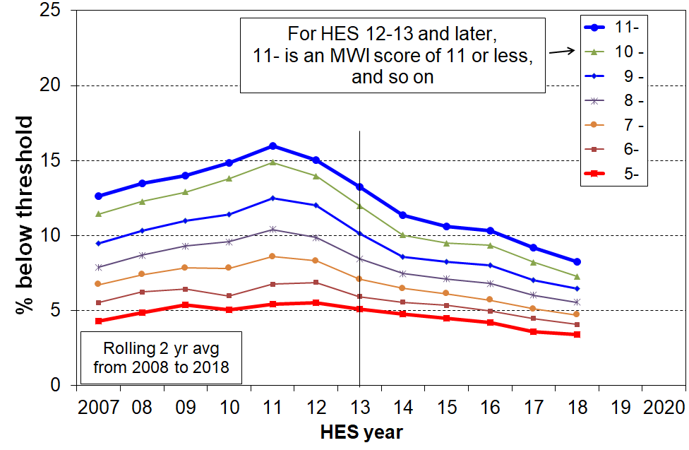
- Trends are shown in the chart for the whole population using a range of thresholds. The two thicker lines (for MWI scores of 11 or less and 5 or less) correspond to the DEP-17 6+/17 and 9+/17 measures used for the Child Poverty Reduction Act material hardship measures.

- For the standard or less severe hardship measure (MWI score of 11 or less), the impacts of the GFC and the recovery are very clear, with the rate first rising to 16% in HES 2011 then falling to 8% in 2018, lower than before the GFC (13%).

- For the more severe hardship measure (MWI score of 5 or less), the rate was reasonably flat through the GFC at around 5%, with a possible slight fall through to 2018 (~3%).

- The difference in trends for the different depths of hardship reflects the following:
- Almost all those in deeper hardship are working-age beneficiaries or low-waged workers with persistent low income – ‘working-aged’ benefit rates in the period were pegged to the CPI, and for 2008 to 2013 the minimum wage was flat in real terms, so their incomes were steady in real terms and not likely to be greatly impacted by the state of the economy. For some, there are also factors either in addition to low income or contributing to their low income (or both) that lead to their being in deeper hardship (see the framework on page 4). Changes in the economy had little impact on this group.
- In contrast, the general state of the economy (wages and employment especially) has a rapid and noticeable impact on those in lesser hardship and those ‘just getting by’. Households in this group can have their actual day-to-day living conditions significantly changed by even modest changes in income, whether increases or decreases.

The incomes of those in hardship
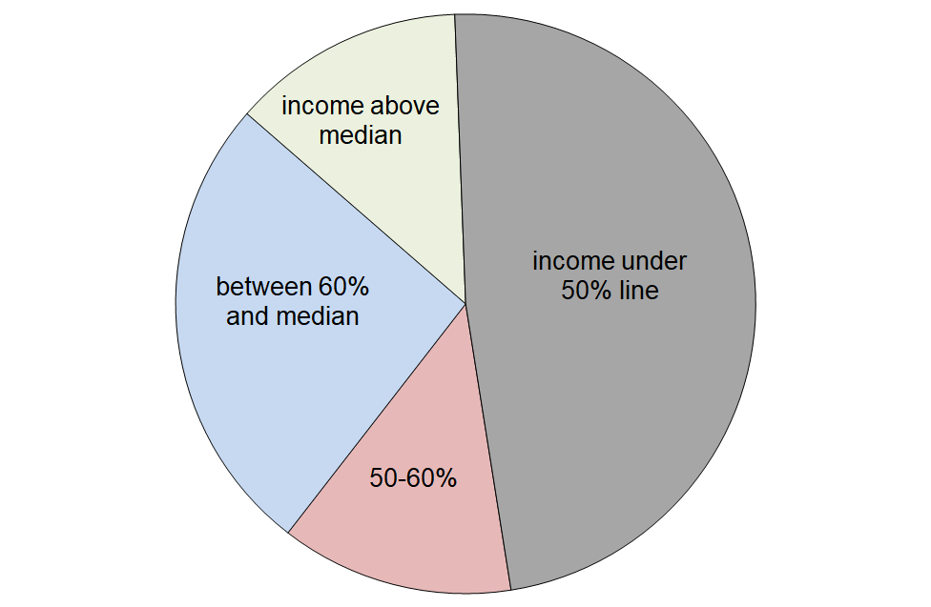
- The pie chart shows the AHC household income bands for the 8% of the population who are identified as being in hardship using the less severe threshold (MWI score of 11 or less, DEP-17 score of 6+), using HES 2017-18 data.

- Just under half (48%) have incomes below the 50% of median AHC line, 13% are in the 50%-60% band, and a further 26% have incomes above the 60% line but below the median. 13% of those in hardship have incomes above the median.

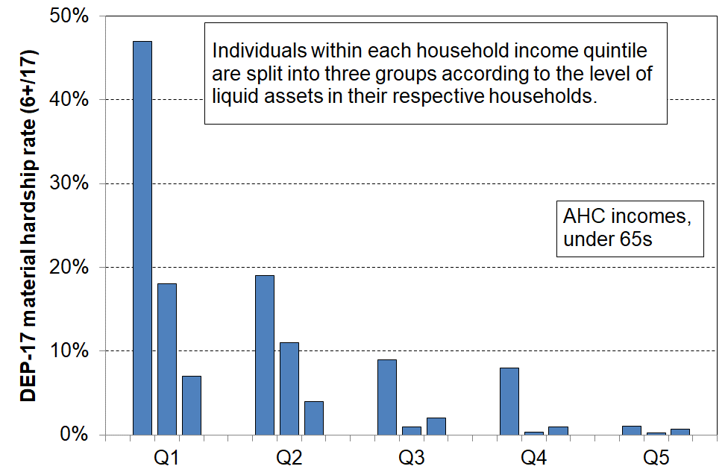
- This wide range of household incomes for those identified as ‘in hardship’ illustrates the point made in the framework used for the reports (see p7) – that is, differences in actual living standards among households reflect not only the impact of differences in household income but also differences in financial assets and other economic resources; differences in special demands on the household budget (such as those arising from high debt servicing costs, high health-related costs, commitments to family and others outside the immediate household); and differences in abilities to use a given income to meet basic needs or to maximise the value of discretionary spending.

- The chart on the right shows that where households with similar incomes have different levels of liquid financial assets, their hardship levels are quite different. For households with similar incomes, lower levels of liquid financial assets means higher levels of material hardship.

Trends in the material hardship rates for the ‘poor’, the ‘near-poor’ and the ‘non-poor’

- As illustrated above, one of the features of the relationship between income and material hardship is that, although living in a household with an income above a given low-income threshold (‘poverty line’) reduces the risk of material hardship, it does not eliminate the risk. Some of the non-poor still experience material hardship, and some of the poor do not.

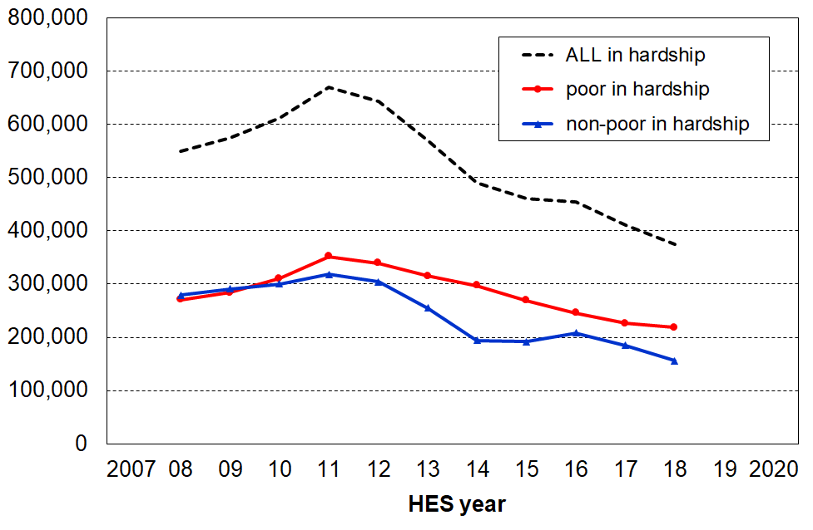
- The non-poor have much lower hardship rates than the ‘poor’ (4% compared with 22% in 2018). This is not a surprise. There are however many more ‘non-poor’ than there are ‘poor’, and the numbers in hardship in each group are broadly similar as shown in the bottom two lines in the chart.

- The analysis uses the 60% AHC low- income line and the material hardship line set at MWI ≤ 11 (ie 6+/17 on DEP-17).

- An important finding from this analysis is that 60% of the reduction in hardship numbers in the four years from the peak in GFC-related recession in 2011 (130,000 out of the total drop of 210,000) came from many ‘non-poor’ households moving out of hardship as their incomes improved through greater employment opportunities and wage growth in the recovery post-GFC.

- Two thirds of the decline in hardship numbers for the ‘non-poor’ came from those with incomes above the 60% AHC threshold and below the median (the ‘near-poor’). It is a reminder that there are households with incomes above even the relatively generous 60% of median AHC low-income line (the ‘near-poor’) whose financial circumstances can best be described as precarious. Relatively small changes in income or unexpected bills can make a significant difference to their day-to-day living conditions.

- The chart above raises the question – how is it that hardship rates for the ‘poor’ can decline? The hardship rates of (some of) the ‘poor’ have fallen as their incomes have on average risen in real terms. This rise is indicated by: (a) the falling anchored line AHC low-income rate; and (b) the fairly flat trend using the fully relative AHC measure which is used to construct the chart above, showing that low incomes were generally keeping up with the median, which itself was rising in real terms in the post-GFC period.

Children

- There is considerable public, media and political interest in the wellbeing of children, including their material wellbeing – how they are faring in accessing their material needs and the necessities of life. The special interest derives from two considerations:
- Children are very dependent on others for their survival, for having their material needs met and for the opportunities to grow and develop in a positive healthy way. Parents, the wider family, the community and the state all have a part to play. No one wants to see children missing out on the basics and being unable to participate in the childhood activities our society expects and values for all children.
- Living in persistent low income and hardship as a child is not only a childhood experience that impacts negatively on children in the here-and-now, it also increases the chances of poor outcomes later in childhood and in adulthood. While much of the observed association between persistent low income and hardship (“poverty”) and poor outcomes can be explained by other factors that drive both the “poverty” and the other poor outcomes, not all of it can. There is now good evidence that childhood experience of persistent low income and material hardship can in itself have a negative impact later on. The impact operates through pathways such as:
- the more limited (financial) resources available for investment in children and their development
- the parental stress arising from the daily pressure of not being able to pay the bills, of having to make difficult trade-off decisions where solutions to one problem create problems of their own in another area, and from a sense of shame and disappointment of not being able to provide for the children
- the fact that the negative impacts show up across multiple domains and can therefore contribute to a larger cumulative impact.
- This is all costly, not only for the individual but also to society as a whole through higher health costs, lower employment, lower wages, lower tax revenue and lower productivity.

Child Poverty Reduction Act (2018) and Stats NZ’s official child poverty statistics

- New Zealand’s CPRA requires governments to report each year on trends in child poverty, using nine static measures and a measure or measures of persistence. The latter is still under development. The static measures include six low-income and two material hardship measures, and one that uses both low-income and material hardship information. The Act requires the Government Statistician to release the relevant information annually. Stats NZ released the 2017-18 baseline rates on 2 April 2019, and are scheduled to release the 2018-19 numbers on 25 February 2020.

- The 2018-19 child poverty numbers will be based on the new much larger HES which has a 20,000 sample rather than the 3,000 or 5,500 sample size of surveys to date. The income data will be drawn from administrative sources which improves the accuracy over survey sources. In preparing the 2017-18 baseline rates, Stats NZ took steps to improve the data quality for 2017-18 and earlier years back to 2006-07. The work done to improve the data quality is summarised in the early part of Appendix One, and described in more detail in a technical paper on Stats NZ’s website.

- The child poverty numbers in the Household Incomes Report are based on the same survey-based HES dataset as in the past, not the ‘new’ dataset created by Stats NZ for establishing the official 2017-18 baseline rates. One of the main reasons that MSD has continued with the standard survey-based dataset is that it enables us to report income and other trends from the late 1980s through to 2018, whereas the ‘new’ dataset that Stats NZ created starts in 2007. The shorter period covered by the new Stats NZ dataset does not adversely impact on the primary task of establishing a baseline for 2017-18, as is required to implement the CPRA.

- This means that there are two datasets in use for reporting on child poverty: the new one created by Stats NZ (Dataset A) and the other survey-based one used by MSD and others (Dataset B). The table below shows the low-income and material hardship rates for children for the nine static measures in the CPRA, comparing the 2017-18 rates produced by each dataset and the associated weights. The Stats NZ rates are the official rates.

- The BHC and material hardship rates are the same, but there is a small difference in the after housing costs (AHC) rates. The BHC, AHC and material hardship trends are the same on both datasets (see Appendix One). Stats NZ and MSD are seeking a better understanding of the cause of the small difference in AHC rates.

Low-income and material hardship for children (0-17 yrs), for the nine static measures in the CPRA:
2017-18 baseline rates (%) and numbers (000s)
 | BHC 50 | BHC 60 | AHC 40 | AHC 50 | AHC 60 | AHC 50 anchored | Material hardship | Severe material hardship | Combined: under AHC 60 and in MH
Stats NZ rates (dataset A) | 16 | 25 | 16 | 23 | 31 | 23 | 13 | 6 | 9
MSD rates (dataset B) | 15 | 24 | 14 | 21 | 31 | 21 | 13 | 6 | 9
Stats NZ numbers (dataset A) | 180 | 280 | 170 | 250 | 340 | 250 | 150 | 70 | 90
MSD numbers (dataset B) | 170 | 280 | 160 | 240 | 350 | 240 | 150 | 70 | 100

Which is the best measure?
How many children are in poverty in New Zealand?

The desire to be able to say that ‘the poverty rate for New Zealand children is X%’ or that ‘there are YY,000 children in poverty’ is understandable. However, there are several reasons why it is neither a realistic nor even a desirable goal.
  - The desire for ‘one number’ assumes that the poverty rate is a relatively straightforward, uncontested and binary statistic (“you’re under the line and in poverty or over it and not in poverty”), in the same category as declaring how many children of a certain age are taller than, say, 130 cm.
  - Income poverty (low income) and material hardship each exist on a continuum from less to more severe. The notion of poverty is a contestable one and different views can reasonably be held on the matter of where to draw the line on the spectrum from more to less severe material disadvantage, whatever measure is used. It’s not that any threshold will do, nor that all measures are equally suspect. There is good evidence that can be drawn on to inform the judgement call: some measures / thresholds are clearly more reasonable and defensible than others. The point is that there is no definitive uncontested way to allocate households to the categories of ‘poor’ and ‘not poor’.
  - Beyond these matters of judgement, it is important to use more than one measure and more than one threshold for each, as trends in poverty rates and in the composition of those identified as poor can be quite different at different depths and for different measures.
- The reports take the view that the most useful and productive approach is to focus on telling a more comprehensive story about trends at different depths, and on seeking to understand why different measures produce different trends and what all this means for policies to address poverty and hardship.
- This multi-measure multi-level approach is in line with the approach taken in the Child Poverty Reduction Act (2018).
- For productive public discussion and debate, it is useful to have some numbers to use. One way to do this, while taking all the above into account, is to use conservative estimates that few would challenge. The Incomes Report provides or refers to evidence that household incomes below 40% of the AHC median are very restrictive. For example, this is around $300 pw for a sole parent plus one child household, $500 pw for a two parent plus two children household, and $350 pw for a couple-only household (all after-housing costs). The combined measure which identifies the poor as those with incomes under the AHC 60 line and who are also in hardship is also a measure at the conservative end of the spectrum. Using these two measures points to a conservative estimate of 100,000 to 170,000 poor children – children whose day-to-day standard of living did not reach an acceptable minimum for New Zealand in 2018.
- [For international comparisons, the choice of measure and threshold is straightforward – use the same measure and threshold as the other countries in the league table.]

Low income (income poverty) for children

“There are no poor children, just poor families”
It is sometimes said that the idea of ‘child poverty’ doesn’t make sense as it’s really about families with financial and material resources that are not adequate for meeting the basic needs of the family (ie it’s not poor children, it’s poor families).
In this report, when it is said that ‘the child poverty rate on a given measure is 13%’, this is a short-hand for ‘13% of children live in households whose total income is below the threshold used in the given measure’. It is too cumbersome to repeat this each time, so the shorthand version is used: “the child poverty rate is 13%”.

- [See the Stats NZ website for the official Child Poverty statistics, and the previous two pages for further background information.]

- Using the AHC anchored line measures there was a slight rise in rates during the recession following the GFC then a steady fall through to 2018.
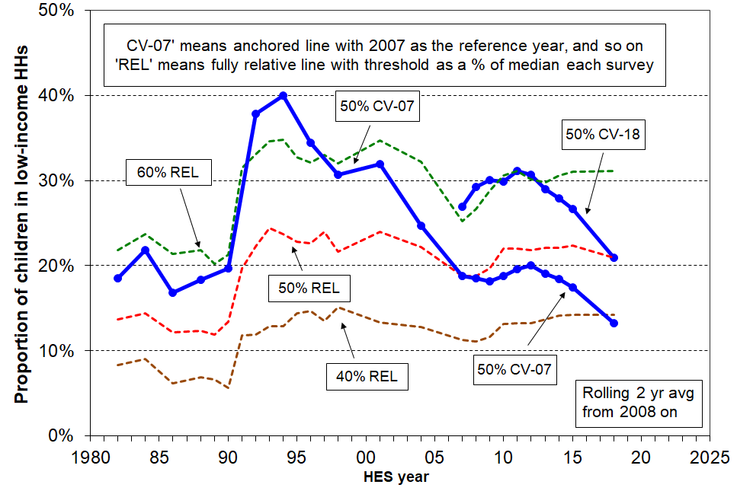
- For example, using the AHC 50% CV-07 measure the low-income rate for children fell from its GFC/recession peak of 20% to 13% in 2018, lower than the pre-GFC rate of 18%.

- Looking at the longer-term picture from 1982, and using the AHC 50% CV-07 measure, the low-income rate for children doubled in a very short period from the late 1980s to early 1990s, reflecting rising unemployment, a falling average wage, demographic changes (more sole parent families), the 1991 benefit cuts and the introduction of market rents in (what we now refer to as) social housing. It then steadily fell through to 2008 with improving employment, a rising average wage, rising female employment, the introduction of income-related rents and Working for Families. This fall in poverty rate through to 2008 indicates that the AHC incomes of many low-income households with children were higher in 2008 than in the mid 1990s (in real, inflation-adjusted terms).

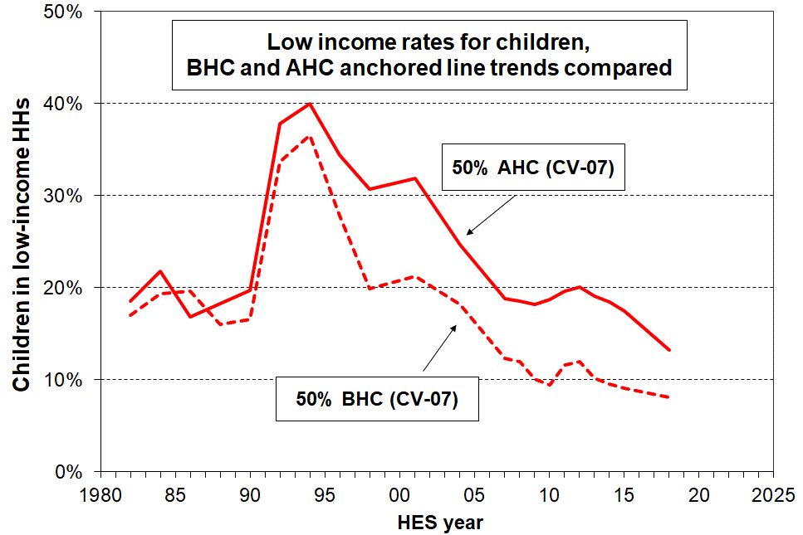
- The longer-term BHC and AHC low-income trajectories are quite different, and show up as different trends for BHC and AHC child poverty rates using anchored line measures. BHC household incomes for low-income households were higher in real terms from 2004 to 2018 than in the mid 1980s. This shows up in the dashed line in the chart on the right, in which BHC anchored line low-income rates from around 2004 on are lower than in the 1980s. In the years 2010 to 2018 the BHC rate was 9-11% compared with 16-20% in the 1980s. On the other hand, AHC low-income rates were much the same in the years to 2015 as in the mid 1980s (18-20%), and have fallen since. This reflects the fact that AHC incomes for low-income households with children were much the same in 2015 in real (inflation-adjusted) terms as in the 1980s, despite the real increase in BHC incomes. This is mainly because housing costs are now much higher relative to BHC incomes, especially for low-income households (see p28 above).

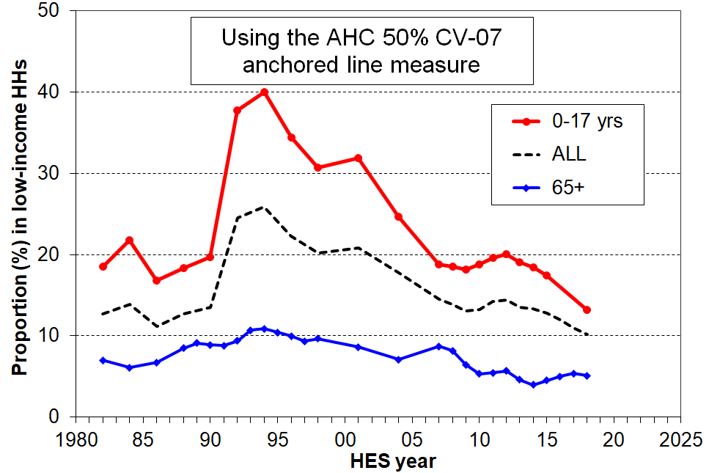
- Low-income rates for children are almost always higher than for the population overall, in part because of the relatively low rates for older New Zealanders on most measures. This is illustrated in the AHC 50% CV-07 graph to the right.

- The one standard measure for which low-income rates for children are lower than for older New Zealanders is the 60% of median fully relative BHC measure. For 2010 to 2015, the rates on average were 22% and 27% for children and older New Zealanders respectively. See the Older New Zealanders section for further discussion on this.

- The three fully relative AHC trend lines (dashed lines in the top chart on the previous page) show that low-income AHC rates for children have been fairly flat over the last 20-25 years on these measures. This indicates no noticeable change in income inequality in the lower half of the AHC incomes distribution in that period. In contrast, the AHC low-income rates have been around double what they were in the 1980s, corresponding to the large change in measured income inequality from the late 1980s to the early 1990s.

- There is no measurable change in depth of AHC relative low-income rates for children over the last 15 to 20 years. One way that increasing depth would show up is that the 40% relative line would move closer to the 50% relative line, showing an increasing proportion in very low income households (under 40%) compared with the numbers between the 40% and 50% lines. This has not happened to any measureable degree.

Three types of child material hardship indices

In broad terms, there are three types of child material hardship indices.
- Those that use only child-specific items (often based on information from the household respondent). An example of this is the MODA measure used in UNICEF’s 2017 Report Card #14 (Multidimensional Overlapping Deprivation Analysis tool). A limitation of this approach is that it does not take account of a wide range of general household items that are very relevant to the material wellbeing of children in the household (eg keeping home warm, no dampness or mould, access to private vehicle, getting appliances repaired or replaced, and so on). It also cannot be used to compare children with other age-groups and household types.
- Those that use both child-specific and general household items. An example of this is the new Child Material and Social Deprivation Index recently developed by UK and European researchers. This addresses the first issue noted above, but still cannot be used to compare children with others.
- Those that use only general household items and items that relate to the adult respondent. This approach addresses both the issues above, but leaves hanging the question as to whether a general household index reasonably reflects the situation of the children in the household. For the purposes of ranking countries in league tables the second and third approaches give very similar results.
The MSD report uses the third approach as cross-group comparisons are priority outputs. It uses the second approach to assist with scale calibration (see the Non-Income Measures Report). The report doesn’t use the first one at all, but reports on individual child-specific items and how their lack is distributed across household income or material well-being deciles.
No items are available that have information based on the responses of children themselves.

Material hardship

- The chart below shows the trends in material hardship for children (aged under 18 years) from 2007 to 2018 (HES years). Up to and including HES 2012, the analysis used MSD’s ELSI measure, then from HES 2013 on it uses the material wellbeing index (MWI), the revised version of ELSI. (See Appendix Six for information on the splicing of these time series).

- The MWI and the DEP-17 indices give almost identical material hardship figures and trends, but the MWI can also give more detailed / fine-grained information at the lower end as well as discriminating above the hardship zone. See Appendix Three for the items used in these indices.
.
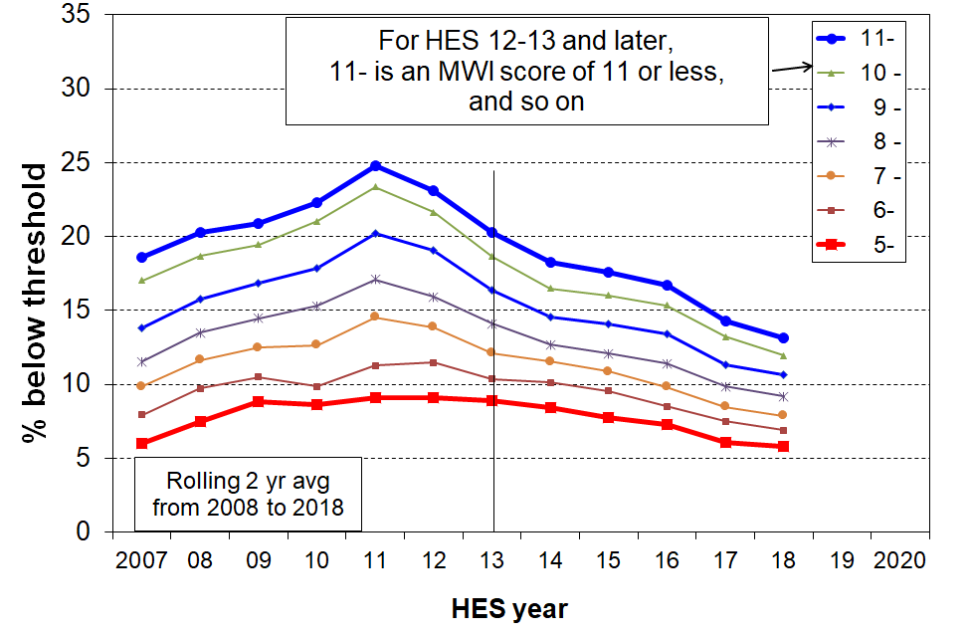
- Trends are shown in the chart using a range of thresholds. The two thicker lines (for MWI scores of 11 or less and 5 or less) correspond to the DEP-17 6+/17 and 9+/17 measures used for the Child Poverty Reduction Act material hardship measures.

- Using the more severe threshold, there was little change through the GFC (~9%), and then a fall to 6% by 2018, close to the pre-GFC level.

- As for the population as a whole, the trend using the less severe measure rose significantly during the GFC (to a maximum of 25%) then fell away as the economy recovered to a 13% by 2018. Material hardship measures generally show larger variation as the economy changes than do low-income measures. (See the charts on p33 for examples from Spain and Ireland.)

Trends in hardship rates for the ‘poor’, the ‘near-poor’ and the ‘non-poor’

- As discussed above, one of the features of the relationship between income and material hardship is that, although living in a household with an income above a given low-income threshold (‘poverty line’) reduces the risk of material hardship, it does not eliminate the risk. Some of the non-poor still experience material hardship, and some of the poor do not.
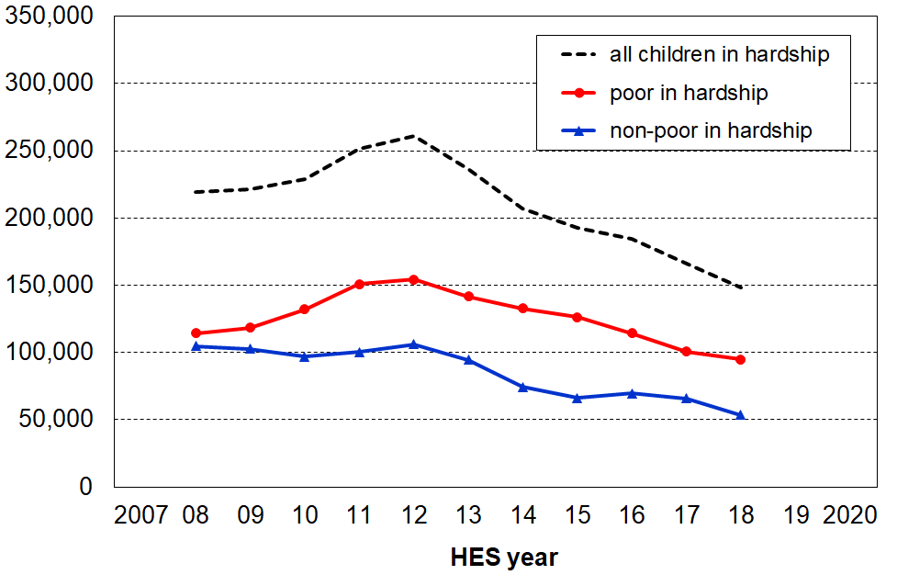
- Children from ‘non-poor’ households have much lower hardship rates than children from ‘poor’ households (7% compared with 31% in 2018). This is not a surprise. There are however many more ‘non-poor’ than there are ‘poor’, and the numbers of ‘non-poor in hardship are significant as shown in the bottom line in the chart.

- The analysis uses the 60% AHC low- income line and the material hardship line set at MWI ≤ 11 (ie 6+/17 on DEP-17).

- An important finding from this analysis is that around 60% of the reduction in child hardship numbers in the four years from the peak in GFC-related recession in 2011-12 (35,000 out of the total drop of 60,000) came from many ‘non-poor’ households moving out of hardship as their incomes improved through greater employment opportunities and wage growth in the recovery post-GFC.

- Two thirds of the decline in hardship numbers for children from ‘non-poor’ households came from those with incomes above the 60% AHC threshold and below the median. It is a reminder that there are households with incomes above even the relatively generous 60% of median AHC low-income line (the ‘near-poor’) whose financial circumstances can best be described as precarious. Relatively small changes in income or unexpected bills can make a significant difference to their day-to-day living conditions.

Those in ‘deeper poverty’ or ‘more severe hardship’

- One of the features of the approach used in the Incomes and Non-incomes Reports is to accept that there is no line that can definitively divide the population into the ‘poor’ and the ‘non-poor’. The reports use and advocate an approach that accepts that poverty and material hardship exist on a continuum from less to more severe. They use thresholds within a plausible and defensible range to give a comprehensive account of what is happening at the different depths.

- There are three conceptualisations of ‘deeper poverty’ / ‘more severe hardship’ used in the reports:
- those in households with very low AHC incomes (say, less than 40% of median AHC incomes)
- those in households with high deprivation scores (eg MWI ≤ 5 (≡ DEP-17 of 9+/17))
- those in households with both low income and experiencing material hardship.
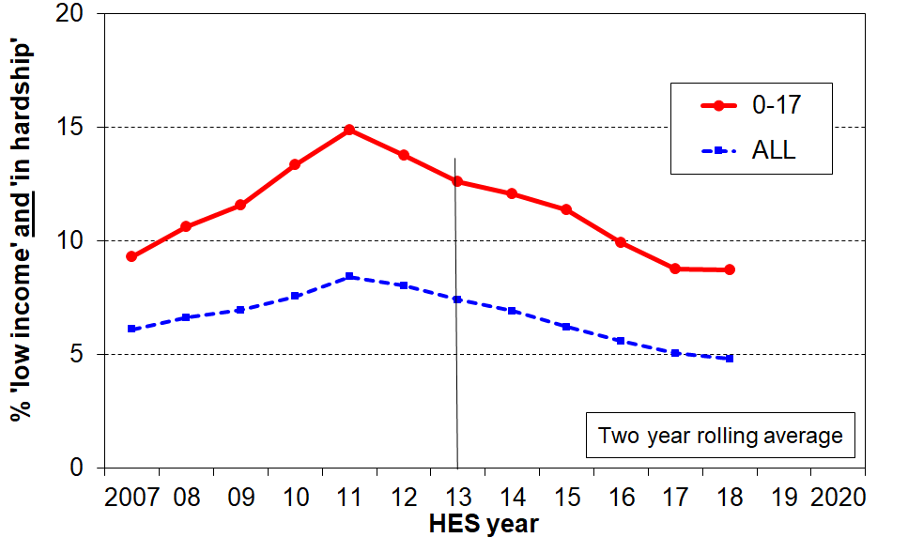
- The third conceptualisation (the overlap group) is used for the chart on the right. Around 9% of children (100,000) live in households whose incomes are below the 60% of median AHC line and who are also in hardship using the standard or less severe threshold (ie MWI ≤ 11, DEP-17 ≡ 6+/17). This is much lower than at the peak of the GFC/recession (15%) and a little lower than before the GFC (~11%).

- For those in hardship but with incomes reasonably above a low-income line there are grounds for expecting living standards to improve over time provided their incomes do not decline and that there are no on-going special demands on the budget (eg from high health costs, high debt servicing, and so on). However, for those in hardship who also continue to have fairly low incomes, there is very little chance of improvement of living standards until incomes rise and stay up.

Poverty and hardship composition for children (which children are poor or in hardship?)

Low-income and material hardship rates for different sub-groups of children indicate the relative risks for children in the different groups. In many cases, however, the sub-groups with the highest rates are relatively small numerically. For example, sole parent families have much higher rates than two parent families, but there are around four times as many children in two parent families. It is therefore important to look at information on the composition of the poor or those in hardship, as well as the information on rates.

Selected information is provided below, based on HES years 2015 and 2018 and using the 50% of median AHC relative measure (AHC 50).

- Half of poor children are Māori/Pacific (around one third of all children are Māori/Pacific).

- Just under half of poor children are from sole parent families and just over half from two parent (around 21% of all children are from sole parent families).

- Half of poor children are from households where the highest educational qualification for parent(s) is school or less (around 30% of all children are in these families).

- Seven out of ten poor children live in rental accommodation (20% HNZC, 50% in private rental).

- A sizeable proportion of children identified as poor or in hardship come from working families (around 40%):
- AHC income poverty rates for children in working families are on average much lower than for those in beneficiary families (eg around 11% and 80% respectively, using the AHC 50 measure), but around 40% of poor children come from families where at least one adult is in full-time work or is self-employed.
- This difference between rates and composition for these two groups arises because there are many times more working families than there are beneficiary families.
- Using material hardship measures gives a similar picture: around 50% of the children in hardship are from working families (using the DEP-17 6+/17 measure defined by Stats NZ for the CPRA), and around 33% using the more severe threshold (9+/17).

- See Section H in the Household Incomes report for more detail.

One-person households (under 65)

- One-person working-age households are a small but growing household type (~5% of all working-age households).

- When looking at the circumstances of selected household types, this group has the second highest income poverty rate after sole-parent households in HES 2018.

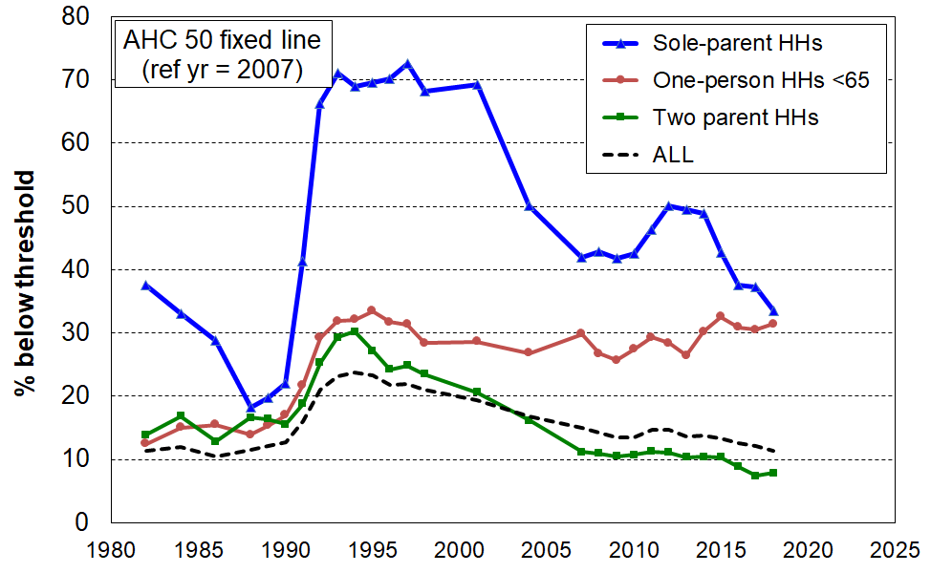
- The chart on the right uses the fixed line AHC 50 low-income measure, with 2007 as the reference year. It shows that from the early 1990s through to 2018 the incomes of low-income one-person households has remained fairly steady in real (CPI-adjusted terms). In the same period low AHC incomes for the population as a whole improved in real terms (the broken line has declined steadily from the mid 1990s to 2018). In particular, households with children saw an improvement in the low-income group, consistently for two-parent households, and also for sole-parent households (the rise during the GFC recession is evident).

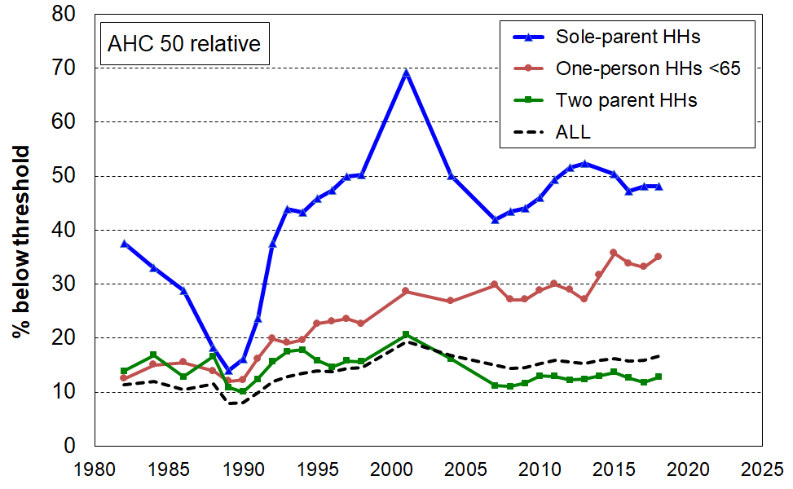
- The second chart (on the right) uses the fully relative AHC 50 measure. It tells the same story – one-person households have lost ground relative to the rest of the population, including households with children. The AHC 50 child poverty rate was much the same in 2018 as in the mid 1990s (~22%), whereas the one-person household rate increased from 20% to 35%.

Older New Zealanders (aged 65+)

- Older New Zealanders (aged 65+) currently make up 15% of the population (700,000). By 2028 this proportion is expected to be close to 20% (1,050,000).

Incomes

- The great majority of those aged 65+ are very dependent on NZS for their survival. For example:
  - 40% of singles have virtually no other income source, 60% report less than $100 pw from non-government sources, and 75% have more than half their income from NZS (ie only 25% have other income that is greater than the gross single living alone NZS rate of $463 pw (2018)).
  - The per capita income of couples is on average much higher than for singles – for example only 35% of couples report less than $100 per capita pw from non-government sources – but most couples are nevertheless still highly dependent on NZS, with just over half having more than half their income from NZS.
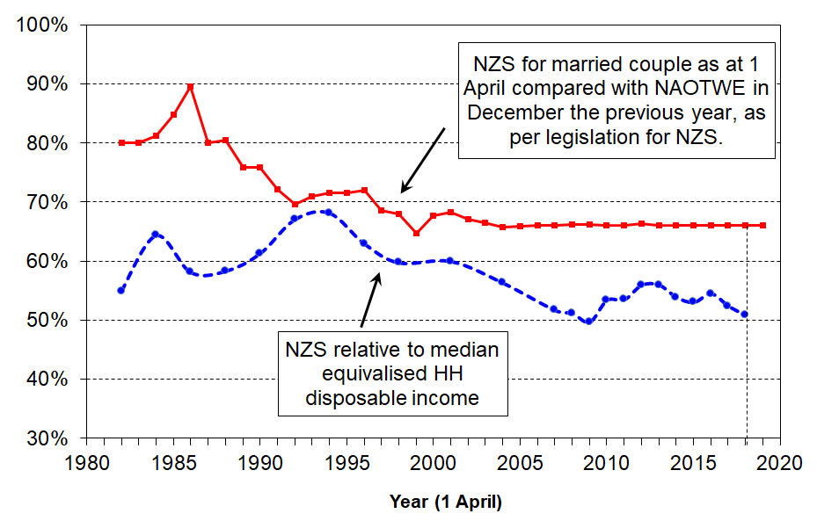
- In 2018, the NZS married couple rate was close to the 66% floor relative to average earnings, as shown in the upper line in the graph.
  - NZS declined in value relative to median household incomes from the mid 1990s to 2009. This is because median household income rose steadily in real terms, while the real value of NZS did not change greatly in real terms from the mid 1990s through to 2007.
  - A rapidly rising household median income saw NZS briefly fall below 50% of the median. The combined effect of income tax changes in 2008 and 2010 and rising after-tax wages pushed the ratio back up to 53% on average over 2015 to 2017, but there are signs that the median is again rising more rapidly than NZS.

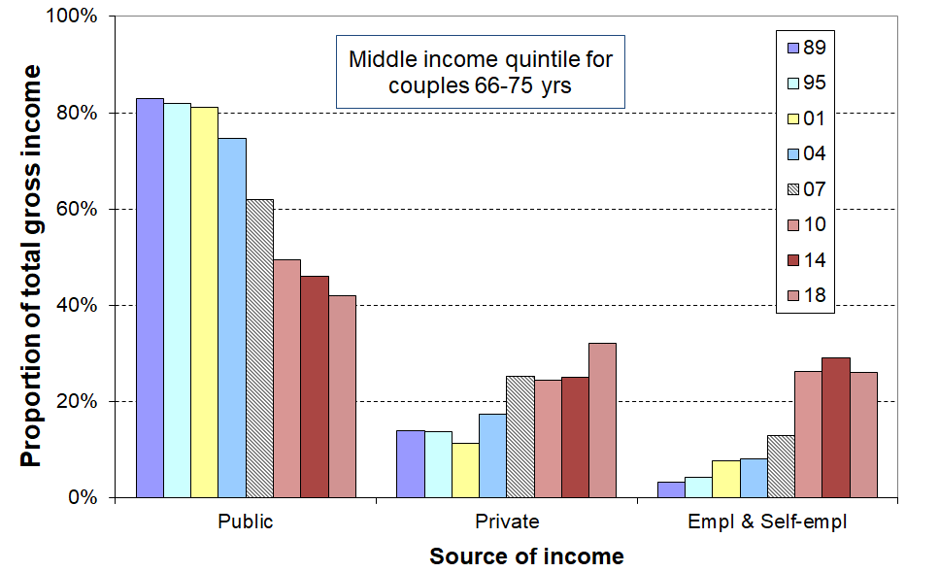
- An emerging feature of the incomes of the 65+ cohort is the strong rise in incomes from employment and self-employment for the “younger” group (aged 65-70), especially couples, starting from the late 2000s:
  - The graph illustrates this change with the trend for couples in their middle income quintile. Employment income in 2010 to 2018 made up almost one third of their total income, compared with around 42% on average from government sources.
  - For decile 7-9 couples, half their income is now from employment and around a quarter from each of NZS and private investment income.
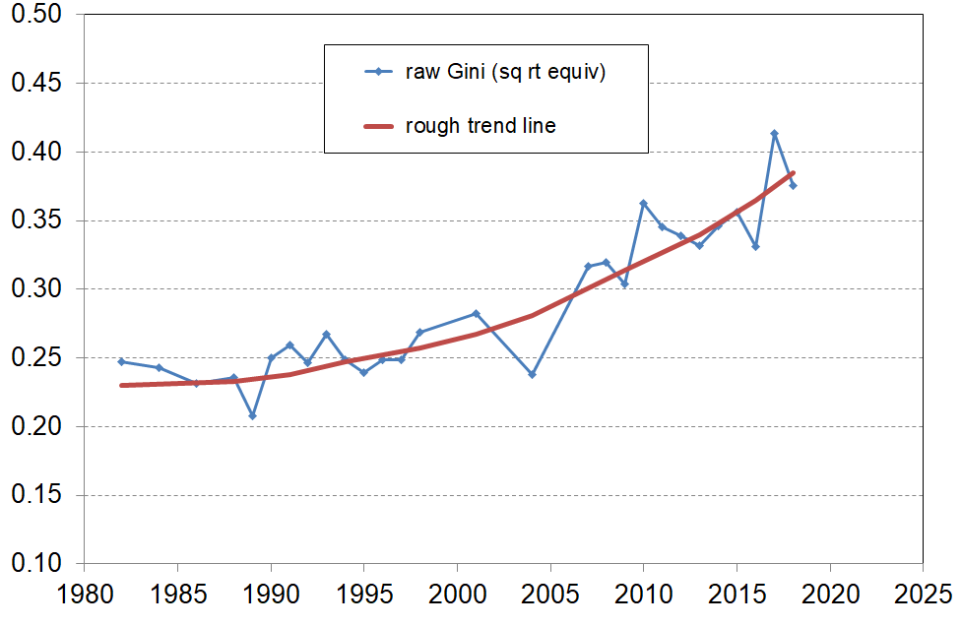
  - There is some increase in employment income for singles but not for as many, and with lower per annum rates.

- This increased employment income for some means increased income inequality among older New Zealanders more generally, as shown by the Gini trend-line.

Income poverty and material hardship among older New Zealanders

- Low-income rates for older New Zealanders remain lower than those for other age groups when using AHC income measures. Hardship rates using non-income measures show the same relativities. The graphs and table below show the details.

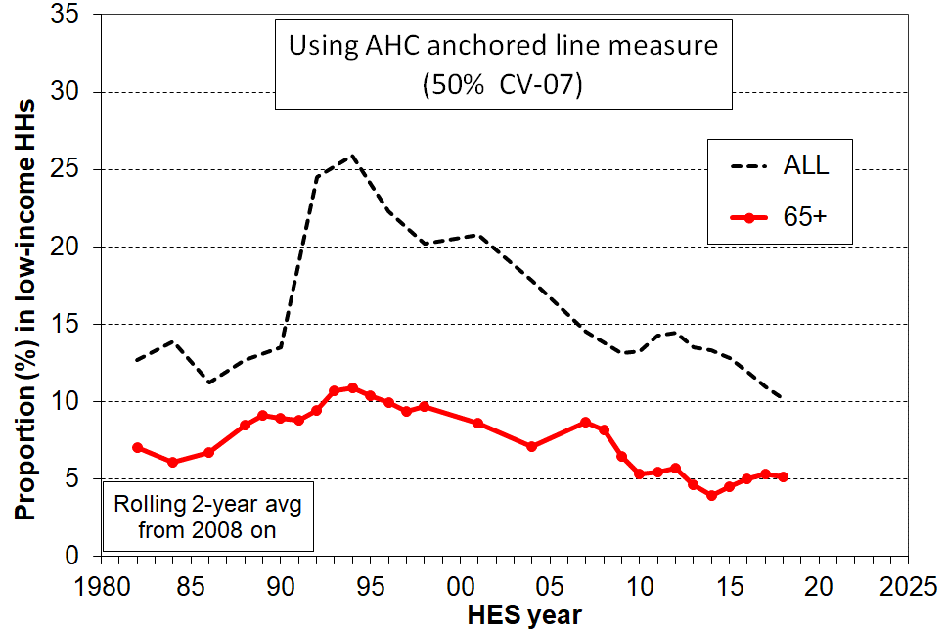
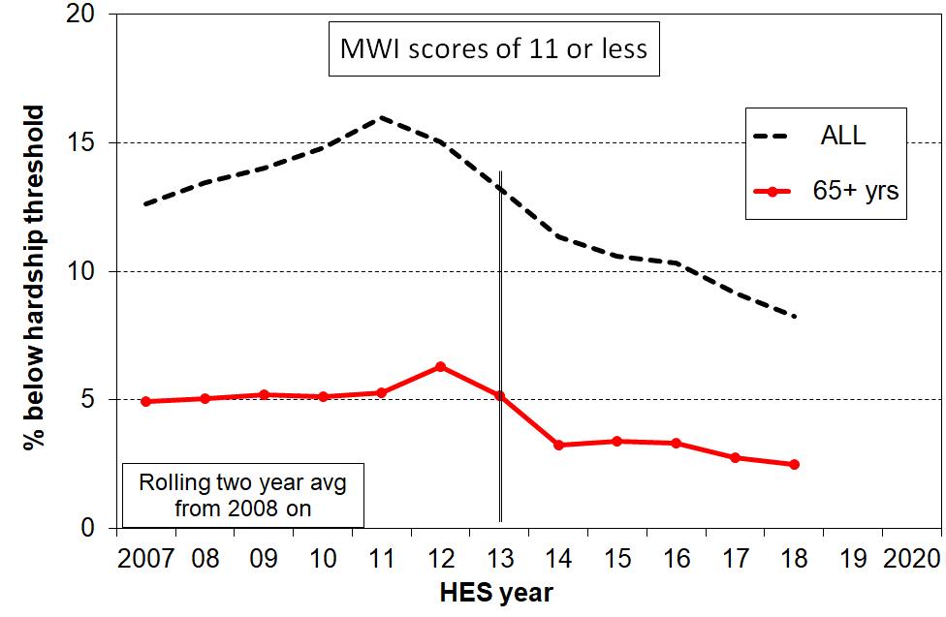
- The large difference between the BHC 50% and BHC 60% rates (5% and 34% respectively) is a reflection of the heavy reliance of older New Zealanders on NZS, as noted above. In international comparisons for older people, using BHC incomes, New Zealand is rated as one of the top performers in the OECD for the 50% BHC low-income measure but is at the other end of the scale for 60% BHC figures, having one of the highest rates in the OECD.

Low income and hardship rates for age groups (%): HES 2018
Age group ==> | 0-17 | 18-24 | 25-44 | 45-64 | 65+ | ALL
Income poverty (low income)
- AHC 60% relative | 31 | 26 | 20 | 18 | 23 | 23
- AHC 50% relative | 21 | 20 | 14 | 14 | 11 | 16
- AHC 40% relative | 14 | 15 | 9 | 10 | 5 | 11
- BHC 60% relative | 24 | 20 | 14 | 14 | 34 | 20
- BHC 50% relative | 15 | 14 | 8 | 10 | 5 | 10
Material hardship
- MWI ≤14 (higher than usual threshold, but gives a population rate the same as for AHC 50 above) | 19 | 11 | 11 | 10 | 5 | 12
- MWI ≤ 11 (standard) ≡ DEP-17 6+/17 | 13 | 9 | 7 | 6 | 2 | 8
- MWI ≤ 5 (more severe) ≡ DEP-17 9+/17 | 6 | 4 | 3 | 3 | 1 | 3

- The lower AHC income poverty and low material hardship rates for older New Zealanders reflect the mix of universal public provision (mainly NZS) and the private provision built up by most of the current cohort over their lifetime. A key component of this private provision is mortgage-free home ownership, which is relatively high among the current cohort (72%).

- Most of those older New Zealanders with the low AHC incomes and high material hardship rates are, unsurprisingly, those who rent / have a mortgage and who have NZS and little or no more to live off.

- Older New Zealanders score well overall on individual hardship items, though there is a small group that is struggling. For example, 4% (25-30,000) report having to put up with feeling cold “a lot” because of costs, compared with 10% for households with children and 7% overall.

- On self-assessed satisfaction with life:
  - 87% say they are satisfied or very satisfied, compared with 82% for the whole population
  - for those in the bottom quintile of material wellbeing, 20% of older New Zealanders say they are dissatisfied or very dissatisfied, compared with 18% for all people in this quintile, and 6% for the whole population.

- Declining mortgage-free home ownership for the cohorts coming through to ‘retirement’ (see bottom of this page) suggest that the low poverty and hardship rates may soon start to rise, unless this impact is mitigated by asset accumulation over the life course by means other than home ownership (eg KiwiSaver and similar savings schemes).

- The increasing proportion of older New Zealanders in paid employment also has the potential to mitigate the impact of declining mortgage-free home ownership, provided these are the same people who need the extra income to pay the mortgage or the rent. The chances are though that in the main they will be non-manual white-collar workers who are more likely to be better off anyway.

- For older working-age adults living on their own (45-64 years), the AHC 50 relative low-income rate doubled in the fifteen years from the mid-1990s to 2010 (from 15% to 30%) and on average for 2014 to 2018 was 35%, second highest after sole-parent households (55%). For this age group as a whole, the rise has been very minor, from 10% in the early 1990s to a steady 12-14% from the 2010 on. This also points to an increasing number of vulnerable older New Zealanders in the future as these figures indicate that an increasing number in this age-group have little freeboard from which to save.

Tenure for older New Zealanders (65+)

- Over the last two decades or so (1994 to 2018), the HES shows that home ownership for older New Zealanders has been steady at ~86%. Renters have been steady at ~12-13%, with 1-2% in a residual category that includes those living with others in a home that another resident owns and those boarding.

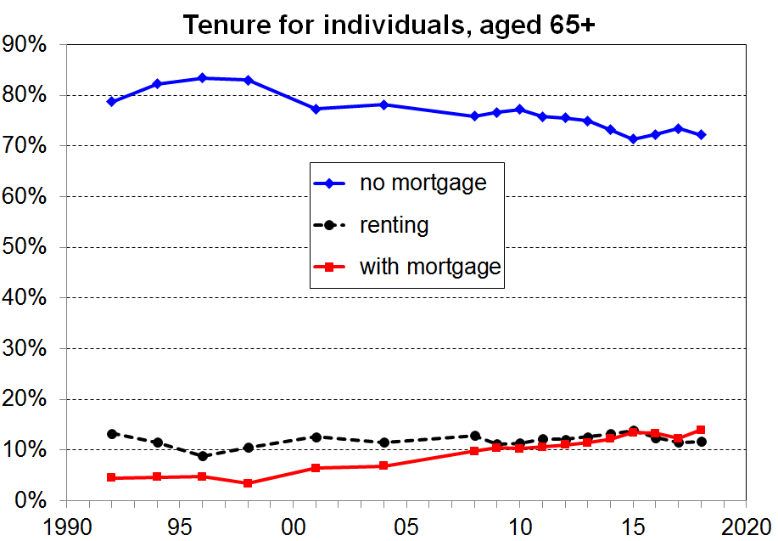
- Since the mid 1990s there has however been a downward trend in the proportion of homeowners (aged 65+) whose dwellings are mortgage-free, down from 83% in the mid-1990s to 78% in the mid-2000s and to 72% on average from 2015 to 2018 (see chart). In that period, around 13% were in a dwelling for which there were still mortgage payments being made, the same proportion as those renting.

- The rising trend in the proportion of older New Zealanders (still) paying a mortgage is a potential concern because it increases the chances of there being more with inadequate after-housing-costs incomes. Whether this trend translates into a real-world increase in the proportion of older New Zealanders experiencing financial or material hardship depends on the characteristics of the households in question. What we know so far is that:
- the increase in the owned-with-mortgage category is mainly for 65+ couples, not singles
- around 60% of the increase for couples from 2007-2009 to 2015-2018 is from households with at least one in full-time employment or self-employment, and 40% from households with little or no income from paid employment
- there is no evidence to date of any rising hardship trend for older New Zealanders - it remains low (~2%, compared with a population rate of 8%)
- there is no evidence to date of any increase in the low-income rates for older New Zealanders using AHC fixed line measures, though there is some recent increase using the 50% AHC relative measure, driven mainly by a strongly rising median.

Tenure for those aged 45-64 years

- Over the last two decades or so (1994 to 2018), the HES shows that home ownership for those aged 45 to 64 years has fallen from around 86% to 77%. In addition, the proportion in this age group who are mortgage-free has declined even more, from around 60% to only 33%. Two thirds (67%) are therefore now paying rent or a mortgage.
The ‘working poor’

In many of the richer nations there are regular media reports of the plight of the ‘working poor’, such as the number making use of food banks and other charity assistance. More formal information sources show that around 30 to 40% of those designated as ‘poor’ in richer nations are from households with at least one full-time worker. The issue is of public policy relevance especially in the context of:
- the widespread policy and political viewpoint that ‘for most people, paid work is the best way out of poverty’
- the considerable resources allocated by governments to ‘make work pay’ when market wages alone do not adequately do this, at least for the way in which households are constructed in these nations.

‘In-work poverty’ and ‘the working poor’ are hybrid concepts: paid employment is an individual-based concept, whereas ‘poverty’, however defined, is a household-based concept. The notion of ‘the working household’ (one or more adults in work) is used to enable reporting on in-work poverty for households or all or some household members. ‘Work’ means ‘paid employment’ in this report, and work status is what it is for the week before interview.

For poverty, standard household-based low-income measures are used, both before deducting housing costs (BHC) and after deducting housing costs (AHC). Material hardship rates are reported using DEP-17, as defined for the Child Poverty Reduction Act (2018).

In-work poverty rates are reported for a range of household work intensities, from ‘at least one full-time’ through to ‘workless’.

Low-wage workers are not the same as the ‘working poor’

Poverty is a household-based notion. Wages are about individuals. The working poor are not the same as the low-waged, as most low-waged individuals live with others whose income they share:
- 80-90% of those with wages less than 105% of the minimum wage are not poor (ie they live in households with total income above standard low-income thresholds).
- looking at the relationship the other way around – one in four working poor households have at least one worker on less than 105% of the minimum wage.

There are several factors that can influence the level of in-work poverty

There is no single main cause of in-work poverty. It is the outcome of the interaction of several factors, including:
- total hours worked in the household
- the average wage rate for working household members
- the value of in-work supports (including the In-work Tax Credit, and child-care subsidies)
- the value of non-employment-related top-ups (such as the Family Tax Credit and Accommodation Supplement)
- the number of people that the household income has to support
- net housing costs (when in-work poverty is measured using AHC income or material hardship approaches).
.
In-work poverty (IWP) rates for those aged 18-64 yrs

- The table below shows the in-work and workless poverty rates for 18-64 year olds using both a common international measure of poverty (60% of median (BHC)) and the AHC 50% of median measure. The DEP-17 material hardship measure (as in Stats NZ’s official child poverty measures) is included for comparison.
- For 18-64 year olds in households with at least one full-time worker, 7-8% are in in-work relative poverty, using either low-income measure. This is around half their overall poverty rate on these measures (15%).
- For 18-64 year olds in households with any employment income (excluding the self-employed), 10% are in in-work relative poverty, using either low-income measure.

Low-income and material hardship rates (%) | 60% BHC | 50% AHC | DEP-17 (6+/17)
Total population (incl self-employed) | 20 | 16 | 8
18-64 yrs
all | 15 | 15 | 7
in a self-employed household | 10 | 12 | 2
in a household with at least one FT (excl SE) | 7 | 8 | 5
in a household with any work (excl SE) | 10 | 10 | 6
in a workless household | 72 | 63 | 29
Composition or profile of the working poor (%) | 60% BHC | 50% AHC | DEP-17 (6+/17)
All aged18-64 yrs | 100 | 100 | 100
self-employed (SE) | 9 | 10 | 4
in a household with at least one FT (excl SE) | 37 | 41 | 54
in a household with any work (excl SE) | 52 | 55 | 64
in a workless household | 40 | 35 | 32

Trends in in-work poverty (IWP) rates

- Using the AHC 50% measure, IWP rates fell a few percentage points from 2004 to 2007 with the introduction of the Working for Families package, remained steady through to HES 2013, with a slight rise since.
- For households with at least one full-time worker, the IWP rates have tracked at around 50-60% of the overall relative low-income rate.
- Using a fixed line approach (AHC 50% CV-07), the IWP rate was falling before the GFC recession, remained steady from HES 2009 to 2014 (6-7%), then began falling again through to HES 2018 (5%).

Single-earner households have become a less viable option for providing economic security and for meeting basic needs.

- For example, using the AHC 60% low-income measure:
  - in the twenty-five years from the early 1990s to 2018, the IWP rates for those aged under 65 living in single-earner households rose from around 23% to 33% for one-adult and multi-adult households combined, in a period where the IWP rate for households with two or more working adults remained fairly steady at 9-11%
  - in the 2017-18 HES, IWP rates for two-parent households with one full-time earner were around three times the rate for when there are two earners
  - around two thirds of working-poor households are single-earner households.

Over the last thirty years, the incomes of workless households have been falling increasingly further behind those in middle-income households
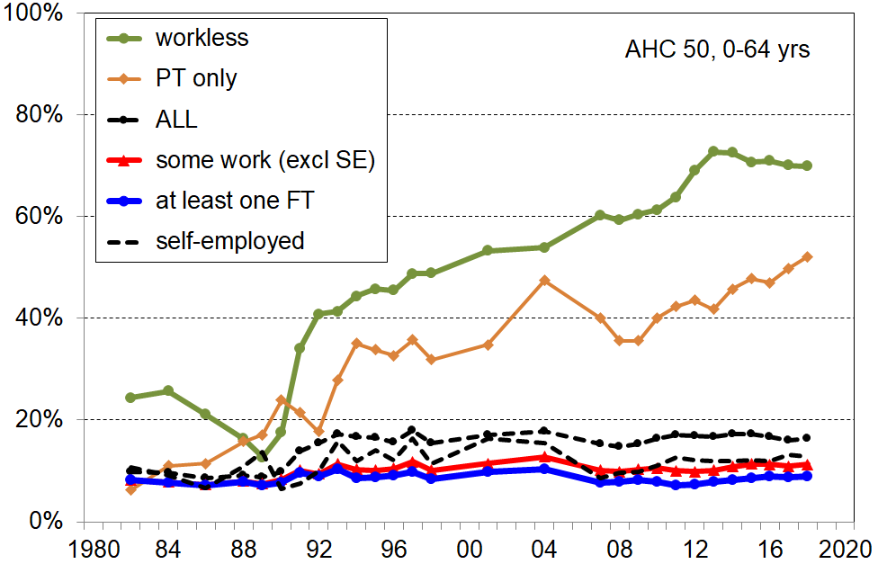
- Low-income rates for workless households rose strongly over the thirty years to 2018, in a period in which the low-income rates for working households remained steady.

- For example, using the AHC 50% relative low-income measure, and looking at all aged under 65 (see chart on the right):
  - the low-income rate for those in workless households rose from 10% in the late 1980s to 40% in the early 1990s (mainly reflecting the 1991 benefit cuts and the introduction of a market-rent approach for social housing), then from 40% to 70% in the twenty-five years to 2018
  - at the same time, the low-income rate for those in working households was steady at 8-10%.
- New Zealand’s IWP rate is close to the UK’s on the AHC 60% measure (13% and 15% respectively for 18-64 yr olds), but the workless rate is much higher in New Zealand (72% compared with 49% in the UK).

Children (aged 0-17 yrs) in poor working households and in workless households:

  - the IWP rate for children in HES 2018 was 11% in households with at least one full-time adult worker using the AHC 50% measure, and 13% using the BHC 60% measure
  - the IWP rates above are around half the overall child poverty rates on the respective meaaures
  - around 4 in 10 of all poor children come from households where there is at least one full-time worker (using the AHC 50% and BHC 60% low-income measures)
  - households with children make up just over 60% of the working poor, 75% if the count is done by individuals rather than households
  - material hardship rates have a similar gradient to those for low-income rates across households with different work intensities, except that the overall hardship rate (13%) is not as different from the IWP rate (9-11%) as it is for the income measures

Low-income and material hardship rates (%) | 60% BHC | 50% AHC | DEP-17 (6+/17)
ALL, 0-17 yrs (incl SE) | 24 | 21 | 13
in a household with at least one FT (excl SE) | 14 | 11 | 9
in a household with any work (excl SE) | 17 | 14 | 11
in a workless household | 82 | 80 | 43

  - children in workless households have very high low-income rates at around 80%
  - around 11% of children live in workless households (similar to the UK, Ireland, Belgium and France, but above the EU median (9%) and well above Finland, Sweden, Netherlands and Portugal (5-6%))

International comparisons

International ranking for in-work poverty is available using comparisons with EU countries using the BHC 60% low-income measure. The EU looks only at the proportion of workers who are in poor households, not at everyone in the household. On this measure:
  - the New Zealand IWP rate for 18-64 year olds for 2017-18 was 8%, just below the below EU-27 average of 10%, and similar to France (8%), Sweden (7%) and the UK (9%)
  - in the decade to 2018, the New Zealand IWP rate tracked slightly upwards staying a little below the similar trend for the average for EU-27 countries which moved from 8 to 10%.

Income mobility information is needed to properly assess the situation of the working poor, but there is limited longitudinal data available to do this analysis

- The HES-based analysis is a static analysis. It provides a snapshot of the population at a given time. A fuller understanding of the IWP issue requires evidence on mobility, following the same people over time. If most of the working poor are poor for only relatively short periods then move on to better things, the issue is much less pressing.
- There is a good body of mobility research for both wages and household incomes more generally, but there is much less on the impact on poverty of moving into work, or on the persistence of IWP. The summary findings below all use the BHC 60 relative poverty measure:

entering and leaving employment
  - For the EU as a whole, around half of people entering employment exited poverty, though this rate varied considerably from one country to another (around 30% to 70% (UK)).
  - Of those that start in workless households then find work, one in four are in IWP two years later (UK).
  - Those in IWP were three times more likely to transition to worklessness than those in non-poor working households (UK).
in-work poverty
  - Around half of those in IWP one year had exited in the following year (EU).
  - For those in IWP, the rates for transition out of poverty were fairly even across the three categories of increased hours, increased hourly wage, and another household member entering employment (EU). The research behind this finding was carried out in a period in which there was little or no policy change, so this potential impact could not be captured and assessed.

Income mobility and poverty persistence

- The HES gives a repeat cross-sectional picture – different people are interviewed each survey. To understand how much income mobility there is, and how long-lasting or brief the poverty spells are, the same people need to be followed each survey. The longitudinal data from Stats NZ’s SoFIE survey provides this information for 2002 to 2009.

- The analysis showed that there is a good deal of movement but that much of it is short-range:
  - 53% are in the same decile or the one next to it after 7 years, the same as in the UK
  - over seven years there is a mix of mobility and immobility – for example, out of those who start in one of the lower three household income deciles in the first year:
    - half are still there after seven years
    - a quarter have moved up to around the middle
    - and another quarter have moved to have incomes above the middle.

- It is important to look at cross-sectional low-income or poverty rates with “longitudinal eyes”, especially now that the SoFIE has finished. One way to do this is through the use of the idea of chronic poverty – this is about having an average household income over several years that is below the average poverty threshold over those years. A useful rule-of-thumb that came out of the SoFIE research was that for every 100 children in low-income households in a HES survey (cross-sectional) we know that:
  - around 60 are in chronic poverty (ie the majority of those in low-income families in any given year are experiencing persistent low income)
  - and, there are another 20 not in current poverty but who still face chronic poverty (ie their household’s current income is “above the line” but on average over several years their average income is below the line).

- Another way of looking at poverty persistence is to count the number of years or surveys (waves) in which people are in low-income households in a given period. This is straightforward, but is potentially misleading as it cannot take into account movements from below to not far above whatever poverty line is selected, and vice versa. Many have this experience. The SoFIE research showed that only 5% of children were in poverty for all or all but one of the seven SoFIE waves, a finding in line with overseas studies. This paints a quite different and much more optimistic picture of the multi-year poverty experience for children than does the chronic poverty approach. The chronic poverty approach is much more robust for this purpose as it takes into account the movements above and below the selected poverty line, and does not just give a blunt “in” or “out” count.

The longer households are in low income the greater the risk of (higher) material deprivation.

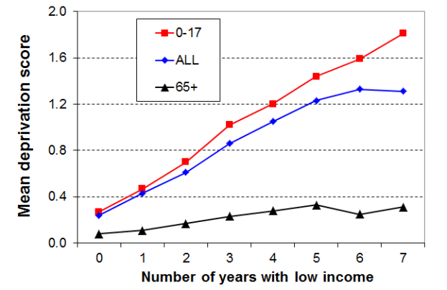
- The analysis for the graph draws on longitudinal data from SoFIE. The high-level finding that the longer that households are in low income the higher is their average deprivation score is not surprising. It is nevertheless one that is not always to the fore in discussions around poverty and hardship figures.
- The relatively flat line for older households reflects the fact that such households often have resources other than current income with which to support consumption for basic needs. This is in line with the income-wealth-consumption-material-wellbeing framework outlined in the introduction.
- The low-income threshold used in the analysis above produced poverty rates above the usual cross-sectional ones – that is, it was a relatively generous threshold. When a lower threshold is used, more in line with the 60% BHC cross-sectional threshold, the cumulative impact of ongoing lower low income leads to higher reported deprivation, as expected.
International comparisons

Household income trends
- In the decade from just before the impact of the GFC began through to HES 2018, household income growth was relatively even across the income spectrum at 17-20% in real terms from the top of the bottom decile up.
- New Zealand’s net gains from before the GFC and recession to HES 2018 are better overall than for many OECD countries – the negative impact was more muted here and the recovery has been stronger than for many. For example:
  - the UK median fell through the GFC and has only just returned to its pre-GFC level (4% above pre-GFC level in latest 2017-18 survey)
  - in Australia, household incomes across all parts of the distribution have been relatively flat since 2007-08, just as the GFC began to have an impact

Income inequality
- The share of income received by the top 1% of tax payers has been reasonably steady in a 7-9% range since the early 1990s, up from 5% in the 1980s:
  - New Zealand ranks in the low to mid range in the OECD for this statistic, similar to Australia, Norway and Sweden.
  - the US (20%), Canada (13%) and the UK (13%) all have higher rates for the top 1% share and have experienced much greater rises than New Zealand since the 1980s (the latest information is from 2013 and 2014).
- Using measures like the 90:10 ratio and the Gini trend line, New Zealand’s income inequality is a little higher than the OECD average, around the same as Australia.

Wealth inequality

- For OECD-type nations wealth inequality is usually around double the level of income inequality. The most wealthy 10% of New Zealand households hold a little more than 50% of all household wealth, whereas the top 10% of households receive a 25% share of all income.
- NZ’s wealth inequality is about average for the OECD, similar to Canada, Norway and France.

Poverty and material hardship

- The OECD and EU publish international league tables that rank countries on their income poverty rates using 50% and 60% of median poverty lines respectively (BHC).
- On the latest available figures (c 2014 for OECD and 2015 for the EU), New Zealand is in the middle of the rankings for both population poverty rates and child poverty rates (slightly above the median in each case).
 | OECD 50% |  | EU 60%
 | All | 0-17 | All | 0-17
NZ | 11 | 14 | 19 | 23
OECD / EU | 10 | 12 | 17 | 21
- These figures are really about income inequality in the lower half of the income distribution. They do not tell us anything about how actual living conditions differ from country to country as median incomes differ so much, depending largely on differences in GDP per capita. To properly compare countries for actual living conditions, non-income measures are needed.
- Using the EU material and social deprivation index (EU-13) with data from HES 2018 (NZ) and 2017 (EU), NZ ranks very well for older people (65+) but not so well for children – a finding consistent with the relativities produced within New Zealand using MWI and DEP-17 measures:
  - the hardship rate for those aged 65+ was 4%, ranking New Zealand near the top among EU nations – similar to Norway, Sweden, Finland and Denmark
  - the population hardship rate was 9%, better than the EU median (14%) and the median for the Euro area (12%) – the lower population rate is driven mainly by the very low rate for older New Zealanders
  - the hardship rate for children was 15%, close to the EU median (16%), and similar to the UK, Ireland, France, Belgium and Spain, but well above the Netherlands, Finland, Sweden and Norway (4-6%), and even Czechia, Estonia and Poland (6-7%).

In-work poverty
- Based on the EU approach which uses the BHC 60% relative measure for poverty and counts only the workers in working households, New Zealand’s in-work poverty rate is 8%. The EU median rate is 10%.
- Using an approach which counts everyone in working households, New Zealand rates are very close to UK rates on both BHC and AHC measures (eg 10% for both countries for those of working-age in working households (any work, not necessarily full-time).

Children in workless households
- In 2018, the HES showed around 11% of children in workless households. This puts New Zealand at the higher end of the spectrum internationally (among EU countries), though only 2 percentage points above the median of 9%. The 2018 figure is an improvement over the 2012 rate of 16% relative to an EU median of 10%.

UN’s Sustainable Development Goals
- On September 2015 all 193 UN member states formally adopted the 2030 Agenda for Sustainable Development which includes a new set of global goals (the Sustainable Development Goals (SDGs)) which replace the Millennium Development Goals (MDGs). One of the differences between the SDGs and MDGs is that the SDGs are universal rather than just focussing on “developing countries”.
- The findings reported in this Overview and in the two main reports that the Overview draws on are relevant to two of the SDGs, one on poverty and the other on inequality.
- The Poverty Goal (#1) is about ‘ending poverty in all its forms everywhere by 2030’. One of the sub-goals is to reduce at least by half the proportion of men, women and children of all ages living in poverty in all its dimensions ‘according to national definitions’. This gives scope for reporting using a suite of measures such as those that are identified in the Child Poverty Reduction Act, and which are available in the Household Incomes Report. It is clearly easier to achieve a 50% reduction on some measures and more challenging on others.
- The Inequality Goal (#10) is about reducing inequality within and between countries, and covers a wide range of inequalities. One of the recommended indicators for inequality reduction is the fully relative 50% of median low-income measure. This is sometimes used for international poverty comparisons (eg by the OECD), though the Incomes Report notes that when it is used for international comparisons it is more properly understood as a measure of inequality in the lower half of the income distribution. The UN’s decision to recommend use of this indicator in the Inequality section is in line with this view.
- Another target for Goal #10 is that member states ‘by 2030, progressively achieve and sustain income growth of the bottom 40% of the population at a rate higher than the national average’.
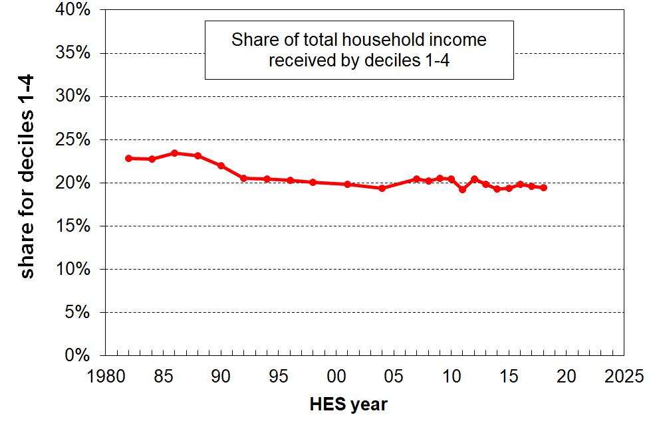
- The graph shows the share of total household income (BHC) for the bottom 40% for New Zealand, 1982 to 2018. If the growth for the bottom 40% is greater than that for average incomes, the trend line will slope up, showing that the bottom 40% is taking a larger slice of the pie (ie is growing faster than the national average). The generally flat trend from the early 1990s through to 2018 shows that the income growth of the bottom 40% has been much the same as that for the national average in that period.

Appendix One

The value and limitations of the HES for the purposes of the reports

All sample surveys have statistical uncertainties

- The HES is a random sample survey of around 3500 households (5500 in 2015 and 2018 surveys). When using information from random samples of a population to get estimates of what’s going on in the population itself, we want the samples to be as representative as possible of the population in question. The better the representation the more confidence we have that the estimate based on the sample is close to the true population figure. All else equal, the estimates are more reliable the larger the sample size. The 2018-19 survey, which Stats NZ is using in its next scheduled child poverty report (February 2020), has a much larger achieved sample size of around 20,000 households.

- As the numbers in the Stats NZ releases and in the MSD reports are based on data from sample surveys, there are always statistical uncertainties:
  - Some of the uncertainties arise by chance from the fact that the information is from a sample rather than the whole population (‘sampling error’). This means, for example, that most numbers are expected to bounce around either side of a trend line, especially for population sub-groups and more so for smaller than for larger ones. Sampling error exists even if a 100% response rate is achieved in a perfectly designed and implemented survey.
  - Other uncertainties and ‘noise’ arise from the fact that the response rate to the survey is always less than 100% (typically around 75-80% in recent years for the HES). If those who do not respond are on average quite different from those who do, and if this difference changes from year to year, then further fluctuations can occur that do not represent real-world fluctuations. For example, if it proves more difficult to get responses from households with low incomes or high material hardship than it does to get responses from other households, then the sample is likely to be biased and the bottom end will likely look better off than expected. Non-response bias is a challenge for all sample surveys. It can to some degree be addressed by applying carefully-designed weights to the sample, but some of the bias can remain even after the population weights are applied to the raw sample numbers.
  - Sample bias is an important example of what is referred to as ‘non-sampling error’. Other examples include incorrect information provided by respondents, data input errors or data handling problems, questionnaire design issues, sample design issues. There is no simple control or measurement for such non-sampling errors, although the risk can be minimised through careful application of the appropriate survey techniques from the questionnaire and sample design stages through to analysis of results.

- The use of the terms ‘sampling error’ or ‘sample error’ can suggest that a mistake has been made; however, sample errors are not mistakes. They represent the inevitable difference (that arises by chance) between the estimate and the true value when using a sample rather than interviewing every household in the population. Even a perfectly designed survey with a 100% response rate has sample error. It is an unfortunate term, but it is well-established and widely used internationally.

- Standard statistical theory provides a way of calculating and talking about sampling uncertainties in terms of “sample errors” and “confidence intervals”. A poverty rate of 17% with a sample error of 1 percentage point means that there is a 95% chance that the true rate is between 16% and 18%. This range is called the “confidence interval”. Other confidence levels can be used but Stats NZ, in line with international practice, uses the 95% confidence interval for reporting sample errors for child poverty estimates.

- This all means that surveys like the HES need to be used with care. The HES is very useful and reliable for many of the themes covered by the MSD reports, but for other others it has limitations that need to be recognised.
Using the HES with care for the purposes of this report

- For the purposes of the MSD reports there are many types of findings of public interest or policy relevance for which the HES is well suited and delivers valuable information. For example:
  - the overall picture of household income distribution (and now wealth as well)
  - the overall picture of material wellbeing, including on specific items of material hardship
  - trends in rates of low income, material hardship, inequality, housing costs relative to income, and so on, when the perspective is over many years
  - relativities between different groups on the above themes – even for smaller groups by combining information from several surveys
  - international comparisons.

- However, when the focus is on very short-term changes, especially year-on-year, or when more precision is required in a given year, the HES (to date) is not able to deliver robust results given its relatively small sample size.

- When looking at a change from one survey to the next, the question often arises as to what is driving the change. Is it a ‘real’ change (driven by policy changes or changes in the economy or the rental housing market)? Or is it just the inevitable random fluctuation that happens with sample surveys (‘sampling error’)?

- Many of these questions become more pressing the smaller is the sub-group being looked at. For example, only around a third of the sampled households contain children, so the sample size for this group is down to approximately 1200 (or 1800 in 2015 and 2018).

- MSD’s reports therefore emphasise the need to look at the general trend over many years, and warn against reaching conclusions based on very short-term changes alone, especially year-on-year changes.

Strategies employed to address statistical uncertainties

- The reports use a range of strategies to address the statistical uncertainties and the other challenges. For example:
- rolling two or three year averages for some time series
- reporting actual estimates, but overlaid with a trend-line to summarise
- using the average over several years when reporting on the composition of low-income groups or those experiencing material hardship, thus allowing reasonable estimates for smaller population groups
- reporting sensitivity analysis when applying different modifications to the original dataset to address anomalies (such as the issue of reported incomes being implausibly low)
- by not reporting results when the uncertainties are too great.

An example of observed year-on-year changes being an unreliable guide to real-world changes

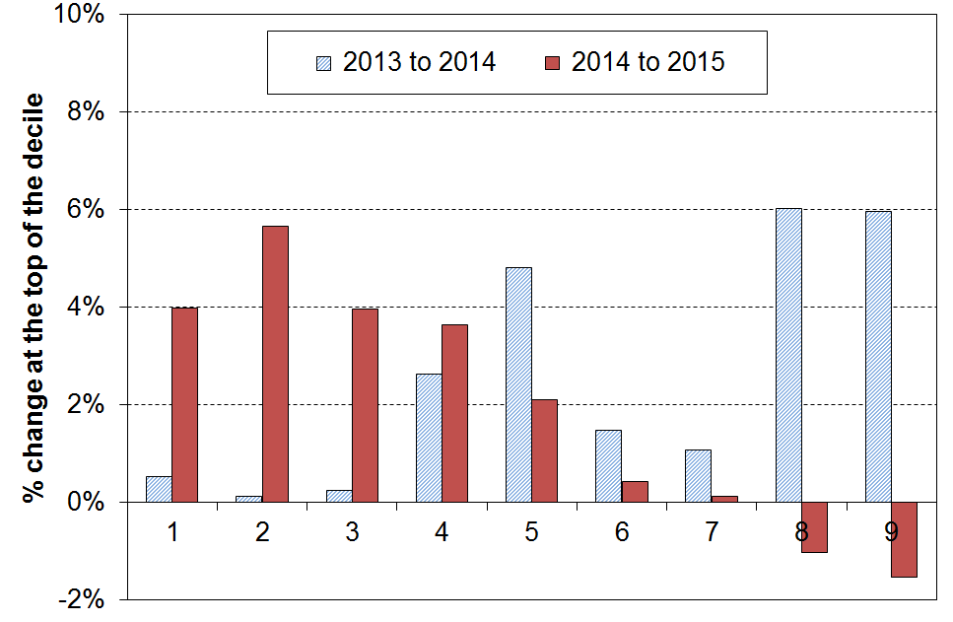
- While reported changes in median household income are usually reliable for giving the actual direction of the change and a good estimate of the size of the real-world change, those for high or low incomes are often not. This is illustrated in the graph below which shows year-on-year changes for incomes at the top of each decile for HES 2013 to 2014, and for HES 2014 to 2015. A tempting summary or headline finding for the 2015 update could have been “higher incomes are falling and lower incomes are rising”. This would be misleading as it puts too much reliance on year-to-year changes for high and low incomes where the uncertainties are at their greatest. As the graph shows, the changes from 2013 to 2014 go the other way and would be equally misleading to rely on on their own.

- The findings about differences or changes are at their strongest when looking at clear trends or changes over several surveys or longer, when comparing rankings using different measures, and when identifying which groups are faring well and which not so well.

Reporting on trends in low-income and material hardship rates for children

In the 2018 Incomes Report and the associated reports using non-income measures, MSD did not publish low-income or material hardship figures for the 2015-16 and 2016-17 HES years.

This decision was made based on a judgement call at the time that there was good reason to believe that the low-income and material hardship figures for households with children for these two years were under-estimates. MSD’s view was that publishing them, even with strong caveats, could easily lead to a premature conclusion that New Zealand had made solid progress in reducing child poverty, when in fact the reported decline mainly reflected either the inevitable uncertainties associated with sample estimates, or some sample bias, or both.

In addition, the Child Poverty Reduction Bill was making its way through the parliamentary process, with a likely consequence being that Stats NZ would be releasing their 2017-18 baseline figures for child poverty in early 2019. If MSD were to publish the 2015-16 and 2016-17 figures, and it turned out that Stats NZ’s 2017-18 figures and the associated back series confirmed MSD’s concerns, then there was the likelihood of distracting confusion over trends in the financial and material wellbeing of households with children.

The detailed case for the ‘pause’ in publishing low-income and material hardship numbers was set out in an MSD report to Minister Sepuloni, released on the MSD website in October 2018, with some further material noted in the recent Working Papers released in association with the Stats NZ child poverty publications on 20 February and 2 April 2019.

MSD’s 2019 reports

MSD has looked carefully at the 2017-18 HES and is satisfied that it is fit for purpose for use across all the charts, tables and other analysis in its 2019 reports, noting the strategies for managing risk for any HES survey as outlined on p6 above. Most of the factors that led to the ‘no publish’ decision no longer apply, though a few remain. The basis for this assessment is elaborated below.

There are two (closely related) datasets available for estimating low-income and material hardship rates for New Zealand.
- The first is the long-running dataset used by MSD for its incomes and other reporting and by Stats NZ for reporting to the OECD’s Income Distribution Database and elsewhere. It has income information from 1982 to 2018, and material hardship information from 2017 to 2018. This is referred to as the HES-TAWA dataset as it contains both HES survey data and essential secondary information produced by the Treasury’s TAWA micro-simulation model (eg TAWA calculates disposable (after tax and transfer) income from the gross income and demographic data available in the survey data). Stats NZ provide standard weights for use with this dataset.
- The second is the special dataset constructed by Stats NZ for its official child poverty release on 2 April 2019 which set the baseline rates required for the implementation of aspects of the Child Poverty Reduction Act (2018). For BHC low income trends, data from the HES and the Household Labour Force Survey (HLFS) are pooled. The income information comes from administrative data, not the surveys themselves. This is referred to in this report as the HES-HLFS dataset. A new set of weights has been calculated for use with this data, based on different benchmarks than the one for the HES-TAWA data. The data in the HES-HLFS dataset is available only from 2007 on.
  - For AHC incomes, administrative data was used for the BHC income component, but as there is no housing cost information in the HLFS, the sample size was limited to that of the HES (5500 in 2017/18). The revised weights are used.
  - For material hardship estimates, the sample was limited to that of the HES (5500 in 2017/18), as the HLFS does not have material hardship information. The revised weights are used.

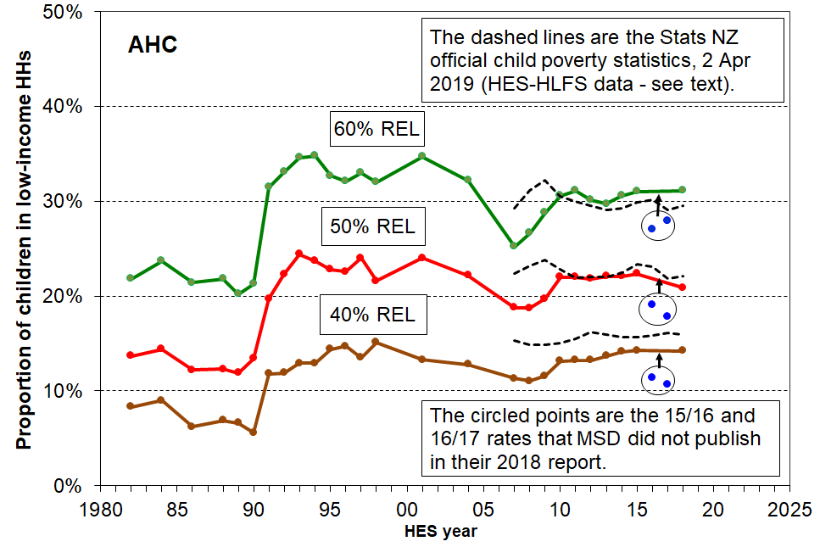
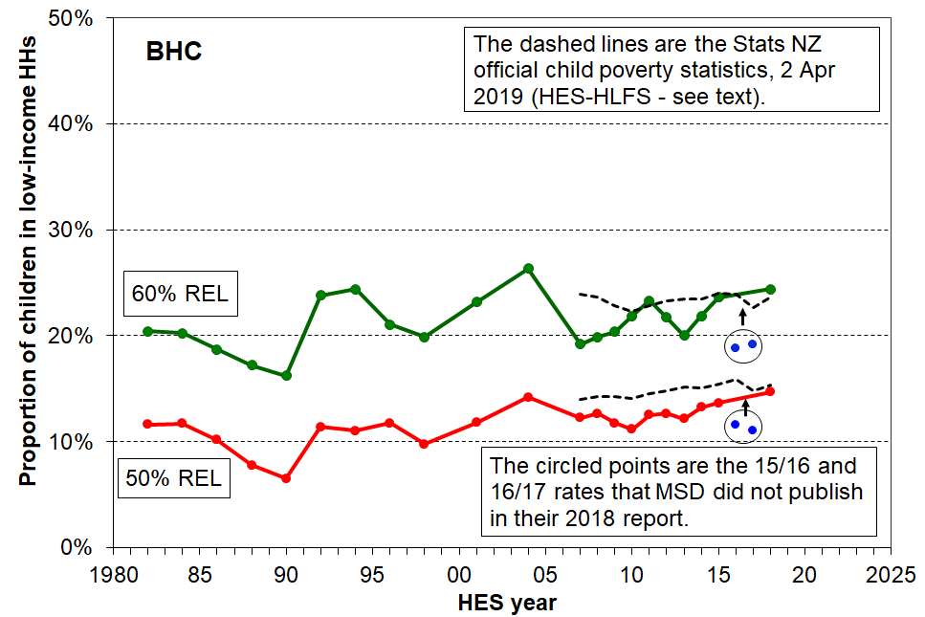
The charts below show the trends for low-income rates for children from 2007 to 2018 using the two data sources noted above. The trend lines use a rolling two-year average from 2008 on.

The main drivers of any differences between the trend lines from the two datasets are not at the level of concept and definition. Any differences that do exist arise in the main from differences in data sources and weights used to convert sample numbers to population estimates:
- The pooling of HES and HLFS samples for BHC incomes reduces sample errors and smoothes the trend line compared with using the HES alone.
- The use of administrative data rather than survey data for income information leads to slightly higher low-income estimates in the Stats NZ 2 April release compared with the MSD numbers, especially for the 40% AHC and 50% BHC measures. Further work is underway to better understand the reasons for the differences.
- The use of revised weights reduces variability as the new weights to some degree better address sample bias in relation to low-income households.

The Stats NZ figures are the official figures.

Key evidence taken into account in the decision to resume publishing child poverty figures

- The trend charts above provide good visual support for both the decision to not publish using 2015-16 and 2016-17 data, and the decision to publish in 2019 using the 2017-18 survey data.

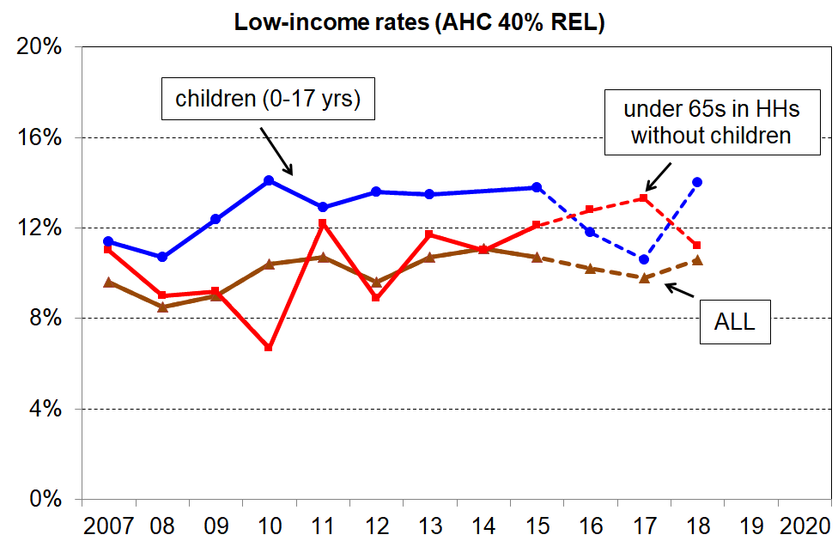
- The AHC relativities for those in households with children and households without children have returned to their expected levels after two years seeming to move in opposite directions without any ready explanation.

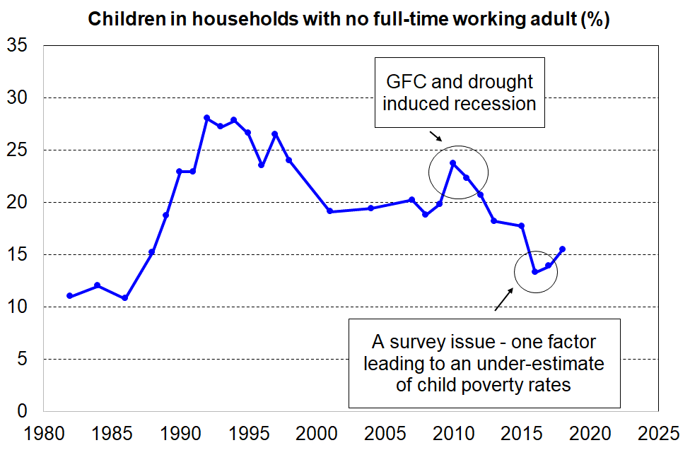
- The trend in the estimated proportion of children living in households with no full-time worker were unusually low in 2015-16 and 2016-17, but in 2017-18 were more like what could be expected.

- The sample and population weighted numbers for sole parent households and beneficiary households with children were low in 2015-16, and returned to their expected levels in 2016-17 and 2017-18. There was also a smaller-than-usual proportion of sole-parent households from the bottom NZDep decile in the 2015-16 sample (9% of all households rather than the usual 13-15%).
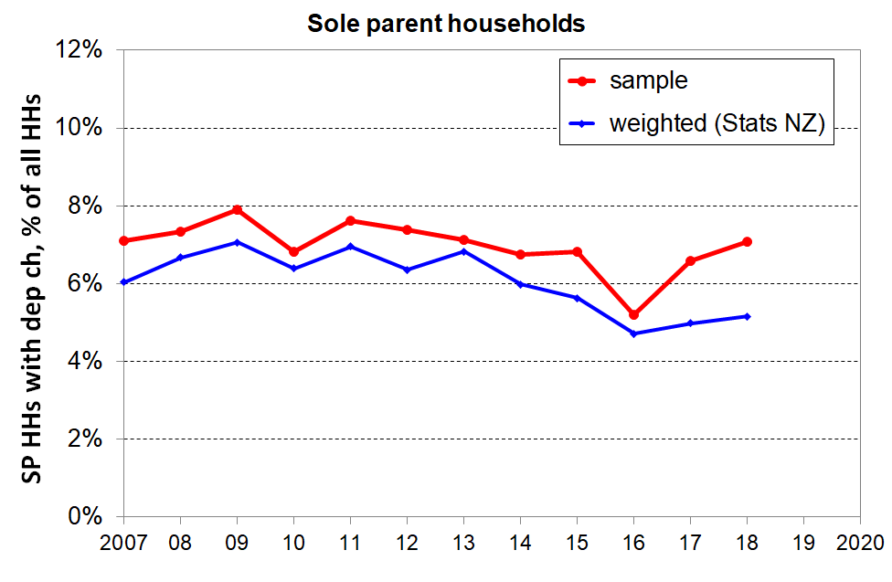
The trends for several of the non-monetary indicators returned (near) to expected levels in 2017-18. For example, the proportion of HES households with children reporting foodbank usage returned to the steady level seen from 2013 to 2015, after the reported drop in 2016 and 2017. The samples for 2015 and 2018 had good numbers from the lowest NZDep decile area, and the 2018 weights grossed the numbers up to the previous levels after a dip in 2016 and 2017.

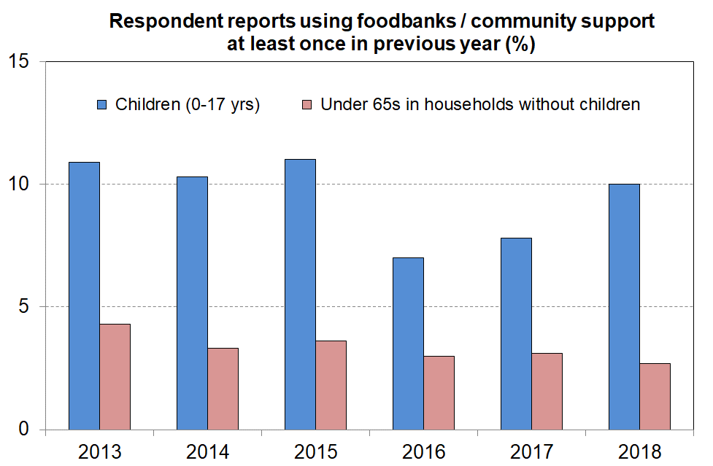
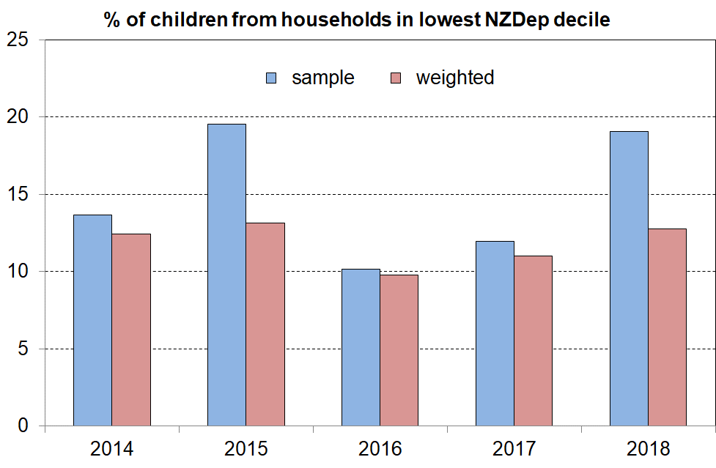

* * * * * * * * * * * * * * * * * * * * *

There remains, however, some evidence of a step-change from 2013-2015 to 2016-2018 for some non-monetary indicators, suggesting some non-response or other bias that the weighting regime was not able to address. For example (as shown in the charts below):
- There was a fall in the proportion of households with children who reported needing to borrow from family and friends to meet basic needs, but for households without children the rate was much the same over the six surveys.
- Reported rates of delaying repairs/replacement of appliances ‘a lot’ for households with children were all lower for 2016 to 2018 than in the previous three years, in contrast to households without children for whom the trend is steady (though 2018 for households with children is more like what would be expected).
- There was a reported fall in the proportion of households with children who were behind on car registration ‘more than once’ in the 12 months prior to interview.
- The self-assessment by working-age beneficiary households that their total income was ‘not enough or only just enough’ was steady at close to 81% in the 2013-2015 period, but only 68% (and steady) in the next three surveys.
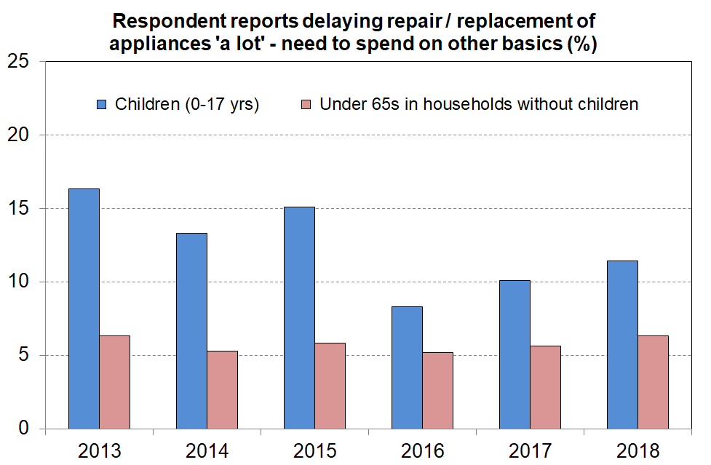
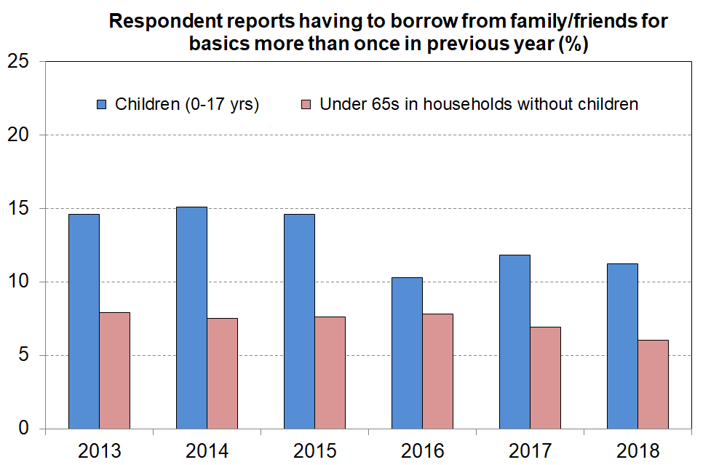

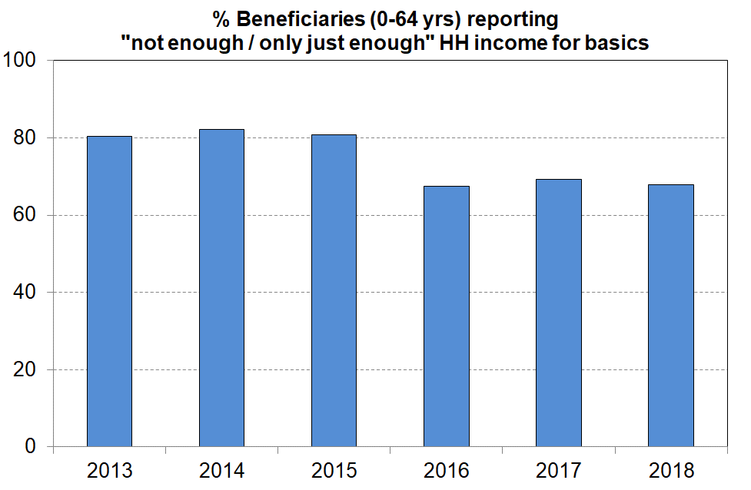
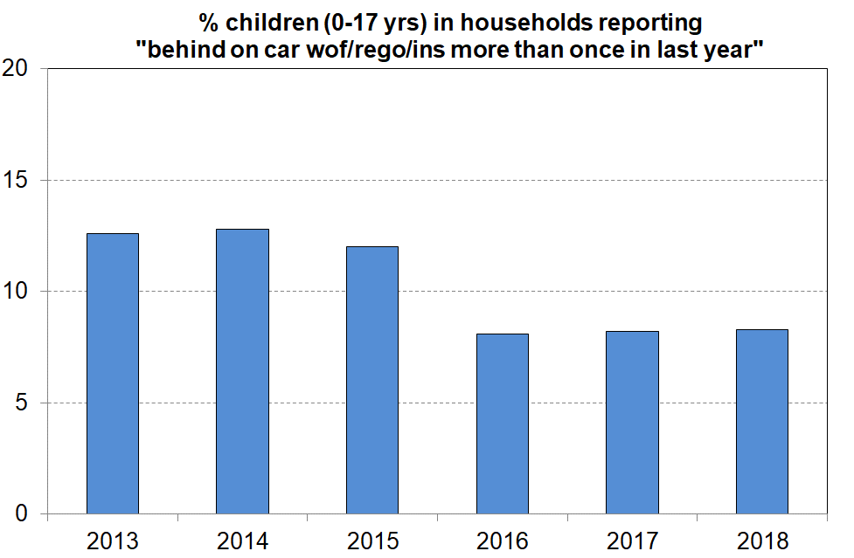

The chart below indicates that compared with 2013 to 2015 there was a sudden large increase in the population of ‘better off’ Māori households in 2016 to 2018: the rate responding ‘more than enough’ to the income adequacy question doubled from 6-8% in 2013 to 2015 to 16-17% in 2016 to 2018. At the same time, the responses of the rest of the population indicate just a small increase for the same time periods.

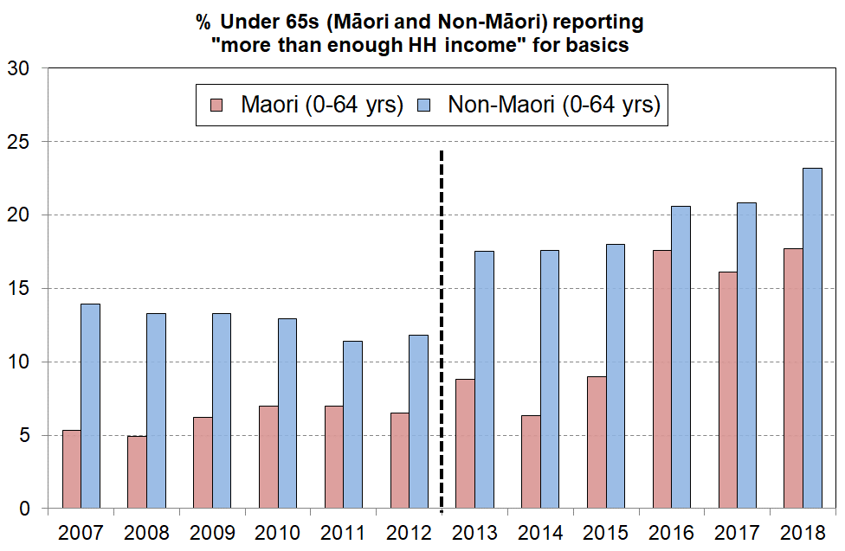
There is no ready explanation for the large change for Māori in terms of policy, economic, housing market or demographic changes. Median household income for Māori (and the rest) rose in real terms in the period, so some increase in this adequacy indicator could be expected, but the size of the change for Māori points to an explanation involving a change in the profile of the achieved sample for 2016 to 2018.

Note: The income adequacy question changed a little in the 2013 HES. The 4 categories changed from ‘not enough / just enough / enough / more than enough’ to ‘not enough / only just enough / enough / more than enough’, but this is unlikely to have changed responses to the ‘more than enough’ option.

The MSD reports will monitor these and similar trends over a longer period and continue to seek to understand the observed changes. The larger sample size for the 2018-19 HES will assist with this.

As for the two previous reports, MSD’s 2019 reports do not use the 2015-16 and 2016-17 numbers for child poverty (low income) reporting in the main body of the report. The trend lines go direct from 2014-15 to 2017-18, leaving out the two intermediate years. This approach is justified by the relatively flat trends reported by Stats NZ in that period (2015 to 2018), using the alternative HES-HLFS dataset and associated weights.

For material hardship trends, the 2019 report does not use 2015-16 HES data as in MSD’s view there is too much cumulative evidence of sample bias. For material hardship time series, the report uses the average of 2014-15 and 2016-17 as the ‘best estimate’ of 2015-16 figures. For other analysis (eg composition of those in households in material hardship), the 2014-15 and 2017-18 data is used, noting the larger sample size for these years (5500 instead of the usual 3500).

There are particular issues at the bottom and top of the income distribution which can lead to misleading findings unless they are identified and addressed

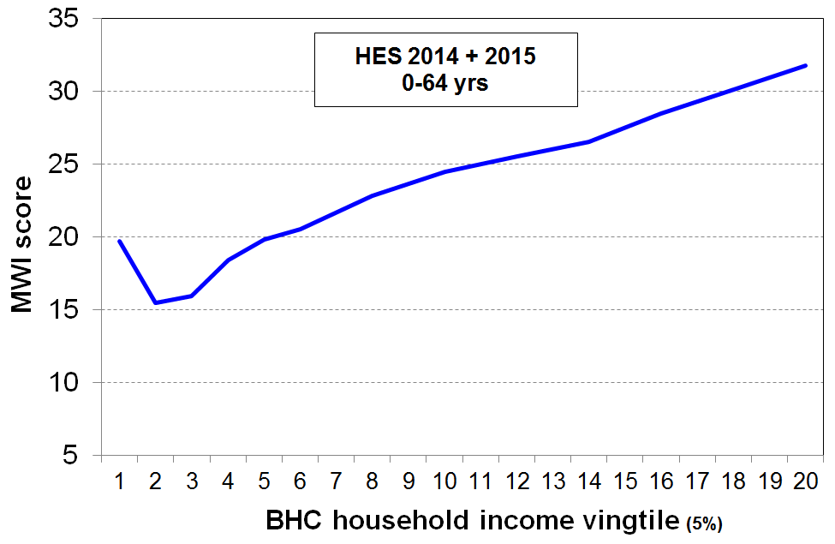
- While the incomes of most of the households in the bottom decile seem plausible (for example, they are in line with main income support levels or the incomes received by households with workers on the minimum wage), there are always some that report implausibly low incomes, lower than beneficiary incomes or much less then declared spending, or both. A few self-employed report negative incomes. The bottom decile is unique in this regard. For example, while there are households in each income decile that report expenditure more than three times their income (around 2-3% of all households), around 80% of these are found in the bottom income decile.

- This means that the average income of the bottom decile cannot be taken as a reasonable estimate of this group’s (relative) material wellbeing. This is supported by the analysis in the graph which shows how the MWI score decreases as expected when coming down the (BHC) income spectrum, except for the bottom income vingtile (5%) whose average MWI score is more like those at the top of the second income decile. This shows that the incomes of those reporting implausibly low incomes are in general not a reliable indicator of the resources available to those households for generating consumption.

- It also means that it is unwise to use very low BHC income thresholds to monitor ‘severe’ poverty as too great a proportion of the households under such thresholds are those with implausibly low reported incomes. The Incomes Report therefore does not go below a 50% of median threshold for BHC incomes, and 40% of median for AHC incomes.

- When the low-income-high-expenditure households are removed from the data, the reported population low-income (poverty) rates are around one percentage point lower (using a 50% of median measure), but the overall directions of the trends do not change. Rates for households with children remain virtually unchanged.

- At the very high end, there are two issues:
- First, households with very high incomes are under-represented in most sample surveys. We know this through comparisons with tax records. This a well-known issue across all OECD and EU countries.
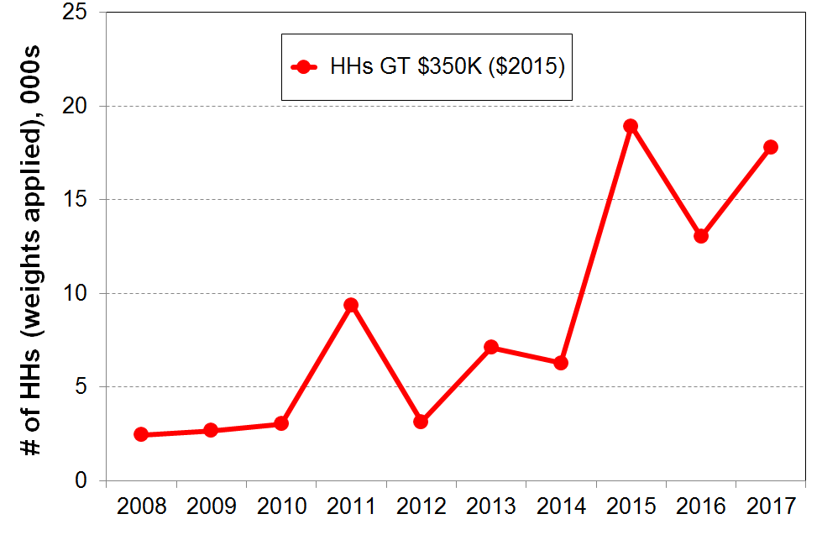
- Second, from survey to survey the number of very high income households and the size of their reported incomes can vary considerably. The graph shows this phenomenon occurring in HES 2011. Future surveys will show whether the 2015, 2016 and 2017 figures are the ‘new normal’ or not. This variability can have a very large and misleading impact on the reported trends in top decile shares of total household income and in inequality measures which take account of all incomes in the sample (eg the Gini coefficient). The resulting fluctuations simply reflect the challenges of consistently achieving a representative sample of very high income households, rather than any real-world changes.

Appendix Two

Where does your household fit on the income distribution?

The Incomes Report often ranks individuals by their household’s equivalised BHC disposable income (ie by their household income, after adjusting for household size and composition). The tables below give the annual (unequivalised) disposable income levels (BHC) of different household types in each (equivalised) income decile. From these tables, most people will be able to locate where they and their households fit on the income distribution.

To use these tables, select the table and column heading that best describes your household or family situation. Go down the column until you find your household’s disposable income range (ie annual after-tax income, including all social assistance from the state). The row gives the equivalised income decile for your household income. For example, a household comprising a sole parent with two children with a disposable income of $51,000 pa is in decile 4.

Table 2A – one-adult households

Where does your household fit in the overall household income distribution (BHC)?
HES 2017
Equivalised income decile | Ordinary dollars (ie not equivalised)
Equivalised income decile | One person,  no children  (reference HH) | Sole parent, one child | Sole parent, two children | Sole parent, three children | Sole parent, four children
Bottom decile | < $19,600 | < $25,500 | < $31,300 | < $37,200 | < $43,100
Decile 2 | 19,600 - 23,300 | 25,500 - 30,300 | 31,300 - 37,300 | 37,200 - 44,300 | 43,100 - 51,300
Decile 3 | 23,300 - 28,300 | 30,300 - 36,800 | 37,300 - 45,300 | 44,300 - 53,800 | 51,300 - 62,300
Decile 4 | 28,300 - 33,100 | 36,800 - 43,000 | 45,300 - 52,900 | 53,800 - 62,800 | 62,300 - 72,700
Decile 5 | 33,100 - 38,200 | 43,000 - 49,600 | 52,900 - 61,100 | 62,800 - 72,500 | 72,700 - 84,000
Decile 6 | 38,200 - 44,000 | 49,600 - 57,100 | 61,100 - 70,300 | 72,500 - 83,500 | 84,000 - 96,700
Decile 7 | 44,000 - 51,200 | 57,100 - 66,600 | 70,300 - 82,000 | 83,500 - 97,300 | 96,700 - 112,700
Decile 8 | 51,200 - 61,100 | 66,600 - 79,400 | 82,000 - 97,700 | 97,300 - 116,100 | 112,700 - 134,400
Decile 9 | 61,100 - 79,500 | 79,400 - 103,300 | 97,700 - 127,200 | 116,100 - 151,000 | 134,400 - 174,900
Top decile | > $79,500 | > $103,300 | > $127,200 | > $151,000 | > $174,900

Note: Use disposable household income when using this table – that is, household income from all sources after paying personal income tax and after receiving all tax credits (eg from Working for Families) and other state transfers (eg NZS, AS, main benefits)
Table 2B – two (and three) adult households

Where does your household fit in the overall household income distribution (BHC)?
HES 2017
Equivalised income decile | Ordinary dollars (ie not equivalised)
Equivalised income decile | Couple or 2 adults sharing | Couple,  one child | Couple,  two children | Couple,  three children | Couple, four children | Three adults, one child
Bottom decile | < $29,400 | < $35,200 | < $41,100 | < $47,000 | < $52,900 | < $39,200
Decile 2 | 29,400 - 35,000 | 35,200 - 42,000 | 41,100 - 49,000 | 47,000 - 56,000 | 52,900 - 63,000 | 39,200 - 46,700
Decile 3 | 35,000 - 42,500 | 42,000 - 51,000 | 49,000 - 59,500 | 56,000 - 67,900 | 63,000 - 76,400 | 46,700 - 56,600
Decile 4 | 42,500 - 49,600 | 51,000 - 59,500 | 59,500 - 69,400 | 67,900 - 79,400 | 76,400 - 89,300 | 56,600 - 66,100
Decile 5 | 49,600 - 57,300 | 59,500 - 68,700 | 69,400 - 80,200 | 79,400 - 91,600 | 89,300 - 103,100 | 66,100 - 76,400
Decile 6 | 57,300 - 65,900 | 68,700 - 79,100 | 80,200 - 92,300 | 91,600 - 105,500 | 103,100 - 118,700 | 76,400 - 87,900
Decile 7 | 65,900 - 76,800 | 79,100 - 92,200 | 92,300 - 107,600 | 105,500 - 122,900 | 118,700 - 138,300 | 87,900 - 102,400
Decile 8 | 76,800 - 91,600 | 92,200 - 109,900 | 107,600 - 128,300 | 122,900 - 146,600 | 138,300 - 164,900 | 102,400 - 122,200
Decile 9 | 91,600 - 119,200 | 109,900 - 143,100 | 128,300 - 166,900 | 146,600 - 190,800 | 164,900 - 214,600 | 122,200 - 159,000
Top decile | > $119,200 | > $143,100 | > $166,900 | > $190,800 | > $214,600 | > $159,000

Note: Use disposable household income when using this table – that is, household income from all sources after paying personal income tax and after receiving all tax credits (from Working for Families) and other state transfers (eg NZS, AS, main benefits).

Appendix Three

Low-income thresholds (poverty lines) used in the Incomes Report

Tables 3.1 and 3.2 below give the value of the report’s low-income thresholds (poverty lines) in ordinary 2018 dollars pw for different household types. The values in 2019 dollars will be much the same as inflation has been low.

The equivalence scale used for adjusting incomes for household size and composition is the ‘modified OECD scale’, as used by Stats NZ for their child poverty statistics and by the EU for all their household income analysis.

Table 3.1
50% and 60% low-income thresholds or ‘poverty lines’ for various household types (BHC)
($2018, per week)
 |  | REL (‘moving’) |  | CV (‘anchored’ /‘fixed’)
Household type | Equiv ratio | 50% of 2018 median | 60% of 2018 median | 50% of 2007 median in $2018 | 60% of 2018 median in $2018
One-person HH | 1.0 | 385 | 460 | 310 | 460
SP, 1 child <14 | 1.3 | 500 | 595 | 405 | 595
SP, 2 children <14 | 1.6 | 610 | 735 | 500 | 735
SP, 3 children <14 | 1.9 | 725 | 875 | 590 | 875
Couple only | 1.5 | 575 | 690 | 465 | 690
2P, 1 child <14 | 1.8 | 690 | 825 | 560 | 825
2P, 2 children <14 | 2.1 | 805 | 965 | 655 | 965
2P, 3 children <14 | 2.4 | 920 | 1100 | 750 | 1100
2P, 4 children <14 | 2.7 | 1035 | 1240 | 840 | 1240
3 adults | 2.0 | 765 | 920 | 625 | 920

Table 3.2
50% and 60% low-income thresholds or ‘poverty lines’ for various household types (AHC)
($2018, per week)
 |  | REL (‘moving’) |  |  | CV (‘anchored’ /‘fixed’)
Household type | Equiv ratio | 40% of 2018 median | 50% of 2018 median | 60% of 2018 median | 50% of 2007 median in $2018 | 60% of 2018 median in $2018
One-person HH | 1.0 | 235 | 295 | 350 | 230 | 350
SP, 1 child <14 | 1.3 | 305 | 380 | 455 | 300 | 455
SP, 2 children <14 | 1.6 | 375 | 470 | 560 | 370 | 560
SP, 3 children <14 | 1.9 | 445 | 555 | 665 | 440 | 665
Couple only | 1.5 | 350 | 440 | 525 | 345 | 525
2P, 1 child <14 | 1.8 | 420 | 525 | 630 | 415 | 630
2P, 2 children <14 | 2.1 | 490 | 615 | 740 | 485 | 740
2P, 3 children <14 | 2.4 | 560 | 705 | 845 | 555 | 845
2P, 4 children <14 | 2.7 | 630 | 790 | 950 | 625 | 950
3 adults | 2.0 | 470 | 585 | 705 | 460 | 705
.
Appendix Four

Lists of items in the MWI and DEP-17, and how to calculate your household’s MWI score and find your ranking

See the table on the next page for a list of the items in the MWI and in DEP-17. A tick () in the column means that this item is in the index.

It also indicates the scoring for each item used in each index.

The raw MWI scores range from 0 to 43, with higher scores meaning higher material living standards. For convenience, the actual MWI scores are converted to a 0 to 35 range, with any raw scores of 8 or less being classed as “0”. This does not lead to any loss of usable information as there are typically only 1-2% in this latter category. For the rest, 8 is deducted from the raw score to give the actual MWI score.

The graph below shows where a given score ranks a household on the MWI distribution. For example, a score of 25 ranks the household at the 42nd percentile (that is, the household is above 42% of other households).

The MWI can discriminate between households better in the lower half than in the upper half of the distribution. The reports clump the top 25% or so together (scores of 33-35) as a “high living standards” group and do not attempt to break it down further.

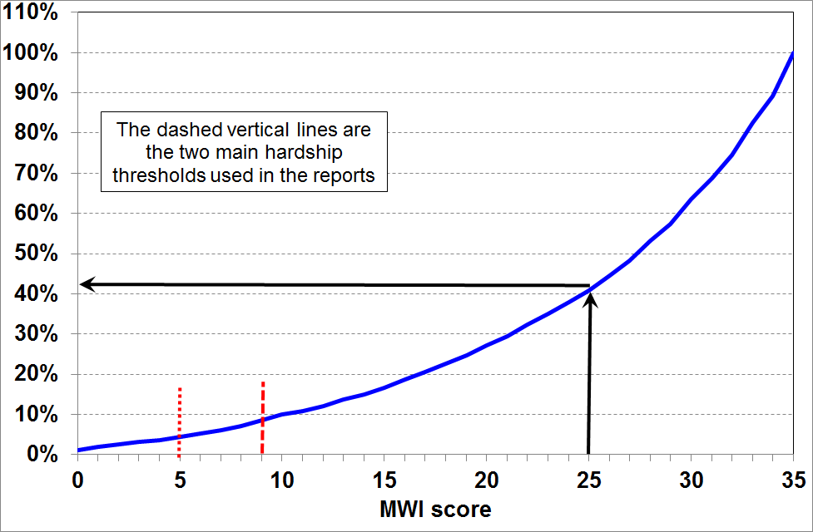

Method 1: Go through the 24 MWI items on the next page and calculate your / your household’s raw score, deduct 8, then use the chart above for a ranking.

Method 2: If you think you are probably in a household with fairly high living standards, it is quicker to go through the 24 items and note which ones you score less than the full amount on, then deduct these amounts from 35.

The non-income items in the HES (from 2013 to 2018), the composition of the MWI and DEP-17,
and how each item is scored for the two indices
Item description |  | MWI | DEP-17 | Your MWI scores
Ownership or participation (have/do, don’t have/do and enforced lack (EL))
For DEP-17, score an EL as 1, otherwise 0
For MWI, score an EL as a 0, otherwise 1
1 | Two pairs of shoes in a good condition and suitable for daily activities | ✓ | ✓
2 | Suitable clothes for important or special occasions | ✓ | ✓
3 | Contents insurance | ✓ | ✓
4 | A meal with meat, fish or chicken (or vegetarian equivalent) at least each 2nd day | ✓ | ✓
5 | A good bed | ✓ | -
6 | Presents for family/friends on special occasions | ✓ | ✓
7 | Holiday away from home at least once every year | ✓ | -
8 | Overseas holiday at least once every three years | ✓ | -
Economising (not at all, a little, a lot) – to keep down costs to help in paying for (other) basic items (not just to be thrifty or to save for a trip or other non-essential)
For DEP-17, score ‘a lot’ as 1, otherwise 0
For MWI, score ‘not at all as 2, ‘a little’ as 1, and ‘a lot’ as 0
9 | Gone without or cut back on fresh fruit and vegetables | ✓ | ✓
10 | Buy cheaper cuts of meat or bought less meat than you would like | ✓ | ✓
11 | Continued wearing worn out clothes | ✓ | -
12 | Put up with feeling cold | ✓ | ✓
13 | Do without or cut back on trips to the shops or other local places | ✓ | ✓
14 | Delay replacing or repairing broken or damaged appliances | ✓ | ✓
15 | Spent less on hobbies or other special interests than you would like | ✓ | -
16 | Postponed visits to the doctor | ✓ | ✓
17 | Postponed visits to the dentist | ✓ | ✓
Housing problems (no problem, minor problem, major problem … in the last 12 months)
For MWI, score as 2, 1 and 0 respectively.
18 | Dampness or mould | ✓ | -
19 | Heating or keeping it warm in winter | ✓ | -
Freedoms/Restrictions
20 | When buying, or thinking about buying, clothes or shoes for yourself, how much do you usually feel limited by the money available? (4 point response options: ‘not at all limited, a little limited, quite limited, very limited)  For DEP-17, score ‘very limited’ as 1, otherwise 0.  For MWI, score as 3, 2, 1 and 0 respectively. | ✓ | ✓
21 | $300 spot purchase for an ’extra’, not a necessity – how limited do you feel about buying it? (5 point response options: not at all limited, a little limited, quite limited, very limited, couldn’t buy it)  For MWI, score as 4, 3, 2, 1 and 0 respectively. | ✓ | -
22 | $500 unexpected unavoidable expense on an essential – can you pay in a month without borrowing? (yes/no)  For DEP-17, score ‘no’ as 1, and ‘yes’ as 0  For MWI, score ‘yes’ as 2 and ‘no’ as 0 | ✓ | ✓
Financial strain (in last 12 months) (not at all, once, more than once)
For DEP-17, score ‘more than once’ as 1, otherwise 0
For MWI, score ‘not at all’ as 2, ‘once’ as 1, ‘more than once’ as 0
23 | Behind on rates or utilities | ✓ | ✓
24 | Behind on car registration, wof or insurance | ✓ | ✓
25 | Behind on rent or mortgage | - | - | n/a
26 | Borrowed from family or friends to meet everyday living costs | - | ✓ | n/a
27 | Received help in the form of food, clothes or money from a welfare or community organisation such as a church or food bank | - | - | n/a
Global self-ratings
28 | Adequacy of income to cover basics of accommodation, food, clothing, etc | - | - | n/a
29 | Satisfaction with life | - | - | n/a
Note: An EL is an enforced lack – an item that is wanted but not possessed because of the cost
Appendix Five

Profiles of living standards at different levels

The tables below give a multi-indicator profile of what day-to-day life is like across the material wellbeing spectrum, using both selected MWI items and some from outside the MWI.

Using selected MWI items, by MWI decile, HES 2014 and 2015 (avg %)
MWI decile ➔ | 1 | 2 | 3 | 4 | 5 | 6 | 7 | 8 | 9 | 10 | ALL
Positive association with MWI score
can pay an unexpected unavoidable $500 bill within a month without borrowing | 12 | 36 | 56 | 74 | 85 | 91 | 96 | 95 | 98 | 100 | 76
delayed replacing or repairing appliances that were not working because of costs [not at all] | 9 | 25 | 47 | 67 | 78 | 90 | 94 | 98 | 99 | 100 | 72
put off going to dentist because of costs [not at all] | 4 | 21 | 31 | 42 | 53 | 68 | 79 | 90 | 96 | 100 | 60
spent less time on hobbies or special interests because of costs [not at all] | 4 | 11 | 17 | 26 | 37 | 59 | 70 | 87 | 95 | 100 | 52
have a holiday overseas at least once every 3 yrs (<65) | 5 | 17 | 25 | 35 | 44 | 51 | 60 | 67 | 69 | 80 | 43
not limited in $300 spot purchase of a non-essential | 0 | 0 | 0 | 3 | 5 | 10 | 17 | 36 | 67 | 100 | 24
Negative association with MWI score
contents insurance [EL] | 62 | 35 | 23 | 13 | 10 | 5 | 4 | 2 | 1 | 0 | 14
put up with feeling cold [a lot] | 56 | 22 | 13 | 5 | 4 | 1 | 1 | 0 | 0 | 0 | 10
put off repairing or replacing broken appliances [a lot] | 64 | 22 | 10 | 3 | 1 | 0 | 0 | 0 | 0 | 0 | 9
put off doctor’s visits [a lot] | 48 | 20 | 8 | 3 | 2 | 1 | 0 | 0 | 0 | 0 | 7
went without fresh fruit and vegetables [a lot] | 32 | 8 | 1 | 0 | 1 | 0 | 0 | 0 | 0 | 0 | 4
clothes for special or important occasions [EL] | 28 | 8 | 1 | 0 | 0 | 0 | 0 | 0 | 0 | 0 | 3
2 pair of shoes in good condition for everyday activities [EL] | 28 | 6 | 1 | 0 | 0 | 0 | 0 | 0 | 0 | 0 | 3
meal with meat, fish or chicken (or vegetarian equivalent) at least each second day [EL] | 10 | 4 | 0 | 0 | 0 | 0 | 0 | 0 | 0 | 0 | 1
borrowed from family or friends to meet everyday living costs [more than once in last 12 months] | 54 | 29 | 21 | 10 | 9 | 4 | 2 | 2 | 0 | 0 | 13

Using items not in the MWI, by MWI decile, HES 2014 and 2015 (avg %)
 | 1 | 2 | 3 | 4 | 5 | 6 | 7 | 8 | 9 | 10 | ALL
received help from food banks or other community groups  [at least once in last 12 months] | 40 | 14 | 8 | 0 | 0 | 0 | 0 | 0 | 0 | 0 | 6
received help from food banks or other community groups [more than once in last 12 months] | 26 | 8 | 4 | 0 | 0 | 0 | 0 | 0 | 0 | 0 | 4
have a get together with friends or extended family for a drink or a meal at least once a month | 48 | 66 | 73 | 76 | 85 | 87 | 91 | 93 | 91 | 93 | 81
- want to, but don’t for reasons other than cost | 15 | 17 | 14 | 11 | 11 | 9 | 7 | 6 | 7 | 6 | 10
access to computer and internet at home (0-64) | 61 | 78 | 88 | 89 | 96 | 96 | 97 | 99 | 98 | 98 | 90
access to computer and internet at home (65+) | 42 | 71 | 61 | 66 | 80 | 77 | 76 | 77 | 79 | 78 | 75

- The final table shows how self-assessed life satisfaction (“taking all areas of life into account”) varies across the material wellbeing spectrum. There is a clear gradient across most of the ten deciles – it is particularly steep at the lower end.

Overall life satisfaction, by MWI decile, HES 2014 and 2015 (avg %)
 | 1 | 2 | 3 | 4 | 5 | 6 | 7 | 8 | 9 | 10 | ALL
satisfied or very satisfied with life right now, taking all areas into account | 34 | 51 | 76 | 78 | 86 | 88 | 89 | 91 | 94 | 96 | 79

Appendix Six

Constructing a material hardship time series from 2007 to 2018

The material hardship time series in the reports uses the Economic Living Standards Index (ELSI) up to and including 2012, and after that the Material Wellbeing Index (MWI). The MWI is the revised version of the ELSI prototype. Both are constructed using non-incomes data from Stats NZ’s Household Economic Surveys (HES), from 2007 to 2018.

Between the 2012 and 2013 surveys there was a major revision of the survey item set: 13 of the 25 ELSI items were dropped and 17 new ones were added. There can therefore be no on-going ELSI time series and, similarly, the new MWI series can run only from 2013. This means a break between 2012 to 2013 with ELSI before the break and MWI after, which potentially thwarts efforts for a time series across the whole period.

Fortunately nine of the twelve items that are common to both the earlier and later datasets are suitable to create a good-enough index (‘DEP-COMMON’) that shows the shape of the trend-lines across the full period, 2007 to 2018, giving a good indication on how to splice the ELSI and MWI series between HES 2012 and HES 2013, the period in which the item sets changed.

The chart below shows the trend for DEP-COMMON for three levels of hardship, and the ELSI-MWI trend used in the reports.

Constructing a material hardship time series, 2007 to 2018:
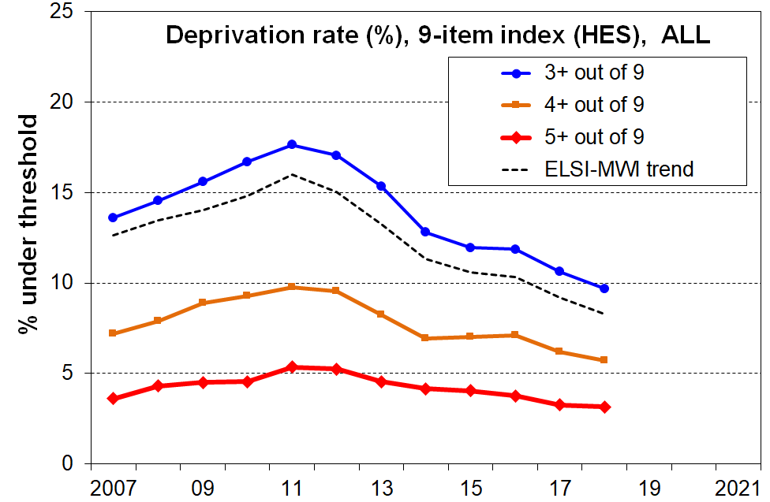
DEP-COMMON (9 items) compared with ELSI-MWI

MSD also reports on material hardship using the DEP-17 index. This can be constructed from HES 2013 on. It produces a trend and levels for material hardship that are almost identical to that produced by MWI (MWI ≤11 ≡ DEP-17 6+/17).

MSD’s DEP-17 material hardship index is used by Stats NZ for their official child poverty statistics (6+/17 and 9+/17 for the two levels of hardship reported).
Appendix Seven

Some common misunderstandings or misrepresentations of the low income and material hardship figures reported for children

There are several fairly commonly-made claims about child poverty and hardship in New Zealand which directly or indirectly use some of the numbers from the reports, but which are claims that the reports do not in fact support. In some cases the reports explicitly show that the claims are misleading or incorrect. Five are noted and discussed below.

“There are [XYZ,000 (choose own preferred number)] children in New Zealand below the poverty line / the bread line”

- Such claims definitively declare how many thousand children are in (income) poverty in New Zealand, as if it were a relatively straightforward, uncontested and binary statistic (“you’re under the line and in poverty or over it and not in poverty”), in the same category as declaring how many children of a certain age are taller than, say, 130 cm.
- The reports show that there is no single low-income measure which satisfactorily divides children into the poor and the non-poor in the way that such claims seek to do. There is a range of plausible thresholds that can be used. There are also factors other than income which determine whether a household has the resources needed to achieve a minimum acceptable standard of living. The reports take the view that the most useful and productive approach is to focus on telling a more comprehensive story about trends at different depths, and on seeking to understand why different measures produce different trends and what all this means for policies to address poverty and hardship.
- This is all in line with the approach taken in the Child Poverty Reduction Act (2018).

“There are [XYZ,000 (choose own preferred number)] children in New Zealand below the poverty line: they don’t have a waterproof coat, shoes in good condition for daily activities, their own bed, a warm dry home, and they have to miss out on participation in sporting and other activities, and so on”

- This claim works off the assumption that all ‘poor’ (low-income) children lack all or most of the items used in the NIMs report to create the hardship indices or in the calibration exercise to select usable thresholds.
- The assumption is not correct. For example, as discussed in this Overview, the reports show that not all low-income households are experiencing hardship: the overlap of the two groups is typically around 40-50% using standard thresholds. In addition, the proportion of low-income households lacking individual items, when taken one at a time, is even lower.
- An example (using HES 2015 and 2018 together):
  - the surveys show that around 9% of all children (95,000) live in homes that report a major problem with dampness and mould
  - for children in households with incomes below the 60% AHC threshold (~320,000), ‘only’ 50,000 live in such homes (15% of the 320,000)
  - though this is 50,000 more than what most would consider acceptable, it is a much smaller group than the 320,000.
- This analysis is not saying that there is not an issue to address. There is, but exaggerations and misleading claims are not helpful for productive public and political debate.

“NZ has one of the highest child poverty rates in the (more developed / richer) nations”

- This claim has usually started with the numbers produced using the 60% AHC relative low-income measure: around 27-30% (300,000) children live in low-income households with incomes below this threshold.
- This relatively large number is then compared with the numbers in international league tables produced by the OECD and others. These tables use only BHC measures. The comparison is an invalid apples-with-carrots comparison. For example, using the OECD’s 50% of median BHC measure the rate for New Zealand is 14%, a little above the OECD median (13%), but half the 27-30% figure above which uses a different measure. The only other country to regularly report AHC rates is the UK and for them the low-income rate for children is close to New Zealand’s using the same measure (30%).
- In their Concluding Observations after the 2016 review of New Zealand, the United Nations Committee on the Rights of the Child (UNCROC) noted that it is “deeply concerned about the enduring high prevalence of poverty among children”. This conclusion was based on submissions by various New Zealand groups who used the apples-with-carrots approach, described above.
- This analysis is not saying that there is not an issue to address. There is, but misleading claims are not helpful for productive public and political debate.

“There is no child poverty in New Zealand”

- Those who make the claim are usually referring to the extreme destitution of some children in ‘third-world’ countries. Reference is made to distended bellies, flies crawling around large sad eyes, no clean water, no good sanitation and so on.
- The ‘poverty’ word is awkward, not only because of the complexity of the notion and the fact that different people have different perspectives on its meaning and its causes, but also because whenever and however it is used it is describing an unacceptable state-of-affairs which demands a remedy. However, no semantic niceties can change the reality that there are children in New Zealand who are going without the very basics, without items and experiences that virtually everyone would say that all children should have and none should be deprived of in New Zealand in 2018. This is shown in the report using Non-incomes Measures. Some individual items tell the same story. For example:
  - 9% of all children (95,000) live in households where the respondent reports that they put up with feeling cold “a lot” to keep costs down (HES 2018)
  - 7% of all children (70,000) live in households which had to use foodbanks and the like “more than once in the last 12 months” (HES 2018)
  - 4-5% of 6-17 year olds (35-40,000) do not have fresh fruit or vegetables each day “because of the cost”, and the bulk of these children are in households with multiple other deprivations (HES 2016)
  - 8% of households with 6-17 year olds do not have two pairs of shoes in good condition, suitable for daily activities, for each child (HES 2016)
  - [These figures will be updated in the next report using 2018-2019 data. The 2016 figures should be taken as conservative estimates given the known issues with the 2016 HES data.]
- As with other exaggerated claims, the ‘no poverty’ claim is not helpful for productive public and political debate, in the face of evidence of unacceptable material disadvantage for some children.

Appendix Eight
Low incomes BHC and AHC
Material hardship
IWTC or similar
Income tax
Gross accommodation costs
Housing subsidies (AS, IRR)
Household size and composition
- who we live with makes a difference
- difficulty accessing available subsidies and services
- high (net) health and disability costs
- high debt servicing
- high transport costs
- support for others outside the household
- limited life-skills
- poor lifestyle choices
(-)
(+)
- economic growth
- productivity
- suitable range of jobs
- jobs with opportunity for progression
- globalisation
- returns on capital and labour
- relative bargaining powers of employers and employees

- discrimination
- public perceptions of “poverty” and its causes
- cultural norms and values, especially in relation to “individual responsibility” and “social solidarity”

- work tests
- targeted financial incentives
- other expectations and institutional arrangements
- degree of targeting of financial assistance

Some of the causes/drivers of poverty also impact directly on other dimensions of wellbeing
- compulsive and addictive behaviours of parents
- education and skill levels of parent(s) in the household
- physical and mental health of parents
Material hardship for children: causes/drivers and consequences
- neighbourhood and community social capital – this can impact especially on some of the individual factors
Other outcomes
- other aspects of current wellbeing
- outcomes over the life course / life chances
Labour market
- HH hours worked
- wage rates
- minimum wage

- financial & physical assets (including basic household goods and appliances)
- local amenities and public transport
- support from outside the household from family, friends and NGOs
- government services and subsidies (eg ECE, GP visits, insulation, food-in-schools)
- hardship assistance (eg non-recoverable SNGs)
- personal skills and abilities, including home production, budgeting and ‘stretching the budget’
(Net) child-care costs
A major demand on the budget that can either be a barrier to taking up employment or can lead to in-work material hardship
PPL & PTC
The framework can be used for looking at poverty and hardship, independent of the threshold selected, including:
- poverty and hardship ‘now’, a relatively static perspective (but impacted by dynamic factors)
- poverty and hardship dynamics, including the persistence of low income and material hardship
- life chances – linking poverty and hardship in childhood to other outcomes in childhood and as an adult.
Core benefits
FTC or similar
Interventions to directly address poor outcomes and/or to mitigate poor outcomes that are consequences of poverty
- other personal qualities and lifestyle choices of parents
For some, the ongoing stress of the experience of persistent low income / hardship can impact on their ability to make decisions / plan for beyond the very short-term

Statistics New Zealand discusses the issue in the data quality section of its HES releases. For example, the information for 2017 HES can be found at: http://datainfoplus.stats.govt.nz/item/nz.govt.stats/b0f27cb1-42dc-4ffa-93c3-4d5bbebfeb3a/88#/nz.govt.stats/6a2a880b-f333-4b84-bf64-fe1a4a4c9fea/102
The chart on p7 points to a fourth possible measure that uses both liquid assets and income together. There are data challenges for this approach: information on liquid assets is available only once each three years, and the robustness of the data collected is still being assessed. The full Incomes Report has a short section in which this possibility is explored.
Source: the World Inequality Database (formerly the World Top Incomes Database) at the Paris School of Economics. (This database is the recognised source for international comparisons for very high income shares.)
The share was 11% in the 1920s and 1930s, and around 8% in the 1950s. For most richer countries, the share received by the top 1% were at their lowest in the last 100 years in the 1970s and 1980s.
The share for the top 0.1% in the USA increased even more dramatically than did the top 1% share, from 2% in the 1970s to 8% just before the GFC.
From 2007 on, housing costs include rent, rates, dwelling insurance, and mortgage principal and interest repayments. Prior to 2007, dwelling insurance is not included. This does not impact the time series to any great degree as it is only since around 2011 that dwelling insurances premia have risen sharply.
For household incomes before adjusting for household size and composition, the 90:10 ratio is 6.7:1 rather than around 4:1 (counting households rather than individuals in their households).
The Income Survey has a sample of around 15,000 households (28,000 adults), much larger than the HES (5500 households in HES 2015, but usually around 3500).
For each graph on this page and the one on the previous page, the deciles are deciles of individuals ranked according to the equivalised disposable income of their respective households. The total income tax paid and government cash transfers received reported for each decile is calculated in ordinary dollars for the households to which the individuals belong.
GDP is a measure of the production of final goods and services in the domestic economy. The income available to the nation for consumption or investment is wider than GDP and includes net income flows with the rest of the world. GNDI measures this wider concept. It is a measure of the volume of goods and services New Zealand residents have command over. The per capita (ie per individual) measure is used as it is a rising per capita trend that indicates rising average living standards. Straight GDP or GNDI can increase just because of population growth, and the increase may or may not indicate rising living standards.
See the full Incomes Report for more detail on the changes from the 1980s to the early 1990s, when incomes fell for most.
Middle class aspirations generally include home ownership with the mortgage repaid before retirement, and having some assurance that the next generation will be better off than the current one. Both these aspirations are challenged these days. Many households are finding that two incomes are needed to have any hope of achieving the dream, and too often even that is not enough. See Patrick Smellie’s April 2019 Listener article https://www.noted.co.nz/currently/social-issues/middle-class-new-zealand-how-tough-is-it/Listener; and a recent paper from the OECD https://www.oecd-ilibrary.org/social-issues-migration-health/under-pressure-the-squeezed-middle-class_689afed1-en.
Statistics New Zealand reports that housing costs took up 17% of household income on average in the 2016 and 2017 HES. The difference in the numbers occurs because (i) Statistics New Zealand uses gross (before tax) income whereas the Incomes Report uses income after tax and transfers, and (ii) the Statistics New Zealand figure is for all ages, rather than the under 65s as above. Both these factors lead to the Statistics New Zealand figure being lower than what is reported here.
To provide robust estimates for some of the smaller groups reported on this page, the figures are all for the average of the three surveys, HES 2013 to 2015. The 2018 HES figures are all a little lower (eg one percentage point for the children’s numbers), but the information from the next (and larger) 2019 HES is needed to provide a robust update.
See Piachaud, D. (1987), ‘Problems in the definition and measurement of poverty’, Journal of Social Policy, 16 (2), p161.
See the new poverty measure proposed by the UK’s Social Metrics Commission which seeks to address the limitations of the usual BHC low incomes approach by taking account of a range of ‘inescapable costs’, liquid assets, and overcrowding.
See www.weag.govt.nz/weag-report/background-papers
Lister (2004), Poverty, Cambridge: Polity Press (p7).
Tomlinson and Walker (2009), ‘Coping with Complexity: Child and Adult Poverty.’ Child Poverty Action Group, London.
In his efforts to reconcile the relative and absolute notions of poverty, Sen distinguished between ‘capabilities’ and ‘functionings’. Capabilities are the potential that people have to lead fulfilled and engaging lives and are absolute and everywhere the same. Functionings, on the other hand, are the facilities and resources required to enable people to achieve their capabilities and are determined by cultural expectations and resource constraints. Sen’s view is that ‘the ability to go about without shame’, like a capability, is at the ‘irreducible absolutist core in the idea of poverty’.
The composition figures using HES 2015 and 2018 are very similar to those derived from HES 2013 to 2015, the years used in the 2018 edition of the Overview.
See the later section on the Working Poor after the Older New Zealanders section.
The figures published by the OECD are a little different than these as the OECD uses a different equivalence scale. The great difference between the 50% and 60% BHC rates remains.
105% of the minimum wage is used as a measure of low wages for illustrative purposes - see Section J in the full Incomes Report for more detail.
AHC 60% is used here to ensure the sample used is large enough to legitimately break the analysis down into single-earner and other household types. The AHC 50% results gives the same high-level message, albeit the differences in rates are not quite as stark as that when using the AHC 60% measure.
The number of children in workless households is always less than the number in beneficiary families. 16% live in beneficiary families, but some of these families live in households where there are other adults who are employed, and some beneficiary families have part-time work.
The EU approach uses the BHC 60% measure, but has two main differences from the one used in the table above: it counts only the workers in working poor households rather than all working age people in these households; and, a person is deemed to be a worker if they were in paid employment for any period in at least seven of the previous twelve months.
We have New Zealand information on exits from benefit receipt to employment, but no robust information on the poverty status of those exiting.
The potential for confusion is exacerbated by the fact that ‘non-sampling errors’ can usually be described as mistakes.
https://www.msd.govt.nz/about-msd-and-our-work/publications-resources/monitoring/household-incomes/index.html
https://www.msd.govt.nz/about-msd-and-our-work/publications-resources/working-papers/index.html#WorkingPapers20191
The calculations in the table assume that any children are aged around 8 to 10 years, but the figures are close enough if the children are younger or older.
Source: OECD Income Distribution Database for 2014 year (HES 2015).

