2014 Household Incomes Report – Key Findings

The Incomes Report and the Household Economic Survey

1 The 2014 Incomes Report updates the previous report with MSD analysis based on the 2012-13 Household Economic Survey (usually called the 2013 HES).

2 The survey took place from July 2012 to June 2013. The incomes question asked about incomes “in the last 12 months”. The latest figures (2013 HES) therefore reflect on average what household incomes were in calendar 2012. The achieved sample size was 3000.

3 The previous 2011-12 HES picked up the beginning of the impact on household incomes of the recovery following the global financial crisis (GFC) and the Christchurch earthquakes. The findings from the 2012-13 survey reflect the ongoing impact of the recovery.

4 The Incomes Report uses household after-tax cash income from all sources, adjusted for household size and composition, as an indicator of a household’s material wellbeing.

Incomes, inequality and housing costs

Household incomes

5 From HES 2011 to HES 2013 median household income rose 4% in real terms (ie 4% faster than inflation), reflecting the impact of the recovery on employment and incomes.

6 This rise followed a similar-sized fall from HES 2009 to HES 2011 driven by the impact of the GFC, Christchurch earthquakes and the associated recession.

7 From HES 2011 to HES 2013 the gains from the recovery were shared reasonably evenly across income deciles, but the negative impact of the recession from HES 2009 to HES 2011 was a little greater for lower income deciles (deciles 1 to 6) than for higher ones.

8 As a result, from HES 2009 to 2013 the net change in average incomes for each of the lower 5 deciles was close to zero, whereas there was around a 5% net gain for the top five deciles.

Income inequality

9 There are many types of inequality that are of public policy relevance – for example: wage inequality, household income inequality, wealth inequality, inequality of health and educational outcomes, and so on. The Incomes Report focuses on income inequality using a range of measures, with more limited material on wealth inequality.
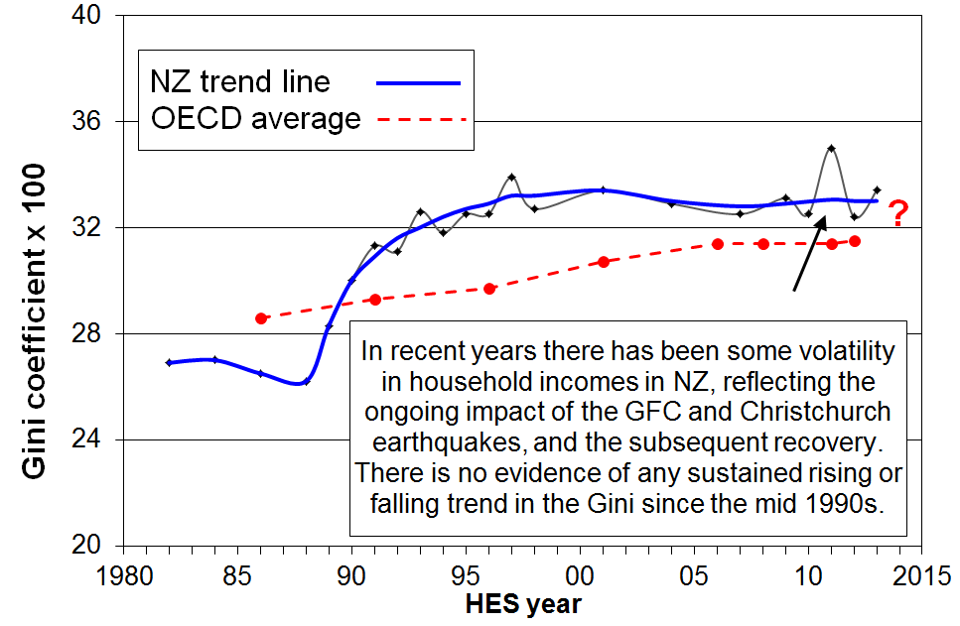
10 Year-on-year income inequality has been volatile recently with the GFC shock impacting on investment returns, employment and wages over the four years from 2008. There is no evidence of any general rise or fall in income inequality using the Gini measure since the mid 1990s. The trend-line is almost flat.

11 The latest available figures for OECD comparisons are for calendar 2011. New Zealand’s trend-line remains a little above the OECD median, at a level similar to Australia, Canada, Italy and Japan, lower than the US, and higher than countries such as Denmark, Norway and Finland.

12 In New Zealand the top decile received 8.0 times the income of the bottom decile (after tax and transfers) in 2011. This is average for the OECD, a little lower than Canada and Australia (8.5).

13 Income inequality can also be looked at in terms of the income share received by those receiving very high incomes. For example, the top 1% in New Zealand received around 8% of all taxable income in 2010 and 2011. This is more than in Denmark, Finland and Sweden (5 to 7%), similar to Norway, France and Australia, lower than Ireland (11%) and Canada (12%), and much lower than the UK (14%) and the US (17%).
- For NZ, the proportion in 2011 (8%) was close to what it was in the mid 1990s (9%).
- For almost all OECD countries, the latest figures are all higher than in the 1980s (eg 10% for France, 40% for NZ and Japan, 60% for Ireland and Canada, 90% for the UK and Australia, and 120% higher for the US).

14 Wealth inequality is usually around double the level of income inequality (using the Gini measure). The most wealthy 10% hold around 50% of all household wealth, whereas the top 10% of income earners receive a 25% share of all income. NZ’s wealth inequality is about average for the OECD.

Trends for main benefit levels, NZS, average wage and median household income

15 The table below shows the different growth or decline patterns for household incomes, average after-tax earnings, New Zealand Superannuation (NZS) and main benefits. Three reference years are used: 1983 for before the 1991 benefit cuts, 1994 for after the cuts, and 2007 for after WFF.

16 While there is no evidence of growing inequality in the population overall or between high income households and the rest in the last two decades or so, there is evidence here that there is a growing gap between the incomes of those heavily reliant on the safety net provided by main working-age benefits, and the rest.
% change from base year
(CPI adjusted – ie ‘real’ changes)
 | 1983 to 2014 | 1994 to 2014 | 2007 to 2014
Median household income | +25 | +45 | +5
Net average ordinary time earnings | +32 | +32 | +12
NZS | +9 | +21 | +12
DPB plus family assistance (with one child) | -17 | +6 | -2
Invalids Benefit – single aged 25+ | -8 | -1 | -1
Note: The change in median household income is to calendar 2012 only (HES 2013). Assuming modest household income growth from 2012 to 2014, a further 3 to 4 percentage points needs to be added to the changes for household income for proper comparisons.

Housing costs relative to income

17 High outgoings for housing costs relative to income (high OTIs) are often associated with financial stress for low- to middle-income households. Low-income households especially (Q1 and Q2) can be left with insufficient income to meet other basic needs such as food, clothing, basic household operations, transport, medical care and education for household members.
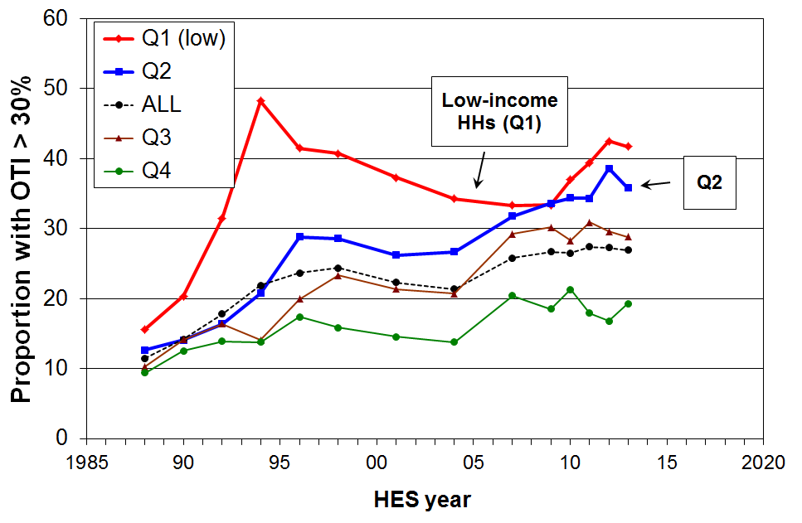
18 Overall, in HES 2013 around 27% of households had high OTIs – that is, housing costs of more than 30% of their disposable (after tax) income.

19 For the bottom two income quintiles (Q1 and Q2), the proportions were 42% and 36% respectively, and there is evidence that the housing stress has been rising in both quintiles over recent years.

20 From the mid 1990s to 2013, around 13 to 15% of households had an even higher OTI (greater than 40%), up from 5% in the late 1980s. For those in the bottom quintile (Q1), the proportion with these higher OTIs peaked in the mid-1990s at 34%, was lower at 25 to 27% from 2004 to 2009, but in 2013 was back to 34%. The proportion of households in the second quintile (Q2) with these higher OTIs rose from around 15-16% in the early 2000s to 20-21% in 2011 to 2013.

21 In June 2013, almost all renters receiving the AS (93%) spent more than 30% of their income on housing costs, three in four spent more than 40% and almost half spent more than 50%.

22 In 2013, 50% of AS recipients were receiving the maximum payment, up from 33% in 2007.
Poverty and material hardship

Measuring poverty and hardship

23 Poverty and hardship in the more economically developed countries are about being excluded from a minimum acceptable way of life in one’s own society because of lack of resources. While it is not an absolute subsistence notion (“third world starvation”), neither is it “just relative” – there are essentials that we expect everyone to have and no one to have to go without even though some of these items may change over time.

24 Poverty and hardship exist on a continuum from less to more severe. The choice of threshold (where we draw the line) impacts on the level reported, but not usually on the trends over time nor on which groups are identified as at higher risk of poverty or hardship.

25 New Zealand has no official measures of poverty or material hardship in the sense of measures to which a government has given formal legitimacy. MSD reports regularly using both income poverty measures and non-income measures of hardship or deprivation. These include internationally comparable measures as used by the EU and OECD.

26 For the short to medium term, MSD gives priority to trends in a “fixed line” or “anchored” income poverty measure (after deducting housing costs (AHC)), and to trends in material deprivation using non-income measures. The rationale for this is the judgement that whatever is happening elsewhere in the income distribution, low income levels should not fall, and that the actual material living conditions of those most disadvantaged should not deteriorate.

27 Trends for (fully) relative poverty lines are reported, and are valued over the longer term (15 to 20+ years), but for the short to medium term these do not carry the same weight. The rationale for this position is driven in part by the ambiguous signals that trends in such (fully) relative measures can give in the shorter-term. For example:
- when all incomes at or below the median rise, but the median rises more quickly than lower incomes, then poverty is reported as increasing despite low incomes increasing
- when all incomes below the median are falling at the same rate, poverty is reported as not changing even though low-income households are in much more difficult circumstances after the reduction in their incomes.

Income poverty for children (see the Summary and Overview for other findings for other groups)

28 In HES 2013, child poverty rates were around 3 percentage points lower on all but one of the standard measures compared with what they were immediately after the GFC impact in HES 2010 and 2011. The HES 2013 rates are similar to what they were in HES 2009 before the impact of the GFC. The was very little change using the 50% AHC moving line measure.

29 Compared with the post-GFC numbers in HES 2010 and HES 2011, in the 2013 HES there were around 30,000 to 40,000 fewer children in households with incomes below the thresholds reported in the table below.

Child poverty rates (%) and numbers on five measures
rates (%) | AHC |  |  | BHC
HES year | ‘fixed line’ (07) 60% | ‘moving line’ 60% | ‘moving line’ 50% | ‘moving line’ 60% | ‘moving line’ 50%
1988 | n/a | 14 | 9 | 20 | 11
2009 | 22 | 25 | 18 | 19 | 11
max post GFC | 24 | 28 | 20 | 23 | 14
2013 | 22 | 24 | 19 | 20 | 11

numbers
2009 | 230,000 | 270,000 | 190,000 | 210,000 | 115,000
2010 and 2011 | 260,000 | 300,000 | 210,000 | 245,000 | 150,000
2013 | 230,000 | 260,000 | 205,000 | 215,000 | 120,000
Note: HES year 2009 = calendar 2008 on average, and so on.

30 There is an age gradient for income poverty with child poverty rates being higher than the rest. Using the AHC 60% fixed line measure the population rate in HES 2013 was 16%, 22% for 0-17 yrs, 18% for 18-44 yrs, 13% for 45-64 yrs and 7% for 65+ yrs.

31 In the longer run AHC child poverty rates in 2013 were close to double what they were in the late 1980s mainly because housing costs in 2013 were much higher relative to income than they were in the late 1980s.

32 At 31 March 2014 New Zealand had 200,000 children (19%) in beneficiary households, down from 233,000 (22%) in 2010 and 280,000 (30%) in 1998.

33 Poverty rates for children in working families are on average much lower than for those in beneficiary families (11% and 75% respectively), but 2 out of 5 poor children come from families where at least one adult is in full-time work or is self-employed. This is an OECD-wide issue – the working poor. The In-work Tax Credit helps in addressing poverty in low-income working families.

34 Seven out of ten poor children live in rental accommodation (20% HNZC, 50% in private rental).

35 Other compositional breakdown:
- half of poor children are Maori/Pacific (34% of all children are Maori/Pacific).
- half of poor children are from sole parent families and half from two parent (24% of all children are from sole parent families).
- half of poor children are from households where the highest educational qualification for parent(s) is school or less (31% of all children are in these families).

Material hardship for children

36 Household income is a really important factor in determining the actual day-to-day living standards of a household, but other things matter too. For example, having the basic household furniture, appliances and other goods and having them in reasonable condition makes a positive difference, especially if household income is low. So too does having some financial reserves, even if modest. On the other hand high housing costs, high debt servicing or high health and disability related costs make a large negative difference.

37 Partly because of the limitations of using household income to identify those whose actual day-to-day living standards are unacceptably low, there is increasing use being made internationally of non-income measures of material hardship. These measures look more directly at how households are actually living rather than just relying on one, albeit very important, input (household income).

38 Using MSD’s Economic Living Standards Index (ELSI), hardship rates for children rose from 15% in the 2007 HES to 21% in HES 2011, then fell to 17% in HES 2012. The trend finding is robust, though the actual levels at any time depend on a judgment call on the threshold used.

39 The 2013 HES included a refreshed suite of non-income indicators. Most of these are used in MSD’s updated index, the Material Wellbeing Index (MWI). The MWI ranks households in much the same order as the ELSI. There is however a discontinuity in the material hardship time series between HES 2012 and HES 2013, so there is no new trend finding in this report.

40 Looking at the lower quintile (20%) of children on each of the AHC income and ELSI measures, the overlap is around 50%:
- because factors in addition to income influence the ELSI scores for households, the finding of only a partial overlap is not surprising
- a further 35% of those who are in hardship come from “near-poor” households, which in this case is those with incomes above the 60% of median line but below the median
- those in the overlap zone (10%) are sometimes said to be in “severe poverty or hardship”.
Income mobility and poverty persistence

41 The HES gives a repeat cross-sectional picture – different people are interviewed each survey. To understand how much income mobility there is, and how long-lasting or brief the poverty spells are, the same people need to be followed each survey. The longitudinal data from Statistics New Zealand’s SoFIE survey provides this information (2002 to 2009).

42 The analysis showed that there is a good deal of movement but that much of it is short-range (53% are in the same decile or the one next to it after 7 years, the same as in the UK). Over seven years there is a mix of mobility and immobility. For example, out of those who start in one of the lower three household income deciles in the first year:
- half are still there after seven years
- a quarter have moved up to around the middle
- and another quarter have moved to have incomes above the middle.

43 It is important to look at cross-sectional poverty rates with “longitudinal eyes”, especially now that the SoFIE has finished. Chronic poverty is about having an average household income over several years that is below the average poverty threshold over those years. For example, for every 100 children in poverty in a HES survey (cross-sectional) we know from the SoFIE research that:
- 60 are in chronic poverty
- there are another 20 not in current poverty but who are in chronic poverty.

44 Another way of looking at poverty persistence is to count the number of years or surveys (waves) in which people are in low-income households in a given period. This is straightforward, but is potentially misleading as it cannot take into account movements from below to not far above whatever poverty line is selected, and vice versa. Many have this experience. The SoFIE research showed that only 5% of children were in poverty for all or all but one of the seven SoFIE waves, a finding in line with overseas studies. This paints a quite different and much more optimistic picture of the multi-year poverty experience for children than does the chronic poverty approach. The chronic poverty approach is much more robust for this purpose as it takes into account the movements above and below the selected poverty line, and does not just give a blunt “in” or “out” count.

Working-age adults living on their own

45 Income poverty rates for one-person working-age households trebled from the 1980s to 2007 and were 29% in the 2013 HES, almost double the overall population rate of 16%. This group has the second highest poverty rate by household type after sole parents (51%).

46 There is little difference in the rate for younger (aged 18 to 44 years) and older (aged 45 to 64 years) one-person households, 28% and 30% respectively.

International comparisons for income poverty and material hardship

47 The OECD and EU publish international league tables that rank countries on their income poverty rates using 50% and 60% of median poverty lines respectively.

48 On the latest available figures (OECD, c 2011 and EU, c 2012), New Zealand is in the middle of the rankings for both population poverty rates and child poverty rates, though slightly above the middle for children on the OECD 50% of median measure.
 | OECD 50% |  | EU 60%
 | All | 0-17 | All | 0-17
NZ | 10 | 13 | 18 | 20
OECD / EU | 10 | 11 | 17 | 21

49 Using the official 2008 EU deprivation index, New Zealand ranked well for older people (65+) and not so well for children – a finding consistent with the relativities produced within New Zealand using the AHC income measure and the ELSI and MWI measures:
  - a 13% population hardship rate, at the EU median
  - an 18% hardship rate for children, above the EU median (15%), and ranking NZ below the richer western European nations against whom we have traditionally benchmarked
  - a 3% hardship rate for those aged (65+), ranking near the top among EU nations.

