2014 Incomes Report: Overview and Summary

What is the Household Incomes Report and what period does it cover?
- The Household Incomes Report (the “Incomes Report”) provides information on trends in the material wellbeing of New Zealanders as indicated by their after-tax household incomes from all sources, 1982 to 2013.
- The Incomes Report is an annual Ministry publication, prepared as part of its work on monitoring and understanding social and economic wellbeing.
- It is based in the main on analysis of data from Statistics New Zealand’s Household Economic Survey (HES) which covers households living in permanent private dwellings.
- The interviews for the latest data were carried out by Statistics New Zealand from July 2012 to June 2013 (the “2013 HES”). The income questions ask about incomes in the twelve months prior to interview. This means that the income information comes from the two-year period from July 2011 to June 2013 – on average from calendar 2012.
- The previous 2011-12 HES picked up the beginning of the impact on household incomes of the recovery following the global financial crisis (GFC) and the Christchurch earthquakes. The 2012-13 survey reflects the on-going impact of the recovery on household incomes.

What types of information does the Incomes Report provide?
- Long-run trends (usually 1982 to 2013) for:
- household incomes
- income inequality
- income poverty rates (proportions below various low-income thresholds)
- housing costs relative to incomes
- sources of income for older New Zealanders.
- Relativities between various population groups (eg by age, household type, hours worked):
- which groups are most at risk of being in poverty or hardship?
- which groups make up the largest proportions of those identified as ‘in poverty’?
- Short-run changes in income poverty and inequality:
- some care is needed in drawing definitive conclusions from relatively small changes from one survey to the next, especially for smaller subgroups
- the findings are more robust for longer-run trends and for subgroup relativities.
- Income mobility and poverty persistence.
- Some limited information on wealth inequality, and on the joint distribution of household income and wealth.
- Material hardship using non-income measures.
- International comparisons for New Zealand relative to EU nations and other OECD nations on income-based poverty and inequality measures, and on material hardship measures.

What does this Summary and Overview cover?
- The opening section outlines the over-arching framework of income, wealth, consumption and material wellbeing used in the report, defines and discusses the income poverty measures the report uses, and introduces the non-incomes approach to measuring material wellbeing that the report also briefly covers.
- The second and longer section brings together the main findings and key messages from the full report. All the figures and findings in the Summary are in the main report.
The income measure used in the report

- The income measure used is household after-tax cash income from all sources for the twelve months prior to interview, adjusted for household size and composition. This is referred to as equivalised disposable household income.

- A household’s after-tax income is affected by a range of factors: wage rates, total hours worked by the adults in the household, rates of social assistance, returns on investment, personal income tax rates and tax credits for families with children.

- Household income is used as an indicator of a household’s material wellbeing or living standards. The approach is well-established internationally and produces useful findings on trends in relative material wellbeing over time and between different subgroups.

- It is important to distinguish between the incomes of individuals, and the incomes of households in which individuals live. When there is more than one person in a household, individual income does not give a reliable indication of access to resources. Trends for individual incomes also follow different paths than those for household incomes.

Incomes before and after deducting housing costs (BHC and AHC)
- The report uses household incomes both before and after deducting housing costs (BHC and AHC respectively), especially for poverty measurement. All else equal, those with higher housing costs have less “residual income” (AHC) for other necessities such as food, clothing, transport, heating, household operations and health care. For households with lower incomes to start with, high housing costs place considerable strains on the household budget and, for some, severe constraints on their living standards.

- Housing costs are, in the short term at least, a fixed cost that households have to meet. The AHC income measure is therefore important for a central goal of the report, which is to assess and report on differences in material wellbeing across different groups, using household income as the indicator. The AHC measures allow more sensible comparisons between groups with quite different housing costs but similar BHC incomes.

Capital gains (and losses)
- A capital (or holding) gain occurs when an asset increases in value or a liability decreases in value. A capital loss occurs when an asset decreases in value or a liability increases in value.

- Examples of capital gains and losses relevant to households are: changes in the prices
of the land and dwellings they own; changes in the prices of valuables they own; changes
in the prices of equities they hold; and changes in the prices of debt securities they hold.

- Capital gains (and losses), whether realised or not, represent changes in net worth or wealth and are not part of the income concept used in this report. This is in line with international protocols established by the UN and used by the OECD itself and by member countries

Income, wealth (net worth), consumption and material wellbeing

- This report is about household incomes, their trends and levels over time, and how dispersed they are (levels of income inequality). While this information is of value in itself, one of the motivations for reporting on household income is to discover what it tells us about the material wellbeing of households – changes over time, and the relative positioning of different groups within the population.

- In line with common practice among all OECD and EU nations, the report takes household income as an indicator or proxy measure of material wellbeing. Given the importance of income and cash in our sort of economy and society (especially so for households that have low incomes, very tight budgets and very limited or negative net worth), the range of financial levers available to a government for influencing the distribution of income, and the ready availability of good income data from surveys and administrative records, there is a sound rationale for reports such as this.

- Income however is not the only economic resource available to a household to generate its consumption possibilities. A household’s wealth (or lack of it) is another crucial factor. A household’s wealth is its total financial and non-financial assets less liabilities – this is sometimes called net worth. Income and net worth together largely determine the economic resources available to households to support their consumption of goods and services and therefore their material standard of living.

- The diagram below shows the relationship between income, wealth and material wellbeing in a simple stylised form. It also indicates that “other factors” that vary from one household to the next can also impact on material wellbeing. These other factors are especially relevant for low-income / low-wealth households, and can make the difference between “just getting by” and not being able to meet basic needs.

Household income
Basic needs / essentials

Resources available for consumption
Discretionary spend / desirable non-essentials

Wealth

Other factors
eg assistance from outside the household (family, community, state), high or unexpected health or debt servicing costs, lifestyle choices, ability to access available resources
Material wellbeing or living standards

- Income can be used for the current consumption of goods and services, or saved to increase wealth for later consumption. Some lower-income households have relatively high wealth levels and can support consumption levels well above those with similar incomes but lower net worth. Low-income households with low net worth levels are especially vulnerable to unexpected expenses or even small drops in income.

- So, income and wealth (net worth) need to be considered together to produce a proper ranking of households from high to low material wellbeing. Regular income surveys are common, but most countries have not had regular surveys of both income and wealth, though there are signs that this is changing. In the 2014-15 HES, for example, Statistics New Zealand is collecting income, wealth and more direct material wellbeing information in the one survey and plans to do so at regular intervals. This is a welcome advance that will allow a more comprehensive understanding of the links between income, wealth and material wellbeing. Even where good income and wealth data are available, there is however no agreed way of combining the two to rank households on a single scale from high to low material wellbeing. This is a significant challenge.

- In the context of the framework indicated in the diagram, household income is taken to be either an imperfect but readily available and very important indicator of the “consumption possibilities” for a household, or as an indicator that allows comparisons of the potential living standards of households, all else assumed equal.

Using non-income measures to measure material wellbeing

- Non-income measures are now widely used in EU and in many OECD nations to more directly measure the material wellbeing of households, especially at the low living standards or “hardship” end of the spectrum.

- Non-income measures (NIMs) focus on the actual living conditions (outcomes) such as access to household durables, the ability to keep warm, have a good meal each day, keep oneself adequately clothed, repair or replace basic appliances as required, visit the doctor, pay the utility and rent/mortgage bills on time, pursue hobbies and other interests, and so on. These more direct non-income measures are sometimes referred to as non-monetary indicators.

- Using this approach, the impacts on material wellbeing of different levels of income and wealth and of differing experiences of the “other factors” noted in the diagram above are all captured in the different scores reported using indices based on NIMs. The HES collects NIM information, and the report has a section on material hardship measured using NIMs.

- Indices based on NIMs have the potential to more robustly rank households by their material wellbeing than do income-based measures, as the latter cannot take account of wealth holdings and other factors.

Income poverty measures used in the report

- Poverty and hardship (deprivation) are about households and individuals who have a day-to-day standard of living or access to resources that fall below a minimum acceptable community standard. Poverty is different from inequality: it is about “not enough” relative to a benchmark rather than simply “less than”.

- Poverty and hardship in the more economically developed countries (MEDCs) are often characterised as being about relative disadvantage rather than being about a more absolute subsistence notion of poverty (“third world starvation and disease”). The relative/absolute distinction has some value but can only take us so far. There are basic essentials that we expect everyone in MEDCs to have and no one to have to go without (eg clean water, adequate food, shelter, cooking facilities, warmth, gas or electricity or both “on tap”, medical care, sanitation, transport, and so on) – these are core “absolute” needs. The way these needs are met changes across time and countries. In MEDCs, the cost to a household of meeting these needs is many times higher in dollar terms than for households in “third world” countries, given the way MEDCs are structured (for example, for food supply and for transport needs for getting from home to work), and given the expectations on citizens for participation.

- This report uses household income as an indicator of the resources available to households to purchase basic goods and services not already provided by the state.

- New Zealand does not have official measures of poverty or material hardship in the sense of measures to which a government has given formal legitimacy. The low-income thresholds or poverty lines used in the report (50% and 60% of median household income) are however widely used in the OECD nations and the EU.

- The report uses two quite different ways of updating the low-income thresholds or “poverty lines” over time and reports trends using both approaches.
- The “fixed line” approach anchors the poverty line in a reference year, then adjusts it each survey with the CPI. This gives a measure of change in relation to a benchmark held fixed in real terms. On this approach a household’s situation is considered to have improved if its income rises in real terms, irrespective of whether its rising income makes it any closer or further away from the middle or average household. The reference year has to be updated from time to time to reflect changing middle incomes and the associated changing notions of a minimum acceptable standard (currently it is 2007).
- The “moving line” or “relative” approach sets the poverty line as a proportion of the median income from each survey so that the threshold changes in step with the incomes of those in the middle of the income distribution. This gives a measure of change in relation to how other households are faring. On this approach the situation of a low-income household is considered to have improved if its income gets closer to that of the median household, irrespective of whether it is better or worse off in real terms.

Using non-income measures for a more direct assessment of material wellbeing and hardship (deprivation)

- Non-income measures (NIMs) are now widely used in EU and OECD nations to more directly measure the material wellbeing of households, especially at the low living standards or hardship end of the spectrum (“material deprivation”). The EU has adopted a material deprivation index as one of its official measures of social exclusion.

- As discussed above, household income can be viewed as one input into the resources households have available to support their material standard of living. Using NIMs is an outcome-focussed approach. The differences in material wellbeing indicated by the different NIM index scores reflect the overall impact of all the different input factors, not just income. Households with the same income can end up with different NIM-based index scores because of the differing impact of the other factors on their living standards.

- In 2002 the Ministry developed an Economic Living Standards Index (ELSI) which ranks households from low to high living standards using NIMs. The items that are used in the index are of two types: essentials that no one should have to go without, and desirable non-essentials that are commonly aspired to. To create the ELSI scores, the items are scored from two different perspectives:
- from an enforced lack perspective in which respondents do not have essential items because of the cost, or have to severely cut back on purchases because the money is needed for other essentials: for example, unable (because of the cost) to have regular good meals, two pairs of shoes in good repair for everyday activities, or visit the doctor; cutting back ‘a lot’ on fresh fruit and vegetables, putting up with the cold, and so on because money is needed for other basics
- from the perspective of the degree of restriction/freedom reported for having or purchasing desirable non-essentials – a freedoms enjoyed perspective, for short: for example, not having to cut back on local trips, not having to put off replacing broken or worn out appliances, being able to take an overseas holiday every three years or so if desired, and not having any great restrictions on purchasing clothing.

- A state of hardship (unacceptably low material wellbeing) is characterised by having many enforced lacks of essentials and few or no freedoms. Higher living standards are characterised by having all the essentials (no enforced lacks) and also having many freedoms and few restrictions in relation to the non-essential items that are asked about.

  - Just as households can be ranked by their incomes, they can also be ranked by their ELSI scores and grouped into deciles or in other ways.

  - In order to use an index like ELSI for measuring material wellbeing it needs to be calibrated so as to give some meaning to the different scores. For the purposes of the use of ELSI in the Incomes Report it is only the calibration at the hardship end of the spectrum that is of relevance. The 16 essentials used in the calibration exercise include such items as: having a meal with meat, fish or chicken (or vegetarian equivalent) at least each second day, buying adequate fresh fruit and vegetables, having suitable clothes for special or important occasions, visiting the doctor as required, paying the rates and electricity on time, repairing or replacing broken or damaged appliances, not having to put up with the cold or borrow from friends or family for everyday basics.

  - An important element of the calibration (and deciding where to draw the hardship threshold) is to look at where on the ranking spectrum the deprivations become very concentrated. The graph below shows how the different ELSI deciles fare in terms of the relative proportions of both enforced lacks of essentials and also of freedoms enjoyed, out of the list of calibration items.

Calibrating ELSI using ‘enforced lacks’ and ‘freedoms/non-essentials enjoyed’ (LSS 2008)
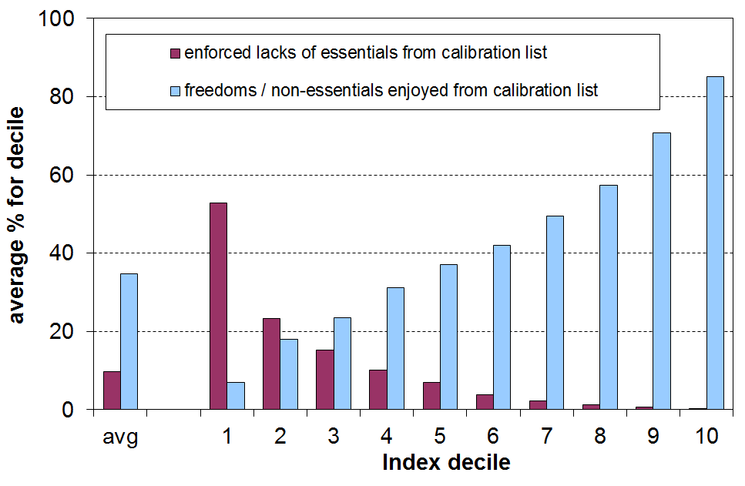

  - The ELSI hardship threshold is set at 6 or more deprivations out of 16 in the calibration list. This gave a population hardship rate of 12% in 2008, just a little above the top of the bottom decile, and close to the income poverty rate using the 50% of median AHC threshold (~13%).

  - Those in hardship using the ELSI measure have on average 8 deprivations out of the 16 used in the calibration list. This compares with around 1 out of 16 deprivations on average for those in the middle of the distribution (deciles 4 to 6). The level at which the hardship threshold is set is therefore consistent with the relative disadvantage notion in which the poor and those in hardship have “resources that are so seriously below those commanded by the average individual or family that they are, in effect, excluded from ordinary living patterns, customs and activities” (Townsend, 1979). It identifies living standards that are below a minimum acceptable standard for New Zealand today, in line with the definition used in the report.

The Material Wellbeing Index (= ELSI, mark 2)

- MSD has further developed ELSI, building off what we have learnt over the last decade of using it. The new index (the Material Wellbeing Index (MWI)) uses 13 of the 25 items from the ELSI list and 11 new ones. The 24 MWI items and 5 other new items were collected in the HES for the first time in HES 2012-13.

- The main difference between the MWI and ELSI is the removal from ELSI of the three items which asked for high level self-assessments of income adequacy, standard of living and satisfaction with standard of living, and the increased emphasis in the MWI on material things that respondents and their households have or can participate in. Overall, household rankings are very similar on the ELSI and the MWI, although there are some subtle differences for some groups because of the removal of the self-assessments from the ELSI. The main report has further detail on the make-up of the MWI.

- The change from ELSI to MWI means that there has to be a discontinuity in the HES-based material hardship series that started in HES 2007 and went through to HES 2012.

A multi-measure approach for monitoring income poverty and material hardship

- MSD’s view is that a multi-measure approach is needed to properly monitor income poverty and material hardship. Poverty and material hardship are themselves multi-dimensional, covering both input and outcome aspects (income and material hardship), differing time periods for looking at household income (one year, several years), and differing ways of updating the thresholds over time.

- For the short to medium term, MSD gives priority to trends in a “fixed line” or “anchored” income poverty measure (after deducting housing costs (AHC)), and to trends in material deprivation using non-income measures. The rationale for this is the judgement that whatever is happening elsewhere in the income distribution, low income levels should not fall, and that the actual material living conditions of those most disadvantaged should not deteriorate.

- Trends for (fully) relative poverty lines are reported, and are valued over the longer term (15 to 20+ years), but for the short to medium term these do not carry the same weight. The rationale for this position is driven in part by the ambiguous signals that trends in such (fully) relative measures can give in the shorter-term. For example:
- when all incomes at and below the median rise, but the median rises more quickly than lower incomes, then poverty is reported as increasing despite low incomes increasing
- when all incomes at and below the median fall at similar rates, poverty is reported as not changing even though low-income households are in much more difficult circumstances after the reduction in their incomes.

- The report uses the 60% of median AHC fixed line measure as the primary one for reporting income poverty trends. This does not mean that the Ministry endorses this as the poverty measure for establishing poverty levels. Rather it is the preferred measure for reporting on trends, selected on pragmatic grounds that assume that low incomes rise in real terms in the medium term and the 60% anchored threshold therefore drops towards a 50% relative line. Thus the main income poverty trend indicator can be kept broadly within a 50% to 60% band.

- Ideally, the report would be able to draw on current longitudinal data to monitor income mobility and the persistence of low incomes and hardship. The data is not available, so general stylised facts have to be drawn from what we do have to better round out the picture.

Ireland: a case study showing the importance of a multi-measure approach, and of prioritising material deprivation and anchored income poverty measures in the short to medium term

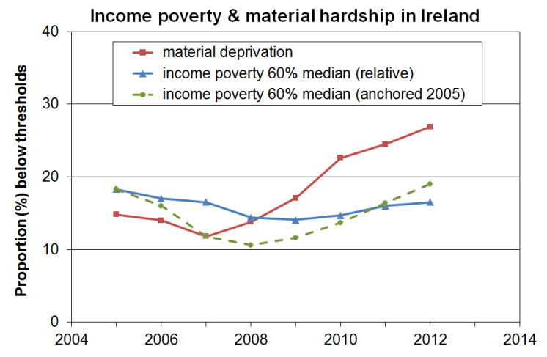
- As the Irish economy slowed and moved into recession in 2008, the material deprivation rate and the anchored poverty rate rose rapidly. On the other hand there was little movement in the fully relative income poverty measure.
- The material deprivation and anchored poverty measures provided the information needed for public policy and public debate. The fully relative measure did not.
- This reflects the fact that the material deprivation and the anchored line poverty measures each use a fixed benchmark against which to assess progress, whereas the fully relative approach does not and is essentially about the trend in inequality in the lower half of the distribution. In the recession the median and lower incomes all fell at fairly similar rates, thus producing a flattish relative poverty line.

Poverty and hardship are multi-dimensional: this report focuses on the incomes dimension
Inequality, poverty and hardship are multi-faceted and multi-dimensional. The focus for the Household Incomes Report is primarily on the incomes dimension. Income matters, but it is the cumulative impact of multiple disadvantage across different domains that has the most significant negative impact on life chances and outcomes, especially for children.

The report has a section on material hardship. It uses non-income measures to report on how households are faring in actual day-to-day living standards (adequate food and clothing, ability to keep warm, visit the doctor, and so on). These are outcome measures, and are determined by many factors in addition to income – for example, the level and quality of financial and household assets, special health costs, debt servicing requirements, and personal qualities. (See Whelan and colleagues (2014) in the references in the main report for a recent EU analysis on this theme.)

Some poverty discussions use a broader notion of poverty which is more about multiple disadvantage or about some of the consequences of poverty and hardship understood as above. Monitoring poverty understood in this way requires a different set of indicators.

On a yet broader canvas, some discussions about the meaning of poverty and hardship and about the challenges of monitoring trends include the multiple causes of poverty and hardship, at both structural-institutional and individual levels. This wider discussion is very important but is beyond the scope of this report.
Summary of Findings

The overview and summary that follows draws out the main findings and key messages from the full report. All the figures and findings in this Summary are in the main report.

The reader is referred to the full report not only for more detailed findings but also for the full description and discussion of the technical and methodological matters that lie behind the figures.

Glossary
- ‘income’ in the Incomes Report refers to household income from all sources after income tax is paid and transfers received, and after adjustment for household size and composition (equivalised disposable household income), unless otherwise stated
- AHC income is household income after deducting housing costs
BHC income is household income before deducting housing costs
- when the income distribution is divided into 100 equal groups each group is called a percentile (P) – the top of the first decile is labelled P10 as it is also the top of the 10th percentile
- poverty rates are usually reported using AHC measures, for both anchored and moving line thresholds – the reference year for the anchored measures is 2007
- OTI is the ‘outgoings-to-income’ ratio for household spending on accommodation. When a household spends more than 30% of its income on accommodation it is said to have a high OTI
- income data from three Statistics New Zealand surveys are used in the report:
HES = Household Economic Survey (most of the information is from this)
NZIS = New Zealand Income Survey, a supplement of the Household
Labour Force Survey
SoFIE = Survey of Family, Income and Employment
- median household income is the income of the middle household – for example, if there are nine households, the middle household is the one ranked #5
- mean household income is the arithmetic average of the incomes of all households
- 2013 HES is short for 2012-13 HES – interviews ask about income “from the previous 12 months”, so on average it is for around calendar 2012
- GFC – global financial crisis
- NAOTWE – net (after tax) average ordinary time weekly earnings
- NIM – a non-income measure, sometimes referred to as a non-monetary indicator
- ELSI – Economic Living Standards Index
- MWI – Material Wellbeing Index

Household incomes

1 Median household income (BHC) rose by 4% in real terms from HES 2011 to HES 2013.
- After 15 years of steady growth in median household income (3% pa in real terms from the 1994 HES to the 2009 HES), the impact of the economic downturn on household incomes began to be seen in the 2010 HES figures which showed very little change from the previous survey. In the 2011 HES the median fell for the first time since the early 1990s, reflecting the full impact of the downturn (down almost 4% from the 2009 HES).

Real household income trends, 1982 to 2013 ($2013)
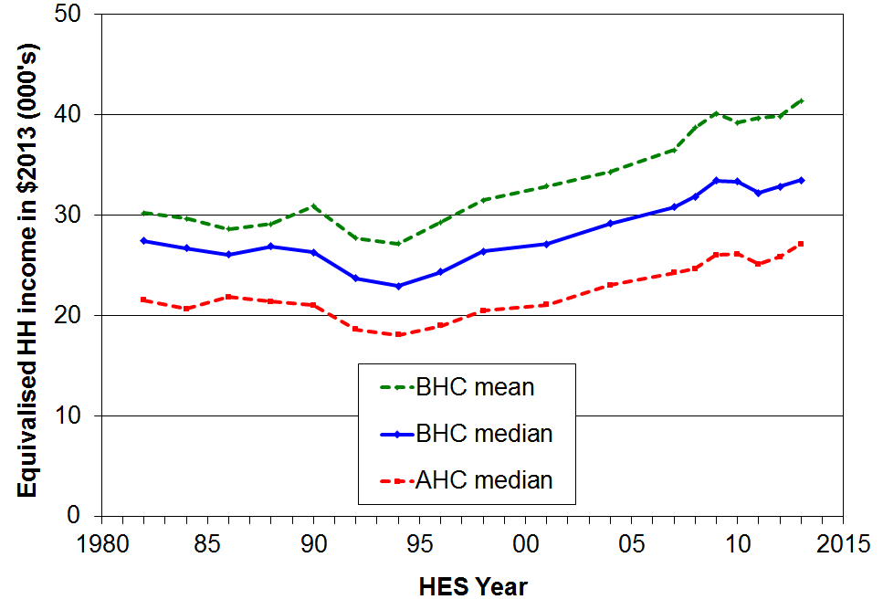

- From HES 2011 to HES 2013, the median increased by 4% in real terms, showing the impact on households of the post-recession recovery.

- The AHC (after deducting housing costs) median has tracked at close to 80% of the BHC median since the mid 1990s, compared with close to 90% in the 1980s, reflecting the higher proportion of household income now spent on housing (rent, rates, mortgage payments).

2 The immediate impact of the recent recession was felt more by low to middle income households (deciles two to six) than by households in the top four deciles, but the gains in the recovery have been more evenly spread.
- The immediate impact of the GFC and associated economic slowdown (HES 2009 to 2011) led to a 3% to 5% decline in incomes for the lower six deciles, with little change for the top four.
- The income gains were more even across the deciles in the recovery phase from HES 2011 to 2013 (4% to 7%), giving a net impact from HES 2009 to HES 2013 as in the graph below.

Real household incomes (BHC), changes for top of deciles: HES 2009 to 2013
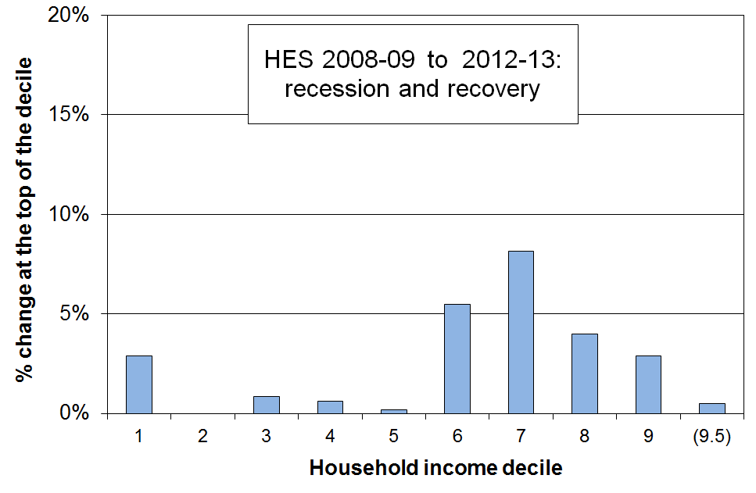
- The net gain at the top of decile one can be attributed in the main to the rise in real terms for NZS as a result of the tax cuts in 2010 which increased after-tax wages to which NZS is pegged. Households whose incomes are from NZS alone or NZS and a little more are at the top of the first decile one and into the bottom of the second.

3 Over the three decades from 1982 to 2013 different income groups fared differently over different periods. The net gains over the last two decades from the mid 1990s to 2013 were similar for all income groups. Because of this similarity in net gains, income inequality in 2013 was similar to what it was in the mid 1990s.

- From 1988 to 1994 there were declines in household income for all except the very top income group (decile ten), with the declines being larger for lower income groups.

- From 1994 to 2004, incomes for middle- to higher-income households grew more quickly than the incomes of the bottom third (around 28% and 15% respectively, in real terms).

- From 2004 to 2007 the Working for Families (WFF) package led to incomes below the median growing more quickly than incomes above the median – the only time in the 25 year period 1982 to 2007 in which this happened.

- From 2007 to 2009 the growth was relatively even across all income groups (7-9%).

- In the two decades from 1994 to 2013, household income growth was similar for deciles 3 to 10 (~2.5% pa), and just a little lower for the lower two deciles (~2% pa). See graph below.

- Because of this similarity in net gains across the board in this period, income inequality in 2013 was around the same as it was in 1994, though much higher than in the late 1980s because of the declines noted above.

Real household incomes (BHC), changes for top of deciles: HES 1994 to 2013
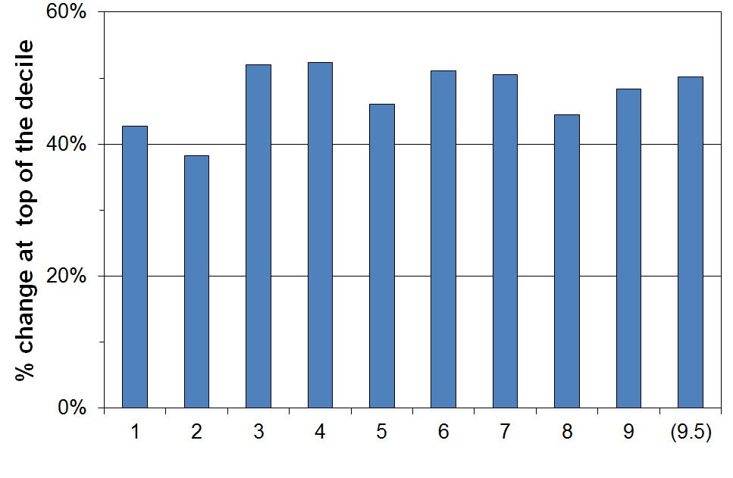

4 From HES 2004 to 2013, the net gains for the lower four deciles were greater than those for deciles 5 to 10.

- Over the decade from HES 2004 to 2013 (which includes the impacts of the WFF package, the recession and early recovery), real income gains were 22% to 25% for the lower four deciles and somewhat less (15% to 17%) for the top six deciles.

Real household incomes (BHC), changes for top of deciles: HES 2004 to 2013
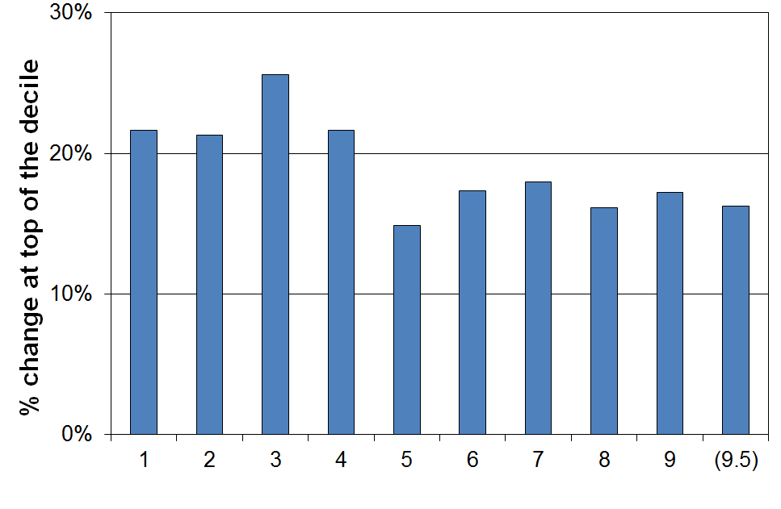
- Given that main benefit levels did not rise in the period, the relatively strong gains for the lower two deciles are at first sight surprising. The gains at the top of the two lower deciles in this period reflect several other factors:
- While 80% of those in households primarily reliant on main working-age benefits are in the lower two deciles, they make up only 38% of this income group.
- Many NZS recipients have incomes from NZS and very little else. Their incomes place them at the top of the bottom decile and into the second decile. The NZS rate is linked to changes in the after tax average wage and they rose as a result of the income tax cuts in 2008 and 2010 as well as because of gross wage increases per se. From 2004 to 2013 NZS rates rose 15% in real terms.
- The introduction of the IWTC for low-wage working families in 2006 lifted incomes of these low-income households relative to the incomes of beneficiary households. Most beneficiary families with children in effect received only a part of the FTC increases in the WFF package as they also had the notional child component removed from their core benefit.
- The rise in the minimum wage in real terms from 2004 to 2008 also raised incomes of some low-income working households.

- There is a growing gap between main benefit levels and NZS, wages and median household income.

- The table below shows the different growth / decline patterns for household incomes, average after-tax earnings, New Zealand Superannuation (NZS) and main benefits. Three reference years are used: 1983 for before the 1991 benefit cuts, 1994 for after the cuts, and 2007 for after WFF.

- A growing gap is forming between benefit levels on the one hand, and NZS, wages and household income on the other.

% change from base year
(CPI adjusted – ie ‘real’ changes)
 | 1983 to 2014 | 1994 to 2014 | 2007 to 2014
Median household income (see note below) | +25 | +45 | +5
Net average ordinary time earnings | +32 | +32 | +12
NZS | +9 | +21 | +12
DPB plus family assistance (one child) | -17 | +6 | -2
Invalids Benefit – single aged 25+ | -8 | -1 | -1
Note: The change in median household income is to calendar 2012 only (HES 2013). Assuming modest household income growth from 2012 to 2014, a further 3 to 4 percentage points needs to be added to the changes for household income noted in the table for more realistic comparisons.

- While there is no evidence of growing income inequality in the population overall or between high income households and the rest in the last two decades or so, there is evidence here that there is a growing gap between the incomes of those heavily reliant on the safety net provided by main working-age benefits, and the rest.

6 The steady rise in median household income from 1994 to 2009 was driven in part by the steady increase in the proportion of two-parent households with children with both parents in paid employment.

- Median household incomes grew 46% in real terms from the low point in 1994 to 2009. In the same period, average net (after tax) ordinary time wages grew 24% in real terms, and gross by 18%.
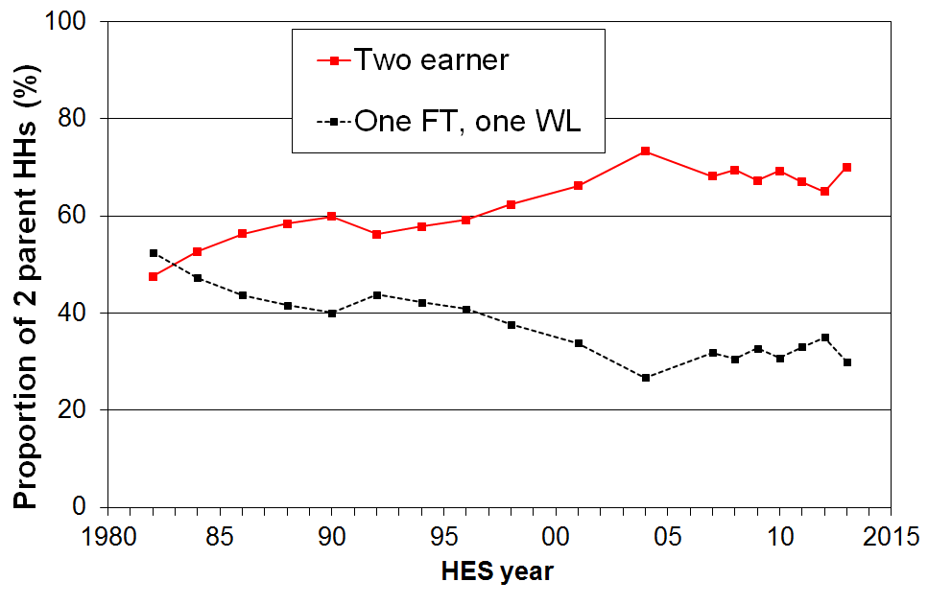
- Much of the difference between the growth of wages and the growth of household income is attributable to increased female labour force participation, especially in two-parent families with dependent children. This increased the average hours of paid employment for these households and therefore their household income rose more quickly than wages. The incomes of two-parent families are very significant in driving changes in the median.
- Around two of every three two-parent families were dual-earner families from 2007 to 2013, up from one in two in the early 1980s. The new pattern seems to have stabilised.
- The most common arrangement in HES 2013 was for both parents to be working full-time (42%), with another 28% with one full-time and the other part-time. In contrast, in 1982 the dominant pattern (52%) was one in full-time work and the other ‘workless’ (WL), with only 20% having both in full-time work.
- There are four factors that impact on household incomes for middle New Zealand families:
  - average gross wage rates in real terms
  - total household hours committed to paid employment
  - income tax rates
  - tax credits for families with children whose incomes around or just below the median.
One or more of these factors will need to contribute strongly if solid median income growth is to be seen in the next decade (cf the Ministry of Business, Innovation and Employment’s target of a 40% growth in real median household income from 2012 to 2025).

Inequality – introduction

7 Income inequality is about how dispersed incomes are, what the size of the gap is between those on ‘higher’ and those on ‘lower’ incomes. There are however many types of inequality other than income inequality that are of relevance to public policy formulation and debate, and it is useful to be clear about which sort of inequality is being discussed at any time.

- Some of the main inequalities often discussed are:
  - market income inequality for individuals:
      - wage differentials across all wage earners
      - focusing on total market income for the very top 1% or so, compared with the rest
  - inequality of disposable household income (income from all sources after taxes and transfers):
      - across all households
      - focusing on the very high income households, compared with the rest
    - inequality of wealth (total assets less liabilities).
  - inequality of community resources and amenities available to local residents
  - inequality of educational outcomes
  - inequality of health outcomes
  - inequality of socio-economic status (combining education, occupation and income)
  - inequality of opportunity.

- The major focus of the Incomes Report is on inequality of household disposable income and the shares of total market income received by top income earners, together with some reference to wealth inequality.

- It is important to maintain a clear distinction between wage inequality, household income inequality and wealth inequality. They are quite different concepts, each with their own unique characteristics.

8 Inequality and poverty are sometimes used as if they are interchangeable ideas. They are different concepts and need to be kept distinct as far as possible.

- Inequality is essentially about the gap between the better off and those not so well off (on whatever measure) – it is about having “less than” or “more than”. Poverty is about household resources being too low to meet basic needs – it is about “not having enough” when assessed against a benchmark of “minimum acceptable standards”.

- A major difference between income inequality and income poverty is that a certain degree of inequality is considered by almost everyone to be inevitable and acceptable, and even desirable. There is no similar widely held view about unacceptably low incomes and material deprivation. Income poverty and material deprivation are by definition unacceptable states of affairs. There can be and is legitimate debate over where to set the low-income or deprivation thresholds, and over the relative merits of different approaches to the income concept used (eg BHC or AHC), but there are very few who advocate for “acceptable levels” of income poverty or hardship. On the other hand, a large part of the debate about income inequality is about what is an acceptable or at a least tolerable level of income (or wealth) inequality. Unlike any debate around income poverty or hardship, there are very few calls for the elimination of income or wealth inequality.

- There is no evidence of any statistical link between the income share received by the top 1% and income poverty rates.

- There is no link between trends in income poverty using a fixed line approach and standard inequality measures.

- The strongest conceptual and statistical link between income poverty and income inequality is between the P50:P20 or P50:P10 percentile ratio inequality measures and standard fully relative income poverty measures in which the threshold is set at a selected proportion of the current median (eg 50% or 60%). All these, both the percentile ratios and the poverty measures, are about inequality in the lower half of the household income distribution and are therefore highly correlated, as expected.

- Maintaining as clear as possible a distinction between poverty and hardship on the one hand and income inequality on the other means that:
- as a society, and as groups within it, we cannot easily avoid having to make the judgement call about minimum acceptable standards, even if we use two or three standards of differing severity
- we are better placed to seek to understand the relationship (if any) between the two, rather than muddying the waters by speaking as the two are one.

9 There is no one definitive measure of income or wealth inequality: there are several common measures used for comparisons within and across nations.

- The Gini coefficient is a common measure of inequality used internationally. It gives a summary of the income differences between each person in the population and every other person. A higher score indicates higher inequality. In OECD countries scores range from 25 (eg Norway and Denmark) to 38 (USA), and even higher (eg Chile 51).

- Decile and quintile shares are commonly used, as are percentile ratios. The advantage of these over the Gini is that the meaning of the numbers is more intuitive for these than for the Gini. For example, a change in the top to bottom decile share ratio from 8 to 9 is more readily grasped by most readers than is a Gini change from 0.28 to 0.33.

- More recently, reliable OECD-wide information on high pre-tax incomes for individuals has been made available on the Top Incomes database (Paris School of Economics).

- Income information is more often collected than is wealth information, but there are signs that more countries are putting resources into collecting good quality wealth information on a more regular basis. Inequality analysis for wealth usually uses the Gini or a selection of decile and quintile share ratios.

Income and wealth inequality in New Zealand

10 Household incomes have been volatile over recent years, reflecting the on-going impact on households of the GFC and the recovery. Using the Gini measure, there is no evidence of any sustained rise or fall in income inequality since the mid 1990s. The trend-line is almost flat.

- The two distinctive features of the trend in income inequality in New Zealand in the last three decades are:
- the rapid and significant rise in income inequality from the late 1980s to the mid 1990s, taking New Zealand from well under the OECD average to well above at that time
- the fairly flat trend line from the mid 1990s to 2013.
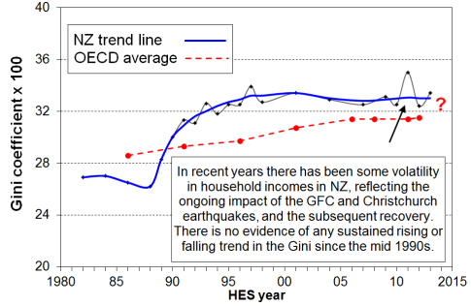
- The OECD average steadily rose over the last three decades, thus bringing the New Zealand and OECD trend lines closer together. On the latest OECD figures (2011/12), income inequality in New Zealand is at a similar level to that in Australia, Canada, Italy and Japan (Ginis of 32-33) and a little lower than the UK (34). Countries such as Denmark, Norway, Finland and Belgium have lower than average inequality (Ginis of 25-26). The US and Israel have higher scores of 39.
- Inequality can also be measured by comparing the share of income received by the top decile (10%) of households with that received by the bottom decile. The ratio for New Zealand was 8.2 in HES 2012 (the latest OECD comparison) and 8.3 in HES 2013 – that is, in HES 2012 the top decile (D10) households received on average 8.2 times the income received by the bottom decile (D1), after taxes and transfers.
- New Zealand is at the middle of the OECD rankings for the D10 to D1 share ratio. In 2011 the ratio for Canada and Australia was 8.5 and for the UK it was 9.6. At the low inequality end of the rankings, the ratio is in the 5 to 6 range for Denmark, Norway, Finland and Belgium, and at the higher end it is 16 for the US and 27 for Chile.
11 Those individuals receiving the top 1% of market income in New Zealand have an 8% share of total income (2011), similar to Norway, Finland and Australia, lower than the UK and Canada (12-13%) and much lower than the US (19%).

- Another way of looking at inequality is to track the share of total pre-tax market income that is received by the top 1%. Such information is not reliably available in sample surveys like the HES, but data based on tax returns are available for international comparisons.

- From the 1920s through to around 2011, English-speaking countries have shown a U-shaped curve for the income share of the top 1% with a lower flattish period from 1950 to the mid 1980s (“the great compression”), and rises since.

- The top 1% in New Zealand received around 8% of all taxable income in 2010 and 2011 (before tax), similar to Norway, Finland and Australia, lower than Ireland and Switzerland (11%) and much lower than the UK and Canada (13%) and the US (18%).

- The trend for the New Zealand share has been steady at around 8-9% since the mid 1990s, with perhaps a slight fall in the last few years. Many OECD countries saw small rises in the period, and in the USA the top 1% share continued to rise strongly, from 13% to 19%.

12 Overall, there is no evidence of any sustained rise or fall in inequality in the last two decades. The level of household disposable income inequality in New Zealand is a little above the OECD median. The share of total income received by the top 1% of individuals is at the low end of the OECD rankings.

Income inequality in New Zealand, 1984 to 2013 HES
 |  | 1984 | 1994 | 2004 | 2009 | 2012 & 2013 for HES, 2010 & 2011 for tax records
Household disposable income, adjusted for household size … data from sample surveys (HES) | Gini x 100 (trend-line) | 26.6 | 32.5 | 32.9 | 32.9 | 32.9
 | Share ratio, D10 to D1 | 6.1 | 8.2 | 9.1 | 8.6 | 8.3
 | Share ratio, Q5 to Q1 | 4.1 | 5.1 | 5.5 | 5.4 | 5.3
 | Share ratio, D10 to D1-4 (Palma) | 0.92 | 1.21 | 1.31 | 1.29 | 1.27
 | Percentile ratio, P90 to P10 | 3.5 | 4.1 | 4.2 | 4.4 | 4.2
 | Percentile ratio, P80 to P20 | 2.4 | 2.7 | 2.9 | 2.9 | 2.7
Individual market income … data from tax returns – avg of year noted and the one either side | Top 1% share | 5.6 | 8.9 | 9.0 | 7.8 | 7.8
 | Top 10% share | 28 | 33 | 33 | 30 | 30
 | Top 10% - 1% share (ie P90 to P99) | 23 | 24 | 24 | 22 | 22

Income inequality in New Zealand compared with other OECD countries, c 2011-2012
(%) | NZ | OECD-34 median | DNK | NOR | FIN | FRA | AUS | CAN | UK | US
Gini x 100 (trend-line) | 32.9 | 30.5 | 25.3 | 25.0 | 26.1 | 30.9 | 32.4 | 31.6 | 34.4 | 38.9
Share ratio, D10 to D1 | 8.2 | 7.6 | 5.3 | 6.1 | 5.5 | 7.4 | 8.5 | 8.5 | 9.6 | 16.5
Share ratio, Q5 to Q1 | 5.2 | 4.8 | 3.6 | 3.7 | 3.7 | 4.7 | 5.4 | 5.2 | 5.6 | 8.2
Share ratio, D10 to D1-4 (Palma) | 1.27 | 1.18 | 0.87 | 0.85 | 0.93 | 1.18 | 1.27 | 1.19 | 1.40 | 1.74
Percentile ratio, P90 to P10 | 4.2 | 3.8 | 2.9 | 2.9 | 3.2 | 3.6 | 4.5 | 4.1 | 4.1 | 6.1
Top 1% share – tax records | 8 | The latest available from 2009 to 2012 | 6 | 8 | 8 | 8 | 9 | 12 | 13 | 19
Top 5% share – tax records | 21 | The latest available from 2009 to 2012 | 17 | 19 | 21 | 21 | 21 | 27 | 28 | 36
Note: See the main report for details about the sources for the figures in the above tables.

13 Wealth is distributed more unequally than income, although the joint distribution of income and wealth is more equal than the distribution of wealth on its own.

- Wealth inequality is a very important part of the inequality story. Unfortunately, data on wealth or net worth (total assets less liabilities) are harder to come by than income data. Where it is available it is often not as robust as income data. Data on wealth mobility is very rare, especially over periods of sufficient length to monitor meaningful changes as changes are usually slow.

- There are nevertheless some well-founded findings about wealth inequality:
  - Wealth Gini scores are typically two to three times those for income.
  - In New Zealand, those in the top income decile receive close to 25% of gross income, while those in the top wealth decile hold 50% of the total wealth.
  - New Zealand’s top decile wealth share (~50%) is similar to those found in many other OECD countries: Australia, Belgium, Finland and the UK (~45%), and France and Canada (~50%). The share for Germany and Austria is around 60%, Norway 65%, and for the USA it is around 75%.
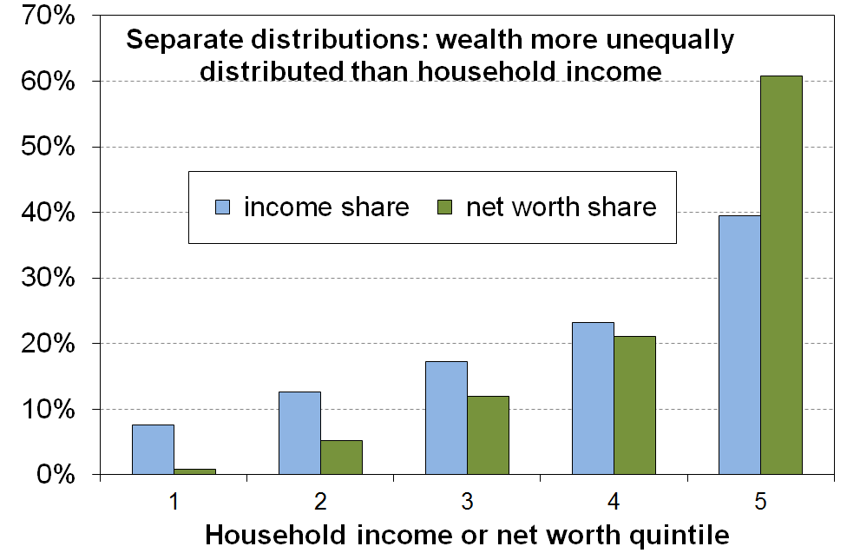
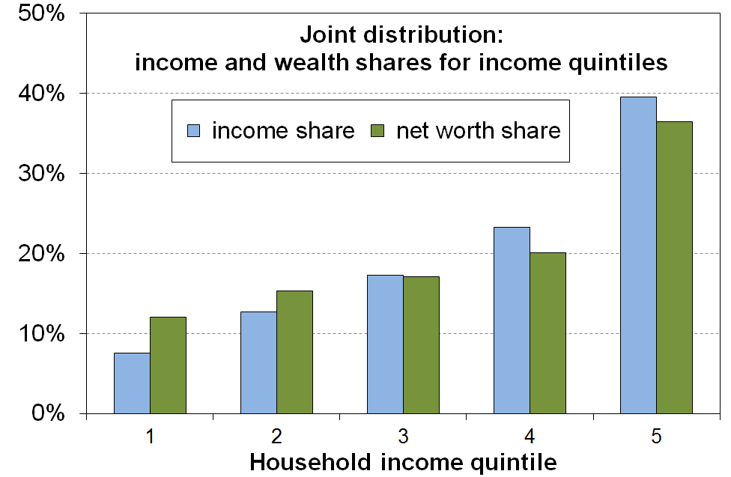
  - The joint distribution of wealth and income is much less unequal than wealth distribution per se. This is because there are many older households with lower income and higher wealth, and a good number of younger (under 45 yrs) households with high income and low to moderate wealth. The graphs below use data from the Australian Survey of Income and Housing for 2009-10.

  - The limited data available on wealth mobility points strongly to low mobility / high immobility for those with very high wealth.

14 The tax and transfer system significantly reduces the inequality that would otherwise exist.

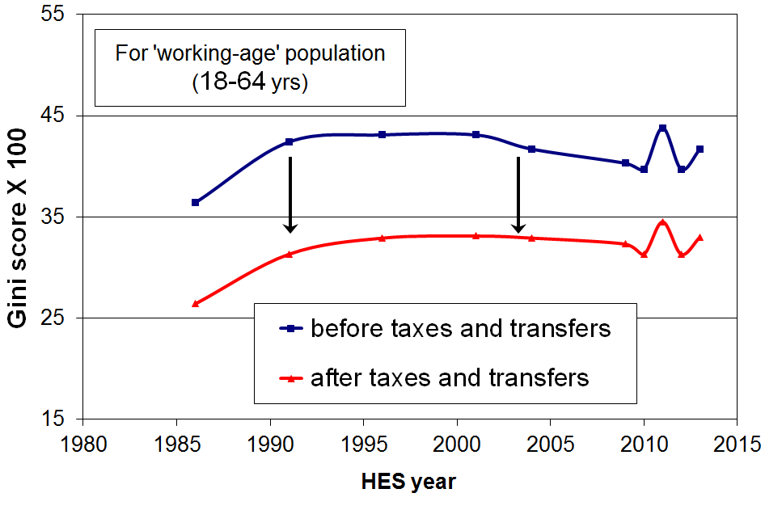
- The graph shows the inequality-reducing impact of taxes and transfers by comparing the Gini scores for household market income and household disposable (after tax and transfer) income for working-age New Zealanders.
- The reduction in the household market income Gini for this group was 21% from 2004 to 2013. This reduction is similar to Australia and Canada (22-23%), less than the UK (28%), and much lower than many European countries such as Norway, France and Austria (33-36% reductions). The median OECD reduction is 28% (c 2011).
- When the full population is used, New Zealand’s reduction in inequality is 28% compared with the OECD median reduction of 35%.
- For half of households with dependent children the amount received through welfare benefits and tax credits is greater than or equal to the amount they pay in income tax.
  - For example, single-earner two-child families with less than around $60,000 from wages pay no net income tax. They receive more from WFF tax credits than they pay in income tax and ACC.
  - Such households nevertheless pay GST on almost all the goods and services they purchase. A more comprehensive analysis needs to include tax paid through GST especially as lower-income households generally apply all or almost all their income to expenditure on GST-able goods and services, whereas higher-income households apply a lesser proportion of their income to GST-able expenditure, with a portion going to savings and interest payments which do not attract GST. GST outgoings are therefore generally a higher proportion of the income of lower-income households than for higher-income households.
- When all households are counted (working age with children, working age without children, and 65+ households), and looking at households grouped in deciles rather than looking at individual households, the total income tax paid by each of the bottom four deciles is less than the total transfers received (tax credits, welfare benefits, NZS and so on). It is only for each of the top five deciles that total income tax paid is greater than transfers received.

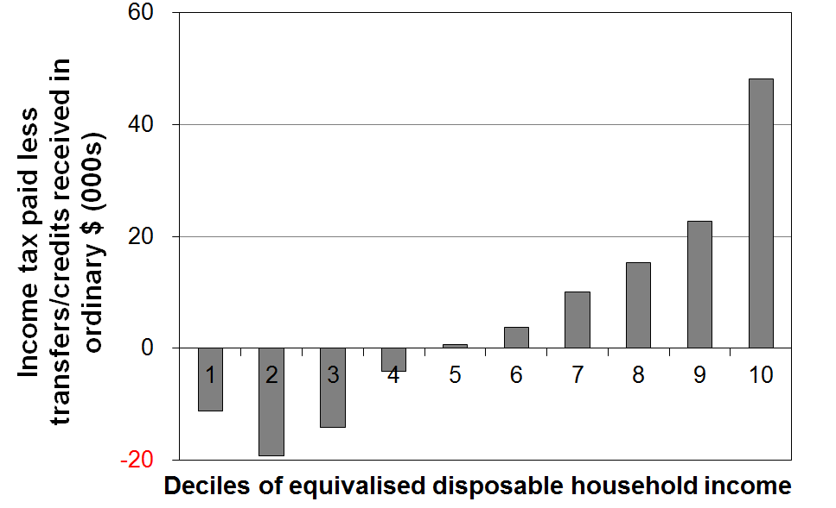
Accommodation costs relative to household income

15 The proportion of lower-income households (those in the bottom two quintiles, Q1 and Q2) with high OTIs rose strongly from HES 2009 to HES 2012. For Q1 the rise was from 33% to 43% - it remained unchanged to HES 2013. Housing stress in the second quintile (Q2) began to increase earlier, rising from 27% in 2004 to 36% in 2013.
- In HES 2013, 27% of households had high OTIs (more than 30%), above the rate for the mid 1990s (22-24%), and much higher than in 1988 (11%).
- This rising long-run trend applies to all income groups, but high housing costs relative to income are often associated with financial stress for low- to middle-income households. Lower-income households especially (Q1 and Q2) can be left with insufficient income to meet other basic needs such as food, clothing, transport, medical care and education for household members.
- The graph below shows that for the bottom quintile (Q1), the proportion with high OTIs steadily reduced from 48% in 1994 to 34% in 2004, as unemployment fell, employment and income rose, and income-related rental policies were introduced in 2000 for those in HNZC houses. From HES 2009 to HES 2013 the proportion rose strongly from 33% to 42%, the highest it has been in the last 25 years except for the peak of 48% in 1994.
- For households with incomes in the second quintile (Q2) there was a strong rise from the 1980s through to the mid 1990s, followed by a relatively flat trend to 2004. Since 2004, the proportion with high OTIs has risen strongly from 27% to 36%.
- For the third quintile (Q3) the proportion with high OTIs settled at around 30% for 2007 to 2013, up from 21% in 2004 and 10% in 1988.

Proportion of HHs with housing cost OTIs greater than 30%, by income quintile
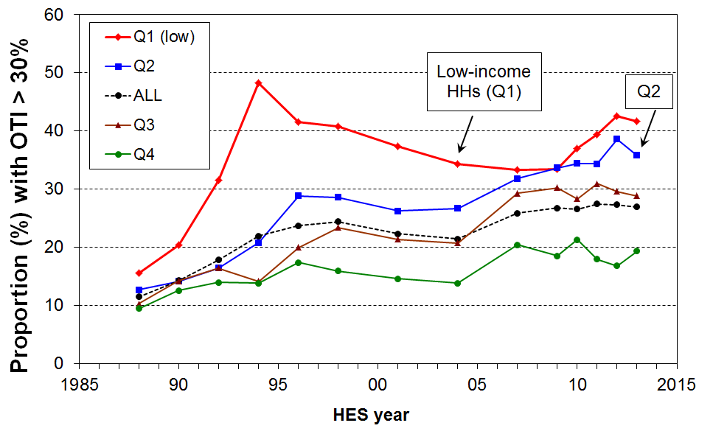
- From the mid 1990s to 2013, around 13-15% of households had an even higher OTI – greater than 40% – up from 5% in the late 1980s. For those in Q1 (bottom quintile), the proportion with these higher OTIs peaked in the mid-1990s at 34%, was lower at 25-27% from 2004 to 2009, but in 2013 was again at 34%. The proportion of households in the second quintile with these higher OTIs rose from around 15-16% in the early 2000s to 20-21% in 2011 to 2013.
- The increasing housing stress for lower-income households reflects significant rises in gross housing costs for many of these households and household incomes that are rising more slowly than housing costs. In addition, the policy settings for the Accommodation Supplement (AS) have remained unchanged since 2005 which means that an increasing proportion of AS recipients are receiving the maximum payment (33% in 2007 and 50% in 2013).
- In June 2013, almost all renters (94%) receiving the AS spent more than 30% of their income on housing costs, three in four spent more than 40% and one in two (48%) spent more than 50%.
Poverty and hardship trends

16 The Incomes Report uses household incomes after deducting housing costs (AHC incomes) for its primary measures of low income / poverty rates.
- The report promotes AHC measures as more robust than BHC measures when using household income as an indicator of material wellbeing (a central goal of the report). Among other things, it allows more sensible comparisons between groups with quite different housing costs but similar BHC incomes.
- Housing costs accounted on average for a much greater proportion of household income for low-income households in 2013 than in the 1980s. This increase cancelled out the gains in BHC incomes for low-income households, leaving AHC incomes for bottom decile households lower in real terms in 2013 than in the 1980s, and much the same for those in the second decile.

17 The Incomes Report uses the “anchored line” approach as its primary one for monitoring medium-term trends in income poverty. Reported poverty levels depend significantly on judgement calls about the threshold used, though in practice there is a limited plausible range of thresholds.
- For monitoring low income / poverty trends in the short to medium term, the Incomes Report uses the “anchored line” approach as this gives a clear indication of what is happening to low incomes in real terms, irrespective of trends in the median or other parts of the income distribution. The Incomes Report takes the view that any positive assessment of social progress requires “anchored” low-income / poverty rates to be falling, whereas the assessment of the meaning of trends for moving line measures is not always straightforward. See the introduction of this Summary for more detail (pp 6-7).
- The OECD is now taking the anchored line approach more seriously in its reporting, and in a report due out later in 2014 UNICEF is also planning on using this approach.
- For reporting on low income / poverty levels the report uses 50% and 60% of median lines for AHC incomes (and 40% for the population as a whole), consistent with the view that poverty and material hardship exist on a spectrum from less to more severe.
  - The 60% of median AHC moving line measure is at the upper end of any credible range of thresholds.
  - The 50% of median BHC moving line measure is a very stringent one. At this level of household income (which includes housing support), many working-age households have to use 50% or more of their budget on housing costs which leaves very little for other essentials.
- In recent years it has become increasingly common for commentators and others to talk about the 60% of median AHC moving line measure as “the” poverty measure as if it were the official New Zealand measure:
  - There are no official New Zealand measures in the sense of a set of measures given formal legitimacy by a government. There is certainly no single measure that is “the” official measure.
- Even if there were a formally endorsed single measure of income poverty about which there was widespread agreement, the fact remains that household income on its own cannot precisely and unambiguously categorise the population into those with and without adequate resources to support a minimum adequate standard of living. This is clear both from the implications of the incomes-wealth-consumption-material-wellbeing framework outlined in the introduction (pages 4-6), and from robust findings from the analysis of the imperfect overlap between the low-income group and those identified as in material deprivation. So, just as for household income in general so also for low-income cut-offs (poverty lines) in particular. They are valuable monitoring instruments, but we need to use them with an awareness of their limitations and imperfections, refraining from over-claiming what they tell us while still drawing on the clear trend and relativity findings that they do produce.
18 In the 2012-13 HES population poverty rates were much the same as in the 2011-12 HES on all the standard measures, and were down by one to two percentage points on the higher levels reached in the 2010-11 HES after the GFC impact.

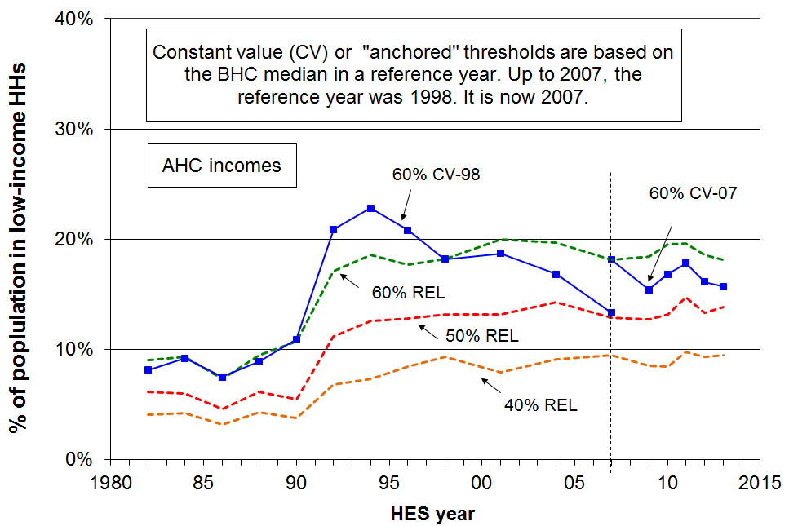

- Using the 60% of median AHC anchored or fixed line measure:
  - the population poverty rate fell strongly from 23% in 1994 to 13% in 2007 (using 1998 as the reference year)
  - using 2007 as the reference year, the population poverty rate fell from 22% in 2004 to 15% in 2009, before the impact of the GFC and rising housing costs drove an increase to 18% in the 2011 HES
  - in the 2013 HES it was down to 16% reflecting the impact of the recovery.
- Using AHC moving line measures, which reflect how many households have incomes that are judged to be “too far” below the median:
  - poverty rates were reasonably steady from the mid 1990s to 2013 – 18% to 20% using the 60% of median measure, and 13% to 14% using the 50% of median measure
  - on both measures, rates in 2013 were around double what they were in the late 1980s, reflecting both increased housing costs relative to income, and some modest increasing inequality in the lower half of the distribution for BHC incomes.

- In 2013, the total population figure was 4.37m. On the measures reported in the table below (p25), between 400,000 and 800,000 people were in households with incomes below the low-income thresholds (ie ‘in poverty’), depending on the measure used.
- In 2013, on the AHC ‘fixed line’ 60% measure, there were 690,000 (16%) below the low-income threshold (ie ‘in poverty’), down from 750,000 in 2007 and 865,000 in 2004.
- New Zealand ranks in the middle of both OECD and EU countries on the 50% and 60% of median BHC measures respectively.

19 On all but one of the standard measures, poverty rates for children in the 2012-13 HES were around 3 percentage points lower than in the 2010-11 HES, back to close to their levels in the 2008-09 HES, just before the impacts of the GFC on household incomes.

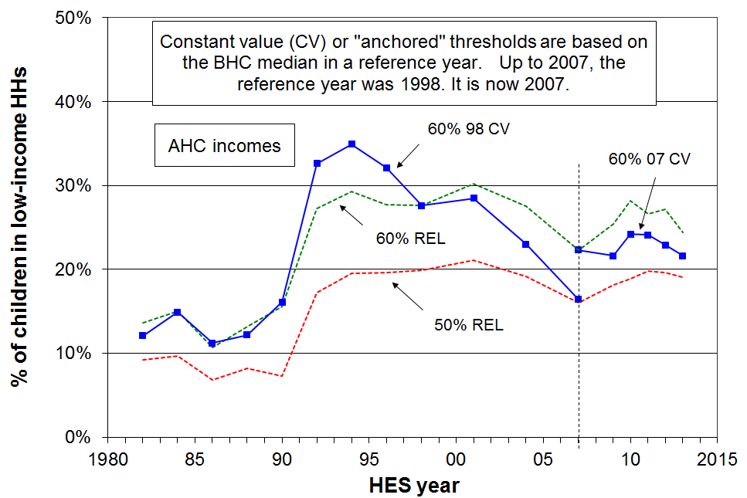

- On the 60% of median AHC anchored or fixed line measure:
  - the child poverty rate fell strongly from 35% in 1994 to 16% in 2007 (using 1998 as the reference year)
  - using 2007 as the reference year, the child poverty rate increased from 22% to 24% as the impact on the GFC on employment and household incomes took effect from 2008-09
  - by the 2012-13 HES, it had fallen back to the pre-GFC level of 22%.
- Using AHC moving line measures:
  - child poverty rates were reasonably steady from 1994 to 2001, then declined quite strongly to 2007 as a result of improving employment rates, the introduction in 2000 of income-related rents for those in HNZC houses, changes to the AS settings in the mid 2000s and the WFF package
  - the child poverty rate on the 60% of median AHC measure is lower in 2013 (24%) than immediately after the GFC crisis (28%), but there is no measurable change using the 50% line (down from 20% to 19%)
  - on both the 50% and 60% AHC moving line measures, child poverty rates are still around double the rates they were in the late 1980s (8% &13% compared with 19% & 24%).
- The longer-run findings on child poverty reflect two factors: first, AHC incomes in 2013 for low-income households were around the same as they were in the 1980s in real terms, and second, median household income has risen in real terms in the period. This means that the incomes of lower-income households with children are further from the median (ie there is higher inequality in the lower half of the distribution in 2013 than in the 1980s).

- In 2013, there were 1.06m dependent children (under 18) – on the measures in the table below, between 120,000 and 260,000 children were in households with incomes below the low-income thresholds (ie ‘in poverty’), depending on the measure used. This is 30,000 to 40,000 lower than at the high point after the GFC impact in the 2009-10 and 2010-11 surveys. The exception is the 50% AHC moving line measure where there is no measurable change post-GFC.
- In 2013, on the AHC ‘fixed line’ 60% measure, there were 230,000 children (22%) in households below the low-income threshold (ie ‘in poverty’), much the same as in 2007 and down from 320,000 (31%) in 2004.
- For child poverty rates using BHC incomes, New Zealand ranks in the middle of EU countries on the 60% of median measure, and a little above the OECD median on the 50% measure.

Income poverty rates and numbers for five measures

Whole population
rates | AHC |  |  | BHC
HES year | AHC ‘fixed line’ (07) 60% | AHC ‘moving line’ 60% | AHC ‘moving line’ 50% | BHC ‘moving line’ 60% | BHC ‘moving line’ 50%
1988 | - | 10 | 6 | 14 | 7
1994 | - | 19 | 13 | 15 | 7
2001 | 25 | 20 | 13 | 18 | 8
2004 | 22 | 20 | 14 | 21 | 10
2007 | 18 | 18 | 13 | 18 | 10
2009 | 15 | 18 | 13 | 18 | 9
2010 | 17 | 19 | 13 | 19 | 10
2011 | 18 | 20 | 15 | 19 | 10
2012 | 16 | 19 | 13 | 18 | 8
2013 | 16 | 18 | 14 | 18 | 9

numbers
2004 | 865,000 | 780,000 | 565,000 | 840,000 | 410,000
2007 | 750,000 | 750,000 | 535,000 | 755,000 | 415,000
2009 | 650,000 | 775,000 | 535,000 | 750,000 | 395,000
2011 | 765,000 | 845,000 | 635,000 | 810,000 | 430,000
2013 | 685,000 | 790,000 | 605,000 | 775,000 | 395,000

Children (aged under 18 years)
rates | AHC |  |  | BHC
 | AHC ‘fixed line’ (07) 60% | AHC ‘moving line’ 60% | AHC ‘moving line’ 50% | BHC ‘moving line’ 60% | BHC ‘moving line’ 50%
1988 | - | 14 | 9 | 20 | 11
1998 | - | 28 | 20 | 20 | 9
2001 | 37 | 30 | 21 | 24 | 12
2004 | 31 | 28 | 19 | 26 | 14
2007 | 22 | 22 | 16 | 20 | 13
2009 | 22 | 25 | 18 | 19 | 11
2010 | 24 | 28 | 19 | 23 | 14
2011 | 24 | 27 | 20 | 22 | 13
2012 | 23 | 27 | 20 | 21 | 12
2013 | 22 | 24 | 19 | 20 | 11

numbers
2004 | 320,000 | 285,000 | 200,000 | 265,000 | 150,000
2007 | 240,000 | 240,000 | 170,000 | 210,000 | 140,000
2009 | 230,000 | 270,000 | 195,000 | 210,000 | 115,000
2010 | 260,000 | 300,000 | 200,000 | 245,000 | 150,000
2011 | 255,000 | 285,000 | 210,000 | 230,000 | 140,000
2013 | 230,000 | 260,000 | 205,000 | 215,000 | 120,000

[In the next section (paras 20 to 27) the poverty measure used is the Social Report’s AHC 60% of median fixed line measure (2007 as reference year), unless otherwise stated.]

More on income poverty for population groups, especially children and older New Zealanders

20 Poverty rates for children in beneficiary families are typically around 75% to 80%, much higher than for children in families with at least one adult in full-time employment (11% in 2012 and 2013).
- After the benefit cuts in 1991, just over 75% of children in beneficiary (‘workless’) families were identified as poor in each HES for the next decade (using 1998 as the reference year). This compared with around 25% before the cuts. Using 2007 as the reference year, the average poverty rate for children in beneficiary families was again close to 75% for 2011 to 2013.
- For beneficiary families with children, AHC household incomes from main benefits, the Family Tax Credit and the Accommodation Supplement are below the AHC 60% anchored line threshold. For beneficiary families in private rental accommodation, their AHC incomes are often only around half of this low-income threshold.
- This raises the question as to why the reported poverty rate for children in beneficiary families is not therefore 100%? There are typically 20-30% of children living in households receiving a main benefit which over the 12 months before the HES interview also received market income. This market income is either from their parent(s) or from other employed adults in the household. The paid employment can be part-time work or full-time work in a part of the year when not in receipt of a benefit. This extra income is enough to take total household income “over the line” for some of these households.
- At 31 March 2014 New Zealand had 200,000 children (19%) dependent on an adult or adults in receipt of a main benefit, down from 233,000 (22%) in 2010 and 280,000 (30%) in 1998.
- In 2013, around 24% of children (260,000) were in households with no full-time worker at the time of interview. The 260,000 does not relate directly to the 200,000 in the previous point as (a) some of the households in which children live have both full-time workers and beneficiaries in them, (b) some have both part-time workers and beneficiaries in them and (c) some children live in working households where the adults work part-time only. Around 15% of children are in households where there is no adult in paid work at all.

21 Nevertheless, on average from 2007 to 2013, two in five poor children (38%) were from households where at least one adult was in full-time employment or was self-employed, down from around one in two (50%) before WFF (2004).
- The WFF package had little impact on poverty rates for children in beneficiary families (close to 75% in both 2004 and 2007), but halved child poverty rates for those in working families (22% in 2004 to 12% in 2007, and close to the same since then).
- Because there are many more children in working families than in workless or beneficiary families, the proportion of poor children who come from working families is much higher than the poverty rates themselves at first sight suggest.
- On average from 2007 to 2013, two in five poor children (38%) came from working families where at least one adult was in full-time employment or was self-employed, down from just over one in two before WFF. For HES 2012-13 the proportion was 41%.
- Using material deprivation measures (MSD’s ELSI and MWI), the proportion of children in hardship coming from working families is even higher at around 50%.
- The New Zealand proportion is not unusual. Similar challenges regarding “the working poor” are found in most OECD countries.

22 Children in sole-parent families have a higher risk of income poverty than those in two-parent families (51% compared with 13% in 2013). Half of poor children lived in sole-parent families and half in two-parent families in 2013.
- Around 90% of sole-parent families had incomes below the overall median in 2013, compared with 50% for two-parent families with dependent children.
- The higher poverty rate and lower family incomes for sole-parent families reflect two things: (a) there is only one potential income earner in the family, and (b) the full-time employment rate for sole parents is relatively low (35% in 2013). 73% of sole parents were in receipt of a main benefit in June 2009. (get later figure)
- From 2007 to 2013 half of poor children were from sole-parent families, higher than in the early 1990s (40%) and much higher than the late 1980s (20%). This long-run change reflects first of all the cutting of benefit rates in 1991, but also both the higher proportion of children living in sole-parent families in 2007-2013, and the higher proportion of two-parent families which are dual-earner families in 2007-2013.
- Around one in three sole-parent families live in households with other adults. Child poverty rates for children living in these sole-parent families (20% to 25%) are much lower than for those in sole-parent families living on their own (65% to 70%) because of the wider household financial resources available to them, both directly and indirectly.

23 Poverty rates for Maori and Pacific children are consistently higher than for European/Pakeha children: on average from 2011 to 2013, just under half (48%) of poor children were Maori or Pacific.
- On average from 2011 to 2013, around 16% of European/Pakeha children lived in poor households, 28% of Pacific children, and 34% of Maori children (double the rate for European/Pakeha children).
- The higher poverty rate for Maori children is consistent with the relatively high proportion of Maori children living in sole-parent beneficiary families and households (eg in March 2013, 44% of DPB recipients were Maori).
- On average from 2011 to 2013, just under half (48%) of poor children were Maori or Pacific: for children overall, around 34% were Maori or Pacific.
- The sample size is too small to allow more precise poverty rates or breakdowns to be given for the smaller ethnic groupings.

24 Seven out of ten poor children live in rental accommodation.
- On average over 2010 to 2012 the poverty rate for children in HNZC accommodation was 54%, those in private rental accommodation 38%, and for those in privately owned homes 13%.
- Just over 70% of poor children live in rental accommodation (53% private rental, 19% from HNZC).
- Around 40% of all children live in private rental or HNZC accommodation, and 60% in privately owned homes (80% of which have mortgage payments).

25 The poverty rate for working-age adults living on their own trebled from 1984 to 2007 on the AHC fixed line measure, and has remained high since (29% in 2013).
- One-person working-age households currently have the second highest poverty rate by household type (after sole-parent households). The rate is high in itself (29%) and high relative to the population as a whole (16%). It is higher than for children (22%) using the same measure.
- There is little difference in the poverty rate for younger (aged 18 to 44 years) and older (aged 45 to 64 years) one-person households, 28% and 30% respectively.
- The poverty rate for this group trebled from 1984 (10%) to 2007 (30%), based on the AHC 60% of median fixed line measure (with 1998 as the reference year).
.
26 While the value of New Zealand Superannuation (NZS) relative to wages was steady from 2004 to 2013, its value relative to median household income declined to a low of 48% in the 2008-09 HES before rising to 54% in the 2012-13 HES.
- While NZS for a couple remained steady at close to 66% of net average ordinary time earnings from 2004 to 2013, its value relative to median household income declined from 58% in 2001 to 48% in 2009.
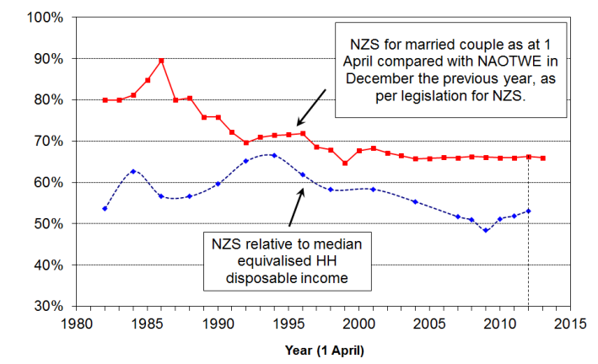
- This relative decline reflected the fact that median household income rose quite strongly in real terms from 2001 to 2009 (+23%), while NZS increased only modestly in real terms (+2%).
- From HES 2009 to HES 2013 the value of NZS recovered to around 54% of the median. The turnaround reflects the combination of: (a) a small net increase in median household income from 2009 to 2013, and (b) the larger increase in NZS (11% in real terms) arising from the tax cuts in 2008 to 2010 and real rises in wages (to which NZS is pegged).
- The vast majority of older New Zealanders remain heavily dependent on NZS for their income:
- 40% have next to no other income, and the next 20%, those in the middle income quintile for older New Zealanders, receive 80% of their income from NZS
- around half of older New Zealanders receive less than $100 pw from non-government sources (eg employment, private superannuation, other investment returns).
- If a 50% of median BHC poverty measure is used (as the OECD does), then the reported poverty rate for older New Zealanders shows a sudden and large increase from close to zero in 2001 to 22% in HES 2009, followed by a similarly large decrease to 13% for 2010 and 11% for 2013.
- This sudden rise and fall of the income poverty rate for older New Zealanders on this measure can easily leave the misleading impression that there was a very large and sudden change for the worse in the actual living conditions of many older New Zealanders, followed by an equally sudden improvement. Neither conclusion is warranted. The rapid changes simply reflect the strong clustering of household incomes for older New Zealanders at and just above the level of NZS (the “pensioner spike”) in the New Zealand income distribution.
- This sort of anomaly is one of the reasons behind the Incomes Report’s advocacy for giving priority to AHC incomes and to non-income measures for assessing the material wellbeing of households, especially for comparing the relative positions of different population groups and monitoring changes over time.

27 Income poverty rates for older New Zealanders still remain lower than those for other age groups when using incomes after deducting housing costs (AHC).
- In 2013, the 60% AHC fixed line poverty rate for the 65+ age group was 7%, compared with 13% for 45-64 year olds, 16% for 18-44 year olds, and 22% for children (aged 0-17 years).
- Similar relativities are shown using the 50% of median moving line AHC measure: 5%, 12%, 15% and 19% respectively.
- Income poverty rates among the 65+ group are higher for those on their own than for couples. For example the average rates for HES 2012 to HES 2013 were 7% and 12% respectively.
- The age group relativities are not new, although the gap between children and older New Zealanders is smaller in 2013 than it was in 1990s. A similar gradient is found using non-income measures. For example, using MSD’s Economic Living Standards Index (ELSI), 5% of older New Zealanders and 17% of children were identified as “in hardship” (2011-12 HES), using a fairly stringent threshold which gave a population hardship rate of 13%.
- The lower AHC income poverty and low material hardship rates for older New Zealanders reflects the mix of universal public provision (mainly NZS) and the private provision built up by most of the current cohort over their lifetime. A key component of this private provision is mortgage-free home ownership which is relatively high among the current cohort.
- This highlights the importance of using the incomes-wealth-consumption-material wellbeing framework for understanding and interpreting traditional income poverty figures, as outlined in the introduction to this Overview and Summary.

Income mobility and poverty persistence

28 The income information above is based on data from repeat cross-sectional surveys from the HES series. For each survey a different sample of households is selected and different individuals are interviewed each time. It is very important too to have longitudinal income information, where the same individuals are followed from one wave of a survey to the next.

- Longitudinal data can give a quite different perspective on trends over time and make possible a richer analysis that can address a new set of questions around income mobility and the persistence of low-income. For example:
  - If 20% of New Zealand children are identified as poor in a given year, what proportion of these stay poor over several years or even longer, and for how many is the low income experience “just” a temporary one?
  - How much does the household income of individuals change over time? Do most people remain in much the same relative position over 5-10 years, or do most move quite a lot?
  - How does income mobility in New Zealand compare with mobility in other countries?
  - Higher income inequality is sometimes seen as more tolerable if there is reasonably high income mobility. How much does income mobility reduce single-year income inequality when inequality is measured for incomes averaged over increasing numbers of years?
- Longitudinal data are available from Statistics New Zealand’s Survey of Families, Income and Employment (SoFIE) for 2002 to 2009. SoFIE has run its course, and there is currently no nationally representative longitudinal survey of New Zealand households that is collecting income and wealth data. Nor is there any longitudinal data collection that follows individuals after they move off a main benefit and into paid work, caring responsibilities, study or elsewhere. We therefore have to rely on data and research from countries like the UK and Australia for longer-term analysis of income mobility and for information on the trajectories of individuals as they move off and (back) onto benefits.

29 Income mobility
- A common way to look at income mobility is to rank individuals by their household incomes, group them into deciles or quintiles, and then see how many move from their original position in the first year to another position in a later year. Some go up, some go down, and others remain in much the same place.
- Over the seven SoFIE waves (annual surveys) there is considerable relative movement. While some move quite a distance, much of the movement is relatively short-range. Patterns for New Zealand are much the same as for countries like Australia, Canada, the UK, Germany, France, Belgium and Ireland.
- For example, after seven waves, just over half the population (54%) were still in either the same decile they started in or in one either side. The figure for the UK was 53%.
- Looking just at those aged 0-57 years in wave one:
- of those starting in deciles 1-3, just over half were still there in wave 7, a quarter had moved up to deciles 4 and 5, and a quarter into the top half (deciles 6-10)
- of those starting in the middle of the income distribution (deciles 4-6), 43% were still there in wave 7, 35% had moved up to deciles 7-10, and 23% had moved down
- of those starting in the top decile, 63% were still there or were in decile 9 in wave 7.
- Income mobility can also be looked at in terms of changes in real (CPI-adjusted) income. On this basis it was found that (during a period when cross-sectional incomes were growing on average for all deciles):
- 20% of those starting in the lowest quintile experienced a net decrease in real income over the 7 waves, 30% doubled their income, and the remaining 50% all experienced real increases of substance, albeit less than double
- overall, 38% experienced real declines, and for a third of these the decline was significant (40%+).
- All of this serves as a reminder of the great variety of income trajectories that different individuals have, a perspective not available when using cross-sectional surveys.

30 Poverty persistence and “chronic poverty”

- Cross-sectional income surveys (like the HES) can tell us how many people are in low-income households at a point in time. They cannot tell us how long people have been in low income nor how much movement in and out of low income there is over time. Longitudinal data can do that.
- Using the 50% of median gross household income threshold produces a cross-sectional population poverty rate of around 15% in each SoFIE wave, and 20% for children. The SoFIE data shows that:
- 39% of the whole population experienced income poverty in at least one wave out of the seven
- 17% were in low income for at least three out of seven waves (11% for 4+)
- 2% were in low income for all seven waves (4% in all or all but one wave)
- The corresponding figures for children are 47%, 13% and 3%.
- Thus, cross-sectional poverty rates can be said to both understate and overstate the “true” low income or poverty experiences of the population:
  - they understate because just over double the number in poverty in a given wave experience at least one year with low income over a seven year period
  - they overstate because the number experiencing more than half the seven years in poverty is lower than the cross-sectional rate.
- Counting the number of waves for which people are below a given poverty line is a straightforward approach but it clearly has limitations, and can be misleading in the impression it leaves. For example, the fact that so few remain in poverty for all or all but one of the seven waves can point to the conclusion that mobility is sufficient to address most concerns that are raised by cross-sectional low-income issues. As the “chronic poverty” section below will show, this is not the case. The main limitation of the number-of-waves approach is that it does not pick up those whose incomes fluctuate from below to just above the line, and vice versa.

Chronic poverty
- One way to address the issue of how best to report on poverty persistence, given that for many households their incomes fluctuate from just above to just below the poverty line and vice versa, is to look at people’s average income over the seven SoFIE waves and to compare that with the average poverty line over the seven waves. People whose average income is below the average poverty line over the seven waves are said to be in chronic poverty.
- By examining the relationship between those in chronic poverty and those in current poverty in each wave, a useful set of findings emerges that allows us to look at cross-sectional income poverty findings with longitudinal eyes.
- The chronic poverty rate is typically around 70% of the current poverty rate for the population as a whole, a little higher for children and Maori (~80%). For example, if the population rate in a given year is 14%, the chronic poverty rate will be 10%.
- However, those in chronic poverty do not form a subset of those in current poverty in a given wave. Some who are in current poverty in a particular wave are not in chronic poverty. Similarly, some who are in chronic poverty are not in current poverty each wave. The diagram below summarises the relationship between current and chronic low income.

Current and chronic poverty:
the chronic oval (on the right) is around 70% the size of the current oval (on the left),
but not all in the chronic oval are in the current oval
current and chronic
current only
chronic only

  - for the population as a whole: out of every 100 in current poverty at any time 50 are also in chronic poverty, and in addition another 20 not in current poverty are in chronic poverty
  - for children, out of every 100 in current poverty at any time 60 are also in chronic poverty, and in addition another 20 not in current poverty are in chronic poverty.
- Thus, looking at cross-sectional rates with longitudinal eyes:
- in any wave, around half are in both chronic poverty and current poverty, the other half being only in current poverty (ie more temporary or transient poverty)
- the people in this more transient group change a lot over seven waves which is why it turns out that the number in low income at least once in seven waves is around double the number in low income at any one time (see above)
- in addition to those identified as being in current poverty in a wave there is another group who are in chronic poverty but not in current poverty
- chronic poverty rates are around 70% of the cross-sectional rates for the population as a whole and more like 80% for children
- very similar findings have been produced for the UK and Australia.
- This picture is in some ways similar to the one we have for the beneficiary population. At any given time, a majority of those on benefit will have been on benefit for many years. A smaller number are new entrants or fairly temporary recipients. Over several years the number who have been on benefit at any time is much greater than the number on benefit at a particular point in time because of the cumulative effect of these temporary recipients.
- The number-of-waves-in-poverty approach can easily lead to an overly optimistic view of the ability of income mobility to resolve low-income issues for the bulk of low-income households.

Material hardship using non-income measures (NIMs)

31 The incomes approach for assessing relative material wellbeing has much to offer, but cannot on its own give a full picture – a more comprehensive perspective is made possible by using information from non-income measures as well.
- The incomes approach has some well-known limitations for assessing the material wellbeing of households:
- as noted in the introduction above, it does not take into account the impact of wealth (such as household assets and financial savings) which can buffer against fluctuations in household income
- it does not capture the impact of unusual costs (such as high health costs or high debt servicing costs), nor of assistance in cash or kind from outside the household
- international income poverty comparisons are especially limited because of differing average incomes across the countries being compared – see #37 below.
- A non-income approach can provide supplementary information to give a more complete picture as well as providing more robust findings where the incomes approach is especially limited. This information can be used in its own right or together with income data to monitor the material wellbeing of New Zealanders.
- From HES 2007 to HES 2012 the HES collected information on the 25 items that go to make up the Ministry’s ELSI measure. This section mainly uses the ELSI measure to report on material hardship.
- The Ministry has significantly revised and improved the ELSI and has developed a 24-item Material Wellbeing Index (MWI) which uses a refreshed set of non-income measures. These new items were included in the 2013 HES. This means that the material hardship time series has to have a discontinuity from HES 2012 to HES 2013, so no trend data are available from HES 2012 to HES 2013.

32 Both the incomes (AHC) and the NIM approaches identify the same population groups that have high and low poverty or hardship rates. However the actual overlap of the ‘income poor’ and ‘those in material hardship’ is only around 50%, a finding in line with international research.
- The limited overlap is not unexpected as day-to-day living standards for a household are determined by much more than just current income: for example past income, the state of repair and range of household goods and appliances in the household, the support in cash and kind from people outside the household, the extra demands on the budget from special health costs and high debt servicing commitments all have an impact over and above current income. This is simply another way of highlighting the point made by the diagram and associated discussion in the introduction to this Overview and Summary.
- The limited overlap means that only half of those in material hardship are in income poverty: the other half have incomes above the poverty line. The bulk of this other half have incomes below the median (and are sometimes referred to as the “near-poor” or as “financially precarious”). In other words, some of the “near-poor” experience material hardship and some of the “poor” do not.

- Four types of findings using NIMs are relevant to the central themes of this report. Paras 33 to 35 have summary findings for the first three. See the main report for the fourth:
- trends in material hardship, using NIMs on their own
- trends in material hardship for those with low household incomes.
- the increased levels of hardship for those in households with persistent low income
- the different living conditions for those in the lowest income quintile compared with those for the majority of households.

33 Material hardship (deprivation) rates increased for some groups from 2007 to 2011, notably for children and older working-age adults living on their own. For children and the population as a whole, hardship rates fell from 2011 to 2012.

- The hardship threshold for the measure used in the graph below is a relatively stringent one, giving a 2007 population hardship rate of 10%. The income poverty rate using the 50% of median AHC poverty threshold was 13% in 2007.

Trends in material hardship (deprivation), 2007 to 2013
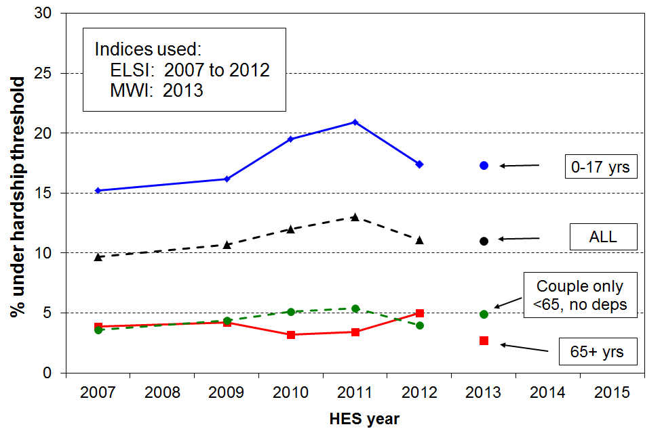

- The trend for the population is not unexpected given the impact of the GFC, economic downturn and recovery, rising to 13% in 2011, and falling to 11% in 2012.
- For children, the hardship rate rose from 15% in 2007 to 21% in 2011 before falling to 17% in 2012.
- Working-age couple households without children, and older New Zealanders (aged 65+) generally experience much lower levels of hardship than other groups (3% to 5%).
- The same sort of hardship trends shown in the graph above are found when using higher and lower thresholds, and also when using a quite differently configured index. The actual estimates of levels of hardship in a given year are of course dependent on the thresholds used but the trend directions (whether up, down or flat) are robust to the choice of threshold and index.
- The HES 2013 figures using the new MWI are also shown on the graph above. The hardship threshold is set to give the same population hardship rate as in HES 2012 using ELSI (11%). The ELSI and MWI rank the population as a whole and different groups in it in much the same way (correlation of 0.95). On both measures, hardship rates for children (17%) are much higher than for older New Zealanders or for working-age couples (~4%).

34 Those living in households with low incomes who are also experiencing material hardship are in very disadvantaged and difficult circumstances. Using the AHC 60% of median low-income threshold and the hardship threshold above, 11% of children (110,000) were in this group in HES 2012, down from 13% (140,000) in HES 2010.
- For those in hardship but with incomes reasonably above the AHC poverty line there are grounds for expecting living standards to improve over time provided their incomes do not decline and that there are no on-going special demands on the budget. However for those in hardship who also have low incomes, there is next to no chance of improvement of living standards until incomes rise and stay up. This is the group sometimes referred to as being in “severe poverty or hardship”.
- For the population as a whole, the size of this group remained much the same from HES 2007 to HES 2009 (~5%), before rising a little in the recession and beginning to fall back as the recovery began.
- For children the proportion rose from 7% in 2007 to 13% (140,000) in 2010 then down to 11% (110,000) in 2012.
- For older New Zealanders (aged 65+), the overlap group is 1% to 2%.
- For HES 2012, the overlap figure is 11% for children and 6% for the whole population.

Trends in the proportion of those who are both income poor and materially deprived, 2007 to 2012
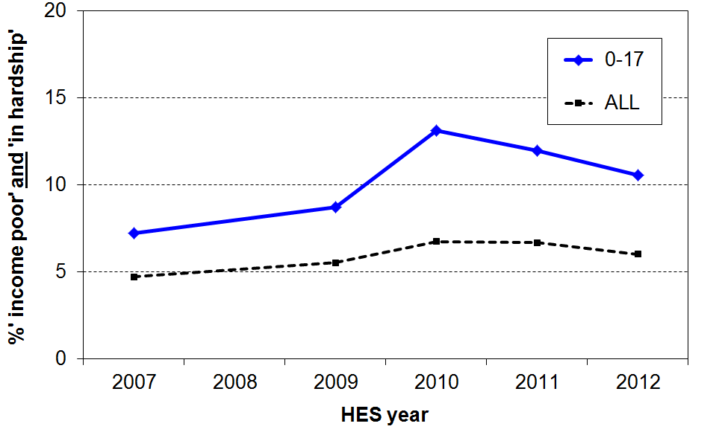
.
- In times of economic growth where the rising standard of living is to some degree shared across the whole population, the trend for the size of the overlap group can be expected to be unambiguously downwards. The upward trend from HES 2007 to HES 2010 reflects above all the impact on employment and household incomes of the shock of the GFC and the economic downturn. The downward trend for children from HES 2010 to HES 2012 shows the effect of the recovery.

35 The longer that households are in low income the greater is their risk of (higher) material deprivation.

- The analysis for the graph below draws on longitudinal data from SoFIE. The high-level finding that the longer that households are in low income the higher is their average deprivation score is not surprising. It is nevertheless one that is not always to the fore in discussions around poverty and hardship figures.
- The relatively flat line for older households reflects the fact that such households often have resources other than current income with which to support consumption for basic needs. This is in line with the income-wealth-consumption-material-wellbeing framework outlined in the introduction.
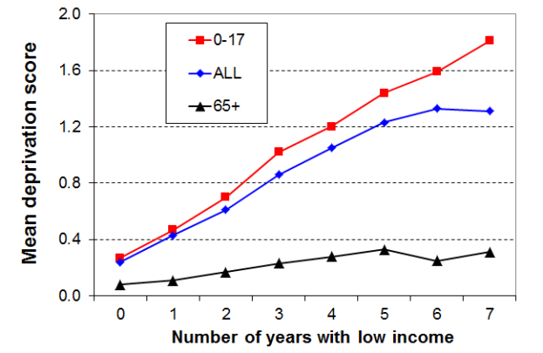

- The low-income threshold used in the analysis above produced poverty rates above the usual cross-sectional ones – that is, it was a relatively generous threshold. When a lower threshold is used, more in line with the 60% BHC cross-sectional threshold, the cumulative impact of ongoing lower low income leads to higher reported deprivation, as expected. The graph is for the whole population.

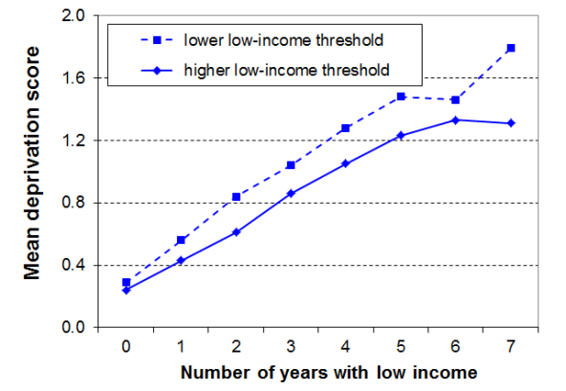

36 International comparisons of income poverty and material hardship
- The OECD and EU publish international league tables that rank countries on their income poverty rates using 50% and 60% of median poverty lines respectively.
- On the latest available figures (OECD, c 2011 and EU, c 2012), New Zealand’s population and child poverty rates are both close to the overall medians on both measures, though the child popverty rate is slightly above the median on the 50% OECD measure.
- These league tables in effect compare how far low-income households are from the median for each country. They can be seen as comparing inequality levels in the lower half of the income distribution.
 | OECD 50% |  | EU 60%
 | All | 0-17 | All | 0-17
NZ | 10 | 13 | 18 | 20
OECD / EU | 10 | 11 | 17 | 21
- The information is however often used as if the rankings indicate the extent of material hardship assessed against a common absolute international standard. Thus a country like the Czech Republic with a child poverty rate of 9% is considered to be “doing better for its children” than, say, Canada (14%), whereas in daily living the “poor” in Canada are much better off than many “non-poor” in the Czech Republic.
- For meaningful international comparisons of material hardship and poverty, there is a strong case that non-income measures (NIMs) are more robust in ranking countries by what most people mean by hardship or poverty levels in more economically developed nations.
  - Using the official 2008 NIM-based EU deprivation index, New Zealand ranked well for older people (65+) and not so well for children. This is consistent with the relativities produced within New Zealand using the AHC income measure. The table below is representative of the full range of EU countries.

Material hardship rates (%) in New Zealand (2008) the EU (2007)
(countries are ranked by the child deprivation rates)
 | All | 0-17 yrs | 65+ yrs
Hungary | 38 | 42 | 35
Poland | 44 | 39 | 41
Slovakia | 36 | 32 | 42
Portugal | 20 | 24 | 26
Greece | 23 | 20 | 29
Italy | 14 | 18 | 14
New Zealand | 13 | 18 | 3
France | 11 | 15 | 8
UK | 10 | 15 | 5
Germany | 13 | 13 | 7
Finland | 10 | 10 | 8
Denmark | 8 | 8 | 4
Netherlands | 6 | 6 | 3
Norway | 5 | 6 | 1

  - The EU have since developed a more robust index which is currently being considered for acceptance as the new official one. There is a high correlation between the old and the new indices, and New Zealand ranks much the same on both. Deprivation rates are also very similar on both measures. For New Zealand, the population, child and 65+ hardship rates are 11%, 18% and 3% respectively on the new measure.

Inequalities within households (intra-household inequality) are also important dimensions of inequality. They are outside the scope of the Incomes Report.
This in turn can assist with a better understanding of the depth of poverty and hardship.
By removing those aged 58+, the impact on the reported transitions of those whose incomes drop significantly when they “retire”, and of those aged 65+ on relatively fixed incomes, is eliminated.
Only gross household income is available in the SoFIE dataset. It turns out that a 50% of gross median threshold gives similar poverty rates to a 60% of median disposable income threshold (income after all taxes and transfers). The special HES datasets that are used for most of the analysis in this report have both gross and disposable household income.
For more information on NIMs and associated indices, see the Ministry’s website: www.msd.govt.nz/about-msd-and-our-work/publications-resources/monitoring/living-standards/index.html
For detailed information on the EU index, see Section D in the MSD report at: http://www.msd.govt.nz/about-msd-and-our-work/publications-resources/monitoring/living-standards/living-standards-2008.html

