Household incomes in New Zealand:
Trends in indicators of inequality and hardship
1982 to 2013

Prepared by Bryan Perry

Ministry of Social Development
Wellington

July 2014

ISBN 978-0-478-32353-5 (Print)

ISBN 978-0-478-32354-2 (Print)

Changes since last report

- The 2014 report updates the previous one with findings based on the 2012-13 Household Economic Survey (referred to as the 2013 HES).

- All the relevant tables and charts from 2010 to 2012 have also been revised following corrections in February 2014 to the income data provided by Statistics New Zealand and the Treasury.

- The international comparisons are updated with the latest available data from the OECD, the EU and the Top Incomes database (usually 2011 or 2012).

- The income inequality sections are expanded to include decile and quintile share ratios and a new inequality measure called the Palma, and are strengthened with a new introductory section.

- More information on wealth inequality is included.

- The material hardship section (Section L) has been expanded and strengthened. There is more detailed discussion on the relationship between measures of income poverty and non-income measures of material hardship.

- The report gives greater prominence to the income-wealth-consumption-material-wellbeing conceptual framework that sits behind the more detailed analysis and which gives coherence to the report’s many strands.

Next report

- The next report is scheduled for mid 2015 based on the 2013-14 HES. (The timing is dependent on the availability of the HES data.)

Availability on MSD website

- This report and previous ones are available on the MSD website (except for those which used the incorrect income data):
www.msd.govt.nz/about-msd-and-our-work/publications-resources/monitoring/index.html

Updates since publication on Tue 8 July 2014

Thu 10 July 2014: Table H.5 replaced with corrected figures.

Acknowledgements

I thank all those who provided comments on earlier drafts, especially Caroline Brooking from Statistics New Zealand whose detailed reviewing has been invaluable, and colleagues within the Ministry of Social Development whose advice, questions and smoothing out of rough patches have added considerably to the report’s robustness, readability and relevance. My thanks too to Nadra Zarifeh whose expert knowledge of the HES datasets and SAS coding have been crucial in the production of this report and previous ones. Responsibility for all the analysis and interpretation in the report (including any errors or omissions) remains mine alone.
Contents

List of Figures and Tables …………………………………………………………….. vii

Abbreviations ……………………………………………………………………………….. xiii

About this report ..……………………………………………………………………….. 1

Summary and Overview ….…..……………………..…………………………………….. 3

Section A Introduction
The income measures used in this report ………………………………………………………………. 37
- Gross and disposable household incomes
- Equivalised disposable household income and (potential) living standards

Income, wealth (net worth), consumption and material wellbeing ………………………………….. 38
- The distributions of household income and wealth, separately and together
- Using non-income measures to measure material wellbeing .

Protocols and technical information for the incomes analysis ……………………………………….. 43
- Equivalisation – comparing incomes across different household and family types
- Income sharing unit and the unit of analysis for the presentation of results
- Rules for determining household membership
- The bottom income decile: income not a reliable indicator of economic wellbeing
- Housing costs and reporting on both BHC and AHC incomes
- Main data source: the Household Economic Survey (HES)
- Population weighting
- Convention for naming HES years
- HES years used in the report
- Special note on the data for the 2008 HES (Income)
- Treatment of negative incomes
- Adjusting for inflation
- Ethnicity
- Household and family types
- Reliability of results
- Summary of key measures used for reporting on income inequality and poverty

Section B Household incomes in 2012-13
Means and medians …………………………………………………………………………..... 57
Income distribution for the whole population, HES 2013 …………..………………………………….. 61
Income distribution for sole-parent and two-parent families, HES 2013 …………………………….. 63
Where does your household fit? ….. ………………………………………………………………. 64
Distribution of individuals across income quintiles by various household and individual
characteristics ….. ………………………………………………………………………………….. 67
Income shares across the distribution ………….………………………………………………………… 72
The re-distribution of income: market income, government cash benefits and income tax,
consumption tax and publicly funded services ….………………………………………………… 73
Section C Trends in key labour market, demographic and social
assistance variables
Introduction ………………………………………………………………………………………. 77
Trends in GDP, employment, unemployment and weekly earnings ……………………………….. 78
Incomes around the median: the longer-term trend …………………………………………………..... 79
Incomes at the lower end of the distribution ……………….………………………………………….. 80
Housing costs ………..…………………………………………………………………………………….. 84

Section D Household incomes and income inequality, 1982 to 2013
Income changes in real terms, 1982 to 2013 …………….………………………………………………. 90
- Whole population, overall trends
- Differing trends for different parts of the distribution (BHC)
- Differing trends for different parts of the distribution (AHC)
- Trends for different household types (BHC)
- Trends in the median by ethnicity (BHC)
Inequality: introduction ………………………………………………………………………………….. 101
Income inequality: summary indicators ………….….…………………………………………………… 103
  - Percentile ratios
  - Quintile and decile share ratios
  - Gini coefficient
Wealth inequality ………………………………………………………….….…………………………….. 109

Section E Low incomes, poverty and material hardship: conceptual and measurement issues
Introduction ………………………………………………………………………………………… 111
What is meant by ‘poverty’ in the more economically developed countries? ………..………………. 112
  - The relative-absolute distinction
  - The relative-absolute synthesis
  - Poverty and hardship in MEDCs: the approach taken in this report
  - Poverty – narrow or wide?
  - Poverty experienced
  - Some common misunderstandings
Constructing measures of income poverty …………...…………………………………………………. 118
  - Key decisions when constructing a measure
  - Using fixed line and moving line measures to adjust thresholds over time
  - Reporting levels and trends for older New Zealanders (aged 65+)
The low-income thresholds (poverty lines) used in this report …………………….……………………. 123
Poverty depth and persistence …………..……..…………………………………………………………. 124
Interpreting and reporting on trends and differences in the poverty figures …………….……………. 124

Section F Headline trends in income poverty, 1982 to 2013
Impact of changing incomes and housing costs on the different poverty measures …………………. 128
Headline trends for the whole population …………….…….……………………………………………….. 130
Headline trends for dependent children ……………..……….…………………………………………….. 134
Sensitivity of levels and trends to choice of poverty line ………………………………………………….. 138
Depth of poverty …………………………………….………………………………………………………….. 139

Section G Trends for the whole population, 1982 to 2013, by various
individual and household characteristics
Age ……………….…………………………….……..………………………………………………………….. 143
Sex …………....…………………………….……..………………………………………………………….. 145
Ethnicity ……………………………………………………………………………………………………….. 145
Highest educational qualification …………………………………………………………………………… 146
Tenure ………………………………………………………………………………………………………… 147
Household and family type …………..….……………….………………………………………………….. 148
Main source of income for ‘working age’ households …………..……………………………………….. 149
Section H Trends for dependent children, 1982 to 2013, by various
individual and household characteristics
Age ……….…………………………….……..………………………………………………………….. 154
Ethnicity ……….…………………………………………………………………………………………….. 155
Highest household educational qualification ……..…………………………………………………… 155
Tenure ……….………………………………………………………………………………………………. 156
Household and family type ………..…………………….………………………………………………….. 156
Work status of adults in the household ……….……..………………………………………………….. 158
Children from income-poor households: composition by their ethnicity and selected household characteristics ..……………………………………………………………………………………….. 159
Children in ‘workless’ and ‘working’ households …………………………..……………………………….. 160

Section I Income trends for older New Zealanders
The BHC incomes of older New Zealanders ………..…………………………………………………. 165
The incomes of older New Zealanders relative to the whole population (OECD comparisons) …….. 166
NZS relative to average earnings and to median household income ………..…………….………….. 166
Sensitivity of reported poverty rates to the choice of poverty line …………..….………….. ………….. 168
Using incomes after deducting housing costs (AHC) to give more stable and reliable results ………. 169
Sources of income for older New Zealanders ………….……………………….…………….………….. 170

Section J International comparisons for income poverty, inequality and wealth
International comparisons of income poverty ………………………………………………….. 175
  - International comparisons using non-income measures
  - Cautions when making comparisons between poverty figures across countries
Population poverty using a 50% BHC threshold ……………………..….…………………… 178
Population poverty using a 60% BHC threshold ……………………..….…………………… 179
Child poverty comparisons using a 50% BHC threshold …………….….…………………… 180
Child poverty comparisons using a 60% BHC threshold …………….….…………………… 181
Children in workless households ………………………………………………………………….. 183
Older New Zealanders …………………………………………..……….….…………………… 183
International comparisons of income inequality .……………………………………………… 186
Trends for (very) high incomes …………………………………………………………………. 190
International comparisons of wealth inequality .……………………………………………… 196

Section K Income mobility and poverty persistence
Introduction ……………………………….……..………………………………………………………….. 197
The SoFIE data ………….……………………………….………………………………………………….. 198
What is meant by income mobility and how is it measured? ………….……………………………….. 199
Selected findings on income mobility …………………………………………………………………… 200
What is meant by low-income persistence and how is it measured? …………..……………………….. 206
Selected findings on low-income persistence ………….………………………………………………… 207

Section L Using non-income measures (NIMs) to assess material hardship
Introduction ………………….……..………………………………………………………….. 211
Changes for HES 2013 and GSS 2014: non-income measures for the HES and GSS ……………… 213
Using non-income measures to assess material wellbeing and hardship (deprivation) ……………… 214
Relationship between low income and material hardship ……………..………………………………. 216
Comparing the results for the incomes and NIM approaches……….…………………………………….. 218
Tracking hardship from the 2006-07 HES to the 2011-12 HES ……………………………. 219
Using NMIs and income together ………………………………………………………………. 221
Using NIMs to illustrate the sorts of restrictions on living standards experienced by low-income
and high-deprivation households ……………………………………………………………………….. 222
Using NIMs to help assess the credibility of a given income poverty threshold ………..…………… 226

References 227

Appendices 233

Appendix 1 Key specifications for the incomes analysis in this report

Appendix 2 Choice of income sharing unit (ISU)

Appendix 3 Equivalence scales: sensitivity of results to choice of scale

Appendix 4 Analysis unit: sensitivity of results to choice of household or individual for calculating medians and reporting poverty rates and inequality

Appendix 5 Incomes before and after deducting housing costs (BHC and AHC)

Appendix 6 Rationale for setting the low-income thresholds or poverty lines

Appendix 7 Indices used to adjust for inflation

Appendix 8 The bottom income decile: income often not a reliable indicator of material wellbeing

Appendix 9 Decile and quintile means and shares (BHC), 1982 to 2012

Appendix 10 Supplementary poverty tables

Appendix 11 Supplementary tables for detailed breakdown for children by household type and so on (Table H.4), using 50% and 60% of median AHC moving line thresholds

List of Figures and Tables

Section A Introduction
Figure A.1 The income-wealth-consumption-material-wellbeing framework used in the report ………… 38
Figure A.2 Gross weekly household income and wealth by age of reference person, Australia, 2011-12 39
Table A.1 Shares of income and wealth by respective quintiles ………………………………………… 40
Table A.2 Shares of wealth by household income quintiles ………………………………………………. 40
Table A.3 The distribution of wealth across household income quintiles, Australia (2009-10) ………… 41
Table A.4 Conversion of equivalised dollars to ordinary dollars for low-to-middle-income households … 45
Table A.5 Achieved sample sizes and response rates for recent HES …………..……………………… 50

Section B Household incomes in 2012-13
Table B.1 Gross, disposable and equivalised disposable household incomes: annual
medians and means (HES 2013) ……………………………………………………………….. 51
Table B.2 Median disposable income (BHC) for different household types (HES 2013) ……..……... 59
Table B.3 Median disposable income (AHC) for different household types (HES 2013) ……….…….. 59
Figure B.1 BHC household income distribution for all individuals: HES 2013 ………….………………. 61
Figure B.2 BHC household income distribution for all individuals: HES 2013 ………………. 61
Figure B.3 Distribution of sole-parent and two-parent family income ………………………….. 62
Table B.4 Where does your household fit in the overall household income distribution (BHC)? ………. 63
Table B.5 Distribution of individuals across income quintiles (BHC) by various household and individual characteristics …………………………………………………………………………………… 68
Table B.6 Composition of income quintiles (BHC) by various household and individual characteristics .. 69
Table B.7 Distribution of individuals across income quintiles (AHC) by various household and individual characteristics ……………………………………………………………………………………. 70
Table B.8 Composition of income quintiles (AHC) by various household and individual characteristics .. 71
Figure B.4 Shares of total income by deciles: HES 2013 …………………………………………………. 72
Table B.9 Shares of total income by quintiles of equivalised disposable household income: international comparisons for c 2012 ……………………………….…..………………………………………. 72
Figure B.5 Cash transfers and income tax paid: HES 2013 ……………………………………………….. 73
Figure B.6 Income tax less government cash transfers: HES 2010 ……………………………………….. 74
Figure B.7 Gini scores (x100) for market and disposable household income, 1986 to 2013 (18-64 yrs) .. 74
Table B.10 Gini scores (x100) for market and disposable household income, 1986 to 2013 (18-64 yrs) .. 75
Figure B.8 The redistribution of market income: HES 1998 …………………………………… 75

Section C Trends in key labour market, demographic and social assistance
variables
Figure C.1 Real GDP annual changes and unemployment rates, 1990 to 2013 ……………………..….. 78
Figure C.2 Employment rate for those aged 15-64, 1988 to 2014 ………….………………………….….. 78
Figure C.3 Net average ordinary time weekly earnings ($ Dec 13) ……….…….…………………….….. 79
Figure C.4 Proportion of 2P HHs by hours of paid employment (where at least one is FT) ……….…… 79
Figure C.5 EFUs in receipt of working-age income-tested benefits ……………………..……………….. 80
Figure C.6 EFUs in receipt of working-age income-tested benefits and individuals receiving
NZS and the Veterans’ Pension ………………………………………………………. 81
Table C.1 Individuals in EFUs in receipt of an income-tested benefit or NZS ………..………………… 81
Figure C.7 Income-tested benefits (plus FTC) and average earnings in real terms for selected HH types 82
Figure C.8 Relativities between main benefit levels, NZS, average wage and median household income 82
Table C.2 Relativities between main benefit levels, NZS, average wage and median household income 83
Figure C.9 Proportion of households with housing cost OTIs greater than 30% (by quintiles) ……….… 84
Table C.3 Proportion of households with housing cost OTIs greater than 30% (by quintiles) ……..... 84
Table C.4 Proportion of individuals in households with housing cost OTIs greater than 30% ………… 84
(by age-group) …………………………………………………………………………………… 85
Figure C.10 Proportion of households with housing cost OTIs greater than 40% ………………..……… 86
Figure C.11 Proportion of lower quintile households with housing cost OTIs greater than
30%, 40% and 50% …………………………………………………..………………..……… 86
Figure C.12 Proportion of second quintile individuals and households with housing cost OTIs
greater than 30% and 40% ………….……………………………………………………..……… 86
Table C.5 Housing stress for AS recipients using three OTI thresholds (30%, 40% and 50%), 2013 ….. 87

Section D Household incomes and income inequality, 1982 to 2013
Figure D.1 Real equivalised household incomes, 1982 to 2013 ………………………………………… 90
Table D.1 Real equivalised household incomes, 1982 to 2013 ………………………………………… 90
Figure D.2 Real equivalised household incomes (BHC): changes for top of deciles, 2007-2013 …….. 91
Figure D.3 Real equivalised household incomes (BHC): changes for top of deciles, 2004-2007 …….. 92
Figure D.4 Real equivalised household incomes (BHC): changes for top of deciles, 1988-1994
and 1994-2004 …………………….………………………………………………………………. 92
Figure D.5 Real equivalised household incomes (BHC): changes for top of deciles, 1988-2004 ……… 93
Figure D.6 Real equivalised household incomes (BHC): changes for top of deciles, 1982-2013 ……… 93
Figure D.7 Household incomes (BHC): decile boundaries, 1982 to 2013 ($2013) ……….…………….. 94
Table D.2 Household incomes (BHC): decile boundaries, 1982 to 2013 ($2013) ……….…..………… 94
Table D.3 Changes in real equivalised household incomes (BHC) relative to selected
base years: index=100 in base year ……………………………………………..…………….. 95
Figure D.8 Household incomes (AHC): decile boundaries, 1982 to 2013 ($2013) ……….……………… 96
Table D.4 Household incomes (AHC): decile boundaries, 1982 to 2013 ($2013) ………..….…………. 96
Figure D.9 Median equivalised household incomes (BHC) for selected household types
1982 to 2013 ($2013) ……….………..…………………………………………………………. 97
Table D.5 Median equivalised household incomes (BHC) for selected household types
1982 to 2013 ($2013) …….. ………..…………………………………………………………. 98
Figure D.10 Median equivalised household incomes (BHC) by ethnicity, 1988 to 2013 ………. ………. 99
Table D.6 Median equivalised household incomes (BHC) by ethnicity, 1988 to 2013 ………… ………. 100
Figure D.11 Income inequality in New Zealand: the P80/P20 ratio …………..……………………………… 105
Table D.7 BHC income inequality in New Zealand: percentile ratios ……………………………………. 105
Table D.8 AHC income inequality in New Zealand: percentile ratios ………..…………………………. 105

Figure D.12 BHC income inequality in New Zealand: quintile share ratio, 1982 to 2013 ………………… 106
Table D.9 BHC income inequality in New Zealand: quintile share ratio, 1982 to 2013 ………………… 106

Figure D.13 Proportion of total income received by deciles 4 to 9, 1982 to 2013 ……….………………… 106

Figure D.14 Inequality in New Zealand: the Gini coefficient …………………………………………………. 106
Table D.10 Inequality in New Zealand: the Gini coefficient ………..………………………………………. 107
Box 1 How the income inequality picture changes depending on the income concept used ……… 108
Figure D.15 Wealth and income distribution in New Zealand (2003-04): cumulative frequency ………… 109

Section E Low incomes, poverty and material hardship: conceptual and measurement issues
Table E.1 CV threshold set at 60% of the 1998 median expressed as a proportion of the contemporary median (BHC), 1982 to 2013 …………………………..………………………………………… 120

Figure E.1 CV threshold set at 60% of the 1998 median expressed as a proportion of the contemporary median (BHC), 1982 to 2013 ………………………….………………………………………… 120

Figure E.2 CV threshold set at 60% of the 1998, 2004 and 2007 medians expressed as a

proportion of the contemporary median (BHC), 1982 to 2009 ………...……………………… 121

Figure E.3 Changing the base year from 1998 to 2004 or 2007 for CV poverty lines: an illustration

using AHC incomes, 60% CV threshold, whole population, 1982 to 2009 ………………… 121

Table E.2 50% and 60% low-income thresholds or ‘poverty lines’ for various household types

(BHC) (2013 dollars, per week) ………………………………………………………………… 123

Table E.3 50% and 60% low-income thresholds or ‘poverty lines’ for various household types

(AHC) (2011 dollars, per week) …….………..………………………………………………… 123

Section F Headline trends in income poverty, 1982 to 2013
Table F.1 Poverty measures reported in Section F ……….………………………………………………. 127

Table F.2 Impact of selected factors on different poverty measures ……….………..……………….. 128

Figure F.1 Proportion of whole population below selected thresholds (BHC): fixed line (CV)

and moving line (REL) approaches compared …………..…………………………………….. 129

Table F.3 Proportion of whole population below selected thresholds (BHC) ……….………………… 131

Figure F.2 Proportion of whole population below selected thresholds (AHC): fixed line (CV)

and moving line (REL) approaches compared …………………………………………………. 132

Table F.4 Proportion of whole population below selected thresholds (AHC) …………………………… 132

Table F.5 Numbers of poor children in New Zealand ……………………………………………………… 134

Figure F.3 Proportion of children below selected thresholds (BHC): fixed line (CV) and moving line

(REL) approaches compared …………………………………………….…………………….. 135

Table F.6 Proportion of children below selected thresholds (BHC) ………….…………………………….. 135

Figure F.4 Proportion of children below selected thresholds (AHC): fixed line (CV) and moving line

(REL) approaches compared …………………………………………………………………….. 136

Table F.7 Proportion of children below selected thresholds (AHC) ………….…………………………… 136
Figure F.5 Proportion below a range of ‘moving line’ thresholds (BHC, REL) ………..…..……………… 137
Figure F.6 Proportions below a range of ‘fixed line’ thresholds (AHC, CV) ………..…….……………….. 137
Figure F.7 Ratio of 50% poverty rate to 60% poverty rate using 1998 CV thresholds (BHC),
total population …..………………………………………………………………………………. 139
Figure F.8 Ratio of 50% poverty rate to 60% poverty rate using 1998 CV thresholds (BHC), dependent children …………………………………………………………………….. 139
Figure F.9 Median poverty gap ratios ……………………………………………….. 140

Section G Trends for the whole population, 1982 to 2013, by various individual and
household characteristics
Table G.1 Poverty measures reported on in Section G for subgroups of the whole population ………. 143

Figure G.1 Proportion of all individuals in low-income households by age, 60% CV threshold (AHC) ... 144
Table G.2 Proportion of all individuals in low-income households by age, 60% CV thresholds (AHC) ... 144

Figure G.2 Changing living arrangements for 18 to 24 year olds ………………………………. 144

Figure G.3 Proportion of all individuals in low-income households by age, 60% REL threshold (AHC) ... 145
Table G.3 Proportion of all individuals in low-income households by age, 60% REL thresholds (AHC) .. 145

Table G.4 Proportion of all individuals aged 15+ in low-income households by sex ………..………… 146

Table G.5 Numbers of all individuals aged 15+ in low-income households by sex ………...………… 146
Table G.6 Poverty rates and composition by highest household educational qualification …………….. 147
Table G.7 Proportion of all individuals in low-income households by tenure

60% and 50% CV thresholds (AHC) ………………………………………………….. 147
Table G.8 Individuals in low-income households by household and family type 60% AHC CV
proportions below the threshold ………………………………………………………. 149
Table G.9 Individuals in low-income households by household and family type 60% AHC CV
composition of those below the threshold ……………………………………………. 150
Figure G.4 Poverty risk ratio by household type, AHC CV 60% threshold, 1984-2008 ……..………… 150

Section H Trends for dependent children, 1982 to 2013, by various individual and
household characteristics
Table H.1 Poverty measures reported on in Section H for subgroups of dependent children ….……. 153

Figure H.1 Proportion of children in low-income households by age (AHC) ……………………. 154
Table H.2 Proportion of children in low-income households by age …………………………… 154
Table H.3 Poverty rates and poverty composition by highest household educational qualification …… 155

Table H.4A Children in low-income households by household and family type: 60% AHC CV

proportions below the threshold …………………………………………………….… 157

Table H.4B Children in low-income households by household and family type: 60% AHC CV

composition of children below the threshold, by household and family type …………….… 157

Table H.5 Summary of poverty rate and composition information for children by personal and
household characteristics …………………………………………………….……………….. 158
Table H.6 Proportion of children in ‘workless’ households (% of all children) ……..……………….. 159
Figure H.2 Proportion of parents of dependent children employed, 1976 to 2006 (Census) ………...… 160
Table H.7 Proportion of sole and partnered mothers employed, FT and PT …….……………..…… 160
Figure H.3 Increasing proportion of two earner two parent households (with dep children) …….…… 161
Table H.8A Proportion of 2P HHs where there is at least one FT adult worker ………………….…… 161
Table H.8A Proportion of children in 2P HHs where there is at least one FT adult worker ………..…… 161
Figure H.4 Poverty rates for children in ‘workless’ and ‘working’ households ……………..…… 162
Figure H.5 Proportion of poor children who live in ‘workless’ households, 1982 to 2009 ……..….…… 163
Figure H.6 Proportion of poor children who live in ‘workless’ households, 1982 to 2009 ………....…… 163

Section I Income trends for older New Zealanders
Figure I.1 BHC household income distribution for older New Zealanders relative to the rest
of the population, HES 2013 ……………………..………………………………………….. ……. 165
Figure I.2 Trends in average earnings, median household incomes and NZS ($2013) …………..………. 166
Figure I.3 NZS relative to average earnings and median household income ……………..……. 167
Table I.1 NZS relative to the median equivalised BHC household income median (%) ……………. 168
Table I.2 Proportion of older New Zealanders (65+) in households with BHC incomes below
low-income thresholds (‘poverty lines’), set at 50% and 60% of the median
in the survey year ………………………………………………………………………..….……. 168
Figure I.4 Sensitivity of income poverty rates for the 65+ to the threshold used:
BHC incomes, 2012 …………………………………………………………………….. 168
Figure I.5 Sensitivity of income poverty rates for the 65+ to the threshold used:
AHC incomes, 2012 ……………………………………….……………………………. 169
Table I.3 Proportions of older New Zealanders (aged 65+) in low-income households,
by HH type, AHC CV98 and CV07 60% measure ….………………………………. 170
Table I.4 Summary of key findings about sources of income for older New Zealanders ……..…… 171
Figure I.6 Proportion of gross income of older New Zealanders (66+) coming from government
transfers (almost entirely NZS and VP) …….………………………………………………. 172
Figure I.7 Income sources for deciles 1-4, all 66+ EFUs ……………………………………….. 172
Figure I.8 Income sources for deciles 5-6, all 66+ EFUs ……………………………………….. 172
Figure I.9 Proportion of gross income of older New Zealanders (66+) coming from government
transfers (almost entirely NZS and VP): one person and couple EFUs compared ………..... 173
Figure I.10 Proportion of income from government transfers for couples (aged 66-75) in
in deciles 7-9 …………………………………………………………………………………… 173
Table I.5 Amount received per week by 66+ EFUs from non-government sources
by decile, HES 2012 ……….…………………………………………………………………… 174
Figure I.11 Income from non-government sources for one person and couple EFUs (66+):
weekly amounts per person, decile upper boundaries, deciles 1-8, HES 2012 ……..…… 174

Section J International comparisons for income poverty and income inequality
Figure J.1 Weak relationship between income poverty and reported income differences ……….……. 176
Figure J.2 Strong negative relationship between median household income and reported
income difficulties ……….………………………………………………………………………. 176
Table J.1 Population poverty rates in the OECD c 2010: 50% of median threshold (BHC) ……….…. 178
Table J.2 Population poverty rates in selected European countries, Canada, the US, Mexico
and Australia c 2010: 60% of median threshold (BHC) …………….…………………………. 179
Table J.3 Child poverty rates in the OECD (%) c 2010: 50% of median (BHC) ……….………..….. 180
Table J.4 Child poverty rates in selected European countries, Canada, the US, Mexico and Australia c 2010: 60% of median threshold (BHC) …………………....…………………………………. 181
Table J.5 International comparisons of the proportion of children living in workless HHs ………..…… 182

Table J.6 65+ poverty rates in the OECD (%) c 2010: 50% of median (BHC) ……………………..…… 183
Table J.7 65+ poverty rates in the selected EU countries and New Zealand (%) c 2011:
60% of median threshold (BHC) ……………..……………………………………….. 184
Figure J.3 Deprivation rates using 9-item EU index for those aged 65+ …………..………………………. 185
Table J.8 Deprivation rates using 9-item EU index for those aged 65+ ………….………………………. 185
Figure J.4 Income inequality across the OECD: Ginis, c 2011 ………..………………..………..…………. 186
Figure J.5 Inequality in New Zealand and OECD trends: the Gini coefficient …..……..…………………. 187
Figure J.6 Proportion of total income received by deciles 4 to 9, 1982 to 2013 .…………………………. 188
Table J.9 Income inequality: using income share ratios, OECD, 2011 ..……………………………….... 189
Figure J.7 Very high incomes: share of income received by the top 1%, 1920 to 2011 …………..…….. 190
Figure J.8 Share of income received by the top 1%, 2010 and 2011 ………….…………………..…….. 191
Figure J.9 Very high incomes: share of income received by the top 5%, 1920 to 2011 …………..…….. 191
Figure J.10 Very high incomes: share of income received by the top 10% (less 1 %), 1920 to 2011 ….. 192
Figure J.11 Share of income received by the top 10%, 1955 to 2010 ………..………………………….. 192
Table J.9 Income inequality: New Zealand and Australia compared ……..…………………………. 194
Table J.10 Wealth inequalities: shares of total wealth held by top wealth decile and
wealth Ginis …………..……………………………………………………………………………. 195

Section K Income mobility and low-income persistence
Table K.1 Income quintile transition probabilities (%) for one wave to the next ………………. 201
Figure K.1 Proportion who move from their original quintile over the seven SoFIE waves ……..…… 202
Table K.2 Income quintile transition probabilities (%) from w1 to w7 ……………………………. 203
Table K.3 Income quintile transition probabilities (%) for Australia, 2001 to 2008 ……….……………. 203
Table K.4 Comparison of relative income mobility in Canada and New Zealand ………………………. 203
Table K.5 Income quintile transition probabilities (%) for w1 to w5, EU and NZ ….…….……………. 203
Table K.6 Income decile transition probabilities (%) from w1 to w7, all respondents ……….…………. 204
Figure K.2 Immobility: in same decile in w5 as in w1 …………………………………………… 204
Figure K.3 Upward mobility: at least one decile up in five waves ………………………………… 204
Table K.6 Income decile transition probabilities (%) from w1 to w7, 0-57 yrs in w1 ………..…………. 205
Figure K.4 Stylised diagram showing the value of the chronic low-income concept
for summarising multi-wave poverty ………………………………………………………..…… 206
Figure K.5 Cumulative number of waves in low income, all respondents ……………………… 207
Table K.8 Persistence of low income for those in low income in a starting wave,
all respondents ……………………………………....……………………………………………. 207
Table K.9 Current and chronic low-income rates ……………………………………………………………. 208
Figure K.6 Current and chronic low-income rates, and overlap: population ………………………………. 208
Table K.10 Composition of low-income group for current only, chronic only and both, and
rates for current (total) and chronic only …………….…………………………………………. 209

Section L Using non-monetary indicators to assess material hardship
Table L.1 Composition of indices used in this report ………..…………………………………………… 213
Figure L.1 Calibration of ELSI …………………………………………………………………………………. 214
Table L.2 Essentials used in the calibration exercise ……………...…………………………………….. 215
Figure L.2 The distribution of incomes for those identified as “in hardship”, HES 2012 ……………….. 216
Table L.3 Self-assessed income adequacy for selected low income and high deprivation groups ….. 217
Table L.4 Comparison of hardship rates based on income and non-income measures,
by selected individual and household/family characteristics (HES 2012) ………..……….… 218
Figure L.3 Material hardship (using ELSI measure) for whole population and selected
sub-groups, 2007 to 2012 ……….…………………………………………………………….…. 219
Figure L.4 Material hardship for children in non-poor families …………………………………. 219
Figure L.5 Material hardship (using FRILS measure) for whole population and selected
sub-groups, 2007 to 2012 …………………………………………………………….…. 220
Figure L.6 Trends in the proportion of those who are both income poor and in hardship, 2007 to 2012 221
Table L.5 Children’s restrictions by their family’s ELSI score ……………………………………………. 223
Table L.6 The day-to-day experience of children in low-income households compared with those of their better-off peers, by AHC income decile ………………………………………………….. 224
Table L.7 Responses to non-incomes items across the income distribution,
a selection from HES 2013 ………………………………………………………………………. 225
Figure L.7 Proportion reporting enforced lacks of basic items by equivalised income decile (AHC) …. 226
Abbreviations

AHC After (deducting) housing costs
AS Accommodation Supplement
BDL Benefit Datum Line
BHC Before (deducting) housing costs
CV Constant value (referring to low-income thresholds or ‘poverty lines’ kept constant in real terms) = ‘fixed lines’
DPB Domestic Purposes Benefit
EFU Economic family unit
EU European Union
Eurostat The Statistical Office of the EU
FT Full-time (30 hours or more per week)
GFC Global Financial Crisis
HES Household Economic Survey
HLFS Household Labour Force Survey
HH Household
HNZC Housing New Zealand Corporation
IB Invalid’s Benefit
MEDC More economically advanced country
NAOTWE Net average ordinary time weekly earnings
NMI Non-monetary indicator
NZPMP New Zealand Poverty Measurement Project
NZS New Zealand Superannuation
OECD Organisation for Economic Co-operation and Development
PMP Poverty Measurement Project
PT Part-time (less than 30 hours per week)
REL Relative-to-contemporary-median (referring to low-income thresholds or ‘poverty lines’ that are calculated as a proportion of the median for the survey year in question) = ‘moving lines’
SB Sickness Benefit
SoFIE Survey of Family, Income and Employment
SP Sole parent
2P Two parent
Taxmod The NZ Treasury’s tax-benefit microsimulation model (up to HES 2004)
Taxwell The NZ Treasury’s tax-benefit microsimulation model (starting with HES 2007)
TPG Total poverty gap
UB Unemployment Benefit
UNICEF United Nations Children's Fund (formerly, the United Nations International Children's Emergency Fund)
WFF Working for Families
WL Workless (adult or HH)

- ‘Dependent children’ are all those under 18 yrs, except for those 16 and 17 year olds who are in receipt of a benefit in their own right or who are employed for 30 hrs or more a week.
- When ‘child’ is used without qualification, it means ‘dependent child’.
- A household ‘with children’ always means a household with at least one dependent child – the household may or may not have adult children or other adults who are not the parents or caregivers.

About this report

This report provides information on the material wellbeing of New Zealanders as indicated by their household incomes from all sources over the period 1982 to 2013. It updates the last report published in 2013 which covered 1982 to 2012.

The income measure used is household after-tax cash income for the twelve months prior to interview, adjusted for household size and composition. This is referred to as equivalised disposable household income and is taken as an indicator of a household’s access to economic resources and of its (potential) living standards.

The major focus of the report is on trends in income-based indicators of inequality and hardship. These trends are set in the context of a description of the changing overall income distribution in the period. Extensive international comparisons are provided.

The report is about more than just the numbers. It also provides commentary, contextual information and technical notes to assist the reader with a better understanding of the indicators and the trend figures they produce.

All results are estimates, based in the main on data from Statistics New Zealand’s Household Economic Survey (HES) which is a sample survey of around 2800 to 3600 private households. The latest income information is from the 2012-2013 HES which had an achieved sample of 3000 private households. The interviews for the survey are conducted face to face and for the 2013 HES were carried out from July 2012 to June 2013. The income questions ask about incomes for the twelve months prior to the interview.

In addition to the updates using the latest HES data, the report also has two sections that were new in the 2012 report:
- one summarising University of Otago (Wellington) research on income mobility and poverty persistence using Statistics New Zealand’s Survey of Family, Income and Employment (SoFIE)
- the other using the non-income measures (NIMs) available in the HES to track material hardship from 2006-07 to 2012-13.

The report is published as part of the Ministry of Social Development’s work on monitoring social and economic wellbeing. It is designed as a consolidated and accessible resource for use by a wide range of individuals and groups (policy advisors, researchers, students, academics, community groups, commentators and citizens more generally), to inform policy development and public debate around poverty alleviation and redistribution policies.

This is the eighth issue in the series of income reports which will be updated in similar format as new HES datasets become available. The next update with new findings is expected in mid 2015 based on the data from the 2014 HES.

The scope of the report is relatively narrow. Its focus is on the material wellbeing of New Zealanders as indicated by the equivalised disposable income of their households, supplemented with the section using NIMs. Although it has a short section on the extent of re-distribution of households’ market income through taxation and government spending, it does not seek to give an account of how household income comes together from individual market incomes, social assistance paid to benefit units, and New Zealand Superannuation paid to older New Zealanders. Nor does the report seek to give a comprehensive explanation of the reported trends by drawing on the usual mix of labour market, demographic and macro-economic and geo-political factors, and on changes in tax and social assistance policy settings. Some limited context is given to point to macro-level changes that impact on household income, but the report is essentially descriptive.

There are several Appendices which provide more detail on some of the concepts, definitions and assumptions used in the report, and how these impact on the reported levels and trends in inequality and poverty.

The Table of Contents and the List of Figures and Tables give comprehensive navigational assistance. An Overview and Summary is provided in the next section – it is available on the website as a standalone document.

Summary inequality figures are available from page 101 and from page 188 (international comparisons), and trends in income poverty for the whole population and dependent children are from page 134 on.

* * * * * * * * * * * * * * *

Copies of the report are available on the Ministry of Social Development’s website at:
www.msd.govt.nz

Feedback on the report is welcomed, especially any suggestions for possible additional information or for the clarification or better presentation of what is already included.

For feedback and enquiries, contact Bryan Perry at: bryan.perry001@msd.govt.nz
Overview and Summary

What is the Household Incomes Report and what period does it cover?
- The Household Incomes Report (the “Incomes Report”) provides information on trends in the material wellbeing of New Zealanders as indicated by their after-tax household incomes from all sources, 1982 to 2013.
- The Incomes Report is an annual Ministry publication, prepared as part of its work on monitoring and understanding social and economic wellbeing.
- It is based in the main on analysis of data from Statistics New Zealand’s Household Economic Survey (HES) which covers households living in permanent private dwellings.
- The interviews for the latest data were carried out by Statistics New Zealand from July 2012 to June 2013 (the “2013 HES”). The income questions ask about incomes in the twelve months prior to interview. This means that the income information comes from the two-year period from July 2011 to June 2013 – on average from calendar 2012.
- The previous 2011-12 HES picked up the beginning of the impact on household incomes of the recovery following the global financial crisis (GFC) and the Christchurch earthquakes. The 2012-13 survey reflects the on-going impact of the recovery on household incomes.

What types of information does the Incomes Report provide?
- Long-run trends (usually 1982 to 2013) for:
- household incomes
- income inequality
- income poverty rates (proportions below various low-income thresholds)
- housing costs relative to incomes
- sources of income for older New Zealanders.
- Relativities between various population groups (eg by age, household type, hours worked):
- which groups are most at risk of being in poverty or hardship?
- which groups make up the largest proportions of those identified as ‘in poverty’?
- Short-run changes in income poverty and inequality:
- some care is needed in drawing definitive conclusions from relatively small changes from one survey to the next, especially for smaller subgroups
- the findings are more robust for longer-run trends and for subgroup relativities.
- Income mobility and poverty persistence.
- Some limited information on wealth inequality, and on the joint distribution of household income and wealth.
- Material hardship using non-income measures.
- International comparisons for New Zealand relative to EU nations and other OECD nations on income-based poverty and inequality measures, and on material hardship measures.

What does this Summary and Overview cover?
- The opening section outlines the over-arching framework of income, wealth, consumption and material wellbeing used in the report, defines and discusses the income poverty measures the report uses, and introduces the non-incomes approach to measuring material wellbeing that the report also briefly covers.
- The second and longer section brings together the main findings and key messages from the full report. All the figures and findings in the Summary are in the main report.
The income measure used in the report

- The income measure used is household after-tax cash income from all sources for the twelve months prior to interview, adjusted for household size and composition. This is referred to as equivalised disposable household income.

- A household’s after-tax income is affected by a range of factors: wage rates, total hours worked by the adults in the household, rates of social assistance, returns on investment, personal income tax rates and tax credits for families with children.

- Household income is used as an indicator of a household’s material wellbeing or living standards. The approach is well-established internationally and produces useful findings on trends in relative material wellbeing over time and between different subgroups.

- It is important to distinguish between the incomes of individuals, and the incomes of households in which individuals live. When there is more than one person in a household, individual income does not give a reliable indication of access to resources. Trends for individual incomes also follow different paths than those for household incomes.

Incomes before and after deducting housing costs (BHC and AHC)
- The report uses household incomes both before and after deducting housing costs (BHC and AHC respectively), especially for poverty measurement. All else equal, those with higher housing costs have less “residual income” (AHC) for other necessities such as food, clothing, transport, heating, household operations and health care. For households with lower incomes to start with, high housing costs place considerable strains on the household budget and, for some, severe constraints on their living standards.

- Housing costs are, in the short term at least, a fixed cost that households have to meet. The AHC income measure is therefore important for a central goal of the report, which is to assess and report on differences in material wellbeing across different groups, using household income as the indicator. The AHC measures allow more sensible comparisons between groups with quite different housing costs but similar BHC incomes.

Capital gains (and losses)
- A capital (or holding) gain occurs when an asset increases in value or a liability decreases in value. A capital loss occurs when an asset decreases in value or a liability increases in value.

- Examples of capital gains and losses relevant to households are: changes in the prices
of the land and dwellings they own; changes in the prices of valuables they own; changes
in the prices of equities they hold; and changes in the prices of debt securities they hold.

- Capital gains (and losses), whether realised or not, represent changes in net worth or wealth and are not part of the income concept used in this report. This is in line with international protocols established by the UN and used by the OECD itself and by member countries

Income, wealth (net worth), consumption and material wellbeing

- This report is about household incomes, their trends and levels over time, and how dispersed they are (levels of income inequality). While this information is of value in itself, one of the motivations for reporting on household income is to discover what it tells us about the material wellbeing of households – changes over time, and the relative positioning of different groups within the population.

- In line with common practice among all OECD and EU nations, the report takes household income as an indicator or proxy measure of material wellbeing. Given the importance of income and cash in our sort of economy and society (especially so for households that have low incomes, very tight budgets and very limited or negative net worth), the range of financial levers available to a government for influencing the distribution of income, and the ready availability of good income data from surveys and administrative records, there is a sound rationale for reports such as this.

- Income however is not the only economic resource available to a household to generate its consumption possibilities. A household’s wealth (or lack of it) is another crucial factor. A household’s wealth is its total financial and non-financial assets less liabilities – this is sometimes called net worth. Income and net worth together largely determine the economic resources available to households to support their consumption of goods and services and therefore their material standard of living.

- The diagram below shows the relationship between income, wealth and material wellbeing in a simple stylised form. It also indicates that “other factors” that vary from one household to the next can also impact on material wellbeing. These other factors are especially relevant for low-income / low-wealth households, and can make the difference between “just getting by” and not being able to meet basic needs.

Household income
Basic needs / essentials

Resources available for consumption
Discretionary spend / desirable non-essentials

Wealth

Other factors
eg assistance from outside the household (family, community, state), high or unexpected health or debt servicing costs, lifestyle choices, ability to access available resources
Material wellbeing or living standards

- Income can be used for the current consumption of goods and services, or saved to increase wealth for later consumption. Some lower-income households have relatively high wealth levels and can support consumption levels well above those with similar incomes but lower net worth. Low-income households with low net worth levels are especially vulnerable to unexpected expenses or even small drops in income.

- So, income and wealth (net worth) need to be considered together to produce a proper ranking of households from high to low material wellbeing. Regular income surveys are common, but most countries have not had regular surveys of both income and wealth, though there are signs that this is changing. In the 2014-15 HES, for example, Statistics New Zealand is collecting income, wealth and more direct material wellbeing information in the one survey and plans to do so at regular intervals. This is a welcome advance that will allow a more comprehensive understanding of the links between income, wealth and material wellbeing. Even where good income and wealth data are available, there is however no agreed way of combining the two to rank households on a single scale from high to low material wellbeing. This is a significant challenge.

- In the context of the framework indicated in the diagram, household income is taken to be either an imperfect but readily available and very important indicator of the “consumption possibilities” for a household, or as an indicator that allows comparisons of the potential living standards of households, all else assumed equal.

Using non-income measures to measure material wellbeing

- Non-income measures are now widely used in EU and in many OECD nations to more directly measure the material wellbeing of households, especially at the low living standards or “hardship” end of the spectrum.

- Non-income measures (NIMs) focus on the actual living conditions (outcomes) such as access to household durables, the ability to keep warm, have a good meal each day, keep oneself adequately clothed, repair or replace basic appliances as required, visit the doctor, pay the utility and rent/mortgage bills on time, pursue hobbies and other interests, and so on. These more direct non-income measures are sometimes referred to as non-monetary indicators.

- Using this approach, the impacts on material wellbeing of different levels of income and wealth and of differing experiences of the “other factors” noted in the diagram above are all captured in the different scores reported using indices based on NIMs. The HES collects NIM information, and the report has a section on material hardship measured using NIMs.

- Indices based on NIMs have the potential to more robustly rank households by their material wellbeing than do income-based measures, as the latter cannot take account of wealth holdings and other factors.

Income poverty measures used in the report

- Poverty and hardship (deprivation) are about households and individuals who have a day-to-day standard of living or access to resources that fall below a minimum acceptable community standard. Poverty is different from inequality: it is about “not enough” relative to a benchmark rather than simply “less than”.

- Poverty and hardship in the more economically developed countries (MEDCs) are often characterised as being about relative disadvantage rather than being about a more absolute subsistence notion of poverty (“third world starvation and disease”). The relative/absolute distinction has some value but can only take us so far. There are basic essentials that we expect everyone in MEDCs to have and no one to have to go without (eg clean water, adequate food, shelter, cooking facilities, warmth, gas or electricity or both “on tap”, medical care, sanitation, transport, and so on) – these are core “absolute” needs. The way these needs are met changes across time and countries. In MEDCs, the cost to a household of meeting these needs is many times higher in dollar terms than for households in “third world” countries, given the way MEDCs are structured (for example, for food supply and for transport needs for getting from home to work), and given the expectations on citizens for participation.

- This report uses household income as an indicator of the resources available to households to purchase basic goods and services not already provided by the state.

- New Zealand does not have official measures of poverty or material hardship in the sense of measures to which a government has given formal legitimacy. The low-income thresholds or poverty lines used in the report (50% and 60% of median household income) are however widely used in the OECD nations and the EU.

- The report uses two quite different ways of updating the low-income thresholds or “poverty lines” over time and reports trends using both approaches.
- The “fixed line” approach anchors the poverty line in a reference year, then adjusts it each survey with the CPI. This gives a measure of change in relation to a benchmark held fixed in real terms. On this approach a household’s situation is considered to have improved if its income rises in real terms, irrespective of whether its rising income makes it any closer or further away from the middle or average household. The reference year has to be updated from time to time to reflect changing middle incomes and the associated changing notions of a minimum acceptable standard (currently it is 2007).
- The “moving line” or “relative” approach sets the poverty line as a proportion of the median income from each survey so that the threshold changes in step with the incomes of those in the middle of the income distribution. This gives a measure of change in relation to how other households are faring. On this approach the situation of a low-income household is considered to have improved if its income gets closer to that of the median household, irrespective of whether it is better or worse off in real terms.

Using non-income measures for a more direct assessment of material wellbeing and hardship (deprivation)

- Non-income measures (NIMs) are now widely used in EU and OECD nations to more directly measure the material wellbeing of households, especially at the low living standards or hardship end of the spectrum (“material deprivation”). The EU has adopted a material deprivation index as one of its official measures of social exclusion.

- As discussed above, household income can be viewed as one input into the resources households have available to support their material standard of living. Using NIMs is an outcome-focussed approach. The differences in material wellbeing indicated by the different NIM index scores reflect the overall impact of all the different input factors, not just income. Households with the same income can end up with different NIM-based index scores because of the differing impact of the other factors on their living standards.

- In 2002 the Ministry developed an Economic Living Standards Index (ELSI) which ranks households from low to high living standards using NIMs. The items that are used in the index are of two types: essentials that no one should have to go without, and desirable non-essentials that are commonly aspired to. To create the ELSI scores, the items are scored from two different perspectives:
- from an enforced lack perspective in which respondents do not have essential items because of the cost, or have to severely cut back on purchases because the money is needed for other essentials: for example, unable (because of the cost) to have regular good meals, two pairs of shoes in good repair for everyday activities, or visit the doctor; cutting back ‘a lot’ on fresh fruit and vegetables, putting up with the cold, and so on because money is needed for other basics
- from the perspective of the degree of restriction/freedom reported for having or purchasing desirable non-essentials – a freedoms enjoyed perspective, for short: for example, not having to cut back on local trips, not having to put off replacing broken or worn out appliances, being able to take an overseas holiday every three years or so if desired, and not having any great restrictions on purchasing clothing.

- A state of hardship (unacceptably low material wellbeing) is characterised by having many enforced lacks of essentials and few or no freedoms. Higher living standards are characterised by having all the essentials (no enforced lacks) and also having many freedoms and few restrictions in relation to the non-essential items that are asked about.

  - Just as households can be ranked by their incomes, they can also be ranked by their ELSI scores and grouped into deciles or in other ways.

  - In order to use an index like ELSI for measuring material wellbeing it needs to be calibrated so as to give some meaning to the different scores. For the purposes of the use of ELSI in the Incomes Report it is only the calibration at the hardship end of the spectrum that is of relevance. The 16 essentials used in the calibration exercise include such items as: having a meal with meat, fish or chicken (or vegetarian equivalent) at least each second day, buying adequate fresh fruit and vegetables, having suitable clothes for special or important occasions, visiting the doctor as required, paying the rates and electricity on time, repairing or replacing broken or damaged appliances, not having to put up with the cold or borrow from friends or family for everyday basics.

  - An important element of the calibration (and deciding where to draw the hardship threshold) is to look at where on the ranking spectrum the deprivations become very concentrated. The graph below shows how the different ELSI deciles fare in terms of the relative proportions of both enforced lacks of essentials and also of freedoms enjoyed, out of the list of calibration items.

Calibrating ELSI using ‘enforced lacks’ and ‘freedoms/non-essentials enjoyed’ (LSS 2008)
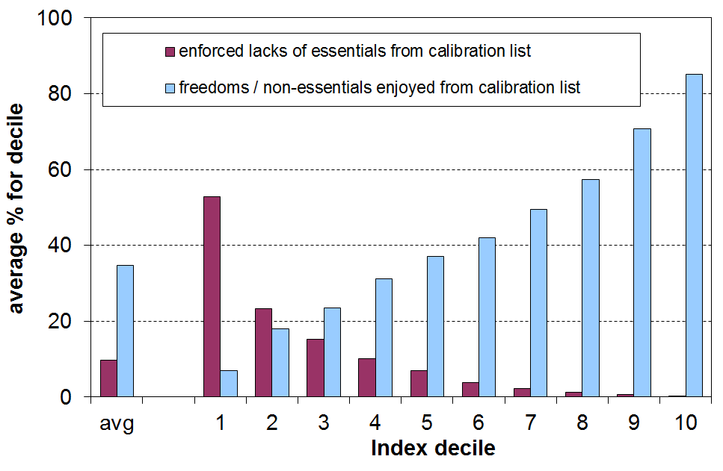

  - The ELSI hardship threshold is set at 6 or more deprivations out of 16 in the calibration list. This gave a population hardship rate of 12% in 2008, just a little above the top of the bottom decile, and close to the income poverty rate using the 50% of median AHC threshold (~13%).

  - Those in hardship using the ELSI measure have on average 8 deprivations out of the 16 used in the calibration list. This compares with around 1 out of 16 deprivations on average for those in the middle of the distribution (deciles 4 to 6). The level at which the hardship threshold is set is therefore consistent with the relative disadvantage notion in which the poor and those in hardship have “resources that are so seriously below those commanded by the average individual or family that they are, in effect, excluded from ordinary living patterns, customs and activities” (Townsend, 1979). It identifies living standards that are below a minimum acceptable standard for New Zealand today, in line with the definition used in the report.

The Material Wellbeing Index (= ELSI, mark 2)

- MSD has further developed ELSI, building off what we have learnt over the last decade of using it. The new index (the Material Wellbeing Index (MWI)) uses 13 of the 25 items from the ELSI list and 11 new ones. The 24 MWI items and 5 other new items were collected in the HES for the first time in HES 2012-13.

- The main difference between the MWI and ELSI is the removal from ELSI of the three items which asked for high level self-assessments of income adequacy, standard of living and satisfaction with standard of living, and the increased emphasis in the MWI on material things that respondents and their households have or can participate in. Overall, household rankings are very similar on the ELSI and the MWI, although there are some subtle differences for some groups because of the removal of the self-assessments from the ELSI. The main report has further detail on the make-up of the MWI.

- The change from ELSI to MWI means that there has to be a discontinuity in the HES-based material hardship series that started in HES 2007 and went through to HES 2012.

A multi-measure approach for monitoring income poverty and material hardship

- MSD’s view is that a multi-measure approach is needed to properly monitor income poverty and material hardship. Poverty and material hardship are themselves multi-dimensional, covering both input and outcome aspects (income and material hardship), differing time periods for looking at household income (one year, several years), and differing ways of updating the thresholds over time.

- For the short to medium term, MSD gives priority to trends in a “fixed line” or “anchored” income poverty measure (after deducting housing costs (AHC)), and to trends in material deprivation using non-income measures. The rationale for this is the judgement that whatever is happening elsewhere in the income distribution, low income levels should not fall, and that the actual material living conditions of those most disadvantaged should not deteriorate.

- Trends for (fully) relative poverty lines are reported, and are valued over the longer term (15 to 20+ years), but for the short to medium term these do not carry the same weight. The rationale for this position is driven in part by the ambiguous signals that trends in such (fully) relative measures can give in the shorter-term. For example:
- when all incomes at and below the median rise, but the median rises more quickly than lower incomes, then poverty is reported as increasing despite low incomes increasing
- when all incomes at and below the median fall at similar rates, poverty is reported as not changing even though low-income households are in much more difficult circumstances after the reduction in their incomes.

- The report uses the 60% of median AHC fixed line measure as the primary one for reporting income poverty trends. This does not mean that the Ministry endorses this as the poverty measure for establishing poverty levels. Rather it is the preferred measure for reporting on trends, selected on pragmatic grounds that assume that low incomes rise in real terms in the medium term and the 60% anchored threshold therefore drops towards a 50% relative line. Thus the main income poverty trend indicator can be kept broadly within a 50% to 60% band.

- Ideally, the report would be able to draw on current longitudinal data to monitor income mobility and the persistence of low incomes and hardship. The data is not available, so general stylised facts have to be drawn from what we do have to better round out the picture.

Ireland: a case study showing the importance of a multi-measure approach, and of prioritising material deprivation and anchored income poverty measures in the short to medium term

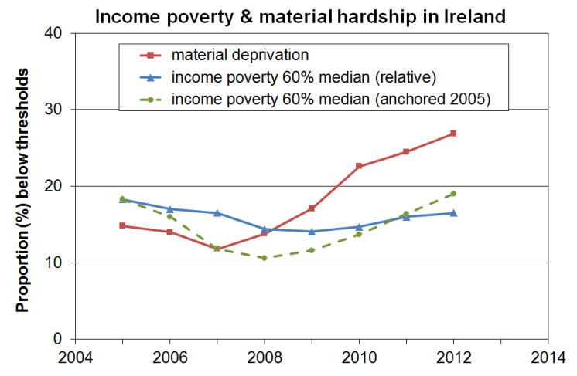
- As the Irish economy slowed and moved into recession in 2008, the material deprivation rate and the anchored poverty rate rose rapidly. On the other hand there was little movement in the fully relative income poverty measure.
- The material deprivation and anchored poverty measures provided the information needed for public policy and public debate. The fully relative measure did not.
- This reflects the fact that the material deprivation and the anchored line poverty measures each use a fixed benchmark against which to assess progress, whereas the fully relative approach does not and is essentially about the trend in inequality in the lower half of the distribution. In the recession the median and lower incomes all fell at fairly similar rates, thus producing a flattish relative poverty line.

Poverty and hardship are multi-dimensional: this report focuses on the incomes dimension
Inequality, poverty and hardship are multi-faceted and multi-dimensional. The focus for the Household Incomes Report is primarily on the incomes dimension. Income matters, but it is the cumulative impact of multiple disadvantage across different domains that has the most significant negative impact on life chances and outcomes, especially for children.

The report has a section on material hardship. It uses non-income measures to report on how households are faring in actual day-to-day living standards (adequate food and clothing, ability to keep warm, visit the doctor, and so on). These are outcome measures, and are determined by many factors in addition to income – for example, the level and quality of financial and household assets, special health costs, debt servicing requirements, and personal qualities. (See Whelan and colleagues (2014) in the references in the main report for a recent EU analysis on this theme.)

Some poverty discussions use a broader notion of poverty which is more about multiple disadvantage or about some of the consequences of poverty and hardship understood as above. Monitoring poverty understood in this way requires a different set of indicators.

On a yet broader canvas, some discussions about the meaning of poverty and hardship and about the challenges of monitoring trends include the multiple causes of poverty and hardship, at both structural-institutional and individual levels. This wider discussion is very important but is beyond the scope of this report.
Summary of Findings

The overview and summary that follows draws out the main findings and key messages from the full report. All the figures and findings in this Summary are in the main report.

The reader is referred to the full report not only for more detailed findings but also for the full description and discussion of the technical and methodological matters that lie behind the figures.

Glossary
- ‘income’ in the Incomes Report refers to household income from all sources after income tax is paid and transfers received, and after adjustment for household size and composition (equivalised disposable household income), unless otherwise stated
- AHC income is household income after deducting housing costs
BHC income is household income before deducting housing costs
- when the income distribution is divided into 100 equal groups each group is called a percentile (P) – the top of the first decile is labelled P10 as it is also the top of the 10th percentile
- poverty rates are usually reported using AHC measures, for both anchored and moving line thresholds – the reference year for the anchored measures is 2007
- OTI is the ‘outgoings-to-income’ ratio for household spending on accommodation. When a household spends more than 30% of its income on accommodation it is said to have a high OTI
- income data from three Statistics New Zealand surveys are used in the report:
HES = Household Economic Survey (most of the information is from this)
NZIS = New Zealand Income Survey, a supplement of the Household
Labour Force Survey
SoFIE = Survey of Family, Income and Employment
- median household income is the income of the middle household – for example, if there are nine households, the middle household is the one ranked #5
- mean household income is the arithmetic average of the incomes of all households
- 2013 HES is short for 2012-13 HES – interviews ask about income “from the previous 12 months”, so on average it is for around calendar 2012
- GFC – global financial crisis
- NAOTWE – net (after tax) average ordinary time weekly earnings
- NIM – a non-income measure, sometimes referred to as a non-monetary indicator
- ELSI – Economic Living Standards Index
- MWI – Material Wellbeing Index

Household incomes

1 Median household income (BHC) rose by 4% in real terms from HES 2011 to HES 2013.
- After 15 years of steady growth in median household income (3% pa in real terms from the 1994 HES to the 2009 HES), the impact of the economic downturn on household incomes began to be seen in the 2010 HES figures which showed very little change from the previous survey. In the 2011 HES the median fell for the first time since the early 1990s, reflecting the full impact of the downturn (down almost 4% from the 2009 HES).

Real household income trends, 1982 to 2013 ($2013)
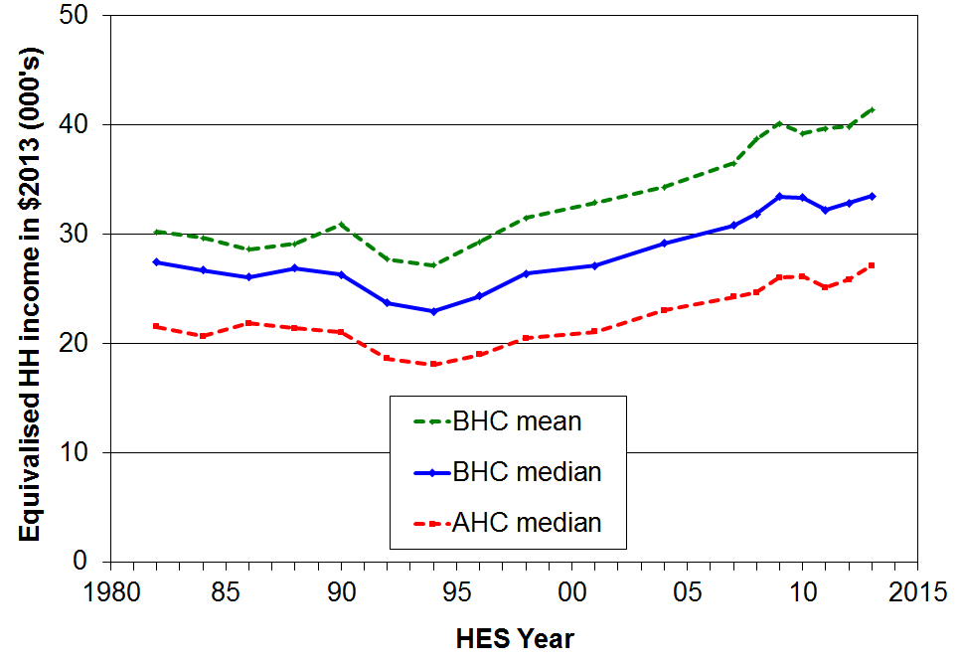

- From HES 2011 to HES 2013, the median increased by 4% in real terms, showing the impact on households of the post-recession recovery.

- The AHC (after deducting housing costs) median has tracked at close to 80% of the BHC median since the mid 1990s, compared with close to 90% in the 1980s, reflecting the higher proportion of household income now spent on housing (rent, rates, mortgage payments).

2 The immediate impact of the recent recession was felt more by low to middle income households (deciles two to six) than by households in the top four deciles, but the gains in the recovery have been more evenly spread.
- The immediate impact of the GFC and associated economic slowdown (HES 2009 to 2011) led to a 3% to 5% decline in incomes for the lower six deciles, with little change for the top four.
- The income gains were more even across the deciles in the recovery phase from HES 2011 to 2013 (4% to 7%), giving a net impact from HES 2009 to HES 2013 as in the graph below.

Real household incomes (BHC), changes for top of deciles: HES 2009 to 2013
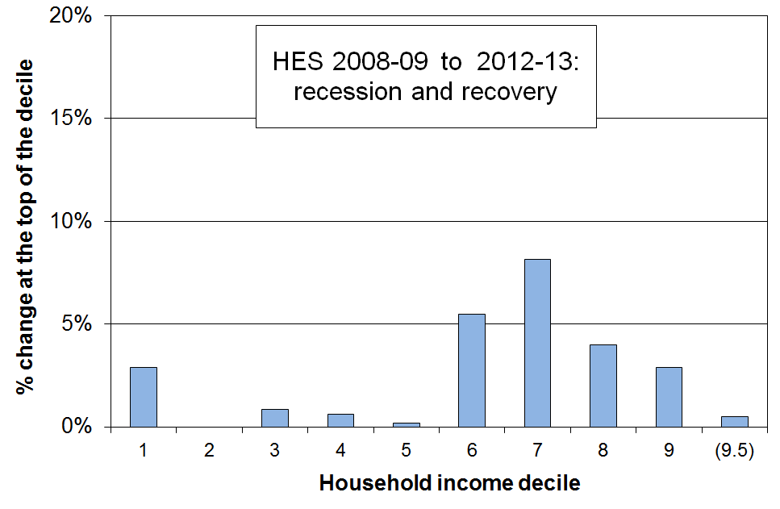
- The net gain at the top of decile one can be attributed in the main to the rise in real terms for NZS as a result of the tax cuts in 2010 which increased after-tax wages to which NZS is pegged. Households whose incomes are from NZS alone or NZS and a little more are at the top of the first decile one and into the bottom of the second.

3 Over the three decades from 1982 to 2013 different income groups fared differently over different periods. The net gains over the last two decades from the mid 1990s to 2013 were similar for all income groups. Because of this similarity in net gains, income inequality in 2013 was similar to what it was in the mid 1990s.

- From 1988 to 1994 there were declines in household income for all except the very top income group (decile ten), with the declines being larger for lower income groups.

- From 1994 to 2004, incomes for middle- to higher-income households grew more quickly than the incomes of the bottom third (around 28% and 15% respectively, in real terms).

- From 2004 to 2007 the Working for Families (WFF) package led to incomes below the median growing more quickly than incomes above the median – the only time in the 25 year period 1982 to 2007 in which this happened.

- From 2007 to 2009 the growth was relatively even across all income groups (7-9%).

- In the two decades from 1994 to 2013, household income growth was similar for deciles 3 to 10 (~2.5% pa), and just a little lower for the lower two deciles (~2% pa). See graph below.

- Because of this similarity in net gains across the board in this period, income inequality in 2013 was around the same as it was in 1994, though much higher than in the late 1980s because of the declines noted above.

Real household incomes (BHC), changes for top of deciles: HES 1994 to 2013
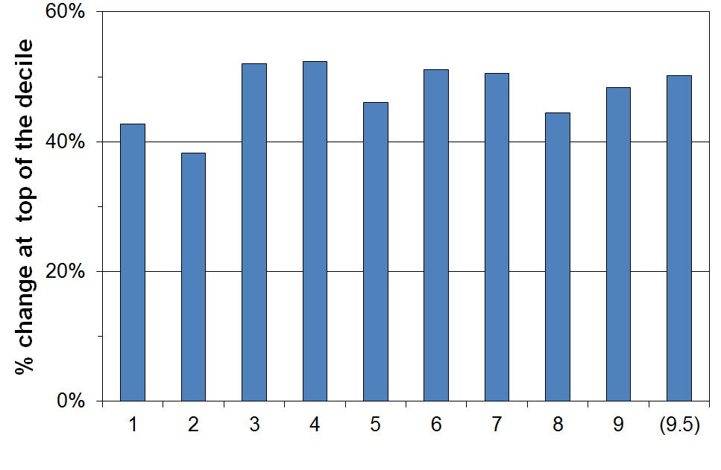

4 From HES 2004 to 2013, the net gains for the lower four deciles were greater than those for deciles 5 to 10.

- Over the decade from HES 2004 to 2013 (which includes the impacts of the WFF package, the recession and early recovery), real income gains were 22% to 25% for the lower four deciles and somewhat less (15% to 17%) for the top six deciles.

Real household incomes (BHC), changes for top of deciles: HES 2004 to 2013
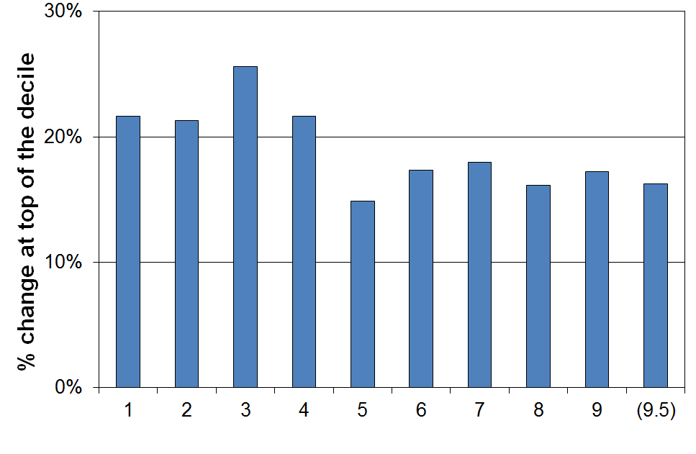
- Given that main benefit levels did not rise in the period, the relatively strong gains for the lower two deciles are at first sight surprising. The gains at the top of the two lower deciles in this period reflect several other factors:
- While 80% of those in households primarily reliant on main working-age benefits are in the lower two deciles, they make up only 38% of this income group.
- Many NZS recipients have incomes from NZS and very little else. Their incomes place them at the top of the bottom decile and into the second decile. The NZS rate is linked to changes in the after tax average wage and they rose as a result of the income tax cuts in 2008 and 2010 as well as because of gross wage increases per se. From 2004 to 2013 NZS rates rose 15% in real terms.
- The introduction of the IWTC for low-wage working families in 2006 lifted incomes of these low-income households relative to the incomes of beneficiary households. Most beneficiary families with children in effect received only a part of the FTC increases in the WFF package as they also had the notional child component removed from their core benefit.
- The rise in the minimum wage in real terms from 2004 to 2008 also raised incomes of some low-income working households.

- There is a growing gap between main benefit levels and NZS, wages and median household income.

- The table below shows the different growth / decline patterns for household incomes, average after-tax earnings, New Zealand Superannuation (NZS) and main benefits. Three reference years are used: 1983 for before the 1991 benefit cuts, 1994 for after the cuts, and 2007 for after WFF.

- A growing gap is forming between benefit levels on the one hand, and NZS, wages and household income on the other.

% change from base year
(CPI adjusted – ie ‘real’ changes)
 | 1983 to 2014 | 1994 to 2014 | 2007 to 2014
Median household income (see note below) | +25 | +45 | +5
Net average ordinary time earnings | +32 | +32 | +12
NZS | +9 | +21 | +12
DPB plus family assistance (one child) | -17 | +6 | -2
Invalids Benefit – single aged 25+ | -8 | -1 | -1
Note: The change in median household income is to calendar 2012 only (HES 2013). Assuming modest household income growth from 2012 to 2014, a further 3 to 4 percentage points needs to be added to the changes for household income noted in the table for more realistic comparisons.

- While there is no evidence of growing income inequality in the population overall or between high income households and the rest in the last two decades or so, there is evidence here that there is a growing gap between the incomes of those heavily reliant on the safety net provided by main working-age benefits, and the rest.

6 The steady rise in median household income from 1994 to 2009 was driven in part by the steady increase in the proportion of two-parent households with children with both parents in paid employment.

- Median household incomes grew 46% in real terms from the low point in 1994 to 2009. In the same period, average net (after tax) ordinary time wages grew 24% in real terms, and gross by 18%.
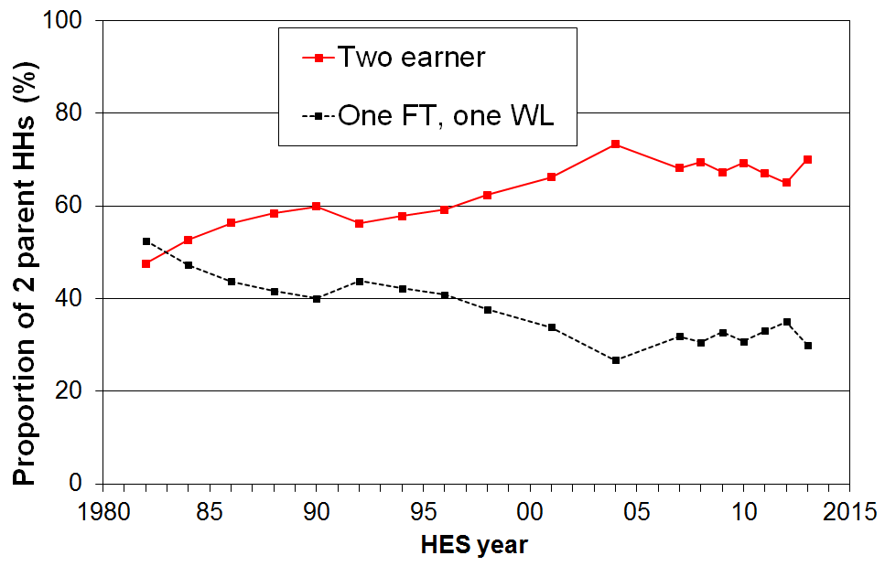
- Much of the difference between the growth of wages and the growth of household income is attributable to increased female labour force participation, especially in two-parent families with dependent children. This increased the average hours of paid employment for these households and therefore their household income rose more quickly than wages. The incomes of two-parent families are very significant in driving changes in the median.
- Around two of every three two-parent families were dual-earner families from 2007 to 2013, up from one in two in the early 1980s. The new pattern seems to have stabilised.
- The most common arrangement in HES 2013 was for both parents to be working full-time (42%), with another 28% with one full-time and the other part-time. In contrast, in 1982 the dominant pattern (52%) was one in full-time work and the other ‘workless’ (WL), with only 20% having both in full-time work.
- There are four factors that impact on household incomes for middle New Zealand families:
  - average gross wage rates in real terms
  - total household hours committed to paid employment
  - income tax rates
  - tax credits for families with children whose incomes around or just below the median.
One or more of these factors will need to contribute strongly if solid median income growth is to be seen in the next decade (cf the Ministry of Business, Innovation and Employment’s target of a 40% growth in real median household income from 2012 to 2025).

Inequality – introduction

7 Income inequality is about how dispersed incomes are, what the size of the gap is between those on ‘higher’ and those on ‘lower’ incomes. There are however many types of inequality other than income inequality that are of relevance to public policy formulation and debate, and it is useful to be clear about which sort of inequality is being discussed at any time.

- Some of the main inequalities often discussed are:
  - market income inequality for individuals:
      - wage differentials across all wage earners
      - focusing on total market income for the very top 1% or so, compared with the rest
  - inequality of disposable household income (income from all sources after taxes and transfers):
      - across all households
      - focusing on the very high income households, compared with the rest
    - inequality of wealth (total assets less liabilities).
  - inequality of community resources and amenities available to local residents
  - inequality of educational outcomes
  - inequality of health outcomes
  - inequality of socio-economic status (combining education, occupation and income)
  - inequality of opportunity.

- The major focus of the Incomes Report is on inequality of household disposable income and the shares of total market income received by top income earners, together with some reference to wealth inequality.

- It is important to maintain a clear distinction between wage inequality, household income inequality and wealth inequality. They are quite different concepts, each with their own unique characteristics.

8 Inequality and poverty are sometimes used as if they are interchangeable ideas. They are different concepts and need to be kept distinct as far as possible.

- Inequality is essentially about the gap between the better off and those not so well off (on whatever measure) – it is about having “less than” or “more than”. Poverty is about household resources being too low to meet basic needs – it is about “not having enough” when assessed against a benchmark of “minimum acceptable standards”.

- A major difference between income inequality and income poverty is that a certain degree of inequality is considered by almost everyone to be inevitable and acceptable, and even desirable. There is no similar widely held view about unacceptably low incomes and material deprivation. Income poverty and material deprivation are by definition unacceptable states of affairs. There can be and is legitimate debate over where to set the low-income or deprivation thresholds, and over the relative merits of different approaches to the income concept used (eg BHC or AHC), but there are very few who advocate for “acceptable levels” of income poverty or hardship. On the other hand, a large part of the debate about income inequality is about what is an acceptable or at a least tolerable level of income (or wealth) inequality. Unlike any debate around income poverty or hardship, there are very few calls for the elimination of income or wealth inequality.

- There is no evidence of any statistical link between the income share received by the top 1% and income poverty rates.

- There is no link between trends in income poverty using a fixed line approach and standard inequality measures.

- The strongest conceptual and statistical link between income poverty and income inequality is between the P50:P20 or P50:P10 percentile ratio inequality measures and standard fully relative income poverty measures in which the threshold is set at a selected proportion of the current median (eg 50% or 60%). All these, both the percentile ratios and the poverty measures, are about inequality in the lower half of the household income distribution and are therefore highly correlated, as expected.

- Maintaining as clear as possible a distinction between poverty and hardship on the one hand and income inequality on the other means that:
- as a society, and as groups within it, we cannot easily avoid having to make the judgement call about minimum acceptable standards, even if we use two or three standards of differing severity
- we are better placed to seek to understand the relationship (if any) between the two, rather than muddying the waters by speaking as the two are one.

9 There is no one definitive measure of income or wealth inequality: there are several common measures used for comparisons within and across nations.

- The Gini coefficient is a common measure of inequality used internationally. It gives a summary of the income differences between each person in the population and every other person. A higher score indicates higher inequality. In OECD countries scores range from 25 (eg Norway and Denmark) to 38 (USA), and even higher (eg Chile 51).

- Decile and quintile shares are commonly used, as are percentile ratios. The advantage of these over the Gini is that the meaning of the numbers is more intuitive for these than for the Gini. For example, a change in the top to bottom decile share ratio from 8 to 9 is more readily grasped by most readers than is a Gini change from 0.28 to 0.33.

- More recently, reliable OECD-wide information on high pre-tax incomes for individuals has been made available on the Top Incomes database (Paris School of Economics).

- Income information is more often collected than is wealth information, but there are signs that more countries are putting resources into collecting good quality wealth information on a more regular basis. Inequality analysis for wealth usually uses the Gini or a selection of decile and quintile share ratios.

Income and wealth inequality in New Zealand

10 Household incomes have been volatile over recent years, reflecting the on-going impact on households of the GFC and the recovery. Using the Gini measure, there is no evidence of any sustained rise or fall in income inequality since the mid 1990s. The trend-line is almost flat.

- The two distinctive features of the trend in income inequality in New Zealand in the last three decades are:
- the rapid and significant rise in income inequality from the late 1980s to the mid 1990s, taking New Zealand from well under the OECD average to well above at that time
- the fairly flat trend line from the mid 1990s to 2013.
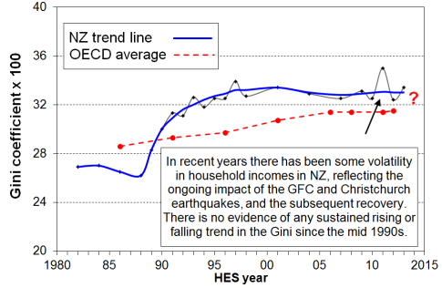
- The OECD average steadily rose over the last three decades, thus bringing the New Zealand and OECD trend lines closer together. On the latest OECD figures (2011/12), income inequality in New Zealand is at a similar level to that in Australia, Canada, Italy and Japan (Ginis of 32-33) and a little lower than the UK (34). Countries such as Denmark, Norway, Finland and Belgium have lower than average inequality (Ginis of 25-26). The US and Israel have higher scores of 39.
- Inequality can also be measured by comparing the share of income received by the top decile (10%) of households with that received by the bottom decile. The ratio for New Zealand was 8.2 in HES 2012 (the latest OECD comparison) and 8.3 in HES 2013 – that is, in HES 2012 the top decile (D10) households received on average 8.2 times the income received by the bottom decile (D1), after taxes and transfers.
- New Zealand is at the middle of the OECD rankings for the D10 to D1 share ratio. In 2011 the ratio for Canada and Australia was 8.5 and for the UK it was 9.6. At the low inequality end of the rankings, the ratio is in the 5 to 6 range for Denmark, Norway, Finland and Belgium, and at the higher end it is 16 for the US and 27 for Chile.
11 Those individuals receiving the top 1% of market income in New Zealand have an 8% share of total income (2011), similar to Norway, Finland and Australia, lower than the UK and Canada (12-13%) and much lower than the US (19%).

- Another way of looking at inequality is to track the share of total pre-tax market income that is received by the top 1%. Such information is not reliably available in sample surveys like the HES, but data based on tax returns are available for international comparisons.

- From the 1920s through to around 2011, English-speaking countries have shown a U-shaped curve for the income share of the top 1% with a lower flattish period from 1950 to the mid 1980s (“the great compression”), and rises since.

- The top 1% in New Zealand received around 8% of all taxable income in 2010 and 2011 (before tax), similar to Norway, Finland and Australia, lower than Ireland and Switzerland (11%) and much lower than the UK and Canada (13%) and the US (18%).

- The trend for the New Zealand share has been steady at around 8-9% since the mid 1990s, with perhaps a slight fall in the last few years. Many OECD countries saw small rises in the period, and in the USA the top 1% share continued to rise strongly, from 13% to 19%.

12 Overall, there is no evidence of any sustained rise or fall in inequality in the last two decades. The level of household disposable income inequality in New Zealand is a little above the OECD median. The share of total income received by the top 1% of individuals is at the low end of the OECD rankings.

Income inequality in New Zealand, 1984 to 2013 HES
 |  | 1984 | 1994 | 2004 | 2009 | 2012 & 2013 for HES, 2010 & 2011 for tax records
Household disposable income, adjusted for household size … data from sample surveys (HES) | Gini x 100 (trend-line) | 26.6 | 32.5 | 32.9 | 32.9 | 32.9
 | Share ratio, D10 to D1 | 6.1 | 8.2 | 9.1 | 8.6 | 8.3
 | Share ratio, Q5 to Q1 | 4.1 | 5.1 | 5.5 | 5.4 | 5.3
 | Share ratio, D10 to D1-4 (Palma) | 0.92 | 1.21 | 1.31 | 1.29 | 1.27
 | Percentile ratio, P90 to P10 | 3.5 | 4.1 | 4.2 | 4.4 | 4.2
 | Percentile ratio, P80 to P20 | 2.4 | 2.7 | 2.9 | 2.9 | 2.7
Individual market income … data from tax returns – avg of year noted and the one either side | Top 1% share | 5.6 | 8.9 | 9.0 | 7.8 | 7.8
 | Top 10% share | 28 | 33 | 33 | 30 | 30
 | Top 10% - 1% share (ie P90 to P99) | 23 | 24 | 24 | 22 | 22

Income inequality in New Zealand compared with other OECD countries, c 2011-2012
(%) | NZ | OECD-34 median | DNK | NOR | FIN | FRA | AUS | CAN | UK | US
Gini x 100 (trend-line) | 32.9 | 30.5 | 25.3 | 25.0 | 26.1 | 30.9 | 32.4 | 31.6 | 34.4 | 38.9
Share ratio, D10 to D1 | 8.2 | 7.6 | 5.3 | 6.1 | 5.5 | 7.4 | 8.5 | 8.5 | 9.6 | 16.5
Share ratio, Q5 to Q1 | 5.2 | 4.8 | 3.6 | 3.7 | 3.7 | 4.7 | 5.4 | 5.2 | 5.6 | 8.2
Share ratio, D10 to D1-4 (Palma) | 1.27 | 1.18 | 0.87 | 0.85 | 0.93 | 1.18 | 1.27 | 1.19 | 1.40 | 1.74
Percentile ratio, P90 to P10 | 4.2 | 3.8 | 2.9 | 2.9 | 3.2 | 3.6 | 4.5 | 4.1 | 4.1 | 6.1
Top 1% share – tax records | 8 | The latest available from 2009 to 2012 | 6 | 8 | 8 | 8 | 9 | 12 | 13 | 19
Top 5% share – tax records | 21 | The latest available from 2009 to 2012 | 17 | 19 | 21 | 21 | 21 | 27 | 28 | 36
Note: See the main report for details about the sources for the figures in the above tables.

13 Wealth is distributed more unequally than income, although the joint distribution of income and wealth is more equal than the distribution of wealth on its own.

- Wealth inequality is a very important part of the inequality story. Unfortunately, data on wealth or net worth (total assets less liabilities) are harder to come by than income data. Where it is available it is often not as robust as income data. Data on wealth mobility is very rare, especially over periods of sufficient length to monitor meaningful changes as changes are usually slow.

- There are nevertheless some well-founded findings about wealth inequality:
  - Wealth Gini scores are typically two to three times those for income.
  - In New Zealand, those in the top income decile receive close to 25% of gross income, while those in the top wealth decile hold 50% of the total wealth.
  - New Zealand’s top decile wealth share (~50%) is similar to those found in many other OECD countries: Australia, Belgium, Finland and the UK (~45%), and France and Canada (~50%). The share for Germany and Austria is around 60%, Norway 65%, and for the USA it is around 75%.
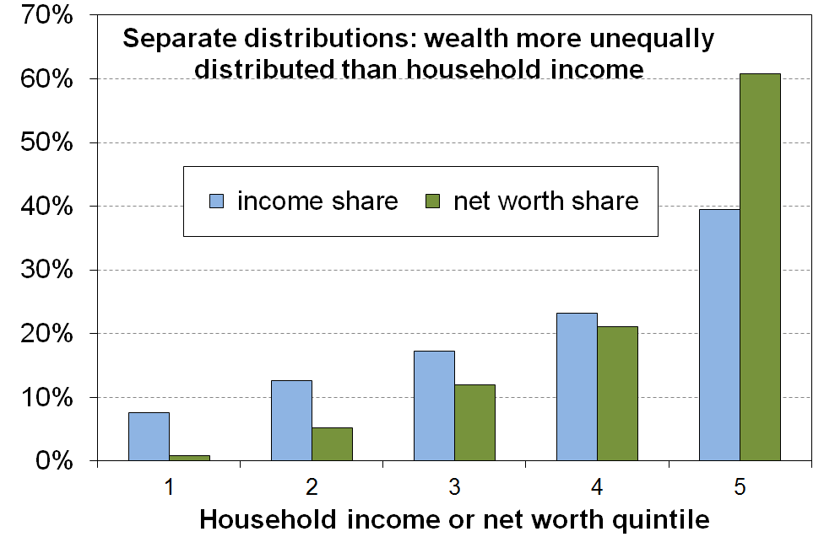
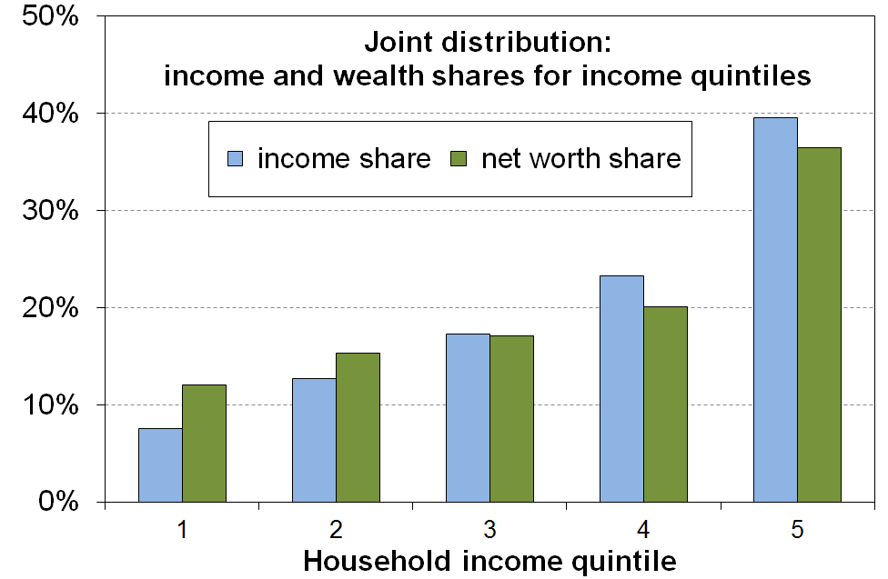
  - The joint distribution of wealth and income is much less unequal than wealth distribution per se. This is because there are many older households with lower income and higher wealth, and a good number of younger (under 45 yrs) households with high income and low to moderate wealth. The graphs below use data from the Australian Survey of Income and Housing for 2009-10.

  - The limited data available on wealth mobility points strongly to low mobility / high immobility for those with very high wealth.

14 The tax and transfer system significantly reduces the inequality that would otherwise exist.

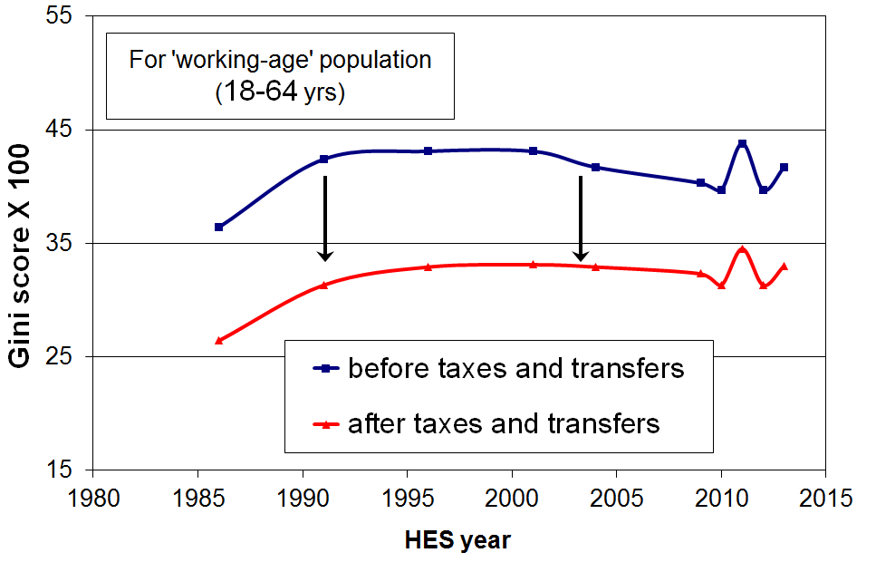
- The graph shows the inequality-reducing impact of taxes and transfers by comparing the Gini scores for household market income and household disposable (after tax and transfer) income for working-age New Zealanders.
- The reduction in the household market income Gini for this group was 21% from 2004 to 2013. This reduction is similar to Australia and Canada (22-23%), less than the UK (28%), and much lower than many European countries such as Norway, France and Austria (33-36% reductions). The median OECD reduction is 28% (c 2011).
- When the full population is used, New Zealand’s reduction in inequality is 28% compared with the OECD median reduction of 35%.
- For half of households with dependent children the amount received through welfare benefits and tax credits is greater than or equal to the amount they pay in income tax.
  - For example, single-earner two-child families with less than around $60,000 from wages pay no net income tax. They receive more from WFF tax credits than they pay in income tax and ACC.
  - Such households nevertheless pay GST on almost all the goods and services they purchase. A more comprehensive analysis needs to include tax paid through GST especially as lower-income households generally apply all or almost all their income to expenditure on GST-able goods and services, whereas higher-income households apply a lesser proportion of their income to GST-able expenditure, with a portion going to savings and interest payments which do not attract GST. GST outgoings are therefore generally a higher proportion of the income of lower-income households than for higher-income households.
- When all households are counted (working age with children, working age without children, and 65+ households), and looking at households grouped in deciles rather than looking at individual households, the total income tax paid by each of the bottom four deciles is less than the total transfers received (tax credits, welfare benefits, NZS and so on). It is only for each of the top five deciles that total income tax paid is greater than transfers received.

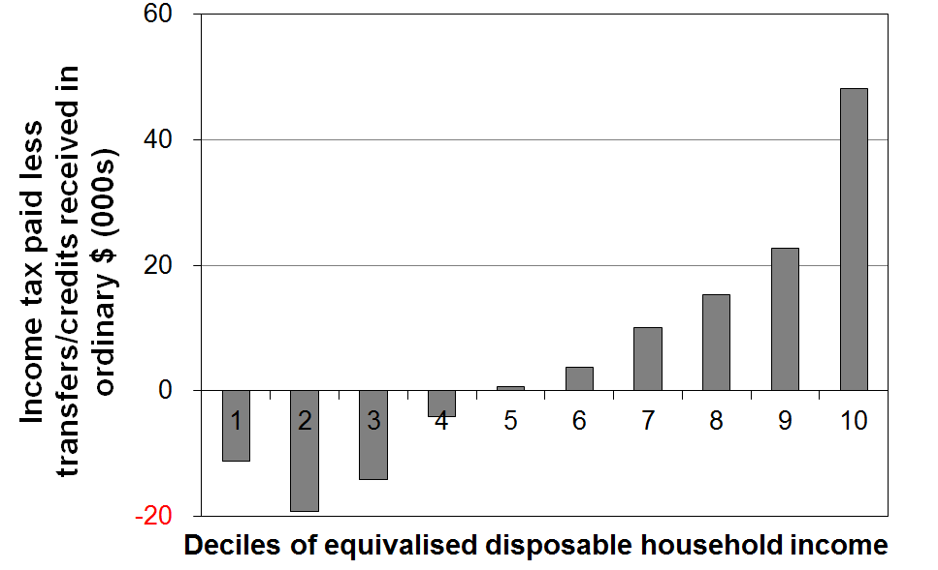
Accommodation costs relative to household income

15 The proportion of lower-income households (those in the bottom two quintiles, Q1 and Q2) with high OTIs rose strongly from HES 2009 to HES 2012. For Q1 the rise was from 33% to 43% - it remained unchanged to HES 2013. Housing stress in the second quintile (Q2) began to increase earlier, rising from 27% in 2004 to 36% in 2013.
- In HES 2013, 27% of households had high OTIs (more than 30%), above the rate for the mid 1990s (22-24%), and much higher than in 1988 (11%).
- This rising long-run trend applies to all income groups, but high housing costs relative to income are often associated with financial stress for low- to middle-income households. Lower-income households especially (Q1 and Q2) can be left with insufficient income to meet other basic needs such as food, clothing, transport, medical care and education for household members.
- The graph below shows that for the bottom quintile (Q1), the proportion with high OTIs steadily reduced from 48% in 1994 to 34% in 2004, as unemployment fell, employment and income rose, and income-related rental policies were introduced in 2000 for those in HNZC houses. From HES 2009 to HES 2013 the proportion rose strongly from 33% to 42%, the highest it has been in the last 25 years except for the peak of 48% in 1994.
- For households with incomes in the second quintile (Q2) there was a strong rise from the 1980s through to the mid 1990s, followed by a relatively flat trend to 2004. Since 2004, the proportion with high OTIs has risen strongly from 27% to 36%.
- For the third quintile (Q3) the proportion with high OTIs settled at around 30% for 2007 to 2013, up from 21% in 2004 and 10% in 1988.

Proportion of HHs with housing cost OTIs greater than 30%, by income quintile
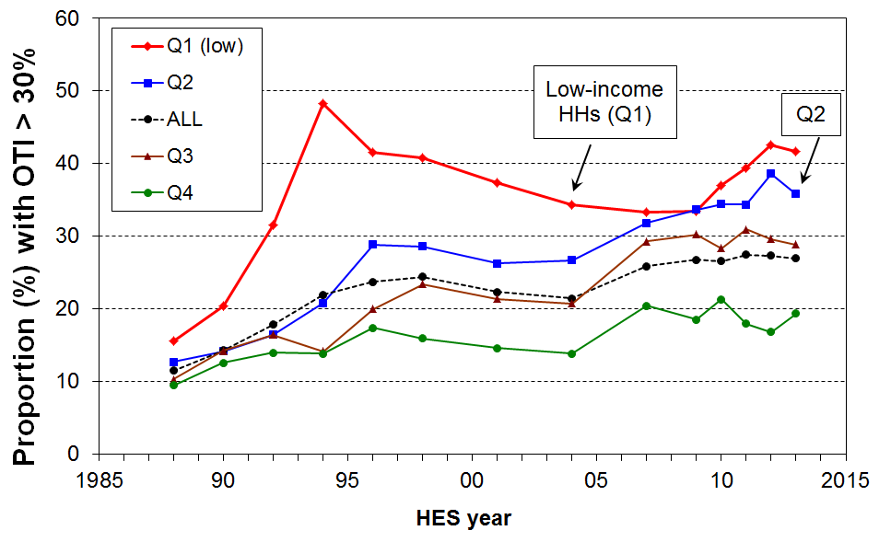
- From the mid 1990s to 2013, around 13-15% of households had an even higher OTI – greater than 40% – up from 5% in the late 1980s. For those in Q1 (bottom quintile), the proportion with these higher OTIs peaked in the mid-1990s at 34%, was lower at 25-27% from 2004 to 2009, but in 2013 was again at 34%. The proportion of households in the second quintile with these higher OTIs rose from around 15-16% in the early 2000s to 20-21% in 2011 to 2013.
- The increasing housing stress for lower-income households reflects significant rises in gross housing costs for many of these households and household incomes that are rising more slowly than housing costs. In addition, the policy settings for the Accommodation Supplement (AS) have remained unchanged since 2005 which means that an increasing proportion of AS recipients are receiving the maximum payment (33% in 2007 and 50% in 2013).
- In June 2013, almost all renters (94%) receiving the AS spent more than 30% of their income on housing costs, three in four spent more than 40% and one in two (48%) spent more than 50%.
Poverty and hardship trends

16 The Incomes Report uses household incomes after deducting housing costs (AHC incomes) for its primary measures of low income / poverty rates.
- The report promotes AHC measures as more robust than BHC measures when using household income as an indicator of material wellbeing (a central goal of the report). Among other things, it allows more sensible comparisons between groups with quite different housing costs but similar BHC incomes.
- Housing costs accounted on average for a much greater proportion of household income for low-income households in 2013 than in the 1980s. This increase cancelled out the gains in BHC incomes for low-income households, leaving AHC incomes for bottom decile households lower in real terms in 2013 than in the 1980s, and much the same for those in the second decile.

17 The Incomes Report uses the “anchored line” approach as its primary one for monitoring medium-term trends in income poverty. Reported poverty levels depend significantly on judgement calls about the threshold used, though in practice there is a limited plausible range of thresholds.
- For monitoring low income / poverty trends in the short to medium term, the Incomes Report uses the “anchored line” approach as this gives a clear indication of what is happening to low incomes in real terms, irrespective of trends in the median or other parts of the income distribution. The Incomes Report takes the view that any positive assessment of social progress requires “anchored” low-income / poverty rates to be falling, whereas the assessment of the meaning of trends for moving line measures is not always straightforward. See the introduction of this Summary for more detail (pp 6-7).
- The OECD is now taking the anchored line approach more seriously in its reporting, and in a report due out later in 2014 UNICEF is also planning on using this approach.
- For reporting on low income / poverty levels the report uses 50% and 60% of median lines for AHC incomes (and 40% for the population as a whole), consistent with the view that poverty and material hardship exist on a spectrum from less to more severe.
  - The 60% of median AHC moving line measure is at the upper end of any credible range of thresholds.
  - The 50% of median BHC moving line measure is a very stringent one. At this level of household income (which includes housing support), many working-age households have to use 50% or more of their budget on housing costs which leaves very little for other essentials.
- In recent years it has become increasingly common for commentators and others to talk about the 60% of median AHC moving line measure as “the” poverty measure as if it were the official New Zealand measure:
  - There are no official New Zealand measures in the sense of a set of measures given formal legitimacy by a government. There is certainly no single measure that is “the” official measure.
- Even if there were a formally endorsed single measure of income poverty about which there was widespread agreement, the fact remains that household income on its own cannot precisely and unambiguously categorise the population into those with and without adequate resources to support a minimum adequate standard of living. This is clear both from the implications of the incomes-wealth-consumption-material-wellbeing framework outlined in the introduction (pages 4-6), and from robust findings from the analysis of the imperfect overlap between the low-income group and those identified as in material deprivation. So, just as for household income in general so also for low-income cut-offs (poverty lines) in particular. They are valuable monitoring instruments, but we need to use them with an awareness of their limitations and imperfections, refraining from over-claiming what they tell us while still drawing on the clear trend and relativity findings that they do produce.
18 In the 2012-13 HES population poverty rates were much the same as in the 2011-12 HES on all the standard measures, and were down by one to two percentage points on the higher levels reached in the 2010-11 HES after the GFC impact.

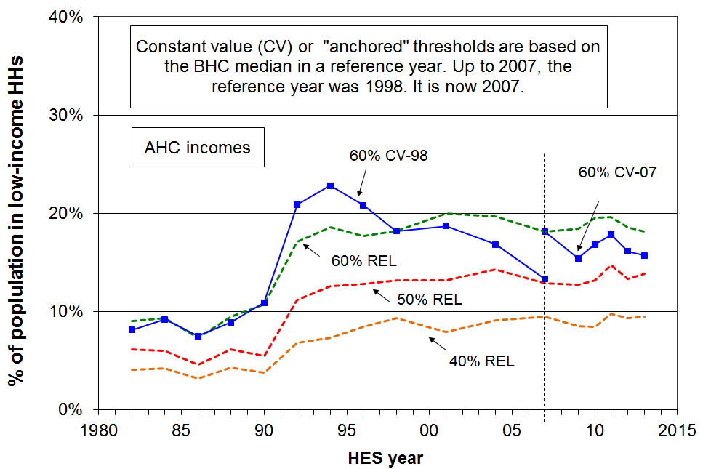

- Using the 60% of median AHC anchored or fixed line measure:
  - the population poverty rate fell strongly from 23% in 1994 to 13% in 2007 (using 1998 as the reference year)
  - using 2007 as the reference year, the population poverty rate fell from 22% in 2004 to 15% in 2009, before the impact of the GFC and rising housing costs drove an increase to 18% in the 2011 HES
  - in the 2013 HES it was down to 16% reflecting the impact of the recovery.
- Using AHC moving line measures, which reflect how many households have incomes that are judged to be “too far” below the median:
  - poverty rates were reasonably steady from the mid 1990s to 2013 – 18% to 20% using the 60% of median measure, and 13% to 14% using the 50% of median measure
  - on both measures, rates in 2013 were around double what they were in the late 1980s, reflecting both increased housing costs relative to income, and some modest increasing inequality in the lower half of the distribution for BHC incomes.

- In 2013, the total population figure was 4.37m. On the measures reported in the table below (p25), between 400,000 and 800,000 people were in households with incomes below the low-income thresholds (ie ‘in poverty’), depending on the measure used.
- In 2013, on the AHC ‘fixed line’ 60% measure, there were 690,000 (16%) below the low-income threshold (ie ‘in poverty’), down from 750,000 in 2007 and 865,000 in 2004.
- New Zealand ranks in the middle of both OECD and EU countries on the 50% and 60% of median BHC measures respectively.

19 On all but one of the standard measures, poverty rates for children in the 2012-13 HES were around 3 percentage points lower than in the 2010-11 HES, back to close to their levels in the 2008-09 HES, just before the impacts of the GFC on household incomes.

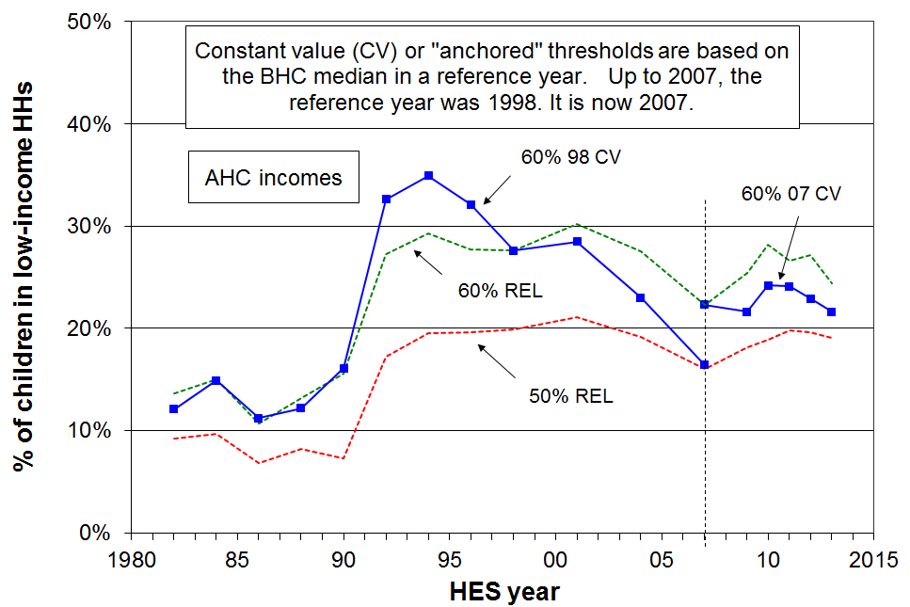

- On the 60% of median AHC anchored or fixed line measure:
  - the child poverty rate fell strongly from 35% in 1994 to 16% in 2007 (using 1998 as the reference year)
  - using 2007 as the reference year, the child poverty rate increased from 22% to 24% as the impact on the GFC on employment and household incomes took effect from 2008-09
  - by the 2012-13 HES, it had fallen back to the pre-GFC level of 22%.
- Using AHC moving line measures:
  - child poverty rates were reasonably steady from 1994 to 2001, then declined quite strongly to 2007 as a result of improving employment rates, the introduction in 2000 of income-related rents for those in HNZC houses, changes to the AS settings in the mid 2000s and the WFF package
  - the child poverty rate on the 60% of median AHC measure is lower in 2013 (24%) than immediately after the GFC crisis (28%), but there is no measurable change using the 50% line (down from 20% to 19%)
  - on both the 50% and 60% AHC moving line measures, child poverty rates are still around double the rates they were in the late 1980s (8% &13% compared with 19% & 24%).
- The longer-run findings on child poverty reflect two factors: first, AHC incomes in 2013 for low-income households were around the same as they were in the 1980s in real terms, and second, median household income has risen in real terms in the period. This means that the incomes of lower-income households with children are further from the median (ie there is higher inequality in the lower half of the distribution in 2013 than in the 1980s).

- In 2013, there were 1.06m dependent children (under 18) – on the measures in the table below, between 120,000 and 260,000 children were in households with incomes below the low-income thresholds (ie ‘in poverty’), depending on the measure used. This is 30,000 to 40,000 lower than at the high point after the GFC impact in the 2009-10 and 2010-11 surveys. The exception is the 50% AHC moving line measure where there is no measurable change post-GFC.
- In 2013, on the AHC ‘fixed line’ 60% measure, there were 230,000 children (22%) in households below the low-income threshold (ie ‘in poverty’), much the same as in 2007 and down from 320,000 (31%) in 2004.
- For child poverty rates using BHC incomes, New Zealand ranks in the middle of EU countries on the 60% of median measure, and a little above the OECD median on the 50% measure.

Income poverty rates and numbers for five measures

Whole population
rates | AHC |  |  | BHC
HES year | AHC ‘fixed line’ (07) 60% | AHC ‘moving line’ 60% | AHC ‘moving line’ 50% | BHC ‘moving line’ 60% | BHC ‘moving line’ 50%
1988 | - | 10 | 6 | 14 | 7
1994 | - | 19 | 13 | 15 | 7
2001 | 25 | 20 | 13 | 18 | 8
2004 | 22 | 20 | 14 | 21 | 10
2007 | 18 | 18 | 13 | 18 | 10
2009 | 15 | 18 | 13 | 18 | 9
2010 | 17 | 19 | 13 | 19 | 10
2011 | 18 | 20 | 15 | 19 | 10
2012 | 16 | 19 | 13 | 18 | 8
2013 | 16 | 18 | 14 | 18 | 9

numbers
2004 | 865,000 | 780,000 | 565,000 | 840,000 | 410,000
2007 | 750,000 | 750,000 | 535,000 | 755,000 | 415,000
2009 | 650,000 | 775,000 | 535,000 | 750,000 | 395,000
2011 | 765,000 | 845,000 | 635,000 | 810,000 | 430,000
2013 | 685,000 | 790,000 | 605,000 | 775,000 | 395,000

Children (aged under 18 years)
rates | AHC |  |  | BHC
 | AHC ‘fixed line’ (07) 60% | AHC ‘moving line’ 60% | AHC ‘moving line’ 50% | BHC ‘moving line’ 60% | BHC ‘moving line’ 50%
1988 | - | 14 | 9 | 20 | 11
1998 | - | 28 | 20 | 20 | 9
2001 | 37 | 30 | 21 | 24 | 12
2004 | 31 | 28 | 19 | 26 | 14
2007 | 22 | 22 | 16 | 20 | 13
2009 | 22 | 25 | 18 | 19 | 11
2010 | 24 | 28 | 19 | 23 | 14
2011 | 24 | 27 | 20 | 22 | 13
2012 | 23 | 27 | 20 | 21 | 12
2013 | 22 | 24 | 19 | 20 | 11

numbers
2004 | 320,000 | 285,000 | 200,000 | 265,000 | 150,000
2007 | 240,000 | 240,000 | 170,000 | 210,000 | 140,000
2009 | 230,000 | 270,000 | 195,000 | 210,000 | 115,000
2010 | 260,000 | 300,000 | 200,000 | 245,000 | 150,000
2011 | 255,000 | 285,000 | 210,000 | 230,000 | 140,000
2013 | 230,000 | 260,000 | 205,000 | 215,000 | 120,000

[In the next section (paras 20 to 27) the poverty measure used is the Social Report’s AHC 60% of median fixed line measure (2007 as reference year), unless otherwise stated.]

More on income poverty for population groups, especially children and older New Zealanders

20 Poverty rates for children in beneficiary families are typically around 75% to 80%, much higher than for children in families with at least one adult in full-time employment (11% in 2012 and 2013).
- After the benefit cuts in 1991, just over 75% of children in beneficiary (‘workless’) families were identified as poor in each HES for the next decade (using 1998 as the reference year). This compared with around 25% before the cuts. Using 2007 as the reference year, the average poverty rate for children in beneficiary families was again close to 75% for 2011 to 2013.
- For beneficiary families with children, AHC household incomes from main benefits, the Family Tax Credit and the Accommodation Supplement are below the AHC 60% anchored line threshold. For beneficiary families in private rental accommodation, their AHC incomes are often only around half of this low-income threshold.
- This raises the question as to why the reported poverty rate for children in beneficiary families is not therefore 100%? There are typically 20-30% of children living in households receiving a main benefit which over the 12 months before the HES interview also received market income. This market income is either from their parent(s) or from other employed adults in the household. The paid employment can be part-time work or full-time work in a part of the year when not in receipt of a benefit. This extra income is enough to take total household income “over the line” for some of these households.
- At 31 March 2014 New Zealand had 200,000 children (19%) dependent on an adult or adults in receipt of a main benefit, down from 233,000 (22%) in 2010 and 280,000 (30%) in 1998.
- In 2013, around 24% of children (260,000) were in households with no full-time worker at the time of interview. The 260,000 does not relate directly to the 200,000 in the previous point as (a) some of the households in which children live have both full-time workers and beneficiaries in them, (b) some have both part-time workers and beneficiaries in them and (c) some children live in working households where the adults work part-time only. Around 15% of children are in households where there is no adult in paid work at all.

21 Nevertheless, on average from 2007 to 2013, two in five poor children (38%) were from households where at least one adult was in full-time employment or was self-employed, down from around one in two (50%) before WFF (2004).
- The WFF package had little impact on poverty rates for children in beneficiary families (close to 75% in both 2004 and 2007), but halved child poverty rates for those in working families (22% in 2004 to 12% in 2007, and close to the same since then).
- Because there are many more children in working families than in workless or beneficiary families, the proportion of poor children who come from working families is much higher than the poverty rates themselves at first sight suggest.
- On average from 2007 to 2013, two in five poor children (38%) came from working families where at least one adult was in full-time employment or was self-employed, down from just over one in two before WFF. For HES 2012-13 the proportion was 41%.
- Using material deprivation measures (MSD’s ELSI and MWI), the proportion of children in hardship coming from working families is even higher at around 50%.
- The New Zealand proportion is not unusual. Similar challenges regarding “the working poor” are found in most OECD countries.

22 Children in sole-parent families have a higher risk of income poverty than those in two-parent families (51% compared with 13% in 2013). Half of poor children lived in sole-parent families and half in two-parent families in 2013.
- Around 90% of sole-parent families had incomes below the overall median in 2013, compared with 50% for two-parent families with dependent children.
- The higher poverty rate and lower family incomes for sole-parent families reflect two things: (a) there is only one potential income earner in the family, and (b) the full-time employment rate for sole parents is relatively low (35% in 2013). 73% of sole parents were in receipt of a main benefit in June 2009. (get later figure)
- From 2007 to 2013 half of poor children were from sole-parent families, higher than in the early 1990s (40%) and much higher than the late 1980s (20%). This long-run change reflects first of all the cutting of benefit rates in 1991, but also both the higher proportion of children living in sole-parent families in 2007-2013, and the higher proportion of two-parent families which are dual-earner families in 2007-2013.
- Around one in three sole-parent families live in households with other adults. Child poverty rates for children living in these sole-parent families (20% to 25%) are much lower than for those in sole-parent families living on their own (65% to 70%) because of the wider household financial resources available to them, both directly and indirectly.

23 Poverty rates for Maori and Pacific children are consistently higher than for European/Pakeha children: on average from 2011 to 2013, just under half (48%) of poor children were Maori or Pacific.
- On average from 2011 to 2013, around 16% of European/Pakeha children lived in poor households, 28% of Pacific children, and 34% of Maori children (double the rate for European/Pakeha children).
- The higher poverty rate for Maori children is consistent with the relatively high proportion of Maori children living in sole-parent beneficiary families and households (eg in March 2013, 44% of DPB recipients were Maori).
- On average from 2011 to 2013, just under half (48%) of poor children were Maori or Pacific: for children overall, around 34% were Maori or Pacific.
- The sample size is too small to allow more precise poverty rates or breakdowns to be given for the smaller ethnic groupings.

24 Seven out of ten poor children live in rental accommodation.
- On average over 2010 to 2012 the poverty rate for children in HNZC accommodation was 54%, those in private rental accommodation 38%, and for those in privately owned homes 13%.
- Just over 70% of poor children live in rental accommodation (53% private rental, 19% from HNZC).
- Around 40% of all children live in private rental or HNZC accommodation, and 60% in privately owned homes (80% of which have mortgage payments).

25 The poverty rate for working-age adults living on their own trebled from 1984 to 2007 on the AHC fixed line measure, and has remained high since (29% in 2013).
- One-person working-age households currently have the second highest poverty rate by household type (after sole-parent households). The rate is high in itself (29%) and high relative to the population as a whole (16%). It is higher than for children (22%) using the same measure.
- There is little difference in the poverty rate for younger (aged 18 to 44 years) and older (aged 45 to 64 years) one-person households, 28% and 30% respectively.
- The poverty rate for this group trebled from 1984 (10%) to 2007 (30%), based on the AHC 60% of median fixed line measure (with 1998 as the reference year).
.
26 While the value of New Zealand Superannuation (NZS) relative to wages was steady from 2004 to 2013, its value relative to median household income declined to a low of 48% in the 2008-09 HES before rising to 54% in the 2012-13 HES.
- While NZS for a couple remained steady at close to 66% of net average ordinary time earnings from 2004 to 2013, its value relative to median household income declined from 58% in 2001 to 48% in 2009.
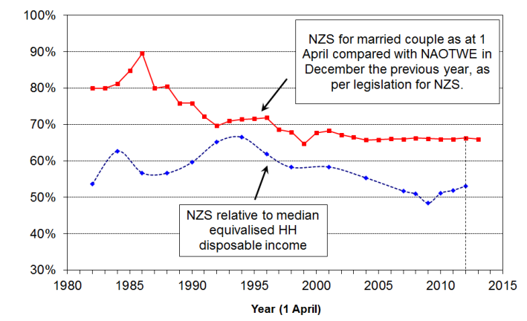
- This relative decline reflected the fact that median household income rose quite strongly in real terms from 2001 to 2009 (+23%), while NZS increased only modestly in real terms (+2%).
- From HES 2009 to HES 2013 the value of NZS recovered to around 54% of the median. The turnaround reflects the combination of: (a) a small net increase in median household income from 2009 to 2013, and (b) the larger increase in NZS (11% in real terms) arising from the tax cuts in 2008 to 2010 and real rises in wages (to which NZS is pegged).
- The vast majority of older New Zealanders remain heavily dependent on NZS for their income:
- 40% have next to no other income, and the next 20%, those in the middle income quintile for older New Zealanders, receive 80% of their income from NZS
- around half of older New Zealanders receive less than $100 pw from non-government sources (eg employment, private superannuation, other investment returns).
- If a 50% of median BHC poverty measure is used (as the OECD does), then the reported poverty rate for older New Zealanders shows a sudden and large increase from close to zero in 2001 to 22% in HES 2009, followed by a similarly large decrease to 13% for 2010 and 11% for 2013.
- This sudden rise and fall of the income poverty rate for older New Zealanders on this measure can easily leave the misleading impression that there was a very large and sudden change for the worse in the actual living conditions of many older New Zealanders, followed by an equally sudden improvement. Neither conclusion is warranted. The rapid changes simply reflect the strong clustering of household incomes for older New Zealanders at and just above the level of NZS (the “pensioner spike”) in the New Zealand income distribution.
- This sort of anomaly is one of the reasons behind the Incomes Report’s advocacy for giving priority to AHC incomes and to non-income measures for assessing the material wellbeing of households, especially for comparing the relative positions of different population groups and monitoring changes over time.

27 Income poverty rates for older New Zealanders still remain lower than those for other age groups when using incomes after deducting housing costs (AHC).
- In 2013, the 60% AHC fixed line poverty rate for the 65+ age group was 7%, compared with 13% for 45-64 year olds, 16% for 18-44 year olds, and 22% for children (aged 0-17 years).
- Similar relativities are shown using the 50% of median moving line AHC measure: 5%, 12%, 15% and 19% respectively.
- Income poverty rates among the 65+ group are higher for those on their own than for couples. For example the average rates for HES 2012 to HES 2013 were 7% and 12% respectively.
- The age group relativities are not new, although the gap between children and older New Zealanders is smaller in 2013 than it was in 1990s. A similar gradient is found using non-income measures. For example, using MSD’s Economic Living Standards Index (ELSI), 5% of older New Zealanders and 17% of children were identified as “in hardship” (2011-12 HES), using a fairly stringent threshold which gave a population hardship rate of 13%.
- The lower AHC income poverty and low material hardship rates for older New Zealanders reflects the mix of universal public provision (mainly NZS) and the private provision built up by most of the current cohort over their lifetime. A key component of this private provision is mortgage-free home ownership which is relatively high among the current cohort.
- This highlights the importance of using the incomes-wealth-consumption-material wellbeing framework for understanding and interpreting traditional income poverty figures, as outlined in the introduction to this Overview and Summary.

Income mobility and poverty persistence

28 The income information above is based on data from repeat cross-sectional surveys from the HES series. For each survey a different sample of households is selected and different individuals are interviewed each time. It is very important too to have longitudinal income information, where the same individuals are followed from one wave of a survey to the next.

- Longitudinal data can give a quite different perspective on trends over time and make possible a richer analysis that can address a new set of questions around income mobility and the persistence of low-income. For example:
  - If 20% of New Zealand children are identified as poor in a given year, what proportion of these stay poor over several years or even longer, and for how many is the low income experience “just” a temporary one?
  - How much does the household income of individuals change over time? Do most people remain in much the same relative position over 5-10 years, or do most move quite a lot?
  - How does income mobility in New Zealand compare with mobility in other countries?
  - Higher income inequality is sometimes seen as more tolerable if there is reasonably high income mobility. How much does income mobility reduce single-year income inequality when inequality is measured for incomes averaged over increasing numbers of years?
- Longitudinal data are available from Statistics New Zealand’s Survey of Families, Income and Employment (SoFIE) for 2002 to 2009. SoFIE has run its course, and there is currently no nationally representative longitudinal survey of New Zealand households that is collecting income and wealth data. Nor is there any longitudinal data collection that follows individuals after they move off a main benefit and into paid work, caring responsibilities, study or elsewhere. We therefore have to rely on data and research from countries like the UK and Australia for longer-term analysis of income mobility and for information on the trajectories of individuals as they move off and (back) onto benefits.

29 Income mobility
- A common way to look at income mobility is to rank individuals by their household incomes, group them into deciles or quintiles, and then see how many move from their original position in the first year to another position in a later year. Some go up, some go down, and others remain in much the same place.
- Over the seven SoFIE waves (annual surveys) there is considerable relative movement. While some move quite a distance, much of the movement is relatively short-range. Patterns for New Zealand are much the same as for countries like Australia, Canada, the UK, Germany, France, Belgium and Ireland.
- For example, after seven waves, just over half the population (54%) were still in either the same decile they started in or in one either side. The figure for the UK was 53%.
- Looking just at those aged 0-57 years in wave one:
- of those starting in deciles 1-3, just over half were still there in wave 7, a quarter had moved up to deciles 4 and 5, and a quarter into the top half (deciles 6-10)
- of those starting in the middle of the income distribution (deciles 4-6), 43% were still there in wave 7, 35% had moved up to deciles 7-10, and 23% had moved down
- of those starting in the top decile, 63% were still there or were in decile 9 in wave 7.
- Income mobility can also be looked at in terms of changes in real (CPI-adjusted) income. On this basis it was found that (during a period when cross-sectional incomes were growing on average for all deciles):
- 20% of those starting in the lowest quintile experienced a net decrease in real income over the 7 waves, 30% doubled their income, and the remaining 50% all experienced real increases of substance, albeit less than double
- overall, 38% experienced real declines, and for a third of these the decline was significant (40%+).
- All of this serves as a reminder of the great variety of income trajectories that different individuals have, a perspective not available when using cross-sectional surveys.

30 Poverty persistence and “chronic poverty”

- Cross-sectional income surveys (like the HES) can tell us how many people are in low-income households at a point in time. They cannot tell us how long people have been in low income nor how much movement in and out of low income there is over time. Longitudinal data can do that.
- Using the 50% of median gross household income threshold produces a cross-sectional population poverty rate of around 15% in each SoFIE wave, and 20% for children. The SoFIE data shows that:
- 39% of the whole population experienced income poverty in at least one wave out of the seven
- 17% were in low income for at least three out of seven waves (11% for 4+)
- 2% were in low income for all seven waves (4% in all or all but one wave)
- The corresponding figures for children are 47%, 13% and 3%.
- Thus, cross-sectional poverty rates can be said to both understate and overstate the “true” low income or poverty experiences of the population:
  - they understate because just over double the number in poverty in a given wave experience at least one year with low income over a seven year period
  - they overstate because the number experiencing more than half the seven years in poverty is lower than the cross-sectional rate.
- Counting the number of waves for which people are below a given poverty line is a straightforward approach but it clearly has limitations, and can be misleading in the impression it leaves. For example, the fact that so few remain in poverty for all or all but one of the seven waves can point to the conclusion that mobility is sufficient to address most concerns that are raised by cross-sectional low-income issues. As the “chronic poverty” section below will show, this is not the case. The main limitation of the number-of-waves approach is that it does not pick up those whose incomes fluctuate from below to just above the line, and vice versa.

Chronic poverty
- One way to address the issue of how best to report on poverty persistence, given that for many households their incomes fluctuate from just above to just below the poverty line and vice versa, is to look at people’s average income over the seven SoFIE waves and to compare that with the average poverty line over the seven waves. People whose average income is below the average poverty line over the seven waves are said to be in chronic poverty.
- By examining the relationship between those in chronic poverty and those in current poverty in each wave, a useful set of findings emerges that allows us to look at cross-sectional income poverty findings with longitudinal eyes.
- The chronic poverty rate is typically around 70% of the current poverty rate for the population as a whole, a little higher for children and Maori (~80%). For example, if the population rate in a given year is 14%, the chronic poverty rate will be 10%.
- However, those in chronic poverty do not form a subset of those in current poverty in a given wave. Some who are in current poverty in a particular wave are not in chronic poverty. Similarly, some who are in chronic poverty are not in current poverty each wave. The diagram below summarises the relationship between current and chronic low income.

Current and chronic poverty:
the chronic oval (on the right) is around 70% the size of the current oval (on the left),
but not all in the chronic oval are in the current oval
current and chronic
current only
chronic only

  - for the population as a whole: out of every 100 in current poverty at any time 50 are also in chronic poverty, and in addition another 20 not in current poverty are in chronic poverty
  - for children, out of every 100 in current poverty at any time 60 are also in chronic poverty, and in addition another 20 not in current poverty are in chronic poverty.
- Thus, looking at cross-sectional rates with longitudinal eyes:
- in any wave, around half are in both chronic poverty and current poverty, the other half being only in current poverty (ie more temporary or transient poverty)
- the people in this more transient group change a lot over seven waves which is why it turns out that the number in low income at least once in seven waves is around double the number in low income at any one time (see above)
- in addition to those identified as being in current poverty in a wave there is another group who are in chronic poverty but not in current poverty
- chronic poverty rates are around 70% of the cross-sectional rates for the population as a whole and more like 80% for children
- very similar findings have been produced for the UK and Australia.
- This picture is in some ways similar to the one we have for the beneficiary population. At any given time, a majority of those on benefit will have been on benefit for many years. A smaller number are new entrants or fairly temporary recipients. Over several years the number who have been on benefit at any time is much greater than the number on benefit at a particular point in time because of the cumulative effect of these temporary recipients.
- The number-of-waves-in-poverty approach can easily lead to an overly optimistic view of the ability of income mobility to resolve low-income issues for the bulk of low-income households.

Material hardship using non-income measures (NIMs)

31 The incomes approach for assessing relative material wellbeing has much to offer, but cannot on its own give a full picture – a more comprehensive perspective is made possible by using information from non-income measures as well.
- The incomes approach has some well-known limitations for assessing the material wellbeing of households:
- as noted in the introduction above, it does not take into account the impact of wealth (such as household assets and financial savings) which can buffer against fluctuations in household income
- it does not capture the impact of unusual costs (such as high health costs or high debt servicing costs), nor of assistance in cash or kind from outside the household
- international income poverty comparisons are especially limited because of differing average incomes across the countries being compared – see #37 below.
- A non-income approach can provide supplementary information to give a more complete picture as well as providing more robust findings where the incomes approach is especially limited. This information can be used in its own right or together with income data to monitor the material wellbeing of New Zealanders.
- From HES 2007 to HES 2012 the HES collected information on the 25 items that go to make up the Ministry’s ELSI measure. This section mainly uses the ELSI measure to report on material hardship.
- The Ministry has significantly revised and improved the ELSI and has developed a 24-item Material Wellbeing Index (MWI) which uses a refreshed set of non-income measures. These new items were included in the 2013 HES. This means that the material hardship time series has to have a discontinuity from HES 2012 to HES 2013, so no trend data are available from HES 2012 to HES 2013.

32 Both the incomes (AHC) and the NIM approaches identify the same population groups that have high and low poverty or hardship rates. However the actual overlap of the ‘income poor’ and ‘those in material hardship’ is only around 50%, a finding in line with international research.
- The limited overlap is not unexpected as day-to-day living standards for a household are determined by much more than just current income: for example past income, the state of repair and range of household goods and appliances in the household, the support in cash and kind from people outside the household, the extra demands on the budget from special health costs and high debt servicing commitments all have an impact over and above current income. This is simply another way of highlighting the point made by the diagram and associated discussion in the introduction to this Overview and Summary.
- The limited overlap means that only half of those in material hardship are in income poverty: the other half have incomes above the poverty line. The bulk of this other half have incomes below the median (and are sometimes referred to as the “near-poor” or as “financially precarious”). In other words, some of the “near-poor” experience material hardship and some of the “poor” do not.

- Four types of findings using NIMs are relevant to the central themes of this report. Paras 33 to 35 have summary findings for the first three. See the main report for the fourth:
- trends in material hardship, using NIMs on their own
- trends in material hardship for those with low household incomes.
- the increased levels of hardship for those in households with persistent low income
- the different living conditions for those in the lowest income quintile compared with those for the majority of households.

33 Material hardship (deprivation) rates increased for some groups from 2007 to 2011, notably for children and older working-age adults living on their own. For children and the population as a whole, hardship rates fell from 2011 to 2012.

- The hardship threshold for the measure used in the graph below is a relatively stringent one, giving a 2007 population hardship rate of 10%. The income poverty rate using the 50% of median AHC poverty threshold was 13% in 2007.

Trends in material hardship (deprivation), 2007 to 2013
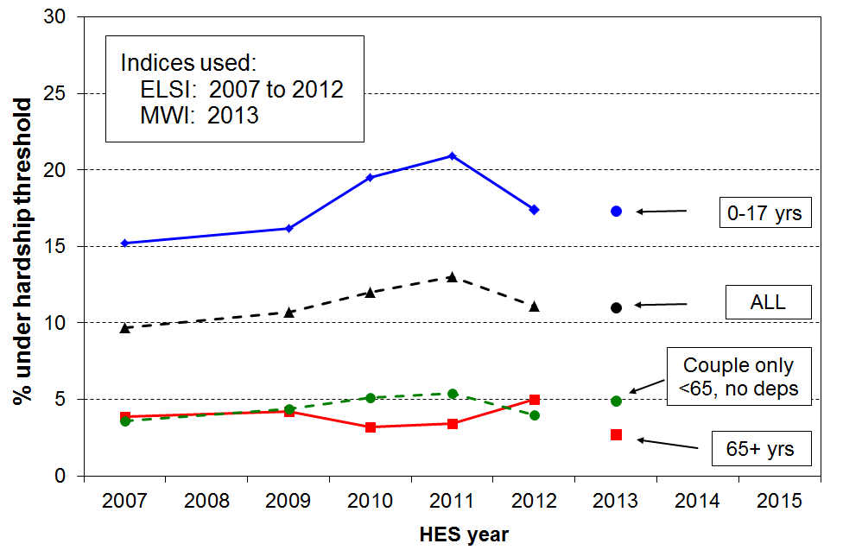

- The trend for the population is not unexpected given the impact of the GFC, economic downturn and recovery, rising to 13% in 2011, and falling to 11% in 2012.
- For children, the hardship rate rose from 15% in 2007 to 21% in 2011 before falling to 17% in 2012.
- Working-age couple households without children, and older New Zealanders (aged 65+) generally experience much lower levels of hardship than other groups (3% to 5%).
- The same sort of hardship trends shown in the graph above are found when using higher and lower thresholds, and also when using a quite differently configured index. The actual estimates of levels of hardship in a given year are of course dependent on the thresholds used but the trend directions (whether up, down or flat) are robust to the choice of threshold and index.
- The HES 2013 figures using the new MWI are also shown on the graph above. The hardship threshold is set to give the same population hardship rate as in HES 2012 using ELSI (11%). The ELSI and MWI rank the population as a whole and different groups in it in much the same way (correlation of 0.95). On both measures, hardship rates for children (17%) are much higher than for older New Zealanders or for working-age couples (~4%).

34 Those living in households with low incomes who are also experiencing material hardship are in very disadvantaged and difficult circumstances. Using the AHC 60% of median low-income threshold and the hardship threshold above, 11% of children (110,000) were in this group in HES 2012, down from 13% (140,000) in HES 2010.
- For those in hardship but with incomes reasonably above the AHC poverty line there are grounds for expecting living standards to improve over time provided their incomes do not decline and that there are no on-going special demands on the budget. However for those in hardship who also have low incomes, there is next to no chance of improvement of living standards until incomes rise and stay up. This is the group sometimes referred to as being in “severe poverty or hardship”.
- For the population as a whole, the size of this group remained much the same from HES 2007 to HES 2009 (~5%), before rising a little in the recession and beginning to fall back as the recovery began.
- For children the proportion rose from 7% in 2007 to 13% (140,000) in 2010 then down to 11% (110,000) in 2012.
- For older New Zealanders (aged 65+), the overlap group is 1% to 2%.
- For HES 2012, the overlap figure is 11% for children and 6% for the whole population.

Trends in the proportion of those who are both income poor and materially deprived, 2007 to 2012
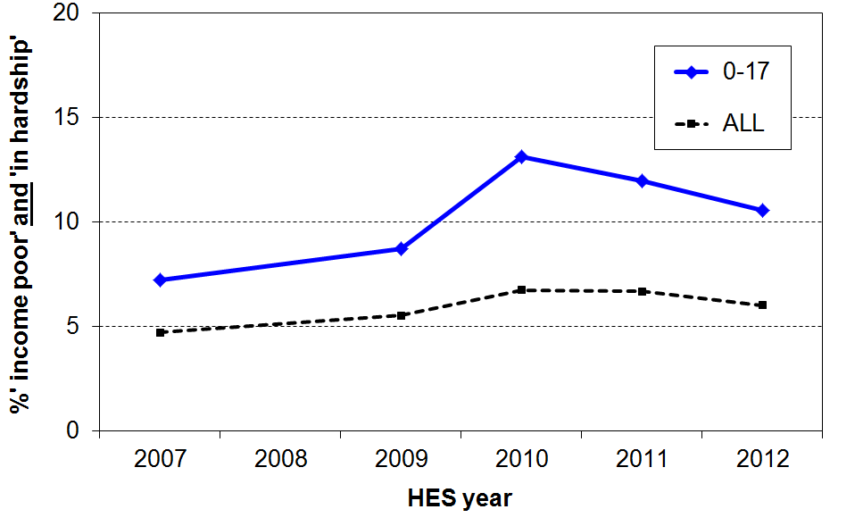
.
- In times of economic growth where the rising standard of living is to some degree shared across the whole population, the trend for the size of the overlap group can be expected to be unambiguously downwards. The upward trend from HES 2007 to HES 2010 reflects above all the impact on employment and household incomes of the shock of the GFC and the economic downturn. The downward trend for children from HES 2010 to HES 2012 shows the effect of the recovery.

35 The longer that households are in low income the greater is their risk of (higher) material deprivation.

- The analysis for the graph below draws on longitudinal data from SoFIE. The high-level finding that the longer that households are in low income the higher is their average deprivation score is not surprising. It is nevertheless one that is not always to the fore in discussions around poverty and hardship figures.
- The relatively flat line for older households reflects the fact that such households often have resources other than current income with which to support consumption for basic needs. This is in line with the income-wealth-consumption-material-wellbeing framework outlined in the introduction.
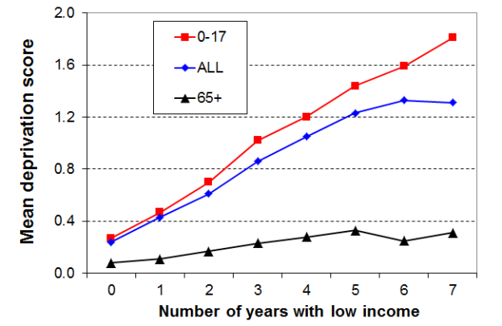

- The low-income threshold used in the analysis above produced poverty rates above the usual cross-sectional ones – that is, it was a relatively generous threshold. When a lower threshold is used, more in line with the 60% BHC cross-sectional threshold, the cumulative impact of ongoing lower low income leads to higher reported deprivation, as expected. The graph is for the whole population.

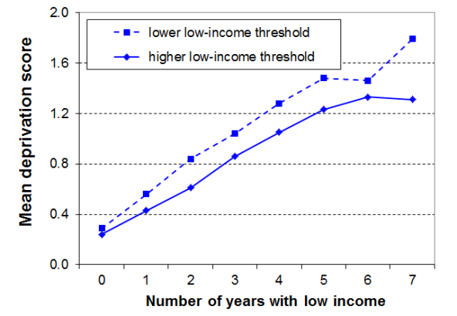

36 International comparisons of income poverty and material hardship
- The OECD and EU publish international league tables that rank countries on their income poverty rates using 50% and 60% of median poverty lines respectively.
- On the latest available figures (OECD, c 2011 and EU, c 2012), New Zealand’s population and child poverty rates are both close to the overall medians on both measures, though the child popverty rate is slightly above the median on the 50% OECD measure.
- These league tables in effect compare how far low-income households are from the median for each country. They can be seen as comparing inequality levels in the lower half of the income distribution.
 | OECD 50% |  | EU 60%
 | All | 0-17 | All | 0-17
NZ | 10 | 13 | 18 | 20
OECD / EU | 10 | 11 | 17 | 21
- The information is however often used as if the rankings indicate the extent of material hardship assessed against a common absolute international standard. Thus a country like the Czech Republic with a child poverty rate of 9% is considered to be “doing better for its children” than, say, Canada (14%), whereas in daily living the “poor” in Canada are much better off than many “non-poor” in the Czech Republic.
- For meaningful international comparisons of material hardship and poverty, there is a strong case that non-income measures (NIMs) are more robust in ranking countries by what most people mean by hardship or poverty levels in more economically developed nations.
  - Using the official 2008 NIM-based EU deprivation index, New Zealand ranked well for older people (65+) and not so well for children. This is consistent with the relativities produced within New Zealand using the AHC income measure. The table below is representative of the full range of EU countries.

Material hardship rates (%) in New Zealand (2008) the EU (2007)
(countries are ranked by the child deprivation rates)
 | All | 0-17 yrs | 65+ yrs
Hungary | 38 | 42 | 35
Poland | 44 | 39 | 41
Slovakia | 36 | 32 | 42
Portugal | 20 | 24 | 26
Greece | 23 | 20 | 29
Italy | 14 | 18 | 14
New Zealand | 13 | 18 | 3
France | 11 | 15 | 8
UK | 10 | 15 | 5
Germany | 13 | 13 | 7
Finland | 10 | 10 | 8
Denmark | 8 | 8 | 4
Netherlands | 6 | 6 | 3
Norway | 5 | 6 | 1

  - The EU have since developed a more robust index which is currently being considered for acceptance as the new official one. There is a high correlation between the old and the new indices, and New Zealand ranks much the same on both. Deprivation rates are also very similar on both measures. For New Zealand, the population, child and 65+ hardship rates are 11%, 18% and 3% respectively on the new measure.

Section A

Introduction

This Introduction outlines the core concepts and assumptions used in the report. More detail is provided on selected issues in the Appendices and in other Sections as indicated.

Following the definitions below of the income measures used in the report, the Introduction is divided into two parts:

- The first outlines and discusses the over-arching income-wealth-material-wellbeing framework used in the report

- The second sets out the key assumptions and approaches used in the income data analysis that forms the basis of the report. More detailed discussion of the income poverty and material hardship measures are in Sections E and L respectively.

The income measures used in this report

Gross and disposable household incomes

Gross household income is the total of all income before tax for the previous 12 months from all sources for all household members aged 15 years or over. Gross household income is calculated directly from the income information given by respondents in the survey.

Disposable household income is the total of all after-tax income for all household members. To calculate disposable income Statistics New Zealand uses the Treasury’s tax-benefit microsimulation model (Taxwell) to estimate tax liabilities for individuals and benefit units. The resulting personal disposable incomes are summed to give disposable household income. Disposable household income is sometimes referred to as net income or after-tax cash income.

Equivalised disposable household income

The primary income measure used in the report is disposable household income for the twelve months prior to interview, adjusted for household size and composition. This is referred to as equivalised disposable household income and is the international standard income measure for reports of this type. The rationale for adjusting for household size and composition and the difference that different equivalence scales make to findings are discussed below, after the next section.

In line with international practice, income from capital (eg interest and dividends) is included, but capital gains themselves are not. A capital gain or loss for a household is treated as a change in net worth or wealth, except where the proposed “capital gain” is in fact income as defined by tax law.
Income, wealth (net worth), consumption and material wellbeing

This report is about household incomes, their trends and levels over time, and how dispersed they are (levels of income inequality). While this information is of value in itself, one of the motivations for reporting on household income is to discover what it tells us about the material wellbeing of households – changes over time, and the relative positioning of different groups within the population.

In line with common practice among all OECD and EU nations, the report takes household income as an indicator or proxy measure of material wellbeing. Given the importance of income and cash in our sort of economy and society, the range of financial levers available to a government for influencing the distribution of income, and the ready availability of good income data from surveys and administrative records, there is a sound rationale for reports such as this.

Income however is not the only economic resource available to a household to generate its consumption possibilities. A household’s wealth (or lack of it) is another crucial factor. A household’s wealth is its total financial and non-financial assets less liabilities – this is sometimes called net worth. Income and net worth together largely determine the economic resources available to households to support their consumption of goods and services and therefore their material standard of living.

The diagram below (Figure A.1) shows the relationship between income, wealth and material wellbeing in a simple stylised form. It also indicates that “other factors” that vary from one household to the next can also impact on material wellbeing. These are especially relevant for low-income / low-wealth households, and can make the difference between “just getting by” and not being able to meet basic needs.

Figure A.1
The income-wealth-consumption-material wellbeing framework used in the report

Household income
Basic needs / essentials

Resources available for consumption
Discretionary spend / desirable non-essentials

Wealth

Material wellbeing or living standards
Other factors
eg assistance from outside the household (family, community, state), high or unexpected health or debt servicing costs, lifestyle choices, ability to access available resources

Income can be used for the current consumption of goods and services, or saved to increase wealth for later consumption. Some lower-income households have relatively high wealth levels and can support consumption levels well above those with similar incomes but lower net worth.

Households with resources that are not adequate for supporting consumption that meets basic needs (those experiencing poverty or hardship) are of special public policy interest. Low-income households with low net worth levels are especially vulnerable to unexpected expenses or even small drops in income. Some are unable to purchase the essentials in the first place.
One of the clear implications of this framework for the central theme of this report (the material wellbeing of New Zealanders as indicated by their household incomes) is that:
- either, income and wealth (net worth) need to be considered together to produce a proper ranking of households from high to low material wellbeing when basing the ranking on economic resources
- or, material wellbeing needs to be measured more directly using non-income measures.

The rest of this part of Section A looks in more detail at these two implications.

The distributions of household income and wealth, separately and together

Income levels and wealth accumulation vary over the life-cycle. Wealth tends to grow steadily through to near “retirement” age, especially through retirement savings, home ownership and mortgage repayment, then is used to varying degrees in “retirement”. Household incomes tend to rise much more rapidly and earlier than wealth, then fall away as paid employment reduces or ceases. Figure A.2 below shows the average trend for Australia.

Figure A.2
Gross weekly household income and wealth by age of reference person, Australia, 2011-12
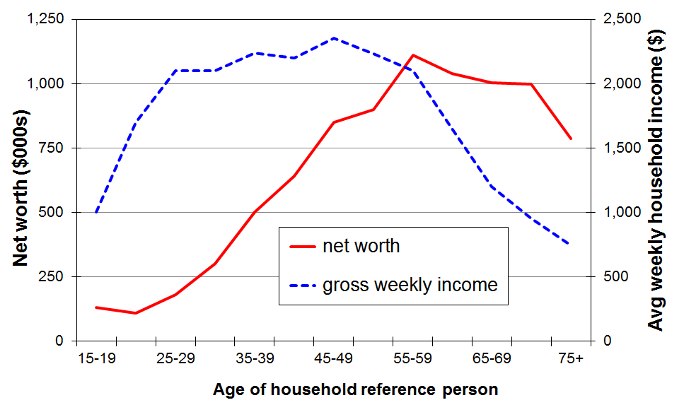
Source: Survey of Income and Housing (ABS), reported in ABS (2013b)

The life-cycle trends shown in Figure A.2 are averages. There are many whose life follows other trajectories that are not so tidy. For example, some accumulate very little wealth and become particularly vulnerable later in their life if their household income drops because of a relationship break-up, illness or redundancy.

Table A.1 shows that wealth is distributed more unequally than income. The figures are similar for both Australia and New Zealand. This is a well-established finding that applies to all OECD and EU countries and to many others.

For both Australia and New Zealand the Gini for wealth is roughly double the income Gini. The ratio of top quintile share to bottom quintile share (S5:S1) is 5 for income for both Australia and New Zealand, whereas the same share ratio for wealth is “off the scale” – around 70 for Australia.

Table A.1
Shares of income and wealth by respective quintiles (%)
 |  | Q1 (low) | Q2 | Q3 | Q4 | Q5 (high) | Share ratio, S5:S1
Household income | Australia | 8 | 13 | 17 | 23 | 40 | 5
Household income | NZ | 8 | 13 | 17 | 23 | 40 | 5
Household wealth | Australia | 1 | 5 | 12 | 21 | 61 | very large ~ 70
Household wealth | NZ | 0 | 5 | 12 | 24 | 59 | very large
Sources: Australia: ABS (2013), Tables 6 and 7, using SIH data.
New Zealand: for income, MSD analysis of HES data; for wealth, unpublished NZ Treasury analysis of SoFIE data (2003-04)

The separate distributions of income and wealth are of interest in themselves, but for the purposes of this report it is the joint distribution of household income and household wealth that matters, especially to better distinguish between households of higher and lower material wellbeing.

Table A.2 shows the joint distribution of income and wealth by reporting the share of total wealth held by households in the five income quintiles. For both Australia and New Zealand the wealth share ratio S5:S1 for income quintiles is much lower (3) than the raw wealth share ratio (70+) and is in fact lower than the income share ratio (5).

Table A.2
Shares of wealth by household income quintiles (%)
HH income quintile ➔ | Q1 (low) | Q2 | Q3 | Q4 | Q5 (high) | Wealth share ratio, S5:S1
Australia | 12 | 15 | 17 | 20 | 36 | 3
New Zealand | 12 | 15 | 14 | 19 | 39 | 3
Sources: Australia: ABS (2013), Tables 6 and 7, using SIH data (2011-12).
New Zealand: unpublished NZ Treasury analysis of SoFIE data (2003-04).

The joint distribution of wealth and income as shown in Table A.2 is a more comprehensive indicator of the distribution of household economic resources than either income or wealth on their own. The difference between the raw wealth distribution and the joint income-wealth distribution reflects in part the fact that people accumulate wealth over the course of their lives. Many older people have relatively high wealth (often in the form of a mortgage-free home in the main) but low income. Many younger households have lower wealth but higher incomes than many older people. Some of all ages have low incomes and low wealth levels.

Using the joint income-wealth distribution for better distinguishing between households with lower and higher material well-being (living standards)

Given the persuasive logic and potential public policy value of using income and wealth information to better identify the most disadvantaged households, why is it that this approach is not used as standard practice? There are two main challenges:
- first, for many countries, there are data limitations in that most regular income surveys do not also have wealth information
- second, it is not clear how best to combine the income and wealth information into one number for each household to allow household rankings to be made.

On the data front, there are signs that better survey data is coming available. The Australian efforts in this regard are well-advanced. In the 2014-15 HES, Statistics New Zealand is collecting income, wealth and more direct material wellbeing information in the one survey and plans to do so at regular intervals. This is a welcome advance that will allow a more comprehensive understanding of the links between income, wealth and material wellbeing.
However, even where good income and wealth data are available, there is no agreed way of combining the two to rank individual households on a single scale from high to low material wellbeing. This remains a significant challenge.

Even if income and wealth information cannot (yet) be combined at a household level to rank households by their economic resources, the information can be clumped at, say, a quintile level on the two dimensions in a simple cross-tabulation that enables the range of joint income and wealth scenarios to be better understood, and for the most vulnerable low-income-low-wealth groups to be identified.

Table A.3 illustrates this based on Australian data for 2009-10. It shows that around one third (35%) of those in the lowest income quintile are also in the lowest wealth quintile, while around a quarter (26%) have wealth in the top two wealth quintiles. Clearly the material wellbeing and actual day-to-day living standards of the latter group will be higher than for those with both low income and low wealth.

Table A.3
The distribution of wealth across household income quintiles, Australia (2009-10)
(%) |  | Household income quintiles
(%) |  | Q1 | Q2 | Q3 | Q4 | Q5
Household wealth quintiles | Q1 | 35 | 25 | 16 | 11 | 5
Household wealth quintiles | Q2 | 17 | 21 | 21 | 22 | 17
Household wealth quintiles | Q3 | 21 | 21 | 23 | 19 | 13
Household wealth quintiles | Q4 | 15 | 19 | 24 | 25 | 20
Household wealth quintiles | Q5 | 11 | 14 | 16 | 23 | 44
 | ALL | 100 | 100 | 100 | 100 | 100
Source: Table 8.3 in OECD (2013), from Australia’s Survey of Income and Housing

It is tempting to use a tidy-looking table like Table A.3 to reach conclusions about what proportions of low-income households (say, Q1) have low living standards and what proportion do not. To get to that next step requires further information about the actual wealth levels in the bottom two to three wealth quintiles. If these quintiles all have very low wealth, and Table A.1 indicates that they do, then the vulnerable low-income group expands from 35% to 74%. As is the case for low-income thresholds themselves, judgement calls have to be made about what wealth levels are sufficient to consider low-income households to no longer be vulnerable or “resource-poor”. In addition, the composition of the household wealth is relevant too, with some types being more liquid and accessible than others.

The 2014-15 HES will allow us to also identify the proportion in each cell in a table like Table A.3 who are also in material hardship (using the non-income measures in the HES). This will give a more comprehensive and robust picture of where the vulnerable groups are in the income-wealth grid.

Using non-income measures to measure material wellbeing

Non-income measures (NIMs) are now widely used in EU and in many OECD nations to more directly measure the material wellbeing of households, especially at the low living standards or “hardship” end of the spectrum.

Using this approach, the impacts on material wellbeing of different levels of income and wealth and of the differing experiences of the “other factors” noted in Figure A.1 are all captured in the different scores reported using indices based on NIMs.

In addition to monitoring material wellbeing using household incomes, MSD also monitors material wellbeing and hardship through the use of non-income measures (NIMs) based around the basics people have and do not have, and the freedoms or restrictions they have in purchasing desirable non-essentials. Further detail is available in this report and in other publications available on MSD’s website.

The HES has collected NIM information since HES 2007, and the report has a section on material hardship measured using NIMs (Section L).

Summing up: the use of household income as an indicator of material wellbeing

In the context of the framework indicated in Figure A.1, household income is taken to be either an imperfect but readily available and very important indicator of the “consumption possibilities” for a household, or as an indicator that allows comparisons of the potential living standards of households, all else assumed equal.

While the incomes approach has recognised limitations, there are several other factors to consider too when assessing its value for monitoring material wellbeing and hardship:
- Income and cash-in-the-hand are very important in our sort of economy and society. This is especially so for households that have low incomes, very tight budgets and very limited or negative net worth. Monitoring trends in low household incomes is very important for understanding how the more vulnerable groups are faring.
- Governments have a wide range of financial levers available to them for influencing the distribution of income. Although governments can also redirect resources to provide subsidies and services that reduce pressures on household budgets or more directly improve material wellbeing, the income levers use a much greater proportion of government expenditure than the subsidies or services (excluding public health and education).
- The ready availability of regular and good quality income data from surveys and administrative records.
- Using household income after deducting housing costs improves the congruence between the report’s findings on the income relativities between population groups and the relativities found using more direct non-income measures.

Protocols and technical information for the incomes analysis

This second part of the Introduction covers the following. See Sections E and L for detailed discussion of the income poverty and hardship measures used in the report.

- equivalisation: comparing incomes across different household and family types
- the income sharing unit and the unit of analysis for the presentation of results
- the bottom income decile: income not a reliable indicator of economic wellbeing
- housing costs
- data source: the Household Economic Survey (HES)
- convention for naming HES years and the HES years used in the report
- treatment of negative incomes
- adjusting for inflation
- ethnicity
- household and family types
- reliability of results
- summary of key measures used for reporting on income inequality and poverty.

Equivalisation: comparing incomes across different household and family types

Equivalisation reflects the two common sense notions that:
- a larger household needs more income than a smaller household for the two households to have similar standards of living (all else being equal), and
- there are economies of scale as household size increases.

Most sets of equivalence ratios also assume that children cost less than adults.

Equivalising is a means of standardising household incomes in terms of household size and composition so that the relative material wellbeing of households of different sizes and compositions can be more sensibly compared. The adjustment also makes comparisons over time more realistic because it takes into account the changes over time in the composition and average size of households.

While considerable research has been undertaken to try to estimate appropriate values for equivalence scales, no universally accepted ‘correct’ set of equivalence ratios has emerged, even when household size and composition are the only factors being considered.

The primary equivalence scale used in the analysis in this paper, the 1988 Revised Jensen Scale, is a scale that (by design) sits in the middle of the range of scales in the literature of that time. It is very close to what has come to be known as ‘the modified OECD scale’ which is now used by Eurostat, Australia, the United Kingdom and others. Different equivalence scales are used for the international comparison sections, in line with the conventions of the sources. Further discussion of the effect of the choice of equivalence scale is provided in Appendix 3.

This paper uses the single person household as the reference household – ie a single person unit has an equivalence scale value of 1.0. A household of a couple and no children (2,0) is rated at 1.54, meaning that such a household is considered to have 1.54 equivalent adults. A two adult, two child household is rated as 2.17. This means that this household type (2,2) is rated as having 2.17 equivalent adults: it requires 2.17 times the income of a single person household to have the same purchasing power or to achieve a comparable material wellbeing, all else being equal.

Other commonly used reference households are the couple, the couple with one child and the couple with two children. The choice of reference household affects the numerical value of equivalised income but makes no difference to any of the distributional, inequality and hardship analysis that follows.

Table A.4 provides a look-up chart to convert equivalised dollars (dollars per equivalent adult) to ordinary dollars and vice versa for selected households.

The first row of figures identifies the family or household type: (1,2) is a one adult, two child household, and so on. The second row gives the values of the equivalence ratios used. The body of the table indicates, for example, that a (2,2) household needs around $28,000 to have the same purchasing power as a (1,1) household with an income of around $18,000. Each has an equivalised income of $13,000 (or, to put it another way, each household has an income of $13,000 per equivalent adult).

Table A.4
Conversion of equivalised dollars to ordinary dollars for households with low-to-middle unequivalised incomes
Equiv income | Income for families and households of various types  in ‘ordinary dollars’
 | (1,0) | (1,1) | (1,2) | (1,3) | (2,0) | (2,1) | (2,2) | (2,3) | (2,4) | (3,0)
 | 1.00 | 1.40 | 1.75 | 2.06 | 1.54 | 1.86 | 2.17 | 2.43 | 2.69 | 1.98
$10,000 | 10,000 | 14,000 | 17,500 | 20,600 | 15,400 | 18,600 | 21,700 | 24,300 | 26,900 | 19,800
$11,000 | 11,000 | 15,400 | 19,300 | 22,700 | 16,900 | 20,500 | 23,900 | 26,730 | 29,600 | 21,800
$12,000 | 12,000 | 16,900 | 21,000 | 24,700 | 18,500 | 22,300 | 26,000 | 29,160 | 32,300 | 23,800
$13,000 | 13,000 | 18,300 | 22,800 | 26,800 | 20,000 | 24,200 | 28,100 | 31,600 | 35,000 | 25,800
$14,000 | 14,000 | 19,700 | 24,500 | 28,800 | 21,600 | 26,000 | 30,400 | 34,000 | 37,700 | 27,700
$15,000 | 15,000 | 21,100 | 26,300 | 30,900 | 23,100 | 27,900 | 32,600 | 36,500 | 40,400 | 29,700
$20,000 | 20,000 | 28,100 | 35,000 | 41,200 | 30,800 | 37,200 | 43,400 | 48,600 | 53,800 | 39,600
$25,000 | 25,000 | 35,100 | 43,800 | 51,500 | 38,500 | 46,500 | 54,000 | 60,800 | 67,100 | 49,400
$30,000 | 30,000 | 42,100 | 52,400 | 61,600 | 46,100 | 55,900 | 64,800 | 72,900 | 80,600 | 59,300
$35,000 | 35,000 | 49,200 | 61,200 | 71,800 | 53,800 | 65,200 | 75,600 | 85,100 | 94,000 | 69,200
$40,000 | 40,000 | 56,200 | 69,900 | 82,100 | 61,500 | 103,700 | 74,600 | 86,400 | 97,200 | 79,000
$45,000 | 45,000 | 63,200 | 78,600 | 92,400 | 69,200 | 83,900 | 97,100 | 109,400 | 120,800 | 88,900
$50,000 | 50,000 | 70,236 | 87,367 | 102,641 | 76,844 | 93,200 | 107,900 | 121,500 | 134,300 | 98,800

This table uses the 1988 Revised Jensen equivalence scale, as does the rest of the report, except where it is stated otherwise.

A (2,3) household is one comprising 2 adults and 3 children (aged under 18 years), and so on.

Income sharing unit and the unit of analysis for the presentation of results

The household is used as the income sharing unit (or unit of income aggregation). All individuals in the household are assumed to benefit reasonably equally from the combined income of the household and to share a similar standard of living. Clearly this is not always the case but it is “defensible as [an approximation] to a very complicated reality of intra- and inter-household patterns of sharing” (Bradbury, 2003:25).

The use of the household as the income sharing unit is in line with international standard practice.

The unit of analysis for reporting purposes is the individual. The household’s equivalised disposable income is attributed to each household member as an indicator of the individual’s (potential) living standards and is used for ranking purposes.

For subgroup analysis individuals are grouped by their own characteristics (eg age), or by the characteristics of their household or family type (eg two-parent, ‘workless’, and so on). In all cases the individual is ranked or classified according to the income of their household as this gives the best income-based indication of their economic wellbeing, in line with the central purpose of this report.

A key subgroup in this report is dependent children. Dependent children are all those under 18 years, except for those 16 and 17 year olds who are in receipt of a benefit in their own right or who are employed for 30 hours or more a week.

For international comparisons using OECD data, children are taken as all those under 18 years. The use of ‘0 to17 years’ rather than ‘dependent children’ makes virtually no difference to the reported results.

The economic family unit (EFU)

An alternative income sharing unit that has sometimes been used is the benefit eligibility unit, often referred to in New Zealand as the economic family unit or EFU. The EFU approach allows for only three ways to group individuals when it comes to income sharing: couple only, two parent with dependent children, and sole parent with dependent children. All other individuals are treated as if they are ‘on their own’ even when they share (to varying degrees) in the general resources of a larger household. The Ministry of Social Development used the EFU approach in incomes analysis from 2002 to 2006 but reverted to the household approach in 2007 as fewer anomalies are created by this approach. It also brought New Zealand back into line with international practice.

Rules for determining household membership

A household for the HES relates to a ‘private household’ which is defined as:

either a single individual living in a dwelling who makes his or her own housekeeping arrangements

or a group of people living in or sharing a dwelling for four or more days a week, who participate in some measure at least in consumption of food purchased for joint use by members (or who, if not dependent upon a household member, contribute some portion of income towards the provision of essentials of living for the household as a whole).

The following are included in the household for survey purposes:

any person who, because of the nature of his or her occupation cannot spend as many as four nights a week in the household but who makes a financial contribution to the running of the household and is not currently a member of another New Zealand resident private household in a permanent dwelling

any person at boarding school or other non-private institution who usually spends holidays or other continuous periods at home, and whose living costs are subsidised by at least 50 percent by the household

any child whose custody is shared between two households but who spends more than half their time in the sampled household – where custody or care is shared equally between two households, the child should be included in the sampled household only if they are there the night the household questionnaire is completed.

The bottom income decile: income not a reliable indicator of material wellbeing

While household income is far from perfect as a measure of material wellbeing it is generally a useful enough indicator. There are however some households for whom it would clearly be very misleading to take their incomes as even a rough and ready indicator of their material living standards. This assessment is based on comparisons with income information from other surveys and known benefit levels, and from HES expenditure information: some households have implausibly low incomes, well below the minimum social support levels; some have reported expenditures well above their reported incomes.

Some of these households will be declaring income from self-employment which can legitimately be much lower than reported expenditure – the declared income may even be negative. Others will have accurately reported their incomes but will have had access to loans, gifts or ‘savings’ in one form or other which have been used for purchasing goods and services. Others will have intentionally or unintentionally under-reported their incomes.

Households with implausibly low incomes per se are of course found only in the bottom decile (bottom 10% of the income distribution). The reported incomes of many at the bottom are less than the incomes provided by government cash benefits or New Zealand Superannuation. This points to mis-reporting or data entry errors.

Those reporting expenditure much higher than reported income are found in most parts of the income distribution but the bulk of them are found in the bottom decile. For example, of all those in households reporting expenditure which is more than three times their income, around 70% to 80% are in the bottom income decile in any survey year.

This noise in the lower end of the income distribution has only a limited impact on most of the indicators used in this report. For example, it does not impact greatly on the medians as the bulk of households in question would remain below the median even if their expenditures were taken as better estimates of their actual income than what was reported as such. Nor does it impact significantly on trends over time for either poverty or inequality indicators.

In general the impact is significant where the indicator is highly dependent on the incomes of those in the bottom decile or a little above it. This means, for example, that point-in-time poverty levels are noticeably affected when poverty lines are set at levels lower than the 50% of median line (eg 40% of median). In addition, the level and trend of the P10 (10th percentile) line and measures of poverty depth (see Section E) are also significantly affected.

As appropriate, the report makes comment on the likely impact of the noise at the bottom end of the income distribution in the text associated with affected indicators.

Appendices 8 and 9 provide a fuller discussion of the issue.

Housing costs

The report provides information based on household income both before deducting housing costs (BHC) and after deducting housing costs (AHC).

Housing costs include all mortgage outgoings (principal and interest) together with rent and rates for all household members. Repairs and maintenance and dwelling insurance are not included. Any housing-related cash assistance from the state (eg Accommodation Supplement) is included in household income. These housing costs make up on average around 45% of the budget for working-age low-income working-age households (bottom three income deciles, unequivalised income). For many, of course, it is 50% or more.

For reporting on overall trends in household income and on income inequality, there is value in seeing the similarities and differences between the two measures (BHC and AHC) and in understanding the differing stories they tell. For reporting on trends in income poverty over time and for comparing hardship across subgroups of the population, the report recommends the use of AHC measures, although both BHC and AHC are reported.

The use of BHC measures is generally taken as the self-evident starting point. They are important for assessing the adequacy of market and social assistance incomes for delivering a minimum acceptable standard of living. Their use also ensures that the material wellbeing of those on low incomes who choose to live where accommodation is less expensive (eg some rural areas) or who live in ‘cheap’ substandard accommodation is not left overstated (relatively) as the use of an AHC approach on its own can do.

The rationale for the report’s position that AHC analysis should also be reported, and that the AHC approach is preferable for subgroup comparisons in New Zealand is that:
- First, variations in housing costs do not necessarily correspond to similar variations in housing quality. This is most significant when comparing the material wellbeing of age groups. Many older individuals are in households that have good accommodation and relatively low housing costs (eg those living in mortgage-free homes). Many in an earlier part of the life cycle have a similar standard of accommodation but relatively high accommodation costs. Ideally, the value of imputed rent for homeowners would be added to income to even up the comparisons (ie the BHC approach has limitations in this regard), but the practical difficulties are considerable. As an approximation for the purposes of comparing material wellbeing, the AHC approach deducts housing costs from after-tax cash income for all households.
- Once a household is committed to a particular residence, outgoings on housing costs cannot easily be adjusted or put off in “tight times” as they can for other expenses like entertainment and recreation, and even to some degree for basics like food and clothing. When the primary focus is on trends in income poverty and hardship, it is important to understand trends in “residual income”, taking housing costs as a given fixed cost in effect. Housing costs represent a very significant proportion of the total spending for many low-income households.
- Third, a unique characteristic of the New Zealand BHC income distribution is the large ‘pensioner spike’ at around the value of New Zealand Superannuation. In recent years, the spike has been located close to a 50% of median poverty line (BHC). In the late 1990s it was around a 60% of median poverty line. The presence of the spike can lead to large variations in reported poverty rates for the 65+ group over time, leaving the misleading impression that there are significant changes in material wellbeing occurring for this group. In addition, the same issue can lead to similarly misleading comparisons with the relative wellbeing of other age groups. An AHC approach largely avoids these issues and is more suitable as the primary measure (for New Zealand at least). See also Section I.

Imputed rent

For households with similar income and similar other characteristics, the consumption possibilities are much greater for households with low housing costs than for those with high housing costs. As discussed above, standard income measures of material wellbeing do not capture this difference: households with the same BHC income are ranked in the same place despite housing cost differences.

The use of “imputed rent” is an important way of dealing with this in a formal way. Imputed rent for home-owners is the difference between the estimated market rent of the dwelling and the usual costs a landlord would incur such as mortgage interest, rates, insurance and minor repairs. For renters whose rent is subsidised, imputed rent is the difference between market rent and actual rent paid.

The inclusion of imputed rent in household income is something to be aspired to. It provides a more realistic and meaningful comparison of the material wellbeing of households of different tenure type. Several OECD and EU countries are developing methodologies to enable this advance to be applied and used, but there is no standard approach agreed to as yet. The imputation is a quite data intensive exercise.

In the meantime, this report uses the AHC approach outlined above to take some account of the implications of different tenure arrangements for comparing the material wellbeing of households.

Further discussion on the relative merits of the BHC and AHC approaches is in Appendix 5.

Main data source: the Household Economic Survey (HES)

The report draws on data from Statistics New Zealand’s Household Economic Survey (HES). The HES was an annual survey from 1982 to 1998, using March years, then three-yearly from 1998 to 2007, using June years from 2001 on. The 2007-2008 survey was the first of the new HES (Income) Surveys which makes income, housing cost and living standard indicator data available in each of the two years between the full HES surveys. The HES (Income) collects the same information on these domains as the full HES does. The full HES (including full expenditure information) is still on a three-yearly cycle. The 2012-2013 HES is the latest full HES.

A sample of approximately 3000 private households is achieved each survey (see Table A.5 below for details). Interviews are conducted face to face. For the full HES, contact with each participating household extends for a period of just over two weeks. During that time, each household member aged 15 years or over keeps an expenditure diary for 14 consecutive days, recalls major purchases made in the previous 12 months, and provides income and employment data. The income information is also for the 12 months prior to interview.

The target population for the HES is New Zealand resident private households living in permanent dwellings. This means, for example, that those in institutions and those in non-permanent dwellings are not included.

Table A.5
Achieved sample sizes and response rates for recent HES (for data held by MSD)
HES year | Achieved sample size | Response rate
2000-01 | 2808 | 73%
2003-04 | 2854 | 73%
2006-07 | 2550 | 62%
2007-08 | 3295 | 77%
2008-09 | 3210 | 74%
2009-10 | 3126 | 69%
2010-11 | 3536 | 81%
2011-12 | 3565 | 83%
2012-13 | 3003 | 67%
Note: The response rate for 2009-10 and later is the post-imputation response rate. For other years it is the pre-imputation response rate. See the text below.

Imputation was introduced into HES for the 2009-10 survey. Imputation is a data set enhancing process that replaces missing values with actual values from similar respondents. At that time, imputation was also applied to the data for the 2006-07, 2007-08 and 2008-09 surveys, and Statistics New Zealand has updated its Hot Off the Press tables and Table Builder information accordingly.

The data used for the Incomes Report does not yet use the imputed values. Statistics New Zealand and the Treasury have been working on having revised datasets available from 2006-07 on, and we expect to use them in the 2015 Incomes report. It is unlikely to make any material difference to the trends and relativities in this report.

The report also uses some net worth and income mobility information from Statistics New Zealand’s longitudinal Survey of Families, Income and Employment (SoFIE).

Population weighting

The preparation of the HES weights provided by Statistics New Zealand to enable population estimates to be produced from the HES sample follow a two stage process:
- the sample design weight (the inverse of the selection probability) is calculated for each private household, along with an adjustment for non-response
- the weight of each household is adjusted using integrated weighting, calibrating to independent benchmarks of the number of people by age, sex, ethnicity and region and the number of households by household size (from estimates based on the 2006 Census for the 2012-13 HES).

The HES weights do not calibrate to the number of people receiving income-tested benefits or New Zealand Superannuation payments. The HES underestimates these numbers by around a third in each survey.

The Treasury has also developed a set of weights for use with its HES-based tax-benefit microsimulation model, Taxwell. The Taxwell weights include the number of beneficiaries as one of the key benchmarks, in accordance with Treasury’s primary use for the HES in the Taxwell model. Treasury’s Taxwell weights therefore provide a better estimate, for example, of the number of children in beneficiary families, although to achieve this there has been a trade-off with achieving other benchmarks. This report almost always uses Statistics New Zealand’s HES weights. Where the Taxwell weights are used, this is made clear in the text.

Convention for labelling HES years

The report adopts a common short-hand convention for describing HES years. For example, “the 2007 HES” is short for “the 2006-07 HES”. The 2007 survey is for the year ending 30 June 2007 with its midpoint in December 2006. For the 1998 HES and earlier ones the survey period was for March years. The 1998 HES therefore has a midpoint of September 1997. There is therefore a good case to be made for the 2006-07 HES being labelled the “2006 HES”. While logic and clarity support this, it would unfortunately fly in the face of common custom and possibly lead to confusion. This report has therefore (reluctantly) followed the custom to date.

In its international league tables and other publications the OECD uses the “2006-07” = 2006 approach. As the OECD’s reports are now much more easily accessible, better promoted and more widely read, there is a better case now for adopting that pattern. It is likely to change for next year’s report.

The income values, inequality figures, poverty rates, and so on for specified HES years are best interpreted as being for the calendar year in which the survey started unless noted otherwise. Particular care is required in establishing which survey year will pick up the implications of policy changes or of significant labour market or GDP changes, or of other major events, when some or all of these changes occur during a survey year.

HES years used in the report

The tables and graphs report for each second HES year from 1982 to 1998 and every three years to 2007, then each survey for 2009 to 2013. Key changes in the income distribution occurred in the years from 1988 and again from 1994. The loss of information that arises from using every second year only does not impact on the overall trends reported as these key years are included in the reporting.

The points on the graphs are all joined by straight or smoothed lines. This is done for presentational purposes only to give the general trends, and should not be taken to mean that the data points in the intervening years would all lie on the interpolated lines.

Special note on the data for the 2008 HES (Income)

The income poverty and inequality figures for 2008 published in the 2009 report are not included in subsequent reports as a significant issue was discovered with the calculated disposable income variable in the Taxwell data in Statistics New Zealand’s 2007-08 HES dataset. Initial investigations suggested that the issue arose from the modeled Accommodation Supplement amounts used in calculating the household income variable. This led to household disposable incomes for the 2007-08 year being understated for many low-income households. The poverty and inequality figures reported in the 2009 report were therefore inflated for the 2008 year.

The issue is now resolved and we expect to be able to report on 2008 findings in the 2015 report.

Treatment of negative incomes

In each HES survey there are a few records showing negative incomes. For this report these negative incomes are re-assigned a value of zero before analysis is undertaken. This is done to reasonably approximate the treatment of negatives asked for by the OECD in the data sent to them by statistical agencies such as Statistics New Zealand and it therefore assists with international comparisons. This treatment of negatives has no effect on medians, no impact on reported trends over time for the approaches used in this report, nor on poverty rates at any point in time, nor on the composition of the poor. It has a very small impact on means and income shares for quintiles.

Adjusting for inflation

Household incomes and low-income thresholds are adjusted for inflation at various places in the report. Household incomes are converted to 2013 dollars for reporting on income trends in real terms. For the reporting on trends in income poverty based on an “anchored” or “fixed line” approach, thresholds are based on proportions of the 2007 median and are held constant in real terms over other years.

The adjustments for inflation are carried out using CPI full-year averages for a March year up to and including the 1998 survey and a June year from 2001. For BHC incomes Statistics New Zealand’s CPIQ.SE9A series is used, with the annual figure being the average of the four quarters for the period. AHC incomes and thresholds from 1989 to 2013 are adjusted using the index from the “All Groups less Housing” series (CPIQ.SE9NS1010) for the survey’s midpoint quarter. For 1982 to 1988 the AHC adjustments are based on the author’s extrapolation of the series. The reported trends in AHC incomes and the size of low-income populations are not greatly sensitive to different assumptions within a plausible range for the index in the estimated years. See Appendix 7 for the indices used.

Ethnicity

Ethnicity of individuals aged 15 and over is as reported by the individual. Children under 15 are attributed with the ethnicity of the survey respondent in years to HES 2004. Starting with HES 2007, ethnicity for children is provided in the survey data, with the information coming from either the children themselves or from their parents. No analysis is carried out based on household or family ethnicity as ethnicity is a characteristic of individuals.

If a respondent reports more than one ethnicity, the ethnicity attributed is determined according to a prioritised classification of Māori, Pacific Island, Other and then European/Pākehā. Using a “total counts ethnicity” approach makes no noticeable difference to the findings in this report. The table below illustrates this using the 50% AHC moving line measure for the whole population. Moving to the total ethnicity convention is on the agenda for a future issue of the Incomes Report.

rate (%) | Prioritised | Total
European/Pakeha | 10 | 11
Maori | 21 | 21
Pacific | 20 | 22
Other | 23 | 22
ALL | 14 | 15

Only limited analysis by ethnicity is reported because of the relatively small sample sizes for Maori, Pacific and Other (especially for Pacific). See the discussion below under “Reliability of results”.
Household and family types

The report uses the following household types for subgroup analysis.

Household type | Definition
One person HH, 65+ | one person aged 65+
Couple HH, 65+ | at least one partner is 65+
One person HH, under 65 | one person aged under 65
Couple HH, under 65 | both partners are under 65
SP with children | SP with children, at least one of whom is dependent
2P with children | 2P with children, at least one of whom is dependent
Other family HHs with children | Family HHs (other than SP or 2P HHs) where there is at least one dependent child
Other family HHs, adults only | Family HHs (other than couples) where there are no dependent children
Non-family HHs | Unrelated individuals

For family types, the report uses the ‘economic family unit’ (EFU). There are four types of EFU:
- couple only
- two parent with dependent children
- sole parent with dependent children
- everyone else (ie unattached individuals who are not dependent children).

In each case the EFU may be living in their own separate household or with others in a wider household.

Note that the household is always used as the income sharing unit. Individuals are attributed with their household’s equivalised income, then assigned to a particular household or family type, carrying their household’s equivalised income with them as an indicator of their material wellbeing.

Reliability of results

As the figures in this report are estimates taken from a sample survey, they are subject to variation as a result of both sampling error and bias due to non-sampling error, especially non-response.

In addition, there are assumptions made in the use of equivalised income as an indicator of (potential) living standards and in constructing the measures of inequality and hardship.

All these factors raise the question of the reliability of the results.

Sampling error

Sampling error is about the variability that occurs by chance because a sample rather than an entire population is surveyed. For example, the relative sampling error for average household income is typically around 4% at the 95% confidence level. This means that there is a 95 percent chance that the true value lies within 4% of the survey mean.

The sampling error is larger the greater is the degree of disaggregation at which results are presented. Special care is therefore needed when interpreting results applying to smaller subgroups. Care is also needed when comparing estimates from one survey to the next as both estimates are subject to sampling error.

Three examples are discussed below to illustrate the issues.

People living in sole parent households are a relatively small subgroup, making up only 8% of the population. In Table B.7 the distribution of the population across household income quintiles is reported by various household types. Only 5% of those in sole parent households are found in the top income quintile. On the other hand, a high proportion have incomes in the lower end of the income distribution. When reading Table B.7 for the distribution of those in this household type across the quintiles, it is reasonable to conclude that “around four in five are found in the bottom two quintiles”, and “there are very few in the top quintile”, but to claim that “15,600 (5% of 312,000) are in the top quintile” would be spurious precision.

Another example is reporting on poverty trends by ethnicity. The example uses changes from HES 2004 to 2007. The Pacific, Maori and Other groups made up 6%, 15%, and 13% respectively of the population in 2007, using the HES weights. Between the 2004 HES and the 2007 HES, the estimated poverty rates using the AHC 60% fixed line measure fell dramatically for those classified as Pacific (29% to 12%), while for Maori there was very little change (22% to 24%). The large change for Pacific is inconsistent with independent information for the period from the Income Supplement (IS) of the Household Labour Force Survey (HLFS) which has a larger sample than the HES. It would be misleading to report on the basis of these two HES surveys that “poverty has reduced significantly for Pacific people” – or, if it went to, say, 25% in HES 2008 that “Pacific poverty rose sharply from 2007 to 2008”.

For those classified as Other for ethnicity the estimated poverty rate fell from 38% (2004) to 21% (2007). Again, this is inconsistent with HLFS-IS information for the period. In this case, the size of the subgroup is itself probably not the only issue. The volatility for those classified as of Other ethnicity is likely to be driven to a large degree by the considerable heterogeneity in this group, and its changing composition over recent years. This heterogeneity adds another source of potential sampling error when using smaller subgroups. It applies much more to a subgroup like those classified as of Other ethnicity than to a similar sized group such as sole parent households discussed above which is more homogeneous in relation to household incomes and factors which impact on these. Those in one person 65+ households are a smaller still subgroup (4%), but are even more homogeneous (eg they are all in the same household type, in the same age group, and are mainly European/Pakeha).

For these reasons, poverty trends by ethnicity are not reported. Instead, trends in median household incomes are provided, and the distribution across quintiles is given to provide an indication of the relative spread of incomes. The median incomes are still subject to sampling error but as they use information from the whole sample rather than just from those at the low end, the trends are more reliable. For poverty levels the report uses the average of the latest three surveys to give a reasonably robust estimate of relativities of one group compared with the others.

The third example is from the reporting on trends in income inequality using the Gini coefficient. From 2008-09 to 2009-10 there was a sizeable decrease in the Gini, and from 2009-10 to 2010-11, an even larger increase. Both these changes are statistically significant. However, the more modest net change from 2008-09 to 2010-11 is not statistically significant. This example illustrates why this report cautions against reading too much too soon into year on year changes, and generally encourages the taking of a longer run perspective on trends.

Non-response

The reliability of the results is also affected by any bias due to differential non-response from households chosen for interview. To go some way to correct for this, when weights are being assigned to households to produce population estimates, those households that are under-represented in the sample are given larger weights to compensate. The weights are chosen so that grossed-up population estimates accord with key control variables such as the age, gender and household type distributions from the latest census or census-based projections.

There is, however, no guarantee that such weighting procedures will deliver accurate population estimates for all variables of interest. One area where this is an issue affecting reliability of results using the HES is in the estimates of the number of beneficiaries. The HES typically underestimates beneficiary numbers by around one-third. The total value of the Accommodation Supplement (AS) reported in the HES is around 40% to 50% of that recorded in the Ministry of Social Development’s administrative data. This may not necessarily mean that half the AS income is missed, as some of the “missing” amount is likely to be counted in the reported benefit income which is in aggregate usually higher than administrative records report.

The report uses Treasury ‘s modelled values of benefit income, modelled WFF tax credits and modelled AS, so the actual reported values do not come into the analysis in the report.

Income as an indicator of material wellbeing

There is a general question as to how well income performs as an indicator of access to resources or as a proxy for living standards, but the most pressing issue, as noted above, is that there are particular problems in the bottom decile where the incomes of many households cannot be taken even as a rough and ready indication of resources. Where the noise in the bottom decile significantly impacts on reported results, the associated text notes and describes the impact. This issue is further discussed in Appendices 8 and 9.

Avoiding unwarranted impressions of precision

The use of too many significant figures or decimal places in reporting results can imply a spurious precision that is inconsistent with the considerations noted above. This applies particularly to poverty rates, and especially for figures relating to subgroups of the whole population. Poverty rates and poverty structure are therefore generally reported to the nearest whole number rather than to one decimal place as is common elsewhere.

Longer-term trends over several surveys and significant differences between subgroups within a year can be counted as providing robust and reliable information. Smaller changes between surveys and small differences between subgroups in the one survey year should not be used to support definitive conclusions about change or differences.

Summary of key measures used for reporting on income inequality and poverty

The table below gives a high-level outline of the measures used in the report for the inequality and poverty analysis. Issues around each decision point are discussed in the main sections that follow and in the Appendices.

Decision point | Option used in this report
income sharing unit | household (HH)
income concept | equivalised disposable HH income (ie after-tax cash income, adjusted for HH size and composition)  - before deducting housing costs (BHC)  - after deducting housing costs (AHC)
equivalence scale | revised Jensen 1988 (except for Section J, the international section, in which the ‘square root’ scale is used for OECD comparisons, and the ‘modified OECD scale’ for EU comparisons
inequality measures | percentile ratios (90/10 and 80/20)  decile and quintile share ratios  Gini coefficient
types of low-income thresholds or ‘poverty lines’ | ‘moving line’ thresholds – set relative to the median for the survey year (REL)  ‘fixed line’ thresholds – anchored in a base year (2007) and kept at a constant value in real terms (CV)
setting of low-income thresholds or ‘poverty lines’ | REL thresholds set at 50% and 60% of the median HH income (BHC)  CV thresholds set at 50% and 60% of the 2007 median HH income (BHC), and adjusted forward and back by the CPI  AHC thresholds are set at 25% less than the corresponding BHC threshold, as an allowance for average housing costs
primary measure for income poverty trends | AHC ‘fixed line’ (60%) – the rationale for this is noted earlier in this Section and is further discussed in Section E.

Section B
Household incomes in 2012-13

This section provides general information on the distribution of household income using the 2013 HES. The following are reported:
- means and medians for gross, disposable and equivalised disposable income
- medians for different household types
- graphs of the income distribution for the whole population
- a table to assist households to identify where they fall in the distribution
- distribution of individuals across household income quintiles by various household and individual characteristics
- income shares for income deciles
- the extent of re-distribution of market income through taxes and cash benefits.

Means and medians

Table B.1 reports median and mean household incomes for the 2013 HES using gross, disposable (after-tax), and equivalised disposable concepts, and the changes in real terms from the 2009 to 2011 HES and from the 2011 to 2013 HES. Longer term trends are reported in Section D.

In the 2012-13 HES, median annual household income after taking account of all income tax paid and transfers received (eg welfare benefits, NZS, WFF tax credits) was $67,700. Mean or average household income was higher at $78,100.

Table B.1
Gross, disposable and equivalised disposable household incomes:
annual medians and means (HES 2013), with changes from recent years
 | Median |  |  | Mean
 | 2012-13 HES | Real changes |  | 2012-13 HES | Real changes
 | 2012-13 HES | 2008-09 to 2010-11 | 2010-11 to 2012-13 | 2012-13 HES | 2008-09 to 2010-11 | 2010-11 to 2012-13
Gross | $79,800 | -6.6% | +4.0% | $98,500 | -4.0% | 2.6%
Disposable (BHC) | $67,700 | -3.6% | +5.6% | $80,500 | -0.5% | 3.4%
Disposable (AHC) | $53,900 | -3.2% | +7.5% | $66,000 | -0.3% | +4.2%
Equiv disposable (BHC) | $33,500 | -3.7% | +4.0% | $41,400 | -1.1% | +4.4%
Equiv disposable (AHC) | $27,100 | -3.5% | +7.9% | $34,000 | -1.0% | +5.6%
Note: The equivalised income rows in the table (the bottom two) use the one person household as the reference. The unit is ‘dollars per equivalent adult’.

The impact on household incomes of the global financial crisis and economic slowdown began to be seen in the 2009-10 HES. Using the 2008-09 HES as the reference year the “2008-09 to 2010-11” columns show the cumulative impact over two surveys.

The gross median income fell by some 7% and disposable (after tax) household income by 4% in real terms. The smaller after-tax decline reflects the higher average income tax rate for higher income households. The household disposable income distribution is less spread than the gross income distribution and the changes from year to year are therefore smaller in percentage terms.

Changes in the mean are a little different than changes in the median as they are strongly influenced by what happens to higher incomes whereas changes in the median are influenced by what happens to incomes in the middle parts of the distribution.

The “2010-11 to 2012-13” columns show evidence of household incomes recovering: a 3% real increase for median gross household income and a 4% rise for median household income after tax and after adjusting household size and composition (equivalised disposable household income).

Medians are calculated by assigning individuals the income of their household, ranking the individuals and finding the middle one. This person-weighted approach is different from the household-weighted approach which simply ranks households by their income and finds the middle household. The person-weighted approach is the international standard for the sort of analysis carried out for this report. See Appendix 4 for further information.

Mean incomes are higher than median incomes because of the skew of the income distribution towards the lower end. The relatively few households with incomes at the very upper ranges of the income distribution have a disproportionately large upward impact on the mean compared with their impact on the median, and therefore pull the mean up above the median. The varying number of very high income households in different years can also lead to the mean being less stable than the median.

Medians for households of different types

The overall median BHC household disposable income in the 2013 HES was $67,700 (ordinary dollars). In equivalised terms this is 33,500 dollars per equivalent adult.

Different household types have different median incomes, some above and some below the overall median. For example, the median household income for households comprising a couple plus one dependent child was $71,600 in ordinary dollars and $36,200 when the ranking is done by equivalised household incomes (ie 36,200 dollars per equivalent adult).

Table B.2 shows the median disposable incomes (BHC) of different household types using incomes before equivalising (centre column) and after equivalising the household incomes (right hand column).

Table B.3 shows the same information for AHC incomes.

Tables B.2 and B.3 show that the median equivalised household incomes for older one-person and couple households, sole-parent households, larger two-parent households and for other family households with children are all below the overall median. This means that these households are all more concentrated in the lower half of the equivalised income distribution.

On the other hand, “working age” couple-only households, two parent with one dependent child households and family households with no dependent children have equivalised medians above the overall median and are therefore more concentrated in the upper half of the equivalised income distribution.

Table B.2
Median disposable income (BHC) for different household types (HES 2013)
in ordinary and equivalised dollars
HH type | Median disposable income for the HH type  (ordinary $) | Median disposable income for the HH type  ($ per equivalent adult)
One person, 65+ | 21,200 | 21,200
Couple, 65+ | 46,400 | 30,200
One person, under 65 | 37,700 | 37,700
Couple, under 65 | 77,400 | 50,300
SP, 1 child | 34,500 | 22,100
SP, 2 children | 35,000 | 19,400
SP, 3 or more children | 36,400 | 17,800
2P, 1 child | 71,600 | 36,200
2P, 2 children | 75,200 | 33,700
2P, 3 or more children | 76,400 | 29,700
Other family HHs with children | 87,400 | 32,800
Family HHs, all < 65 – no children | 86,600 | 44,800
Family HHs, at least one 65+ – no children | 82,700 | 33,100
Whole population | 67,700 | 33,500

Table B.3
Median disposable income (AHC) for different household types (HES 2013)
in ordinary and equivalised dollars
HH type | Median disposable income for the HH type  (ordinary $) | Median disposable income for the HH type  ($ per equivalent adult)
One person, 65+ | 18,500 | 18,500
Couple, 65+ | 41,700 | 22,000
One person, under 65 | 26,600 | 24,400
Couple, under 65 | 63,700 | 39,600
SP, 1 child | 22,100 | 17,600
SP, 2 children | 20,400 | 13,600
SP, 3 or more children | 23,300 | 12,500
2P, 1 child | 57,500 | 28,400
2P, 2 children | 58,200 | 25,600
2P, 3 or more children | 58,200 | 21,200
Other family HHs with children | 67,500 | 27,700
Family HHs, all < 65 – no children | 76,700 | 41,100
Family HHs, at least one 65+ – no children | 65,000 | 31,900
Whole population | 53,900 | 26,300

Note: See the box on the next page for further information about the relationship between the two columns of figures in these tables.

Reconciling Table A.4 with Tables B.2 and B.3
This report uses the one person household as the reference for the equivalising process. The unit is dollars per equivalent adult. To convert ordinary disposable income to equivalised incomes for a particular household type, the ordinary incomes need to be divided by the appropriate equivalence ratio listed in Table A.1 in the Introduction. For example for a (2,1) household, divide by 1.86. This means that a (2,1) household with a disposable income of $65,500 has an equivalised disposable income of $35,200 (ie 35,200 dollars per equivalent adult). (65,500 / 1.86 = 35,200)

This relatively simple conversion can be applied to any individual household. It cannot however be generally applied to medians of the population as a whole or of any subgroup of the population. There are three reasons for this:
- For the population as a whole, the concept of equivalence ratio is meaningless as individuals come from a range of different household types, and different equivalence ratios apply to each of these.
- For some subgroups (eg “other family households with children”), no equivalence ratio is defined as there are unknown numbers of children and adults in each household in this group.
- For any subgroup of households which have children, children of different ages are assigned a slightly different equivalence ratio when using the 1988 Revised Jensen scale. This means that the ranking of individuals using equivalised incomes can end up slightly different than the ranking of individuals using ordinary household incomes for the same household type (eg couple plus one dependent child). This leads to the equivalised median being not quite the same as the “ordinary” income divided by the appropriate equivalence ratio. Note that for couple households without children, the simple conversion does work. See Tables B.2 and B.3.

Income distribution for the whole population, HES 2013

Figures B.1 and B.2 (next page) show the general shape of the income distribution for the whole population, with the 65+ age-group distinguished from the rest.

The graphs also show two of the main low-income thresholds (“poverty lines”) that are used later in the report: 50% and 60% of the (current survey) median for BHC incomes, and these less 25% for AHC incomes.

Apart from the skew to the left with a long right-hand tail of higher household incomes, the distinctive feature of the BHC distribution is the ‘pensioner spike’ just above the 50% threshold, and the strong bunching of those aged 65+ in households with incomes in the 50% to 70% of median range. The pensioner spike arises because:
- New Zealand has a universal pension for those aged 65 and over that is neither income nor asset tested (New Zealand Superannuation (NZS))
- there is no mandatory second tier employment-related component
- in 2013, 50% of those aged 65+ report household incomes of less than $100pw (per capita) from sources other than NZS
- the value of NZS was around 52-54% of the BHC median from 2010 to 2013 and between 51% and 67% from 1988 to 2008.

This strong bunching of incomes for older New Zealanders in the 50% to 70% of median range has implications for the reporting of poverty rates for this group. When using thresholds set as a proportion of the current median, a small shift in the median from one year to the next can lead to a very large change in reported income poverty for the 65+ even though there has been little or no change in their income or living standards. Similarly, using a 50% of median income threshold gives a very different picture than when a 60% threshold is used.

For the AHC distribution, there is still a reasonably strong bunching of incomes between the median and the 60% threshold used with AHC incomes, but the pensioner ‘spike’ is broadened out and in the main lies above the 50% and 60% thresholds. This happens because of the high proportion of older New Zealanders with mortgage-free homes and very low housing costs. Small shifts in the median or the threshold do not therefore have the same disproportionate and misleading effects on (trends in) poverty rates as they do when using BHC incomes. In addition, differing housing costs among some lower-income 65+ households spread their AHC incomes over a wider range than their BHC incomes. These two factors combined form part of the rationale for this report’s position that using AHC incomes is more useful for monitoring poverty trends for older New Zealanders and for making comparisons with the rest of the population. This is discussed further in Section E, Section J and in Appendix 5.

Figure B.1
BHC household income distribution for all individuals: HES 2013
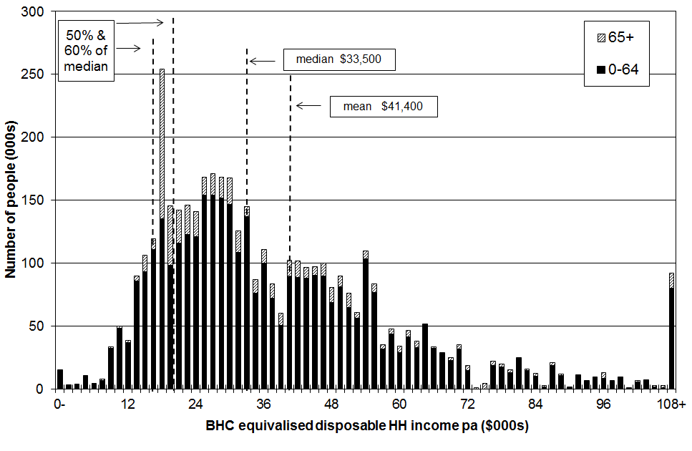

Figure B.2
AHC household income distribution for all individuals: HES 2013
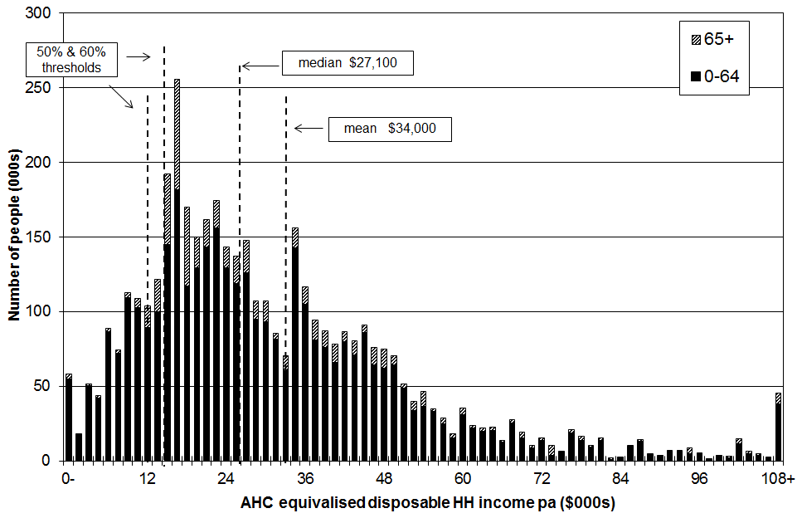

Notes: 1 For both graphs, individuals are grouped by their household incomes in multiples of $1500 pa ($30 pw). This is a rough and ready way of showing the shape of the income distribution and the number of people in different income bands.
2 Figure B.1 draws attention to the pensioner spike in the BHC distribution. In 2013 the pensioner spike was just above the 50% of median line.
3 The AHC low-income thresholds (‘poverty lines’) are set at the 50% and 60% BHC thresholds, less 25% to allow for housing costs. See Appendix 6.

Income distribution for sole parent and two parent families, HES 2013

Figure B.3 shows the distribution of family incomes for sole parent and two parent families. In 2013, around 90% of sole-parent families had incomes below the median household income for all households, with or without children. For two-parent families the proportion was 50%. This is similar to previous years.

The relatively low incomes of sole parent families reflects in the main two factors: (a) there is only one potential earner in a sole parent family, and (b) the relatively low full-time employment rate for sole parents (around 35% in 2013). In June 2009, 73% of working-age sole parents were receiving a main benefit. Only 15% of these sole parents had declared earnings. Sole parent beneficiary families are clustered in the lower part of the income distribution.

Figure B.3
Distribution of sole parent and two parent family income, HES 2013
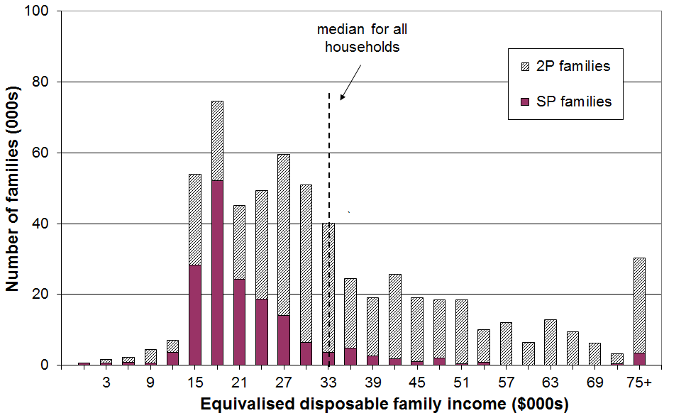

Notes: 1 Individuals are grouped by their family incomes in multiples of $3000 pa ($60 pw).
2 ‘Family’ here means ‘Economic Family Unit’.
3 Treasury’s Taxwell weights are used as they give a better population estimate of the number of beneficiary families.

It is clear from Figure B.3 that whatever standard income poverty measure is used, the proportion of those in sole parent families with incomes below the selected threshold (ie the income poverty rate for sole parent families) will be high in itself, and also higher than for those in two parent families.

Where does your household fit?

Many people do not have a realistic idea as to where they (and their household) fit in the income distribution. Tables B.4A and B.4B give the annual (unequivalised) disposable income levels (BHC) of different household types in each (equivalised) income decile. From these tables, most people will be able to locate where they and their households fit on the income distribution.

To use these tables, select the column heading that best describes your household or family situation. Go down the column until you find your household’s disposable income range (ie annual after-tax income, including all social assistance from the state). The row gives the equivalised income decile for your household income. For example, a household comprising a sole parent with two children with a disposable income of $48,000 pa is in decile 4.

Table B.4A

Where does your household fit in the overall household income distribution (BHC)?
HES 2013
Equivalised income decile | Ordinary dollars (ie not equivalised)
Equivalised income decile | One person,  no children  (reference HH) | Sole parent, one child | Sole parent, two children | Sole parent, three children | Sole parent, four children
Bottom decile | < $17,400 | < $24,400 | < $30,500 | < $35,900 | < $40,600
Decile 2 | 17,400 - 20,900 | 24,400 - 29,300 | 30,500 - 36,600 | 35,900 - 43,100 | 40,600 - 48,700
Decile 3 | 20,900 - 25,500 | 29,300 - 35,700 | 36,600 - 44,600 | 43,100 - 52,500 | 48,700 - 59,400
Decile 4 | 25,500 - 29,400 | 35,700 - 41,200 | 44,600 - 51,500 | 52,500 - 60,600 | 59,400 - 68,600
Decile 5 | 29,400 - 33,500 | 41,200 - 46,900 | 51,500 - 58,600 | 60,600 - 69,000 | 68,600 - 78,000
Decile 6 | 33,500 - 40,800 | 46,900 - 57,100 | 58,600 - 71,400 | 69,000 - 84,100 | 78,000 - 95,100
Decile 7 | 40,800 - 47,700 | 57,100 - 66,700 | 71,400 - 83,400 | 84,100 - 98,200 | 95,100 – 111,100
Decile 8 | 47,700 - 54,900 | 66,700 - 76,900 | 83,400 - 96,100 | 98,200 - 113,100 | 111,100 - 127,900
Decile 9 | 54,900 - 70,100 | 76,900- 98,100 | 96,100 - 122,600 | 113,100 - 144,300 | 127,900 – 163,300
Top decile | > $70,100 | > $98,100 | > $122,600 | > $144,300 | > $163,300

Note: use disposable household income when using this table – that is, household income from all sources after paying personal income tax and after receiving all tax credits (from Working for Families) and other state transfers (eg NZS, AS, main benefits)
Table B.4B

Where does your household fit in the overall household income distribution (BHC)?
HES 2013
Equivalised income decile | Ordinary dollars (ie not equivalised)
Equivalised income decile | Couple or 2 adults sharing | Couple,  one child | Couple,  two children | Couple,  three children | Couple, four children | Three adults, one child
Bottom decile | < $26,800 | < $32,400 | < $37,800 | <$ 42,300 | < $46,900 | < $39,400
Decile 2 | 26,800 - 32,200 | 32,400 - 38,900 | 37,800 - 45,400 | 42,300 - 50,800 | 46,900 - 56,200 | 39,400 - 47,300
Decile 3 | 32,200 - 39,200 | 38,900 - 47,400 | 45,400 - 55,300 | 50,800 - 61,900 | 56,200 - 68,600 | 47,300 - 57,600
Decile 4 | 39,200 - 45,300 | 47,400 - 54,700 | 55,300 - 63,900 | 61,900 - 71,500 | 68,600 - 79,200 | 57,600 - 66,500
Decile 5 | 45,300 - 51,600 | 54,700 - 62,300 | 63,900 - 72,700 | 71,500 - 81,400 | 79,200 - 90,100 | 66,500 - 75,700
Decile 6 | 51,600 - 62,900 | 62,300 - 75,900 | 72,700 - 88,600 | 81,400 - 99,200 | 90,100 - 109,800 | 75,700 - 92,200
Decile 7 | 62,900 - 73,400 | 75,900 - 88,700 | 88,600 - 103,400 | 99,200 - 115,800 | 109,800 - 128,200 | 92,200 - 107,700
Decile 8 | 73,400 - 84,600 | 88,700 - 102,100 | 103,400 - 119,100 | 115,800 - 133,400 | 128,200 - 147,700 | 107,700 - 124,100
Decile 9 | 84,600 - 107,900 | 102,100 - 130,300 | 119,100 - 152,100 | 133,400 - 170,300 | 147,700 - 188,500 | 124,100 - 158,400
Top decile | > $107,900 | > $130,300 | > $152,100 | > $170,300 | > $188,500 | > $158,400

Note: use disposable household income when using this table – that is, household income from all sources after paying personal income tax and after receiving all tax credits (from Working for Families) and other state transfers (eg NZS, AS, main benefits)

Distribution of individuals across income quintiles by various household and individual characteristics

When the population is ranked on their household incomes and divided into five equal groups, each group is called a quintile. A quintile contains 20% of the population.

Table B.5 shows the position of groups of individuals in the household income distribution (BHC) according to various household and individual characteristics. The proportions sum to 100% across the quintiles.

The numbers in each quintile can be obtained by using the information in the right-hand column which gives the number of individuals in the various subgroups. For example, in the lowest quintile (Q1), there are around 175,000 individuals in sole parent households where there are dependent children (56% of 312,000), and 210,000 in two parent households with dependent children (13% of 1,625,000).

Table B.6 shows the composition of each income quintile (BHC) according to various household and individual characteristics. The proportions sum to 100% down the columns for each set of characteristics.

Tables B.7 and B.8 repeat the analysis for AHC incomes.

Caution

When using the figures for smaller sub-groups, the proportions in each quintile should be taken as indicative rather than precise.

For example, in Table B.8 those living in one person 65+ households are reported as making up only 4% of the population. When reading Table B.7 for the distribution of those in this household type across the quintiles, it is reasonable to conclude that “around two thirds are found in the bottom two quintiles”, but to claim that 19,600 (12% of 163,000) are in the top quintile is spurious precision.

Another example is the distribution across the quintiles by ethnicity. With the Pacific group making up only 7% of the population, the same sort of caution applies as for the one person 65+ households noted above. The ‘Other’ group is larger (12%) but is very diverse, so results for each quintile can be volatile from year to year. An example of what it is reasonable to conclude from the analysis in the tables which follow is that household incomes for those of Maori and Pacific ethnicity are similarly distributed across the quintiles (50% to 60% are in the lower two quintiles), and are each quite differently distributed than are household incomes for European/Pakeha (for whom around one third are in the lower two quintiles).

See further comments in Section A under “Reliability of results”.

Table B.5
Distribution of individuals across income quintiles (BHC)
by various household and individual characteristics (%)
(sum to 100% across rows)
HES 2013 | Equivalised disposable household income |  |  |  |  | All individuals (000s)
HES 2013 | Q1 | Q2 | Q3 | Q4 | Q5 | All individuals (000s)
Age
0-17 | 23 | 26 | 23 | 16 | 12 | 1074
18-24 | 18 | 21 | 22 | 22 | 17 | 437
25-44 | 16 | 19 | 20 | 23 | 23 | 1158
45-64 | 15 | 15 | 18 | 24 | 28 | 1112
65+ | 34 | 20 | 16 | 15 | 15 | 586
All | 20 | 20 | 20 | 20 | 20 | 4368
Household type
One person 65+ | 48 | 22 | 13 | 8 | 9 | 163
Couple 65+ | 29 | 21 | 16 | 16 | 19 | 375
One person under 65 | 25 | 11 | 22 | 25 | 17 | 198
Couple under 65 | 12 | 9 | 12 | 26 | 41 | 533
SP with dependent children | 56 | 25 | 11 | 4 | 4 | 312
2P with dependent children | 13 | 26 | 26 | 18 | 17 | 1625
Other family HHs with dependent children | 20 | 24 | 18 | 30 | 7 | 309
Family HHs with no dependent children | 23 | 11 | 21 | 23 | 26 | 580
Non-family HHs | 16 | 18 | 19 | 24 | 28 | 272
All | 20 | 20 | 20 | 20 | 20 | 4338
Ethnicity
European/Pākehā | 16 | 17 | 19 | 22 | 25 | 2885
NZ Māori | 27 | 26 | 19 | 19 | 9 | 651
Pacific | 35 | 30 | 25 | 6 | 5 | 289
Other | 23 | 22 | 22 | 19 | 14 | 543
All | 20 | 20 | 20 | 20 | 20 | 4368
Main source of income (under 65s)
Market | 10 | 21 | 23 | 23 | 24 | 3353
Government transfer | 79 | 16 | 5 | 0 | 0 | 429
All | 18 | 20 | 21 | 21 | 21 | 3782
Tenure (under 65s)
Owned with mortgage | 8 | 16 | 22 | 27 | 26 | 1606
Owned without mortgage | 16 | 16 | 18 | 20 | 31 | 677
Rented - private | 25 | 26 | 22 | 15 | 12 | 1219
Rented - HNZC and local authority | 53 | 26 | 14 | 5 | 2 | 231
Children by household type
Children in SP HHs | 59 | 24 | 9 | 3 | 4 | 180
Children in 2P HHs | 13 | 27 | 28 | 16 | 16 | 746
Children in other family HHs | 22 | 23 | 21 | 28 | 6 | 117
Children in non-family households | * | * | * | * | * | 21
All children | 23 | 26 | 23 | 16 | 12 | 1064

Notes:
1 See note on page 67 for the need for caution in interpreting results for smaller sub-groups.
2 The sample numbers for children in non-family households are too small to give reliable estimates of their distribution across the quintiles.

Interpreting Tables B.5 and B.6: an example
Consider the 0-17 year old group (children).
- Table B.5 (distribution of each group across the quintiles) shows that 49% children are in households in the bottom two income quintiles.
- Table B.6 (composition of each quintile) shows that children make up 28% of all people in households with incomes in the bottom quintile.

Table B.6
Composition of income quintiles (BHC)
by various household and individual characteristics (%)
(sum to 100% down columns)
HES 2013 | Equivalised disposable household income |  |  |  |  | Overall composition
HES 2013 | Q1 | Q2 | Q3 | Q4 | Q5 | Overall composition
Age
0-17 | 28 | 32 | 29 | 19 | 15 | 25
18-24 | 9 | 11 | 11 | 11 | 8 | 10
25-44 | 21 | 25 | 26 | 30 | 30 | 27
45-64 | 19 | 19 | 23 | 30 | 36 | 25
65+ | 23 | 13 | 11 | 10 | 10 | 13
All | 100 | 100 | 100 | 100 | 100 | 100
Household type
One person 65+ | 9 | 4 | 2 | 2 | 2 | 4
Couple 65+ | 12 | 9 | 7 | 7 | 8 | 9
One person under 65 | 6 | 2 | 5 | 6 | 4 | 5
Couple under 65 | 7 | 6 | 8 | 16 | 25 | 12
SP with dependent children | 20 | 9 | 4 | 1 | 2 | 7
2P with dependent children | 24 | 49 | 49 | 34 | 31 | 37
Other family HHs with dependent children | 7 | 9 | 7 | 11 | 3 | 7
Family HHs with no dependent children | 11 | 7 | 14 | 17 | 18 | 13
Non-family HHs | 4 | 6 | 6 | 7 | 9 | 6
All | 100 | 100 | 100 | 100 | 100 | 100
Ethnicity
European/Pākehā | 54 | 57 | 64 | 72 | 83 | 66
NZ Māori | 20 | 20 | 14 | 14 | 7 | 15
Pacific | 12 | 10 | 8 | 2 | 2 | 7
Other | 14 | 14 | 4 | 13 | 9 | 12
All | 100 | 100 | 100 | 100 | 100 | 100
Main source of income (under 65s)
Market | 50 | 91 | 97 | 100 | 100 | 89
Government transfer | 50 | 9 | 3 | 0 | 0 | 11
All | 100 | 100 | 100 | 100 | 100 | 100
Tenure (under 65s)
Owned with mortgage | 19 | 35 | 45 | 56 | 54 | 43
Owned without mortgage | 16 | 14 | 16 | 18 | 27 | 18
Rented - private | 46 | 41 | 34 | 24 | 18 | 32
Rented - HNZC and local authority | 18 | 8 | 4 | 2 | 1 | 6
Children by household type
Children in SP HHs | 45 | 16 | 6 | 4 | 6 | 17
Children in 2P HHs | 41 | 73 | 82 | 74 | 89 | 70
Children in other family HHs | 11 | 10 | 10 | 20 | 5 | 11
Children in non-family HHs | 3 | 2 | 2 | 2 | 2 | 2
All children | 100 | 100 | 100 | 100 | 100 | 100

Notes:
1 See note on page 67 for the need for caution in interpreting results for smaller sub-groups.

Interpreting Tables B.5 and B.6: an example
Consider the 0-17 year old group (children).
- Table B.5 (distribution of children across the quintiles) shows that 49% of this group are in households in the bottom two income quintiles.
- Table B.6 (composition of each quintile) shows that children make up 28% of all people in households with incomes in the bottom quintile.
Table B.7
Distribution of individuals across income quintiles (AHC)
by various household and individual characteristics (%)
(sum to 100% across rows)
HES 2013 | Equivalised disposable household income |  |  |  |  | All individuals (000s)
HES 2013 | Q1 | Q2 | Q3 | Q4 | Q5 | All individuals (000s)
Age
0-17 | 27 | 23 | 23 | 16 | 11 | 1074
18-24 | 20 | 23 | 21 | 22 | 15 | 437
25-44 | 21 | 17 | 20 | 22 | 20 | 1158
45-64 | 16 | 12 | 19 | 22 | 31 | 1112
65+ | 16 | 12 | 19 | 22 | 31 | 586
All | 20 | 20 | 20 | 20 | 20 | 4368
Household type
One person 65+ | 20 | 47 | 12 | 9 | 12 | 163
Couple 65+ | 10 | 31 | 19 | 18 | 23 | 375
One person under 65 | 35 | 8 | 22 | 22 | 14 | 198
Couple under 65 | 14 | 6 | 14 | 25 | 42 | 533
SP with dependent children | 63 | 20 | 11 | 2 | 5 | 312
2P with dependent children | 17 | 23 | 25 | 19 | 15 | 1625
Other family HHs with dependent children | 21 | 24 | 19 | 31 | 5 | 309
Family HHs with no dependent children | 16 | 12 | 18 | 22 | 32 | 580
Non-family HHs | 10 | 20 | 22 | 27 | 21 | 272
All | 20 | 20 | 20 | 20 | 20 | 4338
Ethnicity
European/Pākehā | 15 | 18 | 19 | 23 | 25 | 2885
NZ Māori | 30 | 24 | 19 | 18 | 10 | 651
Pacific | 29 | 33 | 29 | 5 | 4 | 289
Other | 32 | 18 | 21 | 15 | 14 | 543
All | 20 | 20 | 20 | 20 | 20 | 4368
Main source of income (under 65s)
Market | 13 | 18 | 23 | 23 | 23 | 3353
Government transfer | 82 | 14 | 4 | 0 | 0 | 429
All | 21 | 17 | 21 | 21 | 21 | 3782
Tenure (under 65s)
Owned with mortgage | 12 | 16 | 22 | 26 | 24 | 1606
Owned without mortgage | 11 | 9 | 20 | 22 | 38 | 677
Rented - private | 35 | 22 | 20 | 15 | 9 | 1219
Rented - HNZC and local authority | 40 | 32 | 18 | 8 | 2 | 231
Children by household type
Children in SP HHs | 67 | 17 | 10 | 2 | 4 | 180
Children in 2P HHs | 18 | 24 | 26 | 18 | 14 | 746
Children in other family HHs | 24 | 22 | 23 | 27 | 4 | 117
Children in non-family households | * | * | * | * | * | 21
All children | 27 | 23 | 23 | 16 | 11 | 1064

Notes:
1 See note on page 67 for the need for caution in interpreting results for smaller sub-groups.
2 The sample numbers for children in non-family households are too small to give reliable estimates of their distribution across the quintiles.
Interpreting Tables B.7 and B.8: an example
Consider the 0-17 year old group (children).
- Table B.7 (distribution of children across the quintiles) shows that 50% of this group are in households in the bottom two income quintiles.
- Table B.8 (composition of each quintile) shows that children make up 33% of all people in households with incomes in the bottom quintile.
Table B.8
Composition of income quintiles (AHC)
by various household and individual characteristics (%)
(sum to 100% down columns)
HES 2013 | Equivalised disposable household income |  |  |  |  | Overall composition
HES 2013 | Q1 | Q2 | Q3 | Q4 | Q5 | Overall composition
Age
0-17 | 33 | 28 | 28 | 20 | 14 | 25
18-24 | 10 | 11 | 10 | 11 | 8 | 10
25-44 | 28 | 22 | 26 | 30 | 26 | 27
45-64 | 20 | 16 | 24 | 28 | 39 | 25
65+ | 9 | 23 | 11 | 11 | 13 | 13
All | 100 | 100 | 100 | 100 | 100 | 100
Household type
One person 65+ | 4 | 9 | 2 | 2 | 2 | 4
Couple 65+ | 4 | 13 | 8 | 8 | 10 | 9
One person under 65 | 8 | 2 | 5 | 5 | 3 | 5
Couple under 65 | 9 | 4 | 8 | 15 | 25 | 12
SP with dependent children | 22 | 7 | 4 | 1 | 2 | 7
2P with dependent children | 32 | 43 | 47 | 36 | 28 | 37
Family HHs with dependent children | 7 | 9 | 7 | 11 | 2 | 7
Other family HHs with no dependent children | 11 | 8 | 12 | 15 | 21 | 13
Non-family HHs | 3 | 6 | 7 | 8 | 7 | 6
All | 100 | 100 | 100 | 100 | 100 | 100
Ethnicity
European/Pākehā | 49 | 60 | 64 | 76 | 82 | 66
NZ Māori | 22 | 18 | 14 | 13 | 7 | 15
Pacific | 10 | 11 | 10 | 2 | 1 | 7
Other | 20 | 11 | 13 | 10 | 9 | 12
All | 100 | 100 | 100 | 100 | 100 | 100
Main source of income (under 65s)
Market | 56 | 92 | 98 | 100 | 100 | 89
Government transfer | 44 | 8 | 2 | 0 | 0 | 11
All | 100 | 100 | 100 | 100 | 100 | 100
Tenure (under 65s)
Owned with mortgage | 25 | 39 | 45 | 54 | 50 | 43
Owned without mortgage | 10 | 9 | 17 | 19 | 34 | 18
Rented - private | 53 | 40 | 31 | 23 | 14 | 32
Rented - HNZC and local authority | 12 | 11 | 6 | 2 | 1 | 6
Children by household type
Children in SP HHs | 43 | 13 | 7 | 2 | 7 | 17
Children in 2P HHs | 47 | 73 | 80 | 78 | 88 | 70
Children in other family HHs | 10 | 11 | 11 | 18 | 4 | 11
Children in non-family HHs | 1 | 3 | 2 | 3 | 1 | 2
All children | 100 | 100 | 100 | 100 | 100 | 100

Notes:
1 See note on page 67 for the need for caution in interpreting results for smaller sub-groups.

Interpreting Tables B.7 and B.8: an example
Consider the 0-17 year old group (children).
- Table B.7 (distribution of children across the quintiles) shows that 50% of this group are in households in the bottom two income quintiles.
- Table B.8 (composition of each quintile) shows that children make up 33% of all people in households with incomes in the bottom quintile.

Income shares across the distribution

Figures B.1 and B.2 above show that income is not distributed evenly across the population even after taxes and transfers have been taken into account. Figure B.4 presents the same information in a different way by showing the share of the total income that is received by the different income deciles (BHC). Because the income concept is equivalised household disposable income, the information in the graph needs to be interpreted as comparisons of the consumption capabilities for those in the various deciles, having adjusted for household size and composition.

Figure B.4
Shares of total income by deciles: HES 2013
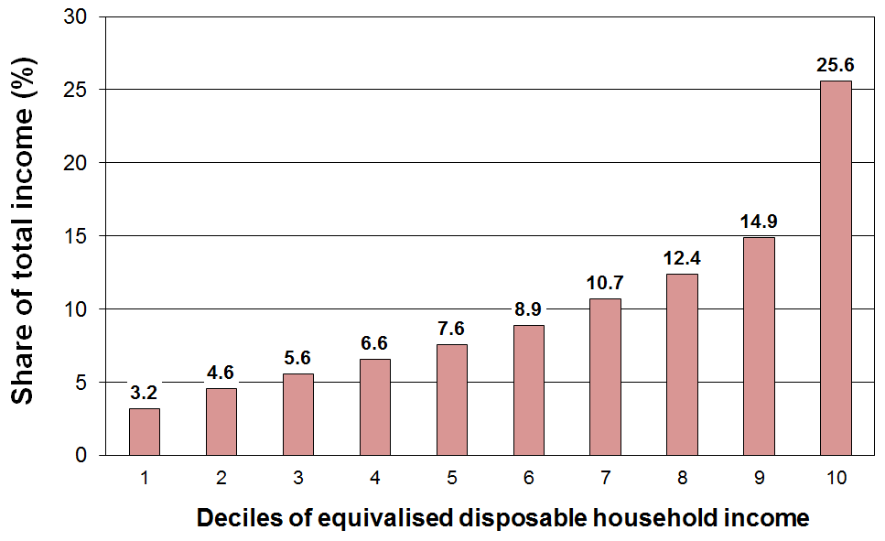

The top 10% receive just over a quarter and the top 30% receive just over a half of the total population (equivalised) income. This is much the same as in recent years. The average figures from HES 2007 to HES 2012 are 25% and 53% respectively.

Table B.9 shows that the distribution of household income in New Zealand is broadly similar to that in the UK, Australia and Canada, but more dispersed than for Finland and Norway.

Table B.9
Shares of total income by quintiles of equivalised disposable household income (%):
international comparisons for c 2012
 | Q1 (low) | Q2 | Q3 | Q4 | Q5 (high)
Norway | 10 | 16 | 19 | 23 | 33
Finland | 10 | 14 | 18 | 23 | 36
Sweden | 9 | 15 | 19 | 23 | 34
France | 9 | 13 | 17 | 22 | 40
New Zealand | 8 | 13 | 17 | 23 | 40
UK | 8 | 13 | 17 | 22 | 41
Australia | 8 | 13 | 17 | 23 | 40
Canada | 7 | 12 | 17 | 24 | 40
Italy | 7 | 13 | 18 | 23 | 39
Spain | 6 | 12 | 17 | 24 | 41
Greece | 6 | 12 | 18 | 24 | 40

Sources: Australia (Table 1 in ABS (2013) for 2012; Canada (Table 202-0606 in Statistics Canada (2011) for 2009; European countries (Eurostat statistical database for Population and Social Conditions for 2012).

The redistribution of income: market income, government cash benefits, income tax, consumption tax and publicly provided services

The income that households receive from wages and salaries, from investments and from people running their own businesses (market income) is redistributed through government intervention via taxation and social expenditure. This reduces the income inequality that would otherwise exist. This section provides an indication of the extent of the redistribution and the impact on inequality.

The extent of the redistribution of income

In interpreting the findings in this section it is important to note that market income is not the counterfactual or “natural state” that would exist if there was no government intervention. The existence of taxes, government expenditure and the apparatus of the welfare state influences citizens’ behaviour in relation to labour market participation, living arrangements, and so on. The analysis can be taken as an indication of the extent of redistribution given that we live in a redistributive welfare state.
Figure B.5
Cash transfers and income tax paid: HES 2013
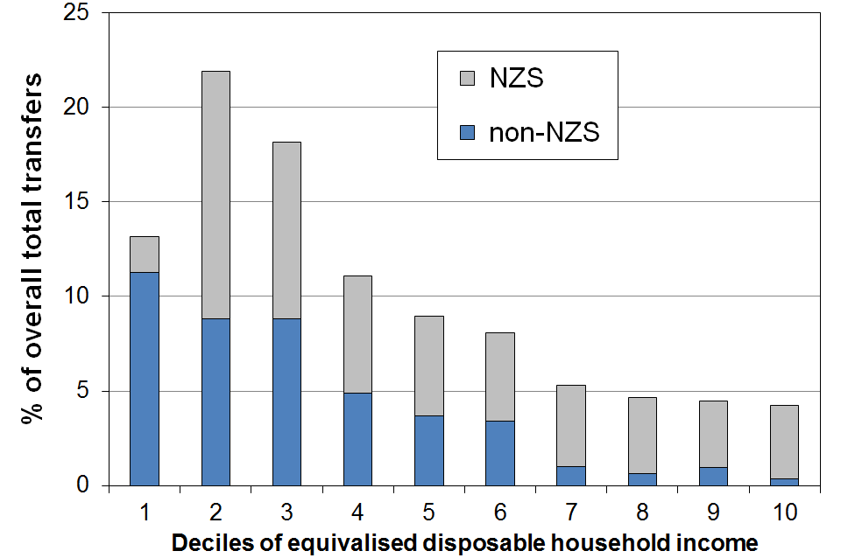
“Government transfers” include working-age welfare benefits, New Zealand Superannuation (NZS), the Accommodation Supplement, Working for Families tax credits, special needs grants, and so on. Figure B.5 (upper) shows the distribution of these transfers across household income deciles, with NZS separated out.

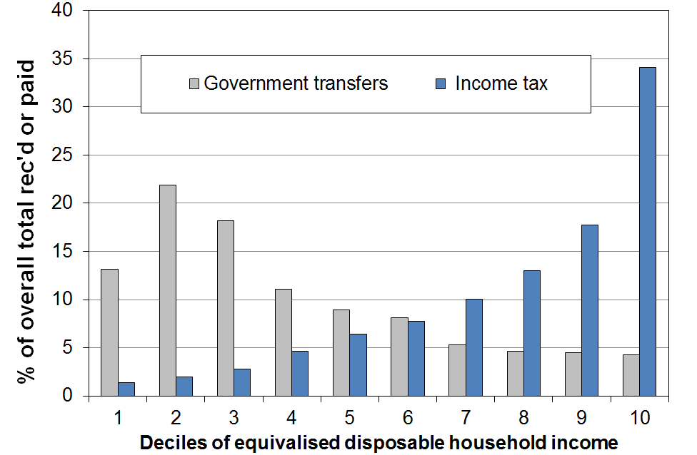
A useful way of looking at the extent of redistribution is to look at the difference between income taxes paid and transfers received for households in different income deciles (see Figure B.5 (lower). For many households, the amount they receive in transfers is greater than what they pay in income tax. They have a negative net tax liability.

One group with negative net tax liability is low- to middle-income households with dependent children. For example, single-earner families with two children can earn up to around $60,000 pa before they pay any net tax. Around half of all households with children receive more in welfare benefits and tax credits than they pay in income tax. The vast majority of older New Zealanders (aged 65+) live in households where there is a negative income tax liability – the income tax they pay is less than the value of New Zealand Superannuation (NZS) they receive. “Working-age” working households without dependent children have a positive income tax liability whatever their income.

Figure B.6
Income tax less govt cash transfers: HES 2013
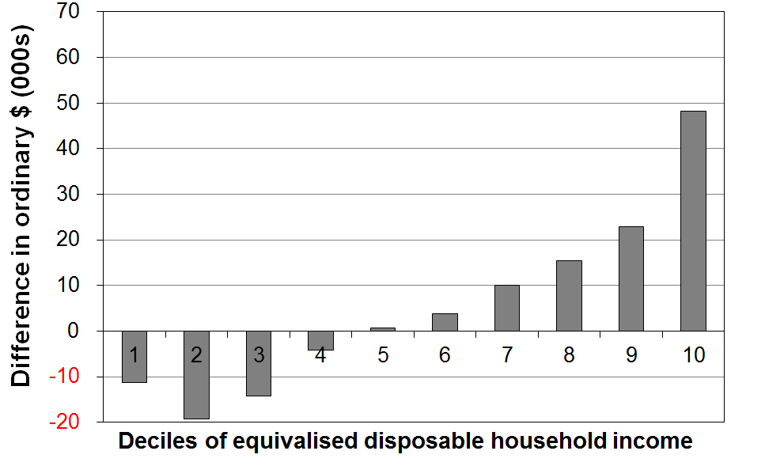
When all households are counted (working age with children, working age without children, and 65+ households), and looking at households grouped in deciles rather than looking at individual households, the total income tax paid by each of the bottom five deciles is less than the total transfers received (tax credits, welfare benefits, NZS and so on). See Figure B.6. It is only for each of the top five deciles that total income tax paid is greater than transfers received.

The inequality-reducing impact of taxes and transfers

Figure B.7 and Table B.10 show the inequality-reducing impact of taxes and transfers by comparing the Gini scores for household market income and household disposable income – that is for household incomes before and after taxes and transfers.

Figure B.7
Gini scores (x100) for market and disposable household income, 1986 to 2013 (18-64 yrs)
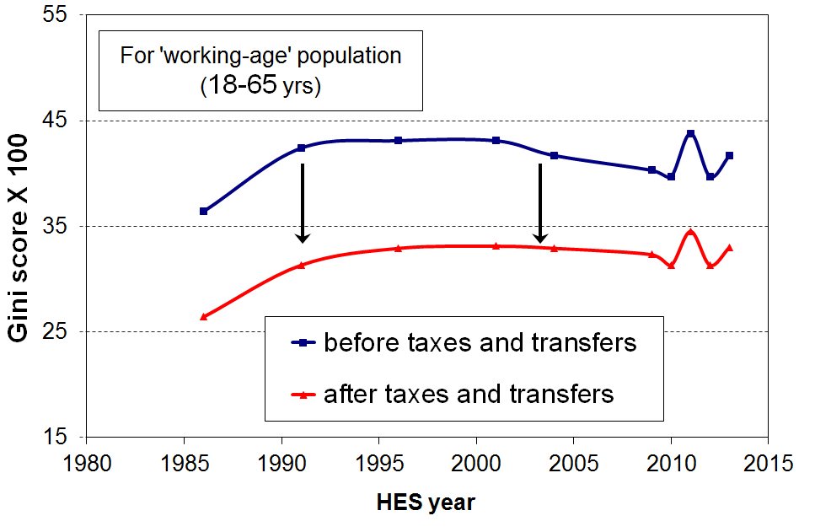

Table B.10
Gini scores (x100) for market and disposable household income, 1986 to 2013 (18-65 yrs)
HES year | Before taxes and transfers (market income) | After taxes and transfers (disposable income) | Reduction (%)
1986 | 36.4 | 26.4 | 27
1991 | 42.4 | 31.3 | 26
1996 | 43.1 | 32.9 | 24
2001 | 43.1 | 33.1 | 23
2004 | 41.7 | 32.9 | 21
2009 | 40.3 | 32.3 | 20
2010 | 39.7 | 31.3 | 21
2011 | 43.8 | 34.5 | 21
2012 | 39.7 | 31.3 | 21
2013 | 41.7 | 33.0 | 21

For working-age New Zealanders (aged 18 to 65 years), the reduction in the household market income Gini was 21% from 2004 to 2013. This reduction is similar to Australia and Canada (~23%), less than the UK (~27%), and much lower than many European countries such as Sweden, Norway, France and Austria (33-36% reductions). The median OECD reduction is 28% (c 2010 and 2011).

When the full population is used, New Zealand’s reduction in inequality is 28% compared with the OECD median of 35%.

“Final” household income

Figure B.5 tells only a part of the government transfer story. A more comprehensive analysis needs to include tax paid through GST especially as lower-income households generally apply all or almost all their income to expenditure on GST-able goods and services, whereas higher-income households apply a lesser proportion of their income to GST-able expenditure, with a portion going to savings and interest payments which do not attract GST. GST is therefore generally a higher proportion of the income of lower-income households than for higher-income households.

Households also receive government-funded health and education services which means that they do not have to pay for them directly from their own income. These services can be seen as a form of income or in-kind government benefit to be counted along with any cash benefits received.

In this broader framework the concept of “final” household income is sometimes used as a means of taking into account cash and in-kind income from the market and the government and consumption taxes as well as income taxes. Crawford and Johnston (2004) have shown that, using a final household income approach, there is further redistribution from more well-off households to less well-off households because households in the higher income deciles pay more consumption tax and also receive less in the way of in-kind benefits from education and health spending combined. They conclude that “final incomes are more equally distributed than disposable incomes” (p29).
Figure B.8
Redistribution of market income: HES 1998
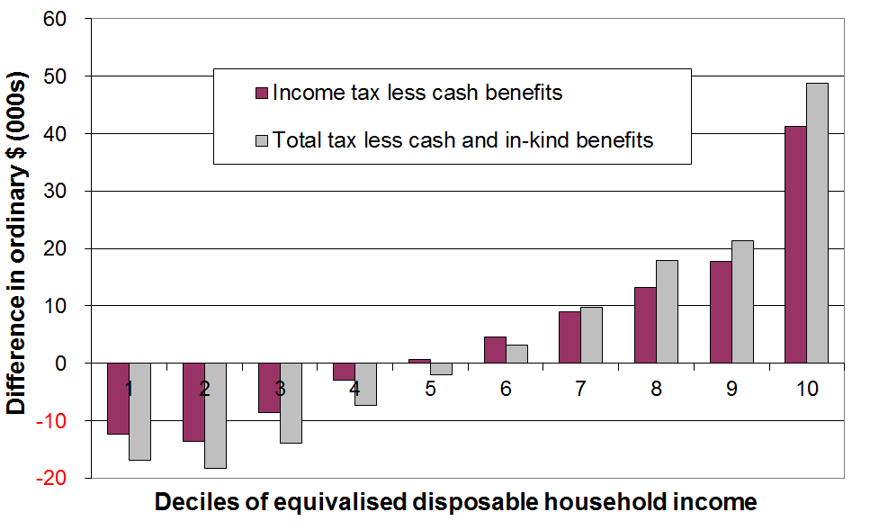
This finding is illustrated in Figure B.7 which compares the redistribution using both the narrower and broader frameworks for 1998.

The large additional transfer to low- to middle-income households through the Working for Families package in 2005 to 2007 and the tax switch changes in October 2010 are not captured in their analysis. The Treasury have since updated the analysis to 2010 (Aziz and colleagues, 2012), and that analysis confirms the earlier findings on inequality, among other things. This is consistent with other similar research from other OECD countries.
Source: Crawford and Johnston (2004)

An example is a 2008 OECD study on the equality-enhancing impact of taxes and cash transfers and of government services. The study found that:
- public expenditure on the provision of social services (mainly health and education) significantly reduces inequality within countries and reduces the range of inequality otherwise found across countries
- the size of the reduction in inequality from government in-kind services is on average less than that achieved by income taxes and transfers, but is still significant – it is around a quarter when using the inter-quintile share and a half when using the Gini coefficient
- the inequality-reducing impact of the countries’ tax and transfer systems is more variable across countries than the impact of public services
- the ranking of countries on inequality does not change very much when moving from a household disposable income measure to the broader measure that includes public services (correlation ~ 0.95).
Section C

Trends in key labour market, demographic, housing costs and social assistance variables

This report is essentially descriptive. It does not attempt, for example, to give a detailed explanation of changes in the income distribution by drawing on what we know about the impacts of key labour market, demographic, macro-economic and geo-political factors and of tax and social assistance policy settings.

This section however goes a little beyond description by providing information on trends in some key variables which clearly impact on the income distribution. These trends provide the basis for a high-level account of changes in the middle and at the lower end of the distribution in line with the main themes and focus of this paper.

At a high level, the trend in real GDP per capita sets the context, although the relationship of the GDP trend to that of disposable household income is not simple or direct. There are many mediating and modifying factors that impact on how the cake is divided up across households, independent of the size of the cake itself.

From a distributional perspective a rough rule of thumb is that median household incomes for the population as a whole generally follow the trend for incomes of two-parent-with-dependent-children households. This group made up around half of those in both the second and middle quintiles from the mid 1990s to 2013 and an even greater proportion during the 1980s. In other words, this group dominates the income distribution from P20 to P60, and changes for this group impact quite significantly on overall household income trends. The median income of this household type is very close to the overall median income in the 1982-2013 period (see Figure D.9 in the next section).

The two factors that impact the most on the incomes of two-parent-with-dependent-children households are average wage rates and the total hours worked by the two parents. The total number of hours worked is in turn related to the overall employment rate and to social norms, in relation to labour force participation for mothers and fathers of dependent children. This section therefore reports on the employment rate (by sex), net average ordinary time weekly earnings (NAOTWE), and the hours worked in two-parent-with-children-households. The trend in median household income is strongly influenced by trends in these factors.

The lower part of the income distribution includes those from households whose main income is from paid employment (“the working poor”) and those from households whose main income is from income-tested benefits or New Zealand Superannuation (NZS). Trends in the numbers below typical low-income thresholds (ie trends in income poverty rates) are therefore strongly influenced by three sets of factors: (a) average wage levels and employment rates; (b) (trends in) the levels of social assistance; and (c) trends in the numbers in receipt of social assistance. Social assistance is taken here to refer to the main income-tested benefits for those under 65, together with the Family Tax Credit (FTC) (formerly Family Support (FS)) and In-Work Tax Credit where there are dependent children, and NZS for those aged 65+.

This section therefore also reports on trends in the total number receiving a main benefit, the real value of the main benefits plus FTC/FS where relevant, and the unemployment rate.

This report promotes the value of using household incomes after deducting housing costs (AHC) as the preferred approach for comparing the material wellbeing of different subgroups of the population. This section therefore also reports on trends in gross expenditure on accommodation as proportion of household income.

Trends in GDP, employment, unemployment and weekly earnings

Figure C.1 shows the pattern of the business cycle from 1982 to 2013 in terms of annual GDP growth and the HLFS unemployment rate. The 2013 HES interviews were carried out from July 2012 to June 2013. The incomes reported by households in the survey are for the twelve months prior to the interview. Those interviewed in July 2012 would therefore be reporting on incomes in the period from August 2011 to July 2012, and so on. The household incomes data in the 2013 HES, as in the 2012 HES, could be expected to reflect the impact of the recovery after the economic slowdown associated with the GFC and the Christchurch earthquakes and other factors.

Figure C.1
Real GDP annual changes and unemployment rates, 1990 to 2013
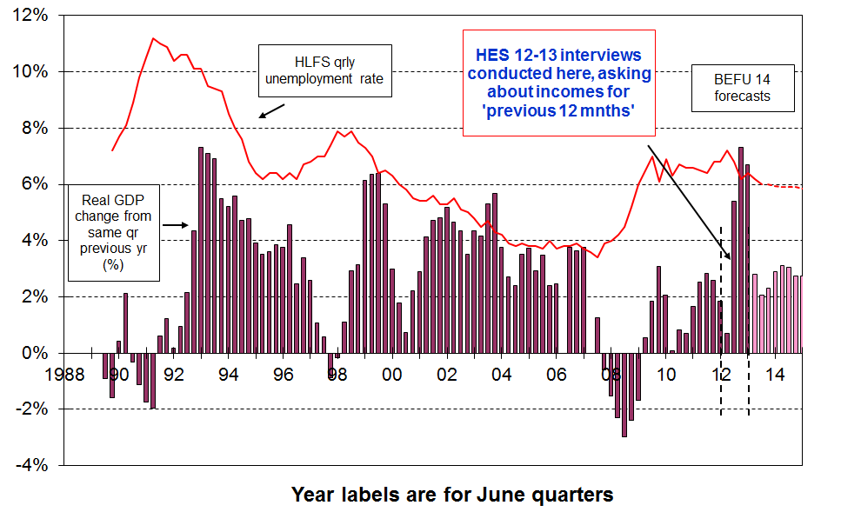

Figure C.2
Employment rate (15-64yrs), 1987 to 2014
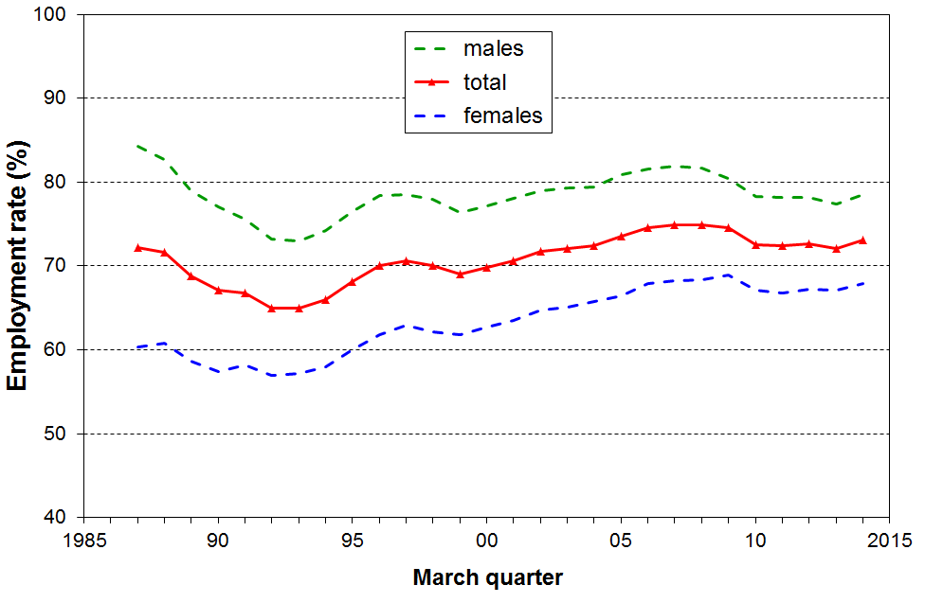

The improving employment rates in 2014 point to a further rise in household incomes in the next HES (2013-14).
Figure C.3 shows the trend in after-tax wages in real terms. They grew 32% in real terms from 1994 to 2013. Gross (before tax wages grew only by 23% in the period. In contrast median household incomes grew 46% in real terms.

Figure C.3
Net average ordinary time weekly earnings ($ Dec 2013)
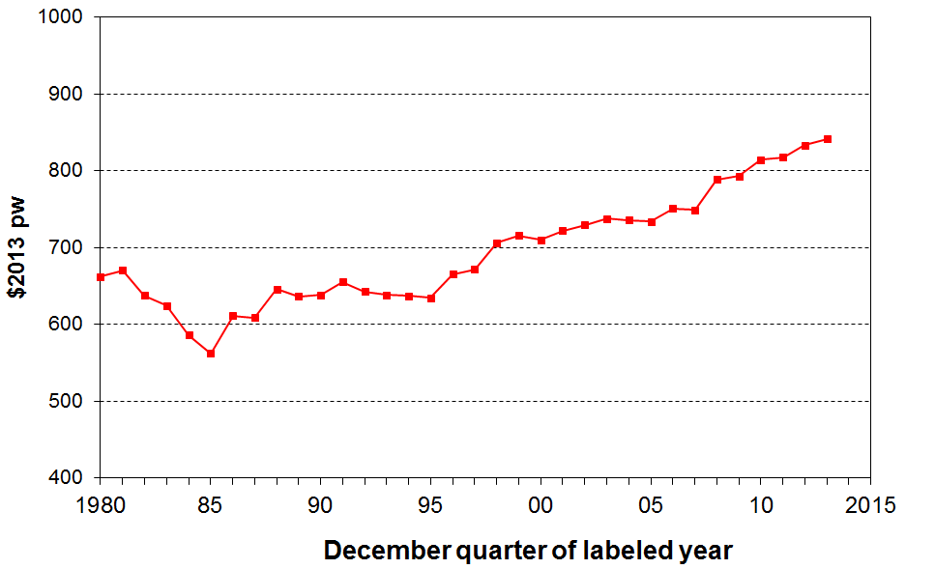

Incomes around the median: the longer-term trend

Figure C.2 shows the trend in the proportion of the population aged 15-64 who are in paid employment for at least one hour per week (the “employment rate”). After falling to a low in 1992 the employment rate rose through to 1996, faltered for two years then rose each year through to 2007, with a slower growth rate from 2004 to 2007. Employment rates fell from 2007 to 2010, returning to 2002 levels, and have been flat since. The female employment rate was considerably higher in 2013 (67%) compared with the mid 1980s (60%) whereas male employment in 2013 (78%) was below what it was in the mid 1980s (85%).

Figure C.4 shows the increasing work intensity in two-parent-plus-dependent-children households, especially since the mid 1990s. The two-earner proportion in recent years (68%) is a little above average for OECD countries (around 60%).

Figure C.4
Proportion of two parent HHs by hours of paid employment (where at least one is FT)
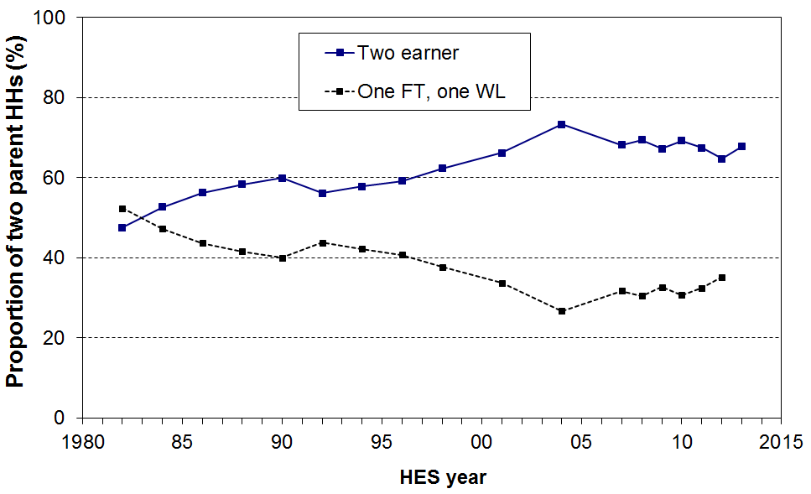
These factors together with the rising average wage point to median household incomes falling away in the early 1990s as employment declined, and rising from the mid 1990s through to 2004, with reasonably strong growth from 2001 to 2004 when all three factors lined up together to drive up income of two parent with dependent children households. From 2004 to 2007, the median incomes of two-parent households could be expected not to change as greatly as their employment hours remained steady overall (Figure C.4), and the WFF package had only an negligible impact on the median.

The movement of the median from 2007 to 2009 and beyond is not readily predictable from this high level model, especially given the volatility of the working hour arrangements for two parent families reported in recent years (more detailed figures behind Figure C.4), the personal tax changes introduced in October 2008, April 2009 and 2010, and changing employment rates.

See Figures D.1 and D.9 in the next section for the trends in median household incomes.

Incomes at the lower end of the income distribution

Incomes at the lower end of the distribution are significantly affected by trends in the levels of social assistance delivered through income-tested benefits and child-related support, and trends in the numbers for whom social assistance income is their primary source of income.

Figure C.5 shows the rise in the total number of EFUs (benefit units) receiving a main benefit through to 1994, the further rise through to 1999, the steady decline to June 2008, the rise through to June 2010 reflecting the recession and the global financial crisis, and the subsequent fall to just over 300,000 in March 2014. Numbers in receipt of the unemployment benefit follow a trend that is a rough mirror image of the employment rate (Figure C.2).

Figure C.5
Number of families / benefit units in receipt of income-tested benefits (all ages), 1986 to 2013:
(30 June figures to 2012, 31 March for 2013 and 2014)

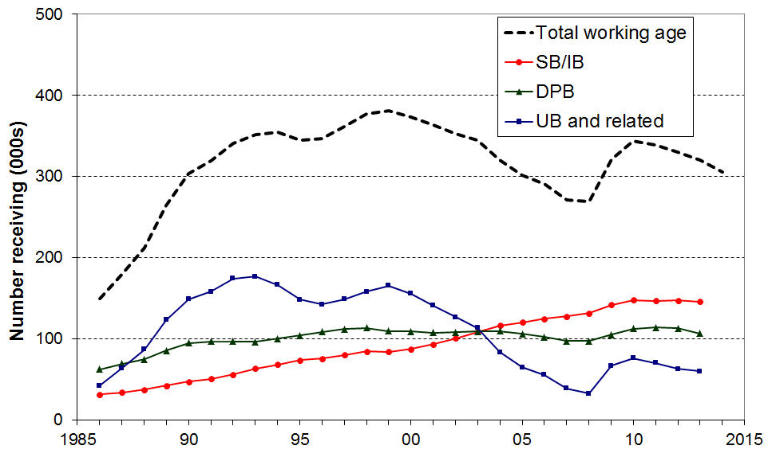

Figure C.5 is based on the number of EFUs receiving an income-tested benefit. Table C.1 (next page) shows both the number of EFUs and the total number of individuals in beneficiary families (EFUs) and the number of individuals receiving NZS.

Figure C.6
Number of families / benefit units in receipt of working-age income-tested benefits and number of individuals receiving NZ Superannuation or Veterans’ Pension:
(30 June figures to 2012, 31 March for 2013)
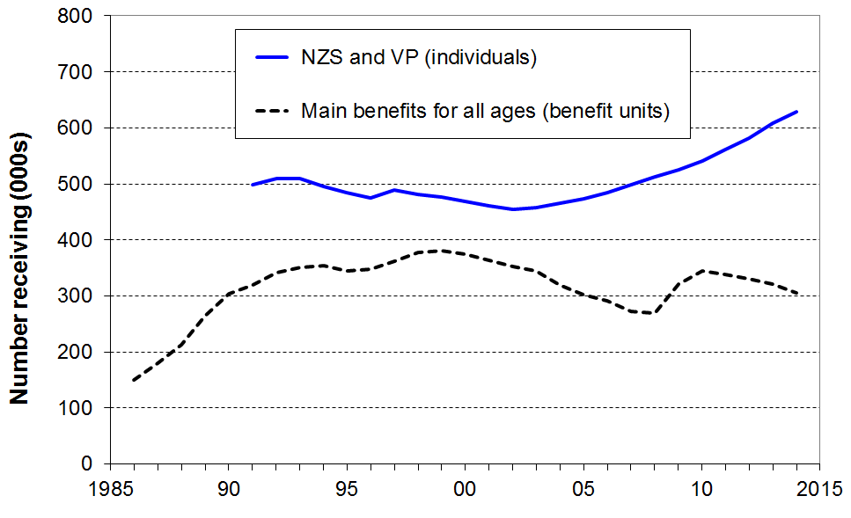

Table C.1
Individuals in EFUs in receipt of an income-tested benefit or NZS (30 June)
 | Total working age EFUs in receipt of an income-tested benefit (000s) | All people (adults and children) where prime recipient of an income-tested benefit is under 65  (000s) | Children (<18) dependent on a recipient of an income-tested benefit (all ages), (000s) | NZS/VP recipients  (000s) | Proportion of children (<18) dependent on a recipient of an income-tested benefit  (%) | Proportion of all people under 65 in an EFU in receipt of an income-tested benefit  (%) | Proportion of whole popln in an EFU in receipt of an income-tested benefit or NZS/VP  (%)
1998 | 368 | 701 | 281 | 477 | 30 | 21 | 31
1999 | 372 | 701 | 277 | 468 | 28 | 21 | 30
2000 | 364 | 684 | 271 | 461 | 27 | 20 | 30
2001 | 354 | 662 | 263 | 454 | 26 | 19 | 29
2002 | 343 | 638 | 256 | 458 | 25 | 18 | 28
2003 | 334 | 622 | 253 | 467 | 24 | 18 | 27
2004 | 309 | 584 | 245 | 473 | 24 | 16 | 26
2005 | 290 | 548 | 233 | 484 | 22 | 15 | 25
2006 | 280 | 523 | 221 | 498 | 21 | 14 | 24
2007 | 261 | 485 | 205 | 513 | 19 | 13 | 24
2008 | 258 | 482 | 200 | 525 | 19 | 13 | 24
2009 | 310 | 554 | 221 | 542 | 21 | 15 | 25
2010 | 333 | 591 | 233 | 561 | 22 | 16 | 26
2011 | 328 | 591 | 232 | 581 | 22 | 15 | 27
2012 | 320 | 575 | 227 | 608 | 22 | 15 | 27
2013  (31 Mar) | 310 | 552 | 217 | 628 | 20 | 14 | 26
2014 (31 Mar) | 295 | 518 | 200 | 655 | 19 | 14 | 26

Sources: Columns 1-4, MSD Statistical Reports and Information Analysis Platform
Columns 5-7 use population estimates from Statistics New Zealand for the denominator

Figure C.7 shows the trend in real terms of average earnings and of income-tested benefits for the period. The earnings measure is net average ordinary time weekly earnings (NAOTWE) and the income-tested benefit measure is the value of the main benefit plus the Family Tax Credit (or Family Support prior to 2007) for which the respective families are eligible in relation to the dependent children in their care. None of the scenario lines include the Accommodation Supplement or the subsidy received by those on income-related rents vis-à-vis market rents.

Figure C.7
Income-tested benefits (plus FTC) and average earnings in real terms for selected HH types
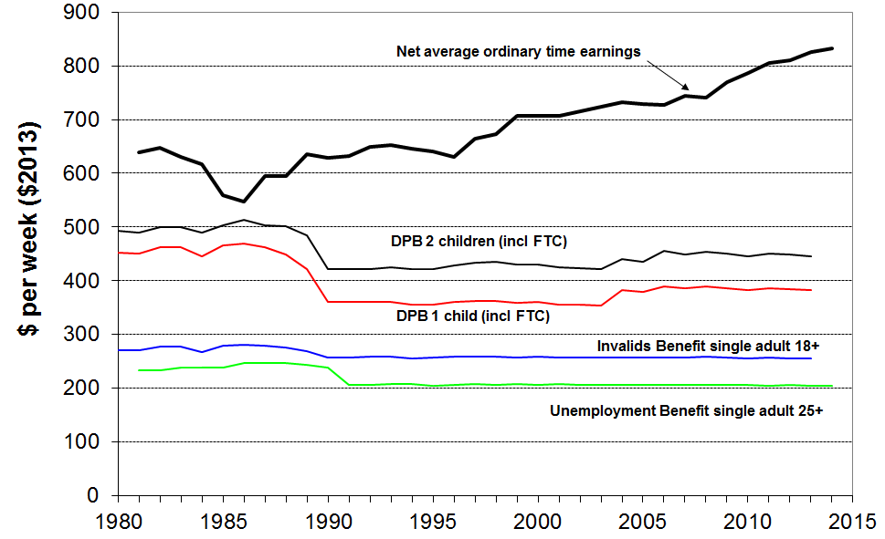

Figures C.8A, C.8B and C.8C expand the comparisons above by including NZS and median disposable household income. They show the different trajectories for the different income measures by using an index set to 100 in 1983, 1994 and 2007 respectively. These three starting points are for before the 1991 benefit cuts, after the benefit cuts and when the economy was growing and benefit numbers had fallen considerably, and after the introduction of the Working for Families package. The three different starting points are shown as for this sort of analysis a different picture can emerge depending on the starting point used.

Figure C.8A
Relativities between main benefit levels, NZS, average wage and median household income,
1983 = 100

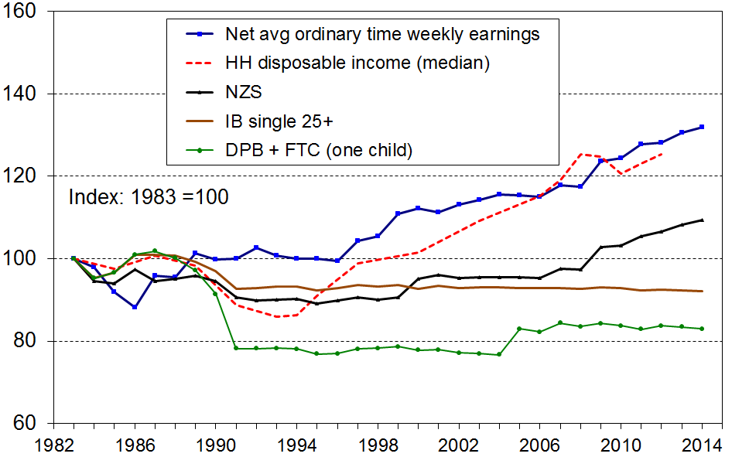

Figure C.8B
Relativities between main benefit levels, NZS, average wage and median household income,
1994 = 100
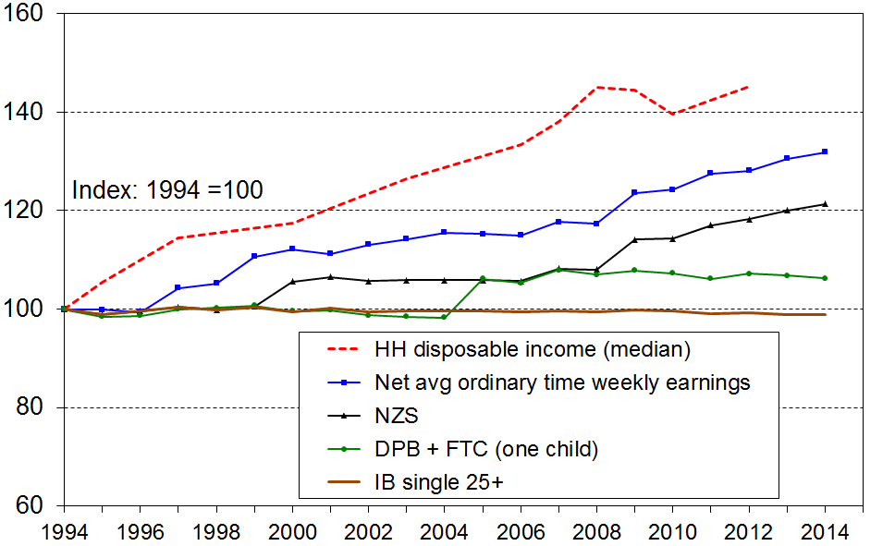

Figure C.8C
Relativities between main benefit levels, NZS, average wage and median household income,
2007 = 100
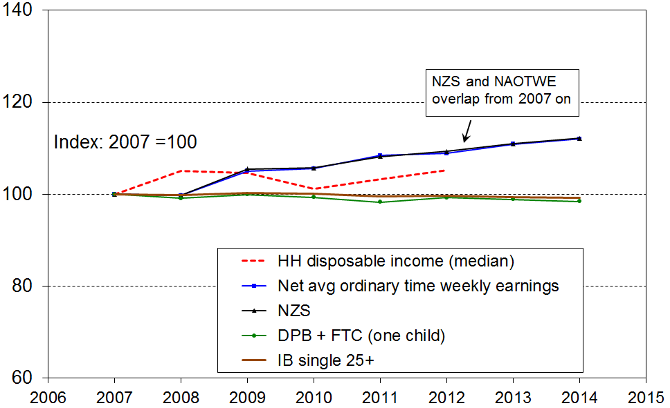
Note: the vertical scale for Fig C.8C is a little different from the one used for both 8A and 8B.

Table C.2
Relativities between main benefit levels, NZS, average wage and median household income:
summary table
% change from base year
(CPI adjusted – ie ‘real’ changes)
 | 1983 to 2014 | 1994 to 2014 | 2007 to 2014
Median household income (see note below) | +25 | +45 | +5
Net average ordinary time earnings | +32 | +32 | +12
NZS | +9 | +21 | +12
DPB plus family assistance (one child) | -17 | +6 | -2
Invalids Benefit – single aged 25+ | -8 | -1 | -1
Note: The change in median household income is to calendar 2012 only (HES 2013). Assuming modest household income growth from 2012 to 2014, a further 3 to 4 percentage points needs to be added to the changes for household income noted in the table for more realistic comparisons.

Housing costs

High housing costs relative to income are often associated with financial stress for low- to middle-income households. Low-income households especially can be left with insufficient income to meet other basic needs such as food, clothing, transport, medical care and education for household members.

Figure C.9 and Table C.3 show the trends by income quintiles for households with high “outgoing-to-income ratios” (OTIs), using 30% as the benchmark for high OTIs.

Figure C.9
Proportion of households with housing cost OTIs greater than 30%, by BHC income quintile
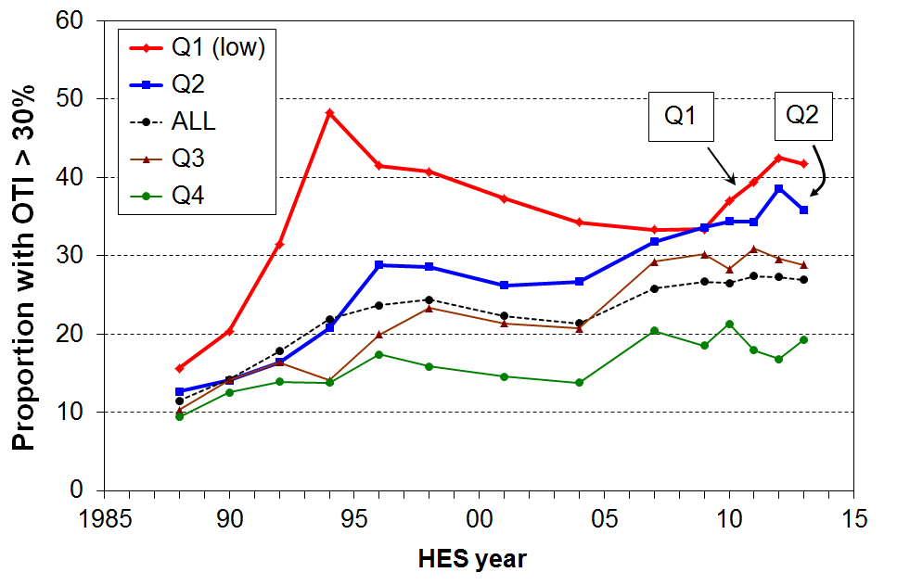

Table C.3
Proportion of households with housing cost OTIs greater than 30%, by income quintile
 | Q1 | Q2 | Q3 | Q4 | Q5 | ALL
1988 | 16 | 13 | 10 | 9 | 9 | 11
1990 | 20 | 14 | 14 | 13 | 10 | 14
1992 | 32 | 16 | 16 | 14 | 11 | 18
1994 | 48 | 21 | 14 | 14 | 13 | 22
1996 | 42 | 29 | 20 | 17 | 11 | 24
1998 | 41 | 29 | 23 | 16 | 13 | 24
2001 | 37 | 26 | 21 | 15 | 12 | 22
2004 | 34 | 27 | 21 | 14 | 12 | 21
2007 | 33 | 32 | 29 | 20 | 14 | 26
2009 | 33 | 34 | 30 | 19 | 18 | 27
2010 | 37 | 34 | 28 | 21 | 12 | 27
2011 | 39 | 34 | 31 | 18 | 14 | 27
2012 | 43 | 39 | 30 | 17 | 9 | 27
2013 | 42 | 36 | 29 | 19 | 9 | 27

In 2013, just over one in four households (27%) had high housing OTIs (>30%), compared with one in five in the early 1990s, and one in ten in the late 1980s.

For the bottom quintile, the proportion with high OTIs steadily reduced from 48% in 1994 to 34% in 2004, as unemployment fell, employment and income rose, and income-related rental policies were introduced in 2000 for those in HNZC houses. It then remained reasonably steady at around one in three through to 2009, but has steadily risen since to be 42-43% in the last two surveys (HES 12 and HES 13).

For households in the second quintile there was a strong rise from the 1980s through to the mid 1990s, followed by a relatively flat trend to 2004. From 2004 (27%), there has been a strong rise in the proportion of Q2 households with OTIs greater than 30%, reaching 37% on average over HES 2012 and HES 2013.

The rise for the third quintile from 2004 (21%) to 2012 and 2013 (30%) is also noteworthy, but unlike the trend for households in the second quintile the rise seems to have stopped.

OTIs greater than 40%

From 2007 to 2013, around 15% of households had an OTI greater than 40% - up from 5% in the late 1980s (see Figure C.10).

For those in Q1 (lower quintile), the proportion with these higher OTIs peaked in the late 1990s at 34%, declined to 25-27% from 2004 to 2009, then rose again to be back at the 1994 rate in 2013 (34%). The proportion in the second quintile rose from 15% in 2001 to 21% on average in 2011 to 2013.

Figure C.10
Proportion of households with housing cost OTIs greater than 40%
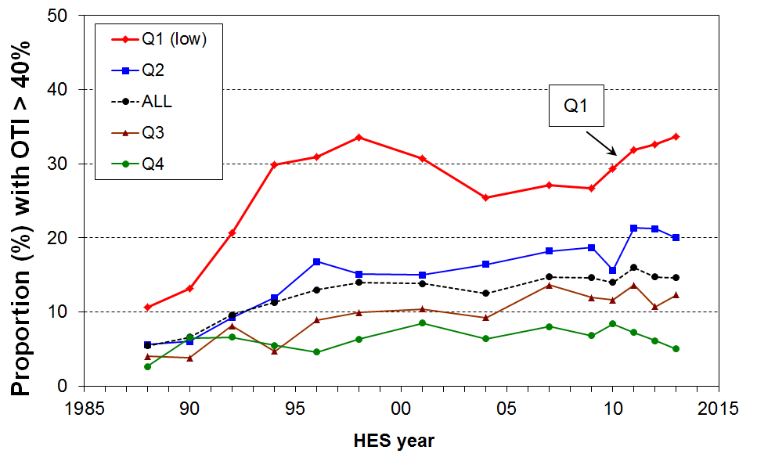

OTIs greater than 50%

In HES 2013, just over one in four Q1 households reported spending more than half their income on accommodation (Figure C.11). This has risen from a steady one in five from 2004 to 2009 and is higher than any time since the time series begins in 1988.

Figure C.11
Proportion of Q1 households with housing cost OTIs greater than 30%, 40% and 50%
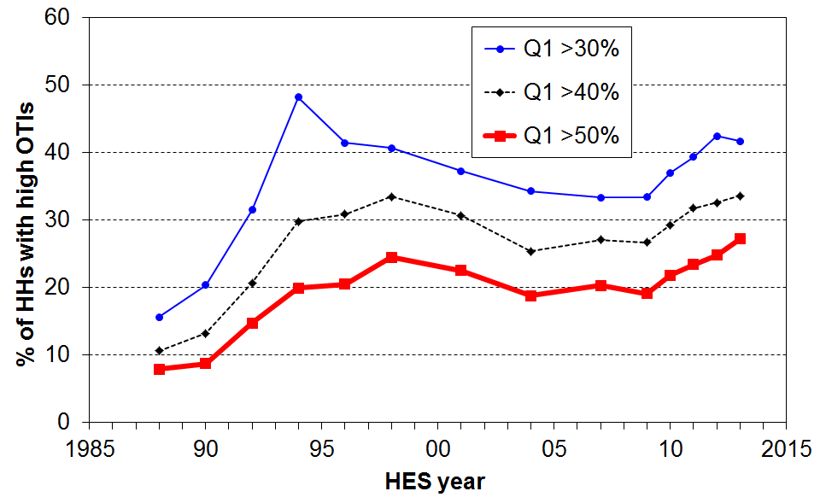

OTI trends using the individual rather than the benefit unit or household as the unit of analysis

Figures C.9 to C.11 above use the household as the analysis unit. For some purposes, such as examining the different levels of housing stress by age, analysis needs to be done using individuals rather than households. Table C.4 provides a breakdown by age group. The proportions with high OTIs in 2013 are on average much higher than in the late 1980s for all age groups (doubling or even tripling for some), although still remaining relatively low on average for older New Zealanders.

Table C.4
Proportion of individuals in households with housing cost OTIs greater than 30%, by age group
 | 0-17 | 18-24 | 25-44 | 45-64 | 65+ | ALL
1988 | 12 | 12 | 15 | 5 | 3 | 11
1990 | 16 | 16 | 18 | 7 | 2 | 14
1992 | 22 | 21 | 24 | 8 | 3 | 18
1994 | 27 | 22 | 28 | 10 | 5 | 22
1996 | 32 | 24 | 28 | 14 | 6 | 24
1998 | 33 | 26 | 31 | 14 | 7 | 26
2001 | 32 | 29 | 28 | 16 | 7 | 25
2004 | 26 | 28 | 25 | 15 | 6 | 22
2007 | 32 | 29 | 33 | 19 | 9 | 27
2009 | 37 | 24 | 35 | 21 | 8 | 28
2010 | 34 | 29 | 33 | 20 | 9 | 27
2011 | 32 | 34 | 33 | 21 | 8 | 27
2012 | 37 | 32 | 35 | 20 | 9 | 28
2013 | 34 | 28 | 35 | 20 | 9 | 27

Long-run trends are very similar whichever unit of analysis is used (compare, for example, the “ALL” columns in Tables C.2 and C.3). There can however be some divergence from survey to survey especially for sub-groups, mainly because the bottom quintile (20%) of households has only around 17% of the total population in it, reflecting in particular the high proportion of small households in decile 2 (the top half of the bottom quintile). As a consequence of this difference, the second quintile of households does not perfectly coincide with the second quintile of individuals.

Figure C.12 compares the trends for second quintile individuals and second quintile households and shows that despite the wobbles and divergences that are evident at times from survey to survey, the trends are the same.

Figure C.12
Proportion of Q2 individuals and households with housing cost OTIs greater than 30% and 40%
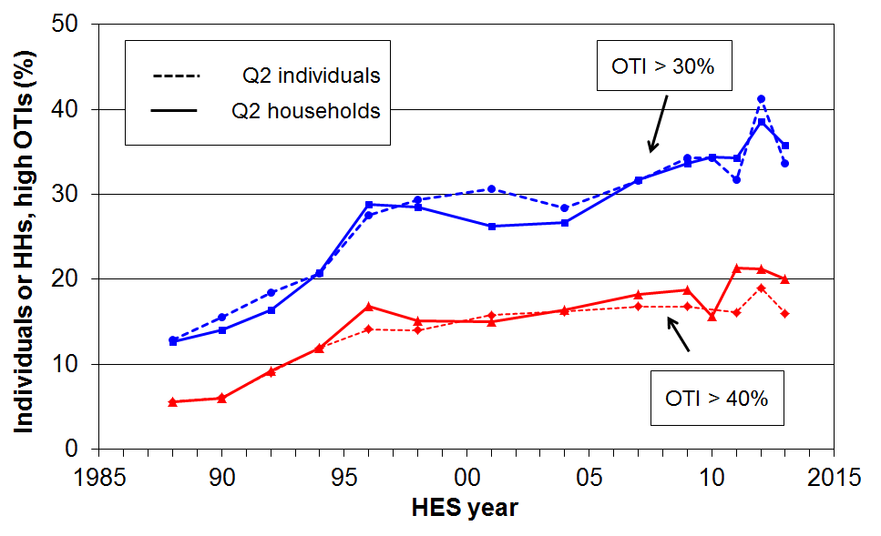

OTIs for those receiving the Accommodation Supplement – information from administrative data

Table C.5 focuses on those households receiving accommodation support through the AS (Accommodation Supplement). It shows the proportions of these AS households that have high OTIs – those that are spending more than 30%, 40% and even 50% of their income on accommodation.
- in 2013, almost all renters (94%) receiving the AS spent more than 30% of their income on housing costs, three in four spent more than 40% and one in two (48%) spent more than 50%
- an increasing proportion of AS recipients are receiving the maximum payment (33% in 2007 and 50% in 2013).

Table C.5
Housing stress for AS recipients using three OTI thresholds (30%, 40% and 50%), 2013
Group | This group as a proportion of all who receive AS | housing costs as a proportion of income
Group | This group as a proportion of all who receive AS | >30% | >40% | >50%
All | 100 | 92 | 67 | 40
Renters | 66 | 94 | 75 | 48
Single adult | 52 | 93 | 71 | 45
2 parent with dependent children | 9 | 89 | 52 | 23
One parent with one child | 17 | 92 | 69 | 42
One parent with 2+ children | 15 | 89 | 64 | 32
NZS/VP | 10 | 83 | 49 | 23

Section D

Household incomes and income inequality,

1982 to 2013

This section reports on:
- changes in equivalised household incomes for the whole population
- changes for different parts of the distribution
- changes in medians for different household types
- the changing shape of the household income distribution
- trends in inequality using income shares, percentile ratios and the Gini coefficient.

Income changes in real terms, 1982 to 2013

Whole population, overall trends

Figure D.1 shows the trends in real equivalised household disposable income (BHC and AHC) from 1982 to 2013.

After 15 years of steady growth in median household income (3% pa in real terms from HES 1994 to HES 2009), the impact of the economic downturn on household incomes showed in the HES 2010 and 2011 figures in which both the BHC and AHC medians declined. The 2012 HES picked up the beginning of the recovery with the median rising 2% in real terms, followed by another 2% to the 2013 HES.

The BHC median fell 15% from 1988 to 1994, and it took until 2001 to restore it to its 1988 level.

The general trend for AHC medians is similar to that for BHC medians, although the AHC median fell from 90% of the BHC median in 1982, to 86% in 1988, and 80% in 1998. Since then the relativity has been steady at 78% to 79%. This reflects how accommodation costs have risen as a proportion of household income for low- to middle-income households since the 1980s.

Figure D.1
Real equivalised household disposable incomes, 1982 to 2013 (2013 dollars)
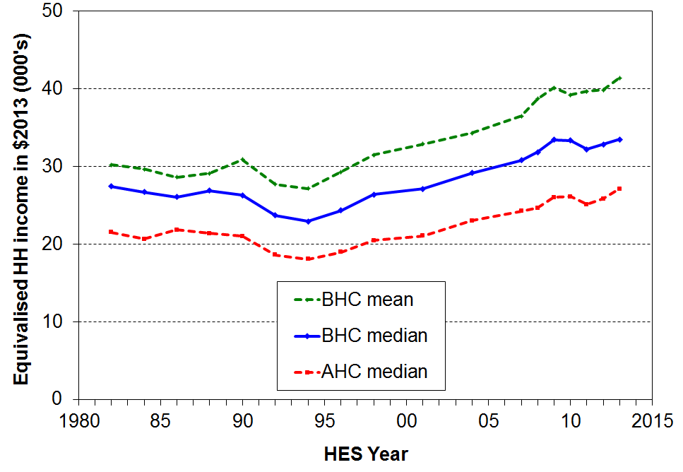

Table D.1
Real equivalised household disposable incomes, 1982 to 2013 (2013 dollars)
 | 1982 | 1986 | 1990 | 1994 | 1998 | 2001 | 2004 | 2007 | 2009 | 2010 | 2011 | 2012 | 2013
BHC mean | 30,200 | 28,600 | 30,900 | 27,200 | 31,500 | 32,900 | 34,300 | 36,500 | 40,100 | 39,200 | 39,700 | 39,800 | 41,400
BHC median | 27,500 | 26,000 | 26,200 | 22,900 | 26,400 | 27,100 | 29,100 | 30,800 | 33,400 | 33,300 | 32,200 | 32,800 | 33,500
AHC median | 21,500 | 21,800 | 21,000 | 18,100 | 20,500 | 21,000 | 23,000 | 24,200 | 26,000 | 26,100 | 25,100 | 25,800 | 27,100

The mean and median generally move in the same direction. The most notable exception is for the period 1988 to 1990 during which the mean rose but the median fell. In this period, average incomes for households in the top quintile of the income distribution rose in real terms but those in the other four quintiles fell (cf Figure D.5). This lowered the median but raised the mean as the impact of the rises of those with higher incomes was the dominant effect.

Differing trends for different parts of the distribution (BHC)

Trends in the overall median or mean household income provide useful high-level summaries, but they tell only a part of the story as different parts of the income distribution (can) show quite different relative movements over time.

One way to show these differing changes is to divide the population into ten equal groups (deciles) and show the trends in real incomes for the median, mean or top of each decile. This part of the analysis uses the latter as it fits well with the use of percentile ratios for summarising trends in inequality, which is done later in this section. Changes for incomes at P95 (the median of the top decile) are also included. Decile means are reported in Appendix 9.

Recent changes (2007 HES to 2013 HES)

Figure D.2 shows the changes for the decile boundaries from HES 2007 to HES 2013, broken down into three two-year comparisons. The top graph shows the 3-4% pa growth across all deciles prior to the GFC. The impact of the GFC is clearly evident in the HES 2009 to 2011 graph, with net declines for deciles 1-6 and no change for the higher income deciles (8-10). The lower graph shows the impact of the recovery on household incomes across the distribution.

Figure D.2
Real equivalised household incomes (BHC): changes for top of deciles, HES 2007 to HES 2013
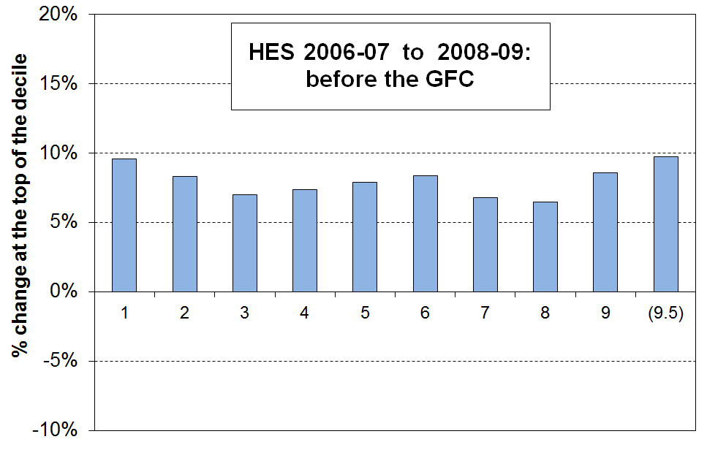

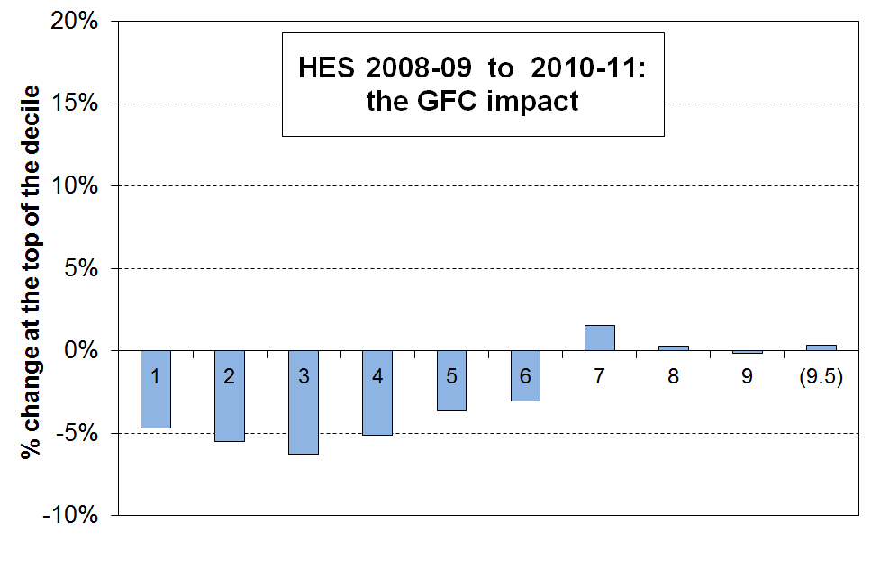

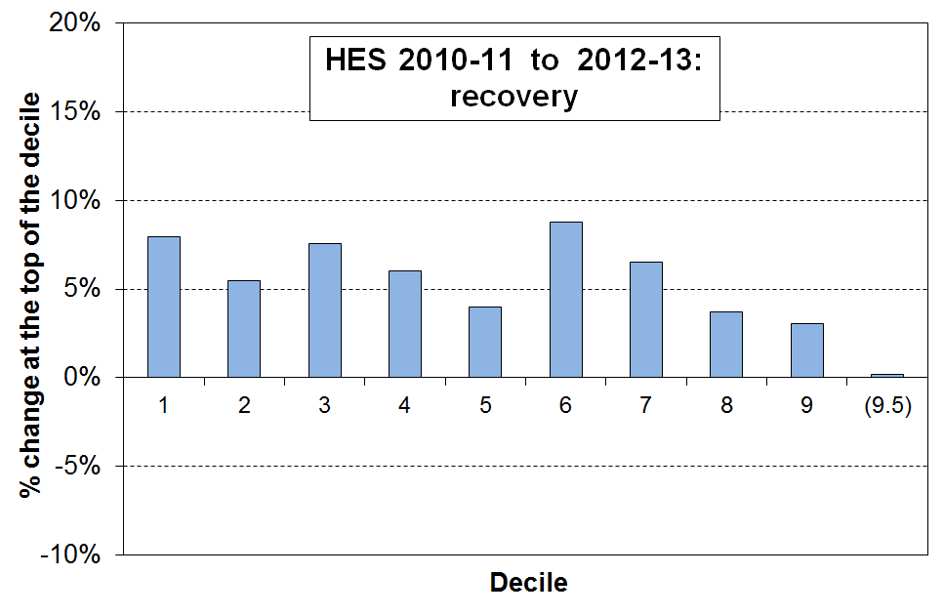
The Working for Families impact (2004 HES to 2007 HES)

The changes from 2004 to 2007 reflected the major part of the impact of the Working for Families package (Figure D.3). The transfer of an extra approximately $1.6b pa to low- to middle-income households with children made a tangible difference to the income distribution. The general pattern up to 2004 had been for the income of higher-income households to rise more quickly than those of lower- to middle-income households. The 2004 to 2007 period was the only one in the 25 years to 2007 in which the incomes of low- to middle-income households grew more quickly than those of households above the median.

Figure D.3
Real equivalised household incomes (BHC): changes for top of deciles, 2004 to 2007
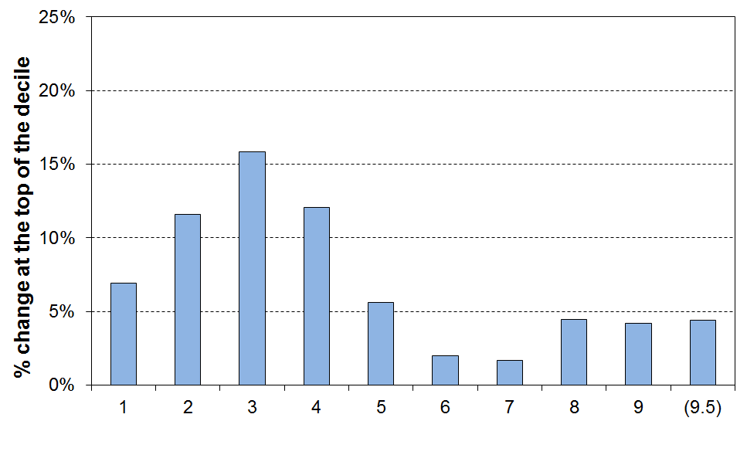

Longer term trends

Figure D.4 shows the differing changes for different parts of the income distribution (top of deciles 1 to 9, plus P95) from 1988 to 2004. The period is divided at 1994 when incomes were at their lowest in real terms.

The graphs show the very large falls in real household income from 1988 to 1994 for all but the very highest income group, followed from 1994 to 2004 by steady and fairly even income growth across the whole income distribution, although the growth for lower income households (bottom 20 to 30%) was not as strong as for the rest.

Figure D.4
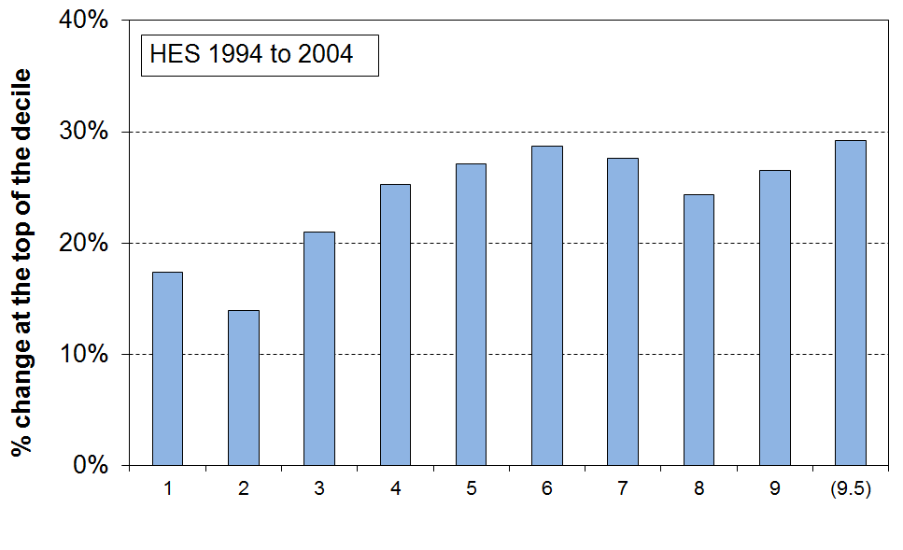
Real equivalised household incomes (BHC): changes for top of deciles, 1988-94, and 1994-04

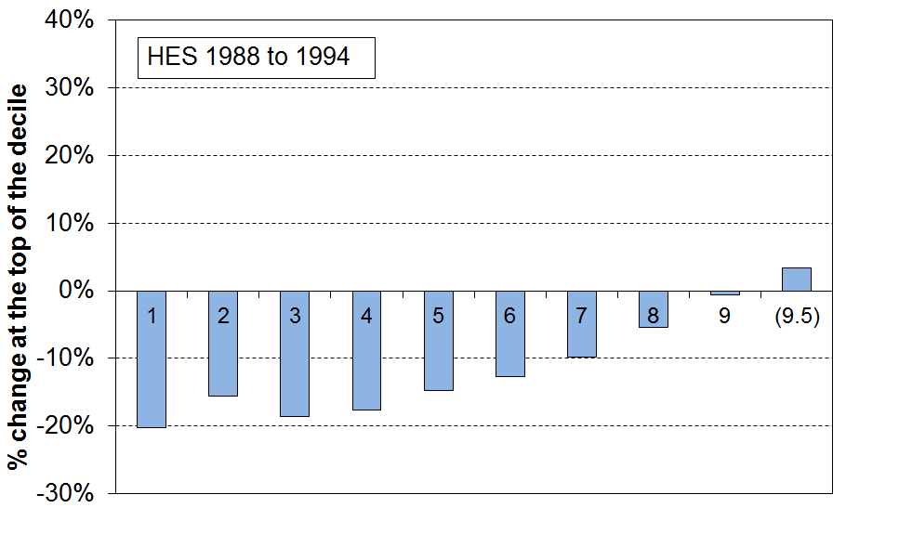
The net effect of the changes from 1988 to 2004 is captured in Figure D.5 which shows the large net increase in inequality that took place in that period. Most of the increase occurred from the late 1980s to the mid 1990s.

Figure D.5
Real equivalised household incomes (BHC): changes for top of deciles,1988 to 2004
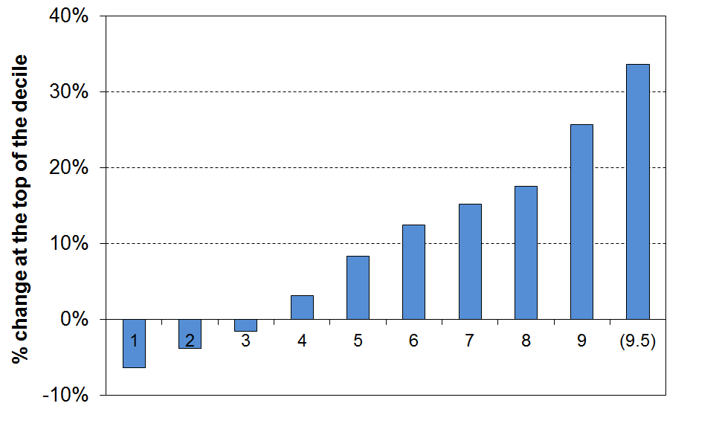

Figure D.6 shows the net changes for the full period from HES 1982 to 2013. All income groups gained in real terms, with the highest income group gaining much more than the rest, and the lowest income group gaining the least. The different growth rates show that income inequality is higher in HES 2013 than in1982 (though most of the change occurred from the late 1980s to the mid 1990s).

Figure D.6
Real equivalised household incomes (BHC): changes for top of deciles,1982 to 2013
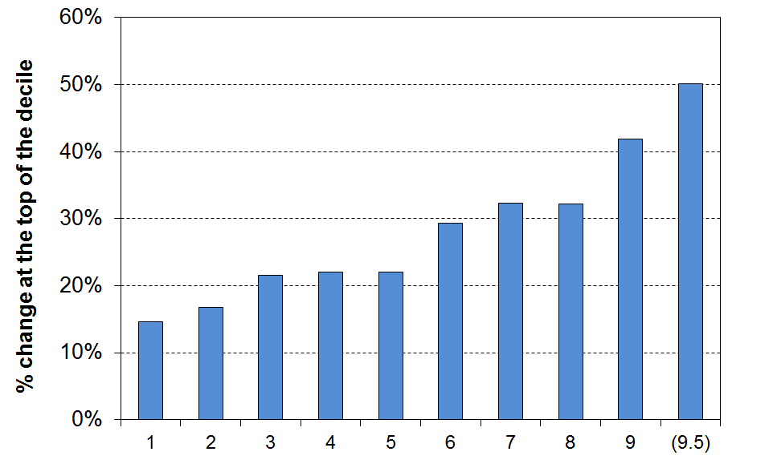

Static and dynamic analysis
In interpreting the time series analysis that is based on the HES data (as above), it is important to understand that the HES provides repeat cross-sectional data with different people interviewed each survey. The HES does not follow the same households or individuals across time. Some individuals do stay in roughly the same income band for many years, some move up and some move down. The degree of income mobility in New Zealand is discussed in Section L using longitudinal data from Statistics New Zealand’s Survey of Family, Income and Employment (SoFIE).

Figure D.7 and Table D.2 show the above analysis in a different way. The greater dispersion of household incomes in HES 2013 compared with the 1980s is clear. For the period as a whole, incomes for households in the top quintile increased proportionately and in absolute terms much more than did the incomes of households in the lower-income deciles.

Figure D.7
Real equivalised household incomes (BHC): decile boundaries, 1982 to 2013
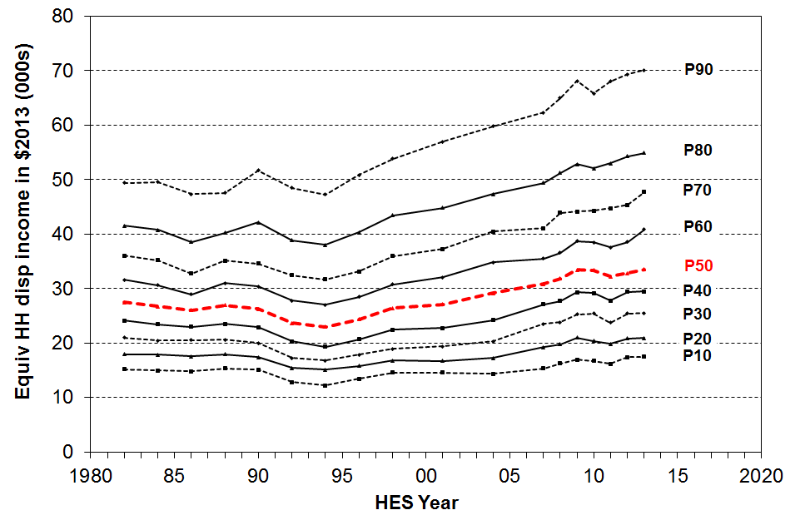

Table D.2
Real equivalised household incomes (BHC): decile boundaries (2013 dollars)
 | 1982 | 1986 | 1990 | 1994 | 1998 | 2001 | 2004 | 2007 | 2009 | 2010 | 2011 | 2012 | 2013
P90 | 49,400 | 47,300 | 51,700 | 47,200 | 53,800 | 56,900 | 59,800 | 62,300 | 68,100 | 65,800 | 68,000 | 69,300 | 70,100
P80 | 41,500 | 38,600 | 42,100 | 38,000 | 43,400 | 44,800 | 47,300 | 49,400 | 52,800 | 52,000 | 53,000 | 54,300 | 54,900
P70 | 36,000 | 32,700 | 34,600 | 31,700 | 35,900 | 37,200 | 40,400 | 41,100 | 44,100 | 44,300 | 45,000 | 45,300 | 47,700
P60 | 31,500 | 28,900 | 30,300 | 27,000 | 30,700 | 32,100 | 34,800 | 35,500 | 38,700 | 38,400 | 37,500 | 38,500 | 40,800
P50 | 27,400 | 26,000 | 26,200 | 22,900 | 26,400 | 27,100 | 29,100 | 30,800 | 33,400 | 33,300 | 32,200 | 32,800 | 33,500
P40 | 24,100 | 23,000 | 22,900 | 19,300 | 22,400 | 22,700 | 24,200 | 27,100 | 29,300 | 29,200 | 27,800 | 29,400 | 29,400
P30 | 21,000 | 20,500 | 20,000 | 16,770 | 18,900 | 19,300 | 20,300 | 23,500 | 25,300 | 25,400 | 23,700 | 25,400 | 25,500
P20 | 17,900 | 17,600 | 17,400 | 15,100 | 16,700 | 16,700 | 17,200 | 19,200 | 21,000 | 20,300 | 19,800 | 20,800 | 20,900
P10 | 15,200 | 14,800 | 15,100 | 12,200 | 14,600 | 14,500 | 14,300 | 15,300 | 16,900 | 16,700 | 16,100 | 17,400 | 17,400

Table D.3 translates the income information in Table D.2 into index form using various base years. The numbers in the body of the table indicate the percentage gains or losses over a given period (119 means a 19% rise; 84 means a 16% fall, and so on).

A disadvantage of using upper decile boundaries is that the top of decile 10 (P100) is very volatile and it is not sensible to report that trend. In line with the graphs above, Table D.3 incorporates information on changes for P95 to give some indication of trends for the top decile, while avoiding the misleading picture that reporting on P100 would give. The inequality part of Section J gives information on trends for very high incomes based on tax records.

Table D.3
Changes in real equivalised household incomes (BHC) relative to selected base years:
index = 100 in base year
HES period | base HES year | P10 | P20 | P30 | P40 | P50 | P60 | P70 | P80 | P90 | P95
1982-2013: overall
1982 - 2013 | 1982 | 115 | 117 | 122 | 122 | 122 | 129 | 132 | 132 | 142 | 150
Relative to low point in 1994
1988 - 1994 | 1988 | 80 | 84 | 81 | 82 | 85 | 87 | 90 | 95 | 99 | 103
1994 - 2013 | 1994 | 143 | 138 | 152 | 152 | 146 | 151 | 151 | 144 | 148 | 150
Relative to 2001, the year the median returned to what it had been in the late 1980s
1988 - 2001 | 1988 | 95 | 93 | 94 | 97 | 101 | 104 | 106 | 111 | 120 | 124
2001 - 2013 | 2001 | 120 | 125 | 132 | 129 | 124 | 127 | 128 | 123 | 123 | 125
The Working for Families impact (as seen in the greater gains for low to middle income HHs)
2004 - 2007 | 2004 | 107 | 112 | 116 | 112 | 106 | 102 | 109 | 102 | 104 | 104
After the WFF implementation through to impact of the GFC on incomes and to the recovery from HES 2011 to HES 2013
2007 - 2009 | 2007 | 110 | 108 | 107 | 107 | 108 | 108 | 107 | 106 | 109 | 110
2009 - 2011 | 2009 | 95 | 94 | 94 | 95 | 96 | 97 | 102 | 100 | 100 | 100
2011 - 2013 | 2011 | 108 | 105 | 108 | 106 | 104 | 109 | 107 | 104 | 103 | 100
Notes 1 P10 = top of decile 1, and so on.
2 Recall that HES 2004 is really HES 2003-04, and that the incomes reported are on average from ~ calendar 2003, and so on.
2 2008 would have been a better year to take as the end of the WFF implementation (ie 2007-08 HES), as the final tranche was rolled out in 2006-07, but the limitations identified in the 2008 data mean that 2007 has to be used (see Introduction for more information on the 2008 data issues). Almost all the WFF impact was however captured by the time of the 2007 HES, so not using 2008 HES as the boundary does not compromise the pattern of findings reflected in Table D.3.

Differing trends for different parts of the distribution (AHC)

Figure D.8 and Table D.4 show the trends in real incomes (AHC) for the top of each decile. The impact of the economic downturn, global financial crisis and rise in rents is clear in the fall in AHC incomes across the income range from the 2009 HES to HES 2011. The decline for the median was 4%. There were severe falls (-7%) for the P30 and P40 regions, that is, for households below the median but above the usual poverty lines. The P10 region declined significantly too, (although this is below the usual poverty lines and is therefore not likely to show up on those figures). The impact of the recovery is evident in the rises across all income deciles from HES 2011 to 2013.

From a longer-term perspective, in HES 2013 household incomes at the top of the bottom decile were lower in real terms than they were in the 1980s. This is the only decile for which this is the case. The net % gains for the next two deciles (deciles 2 and 3) were much lower than for middle to higher income gains. The AHC income distribution was more dispersed in 2013 than in the 1980s.

Figure D.8
Real equivalised household incomes (AHC): decile boundaries, 1982 to 2013 (2013 dollars)
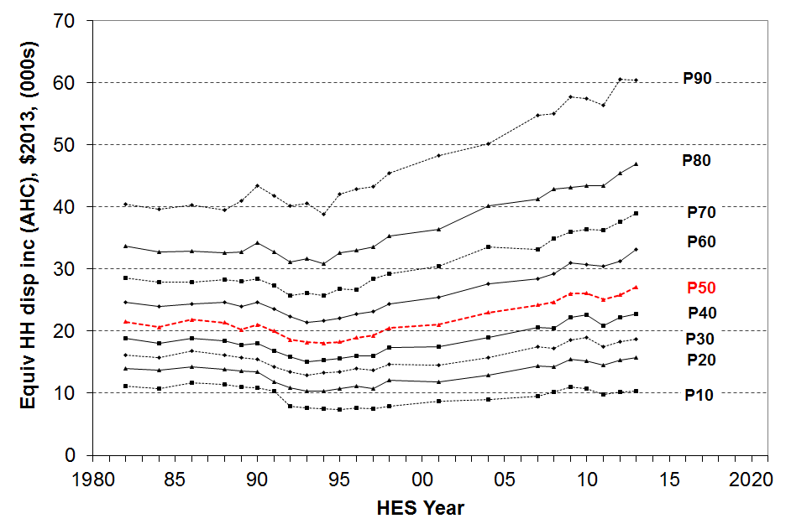

Table D.4
Real equivalised household incomes (AHC): decile boundaries (2013 dollars)
 | 1982 | 1986 | 1990 | 1994 | 1998 | 2001 | 2004 | 2007 | 2009 | 2010 | 2011 | 2012 | 2013
P90 | 40,400 | 40,200 | 43,500 | 38,800 | 45,500 | 48,300 | 50,200 | 54,800 | 57,800 | 57,500 | 56,400 | 60,500 | 60,400
P80 | 33,700 | 32,900 | 34,200 | 30,900 | 35,300 | 36,400 | 40,200 | 41,200 | 43,100 | 43,400 | 43,400 | 45,400 | 47,000
P70 | 28,600 | 27,900 | 28,400 | 25,800 | 29,300 | 30,400 | 33,500 | 33,200 | 36,000 | 36,400 | 36,200 | 37,600 | 39,000
P60 | 24,700 | 24,400 | 24,700 | 21,700 | 24,400 | 25,400 | 27,600 | 28,400 | 31,000 | 30,800 | 30,400 | 31,300 | 33,200
P50 | 21,500 | 21,800 | 21,000 | 18,100 | 20,500 | 21,000 | 23,000 | 24,200 | 26,000 | 26,100 | 25,100 | 25,800 | 27,100
P40 | 18,800 | 18,900 | 18,100 | 15,300 | 17,400 | 17,500 | 19,000 | 20,600 | 22,200 | 22,700 | 20,900 | 22,300 | 22,700
P30 | 16,100 | 16,900 | 15,500 | 13,300 | 14,700 | 14,500 | 16,000 | 17,500 | 18,500 | 19,000 | 17,500 | 18,400 | 18,700
P20 | 14,000 | 14,300 | 13,500 | 10,300 | 12,100 | 11,800 | 13,000 | 14,400 | 15,400 | 15,200 | 14,500 | 15,300 | 15,800
P10 | 11,200 | 11,700 | 10,900 | 7,500 | 8,000 | 8,700 | 9,000 | 9,500 | 11,000 | 10,700 | 9,800 | 10,200 | 10,300

Trends in the median for different household types

Figure D.9 shows the trends in real equivalised household disposable income (BHC) from HES 1982 to 2013 for selected household types.

For all household types, there were relatively large rises in median income in real terms from HES 2007 to 2009: 13% for working age households without children, 9% for two parent households, and 12% for sole parent households (albeit off a low base). For 2009 to 2011, there was a fall in median income for all household types, and especially for sole-parent and one person under 65 households (14% and 9% respectively). The median income of all household types rose in real terms from HES 2011 to HES 2013, except for non-couple family households without children for whom there was no net change.

Trends for those in single and couple 65+ households are omitted from Figure D.9 to avoid clutter, but are shown in Table D.5 (next page):
- For those in one-person 65+ households, median incomes ($2013) remained relatively steady at around $16,000 to $17,000 pa from 1982 to 1998, with a small rise to $18,400 by 2007, and then to $21,000 for 2013. Part of that rise reflects the personal income tax changes in October 2008, April 2009 and October 2010 which have an impact on NZS via the net wage benchmark.
- Median incomes of those in 65+ couple households remained reasonably steady from 1992 to 2001 at around $19,000 pa. From 2004 to 2010, median incomes for these households grew 37% in real terms to $27,400 pa. This rise reflects the increase from 65% to 66% of the average wage for the floor for the married couple rate for NZS (starting in 2006), the increased employment income for some 65+ couples, and the personal income tax changes in October 2008 and April 2009. In the last two surveys (HES 2012 and 2013) their average income was around the same at $27,600 ($42,500 in unequivalised terms). In the 2013 HES the median for this group was $30,200 ($46,500). This group will be closely monitored in the next update to see whether this is just a statistical blip or evidence of the change in trend for older couples.
- See Section I for more information on the incomes of older New Zealanders.

Figure D.9
Median equivalised household incomes (BHC) for selected household types, 1982 to 2013 ($2013)
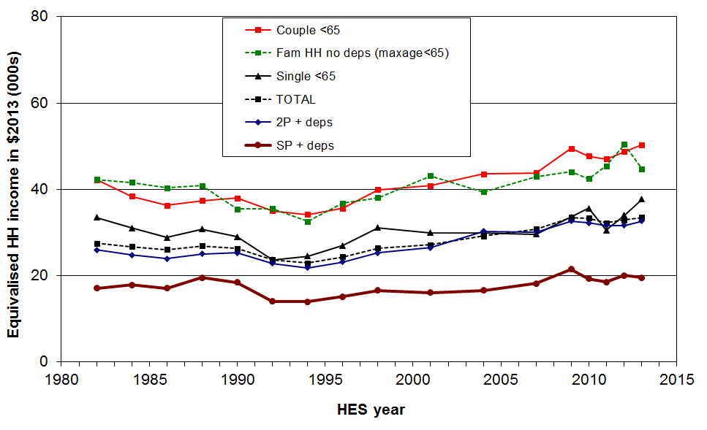
Note: The median incomes in Figure D.10 are equivalised household incomes. Table B.2 gives median household incomes in ordinary (unequivalised) dollars.
Table D.5
Median equivalised household incomes (BHC) for selected household types, 1982 to 2013 ($2013)
 | 1982 | 1986 | 1990 | 1994 | 1998 | 2001 | 2004 | 2007 | 2009 | 2010 | 2011 | 2012 | 2013
Single < 65 | 33,500 | 28,800 | 29,000 | 24,500 | 31,100 | 30,000 | 30,000 | 29,600 | 33,600 | 35,600 | 30,500 | 33,900 | 37,700
Couple < 65 | 42,200 | 36,200 | 38,000 | 34,100 | 39,900 | 40,900 | 43,500 | 43,800 | 49,500 | 47,700 | 47,000 | 48,700 | 50,300
Other multi-adult fam HH <65, no dep ch | 42,300 | 40,400 | 35,400 | 32,500 | 38,000 | 43,100 | 39,400 | 43,000 | 44,100 | 42,400 | 45,400 | 50,400 | 44,800
Two parent | 25,900 | 23,900 | 25,300 | 21,800 | 25,300 | 26,500 | 30,300 | 30,100 | 32,600 | 32,200 | 31,600 | 31,400 | 32,600
Sole parent | 17,000 | 17,100 | 18,400 | 13,900 | 16,600 | 16,000 | 16,600 | 18,100 | 21,500 | 19,300 | 18,500 | 20,000 | 19,500
Couple 65+ | 20,400 | 20,300 | 21,000 | 18,800 | 19,100 | 19,100 | 20,000 | 22,300 | 27,000 | 27,400 | 26,100 | 25,100 | 30,200
Single 65+ | 17,100 | 16,300 | 15,700 | 16,000 | 17,300 | 17,900 | 17,900 | 18,400 | 20,100 | 20,300 | 19,600 | 21,500 | 21,200
ALL | 27,400 | 26,000 | 26,300 | 23,000 | 26,400 | 27,100 | 29,100 | 30,800 | 33,500 | 33,300 | 32,200 | 32,800 | 33,500

Trends in the median by ethnicity

Ethnicity of individuals aged 15 and over is as reported by the individual, and children under 15 are attributed with the ethnicity of the survey respondent. If a respondent reports more than one ethnicity, the ethnicity attributed is determined according to a hierarchical classification of Māori, Pacific Island, Other and then European/Pākehā. The household’s equivalised disposable income is attributed to the individual for ranking purposes, just as it is for analysis by age.

Figure D.10 and Table D.6 show the trends in real equivalised household disposable income (BHC) from the 1988 HES to 2013 by ethnicity.

The overall impact of the GFC, the economic downturn and recovery is still emerging for the Maori and Pacific ethnic groups. The medians for these two groups have been a little volatile since the crisis. At this stage it looks as if the impact of the downturn is proving to be longer-lasting for Maori and Pacifika compared with Eurpean/Pakeha and those of “Other” ethnicity.

From a longer-term perspective, all groups showed a strong rise from the low point in the mid 1990s through to 2010. In real terms, overall median household income rose 47% from 1994 to 2010: for Maori, the rise was even stronger at 68%, and for Pacific, 77%. These findings for longer- term trends are robust, even though some year on year changes may be less certain. For 2004 to 2010, the respective growth figures were 21%, 31% and 14%.

Figure D.10
Real equivalised median household incomes (BHC) by ethnicity, 1988 to 2013 ($2013)
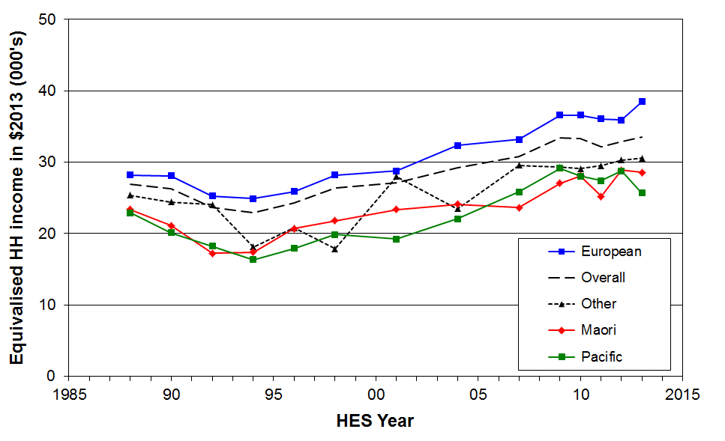

Table D.6
Real equivalised median household income (BHC) by ethnicity, 1988 to 2013 ($2013)
 | 1988 | 1990 | 1992 | 1994 | 1996 | 1998 | 2001 | 2004 | 2007 | 2009 | 2010 | 2011 | 2012 | 2013
Euro/Pakeha | 28,200 | 28,100 | 25,300 | 24,900 | 25,900 | 28,200 | 28,800 | 32,300 | 33,200 | 36,600 | 36,600 | 36,000 | 35,900 | 38,500
NZ Māori | 23,400 | 21,100 | 17,200 | 17,400 | 20,700 | 21,800 | 23,400 | 24,100 | 23,600 | 27,100 | 28,100 | 25,200 | 28,900 | 28,500
Pacific | 22,900 | 20,100 | 18,200 | 16,400 | 17,900 | 19,900 | 19,200 | 22,100 | 25,800 | 29,100 | 28,000 | 27,400 | 28,800 | 25,700
Other | 25,400 | 24,400 | 24,100 | 18,100 | 20,800 | 17,800 | 28,100 | 23,500 | 29,500 | 29,300 | 29,100 | 29,500 | 30,300 | 30,500
ALL | 26,900 | 26,300 | 23,700 | 22,900 | 24,300 | 26,400 | 27,100 | 29,200 | 30,800 | 33,500 | 33,300 | 32,200 | 32,800 | 33,500

The incomes reported in Te Ao Marama

Statistics New Zealand recently published Te Ao Marama, a small collection of statistics relating to Maori. It reports that median income from all sources declined for Maori from 2008 to 2011, whereas median income for the whole population remained reasonably steady in the same period.

Te Ao Marama reports the incomes of individuals not of households. This is why the Te Ao Marama trends are different from those reported in this Incomes Report (which uses household incomes).

Inequality

There are many types of inequality that are relevant to public policy

Income inequality is about how dispersed incomes are, what the size of the gap is between those on ‘higher’ and those on ‘lower’ incomes. There are however many types of inequality other than income inequality that are of relevance to public policy formulation and debate, and it is useful to be clear about which sort of inequality is being discussed at any time.

Some of the main inequalities often discussed are:
  - market income inequality for individuals:
      - wage differentials across all wage earners
      - focusing on total market income for the very top 1% or so, compared with the rest
  - inequality of disposable household income (income from all sources after taxes and transfers):
      - across all households
      - focusing on the very high income households, compared with the rest
  - inequality of wealth (total assets less liabilities).
  - inequality of community resources and amenities available to local residents
  - inequality of educational outcomes
  - inequality of health outcomes
  - inequality of socio-economic status (combining education, occupation and income)
  - inequality of opportunity.

The major focus of the Incomes Report is on inequality of household disposable income and the shares of total market income received by top income earners, together with some reference to wealth distribution and wealth inequality.

It is important to maintain a clear distinction between wage inequality, household income inequality and wealth inequality. They are quite different concepts, each with their own unique characteristics.

Inequality and poverty are sometimes used as if they are interchangeable ideas. They are different concepts and while there are some links between them, they need to be kept distinct as far as possible.

Inequality is essentially about the gap between the better off and those not so well off (on whatever measure) – it is about having “less than” or “more than”. Poverty is about household resources being too low to meet basic needs – it is about “not having enough” when assessed against a benchmark of “minimum acceptable standards”.

A major difference between income inequality and income poverty is that a certain degree of inequality is considered by almost everyone to be inevitable and acceptable, and even desirable. There is no similar widely held view about unacceptably low incomes and material deprivation. Income poverty and material deprivation are by definition unacceptable states of affairs. There can be and is legitimate debate over the meaning of poverty and hardship in more economically developed countries. In building measures, there is debate as to where to set the low-income and deprivation thresholds, and over the relative merits of different approaches to the income concept used (eg BHC or AHC). There are however very few who advocate for “acceptable levels” of income poverty or hardship. On the other hand, when it comes to income (or wealth) inequality a part of the debate is about what is an acceptable or at a least tolerable level of income (or wealth) inequality. Unlike any debate around income poverty or hardship, there are very few calls for the elimination of income or wealth inequality.

There is no evidence of any statistical link between the income share received by the top 1% and income poverty rates.

There is no link between trends in income poverty using a fixed line approach and standard inequality measures.

The strongest conceptual and statistical link between income poverty and income inequality is between the P50:P20 or P50:P10 percentile ratio inequality measures and standard fully relative income poverty measures in which the threshold is set at a selected proportion of the current median (eg 50% or 60%). All these, both the percentile ratios and the poverty measures, are about inequality in the lower half of the household income distribution and are therefore highly correlated, as expected.

On the other hand, there is only a modest correlation between inequality as measured by the Gini and income poverty measured using the fully relative approach. The relationship is stronger when using percentile ratios as the inequality measure. The lack of very strong correlation arises because standard income inequality measures do not focus just on the lower half of the distribution but on both higher and lower incomes (percentile ratios and share ratios) or on all incomes (eg the Gini).

Maintaining as clear as possible a distinction between poverty and hardship on the one hand and income inequality on the other means that:
- as a society, and as groups within it, we cannot easily avoid having to make the judgement call about minimum acceptable standards, even if we use two or three of differing severity
- we are better placed to seek to understand the relationship (if any) between the two, rather than blurring them into the Same Thing.

Income inequality: summary indicators

Income inequality is about how dispersed the income distribution is.

Figures D.5 to D.10 (above) give a visual impression of how the income distribution became more dispersed from 1982 to 2013, with most of that occurring from the late 1980s to the mid 1990s.

There are several ways that are used to summarise the amount of income dispersion or inequality in a single statistic. No one statistic has emerged as the generally accepted way, mainly because each one captures a different aspect of the way the dispersion of incomes changes over time. It is now common to report on more than one indicator and to compare the trends produced by each.

This section uses three types of inequality measure:
- percentile ratios
- quintile and decile share ratios
- the Gini coefficient.

The international section (Section J) also reports on the share of taxable income received by high and very high income individuals based on tax records.

Percentile ratios

When individuals are ranked on the equivalised income of their respective households and divided into 100 equal-sized groups, each group is called a percentile. If the ranking starts with the lowest income then the income at the top of the 10th percentile is denoted P10, the median or top of the 50th percentile is P50 and so on. Ratios of values at the top of selected percentiles, such as P80/P20, are often called percentile ratios. Percentile ratios summarise the relative distance between two points in the income distribution.

The report uses four percentile ratios to provide a succinct picture of trends in income inequality.
- The P90/P10 ratio provides a good indication of the full spread of the distribution, going as far as possible to the extremes without running the risk of being overly influenced by unrepresentative very high incomes or by the difficulties with bottom decile incomes.
- The P80/P20 ratio gives a better indication of the size of the range within which the majority of the population fall and has less volatility than the P90/P10 ratio.
- The P80/P50 and the P20/P50 ratios give an indication of how higher and lower incomes compare with the midpoint.

For the P90/P10, P80/P20 and P80/P50 indicators, the higher the ratio the greater is the level of inequality. For the P20/P50 indicator, the higher the ratio the lower is the level of inequality in this part of the distribution.

Figure D.11 shows the trends for the P80/P20 ratio. Incomes after adjusting for housing costs (AHC) are more dispersed than BHC incomes. The most rapid rises in inequality occurred from around 1988 to 1994. There was a further net rise in the decade from 1994 to 2004 but the rate of increase was slower.

From 2004 to 2007, the P80/P20 ratio fell, indicating decreasing inequality on this measure in the period, mainly as a result of the Working for Families package (2004 to 2007). The impact on incomes of the GFC and the associated downturn and recovery has led to some volatility in the index between the 2009 to 2013 HES. It will take another survey or two before the post-crisis inequality level becomes clear. There is however no evidence of any sustained longer-term rise in inequality on this measure. Current rates are similar to what they were in the mid 1990s and lower than in the early to mid 2000s.

The 90:10 ratio (BHC) is much the same post-GFC (4.0) as it was pre-GFC in 2007 to 2009 (4.1). In contrast the 90:10 AHC ratio as high in 2012 and 2013 (5.9) as it was in 1998, the previous high point.

Figure D.11
Income inequality in New Zealand: the P80/P20 ratio, 1982 to 2013, total population
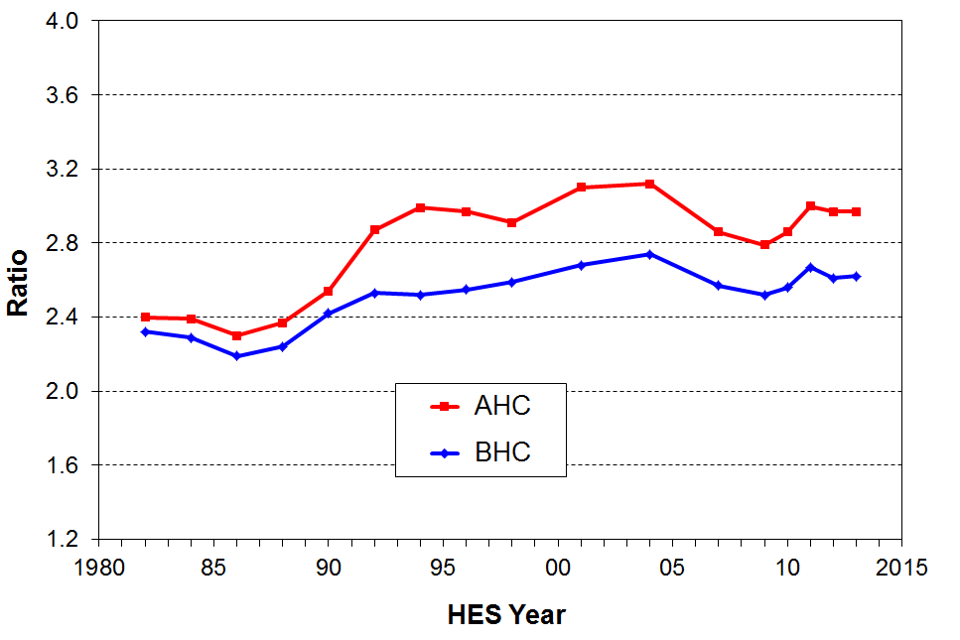

Tables D.7 and D.8 summarise the trends in all four percentile ratios from 1982 to 2013.

Table D.7
BHC income inequality in New Zealand: percentile ratios, 1982 to 2013, total population
 | 1982 | 1986 | 1990 | 1994 | 1998 | 2001 | 2004 | 2007 | 2009 | 2010 | 2011 | 2012 | 2013
P90/P10 | 3.25 | 3.20 | 3.43 | 3.87 | 3.68 | 3.91 | 4.17 | 4.07 | 4.02 | 3.95 | 4.21 | 3.99 | 4.02
P80/P20 | 2.32 | 2.19 | 2.42 | 2.52 | 2.59 | 2.68 | 2.74 | 2.57 | 2.52 | 2.56 | 2.67 | 2.61 | 2.62
P80/P50 | 1.51 | 1.48 | 1.60 | 1.66 | 1.65 | 1.66 | 1.62 | 1.61 | 1.58 | 1.56 | 1.65 | 1.65 | 1.64
P20/P50 | 0.65 | 0.68 | 0.66 | 0.66 | 0.64 | 0.62 | 0.59 | 0.62 | 0.63 | 0.61 | 0.62 | 0.63 | 0.63

Table D.8
AHC income inequality in New Zealand: percentile ratios, 1982 to 2013, total population
 | 1982 | 1986 | 1990 | 1994 | 1998 | 2001 | 2004 | 2007 | 2009 | 2010 | 2011 | 2012 | 2013
P90/P10 | 3.63 | 3.46 | 3.98 | 5.16 | 5.74 | 5.57 | 5.57 | 5.77 | 5.27 | 5.38 | 5.75 | 5.93 | 5.84
P80/P20 | 2.40 | 2.30 | 2.54 | 2.99 | 2.91 | 3.10 | 3.12 | 2.86 | 2.79 | 2.86 | 3.00 | 2.97 | 2.97
P80/P50 | 1.57 | 1.51 | 1.63 | 1.71 | 1.73 | 1.73 | 1.75 | 1.70 | 1.66 | 1.66 | 1.73 | 1.76 | 1.73
P20/P50 | 0.65 | 0.65 | 0.64 | 0.57 | 0.59 | 0.56 | 0.56 | 0.60 | 0.59 | 0.58 | 0.58 | 0.59 | 0.58

Quintile and decile share ratios

The percentile ratios give an indication of how far apart are two points on the income distribution.

The income share ratios compare the shares of total household income received by higher and lower groupings. They are becoming more common: the top to bottom quintile share ratio is used by the EU as one of their top tier formal inequality measures, and the OECD regularly reports on the top to bottom decile share ratio.

There are two measurement challenges for this inequality measure. First, top income households are generally under-represented in sample surveys. This means that measured upper income shares understate the true shares at the top. Similarly, low income shares understate the shares actually received as there are always households with implausibly low reported incomes in the bottom decile (see Appendix 8 and 9 for more on this issue). The percentile ratio approach does not have these issues.

Figure D.12 shows the top to bottom quintile share ratios for the last three decades, 1982 to 2013. Over recent years the 20% of households with higher incomes have on average received around 5.5 times the income of the 20% with lowest incomes. The spike in HES 2011 is part of the volatility after the GFC and is similarly reflected in the Gini (next page). The quintile share ratio shows a similar trend line to the Gini, with a large a rapid increase from the late 1980s to the early 1990s, followed by a slow rise to the late 1990s /early 2000s and then fairly flat since with some volatility. Table D.9 shows the trends in three income share ratios from 1982 to 2013, including the Palma ratio. Further detail on the Palma ratio is provided below.

Figure D.12
BHC income inequality in New Zealand: quintile share ratio for Q5 to Q1, 1982 to 2013
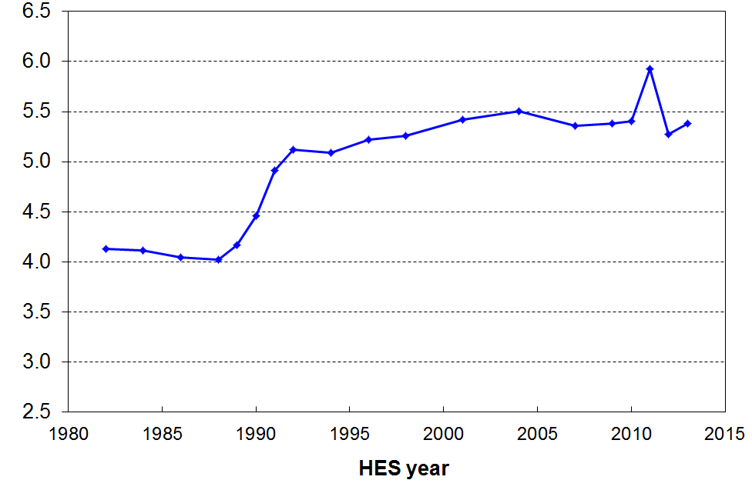

Table D.9
BHC income inequality in New Zealand: decile and quintile shares, 1982 to 2013, total population
 | 1982 | 1986 | 1990 | 1994 | 1998 | 2001 | 2004 | 2007 | 2009 | 2010 | 2011 | 2012 | 2013
Q5/Q1 | 4.13 | 4.04 | 4.46 | 5.09 | 5.26 | 5.42 | 5.51 | 5.36 | 5.38 | 5.41 | 5.93 | 5.28 | 5.38
D10/D1 | 6.15 | 6.06 | 6.35 | 8.03 | 8.66 | 8.32 | 9.15 | 8.59 | 8.35 | 8.62 | 9.71 | 8.23 | 8.29
D10/D1-4 (Palma) | 0.91 | 0.91 | 1.10 | 1.21 | 1.31 | 1.34 | 1.31 | 1.24 | 1.29 | 1.24 | 1.42 | 1.23 | 1.30
Note: this analysis uses the square root equivalence scale as used by the OECD to ensure harmony with the figures used in the international comparisons in Section J.

The Palma: the ratio of the top decile share to the share for the lower four decile shares

The Palma measure or ratio is a relatively new addition to the suite of inequality measures used for international comparisons. It is named after Chilean economist Gabriel Palma whose 2011 paper brought the measure and its rationale to light. The OECD now reports the Palma in its Income Distribution database.

At one level, the Palma is just another share ratio in the wider family of share ratios. It has several features however that make it worth a second look:
- Palma found that among middle income and richer countries those in deciles 5-9 receive around 50% of the total income share, and that this share size seems reasonably stable over time as well as over countries. These are the middle to upper-middle income households between the “rich” and the “poor”. Figure D.13 shows the share for New Zealand has been fairly stable at around 55% from 1990 to 2013.
- He also found that the remaining 50% or so (45% for New Zealand) of total income was split between the top 10% and bottom 40% in quite different ways across the countries he looked at. This inspired the first part of the title for his 2011 paper - “Homogeneous middles and heterogeneous tails".
- He found that the correlation between the Palma and the Gini is close to perfect across the 150 countries in the World Bank dataset he used.
- Given that the Palma is much easier to explain than the Gini, and that it ranks countries in the same order, then he and others are proposing that it might be a useful alternative to the Gini for international comparisons. For example, what does it me4an in practice to say that one country has a Gini of 42 and another 31? On the other hand, a Palma of 2.1 compared with a Palma of 1.7 has specific and easily grasped meaning in terms of the ratio of higher incomes to lower incomes, with the ”middle” remaining constant. The jury is still out on whether it can / ought to / will replace the Gini, but it certainly has the communication edge over the Gini.
- In the international section (Section J), New Zealand is ranked relative to other OECD countries on the Palm ratio.

Figure D.13
Proportion of total income received by deciles 4 to 9, 1982 to 2013

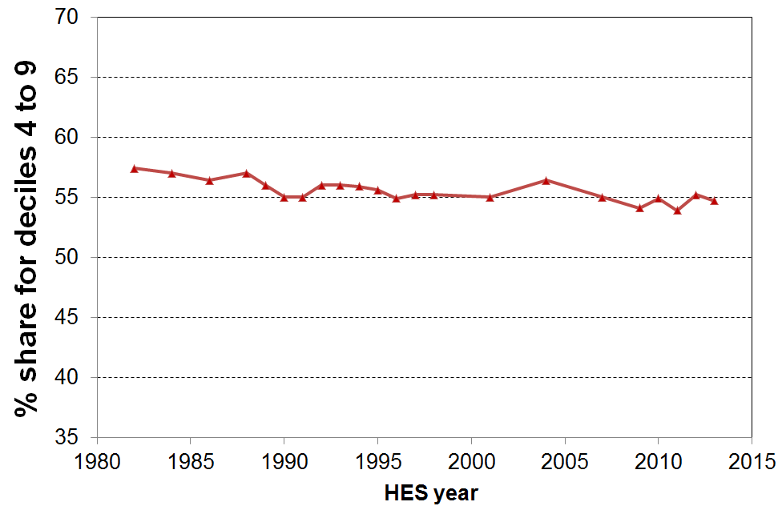

Gini coefficient

In contrast to the percentile ratios and the share ratios the Gini coefficient takes the incomes of all individuals into account. It gives a summary of the income differences between each person in the population and every other person in the population. A difference of, say, $1000 between two high-income people contributes as much to the index as a difference of $1000 between two low-income people.

When comparing changes in income distributions over time, it is important to note that the Gini coefficient is more sensitive to changes in the more dense low-to-middle parts of the distribution than it is to changes more towards the ends of the distribution. The Gini scores (x100) range from 0 to 100 with scores closer to 100 indicating higher inequality and those nearer zero indicating lower inequality (ie greater equality).

The first main feature of Figure D.14 is the steep rise in the Gini coefficient from the late 1980s to the early 1990s. This is a similar trend to that shown by the P80/P20 ratio (Figure D.11) and the Q5/Q1 share ratio (Figure D.12).

The second main feature is the relative flatness of the Gini trendline from the mid to late 1990s through to 2013. The Gini declined a little from 2001 to 2007, reflecting improving employment, reducing unemployment and the impact of the WFF package which boosted incomes for low- to middle-income households with children, then has shown some volatility from 2009 to 2013, the period in which the impact of the GFC and associated economic downturn and recovery is evident in the HES income data. There is as yet no evidence of any sustained rising or falling trend in the Gini in recent years. This is the same finding as is given by the Q5/Q1 share ratio and the Palma.

Figure D.14
Inequality in New Zealand: the Gini coefficient
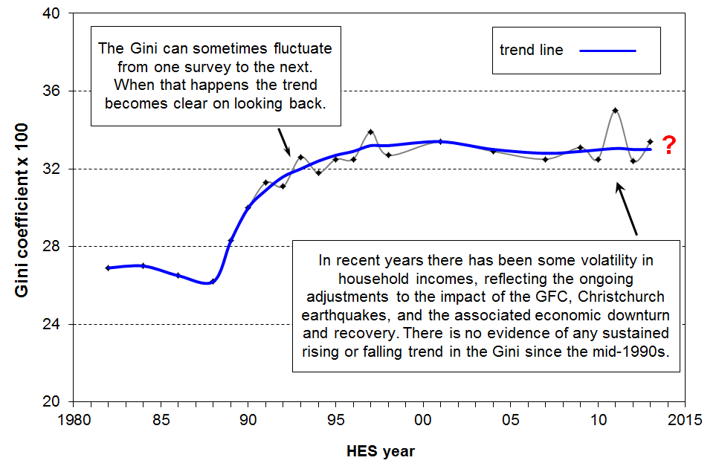

Table D.10 shows that inequality is greater for AHC incomes than for BHC, as is the case when using percentile ratios and share ratios. This reflects the fact that housing costs generally make up a greater proportion of household income for lower-income households than for higher-income households, thus increasing the spread of AHC incomes.

The BHC-1 row uses the “square root” equivalence scale as is standard in OECD publications. The BHC-2 row uses the 1988 Revised Jensen Scale. To avoid confusion, the report uses only the BHC-1 data for Gini inequality graphs both here and in the international section (Section J) and in the summaries. The trends are the same whichever equivalence scale is used.

Table D.10
Income inequality in New Zealand: the Gini coefficient (x100)
 | 1984 | 1988 | 1990 | 1992 | 1994 | 1996 | 1998 | 2001 | 2004 | 2007 | 2009 | 2010 | 2011 | 2012 | 2013
BHC-1 (OECD) | 27.0 | 26.2 | 30.0 | 31.1 | 31.8 | 32.5 | 32.7 | 33.4 | 32.9 | 32.5 | 33.1 | 32.5 | 35.0 | 32.4 | 33.4
BHC-2 | 27.1 | 26.7 | 30.0 | 31.4 | 31.7 | 32.8 | 33.6 | 33.5 | 33.7 | 31.9 | 32.4 | 31.8 | 34.4 | 31.9 | 32.9
AHC | 28.5 | 28.5 | 32.1 | 34.9 | 35.6 | 37.2 | 37.5 | 38.1 | 37.0 | 36.8 | 37.5 | 37.0 | 39.9 | 37.7 | 38.3

For information on longer-run inequality, especially when considering only very high incomes, see Section J.

Box 1
How the income inequality picture changes depending on the income concept used

The level of inequality or dispersion in the distribution of incomes depends on which income concept is used.

This report uses equivalised disposable household income as the income concept for all its income distribution, inequality and poverty analysis. This is the total after-tax income of all individuals in the household, together with Working for Families Tax Credits and other non-taxable income such as the Accommodation Supplement (AS) and so on, adjusted for household size and composition. This is standard international practice for reports of this type, where the focus is on household income as an indicator of the material wellbeing of household members relative to others from other households.

The graph below shows the different levels of inequality that different income concepts produce, using the 80:20 percentile ratio as the measure.

Inequality is lower when the focus moves from individuals to households (HHs). The 80:20 ratio falls from 5.8 for individual taxable income to 3.6 for HH gross taxable income. HH gross taxable income excludes all non-taxable components such as WFF tax credits, AS, and so on. When these are included, inequality drops further (HH gross). Taking personal income tax deductions into account further reduces the 80:20 ratio, as does the adjustment for household size and composition. The 80:20 ratio is more than halved in going from individual taxable income to equivalised disposable HH income. The latter is the best of these income concepts to use when using income to assess the material wellbeing of the population, and of subgroups within it.

80:20 percentile ratio for different income concepts, 2012-13
(HLFS for individuals, HES for households)
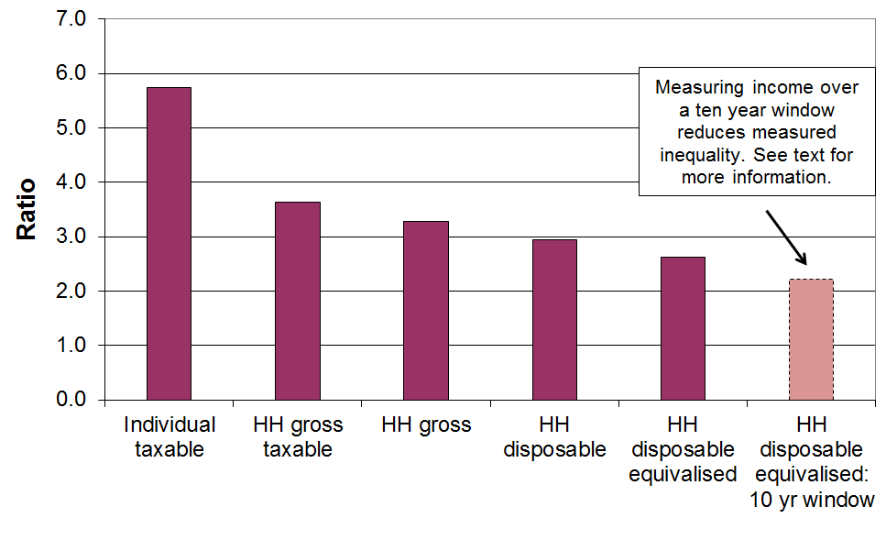

When the same group of individuals is followed over time (longitudinal data), and the income concept is the average household disposable income of the individual over, say, ten years rather than one, then measured inequality falls even further as a result of income mobility. For Australia the fall was around 15% for the 90:10 ratio from 2001 to 2010 and for the UK it was around 15% for the Gini for five year periods starting at various years in the 1990s. The right-hand bar above assumes a 15% reduction for illustrative purposes. See Section L for more on this.

Wealth inequality

Wealth is a key component of a household’s economic resources. See Figure A.1 in the Introduction for the place of wealth in the report’s over-arching framework.

Wealth is distributed much more unequally than income (especially disposable income after tax and transfers).

As shown in Figure D.15, in New Zealand in 2003-2004 the top wealth decile accounted for around 50% of the total wealth, whereas the top income decile accounted for 25% of the total income (see Figure B.4). The Gini for income in 2003-04 was 32, and the wealth Gini was 69. This degree of wealth inequality appears to be not greatly different to what prevails in many other OECD countries (see Section J for details).

Figure D.15
Wealth and income distribution in New Zealand, 2003-2004: cumulative frequency (%)
Source: Wealth data is from unpublished New Zealand Treasury analysis of wave 2 (2003-2004) of Statistics New Zealand’s Survey of Family, Income and Employment. Income data is from the 2003-2004 HES.
Note: The income sharing unit for the incomes analysis is the household. The distribution is of individuals according to their household’s income For the wealth analysis the sharing unit is the EFU (‘family’). The wealth graph would be slightly differently shaped using the household as the sharing unit, but the finding that wealth inequality is much higher than income inequality is robust.

Section E

Low incomes, poverty and material hardship: conceptualisation and measurement issues

For the analysis of trends in income poverty, this report uses low-income thresholds set at 50% and 60% of median household income, adjusted for household size and composition.

Individuals and groups below such lines can be described in a bland analytical way as “low-income populations”, but it is now very common practice in New Zealand and internationally for the 50% and 60% thresholds, and others in that general part of the distribution, to be referred to as “poverty lines” and those below them as “poor” or “in poverty” or “at risk of poverty”.

The growing acceptability of “poverty” language in more official contexts in the more economically developed countries (MEDCs) is reflected in recent OECD and UNICEF publications of international comparisons of poverty rates, and in decisions by the European Union (EU) to regularly publish income-based poverty indicators as part of a wider social reporting by Eurostat.

The positions taken by governments of OECD countries have been mixed with respect to a poverty discourse and whether or not to adopt any official measure or measures of poverty. In the United States, the War on Poverty announced in 1964 and the associated establishment of an official poverty line shortly thereafter have done much to ensure that poverty language has been and still is an accepted part of economic and social policy discourse in the United States. By contrast, in the United Kingdom, a Conservative government in the 1980s and the first half of the 1990s did not approve of poverty language and did not adopt an official measure. “Margaret Thatcher, supported by Helmut Kohl in Germany, … successfully banished the word “poverty” from the political lexicon for a generation. Tony Blair rehabilitated its use in a keynote speech in 1999 [where he] committed the government to eradicating child poverty [within a generation]” (Tomlinson and Walker, 2009:8). The UK now has official measures of child poverty, enshrined in the Child Poverty Act 2010 and supported by the Cameron-Clegg coalition government, albeit the chances of achieving the targets now seem remote. Ireland adopted official poverty measures and a National Anti-Poverty Strategy in 1997. Canada has an elaborate low income measurement regime using low income cut-offs (LICOs), low income measures (LIMs) and a Market Basket Measure (MBM), but Statistics Canada has consistently noted that these are not poverty lines. Neither Australia nor New Zealand have official poverty measures.

As recently as 1996, the government of the time in New Zealand was openly disapproving of any poverty discourse. However, in 2002, in the context of the Agenda for Children, the Labour-led government made a commitment to eliminate child poverty, and in the Speech from the Throne in November 2005, the Governor-General described the Working for Families package as “the biggest offensive on child poverty New Zealand has seen for decades”. In its response to the Children’s Commissioner’s Expert Advisory Group’s 2012 Report on Solutions to Child Poverty, the current National-led government declined to take up the recommendations for a suite of official measures and a set of official targets for reducing child poverty. On the other hand, the government response used “poverty” language throughout its report, setting out its general approach to addressing child poverty. The current National-led government, like the previous Labour-led government, espouses the principle that paid work is the best way to reduce child poverty.

Researchers, advocacy groups and others in all the MEDCs have used poverty language and a range of poverty measures for a long time. The growing acceptance of the discourse by governments and their agencies can be seen as helpful to the extent that it represents official recognition that some citizens are experiencing unacceptable material hardship. It can serve to remind us all that behind the statistics are real people who are to varying degrees experiencing the stressful and demoralising exclusion from ordinary life that financial strictures and material hardship bring.

It is however very easy for such language to be used in a way that ignores the fact that the conceptualisation and measurement are contested. For example it used to be said that “one in three children in New Zealand are below the poverty line”. This claim is really short-hand for “using an income measure after housing costs have been deducted, around one in three children are below a threshold set at 60% of the median”. If another measure were used, the summary sound bite would be different. For example, on the most common measure used by the OECD, using income without deducting housing costs and a lower threshold of 50% of the median, around one in seven children were “below the line” at that time, less than half the one in three rate that was commonly referred to. These observations underline the importance of always being clear as to what measure is being used when reporting poverty rates.

All income poverty measures, even official ones, are constructs requiring judgement calls. These calls have to be made on a range of matters which can at first sight appear to be just technical decisions but which in fact reflect or imply underlying assumptions. There is no clear delineation between the poor and the non-poor that science can identify independent of judgment. This is not to say that any measure will do nor that all measures are equally suspect – some are clearly more defensible and reasonable than others. What is crucial in discussing poverty rates and trends is to identify what measure is being used, and to be aware of the different rationales for and pictures presented by the different measures. One of the goals of this report is to encourage and contribute to that sort of discussion and awareness in measuring, monitoring and better understanding “poverty and hardship” in New Zealand.

This section and the ones that follow:
- Outline key issues involved in conceptualising and measuring poverty using household incomes.
- Report on trends in proportions of people below various low-income thresholds, by:
- age group
- ethnicity (to a limited extent)
- highest household educational qualification
- household and family type
- labour market status
- tenure.
- Summarise findings on income mobility and poverty persistence from recent research using longitudinal income data from the Survey of Families, Income and Employment.
- Report international comparisons of income poverty.
- Provide an integrated account of the findings on poverty and hardship using both household incomes and non-income measures.

What is meant by “poverty” in the more economically developed countries?

Despite the current wide use of poverty language in MEDCs, there is considerable disagreement and at times confusion about what “poverty” actual means or could mean for citizens in the richer nations. The lack of consensus and clarity is to a large degree driven by two fundamental aspects of “poverty”. In the first place, whatever else poverty is understood to be it is in its essence an unacceptable state-of-affairs. Properly understood, “use of the term “poverty” carries with it an implication and moral imperative that something should be done about it” (Piachaud, 1987:161). This makes it very different from other related issues such as inequality which is not in itself considered unacceptable, although there is legitimate debate about what an acceptable level of inequality might be, whatever the measure used.
Disagreements over the definition of poverty run deep and are closely associated with disagreements over both the causes of and solutions to it. In practice all these issues of definition, measurement, cause and solution are bound up together, and an understanding of poverty requires an appreciation of the interrelationships between them all.
Alcock (1993:57)

The second main reason for the lack of consensus and clarity is that there is a prima facie incongruity about using the same word (or concept) to describe both the circumstances of the less-well-off in richer nations, as seriously debilitating and demeaning as these circumstances may be, and also the life-and-death struggles of many in “third world” countries or the deprivations experienced by our forebears in past centuries.

The relative-absolute distinction

A common approach to address this latter point is to make a distinction between absolute and relative poverty.

Absolute poverty is generally based on the notion of subsistence, the minimum needed to sustain life. For example, the UN’s World Summit on Social Development in 1995 in Copenhagen defined absolute poverty as “a condition characterised by severe deprivation of basic human needs, including food, safe drinking water, sanitation facilities, health, shelter, education and information. It depends not only on income but also on access to social services”. Advocates of an “absolute” definition have often claimed a degree of objectivity about the resulting definition, with the focus being on attempts to clearly define subsistence and minimal needs.

A relative approach on the other hand requires many a judgement call. Relative poverty is about the standard of living (actual or potential) of those identified as poor compared with that of those declared to be non-poor. It is about a state of relative disadvantage that is deemed to not meet minimum acceptable community standards. It is now sometimes asserted that in MEDCs there is little or no absolute poverty but that there are varying degrees of relative poverty depending on the stringency or generosity of the threshold used.

While the relative-absolute distinction seems at first sight to be a useful starting point for discussion, it is not only not a clear-cut distinction, it is also an over-simplification that can mislead.

First, the absolute notion turns out to have unavoidable relative aspects, or at least aspects that require a judgement call. For example, there can be legitimate debate as to what the subsistence notion actually covers. Is it just mere physical survival, or do the basics of life include access to basic education and information as in the UN definition above? Even a basic notion such as adequate shelter has to be understood relative to local climate and social convention. Adequate nutrition for adults varies depending on the energy requirements of their daily work, and even in “third world” countries, minimum standards have changed over time.

Furthermore, the absolute concept is also used to describe MEDC income poverty lines held fixed in real terms (starting in a reference or anchor year). This dilutes and muddies the concept. The UK’s annual Households Below Average Income series uses “absolute” in this way. The US poverty line is another, even though the value of the poverty line in the reference year (1965) was derived in a different way than the UK’s absolute line now anchored in 2010-11.

None of this means that the relative approach is therefore correct or even “better”. It too has its challenges. For example, if the real dollar value of the poverty line increases as a society becomes more affluent, and if “today’s comforts and conveniences are yesterday’s luxuries and tomorrow’s necessities” (Fuchs, 1967), then it is difficult to distinguish between the “poor” and those who are just less well-off in an unequal social order. In other words, relative poverty becomes hard to distinguish from inequality.

Adding to the challenges of making sense of and using the relative-absolute distinction is the fact that the notion of “relative” itself has several dimensions. The inherent comparisons required in a relative approach can be about relativities over time (minimum standards change) or relativities between countries (different countries have different minimum standards). As noted above, even an assessment of basic notions such as what adequate nutrition or adequate shelter mean cannot be separated from their social, historical and cultural contexts.

These and other critiques of the relative perspective and the undisputed relative aspects of so-called absolute approaches have led some to conclude that there is no coherent basis for making any sensible claims about poverty in MEDCs, as it is all allegedly just about judgements and assumptions and constructed social needs. Assuming that poverty is about a person or household having inadequate resources to meet their basic human needs, many would argue that nothing definitive can be said about poverty in MEDCs as “the quest for universal and objective needs is [considered to be] a search for a will-o’-the-wisp” (Doyal and Gough, 1991: 21). Thus, some conclude that poverty in MEDCs should simply be seen as a form of inequality.

The relative-absolute synthesis

There is however a way forward. Over the last twenty or thirty years there has been a growing acceptance among many that the way in which the relative-absolute distinction has traditionally been constructed and spoken about is itself a large part of the problem. Rather than seeing them as competing theories, it is proposed that there are grounds for re-stating the relationship between the absolute and relative aspects of poverty. In so doing, it becomes possible to integrate in the one framework the notion of poverty in both MEDCs and “third world” and “developing” countries.

The new synthesis was given impetus through the very public debate in the mid 1980s between Townsend (an advocate of the relative perspective) and Sen (there is an “irreducible absolutist core in the idea of poverty” (Sen, 1983: 159)). Progress continued through Doyal and Gough’s work on a theory of human need (Doyal and Gough, 1991), and by further publications from both Townsend and Sen (separately) that articulated an integrated perspective. Townsend, for example expressed support for the definitions adopted by the 1995 UN World Summit on Social Development in Copenhagen which reflect the integrated approach (see Gordon and Townsend (eds) (2000: 17f)). Rather than outlining the synthesis here, it is incorporated into the following section (especially in a) to f)) which lays out the approach taken in this report.

Poverty and hardship in MEDCs: the approach taken in this report

Building off this new synthesis, this report uses the following framework to underpin its rationale, analysis and findings. It is laid out in a structured way to facilitate discussion and debate about each step of the argument.
- The over-arching concept is that poverty is about resources being inadequate to meet basic human needs. This is a very standard concept.
- Humans are social as well as physical beings and the basic human needs that the resources must meet must reflect both aspects.
- There is a set of basic human needs that are reasonably universal (the absolutist core). See the box below for a list of basic material needs for New Zealand citizens in 2013.
- The way these needs are met varies over time and between countries and cultures (one aspect of relativity).
- To meet these basic needs to minimum acceptable standards in MEDCs often requires many times more dollars per week than for households in “third world” countries. This is because of the different way in which MEDCs are structured in terms of food supply, property rights, transport, labour market, the legal requirements that govern minimum standards for housing, and more generally a mixed economy for the provision of goods and services and different social norms and expectations for citizen participation, and so on. Households, and especially households with children, cannot simply opt out of the structures and expectations of their MEDC society and “go bush” or “live off the land”. The basics set out in c) above, and the societal expectations and human need for some participation above mere physical survival, all place unavoidable minimum demands on the family budget.
- Poverty and hardship in MEDCs are real issues in relation to basic human needs not being met. They are about relative disadvantage within a given society, but there is an “absolutist core” (Sen) of needs that must be met. This is what makes poverty about more than just inequality. Poverty is about “not enough”, not just about “less than”.
- Household income is an important resource for meeting needs in the mixed economy of an MEDC, albeit there are other resources available to or required by households to meet basic needs (for example – household appliances and furnuiture, financial assets, government services).
- There is value in looking at poverty from both an adequacy of resources perspective as well as more directly in terms of the degree to which basic needs are being met in practice. The use of non-income measures of material deprivation is an essential part of a comprehensive monitoring of poverty and hardship.
- There is room for debate about where to “draw the line” for any measure of poverty or material hardship, but in practice there is a reasonably narrow range for credible and defensible thresholds. Drawing on the views of ordinary citizens (for example, through focus groups and surveys) as well as those of experts greatly assists with the setting and legitimisation of poverty thresholds and of lists of items of things that everyone should have and no one should have to go without.
- Poverty and hardship exist on a continuum from less to more severe.
- Assumptions and judgement calls must be clearly declared and sensitivity testing reported to show what difference, if any, the different assumptions make.
- The overall poverty and hardship narrative is not one-dimensional: the story that integrates the trends for several measures needs to be clearly told in a coherent way.

List of basic material needs for New Zealand citizens in 2014
- clean drinking water
- sanitation and waste disposal
- adequate food / nutrition
- hot running water
- suitable clothes and shoes
- adequate housing – shelter / warmth
- dental and medical care as required
- mains electricity or equivalent
- household durable goods:
  - food storage and cooking, sleeping, cleaning and maintenance, having people around, ……
- transport (for employment, supplies, ‘helping’, children …., leisure)
- ICT including a computer in the household and broadband internet access
- social engagement that involves financial cost
- financial resources to cope with unexpected essential expenses

See Doyal and Gough (1991), chapter 10, for a list of needs that goes wider than the material needs listed here.

Poverty – narrow or wide?

Poverty and hardship are multi-dimensional. Different contexts and different purposes require a focus on one or other dimension or indeed on multiple disadvantage across several dimensions. When talking about “poverty” it is important to be clear about which dimension is being discussed, or if the wider notion of multiple disadvantage is in scope that that too is made clear.

Poverty is primarily used to refer to the status of those in households that have income below a given low-income threshold, however determined. This is a narrow but legitimate perspective.

At other times “poverty” is used to describe those whose actual living conditions are very restricted and below minimum acceptable levels. This is a slightly wider perspective as these outcomes are determined by more than just income alone. The report uses “material hardship” or “deprivation” for this aspect.

“Poverty” is also used almost as a catch-all term to refer to any serious disadvantage or cluster of disadvantages experienced by households or geographical areas (for example, low education, poor quality housing and local amenities, poor health, high unemployment).

It is important to be clear just which of these concepts is being used in any given context. This report is about the first notion mainly with a little on the second.

Poverty experienced

The understanding of poverty and the associated measurement approach used in this report is narrowly focused. It is about “unacceptable financial or material hardship” and the insights about this that can be gleaned from a large-scale national survey.

This is a legitimate focus, but in pursuing it it is important to be aware that there is much more to “poverty” than what can be measured (albeit imperfectly) through analysis of data from income or deprivation surveys. These can tell us about the material core (“unacceptable material hardship”), but a different type of research is needed to give insight into how this unacceptable hardship is experienced and understood.

What is at issue here is the non-material as well as the material manifestations of poverty. Poverty has to be understood not just as a disadvantaged and insecure economic condition but also as a shameful and corrosive social relation … [The non-material aspects include] … lack of voice; disrespect, humiliation and assault on dignity and self-esteem; shame and stigma; powerlessness; denial of rights and diminished citizenship … They stem from people in poverty’s everyday interactions with the wider society and from the way they are talked about and treated by politicians, officials, the media and other influential bodies. Lister (2004:7)

What people on low incomes report is a situation of great complexity in which the pressures they face are cumulative. Basics become luxuries that have to be prioritised and saved for. Solutions to one problem create problems of their own, as when saving on heating exacerbates illness and borrowing from the rent money generates arrears and threats of eviction. Poverty feels like entrapment when options are always lacking, the future is looming and unpredictable, and guilt seems ever present, arising from an inability to meet one’s children’s needs, one’s own expectations and society’s demands. Tomlinson and Walker (2009:16)

Some common misunderstandings

There are some common misunderstandings about poverty and its measurement, especially income poverty. These derive in part from misunderstandings about the relative-absolute distinction discussed above and set aside as being more of a hindrance than a help to poverty discourse. The misunderstandings are briefly described below then discussed in the context of framework outlined above and of some empirical findings.

“Income poverty is essentially about inequality”
  - This view derives from the old relative-absolute distinction rather than the synthesis described above. It misses the point about an absolute core of human need that must be met from resources. This latter means that poverty is essentially about “not enough” rather than “less than”.

“Because (income) poverty is relative, no country can ever eliminate poverty”
  - The assertion is based on the view that there will always be a group of households with incomes or living standards that are low relative to those in the middle. By definition, therefore, “the poor will always be with us”.
  - It misses the point that the incomes of the poor can be raised without raising the level of the median. This is what happened when the WFF package was rolled out from 2004 to 2007. The shape of the income distribution at the lower end is not fixed in stone – it can be changed.
  - It is true that measured income poverty is not ever likely to reach zero, but this is because (among other things) there are always households that have very low incomes from time to time even if on average over several years their incomes are above the average poverty line, not because the notion of relative income poverty makes it a necessary conclusion.

“Relative income poverty is an invalid and unhelpful measure – for example, if everyone gets an income rise of $1m then the same number are in poverty as before even though everyone is much better off”
  - Assuming this hypothetical scenario could be carried out, then the day after the income rise everyone would have plenty.
  - But the reality is that for wages and salaries and transfers to increase by this amount and stay that way then presumably firms would have to put up the price of their goods and services to be able to pay these new high wages and salaries.
  - This would be highly inflationary and when a new equilibrium was reached citizens at the bottom of the distribution would once again be finding it difficult to make ends meet as prices would have gone through the roof.

In this report poverty is understood as exclusion from the minimum acceptable way of life in one’s own society because of inadequate resources.

While there is an explicit relative element in the definition, and while judgment calls are needed to establish what “minimum acceptable” means, the minimum acceptable way of life relates to an “absolute core” of things that everyone should have and no one should have to go without, as noted in the box on page 115.

The definition includes both resources and outcome elements – this double perspective is reflected in the use of both income measures and non-income measures in the report (though the focus of the report is on incomes).
Constructing measures of income poverty

Reported levels of income poverty and the direction of trends over time depend not only on changes in the economic circumstances of families and households but also on the specific measure used to produce the poverty numbers.

Key decisions in constructing a measure

The general approach to using household incomes to give headcount measures of poverty and hardship is well-established. Each household member is assigned the equivalised disposable income of their household as an indicator of their (potential) living standards and individuals in the population are ranked accordingly. One or more poverty thresholds are decided on, the numbers below these cut-offs are counted and the numbers or proportions ‘in poverty’ are reported.

Within this general approach there are however a range of decisions on key issues that can make a significant difference to what is reported for levels or trends in poverty numbers, and in the composition of the group identified as poor. Different measures reflect the different decisions at key points on such matters as:
- whether to use incomes before or after deducting housing costs (BHC or AHC)
- which equivalence scale to use, reflecting different judgments about factors such as the strength of the economies of scale as household size increases, and the relative weight to be given to children compared with adults
- where to draw thresholds (poverty lines) that are consistent with a minimum acceptable standard of living, all else equal
- how to update the thresholds from one survey to the next.

Different decisions on the first three matters generally lead to different poverty levels being reported at a given time and some difference in the reported composition of those identified as poor. However the general trends over time tend to be not greatly affected by the choices made for these three factors. This paper reports sensitivity analysis for the different choices made on these issues.

One factor that does have a significant effect on reported trends in income poverty (and the level at a given time) is the decision about how to adjust the low-income threshold(s) over time. There are two common ways in which this adjustment is made and they differ in how they assess whether an improvement has occurred in a household’s income circumstances:
- one approach considers that a low-income household has improved its situation when its income rises in real terms, irrespective of what is happening to the incomes of other households - the ‘fixed line’, ‘anchored’, or ‘constant-value (CV)’ approach;
- the other uses the median household as the reference and an improvement is considered to have occurred when a poor household moves closer to the median – the ‘moving line’ or ‘relative (REL)’ approach.

These two approaches are discussed below.

Using fixed line and moving line thresholds to adjust thresholds over time

The constant-value (CV), ‘fixed line’ or ‘anchored’ approach to adjusting thresholds over time maintains the real value of a chosen poverty line by adjusting it each year with the CPI. On this approach a household’s situation is considered to have improved if its income rises in real terms, irrespective of whether its rising income makes it any closer or further away from the middle or average household.

The relative-to-contemporary-median (REL) or ‘moving line’ approach sets the poverty line as a proportion of the median income from each survey so that the threshold changes in lockstep with the incomes of those in the middle of the income distribution. On this approach the situation of a low-income household is considered to have improved if its income gets closer to that of the median household, irrespective of whether it is better or worse off in real terms.

Both approaches reflect the ‘relative disadvantage’ concept of poverty and hardship. The REL approach is self-evidently a relative approach. The CV approach has to be benchmarked against community standards in some way to start with, then after some years of being kept at the same level in real terms it has to be re-based – again relative to some estimate of community standards.

Both approaches are used in income poverty analysis in OECD-type nations. They each have a valid story to tell about the situation of people in lower-income households.

In the short to medium term, the fixed line (CV) measure can be seen as the more fundamental measure in the sense that it reveals whether the incomes of low-income households are rising or falling in real terms. Whatever is happening to the incomes of the ‘non-poor’, if more and more people end up falling below a CV threshold, as happened in New Zealand from the late 1980s through to the mid 1990s, then in the population at large there is likely to be wide concern about increasing poverty.

In times of good economic growth with rising real wages, rising employment and declining unemployment, poverty rates measured on a CV approach can generally be expected to decline, as they have in New Zealand since the mid 1990s. There is however a limit to how low even CV rates can fall when there is a large beneficiary population on incomes that do not (often) rise in real terms.

The REL or moving line approach can produce counter-intuitive results over time. For example, in times of good economic growth with rising real wages, rising employment and reducing unemployment, median income (and therefore the poverty lines which are simply a proportion of the median) can rise more quickly than the incomes in the lower parts of the income distribution. In these circumstances a REL measure would report increasing poverty even if those in low-income households were experiencing real income growth.

This counter-intuitive result was observed in Ireland in the 1990s: the poor became ‘richer’ in real terms, but because the income growth of the middle income households was even greater, poverty rates grew considerably as measured using a REL threshold. This also happened for New Zealand from 1998 to 2004, albeit on a more modest scale.

The reverse is also possible. It was observed in the Czech Republic, Hungary and Poland in the early 1990s when each of these nations experienced large falls in national income. Real incomes fell, but poverty was reported as declining as measured by a REL approach as a result of the falling median and therefore the lowering poverty thresholds. In New Zealand, real incomes for many fell in the period from 1988 to 1994. Using a threshold held fixed in real terms, the CV approach clearly showed the worsening situation for many of the poor. Using a REL approach, poverty rates stayed reasonably constant in the period as both household incomes and the thresholds set as a proportion of the median were falling. (See Section F.) See also the case study for Ireland on p9 of the Overview and Summary.

This report provides trend information using both the CV and REL approaches, but considers the CV approach as the more fundamental measure for the purposes of tracking material wellbeing using household incomes in the short to medium term.

Two questions are sometimes raised in relation to updating thresholds over time.
- As median household incomes rise (or fall) in real terms, CV or fixed thresholds fall (rise) as a proportion of the contemporary median. How often should the reference year be re-set so that the value of the CV thresholds do not move too far from the implied reference level relative to the population as a whole?
- In times of economic growth, can poverty rates ever fall when measured using a moving line approach?

These are discussed below.

The reference year for measures using a fixed line approach

As median household incomes rise (or fall) in real terms over time, the fixed (CV) poverty lines can become unrealistically low (or high) relative to the contemporary median. The question arises as to how often to re-set the CV poverty lines. The decision on this depends to a large degree on the rate of change in median incomes: higher rates of change mean that the re-setting needs to occur sooner so that the thresholds do not move too far from (or get too close to) average incomes.

Until last year’s report, the Household Incomes series (and their pre-cursors) used 1998 as the base or reference year for setting CV thresholds, adjusting back and forward using the CPI. Because of the way median incomes fell then rose from 1982 to 2008, 1998 CV measures were convenient and appropriate to use for the period.Table E.1 and Figure E.1 show that the CV threshold set at 60% of the 1998 median stayed within a band of 50% to 70% of the BHC median for 1982 to 2008, and within five to six percentage points of 60% for the bulk of the period.

Table E.1
CV threshold set at 60% of the 1998 median
expressed as a proportion of the contemporary median (BHC), 1982 to 2012
1982 | 1984 | 1986 | 1988 | 1990 | 1992 | 1994 | 1996 | 1998 | 2001 | 2004 | 2007 | 2008 | 2009 | 2010 | 2011 | 2012 | 2013
58% | 59% | 61% | 59% | 60% | 67% | 69% | 65% | 60% | 58% | 54% | 51% | 50% | 47% | 48% | 49% | 48% | 47%

Figure E.1
CV threshold set at 60% of the 1998 median
expressed as a proportion of the contemporary median (BHC), 1982 to 2013
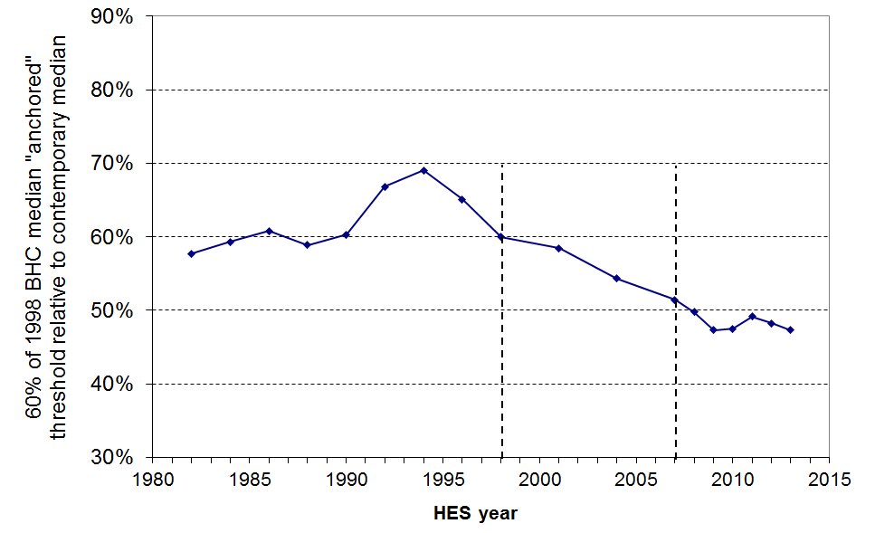

The 2011 report shifted the reference year for ‘fixed line’ poverty measures from 1998 to 2007. Moving the reference year only to 2004 ran the risk of requiring another move of reference year in a relatively few years. The decision to go to 2007 was made with a view to not having to change it again for some time.

Figure E.2 shows the impact of the choice of reference year on where the CV threshold sits relative to the contemporary median. The continued use of a 1998 CV threshold would have lacked credibility, with its value dipping below 50% of the contemporary median in 2009 and highly likely to reduce even further in the near future. Moving only to 2004 seemed to be likely to require a another change in perhaps 2011 or 2012, so the reference year was moved to 2007.

Figure E.2
CV threshold set at 60% of the 1998, 2004 and 2007 medians
expressed as a proportion of the contemporary median (BHC), 1982 to 2009

Figure E.3 shows what a re-basing to 2004 and 2007 does for the AHC 60% CV poverty trend. In effect it simply shifts the trend line up over the whole period.

Figure E.3
Changing the base year from 1998 to 2004 or 2007 for CV poverty lines:
an illustration using AHC incomes, 60% CV threshold, whole population

Reporting on poverty figures back to 1982 using 2007 as the reference year tells us what proportion were ‘poor’ back then relative to a standard set in 2007. While this is interesting (and the report did this two years ago), it has no real value for giving a fair and useful picture of the extent of hardship ‘back then’ relative to the standards prevailing at the time or near to it. In this 2013 report, 2007 CV figures are therefore rarely given for the years before 2007 – only 1998 CV figures are usually given for these earlier years. 1998 CV figures are given in the main tables for 2007 to 2012 to provide overlap comparison for a few years. The intention is to draw a line on any further use of this 1998 CV series for years after the 2012 HES. The discontinuity in the CV series adds a complexity to ‘telling the story’, but it also has the value of making explicit just what the CV (fixed line) approach is about: it emphasises that it too is really a relative measure – a relative measure held fixed for the short-term.

Can poverty rates ever fall using a REL or moving threshold approach?

It has often been pointed out that measuring poverty using a REL or moving threshold approach makes it very difficult for poverty rates to decline during periods of sustained economic growth. During such periods, median household incomes are likely to rise, and unless incomes in the bottom decile or two show an equal or greater rise, then poverty rates using a REL approach will be reported as increasing because the poverty line (set as a proportion of the median) will rise more quickly than the incomes of these low-income households.

This means that to achieve a reduction in poverty using a REL approach there has to be a rate of increase in incomes for low-income households that exceeds the rate of increase at the median. In other words, to achieve REL poverty reduction requires a changing of the shape of the lower end of the income distribution such that it gets moved to the right, closer to the median.

The Working for Families (WFF) package, progressively introduced from 2004 to 2007, put an additional $1.6b per annum mainly into low- to middle-income families once fully implemented. Although a little of the new money went to families at or above the median, the bulk went to families below the median and especially to those well below it. The shape of the bottom end of the income distribution was changed by the WFF package (see Figure D.14), and child poverty rates were reduced from 2004 to 2007 as a result, even on moving line measures.

Reporting levels and trends for older New Zealanders (aged 65+)

Section A drew attention to the pensioner spike as a distinctive feature of New Zealand’s BHC income distribution. The spike is a direct consequence of (a) New Zealand having a universal New Zealand Superannuation (NZS) that is neither income nor asset tested, and (b) there being a good proportion of superannuitants with little other income over and above NZS.

The spike has implications for reporting on income poverty both for the 65+ and more generally. In the period from 1982 to 2004 the value of NZS moved within a range of 56% to 67% of the median household income (BHC). This means that on a BHC basis income poverty rates for the 65+ in the period are reported as near to zero using a 50% threshold. Using a 60% threshold they fell from 25% in 1988 to close to zero in the mid 1990s when the median fell in real terms and NZS was above the 60% threshold, and in 2010 were at 36% as the median had risen in real terms and the NZS value was well below the 60% threshold. These features (low for 50% then high, and very volatile for 60%) mean that a BHC approach for reporting trends in poverty rates for the 65+ is not useful. This is further discussed in Section I.

In 2009, the value of NZS relative to the median had fallen to 48%, so on a 50% of median measure, BHC poverty rates for older New Zealanders are reported as fairly rapidly rising from very low in 2001 to 22% in 2009. This leaves the misleading impression that the living standards of a sizeable group of older New Zealanders took a sudden turn for the worse over the few years up to 2009.

The AHC distribution still has some strong bunching but the pensioner spike is not as sharp. Furthermore, what remains of the spike is well above the 50% of median threshold for AHC incomes, and is mainly above the 60% of median threshold. Small shifts in the median or the threshold do not therefore have the same disproportionate and misleading effects on (trends in) poverty rates for the 65+ as they do when using BHC incomes.

This report therefore uses the AHC approach as the primary one for reporting on poverty rates for the 65+ and therefore for all subgroups so that the comparisons are on the same metric (see Appendix 5 for more detail on this decision, or the Introduction for a summary of the key points).

The low-income thresholds or poverty lines used in this report

Tables E.2 and E.3 below give the value of the report’s low-income thresholds (‘poverty lines’) in ordinary 2013 dollars pw for different household types. The values in 2014 dollars will be much the same as inflation has been low.

This report uses low-income thresholds for BHC incomes set at 50% and 60% of the median equivalised household income (BHC), using both ‘moving’ and ‘fixed’ thresholds (REL and CV (constant value)).

AHC thresholds are calculated by deducting 25% from the corresponding BHC threshold as an allowance for housing costs. Each household’s AHC income is then assessed against the chosen threshold. There is a short discussion of the 25% allowance for housing costs below the tables. The rationale for the choice of thresholds (BHC and AHC) is discussed more fully in Appendix 6.

Table E.2
50% and 60% low-income thresholds or ‘poverty lines’ for various household types (BHC)
(2013 dollars, per week)
 |  | REL (‘moving’) |  | CV (‘anchored’ /‘fixed’)
Household type | Equiv ratio | 50% of 2013 median | 60% of 2013 median | 60% of 2007 median in $2013
One-person HH | 1.00 | 320 | 380 | 355
SP, 1 child | 1.40 | 445 | 535 | 495
SP, 2 children | 1.75 | 555 | 665 | 620
SP, 3 children | 2.06 | 655 | 785 | 730
Couple only | 1.54 | 490 | 585 | 545
2P, 1 child | 1.86 | 590 | 710 | 660
2P, 2 children | 2.17 | 690 | 830 | 770
2P, 3 children | 2.43 | 770 | 925 | 860
2P, 4 children | 2.69 | 855 | 1025 | 955
3 adults | 1.98 | 630 | 735 | 705

Table E.3
50% and 60% low-income thresholds or ‘poverty lines’ for various household types (AHC)
(2013 dollars, per week)
 |  | REL (‘moving’) |  | CV (‘anchored’ /‘fixed’)
Household type | Equiv ratio | 50% of 2013 median | 60% of 2013median | 60% of 2007 median in $2013
One-person HH | 1.00 | 240 | 285 | 265
SP, 1 child | 1.40 | 335 | 400 | 375
SP, 2 children | 1.75 | 415 | 500 | 465
SP, 3 children | 2.06 | 490 | 590 | 550
Couple only | 1.54 | 365 | 440 | 410
2P, 1 child | 1.86 | 445 | 530 | 495
2P, 2 children | 2.17 | 515 | 620 | 580
2P, 3 children | 2.43 | 580 | 700 | 645
2P, 4 children | 2.69 | 640 | 770 | 715
3 adults | 1.98 | 470 | 565 | 525

Note: AHC thresholds are calculated by deducting 25% from the corresponding BHC threshold as an allowance for housing costs. Each household’s AHC income is then assessed against the chosen threshold. See the discussion above.

The 25% allowance for housing costs

The AHC median has been 18-20% lower than the BHC median for the last 20 years or so. This means that middle-income households spend on average 18-20% of their income on housing costs (rent, rates and mortgages). This is clearly a much lower proportion than for lower-income households. For those in HNZC houses (‘state houses’), their rent is set at 25% of their income. We also know that for those renting in the private sector and receiving the AS, almost all pay more than 30% of their income (which includes AS) to rent, and just under half pay more than 50%.

If the AHC thresholds (‘poverty lines’) were simply set at 50% or 60% of the AHC median, this would in effect be allowing only 18-20% of income for housing costs for low-income households. This is unrealistically low compared with what is actually spent. This report sets the AHC thresholds at the BHC thresholds less 25% as an allowance for housing costs. There is a case that something more like a third (30-33%) would be a more realistic allowance. This issue and the general rationale for the choice of thresholds (BHC and AHC) are discussed in Appendix 6.

Poverty depth and persistence

Reporting on trends in headcount poverty rates provides valuable information for assessing our progress as a nation and for informing policy development and debate. However, such information tells only a part of the incomes story. Two other insights are needed to round out the picture: trends in the depth of poverty and in the persistence of poverty for individuals over time.

Understanding poverty depth is about knowing what is happening to the incomes of those identified as poor from survey to survey. Are the poor today in the main sitting just below, say, a 50% threshold, or are they on average much poorer than their counterparts in earlier surveys, generally having incomes below, say, a 40% threshold? There are issues around the quality of the data among households with very low incomes, and these present challenges to providing robust information on poverty depth. Subject to these limitations, measures of poverty depth are discussed and trends reported at the end of the next section (Section F).

Secondly, while surveys like the HES are very valuable they give only repeated snapshot information of a different sample of households each survey. They cannot tell us, for example, how many of the poor in one survey are still among those counted as poor in the next. A more comprehensive picture needs information from surveys which follow the same people over many years and thus enable information on the persistence of poverty and income mobility to be reported. Statistics New Zealand’s longitudinal Survey of Families, Income and Employment (SoFIE) began data collection in 2002-2003 and analysis of the first seven waves is now available. A summary of this, with international comparisons is reported in Section K.

Interpreting and reporting differences and trends in the poverty figures which follow

Four sorts of analyses and comparisons are provided regarding headline trends in Section F and in the more detailed breakdowns in later sections:
- proportions and numbers of people ‘in poverty’ at a point in time
- changes from one survey to the next
- longer-term trends
- relativities between subgroups and composition of those identified as ‘poor’.

The findings and summaries for proportions ‘in poverty’ depend crucially on the threshold and measure used. Where point-in-time poverty rates are being reported, it is strongly recommended that those using the figures from this report also explicitly state what measure is being used (always).

Nothing should be read into small changes from one survey to the next, as sampling and non-sampling errors mean that such differences are unlikely to have any significance (see the Introduction, Section A).

In contrast, analysis of longer-term trends and relativities between subgroups generally produce robust and uncluttered summary findings. Although there is sometimes a difference in trend depending on the particular measure used, these differences are relatively easy to explain from first principles based on the different conceptualisations for the different measures.

More elaborated version of the stylised diagram in Figure A.1

The diagram below shows at a high level the different factors that can impact on living standards. Figure A.1 is the simplified version of this. The level and quality of financial and physical assets, assistance from support networks and government services, and special demands on the household budget can all have significant positive or negative effects on living standards, over and above the effect of current income. As these factors fall differently across different households, households with the same or similar equivalised incomes can have different living standards. For these reasons, current household income, even when adjusted for household size and composition, can only be a rough indicator of actual household living standards.

Same current income – different living standards (material wellbeing)
+
Current HH income
(last 12 months)
- adjusted for HH size and composition
Budgeting knowledge, skills and commitment, and ability to access available resources

Govt services and subsidies

+
+

+
Living standards
(material wellbeing)
Income, gifts, etc received in earlier years

Financial
and
physical
assets

–
Contributions to assets and current budget not picked up by ‘income’
eg - HH production
- help from outside the HH
Special demands on the budget (especially for those with low current incomes and limited financial assets)
eg - health/disability costs
- high accommodation costs
- high debt servicing
- unexpected bills
±
+
Differences in prices for different geographical areas

Another way of looking at the relationship between household income and living standards is to understand equivalised disposable income to be an indicator that allows comparisons of the potential living standards of different households – that is, comparison of the relative levels of consumption of goods and services that individuals could attain given the disposable income of the household in which they live, all else being equal. This recognises that equivalisation takes (reasonable) account of two major differences between households (size and composition), but not of other special demands on the budget, differences in wealth and assistance from outside the household, and so on. All else is in fact not equal.

Whether understood as a rough but readily available proxy for actual household living standards or as a measure of potential living standards (all else being equal), equivalised household disposable income is an important measure to understand and report on. For modern governments, direct income support is one of the most straightforward policy levers available for poverty alleviation. Changes over time in the overall distribution of household income and in the relative position of subgroups can give insight into changes in the social and economic fabric of the country and inform policy evaluation and development. Income information is regularly collected, easily manipulable and relatively easy to understand.

Section F

Headline trends in income poverty, 1982 - 2013

This section reports on the trends in headcount poverty rates – the numbers and proportions of individuals who are in households with incomes below selected thresholds (“poverty lines”).

Information on poverty trends is presented for both the whole population and for dependent children.

A full range of poverty measures is used, as shown in the table below.

Table F.1
Poverty measures reported on in Section F
BHC |  |  |  | AHC
REL  (‘moving line’) |  | CV-98 (to 2007)  CV-07 (from 2007)  (“anchored line”) |  | REL  (‘moving line’) |  | CV-98 (from 1982)  CV-07 (from 2007)  (“anchored line”)
50 | 60 | 50 | 60 | 50 | 60 | 50 | 60
✓ | ✓ | - | ✓ | ✓ | ✓ | - | ✓
Note: ‘CV-98’ indicates that 1998 is the reference year used. ‘CV-07’ uses 2007.

For a fixed or anchored line measure the poverty threshold is set in a reference year (eg at 60% of the median in 1998), then held at constant value (CV) in real terms for other years using the CPI. If the incomes of low- and middle-income households rise in real terms over time, the fixed line poverty threshold eventually becomes too low relative to median income to be useful, and a new reference year has to be chosen. For 1982 to 2007, 1998 was used as the reference year. 2007 is the reference year for 2007 and later years. In this section, poverty figures for 2001 to 2007 are given using both reference years to provide a good overlap for comparison. See Section E for more detail on this.

The thresholds used for the AHC measures are based on the corresponding BHC measure with 25% deducted to allow for housing costs. For example, what is referred to as “the 60% AHC threshold” is equal to the 60% BHC threshold less 25%. This threshold value is applied to the AHC household income distribution and those in households with AHC incomes below the line are counted up. The rationale for this approach is provided in Appendix 6.

While each of the six measures used in this section has an important story to tell, this report recommends the AHC “fixed line” (CV) measure as the primary indicator for monitoring short to medium-term trends. In the longer run the story told by the “moving line” measures needs to be taken into account too. For example, if poverty rates on fixed line measures are falling while rates using a moving line measure are rising then that indicates rising inequality among low- to middle-income households, despite incomes improving in real terms for low-income households. This raises social cohesion and equity issues. No one measure is adequate on its own in the medium to longer term.

The report also recommends the use of an AHC measure for comparing the material wellbeing of various subgroups, as it gives a much more meaningful comparison between groups with very different housing costs (for example, people aged 65+ compared with households with children). A full account of the rationale for this is provided in Section E and Appendix 5.

Section F also reports on poverty depth, using two indicators:
- the ratio of the number below a 50% of median line to the number below a 60% line
- median poverty gap ratios (= median poverty depth).
Impact of changing incomes and housing costs on the different poverty measures

Table F.2 indicates how changes in poverty rates reflect the net impact of changes in:
- BHC incomes at the median
- BHC incomes for low-income households
- housing costs for low-income households.

For example, the top row in Table F.2 indicates that when the median rises, then both BHC and AHC “moving line” poverty rates will rise, provided everything else remains the same. A rising median has no impact on poverty rates measured using a ‘fixed line’ approach.

Table F.2
Impact of selected factors on different poverty measures, 2001 to 2012
when these increase …. | …. the impact on the measured poverty rate is …
 | BHC |  | AHC
 | anchored line (CV2007) | moving line (REL) | anchored line (CV2007) | moving line (REL)
BHC median / incomes around the median ↑ | no impact | ↑ | no impact | ↑
BHC incomes in the bottom quintile (20%) ↑ | ➲ | ➲ | ➲ | ➲
Housing costs (for low-income HHs) ↑ | no impact | no impact | ↑ | ↑

The moving line and the anchored line approaches reflect two quite different notions of poverty

The moving and anchored line approaches to updating the poverty line are both relative approaches – they have that in common. The difference between them is the choice of reference point that each uses to establish the standard against which incomes are assessed.
- The moving line approach sets a poverty line relative to the median, relative to the income of the middle household in the income distribution. This income changes from survey to survey – the poverty line “moves”.
- The anchored or fixed line approach sets the poverty line relative to a fixed standard, set in the reference year relative to the median that year or to some other community standard. The poverty line is then held at that level in real terms – it is an “anchored” or “fixed” line, and its value is not influenced by the changing median in other years.

Each approach has its strengths and limitations, as discussed in Section E. This report takes the fixed line approach as the primary one for monitoring short to medium term trends, simply on the grounds that, at the very least, New Zealanders would want to know whether the incomes of low-income households are rising or falling in real terms, whatever is happening to the incomes of the non-poor. The BHC moving line approach did not and could not pick up the rising hardship of the early to mid 1990s. The fixed line measures could and did.

“There are no poor children, just poor families”

Later in this section, the headline trends for child poverty are reported using a range of measures.

It is sometimes said that the idea of “child poverty” doesn’t make sense as it’s really about families with financial and material resources that are not adequate for meeting the basic needs of the family (ie it’s not poor children, it’s poor families).

In this report, when it is said that “the child poverty rate on a given measure is 18%”, this is a short-hand for “18% of children live in families whose total income is below the threshold used in the given measure”. It is too cumbersome to repeat this each time, so the shorthand version is used: “the child poverty rate is 18%”.

Headline trends for whole population

- Population poverty rates in the 2012-13 HES were in the main similar to those in the 2011-12 HES, and down from their post GFC peak in HES 2010-11 by one to two percentage points, back to pre-GFC levels.

Before Housing Costs (BHC)

- The overall trends from 1982 to 2013 in Figure F.1 clearly show the value and need to monitor poverty rates using both fixed line and moving line approaches. This is well illustrated by looking at two periods: the first half of the 1990s, and from 1994 to 2004.

- The first half of the 1990s:
- in this period there was a very large increase in the number of people in low-income households and a fall in median household incomes
- on a moving line measure, the combined effect of these two changes meant that (relative) poverty rates remained fairly steady and provide no evidence of the growing extent of hardship among low-income households
- on the other hand the fixed line measure gives a very clear indication that there were growing numbers of households with very low incomes.

- From 1994 to 2004:
- there was a continuing decline in the poverty rate on the fixed line measure, but the moving line (relative) poverty rate steadily rose to a peak of 21% in 2004
- the fall in the anchored line poverty rate reflects the falling unemployment, rising employment, rising real wages and increase in the number of two earner families with children
- the rising moving line poverty rate reflects the fact that median income rose more quickly in real terms than the incomes of low-income households – the gap between middle-income and low-income households increased from 1994 to 2004.

- From 2004 to 2007, the upward trend of the moving line poverty rates reversed for the 60% measure and halted for the 50% measure (the WFF impact). The anchored line poverty rate continued to fall.

- For 2007 to 2009, BHC income poverty rates reduced on the fixed line measures, but remained much the same on moving line measures. This means that:
- real BHC incomes rose for some low-income households, leading to fewer in poverty on the fixed line measure, and
- this rise was about the same as the rise in the BHC median leading to no change in poverty rates on the moving line measure.

- Comparisons of moving and fixed line trends over a longer time-scale (1982 to 2007):
- the 60% fixed line CV-98 poverty rate in 2007 (11%) was a little below what it was in the 1980s (12 to 14%)
- the large decline in 60% fixed line poverty rates from 1994 (26%) to 2007 (11%) reflects the significant rise of incomes in real terms for low-income households (see Tables D.2 and D.3)
- in contrast, moving line poverty rates were still higher in 2007 than in the 1980s and the 1990s (even after WFF), reflecting the net widening of the gap between middle-income and low-income households that occurred between 1994 and 2007.

After Housing Costs (AHC)

- Using the AHC anchored line measure (60% of median, reference year = 2007), the poverty rate for the population as a whole fell from 2007 (18%) to 2009 (15%), continuing the downward trend that began from 1994. From 2009 to 2011 the rate rose to 18% in HES 2011 following the GFC and economic downturn, then fell a little to 16% in 2013.
- Anchored line AHC (CV-98) poverty rates were higher in 2007 than in the 1980s, even though BHC incomes were higher in real terms for low-income households. The reason for this is that housing costs made up a much greater proportion of household income for low-income households in 2007 than in 1982. This increase more than cancelled out the gains in BHC incomes for low-income HHs, leaving anchored line poverty rates higher in 2007 than in 1982.
- Using the AHC moving line measure (60%),the population poverty rate rose a little following the GFC impact, falling back to pre-GFC levels (18%) in 2013. 2013 rates were roughly double what they were in the 1980s.

Proportion of all individuals below selected thresholds (BHC)

Figure F.1
Proportion of whole population below selected thresholds (BHC):
fixed line (CV) and moving line (REL) approaches compared
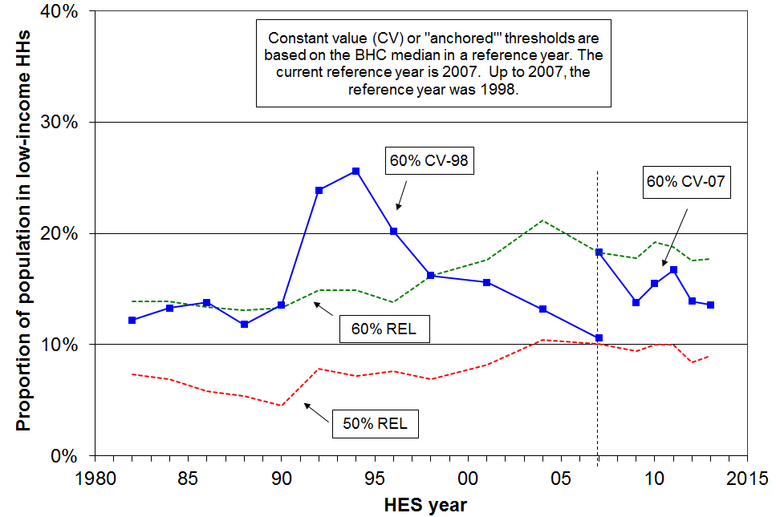

Table F.3
Percentage of whole population below selected thresholds (BHC)
Threshold type | ➔ Constant value |  | Relative to contemporary median |  | Population (million)
HES year | 60% 1998 median | 60% 2007 median | 50% contemp median | 60% contemp median | Population (million)
1982 | 12 | - | 7 | 14 | 3.03
1984 | 13 | - | 7 | 14 | 3.06
1986 | 14 | - | 6 | 13 | 3.07
1988 | 12 | - | 5 | 13 | 3.11
1990 | 14 | - | 5 | 13 | 3.15
1992 | 24 | - | 8 | 15 | 3.23
1994 | 26 | - | 7 | 15 | 3.32
1996 | 20 | - | 8 | 14 | 3.43
1998 | 16 | - | 7 | 16 | 3.54
2001 | 16 | 27 | 8 | 18 | 3.80
2004 | 13 | 25 | 10 | 21 | 3.96
2007 | 11 | 18 | 10 | 18 | 4.13
2009 | 7 | 14 | 9 | 18 | 4.21
2010 | 9 | 16 | 10 | 19 | 4.26
2011 | 10 | 17 | 10 | 19 | 4.31
2012 | 7 | 14 | 8 | 18 | 4.34
2013 | 9 | 14 | 9 | 18 | 4.37

Note: In real terms, the BHC median in 1998 was close to what it was in 1982. There was therefore a good case for using 1998 as the reference year for producing ‘fixed line’ poverty rates back to 1982, as well as for the more usual application moving forwards from 1998. By 2007 the median was 16% up on 1998 and by 2009, 26%. This large change led to the reference year being changed to 2007. As the poverty figures in Table F.3 show, the value of the CV-98 threshold had in 2009 dropped below 50% of the contemporary median (~47%), and has remained below or at this level since then. The intention had been to draw a line on 1998 series shortly after 2009, but the GFC came upon us and this halted the rapid upward trend in the median. We will continue both the 1998 and the 2007 series in the meantime.

Proportion of all individuals below selected thresholds (AHC)

Figure F.2
Proportion of whole population below selected thresholds (AHC):
fixed line (CV) and moving line (REL) approaches compared

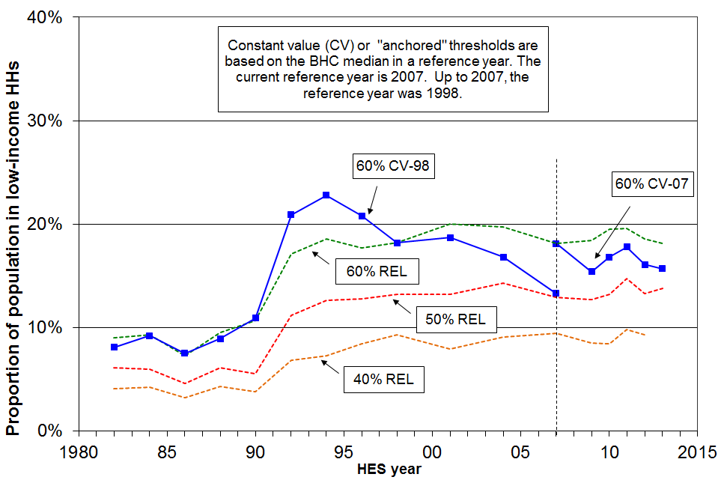

Table F.4
Percentage of whole population below selected thresholds (AHC)
Threshold type | ➔ Constant value |  | Relative to contemporary median |  |  | Population (million)
HES year | 60% 1998 median | 60% 2007 median | 40% contemp median | 50% contemp median | 60% contemp median | Population (million)
1982 | 8 | - | 4 | 6 | 9 | 3.03
1984 | 9 | - | 4 | 6 | 9 | 3.06
1986 | 8 | - | 3 | 5 | 7 | 3.07
1988 | 9 | - | 4 | 6 | 10 | 3.11
1990 | 11 | - | 4 | 6 | 11 | 3.15
1992 | 21 | - | 7 | 11 | 17 | 3.23
1994 | 23 | - | 7 | 13 | 19 | 3.32
1996 | 21 | - | 8 | 13 | 18 | 3.43
1998 | 18 | - | 9 | 13 | 18 | 3.54
2001 | 19 | 25 | 8 | 13 | 20 | 3.80
2004 | 17 | 22 | 9 | 14 | 20 | 3.96
2007 | 13 | 18 | 9 | 13 | 18 | 4.13
2009 | 12 | 15 | 8 | 13 | 18 | 4.21
2010 | 12 | 17 | 8 | 13 | 19 | 4.26
2011 | 14 | 18 | 10 | 15 | 20 | 4.31
2012 | 13 | 16 | 9 | 13 | 19 | 4.34
2013 | 13 | 16 | 9 | 14 | 18 | 4.37

Note: AHC thresholds are calculated by deducting 25% from the corresponding BHC threshold as an allowance for housing costs. Each household’s AHC income is then assessed against the chosen threshold.

See the note under Table F.3 for information on the choice of reference year (1998 or 2007) for the CV figures.

Headline trends for children

Before Housing Costs (BHC)

- On both the 60% fixed line measure (using 2007 as the reference year), and on the 50% and 60% moving line measures, child poverty rates rose from HES 2009 to HES 2010 and HES 2011, reflecting the impact of the GFC on household incomes. In HES 2013, these rates are back to close to their pre-GFC rates.
- On a longer timescale for the moving line measure:
- The rise in moving line child poverty rates from 1990 to 1992 was driven by two factors: the rise in unemployment, and the 1991 benefit rate cuts which decreased real incomes for beneficiaries by a greater amount than the median fell in the period.
- From 1992 to 1998 the 60% of median moving line poverty rate for children fell as unemployment rates fell and incomes for those around the poverty line rose more quickly than the median in the period.
- From 1998 the median continued to grow in real terms, but the incomes of many low-income households with children remained fairly static through to 2004. This meant that the moving line child poverty rate rose to 2004, indicating that low-income households with children were on average further from the median in 2004 than in 1998.
- From 2004 to 2007, this trend was reversed, with rates falling from 26% to 20% (60% threshold), reflecting the impact of the WFF package which transferred considerable financial support to households with children on low to middle incomes. As almost all the extra WFF money went to households below the median, the median itself was largely unaffected.
- the 60% and 50% of median BHC moving line child poverty rates in HES 2013 were around the same as what they were in the 1980s (20%, and 11% respectively).
- On the fixed line measure, poverty rates decline when fewer households have incomes below a threshold held fixed in real terms, irrespective of what is happening elsewhere in the distribution.
- Using the 60% BHC fixed line threshold (1998 reference year), this is what happened from the mid 1990s to 1998 as a result of improving economic conditions, improving employment rates and reducing unemployment.
- From 1998 to 2004 child poverty rates using the 60% threshold remained reasonably steady at 19-22%.
- From 2004 to 2007, the poverty rate fell strongly from 19% to 13% - the WFF impact.

After Housing Costs (AHC)

- On the AHC fixed line measure, the child poverty rate fell significantly from 1994 to 2007 (35% to 16%, using 1998 as the reference year). In HES 2013, child poverty rates on this measure are much the same as in HES 2007 (17% using 1998 as the reference year and 22% with 2007 as the reference year). In between, it rose 2 to 3 percentage points in 2010 and 2011 after the GFC impact.
- On the AHC 60% of median moving line measure, the child poverty rate rose by 3 percentage points (25% to 28%) from HES 2009 to HES 2010 following the GFC impact, but in HES 2013 had returned to close to the pre-GFC rate (24%). This is lower than in the 1990s (28-30%), but double what it was in the 1980s (~12%).
- The trend for the AHC 40% of median moving line measure has been fairly steady since the benefit cuts in 1991 (11-12%).
Housing costs and the longer-run trends in child poverty (1982 to 2007, 2007 to 2013)

- The BHC 60% fixed line child poverty rate (1998 reference year) was lower in 2007 than what it was in the 1980s, and the BHC moving line rates were around the same in 2007 as in the 1980s. The AHC long-run trends are quite different: the fixed line poverty rate in 2007 (1998 reference year) was just a little above what it was in the 1980s, and the moving line rate in 2007 was much higher than in the 1980s.
- A key factor in explaining the longer-term differences between AHC and BHC rates is that housing costs in 2007 on average made up a higher proportion of household expenditure for low-income households than they did in the 1980s. For example, in 1988 17% of those in the bottom quintile lived in households that spent more than 30% of their income on housing. In 2007 there were 39%, after peaking at 52% in 1994.
- The longer-run AHC findings on child poverty reflect the fact that AHC incomes in 2007 for low-income households were around the same as they were in the early 1980s in real terms (so the fixed line child poverty rates are around the same in 2007 as in the 1980s), but that relative to the median, the incomes of lower-income households with children had fallen away (leading to higher moving line poverty rates).
- Both the income-related rental policies introduced in 2000 for those in HNZC houses and changes to the Accommodation Supplement (AS) settings in the mid 2000s helped to reduce net housing expenditure for some low-income households compared to what it would have been. This support contributed to the reductions in child poverty as measured on an AHC approach from 2001 to 2007.
- The policy settings for the AS have remained unchanged since 2005.

How many poor children are there in New Zealand?
(ie How many children live in households with incomes below selected thresholds?)

Table F.5
Numbers of poor children in New Zealand
(ie the number of children in households with incomes below the selected thresholds)
 | BHC |  | AHC
 | BHC ‘moving line’ |  | AHC ‘moving line’ |  |  | AHC ‘anchored line (2007)’
HES year | 50% | 60% | 40% | 50% | 60% | 60% (07 ref)
2001 | 120,000 | 250,000 | 115,000 | 215,000 | 310,000 | 380,000
2004 | 150,000 | 270,000 | 115,000 | 200,000 | 290,000 | 320,000
2007 | 140,000 | 210,000 | 115,000 | 170,000 | 240,000 | 240,000
2009 | 115,000 | 210,000 | 130,000 | 195,000 | 270,000 | 230,000
2010 | 150,000 | 245,000 | 115,000 | 200,000 | 300,000 | 260,000
2011 | 140,000 | 230,000 | 120,000 | 210,000 | 285,000 | 255,000
2012 | 130,000 | 220,000 | 130,000 | 205,000 | 285,000 | 240,000
2013 | 120,000 | 215,000 | 135,000 | 205,000 | 260,000 | 230,000

- Using non-income measures of hardship, and an internationally comparable hardship threshold, around 200,000 children (18%) were below the threshold in 2008.

- There are clearly degrees of severity of poverty and material hardship. For example, children in households with incomes below a 50% AHC moving line measure will experience greater material disadvantage than those just below the 60% threshold, all else being equal. Some in households with incomes above the 60% AHC line will experience hardship because of high debt servicing or health costs, or long-run low income. See Appendix 6 and Section E for further discussion on the setting of the low-income thresholds (“poverty lines”).
Proportion of dependent children below selected thresholds (BHC)

Figure F.3
Proportion of children below selected thresholds (BHC):
fixed line (CV) and moving line (REL) approaches compared
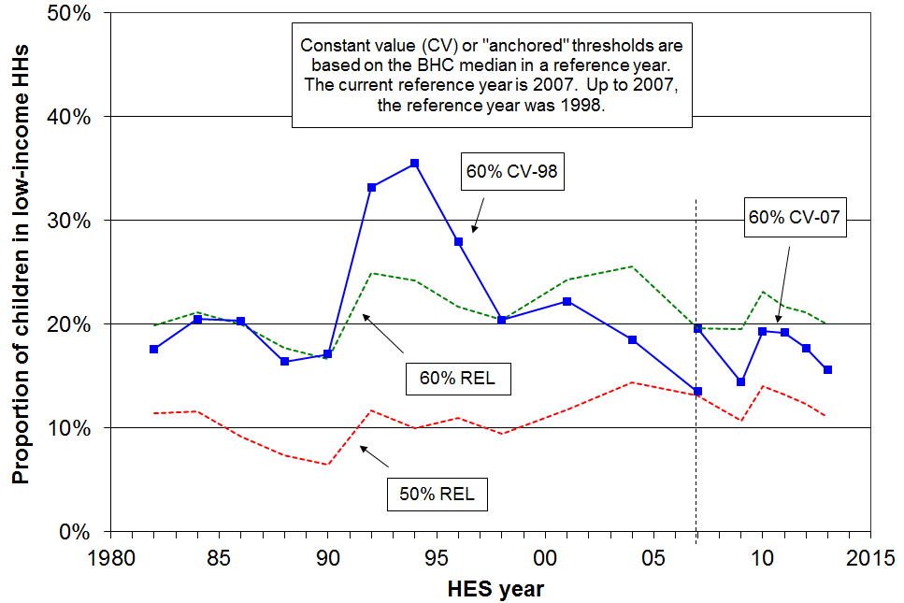

Table F.6
Percentage of children below selected thresholds (BHC)
Threshold type | ➔ Constant value |  | Relative to contemporary median |  | Total children (thousands)
HES year | 60% 1998 median | 60% 2007 median | 50% contemp median | 60% contemp median | Total children (thousands)
1982 | 18 | - | 11 | 20 | 940
1984 | 21 | - | 12 | 21 | 925
1986 | 20 | - | 9 | 20 | 895
1988 | 16 | - | 7 | 18 | 885
1990 | 17 | - | 7 | 17 | 875
1992 | 33 | - | 12 | 25 | 875
1994 | 36 | - | 10 | 24 | 910
1996 | 28 | - | 11 | 22 | 940
1998 | 20 | - | 9 | 20 | 950
2001 | 22 | 35 | 12 | 24 | 1020
2004 | 19 | 30 | 14 | 26 | 1040
2007 | 13 | 20 | 13 | 20 | 1065
2009 | 9 | 14 | 11 | 19 | 1070
2010 | 12 | 19 | 14 | 23 | 1065
2011 | 13 | 19 | 13 | 22 | 1067
2012 | 11 | 18 | 12 | 21 | 1047
2013 | 10 | 16 | 11 | 20 | 1064

Note: In real terms, the BHC median in 1998 was close to what it was in 1982. There was therefore a good case for using 1998 as the reference year for producing ‘fixed line’ poverty rates back to 1982, as well as for the more usual application moving forwards from 1998. By 2007 the median was 16% up on 1998 and by 2009, 26%. This large change led to the reference year being changed to 2007. As the poverty figures in Table F.3 show, the value of the CV-98 threshold had in 2009 dropped below 50% of the contemporary median (~47%), and has remained below or at this level since then. The intention had been to draw a line on 1998 series shortly after 2009, but the GFC came upon us and this halted the rapid upward trend in the median. We will continue both the 1998 and the 2007 series in the meantime.

Proportion of dependent children below selected thresholds (AHC)

Figure F.4
Proportion of children below selected thresholds (AHC):
fixed line (CV) and moving line (REL) approaches compared

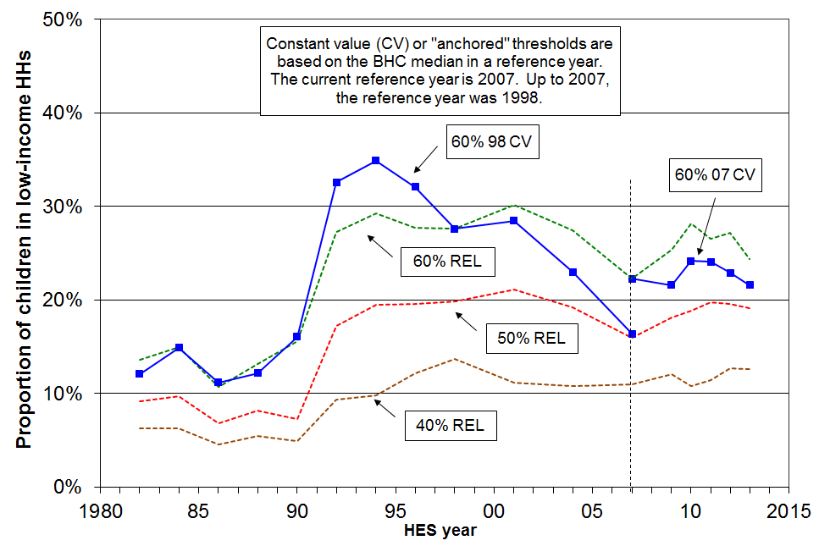

Table F.7
Percentage of children below selected thresholds (AHC)
Threshold type | ➔ Constant value |  | Relative to contemporary median |  |  | Total children (thousands)
HES year | 60% 1998 median | 60% 2007 median | 40% contemp median | 50% contemp median | 60% contemp median | Total children (thousands)
1982 | 12 | - | 6 | 9 | 14 | 940
1984 | 15 | - | 6 | 10 | 15 | 925
1986 | 11 | - | 5 | 7 | 11 | 895
1988 | 12 | - | 5 | 8 | 13 | 885
1990 | 16 | - | 5 | 7 | 16 | 875
1992 | 33 | - | 9 | 17 | 27 | 875
1994 | 35 | - | 10 | 20 | 29 | 910
1996 | 32 | - | 12 | 20 | 28 | 940
1998 | 28 | - | 14 | 20 | 28 | 950
2001 | 29 | 37 | 11 | 21 | 30 | 1020
2004 | 23 | 31 | 11 | 19 | 28 | 1040
2007 | 16 | 22 | 11 | 16 | 22 | 1065
2009 | 17 | 22 | 12 | 18 | 25 | 1070
2010 | 16 | 24 | 11 | 19 | 28 | 1065
2011 | 19 | 24 | 11 | 20 | 27 | 1067
2012 | 18 | 23 | 12 | 20 | 27 | 1047
2013 | 17 | 22 | 13 | 19 | 24 | 1064

Note: AHC thresholds are calculated by deducting 25% from the corresponding BHC threshold as an allowance for housing costs. Each household’s AHC income is then assessed against the chosen threshold.

See the note under Table F.6 for information on the choice of reference year (1998 or 2007) for the CV figures.

Sensitivity of levels and trends to choice of poverty line

Figures F.5 and F.6 show how the choice of threshold impacts on reported poverty rates for a given measure at a point in time and for trends over time. Figure F.5 uses BHC incomes with thresholds set relative to the contemporary median (the REL or moving line approach). Figure F.6 uses AHC incomes with thresholds held constant in real terms (the CV or “anchored line” approach).

The broad trends over time are largely unaffected by the choice of threshold within the usual range, especially in the AHC anchored line case.

The main exception to this generalisation is that for the period from the 2004 HES to the 2007 HES the reversal of the upward trend in ‘low-income rates’ in Figure F.5 (BHC REL) is strong for thresholds set at 60% to 90% of the median, but for lower thresholds (50% and 55%) the trend lines just flatten. This difference reflects the WFF gains in income for lower income households in work or for those moving from benefit to work, compared with those whose main source of income was from a working age benefit or New Zealand Superannuation. For these latter households, many of whom had incomes below a 55% threshold in that period, there were no gains relative to the median from the 2004 HES to the 2007 HES.

The other point of interest is the stark way in which Figure F.6 shows the impact on household incomes of the global financial crisis and associated downturn and recovery. It shows that from HES 2009 to HES 2011 (approximately calendar 2008 to 2010) the low-income rates all rose then fell from HES 2011 to 2013. The impact is detectable in the BHC REL chart (Figure F.5) but is not as stark as the REL low income rates are affected by the movement of the median as well as the changes in the incomes of low-income households.

Figure F.5
Proportion below a range of ‘moving line’ thresholds (BHC, REL)

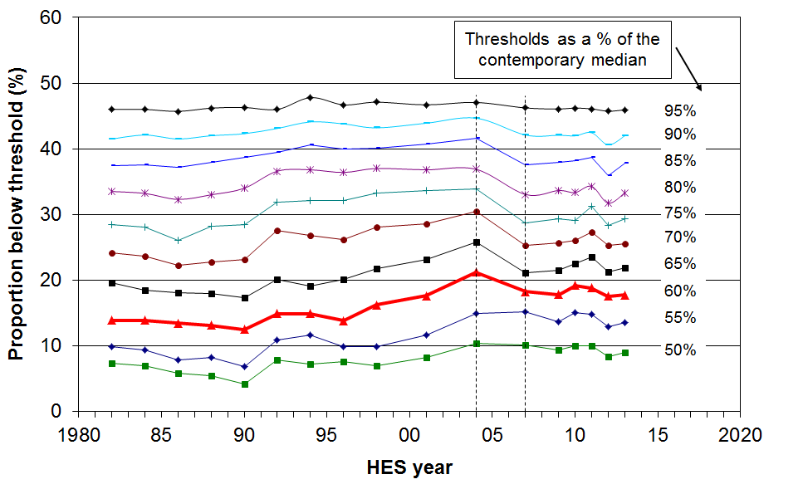

Figure F.6
Proportions below a range of ‘anchored’ thresholds (AHC, CV1998)

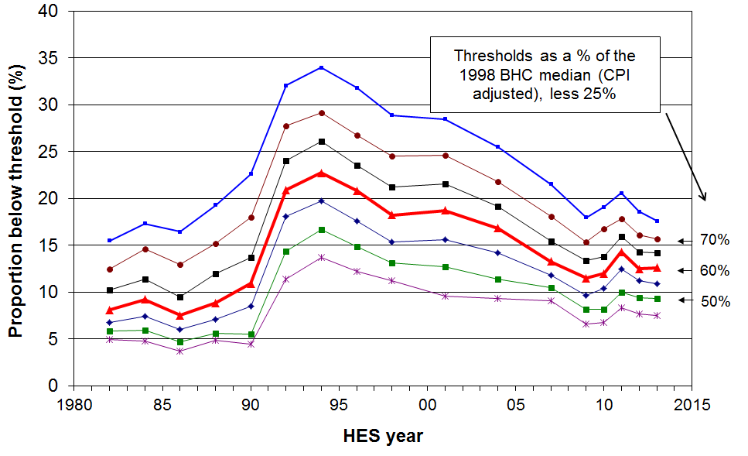

Depth of poverty

Trends in head-count poverty rates tell only a part of the story. It is important also to have an understanding of what is happening to the incomes of those identified as poor, that is, what is happening to trends in the depth of poverty.

This report uses two indicators of poverty depth:

- The ratio of the number below the 50% line to those below the 60% line. The higher this ratio, the greater is the depth of poverty.

- Median poverty gap ratios. These compare the gap between the poverty threshold and the median income of those below the threshold with the threshold itself.

There are issues around the quality of the data among households with very low incomes, and these present challenges to providing robust information on poverty depth. See Appendix 8 for a discussion on the effect of noise in the bottom income decile on measures of poverty depth, and the noise-reducing adjustments to the dataset adopted for the estimates in this section.

This section is not yet updated beyond the 2007 HES and also retains 1998 as the reference year.

Poverty depth: the ratio of 50% poverty rates to 60% poverty rates

Comparing the numbers below a 50% of median threshold with those below a 60% threshold gives an indication of the ‘depth’ of poverty. The higher the ratio, the greater the depth.

Figure F.7 shows that during the 1980s the 60% CV (fixed line) BHC poverty rate for those aged under 65 was relatively steady at around 12%. Poverty depth, however, declined, as measured by the 50% to 60% ratio. In contrast, in the 1998-2004 period, poverty depth as measured by this ratio increased while the poverty rate again remained relatively steady at 15%, pointing to increasing poverty depth. From 2004 to 2007, the ratio was steady and the 60% rate declined, indicating no change in poverty depth.

Figure F.7
Ratio of 50% poverty rate to 60% poverty rate using 1998 CV thresholds (BHC),
population under 65 years

Figure F.8 shows a similar combination of trends for children, except that both the poverty rates and poverty depth (on this measure) are higher for children than for the population as a whole.

Figure F.8
Ratio of 50% poverty rate to 60% poverty rate using 1998 CV thresholds (BHC),
dependent children
Poverty depth: mean and median poverty gap ratios

The median poverty gap ratio compares the gap between the poverty threshold and the median income of those below the threshold with the threshold itself.

The mean poverty gap ratio compares the gap between the poverty threshold and the mean income of those below the threshold with the threshold itself. It is much more affected by the incomes of households with very low incomes than is the median.

Figure F.9 shows that:
- median gap ratios are smaller than mean gap ratios, reflecting the higher concentration of households with incomes nearer the poverty lines compared with the concentration further down
- up to 2004, the estimates of poverty gap ratios are not greatly dependent on whether a REL (‘moving line’) or CV (‘fixed line’) approach is used
- apart from the blip in 1990, the mean gap ratio remained reasonably steady from 1982 to 2004, but has clearly risen from 2004 to 2007 on the REL (moving line) measure

Figure F.9
Mean and median poverty gap ratios

Section G

Trends for the whole population, 1982 to 2013,

by various individual and household characteristics

This section:
- compares trends in poverty rates for subgroups within the population
- reports on the changing composition of those identified as poor on the chosen measures.

The individual and household characteristics used for subgroup analyses are:
- age of the individual
- sex of the individual
- ethnicity of the individual (no trends)
- tenure
- household type
- number of children in the household
- main source of income for households under 65.

For subgroup comparisons, the report recommends the use of AHC measures (see Appendix 5). Table G.1 notes the AHC measures used in this section.

Table G.1
Poverty measures reported on in Section G for subgroups of the whole population
BHC |  |  |  | AHC
REL  (‘moving line’) |  | CV-98 (to 2007)  CV-07 (from 2007)  (‘anchored line’) |  | REL  (‘moving line’) |  | CV-98 (to 2007)  CV-07 (from 2007)  (‘anchored line’)
50 | 60 | 50 | 60 | 50 | 60 | 50 | 60
- | - | - | - | ✓ | ✓ | - | ✓
Note: ‘CV-98’ indicates that 1998 is the reference year used. ‘CV-07’ uses 2007.

Individuals in low-income households by age

- Setting aside the 18-24 year old group, Figure G.1 and Table G.2 show that there has been a hardship gradient across the age groups since the early 1990s, with older New Zealanders having lower income poverty rates than children, and other ages falling in between.
- The position of those aged 18-24 years deteriorated relative to other groups from the 1980s to 2004, but there is some evidence of recovery from 2004 to 2010, although in 2011 and 2012 the rate was back up to close to what it was in 2007.
- Figure G.2 shows how the main living arrangements for 18-24 year olds changed from 1984 to 2010, especially the increasing proportion “still living at home”, and the decreasing proportion “partnered and not at home”. The move ‘back home’ can be seen (initially at least) as a response to the high unemployment and uncertainties through to 1994, and also as a reflection of changing social norms which support delayed partnering and child bearing relative to, say, the 1960s and early 1970s.

Figure G.1
Proportion of all individuals in low-income households by age, 60% CV threshold (AHC)

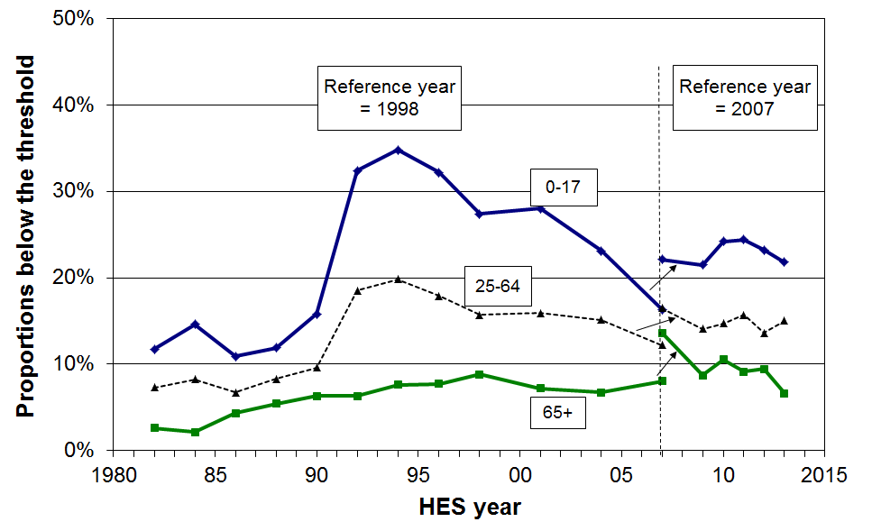

Table G.2
Proportion of all individuals in low-income households by age, 60% CV threshold (AHC)
 | Reference year = 1998 |  |  |  |  |  |  |  | Reference year = 2007
 | 1982 | 1986 | 1990 | 1994 | 1998 | 2001 | 2004 | 2007 | 2007 | 2009 | 2010 | 2011 | 2012 | 2013
0-17 | 12 | 11 | 16 | 35 | 27 | 28 | 23 | 16 | 22 | 22 | 24 | 24 | 23 | 22
18-24 | 6 | 5 | 8 | 20 | 16 | 21 | 22 | 17 | 22 | 14 | 17 | 24 | 20 | 17
25-44 | 9 | 8 | 12 | 23 | 18 | 18 | 17 | 13 | 18 | 15 | 16 | 17 | 16 | 16
45-64 | 4 | 5 | 6 | 15 | 12 | 14 | 13 | 11 | 15 | 13 | 13 | 14 | 11 | 13
65+ | 3 | 4 | 6 | 8 | 9 | 7 | 7 | 8 | 14 | 9 | 11 | 9 | 9 | 7
TOTAL | 8 | 8 | 11 | 23 | 18 | 19 | 17 | 13 | 18 | 15 | 17 | 18 | 16 | 16

Figure G.2
Changing living arrangements for 18-24 year olds, 1984 to 2010

Figure G.3 shows trends in poverty rates by age group using the 60% of median moving line measure (AHC). The hardship gradient is evident here too, with older New Zealanders having lower income poverty rates than younger New Zealanders. However, from 1992 to 2009 the age group poverty trends are quite different using the moving line measure compared with the trends using the fixed line measure (Figure G.1). This reflects the two different notions of poverty that underlie the measures. For example:
- Child poverty on this moving line measure remained steadily high (~28%) from 1994 to 2004, with no fall despite the rising employment, falling unemployment and rising real incomes for many low-income households. The trend reflects the poverty concept for the moving line measure: it is based on distance from the median, rather than distance from a fixed standard held constant in real terms, and the median rose in real terms in the period.
- The only significant fall in child poverty on the moving line measure after 1994 was from 2004 to 2007, reflecting the impact of the WFF package in lifting the incomes of many low- to middle-income families without it having any great impact on the median itself.
- For older New Zealanders, the rise from 1992 to 2009 reflects the fact that the value of the NZS fell in this period relative to the median, even though in real terms the value of the NZS remained steady. From 2009 to 2012, the real value of NZS rose (driven in the main by income tax changes), while the median was relatively unchanged.

Figure G.3
Proportion of all individuals in low-income households by age, 60% REL threshold (AHC)

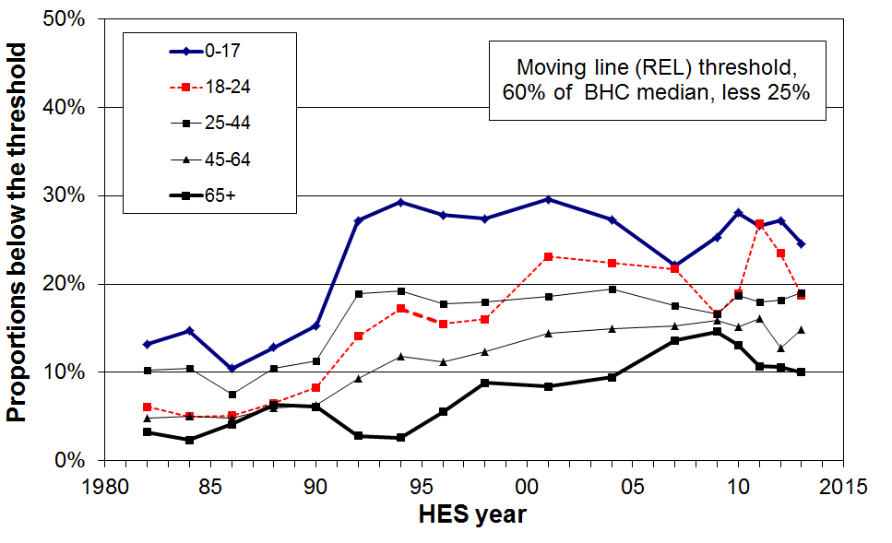

Table G.3
Proportion of all individuals in low-income households by age
A. AHC (REL threshold, 60% of BHC median, less 25%)
 | 1982 | 1984 | 1986 | 1988 | 1990 | 1992 | 1994 | 1996 | 1998 | 2001 | 2004 | 2007 | 2009 | 2010 | 2011 | 2012 | 2013
0-17 | 13 | 15 | 10 | 13 | 15 | 27 | 29 | 28 | 27 | 30 | 27 | 22 | 25 | 28 | 27 | 27 | 25
18-24 | 6 | 5 | 5 | 7 | 8 | 14 | 17 | 16 | 16 | 23 | 22 | 22 | 17 | 19 | 27 | 23 | 19
25-44 | 10 | 10 | 8 | 10 | 11 | 19 | 19 | 18 | 18 | 19 | 19 | 18 | 17 | 19 | 18 | 18 | 19
45-64 | 5 | 5 | 5 | 6 | 6 | 9 | 12 | 11 | 12 | 14 | 15 | 15 | 16 | 15 | 16 | 13 | 15
65+ | 3 | 2 | 4 | 6 | 6 | 3 | 3 | 6 | 9 | 8 | 9 | 14 | 15 | 13 | 11 | 11 | 10
TOTAL | 9 | 9 | 7 | 10 | 11 | 17 | 19 | 18 | 18 | 20 | 20 | 18 | 18 | 19 | 20 | 19 | 18

B. AHC (REL threshold, 50% of BHC median, less 25%)
 | 1982 | 1984 | 1986 | 1988 | 1990 | 1992 | 1994 | 1996 | 1998 | 2001 | 2004 | 2007 | 2009 | 2010 | 2011 | 2012 | 2013
0-17 | 9 | 9 | 7 | 8 | 7 | 17 | 20 | 20 | 20 | 21 | 19 | 16 | 18 | 19 | 20 | 20 | 19
18-24 | 5 | 3 | 2 | 5 | 5 | 10 | 13 | 11 | 12 | 15 | 18 | 17 | 12 | 14 | 21 | 17 | 15
25-44 | 7 | 7 | 6 | 7 | 7 | 13 | 13 | 13 | 13 | 13 | 15 | 13 | 12 | 13 | 14 | 14 | 15
45-64 | 3 | 4 | 3 | 5 | 3 | 6 | 8 | 9 | 10 | 9 | 11 | 11 | 11 | 11 | 13 | 9 | 12
65+ | 1 | 1 | 2 | 2 | 2 | 1 | 1 | 3 | 4 | 3 | 5 | 7 | 7 | 6 | 6 | 7 | 4
TOTAL | 6 | 6 | 5 | 6 | 6 | 11 | 13 | 13 | 13 | 13 | 14 | 13 | 13 | 13 | 15 | 13 | 14
Individuals in low-income households by sex

- Table G.4 shows that from 1988 to 2012 on the preferred AHC fixed line measure, females were slightly more likely than males to be below the threshold.
- Table G.5 gives the numbers in each group for HES 2012 and HES 2013

Table G.4
Proportion of individuals aged 15+ in low-income households by sex,
AHC income, 60% of median (CV threshold)
 | Reference year = 1998 |  |  |  |  |  |  |  |  | Reference year = 2007
 | 1988 | 1990 | 1992 | 1994 | 1996 | 1998 | 2001 | 2004 | 2007 | 2007 | 2009 | 2010 | 2011 | 2012 | 2013
Female | 8 | 9 | 18 | 20 | 18 | 16 | 17 | 15 | 13 | 18 | 14 | 16 | 17 | 15 | 15
Male | 7 | 8 | 16 | 17 | 15 | 13 | 14 | 15 | 11 | 16 | 13 | 13 | 14 | 13 | 13
TOTAL (15+) | 8 | 9 | 17 | 18 | 17 | 15 | 16 | 15 | 12 | 17 | 14 | 15 | 16 | 14 | 14

Table G.5
Numbers of individuals aged 15+ in low-income households by sex, HES 2012 and HES 2013
AHC income, 60% of median (CV threshold)
 | HES 2012 |  | HES 2013
 | Total | “Poor” | Total | “Poor”
Female | 1.77m | 260,000 | 1.78m | 270,000
Male | 1.68m | 220,000 | 1.69m | 210,000
TOTAL (15+) | 3.45m | 480,000 | 3.48m | 480,000

Individuals in low-income households by ethnicity (whole population)

As noted in the Introduction, only limited analysis by ethnicity is reported because of the relatively small sample sizes for Maori, Pacific and Other ethnic groups (especially Pacific). The analysis in this section combines the data from the last two surveys (HES 2012 and 2013) to give an indication of the differences in low-income rates by ethnicity.

Poverty rates for those in the Maori and Pacific ethnic groups are consistently higher than for those in the European/Pakeha ethnic group (roughly double), whatever measure is used.

For example, on average over the two surveys HES 2012 and 2013, using the AHC 60% anchored line measure, 12% of European/Pakeha, 24% of Maori, 23% Pacific and 24% “Other” were in households with incomes below this line.

The above use ethnicity defined on a prioritisation approach (see Introduction). Using a “total count” approach makes little difference for this purpose: the corresponding figures are 13%, 24%, 23% and 25%.

Composition of the poor by ethnicity

It is important to distinguish between the proportion of a group who are counted as poor, and the proportion of the poor who are from a particular group, that is, between rates and composition.

Using the same approach as for the rates above, just under half (49%) of those identified as poor are in the European/Pakeha group, 33% in the Maori and Pacific groups, and 18% in the Other group.

Using a more stringent poverty line (50% of median), the composition proportions are 50%, 32% and 18% respectively. There is no evidence here of greater depth of poverty for any one group.

Individuals in low-income households by highest household educational qualification

There is a well-established positive link between adult educational qualifications and employment opportunities and wages received.

Table G.6 shows the fairly steep gradient for poverty rates for individuals from households of lower and higher educational qualifications.

A higher educational qualification does not of itself guarantee an adequate income however, as the 12% poverty rate for university graduates indicates.

Table G.6
Poverty rates and poverty composition by highest household educational qualification:
individuals under 65, averages over HES 2011 to 2013,
using the AHC CV 60% of median threshold, anchored in 2007
 | Poverty rate (%) | Poverty composition (%) | Child population composition (%) | Risk ratio
No formal qualification | 47 | 17 | 7 | 2.3
School qualification only | 28 | 33 | 23 | 1.4
Post-school non-degree | 17 | 31 | 36 | 0.9
Degree or post-graduate | 12 | 20 | 34 | 0.6

Individuals in low-income households by tenure

- There is a clear hardship gradient across different tenures for those aged under 65 (Table G.7A): low poverty rates for those in mortgage-free homes and a little higher for those who still have a mortgage, and relatively high rates for those in rental properties, especially in HNZC tenancies.
- For those aged 65+, the hardship gradient is also clear (Table G.7B). The figures underline the value of having a mortgage-free home in “retirement” years. This is not a surprising finding given the use of an AHC measure.
- Around half (49%) of all those aged under 65 who are in poverty live in private rental accommodation. The figure rises to two in three (65%) when HNZC and private rentals are counted together.

Table G.7A
Proportion (%) of individuals aged under 65 in low-income households by tenure,
AHC CV threshold (60% of 1998 or 2007 BHC median, less 25%)
 | Reference year = 1998 |  |  |  |  |  |  | Reference year = 2007
 | 1992 | 1994 | 1996 | 1998 | 2001 | 2004 | 2007 | 2007 | 2009 | 2010 | 2011 | 2012 | 2013
Owned or FT without mortgage | 10 | 8 | 9 | 7 | 10 | 9 | 6 | 12 | 7 | 7 | 9 | 4 | 8
Owned or FT with mortgage | 22 | 23 | 20 | 15 | 17 | 12 | 9 | 14 | 12 | 12 | 10 | 11 | 10
Rented - private | 33 | 41 | 36 | 35 | 33 | 30 | 23 | 28 | 26 | 28 | 31 | 27 | 29
Rented – HNZC or local authority | 55 | 64 | 59 | 53 | 37 | 41 | 29 | 37 | 38 | 38 | 47 | 46 | 33
TOTAL (under 65) | 23 | 25 | 22 | 19 | 20 | 18 | 14 | 19 | 16 | 18 | 19 | 17 | 17
Notes: 1 ‘Owned or FT without mortgage’ means that the dwelling is owned by the householders or a Family Trust, and the householders make no mortgage payments.

Table G.7B
Proportion (%) of individuals aged 65+ in low-income households by tenure,
AHC CV threshold (60% of 1998 or 2007 BHC median, less 25%)
 | Reference year = 1998 |  |  |  |  |  |  | Reference year = 2007
 | 1992 | 1994 | 1996 | 1998 | 2001 | 2004 | 2007 | 2007 | 2009 | 2010 | 2011 | 2012 | 2013
Owned or FT without mortgage | 1 | 1 | 1 | 2 | 2 | 2 | 4 | 7 | 3 | 3 | 3 | 2 | 1
Owned or FT with mortgage | 6 | 16 | 15 | 32 | 31 | 11 | 10 | 16 | 20 | 10 | 15 | 16 | 16
Rented | 36 | 53 | 64 | 53 | 30 | 37 | 23 | 44 | 47 | 50 | 45 | 50 | 32
TOTAL (65+) | 6 | 8 | 8 | 9 | 7 | 7 | 8 | 14 | 9 | 10 | 9 | 9 | 7
Notes: 1 ‘Owned or FT without mortgage’ means that the dwelling is owned by the householders or a Family Trust, and the householders make no mortgage payments.
2 For the 65+ ‘owned or FT with mortgage’, the sample numbers are small – the general conclusion that the poverty rate for mortgage payers is significantly higher than for those who own without a mortgage is robust, but the sample numbers do not support precise figures.
3 For the 65+, all renters are grouped together as the sample numbers are too small to split private and HNZC renters.

Individuals in low-income households by household type

Key findings

Using AHC incomes:

- Sole-parent households with dependent children have the highest income poverty rates of all household types (Table G.8), 56% in 2013, similar to the last three surveys.

- Around one in three sole-parent families (EFUs) live in wider households with others. Table G.6 shows the lower poverty rates for these embedded sole-parent EFUs (20% on average over HES 2011 to HES 2013) compared with those who live in sole-parent households on their own (67% in the same period).

- Two-parent households with dependent children have much lower poverty rates than sole-parent households, but there are more poor individuals from this household type than from sole-parent households (Table G.9).

- Table G.9 and Figure G.4 show that while those in households with dependent children continue to make up the bulk of those classified as poor, working-age adults in households without dependent children now make up a larger proportion of the poor than in earlier years (30% on average in 2010 to 2013, compared with 19% in the mid 1990s and 15% in the mid 1980s). This rise is driven not only by the increasing share of households without dependent children but also by the generally higher recent poverty rates compared with 1984 for working-age households with no dependent children.

- Working-age adults in single-person households have the second highest poverty rate of all household types. From the 1980s to 2007, poverty rates for this group trebled (10% to 30% on the 1998 CV standard). In 2012 and 2013, 30% were below the 2007 60% CV AHC threshold: this group made up around 9% of those classified as poor. There is little difference in the poverty rates for younger (18 to 44 years) and older (45 to 64 years) one-person households, 28% and 30% respectively.

- Overall poverty rates for those aged 65+ have been considerably lower than those for the rest of the population over the full period from 1982 to 2013 (Table G.2 above). However, those older New Zealanders living on their own have generally had a much higher proportion below the threshold than have those in couple households (eg 11% compared with 6% for 2013).

Table G.8
Individuals in low-income households by household and family type
60% AHC CV
Proportions below the threshold
 | Reference year = 1998 |  |  |  |  |  |  |  |  |  |  | Reference year = 2007
 | 84 | 86 | 88 | 90 | 92 | 94 | 96 | 98 | 01 | 04 | 07 | 07 | 09 | 10 | 11 | 12 | 13
In all households
Single 65+ | 3 | 9 | 12 | 13 | 10 | 13 | 11 | 14 | 9 | 14 | 12 | 22 | 15 | 21 | 16 | 13 | 11
Couple 65+ | 1 | 2 | 2 | 3 | 4 | 5 | 6 | 5 | 8 | 3 | 6 | 9 | 5 | 6 | 7 | 8 | 6
Single under 65 | 10 | 10 | 12 | 15 | 30 | 30 | 29 | 22 | 28 | 27 | 30 | 36 | 30 | 29 | 36 | 28 | 30
Couple under 65 | 5 | 4 | 6 | 7 | 11 | 12 | 11 | 10 | 9 | 12 | 11 | 13 | 9 | 9 | 14 | 9 | 12
Sole parent with children | 27 | 22 | 15 | 25 | 69 | 72 | 74 | 62 | 70 | 55 | 47 | 57 | 50 | 59 | 61 | 60 | 56
Two parent with children | 12 | 9 | 12 | 12 | 25 | 26 | 21 | 19 | 19 | 16 | 9 | 14 | 13 | 15 | 14 | 14 | 14
Other family HHs with children | 10 | 7 | 3 | 12 | 14 | 16 | 21 | 16 | 13 | 16 | 18 | 21 | 11 | 17 | 16 | 13 | 14
Other family HHs, adults only <65 | 2 | 2 | 2 | 4 | 5 | 6 | 5 | 6 | 6 | 12 | 6 | 9 | 11 | 11 | 9 | 7 | 11
Non-family HHs | 3 | 2 | 7 | 4 | 14 | 22 | 15 | 20 | 24 | 24 | 15 | 16 | 11 | 11 | 17 | 18 | 8
Total population | 9 | 8 | 9 | 11 | 21 | 23 | 21 | 18 | 19 | 17 | 13 | 18 | 15 | 17 | 18 | 16 | 16
In households with dependent children
Total | 13 | 10 | 11 | 14 | 29 | 31 | 29 | 24 | 25 | 20 | 15 | 21 | 18 | 21 | 21 | 20 | 19
- with 1 child | 7 | 7 | 8 | 8 | 26 | 25 | 25 | 19 | 18 | 16 | 17 | 22 | 14 | 19 | 22 | 17 | 21
- with 2 children | 12 | 9 | 9 | 13 | 25 | 28 | 29 | 27 | 26 | 16 | 11 | 15 | 16 | 19 | 16 | 19 | 17
- with 3 or more children | 17 | 13 | 15 | 21 | 36 | 39 | 32 | 27 | 30 | 28 | 19 | 26 | 26 | 27 | 28 | 25 | 21
In families (EFUs) with dependent children
SP families overall | - | - | 13 | 22 | 57 | 62 | 63 | 52 | 61 | 42 | 40 | 49 | 43 | 51 | 53 | 52 | 50
- living on their own | - | - | 17 | 29 | 79 | 76 | 77 | 68 | 76 | 56 | 49 | 59 | 56 | 65 | 70 | 67 | 64
- within wider HHs | - | - | 4 | 9 | 18 | 24 | 31 | 22 | 23 | 20 | 25 | 30 | 18 | 25 | 24 | 20 | 18
2P families | - | - | 11 | 13 | 24 | 26 | 22 | 19 | 19 | 16 | 9 | 14 | 13 | 15 | 14 | 13 | 13
Under 65, by main source of household income in the 12 months prior to interview
Market | 7 | 6 | 7 | 9 | 12 | 14 | 14 | 12 | 13 | 12 | 8 | 11 | 10 | 9 | 10 | 10 | 10
Income-tested benefit | 33 | 28 | 26 | 24 | 64 | 66 | 65 | 61 | 62 | 56 | 54 | 73 | 75 | 74 | 75 | 73 | 72
All in households under 65 | 10 | 8 | 9 | 12 | 23 | 25 | 23 | 19 | 20 | 18 | 14 | 19 | 16 | 18 | 19 | 17 | 17
Under 65, by work status of adults in household at time of interview
Self-employed | - | - | - | - | - | - | - | - | - | - |  | 12 | 12 | 18 | 18 | 14 | 12
One or more FT | - | - | - | - | - | - | - | - | - | - |  | 11 | 9 | 8 | 8 | 8 | 9
None FT | - | - | - | - | - | - | - | - | - | - |  | 59 | 55 | 54 | 65 | 61 | 58
Workless | - | - | - | - | - | - | - | - | - | - |  | 66 | 62 | 59 | 68 | 66 | 64

Notes: 1 ‘01’ means the 2000-01 HES year, and so on.
2 Around one in three sole-parent families (EFUs) live in wider households with others. Note that individuals in the EFU analysis in Table G.6 retain the equivalised income of their household of origin for this analysis on the grounds that those in the wider households share to a reasonable degree in the benefits of the wider households and the economies of scale.
3 The HH type “SP with children” can include non-dependent children and other adults. On the other hand a family that is “SP on own” has only the one adult plus dependent child(ren).

Table G.9
Individuals in low-income households by household type
60% AHC CV
Composition of those below the threshold, by household type
(add down columns for 100%)
 | Reference year = 1998 |  |  |  |  |  |  |  |  |  | Reference year = 2007
 | 86 | 88 | 90 | 92 | 94 | 96 | 98 | 01 | 04 | 07 | 07 | 09 | 10 | 11 | 12 | 13 | Popln in ‘13’
By household type
Single 65+ | 4 | 5 | 5 | 2 | 2 | 2 | 3 | 2 | 3 | 3 | 4 | 4 | 5 | 3 | 3 | 3 | 4
Couple 65+ | 2 | 1 | 1 | 1 | 1 | 2 | 2 | 3 | 1 | 3 | 4 | 3 | 3 | 3 | 4 | 3 | 9
Single under 65 | 5 | 6 | 6 | 6 | 6 | 6 | 5 | 7 | 8 | 11 | 9 | 9 | 8 | 10 | 8 | 9 | 5
Couple under 65 | 7 | 9 | 7 | 6 | 7 | 7 | 8 | 6 | 9 | 10 | 9 | 7 | 6 | 10 | 8 | 9 | 12
Sole-parent with children | 14 | 11 | 16 | 24 | 22 | 28 | 25 | 26 | 19 | 25 | 22 | 27 | 25 | 27 | 26 | 25 | 7
Two-parent with children | 56 | 60 | 51 | 48 | 50 | 43 | 41 | 41 | 35 | 26 | 31 | 32 | 34 | 30 | 31 | 32 | 37
Other fam HHs with ch | 9 | 3 | 7 | 6 | 5 | 7 | 8 | 6 | 10 | 11 | 9 | 6 | 8 | 6 | 7 | 6 | 7
Other fam HHs, adults only | <1 | 2 | 4 | 3 | 3 | 2 | 4 | 3 | 9 | 5 | 7 | 8 | 7 | 5 | 5 | 9 | 9
Non-family HHs | 2 | 5 | 3 | 3 | 4 | 3 | 5 | 6 | 5 | 6 | 5 | 4 | 4 | 6 | 8 | 3 | 6
Under 65, by main source of household income in the 12 months prior to interview
Market <65 | - | - | - | - | - | - | - | - | - | - | 53 | 57 | 47 | 44 | 51 | 52 | 89
Govt < 65 | - | - | - | - | - | - | - | - | - | - | 47 | 43 | 53 | 56 | 49 | 48 | 11
Under 65, by work status of adults in household at time of interview
Self-employed | - | - | - | - | - | - | - | - | - | - | 7 | 9 | 10 | 9 | 6 | 7 | 9
One or more FT | - | - | - | - | - | - | - | - | - | - | 43 | 39 | 30 | 29 | 35 | 39 | 74
None FT | - | - | - | - | - | - | - | - | - | - | 49 | 50 | 56 | 59 | 57 | 53 | 15
- PT only | - | - | - | - | - | - | - | - | - | - | 8 | 9 | 14 | 12 | 12 | 10 | 4
- Workless | - | - | - | - | - | - | - | - | - | - | 41 | 41 | 42 | 47 | 45 | 43 | 11
Total population | 100 | 100 | 100 | 100 | 100 | 100 | 100 | 100 | 100 | 100 | 100 | 100 | 100 | 100 | 100 | 100 | 100

To properly interpret the trends in composition of the poor by household type (as in Table G.8 above), both the trend in poverty rates and the changes over time of the composition of the population as a whole need to be known. One way of integrating and summarising these two trends is to use the ‘poverty risk ratio’ (PRR). The PRR for a given sub-group is the ratio of the poverty rate of that sub-group to that of the population as a whole. This gives an indication of the over- or under-representation of the subgroup at the lower end of the income distribution. A PRR greater than one indicates over-representation.

Figure G.4 shows the trends in the PRR for selected years from 1984 to 2012 for different household types. One person 65+ households have consistently had a higher PRR than couple 65+ households. The PRR rose from 1984 to 2012 for sole-parent households and fell for two-parent households. Perhaps the most significant change is the much higher PRR for one person working-age households in 2012 (1.8) compared with a quarter century earlier in 1984 (1.2).

Figure G.4
Poverty risk ratio by household type, AHC CV 60% threshold, selected years
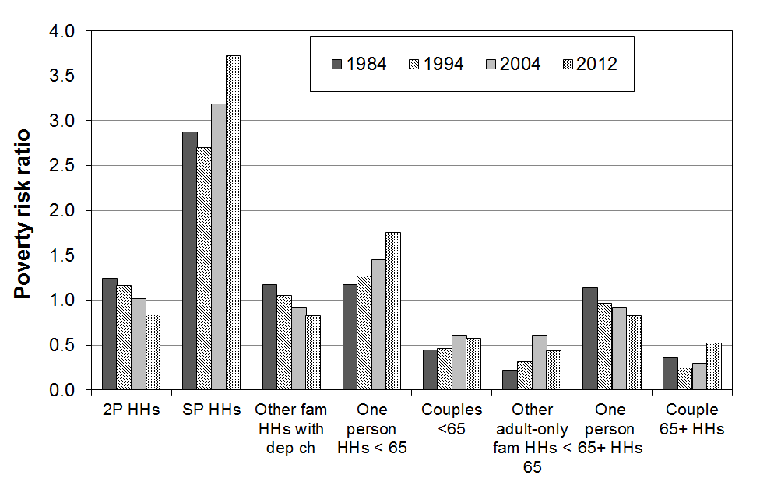
Section H

Trends for dependent children, 1982 to 2013,

by various individual and household characteristics

This section:
- compares trends in poverty rates for subgroups of dependent children
- reports on the changing composition of those children identified as poor.

The individual and household characteristics used for subgroup analyses are:
- age of the children
- ethnicity of children (no time series)
- highest household educational qualification
- tenure
- household type
- family type
- hours of work of adults in households where there are dependent children.

AHC measures are used in this section (Table H.1). The rationale for this approach when comparing subgroups is outlined in Appendix 5. The anchored threshold approach is mainly used. Further tables based on the fully relative approach are in Appendix 11.

Table H.1
Poverty measures reported on in Section H for subgroups of dependent children
BHC |  |  |  | AHC
REL  (‘moving line’) |  | CV-98 (to 2007)  CV-07 (from 2007)  (‘anchored line’) |  | REL  (‘moving line’) |  | CV-98 (to 2007)  CV-07 (from 2007)  (‘anchored line’)
50 | 60 | 50 | 60 | 50 | 60 | 50 | 60
- | - | - | - | ✓ | ✓ | - | ✓

Children in workless and working households

Policy development and public debate around improving the wellbeing of children often involve discussion about the links between child poverty rates and the labour market involvement of their parents. A special subsection at the end of this section therefore brings together in one place a range of information on the numbers of children in workless and working households, their respective poverty rates, and the composition of children identified as poor vis-à-vis the work status of adults in their households.

Poverty rates for children and the composition of poor children

It is important to distinguish between the proportion of a group who are counted as poor, and the proportion of the poor who are from a particular group, that is, between rates and composition.

In Table H.5 (later in this Section) rate and composition statistics are summarised for children by household type, family type, number of children in the household, ethnicity, highest household educational qualification, tenure and main source of income for the household (benefit or market).

Children in low-income households by age

- Figure H.1 shows that from 1982 to 2013, poverty rates for younger children (0 to 11 years) were consistently higher than the rates for older children (12 to 17 years).
- Table H.2 breaks the younger group into two groups (0-6 yrs and 7-11 yrs). In most years there is little difference in poverty rates for these two younger subgroups on any of the three measures.

Figure H.1
Proportion of children in low-income households by age, 60% CV threshold (AHC)

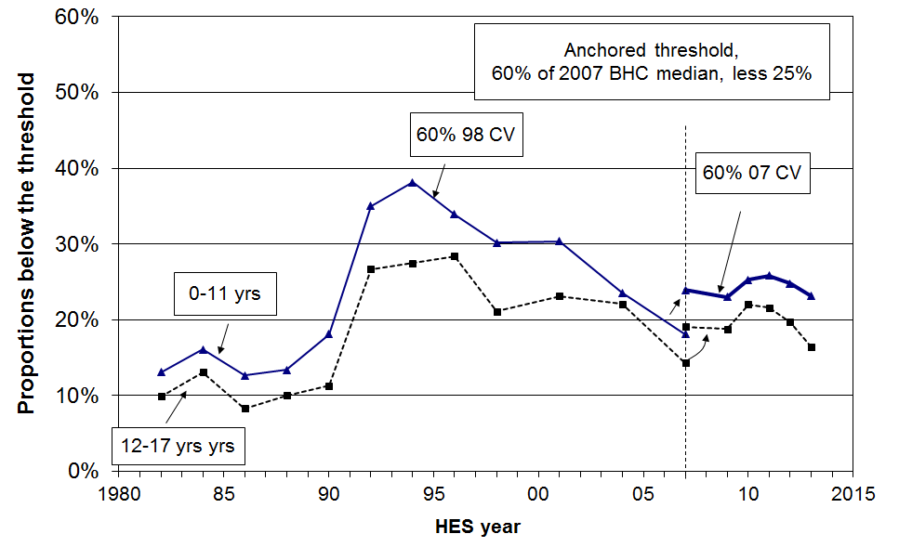

Table H.2
A. Proportion of children in low-income households by age, 60% CV threshold (AHC)
 | Reference year = 1998 |  |  |  |  |  |  |  |  |  |  | Reference year = 2007
 | 1984 | 1986 | 1988 | 1990 | 1992 | 1994 | 1996 | 1998 | 2001 | 2004 | 2007 | 2007 | 2009 | 2010 | 2011 | 2012 | 2013
0-6 | 15 | 13 | 14 | 18 | 36 | 39 | 34 | 31 | 31 | 23 | 20 | 25 | 22 | 25 | 25 | 25 | 24
7-11 | 17 | 12 | 13 | 19 | 33 | 38 | 33 | 29 | 29 | 25 | 16 | 22 | 25 | 26 | 27 | 25 | 22
12-17 | 13 | 8 | 10 | 11 | 27 | 28 | 28 | 21 | 23 | 22 | 14 | 19 | 19 | 22 | 22 | 20 | 16
0-17 | 15 | 11 | 12 | 16 | 32 | 35 | 32 | 27 | 28 | 23 | 16 | 22 | 22 | 24 | 24 | 23 | 22

B. Proportion of children in low-income households by age, 60% REL threshold (AHC)
 | 1982 | 1984 | 1986 | 1988 | 1990 | 1992 | 1994 | 1996 | 1998 | 2001 | 2004 | 2007 | 2009 | 2010 | 2011 | 2012 | 2013
0-6 | 15 | 16 | 12 | 15 | 17 | 30 | 32 | 30 | 31 | 33 | 26 | 25 | 26 | 29 | 27 | 28 | 27
7-11 | 15 | 17 | 12 | 14 | 18 | 28 | 32 | 28 | 29 | 32 | 30 | 22 | 28 | 30 | 29 | 31 | 27
12-17 | 10 | 12 | 8 | 10 | 11 | 23 | 23 | 25 | 21 | 24 | 26 | 19 | 23 | 25 | 24 | 24 | 20
0-17 | 14 | 15 | 11 | 13 | 16 | 27 | 29 | 28 | 28 | 30 | 28 | 22 | 25 | 28 | 27 | 27 | 24

C. Proportion of children in low-income households by age, 50% REL threshold (AHC)
 | 1982 | 1984 | 1986 | 1988 | 1990 | 1992 | 1994 | 1996 | 1998 | 2001 | 2004 | 2007 | 2009 | 2010 | 2011 | 2012 | 2013
0-6 | 10 | 10 | 7 | 9 | 8 | 19 | 22 | 22 | 21 | 24 | 19 | 20 | 18 | 19 | 22 | 22 | 22
7-11 | 10 | 10 | 7 | 8 | 8 | 18 | 21 | 19 | 21 | 21 | 21 | 15 | 22 | 19 | 22 | 21 | 21
12-17 | 7 | 9 | 6 | 7 | 5 | 15 | 16 | 17 | 16 | 17 | 19 | 13 | 15 | 18 | 17 | 16 | 14
0-17 | 9 | 10 | 7 | 8 | 7 | 17 | 20 | 20 | 20 | 21 | 19 | 16 | 18 | 19 | 20 | 20 | 19

Children in low-income households by ethnicity

As noted in the Introduction, only limited analysis by ethnicity is reported because of the relatively small sample sizes for Maori, Pacific and Other ethnic groups (especially Pacific). The sample sizes are even smaller when looking only at children. The analysis in this section combines the data from the last three surveys (HES 2011, 2012 and 2013) to give an indication of the differences in low-income rates for children by ethnicity.

The poverty rates for children in the Maori and Pacific ethnic groups are consistently higher than for those in the European/Pakeha ethnic group, whatever measure is used. For example, on average over 2011 to 2013, using the AHC 60% anchored line measure, around 16% of European/Pakeha children lived in poor households, 34% of Maori children, and 28% of Pacific children (approximately double the rate for European/Pakeha children).

The higher poverty rate for Maori children reflects the relatively high proportion of Maori children living in sole-parent beneficiary families and households (around 43% of DPB recipients were Maori in the 2007 to 2011 period).

On average from 2011 to 2013, just under half (48%) of poor children were Maori or Pacific using this measure. Overall, 34% of children are Maori or Pacific.

Children in low-income households by highest household educational qualification

There is a well-established positive link between parental educational qualifications and a wide range of outcomes for their children. The positive impact is understood to occur through several pathways in addition to genetic endowment. Higher education means: higher family incomes on average, and this improves the chances of higher investment in the children in relation to the things that money can buy; higher chance of more constructive parenting style and a wider range of vocabulary and so on; lower chance of on-going stress in the family from financial pressures. None of these linkages are deterministic, but they do apply “on average”.

Table H.3 shows the steep gradient for poverty rates for children from families with different educational qualifications, supporting aspects of the pathways perspective described above.

Table H.3
Poverty rates and composition by highest household educational qualification (average 2011 to 2013)
 | Poverty rate (%) | Poverty composition (%) | Child population composition (%) | Risk ratio
No formal qualification | 56 | 15 | 6 | 2.4
School qualification only | 33 | 36 | 25 | 1.3
Post-school non-degree | 20 | 31 | 36 | 0.9
Degree or post-graduate | 12 | 17 | 32 | 0.5

Children in low-income households by tenure

Using the AHC 60% fixed line measure, the child poverty rates show a clear gradient across different tenure types. For 2010 to 2012:
- the rates were 54% in HNZC homes, 38% in private rental, 13% in privately owned homes with a mortgage and 2-6% where there is no mortgage
- 53% of poor children lived with their families in private rental accommodation, and another 19% in HNZC homes.

In the early to mid 1990s, the majority of children identified as poor (50 to 55%) came from households that owned their own home. The difference today is in part a reflection of the fact that in the early to mid 1990s 72% of children lived in households that owned the home, whereas in 2010 to 2012 this proportion had fallen to 57%.

Children in low-income households by household type, family type and work status of adults in the household

Using AHC incomes (Table H.4):

- Children living in sole-parent (SP) households experience significantly higher poverty rates than those in two-parent (2P) households and other family households (60%, 14% and 16% respectively in 2013).

- Around one in three SP families (EFUs) live in households with other adults. Children living in these SP EFUs have lower poverty rates than those in SP EFUs living on their own because of the wider household financial resources available to them, both directly and indirectly.

- Although poverty rates for children in SP families are much higher than for children in 2P families, around half of poor children come from 2P families and half from SP families.

- Children in households with three or more children generally have poverty rates considerably higher than those with only one or two children (eg 30% and 20% respectively on average from 2007 to 2012. In 2012, children in these larger households made up just under half of all poor children (45%).

- In 2001 and 2004, around one in two poor children came from households where at least one adult was in full-time paid employment or was self-employed. On average from 2009 to 2013 this proportion had dropped to around two in five (41% in 2013).

- From 1992 to 2004, children in workless households generally had poverty rates around four times higher than for those in households where at least one adult was in full-time work. From 2007 to 2012, the difference was even greater – around six to seven times higher for children in workless households. This to a large degree reflects the greater WFF assistance for working families than for beneficiary families.

- The fall in child poverty rates from 2004 to 2007 for children in one-FT-one-workless 2P households was very large (28% to 9%), reflecting the WFF impact, especially through the In-work Tax Credit.

Table H.4
Children in low-income households by household and family type:
60% AHC CV
A. Proportions of children below the threshold, by household and family type
 | Reference year = 1998 |  |  |  |  |  |  |  |  |  |  |  |  |  |  |  |  |  |  |  |  | Reference year = 2007
 | 84 | 86 |  | 88 |  | 90 |  | 92 |  | 94 |  | 96 |  | 98 |  | 01 |  | 04 |  | 07 |  | 07 | 09 |  | 10 |  | 11 |  | 12 |  | 13
By household type
Children in SP HHs | 31 | 24 |  | 17 |  | 28 |  | 74 |  | 76 |  | 77 |  | 65 |  | 74 |  | 56 |  | 49 |  | 59 | 54 |  | 62 |  | 66 |  | 64 |  | 60
Children in 2P HHs | 13 | 10 |  | 13 |  | 14 |  | 27 |  | 29 |  | 23 |  | 20 |  | 21 |  | 17 |  | 9 |  | 14 | 14 |  | 17 |  | 15 |  | 15 |  | 14
Children in other fam HHs | 14 | 9 |  | 4 |  | 15 |  | 15 |  | 17 |  | 23 |  | 21 |  | 16 |  | 20 |  | 18 |  | 22 | 11 |  | 18 |  | 17 |  | 14 |  | 16
By family type (n1)
Children in SP families | - | - |  | 14 |  | 24 |  | 60 |  | 65 |  | 65 |  | 55 |  | 64 |  | 44 |  | 42 |  | 51 | 46 |  | 52 |  | 55 |  | 52 |  | 51
- in SP families on own | - | - |  | 18 |  | 31 |  | 80 |  | 78 |  | 78 |  | 70 |  | 77 |  | 57 |  | 49 |  | 61 | 57 |  | 67 |  | 72 |  | 69 |  | 66
- within wider HHs | - | - |  | 4 |  | 7 |  | 20 |  | 26 |  | 32 |  | 23 |  | 25 |  | 21 |  | 25 |  | 32 | 19 |  | 24 |  | 25 |  | 22 |  | 18
Children in 2P families | - | - |  | 12 |  | 14 |  | 25 |  | 28 |  | 23 |  | 20 |  | 20 |  | 18 |  | 9 |  | 14 | 14 |  | 16 |  | 14 |  | 14 |  | 13
By # of children in HH
1 or 2 children | 11 | 9 |  | 10 |  | 12 |  | 29 |  | 30 |  | 31 |  | 27 |  | 26 |  | 18 |  | 14 |  | 19 | 18 |  | 21 |  | 20 |  | 21 |  | 21
3 or more children | 19 | 14 |  | 15 |  | 22 |  | 38 |  | 41 |  | 34 |  | 29 |  | 32 |  | 30 |  | 20 |  | 28 | 28 |  | 30 |  | 31 |  | 28 |  | 23
By main source of household income in the 12 months prior to interview
Market | - |  | - |  | - |  | - |  | - |  | - |  | - |  | - |  | - |  | - |  | - | 12 |  | 13 |  | 11 |  | 10 |  | 12 | 12
Income-tested benefit | - |  | - |  | - |  | - |  | - |  | - |  | - |  | - |  | - |  | - |  | - | 76 |  | 82 |  | 82 |  | 80 |  | 80 | 80
By work status of adults at time of interview (all HHs with children)
- Self-employed | 11 | 8 |  | 16 |  | 8 |  | 17 |  | 21 |  | 20 |  | 12 |  | 21 |  | 21 |  | 6 |  | 12 | 17 |  | 20 |  | 17 |  | 18 |  | 13
- One or more FT | 12 | 10 |  | 10 |  | 14 |  | 17 |  | 20 |  | 19 |  | 17 |  | 17 |  | 14 |  | 8 |  | 11 | 11 |  | 10 |  | 9 |  | 9 |  | 10
- None FT | 34 | 23 |  | 18 |  | 26 |  | 73 |  | 75 |  | 74 |  | 66 |  | 72 |  | 58 |  | 49 |  | 63 | 62 |  | 62 |  | 70 |  | 69 |  | 66
- Workless | 38 | 25 |  | 18 |  | 25 |  | 78 |  | 77 |  | 78 |  | 71 |  | 77 |  | 60 |  | 58 |  | 71 | 72 |  | 67 |  | 74 |  | 77 |  | 74
By work status of adults at time of interview (two parent HHs)
- Both full-time | 11 | 11 |  | 9 |  | 7 |  | 12 |  | 10 |  | 18 |  | 8 |  | 6 |  | 7 |  | 3 |  | 5 | 7 |  | 6 |  | 8 |  | 6 |  | 2
- One FT, one PT | 9 | 8 |  | 7 |  | 7 |  | 10 |  | 11 |  | 11 |  | 9 |  | 19 |  | 8 |  | 6 |  | 11 | 6 |  | 12 |  | 4 |  | 8 |  | 8
- One FT, one workless | 15 | 9 |  | 16 |  | 23 |  | 27 |  | 32 |  | 23 |  | 28 |  | 24 |  | 28 |  | 9 |  | 12 | 20 |  | 17 |  | 12 |  | 13 |  | 20
All children, all HHs | 15 | 11 |  | 12 |  | 16 |  | 33 |  | 35 |  | 32 |  | 28 |  | 29 |  | 23 |  | 16 |  | 22 | 22 |  | 24 |  | 24 |  | 23 |  | 21

B. Composition of children below the threshold, by household and family type
 | 84 | 86 |  | 88 | 90 | 92 | 94 | 96 | 98 | 01 | 04 | 07 | 07 | 09 | 10 | 11 | 12 | 13
Children by household type
Children in SP HHs | 19 | 21 |  | 18 | 27 | 36 | 34 | 42 | 40 | 40 | 35 | 38 | 43 | 49 | 42 | 51 | 48 | 47
Children in 2P HHs | 71 | 68 |  | 79 | 65 | 59 | 61 | 50 | 51 | 53 | 52 | 48 | 45 | 44 | 49 | 41 | 44 | 44
Children in other fam HHs | 11 | 11 |  | 4 | 8 | 6 | 4 | 7 | 9 | 6 | 13 | 14 | 12 | 6 | 8 | 8 | 8 | 8
Children by family type (n1)
Children in SP families | - | - |  | 19 | 29 | 39 | 37 | 45 | 44 | 44 | 39 | 56 | 50 | 52 | 48 | 58 | 53 | 51
- in SP families on own | - | - |  | 18 | 26 | 34 | 33 | 39 | 38 | 40 | 33 | 44 | 39 | 45 | 41 | 48 | 45 | 46
- within wider HHs | - | - |  | 2 | 3 | 4 | 4 | 6 | 6 | 4 | 7 | 13 | 11 | 7 | 8 | 9 | 8 | 5
Children in 2P families | - | - |  | 81 | 71 | 61 | 64 | 55 | 56 | 56 | 60 | 44 | 50 | 48 | 52 | 42 | 47 | 49
By main source of household income in the 12 months prior to interview
Market | - |  | - | - | - | - | - | - | - | - | - | - | 45 | 51 | 39 | 34 | 44 | 46
Income-tested benefit | - |  | - | - | - | - | - | - | - | - | - | - | 55 | 49 | 61 | 66 | 56 | 54
By work status of adults (all HHs with children)
Self-employed | 10 | 9 |  | 14 | 4 | 4 | 5 | 6 | 5 | 8 | 7 | 4 | 6 | 10 | 9 | 8 | 7 | 7
One or more FT | 56 | 62 |  | 61 | 57 | 34 | 36 | 39 | 40 | 42 | 45 | 32 | 33 | 36 | 27 | 25 | 28 | 34
None FT | 34 | 29 |  | 26 | 38 | 62 | 59 | 56 | 55 | 50 | 49 | 65 | 62 | 56 | 55 | 67 | 65 | 60
- PT only | 3 | 2 |  | 5 | 6 | 6 | 10 | 9 | 11 | 12 | 12 | 13 | 13 | 11 | 18 | 13 | 16 | 11
- Workless | 31 | 27 |  | 21 | 32 | 56 | 49 | 47 | 44 | 38 | 37 | 52 | 49 | 44 | 47 | 54 | 49 | 49
All children | 100 | 100 |  | 100 | 100 | 100 | 100 | 100 | 100 | 100 | 100 | 100 | 100 | 100 | 100 | 100 | 100 | 100
Notes: 1 Family here is ‘economic family unit’ (see Section A for definition).
“4 out of 10 poor children are from working families” – discussion of this stylised fact

There are three main ways that the HES data can be used to produce an estimate of the composition of poor children by the work status of the adults in their households – that is, of all the children identified as poor by a particular measure, what proportion are from working families? The three approaches (for working-age households) are:
- by source of household income in the 12 months prior to interview, with more than 50% of the household income coming from market income defining the household as a “working household” (higher thresholds can be used if desired)
- by excluding all households in which any adult in the household says that they received any main benefit at all in the last 12 months, with the rest being “working households”
- by including all households which at the time of interview declared self-employment or had at least one adult in full-time employment – this is a relatively high bar to achieve for a household to be considered to be a “working household”.

On average in HES 2012 and HES 2013, the source of income approach identified 45% of poor children as being from working families, the second approach 48%, and the third one 38%. If part-timers were included in the third approach its percentage comfortably goes beyond 38%.

One of the challenges for this analysis is that the standard Statistics New Zealand weights applied to the survey data underestimate the number of beneficiary children in the population by a considerable amount. This leads to an underestimate of the proportion of poor children who are in beneficiary families and an over-estimate of the proportion of poor children coming from working families.

There are two ways of obtaining alternative estimates. One is to use Treasury’s Taxwell weights which are designed to (among other things) give good population estimates of benefit numbers. The other is to take the beneficiary poverty rates (not greatly impacted by weighting) and apply them to beneficiary numbers drawn from administrative data. When these two approaches are used the proportion of children found to be in working households drops by about three to four percentage points.

Whether the estimate is 38% to 48% or more like 35% to 45% is not too important. The most important thing is that we know that a sizeable portion of poor kids come from working families.

The non-incomes approach produces even higher proportions. In 2012, just over 50% of children in hardship were from families who had no adult on benefit at any time in the 12 months prior to interview.

The stylised fact that around 4 in 10 of poor children are from working families has strong evidence to support it.
Children from income-poor households: composition by their ethnicity and by selected household characteristics

Table H.5 brings together in one place the poverty rate and composition information from earlier pages in Section H. The shaded column shows the proportion of poor children in the various sub-groups. Some sub-groups have high poverty rates but if there is a relatively small proportion of children in that sub-group overall, then the proportion of poor children coming from that sub-group is much lower than their poverty rate would suggest (and vice versa). For example:
- the poverty rate for children in sole-parent families living on their own is high at 60%, but only 44% of all poor children come from such families
- on the other hand, the poverty rate for children in two-parent families is much lower at 14%, yet 49% of poor children come from these families
- this difference arises from the fact that there are many more children in two-parent families than in sole-parent families living on their own (76% and 16% respectively).

Table H.5
Poverty rates and composition for children by their ethnicity and by characteristics of their households, based on the 60% of median CV (fixed line) AHC measure:
average over last three surveys, HES 2011 to HES 2013
Dependent children (0-17 yrs):  1,060,000 | Children in income-poor households |  | All children
Dependent children (0-17 yrs):  1,060,000 | What % of this category are poor? | What % of poor children are in this category? | What % of all children are in this category?
 | Poverty rate (%) | Composition of the poor (%) | Approximate composition for all children (%)
Household type
Sole parent HH | 64 | 47 | 18
Two parent HH | 15 | 44 | 69
Multi-adult family HH | 16 | 8 | 12
Family type
Sole parent families | 53 | 53 | 24
- in SP family on own | 69 | 45 | 16
- within a wider HH | 23 | 8 | 8
Two parent families | 15 | 47 | 76
# of children in the household
1 or 2 | 21 | 55 | 63
3+ | 29 | 45 | 37
Ethnicity
Maori | 34 | 34 | 24
Pacific | 34 | 13 | 10
Other | 27 | 14 | 12
Euro/Pakeha | 17 | 38 | 54
Highest household educational qualification
No formal qualification | 55 | 15 | 7
School qualification only | 35 | 38 | 25
Post-school non-degree | 21 | 33 | 38
Degree or post-graduate | 12 | 14 | 30
Main source of income for HH
Benefit | 75 | 63 | 22
Market | 12 | 37 | 78
Tenure
HNZC | 54 | 19 | 9
Private rental | 38 | 53 | 33
Own home | 12 | 28 | 59
Children overall | 23 | 100 | 100
Children in ‘workless’ and ‘working’ households

Policy development and public debate around improving the wellbeing of children often involve discussion about the links between child poverty rates and the labour market involvement of their parents. This subsection contributes to that discussion by reporting on:
- the number and proportion of children in workless and working households
- poverty rates for children, by the work status of the adults in their household
- the composition of poor children, by the work status of the adults in their household.

In a future issue, it is hoped to also have information from SoFIE about ‘churning’ in and out of work for low-income households.

Numbers and proportions of children in working and workless households

Table H.6 shows the trend in the proportion of children in ‘workless’ households and in beneficiary families over time.

The final row in the table (children in beneficiary families) is a “census” as at 30 June each year (31 March for 2012 and 2013), from MSD’s administrative data. This is robust data. In contrast, the first four rows are estimates only, based on the HES sample. We know that the estimates using Statistics New Zealand’s weights consistently under-estimate the number of beneficiaries compared with the administrative data. Generally, the estimates using the Treasury’s Taxwell weights are closer to the administrative data, but the sampling error from the HES can still lead to either or both weighting regimes under- or over-estimating the population numbers.

What can be said with certainty is that more than one in five and perhaps as many as one in four New Zealand children live in households where there is no adult in full-time employment. These rates and the rate for children in workless households are high by OECD and EU standards (see Section J).

Table H.6
Proportion of children in ‘workless’ households (% of all children)
HES year | 86 | 88 | 90 | 92 | 94 | 96 | 98 | 01 | 04 | 07 | 08 | 09 | 10 | 11 | 12 | 13
In workless HHs - SNZ wgts | 12 | 15 | 21 | 23 | 22 | 19 | 17 | 14 | 14 | 15 | 14 | 13 | 17 | 17 | 15 | 14
- TSY wgts | - | - | - | - | - | - | - | - | - | 18 | 16 | 16 | 20 | 19 | 17 | 16
In HHs with no FT worker - SNZ wgts | 15 | 18 | 24 | 28 | 27 | 24 | 23 | 19 | 19 | 21 | 19 | 18 | 25 | 23 | 22 | 22
- TSY wgts | - | - | - | - | - | - | - | - | - | 25 | 22 | 21 | 30 | 25 | 24 | 24
In beneficiary families | - | - | - | - | - | - | 30 | 26 | 24 | 19 | 19 | 21 | 22 | 22 | 20 | 19

Comparing employment rates for adults in sole-parent and two-parent families

Figure H.2 uses Census data to show the proportion of parents of dependent children who were employed (either FT or PT) in the three decades from 1976 to 2006, for both sole and partnered parents.

Table H.7 uses HLFS data to show the proportion of sole and partnered mothers employed, FT and PT, in 1999 and 2009. (Around five in six sole-parent families are headed by sole mothers.)

The key features of the graph and the table for the purposes of this report are:
- the steady rise in the proportion of partnered mothers in employment to around 70% (71% in the 2006 Census, 69% in the 2009 HLFS) – thus increasing the proportion of dual earner two parent families
- the steady rise in the proportion of sole mothers in employment to around 50% (52% in the 2006 Census, 50% in the 2009 HLFS)
- the steady rate of PT employment for both sole and partnered mothers from 1999 to 2009 (19% and 30% respectively)
- the corollary of this, that the increase in mothers’ employment has been driven by their increased FT employment since the late 1990s – in 2009, almost one in three sole mothers were employed FT, a 50% increase from 1999.

Figure H.2

Proportion (%) of parents of dependent children employed, 1976–2006
Source: Figure 3 in MSD (2010), (drawing on the Census of Population and Dwellings)

Table H.7
Proportion of sole and partnered mothers employed, FT and PT
 |  | 1999 | 2009
Employed FT (30+ hrs pw) | Sole mothers | 20 | 31
 | Partnered mothers | 34 | 38
Employed PT (<30hrs pw) | Sole mothers | 19 | 19
 | Partnered mothers | 30 | 30

Source: Derived from Table 3 in MSD (2010), (drawing on the HLFS)

Proportions of children in workless households, by family type

In 2009, 80% of children in workless households were from sole-parent families, 20% from two-parent families. The proportions were very similar in 2007 and 2008.

The proportions here are proportions of all children, including those where the work status of the adults is ‘self-employed’. Almost all the self-employed are in two-parent households. From HES 2009 there were 273,000 children in sole-parent families. Assuming around half are from workless families (see Table H.6 above, based on the HLFS), then around 80% of children in workless families are from sole-parent families (137,000 out of 171,000). This is close to the figure that can be derived directly from the HES.

In September 2009, 73% of sole parents received an income-tested benefit. 90% of these sole-parent beneficiaries received the Domestic Purposes Benefit. In 2013, 35% of sole parents were employed full-time. This is low on international standards.

Increasing proportion of dual-earner two-parent households

Figure H.3 and the associated Table H.8A and H.8B show the trend to increasing work intensity among two-parent households with dependent children. The option of one partner in FT paid employment and one not in paid employment (‘workless’) was the dominant pattern in the early 1980s. In 2013, the most common arrangement was for both parents to be employed FT (42%).
- Around two of every three two-parent families were dual-earner families from 2007 to 2013, up from one in two in the early 1980s. The new pattern seems to have stabilised.
- The most common arrangement in HES 2013 was for both parents to be working full-time (42%), with another 28% with one full-time and the other part-time. In contrast, in 1982 the dominant pattern (52%) was one in full-time work and the other ‘workless’ (WL), with only 20% having both in full-time work.

Figure H.3
Increasing proportion of two-earner two-parent households (with dependent children)

Table H.8A
Proportion of 2P HHs where there is at least one FT adult worker
 | 1982 | 1984 | 1986 | 1988 | 1990 | 1992 | 1994 | 1996 | 1998 | 2001 | 2004 | 2007 | 2009 | 2010 | 2011 | 2012 | 2013
One FT, one WL | 52 | 47 | 44 | 42 | 40 | 44 | 42 | 41 | 38 | 34 | 27 | 32 | 32 | 31 | 33 | 35 | 30
One FT, one PT | 28 | 30 | 30 | 31 | 30 | 29 | 26 | 27 | 27 | 29 | 30 | 31 | 24 | 26 | 26 | 26 | 28
Both FT | 20 | 23 | 26 | 28 | 30 | 27 | 32 | 32 | 35 | 38 | 43 | 38 | 44 | 43 | 41 | 39 | 42

Table H.8B
Proportion of children in 2P HHs where there is at least one FT adult worker
 | 1982 | 1984 | 1986 | 1988 | 1990 | 1992 | 1994 | 1996 | 1998 | 2001 | 2004 | 2007 | 2009 | 2010 | 2011 | 2012 | 2013
One FT, one WL | 54 | 47 | 46 | 43 | 42 | 46 | 46 | 42 | 41 | 36 | 30 | 36 | 36 | 34 | 36 | 39 | 32
One FT, one PT | 28 | 30 | 30 | 30 | 32 | 29 | 26 | 27 | 29 | 31 | 33 | 30 | 24 | 27 | 26 | 28 | 30
Both FT | 19 | 23 | 25 | 27 | 26 | 25 | 29 | 30 | 30 | 33 | 38 | 34 | 39 | 39 | 38 | 34 | 38
Poverty rates and composition for children in working and workless households

Three factors impact on child poverty rates and on the proportion of poor children who come from various subgroups (that is, on the composition of the poor):
- the economy and the labour market (impacting on employment and unemployment rates, wage rates and on benefit numbers (including numbers of sole-parent families))
- demographic shifts and changing cultural norms (eg the number of sole-parent families, whether sole-parent families live in households on their own or with other adults, the proportion of dual-earner two-parent households)
- policy changes (eg policy changes around benefit rates, income-related rents, the AS and WFF all had clear impacts on the child poverty rates for children from working and workless households, and on the relativities between the two groups).

The information in Figures H.4, H.5 and H.6 below illustrate these factors at work and support the following findings:
- child poverty rates in workless households are consistently several times higher than those for children in working households (three to four times higher in 1992 to 2004, six to seven times higher from 2007 to 2013 after WFF)
- child poverty rates in workless households were very high from 1992 to 2001 (after the benefit cuts), typically just under 80% using the AHC 60% fixed line measure (CV-98)
- the introduction of income-related rents contributed to the reduction in the child poverty rate from 2001 (78%) to 2004 (60%) for children in workless households
- the WFF package had little impact on the poverty rates for children in workless households
- the significant drop in poverty rate for children in workless households from the 2009 to the 2010 HES is likely to reflect the fact that many of the “new” beneficiaries came from employment, and although identified as workless at the time of interview still had sufficient income in the 12 months prior to interview to keep the household above the poverty line – this view is supported by the subsequent rises that occurred in HES 2011 and HES 2012
- for children in ‘working’ households (self-employed or at least one FT worker) the child poverty rate from 1992 to 2004 was reasonably steady at around 18-20%
- the WFF impact was significant for this group, with the rate in 2007 (11%) half what it was in 2004 (22%)
- nevertheless, on average from 2007 to 2013, around two in five (40%) poor children still came from working families – down from just over one in two (52%) in 2004 before WFF.

Figure H.4 shows the poverty rates for children in workless and working households. A working household is one where at least one adult is in FT employment, or where the main source of income for the previous 12 months is from self-employment (cf Table H.3 above).

Figure H.4
Poverty rates for children in ‘workless’ and ‘working’ households (AHC 60%, fixed line)
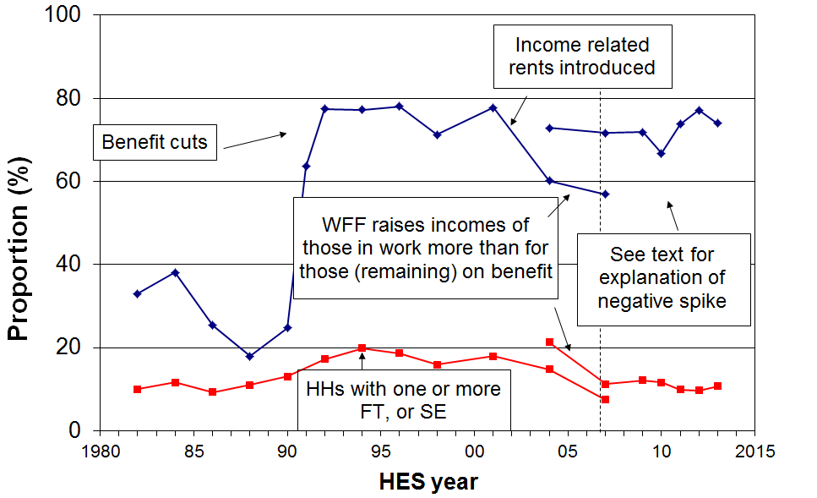
Note: The discontinuity at 2007 arises because of the change of reference year from 1998 to 2007. The 2004 to 2007 changes are shown using both reference years.
Figure H.5 shows the proportion of poor children who live in workless households. As there are fewer children in workless households than in working households the proportion of all poor children who come from workless households is much lower than their poverty rate in any given year. In addition, this proportion is also affected by policy changes and changes in the economy and labour market, as indicated in the text boxes in Figure H.5.

In 1992, after the benefit cuts in 1991 and with unemployment high, the proportion of poor children who came from workless households peaked at 56%. The improving labour market and growing economy then helped to reduce that proportion to 37% by 2004. The WFF package gave greater financial assistance to working families than to (those who remained as) beneficiary families. This was reflected in the decrease in child poverty rates for those in working families. The consequence was a rise to 52% in 2007 in the proportion of poor children who come from workless families. Using the updated reference year (2007), that proportion was 49% in 2013.

Figure H.5
Proportion of poor children who live in ‘workless’ households (AHC 60%, fixed line)
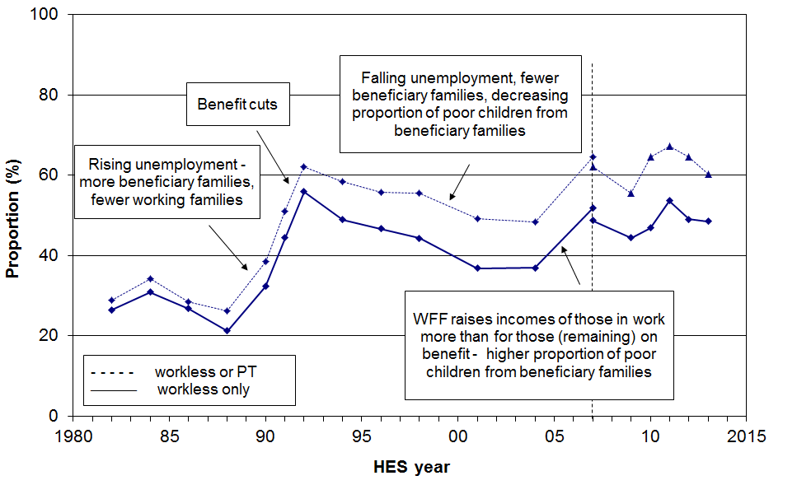

Figure H.6 looks at the composition of children identified as poor from the other perspective – what proportion of poor children come from working households? The trend is overall a mirror image of the one on Figure H.5. The secondary (broken) line omits self-employed households.

The WFF package reduced the proportion of poor children coming from working families from just over one in two (52%) in 2004 to around two in five (40%) on average from 2007 to 2012.

Figure H.6
Proportion of poor children who live in ‘working’ households (AHC 60%, fixed line)
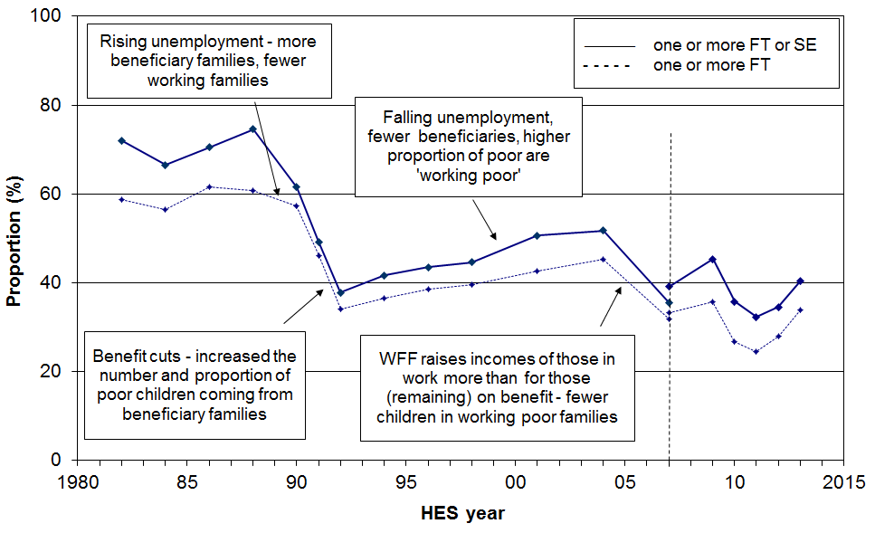
Section I
Income trends for older New Zealanders, 1982 to 2013

This section:
- describes the distribution of incomes for older New Zealanders relative to the rest of the population, noting the ‘pensioner spike’ in the BHC income distribution
- notes the significant sensitivity of reported poverty rates to the choice of BHC poverty line for older New Zealanders (because of the ‘pensioner spike’), and outlines what can be done about this to ensure that trends in reported poverty rates more realistically reflect changes in the relative material wellbeing of older New Zealanders
- compares the value of NZS to average wages and median household incomes
- reports on trends in the relative contributions of state income support (government transfers), employment income, and other private income to the incomes of older New Zealanders.

The BHC incomes of older New Zealanders

Figure I.1 shows the distribution of equivalised household disposable income for individuals. Individuals are grouped by their household incomes in multiples of $1500 pa ($30 pw). The graph clearly shows the ‘pensioner spike’ at close to the 50% of median poverty line, and also the high proportion with incomes between 50% and 60% of the median.

The spike is a direct consequence of (a) New Zealand having a universal New Zealand Superannuation (NZS) that is neither income nor asset tested, and (b) there being a large proportion of older New Zealanders with very little other income over and above NZS.

Figure I.1
BHC household income distribution for older New Zealanders relative the rest of population,
HES 2013
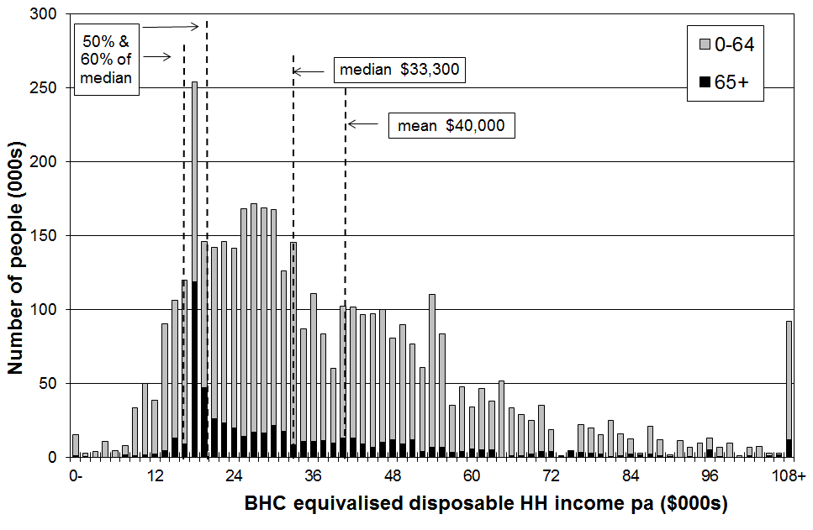
The incomes of older New Zealanders relative to the whole population (OECD comparisons)

In HES 2009, the mean household income for older New Zealanders (65+) was 77% of the population mean (71% of the population median). The mean income for one person 65+ households was 69% of that for couples. The latest OECD comparisons for these statistics are from 2004. At that time the respective New Zealand figures were 68% (OECD average, 82%) and 76% (OECD average, 73%). The figures move around quite a lot from year to year as the means are strongly influenced by the particular group of higher-income older households happen to be surveyed. The medians are much more stable. Nevertheless, what is clear is that the ratio of the average incomes of older New Zealanders to those of the population as a whole is in the ‘low to middle range’ on an OECD league table.

NZS relative to average earnings and median household income

For a very large proportion of older New Zealanders (aged 65+), NZS provides the bulk of their income. In assessing the relative material wellbeing of older New Zealanders it is therefore useful to know how NZS tracks:

in real terms

relative to average wages

relative to median household incomes.

In these comparisons, NZS is the equivalised NZS which puts couple and single living alone rates at the same equivalised dollar value. Average earnings are net average ordinary time weekly earnings (NAOTWE), and median incomes are median equivalised household disposable incomes. Average earnings are just one factor impacting on household incomes. Another major factor is the total number of hours of paid employment being worked by households. These hours have been increasing, so household incomes have risen more rapidly than average wages (since c1994). The October 2008 and 2010 tax cuts also increased net average wages and after-tax household incomes.

Figure I.2 shows that the value of NZS (and its predecessors) has remained reasonably steady in real terms from the mid 1980s through to 2013, whereas there have been considerable movements in average earnings and median household incomes in the period. The NZS nevertheless rose by 15% in real terms from 2007 to 2013, as a result of the rising NAOTWE.

Figure I.2
Trends in average earnings, median household incomes and NZS (in $2013)
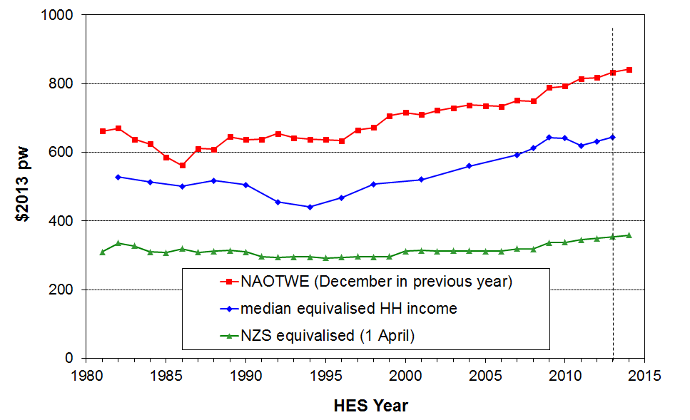
Figure I.3 reformats the information in Figure I.2 to show the trends in NZS relative to average earnings and median household income.

In 2013, the NZS married couple rate was close to the 66% floor relative to average earnings, as shown in the upper trend line in Figure I.3.

NZS has declined in value relative to median household incomes since the mid 1990s. This is because median household income has risen steadily in real terms, while the real value of NZS did not change greatly in real terms from the mid 1980s through to 2007. Table I.1 gives the figures behind the lower trend line in Figure I.3.

Figure I.3
NZS relative to average earnings and median household incomes

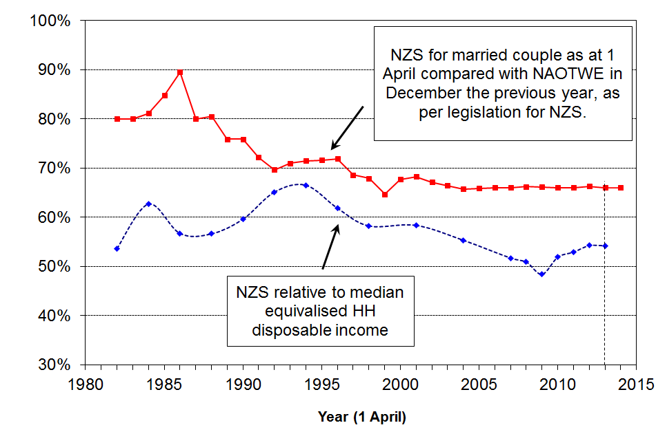

Table I.1
NZS relative to the median equivalised BHC household income median (%)
1984 | 86 | 88 | 90 | 92 | 94 | 96 | 98 | 01 | 04 | 07 | 08 | 09 | 10 | 11 | 12 | 13
63 | 57 | 57 | 60 | 65 | 67 | 62 | 58 | 58 | 56 | 52 | 51 | 48 | 52 | 53 | 54 | 54
Note: NZS is updated on 1 April each year, and sometimes on 1 October also if there have been tax changes. The HES interviews are carried out from 1 July to 30 June. For Figure I.3 and Table I.1, the NZS in year ‘n’ is compared with the HES median for year ‘n to n+1’. For example, the 1 April 2009 NZS is compared with the median for the 2008-09 HES. This is a reasonable approximation, but note that the actual NZS amount received over the 12 months prior to interview depends on the actual interview date for each household. The trend of NZS relative to the household median income in Figure I.3 and Table I.1 is robust for a ‘stylised fact’, but not for the precise micro detail for all older households.

Sensitivity of reported BHC poverty rates to the choice of poverty line

Table I.2 shows the proportion of older New Zealanders (65+) in households with incomes under two commonly used “poverty lines”. The top line uses the OECD equivalence scale to ensure consistency with OECD publications. The second line also uses a 50% of median threshold but adjusts household incomes with the Revised Jensen scale as in the rest of the report.

Using the 50% of median measure (OECD), the poverty rate was close to zero for the whole period 1984 to 2001. This was because the value of NZS was above 50% of the median. By 2009, with the value of NZS just below the 50% of median, the reported “poverty rate” had risen to 22%. From the 2009 HES to the 2010 HES, NZS rose more rapidly than the median which brought the reported poverty rate down to 14%. In 2013 the rate was 10%. (Using a 48% of median threshold, the 2013 rate is close to zero (2%).)

Using a 60% threshold the poverty rates fell from 25% in 1988 to close to zero in the mid 1990s when the median fell in real terms and NZS was above the 60% threshold. By 2004, the rising median had led to 37% of older New Zealanders being classed as ‘in poverty’ on this measure. This fell to 30% on average in 2012 and 2013.

Table I.2
Proportion of older New Zealanders (65+) in households with BHC incomes below low-income thresholds (‘poverty lines’), set at 50% and 60% of the median in the survey year (%)
 | 1984 | 86 | 88 | 90 | 92 | 94 | 96 | 98 | 01 | 04 | 07 | 09 | 10 | 11 | 12 | 13
50% OECD equiv | 2 | 2 | 8 | 2 | 1 | 1 | 1 | 3 | 2 | 9 | 18 | 22 | 14 | 11 | 9 | 10
50% NZ equiv | 1 | 1 | 1 | 1 | 1 | 1 | 1 | 2 | 2 | 3 | 8 | 14 | 5 | 4 | 3 | 4
60% NZ equiv | 14 | 17 | 25 | 20 | 3 | 1 | 3 | 25 | 20 | 37 | 38 | 37 | 34 | 31 | 31 | 29

The large variations in reported poverty rates for the 65+ group (using BHC incomes) can leave the misleading impression that there are significant changes in material wellbeing occurring for this group, when in fact there is very little change occurring.

The pensioner spike has implications for reporting on income poverty for the 65+ and for comparisons of subgroups within the population as a whole. Figure I.4 illustrates the issue using HES 2012 data, showing the sudden rise in poverty rates for the 65+ just above 50% of the median which is the level of NZS for the survey period. Poverty rates for the 65+ are close to zero when a 50% threshold is used, but 31% using a 60% threshold. Other age groups have a much steadier increase in poverty rates as the threshold rises.

Figure I.4
Sensitivity of income poverty rates for the 65+ to the threshold used:
BHC incomes, 2012
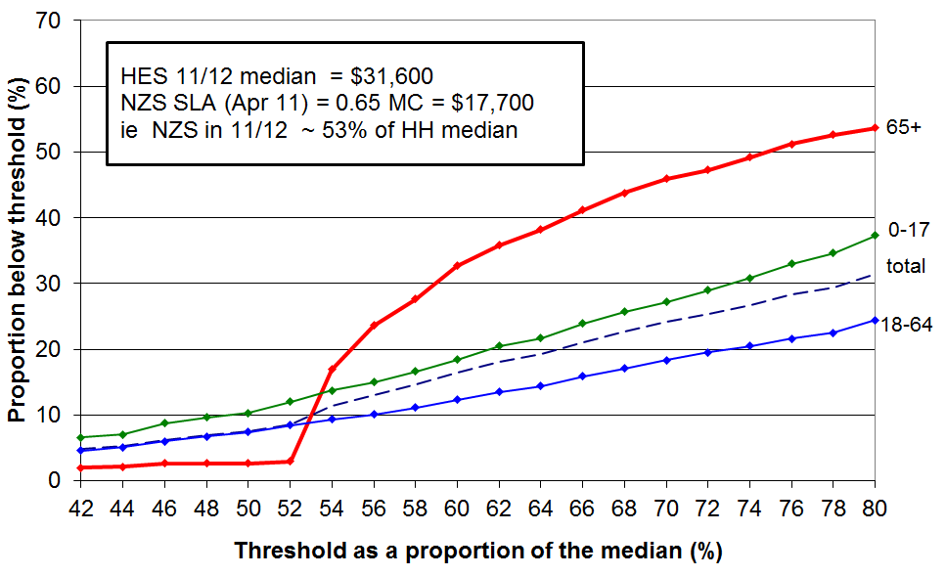
Using incomes after deducting housing costs (AHC incomes) to give more stable and reliable results

There are good grounds for using AHC incomes to compare subgroups, irrespective of the pensioner spike. These are discussed in Appendix 5 and in the Introduction. The pensioner spike for BHC incomes provides another rationale.

The AHC distribution still has some strong bunching but the pensioner spike is not as sharp. Furthermore, what remains of the spike is mainly above the 60% of median threshold for AHC incomes. Small shifts in the median or the threshold do not therefore have the same disproportionate and misleading effects on (trends in) poverty rates for the 65+ as they do when using BHC incomes. This is shown for 2012 in Figure I.5 below.

Figure I.5
Sensitivity of income poverty rates for the 65+ to the threshold used:
AHC incomes, 2012
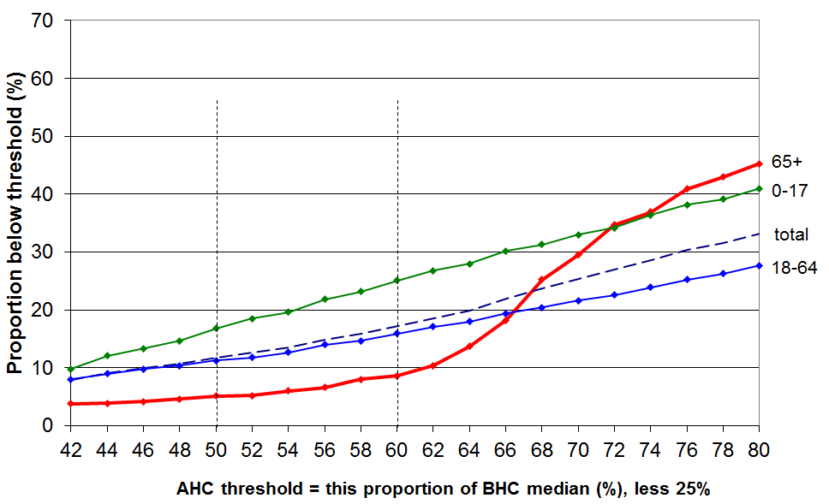

Table I.3 shows that the proportion of older New Zealanders below the 60% fixed line AHC threshold has remained consistently lower than the population as a whole and reasonably low in its own right from 1982 to 2013. Those living on their own generally have higher proportions below the threshold than do those in couple households, and since 2004 have had poverty rates similar to that of the population as a whole. There is very little difference in poverty rates for females and males.

Table I.3
Proportions of older New Zealanders (aged 65+) in low-income households, by HH type:
AHC CV 98 and 07 60% measure
 | reference year = 1998 |  |  |  |  |  |  |  |  |  |  |  | reference year = 2007
 | 1982 | 1984 | 1986 | 1988 | 1990 | 1992 | 1994 | 1996 | 1998 | 2001 | 2004 | 2007 | 2007 | 2009 | 2010 | 2011 | 2012 | 2013
All 65+ | 3 | 2 | 4 | 5 | 6 | 6 | 8 | 8 | 9 | 7 | 7 | 8 | 14 | 9 | 11 | 9 | 9 | 7
Single 65+ | 5 | 3 | 9 | 12 | 13 | 10 | 13 | 11 | 14 | 9 | 14 | 12 | 22 | 15 | 21 | 16 | 13 | 11
Couple 65+ | 1 | 1 | 2 | 2 | 3 | 4 | 5 | 6 | 5 | 8 | 3 | 6 | 9 | 5 | 6 | 7 | 8 | 6
Total popln | 8 | 9 | 8 | 9 | 11 | 21 | 23 | 21 | 18 | 19 | 17 | 13 | 18 | 15 | 17 | 18 | 16 | 10

See also Tables G.3 and G.6B for further information on income poverty trends for older new Zealanders using other AHC measures.

Sources of income for older New Zealanders

This section reports on the sources of income for older New Zealanders using a three-way division:

government transfers - New Zealand Superannuation (NZS), Veterans Pension (VP) and other state support such as the Disability Allowance (DA) and the Accommodation Supplement (AS)
- income from employment and self-employment
- other private income from private superannuation and other investments.

NZS and VP make up around 98% of government transfers for older New Zealanders (66+) as a group. Around 3-4% receive the AS, and 23% the DA (maximum of $57 pw in 2010).

For this subsection, older New Zealanders are taken to be those in the survey aged 66 and over. Those aged 65 are not considered as almost all of them will have received NZS for only a part of the 12 months prior to interview.

All the surveyed 66+ can be classed as belonging to one of two economic family unit (EFU) types: couple EFU with at least one partner aged 66 or more, or one person EFU with the person aged 66 or more. The analysis is at times kept separate for couple and one person EFUs as there are quite significant differences between the two groups regarding the amounts they receive from non-government sources.

In looking at the sources of income for older New Zealanders, the 66+ EFUs are ranked on their equivalised gross income and put into deciles for comparison. Note that these are not deciles based on a ranking of the whole population. Older New Zealanders are clustered in the lower four deciles of the population income distribution (40% were in the lower two deciles in 2012).

There are usually around 700 66+ EFUs in the sample. As the findings focus on stable patterns and clear trends rather than on smaller year on year changes, a sample of this size is adequate.

Summary of findings regarding the sources of income for older New Zealanders

- The great majority of older New Zealanders (aged 66+) are very dependent on NZS and other government transfers for their income
- 40% have virtually no other income source
- the next 20% have on average around 80% of their income from NZS and other government transfers
- this degree of dependence has not changed greatly in the last two decades
- those in couple EFUs tend to have higher per capita non-government income than do those in single person EFUs.
- Around one in three older New Zealanders receive more than half their income from sources other than NZS or VP
- for this group, the proportion of income from other sources has grown a little over recent years, mainly due to increasing non-government income for those in ‘younger’ couple EFUs (aged 66-75)

Table I.4 provides more detail to support and enlarge on these summary findings. The right hand column gives the links to the relevant tables and charts that follow – these support and illustrate the summary above and the findings reported in the table. Around 98% of all government transfers to older New Zealanders come from NZS/VP. For some in lower income deciles, the extra state assistance (eg DA and AS) is significant and is more than the 2% average.

Table I.4
Summary of key findings about sources of income for older New Zealanders
2012 HES | Changes from 1989 to 2010 | Ref
For the great majority, there is very high dependence on NZS … |  | Fig I.6
- NZS provided virtually all the income (98%) for the lower 40% (Q1 and Q2) | - there has been very little change in these proportions since 1989 | Fig I.7
- NZS provided 80% of income for the next 20% (the middle quintile) | - there has been a small but definite decline in this proportion since 2004, from 90% to 80% | Fig I.8
- for the next 20% (Q4), NZS provided half the income | - this is down a little from the 65% to 70% that prevailed from 1989 to 2001 | Fig I.6
the lower 60% reported less than $200 pw (per capita) from sources other than government transfers | - there has been little change since 1989 (in real terms) | Derived from Fig I.11 and I.7
the lower 40% reported less than $20 pw (per capita) from sources other than government transfers | - there has been little change since 1989 (in real terms) | Derived from Fig I.11 and I.7
… and single person EFUs are more dependent on NZS than are couple EFUs
- 60% of all the income for single person EFUs came from government transfers, 45% for couples | - the proportion of all incomes coming from government transfers has declined since 1989, but the proportion for singles is always higher than for couples (eg 70% and 60% respectively in 1998) | Fig I.9
- of the 25% of older NZers reporting more than $400 pw (per capita) non-govt income, 3 in 4 were from couple EFUs and 1 in 4 from single-person EFUs |  | Derived from Fig I.11
For a smaller group (around 30%), income from other sources is significant and for this group the % of total household income coming from these other sources is increasing
- other income made up more than half of total income for 30% of all older NZers (15% of singles and 35% of couples) | - the size of this group has almost doubled since 1998 | Fig I.9
for deciles 8 and 9 together, 38% of their income was from NZS | - this is down from 56% in 1998 and 55% in 1989 | Fig I.6
for ‘younger’ couples (aged 66-75) in deciles 5-6 of this group’s income distribution, 50% of their income came from non-government sources | - this is up from 20% in 1998 and earlier, and is driven by both increasing employment and private income for this group | Fig I.10
for those in the top decile (mainly couples) only 17% of their income was from NZS | - this is down from 29% in 1989 and 23% in 1998 | Fig I.6
Overall …
govt transfers made up around half the reported income (51%) for older NZers as a group, but as the above findings indicate, this aggregate figure masks large differences across the deciles and between single person and couple EFUs | - this (48%) is down from 67% in 1989 and 64% in 1998 | Fig I.6

Figure I.6
Proportion of gross income of older New Zealanders (66+)
coming from government transfers (almost entirely NZS and VP)
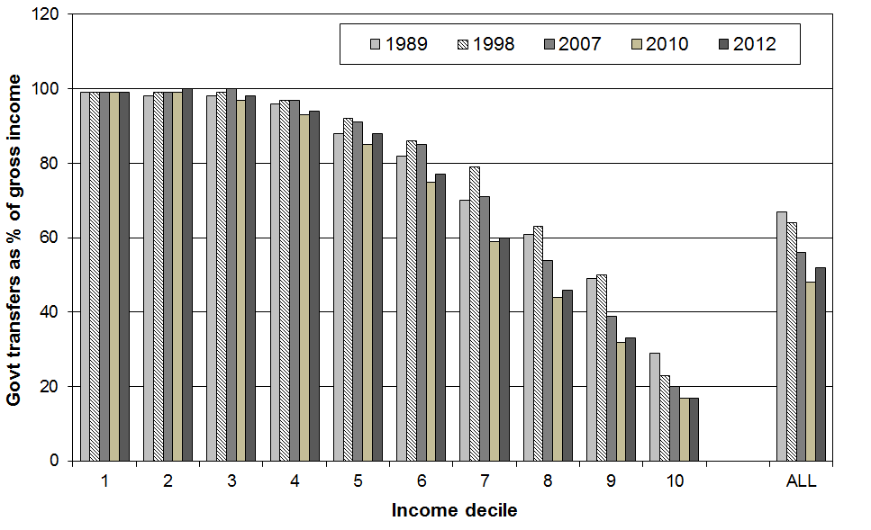

Figure I.7
Income sources for deciles 1-4, all 66+ EFUs
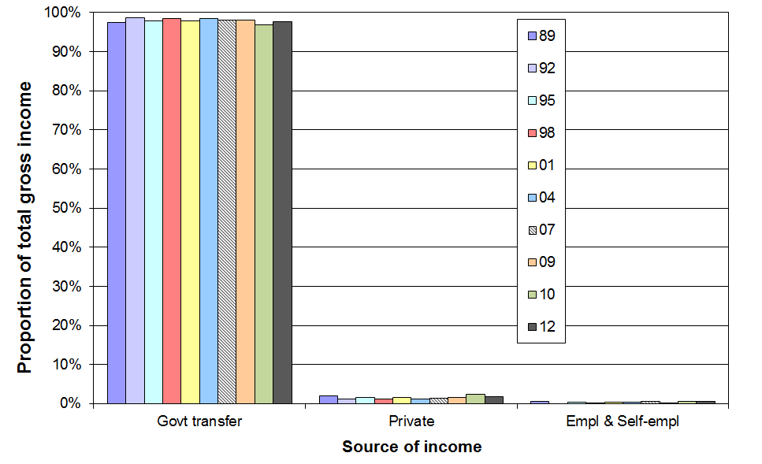

Figure I.8
Income sources for deciles 5-6, all 66+ EFUs
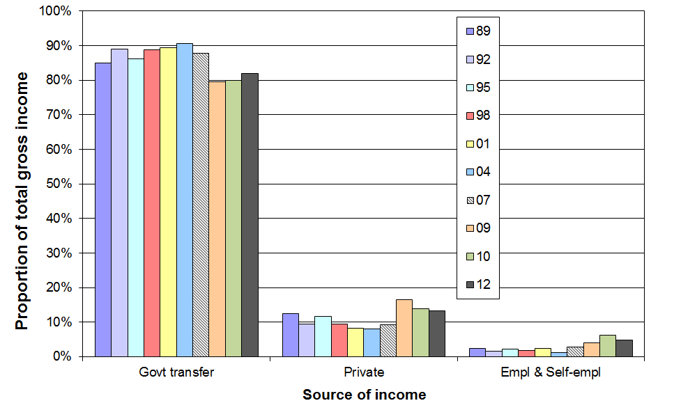
Figure I.9
Proportion of gross income coming from government transfers (almost entirely NZS and VP):
one person and couple EFUs compared, HES 2012
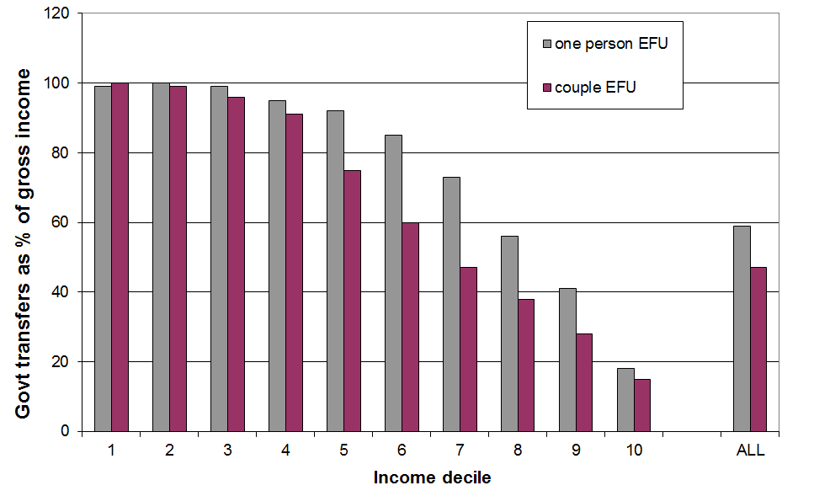

Figure I.10 shows that for a group of ‘younger’ couple EFUs (aged 66-75) there was a strong and sustained increase in income from non-government sources in the decade from 2001 to 2010. The proportion of their income which came from employment increased from 2009 to 2010, although the total dollar amount from employment remained much the same. The proportion and dollar amount coming from other private sources (investment returns) fell.

For these ‘younger’ couples in the middle quintile (deciles 5 and 6), there was a reduction in the proportion of their income coming from NZS (80% to 50% from 2001 to 2010), but for the lower two quintiles for this group dependence on NZS and other government transfers remains high (87%).

There have been no comparable changes for those in one-person EFUs.

Investment income fell a little more from 2010 to 2012 and income from employment remained the same in 2012 as in 2010.

Figure I.10
Changing proportions from three sources for couples (aged 66-75) in deciles 5-6 for couples
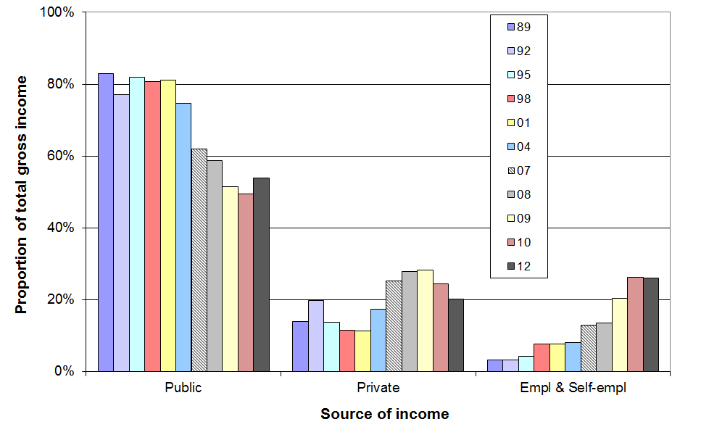

Table I.5 shows the amounts received by one person and couple EFUs (66+) from sources other than government transfers (ie from employment, self-employment, private superannuation and other investments). Each EFU type is ranked separately on their respective non-government incomes. Decile means and decile upper boundaries are given.

Table I.5
Amount received per week by 66+ EFUs from non-government sources by decile, HES 2012
(each EFU type is ranked separately on their respective non-government incomes)
 |  | 1 | 2 | 3 | 4 | 5 | 6 | 7 | 8 | 9 | 10 | TOT
one person EFUs | mean | 0 | 0 | 0 | 4 | 25 | 70 | 175 | 320 | 610 | 2000 | 325
one person EFUs | upper bndry | 0 | 0 | 0 | 10 | 40 | 115 | 255 | 420 | 770 | - | -
couple EFUs | mean | 0 | 0 | 15 | 65 | 190 | 380 | 650 | 955 | 1460 | 3150 | 695
couple EFUs | upper bndry | 0 | 0 | 30 | 100 | 250 | 530 | 765 | 1170 | 1910 | - | -

Note: When making estimates of the number or proportion of individuals (rather than EFUs) receiving less than or more than a given amount from non-government sources, note that there are around 50% more individuals in couple EFUs than in single EFUs (ie the relative weighting is around 3:2).

Figure I.11 plots the upper boundaries from Table I.5 for deciles 1-8 and interpolates to provide a simple means of estimating proportions of older New Zealanders with non-government incomes above or below selected amounts. For couple EFUs, the Table I.4 amounts are halved to convert them to per capita amounts. The top two deciles are omitted to enable a sensible vertical scale to be used.

Figure I.11
Income from non-government sources for one person and couple EFUs (66+):
weekly amounts per person, decile upper boundaries, deciles 1-8, HES 2012
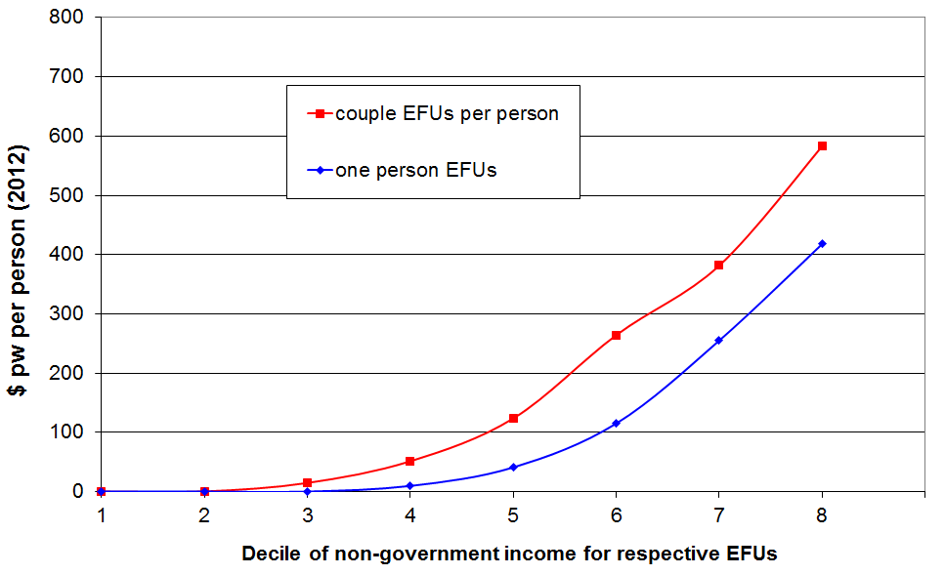

For example, for those in couple EFUs, 47% have less than $100 pw, and for one person EFUs, around 58% have less than $100 pw. There are around 50% more people in couple EFUs than in one person EFUs (3:2 ratio). The weighted average of 47% and 58% is 52%. So, in 2012, around half of older New Zealanders had income of less than $100 pw over and above government transfers, similar to 2010, but down from 56% in 2008 and 60% in 2007.

Section J

International comparisons

for income poverty, inequality and wealth

The information for the international comparisons of income poverty and inequality in this section comes from three sources.

The OECD income inequality and poverty comparisons using household incomes come from information sent to the OECD by national experts based on national survey data and using common assumptions and definitions. The OECD analysis for New Zealand mainly uses information supplied by Statistics New Zealand based on the 2011-12 HES, and some from earlier surveys. The latest comparisons across the OECD as a whole are available for most countries for calendar year 2011 (2011-12 surveys).

The most significant difference between the OECD assumptions and definitions and those used in the rest of this report for New Zealand BHC analysis is that the OECD work uses an equivalence scale that treats children as costing the same as adults (the “square root scale”). This difference generally has only a small to modest impact on the level of various indicators at a given time, and a quite limited impact on trend analysis over time. The use of different equivalence scales can produce different directions for changes from one survey to the next when the changes are small. Long-term trends are not affected.

The comparisons with the EU and other European countries draw mainly on survey-based information compiled by Eurostat for the EU and other European countries. The equivalence scale used in this source is almost identical to the Revised Jensen Scale used in this report for New Zealand analysis.

The information on very high incomes based on tax records rather than sample surveys comes from the World Top Incomes Database held by the Paris School of Economics.

The information for international comparisons of wealth inequality comes from the Luxembourg Wealth Study, the Credit Suisse Global Wealth Databook, and New Zealand Treasury analysis of the 2003-04 wave of the Statistics New Zealand’s Survey of Family Income and Employment (SoFIE) dataset.

International comparisons of income poverty

The OECD poverty indicator uses a moving line approach with a 50% of median BHC threshold. The EU poverty indicator uses a moving line 60% of median BHC threshold.

Comparing poverty rates across countries using the OECD or EU approaches is essentially a comparison of the proportion of people from households that have incomes more than a defined distance from middle incomes for each country. This is consistent with the relative disadvantage notion of poverty and can be useful when looking at trends and relativities within a country, subject to the limitations discussed in Section A. If understood properly, it can also be a useful way of comparing how dispersed or compressed the income distribution is below the median on a country by country basis.

A major difficulty arises, however, when international league tables of poverty rates are seen as ranking countries by their poverty rates understood in terms of the proportion of the population experiencing poor material living conditions assessed against some common international standard. This is still a relative perspective, but the reference is no longer the middle incomes of a particular country, but some notion of minimum acceptable living conditions that is the same for all the countries being compared.

For example, in 2012, using the 60% of median EU measure, the Czech Republic had a poverty rate (10%) that is lower than the rates for Denmark, Sweden and France (13-14%), yet the poverty lines in each of the latter three countries are all above the median household income level for the Czech Republic. What this means is that the Czech Republic has less inequality in the lower half of the income distribution than the others – a smaller proportion more than 40% below the Czech median than other countries. The figures are often mistakenly interpreted or even portrayed as if the league table ranking means that the Czech Republic is doing better than the others for less well-off citizens against some unstated international reference level.

The EU faces this challenge even more pointedly than the OECD – for income poverty measurement, is the reference society the EU or the individual member country? In contrast to the situation described above when the reference is the income levels in a single country, counting the whole EU as one notional country and taking a whole-of-EU median produces a poverty rate of 40% for the Czech Republic, 9% for France and Sweden, and 6% for Denmark (Nolan and Whelan, 2011: 61).

The issues are well illustrated in the two scatter-plots below. The charts draw on data from the OECD’s 2011 Society at a Glance publication. Figure J.1 shows that there is very little relationship between income poverty rates for OECD countries and the proportion who report in Gallup polls that they are finding it difficult or very difficult on their current income. On the other hand Figure J.2 shows that there is a reasonably strong relationship between median household incomes (made comparable through the use of USD Purchasing Power Parities) and the proportion reporting income difficulties.
Figure J.1
Very weak relationship between income poverty and reported income difficulties

Figure J.2
Strong negative relationship between median household incomes and reported income difficulties
Note: Two outliers (Hungary and Greece) have been removed. When they are included the R² value drops to 0.61 – still a reasonably strong relationship.
It appears as if respondents to the Gallup polls have in mind some notion of an internationally comparable minimum standard of living when they give their answers. In contrast, income poverty rates use the median income levels within countries as the benchmarks. The problem arises when people interpret the international income poverty league tables as if they were using a common cross-country standard and give an indication of ‘income difficulties’.

International comparisons using non-income measures

Partly in response to these concerns, the EU has developed and adopted a 9-item deprivation index based on non-income measures (NIMS) as one of its primary social inclusion indicators. The OECD is also taking steps to develop international comparisons of material hardship based on NIMs.

Although these too have their challenges and limitations, they have the potential to provide another useful perspective to set alongside the comparisons based on income.

MSD’s 2008 Living Standards Survey has items in it that allow comparisons of material deprivation with EU countries using NIMs. A summary of findings from this research is included in this section of the Incomes Report.

Cautions when making comparisons between poverty figures across countries: summary

International league tables such as those produced by the OECD, Eurostat and UNICEF have a popular appeal, but need to be treated with considerable caution for several reasons:
- those identified as “poor” in two countries which have the same or similar reported income poverty rates may have quite different actual day-to-day living standards (as discussed above)
- poverty rates for countries can bunch together, and small differences in rates can mean very large differences in rankings – comparison with the median or average is therefore often more useful than the ranking itself for assessing or summarising relative performance
- some countries’ reported rates can change significantly from year to year on a moving line (REL) approach, thus making the choice of comparison years crucial when reporting rankings.

Population poverty using a 50% BHC threshold

- On the OECD 50% of median moving line (REL) measure, the average New Zealand rate through the mid 1990s (1994 to 1996) was 9%, which was at the OECD median.
- By the time of the 2012 HES (approximately calendar 2011) the rate was 10%. Table J.1 shows that this places New Zealand at the OECD median, similar to Canada, lower than Australia (14%), and well below the United States (17%). Iceland, Denmark and the Czech Republic have the lowest proportion with incomes below the 50% line (6%).
- The rate in the 2013 HES was 11%.

Table J.1
Population poverty rates (%) in the OECD-34, c 2011:
50% of median threshold (BHC)
Israel | 21 | New Zealand | 10
Mexico | 21 | OECD median | 10
Turkey | 19 | United Kingdom | 10
Chile | 18 | Switzerland | 10
United States | 17 | Ireland | 10
Japan | 16 | Sweden | 10
Korea | 15 | Slovenia | 9
Spain | 15 | Germany | 9
Greece | 15 | Austria | 9
Australia | 14 | France | 8
Italy | 13 | Norway | 8
Estonia | 12 | Netherlands | 8
Canada | 12 | Slovak Republic | 8
Portugal | 12 | Luxembourg | 8
Poland | 11 | Finland | 7
Belgium | 10 | Denmark | 6
Hungary | 10 | Czech Republic | 6
 |  | Iceland | 6

Source: OECD Income Distribution Database, accessed on 20 June 2014 at www.oecd.org/social/income-distribution-database.htm

Population poverty using a 60% BHC threshold

- Table J.2 shows New Zealand’s relative position among selected European countries, Canada, the United States, Mexico and Australia using a 60% BHC threshold. The New Zealand figure (18%) is based on the 2013 HES (approximately calendar 2012), and the analysis uses the same equivalence scale as the Eurostat analysis. It is just slightly above the EU median.
- For comparison purposes the figures for Canada, the US, Mexico and Australia (from the OECD Income Distribution database) should be reduced by one or two percentage points as the equivalence scale used in the OECD analysis gives population poverty rates approximately that much higher than the one used in the Eurostat analysis.
- In 2004, the New Zealand rate was 21% and the EU median was 16%.

Table J.2
Population poverty rates (%) in selected European countries, Canada, the US, Mexico and Australia
c 2012:
60% of median threshold (BHC)
Mexico * | 28 | United Kingdom | 16
Turkey | 27 | Switzerland | 16
United States * | 25 | Germany | 16
Greece | 23 | Ireland | 15
Romania | 23 | Belgium | 15
Spain | 22 | Luxembourg | 15
Australia * | 21 | Hungary | 14
Canada * | 19 | France | 14
Lithuania | 19 | Austria | 14
Italy | 19 | Sweden | 14
Latvia | 19 | Slovenia | 14
Estonia | 18 | Finland | 13
Portugal | 18 | Denmark | 13
New Zealand | 18 | Slovakia | 13
Poland | 17 | Norway | 10
EU -27 | 17 | Netherlands | 10
EU-15 | 17 | Czech Republic | 10
 |  | Iceland | 8

Sources: Most of the data in the table is drawn directly from the Eurostat statistical database for ‘Living Conditions and Social Protection’, accessed on 22 May 2014. The rates for Canada, the US, Mexico and Australia are drawn from the OECD Income Distribution Database. The OECD uses a different equivalence scale than Eurostat, but the difference that makes for these poverty rates is small and is not enough to impact significantly on rankings (see text above).
Child poverty comparisons using a 50% BHC threshold

- On the OECD 50% of median moving line (REL) measure, the average New Zealand child poverty rate through the mid 1990s (1994 to 1996) was 13%, rising to 15% in 2004.
- By the time of the 2012 HES (approximately calendar 2011) the rate was 14%. Table J.3 shows that this placed New Zealand a little above the median for child poverty for the 34 OECD countries (11%), very close to Australia and Canada (13-14%).
- In the 2013 HES, the New Zealand rate was 13%.

Table J.3
Child poverty rates (%) in the OECD-34, c 2011:
50% of median threshold (BHC)
Israel | 29 | OECD median | 11
Turkey | 28 | Netherlands | 11
Mexico | 26 | France | 11
Chile | 26 | Switzerland | 11
Spain | 22 | Ireland | 10
United States | 21 | United Kingdom | 10
Greece | 20 | Belgium | 10
Hungary | 17 | Korea | 9
Italy | 17 | Sweden | 9
Portugal | 17 | Germany | 8
Japan | 16 | Slovenia | 8
Canada | 14 | Czech Republic | 8
Estonia | 14 | Norway | 5
New Zealand | 14 | Austria | 5
Australia | 13 | Denmark | 4
Poland | 13 | Finland | 3
Slovak Republic | 13 | Iceland | 2
Luxembourg | 12

Source: OECD Income Distribution Database, accessed on 20 June 2014 at www.oecd.org/social/income-distribution-database.htm

Child poverty comparisons using a 60% BHC threshold

- Table J.4 shows New Zealand’s relative position among selected European countries, Canada, the United States, Mexico and Australia using a 60% of median moving line measure (BHC). The New Zealand figure (20%) is based on the 2013 HES (approximately calendar 2012), and the analysis uses the same equivalence scale as the Eurostat analysis. It is at the EU median.
- For comparison purposes the figures for Canada, the US, Mexico and Australia (from the LIS database) should be reduced by one or two percentage points as the equivalence scale used in the LIS analysis gives population poverty rates approximately that much higher than the one used in the Eurostat analysis.
- New Zealand’s rate in the 2004 HES (calendar 2003) was 25%, above the EU 2004 average of 20%. By the time of the 2007 HES, the rate had dropped to 20%, at the EU average. This change reflects the impact of the Working for Families package in raising the incomes of many (working) families with children from the 50% to 60% of median income range to above the 60% of median threshold.

Table J.4
Child poverty rates (%) in selected European countries, Canada, the US, Mexico and Australia
c 2012:
60% of median threshold (BHC)
Turkey 2006 | 36 | New Zealand | 20
Mexico 2004 | 30 | France | 19
Spain | 30 | United Kingdom | 19
United States 2004 | 29 | Switzerland | 18
Greece | 27 | Austria | 18
Italy | 26 | Estonia | 17
Canada 2004 | 25 | Ireland | 17
Latvia | 24 | Belgium | 17
Luxembourg | 23 | Sweden | 15
Hungary | 23 | Germany | 15
Poland | 22 | Slovenia | 14
Portugal | 22 | Czech Republic | 14
Australia 2003 | 22 | Netherlands | 13
Slovak Republic | 22 | Finland | 11
Lithuania | 21 | Iceland | 10
EU-27 | 21 | Denmark | 10
EU-15 | 20 | Norway | 8

Sources: Most of the data in the table is drawn directly from the Eurostat statistical database for ‘Living Conditions and Social Protection’, accessed on 22 May 2014. The rates for Canada, the US, Mexico and Australia are drawn from the LIS Key Figures database at www.lisdatacenter.org accessed on 22 May 2014.

Children in workless households

There is more than one way in which the general concept of “children in workless households” is operationalised and reported by various national and international agencies.

The most straightforward way is to count the number of children in workless households and express this number as a proportion of all children (~15% in HES 2013). This report uses this approach.

A second way is to count up the number of households with children where there is no adult in work, and express this as a proportion of the number of all households with children. This “workless households with children” approach gives a very similar trend to that produced by this report’s “children in workless households” approach, albeit the actual proportions can sometimes be very slightly different than in the first approach.

Table J.5 compares New Zealand with EU countries on the proportion of children in workless households. In 2011, New Zealand was at the high end of the table with a rate of 15%, similar to Hungary, and a little below the United Kingdom (17%). The figure for New Zealand is dependent on the sample weights derived by the Treasury for use with the HES.

Table J.5
International comparisons of the proportion of children living in workless households (%):
EU and New Zealand figures are for 2012 (HES 2012-13)
Ireland | 20 | Estonia | 9
United Kingdom | 17 | Greece | 9
Hungary | 16 | Germany | 9
New Zealand | 15 | Poland | 9
Belgium | 13 | Italy | 8
Lithuania | 13 | Sweden | 8
Turkey | 12 | Portugal | 8
Spain | 12 | Denmark | 8
Latvia | 11 | Czech Republic | 7
EU-27 avg | 11 | Netherlands | 5
France | 10 | Austria | 5
Slovakia | 10 | Finland | 5
EU-27 median | 9 | Luxembourg | 5

Source: Eurostat data accessed on 21June 2014

Older New Zealanders

Extra care needed here
Using household income as an indicator of material wellbeing has some significant and well-known limitations, especially for international comparisons. The reader is referred to the opening pages of Section A and of this Section, the text below, and to Section I for detailed discussion and analysis of the limitations of BHC income-based poverty comparisons, and the potential that they have for leaving misleading impressions as to how countries and groups within them are faring relative to each other. These risks especially apply to comparisons for older people.

Using the 50% of median threshold (OECD measure), New Zealand had one of the higher poverty rates in the OECD in HES 2008-09 for those aged 66+ (22%).

In previous OECD league tables (for c2000 and 2004) New Zealand had the lowest poverty rate in the OECD for the 66+ group (~2%).

The sudden increase occurred because the value of New Zealand Superannuation (NZS) was above 50% of the median household income in earlier years (2001, 2004) but fell just below it during 2009. There are many older New Zealanders whose income is little more than NZS so there is a clumping of 65+ households at around the NZS level. In 2001, NZS had a value of just under 60% of the median. From 2001 to 2009 the median rose in real terms at a faster rate than the real rises in NZS. In 2009 the OECD poverty line (50% of the median) cut through the clump thus producing a large change in the reported poverty rate for older New Zealanders. There is more detail on all of this in Section I.

By the 2011 HES (approximately calendar 2010) the New Zealand rate had fallen to 11% and in the 2013 HES to 9%.

Table J.6
66+ poverty rates in the OECD (%) c 2011:
50% of median threshold (BHC)
Korea | 47 | New Zealand | 9
Mexico | 31 | Portugal | 8
Switzerland | 24 | Ireland | 8
Japan | 22 | Estonia | 7
Israel | 21 | Greece | 7
Chile | 21 | Canada | 7
United States | 19 | Spain | 7
Turkey | 18 | Denmark | 7
Slovenia | 15 | Australia | 6
Belgium | 11 | Slovakia | 6
Austria | 11 | France | 5
Italy | 11 | Hungary | 5
United Kingdom | 11 | Norway | 4
Finland | 10 | Luxembourg | 3
Poland | 10 | Iceland | 3
Sweden | 10 | Netherlands | 2
Germany | 9 | Czech Republic | 2
Source: OECD Income Distribution Database, accessed on 20 June 2014 at www.oecd.org/social/income-distribution-database.htm

This sudden rise and fall of the income poverty rate for older New Zealanders can easily leave the misleading impression that there has been a very large and sudden change for the worse in the actual living conditions of many older New Zealanders, followed by an equally sudden improvement. Neither conclusion is warranted. The rapid changes simply reflect the existence of the “pensioner spike” in the New Zealand income distribution.

In its 2007 country report for New Zealand, the OECD noted that New Zealand has “successfully erased poverty among the elderly”, basing its assessment on the information in the 2000 version of Table J.6. To be consistent, it would have had to report for 2009 something along the lines of “poverty among the elderly in New Zealand is very high compared with other OECD countries and is clearly a matter that the country needs to address.” If it had done so, it would have been consistent, but it would be misleading on both counts.

The opening pages of this section raised serious questions about the value and wisdom of international league tables which use income-based measures of poverty and which leave the reader with the impression that the rankings somehow reflect the degree of material hardship being experienced by different groups across the countries ranked in the table. The rapid and large changes for “poverty rates” for older New Zealanders as noted above provide another reason to treat such tables with great care, or even to not use them at all for international comparisons of “poverty”.

Table J.7 compares poverty rates for older people using a 60% threshold for selected European countries and New Zealand. Using this higher threshold, poverty figures are more stable from year to year as the threshold is above most clumps or pensioner spikes in the income distributions.
Table J.7
65+ poverty rates in selected European countries and New Zealand (%) c 2012:
60% of median threshold (BHC)
Australia 2010 | 52 | Germany | 15
Switzerland | 30 | Romania | 15
New Zealand | 29 | Spain | 15
United States 2010 | 22 | EU-27 and EU-15 | 14
Slovenia | 20 | Poland | 14
Lithuania | 19 | Denmark | 14
Belgium | 18 | Ireland | 11
Finland | 18 | Norway | 10
Sweden | 18 | France | 9
Greece | 17 | Slovakia | 8
Portugal | 17 | Czech Republic | 6
Estonia | 17 | Netherlands | 6
United Kingdom | 16 | Hungary | 6
Italy | 16 | Iceland | 4
Austria | 15

Sources: Most of the data in the table is drawn directly from the Eurostat statistical database for ‘Living Conditions and Social Protection’, accessed on 22 May 2014. The rates for the US and Australia are drawn from the OECD Income Distribution Database. The OECD uses a different equivalence scale than Eurostat, but the difference that makes for these poverty rates is small and is not enough to impact significantly on rankings.

When using household income as an indicator of relative material wellbeing, and especially for comparisons with other age-groups, this report takes the view that an AHC approach is more useful. The rationale for this position is set out and discussed in the Introduction (Section A), in Section I and in Appendix 5. Comparable AHC figures for the EU or OECD are not available.

None of this is meant to imply that the comparison of household incomes within a country is of little or no use. The point is about the limitations of using household incomes for international comparisons of poverty and material hardship among those in the richer nations (eg OECD or EU), especially when it comes to the relative position of older New Zealanders.

Using non-income measures for international comparisons of hardship for older people (65+)

The use of non-income measures (NIMs) provides a useful alternative way of assessing relative material wellbeing. The EU has developed and adopted an official measure of material hardship (deprivation) using NIMs. The 2008 New Zealand Living Standards Survey has the EU questions in it and this allows New Zealand to be located relative to European countries using the EU index. See Perry (2009) for full details on this.

Figure J.3 shows that older New Zealanders have a much lower deprivation rate (3%) than their counterparts in most European countries. As for the population as a whole there is a reasonably clear division between the ‘old’ EU countries and those more recently gaining membership.

Figure J.3
Deprivation rates (% with 3+ enforced lacks) using the 9 item index (EU-1), those aged 65+
EU-25 - MT + NO + IS +NZ (EU 2007, NZ 2008)
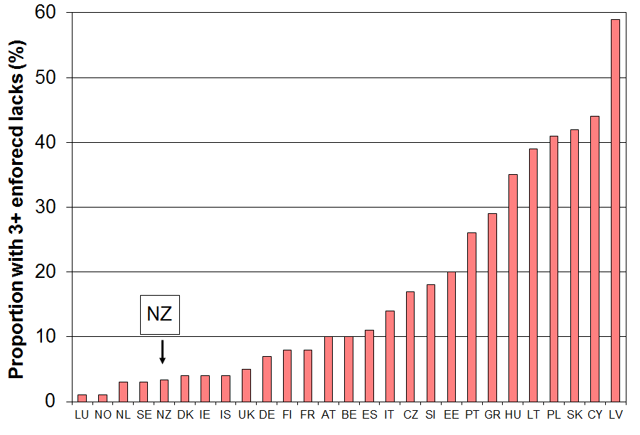

Table J.8
Deprivation rates (% with 3+ enforced lacks) using the 9 item index (EU-1), those aged 65+
EU-25 - MT + NO + IS +NZ (EU 2007, NZ 2008)
 |  | % with 3+ |  |  | % with 3+
Norway | NO | 1 | Spain | ES | 11
Netherlands | NL | 3 | Italy | IT | 14
Sweden | SE | 3 | Czech Republic | CZ | 17
New Zealand | NZ | 3 | Slovenia | SI | 18
Denmark | DK | 4 | Estonia | EE | 20
Ireland | IE | 4 | Portugal | PT | 26
Iceland | IS | 4 | Greece | GR | 29
United Kingdom | UK | 5 | Hungary | HU | 35
Germany | DE | 7 | Lithuania | LT | 39
Finland | FI | 8 | Poland | PL | 41
France | FR | 8 | Slovakia | SK | 42
Austria | AT | 10 | Cyprus | CY | 44
Belgium | BE | 10 | Latvia | LV | 59
Note: An improved 13-item index has been developed by the EU and is in process to becoming the new official measure. The hardship rate and ranking for older New Zealanders remains unchanged on this new index (see Perry 2014, forthcoming).
International comparisons of income and wealth inequality

The latest full set of information available from the OECD is for 2011 (our 2011-12 HES). International comparisons are given for the Gini coefficient, three share ratios for different decile groupings, and for the P90/P10 percentile ratio. The OECD sources do not have comparisons for the P80/P20 ratio.

In contrast to the share ratios and the percentile ratios the Gini coefficient takes the incomes of all individuals into account. It gives a summary of the income differences between each person in the population and every other person in the population. A difference of, say, $1000 between two high-income people contributes as much to the index as a difference of $1000 between two low-income people. The Gini scores (x100) range from 0 to 100 with scores closer to 100 indicating higher inequality and those nearer zero indicating lower inequality (ie greater equality).

Inequality comparisons using the Gini coefficient (c 2011)

Figure J.4 shows inequality rankings for 34 OECD countries for around 2011 using the Gini coefficient. New Zealand’s score of 33 gave a ranking of 22nd out of 34. Rankings are not generally a useful way of comparing countries on league tables as there is often a clustering that can mean that a very minor difference in score can be the difference between a ranking of, say, 10th and 17th. Distance from the median and relativity to countries with whom comparisons are traditionally made are more useful approaches. On the latest OECD figures (c 2011), New Zealand’s Gini score of 33 was close to those of Australia and Ireland (33), a little lower than the UK, Spain and Japan (34), and a little higher than Canada and Italy (32). The OECD-34 median was 31. Countries such as Denmark, Norway and Finland have lower than average inequality (Ginis of 25-26). The US score was 38.

Figure J.4
Income inequality across the OECD: Gini coefficients (x100) c 2010, whole population
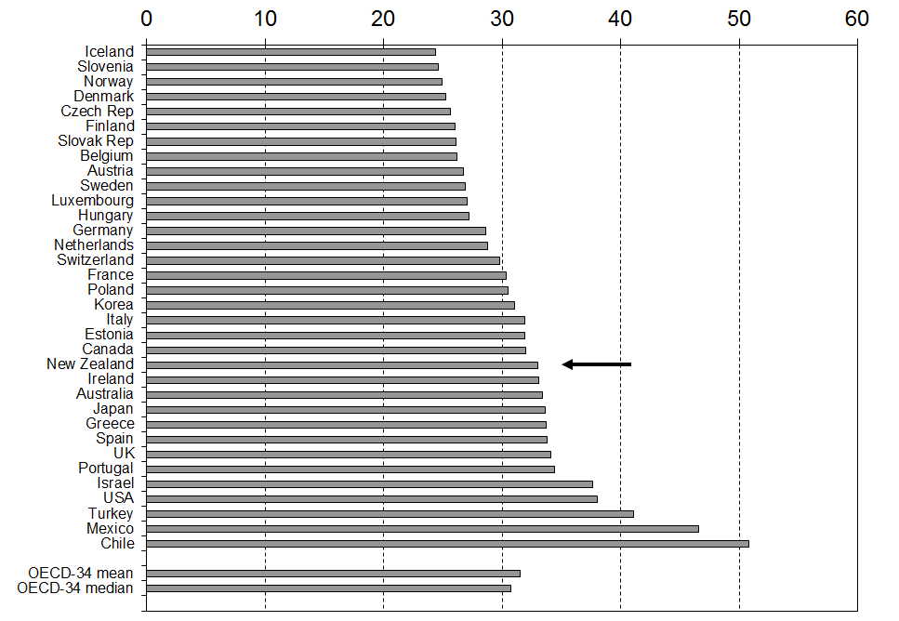
Source: OECD Income Distribution database, accessed on 24 June 2014.
Changing inequality in the OECD and New Zealand: 1982 to 2013

Figure J.5 shows the way inequality as measured by the Gini coefficient has changed in New Zealand over the last thirty years.

From the late 1980s to the mid 1990s income inequality in New Zealand increased significantly and rapidly, taking New Zealand from well under the OECD average to well above. From the mid 1990s to 2012 the trend-line for New Zealand has been relatively flat while the OECD average has risen, thus bringing the two lines closer together.

For the period in which the impact of the GFC and economic downturn and recovery is evident in the HES income data (HES 2009 to HES 2013), the inequality figures are volatile. The volatility reflects the differing size and timing of the impact of the GFC and associated economic downturn and recovery on the various components of market income and different parts of the income distribution.

Figure J.5
Inequality in New Zealand and the OECD trend: the Gini coefficient
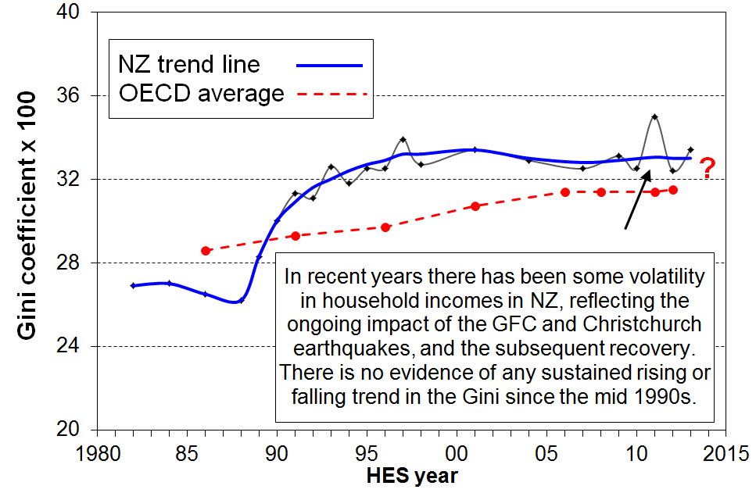

Inequality comparisons using three share ratios

Another approach used by the OECD is to compare the share of total income received by higher income households compared with the share received by lower income households. Three share ratio measures are reported here:
- the D10 to D1 ratio, comparing the top decile share with the bottom decile share
- the Q5 to Q1 ratio, comparing the top quintile share with the bottom quintile share
- the D10 to D1-4 ratio, comparing the top decile share with the share from the bottom four deciles (the Palma measure).

The Palma: the ratio of the top decile share to the share for the lower four decile shares

The Palma measure or ratio is a relatively new addition to the suite of inequality measures used for international comparisons. It is named after Chilean economist Gabriel Palma whose 2011 paper brought the measure and its rationale to light. The OECD now reports the Palma in its Income Distribution database.

At one level, the Palma is just another share ratio in the wider family of share ratios. It has several features however that make it worth a second look:
- Palma found that among middle income and richer countries those in deciles 5-9 receive around 50% of the total income share, and that this share size seems reasonably stable over time as well as over countries. These are the middle to upper-middle income households between the “rich” and the “poor”. Figure J.6 shows the share for New Zealand has been fairly stable at around 55% from 1990 to 2013.
- He also found that the remaining 50% or so (45% for New Zealand) of total income was split between the top 10% and bottom 40% in quite different ways across the countries he looked at. This inspired the first part of the title for his 2011 paper - “Homogeneous middles and heterogeneous tails".
- He found that the correlation between the Palma and the Gini is close to perfect across the 150 countries in the World Bank dataset he used.
- Given that the Palma is much easier to explain than the Gini, and that it ranks countries in the same order, then he and others are proposing that it might be a useful alternative to the Gini for international comparisons. For example, what does it mean in practice to say that one country has a Gini of 42 and another 31? On the other hand, a Palma of 2.1 compared with a Palma of 1.7 has specific and easily grasped meaning in terms of the ratio of higher incomes to lower incomes, with the ”middle” remaining constant. The jury is still out on whether it can / ought to / will replace the Gini, but it certainly has the communication edge over the Gini.
- In the international section (Section J), New Zealand is ranked relative to other OECD countries on the Palm ratio.

Figure J.6
Proportion of total income received by deciles 4 to 9, 1982 to 2013

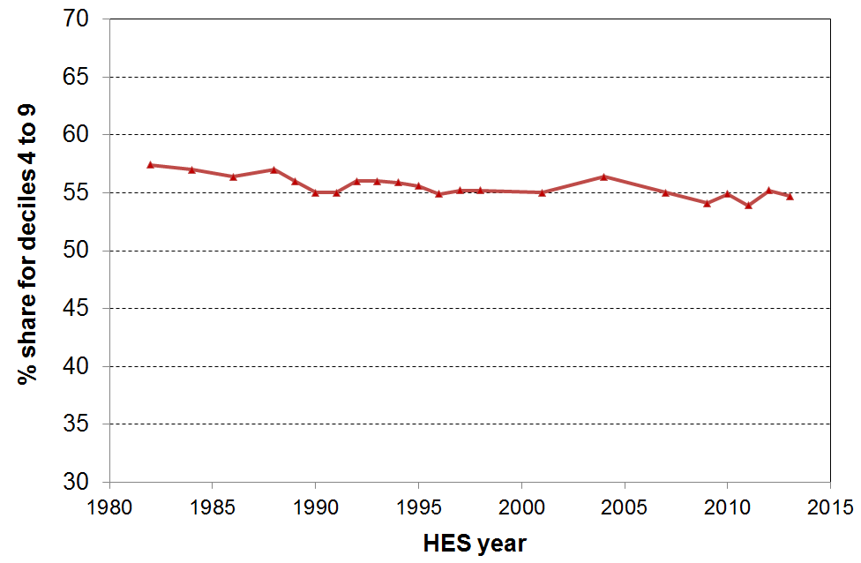
Table J.9 reports these three share ratios for around 2011 for the 34 OECD countries. New Zealand is at or just above the middle of the rankings on each of the three measures

Table J.9
Income inequality using income share ratios, OECD, 2011
 | D10:D1 | Q5:Q1 | D1:D1-4 (Palma)
Denmark | 5.3 | 3.6 | 0.87
Slovenia | 5.3 | 3.6 | 0.81
Finland | 5.5 | 3.8 | 0.93
Czech Republic | 5.5 | 3.7 | 0.89
Iceland | 5.6 | 3.6 | 0.86
Belgium | 5.8 | 4.0 | 0.91
Slovak Republic | 5.8 | 3.9 | 0.89
Luxembourg | 5.9 | 4.0 | 0.97
Norway | 6.1 | 3.8 | 0.85
Sweden | 6.3 | 4.1 | 0.96
Netherlands | 6.6 | 4.1 | 0.99
Switzerland | 6.9 | 4.4 | 1.04
Germany | 6.9 | 4.4 | 1.07
Austria | 7.1 | 4.4 | 0.99
Hungary | 7.3 | 4.5 | 1.04
France | 7.4 | 4.7 | 1.18
Ireland | 7.7 | 4.7 | 1.10
Poland | 7.7 | 4.8 | 1.11
New Zealand | 8.2 | 5.2 | 1.22
Estonia | 9.1 | 5.4 | 1.20
Canada | 8.5 | 5.2 | 1.19
Australia | 8.5 | 5.4 | 1.23
United Kingdom | 9.6 | 5.6 | 1.40
Portugal | 9.9 | 5.8 | 1.36
Italy | 10.2 | 5.6 | 1.22
Korea | 10.2 | 5.7 | 1.13
Japan | 10.7 | 6.2 | 1.30
Israel | 12.5 | 7.4 | 1.55
Greece | 12.6 | 6.3 | 1.30
Spain | 13.8 | 6.7 | 1.34
Turkey | 15.2 | 8.4 | 1.99
United States | 16.5 | 8.2 | 1.74
Chile | 26.5 | 13.0 | 2.93
Mexico | 30.5 | 13.7 | 3.27
Source: OECD Income Distribution Database, accessed on 20 June 2014 at www.oecd.org/social/income-distribution-database.htm
Note: The 8.2 figure for New Zealand in the D10:D1 share ratio is slightly higher than the figure Statistics New Zealand produces and which the OECD therefore uses. We agree on the 2012 figure (HES 2013) of 8.3. MSD and Statistics New Zealand will continue to resolve the minor difference. It makes no difference to New Zealand’s ranking on the measure.

Long-run trends for (very) high incomes

While the bulk of the international comparisons of inequality trends and rankings use the incomes of all households (eg the Gini), or most households (the P90:P10), or at least those of the top and bottom 10% (S10:S1), recent public debate and protest has often been about the way in which those with very high incomes have been receiving a disproportionate share of the growth in overall income compared with the rest (hence the catch-cry of “we are the 99”). Those with very high incomes (for example, the top 1%) make up a small share of the population but their incomes make up a relatively large share of total income (and total income tax paid).

Until recently there was no reliable and internationally comparable data on very high incomes as sample surveys such as the HES do not have large enough samples to pick up enough such households to enable robust figures to be reported. Long-run time series on very high incomes based in the main on income tax data have recently become available on the World Top Incomes database, largely due to the work of Tony Atkinson (UK), Thomas Pikketty (France) and Emmanuel Saez (US). See for example, Atkinson and colleagues (2011) and Alverado and colleagues (2012).

Figure J.7 shows the share of total income received by those with the top 1% of income from the 1920s to around 2010 for the US, the UK, Canada, Australia and New Zealand.

For the US, the UK and Canada there is a clear U-shaped curve with the share of total income received by the top 1% rising fairly steeply for the US and the UK from the mid 1980s, more than doubling from 8% to 19% in 2011 for the US and from 6% to 15% for the UK (although the UK figure has declined to 13% in 2011). For New Zealand and Australia the proportion of total incomes received by the top 1% is less than for the US and the UK, but the rise from the mid 1980s to the mid 2000s is still steep. Ireland also has a U-shaped curve.

Not all OECD countries show the U-shaped curve. For example, France, the Netherlands, Germany and Japan show more of an L-shaped curve: they do not show the rapid rise from the mid-1980s that the English-speaking countries do, remaining steady in the 5-10% range (which is where New Zealand and Australia have ended up in 2010 to 2011).

Figure J.7
Very high income: share of income received by top 1%, 1920 to 2011

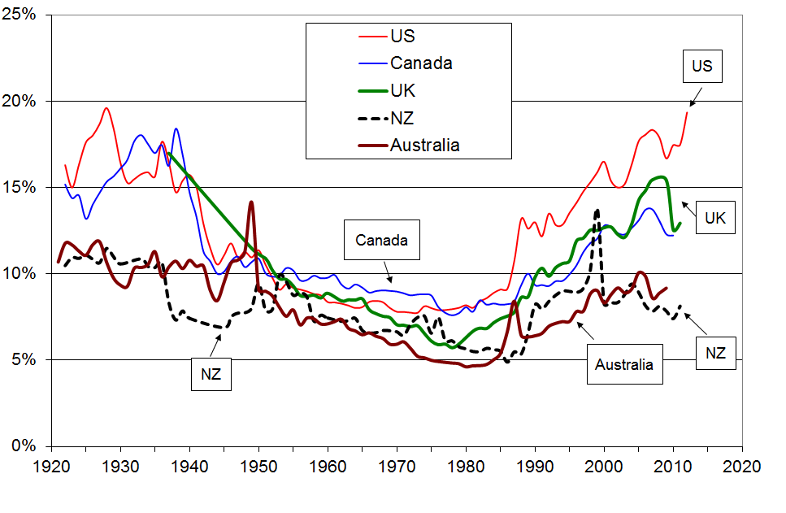

Source: World Top Incomes database accessed on 18 May 2014

The long-run perspective in Figure J.7 can tell more than one story. Taking the end of the “great compression” (1950 to 1980) as the starting point, the conclusion is that for the five English-speaking countries in the graph, inequality (understood as the share of income received by the top 1%) increased strongly to 2011. With the 1920s as the starting point, the “great compression” can be seen as the “aberration” and now the distribution has returned to where it was ninety years ago.

Figure J.8 shows selected OECD countries ranked by their top 1% income share. The top 1% in New Zealand received around 8% of all taxable income in 2010 and 2011 (before tax), more than in Denmark, Finland and Sweden (5 to 7%), similar to Norway, France and Australia, lower than Ireland (11%) and Canada (12%), and much lower than the UK (14%) and the US (17%).

For almost all OECD countries, the latest figures are all higher than in the 1980s (eg 10% for France, 40% for NZ and Japan, 60% for Ireland and Canada, 90% for the UK and Australia, and 120% higher for the US).

Figure J.8
Share of income received by top 1% (2010 & 2011)
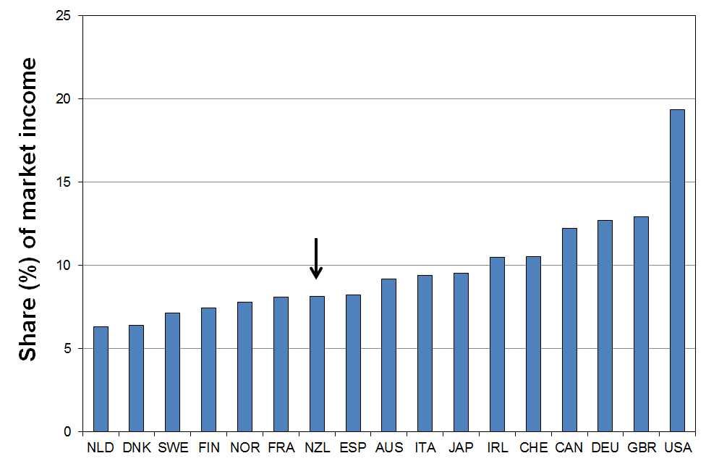

Figures J.9 and J.10 show the trends for the five English-speaking countries shown in Figure J.10 but this time for the top 5% (with the top 1% removed) and the top 10% (with the top 1% removed). The long-run and more recent trends are much flatter for these income groups.

Figure J.9
Very high income: share of income received by the top 5% (less the top 1%), 1920 to 2011
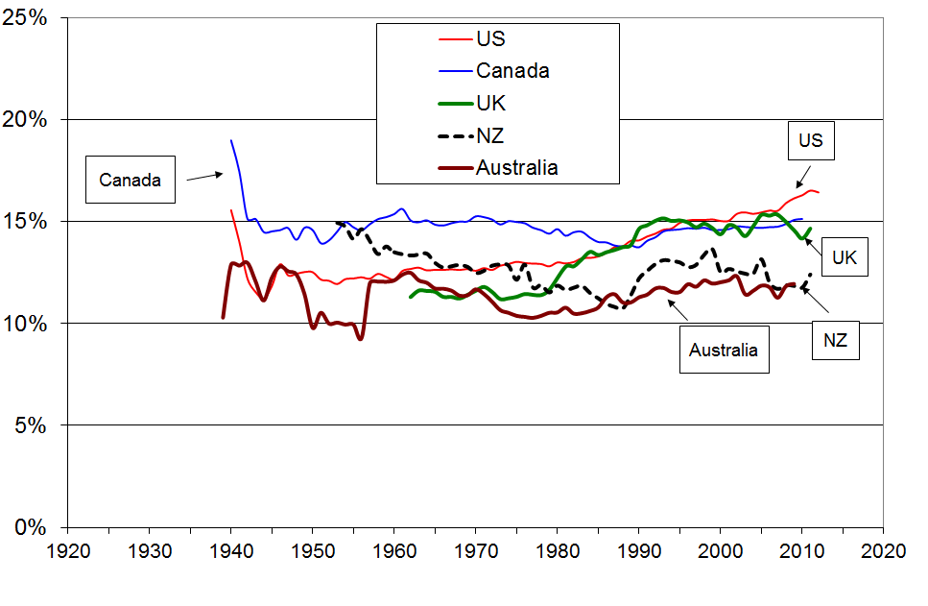

Figure J.10
Very high income: share of income received by the top 10% (less the top 1%), 1920 to 2011
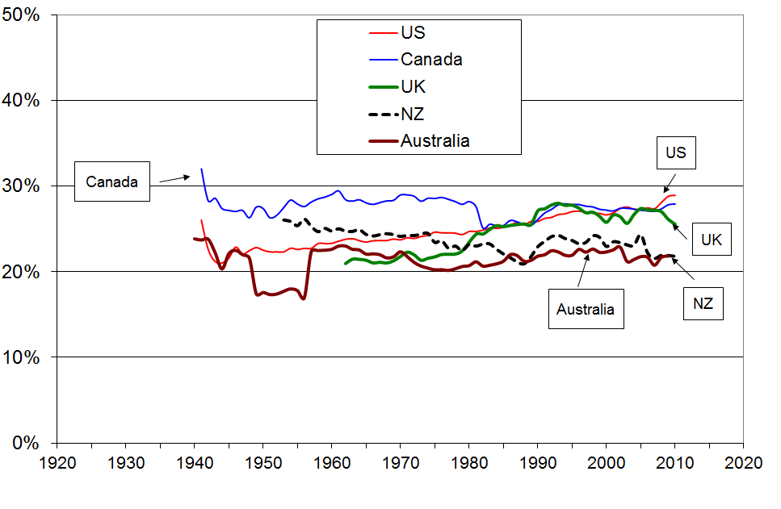

Long-run perspective for the share of income received by the top decile

As noted above, the HES analysis in this report and much of the OECD international comparative analysis are based on sample surveys that begin in the mid 1980s, at the end of the “great compression”. This means that analysis based on these surveys show a generally rising inequality for many countries.

This point is well illustrated in Figure J.11 using the more common “top decile share” measure. The graph shows the rising trend for the HES data from the 1980s, but from the longer perspective from 1955, the income data shows firstly the “great compression” to the 1980s, then a rise to the mid 2000s before falling investment income reduced the share. There is still a broadly U-shaped trend as in Figure J.10 for the top 1% of individuals, albeit the “U” is more flattened as noted in Figure J.13 above.

Figure J.11
Share of income received by top 10%, 1955 to 2013
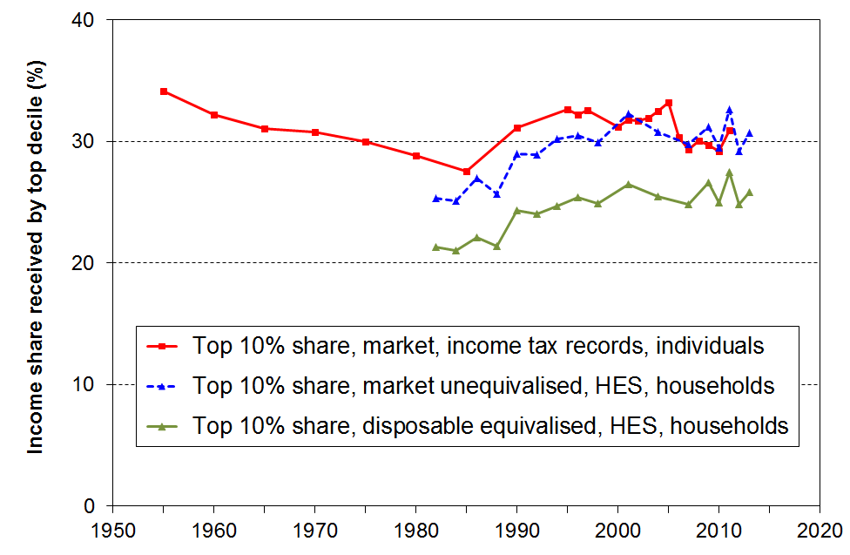

Source: Alvaredo and colleagues (2012), and MSD analysis of HES data.
Note: The data points for 1998 and 1999 for the upper line are omitted to avoid distraction from the main trends – these points were unusually high, reflecting the shifting of income into earlier years ahead of an anticipated tax rise for the top income bracket in 2000.

Correcting the Gini for very high incomes missed in surveys

The Gini inequality figures used by the OECD and others for international comparisons are based on sample surveys. These are known to under-estimate the number of people and households with very high incomes (eg the top 1%). This means that the resulting Gini figures are lower than they would be if the samples were properly representative.

Atkinson (2007) and more lately Alverado (2010) have come up with a formula to correct the sample-based Gini by adding information from the tax records about high individual incomes. If G(sample) is the usual Gini score, then G(corrected) = S + (1-S) * G(sample) where S is the share of total income received by the top 1% or other small group. A key assumption in the derivation of the formula is that the top incomes group is very very small, albeit their income share is non-trivial.

The implication for New Zealand is that any countries with more than 8% share for the top 1% will have a corrected Gini that increases more than New Zealand’s does (see Figure J.8 above). The correction puts New Zealand nearer the OECD median compared with the uncorrected Gini as New Zealand’s top 1% share is relatively low.

Summary

Income inequality in New Zealand, 1984 to 2013 HES
 |  | 1984 | 1994 | 2004 | 2009 | 2012 & 2013 for HES, 2010 & 2011 for tax records
Household disposable income, adjusted for household size … data from sample surveys (HES) | Gini x 100 (trend-line) | 26.6 | 32.5 | 32.9 | 32.9 | 32.9
 | Share ratio, D10 to D1 | 6.1 | 8.2 | 9.1 | 8.6 | 8.3
 | Share ratio, Q5 to Q1 | 4.1 | 5.1 | 5.5 | 5.4 | 5.3
 | Share ratio, D10 to D1-4 (Palma) | 0.92 | 1.21 | 1.31 | 1.29 | 1.27
 | Percentile ratio, P90 to P10 | 3.5 | 4.1 | 4.2 | 4.4 | 4.2
 | Percentile ratio, P80 to P20 | 2.4 | 2.7 | 2.9 | 2.9 | 2.7
Individual market income … data from tax returns – avg of year noted and the one either side | Top 1% share | 5.6 | 8.9 | 9.0 | 7.8 | 7.8
 | Top 10% share | 28 | 33 | 33 | 30 | 30
 | Top 10% - 1% share (ie P90 to P99) | 23 | 24 | 24 | 22 | 22

Income inequality in New Zealand compared with other OECD countries, c 2011-2012
(%) | NZ | OECD-34 median | DNK | NOR | FIN | FRA | AUS | CAN | UK | US
Gini x 100 (trend-line) | 32.9 | 30.5 | 25.3 | 25.0 | 26.1 | 30.9 | 32.4 | 31.6 | 34.4 | 38.9
Share ratio, D10 to D1 | 8.2 | 7.6 | 5.3 | 6.1 | 5.5 | 7.4 | 8.5 | 8.5 | 9.6 | 16.5
Share ratio, Q5 to Q1 | 5.2 | 4.8 | 3.6 | 3.7 | 3.7 | 4.7 | 5.4 | 5.2 | 5.6 | 8.2
Share ratio, D10 to D1-4 (Palma) | 1.27 | 1.18 | 0.87 | 0.85 | 0.93 | 1.18 | 1.27 | 1.19 | 1.40 | 1.74
Percentile ratio, P90 to P10 | 4.2 | 3.8 | 2.9 | 2.9 | 3.2 | 3.6 | 4.5 | 4.1 | 4.1 | 6.1
Top 1% share – tax records | 8 | The latest available from 2009 to 2012 | 6 | 8 | 8 | 8 | 9 | 12 | 13 | 19
Top 5% share – tax records | 21 | The latest available from 2009 to 2012 | 17 | 19 | 21 | 21 | 21 | 27 | 28 | 36
Sources: OECD Income Distribution Database, accessed on 25 June 2014 at www.oecd.org/social/income-distribution-database.htm

World Top Incomes database accessed on 18 June 2014

Comparisons between Australia and New Zealand

Table J.10 shows that household income inequality in Australia and New Zealand (c 2011) was similar on six measures.

Table J.10
Income inequality: New Zealand and Australia compared (avg for 2010 and 2011)
 | New Zealand | Australia
Gini (OECD) | 32.4 | 32.7
80:20 percentile ratio | 2.7 | 2.6
90:10 percentile ratio | 4.2 | 4.4
S10:S1 share ratio | 8.2 | 8.7
Q5:Q1 share ratio | 5.2 | 5.4
Palma | 1.27 | 1.27

Source OECD Income Distribution Database, accessed on 20 June 2014 at www.oecd.org/social/income-distribution-database.htm , and Table S.5 in ABS (2013).

International comparisons of wealth inequality

Wealth is a key component of a household’s economic resources as discussed in the Introduction (Section A). For example, households with low incomes but relatively high wealth levels are able to achieve higher actual living standards than low-income households with low wealth levels. In practice, especially for working-age households, income and wealth are reasonably (but far from perfectly) correlated. Most who are counted as income poor also have negligible financial assets and very low net worth.

In OECD countries, the measurement of wealth is not as developed as wage and income measurement. The data issues faced by individual countries are compounded for comparisons between countries because of differences in methods and definitions. Building on the experience of the Luxembourg Income Study (LIS), a group of researchers and institutions is developing the Luxembourg Wealth Study (LWS), an international project to assemble unit record data on household wealth into a coherent database. The hope is that this will promote a process of reasonable harmonisation of definitions and methodologies across countries, and will facilitate more reliable international comparisons of wealth distribution.

Table J.10 shows some of the findings from early research from the LWS project – the share of total wealth held by the top wealth decile for seven OECD countries, and wealth inequality as measured using the Gini coefficient. New Zealand is not a participant in the LWS, but roughly comparable figures are available using the SoFIE dataset.

Table J.10
Wealth inequality: shares of total wealth held by the top wealth decile (%), and wealth Ginis
 | Italy  2002 | UK  2000 | Finland  1998 | NZ  2003-04 | Canada  1999 | Germany  2002 | Sweden  2002 | USA  2001
Share of wealth held by top decile (%) | 42 | 45 | 45 | 52 | 53 | 55 | 58 | 71
Gini coefficient | 61 | 66 | 68 | 69 | 75 | 80 | 89 | 84
Sources: For New Zealand, the source is Statistics New Zealand (2007), analysis based on the Survey of Family, Income and Employment (2003-04). For the other countries, see OECD (2008), Table 10.3, based on the LWS database. The figures should be taken as indicative only. For more details and an assessment of the reliability of the information from the early LWS research see OECD (2008), Chapter 10. Shorrocks and colleagues (2013) have the same figures in their Credit Suisse Global Wealth Databook.

From Table J.10 and other analysis, two high level findings are that:
- wealth is distributed much more unequally than income (especially disposable income after tax and transfers)
- Gini scores for wealth inequality are generally in the range from 60 to 80, compared with 25 to 40 for income inequality
- for New Zealand, the top wealth decile accounts for around 50% of the total wealth, whereas the top income decile accounts for 25% of the total income
- wealth inequality in New Zealand appears to be not greatly different to what prevails in many other OECD countries.

Section K
Income mobility and low-income persistence

The income information in the earlier sections of the report is based on data from repeat cross-sectional surveys from the Household Economic Survey (HES) series. For each survey a different sample of households is selected and different individuals are interviewed each time.

For this section, the income information is based on seven waves of longitudinal data from Statistics New Zealand’s Survey of Family, Income and Employment (SoFIE) which began in October 2002. Here the same individuals are followed from one wave of the survey to the next. Longitudinal data give a quite different perspective on trends over time and make possible a richer analysis that can address a new set of questions around income mobility and the persistence of low-income. For example:

- If 20% of New Zealand children are identified as poor in a given year, what proportion of these stay poor over several years or even longer, and for how many is the low income experience ‘just’ a temporary one?

- How much does the household income of individuals change over time? Do most people remain in much the same relative position over 5-10 years, or do most move quite a lot?

- How does income mobility in New Zealand compare with mobility in other countries?

- Higher income inequality is sometimes seen as more tolerable if there is reasonably high income mobility. How much does income mobility reduce single-year income inequality when inequality is measured for incomes averaged over increasing numbers of years?

Source of the SoFIE analysis used in this section

The SoFIE figures used in this section are based in the main on the analysis recently published in Carter and Imlach Gunasekara (2012). [This source document is referred to as UO from here on.] This is the first time that findings of this sort have been available for New Zealand. A few tables and findings in this section are based on unpublished SoFIE analysis kindly provided by the UO authors. The international comparisons and some secondary analysis are from other sources as noted.

This section includes:

- A brief description of the SoFIE data and some of its limitations to be aware of when interpreting the findings.

- An outline of the different ways in which income mobility is conceptualised and measured.

- Findings on income mobility with international comparisons.

- An outline of the different ways in which low-income persistence / poverty dynamics is conceptualised and measured.

- Some findings on low-income persistence and the relationship between cross-sectional (current) poverty rates and poverty rates from a longitudinal perspective.

The SoFIE data

The initial SoFIE sample in wave one (2002-03) comprised around 11,500 households and almost 30,000 respondents (22,000 aged 15+). By wave seven (2008-09), just under 14,000 adults (over 15 years) were left, 66% of those in wave one. The overall attrition rate (63% remaining after seven waves) is comparable to other similar international longitudinal surveys such as Australia’s HILDA (69%) and the UK’s BHPS (67%).

The analyses in UO use a ‘balanced panel’ made up of SoFIE participants who were eligible at wave 1 and who responded in all seven waves, giving a usable sample of just under 19,000.

Three features of the SoFIE data have implications for the interpretation of the findings reported in UO and in this section:
- Unweighted sample numbers are used for all the analysis. The attrition noted above was greater among Maori, those with low income and sole parents. This can lead to attrition bias. To partially address the potential bias issues arising from attrition, longitudinal surveys generally use longitudinal weights to adjust the sample back to the original sample composition. Unfortunately, no suitable longitudinal weights were available for the analysis reported in UO. This means, for example, that median and mean incomes will be over-estimated and the estimated proportion with low incomes will be under-estimated more and more in later waves
- The income measure used is gross equivalised household income – that is, household income from all sources before the deduction of income tax but including all reported transfers and Working for Families tax credits, adjusted for household size and composition. For the analysis of the distribution of income and especially for low-income (poverty) analysis, disposable equivalised household income is the standard income measure used – that is, household income from all sources less income tax, adjusted for household size and composition. Households are ranked a little differently when using gross and disposable incomes as the total household tax deduction depends on the way the household income is distributed across adult household members. Income tax is higher, for example, for a multi-adult single earner household than for a multi-adult multi-earner household with the same gross income. It also means that the usual 50% and 60% of median low-income or poverty thresholds give different proportions as ‘poor’ than when using disposable (after tax) household income. The 50% measure gives a population low-income rate of around 15% on average over the seven waves, and the 60% measure gives an average of 24%, compared with 12% and 18% using disposable household income.
- In common with all income surveys there is measurement error. This is especially the case for the bottom income decile (see Appendix 8 for information on this for the HES).

These features have three main implications for interpreting and using the findings reported in this section:
- The figures here and in the source do not support highly detailed conclusions, for example for population groups or for small changes from wave to wave. The findings reported in this section are kept at a high enough level to ensure that the figures are robust enough to support them.
- It is preferable to look at the poverty persistence findings using the 50% of median figures for gross household income as these are closer to the more usual poverty figures reported than are the ones using the 60% of median gross household income (which in effect look at the lower quartile).
- Transitions from decile one will have more noise associated with them than transitions from other parts of the distribution. This section does not use any of these decile one transitions per se in reaching any conclusions on income mobility or movement out of income poverty. The bottom quintile is the smallest low-income group used for that purpose.
What is meant by income mobility and how is it measured?

The income mobility that is the focus of this section is about the changes in the equivalised (gross) household income of individuals over several years.

In broad terms, these changes can come about through changes in either the level of income of the individual or of some other adult household member, or through changes in the composition of the household itself (eg older children moving out, new children being added, changes in partnering arrangements, and so on). The impacts of the latter changes are captured through the equivalisation of the household incomes. (See Section A for information about equivalisation.)

The number of years (waves) over which changes in income are observed varies from study to study. Intra-generational studies range from shorter-term (say, 2 to 10 years) to longer-term ones which cover a greater part of a person’s life-course (say, 15 to 30 years). Others look at inter-generational changes and associations where the focus is on the relationship between the income of parents and that of their children. The SoFIE study falls into the shorter-term intra-generational group with eight waves from 2002-03 to 2009-10. UO uses data from the first seven waves, 2002-03 to 2008-09.

There are several ways to conceptualise and measure income mobility. The three most straightforward to describe and implement are:
- income mobility as change in relative position
- income mobility as absolute change in income – that is, change in income in real terms
- income mobility as measured by the reduction in income inequality as longer income windows are used.

The two sub-sections that follow focus on the first two approaches, relative positional change and absolute change. Inequality analysis using SoFIE data is underway but has not yet been published. Some international analysis from the UK and Australia is available.

Income mobility as change in relative position

To describe changes in relative position individual survey participants are first ranked by their household income, then they are grouped into quantiles (eg quintiles, deciles or even smaller categories). Transitions between quantiles from one wave to the next or to later waves can then be derived.

When looking at the whole population, not everyone can be upwardly mobile on the relative position definition. In the aggregate, income mobility on this approach is close to a zero-sum analysis: for every person who moves up at least one moves down, and so on. For a population group, however, the analysis is not necessarily zero sum provided the quantiles used are those of the population as a whole, as they are in this section. A further factor to take into account is that the relative sizes of population groups may change over the course of a longitudinal study.

Some of those who are reported as changing quantiles will have moved from just under (over) a quantile boundary to just over (under) it – these are the boundary hoppers. The actual change in income from one wave to the next for these people may be quite small. In fact, some who remain within the quantile will have had a greater change in income than the boundary hoppers, but this larger change is not reflected in the quantile change statistic on the relative position approach.

Within the change-in-relative-position approach, one way to provide estimates of positional (im)mobility, taking into account the boundary hopper possibilities and measurement error, is to report on positional change as transition from, say, a given quintile in one wave to a position in a later wave which is either in the same quintile or in the decile either side, where this is possible. Another way of addressing the issue is to examine changes in real incomes per se rather than positional changes relative to the rest.

Income mobility as change in real income

Change in real income over several waves is a very useful indicator of income mobility, reflecting some aspects of change that the relative approach misses. For example, in contrast to the positional change approach, an increase in income for everyone counts as upward mobility even if all relative positions are unchanged. In the relative approach, this scenario would be reported as zero mobility. It is not a zero sum analysis and it is not susceptible to the boundary hopper issue that can arise in the relative position approach.

Benchmarks for high, medium and low relative mobility?

There is no single statistic that can satisfactorily summarise the degree of relative income mobility nor any simple set of statistics that can cover the range of questions that different users may wish to put to the data.

Nor is there any commonly accepted benchmark of what is ‘high’ mobility and what is ‘low’ mobility.

Countries that have long-running longitudinal studies are able to compare mobility in recent years with mobility a decade or more ago in their own population. New Zealand is not in that position. The best that we can do for New Zealand on this matter is to:
- compare ourselves with other countries, using quintile or decile transitions over time periods of similar length
- compare the relative movement of various sub-populations within New Zealand to identify those more mobile and those less so
- decompose mobility into ‘immobility’, and ‘short-range’ and ‘longer-range’ upward and downward mobility.

Selected findings on income mobility

Wave-on-wave mobility (changes in relative position), with international comparisons

The focus of the analysis in this section is on the changes over the full seven-wave window that the UO SoFIE data covers, with some shorter windows used at times to facilitate international comparisons. These multi-year net changes reflect the cumulative effect of repeated short-run changes from one wave to the next.

Table K.1 shows the average movement from one wave to the next for the six wave pairs w1/w2, w2/w3, and so on.

Individuals are ranked by their household’s income in one wave then grouped into quintiles. For the next wave the same individuals are again ranked and allocated to quintiles according to their household’s new income at that time. For each quintile in the first wave the percentage of individuals ending up in each of the quintiles in the next wave is calculated. For example, two thirds (65%) of those in the lower quintile remain there on average from one wave to the next, 23% move up to the second quintile, and so on. The cells on the diagonal (shaded) show the proportion remaining in the same quintile across the period.

Table K.1
Income quintile transition probabilities (%) for one wave to the next:
averages over all 6 wave pairs, 2002 to 2008, all respondents
 |  | Quintile in wave (i+1)
 |  | 1 | 2 | 3 | 4 | 5
Quintile in wave(i) | 1 | 65 | 23 | 7 | 3 | 2
Quintile in wave(i) | 2 | 20 | 52 | 20 | 5 | 2
Quintile in wave(i) | 3 | 7 | 17 | 50 | 21 | 5
Quintile in wave(i) | 4 | 4 | 6 | 18 | 54 | 19
Quintile in wave(i) | 5 | 3 | 3 | 6 | 17 | 72
Source: Table 4 in UO

On average, 41% of the whole SoFIE sample moved to a new quintile between wave pairs – that is, 59% remained in the same quintile in the next wave.

A comparison is available for selected European countries. Nolan and Erikson (2007) use longitudinal data from the European Community Household Panel (ECHP) for most of the EU-15 countries and report that on average 55% remained in the same quintile from wave 1 to wave 2. At this very high level, at least, New Zealand’s mobility / immobility is similar to that in other more economically developed countries (MEDCs).

This general finding is supported at several places in the rest of this section.

Quintile transitions over the seven SoFIE waves, with international comparisons

The focus now moves to looking in more detail at the changes that occur over multi-wave windows, especially the full seven-wave window that the current release of SoFIE data allows.

Figure K.1 shows that as the income window increases mobility increases (and immobility decreases), as one would expect. By w7, 60% have moved from their original quintile, 40% remain in the same one. The upper quintile has the least mobility with just over half (54%) of those in Q5 in w1 being there again in w7.

Figure K.1
Proportion who move from their original quintile over the seven SoFIE waves:
all in sample
Source: Author’s calculations based on unpublished decile transition tables provided by UO authors.

Figure K.1 makes it look as if there is a very large amount of movement between w1 and w2, much more than for later transitions. The reason for the difference is that whatever wave is taken as w1, the w1 to w2 transition is different from any other transition in that in all the others it is possible to return to the quintile or decile of origin (w1), whereas this is not logically possible for the w1/w2 transition. For a w1/w2 transition, an individual either stays or moves – they cannot ‘return’ to w1.

Table K.2 shows the w1 to w7 transitions by initial location in the income distribution (and repeats some of the information shown in Figure K.1). For example, the first row in Table K.2 shows that 45% of those in the lowest income quintile in w1 were still there in w7, 29% had moved up to the second quintile and so on. The cells on the diagonal (shaded) show the proportion remaining in the same quintile across the period.

Table K.2
Income quintile transition probabilities (%) from w1 to w7, SoFIE:
2002 to 2008, full sample
 |  | Quintile in w7 (2008)
 |  | 1 | 2 | 3 | 4 | 5
Quintile in w1 (2002) | 1 | 45 | 29 | 14 | 9 | 4
Quintile in w1 (2002) | 2 | 25 | 35 | 23 | 12 | 5
Quintile in w1 (2002) | 3 | 13 | 18 | 31 | 26 | 11
Quintile in w1 (2002) | 4 | 9 | 11 | 21 | 34 | 25
Quintile in w1 (2002) | 5 | 7 | 7 | 12 | 20 | 54
Source: Table 5 in UO

Table K.3 shows the same types of transitions for Australia based on their HILDA survey. There are strong similarities between Tables K.2 and K.3. The only difference of note is that New Zealand seems to have more mobility out of the lower quintile than Australia does, 55% compared with 42%. It is not clear on the evidence available whether this difference is ‘real’ or simply a product of different methodologies (eg gross rather than disposable income, and unweighted rather than weighted data). What is clear is the remarkable similarity at all other points.

Table K.3
Income quintile transition probabilities (%) for Australia, using HILDA,
2001 to 2008, whole population
 |  | Quintile in w8 (2008)
 |  | 1 | 2 | 3 | 4 | 5
Quintile in w1 (2001) | 1 | 58 | 23 | 10 | 5 | 4
Quintile in w1 (2001) | 2 | 27 | 33 | 21 | 15 | 6
Quintile in w1 (2001) | 3 | 14 | 21 | 30 | 23 | 13
Quintile in w1 (2001) | 4 | 9 | 12 | 21 | 34 | 24
Quintile in w1 (2001) | 5 | 4 | 8 | 15 | 22 | 51
Source: Table 6.6 in Wilkins et al (2011)

Table K.4 shows that income mobility in New Zealand is similar to that in Canada over a five-wave window, with the same exception as for the comparison with Australia.

Table K.4
Comparison of relative (positional) income mobility in Canada and New Zealand:
transition probabilities (%) to higher and lower quintiles, w1 to w5, full sample
 |  | New Zealand (2002-06) |  | Canada (2005-09)
 |  | to a higher quintile in w5 | to a lower quintile in w5 | to a higher quintile in w5 | to a lower quintile in w5
Quintile in w1 | 1 | 51 | 0 | 43 | 0
Quintile in w1 | 2 | 37 | 24 | 41 | 20
Quintile in w1 | 3 | 35 | 30 | 34 | 29
Quintile in w1 | 4 | 24 | 36 | 24 | 38
Quintile in w1 | 5 | 0 | 40 | 0 | 40
 | Avg | 29 | 26 | 28 | 25
Source: Table A.3 in the UO Appendix, and Table 3 in Statistics Canada (2011).

Table K.5 provides further international comparison (with EU countries this time) showing again that income mobility over 5 waves in New Zealand is very similar to that in other MEDCs.

TableK.5
Income quintile transition probabilities (%) for w1 to w5, EU-15 and New Zealand: whole population
 |  | Most of EU-15 | NZ
Quintile in w1 | 1 | 50 | 49
Quintile in w1 | 2 | ‘generally about one third’ | 39
Quintile in w1 | 3 | ‘generally about one third’ | 36
Quintile in w1 | 4 | ‘generally about one third’ | 40
Quintile in w1 | 5 | 60+ | 61
Quintile in w1 | Avg | 40-45 | 45
Sources: Nolan and Erikson (2007) for EU figures
Author’s calculations based on unpublished decile transition tables provided by UO for the NZ figures
Note: EU-15 are the pre-2004 members of the European Union

Decile transitions over the seven SoFIE waves, with international comparisons

Table K.6 repeats Table K.2, this time using deciles. Table K.6 is more fine-grained and used on its own or together with Table K.2 it can provide a more textured picture of income mobility and immobility. While it is more susceptible to issues arising from regression to the mean and to overstated mobility arising from boundary hoppers, with a little care it is a valuable analytical tool. One of the most notable features of Table K.6 is the very high immobility in decile 10, the highest decile: almost half of those who were there in w1 are there again in w7. This contrasts strongly with the middle deciles which experience much more mobility. Even though the lower three deciles and decile 8 have somewhat less mobility than the middle deciles, they are still relatively mobile compared with those starting in decile 10.

Table K.6
Income decile transition probabilities (%) from w1 to w7:
2002 to 2008, all respondents
 |  | Decile in w7 (2008)
 |  | 1 | 2 | 3 | 4 | 5 | 6 | 7 | 8 | 9 | 10
Decile in w1 (2002) | 1 | 24 | 21 | 14 | 13 | 7 | 6 | 6 | 4 | 3 | 3
Decile in w1 (2002) | 2 | 18 | 27 | 19 | 12 | 9 | 6 | 4 | 3 | 1 | 1
Decile in w1 (2002) | 3 | 10 | 20 | 24 | 15 | 11 | 10 | 5 | 3 | 3 | 1
Decile in w1 (2002) | 4 | 9 | 11 | 14 | 17 | 14 | 12 | 9 | 7 | 5 | 2
Decile in w1 (2002) | 5 | 8 | 6 | 8 | 13 | 19 | 17 | 11 | 10 | 6 | 3
Decile in w1 (2002) | 6 | 7 | 5 | 6 | 9 | 14 | 15 | 18 | 13 | 8 | 6
Decile in w1 (2002) | 7 | 6 | 4 | 6 | 6 | 9 | 15 | 17 | 17 | 13 | 8
Decile in w1 (2002) | 8 | 5 | 4 | 4 | 6 | 9 | 9 | 15 | 19 | 19 | 10
Decile in w1 (2002) | 9 | 5 | 2 | 4 | 5 | 5 | 9 | 10 | 15 | 26 | 20
Decile in w1 (2002) | 10 | 5 | 3 | 2 | 3 | 5 | 4 | 6 | 10 | 17 | 46
Source: Unpublished table provided by UO.

International comparisons are available using decile transitions. They provide further support for the finding that at the population level, the overall degree of income mobility for New Zealand appears to be very similar to that for other MEDCs.

Chen (2009) gives comparisons for Canada, the USA, Germany and Great Britain using two measures based on a five-wave window, one of immobility and one of upward mobility. In Figure K.2 and Figure K.3 these statistics are replicated for New Zealand (albeit on gross rather than disposable income), and on these comparisons New Zealand’s mobility picture is again very similar to these other MEDCs.
Figure K.2 Figure K.3
Immobility: in same decile in w5 as in w1 Upward mobility, at least one decile up, w1 - w5

Source: Figs 2 & 3 in Chen (2009), and Table A.3.

For Great Britain Jenkins (2011, Table 5.1) reports that for 1991-1998 (using BHPS data) 54% remained in the same decile as they started in or were in an immediately adjacent decile. Jenkins refers to this as an ‘immobility index’. The New Zealand figure for seven waves was 53%.
Table K.7 repeats Table K.6, this time limiting the respondents to those aged under 58 years. By removing those who were aged 58+ in wave one, the impact on the reported transitions of those whose incomes drop significantly when they ‘retire’, and of those aged 65+ on relatively fixed incomes, is eliminated. The deciles used in Table K.7 are population deciles, not the deciles for the group aged under 58 years. The main impact of removing those aged 58+ is on deciles 2 and 3 (higher percentage of those under 58 years move out). A slightly higher proportion remain at the top (deciles 9 and 10).

Table K.7
Income decile transition probabilities (%) from w1 to w7:
2002 to 2008, respondents aged 0-57 years in w1
 |  | Decile in w7 (2008)
 |  | 1 | 2 | 3 | 4 | 5 | 6 | 7 | 8 | 9 | 10
Decile in w1 (2002) | 1 | 26 | 18 | 13 | 13 | 7 | 6 | 6 | 4 | 3 | 4
Decile in w1 (2002) | 2 | 22 | 18 | 16 | 14 | 11 | 6 | 6 | 4 | 1 | 1
Decile in w1 (2002) | 3 | 12 | 13 | 16 | 18 | 14 | 13 | 6 | 4 | 4 | 2
Decile in w1 (2002) | 4 | 10 | 9 | 11 | 17 | 15 | 14 | 11 | 7 | 6 | 2
Decile in w1 (2002) | 5 | 9 | 5 | 8 | 12 | 19 | 17 | 11 | 11 | 6 | 3
Decile in w1 (2002) | 6 | 8 | 3 | 6 | 9 | 13 | 14 | 18 | 14 | 9 | 6
Decile in w1 (2002) | 7 | 7 | 3 | 4 | 6 | 9 | 14 | 17 | 18 | 14 | 9
Decile in w1 (2002) | 8 | 6 | 3 | 3 | 6 | 9 | 9 | 15 | 19 | 20 | 11
Decile in w1 (2002) | 9 | 5 | 2 | 3 | 5 | 5 | 8 | 10 | 15 | 27 | 22
Decile in w1 (2002) | 10 | 5 | 2 | 2 | 3 | 4 | 4 | 6 | 10 | 16 | 47
Source: Unpublished table provided by UO.

Based on the decile transition table for those aged 0-57 years in wave one:
- of those starting in deciles 1-3, just over half were still there in wave 7, a quarter had moved up to deciles 4 and 5, and a quarter into the top half (deciles 6-10)
- of those starting in the middle of the income distribution (deciles 4-6), 43% were still there in wave 7, 35% had moved up to deciles 7-10, and 23% had moved down.
- of those starting in the top decile, 63% were still there or were in decile 9 in wave 7.

Income mobility as change in real income (‘absolute’ mobility)

Income mobility can also be looked at in terms of changes in real (CPI-adjusted) income. On this basis it was found that (during a period when cross-sectional incomes were growing on average for all deciles):
- 20% of those starting in the lowest quintile experienced a net decrease in real income over the 7 waves, 30% doubled their income, and the remaining 50% all experienced real increases of substance, albeit less than double
- overall, 38% experienced real declines, and for a third of these the decline was significant (40%+)
- for the middle quintile, two in three (64%) experienced a real increase in income, and the increase for two thirds of these was greater than 20%
- 60% of those in the top quintile (Q5) in w1/w2 and almost half (47%) of those in Q4 experienced real decreases, with most of these experiencing decreases of more than 20%.

What is meant by low-income persistence (poverty persistence) and how is it measured?

In order to capture the different aspects of individuals’ low-income experiences from a longitudinal perspective and to do so in a manageable way, a range of taxonomies and categorisations are used in different studies and reports. In this report three approaches are used:
- number of waves in low income in a given window
- proportion of individuals in low income in w1 who are in low income in subsequent waves
- comparison of average income with the average poverty line over the full 7 waves to produce ‘chronic’ low-income figures.

The first two approaches are self-explanatory and straightforward to understand. One of their limitations however is that they cannot distinguish between those on the one hand who move out of low income and go well above the line and those on the other hand who go from just below the line to just above it and vice versa (the boundary hoppers).

One way to get a better understanding of these movements and to deal with the issue of boundary hoppers is to look at people’s average income over the seven waves and to compare that with the average low income (poverty) line over the seven waves. People whose average income is below the average low income (poverty) line over the seven waves are said to be in chronic low income (poverty).

Figure K.4 uses a stylised approach to illustrate the chronic poverty concept. Both households represented in the diagrams are in (current) poverty for 2 waves out of the 7. Household A in the left-hand graph is in chronic poverty, but household B on the right is not. The window used does not have to be 7 waves. It could for example be 4 waves, and if the survey has a long enough life, a trend in the relationship between current and chronic poverty can be established.

Figure K.4
Stylised diagram showing the value of the chronic low-income concept
for summarising multi-wave poverty
Household A Household B

By examining the relationship between those in chronic poverty and those in current poverty in each wave, a useful set of findings emerges that has value in itself, but which also allows us to look at cross-sectional income poverty findings with longitudinal eyes.

Selected findings on low-income persistence (poverty persistence)

Some of the findings in the income mobility section above are relevant in this one too (for example, the ones under Table K.7 above on the destination after 7 waves of those starting in deciles 1-3).

Number of waves in low income (poverty)

Figure K.5 shows the cumulative number of waves that people were in low income (poverty) over the seven waves, using both the 50% and 60% of gross median thresholds.

Figure K.5
Cumulative number of waves in low income, whole population
Source: Derived from Tables 8 and 9 in UO.

(As discussed above, it is preferable to use the figures generated using the 50% of gross median threshold when looking at income poverty persistence.) Although only a very small proportion were in poverty for all 7 waves (2%), Figure K.5 shows that 40% of the population experienced income poverty at least once in seven the seven waves. This means that more than double the number who are reported as in poverty in any one wave (15%) actually experience poverty at least once in the seven waves.

Findings of this sort are very common across countries like Australia, Canada, the UK, Germany and others in the OECD. It arises from the fact that in any wave, out of those who are identified as poor or in low income there are two groups: those who are more permanently in low income, and those who are only temporarily or sometimes in low income. This latter group becomes quite sizeable over seven waves and produces the finding above. The section below on chronic low income picks up on this theme.

Proportion in low income in w1 who are found in low income in subsequent waves

Table K.8 uses the bottom quintile to define low income, and shows the proportion still in low income in subsequent waves. Just under half (45%) are still in or are back in low income after 7 waves and just over half (55%) have moved up.

Table K.8
Persistence of low income for those in low income in a starting wave:
(low income = in bottom income quintile), all respondents
 |  | In low income in this subsequent wave
 |  | w2 | w3 | w4 | w5 | w6 | w7
In low income in this starting wave | w1 | 62 | 57 | 51 | 49 | 46 | 45
In low income in this starting wave | w2 | - | 65 | - | - | - | -
In low income in this starting wave | w3 | - | - | 66 | - | - | -
In low income in this starting wave | w4 | - | - | - | 66 | - | -
In low income in this starting wave | w5 | - | - | - | - | 66 | -
In low income in this starting wave | w6 | - | - | - | - | - | 66
Source: Author’s calculations based on unpublished tables provided by UO.
Chronic low income

Counting the number of waves for which people are below a given poverty line is a straightforward approach but it clearly has limitations, and can be misleading in the impression it leaves. For example, the fact that so few remain in poverty for all or all but one of the seven waves can point to the conclusion that mobility is sufficient to address most concerns that are raised by cross-sectional low-income issues. As this “chronic poverty” section will show, this is not the case. The main limitation of the number-of-waves approach is that it does not pick up those whose incomes fluctuate from below to just above the line, and vice versa.

One way to address the issue of how best to report on poverty persistence, given that for many households their incomes fluctuate from just above to just below the poverty line and vice versa, is to look at people’s average income over the seven SoFIE waves and to compare that with the average poverty line over the seven waves. People whose average income is below the average poverty line over the seven waves are said to be in chronic poverty.

By examining the relationship between those in chronic poverty and those in current poverty in each wave, a useful set of findings emerges that allows us to look at cross-sectional income poverty findings with longitudinal eyes.

To be in chronic low income, an individual’s average household income over the seven waves must be less than the average low-income rate over that time (see Figure L.4 above). Table K.9 compares the current and chronic poverty rates for the whole population, children and Maori. The chronic poverty rate is typically around 80% of the current poverty rate, a little higher for Maori.

Table K.9
Current and chronic low-income rates
 | current (%) | chronic (%)
50% of gross median
whole population | 15 | 11
children(0-11 yrs in w1) | 19 | 16
60% of gross median
whole population | 26 | 21
children (0-17 yrs in w1) | 29 | 24
Maori | 36 | 32

However, those in chronic poverty do not form a subset of those in current poverty in a given wave. Figure K.6 below summarises the relationship between current and chronic low income. Some who are in current poverty in a particular wave are not in chronic poverty. Similarly, some who are in chronic poverty are not in current poverty each wave.

Figure K.6
Current and chronic poverty:
the chronic oval (on the right) is around 70-80% the size of the current oval (on the left),
but not all in the chronic oval are in the current oval
current and chronic
current only
chronic only

Table K.10 summarises the rate and composition figures for current and chronic poverty. A straightforward way to read the table (for the 50% gross rows) is:
  - for the population as a whole: out of every 100 in current poverty at any time 50 are also in chronic poverty, and in addition another 20 not in current poverty are in chronic poverty
  - for children, out of every 100 in current poverty at any time 60 are also in chronic poverty, and in addition another 20 not in current poverty are in chronic poverty.

Table K.10
Composition for current only, chronic only and both, and rates for current (total) and chronic only
 | composition (% of current) |  |  | rate (as % of group)
 | current only | overlap | chronic only | current (total) | chronic only
Whole population
60% gross | 35 | 65 | +15 | 26 | 4
50% gross | 50 | 50 | +20 | 15 | 4
Children
60% gross (0-17, w1) | 35 | 65 | +18 | 29 | 5
50% gross (0-11, w1) | 40 | 60 | +20 | 18 | 4
Maori
60% gross | 25 | 75 | +16 | 36 | 6

The SoFIE has run its course and New Zealand does not have a longitudinal survey that collects income data that will allow further analysis as above. The SoFIE findings do however allow us to look at and interpret cross-sectional rates with longitudinal eyes:
- in any wave, around half are in both chronic poverty and current poverty, the other half being only in current poverty (ie more temporary or transient poverty)
- the people in this more transient group change a lot over seven waves which is why it turns out that the number in low income at least once in seven waves is around double the number in low income at any one time (see above)
- in addition to those identified as being in current poverty in a wave there is another group who are in chronic poverty but not in current poverty
- chronic poverty rates are around 70% of the cross-sectional rates for the population as a whole and more like 80% for children
- very similar findings have been produced for the UK and Australia.

This picture is in some ways similar to the one we have for the beneficiary population. At any given time, a majority of those on benefit will have been on benefit for many years. A smaller number are new entrants or fairly temporary recipients. Over several years the number who have been on benefit at any time is much greater than the number on benefit at a particular point in time because of the cumulative effect of these temporary recipients.

The number-of-waves-in-poverty approach can easily lead to an overly optimistic view of the ability of income mobility to resolve low-income issues for the bulk of low-income households.

Section L
Using non-income measures to assess material hardship

There is increasing acceptance internationally that in addition to income-based measures, non-income measures are needed to provide a more comprehensive and accurate picture of the material wellbeing of households. Income-based measures can be seen as indicators of “command over resources” or as proxies for the “inputs” into material wellbeing.

In terms of the income-wealth-consumption-material-wellbeing framework used in the report and discussed in Section A, Section L focuses on the right-hand side of Figure A.1 (repeated below for convenience), and on the relationship between low household income (income poverty) and low material wellbeing (hardship or deprivation). When the data from the 2014-15 HES become available in 2016 a fuller analysis will be possible, examining the relationship between income, wealth and material wellbeing using non-income measures.

[Figure A.1 repeated]
The income-wealth-consumption-material-wellbeing framework used in the report
Household income
Basic needs / essentials

Resources available for consumption
Discretionary spend / desirable non-essentials

Wealth

Other factors
eg assistance from outside the household (family, community, state), high or unexpected health or debt servicing costs, lifestyle choices, ability to access available resources
Material wellbeing or living standards

Non-income measures (NIMs) focus on the actual living conditions (outcomes) such as access to household durables, the ability to keep warm, have a good meal each day, keep oneself adequately clothed, repair or replace basic appliances as required, visit the doctor, pay the utility and rent/mortgage bills on time, pursue hobbies and other interests, and so on. These more direct non-income measures are sometimes referred to in the literature to non-monetary indicators.

The impetus for pursuing this wider (or alternative) perspective comes from several factors:
- an interest in developing a better understanding of the actual material circumstances of households with low incomes
- an increasing awareness of the limitations of relying on income-based measures alone for assessing household material wellbeing and hardship
- a growing unease about the robustness of international comparisons using income-based measures
- a growing understanding of the multi-dimensional nature of poverty and material hardship and the need to identify these and the relationships between them
- the availability of richer datasets in many more countries and a maturing of the relevant methodologies for analysis of data based on NIMs.

In 2009, the EU adopted a NIM-based material deprivation measure to complement income measures in their portfolio of agreed primary indicators for social inclusion and living conditions. Ireland has for some time used NIMs (in conjunction with income) in its official poverty measure, and the UK uses NIMs as part of its official set of child poverty measures. The OECD has begun to report material hardship relativities among member countries using EU data and information from national surveys where they have been available for non-EU nations such as Australia, New Zealand, Japan, Canada and the USA. In 2012, UNICEF’s Innocenti research team published Report Card #10 which strongly advocated the use of NIMs as well as household income to assess material disadvantage for children.

There are six main ways in which NIMs are used in relation to the central themes of this report:
- to identify the population groups that are at more at risk of hardship, and to compare these with those identified as income poor
- to track hardship trends over time
- to identify those who are both income poor and in material hardship
- to describe in tangible ways what it’s like to live in a low-income (“poor”) household
- to assist with assessing whether a given income poverty threshold is set ‘about right’ (or at least supporting the credibility of a narrow range of thresholds as being more defensible than others outside that range)
- to investigate the increased levels of hardship for those whose households experience persistent low income over several years.

After an introductory section on NIMs, an overview of the indices used by the Ministry and a discussion on the relationship between incomes and material wellbeing (poverty and deprivation/hardship), findings on these six themes are reported on pp220ff based mainly on HES data, and supplemented by findings from the Ministry’s 2008 Living Standards Survey (LSS).

Changes for HES 2013 and GSS 2014: non-income measures in the Household Economic Survey (HES) and the General Social Survey (GSS)

From HES 2007 to HES 2012 the surveys included the 25 items that are used to construct MSD’s Economic Living Standards Index (ELSI).

For the 2013 HES, there was a major revision of this item set. Twelve of the 25 items were dropped and 16 new ones were added, giving 29 in the new list. The Ministry’s new Material Wellbeing Index (MWI) is constructed from 24 of these 29 items. The MWI is a revised and updated version of ELSI, building off what we have learned from using ELSI over the last decade.

The main implication for this report of the change of items is that there has to be a break in the time series for reporting on trends in material hardship. The time series graphs that follow show this discontinuity: a new series begins with HES 2013.

The GSS also included the 25 ELSI items in 2008, 2010 and 2012. The 2014 GSS includes 9 of the 24 MWI items which will enable an MWI short-form index to be constructed. The old 25-item and new 29-item lists are in Table L.1 on the next page.
Reading notes for Table L.1
The numbers 1 to 24 in the left-hand column identify the 24 MWI items. The 5 items marked with an asterisk (*) are the other 5 items now in the HES from 2013 on. The 12 items marked with an “x” are the 12 deleted items.
1 EL = ‘enforced lack’ (= ‘do not have/do because of the cost’ or ‘economise a lot’ to keep costs down to enable spending on other basics)
2 Have = ‘have or do’ for ownership and social participation items, and economise ‘not at all’ for the economising items.
3 The ‘Endorsement’ figures are from the 2008 Living Standards Survey
4 FRILS uses most of the ELSI items but its underlying conceptualisation of material wellbeing is a little different, taking much less account of what respondents want to have or do. It does not use the general self-rating items that play a large part in ELSI.

Table L.1
Composition of the indices used in this report
Item description |  | ‘Have’ | EL | MWI | ELSI-SF | FRILS | DEP
Ownership (have, don’t have and enforced lack) |  | % | %
x | Phone | 99 | <1 | - | ✓ | ✓ | ✓
x | Washing machine | 98 | 1 | - | ✓ | - | -
1 | Two pairs of shoes in a good condition and suitable for you daily activities | 92 | 5 | ✓ | ✓ | ✓ | ✓
x | Ability to keep main rooms adequately warm | 91 | 7 | - | ✓ | ✓ | ✓
2 | Suitable clothes for important or special occasions | 90 | 7 | ✓ | ✓ | ✓ | -
x | Home computer | 83 | 7 | - | ✓ | ✓ | -
3 | Contents insurance | 76 | 12 | ✓ | ✓ | ✓ | ✓
4 | A meal with meat, fish or chicken (or veg equiv) at least each 2nd day | 93 |  | ✓ | - | - | -
5 | A good bed |  |  | ✓ | - | - | -
Social participation (do, don’t do and enforced lack)
6 | Presents for family/friends on special occasions | 91 | 6 | ✓ | ✓ | ✓ | ✓
x | Space for family to stay the night | 84 | 7 | - | ✓ | ✓ | -
x | Family/friends over for a meal at least once each few months | 81 | 5 | - | ✓ | ✓ | ✓
x | Visit hairdresser at least once every three months | 62 | 12 | - | ✓ | - | -
7 | Holiday away from home at least once every year | 62 | 24 | ✓ | ✓ | ✓ | ✓
 | Night out for entertainment or socialising at least once a fortnight | 49 | 18 | - | ✓ | - | -
8 | Overseas holiday at least once every three years | 42 | 39 | ✓ | ✓ | ✓ | -
Economising (not at all, a little, a lot) – to keep down costs to help in paying for (other) basic items
x | Not picked up a prescription | 88 | 4 | - | ✓ | ✓ | ✓
x | Stayed in bed to keep warm | 81 | 7 | - | ✓ | - | -
9 | Postponed a visit to the doctor | 72 | 11 | ✓ | ✓ | ✓ | ✓
10 | Gone without or cut back on fresh fruit and vegetables | 66 | 10 | ✓ | ✓ | ✓ | ✓
11 | Continued wearing worn out clothes | 49 | 18 | ✓ | ✓ | - | -
12 | Spent less on hobbies or other special interests than you would like | 49 | 21 | ✓ | ✓ | ✓ | -
13 | Do without or cut back on trips to the shops or other local places | 46 | 15 | ✓ | ✓ | ✓ | -
x | Put off buying new clothes as long as possible | 33 | 30 | - | ✓ | ✓ | ✓
14 | Buy cheaper cuts of meat or bought less meat than you would like | 39 | 27 | ✓ | - | - | -
15 | Put up with feeling cold | 64 | 10 | ✓ | - | - | -
16 | Postpone or put off visits to the dentist | 54 | 26 | ✓ | - | - | -
17 | Delay replacing or repairing broken or damaged appliances | 65 | 12 | ✓ | - | - | -
Global self-ratings
* | Adequacy of income to cover basics of accommodation, food, clothing, etc | n/a | n/a | - | ✓ | - | -
x | Material standard of living | n/a | n/a | - | ✓ | - | -
x | Satisfaction with material standard of living | n/a | n/a | - | ✓ | - | -
* | Satisfaction with all areas of life
Freedoms/Restrictions
18 | When buying, or thinking about buying, clothes or shoes for yourself, how much do you usually feel limited by the money available? (4 point response from ‘not limited … very limited) | n/a | n/a | ✓ | - | - | -
19 | $300 spot purchase for an ’extra’ – how restricted? (5 point response from ‘ not restricted … couldn’t purchase’) | n/a | n/a | ✓ | - | - | -
20 | $500 unexpected unavoidable expense on an essential – can you pay in a month without borrowing? (yes/no) | 81 (yes) | 19 (no) | ✓ | - | - | -
Financial strain (in last 12 months) |  |  | >1
21 | Behind on utilities in last 12 months? (not at all, once, more than once) | n/a | 11 | ✓ | - | - | -
22 | Behind on car registration, wof or insurance in last 12 months? | n/a | 9 | ✓ | - | - | -
* | Behind on rent or mortgage at any time in last 12 months? | n/a
* | Borrowed from family or friends to meet everyday living costs …? | n/a
* | Received help in the form of food, clothes or money from a welfare or community organisation such as a church or food bank …? | n/a
Housing problems (no problem, minor problem, major problem) |  |  | major
23 | Dampness or mould | n/a | 12 | ✓ | - | - | -
24 | Heating or keeping it warm in winter | n/a | 17 | ✓ | - | - | -
Using non-income measures to assess material wellbeing and hardship (deprivation)

The Ministry has developed a 40-item Economic Living Standards Index (ELSI) which ranks households from low to high living standards using NMIs. A short-form of ELSI (ELSI_SF) was developed and the 25 items needed for it have been in the HES since 2006-07. A Fixed Reference Index of Living Standards (FRILS) was developed as an experimental alternative to ELSI. The composition of these indices is given in Table L.2 above.

The ELSI has recently been updated and further developed into a Material Wellbeing Index (MWI) which uses half of the original ELSI_SF items together with several new ones as noted above. The MWI and the ELSI rank the population in much the same way (correlation of 0.95).

To create the ELSI scores, the NMI items are scored from two different perspectives:
- from an enforced lack perspective in which respondents do not have essential items because of the cost, or have to severely cut back on purchases because the money is needed for other essentials: for example, unable (because of the cost) to have regular good meals, two pairs of shoes in good repair for everyday activities, or visit the doctor; putting up with the cold, and so on because money is needed for other basics)
- from the perspective of the degree of restriction/freedom reported for having or purchasing desirable non-essentials (while having the essentials) – a freedoms enjoyed perspective, for short: for example, having all the essentials, and in addition not having to cut back on local trips, not having to put off replacing broken or worn out appliances, being able to take an overseas holiday every three years or so if desired, and not having any great restrictions on purchasing clothing.

A state of hardship (unacceptably low material wellbeing) is characterised by having many enforced lacks of essentials and few or no freedoms. Higher living standards are characterised by having all the essentials (no enforced lacks) and also having many freedoms and few restrictions in relation to the non-essential items that are asked about.

Just as households can be ranked by their incomes, they can also be ranked by their ELSI scores and grouped into deciles or in other ways.

In order to use an index like ELSI for measuring material wellbeing it needs to be calibrated so as to give some meaning to the different scores. An important element of the calibration (and deciding where to draw the hardship threshold) is to look at where on the ranking spectrum the deprivations become very concentrated. Figure L.1 below shows how those in the different ELSI deciles fare in terms of the relative proportions of both enforced lacks of essentials and also of freedoms enjoyed, out of the list of calibration items.

Figure L.1
Calibrating ELSI using ‘enforced lacks’ and ‘freedoms/non-essentials enjoyed’ (LSS 2008)
For the purposes of the use of ELSI in the Incomes Report it is only the calibration at the hardship end of the spectrum that is of relevance. The 16 essentials used in the calibration exercise are listed below in Table L.2.
Table L.2
Essentials used in the calibration exercise
enforced lack of essentials  - meal with meat, fish or chicken (or vegetarian equivalent) at least each 2nd day  - two pairs of shoes in good repair and suitable for everyday use  - suitable clothes for important or special occasions  - a good bed | economised, cut back or delayed purchases ‘a lot’ because money was needed for other essentials (not just to be thrifty or to save for a trip or other non-essential)  - fresh fruit and vegetables  - meat  - replacing worn out clothes  - put up with being cold  - visits to the doctor  - trips to the shops or other local places  - repair or replace broken or damaged appliances
in arrears more than once in last 12 months (because of shortage of cash at the time, not through forgetting)  - rates, electricity, water  - vehicle registration, insurance or WoF | financial stress and vulnerability  - had to borrow from friends or family more than once in last 12 months to cover everyday expenses for basics  - feel ‘very limited’ by the money available when thinking about purchase of clothes or shoes for self (options were: not at all, a little, quite and very limited)  - could not pay an unexpected and unavoidable bill of $500 within a month without borrowing.
Note: all 16 items used in this aspect of the calibration exercise are in the new MWI.

The ELSI hardship threshold is set at 6 or more deprivations out of 16 in the calibration list. This gives a population hardship rate of 12% in 2008 (using the 2008 LSS data), just a little above the top of the bottom decile, and close to the income poverty rate at that time using the 50% of median AHC threshold (13%).

Those in hardship using the ELSI measure have on average 8 deprivations out of the 16 used in the calibration list. This compares with around 1 out of 16 deprivations on average for those in the middle of the distribution (deciles 4, 5 and 6). The level at which the hardship threshold is set is therefore consistent with the relative disadvantage notion in which the poor and those in hardship have ‘resources that are so seriously below those commanded by the average individual or family that they are, in effect, excluded from ordinary living patterns, customs and activities’ (Townsend 1979). It identifies living standards below a minimum acceptable standard for New Zealand today, in line with the definition used in the report, through the EU and more widely.

In the analysis that follows, using the NIM data from the HES, sensitivity analysis is reported using thresholds that are both a little more and a little less stringent, and using a differently constructed index. This sensitivity analysis shows that the trends from 2007 to 2012 are robust to different judgements on the hardship threshold and the type of index.

Relationship between low income and material hardship (deprivation)

Income poverty and material hardship approaches are often characterised as complementary ways of measuring “poverty” understood in the wider sense of significant disadvantage. This perspective is reinforced by the repeated findings that show that both approaches identify the same population groups as being at higher or lower risk (see for example Table L.4 below).

For understanding the relationship between income measures and non-income measures of material well-being, and especially between low household income and high material deprivation, the “complementary measures” view has some validity. However, the most fundamental aspect of the relationship between the two is the significant mismatch between those identified as poor (ie income poor) and those identified as in hardship or deprivation. The overlap between the income poor and the materially deprived groups is modest across all EU countries and for New Zealand, typically of the order of 35% to 45% for the population as a whole (using BHC incomes).
poor and deprived
poor but not deprived
deprived but not poor

When considering the overlap or mismatch between the two core groups, it is important to make the size of the two groups around the same. If, for example, the deprived group was relatively small or the income-poor group was relatively large, then it is quite possible for the deprived group to be seen as almost a subset of the income poor group, and to conclude that “the vast majority of the poor are not deprived”, or similar. This would be a mistaken conclusion that is simply a logical consequence of the decision about the relative sizes of the groups, not an empirical finding about the true nature of the relationship itself. Even when the groups are of similar size, 55% to 65% of the income poor are not materially deprived, but when they are very different in size the overlap relative to one core group is likely to be very different from the overlap relative to the other. This asymmetry can lead to mistaken conclusions.
p+d
poor, not deprived
deprived, not poor

Figure L.2 examines the overlap in more detail. It shows that around half those in hardship have incomes below a 60% AHC threshold and one third have incomes above this but below the median (“the near poor”).
Figure L.2
The distribution of incomes for those identified as “in hardship”, HES 2012
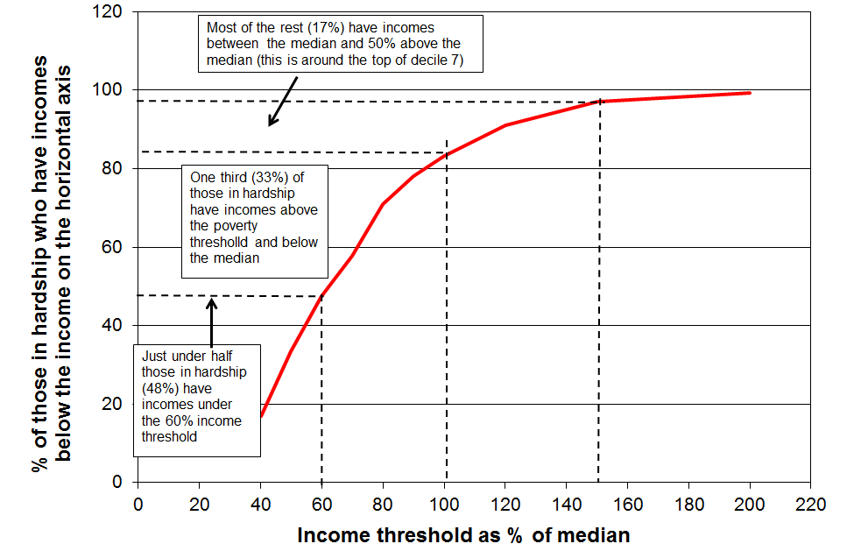
Note: The hardship group is the lower 13-15% defined using the ELSI_SF measure.
Income is AHC household income.
The existence of the mismatch is not surprising. A household’s standard of living (material wellbeing) is determined by its command over resources relative to its needs. Current income, even when measured accurately and adjusted for household size and composition (equivalised) is only one aspect of the resources available to a household: financial assets, the range and quality of household goods, help in cash and in kind from outside the household are all important too, and vary from household to household. Different households also have different demands on the budget from differing debt servicing requirements, health- and disability-related costs, transport costs for getting to paid employment, expectations to assist others outside their own household, and so on. This is further discussed and illustrated in Figure A.1 and the associated text (pp38f).

The mismatch means that there are six groups to consider:
- the income poor
- the materially deprived
- the income poor who are materially deprived (the both/and group)
- the income poor who are not materially deprived
- the materially deprived who are not income poor
- those who are neither.

Table L.3 below shows the proportion of the different groups who report that their household’s income is “not enough” to cover the basics of food, accommodation, clothing, heating and so on. The NIM index used is FRILS rather than ELSI, as ELSI already has the income adequacy question as one of its component items and FRILS does not. The use of FRILS facilitates a more robust investigation of how the different groups on average assess their own income adequacy. The options for the respondent were: not enough, just enough, enough and more than enough.

Table L.3
Self-assessed income adequacy for the six groups noted above, HES 2012
 | ALL | neither | poor only | poor | deprived only | deprived | both
Whole population
size of groups (% of whole population) | 100 | 76 | 9 | 15 | 10 | 15 | 5
% in HHs with “not enough” for the basics | 18 | 10 | 30 | 46 | 43 | 53 | 72
Children (0-17 yrs)
size of groups (% of all children) | 100 | 66 | 12 | 22 | 12 | 22 | 9
% in HHs with “not enough” for the basics | 25 | 12 | 32 | 52 | 44 | 58 | 77
Note: - the AHC 50% of median measure is used for income poverty
- the FRILS measure is used for material deprivation, with the threshold set to give the same proportion as the income poverty measure gives (15%)

Clearly the overlap group (“both”) is the one where the stress and need is the greatest.

Comparing the results for the incomes and NIM approaches

Despite the mismatch discussed above, the population subgroups that are identified as being at higher (or lower) risk of being income poor (AHC) are also identified as being at higher (or lower) risk of material hardship or deprivation.

In the 2012 HES, 13% of the population were identified as poor using the 50% AHC (moving line) measure, and 13% were in hardship as measured using the ELSI measure with the threshold set at 6 or more out of the 16 essential items in Table L.2. For Table L.4 the thresholds for the FRILS measure and the new MWI were adjusted to also give population hardship rates of 12-13%.

Table L.4 reports the poverty and hardship rates for selected subgroups for all four measures. It shows that there is a reasonable similarity in actual proportions identified as ‘income poor’ or ‘in hardship’. In addition it shows that the sub-group relativities are not impacted by the choice of material hardship index that is chosen.

Table L.4
Comparison of hardship rates based on income and non-income measures,
by selected individual and household/family characteristics (2012 HES)
 | Income poverty | Material hardship
 | AHC REL 50 | ELSI | FRILS | MWI
Total population | 13 | 13 | 13 | 12
Age group
0-17 | 20 | 21 | 19 | 19
18-24 | 17 | 14 | 14 | 15
25-44 | 14 | 12 | 12 | 13
45-64 | 9 | 10 | 9 | 9
65+ | 7 | 6 | 8 | 3
Ethnicity (avg over HES 2010, 2011 and 2012)
European | 11 | 10 | 11 | -
Māori/Pacific | 23 | 28 | 31 | -
Family type
SP | 44 | 39 | 34 | 36
2P | 12 | 14 | 14 | 13
Number of children (avg over HES 2010, 2011 and 2012)
One | 19 | 16 | 15 | -
Two | 17 | 15 | 15 | -
Three+ | 27 | 28 | 25 | -
Main source of income for families/households <65
Market | 9 | 10 | 11 | 10
Government | 64 | 43 | 42 | 42

Note: figures for ethnicity and number of children are averages over three surveys to improve the reliability of the estimates, as some of the sub-divisions have relatively low sample numbers.

Tracking hardship, from the 2006-07 HES to the 2011-12 HES

Figure L.3 (using the ELSI) shows the trends in material hardship rates from 2007 to 2012 for the population overall and for selected population groups. The hardship threshold used in Figure L.2 is a relatively stringent one, giving a 2007 population hardship rate of 10%. The income poverty rate using the 50% of median AHC poverty threshold at that time was 13%.

Figure L.3
Trends in material hardship (deprivation), 2007 to 2013

The rise from 2007 to 2011 for the population overall and for children is not unexpected, given the impact of the GFC and the economic downturn. The improved figures for 2011 to 2012 for the population overall and for children reflect the early impact of the recovery.

Three features of the trends in Figure L.3 are worth noting:
- the improvement in hardship figures for children, down from 21% in 2011 to 17% in 2012
- the hardship rate for older New Zealanders (flattish at 4% to 6%) remains much lower than that for children
- the hardship rate older working-age adults living on their own (45 to 64 yrs) increased from 10% in 2007 to an average of 15% from 2010 to 2012 (not shown on graph).

Figure L.4 shows the trends in hardship rates for all children and those from “non-poor” families. It links back to the discussion about the “near-poor” above and is a reminder that there are families with incomes above the 60% of median income poverty line whose financial circumstances can best be described as precarious. Relatively small drops in income or unexpected bills can make a significant difference to their actual day-to-day living conditions.

Figure L.4
Material hardship for children in non-poor families, 2007 to 2012 (ELSI)
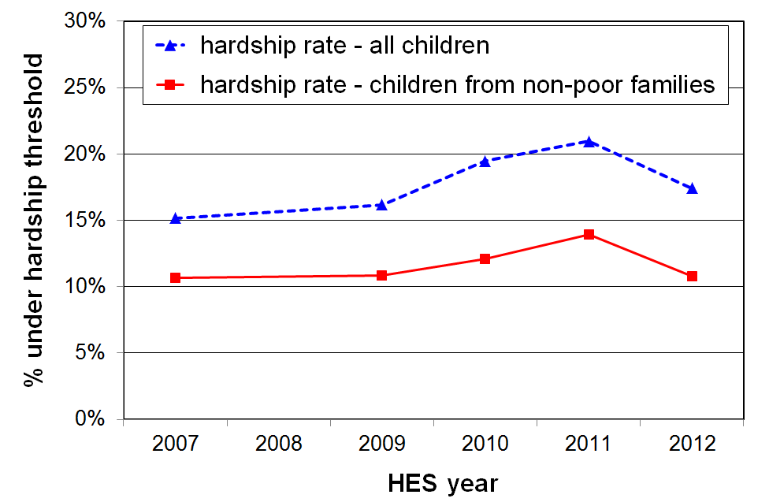

Are the findings sensitive to the choice of threshold or index?

While the actual reported levels of hardship are of course dependent on the thresholds used, the direction of the trends shown in Figure L.3 are robust to the choice of both the threshold and the index used.

For example, using a lower ELSI threshold (more stringent), the hardship rate for children increased from 13% to 17% from HES 2007 to 2011, falling to 15% in 2012. Using a higher threshold (less stringent) the increase was from 18% in 2007 to 24% in 2011, falling to 20% in 2012.

Figure L.5 shows that using the quite differently configured FRILS measure, the pattern was similar with rises for the whole population and children from 2007 to 2011, then a fall from 2011 to 2012. As in Figure L.2 (ELSI), the hardship rate was higher in 2012 than in 2007 for older working-age people living on their own, while for working-age couples and older New Zealanders, hardship rates remained lower than for other groups.

Figure L.5
Material hardship for whole population and selected sub-groups, 2007 to 2012 (FRILS)

Using NIMs and household income together to identify the proportion of those who live in households whose incomes are below the AHC 60% of median poverty line and who are also experiencing material deprivation.

As discussed earlier in this section, one of the features of the relationship between income poverty and material hardship as measured using NIMs is that although living in a household with an income above the poverty line reduces the risk of material hardship, it does not eliminate the risk. Some of the non-poor still experience material hardship (and some of the poor do not).

For those in hardship but with incomes reasonably above the poverty line there are grounds for expecting living standards to improve over time provided their incomes do not decline and that there are no on-going special demands on the budget. However for those in hardship who also have low incomes, there is very little chance of improvement of living standards until incomes rise and stay up.

Figure L.6 shows the trend in the size of the overlap group from 2007 to 2012 for the population as a whole and for children (up from 7% in 2007 to 13% in 2010, and down a little to 11% in 2012).

Those in the overlap group are sometimes referred to colloquially as being in “severe hardship” or “severe poverty”. These are awkward descriptions as “severe poverty” usually means being under a very low income threshold, and “severe hardship” as being under a very stringent hardship threshold. In Ireland they are referred to as the “consistently poor”.

Figure L.6
Trends in the proportion of those who are both income poor and materially deprived, 2007 to 2012

As with the hardship trends noted above, the trend finding here for the overlap group is robust to the choice of both the index used and the threshold applied. For example, using the more stringent ELSI threshold described on the previous page, the overlap group for children was 6% in the 2007, 11% in 2010, and 9% in 2012.

Using non-income measures (NIMs) to illustrate the sorts of restrictions on living standards experienced by low-income and high deprivation households

One of the values of NMIs is their ability to describe in tangible ways what it means to be poor or to be in hardship. The items in the HES can do this to some extent, but a wider range of information is needed to give a fuller picture of what it means in practical day-to-day terms to live in a household with low income. MSD’s 2008 Living Standards Survey gathered a wide range of information on respondents and published material is available using this dataset. In particular, some of the published material uses child-specific items to show the restrictions experienced by children in households with low-income or low living standards. The HES does not have these child-specific items.

In the three tables that follow, the first two are from MSD’s 2008 Living Standards Survey (LSS 2008) and focus on children (aged 0-17years). The third one is from HES 2013 and looks at the whole population. The 2008 LSS has a wider range of items than the HES, including child-specific items such as whether all children have separate beds, have a raincoat, are able to participate in special interests such as music lessons, kapa haka, sports clubs, and so on.

The tables that follow are constructed in two quite different ways:
- The first table ranks households by their ELSI scores, then looks at the sort of restrictions that are faced by children in households with high material deprivation / low material wellbeing compared with those in households with modest to higher day-to-day living standards.
- The other two rank households by their AHC incomes from low to high income, then group them into deciles. The tables show the various items that those in the different income levels do not have, cut back on a lot, or the actions they take to make ends meet (such as borrowing from family and friends).

When using this information, it is important to preserve the distinction between the two ranking methodologies (non-income and income measures), and to avoid using the information from the first table (ranking by material deprivation) as if it applied to low-income households.

Reading notes for Table L.5

- The seven Living Standard Levels are those used in the ELSI reports, and range from Levels 1-2 (the hardship zone) to Level 7 (very high lving standards).

- Level 3 lies between the hardship zone and the ‘OK to high’ zone. A possible descriptor is ‘many here find it difficult to make ends meet’.

2 The 20 items used in the summary multiple deprivation measure are the 12 children’s items in the top half of the table, plus 8 from those applying to the wider family context: unable to keep rooms warm, cut back on fresh fruit and vegetables (a lot), delayed repairs or replacements of appliances (a lot), dampness or mould (major problem), crime or vandalism in the area (major problem), received help from food bank etc (more than once in the last 12 months), late payment of car registration (more than once in last 12 months), late payment of electricity etc (more than once in the last 12 months).

3 For the economising questions the possible responses were ‘not at all’, ‘a little’, or ‘a lot’. ‘A lot’ is used in Table 2. For the housing and crime questions, the possible responses were ‘no problem, ‘minor problem’, or ‘major problem’. Only ‘major problem’ is used.

Table L.5
Children’s deprivations of necessities, and other restrictions or stress points in their day-to-day lives,
by their family’s ELSI score (Living Standards Level), LSS 2008
 | All | hardship zone |  | see note 1 | OK to high
Living standard level (1=low, 7=high) |  | 1 | 2 | 3 | 4 | 5-7
Distribution of children across the levels (%) | 100 | 10 | 10 | 14 | 22 | 45
 |  | one third |  |  | two thirds
Enforced lacks of children’s items (%) – do not have because of the cost
warm winter clothes | 3 | 23 | 6 | 3 | - | -
two pair of good/sturdy shoes | 7 | 42 | 11 | 9 | 3 | -
waterproof coat | 8 | 44 | 16 | 9 | 4 | -
all school uniform items required by the school | 5 | 33 | 9 | 6 | 1 | -
separate bed | 5 | 27 | 8 | 5 | 2 | -
separate bedrooms for children of opposite sex (aged 10+) | 8 | 31 | 17 | 12 | 4 | 1
friends to birthday party | 6 | 40 | 13 | 5 | 1 | -
Economising ‘a lot’ on children’s items to keep down costs to enable other basic things to be paid for (%)
continued with worn out shoes/clothes for the children | 7 | 39 | 21 | 8 | 3 | -
postponed child’s visit to doctor | 2 | 13 | 5 | 4 | - | -
unable to pay for school trip | 3 | 18 | 6 | 5 | - | -
went without music, dance, kapa haka, art, swimming, etc | 9 | 38 | 23 | 13 | 4 | 1
involvement in sport had to be limited | 8 | 34 | 21 | 11 | 3 | -
Multiple lacks of children’s items
3+ of the 12 children’s items above | 10 | 60 | 24 | 13 | 1 | -
4+ of the 12 children’s items above | 6 | 45 | 13 | 5 | - | -
5+ of the 12 children’s items above | 4 | 33 | 8 | 3 | - | -
Enforced lacks reported by respondent in child’s family (%)
could not keep main rooms warm because of cost | 9 | 41 | 20 | 11 | 4 | -
cut back or did without fresh fruit and vegetables (‘a lot’) | 14 | 65 | 34 | 15 | 10 | -
postponed own visit to doctor (‘a lot’) | 15 | 56 | 48 | 22 | 9 | -
delayed repair or replacement of appliances (‘a lot’) | 19 | 73 | 45 | 25 | 14 | 1
no home computer / internet access | 8 | 33 | 18 | 10 | 5 | -
Housing and local community conditions (%)
difficult to keep house warm in winter (major problem) | 22 | 61 | 39 | 33 | 19 | 4
dampness or mould (major problem) | 17 | 47 | 40 | 26 | 14 | 2
crime or vandalism in the area (major problem) | 11 | 30 | 16 | 12 | 7 | 4
Financial strain (%) – for the first 4 items below, the selected response was ‘more than once in the last 12 months’
received help (food, clothes, money) from food bank or similar | 8 | 38 | 23 | 9 | 4 | -
borrowed from family/ friends for everyday living costs | 19 | 62 | 47 | 33 | 12 | 2
late payment of car registration / insurance | 15 | 57 | 35 | 26 | 8 | 1
late payment of electricity, water , etc | 18 | 59 | 36 | 25 | 15 | 1
unable to cope with unexpected $500 expense (ie cannot pay within a month without borrowing) | 26 | 81 | 57 | 40 | 18 | 2
Children’s serious health problems reported by respondent (%)
serious health problems for any child in the last year |  | 50 | 30 | 31 | 30 | 21
Overall dissatisfaction with living standards reported by respondent (%)
dissatisfied or very dissatisfied with material standard of living | 14 | 60 | 30 | 20 | 8 | -
Summary multiple deprivation scores (based on 12 children’s items plus 8 general household items – see note 2)
5+ of 20 | 14 | 81 | 38 | 12 | 2 | -
6+ of 20 | 11 | 73 | 25 | 8 | - | -
8+ of 20 | 6 | 47 | 11 | 3 | - | -

The next two tables rank households by their AHC incomes, in contrast to Table L.5 which ranked households by their score on ELSI which uses non-incomes measures.

Table L.6 shows the much greater chance for specific lacks or for hardships for low-income households with children. The deciles are deciles of AHC income for the whole population. Households with children are not evenly distributed across the full population deciles: for example, 25% of children come from households in the lowest quintile. The children are divided into five broad groups for Table L.6:
- the low-income zone – deciles 1 and 2 (these deciles have similar numbers of children)
- those in households with incomes just above the usual poverty lines – decile 3
- middle-income households – deciles 4 to 6
- households with above average incomes – deciles 7 and 8
- high-income households – deciles 9 and 10

The point of Table L.6 is to give an idea of the great difference in day-to-day life for those children in low-income households compared with those children in the bulk of the rest of the households across the income distribution, as well as to highlight some features of the low-income experience that are of concern in their own right.

Table L.6
The day-to-day experience of children in low-income households compared with that of their better- off peers: proportions of financial stress and hardship items by AHC income decile (%), LSS 2008
Population household income decile (AHC) ➔ | 1 | 2 | 3 | 4 | 5 - 6 | 7 - 8 | 9 - 10
Proportion of children in each population decile ➔ | 13% | 13% | 7% | 13% | 22% | 19% | 14% | 100%
 | Low income |  | Just above usual pov lines | Middle income |  | Above avg income | High income | All children
Could not pay an unexpected expense of $500 within a month without borrowing | 58 | 52 | 34 | 16 | 15 | 5 | 2 | 25
Parent(s) borrowed money from family or friends to meet everyday living costs [more than once in the last year] | 42 | 44 | 27 | 11 | 12 | 6 | 2 | 19
Household received help in the form of food, clothes or money from a welfare/community organisation such as a church or foodbank [more than once in last year] | 20 | 20 | 9 | 3 | 3 | 2 | 1 | 8 (>once)  14 (once or more)
Parent(s) reported EL of a meal with meat, fish or chicken at least each second day | 10 | 5 | 2 | 2 | 2 | 0 | 0 | 3
Dampness or mould is a major problem | 32 | 30 | 23 | 13 | 17 | 9 | 9 | 17
EL for keeping the main rooms of the house adequately warm | 16 | 18 | 9 | 12 | 7 | 2 | 2 | 9
EL of home computer | 30 | 25 | 22 | 16 | 7 | 4 | 4 | 8
Child(ren) went without music, dance, art, swimming, or other special interest lessons because of the cost [a lot] | 20 | 14 | 15 | 6 | 7 | 2 | 1 | 9
Do not have a separate bed for each child | 23 | 13 | 11 | 7 | 6 | 2 | 1 | 8
Do not have enough bedrooms so that children over 10 of the opposite sex are not sharing a room | 30 | 27 | 15 | 16 | 16 | 7 | 5 | 17
Visits by parent(s) to the doctor for themselves postponed [a lot] to keep down costs | 27 | 29 | 22 | 12 | 12 | 10 | 4 | 16
Postponed child visits to the doctor to keep down costs [a lot] | 3 | 7 | 3 | 5 | 0 | 0 | 0 | 2
Note: Three types of survey questions lie behind the information reported in Table L.6:
- Enforced lacks (EL) – the respondent reported wanting the item but not doing / having it because of the cost
- Economising behaviour – respondent reported restricting consumption of a particular item [a lot] to keep costs down to help with the purchase of other basic items
- Do not have an item or have a major problem with a specific item.

Table L.7 uses selections from the new suite of 29 non-income measures that are in the 2012-13 HES. It uses the same approach as in Table L.6: households are ranked by their AHC incomes and the individuals in them are grouped into deciles (10% of the population are in each decile).

The items were selected with a view to not only showing the gradient across the income deciles, but also to paint a picture of how different the day-to-day life experience for those with low incomes can be compared with the rest of the population.

Table L.7
Responses to non-incomes items across the income distribution, a selection from HES 2013
 | % | ALL | 1 | 2 | 3 | 4 | 5 | 6 | 7 | 8 | 9 | 10
Don’t have or do because of cost / need to use money on other basics
 | home contents insurance | 17 | 50 | 36 | 28 | 15 | 14 | 12 | 5 | 7 | 1 | 0
 | put up with feeling cold | 9 | 24 | 16 | 16 | 11 | 8 | 3 | 6 | 3 | 2 | 1
 | postponed or put off dentist | 26 | 45 | 44 | 32 | 28 | 29 | 21 | 26 | 20 | 8 | 7
Housing problems (no problem, minor problem, major problem)
 | dampness or mould (major problem) | 9 | 17 | 14 | 13 | 14 | 7 | 8 | 4 | 3 | 3 | 3
 | heating or keeping it warm in winter (major problem) | 10 | 19 | 20 | 13 | 12 | 12 | 5 | 10 | 5 | 2 | 4
Mulitple deprivations (see below)
 | 4+ out of 13 | 10 | 28 | 23 | 15 | 12 | 7 | 6 | 3 | 4 | 1 | 0
Adequacy of income to cover basics of accommodation, food, clothing, etc
 | not enough | 16 | 45 | 32 | 28 | 20 | 13 | 6 | 10 | 4 | 3 | 1
 | not enough or only just enough | 46 | 80 | 71 | 69 | 58 | 47 | 36 | 40 | 22 | 27 | 9
Satisfaction with all areas of life
 | dissatisfied or very dissatisfied | 9 | 22 | 14 | 9 | 8 | 9 | 7 | 8 | 3 | 5 | 2
 | satisfied or very satisfied | 77 | 49 | 66 | 75 | 71 | 81 | 81 | 78 | 89 | 81 | 94

Note: The 13 deprivation items used are listed in Table L.1 as 1, 2, 4, 6, 10, 11, 13, 15, 17, 21, 23, plus foodbank usage more than once in the 12 months prior to interview.
Using non-monetary indicators (NMIs) to help assess the credibility of a given income poverty threshold

Figure L.7, based on NMI data from the 2012 HES, clearly shows the much greater risk of hardship for low-income households in the lower quintile (20%) than for the rest of the population. The 11 items used are all either necessities or ones that are commonplace among the bulk of the population, or both. The graph shows the proportions reporting either an “enforced lack” of an item because of the cost, or the decision to “economise a lot” on the item so as to be able to pay for other basics.

The lower two deciles stand out as being quite different in their risk of hardship / degree of restriction in day-to-day living standards compared with the rest of the population. This is the essence of what relative disadvantage is all about, as discussed in Section E.

The AHC 60% of median fixed line measure that is commended in this report as the primary income poverty measure for monitoring trends has been in the 15% to 18% range in recent years and is therefore well within the bottom quintile (20%). The 50% and 60% of median moving line AHC measures have recently produced poverty rates of around 14% and 19% respectively, again, within the bottom quintile. None of this proves that these lines are “correct”, but it does provide some reasonable support for setting the thresholds where they are or a little lower. Using 4+ rather than 3+ deprivations gives the same picture: deciles one and two have double the deprivations of deciles 3 to 5.

Figure L.7
Proportion reporting not having / economising a lot on 3 or more of 11 basic items, because of cost:
all households, HES 2012
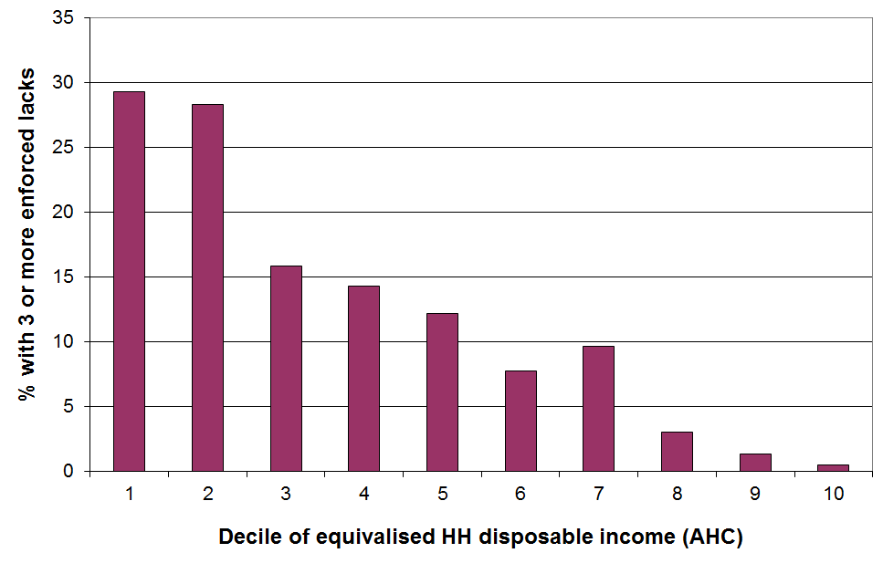

The 11 items used in Figure L.7 are of two types (see also Table L.1 above):
- 7 ‘enforced lacks’ of basics that the respondent ‘wants’ but cannot have or do because of the cost:
- telephone
- good pair of shoes
- heating available in all main rooms
- contents insurance
- give presents to family or friends on special occasions
- have family or friends over for a meal at least once a month
- have a week’s holiday away from home each year
- 4 ‘economising’ items. The survey gives the option of ‘not at all’, ‘a little’ and ‘a lot’ as a response. The graph uses only the more stringent ‘ lot’ response:
- gone without fresh fruit and vegetables to help keep costs down (‘a lot’)
- put off buying new clothes for as long as possible to help keep costs down (‘a lot’)
- postponed or put off visits to the doctor to help keep down costs (‘a lot’)
- did not pick up a prescription to help keep down costs (‘a lot’)

References

Alcock, P. (1993), Understanding Poverty, London: Macmillan
Alvaredo, F. (2010). ‘A note on the relationship between top income shares and the Gini coefficient’, Economics Letters, Manuscript Draft.
Alvaredo, F., Atkinson, A., Piketty, T & Saez, E. (2012). ‘The World Top Incomes Database’, http://g-mond.parisschoolofeconomics.eu/topincomes, 12/08/2012
Atkinson, A. (1989), Poverty and Social Security, Hemel Hempstead: Harvester Wheatsheaf.
Atkinson, A. (2007), ‘Measuring Top Incomes: Methodological Issues, in Atkinson and Picketty (2007) Top Incomes over the Twentieth Century, Oxford: Oxford University Press.
Atkinson, A., Piketty, T & Saez, E. (2011). ‘Top incomes in the long run of history’, Journal of Economic Literature, 49(1), 3-71.
Australian Bureau of Statistics (2013a), Household Income and Income Distribution, Canberra: ABS
Australian Bureau of Statistics (2013b), Household Wealth and Wealth Distribution, Canberra: ABS
Aziz, O., Gibbons, M., Ball, C., & Gorman, E. (2012), ‘The effect on household income of government taxation and expenditure in 1988, 1998, 2007 and 2010’, Policy Quarterly, 8(1), 29-38.
Ballantyne, S., Chapple, S., Mare, D., & Timmins, J. (2004), 'Triggering movements into and out of child poverty: a comparative study of New Zealand, Britain and West Germany', Social Policy Journal of New Zealand, (23), 83-96.
Berthoud, R., Blekesaune, M., & Hancock, R. (2006). 'Are 'poor' pensioners 'deprived'?' Research Report # 364, Department for Work and Pensions.
Boarini, R., & Mira d'Ercole, M. (2006). 'Measures of Material Deprivation in OECD Countries.' Social, Employment and Migration Working Paper # 37, OECD, Paris .
Bradbury, B. (2003), 'Child Poverty: a Review.' Report 3/03, Social Policy Research Centre, University of New South Wales.
Bradshaw, J., Middleton, S., Davis, A., Oldfield, N., Smith, N., Cusworth, L.,& Williams, J. (2008), A Minimum Income Standard for Britain: What people think, Joseph Rowntree Foundation, York.
Brewer, M., Goodman, A., Muriel, A., & Sibieta, L. (2007), 'Poverty and Inequality in the UK: 2007.' Institute for Fiscal Studies Briefing Note No. 73, London.
Brewer, M., Goodman, A., Myck, M., Shaw, J., & Shepherd, A. (2004). 'Poverty and Inequality in Britain: 2004.' Commentary 96, Institute for Fiscal Studies, London.
Brewer, M., O’Dea, C., Paull, G. & Sibieta, L. (2009). ‘The Living Standards of Families with Children Reporting Low Incomes’, DWP Research Report no. 577, London: Department for Work and Pensions.
Carter, K. & Imlach Gunasekara, F. (2012). ‘Dynamics of Income and Deprivation in New Zealand, 2002-2009. A descriptive analysis of the Survey of Family, Income and Employment (SoFIE).’ Public Health Monograph Series No. 24. Wellington: Department of Public health, University of Otago, Wellington.
Chen, W. (2009), ‘Cross-national differences in income mobility: evidence from Canada, the United States, Great Britain and Germany’, Review of Income and Wealth 53 (1), 75-100.
Citro, C. F., & Michael, R. T. (eds) (1995). Measuring Poverty: A New Approach. Washington, DC: National Academy Press.
Cobham, A. & Sumner, A. (2013), ‘Is it all about the tails? The Palma measure of inequality.’ Working Paper 343, Center for Global Devlopment.
Crawford, R., & Johnston, G. (2004), 'Household incomes in New Zealand: the impact of the market, taxes and government spending, 1987/88 to 1997/98.' New Zealand Treasury Working Paper, 04/20.
Creedy, J. & Tuckwell, I. (2003), 'Reweighting the New Zealand Household Economic Survey for Tax Microsimulation Modelling.' New Zealand Treasury Working Paper 03/33.
Department for Work and Pensions (2004), Measuring Child Poverty, DWP.
Department for Work and Pensions (2013), Households Below Average Income 1994/95 - 2011/12 Leeds: Corporate Document Services.
Dixon, S. (1998), 'Growth in the dispersion of earnings: 1984-1997', Labour Market Bulletin, 71-107.
Doyal, L. & Gough, I. (1991), A Theory of Human Need. Basingstoke: Macmillan.
Easton, B. (1995a), 'Poverty in New Zealand, 1981 to 1993', New Zealand Sociology, 10 (2), 182-214.
Easton, B. (1995b), 'Properly assessing income adequacy in New Zealand', New Zealand Economic Papers, 29 (1), 89-102.
Easton, B. (1996), 'Income distribution', in B. Silverstone, A. Bollard, & R. Lattimore (eds), A Study of Economic Reform: The Case of New Zealand. Amsterdam: Elsevier.
Easton, B., & Ballantyne, S. (2002), 'The economic and health status of households.' Wellington School of Medicine.
Eurostat (2005), 'Material Deprivation in the EU.' Statistics in Focus - Population and Social Conditions, 21/2005, Eurostat, Luxembourg.
Eurostat (2008), Living Conditions in Europe. Luxembourg: European Commission.
Eurostat (2009), Key Figures on Europe. Luxembourg: European Commission.
Expert [Canberra] Group on Household Income Statistics (2001). 'Final Report and Recommendations.' Canberra Group, Ottawa.
Fahey, T., Nolan, B., and Maître, B. (2004), Housing, Poverty and Wealth in Ireland. Dublin : Combat Poverty Agency.
Fahey, T. (2007), ‘The case for an EU-wide measure of poverty’, European Sociological Review, 23(1), 35-47
Figari, F., Paulus, A., Sutherland, H., Tsakloglou, P., Verbist, G., Zantomio, F. (2012), ‘Taxing Home Ownership: Distributional effects of including net imputed rent in taxable income.’ IZA Discussion Paper No. 6493, Bonn.
Figari, F., Iacovou, M., Skew, A., & Sutherland, H. (2010), ‘Approximations to the truth: comparing survey and microsimulation approaches to measuring income for social indicators.’ Institute for Social and Economic Research Working Paper 2010-13.
Förster, M., Llena-Nozal, A., & Nafilyan, V. (2014). 'Trends in Top Incomes and their Taxation in OECD Countries', OECD Social, Employment and Migration Working Papers, No 159, OECD, Paris.
Fuchs, V. (1967), ‘Redefining poverty and redistributing income’, The Public Interest (8), 88-95.
Gordon, D. & Townsend, P. (eds) (2000). Breadline Europe. Bristol: Policy Press.
Hills, D et al (2010) An Anatomy of Economic Inequality in the UK.
Hyslop, D., & Maré, D. (2001). 'Understanding changes in the distribution of household incomes in New Zealand between 1983-86 and 1995-98.' New Zealand Treasury Working Paper 01/21.
Hyslop, D., & Yahanpath, S. (2005). 'Income growth and earnings variations in New Zealand, 1998-2004.' New Zealand Treasury Working paper 05/11.
Iceland, J. (2000), 'The family/couple/household unit of measurement in poverty estimation', Journal of Economic and Social Measurement, 26, 1-13.
Iceland, J. & Bauman, J. (2007). ‘Income poverty and material hardship: How strong is the association?, The Journal of Socio-Economics 36 (3): 376-96.
Jantti, M., Sierminska E. and Smeeding T. (2008), “The Joint Distribution of Household Income and Wealth: Evidence from the Luxembourg Wealth Study”, OECD Social, Employment and Migration Working Paper, No. 65, OECD, Paris.
Jenkins, S. (2011). Changing Fortunes: Income Mobility and Poverty Dynamics in Britain. Oxford: Oxford University Press.
Jensen, J., Krishnan, V., Hodgson, R., Sathiyandra, S. G., & Templeton, R. (2006), New Zealand Living Standards 2004, Wellington: Ministry of Social Development.
Jensen, J., Spittal, M., Crichton, S., Sathiyantra, S., & Krishnan, V. (2002), Direct Measurement of Living Standards: the New Zealand ELSI Scale, Wellington: Ministry of Social Development.
Krishnan, V., Jensen, J., & Ballantyne, S. (2002), New Zealand Living Standards 2000, Wellington: Ministry of Social Development.
Lister, R. (2004), Poverty, Cambridge: Polity Press.
Madden, K. (2014), “The heart of poverty: Matching passion with precision for struggling New Zealanders”, Poverty Issues Paper, Maxim Institute, Auckland.
Ministry of Social Development (2010), Sole Parenting: An Update on Key Trends and What Helps Reduce Disdavantage, Wellington: Centre for Social Research and Evaluation, MSD
Mowbray, M. (2001), Distributions and Disparity: New Zealand Household Incomes, Wellington: Ministry of Social Policy.
New Zealand Treasury (2010), Distributional Measures in Relation to Tax Changes: Aide-Mémoire for Minister of Finance, Wellington: New Zealand Treasury
Nolan, B., & Whelan, C. T. (1996), Resources, Deprivation and Poverty, Oxford: Clarendon Press.
Nolan, B., & Whelan, C. T. (2007), ‘On the Multidimensionality of Poverty and Social Exclusion’, in Jenkins, S and Micklewright, J. (eds), Inequality and Poverty Re-examined, Oxford: Oxford University Press.
Nolan, B., & Whelan, C. T. (2011), Poverty and Deprivation in Europe, Oxford: Oxford University Press
Notten, G. & de Neubourg, C. (2011), ‘Monitoring absolute and relative poverty: “Not enough” is not the same as “much less” ‘, Review of Income and Wealth 57 (2), 247-269.
O'Dea, D. (2000). 'The changes in New Zealand's income distribution.' New Zealand Treasury Working Paper, 00/13.
OECD (2007), OECD Economic Surveys, Paris: OECD.
OECD (2008), Growing Unequal: Income Distribution and Poverty in OECD countries, Paris: OECD
OECD (2009), Pensions at a Glance 2009, Paris: OECD
OECD (2011a), Doing Better for Families, Paris: OECD.
OECD (2011b), Society at a Glance, Paris: OECD.
OECD (2013), OECD Framework for Statistics on the Distribution of Household Income, Consumption and Wealth, Paris: OECD.
Palma, G. (2011), ‘Homogeneous middles vs. heterogeneous tails, and the end of the ‘Inverted-U’: the share of the rich is what it’s all about’, Cambridge Working Papers in Economics 1111, Cambridge, University of Cambridge, Department of Economics.
Perry, B. (2002), 'The mismatch between income measures and direct outcome measures of poverty', Social Policy Journal of New Zealand, (19), 101-127.
Perry, B. (2005), 'The choice of income sharing unit for poverty measurement: household or economic family unit?' Unpublished discussion paper, Ministry of Social Development, Wellington.
Perry, B. (2009), ‘Non-income measures of material wellbeing and hardship: first results from the 2008 New Zealand Living Standards Survey, with international comparisons.’ Working Paper 01/09, Ministry of Social Development, Wellington.
Perry, B. (2015, forthcoming), ‘Non-income measures of material wellbeing and hardship in New Zealand: full findings from the 2008 Living Standards Survey and the Household Economic Survey, 2006-07 to 2012-13.’
Piachaud, D. (1987), ‘Problems in the definition and measurement of poverty’, Journal of Social Policy, 16 (2), 147-164.
Saunders, P. (1997), 'Living standards, choice and poverty', Australian Journal of Labour Economics, 1(1), 49-70.
Saunders, P. (1999), 'The Perception of Equality.' Social Policy Research Centre Newsletter (75), University of New South Wales .
Sen, A. (1983),’Poor, relatively speaking’, Oxford Economic Papers, 35, 153-169.
Shorrocks, A., Davies, J., & Lluberas, R. (2013), Credit Suisse Global Wealth Databook 2013, Zurich: Credit Suisse Group AG.
Sierminska, E., Brandolini A. & Smeeding T. (2006), “Comparing Wealth Distribution across Rich Countries: First Results from the Luxembourg Wealth Study”, Luxembourg Wealth Study Working Paper No. 1.
Singley, S. & Callister, P. (2003), ‘Work-poor or working poor? A comparative perspective on New Zealand’s rise in household employment inequality’, Social Policy Journal of New Zealand, (20), 134-155
Statistics Canada (2011), Income of Canadians, 2009, Ottawa: Statistics Canada.
Statistics New Zealand (2007), Wealth Disparities in New Zealand, Wellington: Statistics New Zealand.
Stephens, R. J. (1988), 'Issues in the measurement of poverty and standards of living.' Discussion Paper #48, Department of Economics, Victoria University of Wellington .
Stephens, R., Waldegrave, C., & Frater, P. (1995), 'Measuring poverty in New Zealand', Social Policy Journal of New Zealand, (5), 88-112.
Tax Working Group (2010), ‘A Tax System for New Zealand’s Future: Report of the Victoria University of Wellington Tax Working Group’, Victoria University of Wellington, Wellington.
Tomlinson, M. & Walker, R. (2009), ‘Coping with Complexity: Child and Adult Poverty.’ Child Poverty Action Group, London.
Townsend, P. (1979), Poverty in the United Kingdom, Harmondsworth: Penguin Books.
UNECE (2011), The Canberra Group Handbook on Household Income Statistics, Second Edition, ECE/CES/11, United Nations, Geneva.
UNICEF (2000), 'A League Table of Child Poverty in Rich Nations.' Innocenti Report Card No. 1, UNICEF Innocenti Research Centre, Florence.
UNICEF (2007), Child Poverty in Perspective: An Overview of Child Well-being in Rich Countries, Florence: UNICEF Innocenti Research Centre.
Waldegrave, C., Stephens, R., & King, P. (2003), 'Assessing the progress on poverty reduction', Social Policy Journal of New Zealand, (23), 197-222.
Waldegrave, C., Stuart, S., & Stephens, R. (1996), 'Participation in poverty research: drawing on the knowledge of low-income householders to establish an appropriate measure for monitoring social policy impacts', Social Policy Journal of New Zealand, (7), 191-206.
Whelan, C., Nolan, B., & Maître, B. (2014), ‘Multidimensional poverty measurement in Europe: An application of the adjusted headcount approach’, Journal of European Social Policy 24(2), 183-197.
Whiteford, P. (2009), ‘Family Joblessness in Australia’, A paper commissioned by the Social Inclusion Unit, Department of Prime Minister and Cabinet, Canberra.
Whiteford, P. (2014), “Income and wealth inequality: How is Australia faring?” The Conversation, 5 March 2014, http://theconversation.com/income-and-wealth-inequality-how-is-australia-faring-23483
Wilkins, R., Warren, D., Hahn, M., & Houng, B. (2011), ‘Families, Incomes and Jobs, Volume 6: A Statistical Report on Waves 1 to 8 of the HILDA Survey’. Melbourne Institute of Applied Economic and Social Research, Melbourne.
Wilkins, R. (ed). (2013), ‘Families, Incomes and Jobs, Volume 8: A Statistical Report on Waves 1 to 10 of the HILDA Survey’. Melbourne Institute of Applied Economic and Social Research, Melbourne.
Wilkins, R. (ed). (2014), ‘Families, Incomes and Jobs, Volume 9: A Statistical Report on Waves 1 to 11 of the HILDA Survey’. Melbourne Institute of Applied Economic and Social Research, Melbourne.

The full HES is run each three years (2003-04, 2006-07, 2009-10, and so on). Starting with 2007-08, a shortened version of the full HES is run in the two intervening years to collect data on incomes, housing cost expenditure and living standards indicators. It is referred to as the HES (Income). For more detail on the HES in general, and especially on the 2012-13 HES, see www.stats.govt.nz/hes
Access to the HES and SoFIE data was provided by Statistics New Zealand under conditions designed to meet the confidentiality provisions of the Statistics Act 1975. The results presented in this analysis are the work of the Ministry of Social Development except where otherwise stated.
The report shares many of the assumptions used by the New Zealand Poverty Measurement Project (Stephens et al, 1995; Waldegrave et al, 1996), Mowbray (2001) and Easton (1995a, 1995b, 1996) in their reporting on poverty trends in New Zealand.
Inequalities within households (intra-household inequality) are also important dimensions of inequality. They are outside the scope of the Incomes Report.
This in turn can assist with a better understanding of the depth of poverty and hardship.
By removing those aged 58+, the impact on the reported transitions of those whose incomes drop significantly when they “retire”, and of those aged 65+ on relatively fixed incomes, is eliminated.
Only gross household income is available in the SoFIE dataset. It turns out that a 50% of gross median threshold gives similar poverty rates to a 60% of median disposable income threshold (income after all taxes and transfers). The special HES datasets that are used for most of the analysis in this report have both gross and disposable household income.
For more information on NIMs and associated indices, see the Ministry’s website: www.msd.govt.nz/about-msd-and-our-work/publications-resources/monitoring/living-standards/index.html
For detailed information on the EU index, see Section D in the MSD report at: http://www.msd.govt.nz/about-msd-and-our-work/publications-resources/monitoring/living-standards/living-standards-2008.html
In general, income is regarded as all receipts which are received regularly or are of a recurring nature. The sources are wages and salaries, self-employed income (defined as the before-tax profit/loss of the business), social welfare benefits (including Family Support and its tax credit successors, and the Accommodation Supplement and its pre-cursors), New Zealand Superannuation and war pensions, income from investment, and other regular income (such as maintenance and directors’ fees). For a business which recorded a loss in its latest balance sheet or profit and loss account, the respondent concerned is allocated a negative amount for self-employment income, the amount being the full loss or, in the case of a partnership, the respondent's share of the loss.
For 1982 to 2004, the incomes data is calculated using Taxmod, the predecessor of Taxwell.
UNECE (2011).
See Section E for a more detailed stylised diagram and further discussion.
Australia currently has better developed surveys and datasets on wealth than New Zealand does and the analysis that follows draws on both the Survey of Income and Housing (SIH) run by the Australian Bureau of Statistics (ABS), and the Household, Income and Labour Dynamics in Australia (HILDA) Survey run by the Melbourne Institute and funded by the Australian Department of Social Services. For New Zealand comparisons, unpublished New Zealand Treasury analysis of the wealth and income information from the 2003-04 wave of Statistics New Zealand’s Survey of Family, Income and Employment (SoFIE) is used. In Section L (on mobility and poverty persistence), HILDA data is used to briefly report on wealth mobility.
See Whiteford (2014) for further commentary on the joint distribution.
The OECD recently published a report on a “Framework for Statistics on the Distribution of Household Income, Consumption and Wealth” (OECD, 2013). It was one of the products of a 2011-12 work programme of an OECD expert group, chaired by Bob McCall from the Australian Bureau of Statistics, whose task was to improve existing metrics for measuring people’s economic well-being at the micro level, i.e. at the level of individuals and households.
See Jensen et al (2002), Krishnan et al (2002), Jensen et al (2006), and Perry (2009) available at: http://www.msd.govt.nz/work-areas/social-research/living-standards/index.html
Ideally, equivalence scales would also take into account other factors such as the age of children, the costs of being employed, the extra costs of disability, the differing costs faced by people in different geographical locations, the different ratios needed for households of the same type but of different incomes, and so on. Such considerations further complicate an already fraught estimation process and the common practice is to settle for simpler scales as a rough-and-ready but better-than-nothing approximation. It is important to keep in mind that equivalisation is not intended (or able) to ‘fix’ the fundamental limitations of using current household income as an indicator of available resources, in particular that it does not take into account wealth, or “other factors” as noted in Figure A.1.
‘Canberra Group Handbook’, (UNECE, 2011).
This is sometimes referred to as a person-weighted approach, in contrast to a household-weighted approach. The latter reports the proportion of households below various thresholds, income inequality across households, and so on. The person-weighted approach is the international standard for the sort of analysis reported in this paper. See Appendix 4 for a comparison of poverty rates using the two approaches.
See Appendix 2 in Perry (2005) for an extended discussion on the choice of income sharing unit.
BHC income is the same as disposable or after-tax cash income. AHC income is sometimes referred to as ‘income adjusted for housing costs’, ‘disposable income net-of-housing-costs’ or ‘residual income’.
There is an argument for excluding repayment of mortgage principal from housing costs on the grounds that it is simply a form of near-compulsory saving. This report includes repayment of principal in housing costs on the grounds that for most mortgages there is little scope for adjusting principal repayments to help cope with ‘tight times’. It is in effect income not available to households in the short to medium term for other uses. See Appendix 5 for the difference it makes when mortgage principal is excluded from housing costs.
See the Statistics New Zealand website for general information about the HES, and for Statistics New Zealand’s first release reports. The Hot Off the Press release from November 2013 has analysis and general information on the 2013 HES. See www.stats.govt.nz/browse_for_stats/people_and_communities/Households/household-economic-survey-info-releases.aspx
For more detail on the imputation process and the impact on achieved response rates, see the Technical Appendix to the 2009-10 HES Hot Off the Press release (see link noted in the previous footnote).
An Appendix is being developed to report sensitivity testing on the use of Taxwell and Statistics New Zealand weights for the HES. This new Appendix is expected to be ready for next year’s report.
In reports prior to the 2010 report, the reference or base year for the fixed line poverty measures was 1998. The shift to 2007 has had an impact on the poverty levels for a given point in time, but no significant impact on the trends, nor on subgroup relativities. See pp 53f and Appendix 11 for further discussion on the choice of base or reference year for the fixed line approach to poverty measurement.
Starting with the 2007 HES, the ‘Other’ ethnicity category includes those who identified themselves as ‘New Zealanders’. Prior to this, the proportion reporting in this way was smaller, and they were included with the European/Pakeha category.
For poverty analysis, the denominator has large enough numbers, but the numerator has too few sample numbers to sustain the analysis for the Pacific group. On the other hand, poverty trends are given for people in one person 65+ households, even though this group and those in Pacific households make up about the same proportion of the population (4% to 6%). Poverty trend analysis for the former is unlikely to show the volatility that the latter can show as the 65+ group are much more homogeneous than the Pacific group who come from a wide range of household types, have a wide range of ages and incomes.
See Creedy and Tuckwell (2003) for an account of a HES re-weighting exercise carried out by the New Zealand Treasury for tax-benefit microsimulation modelling purposes using TAXMOD.
In addition to the age qualification, there are also residency requirements.
There is often a bunching in the income distributions in other countries but they tend not to have the spike that New Zealand does because of the different retirement income regimes. For example, see Figure 3.3 in Brewer et al (2004) for the UK.
This is for family or household income adjusted for family size and composition (equivalised family income). Using unadjusted family income makes little difference to this finding.
For example, a survey conducted in 1999 by the Social Policy Research Centre (University of New South Wales, Sydney) showed that the vast majority of Australians thought that their household incomes placed them in the middle of the distribution. Around half thought they were in either the 4th or 5th deciles and virtually none thought they were in the top quintile (Saunders, 1999). A similar perception is likely to hold in New Zealand too.
The calculations in the table assume that any children are aged around 8 to 10 years, but the figures are close enough if the children are younger or older.
See Appendices 8 and 9 for a detailed discussion of the limitations of the income data in decile 1 in relation to its use as an indicator of (potential) living standards.
In Figures B.5 and B.6 the deciles are deciles of individuals ranked according to the equivalised disposable income of their respective households. The difference for each decile between total income tax paid and government cash transfers received is calculated (in ordinary dollars) for the households to which the individuals belong.
OECD Income Distribution Database, accessed on 24 June 2014 at: www.oecd.org/social/income-distribution-database.htm
Note that Figures B.5 and B.7 are both simply cross-sectional snapshots of income re-distribution across the deciles and do not show how incomes of individuals or households change over time. At one point in time a household may be a net ‘receiver’ and at another time, a net ‘payer’.
For example, see ABS (2013), Appendix 4 for Australia.
See Chapter 9 in OECD (2008).
See Section D for more on the Gini and other measures of inequality.
For more detailed analysis and explanation see, for example, Easton (1996), Dixon (1998), O’Dea (2000), Hyslop and Maré (2001), Singley and Callister (2003), Hyslop and Yahanpath (2005).
Changes in tax credits or other forms of state cash assistance for families with children (such as the Working for Families package introduced over the 2004 to 2007 period) can also have significant impacts on the incomes of two-parent families, but generally do not have a great impact on the median itself as they are usually targeted at families below or well below the median.
OECD (2011), Figure 1.10, p38.
Note that if the household incomes derived from social assistance were equivalised, there would be much less of a difference in income between the different household and benefit types used in the graphs.
When the income distribution is divided into 100 equal groups each group is called a percentile (P). The top of the first decile is labelled P10 as it is also the top of the 10th percentile.
When using equivalised household income, virtually all the new money for WFF went to households at or below the median. When using unequivalised income, some of the WFF transfers go to higher-income families who have more dependent children.
When the income distribution is divided into 100 equal groups each group is called a percentile (P). The top of the first decile is labelled P10 as it is also the top of the 10th percentile.
See Section I for details of the NZS ‘floor’.
Using a “total counts” ethnicity approach makes no significant difference to the findings in this report (see Section G).
See the discussion in Section A on the issue of sampling error and the care needed in interpreting estimates for small subgroups like Pacific (6%) or slightly larger subgroups like Other (13%) that are very diverse groups.
In the 2008 Household Incomes Report, the strong rise in the Pacific median and the slight fall in the Maori median from 2004 to 2007 were noted. On the basis of income information from the Household Labour Force Survey (HLFS), which has a larger sample than the HES, caution was advised regarding the 2007 HES figures for each of these groups. The respective medians for 2009 and 2010 in Figure D.11 are more like what is expected from the longer-term trend and the HLFS information. The volatility of the median for those of Other ethnicity remains an issue and most likely reflects the relative heterogeneity of this group.
Inequalities within households (intra-household inequality) are also important dimensions of inequality. They are outside the scope of the Incomes Report.
In practice, it would be very difficult to have a zero measured income poverty rate for a country. This is so, even if a government set out to ensure that all household incomes were topped up to be at least, say, 50% of median household income and this was the single official poverty measure. People change households over the data collection period and therefore change the size and composition of households and therefore the equivalised disposable income of their households. It is also difficult to envisage a policy and associated agency apparatus that could ensure the sort of household income top-up required. There is always measurement error too.
See Palma (2011). My thanks to Brian Easton for drawing the Palma to my attention.
Cobham and Sumner (2014)
A household’s wealth or net worth is its total assets (financial and non-financial) less its total liabilities (mortgage and other home-secured debt, vehicle loans, credit card and instalment debt, educational loans, loans from financial institutions, informal debt, and so on).
In April 2011, following the government-commissioned Independent Review on Poverty and Life Chances by Frank Field, the coalition proposed an expanded set of child poverty and life chance indicators. These included the measures prescribed in the Child Poverty Act but included many more. The response was generally positive although some were concerned that it meant that there was a heightened risk that the core measures would be downplayed. More recently (November 2012), the UK government proposed a new single measure of child poverty which incorporated a wide range of dimensions into the one measure. The proposal met with widespread and stringent criticism for its naivety and intellectual incoherence, not least because of the muddling together in the one measure of causes and consequences as well as the core concepts of poverty and hardship.
New Zealand Herald 13 April 1996.
For one of the earliest examples, see New Zealand Herald 12 April 1996 Section 1(5).
Townsend’s conceptualisation of poverty is illustrated in the following: “Individuals, families and groups in the population can be said to be in poverty when they lack the resources to obtain the type of diet, participate in the activities and have the living conditions and amenities which are customary, or at least widely encouraged, or approved, in the societies to which they belong. Their resources are so seriously below those commanded by the average individual or family that they are, in effect, excluded from ordinary living patterns, customs and activities.” (Townsend 1979:31)
For useful summaries of the transition from relative and absolute as alternatives to the new synthesis, see chapter one in Lister (2004), and chapter 4 in Gordon and Townsend (eds) (2000).
See Section L for more on the use of non-income measures using data from the HES and MSD’s Living Standards Surveys.
Another version of this misunderstanding is the claim that when low-income households have more income transferred to them in an attempt to reduce income poverty, the process is at least partially self-defeating, as this action raises the mean and therefore also raises a poverty line set as a % of the mean (unless there’s a perfectly matching income reduction for those above the mean). The misunderstanding here is that poverty lines are only very rarely set as a % of the mean these days: the median is used as the reference for the middle and raising the incomes of low-income households has no impact on the median.
See also Notten and de Neubourg (2011).
See Table I.2.
Middle-income households spend around 25% of their income on the full Housing Group expenditure category.
Carter and Imlach Gunasekara (2012)
See Section K for selected findings based on non-income measures using data from the HES (2007 to 2011), and the Ministry’s Living Standards Surveys (2000, 2004 and 2008).
Reports of WFF financial support going to above average and even to high-income households with children are normally based on incomes not adjusted for household size and composition.
See Section D in Perry (2009).
It is not clear why there was such a drop in mean income for low-income households in the 1990 HES compared with all other years.
Estimates of poverty rates by ethnicity are too volatile to provide reliable information on survey by survey trends. See the discussions in Section A (Introduction) and Section B. Trends in median household incomes by ethnicity are given in Section D, and indicative relativities between ethnic groups are given in this Section, and in Section H for children.
See p128 for definition of risk ratio.
Some of the embedded SP EFUs are in the HH grouping ‘sole-parent HHs with (any) dependent children’ (along with adult children), and some are in the grouping ‘Other family HHs with children’. Note that individuals retain the equivalised income of their household of origin for this analysis on the grounds that those in the wider households share to a reasonable degree in the benefits of the wider households and the economies of scale.
Preliminary analysis using non-income measures from the 2008 Living Standards Survey indicates that the hardship rates for sole parent families in households on their own are very close to those for sole parent families living with others in a wider household. This is a quite different finding from the income-based one in this report . Further investigation is being undertaken to better understand the difference.
The income poverty relativities between children from the Maori and European/Pakeha ethnic groups are generally relatively stable from survey to survey and are similar to those reported from the 2008 Living Standards Survey (hardship rates of 32% and 14% respectively). Rates for Pacific children are more volatile as the Pacific population is around half that for Maori and the sample numbers are smaller too.
See p154 for definition of risk ratio.
In HES 2013 there were only 50 HNZC households in the sample, compared with 80 to 100 in each of 2010, 2011 and 2012. The 2010 to 2012 average is more robust than the 2013 figure for HNZC tenure.
Preliminary analysis using non-income measures from the 2008 Living Standards Survey indicates that the hardship rates for sole parent families in households on their own are very close to those for sole parent families living with others in a wider household. This is a quite different finding from the income-based one in this report . Further investigation is being undertaken to better understand the difference.
In 2012, 38% of children were in households with 3 or more children, 39% with 2 or more and 23% in one child households.
There is some repetition here from earlier in this Section. Information from this Incomes Report and from elsewhere is brought together in one place for the reader’s convenience.
The proportion of children in beneficiary families is unlikely to ever match either of the other two lines for several reasons: (a) a beneficiary family may live in a household where an adult is in FT work (eg a sole parent family living with the mother’s parents or other relatives), (b) some beneficiary families receive income from PT employment, and (c) the beneficiary information is a snapshot at 30 June whereas the HES based figures are an average over the full year.
The material wellbeing of older New Zealanders is determined by more than just their incomes. Physical and financial assets are important too, as are special demands on the budget such as high health-related or debt-servicing costs. These issues are discussed in the Introduction. See especially Figure A.1 and the reference there to MSD’s research using non-income measures of wellbeing. Nevertheless, income does matter, and in line with the focus of this Incomes report, this section reports only on incomes of older New Zealanders. The international section (Section J) has further relevant material.
For older New Zealanders living alone, NZS is paid at 65% of the married couple rate. The equivalence ratio for a one-person household relative to a couple household is 0.65 (for the equivalences usually used in this report). This means that equivalised household income is the same for older (65+) one person and couple households where there is little or no other income over and above NZS.
The net weekly rates of NZS/VP must by law be adjusted on 1 April each year, in line with any annual percentage increase in the Consumers Price Index (CPI) for the year ending the previous 31 December. After this adjustment, the after-tax weekly amount of NZS/VP payable to a married couple (where both qualify) must be at least 65 per cent of the average wage after tax (NAOTWE), but cannot be greater than 72.5 per cent of the average wage after tax. It is current Government policy to ensure that the after-tax married couple rate is maintained at a minimum of 66 per cent of the average wage after tax. If the after-tax married couple rate after the CPI adjustment is less than 66 per cent of the average wage after tax, a further adjustment is made to bring the rate up to this level. Following the price and wage adjustment, the single sharing and living alone rates are set at: • a lower rate of 60 per cent of the married couple rate for single people sharing accommodation • a higher rate of 65 per cent of the married couple rate for single people who are living alone.
The HES gathers information on those in private residences. This means that older New Zealanders in residential care are not included in the survey findings.
In all other places this report uses the household as the income sharing unit, as the focus is usually on (household) income as an indicator of material wellbeing. This subsection has a different focus – the sources of income for older New Zealanders – and it uses the EFU as the income sharing unit rather than the household, as the EFU is better suited for the task. Some older New Zealanders live in wider households and share in and/or contribute to the overall standard of living of the household, sometimes having their living standards raised by the participation and sometimes having them lowered (eg where the rest of the household contributes little other income). Using the EFU enables the analysis to look just at the 66+ units to report their income sources, distinct from the incomes of the rest of the household.
That is, $100 nominal in 2007 to 2012.
See Appendix 3 for comparisons of trends using different equivalence scales.
The OECD and Eurostat data used in this section is accessible on their websites.
See, for example, Fahey (2007), chapter 1 in Ward and colleagues (2009), and chapter 4 in Nolan and Whelan (2011).
See Boarini and Mira d’Ercole (2006), and OECD (2008).
See Perry (2009), Section D, pp29ff.
Because international league tables almost always use ‘moving line’ (REL) thresholds, the income poverty rate for a country whose median income is falling in real terms can show a decrease in poverty, whereas a country whose median incomes are rising through strong economic growth can show a rise in poverty, even if in both cases the incomes of those with low incomes remain much the same in real terms.
But see the Introduction to this section on the misleading nature of this finding for the Czech Republic.
The rate for Ireland also changed by a large amount, although in their case the rate fell from 2004 (31%) to 2009 (13%). Figures for Australia rose from 27% to 39%. Changes for almost all other OECD countries were in the zero to three percentage point range.
OECD (2007:11).
The Gini score used here is 33, the trend-line figure shown in Figure J.5 below and elsewhere.
See Palma (2011). My thanks to Brian Easton for drawing the Palma to my attention.
Cobham and Sumner (2014)
See Förster and colleagues (2014: 30) for an application of the correction to trends in the US.
A household’s wealth or ‘net worth’ is its total assets (financial and non-financial) less its total liabilities (mortgage and other home-secured debt, vehicle loans, credit card and instalment debt, educational loans, loans from financial institutions, informal debt, and so on).
The Gini score can range from 0 to 100. The higher the score, the greater the inequality.
See UO Table A:1 for detail.
See Jenkins (2011) for a recent and comprehensive discussion of these and other approaches using British data (BHPS).
It is rare that the number of rises is exactly the same as the number of falls. Consider for example the situation where a person moves from decile one in wave one to decile ten some waves later. If that person were the only one with a change in income, then one goes up and nine go down in relative position. With a large sample and the usual employment, wage and demographic changes that occur over several years, the movements are such that the number of rises is usually fairly close to the number of falls.
Table L.1 shows the average for the six two-wave pairs. The proportions are in fact very similar for each of the two-wave pairs.
The EU-15 countries are those who were EU members prior to the enlargement in 2004. Nolan and Erickson (2007) report on 12.
See Perry (2009) for more detail.
ELSI-based findings sit alongside the findings from income-based analyses that make up the bulk of this report and together they give a more textured and comprehensive assessment of the material wellbeing of New Zealand citizens. ELSI-based technical and descriptive accounts of the distribution of living standards in New Zealand in 2000, 2004 and 2008 are available in Jensen et al (2002), Krishnan et al (2002), Jensen et al (2006), and Perry (2009). Technical and descriptive accounts for the MWI are expected early next year in Perry (2015, forthcoming). The already-published material is available in this section of the report and at : http://www.msd.govt.nz/work-areas/social-research/living-standards/index.html .
See Perry (2002) for a summary of the international literature and for detailed discussion on the issue, Iceland and Bauman (2007) for a perspective from the US, and Nolan and Whelan (2012), chapter 6, for a comprehensive and up-to-date analysis based on EU data.
See Table L.1 and the associated text for information on the old and new sets of non-income measures in the HES.

