
Annual Monitoring of
Reading Recovery
The Data for 2013

Research Division
Ministry of Education

ISSN: 1176-1059
ISSN: 1177-4681 (web)
RMR: 1045
© Ministry of Education, New Zealand 2014
Research reports are available on the Ministry of Education’s website Education Counts:
www.educationcounts.govt.nz/publications.

Acknowledgements
The Ministry of Education Research Division would like to thank all the Reading Recovery tutors, teachers, and principals who completed their 2013 annual returns. We greatly appreciate the time and effort that went into providing the information. We would also like to thank National Reading Recovery for their assistance and valuable feedback on the report.

Contents
Acknowledgements i
Executive summary 1
Introduction 3
Data collection method 4
Section 1: Schools and students involved in Reading Recovery 5
Schools involved in Reading Recovery nationally and regionally 6
Access to Reading Recovery for Māori students 7
Access to Reading Recovery for Pasifika students 8
Students’ level of involvement in Reading Recovery by region 9
Access to Reading Recovery over the last ten years 10
Schools’ and students’ level of involvement in Reading Recovery by school decile 11
Section 2: Students involved in Reading Recovery in 2013 13
Students involved in Reading Recovery in 2013 13
Gender and ethnicity of students in Reading Recovery 14
Section 3: Student outcomes from Reading Recovery 15
Reading Recovery outcomes for students who exited Reading Recovery in 2013 16
Students referred on for further support 20
Students unable to continue Reading Recovery 21
Regional variation in the proportion of successfully discontinued and referred on students 22
Time in Reading Recovery for successfully discontinued and referred on students 23
Section 4: Students’ learning gains during Reading Recovery 25
Shift in instructional text levels over the course of Reading Recovery 25
Shift in Burt Word Reading Test scores over the course of Reading Recovery 27
Shift in Writing Vocabulary Task (Clay) — successfully discontinued and referred on students 29
Shifts in reading and writing gains for successfully discontinued and referred on students by decile 32
Shifts in reading and writing for successfully discontinued and referred on students by ethnicity 33
Reading achievement for exiting students in relation to the New Zealand Curriculum Reading Standards 34
Conclusion 36
Appendices 37

Tables and Figures
Table 1 Reading Recovery resources over the past ten years (2004–2013) 5
Table 2 Schools with Reading Recovery in 2013, by region 6
Table 3 Schools with Reading Recovery in 2013, by region—Māori students 7
Table 4 Schools with Reading Recovery in 2013, by region—Pasifika students 8
Table 5 Six-year-old students who entered Reading Recovery in 2013 by region 9
Table 6 Involvement in Reading Recovery by school decile 2013 12
Table 7 Students’ entry into Reading Recovery in 2013* 13
Table 8 Ethnicity and gender of students in Reading Recovery* 14
Table 9 Students’ Reading Recovery outcomes, 2013 15
Table 10 Exiting students’ Reading Recovery outcomes, 2013 16
Table 11 Exiting students’ Reading Recovery outcome by entry status 17
Table 12 Exiting students’ Reading Recovery outcome by gender 18
Table 13 Exiting students’ Reading Recovery outcome by ethnicity 18
Table 14 Proportion of exited students successfully discontinued and referred on by region 22
Table 15 Sessions & weeks for successfully discontinued and referred on students, by entry status 23
Table 16 Average lessons and weeks in Reading Recovery by gender and ethnicity 24
Table 17 Average sessions and calendar weeks in Reading Recovery by school decile 24
Table 18 Writing Vocabulary Task (Clay) stanines for the 6.00–6.50 and 6.51–7.00 years age groups 29
Table 19 Mean entry and exit scores for successfully discontinued students by ethnicity 33
Table 20 Mean entry and exit scores for referred on students by ethnicity 33

Figure A Overview of Reading Recovery resources over the past ten years (2004–2013) 5
Figure B Implementation of and access to Reading Recovery 2004–2013 10
Figure C Students’ and schools’ involvement in Reading Recovery by decile 11
Figure D Students’ Reading Recovery outcomes for the years 2004–2013 16
Figure E Exiting students’ Reading Recovery outcome by school decile 19
Figure F Further support for students’ referred on, as reported by schools 20
Figure G Reasons why students were unable to continue 21
Figure H Instructional text levels at entry and exit for successfully discontinued students 26
Figure I Instructional text levels at entry and exit for referred on students 26
Figure J Burt Word Reading scores at entry and exit for successfully discontinued students 27
Figure K Burt Word Reading scores at entry and exit for referred on students 28
Figure L Writing Vocabulary Task (Clay) scores at entry and exit for successfully discontinued students 30
Figure M Writing Vocabulary Task (Clay) scores at entry and exit for referred on students 31
Figure N Mean entry and exit scores for successfully discontinued students by decile 32
Figure O Mean entry and exit scores for referred on students by decile 32
Figure P Reading achievement on exit from Reading Recovery in relation to Reading Standards 35

Appendix Table 1 Exiting students’ Reading Recovery outcome by school decile 37
Appendix Table 2 Mean sessions & weeks for successfully discontinued and referred on students by decile 37
Appendix Table 3 Mean entry and exit scores for successfully discontinued students by decile 38
Appendix Table 4 Mean entry and exit scores for referred on students by decile 38

Executive summary
This report presents data on state and state-integrated schools that offered Reading Recovery in 2013, and the students who received support from this intervention.

Key findings

Reading Recovery Outcomes
- Reading Recovery outcomes for students who exited the intervention in 2013 were very similar to those of previous years. The majority (79%) of students who exited Reading Recovery made accelerated progress and were successfully discontinued from the intervention. A further 13 per cent of students were referred on for specialist literacy support; five per cent left their school before completing their series of lessons and three per cent were unable to continue their lessons.
- The majority of successfully discontinued students (91%) were reading texts at, or above, the Turquoise level of Ready to Read (the New Zealand Curriculum Reading Standard for ‘After two years at school’) when they exited Reading Recovery. Three-quarters (74%) of these students had not yet completed two years of schooling when they exited Reading Recovery. These results should be interpreted with care as classroom teachers will use a range of evidence (not just the text levels) when making judgements about student achievement in relation to the Standards.
- Data collected from the Burt Word Reading Test and the Writing Vocabulary Task (Clay) provided additional evidence that overall, successfully discontinued students were reading and writing within the average band of performance expected for their age group when they exited the intervention.
- A greater proportion of girls, NZ European/Pākehā and Asian students, and students from decile 8 to 10 schools successfully discontinued their series of lessons than boys, Māori, Pasifika, and students from decile 1 to 3 schools. However, many students (ie, at least 74%) in these latter groups did achieve the levels required to successfully discontinue their Reading Recovery lessons.

Access to Reading Recovery
- In 2013 there were 1,518 Reading Recovery teachers in 1,270 schools delivering 531,002 hours of support to 11,057 students. Over the last decade, the proportion of six-year old students entering Reading Recovery has remained stable, while the number of teachers and students has fluctuated and the average hours of support per student has increased.
- Two-thirds (65%) of state and state-integrated schools with six-year-old students offered Reading Recovery. Three-quarters (76%) of the total six-year-old population in state and state-integrated schools attended schools where Reading Recovery was offered.
- Out of the 10,933 Reading Recovery students (where individual reports were provided), three-quarters (74%; n=8,137) of students attending state and state-integrated schools entered Reading Recovery for the first time. Twenty-three per cent (n=2,527) were carried over from 2012 and the remaining two per cent (n=256) transferred from another school.
- A higher proportion of higher decile schools implemented Reading Recovery than lower decile schools (71% for decile 8 to 10 schools compared to 58% for deciles 1 to 3 schools). However, lower decile schools that did offer Reading Recovery had proportionately more students enter the intervention than higher decile schools (17% for deciles 1 to 3 schools compared to 10% for decile 8 to 10 schools).
- The proportion of Māori students attending schools where Reading Recovery was offered (72%) was slightly lower than that of the total six-year-old population (76%). Whereas, the proportion of Pasifika students attending schools where Reading Recovery was offered (78%) was slightly higher than that of the total six-year-old population (76%).
- A higher proportion of Māori and Pasifika students from schools that did offer Reading Recovery were involved in the intervention than New Zealand European/Pākehā and Asian students.
- Although access to Reading Recovery for Pasifika six-year-olds is high at the national level (78%), the Auckland region continued to have the lowest level of access for Pasifika students (72%) despite nearly three-quarters (71%) of all Pasifika six-year-olds being enrolled in schools in the Auckland region. This trend has been observed in the data for some years.

Introduction
Reading Recovery is an early literacy intervention that aims to reduce reading and writing problems by providing intensive, daily one-to-one literacy instruction to children who are falling behind in reading and writing after one year at school.
Reading Recovery was developed by the late Dame Marie Clay, previously Professor of Education at the University of Auckland.
Reading Recovery was designed to achieve two outcomes:
- To accelerate the reading and writing achievement of six-year-old children who are identified as having made less-than-expected progress after one year of classroom-based literacy teaching
- To identify the small number of students who will need continued additional specialist literacy support.
All state and state-integrated schools can apply for funding from the Ministry of Education to help with the costs associated with the implementation of Reading Recovery.
Reading Recovery data has been monitored and reported on annually by the Ministry of Education since 1984. The purpose of the Annual Monitoring of Reading Recovery report is to provide information about access to the intervention (ie, schools that offered Reading Recovery) and to report on student outcomes and progress as a result of Reading Recovery.

Data collection method
State and state-integrated schools that offered Reading Recovery during 2013 were required to submit two types of forms to the Ministry of Education: an end-of-year school report and individual student reports.
Throughout the year, Reading Recovery teachers recorded student-level information on an electronic data collection system as students entered and exited the intervention. At the end of the year, when all individual student reports had been entered by the teacher(s), the principal of each Reading Recovery school was asked to confirm this information, as well as complete the end-of-year school report. Schools were asked to submit their returns by 20 December 2013.
The school reports provided school-level information such as the number of students involved in Reading Recovery and the number of hours and teachers allocated to Reading Recovery for the year. The Ministry of Education received 1,270 reports from schools that offered Reading Recovery in 2013.
Individual student reports provided student-level information such as the ethnicity, gender and age of the student, the amount of time spent in Reading Recovery, outcome from Reading Recovery, and entry and exit scores on three assessment tools. In their end-of-year reports, schools reported there were 11,057 students involved in Reading Recovery during 2013. Individual student reports were received for 99 per cent (n=10,933) of these students.

Section 1: Schools and students involved in Reading Recovery
In 2013, 1,518 teachers delivered 531,002 hours of Reading Recovery to 11,057 students. This is an average of 48 hours of support per student.
As shown in Figure A, the number of Reading Recovery teachers and the number of students has fluctuated over the past decade, although, overall, the number of teachers has increased. The total number of hours allocated to Reading Recovery and the average hours of support per student have, generally, increased every year over the past decade. Table 1 shows the actual numbers.
Figure A Overview of Reading Recovery resources over the past ten years (2004–2013)
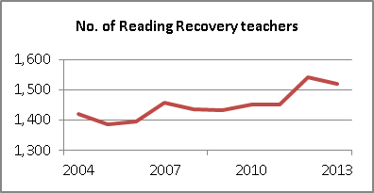 | 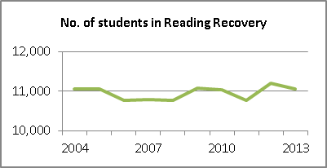
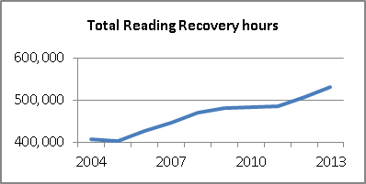 | 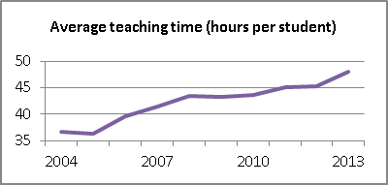
Table 1: Reading Recovery resources over the past ten years (2004–2013)
Year | Number of Reading Recovery teachers | Total Reading  Recovery hours | Number of students in Reading Recovery | Average hours of support (hours) per student
2004 | 1,419 | 407,374 | 11,058 | 36.8
2005 | 1,386 | 401,624 | 11,054 | 36.3
2006 | 1,396 | 425,907 | 10,757 | 39.6
2007 | 1,456 | 446,804 | 10,777 | 41.5
2008 | 1,437 | 468,682 | 10,774 | 43.5
2009 | 1,433 | 480,142 | 11,085 | 43.3
2010 | 1,450 | 482,148 | 11,040 | 43.7
2011 | 1,452 | 484,222 | 10,768 | 45.0
2012 | 1,542 | 507,436 | 11,202 | 45.3
2013 | 1,518 | 531,002 | 11,057 | 48.0

Schools involved in Reading Recovery nationally and regionally
At the national level, access to Reading Recovery remains largely unchanged from 2012. Around two-thirds (65%) of state and state-integrated schools offered Reading Recovery in 2013 and three-quarters (76%) of six-year-old students attended schools that offered Reading Recovery (Table 2). Over the past ten years, access at the school level has been within the range 64 per cent to 67 per cent; and 75 per cent to 78 per cent at the student level. While these figures provide a basic measure of access to Reading Recovery, note that the proportion of students who are offered the intervention within schools varies.
At the regional level, the proportion of schools that offered Reading Recovery was highest in the Nelson (86%), Wellington (80%) Tasman and Taranaki (79%) regions and lowest in the Gisborne (48%), Northland (51%) and Manawatu-Whanganui (52%) regions. Between 2012 and 2013 access to Reading Recovery at the school level did markedly change (that is, by five percentage points or more) in Gisborne and Nelson. (Note, though, that Tasman and Nelson have a comparatively small number of schools.)
Table 2: Schools with Reading Recovery in 2013, by region
Local Body Region | Schools that offered Reading Recovery |  | Total schools with six-year-olds* |  | Access to Reading Recovery**
Local Body Region | N | 6-year-olds on roll | N | 6-year-olds on roll | % of schools |  | % of 6-year-olds
 |  |  |  |  | 2013 | 2012 | 2013 | 2012
Northland | 63 | 1,780 | 124 | 2,450 | 50.8% | 48.8% | 72.7% | 69.4%
Auckland | 236 | 13,148 | 373 | 20,505 | 63.3% | 61.1% | 64.1% | 63.1%
Waikato | 148 | 4,694 | 253 | 6,083 | 58.5% | 59.6% | 77.2% | 75.9%
Bay of Plenty | 74 | 3,401 | 124 | 4,197 | 59.7% | 58.7% | 81.0% | 80.7%
Gisborne | 21 | 579 | 44 | 799 | 47.7% | 59.1% | 72.5% | 88.0%
Hawkes Bay | 53 | 1,748 | 96 | 2,317 | 55.2% | 54.7% | 75.4% | 75.0%
Taranaki | 60 | 1,507 | 76 | 1,626 | 78.9% | 76.3% | 92.7% | 92.2%
Manawatu-Whanganui | 85 | 2,222 | 164 | 3,080 | 51.8% | 55.4% | 72.1% | 74.4%
Wellington | 148 | 5,527 | 185 | 6,330 | 80.0% | 81.2% | 87.3% | 86.5%
Tasman | 23 | 565 | 29 | 621 | 79.3% | 78.6% | 91.0% | 90.1%
Nelson | 12 | 584 | 14 | 601 | 85.7% | 92.3% | 97.2% | 98.3%
Marlborough | 16 | 445 | 25 | 511 | 64.0% | 66.7% | 87.1% | 87.6%
West Coast | 20 | 332 | 31 | 371 | 64.5% | 65.6% | 89.5% | 90.4%
Canterbury *** | 183 | 6,286 | 239 | 7,035 | 76.6% | 73.8% | 89.4% | 86.6%
Otago | 80 | 2,070 | 117 | 2,399 | 68.4% | 64.3% | 86.3% | 77.6%
Southland | 48 | 1,178 | 67 | 1,347 | 71.6% | 67.6% | 87.5% | 85.0%
Total | 1,270 | 46,066 | 1,961 | 60,272 | 64.8% | 64.2% | 76.4% | 75.1%
* Source: Education Information and Analysis Division, Ministry of Education, E4/2:Annual Return of Primary Pupils as at 1 July 2013.
** Care should be taken when interpreting results from regions with a low number (ie, less than n=35) of schools with six-year-old students.
*** Chatham Islands’ data are included with Canterbury.

Access to Reading Recovery for Māori students
Reading Recovery was offered in 68 per cent of state and state-integrated schools with six-year-old Māori students (Table 3). This figure is similar to previous years (it has ranged between 67% and 70% since 2006). Comparing figures in Table 2 and Table 3 shows that Reading Recovery was offered in 68 per cent of schools with six-year-old Māori students and 65 per cent of all schools.
At the student level, access to Reading Recovery for six year old Māori students has remained within the range 69 to 72 per cent since 2006. Looking at those regions with a reasonably large number of schools with six year old Māori students (ie, regions with over 35 such schools), the most marked differences between 2012 and 2013 are the increase in the percentage of schools with 6 year old Māori students offering Reading Recovery in Otago (75% to 81%), and the decrease in Manawatu-Whanganui (from 62% to 56%). Gisborne has also shown a marked decrease between 2012 and 2013 but has a relatively small number of schools with six year old Māori students.
Table 3 Schools with Reading Recovery in 2013, by region—Māori students
Local Body Region | Schools with six-year-old Māori students that offered Reading Recovery |  | Total schools with  six-year-old Māori students * |  | Access to Reading Recovery **
Local Body Region | N | 6-year-olds on roll | N | 6-year-olds on roll | % of schools |  | % of 6-year-olds
 |  |  |  |  | 2013 | 2012 | 2013 | 2012
Northland | 62 | 815 | 119 | 1,305 | 52.1% | 48.3% | 62.5% | 57.7%
Auckland | 220 | 2,119 | 346 | 3,536 | 63.6% | 62.5% | 59.9% | 57.9%
Waikato | 143 | 1,553 | 234 | 2,205 | 61.1% | 60.6% | 70.4% | 70.4%
Bay of Plenty | 73 | 1,386 | 121 | 1,896 | 60.3% | 57.9% | 73.1% | 72.6%
Gisborne | 21 | 388 | 42 | 539 | 50.0% | 60.5% | 72.0% | 83.5%
Hawkes Bay | 50 | 679 | 87 | 925 | 57.5% | 56.7% | 73.4% | 73.4%
Taranaki | 54 | 405 | 68 | 438 | 79.4% | 82.1% | 92.5% | 92.3%
Manawatu-Whanganui | 82 | 742 | 146 | 1,078 | 56.2% | 61.7% | 68.8% | 69.7%
Wellington | 144 | 1,212 | 178 | 1,399 | 80.9% | 84.3% | 86.6% | 86.1%
Tasman | 20 | 63 | 24 | 76 | 83.3% | 81.8% | 82.9% | 93.3%
Nelson | 12 | 98 | 13 | 102 | 92.3% | 92.3% | 96.1% | 98.9%
Marlborough | 14 | 79 | 17 | 85 | 82.4% | 80.0% | 92.9% | 83.0%
West Coast | 18 | 45 | 23 | 52 | 78.3% | 82.6% | 86.5% | 93.2%
Canterbury *** | 164 | 901 | 197 | 1,012 | 83.2% | 78.5% | 89.0% | 85.8%
Otago | 69 | 282 | 85 | 323 | 81.2% | 75.0% | 87.3% | 82.5%
Southland | 44 | 247 | 54 | 285 | 81.5% | 81.1% | 86.7% | 84.6%
Total | 1,190 | 11,014 | 1,754 | 15,256 | 67.8% | 67.3% | 72.2% | 71.1%
* Source: Education Information and Analysis Division, Ministry of Education, E4/2:Annual Return of Primary Pupils as at 1 July 2013.
** Please note that care should be taken when interpreting results from regions with a low number (ie, less than n=35) of schools with six-year-old Māori students.
*** Chatham Islands’ data are included with Canterbury.

Access to Reading Recovery for Pasifika students
In 2013, Reading Recovery was offered in 80 per cent of state and state-integrated schools with six-year-old Pasifika students (Table 4) (compared to 65% of schools with six-year-olds in general). Implementation of Reading Recovery for schools with six-year-old Pasifika students has remained high, within the range 77 to 81 per cent, since this information was first gathered in 2006.
A higher proportion of Pasifika six-year-olds attended schools that offered Reading Recovery compared to the general six-year-old population (78% compared to 76%). Although most Pasifika six-year-olds (71%) were enrolled in schools in the Auckland region, access to Reading Recovery for these students remains the lowest nationally (72%). While this ongoing finding suggests that Reading Recovery is not being offered in some schools with high numbers of Pasifika students in the Auckland region, the proportion of Pasifika six-year-olds attending schools where Reading Recovery was offered did increase for this region in 2013 (72%, up from 70% in 2012 and 65% in 2011).
Looking at those regions with a reasonably large number of schools with six year old Pasifika students (ie, regions with over 35 such schools), the most marked differences between 2012 and 2013 are the increase in the percentage of schools with 6 year old Pasifika students offering Reading Recovery in Otago and Waikato.
Table 4 Schools with Reading Recovery in 2013, by region—Pasifika students
Local Body Region | Schools with six-year-old Pasifika students that offered Reading Recovery |  | Total schools with  six-year-old Pasifika students* |  | Access to Reading Recovery **
Local Body Region | N | 6-year-olds on roll | N | 6-year-olds on roll | % of schools |  | % of 6-year-olds
 |  |  |  |  | 2013 | 2012 | 2013 | 2012
Northland | 20 | 37 | 28 | 48 | 71.4% | 73.3% | 77.1% | 81.0%
Auckland | 208 | 3,157 | 311 | 4,367 | 66.9% | 63.6% | 72.3% | 69.7%
Waikato | 73 | 191 | 87 | 216 | 83.9% | 75.6% | 88.4% | 80.4%
Bay of Plenty | 35 | 84 | 42 | 95 | 83.3% | 85.0% | 88.4% | 86.3%
Gisborne | 10 | 19 | 10 | 19 | 100.0% | 100.0% | 100.0% | 100.0%
Hawkes Bay | 27 | 90 | 35 | 104 | 77.1% | 81.1% | 86.5% | 93.6%
Taranaki | 19 | 30 | 19 | 30 | 100.0% | 89.5% | 100.0% | 88.9%
Manawatu-Whanganui | 44 | 100 | 57 | 121 | 77.2% | 75.6% | 82.6% | 80.5%
Wellington | 123 | 629 | 138 | 670 | 89.1% | 91.7% | 93.9% | 95.3%
Tasman | 6 | 9 | 6 | 9 | 100.0% | 100.0% | 100.0% | 100.0%
Nelson | 8 | 16 | 9 | 17 | 88.9% | 100.0% | 94.1% | 100.0%
Marlborough | 8 | 19 | 9 | 21 | 88.9% | 80.0% | 90.5% | 89.5%
West Coast | 8 | 10 | 9 | 11 | 88.9% | 100.0% | 90.9% | 100.0%
Canterbury | 95 | 264 | 105 | 283 | 90.5% | 87.9% | 93.3% | 93.4%
Otago | 36 | 70 | 40 | 75 | 90.0% | 79.5% | 93.3% | 86.1%
Southland | 16 | 32 | 17 | 33 | 94.1% | 94.7% | 97.0% | 97.6%
Total | 736 | 4,757 | 922 | 6,119 | 79.8% | 77.3% | 77.7% | 75.5%
* Source: Education Information and Analysis Division, Ministry of Education, E4/2:Annual Return of Primary Pupils as at 1 July 2013.
** Please note that care should be taken when interpreting results from regions with a low number (ie, less than n=35) of schools with six-year-old Pasifika students.

Students’ level of involvement in Reading Recovery by region
Just over one in seven (14%) six-year-old students enrolled in state and state-integrated schools entered Reading Recovery in 2013 (Table 5). This figure has remained consistent over the past decade.
The Auckland region had the lowest entry rate (approximately one in ten six-year-olds entered the intervention). As it has since 2005, the West Coast region had the highest rate of student entry into Reading Recovery (approximately one in four six-year-olds entered the intervention).
The percentage of six-year-olds who entered Reading Recovery was fairly stable across the regions between 2012 and 2013.
Table 5 Six-year-old students who entered Reading Recovery in 2013 by region
Local Body Region | Six-year-olds who entered  Reading Recovery in 2013 |  |  | Total six-year-old  school population*
Local Body Region | N | % of total |  | N
Local Body Region | N | 2013 | 2012 | N
Northland | 366 | 14.9% | 14.8% | 2,450
Auckland | 2,294 | 11.2% | 11.4% | 20,505
Waikato | 897 | 14.7% | 15.7% | 6,083
Bay of Plenty | 517 | 12.3% | 13.0% | 4,197
Gisborne | 137 | 17.1% | 17.8% | 799
Hawkes Bay | 354 | 15.3% | 15.6% | 2,317
Taranaki | 306 | 18.8% | 19.6% | 1,626
Manawatu-Whanganui | 412 | 13.4% | 14.2% | 3,080
Wellington | 981 | 15.5% | 16.0% | 6,330
Tasman | 123 | 19.8% | 18.7% | 621
Nelson | 73 | 12.1% | 14.5% | 601
Marlborough | 80 | 15.7% | 15.2% | 511
West Coast | 90 | 24.3% | 26.7% | 371
Canterbury | 897 | 12.8% | 13.8% | 7,035
Otago | 380 | 15.8% | 16.9% | 2,399
Southland | 230 | 17.1% | 20.4% | 1,347
Total | 8,137 | 13.5% | 14.1% | 60,272
* Source: Education Information and Analysis Division, Ministry of Education, E4/2: Annual Return of Primary Pupils as at
1 July 2013.

Access to Reading Recovery over the last ten years
As shown in Figure B, there has been little change in the level of access to Reading Recovery at both the school and student level over the past ten years. Similarly, the percentage of six-year-old students entering Reading Recovery has remained stable since 2004.
Figure B Implementation of and access to Reading Recovery 2004–2013
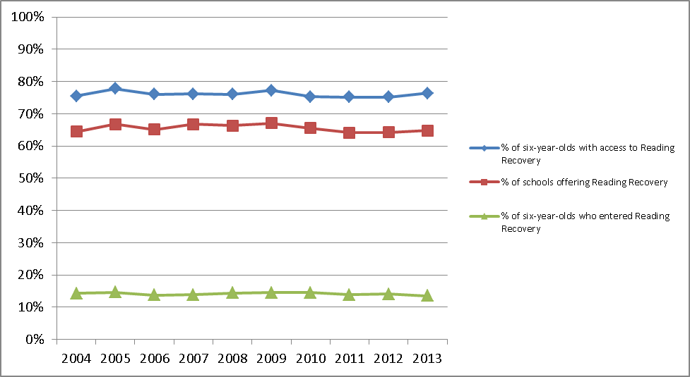

Schools’ and students’ level of involvement in Reading Recovery by school decile
As shown in Figure C, a greater proportion of higher decile schools offered Reading Recovery than lower decile schools. Just over two-thirds of decile 8 to 10 schools (71%, up from 68% in 2012) offered Reading Recovery, compared with 65 per cent (no change from 2012) of decile 4 to 7 schools and 58 per cent (down from 59% in 2012) of decile 1 to 3 schools.
A greater proportion of students in decile 4 to 7 schools (80%) attended schools that offered Reading Recovery compared to students in decile 1 to 3 and decile 8 to 10 schools (72% and 76% respectively).
Although students attending decile 1 to 3 schools had lower levels of access to Reading Recovery, in decile 1 to 3 schools where Reading Recovery was offered, they entered the intervention in greater numbers than students attending higher decile schools. That is, approximately one in six students (17%) in decile 1 to 3 schools entered the intervention, compared with one in seven students (14%) in decile 4 to 7 schools, and one in ten students (10%) in decile 8 to 10 schools. This has been a consistent trend over the past six years.
Figure C Students’ and schools’ involvement in Reading Recovery by decile
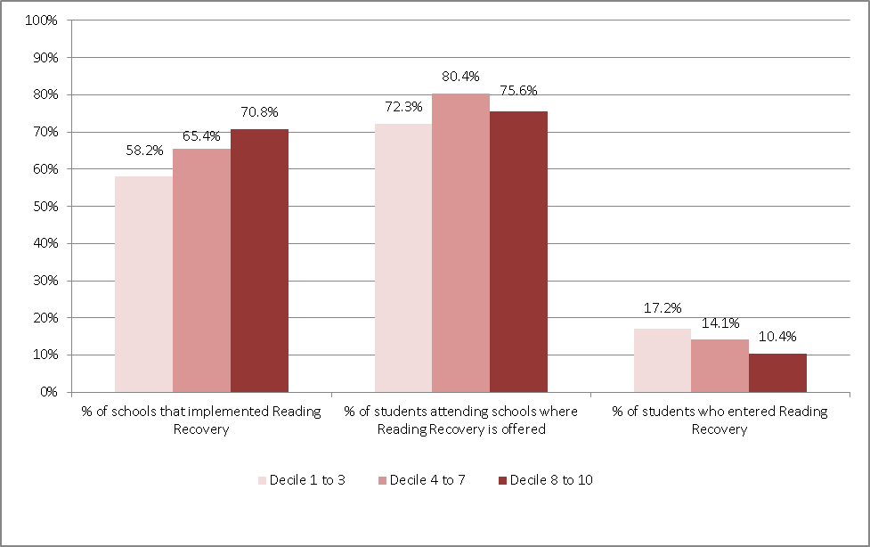

Across the school deciles, the average number of Reading Recovery hours allocated per student ranged from 45 to 52 hours (compared to 41 to 59 hours in 2012). The number of hours allocated per student varied across the deciles.
The largest change in the number of Reading Recovery teachers between 2012 and 2013 occurred in decile 10 schools, with a decrease of 33 teachers.
Table 6 Involvement in Reading Recovery by school decile 2013
Decile | Students who entered  Reading Recovery (%) | Average Reading Recovery hours allocated per student* | Number of teachers  delivering the intervention
Decile | Students who entered  Reading Recovery (%) | Average Reading Recovery hours allocated per student* | 2013 | 2012
1 | 18.9% | 50.1 | 167 | 167
2 | 16.9% | 46.9 | 174 | 168
3 | 15.6% | 47.1 | 155 | 156
4 | 16.9% | 47.6 | 145 | 153
5 | 13.5% | 46.3 | 138 | 135
6 | 13.5% | 44.8 | 136 | 134
7 | 12.9% | 49.5 | 145 | 139
8 | 11.8% | 51.5 | 149 | 149
9 | 11.1% | 49.5 | 150 | 149
10 | 9.1% | 46.4 | 159 | 192
* The average Reading Recovery hours allocated per student is calculated from the number of students that schools counted as having participated in Reading Recovery, and the number of hours the schools had allocated for these students. Thus these averages are an estimate of the number of hours each student might have had.

Section 2: Students involved in Reading Recovery in 2013

Students involved in Reading Recovery in 2013
Three-quarters (74%) of students who were involved in Reading Recovery during 2013 had entered the intervention (started their series of lessons) for the first time in 2013 (Table 7). A further one-quarter (23%) of students were continuing their series of lessons from the previous year in the same school. A small percentage of students (2%) had transferred from another school where they had previously started the intervention. These percentages are very similar to those reported in 2012 and 2011.
^{Table 7} Students’ entry into Reading Recovery in 2013*
 | N | %
Entered Reading Recovery for the first time in 2013 | 8,137 | 74.4%
Carried over from 2012 in the same school | 2,527 | 23.1%
Arrived from another school with incomplete lesson series and continued Reading Recovery | 256 | 2.3%
Missing entry information | 13 | 0.1%
Total | 10,933 | 100.0%
* This table counts students’ first method of entry in Reading Recovery for the 2013 year. Some students who were carried over from 2012, or who entered Reading Recovery for the first time in 2013 transferred to another school at some point during 2013. To avoid double counting, only the first method of entry into Reading Recovery is included. This table only includes students with individual reports (n=10,933). Schools reported a total of 11,057 students involved in Reading Recovery in 2013.

Gender and ethnicity of students in Reading Recovery
Table 8 provides gender and ethnicity data for 10,913 six-year-olds involved in Reading Recovery during 2013. Around two-thirds of all six-year-olds in Reading Recovery were boys (63%, n=6,906) and one-third (37%, n=4,007) were girls. Out of the total six-year-old population for boys and girls respectively, 22 per cent of boys and 14 per cent of girls were involved in Reading Recovery in 2013.
Consistent with ongoing trends, a greater proportion of Māori and Pasifika students were involved in Reading Recovery than NZ European/Pākehā and Asian students. Twenty-eight percent of Māori six-year-old boys and 33% of Pasifika six-year-old boys (Pasifika ethnicity has been disaggregated in Table 8) were involved in Reading Recovery during 2013, compared with 21 per cent of NZ European/Pākehā and 10 per cent of Asian boys (data disaggregated in Table 8). Similarly, 18 per cent of Māori six-year-old girls and 20 per cent of Pasifika six-year-old girls were involved in Reading Recovery during 2013, compared with 12 per cent of NZ European/Pākehā and seven per cent of Asian girls.
^{Table 8} Ethnicity and gender of students in Reading Recovery*
Ethnicity | Boys |  |  | Girls
Ethnicity | Total six-year-old boys in population | In Reading Recovery |  | Total six-year-old girls in population | In Reading Recovery
Ethnicity | N | n | % | N | n | %
Māori | 7,821 | 2,177 | 27.8% | 7,445 | 1,302 | 17.5%
NZ European/Pākehā | 15,091 | 3,128 | 20.7% | 14,266 | 1,729 | 12.1%
Tokelauan | 62 | 11 | 17.7% | 61 | 14 | 23.0%
Fijian | 210 | 47 | 22.4% | 194 | 21 | 10.8%
Niuean | 164 | 25 | 15.2% | 150 | 20 | 13.3%
Tongan | 697 | 274 | 39.3% | 690 | 156 | 22.6%
Cook Island Māori | 461 | 149 | 32.3% | 464 | 86 | 18.5%
Samoan | 1,342 | 456 | 34.0% | 1,330 | 280 | 21.1%
Other Pacific Islands | 151 | 49 | 32.5% | 143 | 23 | 16.1%
South East Asian | 601 | 78 | 13.0% | 556 | 49 | 8.8%
Indian | 1,031 | 133 | 12.9% | 1,004 | 76 | 7.6%
Chinese | 771 | 48 | 6.2% | 754 | 30 | 4.0%
Other Asian | 627 | 56 | 8.9% | 524 | 37 | 7.1%
Other | 783 | 126 | 16.1% | 725 | 89 | 12.3%
Other European | 1,065 | 149 | 14.0% | 1,139 | 95 | 8.3%
Total | 30,877 | 6,906 | 22.4% | 29,445 | 4,007 | 13.6%
* Schools’ enrolment forms usually allow for students to self identify or be identified by their parents/guardians as belonging to more than one ethnic group. However, for the purposes of the Reading Recovery return, students are reported in one ethnic group only. The Reading Recovery return follows the same system of priority recording as used in previous reports. This table only includes students with individual reports (n=10,913) and excludes data from 20 students with missing ethnicity information.

Section 3: Student outcomes from Reading Recovery
At the end of the year, students involved in Reading Recovery were assigned one of five outcomes:
- Successfully discontinued — the student is able to work effectively with their cohort without additional support.
- Carried over — the student is unable to complete their series of lessons in the current year and has had their lesson series continued into the following year.
- Referred on — the student has not reached expected level and further specialist or long-term literacy support is required (see Figure F for further detail).
- Left the school — the student leaves the school before completing their series of lessons (and may or may not have continued at their new school).
- Unable to continue — the student leaves the intervention before completing their support for various reasons (see Figure G for further detail).
In 2013, 59 per cent (n=6,434) of students were successfully discontinued from the intervention. This proportion is a slight decrease on the 61% reported in 2012 and 2011. Twenty-five per cent (n=2,730) of students had their lessons carried over and were expected to continue their lessons the following year. A further 10 per cent (n=1,055) of students were referred on for specialist help or long-term reading support. Four per cent of students (n=428) left their school before their lessons could be discontinued and two per cent (n=243) were unable to continue their lessons for various reasons (see page 21 for a discussion of these reasons.)
^{Table 9} Students’ Reading Recovery outcomes, 2013
Type of outcome | N* | %
Student successfully discontinued lessons | 6,434 | 58.9%
Student’s series of lessons carried over to 2014 | 2,730 | 25.0%
Student referred for specialist help or long-term literacy support | 1,055 | 9.7%
Student left the school before completion | 428 | 3.9%
Student unable to continue | 243 | 2.2%
Missing data | 36 | 0.3%
Total | 10,926 | 100.0%
* A number of students who transferred schools during the year ended up with two student reports (one for each school that they attended while receiving Reading Recovery lessons). To avoid double counting, this table only includes the Reading Recovery outcome for the last school the student attended during the year.

Reading Recovery outcomes for students who exited Reading Recovery in 2013
In total, three-quarters (75%, n=8,160) of students who were involved in Reading Recovery in 2013 exited the intervention during the year. The analysis presented in this section, and Section 4, is based on these students.
As a proportion of students who exited Reading Recovery in 2013, the majority (79%) were successfully discontinued from the intervention (Table 10). A further 13 per cent of students were referred on for specialist help or long-term literacy support. Five per cent left their school before their lessons could be discontinued and three percent were responding but unable to continue their lessons. These findings are consistent with those of 2012 and 2011.
^{Table 10} Exiting students’ Reading Recovery outcomes, 2013
Type of outcome | N* | %
Student successfully discontinued lessons | 6,434 | 78.8%
Student referred for specialist help or long-term literacy support | 1,055 | 12.9%
Student left the school before completion | 428 | 5.2%
Student unable to continue | 243 | 3.0%
Total | 8,160 | 100.0%
* This table only includes the Reading Recovery outcome for the last school the student attended during 2013. It does not include data from students who were carried over to 2014 and students with missing student reports or outcome information.

Figure D shows the relatively small movements in the proportions of exiting students’ various outcomes over the past decade.
Figure D Students’ Reading Recovery outcomes for the years 2004–2013
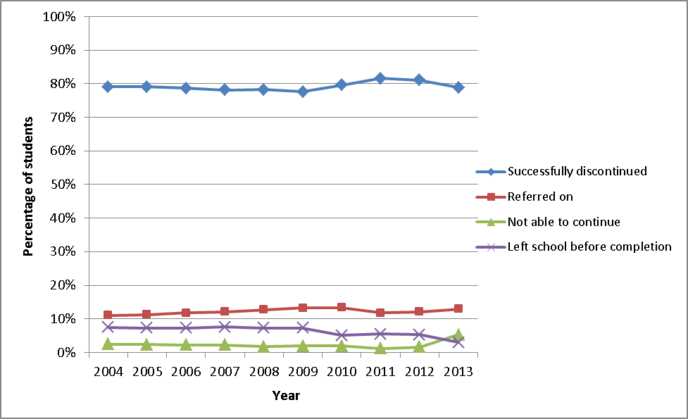

Reading Recovery outcome by entry status
Consistent with the trend over the past ten years, a greater proportion of students who entered Reading Recovery for the first time in 2013 successfully discontinued their series of lessons (80%) than students who were carried over from 2012 (77%) and students who had transferred from another school (72%).
Higher proportions of students who had been carried over from 2012 and students who were transferred from another school were referred on for specialist help or long-term support in 2013 (17% and 18% respectively) than students who entered the intervention for the first time in 2013 (11%). As a guideline students receive at least twenty weeks of support in the intervention before being referred. See Figure F for the different types of specialist or long-term support.
^{Table 11} Exiting students’ Reading Recovery outcome by entry status
Type of Outcome* | Entered for the first time in 2013 % (n=5,416) | Carried over from 2012 %  (n=2,525) | Transferred from another school %  (n=219) | Total  %  (n=8,160)
Student successfully discontinued Reading Recovery lessons | 79.9% | 77.1% | 71.7% | 78.8%
Student referred on for specialist help or long-term reading support | 10.7% | 17.2% | 17.8% | 12.9%
Student left the school before completion | 5.6% | 4.4% | 5.9% | 5.2%
Student unable to continue | 3.7% | 1.3% | 4.6% | 3.0%
Total | 100.0% | 100.0% | 100.0% | 100.0%
* Table does not include students who were carried over into 2014, as they have not yet exited Reading Recovery. Also excludes data from students with missing information about their entry to and/or exit from Reading Recovery. The table is based on students’ initial entry type, and final outcome from Reading Recovery (where more than one school was attended during the year).

Reading Recovery outcome by gender
A higher proportion of girls (82%) successfully discontinued their series of lessons in 2013 than boys (77%). In comparison, a higher proportion of boys (15%) were referred on for specialist help or long-term literacy support than girls (10%). This pattern of results has been observed since 2001.
^{Table 12} Exiting students’ Reading Recovery outcome by gender
Type of Outcome* | Boys %  (n=5,151) | Girls %  (n=3,009) | Total %  (n=8,160)
Student successfully discontinued lessons | 77.1% | 81.8% | 78.8%
Student referred for specialist help or long-term literacy support | 14.7% | 9.8% | 12.9%
Student left the school before completion | 5.2% | 5.3% | 5.2%
Student unable to continue | 2.9% | 3.1% | 3.0%
Total | 100.0% | 100.0% | 100.0%
* Does not include students who were carried over into 2014, as they have not yet exited Reading Recovery. Also excludes data from students with missing information about their Reading Recovery outcome. Table based on students’ final outcome from Reading Recovery (where more than one school was attended during the year).

Reading Recovery outcome by ethnicity
A higher proportion of New Zealand European/Pākehā (83%) and Asian (83%) students successfully discontinued their series of lessons in 2013 than Māori (74%) and Pasifika (74%) students. This pattern of results has been observed since 2001.
Similar proportions of Māori, New Zealand European/Pakeha and Pasifika students were referred on for specialist literacy support in 2013. These proportions were much the same as those reported in 2012 and 2011. However, there was an increase in the proportion of Asian students referred on for specialist literacy support in 2013 compared to 2012 (7%).
A higher proportion of Māori and Pasifika students left the school before their period of support ended or were otherwise unable to continue than their peers in the other ethnic groups.
^{Table 13} Exiting students’ Reading Recovery outcome by ethnicity
Type of Outcome* | Māori %  (n=2,540) | NZ European/  Pākehā %  (n=3,715) | Pasifika %  (n=1,173) | Asian %  (n=382) | Other %  (n=338)
Student successfully discontinued lessons | 74.2% | 82.6% | 74.3% | 83.2% | 84.0%
Student referred for specialist help or long-term literacy support | 14.1% | 12.5% | 13.3% | 11.3% | 9.2%
Student left the school before completion | 7.5% | 2.8% | 8.3% | 3.9% | 6.2%
Student unable to continue | 4.2% | 2.1% | 4.2% | 1.6% | 0.6%
Total | 100.0% | 100.0% | 100.0% | 100.0% | 100.0%
* Does not include students who were carried over into 2014, as they have not yet exited Reading Recovery. Also excludes data from students with missing information about their Reading Recovery outcome and/or ethnicity. Table based on students’ final outcome from Reading Recovery (where more than one school was attended during the year).

Reading Recovery outcome by school decile
As with previous years, Figure E shows that a higher proportion of students attending decile 8 to 10 schools (85%) were successfully discontinued from Reading Recovery than students attending lower decile schools (76% and 80%). A higher proportion of students in lower decile schools were referred on for specialist literacy support or left the school without completing their series of lessons. One in six students (16%) from decile 1 to 3 schools who were involved in Reading Recovery were referred on for further support, compared with one in nine (11%) students in decile 8 to 10 schools. Disaggregated data for each decile is shown in Appendix Table 1.
Figure E Exiting students’ Reading Recovery outcome by school decile
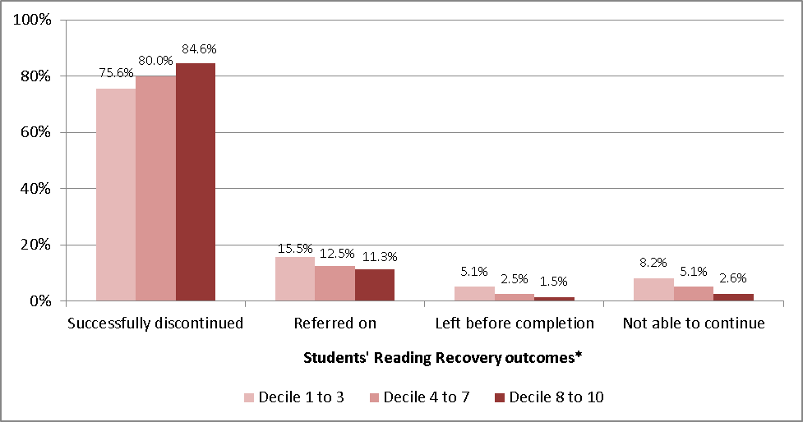
* Does not include students who were carried over into 2013, as they have not yet exited Reading Recovery. Also excludes data from students with missing information about their Reading Recovery outcome and/or ethnicity. Table based on students’ final outcome from Reading Recovery (where more than one school was attended during the year).

Students referred on for further support
In 2013, 1,055 students were referred on from Reading Recovery for specialist help or long-term literacy support. As shown in Figure F, students were most commonly referred to Resource Teachers of Literacy (RT:Lit, 67%). A further 18 per cent of students were referred to Resource Teachers Learning and Behaviour (RTLB). A small percentage of students were referred to other support programmes managed within the school (9%), special education (SE) programmes or funding (2%), in-class support programmes/teacher aides (2%) and other professionals (1%).
Figure F Further support for students’ referred on, as reported by schools
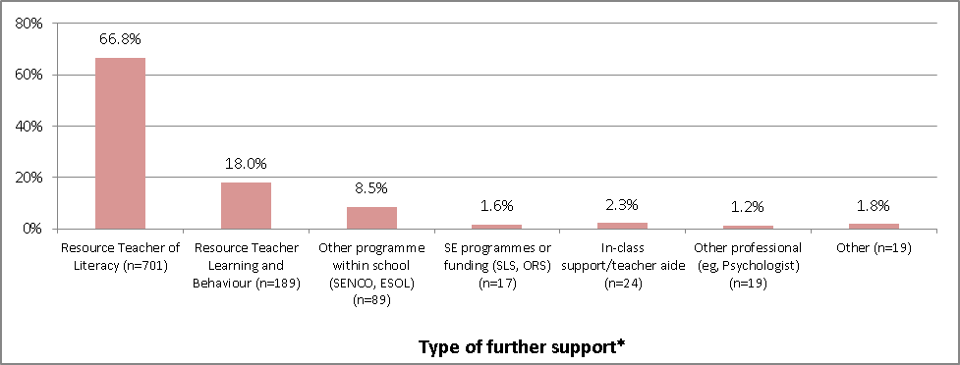
* Percentages may not sum to 100% as students may have been referred on for more than one type of support.

Students unable to continue Reading Recovery
A number of students (n=243) involved in Reading Recovery during 2013 were unable to continue their series of lessons (up from 97 students in 2011, and 125 in 2012). Figure G shows the proportion of cases with various reasons for being unable to continue. The most common reason was because the school was not offering Reading Recovery in 2014 (42% of cases). The ‘Other’ category of reasons (a quarter of cases) include a child’s ill health or a parental decision to withdraw the child from the intervention.
Figure G Reasons why students were unable to continue
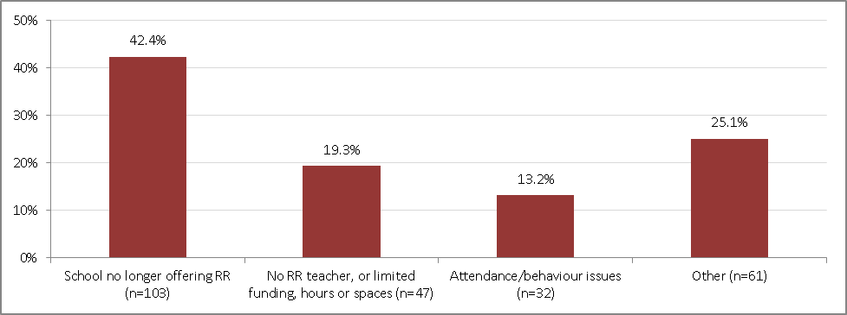

Regional variation in the proportion of successfully discontinued and referred on students
Regional rates of successfully discontinued students from Reading Recovery ranged from 68 percent (West Coast) to 86 per cent (Wellington).
The proportion of students who were referred on from Reading Recovery in 2013 was highest in the West Coast region (22%) and lowest in the Bay of Plenty (8%).
Compared with regional figures from 2012, in 2013 a majority of regions experienced a decrease in the proportion of students being successfully discontinued, and an increase in the proportion of students being referred on for specialist support.
Table 14 Proportion of exited students successfully discontinued and referred on by region
Local Body (Region) | Students successfully discontinued Reading Recovery  (n=6,434) |  |  | Students referred for specialist help or long-term reading support  (n=1,055) |  |  | Total number of students who left Reading Recovery in 2013  (n=8,167)
Local Body (Region) | N | % of total |  | N | % of total |  | N
Local Body (Region) | N | 2013 | 2012 | N | 2013 | 2012 | N
Northland | 254 | 72.4% | 76.5% | 45 | 12.8% | 14.3% | 351
Auckland | 1,733 | 74.1% | 78.0% | 352 | 15.0% | 14.6% | 2,340
Waikato | 732 | 80.2% | 80.0% | 96 | 10.5% | 12.7% | 913
Bay of Plenty | 421 | 82.2% | 84.4% | 40 | 7.8% | 6.7% | 512
Gisborne | 87 | 71.9% | 78.4% | 16 | 13.2% | 12.2% | 121
Hawkes Bay | 277 | 79.6% | 81.4% | 40 | 11.5% | 12.6% | 348
Taranaki | 259 | 82.5% | 85.8% | 37 | 11.8% | 7.1% | 314
Manawatu-Whanganui | 327 | 76.8% | 79.8% | 60 | 14.1% | 11.6% | 426
Wellington | 804 | 86.3% | 84.1% | 87 | 9.3% | 9.4% | 932
Tasman | 110 | 85.9% | 81.5% | 14 | 10.9% | 13.4% | 128
Nelson | 59 | 72.0% | 77.4% | 17 | 20.7% | 12.9% | 82
Marlborough | 70 | 79.5% | 77.5% | 15 | 17.0% | 16.9% | 88
West Coast | 68 | 68.0% | 77.7% | 22 | 22.0% | 20.4% | 100
Canterbury | 717 | 80.4% | 84.0% | 141 | 15.8% | 11.6% | 892
Otago | 317 | 81.9% | 83.1% | 46 | 11.9% | 12.7% | 387
Southland | 199 | 85.4% | 84.4% | 27 | 11.6% | 8.9% | 233

Time in Reading Recovery for successfully discontinued and referred on students
On average, referred on students attended more half-hour lessons (89 lessons over 23 weeks) than did students who were successfully discontinued (74 lessons over 18 weeks). Both groups of students averaged four Reading Recovery lessons per week.

Time in Reading Recovery by entry and exit status
Students who entered Reading Recovery in 2012 and successfully discontinued their lessons in 2013 attended an average of 17 more lessons than did successfully discontinued students who entered and exited the intervention within the 2013 year. This finding is consistent with previous years.
The data presented in Table 15, in conjunction with data from Table 11 (page 17), show that a slightly smaller proportion of carried over students were successfully discontinued (77.1%) than those entering Reading Recovery in 2013 (79.9%). Those carried over students that were successfully discontinued took longer to achieve this outcome than students who entered and exited in one year. This pattern of results has been noted in previous years.
^{Table 15} Sessions and weeks for successfully discontinued and referred on students, by entry status
 | Students successfully discontinued Reading Recovery |  |  | Students referred for specialist help or long-term reading support
 | N | Mean 30-min sessions | Mean calendar weeks | N | Mean 30-min sessions | Mean calendar weeks
Entered for the first time in 2013 | 4,330 | 73.5 | 18.1 | 581 | 88.9 | 22.7
Carried over from 2012 | 1,947 | 89.9 | 22.3 | 435 | 93.1 | 23.8
Transferred from another school | 157 | 82.4 | 20.6 | 39 | 80.6 | 21.3
Total* | 6,434 | 78.7 | 19.4 | 1055 | 90.3 | 23.1
* Table based on students’ initial entry type, and final outcome from Reading Recovery (where more than one school was attended during the year). Excludes data from one student with missing information about their entry into Reading Recovery.

Time in Reading Recovery by gender and ethnicity
Overall, as shown in Table 16, boys who successfully discontinued Reading Recovery had slightly more lessons (80 lessons over 20 weeks) than girls who successfully discontinued (76 lessons over 19 weeks). The differences in the average number of lessons and weeks of Reading Recovery between boys and girls of various ethnic groups who successfully discontinued Reading Recovery were slight.
Boys and girls who were referred on from Reading Recovery had more lessons over a longer period of time than their peers who were successfully discontinued from the intervention. Boys and girls who were referred on had a similar number of lessons (90 and 91 lessons respectively) over the same period of weeks (23).
Māori and Pasifika boys who were referred on had fewer lessons than New Zealand European/Pākehā boys and Asian boys. Māori girls who were referred on had fewer lessons than any other ethnic group.
Table 16 Average lessons and weeks in Reading Recovery by gender and ethnicity
 | Students successfully discontinued  Reading Recovery |  |  |  | Students referred for specialist help or  long-term reading support
 | Mean number of lessons |  | Mean number of weeks |  | Mean number of lessons |  | Mean number of weeks
 | Boys | Girls | Boys | Girls | Boys | Girls | Boys | Girls
Māori | 81.9 | 78.1 | 20.7 | 20.0 | 86.2 | 88.4 | 23.2 | 22.7
NZ European/Pākehā | 78.7 | 75.2 | 19.0 | 18.2 | 93.6 | 91.6 | 23.2 | 22.9
Pasifika | 82.7 | 76.1 | 20.8 | 19.5 | 87.8 | 91.5 | 23.3 | 24.4
Asian | 77.7 | 75.1 | 19.0 | 18.2 | 92.9 | 96.1 | 23.2 | 24.0
Total | 80.2 | 76.3 | 19.7 | 18.9 | 90.1 | 90.7 | 23.2 | 23.1

Time in Reading Recovery by decile
Successfully discontinued students from lower decile (1 to 3) schools attended more lessons (an average of 80 lessons over 21 weeks), than successfully discontinued students from higher decile (8 to 10) schools (77 lessons over 19 weeks).
In comparison, referred on students from higher decile (8 to 10) schools attended more Reading Recovery lessons on average than students from lower decile (1 to 3) schools, over a similar period of weeks.
Disaggregated data for each decile is shown in Appendix Table 2.
Table 17 Average sessions and calendar weeks in Reading Recovery by school decile
Decile grouping | Successfully discontinued students |  | Referred on students
Decile grouping | Mean number  of lessons | Mean number  of calendar weeks | Mean number  of lessons | Mean number  of calendar weeks
Decile 1 to 3 | 80.2 | 20.5 | 87.5 | 23.5
Decile 4 to 7 | 79.1 | 19.3 | 91.9 | 23.0
Decile 8 to 10 | 76.6 | 18.5 | 92.3 | 22.7

Section 4: Students’ learning gains during Reading Recovery
Reading and writing gains in Reading Recovery are assessed across six measures from the Observation Survey of Early Literacy Achievement (Clay, 2013) and the Burt Word Reading Test (NZCER, 1981). Three of these measures are reported to the Ministry: Instructional Text Levels (obtained by taking Running Records), the Burt Word Reading Test and the Writing Vocabulary Task (Clay). These assessments are administered when students begin and end their Reading Recovery lessons. This section presents data for students who successfully discontinued Reading Recovery and students who were referred on from Reading Recovery.

Shift in instructional text levels over the course of Reading Recovery
Figure H and Figure I present instructional text levels at entry to and exit from Reading Recovery for successfully discontinued and referred on students. The equivalent colours of the Ready to Read colour wheel are shown on the horizontal axes.
Both successfully discontinued and referred on students made gains in text levels over the course of their Reading Recovery lessons. Overall, successfully discontinued students made more improvement compared with referred on students. This finding has been the same for the past ten years.
The majority of successfully discontinued students (94%) entered the intervention reading texts ranging from level 1 (Magenta 1) to level 11 (Blue 3). On exit, all successfully discontinued students were reading texts at or above level 13 (Green 2). Most of these students (82%) were reading texts between level 17 (Turquoise 1) and level 20 (Purple 2) upon exit from Reading Recovery.
Figure H Instructional text levels at entry and exit for successfully discontinued students
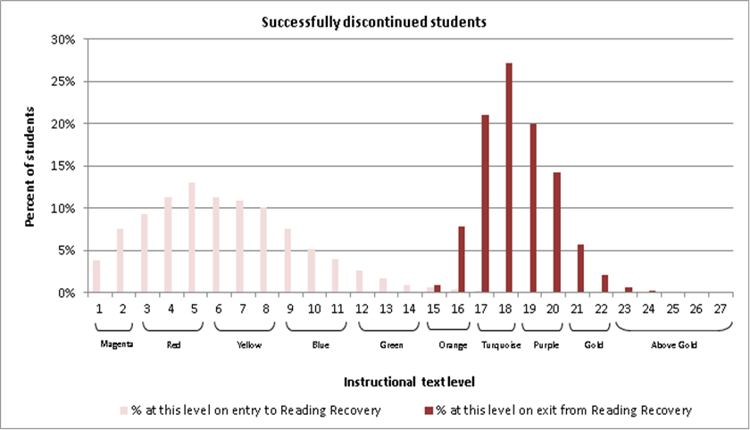
Figure based on data from 6,363 successfully discontinued students with complete text level data.

In comparison the majority (91%) of referred on students entered the intervention reading texts between level 1 (Magenta 1) and level 5 (Red 3). Ninety-nine percent of referred on students entered Reading Recovery reading texts at or below level 8 (Yellow 3). Referred on students were reading a notably wider range of texts when they exited Reading Recovery compared to successfully discontinued students exiting. Eight-two per cent of referred on students were reading texts between level 7 (Yellow 2) and level 16 (Orange 2) when they ended their Reading Recovery lessons.
Figure I Instructional text levels at entry and exit for referred on students
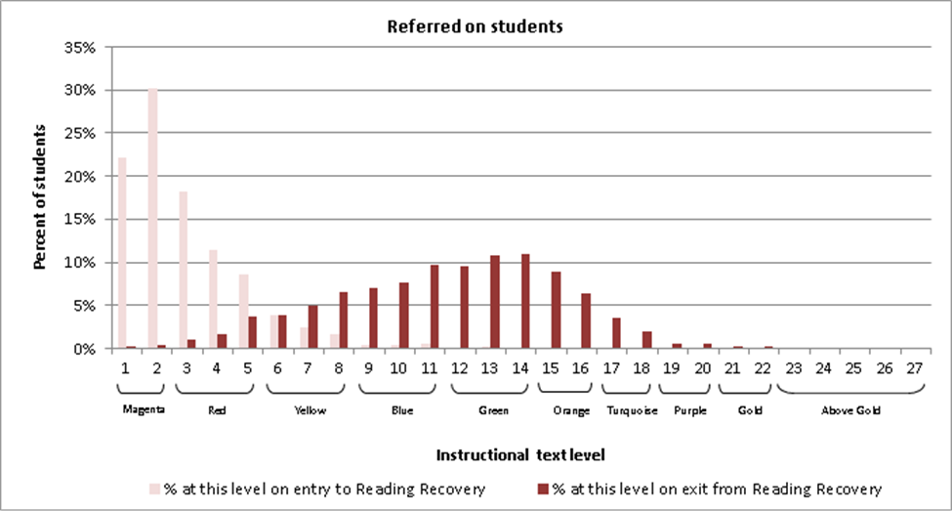
Figure based on data from 950 referred on students who had complete text level data.

Shift in Burt Word Reading Test scores over the course of Reading Recovery
Figure J and Figure K present students’ Burt Word scores at entry to and exit from Reading Recovery, for successfully discontinued and referred on students. The tables attached to the bottom of these graphs compare the average age of students in each group, their average Burt Word score and the equivalent age bands associated with the test at entry to and exit from Reading Recovery.
Most (90%) successfully discontinued students entered Reading Recovery with a Burt Word reading score of 21 or below and almost all (96%) of students exited the intervention with a Burt score of 22 or higher.
Successfully discontinued students had an average Burt Word score of 29 when they exited the intervention. The equivalent age band for a score of 29 is 6.07–7.01 years/months. Given that the average chronological age for successfully discontinued students at exit was 6 years 11 months, this result provides some evidence that, on average, successfully discontinued students obtained Burt Word Reading Test scores at, or close to, the expected level for their age group when they exited the intervention.
Figure J Burt Word Reading scores at entry and exit for successfully discontinued students
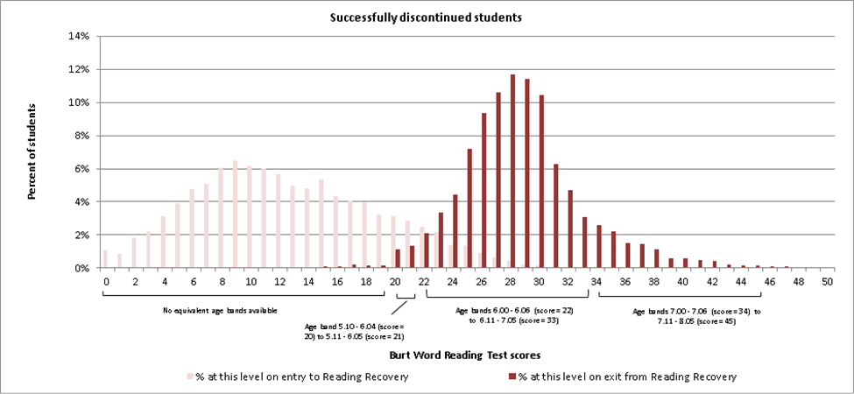
At entry to Reading Recovery |  |  | Upon exit from Reading Recovery
Average age* | Average Burt score | Equivalent age band | Average age* | Average Burt score | Equivalent age band
6 years and 4 months | 13 | Less than 5.10 | 6 years and 11months | 29 | 6.07–7.01
Figure J based on data from n=6,622 successfully discontinued students with Burt Word scores at entry and exit
* A small proportion of students did not have correct date of birth information and could not be included in the calculation of average age. Thus, this figure is our best estimate of the average age of students as they entered and exited the intervention.
Burt Word scores for referred on students upon entry to Reading Recovery were skewed towards the lowest end of the scale. The majority (90%) of these students entered Reading Recovery with a raw Burt Word score of 10 or less (below the 5.10–6.04 age band). At exit, Burt Word scores for referred on students were varied but, overall, higher than they were at entry. The majority (91%) of referred on students exited Reading Recovery with a Burt Word score between 7 (below the 5.10–6.04 age band) and 28 (equivalent age band 6.06–7.00 years).
Consistent with 2012 and 2011 findings, referred on students exited Reading Recovery with an average Burt Word score of 17. The equivalent age band for a score of 17 is less than 5 years 10 months. The average age of referred on students at the time of exit from Reading Recovery was 7 years old. Thus, although many referred on students made gains in relation to the Burt Word test over the course of their Reading Recovery lessons, the aggregated results for this group of students suggest that on average, students obtained Burt Word Reading Test scores below the expected level for their age group when they exited the intervention.
Figure K Burt Word Reading scores at entry and exit for referred on students
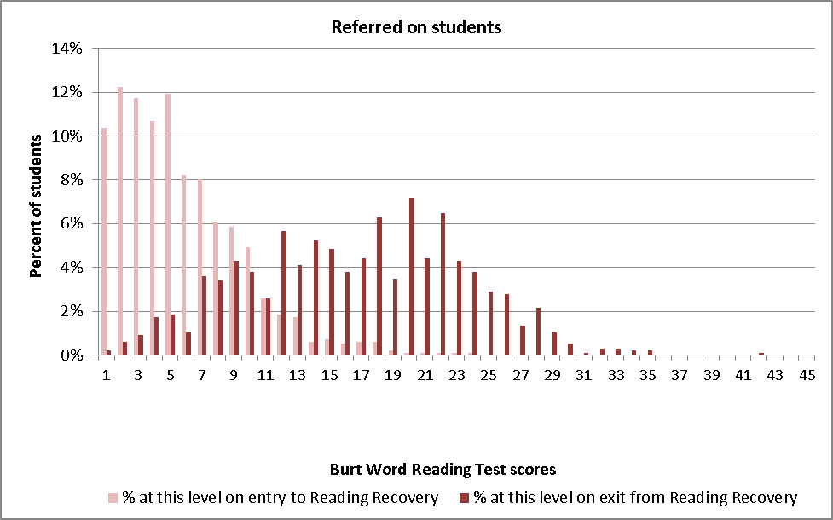
At entry to Reading Recovery |  |  | Upon exit from Reading Recovery
Average age* | Average Burt score | Equivalent age band | Average age* | Average Burt score | Equivalent age band
6 years and 4 months | 6 | Less than 5.10 | 7 years and 0 months | 17 | Less than 5.10
Figure K based on data from 973 referred on students with Burt Word scores at entry and exit.
* A small proportion of students did not have correct date of birth information and could not be included in the calculation of average age. Thus, this figure is our best estimate of the average age of students as they entered and exited the intervention.

Shift in Writing Vocabulary Task (Clay) — successfully discontinued and referred on students
Figure L and Figure M present students’ Writing Vocabulary Task (Clay) scores at entry to and exit from Reading Recovery, for successfully discontinued and referred on students.
Age-based norms for the Writing Vocabulary Task (Clay) are presented as stanines for each of the following age bands (5.01-5.50; 5.51-6.0; 6.01-6.50; 6.51-7.0 years). Stanines are a method of standardising test scores using a nine-point scale (with a mean of five and a standard deviation of two). In this method, test scores are ranked and assigned to a stanine according to the percentile they fall into (see Table 18). For example, the top four per cent of scores are assigned to stanine 9, the next seven per cent of scores are assigned to stanine 8, etc.
Given that the average age of successfully discontinued and referred on students was around 6.5 years on entry to Reading Recovery and closer to 7 years on exit, the stanine scores for the 6.01–6.50 years age band were used for the comparisons on entry and the scores for the 6.51–7.00 years age band were used for the comparisons on exit. The stanine scores for these two age bands are presented in Table 18.
Table 18 Writing Vocabulary Task (Clay) stanines for the 6.00–6.50 and 6.51–7.00 years age groups
Result ranking | 4% | 7% | 12% | 17% | 20% | 17% | 12% | 7% | 4%
Stanine | 1 | 2 | 3 | 4 | 5 | 6 | 7 | 8 | 9
6.01–6.50 years age group
Test Scores | 0-4 | 5-13 | 14-25 | 26-36 | 37-49 | 50-59 | 60-69 | 70-83 | 84+
6.51–7.00 years age group
Test Scores | 0-8 | 9-25 | 26-35 | 36-45 | 46-56 | 57-66 | 67-80 | 81-99 | 100+
Source: Clay MM (2013) An Observation Survey of early literacy achievement (3rd Edition). Auckland: Pearson.
As with the data for the other two assessment measures (Instructional Text levels and Burt Word scores), Figure L and Figure M highlight clear differences in the distribution of Writing Vocabulary Task (Clay) scores achieved by successfully discontinued and referred on students at entry to and exit from Reading Recovery.
The majority (83%) of students who were successfully discontinued had Writing Vocabulary Task (Clay) scores between 6 and 35 when they started their lessons. When they exited Reading Recovery, most (82%) had scores between 41 and 70.
The table below Figure C shows that successfully discontinued students exited Reading Recovery with an average Writing Vocabulary Task (Clay) score of 59. This score falls into the 6th stanine, which is above the mean for the 6.51–7.00 years age group.
This result provides some evidence that on average, successfully discontinued students tended to exit the intervention with Writing Vocabulary Task (Clay) scores that were above, or close to, the average level for their age group.
Figure L Writing Vocabulary Task (Clay) scores at entry and exit for successfully discontinued students
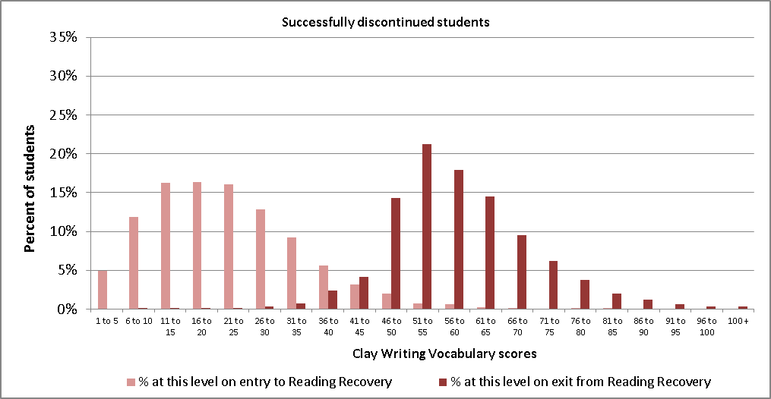
Entry to Reading Recovery |  |  | Exit from Reading Recovery
Average age* | Average Writing Vocabulary Task (Clay) score | Stanine group for 6.01 – 6.50 years | Average age* | Average Writing Vocabulary Task (Clay) score | Stanine group for 6.51 – 7.00 years
6 years and 4 months | 22 | Stanine group 3 | 6 years and 11 months | 59 | Stanine group 6
Figure L based on data from n=6,428 successfully discontinued students with Clay Writing Vocabulary scores at entry and exit from Reading Recovery.
* A small proportion of students did not have date of birth information and could not be included in the calculation of average age. Thus, this figure is our best estimate of the average age of students as they entered and exited the intervention.
Writing Vocabulary Task (Clay) scores for referred on students upon entry to Reading Recovery were skewed towards the lowest end of the scale and the majority (91%) of these students entered Reading Recovery with a Writing Vocabulary (Clay) score of 20 or less. In comparison, 76 per cent of referred on students exited Reading Recovery with Writing Vocabulary Task (Clay) scores of 21 or higher.
The table below Figure M shows that referred on students exited Reading Recovery with an average Writing Vocabulary Task (Clay) score of 31. This score falls into the 3rd stanine, which is below the mean for the 6.51–7.00 years age group. This result shows that on average, referred on students exited the intervention with Writing Vocabulary Task (Clay) scores that were below the average level for their age group
Figure M Writing Vocabulary Task (Clay) scores at entry and exit for referred on students
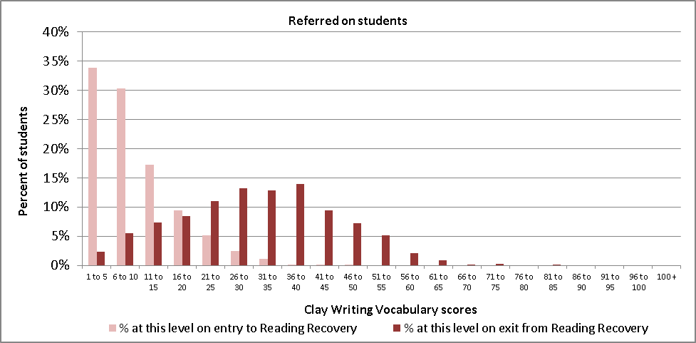
Entry to Reading Recovery |  |  | Exit from Reading Recovery
Average age* | Average Writing Vocabulary Task (Clay) score | Stanine group  for 6.01 – 6.50 years | Average age* | Average Writing Vocabulary Task (Clay) score | Stanine group for 6.51 – 7.00 years
6 years and 4 months | 10 | Stanine group 2 | 7 years and 0 months | 31 | Stanine group 3
Figure M based on data from 1,040 referred on students with Writing Vocabulary Task (Clay) scores at entry and exit from Reading Recovery.
* A small proportion of students did not have date of birth information and could not be included in the calculation of average age. Thus, this figure is our best estimate of the average age of students as they entered and exited the intervention.

Shifts in reading and writing gains for successfully discontinued and referred on students by decile
Consistent with 2011 and 2012 findings, successfully discontinued students from lower decile schools made slightly greater gains in all three measures of reading and writing than successfully discontinued students from higher decile schools (Figure N). This result reflects the fact that students from lower decile schools who were successfully discontinued tended to enter the intervention with slightly lower reading and writing levels than students from higher decile schools, but exit Reading Recovery at a similar level to students at higher decile schools. This result is to be expected as successfully discontinued students must reach the average band for their class cohort before their series of lessons are discontinued.
Figure N Mean entry and exit scores for successfully discontinued students by decile
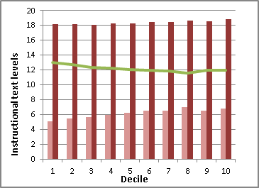 | 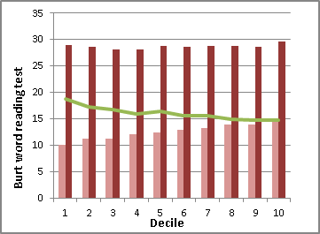 | 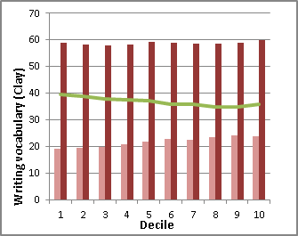
In comparison, there were not such clear differences in the gains made by referred on students from lower and higher decile schools across the three measures (Figure M). Referred on students from lower decile schools however, did tend to have lower entry and lower exit scores on the three reading and writing measures than referred on students from higher decile schools. See Appendix Table 3 and Appendix Table 4 for the data tables for Figures N and O.
Figure O Mean entry and exit scores for referred on students by decile
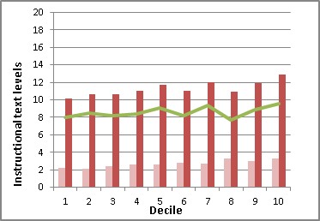 | 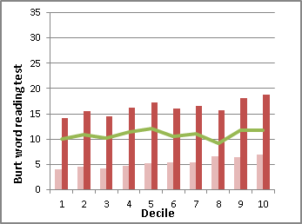 | 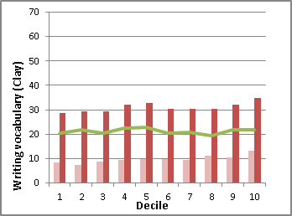
Key to Figures N and O:
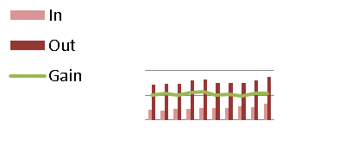

Shifts in reading and writing for successfully discontinued and referred on students by ethnicity
Māori and Pasifika students who successfully discontinued their series of Reading Recovery lessons made slightly greater gains in the three assessment measures than New Zealand European/Pākehā students. As shown in Table 19, this occurred because Māori and Pasifika students tended to enter Reading Recovery with slightly lower assessment scores than New Zealand European/Pākehā students. All three student groups exited the intervention with similar assessment scores.
^{Table 19} Mean entry and exit scores for successfully discontinued students by ethnicity
 | Instructional Text levels |  |  | Burt Word Reading test |  |  | Writing Vocabulary (Clay)
 | In | Out | Gain | In | Out | Gain | In | Out | Gain
Māori | 5.6 | 18.1 | 12.5 | 11.0 | 28.4 | 17.3 | 20.1 | 58.0 | 37.9
NZ European/Pākehā | 6.7 | 18.5 | 11.8 | 13.6 | 28.5 | 15.0 | 23.0 | 58.4 | 35.3
Pasifika | 5.4 | 18.4 | 13.0 | 11.7 | 29.4 | 17.6 | 20.6 | 60.2 | 39.6
Asian | 6.1 | 18.5 | 12.4 | 14.3 | 30.0 | 15.7 | 24.9 | 62.3 | 37.4
Other | 6.3 | 18.8 | 12.4 | 13.9 | 29.8 | 15.8 | 22.0 | 59.6 | 37.5
Table excludes data from students of unknown ethnicity and those with missing ethnicity information.

Across two of the three assessment measures, Pasifika students who were referred on made greater gains, on average, than Māori and New Zealand European/Pākehā students.
^{Table 20} Mean entry and exit scores for referred on students by ethnicity
 | Instructional Text levels |  |  | Burt Word Reading test |  |  | Writing Vocabulary (Clay)
 | In | Out | Gain | In | Out | Gain | In | Out | Gain
Māori | 2.5 | 10.7 | 8.2 | 4.7 | 15.2 | 10.5 | 8.9 | 29.7 | 20.8
NZ European/Pākehā | 2.9 | 11.6 | 8.7 | 5.7 | 16.3 | 10.6 | 10.2 | 31.0 | 20.7
Pasifika | 2.2 | 10.8 | 8.6 | 4.5 | 16.2 | 11.6 | 8.5 | 31.1 | 22.6
Asian | 2.5 | 12.0 | 9.5 | 6.3 | 19.7 | 13.4 | 10.1 | 35.4 | 25.3
Other | 2.5 | 11.5 | 9.0 | 5.9 | 17.6 | 11.8 | 12.5 | 34.3 | 21.7
Table excludes data from students of unknown ethnicity and those with missing ethnicity information.

Reading achievement for exiting students in relation to the New Zealand Curriculum Reading Standards
The following section presents information about students’ reading achievement in relation to the New Zealand Curriculum Reading Standards introduced in 2010. The purpose of this analysis was to investigate the relationship between students’ reading achievement upon exit from Reading Recovery and the National Reading Standard for ‘After two years at school.’
Background to the analysis: The National Reading Standard ‘After two years at school’ is used as a reference point for this analysis. Students typically start Reading Recovery after they have been at school for at least one year. According to the New Zealand Curriculum Reading Standards, a student is expected to be reading texts at the Turquoise level of Ready to Read after two years at school.
It is important to note however, that many students will not yet have completed two years at school at the time they exit Reading Recovery. Therefore, students who are not reading at the standard for ‘After two years at school’ may still be on track to achieve the standard by the end of their second year at school.
Limitations of the analysis: Classroom teachers will use a range of evidence when making judgements about student achievement in relation to the National Standards. The analysis presented here uses evidence from only one source, the Reading Recovery text level data, and should be interpreted with caution.
The years 1–3 Reading Standards are based on the core instructional series (Ready to Read) that supports reading in the New Zealand Curriculum. Reading Recovery teachers select books for individual students from a range of books of equivalent levels. The original Reading Recovery Booklist used by teachers to assist them in their book selection was developed in line with the original Ready to Read series. While there is intended equivalence between the text readability levels and the Ready to Read series, there may be some variation in the extent to which individual books are matched.
The following analysis approximates the text levels provided by Reading Recovery teachers to the colour wheel of the Ready to Read series.
Figure P presents the proportion of students who were reading at the level specified by the New Zealand Curriculum Reading Standard for ‘After two years at school’ (Turquoise level of Ready to Read), disaggregated by Reading Recovery outcome.
Consistent with findings in 2012 and 2011, the majority (91%) of successfully discontinued students were reading texts at or above the Turquoise level of the Ready to Read series when they exited the intervention, and nine per cent were reading at or above the Green level (the standard for ‘After one year at school’) when they exited Reading Recovery. It is important to note that three-quarters (74%) of successfully discontinued students had not yet completed two years of schooling when they exited Reading Recovery.
Six per cent of students who were referred on from Reading Recovery were reading texts at the Turquoise level when they exited the intervention. Almost half (44%) of referred on students were reading texts at or above the Green level (the standard for ‘After one year at school’) but not yet at the Turquoise level and a further 50 per cent were not yet reading at the Green level. A third (33%) of referred on students had completed two years of schooling when they exited Reading Recovery.
For students ‘not able to be continued’, about a third (30%) were reading texts at or above the Green level, but not yet at the Turquoise level. Sixty-six per cent of students were not yet reading texts at the Green level when they exited the intervention. The remaining four per cent were reading texts at the Turquoise level on exit.
In a similar pattern, half (52%) of students who left their school before completing their series of lessons were not yet reading texts at the Green level when they exited the intervention. A further 44 per cent were reading texts at or above the Green level but not yet at the Turquoise level and four per cent were reading at or above the Turquoise level when they exited the intervention.
Figure P Reading achievement on exit from Reading Recovery in relation to Reading Standards
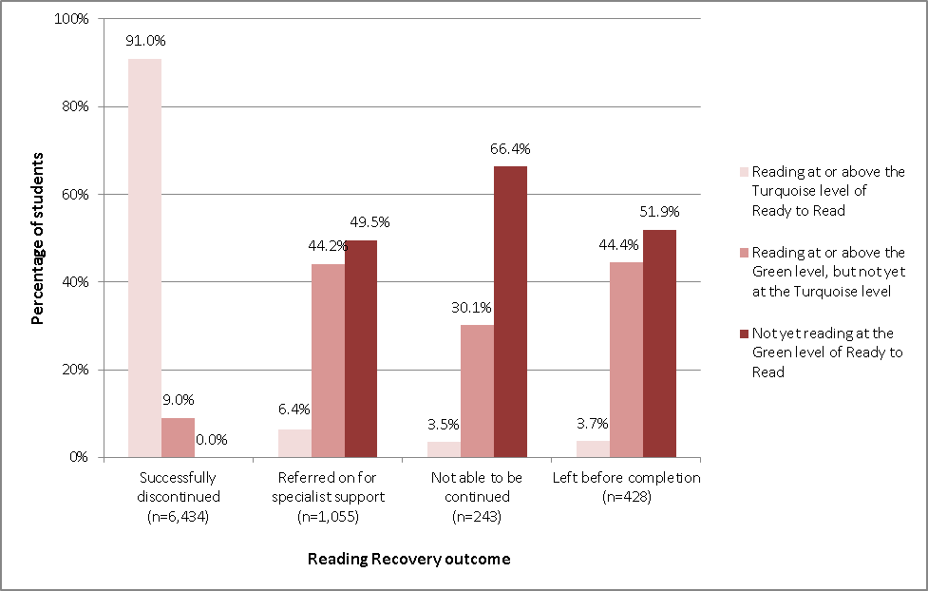

Conclusion
As with previous years, the data presented in the 2013 Annual Monitoring of Reading Recovery report shows that the majority (79%) of students who exited Reading Recovery in 2013 made accelerated progress and were successfully discontinued from the intervention, enabling them to work alongside their cohort without additional literacy support.
Furthermore, most students (91%) who were successfully discontinued from Reading Recovery in 2013 were reading texts at the Turquoise level of Ready to Read (the Reading Standard for ‘After two years of school’). Many of these students (74%) had not yet completed two years of schooling.
Data collected from the Burt Word Reading test and the Writing Vocabulary Task (Clay) provided additional evidence that successfully discontinued students were reading and writing at the average level expected for their age group when they exited the intervention.
Approximately one in eight students (13%) who exited Reading Recovery in 2013 were identified as needing additional literacy support and were referred on for specialist help or long-term literacy support. Overall, these students made some progress during the course of their Reading Recovery lessons, but on average, were reading and writing at levels below the expected levels for their age when they were referred on.
Students’ Reading Recovery outcomes differed across a number of key demographic factors. A higher proportion of girls, NZ European/ Pākehā and Asian students, and students from higher decile schools (decile 8 to 10) successfully discontinued their series of lessons than boys, Māori and Pasifika students, and students from lower decile schools (deciles 1 to 3). It is important to note however, that many Māori and Pasifika students, and students from lower decile schools (deciles 1 to 3) were successfully discontinued from their Reading Recovery lesson series. Further, where these students were successfully discontinued, they tended to make greater gains than NZ European/Pākehā and Asian students, and students from higher decile schools (decile 8 to 10).
For further information about Reading Recovery, contact National Reading Recovery, Faculty of Education, The University of Auckland, Private Bag 92601, Symonds Street, Auckland 1150 or visit the Reading Recovery website www.readingrecovery.ac.nz

Appendices
Appendix Table 1 Exiting students’ Reading Recovery outcome by school decile
Decile* | Successfully discontinued |  | 'Referred on' for specialist support |  | Student unable to continue |  | Student left school before completion |  | Total
Decile* | N | % | N | % | N | % | N | % | N
1 | 678 | 69.2% | 153 | 15.6% | 59 | 6.0% | 90 | 9.2% | 980
2 | 719 | 74.0% | 136 | 14.0% | 44 | 4.5% | 72 | 7.4% | 971
3 | 576 | 74.4% | 117 | 15.1% | 30 | 3.9% | 51 | 6.6% | 774
4 | 649 | 77.1% | 112 | 13.3% | 28 | 3.3% | 53 | 6.3% | 842
5 | 538 | 78.3% | 98 | 14.3% | 15 | 2.2% | 36 | 5.2% | 687
6 | 608 | 83.3% | 75 | 10.3% | 18 | 2.5% | 29 | 4.0% | 730
7 | 589 | 81.8% | 86 | 11.9% | 12 | 1.7% | 33 | 4.6% | 720
8 | 627 | 82.7% | 90 | 11.9% | 18 | 2.4% | 23 | 3.0% | 758
9 | 682 | 84.1% | 99 | 12.2% | 13 | 1.6% | 17 | 2.1% | 811
10 | 768 | 86.6% | 89 | 10.0% | 6 | 0.7% | 24 | 2.7% | 887
* Does not include students who were carried over into 2014, as they have not yet exited Reading Recovery. Also excludes data from students with missing information about their entry to and/or exit from Reading Recovery. Table based on students’ final outcome from Reading Recovery (where more than one school was attended during the year).

Appendix Table 2 Mean sessions & weeks for successfully discontinued and referred on students by decile
Decile | Student successfully discontinued  Reading Recovery |  |  | Student referred for specialist help or long-term reading support
Decile | N | Mean Number of 30 Minute Sessions | Mean Number of Calendar Weeks | N | Mean Number of 30 Minute Sessions | Mean Number of Calendar Weeks
1 | 678 | 80.9 | 21.2 | 153 | 83.8 | 23.3
2 | 719 | 80.7 | 20.4 | 136 | 89.0 | 23.4
3 | 576 | 79.0 | 19.9 | 117 | 90.5 | 23.7
4 | 649 | 80.7 | 19.7 | 112 | 88.8 | 22.5
5 | 538 | 79.1 | 19.4 | 98 | 92.8 | 23.7
6 | 608 | 78.5 | 19.0 | 75 | 87.0 | 21.6
7 | 589 | 78.0 | 19.0 | 86 | 99.3 | 24.3
8 | 627 | 77.1 | 18.9 | 90 | 90.6 | 22.7
9 | 682 | 76.6 | 18.3 | 99 | 91.0 | 22.2
10 | 768 | 76.3 | 18.4 | 89 | 95.5 | 23.3
Total | 6434 | 78.7 | 19.4 | 1055 | 90.3 | 23.1

Appendix Table 3 Mean entry and exit scores for successfully discontinued students by decile
Decile | Instructional Text levels |  |  | Burt Word Reading test |  |  | Writing Vocabulary (Clay)
Decile | In | Out | Gain | In | Out | Gain | In | Out | Gain
1 | 5.1 | 18.1 | 13.0 | 10.1 | 28.9 | 18.8 | 19.3 | 58.9 | 39.5
2 | 5.5 | 18.2 | 12.7 | 11.3 | 28.7 | 17.3 | 19.4 | 58.3 | 38.9
3 | 5.7 | 18.1 | 12.4 | 11.2 | 28.1 | 16.8 | 20.0 | 57.8 | 37.9
4 | 5.9 | 18.3 | 12.3 | 12.1 | 28.1 | 16.0 | 20.8 | 58.2 | 37.4
5 | 6.3 | 18.3 | 12.0 | 12.4 | 28.8 | 16.4 | 21.8 | 59.1 | 37.4
6 | 6.5 | 18.5 | 12.0 | 13.0 | 28.6 | 15.6 | 23.0 | 58.9 | 36.0
7 | 6.5 | 18.4 | 11.9 | 13.2 | 28.8 | 15.6 | 22.7 | 58.6 | 35.9
8 | 7.0 | 18.6 | 11.6 | 13.9 | 28.8 | 14.9 | 23.7 | 58.4 | 34.8
9 | 6.6 | 18.5 | 12.0 | 13.9 | 28.6 | 14.7 | 24.1 | 58.9 | 34.8
10 | 6.8 | 18.8 | 12.0 | 14.8 | 29.6 | 14.9 | 24.0 | 60.0 | 36.0
Appendix Table 4 Mean entry and exit scores for referred on students by decile
Decile | Instructional Text levels |  |  | Burt Word Reading test |  |  | Writing Vocabulary (Clay)
Decile | In | Out | Gain | In | Out | Gain | In | Out | Gain
1 | 2.2 | 10.2 | 8.0 | 4.1 | 14.2 | 10.1 | 8.3 | 28.8 | 20.5
2 | 2.1 | 10.6 | 8.5 | 4.5 | 15.5 | 11.0 | 7.3 | 29.3 | 22.0
3 | 2.4 | 10.6 | 8.2 | 4.2 | 14.5 | 10.3 | 8.9 | 29.4 | 20.5
4 | 2.7 | 11.0 | 8.4 | 4.8 | 16.1 | 11.4 | 9.3 | 32.0 | 22.7
5 | 2.7 | 11.7 | 9.0 | 5.3 | 17.3 | 12.1 | 9.8 | 32.8 | 22.9
6 | 2.8 | 11.0 | 8.2 | 5.5 | 16.0 | 10.5 | 9.8 | 30.3 | 20.5
7 | 2.7 | 12.1 | 9.4 | 5.5 | 16.5 | 11.1 | 9.6 | 30.3 | 20.7
8 | 3.3 | 11.0 | 7.7 | 6.6 | 15.8 | 9.2 | 11.1 | 30.4 | 19.3
9 | 3.0 | 11.9 | 8.9 | 6.4 | 18.1 | 11.7 | 10.5 | 32.2 | 21.7
10 | 3.3 | 12.9 | 9.5 | 7.0 | 18.8 | 11.7 | 13.2 | 34.9 | 21.7

. This figure excludes 124 students whose individual reports were unavailable.
This figure excludes three schools with no students in Reading Recovery, eight schools reporting no Reading Recovery hours, and 17 school reports with null entries. A further 17 schools that had not submitted school reports were identified as having offered Reading Recovery through student reports being submitted from these schools.
. New Zealand Reading Recovery Guidelines, National Reading Recovery Centre, 2011.
. Clay, M.M/ (2013)/ An observation survey of early literacy achievement (3rd Edition). Auckland: Pearson.
. Gilmore, A., Croft, C., & Reid, N. (1981). Burt Word Reading Text: New Zealand Revision. New Zealand Council for Educational Research, Wellington.
. Complete assessment data for students who experienced other outcomes (eg, left school with incomplete lesson series) is often not available.
. For more information about the Reading and Writing Standards see http://nzcurriculum.tki.org.nz/National-Standards.

