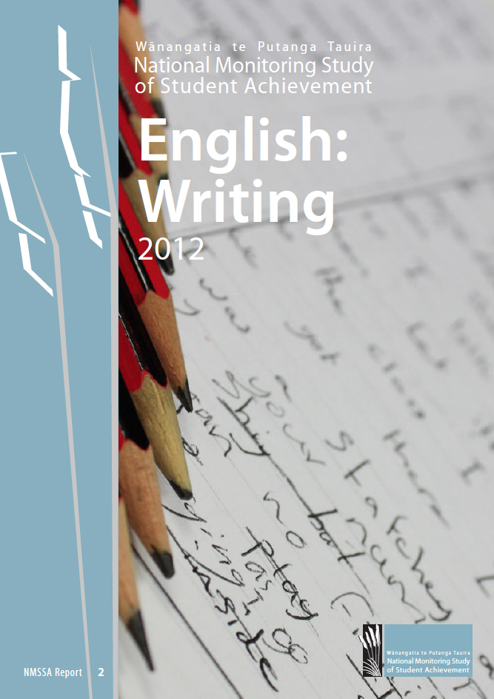

English: Writing
2012
Educational Assessment Research Unit
and
New Zealand Council for Educational Research

NMSSA Report 2
© 2013 Ministry of Education



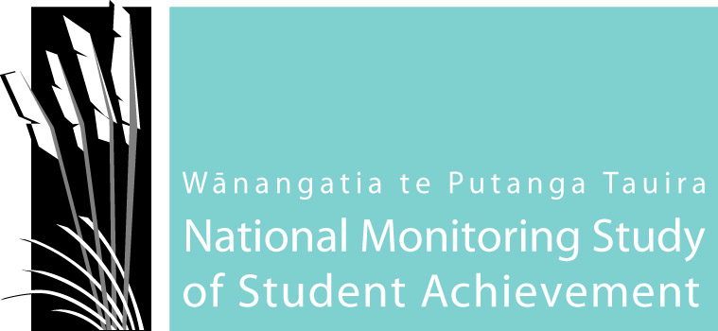
Report 2
National Monitoring Study of Student Achievement, English: Writing 2012
ISSN: 2350-3254 (Print)
ISSN: 2350-3238 (Online)
ISBN: 978-1-927286-02-9 (Print)
ISBN: 978-1-927286-03-6 (Online)
National Monitoring Study of Student Achievement
Educational Assessment Research Unit, University of Otago, PO Box 56, Dunedin 9054, New Zealand Tel: 64 3 479 8561 • Email: nmssa@otago.ac.nz

Contents
6 Acknowledgements
7 Executive Summary
13 Chapter 1 Overview of the National Monitoring Study of Student Achievement
15 Chapter 2 The NMSSA Writing Assessment Programme
28 Chapter 3 Student Achievement in Writing
51 Chapter 4 Understanding Achievement in Writing
63 Chapter 5 Māori Student Achievement in Writing
74 Chapter 6 Pasifika Student Achievement in Writing
84 Chapter 7 Writing Achievement of Students with Special Education Needs
94 Appendix 1 National Monitoring Study of Student Achievement, 2012–2013
100 Appendix 2 Task Overview Grid and Task Template for Process of Writing: Individual Assessments
103 Appendix 3 Curriculum Alignment Procedures for Writing
106 Appendix 4 Effect Sizes Analyses
121 Appendix 5 Opportunities to Learn in Writing for Students with Special Education Needs
125 Appendix 6 Writing Achievement by School Decile and Student Ethnicity
130 Appendix 7 Achievement on Writing for a Variety of Purposes by Writing Prompt

Acknowledgements
The NMSSA project team wishes to acknowledge the very important and valuable support and contributions of many people to this project, including:
- Members of the reference groups: Technical, Maori, Pasifika, and Special Education
- Members of the curriculum advisory panels in Science and Writing
- Principals and students of the schools where the tasks were piloted and the 19 schools where assessment and linking trials were conducted
- Principals, teachers and Board of Trustees members of the 235 schools who participated in the 2012 main study including the linking study
- The more than 6200 children who participated in the assessments
and their parents, whānau and caregivers
- The more than 30 teachers who administered the assessments to the children
- The nearly 60 teachers and senior initial teacher education students
who undertook the marking
- The Ministry of Education Research Team and Steering Committee

2012 Project Team
Management Team Alison Gilmore – Director
Ros Allan – Programme Manager
Lynette Jones – Operations Manager
Chris Joyce – NZCER Manager
Design/Statistics/Psychometrics Alison Gilmore Charles Darr
Denise Quinlan Hilary Ferral
Jordan Gilmore Jacky Burgon
Edith Hodgen
Curriculum/Assessment Ros Allan Chris Joyce Ally Bull
Jane White Rose Hipkins Jan Eyre
Esther Smaill Juliet Twist Trina Taupo
Frances Neill Verena Watson
Programme Support Lynette Jones – Operations / Publications
Linda Jenkins – Administration
James Rae – Digital Platforms & Equipment
Lee Baker – Materials & Raw Data Records
Rachael Kearns – Administration
Jess Mazengarb – Administration
Sarah Boyd – Communications
External advisors Jeffrey Smith – University of Otago
Marama Pohatu – Te Rangatahi Ltd

The name
The Māori phrase, Wānangatia te putanga tauira, is derived from the karakia Mānawatia te putanga tauira, which is about celebrating student success. Wānangatia te putanga tauira is about studying, considering, analysing student success and achievement.
The National Monitoring Study of Student Achievement (NMSSA) is a collaboration between the Educational Assessment Research Unit (EARU) team at the University of Otago and the New Zealand Council for Educational Research (NZCER). We work in partnership with the Ministry of Education (MoE) to maximise the potential of national monitoring and maintain the independence of the programme to ensure the trust of the community, educators and policy makers.

Executive summary
The National Monitoring Study of Student Achievement (NMSSA) – Wānangatia Te Putanga Tauira is designed to assess and understand student achievement across the curriculum at the primary level in New Zealand’s English-medium state schools.
The main purposes of NMSSA are to provide a snapshot of Year 4 and Year 8 student achievement and factors that are associated with achievement; to assess strengths and weaknesses across the curriculum and to monitor change over time. NMSSA also has a specific focus on Māori and Pasifika students and students with special education needs.
NMSSA is a long-term project that commenced in 2012. In this first year of NMSSA it is possible to provide a baseline or snapshot of student achievement in two learning areas of the New Zealand Curriculum (NZC) – science and writing. Data in subsequent years will provide information about student achievement and strengths and weaknesses across the whole curriculum, including key competencies. It will also provide information about literacy and mathematics across the curriculum. In subsequent cycles, when NMSSA repeats its focus on each learning area, NMSSA will be able to report on any changes in achievement and monitor trends over a longer term. Thus, NMSSA is a national monitoring programme that will evolve and develop over time to assess and understand student achievement in New Zealand.
NMSSA follows on from the National Education Monitoring Project (NEMP) that was conducted between 1995 and 2010. NMSSA has built on and extended the design of NEMP to make use of more advanced psychometrics for reporting student achievement and exploring factors associated with that achievement. Thus, NMSSA is able to draw on findings from four cycles of NEMP assessments to retain continuity in monitoring national achievement and trends.
A focus on English: writing
Writing is creating meaning appropriate to the purpose and audience. According to the Literacy Learning Progressions, “Students use their writing to think about, record, and communicate experiences, ideas, and information” (p.6). The NZC presents a series of achievement objectives in the English learning area for each curriculum level that describe how students create meaning for themselves through speaking, writing and presenting. As students progress as writers they develop increasing levels of knowledge, skills and understandings related to creating and conveying meaning. They engage with tasks and texts that are increasingly sophisticated, and do this in increasing depth to meet the demands of their purpose for writing and their audience.
This report presents the findings about the achievement and attitudes of Year 4 and Year 8 students in English: writing and factors that are associated with that achievement. Hereafter, English: writing is referred to as writing. The components of the 2012 writing assessment programme include:
- Writing for a Variety of Purposes is based on the e-asTTle framework and is a measure of students’ writing over seven elements: ideas, structure and language features, paragraphing, vocabulary, sentence structure, punctuation and spelling. This was a paper-and-pencil assessment completed by approximately 2000 students at each year level.
- Process of Writing is a measure of students’ understanding of how to create, shape and refine text. This comprised seven elements: audience awareness, planning, crafting/writing, revising and editing, proofreading, feedback and publishing. This was a series of individual assessments using one-to-one interviews and performance activities completed by approximately 700 students at each year level.
- Student attitudes and learning opportunities in writing, including a measure of their self-efficacy and engagement with writing, were obtained via a questionnaire.
- Teacher perspectives on writing teaching and learning in the school, including their confidence as writing educators and professional support for teaching writing, were obtained via a questionnaire.
Several of the writing measures including both achievement measures were developed using Item Response Theory to report on a scale common to Year 4 and Year 8 students. This allowed comparisons to be made between the two year levels.
The report also describes the achievement of subgroups of students (by gender, ethnicity, school decile and type of school) and the achievement of the key population groups (Māori, Pasifika and students with special education needs) and student and teacher perspectives on the learning and teaching of writing.

Key findings from the report
National student achievement
The Writing for a Variety of Purposes scale is divided into four broad bands, each describing the qualities (ideas, structure and language features, paragraphing, vocabulary, sentence structure, punctuation and spelling) of student writing associated with that part of the scale. The Process of Writing scale is divided into two broad bands describing the progression in seven different elements involved in the assessment (audience awareness, planning, crafting/writing, revising and editing, proofreading, feedback and publishing). The descriptors provide an indication of the progression of writing knowledge and competencies found between Year 4 and Year 8.
An alignment process was used to link the Writing for a Variety of Purposes scale to the descriptions of writing competency described by the Literacy Learning Progressions of the NZC. The process took advantage of the link that already existed between the e-asTTle writing scale and the Literacy Learning Progressions. The exercise allowed performance on the Writing for a Variety of Purposes assessment to be reported in terms of curriculum expectations at different year levels.
In this report, English Curriculum Level 2 is used as the expected level for students at the end of Year 4, and Level 4 as the expected curriculum level for students at the end of Year 8.
- Year 4 students' writing scores ranged across curriculum Levels 1 to 3 with the greatest proportion scoring in Level 2. Year 8 students' writing scores ranged across curriculum Levels 2 to 4 with the greatest proportion achieving in Level 3. The Year 4 result is in line with end of year NZC expectations, while the Year 8 result is below NZC expectations.
- The results show that Year 4 students' writing typically involved writing simple ideas using brief but coherent text, with language features appropriate to the purpose. Their writing showed they were usually successful with beginning and end of sentence punctuation, and their sentences often showed variety in structure. They used correct spelling for a range of personal and high frequency words, and vocabulary sometimes included a few precise words.
- Year 8 students' writing typically included ideas that show some complexity and elaboration. Text was generally coherent with basic paragraphing, and ideas that flowed. The structural and language features were appropriate to purpose and showed some development and control. They typically used a variety of precise vocabulary that added information and enhanced meaning. They wrote sentences that had correct beginning and end punctuation and some correct usage of other punctuation. Sentence structures showed variety, extension and a sense of control. A wide range of high frequency words were spelled correctly, and approximations were made for difficult words.
- Of the five different writing purposes (prompts) used (to explain, persuade, describe, recount and narrate), Year 4 students did least well, on average, at writing a persuasive piece and best, on average, at writing a recount. Year 8 students did least well, on average, when writing an explanation or a descriptive piece than when writing for the other three prompts.
- Of the seven elements in Writing for a Variety of Purposes (ideas, structure and language, organisation, vocabulary, sentence structure, punctuation and spelling), students at both year levels scored, on average, the highest on spelling and the lowest on punctuation. The second strongest element for Year 4 was ideas, while for Year 8 it was sentence structure.
- Year 4 and Year 8 students did not differ markedly, on average, in their understanding of the process of writing. About half of Year 4 students and most Year 8 students were typically able to talk about the audience for their writing, and discuss a pre-writing/planning phase for writing. They were able to talk about crafting of writing, describing at least one aspect such as making choices about ideas, structure of language features, etc. These students generally acknowledged that proofreading is part of the writing process, and were able to talk about making changes to their writing although they were unlikely to articulate why changes should be made. They typically did not mention feedback as a part of the writing process, nor acknowledge publishing as part of the writing process. The lower scoring 50 percent of Year 4 students had not yet reached the level of competence with Process of Writing described here. A very few Year 8 students (5 percent) demonstrated more developed levels of knowledge and skill on the Process of Writing scale.
- As expected, Year 8 students achieved higher scores, on average, than Year 4 students with an average annual effect size of 0.36 on Writing for a Variety of Purposes. This level of growth is towards the higher end of the range found for other curriculum areas (Hattie, 2009) and is significantly higher than that for Process of Writing (0.18). It is also significantly higher than that for NMSSA Science achievement.
- Progress from Year 4 to Year 8 is very similar for all subgroups (e.g. boys and girls, ethnicity, decile and types of school).
- There was a wide distribution of scores at both year levels and some overlap in the achievement of Year 4 students and Year 8 students, particularly in the Process of Writing.
- Results showed that, on average, achievement varied by gender, ethnicity and school decile. For both year levels and both measures of writing, average achievement was higher for girls than boys, lower for Māori and Pasifika students than for non-Māori and non-Pasifika students respectively, and was lower for students from lower decile schools. Findings reported by NEMP in 1998, 2002 and 2006 indicate ongoing disparities between subgroups over this period. NMSSA indicates that the differences continue and are statistically significant.
- There is a complex relationship between ethnicity, school decile and writing achievement. Both factors are significantly associated with results for Writing for a Variety of Purposes, although not for Process of Writing. However, when controlling for decile, the differences between the average scores of NZ European, Māori and Pasifika students disappear for students from decile 1 schools (there were insufficient Pasifika and Māori sample sizes for comparisons at the other decile levels). This contrasts with the finding for NMSSA Science (2012) where differences between ethnicity groups persisted for students from decile 1 schools.
- Feedback about their writing appeared to be a relatively common practice involving teachers and peers. Year 8 students had a greater understanding of the relationship between feedback and improving their writing. Feedback given by students or received from teachers focused primarily on the deep and surface features of writing.
Factors associated with achievement
A number of factors associated with achievement were examined. These included a measure of student attitude to writing, the amount of English spoken at home, writing learning opportunities at school reported by students and teachers, teachers’ confidence as writing educators, and the level of professional and curriculum support provided within school and by professional learning and development (PLD) programmes.
- Overall, Year 4 students were more positive about writing than Year 8 students. Girls were generally more positive than boys at both year levels, and the difference was similar at both year levels. These findings are consistent with those from NEMP since 1998 to 2006.
- Pasifika students scored higher, on average, on the Attitude to Writing scale than European and Māori students at both Year 4 and Year 8 which is also consistent with NEMP findings.
- Attitude to Writing was weakly related to Writing for a Variety of Purposes particularly for students with low Attitude to Writing scores and was more strongly related at Year 8 than Year 4. There was no relationship between Attitude to Writing and Process of Writing.
- Year 4 students reported more frequent involvement in a range of different writing experiences than Year 8 students. The most frequent activities at both year levels were teacher-led; sharing their writing with the teacher, and writing about something their teacher had asked them to write about. A sizable proportion of students in both year levels reported infrequent involvement in many of the experiences.
- Teachers were very positive about writing and their confidence as teachers of writing. This supports the findings by the Education Review Office (2007) that 87 percent of teachers were effective teachers of writing in some or all six quality of teaching indicators.
- Teachers of Year 4 students reported the use of remedial activities outside the classroom more often than those who taught Year 8. Year 8 teachers were more likely to report the use of extension activities outside of the classroom.
- Most teachers reported that they were regularly involved (once a term or more) in a range of professional interactions that supported their teaching of writing. This included working together to plan and prepare, discussing useful approaches to teach writing, and discussing samples of students' work.
- Over 80 percent of Year 4 teachers and 75 percent of Year 8 teachers reported that they were involved in professional development and learning focused on writing in the last 12 months. This is substantially higher than the level of science PLD reported by teachers in NMSSA Science (2012).

Achievement of Māori students
Students could identify with up to three ethnic groups. All students who identified as Māori were included in the Māori analyses. The national sample at Year 4 included 423 Māori students and at Year 8, 353 Māori students. We compare Māori student subgroups to all students in the national sample. When making these comparisons the national sample is referred to as ‘All Students’.
- Year 4 and Year 8 Māori students tended to achieve at a slightly lower level than NZ European students (Chapter 3) and some features of Māori student achievement followed similar patterns to the national samples.
- Between the year levels, as expected, Year 8 Māori students, on average, achieved higher scores than Year 4 Māori students. However, there was a wide distribution of scores at both year levels and considerable overlap in the achievement of Year 4 and Year 8 Māori students. The overall difference in average scores between Year 4 and Year 8 students was greater for Writing for a Variety of Purposes than for Process of Writing as was the case for the national sample.
- For Writing for a Variety of Purposes, the average of Year 4 Māori students was just within Curriculum Level 2. As performance at Level 2 is the expectation described in the NZC, roughly half of Year 4 Māori students might be viewed as achieving at or above curriculum expectations, with the other half below such expectations. In Year 8, the average score was within the upper portion of Level 3. As was also the case with All Students, this was below the expectations outlined in the NZC (Level 4).
- At both year levels, average scores of Māori students on Writing for a Variety of Purposes differed by school decile and gender. This was the measure that assessed a range of writing skills using a piece of the student’s work. On average, Māori girls scored higher than boys and Māori students at high decile schools scored higher than those from low decile schools. In both cases the difference between these groups was similar at both year levels. Differences by school type were not notable at either year level.
- Gender and decile differences were also observed at Year 4 on Process of Writing, the measure that assessed student’s awareness and understanding of a range of processes involved in writing. These differences were not significant at Year 8.
- The percentages of Year 4 and Year 8 Māori students who achieved above the respective national averages were lower than for All Students.
- Approximately 40 percent of Māori students at Year 4 and Year 8 scored above national averages for both writing measures. At Year 4 the above average group included more girls than boys and came evenly from across the full range of school deciles. At Year 8 the same pattern held for gender, but a majority of students came from mid decile schools.
- Just over 80 percent of all Māori students attended low and mid decile schools. This contrasts with just over 50 percent of NZ European students attending low or mid decile schools. When these figures are accounted for, they show that, as for All Students, a higher proportion of Māori students attending high decile schools scored above the benchmark than from mid or low decile schools. However, at Year 8 this difference is less pronounced.
Achievement of Pasifika students
All students who identified as Pasifika were included in the Pasifika analyses. The national sample at Year 4 included 262 Pasifika students and at Year 8, 206 Pasifika students. We compare Pasifika student subgroups to all students in the national sample. When making these comparisons the national sample is referred to as ‘All Students’.
- On average, Pasifika students scored lower than All Students at both year levels. However, the difference between Year 4 and Year 8 Pasifika scores was similar to that for All Students, and notably so for the Writing for a Variety of Purposes measure. This suggests that Pasifika students showed a similar rate of progress to All Students.
- Year 8 Pasifika students achieved higher scores, on average, than Year 4 Pasifika students. However, there was a wide distribution of scores at both year levels and overlap in the achievement of Year 4 students and Year 8 students.
- Writing achievement varied at both year levels for Pasifika students depending on the amount of English spoken at home. Students who spoke English at home ‘always’ or ‘often’ tended to achieve at a higher level than those who spoke English at home 'sometimes' or 'never'.
- There was little difference in average scores for Pasifika students at Year 4 with respect to the type of school they were attending. Year 8 average scores, however, were higher for those Pasifika students attending full primary schools than for Pasifika students in intermediate schools.
- For Writing for a Variety of Purposes, a little over 50 percent of Year 4 Pasifika students achieved in Level 2 of the NZC or above, compared to 65 percent of All Students. Performance by Pasifika students was, on average, in line with expectations outlined in the NZC. A third of Year 8 Pasifika students achieved within Levels 4 and 5, similar to the All Students group. This was below the expectations outlined in the New Zealand Curriculum.
- The percentages of Year 4 and Year 8 Pasifika students who achieved above the national averages were lower than for All Students (51 and 53 percent respectively).
- While 37 percent of Pasifika students at Year 4 scored above the national average, a greater percentage of Pasifika students at Year 8 scored above the national average (48 percent) –almost at the same level as All Students. About 70 percent of these students were girls, a greater percentage than in the All Students group.
- More than 85 percent of all Pasifika students at both year levels attended low and mid decile schools. This contrasts with just over 50 percent of NZ European students attending low or mid decile schools. When this is accounted for, results show that a greater proportion of Pasifika students at high decile schools scored above the national benchmark. This reflects the same relationship between achievement and school decile that was found for All Students.

Achievement of students with special education needs
For the first time, students with special education needs were identified in national monitoring. This represents a major step forward in the inclusion of children with special education needs in reporting national level assessment.
Overall, the numbers of students reported on in Chapter 7 are relatively small and the findings should therefore be interpreted with caution. This is particularly true with regard to the high special education needs group from which many of the special education needs student withdrawals are likely to have come. As such, this group cannot be considered a statistically representative sample.
Participating schools were asked to identify students who had special education needs as:
- High special education needs: For example, ORS funded, Supplementary Learning Support, severe behaviour or communication assistance from Special Education
- Moderate special education needs: For example, provided with a teacher aide from school funds, on the case load for Resource Teachers: Learning and Behaviour (RTLB), or Child Youth and Family Services (CYFS)
- On referral: For example, to Special Education or CYFS with action pending.
Students not falling into any of the above categories were assigned to a no special education needs group.
Although the number of students with high special education needs was very small, students with moderate special education needs made up 8 percent of All Students at Year 4 and 5 percent at Year 8.
- On average, Year 8 students with special education needs scored higher than Year 4 students with special education needs. As with All Students, there was some overlap in the achievement of Year 4 and Year 8 students with special education needs.
- At Year 4 all students with high special education needs, and nearly three quarters of students with moderate special education needs achieved within curriculum Level 1. The remainder achieved at Level 2 or 3. Students identified as being on referral performed in very similar ways to the national sample.
- At Year 8, over one third of students with high special education needs achieved within curriculum Level 2 or 3. Just over one third of students with moderate special education needs achieved within curriculum Level 3 or 4. In contrast, about one third of students in the on referral and the no special education needs groups achieved at Level 4 or above.
- At both year levels, students with high special education needs or moderate special education needs achieved, on average, at a lower level than those with no special education needs or on referral. However, there was a wide range of achievement among the students with moderate special education needs and their scores overlapped with the students with no special education needs or those students on referral. The difference between the average scale scores of students with moderate special education needs and no special education needs groups was about 1.0 scale score units.
- The difference in scores between Year 4 and Year 8 (progress) for students with moderate special education needs and for students on referral was about 25 scale score points (an effect size of about 1.3). This difference is equivalent to that observed for All Students (Chapter 3).
- On average, Attitude to Writing scores were similar across all groups of students within each year level. As with the All Students group, the average Attitude to Writing score declined from Year 4 to Year 8. The no special education needs group showed a smaller decline in average Attitude to Writing between Year 4 and Year 8 than the moderate special education needs group.
- Students with special education needs reported having a similar range of opportunities to learn to write in school as the students with no special education needs. Students with high special education needs reported writing using a computer more often than other groups of students. Year 4 teachers reported using specialist advice to adapt the curriculum for learners with special needs more often than Year 8 teachers did.
- Fifteen percent of Year 4 students and 17 percent of Year 8 students with moderate special education needs scored above their respective national averages.
- Over half of the students on referral (55 percent at Year 4 and 58 percent at Year 8) scored above the benchmark at each year level. This was slightly higher than for All Students.

1
Overview of the National
Monitoring Study of
Student Achievement

1. Purpose of national monitoring
The National Monitoring Study of Student Achievement (NMSSA) – Wānangatia Te Putanga Tauira – is designed to assess and understand student achievement across the curriculum at Year 4 and Year 8 in New Zealand’s English-medium state schools. The main purposes of NMSSA are:
• To provide a snapshot of student achievement against the New Zealand Curriculum (NZC);
• To identify factors that influence achievement;
• To assess strengths and weaknesses across the curriculum;
• To measure change in student achievement over time; and
• To provide high quality, robust information for policy makers, curriculum planners and educators.
The information on educational outcomes and influencing factors that is provided through NMSSA will continue the monitoring undertaken by the National Education Monitoring Project (NEMP) between 1995 and 2010 and complement international studies such as TIMSS and PIRLS and other national evaluation studies.
The project covers all areas of the New Zealand Curriculum, and includes a focus on both key competencies and literacy and mathematics across the curriculum. NMSSA has a particular focus on Māori students, Pasifika students and students with special education needs.
Contextual information is collected to help understand the factors that are associated with students’ achievement. This includes students’ attitudes to, and the opportunities to learn in, the specific learning area being investigated, as well as features of their educational experiences at school and home that support their learning. Teachers provide information about factors such as teachers' confidence in teaching the specific learning area under investigation, learning opportunities provided to students, and the professional and curriculum support provided to teachers.
Each year NMSSA focuses on two learning areas. During the course of a cycle, all learning areas of the curriculum, as well as cross-curriculum elements such as key competencies, and literacy and mathematics across the curriculum, will be monitored. Annual reports of student achievement and influencing factors in each learning area will be compiled. Trends and changes in student achievement within learning areas will be monitored through subsequent cycles. While aspects of student achievement on the key competencies and literacy and mathematics across the curriculum will be assessed each year, reports on these aspects will be produced at the end of each cycle rather than annually. (http://nmssa.otago.ac.nz/)
The project is supported by advisory panels of curriculum experts, reference groups for the priority population groups (Māori, Pasifika, and special education needs), and a technical reference group.

2. The 2012 study
In 2012 the dual focus for the NMSSA study was science and writing. A nationally representative sample of approximately 2000 students at each year level took group-administered paper-and-pencil assessments in both learning areas. These students also responded to questions about their attitudes, learning experiences and support for learning. A sub-sample of approximately 700 students at each year level also took part in individual assessments through one-to-one video-recorded interviews and performance activities. Individual assessments were used for assessing aspects of learning in science and writing most suited to in-depth assessment approaches. The assessments were conducted by experienced, specially-trained classroom teachers with sound cultural awareness. During Term 3, monitoring procedures ensured consistent and high quality administration of assessments and marking. The characteristics of the achieved samples are described in Appendix 1.
As well, at each year level, approximately 200 teachers from the schools involved in the study were invited to respond to a questionnaire about school learning environments and learning opportunities provided for students, their confidence in teaching science and writing, and professional support they received for teaching these learning areas.

3. Structure of the writing report
The report of student achievement in writing is set out in seven chapters:
1. Chapter 1 provides a broad overview of the NMSSA programme.
2. Chapter 2 sets out the development of the writing achievement measures and data collection instruments. The analytical and reporting approaches used to present the findings are also set out in this chapter.
3. Chapter 3 presents the findings for Year 4 and Year 8 student achievement in writing and reports these against levels of the Literacy Learning Progressions of the NZC. It also compares achievement between Year 4 and Year 8 students, and differences among subgroups of gender, ethnicity, school decile and type of school.
4. Chapter 4 examines factors that may be associated with student achievement in writing and draws on information collected from students about their attitude to writing, the amount of English spoken at home, and their learning experiences in writing at school. This is examined alongside information collected from teachers about their confidence in teaching writing, the learning experiences they provide to students, and professional support for teaching writing.
5. Chapter 5 reports the achievement of Māori students in writing and their experiences at school. The characteristics of Māori students who achieve above the national mean are examined in relation to gender, attitude to writing and school decile.
6. Chapter 6 presents the achievement of Pasifika students in writing and their experiences at school in a parallel way to Māori students in Chapter 5. The influence of the amount of English spoken at home on achievement is also examined.
7. •Chapter 7 reports the participation and achievement in writing of students who have special education needs – high/very high needs, moderate needs and students on referral.

2
The NMSSA Writing
Assessment Programme

This chapter provides an overview of the NMSSA assessment programme for writing in the English learning area of the New Zealand Curriculum (NZC). It includes seven parts.
• Part 1 describes writing in the NZC.
• Part 2 sets out the overall writing assessment plan for NMSSA.
• Parts 3, 4, 5 and 6 describe the frameworks, design processes and the reporting scales for the four different components of the writing assessment programme.
• Part 7 provides more information about the scales and describes the graphs and statistics used to report the findings.

1. Writing in the New Zealand Curriculum
Writing is creating meaning appropriate to the purpose and audience. According to the Literacy Learning Progressions, “Students use their writing to think about, record, and communicate experiences, ideas, and information” (p.6). The NZC presents a series of achievement objectives in the English learning area for each curriculum level that describe how students create meaning for themselves through speaking, writing and presenting. As students progress as writers they develop increasing levels of knowledge, skills and understandings related to creating and conveying meaning. They engage with tasks and texts that are increasingly sophisticated, and do this in increasing depth to meet the demands of their purpose for writing and their audience.

2. The NMSSA English: Writing Assessment Plan
An advisory panel of writing curriculum experts was convened to consider writing in the NZC, including a consideration of how the key competencies described in the NZC relate to writing. The panel also identified key contextual questions to better understand student achievement in writing. The discussion with the advisory panel formed the basis for the NMSSA writing assessment plan.
Table 2.1 sets out the writing assessment plan. Several “big questions” were generated to identify the important or significant issues relevant to explore in writing. These led to a number of more “specific questions” relating to (i) assessing achievement in writing and (ii) understanding achievement in writing. The specific questions were used to guide the development of the different components that made up the NMSSA writing assessment programme. The writing assessment plan and subsequent task development was informed by a number of resources.

Table 2.1 The English: Writing Assessment Plan
Big questions
- How well do students …
- write for a range of purposes?
- use the appropriate processes of writing?
- assess their own writing?
- To what extent do various contextual factors influence achievement in writing?
- What are the affective and cognitive factors that influence achievement in writing?
- To what extent do school, whānau and community factors influence achievement in writing?
- What can we say about the role of students’ identity, language and culture on their achievement in writing?
- How do Year 4 and Year 8 differ?
- What is the change over time at Year 4 and Year 8?
Assessing achievement: specific questions
To what extent do students…
- use the constrained skills necessary for writing? (e.g. spelling of high frequency words, handwriting, letter-sound relationships, basic punctuation, etc.)
- use vocabulary and language features to create and support meaning in curriculum tasks?
- reflect on the processes of creating, shaping and refining text?
Demonstrated through:  Purposes for writing  - Explain  - Describe  - Narrate  - Recount  - Persuade | In the contexts of:  Audience  - Peer  - Teacher  - Parent/whānau  - Unknown
Understanding achievement: specific questions
- What do students bring to their learning in writing?
(e.g. goal-setting, using feedback, seeking help, enjoyment, motivation, self-efficacy)
- What do teachers bring to their teaching of writing?
(e.g. enjoyment, engagement, self-efficacy, preparedness and confidence to teach)
- What do teachers/schools provide students with for their learning in writing?
(e.g. learning opportunities for students, learning opportunities for teachers, support for student learning, support for teacher planning, teaching and assessment, support for parents/whānau and sharing information about student learning)
- How do parents/whānau/community support students in learning to write?
(e.g. involvement, resources)

The components of the Writing Assessment Programme
Four components related to assessing and understanding writing achievement were developed to address the writing assessment plan. Two were focused directly on assessing student achievement: one of these was designed to be administered to groups of students and the other involved an individual assessment approach where teacher assessors interacted with individual students.
The two remaining components were focused on collecting contextual and attitudinal information from students and teachers.
Table 2.2 outlines the components. Each component of the assessment programme is described in more depth in the following sections.
Table 2.2 The components of the 2012 NMSSA Writing Assessment Programme
Component | Focus | Assessment approach
Writing for a Variety of Purposes | Demonstrates understanding of, and competence to write for, a given purpose including to:  describe, narrate, explain, persuade and recount | Group-administered assessment:  40-minute paper-and-pencil assessment
Process of Writing | Demonstrates understanding of, and competence in, the components of the writing process | Individual assessments:  one-to-one interview tasks, and performance activities
Student attitudes and learning opportunities in writing | Student views of their self-efficacy and engagement  with writing  Student views of opportunities and experiences for learning writing at school | Paper-and-pencil questionnaire
Teacher perspectives on the teaching and learning of writing in the school | Teacher views of the writing programme in their school  Teacher confidence as teachers of writing  Professional support for teaching writing | Paper-and-pencil questionnaire

Writing for a Variety of Purposes
The Writing for a Variety of Purposes assessment was a group-administered paper-and-pencil assessment of writing that drew on the approach and rubric used by the e-asTTle writing assessment tool. All Year 4 and Year 8 students in the NMSSA study (approximately 2,000 students at each year level) completed the assessment.

Wanting something
Write to narrate (tell) a story in which the main character really wants something but can’t have it.
What do they want? Why do they want it? Who or what is stopping them from having it?
How does it all end?
Think about:
• where your story is set
• who your characters are – what they do, what they say, and how they think and feel
• the problem and how it is resolved (happily or not)
• the order of your ideas and how they are linked
Remember to:
• choose your words carefully
• take care with your spelling, punctuation and sentences
• edit – add or delete words or sentences to improve your work
Figure 2.1 An example of a NMSSA Writing for a Variety of Purposes prompt.
Assessment framework
e-asTTle writing provided a comprehensive framework for assessing writing using a group-administered approach, which has been carefully aligned to NZC and the Literacy Learning Progressions. The approach involves students writing to a prompt to meet a given purpose. The writing is marked using a detailed rubric that evaluates seven elements of writing: ideas, structure and language features, paragraphing, vocabulary, sentence structure, punctuation and spelling. The rubric is supported by examples/exemplars of student writing at different levels, with annotations explaining the marking decisions.
Five purposes for writing were chosen as the basis for the NMSSA assessment programme: to describe, explain, persuade, narrate and recount. Prompts were developed for each purpose. Students were expected to write to a prompt for up to 40 minutes. An example of an NMSSA prompt is shown is Figure 2.1.
Piloting and trialling units
A range of prompts was developed and piloted with classes of students in the Wellington area. The pilots informed the selection of five prompts for use in a small national trial. Three annotated exemplars were developed from pilot scripts for each prompt.
Each prompt was completed by approximately 200 students at Year 4 and Year 8 in the trial. Some students completed two prompts so that the construction of a single reporting scale could be explored. Students’ scripts were marked using the rubric and the scores analysed using an Item Reponse Theory (IRT) model. The results of the trial were used to refine the prompts and exemplars for use in the 2012 study. The Structure and Language Notes that are provided with the e-asTTle rubric, and which support the scoring of the Structure and Language element, were also reviewed to make them more focused and succinct.
The 2012 NMSSA Writing Study
Approximately 2,000 students in the NMSSA study at each year level completed the Writing for a Variety of Purposes assessment. The five prompts were administered in class groups by the teacher assessors with students assigned randomly to one of the prompts.
In order to construct a single reporting scale, a linking exercise was undertaken with an extra sample of Year 4 to 8 students. Each member of the linking sample completed two prompts from a possible eight. The list of prompts comprised the five NMSSA prompts and three e-asTTle prompts. The e-asTTle prompts were included for the purposes of linking the scale created for NMSSA with the existing e-asTTle writing scale.
Marking
Twenty-five markers were trained over two days to score the scripts. Many of the markers had previously been involved in the e-asTTle writing development and already had a strong understanding of the writing rubric.
Markers adhered to a carefully prepared marking design. This ensured prompts, markers and students were linked across the complete dataset and enabled marker harshness/leniency and prompt difficulty to be included in the IRT model used to construct the scale. Markers also took part in regular moderation activities.
The measurement scale
An IRT model was applied to all data to construct a single measurement scale for the Writing for a Variety of Purposes assessment. The scale located student achievement, prompt difficulty, marker harshness/leniency and "thresholds" related to the rubric scoring categories on the same measurement continuum using scale scores. The scale has been constructed so that the average scale score for the Year 4 and Year 8 students is 100 scale score units and the approximate standard deviation for a year level is 20 scale score units. Scale scores range from about 20 to 180 scale score units.
Further details about the measurement scale and its construction can be found in Part 7 of this chapter.
Scale description
Figure 2.2 provides a description of the Writing for a Variety of Purposes scale. The scale is divided into four broad bands, each describing the qualities of student writing associated with that part of the scale.
To create the scale description, thresholds related to each of the scoring categories for the different rubric elements were located on the scale where the modelled probability of scoring in that category or higher was at least 70 percent. This enabled the descriptions provided by the rubric for the different scoring categories to be associated with score ranges on the scale. These descriptions were used to describe the four bands.

Figure 2.2 Scale description for Writing for a Variety of Purposes
Process of Writing assessment
The Process of Writing assessment was made up of a range of tasks, including performance and interview tasks that were administered one to one, or while students were working in small groups. Most tasks were designed to be used at both Year 4 and Year 8. Approximately 700 students, a sub-sample of the NMSSA sample, completed the Process of Writing assessment at each year level. The assessment focused on understanding how to create, shape and refine text. This comprised seven elements: audience awareness, planning, crafting/writing, revising and editing, proofreading, feedback and publishing.
Assessment framework
An assessment framework was written to guide the development of the Process of Writing assessment. It included how opportunities for students to engage with knowledge, attitudes and values that are expressed in the key competencies of the NZC would be included in task designs. Examples of these Key Competencies were: using creative, critical and metacognitive processes to make sense of and communicate information, discussing choices in language that affect understanding, and managing themselves.
A template was used for each task to record the aspect of the Process of Writing being focused on, the curriculum focus, the key competency opportunity, and the assessment approach (interview or performance). A task overview grid was used to track coverage of aspects of the different parts of the assessment framework, and the assessment approaches. In total, four one-to-one interview tasks and two performance tasks were developed.
Figure 2.3 shows an example of an individual writing task (in this case a one-to-one interview).

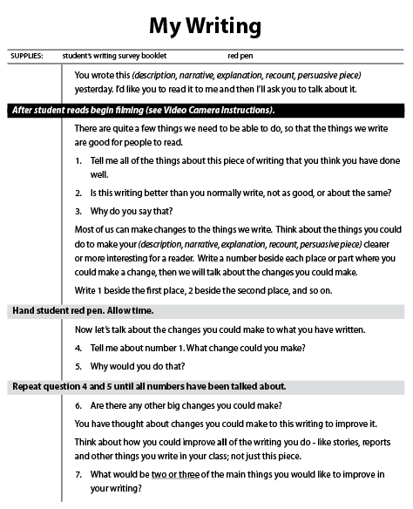
Figure 2.3 An example of individual-assessment writing task
Piloting and trialling
The tasks were piloted in Dunedin schools before being used in a NMSSA trial involving several schools around New Zealand. The student responses from the trials were used to refine the tasks and support the development of scoring guides and administration instructions. An IRT model was also applied to the data at this stage to explore the development of a reporting scale and inform the selection of tasks for the main study.
The 2012 NMSSA Writing Study
Teacher assessors were trained in how to administer the Process of Writing tasks during a four day training session prior to the main study. During the study the tasks were administered to eight students in each school. Teacher assessors were carefully monitored and received feedback to ensure consistency of administration. Student responses were captured on video and paper, and stored electronically for marking. Approximately 700 students at both Year 4 and Year 8 completed the Process of Writing tasks.
Marking
A group of markers, about half of whom had been teacher assessors, were employed to mark the students responses to the tasks. All markers were trained, and quality assurance procedures were used to ensure consistency of marking. The scoring guides were refined during the marking to ensure that they reflected the range of responses found in the main study.
Creating the Process of Writing scale
An IRT model was applied to all student responses from the main study to construct a measurement scale. The scale locates both student achievement and the relative difficulty of the different scoring categories related to each task on the same measurement continuum using scale scores.
Like the Writing for a Variety of Purposes scale, the Process of Writing scale has been constructed so that the average scale score for the combined sample of Year 4 and Year 8 students is 100 scale score units, and the approximate standard deviation for a year level is 20 scale score units. Scale scores range from about 20 to 180 scale score units. Further details about the measurement scale and its construction can be found in Part 7 of this chapter.
Scale description
Figure 2.4 describes the specific writing competencies associated with different parts of the Process of Writing scale. The descriptions are provided in two broad bands and are divided into seven themes to represent the seven different elements involved in the assessment.
To create the scale description, each of the scoring categories associated with the scoring guides used to score each task was located on the scale where the modelled probability of scoring in that category or higher was at least 70 percent. This enabled the descriptions of performance provided in the scoring guides to be associated with different score ranges on the scale. These were examined and then combined to describe the scale across the two bands.
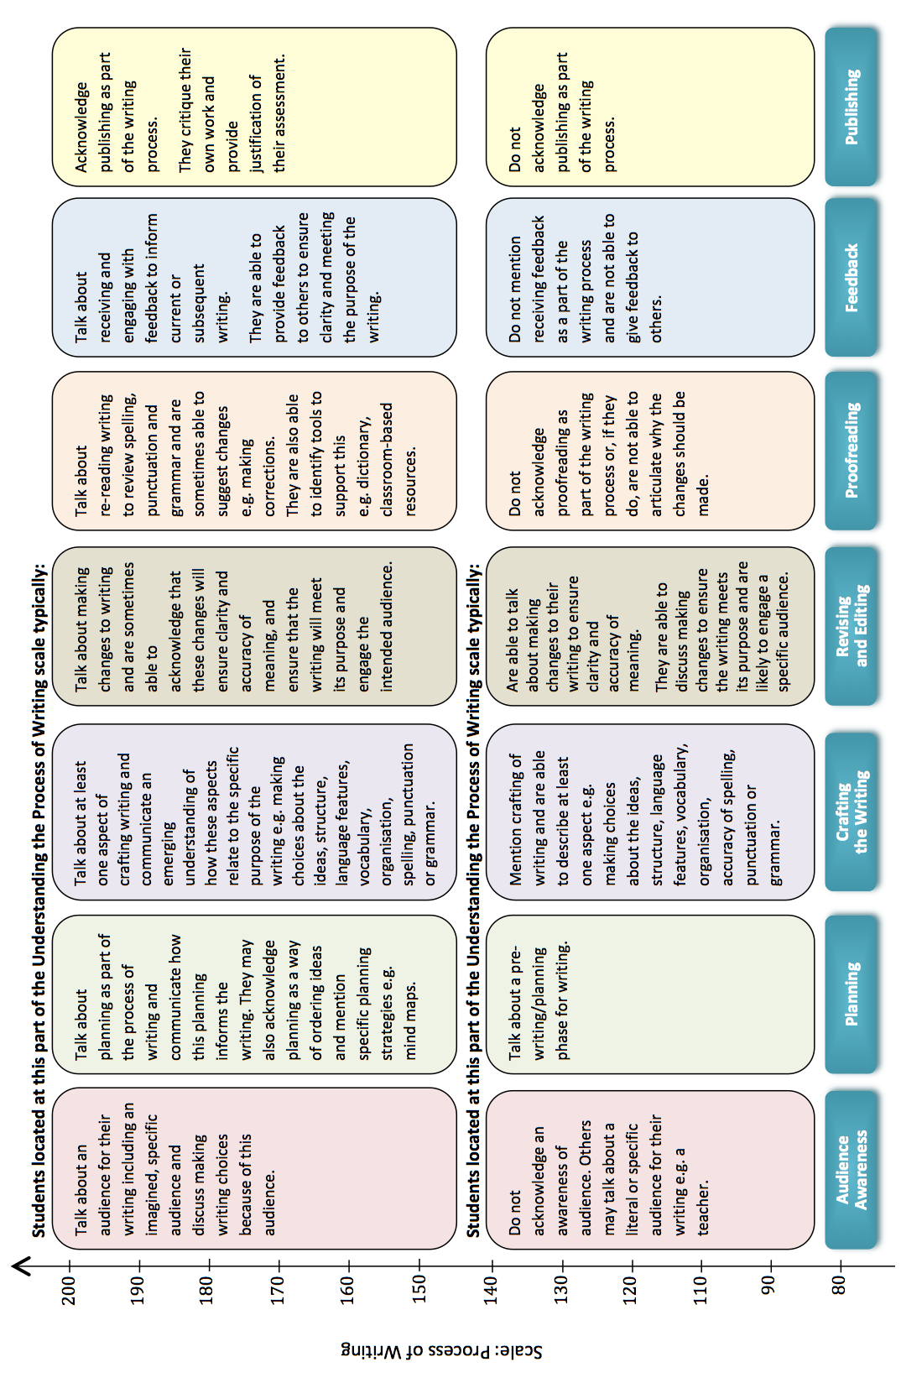
Figure 2.4 Scale description for Process of Writing

5. Student attitudes and learning opportunities in writing
A questionnaire was developed containing sections related to student attitudes to writing, how students perceive learning opportunities in writing, and how often English is spoken in their homes. The questionnaire was the same for Year 4 and Year 8 students and was administered to all students in the 2012 NMSSA writing study.
Attitudes to writing
The section of the questionnaire related to attitudes to writing asked students to show how much they agreed with a number of statements related to their feelings of self-efficacy in writing and level of engagement in learning to write. Students used a four-point agreement scale to respond to each statement (heaps, quite a lot, a little, not at all). The statements were sourced from a range of relevant studies, including NEMP.
Some examples of the statements from the Attitude to Writing section were:
- I am good at writing
- My teacher thinks I am good at writing
- I would like to do more writing at school
- I like doing writing in my own time, when I am not at school
- I think writing is interesting.
A draft version of the Attitude to Writing section was piloted with small groups of students, before being used in a development trial with about 200 students at both Year 4 and Year 8. Responses from the trial were analysed using an IRT model and the results used to inform the development of the final set of statements used in the 2012 NMSSA writing study.
After the main study, an IRT model was applied to all student responses to the Attitude to Writing section of the student questionnaire in order to construct a reporting scale. The scale allows the strength of each student’s overall response to the set of statements to be located on a measurement continuum. Students who responded positively to a large number of statements were given high scale scores. Students whose responses were more negative overall received lower scale scores. As with other NMSSA scales, this scale has been set to have an average of 100 scale units and standard deviation of 20 scale units.
Learning opportunities in writing
The second section of the questionnaire asked students about the opportunities they had to learn or practise writing. Students used a five point scale (4-5 days a week, 2-3 days a week, about once a week, hardly ever and never) to show how often they experienced different opportunities to be involved in activities associated with learning to write. Examples of the learning opportunities included:
Write about something your teacher has asked you to write about
Write about something of your own choice
Write using a computer
Share your writing with other people in the class
Share your writing with the teacher.
A draft list of learning opportunities was piloted and trialled and an analysis of the results used to inform the final list selected for use in the main study. Results from the 2012 study are reported as the percentages of students selecting the different response categories for each learning opportunity.

6. Teacher perspectives on teaching and learning writing in the school
The final component of the NMSSA writing assessment programme was a teacher questionnaire. The questionnaire was developed to collect information related to teachers’ perspectives on teaching and learning writing in their school. It included questions related to their confidence as teachers of writing, the types of learning activities and experiences in writing that they provided for their students, and their opportunities for professional development. The questionnaire was piloted with a teacher focus group and trialled with a small number of teachers from a range of schools before being used in the main study. Teachers who taught writing to the students assessed in the writing study were asked to complete the questionnaire. These results are reported using the percentage of teachers who chose each response.
7. Data analysis and reporting
In this section we provide some technical details around the scales developed to report the writing results, present the graphical formats used throughout the report, and provide some technical background and rationale for some of the statistics used.
IRT scale construction:
The scales used in this report have been developed using the Partial Credit Model (Masters, 1982). The partial credit model (PCM) is one of the family of Rasch measurement models frequently used in studies such as this (PISA 2012, TIMMS 2011). The IRT software package WINSTEPS (Linacre, 2009) was used to develop the writing scales. Some advantages of using the PCM are:
- Both items and students can be located independently on the constructed scale.
- Unlike raw test scores, the measurement scale units represent the same amount of change in achievement across the whole scale.
- Achievement for Year 4 and Year 8 students can be located on the same measurement scale.
- Scales can be described to show what students typically understand and are able to do at different parts of the scale (for example, the scale descriptions in Part 3 and Part 4 of this chapter).
Standardising the scales
The PCM is based on probabilistic units called logits.
The model anchors the scale at the mean of the item difficulties, which is set to zero. As a consequence, logit scores generally range from about -7 to +7 logits. To make the scale units easier to understand and interpret we have transformed the logit scale. For each scale (the two writing achievement scales, and the attitudinal scale) we have set the average for all students (Year 4 and Year 8 combined) to be 100 scale units, and the average standard deviation of each year level to be
20 scale units. This means that scores on each of the writing scales range from around 20 to 180 scale units.
The association between the achievement measures
The two components of the writing assessment programme focused on achievement (Writing for a Variety of Purposes and Process of Writing) were centred on different but overlapping aspects of writing. They also used different assessment approaches to gather information: group-administered paper-and-pencil assessments compared with individual assessments using performance tasks and interviews. The correlation between the two measures is low (0.26).
Scale reliability
Table 2.3 provides reliability indices for each of the reporting scales developed for use in the assessment programme. These relate to the reliability of student scale scores and have been calculated by the WINSTEPS and Facets software used to construct the scales. In looking at the issue of reliability, it is important to keep in mind that the reliability index employed here is a measure of the degree to which all items can be considered to be measuring a single construct. This is appropriate for the Writing for a Variety of Purposes scale as that scale is designed to measure writing ability as it is applied in a variety of contexts. Although there will be some variability in student performance depending on context, one would expect a strong degree of consistency across contexts, and in fact, that is the case with a reliability coefficient of 0.93.
The individual tasks that make up Process of Writing were intentionally designed to look at a wide array of skills and dispositions that comprise writing. The assessment looked at audience awareness, planning, crafting/writing, revising and editing, proofreading, feedback and publishing. We do not necessarily expect, for example, that a strong sense of audience would necessarily be related to the ability to proofread. Thus, the observed reliability of 0.63 for the Process of Writing scale, tells us that we are getting useful information from each of the various tasks that were used here.
The Attitude to Writing scale is intended to provide an overall index of how students view writing and, therefore, a single score should capture how students feel about writing. The reliability here (0.86) is strong for an attitudinal measure.
The correlation between Writing for a Variety of Purposes scores and Process of Writing scores was 0.24 at Year 4 and 0.26 at Year 8. This indicates that the two measures are assessing distinctly different aspects of writing as intended.
Table 2.3 The reliability of the NMSSA measures
Measure | Reliability
Writing for a Variety of Purposes | 0.93
Process of Writing | 0.63
Attitude to Writing | 0.86

Reporting achievement against curriculum levels
An alignment process was used to link the Writing for a Variety of Purposes scale to the descriptions of writing competency described by the Literacy Learning Progressions. The process took advantage of the link that already existed between the e-asTTle writing scale and the Literacy Learning Progressions. The exercise allowed performance on the Writing for a Variety of Purposes assessment to be reported in terms of curriculum expectations at different year levels.
It was decided not to link the Process of Writing scale to curriculum levels.
Defining expected achievement levels
The NMSSA alignment process did not use the basic, proficient and advanced curriculum sub-levels used by e-asTTle writing to define achievement bands. Instead, score ranges on the Writing for a Variety of Purposes scale are associated with each curriculum level as a whole. In this report Curriculum Level 2 is used as the expected level for students at the end of Year 4 and Level 4 as the expected curriculum level for students at the end of Year 8. More information about the curriculum alignment process is provided in Appendix 3.
Use of graphs in the report
Box and whisker plots
Box and whisker plots (box plots) are used extensively throughout this report. They are used to summarise groups of scores. In a box plot scores are ordered from low to high and then divided into four equal-sized groups, called quartile groups. These are displayed as shown in Figure 2.5.
Box
The box shows the middle 50 percent of the scores.
Whiskers
In this report, the whiskers of the box plot do not include outliers (scores that are rare and unusual) and have a maximum length of 1.5 × the inter-quartile range.
Colours used
Box plots for reporting scales use two colours for the middle quartile groups to make it easier to distinguish between them. If printed in grey scale these colours still produce a contrast.
Box plots relating to Attitudes to Writing are presented in a different pair of colours to distinguish them from those relating to achievement.
Grid lines
Grid lines are used on the box plots to make them easier to interpret. These are especially helpful in the graphs with many box plots side by side. The grid lines are placed at every 40 scale score units. They bear no relation to curriculum levels.
Line graph of score distributions
Another type of graph used to display data in this report is the line graph (Fig. 2.6). These are used to show how the distributions of scores for various groups compare with curriculum expectations. The graphs are smoothed versions of the data.
Horizontal lines are placed on the line graphs to show how the scale aligns to the writing curriculum levels. A detailed exercise was undertaken to establish the locations on the scales where one curriculum level merges into the next. Full details of this can be found in Appendix 3.
The lines used to show curriculum levels are always labelled clearly, and should not be confused with the grid lines used in the box plots.
In graphs that display a scale, the scale is always placed on the vertical axis.
Graphs of subgroup differences
A graph using bars has been developed to show the size of difference in scale score units between pairs of subgroups. An example of the display of differences is shown in Figure 2.7.
The display shown compares pairs of Year 4 subgroups for ethnicity. The top of the bar marks the average score for the subgroup that scored higher. The bottom of the bar marks the average score for the subgroup that scored lower. The number above the bar indicates the difference between the averages in scale score points. The dotted red line shows the national average score for all students in Year 4.
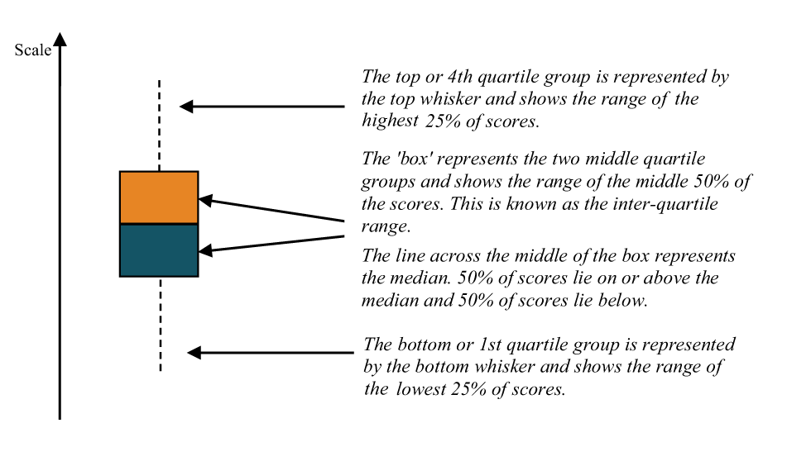
Figure 2.5 Understanding box plots

Effect size statistics and statistical significance
Effect sizes have been used throughout the report to help interpret differences between groups on the measures used in the writing assessment programme. An effect size quantifies the difference between groups in terms of standard deviation units. The calculation of the effect sizes in this report weights the standard deviation for each group by its sample size. Because the standard deviations and sample size for groups can vary, this can mean that the same difference in scale scores results in slightly different effect sizes for different pairs of groups. When comparing two effect sizes it is helpful to consider the scale score differences, distribution of scores and size of group.
Ninety-five percent confidence intervals have been calculated for each effect size reported and used to determine when an effect is statistically significant. When an effect is statistically significant it means that the data supports the hypothesis that the effect size is real (non zero). Statistically significant effect sizes are shown in bold text in the tables of findings.
As well as considering statistical significance, it is also important to consider the educational significance when interpreting differences between groups. When groups are large (as for NMSSA) relatively small effects can be statistically significant.
Effect sizes have been used to examine:
- the difference in achievement between Year 4 and Year 8 students
- the difference between subgroups of students:
- girls/boys;
- NZ European/Non-NZ European, Māori/Non-Māori, Pasifika/Non-Pasifika students;
- schools of high, mid and low decile;
- types of school (at Year 4 - full primary, and contributing; at Year 8 – full primary, intermediate, composite and secondary).
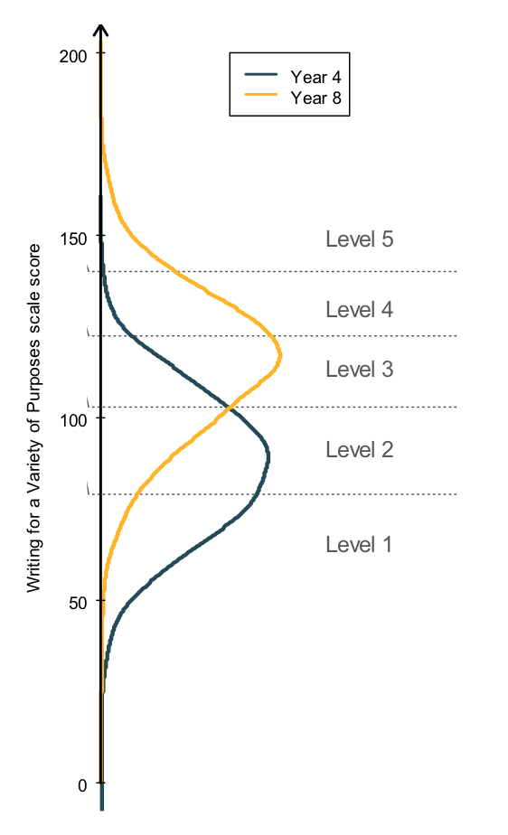
Figure 2.6 An example of a line graph
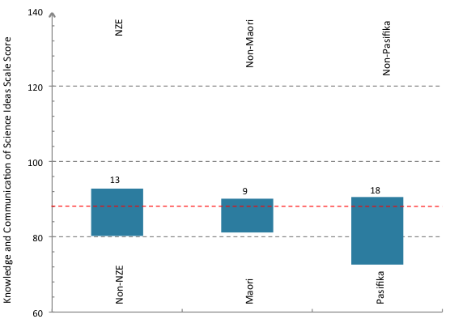
Figure 2.7 The display of differences between ethnicity groups

Displaying effect sizes
A graph has been developed to show effect sizes across various subgroups. This uses blue bars to show the difference between the average scale score for pairs of groups. The size of each difference is given in scale score units. A difference score can be converted to an approximate effect size by dividing by 20. For instance, if the difference between the average scores for two groups is 15 scale score units, then the approximate effect size is 0.75. An example of an effect size display is shown in Figure 2.5. The display shown compares the average scores for ten pairs of Year 8 subgroups on the Writing for a Variety of Purposes measure. The dotted red line shows the national average score for all students in Year 8.
Tables of means, standard deviations, sample size, effect sizes and confidence intervals are included in Appendix 4.
Differences between the effect sizes for different pairs of comparisons were considered significant when the confidence intervals surrounding the respective effect sizes were non-overlapping.

3
Student
Achievement
in Writing

This chapter describes Year 4 and Year 8 student achievement in writing based on the two measures of writing competence developed for the NMSSA study: Writing for a Variety of Purposes, and Process of Writing. It examines how achievement varies within and between year levels, including variation by gender, ethnicity, school decile and type of school. Achievement is also reported against the levels of the NZC, based on the descriptions of performance provided by the Literacy Learning Progressions.
This chapter is organized into six parts. The first and second parts consider achievement for Year 4 and Year 8 students respectively. The third part examines achievement by decile and ethnicity. The fourth part compares achievement between the two year levels. The fifth and sixth parts present a deeper look at student achievement on Writing for a Variety of Purposes and an in-depth commentary on students’ awareness of the process of writing, and their experience and understanding of feedback about their writing.
The box below highlights the major findings for this chapter.

Consider success and achievement of students in writing – an overview
Year 4 students' writing scores ranged across curriculum Levels 1 to 3 with the greatest proportion scoring in Level 2. Year 8 students' writing scores ranged across curriculum Levels 2 to 4 with the greatest proportion achieving in Level 3. The Year 4 result is in line with end of year NZC expectations, while the Year 8 result is below NZC expectations.
There was a wide distribution of scores at both year levels and some overlap in the achievement of Year 4 students and Year 8 students, particularly in the Process of Writing.
Five different writing prompts were used that asked students to either explain, persuade, describe, recount or narrate. Year 4 students scored lower when writing a persuasion than when writing an explanation, a recount or a narration. Year 8 students scored lower when writing an explanation or description than when writing a persuasion, a recount or a narration.
The Writing for a Variety of Purposes score contained seven elements: ideas, structure and language, organisation, vocabulary, sentence structure, punctuation and spelling. At both year levels the highest average scores were for spelling and the lowest average scores were for punctuation. The second strongest element for Year 4 was ideas, while for Year 8 it was sentence structure.
The results show that Year 4 students' writing typically involved writing simple ideas using brief but coherent text, with language features appropriate to the purpose. Their writing showed they were usually successful with beginning and end of sentence punctuation, and their sentences often showed variety in structure. They used correct spelling for a range of personal and high frequency words, and vocabulary sometimes included a few precise words.
Year 8 students' writing typically included ideas that show some complexity and elaboration. Text was generally coherent with basic paragraphing, and ideas that flowed. The structural and language features were appropriate to purpose and showed some development and control. They typically used a variety of precise vocabulary that added information and enhanced meaning. They wrote sentences that had correct beginning and end punctuation and some correct usage of other punctuation. Sentence structures showed variety, extension and a sense of control. A wide range of high frequency words were spelled correctly, and approximations were made for difficult words.
Year 4 and Year 8 students did not differ markedly, on average, in their understanding of the process of writing. About half of Year 4 students and most Year 8 students were able to talk about the audience for their writing, and discuss a pre-writing/planning phase for writing. They were able to talk about crafting of writing, describing at least one aspect such as making choices about ideas, structure of language features, etc. These students generally acknowledged that proofreading is part of the writing process, and were able to talk about making changes to their writing although they were unlikely to articulate why changes should be made. They typically did not mention feedback as a part of the writing process, nor acknowledge publishing as part of the writing process. The lower half of Year 4 students had not yet reached the level of competence with Process of Writing described here. Very few Year 8 students (5 percent) demonstrated a higher level of competence on the Process of Writing scale.
Feedback about their writing appeared to be a relatively common practice involving teachers and peers. Year 8 students had a greater understanding of the relationship between feedback and improving their writing. Feedback given by students or received from teachers focused primarily on the deep and surface features of writing rather than other aspects such as planning and audience awareness.
Results showed that, on average, achievement varied by gender, ethnicity and school decile. For both year levels and both measures of writing, average achievement was higher for girls than boys, lower for Māori and Pasifika students than for non- Māori and non-Pasifika students respectively, and was lower for students from lower decile schools.
These findings reflect those found by NEMP from 1998 to 2006.
There is a complex relationship between the effects of school decile and student ethnicity on Writing for a Variety of Purposes and both of these factors are statistically significant influences on achievement. At both Year 4 and Year 8 the differences between low, mid and high decile schools, and between NZ European, Māori and Pasifika students were statistically significant (at p<.000 for all but one comparison). This was similar to the findings for NMSSA Science (2012).
However, the ethnic group differences disappeared when looking at students from decile 1 schools only. This contrasts with the findings for NMSSA Science (2012) where differences in science achievement persisted between ethnic groups from decile 1 schools.
The average annual progress between Year 4 and Year 8 was 0.36 for Writing for a Variety of Purposes, similar to progress found in other curriculum areas (Hattie, 2009), including NMSSA Science (2012). The progress was similar for all subgroups (e.g. boys and girls, ethnicity, school decile and types of school). This is in contrast to the results for NMSSA Science (2012) where students in high decile schools showed significantly greater progress than those in low decile schools (an overlap of confidence intervals of 0.03).

1. Year 4 achievement in writing
Overall achievement
Table 3.1 provides the average scale scores, standard deviations and sample sizes for Year 4 students on the two NMSSA writing achievement measures.
Table 3.1 Overall measures of writing achievement at Year 4
 | Writing for a Variety of Purposes | Process of Writing
 | Year 4 | Year 4
Average (scale score units) | 86 | 93
SD (scale score units) | 20 | 21
N | 2065 | 694

The average score for Year 4 students in Writing for a Variety of Purposes was 86 scale score units. Drawing on the scale description for this measure, this indicates that the 50 percent of Year 4 students clustered around the average (the middle 50 percent) would typically be able to produce a piece of writing with:
• simple, unelaborated ideas
• some structural and most language features appropriate
to purpose
• a coherent text that may be brief, but ideas flow
• vocabulary that may include a small number of precise words
• sentences with correct structures that show some variety
• beginning and end sentence punctuation
• correct spelling for a range of personal and
high frequency words.
In Process of Writing, Year 4 students scored, on average, 93 scale score units. The highest scoring 50 percent (the upper 50 percent) of Year 4 students showed an emerging understanding of the process of writing. Drawing on the scale description for the Process of Writing scale, these students were typically able to:
• talk about a literal or specific audience for their writing
• talk about a pre-writing/planning phase for writing
• describe at least one aspect of crafting their writing
• talk about making changes to their writing
to ensure clarity and accuracy of meaning.
They generally:
• did not mention receiving feedback as a part of
the writing process
• did not give feedback to others
• did not acknowledge publishing as part of
the writing process.
The lower scoring 50 percent of Year 4 students had not yet reached the level described above.
A curriculum alignment exercise was undertaken to align the Writing for a Variety of Purposes scale with the writing competence expected at different levels of the curriculum.
Table 3.2 shows that the majority of Year 4 students performed at levels associated with NZC Levels 1 to 3, with the largest group scoring in Level 2. The curriculum expectation is that students should be working at Level 2 by the end of Year 4.
An equi-percentile ranking procedure was not carried out because of a weak correlation between the scores on the two measures. A separate alignment exercise was not carried out because of resourcing issues. Further details are provided in Appendix 3.
Table 3.2 Percentage of Year 4 students achieving within
the different writing curriculum levels
 | Percentage of students
 | Year 4
Level 5 | -
Level 4 | 2
Level 3 | 18
Level 2 | 45
Level 1 | 35

Year 4 Achievement by subgroup
Figures 3.1 and 3.2 display the level and spread of scores for key population subgroups in Year 4 on the two writing measures.
Box plots are used to show results by gender, ethnicity, school decile and type of school. The number of students that participated in assessments within each subgroup is provided in Appendix 4.
Differences in achievement across these subgroups were similar on both writing measures. Across both year levels and both measures of writing scores were, on average, lower for boys than girls, lower for Māori and Pasifika students than for NZ European students, and lower for students attending low decile rather than high decile schools.
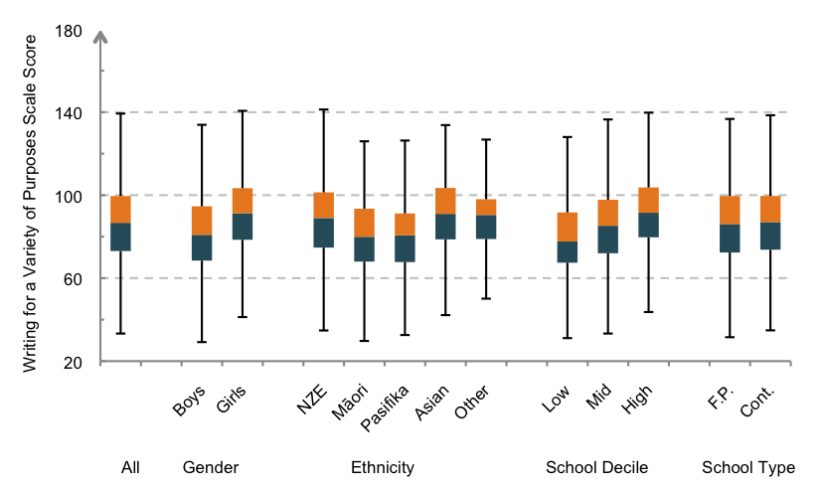
Figure 3.1 Year 4 student scores for Writing for a Variety of Purposes by gender, ethnicity, school decile and type
(NZE=NZ European, F.P.=Full Primary, Cont.=Contributing)
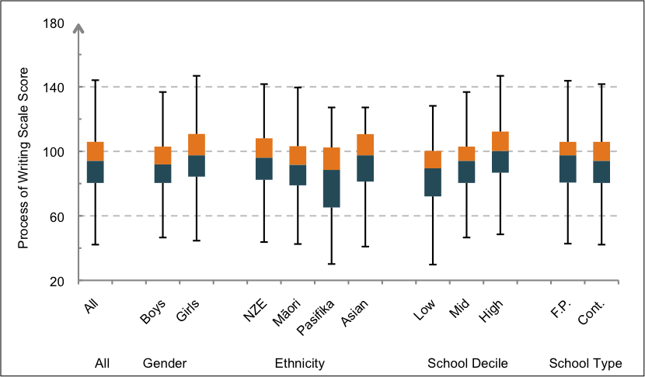
Figure 3.2 Year 4 student scores for Process of Writing by gender, ethnicity, school decile and type
(NZE=NZ European, F.P.=Full Primary, Cont. = Contributing)
Note: The ‘Other’ ethnic group is not shown for Process of Writing because the sample size was too small.

Figures 3.3 and 3.4 display the differences in average scale scores between pairs of subgroups, illustrating their relative effect sizes on the two writing measures. Table 3.3 summarises average scale score differences and effect sizes between subgroups on the two writing measures. The full tables of means, standard deviations, sample sizes, effect sizes and 95 percent confidence intervals are in Appendix 4.
Year 4 girls scored higher than Year 4 boys on both measures. Year 4 students from low decile schools scored, on average, 12 scale points lower than those from high decile schools, an approximate effect size of 0.60.
Differences in achievement by ethnicity were also notable. Achievement was significantly higher for NZ European than non-NZ European students on both scales. Results for Pasifika students were significantly lower than those for non-Pasifika students on both scales. Māori students scored significantly lower than non-Māori on Writing for a Variety of Purposes, but differences on Process of Writing were not significant. Results for non-Māori students include both NZ European and Pasifika students.
On Writing for a Variety of Purposes, the difference in achievement between NZ European, Māori and Pasifika and their respective comparison groups was similar in each case.
There was no difference on either scale between average scores for those attending full primary schools versus those attending contributing schools.
These findings are consistent with the subgroup differences found by NEMP from 1998 to 2006. While NEMP indicated
a decreasing disparity between students from low, mid and high decile schools, the results from NMSSA show that the differences in 2012 remain statistically significant. Similarly,
the differences between NZ European students and Māori and Pasifika students are consistent with those found by NEMP and are statistically significant.

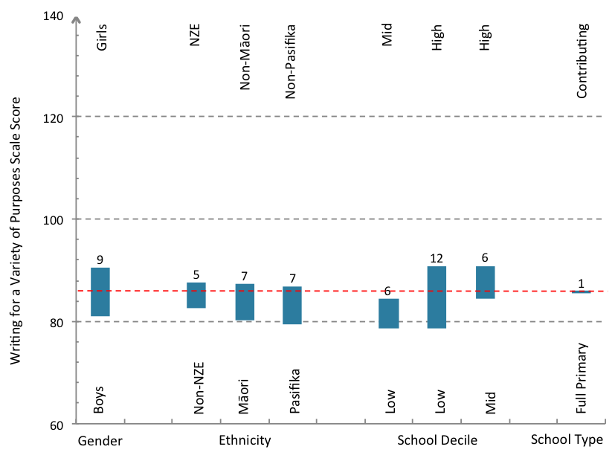
Figure 3.3 Year 4 students: Difference in average scores for Writing for a Variety of Purposes by subgroup (NZE=NZ European)

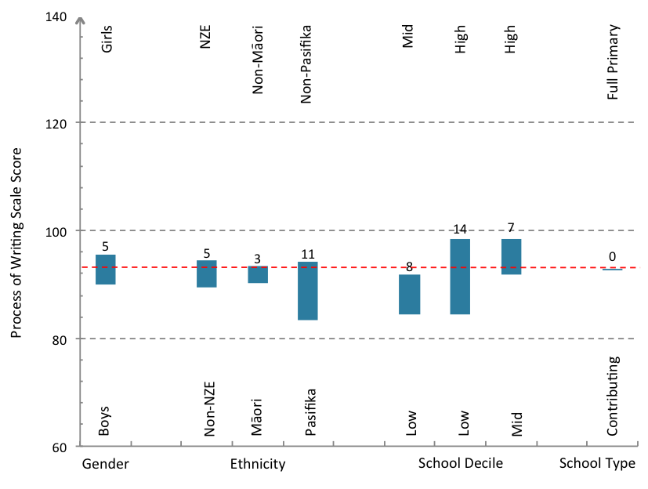
Figure 3.4 Year 4 students: Difference in average scores for Process of Writing by subgroup (NZE=NZ European)
Table 3.3 - Year 4 subgroup differences on writing achievement scales
 | Writing for a Variety of Purposes |  | Process of Writing
 | Scale score differences | Effect size | Scale score differences | Effect size
Gender
Boys/Girls | 10 | -0.49 | 6 | -0.27
Ethnicity
NZ European/Non-NZ European | 5 | 0.26 | 5 | 0.24
Māori/Non-Māori | 7 | -0.37 | 3 | -0.14
Pasifika/Non-Pasifika | 7 | -0.38 | 11 | -0.49
School Decile
Low/Mid | 5 | -0.30 | 8 | -0.36
Low/High | 12 | -0.64 | 14 | -0.68
Mid/High | 7 | -0.33 | 6 | -0.35
Type of School
Full primary/Contributing | 0 | 0.03 | 0 | -0.02

Effect sizes in bold are statistically significant (p<.05)
2. Year 8 achievement in writing
Overall achievement
Table 3.4 provides the average scale scores, standard deviations and sample sizes for Year 8 students on the two NMSSA writing achievement measures.
Table 3.4 Overall measures of writing achievement at Year 8
 | Writing for a Variety of Purposes | Process of Writing
Average (scale score units) | 114 | 107
SD (scale score units) | 20 | 20
N | 1975 | 689

Year 8 students scored an average of 114 scale score units in Writing for a Variety of Purposes. Drawing on the scale description for this measure, this indicates that the 50 percent of Year 8 students clustered around the average (the middle 50 percent) typically demonstrated the competencies already described for Year 4 students, and in addition also typically:
- used ideas that showed some complexity and elaboration
- used structural and language features appropriate to purpose that showed some development and control
- wrote coherent text using basic paragraphs and ideas that flowed
- used a variety of precise vocabulary that added information and enhanced meaning
- used mostly correct sentence structures that showed variety and extension and a sense of control
- wrote sentences that had beginning and end punctuation and some correct use of other punctuation
- used correct spelling for a wide range of high frequency words and approximations of more difficult words.
On the Process of Writing scale, Year 8 students scored higher than Year 4 students with an average score of 107 scale score units. They were operating within the same band described earlier for Year 4, but at a higher level. The lowest scoring Year 8 students (about 16 percent) had not yet reached the level described above, and the highest scoring (5 percent) had more advanced skills.
Table 3.5 shows how Year 8 students performed against the curriculum on the Writing for a Variety of Purposes scale. Student achievement was distributed across five curriculum levels, with the largest group of students scoring in Level 3. Most students scored within Levels 2 to 4, with 8 percent of Year 8 students scoring in Level 5, and 5 percent scoring in Level 1. By the end of Year 8 students are expected to be achieving at Level 4. A large proportion of Year 8 students (65 percent) did not meet that benchmark.
Table 3.5 Percentage of Year 8 students achieving within
the different writing curriculum levels
 | Percentage of students
Level 5 | 8
Level 4 | 27
Level 3 | 37
Level 2 | 23
Level 1 | 5
Year 8 Achievement by subgroup
Figure 3.5 and 3.6 display the distribution of achievement for key population subgroups in Year 8 on the two writing measures. Box plots are used to show results by gender, ethnicity, school decile and type. The number of students that participated in assessments within each subgroup is provided in Appendix 4.
As was the case at Year 4, the pattern of achievement at Year 8 was similar for subgroups across both writing measures with differences between subgroups being generally less pronounced on the Process of Writing scale. On both measures, on average, boys scored lower than girls, and Māori and Pasifika students scored lower, on average, than NZ European students. Similarly, students attending low decile schools scored lower, on average, than those from mid or high decile schools. There was no consistent difference in average scores between students attending different types of school.
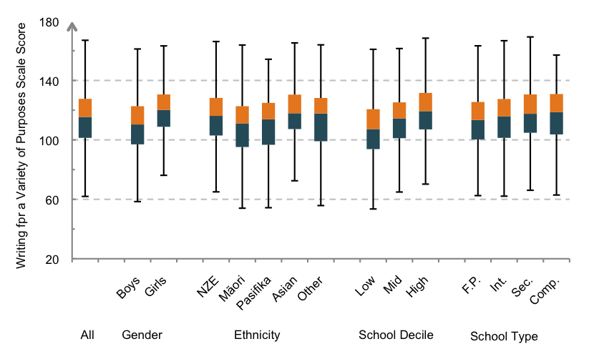
Figure 3.5 Year 8 student scores for Writing for a Variety of Purposes by gender, ethnicity, school decile and type
(NZE=NZ European, F.P.=Full Primary, Int.=Intermediate, Sec.=Secondary, Comp.=Composite)
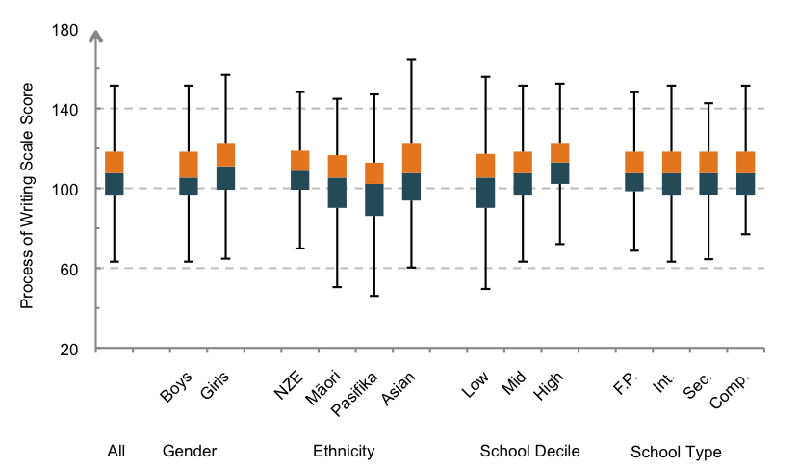
Figure 3.6 Year 8 student scores for Process of Writing by gender, ethnicity, school decile and type
(NZE=NZ European, F.P.=Full Primary, Int.=Intermediate, Sec.=Secondary, Comp.=Composite)
Note: The ‘Other’ ethnic group is not shown for Process of Writing because the sample size was too small.
Figures 3.7 and 3.8 display the differences in average scale scores between pairs of subgroups, illustrating the relative effect sizes these differences represent on the two writing measures. The results show a similar pattern to those for Year 4. Table 3.6 provides the scale score differences together with their respective effect sizes.
Girls scored higher than boys, students from low decile schools scored lower than those from high decile schools, and there was no difference in average achievement between types of schools. Differences in achievement by ethnicity were significant for all of the comparisons made and similar in size. The average score on the Writing for a Variety of Purposes scale was higher for Pasifika than Māori but this was not the case in Process of Writing.
These findings are consistent with the subgroup differences found by NEMP from 1998 to 2006. While NEMP indicated a decreasing disparity between students from low, mid and high decile schools the results from NMSSA show that the differences in 2012 remain statistically significant. Similarly,
the differences between NZ European, Māori and Pasifika students are consistent with those found by NEMP and are statistically significant. The decreasing disparity found by NEMP between NZ European and Pasifika students at Year 8 continues to decrease.
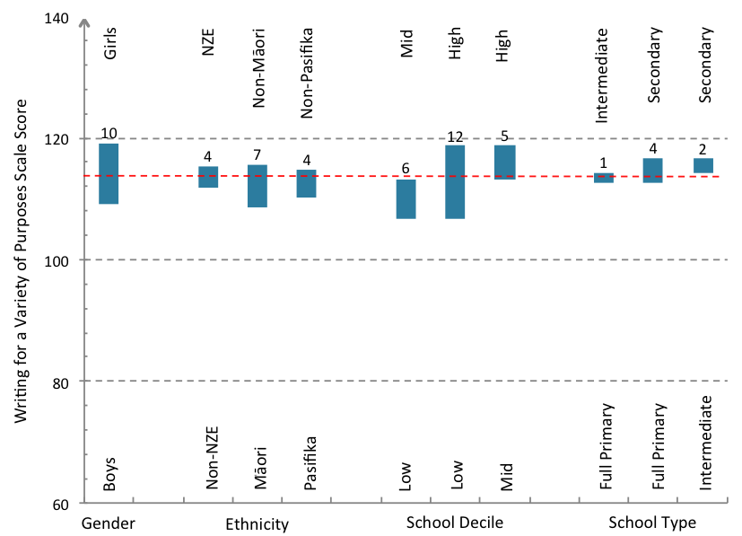
Figure 3.7 Year 8 students: Difference in average scores for writing for a Variety of Purposes by subgroup
(NZE=NZ European)
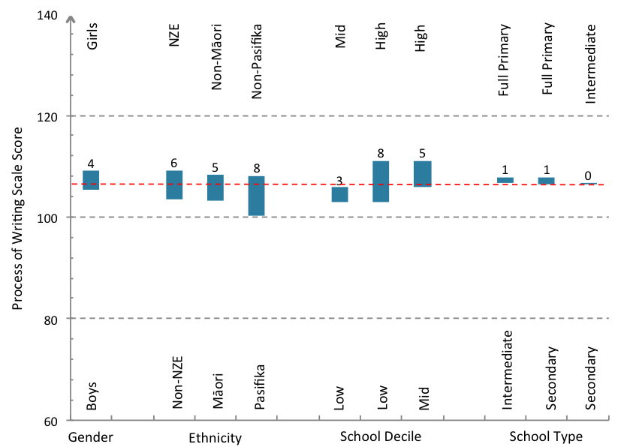
Figure 3.8 Year 8 students: Difference in average scores for Process of Writing by subgroup (NZE=NZ European)
Table 3.6 Year 8: Subgroup differences on writing achievement
 | Writing for a Variety of Purposes |  | Process of Writing
 | Scale score difference | Effect size | Scale score differences | Effect size
Gender
Boys/Girls | 10 | -0.51 | 4 | -0.19
Ethnicity
NZ European/Non-NZ European | 3 | 0.18 | 6 | 0.29
Māori/Non-Māori | 7 | -0.34 | 5 | -0.26
Pasifika/Non-Pasifika | 5 | -0.22 | 8 | -0.41
School Decile
Low/Mid | 6 | -0.33 | 3 | -0.13
Low/High | 12 | -0.61 | 8 | -0.42
Mid/High | 6 | -0.27 | 5 | -0.28
Type of School
Full primary/Contributing | 1 | -0.07 | 1 | 0.06
Full primary/Secondary | 4 | -0.19 | 2 | 0.07
Intermediate/Secondary | 3 | -0.12 | 1 | 0.01

Effect sizes in bold are statistically significant (p<.05)
3. Achievement by decile and ethnicity
The previous sections have highlighted that school decile and student ethnicity are both very important factors associated with writing achievement and that there is a complex interaction between them. Larger proportions of Māori and Pasifika students attend lower decile schools than NZ European students (see Chapters 5 and 6 respectively). Two-way analyses of variance (ANOVA) with Scheffe post hoc analyses were undertaken using prioritised ethnicity groups (NZ European, Māori and Pasifika) that removed the conflation of multiple ethnicities that were used in the findings in the previous sections. The results are detailed in Appendix 6.
The results showed that both ethnicity and decile were significant factors for Writing for a Variety of Purposes but not for Process of Writing. At both Year 4 and Year 8 the differences between low, mid and high decile schools, and between NZ European, Māori and Pasifika students were statistically significant (at p<.000 for all but one comparison). This was similar to the findings for NMSSA Science (2012).
To examine the effect of ethnicity while controlling for school decile, a one-way ANOVA was conducted on writing results for students from decile 1 schools. This decile was selected because there was a sufficient number of students in each ethnic group for analysis. This analysis showed no statistically significant differences in writing achievement by ethnicity. This contrasts with the findings for NMSSA Science (2012) where there were statistically significant differences between NZ European, Māori and Pasifika students in writing achievement.
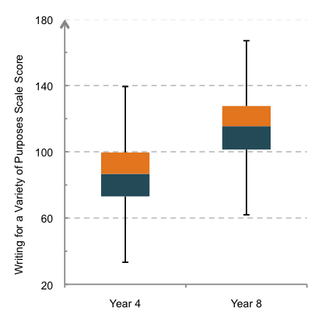
Figure 3.9 Student achievement for Writing for a Variety of Purposes
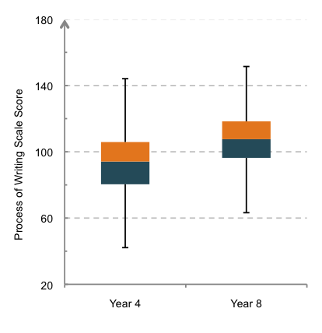
Figure 3.10 Student achievement for Process of Writing

4. Comparison of Year 4 and Year 8 achievement
The use of reporting scales that are common to both Year 4 and Year 8 makes it possible to compare achievement between the two year levels meaningfully. Figures 3.9 and 3.10 show the distribution of Year 4 and Year 8 students on the Writing for a Variety of Purposes scale and the Process of Writing scale respectively. As expected, Year 8 students achieved higher scores, on average, than Year 4 students. However, there was a wide distribution of scores at both year levels and considerable overlap in the achievement of Year 4 students and Year 8 students.
Table 3.7 shows the averages and standard deviations for both writing measures along with the differences in average scores between Year 4 and Year 8 expressed in scale score units and as effect sizes.
The two scales provide views of progress in different aspects of writing. There is a 28 scale score difference between average scores at Year 4 and Year 8 on the Writing for a Variety of Purposes scale (effect size of about 1.4). On the Process of Writing scale there is a smaller difference of 14 points (effect size of about 0.7). The two assessments are focused on different aspects of writing and use different assessment approaches. Writing for a Variety of Purposes involves the production of a piece of writing for a given purpose, while the Process of Writing asks students to articulate an awareness of the different aspects of the writing process such as: audience awareness, planning, crafting/writing, revising and editing, proofreading, feedback and publishing. The results suggest that there is less progress in student understanding of the processes of writing. This may reflect a greater emphasis in schools on crafting writing, rather than understanding and articulating how it was or could be crafted. It could also indicate that developing the ability to articulate an awareness of the processes used to write takes more time and proceeds more slowly.
Table 3.7 Overall measures of writing achievement and difference of achievement by year level
 | Writing for a Variety of Purposes |  | Process of Writing
 | Year 4 | Year 8 | Year 4 | Year 8
Average (scale score units) | 86 | 114 | 93 | 107
SD (scale score units) | 20 | 20 | 21 | 20
N | 2065 | 1975 | 694 | 689
Year 8/Year 4 difference | 28 |  | 14
Effect size | 1.42 |  | 0.73
Average annual effect size | 0.36 |  | 0.18

The overlap in achievement between Year 4 and Year 8 is clearly illustrated in Figure 3.11, which shows scores in Year 4 and Year 8 on the Writing for a Variety of Purposes scale in relation to curriculum levels. The figure shows that the scores for Year 4 students generally sit within Levels 1 to 3, whereas the majority of those for Year 8 students generally fall into Levels 2 to 4. The results for Year 4 students are in line with NZC end of year expectations. However, those for Year 8 are, on average, below the end of year curriculum expectations for this level.
The graph shows that an average increase of about 11 scale score units is required for at least 50 percent of students to be scoring at Level 4 and above by Year 8 (currently about 35 percent). This equates to about 2.5 scale units of additional progress between the current Year 4 starting point and Year 8 (equivalent to an additional effect size of about 0.13 per year).
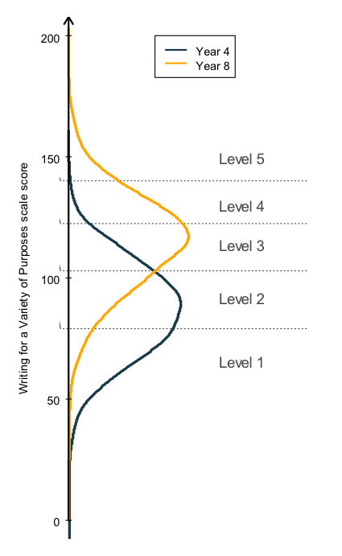
Figure 3.11 Distribution of achievement on Writing for a Variety of Purposes against level of the writing curriculum

Subgroup achievement between Year 4 and Year 8
For gender, ethnic group and decile, Table 3.8 displays the Year 4 and Year 8 average scores on Writing for a Variety of Purposes, the differences between them in scale score units, and the effect sizes related to the differences. Full tables of means, standard deviations, sample sizes and effect sizes are in Appendix 4.
The table details the difference in average scores between one cohort of students at Year 4 and another at Year 8. We use this difference to provide an estimate of progress between these year levels. It should be noted that these differences are for two different cohorts of students, and do not necessarily reflect what the growth of a single cohort of children might be over the course of four years.
Differences between Year 4 and Year 8 average scores on Writing for a Variety of Purposes were very similar for all subgroups. Differences ranged from 27 to 31 scale score units with effect sizes all between about 1.4 and 1.6. This suggests that despite lower levels of achievement by some subgroups, all are making similar progress between Year 4 and Year 8.
Table 3.8 Differences in writing achievement between Year 4 and Year 8 by subgroup
 | Writing for a Variety of Purposes
 | Year 4 average  (scale score units) | Year 8 average  (scale score units) | Score difference  (scale score units) | Effect size²⁰ | Average annual effect size
Gender
Boys | 81 | 109 | 28 | 1.39 | 0.35
Girls | 91 | 119 | 28 | 1.54 | 0.39
Ethnicity
NZ European | 88 | 115 | 27 | 1.39 | 0.35
Māori | 80 | 109 | 29 | 1.47 | 0.37
Pasifika | 79 | 110 | 31 | 1.59 | 0.40
School Decile
Low | 79 | 107 | 28 | 1.48 | 0.37
Mid | 84 | 113 | 29 | 1.46 | 0.37
High | 91 | 119 | 28 | 1.43 | 0.36
Effect sizes in bold are statistically significant (p<.05)
5. Digging deeper into Writing for a Variety of Purposes
The Writing for a Variety of Purposes assessment included five different prompts: explain, persuade, describe, recount and narrate. This section examines the performance of students on each prompt. Figure 3.12 displays the average score for each prompt for Year 4 and Year 8 students. A two-way ANOVA (year level by writing prompt) with Scheffe post hoc analyses was carried out to explore student performance by prompt. The results are summarised in Appendix 7.
The results show that Year 4 students scored significantly lower on the persuasion than the explanation, the recount or the narration. The average score on the recount was also significantly higher than that for the description. Year 8 students scored significantly lower on the explanation and description than on the other three prompts.
The Writing for a Variety of Purposes score contained seven elements: ideas, structure and language, organisation, vocabulary, sentence structure, punctuation and spelling. Each element was marked on a rubric with six descriptors (seven in the case of organisation and punctuation). Figure 3.13 displays the average percentage score on each element for students at Year 4 and Year 8. At both year levels the highest average scores were for spelling and the lowest average scores for punctuation. The second strongest element for Year 4 was ideas, while for Year 8 it was sentence structure.
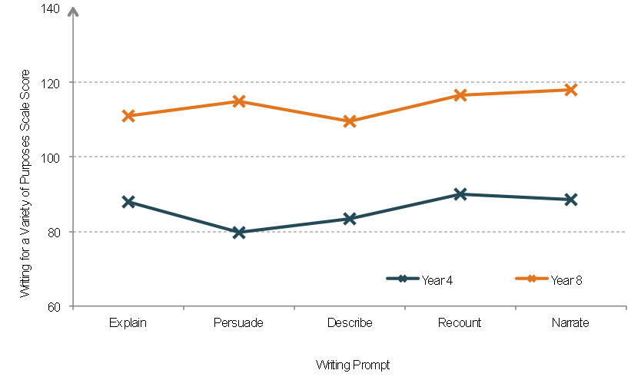
Figure 3.12 Year 4 and Year 8 students average achievement on Writing for a Variety of Purposes by writing prompt
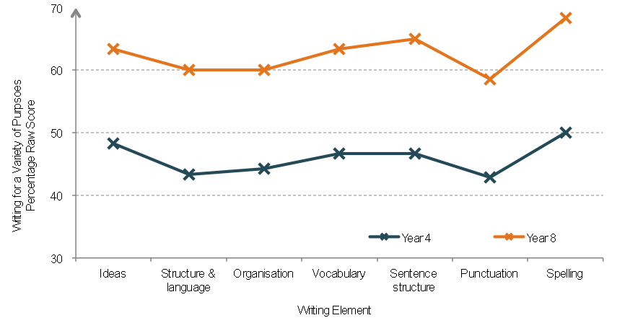
Figure 3.13 Year 4 and Year 8 students average achievement on elements of Writing for a Variety of Purposes

6. Digging deeper into Process of Writing
The Process of Writing assessments provided an in-depth view of students' understanding and awareness of the process of writing. This section of the chapter reports on the profile of findings from three interview and performance tasks that made up the assessments. In these task profiles students
talked about:
- The piece of writing they were asked to do for NMSSA (Writing for a Variety of Purposes);
- Their general awareness of different aspects of the process of writing; and
- Their experiences and understandings of feedback about their writing.
These findings provide insights into the Process of Writing scale score results.
This section reveals that most students felt that the piece of writing they produced for NMSSA was not as good as they would normally write. When provided with an opportunity to make improvements to the piece of writing students focused mainly on making changes that would ensure clarity and accuracy of meaning and changes to spelling, punctuation or grammar.
Student awareness of the different aspects of the writing process was limited primarily to planning and crafting. There was comparatively little awareness of the other aspects of the writing process, and Year 8 students show only a slightly greater understanding than Year 4 students.
The majority of Year 4 and Year 8 students reported participating in giving or receiving feedback with the most frequent focus of feedback being on deep and surface features rather than other aspects, such as planning and audience awareness. A greater proportion of Year 8 students can make the links between receiving feedback and improving their writing and therefore understand the importance of acting on feedback.
In the section that follows, results from a task example are presentd. The 'My Writing' prompts given to students are presented, followed by tables of results for each prompt and discussion of the results. Rounding error occures in some of these tables.
My Writing
Figure 3.14 Writing prompt, 'My Writing'

Q1. Tell me all the things that you have done well
Table 3.9 Things done well
 | Year 4 | Year 8
 | (%) | (%)
Revising/proofreading/reviewing their work | 49 | 57
A general comment or overall statement about writing (e.g. I liked this piece of writing) | 40 | 35
A deep feature/a surface feature/planning/length of text | 5 | 2
No/any other response | 8 | 7

When asked about all the things that they have done well in the piece of writing they had completed the previous day for NMSSA, about half of Year 4 and over half of Year 8 students commented on revising/ proofreading/reviewing their work. The majority of other comments related to a general comment or overall statement about writing (40 percent Year 4; 35 percent Year 8). Very few students mentioned other aspects of writing relating to deep features, surface features, planning or length.
Q2. Is this writing better than you normally write, not as good or about the same?
Table 3.10 Rating own writing
 | Year 4 | Year 8
 | (%) | (%)
Better | 0 | 0
Not as good | 64 | 56
About the same | 18 | 33
Not sure/no response | 18 | 11

Q3. Why do you say that?
(e.g. I have/haven't written a persuasive piece before; I used/didn't use appropriate language for an
explanation; I wrote/didn't write in the style of a ……; my spelling was/wasn't correct
Table 3.11 Reason for rating on own writing
 | Year 4 | Year 8
 | (%) | (%)
Justified with two or more good reasons/ideas | 13 | 9
Justified with one good reason | 72 | 71
Unable to justify | 15 | 19

About two thirds of Year 4 and over half of Year 8 students thought the piece of writing that they had produced for NMSSA was not as good as they normally write. About 20 percent of Year 4 and 33 percent of Year 8 thought it was about the same and none thought that it was better than they normally wrote. This finding is probably understandable given the context for the NMSSA writing task. More than 70 percent of students were ableto give at least one good reason to justify their decision.
Q4. What change would you make?
Q5. Why would you do that?
Q6. Are there any other big changes you could make?
Table 3.12 – Revising, editing and reasoning
Number of changes | Year 4 | Year 8
 | (%) | (%)
0 | 6 | 1
1 | 15 | 8
2 | 19 | 15
3 | 21 | 18
4 | 16 | 23
5 | 9 | 13
6 | 5 | 9
7+ | 9 | 13
Average | 3.2 | 3.9
Almost all students made at least one change to their piece of writing, with some making seven or more. On average, Year 4 students made three changes and Year 8 students made four changes.
Table 3.13 Revising and editing (e-asTTle rubric)
 | Year 4 | Year 8
 | (%) | (%)
Does not talk about/suggest re-reading or revising writing OR mention making any changes to writing | 22 | 7
Mentions a change but doesn't give a reason | 17 | 10
Talks about/suggests [re-reading writing and] making changes to ensure clarity and accuracy of meaning | 54 | 61
Talks about/suggests [re-reading writing and] making changes to ensure that the writing meets its purpose and is likely to engage the intended audience | 7 | 21

About 60 percent of Year 4 students and 80 percent of Year 8 students talked about re-reading the writing and making changes to ensure clarity and accuracy of meaning or ensure that the writing met its purpose and engaged the reader.
Table 3.14 Proofreading (e-asTTle rubric)
 | Year 4 | Year 8
 | (%) | (%)
Does not talk about/suggest making any changes to spelling, punctuation or grammar | 57 | 57
Talks about/suggests re-reading writing to review 'surface' features but doesn't mention making any changes | 6 | 6
Talks about/suggests [proofreading writing and] making changes to spelling or punctuation or grammar | 31 | 29
Talks about/suggests [proofreading writing and] checking and correcting: two aspects (punctuation, spelling, grammar) OR one aspect and mentions using a tool/resource | 5 | 7
Talks about/suggests [proofreading writing and] checking and correcting: all three aspects (punctuation, spelling, grammar) OR two aspects and mentions using a tool/resource | 0 | 1
Just over a third of students at both year levels mentioned proofreading their writing to make changes to spelling or punctuation or grammar. Over half of the students at both year levels did not mention making any changes relating to aspects. Very few students mentioned using a tool/resource (e.g. a spell check or a dictionary) to check and correct some aspect of their writing.
Q7. What would be two or three of the main things you would do to improve in your writing?
Table 3.15 Main ways to improve own writing
 | Year 4 | Year 8
 | (%) | (%)
Work skills/concentration/behaviour/not rushing | 38 | 27
Revising/ proofreading/ reviewing their work | 33 | 31
Publishing | 21 | 34
Deep features/ surface features/ planning/ length | 3 | 5
No/any other response | 4 | 4

When asked what two or three things they would do to improve their writing more generally, students most frequently mentioned revising/editing/proofreading/reviewing/checking their work (33 percent at Year 4, 31 percent at Year 8).
Twenty-one percent of Year 4 and 34 percent of Year 8 would focus on publishing. Thirty-eight percent of Year 4 and 27 percent of Year 8 would focus on their work skills/concentration/behaviour/not rushing their work.

Awareness of aspects of the Process of Writing
In interviews, students were asked what kinds of things they thought about when they were writing. Students’ awareness of the range of aspects in the process of writing was assessed in relation to what they mentioned, unprompted, in the interview. Table 3.16 shows the proportion of students who identified different aspects of the writing process.
Students at both year levels mentioned planning and crafting most frequently.
Table 3.16 Things students think about when writing
Number of changes | Year 4 | Year 8
 | (%) | (%)
Audience awareness | 5 | 17
Planning | 43 | 31
Crafting/writing | 54 | 68
Revising/editing | 7 | 8
Proofreading | 7 | 7
Feedback | 3 | 2
Publishing | 1 | 0

Planning
Of the students who mentioned planning, most students (80 percent at Year 4 and 60 percent at Year 8) were able to talk about a pre-writing/planning phase but without communicating an awareness of how this phase can link with or inform the writing process. However, at Year 8, students reported a greater awareness of both planning and how it can inform writing, and how planning can help organise or order ideas, including using specific planning strategies.
Table 3.17 Students' awareness of planning
 | Year 4 | Year 8
 | (%) | (%)
Talks about the pre-writing/planning phase without communicating an awareness of how this phase links with or informs the writing process | 80 | 60
Talks about planning and communicates an awareness of how planning informs writing | 13 | 25
Talks about planning as a way of organising or ordering ideas and/or mentions using specific planning strategies | 6 | 15

Crafting/writing
Of the students who mentioned crafting/writing, most students (66 percent at Year 4 and 71 percent at Year 8) were able to mention at least one specific aspect of the crafting/writing process. About a quarter mentioned the crafting/writing process more generally. A very small percent (6 and 8 percent) communicated an emerging understanding of how these aspects related to the specific writing purpose.
Table 3.18 Aspects of crafting mentioned by students
 | Year 4 | Year 8
 | (%) | (%)
Mentions/acknowledges the crafting/writing process. e.g. I wrote/I drafted it | 28 | 20
Mentions at least one specific aspect of the crafting/writing process | 66 | 71
Talks about at least one specific aspect of the crafting/writing process and communicates an emerging understanding of how this/these aspect/s relate to the specific writing purpose | 6 | 8
Talks about two or more specific aspects of the writing process and communicates a thorough understanding of how these aspect/s relate to the specific writing purpose | 0 | 1

Feedback
In one-to-one interviews, students were asked a number of questions relating to feedback. In this section, the responses of Year 4 and Year 8 students is displayed for each question in order to provide a detailed account of students’ understanding and use of feedback for writing. The task is outlined below and students’ responses to each interview question follow.
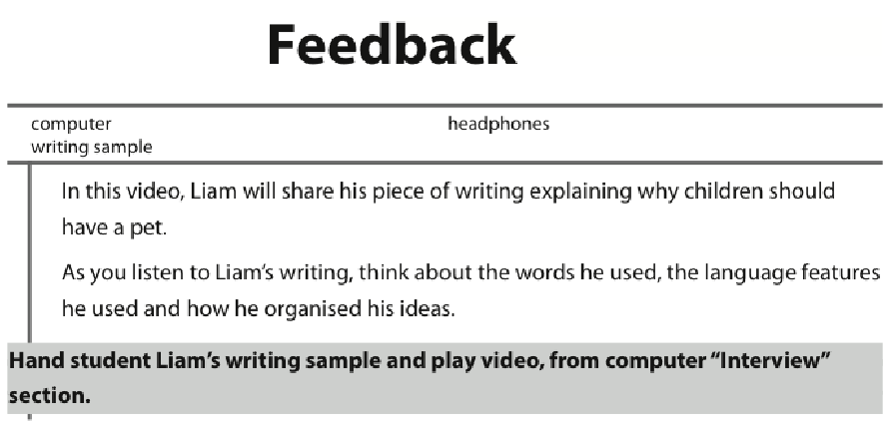
Figure 3.15 Writing prompt, 'Feedback'

Q1. What would you say to Liam that is good about his writing?
Table 3.19 Positive aspects of Liam's writing
 | Year 4 | Year 8
 | (%) | (%)
No positive comments (e.g. I like this piece of writing) | 2 | 1
Deep features (e.g. ideas, structural and language features, organisation, vocabulary, audience awareness/engagement) | 56 | 69
Surface features (e.g. spelling, punctuation, grammar) | 13 | 11
Other* | 29 | 19
* Revising/editing, length, handwriting/neatness, general
Fewer than 2 percent of students at both Year 4 and Year 8 did not make any positive comments. Of the positive responses given ‘deep features’ (e.g. ideas and content; structural and language features; organisation or vocabulary) were mentioned most frequently (56 percent at Year 4 and 69 percent at Year 8). This was much more frequent than for 'surface features' (e.g. spelling, punctuation, grammar, neatness) or other elements of writing.
Q2. What would you say to Liam, that he needs to do, to improve his writing?
Table 3.20 Feedback suggested by students
 | Year 4 | Year 8
 | (%) | (%)
No positive comments | 16 | 4
Deep features | 28 | 40
Surface features | 19 | 32
Other* | 37 | 24
* Revising/editing, length, handwriting/neatness, general
Year 8 students more frequently provided feedback to improve a piece of writing. Most frequently, the feedback was related to ‘deep’ features, rather than to ‘surface’ features. Feedback about other individual writing features was less frequent.
Q3. You have given some feedback for Liam. Feedback is when people comment on your writing.
You might call this conferencing. Feedback can be written or said.
Q4. Do you give feedback to others about their writing?
Table 3.21 Do you give feedback to others?
 | Year 4 | Year 8
 | (%) | (%)
Yes | 74 | 82

In Year 4 around three out of four students reported giving feedback to others about their writing. In Year 8 that had increased to more than four out of five students. This suggests that this practice is a common aspect of the writing programme in schools.
Q5. Do you like to get feedback about your writing?
Table 3.22 Do you like to get feedback?
 | Year 4 | Year 8
 | (%) | (%)
Yes | 78 | 80
No | 8 | 6
Mixed | 13 | 14
In both Year 4 and Year 8 more that 75 percent of students liked getting feedback, and over 10 percent reported mixed feelings about receiving feedback.

Q6. Why do you say that?
Table 3.23 Reasons for appreciating feedback
 | Year 4 | Year 8
 | (%) | (%)
To find out what people think | 15 | 12
Relationship between receiving feedback and improving writing | 39 | 62
Liking/appreciating feedback but does not link to improving writing | 20 | 9
Feedback difficult/unpleasant to receive | 12 | 12
No (or other) response | 13 | 5
Approximately 13 percent in Year 4 and 5 percent in Year 8 did not know why they responded to getting feedback the way they did. Of those that did know, in Year 4 (39 percent) and Year 8 (62 percent) a relationship between getting feedback and improving writing was mentioned. Twenty percent of Year 4 students liked getting feedback without being able to draw the link to improving compared with 9 percent at Year 8. By Year 8 it seems that students had gained an understanding of the importance of acting on feedback to improve their writing.
Q7. Now think about when you get feedback on your writing. What sort of things do people
say or write about your writing? What is the feedback about?
Table 3.24 What is the feedback about?
 | Year 4 | Year 8
 | (%) | (%)
General positive/constructive comment (e.g. good work) | 38 | 25
Deep features | 22 | 34
Surface features | 18 | 28
Handwriting | 7 | 3
Other* | 8 | 8
No feedback given | 7 | 2
* Planning, revising/editing, proofreading, length
Just over 7 percent of Year 4 students report not receiving feedback. At Year 8, this figure was notably lower at 2 percent. When feedback was received, Year 4 students described it most frequently as being a general positive/constructive comment (38 percent), or related to deep features and surface features. Some feedback was related to other aspects of writing such as handwriting, planning, proofreading, length etc.
At Year 8 more specific feedback was received about deep features (34 percent) and surface features (28 percent) with a drop in general positive comments (25 percent) compared to Year 4.

Q8. Who do you get feedback from?
Table 3.25 Who do you get feedback from?
 | Year 4 | Year 8
 | (%) | (%)
Teacher | 41 | 46
Writing buddy/classmate | 47 | 46
Parent/teacher aide | 11 | 8
No one/other | 1 | <1

In Year 4 and Year 8, students received feedback primarily from their writing buddy/classmate (47 percent and 46 percent respectively) or from their teacher (41 percent and 46 percent respectively). A small percentage of Year 4 students (1 percent) and year 8 students (<1 percent) said they get no feedback.
Q9. When do you get feedback about writing?
Table 3.26 When do you get feedback about writing?
 | Year 4 | Year 8
 | (%) | (%)
When finished | 37 | 38
While drafting | 11 | 16
After drafting/editing | 10 | 16
Timing unclear | 35 | 24
No response | 4 | 1
Other* | 3 | 5
* Conferencing, while planning, after publishing
Feedback was given most frequently to Year 4 and Year 8 students ‘when finished’ their writing (37 percent and 38 percent respectively). In both years ‘while drafting’ (11 percent and 16 percent respectively) and ‘after drafting/editing’ (10 percent and
16 percent respectively) were mentioned next most frequently. For 35 percent of the students at Year 4 and 24 percent at Year 8 the timing of feedback was unclear. For a small percentage of year 4 (3 percent) and Year 8 (5 percent) no feedback was given at any stage in the writing process.

Q10 How do you use the feedback that you are given?
Table 3.27 How do you use the feedback that you are given?
 | Year 4 | Year 8
 | (%) | (%)
To improve current piece of writing | 30 | 47
To improve current and future pieces of writing | 5 | 12
To improve next piece/s of writing | 15 | 17
General comment – to improve writing | 16 | 17
Read feedback – don’t use | 12 | 3
No response/unsure | 21 | 5
Nearly 50 percent of Year 8 students said they use the feedback to improve their current piece of writing. This was notably more than in Year 4 (30 percent). In addition to this, 20 percent of Year 4 and 29 percent of Year 8 students said they use the feedback for general improvement or for improving current and future pieces of writing. A much higher percent of Year 4 than Year 8 students reported not using feedback (12 percent and 3 percent respectively) or being unsure about the use of feedback/no response (21 percent and 5 percent respectively).
Q11 What kind of feedback is most helpful for you to improve your writing?
Table 3.28 What kind of feedback is most helpful for you to improve your writing?
 | Year 4 | Year 8
 | (%) | (%)
About deep features | 21 | 27
About surface features | 19 | 19
Constructive/specific feedback | 20 | 35
No response/other | 40 | 19
Forty percent of Year 4 and 19 percent of Year 8 students did not answer this question. Year 4 students mentioned all types of feedback to be equally helpful for them to improve their writing, whereas Year 8 students felt that the most useful feedback was constructive/specific and about the deep features of writing.

4
Understanding
Achievement
in Writing

Understanding factors that impact on student achievement is an important aspect of NMSSA. As described in Chapter 2, the NMSSA writing assessment programme used student and teacher questionnaires to collect data focused on a number of contextual factors. The questionnaires included sections related to:
student attitude to writing
the opportunities to learn writing at school
the amount of English spoken at home
how the teaching of writing was organised in the school
teacher attitudes and confidence about teaching writing
professional interactions and support for teachers related to the teaching of writing.
This chapter describes how students and teachers responded to these sections of the questionnaires. Links are made between student responses and patterns in writing achievement. Year 4 and Year 8 results are reported together so that comparisons between year levels can easily be made.
The box below highlights the major findings for this chapter.

Overall, Year 4 students were more positive about writing than Year 8 students. Girls were generally more positive than boys at both year levels, but the difference between them was less at Year 8 than at Year 4. This is consistent with NEMP findings from 1998 to 2006
Pasifika students scored higher, on average, on the Attitude to Writing scale than New Zealand European (NZE) and Māori students at both Year 4 and Year 8. This is also consistent with NEMP findings from 1998 to 2006.
Attitude to Writing was weakly related to Writing for a Variety of Purposes, particularly for students with low Attitude to Writing scores and was stronger at Year 8 than Year 4. There was no relationship between Attitude to Writing and Process of Writing.
Year 4 students reported more frequent involvement in a range of different writing experiences than Year 8 students. The most frequent activities at both year levels were teacher-led: sharing their writing with the teacher, and writing about something their teacher had asked them to write about. A sizable proportion of students in both year levels reported infrequent involvement in many of the experiences.
Teachers were very positive about writing and their confidence as teachers of writing.
Teachers of Year 4 students reported the use of remedial activities outside the classroom more often than those who taught Year 8. Year 8 teachers were more likely to report the use of extension activities outside of the classroom than Year 4 teachers.
Most teachers reported that they were regularly involved (once a term or more) in a range of professional interactions that supported their teaching of writing. This included working together to plan and prepare, discussing useful approaches to teach writing, and discussing samples of students' work.
Over 80 percent of Year 4 teachers and 75 percent of Year 8 teachers reported that they were involved in professional development and learning focused on writing in the last 12 months. This finding presents a more positive picture of professional confidence and support than was found for NMSSA Science 2012.
1. Year 4 and Year 8 Attitude to Writing
Students develop important attitudes and beliefs about writing and their own ability as writers. A section of the NMSSA student questionnaire focused on students’ attitude to writing. This included their sense of self-efficacy in writing and their engagement as learners who are developing writing skills.
The Attitude to Writing scale was constructed using IRT modelling to measure the overall strength of each student’s response to the section on attitude. This section describes how Year 4 and Year 8 students scored on the Attitude to Writing scale. It also explores the association between attitude scale scores and achievement in writing.
Figure 4.1 displays the distribution of scale scores on the Attitude to Writing measure for Year 4 and Year 8 students. Students, on average, become less positive between Year 4 and Year 8.
Table 4.1 shows the average scale score and standard deviation on Attitude to Writing for each year level. The average scale score is 14 scale score units lower in Year 8 than Year 4. This decline in the average scores represents an effect size of -0.73.
Table 4.2 breaks down the results for girls and boys at both year levels. There was a similar decline in attitudes to writing for boys and girls.
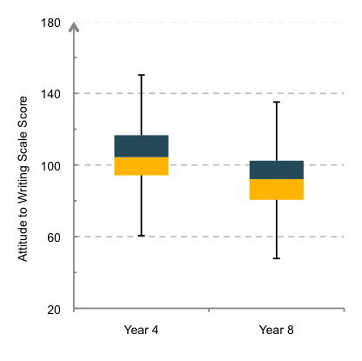
Figure 4.1 Year 4 and Year 8 student scale scores for Attitude to Writing
Table 4.1 Year 4 and Year 8 Attitude to Writing, difference and effect size
 | Attitude to Writing
 | Year 4 | Year 8
Average (scale score units) | 107 | 93
SD (scale score units) | 21 | 19
N | 2070 | 1988
Difference in average | 14
Effect size | -0.73
Effect sizes in bold are statistically significant (p<.05)
Table 4.2 Year 4 and Year 8 Attitude to Writing, difference and effect size for boys and girls
 | Attitude to Writing
 | Boys |  | Girls
 | Year 4 | Year 8 | Year 4 | Year 8
Average (scale score units) | 103 | 89 | 112 | 96
SD (scale score units) | 20 | 19 | 20 | 19
N | 1035 | 990 | 1035 | 998
Difference in average | 14 |  | 16
Effect size | -0.68 |  | -0.82
Effect sizes in bold are statistically significant (p<.05)
Figures 4.2 and 4.3 display the Attitude to Writing results by subgroup for Year 4 and Year 8 respectively. The subgroups shown relate to gender, ethnicity, school decile and type of school. The number of students that completed the Attitudes to Writing section of the questionnaire within each subgroup can be found in Appendix 4. In general, the score distributions were similar across the subgroups at each year level.

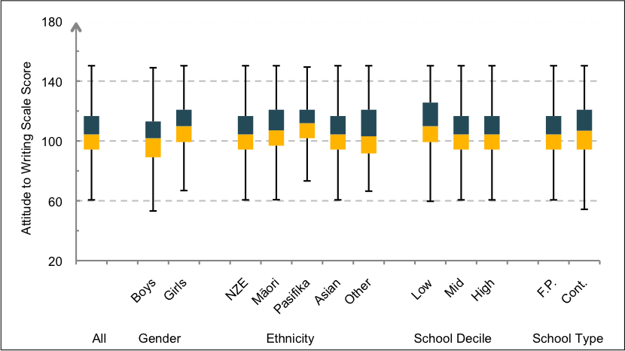
Figure 4.2 Year 4 students Attitude to Writing scores by gender, ethnicity, school decile and type
(NZE=NZ European, F.P.=Full Primary, Cont. = Contributing)
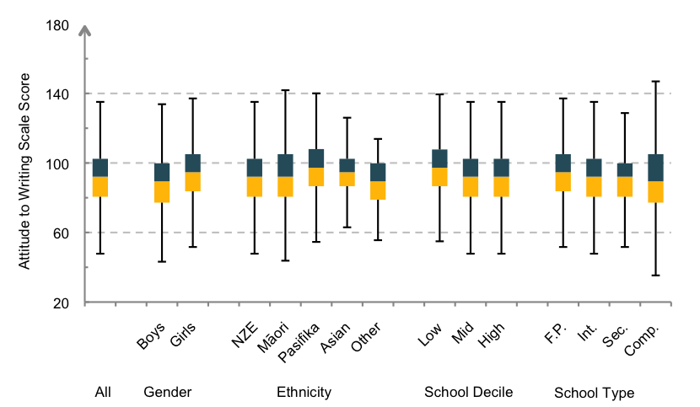
Figure 4.3 Year 8 students Attitude to Writing scores by gender, ethnicity, school decile and type
(NZE=NZ European, F.P.=Full Primary, Int.=Intermediate, Sec.=Secondary, Cont. = Contributing)

Relationship between attitude to writing and writing achievement
Table 4.3 shows the relationship between attitude to writing and writing achievement using the Pearson product-moment correlation coefficient (r). Although the relationship between attitude to writing and writing achievement was very low, it was slightly stronger at Year 8 than at Year 4.
Table 4.3 Correlation (r) between attitude to writing and writing achievement at Year 4 and Year 8
 | Writing for  a Variety of Purposes  (r) | Process of Writing  (r)
Year 4 | 0.14 | 0.04
Year 8 | 0.28 | 0.09

Figures 4.4 and 4.5 show how groups of students with different scores on the attitude measure achieved on the two NMSSA writing achievement measures at Year 4 and Year 8. To construct this graph, three reporting groups were defined on the basis of the Attitude to Writing scale scores: the lowest group of students was made up of students in the bottom quartile of Attitude to Writing scores; the middle group represented the students who scored between the 25th and 75th percentile; and the highest group represented the students who scored in the upper quartile. The distribution of achievement for each of these groups is displayed.
On the Writing for a Variety of Purposes measure (the group-administered measure) students at both year levels who reported a more positive attitude to writing had higher average achievement scores. This pattern did not exist for Process of Writing at Year 4 (the individual assessment measure), where scores were very similar for each attitude group.
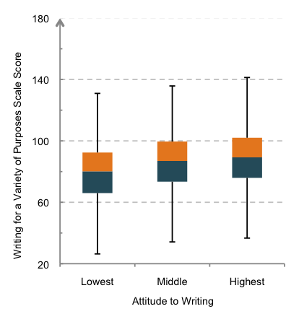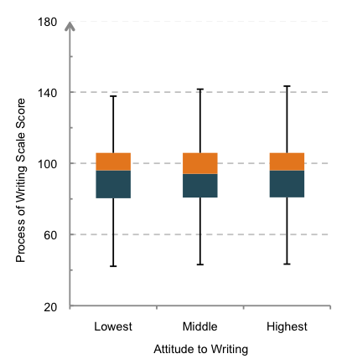
Figure 4.4 Year 4 student writing achievement scores by level of Attitude to Writing
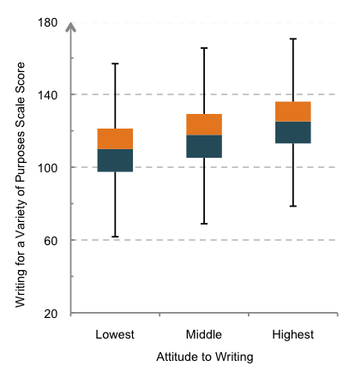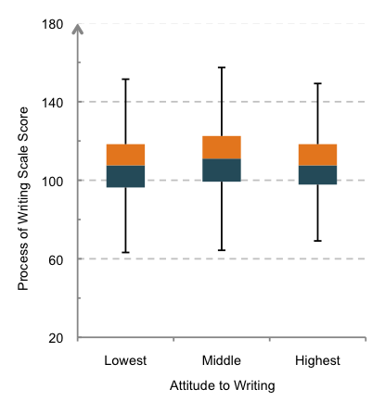
Figure 4.5 Year 8 student writing achievement scores by level of Attitude to Writing
Tables 4.4 and 4.5 show that the differences in average achievement on Writing for a Variety of Purposes were greatest between students who had the lowest attitudes to writing and the other two groups. There were no such differences for Process of Writing. The full tables of means, standard deviations, sample sizes, effect sizes and 95 percent confidence intervals are in Appendix 4.
Table 4.4 Year 4 students: Differences on writing achievement by level of Attitude to Writing
 | Writing for  a Variety of Purposes |  | Process of Writing
 | Scale score dfference | Effect size | Scale score dfference | Effect size
Year 4
Lowest/Middle | 7 | -0.37 | 1 | -0.07
Lowest/Highest | 10 | -0.51 | 1 | -0.08
Middle/Highest | 3 | -0.14 | 0 | -0.01
Effect sizes in bold are statistically significant (p<.05)

Table 4.5 Year 8 students: Differences on writing achievement by level of Attitude to Writing
 | Writing for  Variety of Purposes |  | Process of Writing
 | Scale score dfference | Effect size | Scale score dfference | Effect size
Year 8
Lowest/Middle | 9 | -0.42 | 3 | -0.19
Lowest/Highest | 16 | -0.78 | 1 | -0.05
Middle/Highest | 7 | -0.35 | 2 | 0.16
Effect sizes in bold are statistically significant (p<.05)

2. English spoken at home
NMSSA monitors achievement in schools where English is the medium of instruction. Some students in these schools, however, speak other languages besides English and/or come from homes where other languages are spoken. The NMSSA student questionnaire asked students how often they spoke English at home. The 5-point scale students used to respond was collapsed into three response categories for the purposes of reporting (see Chapter 2 for more details). Table 4.6 shows how the students responded.
Table 4.6 Year 4 and Year 8 student frequency of speaking English at home
 | English spoken at home
 | Year 4 (%) | Year 8 (%)
Always | 67 | 80
Often | 21 | 15
Sometimes/never | 12 | 5

Figures 4.6 and 4.7 display the distributions of writing achievement scores for Year 4 and Year 8 students according to their responses to the question regarding English spoken at home.
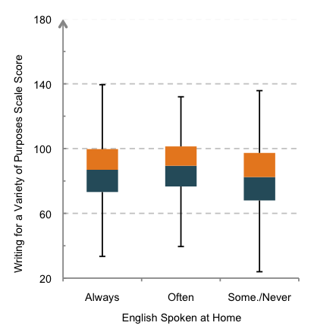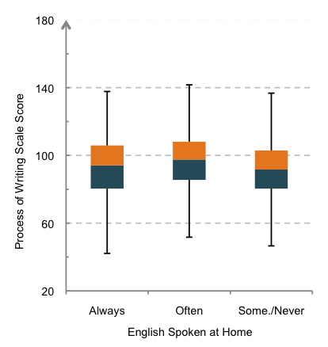
Figure 4.6 Year 4 student writing achievement scores by amount of English spoken at home (Some.=Sometimes)
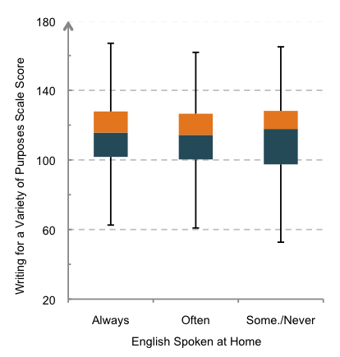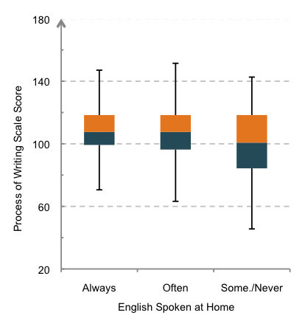
Figure 4.7 Year 8 student writing achievement scores by amount of English spoken at home (Some.=Sometimes)
Tables 4.7 and 4.8 show the differences in average scale scores on the two writing achievement measures for students who reported different levels of English spoken at home for Year 4 and Year 8. These differences are also shown as effect sizes. There was not a consistent relationship between writing achievement and the amount of English spoken at home.
Table 4.7 Year 4 students: Differences in writing achievement by how often English is spoken at home
 | Writing for  a Variety of Purposes |  | Process of Writing
 | Scale score dfference | Effect size | Scale score dfference | Effect size
English spoken at home
Always/Often | 3 | -0.14 | 1 | -0.07
Always/Sometimes-never | 4 | 0.19 | 4 | 0.18
Often/Sometimes-never | 7 | 0.34 | 5 | 0.24

Effect sizes in bold are statistically significant (p<.05)
Table 4.8 Year 8 students: Differences in writing achievement by how often English is spoken at home
 | Writing for  a Variety of Purposes |  | Process of Writing
 | Scale score dfference | Effect size | Scale score dfference | Effect size
English spoken at home
Always/Often | 2 | 0.07 | 1 | 0.05
Always/Sometimes-never | 1 | 0.03 | 7 | 0.33
Often/Sometimes-never | 1 | -0.04 | 6 | 0.26

Effect sizes in bold are statistically significant (p<.05)

3. Opportunities to learn writing at school
A section of the student questionnaire asked students to rate how frequently they were involved in a range of experiences related to learning to write at school. Figures 4.8 and 4.9 show how frequently students in Year 4 and Year 8 reported being involved in a range of writing activities.
Overall, Year 4 students reported more frequent involvement in writing activities than Year 8 students did. The activities most often rated as highly frequent at both year levels were "sharing your writing with the teacher" and "writing about something your teacher has asked you to write about". A fairly large proportion of students in both year levels reported infrequent involvement in many of the writing experiences.
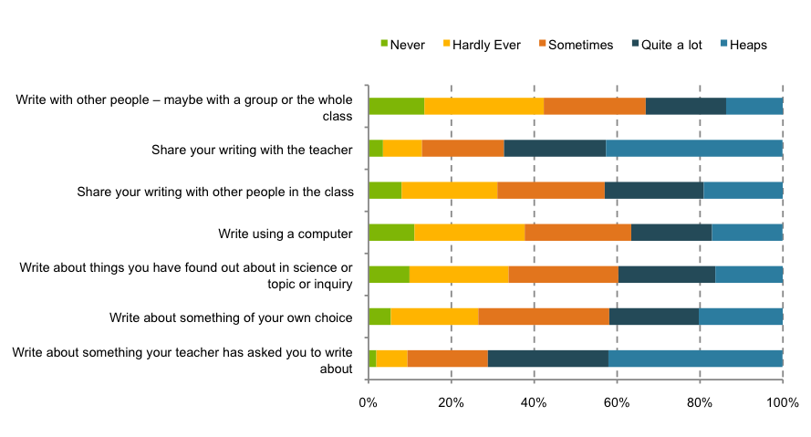
Figure 4.8 Frequency of writing activities reported by Year 4 students
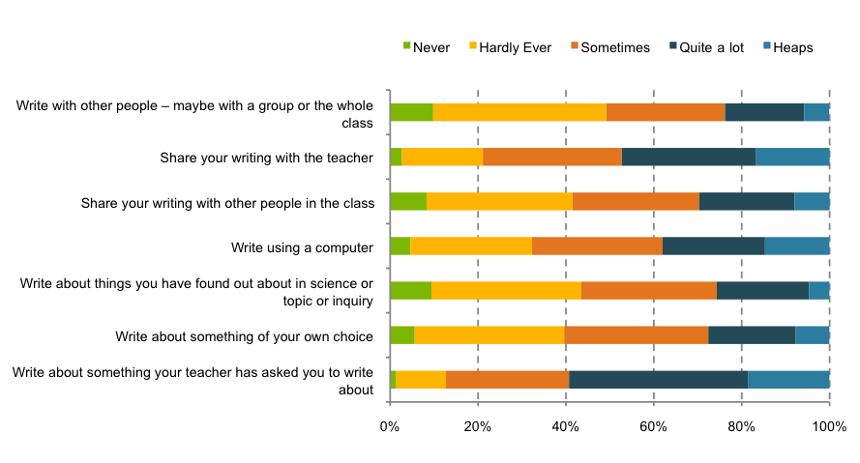
Figure 4.9 Frequency of writing activities reported by Year 8 students

4. Teaching writing at Year 4 and Year 8
Up to two teachers per school were asked to complete a questionnaire about the teaching of writing at Year 4 or Year 8.
Where one existed, the specialist teacher of writing completed one of the questionnaires. At Year 4, 183 teachers completed
the questionnaire (six specialists) and at Year 8 the number was 159 (four specialists).
Teaching writing
The first section of the questionnaire asked the teachers some general questions about their teaching of writing. Table 4.9 shows
the percentage of teachers who responded "Yes" to each of the questions. Thirty percent of teachers at Year 4 reported that they had syndicate or school leadership responsibility for writing. The figure at Year 8 was greater at 43 percent. However, only 8 percent of teachers at Year 4 and 12 percent of teachers at Year 8 had specialist qualifications in writing. Support in the classroom was received from a wide variety of sources. Most often the support was from a teacher aide, especially in Year 4, or from students assisting each other in a peer support role.
Table 4.9 Year 4 and 8 teaching of writing
Question | Percentage answering 'Yes'
 | Year 4 (%) | Year 8 (%)
Do you personally have syndicate or school leadership responsibility for writing? | 30 | 43
Do you have specialist qualifications in writing? | 8 | 12
Do any of the following people help in the classroom with writing?
Teacher aide | 48 | 39
Parent(s)/whānau | 7 | 2
People from the community | 1 | 3
Peers | 23 | 26
Another teacher | 9 | 14
Writing specialist | 7 | 2
Senior students in the school or tuakana/teina relationships | 1 | 8

Teacher attitudes and confidence in teaching writing
Figure 4.10 shows the percentage of teachers who either strongly agreed or agreed with a number of statements about their attitudes to writing, their confidence as teachers of writing and the quality of their writing programme. Overall, at both year levels teachers responded very positively to all questions.
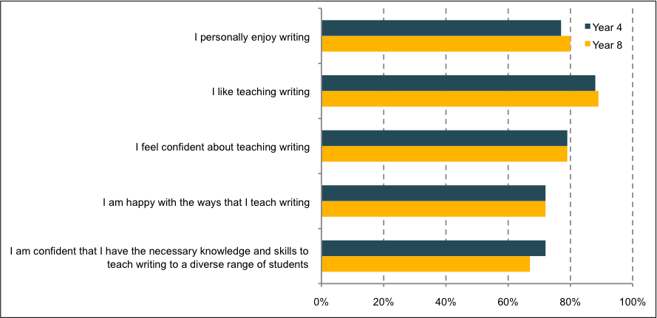
Figure 4.10 Percentage of Year 4 and Year 8 teachers who ‘strongly agree’ or ‘agree’ with statements about
writing
Approaches for teaching to differentiated writing needs of students
Teachers were asked to show which listed approaches they used to meet differentiated needs of the students in their class. Figure 4.11 shows the percentage of teachers at both year levels who indicated they used each approach. The approaches reported most often at both year levels were the use of whole class activities, extra individual assistance within the classroom and writing groups within the classroom. "Remedial activities outside the classroom" was more often reported by teachers at Year 4 (37 percent) than at Year 8 (29 percent), while "Extension activities outside the classroom" was reported more often by teachers at Year 8 (36 percent) than at Year 4 (28 percent). The use of specialist advice to adapt the curriculum for learners with special needs was reported more frequently by teachers at Year 4 (27 percent) than at Year 8 (15 percent).
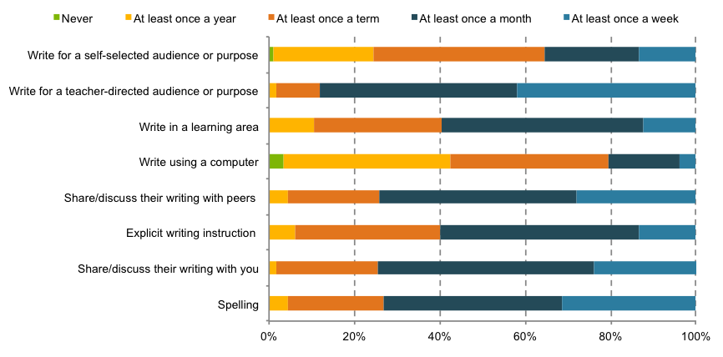
Figure 4.11 Year 4 and Year 8 teachers: Approaches to address differentiated writing needs of students

Writing activities provided by teachers in the classroom
Teachers were asked to report how frequently students in their class were involved in a range of opportunities to learn and practise their writing. Figures 4.12 and 4.13 show the frequency of writing activities reported by teachers of Year 4 and Year 8 students respectively.
Teachers reported that students at Year 4 and Year 8 were involved in similar opportunities to learn writing and that many of these occurred several times a week. Many of the experiences teachers reported as occurring frequently mirrored those reported by students (see Section 3 of this chapter). Both teachers and students reported that writing for a teacher-directed audience or purpose occurred most frequently. Overall, teachers reported that the different opportunities to learn and practise writing occurred more often than students reported.
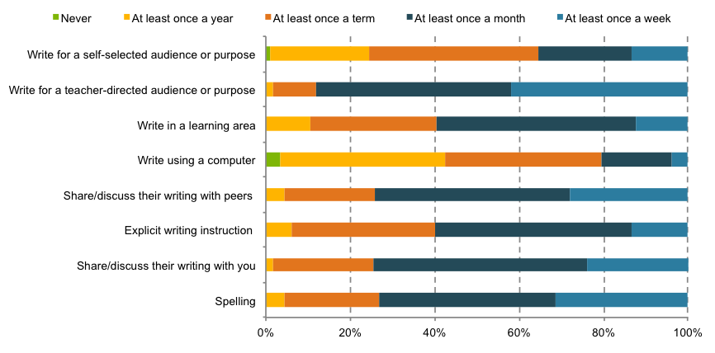
Figure 4.12 Year 4 teachers’ report of how often students in their class are involved in certain writing activities
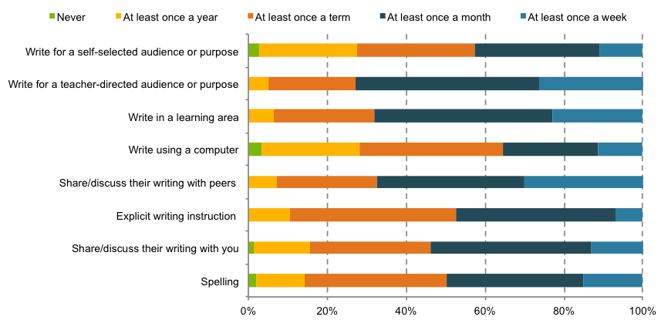
Figure 4.13 Year 8 teachers’ report of how often students in their class are involved in certain writing activities

Professional support and development for teachers in writing
Figures 4.14 and 4.15 display teachers’ reports regarding how often they had different types of interactions with colleagues related to the teaching of writing.
Most teachers reported that they were regularly involved in the different types of interactions and the frequencies reported were consistent across teachers of Year 4 and Year 8. About 85 percent of teachers at both year levels reported that they regularly (once a term or more) worked together to plan and prepare materials, discuss useful approaches to teaching writing to a diverse range of students, and discuss samples of students’ work. Over 30 percent of Year 4 and Year 8 teachers reported never observing a colleague teach writing.
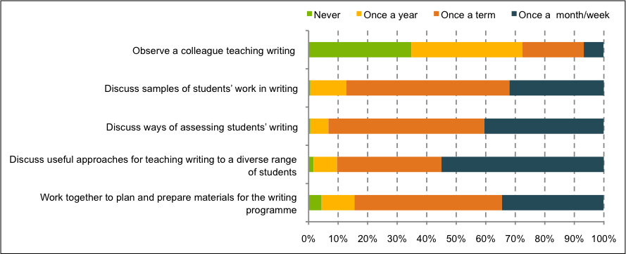
Figure 4.14 Professional interactions with colleagues at Year 4
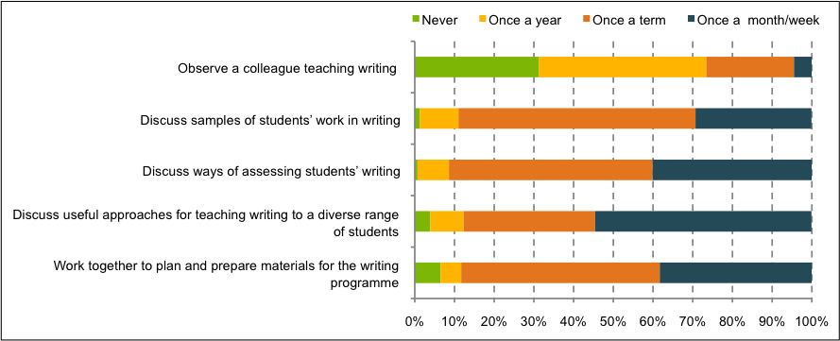
Figure 4.15 Professional interactions with colleagues at Year 8
Figure 4.16 displays how recently Year 4 and Year 8 teachers reported receiving writing professional learning and development (PLD). The figure shows that just over three quarters of Year 4 and Year 8 teachers had received writing PLD in the last year. Nearly all of the rest reported participating in PLD in writing sometime in the past five years.
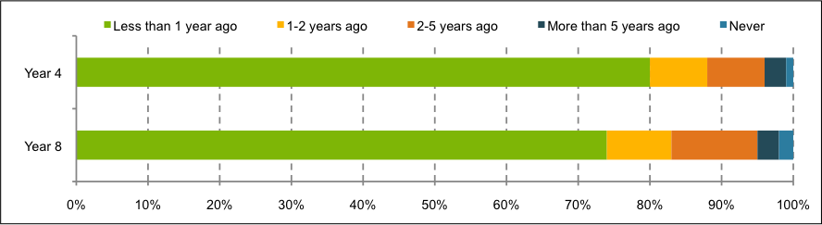
Figure 4.16 Year 4 and Year 8 teacher writing professional learning and development

5
Māori Student
Achievement in
Writing

This chapter presents the findings for Māori student achievement in writing at Year 4 and Year 8. It looks at the variation of achievement within year levels and presents it against the levels of the writing curriculum. It examines the difference in achievement between Year 4 and Year 8, and differences among subgroups of gender, school decile and type of school. It presents details about the decile, gender and attitudes of Māori students who achieve above the national average in writing at Year 4 and Year 8. It also provides information on Māori students’ attitudes to writing.
In this chapter, we compare the Māori students subgroup to all students in the national sample. When making these comparisons the national sample will be referred to as
‘All Students’.
The box below highlights the major findings for this chapter.
Success and achievement of Māori students in writing – an overview
Year 4 and Year 8 Māori students tended to achieve at a slightly lower level than NZ European students (Chapter 3) and some features of Māori student achievement followed similar patterns to the national samples.
Between the year levels, as expected, Year 8 Māori students, on average, achieved higher scores than Year 4 Māori students. However, there was a wide distribution of scores at both year levels and considerable overlap in the achievement of Year 4 and Year 8 Māori students. The overall difference in average scores between Year 4 and Year 8 students was greater for Writing for a Variety of Purposes than for Process of Writing.
For Writing for a Variety of Purposes, the average of Year 4 Māori students was just within Level 2 of the Curriculum Level 2. As performance at Level 2 is the expectation described in the NZC, roughly half of Year 4 Māori students might be viewed as achieving at or above curriculum expectations, with the other half below such expectations. In Year 8, the average score was within the upper portion of Level 3. As was also the case with All Students, this was below the expectations outlined in the NZC (Level 4).
At both year levels, average scores of Māori students on Writing for a Variety of Purposes differed by school decile and gender. This was the measure that assessed a range of technical writing skills using a piece of the student’s work. On average, Māori girls scored higher than boys and Māori students at high decile schools scored higher than those from low decile schools. In both cases the difference between these groups was similar at both year levels. Differences by school type were not notable at either year level.
Gender and decile differences were also observed at Year 4 on Process of Writing, the measure that assessed student’s awareness and understanding of a range of processes involved in writing. These differences were not significant at Year 8.
Approximately 40 percent of Māori students at Year 4 and Year 8 scored above national averages for both writing measures. At Year 4 the above average group included more girls than boys and came evenly from across the full range of school deciles. At Year 8, Māori girls and Māori students from mid decile schools made up about half of the group.
Just over 80 percent of all Māori students attended low and mid decile schools. This contrasts with just over 50 percent of NZ European students attending low or mid decile schools. When these figures are accounted for, they show that, as for All Students, a higher proportion of Māori students attending high decile schools scored above the benchmark than from mid or low decile schools. However, at Year 8 this difference was less pronounced.
1. Year 4 Māori student achievement in writing
Table 5.1 shows how Māori students in Year 4 performed on the two NMSSA writing assessments. It provides the average scale scores for each assessment along with standard deviations and sample sizes.
For Māori students at Year 4, the average score on the Writing for a Variety of Purposes measure was 80 scale score units, 10 scale points lower than the average for the Process of Writing scale. Scores varied less on the Writing for a Variety of Purposes scale than for the Process of Writing scale. This was in contrast to All Students at Year 4 where the difference in average scores was less and the variation in scores was similar.
Drawing on the scale description for Writing for a Variety of Purposes (Chapter 2) the middle 50 percent of Year 4 Māori students typically wrote simple ideas in brief but coherent text using language and some structural features appropriate to their purpose. These students showed an increasing control of the beginning and end of sentence punctuation and wrote sentences that began to show variety in structure. Their vocabulary was likely to include a small number of precise words. They typically used correct spelling for a range of personal and high frequency words.
For the Process of Writing scale, the middle 50 percent of Year 4 students were typically able to discuss some aspects of planning and crafting their writing, and to discuss how they could improve its clarity and meaning. They generally did not mention receiving feedback or publishing as a part of the writing process and were not able to give feedback to others.
The curriculum alignment exercise undertaken to link performance on the Writing for a Variety of Purposes scale to the NZC allows these results to be reported in terms of curriculum expectations (Appendix 3).
Table 5.2 sets out the percentage of Year 4 Māori students in each curriculum level for the Writing for a Variety of Purposes scale. At Year 4, 52 percent of Māori students achieved at Level 2 or above, compared to 75 percent for All Students. Just below 50 percent of Year 4 Māori students scored within Level 1.
Table 5.1 Overall measures of Māori writing achievement at Year 4
 | Writing for a Variety of Purposes | Process of Writing
 | Year 4 | Year 4
Average (scale score units) | 80 | 90
SD (scale score units) | 18 | 24
N | 423 | 143

Table 5.2 Percentage of Year 4 Māori students achieving across the writing curriculum levels compared to
the All Students group
 | Writing for a Variety of Purposes
 | Māori students (%) | All students (%)
Level 5 | - | -
Level 4 | - | 2
Level 3 | 11 | 18
Level 2 | 41 | 45
Level 1 | 48 | 35

2. Year 8 Māori student achievement in writing
Table 5.3 reports the performance of Māori students in Year 8 on the two NMSSA writing assessments. The table provides average scale scores, standard deviations and sample sizes for each assessment.
The average achievement in Writing for a Variety of Purposes Year 8 was 109 scale score units. This was just within a higher competency band (described in Chapter 2) than Year 4 students. The middle 50 percent of Year 8 Māori students typically demonstrated the competencies described earlier for Year 4 students, and could describe more complex ideas in a coherent text using appropriate structural and language features. They typically used a more precise vocabulary with correct spelling for high frequency words and punctuated beginnings and ends of sentences correctly.
For the Process of Writing scale, the average achievement score for Māori Year 8 students was 103 scale score units. The middle 50 percent of Year 8 students was only just slightly more developed than Year 4 students and demonstrated the same competencies described earlier.
Table 5.4 shows how Year 8 Māori students performed against the curriculum on the Writing for a Variety of Purposes assessment. Achievement was distributed across the curriculum levels with about 25 percent of students at Levels 4 and 5. About 65 percent of Māori students scored within Levels 2 and 3. The pattern of achievement was similar to the All Students group, however, a greater proportion of Māori students was within Levels 1 and 2 than All Students.
Table 5.3 Overall measures of Māori writing achievement at Year 8
 | Writing for a Variety  of Purposes | Process of Writing
 | Year 8 | Year 8
Average (scale score units) | 109 | 103
SD (scale score units) | 20 | 20
N | 368 | 133

Table 5.4 Percentage of Year 8 Māori students achieving across the writing curriculum levels
compared to the All Students group
 | Writing for a Variety of Purposes
 | Māori students (%) | All students (%)
Level 5 | 3 | 8
Level 4 | 23 | 27
Level 3 | 36 | 37
Level 2 | 30 | 23
Level 1 | 8 | 5

3. Comparison of Year 4 and Year 8 Māori student achievement
Figures 5.1 and 5.2 show the distribution of Year 4 and Year 8 students on the Writing for a Variety of Purposes, and the Process of Writing scales respectively. As expected, on average, Year 8 Māori students had higher achievement scores than Year 4 Māori students. There was a wide distribution of scores at both year levels on Writing for a Variety of Purposes, and some overlap in the achievement of Year 4 students and Year 8 students. On Process of Writing, the overlap between Year 4 and Year 8 was greater. The patterns for both measures were similar to the All Students group.
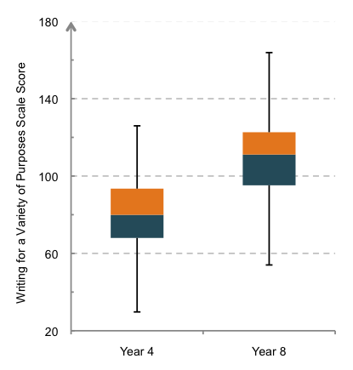
Figure 5.1 Māori student achievement for Writing for a Variety of Purposes
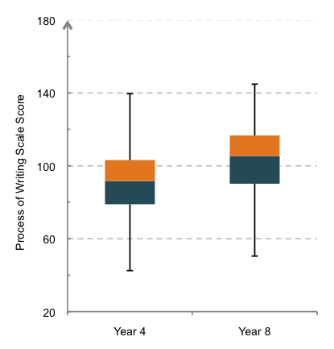
Figure 5.2 Māori student achievement for Process of Writing

Figures 5.3 and 5.4 show the spread of achievement across the curriculum levels for Year 4 and Year 8 Māori students on Writing for a Variety of Purposes. The average achievement score of Year 4 Māori students was just within the lower end of Level 2 of the NZC. For Year 8 Māori students, the average score was within Level 3. The results for Year 4 are within curriculum expectations for the majority of students. However, those for Year 8 are below Level 4, the outlined level. This was the case also for the Year 8 All Students group.
The figures show that, on average, Māori students at Year 4 and Year 8 scored lower than All Students on Writing for a Variety of Purposes. However, the Māori student group, at Year 8 in particular, had a greater proportion of students scoring below the average – a skewed distribution.
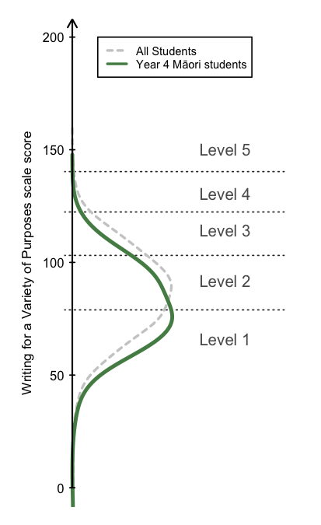
Figure 5.3 Distribution of Year 4 Māori student achievement on Writing for a Variety of Purposes against levels of
the curriculum
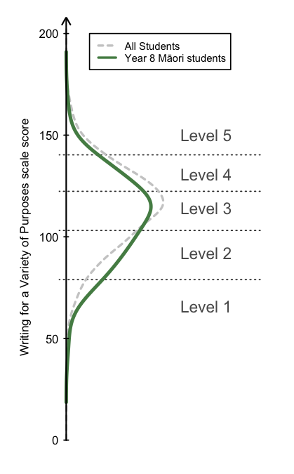
Figure 5.4 Distribution of Year 8 Māori student achievement on Writing for a Variety of Purposes against levels of
the curriculum
Table 5.5 shows the differences in average scores between Year 4 and Year 8 Māori students expressed in scale score units and effect sizes, and the averages and standard deviations for both writing measures. The differences between the average score for Year 4 and Year 8 students was 29 scale points for Writing for a Variety of Purposes and 13 for Process of Writing. These differences represented effect sizes of about 1.5 for Writing for a Variety of Purposes and 0.59 for Process of Writing with average annual effect sizes of 0.37 and 0.15. This pattern of effect sizes is similar to the national sample.
The average scores for Māori students were lower than those for the full national sample at both year levels on Writing for a Variety of Purposes (See Chapter 3).
Table 5.5 Overall measures of Māori writing achievement and difference of achievement by year level
 | Writing for a Variety of Purposes |  | Process of Writing
 | Year 4 | Year 8 | Year 4 | Year 8
Average (scale score units) | 80 | 109 | 90 | 103
SD (scale score units) | 18 | 20 | 24 | 20
N | 423 | 368 | 143 | 133
Difference (scale score units) | 29 |  | 13
Effect size²⁸ | 1.47 |  | 0.59
Average annual effect size | 0.37 |  | 0.15
Effect sizes in bold are statistically significant (p<.05)
Subgroup comparisons
Figures 5.5 and 5.6 display the achievement results for Year 4 Māori students on Writing for a Variety of Purposes and Process of Writing respectively, for gender, ethnicity, school decile and type of school. The overall pattern of results was the same for both scales. Year 4 Māori girls scored higher than Year 4 Māori boys, on average, and average scores for Year 4 Māori students attending high decile schools were higher than those for students from low decile schools. This difference was greater on the Process of Writing measure. Differences by school type were not notable. The full tables of means, standard deviations, sample sizes, effect sizes and 95 percent confidence intervals are in Appendix 4.
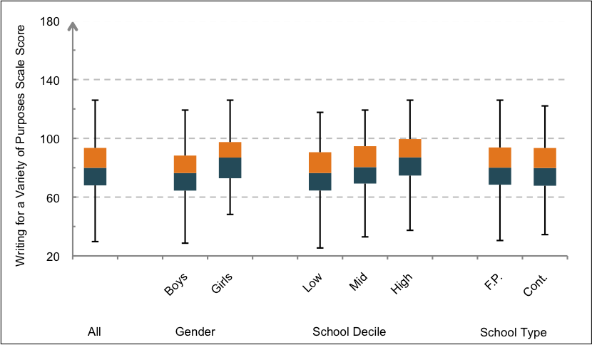
Figure 5.5 Year 4 Māori student scores for Writing for a Variety of Purposes by gender, school decile and type of
school (F.P.=Full Primary, Cont.=Contributing)
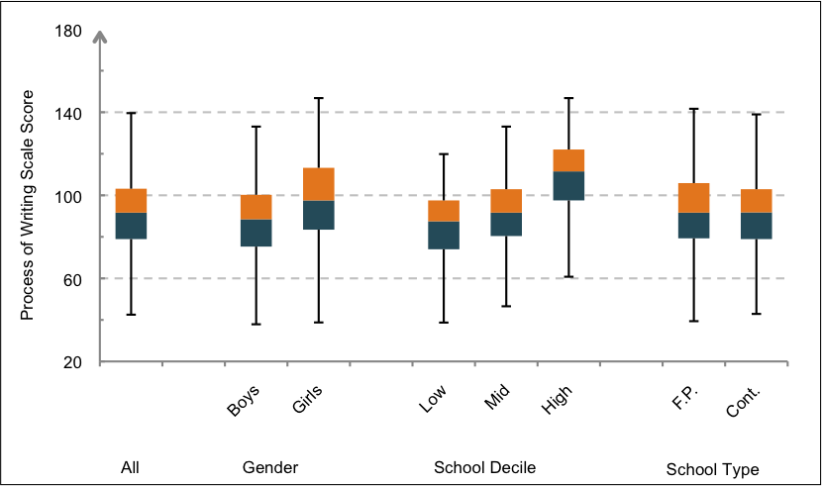
Figure 5.6 Year 4 Māori student scores for Process of Writing by gender, school decile and type of school
(F.P.=Full Primary, Cont.=Contributing)

Figures 5.7 and 5.8 show the level and spread of scores for Year 8 Māori students on Writing for a Variety of Purposes for gender, school decile and school type. On average, achievement varied by both gender and school decile but not school type. As at Year 4, on average, Year 8 Māori girls scored higher than Year 8 Māori boys, and students from low decile schools scored lower than those from high decile schools.
At Year 8, for Process of Writing there were no subgroup differences.
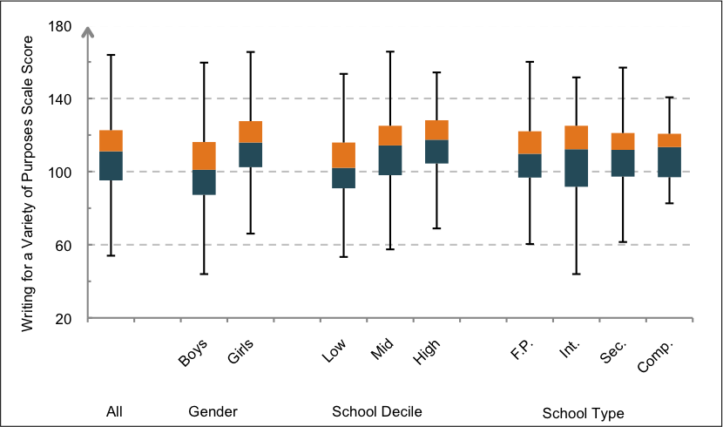
Figure 5.7 Year 8 Māori student scores for Writing for a Variety of Purposes by gender, school decile and type of
school (F.P.=Full Primary, Int.=Intermediate, Sec.=Secondary, Comp.=Composite)
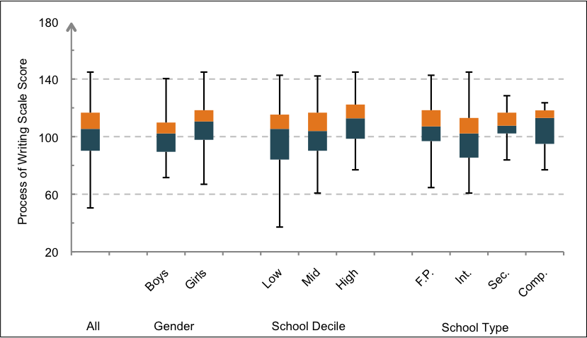
Figure 5.8 Year 8 Māori student scores for Process of Writing by gender, school decile and type of school
(F.P.=Full Primary, Int.=Intermediate, Sec.=Secondary, Comp.=Composite)
Table 5.6 sets out the average scale score differences between subgroups and the corresponding effect sizes at Year 4 and Year 8 for Writing for a Variety of Purposes. As illustrated earlier, average achievement of Māori students at both year levels varied by school decile and gender. The effect size of the difference between the average scores of boys and girls and students from low and high decile schools was similar (effect size of 0.61 at Year 8). Achievement did not vary significantly by school type at either year level.
Table 5.6 Year 4 and Year 8 Māori students: Subgroup differences on Writing for a Variety of Purposes
 | Writing for a Variety of Purposes
 | Year 4 |  | Year 8
 | Scale score difference | Effect size | Scale score difference | Effect size
Gender
Boys/Girls | 9 | -0.52 | 12 | -0.61
School Decile Group
Low/Mid | 4 | -0.24 | 8 | -0.41
Low/High | 9 | -0.46 | 12 | -0.61
Mid/High | 5 | -0.23 | 4 | -0.18
Type of School
Contributing/Full primary | 0 | -0.01 | - | -
Composite/Full primary | - | - | 1 | 0.09
Full Primary/Intermediate | - | - | 1 | 0.02
Full Primary/Secondary | - | - | 1 | -0.07
Intermediate/Secondary | - | - | 2 | -0.08
Effect sizes in bold are statistically significant (p<.05)

Table 5.7 sets out the average scale score differences between subgroups and corresponding effect sizes at Year 4 and Year 8 for Process of Writing. Achievement of Māori students at Year 4 varied by school decile and gender, but these differences were not significant at Year 8. On average, at Year 4, boys scored lower than girls, and students from high decile schools scored higher than those from mid and low decile schools.
Table 5.7 Year 4 and Year 8 Māori students: Subgroup differences on Process of Writing
 | Writing for a Variety of Purposes
 | Year 4 |  | Year 8
 | Scale score difference | Effect size | Scale score difference | Effect size
Gender
Boys/Girls | 11 | -0.49 | 6 | -0.28
School Decile Group
Low/Mid | 6 | -0.29 | 3 | -0.11
Low/High | 24 | -1.03 | 9 | -0.43
Mid/High | 18 | -0.73 | 6 | -0.36
Type of School
Contributing/Full primary | 4 | 0.15 | - | -
Composite/Full primary | - | - | 1 | 0.01
Full Primary/Intermediate | - | - | 3 | 0.17
Full Primary/Secondary* | - | - | 5 | -0.25
Intermediate/Secondary | - | - | 8 | -0.48
Effect sizes in bold are statistically significant (p<.05)
* N=37 for secondary

4. Benchmarking Māori success
This section examines the profiles of Year 4 and Year 8 Māori students who scored above the average score on the Writing for a Variety of Purposes scale for Year 4 and Year 8 respectively. They are compared with the students from the national sample (All Students) who also scored above the national averages for Year 4 and Year 8 respectively. The 2012 national average serves as a benchmark to compare writing results for different groups in this year. This benchmark may also be used to compare writing results across future cycles of NMSSA.
In this section we examine the Writing for a Variety of Purposes benchmark only. Numbers were too small in the relevant subgroups on the Process of Writing measure to make reliable statements about differences.
Table 5.8 shows the number and percentage of Year 4 and Year 8 Māori students who scored above their respective benchmark along with the level and spread of their writing scores. The percentage of Māori students scoring above the benchmark was marginally higher at Year 8 than Year 4. Although the percentage of Māori students scoring above the benchmark was smaller than that for All Students, this difference was slightly less at Year 8.
At both year levels the average scores for Māori students were three scale points or less lower than for All Students in the same category (an effect size of about 0.20).
Table 5.8 Year 4 and Year 8: Summary statistics for students scoring above the benchmarks for their year
 | Year 4 students scoring above  the national Year 4 average |  |  | Year 8 students scoring above  the national Year 8 average
 | Writing for a Variety of Purposes
 | Māori students | All students | Māori students |  | All students
No. above benchmark (of total group) | 167 (of 423) | 1056 (of 2065) | 159 (of 368) |  | 1053 (of 1975)
Percent of respective group | 39% | 51% | 43% |  | 53%
Average (scale score units) | 98 | 101 | 127 |  | 129
SD (scale score units) | 9 | 11 | 10 |  | 12

Figures 5.9 and 5.10 contrast the group of Māori students who scored above the benchmark with the All Students group who scored above the benchmark at Year 4 and Year 8 respectively in relation to gender, school decile and attitudes to writing.
At Year 4, girls made up about 60 percent of both groups scoring above the benchmark. At Year 8, a similar proportion was found for the All Students group, while Māori girls comprised nearly 70 percent of the Māori student group.
There were similar profiles on Attitude to Writing for Māori students and All Students achieving above the national mean. About half of Year 4 students came from the highest Attitude to Writing group and a further 30-40 percent from the middle group. However, at Year 4, a slightly greater proportion of Māori students came from the lowest Attitude to Writing group.
The greater proportion of students in both benchmark groups at Year 4 coming from the lowest attitude to writing group reflects the general decline in Attitude to Writing between Year 4 and Year 8.
The spread of Māori students achieving above the mean was relatively even across the low, mid and high school deciles at Year 4. At Year 8, over half of the Māori student group were from mid decile schools with the remainder coming equally from low and high decile schools. In contrast, for the All Students group at both year levels, nearly 50 percent of students scoring above the benchmark came from high decile schools.
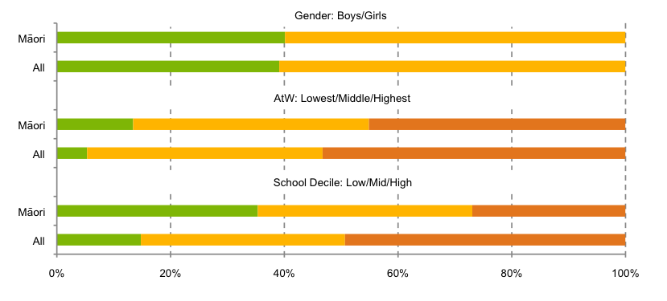
Figure 5.9 Year 4: Percentage of Māori students and All Students scoring above the benchmark in writing by
gender, Attitude to Writing and school decile (AtW=Attitude to Writing)
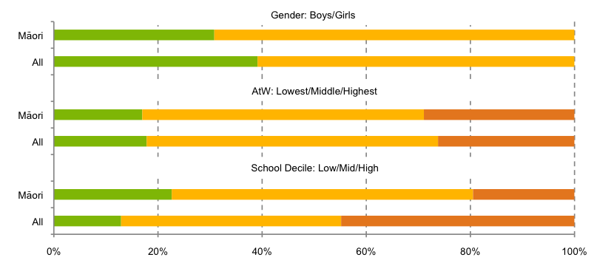
Figure 5.10 Year 8: Percentage of Māori students and All Students scoring above the benchmark in writing by
gender, Attitude to Writing and school decile (AtW=Attitude to Writing)

Māori student achievement by school decile
Tables 5.9 and 5.10 show the total number of Māori students assessed in writing and the number of Māori students who achieved above their benchmark, broken down by school decile. At both year levels about 80 percent of all Māori students came from low and mid decile schools. This contrasts with just over 50 percent of NZ European students attending low and mid decile schools (Table 5.11).
The number of Year 4 Māori students who achieved above the national mean was similar from low and mid decile groups, with slightly fewer coming from high decile schools. However, when considered as a proportion of all Māori students attending those decile groups, a different picture emerges. A higher proportion of Māori students attending high decile schools scored above the benchmark than from mid or low decile schools. For example, 42 percent of all Year 4 Māori students attended a low decile school and 33 percent of those scored above the benchmark. In contrast, 19 percent of Māori students attended a high decile school, and 54 percent of those students achieved above the benchmark. This pattern was similar to All Students. However, unlike the All Students sample, there were similar proportions of Māori students from both low and mid decile schools.
Achievement by decile at Year 8 was considerably different. At both year levels, just over half of the students who scored above the benchmark came from high decile schools. At Year 8 the proportion of students that came from mid decile schools was almost as great.
Table 5.9 Year 4: Number and percent of Māori students by school decile
 | All Māori students |  | Māori students who achieved above the national average as a percentage of all Māori in that decile group
 | N | % | N | %
School Decile
Low | 178 | 42 | 59 | 33
Middle | 167 | 39 | 63 | 38
High | 83 | 19 | 45 | 54
Total | 428 | 100 | 167 | –

Table 5.10 Year 8: Number and percent of Māori students by school decile
 | All Māori students |  | Māori students who achieved above the national average as a percentage of all Māori in that decile group
 | N | % | N | %
School Decile
Low | 132 | 35 | 36 | 27
Middle | 190 | 50 | 92 | 48
High | 57 | 15 | 31 | 54
Total | 379 | 100 | 159 | –

Table 5.11 Number and percent of NZ European students by school decile
 | NZ European students
 | Year 4 (%) | Year 8 (%)
School Decile
Low | 8 | 9
Middle | 44 | 45
High | 49 | 46

6
Pasifika Student
Achievement in
Writing

This chapter presents the findings for Pasifika student achievement in writing at Year 4 and Year 8. It looks at the variation of achievement within year levels and presents results against the levels of the writing curriculum. It examines the difference in achievement between Year 4 and Year 8, and differences between subgroups of gender, school decile and type of school, and amount of English spoken in the home. It presents details about the school decile, gender and attitudes of Pasifika students who achieved above the national average in writing at Year 4 and Year 8. It also provides information on Pasifika students’ attitudes to writing.
In this chapter, we compare the Pasifika students subgroup to all students in the national sample. When making these comparisons the national sample will be referred to as ‘All Students’.

Success and achievement of Pasifika students in writing – an overview
On average, Pasifika students scored lower than All Students at both year levels, although differences were slight at Year 8.
This suggests that Pasifika students showed a similar rate of progress, between Year 4 and Year 8, to All Students. Many specific features of Pasifika student achievement also followed similar patterns.
As expected, Year 8 Pasifika students achieved higher scores, on average, than Year 4 Pasifika students. However, there was a wide distribution of scores at both year levels and overlap in the achievement of Year 4 students and Year 8 students.
Writing achievement varied at both year levels for Pasifika students depending on the amount of English spoken at home. Students who spoke English at home ‘always’ or ‘often’ tended to achieve at a higher level than those who spoke English at home 'sometimes' or 'never'.
There was little difference in average scores for Pasifika students at Year 4 with respect to the type of school they were attending. Year 8 average scores, however, were higher for those Pasifika students attending full primary schools than for Pasifika students in intermediate schools.
For the Writing for a Variety of Purpose measure, a little over 50 percent of Year 4 Pasifika students achieved in Level 2 of the NZC or above, compared to 65 percent of All Students. Performance by Pasifika students was, on average, in line with expectations outlined in the NZC. A third of Year 8 Pasifika students achieved within Level 4 or higher, similar to the All Students group. This was below the expectations outlined in the NZC.
While 37 percent of Pasifika students at Year 4 scored above the national average, a greater percentage of Pasifika students at Year 8 scored above the national average (48 percent). About 70 percent of these students were girls, a greater percentage than the All Students group.
More than 85 percent of all Pasifika students at both year levels attended low and mid decile schools. This contrasts with just over 50 percent of NZ European students attending low or mid decile schools. When this is accounted for, results show that a greater proportion of Pasifika students at high decile schools scored above the national benchmark. This reflects the same relationship between achievement and school decile that was found for All Students.
1. Year 4 Pasifika student achievement in writing
Table 6.1 shows how Year 4 Pasifika students performed on the two writing assessments. It provides the average scale scores, standard deviations and sample sizes.
Scores for Pasifika students varied more on the Process of Writing scale than on Writing for a Variety of Purposes. This contrasts with the results for All Students where the standard deviation on both scales is about 20 scale score units.
At Year 4, the average score for Pasifika students in Writing for a Variety of Purposes was 79 scale score units. Using the scale description prepared for the Writing for a Variety of Purposes scale this result indicates that the 50 percent of Year 4 Pasifika students with scores clustered around the average (the middle 50 percent) typically wrote simple ideas in brief but coherent text, using language and some structural features appropriate to their purpose. These students showed an increasing control of the beginning and end of sentence punctuation, and wrote sentences that showed some variety in structure. Their vocabulary was likely to include a small number of precise words. They typically used correct spelling for a range of personal and high frequency words.
For the Process of Writing scale, Year 4 Pasifika students had an average of 83 scale score units. This time drawing on the description for the Process of Writing scale, the top 50 percent of Year 4 students were typically able to discuss some aspects of planning and crafting their writing, and to discuss how they could improve its clarity and meaning. They generally did not mention receiving feedback or publishing as a part of the writing process and were not able to give feedback to others.
The curriculum alignment exercise undertaken to link performance on the Writing for a Variety of Purposes scale to the NZC allows these results to be reported in terms of curriculum expectations.
Table 6.2 shows Year 4 Pasifika student performance for the Writing for a Variety of Purposes scale across the curriculum levels, and compares these results to those for All Students. Over 50 percent of Pasifika students achieved in Level 2 or above, compared to 65 percent of All Students. Level 2 represents the expected level of performance for Year 4 students at the end of the year.
Table 6.1 Year 4 Pasifika student writing achievement
 | Writing for a Variety of Purposes | Process of Writing
 | Year 4 | Year 4
Average (scale score units) | 79 | 83
SD (scale score units) | 19 | 24
N | 263 | 96

Table 6.2 Percentage of Year 4 Pasifika and All Students achieving across the curriculum levels
 | Writing for a Variety of Purposes
 | Pasifika students (%) | All students (%)
Level 5 | - | -
Level 4 | - | 2
Level 3 | 10 | 18
Level 2 | 44 | 45
Level 1 | 46 | 35
2. Year 8 Pasifika student achievement in writing
Table 6.3 provides the average scale scores, standard deviations and sample sizes for Year 8 Pasifika students on the two measures of writing.
At Year 8, the average score for Pasifika students in Writing for a Variety of Purposes was 110 scale score units. In terms of the description for this scale, the Year 8 average score fell just within the band of description above the band associated with Year 4 students. The middle 50 percent of Year 8 Pasifika students typically demonstrated the competencies described for Year 4, and could also typically describe more complex ideas in a coherent text using appropriate structural and language features. They typically used a more precise vocabulary with correct spelling for high frequency words, and punctuated beginnings and ends of sentences correctly.
For Process of Writing, the average score for Year 8 Pasifika students was 100 scale score units. The middle 50 percent of Year 8 Pasifika students scored within the same descriptive band as Year 4 students although higher on the scale. This was also the case for All Students.
Table 6.4 shows how Year 8 Pasifika students performed against the curriculum on Writing for a Variety of Purposes. Thirty three percent of Year 8 Pasifika students achieved within Levels 4 and 5, similar to the All Students group (35 percent). The percentages achieving within Levels 1 to 3 was also similar to All Students. Average achievement at Year 8 was below expectations set out in the NZC (Level 4).

Table 6.3 Year 8 Pasifika student writing achievement
 | Writing for a Variety  of Purposes | Process of Writing
 | Year 8 | Year 8
Average (scale score units) | 110 | 100
SD (scale score units) | 20 | 19
N | 212 | 67

Table 6.4 Percentage of Year 8 Pasifika and All Students achieving across curriculum levels
 | Writing for a Variety of Purposes
 | Pasifika students (%) | All students (%)
Level 5 | 5 | 8
Level 4 | 28 | 27
Level 3 | 32 | 37
Level 2 | 29 | 23
Level 1 | 6 | 5

3. Comparison of Year 4 and Year 8 Pasifika student achievement
Figures 6.1 and 6.2 show the distribution of Year 4 and Year 8 Pasifika students on the Writing for a Variety of Purposes, and the Process of Writing scales respectively. As expected, on average, Year 8 Pasifika students scored higher than Year 4 Pasifika students. However, similar to All Students, there was overlap in the achievement of Year 4 students and Year 8 students. On Process of Writing, the overlap between Year 4 and Year 8 was greater than for Writing for a Variety of Purposes.
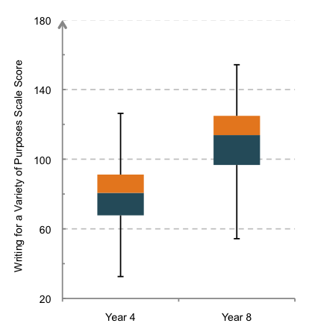
Figure 6.1 Pasifika student achievement for Writing for a Variety of Purposes
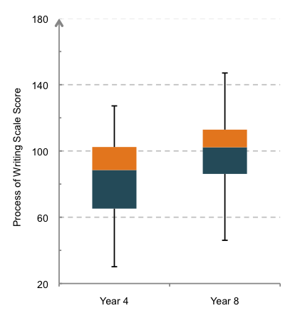
Figure 6.2 Pasifika student achievement for Process of Writing
Figures 6.3 and 6.4 illustrate the spread of achievement across the curriculum levels for Year 4 and Year 8 Pasifika students on the Writing for a Variety of Purposes measure. They show the extent of the overlap between the year levels, and that the average score for Year 4 Pasifika students was within Level 2, with the average for Year 8 Pasifika students within Level 3. It should be noted that for Pasifika students at Year 4, the average score was at the low end of Level 2, while for Year 8 it fell in Level 3.
At Year 8 the distribution of scores for Pasifika students was slightly more skewed towards lower curriculum levels than for All Students.
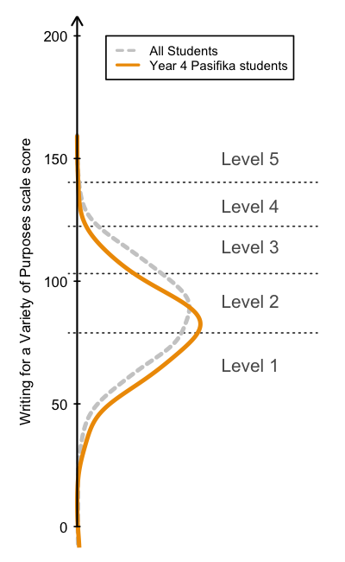
Figure 6.3 Distribution of Year 4 Pasifika and All Student achievement on Writing for a Variety of Purposes against levels of the curriculum
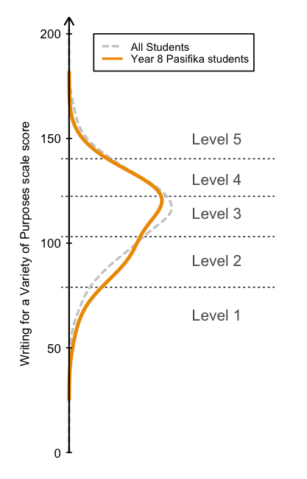
Figure 6.4 Distribution of Year 8 Pasifika and All Student achievement on Writing for a Variety of Purposes against levels of the curriculum
Table 6.5 shows summary statistics for the Year 4 and Year 8 Pasifika students, including the differences in average scores expressed in scale score units and effect sizes. The difference between the average score for Year 4 and Year 8 students was
31 scale points on the Writing for a Variety of Purposes measure and 17 scale points on the Process of Writing measure.
The effect sizes for the difference between Year 4 and Year 8 Pasifika students for Writing for a Variety of Purposes was twice that for Process of Writing. This pattern of effect sizes was similar to All Students.
Table 6.5 Pasifika student writing achievement and difference of achievement by year level
 | Writing for a Variety of Purposes |  | Process of Writing
 | Year 4 | Year 8 | Year 4 | Year 8
Average (scale score units) | 79 | 110 | 83 | 100
SD (scale score units) | 19 | 20 | 24 | 19
N | 263 | 212 | 96 | 67
Difference (scale score units) | 31 |  | 17
Effect size³⁷ | 1.59 |  | 0.78
Average annual effect size | 0.40 |  | 0.20
Subgroup comparisons
Figures 6.5 and 6.6 use box plots to show score distributions for Pasifika students on the Writing for a Variety of Purposes scale in Year 4 and Year 8 respectively. Box plots are provided according to gender, school decile, type of school and the frequency with which English is spoken at home. The numbers of Pasifika students in the Process of Writing sample group were too small to show reliable results for subgroup differences.
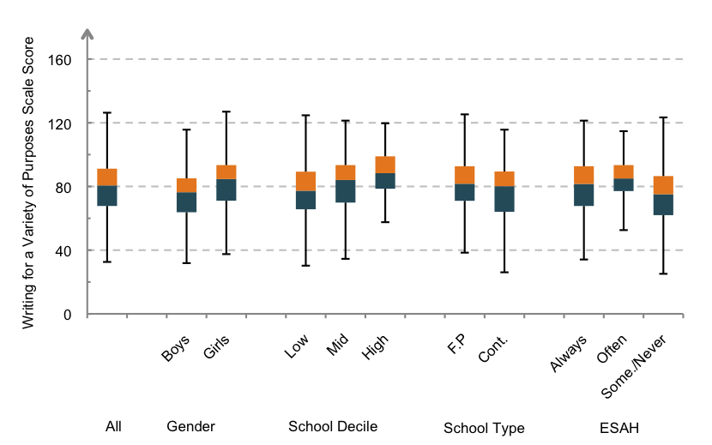
Figure 6.5 Year 4 Pasifika student scores for Writing for a Variety of Purposes by gender, school decile and type, and English spoken at home
(F.P.=Full Primary, Cont.=Contributing, Some.=Sometimes, ESAH=English spoken at home)
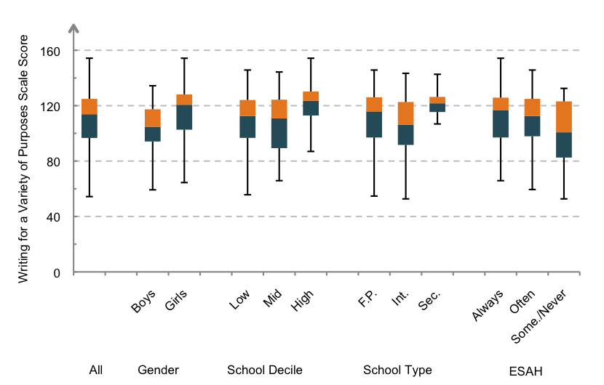
Figure 6.6 Year 8 Pasifika student scores for the Writing for a Variety of Purposes by gender, school decile and type, and English spoken at home
(F.P.=Full Primary, Int.=Intermediate, Sec.=Secondary, Some.=Sometimes, ESAH=English spoken at home)
Table 6.6 summarises differences in average scores on the Writing for a Variety of Purposes scale and the effect sizes these represent for different pairs of Pasifika student subgroups at Year 4 and Year 8. The full tables of means, standard deviations, sample sizes, effect sizes and 95 percent confidence intervals are in Appendix 4.
The average scores at both year levels varied by school decile, gender and the amount of English spoken at home. Pasifika girls, on average, scored higher than Pasifika boys, and Pasifika students from low decile schools scored lower than those from high decile schools at both year levels. The gap between the performance of Pasifika students at mid and high decile schools was not statistically significant at Year 4 but was at Year 8, with students from high decile schools scoring higher than those from mid decile schools.
The difference in average scores between Pasifika students at full primary schools and those at contributing schools was not a statistically significant effect at Year 4. At Year 8, however, Pasifika students in full primary schools scored significantly higher than those in intermediate schools. It is important to note that any differences between school type could reflect differences in the make-up of schools in each group, for instance the balance of deciles.
Across both year levels, Pasifika students who spoke English at home ‘sometimes' or 'never’ scored lower, on average, than those who spoke English at home ‘always’ or ‘often’.
Table 6.6 Year 4 and Year 8 Pasifika students: Subgroup differences on writing achievement
 | Writing for a Variety of Purposes
 | Year 4 |  | Year 8
 | Scale score differences | Effect size | Scale score differences | Effect size
Gender
Boys/Girls | 8 | -0.39 | 12 | -0.64
School Decile Group
Low/Mid | 5 | -0.27 | 2 | 0.09
Low/High | 11 | -0.61 | 9 | -0.48
Mid/High | 6 | -0.35 | 11 | -0.55
Type of School
Contributing/Full primary | 4 | -0.21 | - | -
Full primary/Intermediate | - | - | 7 | 0.39
English Spoken at Home
Always/Often | 3 | -0.21 | 2 | 0.09
Always/Sometimes-Never | 7 | 0.36 | 11 | 0.53
Often/ Sometimes-Never | 10 | 0.55 | 9 | 0.44

Effect sizes in bold are statistically significant (p<.05)
4. Benchmarking Pasifika success
This section contrasts the profiles of Year 4 and Year 8 Pasifika students who scored above the national average at their year level on the Writing for a Variety of Purposes scale. They are compared with students from the All Students group who also scored above the national averages for Year 4 and Year 8 respectively. The average score for All Students assessed in writing in 2012 has been used as a benchmark to compare results for different key population groups in this round of reporting. The same benchmark score may also be used to compare writing results in future cycles of NMSSA assessment.
Table 6.7 shows the number (and percentage) of Year 4 and Year 8 Pasifika and All Students who scored above the benchmark for their year level, along with the level and spread of their writing scores. At Year 4, 37 percent of Pasifika students scored above the benchmark compared with 51 percent of All Students at Year 4. At Year 8, this increased to nearly half of Pasifika students who scored above the benchmark, compared with 53 percent of All Students. At both year levels, the difference between the average scores of the Pasifika students and All Students who scored above the benchmark was small (two to three scale score units).
Table 6.7 Year 4 and Year 8: Summary statistics for students scoring above the benchmarks for their year
 | Year 4 students scoring above  the national Year 4 average |  |  | Year 8 students scoring above  the national Year 8 average
 | Writing for a Variety of Purposes
 | Pasifika students | All students | Pasifika students |  | All students
No. above benchmark (of total group) | 97 (of 263) | 1056 (of 2065) | 102 (of 212) |  | 1053 (of 1975)
Percent of respective group | 37% | 51% | 48% |  | 53%
Average (scale score units) | 98 | 101 | 127 |  | 129
SD (scale score units) | 9 | 11 | 8 |  | 12

Figures 6.7 and 6.8 contrast the group of Pasifika students who scored above the benchmark with the group of All Students who scored above the benchmark at Year 4 and Year 8 respectively. This is shown in relation to gender, attitudes to writing and school decile. To make comparisons in terms of Attitude to Writing, the Attitude to Writing scale was divided into three score ranges representing low, middle and high scores.
As can be seen, the Pasifika group differed from the All Students group in terms of gender balance and school decile. In contrast to All Students at Year 4 and Year 8, the Pasifika group included a higher percentage of girls than boys. In addition, about half of the above benchmark Pasifika students came from low decile schools at Year 4 and Year 8 compared to
about 15 percent of the All Students group. The converse was true for students from high decile schools; about 50 percent of All Students group came from high decile schools compared to 20 percent of Pasifika students.
At both year levels the above benchmark groups of Pasifika and All Students showed similar patterns with respect to Attitude to Writing. In general, students in the benchmark groups have higher attitude scores. A greater proportion of benchmark students came from the lowest attitude group at Year 8 than Year 4, and a correspondingly smaller proportion came from the highest attitude group. These results reflect the fact that Attitude to Writing, overall ,declined from Year 4 to Year 8.
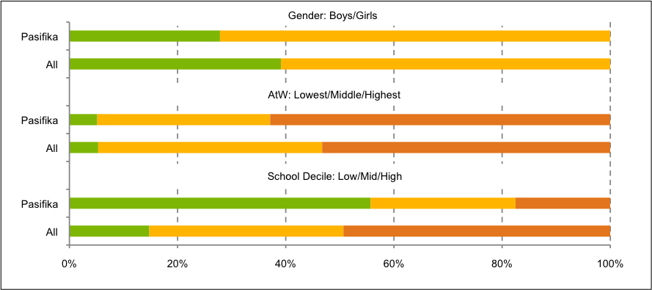
Figure 6.7 Year 4: Percentage of Pasifika students and All Students scoring above the national mean in writing by gender, Attitude to Writing, and school decile (AtW=Attitude to Writing)
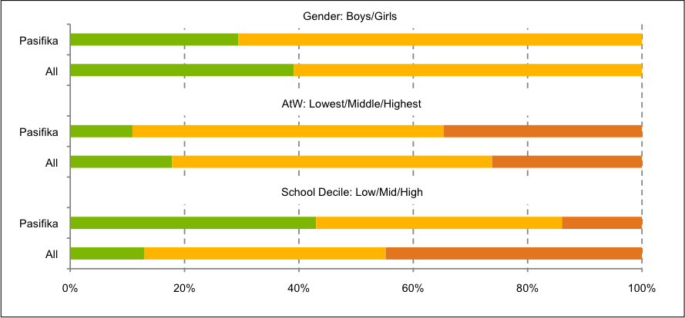
Figure 6.8 Year 8: Percentage of Pasifika students and All Students scoring above the national mean in writing by gender, Attitude to Writing, and school decile (AtW=Attitude to Writing)
Pasifika student achievement by school decile
Tables 6.8 and 6.9 show, for Year 4 and Year 8, the total number of Pasifika students assessed in Writing for a Variety of Purposes and the number of Pasifika students who achieved above the benchmark for their year, broken down by school decile.
At both year levels more than 85 percent of Pasifika students came from low and mid decile schools, with about two thirds from low decile at Year 4. This contrasts with just over 50 percent of NZ European students attending low and mid decile schools (Table 6.10). When considered in relation to the number of all Pasifika students in each decile group, a greater proportion of Pasifika students who scored above the national averages came from higher decile schools. This mirrors the relationship between school decile and achievement for All Students.

Table 6.8 Year 4: Number and percentage of Pasifika students by school decile
 | All Pasifika students |  | Pasifika students who achieved above  the national average as a percentage of  all Pasifika in that decile group
 | N | % | N | %
School Decile
Low | 174 | 65 | 54 | 31
Middle | 62 | 23 | 26 | 42
High | 32 | 12 | 17 | 53
Total | 268 | 100 | 97

Table 6.9 Year 8: Number and percentage of Pasifika students by school decile
 | All Pasifika students |  | Pasifika students who achieved above  the national average as a percentage of  all Pasifika in that decile group
 | N | % | N | %
School Decile
Low | 127 | 59 | 56 | 44
Middle | 59 | 27 | 26 | 44
High | 30 | 14 | 20 | 67
Total | 216 | 100 | 102

Table 6.10 Number and percentage of NZ European students by school decile
 | NZ European students
 | Year 4 (%) | Year 8 (%)
School Decile
Low | 8 | 9
Middle | 44 | 45
High | 49 | 46
Rounding to integers means that percentages do not always add up to 100 percent

7
Writing
Achievement of Students with
Special Education Needs

This chapter focuses on how students with special education needs achieved in writing at Year 4 and Year 8. It examines the variation of achievement within year levels and the differences in writing achievement and attitudes to writing between Year 4 and Year 8. It also examines differences in achievement between students in different categories of special education needs. We present achievement of students with special education needs against the levels of the NZC based on the descriptions of performance provided by the Literacy Learning Progressions, and provide a profile of students with special education needs who achieved above the national average in writing at Year 4 and Year 8.
Results are presented for the Writing for a Variety of Purposes measure of writing achievement developed for this study. The number of students with special education needs who undertook the individual assessments was too small to provide reliable reporting on the Process of Writing measure.
In this chapter, we compare students with special education needs to all students in the national sample. When making these comparisons the national sample will be referred to as ‘All Students’. We also make comparisons to a complementary group of students who do not fall into any of the special needs categories. This group is referred to in tables and graphs as the ‘no special education needs’ group.
The box below highlights the major findings for this chapter.
Success and achievement of students with special education needs in writing – an overview
For the first time in national monitoring, students with high and moderate education needs were identified. This represents a major step forward in the inclusion of children with special education needs in national level assessment. Although the number of students with high special education needs was very small, students with moderate special education needs made up eight percent of All Students at Year 4 and five percent at Year 8.
On average, Year 8 students with special education needs scored higher than Year 4 students. As with All Students, there was some overlap in the achievement of Year 4 and Year 8 students.
At Year 4 all students with high special education needs, and nearly three quarters of students with moderate special education needs achieved within curriculum Level 1.
The remainder achieved at Level 2 or 3. Students identified as being on referral performed in very similar ways to the national sample.
At Year 8, over one third of students with high special education needs achieved within Curriculum Level 2 or 3. Just over one third of students with moderate special education needs achieved within Curriculum Level 3 or 4. In contrast, about one third of students in the on referral and the no special education needs groups achieved at Level 4 or above.
At both year levels, students with high or moderate special education needs achieved, on average, at a lower level than those with no special education needs or those on referral. However, there was a wide range of achievement amongst the students with moderate special education needs and their scores overlapped with the students with no special education needs or on referral. The difference between the average scale scores of the moderate special education needs and no special education needs groups corresponded to an effect size of about 1.0 at both year levels.
The difference in scores between Year 4 and Year 8 was about 25 scale score points for students with moderate education needs and for students on referral (an effect size of about 1.3). This difference is equivalent to that observed for All Students (Chapter 3).
On average, Attitude to Writing scores were similar across all groups of students within each year level. As with the All Students group, the average Attitude to Writing score declined from Year 4 to Year 8. The no special education needs group showed a smaller decline in average Attitude to Writing between Year 4 and Year 8 than the moderate special education needs group.
Students with special education needs reported having a similar range of opportunities to learn to write in school as the students with no special education needs. Year 4 teachers reported using specialist advice to adapt the curriculum for learners with special education needs more often than Year 8 teachers did.
Students with special education needs reported having a similar range of writing activities in school as the students with no special education needs. Students with high special education needs reported writing using a computer more often than other groups of students.
Fifteen percent of Year 4 students and 17 percent of Year 8 students with moderate special education needs scored above the respective national average.
Over half of the students on referral (55 percent at Year 4 and 58 percent at Year 8) scored above the benchmark at each year level. This was slightly higher than that for All Students.
1. Including students with special education needs in NMSSA
For the first time in national monitoring, students with high and moderate education needs were explicitly included in the study.
This represents a major step forward in the inclusion of children with special education needs in national level assessment.
Participating schools identified students’ special education needs as:
- High special education needs: For example, ORS funded, Supplementary Learning Support (SLS), severe behaviour or communication assistance from Special Education
- Moderate special education needs: For example, provided with a teacher aide from school funds, or on the case load for Resource Teachers: Learning and Behaviour (RTLB) or Child Youth and Family Services (CYFS)
- On Referral: For example, referred to Special Education or CYFS with action pending.
Students not falling into any of the above categories for the purposes of this study have been described as the no special education needs group.
The categories of special needs used were based on the Ministry’s definitions and selected to be practical and workable to enable principals to readily identify children with these levels of special education needs. Students with special education needs were encouraged to participate using the level of assistance normally provided to them. Schools and parents were able to withdraw any students for whom the experience of participating in NMSSA would be inappropriate. For example, a child may have been withdrawn if they had: very high special education needs that could not be accommodated, anxiety, or behaviour issues. Students withdrawn for reasons of special education needs numbered 37 at Year 4, and 35 at Year 8.
Table 7.1 displays the number of Year 4 and Year 8 students in each category of special education needs who completed the Writing for a Variety of Purposes assessment. Although the numbers of students with high special education needs were extremely small, the numbers with moderate special education needs were larger and allowed analysis of achievement and some comparison with the national sample. Students with moderate special education needs made up eight percent of the national sample at Year 4, and five percent at Year 8.
Overall, the numbers of students reported on in this chapter are relatively small and the findings should therefore be interpreted with caution. This is particularly true with regard to the high special education needs group from which many of the special education needs student withdrawals are likely to have come. As such, this group cannot be considered a statistically representative sample.
Table 7.1 Breakdown of students with special education needs and no needs by year level who completed the Writing for a
Variety of Purposes assessment
 | Year 4 |  | Year 8
 | N | Percentage of national sample (%) | N | Percentage of national sample (%)
High special education needs | 8 | <1 | 11 | <1
Moderate special education needs | 161 | 8 | 99 | 5
On referral | 76 | 4 | 85 | 4
No special education needs | 1808 | 88 | 1771 | 90
Total | 2053 | 100 | 1966 | 100

2. Year 4 achievement in writing for students with special education needs
Tables 7.2 shows the average and standard deviation on the Writing for a Variety of Purposes assessment for Year 4 students in different categories of special education need compared to students with no special education needs.
The average score for Year 4 students in Writing for a Variety of Purposes was 44 scale score units for students with high special education needs, 68 for students with moderate special education needs, and 88 for those who were on referral (the same as students categorised as no special education needs). Drawing on the scale description for the Writing for a Variety of Purposes assessment, Year 4 students in the moderate special education needs category whose scores were average or above (66 scale score units or greater) typically used simple ideas and wrote in brief but coherent text using language and some structural features appropriate to their purpose. These students showed some control of the beginning and end of sentence punctuation, and wrote sentences that showed some variety in structure. Their vocabulary was likely to include a small number of precise words. They typically used correct spelling for a range of personal and high frequency words.
As the high special education needs group was very small it is not appropriate to describe ‘typical’ performance for this group at either year level. The middle 50 percent of the on referral group typically demonstrated the competencies described for Year 4 students in Chapter 3.
Table 7.2 - Year 4: Achievement on Writing for a Variety of Purposes for students in different categories of special education need
 | High special education needs | Moderate special education needs | On referral | No special education needs
Average (scale score units) | 44 | 68 | 88 | 88
SD (scale score units) | 28 | 20 | 16 | 19
N | 8 | 161 | 76 | 1808
Table 7.3 reports achievement for special needs students in terms of curriculum levels. The table shows that for Writing for a Variety of Purposes, all Year 4 students with high special education needs, and most of those with moderate special education needs, scored within Level 1. Students on referral, like the All Students group, mostly scored within Level 1 or 2 with the largest group in Level 2.
Table 7.3 – Percentage of Year 4 students with different categories of education needs achieving within the writing curriculum levels
 | High special education needs | Moderate special education needs | On referral | All students
 | % | % | % | %
Level 5 | - | - | - | -
Level 4 | - | - | - | 2
Level 3 | - | 1 | 16 | 18
Level 2 | - | 28 | 49 | 45
Level 1 | 100 | 71 | 34 | 35
Table 7.4 displays the differences in average scale scores between groups of students at Year 4. Effect sizes, calculated to quantify the differences in achievement, are also displayed for the moderate special education needs, on referral and no special education needs groups. No effect sizes have been reported for the high special needs group throughout this chapter due to the small numbers involved. The difference in average scores between students with moderate special needs versus those with no special education needs generated an effect size of 1.0 at Year 4. There was no significant difference in average scores between students on referral and those with no special education needs. As a comparison, the effect size related to the difference between the average score for all Year 4 students and the average score for all Year 8 students was 1.4.
Table 7.4 Year 4 difference in achievement between categories of special education need and no needs
 | Writing for a Variety of Purposes
 | Difference in  average scale score | Effect size
Moderate special needs/No special education needs | 19 | -1.00
Moderate special education needs/On referral | 20 | -1.11
On Referral/No special education needs | 1 | 0.04
Effect sizes in bold are statistically significant (p<.05)

3. Year 8 achievement in writing for students with special education needs
Table 7.5 displays the mean and standard deviation of writing achievement for Year 8 students in different categories of special education needs compared with students with no special education needs.
The average score for Year 8 students in Writing for a Variety of Purposes was 73 scale score units for students with high special education needs, 94 for students with moderate special education needs, and 113 for those who were on referral.
Drawing on the scale description for Writing for a Variety of Purposes, the middle 50 percent of students with moderate special education needs typically demonstrated the competencies described for Year 4 students, but at a more advanced level. The top 25 percent of students with moderate special education needs and the middle 50 percent of the on referral group were also able to describe more complex ideas in coherent texts using appropriate structural and language features. They typically used more precise vocabulary with correct spelling for high frequency words, and punctuated beginnings and ends of sentences correctly.
Table 7.5 Year 8: Achievement on Writing for a Variety of Purposes for students in different categories of special education need
 | Writing for a Variety of Purposes
 | High special  education needs | Moderate special  education needs | On referral | No special  education needs
Average (scale score units) | 73 | 94 | 113 | 116
SD (scale score units) | 25 | 19 | 21 | 19
N | 11 | 99 | 85 | 1771

Table 7.6 shows how Year 8 students with special education needs performed on the Writing for a Variety of Purposes measure in terms of the curriculum levels. Over one third (four out of 11) of Year 8 students with high special education needs achieved within curriculum Level 2 or 3. Just over one third of students with moderate special education needs achieved within Level 3 or 4. In contrast, about one third of students in the on referral group, a similar proportion to the no special education needs group, achieved at Level 4 or above.
Table 7.6 Percentage of Year 8 students with different categories of education needs achieving within the different writing curriculum levels
 | Writing for a Variety of Purposes
 | High special  education needs (%) | Moderate special  education needs (%) | On referral  (%) | All students  (%)
Level 5 | - | - | 9 | 8
Level 4 | - | 4 | 25 | 27
Level 3 | 18 | 29 | 35 | 37
Level 2 | 18 | 44 | 26 | 23
Level 1 | 64 | 22 | 5 | 5

Table 7.7 displays the differences in average scale scores between groups of Year 8 students with different categories of education need and their corresponding effect sizes. The difference in achievement between students with moderate special education needs and those with no special education needs was equivalent to an effect size of 1.1 at Year 8. There was no significant difference in achievement between students who were on referral and those who had no special education needs. This pattern of difference between the groups is similar to that found in Year 4.
Table 7.7 Year 8 difference in achievement between categories of special education need and no special education needs
 | Writing for a Variety of Purposes
 | Difference in  average scale score | Effect size
Moderate special needs/No special education needs | 22 | -1.14
Moderate special education needs/On referral | 19 | -0.95
On Referral/No special education needs | 3 | -0.14
Effect sizes in bold are statistically significant (p<.05)

4. Comparison of Year 4 and Year 8 student achievement in writing
Figures 7.1 and 7.2 show the distributions of Year 4 and Year 8 students according to category of special education needs for the Writing for a Variety of Purposes scale. Scores varied more at Year 8 than at Year 4 for all groups except moderate special education needs.
On average, in both year groups students with high and moderate special education needs scored lower than those on referral. Students on referral scored at a similar level to the respective All Students groups at both year levels. There is considerable overlap in terms of scores across the special needs categories, between the special needs categories and All Students, and between year levels.
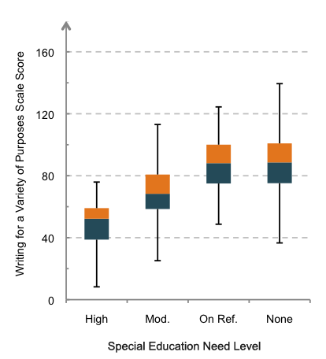
Figure 7.1 Year 4: Distribution of achievement on Writing for a Variety of Purposes (Mod.=Moderate, Ref.=Referral)
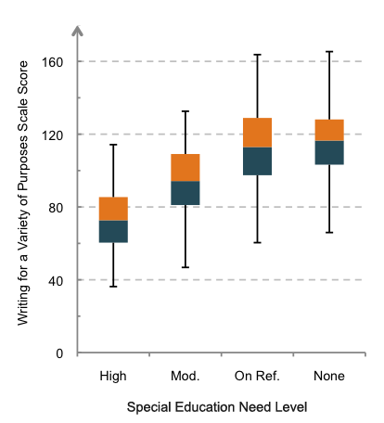
Figure 7.2 Year 8: Distribution of students on Writing for a Variety of Purposes (Mod.=Moderate, Ref.=Referral)
At Year 4 almost 30 percent of students with moderate special education needs scored within Level 2 of the NZC for Writing for a Variety of Purposes. At Year 8, a third of students with moderate special education needs scored within Levels 3 and 4. The results for both year levels are below the curriculum expectations. However, Year 8 students are clearly performing at a higher level as discussed below.

Table 7.8 displays, for the different categories of special education needs, the differences between Year 4 and Year 8 students in scale score units and effect sizes. This table details the difference in average scores between one cohort of students at Year 4 and another at Year 8. We use this difference to provide an estimate of progress between these year levels. It must be noted that this is not a measure of actual progress by a particular group of students across four years, but instead compares two separate cohorts.
The difference in average scores between Year 4 and Year 8 was similar for students in the moderate special education needs, on referral, and no special education needs groups (effects sizes of 1.4, 1.3 and 1.5 respectively). On average, progress from Year 4 to Year 8 in all special needs groups ranged from 25 to 28 scale score points, indicating that a similar amount of progress was made by all needs groups. This amount of progress is also comparable to that made between Year 4 and Year 8 by students with no special education needs.
Table 7.8 Difference in achievement by category of special education needs on the Writing for a Variety of Purposes scale
Difference between Year 4 and Year 8
on Writing for a Variety of Purposes
 | Difference in  average scale score | Effect size⁴⁴
Moderate special needs | 26 | 1.35
On referral | 25 | 1.33
No special education needs | 28 | 1.47
Effect sizes in bold are statistically significant (p<.05)
5. Year 4 and Year 8 Attitude to Writing
Figure 7.3 displays the average Year 4 and Year 8 scores on the Attitude to Writing scale and the differences between these scores for students in the different categories of special education needs. Average Attitude to Writing scores were lower for the high special education needs and moderate special education needs groups than for those on referral and the no special education needs group at both year levels. Attitude to Writing scores were lower overall in Year 8 than Year 4. Overall differences between Year 4 and Year 8 were similar for each category of special education needs except for the no special education needs group, which showed a smaller decline in average Attitude to Writing than the moderate special education needs group. Table 7.9 provides these results in tabular form.
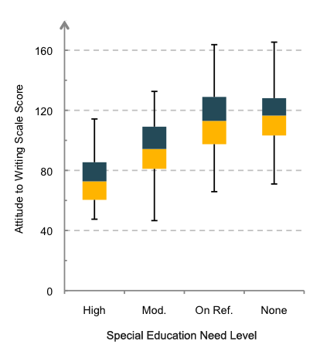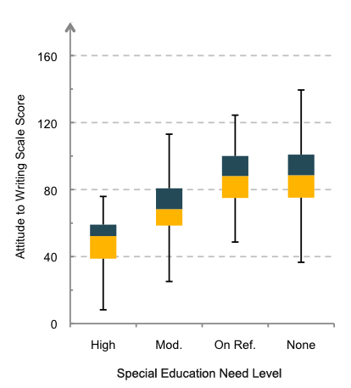
Year 4 Year 8
Figure 7.3 Year 4 and Year 8 students with different categories of education needs scores on Attitude to Writing (Mod.=Moderate, Ref.=Referral)

6. Opportunities to learn writing
Students were asked to identify how often they were involved in a range of writing activities at school. Appendix 5 shows the distribution of responses for students with high special education needs, moderate special education needs, students on referral and those with no special education needs. The range and frequency of learning experiences reported by students with special education needs were very similar to those for students on referral or with no special education needs. Overall, Year 4 students with special education needs reported more frequent involvement in writing activities than Year 8 students did. The activities most often rated as highly frequent at both year levels were "sharing your writing with the teacher" and "writing about something your teacher has asked you to write about". A relatively high proportion of students with high special education needs reported that they wrote using a computer.
The use of specialist advice to adapt the curriculum for learners with special needs was reported more frequently by teachers at Year 4 (27 percent) than at Year 8 (15 percent).
7. Benchmarking success for students with special education needs
This section contrasts the profiles of Year 4 and Year 8 students with different categories of special education needs who scored above the national average at their year level. They are compared with the students from the All Students group who also scored above the national averages for Year 4 and Year 8 respectively, on the Writing for a Variety of Purposes scale. The 2012 national average serves as a benchmark to compare writing results for different groups in this cycle of NMSSA. It may also be used to compare writing results from future cycles of NMSSA assessment.
Tables 7.10 and 7.11 show the number and percentage of Year 4 and Year 8 students with special education needs who scored above the benchmarks for their year, and the level and spread of their scores. No students with high special education needs scored above the benchmark at either year level. At both year levels 15 to 17 percent of students with moderate special education needs scored above the benchmark. The percentage of students on referral that scored above the benchmark at each year level was slightly higher than that for All Students.
Table 7.10 Summary statistics for Year 4 students by categories of special education needs and All Students scoring above the Year 4 benchmark
 | Year 4 students scoring above the Year 4 benchmark
 | High special education needs | Moderate special education needs | On referral | All students
Number above benchmark (and total group) | 0 (of 8) | 24 (of 161) | 42 (of 76) | 1056 (of 2065)
Percentage of respective group | 0% | 15% | 55% | 51%
Average (scale score units)* | 99 |  |  | 101
SD (scale score units) | 9 |  |  | 11

Table 7.11 Summary statistics for Year 8 students by categories of special education needs and All Students scoring above the Year 8 benchmark
 | Year 8 students scoring above the Year 8 benchmark
 | High special education needs | Moderate special education needs | On referral | All students
Number above benchmark (and total group) | 0 (of 11) | 17 (of 99) | 49 (of 85) | 1053 (of 1975)
Percentage of respective group | 0% | 17% | 58% | 53%
Average (scale score units)* | 127 |  |  | 128
SD (scale score units) | 11 |  |  | 12
* the groups of students with special education needs have been combined

Figures 7.4 and 7.5 contrast the profiles of students with special education needs who scored above the national average with those of All Students, by gender, Attitude to Writing score, and school decile. The profile for the students with special education needs was created by combining the three groups because of the small numbers in individual categories.
At Year 4, for the combined group of students with special education needs, girls and boys were equally represented. This contrasted with the national sample where girls comprised about 60 percent of the above average group. At Year 8, there were more girls than boys in both groups, but the gender difference in the special education needs groups was slightly smaller.
Year 8 students with special education needs had a similar profile to the national sample in terms of their Attitude to Writing scores. Over 80 percent of students from both groups came from mid and high decile schools, with fewer than one in five coming from low decile schools.
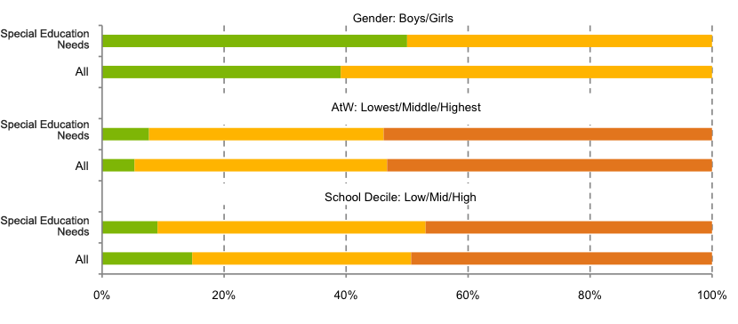
Figure 7.4 Percentage of Year 4 students with special education needs and All Students scoring above benchmark in writing by gender, Attitude to Writing and school decile (AtW=Attitude to Writing)

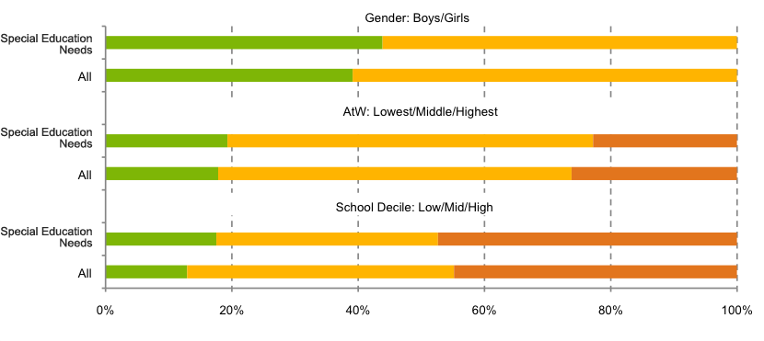
Figure 7.5 Percent of Year 8 students with special education needs and All Students scoring above the benchmark in writing by gender, Attitude to Writing and school decile (AtW=Attitude to Writing)

APPENDIX 1:
National Monitoring Study of Student Achievement
2012–2013
Samples for 2012
A two-stage sampling design was used to select nationally representative samples of students at Year 4 and at Year 8. The first stage involved sampling schools, and the second step involved sampling students within schools.
A stratified random sampling approach was taken with the intention of selecting 100 schools at Year 4 and 100 schools at Year 8. Twenty-five students were randomly selected from each school making up a sample of approximately 2000 students at Year 4 and 2000 students at Year 8.
To select the Year 4 and Year 8 students for 2012, the MoE 2011 school returns for Year 3 and Year 7 respectively were used.
Sampling of schools
The following bullet points describe the sampling algorithm:
- From the complete list of NZ schools, select two datasets – one for Year 3 students and the other for Year 7 students.
- Exclude:
- Schools which have fewer than 8 Year 3[7] students
- Private schools
- Special schools
- Correspondence School
- Secondary schools that do not have Year 3 or 7 students
- Kura Kaupapa Māori.
- Stratify the sampling frame by region and, within that, by quintile (decile bands).
- Within each region by quintile stratum order schools by Year 3 [7] roll size.
- Arrange strata alternately in increasing and decreasing order of roll size.
- Select a random starting point.
- From the random starting point, cumulate the Year 3[7] roll, continuing cyclically at start of file.
- Calculate the sampling interval as:
- Total number of Year 3[7] students / 100 (number of schools required in sample).
- Assign each school to a "selection group" using this calculation:
- Selection group = ceiling (cumulative roll/sampling interval).
- Select the first school in each selection group to form the final sample.
If a school is selected in both the Year 3 and Year 7 samples:
- Randomly assign it to one of the two samples.
- Locate the school in the unassigned sample and select its replacement school (next on list).
- Repeat the process for each school selected in both samples.
The sample frames constituted 1439 schools for Year 3 and 1234 schools for Year 7 after exclusions had been applied.
One school was listed in both samples. It was retained in the Year 4 sample and replaced in the Year 8 sample.
Schools were then invited to participate. Those that declined to participate were substituted using the following procedure:
- From overall school sample frame, select school one row below the school withdrawn
- Verify that the substitute school is of similar type, decile, size
- If not of a similar profile, re-select by going to one row above the school withdrawn
- Verify profile. If not similar, select school two rows below the school withdrawn. Continue in this sequence until
a substitute is found
In total, 77 schools (34 at Year 4 and 43 at Year 8) were approached to participate in NMSSA either as part of the original sample or as
a replacement school and declined to do so, or withdrew after agreeing to participate. Sixteen schools were unable to be replaced due to lack of available time before school visits commenced. This resulted in a slightly reduced sample of schools overall.
The achieved samples of schools
The participation rate of schools before substitution was 66 percent at Year 4 and 57 percent at Year 8. After substitution, the achieved sample of 93 schools at Year 4 represented a participation rate of 93 percent; and the achieved sample of 91 schools at Year 8 represented a response rate of 91 percent.
Sampling of students
After schools agreed to participate in the programme, they were asked to provide a list of all Year 4 (or Year 8) students, identifying any students for whom the experience would be inappropriate (e.g. high special needs, very limited English language). The procedure for selecting students for the group-administered sample and the individual sample was as follows:
- Each school provided a list of all students in their school at Year 4[8] (in 2012). The lists were arranged alphabetically. A computer-generated random number between 1 and 1,000,000 was assigned to each student. Students were ranked by their random number from highest to lowest. The first 25 students in the ordered list were identified as belonging to the group-administered sample. The first eight students were identified as also belonging to the individual sample. Where there were more than 25 students in a year level, up to five students next on the list were selected as ‘reserves’ for potential replacements if required.
- The school lists of selected students were returned to schools and letters of consent were sent to the parents of all students.
- The children of parents who declined to have their child participate were withdrawn from the list. Principals also identified additional students for whom the experience would be inappropriate (e.g. students with very high needs, students with very limited English language, or students who had been incorrectly listed as Year 3 or 7 students).
- Prior to the start of school visits, withdrawn students were replaced by the student with the next rank on the school’s student sample list. Students continued to be replaced up until two weeks prior to teacher assessors (TAs) arriving in schools to conduct the assessments. This time schedule was put in place as any later withdrawals meant we would not have had sufficient time to advise parents of substitute students.
- On the day before arrival in each school, TAs checked the final student list.
- On-site replacements of students by TAs were made if:
- any of students 1 – 8 (the individual sample) were absent or withdrawn (e.g. by principal) on the first day, prior to the start of assessments. They were replaced with student 9 and/or 10 only.
- any of students 9 – 25 were absent or withdrawn (e.g. by principal) on the first day the TA replaced from 26 - 30 using 26 first, then using progressively down the list. Students 26 - 30 were not allowed to be included in the individual sample.
- If students were absent or withdrawn (e.g. by principal) after the start of the assessment programme, no replacements were made.
The achieved samples of students at Year 4
Table A1.1 shows that at Year 4 initial lists with 2156 randomly selected students were returned to schools. Principals identified 156 students for whom the experience would be unsuitable. The ‘eligible’ sample was reduced to 2000. Forty-seven students were withdrawn from the study by parents. Substitutions were selected for 157 students, and not available for 26.
The achieved group-administered sample included 2096 students representing a participation rate of 90 percent.
The achieved individual sample at Year 4 was 736 students representing a participation rate of 92 percent. The combined school and student participation rates for the two samples were 84 percent and 86 percent respectively.
Table A1.2 contrasts the characteristics of the samples with the population.
Table A1.1 The selection of Year 4 students for the group-administered sample
 | N
Intended sample of students | 2156
Students withdrawn by principal before sample selected | 156
Eligible sample | 2000
Students withdrawn by parents after sampling | 47
Supplement students used | 157
Students for whom there were no substitutes | 26
Achieved sample | 2096

Table A1.2 Comparison of group-administered and individual samples with population characteristics at Year 4
 | Population | Group-administered sample  n = 2096 | Individual sample  n = 736
 | % | % | %
Gender
Boys | 51 | 50 | 52
Girls | 49 | 50 | 48
Ethnicity
European | 54 | 58 | 57
Maori | 23 | 19 | 20
Pasifika | 11 | 11 | 13
Asian | 10 | 10 | 10
Other | 3 | 2 | 2
School Decile
Low | 26 | 21 | 24
Middle | 34 | 38 | 38
High | 40 | 41 | 39
School Type
Contributing (Year 1-6) | 55 | 58 | 55
Full Primary (Year 1-8) | 40 | 41 | 44
Composite (Year 1-13) | 5 | 1 | 1
MOE Region
Central North | 21 | 17 | 17
Central South | 18 | 19 | 21
Northern | 39 | 42 | 40
Southern | 22 | 21 | 22
* Rounding to integers means that percentages do not always add up to 100 percent
The achieved samples of students at Year 8
Table A1.3 shows that at Year 8 initial lists with 2128 randomly selected students were returned to schools. Principals identified 71 students for whom the experience would be unsuitable. The ‘eligible’ sample was reduced to 2057. Forty-four students were withdrawn from the study by parents. Supplements were selected for 281 students, and not available for 54.
The achieved group-administered sample included 2014 students representing a participation rate of 82 percent.
The achieved individual sample at Year 8 was 719 students representing a participation rate of 90 percent. The combined school and student participation rates for the two samples were 75 percent and 82 percent respectively.
Table A1.4 contrasts the characteristics of the samples with the population.
Table A1.3 The selection of Year 8 students for the group-administered sample.
 | N
Intended sample of students | 2128
Students withdrawn by principal before sample selected | 71
Eligible sample | 2057
Students withdrawn by parents after sampling | 44
Supplement students used | 281
Students for whom there were no substitutes | 54
Achieved sample | 2014

Table A1.4 Comparison of group-administered and individual samples with population characteristics at Year 8
 | Population | Group-administered sample  n = 2096 | Individual sample  n = 736
 | % | % | %
Gender
Boys | 51 | 50 | 49
Girls | 49 | 50 | 51
Ethnicity
European | 56 | 61 | 62
Maori | 22 | 18 | 19
Pasifika | 10 | 8 | 8
Asian | 9 | 10 | 8
Other | 3 | 2 | 3
School Decile
Low | 22 | 18 | 18
Middle | 42 | 44 | 44
High | 36 | 38 | 38
School Type
Full Primary (Year 1-8) | 35 | 38 | 44
Intermediate | 47 | 40 | 36
Secondary (Year 7-13) | 14 | 14 | 13
Composite (Year 1-13 & 7-10) | 4 | 7 | 7
MOE Region
Central North | 22 | 24 | 25
Central South | 17 | 18 | 19
Northern | 39 | 35 | 33
Southern | 22 | 24 | 23
* Rounding to integers means that percentages do not always add up to 100 percent
Should weights be applied to the NMSSA sample?
A post-hoc investigation was carried out to determine whether or not weights should be applied to the NMSSA sample.
Integrity of demographic data available for weighting
At the time of investigation the only ethnicity data we had was approximate. To get full ethnicity data for each school involved (from ENROL, for instance) would have exceeded our time constraints. We used the Ministry of Education school demographic files, which carry ethnicity data only as a school variable. The proportions of NZ European, Māori, Pasifika and Asian students are specified at school level only. This means, for example, that the proportion of Māori students in a school in Year 4 was approximated by the overall proportion of Māori students for the whole school. The outcomes of this investigation reflect this approximated data. We also do not know how ethnicity has been recorded on the MoE files. It appears to be prioritised ethnicity which is at odds with the analyses by ethnicity in NMSSA.
Other weighting issues
The sample numbers and percentages in the previous sections show that a reasonably representative sample has already been achieved. In general, weighting a sample should not be regarded as a “fix all” method which will always remove bias from estimates.
Serious deviations from representativeness in the sample may cause sample weights to become very small or very large. Under-represented subgroups will tend to have large weights applied. In this case we would have to assume that the under-sized sample subgroup is actually representative of the population subgroup. The smaller the sample subgroup the less sure we can be that this is the case.
Weighting
In this investigation weights were calculated for Quintile x Gender x Māori/Non-Māori classes. There were 20 weighting classes at each year level.
Weight = Class probability_{N} / Class probability_{S}
where
Class probability_{N} = P(belonging to quintile 1 – 5) * P(being M/F) * P(being Māori/Non-Māori) in the population,
and
Class probability_{S} = P(belonging to quintile 1 – 5) * P(being M/F) * P(being Māori/Non-Māori) in the sample
Note: Subscript N denotes “national”, and subscript S denotes “sample”
The largest weight at Year 4 was 2.9, and at Year 8 the largest weight was 2.2.
Results
- Weighting would be unlikely to make a substantial difference to the national averages reported
- Weighting would be unlikely to make a substantial difference to the results reported by gender
- Weighting would be unlikely to make a substantial difference to the results reported by decile
- Weighting may make a slight difference to results by the Māori/non-Māori subgroup
The differences for the Māori subgroup indicated that levels of writing achievement in this subgroup may be slightly under-estimated. However, it is important to note that the weights have been calculated using approximated ethnicity data. The amount of difference to results in this round of NMSSA incurred by not using sample weights would be very unlikely to change overall inferences.
The possibility of weighting would need to be looked into at a much earlier stage in future rounds of the NMSSA if an accurate and robust weighting procedure is to be carried out to remove sample bias.
Table A1.5 Composition of the Year 4 and Year 8 Māori samples for writing
 | Knowledge and Communication of Writing and Ideas |  | Nature of Writing
 | N | % | N | %
Year 4 Boys | 235 | 55 | 90 | 58
Girls | 188 | 45 | 64 | 42
Total | 423 |  | 154
Year 8 Boys | 179 | 47 | 66 | 47
Girls | 199 | 53 | 74 | 53
Total | 378 |  | 140

Table A1.6 Composition of the Year 4 and Year 8 Pasifika samples for writing
 | Knowledge and Communication of Writing and Ideas |  | Nature of Writing
 | N | % | N | %
Year 4 Boys | 111 | 42 | 47 | 44
Girls | 149 | 58 | 59 | 56
Total | 260 |  | 106
Year 8 Boys | 98 | 45 | 32 | 45
Girls | 118 | 55 | 39 | 54
Total | 216 |  | 71

Table A1.7 Composition of the Year 4 and Year 8 samples of students with special education needs
and the comparison group of those with no special education needs for writing
 | Year 4 |  | Year 8
 | N | % | N | %
High Needs | 8 | <1 | 9 | <1
Moderate Needs | 162 | 8 | 95 | 5
On Referral | 74 | 4 | 85 | 4
No Needs | 1820 | 88 | 1716 | 90
Total | 2064 | 100 | 1905 | 100

APPENDIX 2:
Task Overview Grid and Task Template for
Process of Writing: Individual Assessments

The assessment framework for Process of Writing included opportunities for students to engage with knowledge, attitudes and values that are expressed in the Key Competencies, e.g. using creative, critical and metacognitive processes to make sense of and communicate information, discussing choices in language that affect understanding, and managing themselves.
The task overview grid (Table A2.1) tracked the coverage of aspects of the different parts of the assessment framework, and the assessment approaches.
Table A2.1 Task overview grid
Task Name | Understanding how to create, shape and refine texts | Constrained skills
Interview
Talking About My Writing | X
My Writing | X
Feedback | X
Special Features |  | X
Performance
Spelling |  | X
Oil and Water - explanation | X | X

A task template was used to record the aspect of Process of Writing being focused on, the curriculum focus, the key competency opportunity, and the assessment approach (interview or performance).
Table A2.2, on the following page, is an example of the specifications for one individual assessment task. Task development is an iterative process and this specification sheet is used to outline the intent of the task, the links to the science curriculum, specific questions (and justifications) and marking criteria.
Table A2.2 Task specifications
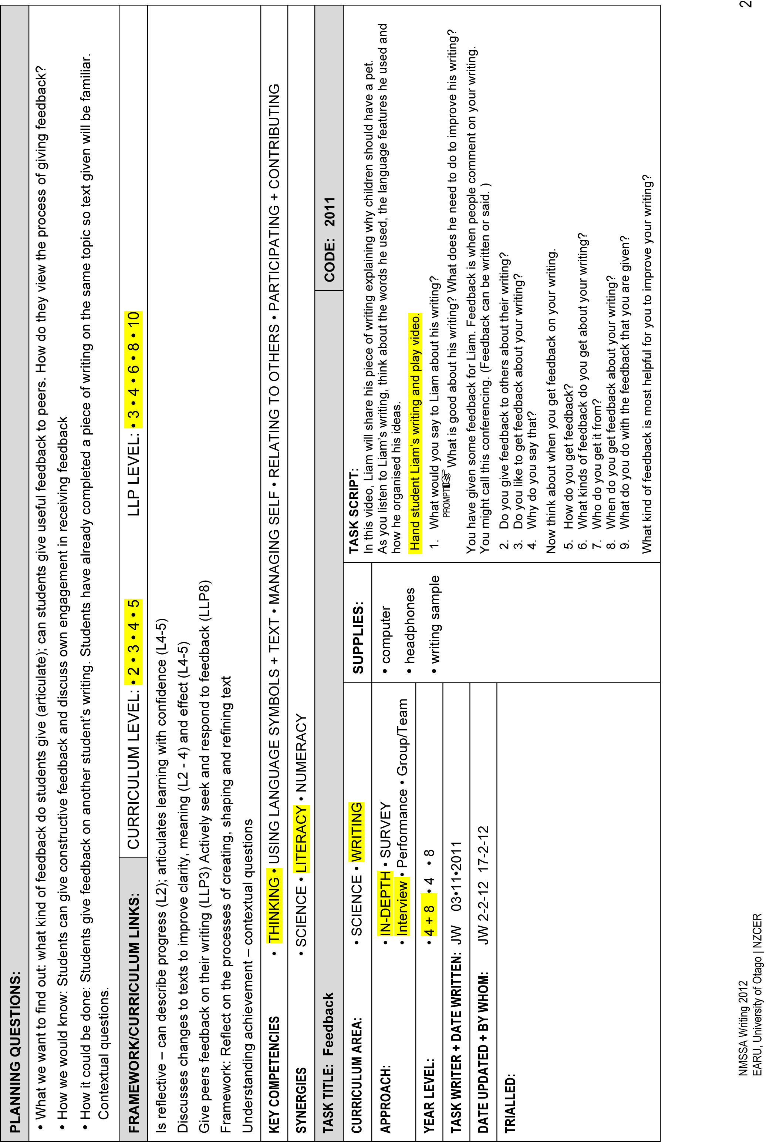

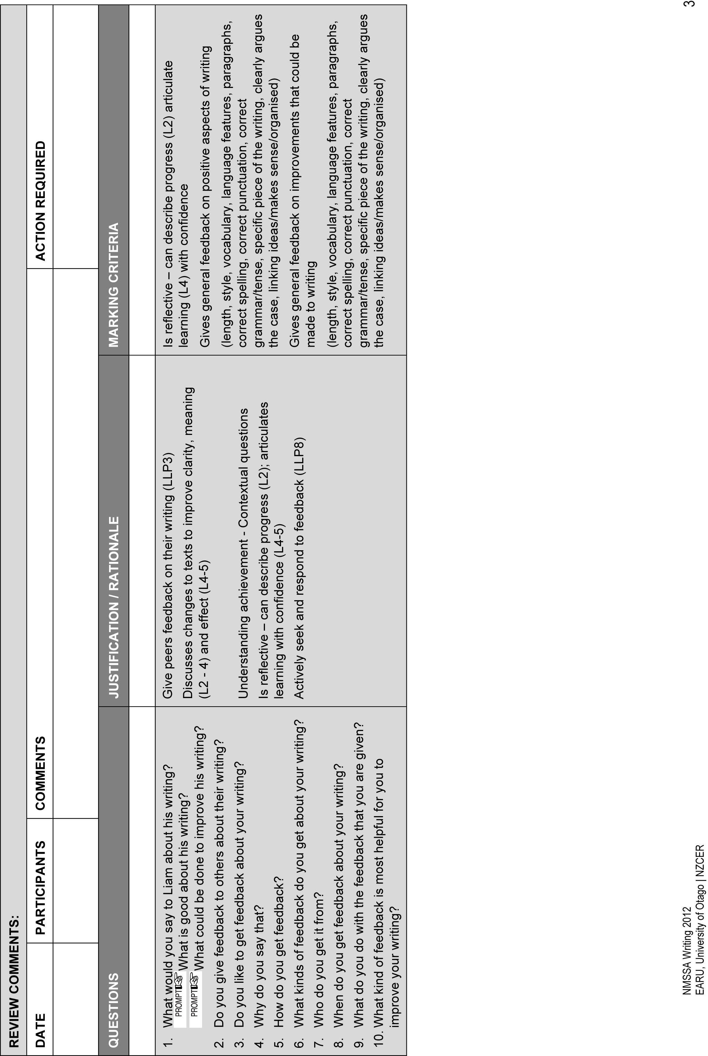
APPENDIX 3:
Curriculum Alignment Procedures For Writing
Introduction
This appendix provides information about the processes used to develop reporting against the NZC for the 2012 National Monitoring Study of School Achievement (NMSSA) of writing.
It briefly describes the two writing achievement measures used in the 2012 study before and explains the work that was done to achieve curriculum reporting.
Background
Two writing measures were used in the NMSSA 2012 study. Writing for a Variety of Purposes was a group-administered assessment that involved students completing a piece of writing in response to a given prompt. Over 5000 students were administered the Writing for a Variety of Purposes assessment. Process of Writing was a one-on-one assessment made up of interview and performance tasks. About 700 students from each of Year 4 and Year 8 completed the Process of Writing assessment.
A separate reporting scale was constructed for each assessment using the Rasch Model. For each assessment Year 4 and Year 8 results could be located on their respective scales.
To report against curriculum levels it was necessary to define performance ranges on the scale that matched the performance expectations described in curriculum documents. This is usually done using a standard setting exercise. However, because the Writing for a Variety of Purposes scale is based on the same framework and scoring rubrics as e-asTTle writing , it was decided to use the curriculum alignment that underpinned the e-asTTle writing scale.
The e-asTTle writing scale
e-asTTle writing is able to report against a series of curriculum level descriptors. Each descriptor is associated with a range of scores on the e-asTTle scale. The cut-points that define each range were decided on using the results of two independent curriculum alignment exercises carried out in 2011 and 2012. These exercises made use of an extended Angoff approach. The NMSSA curriculum alignment for Writing for a Variety of Purposes has built on this previous work by taking advantage of the strong link between the e-asTTle writing scale and the NMSSA writing scale. In effect the cut-points for the e-asTTle writing scale have been applied to the Writing for a Variety of Purposes scale.
Linking the e-asTTle scale with the Writing for a Variety of Purposes scale
e-asTTle writing and Writing for a Variety of Purposes use the same rubric to score students' writing. However, the two assessments use different prompts and their reporting scales have been developed independently. In order to use the cut-points established for e-asTTle writing it was important to show that there was a strong link between the two scales. In particular:
- the thresholds related to the scoring categories provided in the rubric should maintain their relative positioning on each scale
- the demands (difficulty) of the five prompts used for NMSSA should be able to be compared to the difficulty of the prompts used in e-asTTle writing
- any difference in terms of marking styles between the two sets of markers involved in the development of each scale should be identifiable.
Comparing thresholds and scores

The thresholds related to the scoring categories for each rubric were compared by plotting them against each other. Figure A3.1 shows there was very little difference between the two sets of thresholds (overall correlation 0.99).
The score conversion tables which convert raw rubric scores to scale scores were also compared (see Figure A3.2). There was very little difference in the scale locations associated with the same rubric score on each assessment (correlation 0.998).
Both scales involved the use of nationally representative samples in their development. The e-asTTle year level norms indicate an effect size of about 1.5 to describe the difference in writing achievement between Year 4 and Year 8. This is consistent with the NMSSA study where the effect size of the difference between the two year group averages is estimated at 1.4.
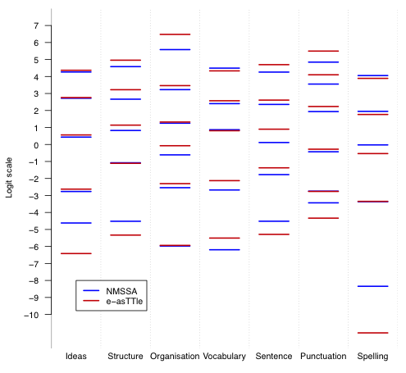
Figure A3.1 Comparison of element thresholds for NMSSA and e-asTTle writing scale

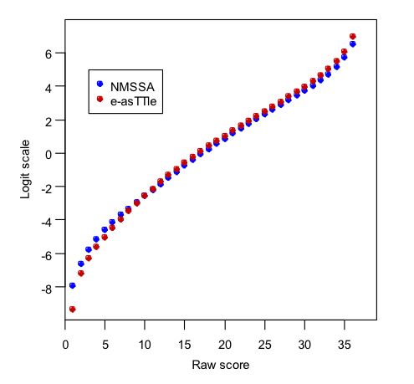
Figure A3.2 Comparison of scale scores vs. raw scores for NMSSA and e-asTTle writing scales

Prompt difficulty
Prompts can be more or less difficult. The multi-facet Rasch model behind the e-asTTle writing and Writing for a Variety of Purposes scales takes this into account when converting raw scores for a prompt to a scale location. In order to compare the difficulty of the five prompts developed for the NMSSA study with prompts used by e-asTTle writing, three e-asTTle writing prompts were included in part of the NMSSA study. Students who completed one of these prompts also completed one of the NMSSA prompts. This allowed the difficulty of the NMSSA prompts to be compared with the difficulty of the existing e-asTTle prompts.
Marking
One group of markers may apply the marking rubrics differently from another group of markers. In order to validate using the e-asTTle scale cut-points it was important to have some evidence that any difference between marker groups was understood. A large group of markers was employed to mark the NMSSA writing scripts. Some of the markers had previously been involved in marking e-asTTle scripts, and were therefore familiar with the e-asTTle rubrics and marking practices. Additionally, in both studies the same group of researchers trained the markers to apply the marking rubrics. Both these situations lent consistency to the marking processes in NMSSA and ameliorated possible bias due to having a different group of markers for each study.
It was not possible to directly compare the groups of markers involved in the development of the two scales by double marking scripts from the e-asTTle development. However, the work described above provided confidence that the two scales could be mapped to one another successfully.
Alignment of NMSSA Writing for a Variety of Purposes scale with the curriculum
The following procedure was used:
- e-asTTle scale scores defining curriculum level cut-points were converted into raw scores. This constitutes an inverse operation to locating students on the e-asTTle scale where a student's raw score is converted into a scale score.
- The raw scores representing curriculum cut-points were then converted into NMSSA scale scores. This was achieved by using the seven sets of NMSSA thresholds (item parameters) developed in the construction of the NMSSA scale, Writing for a Variety of Purposes.
- Table A3.1 shows the cut-points identified on the Writing for a Variety of Purposes scale. Curriculum Level 2 is located at 79 - 103 scale units; Curriculum Level 3 is located at 103 to 122 scale units and so on.
Table A3.1 Curriculum level cut-points on the Writing for a Variety of Purposes Scale
Writing for a Variety of Purposes
Curriculum level cut-points
 | Scale score units
Level 1 | up to 79
Level 2 | >79 – 103
Level 3 | >103 – 122
Level 4 | >122 – 140
Level 5 | >140

The Process of Writing scale
It was planned that the alignment of the Process of Writing scale to the NZC would be conducted by equi-percentile scaling against Writing for a Variety of Purposes scale scores because of the limited time and resource available. However, this procedure was considered to be inappropriate due to the following limitations:
- The student scores for the Process of Writing scale showed a weak correlation (0.24 at Year 4 and 0.26 at Year 8) with the scores for Writing for a Variety of Purposes.
- WINSTEPS gave a person reliability of 0.63 for the Process of Writing scale. This reliability measure indicates that there is more measurement error associated with individual students' scores on this scale.
- The Process of Writing scale was not able to make much distinction between Year 4 and Year 8 students. That is, there was a large overlap in scores between the two year levels. This indicates that the two NMSSA writing scales do not have the same sized units, and therefore are not comparable.

APPENDIX 4:
Effect Sizes Analyses

1. All Students
1.1 Year 4 subgroup means, standard deviations and sample sizes
1.2 Year 4 subgroup effect sizes and confidence intervals
1.3 Year 8 subgroup means, standard deviations and sample sizes
1.4 Year 8 subgroup effect sizes and confidence intervals
1.5 Year 8/4 subgroup means, standard deviations and sample sizes
1.6 Year 8/4 differences, effect sizes and confidence intervals
2. Māori Students
2.1 Year 4 subgroup means, standard deviations and sample sizes
2.2 Year 4 subgroup effect sizes and confidence intervals
2.3 Year 8 subgroup means, standard deviations and sample sizes
2.4 Year 8 subgroup effect sizes and confidence intervals
2.5 Year 8/4 subgroup means, standard deviations and sample sizes
2.6 Year 8/4 differences, effect sizes and confidence intervals
3. Pasifika Students
3.1 Year 4 subgroup means, standard deviations and sample sizes
3.2 Year 4 subgroup effect sizes and confidence intervals
3.3 Year 8 subgroup means, standard deviations and sample sizes
3.4 Year 8 subgroup effect sizes and confidence intervals
3.5 Year 8/4 subgroup means, standard deviations and sample sizes
3.6 Year 8/4 differences, effect sizes and confidence intervals
4. Students with Special Education Needs
4.1 Year 4 subgroup means, standard deviations and sample sizes
4.2 Year 4 subgroup effect sizes and confidence intervals
4.3 Year 8 subgroup means, standard deviations and sample sizes
4.4 Year 8 subgroup effect sizes and confidence intervals
4.5 Year 8/4 subgroup means, standard deviations and sample sizes
4.6 Year 8/4 differences, effect sizes and confidence intervals All Students

All Students
1.1 Year 4 All Students: Subgroup means, standard deviations and sample sizes
 |  | Writing for a Variety of Purposes Ideas |  |  | Process of Writing |  |  | Attitude to Writing
Variable |  | Boys | Girls |  | Boys | Girls |  | Boys | Girls
Gender | N | 1032 | 1033 |  | 359 | 335 |  | 1035 | 1035
Gender | Mean | 81.1 | 90.5 |  | 90.1 | 95.5 |  | 102.5 | 112.1
Gender | SD | 19.7 | 18.6 |  | 21.0 | 19.7 |  | 20.3 | 20.0
 |  | NZ European | Māori | Pasifika | European | Māori | Pasifika | European | Māori | Pasifika
Ethnicity | N | 1326 | 423 | 263 | 445 | 143 | 96 | 1331 | 424 | 264
Ethnicity | Mean | 87.6 | 80.3 | 79.3 | 94.5 | 90.3 | 83.4 | 105.9 | 109.5 | 112.7
Ethnicity | SD | 19.9 | 18.1 | 19.2 | 18.9 | 23.9 | 24.2 | 21.0 | 20.2 | 20.0
 |  | Non-NZ Euro | Non-Māori | Non-Pasifika | Non-NZ Euro | Non-Māori | Non-Pasifika | Non-NZ Euro | Non-Māori | Non-Pasifika
Ethnicity | N | 740 | 1642 | 1804 | 249 | 551 | 600 | 740 | 1646 | 1808
Ethnicity | Mean | 82.6 | 87.2 | 86.8 | 89.5 | 93.3 | 94.2 | 109.9 | 106.7 | 106.5
Ethnicity | SD | 19.1 | 19.9 | 19.7 | 22.9 | 19.5 | 19.5 | 19.9 | 20.8 | 20.7
 |  | Low | Mid | High | Low | Mid | High | Low | Mid | High
School Decile | N | 442 | 785 | 838 | 158 | 265 | 271 | 443 | 786 | 841
School Decile | Mean | 78.7 | 84.4 | 90.8 | 84.3 | 91.9 | 98.4 | 112.0 | 106.4 | 105.7
School Decile | SD | 19.1 | 19.7 | 18.8 | 22.7 | 18.9 | 18.9 | 21.2 | 20.2 | 20.6
 |  | Contributing | Full Primary |  | Contributing | Full Primary | - | Contributing | Full Primary
School Type | N | 1183 | 857 |  | 382 | 305 | - | 1191 | 854
School Type | Mean | 86.1 | 85.6 |  | 92.5 | 93.0 | - | 107.5 | 107.2
School Type | SD | 19.2 | 20.4 |  | 19.9 | 21.5 | - | 20.5 | 21.1
 |  | Lowest | Middle | Highest | Lowest | Middle | Highest
Attitude to Writing | N | 298 | 998 | 757 | 101 | 327 | 254
Attitude to Writing | Mean | 78.5 | 86.0 | 88.6 | 91.7 | 93.1 | 93.3
Attitude to Writing | SD | 21.1 | 19.3 | 18.9 | 20.4 | 20.3 | 20.4
 |  | Always | Often | Sometimes/Never | Always | Often | Sometimes/Never | Always | Often | Sometimes/Never
English Spoken at Home | N | 1385 | 416 | 245 | 457 | 137 | 89 | 1376 | 420 | 239
English Spoken at Home | Mean | 85.9 | 88.6 | 82.1 | 93.0 | 94.4 | 89.2 | 107.0 | 109.4 | 108.7
English Spoken at Home | SD | 19.8 | 17.7 | 20.2 | 20.2 | 20.6 | 21.6 | 22.0 | 20.9 | 22.9

1.2 Year 4 All Students: Subgroup effect sizes and confidence intervals
 |  | Writing for a Variety of Purposes Ideas |  |  | Process of Writing |  |  | Attitude to Writing
Variable | Comparison | Effect Size | Lower | Upper | Effect Size | Lower | Upper | Effect Size | Lower | Upper
Gender | Boys/Girls | -0.49 | -0.58 | -0.41 | -0.27 | -0.41 | -0.12 | -0.48 | -0.56 | -0.39
Ethnicity | NZ Euro/Non-NZ Euro | 0.26 | 0.17 | 0.35 | 0.24 | 0.08 | 0.40 | 0.13 | 0.01 | 0.26
Ethnicity | Māori/Non-Māori | -0.37 | -0.47 | -0.26 | -0.14 | -0.34 | 0.05 | 0.03 | -0.09 | 0.16
Ethnicity | Pasifika/Non-Pasifika | -0.38 | -0.51 | -0.25 | -0.49 | -0.73 | -0.26 | -0.02 | -0.13 | 0.09
School Decile | Low/Mid | -0.30 | -0.41 | -0.18 | -0.36 | -0.56 | -0.16 | 0.27 | 0.15 | 0.39
School Decile | Low/High | -0.64 | -0.76 | -0.53 | -0.68 | -0.88 | -0.47 | 0.30 | 0.18 | 0.41
School Decile | Mid/High | -0.33 | -0.43 | -0.24 | -0.35 | -0.51 | -0.18 | 0.03 | -0.07 | 0.13
School Type | Contributing/Full Primary | 0.03 | -0.06 | 0.11 | -0.02 | -0.18 | 0.13 | 0.01 | -0.07 | 0.10
Attitude to Writing | Lowest/Middle | -0.37 | -0.50 | -0.24 | -0.07 | -0.29 | 0.16
Attitude to Writing | Lowest/Highest | -0.51 | -0.64 | -0.37 | -0.08 | -0.31 | 0.15
Attitude to Writing | Middle/Highest | -0.14 | -0.23 | -0.04 | -0.01 | -0.17 | 0.15
English Spoken at Home | Always/Often | -0.14 | -0.25 | -0.03 | -0.07 | -0.26 | 0.12 | -0.11 | -0.22 | 0.00
English Spoken at Home | Always/(Sometimes/Never) | 0.19 | 0.06 | 0.33 | 0.18 | -0.05 | 0.41 | -0.07 | -0.21 | 0.06
English Spoken at Home | Often/(Sometimes/Never) | 0.34 | 0.18 | 0.50 | 0.24 | -0.02 | 0.51 | 0.03 | -0.13 | 0.19

1.3 Year 8 All Students: Subgroup means, standard deviations and sample sizes
 |  | Writing for a Variety of Purposes Ideas |  |  | Process of Writing |  |  | Attitude to Writing
Variable |  | Boys | Girls |  | Boys | Girls |  | Boys | Girls
Gender | N | 983 | 992 |  | 343 | 346 |  | 990 | 998
Gender | Mean | 109.2 | 119.1 |  | 105.4 | 109.1 |  | 89.0 | 96.3
Gender | SD | 20.7 | 18.6 |  | 18.4 | 20.4 |  | 19.2 | 18.6
 |  | European | Māori | Pasifika | European | Māori | Pasifika | European | Māori | Pasifika
Ethnicity | N | 1312 | 368 | 212 | 462 | 133 | 67 | 1318 | 372 | 211
Ethnicity | Mean | 115.4 | 108.6 | 110.3 | 109.1 | 103.2 | 100.1 | 91.7 | 92.6 | 97.6
Ethnicity | SD | 20.2 | 20.4 | 19.7 | 18.6 | 20.2 | 18.9 | 19.7 | 19.7 | 18.0
 |  | Non-NZ Euro | Non-Māori | Non-Pasifika | Non-NZ Euro | Non-Māori | Non-Pasifika | Non-NZ Euro | Non-Māori | Non-Pasifika
Ethnicity | N | 663 | 1608 | 1763 | 227 | 556 | 622 | 670 | 1617 | 1777
Ethnicity | Mean | 111.8 | 115.5 | 114.7 | 103.4 | 108.2 | 108.0 | 94.7 | 92.7 | 92.1
Ethnicity | SD | 20.1 | 20.0 | 20.3 | 20.6 | 19.2 | 19.4 | 18.2 | 19.2 | 19.3
 |  | Low | Middle | High | Low | Middle | High | Low | Middle | High
School Decile | N | 359 | 858 | 758 | 128 | 301 | 260 | 354 | 868 | 766
School Decile | Mean | 106.8 | 113.3 | 118.7 | 103.1 | 105.8 | 111.0 | 96.7 | 92.2 | 91.4
School Decile | SD | 19.1 | 19.8 | 20.2 | 20.4 | 19.9 | 17.9 | 18.1 | 18.7 | 20.1
 |  | Composite | Full Primary |  | Composite | Full Primary |  | Composite | Full Primary
School Type | N | 122 | 759 |  | 37 | 301 |  | 472 | 352
School Type | Mean | 117.1 | 112.7 |  | 109.9 | 107.7 |  | 91.6 | 93.8
School Type | SD | 20.6 | 19.3 |  | 20.7 | 19.5 |  | 17.9 | 18.9
School Type |  | Intermediate | Secondary |  | Intermediate | Secondary |  | Intermediate | Secondary
School Type | N | 789 | 305 |  | 250 | 101 |  | 685 | 479
School Type | Mean | 114.2 | 116.7 |  | 106.6 | 106.4 |  | 95.6 | 88.8
School Type | SD | 20.5 | 21.5 |  | 19.7 | 18.3 |  | 20.2 | 18.7
 |  | Lowest | Middle | Highest | Lowest | Middle | Highest
Attitude to Writing | N | 770 | 931 | 258 | 278 | 312 | 87
Attitude to Writing | Mean | 108.3 | 116.6 | 123.5 | 105.5 | 109.4 | 106.5
Attitude to Writing | SD | 19.1 | 20.0 | 19.5 | 20.3 | 19.3 | 17.2
 |  | Always | Often | Sometimes/Never | Always | Often | Sometimes/Never | Always | Often | Sometimes/  Never
English Spoken at Home | N | 1574 | 293 | 102 | 558 | 89 | 38 | 1575 | 297 | 106
English Spoken at Home | Mean | 114.5 | 113.0 | 113.9 | 107.9 | 106.8 | 101.2 | 91.6 | 94.2 | 97.4
English Spoken at Home | SD | 20.2 | 19.5 | 23.0 | 19.0 | 21.3 | 21.6 | 17.8 | 18.3 | 17.6
1.4 Year 8 All Students: Subgroup effect sizes and confidence intervals
 |  | Writing for a Variety of Purposes Ideas |  |  | Process of Writing |  |  | Attitude to Writing
 | Comparison | Effect Size | Lower | Upper | Effect Size | Lower | Upper | Effect Size | Lower | Upper
Gender | Boys/Girls | -0.51 | -0.59 | -0.42 | -0.19 | -0.34 | -0.04 | -0.39 | -0.47 | -0.30
Ethnicity | NZ Euro/Non-NZ Euro | 0.18 | 0.08 | 0.27 | 0.29 | 0.13 | 0.45 | -0.16 | -0.25 | -0.07
Ethnicity | Māori/Non-Māori | -0.34 | -0.45 | -0.22 | -0.26 | -0.45 | -0.06 | -0.01 | -0.12 | 0.11
Ethnicity | Pasifika/Non-Pasifika | -0.22 | -0.36 | -0.08 | -0.41 | -0.66 | -0.16 | 0.30 | 0.16 | 0.44
School Decile | Low/Mid | -0.33 | -0.46 | -0.21 | -0.13 | -0.34 | 0.07 | 0.25 | 0.12 | 0.37
School Decile | Low/High | -0.61 | -0.73 | -0.48 | -0.42 | -0.63 | -0.20 | 0.28 | 0.16 | 0.40
School Decile | Mid/High | -0.27 | -0.37 | -0.18 | -0.28 | -0.44 | -0.11 | 0.04 | -0.06 | 0.14
School Type | Comp/Full Primary | 0.22 | 0.02 | 0.42 | 0.11 | -0.24 | 0.46 | -0.17 | -0.38 | 0.03
School Type | Comp/Intermediate | 0.14 | -0.05 | 0.33 | 0.17 | -0.19 | 0.52 | -0.06 | -0.26 | 0.14
School Type | Comp/Secondary | 0.02 | -0.19 | 0.23 | 0.18 | -0.21 | 0.57 | 0.01 | -0.21 | 0.23
School Type | Full Primary/Intermediate | -0.07 | -0.17 | 0.03 | 0.06 | -0.11 | 0.23 | 0.13 | 0.03 | 0.22
School Type | Full Primary/Sec | -0.19 | -0.33 | -0.06 | 0.07 | -0.15 | 0.29 | 0.20 | 0.07 | 0.33
School Type | Intermediate/Sec | -0.12 | -0.25 | 0.02 | 0.01 | -0.22 | 0.24 | 0.08 | -0.06 | 0.21
Attitude to Writing | Lowest/Middle | -0.42 | -0.52 | -0.33 | -0.19 | -0.36 | -0.03
Attitude to Writing | Lowest/Highest | -0.78 | -0.93 | -0.64 | -0.05 | -0.28 | 0.18
Attitude to Writing | Middle/Highest | -0.35 | -0.48 | -0.21 | 0.16 | -0.07 | 0.39
English Spoken at Home | Always/Often | 0.07 | -0.05 | 0.20 | 0.05 | -0.18 | 0.29 | -0.14 | -0.26 | -0.01
English Spoken at Home | Always/(Sometimes/Never) | 0.03 | -0.19 | 0.24 | 0.33 | -0.02 | 0.68 | -0.33 | -0.52 | -0.13
English Spoken at Home | Often/(Sometimes/Never) | -0.04 | -0.28 | 0.19 | 0.26 | -0.12 | 0.64 | -0.18 | -0.40 | 0.04

1.5 Year 8/Year 4 All Students: Subgroup means, standard deviations and sample sizes
 |  | Writing for a Variety of Purposes Ideas |  | Process of Writing |  | Attitude to Writing
 |  | Year 4 | Year 8 | Year 4 | Year 8 | Year 4 | Year 8
All Students | N | 2065 | 1975 | 694 | 689 | 2070 | 1988
All Students | Mean | 85.8 | 114.2 | 92.7 | 107.2 | 107.3 | 92.7
All Students | SD | 19.8 | 20.3 | 20.5 | 19.5 | 20.7 | 19.2
 |  | Year 4 - Boys | Year 8 - Boys | Year 4 - Boys | Year 8 - Boys | Year 4 - Boys | Year 8 - Boys
Gender - Boys | N | 1032 | 983 | 359 | 343 | 1035 | 990
Gender - Boys | Mean | 81.1 | 109.2 | 90.1 | 105.4 | 102.5 | 89.0
Gender - Boys | SD | 19.7 | 20.7 | 21.0 | 18.4 | 20.3 | 19.2
 |  | Year 4 - Girls | Year 8 - Girls | Year 4 - Girls | Year 8 - Girls | Year 4 - Girls | Year 8 - Girls
Gender - Girls | N | 1033 | 992 | 335 | 346 | 1035 | 998
Gender - Girls | Mean | 90.5 | 119.1 | 95.5 | 109.1 | 112.1 | 96.3
Gender - Girls | SD | 18.6 | 18.6 | 19.7 | 20.4 | 20.0 | 18.6
 |  | Year 4 - European | Year 8 - European
Ethnicity - European | N | 1326 | 1312
Ethnicity - European | Mean | 87.6 | 115.4
Ethnicity - European | SD | 19.9 | 20.2
 |  | Year 4 - Māori | Year 8 - Māori
Ethnicity - Māori | N | 423 | 368
Ethnicity - Māori | Mean | 80.3 | 108.6
Ethnicity - Māori | SD | 18.1 | 20.4
 |  | Year 4 - Pasifika | Year 8 - Pasifika
Ethnicity - Pasifika | N | 263 | 212
Ethnicity - Pasifika | Mean | 79.3 | 110.3
Ethnicity - Pasifika | SD | 19.2 | 19.7
Decile - Low | N | 442 | 359
Decile - Low | Mean | 78.7 | 106.8
Decile - Low | SD | 19.1 | 19.1
 |  | Year 4 - Mid | Year 8 - Mid
Decile - Mid | N | 785 | 858
Decile - Mid | Mean | 84.4 | 113.3
Decile - Mid | SD | 19.7 | 19.8
 |  | Year 4 - High | Year 8 - High
Decile - High | N | 838 | 758
Decile - High | Mean | 90.8 | 118.7
Decile - High | SD | 18.8 | 20.2

1.6 Year 8/Year 4 All Students: Differences, effect sizes and confidence intervals
 | Writing for a Variety of Purposes Ideas |  |  |  | Process of Writing |  |  |  | Attitude to Writing
 | Difference | Effect Size | Lower | Upper | Difference* | Effect Size | Lower | Upper | Difference* | Effect Size | Lower | Upper
All Students | 28.4 | 1.42 | 1.48 | 1.36 | 14.3 | 0.73 | 0.83 | 0.62 | -14.6 | -0.73 | -0.67 | -0.79
Gender
Boys | 28.1 | 1.39 | 1.48 | 1.31 | 15.3 | 0.78 | 0.92 | 0.63 | -13.8 | -0.68 | -0.60 | -0.77
Girls | 28.6 | 1.54 | 1.63 | 1.45 | 13.6 | 0.68 | 0.83 | 0.53 | -15.8 | -0.82 | -0.73 | -0.91
Ethnicity
European | 27.8 | 1.39 | 1.46 | 1.31
Māori | 28.3 | 1.47 | 1.61 | 1.33
Pasifika | 31.0 | 1.59 | 1.77 | 1.41
School Decile
Low | 28.1 | 1.48 | 1.61 | 1.34
Mid | 28.9 | 1.46 | 1.56 | 1.36
High | 27.9 | 1.43 | 1.53 | 1.33

* Mean (Year 8) – Mean (Year 4)
Māori Students
2.1 Year 4 Māori Students: Subgroup means, standard deviations and sample sizes
 |  | Writing for a Variety of Purposes |  |  | Process of Writing
Variable |  | Boys | Girls |  | Boys | Girls
Gender | N | 235 | 188 |  | 84 | 59
Gender | Mean | 76.3 | 85.3 |  | 85.7 | 96.8
Gender | SD | 18.0 | 16.9 |  | 24.9 | 20.8
 |  | Low | Mid | High | Low | Mid | High
School Decile | N | 174 | 166 | 83 | 69 | 49 | 25
School Decile | Mean | 77.0 | 81.1 | 85.5 | 83.9 | 90.3 | 107.6
School Decile | SD | 16.9 | 17.5 | 20.2 | 21.5 | 22.7 | 24.7
 |  | Contributing | Full Primary |  | Contributing | Full Primary
School Type | N | 242 | 179 |  | 86 | 56
School Type | Mean | 80.2 | 80.4 |  | 91.7 | 88.1
School Type | SD | 17.6 | 18.5 |  | 23.1 | 25.3

2.2 Year 4 Māori Students: Subgroup effect sizes and confidence intervals
 |  | Writing for a Variety of Purposes |  |  | Process of Writing
Variable | Comparison | Effect Size | Lower | Upper | Effect Size | Lower | Upper
Gender | Boys/Girls | -0.52 | -0.71 | -0.33 | -0.49 | -0.82 | -0.16
School Decile | Low/Mid | -0.24 | -0.45 | -0.03 | -0.29 | -0.66 | 0.08
School Decile | Low/High | -0.46 | -0.73 | -0.18 | -1.03 | -1.50 | -0.55
School Decile | Mid/High | -0.23 | -0.50 | 0.04 | -0.73 | -1.22 | -0.24
School Type | Contributing/Full Primary | -0.01 | -0.21 | 0.18 | 0.15 | -0.19 | 0.49

2.3 Year 8 Māori Students: Subgroup means, standard deviations and sample sizes
 |  | Writing for a Variety of Purposes |  |  | Process of Writing
Variable |  | Boys | Girls |  | Boys | Girls
Gender | N | 171 | 197 |  | 62 | 71
Gender | Mean | 102.2 | 114.2 |  | 100.3 | 105.7
Gender | SD | 20.8 | 18.4 |  | 16.0 | 23.1
 |  | Low | Mid | High | Low | Mid | High
School Decile | N | 131 | 184 | 53 | 43 | 65 | 25
School Decile | Mean | 102.8 | 111.0 | 114.7 | 100.4 | 102.7 | 109.1
School Decile | SD | 19.2 | 20.4 | 20.1 | 24.3 | 18.2 | 16.6
 |  | Full Primary | Intermediate | Secondary | Full Primary | Intermediate
School Type | N | 159 | 158 | 39 | 62 | 55
School Type | Mean | 108.5 | 108.2 | 110.1 | 104.2 | 100.7
School Type | SD | 19.3 | 20.9 | 23.96 | 22.2 | 19.1

2.4 Year 8 Māori Students: Subgroup effect sizes and confidence intervals
 |  | Writing for a Variety of Purposes |  |  | Process of Writing
Variable | Comparison | Effect Size | Lower | Upper | Effect Size | Lower | Upper
Gender | Boys/Girls | -0.61 | -0.82 | -0.41 | -0.28 | -0.62 | 0.06
School Decile | Low/Mid | -0.41 | -0.64 | -0.19 | -0.11 | -0.51 | 0.29
School Decile | Low/High | -0.61 | -0.93 | -0.28 | -0.43 | -0.90 | 0.05
School Decile | Mid/High | -0.18 | -0.49 | 0.12 | -0.36 | -0.82 | 0.09
School Type | Full Primary/Intermediate | 0.02 | -0.20 | 0.24 | 0.17 | -0.19 | 0.53
 | Full Primary/Secondary | -0.07 | -0.45 | 0.30
 | Intermediate/Secondary | -0.08 | -0.45 | 0.28

2.5 Year 8/Year 4 Māori Students: Subgroup means, standard deviations and sample sizes
 |  | Writing for a Variety of Purposes |  | Process of Writing
 |  | Year 4 | Year 8 | Year 4 | Year 8
All students | N | 423 | 368 | 143 | 133
All students | Mean | 80.3 | 108.6 | 90.3 | 103.2
All students | SD | 18.1 | 20.4 | 23.9 | 20.2
 |  | Year 4 - Boys | Year 8 - Boys | Year 4 - Boys | Year 8 - Boys
Gender - Boys | N | 235 | 171 | 84 | 62
Gender - Boys | Mean | 76.3 | 102.2 | 85.7 | 100.3
Gender - Boys | SD | 18.0 | 20.8 | 24.9 | 16.0
 |  | Year 4 - Girls | Year 8 - Girls | Year 4 - Girls | Year 8 - Girls
Gender - Girls | N | 188 | 197 | 59 | 71
Gender - Girls | Mean | 85.3 | 114.2 | 96.8 | 105.7
Gender - Girls | SD | 16.9 | 18.4 | 20.8 | 23.1

2.6 Year 8/Year 4 Māori Students: Differences, effect sizes and confidence intervals
 | Writing for a Variety of Purposes |  |  |  | Process of Writing
 | Difference | Effect Size | Lower | Upper | Difference | Effect Size | Lower | Upper
All students | 28.3 | 1.47 | 1.61 | 1.33 | 12.9 | 0.59 | 0.82 | 0.35
Gender
Boys | 25.9 | 1.34 | 1.54 | 1.14 | 14.6 | 0.71 | 1.04 | 0.39
Girls | 28.9 | 1.64 | 1.84 | 1.44 | 12.0 | 0.41 | 0.75 | 0.06

Pasifika Students
3.1 Year 4 Pasifika Students: Subgroup means, standard deviations and sample sizes
 |  | Writing for a Variety of Purposes |  |  | Process of Writing
Variable |  | Boys | Girls |  | Boys | Girls
Gender | N | 114 | 149 |  | 43 | 53
Gender | Mean | 75.1 | 82.6 |  | 82.5 | 84.2
Gender | SD | 19.7 | 18.3 |  | 23.6 | 24.9
 |  | Low | Mid | High | Low | Mid | High
School Decile | N | 171 | 61 | 31 | 58 | 26 | 12
School Decile | Mean | 76.9 | 81.9 | 87.9 | 79.5 | 86.3 | 96.0
School Decile | SD | 19.6 | 17.9 | 16.7 | 23.7 | 24.2 | 22.8
 |  | Contributing | Full Primary |  | Contributing | Full Primary
School Type | N | 149 | 112 |  | 52 | 43
School Type | Mean | 77.7 | 81.6 |  | 84.3 | 82.1
School Type | SD | 19.1 | 19.3 |  | 24.4 | 24.4
 |  | Always | Often | Sometimes/Never | Always | Often | Sometimes/Never
English Spoken at Home | N | 116 | 65 | 82 | 37 | 23 | 36
English Spoken at Home | Mean | 80.7 | 84.2 | 73.6 | 87.5 | 86.4 | 77.3
English Spoken at Home | SD | 17.1 | 16.0 | 22.8 | 21.7 | 26.9 | 24.1

3.2 Year 4 Pasifika Students: Subgroup effect sizes and confidence intervals
 |  | Writing for a Variety of Purposes |  |  | Process of Writing
Variable | Comparison | Effect Size | Lower | Upper | Effect Size | Lower | Upper
Gender | Boys/Girls | -0.39 | -0.64 | -0.15 | -0.07 | -0.47 | 0.33
School Decile | Low/Mid | -0.27 | -0.55 | 0.02 | -0.29 | -0.75 | 0.18
School Decile | Low/High | -0.61 | -0.97 | -0.25 | -0.71 | -1.32 | -0.10
School Decile | Mid/High | -0.35 | -0.78 | 0.08 | -0.41 | -1.09 | 0.26
School Type | Contributing/Full Primary | -0.21 | -0.45 | 0.04 | 0.09 | -0.31 | 0.49
English Spoken at Home | Always/Often | -0.21 | -0.51 | 0.09 | 0.05 | -0.49 | 0.58
English Spoken at Home | Always/(Sometimes/Never) | 0.36 | 0.06 | 0.65 | 0.45 | -0.01 | 0.91
English Spoken at Home | Often/(Sometimes/Never) | 0.55 | 0.22 | 0.87 | 0.36 | -0.17 | 0.89

3.3 Year 8 Pasifika Students: Subgroup means, standard deviations and sample sizes
 |  | Writing for a Variety of Purposes |  |  | Process of Writing
Variable |  | Boys | Girls |  | Boys | Girls
Gender | N | 95 | 117 |  | 32 | 35
Gender | Mean | 103.7 | 115.7 |  | 97.5 | 102.6
Gender | SD | 18.4 | 19.1 |  | 17.0 | 20.4
 |  | Low | Mid | High | Low | Mid | High
School Decile | N | 126 | 58 | 28 | 44 | 13 | 10
School Decile | Mean | 109.5 | 107.8 | 119.1 | 98.8 | 101.0 | 104.9
School Decile | SD | 18.7 | 20.4 | 20.8 | 17.4 | 22.2 | 21.8
 |  | Full Primary | Intermediate |  | Full Primary | Intermediate
School Type | N | 114 | 83 |  | 40 | 23
School Type | Mean | 112.3 | 104.8 |  | 99.5 | 100.8
School Type | SD | 19.0 | 19.9 |  | 17.8 | 21.5
 |  | Always | Often | Sometimes/Never | Always | Often | Sometimes/Never
English Spoken at Home | N | 107 | 72 | 33 | 29 | 24 | 14
English Spoken at Home | Mean | 112.6 | 110.8 | 101.7 | 101.6 | 10.20 | 93.8
English Spoken at Home | SD | 18.7 | 19.0 | 22.4 | 19.1 | 17.0 | 21.6

3.4 Year 8 Pasifika Students: Subgroup effect sizes and confidence intervals
 |  | Writing for a Variety of Purposes |  |  | Process of Writing
Variable | Comparison | Effect Size | Lower | Upper | Effect Size | Lower | Upper
Gender | Boys/Girls | -0.64 | -0.91 | -0.37 | -0.27 | -0.75 | 0.21
School Decile | Low/Mid | 0.09 | -0.23 | 0.40 | -0.11 | -0.78 | 0.55
School Decile | Low/High | -0.48 | -0.91 | -0.06 | -0.31 | -1.05 | 0.42
School Decile | Mid/High | -0.55 | -1.00 | -0.09 | -0.18 | -1.00 | 0.65
School Type | Full Primary/Intermediate | 0.39 | 0.10 | 0.67 | -0.07 | -0.60 | 0.46
 | Full Primary/Secondary | -0.70 | -1.19 | -0.21
 | Intermediate/Secondary | -1.14 | -1.64 | -0.64
English Spoken at  Home | Always/Often | 0.09 | -0.20 | 0.39 | -0.02 | -0.56 | 0.52
English Spoken at  Home | Always/(Sometimes/Never) | 0.53 | 0.12 | 0.94 | 0.38 | -0.27 | 1.04
English Spoken at  Home | Often/(Sometimes/Never) | 0.44 | 0.02 | 0.87 | 0.42 | -0.26 | 1.11

3.5 Year 8/Year 4 Pasifika Students: Subgroup means, standard deviations and sample sizes
 |  | Writing for a Variety of Purposes |  | Process of Writing
 |  | Year 4 | Year 8 | Year 4 | Year 8
All students | N | 263 | 212 | 96 | 67
All students | Mean | 79.3 | 110.3 | 83.4 | 100.1
All students | SD | 19.2 | 19.7 | 24.2 | 18.9
 |  | Year 4 - Boys | Year 8 - Boys | Year 4 - Boys | Year 8 - Boys
Gender - Boys | N | 114 | 95 | 43 | 32
Gender - Boys | Mean | 75.1 | 103.7 | 82.5 | 97.5
Gender - Boys | SD | 19.7 | 18.4 | 23.6 | 17.0
 |  | Year 4 - Girls | Year 8 - Girls | Year 4 - Girls | Year 8 - Girls
Gender - Girls | N | 149 | 117 | 53 | 35
Gender - Girls | Mean | 82.6 | 115.7 | 84.2 | 102.6
Gender - Girls | SD | 18.3 | 19.1 | 24.9 | 20.4

3.6 Year 8/Year 4 Pasifika Students: Differences, effect sizes and confidence intervals
 | Writing for a Variety of Purposes |  |  |  | Process of Writing
 | Difference | Effect Size | Lower | Upper | Difference | Effect Size | Lower | Upper
All students | 31.0 | 1.59 | 1.77 | 1.41 | 16.7 | 0.78 | 1.08 | 0.47
Gender
Boys | 28.6 | 1.50 | 1.77 | 1.23 | 0.30 | 0.74 | 1.19 | 0.29
Girls | 33.1 | 1.77 | 2.01 | 1.53 | 18.4 | 0.81 | 1.23 | 0.39

Special Education Needs (SEN) Students
4.1 Year 4 Special Education Needs Students: Subgroup means, standard deviations and sample sizes
 | Writing for a Variety of Purposes |  |  |  |  | Attitude to Writing
 | High Needs | Moderate Needs | On Referral | No Needs | All Needs | High Needs | Moderate Needs | On Referral | No Needs | All Needs
N | 8 | 161 | 76 | 1808 | 245 | 8 | 161 | 76 | 1813 | 245
Mean | 43.8 | 68.2 | 88.1 | 87.5 | 73.6 | 104.4 | 105.5 | 110.6 | 107.4 | 107.0
SD | 28.1 | 19.6 | 16.4 | 18.9 | 21.7 | 22.9 | 22.8 | 22.4 | 20.5 | 22.7

4.2 Year 4 Special Education Needs Students: Subgroup effect sizes and confidence intervals
 | Writing for a Variety of Purposes |  |  | Attitude to Writing
Comparison | Effect Size | Lower | Upper | Effect Size | Lower | Upper
Moderate/On Referral | -1.11 | -1.37 | -0.84 | -0.23 | -0.50 | 0.05
Moderate/No Needs | -1.00 | -1.16 | -0.84 | -0.09 | -0.26 | 0.08
On Referral/No Needs | 0.04 | -0.18 | 0.25 | 0.15 | -0.09 | 0.39
All Needs/No Needs | -0.68 | -0.82 | -0.54 | -0.02 | -0.15 | 0.12

4.3 Year 8 Special Education Needs Students: Subgroup means, standard deviations and sample sizes
 | Writing for a Variety of Purposes |  |  |  |  | Attitude to Writing
 | High Needs | Moderate Needs | On Referral | No Needs | All Needs | High Needs | Moderate Needs | On Referral | No Needs | All Needs
N | 11 | 99 | 85 | 1771 | 195 | 11 | 101 | 88 | 1779 | 200
Mean | 73.2 | 94.1 | 112.8 | 115.7 | 101.1 | 91.2 | 82.8 | 95.1 | 93.1 | 88.7
SD | 24.6 | 18.6 | 20.7 | 19.4 | 22.8 | 13.8 | 18.5 | 16.0 | 19.4 | 18.1

4.4 Year 8 Special Education Needs Students: Subgroup effect sizes and confidence intervals
 | Writing for a Variety of Purposes |  |  | Attitude to Writing
Comparison | Effect Size | Lower | Upper | Effect Size | Lower | Upper
Moderate/On Referral | -0.95 | -1.25 | -0.66 | -0.71 | -1.00 | -0.43
Moderate/No Needs | -1.14 | -1.33 | -0.94 | -0.55 | -0.74 | -0.35
On Referral/No Needs | -0.14 | -0.37 | 0.08 | 0.11 | -0.08 | 0.31
All Needs/No Needs | -0.69 | -0.69 | -0.69 | -0.24 | -0.38 | -0.10
4.5 Year 8/Year 4 Special Education Needs Students: Subgroup means, standard deviations and sample sizes
 |  | Writing for a Variety of Purposes |  | Attitude to Writing
 |  | Year 4 | Year 8 | Year 4 | Year 8
No Needs | N | 1808 | 1771 | 1813 | 1779
No Needs | Mean | 87.5 | 115.7 | 107.4 | 93.1
No Needs | SD | 18.9 | 19.4 | 20.5 | 19.4
High Needs | N | 8 | 11 | 8 | 11
High Needs | Mean | 43.8 | 73.2 | 104.4 | 91.2
High Needs | SD | 28.1 | 24.6 | 22.9 | 13.8
Moderate Needs | N | 161 | 99 | 161 | 101
Moderate Needs | Mean | 68.2 | 94.1 | 105.5 | 82.8
Moderate Needs | SD | 19.6 | 18.6 | 22.8 | 18.5
On Referral | N | 76 | 85 | 76 | 88
On Referral | Mean | 88.1 | 112.8 | 110.6 | 95.1
On Referral | SD | 16.4 | 20.7 | 22.4 | 16.0
All Needs | N | 245 | 195 | 245 | 200
All Needs | Mean | 73.6 | 101.1 | 107.0 | 88.7
All Needs | SD | 21.7 | 22.8 | 22.7 | 18.1

4.6 Year 8/Year 4 Special Education Needs Students: Differences, effect sizes and confidence intervals
 | Writing for a Variety of Purposes |  |  |  | Attitude to Writing
 | Difference | Effect Size | Lower | Upper | Difference | Effect Size | Lower | Upper
No Needs | 28.2 | 1.47 | 1.54 | 1.41 | -14.3 | -0.72 | -0.65 | -0.78
High Needs | 29.4 | 1.12 | 2.04 | 0.19 | -13.2 | -0.72 | 0.25 | -1.70
Moderate Needs | 25.9 | 1.35 | 1.60 | 1.10 | -22.7 | -1.10 | -0.86 | -1.34
On Referral | 24.9 | 1.33 | 1.64 | 1.02 | -15.5 | -0.81 | -0.49 | -1.12
All Needs | 27.5 | 1.23 | 1.42 | 1.05 | -18.3 | -0.90 | -0.71 | -1.09

APPENDIX 5:
Opportunities to Learn in Writing for Students
with Special Education Needs
Year 4 students
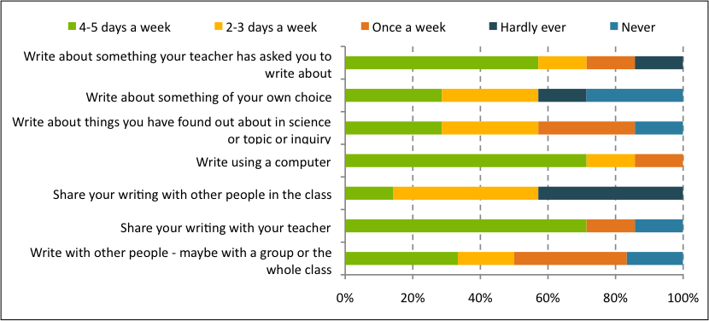
Fig A5.1 Year 4 Students: High special education needs

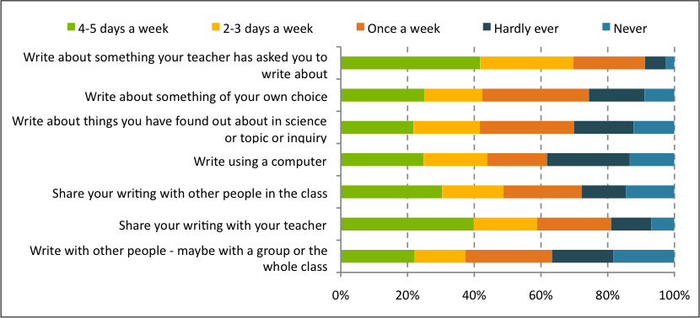
Fig A5.2 Year 4 Students: Moderate special education needs

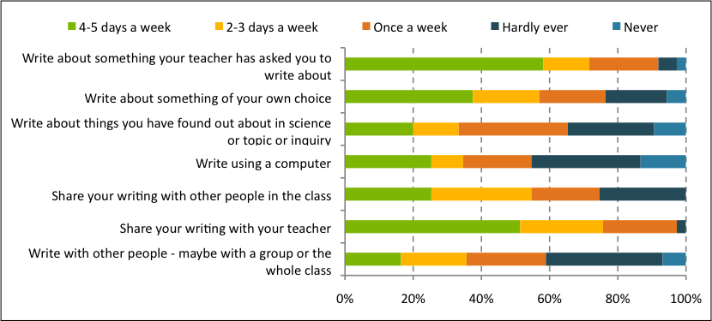
Fig A5.3 Year 4 Students: On referral

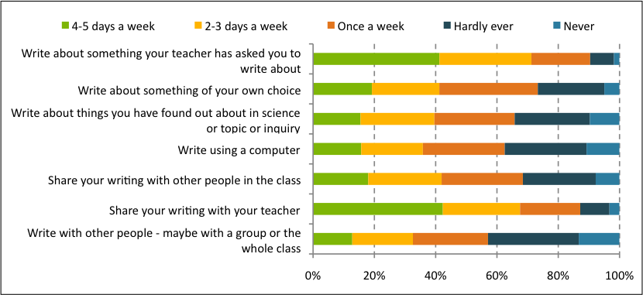
Fig A5.4 Year 4 Students: No special education needs
Year 8 students
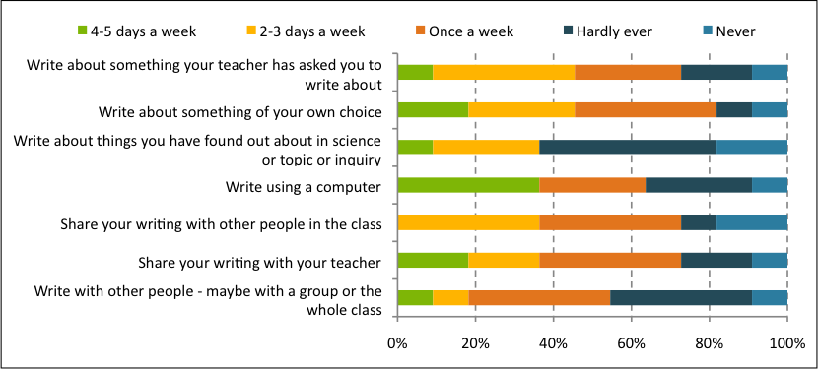
Fig A5.5 Year 8 Students: High special education needs

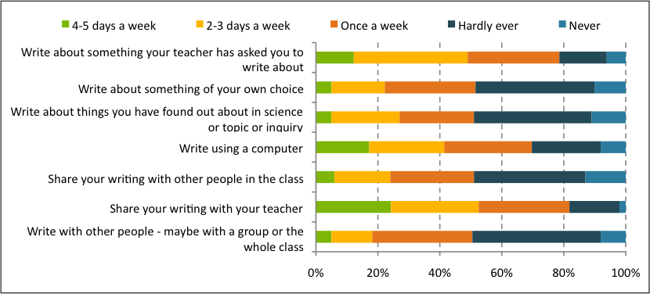
Fig A5.6 Year 8 Students: Moderate special education needs

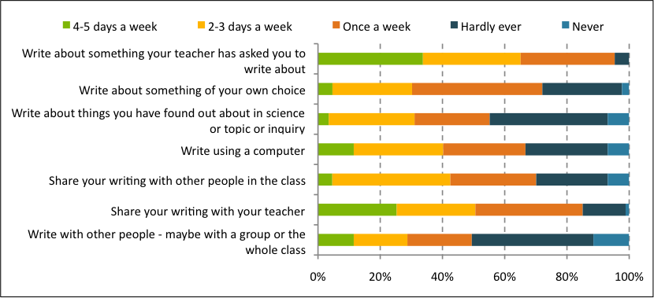
Fig A5.7 Year 8 Students: On referral

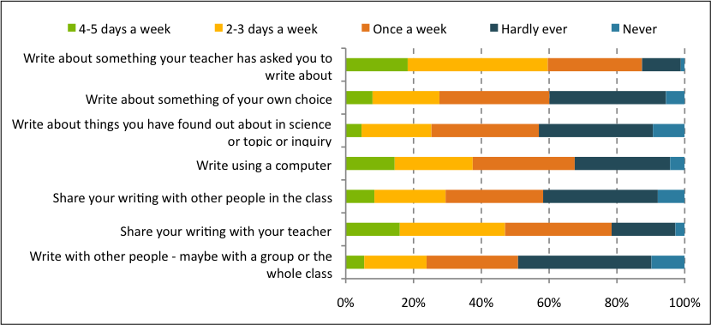
Fig A5.8 Year 8 Students: No special education needs

Appendix 6:
Writing Achievement by School Decile
and Student Ethnicity
Analyses of variance (ANOVA)
This appendix summarises writing achievement by school decile and student ethnicity.
Part 1 presents the two-way analyses of variance (ANOVA) and post hoc comparisons for Year 4 and Year 8.
Part 2 presents the one-way ANOVAs and post hoc comparisons for Year 4 and Year 8 students in low decile schools.
Part 1 Writing achievement by school decile and student ethnicity - two-way ANOVA
YEAR 4
Table A6.1 Two-way ANOVA tables for Year 4 writing achievement
Writing for a Variety of Purposes
Source | Type III Sum of Squares | Df | Mean Square | F | Sig.
Model | 13409623.090 | 9 | 1489958.121 | 4007.747 | .000
Ethnicity | 5238.142 | 2 | 2619.071 | 7.045 | .001
School Decile | 10755.464 | 2 | 5377.732 | 14.465 | .000
Ethnicity * School Decile | 757.234 | 4 | 189.308 | .509 | .729
Error | 679222.935 | 1827 | 371.770
Total | 14088846.025 | 1836

Process of Writing
Source | Type III Sum of Squares | df | Mean Square | F | Sig.
Model | 5269183.993 | 9 | 585464.888 | 1458.661 | .000
Ethnicity | 2060.115 | 2 | 1030.057 | 2.566 | .078
School Decile | 8801.801 | 2 | 4400.901 | 10.965 | .000
Ethnicity * School Decile | 2907.400 | 4 | 726.850 | 1.811 | .125
Error | 244033.885 | 608 | 401.372
Total | 5513217.878 | 617

Table A6.2 Means, standard deviations, sample sizes and statistically significant Scheffe post hoc comparisons
for Year 4 writing achievement
 |  | Writing for a Variety of Purposes |  | Process of Writing
School Decile |  |  | Post hoc comparisons* |  | Post hoc comparisons*
Low | Mean | 78.0 | Low / Mid  Low / High  Mid / High | 83.7 | Low / Mid  Low / High  Mid / High
Low | SD | 19.0 | Low / Mid  Low / High  Mid / High | 23.2 | Low / Mid  Low / High  Mid / High
Low | N | 404 | Low / Mid  Low / High  Mid / High | 148 | Low / Mid  Low / High  Mid / High
Mid | Mean | 84.0 | Low / Mid  Low / High  Mid / High | 91.6 | Low / Mid  Low / High  Mid / High
Mid | SD | 20.0 | Low / Mid  Low / High  Mid / High | 19.0 | Low / Mid  Low / High  Mid / High
Mid | N | 716 | Low / Mid  Low / High  Mid / High | 237 | Low / Mid  Low / High  Mid / High
High | Mean | 90.7 | Low / Mid  Low / High  Mid / High | 98.3 | Low / Mid  Low / High  Mid / High
High | SD | 18.8 | Low / Mid  Low / High  Mid / High | 19.2 | Low / Mid  Low / High  Mid / High
High | N | 716 | Low / Mid  Low / High  Mid / High | 232 | Low / Mid  Low / High  Mid / High
Ethnicity
NZ European | Mean | 88.1 | NZ Euro / Māori  NZ Euro / Pasifika | 94.7 | NZ Euro / Māori  NZ Euro / Pasifika  Māori /Pasifika
NZ European | SD | 20.0 | NZ Euro / Māori  NZ Euro / Pasifika | 18.3 | NZ Euro / Māori  NZ Euro / Pasifika  Māori /Pasifika
NZ European | N | 1206 | NZ Euro / Māori  NZ Euro / Pasifika | 398 | NZ Euro / Māori  NZ Euro / Pasifika  Māori /Pasifika
Māori | Mean | 80.2 | NZ Euro / Māori  NZ Euro / Pasifika | 90.2 | NZ Euro / Māori  NZ Euro / Pasifika  Māori /Pasifika
Māori | SD | 18.2 | NZ Euro / Māori  NZ Euro / Pasifika | 24.1 | NZ Euro / Māori  NZ Euro / Pasifika  Māori /Pasifika
Māori | N | 402 | NZ Euro / Māori  NZ Euro / Pasifika | 135 | NZ Euro / Māori  NZ Euro / Pasifika  Māori /Pasifika
Pasifika | Mean | 79.5 | NZ Euro / Māori  NZ Euro / Pasifika | 83.4 | NZ Euro / Māori  NZ Euro / Pasifika  Māori /Pasifika
Pasifika | SD | 19.7 | NZ Euro / Māori  NZ Euro / Pasifika | 23.9 | NZ Euro / Māori  NZ Euro / Pasifika  Māori /Pasifika
Pasifika | N | 228 | NZ Euro / Māori  NZ Euro / Pasifika | 84 | NZ Euro / Māori  NZ Euro / Pasifika  Māori /Pasifika

* All comparisons listed statistically significant at p<.05
YEAR 8
Table A6.3 Two-way ANOVA tables for Year 8 writing achievement
Writing for a Variety of Purposes
Source | Type III Sum of Squares | df | Mean Square | F | Sig.
Model | 22748221.770 | 9 | 2527580.197 | 6555.897 | .000
Ethnicity | 3304.997 | 2 | 1652.499 | 4.286 | .014
School Decile | 8785.141 | 2 | 4392.570 | 11.393 | .000
Ethnicity * School Decile | 1306.986 | 4 | 326.746 | .847 | .495
Error | 675856.855 | 1753 | 385.543
Total | 23424078.625 | 1762

Process of Writing
Source | Type III Sum of Squares | df | Mean Square | F | Sig.
Model | 7034591.661 | 9 | 781621.296 | 2163.705 | .000
Ethnicity | 3918.843 | 2 | 1959.422 | 5.424 | .005
School Decile | 1115.934 | 2 | 557.967 | 1.545 | .214
Ethnicity * School Decile | 863.265 | 4 | 215.816 | .597 | .665
Error | 217467.722 | 602 | 361.242
Total | 7252059.383 | 611

Table A6.4 Means, standard deviations, sample sizes and statistically significant Scheffe post hoc comparisons
for Year 8 writing achievement
 |  | Writing for a Variety of Purposes |  | Process of Writing
School Decile |  |  | Post hoc comparisons* |  | Post hoc comparisons*
Low | Mean | 105.8 | Low / Mid  Low / High  Mid / High | 102.8 | N/A
Low | SD | 18.7 | Low / Mid  Low / High  Mid / High | 20.4 | N/A
Low | N | 325 | Low / Mid  Low / High  Mid / High | 116 | N/A
Mid | Mean | 112.7 | Low / Mid  Low / High  Mid / High | 105.6 | N/A
Mid | SD | 19.5 | Low / Mid  Low / High  Mid / High | 19.8 | N/A
Mid | N | 783 | Low / Mid  Low / High  Mid / High | 271 | N/A
High | Mean | 118.4 | Low / Mid  Low / High  Mid / High | 111.5 | N/A
High | SD | 20.4 | Low / Mid  Low / High  Mid / High | 17.6 | N/A
High | N | 654 | Low / Mid  Low / High  Mid / High | 224 | N/A
Ethnicity
NZ European | Mean | 115.6 | NZ Euro / Māori*  NZ Euro / Pasifika* | 109.5 | NZ Euro / Māori  NZ Euro / Pasifika
NZ European | SD | 19.9 | NZ Euro / Māori*  NZ Euro / Pasifika* | 18.7 | NZ Euro / Māori  NZ Euro / Pasifika
NZ European | N | 1237 | NZ Euro / Māori*  NZ Euro / Pasifika* | 425 | NZ Euro / Māori  NZ Euro / Pasifika
Māori | Mean | 108.1 | NZ Euro / Māori*  NZ Euro / Pasifika* | 103.2 | NZ Euro / Māori  NZ Euro / Pasifika
Māori | SD | 20.3 | NZ Euro / Māori*  NZ Euro / Pasifika* | 20.2 | NZ Euro / Māori  NZ Euro / Pasifika
Māori | N | 355 | NZ Euro / Māori*  NZ Euro / Pasifika* | 128 | NZ Euro / Māori  NZ Euro / Pasifika
Pasifika | Mean | 109.6 | NZ Euro / Māori*  NZ Euro / Pasifika* | 99.6 | NZ Euro / Māori  NZ Euro / Pasifika
Pasifika | SD | 19.1 | NZ Euro / Māori*  NZ Euro / Pasifika* | 19.4 | NZ Euro / Māori  NZ Euro / Pasifika
Pasifika | N | 170 | NZ Euro / Māori*  NZ Euro / Pasifika* | 58 | NZ Euro / Māori  NZ Euro / Pasifika

* All comparisons listed statistically significant at p<.05
Part 2 Writing achievement by student ethnicity for low decile schools - one-way ANOVA
YEAR 4
Table A6.5 One-way ANOVA Table for Year 4 writing achievement for students from low decile schools
 | Sum of Squares | df | Mean Square | F | Sig.
Writing for a Variety of Purposes
Between Groups | 1327.242 | 2 | 666.621 | 1.837 | .161
Within Groups | 144892.409 | 401 | 361.328
Total | 146219.650 | 403
Process of Writing
Between Groups | 1254.254 | 2 | 627.127 | .784 | .457
Within Groups | 320594.712 | 401 | 799.488
Total | 321848.966 | 403

Table A6.6 Means, standard deviations, sample sizes Year 4 writing achievement for students from low decile schools
Ethnicity |  | Writing for a Variety of Purposes | Process of Writing
NZ European | Mean | 81.7 | 119.5
NZ European | SD | 21.1 | 25.9
NZ European | N | 76 | 76
Māori | Mean | 77.5 | 114.6
Māori | SD | 17.2 | 28.2
Māori | N | 175 | 175
Pasifika | Mean | 76.7 | 115.7
Pasifika | SD | 20.0 | 29.4
Pasifika | N | 153 | 153

YEAR 8
Table A6.7 One-way ANOVA Table for Year 8 writing achievement for students from low decile schools
 | Sum of Squares | df | Mean Square | F | Sig.
Writing for a Variety of Purposes
Between Groups | 1837.292 | 2 | 918.646 | 2.650 | .072
Within Groups | 111610.575 | 322 | 346.617
Total | 113447.867 | 324
Process of Writing
Between Groups | 805.864 | 2 | 402.932 | 1.062 | .347
Within Groups | 122213.605 | 322 | 379.545
Total | 123019.470 | 324

Table A6.8 Means, standard deviations, sample sizes Year 8 writing achievement for students from low decile schools
Ethnicity |  | Writing for a Variety of Purposes | Process of Writing
NZ European | Mean | 106.5 | 125.41
NZ European | SD | 18.0 | 15.3
NZ European | N | 89 | 89
Māori | Mean | 103.0 | 123.3
Māori | SD | 19.0 | 21.4
Māori | N | 128 | 128
Pasifika | Mean | 108.5 | 121.3
Pasifika | SD | 18.6 | 20.2
Pasifika | N | 108 | 108

APPENDIX 7:
Achievement on Writing for a Variety of Purposes
by Writing Prompt
This appendix summarises achievement of Year 4 and Year 8 students on Writing for a Variety of Purposes by writing prompt. Five prompts were used: explain, persuade, describe, recount and narrate.
YEAR 4
Table 7.1 One-way ANOVA tables for Year 4 achievement on Writing for a Variety of Purposes by writing prompt
 | Sum of Squares | df | Mean Square | F | Sig.
Between Groups | 29310.765 | 4 | 7327.691 | 19.478 | .000
Within Groups | 785500.670 | 2088 | 376.198
Total | 814811.435 | 2092

Table 7.2 Means, standard deviations, sample sizes and statistically significant Scheffe post hoc
comparisons for Year 4 achievement on Writing for a Variety of Purposes by writing prompt
Writing Prompt | Mean | Std. Dev | N | Post hoc comparisons*
Explain | 87.8 | 19.5 | 478 | Persuade / Explain  Persuade / Recount  Persuade / Narrate  Describe / Narrate
Persuade | 79.8 | 21.1 | 408
Describe | 83.5 | 17.7 | 406
Recount | 90.1 | 19.3 | 388
Narrate | 88.7 | 19.2 | 413

YEAR 8
Table 7.3 One-way ANOVA tables for Year 8 achievement on Writing for a Variety of Purposes by writing prompt
 | Sum of Squares | df | Mean Square | F | Sig.
Between Groups | 21997.774 | 4 | 5499.444 | 13.876 | .000
Within Groups | 795435.493 | 2007 | 396.331
Total | 817433.267 | 2011

Table 7.4 Means, standard deviations, sample sizes and statistically significant Scheffe post hoc
comparisons for Year 8 achievement on Writing for a Variety of Purposes by writing prompt
Writing Prompt | Mean | Std. Dev | N | Post hoc comparisons*
Explain | 110.6 | 18.5 | 394 | Explain / Recount  Explain / Narrate  Describe / Persuade  Describe / Recount  Describe / Narrate
Persuade | 115.0 | 18.8 | 419
Describe | 109.5 | 19.8 | 390
Recount | 116.5 | 22.0 | 408
Narrate | 118.1 | 20.3 | 401
 | 110.6 | 18.5 | 394

- All post hoc comparisons statistically significant at p<.01

 | ISSN: 2350-3254 (Print)  2350-3238 (Online) |  | ISBN: 978-1-927286-02-9 (Print)  978-1-927286-03-6 (Online)
Report 2: NMSSA, English: Writing 2012 |  |  | New Zealand Government

Hattie, J. (2009) Visible Learning: A Synthesis of Over 800 Meta-Analyses Relating to Achievement, London & New York: Routledge, Taylor& Francis
National Monitoring Study of Student Achievement, Science 2012, Educational Assessment Research Unit, Otago University and the New Zealand Council for Educational Research
Deep features of writing include ideas/content, structural and language features, organisation, vocabulary, audience awareness/engagement. Surface features of writing include spelling, punctuation, grammar, neatness.
http://www.ero.govt.nz/National-Reports/The-Teaching-of-Writing-Good- Practice-in-Years-4-and-8-July-2007/
http://www.tki.org.nz/r/assessment/exemplars/eng/teachers_notes/written_lang_e.php Ministry of Education (2006) Effective Literacy Practice in Years 5 to 8, Wellington, Learning Media Ministry of Education (2007) The New Zealand Curriculum for English-medium Teaching and Learning in Years 1-13. Wellington: Learning Media Ministry of Education (2010) The literacy Learning Progressions. Wellington: Learning Media.
The term “prompt” (rather than “task”) emphasises the role of “prompting” rather than “prescribing” writing. This emphasis encourages students to draw on their individual and cultural knowledge to interpret the writing topic. The students are prompted to write (to communicate) continuous texts to a general adult audience/sophisticated audience.
See Appendix 2 for the task overview grid and an example of a task template.
Masters, G.N. (1982). A Rasch model for partial credit scoring. Psychometrika, 47, 149-174.
PISA 2012. http://www.educationcounts.govt.nz/topics/research/pisa_research/pisa_2012
TIMMS 2011. http://www.educationcounts.govt.nz/topics/research/timss
Linacre, J. M. (2009). WINSTEPS Rasch measurement computer program. Chicago: Winsteps.com
Descriptions of both these measures are provided in Chapter 2.
Details of scale descriptions for both writing measures are provided in Chapter 2.
Curriculum alignment for the writing scale is described fully in Appendix 3.
Students could identify with up to three ethnic groups and could therefore be present in multiple ethnic groups. Student ethnicity data was obtained from student NSN information held on the Ministry of Education ENROL database.
Low decile schools (1–3); Mid decile schools (4–7); High decile schools (8–10) (http://www.minedu.govt.nz/NZEducation/ EducationPolicies/Schools/SchoolOperations/Resourcing/OperationalFunding/Deciles.aspx)
Full Primary (Year 1–8); Contributing (year 1–6); Intermediate (Year 7–8); Composite (Year 1–13); Secondary (Year 7–13)
Chapter 2 provides a full scale description for the Process of Writing scale
Figure 3.11 represents a smoothed version of the data.
Effect sizes for this table are calculated as Mean _{Year 8} – Mean _{Year 4}
National Monitoring Study of Student Achievement, Science 2012, Educational Assessment Research Unit, Otago University and the New Zealand Council for Educational Research
Chapter 2 describes this section of the questionnaire and the Attitude to Writing scale.
Students could identify with up to three ethnic groups and could therefore be present in multiple ethnic groups. Student ethnicity data was obtained from student NSN information held on the Ministry of Education ENROL database.
Low decile schools (1–3); Mid decile schools (4–7); High decile schools (8–10) (http://www.minedu.govt.nz/NZEducation/EducationPolicies/Schools/SchoolOperations/Resourcing/OperationalFunding/Deciles.aspx)
Full Primary (Year 1–8); Contributing (Year 1–6); Intermediate (Year 7–8); Composite (Year 1–13); Secondary (Year 7–13)
Students could identify with up to three ethnic groups. All students who identified as Māori were included in these analyses.
Figure 5.3 and 5.4 represent smoothed versions of the data.
Effect sizes for this table are calculated as Mean _{Year 8} – Mean _{Year 4}
Students could identify with up to three ethnic groups and could therefore be present in multiple ethnic groups. Student ethnicity data was obtained from student NSN information held on the Ministry of Education ENROL database.
Low decile schools (1–3); Mid decile schools (4–7); High decile schools (8–10) (http://www.minedu.govt.nz/NZEducation/EducationPolicies/Schools/SchoolOperations/Resourcing/OperationalFunding/Deciles.aspx)
Full Primary (Year 1–8); Contributing (Year 1–6); Intermediate (Year 7–8); Composite (Year 1–13); Secondary (Year 7–13)
Students could identify with up to three ethnic groups. All students who identified as Pasifika were included in these analyses.
See Chapter 3 for more information about achievement for all students on the writing measures.
The scale description and information about its development is described in Chapter 2.
Curriculum alignment is fully described in Appendix 4.
Figures are smoothed representations of the data.
Effect sizes for this table are calculated as Mean _{Year 8} – Mean _{Year 4}
Low decile schools (1–3); Mid decile schools (4–7); High decile schools (8–10) (http://www.minedu.govt.nz/NZEducation/EducationPolicies/Schools/SchoolOperations/Resourcing/OperationalFunding/Deciles.aspx)
Full Primary (Year 1–8); Contributing (Year 1–6); Intermediate (Year 7–8); Composite (Year 1–13); Secondary (Year 7–13)
More information about the Attitude to Writing scale can be found in Chapter 2.
The Ministry of Education definitions were used.
The categories of special education need were those common in schools and therefore easy for schools to respond to. Schools were asked to describe the funding supports in place for children with special education needs to access the curriculum, through ORS, SLS, RTLB, MoE specialist staff, and school funds. To capture any unmet needs they were also asked to note students who were on referral to MoE specialist staff, RTLB etc. These categories were discussed and endorsed by the NMSSA special education needs reference group.
A curriculum alignment exercise was undertaken to link performance ranges on the Writing for a Variety of Purposes scale to the NZC. Creating this link allowed scale scores to be reported in terms of curriculum expectations. See Appendix 3 for details of the curriculum alignment process.
Effect size in this table is reported as Mean _{Year 8} – Mean _{Year 4}
See Chapter 3 for information on the Attitude to Writing scale
Decile 1 and 2 = Quintile 1; Decile 3 and 4 = Quintile 2; Decile 5 and 6 = Quintile 3; Decile 7 and 8 = Quintile 4; Decile 9 and 10 = Quintile 5
Roll size refers to the year level in question i.e. roll size for Year 3 [7] students
This is done so that when replacements are made across stratum boundaries the replacement school is of a similar size to the one it is replacing.
School participation rate is defined as the number of schools that participated (the achieved sample) as a percentage of the number of schools required.
Due to the educational political climate at the time it was difficult to recruit schools.
Student participation rate is defined as the number of students assessed (the achieved sample) as a percentage of the total number of participating students who were originally selected, substitute students and originally-selected students who did not participate where there were substitute students or not.

