

National co-ordination and evaluation of the Secondary Literacy Project (SLP)
2009-2012
Summary report

ISBN: 978-0-478-40600-9
ISBN: 978-0-478-40601-6 (web)
RMR-1005
© Ministry of Education, New Zealand 2013
Research reports are available on the Ministry of Education’s website Education Counts:
www.educationcounts.govt.nz/publications.

Opinions expressed in this report are those of the authors and do not necessarily coincide with those of the Ministry of Education.

National Co-ordination and Evaluation of Secondary Literacy Project 2009-2012

Summary Report

Auckland UniServices Limited
A wholly owned company of
The University of Auckland

Prepared for:  Ministry of Education  45-47 Pipitea Street  Wellington | Prepared by:  Aaron Wilson  Professor Stuart McNaughton  Faculty of Education

Acknowledgements
We warmly acknowledge the substantial contribution that different groups in the practice and learning community have made to the Secondary Literacy Project.
We especially acknowledge the teachers, Principals and Literacy Leaders at the schools with whom we worked, and the Regional and Literacy Facilitators from the School Support Services for their time and contribution.
As part of the learning community, due mention is afforded to the Ministry of Education personnel, in particular, Rachel Wikaira, the Senior Advisor for Secondary English and Literacy.
Other staff members at the Woolf Fisher Research Centre also contributed to the completion of this research project and report: Dr Jesse Allpress, Victoria Cockle, Selena Hsiao, Sophie Kercher, and Angela McNicholl had particular input.

Table of Contents
1. Introduction 2
2. Project Goals 2
3. Project Design 2
3.1 A Model of Effective Adolescent Literacy Instruction 2
3.2 Cascading Structure 2
3.2.1 National Co-ordination 2
3.2.2 Literacy Facilitation 2
3.2.3 Literacy Leadership 2
4. Shifts in School Capability 2
4.1 Prior SLP Research and Evaluation 2
4.2 Evidence from 2011 2
4.2.2 Shifts in Literacy Leadership 2
4.2.3 Teacher Shifts 2
5 Shifts in Student Achievement 2
5.1 Shifts in Cohort 1 and 2 SLP schools as a whole 2
5.2 Shifts in individual SLP schools 2
6. Implications and Recommendations 2
6.1 Research and Development 2
6.2 Addressing the Summer Learning Effect 2
6.3 Extending the Duration and Intensity of SLP 2
6.4 Focus Group Design 2
6.5 Why do Students Appear to Make More Shifts in Year 9 than Year 10? 2
6.6 Regional Differences in Effectiveness 2
6.7 Subject Literacy Assessment Tools 2
6.8 Impacting on NCEA 2
6.9 The Limits of a Cascading Model 2
References 2

1. Introduction
This is the summary report for the Secondary Literacy Project (SLP) 2009-2012. The purpose of this report is to give a brief summary of the eighth and final milestone for the National Co-ordination and Evaluation of the SLP. We will present evidence about the implementation of SLP and about shifts in student achievement, literacy teaching and literacy leadership.
SLP was a Ministry of Education funded secondary school literacy professional development initiative with the overarching aim of increasing the achievement of underachieving Year 9 and 10 students in reading and writing, particularly for underachieving Māori and underachieving Pasifika students. SLP was not conceptualised as a ‘remedial’ literacy programme but aspired rather to foster the sophisticated, subject-specific literacy skills and knowledge students need to succeed at school and beyond. The project aimed to develop quality literacy teaching in mainstream subject-area classrooms as the main mechanism for achieving the student achievement goals. Thirty schools participated in 2009-2010 (Cohort 1), and another thirty in 2010-2011 (Cohort 2) (see Figure 1). Participating schools each received support, including professional development support and funding, over a two-year period.
Figure 1: Dates of Cohort school involvement
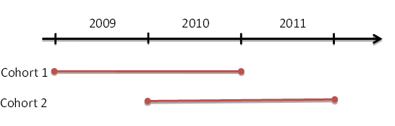
2. Project Goals
The expected outcomes of the project, over three years, were to:
- Raise student achievement in literacy in Years 9 and 10, particularly for underachieving Māori and Pasifika students.
- Increase leaders’ and teachers’ knowledge and skills for evidence-based practice.
- Enhance leaders’ and teachers’ knowledge of effective practice.
- Develop effective professional learning communities that promote ongoing inquiry into the effectiveness of literacy teaching and learning, professional learning, collaborative problem solving, and reflective practice.
There was a specific targeting of underachieving Māori and underachieving Pasifika students in SLP. For Māori students, SLP was designed to give effect to Ka Hikitia – Managing for Success. For Pasifika students, SLP was designed to give effect to the Pasifika Education Plan, to improve outcomes for Pasifika peoples in New Zealand and increase Pasifika presence, engagement and achievement. We have taken a specific stance in relation to the focus on ‘underachieving’ Māori and Pasifika students. Our stance has been that the schools selected for SLP have Māori and Pasifika students whose achievement levels and distributions are not well matched to nationally-expected levels and distributions. This means the Māori and Pasifika students at these schools can be considered, as a group, as ‘underachieving’ (although we would prefer terminology that focused on the school, eg, the students are ‘underserved’). We have not focused on Māori and Pasifika students who are underachieving by comparison with peers at their schools, but rather nationally. The criteria used to judge effectiveness under these conditions is that accelerated gains need to be made and that Māori and Pasifika students’ achievement needs to match expected national distributions of achievement.
The common project measure of literacy achievement was e-asTTle reading and all SLP schools were required to assess all Year 9 and 10 students using e-asTTle reading at the beginning and end of each year. Because of early difficulties with the e-asTTle tool, reliable data were only available for years 2010 and 2011. The curriculum expectation is that students achieve at curriculum level 5B by end of Year 9 and at 5A by end of Year 10. The national means for e-asTTle reading are 1519 (4A) at end of Year 9 and 1567 (5B) at end of Year 10.

3. Project Design
3.1 A Model of Effective Adolescent Literacy Instruction
A model for effective adolescent literacy instruction was developed that consisted of two overarching principles and eleven guidelines (http://literacyonline.tki.org.nz/Literacy-Online/Teacher-needs/Professional-support/Leading-Professional-Learning-about-Adolescent-Literacy). This model proposed the Guidelines for Effective Adolescent Literacy Instruction, consisting of two fundamental principles:
- Effective teachers have developed expertise. An important assumption of SLP was that teachers need more than just a toolbox of literacy teaching activities; they need the expertise to understand when, where, why, how and for whom these activities are likely to prove effective. They need an understanding of the theoretical underpinnings of effective literacy practice, as well as the practical knowledge and skills to enact and evaluate the effectiveness of this practice in their classrooms.
- Effective instructional decisions need to be based on quality evidence and ongoing inquiry. SLP aimed to increase the effectiveness with which teachers and schools could use evidence from a range of sources, such as student voice and e-asTTle reading, to identify and prioritise student literacy learning needs and to evaluate the impact of changed instructional practices.
The model also proposed eleven guidelines for optimal literacy instruction, which:
- Provides students with extensive opportunities to engage with a wide range of appropriately-challenging written text.
- Is differentiated to address individual literacy needs, interests and experiences.
- Clarifies and shares literacy learning intentions and criteria for success.
- Provides students with specific feedback about the literacy aspect(s) of their learning.
- Supports students to make effective use of how texts are organised (eg, headings, different paragraph structures).
- Develops students’ skills to make links to prior knowledge and/or build necessary background knowledge.
- Develops students’ vocabulary and vocabulary-solving skills.
- Develops students’ skills to employ key comprehension and writing strategies.
- Develops students’ skills to flexibly use and integrate written, oral, and visual modes.
- Develops students’ skills in both receptive and productive language use.
- Develops students’ skills to engage with text beyond a literal/factual level.
The Guidelines for Effective Adolescent Literacy Instruction provided the curriculum for teachers’ professional learning about literacy.
3.2 Cascading Structure
The project design was a cascading structure: the Woolf Fisher Research Centre was responsible for the national co-ordination of SLP; external professional development support was delivered to schools via regional School Support Services; and each school appointed a teacher in the school to the role of Literacy Leader responsible for leading SLP at the school level. The Literacy Leaders worked with subject teachers to develop their knowledge of the guidelines listed above and to support them to activate new literacy knowledge and practices in their classrooms.

3.2.1 National Co-ordination
The National Co-ordination role was to provide professional leadership for SLP which included:
- Leading the overall design of SLP and communicating this design to participants.
- Planning and leading national wānanga.
- Leading resource development and developing common project tools, particularly tools which supported literacy-focused inquiry and knowledge building at the levels of student, teachers, leadership and organisation.
- Conducting and reporting data analysis.
- Monitoring and providing feedback about processes at the School Support Services and school leader levels.
- Providing professional learning for School Support Service Facilitators.

3.2.2 Literacy Facilitation
The main aim of the Literacy Facilitator roles was to develop the capability of the Literacy Leaders and other school leaders to lead SLP in their own schools. Literacy Facilitators worked with Literacy Leaders to develop three aspects of knowledge:
- Adolescent literacy pedagogical content knowledge.
- Knowledge of inquiry so that they could identify and prioritise student literacy learning needs and the teaching knowledge and practices that contributed to these.
- Knowledge and skills to design and lead effective professional learning sessions with teachers at their school.
Literacy facilitation teams from the six Schooling Support Services developed Literacy Leader capabilities through regular work in the schools and in regional workshops/wānanga attended by Literacy Leaders from other SLP schools. They also provided support between formal visits via phone and email. Literacy Facilitators collaborated with Literacy Leaders and school leaders to support needs-analysis, plan professional learning, develop structures and leadership attributes, and evaluate the intervention in accordance with the overall SLP design. While Literacy Facilitators sometimes led professional development sessions in schools, this was mainly for the purpose of modelling effective facilitation to Literacy Leaders. The emphasis in this model on capability building was a marked change in the Literacy Facilitator role from that in previous secondary school interventions, where much of the Literacy Facilitator role had involved working directly with teachers.

3.2.3 Literacy Leadership
The professional development that Literacy Leaders designed for teachers took place at two levels. Firstly, all Literacy Leaders delivered regular sessions about literacy and literacy inquiry with all staff, for example, at whole-staff meetings. Secondly, Literacy Leaders worked more intensively with a smaller group of 10-12 teachers for whom the school received additional funding for release. The majority of schools in 2010 and 2011 employed a Focus Group structure when working with this smaller group of teachers. In one type shown in Figure 2, the Focus Group comprises those teachers who are teaching a common class or classes of students (Focus Class). In this type, the evidence base and the focus of inquiry is specific to that common Focus Class of students and their learning across the subject areas represented by the teachers. This type typically occurred with two other features, so we have built these into this type. The first feature is a dedicated and highly-active Literacy Leader leading the inquiry with the Focus Group teachers, plus strong support by a member of the Senior Management Team: often a Deputy Principal with special responsibilities. The second feature was planned extension to the wider staff through staff meetings and structured professional development. This was done in different ways in different schools.

4. Shifts in School Capability
4.1 Prior SLP Research and Evaluation
Research in 2010 was conducted in association with SLP (McNaughton, Wilson, Jesson & Lai, 2012). The research identified dimensions of the cascading model which were associated with student achievement gains. The overall conclusion was that “[t]he most effective model that emerges from these data is one that has a core design focused on common students, where the Focus Group teachers have considerable guidance and professional input from the [Literacy Leader], and at least one member of the Senior Management Team is an active and dedicated supporter. The [professional development] has high intensity and breadth in the sense of having frequent sessions and planned extension to the whole staff. Inquiry processes which are evidence-based are focused on these students, within the context of an overarching concern for Māori and Pasifika students’ achievement. In this model, SLP tended to have high coherence with the core programme in the school and other intervention programmes.” (p. 27). One of the dimensions of the model, a design for the Professional Learning Community in the school, emerges as particularly important for effectiveness. This design can be seen in Figure 2.
Figure 2: SLP Optimal Model Dimension 1: Professional Learning Community design. Student Focus Class with Literacy Leader and Senior Manager and planned extension
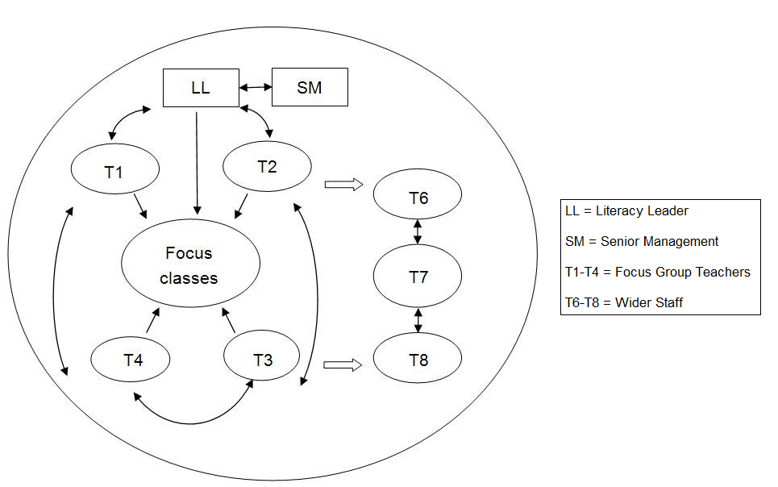
4.2 Evidence from 2011
In this report we summarise evidence that was collected as part of the role of National Co-ordinator. The evidence base is limited and the scope of our contract did not allow systematic research or evaluation of aspects of SLP other than those related to student achievement data. The evidence about shifts for schools, Literacy Leaders and teachers was reported to us by Literacy Facilitators as part of our monitoring and feedback role. Further evidence of shifts for students came from the Progress and Summative Reports that Literacy Facilitators completed in partial fulfilment of their reporting responsibilities to the Ministry of Education. These have not been checked for accuracy.
One important source of evidence about these other outcomes was a questionnaire that Literacy Facilitators completed for their Summative Report to the National Co-ordinator in December 2011. Literacy Facilitators rated the extent to which specific project outcomes were achieved in each cohort of schools in which they had worked. As shown in Figure 3, Literacy Facilitators judged the project to have been very effective in developing capabilities of the Literacy Leader, only modestly successful for creating professional learning communities, and moderately successful for all other dimensions.
Figure 3: Literacy Facilitators’ judgements regarding the success of the project
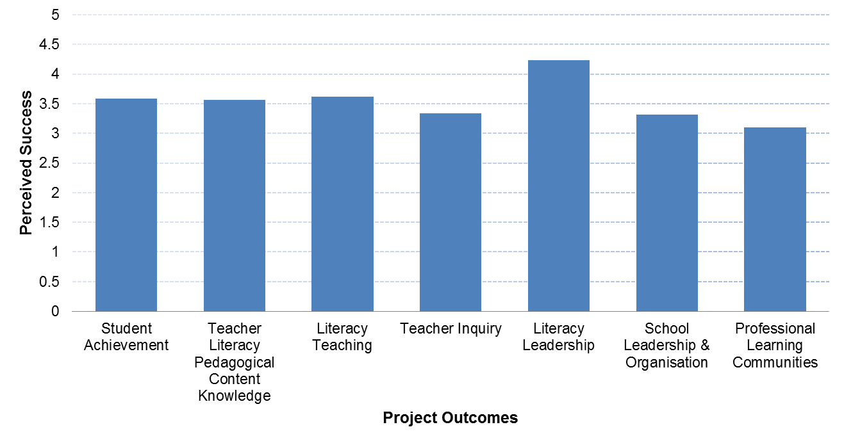

4.2.2 Shifts in Literacy Leadership
Literacy Leaders almost always rated the professional learning opportunities provided by their Literacy Facilitators and regional teams very highly. The majority of Literacy Leaders were selected for their role because they were already regarded as effective teachers with expertise in literacy teaching. However, many Literacy Leaders themselves acknowledged that they came to SLP with gaps as well as strengths in this knowledge. Most Literacy Facilitators reported examples in which the literacy knowledge of Literacy Leaders had deepened as a result of SLP, particularly in their understanding of the specialised literacy demands of different subjects. There were rather more reported shifts in respect of Literacy Leaders’ knowledge of inquiry and professional development. The most commonly-reported shift in the area of inquiry was to do with analysing data from e-asTTle. Shifts in Literacy Leaders’ knowledge of leading inquiry about teaching were also commonly reported with the majority of reports identifying that Literacy Leaders now had more confidence and knowledge to undertake classroom observations.
A major area of further professional learning was identified. This was the use of multiple sources of data to make accurate teacher judgements of students’ strengths and needs in literacy. The knowledge needed by participants to understand the relationship between patterns of teaching and patterns of student achievement was, in many cases, still developing. An ongoing weakness in many Literacy Facilitators’ reports throughout the project was to do with the linking of evidence between layers; the intervention logic was that the professional development would be linked to teacher needs that, in turn, were linked to the identified student needs. In many cases either the links were unclear or the identified needs at one or more levels lacked enough specificity for the intended alignment to be assessed. Future implementation and evaluation will need to consider the relationships of literacy pedagogical content knowledge with inquiry and change in practice more systematically. This may be particularly important in those potential development programmes employing a cascading structure like SLP.
For some, the Literacy Leader role was their first formal leadership role in a school and many Literacy Facilitators reported large shifts in the knowledge and confidence of Literacy Leaders to lead professional learning. Almost all of the Literacy Facilitator reports refer to Literacy Leaders having developed considerably greater confidence to lead large, whole-staff sessions effectively and to provide clear and challenging feedback to teachers – and in several cases – to school leaders. One Literacy Facilitator, when commenting on a Literacy Leader who came to the role as “a very effective and reflective classroom teacher”, noted that “the opportunity to lead whole school professional development has given her the vehicle to further develop her leadership skills.” Other Literacy Leaders have also informally reported this phenomenon to the National Co-ordinator and a number of Literacy Leaders have since been appointed to other leadership roles. It may be that roles, such as the Literacy Leader role, provide an alternative and highly-rewarding leadership pathway for teachers.

4.2.3 Teacher Shifts
Literacy Facilitators agreed that the majority of Focus Group teachers became more aware of the literacy and language demands of their subject and more committed to teaching students to meet these literacy demands. Focus Group teachers were also reported as having increased self-efficacy for literacy teaching. Literacy Facilitator reports noted that departments including mathematics, social sciences, science, technology and physical education had made large changes in their teaching and planning and literacy had become an accepted part of their subject teaching responsibilities. For some departments in some schools this represented a marked shift from a situation in which much of the literacy teaching expertise had resided only in the English department. Despite these shifts, many reports also acknowledged that some departments had yet to really engage with subject literacy.
There is evidence of teachers having developed greater subject literacy pedagogical knowledge during their participation in SLP. However, despite progress, many teachers’ knowledge of literacy and language is still at an emergent level.
One of the shifts in teachers’ literacy knowledge and practice that was most-commonly identified was an increase in the number of opportunities for reading and writing in subject areas. This is a major outcome as many Literacy Facilitators had identified previously that teaching practices likely to contribute to ‘Matthew Effects’ , in which the ‘rich get richer and the poor get poorer’, were prevalent and had commented on the paucity of reading opportunities and text quality in many classrooms, particularly those in which there were proportionally higher numbers of Māori and Pasifika students. One Literacy Facilitator reported that many of the teachers in his region had previously avoided having students read because students had actively resisted reading when they had tried to do so in the past. Instead, the teachers would summarise texts themselves and present the information orally, through notes to be copied, or through ‘fun’ activities. A Literacy Facilitator in another region reported for one school that, “initial observations of amount of text used showed that very little class time was devoted to reading and writing in Years 9 and 10 but ‘amplify not simplify’ has now become a widely-used mantra.” Despite this progress, many of the Literacy Facilitators identified the need for further change because of high variance in the expectations that different teachers in the schools had for students to read and write appropriately-challenging texts.
Another reported shift was to do with a move to literacy pedagogy that was more responsive to the (multiple) cultures of Māori and Pasifika students in that class. Specific changes in teaching practice noted including more deliberate selection of texts and contexts for literacy instruction and an increase in the amount of co-operative learning activities undertaken. With the limited information available, we are unable to offer a judgement about whether such activities are indeed more ‘culturally responsive’.
In terms of inquiry, by the end of the project, Literacy Facilitators reported that most teachers could confidently interpret e-asTTle reading data and use it to identify patterns of literacy strengths and gaps for their classes. A smaller number could also do this for different groups of students within each class. There was also evidence of systematic collection of student voice at the end of the project whereas, according to one Literacy Facilitator, this had been, “virtually unheard of two years ago.” Despite the positive shifts towards a more inquiry-based approach to literacy instruction, a recurrent theme in the Literacy Facilitator reports is that there is still much more that needs to happen. Every Literacy Facilitator report mentioned that some of the Focus Group teachers did not engage with or respond to the professional learning about inquiry. This suggests that professional learning about literacy inquiry needs to be broadened in the schools so that it includes all Focus and Non-Focus Group teachers. The reports also suggest that, even for the ‘engaged’ Focus Group teachers, much of the teachers’ knowledge of literacy inquiry is still at an emergent or intermediate level and therefore professional learning opportunities are needed so that inquiry knowledge is deepened.

5 Shifts in Student Achievement
In this section we report evidence of shifts in student achievement across two cohorts of SLP schools as a whole. We also present evidence of shifts in individual schools.
5.1 Shifts in Cohort 1 and 2 SLP schools as a whole
The evidence reported here is of shifts in student achievement. The data came from two main analyses. The first analysis examined one group of students in the second Cohort of schools over two years, from their beginning of secondary school in Year 9 in 2010 to the end of Year 10 in 2011 (giving four time points). A total of 2,121 students were included, comprising of slightly more males (56%) than females (44%) and coming mainly from NZ European (48%), Māori (17%), and Pasifika (17%) ethnic backgrounds (all other students comprised 17%). The second analysis was a Two-Time-Point Pre-Post analysis which compared gains of different groups of Year 9 and Year 10 students across one full school year (between Term 1 and Term 4) for 2010 (Cohort 1 and 2) and 2011 (Cohort 2 only). The number of students at each year level in any one year ranged from approximately 3,200 to 3,350.
Two main findings emerged from the first analysis, which examined one full cohort of students over four time points and which are presented in Figure 4.
Firstly, Māori and Pasifika students made progress over two years at the same rate as students from NZ European and Other groups in the schools and each was similar to nationally-expected patterns. SLP did not achieve its ambitious goal of accelerating the achievement of these Māori and Pasifika students over two years to match national norms or expected curriculum levels. However, achieving a parallel rate of gain may be an important shift in itself if these groups had previously made less than parallel progress, but we do not have achievement evidence from the schools before the intervention to test this. The parallel rate of gain meant Māori and Pasifika students remained at 2 curriculum sublevels below NZ European students and 1 curriculum sub-level below Other ethnicity students at the end of Year 10.
Secondly, there was evidence of a Summer Learning Effect which disproportionately affected Māori and Pasifika students. The expected (normal) gain for students over the summer break is 10 e-aRs. The total cohort of SLP students made a gain of 7 e-aRs between Term 4, 2010 and Term 1, 2011. NZ European students gained 9 e-aRs and Other ethnicity students gained 12 e-aRs, whereas Māori students made a gain of only 1 e-aRs and Pasifika students made a gain of 2 e-aRs. This low rate of gain over summer was similar for students in Focus and Non-Focus classes. This was one reason for not achieving (over two years) accelerated gains.
Figure 4: Mean e-asTTle score from Term 1, 2010 to Term 4, 2011 by ethnicity. The summer holiday period is represented by a dotted line
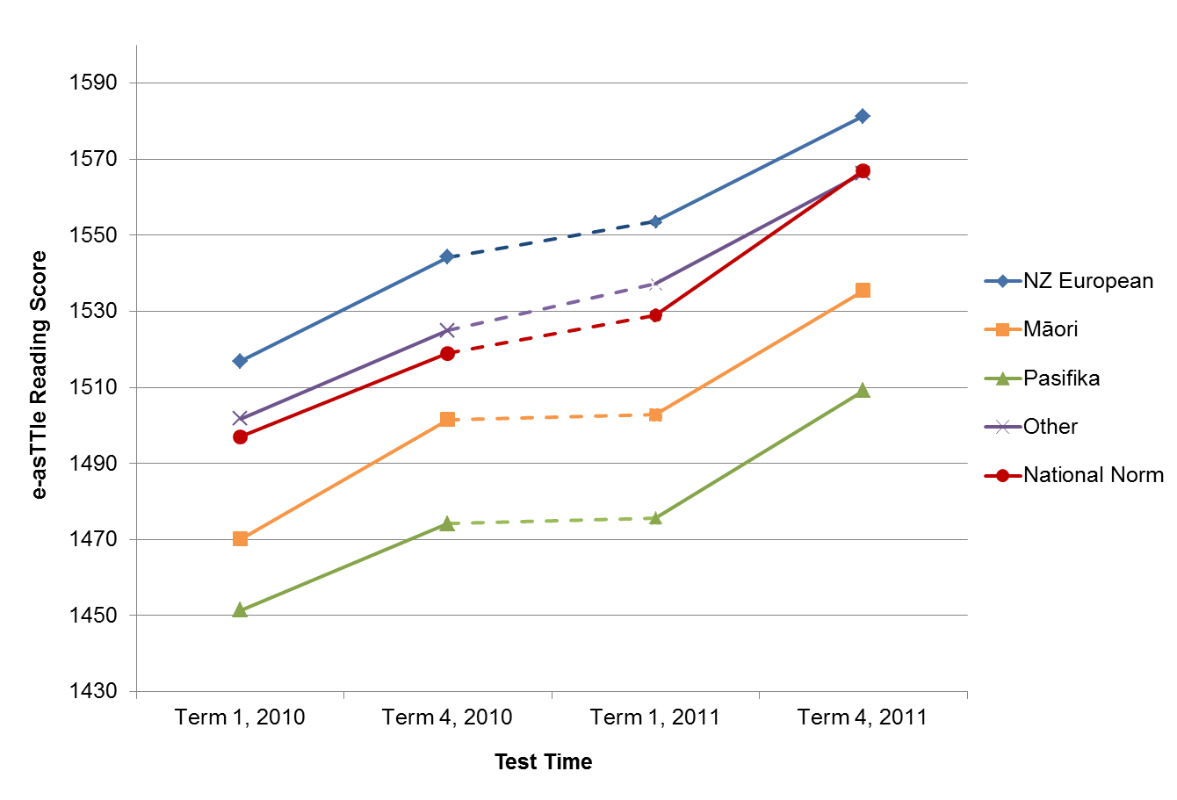
The second analysis was a Two-Time-Point Pre-Post analysis which compared gains of each cohort group across one full school year (between Term 1 and Term 4). Year 9 and 10 students were compared separately in these analyses. This provided a comparison of shift at each year level, across three separate groups of students – Cohort 1 in 2010, Cohort 2 in 2010 and Cohort 2 in 2011. This analysis is summarised in Figures 5 and 6 below.
Figure 5: Rates of gain for different Year 9 cohort groups
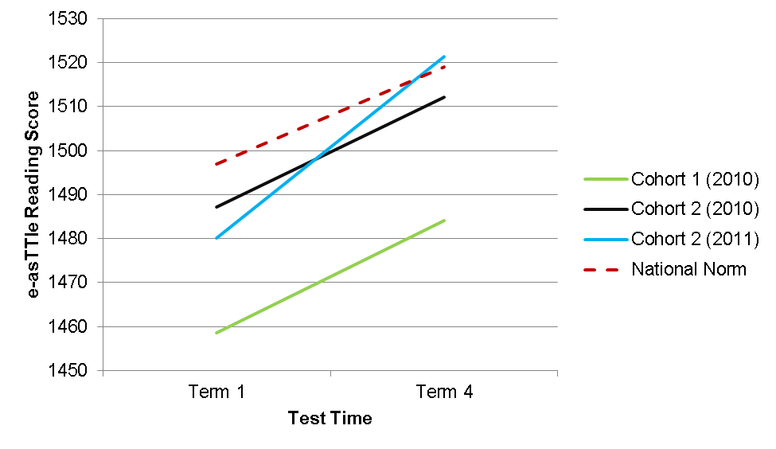
Figure 6: Rates of gain for different Year 10 cohort groups
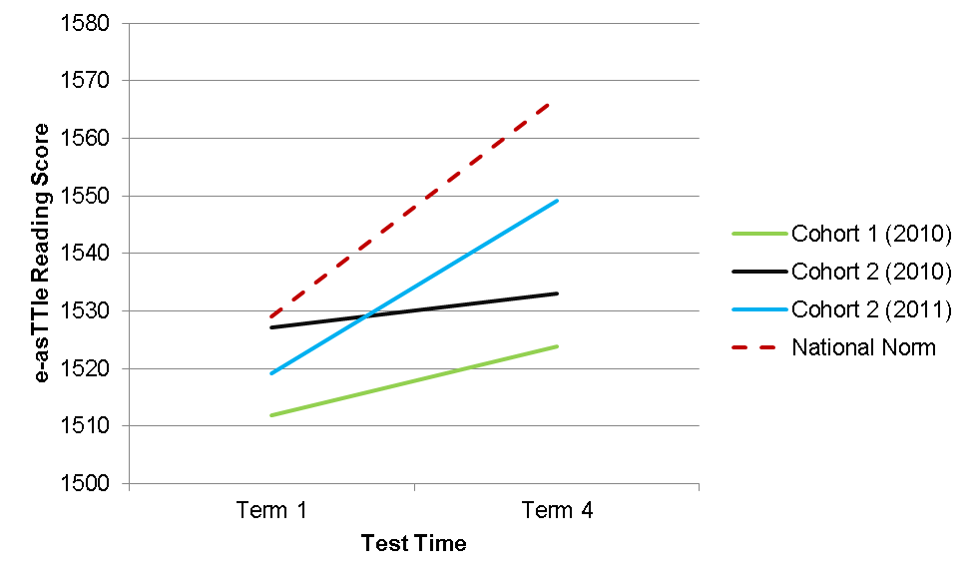
Four key findings emerged from this analysis.
Firstly, schools became more effective in their second year of the project. Cohort 2 schools in their second year achieved acceleration in achievement for their Year 9 students, and the acceleration was sufficient to reach nationally-expected levels. The gain with the new group of Year 9 students was significantly higher than the previous group of students in the first year (d = 0.34). A similar pattern was found for Year 10 students although despite having significantly higher rates of gains, they were not accelerated gains compared with nationally expected gains in Year 10. Greater gains in the second year occurred for Māori and Pasifika students, as for other students, although there was some variation in rates between groups. This may be very important given that there was no pre-intervention baseline of student achievement. If we treat the first year of SLP as a baseline and the second year as an intervention then we have very convincing evidence of improvement associated with SLP. Of course, given that some shifts already are likely to have occurred in the first year these data may well underestimate the total change in pattern.
Secondly, schools appear to be successfully targeting Focus Classes to those students who need them most (ie, low achieving students).
Thirdly, in a previous SLP research report we have identified the Focus Group structure as associated with stronger effects of SLP (McNaughton et al., 2011). In that report, we detailed that in 2010, at Year 9, Māori students in Focus Classes had made significantly greater gains than Māori students not in Focus Classes in the same school (31 e-aRs compared to 20 e-aRs). This amounted to a 44% increase over expected gain by those in Focus Classes, compared with a less than expected gain by those not in Focus Classes. The effect size was small to moderate (d = 0.21), but students were within expected curriculum levels in Term 4, 2010. A similar pattern occurred at Year 10 where Māori students in Focus Classes made significantly greater gains (28 e-aRs) which were close to four times more than students not in Focus Classes (8 e-aRs) and were within expected curriculum levels. The effect size was moderate (d = 0.37). This is a comparison between groups within an intervention. Given all Māori students received the intervention in some form, the effect size reflects a very significant educational finding.
The longitudinal analysis of the groups of Cohort 2 students from the beginning of 2010 to the end of 2011 showed slightly greater gains for students in Focus Classes, however this did not confer an overall significantly-greater advantage. When evaluating the specific effects of Focus Classes in the second year of SLP participation for Cohort 2 schools, however, Focus Classes were significantly more effective for Māori students and for Pasifika boys (but not Pasifika girls or Other ethnicity girls), even when accounting for initial levels of achievement. After accounting for initial achievement levels (see ‘adjusted gains’ in Table 1), Māori students and Pasifika boys in Focus Classes gained between 5 and 8 e-aRs more than Non-Focus Class students, which meant acceleration was achieved. What this means is that in Year 9 in the second year of Cohort 2 schools, Māori boys in Focus Classes made adjusted gains of 37 e-aRs, compared to 30 e-aRs for Māori boys in Non-Focus Classes. Similarly, Pasifika boys in Focus Classes made 37 e-aRs adjusted gain, whereas Pasifika boys in Non-Focus Classes made 29 e-aRs gain (the nationally expected gain is 22 e-aRs, and so these gains reflect a meaningful acceleration). The gains of other students can be seen in Table 1.
Table 1: Raw and Adjusted e-aRs Gains for Year 9 Cohort 2, 2011 Students
 |  | Raw Gains |  | Adjusted Gains
 |  | Focus Class | Non-Focus Class | Focus Class | Non-Focus Class
NZ European | Male | 46 | 47 | 45 | 51
NZ European | Female | 48 | 36 | 49 | 43
Māori | Male | 46 | 38 | 37 | 30
Māori | Female | 42 | 33 | 36 | 31
Pasifika | Male | 47 | 37 | 37 | 29
Pasifika | Female | 29 | 40 | 24 | 34
Other | Male | 46 | 45 | 43 | 46
Other | Female | 36 | 44 | 36 | 51
Note. Adjusted gains reflect adjustment to control for students’ initial reading achievement. Adjusted gain scores provide a more accurate picture of the effect of the Focus Classes, by accounting for the possibility that students who were placed in Focus Classes might have improved more even without the Focus Class intervention.
Fourthly, schools in the Canterbury region had the highest gains throughout the 2011 academic year and the unadjusted rate of gain of Māori students (75 e-aRs; n = 50) was accelerated such that by Term 4 their e-asTTle scores were above the national norm and the same or very close to the scores of NZ European and Other ethnicity students nationwide. The rates of gain for NZ European and Other ethnicity students in this region were 57 and 44 e-aRs, respectively (there were only n = 4 Pasifika students, so their gains are not reported). The patterns of achievement in the Canterbury region are also notable for the fact that no Focus Group structure was used in these schools.
5.2 Shifts in individual SLP schools
Further descriptive analyses looked at shifts at the school level. As Figure 7 shows, for Year 9 students, 24 of the 27 (89%) schools gained more than the national average gain of 22 e-aRs. Eleven of those schools gained more than 44 e-aRs, reflecting a gain of more than twice the national average. For Year 10 students, fewer schools exceeded the national average gain (see Figure 8). For this year level, 10 out of 26 schools gained more than the national average. Only four of those schools gained 22 e-aRs or more than the national average. One school was excluded from the Year 9 analysis, and two schools were excluded from the Year 10 analysis because they had fewer than 10 students at that year level.
Figure 7: Average e-asTTle reading score gains for each school, for Cohort 2, Year 9 students between Term 1 and Term 4, 2011
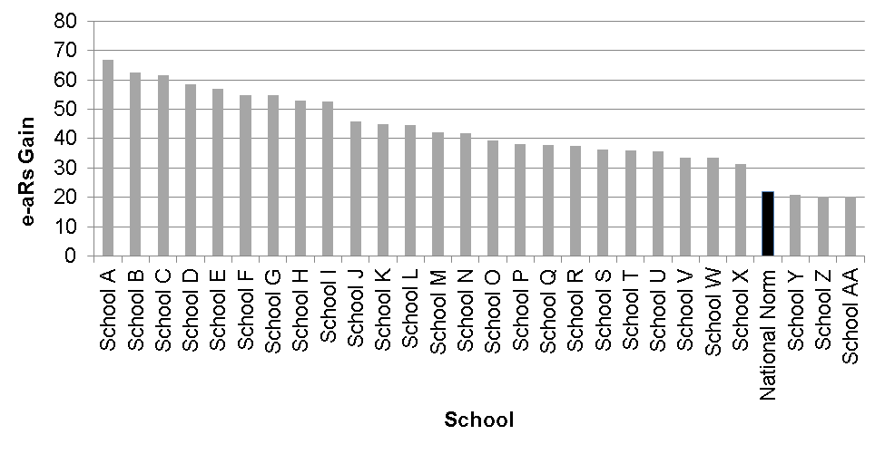
Figure 8: Average e-asTTle reading score gains for each school, for Cohort 2, Year 10 students between Term 1 and Term 4, 2011
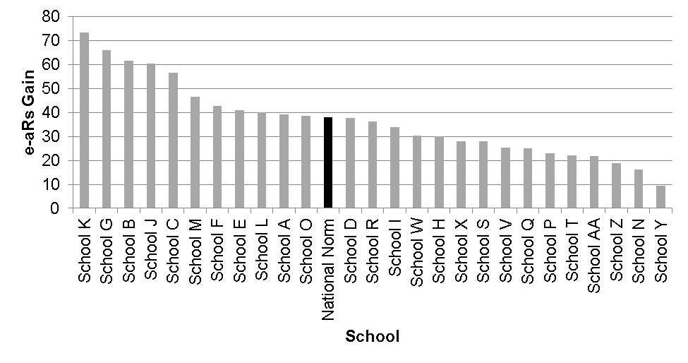
The school gains seen in Figures 7 and 8 were themselves then averaged to obtain a picture of the gains made in an average school. These average school gains can be seen in Figure 9 for Year 9 scores, and in Figure 10 for Year 10 scores. This form of averaging is different to analyses shown earlier (in Figures 5 and 6), which represent average student gains. This distinction is important because Figures 9 and 10 show the rates of gain for an average school, regardless of its size (the average is not weighted for school size, so a school with few students has the same impact on the reported gain as a school with many students). The figures should therefore be used to understand the rate of gain that was achieved by the average school, not the average student.
Figure 9: Mean school gain for Cohort 2 schools in 2011: Year 9
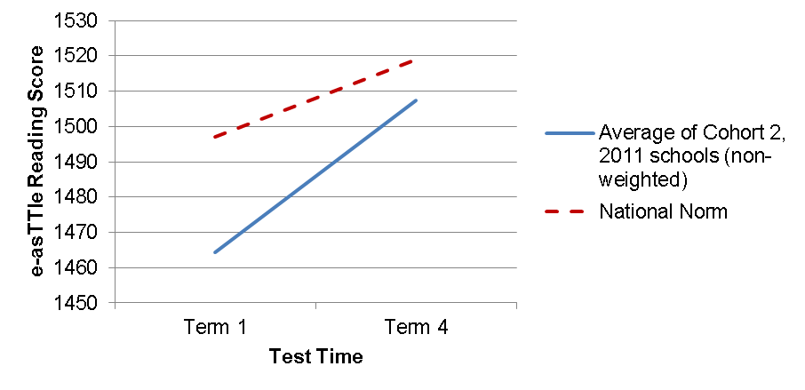
Figure 10: Mean school gain for Cohort 2 schools in 2011: Year 10
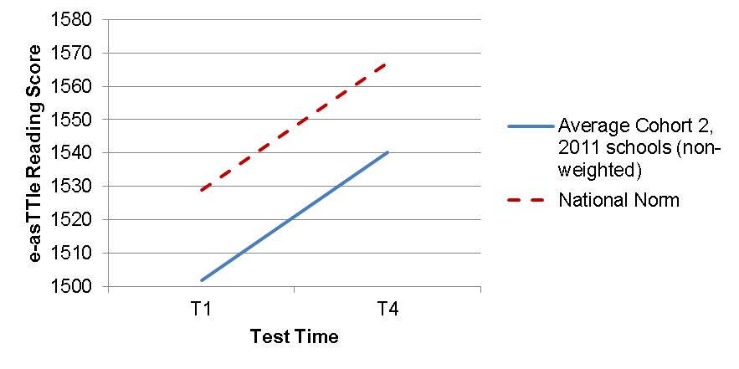
Figure 9 shows that Cohort 2 schools made a marked improvement at Year 9 with mean scores at Term 4 much closer to national mean scores than they had been at Term1. However, as shown in Figure 10, this was not the case at Year 10. The issue of greater gains at year 9 than Year 10 is discussed in Section 6.5 below.

6. Implications and Recommendations
There is sufficient evidence to suggest that under optimal conditions SLP can deliver accelerated gains for Māori and Pasifika students in secondary schools. This finding is particularly important given that the level of resourcing for each school was considerably less than that for other whole-school secondary interventions in New Zealand and overseas. A limited estimate of the full costs (Ministry, School, National Coordination and Research) suggests approximately $50-60,000 per school per year. In a previous research report (McNaughton et al., 2011) we identified a number of these optimal conditions and their implications. These included that: an appropriately-recognised and resourced role is established as the leader of inquiry and professional development within the school, with status and time to implement the role; a Focus Class organisation be present in intervention designs for secondary schools; and that the cascade model be modified to be more like a research and development model built around a leader of inquiry.
6.1 Research and Development
There is clearly more research and development needed to design the most effective conditions, content and processes but even in the current design, accelerated gains for Māori students (and Pasifika boys) were found – under the kinds of optimal conditions identified in the SLP Research Report (McNaughton et al., 2011). Further research-based knowledge is needed about how to achieve generalised and continuing effects of accelerating achievement and gains in achievement distributions so that they are no different from those expected nationally. Among the questions remaining are how can equally-powerful effects be obtained in Year 10, particularly with Pasifika girls, and over summer? The SLP has identified a number of the optimal conditions and constraints and these carry further implications.
6.2 Addressing the Summer Learning Effect
The Summer Learning Effect has important implications for SLP. Our analyses over four time points suggest a staircase effect for Māori and Pasifika students in which the relatively good gains made during the school year are eroded by a plateau over the summer months. Research in New Zealand and internationally shows that there are significant differences among schools and classes in the size of the Summer Learning Effect. The research also shows that school-based programmes can impact on the Summer Learning Effect . This suggests that there are actions that schools and teachers could take to reduce the Summer Learning Effect for Māori students and Pasifika students. Such actions might include instruction to promote wide reading; out of school reading programmes; community/home-school partnerships; and ensuring that all instructional time between testing points is used optimally, that is, effective literacy instruction is maintained right to the end of the school year and recommences quickly at the beginning of the new school year.
6.3 Extending the Duration and Intensity of SLP
The finding that SLP schools became significantly more effective in their second year of the project is very important. This supports numerous other studies suggesting that school improvement interventions need to be sustained over several years in order to be effective. Our recommendation to the Ministry is that similar projects in secondary schools should be extended to last for at least three years with a deliberate focus on sustainability and perhaps a gradual reduction of support from the third year. This recommendation is based on our evidence that, (a) schools improved more in their second year and, (b) despite this, SLP had not yet achieved its ambitious goal of accelerating Māori and Pasifika student achievement after two years. The Learning Schools Model (McNaughton & Lai, 2009) which has been demonstrably effective in reducing disparity when applied to primary and secondary schools has employed this three-year structure.
6.4 Focus Group Design
The finding that Focus Classes appear to be particularly effective for Māori students and Pasifika boys is very important, as it clearly identifies a strategy for raising the achievement of these groups of students. It is not clear why it was less effective for Pasifika or Other ethnicity girls in 2011 and more investigation is needed to identify modifications that could be made to Focus Group processes which would make them more effective for these groups. More investigation would also be needed to identify why the pattern of effectiveness identified in the SLP Research Project was not replicated in 2011. One explanation may be that Cohort 2 schools had been more effective in spreading professional learning from a small number of teachers in Focus Groups to the wider school in their second year in SLP, for example, through more strategic deployment of Focus Groups, whole-staff professional development, organisational structures, and leadership.
6.5 Why do Students Appear to Make More Shifts in Year 9 than Year 10?
There were quite marked differences in the gain scores of Year 9 and Year 10 students. Whereas Year 9 students made an overall shift of 42 e-aRs points in 2011, Year 10 students made only 30 e-aRs points. This is, according to the e-asTTle national norms, the reverse of the pattern nationally with norm gain scores for Year 9 and 10 being 22 and 38 e-aRs points respectively. There are at least two supportable explanations for this phenomenon. One is that the difference in gain scores is related to the fact that that Year 10 students on average start with higher scores and therefore there may be a ceiling effect in which SLP become less effective at addressing literacy knowledge at a certain level of complexity. To test this would require controlling for starting score when comparing Year 9 and 10 students. Another explanation is that a problem with e-asTTle norms has masked what might be a national pattern. Anecdotally, New Zealand teachers have often claimed that students in Year 10 (Form 4) are less academically engaged than Year 9 students for whom secondary school is still a novelty and Year 11 when they are working toward NCEA Level 1. These are important avenues of inquiry which could help us understand what we can do better to accelerate gain scores at Year 10 to, at least, match those at Year 9.
6.6 Regional Differences in Effectiveness
The finding that one region was more effective, particularly for Māori students, is also significant in the context of a cascading model like SLP. Analysis of Literacy Facilitator Progress and Summative Reports show high literacy pedagogical content knowledge, high inquiry and high quality facilitation from this region’s School Support Services facilitation team throughout the project, however it is not possible to attribute the region’s success to any set of factors without a more appropriate evaluation design. Further analysis into this outlier region could sharpen the design of future interventions of this sort.
6.7 Subject Literacy Assessment Tools
Difficulties with the e-asTTle tool have been reported throughout the project. In addition to the effect these had on the workload of teachers, Literacy Leaders, school leaders, Literacy Facilitators, the National Co-ordinator and the Ministry, it is likely to have impacted on the inquiry processes at the heart of SLP. One thing that may have contributed to the Cohort 2 schools making greater gains in 2011 was that this was the only year in the project where schools were able to generate accurate achievement reports in a timely fashion. In addition, the lack of available data from 2009 has weakened the evaluation design. For example, the finding that Cohort 2 schools were more effective in their second year would have been strengthened if we had also been able to compare the progress that Cohort 1 schools made in their first and second years. Also, it may be important for similar projects to use other Literacy measures as well as, or instead of, e-asTTle reading. Although the tests created by the National Co-ordinator were designed to reflect the reading demands of a broad range of learning areas, the fact remains that because e-asTTle reading was designed to assess students’ reading against the English curriculum it may therefore provide limited information about students’ reading in science, mathematics and other learning areas. This is not a reflection on the tool itself but rather its application in this project.
6.8 Impacting on NCEA
The SLP Research Report (McNaughton et al., 2011) commented that impacting reading and writing at Years 9 and 10 may not be sufficient to enable higher pass rates at NCEA consistent with Ka Hikitia targets and the expectations of the Pasifika Education Plan. A very significant research and policy question remains: Is the focus on underachievement in Years 9 and 10 necessary and/or sufficient to impact markedly on measures of engagement with the New Zealand Curriculum and, notably, nationally-expected levels of success at NCEA Level 2 and University Entrance for Māori and Pasifika students? There is clearly an urgent need to answer this question and identify the programmes and interventions that can deliver higher pass rates at these higher levels, as well as at Years 9 and 10. We contend that quality programmes of subject literacy instruction at Year 9 and 10 are a necessary but not sufficient condition for improving student outcomes in the senior secondary school.
6.9 The Limits of a Cascading Model
Going beyond the evidence from this report and other SLP research, there are suggestions that a model, other than the cascading implementation model, might be needed. A new model would focus the functions of inquiry and implementation more directly within the role and function of the leader of inquiry and professional development in the school. In this model, a research and development team would provide direct professional development support and research and evaluation support to build the expertise for that leader to design and lead the systematic inquiry into students’ needs and the fine-tuning of instruction across content areas. The role would need extensive graduate-level training and would need to be a specifically designated and funded position rather than an ‘add-on’ or modification of an existing role such as a Head of Department. Rather than a cascading model, a research and development partnership model may be more powerful (McNaughton et al., 2011). This would involve an overlap involving professional learning communities, with the Lead Teacher at the union (the common intersection).

References
Alexander, K. L., Entwisle, D. R., & Olson, L. S. (2007). Lasting consequences of the summer learning gap. American Sociological Review, 72(2), 167-180.
Allington, R. L., Johnston, P. H., & Day, J. P. (2002). Exemplary Fourth-Grade Teachers. Language Arts, 79(6), 462-466.
Lai, M. K., McNaughton, S., Amituanai-Toloa, M., Turner, R., & Hsiao, S. (2009). Sustained Acceleration of Achievement in Reading Comprehension: The New Zealand Experience. Reading Research Quarterly, 44(1), 30-56.
McNaughton, S., & Lai, M. K. (2009). A model of school change for culturally and linguistically diverse students in New Zealand: a summary and evidence from systematic replication. Teaching Education, 20(1), 55-75.
McNaughton, S., Wilson, A., Jesson, R., & Lai, M. K. (2012). Research into the Implementation of the Secondary Literacy Project (SLP) in Schools. Report for the Ministry of Education. Wellington: Ministry of Education.
Stanovich, K. E. (1986). Matthew Effects in Reading: Some Consequences of Individual Differences in the Acquisition of Literacy. Reading Research Quarterly, 21(4), 360-407.
Walqui, A. (2006). Scaffolding Instruction for English Language Learners: A Conceptual Framework. The International Journal of Bilingual Education and Bilingualism, 9(2), 159-180.


Ministry of Education
45-47 Pipitea Street
PO Box 1666
Thorndon
Wellington 6140
Email information.officer@minedu.govt.nz
Phone 04 463 8305
Fax 04 463 8312

www.educationcounts.govt.nz
© Crown copyright, 2013
All rights reserved, enquiries should
be made to the publisher.

Published March 2013


ISBN 978-0-478-40600-9 (print)
ISBN 978-0-478-40601-6 (web)
RMR-1005

http://e-asttle.tki.org.nz

