Attendance in New Zealand
Schools 2012

Table of Contents
Executive Summary 3
Introduction 4
Aims and Methodology 4
Definitions of Attendance 4
Response Rates 5
National Absence Rates 6
Analysis of Absences on Different Days of the Week 7
Analysis of School Factors 8
Analysis of Student Factors 10
Absence Across Different Regions 13
Data Considerations 16

List of Figures
Figure 1: Absences and School Type 8
Figure 2: Absence Type by School Decile 9
Figure 3: Absence Rates by Gender and Current Year Level 10
Figure 4: Frequent truant rates by ethnicity for years 9 and 10 students 12
Figure 5: Frequent truant rate of students in years 9 and 10, by Ministry region and ethnicity 14

List of Tables
Table 1: National absence rates (2004, 2006, 2009,2011 and 2012) 6
Table 2: Absence for each day of the week (2009, 2011 and 2012) 7
Table 3: Absence and ethnicity (2009, 2011 and 2012) 11
Table 4: Absence by Regional Council 13
Table 5: Absence by Ministry regional office 14

Executive summary

- In 2012, all state and state integrated schools were invited to participate in the attendance survey. The response rate was 88% (compared to 88% in 2011, 85% in 2009, 91% in 2006 and 87% in 2004).

- The estimated national absence rate in 2012 was 9.6%. This was lower than the previous surveys (10.2% in 2011, 11.6% in 2009, 11.5% in 2006 and 10.9% in 2004).

- The total unjustified absence rate, or truancy rate, decreased to 3.8%. This compares to 4.0% in 2011, 4.2% in 2009, 4.1% in 2006 and 3.4% in 2004.

- The national frequent truant rate (students who were unjustifiably absent for three or more days in the survey week) was 1.0% which was the same as in 2011. Frequent truancy was highest for students in year 13 (2.3%) and for Māori students (1.8%).

- The Ka Hikitia target is to decrease the frequent truant rate for year 9 and 10 Māori students from 2.8% in 2009 to 2.0% in 2015. The frequent truant rate for year 9 and 10 Māori students in 2012 was 2.4%, which is 0.1% higher than 2011.

Introduction

Participating in education is fundamental to student achievement. The Education Act 1989 requires that parents enrol their children at school and ensure they attend school whenever it is open for instruction unless there is a good reason for them to be absent.

Every day a student is not at school is a day they are not learning. Over time, patterns of non-attendance can place students at risk of poor achievement and early drop-out, thus compromising outcomes in life across a range of social and economic measures.

Aims and methodology

The 2012 attendance survey gathered data on student attendance during the week of 11-15 June 2012. The research aimed to investigate the relationships between absence and school level factors (e.g. school type, region, or decile) or student factors (e.g. gender, ethnicity, and year level of the student).

In 2012, all state and state integrated schools in New Zealand were invited to participate in the attendance survey. Similarly in 2011, all state and state integrated schools were invited. In 2009, to reduce compliance costs, a representative sample of 768 schools was invited to participate. In 1998, 2002, 2004 and 2006, all state and state integrated schools were invited to participate in the national surveys.

As in 2009 and 2011, two forms of data collection were used. Schools that use a module in their Student Management Systems (SMS) to enter their attendance records electronically were asked to provide an extract from the electronic Attendance Register (eAR). Schools that do not use eAR were invited to take part in the paper version of the survey.

The electronic files supplied by schools contain detailed attendance records from the survey week 11-15 June 2012. Each record was converted to a single attendance code. Schools recording absences on the paper form were required to make their own judgement as to whether a student was absent for all or part of a day, and whether that absence was justified based on the definitions and instructions supplied.

Definitions of Attendance

Absence was collected for each student for each day of the week. The year level, gender and ethnicity of the absent student were also collected. The rate for each absence type given below was calculated based on the total school rolls for the participating schools and related to an average (mean) daily absence for the week per 100 students. It should be noted that this does not tell us whether it was the same students that were absent for a number of days, or whether different students were absent each day.

Absences were classified into three main absence types; justified absences (J), unjustified absences (U), and intermittent unjustified absences (I).

Justified absences: Absences recorded in the register, and marked as having being satisfactorily explained. A school principal has to make a judgement as to which explanations they will accept. The basis for such judgements is a matter of school policy, and as such the balance of justified and unjustified absence may vary slightly from school to school. For the schools with eAR data, students who had attended less than 240 minutes of classes in a day but had NO unjustified absences were counted as a justified absence.

Unjustified absences: Absences which are not explained, or not explained to the satisfaction of the school. For the schools with eAR data, students who attended less than 120 minutes of their classes and had at least one unjustified absence were counted as unjustified absence.

Intermittent unjustified absences: The student is absent for part of a morning (or afternoon) or part of a period without justification. For example, a student who arrives 15 minutes late to school without a reason, or with a reason that is not acceptable to the principal, would be recorded as an intermittent unjustified absence. For the schools with eAR data, students who attended classes for more than 120 minutes and had 2 or more unjustified absences were counted as an intermittent unjustified absence.

The three absences were then summarised into total unjustified absence (the sum of U and I), and overall absence (the sum of J, U and I).

The rate of frequent truants was also estimated. A student was classified as a frequent truant if they had three or more unjustified absences (U) during the survey week. The rate of frequent truants provides an indication of the proportion of students who are truant (or who are unjustifiably absent from school) at least three times a week.

Response Rates

Of the 2465 schools invited to participate in the survey, completed returns were received from 2166 schools, a response rate of 88% (88% in 2011). In total, the responding schools had approximately 650,000 students on their rolls, equating to 88% of the student population in all state and state integrated schools on 1 July 2012.

National Absence Rates

The estimate of the total absence rate in 2012 was 9.6%. This is lower than the previous surveys (10.2% in 2011, 11.6% in 2009, 11.5% in 2006, and 10.9% in 2004).

The total unjustified absence rate, or truancy rate was 3.8% (compared to 4.0% in 2011). This is made up of 2.3% unjustified absences, and 1.5% intermittent unjustified absences. The justified absence rate is also lower than previous years, at 5.9%. See Table 1.

In 2012, approximately 62,000 students were absent from school for all or part of a day during the survey week. Of these, 15,000 students were unjustifiably absent from school.

Table 1: National Absence Rates (2004, 2006, 2009, 2011 and 2012)

Year* | Unjustified Absence Rate (%) | Intermittent Unjustified Absence Rate (%) | Total Unjustified Absence Rate (%) | Justified Absence Rate (%) | Total Absence Rate (%) | Frequent Truant Rate (%) **
2004 | 2.1 | 1.3 | 3.4 | 7.5 | 10.9 | -
2006 | 2.3 | 1.8 | 4.1 | 7.4 | 11.5 | -
2009 | 2.2 | 2.0 | 4.2 | 7.4 | 11.6 | -
2011 | 2.3 | 1.7 | 4.0 | 6.2 | 10.2 | 1.0
2012 | 2.3 | 1.5 | 3.8 | 5.9 | 9.6 | 1.0

* In 2004 and 2006 data were collected using paper forms only. The use of electronic data and paper forms started in 2009, In this year only a representative sample of schools were invited to do the survey, and their absences were weighted to estimate absence rates at the national level. In 2011 and 2012 all state and state integrated schools were invited to participate.
** The frequent truant rate was only calculated in 2011 and 2012

The national rate of frequent truants in 2012 was 1.0%, which was unchanged from 2011.

Analysis of Absences on Different Days of the Week

Table shows the absence rates by each day of the week. The absence rate was fairly uniform over the week but, as in previous years, the total absence rate was highest for days on either side of the weekend with 10.0% of students absent on Monday and 11.3% absent on Friday. The total unjustified absence rate was still highest on Friday at 4.8%.

Table 2: Absence for Each Day of the Week (2009, 2011 and 2012)

Year | Day of the week | Unjustified Absence Rate (%) | Intermittent Unjustified Absence Rate (%) | Total Unjustified Absence Rate (%) | Justified Absence Rate (%) | Total Absence Rate (%)
2009 | Monday | 2.3 | 1.8 | 4.1 | 7.5 | 11.5
2009 | Tuesday | 1.8 | 2.0 | 3.8 | 7.3 | 11.1
2009 | Wednesday | 1.9 | 2.1 | 4.0 | 7.0 | 11.0
2009 | Thursday | 2.1 | 2.0 | 4.1 | 7.4 | 11.5
2009 | Friday | 2.8 | 2.2 | 5.0 | 7.7 | 12.8
2011 | Monday | 2.4 | 1.6 | 4.0 | 6.6 | 10.6
2011 | Tuesday | 1.7 | 1.5 | 3.2 | 5.8 | 9.0
2011 | Wednesday | 1.9 | 1.8 | 3.7 | 5.9 | 9.6
2011 | Thursday | 2.1 | 1.7 | 3.8 | 5.8 | 9.6
2011 | Friday | 3.1 | 1.9 | 5.0 | 7.0 | 12.0
2012 | Monday | 2.4 | 1.2 | 3.6 | 6.4 | 10.0
2012 | Tuesday | 1.8 | 1.3 | 3.1 | 5.5 | 8.6
2012 | Wednesday | 2.0 | 1.5 | 3.5 | 5.3 | 8.8
2012 | Thursday | 2.1 | 1.6 | 3.7 | 5.5 | 9.2
2012 | Friday | 3.1 | 1.7 | 4.8 | 6.5 | 11.3

Analysis of School Factors

Absence and Type of School

The total absence rates for primary, contributing and intermediate schools were similar at around 7.5% (Figure 1). In secondary schools, the total absence rate was higher, at 10.5% for year 7-15 secondary schools and 13.9% for year 9-15 secondary schools. This shows a similar pattern to previous years.

The total unjustified absence rate was also higher in secondary schools (4.7% for year 7-15 secondary schools and 7.1% for year 9-15 secondary schools). This compares to 2.1% for primary, 2.0% for contributing and 2.2% for intermediate schools.

Special schools had the highest justified absence rate of all school types, at 9.4%. However, the total unjustified rate at special schools was the lowest, at 1.3%.

Figure 1: Absences and school type

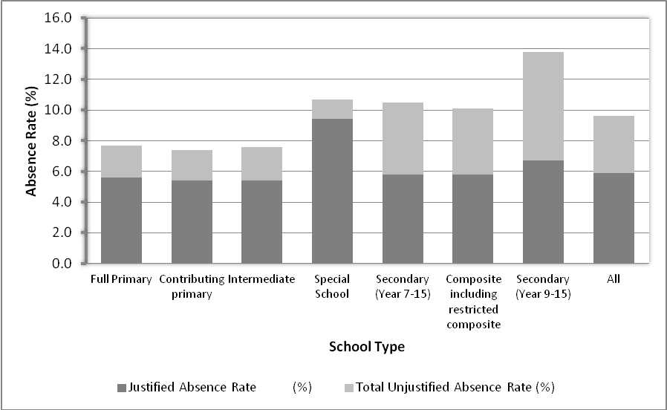

The rate of frequent truants also differs by school type. Secondary schools had a higher rate of frequent truants (students who were unjustifiably absent at least three times during the survey week) when compared to schools who cater for younger students (1.5% for year 9-15 secondary schools compared to 0.8% for primary schools).

Absence and School Decile

Justified absences were similar across all deciles, but high decile schools had lower unjustified absence rates. In decile 1 and 2 schools, total unjustified absence rates were 6.3% and 6.4% respectively. This compared to 2.4% in decile 9 schools and 1.9% in decile 10 schools, (Figure 2).

Figure 2: Absence Type by School Decile

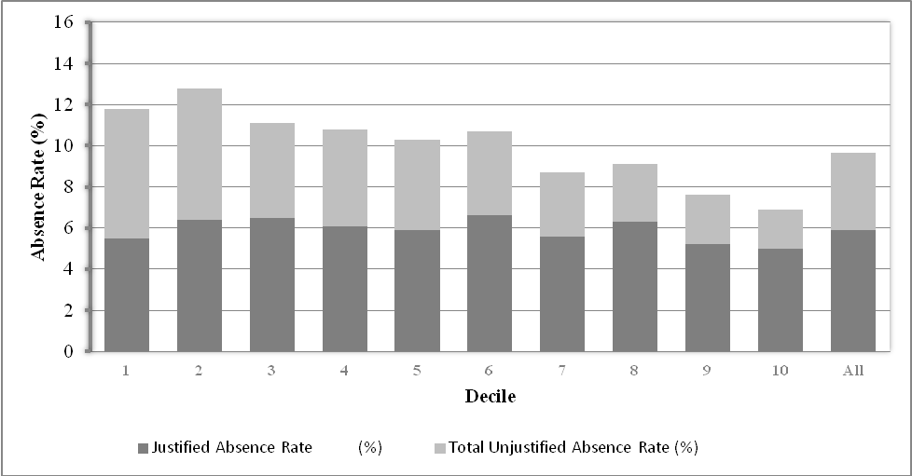

Low decile schools had higher rates of frequent truants when compared to high decile schools: 2.4% for decile 1 schools and 1.8% for decile 2 schools compared to 0.5% for decile 9 and 10 schools.

Analysis of Student Factors

Absence and Gender of Student and Current Year Level

Absence rates for male and female students were similar. In 2012, 9.6% of females and 9.7% of males were absent for all or part of the day during the survey week.

Absence increases rapidly from year 8 to year 13 (see Figure 3).

Figure 3: Absence Rates* by Gender and Current Year Level

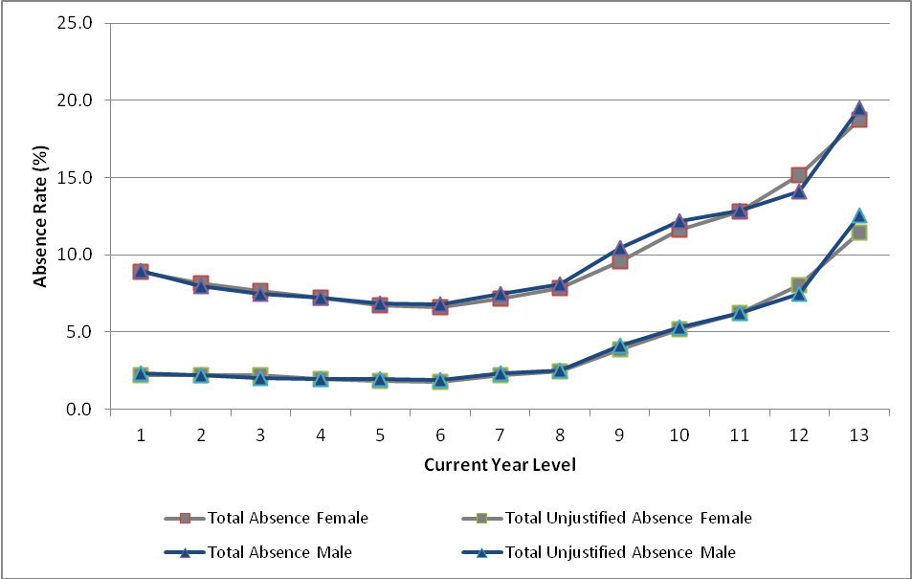

Students in higher year levels have a higher frequent truant rate, 2.3% for year 13 female students and 2.2% for year 13 male students, compared to 0.9% for year 1 female students and 0.8% for year 1 male students.

Absence and ethnicity

Table 3 shows the absence rates for students by ethnicity. Between 2011 and 2012, the total absence rates for students from all ethnic groups except Pasifika decreased. In 2012, Māori and Pasifika students had approximately twice the rate of unjustified absence compared with Asian and European/Pākehā students.

Table 3 Absence and ethnicity 2012

Year | Ethnic Group | Unjustified Absence Rate (%) | Intermittent Unjustified Absence Rate (%) | Total Unjustified Absence Rate (%) | Justified Absence Rate (%) | Total Absence Rate (%) | Frequent Truant Rate (%)
2009 | European/Pākehā | 1.3 | 1.7 | 3.0 | 7.2 | 10.3 | -
2009 | Māori | 4.1 | 2.4 | 6.5 | 8.4 | 14.9 | -
2009 | Pasifika | 3.9 | 2.7 | 6.6 | 7.2 | 13.8 | -
2009 | Asian | 1.1 | 1.8 | 2.9 | 4.4 | 7.4 | -
2009 | MELAA* | - | - | - | - | - | -
2009 | Other* | 2.3 | 2.8 | 5.1 | 12.8 | 17.9 | -
2009 | All | 2.2 | 2.0 | 4.2 | 7.4 | 11.6 | -
2011 | European/Pākehā | 1.5 | 1.4 | 2.9 | 6.2 | 9.2 | 0.6
2011 | Māori | 4.0 | 2.5 | 6.5 | 6.9 | 13.4 | 1.8
2011 | Pasifika | 3.4 | 2.2 | 5.5 | 5.8 | 11.4 | 1.4
2011 | Asian | 1.2 | 1.4 | 2.5 | 4.3 | 6.8 | 0.5
2011 | MELAA* | - | - | - | - | - | -
2011 | Other* | 2.2 | 2.0 | 4.2 | 8.7 | 12.9 | 0.8
2011 | All | 2.3 | 1.7 | 4.0 | 6.2 | 10.2 | 1.0
2012 | European/Pākehā | 1.6 | 1.2 | 2.8 | 5.9 | 8.6 | 0.6
2012 | Māori | 4.0 | 2.0 | 6.0 | 6.6 | 12.6 | 1.8
2012 | Pasifika | 3.4 | 1.9 | 5.4 | 6.0 | 11.4 | 1.4
2012 | Asian | 1.3 | 1.2 | 2.5 | 4.1 | 6.6 | 0.5
2012 | MELAA* | 2.1 | 1.7 | 3.8 | 5.2 | 9.0 | 0.7
2012 | Other* | 2.8 | 1.3 | 4.1 | 11.1 | 15.2 | 1.3
2012 | All | 2.3 | 1.5 | 3.8 | 5.9 | 9.6 | 1.0

* MELAA was a new category in this survey for 2012. It stands for Middle Eastern, Latin American and African which were previously included in ‘Other’.

The frequent truant rate was highest for Māori (1.8%) and Pasifika (1.4%) students compared to European/Pākehā (0.6%), Asian (0.5%) and MELAA students (0.7%).

Improving attendance in years 9 and 10 plays an important part in ensuring ongoing engagement in learning and achievement. One of the targets of Ka Hikitia is to reduce the frequent truant rate of Māori students in years 9 and 10. In March 2011, a mid-term review was conducted, and the target was revised to decrease the frequent truant rate of year 9 and 10 Māori students from 2.8% in 2009 to 2.0% by 2015.

In 2012 the frequent truant rate for year 9 and 10 Māori students was lower than in 2009 but it was 0.1% higher than in 2011 at 2.4% (see Figure 4).

The 2012 frequent truant rate for year 9 and 10 Pasifika students increased by 0.1% (1.3% in 2011 and 1.4% in 2012).

The rates for Māori and Pasifika students were higher than the rates for non-Māori and non-Pasifika students (0.7% and 1.1% respectively).

Figure 4: Frequent truant rates by ethnicity for years 9 and 10 students

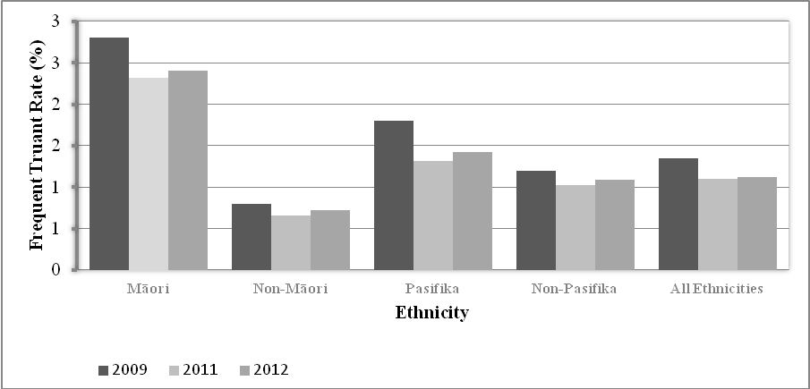

Absence across different regions

Regional Council

Table 4 shows absence rates by regional council. In 2012, the total absence rate varied from 8.3% in the Otago and Tasman regions to 12.7% in Gisborne.

The total unjustified absence rate also varied between regions, ranging from 2.4% in the Tasman region to 7.3% in the Gisborne region. Northland, Waikato, Bay of Plenty, Gisborne, Hawkes Bay, Taranaki and West Coast regions had an unjustified absence rate above the 2012 national average.

Table 4: Absence by Regional Council

Regional Council | Total Absence Rate (%) |  |  |  | Total Unjustified Absence Rate (%) |  |  | Frequent Truant Rate (%)
Regional Council | 2009 | 2011 | 2012 | 2009 |  | 2011 | 2012 | 2009 | 2011 | 2012
Northland | 13.0 | 13.1 | 11.4 | 4.8 |  | 5.9 | 5.1 | - | 1.9 | 1.9
Auckland | 11.4 | 9.3 | 8.9 | 4.4 |  | 3.7 | 3.5 | - | 0.9 | 1.0
Waikato | 13.6 | 11.6 | 11.5 | 4.9 |  | 4.9 | 4.6 | - | 1.1 | 1.1
Bay of Plenty | 13.6 | 11.8 | 10.6 | 4.3 |  | 5.5 | 4.4 | - | 1.1 | 1.1
Gisborne | 14.9 | 13.1 | 12.7 | 7.9 |  | 7.5 | 7.3 | - | 3.8 | 2.1
Hawkes Bay | 12.0 | 9.9 | 10.4 | 4.2 |  | 3.9 | 4.7 | - | 0.8 | 1.0
Taranaki | 10.6 | 9.9 | 10.1 | 4.4 |  | 4.2 | 4.2 | - | 1.1 | 1.4
Manawatu-Wanganui | 10.3 | 10.2 | 9.2 | 2.3 |  | 3.2 | 2.9 | - | 0.8 | 0.7
Wellington | 12.8 | 10.8 | 9.6 | 5.7 |  | 4.0 | 3.7 | - | 0.7 | 0.8
Tasman | 9.4 | 7.3 | 8.3 | 2.6 |  | 2.2 | 2.4 | - | 0.5 | 1.0
Nelson | 9.4 | 9.1 | 9.7 |  |  | 3.1 | 3.6 | - | 0.6 | 0.5
Marlborough | 9.4 | 10.6 | 10.8 |  |  | 2.8 | 3.0 | - | 0.8 | 1.0
West Coast | 9.4 | 9.8 | 10.3 |  |  | 3.9 | 4.3 | - | 0.9 | 1.3
Canterbury* | 10.1 | 9.7 | 9.4 | 3.3 |  | 3.3 | 3.5 | - | 0.7 | 1.0
Otago | 8.3 | 8.6 | 8.3 | 2.7 |  | 2.2 | 2.5 | - | 0.6 | 0.7
Southland | 9.3 | 10.3 | 8.8 | 2.9 |  | 3.7 | 3.1 | - | 1.0 | 0.8
National Average | 11.6 | 10.2 | 9.6 | 4.2 |  | 4.0 | 3.8 | - | 1.0 | 1.0

* Due to the earthquakes in 2011 figures for Canterbury may not represent 'typical' rates for the region. Please refer to the Data Considerations section for more information. Figures should be treated with caution.
Due to the nature of the sample used in 2009, results for Tasman, Nelson, Marlborough and West Coast were not able to be released separately.
Ministry of Education Regional Offices

In 2012, all four Ministry regions had a similar level of absence, with Central North having the highest total absence rate. Central North also had the highest unjustified absence rate. The frequent truant rates were very similar across all regions.

Table 5: Absence Rates by Ministry Regional Office

Ministry of Education Region | Unjustified Absence Rate (%) | Intermittent Unjustified Absence Rate (%) | Total Unjustified Absence Rate (%) | Justified Absence Rate (%) | Total Absence Rate (%) | Frequent Truant Rate (%)
Northern | 2.4 | 1.2 | 3.6 | 5.5 | 9.1 | 1.0
Central North | 3.0 | 1.8 | 4.7 | 6.3 | 11.1 | 1.1
Central South | 1.8 | 1.7 | 3.5 | 6.0 | 9.5 | 0.8
Southern | 1.8 | 1.5 | 3.2 | 6.0 | 9.2 | 0.9
National Average | 2.3 | 1.5 | 3.8 | 5.9 | 9.6 | 1.0

Figure 5 shows frequent truant rates for year 9 and 10 students. In 2012, Central North had the highest rate (1.4%), with the lowest in the Southern region (0.9%).

Figure 5: Frequent Truant Rate of Students in Years 9 and 10, by Ministry of Education Region and Ethnicity 2012

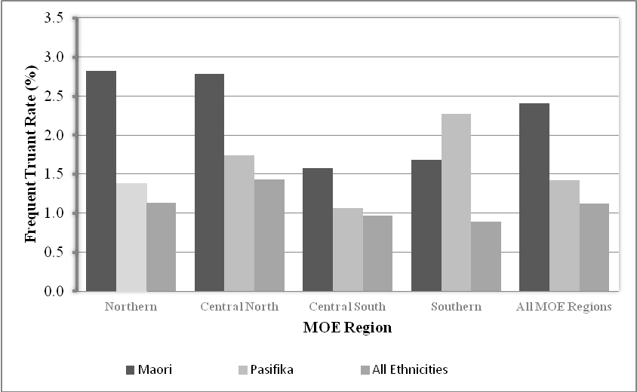

By ethnicity, year 9 and 10 Māori students had the highest frequent truant rates in all Ministry regions apart from Southern region (1.7%). This has increased since 2009 (1.2%). In the Central South region, the year 9 and 10 frequent truant rate has increased slightly since 2009 to 1.6%, but is still lower than the 2006 rate.

For Pasifika year 9 and 10 students, Southern had the highest rate of frequent truants (2.3%). Since 2009, the rate has decreased in Northern and Central North regions. In Central South and Southern regions, the year 9 and 10 frequent truant rate increased from 2009 to 2011 (0.2% and 0.8% to 1.1% and 2.3%), however Central South’s results are still lower than the 2006 rate (1.8%).
Data Considerations

Time frame

The survey was carried out in the week of 11-15 June 2012, close to the middle of the second school term. This week was the same week of term as the 2009 and 2011 surveys. By analysing data from a similar time of year, factors such as winter illness would have been at broadly similar levels.
Unlike in 2011, there were no major changes in the 2012 school term. Some schools and local area activities resulted in school closures during the week. For schools that were closed or had data missing on days during the survey week, the missing data was replaced with alternative day/s from a different week. Schools participating using paper forms were advised to use alternative day(s) from 18-22 June. For schools that submitted electronic data, the corresponding day(s) from either the previous week or the week after were chosen at random.
Effect of the Christchurch Earthquake
On 13 June 2011, Christchurch experienced a large earthquake which struck on the first day of the national attendance survey. Because of this, schools that participated in the 2011 attendance survey may have absences that were not typical for their school. Estimates of absence for the Canterbury region must be treated with caution.

Comparisons with Previous Surveys

This section outlines some of the known issues with making comparisons between this survey and previous surveys of attendance in New Zealand State and State Integrated schools.

Prior to 2009, surveys were carried out in mid-August and early-September. Due to feedback from schools, starting 2009, surveys were carried out in mid-June, when absences due to winter illnesses were expected to be lower.

The 2009, 2011 and 2012 surveys used the same instructions as the 2004 and 2006 surveys. However, in 2004 and 2006, data were collected using paper forms only. The use of electronic data and paper survey started in 2009 where only a representative sample of schools were invited to do the survey and absences were weighted to estimate absence rates at a national level. Due to the nature of the sample and the number of responses from schools, some comparisons against 2009 are not possible.

In 2012, Teen Parent Units were not included in the computation of national absence rates. Instead, they were put together in a separate data set and made available for reporting, if required.

Authors:
Maris Mallari, Research Analyst, Marian Loader, Team Leader Analysis, Education Information and Analysis, Ministry of Education
Email: maris.mallari@minedu.govt.nz
Telephone: 64-4-463-8000
Fax: 64-4-463-8088

Published:
Tertiary, International and System Performance
Ministry of Education

http://www.minedu.govt.nz/theMinistry/PolicyAndStrategy/KaHikitia/MidTermReview.aspx
Note: Year 13 includes students in years 13, 14 and 15.
Ka Hikitia – Managing for Success. Māori Education Strategy 2008-2012. Wellington: Ministry of Education.
Please note that these figures are not age standardised. Therefore, some of the differences between regions may be due to the different age distribution between regions (i.e. one region may have an older student population than another).

