Attendance in New Zealand
Schools 2011

Table of contents
Attendance in New Zealand schools 2011 1
Executive summary 3
Introduction 4
Research aims and methodology 4
Definitions of attendance 5
Response rates 5
National absence rates 6
Analysis of absences on different days of the week 7
Analysis of school factors 8
Analysis of student factors 10
Absence across different regions 13
Considerations of the data 15

List of figures

Figure 1: Absences and school type 8
Figure 2: Absence type by school decile 9
Figure 3: Absence rates by gender and current year level 10
Figure 4: Frequent truant rates by ethnicity for years 9 and 10 students 11
Figure 5: Frequent truant rate of students in years 9 and 10, by Ministry region and ethnicity 14

List of tables

Table 1: National absence rates (2004, 2006, 2009 and 2011) 6
Table 2: Absence for each day of the week (2009 and 2011) 7
Table 3: Absence and ethnicity 11
Table 4: Absence across different regions 13
Table 5: Absence and Ministry regional office 14

Executive summary

- In 2011, 2470 state and state integrated schools were invited to participate in the attendance survey. The response rate was 88% (compared to 85% in 2009, 91% in 2006 and 87% in 2004).

- The estimated national absence rate in 2011 is 10.2% (compared to 11.6% in 2009, 11.5% in 2006 and 10.9% in 2004).

- The total unjustified absence rate, or truancy rate, has also decreased to 4.0%. This compares to 4.2% in 2009 and 4.1% in 2006.

- The national frequent truant rate is 1%. Frequent truants, or students who were unjustifiably absent for three or more days in the survey week, is highest for students in year 13 (2.1%) and for Māori students (1.8%).

- The revised Ka Hikitia target is to decrease the Māori frequent truant rate from 2.8% in 2009 to 2.0% in 2015. The frequent truant rate for year 9 and 10 Māori students in 2011 is 2.3%, which is on track to meet this target.

Introduction

Participating in education is fundamental to student achievement. The Education Act 1989 requires that parents enrol their children at school and ensure they attend school whenever it is open for instruction unless there is a good reason for them to be absent.

Every day a student is not at school is a day they are not learning. Over time, patterns of non-attendance can place students at risk of poor achievement and early drop-out, thus compromising their later outcomes in life across a range of social and economic measures.

The Ministry of Education continues to actively promote student attendance and engagement in education through a multi-year programme of work. The attendance and engagement work programme aims to build schools’ Information Technology (IT) capability to manage attendance effectively, promote effective practice through new attendance guidelines, and increase student attendance.

To better support schools to improve student attendance, the District Truancy Service (DTS) and the Non-Enrolled Truancy Service (NETS) are being combined into one integrated Attendance Service. The new service will be rolled out from October 2012.

This survey on attendance was carried out in June 2011. The survey aims to inform the Ministry’s work to improve student attendance as a foundation for engagement in learning and achievement.

Research aims and methodology

The 2011 attendance survey gathered data on student attendance during the week of 13-17 June 2011. The research aimed to investigate the relationships between absence and school level factors (eg, school type, region, decile) and by student factors (eg, gender, ethnicity, and year level of the student).

In 2011, 2470 state and state integrated schools in New Zealand were invited to participate in the attendance survey. In 2009 to reduce compliance costs, a representative sample of 768 schools were invited to participate. All state and state integrated schools were invited to participate in the previous national surveys in 1998, 2002, 2004 and 2006.

As with 2009, two forms of data collection were used. Schools that use a module in their Student Management Systems (SMS) to enter their attendance records electronically were asked to provide an extract from the electronic Attendance Register (eAR). Schools that do not use eAR were invited to take part in the paper version of the survey.

The schools recording absence on the paper form were required to make their own judgement of whether a student was absent for all or part of a day, and whether that absence was justified based on the definitions and instructions supplied. The Ministry of Education applied the same business rules to schools doing the paper survey and to the SMS vendors to define the type and duration of students’ absences from school, based activities marked in the eAR data.

This report contains the findings from the 2011 attendance survey. Where appropriate, comparisons have been made to previous surveys. Supporting data tables are available in an excel document that can be downloaded from www.educationcounts.govt.nz.

Definitions of attendance

Absence was collected for each student for each day of the week. The year level, gender and ethnicity of the absent student were also collected. The rate for each absence type given below is calculated based on the total school rolls for the participating schools and relate to an average (mean) daily absence for the week per 100 students. It should be noted that this does not tell us whether it is the same students that are absent, or whether different students are involved each day.

Absences were classified into three main absence types; these were justified absences (J), unjustified absences (U), and intermittent unjustified absences (I).

Justified absences: Absences recorded in the register, and marked as having being satisfactorily explained. A school principal has to make a judgement as to which explanations they will accept. The basis for such judgements is a matter of school policy, and as such the balance of justified and unjustified absence may vary slightly from school to school. For the schools with eAR data, students who had attended less than 240 minutes of classes in a day but had NO unjustified absences were counted as a justified absence.

Unjustified absences: Absences which are not explained, or not explained to the satisfaction of the school. For the schools with eAR data, students who attended less than 120 minutes of their classes and had at least one unjustified absence were counted as unjustified absence.

Intermittent unjustified absences: The student is absent for part of a morning (or afternoon) or part of a period without justification. For example, a student who arrives 15 minutes late to school without a reason, or with a reason that is not acceptable to the principal, would be recorded as an intermittent unjustified absence. For the schools with eAR data, students who attended classes for more than 120 minutes and had 2 or more unjustified absences were counted as an intermittent unjustified absence.

The three absences were then summarised into total unjustified absence (the sum of U and I), and overall absence (the sum of J, U and I).

The rate of frequent truants was also estimated. A student was classified as a frequent truant if they had three or more unjustified absences (U) during the survey week. The rate of frequent truants provides an indication of the proportion of students who are truant (or who are unjustifiably absent from school) at least three times a week.

Response rates

Of the 2470 schools invited to participate in the survey, completed returns were received from 2180 schools, a response rate of 88% (85% in 2009). In total, the responding schools had approximately 625,000 students on their rolls, equating to 87% of the student population in all state and state integrated schools on 1 July 2011.

National absence rates

The estimate of the total absence rate in 2011 is 10.2%. This is lower than previous surveys (11.6% in 2009, 11.5% in 2006 and 10.9% in 2004). The margin of error for the 2009 estimate of national absence was 2.1% (with 95% confidence), therefore the difference between the 2009 and 2011 absence rates are not significant.

The total unjustified absence rate is 4.0% (compared to 4.2% in 2009). This is made up of 2.3% unjustified absences, and 1.7% intermittent unjustified absences. The justified absence rate is also lower than previous years, at 6.2%. See Table 1.

In 2011, approximately 74,000 students were absent from school for all or part of a day during the survey week. Of this, 29,000 students were unjustifiably absent from school.

Table 1: National absence rates (2004, 2006, 2009 and 2011)
Year | Total  Absence rate (%) | Justified  absence rate (%) | Unjustified absence rate (%) | Intermittent unjustified absence rate (%)
2004 | 10.9 | 7.5 | 2.1 | 1.3
2006 | 11.5 | 7.4 | 2.3 | 1.8
2009 | 11.6 | 7.4 | 2.2 | 2.0
2011 | 10.2 | 6.2 | 2.3 | 1.7

The national rate of frequent truants is 1.0%. This means that in 2011, 1.0% of all students were unjustifiably absent from school at least three times during the survey week.

Analysis of absences on different days of the week

Table 2 shows the results of the 2011 survey by each day of the week. The overall absence rate is fairly uniform over the week but as in previous years absence is highest for days either side of the weekend, with 10.6% of students absent on Monday and 12.0% absent on Friday.

Unjustified absences were similar across the week in both 2009 and 2011, however there is a slight increase in unjustified absence on Friday (2.8% in 2009 compared to 3.1% in 2011).

Table 2: Absence for each day of the week (2009 and 2011)
Day of the week | Total  Absence rate (%) |  | Justified  absence rate (%) |  | Unjustified absence rate (%) |  | Intermittent unjustified absence rate (%)
Day of the week | 2009 | 2011 | 2009 | 2011 | 2009 | 2011 | 2009 | 2011
Monday | 11.5 | 10.6 | 7.5 | 6.6 | 2.3 | 2.4 | 1.8 | 1.6
Tuesday | 11.1 | 9.0 | 7.3 | 5.8 | 1.8 | 1.7 | 2.0 | 1.5
Wednesday | 11.0 | 9.6 | 7.0 | 5.9 | 1.9 | 1.9 | 2.1 | 1.8
Thursday | 11.5 | 9.6 | 7.4 | 5.8 | 2.1 | 2.1 | 2.0 | 1.7
Friday | 12.8 | 12 | 7.7 | 7.0 | 2.8 | 3.1 | 2.2 | 1.9
National Average* | 11.6 | 10.2 | 7.4 | 6.2 | 2.2 | 2.3 | 2.0 | 1.7
* Includes students from Special schools, who were not included in prior to 2009.

Analysis of school factors

Absence and type of school

Figure 1 shows that the total absence rate for primary, contributing and intermediate schools are similar at around 8%. In secondary schools, the total absence rate is higher, at 11.5% for year 7-15 secondary schools and 14.1% for year 9-15 secondary schools (which includes teen parent units). This shows a similar pattern to previous years.

The total unjustified absence rate is also higher in secondary schools (5.4% for year 7-15 secondary schools and 7.3% for year 9-15 secondary schools). This compares to 2.3% for primary, contributing and intermediate schools.

Special schools have the highest justified absence rate of all school types, at 10.8%. However, the total unjustified rate at special schools is the lowest, at 1.0%.

Figure 1: Absences and school type
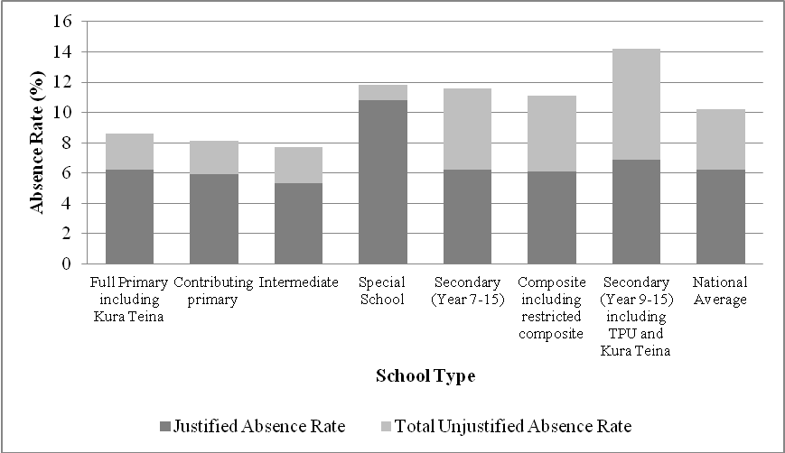

The rate of frequent truants also differs by school type. Secondary schools have a higher rate of frequent truants (students who were unjustifiably absent at least three times during the survey week) when compared to schools who cater for younger students (1.4% for year 9-15 secondary schools compared to 0.8% for primary schools).

Absence and school decile

Justified absences are similar across all deciles (at approximately 6% in 2011), but high decile schools have lower unjustified absence rates. In decile 1 and 2 schools, total unjustified absence rates are 6.3% and 6.8% respectively. This compares to 2.1% in decile 9 schools and 2.0% in decile 10 schools, see Figure 2.

Figure 2: Absence type by school decile

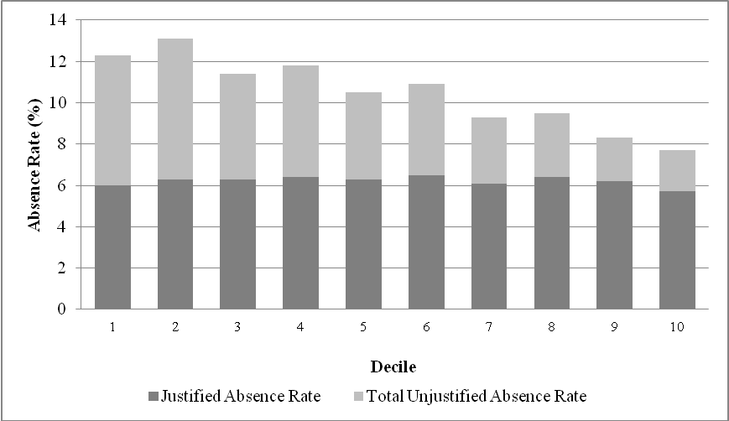

The rate of frequent truants also differs by school decile. Low decile schools have higher rates of frequent truants when compared to high decile schools (2.3% for decile 1 schools and 2.0% for decile 2 schools compared to 0.5% for both decile 9 and 10 schools).

Analysis of student factors

Absence and gender of student and year level

Absence rates for male and female students are very similar. In 2011, 10.4% of females were absent for all or part of the day during the survey week (11.7% in 2009), compared to 10.0% of males (11.4% in 2009).

Absence increases rapidly from year 9 to year 13 (see Figure 3). However, between 2009 and 2011, absence rates have decreased for all year levels, in both genders. In 2009, the total absence rate for female year 13 students was 22.5%. In 2011 this is 19.9%. For male year 13 students, 21.3% were absent in 2009 compared to 18.5% in 2011. Please see Education Counts for the full table.

Figure 3: Absence rates by gender and current year level
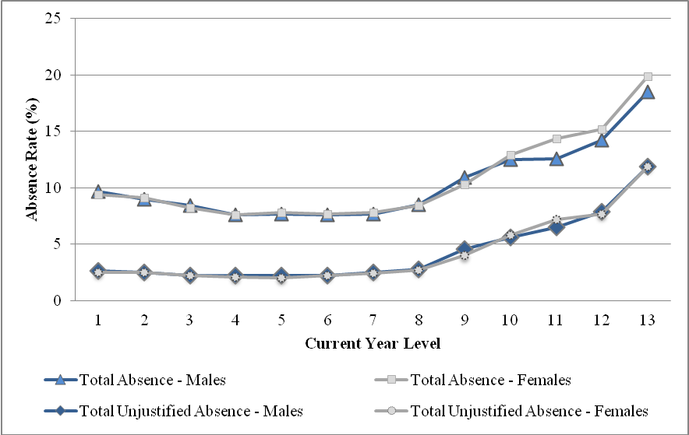

Similar to the figures for absence by school type, students in higher year levels have a higher frequent truant rate (2.2% for year 13 female students and 1.9% for year 13 male students, compared to 0.9% for both male and female year 1 students). This suggests that students in the secondary year levels “skip” school more often than those in younger year levels.

Absence and ethnicity

Table 3 shows the absence rates for students by the four main ethnic groups in 2009 and 2011. In 2011, the total absence rates for students from all ethnic groups have decreased. Māori and Pasifika students continue to have approximately double the rate of unjustified absence when compared with NZ European and Asian students.

In 2009, the justified absence rate increased slightly for Pasifika students. The 2011 justified absence rate shows that the rate has decreased to approximately the same as 2006 (5.8% in 2011, compared to 7.2% in 2009 and 5.9% in 2006).

Table 3: Absence and ethnicity
Ethnicity | Absence rate (%) |  | Justified absence rate (%) |  | Unjustified absence rate (%) |  | Intermittent unjustified absence rate (%)
Ethnicity | 2009 | 2011 | 2009 | 2011 | 2009 | 2011 | 2009 | 2011
NZ European | 10.3 | 9.1 | 7.2 | 6.2 | 1.3 | 1.5 | 1.7 | 1.4
Māori | 14.9 | 13.4 | 8.4 | 6.9 | 4.1 | 4.0 | 2.4 | 2.5
Pasifika | 13.8 | 11.4 | 7.2 | 5.8 | 3.9 | 3.4 | 2.7 | 2.2
Asian | 7.4 | 6.8 | 4.4 | 4.3 | 1.1 | 1.2 | 1.8 | 1.4
Other* | 17.9 | 14.2 | 12.8 | 9.5 | 2.3 | 2.6 | 2.8 | 2.1
National Average | 11.6 | 10.2 | 7.4 | 6.2 | 2.2 | 2.3 | 2.0 | 1.7
* Cannot interpret differences in the Other ethnicity grouping as students with unknown ethnic background tend to be grouped in Other.

Frequent truants

The overall frequent truant rate is highest for Māori (1.8%) and Pasifika (1.4%) students (compared to NZ European students 0.6% and Asian students 0.5%).

Improving attendance in years 9 and 10 plays an important part in ensuring ongoing engagement in learning and achievement. One of the targets of Ka Hikitia is to reduce the frequent truant rate of Māori students in years 9 and 10. In March 2011, a mid-term review was conducted, and the target was revised to decrease the frequent truant rate of year 9 and 10 Māori students from 2.8% in 2009 to 2.0% by 2015. The frequent truant rate for year 9 and 10 Māori students in 2011 is 2.3% which is on track to meet this target (see Figure 4).

The 2011 frequent truant rate for year 9 and 10 Pasifika students has also decreased since 2006, from 3.1% to 1.3% in 2011.

Although the rate of frequent truants has decreased, the rates for Māori and Pasifika students are still higher than the rates for non-Māori and non-Pasifika students (0.7% and 1.0% respectively).

Figure 4: Frequent truant rates by ethnicity for years 9 and 10 students
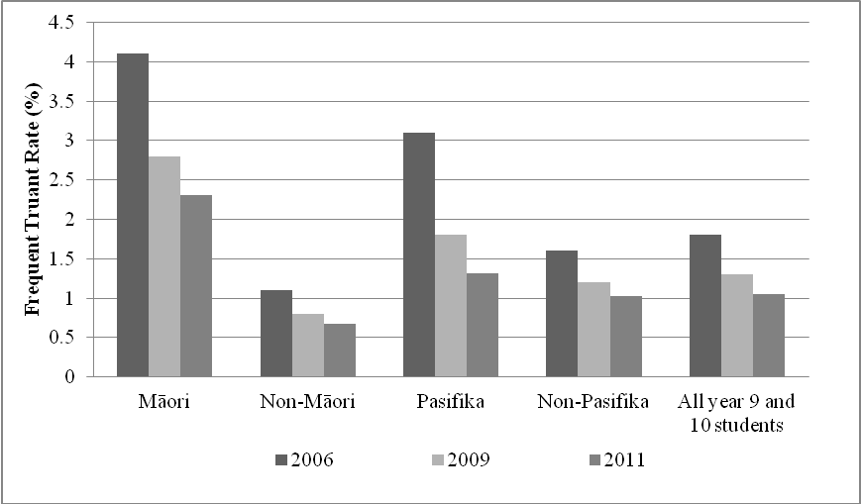

Absence across different regions

Region

Table 4 shows absence rates by region. The absence rate varied from 7.3% in the Tasman region to 13.1% in both the Gisborne and Northland regions. Between 2009 and 2011 the total absence rate has decreased in most regions.

The total unjustified absence rate also varied between regions, ranging from 2.2% in the Tasman region to 7.5% in the Gisborne region. Northland, Bay of Plenty, Manawatu-Wanganui, and Southland all had an increase in unjustified absence rates between 2009 and 2011. Northland, Waikato, Bay of Plenty, Gisborne and Taranaki had an unjustified absence rate above the 2011 national average.

For absence rates broken down by territorial authority, please see the Appendix: Absence rates by territorial authority (TA).

Table 4: Absence across different regions
Region | Total absence rate (%) |  |  | Total unjustified absence rate (%)
Region | 2006 | 2009 | 2011 | 2006 | 2009 | 2011
Northland | 12.6 | 13.0 | 13.1 | 4.6 | 4.8 | 5.9
Auckland | 10.9 | 11.4 | 9.3 | 4.2 | 4.4 | 3.7
Waikato | 12.5 | 13.6 | 11.6 | 4.6 | 4.9 | 4.9
Bay Of Plenty | 12.6 | 13.6 | 11.9 | 5.8 | 4.3 | 5.5
Gisborne | 12.9 | 14.9 | 13.1 | 5.7 | 7.9 | 7.5
Hawkes Bay | 12.1 | 12.0 | 9.9 | 4.4 | 4.2 | 3.9
Taranaki | 11.3 | 10.6 | 10.0 | 3.6 | 4.4 | 4.2
Manawatu-Wanganui | 10.8 | 10.3 | 10.6 | 3.6 | 2.3 | 3.4
Wellington | 11.5 | 12.8 | 10.7 | 3.7 | 5.7 | 4.0
Tasman | 13.2 | 9.4 | 7.3 | 1.0 | 2.6 | 2.2
Nelson | 14.5 | 9.4 | 9.1 | 4.1 | 2.6 | 3.1
Marlborough | 13.0 | 9.4 | 10.6 | 4.6 | 2.6 | 2.8
West Coast | 11.9 | 9.4 | 9.8 | 3.5 | 2.6 | 3.9
Canterbury* | 11.2 | 10.1 | 9.7 | 3.3 | 3.3 | 3.3
Otago | 10.7 | 8.3 | 8.5 | 2.4 | 2.7 | 2.2
Southland | 13.0 | 9.3 | 10.3 | 3.7 | 2.9 | 3.7
National Average | 11.5 | 11.6 | 10.2 | 4.1 | 4.2 | 4.0
*Note: Due to the earthquakes in 2011, figures for Canterbury may not represent ‘typical’ rates for the region. Please refer to the Considerations of the data section for more information.
Due to the nature of the sample used in 2009, results for Tasman, Nelson, Marlborough and West Coast regions are grouped.
Ministry of Education Regional Offices

In 2011, all four Ministry regions had a similar level of absence, with Central North and Central South having slightly higher absence rates than the Northern and Southern Regions. Central North also had the highest unjustified absence rate when compared to other regions.

Table 5: Absence and Ministry regional office
Ministry Region | Total  Absence rate (%) | Justified  absence rate (%) | Unjustified absence rate (%) | Intermittent unjustified absence rate (%)
Northern | 9.7 | 5.8 | 2.4 | 1.5
Central North | 11.5 | 6.4 | 3.1 | 2.0
Central South | 10.5 | 6.8 | 1.8 | 2.0
Southern | 9.4 | 6.3 | 1.5 | 1.5

Frequent Truants
The rate of frequent truants also varied among regions. Figure 5 shows the differences in frequent truant rates for year 9 and 10 students. In 2011, Central North had the highest rate (1.3%), with the lowest in the Southern region (0.6%).

By ethnicity, year 9 and 10 Māori students had the highest frequent truant rates in all Ministry regions, particularly in Northern and Central North regions (2.8% and 2.5%). This has decreased since 2009 (Northern, 3.1% and Central North, 3.6%). In the Central South region, the year 9 and 10 frequent truant rate has increased slightly since 2009 to 1.8%, but is still lower than the 2006 rate.

For Pasifika year 9 and 10 students, Central North had the highest rate of frequent truants (1.6%). Since 2009, the rate has decreased in Northern, Central North and Southern regions. In Central South, the year 9 and 10 frequent truant rate increased from 2009 to 2011 (0.2% to 1.2%), however it is still lower than the 2006 rate (1.8%).

Figure 5: Frequent truant rate of students in years 9 and 10, by Ministry region and ethnicity
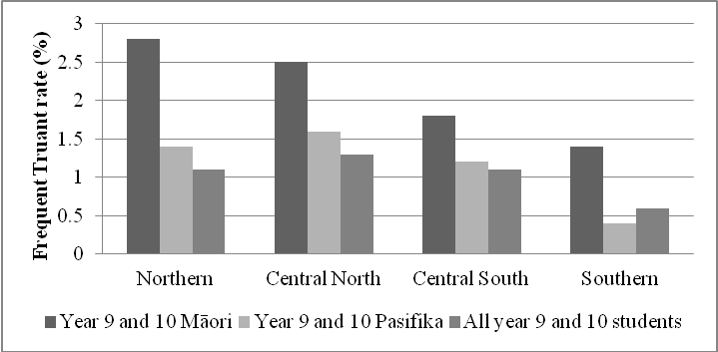

Considerations of the data

Time frame
The survey was carried out in the week of 13-17 June 2011, close to the middle of the second school term. This week was the same week of term as the 2009 survey which was undertaken during 8-12 June. By analysing data from a similar time of year, factors such as winter illness would have been at similar levels.
Due to the changes in the 2011 school term due to the Rugby World Cup, some schools were involved in school activities such as senior exams during the survey week. Some schools, particularly in the Waikato Region, may have had increased absences due to local activities such as Field Days.

Effect of the Christchurch earthquake
On 13 June 2011, Christchurch experienced a large earthquake. The earthquake struck on the first day of the national attendance survey.

During this week many students were either kept at home by parents or students were unable to get to school, therefore disrupting normal school attendance patterns. Many schools were also closed on Tuesday 14 June, and several schools had temporary closures during the remainder of the week in order for building and infrastructure checks to be carried out.

For the national attendance survey, schools that were able to provide data electronically using eAR did so. For schools participating in this way, data was analysed for the week of 30 May 2011 to 3 June 2011. This week was the first five day week prior to the earthquake (the week starting 6 June was only a four day week due to Queen’s birthday weekend).

For schools participating using the paper version of the survey, schools had the option to complete the survey for the remainder of the week if the school was open, or to complete the survey during the following week (20-24 June 2011). Several schools decided to opt-out of the 2011 attendance survey.

Due to the earthquakes, aftershocks and ongoing problems Christchurch faces, schools that participated in the 2011 attendance survey may have absences that were not typical for their school. Estimates of absence for the Canterbury region must be treated with caution.

Comparisons with previous surveys
This section outlines some of the known issues with making comparisons between this survey and previous surveys of attendance in New Zealand State and State Integrated schools.

Prior to 2009, surveys were carried out in mid-August and early-September. Due to feedback from schools, the 2009 and 2011 surveys were carried out in mid-June, when absences due to winter illnesses were expected to be lower.

The 2009 and 2011 surveys used the same instructions as the 2004 and 2006 surveys. However schools using eAR were able to provide an electronic download of their attendance data and the Ministry followed the instructions given to schools to analyse the paper forms.

Schools may interpret instructions differently, by utilising the eAR data, the calculation of absence rates is made consistent between schools. Also, if definitions of unjustified or justified absence change in the future the eAR data can be reprocessed to match new definitions.

The attendance rates calculated for this time-series are based on attendance and absence over a whole-day. The SMS systems and some international studies are based on attendance over half-days rather than whole-days. The eAR data can be processed into half-day absences, the surveys collected using the paper survey cannot.

In 2009, to reduce the compliance cost to schools, a sample of 765 schools were invited to participate in the attendance survey. Responses were received from 653 schools and absences were weighted to estimate absence rates at a national level. Due to the nature of the sample, and the number of responses from schools, some comparisons between 2009 and 2011 absence rates are not possible.

Absence rates by territorial authority (TA)

The table below shows total absence and unjustified absence in 2004, 2006 and 2011. Please note that the percentages given for Auckland are based on the old mappings for territorial authority, not the new mappings based on Auckland super city.

In 2009, to estimate national absence rates, a representative sample of schools participated in the survey. Figures by territorial authority cannot be calculated for 2009.

Territorial Authority Districts | Total absence rate (%) |  |  | Total unjustified absence rate (%)
Territorial Authority Districts | 2004 | 2006 | 2011 | 2004 | 2006 | 2011
Far North District | 13.0 | 13.7 | 14.0 | 5.1 | 5.9 | 7.0
Whangarei District | 11.4 | 12.2 | 11.6 | 4.1 | 4.0 | 5.2
Kaipara District | 10.6 | 10.9 | 16.5 | 3.2 | 3.4 | 5.0
Rodney District | 9.7 | 11.9 | 8.9 | 1.9 | 3.0 | 2.6
North Shore City | 9.4 | 10.2 | 7.9 | 2.4 | 3.3 | 2.4
Waitakere City | 10.1 | 10.7 | 9.7 | 3.4 | 4.1 | 3.9
Auckland City | 10.5 | 9.9 | 8.8 | 3.5 | 3.4 | 3.0
Manukau City | 10.0 | 11.8 | 9.9 | 4.0 | 5.6 | 4.7
Papakura District | 8.6 | 12.1 | 11.0 | 3.8 | 5.8 | 4.3
Franklin District | 9.1 | 11.1 | 10.9 | 2.5 | 4.6 | 5.5
Thames-Coromandel District | 11.3 | 9.7 | 11.7 | 3.8 | 1.9 | 5.5
Hauraki District | 9.3 | 12.6 | 12.1 | 2.8 | 4.5 | 5.8
Waikato District | 10.1 | 13.5 | 11.3 | 3.1 | 3.8 | 5.0
Matamata-Piako District | 7.8 | 10.2 | 10.3 | 1.9 | 4.1 | 5.0
Hamilton City | 9.5 | 13.7 | 11.6 | 3.1 | 5.3 | 4.4
Waipa District | 9.3 | 11.2 | 11.1 | 2.9 | 4.7 | 3.5
Otorohanga District | 7.3 | 14.6 | 10.5 | 1.8 | 6.3 | 6.1
South Waikato District | 13.2 | 13.0 | 13.3 | 7.7 | 6.7 | 6.6
Waitomo District | 9.6 | 11.2 | 12.4 | 2.5 | 2.8 | 4.0
Taupo District | 11.3 | 11.8 | 12.8 | 3.2 | 3.0 | 6.8
Western Bay Of Plenty District | 9.6 | 11.0 | 9.7 | 2.6 | 3.9 | 3.3
Tauranga City | 11.5 | 10.8 | 11.7 | 4.4 | 4.0 | 5.4
Rotorua District | 12.0 | 14.2 | 11.8 | 5.1 | 7.5 | 5.4
Whakatane District | 12.7 | 15.4 | 13.1 | 4.9 | 8.2 | 7.5
Kawerau District | 12.2 | 13.7 | 18.3 | 3.0 | 7.9 | 10.3
Opotiki District | 10.9 | 14.1 | 15.3 | 4.8 | 6.5 | 8.1
Gisborne District | 12.4 | 12.9 | 13.1 | 5.0 | 5.7 | 7.5
Wairoa District | 15.9 | 12.4 | 11.2 | 7.6 | 5.3 | 5.9
Hastings District | 11.5 | 12.7 | 10.6 | 3.4 | 5.4 | 4.3
Napier City | 11.9 | 10.9 | 9.2 | 3.3 | 3.2 | 3.4
Central Hawkes Bay District | 13.2 | 14.8 | 8.8 | 2.6 | 4.4 | 2.9
New Plymouth District | 9.8 | 11.9 | 9.1 | 2.8 | 3.8 | 3.6
Stratford District | 8.0 | 8.4 | 10.9 | 1.9 | 2.3 | 4.7
South Taranaki District | 10.6 | 10.8 | 12.1 | 4.0 | 3.7 | 5.7
Ruapehu District | 13.0 | 15.7 | 15.3 | 6.0 | 9.7 | 8.9
Wanganui District | 9.6 | 11.9 | 11.4 | 2.6 | 3.9 | 4.1
Rangitikei District | 12.3 | 13.5 | 7.2 | 1.9 | 4.2 | 2.3
Manawatu District | 8.3 | 8.1 | 9.1 | 0.6 | 1.4 | 2.4
Palmerston North City | 11.4 | 7.7 | 8.9 | 3.2 | 1.7 | 1.7
Tararua District | 13.7 | 9.6 | 12.1 | 4.4 | 2.4 | 4.6
Horowhenua District | 10.5 | 14.4 | 13.4 | 3.1 | 6.2 | 4.9
Kapiti Coast District | 9.4 | 11.4 | 12.6 | 2.1 | 3.3 | 4.9
Porirua City | 15.9 | 12.5 | 10.4 | 5.5 | 4.7 | 3.0
Upper Hutt City | 12.1 | 10.7 | 8.4 | 1.9 | 3.0 | 2.3
Lower Hutt City | 16.0 | 11.9 | 9.7 | 5.3 | 4.8 | 3.3
Wellington City | 13.5 | 10.9 | 11.5 | 3.2 | 3.1 | 4.4
Masterton District | 16.5 | 13.7 | 9.0 | 3.6 | 4.5 | 3.5
Carterton District | 11.2 | 8.9 | 8.7 | 1.4 | 0.5 | 4.4
South Wairarapa District | 14.2 | 10.0 | 15.8 | 0.9 | 0.9 | 9.9
Tasman District | 10.6 | 13.2 | 7.3 | 1.0 | 2.2 | 2.2
Nelson City | 11.4 | 14.5 | 9.1 | 4.1 | 4.8 | 3.1
Marlborough District | 12.0 | 13.0 | 10.6 | 4.6 | 4.1 | 2.8
Kaikoura District | 12.3 | 15.2 | 13.7 | 1.4 | 5.2 | 6.7
Buller District | 7.9 | 9.3 | 10.3 | 0.5 | 2.0 | 3.7
Grey District | 12.1 | 10.6 | 8.5 | 4.7 | 3.3 | 3.6
Westland District | 11.8 | 17.2 | 11.7 | 3.8 | 8.3 | 4.9
Hurunui District | 10.7 | 9.9 | 8.5 | 2.2 | 2.3 | 2.2
Waimakariri District | 11.4 | 11.5 | 11.2 | 2.6 | 3.2 | 3.2
Christchurch City* | 12.2 | 11.0 | 9.8 | 3.8 | 3.7 | 3.4
Banks Peninsula District | 13.4 | 11.2 | 7.5 | 2.0 | 2.1 | 2.8
Selwyn District | 9.6 | 12.4 | 8.8 | 2.4 | 2.2 | 3.0
Ashburton District | 12.4 | 12.7 | 11.4 | 5.2 | 4.4 | 3.8
Timaru District | 8.3 | 10.4 | 9.8 | 1.9 | 1.9 | 1.8
MacKenzie District | 5.9 | 10.1 | 12.2 | 0.9 | 2.0 | 1.6
Waimate District | 6.6 | 11.4 | 8.1 | 0.4 | 1.0 | 0.3
Waitaki District | 9.2 | 9.0 | 5.1 | 1.2 | 1.5 | 1.1
Central Otago District | 8.0 | 9.5 | 8.2 | 1.5 | 1.7 | 1.6
Queenstown-Lakes District | 6.8 | 12.5 | 7.1 | 1.2 | 2.3 | 3.1
Dunedin City | 9.6 | 11.0 | 8.5 | 3.3 | 2.8 | 2.1
Clutha District | 8.9 | 9.9 | 8.6 | 1.6 | 2.2 | 2.8
Southland District | 7.8 | 10.2 | 9.9 | 1.0 | 1.7 | 3.8
Gore District | 8.9 | 9.8 | 9.5 | 1.9 | 0.6 | 4.8
Invercargill City | 11.7 | 14.8 | 10.8 | 2.4 | 5.2 | 3.4
National Average | 10.9 | 11.5 | 10.2 | 3.4 | 4.1 | 4.0
*Figures for Christchurch may not represent ‘typical’ rates for the region. Please refer to the “Considerations of data” section for more information.

Authors:
Tracey Ryan, Research Analyst, Marian Loader, Team Leader Analysis, Education Information and Analysis, Ministry of Education
Email: tracey.ryan@minedu.govt.nz
Telephone: 64-4-463-8000
Fax: 64-4-463-8088

Published:
Tertiary, International and System Performance
Ministry of Education

ISSN 2253-2005

http://www.minedu.govt.nz/theMinistry/PolicyAndStrategy/KaHikitia/MidTermReview.aspx
Note: Year 13 includes students in years 13, 14 and 15.
Ka Hikitia – Managing for Success. Māori Education Strategy 2008-2012. Wellington: Ministry of Education.
Please note that these figures are not age standardised. Therefore, some of the differences between regions may be due to the different age distribution between regions (ie, one region may have an older student population than another).

