

Making Use?

Views on the use and usefulness of the Tertiary Education Strategy 2002/07
A report on a research contract undertaken for the Ministry of Education by Synergia Ltd

Report
Making Use? – views on the use and usefulness of the Tertiary Education Strategy 2002/07

This paper reports the results of a research contract undertaken for the Ministry of Education by Synergia Ltd. The research involved interviews with people in tertiary education organisations and some stakeholder groups on their responses to the government’s Tertiary Education Strategy 2002/07.
Opinions expressed in this report are those of the author and of those he interviewed and do not necessarily coincide with those of the Ministry of Education.
The report was prepared by:
Miles Shepheard
Synergia Ltd
PO Box 31-212
Milford
Auckland
www.synergia.co.nz
under contract to the Ministry of Education

Acknowledgements
The author would like to thank all those extremely busy people in the wide range of organisations for the way in which they gave unstintingly of their views.

Published by:
MINISTRY OF EDUCATION
Crown Copyright
All rights reserved
All enquiries should be made to the publisher
August 2006
ISBN 0-478-13549-1 (print)
ISBN 0-478-13550-5 (web)
This report is available from the Ministry of Education’s Education Counts website: http://educationcounts.edcentre.govt.nz/

Contents
1. Introduction 5
2. The intent and role of the TES 7
3. Responses to the TES 9
4. Suggested changes for the next TES 13
5. Universities 15
6. Institutes of technology and polytechnics 19
7. Industry training organisations 23
8. Private training establishments 25
9. Wānanga and iwi 27
10. Pasifika 31
11. Student associations 35
12. Business and development stakeholders 37
Appendix 1: Organisations Consulted 41
Appendix 2: Influencing a complex system: a way forward 43

Acronyms:
ITO: Industry Training Organisation
ITP: Institute of Technology and Polytechnic
PBRF: Performance Based Research Fund
PTE: Private Training Establishment
SSG: Special Supplementary Grant
STEP: Statement of Tertiary Education Priorities
TEC: Tertiary Education Commission
TEO: Tertiary Education Organisation
TES: Tertiary Education Strategy

Executive summary
This report presents the results of interviews, undertaken by Miles Shepheard and colleagues of Synergia Ltd, with key people in tertiary education organisations and stakeholder groups. The interviews covered the usefulness and usability of the Tertiary Education Strategy 2002/07 (TES) as a strategy document, and suggestions for how to improve the next TES.
- The TES was well regarded as a position paper – it is high level, unobjectionable and hard to argue with.
- The TES is generally seen as giving little sense of priorities. This limits its usefulness in decision making.
- There were few comments that suggested an appreciation of an urgent imperative for system change. Instead there were numerous comments about the need for specific changes, often expressed instrumentally as the need for more skilled people in the workforce.
- The Statement of Tertiary Education Priorities (STEP) was seen as the driver of change, largely through profiles and funding. The government’s emphasis on the STEP and profiles as the levers of change has clearly been universally recognised and responded to.
- Established organisations tend to use the TES to check that their existing policies comply and to retrofit their programmes and profiles to the funding and other requirements, rather than their substantive decision making being driven by the TES. They look to their own strategic and other plans for the rationale for decisions.
- A number of organisations which were undergoing changes found the TES particularly useful in plotting new directions, in redirecting activities and in speeding up processes of change which had been initiated under other circumstances.
- Some organisations which have previously felt that their efforts were marginalised now feel that their work is recognised. Chief amongst these are the organisations offering foundation skills.
- Māori and Pasifika interviewees had distinctive views. They strongly support the TES because they see it as greatly assisting Māori and Pasifika capacity and capability building and they believe that the TES shows the direction for New Zealand’s future. However, they expressed considerable frustration about what they see as poor implementation
- The universities, and at least one ITP, would prefer the Tertiary Education Commission (TEC) to be a positive partner and less of an adversary, and want to successfully engage, but there needs to be a way to do so consistently.
- There were many specific changes suggested for the content of future documents and for the processes involved.
- A conclusion reached is that, if the next strategy is to have real effect in creating system change it will need to:
  - articulate a vision of the desired end state in which organisations can see their ends identified with the ends of the strategy
  - articulate a change imperative and change logic, by which organisations understand what is to be done and why, and can plan their own actions
  - have a process of implementation that sends clear signals by which behaviour is moderated.
- One comment implies an alternative view – that the TES should be more clearly a government strategy, not a sectoral one: “The fact that the TES exists is possibly all that needs to occur”.

Introduction

Purpose
The Ministry of Education commissioned Miles Shepheard (Synergia Ltd) to provide this report as part of the evaluation of the TES.
The focus of this report is on the usefulness and usability of the TES as a strategy document, drawing on the results of interviews Miles Shepheard and his colleagues undertook with key people from tertiary education organisations (TEOs) and stakeholder groups. The report sets out the intentions espoused in the TES, then comments on the ways in which respondents found the documents helpful or unhelpful. The summarised interviews, arranged by group, appear later in the report.
Appendix 2 provides a framework within which one might consider the development of the next TES, and point towards ways that it might increase its impact.

The Tertiary Education Strategy
The TES is the centrepiece of a series of reforms of the tertiary education system. The role of the TES is to present a vision of the development of New Zealand’s tertiary education system and to show how this development is consistent with, and linked to, the government’s broader vision for economic and social development.
The strategy is not a ‘top-down’, prescriptive document, with detailed plans and targets. Rather, it is intended as a framework for thinking about improved tertiary education outcomes; it is expected that it will be responded to in different ways in different parts of the system. However, it is intended that publicly funded tertiary education would be consistent with the overall strategy and its goals and outcomes.
The TES is made up of six interrelated strategies:
- Strengthen system capability and quality
- Te rautaki mātauranga Māori – contribute to the achievement of Māori development aspirations
- Raise foundation skills so that all people can participate in our knowledge society
- Develop the skills New Zealanders need for our knowledge society
- Educate for Pacific peoples’ development and success
- Strengthen research, knowledge creation and uptake for our knowledge society.
Across these strategies there are 35 objectives. While the objectives are presented as relating to one of the six strategies, many of them are interconnected and overlap with key concepts in other strategies.

In addition to the strategies and objectives, there are nine key changes threaded through the TES which provide a focus on the overall changes sought throughout the system. The change messages are:
- Greater alignment with national goals
- Stronger linkages with business and other external stakeholders
- Effective partnership arrangements with Māori communities
- Increased responsiveness to the needs of, and wider access for, learners
- More future-focussed strategies
- Improved global linkages
- Greater collaboration and rationalisation within the system
- Increased quality, performance, effectiveness, efficiency and transparency
- A culture of optimism and creativity.
The TES is supported by the STEP, which sets out shorter-term priorities in more specific detail. The first STEP, in 2003, provided a breakdown of areas of responsibility for achieving the strategy, between government agencies and tertiary education organisations. The second STEP, in 2005, had a much stronger emphasis on specific priority areas.
The TEC gives effect to the STEP through negotiating charters and profiles, allocating funding and facilitating consultation and greater connectedness within the system.

Method
During April and May 2006, representatives from a sample of TEOs and stakeholder groups were interviewed. The interviews covered the usefulness of the TES and STEP and the ways in which the organisations and groups have been able to put them to use.
The small number of organisations interviewed in any category means that not all views are represented. It also means that analysis of the frequency of comment or relative strength of opinion is generally unnecessary. Where opinions were expressed by only one person, or where contrary opinions were expressed, these have been included.
A second round of interviews captured a number of views that were unavailable during the initial round, and increased the number of interviewees in some categories.
The organisations interviewed are listed in an Appendix 2.
The responses in the report are the views of the people interviewed, with as little editing as possible. The sections on changes for the next TES represent the full range of suggestions made.

The intent and role of the TES
The TES sets out to achieve several purposes. They are illustrated in the key elements abstracted below, largely verbatim, from the Minister’s introduction.
- The TES is intended as the centrepiece of a series of reforms of this very diverse tertiary education system. The role of this document is to present a vision for the development of the New Zealand tertiary education system over the next five years and to illustrate how this vision is consistent with, and linked to, government’s broader vision for the nation's economic and social development.
- The TES is about how tertiary education is going to make its contribution to realising the government’s broader goals.
- The intention here is to identify the key aspects of our tertiary education system that must change in order to make a real and substantial difference to New Zealand’s future development, and to outline strategies in six key areas in which we will need to lift our performance over the next five years.
- This TES is not about prescribing a ‘top down’ approach in a detailed manner, nor is it about a rigid plan which will describe everything the system does in the next five years. Instead, this TES is intended as a framework for thinking about improved tertiary education outcomes and a set of signals that will need to be interpreted in different ways in different parts of the system.
- The TES is one for ‘tertiary education’. It is about all learning that takes place post-school. It is as much about what happens on the job as it is what happens in universities and research institutes. It is as much about foundation education and training which bridges people into further education and training, or into a job, as it is about world-class doctoral study. It is as much about relevance as it is about excellence.
- Although this document looks to a five-year horizon, it is not intended as a static plan that will remain unchanged over the period. A key aspect of this TES is the ongoing strategic dialogue which supports it and which will ensure that it remains a dynamic and living document. Effective implementation will require a partnership between government and a wide range of stakeholders, including the sector itself, and the regions, industries, and communities that it serves.
- As these agencies and stakeholders work together to implement this TES, they will need to find new ways of working together on the key issues facing tertiary education. In many respects this process of ongoing strategy review and development, begun in the consultation workshops and to be continued by the TEC, is as important as this plan itself.
- As we work together to create the vision outlined here, we face many challenges. We will need to make some tough decisions at times. As a small nation with low economic growth at present, we will be continually challenged to do more with less and to spend the money we can afford wisely. We will face difficult policy co-ordination issues at both local and regional levels. We will be required to find a new balance between competitive and collaborative forces. We will need to balance a tertiary education system that has very successfully encouraged high levels of participation with the development of niche areas of specialisation and world class capability. These challenges are also exciting opportunities to be innovative and to improve education outcomes. By working together, by focusing firmly on the future needs of New Zealand, and by learning from our mistakes, we can create a superb and dynamic tertiary education system which will be the envy of other small nations and which will help us to secure the economic growth we need and the prosperous, confident nation and distinctive culture to which we aspire.
- The TES is a high-level document that will be supported by other documents with a shorter-term focus, in particular the STEP. These should be read in conjunction with documents which describe particular policies or instruments in more detail, such as upcoming reports on charters and profiles, funding, performance-based research, and assessments of strategic relevance.
- This TES will be a living entity, breathing life into a new set of institutions, and a new approach to setting priorities and funding learning.

Responses to the TES

General
The intention of the TES is to bring about system change: tertiary education is seen as a crucial determinant of future prosperity.
The lasting and most powerful impression from the interviews is the almost unanimous view that the document expresses the government’s purpose or vision, rather than expressing a call to action for the TEOs themselves. Except for a handful of interviewees who expressed very strong support for the TES as embodying a vision for the country, the document is not seen as expressing ‘our strategy’ to take New Zealand through the first quarter of the twenty-first century.
This perspective is reflected in the ways in which organisations make use of the TES – not as means to a greater end, but as means to further each organisation’s ends. There is no widely articulated sense that this is an overall partnership focused strategy, in which each organisation sees its future, and in which each understands the vital contribution that it makes to the progress of the whole.
This perspective is the unsurprising consequence of the process used in the development and dissemination of the TES: the draft document was distributed for comment and, despite numerous changes, the sense lingered that the government had already determined the outcome and was simply checking for potential pitfalls.
If tertiary education is an important determiner of the country’s future, then the document and the strategy development and implementation process used was simply not up to the task of bringing about its espoused system change.
That said, there are many complicating factors in setting an overall strategy for tertiary education. Organisations are concerned about their autonomy, academic freedom is a central issue for some, and compliance costs are an important factor for many. An effective sector strategy must deal with issues such as these in the development and deployment processes.

The current situation
In the interviews, there was broad agreement on most of the themes represented. However in all cases, for any perspective offered, an alternative view was held by someone.
Taken broadly, there is a general pattern to the responses.
- Established organisations tend to use the TES to check that their existing policies comply, and that current requirements for funding can be justified under the TES. They look to their own strategic and other plans for the rationale for decisions.
- A number of organisations which were undergoing changes found the TES particularly useful in plotting new directions, in redirecting activities and in speeding up processes of change which had been initiated under other circumstances.
- Some organisations which have previously felt that their efforts were marginalised now feel that their work is recognised. Chief amongst these are the organisations offering foundation skills.
- Māori and Pasifika interviewees had distinctive views. They tended to agree with others about the influence of the TES via profiles and funding. However, they strongly support the TES because they see it as greatly assisting Māori and Pasifika capacity and capability building and they believe that the TES shows the direction for New Zealand’s future.

The TES’s success in articulating a vision or end state
There is general agreement that the initial document is high level, unobjectionable, and hard to argue with. In this regard the TES is generally reckoned to be useful as a statement of positioning, inclusive of most points of view. This is both its strength and its weakness, since it does not give grounds for choosing one priority over another. It is “a good foundation that lacks the details that will give it real impact”. On this view it reflects the general aspirations of most people, but does not sufficiently encapsulate people’s aspirations that it acts as a stimulator of action.

The TES’s success in outlining the change imperative and change logic
There were few comments that suggested an appreciation of an urgent imperative for system change. Instead there were numerous comments about the need for specific changes, usually expressed instrumentally as the need for more skilled people.
The underlying change logic was recognised by most interviewees as using funding to influence decision making.

The impact of the TES and STEP
Interviewees overwhelmingly stated that the primary driver of change was through the funding mechanism – that their organisations were instrumentally driven and would react to whatever signals increases and decreases in funding sent. Some pointed out that while they would react, the real drivers for their organisations were in their own strategies. The government’s emphasis on the STEP and profiles as the levers of change has clearly been universally recognised and responded to, and has hence been very influential.
There were, however, criticisms of a too great dependence on the STEP to drive real change: “To be useful as a real strategy it would need to set out the government’s desired ends, the likely consequences of aspiring to those ends, the choices and decisions to be made in moving towards them, and how resources would be allocated to achieve them.”
In rare cases there was a close link between the TES, STEP and profile, and the core planning of an organisation. In two Institutes of Technology and Polytechnics (ITPs) everything they do at a policy and planning level link back into the high levels goals of the TES. In one they look to the STEP as a direct driver of behaviour and this has lead to the organisation changing its behaviour and has allowed and promoted changes and ultimately promoted its success.
Some parts of the TES, such as the emphasis on foundation learning and bridging education, are very helpful in justifying activities which are were already undertaken by an organisation for reasons other than the TES.
The TES is generally seen as failing to give any sense of priorities and this limits its usefulness in decision making. For some respondents, the six goals and thirty five objectives, coupled with too many supporting documents, make it difficult and unnecessarily time consuming to use. “To really understand the TES we have to be able to read each document in relation to each other”.
In his introduction (abstracted in the previous section), the then Minister set out some specific signals. Few of those signals have been powerful enough to induce marked system change. Only the TES’s broad-based view of tertiary education is unanimously recognised and widely applauded. The other signals have failed to provide drivers for system change.
The implementation of the TES – its communication and subsequent support – were often mentioned as a subject for concern. While the Ministry of Education came in for criticism, the strongest was reserved for the TEC. Frequent staff turnover as the organisation was created and built was seen as impacting the development of real expertise; the lack of influence of Pasifika staff is seen as indicative of a lack of real commitment; the monitoring and measurement tools are universally seen as insufficient.

Implications for the next iteration of the TES
There were numerous helpful specific suggestions made for improving the next TES. These are set out in the next section.
There are some fundamental implications if the continued intention of the TES is to bring about system change, aimed at making a major contribution to New Zealand’s future prosperity.
Any strategy to create system change needs, at the very minimum:
- to articulate a vision of a desired end state which has a supportive constituency, in which participants see their ends identified with the ends of the strategy
- to articulate a change imperative and change logic, by which participants understand what is to be done and why, and can confidently undertake independent actions
- a process of implementation that sends clear signals by which behaviour is moderated.
These elements are elaborated in the Appendix 2.

Suggested changes for the next TES
All of the suggested changes for the next strategy made by the interviewees are organised here by theme. The common, almost universal, suggestions are:
- Keep it short
- Be specific about what the government really wants
- Do not attempt to change direction frequently – policies and programmes take time to work.

Key characteristics
- Keep the TES relatively short, straightforward and as specific as possible
- Have a clear statement of the underlying philosophical, social and economic model within which education contributes
- Outline the goals and how they relate to each other
- Specify the outcomes the government really wants, how they will be measured, and when they are to be achieved by
- Include a greater emphasis on the relationship between communities, stakeholders, business and potential students
- Articulate the nature and contribution of different organisations
- Be sufficiently inspirational to be of use to teachers and managers
- Have as low compliance costs as possible
- Make the STEP be five yearly, with about 20 pages; two or three things to focus on
- Be less sector focused, and link the TES with the outside world.

Content
- Begin by showing what’s not working in areas, and point to areas needing focus to emphasise sustainability; sustainable ecology; and support the international emphasis on indigeneity and cultural identity
- Include an emphasis on foundation skills
- Consider our responsibilities to the Pacific region.

Sector specific suggestions
- The issues that business would like to see addressed in the next TES are: engagement, relevance, quality and value
- The TES should discuss the non-funded, non-reporting part of the system which is currently ignored, and examine where the two systems (of informal and formal education) interact to allow stair-casing
- A well-articulated funding strategy would be appreciated.

Layout
- To assist reading, use diagrammatic representation of the strategies, activities, and the linkages; develop an overall map of connections between the organisations and agencies involved; and use graphic representations as summaries of each section for quick scanning.
- The documents assume common backgrounds and understandings of terms, so definitions of, say, foundation learning, would be helpful.

Dissemination
- For the future, disseminate the document widely and make the Ministry of Education responsible for dissemination (they were thought by some respondents to have better systems and commitment), and when undertaken, talk to line staff in TEOs to judge the level of dissemination
- The TES needs to communicate down through the ranks. The Performance-Based Research Fund (PBRF) was the first instance where changes impacted on academics - it communicated the need for change more directly with people. The extent to which people need to be engaged with the TES is still unclear
- Take the TES to representative communities

General
- Instead of the TES why not have a wider educational strategy for New Zealand – link all levels of education together
- In addition to the national document, develop one that considers the Pacific region and reinforces the strategic relationships with education organisations within the region
- A final comment supporting the TES:
“The fact that the TES exists is possibly all that needs to occur”.

Universities

There is a range of university responses
There was general agreement among those interviewed from universities that the TES sets the government’s direction and is for general guidance. To this extent it is well supported. When looking to the TES for specific guidance there were very mixed responses. In only specific and limited circumstances was the TES seen as helpful in planning.

Relevance

Useful foundation at about the right level
There is general agreement from universities that the current TES is high level, unobjectionable, and hard to argue with. It is regarded as more guide and charter than strategy, letting stakeholders know the government’s purpose and focus. It is about improving the situation, rather than making substantive changes.
It was commented that the content reflects the iterative consultation process used to develop it – it includes all views gathered and, in doing so, reflects a political overlay and avoids difficult questions. An alternative view saw the content and structure of the TES as the result of an ideological debate – market driven, but controlled by government dictat.
It appears to some that the government has tended to claim a number of initiatives such as the Partnership for Excellence programme, as if they were part of the TES, despite these initiatives having independent genesis.
There is a persistent concern that the TES should not compromise organisational autonomy. Interviewees believe that the government needs to maintain care around autonomy and needs to be careful with the mindset that “government owns universities”.

What the TES is being used for and how useful it is

Generally compliance, some specific assistance
As a document that “sets out to right the ills of the nation”, interviewees thought that education’s contribution to the whole is quite well spelt out. Guidance to the sector itself is less useful, since it is unclear what specific outcomes the TES is trying to influence or change.
It was commented that there was an inherent logic missing in the strategic framework within the first TES; that it lacks the elements which would foster the making of choices and the allocation of resources. It is therefore regarded as too broad to affect behaviour. To be useful as a real strategy, the TES would need to set out the government’s desired ends, the likely consequences of aspiring to those ends, the choices and decisions to be made in moving towards them, and how resources would be allocated to achieve those ends. This level of detail is seen as necessary to achieve real outcomes and to change behaviour.
Whilst six goals are seen as useful, thirty five objectives were seen as too many to be helpful in providing direction for making choices. In addition the TES appears to ask universities to address all priorities, rather than differentiating themselves, whereas not all TES strategies apply. For example, community education and foundation learning are less relevant for universities.
The universities believe that the government tends to see the sector as cohesive, whereas it comprises a number of autonomous organisations, which do not share all interests. The TES therefore, has different levels of relevance for different TEOs.
All the universities interviewed believe that they are already doing most things for their own reasons; they have their own strategies which drive their behaviour. For them government funding is only one source of funding, and hence influence. Real changes happen at the level below the TES.
The instance cited where the TES had a more direct influence was a case where it provided a strong focus after a change of operational circumstances, providing direction for the cycles of planning which were in place prior to the TES.

Responses to the STEP
The STEP is seen as providing a more specific focus; it is taken particular notice of when funding signals are sent. In all cases the primary use of the documents, taken together, was compliance: to show that their profiles align with the TES. The interviewees unanimously believed that much time is taken up with this.
The frequency of versions of the STEP is also seen to varying degrees as a problem. Implementing strategy takes time, as does changing the direction of the planning and financial cycles. A yearly revision of the document is regarded as premature.
Despite its more specific focus the STEP is not regarded as driving the planning process, and in one instance at least, as a practical measure, the profile was developed first and then matched with the STEP. Experience in one institution showed that writing extremely explicit elements, which could be ticked as recognisable, in the TES got them through the process more quickly.
Longer term certainty of funding would be more helpful than having to constantly react to drip feeding; especially as there are 17 or 18 contestable funds supporting the areas identified in the TES.

Impact

No impact on academic matters, limited impact on research
All universities pointed out that they had strategies which preceded the TES, and that their content was generally closely aligned with the TES. Internal university documents refer to their own strategies rather than to the TES, and major institutional changes are similarly driven.
Interviewees believed that the TES has had little impact on academic decisions. Design of courses, for instance, is driven by their own needs as expressed by students, employers and others. However, these needs are similar to those expressed in the TES. For instance, a course such as a postgraduate Social Science Research Methods paper will be driven by staff and student needs. Additionally, the presence of a theme or expressed need in the TES will accord with academic decisions, but does not drive them. Other certificate level courses such as Science for Māori and Pasifika also fit, but are not driven by, the TES.
The universities believe that they have not changed their behaviour to attract financial benefit. However, funding affects some behaviour. Institutions respond to the more specific and focused signals in the PBRF – primarily ensuring that their efforts meet its requirements. As one institution pointed out, “If funding were to be withdrawn from taught Masters courses, then we would respond”.
The costs of developing portfolios add to pressures and costs. A funding anomaly clear to one institution was the way that emphasis in the TES is placed on increasing the base for Māori and Pasifika, yet, when it comes to funding, a sliding scale operates which favours postgraduate education.
TEC’s Distinctive Contributions of Tertiary Education Organisations document had the most impact on one university, where it gave a strong indication that, because of history, the prevailing thinking of the TEC and the university were out of alignment. Although the university had already begun to move in the required direction, the document proved helpful in discussions with senior staff and sped up the process of change.

Development and implementation process
The TEC set up a universities group to develop profile guidelines early in the planning process – people met monthly. It was felt that there was good discussion between universities and the TEC. However, this knowledge was lost with the high turnover of staff.
There was some tension during the implementation process. One university described how ‘the penny dropped’ as to its cause when they realised that, in the particular conversation, the TEC was concerned with teaching, while the university was concerned with its overall position and relationships.
It is recognised that there will always be things in the TES that do not apply to an institution and that there needs to be mutual understanding about what those differences are.
The universities would prefer the TEC to be a positive partner and less of an adversary and want to successfully engage, but there needs to be a way to do so consistently.

Changes suggested by interviewees for the next TES
- There is a general feeling that if the current document is taken as a general foundation document, the next edition should be relatively short, straightforward, as specific as possible and cheap to implement by way of time and expense for providers
- The next TES needs to state clearly what the government really wants, move on from the general themes of access, excellence and relevance and include the details of how the government intends to bring each about
- Given the current effort that goes into compliance the next changes should be made with as low compliance costs as possible
- A well articulated funding strategy would be appreciated
- One university expressed the concern that discussion of common indicators – indicating compliance with the intent of the TES – might result in strategic targets formally incorporated into the profile. This was seen as moving towards more prescriptive measures. They saw considerable dangers in this move: the “over regulation of the under funded” with possible unintended consequences
- The TES needs to communicate down through the ranks. The PBRF was the first instance where changes impacted on academics – it communicated the need for change more directly with people. The extent to which people need to be engaged with the TES is still unclear
- One university reiterated that the TES is important, but secondary; that their own needs dominate, and that the needs of the TEC come next. In support of the TES they commented: “The fact that the TES exists is possibly all that needs to occur”.

Institutes of technology and polytechnics

There is a range of responses from ITPs
The experience of ITPs, as expressed in the interviews, is uneven, and depends upon the growth and positioning of the institution concerned. The overall experience is not unlike that of the universities, although the specific experiences differ.

Relevance

Useful reference, varied perceived relevance
In one institution, the TES was welcomed with “here it is, we need to use it”. It has been very much a part of the planning process for that institution, enabling them to scan the breadth of its courses and look for the gaps. They commented that is also true that it has been almost impossible for them to not use it: the government has been observing them, they have special obligations to the Crown, and they were in financial distress in the recent past.
Another institution described it as a ‘motherhood’ document. They could not find anything in the TES to disagree with; however they also found it largely cosmetic, with little impact. As a ‘soft’ statement of intention and a framework for dialogue they regard it as very clear – provided there is no attempt to engage with the thirty five objectives. They do not regard it as a plan, but they would not wish it to be too detailed since they are consciously positioning themselves. They believe that their specific imperatives come from the community. The TES supports institutions in this regard in the way that it encourages institutions to respond to their community’s needs. However, it should also drive the institution’s direction and it fails to do this. It was anticipated that the TES would provide the anchor from which a strategy would develop. They do not believe that this has occurred to date.

What the TES is being used for and how useful it is

High level discussion, supports initiatives underway, doesn’t help choices
In one ITP, everything it does it links back into the high level goals of the TES. It has been referred to in staff fora as an affirming document.
Another agreed that everything they do in policy and planning is linked to the TES and the STEP. This is not because it's inherently a good thing to do, but rather, because if what they want to do requires TEC approval, they have to show how it links. “In other words, it's not that we have specific commitment to the TES and STEP, even if we agree with their thrust.”
Another institution sees a tension between top down and bottom up planning. While the TES documents show the general direction, their own profile and strategic plans articulate their particular direction. They believe that ITPs occupy a privileged position in their area and that possible changes of direction in a new version of the TES are a potential concern, particularly if it embodies threats to its autonomy.
The ITPs agreed that some parts of the TES, such as the emphasis on foundation learning and bridging education, are very helpful in justifying activities which were undertaken by the institution for other reasons. However, by the same token, because it doesn’t help them to narrow down their options sufficiently to add value, it is difficult to pick out which drivers are particularly important.

Responses to the STEP
The TES was seen by the interviewees as a high-level document – the ITPs look to the STEP as a more direct driver of behaviour. The management group of one ITP had a retreat around the STEP and then reflected their understandings and decisions back into the organisation. For this institution, the STEP has offered a good focus back to the TES. This has lead to the institution changing its behaviour and has allowed and promoted these changes and ultimately has promoted its success. This focus on the STEP and the TES has contributed significantly to this institution’s success.
At another ITP, they believe that the STEP offers support for what the institution wishes to do anyway.
Another pointed out that the current STEP has caused them to include a formal assessment of strategic relevance in their Programme Advisory Committee agenda. Each year, the committee is asked to affirm that the programme content is relevant and meets industry needs.
An ITP commented that TEC has missed an opportunity. The TES and STEP seem to have encouraged the TEC to consider itself the policeman, to adopt a one-size-fits-all approach to documentation (in which guidelines on content, criteria and assessment emphasise contribution to the TES and STEP), and to make the processes essentially application-based (i.e. submit the work for approval in order to get funded). They have therefore missed the opportunity to adopt the view that TEC and TEOs are inextricably linked in the drive to achieve the government's goals - that they need us as much as we need them - and to practice more collegial working.

Impact

Varied experiences
In one institution, the TES provided a framework and template which has been a very effective planning tool. In another, it has had no real impact, except for its influence in the process of obtaining funding.
Despite the usefulness of the STEP to one institution, it felt that there has been policy development ‘on the hoof’. The clarity about intentions and detail that is critical to change is missing.
One institution noted that while it has worked hard to be in-sync with the TES, an analysis had suggested that it is not aligned.
Another institution was not sure that the central agencies had an understanding of the complex dynamics in the education sector. For example, the institution responds to the community’s demand for a course or recognises a need in the community for a short course. It then explores the logical fit with the TES. However, even where it fits, a course is often not funded. There is some concern in that institution that while it has grown out of the community and had a strong base in educational centres, this base has been lost as the institution works towards its new role inside the TES. Like all the other institutions, planning is driven by funding. The CEO reflected that the factors affecting successful funding, such as “greater alignment with national goals” and “effective partnership arrangements with Māori communities”, will be the drivers, but that the link within the TES document may be somewhat lost.
One institution pointed out that a consequence of the lack of a concrete strategy has been a plethora of pilot schemes with few generalisable outcomes attached. Consequently pilot follows pilot, rather than finding ways to build them into core business. Such pilots do not amount to a policy framework.

Development and implementation process
The ITPs would appreciate broader consultation and over a longer time – “the short period increases the likelihood of unintended consequences”.

Changes suggested by interviewees for the next TES
- Be specific, yet not limiting; make better connections to other government policies
- One institution believes that they will use the TES into the future. It is satisfied that the TES need not be any more specific than it is, since it wishes to maintain its flexibility in the world it operates in, especially in relation to cultural alignment
- Another argues that it is now time to become more specific – to define such notions as ‘network of provision’ and to then drive discussion about the perennially difficult problem of how to measure success. They believe that it will then be possible to consider what data will be needed and how it might be used. It is also time to set targets in order to bring focus to key areas
- A concern was raised that, although the TES was a good start, it is not linking well with other bodies of government and therefore updating the TES is timely. They believe that there is a need to articulate how the TES fits with, and contributes to, the greater policy matrix of government, since there appear to be contradictions. An example was given of an apparent national – regional conflict, where two policies seem to have conflicting implications: the government’s digital strategy supports home-based education through computers, however in their experience, the TES did not. In these circumstances, they believed, the TES limited the institution’s offerings to its prospective students and limited its growth
- As an important contributor to economic and social policy, the TES should be strengthening its contribution to social initiatives such as sustainability
- The TES is the framework for planning into the future: the government should be driving the strategy.

Industry training organisations

Mixed views: varied support, irrelevant for most
Industry training organisations (ITOs) are diverse, and their responses to the TES documents reflect both some inherent similarities and some aspects of this diversity.

Relevance
Most ITOs indicated that they did not find the TES very useful at all. While they are supportive of legislative prescription, some mentioned that they are not well disposed toward ‘social engineering’. Most considered that the quality of their training was driven by the business plan rather than from a strategy direction.
One ITO, on the other hand, offered a contrary view, considering the document to be liberating and providing a framework across their business.
Another considered that the profile was useful, permitting the overt inclusion of such issues as iwi fishing ventures, literacy issues and other ‘social engineering’ matters that are difficult to attract industry funding for. Another strongly agreed, citing literacy and Māori and Pasifika initiatives.

Responses to the TES and STEP documents
One ITO expressed disappointment with the most recent STEPs, pleading that they lacked the simplicity and logic of the original offering.
Concern was expressed about shifts in resources without regard to the impact on industries. And it was noted that there is an apparent disregard of increasing compliance costs.
The ITOs were of the opinion that the TES documents need to take account of the fact that the audiences are quite diverse – that ‘industry participation’ is somewhat different from the method of management of an educational organisation. Documents that suit an educational organisation do not necessarily suit industry. “While industry is fully supportive of the goals of accountability there is a clear need to be able to establish and report these in a much more user-friendly manner than at present.”
There was a plea that the next version should be enabling rather than prescriptive and one ITO was concerned at the lack of feedback on the implementation of the TES. They would like to know whether the combined efforts are achieving the desired results.

Changes suggested by interviewees for the next TES
- Make the statements five yearly and have less in them
- Develop a really clear statement of the underlying philosophical, social and economic model within which education contributes
- Articulate what outcomes the TES is expected to achieve, how they will be measured, and when they are to be achieved by. There should be an explanation of how the goals relate to each other, so that judgements can be made.

Private training establishments

Mixed views, but documents generally unclear and difficult to use

Relevance

Relevant, but lacking rigour
Interviewees from private training establishment (PTEs) believe that the TES is relevant, but found that thirty five objectives mean that there was no sense of priorities or where to enact them. They regarded the documents as ‘government wish-lists’, with little follow through and no associated resources or commitments. For them, the documents lacked clear focus on what is important, namely congruence and accountability. “They are nice looking documents with too little direction and lacking rigour, and so there is no supporting logic and focus.”

What the TES is being used for

Policy, funding, influencing
One organisation uses the TES for developing policy and influencing providers of specific courses, not for delivery, and to develop the charter and profile. The strategies are also used as the basis for lobbying: ‘Our work is contributing to …” (but with little success).
The organisation is continually looking to see where the government is promoting or espousing changes that the workplace might be interested in. They pay particular attention to government signals; however the STEP and the TES have lost currency with them in the face of recent government action. The TES is used as a founding document, providing a framework to work with specific providers – to check what they do and articulate their needs. The organisation’s funding is programme, not student-based, and the documents are not helpful for developing contracts, developing networks or taking action.

Impact

Some impatience with the document and government support for important parts of it
For one organisation, Strategy Three (foundation skills) is particularly important. However, although the documents espouse the strategy, there are no resources and little is said on resource allocation. As a result, enactment is difficult. In combination, the documents do show an espoused urgency and concern for foundation learning, but the TES itself does not do so.
The same organisation believes that it is working in areas at the core of the TES: “Depending on how you view our contribution to education, you might say that we contribute to 90% of the document’s intent or to one or two areas.” Because of this, the organisation needs to use all the documents in order to make sense of the TES, and in order to make the best representation for funding. This made it very time consuming and difficult, as they could not construct the profile by reference to any single document, although the STEP helped.

Development and implementation process
The consultation process was backwards – the TES developed and then opinions sought.

Changes suggested by interviewees for the next TES
- Begin the next document by showing what is not working in areas, and point to areas needing focus - it is better to have two or three things to focus on.
- Set out how organisations are to carry out what is needed.
- To assist reading use diagrammatic representation of strategies, activities, and the linkages; develop an overall map of connections between the organisations and agencies involved; and use graphic representations as summaries of each section for quick scanning.
- The documents assume common backgrounds and understandings of terms, so definitions of foundation learning, for example, would be helpful.

Wānanga and iwi

Good start, needs work
Interviews were conducted with representatives of both wānanga and iwi. Both see the overall TES differently from many other organisations – they see it as a vital social and economic mechanism, rather than as simply a guide to the delivery of educational programmes.

Relevance

TES is important for the future
The TES is seen as a useful foundation document, which looks at New Zealand as a whole. It can be read in a number of ways - as aspirational, as a contribution to the discussion about national identity or as a guide to the provision of practical programmes which assist Māori. The intent of the TES is seen as good, and it sets out its arguments well, however, for a number of reasons, its practicality is limited and it is not taken as guidance.

What the TES is being used for and how useful it is

Capacity, capability and social development
The interviewees stated that the TES delivers a strong message of support for Māori development and advancement through Strategy Two which Māori would not want to see lessened.
There is considerable support for a number of themes in the TES. Supporting effective partnerships with communities is seen as central to the nature of the contribution of wānanga. Other, inter-organisational partnerships also need nourishing, and the nature of these relationships between different organisations needs greater definition and refinement, particularly the role and contribution of each.
Building capacity and capability, particularly leadership, was acknowledged by interviewees to be especially important. Māori concepts have a place in the TES. Wānanga are refining the symbols and their contributions to national identity – haka, dress, health and so on.
In relation to the TES’s emphasis on social development, it was commented that attention should be paid to and cover the widest possible range of needs. But it was also acknowledged that a broad view could lead to the neglect of some important areas through a lack of focus. The TES is therefore seen as the basis of a good system, but the practice resulting from it is regarded as nowhere near fulfilling the aims of the TES.
The translation from conception to execution has proven frustrating for those interviewed. The need for and purpose of change are well understood, however, the approach to change, within which the TES sits, is unclear and frustrating. The lack of policy drivers and funding incentives or disincentives has led to apparent slowness and rigidity in policy development, and consequently some useful established programmes have been left without policy or funding support; some innovative thinking has been allowed to dissipate.
Further, the TES is seen to be required to rationalise why a delivery proposal should be funded rather than the proposal being supported for its strength of evidence. It was commented that there is a blur between overall outcomes, intermediate outcomes, and a lack of clear connection with outputs - delivery proposals and related interventions. Interviewees argued that there is a short-term focus on accessing funds, rather than an emphasis on the articulation of defensible connections between delivery proposals, inter-organisational propositions and strategic intent.

Impact

Poor implementation
Interviewees argued that the impact has been variable. Māori organisations have been working on Strategy Two long before it became a strategy. However, the TES has had a positive impact in some specific areas, outlined below. In other areas, despite the parameters, priorities and expectations being signalled efficiently, and despite clear signals of change being visible, it is perceived that government agencies lack the ability to work through the transitions and to demonstrate changes in their own behaviour and engagement with sector organisations.
There are examples of instances where the TES has had an impact on academic matters through its support of innovative efforts. For example, the results of research on e-learning in Māori families, and on the relationship between e-learning and success rates, have influenced the selection and structure of some courses. In one institution every person enrolling to do a foundation course must purchase a laptop or PC for the home. These moves would probably have taken place without the TES, but the thinking that supports this is important, and the results will have a powerful effect on change in the homes affected. There are other good programmes that are working well but these are not being supported by the TES.
Administratively, in terms of impact, it was acknowledged that staff are probably unaware of the TES, but that it is used in planning and in seeking finance. STEP revisions are seen to come too often – a three-year certainty of funding would definitely be more stable.

Issues
There were a number of issues mentioned which were seen to touch on the relationship between wānanga and the TES. Most are relevant to all New Zealanders.
- There are important questions for the future which have implications for the TES: the place of New Zealand in the world, how New Zealand innovations can be useful to others – particularly in areas of importance to New Zealand: ecological sustainability and our role in kaitiakitanga (guardianship of natural resources); pollution; forests; power; water
- The three wānanga are working at the social development level; and working on social development with other indigenous people throughout the world
- The continuing place of the Treaty of Waitangi in the TES is important. More knowledge of the Treaty is needed and how this learning fits in with foundation level studies. There are two important aspects: public understanding and an increase in knowledge in the governance of organisations
- The inclusion of literacy and foundation learning in the TES not only recognises a crucial need, it expresses the political will to address it. It has brought into public discussion fundamental issues such as who decides what is relevant; who decides what counts as relevant learning to an individual; and who pays for what
- The connection with the labour market will be an increasingly important part of the next few years’ development
- There is a need to think regionally about community needs within the TES, for example, the different needs of Māori in the North versus the South Island
- Māori providers need to think through the process of engagement with the TES, in order to achieve the desired outcomes.

Changes suggested by interviewees for the next TES
- The next version of the TES should emphasise sustainability, sustainable ecology, and support the international emphasis on indigeneity and cultural identity
- It should consider our responsibilities to the Pacific, rather than simply attracting Asian students in large numbers
- It should be sufficiently inspirational to be of use to teachers and managers
- There should be a greater emphasis on the relationship between communities, stakeholders, business and potential students; and the nature and contribution of different organisations should be articulated in the TES
- Practically, there should be much greater attention, visibility and reference to the nature and extent of the policy and funding settings which are expected to give effect to the TES.

Pasifika

Good start, poor implementation
As with Māori, the overall TES is viewed differently by Pasifika – as a vital social and economic mechanism, rather than simply as a guide to the delivery of educational programmes.

Relevance of the TES

It gets us to the top table
The TES is viewed as positive for Pasifika, giving useful guidance and having an impact on behaviour.
First, interviewees saw the TES as putting a stake in the ground, in order to bring cohesion to the direction of New Zealand education.
Secondly, it was felt that the needs of Pasifika are understood at the top level of government and are expressed in some fashion in the TES. This has brought about a shift in the TEOs’ approach to Pasifika. For the first time, Pasifika are looked at in the context of strategic leadership – and the common recruitment and liaison roles are now seen within a leadership context. The TES mandates Pasifika expertise to contribute at a strategic level, and several institutions have responded: AUT, Massey, Victoria and Unitec all have senior management Pasifika positions. Massey has added a professorial mandate to their senior Pasifika position.
Thirdly, the TES has wide implications for the economic, cultural and social development of New Zealand, so it is important that the Ministry of Health, the Ministry of Social Development and other agencies are also a part of improving the educational framework of New Zealand.

What the TES is being used for
Interviewees reported that as a whole TEOs are using the TES to develop their organisational profiles and orient their charters. This is an improvement. The fact that there is a TES to be referred to has been a big step forward, and has allowed many Pasifika organisations to link into funding opportunities.

Impact

But the door has opened enough for only a foot
It is felt that there are a number of TEO responses to the TES which, taken together, have prevented the concepts in the TES being translated into reality.
Whilst the TES priorities are clear, it is difficult to measure the spirit of intent within a TEO. It is felt that the words in many TEO profiles reflect the TES’s intent, but that their actions do not reflect them. The cultures of some organisations drive claims made about the numbers of Pasifika students and their response to Strategy Five. In reality, it is a desk exercise and they are struggling to meet their obligations.
In some organisations, positions are simply documented: there is a paragraph in the charter or profile referring to Pasifika, and the organisation believes that it has fulfilled its obligations to meet the TES’s requirements. In other organisations, resources available are insufficient to provide really tangible support.
The TES seems not to have been disseminated very well through the networks of government, as there appears to be considerable divergence within government organisations. Interviewees commented that even the Ministry of Education and the TEC, which are seen to have an obligation to build their own capacity in order to respond to and assist the sector to be responsive to Pasifika needs, have shown few signs to them of capacity building. It was noted that the TEC had increased its Pasifika staff capacity through establishing Pacific Senior Advisor positions. However, it was felt that the TEC did not give due recognition to advisors’ expertise in contributing advice at a senior management or strategic level. These positions appeared to be there only to manage community engagement with PTEs and ITOs.
Many Pasifika people are frustrated that although the documents signal intent – promoting higher education for Pasifika communities – they fail to say what that translates into for communities or for tertiary organisations, and so makes giving substance to the intentions expressed very difficult.
The TES has also not been well communicated to its target audience. Pasifika people need time to digest the TES in a way that is Pasifika: ‘community ownership is the way to move forward’. The fact that little responsibility seems to have been taken for the dissemination of the TES into the Pasifika community is seen by the interviewees as a further commentary on the lack of commitment of the Ministry and TEC.
Taken together the comments above explain the mixed feelings Pasifika people expressed.
It was recognised that it is difficult to insist that TEOs respond to the TES – the TES itself cannot bring about such changes. It was suggested that how organisations’ responses to the TES are reviewed and measured might make a difference: if the numbers of Māori and Pasifika graduates were published, along with other enrolment and attainment statistics, then families and communities could judge which organisations were most suitable for Pasifika students.
The view prevails that the STEP has not been well promoted, but when read is very clear. It was pointed out that the difficulty is less the clarity of the document and more getting the document to the people and getting the people to read it. Publications can be hard to digest and this is a skill in itself, which some people in the community are good at and others are not.
There are some perverse, but not unexpected results. Funding is driving behaviour – “here is a nice course, now we will consult with the local Pasifika liaison person”; “providers are looking for a rubber stamp, rather than consulting stakeholders within the community”. This has been driven by a focus on enrolments and not on community needs. Potentially, it becomes a ticking-the-box exercise for funding, with the result that courses are available and people are not attending. Because funding is the driver rather than the TES and because the results are not always useful, there is an expressed view that there needs to be a different way of funding courses for Pasifika that allows everyone to participate and feel comfortable.
Pasifika people are very concerned that courses should be developed with the community in mind. They wish to learn new and innovative ideas; however courses delivered in traditional classrooms can be threatening and jeopardise engagement. Different venues and the use of Pacific languages is very important if Pasifika people are to take maximum advantage of the opportunities.
It was suggested that understanding of, and engagement with, the TES and Strategy Five is a lot stronger in the North Island than in the South.
A specific concern relating to the security of tenure of Pasifika liaison people were mentioned. The Special Supplementary Grants (SSGs) enable the employment of a Pasifika liaison officer. A perceived weakness in relation to the SSGs is that institutions turn a blind eye to, or do not understand, that the fund is a supplementary grant. This means that its purpose is to assist the institution to establish support initiatives with a view to making them an entrenched part of the support landscape, and more importantly part of its core budgets. Too often, institutions renege on their responsibility to fully resource and fund initiatives because of the SSGs. If the SSG funding goes, so will the liaison officer.

Development and implementation process
The manner of the development of the TES was criticised. The initial draft included no reference to Pasifika - only when a Senior Policy Advisor at Ministry of Pacific Island Affairs managed to get that Ministry behind a push to have a Pasifika-specific reference in the TES was there a nationwide consultation process and subsequent mention of Pasifika in the TES.
Pasifika people wish to be engaged at the outset and then move forward with the TES. “Consultation does not mean flying people from around the country to give a head nod to something that is already written.”

Changes suggested by interviewees for the next TES
- For the future, disseminate the document well and make the Ministry of Education responsible for dissemination and implementation (they have much better systems and commitment than the TEC), and when undertaken, talk to line staff to judge the level of dissemination
- Take the TES to representative communities
- Publish the numbers of Māori and Pasifika graduates for each TEO, along with other enrolment and attainment statistics
- There should be a continual emphasis on foundation skills in order to create a love of learning
- Instead of the TES develop a wider educational strategy for New Zealand – link all levels of education together.
- In addition to the national document, develop one that considers the Pacific region and reinforces the strategic relationships with education organisations within the region
- Strategy Five needs strengthening, it needs to specifically discuss the business and social responsibilities towards Pasifika assumed in the TES
- It would be useful to refer to the international educational opportunities New Zealand has and the encouragement of good thinkers in the New Zealand education system
- Broaden the TES to take into consideration cultural and social impacts on society
- There needs to be a way of funding TEOs that are genuinely engaged and satisfying community needs, rather than simply meeting TEC requirements.

Student associations
The New Zealand University Students’ Association had an expectation that the TES would lead to a superior, affordable, accessible and high quality public tertiary education system. The Association views quality teaching and learning within the public tertiary education system as important and believes that the tertiary system must promote excellence in skills, sound and contemporary pedagogical methods that are learner centred, and high quality research and scholarship.
However, since the TES was published, the Association believes that the public tertiary education system in New Zealand has barely moved in the direction that was hoped. While the TES’s broad-based view of tertiary education is meant to have led to a far more co-operative tertiary sector, that seeks to bring about a range of positive social and cultural outcomes, signals have failed to provide drivers for change. More specific and measurable goals and outcomes need to be signalled within the TES and STEP.
The Association suggests that the TES may be too broad to affect behaviour and should include a greater level of detail in order to achieve real outcomes and to change behaviour. The government needs to make sure that tertiary institutions give the TES far more attention.
The Association believes that tertiary institutions need to make use of the TES and STEP documents in more collaborative ways. It seems that tertiary institutions are using both the STEP and TES in varying ways. Instead of recognising the importance of both documents when engaging in the institution’s planning process, the two documents are often used in isolation from each other.
The TES placed a lot of emphasis on the tertiary education system meeting and serving the needs of the economy and business. However, when consulted on the draft Strategy previously, the Association made it clear that they believe that post-compulsory education is simply not just about employment, strict economic benefits or the education system simply serving the needs of business. Instead, the Association believes that public tertiary education has the power to not only transform the lives of, and empower individuals, but also to change our society for the better and improve participation in our democracy. The Association believes that open access to tertiary education is imperative to further increasing participation in quality higher education, and there is a correlation between higher tertiary participation and positive social and cultural outcomes. The Association see tuition fees, student loans and lack of access to student living allowances as barriers to broad-based tertiary participation.
While the TES outlines the need for a more co-operative and equitable tertiary system, the Association does not believe that the TES has brought about the social and cultural outcomes that were in anticipated in the time frame intended. Statistics reveal that there is significant unequal participation at varying levels of the tertiary sector. In recent years, there have been continued tuition fee increases, particularly at the bachelor and postgraduate level. The Association believes the government has failed to provide adequate student support for all students, while levels of student debt increase. The Association believes this has had a more negative impact on women, Māori and Pasifika graduates. In light of the tertiary education policy context that currently exists, the Association sees a clear contradiction in what the government aims to achieve through the TES while allowing market-based and user pays tertiary education policies to continue and remain within the public tertiary education system.

Business and development stakeholders

Relevance to organisation

From irrelevant to helpful, but lacking impact
From a general business perspective, the TES was seen as positive: it tends to be long, although well written, clear and with a good message. By comparison the evaluation and measurement section looked like an afterthought and was disappointing.
They found the TES, in its present form, to be inaccessible for most business people: too many strategies and objectives, making it hard to get a sense of priorities. What business is looking for in the TES is recognition that business is a valued stakeholder for tertiary education: that key stakeholders are students, staff and employers.
Most business stakeholders see the TES as designed to steer the system, to depict the system’s parts as a whole, with government actions set up as markers. However, without real funding changes it has not become an integrated system, and is not collaborative. Because funding drives behaviour and some TEOs exploit opportunities, the government has been forced to make ad hoc interventions.
In the view of one association, the only usefulness of the TES is as an overarching framework and an expression of the government’s views. In its view the TES has had almost no impact and the case studies are superfluous. They believe that the TES has nothing to do with community views, having been developed by the Ministry and officials, who imagined that writing a tertiary education strategy would make it happen. Compliance and justification drive all efforts to use the TES, and what has to be done to get the money determines the relationship to the STEP. In addition, they believe that the stated objectives have not been supported by further government action.
Another organisation saw the TES as a statement about what government believes is valuable. It believes that the TES sets the context for trends, providing a starting point for conversations and for outlining general points about what the government wants. In one sense it can be used to hold government to account. However, because it is so inclusive it does not offer or set direction. They argue that much of what it contains will be superseded by fiscal changes, Treaty claims, lawsuits and so on – not driven by strategy.
The TES includes some clear messages about building stronger linkages with business, including, albeit brief, material on bringing a workplace component into courses and more mobility of skilled people between businesses and the tertiary system. However, from businesses’ perspective, the messages are diluted because innovation is listed in the purposes of education after such aspects as social and Māori development. The emphasis seems wrong to them and there is no mention in the purposes of meeting business needs and addressing skill shortages. It is a question of emphasis and prominence in the strategies themselves.
In Strategy One – on system capability – there is talk of learner and wider public confidence in the quality of the system. Interviews saw this as a missed opportunity to talk specifically about business confidence in the system. Because business ultimately employs graduates, specific mention of business here makes more sense than lumping them in with the wider public. Linkages with business in the TES are very good in specific sections, but not overall. The TES should be a tool to send the message that links with business are not just through vocational courses.
Strategy Four – on knowledge, society and skills – was seen as the strongest part of the document for business: matching skills with need and focusing on both generic and specialist skills.
Strategy Six – on research and innovation – seems rather too introspective for business, but they welcome objective thirty four, the commercialising of research.
The monitoring and evaluation system, as set out in the TES document, is seen to be inadequate. The system would be strengthened by input from employers, which is more than simply graduate destination surveys. Businesses want to see measurement of outcomes – not just of those things that can be readily measured.
An interesting aside made by one interviewee was that the TES used the term economic transformation long before it became fashionable.
From the perspective of regional and local economic development, the challenge is to build capability and fill skills gaps. The TES is seen as a good document, glossy and sensible, and setting direction, but there are a number of elements missing: it does little for Māori and Pasifika people. It is missing the last chapter – what, who, when, milestones and how to measure the results. The focus is too broad for the purposes or regional and local economic development.
The focus of people engaged in regional economic development is immediate: what they need to know is – what’s available, where to go, to whom, and how to fix things. The focus of the TES is so much broader than this that it is of little help in assessing assistance to fill skill gaps. If the skill and infrastructural needs and the blockages were clear, then it would be possible to work more usefully with government.

What the TES is being used for
All of those interviewed thought that the TES and accompanying documents are largely used by TEOs to secure funds.

Impact

The views are mixed: perceived winners and losers
In the view of one business stakeholder, the documents demonstrate the government’s antipathy to private provision of education. TEC’s Distinctive Contributions paper sent the message that PTEs were regarded as filling niches in the market. This recognised their position in the system, but marginalised them.
This stakeholder believes that the latest STEP has had some influence, not necessarily for the better. They point out that the measurement criteria for PTEs – student completions, pass rates, students getting jobs etc – set a harder test than is applied to, for example, ITOs. The private sector is thereby held to a higher standard than the public sector. They believe that unless dollars are tied to the TES it is not much help.
One association regards the charters and profiles as a waste of time, with only compliance value. Since there is no analysis of them by the TEC, there is no learning either inside TEC or back into the sector.
In the view of another association, the inclusion of ITOs and the roles they play in the TES is in accord with the government’s emphasis on the economic importance of skill development. It also ensures that these organisations do not take too narrow a view of their role, and hence that their profiles reflect the STEP. Specific comments in the TES about such aspects as the need for collaboration have made a difference to the views taken by providers. However, because the documents stay at a general level and do not specify detail they lose value. There is the feeling that the government tried not to offend anyone. Some consequent decisions have nothing to do with the TES or STEP, but with rectitude.
In one association’s view the STEP allows the story to be told of the need for numeracy and so on. It illustrates that officials heard what stakeholders and providers said and caused a useful debate about meaning. However, they have a number of concerns. They do not approve of the ideas about stair-casing. They pointed out that higher levels of qualification do not equate to a higher level of skills available in the workforce. As more people undertake workplace training, so the numbers of certificate (but not necessarily skills) will increase. In their eyes it is unfortunate that informal learning practices are ignored in the measures and funding.
Unusually, the frequency of the STEP was not seen as an issue.

Changes suggested by interviewees for the next TES
- Articulate what outcomes the TES is expected to achieve, how they will be measured, and when they are to be achieved by
- A new ‘imperatives for change’ section would give a sharp start to the document
- There should be an explanation of how the goals relate to each other, so that judgements can be made
- The TES should discuss the non-funded, non-reporting part of the system which is currently ignored, and examine where the two systems (of informal and formal training) interact to allow stair-casing
- It would be useful to know how the TEC is now engaging with other agencies to help develop and deliver the next version
- Less sector focus would be useful, linking strategies with the outside world
- The specific issues that business would like to see addressed in the next TES are: engagement, relevance, quality and value.

Appendix 1: Organisations Consulted
This appendix lists only the organisations that participated in interviews and/or provided comment on the report. A number of other organisations were contacted for interview or comment and expressed interest, but in the end did not participate.

Universities
Auckland University of Technology
The University of Auckland
The University of Canterbury

Institutes of Technologies and Polytechnics
NorthTec (Northland Polytechnic)
Manukau Institute of Technology
Tai Poutini Polytechnic

ITOs
All ITOs were canvassed directly at an Industry Training Federation meeting

Wānanga and iwi
Te Wānanga O Raukawa
Te Puna Mātauranga o Whanganui
Te Tapuae o Rehua

Pasifika
Pacific Island Tertiary Providers of New Zealand (PITPONZ)
Centre for Pacific Development and Support, Unitec

PTEs
Literacy Aotearoa
Workbase
Independent Tertiary Institutions (ITI)

Stakeholders
Business New Zealand
Economic Development Association of New Zealand

Schools
Discovery 1 School

Student associations
New Zealand University Students’ Association.

Appendix 2: Influencing a complex system: a way forward
The TES sets out to change the system by way of a ‘strategic learning’ strategy. It seeks to establish a platform for distributed learning and distributed leadership, rather than using a content-based strategy which provides a mandatory direction and thereby elaborates the obligations of each participant in the system,. It seeks in this way to influence the platform building by others, allowing each participant to develop according to its own terms, to sometimes lead and sometimes follow. It attempts to influence and support emergent activities undertaken by various and varied educational organisations in their own interests, but in accord with the general direction laid down by the TES. Such a strategy is successful to the extent that actors identify to a greater or lesser extent the interests of the whole system with their own.
Influencing a complex system in this manner takes considerable time, and the influence of multiple interventions and multiple actions by a multitude of players. In such situations the strategies themselves are insufficient instruments of change: they depend on building effective supportive contexts inside which they can provide direction and support. Such supportive contexts occur most usefully where all participants in the system are seen as each contributing usefully to the whole; where interests are not assumed to be antagonistic unless they can be shown not to be contributing to the development of the whole.
One perspective, briefly outlined below, highlights the types of intervention and their place. It is a variation on David Kolb’s Learning Cycle.
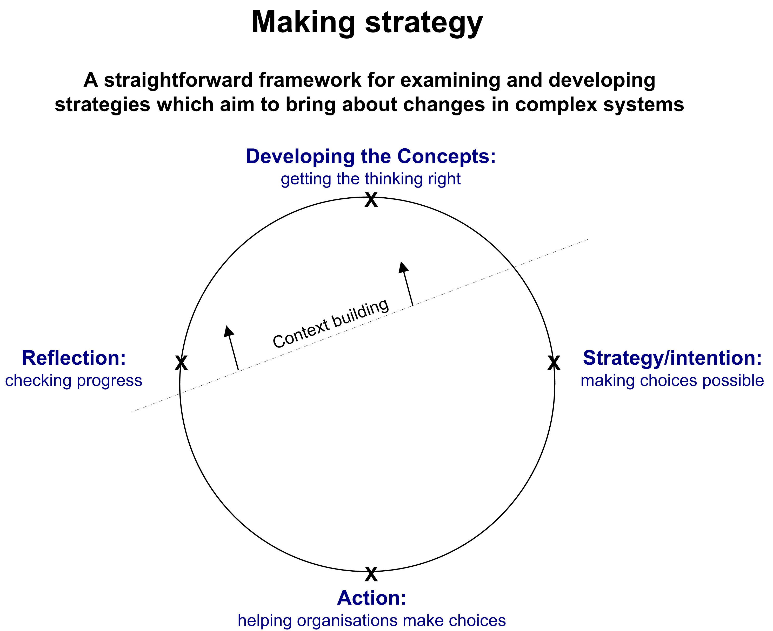

In this model there are four stages:
- The development of the concepts: getting the thinking right
- The articulation of the strategy and interventions: making choices possible
- Taking action: helping organisations to make their choices
- Reflection: checking progress and improving the strategy
The cycle is iterative and only initially linear, feeding on the knowledge and commitment developed at each stage; the stages themselves tend to have somewhat fuzzy boundaries, overlapping in useful ways.
At each stage, building the context within which the strategy can be successful is as important as the focus on the implementation of the strategy itself.
There are common elements across all stages:
- Influencing thinking as a reciprocal process involving many parties
- Involvement of a broad range of parties together in investigating ideas, in learning and building common understanding
- Testing ideas, sharing experiences of success and failure.

Stage one, developing concepts: getting the thinking right
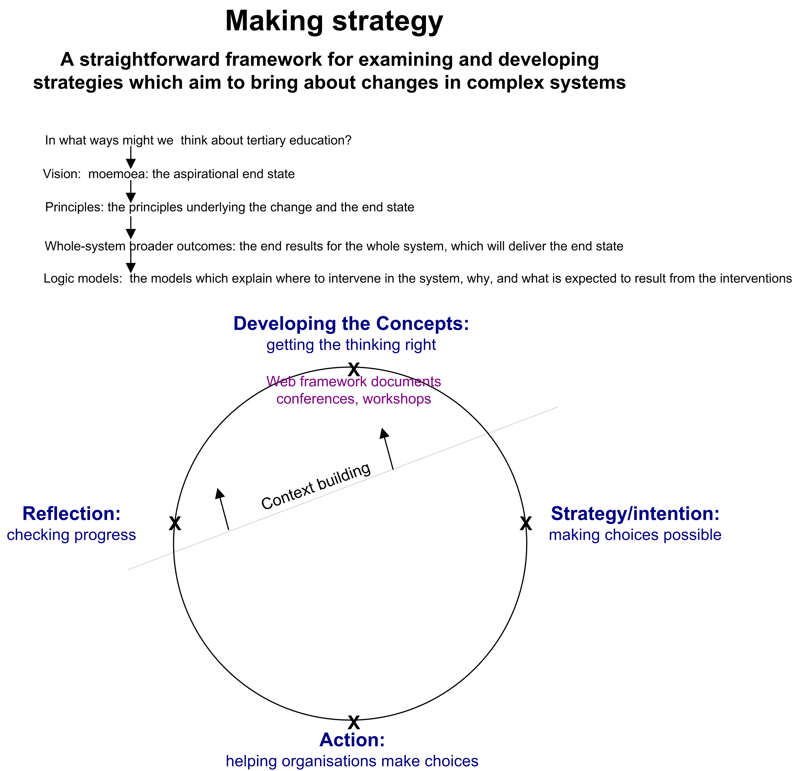
The two critical tasks in this stage are getting the thinking right and building shared understanding. The latter is achieved largely through genuine involvement in the former. There are numerous ways to think about tertiary education, each offering a partial view, each adopted by groups with different interests. Discussion of these ways of thinking provides a starting point for reflection about the whole system, its ends and its constituent parts.
Building a successful constituency for change depends on developing the participants’ understanding, general agreement and commitment to a number of key elements:
- to the vision, or satisfying end state (a moemoea, or dream, of a successful future)
- to the principles underlying the change process and the end state
- to the broader system outcomes, within which they see the achievement of their own interests
- to the logic providing the rationale for interventions and changes
- to understanding and appreciating the diverse contributions to the whole made be the range of participants in the system.
Broad-based engagement in consideration of these elements and articulation of the interests which together constitute the whole is a powerful contribution to getting the thinking right.

Stage two, articulation of the strategy: making choices possible
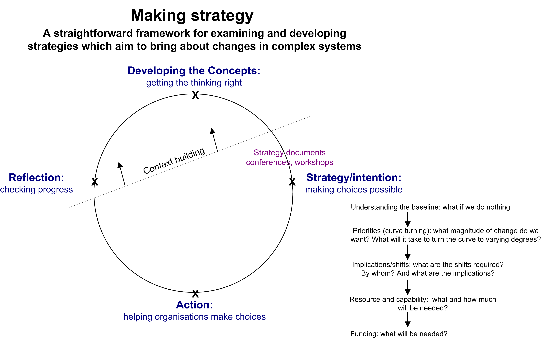
A learning-based strategy depends initially on the ability of parties to sufficiently identify their interests with those of the whole system that they are willing to engage in the process of change. However, translating espoused willingness into action requires quite specific knowledge to support the kinds of distributed leadership and decision making that will be required.
- understanding the whole system’s baseline performance: what will happen if nothing is done
- understanding the magnitude of change needed. What will it take to turn the curve from its current path to the desired direction? What then are the priorities that will give momentum to the turn?
- developing and understanding the intervention logic which will provide the rationale for specific changes and point to their intended results
- elaborating the implications for the whole system and for the various participants in it under a number of curve-turning scenarios
- determining the (minimum) resources required – for the whole and the parts, and the potential sources
- developing the several strands of activity and innovation which might be pursued simultaneously, and understanding what conditions will encourage success.
The properties of the system which emerge as participants take action cannot be accurately predicted. However these properties, if fed back into the ongoing discussions and reflections, powerfully affect the ability of participants to contribute successfully.

Stage three, action: helping organisations to make choices
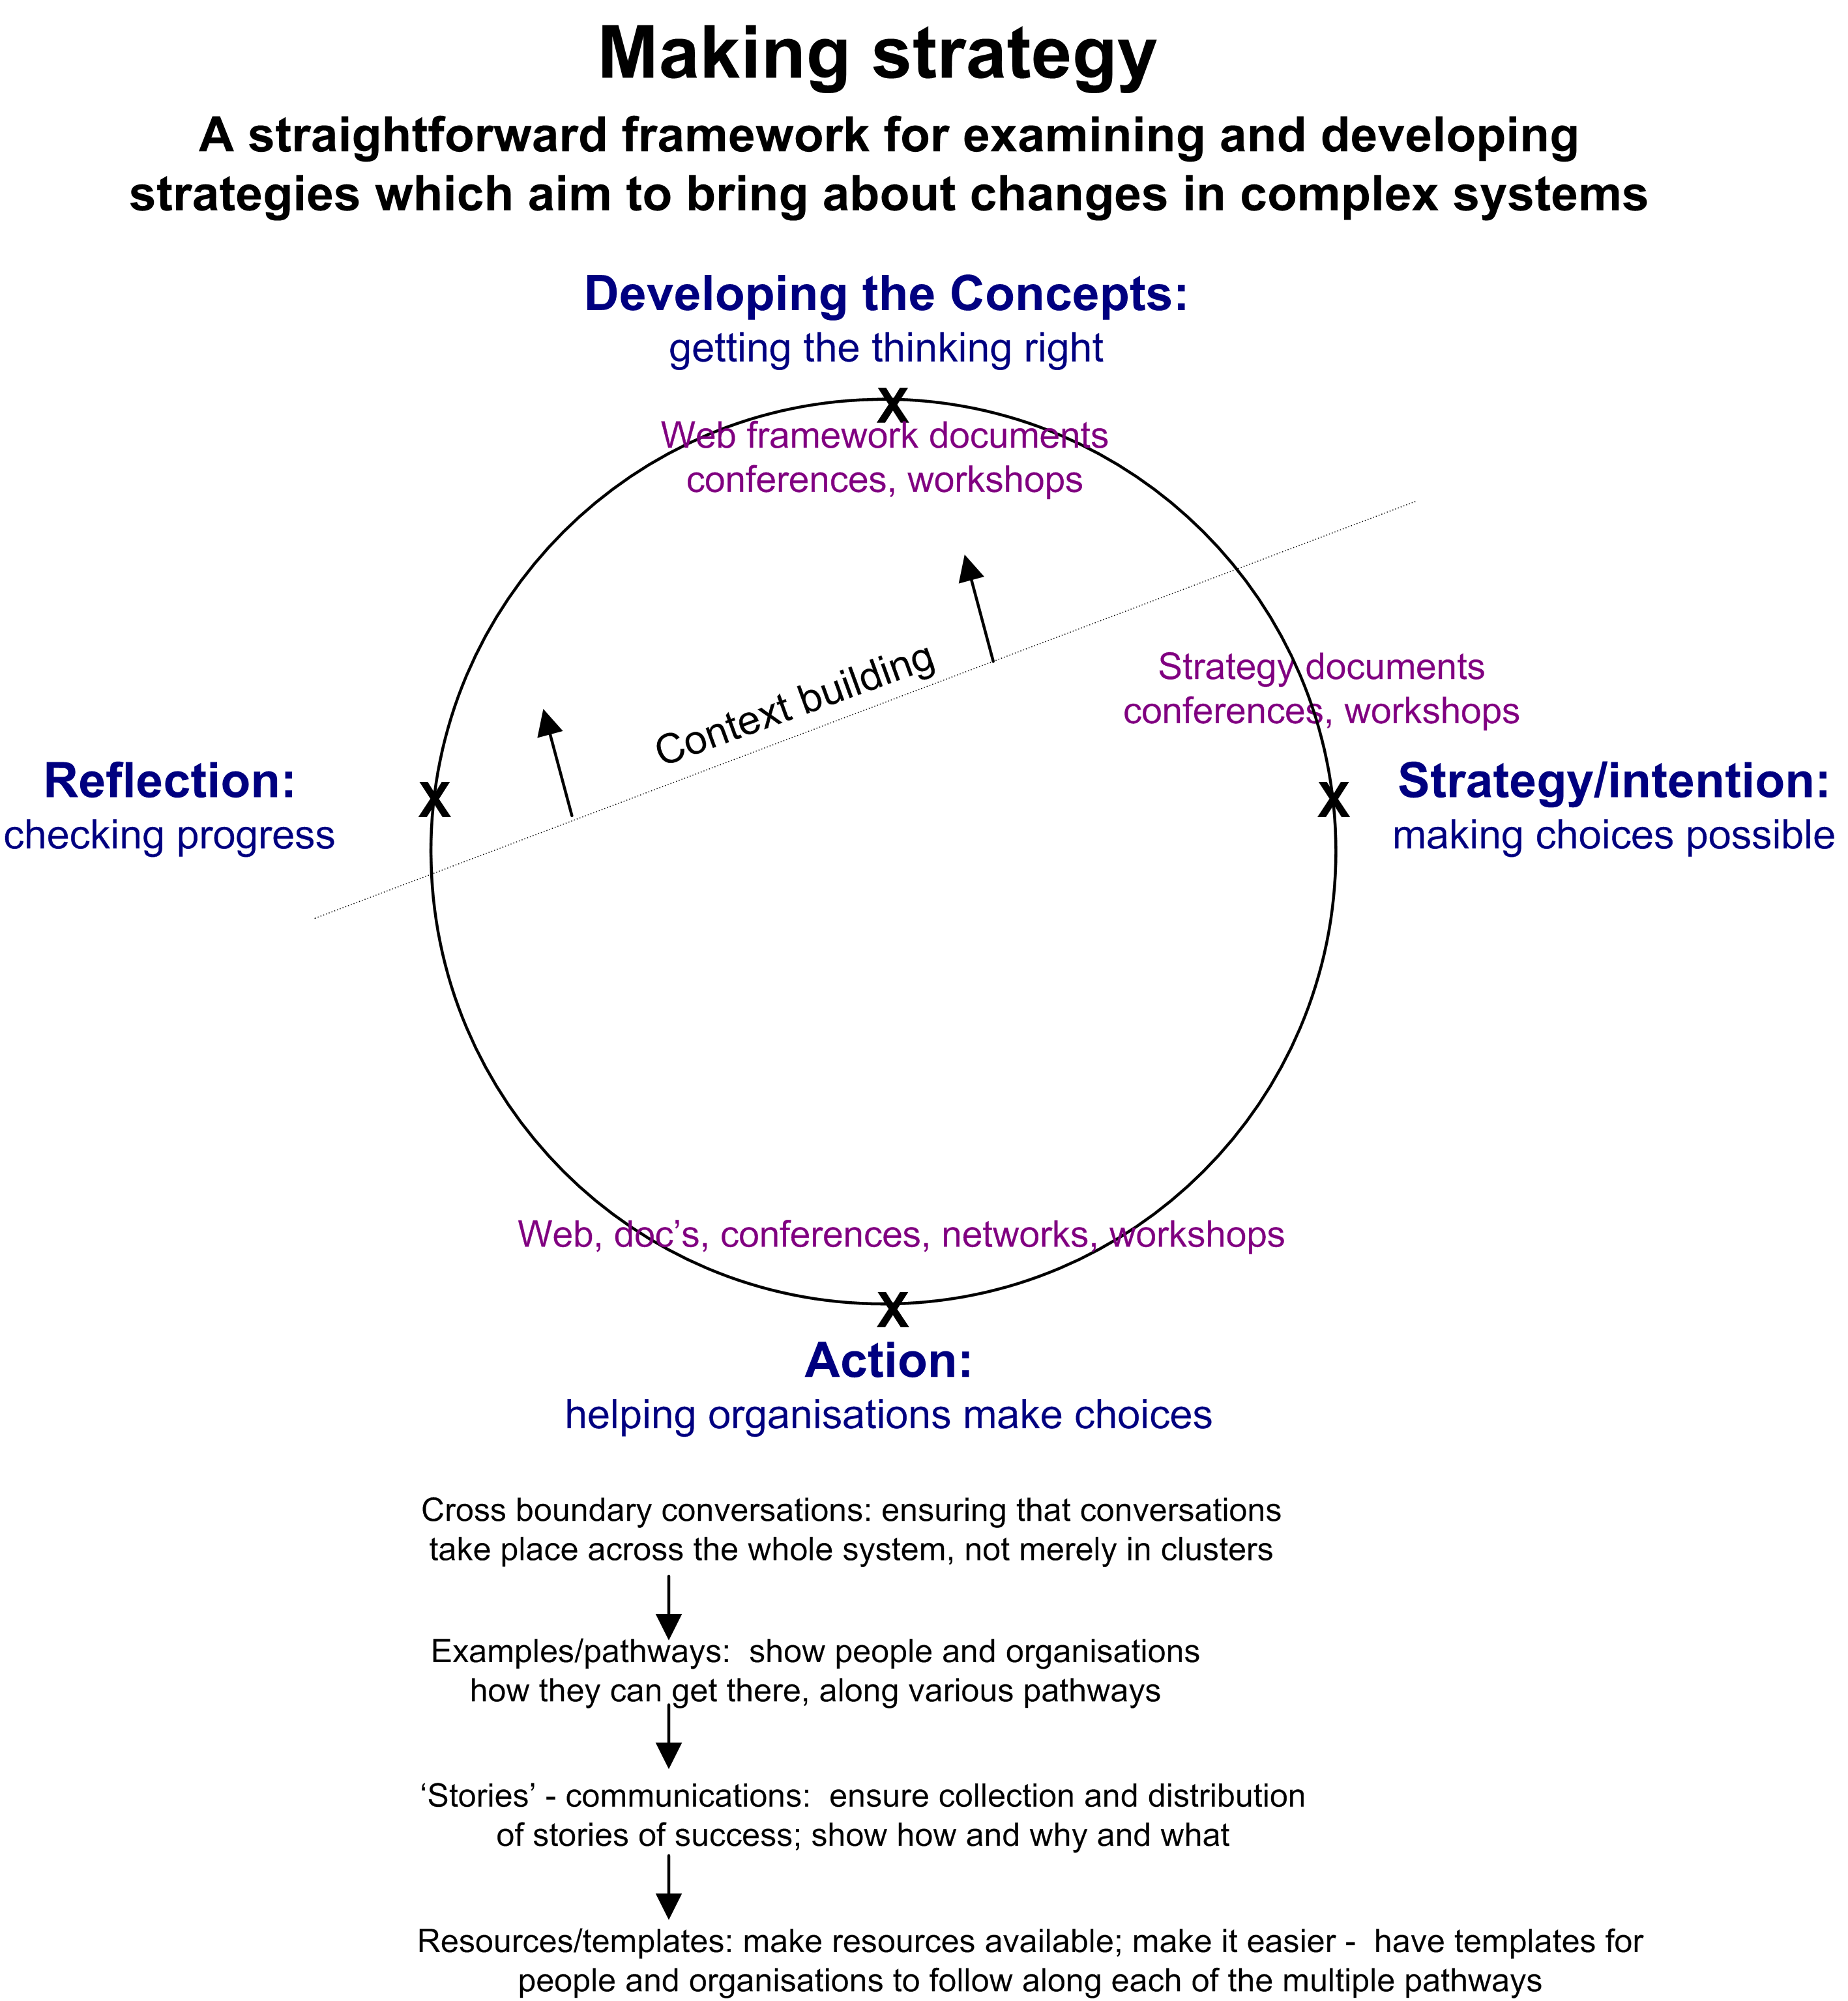
The strategy development and enactment process outlined here is only nominally linear. Participants take action when it best suits them; some will make decisions while the ramifications of the strategy are being worked out, others will wait for the details. However, subsequent to the process of making choices possible there are numbers of activities which will support organisations in their choice making:
- continuously making explicit the nature and dynamics of the whole system and its parts is an important ingredient in understanding the possibilities for action
- ensuring cross-boundary and ‘whole system’ conversations is a primary task of the authority promoting the strategy. Such regular and challenging conversations serve to broaden participants’ perspectives, increase their understanding and support their degree of confidence to make decisions.
- building understanding and confidence:
      - elaborating the various pathways that organisations can successfully take
      - collecting and distributing stories of success that show how, why and where organisations have been successful
- making it easy for organisations to innovate, change, and make decisions:
      - developing templates and other resources that they can follow.

Stage four, reflection: checking progress and improving the strategy
Strictly speaking this set of activities is not a ‘stage’ at all. However, it is easier to elaborate if outlined separately. Feedback is best when it is relevant – timely and pertinent.
There are a number of essential and mutually reinforcing types of feedback:
- performance indicators are essential to measure progress made and to what end (against what criteria). Developed collaboratively in stage one, they are a powerful incentive to change and driver of accountability.
- understanding what has led to success and failure is a critical component of an organisation’s (or system’s) readiness to change. Research and evaluation which establishes agreed data upon which to base discussion and decisions gives real impetus to change efforts. Its absence is an acknowledged impediment.
- learning from the system and from experience in other contexts - stories of success and failure – assists people’s ability to understand the choices they face. They reinforce or challenge experience.
- feedback loops and other information flows need to be explicitly designed into the process in order to speed the flow of topical information to whoever needs it. Information and its distribution is the lifeblood of any strategy. It supports or confounds the exercise of judgement; it enables participation or creates outsiders.
The elements of the four stages, taken together are a framework for undertaking change in complex systems. Some elements are more specific than others, all involve the building of a context of support within which the strategy can operate.

Some comments in relation to the model
- It seems clear that there is much context building to be done. Numerous participant bodies were involved in the equivalent of stage one, however, the involvement was not in the nature of the engagement envisaged here. There is no general agreement around a moemoea, the principles and logic models are not clear, and understanding and acceptance of the whole system’s broader outcomes features rarely in discussions of the TES. It appears that the context is insufficient to support rapid progress in the TES.
- Considerable work has been done within the Ministry of Education and the TEC around priorities and in collecting performance data. The TES’s context (the failure to build a sufficiently strong constituency within the sector towards the TES) and the manner of collection and the use to which such data are put ensure that the potential impact and usefulness of the information are not realised.
- Research and evaluation are underway and there are a number of papers available through the TEC and Ministry’s websites – though the Ministry’s research and information website has been under-promoted and the TEC website is not easy to navigate and uninviting. The examples in the TES have had less success than their potential would suggest.
It appears that the TES documents were helpful to users to a limited degree. In terms of the intentions set out by the Minister, they were partially successful. All the mechanisms which support a successful strategy (performance indicators, stories of success) will deliver only moderate results if the context of support is not strong enough to enable the strategy to work.

The Complex Change Model

Office of the Associate Minister of Education (Tertiary Education), Tertiary Education TES 2002/07, Ministry of Education, 2002, pp 4-7.
Special Supplementary Grants (SSGs) are made available to tertiary education institutions for specific purposes. Current SSGs include grants to provide support to Māori and Pasifika students and also to tertiary students with disabilities.
David A Kolb, Experiential Learning: Experience as the Source of Learning and Development, Prentice-Hall, 1984

