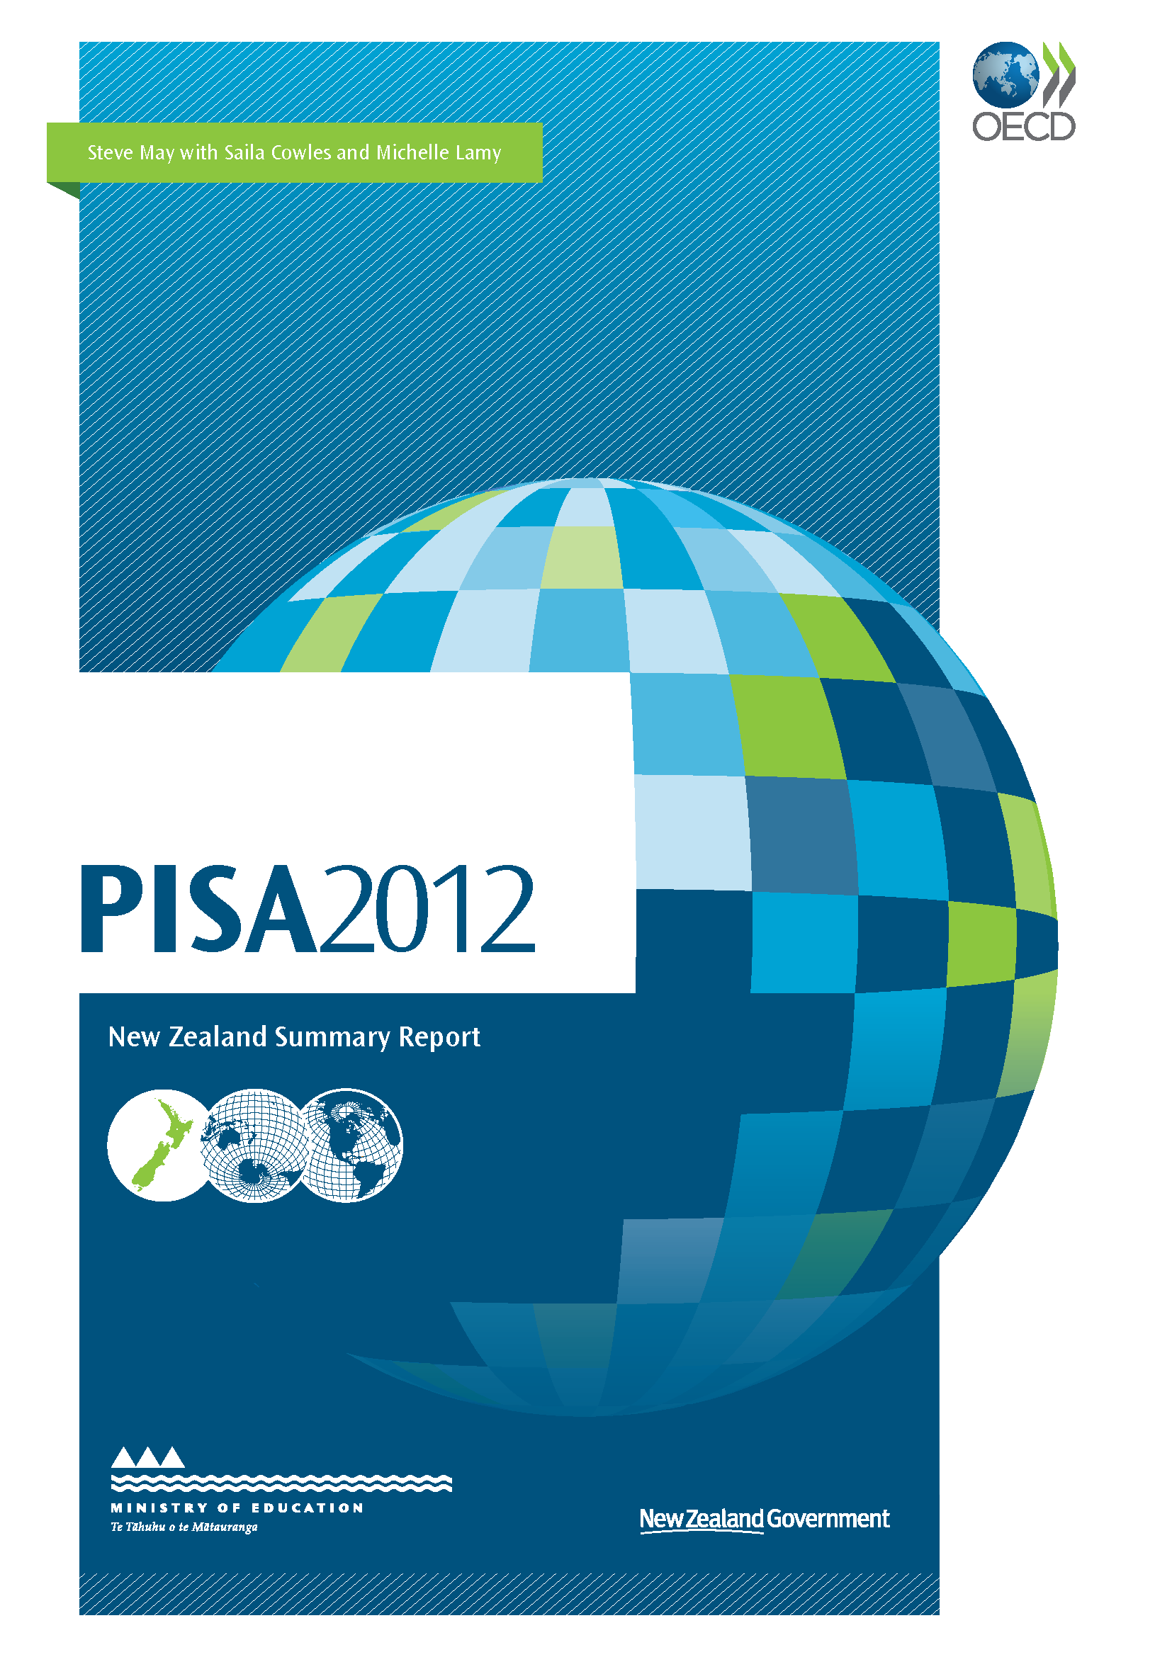
Foreword
The PISA survey measures the abilities of 15-year-olds in mathematics, science and reading. The survey is undertaken every three years by the OECD. In 2O12, 65 countries participated.
The 2012 results for New Zealand show a decline in mathematics, reading, and science ability since 2009. The proportion of students at the lowest levels of achievement has increased. New Zealand’s results are still above the OECD average in mathematics, reading and science. However, New Zealand is being overtaken by more countries and caught up by others.
The decline in performance is the result of the accumulation of a combination of factors over time. The PISA result was foreshadowed by information from earlier studies such as the National Education Monitoring Project and the Trends in International Maths and Science Study.
The 15-year-olds assessed in the survey started school in 2002, during a period of great change in the New Zealand schooling sector. This included a huge influx of new teachers at the end of the 1990s and early 2000s, largely as a result of roll growth and increased teacher:student ratios. This put strain on the sector to absorb high numbers of beginning teachers, as well as overseas-trained teachers. At the same time, the system of teacher training was changing, with training becoming more academically focused.
During the 2000s there were attempts to address inequity of achievement among students and to lift the quality of learning and teaching overall. For example, new models for leadership development were introduced and revised strategies for schooling improvement were rolled out.
There have been some successes, and there are pockets of excellence in achievement, including in schools in disadvantaged areas. But these successes do not spread easily to other schools.
The system as it is arranged in New Zealand does not easily support the spread of good practices between schools, and direct interventions in schools that struggle with student achievement have not always been as effective as expected.
A number of initiatives are expected to halt the observed decline and lift achievement. These have been introduced to encourage more use of individual student achievement data, further support the quality of teaching, and promote high-level leadership in the education sector. However, more will be needed if New Zealand is to return to its previous position.
An overview of PISA 2012
What is PISA?
The Programme for International Student Assessment (PISA) is an international study that assesses and compares how well countries are preparing their 15-year-old students to meet real-life opportunities and challenges.
PISA provides countries with information on student achievement and how this relates to student and family, school-level, teaching and learning, and system-related factors. This information can be used to better understand student achievement both within and across countries.
What does PISA 2012 assess?
Each time PISA is administered, three key areas of knowledge and skills are assessed – reading literacy, mathematical literacy and scientific literacy, with a focus on one of these literacy areas.
The focus of PISA 2012 was mathematical literacy.
PISA 2012 also offered assessment of two other areas – problem solving and financial literacy. New Zealand participated in the assessment of financial literacy, but not problem solving. Results from the assessment of these two areas will be available in mid-2014.
In each country students complete a two-hour test booklet in their language of instruction for the assessment of mathematical, reading, scientific and financial literacy. A computer-based assessment was used for problem solving, and optional computer-based assessments were offered for mathematics and reading. New Zealand did not participate in these computer-based assessments.
The term ‘literacy’ is used to capture “the capacity of students to apply knowledge and skills in key subject areas and to analyse, reason and communicate effectively as they pose, solve and interpret problems in a variety of situations”. As such, PISA is not restricted to assessing how well students have mastered the content of a specific school curriculum. Instead, PISA uses a broad approach to “determine the extent to which young people have acquired the wider knowledge and skills in reading, mathematics and science that they will need in adult life”.
In other sections of this report mathematical, reading and scientific literacy are referred to as mathematics, reading and science.
What additional information is gathered?
Background information is also gathered in each PISA cycle from questionnaires completed by students and school principals. These questionnaires allow for the relationship between related information and achievement to be examined.
How often is PISA administered?
PISA has been administered every three years since it began in 2000. Reading literacy was the main focus in the first cycle. Mathematical literacy was the focus in 2003, scientific literacy in 2006, reading literacy in 2009 and mathematical literacy was again the focus in 2012. Rotating the main focus for each cycle of PISA provides in-depth and detailed information on one main subject along with an ongoing source of achievement data on two minor subjects.
The in-depth information on mathematical literacy from the 2003 and 2012 administrations of PISA provide an opportunity to look at changes in mathematical literacy, and changes in the relationship between related factors and achievement.
Who participates in PISA?
Approximately half a million 15-year-old students from 65 participating countries participated in PISA 2012, including the 34 Organisation for Economic Co-operation and Development (OECD) member countries. In New Zealand, over 5,000 students from 177 schools took part. The majority of New Zealand students who took part in PISA 2012 started school in 2001. Some will have started in 2002.
Schools and students are randomly selected to ensure the sample is representative of the New Zealand 15-year-old population. Schools are selected by the international consortium that carries out PISA based on the following characteristics: size, decile, location (urban or rural), authority (state or independent) and type (co-educational or single-sex). Students are selected randomly from all students in these schools within a specific age group (between 15 years 3 months and 16 years 2 months).
Why participate in PISA?
PISA assesses students who have completed around 10 years of compulsory schooling. PISA results are an important source of information in New Zealand, measuring progress toward:
- building a world-leading education system that equips all New Zealanders with the knowledge, skills and values to be successful citizens in the 21st century;
- reducing underachievement in education; and
- driving the improvement of educational performance across our education system to improve education outcomes for all young New Zealanders.
PISA not only provides measurement of New Zealand’s progress toward these goals over time, but also our performance in equipping students with skills and reducing disparities in achievement relative to other countries.
PISA results help to inform future policy developments and contribute to the sector’s understanding of the teaching of reading, mathematics and science.
Who organises PISA?
PISA is an initiative of the OECD and a collaborative effort of participating countries. A group of international research organisations was responsible for developing and overseeing PISA 2012 internationally.
This consortium was led by the Australian Council for Educational Research (ACER), and included: cApStAn Linguistic Quality Control (Belgium); Deutsches Institut für Internationale Pādagogische Forschung (DIPF, Germany); Educational Testing Service (ETS, USA); Institutt for Lærerutdanning og Skoleutvikling (ILS, Norway); Leibniz - Institute for Science and Mathematics Education (IPN, Germany); National Institute for Educational Policy Research (NIER, Japan); The Tao Initiative: CRP - Henri Tudor and Université de Luxembourg EMACS (Luxembourg); Unité d’analyse des systèmes et des pratiques d’enseignement (aSPe, Belgium); and Westat (USA).
In New Zealand, the Comparative Education Research Unit within the Ministry of Education’s Research Division is responsible for implementing and analysing PISA results.
How does the OECD ensure the quality of data?
A number of quality assurance procedures are put in place, both nationally and internationally, to ensure that high-quality data are obtained. These include:
- rigorous training of staff;
- detailed documentation;
- monitoring of sampling procedures;
- quality checks and tracking progress at a number of stages, such as test administration; and
- strict procedures for coding, data entry, data cleaning, and checking.
Further details will be outlined in the PISA 2012 Technical Report (OECD, forthcoming).
Key results.
- New Zealand’s average scores in mathematics, reading and science have declined since 2009.
- New Zealand’s performance in these subjects has also declined relative to other countries.
- However, New Zealand’s average achievement in mathematics, science and reading remains above the OECD average.
- Compared to earlier cycles of PISA there are larger proportions of New Zealand students with low performance in mathematics and science (below PISA proficiency Level 2). The OECD considers proficiency Level 2 as the baseline level at which students begin to demonstrate the competencies that will enable them to participate actively in life situations.
- While the proportion of top performers in reading (PISA proficiency Level 5 or higher) has declined, the proportion of students at the highest level (Level 6) has not declined by much. New Zealand still has one of the largest proportions at this level among participating countries.
New Zealand achievement in an international context
How well did New Zealand students perform in mathematics?
New Zealand students (at 500 points on the PISA mathematics scale) performed above the OECD average of 494 points.
Figure 1.1 shows New Zealand’s average score was significantly below 17 countries, including ten OECD members. Eight other countries (all OECD members) including Australia and the United Kingdom had similar average scores to New Zealand. Thirty nine countries scored lower than New Zealand. Fifteen of these countries are OECD members.
PISA proficiency levels describe the types of mathematics tasks that students can do and relate this to the mathematics scale. Students at Level 6 are capable of advanced mathematical thinking and reasoning, whereas those at Level 1 can only complete relatively basic mathematical tasks. Level 2 is considered to be a baseline level at which students begin to demonstrate the competencies that will enable them to participate actively in mathematics-related life situations.
New Zealand had a slightly larger proportion of top-performing students who were at Level 5 or above (15 percent) compared to the OECD average (13 percent).
The proportion of New Zealand students performing below Level 2 (23 percent) was the same as the OECD average (23 percent).
Compared to countries with a similar average score, New Zealand has a larger proportion of both students who can complete only relatively basic mathematical tasks (below Level 2) and students who are capable of advanced mathematical thinking (Level 5 and above).
Figure 1.1 Average mathematics scores and proficiency levels
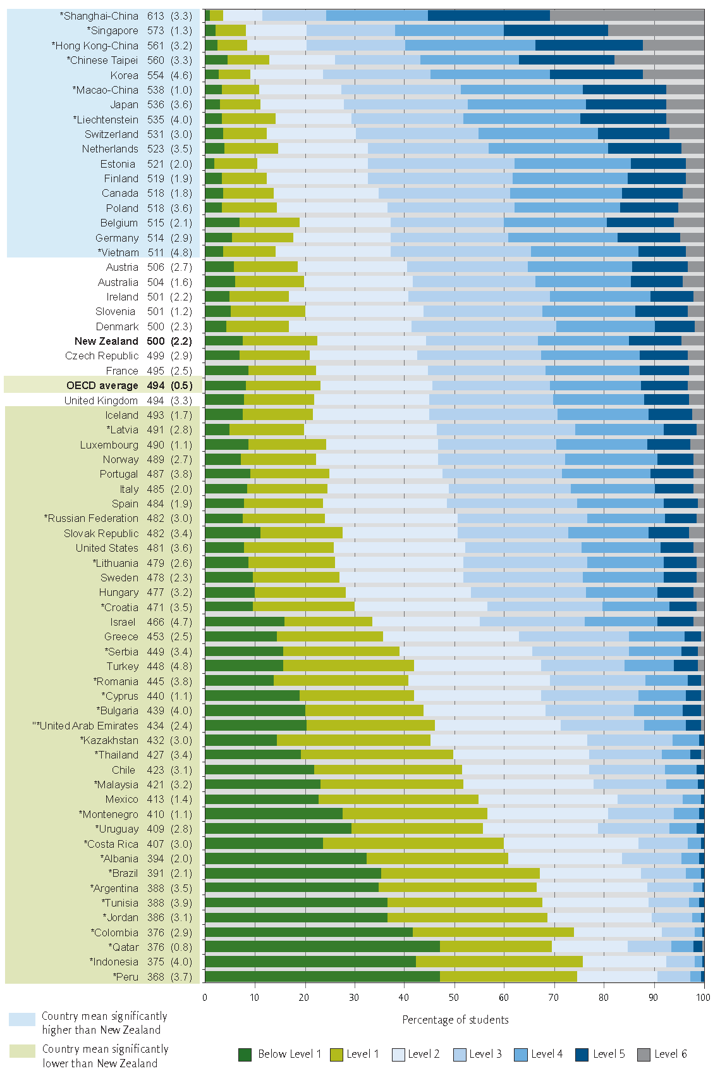
Note: Standard errors are presented in parentheses.
* before country name denotes a non-OECD country/economy
Source: Adapted from Volume I: What Students know and can do: Student Performance in Mathematics, Reading and Science OECD (2013)
How has mathematics performance changed over time?
The average mathematics score of New Zealand students declined between 2003 and 2012 from 523 to 500 points. Figure 1.2 shows that most of the decline occurred between 2009 and 2012.
The trend in mathematics achievement is measured from PISA 2003, as this is the first time mathematics was the focus area of the PISA assessment and all four content areas of the current PISA mathematics framework were covered.
New Zealand (23 points) is one of several countries that had a decline in mathematics performance in PISA between 2003 and 2012. Other countries include Australia (20 points), Finland (26 points), and Sweden (31 points).
During this time, some countries have made gains. These include Asian countries such as Hong Kong-China, Korea and Macao-China. Germany and Poland, below New Zealand in 2003, now have higher average scores than New Zealand.
Figure 1.3 shows that the change in average score for New Zealand reflects a larger proportion of New Zealand students performing below Level 2. These are students that can complete only relatively basic mathematical tasks and whose lack of skills is a barrier to learning. In 2012, 23 percent of New Zealand students were below Level 2 compared with 15 percent in 2003.
The proportion of New Zealand students who attained Level 5 and above also declined between 2003 (21 percent) and 2012 (15 percent). The proportion of students who attained Level 6 and are able to do complex mathematical tasks is slightly smaller in 2012 (5 percent) than in 2003 (7 percent).
Further evidence of the decline in average performance can be found by looking at New Zealand students’ scores on a selection of mathematics questions that remained constant over successive cycles of PISA. Students in PISA 2012 scored on average 3 percent lower on each question compared to students in PISA 2009.
Figure 1.2 Trends in New Zealand average mathematics scores
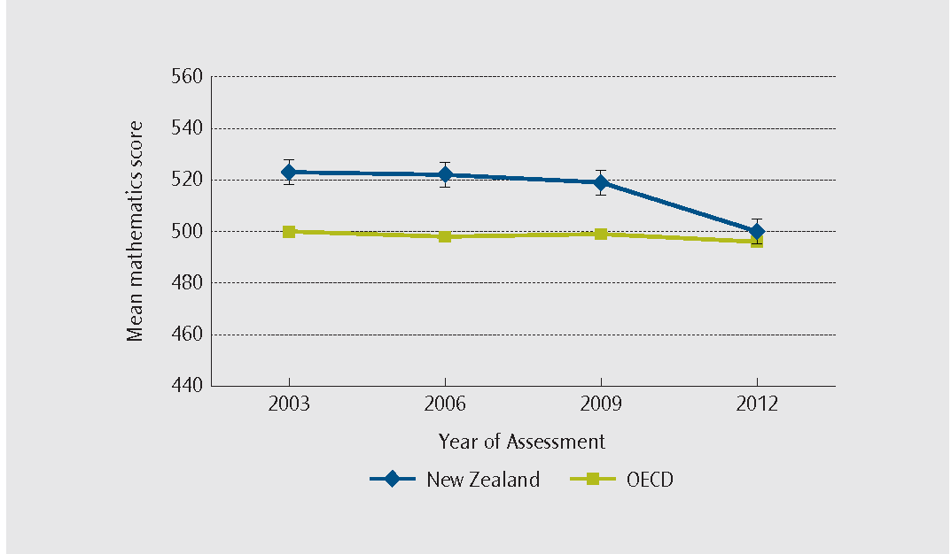
Note: error bars on the graph provide a 95 percent confidence interval for the estimate of the average.
Figure 1.3 Trends in New Zealand mathematics proficiency levels
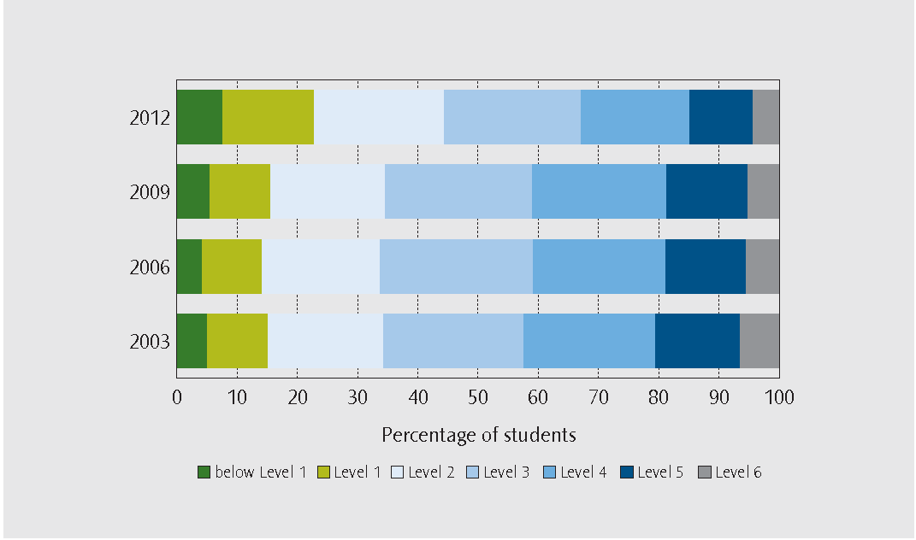
mathematics
What are the areas of strength of New Zealand students in mathematics?
Achievement scores were calculated for three mathematical processes that describe what individuals do to connect the context of the PISA questions with mathematics, and then to solve those questions. Scores were also calculated for four mathematical content areas that were covered by different questions.
The three mathematical processes are:
- formulating situations mathematically;
- employing mathematical concepts, facts, procedures and reasoning;
- interpreting, applying and evaluating mathematical outcomes.
Approximately half of the PISA questions measured the process of employing, with one quarter of the questions measuring formulating and another quarter measuring interpreting. Figure 1.4 shows that, of the three mathematical processes, New Zealand students do best on interpreting tasks.
New Zealand students perform on average higher on tasks related to interpreting (511 points) than the OECD average (497 points). For formulating (496 points) and employing (495 points) New Zealand students’ average scores are similar to the OECD averages for the respective processes. New Zealand’s strength in interpreting differs from nine of the ten top-performing countries in PISA 2012 whose relative strength is formulating.
The four broad mathematical content areas in PISA are:
- change and relationships;
- space and shape;
- quantity;
- uncertainty and data.
Each area is measured by approximately one quarter of the questions in the PISA assessment. These content areas can be translated to the New Zealand mathematics curriculum as follows:
- change and relationships mainly deals with aspects covered by algebra;
- space and shape are covered by geometry and measurement;
- quantity is covered by number and measurement;
- uncertainty and data are covered by statistics.
While these are separate categories, each of the PISA content areas can draw on aspects covered in any of the New Zealand mathematics curriculum strands. For example, a complex quantity task may also draw on students’ algebra skills.
The PISA assessment also draws on mathematical skills and competencies that are covered by other areas of the New Zealand curriculum. For example, the interpretation of data may be taught within the context of social studies, geography or the sciences.
Looking at the four content areas (Figure 1.5), New Zealand students perform best on average on tasks related to uncertainty and data (506 points). This average score is higher than the OECD average (493 points) for this content area.
Space and shape was an area of relative weakness for New Zealand students in the PISA context (491 points). The New Zealand average in space and shape is very similar to the OECD average (490 points).
New Zealand’s relative strength in uncertainty and data differs from seven of the top ten PISA countries whose relative strength lies in space and shape.
More detailed analysis of New Zealand’s performance in mathematical processes and content areas is presented in “PISA 2012 Spotlight on Mathematics Achievement” (Cowles, forthcoming).
Figure 1.4 Comparison of performance on the different process subscales
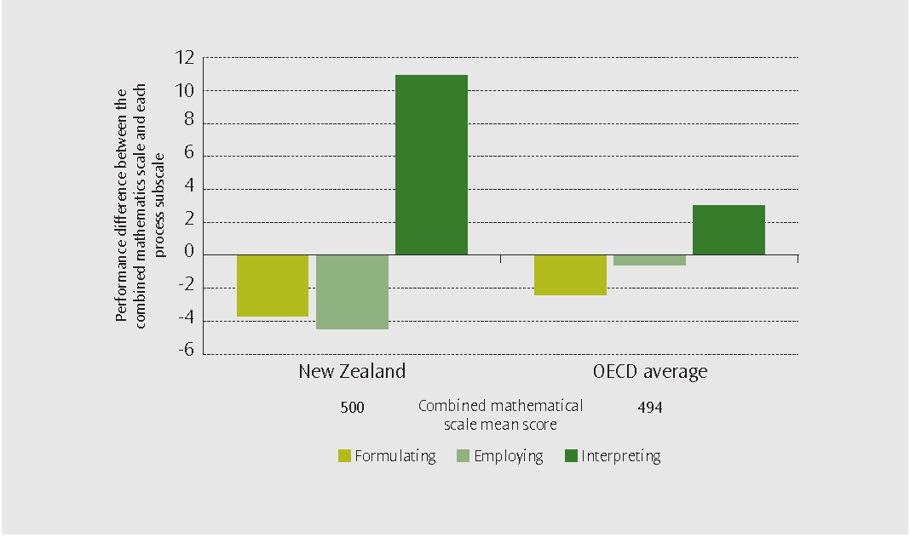
Figure 1.5 Comparison of performance on the different content areas
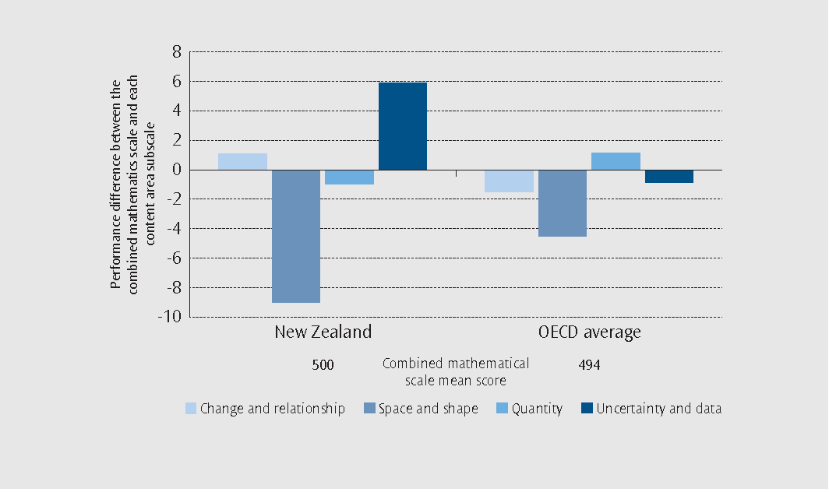
reading
How well did New Zealand students perform in reading?
New Zealand students’ average score for reading in PISA 2012 (512 points) was higher than the OECD average (496 points).
Figure 2.1 shows that New Zealand’s average reading score was significantly below nine countries, including five OECD countries. Eleven other countries, of which eight are OECD members, had similar scores to New Zealand. This included Australia, which had the same average score as New Zealand. There were 44 countries with lower average scores than New Zealand, of which 20 are OECD members.
Proficiency levels in the PISA assessment describe the types of reading tasks that students can do. Students at Level 6 are capable of the most complex reading tasks and those below Level 2 have difficulty with all but the simplest reading tasks measured by PISA. Level 2 is considered a baseline level at which students begin to demonstrate the reading skills and competencies that will enable them to participate effectively later in life.
The proportion of New Zealand students performing below Level 2 (16 percent) was similar to the OECD average (18 percent). However, New Zealand had a slightly larger proportion of top performing students who were at Level 5 or above (14 percent) compared to the OECD average (8 percent). Only four countries had more than 2 percent of top performing students at Level 6, including New Zealand (3 percent), Japan (4 percent), Shanghai-China (4 percent), and Singapore (5 percent). These are advanced readers.
Compared to countries with a similar average score, New Zealand tends to have a larger proportion of both students who can complete only relatively basic reading tasks (below Level 2) and students who are capable of advanced reading tasks (Level 5 and above).
Figure 2.1 Average reading scores and proficiency levels
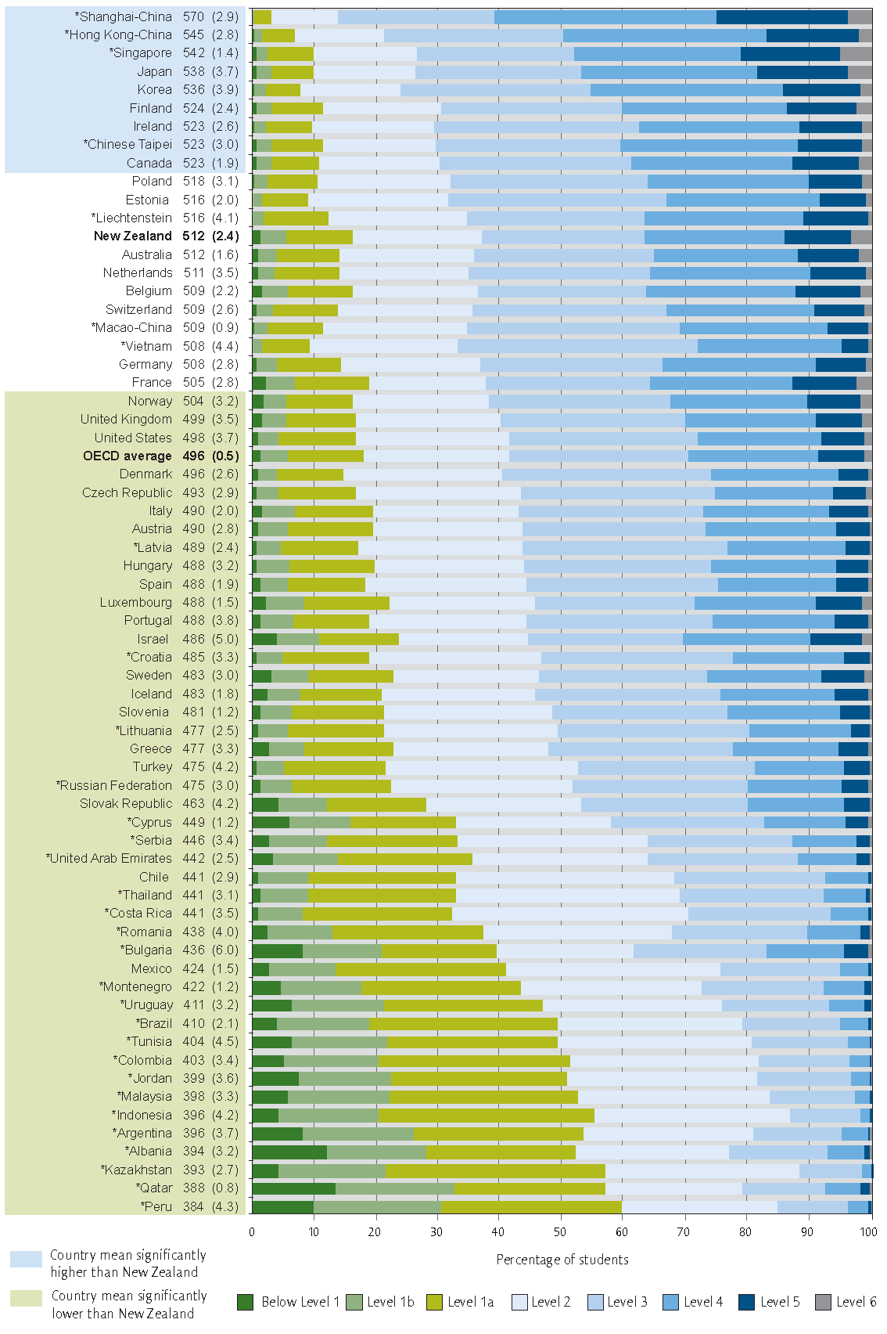
Note: Standard errors are presented in parentheses.
* before country name denotes a non-OECD country/economy
Source: Adapted from Volume I: What Students know and can do: Student Performance in Mathematics, Reading and Science OECD (2013)
Reading
How has reading performance changed over time?
PISA was first administered in 2000 with reading as the main focus. New Zealand’s average reading score (512 points) in PISA 2012 was lower than in 2000 (529 points).
Figure 2.2 shows that most of the decline in reading literacy occurred between 2009 and 2012. This is consistent with the decline observed in mathematical literacy. In 2009, New Zealand’s average score for reading (521 points) was not very different from our average score in PISA 2000 (529 points).
Countries that scored above the OECD average in 2000 and have demonstrated larger declines than New Zealand (17 points) include Finland (22 points), Iceland (24 points), and Sweden (33 points). The decline in the average reading score for Australia (16 points) was similar to that of New Zealand. In contrast, the increase in average reading scores for Poland (39 points) and Germany (24 points) means both these countries, who were below New Zealand in reading in 2000, are now on par.
Figure 2.3 illustrates changes in the proportion of students below Level 2 and above Level 5 since PISA 2000. In 2000, just under 14 percent of students in New Zealand were poor readers whose reading skills were unlikely to support their learning (below Level 2). This has increased to just over 16 percent of students in 2012.
Over the same period, the proportion of students who are advanced readers (Level 5 and above) has declined from 19 percent to 14 percent.
The proportion of students who are very advanced readers (Level 6) has remained the same (3 percent) between PISA 2009 and PISA 2012.
Figure 2.2 Trends in New Zealand average reading literacy scores
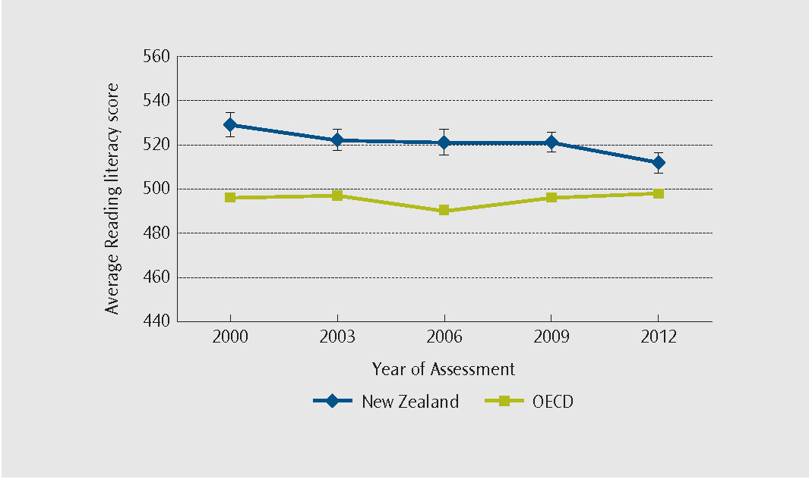
Note: error bars on the graph provide a 95 percent confidence interval for the estimate of the average.
Figure 2.3 Trends in New Zealand reading proficiency levels
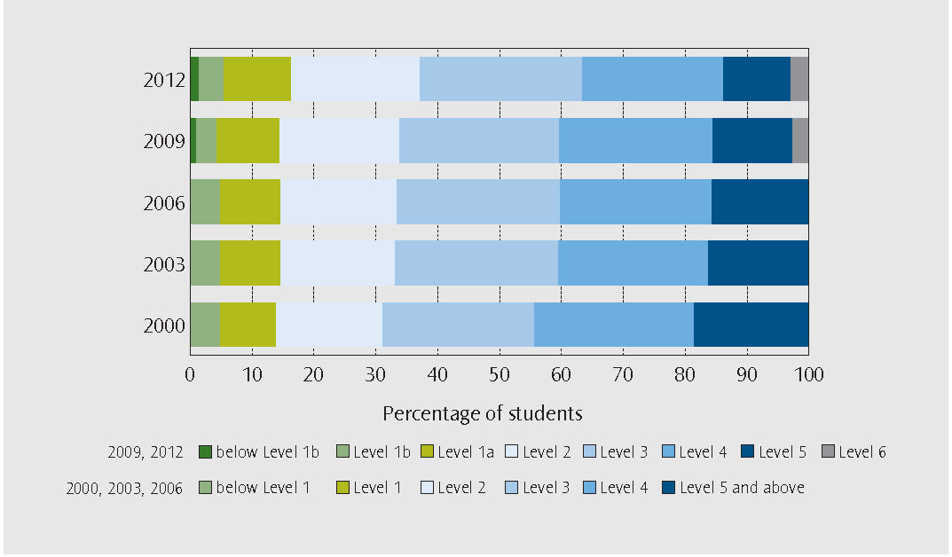
Note: In 2009 Level 1b and Level 6 were added to provide a finer distinction of the proficiency levels of students that were previously classified as below Level 1 and at Level 5 and above for the 2000, 2003 and 2006 assessments.
SCience
How well did New Zealand students perform in science?
The average science score of New Zealand students (516 points) was higher than the OECD average (501 points).
Figure 3.1 shows that New Zealand’s average science score was significantly below 15 countries, eight of which are OECD members. This includes Australia and Canada. Five OECD countries, including the United Kingdom, had similar scores to New Zealand. Forty-four countries, of which 20 are OECD members, had lower average scores than New Zealand.
Proficiency levels describe the types of science tasks that students can do. Students performing at Level 6 are adept at using their scientific knowledge in a variety of complex situations. Students performing below Level 2 have limited scientific knowledge that can only be applied in a few familiar situations.
As can be seen in Figure 3.1, the proportion of New Zealand students performing below Level 2 (16 percent) was similar to the OECD average (18 percent). However, New Zealand had a slightly larger proportion of top performing students who were at Level 5 or above (13 percent) compared to the OECD average (8 percent). Only six countries had 3 percent or more of students performing at Level 6, including New Zealand, Australia, Japan and Finland (all with 3 percent), as well as Shanghai-China
(4 percent) and Singapore (6 percent).
These results are similar to the pattern observed in mathematical and reading literacy, where New Zealand tends to have a larger proportion of both students who are relatively poor performers (below Level 2) and students who are advanced performers in science (Level 5 or above) when compared to other countries with a similar average score.
Figure 3.1 Average science scores and proficiency levels
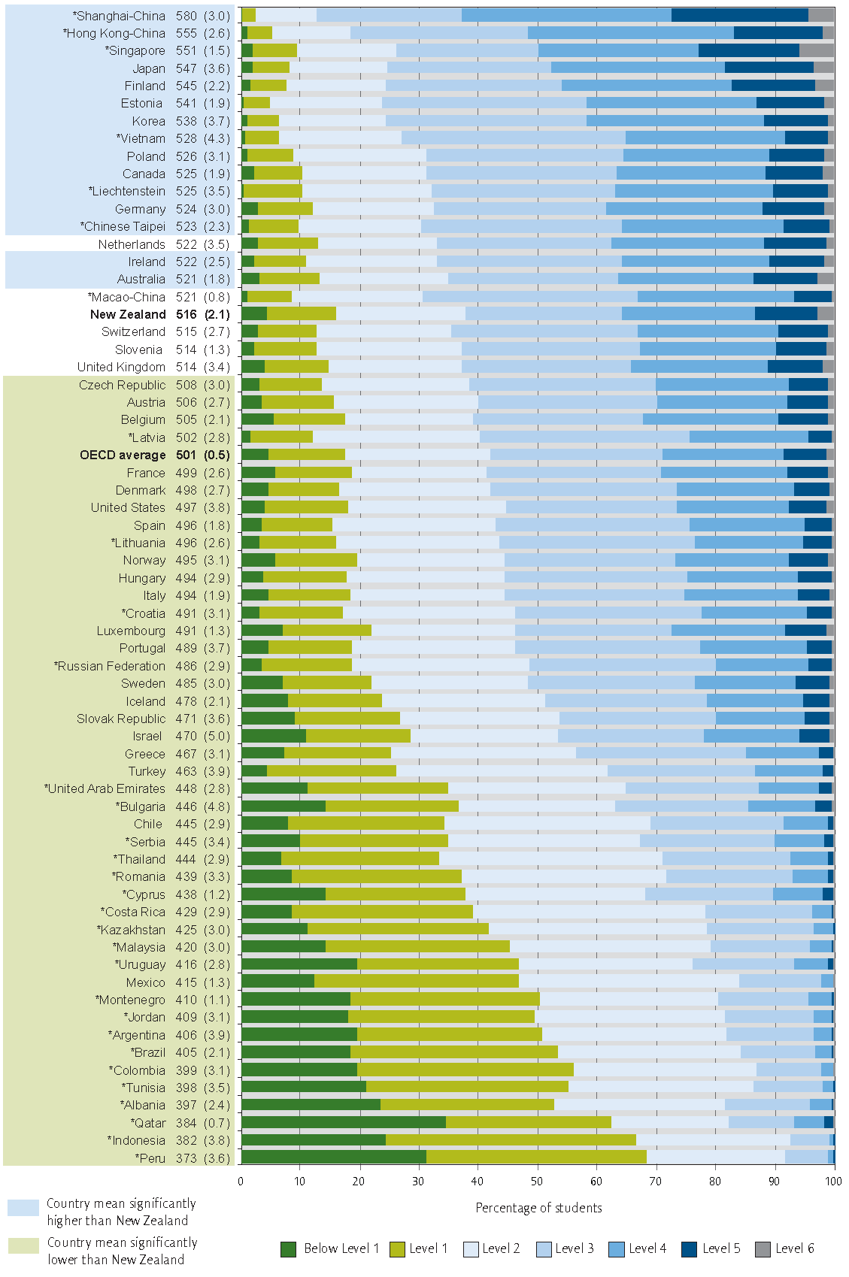
Note: Standard errors are presented in parentheses.
* before country name denotes a non-OECD country/economy
Source: Adapted from Volume I: What Students know and can do: Student Performance in Mathematics, Reading and Science OECD (2013)
science
How has science performance changed over time?
In the first two cycles of PISA (2000 and 2003) science was a minor focus and had only a limited number of test questions. These questions did not cover the full breadth of the science framework developed for PISA 2006 when science was the major focus. For this reason, changes in science are only reported since the PISA 2006 assessment.
Figure 3.2 shows that compared to New Zealand’s average science score in 2006 (530 points) and 2009 (532 points), New Zealand’s average science score in PISA 2012 declined (516 points). From 2006 to 2012 the OECD average for science increased slightly (from 498 points to 501 points).
Figure 3.3 shows a small increase in the proportion of students who are poor performers in science (below Level 2), from
14 percent in 2006 to 16 percent in 2012. There has also been a small decline in the proportion of students who are advanced performers in science (Level 5 or above) from 18 percent in 2006 to 13 percent in 2012.
Figure 3.2 Trends in New Zealand average science scores
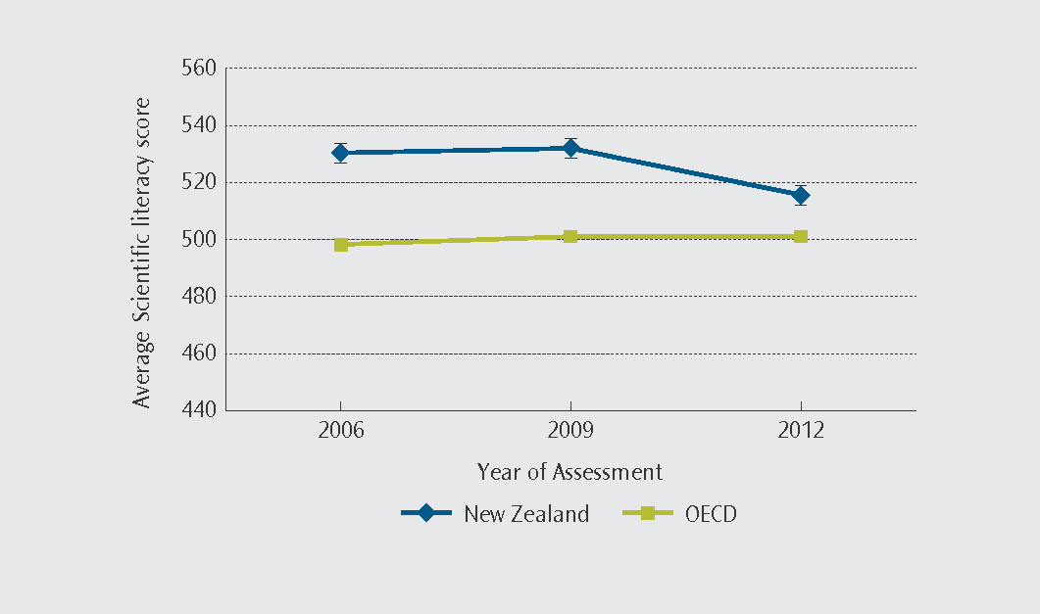
Note: error bars on the graph provide a 95 percent confidence interval for the estimate of the average.
Figure 3.3 Trends in New Zealand science levels
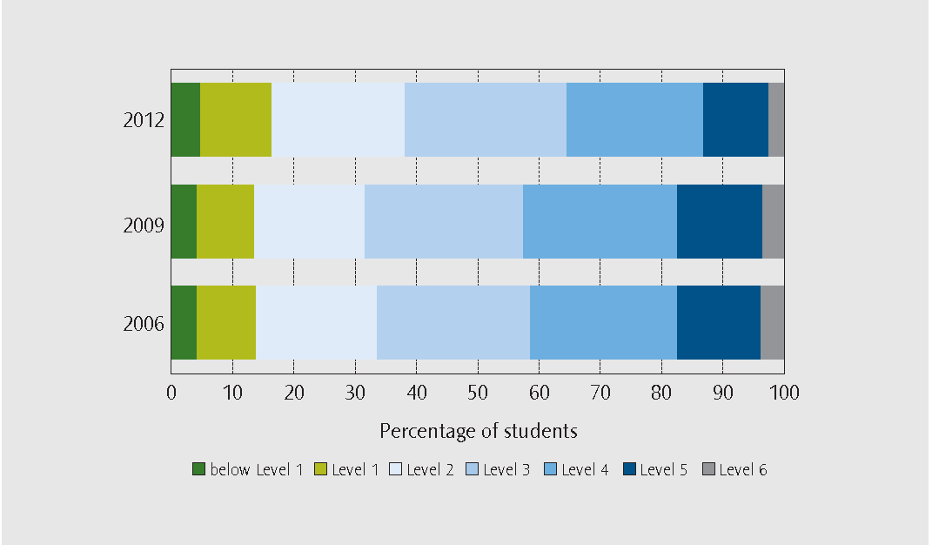
SCience
How many New Zealand students are top performers in more than one area?
In each of the areas of mathematics, reading and science there are New Zealand students who perform really well. The OECD suggests that these are the pool from which countries will get their next generation of innovators:
“The rapidly growing demand for highly skilled workers has led to a global competition for talent. High-level skills are critical for creating new knowledge, technologies and innovation and, as such, are key to economic growth and social development. Looking at the top performing students in reading, mathematics and science allows countries to estimate their future talent pool”
In PISA, top performers have been defined as the students achieving at Level 5 and above in each area. A student who is a top performer in mathematics may also be a top performer in science but not necessarily a top performer in reading. Figure 4.1 looks at the overlap among those who are top performers in one or more of reading, mathematics and science for the OECD and figure 4.2 displays this overlap for New Zealand.
About one in five students (21 percent) in New Zealand are among the top performers in at least one subject area, compared to the OECD average of 16 percent.
Students who are top performers in mathematics, science and reading are defined as all-rounders. New Zealand has a relatively high proportion of students who are all-rounders (8 percent) compared to the OECD average (4 percent).
Korea and Australia have the same proportion of all-rounders as New Zealand (8 percent). The only countries that have a larger proportion of all-rounders than New Zealand are the very high performing countries Hong Kong-China (11 percent), Japan (11 percent), Singapore (16 percent), and Shanghai-China (20 percent).
Figure 4.1 Overlapping of top performers in mathematics, reading and science on average in the OECD
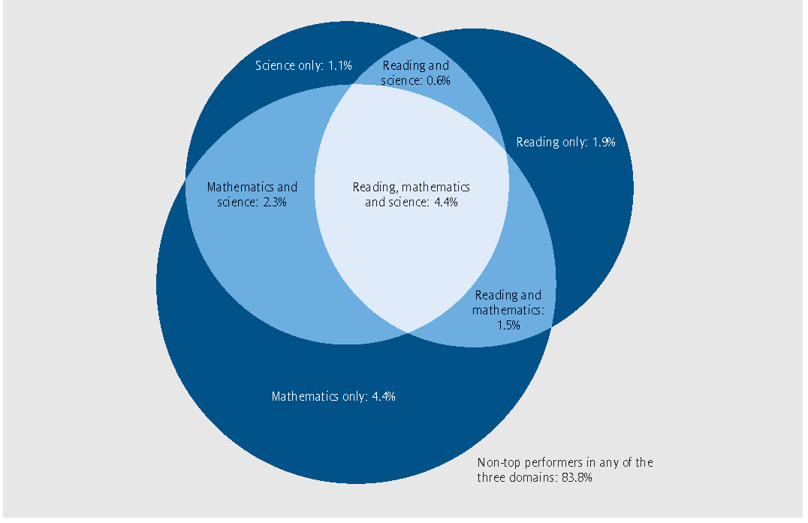
Source: Figure 1.2a , Volume I: What Students know and can do: Student Performance in Mathematics, Reading and Science OECD (2013)
Figure 4.2 Overlapping of top performers in mathematics, reading and science on average in New Zealand
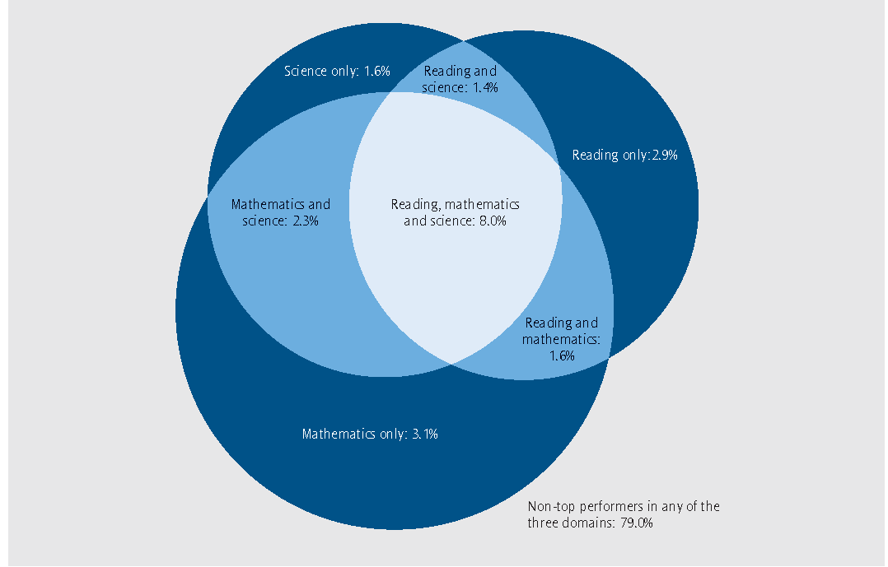
Source: Adapted from figure 1.2a Volume I: What Students know and can do: Student Performance in Mathematics, Reading
and Science OECD (2013)
Boys and girls
Is there a difference between the performance of New Zealand boys and girls, and how has this changed over time?
In 2012 New Zealand boys had a higher mathematics average score (507 points) than girls (492 points). In contrast, New Zealand girls demonstrated a higher reading literacy average score (530 points) than boys (495 points). In science there was very little difference between boys (518 points) and girls (513 points).
While this has generally been the pattern for all of the cycles of PISA to date, there are differences between the subject areas in terms of the extent of these gender differences over time. Figures 5.1 to 5.3 illustrate how the performance of boys and girls and the gender differences have changed in each subject area.
In mathematics, the average for both boys and girls declined (by 24 points each) between 2003 to 2012. Most of this decline for both boys and girls was observed between 2009 and 2012.
In reading, the performance of girls has declined by 23 points since 2000, whereas the performance of boys has only declined by 11 points. Most of this decline for boys and girls occurred between 2009 and 2012.
In science, the performance of girls has declined (by 19 points) since 2006. The performance of boys has declined less over the same period (by 11 points). Boys have a marginally higher average science score in 2012 than girls.
The changes in average scores over time are also reflected in changes of the proportions of students performing below proficiency Level 2 (poor performers) and at or above Level 5 (top performers).
In mathematics the proportion of boys who have poor mathematical skills increased between 2003 (15 percent) and 2012 (22 percent). Over the same time period, the proportion of boys who were top performers fell from 24 percent to 18 percent. The proportion of girls with poor mathematical skills also increased between 2003 (16 percent) and 2012 (24 percent) and the proportion of girls who were top performers decreased from 17 percent to 12 percent.
In reading, boys have showed little change in the proportions of poor performers (19 percent in 2000 compared with 21 percent in 2012) and top performers (14 percent in 2000 compared with 11 percent in 2012). Similarly the proportion of girls who were poor performers increased to a limited extent (8 percent in 2000 compared with 11 percent in 2012). But, reflecting the larger change in the average score for girls, the proportion of girls who were top performers has declined noticeably (24 percent in 2000 compared with 17 percent in 2012).
In science there was a small increase in the proportion of boys performing below Level 2 (from 15 percent in 2006 to 17 percent in 2012). The proportion of boys performing at Level 5 and above declined (from 18 percent in 2006 to 15 percent in 2012). The proportion of girls performing below Level 2 was 12 percent in 2006, increasing to 15 percent in 2012. Conversely, the proportion of girls performing at Level 5 and above was 17 percent in 2006, decreasing to 12 percent in 2012.
Figures 5.1 – 5.3 Average mathematics, reading and science performance of New Zealand boys and girls
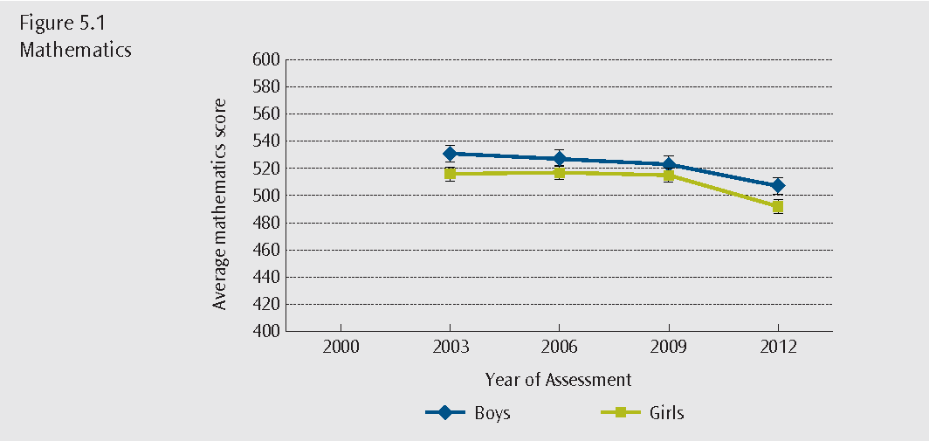
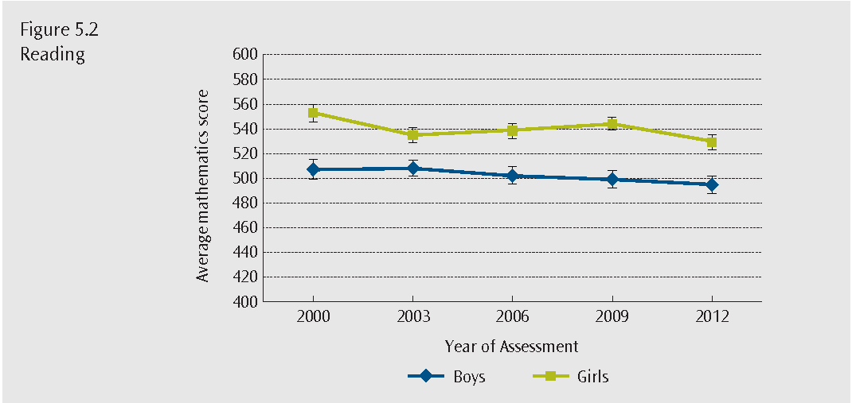
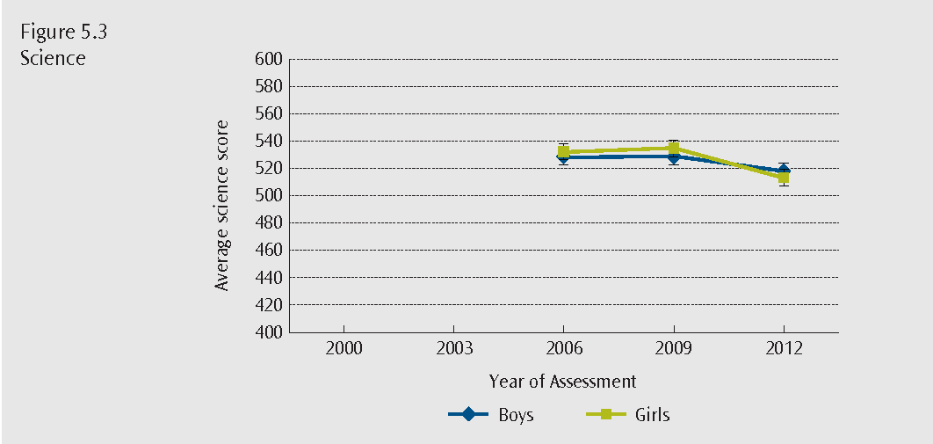
Note: error bars on the graphs provide a 95 percent confidence interval for the estimate of the average.
Graphs begin at the year the subject was first the major focus of the year of assessment
māori students
Achievement of New Zealand’s priority learners
In addition to sub-groups of the population that can be compared internationally, such as boys and girls - data collected specifically for New Zealand provides an understanding of the performance of specific sub-groups of the population. This section looks at the achievement of New Zealand’s priority learners — Māori, Pasifika and low socio-economic students — in mathematics, reading and science in PISA 2O12, and how the achievement of these sub-groups has changed over time.
How well are Māori students achieving, and how has this changed over time?
Māori students are one of the Ministry of Education’s priority learner groups. The performance of Māori learners, or of students from any other ethnic background, is not included in the international reports prepared by the OECD. Data on students’ ethnic backgrounds is only generated and analysed in country reports. Ensuring Māori enjoy and achieve success in the New Zealand education system is at the heart of the Māori education strategy Ka Hikitia – Accelerating Success 2013 – 2017. PISA provides a regular way to report on this for Māori students at 15 years of age.
The average score in mathematics for Māori students was 452 points in 2012 and 477 points in 2003.
The average score in reading for Māori students was 466 points in 2012 and 482 points in 2000.
The average score in science for Māori students was 469 points in 2012 and 480 points in 2006.
Figures 6.1 to 6.3 show the average score for Māori students in mathematics, reading and science was below the average score for both New Zealand students and the OECD.
Figures 6.4 to 6.6 show that Māori students are represented at all proficiency levels.
Over one-third of Māori students were performing below Level 2 in mathematics (38 percent) and over one quarter in reading (27 percent) and science (25 percent).
Māori students are represented among the top performers in PISA with 5 percent of students performing at Level 5 and above in each of mathematics, reading and science.
Figures 6.1 – 6.3 Average mathematics, reading and science performance of Māori students
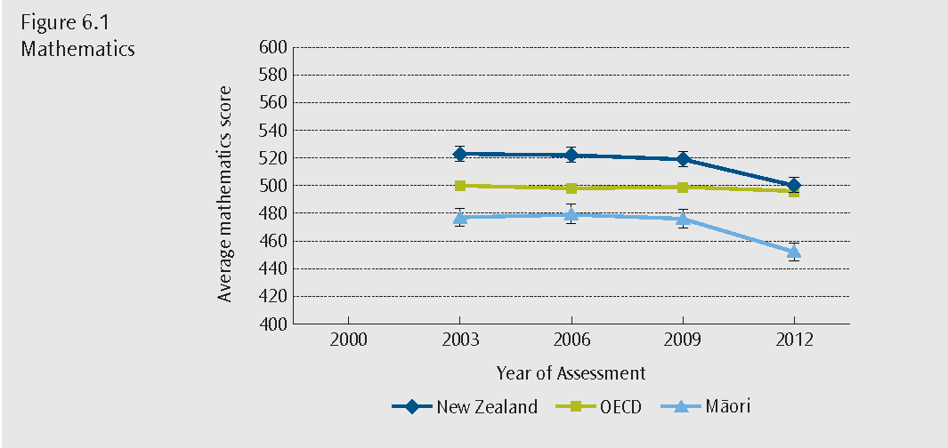
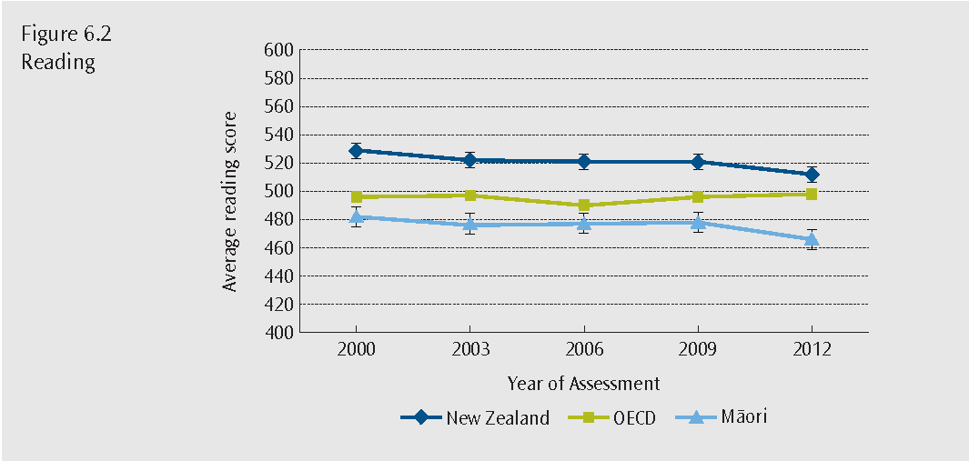
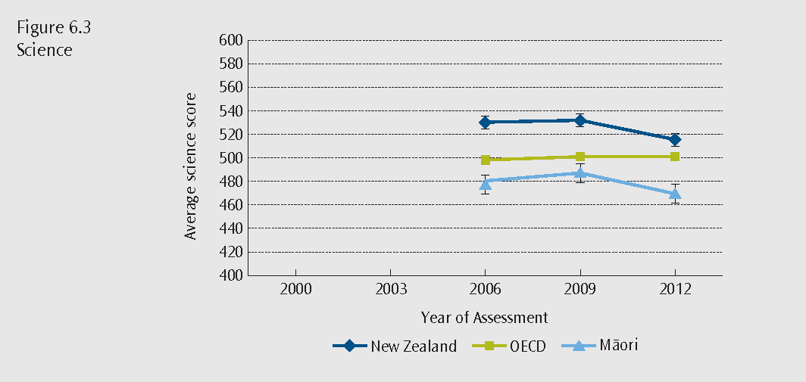
Note: error bars on the graphs provide a 95 percent confidence interval for the estimate of the average.
Graphs begin at the year the subject was first the major focus of the year of assessment
Figures 6.4 – 6.6 Proficiency levels of Māori students for mathematics, reading and science
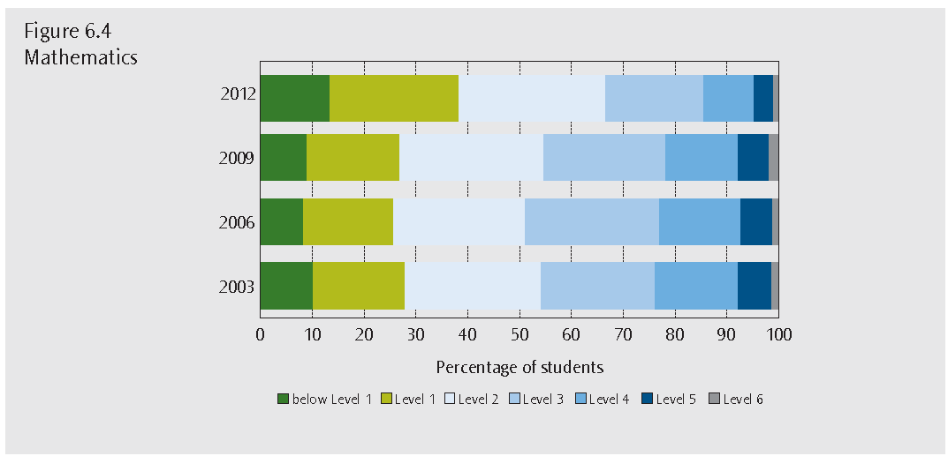
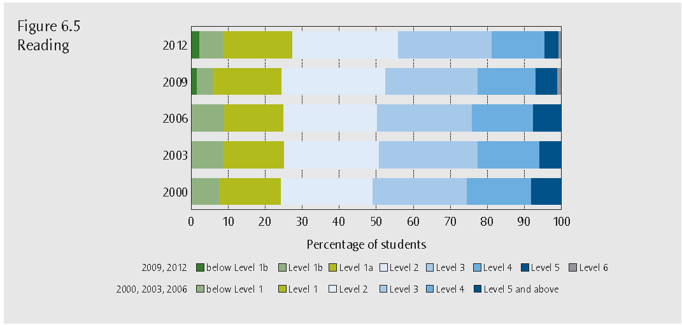
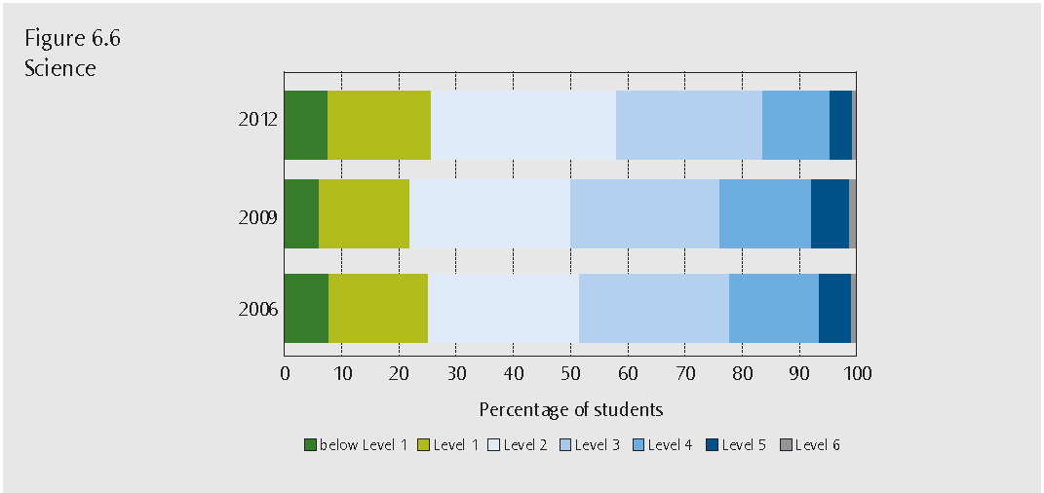
Note: In 2009 Level 1b and Level 6 were added to provide a finer distinction of the proficiency levels of students that were previously classified as below Level 1 and at Level 5 and above for the 2000, 2003 and 2006 assessments.
pasifika students
How well are Pasifika students achieving, and how has this changed over time?
Pasifika students are one of the Ministry of Education’s priority learner groups. Ensuring Pasifika students are participating, engaging and achieving within the New Zealand education system is at the heart of the Pasifika Education Strategy 2013 – 2017. PISA provides a regular way to report on that for Pasifika students at 15 years of age.
The average score in mathematics for Pasifika students was 431 points in 2012 and 455 points in 2003.
The average score in reading for Pasifika students was 446 points in 2012 and 459 points in 2000.
The average score in science for Pasifika students was 439 points in 2012 and 453 points in 2006.
Figures 7.1 to 7.3 show the average score for Pasifika students in mathematics, reading and science was below the average score for both New Zealand students and the OECD.
In 2012, nearly half of Pasifika students performed below Level 2 in mathematics (46 percent), with relatively few Pasifika students attaining Level 5 and above (3 percent). Over one-third of Pasifika students performed below Level 2 for reading (34 percent) and science (38 percent) and a relatively small proportion attained Level 5 and above in reading (4 percent) and science (3 percent).
Figures 7.4 to 7.6 show the change in the proportions of Pasifika students at each proficiency level.
pasifika students
Figures 7.1 – 7.3 Average mathematics, reading and science performance of Pasifika students
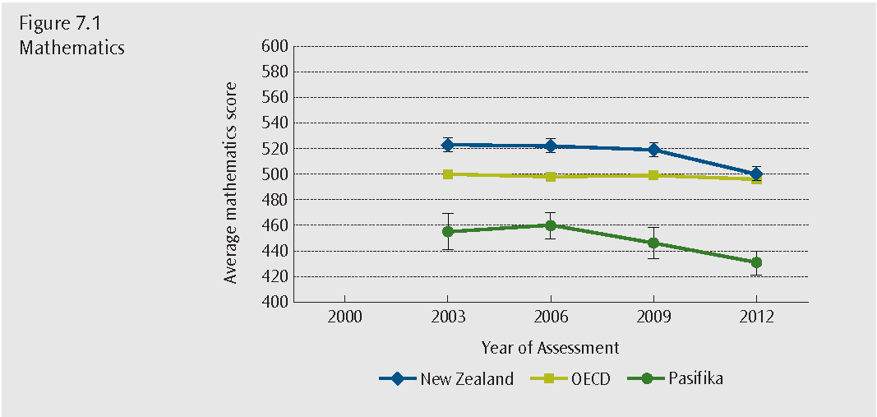
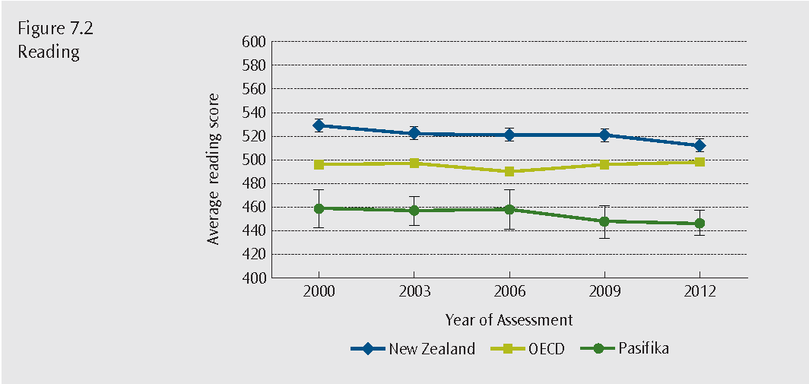
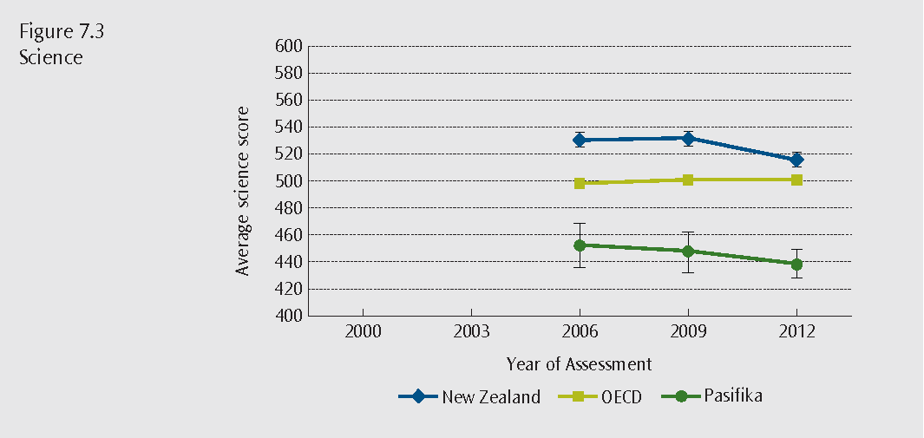
Note: error bars on the graphs provide a 95 percent confidence interval for the estimate of the average.
Graphs begin at the year the subject was first the major focus of the year of assessment
Figures 7.4 – 7.6 Proficiency levels of Pasifika students for mathematics, reading and science
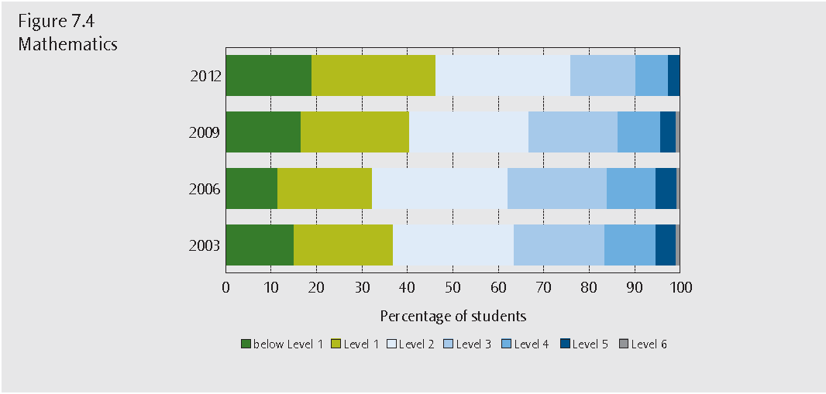
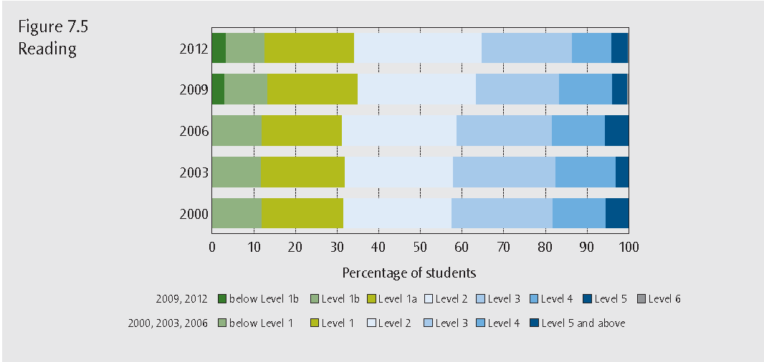
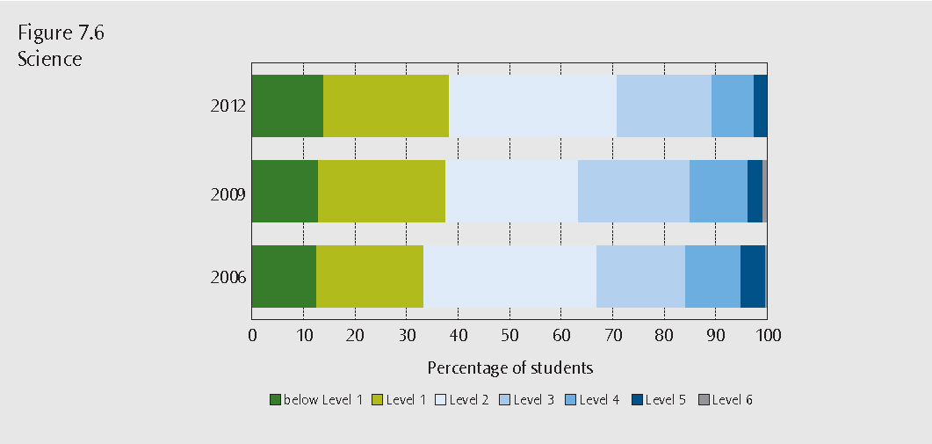
Note: In 2009 Level 1b and Level 6 were added to provide a finer distinction of the proficiency levels of students that were previously classified as below Level 1 and at Level 5 and above for the 2000, 2003 and 2006 assessments.
low socio-economic
How well are New Zealand students from low socio-economic backgrounds achieving, and how has this changed over time?
Improving education outcomes for students from low socio-economic areas is a priority for the Ministry of Education.
In PISA socio-economic status is measured through the PISA index of economic, social and cultural status (ESCS). This index is taken from information reported by the student about their parents’ occupations, the highest education level of their parents and possessions in the home. The latter included things such as whether the student had access to educational resources like desks, computers and books, as well as possessions that would likely be related to parental income, such
as a dishwasher, pay television, and the number of mobile phones, televisions, computers and cars
in the household.
The ESCS index for a student, or the average for a country, provides a value relative to the average level of socio-economic status across the OECD. Most scores fall between -1 and + 1. If a student
has a value on the ESCS index of -1 it means their socio-economic status is less than 84 percent of OECD students. A score of +1 means their socio-economic status is greater than 84 percent of
OECD students.
The overall ESCS index value for New Zealand is 0.04, which is not different from the OECD average.
To enable comparison between students from different socio-economic backgrounds within New Zealand they have been divided into four quarters according to their score on the ESCS index. For example, the 25 percent of students with the lowest ESCS index value in New Zealand are identified
as low socio-economic students. The same classification is used each year PISA is assessed to ensure we are always comparing the lowest 25 percent of students on the ESCS index.
The overall average mathematics score for low socio-economic students in PISA 2012 (444 points) was well below the New Zealand and OECD averages for all students and also below the 2003 average score for New Zealand low socio-economic students (472 points). Figure 8.1 shows a similar trend in the scores of other socio-economic quarters from 2003 to 2012.
The average score for low socio-economic students in reading decreased between 2003 (468 points) and 2012 (458 points). The average scores for all socio-economic quarters have declined in this period (see Figure 8.2).
The average science score for low socio-economic students declined between 2006 (480 points) and 2012 (458 points). The low/medium socio-economic group is the only group not to have a noticeable decline in science average score between 2006 and 2012 (see Figure 8.3).
Figures 8.1 – 8.3 Average mathematics, reading and science performance by quarters of socio-economic status
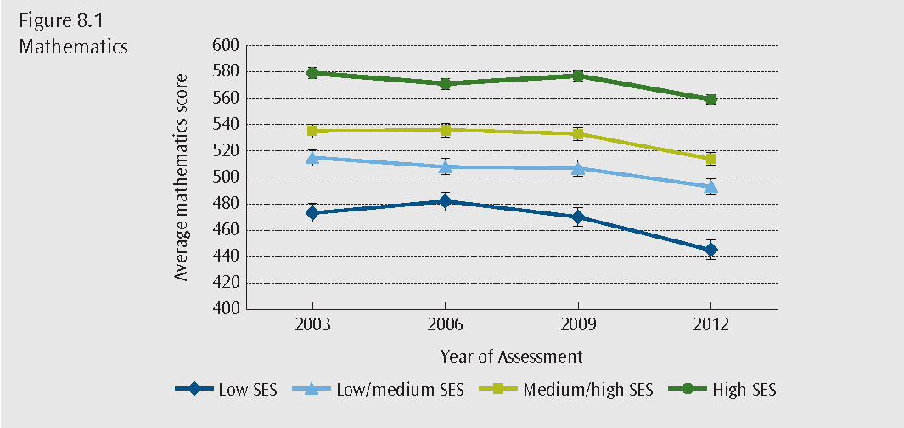
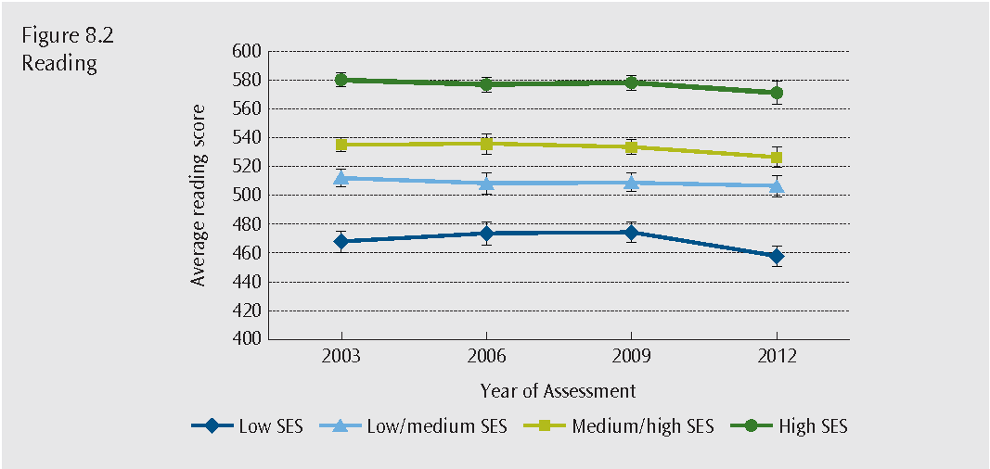
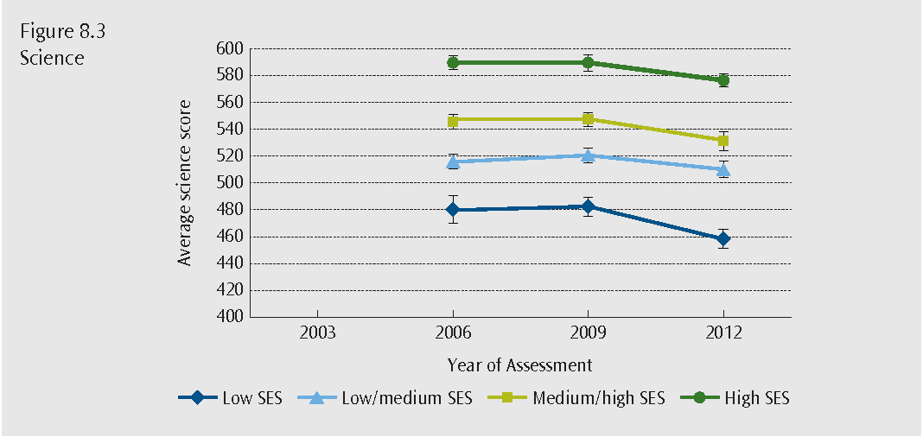
Note: error bars on the graphs provide a 95 percent confidence interval for the estimate of the average.
Graphs begin at the year the subject was first the major focus of the year of assessment, except reading where ESCS is not available for PISA 2000.
low socio-economic
Figures 8.4 – 8.6 Proficiency levels of low socio-economic students for mathematics, reading and science
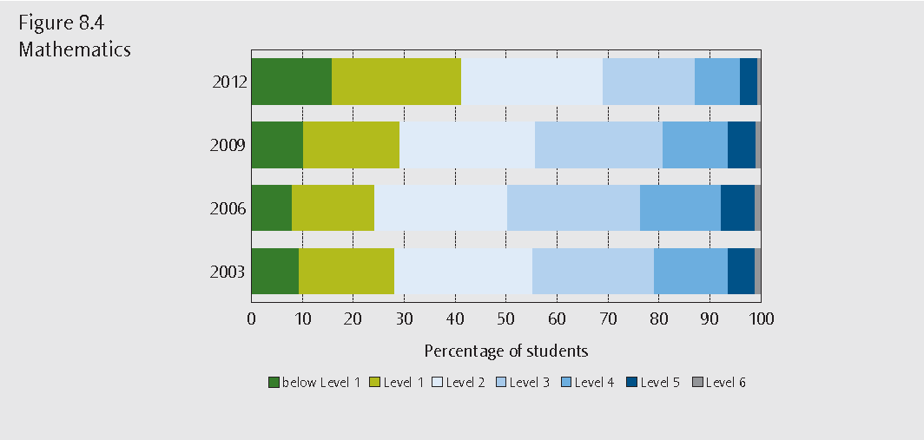
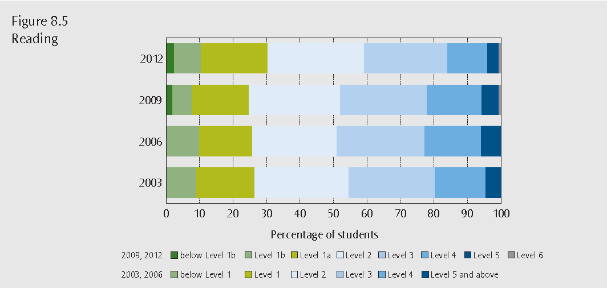
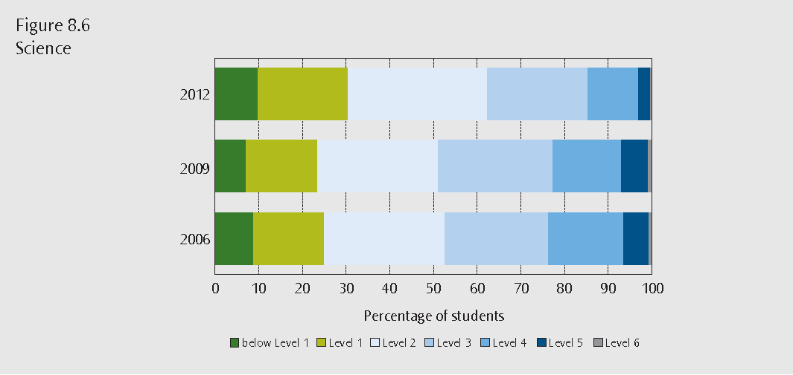
Note: In 2009 Level 1b and Level 6 were added to provide a finer distinction of the proficiency levels of students that were previously classified as below Level 1 and at Level 5 and above for the 2000, 2003 and 2006 assessments.
Graphs begin at the year the subject was first the major focus of the year of assessment, except reading where ESCS is not available for PISA 2000.
Figures 8.4 to 8.6 show the change in the proportions of low socio-economic students at each proficiency level. The proportions performing below Level 2 in mathematics increased from 28 percent in 2003 to 41 percent in 2012. The proportions below Level 2 in reading have not increased (26 percent in 2003 and 30 percent in 2012). In science the proportion below Level 2 went from
25 percent in 2006 to 30 percent in 2012.
The proportion of top performing students who achieve at Level 5 or above has not changed for
low socio-economic students in reading. However there have been small declines in mathematics
(7 percent in 2003 and 4 percent in 2012) and science (7 percent in 2006 to 3 percent in 2012).
Achievement in New Zealand is more closely linked to socio-economic status than in other countries. On average in the OECD 15 percent of the differences in student achievement are accounted for by socio-economic status; in New Zealand it is 18 percent (82 percent of performance is explained by other factors) and the relationship is relatively strong.
However, achievement is influenced by more than just low socio-economic status. Quality teaching, expectations of performance, school leadership and when relationships between parents and teachers focus on learning make a large contribution to results.
Equity in mathematics achievement
The best performing education systems provide high-quality education to all students. These systems not only have large proportions of students at the highest levels of reading, mathematics and science proficiency – but also relatively few students at the lower levels. These are education systems characterised by a relatively small spread in scores and a relatively high average performance.
One of the ways we can look at equity in mathematics is by looking at the spread of mathematical achievement scores.
What is the spread of New Zealand students’ performance in mathematics?
One measure of a country’s spread of scores (variation in mathematics performance) is the difference between students’ scores at the upper end of the achievement distribution (the 90th percentile) and the lower end (the 10th percentile).
The spread of scores in a country helps identify whether it is achieving equity in its education system. New Zealand has one of the widest spreads of scores in mathematics in the OECD, which means that the New Zealand education system has relatively large differences among 15-year-olds in mathematics.
Figure 9.1 shows the spread in achievement of participating countries. Examples include Canada with relatively high equity and the United Kingdom, Australia, New Zealand and Singapore with relatively low equity in mathematics performance. Of these countries New Zealand has the second lowest equity – the greatest spread of scores among its students.
Figure 9.1 also shows the average performance of these countries in terms of their achievement.
This allows a comparison of average performance with equity of performance. Singapore is unusual in that it is one of the highest performing countries on average, but it has relatively low equity. New Zealand is in the same upper left section as Singapore and Australia. This means New Zealand is also characterised by relatively high achievement and relatively low equity. This is consistent with the information provided on New Zealand students’ performance on the mathematics proficiency levels.
Figure 9.1 Achievement and differences in mathematics between the top 10 percent and bottom 10 percent of students within each country
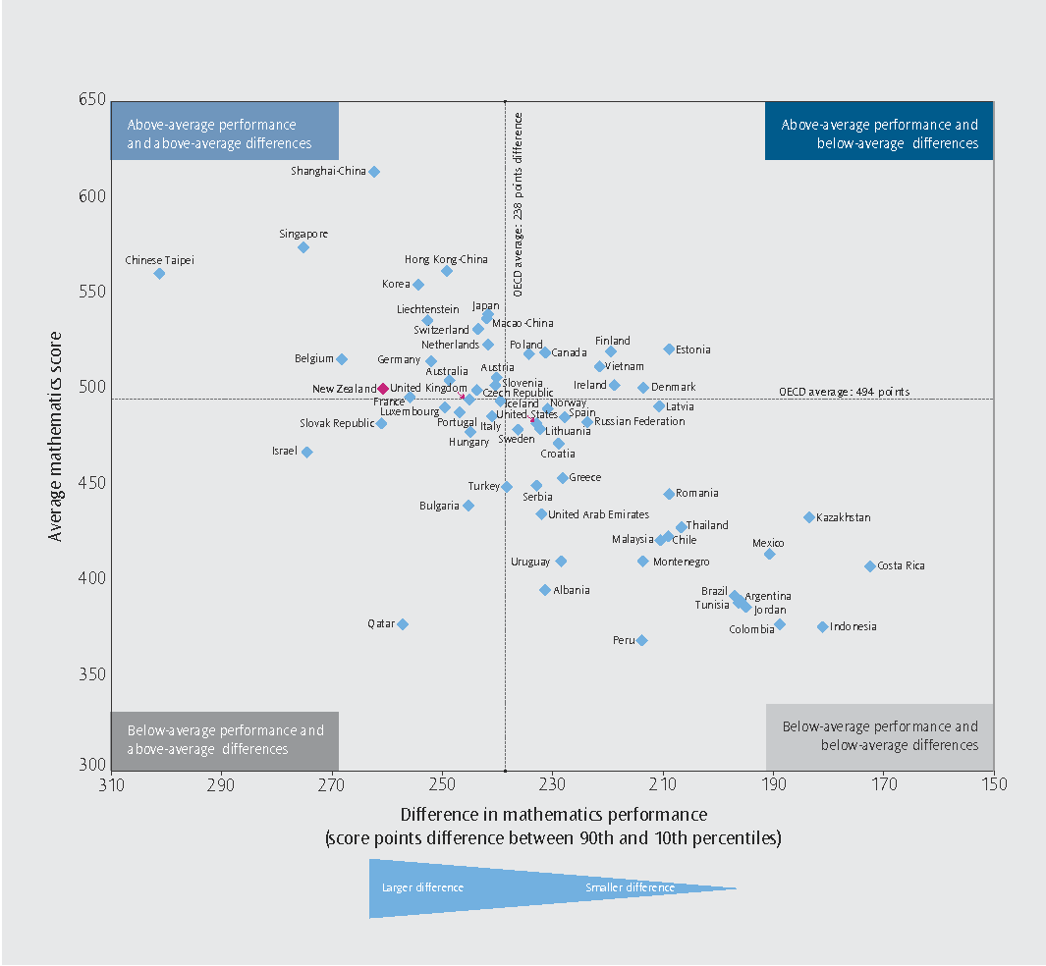
How much of the difference in New Zealand student performance in mathematics is associated with differences between schools?
The previous section looked at the spread of scores across New Zealand and found, particularly relative to some other countries, New Zealand has a wide spread of achievement. Going further,
we can look at the differences in achievement that occur within and between schools and how
New Zealand compares with other countries.
To some extent how much difference there is between and within schools is related to the type of education system. For example, in countries like Germany where the students are tracked to different types of schools early on, the differences within schools are relatively small and the differences between schools are relatively large. In other countries such as Finland where there is a comprehensive system and students are not tracked, the differences in schools are likely to be bigger when compared to the differences between schools. This needs to be taken into account when making comparisons with other countries.
Figure 9.2 shows the differences between and within schools in mathematics achievement for countries that participated in PISA 2012. Countries with large between-school differences have large differences between the average mathematics performances of schools. As above, these can often be countries where schools have different educational programmes (or tracks) for their 15-year-olds. Other countries may have little differences in the average performance of different schools and the differences in student performance are mainly attributable to differences in achievement within schools.
Figure 9.2 shows that New Zealand particularly stands out because of larger differences within schools compared to countries in a similar position on the table. While other countries such as Finland also have large within-school differences, a larger difference between schools is evident in New Zealand. This means that there are larger differences in the average performance of New Zealand schools compared to schools in Finland.
The differences between schools in Australia, the United Kingdom and Singapore are similar to
New Zealand. The spread of scores within their schools is greater than the OECD average, although not as large as in New Zealand.
For New Zealand and these countries there are noticeable differences between the average performances of schools. This means that some schools will have higher average achievement than other schools within the same country. The relatively large differences within schools means that these countries will also tend to have students with a wide range of abilities in many of their schools.
Between 2003 and 2012 there were small increases in the differences in New Zealand students’ mathematics performance between schools, and small declines in the differences within schools.
Figure 9.2 Between and within-school variation in mathematics achievement
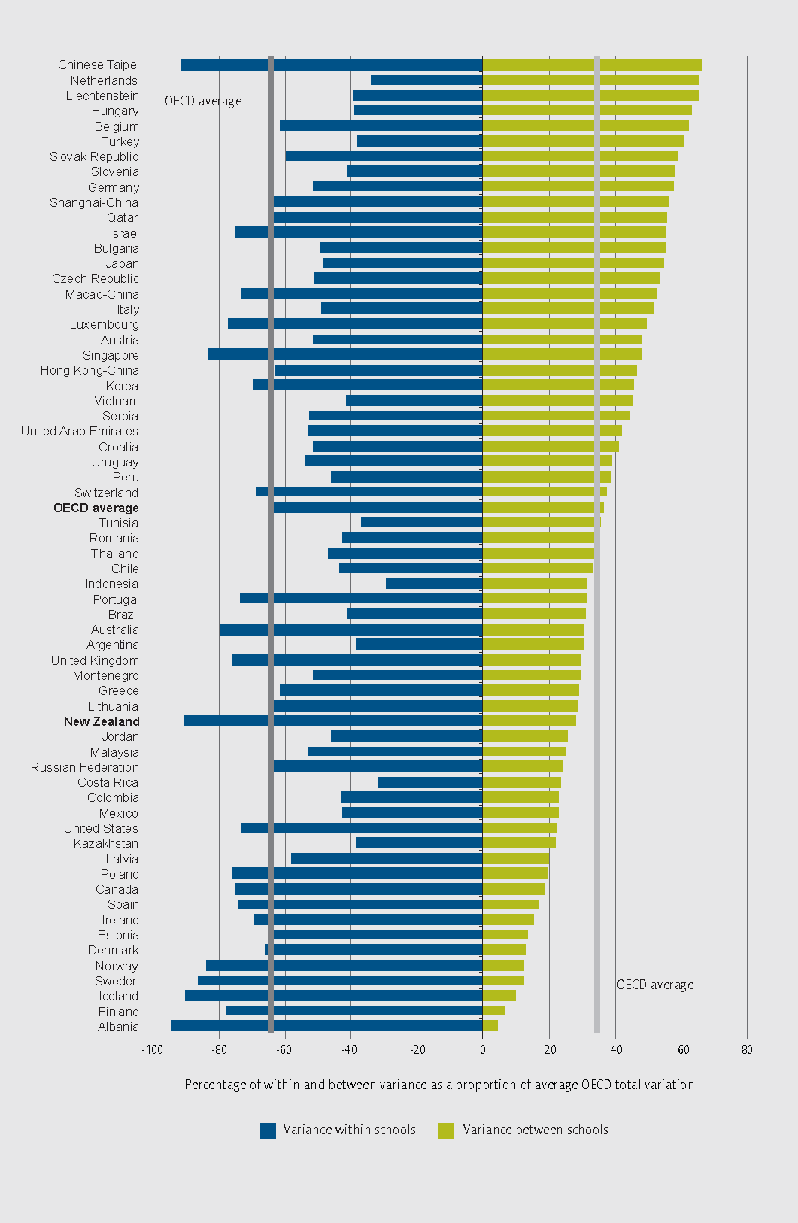
Source: Adapted from figure 2.7 Volume II: Excellence through Equity: Giving Every Student the Chance to Succeed (OECD, 2013)
How do other student background factors relate to mathematics achievement?
Within the New Zealand student population there are demographic characteristics that are often associated with differences in average achievement. The PISA international reports explore some of these relationships for several groups, including students from single-parent families, immigrant students, students from rural communities and students who speak a language at home that is different from the language of instruction.
Figure 9.3 shows the difference in mathematics performance between students in these groups and the rest of the population. As many of these factors are often linked with socio-economic status, Figure 9.3 shows what this difference would be after taking socio-economic background into account. In other words, this shows us what the differences would be between students in these groups and students in the rest of the population who come from the same socio-economic background.
About 20 percent of New Zealand 15-year-olds are from single parent families compared to 13 percent on average across the OECD. Students from single-parent families in New Zealand scored 487 points, on average, in mathematics. This is the same as the OECD average for students from single parent families. In New Zealand, the difference in mathematics performance between students from single-parent families and other family types was 19 points, similar to the OECD average of 15 score points. After taking socio-economic status into account the OECD difference remains and is 5 points lower than students from other family types, but in New Zealand the difference all but disappears (only 1 point lower). This means that for students from similar socio-economic background there is no noticeable difference in average score between students from single parent families and the rest of the population.
Over half of New Zealand 15-year-old students (56 percent) attend schools in urban centres with more than 100,000 inhabitants, 38 percent attend schools in urban areas from 3,000 to 100,000 inhabitants, and only 6 percent attend schools in very small towns or rural communities with less than 3,000 inhabitants. The OECD average proportions are 36 percent, 56 percent and 11 percent respectively.
In New Zealand, students in large urban areas score 513 points on average, followed by students in small urban areas with 492 points and then students in rural communities 458 points. On average, in New Zealand, students in large urban areas perform better than the OECD average, students in small urban areas perform the same, while students in rural communities perform less well. The differences between the average scores for students from these community sizes are relatively large for both New Zealand and the OECD, although the difference between large urban schools and rural schools is greater for New Zealand (55 score points) compared to the OECD average (31 score points). When we compare students with the same level of socio-economic background these differences are generally still large – with the exception of the difference between large and smaller urban areas in New Zealand, as shown in Figure 9.3.
New Zealand has a large migrant community compared to most OECD countries. From PISA 2012 data, about 27 percent of 15-year-olds in New Zealand were either born overseas (first generation immigrants), or, if they were born in New Zealand, both their parents were born overseas (second generation immigrants) and are defined as immigrants. Across the OECD, 11 percent of students fall under this definition.
Figure 9.3 Differences in mathematics achievement for specific groups of the New Zealand population compared to the OECD average differences for the same groups
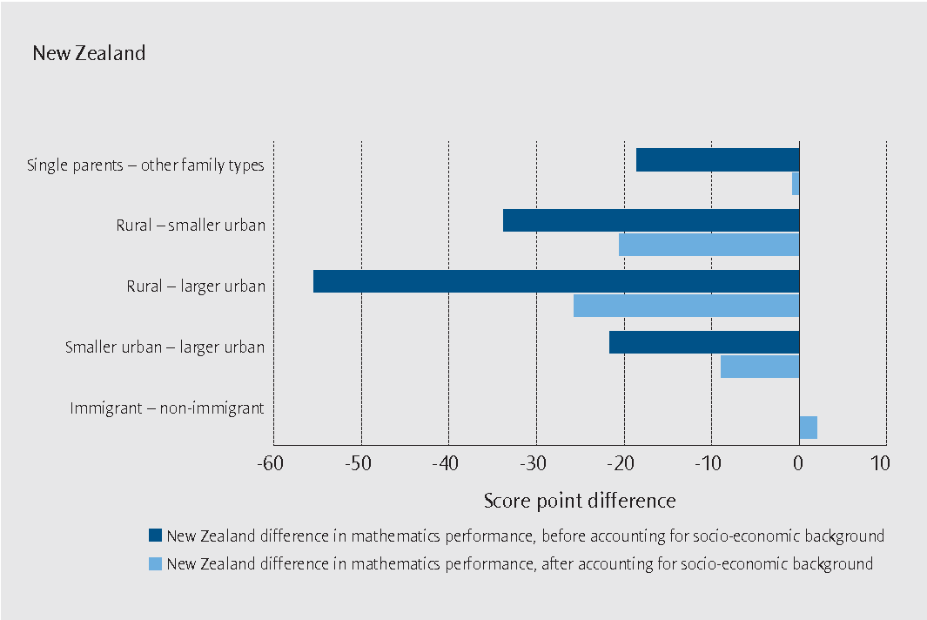
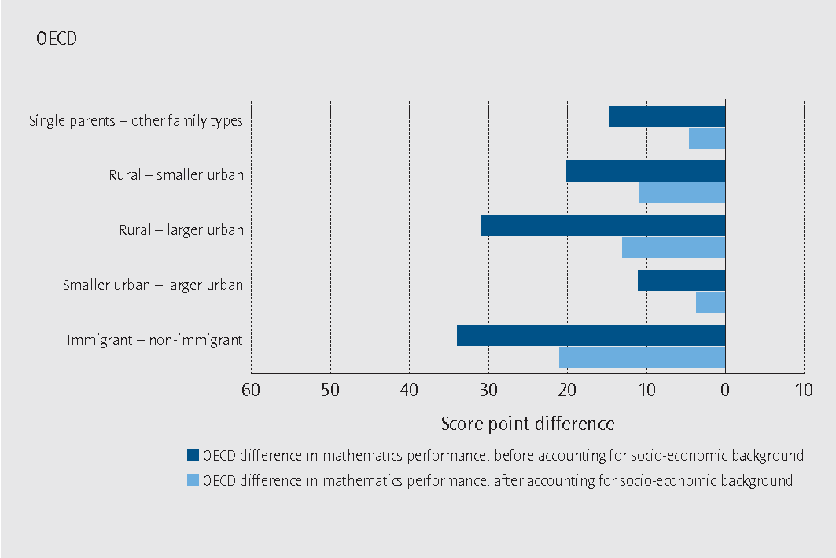
There was no difference in New Zealand between immigrant and non-immigrant students, with both groups scoring on average 501 points. This is unlike the average OECD country, where immigrant students score 37 points below their non-immigrant counterparts (463 as opposed to 500 points). The New Zealand immigrant population is a diverse group where particular immigrant groups perform better in mathematics than other immigrant groups. For example, first generation immigrants scored 17 points higher than second generation immigrants.
While this result is likely to be influenced by New Zealand immigration policies, other factors may also play a role in the relationship between immigration and achievement. One such factor is the language spoken in the home.
In New Zealand, immigrant students who speak English in the home most of the time score, on average, 515 points, 25 points higher than immigrants who speak another language. However, when the same comparison is made for students with the same level of socio-economic background there is very little difference between the two groups. Each of these groups comprises approximately 14 percent of the New Zealand population.
This means that New Zealand students who do not speak English at home, whether immigrants or non-immigrants, are achieving at lower levels than those who do.
Other factors which are likely to have an impact on achievement will be explored in later publications from PISA 2012.
Mathematics achievement and the learning environment in New Zealand
In addition to the assessments of mathematics, science and reading, students provided responses to an extensive set of questions about their family background, their attitudes towards mathematics and their learning experiences in mathematics.
Principals of participating schools also provided background information. These two sources of information provide us with some insights into the learning environment for mathematics and how this relates to achievement.
This section draws upon analysis to be presented in a forthcoming New Zealand PISA 2O12 publication “PISA 2012: Spotlight on the learning environment”.
How does the learning environment relate to achievement?
The Spotlight on learning environment report examines several factors relating to the learning environment, exploring some of the differences that occur within New Zealand in exposure to mathematical content, the way mathematical content is delivered, and student behaviours that hinder learning. It also looks at how New Zealand compares in an international context.
Differences within schools in the mathematics achievement of New Zealand students are relatively large. Students’ socio-economic background accounts for a relatively small proportion of these differences within schools. This means that looking at students’ opportunities to learn, factors relating to instruction and factors that hinder learning, can help us to understand some of the differences in performance among students in the same school in mathematics achievement.
Opportunities to learn:
- Greater student familiarity with mathematical concepts and exposure to formal mathematics is related to higher mathematics achievement.
Delivery of content:
- Greater perceived use of cognitive activation by students, where teachers encourage students to reflect on their learning in class, was related to higher mathematics achievement, but greater perceived use of student-orientation and formative assessment by students were related to lower mathematics achievement.
- Better perceived teacher-student relations by students was associated with higher mathematics achievement.
- The more principals perceive that teacher-related factors, such as not meeting individual student’s needs, hinder student learning, the lower the mathematics achievement of students.
- Additional mathematics lessons and extracurricular mathematics activities were related to higher mathematics achievement.
- Better perceived quality of educational resources by principals was related to higher mathematics achievement.
- Higher perceived shortage of teachers by principals was related to lower mathematics achievement.
Disruptive learning environment:
- Less perceived disruptive behaviour (a more positive disciplinary climate) in the classroom and school by principals was related to higher mathematics achievement.
- More frequent tardiness and truancy was related to lower mathematics achievement.
Of the factors examined, the amount of exposure to formal mathematics, tardiness, truancy and disruptive student behaviour in the classroom have the largest impact on mathematics achievement for New Zealand students.
New Zealand stood out among participating countries for the high proportion of students attending schools where students are grouped by ability across and within mathematics classes, and for having some of the strongest impacts of:
- exposure to formal mathematics on mathematics achievement;
- teacher-student relations on mathematics achievement;
- disciplinary climate on mathematics achievement; and
- truancy on mathematics achievement.
New Zealand also stood out among participating countries for having some of the largest disparities between:
- public and private schools in quality of educational resources;
- advantaged and disadvantaged schools in teacher shortage;
- advantaged and disadvantaged students in tardiness; and
- advantaged and disadvantaged students in truancy.
The results demonstrate that New Zealand students have varied access to learning environments that support strong achievement in mathematics in terms of student exposure to formal mathematics, access to qualified teachers, access to quality physical infrastructure and educational resources, and ability to work in a classroom which is disrupted less by student behaviour.
Further information from PISA 2012
This report and further information from PISA 2012 are available from the Ministry of Education, Education Counts website at:
www.educationcounts.govt.nz/topics/research/pisa_research/pisa_2012
Future national publications for PISA 2012 will be added to this website.
The relationship of other student, school and system level factors to mathematics achievement will be explored further in upcoming national publications on PISA 2012. Many of these factors are covered in an international context in Volumes III and IV of the international reports for PISA 2012.
The OECD PISA 2012 international Volume I:“What Students Know and Can Do: Student Performance in Mathematics, Reading and Science” (OECD, 2013) offers a comparative view of achievement in mathematics, reading and science.
The forthcoming publication “Spotlight on mathematics achievement” (Cowles with May, forthcoming) will provide a more in-depth look at mathematics achievement in New Zealand, including performance on each of the three mathematics processes and four content areas.
The OECD Volume II: “Excellence through Equity: Giving Every Student the Chance to Succeed” (OECD,2013) covers issues relating to equity in achievement outcomes. This national summary report covers topics included in these two international volumes (Volumes I and II).
The OECD Volume III: “Ready to Learn: Students’ Engagement, Drive and Self-Beliefs” (OECD,2013) covers how countries compare on measures of student engagement, drive and belief, how they interact, and how these measures relate to student achievement.
The OECD Volume IV: “What Makes a School Successful: Resources, Policies and Practices” (OECD,2013) looks at how resources, policies and practices at the school and system level relate to student achievement.
Another New Zealand publication, “PISA 2012: Spotlight on the Learning environment”.
(Lamy, forthcoming), will cover aspects of volumes III and IV that relate to the learning environment in New Zealand.
Upcoming national publications from PISA 2012 will look at topics such as how student attitudes relate to mathematics achievement, provide a more in-depth look at equity issues, and explore specific questions relating to the relationship of background information to achievement.
The OECD international reports and further information on PISA in an international context can be found on the OECD PISA webpage www.oecd.org/pisa/

Definitions and technical notes
PISA 2012 literacy definitions
Mathematical Literacy: An individual’s capacity to formulate, employ, and interpret mathematics in a variety of contexts. It includes reasoning mathematically and using mathematical concepts, procedures, facts and tools to describe, explain and predict phenomena. It assists individuals to recognise the role that mathematics plays in the world and to make the well-founded judgements and decisions needed by constructive, engaged and reflective citizens.
Reading Literacy: An individual’s ability to understand, use, reflect on and engage with written texts, in order to achieve one’s goals, to develop one’s knowledge and potential, and to participate in society.
Scientific Literacy: Scientific literacy refers to an individual’s:
- Scientific knowledge and use of that knowledge to identify questions to acquire new knowledge, to explain scientific phenomena, and to draw evidence-based conclusions about science-related issues;
- Understanding of the characteristic features of science as a form of human knowledge and enquiry;
- Awareness of how science and technology shape our material, intellectual, and cultural environments;
- Willingness to engage in science-related issues, and with the ideas of science, as a reflective citizen.
Technical Notes
Average
Student performances in PISA are reported using means (a type of average) for groupings of students. In general, the mean of a set of scores is the sum of the scores divided by the number of scores and it is referred to in this report as ‘the average’. Note that for PISA, as with other large-scale studies, the means for a country are adjusted slightly (in technical terms ‘weighted’) to reflect the total population of 15-year-olds rather than just the sample.
OECD average
The OECD average includes only the OECD countries: no non-OECD (partner) countries are included in this average. The OECD average is the average of the means for the OECD countries.
Points – or scale score points
The design of PISA allows for a large number of questions to be used in reading, mathematics and science, but each student answers only a proportion of these questions. PISA employs techniques to enable population estimates of achievement to be produced for each country even though a sample of students responded to differing selections of questions. These techniques result in scores which are on a scale with an average value of 500. Scores on this scale are referred to in this report as points. About two-thirds of students across OECD countries score between 400 and 600 points.
Proficiency levels
PISA developed proficiency levels to describe the range in literacy across 15-year-old students. The proficiency levels describe the competencies of students achieving at that level and are anchored at certain score points on the achievement scale. Note that students were considered to be proficient at a particular level if, on the basis of their overall performance, they could be expected to answer at least half of the items in that level correctly. Typically, students who were proficient at higher levels had also demonstrated their abilities and knowledge at lower levels.
Standard error, confidence intervals and error bars
Because of the technical nature of PISA, the calculation of statistics such as averages and proportions has some uncertainty due to (i) generalising from the sample to the total 15-year-old school population, and (ii) inferring each student’s proficiency from their performance on a subset of items. The standard errors (usually given in brackets) provide a measure of this uncertainty. In general, we can be 95 percent confident that the true population value lies within an interval 1.96 standard errors either side of the given statistic. This has been displayed on graphs in this report as error bars. The error bars provide a measure of the precision of the estimate of the average.
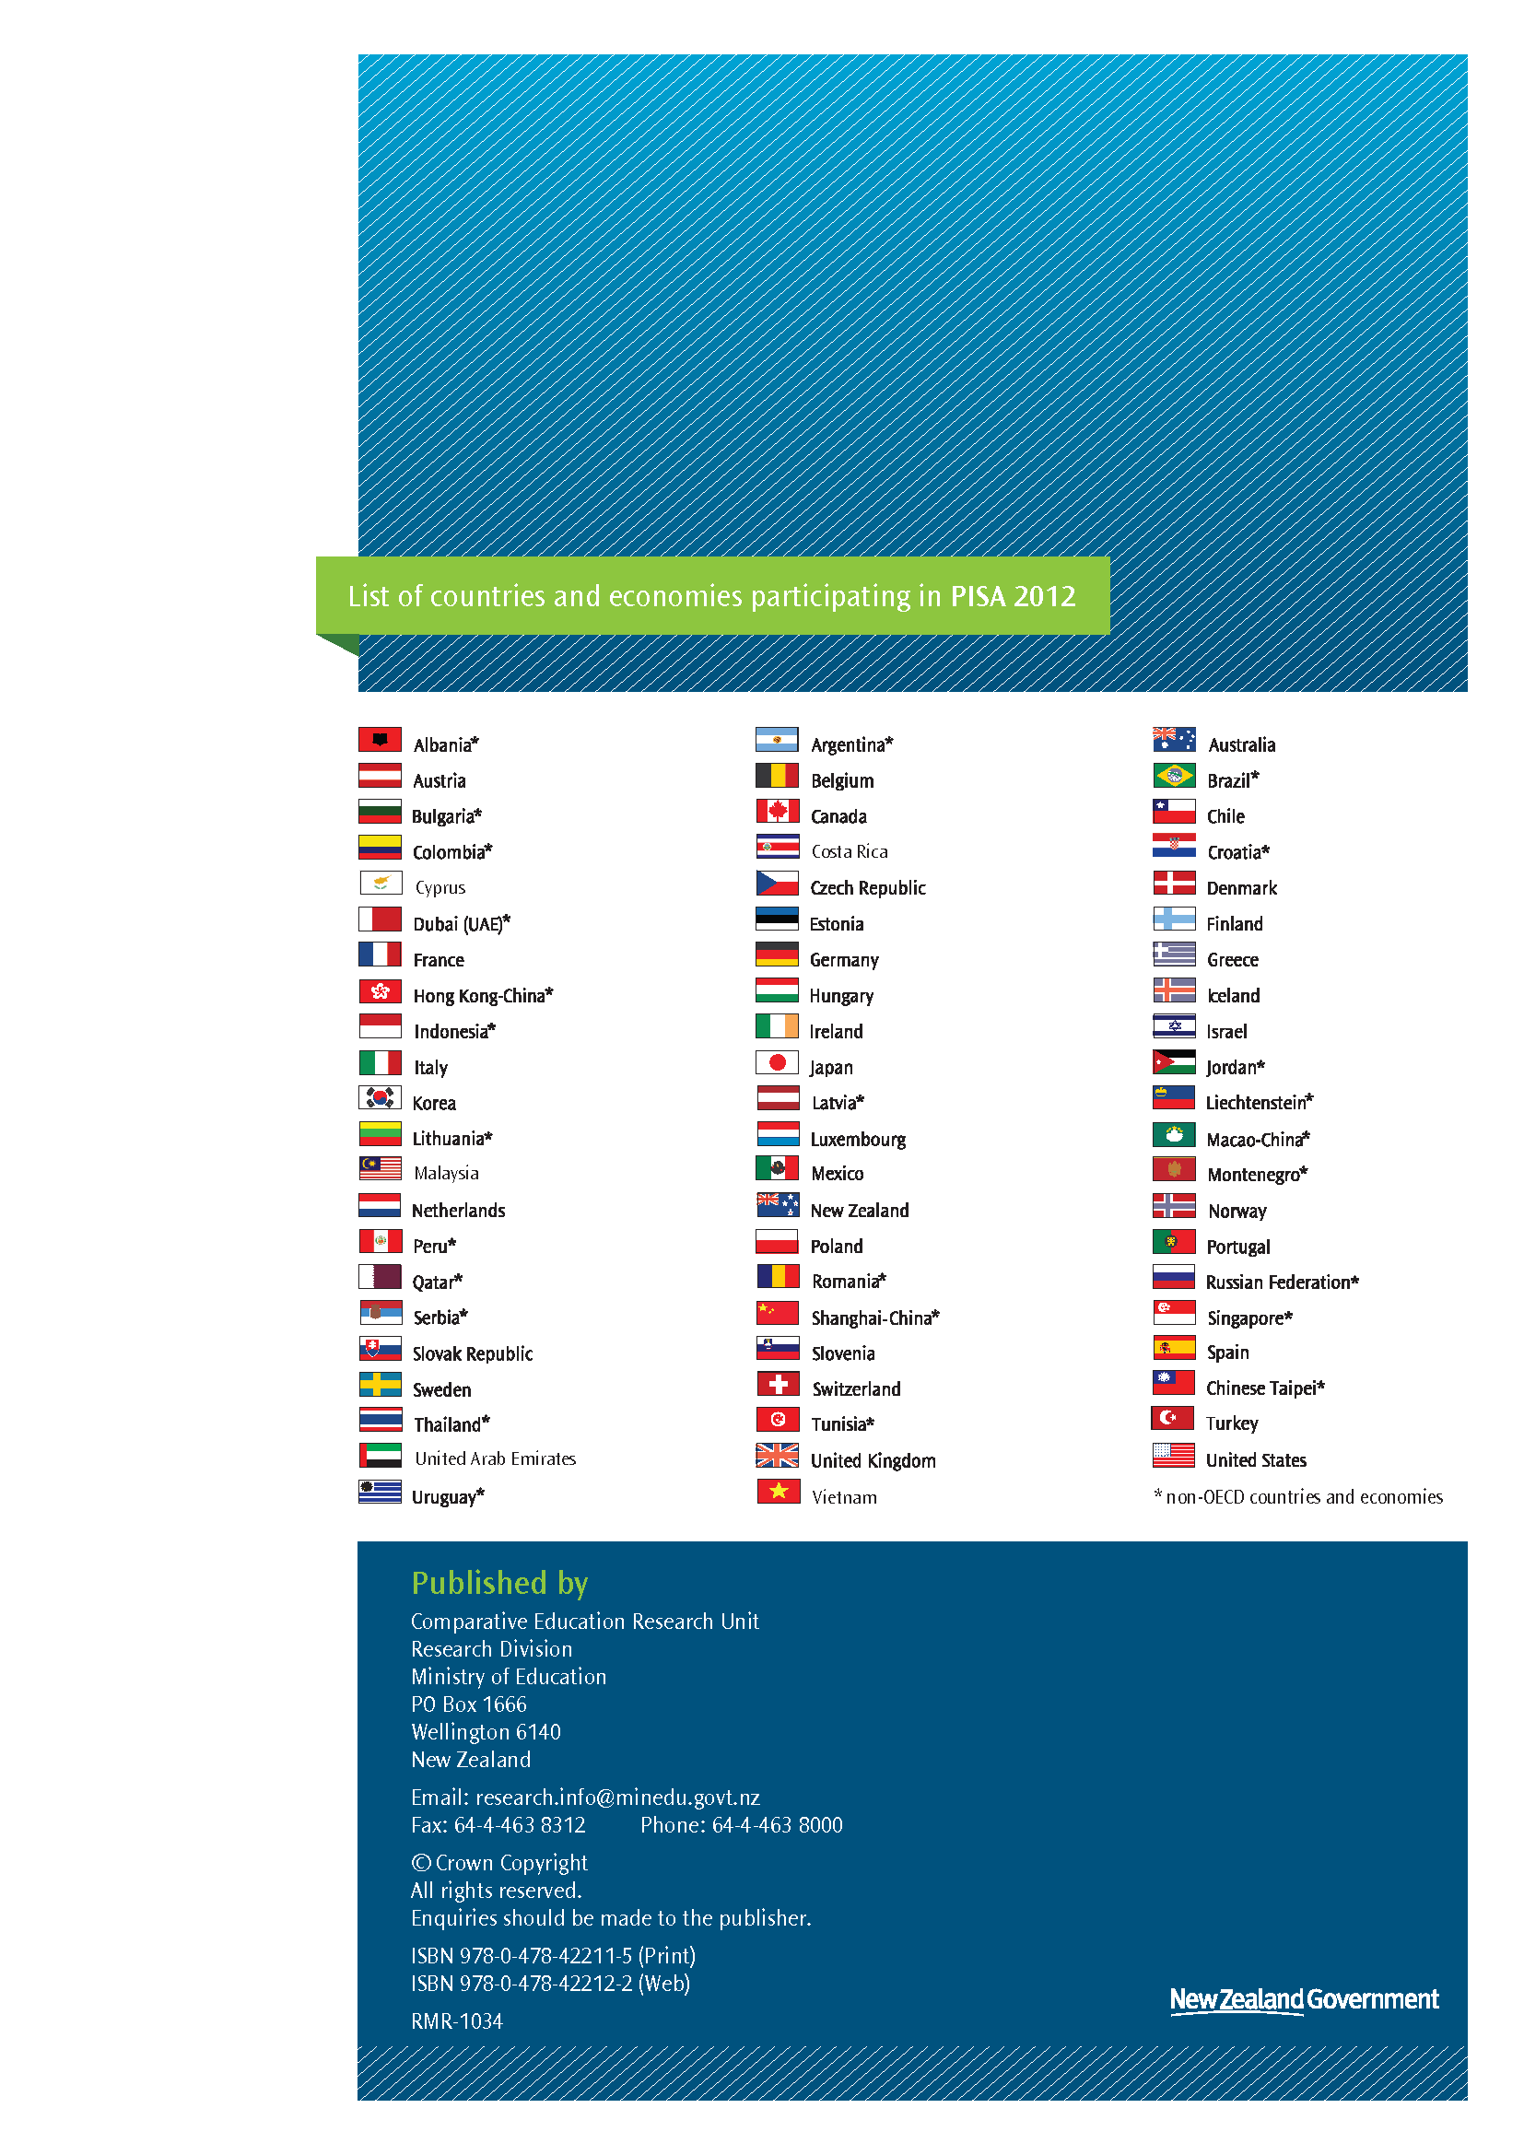

Students are aged between 15-years-3-months and 16-years-2-months. As most students are aged 15, they are referred to as ‘15-year-olds’ for brevity.
In New Zealand PISA was administered only in English.
New Zealand did participate in the computer-based Electronic Reading Assessment as part of PISA 2009. The performance of New Zealand students is reported in “PISA 2009: Digital Readers at age 15: Results from the PISA 2009 Electronic Reading Assessment” (Kirkham, 2012).
PISA 2012 Assessment and Analytical Framework (OECD, 2013, p.16)
Ibid, p.14
PISA participants include both countries and economies. Examples of economies or regions are Shanghai-China, Hong Kong-China and Macao-China. For brevity the word countries in this report will refer to both countries and economies.
This includes nearly 1,000 students who took part in the financial literacy component.
A full description of proficiency levels is provided in PISA 2012 Assessment and Analytical Framework (OECD, 2013).
The PISA 2000 mathematics assessment only covered two (space and shape, and change and relationships) of the four content areas of the framework.
Level 6 proficiency was introduced into the reading proficiency levels in 2009.
Volume I: What Students know and can do: Student Performance in Mathematics, Reading and Science OECD (2013).
Ministry of Education Statement of Intent 2013-2018. New Zealand Government May 2013.
Ministry of Education Statement of Intent 2013 – 2018. New Zealand Government May 2013
68 percent of students in the OECD will have values that range between -1 and +1, and 95 percent of students will have values that range between -2 and +2.
The 25 percent of students with the next highest ESCS index values are referred to as low/medium, with medium/high the next group and high being the quarter of students with the highest ESCS index values.
The socio-economic index is not available for analysis of reading data from PISA 2000.
Note rounding causes the slight discrepancy between OECD average scores and difference figures. Students missing immigrant information cause the slight discrepancy between New Zealand immigrant and non-immigrant averages and the overall New Zealand average of 500.
Student socio-economic background as measured by the PISA index of Economic Social and Cultural Background explained a larger proportion of the differences between schools.

