Acknowledgements

The authors gratefully acknowledge the assistance of Raelene Butters, Jit Cheung, Christabel Dillon, David Earle, Shona Ramsay, Lisa Rodgers, Lynne Whitney, the National Research Bureau and Associate Professor, Frank Sligo, Massey University. The authors also gratefully acknowledge the time and effort invested by the respondents to the ALL and IALS surveys.

Contents

Overview 4
Key findings 4
1. Introduction 7
2. Educational Participation 8
Educational participation 8
Prose literacy and educational participation 10
Document literacy and educational participation 12
Numeracy and educational participation 13
3. Self-assessed Numeracy and Up-skilling 17
Numeracy and self-assessed numeracy 17
Numeracy, self-assessed numeracy and up-skilling 18
4. Labour Force Status 21
Labour force status 21
Prose literacy and labour force status 22
Document literacy and labour force status 24
Numeracy and labour force status 26
Problem-solving and labour force status 27
5. Income 29
Document literacy and income 29
Numeracy and income 31
6. Occupation 33
Occupation 33
Document literacy and occupation 34
Numeracy and occupation 37
Size of employer 39
7. Industry 40
Industry 40
Document literacy and industry 41
Numeracy and industry 43
8. Glossary 46
9. Publications 50

Overview

- How is literacy skill distributed across the New Zealand adult population according to educational participation?

- How is literacy skill distributed across the New Zealand adult population according to work-related factors such as labour force status, occupation or industry of employment?

- Have there been any changes in these distributions over the past 10 years?

- How do the up-skilling (ie, further education and training) activities of New Zealand adults vary according to both their measured and their self-assessed numeracy skill?

The Adult Literacy and Life Skills (ALL) survey was designed to answer these and other questions.

Why do we need these answers? The labour force demands of a modern economy are becoming increasingly complex. If New Zealand is to improve (or even maintain) its position in the world economy it must develop a workforce with high levels of generic and technical skills. The ALL survey provides an insight into our current skill levels, and this insight is essential for the development of initiatives to enhance (and maintain) these levels. In the longer term, having datasets from the 1996 International Adult Literacy Survey (IALS) and ALL gives us a baseline against which to measure gain (and loss) in national levels of skill development.

This report is the second in a series of four that investigate the initial results of the ALL survey. It presents an overview of New Zealanders’ skills in relation to educational and labour force characteristics, and any changes since 1996.

Key findings

Education

- Greater literacy, numeracy and problem-solving skills were strongly associated with higher levels of educational participation.

- A large shift toward increased levels of educational participation of the 16–65 year-old population occurred over the decade between the 1996 IALS and the 2006 ALL studies.

- Literacy skill decreased for each level of educational participation, with the smallest decrease for those with tertiary education. However, due to very large shifts in the distribution of educational participation (toward participation in higher levels of education) the net change from 1996 to 2006 for all levels of educational participation combined was an increase in literacy skill.

- People with higher numeracy skill were, on average, more likely to participate in non-formal up-skilling than those with low numeracy skill (regardless of their perception of their numeracy skill).

- People with low numeracy skill who self-assessed as having low numeracy skill were, on average, less likely to participate in formal up-skilling than the rest of the adult population.

Work and income

- In almost all labour force categories literacy skill increased between 1996 and 2006. In particular, the literacy skill of the poorer performers in IALS (the unemployed, retirees and homemakers) increased substantially.

- In literacy, numeracy and problem-solving, the employed and students had, on average, the greatest skill, the retired and homemakers less, and the unemployed the least.

- Those whose incomes were in the highest 40% tended to have higher numeracy and document literacy skill than the rest of the adult population.

Occupation

- Professionals had the highest numeracy skill overall, and those employed in the elementary occupations the lowest.

- Service and sales workers made up the greatest proportions of both those with low document literacy skill and those with low numeracy skill.

Industry

- Agriculture and fisheries industry employees had the lowest numeracy skill overall, and employees in the finance and real estate and health and education industries had the highest.

- The health and education industry had the largest percentages of both employees with low document literacy skill and employees with low numeracy skill. The health and education industry also had the largest percentages of employees with high document literacy skill and employees with high numeracy skill.

1. Introduction

The Adult Literacy and Life Skills (ALL) survey is an investigation of the distribution of certain skills among people aged 16 to 65. The skills tested are literacy (both prose literacy and document literacy), numeracy and problem-solving. The survey is conducted across a number of countries, as well as providing information specific to New Zealand.

The ALL survey follows a similar survey conducted in 1996: the International Adult Literacy Survey (IALS). Parts of the ALL survey are directly comparable to this earlier work. In particular, prose literacy and document literacy can be compared to provide a picture of some of the changes that have occurred over the previous decade.

For further information, please refer to The Adult Literacy and Life Skills (ALL) Survey: An Introduction (available at www.educationcounts.govt.nz). This publication is intended as a companion to any reporting on the ALL survey and contains such general information as the nature of the ALL survey and its application, as well as definitions, and descriptions of the skill domains and levels. Further information can also be found in the glossary on page 46, including definitions of the skills tested by the ALL survey (prose literacy, document literacy, numeracy and problem-solving) and the ways in which these are measured (levels of proficiency).

The focus of this report is on the distribution of literacy skills in New Zealand according to educational participation, labour force status, occupation, industry of employment, income and size of employer. Where possible, this report compares these distributions with those from the 1996 IALS survey. This report also includes an analysis of patterns of participation in up-skilling in New Zealand according to measured numeracy skill and self-assessed numeracy skill.

This report is the second in a series of four looking at the high-level results from the ALL survey. More in-depth analysis will be undertaken once this initial series has been completed.

2. Educational Participation

- How did the distribution of educational participation in the adult population change between 1996 and 2006?

- How did the distributions of literacy skills according to educational participation change between 1996 and 2006?

This section examines these questions.

The ALL survey directly measured four skill domains: prose literacy, document literacy, numeracy and problem-solving.

Educational participation
Educational participation, as measured by the ALL survey, is the highest level of schooling completed by a person. Educational participation is not the same as attainment of qualifications; for example, a person could complete Year 11 (or the equivalent) but not achieve a qualification. To ensure that the following analyses are statistically robust, educational participation is summarised by three levels:

- lower secondary or less − the person completed at most Year 10 (or the equivalent)

- higher secondary − the person completed more than Year 10 (or the equivalent) but no more than Year 13 (or the equivalent)

- tertiary − the person participated in a tertiary education programme.

In the IALS and ALL surveys these data are self-reported. The resulting distributions of educational participation are recorded in Figure 2.1.

A very large shift in self-reported educational participation occurred between 1996 and 2006. The percentages of those reporting having higher secondary education or tertiary education rose considerably, while the percentage of those reporting having lower secondary education only fell correspondingly.

Figure 2.1: Distribution of educational participation, IALS and ALL

Note:
Percentages are rounded to the nearest whole number.

When interpreting these results it is useful to note that considerable change has occurred in the tertiary sector between 1996 and 2006. According to administrative data held by the Ministry of Education there was a significant increase in participation in tertiary education between 1996 and 2006. There have also been changes in tertiary provision, with government funding providing an incentive for participation and growth (until 2005). In particular, there was growth in provision by private training establishments, significant growth in enrolments at wānanga, and a steady growth in polytechnics and institutes of technology. Also (although not captured in the statistics summarised here), there was growth in formal work-based learning through industry training.

In general, tertiary education became easier to access for a wider range of people, and many who had not succeeded at school were provided with a chance to re-engage in education.

It is also useful to note that those in the oldest age cohort in the IALS survey (aged between 56 and 65 in 1996) were aged between 66 and 75 in 2006 and therefore not part of the ALL survey (which sampled those aged 16 to 65 in 2006). This oldest IALS age cohort had a larger proportion with low secondary or less educational participation than the whole IALS population. Therefore, changes in the reported distribution of educational participation will have been influenced by this age cohort not being sampled in the ALL survey.

Prose literacy and educational participation
Prose literacy is the ability to read and understand continuous texts (such as news stories, editorials, brochures and instruction manuals). Prose literacy skill was measured by both the IALS and ALL surveys and its distribution among the adult population of New Zealand according to educational participation is shown in Figure 2.2.

Prose literacy skill decreased for each level of educational participation, with the smallest decrease for those with tertiary education. However, due to very large shifts in the distribution of educational participation (toward participation in higher levels of education) the net change from 1996 to 2006 for all levels of educational participation combined was a small increase in prose literacy skill.

Figure 2.2: Prose literacy and educational participation, IALS and ALL

Note:
1. Levels 3, 4 and 5 are combined to give more robust statistical information.
2. Percentages are rounded to the nearest whole number.

Figure 2.2 shows that for both the IALS and ALL surveys, greater educational participation indicates higher levels of prose literacy skill. Figure 2.2 also shows that:

- for those with lower secondary or higher secondary educational participation, the percentages at levels 1 and 2 increased while those at levels 3, 4 or 5 decreased

- for those with tertiary educational participation, the percentage at level 1 was relatively stable, while that at level 2 increased and that at levels 3, 4 or 5 decreased

- the net change for all levels of educational achievement was a decrease in the percentage at level 1 (from around 18 to 13%) while the percentage at level 2 remained relatively stable (moving from around 29 to 31%) and that at levels 3, 4 or 5 also remained relatively stable (moving from around 54 to 56%).

Document literacy and educational participation
Document literacy is the ability to read and understand discontinuous texts (such as charts, maps, tables, job applications, payroll forms and timetables). Document literacy skill was measured by both the IALS and ALL surveys, and its distribution among the adult population of New Zealand according to educational participation is shown in Figure 2.3.

As with prose literacy, document literacy skill decreased for each level of educational participation, with a smaller decrease for those with tertiary education. However, due to very large shifts in the distribution of educational participation (toward higher levels of participation), the net change from 1996 to 2006 for all levels of educational participation combined was an increase in document literacy skill.

Figure 2.3: Document literacy and educational participation, IALS and ALL

Note:
1. Levels 3, 4 and 5 are combined to give more robust statistical information.
2. Percentages are rounded to the nearest whole number.

Figure 2.3 shows that, in both 1996 and 2006, greater educational participation was strongly associated with higher levels of document literacy skill – as for prose literacy. The difference in overall document literacy skill between those with lower secondary and those with tertiary education increased since 1996. However, as in other countries, literacy skills did not determine educational participation, and substantial proportions of people continued to have low levels of education with high skills, and high levels of education with low skills.

Figure 2.3 also shows that:

- for those with lower secondary educational participation the percentage at level 1 increased, at level 2 it remained stable, and at levels 3, 4 or 5 it decreased

- for those with higher secondary educational participation the percentages at levels 1 and 2 increased, while the percentage at levels 3, 4 or 5 decreased

- for those with tertiary educational participation the percentage at level 1 was relatively stable, as was that at levels 3, 4 or 5, whereas the percentage at level 2 increased

- the net change for all levels of educational achievement was a decrease in the percentage at level 1 (from around 21 to 14%), while the percentage at level 2 remained relatively stable (moving from around 30 to 29%) and that at levels 3, 4 or 5 increased (from around 50 to 57%).

Numeracy and educational participation
Numeracy is the ability to read and process mathematical and numeric information in diverse situations. Numeracy skill was measured in the ALL survey only and its distribution among the adult population of New Zealand according to educational participation is shown in Figure 2.4.

Greater educational participation was a strong indicator of higher levels of numeracy skill. For example, the proportion of the population with lower secondary education who had level 3, 4 or 5 numeracy skill was around 13%, whereas the proportion of the population with tertiary education who had level 3, 4 or 5 numeracy skill was around 66%.

Figure 2.4: Numeracy and educational participation, ALL only

Note:
1. Levels 3, 4 and 5 are combined to give more robust statistical information.
2. Percentages are rounded to the nearest whole number.

Figure 2.4 shows a very strong association between educational level and numeracy skill. However, as for prose and document literacy, educational level did not determine numeracy skill.

- The population with higher secondary education or more had a substantially smaller proportion with level 1 numeracy skill, and a substantially greater proportion with levels 3, 4 or 5 numeracy skill than the population with lower secondary or less.

- The population with lower secondary education had substantially lower numeracy skill than the total population, whereas the population with tertiary education had substantially higher numeracy skill than the total population.

Problem-solving and educational participation
Problem-solving is the ability to reason and think analytically in situations where no routine procedure exists. Problem-solving skill was measured in the ALL survey only, and its distribution among the adult population of New Zealand according to educational participation is shown in Figure 2.5.

Lower secondary educational participation was a strong indicator of lower levels of problem-solving skill. In particular, a large proportion of the population with lower secondary education had very low (level 1) problem-solving skill.

Figure 2.5: Problem-solving and educational participation, ALL only

Note:
1. Four levels of proficiency were measured in problem-solving.
2. Levels 3 and 4 are combined to give more robust statistical information.
3. Percentages are rounded to the nearest whole number

Figure 2.5 shows that:

- the population with higher secondary education or more had a substantially smaller proportion with level 1 problem-solving skill, and a substantially greater proportion with levels 3 and 4 problem-solving skill, than the population with lower secondary or less education

- the population with lower secondary education had substantially lower problem-solving skill than the total population, whereas the population with tertiary education had substantially higher problem-solving skill than the total population.

3. Self-assessed Numeracy and Up-skilling

- How did the self-assessed numeracy skill of respondents compare with their measured numeracy skill?

- What differences were there in the patterns of up-skilling between those with low numeracy skill and those with higher numeracy skill?

- What differences were there in the patterns of up-skilling between those with low self-assessed numeracy skill and those with higher self-assessed numeracy skill?

This section examines these questions.

Numeracy and self-assessed numeracy

Numeracy is the ability to read and process mathematical and numeric information in diverse situations. Numeracy skill was measured in the ALL survey only. The graphs and analysis in this section are divided into two categories: low (levels 1 or 2) and higher (levels 3, 4 or 5).

Numeracy is the only domain for which respondents to the ALL survey supplied a self-assessment of their competence.

The distribution of numeracy and self-assessed numeracy skill among the adult population of New Zealand is shown in Table 3.1.

Around four-fifths of New Zealand adults assessed themselves as having higher numeracy skill, but when measured only half actually had higher numeracy skill. Of those who assessed themselves as having low numeracy skill, around a quarter were measured as having higher numeracy skill.

In this section the following definitions of self-assessed numeracy skill are used.

- Higher self-assessed numeracy skill refers to those respondents who either strongly agreed or agreed with the statement “I am good with numbers and calculations”.

- Low self-assessed numeracy skill refers to those respondents who either strongly disagreed or disagreed with the statement “I am good with numbers and calculations”.

Table 3.1: Numeracy and self-assessed numeracy, ALL only

Note:
Percentages are rounded to the nearest whole number.

Table 3.1 shows that around 14% of New Zealand’s adult population assessed themselves as having low numeracy skill and were measured as having low numeracy skill. In contrast, around 37% assessed themselves as having higher numeracy skill but were measured as having low numeracy skill. These two percentages add to show that around 51% of New Zealand’s adult population were measured as having low numeracy skill.

Table 3.1 also shows that:

- New Zealand adults tended to over-estimate their numeracy skill; for example, while around four-fifths of New Zealand adults assessed themselves as having higher numeracy skill, only around half were measured as having higher numeracy skill

- some New Zealand adults underestimated their numeracy skill; for example, of those who assessed themselves as having low numeracy skill, around a quarter were measured as having higher numeracy skill.

Numeracy, self-assessed numeracy and up-skilling
The ALL survey collected information on respondents’ participation in up-skilling and measured their numeracy skill. It also collected information on respondents’ self-assessed numeracy skill. Analysing the associations, in the ALL data, between these three characteristics: participation in up-skilling, numeracy and self-assessed numeracy skill adds important information to an existing body of research.

Figure 3.1 shows the percentages of each of the subpopulations defined by measured numeracy skill and self-assessed numeracy skill who self-reported as participating in various types of up-skilling.

People with higher numeracy skill were, on average, more likely to participate in non-formal up-skilling than those with low numeracy skill (regardless of their perception of their own numeracy skill). People with low numeracy skill who “self-assess” as having low numeracy skill were, on average, less likely to participate in formal up-skilling than the rest of the population.

In the graphs and analysis provided in this section the following definitions are used.

- Formal up-skilling refers to full-time or part-time participation in any course that is part of a programme of study leading toward a certificate, degree or diploma (for example, participation in a plumbing apprenticeship).

- Non-formal up-skilling refers to participation in any course that is not part of a programme of study leading toward a certificate, degree or diploma (for example, participation in a photography course at night-school).

- Self-directed or none refers to either no participation in any up-skilling activities, or participation in up-skilling activities such as guided tours, trade fairs or learning from instructional media.

Respondents who reported undertaking up-skilling, both formally and in any other way, were recorded as undertaking up-skilling formally. Respondents who reported undertaking up-skilling non-formally and in a self-directed way were reported as undertaking up-skilling non-formally.

Figure 3.1: Numeracy, self-assessed numeracy and up-skilling, ALL only

Note:
Percentages are rounded to the nearest whole number.

Irrespective of their self-assessed numeracy skill, people with higher numeracy skill were, on average, more likely to participate in non-formal up-skilling than those with low numeracy skill.

For those with low numeracy skill who self-assessed as having low numeracy skill, the proportion participating in formal up-skilling (around 22%) was lower than for any other combination of numeracy and self-assessed numeracy skill (around 26 to 28%).This indicates that people with low numeracy skill who self-assessed as having low numeracy skill were, on average, less likely to participate in formal education.

4. Labour Force Status

- How did the distribution of labour force status across the population change between 1996 and 2006?

- How did the distribution of literacy skill according to labour force status change between 1996 and 2006?

This section examines these questions.

Labour force status
Figure 4.1 shows the changes in the distribution of labour force status across the adult population of New Zealand that occurred between 1996 and 2006, as measured by the ALL survey. Note that the definition of labour force status used in the IALS and ALL survey differs from that used in Statistics New Zealand’s Household Labour Force Survey. For the definition used in the IALS and ALL surveys, please see the glossary.

The most noticeable changes in the distribution of labour force status (as measured by the IALS and ALL surveys) were that the percentage of the employed increased since 1996, and the percentage of homemakers decreased.

Figure 4.1: Distribution of labour force status, IALS and ALL

Note:
Percentages are rounded to the nearest whole number.

Figure 4.1 shows that:

- there was an increase in the percentage of people employed (from around 68 to 72%)

- there was a decrease in the percentage of people who are homemakers (from around 12 to 8%)

- the other labour force categories remained relatively stable (each changing no more than 2 percentage points).

Prose literacy and labour force status
Prose literacy skill was measured by both the IALS and ALL surveys, and its distribution among the adult population of New Zealand by labour force status is shown in Figure 4.2.

Overall, the prose literacy skill of the unemployed, the retired and homemakers increased, while those of the employed remained stable.

Figure 4.2 shows the percentages of the adult population of New Zealand at each prose literacy level and labour force status for the IALS and ALL surveys.

Figure 4.2: Prose literacy and labour force status, IALS and ALL

Note:
1. Levels 3, 4 and 5 are combined to give more robust statistical information.
2. Percentages are rounded to the nearest whole number.
3. For the IALS survey, the data for the student category for prose literacy were not of sufficient quality to allow reporting.

Figure 4.2 shows that across the two surveys people who were employed had higher prose literacy skill overall. Students in the ALL survey also had high prose literacy skill.

Figure 4.2 also shows that:

- for the employed, the percentage at each prose literacy level remained stable across the two surveys, with the majority of the employed population having level 3, 4 or 5 prose literacy

- for the unemployed, the percentage at prose literacy level 1 decreased substantially, while the percentages at prose literacy level 2 and at levels 3, 4 or 5 increased substantially

- for the retired and for homemakers, the percentage at prose literacy level 1 substantially decreased while that at levels 3, 4 or 5 increased.

Document literacy and labour force status
Document literacy skill was measured by both the IALS and ALL surveys, and its distribution among the adult population of New Zealand by labour force status is shown in Figure 4.3.

Overall, the document literacy skill of all labour force status categories increased. In particular, those of the unemployed, the retired and homemakers rose substantially.

Figure 4.3 shows the percentages of the adult population in New Zealand at each document literacy level, by labour force status.

Figure 4.3: Document literacy and labour force status, IALS and ALL

Note:
1. Levels 3, 4 and 5 are combined to give more robust statistical information.
2. Percentages are rounded to the nearest whole number.

Figure 4.3 shows that:

- for the employed, the percentage at each document literacy level remained relatively stable across the two surveys, with the majority of the employed population having level 3, 4 or 5 document literacy

- for the unemployed, the percentage at document literacy level 1 decreased substantially, while the percentages for document literacy level 2 and for levels 3, 4, and 5 increased substantially

- for the retired and for homemakers, the percentage at document literacy level 1 decreased substantially while that at levels 3, 4 or 5 increased.

These patterns were also observed for prose literacy.

Figure 4.3 also shows that for students the percentage at document literacy level 1 decreased substantially, while that at levels 2 and 3, 4 or 5 increased.

Numeracy and labour force status
Numeracy is the ability to read and process mathematical and numeric information in diverse situations. Numeracy skill was measured in the ALL survey only, and its distribution among the adult population of New Zealand by labour force status is shown in Figure 4.4.

Overall, the numeracy skill of students and the employed were higher than those of other labour force categories. The numeracy skill of the unemployed was substantially lower than those of other labour force categories.

Figure 4.4 shows the percentages of the adult population of New Zealand at each numeracy level, by labour force status.

Figure 4.4: Numeracy and labour force status, ALL only

Note:
1. Levels 3, 4 and 5 are combined to give more robust statistical information.
2. Percentages are rounded to the nearest whole number.

Figure 4.4 shows that:

- the majority of the employed and students had level 3, 4 or 5 numeracy skill

- the majority of the unemployed had level 1 or 2 numeracy skill

- the numeracy skill distributions for homemakers and the retired sat between these two extremes.

Problem-solving and labour force status
Problem-solving is the ability to reason and think analytically in situations where no routine procedure exists. Problem-solving skill was measured in the ALL survey only, and its distribution among the adult population of New Zealand by labour force status is shown in Figure 4.5.

For each labour force category, the majority of the population had low (level 1 or 2) problem-solving skill. The majority of the unemployed had very low (level 1) problem-solving skill.

Figure 4.5 shows the percentages of the adult population of New Zealand at each problem-solving level, by labour force status.

Figure 4.5: Problem-solving and labour force status, ALL only

Note:
1. Four levels of proficiency were measured in problem-solving.
2. Levels 3 and 4 are combined to give more robust statistical information.
3. Percentages are rounded to the nearest whole number.

Figure 4.5 shows that while all labour force status categories had the majority of their populations at problem-solving skill levels 1 or 2:

- the employed and students had similar distributions of problem-solving skill, with the largest percentage of each population at level 2, the next largest percentage at levels 3 or 4, and the smallest percentage at level 1

- the retired and homemakers had similar distributions of problem-solving skill, with the largest percentage of each population at level 2, the next largest percentage at level 1, and the smallest percentage at levels 3 or 4

- the unemployed had the lowest overall problem-solving skill, with the largest percentage of the unemployed population at level 1, the next largest at level 2, and the smallest at levels 3 or 4.

5. Income

- How did the distributions of document literacy and numeracy skill among the adult population of New Zealand vary according to income?

This section examines this question.

Surveys such as ALL and IALS routinely report income by “quintile”. For the purposes of this document, a quintile is one of five subpopulations of approximately equal size into which a population can be divided. For example, the lowest income quintile is the fifth of the population with the lowest income.

The reason for reporting income by quintile is that it controls for changes in all incomes over time. This allows incomes from 2006, for example, to be meaningfully compared with those from 1996.

The income quintile ranges for the ALL survey are as follows:

- lowest: $0 − $10,000

- low: $10,001 − $24,000

- middle: $24,001 − $39,000

- high: $39,001 − $57,000

- highest: $57,001 and higher.

Document literacy and income
Document literacy skill was measured by both the IALS and ALL surveys, and its distribution among the adult population of New Zealand by income quintile is shown in Figure 5.1. Figure 5.2 compares the mean document literacy score of the ALL and IALS surveys for each income quintile.

Higher document literacy skill was associated with those in the high-income quintile, and particularly with those in the highest-income quintile.

Figure 5.1 shows the percentages of the adult population of New Zealand at each document literacy level, by income quintile.

Figure 5.1: Document literacy and income, ALL only

Note:
1. Levels 4 and 5 are combined to give more robust statistical information.
2. Percentages are rounded to the nearest whole number.

Figure 5.1 shows little difference between the document literacy skill distributions of those populations with the lowest, low and middle income. For example, the percentage of the population at levels 4 or 5 for the lowest and middle quintiles was 15% and that for the low quintile was 12%. However, the percentage of the population at levels 4 or 5 for the high quintile (around 21%) was substantially greater, and that for the highest income quintile (around 36%) was substantially greater again.

Figure 5.2: Document literacy means and income, IALS and ALL

Figure 5.2 shows that there have been increases in the mean document literacy scores in each of the income quintiles. These increases have been about the same size.

Numeracy and income
Numeracy skill was measured in the ALL survey only, and its distribution among the adult population of New Zealand by income quintile is shown in Figure 5.3.

As with prose literacy, higher numeracy skill was associated with those in the high-income quintile, and particularly with those in the highest income quintile.

Figure 5.3 shows the percentages of the adult population in New Zealand at each numeracy level, by income quintile.

Figure 5.3: Numeracy and income, ALL only

Note:
1. Levels 4 and 5 are combined to give more robust statistical information.
2. Percentages are rounded to the nearest whole number

Figure 5.3 shows that the relationship between numeracy and income was similar to that between document literacy and income.

There was little difference between the numeracy skill distributions of the lowest, low and middle income (the percentage of the population at levels 4 or 5 for the lowest and middle quintiles was 12% and for the low quintile was 10%).

Again, the percentage of the population at levels 4 or 5 for the high quintile (around 20%) was substantially greater than for the lower quintiles, and that for the highest income quintile (around 35%) was substantially greater again.

6. Occupation

- How did the distribution of employees’ occupations change between 1996 and 2006?

- How did the distributions of document literacy skills according to occupation change between 1996 and 2006?

- How was the distribution of occupation for those with low skill different from those with higher skill?

- How did the prose literacy, document literacy, numeracy and problem-solving skills of employees vary for different sizes of employers?

This section examines these questions.

Occupation
The IALS and ALL surveys collected information on respondents’ self-reported occupation. This information was recorded using the ISCO (International Standard Classification of Occupation) classification. Here, for statistical robustness, this information is summarised (according to ISCO major group title) as follows (examples of occupations in each group follow the group name):

- manager − legislators, senior administrators and managers

- professional − professionals

- technician − technicians and associate professionals

- clerical − clerical workers, secretaries, receptionists

- service and sales − service workers and shop and market sales workers

- agriculture and fisheries − orchardists, fishery workers, farmers

- trades − craft and related trades workers

- machine − plant and machine operators and assemblers

- elementary − cleaners, labourers.

The most noticeable changes in the distribution of occupation across the employed adult population of New Zealand were increases in the proportions of professionals, and decreases in the proportions of agriculture and fisheries employees and machine employees.

Figure 6.1 shows the distributions of occupation across the employed population measured by the IALS and ALL surveys.

Figure 6.1: Distribution of occupation, IALS and ALL
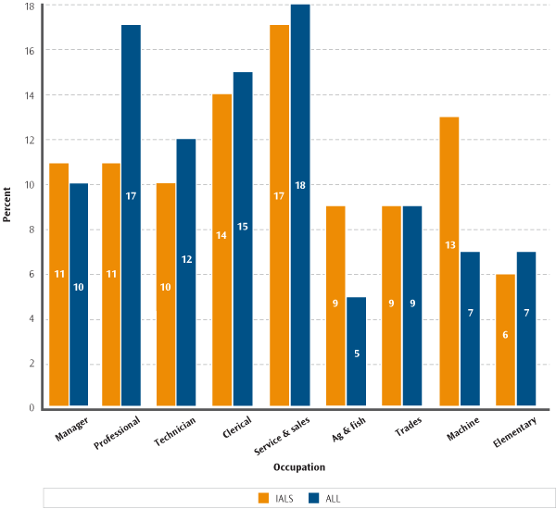

Note:
Percentages are rounded to the nearest whole number.

Figure 6.1 shows noticeable increases in the proportions of professionals and decreases in the proportions of agriculture and fisheries employees and machine employees.

Document literacy and occupation
Document literacy skill was measured by both the IALS and ALL surveys, and its relationship with occupation is explored in Figures 6.2 and 6.3.

Of those with low ALL document literacy skill, the greatest proportion were employed as service and sales workers. Of those with higher ALL document literacy skill, the greatest proportion were employed as professionals.

Figure 6.2 shows, for each occupation grouping, the percentages of the adult population of New Zealand at each document literacy level. Figure 6.3 shows the distribution of occupations among those with low document literacy skill and those with higher document literacy skill.

Information from Figures 6.1, 6.2 and 6.3 can be combined to draw a number of conclusions. For example, the proportion of trades workers with low ALL document literacy skills was middle-ranking when compared with other occupations (Figure 6.2). However, trades workers accounted for a relatively small proportion of all occupations (Figure 6.1) and they also accounted for a small proportion of occupations for those with low document literacy skills (Figure 6.3).

Figure 6.2: Document literacy and occupation, IALS and ALL
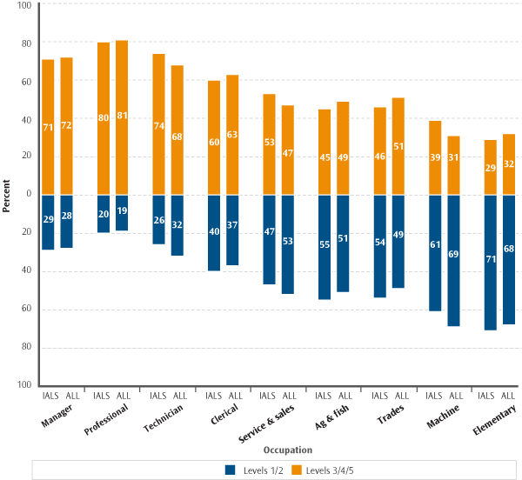

Note:
1. Levels 1 and 2 and levels 3, 4 and 5 are combined to give more robust statistical information.
2. Percentages are rounded to the nearest whole number

Figure 6.2 shows the changes that have occurred in the document literacy levels by occupation categories between 1996 and 2006.

Figure 6.3: Occupation distributions, by document literacy, ALL only
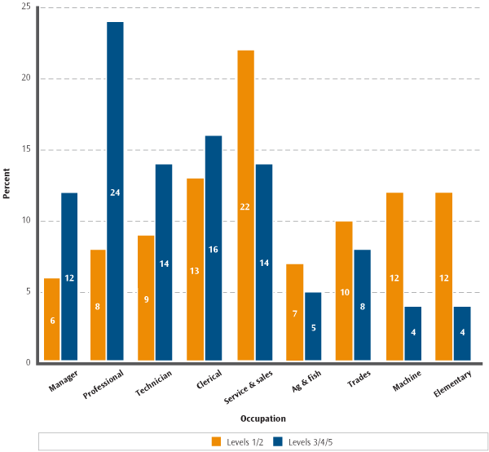

Note:
1. Levels 1 and 2 and levels 3, 4 and 5 are combined to give more robust statistical information.
2. Percentages are rounded to the nearest whole number

Figure 6.3 shows that professionals made up the largest proportion of those with higher document literacy skill, and service and sales workers made up the largest proportion of those with low document literacy skill.

Numeracy and occupation
Numeracy skill was measured by the ALL survey only, and its relationship with occupation is explored in Figures 6.4 and 6.5.

Professionals had the highest numeracy skill, and the elementary occupations the lowest. Professionals made up the largest proportion of those with higher numeracy skill, and service and sales workers made up the largest proportion of those with low numeracy skill.

Figure 6.4 shows, for each occupational grouping, the percentages of the adult population of New Zealand at each numeracy level. Figure 6.5 shows the distribution of occupations among those with low numeracy skill and among those with higher numeracy skill.

Information from Figures 6.1, 6.4 and 6.5 can be combined to draw a number of conclusions. For example, the proportion of the elementary and machine occupations with low numeracy skill was large when compared with other occupations (Figure 6.4). However, elementary and machine occupations accounted for a relatively small proportion of all occupations (Figure 6.1), and a middle-ranking proportion of occupations for those with low numeracy skill (Figure 6.5).

Figure 6.4: Numeracy and occupation, ALL only
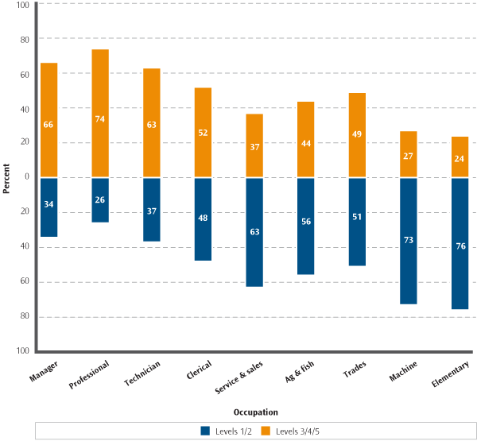

Note:
1. Levels 1 and 2 and levels 3, 4 and 5 are combined to give more robust statistical information.
2. Percentages are rounded to the nearest whole number

Figure 6.4 shows that “professionals” had the highest numeracy skill and the “elementary” occupations the lowest (only slightly lower than those of “machine” workers).

Figure 6.5: Occupation distributions, by numeracy, ALL only
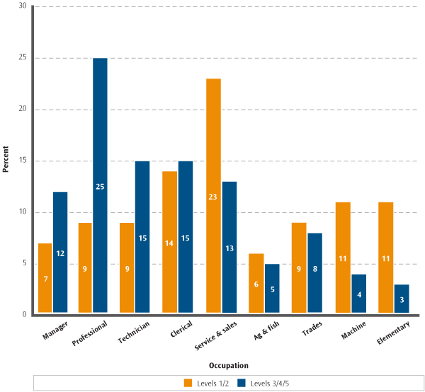

Note:
1. Levels 1 and 2 and levels 3, 4 and 5 are combined to give more robust statistical information.
2. Percentages are rounded to the nearest whole number

Figure 6.5 shows that, as for document literacy, professionals made up the largest proportion of those with higher numeracy skill, and service and sales workers made up the largest proportion of those with low numeracy skill.

Size of employer
Size of employer, as measured by the ALL survey, recorded the respondent’s estimate of the number of people employed by his or her employer at all locations. The association of size of employer with each of prose literacy, document literacy, numeracy and problem-solving skills was analysed. For each of the domains the results were similar, showing that the distribution of skill did not vary with the size of the employer.

The distribution of prose literacy, document literacy, numeracy and problem-solving skills of employees did not vary with the size of the employer.

7. Industry

- How did the distribution of the industry of employment among the adult population of New Zealand change between 1996 and 2006?

- How did the distributions of literacy skill according to industry change between 1996 and 2006?

- How was the distribution of industry for those with low skill different from the distribution of industry for those with higher skill?

This section examines these questions.

Industry
The IALS and ALL surveys collected information on respondents’ self-reported industry of employment. This information was recorded using the ISIC (International Standard Industrial Classification of all economic activities) classification. Here, for statistical robustness, this information is summarised (according to groups of ISIC categories) as follows (examples of industries in each group follow the group name):

- agriculture and fisheries − agriculture, hunting, forestry and fishing

- manufacture − manufacturing of all types

- construction − construction of all types

- trade − wholesale trade, retail trade, hospitality

- transport and communications − transport, storage and communications

- finance and real estate − financing, insurance, real estate and business service

- health and education − community, social and personal service.

There were two other groups of ISIC categories (mining and quarrying; and electricity, gas, and water), but the membership of these categories was too small to allow robust statistical analyses. These two groups have not been included in the graphs in section 7.

The most noticeable change in the distribution of industry across the employed adult population of New Zealand was an increase in the proportion of employees in the health and education industry.

Figure 7.1 shows the distributions of industry across the employed population measured by the IALS and ALL surveys

Figure 7.1: Distribution of industry, IALS and ALL

Note:
1. Percentages are rounded to the nearest whole number.
2. For the IALS and ALL surveys, the data for the “mining and quarrying” and “electricity, gas, and water” categories were of insufficient quality to report.

Figure 7.1 shows an increase in the proportion of employees in the health and education industry and decreases in the proportions of employees in the manufacture, and finance and real estate industries.

Document literacy and industry
Document literacy skill was measured by both the IALS and ALL surveys, and its relationship with industry is explored in Figures 7.2 and 7.3.

Of those with low document literacy skill, the greatest proportion was employed in the health and education industry. Of those with higher document literacy skill, the greatest proportion was also employed in the health and education industry.

Figure 7.2 shows, for each industry, the percentages of the adult population of New Zealand at each document literacy level. Figure 7.3 shows the distribution of industry of employment among those with low document literacy skill and among those with higher document literacy skill.

Information from Figures 7.1, 7.2 and 7.3 can be combined to draw a number of conclusions. For example, the proportion of the health and education industry employees with low document literacy skill was small when compared with other industries (Figure 7.2). However, the health and education industry accounted for the largest proportion of all industries (Figure 7.1) and the largest proportion of industries for those with low document literacy skill (Figure 7.3).

Figure 7.2: Document literacy and industry, IALS and ALL

Note:
1. Levels 1 and 2 and levels 3, 4 and 5 are combined to give more robust statistical information.
2. Percentages are rounded to the nearest whole number.
3. For the IALS and ALL surveys the data for the “mining and quarrying” and “electricity, gas, and water” categories were of insufficient quality to report.

Figure 7.2 shows the changes that have occurred in document literacy levels by industry categories between 1996 and 2006. There was a rise of around 7 percentage points in the population of employees in the manufacturing industry having levels 3, 4 or 5 document literacy skill.

Figure 7.3: Industry distributions, by document literacy, ALL only

Note:
1. Levels 1 and 2 and levels 3, 4 and 5 are combined to give more robust statistical information.
2. Percentages are rounded to the nearest whole number.
3. The data for the “mining and quarrying” and “electricity, gas, and water” categories were of insufficient quality to report.

Figure 7.3 shows that employees in the health and education industry made up the largest proportion of those with higher document literacy skill and also made up the largest proportion of those with low document literacy skill.

Numeracy and industry
Numeracy skill was measured by the ALL survey only, and its relationship with industry is explored in Figures 7.4 and 7.5.

Those employed in the agriculture and fisheries industry had the lowest numeracy skill overall, and those employed in the finance and real estate industry and in the health and education industry had the highest. Of those with low numeracy skill, the greatest proportion was employed in the health and education industry. Of those with higher numeracy skill, the greatest proportion was also employed in the health and education industry.

Figure 7.4 shows, for each industry, the percentages of the adult population of New Zealand at each numeracy level. Figure 7.5 shows the distribution of industry groups among those with low numeracy skill and among those with higher numeracy skill.

Information from Figures 7.1, 7.4 and 7.5 can be combined to draw a number of conclusions. For example, the proportion of the health and education industry employees with low numeracy skill was small when compared with other industries (Figure 7.4). However, the health and education industry accounted for the largest proportion of all industries (Figure 7.1) and the largest proportion of industries for those with low numeracy skill (Figure 7.5).

Figure 7.4: Numeracy and industry, ALL only

Note:
1. Levels 1 and 2 and levels 3, 4 and 5 are combined to give more robust statistical information.
2. Percentages are rounded to the nearest whole number.
3. The data for the “mining and quarrying” and “electricity, gas, and water” categories were of insufficient quality to report.

Figure 7.4 shows that employees in the finance and real estate and health and education industries had the highest numeracy skill, and employees in the agriculture and fisheries industry had the lowest.

Figure 7.5: Industry distributions, by numeracy, ALL only

Note:
1. Levels 1 and 2 and levels 3, 4 and 5 are combined to give more robust statistical information.
2. Percentages are rounded to the nearest whole number.
3. The data for the “mining and quarrying” and “electricity, gas, and water” categories were of insufficient quality to report.

Figure 7.5 shows that, as was the case for document literacy, employees in the health and education industry made up the largest proportion of those with higher numeracy skill and also made up the largest proportion of those with low numeracy skill.

8. Glossary

ALL – the Adult Literacy and Life Skills survey, which was conducted by 12 countries between 2003 and 2008/09 (note that at the beginning of 2008 three of these countries have still to complete their participation in ALL).

Document literacy – the ability to read and understand discontinuous texts (such as charts, maps, tables, job applications, payroll forms and timetables).

Educational participation – records the highest level of schooling completed by a person. Note that educational participation is not the same as qualifications attained; for example, a person could complete Year 11 (or the equivalent) but not achieve a qualification. In this document, educational participation is summarised in three levels:

- lower secondary or less − the person completed at most Year 10 (or the equivalent)

- higher secondary − the person completed more than Year 10 (or the equivalent) but no more than Year 13 (or the equivalent)

- tertiary − the person participated in a tertiary education programme.

IALS – the International Adult Literacy Survey, which was conducted by 23 countries/regions between 1994 and 1998.

Higher literacy or numeracy − levels 3, 4 or 5.

Industry – this information was recorded using the ISIC (International Standard Industrial Classification of all economic activities) classification. Here, for statistical robustness, this information is summarised (according to groups of ISIC categories) as follows. Examples of industries in each group follow the group name.

- agriculture and fisheries − agriculture, hunting, forestry and fishing

- manufacture − manufacturing of all types

- construction − construction of all types

- trade − wholesale trade, retail trade, hospitality

- transport and communications − transport, storage, and communications

- finance and real estate − financing, insurance, real estate and business service

- health and education − community, social and personal service.

There were two other groups of ISIC categories (mining & quarrying, and electricity, gas, & water), but the membership of these categories was too small to allow robust statistical analyses.

Labour force status – for the IALS and ALL surveys the respondents are provided with several possible answers to the question “What is your current work situation?” The one-word summaries of these answers − together with the answers themselves − follow:

- employed − summarises the possible answer “Employed or self-employed”

- unemployed − summarises the possible answer “Not employed and looking for work”

- retired − summarises the possible answer “Retired”

- student − summarises the possible answer “A student (including work programmes)”

- homemaker − summarises the possible answer “Doing unpaid household work”.

Respondents can also respond with the possible answer “Other”, but this is not reported.

Levels − prose literacy, document literacy and numeracy are assigned five cognitive levels.
Level 1 | Read simple documents, accomplish literal information-matching with no distracting information, and perform simple one-step calculations.
Level 2 | Search a document and filter out some simple distracting information, make low-level inferences, and execute one- or two-step calculations and estimations.
Level 3 | Perform more complex information-filtering, sometimes requiring inferences, and manipulate mathematical symbols, perhaps in several stages.
Level 4 | Integrate information from a long passage, perform more complex inferences and complete multiple-step calculations requiring some reasoning.
Level 5 | Make high-level inferences or syntheses, use specialised knowledge, filter out multiple distractors, and understand and use abstract mathematical ideas with justification.

Problem-solving has been assigned four cognitive levels. For a description of typical tasks for the problem-solving domain (and a fuller description of prose and document literacy along with numeracy), see pages 17 and 18 of Learning a Living: First Results of the Adult Literacy and Life Skills Survey (available at www.statcan.ca/english/freepub/89-603-XIE/2005001/pdf.htm).

Low literacy or numeracy − levels 1 or 2.

Mean – in general, the mean of a set of scores is the sum of the scores divided by the number of scores.

Numeracy – the ability to read and process mathematical and numeric information in diverse situations.

Occupation – this information was recorded using the ISCO (International Standard Classification of Occupation) classification. Here, for statistical robustness, this information is summarised (according to ISCO major group title) as follows (examples of occupations in each group follow the group name):

- manager − legislators, senior administrators and managers

- professional − professionals

- technician − technicians and associate professionals

- clerical − clerical workers, secretaries, receptionists

- service and sales − service workers and shop and market sales workers

- agriculture and fisheries − orchardists, fishery workers, farmers

- trades − craft and related trades workers

- machine − plant and machine operators and assemblers

- elementary − cleaners, labourers.

Problem-solving – the ability to reason and think analytically in situations where no routine procedure exists.

Prose literacy – the ability to read and understand continuous texts (such as news stories, editorials, brochures and instruction manuals).

Quintile – for the purposes of this document, a quintile is one of five subpopulations of approximately equal size into which a population can be divided. For example, the lowest income quintile is the fifth of the population with the lowest income.

Self-assessed numeracy – the respondent’s assessment of their own numeracy skill.

- Higher self-assessed numeracy skill refers to those respondents who either strongly agreed or agreed with the statement “I am good with numbers and calculations”.

- Low self-assessed numeracy skill refers to those respondents who either strongly disagreed or disagreed with the statement “I am good with numbers and calculations”.

Simpson’s Paradox – a statistical phenomenon whereby an observed statistical pattern is changed or reversed in the presence of a previously hidden weighting variable. Here is a simple example. Peter catches a fish two days a week and Thomas catches a fish four days a week, but Peter catches more fish per week than Thomas. The apparent paradox is explained by the hidden fact that Peter’s fish are more than twice as heavy as Thomas’s.

In Figure 2.2 the proportion of the population represented by each column of the graph (the hidden weighting variable) is not displayed in the figure. So one might expect that the decrease represented in the first, second and third pairs of columns would result in a decrease in the fourth pair of columns. However, this is not the case, resulting in an apparent paradox. In the presence of the weighting variable (as displayed in Figure 2.1), the apparent paradox is explained.

Up-skilling – undertaking further education and training.

- Formal – participation in any course that is part of a programme of study leading toward a certificate, degree or diploma.

- Non-formal – participation in any course that is not part of a programme of study leading toward a certificate, degree or diploma.

- Self-directed or none – either no participation in any up-skilling activities or participation in up-skilling activities such as guided tours, trade fairs, learning from instructional media, etc.

Very high literacy or numeracy − level 4 or 5.

Very low literacy or numeracy − level 1.

9. Publications

Adult Literacy and Life Skills Survey

September 2007 |  | The Adult Literacy and Life Skills (ALL) Survey: An Introduction
December 2007 |  | The Adult Literacy and Life Skills (ALL) Survey: Headline Results and Background
December 2007 |  | The Adult Literacy and Life Skills (ALL) Survey: Further Investigation
March 2008 |  | The Adult Literacy and Life Skills (ALL) Survey: Overview and International Comparisons
April 2008 |  | The Adult Literacy and Life Skills (ALL) Survey: Education, Work and Literacy

These are available at www.educationcounts.govt.nz.

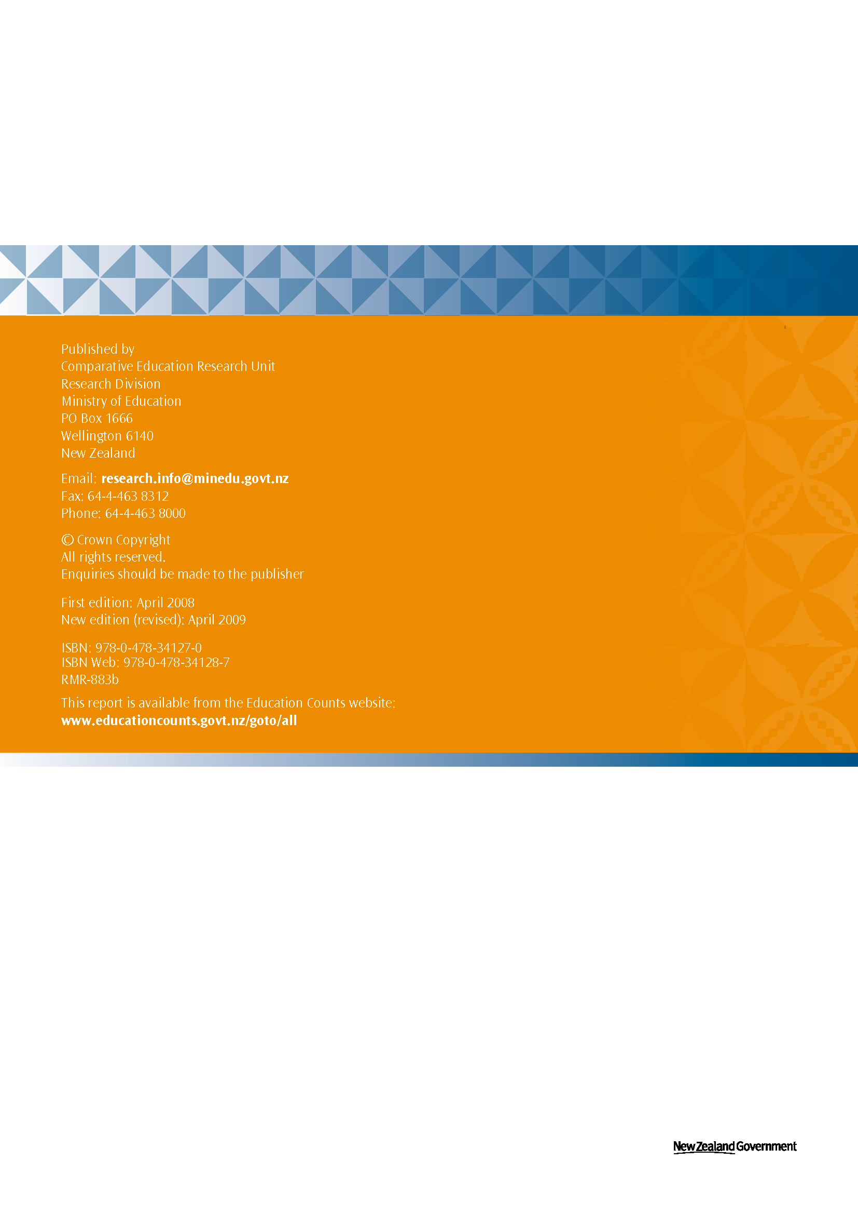

Participants in the ALL and IALS surveys were categorised as “lower secondary or less”, “higher secondary”, or “tertiary” according to their self-reported highest level of educational participation.
Participants in the ALL and IALS surveys were categorised into nine occupational groupings. An example of one grouping is managers, which includes such occupations as senior administrators, legislators and corporate managers.
Participants in the ALL and IALS surveys were categorised into nine industry groupings. An example of one grouping is agriculture and fisheries, which includes such industries as agriculture, hunting, forestry and fisheries.
In the ALL and IALS surveys educational level is coded using the International Standard Classification of Education (ISCED).
People with lower secondary or less education most likely left school before having an opportunity to sit School Certificate or NCEA level 1.
People with higher secondary education will have stayed at school long enough to sit school qualifications.
In 1996, 9.1% of the adult population were enrolled in formal tertiary education, representing approximately 261,000 students. In 2006, the participation rate peaked at 13.7%, representing approximately 448,000 students.
This is an example of a phenomenon sometimes known as Simpson’s Paradox – see the glossary.
A very similar problem-solving domain was measured in the 2003 cycle of the Programme for International Student Assessment (PISA), an OECD study of 15-year-old student assessment. PISA found a high correlation internationally between problem-solving and mathematics skills.
Up-skilling refers to adult education in a broad sense – any further education and training activities.
For example, see J. Bynner, S. Parsons (1997), Does Numeracy Matter? Evidence from the National Child Development Study on the Impact of Poor Numeracy on Adult Life, Basic Skills Agency, London.
Statistics New Zealand’s Household Labour Force Survey (HLFS) shows that the unemployment rate was much lower in 2006 than in 1996. The June 2006 unemployment rate was 3.6%, with 80,000 people unemployed; the 1996 figures were 5.9% and 110,000, out of a smaller total population. ALL counts the unemployed as those reporting as currently (a) not working and (b) looking for work. ALL therefore counts more people as unemployed than the HLFS, which adds the further criteria of actively seeking work and being available for work.
The statistics for the student category in the IALS survey was not accurate enough to report because of small sample size.
The document literacy and numeracy domains were selected for analyses by income because they represent key work-related skills.

