Acknowledgements

The authors gratefully acknowledge the assistance of Raelene Butters, Jit Cheung, Christabel Dillon, Shona Ramsay, Lisa Rodgers, Lynne Whitney, and the National Research Bureau. The authors also gratefully acknowledge the time and effort invested by the respondents of the ALL and IALS surveys.

Contents

Overview 4
Key findings 4
1. Introduction 6
2. Results – literacy, numeracy and problem-solving in New Zealand 7
Prose literacy in New Zealand 7
Document literacy in New Zealand 10
Numeracy in New Zealand 12
Problem-solving in New Zealand 14
3. Results – international comparisons 16
Prose literacy – international comparisons 16
Document literacy – international comparisons 19
Numeracy – international comparisons 21
Problem-solving – international comparisons 23
4. Participation in up-skilling – international comparisons 26
Document literacy and participation in up-skilling 27
Formal and non-formal up-skilling in New Zealand 28
Self-directed up-skilling and no up-skilling in New Zealand 29
Formal and non-formal up-skilling in Canada and the USA 29
Self-directed up-skilling and no up-skilling in Canada and the USA 29
5. Immigration – international comparisons 30
Immigration – international comparisons 31
Immigration and prose literacy – international comparisons 32
Immigration and numeracy – international comparisons 33
6. Glossary 34
7. References 36
8. Publications 37

Overview

- How is literacy skill distributed across the New Zealand adult population?

- Has there been any change in this distribution over the past 10 years?

- Do the further education and training activities of New Zealand adults vary according to their literacy skills?

- How do the skills of adults in New Zealand compare with those of adults from other countries?

The Adult Literacy and Life Skills (ALL) survey is designed to answer these and other questions.

Why do we need to answer these questions? The labour-force demands of a modern economy are becoming increasingly complex. If New Zealand is to improve or maintain its position in the world economy, it must develop a workforce with high levels of generic and technical skills. The ALL survey provides an insight into our current skill levels. This insight is essential for the development of any future initiatives to further enhance and maintain these levels. In the longer term, having both the ALL data and data from the 1996 International Adult Literacy Survey (IALS) gives us a baseline against which to measure change in levels of skills in the New Zealand population.

This report is the first in a series of four that investigates the initial results of the ALL survey. It will present an overview of the distribution of literacy skills in New Zealand, changes to that distribution since 1996, and a comparison of New Zealand’s distribution of literacy skills with those of Canada, the USA and Australia.

Key findings

- From 1996 to 2006 the proportion of the adult population of New Zealand with very low literacy skills reduced substantially, but a proportion with low literacy skills persists.

- Similar changes have occurred in Canada, the USA and Australia.

- In New Zealand, the improvement in document literacy skill has been more pronounced than in Canada, the USA and Australia.

- The adult population of New Zealand has large subpopulations with low numeracy and low problem-solving skills.

- The adult populations of Canada, the USA and Australia also have large sub-populations with low numeracy skills. In addition, Canada and Australia have large subpopulations with low problem-solving skills.

- New Zealand adults with low document literacy skills are less likely to participate in any up-skilling activities than those with higher document literacy skills. However, participation in formal up-skilling does not appear to be affected by adults’ document literacy skills.

- The patterns of up-skilling in New Zealand differ from Canada and the USA, where participation in formal up-skilling was greater amongst those with higher document literacy skills.

- In New Zealand, established immigrants have higher literacy and numeracy skills, overall, than recent immigrants. Established immigrants also make up a larger proportion of the adult population than recent immigrants.

- By contrast, in Canada and the USA, recent immigrants have higher literacy and numeracy skills, overall, than established immigrants. There also, established immigrants make up a larger proportion of the adult population than recent immigrants.

- In New Zealand, immigrants (both recent and established) have higher levels of prose and numeracy skills than both recent and established immigrants in Canada and the USA.

1. Introduction

The Adult Literacy and Life Skills (ALL) survey is an investigation of the distribution of certain skills among people aged 16 to 65. The skills tested are literacy, numeracy and problem-solving. The survey is conducted across a number of countries, which allows for cross-country comparison as well as providing information specific to New Zealand.

The ALL survey follows a similar survey conducted in 1996: the International Adult Literacy Survey (IALS). Parts of the ALL survey are directly comparable to this earlier work, and the comparison provides a picture of some of the changes that have occurred, both internationally and nationally, over the previous decade.

For further information, please refer to The Adult Literacy and Life Skills (ALL) Survey: An Introduction (available at www.educationcounts.govt.nz). This publication is intended as a companion to any reporting on the ALL survey and contains such general information as the nature of the ALL survey and its application, as well as definitions, and descriptions of the skill domains and levels. Further information may also be found in the glossary on page 40 of the present document.

The focus of this report is on the distribution of literacy skills in New Zealand, changes that may have occurred since the IALS survey in 1996, and some comparison of literacy skills in New Zealand with those in Canada, the USA and Australia. The report also includes an analysis of participation in up-skilling in New Zealand, Canada and the USA. Finally, the distribution of literacy skill according to immigration status in each of these countries is examined.

This report is the first in a series of four which look at the high-level results from the ALL survey. More in-depth analysis will be undertaken once this initial series has been completed.

2. Results – literacy, numeracy and problem-solving in New Zealand

- How did the distribution of literacy skills in New Zealand change between 1996 and 2006?

- What proportion of the adult population of New Zealand has high numeracy and problem-solving skills?

This section examines these and other questions.

The ALL survey directly measures four skill “domains”: prose literacy, document literacy, numeracy and problem-solving. A description of New Zealand’s performance in each of these domains follows.

Prose literacy in New Zealand

Prose literacy is the ability to read and understand continuous texts (such as news stories, editorials, brochures and instruction manuals). Prose literacy skill was measured by both the IALS and ALL surveys, and its distribution among the adult population of New Zealand is shown in Figures 2.1 and 2.2.

Within the New Zealand adult population, the subpopulation with very high (levels 4 or 5) prose literacy skills has shrunk, and the subpopulation with very low (level 1) prose literacy skills has shrunk substantially.

Figure 2.1 shows the percentages of the adult population of New Zealand at each prose literacy level. Figure 2.2 presents the distribution of prose literacy scores for New Zealand adults using box plots.

Figure 2.1: Prose literacy in New Zealand – distribution of levels, IALS and ALL
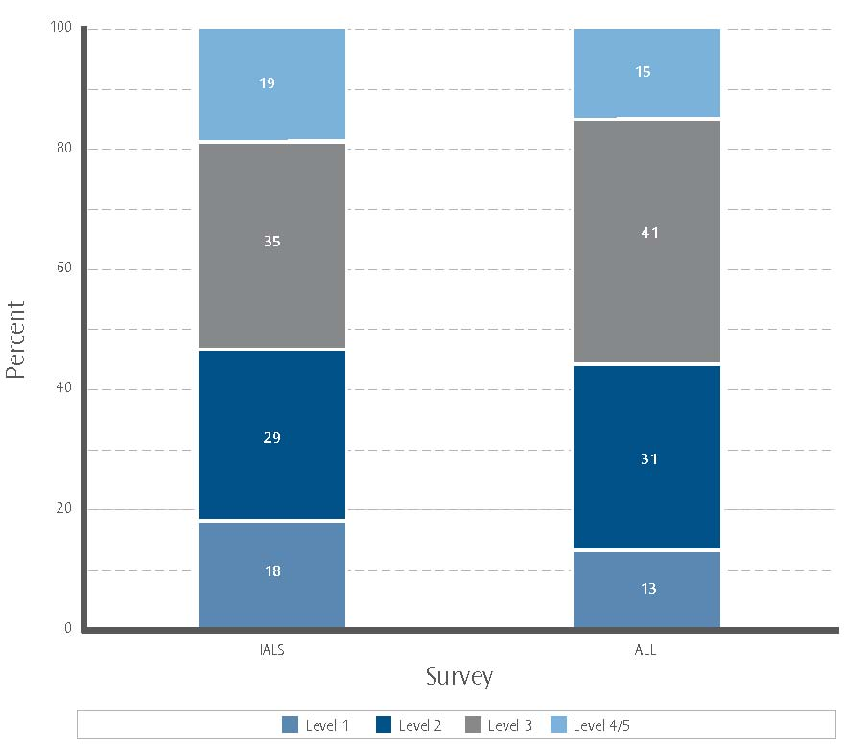

Note
1. Levels 4 and 5 are combined to give more robust statistical information.
2. Percentages are rounded to the nearest whole number.

As Figure 2.1 indicates, the percentage of the population at level 1 decreased substantially between the IALS and ALL surveys, while for level 2 it remained relatively stable and for level 3 it increased substantially. There was also a decrease between the surveys in the percentage of the population at levels 4 or 5. For a description of tasks at these levels, see the Glossary.

Figure 2.2: Prose literacy in New Zealand – distribution of scores, IALS and ALL
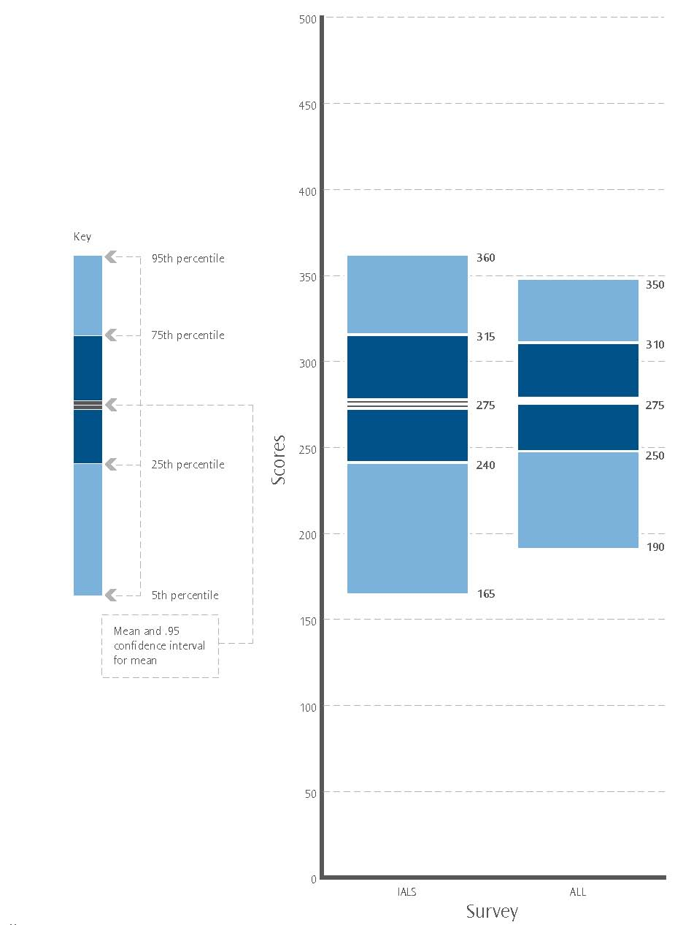

Note:
Scores rounded to the nearest multiple of 5.

Figure 2.2 shows that the mean performance for ALL and IALS was similar (around 275). In addition, the 5th to 95th percentile range for the ALL survey was much narrower than that for IALS. This indicates that the subpopulations defined by either very high or very low prose literacy have shrunk.

Document literacy in New Zealand

Document literacy is the ability to read and understand discontinuous texts (such as charts, maps, tables, job applications, payroll forms and timetables). Document literacy skill was measured by both the IALS and ALL surveys, and its distribution among the adult population of New Zealand is shown in Figures 2.3 and 2.4.

Within the New Zealand adult population, the subpopulation with very low (level 1) document literacy skills has decreased substantially.

Figure 2.3 shows the percentages of the adult population in New Zealand at each document literacy level. Figure 2.4 presents the distribution of document literacy scores for New Zealand adults using box plots.

Figure 2.3: Document literacy in New Zealand – distribution of levels, IALS and ALL
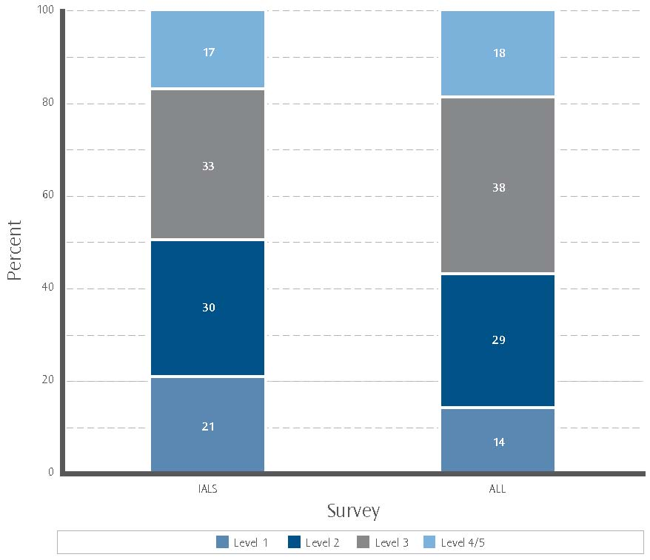

Note
1. Levels 4 and 5 are combined to give more robust statistical information.
2. Percentages are rounded to the nearest whole number.

As Figure 2.3 indicates, the percentage of the population at level 1 decreased substantially between the IALS and ALL surveys, while for level 2 it remained stable and for level 3 it increased substantially. The percentage of the population at level 4 or 5 remained stable across the two surveys.

Figure 2.4: Document literacy in New Zealand – distribution of scores, IALS and ALL
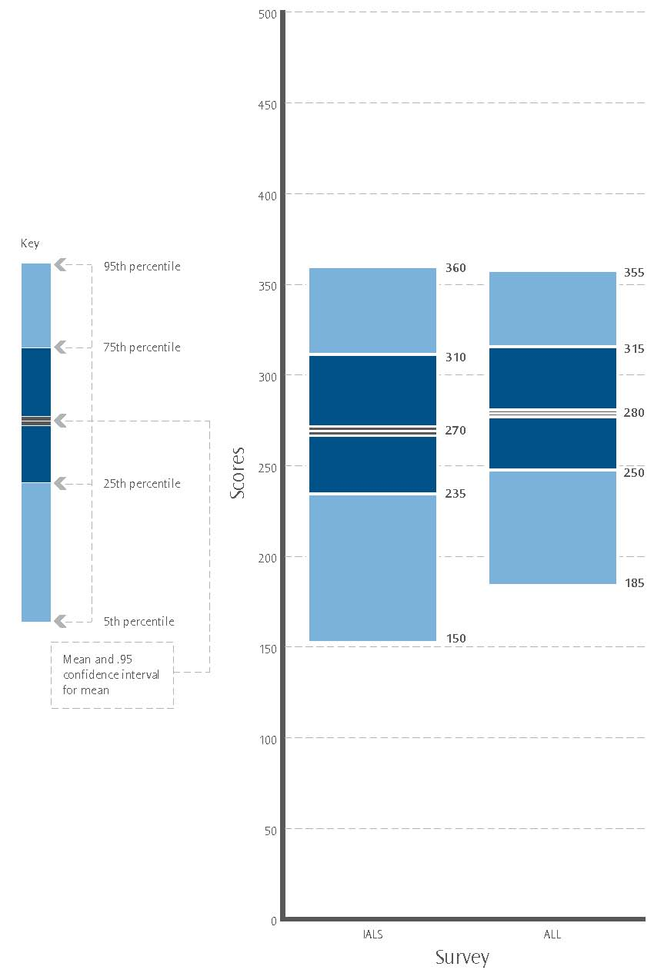

Note:
Scores rounded to the nearest multiple of 5.

Figure 2.4 shows that the mean performance for ALL was substantially higher than that for IALS. It also shows that the 5th to 95th percentile range for the ALL survey was much narrower than that for IALS.

Note that like prose literacy, the 5th percentile rose substantially. But unlike prose literacy the 95th percentile did not fall substantially. This indicates that the subpopulation defined by very low (level 1) document literacy has shrunk.

Numeracy in New Zealand

Numeracy is the ability to read and process mathematical and numeric information in diverse situations. It was measured in the ALL survey but not in IALS, meaning that comparisons of skill levels for the New Zealand population between 1996 and 2006 are not possible. The distribution of numeracy skill among the adult population of New Zealand is shown in Figures 2.5 and 2.6.

Within the New Zealand adult population there is a large subpopulation with low (levels 1 or 2) numeracy skill.

Figure 2.5 shows the percentages of the adult population of New Zealand at each numeracy level. Figure 2.6 presents the distribution of the numeracy scores of New Zealand adults using a box plot.

Figure 2.5: Numeracy in New Zealand – distribution of levels, ALL only
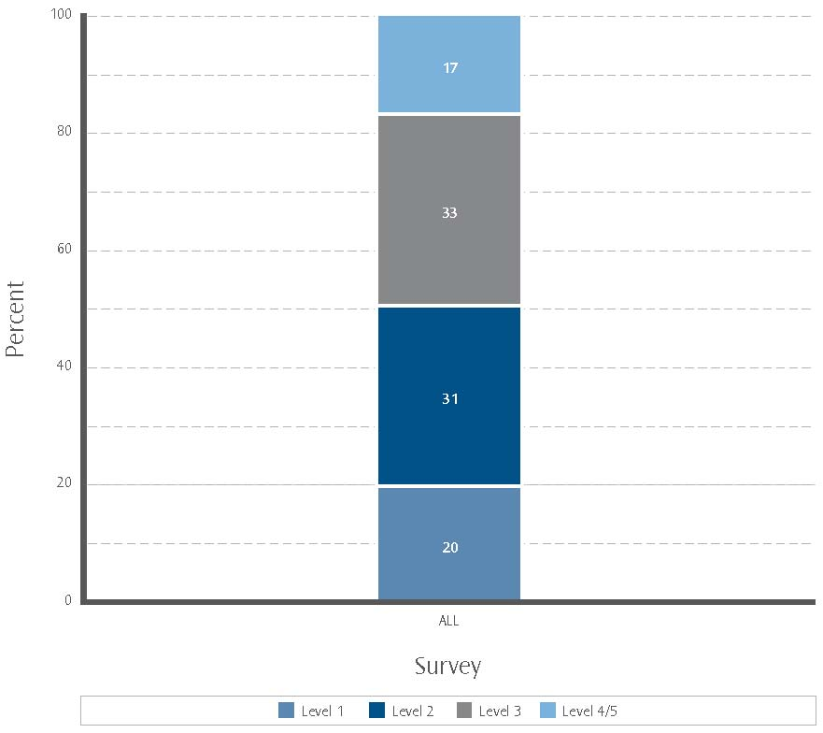

Note
1. Levels 4 and 5 are combined to give more robust statistical information.
2. Percentages are rounded to the nearest whole number.

As Figure 2.5 indicates, the percentage of the population at level 1 was substantially lower than that for level 2 and level 3. The percentage of the population at levels 4 or 5 was lower than that for the other levels. The figure shows that half of the New Zealand adult population have numeracy skills at either level 1 or 2.

Figure 2.6: Numeracy in New Zealand – distribution of scores, ALL only
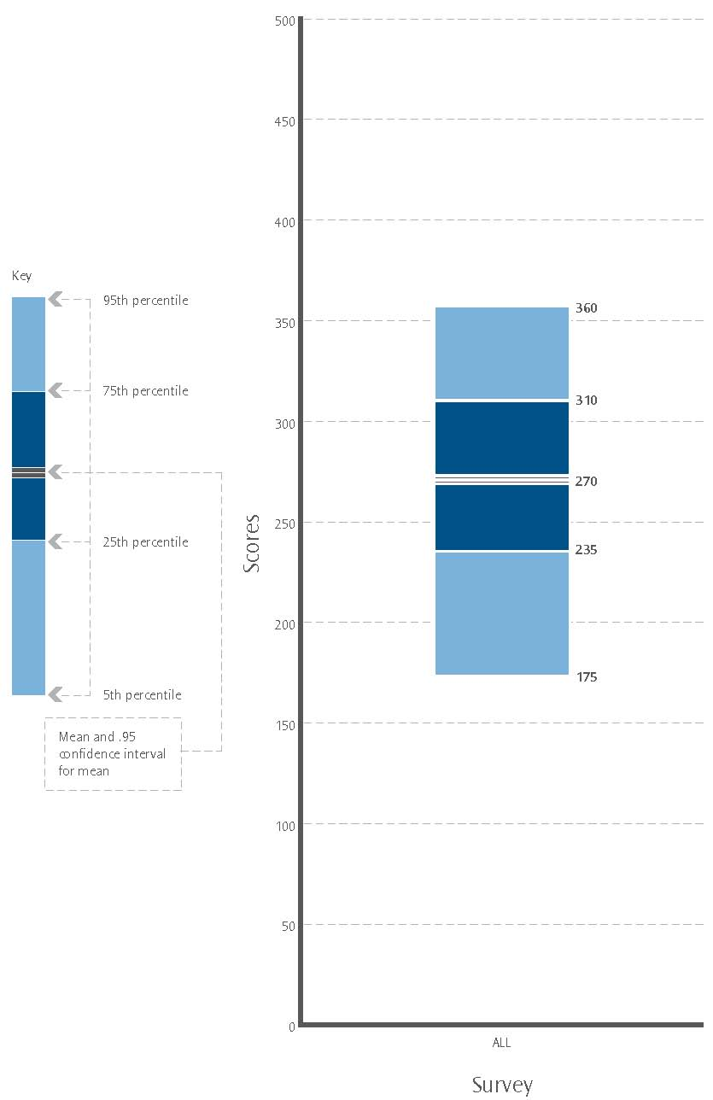

Note:
Scores rounded to the nearest multiple of 5.

Problem-solving in New Zealand

Problem-solving is the ability to reason and think analytically in situations where no routine procedure exists. It was measured in the ALL survey but not in IALS, meaning that comparisons of skill levels for the New Zealand population between 1996 and 2006 are not possible. The distribution of problem-solving skill among the adult population of New Zealand is shown in Figures 2.7 and 2.8.

The New Zealand adult population has a large subpopulation with low (levels 1 and 2) problem-solving skills.

Figure 2.7 shows the percentages of the adult population in New Zealand at each problem-solving level. Figure 2.8 presents the distribution of the problem-solving scores for New Zealand adults using a box plot.

Figure 2.7: Problem-solving in New Zealand – distribution of levels, ALL only
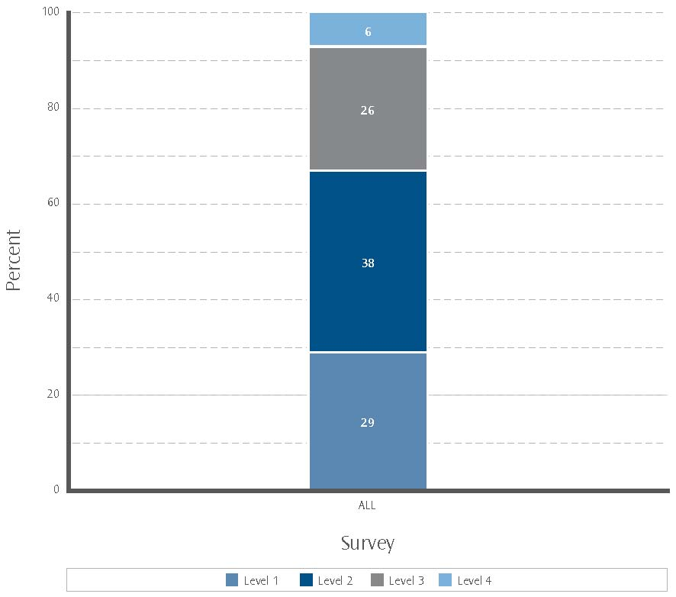

Note
1. Four levels of proficiency were measured in problem-solving.
2. Percentages are rounded to the nearest whole number.

Figure 2.7 shows that the percentage of the population at level 1 was substantially lower than that for level 2 but higher than that for level 3. The percentage of the population at level 4 was substantially lower than that for the other levels. Levels 1 and 2 represent around two-thirds of the New Zealand adult population. For a description of tasks at these levels, see the reference in the Glossary.

Figure 2.8: Problem-solving in New Zealand – distribution of scores, ALL only
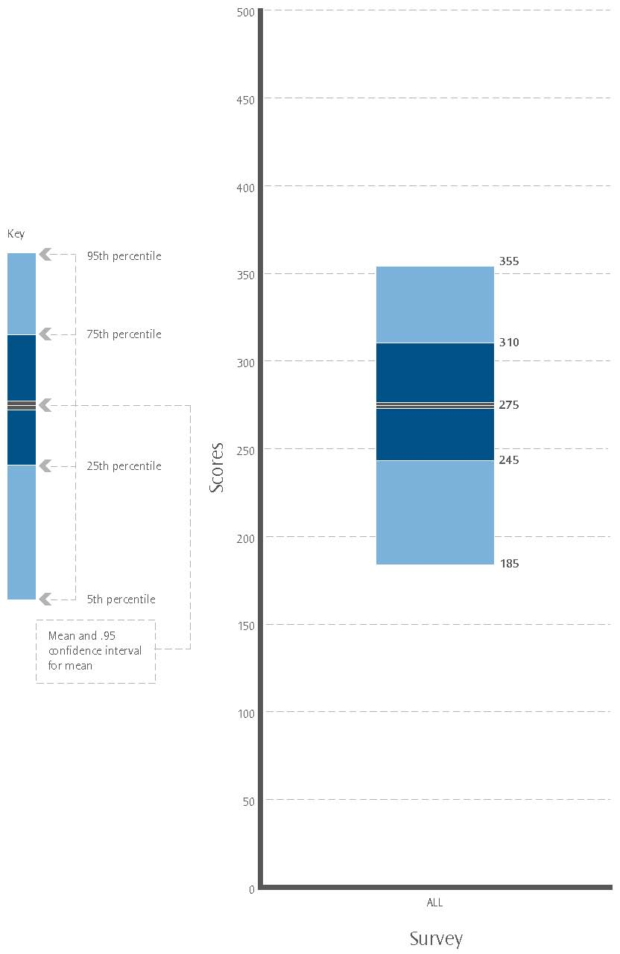

Note:
Scores rounded to the nearest multiple of 5.

3. Results – international comparisons

- How does the distribution of literacy skills in New Zealand compare with that in other countries participating in the ALL survey?

This section examines this question by comparing New Zealand with Australia, the English-speaking part of Canada, and the USA.

These countries were chosen for comparison with New Zealand because:

- all participated in both the IALS and ALL surveys, allowing for comparison between the two surveys

- all administered the IALS and ALL surveys in the English language

- the data for these four countries were available (although not for all domains)

- historical, social and educational commonalities, across the countries, make comparison with New Zealand more valid.

Please note: in the following text “Canada” refers to the English-speaking part of Canada; in the USA, the ALL survey did not record problem-solving information; Australia has been included in analysis only where comparable data have been able to be sourced from the November 2007 release of results by the Australian Bureau of Statistics (no score distribution data were available at the time of publication); although these countries collected their survey data in different years, a nine- to ten-year gap between the IALS and ALL surveys is common to all.

Prose literacy – international comparisons

Prose literacy skill was measured by both the IALS and ALL surveys, and its distribution among the adult populations of New Zealand, Australia, Canada and the USA is shown in Figure 3.1, and in Figure 3.2.

For all countries, the subpopulations with very low (level 1) prose literacy and very high (levels 4 or 5) prose literacy skill has shrunk. This pattern exists across most of the countries that took part in both the IALS and ALL survey.

Figure 3.1 shows the percentages of the adult populations of New Zealand, Australia, Canada and the USA at each prose literacy level. These are anchored at the boundary of levels 2 and 3 to allow comparison of either “low literacy” (levels 1 or 2) or “higher literacy” (levels 3, 4 or 5) between populations. Figure 3.2 presents the distribution of prose literacy scores for the adult populations of New Zealand, Canada and the USA adults using box plots.

Figure 3.1: International prose literacy – distribution of levels, IALS and ALL
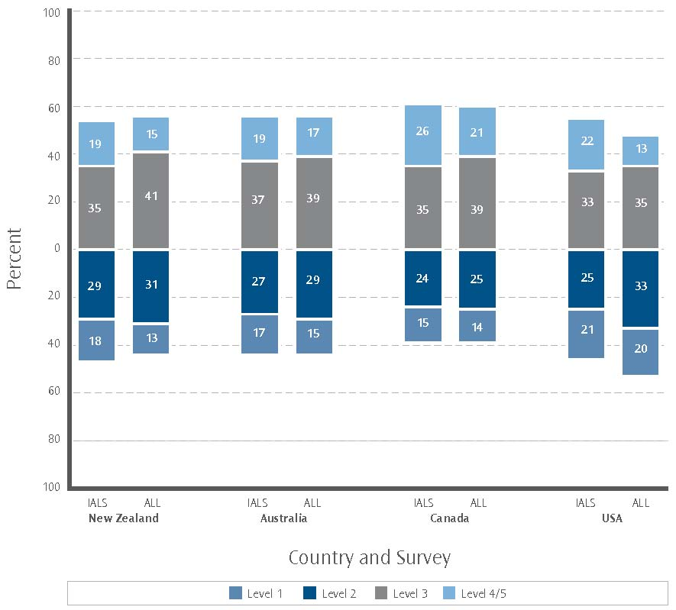

Note
1. Levels 4 and 5 are combined to give more robust statistical information.
2. Percentages are rounded to the nearest whole number.

Figure 3.1 shows that between the IALS and ALL surveys, the percentage of the population at level 1 either decreased or remained stable across all countries. Across the two surveys, the percentage of the population at level 2 remained relatively stable for New Zealand, Australia and Canada, while for the USA it increased. For all four countries, the percentage of the population at level 3 increased between surveys. In contrast, the percentage of the population at levels 4 or 5 remained relatively stable for Australia but decreased for New Zealand, Canada and the USA.
Figure 3.2: International prose literacy – distribution of scores, IALS and ALL
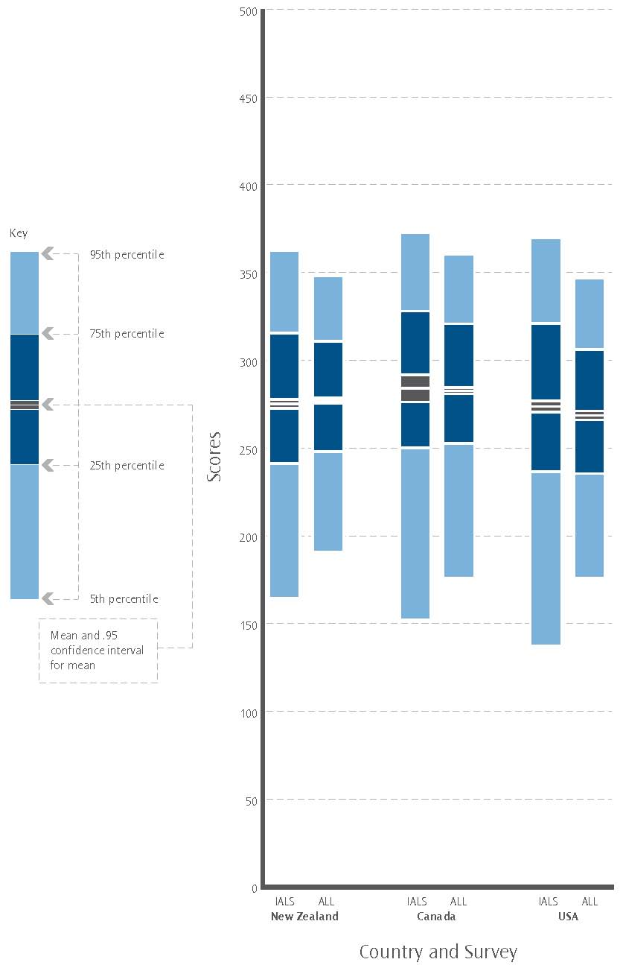

Note:
1. Scores rounded to the nearest multiple of 5.
2. Australian data not available at time of publication.

Figure 3.2 shows that across the IALS and ALL surveys the mean performance for Canada (stable at around 285) was higher than that for New Zealand (stable at around 275), and higher than that for the USA (around 275 for IALS and 270 for ALL).

Also, for all countries, the 5th to 95th percentile range for the ALL survey was narrower than that for IALS, as was the 25th to 75th percentile range. This indicates that, in New Zealand, Canada and the USA, the spread of prose literacy skills has compressed, over 10 years, with distributions now closer to the means.

Document literacy – international comparisons

Document literacy skill was measured by both the IALS and ALL surveys, and its distribution among the adult populations of New Zealand, Canada, the USA and Australia is shown in Figure 3.3, and in Figure 3.4.

Document literacy skill has increased, on average, in all countries and the subpopulations with low (level 1 or 2) document literacy skill in each country have shrunk. This is more pronounced in New Zealand, with improvement in the ALL survey results placing it on a par with Australia.

Figure 3.3 shows the percentages of the adult populations of New Zealand, Canada, the USA and Australia at each document literacy level. These are anchored at the boundary of levels 2 and 3 to allow comparison of either “low literacy” (levels 1 or 2) or “higher literacy” (levels 3, 4 or 5) between populations. Figure 3.4 presents the distribution of document literacy scores for the adult populations of New Zealand, Canada and the USA using box plots.

Figure 3.3: International document literacy – distribution of levels, IALS and ALL
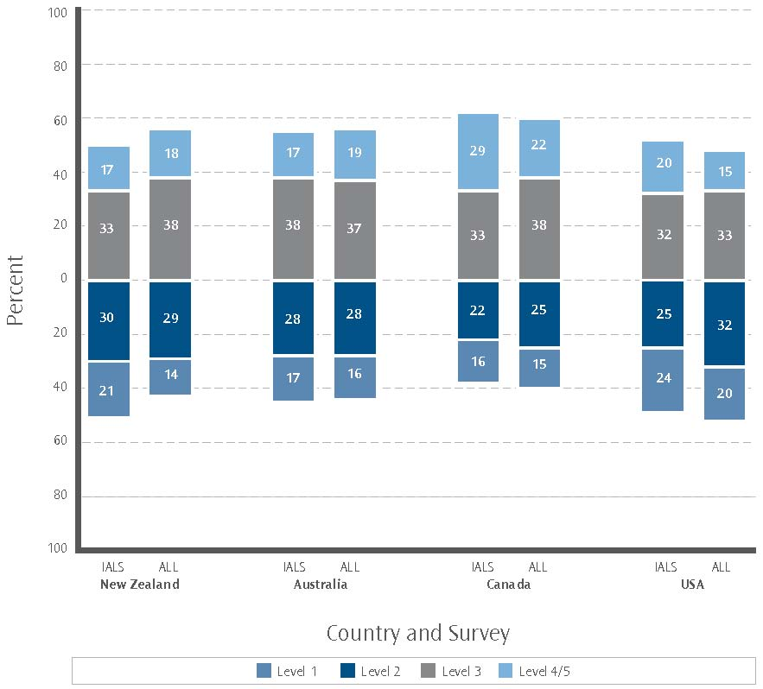

Note
1. Levels 4 and 5 are combined to give more robust statistical information.
2. Percentages are rounded to the nearest whole number.

As Figure 3.3 indicates, the decrease between the IALS and ALL surveys in the percentage of the population at level 1 was more substantial for New Zealand than for Australia, Canada or the USA.

Between the two surveys, the percentages of the population at level 2 for New Zealand and Australia remained stable while the percentages for Canada and the USA increased. There was an increase in the percentage of the population at level 3 for New Zealand and Canada, while Australia and the USA remained relatively stable. For New Zealand and Australia the percentage of the population at level 4 or 5 remained relatively stable, while for Canada and the USA it decreased.

Figure 3.4: International document literacy – distribution of scores, IALS and ALL
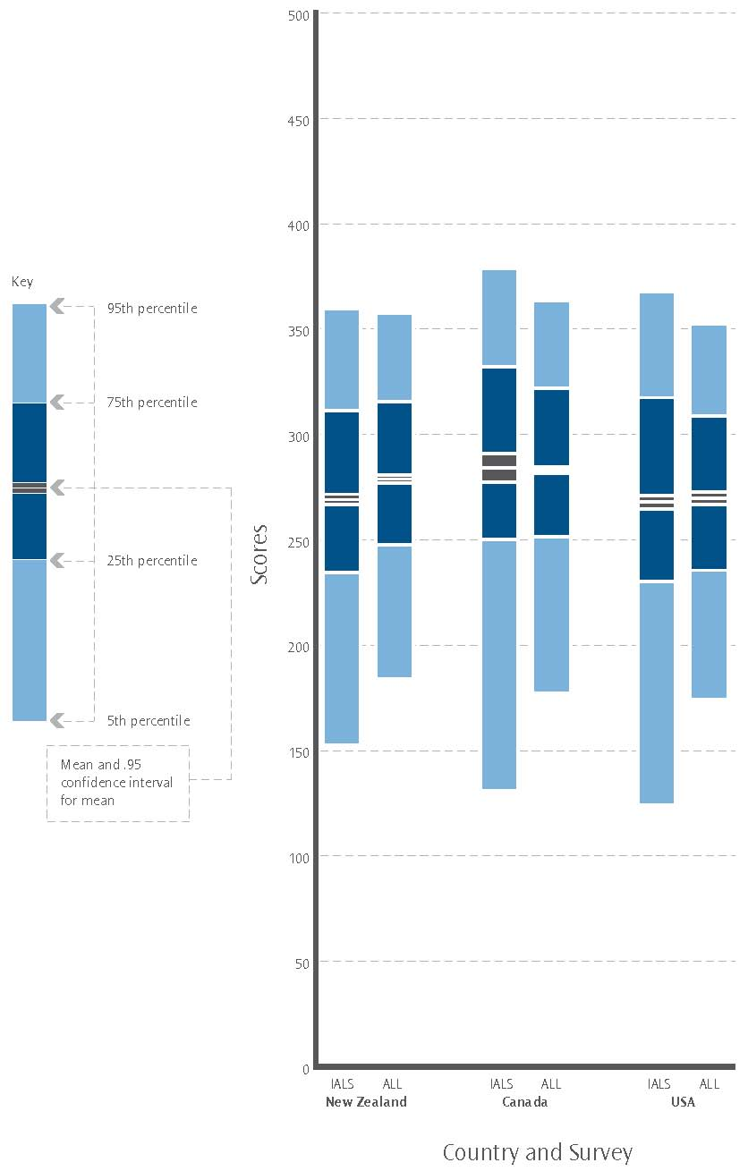

Note:
1. Scores rounded to the nearest multiple of 5.
2. Australian data not available at time of publication.

From Figure 3.4 we can see that the document literacy means of the ALL and IALS surveys increased for New Zealand (moving from around 270 to around 280) but remained stable for Canada (at around 285) and the USA (at around 270).

The figure also indicates that the results for all three countries showed a reduction of the 95th percentile (although less markedly for New Zealand) and a substantial increase in the 5th percentile. However, while New Zealand’s 25th and 75th percentiles both increased, this was not the case for Canada or the USA, where the 75th percentiles fell and the 25th percentiles either remained stable (Canada) or rose (the USA).

This means that while the New Zealand subpopulation defined by very low (level 1) document literacy has shrunk, in Canada and the USA the subpopulations defined by both very low and very high (level 4 or level 5) document literacy have shrunk.

Numeracy – international comparisons

Numeracy skill was measured by the ALL survey only, and its distribution among the adult population of New Zealand, Australia, Canada, and the USA is shown in Figure 3.5, and in Figure 3.6.

New Zealand, Canada and Australia have similar distributions of numeracy skill, all with large proportions of their populations having low (levels 1 or 2) numeracy skills. However, the USA has an even larger proportion of its population with low numeracy skill levels.

Figure 3.5 shows the percentages of the adult population of New Zealand, Australia, Canada and the USA at each numeracy level. These are anchored at the boundary of levels 2 and 3 to allow comparison of either “low numeracy” (levels 1 or 2) or “higher numeracy” (levels 3, 4 or 5) between populations. Figure 3.6 presents the distribution of numeracy skill for the adult populations of New Zealand, Canada and the USA using box plots.

Figure 3.5: International numeracy – distribution of levels, ALL only
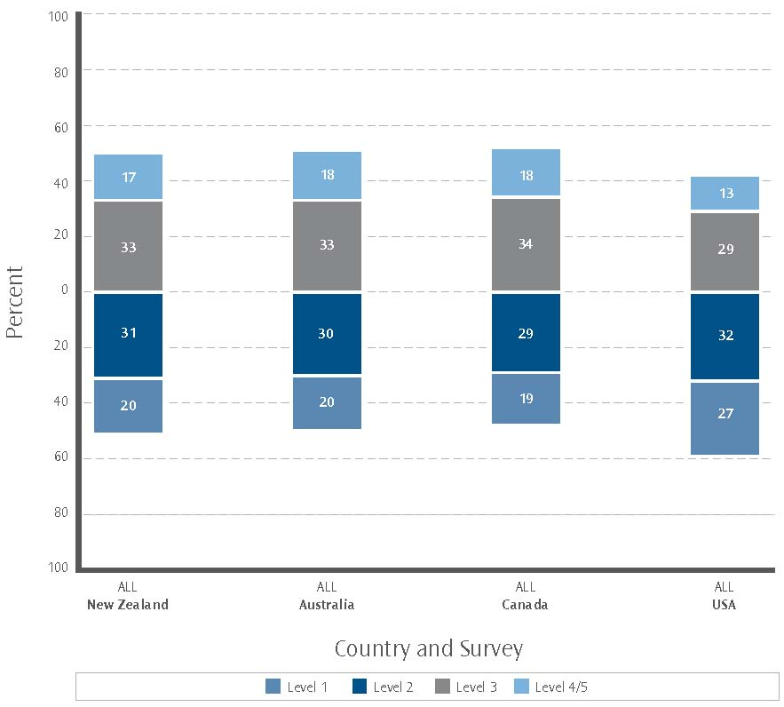

Note
1. Levels 4 and 5 are combined to give more robust statistical information.
2. Percentages are rounded to the nearest whole number.

Figure 3.5 shows the following:

- For New Zealand, the percentage of the population at level 1 was substantially lower than that for either levels 2 or 3. The percentage of the population at levels 4 or 5 was lower than that for the other levels.

- For the USA, the percentage of the population at level 1 was substantially higher than that for New Zealand, Canada or Australia and that at level 3 was lower. The four countries had similar percentages at level 2.

- The percentage of the population of the USA at levels 4 or 5 was lower than that of Canada, Australia or New Zealand.

Figure 3.6: International numeracy – distribution of scores, ALL only
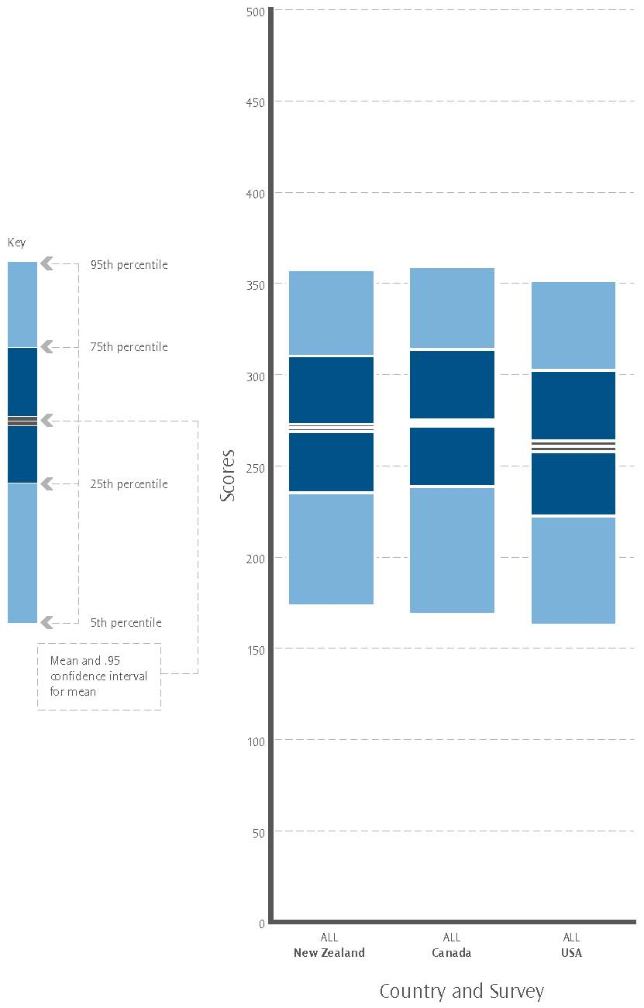

Note:
1. Scores rounded to the nearest multiple of 5.
2. Australian data not available at time of publication.

Figure 3.6 shows that New Zealand’s mean was around 270, Canada’s was around 275 and that of the USA around 260. The figure also shows that each statistic for Canada was similar to that for New Zealand, but higher than that for the USA.

Problem-solving – international comparisons

Problem-solving skill was measured by the ALL survey only, and its distribution among the adult population of New Zealand, Canada and Australia is shown in Figures 3.7 and 3.8. Problem-solving skill was not measured in the USA.

New Zealand, Canada and Australia have very similar distributions of problem-solving skill.

Figure 3.7 shows the percentages of the adult population of New Zealand, Canada and Australia at each problem-solving level. These are anchored at the boundary of levels 2 and 3 to allow comparison of either “low problem-solving skills” (levels 1 or 2) or “higher problem-solving skills” (levels 3 or 4) between populations. Figure 3.8 presents the distribution of problem-solving scores of the adult populations of New Zealand and Canada using box plots.

Figure 3.7: International problem-solving – distribution of levels, ALL only
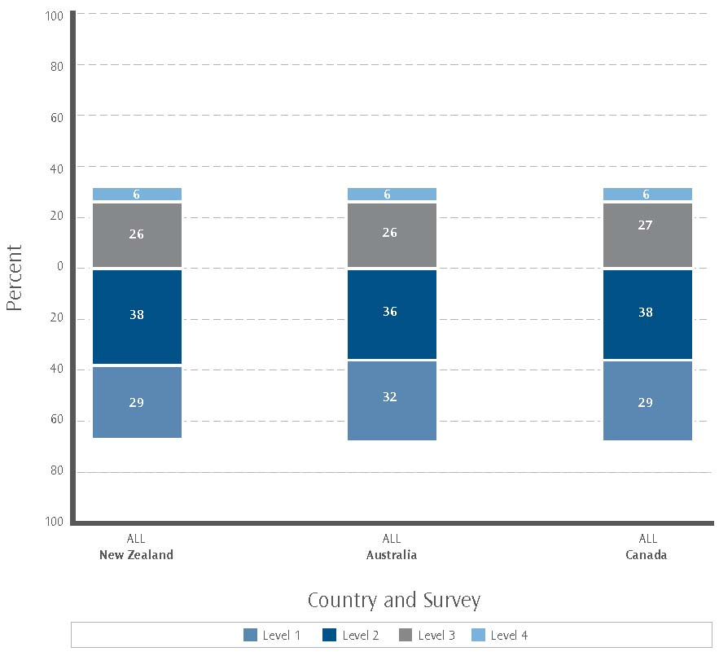

Note
1. Four levels of proficiency were measured in problem-solving.
2. Percentages are rounded to the nearest whole number.
3. Problem-solving not measured in USA.

As Figure 3.7 indicates, the percentage of the population at each level was similar for all three countries.

Figure 3.8: International problem-solving – distribution of scores, ALL only
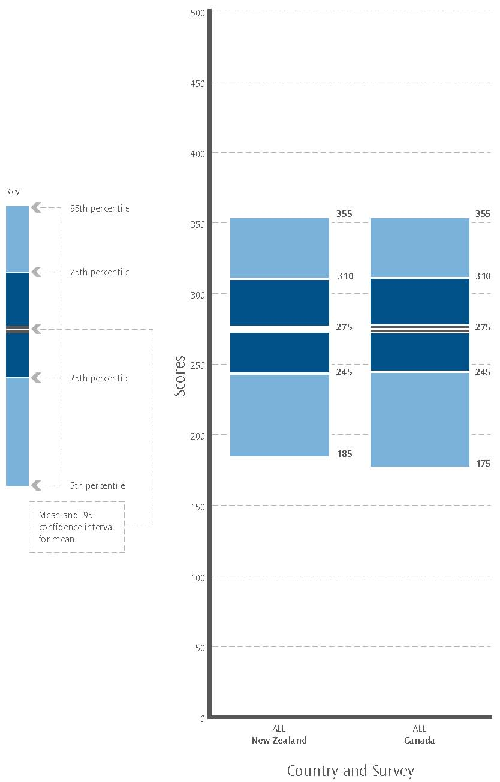

Note:
1. Scores rounded to the nearest multiple of 5.
2. Australian data not available at time of publication.
3. Problem-solving not measured in USA.

As Figure 3.8 indicates, both New Zealand and Canada had almost identical 25th and 75th percentiles and their means were both around 275. The 5th to 95th percentile range for New Zealand was narrower than that for Canada. Although New Zealand’s 5th percentile was higher than Canada’s, both countries performed almost identically at the 95th percentile.

4. Participation in up-skilling – international comparisons

Here, “up-skilling” refers to adult education in a broad sense: any further education and training activities undertaken to increase one’s skills.

- Do patterns of up-skilling vary internationally?

- Are there differences in the patterns of up-skilling between those with lower document literacy skill and those with higher document literacy skill?

This section uses the ALL survey data to examine these and other questions.

In New Zealand there was little difference in the participation rate in formal up-skilling between those with level 1 or 2 document literacy and those with levels 3, 4 or 5.

In Canada and the USA, those with levels 3, 4 or 5 document literacy had higher participation in formal up-skilling than those with levels 1 or 2.

For all countries, the percentage of those who reported participating in no up-skilling activities was substantially higher among those with level 1 or 2 document literacy.

Regardless of country and level of document literacy, participation in self-directed up-skilling was undertaken by roughly two-fifths of the population.

In the graphs and analysis of ALL data provided in this section, the following definitions are used:

- Formal full-time up-skilling refers to full-time participation in any course that is part of a programme of study leading toward a certificate, degree or diploma (for example, participation in a plumbing apprenticeship).

- Formal part-time up-skilling refers to part-time participation in any course that is part of a programme of study leading toward a certificate, degree or diploma (for example, part-time participation in a Bachelor of Arts degree).

- Non-formal up-skilling refers to participation in any course that is not part of a programme of study leading toward a certificate, degree or diploma (for example, participation in a photography course at night-school).

- Self-directed up-skilling refers to frequent participation in up-skilling activities such as guided tours, trade fairs, learning from instructional media, etc.

Respondents who reported undertaking up-skilling both formally (either part-time or full-time) and in any other way were recorded as undertaking up-skilling formally. Respondents who reported undertaking up-skilling non-formally and in a self-directed manner were reported as undertaking up-skilling non-formally.

Document literacy and participation in up-skilling

Figure 4.1 shows the percentages of the adult population who self-reported as participating in various types of up-skilling. It looks at New Zealand, Canada and the USA for those with low document literacy skill (levels 1 or 2), and for those with higher document literacy skill (levels 3, 4 or 5). The Australian data were not available at the time of publication.

Figure 4.1: International participation in up-skilling – ALL survey
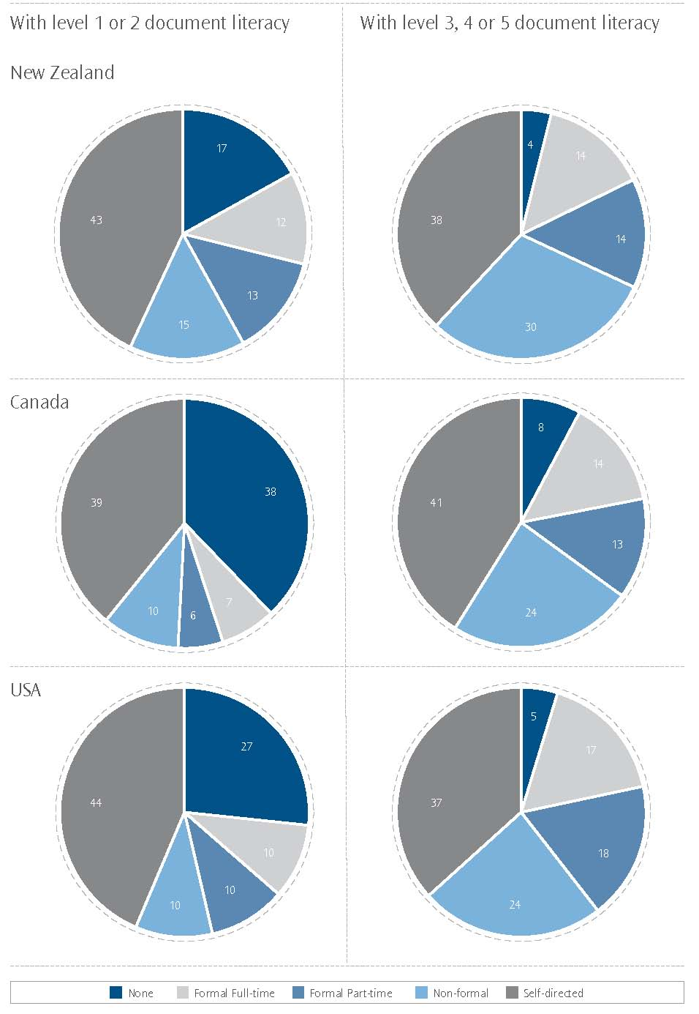

Note: Percentages rounded to the nearest whole number.

Formal and non-formal up-skilling in New Zealand
The percentage of participants in formal full-time up-skilling was almost the same for those with lower (levels 1 or 2) and those with higher (levels 3, 4 or 5) document literacy skill. Similarly, the percentage of participants in formal part-time up-skilling was almost the same for those with lower and those with higher levels of document literacy skill. However, the percentage of participants in non-formal up-skilling was greater among those with higher document literacy skill than among those with lower document literacy skill.

Self-directed up-skilling and no up-skilling in New Zealand
There was a small difference between the percentage of those participating in self-directed up-skilling who had lower and those who had higher document literacy skill. Those who participated in no up-skilling activities made up a larger proportion of the population with lower document literacy skill than those with higher document literacy skill.

Formal and non-formal up-skilling in Canada and the USA
In contrast with New Zealand, for Canada and the USA the percentage of participants in formal full-time up-skilling was smaller among those with lower than among those with higher document literacy skill. Similarly, the percentage of participants in formal part-time up-skilling was smaller for those with lower than for those with higher document literacy skill. For both Canada and the USA, the percentage of participants in non-formal up-skilling was greater among those with higher document literacy skill than among those with lower document literacy skill.

Self-directed up-skilling and no up-skilling in Canada and the USA
Similar to New Zealand, in Canada and the USA there was a small difference between the percentage of those participating in self-directed up-skilling who had lower as opposed to higher document literacy skill. Those who participated in no up-skilling activities made up a much larger proportion of the population with lower document literacy skill than of those with higher document literacy skill.

5. Immigration – international comparisons

- What does the prose literacy skill distribution of recent immigrants look like?

- How do the numeracy skills of established immigrants vary internationally?

This section uses the ALL survey data to examine these and other questions for New Zealand, Canada and the USA (the Australian data were not available at the time of publication). The New Zealand ALL survey measures literacy and numeracy skills using an English language test, while immigrant respondents may or may not have an English-speaking background.

The ALL survey results show a strong migration-status effect on skills in all three countries, although New Zealand’s pattern is different from Canada’s and the USA’s. In New Zealand, established migrants’ skills sit between those of recent and non-migrants. In contrast, in Canada and the USA, established migrants have lower skills than either recent migrants or non-migrants.

Migration status has a greater effect on the prose literacy domain than on numeracy. This is consistent with the evidence that numeracy skills are less strongly related to first language than literacy skills. However, the migration-status effect on these two domains has the same broad pattern across migration status and countries.

In New Zealand, established immigrants have higher prose literacy skills and numeracy skills, overall, than recent immigrants. Established immigrants make up a larger proportion of the adult population than recent immigrants. Non-immigrants have the highest prose literacy and numeracy skills, overall, and make up the largest proportion of the adult population.

In Canada and in the USA, recent immigrants have higher prose literacy and numeracy skills, overall, than established immigrants. Established immigrants make up a larger proportion of the adult population than recent immigrants. Non-immigrants have the highest prose literacy and numeracy skills, overall, and make up the largest proportion of the adult population.

In Canada, the USA and New Zealand, the differences within the distribution of numeracy skills, while similar to those of literacy, are less pronounced.

In the graphs and analysis provided in this section the following definitions are used:

- A recent immigrant is a person who has been in the country in which they responded to the ALL survey for less than five years and was not born there.

- An established immigrant is one who has been in the country in which they responded to the ALL survey for more than five years and was not born there.

- A non-immigrant is a person who was born in the country in which they responded to the ALL survey.

Immigration – international comparisons

Figure 5.1 shows the percentages of recent immigrants, established immigrants and non-immigrants in the adult populations of New Zealand, Canada and the USA, as estimated by the ALL survey.

Figure 5.1: Immigration status of ALL respondents
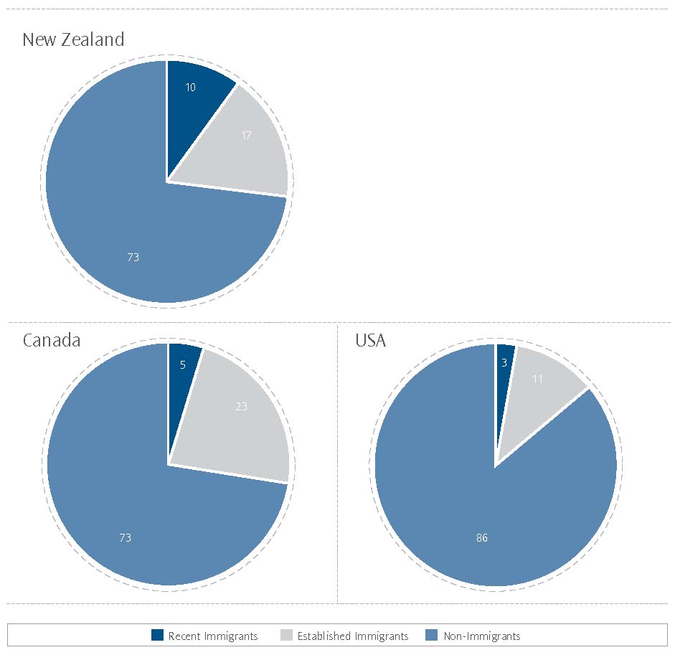

Note:
Percentages rounded to the nearest whole number.

Figure 5.1 indicates that New Zealand and Canada have similar percentages of non-immigrants. It also shows that New Zealand has the largest percentage of recent immigrants, with recent immigrants only making up around 5 percent of the adult population of Canada and around 3 percent in the USA. New Zealand and the USA have smaller percentages of established immigrants in their adult populations than Canada.

Immigration and prose literacy – international comparisons

Figure 5.2 shows – for recent immigrants, established immigrants and non-immigrants in the adult populations of New Zealand, Canada and the USA – the percentage of each subpopulation at each prose literacy skill level. These are anchored at the boundary of levels 2 and 3 to allow comparison of either “low literacy” (levels 1 or 2) or “higher literacy” (levels 3, 4 or 5) between populations.

Figure 5.2: Immigration and prose literacy – distribution of ALL survey levels
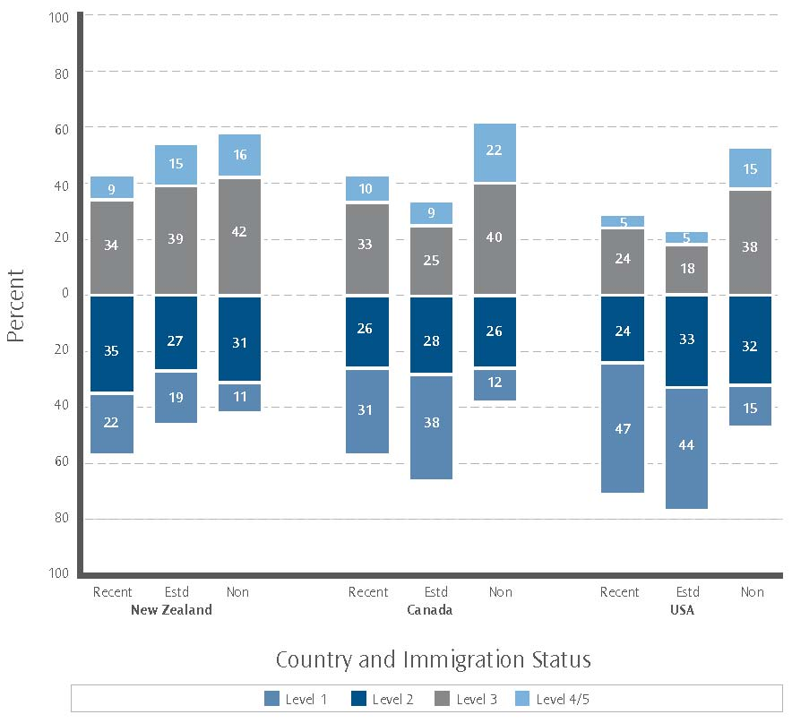

Note
1. Levels 4 and 5 are combined to give more robust statistical information.
2. Percentages are rounded to the nearest whole number.
3. “Recent” abbreviates “recent immigrants”, “Estd” abbreviates “established immigrants” and “Non” abbreviates “non-immigrants”.

Figure 5.2 indicates that, for New Zealand, non-immigrants have higher prose literacy skills, overall, than established immigrants, who in turn have higher prose literacy skills, overall, than recent immigrants.
By contrast, in Canada and in the USA, non-immigrants have higher prose literacy skills, overall, than recent immigrants, who in turn have higher prose literacy skills, overall, than established immigrants.

Immigration and numeracy – international comparisons

Figure 5.3 shows – for recent immigrants, established immigrants and non-immigrants in the adult populations of New Zealand, Canada and the USA – the percentage of each subpopulation at each numeracy skill level. These are anchored at the boundary of levels 2 and 3 to allow comparison of either “low numeracy” (levels 1 or 2) or “higher numeracy” (levels 3, 4 or 5) between populations.

Figure 5.3: Immigration and numeracy – distribution of ALL survey levels
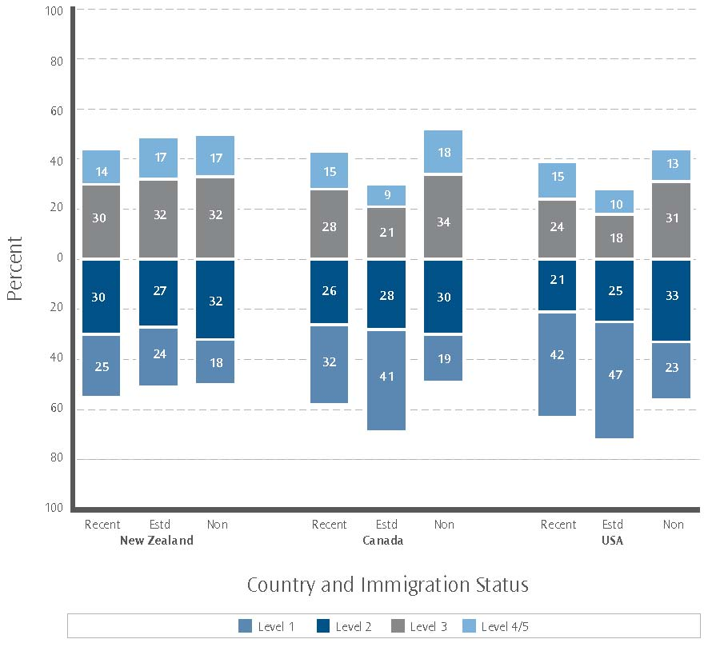
Note
1. Levels 4 and 5 are combined to give more robust statistical information.
2. Percentages are rounded to the nearest whole number.
3. “Recent” abbreviates “recent immigrants”, “Estd” abbreviates “established immigrants” and “Non” abbreviates “non-immigrants”.

Figure 5.3 shows that non-immigrants in New Zealand have higher numeracy skills, overall, than established immigrants, who in turn have higher numeracy skills, overall, than recent immigrants. The differences in skill levels in numeracy between these three groups were less marked than those for prose literacy.

By contrast, in Canada and in the USA non-immigrants have higher numeracy skills, overall, than recent immigrants, who in turn have higher numeracy skills, overall, than established immigrants.

New Zealand immigrants (both recent and established) have higher levels of prose literacy and numeracy skills than recent and established immigrants in Canada and the USA. This reflects differing migration policies and patterns in relation to the selection of migrants, and the resulting composition of migrant populations.

6. Glossary

ALL – the Adult Literacy and Life Skills survey, which was conducted by 12 countries between 2003 and 2009 (note that at the beginning of 2008 three of these countries have still to complete their participation in ALL).

Document literacy – the ability to read and understand discontinuous texts (such as charts, maps, tables, job applications, payroll forms and timetables).

Error – because of the technical nature of the IALS and ALL surveys, the calculation of statistics such as means and percentages has some uncertainty. The standard errors provide a measure of this uncertainty.

Higher literacy or numeracy – levels 3, 4 or 5.

IALS – the International Adult Literacy Survey, which was conducted by 23 countries/‌regions between 1994 and 1998.

Immigration status:
Recent immigrant – a person who has been in the country in which they responded to the ALL survey for less than five years and was not born there.

Established immigrant – a person who has been in the country in which they responded to the ALL survey for more than five years and was not born there.

Non-immigrant – a person who was born in the country in which they responded to the ALL survey.

Levels – prose literacy, document literacy and numeracy are assigned five cognitive levels, while problem-solving has been assigned four cognitive levels.

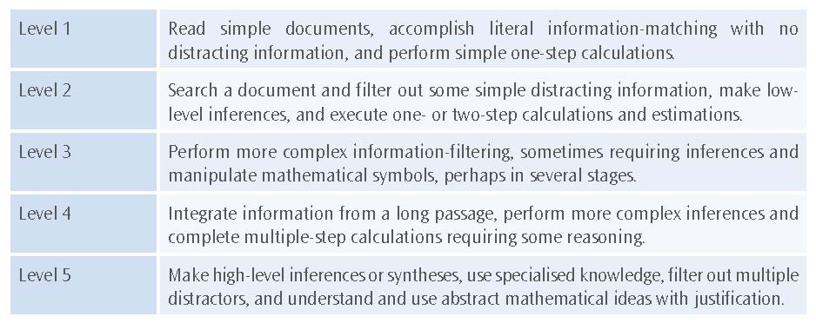

For a description of typical tasks for the problem-solving domain (and a fuller description of prose and document literacy along with numeracy), see pages 17 and 18 of Learning a Living: First Results of the Adult Literacy and Life Skills Survey (available at www.statcan.ca/english/freepub/89-603-XIE/2005001/pdf.htm).

Low literacy or numeracy – levels 1 or 2.

Mean – in general, the mean of a set of scores is the sum of the scores divided by the number of scores.

Numeracy – the ability to read and process mathematical and numeric information in diverse situations.

Percentile – in this publication, box-plot graphs have been used to show how adults score in relation to the score scale of relevant domains. These box-plot graphs incorporate percentiles. The lowest reported is the 5th percentile – the score at which only 5 percent of adults achieved a lower score. The highest reported is the 95th percentile – the score at which 95 percent of adults achieved a lower score.

Problem-solving – the ability to reason and think analytically in situations where no routine procedure exists.

Prose literacy – the ability to read and understand continuous texts (such as news stories, editorials, brochures and instruction manuals).

Up-skilling – undertaking further education and training.

Formal – participation in any course that is part of a programme of study leading toward a certificate, degree or diploma.

Full-time – full-time participation.

Non-formal – participation in any course that is not part of a programme of study leading toward a certificate, degree or diploma.

Part-time – part-time participation.

Self-directed – frequent participation in up-skilling activities such as guided tours, trade fairs, learning from instructional media, etc.

Very high literacy or numeracy – level 4 or 5.

Very low literacy or numeracy – level 1.

7. References

The Adult Literacy and Life Skills (ALL) Survey: An Introduction (available at www.educationcounts.govt.nz)

Learning a Living: First Results of the Adult Literacy and Life Skills Survey (available at www.statcan.ca/english/freepub/89-603-XIE/2005001/pdf.htm)

Adult Literacy and Life Skills Survey: Summary Results, Australia, 2006 (available at www.abs.gov.au/AUSSTATS/abs@.nsf/mf/4228.0?OpenDocument)

Literacy in the Information Age, OECD and Statistics Canada, 2000

8. Publications

Adult Literacy and Life Skills Survey

September 2007 |  | The Adult Literacy and Life Skills (ALL) Survey: An Introduction
December 2007 |  | The Adult Literacy and Life Skills (ALL) Survey: Headline Results and Background
December 2007 |  | The Adult Literacy and Life Skills (ALL) Survey: Further Investigation
March 2008 |  | The Adult Literacy and Life Skills (ALL) Survey: Overview and International Comparisons

These are available at www.educationcounts.govt.nz.
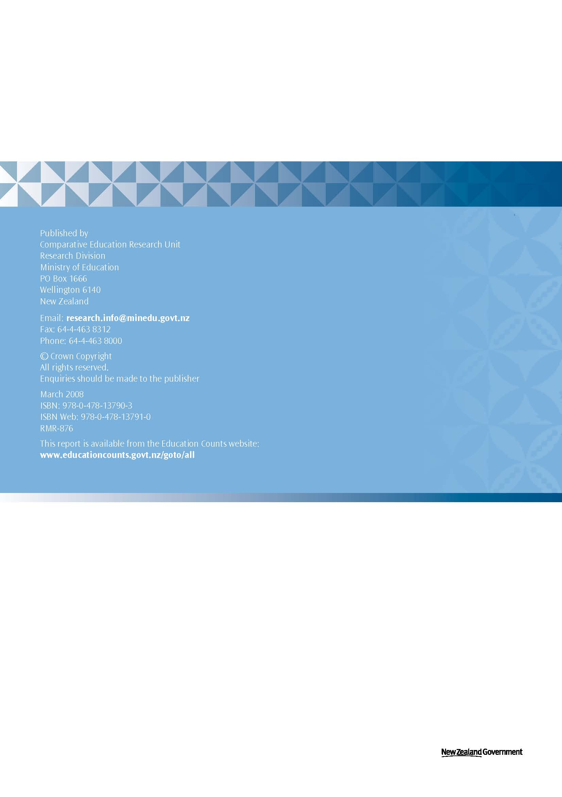

Problem-solving was not measured in the USA.
The criterion for inclusion in the ALL survey is usually “resident in a private household”, and some recent immigrants may be temporary, rather than long-term or permanent.

