The Adult Literacy and Life Skills (ALL) Survey: An Introduction
By Paul Satherley, and Elliot Lawes

Overview
How literate are New Zealand adults? How does the literacy of New Zealand adults change according to their income? How does their literacy compare with that of adults from other countries?

The Adult Literacy and Life Skills (ALL) Survey aims to answer these and other similar questions.

This document is intended as an introduction to the ALL survey. It seeks to explain the nature of the ALL survey, its application and how the ALL survey results will be presented. It contains none of the ALL survey results.

This document is also intended as a companion to subsequent reporting on the ALL survey.

Key points
- The ALL survey measures skills in the adult population at national and international levels.
- The findings of the ALL survey will be of use to policy makers, adult-literacy providers, the literacy research community and the public.
- To enhance their utility, the findings of the ALL survey will be often presented in graphical form.
- The initial findings of the ALL survey will be released in a sequence of publications in late 2007 and early 2008.

1. Introduction
The Adult Literacy and Life Skills (ALL) Survey is an investigation of the distribution of certain skills (such as literacy, numeracy, and document interpretation) among the adult population. It is conducted at both international and national levels. This allows for comparison with other countries as well as providing information specific to New Zealand.

The ALL survey follows a similar survey conducted in 1996 – the International Adult Literacy Survey (IALS) – and is, in part, directly comparable to this earlier work. This comparison will provide a picture of some of the changes in skills, both nationally and internationally, over the previous decade.

As mentioned above, this document is intended as an introduction to the ALL survey and as a companion to any subsequent ALL survey reporting. It contains none of the ALL survey findings, but does indicate how these will be reported. It also provides the reader with some references to further information on the ALL survey.

2. The ALL survey in detail
The ALL survey is large and complex. The following questions and answers aim to give the reader some insight into its content.

What information will the ALL survey findings provide?
Strong evidence exists internationally that, for the populations of developed countries, full participation in society and the labour market is linked to the capacity to accumulate knowledge and to develop and maintain a broad range of skills.

The ALL survey results will provide new information on the relationships between skill levels and the labour market, economic growth, and education systems and services. They will throw new light on the role of skills in creating social equity and inequity in economic outcomes, particularly for groups functioning, on average, below the level of competence.

Who does the ALL survey focus on?
The ALL survey is designed to measure the distribution of particular abilities throughout the adult population. In this context, ‘adult’ means any person between the ages of 16 and 65 living in a private household.

What does the ALL survey measure?
As its name indicates, the ALL survey is intended to measure literacy and life skills. In particular, proficiency in four domains is measured:

Prose literacy is concerned with continuous text – such as the type found in books and newspaper articles.

Document literacy deals with discontinuous text – such as graphs, charts and tables.

Numeracy addresses mathematical and numerical information.

Problem-solving involves analytical thinking, reasoning and logic.

How is the ALL survey testing implemented?
The New Zealand implementation of the ALL survey has a random, geographically based sample design.

In addition, enough Māori and Pasifika respondents are included in the ALL survey design to allow for statistically useful analyses of these ethnic subpopulations.

Each survey is administered face-to- face by an interviewer of the National Research Bureau Ltd, according to the strict guidelines laid down by Statistics Canada. (See section 2.h.)

What are the elements of an ALL survey interview?
The respondent provides the interviewer with two types of information. Both of these types of information will be used in the reporting of the ALL survey findings.

The first type of information concerns the background of the respondent. This includes factors such as the respondent’s gender, ethnicity, labour-force status, employment status and so on. This type of information potentially allows investigation of the distribution of adult literacy and life skills through subpopulations (an example of a subpopulation is Mäori women between the ages of 20 and 30 who have university degrees).

The second type of information concerns the proficiency of the respondent in one or two of the domains described in section 2.c. The respondent provides this information by answering a sequence of written questions.

What do typical questions look like?
Some example questions designed to measure the proficiency of the respondent follow.

Sample numeracy question:
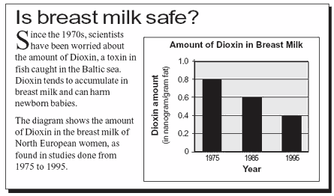

Compare the percent of change in the Dioxin level from 1975 to 1985 with the percent of change from 1985 to 1995. Which percent of change is larger? Explain your answer.

Sample prose literacy question:
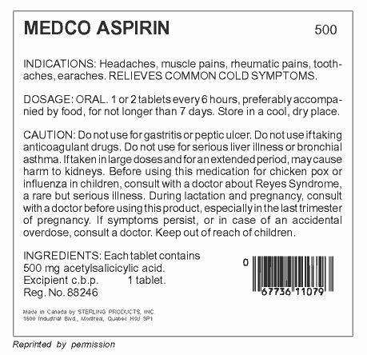

List three situations for which you should consult a doctor.

How are an individual’s skills measured by the ALL survey?
To each individual, and for each of the domains mentioned in section 2.c, a score from zero to 500 is assigned. Zero indicates extremely low proficiency, and 500 extremely high. In addition, based on this score, one of five ‘cognitive levels’ is assigned. These cognitive levels are used in national and international comparison, essentially as a benchmark. The following list provides descriptions of typical tasks associated with each cognitive level.

Level 1 (Scores 0–225):
Tasks at this level require the ability to read simple documents, accomplish literal information-matching with no distractions, and perform simple one-step calculations.

Level 2 (Scores 226–275):
This level includes tasks that demand the capacity to search a document and filter out some simple distracting information, achieve low-level inferences, and execute one- or two-step calculations and estimations.

Level 3 (Scores 276–325):
Typical tasks at level 3 involve more complex information-filtering, sometimes requiring inferences and the facility to manipulate mathematical symbols, perhaps in several stages.

Level 4 (Scores 326–375):
A level 4 task might demand the integration of information from a long passage, the use of more complex inferences and the completion of multiple-step calculations requiring some reasoning.

Level 5 (Scores 376–500):
Level 5 tasks incorporate the capability to make high-level inferences or syntheses, use specialised knowledge, filter out multiple distractors, and to understand and use abstract mathematical ideas with justification.

Note that the description of these cognitive levels is slightly different for the problem-solving domain.

Results are generally presented with levels 4 and 5 amalgamated under ‘higher levels of proficiency’.

Who implements the ALL survey?
Several agencies are involved in the implementation of the ALL survey.

The ALL survey is a joint project of the Government of Canada, the US National Center for Education Statistics (NCES) and the Organisation for Economic Co-operation and Development (OECD).

The survey is constructed, under contract to these agencies, by the Educational Testing Service (ETS) in consultation with the government of each participating country. In the case of New Zealand, the government is represented by the Ministry of Education. For all participating countries, this construction process is monitored by Statistics Canada (representing the Government of Canada). Such monitoring ensures that participating countries conduct the ALL survey in a standard way, to ensure internationally comparable results.

In New Zealand, the ALL survey is administered, under contract to the Ministry of Education, by the National Research Bureau Ltd. Again, this administration process is overseen by Statistics Canada.

It is anticipated that the overall international results will be released by Statistics Canada at the end of 2008. These will be focused on international comparisons.

The New Zealand-based results will be released by the Ministry of Education according to the tentative timeline in section 4.

Which countries are involved in the ALL survey?
At an international level, the ALL survey has been carried out in two groups of countries.

The first group of countries has already completed the survey. A report on the findings for this group has been released (see section 5). This group consists of Canada, Italy, Norway, Switzerland, the United States of America, Bermuda and the Mexican state of Nuevo Leon.

The countries in the second group are at varying stages of completion of the ALL survey. This group includes Australia, Korea, Hungary, New Zealand, the Netherlands and Germany.

As mentioned in section 2.h, it is anticipated that the overall results including all of the participating countries will be released by Statistics Canada at the end of 2008.

How do the ALL survey and IALS compare?
The IALS survey was similar in content and purpose to the ALL survey. It was administered in New Zealand in 1996. In order to use these two studies to measure any changes in skill levels since 1996, the nature of their similarities (and differences) is important.

The prose literacy and document literacy domains of the two studies are directly comparable. So we can, for example, measure the change in a subpopulation’s average prose literacy between 1996 and 2006.

However, the quantitative literacy domain of the IALS survey is not comparable with the numeracy domain of the ALL survey, and the problem-solving domain of the ALL survey is entirely new.

3. How will the findings be presented?
The information in the ALL survey findings will be complex but, wherever possible, graphical techniques will be used to make this information easier to understand.

This section is intended as a guide to interpreting the ALL survey findings and, in particular, to interpreting graphical representations of these.

Please note that the graphs in this section are not the findings of the ALL survey. They are merely representative of the way in which some of the findings will be presented.

Statistics and error
Various statistics will be used to report the ALL survey findings. Since the ALL survey is based on a sample (i.e. not all of the population participates), each of these statistics will have an associated error. However, it is possible to estimate and report these errors.

Since the relevant statistics will often be presented in graphical form, errors will also be displayed graphically.

Graphs of means and percentiles
ALL survey findings will often be reported using means (averages) and some percentiles. Usually the 5th, 25th, 75th and 95th percentiles will be reported. (For example, the 25th percentile is the score at or below which 25 percent of the population scored.)

These statistics (in particular, the mean) have the advantage of providing an accessible and natural summary of the performance of the relevant population.

One limitation of these statistics is that they cannot be used to compare how well a given population performs in one domain with how well the same population performs in another domain. This is essentially because of the way in which the domains are constructed.

A convenient way to report the mean and the 5th, 25th, 75th and 95th percentiles is using a box-plot.

Figure 1: Numeracy in Subpopulations 1 and 2
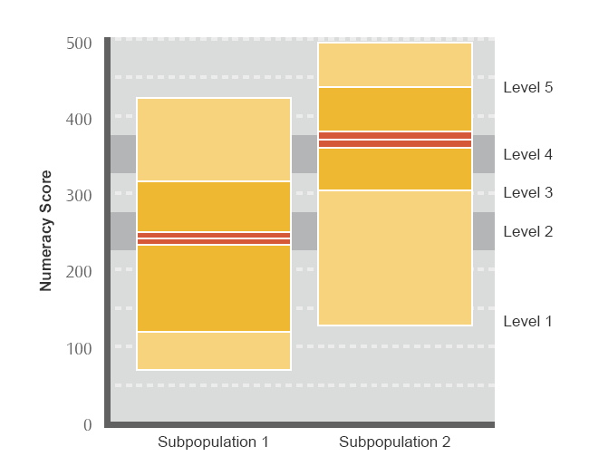

For example, Figure 1 shows that the 5th percentile of numeracy in subpopulation 2 is about 130, the 25th percentile is about 300, the mean is about 360, the 75th percentile is about 430 and the 95th percentile is about 490.

Note that an indication of the error of each of the mean is given – this is the broader horizontal band surrounding the horizontal line that indicates the location of the mean. The width of the horizontal band shows the magnitude of the error associated with the mean. The cognitive levels (defined in section 2.g.) form a background to the box-plots shown in Figure 1.

Graphs of levels
Some useful statistics that encapsulate part of the information in the ALL survey findings are the percentage of the population represented in each of the cognitive levels referred to in section 2.g. These statistics can be computed for any of the four domains mentioned in section 2.c.

These statistics don’t provide such a natural summary of the performance of a population as do the mean and percentiles, but they do have one advantage: the percentage of a population at a given level for a specified domain can be compared with that for a different domain.

There are several ways to graphically present these statistics.

Figure 2: Prose Literacy and Numeracy in Subpopulations 1 and 2
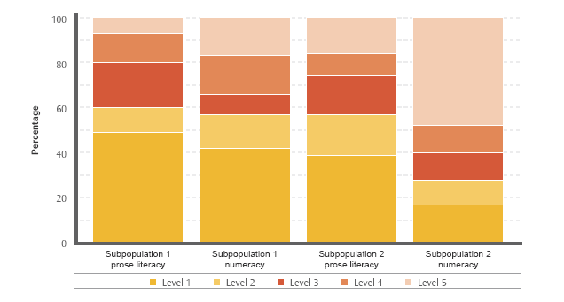

Figure 2 shows that about 50 percent of subpopulation 1 adults had prose literacy scores at level 1. This compares with about 40 percent for subpopulation 2.

Similarly, about 10 percent of subpopulation 1 adults had prose literacy scores at level 2. This compares with about 20 percent for Subpopulation 2, and so on.

Similar comparisons can be carried out for numeracy.

The presentation in Figure 2 does not allow for representation of the errors associated with each level, subpopulation and domain. One way to represent errors is as follow.

Figure 3: Prose Literacy and Numeracy in Subpopulations 1 and 2
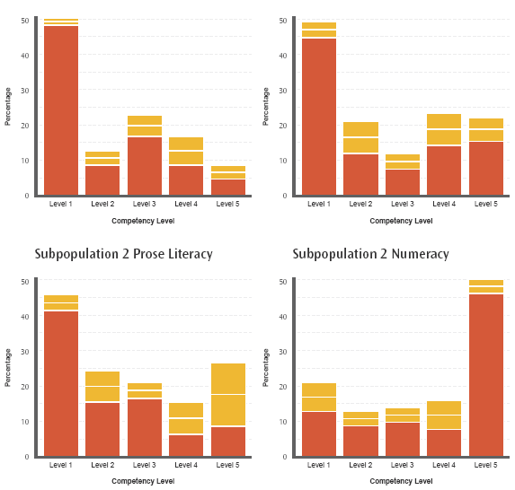

The information in Figure 3 can be interpreted as in Figure 2 but the additional information here is the error associated with each level. This is represented by the broader horizontal band surrounding the line that marks the percentage of the population at that level.

The same information could also be graphed in another way.

Figure 4: Prose Literacy and Numeracy in Subpopulations 1 and 2
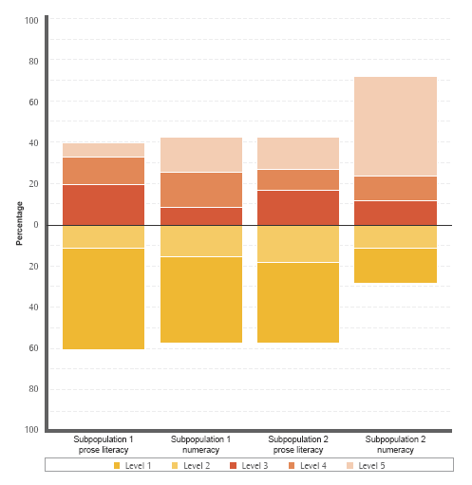

Again, the information in Figure 4 can be interpreted as in Figure 2.

Note that this format does not allow for representation of error, but does emphasise the contrasts between the percentages in levels 1 and 2 for the two subpopulations and two domains. For a column associated with a given subpopulation and domain, the greater the amount of the column that sits above the horizontal line at percentage zero, the smaller the percentage of the subpopulation measured at levels 1 and 2.

Line graphs
The age of a respondent is one of the pieces of information collected in the ALL survey. This allows for the study of how various statistics change with age. One appropriate way to show this information is using a line graph.

Figure 5: Percentage Reaching Higher Levels of Literacy by Age in Country 1
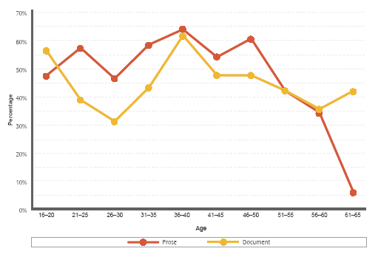

Figure 5 shows, for example, that around 6 percent of the 61-65 year-old adult population of country 1 achieved higher levels (i.e. levels 4 and 5) of proficiency in prose literacy. Among the same age demographic, 45 percent achieved higher levels of proficiency in document literacy.

Note that error is not represented here. This is mainly because of the visual clutter such a representation would cause.

4. Timeline
A sequence of four brochures will be released, followed by a longer report. The brochures will be largely independent from one another. The report may reiterate some of the material of the brochures in the course of a more in-depth presentation of the ALL survey findings.

A tentative timeline for the release of the ALL survey findings follows.

Brochure 1: Overview – January 2007
The overview will summarise how each of the ALL survey domains is distributed through the New Zealand adult population and will compare New Zealand’s ALL survey findings with those of other countries.

Brochure 2: Education and Labour Force Status – February 2008
This brochure will outline how the ALL survey domains are distributed through the New Zealand adult population according to educational status and labour-force status.

Brochure 3: Gender and Ethnicity – March 2008
The gender and ethnicity brochure will focus on how each of the ALL survey domains is distributed through the New Zealand adult population for women and men, and for different ethnic groups.

Brochure 4: April 2008
This brochure will investigate how the ALL survey domains are distributed through the New Zealand adult population for different age groups.

Report – Late 2008
This report is likely to include:
- a profile of the literacy, numeracy and problem-solving skills of New Zealand adults
- a description of the changes in literacy skills from 1996 to 2006
- a description of patterns of participation in adult education and training
- a description of aspects of literacy skills in the workplace
- a description of associations between literacy, recreation and social participation
- a summary of results for adults with low skills.

5. Further information
www.educationcounts.edcentre.govt.nz/research/all.html
This is the URL of the New Zealand ALL survey homepage and contains links to the OECD, Statistics Canada and National Center for Education Statistics (NCES) websites.

www.nces.ed.gov/surveys/all/items.asp
This URL is part of the NCES website and is where the sample questions presented above may be found. There are more samples on this website as well as a wealth of other material.

www.statcan.ca/english/freepub/89-603-XIE/2005001/pdf.htm
This URL is part of the Statistics Canada website and contains the first international ALL survey report (concerning Canada, Italy, Norway, Switzerland, the United States of America, Bermuda and the Mexican state of Nuevo Leon).

www.nrb.co.nz
This URL is the homepage of the National Research Bureau Ltd – the company contracted to design and administer the ALL survey in New Zealand.

www.ets.org
This URL is the homepage of the Educational Testing Service, which is responsible for design and construction of the ALL survey.

Enquiries
Enquiries about this project may be directed to the Comparative Education Research Unit, Research Division, Ministry of Education
Email: research.info@minedu.govt.nz
Fax: 64-4-463 8312
Phone 64-4-463 8000

Published by: Comparative Education Research Unit, Ministry of Education

© Ministry of Education
All rights reserved

All enquiries should be made to the publisher
August 2007

This report is available from the Education Counts website:
www.educationcounts.edcentre.govt.nz/goto/all

ISBN: 978-0-478-13670-8
ISBN Web: 978-0-478-13671-5

