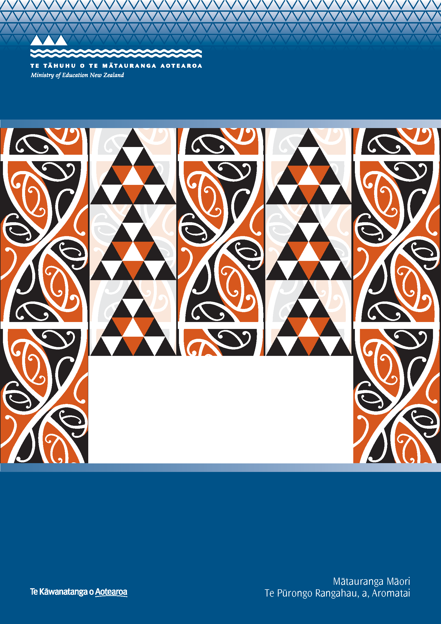
Te Kotahitanga: Maintaining, replicating and sustaining change
Report for Phase 3 and Phase 4 schools: 2007-2010

Report to the Ministry of Education

R Bishop, M Berryman, J Wearmouth, M Peter and S Clapham
Faculty of Education, University of Waikato

ISBN: 978-0-478-38632-5
ISBN: 978-0-478-38633-2 (web)
RMR-988

© Ministry of Education, New Zealand — 2011
Research reports are available on the Ministry of Education’s website Education Counts:
www.educationcounts.govt.nz/publications.

Opinions expressed in this report are those of the authors and do not necessarily coincide with those of the Ministry of Education

He Whakamārama
The kōwhaiwhai design on the cover is featured in Te Wāhanga, a meeting room in the Ministry of Education’s Head Office dedicated to te ao Māori. The kōwhaiwhai symbolises the journey from one generation to the other. The continuous line indicates the passage of time. The pattern in red depicts the generations of today and the black represents those who have passed on. The triangle is a symbol regularly used in tukutuku, raranga and tāniko designs to depict strength and determination. The cover, then, is symbolic of the challenge that education has offered and continues to offer those who have passed on and those of today.


Te Kotahitanga: Maintaining, Replicating and
Sustaining Change

Report for Phase 3 and Phase 4 Schools: 2007–2010

R. Bishop, M. Berryman, J. Wearmouth, M. Peter and S. Clapham
Faculty of Education
University of Waikato
Final report

Acknowledgements
This project was funded by the New Zealand Ministry of Education and conducted by the Te Kotahitanga Research and Professional Development Team at the University of Waikato. We are particularly grateful to the staff of Ministry of Education for their support in this work.
Our thanks must go to the students, teachers, senior leadership team members, principals and board of trustee members who have continued to support the Te Kotahitanga reform initiative in schools and have so willingly and generously given their time in sharing their thoughts and experiences with us.
In preparing this report, we would like to thank the whole Te Kotahitanga team most sincerely for their invaluable contributions and support:
- our rōpū whakaruruhau, Rangiwhakaehu Walker, the late Mate Reweti, Morehu Ngatoko and Koroneihana Cooper who provided invaluable cultural leadership guidance and expertise. They were assisted by Soli Weiss and Donna Fengewisch
- Te Arani Barrett for her expertise in project management
- Amos Jefferies and Scott Sutherland for their work with the analysis of student outcome data in schools and preparation of material for this report
- the team of regional coordinators who provided professional development support for the schools: Robbie Lamont, Iti Joyce, Marion Evans, Dawn Lawrence, Aroha Matthews and Barney Wharakura
- Dannielle Jaram and Annie Siope for assistance with data collection and analysis, and administration of the project
- Paul Woller for assistance with data collection and analysis.
Te Kotahitanga was initially developed from a theoretical base identified by Russell Bishop and was further developed and directed by Russell Bishop and Mere Berryman, and managed by Te Arani Barrett, with support in the preparation of this report from Janice Wearmouth.

Table of contents
Executive summary 1
Key questions 1
Key findings 2
References 7
Chapter 1: Maintenance, replicability and sustainability 9
1.0 Introduction 9
1.1 The purpose of this report 9
1.2 The history of Te Kotahitanga 9
1.3 Towards a model for scalability and sustainability 20
1.4 Outline of the report 23
1.5 References 24
Chapter 2: Research methods 27
Summary of research methods 27
2.0 Introduction 27
2.1 The Te Kotahitanga Observation Tool 28
2.2 Quantitative student achievement data 35
2.3 Configuration maps 37
2.4 “Levels of Use” protocols 39
2.5 Document scrutiny 41
2.6 Case studies 41
2.7 Survey design 43
2.8 Te Kotahitanga collaboration website and relational database 43
2.9 References 47
Chapter 3: Maintaining the gains: Phase 3 49
Summary of findings 49
3.0 Introduction 50
3.1 Student outcomes 51
3.2 Changes in classrooms evidenced through the Observation Tool 60
3.3 “Levels of Use” outcomes 80
3.4 Retention of staff in the Te Kotahitanga programme 82
3.5 Teachers’ survey, July to August 2010 83
3.6 Phase 3 leaders’ survey, July to August, 2010 88
3.7 Configuration maps 92
3.8 “State of the Nation” reports 95
3.9 GPILSEO evidence from Education Review Office reports 96
3.10 References 97
Chapter 4: Replicating the gains: Phase 4 99
Summary of findings 99
4.0 Introduction 100
4.1 Student outcomes 101
4.2 Changes in classrooms evidenced through the Observation Tool 109
4.3 Retention of staff in Phase 4 of the Te Kotahitanga programme 125
4.4 Teachers’ survey, July to August 2010 126
4.5 Leaders’ survey, July–August, 2010 130
4.6 Configuration maps 134
4.7 “State of the Nation” reports 137
4.8 GPILSEO evidence from Education Review Office reports 138
4.9 References 140
Chapter 5: Professional Development Programme, 2007 to 2010 141
Summary of findings 141
5.0 Introduction 141
5.1 Summary of professional development to the end of 2007 143
5.2 Overview of professional development from 2008 to 2010 148
5.3 Te Kotahitanga professional development: Purpose, process and content 150
5.4 Review of Practice and Development (RP&D) 150
5.5 Professional development resources 165
5.6 Reflections on the Te Kotahitanga model of professional development 170
5.7 References 173
Chapter 6: Indicators of Sustainability in Phase 3 schools 175
Summary of findings 175
6.0 Introduction 176
6.1 GPILSEO: summary information 177
6.2 Examples of shifts in positioning and practices 195
6.3 Te Kotahitanga after seven years in one school 201
6.4 References 214
Chapter 7: Conclusions and Future Developments for Te Kotahitanga 215
7.0 Conclusions 215
7.1 Differentiation of implementation and maintenance among Phase 3 schools 219
7.2 Future developments 221
7.3 Transformation of the contractual arrangements between professional development providers and the schools 232
7.4 Conclusion 232
7.5 References 232

Executive summary
The purpose of this report is to document the outcomes of the implementation of Te Kotahitanga in Phase 3 and 4 secondary schools from 2007 to 2010. Most quantitative data pertain to the years 2007 to 2009, whereas the qualitative data were collected during the period 2009 to 2010. During these four years, the Phase 3 schools were in their fourth to seventh year of implementing the project in their schools. Phase 4 schools were in their first to fourth years of the programme.

Key questions
The key questions we investigated for this report were:
- Did the Phase 3 schools maintain the changes to teaching practices and student outcomes in 2007 to 2009 that they had made during 2004 to 2006? (Data for this earlier period is to be found in Bishop, Berryman, Cavanagh, & Teddy, 2007).
- Did the Phase 4 schools replicate the changes in teaching practices and student outcomes during 2007 to 2009 that were made by Phase 3 schools during the period 2004 to 2006?
- What was the professional development intervention that enabled the changes in teaching practices to occur?
- How did school leaders maintain the changes in Phase 3 schools and what did we learn about sustainability from their attempts?
These questions were investigated using a mixed-methods research approach using both:
- quantitative methods, including student achievement data, observations of teacher and student behaviour in previously defined categories, and self-reports of intentions and experiences collated through questionnaires and rating scales
- qualitative methods, including semi-structured and open-ended interviews and documentary analysis.
Data collection was carried out in accordance with the University of Waikato’s ethical requirements and the American Education Research Association (AERA) guidelines for reporting on empirical social science research in educational settings (AERA, 2006).
Findings are presented in Chapters 3 to 6, against each of the four key questions.
Chapter 3 presents the changes that were maintained in the Phase 3 schools as evidenced through improvements in Māori student outcomes, changes in teachers’ discursive positioning and classroom practices, and changes in school management and structures to support project implementation (key question 1).
Chapter 4 discusses the degree to which patterns of Māori student outcomes, changes in teachers’ discursive positioning and classroom practices, and changes in school management and structures in Phase 4 were replications of those established earlier in Phase 3 schools (key question 2).
Chapter 5 considers the elements of effective professional development that sets out to refine and develop new ways of working to support the improvement of Māori students’ learning and achievement (key question 3).
Chapter 6 identifies the degree to which Te Kotahitanga is being embedded in the Phase 3 schools as indicators of sustainability (key question 4).
Chapter 7 draws some conclusions and points to future directions.

Key findings
Key finding 1: Improvements in Māori student achievement patterns were maintained in Phase 3 schools.
Key finding 2: Changes in teachers’ discursive positioning and classroom practices were maintained in Phase 3 schools.
Key finding 3: Phase 4 schools replicated the patterns of Māori student achievement seen earlier in Phase 3 schools.
Key finding 4: Phase 4 schools replicated the changes in Te Kotahitanga teachers’ classroom practices and discursive positioning seen earlier in Phase 3 schools.
Key finding 5: In both phases of the Te Kotahitanga project, teachers have built their knowledge, skills, and capacities through the implementation of the Te Kotahitanga Effective Teaching Profile. Simultaneously, their Māori students have experienced continuous improvement in numeracy and literacy, in the junior school, and made significant gains in external examinations.
Key finding 6: The central professional development process of the project was maintained in schools and further dimensions were trialled, adapted and added to the programme to ensure sustainability.
Key finding 7: There were differences in the degree to which the schools had implemented and maintained the implementation of the project, with consequent implications for sustainability. This variation was exacerbated when the principal changed during the period of the implementation.
Key finding 8: Those schools that fully implemented and sustained the programme in an integrated way had the best outcomes for Māori students.
Key finding 9: School leadership is a vital component of effective implementation and sustainability of Te Kotahitanga, and we need to develop a more systematic intervention based on the GPILSEO model to more effectively support leadership at all levels.

1. Maintaining changes for teachers and gains for Māori students in Phase 3 schools
Did the Phase 3 schools maintain the changes to teaching practices and student outcomes in 2007 to 2009 that they had made during 2004 to 2006? (Data for this earlier period are to be found in Bishop et al., 2007).

Key finding 1: Improvements in Māori student achievement patterns were maintained in Phase 3 schools
- In every comparison of asTTle gain scores in reading and mathematics in Years 9 and 10, Māori students improved between pre- and post-tests.
- Where in 2007 and 2008, Māori and non-Māori were achieving the same asTTle gain scores in reading and mathematics in Years 9 and 10, or where non-Māori in Phase 3 schools were achieving better, by 2009 Māori students were achieving at least as well, if not better, than non-Māori in most comparisons.
- Year 10 Māori students achieved the same as or higher asTTle gain scores than the national norm for all students in the reading and mathematics assessments, in 2008 and 2009.
- Māori students’ achievements in NCEA outcomes improved between 2007 and 2009 in Years 11 and 12. In Year 13 there was a non-significant decrease in achievement, also reflected at national level.
- Between 2005 and 2006, Year 11 Māori students in Phase 3 schools doubled the percentage points gain of the national cohort of Māori students. In subsequent years they improved on this achievement level.
- Between 2007 and 2009, the percentage points gain made by Year 12 Māori students in terms of NCEA Level 2 and above was double that of the national cohort of Māori students.

Key finding 2: Changes in teachers’ discursive positioning and classroom practices were maintained in Phase 3 schools
Data from the Observation Tool indicated that:
- for all cohorts, a high level of relationships was maintained from the first year of teachers’ participation
- there was a general increase in the use of discursive practices by term 4, 2009, relative to term 1 of the first year of participation
- the percentage of time teachers spent at the front of the classroom decreased in their first year of participation relative to the baseline
- there was an increase in the cognitive level of the lessons relative to the baseline, that was maintained through the first three years of participation
- the percentage of student engagement increased significantly in the first year relative to the baseline and was maintained in the second and third year
- the level of work completion by Māori students increased and was maintained.

Embedding the project in Phase 3 schools
Overall, in the surveys that were undertaken, teachers and leaders reported positively on the processes of embedding GPILSEO elements in their schools.
Overall, leaders were also very positive in their self-evaluations as leaders in Te Kotahitanga schools and also in their evaluations of the systems and organisation supporting the project in their schools, but in this latter case slightly less so.
In terms of staff retention in the project, the greatest number of withdrawals took place in the first two years of teachers in cohort 1. Subsequently very few teachers chose to withdraw.

2. Replicating changes for teachers and gains for Māori students in Phase 4 schools
Did the Phase 4 schools replicate the changes in teaching practices and student outcomes during 2007 to 2009 that were made by Phase 3 schools during the period 2004 to 2006?

Key finding 3: Phase 4 schools in 2007–2009 replicated the patterns of Māori student achievement seen earlier in Phase 3 schools
Māori student achievement in Phase 4 schools showed that:
- in every comparison of asTTle gain scores in reading and mathematics in Years 9 and 10, Māori students’ achievement improved between pre- and post-tests
- in 2007, 2009 and 2010, in half of the comparisons of mathematics achievement within Phase 4 schools, non-Māori students improved more than Māori students and in half they improved equally. However, Year 10 Māori students achieved higher gain scores than the national norm for all students in asTTle mathematics assessments in both 2008 and 2009
- in asTTle reading by 2009 Māori students outperformed non-Māori in terms of learning gain within Phase 4 schools in three out of four results
- in terms of national comparisons, Year 10 Māori students achieved a 50% increase in gain scores in asTTle reading assessments between 2008–2009, and almost achieved the same level of gain scores as the national norm for all students in 2009
- NCEA Level 1 and above in Year 11, and Level 2 and above in Year 12, showed a marked improvement:
- Year 11 students made twice the gain of the national cohort of Māori students at Year 11 in NCEA Level 1 and above, in terms of percentage points
- Year 12 Māori students also made a greater percentage points gain at NCEA Level 2 and above (9% higher) than the national cohort of Year 12 students.

Key finding 4: Phase 4 schools replicated the changes in Te Kotahitanga teachers’ classroom practices and discursive positioning seen earlier in Phase 3 schools
Changes in Te Kotahitanga teachers’ classroom practices in Phase 4 schools, as evidenced by data from the Observation Tool, included:
- for all cohorts, a high level of relationships, maintained from the first year of participation
- a general increase in the use of discursive practice by term 4, 2009, relative to term 1 of the first year of participation
- a decrease in the percentage of time teachers spent at the front of the classroom in teachers’ first year of participation relative to the baseline
- an increase in cognitive level of the class, relative to the baseline, that was maintained across time
- an increase in the percentage of student engagement that was maintained across time
- maintenance of the high level of work completion by Māori students already established at baseline.

Replicating the project in Phase 4 schools
Overall, in the surveys that were undertaken, teachers and leaders reported positively on the processes of beginning to understand the GPILSEO elements in their schools.
Leaders were very positive in their self-evaluations as leaders in Phase 4 schools and also in their evaluations of the systems and organisation supporting the project in their schools.
In terms of staff retention in the project, very few teachers withdrew from the project. Those few left mostly in the first year of membership.

3. The process of effective professional development
What was the professional development intervention that enabled the changes in teaching practices to occur?

Key finding 5: In both phases of the Te Kotahitanga project, teachers have built their knowledge, skills, and capacities through the implementation of the Te Kotahitanga Effective Teaching Profile. Simultaneously, their Māori students have experienced continuous improvement in numeracy and literacy, in the junior school, and made significant gains in external examinations.

Key finding 6: The central professional development process of the project was maintained in schools and further dimensions were trialled, adapted and added to the programme to ensure sustainability
Analysis of evidence from Te Kotahitanga professional development indicates that:
- the tools developed to support the professional development associated with Te Kotahitanga were trialled, evaluated and proven to be fit for purpose
- providing inconsistent direction and less hands-on support to Phase 3 schools in 2007 and 2008 resulted in variable outcomes in terms of sustainability
- the central project team should provide support for school leadership in implementing and maintaining the project
- the integrity of the professional development cycle in schools should be maintained
- Phase 4 schools have shown more adherence to the integrity of the Te Kotahitanga model; however
- there is still wide variance from one school to another
- one-third of schools still require more intensive support
- there is a wide range of knowledge and prior experiences across the group of lead facilitators
- school leadership provide differing levels of support for implementation of Te Kotahitanga
- the Review of Practice and Development (RP&D) cycle developed by the central project team is effective in quality assuring facilitation teams’ responses to their teachers and teachers’ responses to their Māori students, whilst also maintaining the integrity and purpose of Te Kotahitanga
- distance support is most effective when it is blended with face-to-face relationships and support.

4. The degree to which Te Kotahitanga is embedded in Phase 3 schools
How did school leaders maintain the changes in Phase 3 schools and what did we learn about sustainability from their attempts?

Key finding 7: There were differences in the degree to which the schools had implemented and maintained the implementation of the project, with consequent implications for sustainability. This variation was exacerbated when the principal changed during the period of the implementation

Key finding 8: Those schools that fully implemented and sustained the programme in an integrated way had the best outcomes for Māori students.

Key finding 9: School leadership is a vital component of effective implementation and sustainability of Te Kotahitanga, and we have developed a more systematic intervention based on the GPILSEO model to more effectively support leaders at all levels
It is clear from the analysis of the overall patterns from Phase 3 schools that Māori student achievement patterns continued to improve in association with the maintenance of changes in teacher’s practices. However, the individual case studies analysis that was undertaken in 2009 and 2010 of Phase 3 schools in their sixth and/or seventh year of the project, and which used the GPILSEO model as an analytical tool to investigate the degree to which schools were supporting the pedagogic intervention, showed that there were marked differences in the degree to which the schools had actually implemented the model and how they were maintaining the implementation of the project, with consequent implications for sustainability.
Phase 3 schools can be seen as falling within one of four categories:
- high implementers and high maintainers of the project (four schools)
- previously high implementers but currently low maintainers (three schools)
- previously partial implementers, but currently poised to implement fully (four schools)
- low implementers and low maintainers (one school).
In three of the four years between 2006–2009, Year 11 Māori students’ achievements at NCEA Level 1 were significantly better in high/previously high implementers (the first two categories above) than in the previously partial/low implementers (the lower two categories above).
A comparison of Māori students’ achievements in two schools, both of the same decile rating, indicates that, in the high implementing, high maintaining school:
- the proportion of Māori to non-Māori students’ suspension and stand-down rates was consistently lower than the lowest implementing and maintaining school
- Māori students’ achievements in literacy and numeracy requirements at NCEA Level 1 and in NCEA Level 1 science overall were higher than in the lowest implementing and maintaining school
- in each school and at every level of responsibility there are shining examples of colleagues who implement the Effective Teaching Profile to a very high degree, and who are supporting Māori students to enjoy success in education as Māori very effectively.
The seven schools in the first two categories are, or have been, very effective implementers of the Effective Teaching Profile in the majority of their teachers’ classrooms through use of the project’s central institutions (Induction hui, observations, feedback, co-construction meetings and shadow coaching). They have also reported steady gains in Māori student attendance, retention, engagement and achievement (AREA) in their schools. In terms of the GPILSEO model, there are a number of additional features these schools have in common. In these schools:
- the senior leadership teams are agentic leaders and present a united front in their determination to support the implementation of the school’s goal to improve the achievement of Māori students and to reduce educational disparities and these visions are of a long-term nature. There are also clear specific measurable goals in regards to Māori student achievement in these schools
- there has been marked changes made in the institutional and structural arrangements in the school in a manner that is clearly responsive to the needs of the pedagogic intervention, including policy development and implementation
- there has been a concerted effort to effectively distribute leadership throughout the school
- most or all of their staff are included in the project
- there is evidence of their making steady progress towards improving positive supportive learning relations with their Māori parents and community
- there has been a concerted effort to ensure improvements in evidence gathering, analysis and use
- ownership of the project, its goals and means of implementation is fundamental to their thinking and practice. This latter development means that there has been a reprioritising of funds available in the school so as to support the establishment of an ongoing professional development function (facilitators) in these schools.

References
American Educational Research Association (AERA). (2006). Standards for reporting on empirical social science research in AERA publications. Educational Researchers, 35(6), 3344.
Bishop, R., Berryman, M., Cavangah, T., & Teddy, L. (2007). Te Kotahitanga phase 3 whanaungatanga: Establishing a culturally responsive pedagogy of relations in mainstream secondary school classrooms. Wellington, New Zealand: Ministry of Education.
Johnson, R. B., & Onwuegbuzie, A. J. (2004). Mixed methods research: A research paradigm whose time has come. Educational Researcher, 33(7), 14–26.

Chapter 1: Maintenance, replicability and sustainability

1.0 Introduction
This chapter outlines the purpose of this report, the history of the Te Kotahitanga project and what each chapter contains.

1.1 The purpose of this report
The purpose of this report is to document the outcomes of the implementation of Te Kotahitanga in Phase 3 and 4 secondary schools from 2007 to 2010. Most quantitative data pertain to the years 2007 to 2009, whereas the qualitative data were collected during the period 2009 to 2010. During these four years, the Phase 3 schools were in their fourth to seventh year of implementing the project in their schools. Phase 4 schools were in their first to fourth years of the programme.
The purpose of extending the project into these extra years beyond those required to establish the project in the Phase 3 schools, was firstly to identify if the Phase 3 schools were able to maintain the gains they had made in teacher practices and student achievement during the first three years of the project. A second main focus is on whether the schools in Phase 4 are following a similar pathway to the earlier group of schools (Phase 3) in their implementation of the project. In addition, the research sought to identify the conditions necessary for the schools to sustain and embed the practices and learnings from Te Kotahitanga. While we are reporting on what occurred in these schools over the period 2008 to 2010, we draw on data from previous years for comparison purposes.

1.2 The history of Te Kotahitanga

1.2.1 Te Kotahitanga Phase 1
In 2001 and 2002 the first phase of the Te Kotahitanga research project was developed and implemented by the Māori Education Research Team at the School of Education, University of Waikato, in partnership with the Poutama Pounamu Education Research and Development Centre, based at Tauranga. The project began with the research team talking to Year 9 and 10 Māori students (and other participants in their education) in a range of schools including single sex to co-educational, high to low decile, urban to rural, large to small, and high to low proportions of Māori students. Using a collaborative storying approach (Bishop, 1996), a sequence of in-depth, semi-structured interviews as conversations was used to construct a series of narratives of experience (Bishop & Berryman, 2006), that were then used for a range of activities (see below), with an overall goal of finding out how teachers and schools could reduce educational disparities through raising the educational achievement of Māori children.
The project itself started with a short scoping exercise in 2000 to identify possible research approaches. The primary finding of this scoping exercise was that of the importance and usefulness of student voice to the Research and Development process (Bishop, Berryman, Tiakiwai & Richardson, 2003). Starting a project by talking with students is not usual, but as Cook-Sather (2002) identified in a large meta-analysis, such authorising of students’ experiences and understandings can directly improve educational practice in that when teachers listen to and learn from students, they can begin to see the world from the perspective of those students. This, in turn, can help teachers make what they teach more accessible to students. These actions can also contribute to the conceptualisation of teaching, learning, and the ways we study as being more collaborative. Further, students can feel empowered when they are taken seriously and attended to as knowledgeable participants in learning conversations; and they can be motivated to participate constructively in their education. In addition, Cook-Sather further identified that authorising students’ perspectives is a major way of addressing power imbalances in classrooms in order for students’ voices to have legitimacy in the learning setting. In short, as Cook-Sather states: ‘‘Authorising student perspectives is essential because of the various ways that it can improve educational practice, re-inform existing conversations about educational reform, and point to the discussions and reform effects yet to be undertaken’’ (p. 3).
In the Te Kotahitanga narratives, the children clearly identified that the main influence on their educational achievement was the quality of the in-class relationships and interactions they had with their teachers. They also explained how teachers could create a context for learning in which Māori students’ educational achievement could improve by changing the ways they related to and interacted with Māori students in their classrooms. It was clear from their experiences that if Māori students are to achieve at higher levels, and educational disparities are to be reduced, then teachers must relate to and interact with these students in a different manner than was most commonly happening.

1.2.2 Uses of the narratives
The narratives of experience and the collaborative storying approach were useful in the project in a variety of ways. Firstly, the analysis of the narratives identified the usefulness of the concept of discourse as a means of identifying the thoughts, words and actions shaped by power relations; those complex networks of images and metaphors that the various people in the stories drew upon to create meaning for themselves about their experiences with the education of Māori students. A critical reading of the narratives illustrates the effect of discursive positioning where some discourses offer solutions, while others merely perpetuate the status quo. For example, despite most teachers wishing to make a difference for Māori students’ educational achievement, they were not able to do so because of their discursive positioning, whereas others, discursively positioned agentically, were able to offer numerous solutions to seemingly immutable changes. However, despite our occupying “subject positions within discourse” (Burr, 1995, p. 146), teachers do have the freedom to shift their discursive positions by positively and vehemently rejecting deficit theorising as a means of explaining Māori students’ educational achievement levels. Such discursive (re)positioning is possible, because it is not just a matter of our being subject to, or a product of, discourse; we have agency that allows us to (re)story our lives. As Burr argues, this narrative notion “allows us the possibility of personal and social change through our capacity to identify, understand and resist the discourse we are also subject to” (p. 153).
Secondly, the interviews for the narratives were conducted in a kaupapa Māori manner (Bishop, 1997; 2005) in order that the participants were able to explain the meanings they constructed about their educational experiences either as or with Māori students in ways that acknowledged their self-determination. The students, for example, clearly pointed out the main influences on their educational achievement by articulating the effect and consequences of their living in a minoritised space. That is, they explained how they were perceived in pathological terms by their teachers, and how this has had a negative effect on their lives. The whānau members and the principals were also able to identify the main influences upon Māori students’ education from their own experiences. Similarly their teachers were able to explain the vast range of experiences and meanings they ascribed so that they were able to speak in a way that legitimated their representations.
Thirdly, the detailed narratives of experience are used at the start of the professional development part of this project in response to Bruner’s (1996) understanding that “our interactions with others are deeply affected by our everyday intuitive theorizing about how others’ minds work” (p. 45). In other words, it is necessary to acknowledge that teachers are not simply vessels to be “filled” by the expert outsider but rather that they do have strongly held theories of practice that affect and direct their practice and maybe some of these positions offer hope and maybe some do not. Indeed, it is clear that many of these theories that teachers hold could well do with being challenged through the creation of a situation of cognitive, emotional or cultural dissonance by the provision of evidence that is outside of the usual experiences of the teachers. Teachers can then use this evidence to critically reflect upon their discursive positioning and the implications of this positioning for student learning. However, it is clear that this challenging needs to be undertaken in a non-confrontational manner, one that acknowledges the mana of the teachers where manaakitanga (caring for others) overrides aspirations to argue with, to chastise or to correct the ideas of one’s guests. Therefore the focus of the professional development is to create a culturally appropriate and responsive context for learning wherein teachers can reflect upon the evidence of the experiences of others in similar circumstances, including, perhaps for the first time, the students. In this manner, teachers can critically evaluate where they position themselves when constructing their own images, principles and practices in relation to Māori students in their own classrooms. Sharing these vicarious experiences of schooling enables teachers to reflect upon their own understandings of Māori children’s experiences and consequently upon their own theorising or explanations about these experiences and their consequent practice. In this way, teachers are afforded the opportunity to reflect critically upon their own discursive positioning and the implication of this positioning for their own agency and for Māori students’ learning.
Fourthly, the students were clear about how teachers, in changing how they related and interacted with Māori students in their classrooms, could create a context for learning wherein Māori students’ educational achievement could improve, by placing the self-determination of Māori students at the centre of classroom relationships and interactions. In addition, interviewees who positioned themselves within the discourse of relationships were able to add numerous practical solutions to the problems of educational disparities facing Māori students. These stood in contrast to the very limited, and mainly impractical (especially for classroom teachers) solutions offered by those who discursively positioned themselves within other discourses; for example, those that blamed the child or their homes or the structures of the education system for Māori students’ learning difficulties. It was through the ideas of those who were positioned within the agentic, relationship discourse, and this included most of the students, their families, their principals and some of their teachers, that what has been termed the Te Kotahitanga Effective Teaching Profile was developed (see Table 1.1 on next page).
Table 1.1: The Te Kotahitanga Effective Teaching Profile
Te Kotahitanga Effective Teaching Profile (Bishop, et al., 2003)
Effective teachers of Māori students create a culturally appropriate and responsive context for learning in their classroom.
In doing so they demonstrate the following understandings:
- they positively and vehemently reject deficit theorising as a means of explaining Māori students’ educational achievement levels (and professional development projects need to ensure that this happens)
- teachers know and understand how to bring about change in Māori students’ educational achievement and are professionally committed to doing so (and professional development projects need to ensure that this happens)
in the following observable ways:
  - Manaakitanga: They care for the students as culturally-located human beings above all else.
(Mana refers to authority and akiaki, the task of urging some one to act. It refers to the task of building and nurturing a supportive and loving environment).
  - Mana motuhake: They care for the performance of their students.
(In modern times mana has taken on various meanings such as legitimation and authority and can also relate to an individual’s or a group’s ability to participate at the local and global level. Mana motuhake involves the development of personal or group identity and independence).
  - Whakapiringatanga: They are able to create a secure, well-managed learning environment by incorporating routine pedagogical knowledge with pedagogical imagination.
(Whakapiringatanga is a process wherein specific individual roles and responsibilities are required to achieve individual and group outcomes).
  - Wānanga: They are able to engage in effective teaching interactions with Māori students as Māori.
(As well as being known as Māori centres of learning wānanga as a learning forum involves a rich and dynamic sharing of knowledge. With this exchange of views ideas are given life and spirit through dialogue, debate and careful consideration in order to reshape and accommodate new knowledge).
  - Ako: They can use a range of strategies that promote effective teaching interactions and relationships with their learners.
(Ako means to learn as well as to teach. It refers both to the acquisition of knowledge and to the processing and imparting of knowledge. More importantly ako is a teaching-learning practice that involves teachers and students learning in an interactive dialogic relationship).
  - Kotahitanga: They promote, monitor and reflect on outcomes that in turn lead to improvements in educational achievement for Māori students.
(Kotahitanga is a collaborative response towards a commonly held vision, goal or other such purpose or outcome).

1.2.3 How the Effective Teaching Profile was constructed
The Effective Teaching Profile was constructed by reflecting upon the numerous conversations we had with the students, their whānau, their principals and their teachers when we were constructing the narratives of experience (Bishop & Berryman, 2006). These narratives are the heart of the project and are central to the professional development part of Te Kotahitanga, which seeks to assist teachers to implement the Effective Teaching Profile in their classrooms to improve Māori students’ achievement. The narratives are used to allow teachers to critically reflect upon and match their own understandings about how Māori students see the world and experience schooling with how Māori students themselves understand their own experiences of schooling. This reflection is a necessary part of the consideration by teachers of the part they play in their students’ learning.
The ability of students to articulate their experiences clearly and in detail formed the basis of this profile, as the students told us about the types of relationships and interactions between themselves and their teachers that both hindered their educational achievement and also promoted their advancement.
The Effective Teaching Profile is made up of two parts. The first identifies two major understandings that effective teachers possess. These are that effective teachers:
- understand the need to explicitly reject deficit theorising as a way of explaining Māori students’ educational achievement levels
- take an agentic position in their theorising about their practice.
That is, effective practitioners express their professional commitment and responsibility to bring about change in Māori students’ educational achievement by accepting professional responsibility for the learning of all their students.
The second part of the Effective Teaching Profile identifies six relationships and interactions that can be seen in effective teachers’ classrooms on a daily basis where they:
- care for the students as culturally located individuals
- have high expectations for students’ learning
- are able to manage their classrooms so as to promote learning
- are able to engage in a range of discursive learning interactions with students, or facilitate students to engage with others in these ways
- know a range of strategies that can facilitate learning interactions
- collaboratively promote, monitor and reflect on students’ learning outcomes in order to modify their instructional practices in ways that will lead to improvements in Māori student achievement and share this knowledge with their students.
These six dimensions can also be grouped into two groups, the caring relationship dimension and the learning relationship dimension. However, it is probably more practical to see them as six dimensions of effective teaching for Māori students as these dimensions occur simultaneously in the classrooms of effective practitioners.
The implementation of the Effective Teaching Profile allows educators to create learning contexts that will improve the learning engagement and achievement of Māori students by developing learning−teaching relationships where the following notions, detailed in Bishop and Glynn (1999), are paramount.
- Power is shared: Learners can initiate interactions, and a learner’s right to self-determination over learning styles and sense-making processes is regarded as fundamental to power-sharing relationships, and collaborative critical reflection is part of an ongoing critique of power relationships.
- Culture counts: Classrooms are places where learners can bring “who they are” to the learning interactions in complete safety, and where their knowledge is acceptable and legitimate.
- Learning is interactive and dialogic: Learners are able to be co-inquirers (i.e., raisers of questions and evaluators of questions and answers); learning is active and problem-based, integrated and holistic; learning positioning is reciprocal (ako); knowledge is co-created; and classrooms are places where young people’s sense-making processes and knowledge are validated and developed in collaboration with others.
- Connectedness is fundamental to relations: Teachers are committed to and inextricably connected to their students and the community; and school and home/parental aspirations are complementary.
- There is a common vision: There is an agenda for excellence for Māori in education.
In short, implementing the Effective Teaching Profile provides an opportunity for educators to develop an education:
- in which power is shared between self-determining individuals within non-dominating relations of interdependence
- where culture counts
- where learning is interactive, dialogic and spiralling
- where participants are connected and committed to one another through the establishment of a common vision of what constitutes excellence in educational outcomes.
In this way, following Gay (2000), Villegas and Lucas (2002), Sidorkin (2002) and Cummins (1995), we propose that the above context for learning can best be described as a culturally responsive pedagogy of relations.

1.2.4 Te Kotahitanga Phase 2
Initially, in its first phase, the project was conducted by a small team of researchers/professional developers external to the school, with a small number of teachers within four schools. This process of implementation was conducted with the express intention of seeing if changing classroom relationships and interactions could bring about changes in Māori student outcomes (Bishop et al., 2003). From this experience we learnt two major lessons. The first was that working with only a small number of teachers within a school turned them into an enclave, somewhat separate from their peers and this did not promote collaborative problem-solving. The second was, as the numbers of schools and teachers involved in the second phase grew, we needed to hand over the in-school component of the project to teams of in-school facilitators, who were provided with professional development and supported by the external developers of the project. These facilitators were staff released from their usual teaching duties to undertake training and to implement the project in their schools. Resource Teachers Learning and Behaviour (RTLBs) and Schools’ Advisory Services staff were also included as part of the implementation teams in schools and were trained to implement the reform activities and conduct the follow-up sessions.
The professional development approach used was very similar to that developed in the first phase of the project. That is, initially teachers, facilitators and professional developers planned (out of school) intensive opportunities to develop relationships and set mutually agreeable goals, outcomes, protocols and parameters for success. Everyone involved learnt about all aspects of the Effective Teaching Profile, including how this would be observed in classrooms. Instruction and demonstration were followed by opportunities for teachers to perform or practise the new procedures in an authentic classroom context with in-class support.
In Phase 2 we worked with three schools: two secondary (Schools 1 and 2) and one contributing intermediate (School 3). By 2003, nearly 80% of the staff in School 1 were involved, having been brought into the project in cohorts of 30 in the first and subsequent years. This level of participation enabled the researchers to formulate a theory and method of professional development for a “whole-school” approach. In contrast, in School 2, 11 teachers (10% of the teaching staff) took part in the project in 2002 and 2003 working with two target classes. This latter approach confirmed for us the benefits of teachers working in cross-curricular groups, examining and planning for the learning needs of specific target classes. These two approaches―the whole-school focus and working with teachers around specific target classrooms―combined into a comprehensive model that informed the development of the third phase of the project, which started in late 2003. As a result of our experiences in the Phase 2 schools, a number of elements of successful professional development of this type became clearer.
Firstly, creating, trialling and evaluating a professional development programme that can assist and support teachers to develop what Gay (2000) terms a “culturally responsive context for learning” has benefits in terms of changes in teachers’ classroom practice, their level of satisfaction with teaching and students’ behaviours and learning outcomes. However, it is important to note that the development of a specific context for learning will not necessarily bring about changes in the academic achievement of Māori students. As Timperley, Phillips, and Wiseman (2003) warn, professional communities of teachers who focus solely on themselves and their teaching may not necessarily see improvements in student outcomes. Rather, there is a need to develop professional learning communities that focus on evidence as a means to improving student learning and achievement. In many ways, what we learnt in Phase 2 was that the preoccupation of the professional development team with sequence and working with teachers, and the context for learning they created, resulted in the development of professional communities focused on the needs of the profession rather than professional learning communities focused on learning.
We also learnt that we needed to strengthen one of the reform activities, the co-construction meetings, as places where teachers from a variety of subject areas are facilitated to focus on the learning needs of the students they teach in a common target class. In this way the teachers can critically reflect on student data gathered for formative purposes relating to student participation (attendance, engagement) and achievement, and then identify what changes in practice are necessary to ensure progress. In addition, we further developed the process of teacher observation, feedback and individual goal setting to feed into these collegial co-construction meetings. At the co-construction meetings, rather than focusing solely on curriculum areas, facilitators supported teachers to reflect on a range of evidence and engage in co-constructing goals for improving the learning outcomes of a class of students in line with the evidence viewed. Co-construction meetings were followed by in-class shadow coaching aimed at supporting teachers to achieve their goals of changing their instructional practice to further monitor and improve student learning.
It became clear at this point that sustaining the process of reform would involve institutionalising the pattern of reform activities within the school. These activities would involve annual school-based professional development staff Induction hui (meetings held within Māori cultural settings) to progressively introduce new staff to a continuous programme of critical reflection on their own “discursive positioning” in relation to Māori students. These hui would be followed by in-class observation, feedback, evidence-based co-construction meetings and shadow coaching. This would involve trained and proficient in-school facilitators providing feedback, in its broadest sense, to teachers and participating in co-constructing with teachers how they could change their practice in ways that would enhance Māori students’ learning and achievement. In turn, the in-school facilitators would be supported by Research And Professional Development staff whose task was to support the school to maintain the integrity of the programme in the schools.

1.2.5 Te Kotahitanga Phase 3
In late 2003, Te Kotahitanga entered its third phase of implementation, this time increasing the scale of the project to include 12 secondary schools with a similar range to those when we first talked to the students: large to small, urban to rural, single sex to co-educational, high decile to low decile, and those with a high proportion of Māori students to a low proportion of Māori students. All these schools were required to have at least 20% Māori students. The professional development continued to apply what the Research and Development team had learnt to be most effective from the two previous Te Kotahitanga phases. In this third phase, the in-school professional development for teachers was again undertaken by in-school facilitators, who were provided with professional learning opportunities by the Research and Development team to learn how to best support teachers to implement the Effective Teaching Profile in their classrooms through a sequence of professional development activities. The professional development for teachers followed a series of formal and informal introductory meetings, where the project was outlined to each school’s leader and staff.
Once schools undertook to participate in the project, they selected a facilitation team, which consisted of school staff released for the task, augmented by staff from the Schools’ Support Services and RTLB support teams. These teams were provided with focused professional development by the Research and Development team to undertake a series of baseline data-gathering activities and teacher-specific professional development in their schools. The professional development to operationalise the Effective Teaching Profile in classrooms involves applying the acronym GEPRISP as the initial implementation mode, and PSIRPEG (Bishop, Berryman, Cavanagh, & Teddy, 2007a; Bishop, Berryman, Powell, & Teddy, 2007b) as the classroom implementation and evaluation model, initially this occurs through group-focused activities external to classrooms, followed by an ongoing cycle of activities working in classrooms with teachers.
The acronym GEPRISP, as a mnemonic device, reminds teachers that this project is focused on the goal of improving Māori students’ educational achievement, and that the means of doing so starts with an examination of Māori students’ experiences of schooling and of teachers’ discursive positioning in relation to the goal and Māori students’ experiences.
The importance of relationships, interactions, strategies and planning that can be used to reach the goal is then detailed. To implement what has been learnt at the Induction hui, the order of GEPRISP is reversed to PSIRPEG, where teachers focus on their need to undertake classroom and lesson planning that will use a range of strategies to promote discursive interactions in their classrooms, which in turn will develop caring and learning relationships, which in turn will reinforce teachers’ agentic discursive positioning. Together these all work towards improving Māori students’ educational experiences and promote the goal of improving Māori students’ educational engagement, participation and achievement.

1.2.6 The professional development process
The professional development process is fully explained in Chapter 3. In brief, these activities start with the Hui Whakarewa (a three-day staff induction workshop), at which the narratives of experience (Bishop & Berryman, 2006) are used to create a learning context in which teachers are able to critically reflect on their own discursive positioning in relation to Māori students. The application of the Effective Teaching Profile is then explained, as are strategies and modes of planning for the implementation of the profile in their classrooms. How facilitators will observe in classrooms is also detailed, and the return to classrooms is planned for. This initial hui is then followed by the in-school term-by-term cycle of four specific but interdependent activities that have emerged from the previous phases. These involve:
- individual teacher observations using the Te Kotahitanga Observation Tool (trialled and developed in Phases 1 and 2)
- individual teacher feedback and co-construction sessions reflecting on specific events observed in the formal observation, along with individual goal setting
- group co-construction meetings for teachers of a common class reflecting on student participation and achievement evidence and the co-construction of focused group goal setting
- targeted shadow-coaching sessions in order to move towards targeted goals (both individual and group, from feedback and co-construction sessions).
In addition, staff are involved in “new knowledge”, “new strategy” or “new assessment” professional development sessions, which tend to be run by the school leaders on an as-needed basis. This total programme is called the Te Kotahitanga Cycle Plus, which refers to the term-by-term cycle of observations, followed by feedback, co-construction meetings and shadow coaching, along with the “plus” of new approaches sessions.
By 2005, we had developed the model as a series of feedback loops (see Figure 1.1) between the major participants in the project. The diagram illustrates both vertical and horizontal connections between participants, indicating that supportive feedback can be sought from and provided by peers in other settings, as well as from knowledgeable “others”. Such a network of relationships is termed by G. Hall (personal communication, October 2007) an “output” model, as compared to the more traditional “input” model that seeks to transmit predetermined knowledge. By this it is meant that outputs―in the form of evidence of thinking, theorising and explanations―are used by the recipient to provide feedback or feed-forward to the learner. More commonly, from our experience, we find this feedback loop approach creates a learning relationship where co-construction of learning takes place, and where both parties collaborate to determine how practice at all levels of the model might be modified in the light of evidence of current performance.

Figure 1.1: Te Kotahitanga iterative relationship model: The evidence and feedback cycle central to the project
Research and Professional Development Team
 |  | 1. | 2 |  | 1. | 2.
Facilitators | 1 | Facilitators |  | 1 | Principals |  | 1 | Principals
Facilitators | 2 |  |  | 2 |  |  | 2 | Principals
 |  | 1 | 2
Teachers | 1 | Teachers |  |  | Legend  - = Evidence  - = Feedback
Teachers | 2
 |  | 1 | 2
Students | 1 | Students
Students | 2

The project set out to eventually involve all or most of the 12 schools’ staff in the project, and after four years of implementation signs of success―in terms of a wide range of variables, including the primary goal of raising Māori student achievement―were apparent. Details of the first two years of this phase of the project are contained in Bishop et al., (2007a; 2007b); the next two in Bishop et al., (2008).

1.2.7 Te Kotahitanga Phase 4
In 2005, the project reached a point where it appeared to be suitable for replication or expansion to sites other than those where the reform was still being developed and tested. As a result, 21 new schools (Phase 4), were invited to participate in the project alongside the 12 Phase 3 schools that had entered in 2003. The research focus for these new schools became that of replicability; that is, would these schools follow a similar implementation pathway to the earlier group of schools and would they see similar changes in teachers’ classroom practices and gains in outcomes for Māori students in association with this replicated implementation.
Further, as we continued to implement the pedagogic intervention that was Te Kotahitanga at that point with the original 12 schools, a new set of considerations came into play. These new considerations concerned how such a classroom reform might be sustained and taken to scale. Sustaining reform projects in schools is extremely difficult, even if initially well implemented, because of the tendency of reform projects to founder once initial external support and funding are withdrawn (Coburn, 2003; Sarason, 1993). We therefore had to return to the literature to ascertain just how this could be achieved. From this literature review, the theoretical base for sustaining and scaling (as these issues are, in fact, different sides of the same coin) whole-school reform was developed. The model that was developed was then detailed in a monograph in 2005 (Bishop & O’Sullivan, 2005), and eventually expanded into a book, Scaling Up Education Reform (Bishop, O’Sullivan, & Berryman, 2010), that sought to identify what school leaders needed to do in schools seeking to embed and sustain the gains made in the classroom reform initiative. The book sets out the GPILSEO model of sustainability and scalability (see Figure 1.3 below) that draws on a wide range of local and international literature, covering both theoretical and practical issues. It seeks to identify just what is needed to sustain large-scale reform projects such as Te Kotahitanga beyond the initial implementation phase, alongside what is needed to successfully scale up such sustainable reforms.
It is important to note at this point that while developing a theoretical model for sustaining and scaling educational reform within the project schools, we did not have the time during the period of this research to develop and implement an intervention at the school level for school leaders on similar lines to that which we had developed for teachers at the classroom level. Therefore, while the GPILSEO model features in this report, it is by way of being used as an analytical tool to identify what school leaders have undertaken in their schools in response to the implementation of Te Kotahitanga, rather than our reporting on the outcomes of a systematic, school-wide intervention. Using evidence from this report, in Chapter 7, we detail what just such an intervention could look like. Indeed, this intervention model is currently being implemented in Phase 5 schools.

1.3 Towards a model for scalability and sustainability
A significant stepping-off point in the search for an effective model for scalability and sustainability was the large meta-analysis conducted by Coburn (2003). Significantly, for our purposes, she noted that few studies consider these issues of scalability: only 18 of 44 projects she studied focused on efforts to scale up reform initiatives, and these “involved investigations of schools that had been involved in the reform for four or more years” (p. 6). Most of the studies she reviewed were of schools in their first few years of implementing a new, externally-generated reform. Of particular significance to us was her concern that only one of the 44 projects she found, looked at schools involved in reforms for which “an implementation period with additional resources and attention had officially ended” (p. 6). Couple these concerns with the title of Sarason’s (1993) book, The Predictable Failure of Educational Reform, and the incentive became very strong to develop a model that would ensure the gains made by the Phase 3 schools in raising Māori students’ achievement were not just a flash in the pan.
Therefore, a major question that is not well addressed in the literature concerns how schools that have successfully initiated an educational reform sustain this reform in the face of the withdrawal of, or change in, external funding and personnel, competing priorities for resources, changing demands on schools, and teacher and leadership turnover. This, in turn, leads to the larger question of how sustainable reforms might be taken beyond those in the initial project. Coburn (2003) suggests that externally funded reforms, such as Te Kotahitanga, are particularly vulnerable to this problem “because implementation typically involves a short-term influx of resources, professional development, and other forms of assistance to facilitate implementation that dissipates over time as external developers turn this attention to other sites” (p. 6). Yet Timperley, Wilson, Barrar, and Fung (2007) argue that external developers are a crucial ingredient in the successful development and implementation of effective professional development and the provision of professional learning opportunities for teachers.
Coburn (2003) provides a model in her paper, and this model proved to be a useful starting heuristic for considering how to take a project to scale in a large number of classrooms in project schools, how to sustain the gains made in these classrooms and schools, and how to take the project to other schools once it had proven to be successful in the initial schools. Coburn indicates four main components: pedagogy, sustainability, spread and ownership.
There are a number of definitions of what constitutes “sustainability”. By definition, time is an element that is central to all of them. Firstly, there is the question of the degree to which the processes of change, which in this case is the professional development cycle in schools, are being maintained with integrity over time. At classroom level, as Coburn (2003, p. 6) notes, an initiative is better able to be sustained if teachers have a “deep understanding of the pedagogical principles of reform” and, thus, “are better able to respond to new demands and changing contexts in ways that are consistent with underlying principles of reform.” This applies to experienced, as well as new, members of the project in schools in terms of their changes in discursive positioning as well as in teaching practices. Then there is the degree to which mechanisms, systems and/or structures are “in place at multiple levels of the system to support [teachers’] efforts … connections with other schools or teachers engaged in similar reform … and normative coherence between the district policy context and the reform” (ibid.).
In light of our experiences in Te Kotahitanga and the literature we reviewed for the book, we developed Coburn’s model by adding three more components: the need for an unrelenting focus on improving Māori (or any target) students’ educational achievement; the need for leadership that is proactive, responsive and distributed; the need to develop further evaluation and monitoring instruments, along with the need to raise the capacity and capability of staff in the schools to undertake this evaluation and monitoring.
The following model (Figure 1.2) was developed initially in a study funded by Ngā Pae o te Māramatanga, and the first part of the results was initially published as a monograph (Bishop & O’Sullivan, 2005).
Figure 1.2: GPILSEO: A reform initiative must have these elements from its inception
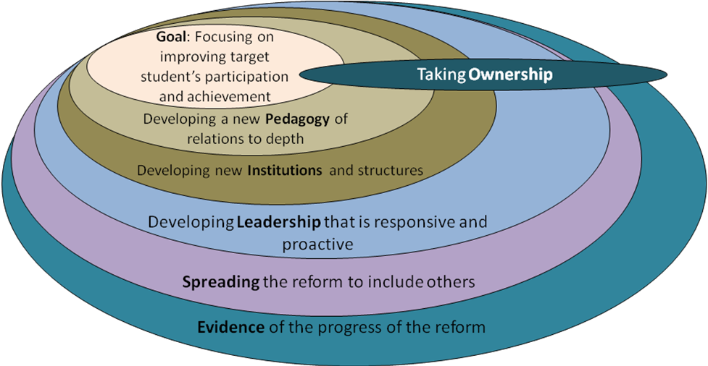
Source: Bishop and O’Sullivan, 2005, p. 69
The theoretical model in Bishop and O’Sullivan (2005) uses the acronym GPILSEO as a mnemonic device for the essential elements of a reform initiative at the school and system levels. This model suggests that in order to ensure the reform initiative will be sustainable and scalable, the following elements (shown in Figure 1.3 below) should be present in the reform initiative from the very outset. Each element includes a clear focus.
Figure 1.3: GPILSEO: Elements and foci
- GOALS: establishing goals and a vision for reducing disparities through improving targeted students’ educational achievement in its widest sense.
- PEDAGOGY: embedding a new pedagogy to depth in order to change the core of educational practice.
- INSTITUTIONS: developing new institutions and organisational structures to support in-class initiatives.
- LEADERSHIP: developing leadership that is responsive, pro-active and distributed.
- SPREAD: spreading the reform to include all teachers, parents, community members and external agencies.
- EVIDENCE: developing and using appropriate tools and measures of performance to provide evidence to monitor the progress of targeted students and the reform in the school/s as a means of modifying core classroom and school practices.
- OWNERSHIP: creating opportunities for all involved to take ownership of the reform in such a way that the original objectives of the reform are protected and sustained.
Source: Bishop and O’Sullivan, 2005
It is important to emphasise that although each element is presented as if it should be implemented in an orderly, linear fashion, this is not how it works in reality. Rather, each element is interdependent and interacts with the others in a variety of ways and in a variety of settings.
The term “sustainability” does not just imply sustainability of the process of the reform initiative itself, however. There is also the question of the sustainability of students’ outcomes—in the case of Te Kotahitanga, that means improved engagement in classrooms and schools of Māori students generally, as well as improved learning outcomes.
The issue of time has already been mentioned. Sustainability of the project, its processes and structures and its outcomes for students and teachers means change sustained for the life of the project and, potentially, for the future.
Replicability is a concept closely associated with sustainability. In this report, it is used to mean the extent to which implementation of the project, together with its processes and structures, can be replicated from one phase to another of the project, and also the extent to which patterns of changes in teachers’ classroom practices and gains in outcomes for Māori students associated with the project’s implementation are predictable.

1.4 Outline of the report
In Chapter 2, we discuss the research methodology and techniques for the collection and analysis of data gathered for the purpose of the overall evaluation of the extent to which Te Kotahitanga can be seen as being sustainable in schools. This chapter is concerned most specifically with methods of data collection and analysis for evaluation purposes. There is some overlap, however, between methods used to collect data for this report and for the ongoing professional development of staff in Te Kotahitanga schools. We discuss the mixed-methods approach that we have adopted, and note how we have complemented one method with others to fit together insights offered by quantitative and qualitative data in response to our understanding of the world of schools as complex and dynamic. We make particular mention of the fact that data collection in association with this report has been carried out in accordance with the the ethical requirements of the University of Waikato as well as the American Education Research Association (AERA) guidelines for reporting on empirical social science research in educational settings (AERA, 2006).
In Chapter 3, to address the question “Did the Phase 3 schools maintain the changes to teaching practices and student outcomes in 2007 to 2010 that they had made during 2004 to 2006?”, we analyse changes in student outcomes in the 12 schools using data from asTTle assessments in literacy and numeracy in Years 9 and 10, and NCEA Levels 1, 2 and 3. We discuss changes in teacher practices in relation to the Effective Teaching Profile as evidenced in data collected through the Observation Tool and as reported in “Levels of Use” interviews. We also examine the current position of principals in relation to school management for sustaining improvements in Māori students’ engagement and achievement. In relation to schools’ responses to the implementation of the project, we set out an analysis of the teachers’ and leaders’ surveys (conducted in July–August 2010) of the extent to which GPILSEO is embedded in their schools.
In Chapter 4, to address the question “Did the Phase 4 schools replicate the changes in teaching practices and student outcomes during 2007 to 2009 that were made by Phase 3 schools during the period 2004 to 2006?” we followed a similar approach to that used in Chapter 3. That is, we analyse changes in student outcomes in the 12 schools using data from asTTle assessments in reading and mathematics in Years 9 and 10, and NCEA Levels 1, 2 and 3. We discuss changes in teacher practices in relation to the Effective Teaching Profile as evidenced in data collected through the Observation Tool and as reported in “Levels of Use” interviews. We also examine the current position of principals in relation to school management for sustaining improvements in Māori students’ engagement and achievement. In relation to schools’ responses to the implementation of the project we set out an analysis of the teachers’ and leaders’ surveys (conducted in July-August 2010) of the extent to which GPILSEO is embedded in their schools.
Chapter 5 is concerned with the ongoing cycle of professional development associated with Te Kotahitanga. At every stage of the project there has been careful consideration of the kind of professional development that would enable facilitators and teachers in schools, and, later, regional facilitators and principals, most effectively to support the implementation of the Effective Teaching Profile in classrooms. Each new development and each new data collection tool has been piloted and evaluated and then progressively refined as we have learned from experience what is most effective in facilitating engagement and achievement of Māori students in schools. Chapter 5 first summarises developments that took place before the beginning of 2008 that have already been discussed in previous reports. It goes on to outline and discuss the cycle of development since that time.
In Chapter 6, we examine in more depth the extent to which the seven elements of GPILSEO are apparent in the 12 Phase 3 schools. The material that has been collated here was collected in a series of visits to these schools in 2009–2010 through individual and focus group interviews with a whole range of board of trustee members, principals, senior leadership teams, staff and students at these schools, as well as through scrutiny of the latest ERO reports, Ministry of Education databases of student achievement, school documents and records of in-class observations by the facilitators in these schools. The chapter opens with an overall summary of GPILSEO in these schools, and compares Māori students’ outcomes at NCEA Level 1 in two groups of Phase 3 schools: high or previously high implementing, and partial or low implementing schools. It then compares Māori student outcomes in more detail in two schools, one high implementing and high maintaining, the other low implementing and low maintaining. It goes on to offer overview pen-portraits of individuals who have experienced change and development at different points in the Te Kotahitanga system: principal, head of department, teacher and student. It continues with one in-depth school case study. This school was chosen because it illustrates what can be achieved when there is a strong commitment by everyone involved to embrace the principles and practices of Te Kotahitanga wholeheartedly and to use it as the core into which other initiatives can be woven.
Chapter 7 draws the report together in a series of conclusions and then details how Te Kotahitanga has been developed in line with the findings of this research and outlines future directions for the programme.

1.5 References
American Educational Research Association (AERA). (2006). Standards for reporting on empirical social science research in AERA publications. Educational Researchers, 35(6), 33–44.
Bishop, R. (1996). Collaborative research stories: Whakawhanaungatanga. Palmerston North, New Zealand: Dunmore Press.
Bishop, R. (1997). Interviewing as collaborative storying. Education Research and Perspectives, 24(1), 28–47.
Bishop, R. (2005). Freeing ourselves from neocolonial domination in research: A Kaupapa Māori approach to creating knowledge. In N. Denzin & Y. Lincoln (Eds.), The Sage handbook of qualitative research (3d ed., pp. 109–138). Thousand Oaks, CA: Sage.
Bishop, R. & Glynn, T. (1999). Culture counts: Changing power relations in education. Palmerston North, New Zealand: The Dunmore Press.
Bishop, R., Berryman, M., Tiakiwai, S., & Richardson, C. (2003). Te Kotahitanga phase 1: The experiences of Year 9 and 10 Māori students in mainstream classrooms. Wellington, New Zealand: Ministry of Education.
Bishop, R., & O’Sullivan, D. (2005). Taking a reform project to scale: Considering the conditions that promote sustainability and spread of reform. A monograph. Unpublished report to Ngā Pae o te Māramatanga: The National Institute of Research Excellence for Māori Development and Advancement. Auckland: University of Auckland Press.
Bishop, R., & Berryman, M. (2006). Culture speaks: Cultural relationships and classroom learning. Wellington, New Zealand: Huia Publishers.
Bishop, R., Berryman, M., Cavangah, T. & Teddy, L. (2007a). Te Kotahitanga Phase 3 Whanaungatanga: Establishing a culturally responsive pedagogy of relations in mainstream secondary school classrooms. Wellington, New Zealand: Ministry of Education.
Bishop, R., Berryman, M., Powell, A. & Teddy, L. (2007b). Te Kotahitanga Phase 2: Towards a whole school approach. Wellington, New Zealand: Ministry of Education.
Bishop, R., Berryman, M., Cavanagh, T., Teddy, L., Clapham, S., Lamont, R., . . . & Jaram, D. (2008). Te Kotahitanga: Towards sustainability and replicability in 2006 and 2007. Report to the New Zealand Ministry of Education, Wellington, New Zealand.
Bishop, R., O’Sullivan, D., & Berryman, M. (2010). Scaling up education reform: Addressing the politics of disparity. Wellington, New Zealand: NZCER Press.
Bruner, J. (1996). The culture of education. Cambridge, MA: Harvard University Press.
Burr, V. (1995). An introduction to social constructionism. London: Routledge.
Cook-Sather, A. (2002). Authorizing students’ perspectives: Towards trust, dialogue, and change in education. Education Researcher, 31(4), 3–14.
Coburn. C. E. (2003). Rethinking scale: Moving beyond numbers to deep and lasting change. Educational Researcher, 32(6), 3–12.
Cummins, J. (1995). Power and pedagogy in the education of culturally diverse students. In J. Fredericskon & A. F. Ada (Eds.), Reclaiming our voices: Bilingual education, critical pedagogy, and praxis (pp. 139–162). Ontario, CA: California Association for Bilingual Education.
Gay, G. (2000). Culturally responsive teaching: Theory, research, and practice. New York, NY: Teachers College Press.
Sarason, S. B. (1993). The predictable failure of educational reform: Can we change the course before it’s too late? San Francisco: Jossey-Bass Publishers.
Sidorkin, A. M. (2002). Learning relations. New York, NY: Peter Lang.
Timperley, H. S., Phillips, G., & Wiseman. J. (2003). Shifting the focus: Achievement information for professional learning: A Summary of the sustainability of professional development in literacy – parts 1 and 2. A report to the Ministry of Education. Wellington, New Zealand.
Timperley, H., Wilson, A., Barrar, H., & Fung, I. (2007). Teacher professional learning and development: Best evidence synthesis iteration [BES]. Wellington, New Zealand: Ministry of Education.
Villegas, A. M., & Lucas, T. (2002). Educating culturally responsive teachers: A coherent approach. Albany, NY: State University of New York Press.

Chapter 2: Research methods

Summary of research methods
In order to examine how Te Kotahitanga is being implemented in schools and the degree to which it is currently being maintained, replicated and sustained in schools has led us to adopt a mixed-methods research approach. We have examined phenomena of different kinds:
- quantitative, including student achievement data, observations of teacher and student behaviour in previously defined categories, and self-reports of intentions and experiences collated through questionnaires and rating scales
- qualitative, including semi-structured and open-ended interviews and documentary analysis.
Triangulation of methods and data sources in this way has enabled us to be rigorous in our approach to this report:
- Statistical analyses of difference, of changes over time and of correlational data complement analyses of qualitative material to fit together insights offered by quantitative and qualitative data in response to our understanding of the world of schools as complex and dynamic (Johnson & Onwuegbuzie, 2004).
Data collection has been carried out in accordance with the ethics requirement of the University of Waikato and the American Education Research Association (AERA) guidelines for reporting on empirical social science research in educational settings (AERA, 2006).

2.0 Introduction
Te Kotahitanga is a Research and Development programme framed within a kaupapa Māori research approach. As noted in the previous chapter, this approach provides the conceptual framework for the development of the methods by which:
- the project is being implemented in schools, which includes the professional development of staff in both the schools and the wider Research and Development team
- the data were gathered for the purpose of evaluating the extent to which the project can be seen as being maintained, replicated and sustained in schools.
This chapter is concerned most specifically with methods of data collection and analysis for evaluation purposes. There is some overlap, however, between methods used to collect data for this report and for the ongoing professional development of staff in Te Kotahitanga schools.
The research outcomes in this report represent an attempt to provide warranted assertions about Te Kotahitanga and its participants, including Māori students as well as their teachers, and other staff in their schools. This intention to understand what has happened during the course of the project, its outcomes for Māori students and the degree to which it is currently sustainable in schools, has led us to examine phenomena of different kinds: quantitative, including observations of teacher and student behaviour in previously defined categories, student achievement data, and self-reports of intentions and experiences collated through questionnaires and rating scales; and qualitative, including semi-structured and open-ended interviews and documentary analysis. Triangulation of methods and data sources in this way has enabled us to be rigorous in our approach to this report. We have complemented statistical analyses of difference, change of time and correlational data—for example, one-way repeated measures ANOVAs, t-tests, z-tests of two proportions, Wilcoxon Signed Ranks and Mann Whitney tests—with analyses of qualitative material to fit together insights offered by quantitative and qualitative data in response to our understanding of the world of schools as complex and dynamic (Johnson & Onwuegbuzie, 2004). In terms of the quantitative, statistical aspects of this study, our choice of statistical analysis was largely determined by the available data. The design might be termed “quasi-experimental, non-equivalent/non-randomised, comparison” (Borman, 2005; Whitehurst, 2003), given that allocation of schools to Te Kotahitanga, and teachers within those schools, was not randomised and that the groups to which we have compared Māori students in Phase 3 and 4 schools were not equivalent. In Phase 3 and Phase 4 schools, the research team had no control over either the selection of schools or the teachers that joined Te Kotahitanga. The Ministry of Education selected the 12 schools in Phase 3 from those participating in the ministry’s Schooling Improvement Initiative, and the schools determined their own means of selecting teachers to participate in the project, primarily through asking for volunteers. In the case of Phase 4, the assignment of schools was through an application process that prioritised their numbers and percentage of Māori students, not their suitability for a research project. In this phase, schools also determined their own means of selecting teacher participants, again primarily through voluntary means.
Data collection in association with this report has been carried out in accordance with the American Education Research Association (AERA) guidelines for reporting on empirical social science research in educational settings (AERA, 2006). These standards were followed to ensure that the report is warranted; that is, adequate evidence is provided to justify the results and conclusion and made transparent to enable the logic of the work, data collection methods and interpretation of results to be clear. There has also been adherence to ethical guidelines of the University of Waikato and of AERA (2006).

2.1 The Te Kotahitanga Observation Tool
Central to data collection in the project for the purposes of both teacher professional development and project evaluation is the Te Kotahitanga Observation Tool. This tool is designed to record evidence of each of the understandings from the Te Kotahitanga Effective Teaching Profile, as previously identified in Chapter 1. It provides the framework for classroom observations and is focused on gathering evidence about teachers’ interactions and relationships with Māori students. Using this tool, the nature of teachers’ relationships and interactions with Māori students is coded by trained observers who are part of the facilitation team in each Te Kotahitanga school team. The evidence gathered is then fed back to teachers by the trained observer/facilitator and discussed as the basis for teachers’ ongoing individual professional learning.
The development of the Te Kotahitanga Observation Tool drew upon understandings from both kaupapa Māori and sociocultural perspectives on human learning. Kaupapa Māori perspectives emphasise the importance of relationships that are collective and interdependent and at the same time set high expectations that are mutually responsive and evolving. Sociocultural perspectives emphasise the responsive social and cultural contexts in which learning takes place as being key components to successful learning (Glynn, Wearmouth, & Berryman, 2006; Gregory, 1996; Rogoff, 1990; Vygotsky, 1978). Sociocultural perspectives highlight the acquisition of knowledge and skills through social interactions and activities, in formal and informal settings. Contextualised social interactions such as these are also increasingly seen as fundamental to the acquisition of intellectual knowledge and skills (Bronfenbrenner, 1979; Bruner, 1996; Glynn, Wearmouth, & Berryman, 2006; McNaughton, 2002; Vygotsky, 1981; Wood, Bruner, & Ross, 1976).
By means of this tool, important information is collected through direct observation of teachers and students in the social setting of the classroom where the Effective Teaching Profile is being implemented. The Observation Tool therefore provides the framework for monitoring the degree to which participating teachers are incorporating the relationships and interactions from the Effective Teaching Profile into their everyday teaching.
The Te Kotahitanga Observation Tool and the recording conventions used were first developed by the research team during Phase 1 (Bishop et al., 2003) of Te Kotahitanga, then further refined and developed during Phase 2 of Te Kotahitanga (Bishop et al., 2007). Side one of the tool is a variation of the time sample sheets developed for the Mangere Guidance Units (Glynn, Thomas, & Wotherspoon, 1978) and a collaborative home and school behaviour programme, Hei Āwhina Mātua (Glynn, Berryman, Atvars, & Harawira, 1997). Side two of the tool was developed by the research team in order that all the dimensions of the Effective Teaching Profile were covered during the observation.
Side one as currently developed (see Template 2.1 in Appendix B,) is used to quantify evidence of teaching and learning interactions between the teacher and Māori students in one lesson reflecting elements 4–6 of the Effective Teaching Profile. Side two (see Template 2.2 in Appendix B,) aims to gather evidence of the relationships between teachers and Māori students in this same setting; that is, the first three elements of the effective teaching profile.
Evidence of the teaching and learning interactions observed using side one of the Observation Tool includes the teacher’s:
- description of the lesson
- level of cognitive challenge of the lesson for the specific class of students being observed
- range of pedagogical interactions used with students, from traditional and transmission to more interactive and co-constructive
- direct interactions with student groupings, from whole class, small group or individual student
- own location throughout the observation.
Table 2.1 in Appendix A outlines the interpretation of the coding schedule on the right-hand side of side one of the observation tool. Side one includes evidence about the lesson from five Māori students on:
- these students’ engagement with the lesson
- their work completion, in line with expectations observed to have been set by the teacher
- their location throughout the observation.
Side one is also used to gather any other relevant information about the teacher, the lesson or the class in order to add richness to the observation information.
Side two of the Observation Tool is used to gather evidence about the:
- teacher’s relationships with Māori students
- teacher’s expectations of Māori students’ learning and behaviour
- visible signs of culture in the classroom
- responsiveness of the teacher to Māori students and their culture
- strategies being used by the teacher.
Each observation is followed closely with a feedback session during which time the observer/facilitator and the teacher deconstruct and discuss the evidence recorded during the observed lesson and together co-construct new directions for the future teaching. These future goals, planned with the teacher, are also recorded on side two of the Observation Tool.

2.1.1 Reliability and validity
Issues of the reliability and validity of the tool are fundamental to the trustworthiness of the data that is collated and analysed. The Te Kotahitanga Research and Professional Development Team has trained in-school facilitators how to use the Observation Tool through Module 3B Mahi Tahi: Te Kotahitanga Observation Tool (Te Kotahitanga Research and Professional Development Team, 2006). The team has also trained the facilitators how to enter information into the Observation Tool data entry programme through the use of the Observation Programme: Version 1.2.4 User Manual (Te Kotahitanga Research and Professional Development Team, 2007).
A study of the tool’s reliability and validity was conducted by the Research and Professional Development Team across the 12 schools involved in the project in 2006 (Berryman, & Bishop, 2011). This study was conducted in accordance with the guidelines for reporting on empirical social science research in educational settings (American Educational Research Association, 2006), with due regard for rigorous and transparent collection, collation and analysis of appropriate data as well as for ethical considerations, including sharing the logic of the study and activities that led from the initiation of the project to interpretation of results.
The study involved 443 observations of up to 43 teachers and more than 200 Māori students. Two regional coordinators acted as the first observers and 38 in-school facilitators acted as the second. The template for the shared summary sheet is included in Template 2.3 in Appendix B.
Testing for consistency began by conducting synchronous observations (two people observing the same teacher in the same lesson over the exact same time period), by the professional development coordinator and an experienced regional coordinator. These two observers were the most experienced. One had been a teacher observed by others using the tool. Both had used the Te Kotahitanga Observation Tool on a regular basis for more than three years in their role as Te Kotahitanga facilitators and as trainers of facilitators.
Two synchronous observations by the professional development coordinator and the regional coordinator produced consistent results across the items on the Observation Tool with at least 80% agreement between observers. The professional development coordinator then completed a number of synchronous observations with the second and third regional coordinators. If 80% agreement was not reached after the first synchronous observation, observations were repeated and followed by formative feedback and discussion until at least 80% agreement between observers was achieved over more than one consecutive synchronous observation. Having established 80% agreement with each of the regional coordinators, this team (the professional development coordinator and the three regional coordinators), then followed the same procedure with 38 Te Kotahitanga facilitators in the 12 Phase 3 Te Kotahitanga schools.

2.1.1.1 Reliability
Evidence for measurement reliability was obtained for the following items on side 1 of the tool: student engagement, student work completed, cognitive level of lesson, teacher location, and teacher interactions their nature and with whom. Two forms of evidence for measurement reliability were obtained:
- inter-rater reliability where two observers observed a teacher simultaneously
- Cronbach’s alpha to determine the internal consistency of items assumed to be related (Leech, Barrett, & Morgan, 2005).
Results of Pearson’s product–moment correlation coefficent of inter-rater reliability ratings indicated:
- adequate to very good reliability for items focused on student engagement
- good to very good reliability for items focused on work completed
- medium reliability for items focused on the cognitive level of the lesson
- good reliability for teacher location (front) scores
- good to very good reliability for teacher location (other) scores.
(See Table 2.2 in Appendix A for details of Pearson’s r.)
Cronbach’s alpha for the items related to:
- student engagement, the five items were summed to create a student percentage engagement score of 85%, indicating that the items form a scale with good to very good internal consistency
- student work completion, when the five items were summed to create a composite student work completed score, was .94%, indicating a high degree of internal consistency.
Side two of the Observation Tool relates to the relationships between the teacher and Māori students, and covers six dimensions within contexts of culturally responsive pedagogy of relations. These six dimensions are:
- caring for Māori students as culturally located
- having high expectations for learning performance of Māori students
- having high expectations of the behavioural performance of Māori students
- providing a well-managed (management) learning environment
- providing culturally appropriate learning contexts for Māori students
- providing culturally responsive learning contexts for Māori students.
A Pearson’s correlation coefficient was computed to assess inter-rater reliability of the six relationships’ scores (caring; performance; behaviour; management of the learning environment; culturally appropriate; and culturally responsive). The Pearson’s correlation coefficients were: caring, r(42) = .81; performance, r(40) = .92; and culturally responsive, r(41) = .86. The results indicate that there is a good to very good inter-rater reliability for these six scores.
Cronbach’s alpha was then computed to assess whether a reliable scale was formed when the six items were combined to create a composite relationship score. Chronbach’s alpha for the six items was .92, which indicates that the items form a scale that has very good internal consistency. Based on the results of this study we can reasonably conclude that the tool is reliable and valid for use in New Zealand secondary English-medium schools for observing teachers who are participating in Te Kotahitanga. Also, we can reasonably conclude that data obtained by using this tool are suitable to use for formative and summative purposes.

2.1.1.2 Validity
The team was very concerned that the tool should meet criteria that would enable confidence in relation to:
- content validity—how far data collection occurred in the area that was intended
- consequences validity—the extent to which the assessment served its intended purpose.

Content validity
The Te Kotahitanga Observation Tool is linked directly to the Te Kotahitanga Effective Teaching Profile and is focused on gathering evidence about teacher/student interactions and teacher relationships with Māori students. Observations focus on student and teacher behaviour, and also a wide range of other factors that contribute to student behaviour and learning. Cultural guidance for the development of the tool was provided by kuia whakaruruhau Rangiwhakaehu Walker and Mate Reweti of the Poutama Pounamu Research Centre.

Consequences validity
The Te Kotahitanga Observation Tool has been designed to enable teachers to share in the process of monitoring and reflecting on their attempts to implement what they learned through the professional development provided at the Hui Whakarewa (Induction hui), so that their professional development occurs in a power-sharing context wherein self-determining individuals work together to set goals and reflect on outcomes (Bishop & Glynn, 1999). The cyclic nature of the observation, feedback, co-construction and shadow coaching that forms the basis of the professional development programme ensures that there are ongoing opportunities for reflection and feedback. The information provided by the Te Kotahitanga Observation Tool enables observers to provide teachers with feedback and feed-forward on observed teacher–student learning interactions, and the relationships between the teacher and Māori students. The in-class observation is then followed by opportunities for the teacher and the observer to talk about their in-class experiences and to co-construct new directions for future teaching.

2.1.2 Observational data analysis
The aim of collecting material associated with the Observation Tool as it relates to this report in both Phase 3 and Phase 4 schools was to assess how well Te Kotahitanga project teachers have implemented the Effective Teaching Profile into their classrooms. The analysis in both Phases 3 and 4 focused on changes in Effective Teaching Profile implementation relative to the baseline. In Phase 3 schools it also focused on maintenance of the implementation since 2003. The following measures were obtained from the Observation Tool: percentage of discursive practice, teacher interactions with the whole class, individual students and group of students, teacher location in the classroom, level of relationships, cognitive level of the lesson and classroom, percentage of engagement of Māori students during the lessons observed, and work completion of Māori students.
We examined the activity of teachers, grouped into cohorts according to their starting years in the project. Baseline observations for cohort 1 were completed in the last term of 2003 (Phase 3), and also in the last term of 2006 (Phase 4). For all other cohorts in both phases baseline observations were completed before any professional development related to Te Kotahitanga. The last of the cohorts, included in analyses for this report, cohort 6 (Phase 3) and cohort 3 (Phase 4), started to participate in the project in 2009.

2.1.2.1 Methodology
Twelve schools took part in the Phase 3 study. In schools that adhered to the Te Kotahitanga professional development cycle to the letter, teachers were observed once every term in each school year of participation. Before term 3, 2009, observation data were sent to the project team either in hard copies or in electronic form. Starting from term 3, 2009, with the introduction of the web-based Observation Tool, the research team was able to access the data as soon as they were uploaded by the participating schools on Te Kotahitanga website.
Owing to a number of constraints, for example teachers’ short-term leave, time-table changes, facilitation staff constraints and so on, the research team did not always receive complete sets of observation data (i.e., one observation for each term in each year of their participation) for all teachers. Further, in Phase 3, in later years of participation some schools concentrated on observing only teachers from later cohorts and/or teachers who had not showed significant progress. Tables 2.3 and 2.4 in Appendix A, show the number of observations for each cohort in each term of each year of participation.
All measures were analysed using SPSS (Statistical Package for Social Sciences).
For all measures we conducted some combination of non-inferential statistics and/or inferential statistics to investigate the magnitude of implementation of the Effective Teaching Profile:
- We used non-inferential statistics to assess means and standard deviations for each cohort over all four terms in 2004 to 2009 (Phase 3) and 2007 to 2009 (Phase 4) for discursive practice:
- trends and patterns of discursive practice by cohort from 2004 to 2009 (Phase 3) and 2007 to 2009 (Phase 4). Here we selected only those teachers who had all four observations in a given school year (i.e. one observation in each term). A drop in sample size in 2009 reflects a general decline in the number of teachers observed as the project progressed. This largely resulted from a decision taken by some schools to focus more intensively on co-construction sessions rather than observation and feedback for teachers who had been in the project for more than 3 years. Tables 2.5 and 2.6 in Appendix A shows the number of teachers, for each cohort in each year, who were observed in all four terms
- trends and patterns for low users of discursive practice (20% or lower) of all cohorts from 2004 to 2009 (Phase 3), and by cohort from 2007 to 2009 (Phase 4).
- We used inferential statistics to assess:
- shifts during the first three years of implementation relative to the baseline for cohorts 1 to 3 (Phase 3) and cohort 1 (Phase 4)
- shifts during the first two years of implementation relative to the baseline for cohort 2 (Phase 4)
- shifts in the first year of implementation relative to the baseline for cohorts 4 to 6 (Phase 3), and cohort 3 (Phase 4)
- for discursive practice, interactions with the whole class, teacher location, level of relationships (Phase 4 only), cognitive level of class, student engagement and work completion.
For these inferential analyses, we selected only teachers who:
- in Phase 3, were observed at baseline and at least in term 3 of their first three years of participation (for cohorts 1 to 3) or who were observed at baseline and term 3 of their first year of participation (for cohorts 4 to 6)
- in Phase 4, were observed at baseline and at least in term 3 of their first two (for cohort 2) or three (for cohort 1) years of participation or who were observed at baseline and term 3 of their first year of participation for cohort 3.
To maximise our sample size we used data from only one term in each year for comparison purposes. Otherwise repeated-measures analysis would have not been possible. For our longitudinal analysis, term 3 observations were chosen in order to provide us with the greatest possible sample size to allow for reliable time comparison.
Table 2.7 in Appendix A shows the number of teachers who were observed in t3 of their first three consecutive years of participation. Cohorts 5 and 6 have been excluded from this table because at the end of 2009 they had not been in the project for three years or longer. Table 2.8 in Appendix A shows the number of Phase 4 cohort 1 teachers who were observed at baseline and in term 3, 2008 and 2009, and the number of cohort 3 teachers who were observed at baseline and in term 3, 2009.
For level of relationships in Phase 3 we investigated:
- changes in the measure during the first three years of implementation for cohorts 1 to 4
- changes in the measure during the first two years of implementation for cohort 5
- the measure in the first year of implementation for cohort 6.
We used measures of association to assess relationship between discursive practice and interactions with the whole class.
The inferential tests we conducted were:
- for continuous measures (i.e. discursive practice, interactions with the whole class, teacher location, and student engagement), a one-way repeated measures ANOVA and paired samples t-tests. Univariate ANOVA was used to test longitudinal changes for cohorts 1 to 3 (Phase 3) and 1 to 2 (Phase 4), and paired samples t-tests were used to compare differences between a baseline and the first year of implementation for cohorts 4 to 6 (Phase 3) and cohort 3 (Phase 4)
- for ordinal measures (i.e. level of relationships, cognitive level of classroom and level of student work completion), a non-parametric Friedman’s related-samples test for data collected on the same group of teachers at three or more time points. Wilcoxon matched pairs signed-ranks test was used to analyse data collected on the same group of teachers at two different time points
- a Pearson product–moment correlation coefficient to test the association between the discursive practice and the interactions with whole class.
We adopted a minimum significance level of p < 0.05 for all analyses.

2.2 Quantitative student achievement data
As a test of how well project teachers were implementing the Effective Teaching Profile in both Phase 3 and Phase 4 schools, we examined changes in Māori students’ achievement in literacy and numeracy in Years 9 and 10 compared to non-Māori students in the same schools, and Year 10 compared to the national norms for all students. We also examined changes in national cohorts of Māori students’ achievement in NCEA qualifications.

2.2.1 asTTle data
In order to assess Māori students’ achievement at the beginning of the project in Phase 3 schools (2004–2005) Essential Skills Assessment for Literacy (ESA) was used. However, with the introduction of the Assessment Tool for Teaching and Learning (asTTle) in 2005, we discontinued the use of ESA. asTTle data collection in 2005 was limited to mathematics data and only some of Phase 3 schools were able to conduct pre- and post-tests for their students, because of time constraints, information technology, server problems and so on. By 2006, schools’ familiarity and confidence with the use of asTTle had improved and the research team was able to collect asTTle mathematics and/or reading results for Year 9 and 10 students from eight of the 12 Phase 3 project schools.
In 2007, when Phase 4 schools first started to participate in the study, most were already using asTTle as a formative tool to assess and inform classroom practice. Mathematics and reading asTTle (version 4) data for Year 9 and Year 10 students were provided for years 2007 and 2008. Some schools were using e-asTTle in 2009 but, as noted already, we are not able to use 2009 e-data in this report.
In 2009, e-asTTle, the online version 4 asTTle, was introduced and some schools chose to use this. However, at the end of 2009 and the beginning of 2010, schools were informed by the Ministry of Education that there were recalibration issues with reading test scores. As a result of questionable validity of e-asTTle reading test results, we are not able to use 2009 e-data in this report. Hence, this report includes asTTle data analyses of most—but not all—project schools for the period 2007–2009.
Tables 2.9 to 2.12 in Appendix A display the number of Māori and non-Māori students in Phase 3 tested for mathematics and reading in 2006, 2007, 2008 and 2009. Tables 2.13 to 2.15 in Appendix A display the number of Māori and Non-Māori students in Phase 4 tested for mathematics and reading in 2007, 2008 and 2009.
Most schools developed their own testing schedules and protocols to test Year 9 and Year 10 students. Generally speaking, students were tested at the beginning and at the end of the school year to enable a pre–post-test comparison. Some schools only tested their students at the end of the school year. In these schools, test results from the end of the previous school year (including pre-enrolment data for Year 9 students) were used as pre-tests. One project school tested their students only at the beginning of each school year. Given that the time period between tests for students tested at the beginning and at the end of one school year was much shorter than for students tested at the end of consecutive school years, we divided the students into two groups for the analyses. The testing schedule for pre–post-test within one year will be referred to as Schedule 1 (pre–post-test) in this report. The testing schedule for pre–post-test across one year will be referred to as Schedule 2 (post–post-test). Analyses in this report included data from schools which either followed Schedule 1 and/or Schedule 2.
Further, students who could not be identified as either Māori or non-Māori have been excluded from the analyses. Since scoring scale for e-asTTle tests was different from the V4 asTTle version, scores from e-asTTle tests have been converted into V4 asTTle scores to allow the combined analyses.
The Statistical Package for the Social Sciences (SPSS) was used to investigate changes in the academic achievement of Māori and non-Māori students. In order to compare pre- and post-test results for Māori and non-Māori students, a repeated measures analysis of variance (ANOVA) on the mathematics and reading asTTle scores was performed for each testing schedule separately for years 2006 to 2009. Repeated measures, two (pre–post-test) × two (ethnicity) ANOVA with a within-subject factor of test (pre–post-testing) and between-subject factors of ethnicity (Māori vs. non-Māori students), were conducted for Year 9 and Year 10 students.
ANOVA results would enable us to see whether there was a general improvement from pre-test to post-test and whether the changes in achievement between pre- and post-tests were comparable between Māori and non-Māori students.

2.2.2 NCEA outcomes

2.2.2.1 Phase 3 and 4 schools
Using data supplied by the Ministry of Education to the Te Kotahitanga project team, (July to August, 2010), we investigated sustainability of changes in NCEA outcomes in Phase 3 and 4 schools using a combination of descriptive statistics, one-way repeated measures ANOVAs, t-tests and Wilcoxon Signed Ranks tests.
In Phase 3 schools, the following comparisons were made:
- Year 11 Māori students’ achievement gains in NCEA Level 1 and above in 2007 to 2009 in comparison with NCEA Level 1 achievement in 2006 to see if the highly significant learning gains from 2005 to 2006 had been maintained.
- The increase in percentages of Year 11 Māori students who did/did not obtain NCEA Level 1 and above in 2007 to 2009.
- The percentage of Year 12 Māori students who gained NCEA Level 2 and above in 2007 to 2009 in Phase 3 schools compared with the national cohort of Year 12 Māori students.
- The increase in percentages of Year 12 Māori students who did/did not obtain NCEA Level 1 and above in 2007 to 2009.
- The percentage of Year 13 Māori students in Phase 3 schools who gained NCEA Level 3 and above in 2007 to 2009 compared with the national cohort of Year 13 Māori students.
In Phase 4 schools we compared the following:
- The increase in percentage of Year 11 Māori students in Phase 4 schools gaining NCEA Level 1 and above, 2007 to 2009, in comparison with the national cohort of Māori students.
- The difference in percentage of Māori students in Phase 4 schools who did/did not gain NCEA Level 1 and above 2007 to 2009
- The increase in percentage of Māori students in Phase 4 schools gaining NCEA Level 2 and above.

2.2.2.2 Comparison between NCEA achievement in Phase 3 and 4 schools
To investigate replicability of Māori students’ NCEA outcomes in Phases 3 and 4 we first compared improvement trends in Year 11 NCEA Level 1 and above across time, 2007 to 2009, using a two-way ANOVA. Using the same method we also compared:
- trends in those not achieving NCEA Level 1 across time
- differences between those achieving and not achieving NCEA Level 1 across time.
When it was clear that data for both cohorts behaved in a similar way in each comparison we were able to test out the following, using paired samples t-tests:
- overall change in the percentage of Year 11 students in Phases 3 and 4 gaining NCEA Level 1 and above
- overall change in the percentage of Year 11 students in Phases 3 and 4 not gaining NCEA Level 1
- overall change in the difference between those achieving and not achieving NCEA Level 1.

2.3 Configuration maps
Hall and Hord (2006) discuss “Innovation Configurations” as tools for mapping both the “idealized change developer as well as the various operational forms of the change that can be observed in classrooms” (p. 112). Using this concept, Bishop (unpublished), in discussion with other members of the Te Kotahitanga research team, developed two configuration maps which take account of the processes and practices implicit in both GEPRISP and GPILSEO:
- The leadership configuration map (see Table 2.16 in Appendix A) is designed for school leaders to assess the extent to which they feel they are effective in leading the initiative in their schools to date.
- The institutional configuration map is intended to assess the extent to which leaders feel their schools have achieved an effective level of implementation of Te Kotahitanga in their efforts to improve the learning outcomes of Māori students to date (see Table 2.17 in Appendix A).
Hall and Hord (2006) note a number of principles associated with implementing change in organisations. All of these apply to Te Kotahitanga:
- “Change is a process not an event” (p. 4). As these authors note, typically, in education, most changes take between three to five years before they are implemented at a high level. Change is a process by which people and organisations become skilled in the use of new practices.
- Development of an innovation is not synonymous with its implementation. Very often developers have a much higher profile than implementers, and resources tend to be front end-loaded. In Te Kotahitanga schools, principals have to have a great deal of persistence and patience to oversee the implementation of the project, once the first flush of enthusiasm for the new initiative has died down.
- Successful organisational change requires change at the level of every individual within that organisation.
- “Innovations come in different sizes” (p. 7). Complex school changes such as Te Kotahitanga are large scale and require major changes in the role and function of principals and teachers. This, in turn, necessitates specialised professional development.
- Key to the success of the change process is ongoing negotiation and consultation. This includes brief, informal conversations through chance meetings as well as formal training workshops.
- Sustaining change requires support from the principal and senior management to secure the necessary infrastructural changes and resources for the long term.
- Change mandated from the top of an organisation can be effective if supported by ongoing communication, professional development, and time for implementation.
- Schools require external support from the education system as a whole to implement and sustain change.
- “Facilitating change is a team effort” (p. 12). This team extends beyond the school.
- Resistance to change should be understood for what it is—resistance either to moving outside the “comfort zone”; having serious questions about the efficacy of the change unanswered; and the discomfort involved in undergoing change—and appropriate steps should be taken to address each.
- There needs to be an open and collaborative approach to change, with staff in the organisation who identify what they must learn to realise the change and an overall leader who works supportively with colleagues. In Te Kotahitanga, for example, discussion between school facilitators and teachers about what has been observed in classrooms, and co-construction sessions between facilitators and staff play an important part in staff development.
Hall and Hord (2006) describe the kind of staff in a school who maintain an open collaborative approach to change as a “professional learning community” defined in terms of five modes of operating (p. 36):
- “shared values and vision”
- “collective learning and its application”
- “supportive and shared leadership”
- “supportive conditions” (both physical structures and human capacities)
- “shared personal practice”.
Timperley, Wilson, Barrar, and Fung (2007) and Bishop, O’Sullivan, and Berryman (2010) note also that such professional learning communities among teachers must have a clear focus on improved student outcomes.
Following Hall and Hord (2006, p. 126), three key questions were reiterated through the process of developing the institutional analysis configuration map:
- What does the innovation look like when it is in use?
- What would I see and where it is well used (and not as well)?
- What will teachers and students be doing when the innovation is in use?
Hall and Hord comment (2006, p. 124):
Developing an IC map is a challenging endeavour. It ... is energizing for those who really are interested in having implementation of an innovation succeed.... Additional rewards come when the first draft of the IC is shared with interested ... principals and other change facilitators.
The configuration maps were completed by principals and deputy principals at the leadership hui in May, 2010. They have a number of uses:
- There is mobility in the current cohort of principals and other school leaders in Phases 3 and 4. Some are new to Te Kotahitanga, albeit they may be very experienced educators. The leadership configuration maps are a useful tool for self-evaluating principals’ leadership skills and competencies as well as a diagnostic tool for planning training and development for senior leadership in Te Kotahitanga schools.
- The institutional analysis configuration maps provide a summative assessment of the development of institutions towards effectiveness in implementing the project at one point in time, as well as a position statement against which future development can be judged and effective strategies developed.

2.3.1 Reliability
Reliability of these configuration maps can be assessed in two ways. Firstly, as Hall and Hord (2006, p. 129) note, these maps have been “widely embraced across the English-speaking cultures/nations as an excellent tool to define and support implementation of new practice.” Secondly, as may be seen in chapters 5 and 6 below, the outcomes of the leadership and institutional maps completed at the leadership hui in May, 2010, indicate very similar patterns for Phases 3 and 4, implying a high level of test-retest reliability.

2.4 “Levels of Use” protocols
As with configuration maps, “Levels of Use” (LoU) interviews can be used diagnostically and for the purpose of indicating areas for professional development. Alternatively the Levels of Use interviews can provide information about the extent to which an innovation is being used. Hall and Hord (2006) estimate that an innovation has reached the point of sustainability where the Level of Use of a minimum of 60% of the staff is at least “routine” (see below for a definition of this).
Hall and Hord’s (2006) concept of Levels of Use has, as they say (p. 159), “to do with behaviors and portrays how people are acting with respect to a specified change”. As they go on to comment (p. 161):
- “With any innovation, each person exhibits some kind of behaviours and thus can be identified as being at a certain Level of Use.
- The decision points that operationalise the levels and the information related to categories contribute to the overall description of an individual’s Level of Use.
- ( ... )
- An interview is the only means by which to successfully and efficiently collect LoU information. ...
- ... rigorously collected LoU data can be used for conducting research studies of change and for evaluating the extent of implementation.
- The Levels of Use are presented in a logical sequence, but this is not always followed by everyone. ...”
Levels of Use can be assessed through the use of a specially designed interview schedule. The Levels of Use interviews consisted of a set of questions designed to elicit information about teachers’ knowledge of Te Kotahitanga in terms of whether they were acquiring information about the project; sharing; assessing; planning; status reporting; or performing this information.
A summary of the Levels of Use definitions from Hall and Hord (2006) are offered below. The Levels of Use are distinct states that lie on a y-axis representing different, observable types of behaviour and patterns of use of the project, that is, the Effective Teaching Profile, as exhibited by individuals and groups. These levels characterise users’ development in acquiring new skills and their varying use of the Effective Teaching Profile. Each level encompasses a range of behaviours, but is limited by a set of identifiable “decision points”. For descriptive purposes, each level is defined by seven categories. The categories on which all the levels and decision points are based run along an x-axis. The Levels of Use categories are:
- knowledge: practical and theoretical understanding of the Te Kotahitanga
- acquiring information: actions taken to seek information about Te Kotahitanga
- sharing: individual staff communicating how they are involved in Te Kotahitanga with others
- assessing: mentally evaluating actual or potential use of the project
- planning: looking beyond the immediate use of the project to the future
- status reporting: the individual staff member giving an overview of the use of Te Kotahitanga
- performing: actual use of Te Kotahitanga and what it looks like in the classroom.
The Levels of Use (LoU) scale point definitions, in terms of Te Kotahitanga, are as follows:
- LoU 0 are non-use users who have little or no knowledge of the Te Kotahitanga, no involvement with it and are doing nothing toward becoming involved.
- LoU 1 are orientation users who have acquired or are acquiring information about the project and/or have explored or are exploring its values, purposes and its demands upon the user and the school system.
- LoU 2 are preparation users who are preparing for the first use of the Effective Teaching Profile.
- LoU 3 are mechanical users of the Effective Teaching Profile who focus most of their effort on the short-term, day-to-day use with little time for reflection. Changes that are made are more to meet the user’s needs than for the needs of their students.
- LoU 4a are routine users whose use of the Effective Teaching Profile has become routine with very few changes being made for ongoing use. Little preparation or thought is being given to improving the use of the project or its implications.
- LoU 4b are refinement users who vary their use of the Effective Teaching Profile to increase the effect on students within their classrooms. Variations are based upon knowledge of both short- and long-term consequences for students.
- LoU 5 are integration users who combine their own efforts to use the project with related activities of other staff to achieve a collective effect on Māori students’ achievement in schools.
- LoU 6 are renewal users who re-evaluate the quality of use of the project, who seek major modifications of or alternatives to the current project to achieve increased effect on Māori students’ achievement. They examine new developments related to the project, and explore new goals for themselves and their schools.
Reliable use of the instrument was assured through training and certification of the central project team by Gene Hall in June and October, 2007. The sole users of this instrument were by these trained and certified researchers.

2.5 Document scrutiny
A number of documents were scrutinised for evidence of sustainability of Te Kotahitanga in Phase 3 and 4 schools and the extent to which Te Kotahitanga can be seen as an integral part of each school:
- reports from the Education Review Office (ERO)—after ERO carries out an inspection of New Zealand schools, the subsequent ERO reports are made available for public scrutiny. We used the latest ERO reports on Phase 3 and 4 schools to inform this report. Material was coded using the GPILSEO framework to evaluate the extent to which Te Kotahitanga appeared to be embedded in the schools’ systems, reported by ERO inspectors at the time of the inspection. Qualitative material was also used from these reports to illustrate what the codings meant in practice. To ensure consistency of coding the data, two researchers coded all the reports independently. A third researcher then identified discrepancies between the codings of the first two, and these discrepancies were reconciled through discussion between the three. The template for the codings is attached as Table 2.18 in Appendix A
- “State of the Nation” analyses—each year Te Kotahitanga schools are asked to summarise their response to the core tasks associated with the project. This includes the number of teachers in the project, the time allocated to the project for each member of the facilitation team, how each component of the professional development cycle is operating, and something the school is proud of and something it is being challenged by in relation to Te Kotahitanga. The documents containing this information are known as the “State of the Nation” analyses. The aspects of these analyses that pertain to sustainability of the project and that are reported in the current document are the facilitators’ perceptions of challenges and successes in schools, analysed against the GPILSEO acronym. The framework of analysis for these perceptions is included in Table 2.19 in Appendix A.

2.6 Case studies
In 2009 and 2010, the research team conducted a series of case studies of each of the Phase 3 school. In each Phase 3 school, interviews were undertaken with the following three groups of participants:
- school leaders
- teachers
- Māori students.
In order to capture their experiences of Te Kotahitanga, the interviews were conducted differently with each group.
Semi-structured interviews with school leaders covered the following areas:
- position/role in the school
- degree of involvement with Te Kotahitanga
- personal perceptions of the reason for the project implementation in the school and its effectiveness (or otherwise)
- changes in the school brought about by as a result of the project
- perceptions of the work of, and involvement with, the facilitation team.
The interview schedules for school leaders are attached (Templates 2.4 and 2.5 in Appendix B).
Semi-structured interviews with teachers consisted of an open-ended reflection on the project, how it was implemented in the school, and its strengths, challenges and perceptions of the degree of effectiveness in meeting its aims.
Group-focused, semi-structured interviews-as-conversations were also held with groups of Māori students. These were undertaken by the same two researchers in each of the six schools over two days, with students selected by the school, at each year level. The following areas were covered in these interviews:
- What do you know about Te Kotahitanga?
- What’s it like to be a Māori student at this school?
- In your experience, what do effective teachers do?
- Explain how effective this has been for you?
- How do your whānau find out what’s happening with you at school?
- Tell us about the leaders in your school?
- What are your goals for the future?
- How will what you have been learning impact on your goals?
All interviews were conducted in accordance with the ethical guidelines of the University of Waikato and the American Education Research Association (2006). All participants gave full informed written consent based on a clear understanding of the use of the information gained and the outcomes of the research. They signed a detailed consent form outlining the purpose of the research. Any participation was entirely voluntary. Participants were informed that they did not have to take part in any aspects of the research that they do not want to, and that they had the right to withdraw at any time up to the end of data collection. Participants’ names were replaced with pseudonyms and any identifying information removed.
Interviews were recorded, transcribed and the transcriptions stored on a password-protected database accessible only to members of the research team.
Interview transcripts were subjected to thematic analysis by two researchers working collaboratively and simultaneously. The aim of this analysis was produce trustworthy results, drawn from “research-in-use” rather than “research-in-theory” (Kaplan, 1964, as cited in Robson 2001). McLeod (1994) writes of five stages of qualitative data analysis: immersion, categorisation, phenomenological reduction, triangulation and interpretation in the qualitative approach to analysis. This first step was to go through the interview data and break it down into meaningful units, treating the information sensitively. This was followed by grouping together elements in categories and themes, testing how they fitted together and being prepared to list separately ideas and interpretations that emerged.
The detailed case studies will be reported in a separate publication. However, summaries of case studies of Phase 3 schools have been compiled for this report to indicate the context to which elements of GPILSEO are embedded in each. In addition, one longer case study has been included to indicate what successful implementation of Te Kotahitanga can look like in practice. This case study illustrates what can be achieved in raising Māori students’ achievement. It also indicates the point at which the project can be seen as sustainable when there is a strong commitment by the board of trustees, principal, senior management and the vast majority of teaching staff to work with the school facilitation team to embrace the principles and practices of Te Kotahitanga wholeheartedly and to use it as the core into which other initiatives can be woven. This single case study offers rich description of a single instance of very good practice in establishing and sustaining the project in one school, and, in so doing, illustrates all aspects of GPILSEO. This case study includes qualitative and quantitative information from interviews, observations, students outcomes, documentary material, and so on. While some of the practices in the school are necessarily context-bound, at the same time there is sufficient that can be translated to other school contexts to highlight this particular site as one that offers approaches to establishing and embedding the project that might be useful for others to think about.

2.7 Survey design
Two web-based electronic surveys were designed, one for leaders and one for regular teachers in the project. Questions were designed to elicit responses related to the GPILSEO model for school reform and covered each of the seven dimensions: goals, pedagogy, institutions, leadership, spread, evidence and ownership. These were a mixture of questions that were:
- structured to elicit responses either ranked on a Likert scale, or that were closed choice
- unstructured to enable respondents to offer a richer picture of aspects of the GPILSEO process, ensure that nothing significant was omitted and allow for respondents’ words to be quoted where appropriate in this report.
The templates for both questionnaires are included as Templates 2.6 and 2.7 in Appendix B.
In both questionnaires, a number of questions in the various categories overlap. For example, those questions categorised as “institutions” but that refer to changes in institutions made by the school might equally have been deemed as belonging to the category “ownership”. See Tables 2.20 and 2.21 in Appendix A for summaries of questions in each category.

2.8 Te Kotahitanga collaboration website and relational database
The Te Kotahitanga relational database and its website interface have been developed over a period of time to accommodate a large quantity of data, and data that are more than two dimensional. MySQL was chosen because it is the software in use within the University of Waikato’s School of Education for all SQL-language relational databases. The website interface has been developed to enable collaboration between team members across many platforms and locations, leveraging the University of Waikato online security systems for protection.
The database tables are designed in a semi-modular layout with several of these modular sections depending on others. The construction and testing of the website has by necessity had to follow the dependency tree of the database sections. The spreadsheet documents received as input to the system roughly translate on a one-to-one basis to these sections of database. The output reports correspond similarly on a one-to-one or two-to-one basis.

2.8.1 Website areas
The graphical display of the website has been built to match the education.waikato.ac.nz website. Some display hooks have been provided in a generic way for CSS development and the structural layout has been coded in HTML 4.01 Strict with a modular design to ease the graphical changes. CSS hooks from the University of Waikato website have been used wherever possible to ease any future changes made at the Faculty of Education end.
The database website interface has been built two pages deep. The top layer is always present and available at a single click on the left-hand menu.

2.8.2 Maintenance of security and confidentiality
The left-hand menu is segregated into seven sections which are made visible depending on the access level of the person reading the page. Only the “Te Kotahitanga” and “Downloads” sections are visible without a log-in.
Access to the project is made possible by the allocation of a staff privilege for “TKI readers” or “TKI editors” from the Faculty of Education technical staff through the university staff security systems:
- “TKI readers” enables additional access to staff and school details in the spreadsheets section and observation summaries from the “Files received” section. It is therefore possible to identify which schools have sent observation data to the project and which have not.
- “TKI editors” enables full access to import all data and export any reports available. Colleagues assigned this level are made fully aware of the confidential nature of the information to which they have access.
Additionally:
- University technical staff have an additional section made available for them to perform SQL-level maintenance on the database should a rebuild or record garbage collection be required.
- There is a third level of access for school facilitators to access and enter the observation records for their schools.
All access privileges are withdrawn when a colleague leaves the project.

2.8.3 Menu sections

2.8.3.1 Te Kotahitanga
This section lists the brief statistics about the project on the about/home page such as aggregate count of teachers in the project, number of schools participating, and so on.

2.8.3.2 Downloads
This section provides project staff, principals and school data personnel with the facility to download the consent forms and participant teacher and facilitator profiles they need return prior to participating in the project.

2.8.3.3 Upload files
In this section, project team members can upload into the regional database any data file received from the schools. Data comes into the project in a number of broad areas:
- staff details: the teacher profiles received on joining the project and kept updated alongside their observation checklist
- observation data: the Observation Tool datasheets and the observation completion checklists for individual participating teachers. With the rollout of the web-based Observation Tool (version 1.3), these files have been replaced by direct record entry and real-time reporting feedback to schools. Any of the output from this section can be filtered down by school, individual teacher, phase, facilitator monitoring, ethnicity of the teacher observed, year, or term within a year
- enrolment data: the school roll and class lists
- asTTle Data: the asTTle results for student tested in terms 1 and 2 as pre-test results and terms 3 and 4 as post-test results
- upload queue: a summary of all items which have been uploaded and are awaiting further manual or automatic handling
- upload history: a dated summary of past uploads, allowing staff to browse back over the audit trail.

2.8.3.4 Spreadsheets
This section is where project team members can generate reports based on the regional database content which has been uploaded, for example:
- School details, listing schools participating in the project, including the school contact details and decile ratings.
- Observation data, which might be:
- report: linear by teacher for SPSS, giving an export of the observations made on teachers across a whole year of observation for single-year analysis by SPSS
- report: summary of teacher observations for a selected year
- report: standout teachers, including all years following selected year.
- SMS enrolment data, such as:
- enrolment by form, including year-level groupings
- enrolment by class, including student enrolment in subject classes with teacher details.
- SMS attendance data: a number of reports focused around school enrolment and attendance figures. All reports can be filtered down by School, and Year Level of the involved students:
- KAMAR 2007 formats gives an export matching the 2007 output of the KAMAR SMS: a list of students and their attendance by subject class
- SPSS: absence exports
- SPSS: student attendance cross-years.
- SMS other, such as:
- class codes: detailed information about class codes.

2.8.3.5 asTTle data
- SPSS exports
- Student asTTle results (pre–post and post–post): a per-student export of school, demographics, and pre–post results for each year on Class class Codescodes: detailed information about class codes.
- Record in the regional database. Can be filtered down to specific school, year, test types. Allows selection of a post-test from previous year for analysis in place of the pre-test.
- Student asTTle results (pre–post and post–post vs classes): a per-student export of school, demographics, and pre–post results for each year on record in the regional database along with subject classes the student enrolled in that year with the associated teachers ID in the school and project. The records may be filtered down by school, year or test type.
- Non-SPSS exports
- Individual tests results pre- or post-test gives an export displaying tests in the raw asTTle.csv format they were received, but with an additional column indicating SchoolID. This gives raw test name and dates as received, test score, and limited demographics.
- Individual tests with sorting gives an export displaying a polished summary of the regional database stored tests allowing the records to be sorted and previewed in a number of ways.

2.8.3.6 Export queue
This is a summary of all items which have been exported.

2.8.3.7 Content
This is viewable directly through the web interface.
- SPSS codes/levels: displays codes and their meanings.
- All per school: displays a listing of all data stored about this school. Sectioned by type of data (observations, enrolments, attendance records, and so on).
- SMS data:
  - enrolment: displays enrolment numbers for current year on a per-term basis
  - classes: summary of all classes provided within individual schools.
- Attendance: per-school summary of attendance records in the regional database.
- asTTle: per-school summary of the asTTle test results.
- Stand-downs/exemptions: per-term summary of number of students that received early release exemptions, suspensions or stand-downs.
- Observations: per-school summary of observations taken per school per term and for any baselines taken that year.
- Observed teachers: number of teachers in the project observed on a term-by-term basis.
The database content logical data layout is attached as Templates 2.8 to 2.14 in Appendix B.

2.9 References
American Educational Research Association (AERA). (2006). Standards for reporting on empirical social science research in AERA publications. Educational Researchers, 35(6), 33–44.
Berryman, M., & Bishop, R. (in publication). Te Kotahitanga observation tool: Development, use, relaiability and validity. Waikato Journal of Education.
Bishop, R., & Glynn, T. (1999). Culture counts: Changing power relations in education. Palmerston North, New Zealand: Dunmore Press.
Bishop, R., Berryman, M., Cavanagh, T., & Teddy, L. (2007). Te Kotahitanga phase 3 Whanaungatanga: Establishing a culturally responsive pedagogy of relations in mainstream secondary school classrooms. Wellington, New Zealand: Ministry of Education.
Bishop, R., Berryman, M., Tiakiwai, S., & Richardson, C. (2003). Te Kotahitanga: The experiences of year 9 and 10 Māori students in mainstream classrooms. Final report to the Ministry of Education Research Division. Wellington, New Zealand: Ministry of Education.
Bishop, R. (unpublished). Leadership configuration map. [After G. E. Hall & S. M. Hord. (2006) Implementing change: Patterns, principles and potholes (2nd ed.). Boston, MA: Pearson Education.]
Bishop, R. (unpublished) Institutional analysis: Configuration map. [After G. E. Hall & S. M. Hord. (2006). Implementing change: Patterns, principles and potholes (2nd ed.). Boston, MA: Pearson Education.]
Borman, G. D. (2005). National effort to bring reform to scale in high-poverty schools: Outcomes and implications. In L. Parker (Ed.), Review of research in education, 29 (pp. 1–28). Washington DC: American Educational Research Association.
Bronfenbrenner, U. (1979). The ecology of human development. Cambridge, MA: Harvard University Press.
Bruner, J. (1996). The culture of education. Cambridge, MA: Harvard University Press.
Glynn, E. L., Thomas, J. D., & Wotherspoon, A. T. (1978). Applied psychology in the Mangere Guidance Unit: Implementing behavioural services in the school. The Exceptional Child, 25(2), 115–126.
Glynn, T., Berryman, M., Atvars, K., & Harawira, W. (1997). Hei āwhina mātua, a home and school behavioural programme. Final Report to the Ministry of Education, Wellington.
Glynn, T., Wearmouth, J., & Berryman, M. (2006). Supporting students with literacy difficulties: A Responsive approach. Open University Press/McGraw-Hill Education.
Gregory, E. (1996). Making sense of a new world, London: Paul Chapman.
Hall, G. E., & Hord, S. M., (2006). Implementing change: Patterns, principles and potholes (2nd ed.). Boston, MA: Pearson Education.
Johnson, R. B., & Onwuegbuzie, A. J. (2004). Mixed methods research: A research paradigm whose time has come. Educational Researcher, 33(7), 14–26.
Robson, C. (2001). Real world research: A resource for social scientists and practitioner-researchers. Oxford, UK: Blackwell Publishers.
Leech, N. L., Barrett, K. C., & Morgan, G. A. (2005). SPSS for intermediate statistics: Use and interpretation (2nd ed.). London: Lawrence Erlbaum Associates.
McLeod, J. (1994). Doing counselling research. London: Sage.
McNaughton, S. (2002). Meeting of minds. Wellington, New Zealand: Learning Media.
Rogoff, B. (1990). Apprenticeship in thinking: Cognitive development in social context. New York: Oxford University Press.
Te Kotahitanga Research and Professional Development Team. (2006). Module 3B mahi tahi: Te Kotahitanga Observation Tool. Hamilton, New Zealand: University of Waikato, School of Education.
Te Kotahitanga Research and Professional Development Team. (2007). Observation programme: Version 1.2.4 user manual. Hamilton, New Zealand: University of Waikato, School of Education.
Timperley, H., Wilson, A., Barrar, H. & Fung, I. (2007). Teacher professional learning and development: Best evidence synthesis iteration [BES]. Wellington, New Zealand: Ministry of Education.
Vygotsky, L. S. (1978). Mind in society: The development of higher psychological processes. Cambridge MA: Harvard University Press.
Vygotsky, L. (1981). The genesis of higher mental functions. In J. V. Wertsch, The concept of activity in Soviet psychology. New York, NY: MR Sharpe.
Whitehurst, G. J. (2003). The Institute of Education Sciences: New wine, new bottles. A paper presented at the American Education Research Association, 2003 Annual Meeting Presidential Invited Session.
Wood, D., Bruner, J., & Ross, G. (1976). The role of tutoring in problem solving. Journal of Child Psychology and Psychiatry, 17, 89–100.

Chapter 3: Maintaining the gains: Phase 3

Summary of findings
Overall, the Phase 3 schools demonstrated that they have maintained the changes in teacher practice and student outcomes that were made earlier in the 2004 to 2006 period.

Patterns of Māori student achievement
In Phase 3 schools in 2007–2009, Māori students’ achievement continued to improve, following the improvement pattern established in the first three years of the project:
- In every comparison of asTTle gain scores in mathematics and reading in Years 9 and 10, Māori students improved between pre- and post-tests.
- Where in 2007 and 2008 Māori and non-Māori were achieving the same asTTle gain scores in mathematics and reading in Years 9 and 10, or where non-Māori in Phase 3 schools were achieving better, by 2009 Māori students were achieving at least as well, if not better, than non-Māori in most comparisons.
- Year 10 Māori students achieved the same as or higher asTTle gain scores than the national norm for all students in the mathematics and reading assessments—in 2008 and 2009.
- Māori students’ achievements in NCEA outcomes improved between 2007 and 2009 in Years 11 and 12. In Year 13, there was a non-significant decrease in achievement that was reflected at national level also.
- Between 2005 and 2006, Year 11 Māori students in Phase 3 schools doubled the percentage points gain of the national cohort of Māori students. In subsequent years they improved on this achievement level.
- Between 2007 and 2009, the percentage points gain made by Year 12 Māori students in terms of NCEA Level 2 was double that of the national cohort of Māori students.

Changes in Te Kotahitanga teachers’ discursive positioning and classroom practices
Changes in Te Kotahitanga teachers’ discursive positioning and classroom practices were clearly evident in Phase 3 schools. Data from the Observation Tool indicated that:
- for all cohorts, a high level of relationships was maintained from the first year of teachers participation
- there was a general increase in the use of discursive practices by term 4, 2009, relative to term 1 of the first year of participation
- the percentage of time teachers spent at the front of the classroom decreased in their first year of participation relative to the baseline
- there was an increase in the cognitive level of the lessons relative to the baseline, that was maintained through the first three years of participation
- the percentage of student engagement increased significantly in the first year relative to the baseline and was maintained in the second and third year
- the level of work completion by Māori students increased and was maintained.

Perceptions of sustainability of the project
- In terms of staff retention in the project, the greatest number of withdrawals took place in years 1 and 2 of cohort 1. Subsequently very few teachers chose to withdraw.
- Overall teachers and leaders reported positively on the sustainability of the project in their schools in the surveys that were undertaken.
- Overall, leaders were also very positive in their self evaluations as leaders in Te Kotahitanga schools and also in their evaluations of the systems and organisation supporting the project in their schools, but in this latter case slightly less so.

3.0 Introduction
Chapter 3 addresses the following question:
Did the Phase 3 schools maintain the changes to teaching practices and student outcomes in 2007 to 2010 that they had made during 2004 to 2006?
In this chapter we analyse changes in student outcomes in the 12 Phase 3 schools using data from asTTle assessments in reading and mathematics in Years 9 and 10, and NCEA Levels 1, 2 and 3. We also discuss changes in teacher practices in relation to the Effective Teaching Profile and in the levels of student engagement and work completion as evidenced in data collected through the Observation Tool. We go on to consider the degree to which the Levels of Use of the Effective Teaching Profile and teacher retention in the programme indicate likely sustainability of the project in schools.
We then examine the extent to which GPILSEO appears to be embedded in these schools as evidenced in:
- the teachers’ and leaders’ surveys that were conducted in July-August 2010
- the configuration maps that identify principals’ and senior leaders’ perceptions of:
- their current position in relation to school management
- the state of their own school structures and organisation with regard to sustaining improvements in Māori students’ engagement and achievement
- evidence from lead facilitators’ reports at their annual hui
- Education Review Office reflections on the influence of Te Kotahitanga on teachers’ practices in published school reports.

3.1 Student outcomes
In relation to overall student outcomes, we hypothesised that:
- Māori students in Te Kotahitanga schools would show an improvement in their academic achievement
- their scores would start to approximate those of non-Māori students.
Two separate sets of calculations were therefore performed to compare Māori students’ achievement against:
- non-Māori students in their own schools
- national norms for asTTle points gain for all students.
Both hypotheses were supported by the analyses we undertook. In terms of reading and mathematics:
- in every comparison of asTTle gain scores in reading and mathematics in Years 9 and 10, Māori students improved between pre- and post-tests
- in almost all comparisons of Māori and non-Māori students in Phase 3 schools, where in 2007 and 2008 Māori and non-Māori were achieving the same, or where non-Māori were achieving better, by 2009 Māori students were achieving at least as well, if not better, than non-Māori except for Schedule 1 Year 9 mathematics
- in comparison to national norms of student achievement in asTTle gain scores for both reading and mathematics, Year 10 Māori students did at least as well if not better than the national norms for all students.
With regard to NCEA outcomes:
- Māori students’ achievements in NCEA outcomes improved between 2007 and 2009 at all levels except in Year 13, where there was a non-significant decrease in achievement that was reflected at national level also
- Year 11 students in Phase 3 schools maintained the achievement gain they had made between 2005 and 2006. In Year 12, the percentage points gain made by Māori students in terms of Level 2 and above was double that of the national cohort of Māori students.

3.1.1 Mathematics and reading achievement, Years 9 and 10, 2007 to 2009
Te Kotahitanga is a non-subject-specific intervention. We have used mathematics and reading achievement in Years 9 and 10 as proxy indicators of achievement gain to which the project has contributed. Mathematics and reading scores are the only effective between-schools measures we have, and it is reasonable to anticipate that the gains made in these curriculum areas are reflected across others. Two separate sets of calculations were therefore performed to compare Phase 3 Māori students’ achievements against:
- non-Māori students in their own schools
- national norms for asTTle points gain for all students.
For the comparison with non-Māori students in Phase 3 schools, a repeated measures analysis of variance (ANOVA) on the pre- and post-test mathematics and reading asTTle scores for Māori and non-Māori students was performed for each testing schedule separately for the years 2007–2009. These results enabled us to see whether there was a general improvement from pre- to post-test and whether the differences in achievement were comparable between Māori and non-Māori students.
For the comparison with national norms, we had to use norms for all students because there are no published norms for Māori students’ mathematics and reading means or their gain scores in asTTle version 4 (personal telephone conversation with a member of the asTTle Help Desk, Friday 10 September, 2010). Table 3.1 below shows the asTTle scale point means for mathematics and reading for a national sample of Year 8, 9 and 10 students in New Zealand schools and the norms for gain scores from Year 8 to 9, and from Years 9 to 10.
Table 3.1: asTTle scale point means and gain score norms
asTTle | Norms for: | Year 8 | Year 9 | Year 10 | Gain Score Year 8–Year 9 | Gain Score Year 9–Year 10
Maths | All students | 638 | 774 | 807 | 136 | 33
Reading | All students | 517 | 634 | 728 | 117 | 94
(adapted from the asTTle handbook, version 4, Chapter 3–26, (Hattie et al., 2004, accessed 10 October 2010 from http://legacy.tki.org.nz/r/asttle/pdf/manual/chapter-3-reporting.pdf)
These norms represent gains made from the end of one year to the end of the next. We therefore calculated gain scores post–post (i.e. end of one year to end of subsequent year) using Te Kotahitanga asTTle data for Year 10 Māori in Phase 3 for years 2007 to 2009. We then compared these with progress (gain scores) made by all students based on the national norms.

3.1.1.1 Results
The outcomes of the asTTle analyses support both of our hypotheses.
Specifically, in asTTle mathematics:
- in 2007, Schedules 1 and 2, in three out of four comparisons, non-Māori students improved more than Māori students and in one they improved equally
- in 2008, in half of the comparisons, non-Māori students improved more than Māori and in the other half they improved equally
- in 2009, Year 9 and 10 Māori and non-Māori students improved equally for Schedule 2, and in Schedule 1, Year 10 Māori students improved significantly more than non-Māori
- in terms of comparison with national norms in mathematics achievement, Year 10 Māori students achieved higher asTTle gain scores than the national norm for all students in two out of the three mathematics assessments: 2008 and 2009.
In asTTle reading:
- in 2007, Schedules 1 and 2, in half of the comparisons non-Māori students improved more than Māori students and in the other half they improved equally
- in 2008, in all of the comparisons Māori and non-Māori students improved equally
- in 2009, Year 10 Māori and non-Māori students improved equally for Schedule 2, and in Schedule 1, Year 9 and 10 Māori students improved significantly more than non-Māori
- in terms of comparison with national norms in reading achievement, Year 10 Māori students achieved the same as, or higher asTTle gain scores than, the national norm for all students in two out of the three reading assessments: 2008 and 2009.

3.1.1.2 Mathematics

2007
For both year levels in Schedule 1 and for Year 10 in Schedule 2, non-Māori students improved significantly more than Māori students. The difference in gain scores for Year 9 Māori and non-Māori students were not significantly different for Schedule 2. Table 3.1 in Appendix A shows pre- and post-test scores for asTTle mathematics Schedule 1 and 2, 2007. Results of two-way repeated measures ANOVAs can be found in Table 3.2, Appendix A.

2008
Table 3.3 in Appendix A, shows pre- and post-test scores for asTTle mathematics Schedule 1 and 2, 2008. For Schedule 2 both Year 9 and Year 10 non-Māori students improved significantly more than Māori students.
For Schedule 1 the difference in gain scores for Year 9 Māori and non-Māori students was not significant. These results can be found in Table 3.4, in Appendix A.

2009
Table 3.5 in Appendix A shows pre- and post-test scores for asTTle mathematics Schedule 1 and 2, 2009. The gain scores for Years 9 and 10 Māori and non-Māori students in Schedule 2 were not significantly different.
For Schedule 1:
- non-Māori students improved significantly more than Māori students in Year 9
- Māori students improved significantly more than non-Māori students in Year 10.
These results can be found in Table 3.6 in Appendix A.

Comparison with national norms for all students
Year 10 Māori students in Phase 3 (Schedule 2) achieved higher gain scores than the national norm for all students in two out of the three mathematics assessments: 2008 and 2009, as shown in Table 3.2 below.
Table 3.2: Year 10 Māori students’ asTTle gain scores in mathematics: comparison with national norms for all students
Year level | Students | Gain score  2007-2008 | Gain score  2008-2009 | National gain score  (all students)
10 | Māori | 81 | 75 | 33

3.1.1.3 Reading

2007
For Year 9 in Schedule 1 and for Year 10 in Schedule 2, non-Māori students improved significantly more than Māori. Table 3.7 in Appendix A shows pre- and post-test scores for asTTle reading Schedule 1 and 2, in 2007. However, the differences in gain scores between Māori and non-Māori students were not statistically significant for Year 10 Schedule 1 or for Year 9 Schedule 2.
Results of two-way repeated measures ANOVAs can be found in Table 3.8 in Appendix A.

2008
Table 3.9 in Appendix A shows pre- and post-test scores for asTTle reading Schedule 1 and 2, in 2008. For both Schedules the gain scores for Years 9 and 10 Māori and non-Māori students were not significantly different. These results can be found in Table 3.10 in Appendix A.

2009
Table 3.11, in Appendix A, shows pre- and post-test scores for asTTle reading Schedule 1 and 2, in 2009. No data were available for Year 9 Schedule 2 analyses.
For Year 10, Schedule 2, the difference in gain scores between Māori and non-Māori students was not significant.
In Schedule 1, Years 9 and 10 Māori students improved significantly more than non-Māori students.
These results can be found in Table 3.12 in Appendix A.

Comparison with national norms for all students
In terms of national comparisons, Year 10 Māori students in Phase 3 (Schedule 2) achieved the same as or higher gain scores than the national norm for all students in two out of the three reading assessments, as shown in Table 3.3 below.
Table 3.3: Year 10 Māori students’ asTTle reading gain scores: Comparison with National norms for all students
Year level | Students | Gain score  2007-2008 | Gain score  2008-2009 | National gain score  (all students)
10 | Māori | 94 | 96 | 94

3.1.1.4 Summary of asTTle results
AsTTle mathematics and reading analyses revealed similar changes, over the three-year period 2007-2009, for Years 9 and 10 students for both Schedule 1 and Schedule 2:
- in Schedule 2 in mathematics and reading, although scores for non-Māori students were higher than for Māori students, Māori students improved as much if not more than non-Māori students in later years
- gain scores in both reading and mathematics were the same as, or higher than, the national norm for all students, irrespective of ethnicity, in 2008 and 2009
- for Schedule 1, in Year 9 in reading, as well as Year 10 Schedule 1 in mathematics, non-Māori students improved significantly more than Māori students in 2007. In 2008 Māori and non-Māori students improved equally; in 2009 Māori students improved significantly more than non-Māori students.
An example of this three-step process in which Māori students are closing the achievement gap relative to non-Māori students is shown in Figures 3.1 to 3.3 below. In 2007, improvement in mathematics for Year 10 non-Māori students was significantly greater than for Māori students. (see Figure 3.1)
Figure 3.1: 2007 asTTle results in mathematics for Schedule 1, Year 10 Māori and non-Māori students
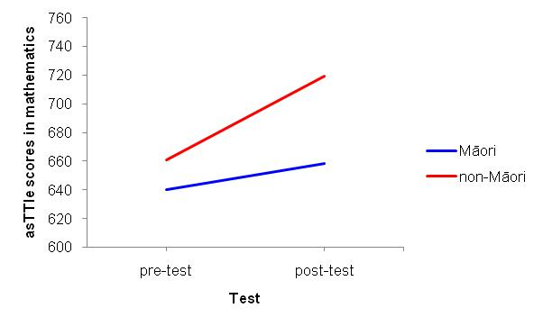
In 2008, the gains were the same for Māori as for non-Māori students in the Te Kotahitanga schools (see Figure 3.2)
Figure 3.2: 2008 asTTle results in mathematics for Schedule 1, Year 10 Māori and non-Māori students
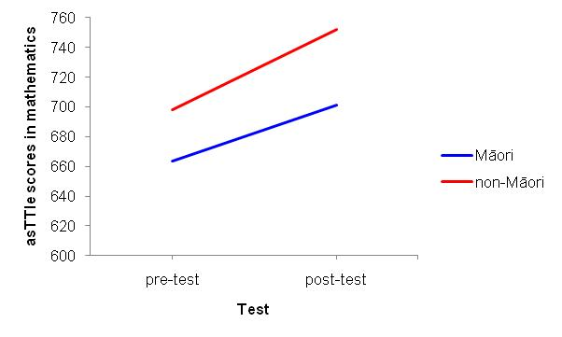
In 2009, Māori students improved significantly more than non-Māori students in the Te Kotahitanga schools (see Figure 3.3 below).
Figure 3.3: 2009 asTTle results in mathematics for Schedule 1, Year 10 Māori and non-Māori students
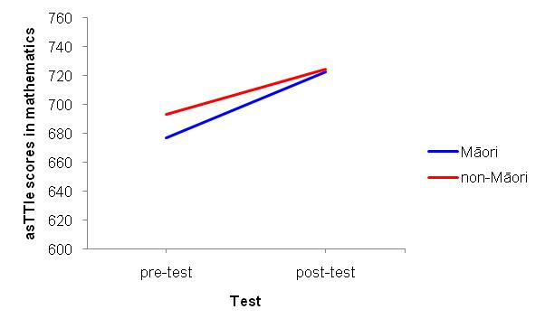
Figures 3.1, 3.2 and 3.3 illustrate the improvement in students’ asTTle results in mathematics that a group of teachers from across a number of Te Kotahitanga schools was able to achieve in successive years for different student cohorts.

3.1.2 NCEA achievement, Years 11, 12 and 13
The outcomes of the analyses of Māori students’ achievement in NCEA levels also support both of our hypotheses about Māori students’ achievement in Te Kotahitanga schools:
- Māori students’ achievements in NCEA outcomes between 2007 and 2009, improved at all levels except in Year 13 where there was a decrease in achievement. This decrease which was also seen at a national level was not significant.
- Year 11 Māori students in Phase 3 schools improved on the NCEA Level 1 they had reached in 2006 when their percentage points gain from 2005, the first year of implementation of the project, was double that of the national cohort of Māori students.
- In 2007 and 2009, Year 11 Māori students’ achievements at NCEA Level 1 and above were significantly better than those of the national cohort.
- In Year 12, the percentage points gain made by Māori students in terms of NCEA Level 2 and above between 2007 and 2009 was double that of the national cohort of Māori students.

3.1.2.1 Year 11, NCEA Level 1
In 2006, the first full cohort of students from Phase 3 schools reached Year 11. The New Zealand Qualifications Authority (NZQA) carried out an analysis of the National Certificate of Educational Achievement (NCEA) Level 1 results in these 12 schools in comparison to their 2005 results. This showed that the increase in the percentage of Māori students gaining NCEA Level 1 from Te Kotahitanga schools was greater than the increase for students from non-Te Kotahitanga schools, weighting for decile (i.e., the NCEA Level 1 achievement rates nationally for each decile level were multiplied by the number of Te Kotahitanga schools at each decile level, the products were summed, and the result was divided by 12, the total number of Te Kotahitanga schools.). This increase was also very marked for Pasifika students.
The following figure shows the percentage point gains for Māori in these schools.
Figure 3.4: Percentage point gain for Māori students at NCEA Level 1 in Phase 3 schools,
2005–2006
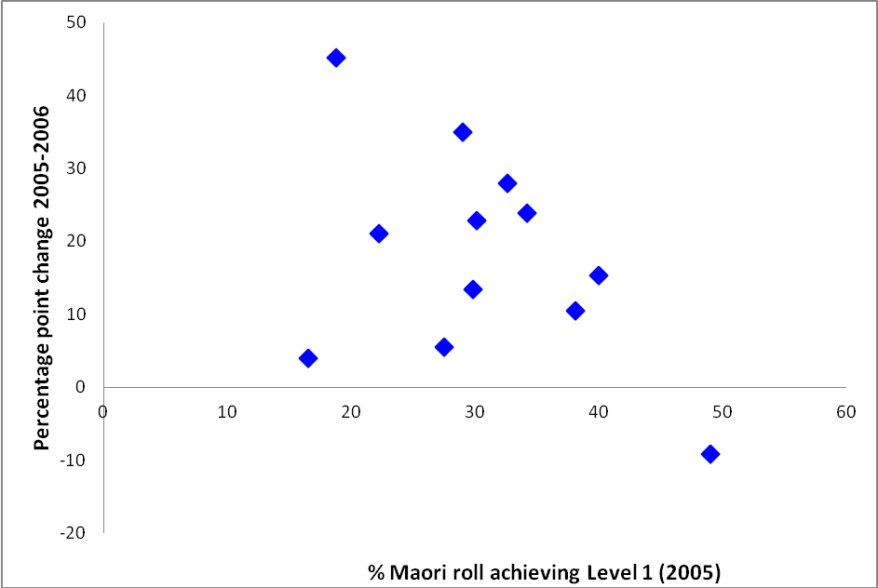
Table 3.4 below indicates gains for Māori and Pasifika students between 2005 and 2006 in NCEA Level 1 in both Te Kotahitanga and non-Te Kotahitanga schools. The 16.4% increase in 2006 for Māori students in Te Kotahitanga schools represents a 50% increase over the 2005 levels of attainment, indicating that as Timperley et al., (2007) note, the programme was having a long-term positive effect on these students in addition to its immediate positive effect across the student body.
Table 3.4: Māori and Pasifika students’ achievement levels in NCEA Level 1 in Te Kotahitanga and non-Te Kotahitanga schools in 2005–2006
Ethnicity | Te Kotahitanga schools |  |  |  |  |  | Increase in  % points  2005–2006
Ethnicity | Year 11 students on roll, N |  | Year 11 students gaining NCEA Level 1
Ethnicity |  |  | N |  | % |  | Te Kotahitanga schools | National cohort (decile weighted)
Ethnicity | 2005 | 2006 | 2005 | 2006 | 2005 | 2006 | Te Kotahitanga schools | National cohort (decile weighted)
NZ Māori | 973 | 952 | 312 | 461 | 32.1 | 48.4 | 16.4 | 8.9
Pasifika | 292 | 283 | 69 | 110 | 23.6 | 39.0 | 15.4 | 6.1

Data from the Ministry of Education in 2010 show that, between the years 2007 and 2009, these achievement levels were maintained in Te Kotahitanga schools and improved upon, apart from a slight dip in 2008 (Table 3.5 below). While the national achievement levels for Māori at NCEA Level 1 also show improvement, they have not reached the same levels as those of Te Kotahitanga schools.
Table 3.5: Year 11 Māori students’ achievement in NCEA Level 1, 2007–2009
Year | All Schools | Te Kotahitanga Schools
2007 | 43.90 | 48.60
2008 | 44.20 | 44.40
2009 | 47.70 | 50.2

A z-test for two proportions shows that:
- in 2007, there was a significant difference between the achievement of Māori students at NCEA Level 1 and above and that of the national cohort of Māori students (z value: 2.405, p<.01).
A z-test for two proportions shows that:
- in 2009 the difference between Year 11 NCEA Level 1 and above in Phase 3 schools and that of the national cohort of Māori students was also significant (z value: 1.77, p<.05).
The importance of these results is that, statistically, Year 11 Māori students’ achievements at NCEA Level 1 in Phase 3 schools were significantly better than those of the national cohort in both 2007 and 2009 (see Figure 3.5 below).
Figure 3.5: Year 11 Māori students’ achievement at NCEA Level 1 in Phase 3 Te Kotahitanga schools and all schools, 2007 to 2009
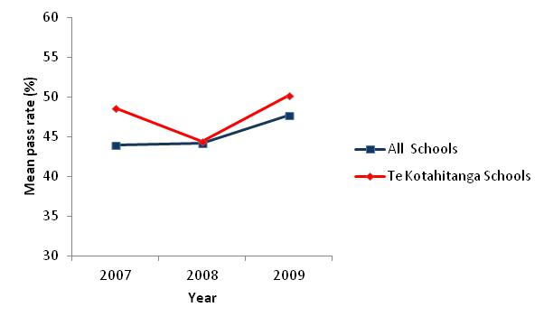
We compared the percentages of Year 11 students who did and did not obtain a NCEA Level 1 or above in years 2007, 2008 and 2009 in Phase 3 schools using a one-way repeated-measures ANOVA. The change in achievement levels was not significant, p > .05. Similarly, the percentage of students who did not obtain a NCEA Level 1 or above did not decrease significantly over the three-year period.

3.1.2.2 Year 12, NCEA Level 2 and above
In Year 12 in Phase 3 schools, the percentages of Māori students gaining at least NCEA Level 2 in Year 12 rose from 45.4% in 2007, to 48.8% in 2008 to 52.5% in 2009. This compares with national figures for Māori achievement of 49.3%, 51.8% and 52.8% (see Figure 3.6).
Figure 3.6: Year 12 Māori students’ achievement at NCEA Level 2, 2007 to 2009
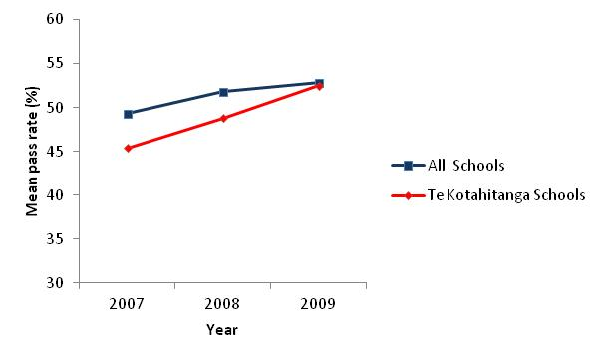
National figures therefore rose by 3.5 percentage points while Phase 3 figures rose by 7.1 percentage points (see Table 3.6 below).
All data have been obtained from the Ministry (August, 2010).
Table 3.6: Year 12 Māori students’ achievement in NCEA Level 2, 2007–2009
Year | N | Achievement (%) | Increase in percentage points 2007–2009
Year | N | Achievement (%) | Te Kotahitanga schools | National cohort
2007 | 301 | 45.40 | 7.10 | 3.50
2009 | 361 | 52.50 | 7.10 | 3.50

At the same time there was an increase in actual numbers of Māori students achieving at least NCEA Level 2 in Year 12 of 19.9%, whilst the increase in numbers at national level for Māori was 18.5%.
We compared the percentages of Year 12 students who did and did not obtain NCEA Level 2 and above in Phase 3 schools in years 2007, 2008 and 2009, using a one-way repeated-measures ANOVA, but the increase was not significant, p > .05.
At the same time in Year 13, there was a decrease in the percentages of Māori students gaining at least NCEA Level 3 in both Phase 3 schools and at the national level. We compared the percentages of Year 13 students who did and did not obtain NCEA Level 3 in the years 2007, 2008 and 2009 using a one-way repeated-measures ANOVA. The decrease was not significant, p > .05.
Percentages of Māori students who met the requirements for University Entrance (UE) in Phase 3 schools between 2007 and 2009 have remained consistently above the figures for 2006 in these schools. The actual number of students has risen from 82 to 107; that is, an increase of 30.5%, whilst the overall percentage increase has been 2.4%.

3.2 Changes in classrooms evidenced through the Observation Tool
Implementation of the Effective Teaching Profile in classrooms should bring about change in a number of teachers’ classroom practices and students’ in-class behaviour, as evidenced through the Observation Tool. The changes that we report on here are:
- teacher-student relationships
- teachers’ discursive practice
- student–teacher location
- cognitive level of the class
- student engagement
- level of work completion.
In terms of relationships, for all cohorts a high level of relationships was maintained from Year 1 for all cohorts
For discursive practices, a similar pattern of the use exists for each cohort over the years. There is a general increase in the use of discursive practice by term 4, 2009 relative to term 1 of the first year of participation.
For teacher location, the percentage of time spent at the front of the classroom significantly decreased in teachers’ first year of participation relative to the baseline.
In terms of cognitive level of the class, there was an increase relative to the baseline that was maintained through the first three years of participation.
For student engagement, the percentage increased significantly in year 1 relative to the baseline and was maintained in the second and third year.
In terms of the level of work completion by Māori students, this increased and was maintained.

3.2.1 Measured change in teacher–student relationships
Implementation of the Effective Teaching Profile carries with it a very strong focus on the quality of teacher–student relationships. Our hypothesis regarding such relationships was:
- teachers will establish and maintain a high level of factors 1 and 2 during their first three years of participation.
Data from the Observation Tool indicated that, for all cohorts, a high level of both factors was established. For factor 1 relationships, a very high level generally was maintained from year 1. For factor 2, a high level was reached at the latest by year 3.
Figures 3.7 to 3.10 show the level of relationship for cohorts 1–3 for factors 1 and 2.
Figure 3.7: Shifts in factor 1 and 2 (levels of relationship) for cohort 1 between 2004 and 2006
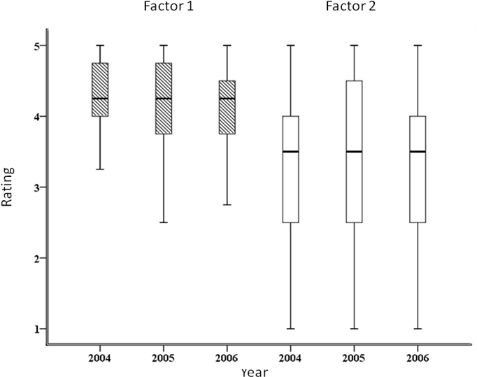
Figure 3.8: Shifts in factor 1 and 2 (levels of relationship) for cohort 2 between 2005 and 2007
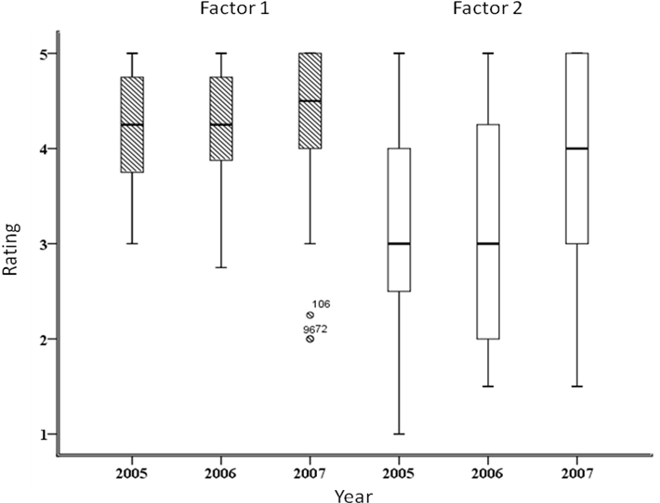
Figure 3.9: Shifts in factor 1 and 2 (levels of relationship) for cohort 3 between 2006 and 2008
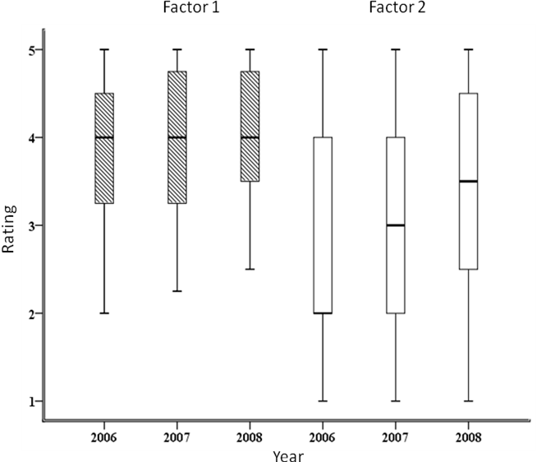
Figure 3.10: Shifts in factor 1 and 2 (levels of relationship) for cohort 4 between 2007 and 2009
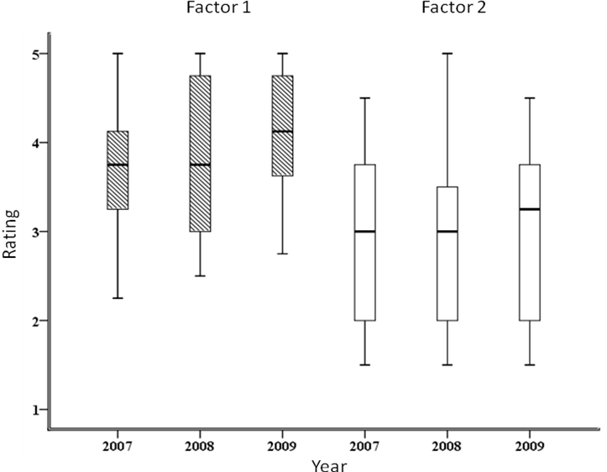
In accordance with our hypothesis, our observations revealed:
- for cohort 1 teachers, a high rating for factor 1 relationships over the first three years of participation. The rating for factor 2 relationships was also high and also maintained over the three years
- for cohorts 2 and 3 teachers, a very high rating for factor 1 relationships over the first three years of participation. The rating for factor 2 relationships was mainly around the middle of the scale for the first two years but significantly increased in year 3 of participation, z = -3.115, p = .002 and z = -2.528, p = .011 for cohorts 2 and 3 respectively
- for cohort 4 teachers, a high rating for factor 1 over the first two years of participation and an increase in year 3. A similar pattern but on a slightly lower rating was observed for factor 2.
Figures 3.11 to 3.12 illustrate the shift in factor 1 and 2 of relationships for cohort 5 and show the level of relationships for factor 1 and 2 in the first year of participation for cohort 6.
Figure 3.11: Shifts in factor 1 and 2 (levels of relationship) for cohort 5 between 2008 and 2009
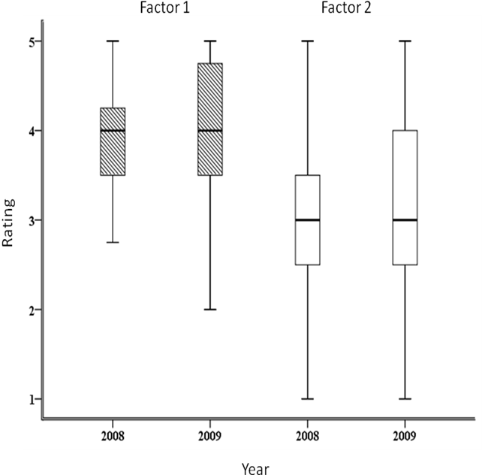
Figure 3.12: Rating for factor 1 and 2 (levels of relationship) for cohort 6 in 2009
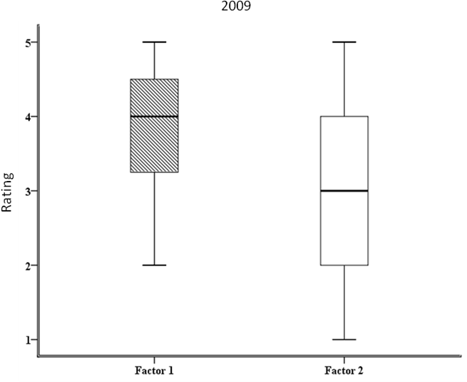
In accordance with our hypothesis, our observations revealed:
- for cohort 5 teachers, a high rating for factor 1 relationships over the first two years of participation. The rating for factor 2 relationships was mainly around the middle of the scale for both years
- a similar rating for cohort 6, indicating a high rating for factor 1 relationships in the first year of participation and a slightly lower rating for factor 2.
Table 3.13 in Appendix A gives the results of Friedman’s related samples test for factors 1 and 2 of level of relationships.

3.2.2 Discursive practice
Greater use of discursive practice in classrooms is an important aspect of the implementation of the Effective Teaching Profile. Research questions of interest in relation to data from the Observation Tool in this respect were:
- How does the incidence of teachers’ discursive practice change from term to term within one school year?
- Does this pattern change in consecutive years?
- Is the overall pattern the same for each cohort?

3.2.2.1 Patterns of practice
As can be seen in Figure 3.13, a similar pattern of the use of discursive practice exists for each cohort over the years. There is a general increase in the use of discursive practice by term 4, 2009 relative to term 1 of the first year of participation:
- Most cohorts start with a low percentage of use of discursive practices in term 1 and consistently increase the use by term 2, 3 and 4 in any one year.
- Increased use of such practice can be observed for all years (2004 to 2008) and all cohorts except cohort 4.
- Discursive practice systematically decreased from term 4 to term 1 of the following year. This drop, commonly referred to as “summer slump” (comparable to achievement drop for students over the summer holidays) (Lai, McNaughton, Timperley & Hsiao, 2009), lessens in later years of participation and is less apparent for new cohorts.
However, the pattern for 2009 is slightly different. The focus of observations in 2009 had changed from observing all teachers in all cohorts to only observing newer cohorts and/or teachers who had not showed significant progress. It is therefore unsurprising that the percentage of discursive practice in term 1 of 2009 for most cohorts is smaller compared to any of the previous terms. Additionally, cohorts 3, 4 and 5 do not show an increase in the percentage of discursive practice from term 1 to term 4.
Figure 3.13: Percentage of discursive practice for each cohort by term for all years of participation
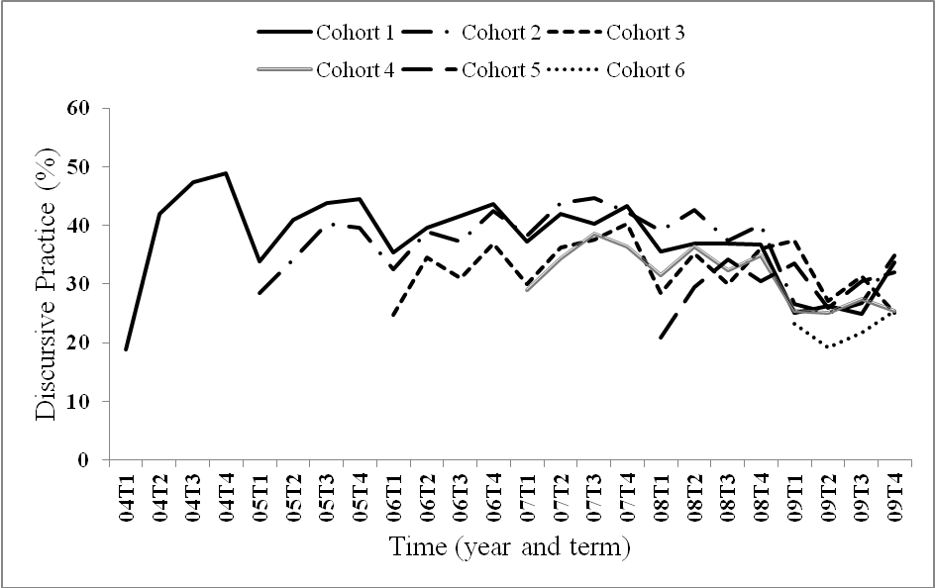

3.2.2.2 Patterns for low users of discursive practice (≤20%), 2004 to 2009
As discursive practice is so important in the Effective Teaching Profile, a subset of data, that for low users of discursive practice, was investigated to determine:
- whether the percentage of low users changed from term to term within one school year
- whether this pattern changed in consecutive years.
Table 3.14 in Appendix A illustrates the percentage of teachers (all cohorts combined) with 20% or less discursive practice by term for years 2004–2009. As can be seen in this table, with the exception of 2009, there was a general decrease in the percentage of teachers using 20% or less discursive practice from term 1 to term 4 for each year. A similar pattern was also observed for term 1 across all years (except in 2009).

3.2.2.3 Measured changes in discursive practice
In terms of the sustainability of changed classroom practice, it was important to investigate whether the changes had occurred by chance, or whether differences in practice were significant and sustained.
In regard to the first three years of implementation of the project relative to the baseline for cohorts 1 to 3, we hypothesised that:
- there would be an increase in the percentage of discursive practice relative to the baseline
- that increase would be maintained over the years.
Results of a one-way repeated measures ANOVA can be found in Tables 3.15 and 3.16 in Appendix A.
Percentages of discursive practice for cohorts 1 to 3 are illustrated in Figures 3.14 to 3.16 below.
Figure 3.14: Shifts in discursive practice from baseline to 2004, 2005 and 2006 for cohort 1
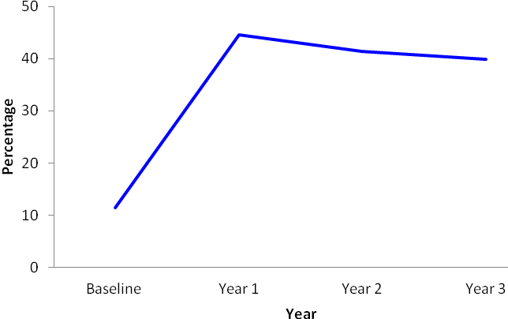
Figure 3.15: Shifts in discursive practice from baseline to 2005, 2006 and 2007 for cohort 2
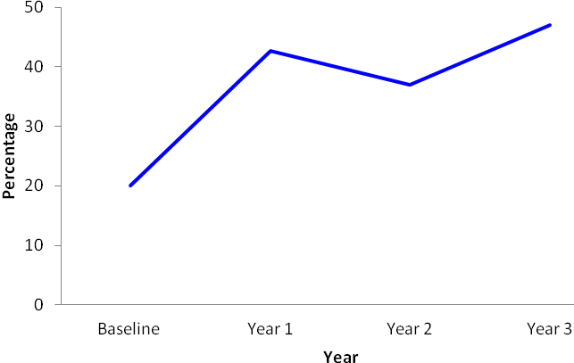
Figure 3.16: Shifts in discursive practice from baseline to 2006, 2007 and 2008 for cohort 3
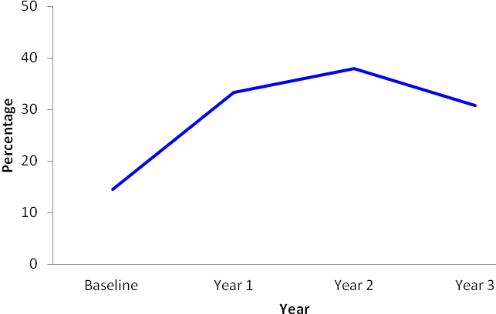
The results for cohorts 1 to 3 revealed that there was a significant increase in discursive practice from baseline to their first year of participation. This increase was maintained in the second and third year.
For cohorts 4 to 6, we hypothesised that there would be an increase in the percentage of discursive practice relative to the baseline. Consistent with our hypothesis, there was a significant increase in discursive practice from baseline to term 3, 2007 for cohort 4 teachers p<.01. The data showed a general lack of significant differences between baseline and term 3 observations for cohorts 5 and 6.
The results of a paired samples t-test are represented in Table 3.17 in Appendix A.

3.2.2.4 Measured change in incidence of whole-class interactions
Change in the pattern of use of discursive practice implies change also in the incidence of teacher interactions with the whole class. We hypothesised that, with effective implementation of the effective teaching profile in Phase 3 schools and with an increase in the percentage of discursive practice:
- there would be a decrease in the percentage of interactions with the whole class
- there would be a decrease in the percentage of interactions with the whole class relative to the baseline
- a decrease would be maintained over the years.
The calculation of a Pearson correlation coefficient was obtained for discursive practice and interactions with the whole class. Tables 3.18 and 3.19 in Appendix A indicate that there was a small-to-medium significant negative correlation between the percentage of discursive practice and the percentage of interactions with the whole class. A high percentage of discursive practice was associated with a greater number of group and individual interactions. This outcome was observed for all cohorts.
Descriptive statistics and the results of a one-way repeated measures ANOVA can be found in Tables 3.20 and 3.21 in Appendix A.
The percentage of interactions with the whole class for cohorts 1 to 3 are shown in Figures 3.17 to 3.19 below.
Figure 3.17: Shifts in percentage of interactions with whole class for cohort 1 between baseline and term 3, 2004 to 2006
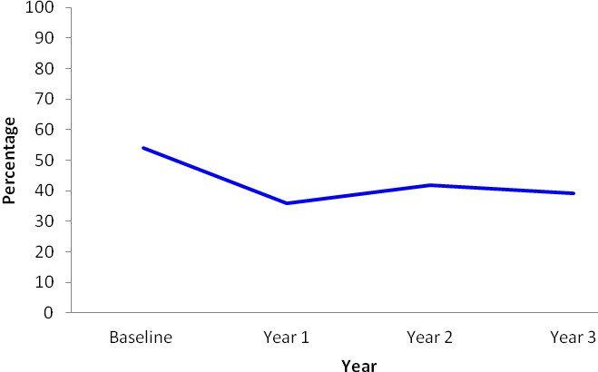
Figure 3.18: Shifts in percentage of interactions with whole class for cohort 2 between baseline and term 3, 2005 to 2007
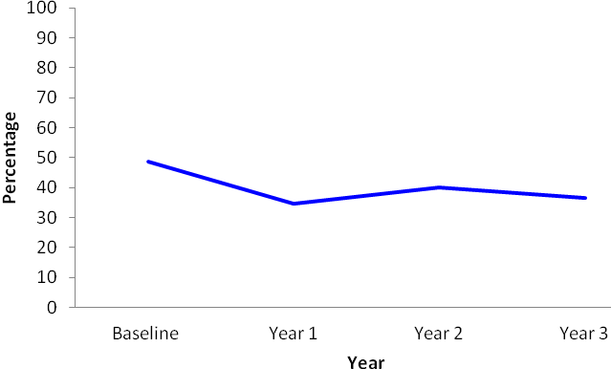
Figure 3.19: Shifts in percentage of interactions with whole class for cohort 3 between baseline and term 3, 2006 to 2008
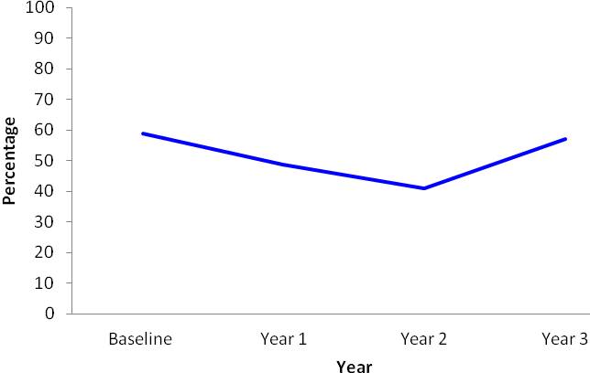
As hypothesised, for cohorts 1 and 2, there was a significant decrease in the percentage of whole-class interactions in their first year of participation relative to the baseline. Cohort 1 maintained this decrease in years 2 and 3 of participation. Cohort 2 maintained this decrease in their third year of participation. For cohort 3 there was a significant decrease in the percentage of whole-class interactions in their second year of participation relative to the baseline.
Results of a paired samples t-test illustrating changes in interactions with the whole class in their first year of participation for cohorts 4 to 6 relative to the baseline are represented in Table 3.22 in Appendix A.
Consistent with our hypothesis, there was a significant decrease in interactions with whole class from baseline to term 3, 2007 for cohort 4 teachers. The data showed a lack of the significant differences between baseline and term 3 observations for cohorts 5 and 6.

3.2.3 Measured change in student–teacher location
We hypothesised that if there was an increase in teacher discursive practice, it was also likely that:
- there would be a decrease in the percentage of time a teacher is located in the front of the classroom relative to the baseline
- the decrease would be maintained over the years.
To examine this, we needed first to examine shifts in student location in the classroom.
Table 3.23 in Appendix A shows the shifts of Māori students’ location analyses for cohorts 1 and 2.
Results of paired samples t-test (see Table 3.24 in Appendix A), for Phase 3 schools, showed that there were no significant differences in the percentage of Māori students seated in the front of the classroom between the baseline and any other year of participation for all cohorts.
Figures 3.20 to 3.22 illustrate the percentage of teachers being located at the front of the classroom for cohorts 1 to 3. Results of a one-way repeated measures ANOVA can be found in Table 3.25 in Appendix A.
Figure 3.20: Comparisons between baseline and term 3 of the first three years of participation for teacher location at the front of the class for cohort 1
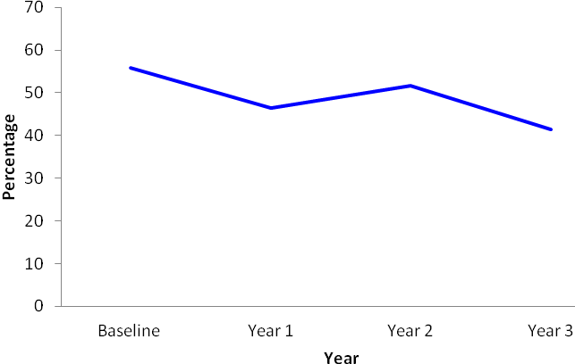
Figure 3.21: Comparisons between baseline and term 3 of the first three years of participation for teacher location at the front of the class for cohort 2
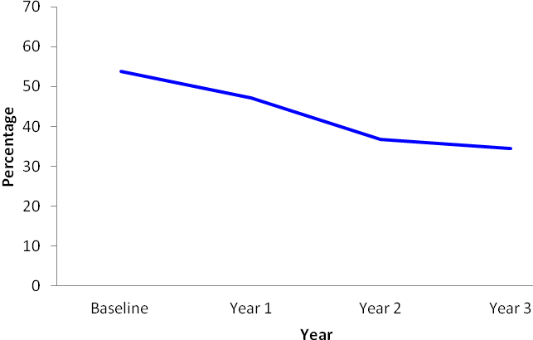
Figure 3.22: Comparisons between baseline and term 3 of the first three years of participation for teacher location at the front of the class for cohort 3
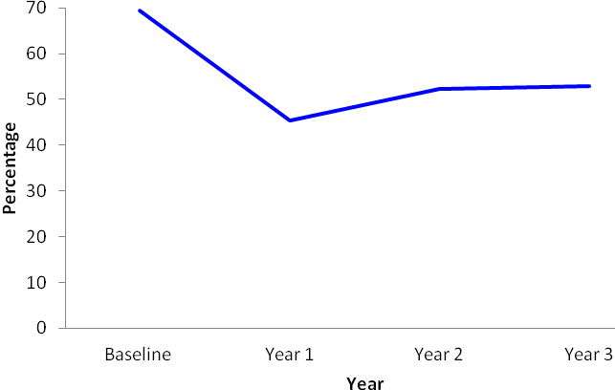
In accordance with our hypothesis, the percentage of time spent at the front of the classroom for cohort 1 and 3 teachers significantly decreased in their first year of participation relative to the baseline. For cohort 1, this decrease was maintained in the third year and for cohort 3 this decrease was maintained in the second and third year of their participation. For cohort 2 teachers, the percentage of time spent at the front of the classroom decreased in their second year of participation relative to the baseline. The difference was marginally significant and was maintained in their third year.
The results of a paired samples t-test to show the shifts in the percentage of time teachers spent in the front of the classroom in the first year of participation for cohorts 4 to 6 relative to the baseline are represented in Tables 3.26 and 3.27 in Appendix A.
As hypothesised, in their first year of participation, cohort 4 teachers spent significantly less time in the front of the classroom relative to the baseline. Further, during their first year of participation, cohort 5 teachers spent approximately 41% of their time in the front of the classroom, indicating no significant change relative to the baseline. During baseline as well as in their first year of participation, cohort 6 teachers spent approximately 50% of their time moving throughout the classroom while the other 50% was spent in the front of the classroom. This pattern was maintained over time.

3.2.4 Measured change in cognitive level of the class
We hypothesised that implementation of the programme would bring about higher teacher expectations of their Māori students and, therefore, result in teachers increasing the cognitive level of their teaching in the classroom.
Results of a non-parametric Friedman’s related-samples test can be found in Table 3.28 in Appendix A.
The cognitive level of class for cohorts 1 to 3 is shown in Figures 3.23 to 3.25.
Figure 3.23: Shifts between baseline and term 3 of the first three years of participation for cognitive level of class for cohort 1
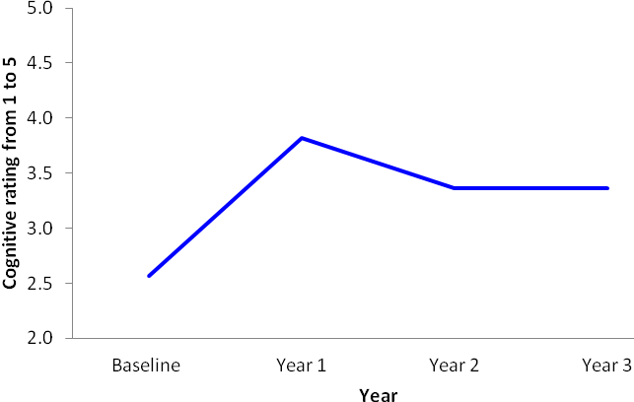
Figure 3.24: Shifts between baseline and term 3 of the first three years of participation for cognitive level of class for cohort 2
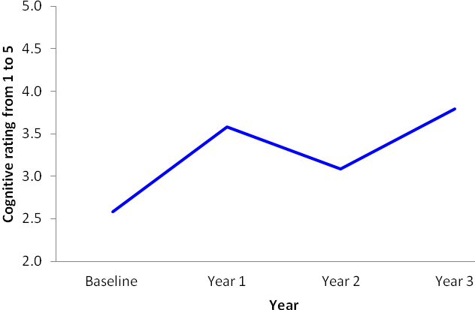
Figure 3.25: Shifts between baseline and term 3 of the first three years of participation for cognitive level of class for cohort 3
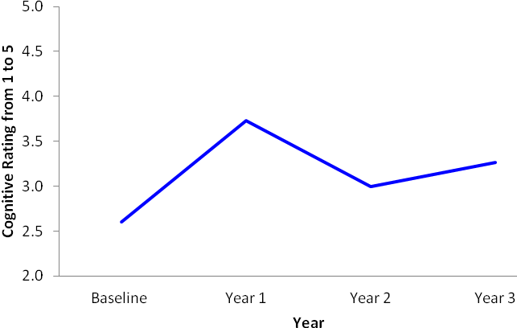
As hypothesised, there was a significant increase in the cognitive level of the class for cohorts 1 to 3 relative to the baseline and this increase was maintained through the first three years of participation. Table 3.29 in Appendix A gives the outcomes of a Wilcoxon matched pairs signed-ranks test.
A Wilcoxon matched pairs signed-ranks test was also conducted to test differences in the cognitive level of class in the first year of participation for cohorts 4 to 6 relative to the baseline.
Table 3.30 in Appendix A represents the results of the analyses for cohorts 4 to 6.
For cohorts 4 to 6, the mean difference in the cognitive level of class between the baseline and term 3 was not significant.

3.2.5 Measured change in student engagement
We hypothesised that, given an increase in discursive practice:
- there would be an increase in Māori student engagement in the classroom
- the increase would be maintained over time.
Table 3.31 in Appendix A gives the mean and standard deviation for the percentage of Māori student engagement.
The results of a one-way repeated measures ANOVA can be found in Table 3.32 in Appendix A.
Figures 3.26 to 3.28 illustrate the percentage of engagement for Māori students for cohorts 1 to 3.
Figure 3.26: Shifts between baseline and term 3 of the first three years of participation for student engagement for cohort 1
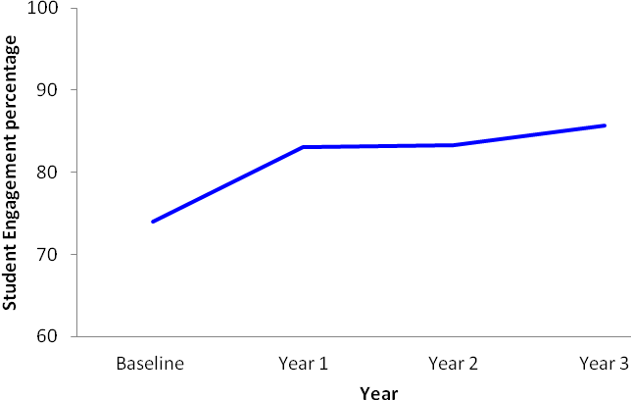
Figure 3.27: Shifts between baseline and term 3 of the first three years of participation for student engagement for cohort 2
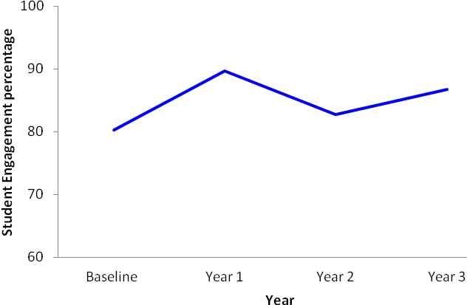
Figure 3.28: Shifts between baseline and term 3 of the first three years of participation for student engagement for cohort 3
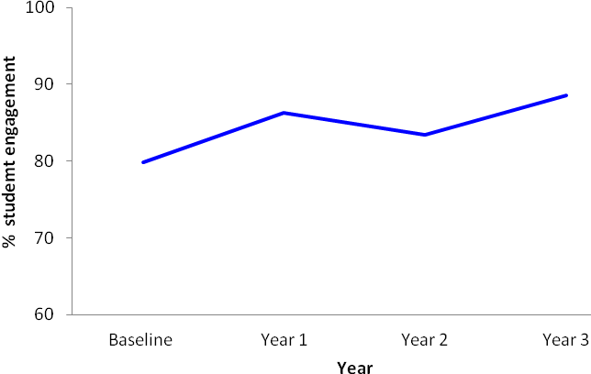
As hypothesised:
- the percentage of engagement for Māori students of cohort 1 teachers increased significantly in year 1 relative to the baseline. This increase was maintained in the second and third year
- the percentage of engagement for Māori students of cohort 2 teachers increased significantly in their first year relative to the baseline. This increase was slightly reduced in year 2 but there was another increase the following year and therefore the initial increase was maintained by year 3.
For cohort 3 teachers, there were no significant changes in any year of participation relative to the baseline. However, results of a paired samples t-test revealed that the percentage of engagement of Māori students was significantly higher in year 3 of participation relative to the baseline.
Table 3.33 in Appendix A represents the results of a paired samples t-test to show shifts in the percentage of engagement of Māori students for cohorts 4 to 6 in the first year of participation relative to the baseline.
The mean difference in the percentage of Māori student engagement between the baseline and the first year of participation for cohorts 4 and 5 was not significant.

3.2.6 Level of work completion
In regard to work completion, we hypothesised that, with an increase in discursive teaching practice:
- there would be an increase in the level of work completion for Māori students
- this increase would be maintained over time.
Results of a non-parametric Friedman’s related-samples test can be found in Table 3.34 in Appendix A.
Figures 3.29 to 3.31 illustrate the level of students’ work completion in the classrooms of cohorts 1 to 3.
Figure 3.29: Shifts between baseline and term 3 of the first three years of participation for student work completion for cohort 1 classrooms
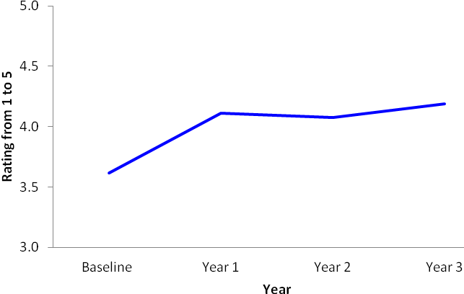
Figure 3.30: Shifts between baseline and term 3 of the first three years of participation for student work completion for cohort 2 classrooms
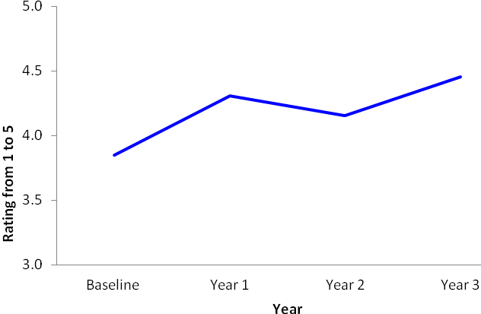
Figure 3.31: Shifts between baseline and term 3 of the first three years of participation for student work completion for cohort 3 classrooms
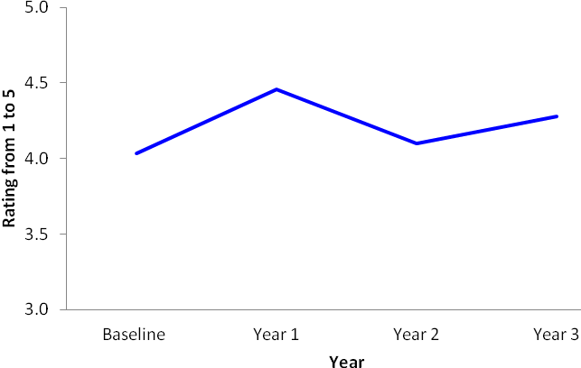
As hypothesised:
- there was a significant increase in the level of students’ work completion for cohorts 1 and 2
- the level of students’ work completion for cohort 3 was already high at baseline and remained the same for the next three years of participation.
A Wilcoxon matched pairs signed-ranks test was conducted to test differences in the level of students’ work completion in the first year of participation for cohorts 1 to 3, and 4 to 6 relative to baseline. Tables 3.35 and 3.36 in Appendix A represent the results of the analyses.
The mean difference for the level of work completion between baseline and term 3 observations for cohorts 4 to 6 was not significant.

3.2.7 Summary of analysis of data from the Observation Tool
In our analysis of data from the Observation Tool, we expected evidence of successful implementation and sustained practice of the Effective Teaching Profile through various measures of teachers’ and students’ performances. The main hypotheses were that implementing the effective teaching profile would bring about:
- a change from mainly traditional to more discursive practice
- a change from whole-class interactions to individual students and/or group interactions
- a change in teachers’ location
- a change in relationships between teachers and students
- an increase in the cognitive level of the class
- an increase in Māori students’ engagement
- an increase in Māori students’ work completion.
Additional analysis of Māori students’ location in classrooms was conducted to examine possible changes in the seating location of Māori students in the classroom.
In addition to observing significant changes in the aforementioned measures, equally important for Phase 3 schools would be to observe the continuation of the observed changes (due to the continual support provided to teachers) in consecutive assessments. This would represent a strong evidence base for claiming sustainability of the programme.
In relation to discursive practice and interactions with the whole class, we found the following:
- For discursive practice, results revealed a significant increase in the first year of participation relative to the baseline for cohorts 1 to 4. The percentage of discursive practice for cohort 5 was already high at baseline (34%) and hence did not significantly change in their first year. Changes for cohort 6 were non-significant. These results suggest that teachers adopted a significantly higher proportion of discursive interactions (i.e., co-construction, feed-forward academic positive, feed-forward academic negative, feedback academic positive, feedback academic negative, and prior knowledge) in their teaching and that this may well be related to the “spill-over” effect of Te Kotahitanga professional development on professional development in their schools generally.
- Teachers of cohorts 1 to 5 showed the same patterns for their use of discursive practice for years 2004 to 2008, namely:
- a steady increase from term 1 to term 4
- pattern repeats for each year of participation
- a drop over the summer break
- an overall increase from first observation after Hui Whakarewa to the most recent observation
- The general pattern for 2009 was different compared to the earlier years. This was to be expected, however, given that the focus of observations in 2009 had changed from observing all teachers in all cohorts to only observing newer cohorts and/or teachers who had not showed significant progress:
- the summer drop from term 4 2008 to term 1 2009 is greater for most cohorts compared to previous years
- shifts in discursive practice from term 1 2009 to term 4 2009 were different compared to previous years: cohorts 3, 4 and 5 had showed either lack of increase or an actual decrease; cohort 6 had a small increase and cohorts 1 and 2 had an increase but the percentage of discursive practice for each term in 2009 was still lower than for the comparable term in previous years
- Further analyses revealed a steady decrease of the percentage of teachers using 20% or less discursive practice. The decrease is apparent from term 1 to term 4 for all cohorts (e.g., in 2004, a decrease from 61% to 4%). This pattern is repeated in each year with exception of 2009.
- Alongside the increase in the percentage of discursive practice, we observed a significant decrease in the percentage of interactions with the whole class relative to the baseline. For Phase 3, cohorts 1, 2 and 4 showed a significant decrease in their first year of participation and cohort 3 in their second year.
- Further analysis to test correlation between discursive practice and interactions with whole class revealed a small to medium association; that is, a high percentage of discursive practice was associated with a low percentage of interactions with the whole class. This outcome was observed for all cohorts.
- It is of great significance that the comparison between baseline and years 2 and 3 of participation showed that these shifts in discursive practice and interactions were maintained in Phase 3 schools.
With regard to teachers’ location in the classroom:
- Phase 3 schools showed a significant decrease in the percentage of teachers standing in front of the class. Thus the teachers’ shift away from being located at the front of the class and their shift away from interacting with the whole class should enable teachers to establish closer and more effective caring and learning relationships with Māori students which in turn may enhance Māori students’ achievements.
At the beginning of the project, baseline data for the level of relationships were not recorded. Hence analyses focused on shifts in the level of relationships during the first three years of participation. Shifts are shown using a 1 to 5 Likert scale (1 being the lowest; 5 being the highest):
- For cohorts 1 to 3, strong evidence was observed (3.9 to 4.3) during the first three years of participation that teachers cared for their Māori students, had high expectations for their learning performance and behaviour and provided a well-managed classroom (factor 1).
- For cohort 4, there was a significant increase in the level of relationships in factor 1, in their third year of participation.
- Further, for cohort 1 teachers, the level of culturally appropriate and responsive teacher–student relations (factor 2), remained between 3.2 and 3.5, during their first three years of participation. For cohorts 2 and 3, this level significantly increased in their third year of participation. The level for cohort 4 remained between 2.9 to 3.0.
- The level of relationships for cohort 5 remained between 3.9 and 4.0 for factor 1 and at 3.1 for factor 2. And cohort 6 indicated a level of 3.9 for factor 1 and 2.9 for factor 2.
Results for the cognitive level of the class revealed:
- for cohorts 1 to 3, a significant shift from baseline (level at 2.6 for all cohorts) to the first year of participation (levels between 3.6 and 3.8)—an increase that was maintained in the following years
- for cohorts 4 to 6, that the cognitive level was already high at baseline and stayed the same in the first year of participation.
With regard to Māori student engagement and work completion:
- Cohorts 1 and 2 showed for both measures, a significant increase in the first year of participation. The percentage of student engagement after the first three years of participation for cohorts 1 to 3 achieved an impressive 86% to 89% in learning engagement in class and 84% to 88% in level of work completion.
- For cohorts 4 and 5, the percentage of engagement was high from the onset (83% to 87%) and remained high in the first year of participation (85% to 88%). Similarly, work completion was also high from the beginning (80% to 86%) and remained unchanged.
Overall, therefore, for Phase 3 schools, data from the Observation Tool indicate improvements in the implementation of the Effective Teaching Profile and, more importantly, that these improvements were sustained over time.

3.3 “Levels of Use” outcomes
As Hall and Hord (2006) note, the outcomes of “Levels of Use” (LoU) ratings are a useful indicator of the likely sustainability of a project in a school. The following, Table 3.7, presents the Levels of Use rankings and the total numbers of teaching staff who participated in these interviews, in each of the 12 schools in Phase 3. Overall, 75.2% of teachers interviewed in these schools were rated as routine users or above. This is well above the figure of 60% that is noted by Hall and Hord as needed for sustainability.
Table 3.7: Levels of Use (LoU) ratings for teachers in Phase 3 schools
School | LOU 0  Non-use | LOU 1  Orientation | LOU 2  Preparation | LOU 3  Mechanical | LOU 4a  Routine | LOU 4b  Refinement | LOU 5  Integration | LOU 6  Renewal | % at LOU 4a+ | N = staff Interviewed
1 |  |  |  | 12  (40%) | 13 (43.3%) | 4 (13.3%) | 1 (3.3%) |  | 60% | 30
2 |  |  |  | 8  (25.8%) | 16  (51.6%) | 6  (19.4) | 1  (3.2%) |  | 74.2% | 31
3 |  |  |  | 1  (3.8%) | 14  (53.8%) | 7  (26.9%) | 4  (15.4%) |  | 96.2% | 26
4 |  |  |  | 1  (5.9%) | 10  (58.9%) | 5  (29.4%) | 1  (5.9%) |  | 94.1% | 17
5 |  |  |  | 9  (17%) | 22  (41.5%) | 16  (30.2%) | 6  (11.3%) |  | 83% | 53
6 |  |  |  | 2  (18.2%) | 3  (27.3%) | 4  (36.4%) | 2  (18.2% |  | 81.8% | 11
7 | 2  (6.3%) | 3  (9.4%) | 2  (6.3%) |  | 12  (37.5%) | 7  (21.9%) | 5  (15.6%) | 1  (3.1%) | 78% | 32
8 |  |  |  |  | 4  (22.2%) | 6  (33.3%) | 8  (44.4%) |  | 100% | 18
9 | 1  (2.2%) | 3  (6.6%) | 1  (2.2%) | 13  (28.3%) | 14  (30.4%) | 7  (15.2%) | 7  (15.2%) |  | 60.9% | 46
10 | 2  (6.7%) | 2  (6.7%) |  | 7  (23.3%) | 11  (36.7%) | 4  (13.3%) | 4  (13.3%) |  | 86.7% | 30
11 |  |  |  | 5  (20%) | 15  (60%) | 1  (4%) | 4  (16%) |  | 80% | 25
12 | 2  (8.3%) |  |  | 9  (37.5%) | 8  (33.3%) | 4  (16.7%) | 1  (4.2%) |  | 70.8% | 24
School Totals | 7 | 8 | 3 | 67 | 142 | 71 | 44 | 1 | 258 | 343
% totals | 2 | 2.3 | 0.87 | 19.5 | 41.4 | 20.7 | 12.8 | 0.29 | 75.2 | 100
(%) = % of teachers interviewed.
Overall, the Levels of Use analysis would indicate that Te Kotahitanga is being sustained in these schools. However, only an in-depth, school-by-school analysis would reveal the future potential for sustainability in each one. Our case study research (see Chapter 2 for details) indicated the following patterns:
- Schools 1, 2 and 7 in Table 3.7 above are those described in Chapter 7 as having implemented Te Kotahitanga to a high degree in the past, certainly in the first three years, but as having allowed the cycle of professional development associated with the project to collapse. While the teachers trained to implement the Effective Teaching Profile and committed to the project remain at the school, it is likely that culturally appropriate and culturally responsive practices will be maintained in some classrooms. However, analysis of the turnover of staff in these same schools and incomplete project implementation may imply that there will be project “washout” in these schools in the future.
- Schools 3, 4, and 5 have very high overall ratings that range from 96.2% LoU 4(a) and above to 83% (see Table 3.7 above). These reflect the nature of the project in these schools as fully implemented and where we might predict that Te Kotahitanga is sustainable while it retains the commitment of the principal, board of trustees and senior management team. School 6 also has a high rating, but those teachers who were interviewed were those who had chosen to be members of the project and were teaching the Te Kotahitanga and whānau classes.
- Schools 8 and 10 again have high ratings (100%; 86.7%). School 8 has had a very recent very rapid increase (over 100%) in NCEA Level 1 achievement for Māori students and a good number of staff, including the principal, are highly committed to the project now. School 10 has steadily increasing NCEA Level 1 achievement for Māori, but it is clear that numbers of staff and heads of departments are not supportive of the project. Nevertheless, when new staff are employed, commitment to Te Kotahitanga is expected, so it may be anticipated that the project will gradually become sustainable in the school.
- In School 9, the figures give a clear reflection of the split between staff who support, and those who have little understanding of the project. Again, however, new staff are expected to become a member of the project on appointment, so movement towards sustainability across the school may be anticipated, particularly given the strength of the current facilitation team.
- School 11 has a high percentage rating for those staff who were interviewed (80% LoU 4(a) and above). Given that this is the school where the project began very strongly, was undermined but is now in the process of resurrection, this is a very positive position in relation to overall level of use.
- In the final school, School 12, the only staff interviewed were new to the school; that is, those staff very recently inducted into the project. This is the school where the project never really became established properly (see Chapter 7 for an explanation).

3.4 Retention of staff in the Te Kotahitanga programme
In a discussion of sustainability of the project in any school, it is important to examine the degree to which teachers experienced in the use of the Effective Teaching Profile have been retained. Analysis of retention of Te Kotahitanga staff in the Phase 3 schools indicates that, in general terms, the greatest number of withdrawals from the programme took place in years 1 and 2 of teachers in cohort 1. Subsequently very few teachers chose to withdraw. In addition, although numbers leaving these schools may seem to be large in some cases, many teachers have taken their experience of professional development in the programme to other schools.
Overall, of the total numbers of teachers who joined cohort 1 of the programme in Phase 3 (N = 414), 39% remained in term 4, 2009 (see Table 3.39 in Appendix A). Approximately:
- 47% had withdrawn from the programme at some point
- 23% had left the school
- 9% had withdrawn from the programme and then returned.
Where teachers had withdrawn from the project, this had taken place mostly in the first or second year of membership. Interview evidence suggests that withdrawal might have occurred for a number of reasons. In the early days of the project (2004 to 2005):
- the principal and/or facilitators and/or senior management team may not have realised the degree of change in the organisation of the school that was needed to accommodate the cycle of professional development
- some teachers may not have realised the degree of change that was needed in their own classroom practices to address the Effective Teaching Profile and may not have been prepared to accommodate this
- some teachers may have felt threatened as competent practitioners if it became clear to them that they had been teaching in ways that were unsupportive of Māori students’ learning and achievement
- some facilitators may have been less able to offer advice and support in ways that teachers experienced as constructive
- those in positions of authority in the school hierarchy may not have welcomed observations and feedback from facilitators less experienced or lower in status than themselves
- some schools’ systems of data collection and record keeping, and the kinds of tests and assessments that were used to evaluate students’ progress were often not compatible with what was needed for a centralised Research and Development project across a number of schools.
Te Kotahitanga had not been running long enough at this point for it to be apparent whether these issues would occur when any intervention of this sort was introduced into schools.
In subsequent years in cohort 1, there were very few withdrawals from the project.
It is interesting that in some schools in the first cohort of teachers, significant numbers of teachers who had withdrawn—up to 20% of the original cohort number—subsequently returned to the project. In some schools also, both withdrawals and return to membership were coincidental with changes of facilitators and/or principals.
Turnover of staff as a result of resignation from the school is also a critical factor in sustainability terms and means that there is a clear need for ongoing professional development for replacement staff. By the end of term 2, 2009, a total of 47.2% of the original 2003 cohort had left these schools. Again, as in percentages of withdrawals, the proportions of cohort 1 staff leaving these schools are variable from school to school and range from 32% to 67%.
The pattern of withdrawals in cohort 2 is rather different. The highest overall percentage of withdrawals took place in the first year of the project and is the same proportion (9%) as in cohort 1. A much lower percentage overall withdrew (c. 16%) than in cohort 1. Interestingly, in six of the schools, approximately the same proportions of teachers who withdrew from the project returned at some point.
After staff leavers have been taken into consideration, the percentage of cohort 2 (48%) still remaining in schools in term 4, 2009, is about the same as cohort 1.
Cohort 3 had a much lower percentage of withdrawals overall (c. 10%) than cohorts 1 and 2, again mostly in the first year, although much reduced from cohort 1. The proportion of staff leavers is also slightly lower, but only as might be expected from shorter length of service in the school.
In conclusion, it may be that some of the same reasons for withdrawals pertain in cohorts 2 and 3 as in cohort 1. However, it seems that already by cohort 2, schools were beginning to come to terms with the implications for change at a number of levels that the implementation of Te Kotahitanga brings with it, and that this is almost certainly the case by cohort 3.

3.5 Teachers’ survey, July to August 2010
An electronic survey of teachers was conducted through July to August of 2010. A summary of the teachers’ survey responses is given below. The complete analysis is attached as Survey Analysis 1 in Appendix B.
In total, just over 50% of the members of the project in 11 of the 12 schools responded to the teachers’ surveys. Questions were compiled in relation to the GPILSEO process (see Chapter 2 for details of questionnaire design and construction). While survey responses cannot be seen as a proxy for actual behaviour, where questions relate to personal practice, nevertheless they provide a useful set of data to be triangulated with other forms of evidence of sustainability of the project in schools. Responses have been reported as percentages except for individual qualitative comments. These latter have been reported in the form of raw numbers as these numbers tend to be very low. Where there is no number in parentheses, the frequency of reporting is 1 only.

3.5.1 Goals
Questions 1 to 8 related to goals. Where the Likert scale was used, 1 represented “strongly agree” and 4 “strongly disagree”.
Across all groups of teachers in Phase 3, there was a strong perception that the personnel in schools who helped set the goals were, in this order of contribution: facilitators (86.71% agreement); teachers themselves (70.52% agreement); principals (46.24% agreement); senior management team (32.94% agreement); HoDs (27.17% agreement); lead facilitator only (13.29% agreement); HoFs (12.14% agreement).
With an overall mean of 1.83—that is, between “strongly agree” and “agree” (mode: 2)—it would seem that teachers generally are confident in their perceptions that, currently, Phase 3 schools have both the vision and the means to improve Māori student achievement.

3.5.2 Pedagogy
Questions 9 to 19 related to pedagogy.
With an overall mean of 1.88—that is, between “strongly agree” and “agree” (mode: 2)—it would seem that teachers generally are confident in their perceptions that they have the opportunity to avail themselves of Te Kotahitanga-related professional development, and do so, and that, generally, they put these principles into effect in their classrooms.
Descriptions of the support for improved classroom practice and critical reflection on student outcomes since becoming a member of Te Kotahitanga were almost entirely related to aspects of the Te Kotahitanga professional development cycle. A few respondents (5) also mentioned professional learning groups, making use of student voice (2), and other in-school professional development activities.

3.5.3 Institutions (systems and structures)
Questions 20 to 28, 53 to 62, and 65 to 67 refer to the institutions (systems and structures) in the school that support Te Kotahitanga.
The mean number of classroom observations by a facilitator was reported as varying in accordance with the length of time teachers had been members of the project.
Feedback and attendance at co-construction meetings similarly, varied by length of experience in Te Kotahitanga.
These findings reflect the fact that, in Phase 3, a number of schools have chosen to drop some of the intensive observation and feedback cycle in favour of co-construction meetings alone, focused on improving Māori student achievement.
The aspect of the professional development cycle that occurs less frequently is shadow coaching, with virtually the same number of sessions irrespective of length of experience in the project.
The most effective components of the Te Kotahitanga professional development cycle were identified as: feedback sessions (72.83%), classroom observations (58.38%), co-construction meetings (52.02%), shadow coaching (23.12%).
The same order of components of the Te Kotahitanga professional development cycle were considered to be essential aspects of any future professional development programme in schools, but in this case the percentage response to the first element, feedback sessions, was much lower: feedback sessions (59.54%), classroom observations (58.96%), co-construction meetings (58.38%), shadow coaching (28.90%).
Reasons given why these components should become permanent mainly related to the usefulness of objective observation and constructive feedback related to clear evidence from a well-informed peer, and the opportunity to share ideas and learn from others in a safe environment. One example of this reads: “Classroom observations gives input of another professional into your teaching methods; a useful tool for any professional situation. Your teaching is seen through other eyes. Debrief needs to be non-threatening and supportive (as per Te Kotahitanga objectives)”. In the same vein, one respondent wrote: “It is imperative that facilitators are adequately trained to be able to work with teachers in the way that best suits their teaching and learning needs, and that adequate time is provided for this to be completed effectively”. A very few respondents (6) were very clear that the elements of the professional development cycle should not be made permanent. Three more chose to respond with “No comment”.
Most respondents reported that the school timetable had changed to allow for feedback sessions and/or co-construction meetings within school time (mean: 1.58; mode: 1). It was reported that times, agenda and purposes of meetings are not well clarified, however (overall mean for all levels of experience: 2.44; mode: 3).
Overall, there seems to be some lack of certainty about whether staff promotion procedures now take account of personal engagement with raising the standard of Māori students’ learning and achievement in all schools (mean: 1.87, mode: 1 for those in the project for one to two years; mean: 2.15, mode: 1 for those in the project for three to five years; mean 2: .16, mode: 3 for those in the project for six or more years). The more negative response of those who had been in the project for the longest period may be a result of the fact that some members of the first cohorts may have experienced a reduction in status as a consequence.
Respondents did not feel overall that school policies related to discipline are particularly well focused on supporting students’ learning and achievement yet (overall mean: 2.49, mode: 3) or that policies related to student streaming/banding have been designed to support students’ learning and achievement (overall mean: 2.17, mode: 3).
Te Kotahitanga goals are not yet included in departments’ plans as a general policy (overall mean: 2.64, mode: 3).
The findings in relation to school institutions above imply that there is much work still to be done to ensure that the focus on improvement in Māori students’ learning and engagement should be clear at every level in the school: whole school, departments, classrooms. It was prior understanding of this that led the Te Kotahitanga development team in terms 3 and 4 of 2010 to introduce leadership co-construction meetings where school-wide evidence of Māori student achievement is examined and the implications discussed for changes at the level of school-wide systems and structures (institutions).

3.5.6 Spread
Questions 29 to 35 refer to the spread of Te Kotahitanga around the school and beyond.
Responses to these questions, as for those in the previous section, imply that there is still much work to be done in relation to spread in some Phase 3 schools. Teachers were not very positive about:
- being in touch with external networks so as to enhance Te Kotahitanga practices inside the school (mean: 2.95; mode: 3) or
- being involved in sharing the outcomes of the combined efforts to improve Māori students’ learning and achievement with Māori parents and community members on a regular basis (mean: 2.81; mode: 3).
A good number of respondents felt that relationships with Māori parents and communities had changed in the past few years:
- Māori families and whānau are more actively involved with the children’s education (11).
- Schools are making a greater effort to share children’s successes with families and whānau and to invite parents into schools, for example through the establishment of whānau hui in some places, with the result that families feel more comfortable coming into schools to discuss their children’s progress (27).

3.5.7 Evidence
Questions 36 to 41 and 63 to 64 refer to the use of evidence in schools to support the improvement of Māori students’ learning and engagement.
The majority of respondents believed that the collection and processing of student outcomes data had changed since the school and/or they had been part of Te Kotahitanga. Forty-eight respondents commented on the way that data collection in their school had changed to focus more clearly on the progress of individual students, Māori in particular.

3.5.8 Leadership
Questions 45 to 52 referred to leadership of the facilitation team in the respondents’ schools.
Overall respondents felt that the facilitation teams in their schools were mostly effective.
Responses to the following items were the least positive in this group:
- creating powerful connections to the Māori community to support Māori students’ learning and achievement (mean: 2.47; mode: 3)
- selecting, developing and using smart tools for supporting improved learning and achievement for Māori students (mean: 2.44; mode: 3).

3.5.9 Ownership
Questions 42 to 44 and question 68 referred to ownership of Te Kotahitanga within the school.
Ways in which respondents felt that the collection and processing of student outcome data needs to change to support the improvement of Māori students’ learning and achievement further included:
- improved user-friendliness so that staff, students and parents can understand the data (5)
- more input from students to challenge them to reach higher (4)
- more formative assessment (3)
- more consistent and accurate analysis of data at departmental level (7).
Some of the changes that had occurred in the overall culture of the school since respondents had been part of Te Kotahitanga were:
- a more inclusive style of teaching with less deficit theorising (10)
- parents attending meetings to review their children’s progress more often
- teachers’ higher expectations of students
- more awareness of Māori students’ needs (4)
- more staff sharing the same viewpoint and engaging in reflective conversations about practice (8)
- openness amongst staff to change (2)
- more focus on individual students’ progress and raising Māori students’ achievement (3)
- more collaborative working between staff (4)
- staff more used to being observed in classrooms (3)
- better relationships between students and staff (17)
- higher expectations of students (2)
- students prouder of their school (2)
- Māori students more motivated and engaged (2)
- greater emphasis on promotion, use and celebration of Māori culture, language and students’ achievements (15)
- greater retention of Māori students (3)
- increase in school roll (3)
- no change (7).
Included in the most useful things respondents felt they had done to ensure that the gains made in Māori students’ learning and achievement in their classroom were maintained were:
- making sure that teachers are making the shifts and understanding why
- ensuring a positive and friendly relationship with all students (22)
- encouragement of peer-supported student learning (2)
- developing the cultural aspect in the classroom
- involvement in extra-curricular activities
- recognising each student as an individual (2)
- questioning in a way that enables self-determination
- learned the power of differentiation
- involving support staff with documentation and pedagogical discussions
- sharing pre- and post-test data with students and discussing future steps in learning (2)
- use of learning objectives to inform teaching
- co-constructing success criteria for each lesson with student (5)
- enabling shared-decision-making (6)
- varying teaching methods
- maintaining high expectations (9)
- building a relationship with the family and whānau of students (2)
- formative feedback to students (2)
- using data to inform practice (4)
- tracking individual student progress
- offering additional individual tutorials outside lesson time
- consistency, encouragement, belief and persistence (5)
- valuing the culture of all students to enhance the learning process (6)
- asking for feedback from peers (2)
- creating a respectful environment and a culture of achievement (4).

3.6 Phase 3 leaders’ survey, July to August, 2010
A summary of the leaders’ survey responses is given below. The complete analysis is attached as Survey Analysis 2 in Appendix B.
In total, there were 100 responses from leaders in the Phase 3 schools: 11 out of the 12 principals, 20 APs/DPs, 39 HoDs/HoFs/deans, 20 facilitators and 2 others. As with the teachers’ survey, questions were compiled in relation to the GPILSEO process (see Chapter 2 for details of questionnaire design and construction). Responses have been reported in percentages except for qualitative comments. These have been reported as raw numbers because the numbers tend to be very small. Where there is no number in parentheses the frequency of reporting is 1 only.

3.6.1 Goals
Questions 1 to 9 related to goals. Where the Likert scale was used, 4 represents “strongly disagree”; 3: “disagree”, 2: “agree”; and 4 “strongly agree”.
Overall, there was a very positive response (mean: 1.77; mode: 2) from Phase 3 leaders in relation to the degree to which their schools have set goals for Māori students achievement and created systems to support their realisation. With an overall mean of 1.77—that is, between “strongly agree” and “agree” (mode: 2)—it would seem that leaders are confident in their perceptions that, currently, Phase 3 schools have both the vision and the means to improve Māori student achievement.
There was general agreement from all groups that these schools shared their goals with the Māori community but overall ratings were lower than the items above that referred to in-school activities (mean: 2.1). Principals were the most confident (mean: 1.9; mode: 2) and facilitators the least (mean: 2.4; mode: 2).
Systems set up for reaching these goals were variously described as:
- professional development cycle: 45 responses in total (principals and APs/DPs, 18; Hods/HoFs/deans, 16; facilitators, 11)
- more focused collection and use of evidence/data: 14 responses in total (principals and APs/DPs, 4; HoDs/HoFs/deans, 7; facilitators, 3)
- academic interviews/mentoring programme/homework centre: 11 responses in total (principals and APs/DPs, 5; Hods/HoFs/deans, 4; facilitators, 2)
- focus on culturally appropriate practices: 5 in total (principals and APs/DPs, 1; Hods/HoFs/deans, 4)
- focus on rejecting deficit theorising: 4 total (principals and APs/DPs: 2; Hods/HoFs/deans: 1, facilitators: 1)
- strategic Planning / timetabling to include departments: 28 total (principals and APs/DPs: 10; Hods/HoFs/deans: 9; facilitators 9)
- school annual plan / timetabling to include whole school: 14 total (principals and APs/DPs: 6; Hods/HoFs/deans: 2, facilitators: 6)
- relationships in the classroom: 8 total (principals and APs/DPs: 1; Hods/HoFs/deans: 5, facilitators: 2)
- external relationships: 3 total (principals and APs/DPs: 1; Hods/HoFs/Deans: 1, facilitators: 1).
Perceptions of how the contributions of the various groups to meeting the goals were made are typified in the comments of one HoD/HoF/dean who said that the school’s goals were set through: ‘The usual review cycle. The BoT and SMT [board of trustees and senior management team] set the school-wide goals, clearly identifying the goals specific to Māori student achievement. Then middle management and finally classroom teachers interpret and implement these goals. (They put flesh to the bones, texture on the drawings) and the success is monitored by the individual, middle management and SMT for reporting to the BoT and the school stakeholders, community, Ministry, etc.”
There was an interesting difference of opinion over who it actually was that helped to set the schools’ goals:
- Principals felt it was the senior management team (100%), teachers and board of trustees (both groups: 90.9%), principals (81.8%), and facilitators (72.7%).
- APs and DPs thought it was the principal (95%), senior management team (90%), teachers (80%), and facilitators (75%).
- HoDS, HoFs and deans reported it was the facilitators (69.2%), the principal (66.7%), the senior management team (61.5%), and teachers (58.97%).
- Facilitators reported that it was the principal (85%), facilitators (70%), teachers (65%), and the senior management team/board of trustees (60%).

3.6.2 Pedagogy
Questions 10 to 25 related to pedagogy.
The majority of leaders felt that their support of teachers to improve their classroom practice had changed since their school had been part of Te Kotahitanga. Overwhelmingly (principals: 11, APs/DPs: 20, HoDs/HoFs/deans: 39, facilitators: 20) they expressed their commitment to supporting teachers improve their classroom practice by embedding elements of the Te Kotahitanga professional development cycle within their schools. Many of the schools’ leaders reported that clearer school-wide goals that focus on Māori student achievement and the use of evidence are now being used to inform teacher practice.

3.6.3 Institutions (systems and structures)
Questions 26 to 30, and 63 to 88 refer to the institutions (systems and structures) in the school that support Te Kotahitanga.
Components of the Te Kotahitanga professional development programme that these leaders had found to be the most effective in helping teachers to improve their classroom practice were: feedback sessions (79.35%), classroom observation (69.57%), co-construction meetings (67.39%), and shadow coaching (43.48%). Interestingly, 100% of principals thought both observation and feedback were the most effective, while associate principals and deputy principals also thought these two components were the most effective. Facilitators, on the other hand, rated feedback and co-construction as the most effective.
The components of the professional development cycle that they felt should become a permanent part of their school’s professional development programme were: feedback sessions (80.43%), co-construction meetings (78.26%), classroom observation (75%), and shadow coaching (56.52%). One hundred percent of principals thought both observation and feedback should become permanent, associate principals and deputy principals also thought these two elements were the most important, while for facilitators the order was observation and co-construction (95%) then feedback (85%) and shadow coaching (80%).
Explaining why these components should become permanent, almost all leaders were very positive about the whole professional development cycle (11 principals, 20 associate principals and deputy principals, 39 heads of departments/faculty and deans, 20 facilitators). One principal said: “The whole professional learning model is superb. Any tinkering with it will weaken the outcomes.” One of the associate principals/deputy principals commented “It is best practice for all schools and all teachers”. One HoD/HoF/dean commented: “The Te Kotahitanga facilitator is the human camera who is an expert teacher and trained to give effective feedback, including having those difficult conversations, building together what needs to be addressed and then being supported in the practice. It also makes me accountable. Great teaching tips are shared”. There were a very few provisos related, for example:
- to the quality of the facilitator: “… facilitators need to be abreast of teachers’ prior knowledge and ascertain if they too are Māori so that PD [professional development] is tailored, appropriate and emancipatory” (HoD/HoF/dean)
- to time constraints: “Teachers are resentful of using non-contact hours” (HoD/HoF/dean).

3.6.4 Leadership
Questions 31 to 35, and 55 to 62 refer to leadership in the school that supports Te Kotahitanga.
Leaders were confident that they:
- ensured that all staff they were responsible for had the opportunity to participate fully in Te Kotahitanga (mean: 1.5, mode: 1) with principals rating themselves the highest (mean: 1.0, mode: 1), and HoDs/HoFs/deans (mean:1.9, mode: 1) the lowest. Given their relative roles in the school and in the project as it was implemented in the Phase 3 schools, this finding is unsurprising.
Asked what they would do differently in supporting the implementation and/or spread of Te Kotahitanga in their school, leaders gave a whole range of different answers including:
- integrate Te Kotahitanga programme with curriculum leadership earlier (principal, 2 AP/DPs, 3 facilitators)
- hold a once-weekly meeting between the principal/senior management team and the lead facilitator, and once a term with the whole facilitation team (principal)
- make it compulsory from the beginning (2 principals, 2 AP/DPs)
- have all staff to attending co-construction meetings, with evidence (principal, AP/DP)
- move faster earlier (principal)
- have more regular professional development in the annual calendar for everyone (principal, AP/DP, HoD/HoF/deans, 3 facilitators)
- involve kaumatua throughout (principal, AP/DP, facilitator)
- hire a totally committed facilitator from the beginning with a permanent post and more time allowance to ensure stability (principal)
- integrate its principles and practices into a whole-school approach (AP/DP)
- plan more carefully what to do with those who refuse to join (AP/DP, HoD/HoF/dean)
- work with heads of bilingual units, and hold all hui on the marae (AP/DP)
- have greater involvement with whānau (HoD/HoF/dean)
- have more co-constructions (HoD/HoF/dean)
- change the system of pre-booked observations to walk-throughs (HoD/HoF/dean)
- ensure the full support of the senior management team (HoD/HoF/dean, 4 facilitators)
- place more emphasis on what constitutes culturally responsive and culturally appropriate practices (facilitator).

3.6.5 Spread
Questions 17, 36 to 38, and 89 refer to the spread of Te Kotahitanga in the school.
The vast majority of respondents felt that Te Kotahitanga had spread within the school since they had joined.
The majority of principals and facilitators reported themselves as networking with leaders in other schools in relation to Te Kotahitanga, but few of the other groups, as might be anticipated in relation to their roles in the school.

3.6.6 Evidence
Questions 39 to 52 refer to the schools systems in relation to evidence about Māori students’ achievement and attendance.
Overall respondents were very positive about using the school systems they now had in place. They used evidence to:
- inform their educational responses to Māori students' educational needs (mean: 1.7, mode: 2). Principals were the most confident (mean: 1.45, mode: 1), and HoDs/HoFs/deans (mean: 1.9, mode: 2) the least.
The majority of leaders perceived that the collection and processing of student outcomes data had changed since the school had been part of Te Kotahitanga. Forty-three respondents commented on the way that data collection in their school had changed to focus more clearly on the progress of individual students, Māori in particular.

3.6.7 Ownership
Questions 53 and 54 refer to the schools’ ownership of Te Kotahitanga.
The majority of respondents reported that they had adapted the practices of Te Kotahitanga in their school. Leaders reported that they had adapted the practices of Te Kotahitanga in their school in the following ways:
- collective school-wide achievement plans and goals; that is, annual plans (principals/DPs/APs 1; HoDs/HoFs/Deans: 2)
- strategic plans and goals from departments to fit the Te Kotahitanga goal of raising Māori student achievement (heads of department/faculty: 1)
- variations to co-construction meetings (from core classes to departments to whole school to duration in time and frequency) (principals/DPs–APs: 7; HoDs/HoFs: 1)
- aligning and linking it to other initiatives such as restorative justice and academic counselling (HoDs/HoFs: 1)
- greater emphasis on promotion, use and celebration of Māori culture, language and students’ achievement (principals/DPs–APs: 1;HoDs/HoFs 1; facilitators: 1).
The majority of respondents also reported that the overall culture of the school had changed since they had been part of the project. Some of the changes that had occurred in the overall culture of the school since respondents had been part of Te Kotahitanga were:
- more staff sharing the same viewpoint and engaging in reflective conversations about practice (14)
- openness to change among staff (2)
- more focus on individual students’ progress and raising Māori students’ achievement (16)
- more collaborative working between staff (2)
- better relationships between students and staff (12)
- higher expectations of students (3)
- students prouder of their school (1)
- Māori students more motivated and engaged (4)
- greater emphasis on promotion, use and celebration of Māori culture, language and students’ achievement (7).

3.7 Configuration maps
As noted already in Chapter 2, leadership and institutional configuration maps were completed by school leaders at the leadership hui in May, 2010. These maps also provide an important indicator of school leaders’ perceptions of the sustainability of the project in their own institutions.
Overall, leaders were very positive in their self-evaluations and also in their evaluations of the systems and organisation supporting the project in their schools, but in this latter case slightly less so.

3.7.1 Leadership configuration map
Table 2.16 in Chapter 2 Appendix A is the actual leadership configuration map showing the 12 dimensions against which school leaders were asked to rate their leadership. Table 3.38 in Appendix A shows the number and percentage of respondents at each level of self-evaluated confidence and competence in the dimensions of leadership deemed to be important to the sustainability of the project.
In Phase 3, the two areas where principals felt most confident were:
- in their ability, either fully developed or developing, to inspire and motivate others to achieve a common vision, as evidenced by the establishment of a group committed to implement it
- in their belief that the responsibility and authority for the goals of the institution are owned by the institution.
Another area in which leaders were very confident was in their own leadership of the development and establishment of specific measurable goals related to Māori student attendance, retention, engagement and achievement so that progress can be shown, monitored over time and acted upon.
These three areas are clearly conceptually related in terms of the commonality of focus on overall goals and vision.
Three further areas of high confidence relate to:
- leadership of institutional change: changing the institution’s framework, organisation and structure so as to ensure an orderly and supportive environment that supports reaching goals of the school
- use of evidence of student experiences and progress to inform institutional changes
- strategic allocation of resources and, in so doing, demonstrating ownership of the goals of the institution.
The area of least confidence was in the selection, development and use of “smart” tools to prioritise personal strategic thinking and learning.
Figure 3.32 next, indicates these differences very clearly, and also shows that in seven of the twelve areas, self-reports were very positive (4 or above).
Figure 3.32: Analysis of responses to leadership configuration map for Phase 3
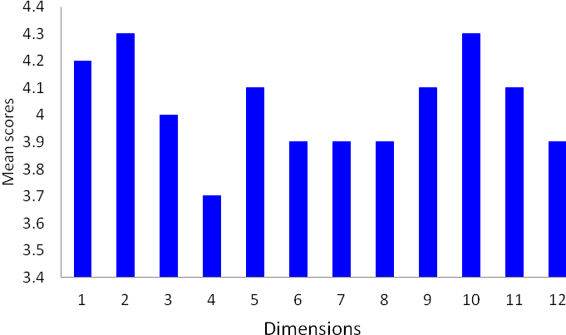

3.7.2 Institutional configuration map
Table 2.17 in Chapter 2 Appendix A is the actual institutional configuration map showing the 16 dimensions against which school leaders were asked to rate their school institutions. Table 3.39 in Appendix A shows the number and percentage of respondents evaluating the particular dimensions of their institution perceived as important to the sustainability of Te Kotahitanga.
Interestingly, and in line with the findings related to the leadership configuration map, in the eyes of the leaders, the area of their institutions most fully developed in supporting improvement of Māori student attendance, retention, engagement and achievement (AREA) by specified measures is that of the establishment of a clearly focused academic vision, goals and targets. Also, well established are:
- quality systems to identify Māori student attendance, retention, engagement and achievement that allow schools to monitor their progress over time and to inform our institutional responses
- demonstration of understanding that pedagogic (instructional) leadership has powerful effects on student outcomes and that such leadership is distributed throughout the institution
- systems for teachers to assist Māori learners to use evidence of their own progress in order to identify what they need to learn next.
In addition, a perception that pedagogies for improving Māori student learning and associated AREA are more and more a focus of the professional learning opportunities provided for teachers in the Phase 3 schools was highly rated. However, surprisingly given that this is a central focus of the project, this was not the highest rated item.
The item that received the lowest rating was the perception of teachers as able to approach lesson planning in a way based on their responding to a detailed understanding of Māori and other students’ progress and prior knowledge. Here leaders felt that only some teachers, and at best most— but never all—are beginning to develop such an approach. There was another item where leaders perceived that not all teachers used classroom pedagogy most conducive to Māori students’ learning. This item related to the regular use of a range of discursive teaching interactions, including using students’ prior knowledge, providing feedback and feed-forward and engaging in the co-construction of new knowledge with students.
One implication of these findings is that, if the leaders are correct in their perceptions, albeit that the project may be sustainable because the majority of teachers are supportive of it in many schools, there is still the potential for higher Māori student achievement if all, rather than some or most teachers were to plan their lessons in response to their understanding of the prior knowledge and progress of those students and if they were all to engage in a range of discursive teaching interactions on a regular basis.
Figure 3.33 below shows that 15 of the 16 areas of self-report were above 3.5 and thus quite positive.
Figure 3.33: Analysis of response to institutional configuration map for Phase 3
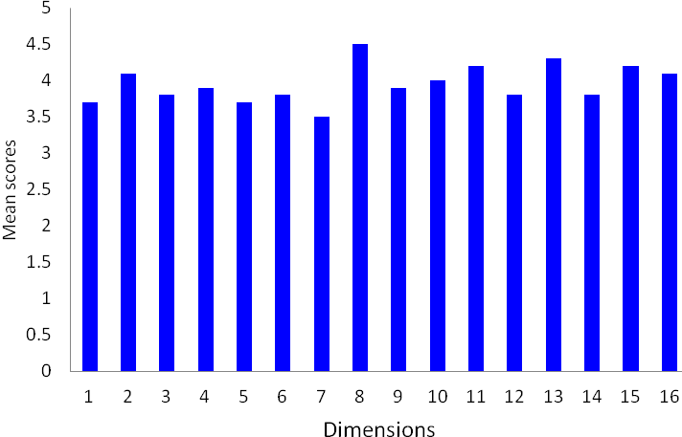

3.8 “State of the Nation” reports
One way to predict the sustainability of Te Kotahitanga in Phase 3 schools with a reasonable degree of accuracy is to track the challenges and success of the implementation of the project over time through the eyes of the lead facilitators and to evaluate the degree to which these have changed over time. In particular, it is important to see whether the challenges appear to be insurmountable or whether they have been overcome.

3.8.1 Challenges in project implementation, 2006 to 2010
Table 3.40 in Appendix A summarises the challenges reported by the lead facilitators at each of their annual hui, from 2006 through to 2010, in relation to their embedding of Te Kotahitanga in their own school.
In 2006 the challenge reported most often by the lead facilitators in the Phase 3 schools was that associated with achieving consistency among school institutions that were set up to support the project. For example:
Making sure our team are all on the same page and our communication lines are consistent and operating as best they can (School 3).
After three years will full groups being trained we have only trained half the staf (School 5).
Considering systemic changes such as timetabling and professional development meetings (School 12).
Issues related to leadership of the project were reported next most often. In two cases this referred to grappling with resistance from some teachers, as in School 3:
Resistance of a minority of teachers who have taken up far too much of our team’s time.
Next came the issue of effective use of data, data analysis and effective data management systems, for example:
Developing systems of effective data analysis re Māori student achievement to better inform our teaching practice and students’ learning.
By 2010, concerns about school institutions featured in all the schools that submitted information. In three cases this was related to funding and resources to support the programme. Otherwise concerns were linked more with maintaining the integrity of the professional development programme and the regularity of the cycle of associated activities.

3.8.2 Exciting things” data: 2006 to 2010
In 2006, what was reported most commonly as the most exciting initiative was the further development of school institutions to support the core business of the project (See Table 3.41 in Appendix A). For example, in:
increasing the size of our team ... collegial support networks across departments (School 3).
Our own survey in 2005 indicated that the Te Kotahitanga teachers appreciated the support the facilitation team gives them and they have indicated strong agreement with making Te Kotahitanga sustainable and fundamental to the learning culture at our school (School 4).
Spread—through the staff and in the surrounding community—was the next most commonly reported development. For example:
Whole involvement—came through in the teacher interviews (School 1).
We have developed pamphlets using information on the six key learning relationships and the principal is using these as the basis for whole staff PD [professional development] sessions once every 3 weeks (School 7).
Māori student achievement was noted as a point of celebration in five schools, and continued to be reported by numbers of schools in every report to 2010.

3.9 GPILSEO evidence from Education Review Office reports
The most recent reports on Phase 3 schools by the Education Review Office (ERO) were written at different stages of the development of the project when schools had been in the project for between four and six years. Schools have not been identified in this section to protect confidentiality. In all these schools, from 2007 there was favourable comment on change in pedagogy to some degree, again, as in Phase 4 schools, with a particular focus on positive relationship-building. In four schools, this was reported as a special strength of the school, and in all four this was overtly associated with Te Kotahitanga. In every school, also, there was some positive comment about leadership within the school, albeit much more in some than in others, as well as improvement in student achievement.
The reports from 2007 indicate that two of the schools had already experienced significant improvements in their students’ achievement and gone further than the other two in embedding aspects of GPILSEO. At one school in particular, clarity of goals in focusing on Māori students’ learning, changes in pedagogy, strength of leadership, spread and ownership of the project were all singled out for special mention, and most were attributed to the influence of Te Kotahitanga; for example:
Most teachers are enthusiastic about and supportive of the purpose and direction of Te Kotahitanga, and express confidence in the project aims that "teachers can make a difference". They have identified strategies for increasing student engagement and have appreciated the constructive feedback from facilitators and the challenges to deficit theories. Teaching practices are benefiting from the project's collegial planning and evaluation model (School 3).
The other two schools had seen some improvement in student outcomes, but, in general, the elements of GPILSEO were reported much less strongly.
The reports from 2009 indicate that three of the schools had witnessed significant improvements in students’ achievement. The reports of two of these schools highlight aspects of GPILSEO in the clarity of their goals in focusing on Māori students’ learning, the establishment of school institutions supportive of Māori students’ learning and achievement, strength of leadership, and ownership of the project more than in the other schools. At one school in particular, change in pedagogy was mentioned specifically, and was linked to the influence of Te Kotahitanga, for example:
Students, including Year 9 and 10 students, generally experience good quality teaching. All teachers have benefited from school-wide professional development in the principles and practices of Te Kotahitanga, which focuses on developing strong and meaningful relationships with students. Teaching and learning in the sample of classrooms visited by ERO was characterised by:
- respectful relationships between teachers and students, and amongst students, contributing to a positive tone
- clear routines and expectations for on-task learning, with generally good levels of engagement
- well planned, well resourced and well organised lessons
- teachers with information about students’ reading skill levels
- in senior classrooms, in particular, students having a good understanding of their course requirements and progress
- In some classrooms, students had good opportunities for collaborative learning and a variety of strategies were used to meet the learning needs of a diverse range of students (School 5).
By 2009, the issue of spread was being commented on positively in all schools, as was the use of evidence to support student learning gain. In the schools where improved student achievement received special mention from ERO, like the two schools in the 2007 reports, strong, effective leadership with a clear sense of purpose was also highlighted. For the most part this meant the principal, board of trustees and senior management of the school. For example, in the report about one school, ERO commented:
The principal provides strong leadership. She is experienced, has high expectations for staff and students, and continues to effectively promote the profile of the school in the wider community. Under her leadership there is a clear focus on raising achievement and there are many opportunities for girls to succeed.
The board is strongly committed to making sound financial provision for positive learning experiences for students. The school's strategic plan provides clear direction about educational priorities with a well articulated and agreed intention to improve levels of student engagement and achievement. Trustees, along with staff continue to place a high priority on the partnership that the school has with its community (School 1).
In the ERO reports of three schools, clear goals for Māori students’ achievement, strength and clarity of leadership and overall ownership of Te Kotahitanga were much less strong. In these same schools Māori student learning gain was less apparent also.
A summary of data from these ERO reports is attached as Table 3.42 in Appendix A.

3.10 References
Hall, G. & Hord, S. (2006). Implementing change: Patterns, principles, and potholes (2nd ed.). Boston, MA: Allyn & Bacon.
Hattie, J. A. C., Brown, G. T. L., Keegan, P. J., MacKay, A. J., Irving, S. E., Cutforth, S. (2004). Assessment tools for teaching and learning (asTTle) manual version 4 2005. Wellington, New Zealand: University of Auckland/Ministry of Education/Learning Media. http://legacy.tki.org.nz/r/asttle/pdf/manual/chapter-3-reporting.pdf, accessed September 10, 2010.
Lai, M. K., McNaughton, S., Timperly, H & Hsiao, S. (2009). Sustainability of effective teaching and school practices: Developing a model for sustaining and extending reading achievement. A summary. Wellington, New Zealand: NZCER.
Timperley, H., Wilson, A., Barrar, H. & Fung, I. (2007). Teacher professional learning and development: Best evidence synthesis iteration [BES]. Wellington, New Zealand: Ministry of Education.

Chapter 4: Replicating the gains: Phase 4

Summary of findings
Overall, the Phase 4 schools demonstrated that they had replicated the changes in teacher practice and student outcomes that were made earlier in Phase 3 schools.

Patterns of Māori student achievement
In Phase 4 schools in 2007–2009, Māori students’ achievement in the first three years of the implementation of Te Kotahitanga followed largely the improvement pattern of Phase 3 schools in the first three years of their participation of the project:
- In every analysis of asTTle gain scores in mathematics and reading in Years 9 and 10 in Phase 4 schools, Māori students’ achievement improved between pre- and post-tests.
- Although asTTle scores for non-Māori students were higher than for Māori students, Māori students improved as much as non-Māori students in later years.
- In 2007 and 2008, in mathematics and reading, Year 9 and Year 10 Māori students and non-Māori students improved equally in half of all comparisons. By 2009, Year 9 and Year 10 Māori and non-Māori students improved equally in the majority of all comparisons.
- Between 2008 and 2009, in terms of national comparisons, Year 10 Māori students in Phase 4 schools achieved a 50% increase in gain scores in asTTle reading assessments and had almost closed the gap to that of the national norm for all students in 2009.
- Māori students’ achievement in Phase 4 schools at NCEA Level 1 in Year 11, and in NCEA Level 2 in Year 12, showed a marked improvement. Year 11 Māori students in Phase 4 schools made twice the percentage point gain of the national cohort of Māori students at Year 11 in NCEA Level 1. Year 12 Māori students in Phase 4 schools also made a greater percentage point gain at NCEA Level 2 (9% higher) than the national cohort of Year 12 students.

Changes in Te Kotahitanga teachers’ classroom practices and discursive positioning
Changes in Te Kotahitanga teachers’ classroom practices in Phase 4 schools, as evidenced by data from the Observation Tool, included:
- for all cohorts a high level of relationships, maintained from Year 1
- a general increase in the use of discursive practice by term 4, 2009, relative to term 1 of the first year of participation
- a decrease in the percentage of time teachers spent at the front of the classroom in teachers’ first year of participation relative to the baseline
- an increase in the cognitive level of the lessons relative to the baseline, that was maintained across time
- an increase in the percentage of student engagement that was maintained across time; and maintenance of the high level of work completion by Māori students already established at baseline.

Perceptions of sustainability of the project
In terms of staff retention in the project, very few teachers withdrew from the project. Those few left mostly in the first year of membership.
Overall teachers and leaders reported positively on the sustainability of the project in their schools in the surveys.
Leaders were very positive in their self evaluations as leaders in Phase 4 schools and also in their evaluations of the systems and organisation supporting the project in their schools.

4.0 Introduction
Chapter 4 is concerned with the following question:
Did the Phase 4 schools replicate the changes in teaching practices and student outcomes during 2007 to 2009 that were made by Phase 3 schools during the period 2004 to 2006?
Three schools from the original cohort of 21 Phase 4 schools have been omitted from the discussions for the following reasons:
- One school withdrew from the project prior to three full years of project membership because the principal was concerned that the funding provided by the project was not adequate.
- By Phase 4 of the project, we had become fully aware of the importance of senior leadership in schools to the implementation of a school reform initiative such as Te Kotahitanga. Two schools had both experienced serious issues related to management at senior level during these three years. These issues prevented Te Kotahitanga from being implemented properly and therefore invalidated the project outcomes in these schools. (The concerns related to management at both schools are now a matter of public record.)
In this chapter we analyse changes in student outcomes in 18 of the Phase 4 schools, therefore, using data from asTTle assessments in reading and mathematics in Years 9 and 10, and NCEA Levels 1, 2 and 3. We also discuss changes in teacher practices in relation to the Effective Teaching Profile and in the levels of student engagement and work completion as evidenced in data collected through the Observation Tool. We go on to consider the degree to which teacher retention in the programme indicates likely maintenance of the project in schools. We then examine the extent to which the dimensions of the GPILSEO model appear to be embedded in these schools as evidenced in:
- the teachers’ and leaders’ surveys that were conducted in July–August 2010
- the configuration maps that identify principals’ and senior leaders’ perceptions of:
- their current position relation to school management
- the state of their own school structures and organisation with regard to sustaining improvements in Māori students’ engagement and achievement
- evidence from lead facilitators’ reports at their annual hui
- Education Review Office (ERO) reflections, in published school reports, on the influence of Te Kotahitanga on teachers’ practices.

4.1 Student outcomes
As for Phase 3 schools, in relation to overall student outcomes in Phase 4 schools, we hypothesised that, as a result of implementing the Effective Teaching Profile in classrooms:
- Māori students in Te Kotahitanga schools would show an improvement in their academic achievement
- their scores would start to approximate those of non-Māori students.
Two separate sets of calculations were therefore performed to compare Phase 4 Māori students’ achievements against:
- non-Māori students in their own schools
- national norms for asTTle points gain for all students.
Both hypotheses were supported:
- In every analysis of asTTle gain scores in mathematics and reading in Years 9 and 10 in Phase 4 schools, Māori students’ achievement improved between pre- and post-tests.
- Although asTTle scores for non-Māori students were higher than for Māori students, Māori students improved as much as non-Māori students in later years.
- In 2007 and 2008, in mathematics and reading, Year 9 and Year 10 Māori students and non-Māori students improved equally in half of all comparisons. By 2009, Year 9 and Year 10 Māori and non-Māori students improved equally in the majority of all comparisons.
- Between 2008 and 2009, in terms of national comparisons, Year 10 Māori students in Phase 4 schools achieved a 50% increase in gain scores in asTTle reading assessments and had almost closed the gap to that of the national norm for all students in 2009.
- Māori students’ achievement in Phase 4 schools at NCEA Level 1 in Year 11, and in NCEA Level 2 in Year 12, showed a marked improvement. Year 11 Māori students in Phase 4 schools made twice the percentage point gain of the national cohort of Māori students at Year 11 in NCEA Level 1. Year 12 Māori students in Phase 4 schools also made a greater percentage point gain at NCEA Level 2 (9% higher) than the national cohort of Year 12 students.

4.1.1 Reading and mathematics achievement in Years 9 and 10, 2007 to 2009
For the comparison with non-Māori students in Phase 4 schools, a repeated measures analysis of variance (ANOVA) on the pre- and post-test mathematics and reading asTTle scores for Māori and non-Māori students was performed for each testing schedule separately for the years 2007 to 2009. These results enabled us to see whether there was a general improvement from pre- to post-test and whether the differences in achievement were comparable between Māori and non-Māori students.
For the comparison with national norms, as noted in Chapter 3, we had to use norms for all students because there are no published norms for Māori students’ reading and mathematics means and gain scores in asTTle version 4 (personal telephone conversation with a member of the asTTle Help Desk, Friday 10 September, 2010). We therefore calculated gain scores post-post (i.e. end of one year to end of subsequent year) using Te Kotahitanga asTTle data for Year 10 Māori in Phase 4 for years 2008 and 2009. We then compared these with progress (gain scores) made by all students based on the national norms.

4.1.1.1 Results
As noted above, the outcomes of the asTTle analyses supported both our hypotheses, again as for Phase 3 schools:
- in half of the comparisons in 2007 and 2008, Māori and non-Māori were achieving the same. However, by 2009 for all four comparisons Māori students were achieving as well as non-Māori, except for Schedule 2 Year 9 mathematics and reading.
Specifically, in asTTle mathematics for Phase 4 schools:
- in 2007 and 2008, non-Māori students improved more than Māori students in half of the comparisons and in half they improved equally, however, by 2009 Māori and non-Māori students improved equally in three out of the four comparisons
- Year 10 Māori students achieved higher gain scores than the national norm for all students in asTTle mathematics assessments in both 2008 and 2009.
In asTTle reading:
- in 2008, in half of the comparisons non-Māori improved more than Māori, and in the other half they improved equally, but by 2009 Māori students and non-Māori students improved equally in the majority of all comparisons
- Year 10 Māori students achieved a 50% increase in gain scores in asTTle reading assessments between 2008 and 2009, and almost achieved the same level of gain scores as the national norm for all students in 2009.

4.1.1.2 Mathematics

2007
For Schedule 1, there was a significant test by ethnicity interaction for Year 9 and 10 students. Namely, both Years 9 and 10 non-Māori students improved significantly more than Māori students. Table 4.1 in Appendix A shows pre- and post-test scores for asTTle mathematics Schedule 1, 2007.
For Schedule 2, the difference in gain scores for Years 9 and 10 Māori and non-Māori students was not significant.
Results of two-way repeated measures ANOVAs can be found in Table 4.2 in Appendix A.

2008
For both Years 9 and 10 in Schedule 1, non-Māori students improved significantly more than Māori.
In Schedule 2, gain scores for Years 9 and 10 Māori and non-Māori students were not significantly different.
Table 4.3 in Appendix A shows pre- and post-test scores for asTTle mathematics Schedule 1 and Schedule 2, 2008. Results of two-way repeated measures ANOVAs can be found in Table 4.4 in Appendix A.

2009
Table 4.5 in Appendix A shows pre- and post-test scores for asTTle mathematics Schedule 1 and Schedule 2, 2009. For Schedule 2, Year 9 non-Māori students improved significantly more than Year 9 Māori students, but the difference in gain scores for Year 10 Māori students was not significant.
In Schedule 1, the difference in gain scores for Years 9 and 10 Māori and non-Māori was not significant.
These results can be found in Table 4.6 in Appendix A.

Comparison with national norms for all students
In terms of mathematics achievement, Year 10 Māori students achieved higher gain scores than the national norm for all students in asTTle mathematics assessments in both 2008 and 2009, as shown in Table 4.1 below.
Table 4.1: Year 10 Māori students’ asTTle gain scores in mathematics: comparisons with national norms for all students
Year level | Students | Gain score  2007-2008 | Gain score  2008-2009 | National gain score  (all students)
10 | Māori | 90 | 84 | 33

4.1.1.3 Reading

2007
Table 4.7 in Appendix A shows pre- and post-test scores for asTTle reading Schedule 1 and Schedule 2, 2007. For Year 10 in Schedule 2, non-Māori students improved significantly more than Māori.
For Year 9, Schedule 1 Māori students improved significantly more than non-Māori students.
The gain scores for Māori and non-Māori students were not significantly different for Year 10 in Schedule 1 or for Year 9 in Schedule 2.
Results of two-way repeated measures ANOVAs can be found in Table 4.8 in Appendix A.

2008
Table 4.9 in Appendix A shows pre- and post-test scores for asTTle reading Schedule 1 and Schedule 2, 2008. For Schedule 1 Years 9 and 10, non-Māori students improved significantly more than Māori students.
For Years 9 and 10 Schedule 2, gain scores for Māori and non-Māori were not significantly different.
These results of two-way repeated measures ANOVAs can be found in Table 4.10 in Appendix A.

2009
Table 4.11 in Appendix A shows pre- and post-test scores for asTTle reading Schedule 1 and Schedule 2, 2009.
For Year 9 students, Schedule 2 non-Māori students improved significantly more than Māori.
Gain scores for Years 9 and 10 Schedule 1 and Year 10 Schedule 2 for Māori and non-Māori students were not significantly different.
These results of two-way repeated measures ANOVAs can be found in Table 4.12 in Appendix A.

Comparison with national norms for all students
In terms of reading achievement, Year 10 Māori students improved their gain scores by 50% from 2008–2009, and almost reached the same level of improvement gain as all students as shown in Table 4.2:
Table 4.2: Year 10 Māori students’ asTTle gain scores in reading: comparisons with national norms for all students
Year level | Students | Gain score  2007-2008 | Gain score  2008-2009 | National gain score  (all students)
10 | Māori | 61 | 93 | 94

4.1.1.4 Summary of asTTle results
AsTTle mathematics and reading analyses revealed similar changes, over the three year period, for Years 9 and 10 students for both Schedule 1 and Schedule 2 assessments. In both schedules, although scores for non-Māori students were higher than for Māori students, in later years the improvement was of the same magnitude for non-Māori and Māori students. That is, they were following the pattern seen in Phase 3 schools.
In terms of comparisons with national norms for all students, Year 10 Māori students achieved higher gain scores than the national norm in asTTle mathematics assessments in both 2008 and 2009. They improved their gain scores in reading by 50% between 2008–2009, and almost achieved the same levels in achievement gain as the national norm.

4.1.2 NCEA achievement in Phase 4 schools, 2007 to 2009
As in Phase 3, the outcomes of the analyses of Māori students’ achievement in NCEA levels also support both our hypotheses about Māori students’ achievement in Te Kotahitanga schools:
- Māori students’ achievement in Phase 4 schools at NCEA Levels 1 in Year 11, and Level 2 and above in Year 12, shows a marked improvement between the years 2007, when Te Kotahitanga was first introduced, and 2009, when the first full cohort of students from these schools reached Year 11 and the Year 10 cohort of 2007 reached Year 12.
- Year 11 students in Phase 4 schools made twice the gain of the national cohort of Māori students at Year 11 in NCEA Level 1 and above, in terms of percentage points between 2007 and 2009. Year 12 Māori students in Phase 4 schools also made a greater percentage points gain at NCEA Level 2 and above than the national cohort of Year 12 students.

4.1.2.1 Year 11, NCEA Level 1
Across the 18 Phase 4 schools, there was an 8-point increase in the mean percentage of Year 11 Māori students gaining NCEA Level 1 during this time period. The increase in the national mean percentage of Māori students gaining this qualification over this period of time was 3.8 points; that is, the percentage points gain in Phase 4 Te Kotahitanga schools was double that in the national cohort of Māori in Year 11, as shown in Table 4.3.
Table 4.3: Year 11 Māori students NCEA Level 1, 2007 to 2009
 |  |  | Increase in percentage points (%)
Year | N | Achieved (%) | Te Kotahitanga schools | National cohort
2007 | 396 | 38.91 | 8.00 | 3.80
2009 | 484 | 46.91 | 8.00 | 3.80

In 2007, Māori students in Phase 4 schools achieved proportionately less at Year 11 than students in the national cohort. By 2009, the difference between achievement levels of Māori students in Year 11 in the national cohort and in Phase 4 Te Kotahitanga schools had reduced from about 5 percentage points to about 0.8 percentage points, as shown in Table 4.4 below.
Table 4.4: Achievement of Year 11 Māori students NCEA Level 1, Phase 4 and national cohort of Māori students
 | % NCEA Level 1 achievement in 2007, Year 11 | % NCEA Level 1 achievement in 2009, Year 11
National cohort | 43.90 | 47.70
Phase 4 schools | 38.91 | 46.91
Difference in % points | 4.99 | 0.79

A z-test for two proportions indicated that in 2007 there was a significant difference between the achievement of Year 11 Māori students at NCEA Level 1 and above in Phase 4 schools and the national cohort of students, where the national cohort did better (z value: 3.294, p<.01). By 2008, the same test indicates that the difference between the two groups was no longer significant (z = 1.324). In 2009, the difference between the groups was even smaller and, again, not significant (z = 0.647, p > .05).
The importance of these results is that, whereas in 2007, Year 11 Māori students NCEA results were significantly worse than the national cohort of Māori students, after one year this difference was no longer significant and after two years the difference had reduced again and was very small.
Figure 4.1: Trends in Year 11 Māori students’ NCEA Level 1 in Phase 4 Te Kotahitanga and all schools, 2007 to 2009

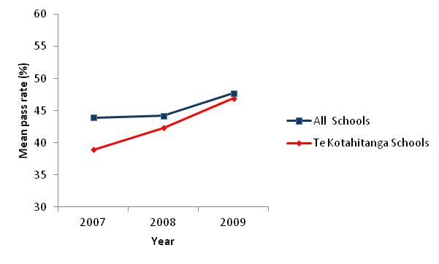
Results of the one-way repeated measures ANOVA revealed that the mean percentage of students who obtained NCEA Level 1 in Year 11 increased significantly over time, F (1,17) = 6.19, p = 0.005. Although the difference in percentages was not significant in consecutive years (e.g., 2007 vs. 2008), a t-test comparing percentages in 2007 and 2009 revealed a significant increase in the percentage of students who obtained NCEA Level 1 in Year 11, t(17) = 4.04, p = 0.001.
Figure 4.2: Increase in Māori students’ achievement in NCEA Level 1 at Year 11 in Phase 4 schools, 2007 to 2009
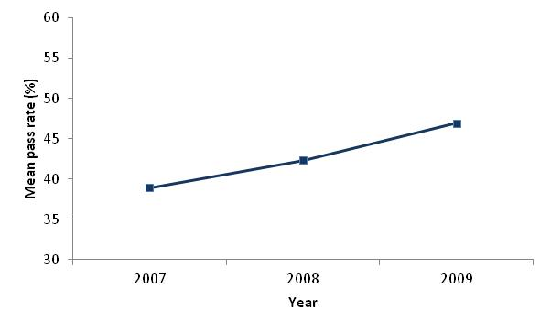
Table 4.5: Mean percentage, standard deviation and number of Māori students achieving NCEA Level 1, 2007 to 2009
Year | M (%) | SD | N
2007 | 38.91 | 10.36 | 18
2008 | 42.34 | 15.18 | 18
2009 | 46.91 | 12.30 | 18

The mean percentage of students who did not obtain NCEA Level 1 in Year 11 reduced from 56.2% to 52.4%, as indicated in Figure 4.3 below. However, this does not represent a statistically significant change over time, p >.05.
Figure 4.3: Reduction in percentage of Māori students not achieving NCEA Level 1 qualification at Year 11 in Phase 4 schools, 2007 to 2009
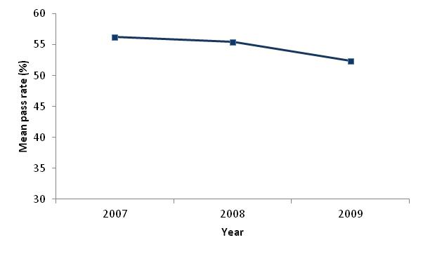
Between 2007 and 2009, the percentage of Māori students who did not achieve a qualification at NCEA Level 1 reduced by 3.8% in Phase 4 schools as shown below in Table 4.6.
Table 4.6: Mean percentage, standard deviation and number of Māori students not achieving NCEA Level 1, 2007 to 2009
Year | M (%) | SD | N
2007 | 56.21 | 11.51 | 18
2008 | 55.42 | 17.85 | 18
2009 | 52.36 | 13.67 | 18

A Wilcoxon Signed Ranks Test (see Table 4.13 in Appendix A) shows a significant reduction in the difference between the number of Māori students not gaining NCEA Level 1 in Year 11, and the number gaining it (p<.01).
Given that NCEA Level 1 is the first in the National Qualifications Framework, the importance for their future life chances of a significant increase in the proportions of Māori students gaining this qualification, and the clear reduction in the proportions of students failing to achieve this, cannot be overstated.

4.1.2.2 Year 12, NCEA Level 2 and above
In 2009, the first cohort of Year 10 students whose teachers had joined the Te Kotahitanga programme in 2007 reached Year 12. It is therefore worthwhile to report the Year 12 NCEA Level 2 and above results for 2009 in comparison with 2007.
As shown inTable 4.7 below, the percentages of Māori students gaining at least NCEA Level 2 in Year 12 in Phase 4 schools, rose from 46.98% in 2007 to 51.66% in 2009. This compares with national figures for Māori achievement of 49.3% and 52.8%. National figures therefore rose by 3.5 percentage points while Phase 4 figures rose by 4.7 percentage points. All data have been obtained from the Ministry (August, 2010).
Table 4.7: Year 12 Māori students’ NCEA Level 2, 2007 to 2009
Year | N | Achievement (%) | Increase in percentage points (%)
Year | N | Achievement (%) | Te Kotahitanga schools | National cohort
2007 | 298 | 46.98 | 4.70 | 3.50
2009 | 381 | 51.66 | 4.70 | 3.50

At the same time, there was an increase in actual numbers of Māori students achieving at least NCEA Level 2 in Year 12 of 27.9% (83 students), whilst the increase in numbers at national level for Māori was 18.5%.
Figure 4.4: Trends in Year 12 Māori students’ NCEA Level 2, in Phase 4 Te Kotahitanga and all schools, 2007 to 2009
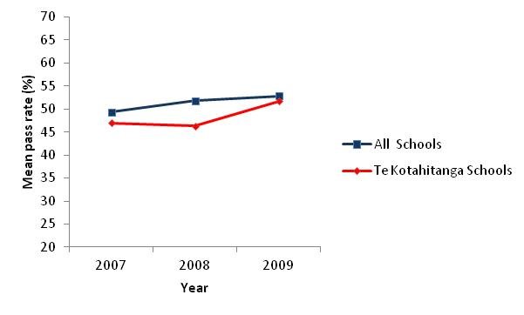
Table 4.8: Mean percentage, standard deviation and number of Māori students achieving NCEA Level 2, 2007 to 2009
Year | M (%) | SD | N
2007 | 46.98 | 18.49 | 18
2008 | 46.29 | 18.98 | 18
2009 | 51.66 | 13.92 | 18

Table 4.9: Mean percentage, standard deviation and number of Māori students not achieving NCEA Level 2, 2007 to 2009
Year | M | SD | N
2007 | 38.28 | 14.76 | 18
2008 | 34.97 | 14.92 | 18
2009 | 34.53 | 14.45 | 18

None of the ANOVAs was significant in terms of comparing the percentage of Year 12 students who did and did not obtain NCEA level in 2007, 2008, 2009 in Phase 4 schools. Further, t-tests comparing 2007 to 2009 were not significant either.

4.2 Changes in classrooms evidenced through the Observation Tool
As for Phase 3 schools (see Chapter 3), the changes that we report on here are:
- teacher–student relationships
- teachers’ discursive practices
- student–teacher location
- cognitive level of the class
- student engagement
- level of work completion.
In terms of:
- relationships, there was a significant increase in the level of relationships in all years relative to the baseline
- discursive practices, all cohorts started with a low percentage of use in term 1 and consistently increased the use by term 2, 3 and 4 in any one year
- student–teacher location, the percentage of time spent at the front of the classroom decreased over time relative to the baseline
- cognitive level, there was an increase in the level of class across time relative to the baseline
- Māori student engagement, the percentage increased significantly over time relative to the baseline
- level of work completion, the level was high at baseline, and remained high.

4.2.1 Measured change in teacher–student relationships
To investigate the quality of relationships associated with implementation of the Effective Teaching Profile, we hypothesised that:
- teachers will establish or maintain a high level of relationships during their first years of participation.
Results of a non-parametric Friedman’s related samples test and a Wilcoxon matched pairs signed ranks test (if Friedman was significant) for level of relationships supported our hypothesis (see Tables 4.14 and 4.15 in Appendix A.) There was a significant increase in the level of relationships in all years relative to the baseline. For teachers in the first cohort, this increase was maintained in years 2–3 and also for cohort 2 this increase was maintained in the second year of participation.
Figures 4.5 to 4.7 show the level of relationship for teachers in cohorts 1 to 3.
Figure 4.5: Shifts in levels of relationship for cohort 1 between baseline and years 2007 to 2009
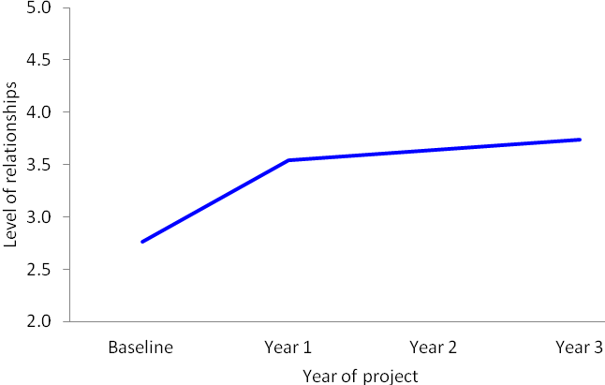
Figure 4.6: Shifts in levels of relationship for cohort 2 between baseline and years 2008 to 2009
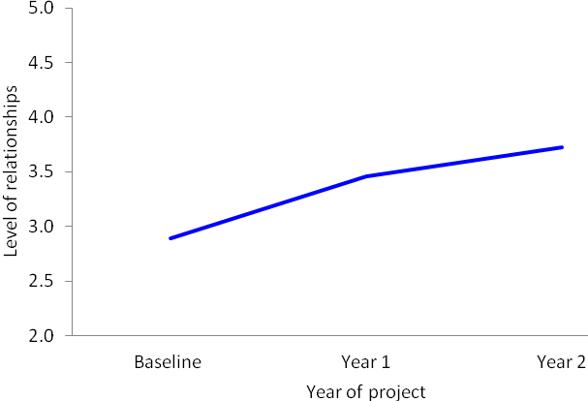
Figure 4.7: Shifts in levels of relationship for cohort 3 between baseline and 2009
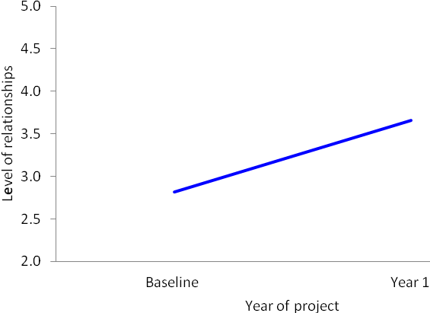

4.2.2 Discursive practice
To investigate the issue of the extent to which implementation of the Effective Teaching Profile in classrooms encourages greater use of discursive practices by teachers, we researched the following questions, as for Phase 3:
- How does the incidence of teachers’ discursive practice change from term to term within one school year?
- Does this pattern change in consecutive years?
- Is the overall pattern the same for each cohort?

4.2.2.1 Patterns of practice
As can be seen in Figure 4.8 below, a similar pattern of the use of discursive practices existed for each cohort over the years:
- All cohorts start with a low percentage of use of discursive practices in term 1 and consistently increase the use by terms 2, 3 and 4 in any one year. There is an overall increase from first observation after Hui Whakarewa to the most recent observation.
- This increase can be observed for all years (2007–2009) and all cohorts. Thus, there is a general increase in the use of discursive practices by term 4, 2009 relative to term 1 of the first year of participation.
Figure 4.8: Percentage of discursive practices for each cohort by term for all years of participation
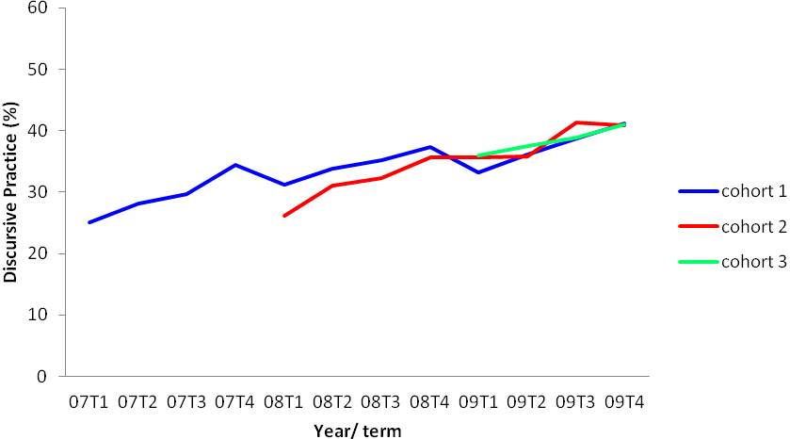
Discursive practice systematically decreased from term 4 to term 1 of the following year for cohort 1 only. This “summer slump” (Lai, McNaughton, Timperley, & Hsiao, 2009) is not apparent for cohort 2.

4.2.2.1.1 Patterns for low users of discursive practices (≤20%), 2004 to 2009
A subset of data for low users of discursive practices, was investigated to determine whether:
- the percentage of low users changed from term to term within one school year
- this pattern changed in consecutive years
- the pattern was the same for each cohort.
Table 4.16 in Appendix A illustrates the percentage of teachers by cohorts with 20% or less discursive practice by term for years 2007 to 2009. As can be seen in this table, there was a general decrease in the percentage of teachers using 20% or less discursive practice from term 1 to term 4 for each cohort in each year. Cohorts 1 and 2 show the same pattern for their first year of participation, starting at just over 40% in term 1 and decreasing their numbers of teachers using 20% or less discursive practice by 15% in term 4. The percentage of low users in cohort 3 is lower in their first year compared to the first years of cohorts 1 and 2, perhaps indicating a spill-over effect in the use of discursive practice for later cohorts. In 2009, all three cohorts show similar percentages of low users for each term.

4.2.2.2 Measured changes in discursive practice
To investigate whether the changes in the use of discursive practice had occurred by chance, or whether differences were significant and sustained, we hypothesised that:
- there would be an increase in the percentage of discursive practice relative to the baseline for cohorts 1–3 in the first three years of implementation of the project.
Results of a one-way repeated measures ANOVA for cohorts 1–2 and a paired samples t-test for cohort 3 can be found in Tables 4.17a, 4.17b and 4.18 in Appendix A.
Percentages of discursive practice for cohorts 1–3 are illustrated in Figures 4.9 to 4.11.
Figure 4.9: Shifts in discursive practice from baseline to 2007, 2008 and 2009 for cohort 1
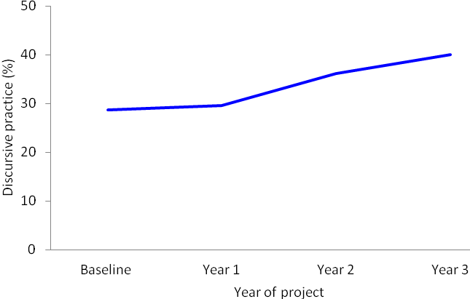
Figure 4.10: Shifts in discursive practice from baseline to 2008 and 2009 for cohort 2
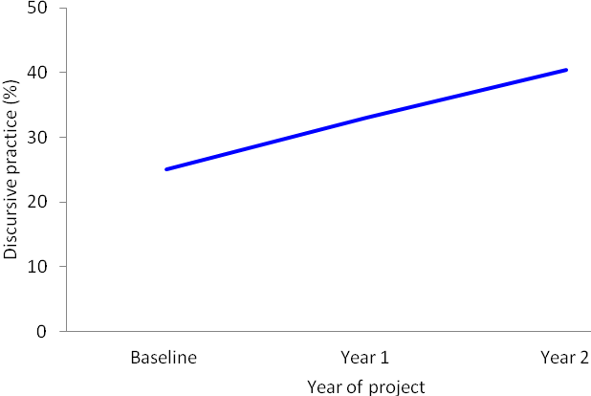
Figure 4.11: Shifts in discursive practice from baseline to 2009 for cohort 3
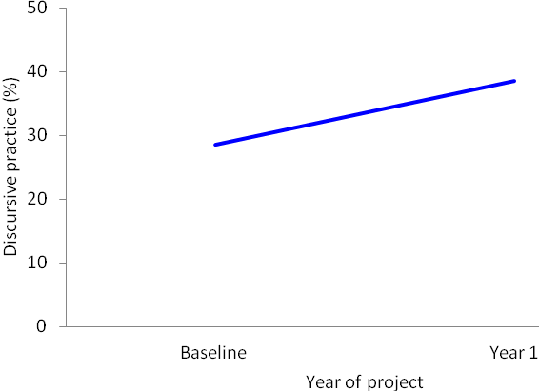
As hypothesised, the results for cohorts 1–3 revealed that there was a significant increase in discursive practice from baseline to all years of their participation, except for cohort 1 which did not show a significant change from baseline to year 1.

4.2.2.3 Measured change in incidence of whole-class interactions
We hypothesised that, with effective implementation of the Effective Teaching Profile in Phase 4 schools and with an increase in the percentage of discursive practices:
- there would be a decrease in the percentage of interactions with the whole class
- there would be a decrease in the percentage of interactions with the whole class relative to the baseline.
The calculation of a Pearson correlation coefficient was obtained for discursive practice and interactions with the whole class, shown in Table 4.19 in Appendix A (Descriptive statistics are attached as Table 4.20 in Appendix A).
The results indicate that there was a small-to-medium significant negative correlation between the percentage of discursive practice and the percentage of interactions with the whole class. A high percentage of discursive practice was associated with a low percentage of interactions with the whole class. This outcome was observed for all cohorts during all years.
Results of a one-way repeated measures ANOVA for cohorts 1 and 2 and a paired samples t-test for cohort 3 can be found in Tables 4.21 to 4.23 in Appendix A.
The percentage of interactions with whole class for cohorts 1–3 are shown in Figures 4.12 to 4.14.
Figure 4.12: Shifts in percentage of interactions with whole class for cohort 1 between baseline and 2007 to 2009
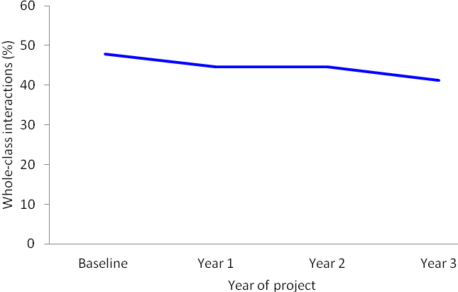
Figure 4.13: Shifts in percentage of interactions with whole class for cohort 2 between baseline and 2008 to 2009
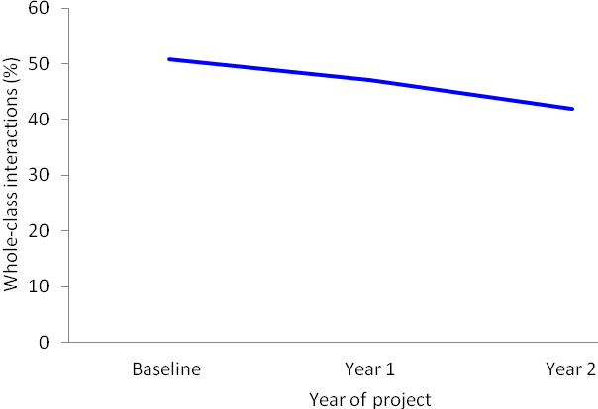
Figure 4.14: Shifts in percentage of interactions with whole class for cohort 3 between baseline and 2009
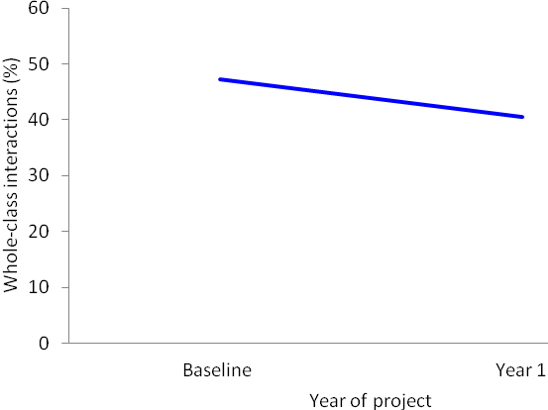
As hypothesised, for cohort 1 there was a marginal decrease in the percentage of whole class interactions in their third year of participation relative to the baseline. Results for cohort 2 revealed a significant decrease in their second year of participation relative to the baseline. Cohort 3 showed a significant decrease in the percentage of whole class interactions in their first year of participation relative to the baseline. These data show that the movement away from whole-class instruction towards more group and/or individual interactions was taking place consistently across all cohorts.

4.2.3 Measured change in student–teacher location
We hypothesised that an increase in teacher discursive practice would mean a decrease in the percentage of time a teacher is located in the front of the classroom relative to the baseline
First we examined shifts in student location in the classroom.
Table 4.24 in Appendix A shows the shifts of Māori students’ location analyses for cohorts 1–3.
Results of a one-way repeated measures ANOVA for cohorts 1–2 and of a paired samples t-test for cohort 3 can be found in Tables 4.25 to 4.26 in Appendix A.
These data, for Phase 4 schools, showed that there were no significant differences in the percentage of Māori students seated in the front of the classroom between the baseline and any other year of participation.
Then we looked at teacher location (see Table 4.27 in Appendix A for descriptive statistics.) Results of a one-way repeated measures ANOVA for cohorts 1–2 and of a paired samples t-test for cohort 3 can be found in Tables 4.28 and 4.29 in Appendix A. Figures 4.15 to 4.17 illustrate the percentage of time teachers were located at the front of the classroom for cohorts 1–3.
Figure 4.15: Comparisons between baseline and the first three years of participation for teacher location at the front of the class for cohort 1
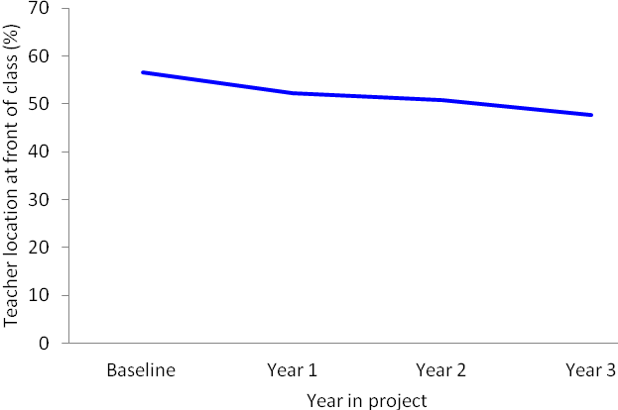
Figure 4.16: Comparisons between baseline and the first two years of participation for teacher location at the front of the class for cohort 2
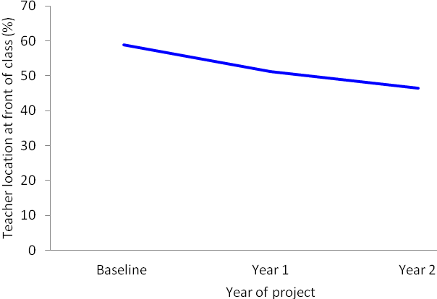
Figure 4.17: Comparisons between baseline and first year of participation for teacher location at the front of the class for cohort 3
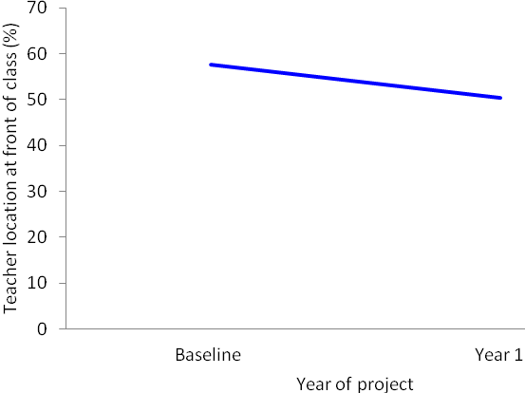
In accordance with our hypothesis, the percentage of time spent at the front of the classroom for cohort 1 teachers marginally decreased in their third year of participation relative to the baseline. Results for cohort 2 revealed a significant decrease in their second year of participation relative to the baseline. Cohort 3 showed a marginal decrease in the percentage of teachers located at the front of the classroom in their first year of participation relative to the baseline. The change in teacher location to other areas of the classroom means that students are more likely to be able to interact with teachers in groups or individually, a feature desired by Māori students in their narratives of experience (Bishop & Berryman, 2006).

4.2.4 Measured change in cognitive level of the class
We hypothesised that the implementation of the Effective Teaching Profile would result in teachers increasing the cognitive level of their teaching in the classroom.
Results of a non-parametric Friedman’s related-samples test for cohorts 1–2 and a Wilcoxon matched pairs signed-ranks test for cohort 3 can be found in Tables 4.30 and 4.31 in Appendix A.
The cognitive level of class for cohorts 1–3 are shown in Figures 4.18 to 4.20.
Figure 4.18: Shifts between baseline and the first three years of participation for cognitive level of class for cohort 1
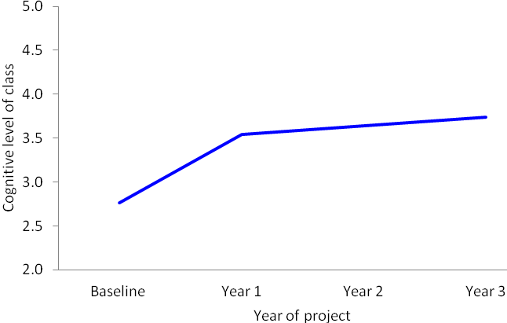
Figure 4.19: Shifts between baseline and the first two years of participation for cognitive level of class for cohort 2
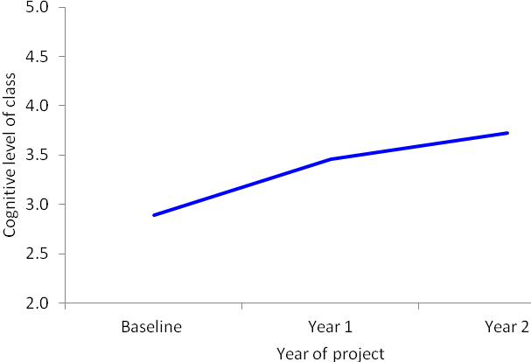
Figure 4.20: Shifts between baseline and the first year of participation for cognitive level of class for cohort 3
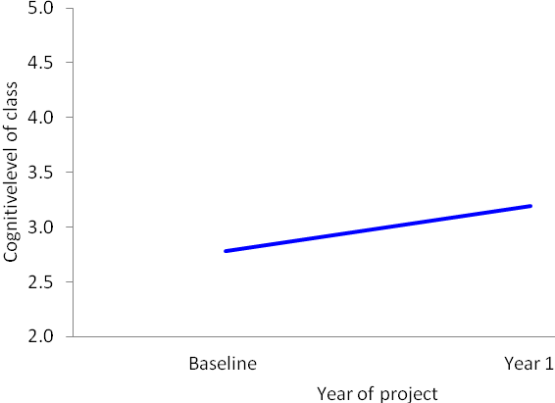
As hypothesised, there was a significant increase in the cognitive level of class for cohorts 1 and 3 in the first year of their participation relative to the baseline.

4.2.5 Measured change in student engagement
We hypothesised that, given an increase in discursive practice:
- there would be an increase in Māori student engagement in the classroom.
The results of a one-way repeated measures ANOVA for cohorts 1 to 2 and of a paired samples t-test for cohort 3 can be found in Tables 4.32 and 4.33 in Appendix A (Descriptive statistics are attached as Table 4.34 in Appendix A).
Figures 4.21 to 4.23 illustrate percentage of engagement for Māori students for cohorts 1 to 3.
Figure 4.21: Shifts between baseline and the first three years of participation for student engagement for cohort 1
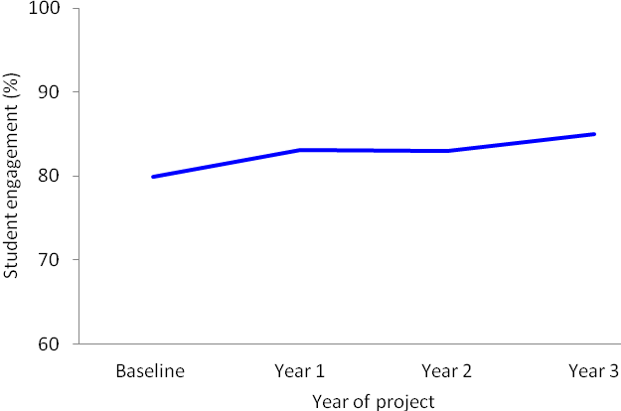
Figure 4.22: Shifts between baseline and term 3 of the first two years of participation for student engagement for cohort 2
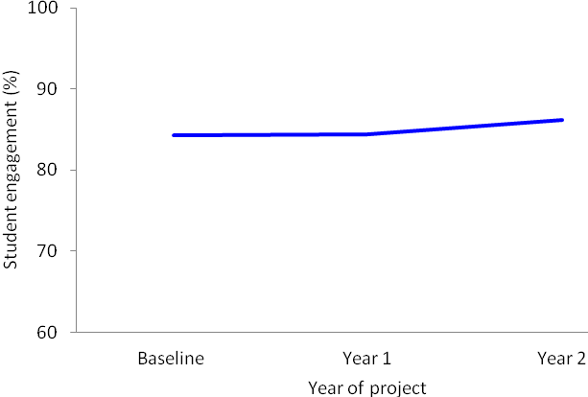
Figure 4.23: Shifts between baseline and the first year of participation for student engagement for cohort 3
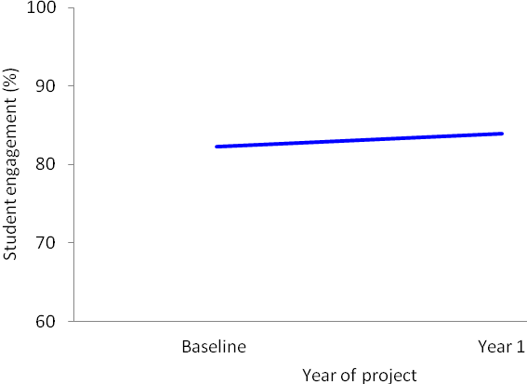
As hypothesised, the percentage of engagement for Māori students of cohort 1 teachers increased significantly in year 3 relative to the baseline. Data showed lack of significant changes for teachers in cohorts 2 and 3.
4.2.6 Level of work completion
In regard to work completion, we hypothesised that, with an increase in discursive teaching practice:
- there would be an increase in the level of work completion by Māori students.
Results of a non-parametric Friedman’s related-samples test for cohorts 1–2 and a Wilcoxon matched pairs signed-ranks test for cohort 3 can be found in Tables 4.35 and 4.36 in Appendix A.
Figures 4.24 to 4.26 below illustrate the level of students’ work completion for cohorts 1–3.
Figure 4.24: Shifts between baseline and term 3 of the first three years of participation for student work completion for cohort 1 classrooms
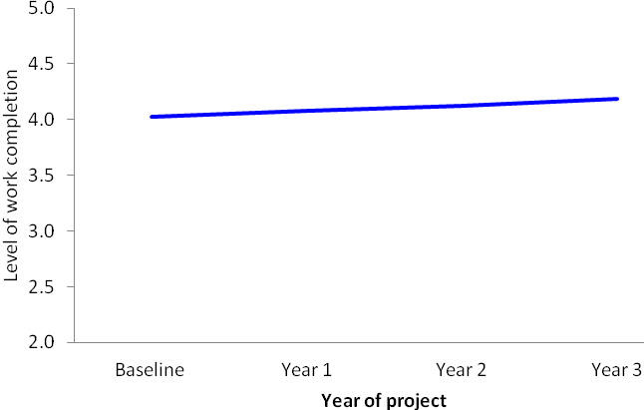
Figure 4.25: Shifts between baseline and term 3 of the first two years of participation for student work completion for cohort 2 classrooms
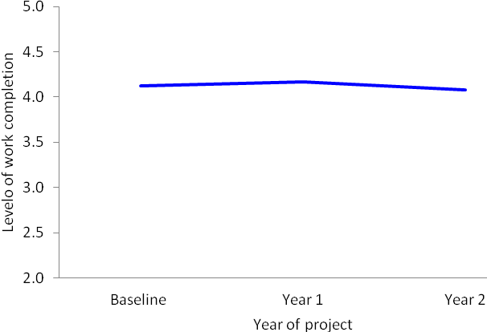
Figure 4.26: Shifts between baseline and term 3 of the first year of participation for student work completion for cohort 3 teachers’ classrooms
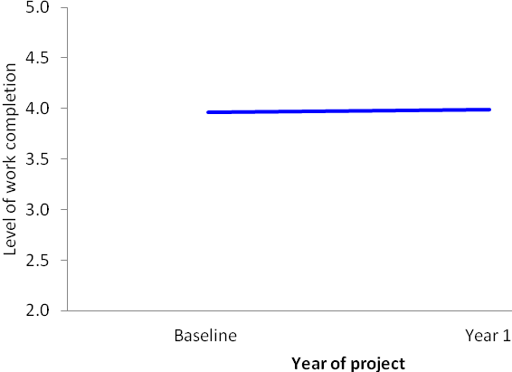
Data showed lack of significance in shifts for student work completion for all cohorts. This finding is not surprising given that work completion was high from baseline.

4.2.7 Summary of analysis of data from the Observation Tool
In our analysis of data from the Observation Tool we expected to evidence successful implementation and sustained practice of the Effective Teaching Profile through various measures of teachers’ and students’ performances. The main hypotheses were that implementing the Effective Teaching Profile would bring about:
- a change from mainly traditional to more discursive practices
- a change from whole-class interactions to more opportunities for individual students and/or group interactions
- a change in teachers’ location
- an improvement in caring relationships between teachers and students
- an increase in the cognitive level of the class
- an increase in Māori students’ engagement
- an increase in Māori students’ work completion.
Additional analysis of Māori students’ location in classrooms was conducted to examine possible changes in the seating location of Māori students in the classroom.
In relation to discursive practice and interactions with the whole class:
- For discursive practices, for cohort 1, results revealed a significant increase in the second year and for cohorts 2–3 in the first year of participation relative to the baseline. Both cohorts 1 and 2 maintained that increase in the following year. These results suggest that teachers adopted a significantly higher proportion of discursive interactions (i.e. co-construction, feed-forward academic positive, feed-forward academic negative, feedback academic positive, feedback academic negative, and prior knowledge) in their teaching.
- Teachers of cohorts 1–3 show the same patterns for their use of discursive practices for years 2007–2009:
- a steady increase from term 1 to term 4
- repeated pattern for each year of participation
- a drop over the summer break (for cohort 1 only)
- an overall increase from first observation after Hui Whakarewa to the most recent observation
- Further analyses revealed a steady decrease of the percentage of teachers using 20% or less discursive practice. The decrease is apparent from term 1–term 4 for all cohorts (e.g., for cohort 1 in 2007, a decrease from 43.6%–28.1%). This pattern is repeated in 2008 and 2009. At the end of 2009, the percentage of low users for cohorts 1–2 dropped to 14.1%–16.8% from 41.7%–43.6% at the beginning of participation. For cohort 3 the percentage of low users was 24.2% and dropped to 11.6%.
- Alongside the increase in the percentage of discursive practice, we observed a significant decrease in the percentage of interactions with the whole class relative to the baseline. For Phase 4, cohorts 2–3 showed a significant decrease in their second or first year of participation respectively and results for cohort 1 showed a marginal decrease in their third year.
- Further, analysis to test correlation between discursive practices and interactions with whole class revealed a small to medium association; that is, a high percentage of discursive practice, with a low percentage of interactions with the whole class. This outcome was observed for all cohorts in all years.
With regard to location of students and teachers in classrooms:
- The results on the seating location for Māori students showed that they occupy various locations within a classroom. For teachers in cohorts 1 to 3, we observed approximately one-third of Māori students being located at the front of the class. This percentage remained unchanged during all years of participation.
- In respect of teachers’ location in the classroom, results indicated a significant shift for teachers in cohort 2 in their second year of participation. In general teachers for all cohorts spend approximately 50% of their time moving throughout the classroom while the other 50% is spent in the front of the classroom.
Regarding relationships in classrooms:
- A significant improvement relative to the baseline was observed for the relationships between teachers and Māori students. For all cohorts in all years following the baseline observation, we observed strong evidence that teachers cared for their Māori students, had high expectations for their learning performance and behaviour, and generally developed more culturally appropriate teacher–student relations.
For the cognitive level of the class:
- Results for teachers in cohort 1 and cohort 3 revealed a significant shift from baseline to the first year of participation. The increase was maintained for teachers in cohort 1 in the following years. In 2009, the cognitive level for all cohorts was at approximately 3.2.
In regard to Māori student engagement and work completion:
- Cohort 1 showed, for student engagement, a significant increase in the third year of participation. For cohorts 2 and 3 the percentage of student engagement was high from the onset (82%–84%) and remained high in the following year(s) (84% to 96%). For all cohorts, work completion was between 79% and 82% at the beginning and remained unchanged.
Overall, therefore, for Phase 4 schools, data from the Observation Tool indicate strong implementation of the Effective Teaching Profile in most cases.

4.3 Retention of staff in Phase 4 of the Te Kotahitanga programme
In terms of maintaining Te Kotahitanga-trained teachers in Phase 4 of the programme, of the original 1,273 members of the project in cohorts 1–3 in Phase 4, 932 remained in term 4, 2009.
Overall, of the total numbers of teachers who joined cohort 1 of the programme, (N = 658), 66% remained in term 4, 2009 (see Table 4.37 in Appendix A). Approximately:
- 5% had withdrawn from the programme at some point
- 31% had left the schools
- 1% had withdrawn from the programme and then returned.
It is very noticeable that very few teachers, 5%, had withdrawn from the project by term 4, 2009. Withdrawal had taken place mostly in the first year of membership. Of these, 25% subsequently returned to the project. There were far more staff resignations from the schools, reflecting the usual pattern of staff turnover (204 by term 4, 2009), than withdrawals.
Cohort 2 teachers in Phase 4 show a very similar pattern of withdrawals and resignations from the schools. Only 2% of the original total withdrew and 1.5% then returned.
Again in cohort 2, resignations from these schools (25% of original) were in far greater numbers than withdrawals from the project (2%).
Cohort 3 began in the project at the end of 2008 or the beginning of 2009, so it is hardly surprising that retention figures are very high (1% withdrawal; 7% resignation).

4.4 Teachers’ survey, July to August 2010
An electronic survey of teachers was conducted between July and August of 2010. A summary of the teachers’ survey responses is given below. The complete analysis is attached in Appendix B as Survey Analysis 1.
About 30% of teachers in the project (from 12 of the 18 Phase 4 schools) responded to the survey. Questions were compiled around the GPILSEO process (see Chapter 2 for details of questionnaire design and construction).
A summary of teachers’ responses to the survey is set out below. The complete analysis is attached as Survey Responses 1 in Appendix B.

4.4.1 Goals
Questions 1 to 8 related to goals. Where the Likert scale was used, 1 represents “strongly agree”, 2: “agree”, 3: “disagree” and 4 “strongly disagree”.
Across all groups of teachers in Phase 4, there was a clear perception that the two groups who had contributed the most strongly to setting the goals were, in this order of contribution: facilitators (91.09%% agreement) and teachers themselves (78.22% agreement). For most respondents next in importance were the senior management team (44.55% agreement) and principals (43.56 agreement). Next came heads of department (34.65 agreement); heads of faculty (15.84% agreement) and lead facilitators (13.86% agreement).
With an overall mean of 1.97—that is, “agree” (mode: 2)—it would seem that teachers generally are confident in their perceptions that, currently, Phase 4 schools have both the vision and the means to improve Māori student achievement. However, they are least certain that goals are being shared with the Māori community.

4.4.2 Pedagogy
Questions 9 to 19 related to pedagogy.
Again, there was a very positive response from teachers at all levels of experience in the programme in relation to the degree to which they, as teachers:
- were actively involved in professional learning associated with Te Kotahitanga
- were able to apply the principles and practices of Te Kotahitanga to the classes they taught (mean: 1.75; mode: 2).
With an overall mean of 1.82—that is, between “strongly agree” and “agree” (mode: 2)—it appears that Phase 4 teachers generally feel that they have the opportunity to access Te Kotahitanga-related professional development, and do so, and that, generally, they put the Effective Teaching Profile into effect in their classrooms.
Comments about the support for improved classroom practice and critical reflection on student outcomes since becoming a member of Te Kotahitanga were almost all related to the professional development cycle. A few respondents (2) also mentioned professional learning groups, personal study and other in- and out-of-school school professional development activities.

4.4.4 Institutions (systems and structures)
Questions 20 to 28, 53 to 62, and 65 to 67 refer to the institutions (systems and structures) in the school that support Te Kotahitanga.
The mean number of times of classroom observations by a facilitator was reported as varying in accordance with the length of time teachers had been members of the project.
Teachers’ feedback and attendance at co-construction meetings similarly, also varied by length of experience in Te Kotahitanga.
In Phase 4, with the reducing funding model, some of the larger schools that had employed a large team to cover the numbers of teachers matched the reduction of funding with a reduction in the size of their facilitation teams. In order to do this, those schools tended to curtail the observation and feedback cycle. Co-construction meetings were often seen as an important means of maintaining a focus on Māori students’ achievement.
The aspect of the professional development cycle that occurred less frequently was shadow coaching, with virtually the same number of sessions irrespective of length of experience in the project.
The most effective components of the Te Kotahitanga professional development cycle were identified as: feedback sessions (82.18%), classroom observations (65.35%), co-construction meetings (57.43%), shadow coaching (26.73%).
The components of the Te Kotahitanga professional development cycle considered to be essential aspects of any future professional development programme in schools were, in the following order: classroom observations (70.30%), feedback sessions (68.32%), co-construction meetings (64.36%), and shadow coaching (30.69%). This finding is ironic given that schools maintained co-constructions rather than observations and feedback when central funding for the programme was reduced.
Overall comments about the professional development cycle were extremely positive. Reasons the various components should become permanent were mostly concerned with the opportunity for personal reflection on classroom practice following objective observation and constructive feedback based on clear evidence from a respected peer, and the chance to share ideas and experiences of good and effective practice with others in a safe environment. One teacher example reads: “Having the opportunity to regularly reflect on your practice in a safe environment in which you can get help with developing as a teacher is vital. Co-construction enables cross-curricular support and has the potential to help us more effectively target the individual needs of students”.
Most respondents reported that the school timetable had changed to allow for feedback sessions and/or co-construction meetings within school time (mean: 1.79; mode: 1). It was reported that times, agenda and purposes of meetings were not well clarified, however (overall mean for all levels of experience: 2.38; mode: 3).
Overall, there seems to be some lack of certainty about whether staff promotion procedures now take account of personal engagement with raising the standard of Māori students’ learning and achievement in all schools (mean: 2.16, mode: 1 for those in the project 1–2 years; mean: 1.93, mode: 1 for those in the project 3–5 years; mean 1.77, mode: 1 for those in the project 6-plus years).
Respondents did not feel overall that school policies related to discipline were particularly well focused on supporting students’ learning and achievement yet (overall mean: 2.22, mode: 3) or that policies related to student streaming/banding had been designed to support students’ learning and achievement (overall mean: 2.17, mode: 1). Having said this, however, there was some difference between the means for the individual groups of respondents with respect to this question (mean: 2.20, mode: 3 for those in the project 1–2 years; mean: 1.83, mode: 1 for those in the project 3–5 years; mean 2.08, mode: 1 for those in the project 6-plus years).
Te Kotahitanga goals were not yet included in department’s plans as a general policy (overall mean: 2.67, mode: 3). Nor were Te Kotahitanga goals regularly included in the school’s plans in the eyes of most respondents.
The findings in relation to school institutions above imply that there is much work still to be done to ensure that the focus on improvement in Māori students’ learning and engagement should be clear at every level in the school: whole school, departments and classrooms. See Chapter 5 for discussion of the introduction of leadership construction meetings by the Te Kotahitanga Research and Development team in terms 3 and 4 of 2010 to address these issues at the level of school-wide systems and structures (institutions).

4.4.5 Spread
Questions 29 to 35 refer to the spread of Te Kotahitanga around the school and beyond.
A good number of respondents felt that relationships with Māori parents and communities had changed in the past few years. For example, 44 respondents felt that Māori families and whānau were more actively involved with the children’s education for a whole variety of reasons. Schools were seen to be making a greater effort to go out into the community, to contact families for positive reasons as well as negative, to share children’s successes with families and whānau and to invite parents into schools, for example through the establishment of whānau hui. The result was that families felt more comfortable coming into schools to discuss their children’s progress.
On the other hand, teachers were not very positive about:
- being in touch with external networks so as to enhance Te Kotahitanga practices inside the school (mean: 2.86; mode: 3) or
- being involved in sharing the outcomes of the combined efforts to improve Māori students’ learning and achievement with Māori parents and community members on a regular basis (mean: 2.70; mode: 3).

4.4.6 Evidence
Questions 36 to 41 and 63 to 64 refer to the use of evidence in schools to support the improvement of Māori students’ learning and engagement.
Overall, respondents were very positive about their use of evidence and the systems in place to:
- inform their responses to Māori students' educational needs (mean: 1.88; mode: 2)
- inform changes in their teaching practice (mean: 1.72; mode: 2)
- share progress with students so that students can better determine their next learning steps (mean: 1.82; mode: 2).

4.4.7 Leadership
Questions 45 to 52 referred to leadership of the facilitation team in the respondents’ schools.
Overall respondents felt that the facilitation teams in their schools were mostly effective in terms of:
- providing and participating in teacher learning and development (mean: 2.12; mode: 2)
- engaging in constructive problem talk (mean: 2.20; mode: 2).
Responses to the following two items were the least positive in this group:
- creating powerful connections to the Māori community to support Māori students’ learning and achievement (mean: 2.60; mode: 3)
- selecting, developing and using smart tools for supporting improved learning and achievement for Māori students (mean: 2.42; mode: 3).

4.4.8 Ownership
Questions 42 to 44 and question 68 referred to ownership of Te Kotahitanga within the school.
Forty-six respondents commented on the way that data collection in their school had changed to focus more clearly on the progress of individual students, Māori in particular. However, a few noted that this was associated with directives from the Ministry of Education as much as Te Kotahitanga.
Ways in which respondents felt that the collection and processing of student outcome data needed to change to support the improvement of Māori students’ learning and achievement further included:
- improving accessibility so that staff, students and parents could understand the data (7)
- targeting individual learning needs and goals of students (1)
- sharing data more consistently with students to monitor progress and challenge them to reach higher (4)
- having more consistent and accurate analysis of relevant data at departmental as well as school level to track students’ progress and focus on supporting teachers in need (9).
Some of the changes that had occurred in the overall culture of the school since respondents had been part of Te Kotahitanga were:
- more staff sharing the same viewpoint and engaging in professional conversations about practice (7)
- more collaborative working between staff (6)
- better relationships between students and staff (9)
- greater emphasis on promotion, use and celebration of Māori culture and language (15).
The most useful thing respondents felt they had done to ensure that the gains made in Māori students’ learning and achievement in their classroom were maintained, were:
- ensuring a positive and friendly relationship with all students (23)
- recognising each student as an individual (4)
- varying teaching methods and incorporating new pedagogies (7)
- creating a respectful environment and a culture of achievement (7)
- continuing personal reflection and professional learning (4).

4.5 Leaders’ survey, July–August, 2010
In total, there were 89 valid responses from leaders in the Phase 4 schools: 16 principals, 12 APs/DPs, 40 HoDs/HoFs/Deans, 20 lead facilitators/facilitators (in this section referred to as facilitators) and one other. As with the teachers’ survey, questions were compiled around the GPILSEO process (see Chapter 2 for details of questionnaire design and construction).
A summary of leaders’ responses to the survey is set out below. The complete analysis is attached as Survey Responses 2in Appendix B.

4.5.1 Goals
Questions 1 to 9 related to goals. Where the Likert scale was used, 4 represents “strongly disagree”; 3: “disagree”, 2: “agree”; and 4 “strongly agree”.
Overall, there was a very positive response (mean: 1.82; mode: 2) from Phase 4 leaders in relation to the degree to which their schools have set goals for Māori students achievement and created systems to support their realisation.
There was general agreement from all groups that these schools shared their goals with the Māori community but overall ratings were lower than the items above that referred to in-school activities (mean: 2.3). Principals were the most confident (mean: 1.9; mode: 2) and facilitators the least (mean: 2.35; mode: 2).
Systems set up for reaching these goals were variously described as:
- the professional development cycle: 50 total: principals and APs/DPs: 13; HoDs/HoFs/deans: 24; facilitators: 13
- a more focused collection and use of evidence/data: 26 total (principals and APs/DPs: 10; Hods/HoFs/deans: 9; facilitators: 7)
- academic interviews/mentoring programme/homework centre: 10 total (principals and APs/DPs: 7; HoDs/HoFs/deans: 1; facilitators: 2)
- a focus on culturally appropriate practices: 5 total (principals and APs/DPs: 2; HoDs/HoFs/deans: 3)
- a focus on rejecting deficit theorising: 1 total (principals and APs/DPs: 1)
- strategic planning/timetabling to include departments: 43 total (principals and APs/DPs: 18; Hods/HoFs/deans: 14; facilitators: 11)
- school annual plan/timetabling to include whole school: 17 total (principals and APs/DPs: 9; HoDs/HoFs/deans: 3; facilitators: 5).
There was an interesting difference of opinion over who it actually was that helped to set the schools’ goals:
- Principals felt it was principals (100%), the senior management team (93.8%), teachers (81.25%) and facilitators (62.57%), with much less contribution from other groups.
- APs and DPs thought it was facilitators (91.7%), the principal and senior management team (75%), teachers (67%) and the board of trustees (58.33%), with minor contributions from others.
- HoDS, HoFs and deans reported it was the facilitators (95.0%), teachers (74.2%), the principal (50.0%) and the senior management team (47.55%), and little from others.
- Facilitators reported that it was the principal and teachers (75.0%), the senior management team (65%), and facilitators (60%).
- Leaders’ responses to the question of the way in which school goals are set suggest that there are two different approaches to this. Through one, the goals are drafted by the principal/senior management team and then put out for consultation, as exemplified by the comments of one principal: “Draft goals were given to all staff as developed by SMT [senior management team] and teachers had an opportunity for input before the final development plan was put together.” The other approach appears to function the other way round; for example another leader suggested: “Essentially our goal is to raise Māori achievement in the school. For setting the ‘big’ goal, this was done at the Te Kotahitanga hui at the beginning and involved half of our staff, including some HoDs, HoFs, etc.” It is not possible to categorise the responses clearly enough to work out exact proportions, but it seems clear that the first method predominates.

4.5.2 Pedagogy
Questions 10 to 25 related to pedagogy.
There was a very positive response generally from leaders at all levels about active involvement in Te Kotahitanga and the degree to which they, as leaders:
- were actively involved in professional learning associated with Te Kotahitanga
- could apply its principles to new circumstances as they arose in the school (mean: 1.7; mode: 2).
Overall, leaders were fairly confident, but less certain than in their responses above, that teachers in their schools:
- had developed in-depth knowledge of the theoretical principles of Te Kotahitanga
- could apply these principles flexibly in their classrooms.
The majority of leaders felt that their support of teachers to improve their classroom practice had changed since their school had been part of Te Kotahitanga. Overwhelmingly, school leaders reported (principals: 14; APs/DPs: 12; HoDs/HoFs/deans: 12; facilitators: 18) that they were committed to supporting teachers improve their classroom practice by embedding elements of the Te Kotahitanga professional development cycle within their schools. Many of the schools leaders reported that clearer school-wide goals that focused on Māori student achievement and the use of evidence were now being used to inform teacher practice.

4.5.3 Institutions (systems and structures)
Questions 26 to 30, and 63 to 88 refer to the institutions (systems and structures) in the school that support Te Kotahitanga.
Components of the Te Kotahitanga professional development programme that these leaders had found to be the most effective in helping teachers to improve their classroom practice were: feedback sessions (86.52%), classroom observation (73.03%), co-construction meetings (70.79%), shadow coaching (49.4%). Interestingly, all groups individually rated these elements of the professional development cycle in the same order of importance.
The components of the professional development cycle that they felt should become a permanent part of their school’s professional development programme were: classroom observation (78.65%), co-construction meetings (78.65%), feedback sessions (77.53%), shadow coaching (56.52%). The element that had the lowest rating across all groups was shadow coaching.
Explaining why these components should become permanent:
- five principals, seven APs/DPs, 18 HoDs/HoFs/deans and 11 facilitators mentioned their potential for changing teachers’ classroom practices
- five principals, one AP/DP, 3 HoDs, and three facilitators commented on the direct effect of the professional development cycle on Māori students’ learning and achievement.

Leadership
Questions 31 to 35, and 55 to 62 refer to leadership in the school that supports Te Kotahitanga.
Leaders were confident that they ensured that:
- all staff they were responsible for had the opportunity to participate fully in Te Kotahitanga (mean: 1.4, mode: 1) and that
- all teachers they were responsible for were able to apply the principles and practices of Te Kotahitanga in their classrooms (mean: 1.7, mode: 2).
Asked what they would do differently in supporting the implementation and/or spread of Te Kotahitanga in their school if they were to start again, leaders gave a range of different answers, including that they would:
- make it compulsory from the beginning: (2 principals, 3 AP/DPs, HoD/HoF/deans)
- take more time to cover the theory with all staff (2 principals, 2 facilitators)
- ensure full support of the senior management team, who should understand Te Kotahitanga and work with the lead facilitator (AP/DP, 6 facilitators)
- integrate Te Kotahitanga programme with curriculum leadership (3 HoD/HoF/deans, 3 facilitators).

Spread
Questions 17, 36 to 38, and 89 refer to the spread of Te Kotahitanga in the school.
The vast majority of respondents felt that Te Kotahitanga had spread within the school since they had joined.
The majority of principals and facilitators reported themselves as networking with leaders in other schools in relation to Te Kotahitanga, but few of the other groups reported this, as might be anticipated in relation to their roles in the school.

Evidence
Questions 39 to 52 refer to the schools systems in relation to evidence about Māori students’ achievement and attendance.
The vast majority of leaders perceived that the collection and processing of student outcomes data had changed since the school had been part of Te Kotahitanga. Fifty-three respondents commented on the way that data collection in their school had changed to focus more clearly on the progress of individual students, Māori in particular.
However, a majority of HoDs/HoFs/deans also felt that the collection and processing of student outcome data needed to be improved. Ways in which respondents felt that the collection and processing of student outcome data needs to change to support the improvement of Māori students’ learning and achievement further included:
- improved user-friendliness so that staff, students and parents can understand the data (11)
- more consistent and accurate analysis of data at departmental level (5).

Ownership
Questions 53 to 54 refer to the schools’ ownership of Te Kotahitanga.
The majority of respondents reported that they had adapted the core practices of Te Kotahitanga in their school, in the following ways:
- incorporating Te Kotahitanga into collective school-wide achievement plans and goals; i.e., annual plans (principals/DPs/APs: 1; HoDs/HoFs: 5; facilitators: 1)
- varying co-construction meetings (e.g., extending Te Kotahitanga from core classes to departments to whole school to duration in time and frequency) (principals/DPs-APs 5; HoDs/HoFs 1; facilitators: 8)
- aligning and linking Te Kotahitanga to other initiatives such as Restorative Justice and Academic Counselling (principals/DPs/APs 3; HoDs/HoFs: 1).
The majority of respondents also reported that the overall culture of the school had changed since they had been part of the project. Some of the changes that had occurred in the overall culture of the school since respondents had been part of Te Kotahitanga were:
- a more inclusive style of teaching with less deficit theorising (18)
- more awareness of Māori students’ needs (5)
- better relationships between students and staff (7)
- greater emphasis on promotion, use and celebration of Māori culture, language and students’ achievement (9).

4.6 Configuration maps
As noted already in Chapter 2, leadership and institutional configuration maps were completed by Phase 4 school leaders at the leadership hui in May, 2010. They provide an important indicator of the perceptions of these school leaders for embedding of the project in their own institutions.

4.6.1 Leadership map
Table 4.10 below shows the number and percentage of respondents at each level of self-evaluated confidence and competence in the areas of leadership deemed by Phase 4 leaders to be important to sustainability of the project.
Table 4.10: Leadership Configuration Map Phase 4 May 2010, N = 19
Dimensions of leadership | Ratings, 1–5 |  |  |  |  |  |  |  |  |  | Mean
Dimensions of leadership | 5 |  | 4 |  | 3 |  | 2 |  | 1 |  | Mean
1 | 3 | 15.8% | 12 | 63.2% | 3 | 15.8% | 1 | 5.3% | 0 | 0% | 3.9
2 | 3 | 15.8% | 14 | 76.7% | 2 | 10.5% | 0 | 0% | 0 | 0% | 4.1
3 | 5 | 26.3% | 10 | 52.6% | 3 | 15.8% | 1 | 5.3% | 0 | 0% | 4
4 | 2 | 10.5% | 6 | 31.6% | 8 | 42.1% | 1 | 5.3% | 0 | 0% | 3.2
5 | 3 | 15.8% | 13 | 68.4% | 2 | 10.5% | 1 | 5.3% | 0 | 0% | 3.9
6 | 1 | 5.3% | 7 | 36.8% | 9 | 47.4% | 2 | 10.5% | 0 | 0% | 3.4
7 | 0 | 0% | 5 | 2.6% | 13 | 68.4% | 1 | 5.3% | 0 | 0% | 3.2
8 | 1 | 5.3% | 10 | 52.6% | 7 | 36.8% | 1 | 5.3% | 0 | 0% | 3.6
9 | 2 | 10.5% | 9 | 47.4% | 5 | 26.3% | 2 | 10.5% | 0 | 0% | 3.4
10 | 4 | 21.1% | 10 | 52.6% | 5 | 26.3% | 0 | 0% | 0 | 0% | 3.9
11 | 7 | 36.8% | 9 | 47.4% | 3 | 15.8% | 0 | 0% | 0 | 0% | 4.2
12 | 2 | 10.5% | 12 | 63.2% | 5 | 26.3% | 0 | 0% | 0 | 0% | 3.8

In Phase 4, the two areas where principals felt most confident were:
- their ability, either fully developed or developing, to inspire and motivate others to achieve a common vision, as evidenced by the establishment of a group committed to implement it
- their strategic allocation of resources, which thus demonstrated their ownership of the goals of the institution.
Another area in which leaders were very confident, or were becoming confident, was in their own support for the implementation of discursive pedagogic relationships and interactions in the classroom, including assisting with planning, coordinating and evaluating teaching and the curriculum.
Evaluated lowest were:
- selecting, developing and using ‘smart’ tools to prioritise personal strategic thinking and learning
- leading the development of educationally powerful home and school connections.
Next lowest were:
- creating the development of educationally powerful connections such as networks with other similar institutions
- developing the skills and knowledge to use evidence of student experiences and progress to engage fully in constructive problem-talk so as to inform institutional changes.
Figure 4.27 indicates these differences very clearly, and also shows that in 7 of the 12 areas, self-reports were very positive (4 or above).
Figure 4.27: Leadership configuration map for Phase 4
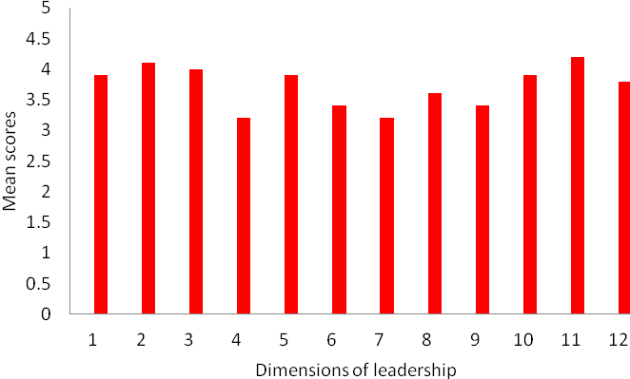

4.6.2 Institutional configuration map
Table 4.11 below shows the number and percentage of respondents evaluating particular aspects of their institution perceived as important to the sustainability of Te Kotahitanga.
Table 4.11: Institutional Analysis Configuration Map Phase 4 May 2010
Dimensions of institution | Ratings (1–5) |  |  |  |  |  |  |  |  |  | Mean
Dimensions of institution | 5 |  | 4 |  | 3 |  | 2 |  | 1 |  | Mean
1 | 0 | 0% | 6 | 31.6% | 13 | 68.4% | 0 | 0% | 0 | 0% | 3.3
2 | 1 | 5.2% | 14 | 73.7% | 4 | 21.1% | 0 | 0% | 0 | 0% | 3.8
3 | 0 | 0% | 14 | 73.7% | 5 | 26.3% | 0 | 0% | 0 | 0% | 3.7
4 | 0 | 0% | 13 | 68.4% | 6 | 31.6% | 0 | 0% | 0 | 0% | 3.7
5 | 0 | 0% | 8 | 42.1% | 11 | 57.9% | 0 | 0% | 0 | 0% | 3.4
6 | 0 | 0% | 9 | 47.4% | 10 | 52.6% | 0 | 0% | 0 | 0% | 3.5
7 | 0 | 0% | 5 | 26.3% | 14 | 73.7% | 0 | 0% | 0 | 0% | 3.3
8 | 5 | 26.3% | 10 | 52.6% | 3 | 15.8% | 1 | 5.2% | 0 | 0% | 4
9 | 3 | 15.8% | 7 | 36.8% | 8 | 42.1% | 1 | 5.2% | 0 | 0% | 3.6
10 | 6 | 31.6% | 11 | 57.9% | 2 | 10.5% | 0 | 0% | 0 | 0% | 4.2
11 | 5 | 26.3% | 9 | 47.4% | 4 | 21.1% | 1 | 5.2% | 0 | 0% | 3.9
12 | 1 | 5.2% | 2 | 10.5% | 12 | 63.2% | 4 | 21.1% | 0 | 0% | 3
13 | 3 | 15.8% | 8 | 42.1% | 8 | 42.1% | 0 | 0% | 0 | 0% | 3.7
14 | 0 | 0% | 9 | 47.4% | 10 | 52.6% | 0 | 0% | 0 | 0% | 3.5
15 | 1 | 5.2% | 6 | 31.6% | 9 | 47.4% | 3 | 15.8% | 0 | 0% | 3.3
16 | 4 | 21.1% | 7 | 36.8% | 8 | 42.1% | 0 | 0% | 0 | 0% | 3.8

Interestingly, the most highly evaluated item was a perception that pedagogies for improving Māori student learning and associated attendance, retention, engagement and achievement are more and more a focus of the professional learning opportunities provided for teachers in the Phase 4 schools. This is a particularly important finding in Phase 4, given that this is a central focus of the Te Kotahitanga project. Also highly rated, and highly significant to sustainability of the project, is the perception that the leaders’ institutions are developing an academic vision, goals and targets focused on Māori student attendance, retention, engagement and achievement by specified measures.
The item that received the lowest rating was the leaders’ perceptions of their institutions as beginning to develop strong evidence-driven networks with other institutions of a similar nature to develop a focus on working together to address the need to improve Māori students’ attendance, retention, engagement and achievement.
There were no leaders who felt that, in their institutions, Māori students’ performance statistics, in terms of attendance, retention, engagement and achievement, are the same as, or better than, national averages for all students.
Further, there were no leaders who felt that all the teachers in their schools:
- understand that many factors influence Māori students attendance, retention, engagement and achievement, but are adamant that they are able to improve Māori students educational attendance, retention, engagement and achievement within their institution
- demonstrate caring relationships and high expectations of Māori students learning on a daily basis
- use a range of discursive teaching interactions including using student’s prior knowledge, providing feedback and feed-forward and engaging in the co-construction of new knowledge with students on a regular basis
- use a wide range of teaching strategies on a daily basis which tend to promote interactive, collaborative learning among students
- base their lesson planning on their responding to a detailed understanding of Māori and others students’ progress and prior knowledge.
Albeit the project may be sustainable in many schools where the majority of teachers are supportive of it, if the leaders are correct in their perceptions, there is still the potential for higher Māori student achievement if all, rather than some or most, teachers were to adopt pedagogy that reflects the points above.
Figure 4.28: Institutional configuration map
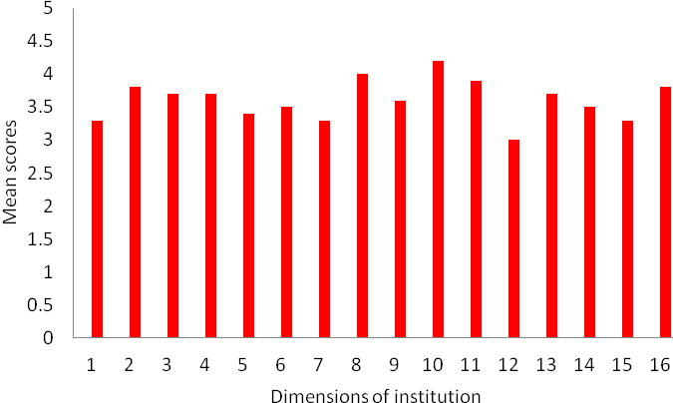

4.7 “State of the Nation” reports
The “State of the Nation” reports from the Phase 4 schools’ facilitators at the annual hui track the challenges and successes of the implementation of the project between 2009 and 2010 through the eyes of the lead facilitators and provide one indicator of the sustainability of the project in terms of, in particular, whether the challenges appear to be insurmountable of whether they have been overcome.

4.7.1 Challenges in project implementation, 2009 to 2010
Table 4.38 in Appendix A summarises the challenges reported by the lead facilitators at their annual hui, 2009 and 2010, in relation to GPILSEO.
Information from the “State of the Nation” report was only available for 2009 and 2010, for Phase 4 schools.
In 2009, the most common concern was related to school institutions. Two schools reported issues with funding/resources, for example:
Funding. (School 9)
Other challenges related to school institutions were associated more with maintaining the integrity of the team of facilitators:
New facilitators-where from? (School 15)
We continue to work to become embedded in the systems and the structures of the school. (School 6)
How to achieve spread—both internally and through the local community—was reported as a challenge by seven schools, for example:
All staff embracing the project. (School 17)
The Te Kotahitanga model is not being transferred into other areas of the school (e.g. protocols re: meetings, interactions in senior classes). (School 15)
Leadership issues, both among senior management for the project, and among the team in continuing to inspire other colleagues to maintain motivation in relation to Te Kotahitanga and to agency in classrooms, was mentioned in six reports. For example:
Breaking through the ‘front’ and finding out the real cause of negativity. (School 8)
Keeping the momentum going as the ‘Team’ undergoes change of personnel. (School 3)
In 2010, issues related to school institutions remained the most frequently reported challenge. In 5 schools, these were associated with funding or resourcing issues. Otherwise they related to ensuring that the maintenance of the whole cycle of professional development activities, for example:
Smaller number of facilitators and the ability to reach all teachers without compromising any aspect of the programme. (School 4)
Now being challenged by reluctant participants re the use of non-contact time for feedback/co-construction. (School 3)
Spread—internally and externally—also featured highly (5 schools) in the list of challenges, for example:
Exploring the GPILSEO model with SMT, staff, students and whānau. (School 13)

4.7.2 “Exciting things” data: Phase 4
In 2009, the most commonly reported achievement related to pedagogy (see Table 4.39 in Appendix A). In three schools, this related to Māori students’ achievement (School 12, School 5 and School 4)—and a different three schools also reported this in 2010 (School 16, School 14 and School 10).
Interestingly, given that the most challenges were reported with schools’ institutions, the second highest number of achievements was also noted with institutions. These were explained as, for example:
Initiatives are fitting into Te Kotahitanga (School 15).
We have a team now! (School 9).
Interestingly also, given the high number of challenges noted with spread, this was an area reported as having a high success rate. For example:
95% of our teachers in the cohort (School 18).
A united vision (School 5).
Achievements related to the establishment and growth of school institutions remained the most frequently reported; in 2010, for example:
We are trying to make it sustainable and it is a time of change—great to be involved in this and seeing the links between Te Kotahitanga, the new curriculum and other initiatives such as restorative justice, academic counselling and the Secondary Literacy and Numeracy projects (School 15).

4.8 GPILSEO evidence from Education Review Office reports
The most recent reports on Phase 4 schools by the Education Review Office (ERO) were written when schools had been in the project for different periods of time, between one and four years. Schools have not been identified in this section to protect their confidentiality. Summarising the reports in tabular form necessarily means that the richness of the verbal descriptions is lost. Nevertheless, these summaries have the potential to point to overall trends and patterns in the implementation of GPILSEO in the schools in comparison with improved student achievement.
In all these schools, from 2007 there was favourable comment on change in pedagogy to some degree. In 18 schools, there was particular comment on practices linked to Te Kotahitanga and the Effective Teaching Profile, especially positive relationship-building. In two of these schools, where improved student achievement was specifically highlighted, there was particular comment also on the clarity of goals related to raising Māori students’ achievement and on the quality of leadership in the school by the principal, board of trustees and senior management.
The reports from 2007 indicate that in two of the schools, there were already clear signs of aspects of GPILSEO after only one year in the project. Common to both was particular mention of clarity of goals related to Māori students’ learning, strength of leadership in the school and use of evidence to support student learning gain. The ERO report on one school reads, for example:
The school’s strategic and annual plans, and annual achievement targets set clear expectations for raising student achievement.
Trustees and school leaders have set clear direction for school improvement. Extensive consultation with all stakeholders is a feature of strategic and annual planning. Annual targets are data generated and relate firmly to student achievement. Both department and individual teacher development goals are aligned to the annual plan. There is common understanding and shared purpose in the direction the school is taking.
However, for two other schools, School 20 and School 6, there is little positive comment on goals or ownership of the project, and less focus on the quality of school leadership than was seen in the other schools. Little overall improvement to student learning and achievement was also reported by ERO in one of these schools:
The overall achievement of Māori students is significantly below those of other students at all levels in the school. The proportion of Māori students leaving school without a qualification is greater than that for similar schools, and retention of these students to Year 13 also remains a challenge.
The reports in 2008 show that, after two years in the project, in ERO’s view, two schools, lacked clear goals in relation to Māori students’ achievement, and there was little evidence of ownership of the project. In relation to one of them, for example, ERO commented:
Most students attending [School 19] are Māori. Their culture is inadequately reflected in the school environment and teaching programmes. An action plan pertaining to Māori was mooted, but has been inactive since 2007.
In one school, ERO’s (2008, 2009) perception of lack of strong leadership and vision is clear also:
Teachers and senior managers do not have a shared vision and commitment to the school’s systems for student behaviour management and pastoral care. In addition, the board and principal have not created a vision that staff, students and the community can share and commit to. Mistrust and miscommunication prevent required progress.
In these two schools where improved pedagogy among some staff is noted, it is linked to Te Kotahitanga as, for example:
Staff involvement in Te Kotahitanga, an initiative promoting Māori student achievement, is having a positive impact on the ways in which staff are working together to broaden their teaching strategies and develop programmes that acknowledge student strengths, interests and abilities.
It is also noted, however, that Te Kotahitanga on its own will not solve structural and organisational issues in schools as, again:
There is no real evidence that the school leadership have any clear goals with regards to transformative future goals, at least any that are transparent to the rest of the school. ...The school still seems to be implementing Te Kotahitanga as an add-on, as something that applies just to the classroom’s pedagogical practice. They do not associate positioning to account for anything and this is evident in their application of behaviour management. They do not weave the professional development programmes together.
The reports from 2009 and 2010 indicate that all but two schools, had framed and institutionalised clear goals around improved learning and achievement for Māori students, all but two had begun to embed school institutions required to support the project adequately. Leadership was very strong in three schools and a matter of positive comment in all but three. Use of evidence to support improved learning was reported positively to some degree in all but two schools. A sense of ownership was not reported on very much, except in two. Students’ achievement was noted as improving to some extent in all but four schools.
In 2009 also, one school, which had very strong improvement in student achievement, was also very strong in the clarity of goal setting around Māori student learning, pedagogy associated with Te Kotahitanga, the strength and direction of leadership from the principal, board of trustees and senior management, and also spread through the school:
The school has identified a sound approach and developed a comprehensive annual plan to raise Māori student achievement. Implementation of this plan is underpinned by student achievement information and the philosophy and practices of Te Kotahitanga. Parents are actively involved in this process. They initially share their ideas and expectations about student achievement and continue to hear about and contribute to the plan In addition, departments are identifying goals and learning and teaching strategies to bring about improved student achievement.
High student achievement was also a matter for comment at another school. However, unlike other schools, this was not also accompanied by very strong leadership:
These positive aspects [i.e. student achievement] are especially noteworthy given that the college has been through an unsettled period marked by frequent leadership changes and board of trustee disharmony that was impeding the effective governance of the school.
Te Kotahitanga was identified as one of the initiatives that had contributed to improvements in students’ achievements:
Various initiatives were contributing to the improved student achievement results. Te Kotahitanga, an initiative designed to help teachers achieve success for Māori students, had been introduced in 2007.
In two of the four schools where there appeared to be little sign of improved levels of Māori student achievement, there seems to be little reported evidence of strength of leadership from the principal, board of trustees and senior management of the school. At the same time, however, where there was an improvement in the pedagogy of some teachers it was linked to the introduction of Te Kotahitanga.
A summary of data from ERO reports of Phase 4 schools is attached as Table 4.40 in Appendix A.

4.9 References
Bishop, R., & Berryman, M. (2006). Culture speaks: Cultural relationships and classroom learning. Wellington, New Zealand: Huia Publishers.
Lai, M. K., McNaughton, S., Timperly, H., & Hsiao, S. (2009). Sustainability of effective teaching and school practices: Developing a model for sustaining and extending literacy achievement. [A summary.] Wellington, New Zealand: NZCER.

Chapter 5: Professional Development Programme, 2007 to 2010

Summary of findings
The evidence emerging from Te Kotahitanga schools and facilitation teams continues to be a very good indicator of how to effectively support the raising of Māori students’ participation and achievement:
- An important lesson learned from these schools was that, as well as support for school leadership, we needed to maintain the integrity of the professional development cycle in schools. Providing inconsistent direction and less hands-on support to Phase 3 schools in 2007 and 2008 resulted in variable outcomes in terms of sustainability.
- Phase 4 schools show more adherence to the integrity of the Te Kotahitanga model than Phase 3. However, there is still a wide variance from one school to another with a third of schools still requiring more intensive support. This is often due to movement of key staff but is also indicative of the wide range of knowledge and prior experiences across the group (particularly with respect to lead facilitators) and the differing levels of support for implementation of Te Kotahitanga from school leadership.
- The Review of Practice and Development (RP&D) cycle is supporting Phase 3 and 4 schools’ to continue to be responsive to their teachers and to their Māori students, while also maintaining the integrity and purpose of Te Kotahitanga.
- The tools developed to support the professional development associated with Te Kotahitanga have been trialled, evaluated and proven to be fit for purpose.
- Distance support is most effective when it is blended with ongoing face-to-face relationships and support.

5.0 Introduction
Chapter 5 is concerned with the following question:
What was the professional development intervention that enabled the changes in teaching practices to occur?
Underpinning the professional development model adopted by the Te Kotahitanga Research and Development project is an understanding that Te Kotahitanga is a Research and Development project which builds on lessons learned from experience and refines and develops new ways of working as a result. Fundamental to the principles on which it is based is the intention to create power-sharing contexts wherein self-determining individuals work together to set goals and reflect on outcomes (Bishop & Glynn, 1999). Each year, a number of national professional development hui are provided for Te Kotahitanga facilitation teams. Once a year, in addition, there is a hui specifically for principals and lead facilitators. Regional coordinators and other members of the Research and Development team follow up these hui with term-by-term, critical reflections in schools on the cycle of tasks that are central to Te Kotahitanga. This cycle involves the tasks of observations, feedback, co-construction and shadow coaching undertaken by members of the school facilitation team. The ongoing external support from the Research and Development team follows an iterative in-school process of first standing alongside school facilitators in a shadow coaching role through each of the Te Kotahitanga tasks. This usually occurs in the weeks after new information has been presented at hui. Ongoing external support continues with critical reflections through a process of Review of Practice and Development. A set of specific tools, to undertake the shadow coaching and Review of Practice and Development activities, has now been developed and trialled and are proving to be fit for purpose. These processes and related tools continue to ensure that there are ongoing opportunities for reflection and feedback based on the rigorous and objective gathering and mutual sharing of evidence, followed by the setting of new goals with which to redefine the way ahead for raising the achievement of Māori students.
This chapter therefore, begins by offering an overview of the professional development programme from the beginning of Phase 1. A previous report to the Ministry of Education (Bishop et al., 2008) described the Phase 3 and Phase 4 professional development provided to Te Kotahitanga schools throughout 2006 and 2007 and included participants’ evaluations. This chapter therefore summarises what took place from 2006 to the end of 2007 and presents an overview of the professional development associated with the embedding of culturally responsive pedagogy in classrooms from the beginning of 2008 to the end of 2010. It then describes in more detail the iterative and interdependent nature of these components of work as we have sought to sustain the work of Te Kotahitanga with Phase 3 schools and replicate it with Phase 4. An example of this is the professional development carried out through the processes of shadow coaching and Review of Practice and Development. This chapter focuses on the outcomes from the shadow coaching and the Review of Practice and Development provided to Phase 3 and Phase 4 facilitation teams in order to understand how tasks, central to the embedding of culturally responsive pedagogy in classrooms, were maintained by Phase 3 and replicated by Phase 4 schools. The tools developed to support the professional development that we describe here will be considered together with the outcomes from the processes as they were implemented in schools. Finally, we will discuss the Rongohia te Hau and leadership co-construction meetings, which are the latest components of professional development that are currently being developed and implemented to embed sustainable school systems in support of Te Kotahitanga.

5.1 Summary of professional development to the end of 2007
Since its inception, Te Kotahitanga has developed as a project with iterative cycles of research and development, each building on previous experiences and evaluation of those experiences.

5.1.1 Overview of iterative and cyclical nature of Te Kotahitanga professional development
Professional development for teachers and facilitators has been, and remains, at the core of Te Kotahitanga. It is developed in an iterative spiral of activities. Figure 5.1 next illustrates the cycle of research, evaluation, development, and new learning accumulated in one phase and taken into the next:
Figure 5.1: Schematic of the process of professional development within Te Kotahitanga
Phase 1
Phase 2
Phase 3
Phase 3/4
Research
and
development
Research
and
development
New learning from Phase 1 taken into Phase 2
Research
and development
New learning from Phases 1 and 2 taken into Phase 3
New learning from Phases 1, 2 and 3 taken into Phase 3/4
New learning from Phases 1, 2, 3, 3/4 taken into
Phase 5

Figure 5.2 next is a flow chart indicating the developmental nature of this professional development across phases and summarising what was learned in each phase and taken through to the next.
Figure 5.2: Flowchart summarising development of professional development within Te Kotahitanga
Phase 1
(4 schools)
Introduction of whakaruruhau group
Gathering and use of student narratives from 5 schools
Trialling use of student narratives in out-of-school professional development sessions
Development and trial of side one of Observation Tool and feedback
Development and trial of Effective Teaching Profile
Co-construction with individual teachers of appropriate pedagogical responses
Shadow coaching
Poutama Pounamu and University of Waikato
↓
Phase 2
(3 schools)
Formalised use of student narratives in Hui Whakarewa
Developed and trialled Side 2 of Observation Tool
Introduced group co-constructions with teachers around a target class
Introduction of in-school lead facilitator with professional development
↓
Phase 3
(12 schools)
Development of resources to support professional development (DVDs, hand outs, e-community)
Formalising and, later, streamlining professional development cycle in schools (Hui Whakarewa, observations, feedback and co-construction meetings, shadow coaching)
Professional development for facilitation team out of schools
In-school support for facilitators from central professional development team
Quality assurance of feedback and co-construction meetings
Regional hui for facilitators
Development of the tablet (electronic) Observation Tool
Focus on School Management Systems (SMS) and reliable school evidence
Formalising of facilitation teams for schools (Resource Teachers: Learning and Behaviour, School Support Services, in-school facilitator)
Introduction of regional coordinators
Development of further out-of-school and in-school professional development for facilitators
↓
Phase 3/4
(21 schools)
Manu Hou for new facilitators
Quality assurance on observations and Hui Whakarewa
Co-construction meetings for leaders
Te Kotahitanga conference
Te Kotahitanga leaders’ hui
GPILSEO Phases 3 and 4
Introduction of 0800 helpline
Revision of support materials
Introduction of Masters-level paper on Te Kotahitanga
↓
Web-based Observation Tool
Rongohia te Hau
Student surveys, teacher surveys in schools
Tools for Review of Practice and Development
Responsive site visits

5.1.2 Summary of professional development activities 2006 to 2007
Throughout 2006 and 2007, the Research and Development team provided a cycle of professional development hui for all members of school-based Te Kotahitanga teams, including their principals. This cycle of hui, for both the Phase 3 and 4 schools, is listed in Table 5.1 below.

Table 5.1: Timeline and content of professional development hui in 2006 and 2007
 | Phase 3 | Purpose and focus of hui | Phase 4 | Purpose and focus of hui
2006 | Manu Hou (“new bird”)  (February)  New facilitators | Introduction to the theory and practices of Te Kotahitanga facilitators  Focus: GEPRISP and cycle of in-school professional development
2006 | National hui (term 2)  Day 1: Principals & lead facilitator (LF) only  Days 2–4: All facilitators & principals | Report back of data from schools and from Research and Development team  Joint critical reflection on implementation model (GPILSEO) within and across schools
2006 | 3 x 1 day Regional hui (term 3)  All facilitators | Sharing new Te Kotahitanga resources  Feedback on key themes from inter-observer reliability exercise  Analysis of taped feedback and co-construction sessions  Report back on asTTle testing
2006 | Leadership hui (term 4)  Principals and lead facilitators | Sustainability and GPILSEO  Emergence of professional development model where participants’ questions are encouraged, evidence is interrogated, learning is in the conversation and reciprocal | Induction Hui Whakarewa (October)  All principals and facilitators  Induction hui 2 (November)  All facilitators  Principals invited | 1. GEPRISP and in-school professional development cycle, with an emphasis on conducting classroom observations  2. Preparing in-school facilitators to implement professional development cycle: Hui Whakarewa, classroom observations, feedback, co-construction, shadow coaching  Regional Coordinators provide in-school follow-up shadow coaching

2007 | Manu Hou (February)  New facilitators across Phase 3 /4 | Introduction to the theory and practices of Te Kotahitanga facilitators with a focus on GEPRISP and the cycle of in-school professional development
2007 | National hui (early term 2)  All facilitators  Principals invited | Learning conversations on what Te Kotahitanga looks like in schools (evidence!); what we want it to look like;  barriers to success; and  plans for moving forward | National hui (Late term 1)  All facilitators  Principals invited | Opportunity for school-based teams to share experiences, problem-solve and set goals for the next cycle  Collection and management of school data
2007 | Regional hui (term 3)  No Phase 3 Regional hui. Three new facilitation teams invited to attend Phase 4 regional hui |  | 4 x 1 day Regional hui (term 3)  All facilitators  Principals invited | Implementation of professional development cycle: effective shadow coaching, feedback process  Managing resistance  Sharing experiences across schools
2007 | Leadership hui (early November)  Principals and lead facilitators | Planning for professional development support in 2008.  Guest speakers: Prof Gene Hall (University of Nevada) and MoE colleagues | Leadership hui (end of October)  Day 1: Lead facilitators only  Days 2–3: All principals and lead facilitators | Consider implications of GPSILEO for sustainability  Co-construction of goals and plans for 2008

5.2 Overview of professional development from 2008 to 2010
Table 5.2 below outlines the list of professional development hui provided to Phase 3 and Phase 4 school facilitation teams, from 2008 to 2010 together with an overview of the professional development carried out through the processes of shadow coaching (SC) and Review of Practice and Development (RP&D).

Table 5.2: Overview and content of Te Kotahitanga professional development from 2008–2010
Overview: PD to Phase 3 & 4 school facilitators carried out through shadow coaching (SC) and Review of Practice and Development (RP&D)
Purpose: Introduce & theorise Te Kotahitanga tasks |  | Purpose: Embed culturally responsive pedagogies in classrooms |  |  |  |  |  |  |  |  |  | Purpose: Develop sustainable school systems
Phase | Yearly face-to-face PD hui 2008 to 2010 | Activity 1: Hui Whakarewa |  | Activity 2: Classroom observations |  | Activity 3: Feedback meetings |  | Activity 4: Co-construction meetings |  | Activity 5: Shadow-coaching goals |  | Activity 6: Rongohia te Hau and leadership co-construction meetings
Phase | Manu Hou (all phases)  Term 1/ 2 facilitators’ hui (available to Phase 4)  Leadership hui (both phases)  Regional hui (both phases)  Regional leadership hui term 3 (both phases)  Term 4 facilitators’ hui (available to Phase 4) | SC | RP&D | SC | RP&D | SC | RP&D | SC | RP&D | SC | RP&D | SC | RP&D
Ph 3  Began in 2003 |  | **  2004 and 2005 | 2006 and 2007 | **  2004 and 2005 | 2006 and 2009 | **  2004 and 2005 | **  2009 | ** | 2009 | **  Trial and implement  2010 to 2011 |  | Trial 2009  Implement  2010
Ph 4  Began in 2006 |  | 2006 and 2007 | 2008 and 2009 | 2007 | 2008 | 2007 | 2009 | ** | 2009 |  |  | Implement  2010 | 2011
Key ** Responsive school visits and feedback from analysis of taped feedback and co-construction meetings in 2006 and 2007; however, formal Review of Practice and Development of feedback and co-construction meetings began in 2009.

5.3 Te Kotahitanga professional development: Purpose, process and content
Te Kotahitanga professional development hui serve two main purposes:
- they signal, theorise and define new work that can be expected to occur in the short term
- they support Te Kotahitanga facilitators and principals to reflect critically on the work of Te Kotahitanga as it is occurring in their schools.
Contexts are designed in which new learning is intrinsic both to the theoretical underpinnings and to the tools provided by the Research and Development team. New learning is also in the facilitated conversations where leaders and facilitators construct new understandings with each other and with the Research and Development team.
The Research and Development team also undertakes shadow coaching (SC) exercises where they stand alongside facilitators in schools. Shadow coaching has occurred in Hui Whakarewa (Activity 1), classroom observations (Activity 2), feedback meetings (Activity 3), co-construction meetings (Activity 4) and the actual shadow coaching of teachers to meet the goals that have been set (Activity 5). As previously reported (Bishop et al., 2007), the purpose of all five is to introduce and maintain culturally responsive pedagogies in classrooms with teachers, through the use of the Effective Teaching Profile and GEPRISP. Shadow coaching of facilitation teams in these core Te Kotahitanga activities began in 2006 in both Phase 3 and then Phase 4 schools. The summative, critical reflection process on each of these activities followed. This is known as Review of Practice and Development.
In 2009, a newly conceptualised and developed component of professional development, Rongohia te Hau and leadership co-construction meetings (Activity 6), was added to these five activities. This component is designed to develop and sustain school systems and structures that will support the work of Te Kotahitanga through the use of the GPILSEO framework.
Alongside the Te Kotahitanga professional development activities, responsive school visits have occurred on a needs-be basis. New resources continue to be developed. The professional development is supported at a distance, with all Phase 3 and 4 facilitators and principals having access to the Te Kotahitanga e-community. All lead facilitators and principals also have access to an 0800 Te Kotahitanga helpline number.

5.4 Review of Practice and Development (RP&D)
Reflection on the way the project has developed had led us to a realisation that the Research and Development team and schools need mechanisms to help them better understand the extent to which the Te Kotahitanga in-school professional development activities as listed above are being undertaken in schools by all members of their Te Kotahitanga facilitation teams. We have found that this exercise is necessary for both summative and formative purposes:
- to find out, for quality assurance purposes, how well and with what degree of integrity the tasks are being carried out (summative purposes)
- to provide additional professional feedback and feed-forward (formative purposes) to assist the lead facilitator to embed these activities in schools effectively.
Once they have completed the process themselves, lead facilitators are then encouraged to complete the procedure with every member of their team. This helps to ensure both consistency and effectiveness across all team members. These practices have become known as the Review of Practice and Development, or RP&D.
In 2006, we began to develop a set of “smart tools” to undertake this work. These new tools have allowed us to engage with lead facilitators in all schools. When this task has been completed, the tools are left with lead facilitators to help sustain the goals, pedagogy and new institutions of Te Kotahitanga in schools. Tools discussed in this section have all been presented in Appendix A.

5.4.1 Activity 1: Review of Practice and Development of Hui Whakarewa
Through the processes of the Review of Practice and Development, observations of the entire Hui Whakarewa were undertaken to understand the extent to which Phase 3 and, later, Phase 4 schools, were able to sustain this component of professional development on their own. The tool created for this review was based directly upon the Hui Whakarewa module (see Template 5.1 in Appendix A). During the Hui Whakarewa, each of the activities considered to be key to the hui are observed and assessed by one or two observers from the Research and Development team. Assessments are based on the degree to which the activities observed are seen to meet their intended purpose. The observer gives a rating on a scale of 0 to 5 (0 being not included to 5 being a very strong match). Descriptors for this scale are listed on Template 5.2 in Appendix A. The individual hui activities are rated under the following categories: culturally appropriate; culturally responsive; and from the GEPRISP framework, Goal, Experiences, Positioning (GEP); Relationships, Interactions (RI); and Strategies, Plan (SP). Ratings from each element are then averaged across all of the activities to provide an overall score per school. A comparison of Phase 3 schools alongside their mean average appears in Figure 5.3 below.
Figure 5.3: Phase 3 Hui Whakarewa 2006 to 2007: Mean average rating by school
Data from Figure 5.3 show that, on average, Phase 3 schools held Hui Whakarewa that were a fair match to the module, that is, with similarities between the purpose, the processes and the resources. Five schools scored above 3.5 and six schools scored between 1.75 and 2.6. Some schools combined with other schools to run their Hui Whakarewa. Schools that scored in the lower range were more likely to have compromised the required activities by shortening the length of their hui. For example the school that scored the lowest had a one-day hui. A finer grained analysis of their hui, however, showed that they had prioritised the most essential activities and intended to incorporate other activities into their term’s programme. This evidence suggests that, after three years, while five schools had maintained the purposes and processes of the Hui Whakarewa, six others had begun to adapt and potentially shift the focus or purpose of the Hui Whakarewa.
The combined average, of Phase 4 schools appears in Figure 5.4 below.
Figure 5.4: Phase 4 Hui Whakarewa 2008 to 2009: Average rating by school
average rating
Hui Whakarewa Phase 4 average rating by school
0.00
0.50
1.00
1.50
2.00
2.50
3.00
3.50
4.00
4.50
5.00
School
14
School
15
School
12
School
16 &
Phase 3
School
10
School
13
School
4
School
5
School
17
Average
Schools
18 & 7
School
6
School
19
School
10 & 3
School
20
Schools
9 & 2
Schools
Data from Figure 5.4 show that on average, Phase 4 schools also held Hui Whakarewa that were a fair match to the module with similarities between the purpose, the process and the resources. Nine schools scored above 3.2 and nine schools scored between 3.0 and 1.75. Again, some schools combined with other schools to run their Hui Whakarewa including one Phase 3 school that combined with a Phase 4 school. While the lower end of the range was not as wide in Phase 4 schools, it was again obvious that some schools compromised their activities by shortening the length of their hui.
A comparison of overall average ratings between Phase 3 and Phase 4 schools can be found in Figure 5.5 below. These data are presented under the overall average for that phase, then against the following most essential categories: culturally appropriate; culturally responsive; goal, experiences, positioning (GEP); relationships, interactions (RI); and strategies, plan (SP).
Figure 5.5: Hui Whakarewa comparison of average scores Phase 3 2006 to 2007
and Phase 4 2008 to 2009
Evidence from Figure 5.5 suggest that, after two years, Phase 4 schools who had been in Te Kotahitanga for less time than Phase 3 schools, were well able to replicate a comparable trend to that set by Phase 3 schools.
From this Review of Practice and Development, we also identified the need to develop a module for shorter Hui Whakarewa. This was especially important as the size of the cohort of teachers being introduced to Te Kotahitanga reduced. A module for fewer than 10 teachers, over two days, has now been developed and trialled.

5.4.2 Activity 2: Review of Practice and Development of observations
There are two components to the activity to review the practice and development of observations. The first component, undertaken through synchronous observations, reviews the observations undertaken by the lead facilitator and then the lead facilitator reviews observations undertaken by members of their own team. The second component, “Flick and Finger”, reviews how the observations are being managed by the team as a whole. The processes involved in these components are discussed further below and outcomes are reviewed.

5.4.2.1 Synchronous observations
A member of the Research and Development team conducts a synchronous in-class teacher observation with the lead facilitator and collates their combined observations on the Review of Practice and Development of the observations tool. A follow-up conversation is then held at which all evidence collated during the observation is discussed and compared. If 80% or more agreement in evidence between the lead observer and lead facilitator did not occur in the first synchronous observation, a second synchronous observation between the observer and the lead facilitator is timetabled. Once 80% or more agreement in evidence is reached, the lead facilitator is then supported to undertake similar synchronous observations and follow-up conversations with each member of their school team. Although new facilitators needed to repeat this exercise, none of the repeat observations were included in Table 5.3 or Table 5.4.
From these synchronous in-class observations, correlations are calculated for four different elements of the observation sheet (co-construction to prior knowledge interactions; feed-forward behaviour to instruction interactions; engagement and work completed; relationships), then an average correlation is calculated. The tool created for this comparison was based directly upon the Observation Tool and can be found as Template 2.1 in Chapter 2 Appendix B).

5.4.2.2 Review of Practice and Development on Phase 3 observations in 2006 and 2009
Correlations from Phase 3, 2006 and then again in 2009 appear in Table 5.3 below. These correlations have been interpreted according to the rule of thumb provided by George and Mallery (2003, p. 231):
- ≥ .9 is excellent
- ≥.8 is good
- ≥.7 is acceptable
- ≥ .6 is questionable
- ≥ .5 is poor
- ≤ .5 is unacceptable.
Table 5.3: Review of Practice and Development on Phase 3 observations 2006 and 2009
2006 N = 43 |  |  |  |  | 2009 N = 8
Co-C to Pr Kn | FFB+ to Instr | Eng & Wk Comp | Caring culture | Mean | Co-C to Pr Kn | FFB+ to Instr | Eng & Wk Comp | Caring culture | Mean
0.58 | 0.81 | 0.98 | 0.79 | 0.79 | 0.79 | 0.77 | 0.95 | 0.84 | 0.85

Data from Table 5.3 show that, in 2006, 43 facilitators undertook the Review of Practice and Development exercise with a Research and Development team member and an overall mean correlation of 0.79 (acceptable) was reached. These data also show that for this group, the most challenging element to score were the interactions ranging from prior knowledge to co-construction, while the least challenging to score was the engagement and work completed element. For new Phase 3 facilitators who went through this exercise in 2009, a higher overall mean correlation of 0.85 (good) was reached. It should be noted that some of these facilitators may have had more than two years practice with observations before undertaking this exercise. For them, there was minimal difference between the two most challenging elements to score (between prior knowledge to co-construction interactions (0.79) and feed-forward behaviour positive to instruction interactions (0.77), while the least challenging to score was again the engagement and work completed element. This evidence suggests that new comers into Phase 3 teams are maintaining similar results to those achieved by the earlier Phase 3 team members.

5.4.2.3 Review of Practice and Development on Phase 4 observations in 2009
Correlations from Phase 4, 2009 appear in Table 5.4 below:
Table 5.4: Review of Practice and Development on Phase 4 observations in 2009
2009 N=19
Co-C to Pr Kn | FFB+ to Instr | Eng & Wk Comp | Caring culture | Mean
0.72 | 0.77 | 0.81 | 0.78 | 0.78

Data from Table 5.4 show that in 2009, 19 lead facilitators undertook the Review of Practice and Development exercise with Research and Development team member conducting the process of synchronous observations. An overall mean correlation of 0.78 (acceptable) was reached. These data also show that for this group, the most challenging and least challenging elements to score were the same as those identified by the first cohort of Phase 3 facilitators who had been in the Te Kotahitanga for a similar period of time. The most challenging elements were prior knowledge to co-construction interactions, and the least challenging was again engagement and work completed. Despite these facilitators having all had less than two years practice with observations, it is clear that they have been able to replicate similar outcome patterns in this exercise, as were achieved by their Phase 3 counterparts.

5.4.2.4 “Flick and Finger” review of observations
During the same time that the synchronous observations were gathered, an overview of the observations within each school was also completed to understand how the task of observations across the whole cohort of teachers has been managed by the team and how it could be better managed in the future. This process included developing a better understanding of how individual members within the team are contributing to the observation activity. The process began by “flicking” through all of the observations undertaken in the previous term, then using the “Flick and Finger” tool (see Template 5.3 in Appendix A), to reflect upon time allocations and the numbers of observations completed by each member of the team. The lead facilitator and the Research and Development team member considered the implications of the team’s practice by analysing the evidence in a discussion focused on “fingering” (that is identifying) themes that would become the next Te Kotahitanga priorities for the team. The lead facilitator then reflected on these findings and shares these with the rest of the school-based team at their next team meeting.

5.4.3 Activity 3: Review of Practice and Development of feedback
Through the process of Review of Practice and Development, observations were also undertaken of feedback meetings. The tool created for this review (see Template 5.4 in Appendix A) was based directly upon the feedback module. During the observation of the feedback meeting each of the activities considered to be key to the meeting were observed and assessed by a Research and Development team member. Each component observed is given a numerical value and the overall total is scored out of 100%. Following the feedback observation, feedback is given to the facilitator using the evidence collated in the completed Review of Practice and Development feedback tool.
Synchronous Skype and face-to-face feedback sessions were trialled in 2008 to 2009, with a number of Phase 4 schools. From this trial we learned that when the technology was working, observations of feedback sessions through Skype could be scored as accurately as the face-to-face observations. However, constant difficulties with connectivity saw the trial suspended. In 2009, Phase 3 and Phase 4 schools went through face-to-face Review of Practice and Development observations of feedback meetings with Regional Coordinators from the Research and Development team.
Figure 5.6 below compares evidence from the Review of Practice and Development of feedback of 13 Phase 3 facilitators with 44 Phase 4 facilitators.
Figure 5.6: Comparison of Phase 3 and Phase 4 Review of Practice and Development of feedback meetings
Data from Figure 5.6 show that Phase 4 facilitators, with far less experience, achieved more highly than Phase 3 facilitators in this Review of Practice and Development feedback exercise.
5.4.4 Activity 4: Review of Practice and Development of Co-construction meetings
Through the process of Review of Practice and Development, observations were also undertaken of co-construction meetings. The tool created for this review (see Template 5.5 in Appendix A) was based directly upon the co-construction module. During the observation of the co-construction meeting each of the activities considered to be key to the meeting were observed and assessed by a Research and Development team member. Each component observed was given a numerical value and the overall total was scored out of 100%. Following the co-construction observation, feedback was given to the facilitator using the completed Review of Practice and Development co-construction observation-tool.
Figure 5.7: Comparison of Phase 3 and Phase 4 Review of Practice and Development of co-construction meetings
Data from Figure 5.7 show that, again, Phase 4 facilitators with far less time and experience in Te Kotahitanga, achieved more highly in this review of process and development of co-construction than Phase 3.

5.4.5 Activity 5: Reviewing and coaching facilitators’ shadow coaching of teachers
Many critical conversations about the quality of the goals being set and the purpose of these goals emerged from the Review of Practice and Development of co-construction meetings. When the goals were not focused on what teachers themselves could do to raise Māori students’ participation and achievement, and when they were also not specific, achievable, and measurable (SAM) and/or able to be completed and evaluated by the next feedback or co-construction session (time-framed), then shadow coaching became much more difficult. Discussions, focused on goal setting at the level of co-construction meetings, revealed a need to begin to reflect with facilitation teams on their own role as shadow coaches. Themes from these discussions aligned with Phase 3 and Phase 4 facilitators who have reported in the past an inconsistency in including shadow coaching into the Te Kotahitanga professional development cycle. Where shadow coaching had been provided it was more often described as ad hoc and informal. These discussions led to a focus on reviewing the shadow coaching activity and the development of a tool for reviewing shadow coaching (see Template 5.6 in Appendix A).
Reviewing and coaching the shadow coaching activity takes the form of constructing new learning through the conversations that the team can have from their use of existing filed evidence. From their files, the team selects evidence from five teachers, then using the tool for reviewing shadow coaching, they carefully test whether the goal linked to shadow coaching had previously been specific, achievable, and measurable (SAM). This conversation helps facilitators to see more clearly how shadow coaching might effectively “fall out of” the goal that had been set. The need to evaluate the goal against the elements of PSIRPEG was another necessary conversation. From these conversations, facilitators began to understand the importance of the PSIRPEG structure if they were to engage teachers in an examination of their own theorising and thus ensure that the goal was specifically linked to culturally responsive pedagogy. In some cases, Research and Development team members facilitated conversations in which actual goals were used to discuss possible shadow coaching activities and the way in which this could be managed within the term-by-term professional development cycle.

5.4.6 Activity 6: Reviewing and shadow coaching Rongohia te Hau and Leadership Co-construction meetings
In 2010, the professional development work with Phase 3 and Phase 4 schools has aimed at a stronger integration of GPILSEO into Te Kotahitanga schools. This plan includes two new components of work. These begin with Rongohia te Hau, culminating in the facilitation team co-construction meeting, and the senior leadership co-construction meeting that follows closely afterwards. These meetings are designed to bridge a gap that was identified in the 2009 trial of leadership co-construction meetings. As we considered how to bridge this gap, it became clear that a process was needed to collect relevant evidence of facilitation teams’ practices and effectiveness to inform the leadership GPILSEO co-construction planning and goal setting in supporting teachers to implement the Effective Teaching Profile across the school. The plan for this process of data collection is outlined in Figure 5.8 below.
Figure 5.8: Components of evidence leading to the facilitation team and leadership co-construction meeting
Rongohia te Hau involves the gathering of three sets of evidence from teachers’ implementation of a culturally responsive pedagogy of relations in their classrooms. It then involves supporting facilitators to consider the implications of this evidence on their own practices, as they have been able to influence others towards sustaining improved educational outcomes for Māori students at the level of classroom pedagogy.
For Rongohia te Hau, evidence is collected through:
- student surveys that use a tool whereby responses to a number of brief statements, linked to students’ experiences of the effective teaching practice, are gathered. Responses, according to a five-point scale, provide an indication of the frequency of these experiences for students in their classrooms (see Template 5.7 in Appendix A)
- teacher surveys that use a tool whereby responses to a number of brief statements linked to teachers’ experiences of the professional development provided by facilitators are gathered. Responses, according to a five-point scale, provide an indication of the degree to which teachers have agreed with the professional development or not (see Template 5.8 in Appendix A)
- walk-through observations developed with the intention of providing a mechanism for collecting evidence of the degree to which a culturally responsive pedagogy of relations has been embedded in classrooms. Walk-through observations are completed for a sample of 30% of teachers who have participated in the Te Kotahitanga professional development (see Template 5.9 in Appendix A).

5.4.6.1 Student survey based on the Effective Teaching Profile
A student survey based on the Effective Teaching Profile was developed that could be administered with all students, Māori and non-Māori. Items on the survey cover each of the descriptors found in the Effective Teaching Profile. The survey is introduced by asking students to think about their experiences of being a learner in their school and with the range of teachers with whom they work. They are asked to consider how often they believed they had those experiences as a learner. Students then make a series of multiple-choice responses with a space at the bottom of the page to write a comment. Three of the items are about the school and nine are about the teachers in their classes.
Most schools surveyed all Year 9 and Year 10 students. A few schools surveyed across the year groups. Data from the student survey for Year 9 and 10 students in Phase 3 schools are presented in Figure 5.9. Data from the student survey for Year 9 and 10 students in Phase 4 schools follows in Figure 5.10. The rating scales used in these figures are presented in two groups; first the 3 to 5 rating (3 is sometimes; 4 is mostly: 5 is always) are grouped together; then the 1 to 2 rating (1 is never; 2 is hardly ever) are grouped together. These ratings are presented across the range of survey questions.
Figure 5.9: Outcome of student survey in Phase 3 schools, 2010
Phase 3 data, involving more than 1,000 Māori students, indicate that the vast majority of these Māori students scored the “sometimes” to “always” categories on the items concerned with:
- feeling good about their school
- having opportunities to do the things that they want to do
- knowing and respecting their teachers and their teachers knowing and respecting them
- being helped with their learning
- having teachers who expect that they will achieve.
Although there were more students who scored within the 1 to 2 rating, most students still scored in the “sometimes” to “always” categories on the experiences concerned with teachers who:
- listen to students’ ideas
- care about students
- know how to make learning fun
- let students help each other with their work
- share students results with them so that they can do better.
Thus these students were all very positive.
Importantly, these data for individual schools meant that facilitators were now clear about the areas that they needed to target going forward with teachers. Phase 3 data for non-Māori students were also analysed and showed a similar trend.
Data from the student survey for Phase 4, Year 9 and 10 Māori students, appears in Figure 5.10 below.
Figure 5.10: Outcome of student survey in Phase 4 schools, 2010
Phase 4 data, involving more than 1,400 Māori students, again indicate that the vast majority of these Māori students scored the “sometimes” to “always” categories on the items concerned with:
- feeling good about their school
- having opportunities to do the things that they want to do
- knowing and respecting their teachers and their teachers knowing and respecting them
- being helped with their learning
- having teachers who expect that they will achieve.
Again, although there were more students who scored within the 1 to 2 rating, most students still scored in the “sometimes” to “always” categories on the experiences concerned with teachers who:
- listen to students’ ideas
- care about students
- know how to make learning fun
- let students help each other with their work
- share students results with them so that they can do better.
Thus on all categories students were still very positive. Phase 4 facilitators also spoke of the clarity this provided them in terms of the areas that they needed to target going forward with teachers. Phase 4 data for non-Māori students was also analysed and maintained a similar trend.

5.4.6.2 Teacher feedback on Te Kotahitanga professional development activities
A teacher survey was developed to elicit teacher feedback on the value they attributed to each of the Te Kotahitanga professional development activities they had received from their facilitation teams. Data from the teacher survey for Phase 3 schools are presented in Figure 5.11. Data from the teacher survey for Phase 4 schools follows in Figure 5.12. The rating scale used in these figures is grouped as a positive rating (strongly agree; agree) a neutral rating and a negative rating (disagree; strongly disagree).
Figure 5.11: Outcome of teacher survey in Phase 3 schools, 2010
Phase 3 data, involving more than 300 teachers, indicate that the vast majority of these teachers were either in strong agreement or agreement that the professional development that they had received was valuable to them. Fewer teachers provided a neutral rating and even fewer teachers provided a negative rating (disagree; strongly disagree).
Figure 5.12: Outcome of teacher survey in Phase 4 schools, 2010
Phase 4 data, involving more than 400 teachers, indicate that again the vast majority of these teachers were either in strong agreement or agreement with the professional development that they had received, fewer teachers provided a neutral rating and even fewer teachers again provided a negative rating (disagree; strongly disagree).

5.4.6.3 Walk-through observations
Walk-through observations were completed for a sample of at least 30% of teachers who have participated in the Te Kotahitanga professional development. This exercise has now been completed in all Phase 3 and Phase 4 schools. Walk-through observations are making observations of classroom environments and pedagogy looking for evidence of culturally responsive pedagogy of relations (CRP of R). Observations are followed by a sorting exercise, involving all members of the school-based facilitation team and at least one member of the Te Kotahitanga Research and Development team. This involves using existing prior observations and knowledge about teachers to confirm the sorting of individual teacher observations into one of five piles (1, no evidence of culturally responsive pedagogy of relations; 2, little evidence of culturally responsive pedagogy of relations; 3, some evidence of culturally responsive pedagogy of relations; 4, a range of evidence of culturally responsive pedagogy of relations; 5, a lot of evidence of culturally responsive pedagogy of relations across a wide range). The five piles are then collapsed into the three piles shown in Table 5.5 below (basic, pile 1; developing, pile 2 and 3; integrated, pile 4 and 5).
Table 5.5: Walk-through observations in Te Kotahitanga schools 2010
Teacher outcomes from walk-through observations in Te Kotahitanga schools 2010
Phase | N schools | 2010 active  Te Kotahitanga teachers | Basic | Developing | Integrated
Phase 3 | 11 schools | 550 | 13 | 55 | 73
Phase 4 | 20 schools | 950 | 12 | 249 | 135

Data in Table 5.5 confirm that, while many teachers are integrating the elements of the Effective Teaching Profile into their classrooms, there are still many more who need to develop these skills further before they will be fully integrated and a small group who need more help than is able to be provided through the current Te Kotahitanga professional development.
Rongohia te Hau culminates in the use of student, teacher and classroom evidence from the above sources (i.e., student and teacher surveys and walk-through observations), together with any other evidence of teacher and/or facilitation practice that the team wishes to include, to support a pedagogical co-construction meeting with all members of the facilitation team in terms of implications for the team’s work of embedding the Effective Teaching Profile in classrooms. Where data collection has been completed by the school-based facilitation team evidence from Rongohia te Hau may be further supported with:
- the facilitation team’s analysis of the Effective Teaching Profile descriptors
- evidence contained within the “State of the Nation” (current and historical) PowerPoint presentations.
At this meeting of the school facilitation team, the evidence is synthesised and, based on the implications of the evidence for them as a team, a goal is set (see Templates 5.10 and 5.11 in Appendix A). In turn, the summary of evidence from Rongohia te Hau (see Template 5.12 in Appendix A) informs the leadership co-construction meeting.

5.4.6.4 Leadership co-construction meeting
The summary of evidence is tabled by the lead facilitator at the leadership co-construction meeting soon after the meeting of facilitators. Other members of the senior leadership/management team (SLT/SMT) also bring evidence of school-wide, Māori student participation and achievement according to their delegated areas of responsibilities (see Template 5.13 in Appendix A).
Each school in Phase 3 and 4 is being invited to hold a leadership co-construction meeting in term 2 to term 4 of 2010. Although schools will be able to determine who attends this meeting, it has been recommended that the principal, the lead facilitator, members of the senior management team and a representative from the board of trustees should participate. Initially a member of the professional development team has facilitated these meetings to provide shadow coaching of the task. All but six Phase 3 and Phase 4 schools had been shadow coached through these activities by a member of the Research and Development team, by the end of term 3, 2010. It is intended that subsequently, principals themselves will facilitate leadership co-construction meetings.
Evidence gathering activities for leadership co-construction meetings have included:
- GPILSEO stocktake
- leadership configuration map
- evidence of outcomes of Māori students’ achievement, retention, engagement and attendance (AREA) collected by both middle managers (HOFs/HODs) and senior management (SMT).
Like other co-construction meetings in Te Kotahitanga, the leadership co-construction meeting is understood to be an evidence-driven, professional learning conversation. At these meetings, evidence is discussed and evaluated against the GPILSEO model and a specific, achievable and relevant goal, focused on one or more components of GPILSEO, is set (see Template 5.14 in Appendix A). In each school, the co-constructed leadership goal is then implemented by the senior management team and reviewed at the next leadership co-construction meeting. It is intended that the leadership co-construction meetings will continue as a cyclic institution within schools. At each leadership co-construction meeting, previous goals will be reviewed and a new goal set in response to the new set of evidence informing that meeting.

5.5 Professional development resources
Since 2006, a number of new Te Kotahitanga resources have been planned and developed in collaboration with CWA New Media. These resources support the Te Kotahitanga Research and Development team to promote the learning of Te Kotahitanga facilitation team members and teachers in schools. These resources have included an e-community, DVD resources and more recently a new Te Kotahitanga website.

5.5.1 Te Kotahitanga e-community
In 2006, CWA New Media in Wellington was contracted by the Ministry of Education to develop an online community for Te Kotahitanga, to manage the site on a day-to-day basis and to provide initial training and ongoing user and technical support for facilitators. Initially the e-community was rarely used by facilitators. A number of factors were identified as barriers including:
- insufficient time
- difficulty prioritising time to interact online
- difficulties with access to internet enabled computers at school
- lack of confidence or expertise in the online environment
- the problematic nature of online facilitation provided by a colleague appointed by CWA with no prior knowledge or experience of Te Kotahitanga that would have given contextual authenticity to responses.
Since 2007, a person from the Research and Development team has been allocated time to develop and grow the e-community. Feedback and reflections from the e-community continue to indicate that for those who participate on a regular basis, it has begun to make a worthwhile contribution to the other Te Kotahitanga professional development activities. This is especially successful when activities from the face-to-face hui can be taken into the e-community or, vice versa, when activities and theorising that has occurred in the e-community can be taken into contexts that are face-to-face. Table 5.6 below outlines the current status of the e-community development accessible by Phase 3 and 4 schools.
Table 5.6: The current status of the e-community development for Phase 3 and 4 Schools
Community | Participants | Activities within the community
Phase 3 | Phase 3 facilitators Waikato professional development (PD) team | Whakawhanaungatanga: A space for less formal interpersonal interactions  Learning conversation forums: Discussion threads inviting facilitators across schools to engage in learning conversations-at-distance with a particular focus on GEPRISP and the core business of facilitation teams  Success stories: A space for sharing shifts in teacher/facilitator practice and improved outcomes for Māori students  Hui resources: Resources leading into and emerging from face to face PD hui  News forum: News and upcoming events specific to each phase is posted in their community space; news relevant to both Phase 3 and 4 is posted within Talking Together
Phase 4 | Phase 4 facilitators Waikato PD team
Talking together | Phase 3 and 4 facilitators  Waikato PD team
Leadership | Phase 3 and 4 principals, senior managers and lead facilitators  Waikato PD team | Learning conversation forums: Discussion threads inviting Te Kotahitanga leaders across schools to engage in learning conversations-at-distance around GPILSEO aspects of Te Kotahitanga  Leadership hui resources: Resources leading into and emerging from face to face PD hui  Leadership voices: Audio files from interview with former principal of a Phase 3 school  Training session forums: Archived and current training forums with links to a step by step user guide
Waikato PD team | Waikato PD team | News forum: News specific to the PD team  Social forum: A space for less formal interpersonal interactions  Learning conversations: Discussion threads for the PD team to engage in learning conversations-at-distance around the role of the Regional Coordinator, theorising of day to day core business and collaborative planning for PD

Resources | All Phase 3 and 4 facilitators and principals  Waikato PD team | GPILSEO: Learning together forums: Discussion threads created in response to a request from one regional cluster of schools for a space to have GPILSEO focused learning conversations-at-distance between facilitators and school leaders across Phase 3 and 4  Learning library: A collection of links to relevant online professional readings  Nga whakataukī mo Te Kotahitanga:A collection of whakatauki shared by schools and linked to Te Kotahitanga  Sharing resources forum: A space for facilitators to upload relevant resources for sharing  Manu Hou forums: Archived training forums and historical learning conversations for Manu Hou participants  Hui resources: Resources leading into and emerging from face to face PD hui  Modules: Online versions of Module 2 (GEPRISP), Module 3A (The Effective Teaching Profile) and associated resources and discussion forums, Module 3B (Te Kotahitanga Observation Tool), Module 3C (feedback, co-construction and shadow coaching) and associated video resources, Module 4 (te Hui Whakarewa), Module 4A (Hui Whakarewa resources)  Multi-media resources: Other resource material including video and power-point presentations

5.5.2 DVD resources
DVDs have been developed to highlight effective teachers’ implementation of the Effective Teaching Profile, and to identify, interpret and code interactions and relationships from the Effective Teaching Profile in teachers’ classroom practices. Others focus on the feedback, co-construction and shadow-coaching cycle. Leadership within Te Kotahitanga, specifically the role of the principal and the lead facilitator have seen the development of another set of DVDs with a further mini case study from a Phase 4 school that focuses on one co-construction group. In 2009, a series of Year 13 students were filmed in the Phase 3 case study schools to reflect back on their experiences of education since beginning at Year 9. In 2010, filming has occurred at the leadership hui, and in four of the Te Kotahitanga Phase 4 schools. Some of these DVDs are again focusing on and highlight effective teachers’ implementation of the Effective Teaching Profile. Others are gathering stories of school leaders working towards the promotion of sustainability through their use and theorising of the GPILSEO framework.

5.5.3 Te Kotahitanga website
In 2010, the establishment of a new Te Kotahitanga website provides more effective information sharing opportunities within and beyond the Te Kotahitanga project team and schools. As one of the Ministry of Education’s Realising Māori Potential suite of initiatives, the project team now has improved capability to maintain site content in order to keep information current and dynamic. Filming of new material in schools has resumed and once the material is ready, clips will be uploaded. Links to the e-community, the University of Waikato’s web-based Observation Tool and an events calendar have been included, as well as the Te Kotahitanga Changes Conference 2010 management facility. These aspects will be a focal point for information dissemination.

5.5.4 0800 Help desk
An 0800 telephone line was set up and trialled in 2007 to provide on-the-spot support and advice for Te Kotahitanga lead facilitators and provide professional support to schools when regular visits from a regional coordinator were not viable.
Protocols for the 0800 number were established to ensure that the helpline was principally available to lead facilitators or their nominated representative. This encouraged teams to continue to problem-solve within the school context as a collaborative localised, first option. In this way, lead facilitators remained aware of any issues within their schools rather than individual facilitators seeking external support on their own. Queries relating to the Ministry of Education would be directed back, and those relating to data or the management of the project would be directed to the appropriate people within the Research and Development team.
Protocols have continued to be successful in encouraging teams to problem solve internally and seek external assistance only when local solutions were not forthcoming.
Table 5.7 below outlines the ongoing development and status of these resources for Phase 3 and 4 schools.
Table 5.7: Stages of development for resources associated with Te Kotahitanga professional development in schools
E-community and website |  | 0800 Help desk | Filming /DVD
2006 | CWA and the Research and Development (R&D) team liaise to clarify the purpose of the e-community, negotiate roles and responsibilities and select five trial schools in Phase 3 |  | Filming in Phase 3 and 4 schools for case study DVDs
2007 | Trial completed, feedback collected from trial schools and modifications made to Moodle site based on feedback from users and R&D team.  Role of online facilitator formalised within R&D team  Module 3C added as online resource.  Remaining Phase 3 teams, 21 Phase 4 teams, all Phase 3 & 4 principals and regional coordinators inducted into e-community by the end of term 4 | 0800 Helpdesk set up, Available to all Phase 3 and 4 lead facilitators and principals | Filming with kuia and kaumatua for e-community
2008 | Ongoing development of Phase 4 community  Development of talking together space for Phase 3 and 4 facilitators  Closer links developed between face-to-face professional development and e-community  Review of the e-community and changes made in response to feedback from participants including archiving older discussion forums  All Phase 4 schools supported to install web-cams and Skype  Trial of distance RP&D of feedback meetings using web-cams and Skype completed in 9 schools  Online version of Module 3C with associated video resources | 0800 number ongoing
2009 | Introductory training provided for new facilitators at Manu Hou hui  Ongoing R&D team monitoring of learning conversations within discussion forums.  Online versions of Module 2, 4 and 4A.  Training and support for new regional coordinators as online facilitators  Ongoing efforts to engage principals in online discussions | 0800 number ongoing | Filming in Phase 4 schools for student voices DVD
2010 | Te Kotahitanga website redeveloped by CWA and R&D team | 0800 number ongoing | Filming in Phase 4 schools for further case study DVDs on the Effective Teaching Profile and leaders working with the GPILSEO framework

5.6 Reflections on the Te Kotahitanga model of professional development
Professional development activities within Te Kotahitanga have revealed a professional development model that in many respects replicates the Effective Teaching Profile being applied by Te Kotahitanga teachers in classrooms. In the words of one of the lead facilitators:
The … professional development hui have been exemplary in terms of helping us to support our teachers. They have been well paced, resourced and they have modelled co-construction, in fact the Effective Teaching Profile.
At each professional development hui, facilitators who have participated in the professional development have been quick to take an agentic position, focusing on what they can do and in the main showing a huge commitment to learning how to bring about change in order to support the educational achievement of Māori students. Those that stay in these positions learn the importance of developing strong relationships with other people in the project and commit to the challenging task of bringing about school-wide reform. The relationships that are developed are based on a strong commitment and belief in the common goal of raising Māori students’ achievement and a common understanding that what we can do interdependently is more powerful than what any one of us can do independently (Berryman, Glynn, Togo, & McDonald, 2004). The following lead facilitator likens this to being part of a family.
… [T]o be in Te Kotahitanga is a lifetime commitment. Okay we’re not just going on a course with … and then coming home and being left to ourselves. Being in Te Kotahitanga we’re part of the community and we’ve got the support of each other … You have got that community group. Also we’ve got like Auntie Nan on one level you know that’s quite important for me and we’ve got [the R&PD team] at the next level and then us so it’s truly is a family and we’re not left to do things on our own. And so all of our ideas, all of our experiences are valued and that’s what has happened in the last couple of years.
As teachers in Te Kotahitanga classrooms are encouraged to develop relationships of trust and care with Māori students, members of the Research and Development team attempt to develop the same relationships in the professional development with facilitators. The professional development sessions are seen as opportunities to be both strengthened and rejuvenated by meeting, talking, and learning from each other.
Our team felt strengthened by the increase in knowledge and strategies role modelled to us by the [R&PD] team. Every hui was a chance to rejuvenate the batteries and enthusiasm—it served to centre us again on the right course. Many thanks for that.
Without the training there would be no ETP [Effective Teaching Profile] for us to support. The training [has] been invaluable. The time to talk with others when meeting for the hui has also been of significant value.
Just as in the Effective Teaching Profile, relationships such as these are able to support a professional development model that utilises a range of teaching and learning interactions where knowledge is both transmitted and constructed.
The first couple of hui that I went to … I felt like I was stood down and all this stuff was bombarding me and I needed to take it away and spend three weeks on an island to digest it. I remember saying to people I just want time to sit down and be able to talk about this and kind of get my head around this and soak it in. But there wasn’t that time, it was like right we’ve only got three days and like set go.

5.6.1 The shift in pedagogy
Although for some beginning on this pathway these sessions can be quite daunting, others talk about the professional development as a journey where expertise is shared and all contributions are valued and respected. They learn that what is talked about and incorporated into the professional development hui is what they will be encouraging teachers to do in their classrooms with students.
We’ve come out of a hierarchal core model and it takes [time], you just can’t go from one island to another and suddenly belong there. We actually have to lose those traits and develop these new ones so this has been part of the journey. So looking back you can say you need to start off in that way [being talked to] but as people you need that opportunity to develop the ability to sit in a group of people and know you are going to collaborate, you are going to have shared expertise, you are going to value and respect everybody because that’s how we function. We are there facilitating those sorts of interactions and we are encouraging teachers to have those interactions in the classrooms and so it makes perfect sense to be living it but I do say that it takes time to get there just like those teachers.

5.6.2 Knowledge as constructed
Rather than a model of professional development driven by an outside expert, this model of professional development is based on the understanding that all individuals participating in Te Kotahitanga bring particular expertise with them. When learning contexts are developed where each individual is able to contribute their expertise for the collective benefit of the whole group, everybody learns.
The ongoing group discussions with other facilitators [are] very helpful, either by affirming what we are doing or learning from them and by verbalising our thinking, we deepen our understanding.
Facilitators bring expertise relating to the implementation of Te Kotahitanga within their own schools and the Research and Development team brings expertise emerging from a research perspective, a view across schools, and knowledge of the project historically over time. In the words of the following lead facilitator, this professional development is about relationships among people and not about being provided with just a “box of tricks.”
... it’s about dealing with people as people as holistic. You know everybody sharing and bringing in their own cultural perspectives, spirituality and those other things. Other professional development things you go [to], you pick up your box of tricks and you take them back. You might as well go and buy a book and try and work it out because there is no personal connection in it.
Facilitators contend that this professional development is unlike any other professional development they have engaged in. In the final table an attempt to capture some of these differences has been made using an adaptation from the traditional and discursive classrooms continuum, developed by Bishop and Glynn (1999, p, 147).
Table 5.8 Discursive professional development
 | Discursive professional development
Participants | - Agenda is responsive to the learners’ needs  - Learners are co-inquirers  - Expect to and are able to contribute  - Expect to bring own experiences and evidence to critically reflect on  - Strong relationships develop between participants as part of the agenda
Knowledge | - Expertise resides within the group, is participant driven and makes sense  - Is evidence-based and outcomes-focused  - Driven by the application of theory to evidence; and practice to outcome with ongoing critical reflection
Pedagogy | - Interactive and cooperative learning interactions  - Active learning  - Many speakers, many listeners  - Facilitated learning conversations draw on participants’ prior knowledge and experience  - Ako, participants as teachers and as learners
Motivation | - Intrinsic focus  - Work continues long after the session  - Ongoing critical reflection of the kaupapa and application drives participation
Professional Developer | - Facilitates learning and the co-construction of knowledge  - Is allowed to ‘not know’  - Is prepared and able to change the what, when, where and how of the learning agenda  - Expect that participants will contribute expertise  - Develops strong and lasting relationship with participants
(Adapted from the traditional and discursive classrooms continuum, Bishop and Glynn, 1999, p. 147)
As suggested by Bishop and Glynn (1999) and by Bishop, Berryman, Glynn, & Richardson (2000), this model of professional development is one that creates power-sharing contexts wherein self-determining individuals work together to both share and construct new knowledge. Evidence is used for both summative and formative purposes, allowing those involved to reflect on outcomes with the express purpose of determining the next best steps and setting new goals that will support this to happen. The ongoing evidence generated from the work in schools forms the basis of the professional development programme. Regular scheduled professional development activities provide opportunities for critical reflection on the cycle of observation, feedback, co-construction and shadow coaching undertaken by school-based Te Kotahitanga facilitators. This cycle continues to ensure that there are ongoing opportunities for reflection and feedback based on the accurate and objective gathering and mutual sharing of evidence, followed by the setting of new goals with which to redefine the way ahead for raising the achievement of Māori students.

5.7 References
Berryman, M., Glynn, T., Togo, T., & McDonald, S. (2004). Akoranga whakarei: Enhancing effective practices in special education, findings from four kura rumaki. Wellington, New Zealand: Ministry of Education (Group Special Education).
Bishop, R., Berryman, M., Cavanagh, T., Teddy, L., Clapham, S., Lamont, R., . . . & Jaram, D. (2008). Te Kotahitanga: Towards sustainability and replicability in 2006 and 2007. Wellington, New Zealand: Ministry of Education.
Bishop, R., Berryman, M., Cavangah, T. & Teddy, L. (2007). Te Kotahitanga Phase 3 Whanaungatanga: Establishing a culturally responsive pedagogy of relations in mainstream secondary school classrooms. Wellington, New Zealand: Ministry of Education.
Bishop, R., Berryman, M., Glynn, T., & Richardson, C. (2000). Diagnostic assessment tools in Māori medium education: Stocktake and preliminary evaluation. Final Report to the Ministry of Education. Wellington, New Zealand: Ministry of Education.
Bishop, R. & Glynn, T. (1999). Culture counts: Changing power relations in education. Palmerston North, New Zealand: Dunmore Press.
George, D., & Mallery, P. (2003). SPSS for Windows step by step: A simple guide and reference. 11.0 update (4th ed.) Boston: Allyn & Bacon.
Robinson, V., Hohepa, M., & Lloyd, (2008). School leadership and student outcome: Identifying what works and why. A best evidence synthesis iteration. Wellington, New Zealand: Ministry of Education.

Chapter 6: Indicators of Sustainability in Phase 3 schools

Summary of findings
The individual case studies analysis that was undertaken in 2009 and 2010 of Phase 3 schools in their sixth and/or seventh year of the project, and that used the GPILSEO model as an analytical tool to investigate the degree to which schools were supporting the pedagogic intervention, showed that there were marked differences in the degree to which the schools had actually implemented the model and how they were maintaining the implementation of the project, with consequent implications for sustainability.
Phase 3 schools can be seen as falling within one of four categories:
- high implementers and high maintainers of the project (4 schools)
- previously high implementers but currently low maintainers (3 schools)
- previously partial implementers, but currently poised to implement fully (4 schools)
- low implementers and low maintainers (1 school).
In each school and at every level of responsibility there are shining examples of colleagues who implement the Effective Teaching Profile to a very high degree, and who are supporting Māori students to enjoy education success as Māori very effectively.
Māori students’ achievement at Year 11 NCEA Level 1 in high/previously high implementing schools (the first two categories) was significantly higher than in partial/low implementing schools (the latter two categories) in three out of four years from 2006 to 2009.
A comparison of Māori students’ achievements in two schools, both of the same decile rating, indicates that, in the high implementing, high maintaining school:
- the proportion of Māori to non-Māori students’ suspension and stand-down rates was consistently lower when compared with the lowest implementing and maintaining school
- Māori students’ achievements in mathematics and reading requirements at NCEA Level 1 and in NCEA Level 1 science overall were higher than in the lowest implementing and maintaining school.
The seven schools in the first two categories above are or have been very effective implementers of the Effective Teaching Profile in the majority of their teachers’ classrooms through use of the project’s central institutions (induction hui, observations, feedback, co-construction meetings and shadow coaching. They have also reported steady gains in Māori student attendance, retention, engagement and achievement (AREA) in their schools. In terms of the GPILSEO model there are a number of additional features these schools have in common. In these schools:
- The senior leadership teams are agentic leaders and present a united front in their determination to support the implementation of the school’s goal to improve the achievement of Maori students and to reduce educational disparities and these visions are of a long-term nature. There are also clear specific measurable goals in regards to Māori student achievement in these schools.
- There has been marked changes made in the institutional and structural arrangements in the school in a manner that is clearly responsive to the needs of the pedagogic intervention, including policy development and implementation.
- There has been a concerted effort to effectively distribute leadership throughout the school.
- Most or all of their staff are included in the Te Kotahitanga project.
- There is evidence of their making steady progress towards improving positive supportive learning relations with their Māori parents and community.
- There has been a concerted effort to ensure improvements in evidence gathering, management, analysis and use.
- Ownership of the project, its goals and means of implementation is fundamental to their thinking and practice. This latter development means that there has been a reprioritising of funds available in the school so as to support the establishment of an ongoing professional development function (facilitators) in these schools.

6.0 Introduction
This chapter addresses the question:
How did school leaders maintain the changes in Phase 3 schools and what did we learn about sustainability from their attempts?
By sustainability we mean:
the provision of a means whereby the reform is able to be deepened and extended by teachers, school leaders and policy makers in response to a changing student curriculum, and context, over time and circumstance
(Bishop et al., 2010, p. 8).
In this chapter we examine in more depth the extent to which the seven elements of GPILSEO, that is, the elements required for sustainability of the project in schools, are apparent in the 12 Phase 3 schools. Central to this analysis is the effective implementation of the Effective Teaching Profile in project school classrooms. Chapters 3 and 4 of this report detail the evidence that we have gathered to identify that this has been occurring effectively in Phase 3 and 4 schools. Now we turn to the issue of what the schools, and their leaders, have done to sustain the implementation of the Effective Teaching Profile which, after all, is the most important aspect of the total intervention.
We set out to investigate what means the schools had used to ensure that the new learnings associated with the reform had been able to be deepened and extended. This research was undertaken in 2009 and 2010, by means of a school-by-school, case study analysis, using the GPILSEO model as an analytical tool, to identify what each of the 12 Phase 3 schools were doing to support the implementation of the Effective Teaching Profile in their respective schools. (Please see Chapter 2 for details of this case study approach.)
The material that is presented here was collected in a series of visits to these schools in 2009 and 2010 through individual and focus group interviews with a range of board of trustee members, principals, senior leadership teams, staff and Māori students at these schools, as well as through scrutiny of the latest ERO reports, Ministry of Education databases of student achievement, school documentary analysis, and records of in-class observations by the facilitators in these schools that are held by the project team. This research produced a great deal of data which cannot realistically be included in this report. Therefore, we are presenting it in summary form.
The chapter begins by outlining the characteristics of the four categories listed in the summary above. This categorical structure was derived from our analysis of the information we gathered from the schools against the GPILSEO framework. The chapter then compares Māori students’ outcomes in two groups of Phase 3 schools: high/previously high implementing, and partial/low implementing schools. It then compares student outcomes in more detail in two schools, one high implementing and high maintaining, and the other low implementing and low maintaining. The chapter goes on to offer overview pen-portraits of individuals who have experienced change and development at different points in the Te Kotahitanga system—principal, head of department, teacher and student—and continues with one in-depth school case study. The particular school was chosen as the focus of the case study not only because it exemplifies the whole Phase 3 cohort of schools, but because it shows what can be achieved when there is a strong commitment by the board of trustees, principal, senior leadership and the vast majority of teaching staff to work with the school facilitation team to embrace the principles and practices of Te Kotahitanga wholeheartedly and to use it as the core into which other initiatives can be woven. There is no claim here that Te Kotahitanga is the sole reason why so much has been achieved at the school in terms of raising Māori students’ learning and achievement. However, it has been at the apex of developments, the sum of which might well be seen as more than the combination of its individual parts. Each new initiative has bootstrapped on the last with powerful results.

6.1 GPILSEO: summary information
The individual case studies analysis that was undertaken in 2009 and 2010 of Phase 3 schools in their sixth and/or seventh year of the project, and that used the GPILSEO model as an analytical tool to investigate the degree to which schools were supporting the pedagogic intervention, showed that there were marked differences in the degree to which the schools had implemented the model and how they were maintaining the implementation of the project, with consequent implications for sustainability. These schools can be seen as falling within one of four categories:
- those schools who are high implementers and high maintainers of the project
- those schools who were previously high implementers but currently are low maintainers
- those schools who were previously partial implementers, but who now are currently poised to implement fully
- those schools who have always been low implementers and remain low maintainers.

6.1.1 Characteristics of the four categories

6.1.1.1 Characteristics of high implementers, high maintainers
It is clear from these outlines of this first group of schools that what characterises them, above all, is very clear evidence that all aspects of GPILSEO are thoroughly embedded into these schools’ systems and organisations. Strong leadership with a clear vision for improving Māori student achievement is pervasive in the school, facilitating the establishment of institutions that support the maintenance of the integrity of the Te Kotahitanga professional development cycle, and recognising the importance of encouraging classroom practices that clearly reflect the Effective Teaching Profile. The result is, as some teachers commented, Te Kotahitanga is “just what we do here”. There is clear evidence in all of these schools that these schools have taken on the project as their own and have changed funding, the institution’s policies, structures and systems in order to address their strategic goals of improving Māori student achievement.

6.1.1.2 Characteristics of previously high implementers but currently low maintainers
It seems that what characterises this group of schools is the sense that, overall, the project and its associated institutions were implemented well initially so that there remains a strong residual effect among the first cohorts of teachers. However, the professional development cycle, in particular co-construction hui, have been allowed to fall into abeyance. The implications are that the means of sustaining the implementation of the Effective Teaching Profile, which is the essence of this project, no longer exist in these schools. In the first two, however, there is strong agentic leadership in maintaining a clear focus on Māori students. In the latter, the focus on Māori student achievement and a means to support improvement is not clear.

6.1.1.3 Characteristics of previously partial implementers but currently poised to implement fully
This is the group of schools that has experienced the most problems with implementing the project. For one it was lack of support from heads of department, for another it was a new principal who did not support the project, a third experienced a marked divide within the school between the bilingual unit and the English-medium classes and the fourth had teachers who were just not responsive to the opportunities to change their teaching practices. Whatever the case, these schools are now characterised by a very strong determination on the part of the current principals and facilitation teams to focus more clearly, sometimes to renew the focus, on the achievement of Māori students. While this is not always supported by all the members of the senior leadership teams and by all the heads of department or faculty, and the spotlight on improving Māori students’ achievement is at times overshadowed by that on improving the achievement of all students, these leaders remain determined to overcome these barriers. There is a very real sense in these schools of a deliberate intention to support the improvement of Māori students’ achievement by the appointment of new staff with sympathy for Te Kotahitanga, in the strength of purpose in the facilitation teams and many of the teachers who are already members of the project, and in the drive among the principals and other senior leadership team members who are supportive of the project. In other words, while these four schools may have experienced some difficulties in implementing and developing the means of sustaining the project, their leaders are determined that they will do so in the future.

6.1.1.4 Characteristics of low implementer, low maintainer
There is little evidence that, after the initial introduction to the project, the institutions were ever implemented fully. Teachers talk of a piece of professional development that is very restricted in scope and only really affects new arrivals on the staff.

6.1.2 Summaries of case studies
The data for each cluster of schools are summarised separately below, school by school, in relation to the use of Te Kotahitanga and the Effective Teaching Profile, highlighting which aspects of GPILSEO are apparent, and how. Overall there is a great deal of evidence that the project is sustainable in most of these schools, but with provisos as noted in the discussion below.

6.1.2.1 High implementers, high maintainers
Four schools fall into this category. In each the principles and practices of Te Kotahitanga are clearly evident and the project is embedded into the school’s structure and organisation. The aspects of GPILSEO that are clearly evident in these schools are as follows:

School 3
Goal: As ERO commented, already by the fourth year of the project, strategic goals and resourcing had been directed to improving learning outcomes for Māori students and supporting students who were underachieving. Strategies to achieve these goals were based on Te Kotahitanga.
Pedagogy: 96.2% of the 42 staff interviewed (25 out of 26) were performing at either routine (14), refined (7) or integrated (21) in their Levels of Use of the programme. Data from the Observation Tool indicate a general trend of increased discursive practices and improving relationships. The most prevalent message heard in the school was the acknowledgement by most staff (and Māori students) of the importance of relationships for learning. The overwhelming majority of students in the Te Kotahitanga classes are engaged with their learning.
Institutions: The professional development cycle is strong and very clear in the school. In the interviews, many teachers and leaders reflected on the annual ritual of the three-day Hui Whakarewa on the marae at the beginning of the school year with the introduction to Te Kotahitanga to each new cohort of teachers. The rest of the school staff join them on day three. The school has worked consistently to modify polices and processes so as to support implementation of the Effective Teaching Profile in the classrooms.
Leadership: The clear, consistent and unwavering vision for improvement in Māori students’ engagement and achievement in education had continued despite a change of principal. School leaders had moved to problem solve what they could do, rather than focus on things that were outside of their control to change. The facilitation team had changed in membership over time, but is currently characterised by strong, clear leadership.
Spread: Membership of the project is compulsory for staff. School leaders were able to talk about very concrete steps the school had taken to embed Te Kotahitanga within the structures of their school. For example, one structure involved making it explicit in the teacher contract that they would adopt the principles of Te Kotahitanga. Moves to include Māori parents/families more effectively are being pursued.
Evidence: This school has adopted a strategy for the use of data that mirrors the process of Te Kotahitanga in trying to understand what their own response needs to be to improve the achievement of Māori students. Analysis of NCEA results shows a steady improvement from 2005 when Māori students in this school were achieving less than the national average to 2008 when Māori students were achieving above the national average for Māori. Between 2005 and 2009, University Entrance qualifications and Level 3 NCEA achievements improved two and a half times, while the numbers of Māori student school leavers with 80 credits or more has improved by 33%.
Ownership: From the start there has been strong support for Te Kotahitanga from senior management with their unwavering vision of what could be achieved for all Māori students through the project, not just for the majority of students. The net outcome has been a transformation in the achievement of Māori students.

School 4
Goal: The goal of improving Māori students’ participation and achievement shines through clearly. Overwhelmingly staff agreed about the importance of the Hui Whakarewa in bringing staff together and establishing their focus on Māori students’ relationships, learning and achievement. From a position of very poor student achievement overall in 2003, the school is now regarded as promoting students’ learning in a very positive way. Te Kotahitanga has been fundamental in bringing about this change.
Pedagogy: 94% of the staff interviewed (16 out of 17) were performing at either routine (10), refined (5) or integrated (1) in their Levels of Use of the programme. In-class observations indicate an improvement in discursive practices and in the relationships of teachers with Māori students. ERO commented on the number of experienced staff who provide stability and expertise for their students’ welfare and learning.
Institutions: New developments are aligned with Te Kotahitanga, for example the opening of the school marae. By common consent among the staff, the observation/feedback/co-construction cycle is core to improving teaching and learning for Māori students in particular, but for others as well.
Leadership: There is a lack of whole-school shared decision-making, as noted by ERO. However, the principal creates the space for the lead facilitator to carry out her professional development role effectively by the public support and respect he affords her. Co-construction meetings provide a forum where all can contribute in a community of equals irrespective of status or position, including the principal.
Spread: The majority of teachers see the implementation of the Effective Teaching Profile as just an accepted and automatic part of what they do. The overall sense of worth and positive identity as Māori; loyalty to the school and the importance of student-staff relationships dominated students’ interviews.
Evidence: The school’s involvement in Te Kotahitanga has provided a clear model for considering the achievement of Māori students against key targets. In the main, the focus on assessment, monitoring and record-keeping is maintained within an understanding of the importance of relationship-building at all levels in the school. Students outcomes at NCEA Level 1 in particular had fluctuated somewhat, but in 2009 had reached their highest level ever.
Ownership: The majority of teachers interviewed reported that they see the implementation of the Effective Teaching Profile as just an accepted and automatic part of what they do. Leaders are supportive of this analysis and have oriented the school towards achieving their goal of improving Māori student achievement.

School 5
Goal: There is a whole school effort towards achieving the goal of raising the educational achievement of Māori students in a carefully planned, coherent and respectful manner with everyone’s involvement is clear in documents, interviews, observations and new initiatives.
Pedagogy: Using “Levels of Use” criteria, 83% of the staff interviewed (44 out of 53) were performing in Te Kotahitanga at either routine (22), refined (16) or integrated (6) levels.
Teachers talk of “open dynamic classrooms”. Observation data indicated a general trend of improving relationships from the beginning of each year to the end. Most Māori students feel they are treated respectfully and spoke of strong relationships with teachers.
Institutions: There is a concerted effort to align all new initiatives within the school, for example restorative practice and academic counselling, under the Te Kotahitanga umbrella in order to address the school’s vision and goals. These initiatives include programmes from other tertiary education institutions. The Te Kotahitanga professional development cycle is well instituted within the school.
Leadership: ERO has commented on the responsiveness and inclusivity or the principal. Leadership is distributed. Board of trustee members, the senior management team and staff understand that embedded change requires a process of development. They are united in their determination to improve Māori students’ engagement, attendance and achievement. The facilitation team is very experienced, strong and well respected.
Spread: The overwhelming majority of staff are now trained and participate with a very high level of personal engagement. Everywhere references to the programme in public places in the school are explicit, reflecting its embedded nature. Parents are well received and included via effective academic counselling programmes.
Evidence: There has been a very strong drive to use data related to students’ attendance and achievement in a highly focused manner. Comprehensive data are available and used at every level in the school. There has been a rapid improvement in students’ achievement in external examinations from 2005 when Māori students in this school were achieving less than the national average at NCEA Level 3 and around the average at the other two levels, to 2008 when these students had tripled their achievement at Level 3 and nearly doubled it at Level 2. There has also been an improvement overall in attendance from 2005.
Ownership: All other initiatives are woven into Te Kotahitanga and are included only if they contribute to reaching the school’s goals.

School 6
Goal: A culture of data/evidence driven decision-making pervades the school, with a sharpened focus on Māori student achievement. This goal of improving Māori students’ achievement is clearly reflected in all school documentation.
Pedagogy: 82% of the staff interviewed were performing at either routine (3), refined (4) or integrated (2) Levels of Use. In-class observation data indicated an improvement in discursive interactions and in the relationships of teachers with Māori students.
Institutions: Initially the principal had made membership of the project compulsory for the staff. However, that engendered considerable resistance so it was made voluntary. As a result the staff was split. There are discrete Te Kotahitanga classes in Years 9 and 10 into which parents and families choose to have their children enrolled. The staff who teach these classes are members of the project. Most of these teachers find the professional development cycle supportive and the Hui Whakarewa effective. When the original principal left in 2007, the deputy became the acting principal and extended the Te Kotahitanga practice of co-construction meetings from being for project members only to become compulsory co-construction meetings for all staff. This means that now there is no longer a split staff. The Te Kotahitanga project members and all other staff meet to discuss the progress and future direction of all junior classes, using the Te Kotahitanga co-construction procedures and student evidence to support student learning.
Leadership: Development of the project in this school illustrates how leadership that creates a context that is responsive and supportive of an initiative is a necessary condition for reform. The previous principal was not a member of the Te Kotahitanga project in the school and allowed the staff to split into project and non-project groups. However, a dedicated facilitation team kept the project alive in the school until recently when the new (acting) principal brought a much stronger focus onto the project’s processes across the whole school. The facilitation team continues to be held in high regard.
Spread: As a result of initial problems with compelling teachers to join Te Kotahitanga and later rescinding this decision, students have been grouped into Te Kotahitanga and non-Te Kotahitanga classes in Years 9 and 10. This had prevented the project becoming part of a school wide approach to addressing Māori student achievement until recent structural reforms have included all staff into addressing the schools’ goal of improving Māori student achievement. In the hands of committed facilitators and a group of dedicated Te Kotahitanga teachers, the project survived and developed in this school to the point where over two-thirds of the staff are voluntary Te Kotahitanga participants. The Te Kotahitanga practice of co-construction meetings for project members only, following observation and feedback, has been extended to co-construction meetings for all staff to discuss the progress and future direction of all junior classes.
Evidence: The school has developed its data management systems effectively to the point where evidence of Māori student progress is used regularly at all levels within the school to inform changes in practice. There was been a steady improvement between 2005, when Māori students were achieving less than the national average at NCEA Level 3 and around the average at the other two levels, and 2007, when these students had more than tripled their achievement at Level 3, and raised achievement at the other two levels by 50%. Subsequently there has been some fluctuation, but generally the improvement was maintained overall and in line with the very strong focus on ongoing monitoring and use of student achievement and attendance data.
Ownership: As Hall and Hord, (2006) identify, where a principal does not lead a school effectively, factions form within the staff and strong leaders among these factions can lead the school off into directions other than that desired by the governing bodies. There was potential for this to happen in this school after the initial attempt by the principal to make the project compulsory failed. However, the strong members of the facilitation team formed an alternative faction, assisted by members of the local Māori community and the board of trustees, maintaining the presence of Te Kotahitanga within the school, despite the original principal’s attempts to abandon the project and it goals of improving Māori student achievement. Recently, the persistence of the facilitators has paid off when the new acting principal has re-included all staff into what has been shown to be effective means of improving classroom pedagogies that improve Māori students’ achievement.

6.1.2.2 Previously high implementers but currently low maintainers
Three schools fall into this category. It is clear that previously the project had been well implemented in the classrooms and had begun to be embedded into the structure and organisation of these schools. In all three schools, there are strong residual effects of the project. In two of the schools, the main components of the professional development cycle as a whole are no longer occurring. However, in these two there is a very strong leadership effect in that the leaders, in particular the principals, continue to maintain a very strong focus on Māori student achievement, albeit not necessarily through the Te Kotahitanga professional development cycle. In the third of the schools, the project has diminished in importance among the staff.

School 1
Goal: The school has developed a very clear school wide goal of improving Māori student achievement and staff have been encouraged to be part of the process of achieving this goal. Previously Te Kotahitanga was central to achieving this goal.
Pedagogy: 60% of the 30 staff interviewed were performing at either routine (13), refined (4) or integrated (1) Levels of Use of the programme. Observation data indicate an upward trend of increased discursive practices in 2006 mirrored by a downward trend in 2007 after the facilitation team changed. However, there was an upward trend in improved relationships across the two years.
Institutions: The overall principles of Te Kotahitanga are reflected in the school’s strategic plans, but are not central to them. Since the departure of the experienced facilitation team members who implemented the project very effectively in the first three years, the central structure of the project: the observation, feedback, co-construction and shadow-coaching sessions, are not being conducted frequently enough or in the consistent pattern that was the case in the first three years. The central professional development practices of co-construction meetings that sustain the critical reflection on practice in light of evidence of student performance are no longer a significant feature of this school. Teachers also vary in their current appraisal of the usefulness of the observation and feedback interactions with facilitators. Students mentioned particular school systems and structures that supported their positive identity formation as Māori at the school level, for example peer support groups and practices external to the classrooms.
Leadership: The principal is reported as providing strong leadership with high expectations for both staff and students. Board of trustee leaders are keen to maintain the gains made by Te Kotahitanga.
Spread: Across all year groups of students there was overwhelming agreement that this school was a very positive environment for Māori. There are now a decreasing number of staff members exhibiting effective implementation of the Effective Teaching Profile. Strong community relationships have always been a feature of this school.
Evidence: The emphasis on Māori student attendance, engagement and achievement has become widespread. Some students in Years 12 and 13 suggested that, for them, changes in Māori school leavers’ achievement levels had been evident from Year 9. This time coincides with the beginnings of Te Kotahitanga in this school.
Ownership: The current facilitation team rather lacks the degree of skill, experience and expertise to implement all of the elements that comprise the professional development cycle effectively. When we visited, the cycle of observations and co-construction meetings was not taking place regularly and the ongoing changes in new teachers’ classroom pedagogy needed to improve Māori students’ achievement, was not occurring. Among longer-term staff, a residual effect was observable. There is a strong desire among senior leadership to resurrect the situation that existed in the earlier years of Te Kotahitanga.

School 2
Goal: The goal of improving all students’ participation and achievement is reflected through the wide range of specialist facilities to meet the needs of all individuals and groups of students. However, the school also features a strongly stratified streaming structure, including accelerant classes and classes for students seen as having challenging behaviour. Classes at the lower end of the hierarchy are comprised predominantly of Māori students.
Pedagogy: using the “Levels of Use” criteria, 84% of the 51 staff interviewed were performing at either routine (17), refined (5) or integrated (21) levels. The themes dominating students’ discussion of their experiences were (in)equality of their treatment as Māori, the importance of relationships between students and teachers, responsiveness to individuals, and respect for, and interest in cultural differences. Students in this school talked about two quite different experiences of being Māori. One was that it was ‘normal’. The other was that Māori were treated quite differently from non-Māori. These experiences appeared to be associated with the stream in which the students had been placed or the Year at which they were at.
Institutions: Te Kotahitanga professional development structures were reported by teachers as having changed dramatically since 2008. Observations and feedback were no longer part of a regular term-by-term cycle. Co-construction meetings were non-existent or serving a range of different purposes. However, some elements of Te Kotahitanga meetings were filtering into departmental meetings and many heads of department were keen to maintain the gains they had seen in earlier years. Many teachers reported a return to more traditional modes of professional development which have little bearing on supporting change in classroom pedagogies.
Leadership: When Te Kotahitanga was first introduced, strong senior management, together with a committed team of facilitators, ensured that the programme was implemented as it had been intended. ERO reported that a strong and cohesive leadership underpinned the vision of the school’s community working together to support student achievement. Since the departure of experienced facilitation team members, the central structure of the project: the observation, feedback, co-construction and shadow-coaching sessions, were not being conducted frequently enough or in the consistent pattern that was the case in the first three years.
Spread: In the past two years, the structure and organisation of the programme has become barely recognisable as a result of the loss of significant members of the facilitation team and the senior management team and the influx of new teachers untrained in Te Kotahitanga methods and approaches. This has been exacerbated by a rapid roll growth that has created many problems for the school.
Evidence: From 2007 to 2009, in percentage terms, NCEA qualifications have gradually improved across all levels of achievement. This may well be illustrating the residual effects of providing effective professional development for staff. For example, the principal commented on teachers’ growing confidence to use classroom data effectively and the school-wide system that is now helping to manage their data, across departments and across the school more effectively.
Ownership: The leaders in this school have struggled to maintain the earlier gains made as a result of their eager participation due to a number of factors including rapid roll growth with consequent staffing issues alongside the departure of key members of the very effective facilitation team. The board of trustee’s chairperson and the principal are very keen to return to a full implementation of the project’s professional development dimensions in their school and are working towards this end.

School 7
Goals: In 2003 the schools’ leaders joined the project with great enthusiasm. However, a change in principal has seen a reduced focus on Māori students’ achievement, a reduction in the number of teachers participating in the project and, as ERO has noted, a reduction in the quality of classroom pedagogy. As noted below, since 2006 the school has also seen a decline in student achievement following a rapid gain between 2004 and 2006.
Pedagogy: The residual effect of a general change in teaching practice resulting from effectively facilitated professional development can still be seen in measures of relational and discursive practices from teacher observation data in 2009. These show that those teachers still participating in the project are very effective implementers of the Effective Teaching Profile. However, the latest ERO report has been critical of the diminishing quality of pedagogic interactions in the school as more teachers have returned to an over-reliance on traditional transmission patterns of classroom interactions. Moreover, after rising over 39% from 2003 to 2006, NCEA Level 1 results fell by 33% between 2006 and 2009.
Institutions: Te Kotahitanga is now seen as separate from other professional development activities and is no longer as central to the school’s activities as it was in 2004 to 2006.
Leadership: The initiating principal demonstrated a strong coherent leadership approach with a clear vision of how the project could function as the overall umbrella under which other improvement initiatives might be gathered. This has been replaced by leadership consisting of a series of discrete roles delegated to various members of the senior management team.
Spread: Interviews with staff revealed that the project has become somewhat isolated within the school and is contracting rather than spreading. Community relationships are seen as being problematic.
Evidence: Evidence systems in the school are not oriented towards supporting Te Kotahitanga institutions. By 2005 and 2006, following the third year of the project, a number of changes became apparent, for the first time in the history of the school, Māori students’ pass rates in external examinations began to improve and they did so dramatically; from 24% gaining NCEA Level 1 to over 63%. This was accompanied by a general improvement in the tone of the school. However, as ERO noted, the diminution in focus on the project has seen an associated lowering of student achievement in external examinations and general tone of the school.
Ownership: Initiating leaders were clear that the project was central to the functioning of the school and was tied to all activities. The current leadership has removed this linkage and created the project as an enclave within the school. There is no clear desire to change this situation as there is no evident understanding of the relationship between teaching practices and student outcomes.

6.1.2.3 Previously partial implementers, but currently poised to implement fully
In the past, four schools had implemented the project in part only. However, it seems clear from the evidence that these schools are now in a position to implement the project in full, and that their intention to do so is supported by the majority of the members of their senior leadership teams and teachers.

School 8
Goals: In the early years of the project, the initiating principal clearly promoted the improvement of Māori student achievement as a specific goal for the school. The current principal, on taking on the primary leader’s role in 2007, was not so sure then, but was able to detail recent changes in his thinking. His emphasis now is on setting clear goals for improving Māori student achievement, caring for Māori students’ welfare and reforming the institution of the school to support Māori students more effectively. He has been careful that the goals and vision of the school incorporate those of the new national curriculum, national administrative and educational guidelines and that these all align with Te Kotahitanga.
Pedagogy: There appears to be a big divide between those teachers who were already effective with Māori students and those who have become more effective through the project, with those teachers who were not effective in the early days of the project and who have remained ineffective. Of the staff who were interviewed using the Levels of Use protocols, 62% were rated as 4A and above, indicating at least routine use of the Effective Teaching Profile in classrooms. However, one senior leader estimated that the classroom practices of around 40% of the staff remain unchanged, a major impediment to a school-wide reform.
Institutions: In the past few years major aspects of the project, such as co-construction meetings, have not been prioritised by the staff, as evidenced by few teachers attending the term-by-term meetings, and few bringing effective and useful data when they did attend. However, all staff interviewed and the senior leaders now see co-construction meetings as the main benefit of the professional development cycle. Consequently, co-construction meetings are now run three times per term so as to better monitor their tracking of class goals.
Leadership: From a position of some lack of interest in the project, recently the principal has initiated some major initiatives to modify the schools’ policies, processes and structures to more effectively support student learning and achievement through changing teachers’ practices all linked under the umbrella of Te Kotahitanga.
Spread: At the start of the project many teachers withdrew, but all have returned. However a significant proportion of the staff remain outside of the project. Community relations remain an issue.
Evidence: Systems for gathering and using data effectively are being developed within the school. Between 2008 and 2009, since the renewed focus on Māori students’ achievement, the Māori students’ NCEA Level 1 results have improved by more than 100%.
Ownership: There is a revitalisation of the project in the school. Leaders are taking ownership for Te Kotahitanga and adapting it to their local needs, for example by increasing the number of per-term co-construction meetings focused on Māori students’ learning, and by the use of student voice for reflective evaluation in the school.

School 9
Goal: There is a strong focus on improved learning and engagement of Māori students, however, the effect is rather dissipated because the school is divided into an English-medium section and a bilingual unit.
Pedagogy: As Te Kotahitanga has spread, staff noticed a different relationship in many classrooms, and, consequently, fewer problems. Since 2003, the teachers most likely to get into difficult-to-solve stand-offs with students are not the Te Kotahitanga teachers. There is a clear divide among staff. 60% of staff were rated as 4A and above on the ‘Levels of Use” interviews, indicating at least routine use of the Effective Teaching Profile in classrooms.
Institutions: There is a very strong facilitation team. The cycle of professional development activities associated with Te Kotahitanga is timetabled, including co-construction sessions. This is organised by the associate principal.
Leadership: The principal supports Te Kotahitanga absolutely. He does not see himself as leading Te Kotahitanga but as encouraging distributed leadership. He knows that, to achieve its goals, an organisation has to have structures and processes that align. However, the separatist philosophies of the bilingual unit do not fit this aim.
Spread: The existence of a discrete Māori bilingual unit that is inaccessible to the rest of the school has, up to this point, rather militated against widespread dissemination of Te Kotahitanga principles and practices. However, the new lead facilitator is attempting to build connections with the local Māori community as a means of mitigating this divide.
Evidence: There is a strong focus on ongoing review of evidence relating to Māori students’, and other students’ achievement. Retention and achievement have improved since 2003. They stalled after one lead facilitator left and there was no replacement for a time, but student evidence has started to improve again.
Ownership: There is a strong focus on professional development in the school. Te Kotahitanga is the model for improving Māori students’ achievement, and the role of professional development coordinator is integrated with that of Te Kotahitanga lead facilitator.

School 10
Goal: Goals for improved Māori achievement have been subverted into goals for the achievement of all students.
Pedagogy: There is a strong contingent of staff of all ages, genders and ethnicities and across all curriculum areas who are fully committed to the principles and practices of Te Kotahitanga and reflect the practices of the Effective Teaching Profile as supported by evidence provided by the students we interviewed. Others are the opposite. 37% of staff interviewed are below the threshold for sustainability of Te Kotahitanga according to their rating during the “Levels of Use” interviews.
Institutions: Despite the school’s commitment to supporting the project, through the board of trustees providing ongoing funding for facilitators, Te Kotahitanga remains peripheral to the school. It is only provided for half of the staff and as a means of inducting new staff into the school. Its central institutions have been modified away from their focus on Māori students. However, there is a very strong facilitation team determined to renew efforts to bring the project and its associated institutions more clearly into a central position in the school.
Leadership: The principal has become a very strong pedagogic leader but has the full support of some members of the senior leadership team and some heads of department only. The principal visits classrooms regularly, and provides weekly professional development sessions for staff.
Spread: At present Te Kotahitanga is still a “bolt-on” to the school (lead facilitator’s comment).
Evidence: The principal himself identifies subject-by-subject and teacher-by-teacher, student success rates. Despite overall academic achievement increasing, Māori student achievement remains behind at Level 1 NCEA, but is slowly improving.
Ownership: Alignment between the various improvement initiatives that have been instigated is not very clear because the compatibility of their underlying principles is not apparent, nor are they clearly orientated to specifically raising Māori student achievement.

School 11
Goal: When the project was first introduced into the school the goal of raising Māori students’ achievement and implementing Te Kotahitanga was very strong. After a change at the top level, the project fell into abeyance and staff overall became very stressed and disenchanted. However, with a further change in principal, there is now a renewed focus from both the board of trustees and principal on implementing the Effective Teaching Profile properly in order to improve Māori students’ achievement.
Pedagogy Following the introduction of the project and discursive repositioning of many staff, a growth in positive student-staff relationships began to pervade the whole school. Then the principal changed and introduced a new approach. This, as reported to us in students’ and staff interviews, resulted in stress that spilled over into classrooms to the extent that students’ noticed teachers’ anxiety. With new leadership, however, many staff are hopeful that renewed opportunities will open out for re-building these relationships.
Institutions: In 2004, the first three-day Induction hui was hosted by a local wānanga and then in later years these annual hui were shifted to local marae. The in-school component of the project, that is the term-by-term observation, feedback, co-construction and shadow-coaching cycle was introduced and developed in the school over the first three years of the project, 2004 to 2006. Later these institutions were cut right back, but there is every reason to think that these will be restored fully.
Leadership: At the inception of Te Kotahitanga in the school the principal took a strong leadership role in promoting the project. For example, he took it upon himself to encourage people to join, his aim being to gain a critical mass of staff. Subsequently the project waned under leadership that demanded individual accountability from staff and demonstrable value for money. A new principal may well lead the resurrection of the project.
Spread: Following a very successful launch of the project, a new principal was opposed to its principles and the project all but ceased in its original form. The new leadership in this school is keen to revive the almost defunct project and extend it to all staff at all levels.
Evidence: Between the time of the implementation of the project and a dramatic increase in Māori student outcomes at NCEA Level 1, there was a dramatic drop in Māori student achievement of 30% after the first change in principal. This occurred in association with the lack of focus on Te Kotahitanga and the kinds of evidence required to monitor and respond appropriately to Māori students’ achievement.
Ownership: Under the leadership of the original principal, and from its inception, the school took strong ownership of the project. Although this ownership was then undermined by the next principal, it is likely that the school could regain ownership under the third, most current principal.

6.1.2.4 Low implementer, low maintainer
One school only is in this category. The professional development process of Te Kotahitanga does not really exist in this school.

School 12
Goal: The principal is clear that, ever since the school joined the project, raising Māori student achievement has been the key focus of the school and Te Kotahitanga remains the umbrella under which all of the rest of the school’s professional development provisions sit. However, other members of the senior leadership team do not share this vision and see that there are too many disparate initiatives in the school.
Pedagogy: A number of staff who were part of the Te Kotahitanga staff in the early years of the project, well understand and still implement the practices promoted by the project. However, others do not. Year 13 students found it “difficult” to be Māori at the school. They explained that this was due to the negative stereotypes about Māori that exist within the school and the community. These stereotypes included their coming from poor families, having gang affiliations, being drug users and/or just being stupid.
Institutions: Few staff are observed in action and once they are removed from the term-by-term observation and feedback cycle, they are no longer part of co-construction meetings.
Leadership: Te Kotahitanga as a whole school initiative never really developed in this school and instead has been replaced with a collection of professional development activities that now focus on providing a series of effective teaching strategies for all.
Spread: A number of staff described the project as a small professional development initiative that only really exists to support teachers new to the school. There are no institutional practices, such as co-construction meetings, remaining, to reinforce and build on these practices.
Evidence: There is no systematic or ongoing means of supporting staff to use evidence for formative practices. NCEA Level 1 results have fluctuated since 2006, but, overall, have shown a downward trend that in 2009 was nearly 20% lower than in 2006.
Ownership: The lead facilitator sees the key elements of Te Kotahitanga as being culturally appropriate activities such as waiata, mihimihi, karakia and such like. All staff are expected to participate in these activities. However there are no clear links to the pedagogy in the school.

6.1.3 Comparison of Māori student outcomes in high implementing and partial or low implementing schools
Variations in the level of implementing the project have the potential to impact differentially on student outcomes in the project schools. In future reports, when we have tested the categorical framework above more fully, we will be in a more informed position to test out this hypothesis across all the Te Kotahitanga schools. However, for a number of reasons we are not in a position to test this out conclusively at the present time:
- Te Kotahitanga is an ongoing research and development project where data, and their associated patterns, are emerging rather than be able to be predictable to a high level of confidence.
- The number of schools in each of the four categories above, and therefore the data set relating to each, is too small to draw firm conclusions.
For now, therefore, we have chosen to compare student outcomes in two ways:
- We divided schools in the four categories above into two groups:
  - Group 1 is the high implementers, high maintainers, together with the previously high implementers and currently low maintainers.
  - Group 2 is the previously partial implementers together with the low implementers/low maintainers.
We hypothesised their student outcomes at NCEA Level 1 would be higher in Group 1 than Group 2.
- We took two of the schools, a high implementer, and the other is a low implementer. We then compared Māori student outcomes on a number of dimensions. These schools have the same decile rating and the difference between the proportions of Māori and non-Māori in their student populations is small. The schools are:
- the lowest implementer of Te Kotahitanga (School 12)
- School 5, which is the school in the highest implementing category that has the same decile rating as School 12.
The dimensions for comparisons are:
- the proportions of Māori to non-Māori students’ suspensions and stand-downs, 2004 to 2009
- Māori students’ NCEA Level 1 outcomes between 2006 and 2009 in the curriculum areas where student numbers tend to be the highest: the core subjects of literacy, mathematics and science.
We hypothesised that, in a high implementing school, in this case School 5:
- the proportion of Māori to non-Māori students’ suspensions and stand-downs would be lower than in a low implementing school, in this case School 12
- Māori students’ achievements in the core subjects; literacy, numeracy and science at NCEA Level 1 would be higher than in a low implementing school, School 12.
Our hypotheses were largely supported in that:
- in relation to Group 1 and 2 schools:
- Māori student achievement at NCEA Level 1 in 2008 and 2009 was significantly higher in Group 1 schools (high implementers or previously high implementers) than in Group 2 schools (partial or low implementers) and
- in relation to Schools 5 and 12:
- for three out of the first four years of the project, the percentage of Māori students stood down or suspended in comparison with non-Māori was significantly lower in School 5 when compared with School 12. There were no significant differences in the latter two years, although a visual inspection of the data indicates that these percentages are proportionately lower in School 5
- in 2006, the percentage of Māori students achieving both literacy and numeracy requirements at NCEA Level 1 was significantly higher in School 12 in comparison with School 5. However, as the project became more embedded in School 5 the situation reversed and from 2008 Māori students’ achievement in School 5 was significantly higher than in School 12 and
- for three of the four years between 2006 and 2009, the percentage of Māori students achieving NCEA Level 1 Science was significantly higher in School 5 in comparison with School 12. A visual inspection of the data indicates that these percentages are also higher in School 5 in the other year in both cases, although not significantly so.

6.1.3.1 Comparison of NCEA Level 1 Māori student outcomes in high implementing and partial or low implementing schools
We carried out a z-test of two proportions to see whether there was any difference in Group 1 (high/previously high implementing) schools and in Group 2 (partial/low implementing) schools. Table 6.1 below compares Māori student outcomes in Year 11 at NCEA Level 1 between Group 1 and Group 2 schools.
Table 6.1: Comparison of Māori student outcomes at Year 11 NCEA Level 1, 2006 to 2009, between Group 1 and Group 2 schools
Implementation categories | Mean % pass NCEA Level 1
Implementation categories | 2006 | 2007 | 2008 | 2009
Group 1, Categories 1 and 2 | 50.99 | 49.23 | 47.88 | 54.65
Group 2, Categories 3 and 4 | 42.96 | 45.06 | 36.79 | 43.0107527
z value | 2.44 | n.s. | z =3.4 | z = 3.49
p value | p < .005 | n.s. | p < .001 | p < .001

The data in Table 6.1 indicates that:
- in every year between 2006 and 2009, the mean percentage pass rate in Year 11, NCEA Level 1 for Māori students in Group 1 was higher than in Group 2
- the mean percentage Māori students’ pass rate in Year 11, NCEA Level 1 was significantly higher in Group 1 schools than in Group 2 in 2006 (p < .05), 2008 (p < .001) and in 2009 (p < .001).

6.1.3.2 Comparisons of Māori students’ suspensions and stand-downs in Schools 5 and 12
Overall, there was a greater proportion of Māori when compared with non-Māori students who were stood-down or suspended in School 12 in comparison with School 5 between 2004 and 2009.
Table 6.2 below indicates the percentage of Māori and non-Māori students in each school that were suspended or stood down between 2004 and 2009.
Table 6.2: Percentages of Māori and non-Māori students’ suspensions and stand-downs, 2004 to 2009
Year | Ethnicity | School 5 |  | School 12
Year | Ethnicity | Suspensions | Stand-downs | Suspensions | Stand-downs
2004 | Māori | 25.00 | 27.13 | 38.46 | 57.69
2004 | non-Māori | 75.00 | 72.87 | 61.54 | 42.31
2005 | Māori | 28.13 | 32.36 | 71.79 | 57.50
2005 | non-Māori | 71.88 | 67.64 | 28.21 | 42.50
2006 | Māori | 33.33 | 22.97 | 83.33 | 66.67
2006 | non-Māori | 66.67 | 77.03 | 16.67 | 33.33
2007 | Māori | 13.16 | 30.18 | 63.16 | 40.00
2007 | non-Māori | 86.84 | 69.82 | 36.84 | 60.00
2008 | Māori | 30.77 | 46.81 | 53.85 | 55.56
2008 | non-Māori | 69.23 | 53.19 | 46.15 | 44.44
2009 | Māori | 53.66 | 44.60 | 59.09 | 71.43
2009 | non-Māori | 46.34 | 55.40 | 40.91 | 28.57

We carried out a z-test analysis (two-tailed) to see whether the proportion of Māori students who were stood down or suspended in School 5 was significantly different from the proportion of Māori students stood down or suspended in School 12.
Results are detailed in Table 6.3 below and the data shows that:
- for 2005, 2006 and 2007, the proportion of Māori students who were suspended was significantly different in School 5 from School 12
- for 2004, 2005, and 2006, the proportion of Māori students who were stood down was significantly different in School 5 from School 12
- there were no significant differences for 2008 and 2009.
Table 6.3: Outcomes of z-test analysis comparing differences in percentages of Māori: non-Māori students’ suspensions and stand-downs, 2004 to 2009
Year | Suspensions | Stand-downs
Year | z value | z value
2004 | n.s. | 4.14
2005 | 3.43* | 2.93
2006 | 2.68* | 2.58
2007 | 3.58* | n.s.
2008 | n.s. | n.s.
2009 | n.s. | n.s.
*: p < .01
These data have to be treated with caution given the pre-existing small difference in the proportion of Māori to non-Māori students in these schools. However, they can be taken to represent clear trends in the greater proportional over-representation of Māori in the suspension and stand-down rates in School 12.

6.1.3.3 Comparisons of Māori students’ achievement in both literacy and numeracy qualifications at NCEA Level 1, and in NCEA Level 1 science in Schools 5 and 12
Overall, by 2009, when the project had become firmly embedded in School 5, there was a greater proportion of Māori when compared with non-Māori students who achieved both literacy and numeracy requirements at NCEA Level 1, and who achieved NCEA Level 1 science.
Table 6.4 below indicates the numbers, and percentages, of Māori students who achieved both literacy and numeracy requirements at NCEA Level 1, 2006 to 2009:
Table 6.4: Percentages of Māori students’ achieving both literacy and numeracy requirements at NCEA Level 1, 2006 to 2009
Year | School 5 |  | School 12
Year | N | % | N | %
2006 | 63 | 58.3 | 76 | 81.7
2007 | 82 | 75.2 | 62 | 72.9
2008 | 75 | 74.3 | 57 | 66.3
2009 | 88 | 77.9 | 54 | 65.9

We carried out a z-test analysis to see whether there was any significant difference between the percentage of Māori students gaining both literacy and numeracy requirements at NCEA Level 1 in Schools 5 and 12. The data in Table 6.5 below shows that, in 2006, Māori students’ achievement in gaining both literacy and numeracy requirements at NCEA Level 1 was significantly better in School 12 than in School 5. However, as Te Kotahitanga became more embedded in School 5, so the situation was reversed. By 2009, Māori students’ achievement in gaining both literacy and numeracy requirements at NCEA Level 1 was significantly better in School 5 than in School 12. The data show, specifically:
- in 2006, the percentage of Māori students gaining both numeracy and literacy requirements was significantly higher in School 12 than in School 5 (z = 3.52; p < .001)
- in 2007, there was no significant difference between the percentages in the two schools
- in 2008, the percentage of Māori students gaining both numeracy and literacy requirements was proportionately higher in School 5 than in School 12. The difference can be seen as marginal (z = 1.036; p = .07, two-tailed)
- in 2009, the percentage of Māori students gaining both numeracy and literacy requirements was significantly higher in School 5 than in School 12 (z = 1.696; p < .05, one-tailed).
Table 6.5: Outcomes of z-test analysis comparing differences in percentages of Māori students’ achieving both literacy and numeracy requirements at NCEA Level 1, 2006 to 2009
Year | z-test outcomes
2006 | 3.52**
2007 | n.s.
2008 | 1.036
2009 | 1.696*
*: p<.05, p=.07 (marginal)
**: p<.01
Table 6.6 below indicates the numbers, and percentages, of Māori students who achieved NCEA Level 1 science, 2006 to 2009.
Table 6.6: Percentages of Māori students’ achieving NCEA Level 1 science, 2006 to 2009
Year | School 5 |  | School 12
Year | N | % | N | %
2006 | 78 | 60.1 | 22 | 25.3
2007 | 59 | 33.3 | 20 | 26
2008 | 51 | 50 | 37 | 35.3
2009 | 30 | 43.4 | 22 | 35.4

We carried out a z-test analysis to see whether there was any significant difference between the percentage of Māori students gaining NCEA Level 1 science in Schools 5 and 12. The data in Table 6.7 below shows that in 2006, 2007 and 2008 Māori students’ achievement in NCEA Level 1 science was significantly better in School 5 than in School 12. In 2009, there was no significant difference, although the pass rate was 7% higher in School 5 than in School 12. The data show, specifically:
- in 2006, the percentage of Māori students gaining NCEA Level 1 science was significantly higher in School 5 than in School 12 (z = 4.93; p < .001)
- in 2007, the percentage of Māori students gaining NCEA Level 1 science was higher in School 5 than in School 12 but the significance level of the difference was marginal (z = 0.964; p = .07)
- in 2008, the percentage of Māori students gaining NCEA Level 1 science was significantly higher in School 5 than in School 12 (z = 2.042; p < .05)
- in 2009, the difference in achievement in NCEA Level 1 science was not significant. However, 7% more Māori students gained this qualification in School 5 than in School 12.
Table 6.7 Outcomes of z-test analysis comparing differences in percentages of Māori students’ gaining NCEA Level 1 science, 2006 to 2009
Year | z-test outcomes
2006 | 4.93**
2007 | 0.964⁺
2008 | 1.036*
2009 | 0.756
*: p < .05
**: p < .01
+: p = .07 (marginal)

6.2 Examples of shifts in positioning and practices
The illustrations below have been chosen to illustrate the power of Te Kotahitanga in bringing about development in the whole school from the position of the principal and heads of department; teachers’ changes in positioning and practices in classrooms; and changes in students’ current experiences of schooling and hopes and aspirations for their futures. These illustrations might have been gathered from any one of the twelve schools, but have been picked out from a number of schools, all different.

6.2.1 One principal’s experience
Fundamental to the integration of the project’s principles and practices into one of the schools has been the leadership and consistent support of the principal. He explained its inception in the school:
I came here, just before Te Kotahitanga started. … In the holidays, before I started, I walked around the school. There was only one classroom really where there was any evidence that there were Māori students in this school. That has changed hugely because people were just not aware of it. Whereas over 60% of our kids identify as Māori and I suspect that there are even a higher percentage who are. … So when [MoE colleagues] rang and talked about [Te Kotahitanga] I said yes I would get an application in and I did. I sat in here and beavered away over it, largely on my own, because it had to be in, in a relatively short period of time. Then I went to the staff and said, “I’ve got this project for us.” Several of them had commented that they already thought we had too much on … that we were over-projected but in the end we finally agreed to go with it. And one of the things we did, unlike some of the schools that went in … we started at the end of that year when it was still fresh in my mind. I closed the school three days early. I said to the staff, “I won’t use any of your holiday time and you give me three days on the marae”. So we all got on the school bus and headed off to the marae. I thought it went very well and staff came away feeling very positive about the whole thing too.
The lead facilitator agreed that the project arose out of a concern that “we’d got to change what we were doing because obviously what we were doing was not working for Māori students”. The initiative was:
… definitely led by our principal from a concern that Māori students weren’t doing very well in relation to the other students in our school and him being aware of what was happening nationally for Māori students raised red flags. He went along and listened to a presentation about Te Kotahitanga...
The principal is totally committed to the project to the extent that he would fund it out of school funds if necessary. He has expressed his determination that the Te Kotahitanga programme will succeed and be sustained and has adopted a very strong externally-focused advocacy role for the school.

6.2.2 One head of department’s experience
One head of mathematics reflected on how the professional development cycle of Te Kotahitanga had helped her to change her classroom practice beyond the “traditional style lesson where you sit and explain something for an hour” that students disliked. She felt that:
They actually want a variety of activities. I’ve been combining that a lot now with the SOLO taxonomy … it looks at students being aware of the thinking that they’re doing in maths, whether they’re thinking at a surface level or whether they’re getting into the deeper relational thinking. And they’re starting to bring that into NCEA now so the new changes are saying that merit is using relational thinking, and excellence is using extended abstract thinking. I’m starting to use that a lot in the classroom so that students are aware that when they’re learning something or discovering something and it’s really, really hard it’s because they’re working at that high relational extended abstract level. But when they’re just learning what a polygon is and the names of polygons it’s basic knowledge. … They’re becoming more and more aware of their thinking and where they need to shift it to perform better.
For me as a teacher, I’m constantly looking at areas to push them up to the next level but also for the students being aware of where they’re at in their thinking and what they can do to push themselves to the next level.
Probably those two things—Te Kotahitanga and the change I made there and SOLO—are the two things I suppose that I would say have had the most impact on my teaching in the last 10 to 15 years.
I was probably quite a traditional teacher, very well planned and organised. I don’t think you change in that respect and so I’d have everything sitting there and whatever, but it would be very traditional. You know, “Come in, okay, this is what we’re going to do now. Do it.” whatever. Yes, but what Te Kotahitanga did was make me realise the importance of the relationship thing. I think that just consolidated what I thought anyway. I probably felt that was a really important thing and that reinforced it for me. But I think the different activities, the cooperative learning, the getting the students to discover stuff, that sort of thing. That was the thing that I saw that students loved to do, that it made a difference and it made a difference to their learning, their understanding and their enjoyment of maths. And when I started to see that happen then I became more enthusiastic about doing it, and so now it’s part of my teaching practice. … Most lessons I try to make sure that there are different group activities and things.
I think I’ve had some amazing results over the years, some outstanding ones. It’s hard to say whether the results have improved because of those strategies or whether it’s because of the fact that I’ve put a lot of effort into making sure that I’m well up with what the students need to know. I think students’ enjoyment of maths, though, would certainly have come about through those strategies.
Retention of students in terms of choosing maths until Year 13 … over the years has increased. For example I’ve always taken the calculus class oh for the last seven or eight years anyway and the numbers have certainly increased there. We’ve had up to 13 students doing calculus, which is very good. ... But then it depends on the year group. I mean it can drop down again. I’ve got eight students this year. I think that’s pretty good. Three are Māori students.
This head of department reflected on the school co-construction meetings that were developed on the model of the Te Kotahitanga co-constructions but are now being used beyond the programme to raise achievement:
I find the co-construction meetings very useful and not just for Te Kotahitanga. And in fact we’ve got quite a big change now in professional development that we’re doing this term and that was initiated by the principal. … We wanted it more around classes and using the data … Getting the data, analysing the data, and then working on strategies to improve … Māori student achievement. So we’ve actually initiated the fact that there will be more co-construction meetings in a term. So instead of maybe having one at the beginning and setting goals and one at the end there’s now going to be about three or four. And they’re very valuable I think because that’s when you get your professional conversations, your learning conversations. And you’re getting teachers talking about what they’re doing in the classroom, what’s working well, what strategies that work well with different students as well. I mean to me they’re the most positive professional development that you could have.
For us we felt that smaller group PD which focused on classes, or focused on small department meetings and inter-changing all the time was the most useful PD.
Basically our goal was to improve student achievement firstly. To do this we had to have data to start with so that it was measurable and all those other things. And so the idea was that we would get together. Today for example we’re looking at e-asTTle data. …
It will be all of the staff PD today. So for today it’s whole staff so that we can look at those results and know what they mean. Then we take them back to our department meeting next week and we will look at what we can do as a department. And then there might be a co-construction meeting in another week or so. And then we will look at the strategies we’re using and share those, so it’s constantly going into these little groups with all the sharing happening.
That is the idea of our co-construction meeting. So the co-construction meeting is around a class so you will get every teacher that teaches that class there.
We’re bringing evidence. You bring evidence along and the evidence often focuses a little bit more on Māori student achievement. So when we bring what’s happened, like I’ve brought in asTTle data before and that’s when we can look at specific students. I’d say the Māori students are up there. They’re not slipping behind, but that we probably do have a lot more Māori students in those lower classes than certainly than we do in the top class say. … I think you know we do work at trying to bring them up.
I quite like asTTle because you can set a goal from it. I’ve done that for a few years. Well last year I had year 9 and I noticed in one topic it might have been number or something that their surface thinking skills were quite high as a class but their deep thinking were quite low. So that became my goal. And then I used to give the students back their feedback form and they would have to set a goal so they had their individual goal. For some students it was just to move up a level. Some students would notice that their surface thinking skills were high but their deep thinking low and they’d want to increase their deep thinking as well. But we’d both have a goal, and we’d both say how we were going to do it to. … And then at the end I would test them and I’d take it back and I’d say look we’ve achieved our goal. We are now here as opposed to where we were before.
And then when they sat the test at the end the evidence had shown it had made a difference. And that’s what I like because it is measurable.
Reflecting on her role in her department and the extent to which she had become a pedagogical leader, this head of department stated:
My role in the department is a mix of everything—well that’s the way I see it. I mean I’ve got to administer the department so there’s all the meetings and the budget and all this stuff. But there’s also the mentoring role I see myself as the leader, the maths curriculum leader. I know I’ve got that expertise behind me so I’ve got to assist other teachers. So I assist them in the teaching, teaching strategies, what cooperative activities we can learn that make a difference. Mentoring—I’ve got a new teacher this year in the department so I spend time with her, talking to her and mentoring her. So all those roles really I see are important.
I’m probably flitting into the classrooms now and then but I think I’m like a role model for maths staff and I’ve really got to practise what I preach … because I’m trying to do all these things I’m out there encouraging teachers to use these activities as well. … I found a really nice resource which is basically a jigsaw puzzle but you can produce them in mathematics and they’re an amazing cooperative activity. When you use one of those in the classroom you get 100% engagement of students. They are absolutely amazing. I found this resource and I’ve downloaded the thing and we’re producing them all the time now. And I bring those along to meetings and I say, “I’ve used these with my students they absolutely love them, feel free to take it or generate your own.” So it’s that sort of thing. I see myself as finding stuff, finding it really good and passing it on. But I’m also encouraging them to do it the other way as well and share what they find really good and what’s working for them.
I’ve had the SCT role in this school for the last 4 years. I’m not now because you can’t be a specialist classroom teacher and a head of department as well so I forfeited that role this year. But I used to, I did a big thing when I researched into SOLO taxonomy for my own classes I then presented that research back to the staff that I put in, you know even with student voice and all that sort of thing. And I did a lot of that sort of thing. Part of my SCT role I felt was not just mentoring teachers and sometimes there were times when there weren’t teachers asking for my help so I would use that to look into something in a big way and get student voice on it and then present it back to the staff.
To me if you don’t get student voice how do you know what they’re thinking? I do it all the time in the classroom. And I always encourage my department people to say you know if you try an activity always ask the kids “Did you enjoy this?” “Was it helpful to you?” because they’re the best ones to tell you … they’re going to be honest. If they don’t like it they’re very quick to say, “This sucks. Don’t do this again miss.” … One day … I found this PowerPoint online. I thought oh this explains it really well so I put it up for my Year 10 and I said, “Was that good?” at the end of it. They said “No! It was so confusing. We would prefer you to explain it on the board.” Now that was giving me feedback. If I hadn’t asked them I would have probably shown that PowerPoint every year thinking this is great but they felt that it was a waste of time. So I think student voice in everything is essential.
The students commented on how they really appreciated this kind of approach. Year 10 students, for example, said:
My maths teacher is like real good. She like does heaps of variety and activities. Like she’ll have us do bookwork and then a game and just like heaps of different stuff and our whole class is like addicted to her teaching. And so we all like get it … and then she like gives us homework on it. It’s not too much but it’s enough so that we don’t forget it.
Year 13 students added:
She’s a really good teacher … she’s our maths teacher.
She’s like super brainy—eh.
She doesn’t like just teaching you steps of how to do something she likes to make sure you understand what you’re doing and it’s really good.
And she teaches you like different ways to solve a problem (student cuts across) so if you can’t do it that way she’ll come along and she’ll show you another way you can do it. Like she taught us everything we learnt last year in like half a period and we were doing it better than we were doing it last year. She’s really good.
She goes over the whole test with the class.
She does feedback sheets. Like we’re doing calculus and in the middle of calculus she’ll chuck in a feedback sheet. And it’ll just be one question of each like subtopic we’ve done … at the end of it she’s got student feedback and we’ll write what we’re getting and what we’re not getting and how we feel about it and then she’ll mark that and then give us feedback from what we say and what she thinks we need to work on.
Yeah the teacher is really good. She’s really good at explaining everything.
She goes through examples on the board and like teaches us the rules and steps that we have to do and just gives us questions that we have to answer.
She helps us if we have any questions. We can just ask her and she’ll sit down with us.

6.2.3 One teacher’s experience
Quantum leaps in teaching practices
After being in Te Kotahitanga for four years, a teacher described the change in teaching practices associated with Te Kotahitanga as a paradigm shift:
The difference between classical physics and quantum physics; Newton, classical physics ... the whole process, that once everything’s in place the whole universe is in place. Quantum physics: all about possibilities and probabilities. It’s about moving this from classical physics to quantum physics...
And we’re in the middle of it. … And you’re seeing it everywhere, you’re seeing it in lots of different places. Yeah, there’s lots of difference, working from prescribed, determining and fatalistic approaches to possibilities and probabilities.
I mean, this is where, Te Kotahitanga has done this. It’s allowed us the opportunity to say this. Now, if Te Kotahitanga wasn’t here we would still be prescriptive and so it opens up the opportunities, it switches us from the paradigm of let’s stick with classical physics that the world is going to go round here all the time, to the possibility that hey, we can actually do this and it’s opened up the possibility; it’s basically, to be honest, it’s freed the creativeness of teachers.
’Cause it’s that opportunity. Now, you could argue how much there, was Te Kotahitanga? But Te Kotahitanga has pointed people in that direction, it’s allowed, to a certain extent, the justification in terms of hey it’s ok to think this way, it’s ok to do these things, it’s ok to celebrate it this way…
It actually put people in those mindsets to actually have those conversations and as a consequence of those conversations then you have that change; the changed focus, the changed attitudes...
It’s become embedded in the school. ‘I can make a difference’. But it’s also the fact that you can actually say that.
The next step that has to happen is that it’s one thing to have brand-new processes, but it’s getting to that process of going beyond that brand-new process; the idea that hey, asking the kids what solution would they come up with so in other words even though 9NC comes up with this and it’s a fantastic thing, it’ll go straight across the whole of the department, it’s owned by 9NC, not necessarily by the individuals in 9AB, where they might come up with a totally different process. And so it’s that … yeah, it’s getting that next step in there. There are new processes, brilliant, brilliant new processes but you also need to have that actually appearing in your [own] class rather than just borrowing it all the time.
This teacher had found that he could make a difference with others by focusing on relationships, embedding the notion that there is potential and possibility in all people, and encouraging teachers to understand their own agency. Working in this way with students had resulted in fewer resistant behaviours and higher student engagement. In these contexts students were able to work more autonomously and with greater use of non-directed activity, and achieve more creative thinking and higher levels of attainment.

6.2.4 One student’s experience
One student’s story of the Te Kotahitanga class
The most compelling story about what Te Kotahitanga meant came from a Year 13 student:
I started here in 2005. I was coming here with big expectations but then I sort of got caught up with the wrong crowd. I was in the mainstream [class] and I just felt unwanted from some of the teachers and they really made me feel worthless. Like I was just “no-one” in that class, it sort of pushed me to boundaries that I’ve never ever sort of gone before. Like I tried...
Then I got really heavily into my drugs. Yeah really heavily into that... I got really bad in my drinking alcohol and stuff like that. I was bringing that all into school and stuff which was making me do real bad but I only did work for one teacher...
That was my English teacher because she made me feel like I had something ... that I was worth something, that made me want to work all the time for her but with my other teachers ... they made me feel stupid like I was dumb. That’s why I was bad in their classes.
I got heavily into my drugs until one day my mum picked me up, she was crying. It sort of touched me, it woke me up. You know it was time for a change it wasn’t only affecting myself but it was affecting my loved ones, all my parents and stuff. It gave me a wake-up call.
The Te Kotahitanga facilitators put me in this Te Kotahitanga system and it took me awhile to get used to it, because I really wasn’t used to teachers going that extra mile for me. I was so used to them just only telling me what to do and if I didn’t do it they’ll give up. Yet those teachers were going the extra mile for me all the time.
I didn’t really notice that until I was in there for about a term and then I sort of woke up and thought about ‘yeah these teachers here are here to teach me’ so I might as well give them a go. Then I got really hard out into the system of Te Kotahitanga and it changed my life. It really did because if I hadn’t of jumped into the system you know I probably wouldn’t have been in school right now.
Like if I didn’t go into the Te Kotahitanga system that they had, I wouldn’t be here.
School staff confirmed the details of his story. Once back in school, he had responded well within the Te Kotahitanga classes and succeeded as a senior student both in leadership and academic pursuits, so much so that he had been accepted for university for the following year.

6.3 Te Kotahitanga after seven years in one school
The case study school is a large, decile 5, multicultural, co-educational urban secondary. Of the total school roll, 549, or 23%, are Māori students. Of the total number of 154 teachers in the school, 137 are members of the Te Kotahitanga project. Fifty-three of these have three or more years’ experience as members of this programme.
There is a very strong, clearly articulated commitment to addressing the educational needs and interests of the large and diverse student population in the school from a position of mutual understanding, respect, cultural awareness and responsiveness to the needs of students, their families and whānau. The school motto, which relates to high achievement, is reflected in the way in which, as the lead facilitator in the school comments, the principal talks all the time to the students about coming to school every day, staying at school, going into classrooms, being ready to learn and staying in school until Year 13.
The principles and practices of Te Kotahitanga have provided a framework against which the appropriateness of other potential initiatives can be evaluated in terms of an underlying philosophy and values. The professional code of practice that Elmore et al., (2004) has identified as being missing from education is, according to the senior leaders of this school, provided for them by Te Kotahitanga. The consequence is that the whole school effort towards achieving the goal of raising the educational achievement of Māori students as well as their peers can be channelled in a carefully planned, coherent and respectful manner with everyone’s involvement. Until the advent of Te Kotahitanga in 2003, this was not the case; as the principal comments, this was because he did not have the tools to undertake the necessary reform within the school.
In a project in the school that was related to students’ future employment, Copas (n.d.) described Te Kotahitanga and its focus on improving the academic achievement of Māori students as peripheral to the school. Since that time there has been a gradual and careful transformation of the situation to the current position where the principles and practices of the reform are now clearly central to the school’s daily existence. As one of the teachers said:
[Te Kotahitanga] it’s a major thing. It’s implemented and its part of [School 5]. It’s the way we do things and we often forget that it’s Te Kotahitanga because it’s [School 5].
Before the introduction of Te Kotahitanga, ERO (2002) had already commented on “the positive atmosphere and very good educational opportunities” available at the school as well as the ongoing reflection, focus and sense of purpose on providing students with high quality education. Te Kotahitanga has given staff the means by which this determination to develop and provide good quality programmes that are responsive to students’ diverse needs and abilities can be realised at classroom level where the most significant student learning occurs.
The consequence of the implementation of specific strategies to improve Māori student engagement and achievement, with Te Kotahitanga at their core, has been a steady and obvious increase in measured outcomes. ERO (2006) noted that the positive influence of Te Kotahitanga is seen in the:
increased engagement of students in learning, a strengthening of relationships and interactions within the classroom, and improvements in attendance figures and diagnostic test results in literacy and numeracy.
Since the 2006 ERO report, students’ achievement has improved further. Many students enter Year 9 with low levels of attainment in literacy and numeracy. Achievement data for Year 9 and 10 students show significant improvement in reading and numeracy, while the number of senior students who are gaining credits in the National Qualifications Framework/National Certificates of Educational Achievement (NQF/NCEA) has improved.
The most recent ERO inspection was excellent. According to the principal, the inspectors said they could see the effects of Te Kotahitanga and restorative justice happening in the classrooms. They could see the relationships between teachers and students and were impressed with the way teachers dealt with issues with students whose behaviour was experienced as challenging.

6.3.1 Developments in teaching practices
Both quantitative and qualitative data indicate that a number of improvements have taken place in pedagogy and students’ achievement in classrooms where the teaching was carried out by teachers in the Te Kotahitanga project.

6.3.1.1 Evidence from “Levels of Use” interviews
Analysis of teacher and school leaders interviews using Hall and Hord’s (2006) Levels of Use of the innovation showed that 83% of the staff interviewed (44 out of 53) were performing in Te Kotahitanga at either routine (22), refined (16) or integrated (6) levels. All of these levels indicate satisfactory implementation of the central elements of the reform at a teacher/classroom level at increasing levels of competency (routine to integrated).

6.3.1.2 Evidence from teacher and head of department interviews
Teachers’ comments often reflected a sense of the importance of their relationships with their students:
The main thing I see is you get to build a better relationship with the students, you can bring out the best in them. Also to have high expectations, that is basically with all students whether they are Māori or not. … Relationships, if someone believes that you truly believe in them, that’s important.
Some teachers also talked of being responsive to students, thus enabling the students to bring themselves and their own world views and understandings into classrooms:
Main influences affecting Māori student achievement: the teaching itself, the group work and the bringing [learning] out of their [students’] experiences and relating it back to the kids.
One of the Te Kotahitanga teachers described his own classroom pedagogy:
I like to have a very open dynamic classroom. I like to be actively engaged, like to be on the move and that can be really time consuming and stressful, and it wears you out. But I think that is really important. I like to get on to the students’ level and talk to them and if that means only a couple of seconds, minutes with each kid in each lesson, that’s more than just standing at the front and just preaching at them, lots of group work as well and lots of open discussions and facilitated discussions so it’s more co-constructive rather than me then just giving them content. There’s a lot more conceptual development.
Another Te Kotahitanga teacher from this school talked about their experience of pedagogical change.

A new teacher’s experience of pedagogical change
A teacher who had moved to New Zealand from another country a few years previously reflected on her experiences of Te Kotahitanga as an outsider with a deep commitment to facilitating children’s learning:
It is important for me to teach Māori kids that are here, the best way that I possibly can. Although you like to think you do a good job of it, there’s different ways in which they can be taught and how you can better your own teaching and benefit the lives of these kids.
The transition of coming to New Zealand was more difficult than my arranged marriage. It was the most difficult thing I’ve ever done ... but I received a lot of help, I got help from the different things in school that put me right on track. I’ve always got support when I wanted it
Te Kotahitanga came as this new concept, they say it’s raising Māori achievement and I thought how can I make this possible? How can I segregate the class and only teach Māori students? Because once you get into the classroom environment, you forget because everybody’s your student. But as I started teaching I knew Māori students needed something more and that’s the reason the government is funding them. Slowly my focus did go there because I felt that they do need a little more of strong boundaries, at the same time be loving, caring and understanding, making them work in groups, sit next to them and talk to them. They like all that. They feel that I’m being a part of them [the students], that you’re making an effort and that’s what they like.
They’re loud. They laugh a lot and laugh too loud. For me as a teacher this was different. I had to change. I accepted that this is the way it had to be so.
Today with Te Kotahitanga I feel I am moving up. My observer tells me that and I’m so happy and I’m very pleased to be part of Te Kotahitanga, part of everything, the first year teachers support, everything, the Collins reading programme, everything. I think it also depends on the attitude, the teachers, their attitude is very, very important. I should also be willing to change because this is what this thing [Te Kotahitanga] wants, this environment wants
It was difficult for me to teach Māori words, feed-forward, feedback, all those concepts were new. To teach Māori [students] was not easy for me, even to pronounce it was difficult but I do introduce as much as possible in class and I do call on Māori students in class [to do this].
After five years teaching here, I’ve decided that this is the school that I’ll retire at. Isn’t that great!

6.1.3.3 Evidence from classroom observations
In-class observation data, collected through the Observation Tool (discursive practices and relationships) and analysed using the Statistical Package for the Social Sciences (SPSS) has indicated an improvement in discursive practices and in the relationships of teachers in the Te Kotahitanga programme with their Māori students. The results indicate a general trend of increased use of discursive practices and in the relationships of teachers in the Te Kotahitanga programme.

6.1.3.4 Evidence from Māori students’ reported experiences
Students at all class levels spoke about being Māori at this school. Most identified that being Māori in this school is normal:
I don’t feel a lot different there are other kids that are other cultures. We get treated the same.
Me I just feel normal because nobody treats people racist so I just feel comfortable.
I like to be Māori and I am proud of it but I don’t brag about it in school. It is probably something worth bragging about but I don’t really see it much. I just happen to be one that is all.
In this school, most Māori students are treated respectfully, just as are all other students. Few felt singled out negatively, and in most cases they talked about the benefits of the opportunities that are available to them and that are aimed at helping them to stay and succeed at school. One of the initiatives that students talked about was:
Māori mentoring. ... Students … come in and help us after school ... help us with homework. They come in and tell us about their experiences with University. They just give us an idea how it works. They try and get us to go there. They also help us with homework. ... They give us like programmes like how to work on essays. They give us papers if we are working on essays they will give us plans how to work on them.
Many Māori students were very aware that the alternative to being in school at Year 11, 12 and 13 was not good and that even though this was a reality for some of their friends and family, it was not what they aspired to.
To me it is mean being at school and being a Māori because not much Māori make it through school and I can be noticed as a Māori that is at school, and not as a bum. (Year 11)
Students were asked how they saw themselves.
Our class is full of different ranges of ability. Some of us can do things and some of us can’t. But we can help each other on our weakness. We are all different.
Students explained why they engaged with their learning with one of their teachers, even though they had a reputation for not behaving well with others.
Because of our reputation she has faith that she can change us, how we are ... in our behaviour and stuff... She has high expectations for our class and she knows we can do it.
She has faith and pride in our class... She will keep pushing you and she will support you until you get it right. ... Yeah she cares about us. ... She thinks of us as whānau.
They talked about other teachers who were Māori whom they got on with.
They respect us and we respect them. ... Because we know that they actually care about us.
They want to try to keep us and they always persevere with our stuff and I know as an individual that they try to keep us achieving.
However, they also talked about teachers who were not Māori whom they got on with.
She would help you work at your work. Sometimes we would struggle with things and even though she did not have enough time she would try and help everyone at the same time. … She would try to make our strengths more stronger.

Effective teachers
Students across the school were quick to talk about their effective teachers. They talked about these teachers in terms of a range of similar qualities. Of paramount importance to all students were the relationships that they had with their teachers.
I think building a strong relationship with us and getting to know the teachers really well. The Science teacher, I used to be at his office every single lunch time and having chats with him. No, not as a naughty student. I got to know him well. ... I could talk to him about anything.
Yep building that trust. That you trust them and they know your weakness and will help you. (Year 13)
When asked why relationships were important students said:
It makes you feel wanted in the class. Not just a student. Not just anyone, she wants to teach you. (Year 9)
If you have a good relationship with them [teachers] you feel more free to ask them questions. Like I don’t even talk to one of my teachers, because she is coming across that she likes certain students. I just happen to not be one of those people. So I do my work but I don’t have a very good relationship. I wouldn’t call it a relationship at all. All my other teachers I am really good with and I get good marks and everything.
You have more respect for the [teachers] … If they respect you back.
Year 10 students talked about how sometimes these kinds of relationships with teachers happen almost straight away.
I guess we just interacted with him straight away when we got into his class.
He kind of knows us, knows what you can do and if he is not happy with what we are doing when we are having problems then he encourages us to do it. So it is kind of fun in that class. (Year 10)
While a year 13 student talked about how relationships should not be taken for granted and that sometimes they needed to be built.
Yeah my English teacher in the first half the teacher hated me and I hated her. We got over our difference and we rebuilt that relationship with each other and she actually helped me with stuff. When she hated me, I didn’t do that well. But when I actually got down and did my work, she came over and helped me. It was just building a relationship. (Year 13)
Some of the students talked about how relationships with teachers gave them confidence in teachers believing in them, having high expectations of them and wanting to teach them. It also gave them confidence in themselves.
They’ve got confidence in you. Yeah that they believe in you. It raises your self esteem. I don’t like having a teacher that thinks you’re going to fail. If a teacher believes in you, you know they don’t think you’re going to fail, they want you to pass and they want you to achieve.
They’re always on my back like they always want me to pass. Not always on my back but reminding me stuff ... yeah that’s what they said to me anyway they believe in me. Yeah I had it from a few teachers so it’s pretty special actually. ... They want you to pass. (Year 12)
Teachers who actually want to teach you and to help you. They just enjoy having you in class.
Like she didn’t say you have to get this mark and stuff like that. It was almost like we had tricked ourselves into that we should have high expectations.
I think it was the expectations we put on each other. I don’t know how she did it. (Year 13)
Many students talked about effective teachers as those who listened to and were responsive to their own questions and ideas.
I like to ask questions if I don’t understand something and when I ask the questions I want the answer there. Like if they don’t give it then I’m like get annoyed. If I don’t understand something that they have said I ask them to teach it a different way so that I can understand it. Because sometimes it is confusing.
When you don’t understand he doesn’t get all angry. He doesn’t say why don’t you understand or why didn’t you listen. He tries to figure out what you don’t understand and tells you how to work it out. (Year 11)
Students also liked teachers who were able to teach their subject well but who also gave feedback on the tasks that they set.
Like stuff that we get stuck on the teacher won’t just explain it without writing it down on a piece of paper she walks around with a refill pad and she will come over and we will tell her what we need to be done. Basically we don’t know how to do it and then she will basically explain it while writing it down and do it step by step on how we actually do it. It is a lot better doing it that way for me and also she does it on the board but sometimes it is hard for me to understand what she has to say. It makes it a lot easier when she comes and explains it to me. (Year 11)
Remember our maths class in Year ten? ... That was pretty intense. I don’t know how she managed it. In year ten we did a year eleven course and we did it in four months a full years course in four months. I don’t know how our teacher did that but she obviously did because we all passed. (Year 11)
Many students suggested that feedback was also related to teachers who promote, monitor and reflect on outcomes with them.
We get given back our tests, and some of them we get graded with the NCEA standards—achieved, merit, or excellence. It’s really cool when you see it’s not just A when actually it’s an M or an E you feel really cool and quite proud sometimes that you actually got a merit or an excellence (Year 10).
You can see if you are above average and your percentage... They give you your test and they mark it and you can take it home and look at it. ... I got one yesterday and it said what your weak areas were, and your gaps and all that. ... You can just work on just that part instead of not knowing what you failed in and work on everything and waste all that time (Year 9).
When they’re marking, they kind of jot down what everybody, because usually there’s one thing in the test that everybody struggled on, and they jot that down what everybody’s struggling on and they quickly explain it again (Year 10).
Teachers such as these are often able to use a wide range of interactive strategies.
In science the teacher has asked us if we want to teach the actual class. ... We get in a group, we are planning it now. We just get up in front of the class and we write on the board and teach them and do the experiments. ... We did that in social studies there wasn’t a common theme, the teacher would get one from our class. She says like tomorrow you will be teaching the lesson and she would give them a plan and it helped them and we understood everything in our study. We learnt and it helped them get a better understanding of it because they were pretty much teaching us. They had a depth of knowledge about it and it worked. Like it was one of our class teaching it (Year 11).
From the experiences of the students in these schools it seems clear that their effective teachers are implementing all the elements of the Effective Teaching Profile. Further, in the experiences of these students, the majority of their teachers are effective. Those who are not effective (a very small number) are the complete opposite and these are from all ethnic groups including Māori.
Students told us that in this school there were effective teachers across the curriculum and across the year groups.
Examples of effective teachers
My art teacher is cool, she is my dean, we are close as, I can tell her anything. She expects high of you but she doesn’t put the pressure there. But she just keeps reminding you in a positive way like if you draw that you will get three credits for it. If you finish this by next week you will have this many credits. So she puts it in a way that you want to do it. You want to get something out of it and she is straight up too. (Year 12)
My effective teacher is my maths teacher as well. She’s from a Pacific nation and I can understand her. She’s like all basic, shows the basic ways not the technical ways. When she was telling me what to do in Tongan because I can speak Tongan and it made it easier because it was easier to understand. She was just simple straight to the point. She’d explain to the whole class and then asked if anybody still doesn’t understand then put them in a group and talk to them and see how they do it. [People could talk within the group?] Yeah like she’d give us examples and like we would answer them just so she knew that we could understand. Then she would ask who didn’t understand it and then she would teach them a little bit more.
My maths teacher is my favourite teacher because she explains everything and it’s so easy because she explains it. At the start of the lesson she will explain it and she writes up some notes and we copy and she goes around the whole class of every single person and makes sure you can do it and if we can’t she will redo it on the board again. She is really helpful. For homework if she thinks one or two people are struggling she will give you extra homework. But it is not like it is a bad thing it is a good thing cause they actually like it that she has given them extra homework and helping them.
My social studies teacher I really enjoy it because she takes on a hands-on approach like we were learning about the world war two and the environment the Jewish people were in. So one day we came into class and we sat down and she came in and she spoke full German and she pulled down these slide shows and everything on like how the Jewish people were bad and everything as if we were in a German classroom. It was very effective to see how like the propaganda of this like trying to brainwash the children and it was very effective. It’s just things like that like we weren’t prepared for it or anything and she just done it and it was like a completely different way to teach us and it really worked and that was quite cool. Yeah something not the normal way of learning it was different which I really enjoy.
My English teacher she is a good teacher. She is hard. She is interactive with the students. So she will go and sit by you and attend to you when you need help rather than tell you from the board. She is always helpful for the class. She is not always working from the board she is always walking around ... moving around to all the people that need help. Your whole class is real, real talkative. Yeah. She doesn’t mind us talking. We have like little talks and then she just starts okay buck up and you start doing your work (Year 12)

6.3.2 Improvements in Māori students’ academic outcomes
The Ministry of Education’s analysis of NCEA results across all levels show a rapid improvement from 2005 when Māori students in this school were achieving less than the national average at NCEA Level 3 and about the average at the other two levels, to 2008 when these students had tripled their achievement at Level 3 and nearly doubled it at Level 2.
Changes in Years 9 to 10 Māori students’ asTTle literacy test scores also indicate improvement for these students as do their asTTle mathematics tests.

6.3.3 Changes at the school level

6.3.3.1 School vision and goals
The senior leadership team in this school present a united front in their determination to support the implementation of the school’s goal to improve the achievement of Māori students and their peers. The school’s board of trustees, principal and staff are open to innovation and responsive to their students and their families. Hence, they are both very supportive of the Te Kotahitanga initiative and very keen to know if it is making a difference to Māori students’ sense of inclusion in the school, behaviour, retention and learning. The board communicates regularly with parents and has a strong commitment to ensuring that it is well informed about student achievement and welfare. The project’s strong focus on assessment, monitoring and record-keeping is a crucial factor in enabling board members to track student progress and support decision-making about the allocation of resources to ensure the sustainability of the project.
The principal is described by ERO (2006) as “a responsive and inclusive leader”. There is an understanding on his part that the future of the country depends on the achievement of children currently in its schools: “Education is the future of the country”. He makes a point of speaking with outside bodies about education and the significance to the future health and prosperity of the whole country of raising the achievement of Māori and Pasifika students and reducing disparity now.
The principal identified the issue of educational disparities as the major problem for the school and indeed for the whole country on his appointment to the school in 1994. His commitment to reducing these disparities in a school where the culture and ethos is based on respect and where students can stand tall in their awareness of themselves as Māori, strong in their own identity and with a sense of themselves as capable of very high achievement at school and beyond has been unwavering ever since. He makes a practice of looking for expert advice in best practice in education and acts in the interest of educational excellence. He likens the school processes to a four-legged stool:
The seat of the stool is student learning and achievement. Stool legs represent the strategic focus of the school’s various programmes and initiatives—one leg is parents, one is teachers, one is learners and one is school systems. If you remove one of the legs the stool falls over.
(Ministry of Education, 2009, p. 5)
His leadership style was described as subtle in that, while he appears to be constantly introducing new initiatives, he “allows people to do what they do”. That is, innovation is implemented in such a way that staff are able to engage in a way that respects their own understandings and aspirations. The principal is aware that embedded change requires a process of development, and is not a question of picking up a product. Staff have been given the option of joining Te Kotahitanga. It is not compulsory. The principal wants colleagues to be committed to the project, not to be conscripts. In effect, the relationship between the principal and the staff is similar to that which is aimed at by the Te Kotahitanga project, which is to support teachers to establish relations with students that are respectful of their rangatiratanga, and that it is their right to be autonomous within non-dominating relationships of interdependence. Overall, the impression that leaders give of the school’s approach to realising their goals regarding Māori students’ achievement is one of a fluid weaving of initiatives together to address the school’s vision and goals.
The principal realises he needs to keep in close touch with what is going on in the school. There is reciprocal communication between the principal and the lead facilitator every day. She is regarded as the “consummate professional”. Previously, there was a turnover of facilitators who could not really bring staff together. The current facilitator is “brilliant” at bringing people together. There is a queue of people waiting to become facilitators. Leadership is distributed, very obvious and very effective.

6.3.3.2 Development of school structures
There has been a concerted effort to align all initiatives within the school to address the school’s vision and goals. The principal described the process of this aligning of initiatives as a work in progress; that is, a gradual process through which the staff have been developing a means of addressing their overarching goal of improving Māori (and other) students’ achievement and reducing disparities. The associate principal explained that the school had tried many things in the past to provide students with a quality common educational experience; however, they did not have a comprehensive philosophical and pragmatic framework within which to conceptualise this.
In 2002, the year prior to the introduction of Te Kotahitanga, a restorative practices initiative was introduced to provide a constructive means of resolving concerns related to relationships and to promote high expectations of students as autonomous learners. Restorative practice is a programme that was also developed as a theory-based reform programme to support the implementation of an alternative approach to traditional or even the more modern assertive approaches to discipline that leave little room for children to make mistakes and to similarly make amends. The success of this approach is demonstrated in Table 6.8 below in relation to suspensions among Māori students. Numbers fluctuated between 2000 and 2008. However, Table 6.8 below shows clearly that the sharp reduction in suspensions of Māori students after 2002 coincided with the introduction of the restorative practice initiative in the school in that year, and the advent of Te Kotahitanga in 2003.
Table 6.8: Numbers of Māori students suspended from school in the years 2000–2008
Year | 2000 | 2001 | 2002 | 2003 | 2004 | 2005 | 2006 | 2007 | 2008
Māori Suspensions | 29 | 25 | 27 | 17 | 7 | 12 | 14 | 10 | 16

However, it was not until Te Kotahitanga was brought into the school in the fourth term of 2003 that the school had an initiative with a comprehensive and coherent philosophy, set of principles and value system into which previous developments could be linked and conceptually woven. The deputy principal described how Te Kotahitanga had provided them with a map for the way to develop their school as a learning institution so that the whole institution is oriented to addressing their vision and goals. Evidence of the integration of curriculum and Te Kotahitanga principles and practices is to be seen in most curriculum areas. Teachers now have a map that shows them a consistent model of teaching which has as its cornerstone principle the relationships between teachers and students. Notably, the Numeracy project supports teachers by providing them with a means of gathering and recording evidence of student achievement that they can then take to the co-construction meetings where they work with other teachers of a common class to collaboratively develop goals and strategies for improving the learning of Māori students in this class.
Since Te Kotahitanga’s inception into the school, a number of initiatives have been introduced that align with its principles. For example, an academic counselling programme started in 2006. These two programmes operate at different levels in the school and, together, have a powerful influence over improvements in students’ learning and progress. Academic counselling is a data-driven conversation between a dean (who is part of the pastoral care system) and a group of students from that dean’s year level about goal setting and goal realisation. Te Kotahitanga primarily focuses on addressing Māori students’ educational needs inside the classroom by supporting teachers to develop caring and learning relationships. Embedded within relationships such as these is the use of a wider range of learning interactions that includes co-construction, feedback and feed-forward. These relationships and interactions are seen, in turn, to be associated with improved Māori students’ participation, engagement in learning and achievement. The academic counselling process allows for students’ educational needs to be assessed at a level beyond the classroom and for the dean to identify appropriate support structures for the students from the range of learning support services provided by the school. In this process, the dean is able to use the wealth of evidence that is collated for them by the student achievement officer to collaboratively identify goals, achievements and pathways for educational support for their learning needs. One benefit of the programme is that it enables students’ voices to be heard in the school. The dean, for example, is able to act as a conduit for any worries that students have about their learning relationships with their teachers by relaying their anxieties to the teachers concerned, either personally if they feel able to do so, or through the more formal structures of the departmental heads who are the teachers’ primary line managers. In this way, academic counselling supports the principles of Te Kotahitanga through the focus on supporting the development of caring and learning relationships between Māori students and their teachers. Academic counselling has been very successful in this school in supporting students and teachers. A further, associated, benefit is in increasing the engagement of Māori parents. On academic counselling days, all parents are invited, the school is closed for the day, the meeting is advertised in four community languages, user-friendly NCEA information is provided, food is served and baby-sitting is made available. This has seen the participation rates for parents increase from only a few parents attending parents’ evenings to now up to 75% of parents attending the day long sessions. The success of the programme is such that the local university has sought funding to support the school spreading this approach to mentoring students to eight other schools in the region.
Other programmes compatible with Te Kotahitanga principles and practices that have been implemented have been evaluated and found to be supportive of the drive towards raising Māori student achievement. These include Starpath and the school’s beginning teacher’s programme. Starpath is a programme developed at the University of Auckland that seeks to identify barriers to the pathways that Māori and Pasifika students need to be on in order for them to be able to enter tertiary education when they leave secondary school. The heavy emphasis on data gathering for formative decision-making that is fundamental to this programme has had a significant effect on the development of the culture of evidence-based problem-solving. The beginning teachers’ programme uses the specialist classroom teacher allowance to release an experienced staff member, who is also a trained Te Kotahitanga facilitator, to institute many of Te Kotahitanga principles and practices into the support programme for new staff into the school.

6.3.3.3 Changes in school culture
ERO (2006) notes how teacher involvement in the Te Kotahitanga programme contributes to their professional conversations and reflections about best practice in teaching and learning to enhance the achievement of all students at the school.
Indeed, the most recent ERO report commented on the striking quality of the relationships between the staff and the students, between the students and between the staff in the school. Both ERO and the school leaders readily attributed this to the gradual implementation of Te Kotahitanga within the school and the schools taking on the underlying theoretical underpinnings of the programme and applying it across the school.
In terms of visual signs and symbols, it is clear that Te Kotahitanga has had an effect on raising awareness of Māori culture. Classroom walls frequently display te reo Māori me ōna tikanga and references to the goals, philosophy and values of the project are evident in the staffroom.
Celebration of students’ participation and success in national examinations, and in regional and national sporting and cultural competitions is also evident in public areas of the school.
Māori students walk tall in this school.

6.3.3.4 Development of support for teachers
The kind of ongoing professional development offered by the facilitation team is experienced by many teachers in the project as important in maintaining and sustaining dynamic, respectful and responsive classroom pedagogy:
It’s validating whereas if there was nothing, probably in another six months we’d just go back to our old routines, schooling in the dark. So I actually think it’s a good routine as a form of professional development. Other professional development that you do, you go out of the school, you do a course, you come back and go, what was that again? It was inspiration for a day which is important, that’s got it’s own benefits but it doesn’t really apply to the situation and it’s horrible, the old way of professional development and then you’re supposed to come back and be the expert. … To me, this sort of ongoing professional development is a better way to go. It keeps you on track. You do also feel that if you have an issue or something, there is a team that you can go to.
Teachers have a high level of regard for the facilitators and other leaders.
They helped me a lot especially with my beginning years here, ‘cause I got a lot of support from the facilitators, they used to come in to class and give me strategies, like [name of lead facilitator] has been in some of my previous classes for a long period of time because I was having problems with their behaviour so she used to come in and sit in the back of the classroom and give a lot of support, so the support and also the co-construction meetings I feel were really useful and also to get to know the Māori students better, and to realise how important is to relate to them.

Reflections on the role of lead facilitator
The lead facilitator reflected on what the experience of facilitation means to her, a Pakeha:
[I]t’s been a fantastic journey for me. … I’ve learned a huge amount of my own history … when I came into this. I had very little Māori knowledge or background. I grew up in the South Island.
I’ve met so many families of Māori people, just amazing. The one fact I didn’t expect to come out of the whole thing was for me to feel nurtured and cared for—in many kinds of places that has happened and I’ve met people and that’s just been such a positive bonus.
She went on to reflect on some of her first experiences as lead facilitator:
… the first observation that I did in the new year, in 2007, was with one of our heads of department, a good teacher who was just new in the project that year so it was his first ob and my first one of the year. I did his observation and his feedback and at the end of it we’d talked about a lot of strategies. He told me about shifts that he’d made already in the first few weeks of the year before I’d got there which I could see and they’d been [implemented] in his classroom. There had been one Māori student that I was observing and all the time that he was doing the initial introductory teaching she was just sitting with her head on the desk and she wasn’t doing any work at all. Then he started moving around the classroom as the kids got underway he went over to her and said, ‘Are you all right?’ And she—he told me afterwards, I wasn’t close enough to quite hear—but she said, ‘No, I’m not, I’ve got a sore stomach and I hardly slept last night’ and he said ‘Oh, ok’ and just left it at that. I watched—because I was doing the observation. From that point on she was engaged for the whole of the rest of the lesson. She sat up and joined in and participated. I think he asked her did she want to go to the nurse and she said ‘No, I think I’ll be ok’ and from that point she was engaged, so she was thirty per cent off task and then seventy per cent on. When I talked to him afterwards he said for him that was a challenge. For him the big thing had been relationships. An older male teacher; he had started with this particular Year 10 class standing on the steps outside his classroom door and greeting them as they came in and he could see it had just transformed the class. He said he would have gone up to that girl previously and said, ‘Why aren’t you working?’ But he decided to take it differently so he asked her a question, ‘Are you all right?’ And he was just blown away by the response and when I showed him on the Observation Tool, he just was stunned. And because he was head of department he also is doing observation in other people’s classes and he came back to tell me a week later that he’d been in another class and he’d seen a similar situation where that teacher dealt with it the same way and they’d talked about it and it’s like spreading through a department in that way, that there’s a different way of treating kids. And his classroom has just gone from good to excellent just because those relationships are there. I mean, he was always a good teacher but … our shadow coaching for our very good teachers often happens within the feedback session because we find that sitting down, reflecting together, they know what they want to do and they know how to get there; and this teacher was like that. I said to him, ‘You know, we’ve talked about all these different strategies, do you need anything else from me?’ And he said, ‘No, I don’t think so’, he said, ‘I know what I want to try now and I know how I’m going to do it’. And then he looked at me and he said, ‘You have given me two hours today; I cannot remember when anyone else did that for me’. And that, I think, is part of the professional development side of it. It’s why teachers are so tired and burnt-out. Nobody ever did that for them and that that’s part of this so it’s a positive for the teachers as well as for the students. I was talking to one of our young Pacific Island teachers this morning who was waiting for his interview and we were talking about our Pacific Island kids and he agreed with me that we think particularly over the last three years where we’ve acknowledged Māori culture it’s flowed on that it’s also okay to acknowledge other cultures. We think our kids are becoming much more confident about their own languages. One of my facilitators was in an art class doing an observation and the teacher just was walking around the room and he went up and he said to the student, ‘That’s beautiful work you’ve done there, I love the pattern that you’ve got in the middle’. And the student looked at him and said, ‘Do you speak Te Reo, sir?’ And he made a comment which said, ‘No, I can only say “Come and get your dinner” in Māori’, which he said in Māori, ‘But I can’t speak any more than that. I’m sorry,’ and we went on to the next group. But the three students who were one Māori and two Pacific Islanders had a short conversation before they went back to work about how many languages do you speak and what do you speak? And it’s almost that we’d seen there’s just a much greater enhancement across the school of, ‘It’s okay to acknowledge that’. ‘
The Hui Whakarewa was seen by many as key for uniting the staff cohorts into collegial learning communities within the school when teachers first join the Te Kotahitanga programme.
The awareness of teachers’ own agentic positioning and cultural location that the hui brings to the fore is found to be both empowering and humbling.
I consider it revolutionary, successful, because for four days on the marae and you know maybe ten observations the boost in general awareness on what one’s about and how to do it and how to emphasise certain things is really phenomenal. I’d rate it more highly then a whole year of training college, as it was when I went there. I see Te Kotahitanga as having come along and giving an official status to a new way of working with students, and the fact that is pretty much in this school universal has meant that anyone who doesn’t like these ways are now out on a limb, in terms of money or value of time its been fantastic. Every time somebody says it’s about raising achievement levels of Māori students I say “No, it’s not”. It’s about raising the achievement level of all students and teachers, so if I had any criticism on the underlying philosophy, I think that it keeps on being visibly on Māori students but its not its for any student from many culture. It was the first time I’ve been on a marae, and those days that I spent there with those people learning different ways of relating and behaving is quite memorable and inspiring.
Beginning teachers are well supported initially by the beginning teacher mentoring programme and then by Te Kotahitanga. A number of teachers at all levels of experience commented that at co-construction meetings they are able to engage on learning conversations based upon evidence of student performance and they really appreciate the learning and personal affirmations of these conversations.
Co-construction meetings, I find very useful especially we pinpoint certain students on how we teach them and how we count the students learning ability. Sometimes we come to a big block as to how we approach the student. Sometimes a student might open up to a certain teacher and tell the teacher what is the problem with the student’s private life, so more or less the teacher tells us in a confidential report and we just share the knowledge. I think co-construction meetings are very, very good.

6.3.4 Conclusion
Five years after Te Kotahitanga was introduced into the school, its role and function in support of raising Māori students’ achievement and personal identities as learners can be interpreted in a number of ways. Some members of the school staff suggested that it provides the framework into which all the other initiatives focused on Māori students’ achievement are woven. In this sense the school has set out to bring together a number of different initiatives focused on the same goal of Māori achievement which are all underpinned by the same principles as Te Kotahitanga. New initiatives are not introduced without a consideration of whether and how they will align.
There are other ways of viewing the significance of Te Kotahitanga in the school, however. For example, as the deputy principal agreed, it is the means by which areas in need of development with regard to Māori student achievement are thrown into sharp relief. That is, the implementation of the pedagogies of the Effective Teaching Profile has highlighted what can be done.
Membership of the Te Kotahitanga programme is not compulsory for teachers in this school. Despite this, the overwhelming majority are now trained and participate with a very high level of personal engagement. The support from senior management for Te Kotahitanga is overt and very visible. Everywhere references to the programme in public places in the school are explicit, reflecting its embedded nature.
Whilst the facilitation team has undergone many changes, it is committed, skilled and has been stable for almost three years now. The individual members are highly respected and the team as a whole is seen as integral to leadership in the school.
Overall, there is a very strong sense that Māori students are very comfortable in the school, are attending well, participating in the broad curriculum, and, above all, are achieving.

6.4 References
Copas, S. (n.d.). Te Kotahitanga: Organisational development and sustainability. A discussion paper based on the 2006/2007 training hui for project leaders and staff from the 12 Phase 3 schools. Unpublished manuscript.
Elmore, R. (2004). School reform from the inside out: Policy, practice and performance. Cambridge, MA: Harvard Education Press.
Hall, G. & Hord, S. (2006). Implementing change: Patterns, principles, and potholes (2nd ed.). Boston, MA: Allyn & Bacon.
Ministry of Education (2009, May 9). Promising results from four-year Te Kotahitanga journey. Tukutuku Kōrero, 4–5. Wellington: Ministry of Education.

Chapter 7: Conclusions and Future Developments for Te Kotahitanga

7.0 Conclusions
The purpose of this report was to document the outcomes of the implementation of Te Kotahitanga in Phase 3 and 4 secondary schools from 2007 to 2010. Most quantitative data presented in the report pertains to the years 2007 to 2009, whereas the qualitative data was collected during the period 2009 to 2010. During these four years, the Phase 3 schools were in their fourth to seventh year of implementing the project in their schools. Phase 4 schools were in their first to fourth years of the programme.
The research addressed four questions:
- Question 1: Did the Phase 3 schools maintain the changes in 2007 to 2009 that they had made to teaching practices and student outcomes during 2004 to 2006?
- Question 2: Did the Phase 4 schools replicate the changes in teaching practices and student outcomes during 2007 to 2009 that were made by Phase 3 schools during the period, 2004 to 2006?
- Question 3: What was the professional development intervention that enabled the changes in teacher practice to happen?
- Question 4: How did school leaders maintain the changes in Phase 3 and Phase 4 schools and what did we learn about sustainability from their attempts?

Question 1: Did the Phase 3 schools maintain the changes to teaching practices and student outcomes in 2007 to 2009 that they had made during 2004 to 2006?
The present research shows reliably that Phase 3 schools (in their fourth through to seventh year of the project’s implementation) maintained the gains in Māori students’ achievement and the improvements in teachers’ practices that were made in the first three years of their participation in the Te Kotahitanga project. To illustrate the parallel between changes in teachers’ practice and raising the achievement of Māori students, we have again used Elmore’s (2002) model (Bishop et al., 2009, p. 6). This model depicts improvement over time by showing the quality of teachers’ practice and students’ performance on the vertical axis and time on the horizontal axis. The general northeasterly slope of the lines indicates continuing improvement. Figure 7.1 below is the second time we have used this model; the first time covered the period 2004 to 2006, when the model showed an overall improvement was made in the key variables. This time, the model illustrates that these improvements over time have been maintained.
Figure 7.1: Improvement of teachers’ practice and students’ performance and achievement in Phase 3 schools
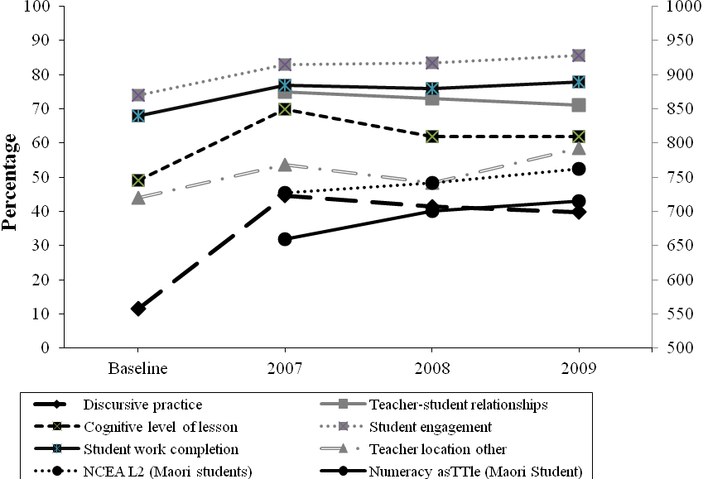
Data for Figure 7.1 were taken from (a) the Observation Tool—percentage of discursive practice; level of teacher–student relationships; cognitive level of the lesson; percentage of times teachers are not located at the front of the classroom; Māori students’ engagement and Māori students’ work completion; (b) the assessment Tool for Teaching and Learning (asTTle)—asTTle mathematics scores; and (c) NCEA Level 2 results. The results for the Observation Tool and NCEA were expressed as percentages, so there was a common unit of measurement; these are shown on the left, while asTTle scores are shown on the right. Positive slopes of the quantitative results, combined with the results of qualitative data analysis, clearly indicate that there is an association between Te Kotahitanga teachers’ implementation of the Effective Teaching Profile and Māori students’ achievement. The multiple indicators in Figure 7.1 (Creswell, 2005), show that while Te Kotahitanga teachers have improved in their use of the Effective Teaching Profile, simultanenously their Māori students have improved in numeracy, literacy, and external, cross-curricular examinations.

Question 2: Did the Phase 4 schools replicate the changes in teaching practices and student outcomes during 2007 to 2009 that were made by Phase 3 schools during the period, 2004 to 2006?
The evidence in this report shows that Phase 4 schools (in their first through to third year of the project’s implementation during 2007 to 2009) replicated the pattern of results observed earlier in Phase 3 schools during the period 2004 to 2006 (Bishop et al, 2007). Changes in Te Kotahitanga teachers’ classroom practices in Phase 4, after three years in the project, in broad terms reflect the changes in Phase 3 teachers’ practices that were seen after the first three years in the project. In both phases, there was a similar pattern of very positive sustained teacher-student relationships and improvements in the mean percentage of discursive practices. In addition, the cognitive level of the lessons, as an indicator of teachers’ expectations, rose and was maintained, as were high levels of Māori students’ completed work and the consistently high levels of Māori students’ engagement.
In terms of student achievement, one example of student outcomes further illustrates this pattern. When the first full cohort of students reached Year 11 in the Phase 3 schools in 2006, the percentage of Maori students gaining NCEA Level 1 and above was double that of the previous year’s Maori students when compared ot the gains made by a comparable group of Maori students; the comparison group being weighted for decile. Similarly, when the first full cohort of students reached Year 11 in Phase 4 schools in 2009, Māori students made twice the gain compared to the national cohort of Māori students, in terms of percentage points. Thus, Māori students, who had been in project schools for three years, made very large improvement gains in NCEA Level 1 in both phases, and Phase 4 schools replicated the gains made by Phase 3 schools at the same stage of the project’s implementation.
Evidence presented in this report demonstrates that the pattern for Phase 4 schools in terms of the Elmore graph above is very similar to that shown for Phase 3. As Figure 7.1 captures similar trends of results in Phase 3 and Phase 4 schools, it is clear that in both phases Te Kotahitanga project teachers have built their knowledge, skills, and capacities through the implementation of the Te Kotahitanga Effective Teaching Profile. At the same time, their Māori students have experienced continuous improvement in numeracy and literacy, in the junior school, and made significant gains in the second year of external examinations.

Question 3: What was the professional development intervention that enabled the changes in teacher practice to occur?
This report also records that during the period 2007 to 2010, the basic professional development programme of induction hui, observations, feedback, co-construction meetings and shadow-coaching was maintained in Phase 3 schools and implemented effectively in Phase 4 schools. In addition, during this period, a number of refinements were made to the professional development process so that there would be a greater chance of the change process that is engendered by the professional development being sustained by the facilitation teams within the schools once the universtiy-based Reseach and Development team withdrew.
There are also indications from our separate investigations into these schools undertaken during 2009 and 2010, from the analysis of the implementation of the professional development process and from the observations undertaken by regional coordinators during their school visits, that the professional development model is being implemented more efficiently in Phase 4 schools than had been the case in Phase 3 schools earlier and as a result there are more effective implementers of the Effective Teaching Profile in these schools than in the schools of the earlier phase. By way of verification of this observation, in their independent evaluation of Te Kotahitanga undertaken during 2006 to 2008, Meyer et al., (2010) observed that the percentage of high implementers of the Effective Teaching Profile was higher in Phase 4 schools: “Approximately two in five at the Phase 4 schools and one in five at the Phase 3 schools were evidencing high implementation of the Effective Teacher Profile...” (p. 7). While Meyer et al., (2010) suggest many reasons for this trend, they do acknowledge that the result may be due to improvements in the delivery of the Te Kotahitanga model.
This outcome is perhaps not surprising given that the Phase 4 schools faced entirely different circumstances from Phase 3 schools. For example, Phase 3 schools were the first large set of schools to implement what was still an evolving, developing project. They were provided with very short-term, one-year funding as the project developed; they were supported by a Research and Development team that was also funded on a short-term, year-by-year cycle, and that was subject to many political considerations. Teachers in Phase 3 schools were conscious of the strong opposition to the project from teachers’ associations and were often unsettled by insistence that teachers’ participation in the project be voluntary. This meant that many schools were not able to bring all of their staff into the project; this included many middle-managers who held the key to change in their subject departments. Many principals found the insistence that Te Kotahitanga be voluntary strange and difficult to manage when other professional development programmes in their schools, such as literacy and numeracy, were expected to be compulsory for all staff. In addition, many were unsettled by the project leaders’ insistence that focus should be on Māori students, and that this would benefit all students, including Māori. Additionally, in the early years of the project (2004 and 2005) there was evidence of considerable teacher resistance to the project, but as the evidence on teacher retention demonstrates, teacher withdrawals were only significant in the early years; once the project was established, there were few withdrawals.
Many of these early concerns have now been assuaged and in comparison to Phase 3 schools, Phase 4 schools were provided with secure funding for three years with assurances of ongoing funding from the outset; many of the issues that confronted the Phase 3 schools have now been addressed and resolved. In terms of staff retention in the project, the greatest number of withdrawals took place in Phase 3, in year 1 and 2 of cohort 1, and year 1 of Phase 4. Subsequently very few teachers chose to withdraw.

Question 4: How did school leaders maintain the changes in Phase 3 and Phase 4 schools and what did we learn about sustainability from their attempts?
Overall, teachers and leaders reported positively on the sustainability of the project in their schools. Teachers and leaders in both phases generally perceived that their schools have both the vision and the means to improve Māori students’ achievement, and that teachers have the opportunity to access Te Kotahitanga-related professional development. Teachers and leaders also felt that there is much work still to be undertaken to ensure that the focus on improvement in Māori students’ learning and engagement is clear at every level in the school. Generally, teachers and leaders in both phases felt that the facilitation teams in their schools were mostly effective in terms of providing and participating in teachers’ learning and development. Many teachers and leaders reported that relationships with Māori parents and communities had changed in the past few years, that schools were making a greater effort to share children’s successes with families and whānau, and that an increasing number of families are more comfortable coming into schools to discuss their children’s progress. Many teachers and leaders commented on the way that data collection in their school had changed to focus more clearly on the progress of individual students, Māori in particular. The majority of teachers and leaders in both phases reported that, since they had been part of the project, the overall culture of the school had changed, in particular to reflect more positive relationships between teachers and Māori students. Overall, leaders were very positive in their self-evaluations as leaders in Te Kotahitanga schools and in their evaluations of the systems and organisation supporting the project in their schools, but in this latter case slightly less so. In addition, Phase 4 schools’, teachers’ and leaders’ self-reported changes, verified by external reviews made by the Education Review Office, clearly follow the pattern of results established in the Phase 3 schools.
In sum, schools are reporting (this is verified by the Education Review Office) that they are establishing the conditions, identified as necessary by the GPILSEO analytical model, to sustain the project’s gains in terms of changes in teachers’ practices and in Māori students’ outcomes. Within this framework, students benefited from implementation of the Effective Teaching Profile in their classrooms; in many cases, the benefit is comparable to that of their Māori peers nationally; equally often the benefit is comparable to that of their non-Māori peers—both within the school and nationally. What is of the most interest and importance is that, and this is more readily seen in Phase 3 than Phase 4 schools, as teachers become more proficient at implementing the Effective Teaching Profile, and as this implementation becomes more of the norm within their schools (such that the school‘s culture changes to become more supportive in GPILSEO terms), Māori students perform better. Such results indicate that prolonged exposure to the Effective Teaching Profile brings Maori students’ achievement closer to that of non-Māori students.

7.1 Differentiation of implementation and maintenance among Phase 3 schools
It is clear from the analysis of the overall patterns from Phase 3 schools that Māori student achievement patterns continued to improve in association with the maintenance of changes in teacher’s practices. However, the individual case studies analysis that was undertaken in 2009 and 2010 of Phase 3 schools in their sixth and/or seventh year of the project, and that used the GPILSEO model to investigate the degree to which schools were supporting the pedagogic intervention, showed that there were marked differences in the degree to which the schools were supporting the implementation of the project, with consequent implications for sustainability.
Phase 3 schools can be seen as falling within one of four categories:
- high implementers and high maintainers of the project (4 schools)
- previously high implementers but currently low maintainers (3 schools)
- previously partial implementers, but currently poised to implement fully (4 schools)
- low implementers and low maintainers (1 school).
The seven schools in the first two categories are or have been very effective implementers of the Effective Teaching Profile in the majority of their teachers’ classrooms through use of the project’s central institutions (Induction hui, observations, feedback, co-construction meetings and shadow coaching (see Bishop & Berryman, 2010). They have also reported steady gains in Māori student attendance, retention, engagement and achievement (AREA) in their schools. In terms of the GPILSEO model there are a number of additional features these schools have in common. In these schools:
- the senior leadership teams are agentic leaders and present a united front in their determination to support the implementation of the school’s goal to improve the achievement of Maori students and to reduce educational disparities and these visions are of a long-term nature. There are also clear specific measurable goals in regards to Māori student achievement in these schools
- there has been marked changes made in the institutional and structural arrangements in the school in a manner that is clearly responsive to the needs of the pedagogic intervention, including policy development and implementation
- there has been a concerted effort to effectively distribute leadership throughout the school
- most or all of their staff are included in the project
- there is evidence of their making steady progress towards improving positive supportive learning relations with their Māori parents and community
- there has been a concerted effort to ensure improvements in evidence gathering, analysis and use
- ownership of the project, its goals and means of implementation is fundamental to their thinking and practice. This latter development means that there has been a reprioritising of funds available in the school so as to support the establishment of an ongoing professional development function (facilitators) in these schools.
Schools in the first category are those who have managed to embed the project into their systems, policies and processes to the extent that it will be maintained no matter what. It is now part of these schools; it is business as usual. These schools have institutionalised the central change dimensions of Te Kotahitanga, but many have struggled and continue to struggle to fund the facilitator/s’ positions within their schools now that project funding has ceased, but they are convinced that the role of the facilitator needs to be a permanent one in their schools. There is a strong evidence that the underlying theories and principles of the project have been taken on as their own by these school’s leaders, especially the understanding about the strong relationship between the quality of teachers’ theorising and practice with Maori student outcomes. One principal explained that the professional code of practice that Elmore (2004) has identified as being missing from education is provided for them by Te Kotahitanga. In this and the other schools in this group, as well as creating a means of providing students with a common learning experience, the principles and practices of Te Kotahitanga have provided these schools with a framework against which the appropriateness of other potential initiatives can be evaluated in terms of an underlying philosophy and values, and a central core into which these initiatives can be woven. As one principal explained,
A lot of time is spent evaluating new initiatives. Staff are very busy so we can’t afford to just get involved into any new initiative. We are to look carefully at any new initiative to see how it fits into our school’s philosophy and goals. Something new has to rate. We have a ruler now as [to] what is an effective programme and we use that. … Any new initiative has to match up to Te Kotahitanga. (Principal)
The consequence is that the whole school’s efforts towards achieving the goal of raising the educational achievement of Māori students as well as their peers can be channelled in a carefully planned, coherent and respectful manner with everyone’s involvement.
Schools that fit into the second category of the typology are those who had initially implemented the central dimensions of the project (annual induction workshop, observations, feedback, co-construction and shadow coaching) and who had taken responsibility for changing teacher practice in their schools to include all or most of their staff. However, currently all three schools in the second category have allowed parts of the professional development cycle to be eroded. This is not surprising given the problems of providing ongoing support for facilitators and funding problems (see below). While their current staff are exhibiting very clearly their commitment and abilities to maintain the implementation of the Effective Teaching Profile, with the lack of institutionalisation of the central elements of the professional development cycle, there are limited opportunities for the induction of new staff into the means of implementing the Effective Teaching Profile in their classrooms through the process of observations and feedback. Further, the main means of sustaining the implementation in teachers’ classrooms, the co-construction meetings and associated shadow coaching, are not being maintained as a regular institution within these school. On a positive note, two of these schools are investigating means of reintroducing these institutions to their schools and fully understand the connection between changes in teachers’ practice and improved Māori student outcomes.
Schools in the third category are those who have found many problems in their way to full implementation of the project. These include changes in principal leadership and hence in strategic direction, strong resistance from middle managers, problems with funding, problems with rapid turnover of facilitators, competition between bilingual units and mainstream classes, sporadic implementation of the project and competition for resources from other projects. These problems have meant the implementation of the Effective Teaching Profile through the professional development cycle was never consistently implemented and/or spread to most or all of the staff in these schools. However, there are pockets of excellence at both individual teacher and subject department levels and in all cases, the new leadership in these schools are keen and are well poised to reinstate the central institutions of Te Kotahitanga, to fund facilitators from their own funds and are expecting to see appropriate school-wide rewards for their actions.
The one school in the fourth category had found problems with both implementing the project and revisiting this problem and has moved to alternative approaches to improving Māori student achievement.
The pattern outlined above is reflected in the patterns of Māori student achievement. It is clear that Māori students in the seven schools in the first two categories are making sound progress, whereas Māori students in the latter five are not.

7.2 Future developments
Despite all the challenges that the Phase 3 schools faced, they are able to provide us with an understanding of what constitutes sustainability and, most importantly, they have provided us with a formative picture of what the project should look like in the future, indeed of what it now looks like in Phase 5 schools. Below we consider a number of developments to the project that have the potential to make the project sustainable in schools beyond the period of central funding by the Ministry of Education. These developments will take place within the new contractual arrangements (Service Level Agreements), between the University of Waikato as professional development providers and the project schools. These new arrangements improve the flow of information in the school–project team partnership and, therefore, the potential for improved responsiveness on all sides. In addition to the suggestions below, we are also increasing the means whereby project schools can monitor their progress towards the effective implementation of the project in their schools and evaluating the effectiveness of these means. These measures will add to the quality assurance and capacity-building measures already incorporated into the professional development programme.

7.2.1 The expansion of Te Kotahitanga as an intervention beyond the classroom
During the period covered by this report, we have used the GPILSEO model as an analytical tool to identify what the schools had done to support the implementation of the pedagogic intervention that was Te Kotahitanga up to that point. We have shown the value of a case study approach in that all the schools’ leaders and leadership teams had responded to the project in different ways. We have seen that some school leadership teams were able to address many of the dimensions of the GPILSEO model, while others were less able to do so, this latter tendency being exacerbated when the principal changed during the period of the implementation. Overall, the lessons we have learned from this current analysis of the Te Kotahitanga programme indicate that school leadership is a vital component of effective implementation of Te Kotahitanga in a way that is sustainable, and suggest that we need to develop a more systematic intervention based on the GPILSEO model. This is necessary so that school structures and institutions can be more effectively developed to support the reform of effective, culturally responsive classroom pedagogy with the goal of improving Māori students’ learning and achievement. Such an intervention is vital if, for example, there is a chance of the principal resigning during the period of the implementation of the project. A number of implications follow from this understanding. Two of the most important of these are that:
- a distributed leadership model needs to be established within the schools so that all leaders in the school are engaged in implementing the elements of the GPILSEO model in accordance with their level of responsibility
- the role of middle-level leaders such as heads of subject areas (heads of faculty and heads of department) should be reconceptualised to include a clear focus on improving teaching and learning such that they support the improvement of Māori students’ learning and achievement.

7.2.2 Distributed leadership
A distributed leadership model for implementing the elements of GPILSEO would clearly reduce the potential for the project to be abandoned if the new principal does not support its implementation, as was the case in one school. When talking to heads of department and faculty in the case study interviews, we found that those middle management leaders who were able to act as pedagogic leaders were seeing great changes taking place within their departments. Just as some principals were able to implement effectively the various dimensions of the GPILSEO model in their schools, so, too, some heads of department were able to implement these dimensions within their subject departments. Some others were frustrated that there was not a school-wide system that made it possible for all of them to support the teachers for whom they were responsible to improve their pedagogical practices more effectively.
To develop a distributed leadership model most effectively, the Te Kotahitanga professional development programme should be expanded to support the development of a series of co-construction meetings to establish professional learning communities at a number of levels within the schools. At each level in the school, the primary focus of these meetings would be the improvement of student learning and educational outcomes through collaborative problem-solving based on evidence of students/groups of students’ educational performance in relation to established goals. These meetings would be prime opportunities for leaders to interrupt deficit explanations about Māori student achievement and seek alternative explanations in order that teachers and other leaders are able to work in an agentic manner.
Table 7.1: Levels of Co-construction hui
Level | Function | Who should participate?
School level | Term-by-term problem-solving and goal setting pertaining to progress of Māori students towards school attendance, retention, engagement and achievement (AREA) goals | Principal (chair), board of trustees’ chair, senior management team members  Other senior staff
Heads of department or faculty and deans level | Using evidence gathered at departmental level, heads of department and faculty co-construct ways that they can support their staff to support Māori student learning. | Chaired by principal  Heads of department and faculty, and deans
Classroom level (note that this is the current practice within Te Kotahitanga schools.) | Using evidence of Māori student performance in their classes, teachers co-construct ways that can change their teaching so that Māori students can more effectively improve their learning and outcomes | Chaired by facilitators for teachers in cross-disciplinary settings (as developed in previous phases of Te Kotahitanga).

Co-construction meetings and associated follow-up activities would provide for iterative sense- making opportunities that take leaders beyond superficial understandings of language, culture and identity and their place in Māori learner such as the taha Māori approaches common in the 1980s. They would also provide leaders with an opportunity to explicitly focus on their developing skills and understanding fundamental to pedagogical leadership. This in turn would allow for teacher practices that would build caring and learning relationships and interactions leading to improved outcomes for and with Māori learners. In this way, a distributed leadership pattern would be supported within each school that would provide intellectual challenge in a ‘job-embedded’ situation. It is important that, built into the project from its inception is this pattern of support which would cater for the different circumstances and contexts of boards of trustees, principals, senior leadership teams and schools.

7.2.3 Who does what?
Each of the dimensions of the GPILSEO model should be implemented differently at different levels of the distributed leadership pattern within the school depending upon the leader’s level of responsibility. The following tables illustrate some of the ways leaders could implement the model of reform.
Table 7.2: Implementation of the GPILSEO model by principals and boards of trustees
Goal | Ensure that the school sets goals related to improving Māori student attendance, retention, engagement and achievement (AREA), developing staff commitment to the goal, ensuring the goals are clear, measurable and achievable
Pedagogy | Ensure that the conditions where effective pedagogy can occur are provided by:  developing a culture of evidence-based, problem-solving within the school  maintaining orderly and supportive teaching and learning environments
Institution | Ensure that institutional, organisational and structural supports are aligned so as to support effective pedagogy in classrooms, and constructive problem-solving conversations for effective pedagogical purposes.
Leadership | Ensure that leadership is distributed throughout the organisation so that leadership tasks are carried out at appropriate levels
Spread | Ensure that all teachers are involved in realising the goals of the school  Create educationally meaningful relationships within the school and beyond through effective networking  Ensure that Māori parents and families are able to participate in their children’s education
Evidence | Ensure that data management systems are appropriate for formative and summative purposes  Ensure that discipline systems are aligned with pedagogic practices
Ownership | Ensure that schools resources, including staffing and finance, are strategically aligned to pedagogical purposes  Ensure that a culture of Māori student improvement becomes normal in the school

Some of the activities that principals and boards of trustees would be supported to lead, include:
- setting vision and goals in relation to Māori achievement
- changing the organisational structure and policies to support pedagogic reform
- spreading the reform to include all concerned
- ensuring ownership of the reform
- recruiting only staff who will commit to the reform
- changing school policies and processes that limit Māori student achievement; for example, adopting a policy of having classes that are not streamed, and changing the discipline system
- overseeing the compatibility of assessment and reporting with school’s aspirations to include parents and community in the education of their students
- integration of all professional development in the school so that all professional development is focused on achieving the school’s goals
- ensuring that funding is reprioritised so as to achieve the school’s goals.
Table 7.3: Implementation of the GPILSEO model by the senior leadership team
Goal | Ensure that the means of implementing the goals of the school are effectively working
Pedagogy | Provide active oversight support for the conditions wherein effective pedagogy can occur  Support the implementation of a culture of evidence-based problem-solving across the school
Institution | Ensure that institutional, organisational, and structural supports are aligned to support effective classroom pedagogies  Ensure that orderly and supportive learning environments are implemented effectively
Leadership | Undertake tasks appropriate to the senior leadership team member as part of a distributed leadership approach
Spread | Ensure that the means of spreading the reform to all members, leaders, students and their families is working effectively
Evidence | Ensure that data management systems are working to support formative and summative purposes  Ensure that discipline systems are working in association with pedagogic processes
Ownership | Assist with ensuring that school resources, including staffing and finances, are strategically aligned with pedagogic purposes

Some of the ways senior management team members might ensure this happens would be to:
- induct new teachers into the school culture
- ensure quality data management systems are in place and working
- reform the timetable to allow Te Kotahitanga pedagogic interventions to take place in a quality, sustainable manner
- ensure that the discipline system works in a way that is supportive of caring and learning classroom relationship
- ensure that all professional development initiatives work in concert towards the school’s goals
- support teachers who are having problems coming to terms with the transformation of the school’s culture
- participate in head of department and faculty co-construction meetings.
Table 7.4: Implementation of the GPILSEO model by heads of department or faculty, and deans
Goal | Ensure that goals are established at appropriate levels that focus on improving Māori student attendance, retention, engagement and achievement (AREA) goals
Pedagogy | Provide active oversight and consideration of the teaching programme  Observe in classrooms and provide effective feedback  Ensure there is an intensive focus on the teaching and learning relationship
Institution | Hold departmental-level co-construction meetings that promote collective responsibility and accountability and that provide the opportunity to engage in problem-solving conversations about student achievement and well-being at the department level  Ensure orderly and supportive working and learning environments
Leadership | Ensure that leadership is promoted among teachers and students
Spread | Ensure that all teachers are included in co-constructing improved pathways for Māori learners
Evidence | Ensure that evidence of student performance is used for the systematic monitoring of student progress and pedagogic improvement  Ensure assessment results are used for ongoing programme improvement.
Ownership | Ensure that all departmental/faculty resources are strategically aligned to pedagogical purposes

Some of the ways that deans and heads of department or faculty could ensure the implementation of the GPILSEO reform model include:
- setting Māori student achievement goals for their department/faculty
- gathering evidence of the participation and achievement of Māori students in their department/faculty
- from this evidence, determining the implications for Māori students, for teachers in the department and for themselves as pedagogic leaders
- acting as a pedagogic leader for staff to support individual teachers’ pedagogy emerging from evidence of student outcomes and from evidence of teacher observations
- acting as a general pedagogic leader (emerging from aggregated teacher observation data)
- reprioritising funding and resourcing at appropriate levels
- supporting the use of assessment for pedagogic purposes
- participating in co-construction meetings for heads of department or faculty
- conducting co-construction meetings for subject departments. Deans would conduct co-construction meetings for cross-curricular groupings to:
    - collaboratively plan future teaching based on evidence of student performance; that is, collegial discussion about the relationship between what is taught and what is learned
    - coordinate results to feed back to teachers
    - evaluate teaching in ways that are useful to teachers
    - support teachers through resource allocation, timetabling, and assessment procedures.

7.2.4 Re-conceptualising the role of heads of department and faculty
Central to a consideration of sustainability of reform in classroom practices and consequent improvement of Māori students’ learning, should be a re-conceptualisation of the roles of heads of department and faculty. This would require a shift from the traditional roles of these positions from the current emphasis on administering the department or faculty to one where staff in these roles are supported to become more closely focused on the core business of improving teaching and learning in ways that have an effect on Māori students’ learning and educational outcomes.
There are currently two limitations faced by heads of department and faculty in making this transition. The first is that they are subject to huge demands on their time made by administering internal assessments, including NCEA. Secondly, heads of department or faculty are also usually responsible for implementing the appraisal system within their departments. In effect, therefore, there are two sets of roles that are potentially in conflict with one another;
- the administrative/appraisal role
- the pedagogical leader’s role.
The pedagogic leader’s role is one where the head of department or faculty can be supported by our regional coordinator and the school’s senior management team to support teachers in a deliberate, open, supportive engagement about areas that need improvement.
To be able to engage fully in openly sharing evidence of areas that need to be improved, the formative purpose, teachers need to be assured that their attempts to improve remain confidential; that is, they are able to make mistakes and reveal weaknesses in an environment that remains private and is not part of the public record. Appraisal on the other hand becomes part of the public record. Often it remains a summative evaluation of teachers’ competency measured against a set of standards.
This public/private, formative/summative conflict may well be able to be resolved by some heads of department or faculty in some schools in a collaborative manner with their staff and we would encourage these heads of department or faculty and their schools to engage in conversations to ensure that this occurs. However, our evidence would tend to indicate that in most cases the two sets of roles should be separated within the schools.
Just how this would occur will vary from school to school depending on size, experiences of the staff, heads of department or faculty involved, the organisation’s structures and so on. We would seek to support leadership teams to engage in an open conversation, as part of the co-construction meetings, to determine just how this differentiation of roles could occur, or indeed if it needs to occur. Examples might be:
- A senior head of department may decide to continue with the role of administration and appraisal and ask an aspiring head of department or someone with high levels of pedagogical skills and content knowledge to engage in supporting teachers through observations and feedback sessions and co-construction meetings, with pedagogical skills and content knowledge.
- In smaller schools, the principal and senior management team may opt to take the task of staff appraisal off the heads of department to release them to become pedagogic leaders.
- The schools may understand that their appraisal system does offer sufficient means of providing formative support for teachers and their teachers are in agreement with this dual approach.
There should also be consideration of a change in the role of the dean away from pastoral care of students, academic counselling and behaviour issues to work more at the interface between students and teachers to improve the relationships that are so vital to improving effective teaching and learning.

7.3 Transformation of the contractual arrangements between professional development providers and the schools
In the earlier phases of the project, the contract for services and the provision of funds to the schools was held and implemented by the Ministry of Education. During the years covered by this report, it came clear that this process was not efficient as the schools were reporting to the Ministry of Education as the funding agency and not to the Research and Development team. It was decided that the contract be changed at the start of Phase 5 so that there would exist a Service Level Agreement (SLA) between the Research and Development team and the schools who would provide milestone reports to the Research and Development team as to their progress. This has proven to be so successful that the next iteration of the Phase 4 contract will contain the same provisions. One of the major benefits, apart from the information flow being improved, is that the principals can be provided with feedback from a member of the Research and Development team about their attempts at implementing the GPILSEO dimensions in their schools. This feedback reiterates the pattern of feedback loops; that is activity and feedback established in Te Kotahitanga classrooms between learners, and also between facilitators and members of the Research and Development team. Extending this very effective learning strategy to the school leadership extends the development of the project as a series of feedback loops.

7.4 Conclusion
The data in this report illustrate that Phase 3 schools are maintaining the pattern of changes in teacher practice and student outcomes that they developed in the first three years of their implementation of the Te Kotahitanga project. Phase 4 schools are following the pattern established earlier by Phase 3 schools. Both sets of schools are starting to show predictable outcomes associated with gains made during the school year on norm-referenced, standardised measures of literacy and numeracy at Years 9 and 10 and external measures at Years 11 to 13. The overall general trend of these efforts is that Māori students are beginning to learn at the same rate as non-Māori students in Te Kotahitanga schools. In addition, those Phase 3 schools that have had consistent and effective leadership of the Te Kotahitanga reform are able to demonstrate the ways they have institutionalised this reform so that it has become sustained in their schools. That some Phase 3 schools were not able to do so, and some Phase 4 schools are following their pattern, has resulted in our developing an additional professional development programme, this time to support a distributed leadership approach within the schools to ensure that more schools can successfully sustain the reform in the future.

7.5 References
Bishop, R. & Berryman, M. (2010). 'Te Kotahitanga: culturally responsive professional development for teachers', Teacher Development, 14: 2, 173 — 187
Bishop, R., O’Sullivan, D., & Berryman, M. (2010). Scaling up education reform: Addressing the politics of disparity. Wellington, New Zealand: NZCER Press.
Creswell, J. W. (2005). Educational Research: Planning, conducting, and evaluating quantitative and qualitative research (second edition). Columbus, Ohio: Pearson Merrill Prentice Hall.
Elmore, R. (2004). School reform from the inside out: Policy, practice and performance. Cambridge, MA: Harvard Education Press.
Meyer, L., Penitito, W., Hynds, A., Savage, C., Hindle, R., & Sleeter, C. (2010). Evaluation of the Te Kotahitanga programme. Wellington, New Zealand: Ministry of Education.
Robinson, V., Hohepa, M., & Lloyd, C. (2008). School leadership and student outcome: Identifying what works and why. A best evidence synthesis iteration. Wellington, New Zealand: Ministry of Education.

The national cohort was weighted for decile levels.
One school was high implementing, high maintaining, and the other low implementing and low maintaining.
This term refers to the categorisation of schools according to the average socioeconomic status of the parents of the students attending the schools.
Intermediate schools are public schools for students in Levels 7 and 8, or those aged between 10 and 12 years.
Thirteen different types of interactions were recorded using the observation tool. Co-construction, feed-forward academic positive, feed-forward academic negative, feedback academic positive, feedback academic negative, and prior knowledge constitute the measure of discursive practice while feed-forward behaviour positive, feed-forward behaviour negative, feedback behaviour positive, feedback behaviour negative, monitoring, instructions, and other constitute the measure of traditional practice. The focus of our analysis was on differences in discursive practice. The counts of those interactions which constituted the measure of discursive practice were summed and converted into percentages for the analysis.
In cohorts 1 and 2 of Phase 3, numbers of teachers withdrew from the project in years 1 and 2. See Chapter 4, section 4.4, for a discussion of this point. In later cohorts very few teachers withdrew.
This is appropriate as no great differences have been observed between terms 2 and 3.
There are six different dimensions of relationships: manaakitanga (caring for Māori students); mana motuhake (caring for the learning performance of Māori students and for their behaviour performance); whakapiringatanga (well managed learning environment, culturally appropriate context and culturally responsive context). In Phase 3 an exploratory factor analysis indicated that the six dimensions could be combined into two factors. Caring, expectations for performance and behaviour, and classroom management constituted factor 1. Providing a culturally appropriate context and culturally responsive learning context constituted factor 2. However, it is clear that after the first three years of implementation in Phase 3, in some cohorts the six dimensions correlated highly. It appears therefore that experience and further professional development on the part of the facilitators was enabling them to understand these six dimensions as part of one overall concept “relationships” and apply the observation tool accordingly. In addition, it may be that the longer teachers are in the project, the more they understand and practise concepts of cultural appropriateness and responsiveness. This interpretation is supported by the later factor analysis of Phase 4 observations of relationships. Here, an exploratory factor analysis indicated that the six dimensions could be combined into one factor. Therefore, for each teacher, an average of the six dimensions of relationships was calculated.
For reasons that we discuss in Chapter 4, the sample of Year 9 students’ data available for comparison with asTTle national norms was too small to make this exercise meaningful. Hence for comparison with national norms we were restricted to Year 10 students’ outcome data only.
Explanation and results of the ESA for Year 9 and Year 10 in the project schools in 2004 and 2005 can be found in Te Kotahitanga Phase 3 Whanaungatanga: Establishing a Culturally Responsive Pedagogy of Relations in Mainstream Secondary School Classrooms (Bishop, Berryman, Cavanagh, & Teddy, 2007).
asTTle is also used for formative purposes, making it a very useful tool for use in schools.
Again, our project data has been gathered from that primarily used within the schools. Despite our requesting them to do so, some schools just did not (or could not) use asTTle.
See Chapter 1 for a discussion of these acronyms.
The national cohort was weighted for decile levels.
In order to maintain the anonymity of schools, direct references have not been given to the schools’ individual ERO reports.
For a definition of what is meant by “Schedule 1” and “Schedule 2”, please see Chapter 2.
The sample of post–post scores available for Year 9 students was limited to one school in Phase 3. We therefore omitted this data from our discussion in the current section because our sample size was too small to enable meaningful comparison with national norms.
The analysis of NCEA results was carried out by Dr Michael Johnston, Research and Knowledge Services, New Zealand Qualifications Authority (Timperley, Wilson, Barrar, & Fung, 2007).
See Chapter 2 for discussion of factors 1 and 2 in relation to “relationships” as identified on the observation tool. Caring, expectations for performance and behaviour, and classroom management constitute factor 1. Providing a culturally appropriate context and culturally responsive learning context constitute factor 2.
See Chapter 2 for further discussion of the rationale underpinning Hall and Hord’s (2006) “levels of use” interviews.
Phase 3 schools are numbered from 1–12 to protect their anonymity. The same school numbers for each school are used consistently throughout this report.
In the outcomes of this survey the following abbreviations have been used: P – principal; DP – deputy principal; HoD – head of department; HoF – head of faculty; LF – lead facilitator.
In the outcomes of this survey, the following abbreviations have been used: P – principal; AP – associate principal; DP – deputy principal; HoD – head of department; HoF – head of faculty; LF – lead facilitator.
The sample of post–post scores available for Year 9 students, 2007 to 2009, and Year 10 students in 2007 in Phase 4 was limited to 1–3 schools. We therefore omitted this data from our discussion in the current section because our sample size was too small to enable meaningful comparison with national norms.
Please note that the caring relationship measure includes teachers caring for Māori students as culturally located individuals (“Māori learning as Māori”), teachers demonstrating their having high expectations of Māori students as learners and of their behaviour, and teachers demonstating their abilites to manage a well-organised classroom learning environment.
See Chapter 1 discussion of observation tool for an explanation of the significance of this level.
In the outcomes of this survey, the following abbreviations have been used: P – principal; DP – deputy principal; HoD – head of department; HoF – head of faculty; LF – lead facilitator.
The reason for six schools not being represented in the survey was due to technical problems associated with the electronic nature of the survey rather than any refusal to engage by the teachers in these schools.
Responses have been reported as percentages except for individual qualitative comments. These latter have been reported in the form of raw numbers as these numbers tend to be very low.
It is very difficult to establish a realistic participation figure as the category “leaders” included leaders at a number of levels in the schools. For example, while nearly 90% of principals and senior leadership team members completed the survey, it was difficult to measure head of department participation. In addition, in many ways it is not realistic to include heads of department as they were never specifically targeted in the intervention in the ways that principals and senior leadership team members were. Having said that, however, those heads of department who did respond have been included as our research has shown the need for their inclusion in a focused intervention in the future (see Chapter 7 for details).
In the outcomes of this survey, the following abbreviations have been used: P – principal; DP – deputy principal; HoD – head of department; HoF – head of faculty; LF – lead facilitator.
Responses have been reported as percentages except for individual qualitative comments. These latter have been reported in the form of raw numbers as these numbers tend to be very low.
“Smart tools” have been defined by Robinson, Hohepa, and Lloyd, (2008) as tools that incorporate sound theories about the tasks for which they have been designed and furthermore they are tools that are well designed. By this definition a smart tool is an educational tool that is well theorised and will “assist the users to achieve the intended purposes” of the activity in which the tools are used (Robinson et al., 2008, p. 133).
The school numbers 1–12 in Figure 3.1 are those that are used consistently in this report to refer to the 12 Phase 3 schools to maintain their anonymity.
Numbers have been used in place of school names to preserve their anonymity.
The data in the mean columns in Tables 5.3 and 5.4 are not the mean of the four measures in each table but rather a mean of each correlation from the individual observations.
One school was high implementing, high maintaining, and the other low implementing and low maintaining.
The school numbers we have adopted here are those used earlier in this report in Chapters 4 and 5 and hence do not appear in numerical order in this chapter.
In doing this we assumed that the residual effect of previous high implementation would have a positive effect on student achievement.
The average (mean) difference between 2004 and 2009 was around 6%.
These are the years for which we have used Ministry of Education data for all the analyses in Chapters 4–6 of this report.
For suspensions and stand-downs, the data available to us date from 2004 to 2009. For NCEA Level 1 qualifications, the data date from 2006 to 2009.
A z-test of two proportions is appropriate where the data available are percentages and raw numbers in two samples, but not standard deviations.
In 2007, the significance of the difference was marginal (p =.07).

