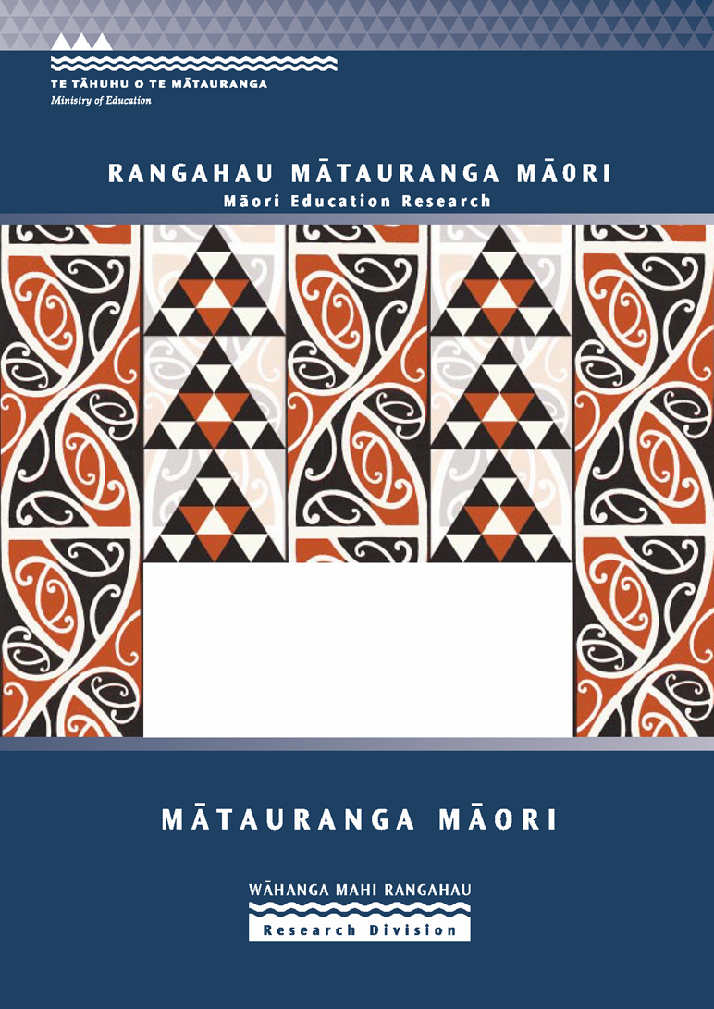

Te Kōtahitanga Phase 3 Whānaungatanga: Establishing a Culturally Responsive Pedagogy of Relations in Mainstream Secondary School Classrooms
Report to the Ministry of Education
R. Bishop, M. Berryman, T. Cavanagh & L. Teddy

Te Tere Auraki (to navigate the mainstream river) is a research and professional development strategy focused on improving teaching and learning for Māori students in mainstream schools. Te Kōtahitanga is a project that sits within this strategy.

ISBN 978-0-478-13648-7
Web Copy ISBN 978-0-478-13649-4
RMR-840

© Ministry of Education, New Zealand — 2007
Research reports are also available on the Ministry’s website: www.minedu.govt.nz/goto/2107 and on Education Counts: www.educationcounts.edcentre.govt.nz/research/index.html

Opinions expressed in this report are those of the authors and do not necessarily coincide with those of the Ministry of Education


Te Kōtahitanga Phase 3
Whānaungatanga: Establishing a
Culturally Responsive Pedagogy of
Relations in Mainstream Secondary School Classrooms.

Final Report
Ministry of Education Research Division Wellington
EXTERNAL RESEARCH CONTRACT WITH:
Māori Education Research
School of Education, University of Waikato, Hamilton
AND
Poutama Pounamu Research and Development Centre
GSE Ministry of Education Tauranga
PREPARED BY:
R.Bishop, M.Berryman, T.Cavanagh and L.Teddy.

March 2007



TE KŌTAHITANGA

The wavy lines at the base of the model come from the New Zealand Ministry of Education’s logo where they represent the waterways of our island nation and the life blood of Aotearoa New Zealand. In this model they show the Ministry’s funding and support to the project. The zig zag lines at the top come from the Māori symbol for ‘niho taniwha’ or teeth of the taniwha. ‘Niho taniwha’ make metaphoric references to relationships, guardianship and leadership. The zig zag lines in this model represent the role of the University of Waikato and the participation of researchers from this institution who worked in partnership with researchers from the MOE, GSE, Poutama Pounamu research centre.

The symbol of concentric circles in the centre represents Māori students and their families and their central place in this project. The innermost circle represents the students themselves within their whānau (family, second circle), their hapū (sub-tribe, third circle), their iwi (tribe, fourth circle) and their culture provided by the remaining overlay of circles. On either side is a double spiral. The centre of the double spiral is understood to represent the interconnectedness of passive and active elements from whence change can be generated. The double spiral to the left represents Māori educators, while the double spiral to the right represents non-Māori educators. Reading from left to right it can also be noted that this research was by Māori, for Māori and for non-Māori. Raising Māori students’ achievement is seen to be inextricably interconnected with the creation of culturally appropriate and responsive learning contexts. Graphically the waves and the niho taniwha placed on either side of the learning contexts suggest that research informs practice and practice informs research, and that this process is iterative and ongoing.
Acknowledgements

This project was funded by the Curriculum Teaching and Learning Division of the Ministry of Education and conducted by Māori Education Research of the School of Education, University of Waikato and Poutama Pounamu Research and Development Centre. The latter group were formerly of the Specialist Education Services and now are part of Group Special Education of the Ministry of Education.

Firstly, our thanks must again go to the students who so willingly shared their stories in the initial phase of this project upon which this whole project is based. These students understood that they themselves might not benefit from their stories, but that these may indeed help other students like them in the future.

Secondly, we also wish to again thank the parents, the principals and the teachers who also shared their stories with us in Phase 1 of the project. These stories have now been published as Culture Speaks: Cultural Relationships and Classroom Learning.

Many other people in many different roles supported and contributed to this project. We are very grateful to our Advisory Committee members, (which consisted of Waikato School of Education staff members, experts from related fields and Ministry of Education staff), for their critical consideration and insights during the project. We are particularly grateful to the staff of Ministry of Education, Cheree Nuku in the initial stage and Lynette Bradnam latterly, for their support for improving mainstream education for Māori students.

The project was developed and directed by Professor Russell Bishop assisted by Tom Cavanagh, Lani Teddy, Sandra Clapham, Pare Kana, Kura Hingston and Alison Powell. Project management was provided by Kirstin Trainor-Smith in 2003 and then by Titahi Tarawa as well as administration assistance by Allanah Ashwell.

This team worked in partnership with the Poutama Pounamu research whānau in Tauranga, which is led by Mere Berryman who helped develop the project and the professional development aspects. Our rōpu whakaruruhau, Rangiwhakaehu Walker and Mate Reweti provided invaluable cultural leadership, guidance and expertise. They were assisted by Moehu Ngātoko, Soli Weiss, Tracey Togo and Donna Fengewisch.

Table of Contents

Executive Summary 1
Introduction and Overview 5
Chapter 1: Developing a Culturally Responsive Pedagogy of Relations 7
Rangatiratanga: relative autonomy/self-determination 10
Taonga Tuku Iko (Cultural Aspirations) 11
Ako (reciprocal learning) 11
Kia piki ake i ngā raruraru o te kainga (mediation of socio-economic and home difficulties) 12
Whānau: (Extended family) 12
Kaupapa (collective vision, philosophy) 14
Implications of these Metaphors 14
A Culturally Responsive Pedagogy of Relations 16
The Students 18
The Whānau 19
The Principals 19
The Teachers 19
Interpretation of the Narratives of Experience: Development of the Analytical Model 21
Discursive Positioning 23
Uses Of The Narratives 24
How The Effective Teaching Profile Was Constructed 26
How The Effective Teaching Profile Was Constructed 27
Manaakitanga 28
Mana Motuhake 29
Ngā Whakapiringatanga 29
Wānanga 29
Ako 30
Kōtahitanga 30
Conclusions 32
Chapter 2: Implementing the Effective Teaching Profile: The Professional Development Intervention 35
Introduction and Overview 35
PART A: Implementing The Effective Teaching Profile 35
Activity No 1: The induction hui: the hui whakarewa 36
PSIRPEG: The Model for Implementing the Effective Teaching Profile in the classroom 38
Activity No 2: Te Kōtahitanga Observations 40
Activity No 3: Individual Teacher Feedback 40
Activity No 4: The Co-construction Meeting 42
Activity No 5: Shadow Coaching 42
The Professional Development Model 43
The First Order of the Professional Development Implementation Model 44
The Second Order of the Professional Development Implementation Model. 45
Third Order of the Professional Development Implementation Model 45
Principals’ support 46
Resources Developed To Support The Te Kōtahitanga Professional Development 46
Project Structure: 49
PART B: Demographic Information And Descriptives Of Participating Schools, Facilitators And Teachers 51
Participation of facilitators 51
Participation of Teachers 52
Summary 56
Chapter 3: Research Methodology 57
Methodological Framework 57
Kaupapa Māori Research 59
Chapter 4: So what happened in the classrooms? Results from the In-class observation tool. 63
Introduction 63
I). Shifts In Classroom Interactions 63
a). Shifts from traditional to discursive interactions 63
b) Teacher use of discursive practice 72
c). Shifts between whole class, individual and group interactions 74
II) Shifts In Classroom Relationships 75
III) Shifts In Teacher And Māori Student Proximity 76
IV) Shifts In The Cognitive Level Of Lessons 79
V) Shifts In Māori Student Academic Engagement And Student Work Completion 80
Summary 82
Chapter 5: Analysis of two new institutions established to support classroom implementation of the Effective Teaching Profile 85
Introduction 85
The Evolving Method Of Collection And Analysis 86
Analysis One 86
Analysis Two 88
Framework for Treatment Integrity Analysis 88
Conversations from Feedback and Co-construction Sessions 89
Feedback Sessions: Conversations from Facilitators and Teachers According to the Themes and Sub-themes 90
Co-construction Sessions: Conversations from Facilitators and Teachers According to the Sub-themes 98
Overall Quantitative Analysis Of Taped Feedback And Co-Construction Sessions 2004 105
Overall Quantitative Analysis Of Taped Feedback And Co-Construction Sessions 2005 107
Learning Outcomes From The Treatment Integrity Procedure 110
Chapter 6: Te Kōtahitanga 2005 Teacher Participation Survey Results 113
Introduction 113
Results 114
Quantitative Data Analyses 114
Analyses of Part 1 of the survey. 114
Analyses of Parts 1-5 of the survey 115
Inferential statistical analyses of survey questions. 116
Analyses of teacher positioning questions. 119
Qualitative Data Analyses 120
Conclusions 125
Chapter 7: Teachers’ experiences of the Effective Teaching Profile 127
Introduction 127
Method 127
Framework for analysis 128
Analysis Of Interviews 129
Experiences of the Te Kōtahitanga training and narratives 129
Teachers’ philosophical positioning 133
The professional development cycle 135
The observations 135
Feedback 136
Co-construction meetings 137
Shadow coaching 139
Facilitation, collegial and senior management support 139
Principal and senior management support 142
The impact of Te Kōtahitanga and focusing on Māori 143
Suggestions for new teachers 143
Suggestions about the professional development 145
The Te Kōtahitanga difference 148
Summary 149
Conclusion 151
Chapter 8: Māori students’ classroom experiences of highly effective teachers: 2004-2005 153
Introduction 153
Method 153
Framework for analysis 155
Analysis Of Student Interviews 157
Manaakitanga 157
Mana motuhake 159
Ngā whakapiringatanga 161
Wānanga 162
Ako 164
Kōtahitanga 165
Summary 165
Teacher positioning about Māori students 166
Relationships 167
Outcomes 169
Conclusion 170
Chapter 9: Te Kōtahitanga 2004-2005 Student Achievement Results and Discussion 173
Introduction 173
Assessment Tool For Teaching And Learning (asTTle) 173
Results 175
Discussion 176
Essential Skills Assessment (ESA) 177
Stanines 177
Results 178
Discussion 179
Raw Score 181
Results 181
Discussion 182
Conclusions 183
Chapter 10: Summary and Conclusions 185
Summary 185
Conclusions 187
1. The Effective Teaching Profile 187
2. Anti-deficit thinking 189
3. The importance of relationships 190
4. Teacher-student interactions 191
5. The dominant pattern of teacher-student interactions 192
6. Addressing Student Achievement 193
7. Towards Sustainability and Scale 194
References 199
APPENDIX A 207
Te Kōtahitanga In-Class Observation Sheet 207
APPENDIX B 211
Taped Feedback/Co-Construction Sessions: Analysis Form 211
APPENDIX C 213
Te Kōtahitanga Teacher Participation Survey 213
APPENDIX D 225
Te Kōtahitanga Phase 3 Teacher Interviews 225
APPENDIX E 227
Te Kōtahitanga Phase 3 Student Interviews 227
APPENDIX F 231
Evidence About Effectiveness Of Te Kōtahitanga From Education Review Office (ERO) Reports 231
APPENDIX G 245

