mathematics

Key findings from the Trends in International Mathematics and Science Study (TIMSS) 2010/11

Year 5 Mathematics

Robyn Caygill, Sarah Kirkham, and Nicola Marshall

What is TIMSS?
The Trends in International Mathematics and Science Study (TIMSS) measures trends in mathematics and science achievement at the fourth and eighth grades (Years 5 and 9) as well as monitoring curricular implementation and identifying the most effective instructional practices from around the world. Conducted on a regular 4-year cycle, TIMSS has assessed mathematics and science since 1994. More than 300,000 students from 52 countries and seven benchmarking participants around the world took part in TIMSS 2010/11 at the middle primary level.

What does TIMSS consist of?
TIMSS consists of assessments of students’ achievements in mathematics and science. Each student answered a combination of mathematics and science questions. The assessment was a pencil-and-paper test containing both multiple-choice and constructed- response questions. Following this, students were given a questionnaire containing questions about themselves and their opinions about mathematics and science. Principals, teachers and parents were also given questionnaires to gain further information about the context in which mathematics teaching and learning take place. In New Zealand, the assessments and questionnaires were conducted in English.
The TIMSS assessments are organised around two dimensions: a content dimension specifying the domains or subject matter to be assessed within mathematics and science; and a cognitive dimension specifying the domains or thinking processes to be assessed. The content dimensions for mathematics are: number, geometric shapes and measures, and data display. The cognitive domains are: knowing, applying, and reasoning.

Why participate in TIMSS?
Although it is often assumed that the international studies are only useful for international benchmarking purposes, the real value of TIMSS lies in its ability to provide a rich picture of mathematics and science achievement within the New Zealand context and over time.
TIMSS (along with other international assessment studies) can provide information about the performance of the New Zealand education system at the national level and in a global context. The information from studies such as TIMSS is used in the development and review of policy frameworks and also to inform and improve teaching practice. Developments arising out of previous cycles of TIMSS include resource materials for schools and teachers along with teacher in-service training programmes.

Key Findings

Achievement in an international context
• New Zealand Year 5 students had relatively low mathematics achievement when compared with other participating countries, lower than 29 countries, similar to 4, and higher than 16 countries.
• Although not different from 2006/07, New Zealand Year 5 students in 2010/11 had significantly lower mathematics achievement on average than in 2002/03. However, the mean mathematics achievement in 2010/11 is still significantly higher than the first cycle of TIMSS in 1994/95.
• In the international context, the range of achievement within New Zealand was moderate. This is in contrast to the 15-year- old students assessed in PISA where New Zealand has one of the widest ranges of achievement.
• There was a relatively high proportion of very low achievers (students who did not reach the low benchmark) in this cycle of TIMSS compared with countries with similar proportions of advanced achievers.
• Instructional hours in mathematics in New Zealand middle primary classrooms were relatively high compared with many countries but a lot lower than Australia and Northern Ireland.
• The decrease in mean mathematics achievement among New Zealand students seems to be mainly due to a decrease in achievement on questions about statistics, and geometry and measurement. The area of statistics (called ‘data display’ in TIMSS) remains the area of greatest strength for New Zealand students.
• In terms of the cognitive skills required to solve mathematics problems, there was a significant decrease in mean achievement on questions requiring reasoning. However, reasoning and applying remained a strength compared with knowing.

Equity in the New Zealand system
• Average mathematics achievement is the same for Year 5 girls and boys but there is a wider range of achievement among boys than among girls.
• There are advanced achievers and very low achievers in all ethnic groupings. However, there were proportionately more Päkehä/European and Asian advanced achievers compared with the Pasifika and Mäori ethnic groupings. There were also more very low achievers among Pasifika and Mäori groupings than among Päkehä/European and Asian groupings.
• Pasifika students had higher mean achievement, on average, in 2010/11 than in 2006/07.
• Regardless of the measure used to assess socio-economic status (SES), students with lower SES had lower achievement than students with higher SES. In particular, on an international measure of the SES of the school attended, students in schools with a greater concentration of affluent students had higher achievement than students in schools with a greater concentration of disadvantaged students. On this measure New Zealand had one of the highest differences in achievement between these two groups.

Student attitudes
• New Zealand middle primary students were generally positive about learning mathematics. Students who were more positive about learning mathematics had, on average, higher achievement than those who were more negative. The self-confidence of students had a stronger relationship with mathematics achievement than how much they like learning mathematics.
• Fewer New Zealand middle primary students were confident in their ability to do mathematics compared with many other countries.
• Year 5 boys reported liking mathematics more and were more confident in mathematics than girls in New Zealand, and both these factors had a stronger relationship with achievement for boys than for girls.
• A greater proportion of Pasifika and Asian students reported liking mathematics than Mäori or Päkehä/European students. Asian students were more likely to report high levels of confidence in learning mathematics than students from the other ethnic groupings. Päkehä/European students expressed lower levels of confidence in learning mathematics compared to Mäori, Pasifika and Asian students.

Teaching

• Fewer New Zealand middle primary teachers felt well prepared to teach topics in mathematics compared with their peers in other countries and fewer expressed high levels of confidence in their ability to teach mathematics.
• New Zealand teachers tended to use whole class teaching and require memorisation of facts less frequently than their peers in other countries. In contrast they appeared to use group work more frequently (students working independently from the teacher while the teacher was occupied with other tasks).
• New Zealand classrooms were more likely to have computers available for instructional use compared with other countries and these were more likely to be used regularly for mathematics instruction and for looking up ideas and information than they were in other countries.

School climate for learning
• Year 5 students generally perceived their school to be a good place to be. More than eight out of ten students agreed that they liked being at school and felt safe there. A higher proportion of girls than boys were positive about school and Pasifika and Asian students were the most positive of the ethnic groupings.
• Teachers and principals were generally very positive about their school climate for learning, including having a safe environment, knowledgeable staff, supportive parents, and well-behaved students. However, principals tended to be slightly less positive about the teaching staff and more positive about parental support than the teachers.
• Parents were very positive about their children’s schools, although a number of the parents who responded also indicated that they would like to be better included in and informed about their child’s education.
• Compared to students in other countries, a relatively high proportion of New Zealand Year 5 students reported experiencing negative behaviours from other students at least monthly. A higher proportion of boys than girls experienced these behaviours but no particular ethnic grouping experienced these negative behaviours more than would be expected based on their proportion of the population.
• Teachers of Year 5 students indicated that there were several factors that presented at least some limitations to their teaching of mathematics, particularly having students with a lack of prerequisite knowledge or skills.
• Compared with most other countries, more New Zealand teachers thought that students suffering from not enough sleep were a hindrance to their teaching.
• More than half of the TIMSS Year 5 students had teachers who perceived various issues were at least a minor problem in their current school, particularly teachers having too many teaching hours or inadequate workspace. New Zealand teachers were relatively positive about their working conditions compared to most other TIMSS countries.
• Principals were asked to consider a list of resources and indicate if a lack of each resource had an impact on instruction. A lack of computers for instruction was the resource that most affected instruction. The average number of computers available to Year 5 students had risen since the previous cycle however. Around a quarter of students also had principals who indicated that the lack of technologically competent staff, computer software for mathematics instruction, and library materials relevant to mathematics instruction also limited instructional capability by some or a lot.
• According to principals’ estimates of the numeracy abilities of students when they began school, mathematics achievement at Year 5 was higher in schools where the cohort were more mathematically able when they began school. In general, the higher decile schools were more likely to report higher proportions of able students in their school intake.

School leadership
• Principals of New Zealand schools with Year 5 students in them were more likely than the international average to report spending a lot of time on promoting and developing educational goals, and on monitoring student progress.
• On average, New Zealand principals reported spending less time than their international counterparts on addressing student behaviour issues.

Information

National Reports
The key findings in this pamphlet summarise the information from the national report:
Year 5 students’ mathematics achievement in 2010/11: New Zealand results from the Trends in International Mathematics and Science Study (TIMSS)
Authors: Robyn Caygill, Sarah Kirkham and Nicola Marshall
This report describes the mathematics achievement of Year 5 students in TIMSS 2010/11. New Zealand’s achievement is examined, along with comparisons with other countries and trends in TIMSS achievement over time. Analyses of achievement by sub-groupings (such as gender and ethnicity) and background information are also presented.
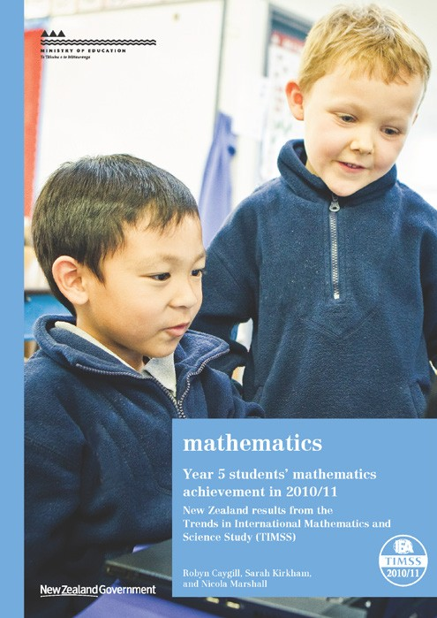

Along with this report on Year 5 mathematics, the documents listed below form a suite of reports about New Zealand’s participation in TIMSS 2010/11 (www.educationcounts.govt.nz/ goto/timss). Further analyses will be undertaken in 2013.

Other national reports

Year 5 students’ science achievement in 2010/11: New Zealand results from the Trends in International Mathematics and Science Study (TIMSS)
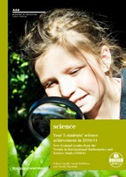

Year 9 students’ mathematics achievement in 2010/11: New Zealand results from the Trends in International Mathematics and Science Study (TIMSS)


Year 9 students’ science achievement in 2010/11: New Zealand results from the Trends in International Mathematics and Science Study (TIMSS)
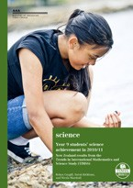

International Reports
International findings for mathematics (Mullis, Martin, Foy, & Arora, 2012) for TIMSS 2010/11 have been published by the IEA and are available from IEA http://www.iea.nl/ and TIMSS & PIRLS study centre http://timss.bc.edu/.
Methods and Procedures in TIMSS and PIRLS 2011 (Martin & Mullis. (Eds.), 2011) contains a detailed account of the procedures for scoring, translation of materials, sampling, survey operations, quality assurance, sampling weights, item analysis, scaling, and reporting and can be found at http://timssandpirls.bc.edu/methods/index.html.
The TIMSS 2011 user guide for the international database (to be published in 2013) contains information on how to analyse the data.
TIMSS has also published the TIMSS 2011 encyclopedia: a guide to mathematics and science education around the world (Mullis, Martin, Minnich, Stanco, Arora, Centurino & Castle (Eds.) 2012) to provide a context in which the TIMSS results can be examined. This encyclopaedia contains short reports from each country describing mathematics and science education policies and practices in that country.

Publishing Info
Comparative Education Research Unit
Research Division Ministry of Education PO Box 1666
Wellington 6140
New Zealand

Email: research.info@minedu.govt.nz
Fax: 64-4-463 8312
Phone: 64-4-463 8000
© Crown Copyright
All rights reserved.

Enquiries should be made to the publisher. January 2013
RMR-1008a

