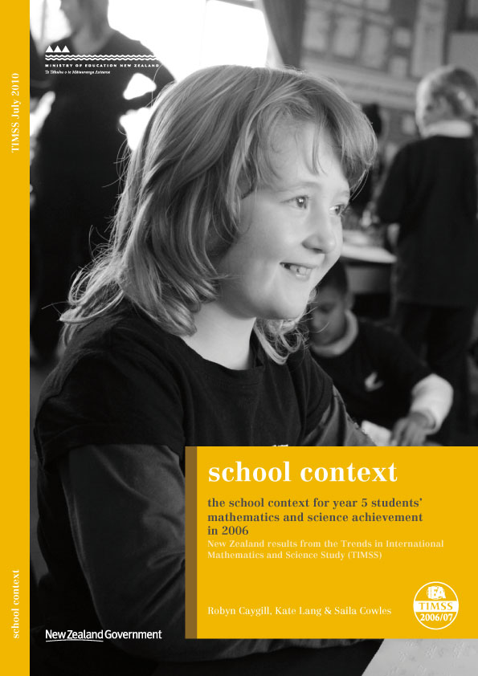

Overview of TIMSS

What is TIMSS?
The Trends in International Mathematics and Science Study (TIMSS) measures trends in mathematics and science achievement at the fourth and eighth grades (Years 5 and 9) as well as monitoring curricular implementation and identifying the most promising instructional practices from around the world.
Conducted on a regular 4-year cycle, TIMSS has assessed mathematics and science in 1994/95¹, 1998/99, 2002/03, and 2006/07 with planning underway for 2010/11.

What does TIMSS consist of?
TIMSS consists of assessments of students’ achievements in mathematics and science, along with questionnaires for students, teachers, and principals to gather background information. The background information provides a context within which the achievement can be examined.
The TIMSS assessments are organised around two dimensions: a content dimension, specifying the domains or subject matter to be assessed within mathematics and science; and a cognitive dimension, specifying the domains or thinking processes to be assessed. These domains are published in the TIMSS 2007 assessment frameworks (Mullis, Martin, Ruddock, O’Sullivan, Arora, and Erberber, 2005). The contextual factors associated with students’ learning in mathematics and science are also included in the frameworks to guide questionnaire development.

How was TIMSS developed?
The TIMSS tests were developed cooperatively with representatives from participating countries. Questions were field-tested with a representative sample of students in these countries and the results generated were used to select and refine the questions for the final test. Questions for the background questionnaires underwent a similar process.

Who participated?
Note that this cycle of the study is called TIMSS 1995 internationally as most countries participated in 1995. However southern hemisphere countries conducted the assessment towards the end of 1994 so in New Zealand reports the study is referred to as TIMSS 1994/95. Similarly for the subsequent cycles, the two years in which administrations occurred in participating countries are indicated.
2Mongolia does not appear in any international comparisons because they were unable to meet sampling criteria. Selected results for Mongolia appear in Appendix E of Martin, Mullis, and Foy (2008). Throughout the report 36, rather than 37, countries are discussed at the middle primary level.
In TIMSS 2006/07, approximately 425,000 students in 59 countries from all around the world took part. Participants included 183,150 students from 37 countries and 7 benchmarking participants at the middle primary level, and 241,613 students from 50 countries and 7 benchmarking participants at the lower secondary level.² In this cycle of TIMSS 4940 New Zealand Year 5 students from 220 schools participated. New Zealand did not participate at the lower secondary level.

Who administered TIMSS?
A consortium was responsible for managing the international activities required for the project. This consortium comprised: the International Study Centre, Lynch School of Education at Boston College, (Massachusetts) United States; the IEA Secretariat in Amsterdam, the Netherlands; the IEA’s Data Processing Centre in Hamburg, Germany; Statistics Canada in Ottawa, Canada; and the Educational Testing Service (ETS) in Princeton, New Jersey in the United States. In New Zealand the Comparative Education Research Unit in the Ministry of Education was responsible for carrying out TIMSS.

What procedures were used to ensure the quality of the data?
TIMSS procedures are designed to ensure the reliability, validity, and comparability of the data through careful planning and documentation, cooperation among participating countries, standardised procedures, and attention to quality control throughout. Procedures included verification of translations and layout of booklets and questionnaires, monitoring of sampling activities, international and national quality control observers during test administration, checking of data, detailed manuals covering procedures, and rigorous training for all involved. Members of the consortium ensured procedures were adhered to by all participating countries.

Why participate in TIMSS?
Although it is often assumed that the international studies are only useful for international benchmarking purposes, the real value of TIMSS lies in its ability to provide a rich picture of mathematics and science achievement within New Zealand and over time.
TIMSS (along with other international assessment studies) can provide information about the performance of the New Zealand education system at the national level within a global context. The information from studies such as TIMSS is used in the development and review of policy frameworks and also to inform and improve teaching practice. Developments arising out of previous cycles of TIMSS include resource materials for schools and teachers along with teacher in-service training programmes.

Table of Contents
Acknowledgements 2
Key findings 3
Introduction 5
An overview of TIMSS 2006/07 achievement results 5
Focus of this report 6
Value of examining school context 7
School Characteristics 8
Instructional time 8
School size 11
Classroom size 12
School location 12
Socio-economic composition of student population 13
School management 19
The role of the school principal 19
Parental involvement 21
Do schools encourage home involvement? 21
Availability of school resources to support learning 23
Computers and software 24
Teachers and support staff 24
Science laboratories 24
Assistance available during science experiments 24
Summary measures of availability of school resources 25
School climate 30
Perceptions of climate for learning 30
Perceptions of school safety and student behaviours 37
Conclusion 46
Appendix 49
References 58
Definitions and technical notes 59

Acknowledgements
TIMSS is a collaborative effort internationally and nationally. There are many people that have been involved and it is not possible to thank all of them individually here. However, there are a few key groups of people that we would like to acknowledge.
This study was made possible by the cooperation of the schools, teachers, and students that participated. Thanks to these participants, large amounts of data have been collected about the teaching and learning of New Zealand Year 5 students.
Thanks also to the many members of the Research Division and also those from the wider ministry that have contributed to the successful collection of data for TIMSS.
Finally thanks to those that contributed to this publication by reviewing, editing and publishing this report.
Robyn Caygill
TIMSS National Research Coordinator
Kate Lang and Saila Cowles

Key findings

School characteristics
- Principals reported that New Zealand Year 5 students spent an average of 148 hours a year doing mathematics in 2006/07, 6 hours more than in 2002/03. Considerably less time was spent on science instruction than mathematics. New Zealand Year 5 students spent only 45 hours a year, on average, doing science, which was 21 hours less than in 2002/03.
- On average, New Zealand teachers reported that they spent more of their mathematics instruction time on number compared to many other participating countries. It is worth noting that number was the only mathematics domain in which New Zealand scored significantly lower than the international TIMSS average score. However, number was the weakest domain for all English-speaking countries – perhaps reflecting the complexity of the English words for numbers.
- New Zealand students spent relatively less time on physical science compared with life science or earth science. Physical science was the area in which our students performed least well.
- Average school size has increased over time. Differences in mathematics and science achievement scores by school size are not significant.
- Students in high-decile band schools did significantly better in mathematics and science than those in medium-decile band schools, who performed significantly better than students in low-decile band schools. The pattern of higher achievement among schools in higher decile bands has been consistent over time.
- Students who attended schools with higher proportions of students from affluent backgrounds did better in mathematics and science, on average, than those who attended schools with higher proportions of students from economically disadvantaged homes. Similarly, students attending schools with a predominance of English speakers had higher mathematics and science achievement, on average, than students in schools where English was not the first language among more than half of students attending those schools.

School management
- Principals in New Zealand spent, on average, close to half their time on administrative duties, which was one of the highest proportions reported among participating countries.
- Principals of larger schools spent more time on administrative duties compared to their counterparts in smaller schools, while principals of small schools spent more time teaching than their counterparts in larger schools.
- Parental involvement in schools was actively encouraged by all schools at the Year 5 level.

School resources
- Principals were asked to consider a list of resources and indicate whether a lack of each resource had an impact on instruction. In general, a lack of science-oriented resources was more of a problem than mathematics-oriented resources, although the principals of nearly half of the students indicated that lack mathematics-oriented resources in their school impacted negatively on instruction. In particular, the resource most commonly perceived by New Zealand principals as having a negative impact on instructional capability was a lack of science laboratory equipment and materials.

School climate
- Most students perceived their school as a good place to be, with nearly all students (97%) agreeing that ‘teachers at my school want students to do their best’.
- Teachers generally gave positive responses to questions about school climate for learning. However, there were some aspects which teachers were not so positive about - in particular, students’ desire to do well and parental support for learning.
- Principals were also positive about their school climate and tended to be most positive about teacher’s behaviours.
- Compared to students in other countries, relatively high proportions of New Zealand students reported experiencing negative behaviours in the month prior to testing. While reported incidences of theft have decreased since previous cycles of TIMSS, the perceived levels of being left out of activities by other students has increased.
- Teachers were very positive about the safety of their schools, with most of them agreeing with statements on safety of the school environment.
- Achievement was higher among students whose schools were rated as having a positive or safe environment. Students whose schools were rated less positively tended to have lower achievement.

Introduction
The Trends in International Mathematics and Science Study (TIMSS) is conducted every four years. It assesses children at middle primary and lower secondary. The 4th cycle was conducted during 2006/07 with New Zealand taking part along with 35 countries in the middle primary component. The international results were released in December 2008 and the reports can be found at timss.bc.edu/isc/publications.html. New Zealand researchers have also written New Zealand focused reports which can be accessed from www.educationcounts.govt.nz/publications/series/2571/timss_200607.

An overview of TIMSS 2006/07 achievement results
The New Zealand focussed reports previously released focus on mathematics (Caygill & Kirkham, 2008) and science (Caygill, 2008) achievement.

Achievement in mathematics
Overall, mathematics achievement of New Zealand Year 5 students has improved since 1994 in terms of both average achievement and the distribution of achievement. This is demonstrated by a higher mean and a narrower range in 2006 than in 1994. The positive aspect of this change is that fewer students are demonstrating very low achievement, while a similar proportion of New Zealand students are gaining very high scores. In international terms, New Zealand Year 5 mathematics achievement is fairly mediocre, and although it is significantly higher than 12 of the 36 TIMSS countries participating at the middle primary level, it is also significantly lower than 19 of the 36 countries.
Year 5 students continue to demonstrate relative strengths in aspects of mathematics. They tend to perform relatively better on data display questions compared to number. Students also perform relatively better on questions that involve reasoning compared to questions that assess knowledge.

Achievement in science
Overall, the mean science achievement of New Zealand Year 5 students was about the same in 2006 as in 1994. Although an increase in mean science achievement was observed in 2002, relative to earlier years, this performance was not sustained in 2006. In terms of the distribution of science achievement across the range of scores, this was narrower in 2006 than in 1994. A positive aspect of this change is that fewer students are demonstrating very low achievement, but it also means a smaller proportion of New Zealand students are gaining very high scores. In international terms, New Zealand Year 5 science achievement is fairly mediocre, and although it is significantly higher than 13 of the 36 countries participating in TIMSS at the middle primary level, it is also significantly lower than 21 of the 36 countries.
Year 5 students continue to demonstrate relative strengths in aspects of science. They tend to perform relatively better on earth science questions compared to life and physical science. Students also perform relatively better on questions that involve demonstrating knowledge compared to applying knowledge or reasoning.
Teachers of New Zealand Year 5 students reported spending far fewer hours on science instruction in 2006 than in 2002.

Achievement by background characteristics
Both high and low performers were found among boys and girls with no difference in their average mathematics or science performance. Similarly, both high and low performers were found in all ethnic groupings. However, Asian students achieved higher in mathematics, on average, than Päkehä/European and both these groups achieved higher than that of Mäori and Pasifika students. The pattern was slightly different for science achievement, with Päkehä/European and Asian students having similar science achievement, on average, and their mean science achievement was higher than that of Mäori and Pasifika students. Mäori students had higher mean mathematics and science achievement than Pasifika students.
In terms of other background characteristics, mathematics and science achievement was higher, on average, among students:
- who regularly spoke English at home;
- who were born in New Zealand;
- who were from higher socio-economic backgrounds;
- whose school community had a lower level of economic disadvantage; and
- who reported a small or moderate amount of time in out-of-school leisure activities.

Focus of this report
This report is the third in the New Zealand reporting series. In addition to data on achievement in mathematics and science, TIMSS collects a vast amount of contextual information, including responses to questions about the school gathered from teachers, school principals and students. This report focuses on those responses to questions about the schools and examines characteristics of schools, school management, resources, and climate. The relationship between some school context variables and mathematics and science achievements is also examined.
This report aims to give a comprehensive coverage of the background questions about schools asked in the TIMSS 2006/07 cycle. Comparisons with previous cycles are also presented where possible.
As part of the analyses for this report, the responses of New Zealand students, teachers, and principals were compared to those in the other 35 participating countries. However, not all countries are presented in tables and graphs, nor are all countries discussed in the text. Countries presented in tables include English-speaking countries, high-performing countries, and Norway and the Netherlands. English-speaking countries include Australia, England, Scotland, and the United States, with Singapore also testing in English. High-performing countries include Chinese Taipei, Singapore, Hong Kong SAR, Japan, and the Russian Federation, for both mathematics and science, with Kazakhstan performing well in mathematics but not as well in science. Countries are ranked in tables from highest country to lowest.
Where possible, standard errors are presented in tables and data is presented in graphs. Otherwise data and standard errors can be found in tables in the appendix at the end of this report.
Note that this report illustrates relationships between variables but does not attempt to demonstrate that particular school contexts cause particular mathematics and science achievements. In most instances, unless otherwise stated, percentages that are reported are the percentages of Year 5 students rather than the percentages of schools or percentages of principals. That is, school context characteristics are described as attributes of students rather than attributes of schools.

Value of examining school context
One of the useful aspects of TIMSS is that it examines the contextual factors that are related to student achievement. Student learning takes place for the individual within a classroom, situated in a school. A student brings a personal context with them to school, including previous experiences, family support for learning, socio-economic background, cultural experiences and personal preferences and interests. This report focuses on just one aspect that can influence student learning, the school context.
It seems intuitive that a well-resourced and well-managed school, where students and staff are happy and healthy, is going to have higher achieving students than a school that is struggling financially, poorly managed, and contains disillusioned teachers and badly-behaved students. Indeed, research has established relationships among school leadership, school climate, and student achievement. The Second Regional Comparative and Explanatory (SERCE) study concluded that “…schools are in a position to contribute importantly to student performance. While the socioeconomic dimension has a strong influence on performance, school-related variables can help significantly to reduce the learning inequalities associated with social inequity. … the school climate variable was confirmed to have the greatest impact on student performance. It follows that, in order to promote learning among students, it is essential to provide a welcoming and warm environment based on mutual respect.” (Valdés et. al., 2008, p.45).
Hoy and Hannan (1997) also examined the school climate using the phrase ‘organisational health’ to define the aspect of a school that they were interested in. They found that “dimensions of organizational [sic] health were significantly related to student achievement even when the socioeconomic status of the school was controlled” (p. 290).
Michigan State University publish ‘Best Practice Briefs’ to help inform the practice in schools. Brief 31 (Tableman, 2004) notes that reform to improve students’ academic performance generally requires changing school climate and culture alongside instructional change. Comments from Mayer reiterate the same idea. “We expend a great deal of resources attempting to create schools that provide quality education for young people. Yet, as we search for the latest technological advances to increase our effectiveness in education, we can neglect the fundamental need for a school to be a safe and welcoming place for children to learn and thrive.”
Thus the school context within which Year 5 students learning takes place in New Zealand is worth examining and reflecting on. Are there policies at a national level that could help change school dynamics? Are there things schools can do with the resources they have to help change the climate and thereby contribute to improved teaching and learning? This report examines some of the aspects of school context within which students’ mathematics and science learning takes place and will provide school staff and policy makers with empirical evidence to help make informed decisions.

School Characteristics

Instructional time
In TIMSS 2006/07, New Zealand primary school principals reported that their schools were open for instruction for 196 days a year, on average, which was slightly above the international average of 192 days. On a typical day, schools averaged just over 4 hours of instructional time; about the same as other participating countries.
We asked teachers and principals about the amount of time spent on maths and science instruction each week. Table 1 provides data from a selection of countries that took part in TIMSS 2006/07. New Zealand Year 5 students spent around 16 percent of total instructional time, on average, on mathematics per week; about the same as the average for all participating countries. This was a significant increase of one percentage point since the previous cycle of TIMSS in 2002/03.
Over the school year, New Zealand teachers reported spending 148 hours, on average, a year on mathematics; slightly more than the international average of 144 hours and 6 hours more per year than in 2002/03. The amount of instructional time does not appear to have a direct impact on student achievement. For example, Chinese Taipei is one of the top performing countries in mathematics, but its teachers only spent an average of 13 percent of classroom time on mathematics, or 112 hours per year. Note, however, that teachers in Chinese Taipei usually assign more mathematics homework per week than New Zealand teachers (for further details see Mullis, Martin & Foy, 2008).
All the countries that took part in TIMSS 2006/07 spent less time on science instruction when compared to mathematics. On average, New Zealand spent only 5 percent of class instructional time on science, which was 3 percentage points less than the international average of 8 percent. There was a significant decrease of 2 percentage points in the average number of instructional hours per week spent on science in New Zealand, at the Year 5 level between 2002/03 and 2006/07. Over a year, the amount of time spent on science was 45 hours in 2006/07, a drop of 21 hours from 2002/03.
The total instructional time spent in mathematics and science adds to about 21 percent, on average, across New Zealand. In comparison, more time is spent on language and literacy activities as found by the Progress in International Reading Literacy Study (PIRLS) 2005/06. PIRLS 2005/06 asked principals and teachers to report the number of hours per week spent on reading and language at the Year 5 level. On average, 37 percent of weekly instructional time was spent on language and related activities, and a further 23 percent on reading (Chamberlain, 2007).

Time spent on different domain areas of mathematics
TIMSS divides Year 5 mathematics content into three domains; number, geometric shapes and measures, and data display. Note that number is defined in TIMSS as including both number and algebra topics. The latest version of the New Zealand curriculum now also combines both of these topics in the Number and Algebra strand. New Zealand teachers reported that they spent two-thirds (66%) of their mathematics instruction time on number - more time in fact that any other country taking part in the study. The average amount of time spent across all countries was 50 percent. However, New Zealand students are relatively weak on number; it was the only domain where New Zealand scored significantly lower than the TIMSS scale average of 500 (see Caygill and Kirkham, 2008 for more information).
Table 1: Mathematics and science instructional time for selected countries in TIMSS 2006/07
Country | Total number of hours of instruction per week | Maths instructional time as % of total | Difference from 2002/03 |  | Mean maths score | Science instructional time as % of total | Difference from 2002/03 |  | Mean science score
United States | 30 | 16 | 2 | ① | 529 (2.4) | 8 | 0 |  | 539 (2.7)
Netherlands | 27 | 16 | 0 |  | 535 (2.1) | 3 | 0 |  | 523 (2.6)
Hong Kong SAR | 27 | 15 | 1 |  | 607 (3.6) | 7 | -1 |  | 554 (3.5)
Singapore | 26 | 21 | 3 | ① | 599 (3.7) | 9 | 2 | ① | 587 (4.1)
England | 25 | 19 | - |  | 541 (2.9) | 7 | - |  | 542 (2.9)
Scotland | 25 | 19 | 0 |  | 494 (2.2) | 5 | - |  | 500 (2.3)
Australia | 25 | 18 | 0 |  | 516 (3.5) | 5 | 0 |  | 527 (3.3)
New Zealand | 24 | 16 | 1 | ① | 492 (2.3) | 5 | -2 | ② | 504 (2.6)
Chinese Taipei | 23 | 13 | 2 | ① | 576 (1.7) | 9 | 0 |  | 557 (2.0)
Norway | 23 | 13 | 1 |  | 473 (2.5) | 5 | 1 | ① | 477 (3.5)
Kazakhstan | 22 | 18 | n/a |  | 549 (7.1) | 7 | n/a |  | 533 (5.6)
Japan | 22 | 16 | 3 | ① | 568 (2.1) | 9 | 2 | ① | 548 (2.1)
Russian Federation | 19 | 17 | 3 | ① | 544 (4.9) | 6 | 2 | ① | 546 (4.8)
International Avg. | 24 | 16 |  |  | 500 | 8 |  |  | 500
Notes: A dash (-) indicates comparable data are not available; n/a indicates that the country did not participate in the 2002/03 study at this level.
Standard errors are presented in parentheses.
① and ② indicate that the change between 2002/03 and 2006/07 was statistically significant.
Source: Adapted from Exhibit 5.1 Mullis, Martin and Foy, 2008 and Exhibit 5.2 Martin, Mullis and Foy, 2008.
New Zealand spent a smaller proportion of mathematics instructional time on geometric shapes and measures than the average for TIMSS countries in the 2006/07 study; 17 percent of yearly instructional time compared with 24 percent. Our average scale score in this domain was almost the same as the international average. New Zealand scored highest in the data display content domain, in tasks such as drawing and interpreting graphs and tables. However, although our students scored significantly above the international mean in this domain, they only spent an average of 13 percent of class time working on data display tasks compared with 16 percent internationally.
For most English-speaking countries, number was the weakest domain. The exception was the United States, where students did equally poorly (relative to data and chance) on the number and geometric shapes and measures domains. The relatively poorer performance of the United States students in the geometric shapes and measures domain is perhaps not a surprising finding given their continued use of the imperial measurement system. The poor relationship between the English words for numbers and the numerical meanings is a possible hindrance for some children during their early number learning. Chinese words, in contrast, reflect the composition of the numbers in a base-10 structure: the Mandarin word for 13 shi san is made up of shi (ten) and san (three). Kipatrick, Swafford and Findell (eds., 2001) report that studies have shown that “the organisation of number names does indeed play a significant role in mediating children’s mastery of this symbolic system” (p. 167). In contrast with the English-speaking countries, Singapore, Chinese-Taipei, and Hong Kong SAR had their highest achievement in the number domain.
In summary, there does not appear to be a direct link between the amount of time spent on the three main mathematics domains and student achievement, as illustrated by Table 2. However, it is likely that other factors, such as linguistic complexities, are confounding any link there might be.
Table 2: Mathematics instructional time per year for selected countries in TIMSS 2006/07
Country | Total hours of maths instruction per year | Number |  | Geometric Shapes and Measures |  | Data Display
Country | Total hours of maths instruction per year | Percent of time per year | Mean scale score | Percent of time per year | Mean scale score | Percent of time per year | Mean scale score
Singapore | 201 | 55 | 611 | 27 | 570 | 14 | 583
England | 183 | 56 | 531 | 22 | 548 | 18 | 547
Scotland | 181 | 56 | 481 | 21 | 503 | 16 | 516
Netherlands | 179 | 64 | 535 | 14 | 522 | 16 | 543
Australia | 174 | 57 | 496 | 22 | 536 | 15 | 534
United States | 171 | 54 | 524 | 20 | 522 | 19 | 543
Hong Kong SAR | 150 | 53 | 606 | 29 | 599 | 15 | 585
New Zealand | 148 | 66 | 478 | 17 | 502 | 13 | 513
Japan | 136 | 49 | 561 | 29 | 566 | 18 | 578
Kazakhstan | 133 | - | 556 | - | 542 | - | 522
Norway | 115 | 61 | 461 | 24 | 490 | 11 | 487
Chinese Taipei | 112 | 53 | 581 | 28 | 556 | 14 | 567
Russian Federation | 110 | - | 546 | - | 538 | - | 530
International Avg. | 144 | 50 | 500 | 24 | 500 | 16 | 500
Note: A dash (-) indicates comparable data are not available.
Standard errors are not presented here for ease of reading but can be found in Table 32 in the Appendix.
Total time may not add to 100 percent as the “Other” category is not included in table.
Source: Adapted from Exhibits 5.2 & 5.3 Mullis, Martin and Foy, 2008.

Time spent on different domain areas of science
Science is divided into three content domains; life science, physical science and earth science. New Zealand students spent more time on life science topics during the school year (43%) than the two other domains (26% on physical science and 28% on earth science). Relatively less time was spent on physical science, an area in which our students performed least well. Overall, countries performing at a relatively high level in physical science spent more time working in this area, relative to the other two domains, although this was not the case across all countries. High-achieving countries, such as Singapore and Chinese Taipei, spent over 40 percent of class time on physical science. However, these countries did very well in all content domains, regardless of the class time allocated to them.
Table 3: Science instructional time per year for selected countries in TIMSS 2006/07
Country | Total hours of science instruction per year | Life Science |  | Physical Science |  | Earth Science
Country | Total hours of science instruction per year | Percent of time per year | Mean scale score | Percent of time per year | Mean scale score | Percent of time per year | Mean scale score
United States | 89 | 34 | 540 | 28 | 534 | 31 | 533
Japan | 82 | 36 | 530 | 42 | 564 | 21 | 529
Singapore | 82 | 36 | 582 | 48 | 585 | 13 | 554
Chinese Taipei | 79 | 32 | 541 | 43 | 559 | 21 | 553
Hong Kong SAR | 72 | 39 | 532 | 28 | 558 | 24 | 560
England | 70 | 37 | 532 | 36 | 543 | 24 | 538
Kazakhstan | 52 | 28 | 528 | 18 | 528 | 32 | 534
Scotland | 51 | 41 | 504 | 29 | 499 | 26 | 508
Australia | 46 | 40 | 528 | 25 | 522 | 28 | 534
New Zealand | 45 | 43 | 506 | 26 | 498 | 28 | 515
Norway | 44 | 42 | 487 | 18 | 469 | 36 | 497
Russian Federation | 40 | 33 | 539 | 12 | 547 | 33 | 536
Netherlands | 33 | 56 | 536 | 16 | 503 | 22 | 524
International Avg. | 67 | 40 | 500 | 25 | 500 | 24 | 500
Note: Standard errors are not presented here for ease of reading but can be found in Table 33 in the Appendix.
Total time may not add to 100 percent as the “Other” category is not included in table.
Source: Adapted from Exhibits 5.3 & 5.4 Martin, Mullis and Foy, 2008.

School size
The total enrolment of schools that participated in TIMSS 2006/07 ranged from 13 to 1,449 students, with an average of 384. Around three-quarters (74%) of all New Zealand Year 5 students attended mid-size schools with between 175 and 679 students, which was a similar proportion to 2002 (77%). Relatively few students attended large schools with 680 students or more (8%), and 18 percent were in small schools with less than 175 students.
Although the mean mathematics score of students in large schools appears to be the highest of the four size bands (see Table 4) the differences between the groups are not significant. There are also no significant differences in science achievement by school size.
Table 4: Proportion of New Zealand Year 5 students and mean achievement scores by size of school band in TIMSS 2006/07
School size band | % of students | Mean achievement score
School size band | % of students | Mathematics |  | Science
Small (less than 175 students) | 18 | 485 | (5.9) | 503 | (5.8)
Small to Medium (175 to 399 students) | 40 | 488 | (4.1) | 501 | (4.9)
Medium to Large (400 to 679) | 34 | 497 | (4.2) | 505 | (4.4)
Large (680 students or more) | 8 | 510 | (10.2) | 517 | (10.6)
New Zealand | 100 | 492 | (2.3) | 504 | (2.6)
Note: Standard errors are presented in parentheses.
New Zealand primary schools have increased in size since the first cycle of TIMSS in 1994/95. Only 26 percent of schools taking part in TIMSS at the Year 5 level had 400 students or more in 1994/95 compared with 42 percent in 2006/07. Conversely, the proportion of students in small schools of less than 175 students dropped from 25 percent to 18 percent over the same period. In both 1994/95 and 2006/07 no variations in mathematics or science achievement by school size were observed.

Classroom size
TIMSS asked teachers about the size of their mathematics and science classes, as larger or smaller classes can influence how the teacher chooses to teach mathematics and science topics. At Year 5, students tend to have the same teacher for both mathematics and science. Average class size in New Zealand was 26 students in 2006/07, the same as the international average. In the majority of countries, students are in medium-sized classes (with 20 to 32 students), with notable exceptions including Singapore, Hong Kong SAR, Yemen, Chinese Taipei, Colombia and Japan, all of which had average class sizes of more than 30 students.
Class sizes in New Zealand have decreased since the first cycle of TIMSS; in 1994 the average class size was 29 students, significantly higher than 26 students in 2006/07. It is difficult to disentangle the relationship between class size and achievement. For example, in some countries smaller classes tend to be in rural areas where there are fewer resources, and larger classes in urban areas with more resources. Remedial classes may also be smaller. However, TIMSS studies repeatedly show that high performing Asian countries, such as Singapore and Hong Kong SAR, have some of the largest class sizes. For example, in Singapore, 94 percent of all students are in classes of more than 32 students.

School location
Most New Zealand students (73%) attend schools in main urban areas (with populations of 30,000 or more) with the remaining 27 percent of students at schools in smaller cities, towns and rural areas. A comparison of the mean achievement scores for students in both locations shows no significant difference for either mathematics or science. However, in the previous TIMSS 2002/03 study there was a significant difference between the two in both mathematics and science mean scores, with students attending schools in main urban areas doing better overall than those in smaller cities, towns and rural areas. Note that the categorisation was different prior to the 2002/03 cycle, so no comparisons have been made with earlier cycles.
Table 5: Proportion of New Zealand Year 5 students and mean achievement scores by school location in TIMSS 2006/07
School location | % of students | Mean achievement score
School location | % of students | Mathematics |  | Science
2006
Large Urban Area (30,000 pop. or more) | 73 | 493 | (2.9) | 503 | (3.1)
Smaller urban and rural (less than 30,000 pop.) | 27 | 491 | (3.6) | 507 | (4.3)
New Zealand | 100 | 492 | (2.3) | 504 | (2.6)
2002
Large Urban Area (30,000 pop. or more) | 71 | 500 | (2.5) | 527 | (2.5)
Smaller urban and rural (less than 30,000 pop.) | 29 | 484 | (5.0) | 515 | (5.4)
New Zealand | 100 | 496 | (2.1) | 523 | (2.3)
Note: Standard errors are presented in parentheses.

Socio-economic composition of student population

School decile
The Ministry of Education allocates resources, such as Targeted Funding for Educational Achievement (TFEA), based on school decile indicators. A school’s decile indicates the extent to which a school draws its students from low socio-economic communities. In general, decile 1 schools are the schools with the highest proportion of students from socio-economically disadvantaged communities, while decile 10 schools are the schools with the lowest proportion of students from these communities.
Analysis of the TIMSS 2006/07 results showed similar trends to the previous cycle in 2002/03. Students in low-decile band schools had significantly lower mean mathematics and science achievement than students in medium and high-decile band schools. Similarly, students in medium-decile band schools had significantly lower mean achievement scores in both subjects than those in high-decile band schools. Note that differences are averaged across groups of students; within each decile band there was a range of achievement, with some students in low-decile band schools having high achievement and vice versa.
Table 6: Proportion of New Zealand Year 5 students and mean achievement scores by decile band* in TIMSS 2006/07
Decile band | % of students | Mean achievement score
Decile band | % of students | Mathematics |  | Science
Low (Deciles 1-3) | 28 | 443 | (4.5) | 451 | (5.4)
Medium (Deciles 4-7) | 35 | 492 | (3.7) | 505 | (4.1)
High (Deciles 8-10) | 35 | 528 | (2.6) | 541 | (2.8)
Independent | 2 | ~ | ~ | ~ | ~
New Zealand | 100 | 492 | (2.3) | 504 | (2.6)
Note: Standard errors are presented in parentheses.
Tilde (~) indicates that there was insufficient data to report achievement. Although the weighted percentage of students in independent schools in TIMSS was 2 percent, the number of schools from which they were sampled was too small (less than 10 schools) to be able to report their mean.
* State and state-integrated schools only.
The trend in higher achievement among schools in higher decile bands has been consistent over time, as shown below in Figure 1.
Figure 1: Mean achievement scores for New Zealand Year 5 students by decile band* for 1994, 1998, 2002 and 2006
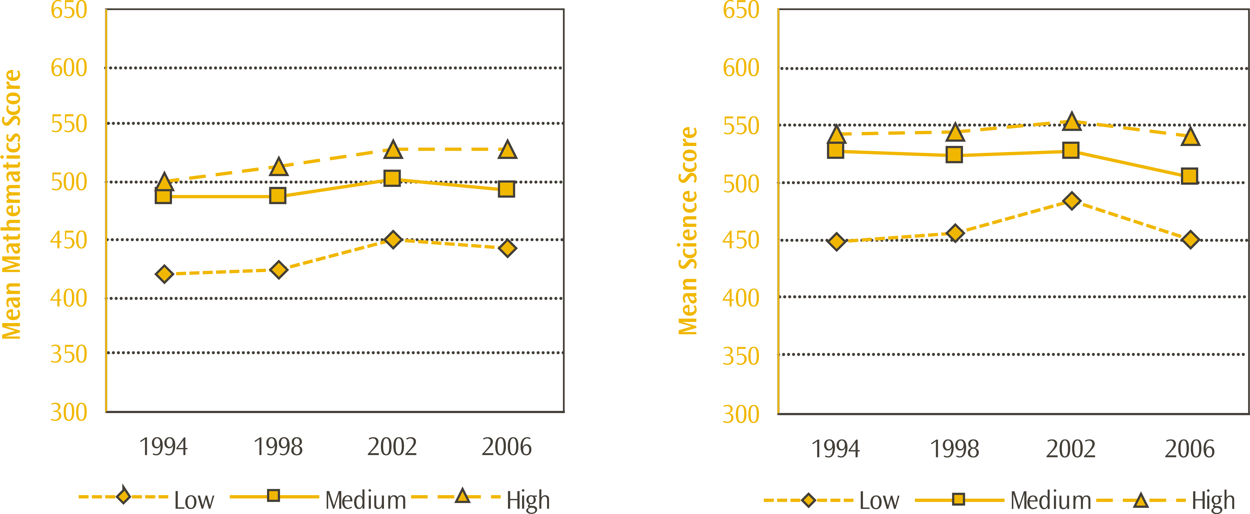
Note: Data can be found in Table 34 in the Appendix.
* State and state-integrated schools only.
Analysis by international benchmarks demonstrates the range in achievement within decile groupings as well as the relatively higher average achievement of high-decile students. There are four benchmarks linking student performance on the TIMSS achievement scales to performance on the questions and describing what students can typically do at set points on the scales. The benchmarks are four points on the achievement scale: advanced (625), high (550), intermediate (475), and low (400).
In mathematics, only one percent of students in the low-decile band reached the advanced benchmark compared with 10 percent of high decile students. Corresponding figures for science were 2 and 13 percent respectively. Table 7 below also shows that relatively fewer students (70% and 72% respectively) in low-decile band schools met the low benchmarks for mathematics and science, whereas 95 percent of students in the high-decile band met the low benchmark set at 400 scale points in each of mathematics and science. On a more positive note, over 10 percent of students who attend low-decile band schools met high or advanced benchmarks in 2006/07.
Table 7: Proportion of New Zealand Year 5 students reaching each international benchmark by school decile band* in TIMSS 2006/07
School Decile Band | Percentage of Year 5 students reaching each benchmark
School Decile Band | Advanced  (625) |  | High  (550) |  | Intermediate  (475) |  | Low  (400)
Mathematics
Low (Deciles 1-3) | 1 | (0.5) | 10 | (1.1) | 36 | (2.1) | 70 | (2.5)
Medium (Deciles 4-7) | 3 | (0.7) | 24 | (1.6) | 61 | (2.0) | 87 | (1.5)
High (Deciles 8-10) | 10 | (0.9) | 41 | (1.7) | 78 | (1.3) | 95 | (0.9)
New Zealand | 5 | (0.5) | 26 | (1.0) | 61 | (1.1) | 85 | (1.0)
Science
Low (Deciles 1-3) | 2 | (0.4) | 12 | (1.7) | 40 | (2.7) | 72 | (2.5)
Medium (Deciles 4-7) | 6 | (0.8) | 30 | (1.7) | 67 | (2.0) | 89 | (1.4)
High (Deciles 8-10) | 13 | (0.8) | 48 | (1.8) | 81 | (1.5) | 95 | (0.9)
New Zealand | 8 | (0.5) | 32 | (1.0) | 65 | (1.2) | 87 | (1.0)
Note: Standard errors are presented in parentheses.
* State and state-integrated schools only.

Students from economically disadvantaged homes
TIMSS asked school principals to report on the economic composition of their school by asking them to estimate the proportion of students in their school from economically disadvantaged homes. In New Zealand, 44 percent of students attended schools with few economically disadvantaged students (10% or less) and a further 23 percent of students attended schools where more than 50 percent of students were economically disadvantaged. These proportions have not changed significantly since 2002/03.
Relative to many other countries, New Zealand had a large proportion of students in schools where the principal estimated more than 50% of students came from economically disadvantaged homes (see Table 8 for a selection of countries). Although the international average was 23 percent, the same as New Zealand, this average was inflated by countries such as Colombia (82%), Morocco (76%), and El Salvador (70%) where the vast majority of students were in this category. In contrast, Singapore, Japan, Chinese Taipei, and Kazakhstan had less than four percent of students in this category. Of the English-speaking countries, Australia, Scotland and England all had around 15 percent of students in this category, while the United States had 42 percent.
Table 8: Principals’ reports on the percentages of students in their schools coming from economically disadvantaged homes for selected countries in TIMSS 2006/07
 | Proportion of students in each category of estimated proportion of economically disadvantaged students
Country | Few (0-10%) |  | 11-25% |  | 26-50% |  | More than 50%
Japan | 64 | (3.8) | 24 | (3.5) | 10 | (2.4) | 1 | (1.0)
Chinese Taipei | 63 | (3.9) | 27 | (3.6) | 7 | (2.3) | 3 | (1.7)
Netherlands | 61 | (4.0) | 16 | (3.5) | 15 | (3.8) | 7 | (2.1)
Singapore | 60 | (0.0) | 30 | (0.0) | 9 | (0.0) | 1 | (0.0)
Kazakhstan | 52 | (4.2) | 26 | (4.6) | 18 | (4.4) | 3 | (1.3)
Scotland | 44 | (4.3) | 26 | (4.4) | 16 | (3.8) | 14 | (2.7)
New Zealand | 44 | (2.6) | 20 | (2.6) | 13 | (1.6) | 23 | (1.7)
England | 38 | (4.0) | 31 | (3.5) | 15 | (3.3) | 16 | (3.0)
Australia | 34 | (4.5) | 30 | (3.0) | 22 | (4.4) | 14 | (3.1)
Russian Federation | 28 | (3.6) | 33 | (3.0) | 20 | (2.6) | 19 | (2.3)
Hong Kong SAR | 26 | (4.1) | 23 | (4.3) | 30 | (4.5) | 21 | (3.7)
United States | 19 | (2.2) | 21 | (2.5) | 18 | (2.9) | 42 | (2.8)
Norway | - | - | - | - | - | - | - | -
International Avg. | 34 | (0.6) | 26 | (0.6) | 17 | (0.5) | 23 | (0.5)
Note: A dash (-) indicates comparable data are not available.
Standard errors are presented in parentheses.
Source: Adapted from Exhibit 8.1 Mullis, Martin and Foy, 2008 and Exhibit 8.1 Martin, Mullis and Foy, 2008.
Across the TIMSS countries, there was a positive association, on average, between attending schools with fewer students from economically disadvantaged homes, and mathematics and science achievement. New Zealand’s mathematics results show that there is an 84 score point difference in favour of students from schools with 10 percent or less economically disadvantaged students, compared with those with more than 50%. This is a much bigger gap than the average score across all countries of 47. See Figure 2 for differences in mathematics achievement for these two groups for a selection of countries, ordered from smallest difference to largest. Note that there were too few students in schools with more than 50% disadvantage in Japan and Singapore to report achievement.
For the science results the gap was even wider for New Zealand at 90 score points, on average, compared with 50 points internationally as illustrated in Figure 3. Generally across countries the gap was wider for science than for mathematics with only Hong Kong SAR and the Russian Federation having the gap for mathematics wider than science.
Figure 2: Mathematics achievement of students by principals’ estimates of the level of economic disadvantage in their schools for selected countries in TIMSS 2006/07
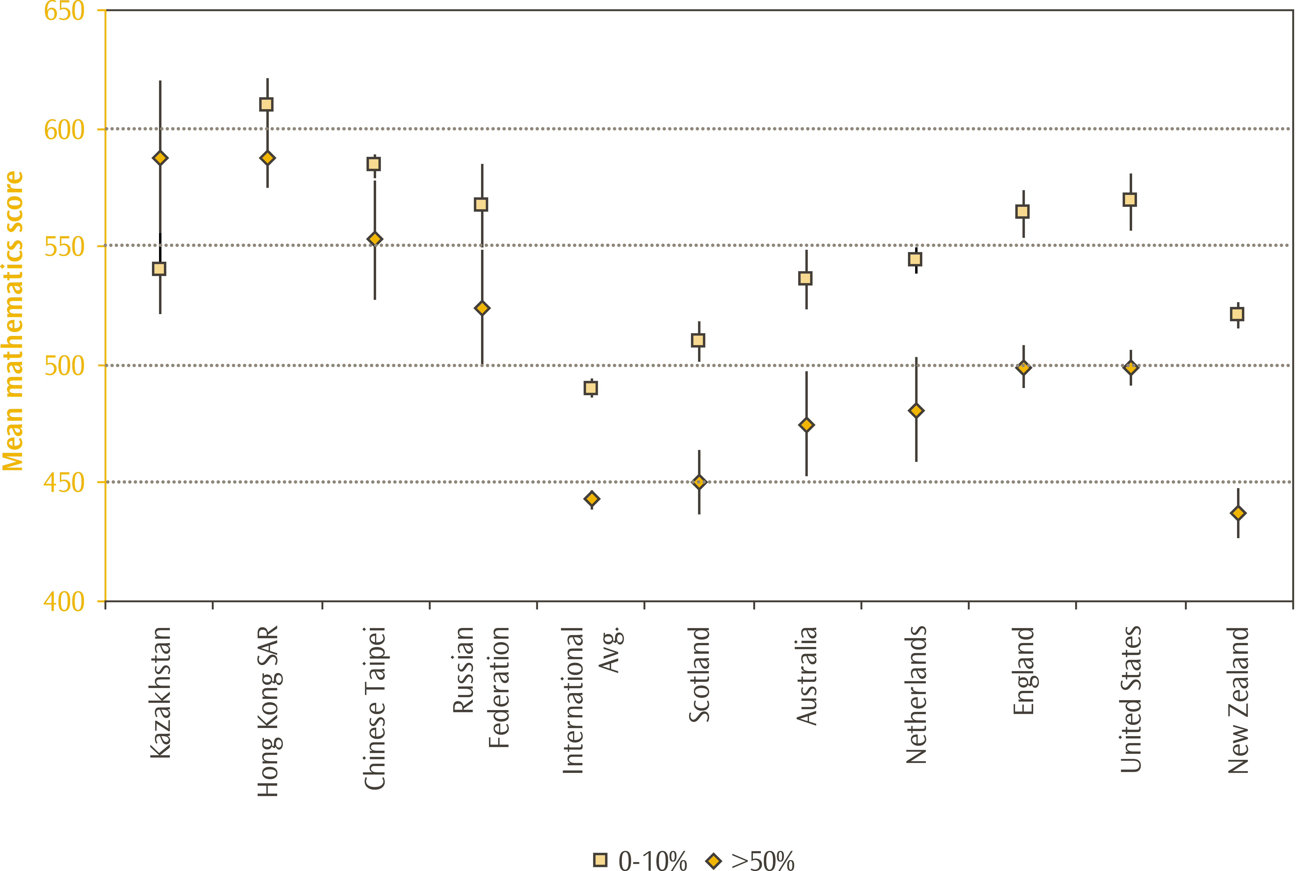

Figure 3: Science achievement of students by principals’ estimates of the level of economic disadvantage in their schools for selected countries in TIMSS 2006/07
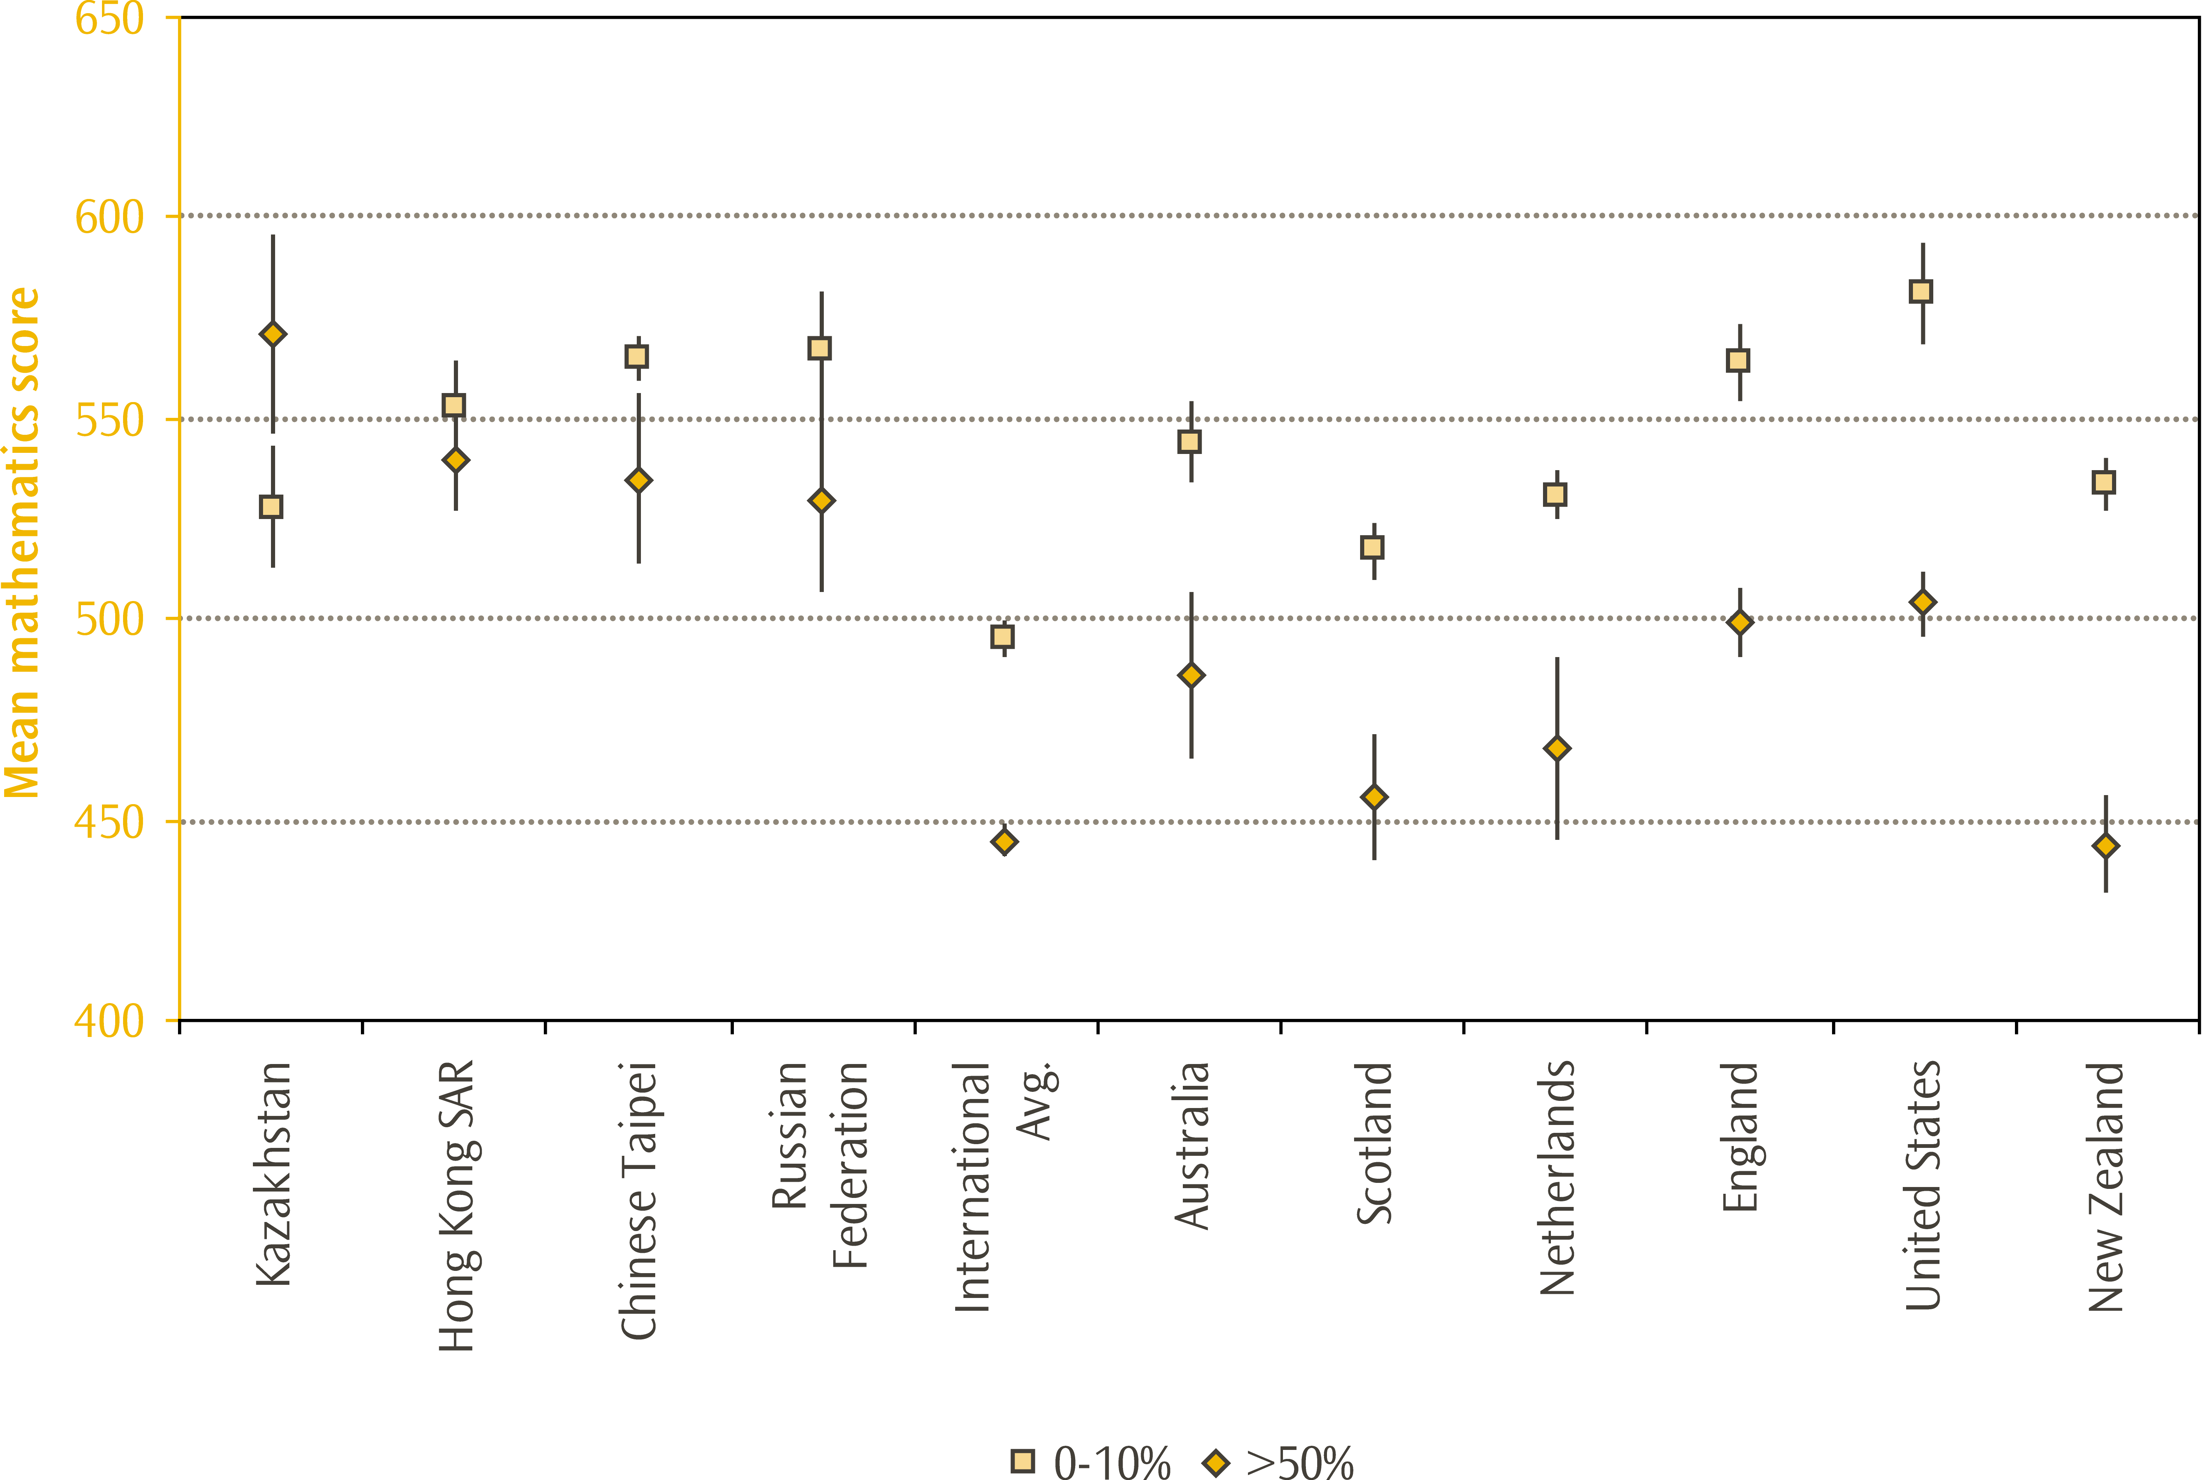
Note: Lines extending from the points represent the 95% confidence interval, e.g. the range within which we are 95 percent confident that the true population value lies.
Data can be found in Tables 35 and 36 in the Appendix.
There were too few students in the ‘more than 50% disadvantaged’ category for Singapore and Japan, so no accurate measure of achievement could be displayed for these countries. Note also that no comparable data was collected for Norway.
Sources: Figure 2–Exhibit 8.1 Mullis, Martin and Foy, 2008.
Figure 3–Exhibit 8.1 Martin, Mullis and Foy, 2008.

TIMSS achievement and language spoken by students
Principals reported on the percentage of students in their schools for whom the test language was their first language, using three categories; more than 90 percent of students, 50 to 90 percent of students, and less than 50 percent of students. The majority of students that took part in the 2006/07 TIMSS assessment attended schools where most of the other students in their school spoke the test language as their native language. In New Zealand, only 10 percent of students attended schools where less than 50 percent of students spoke English as their first or native language; this figure had increased slightly since 2002/03. In comparison, Singapore had the largest proportion of students (75%) in schools where less than 50% had the test language as their first language reflecting a true multilingual society. The Islamic Republic of Iran (46%) and Chinese Taipei (27%) had the next largest proportion of students in this category.
Table 9: Principals’ reports on percentages of students having the language of the test as their first language for selected countries in TIMSS 2006/07
Country | Proportion of students
Country | Schools with more than 90% of students having the language of the test as 1st language |  | Schools with 50-90% of students having the language of the test as 1st language |  | Schools with less than 50% of students having the language of the test as 1st language
Japan | 99 | (0.7) | 1 | (0.0) | 0 | (0.0)
Hong Kong SAR | 96 | (1.6) | 3 | (1.3) | 1 | (0.0)
Scotland | 87 | (3.3) | 11 | (3.0) | 2 | (1.3)
Norway | 80 | (3.8) | 17 | (3.7) | 3 | (1.6)
Russian Federation | 70 | (2.7) | 19 | (2.7) | 11 | (1.6)
England | 68 | (3.9) | 17 | (3.4) | 15 | (2.9)
New Zealand | 65 | (3.0) | 26 | (3.1) | 10 | (1.6)
Netherlands | 62 | (4.1) | 28 | (3.7) | 11 | (3.0)
United States | 62 | (3.0) | 26 | (2.9) | 12 | (2.0)
Australia | 62 | (4.1) | 23 | (4.2) | 15 | (3.3)
Kazakhstan | 53 | (5.0) | 34 | (4.9) | 12 | (2.4)
Chinese Taipei | 39 | (4.2) | 34 | (3.9) | 27 | (3.9)
Singapore | 3 | (0.0) | 22 | (0.0) | 75 | (0.0)
International Avg. | 73 | (0.5) | 17 | (0.5) | 10 | (0.3)
Note: Standard errors are presented in parentheses.
Source: Adapted from Exhibit 8.2 Mullis, Martin and Foy, 2008 and Exhibit 8.2 Martin, Mullis and Foy, 2008.
Average mathematics and science achievement was highest among New Zealand students attending schools with more than 90 percent of students having the test language as their first language, and lowest among schools with less than half the students with the test language as their first language. It is interesting to note that the achievement gap between these two groups varies greatly across the participating countries. Figures 4 and 5 illustrate these achievement differences for a selection of countries. In New Zealand the 46 and 55 point gaps for mathematics and science achievement respectively were relatively large; the international equivalent was 15 and 25 score points.
By comparison, in Australian schools there was very little difference in the average achievement of schools with high and low proportions of students with English as their first language. In other words, English (or the language of the test) as a first language seems to be more closely linked to higher achievement in New Zealand schools than in most other TIMSS countries. However, a number of other inter-related factors, such as the ethnic or socio-economic composition of the school or students, may contribute to differences between the participating countries.
There was no significant change in maths or science achievement by students’ first language since the previous cycle of TIMSS in 2002/03.
Figure 4: Mathematics achievement of students by principals’ reports on percentages of students having the language of the test as their first language for selected countries in TIMSS 2006/07
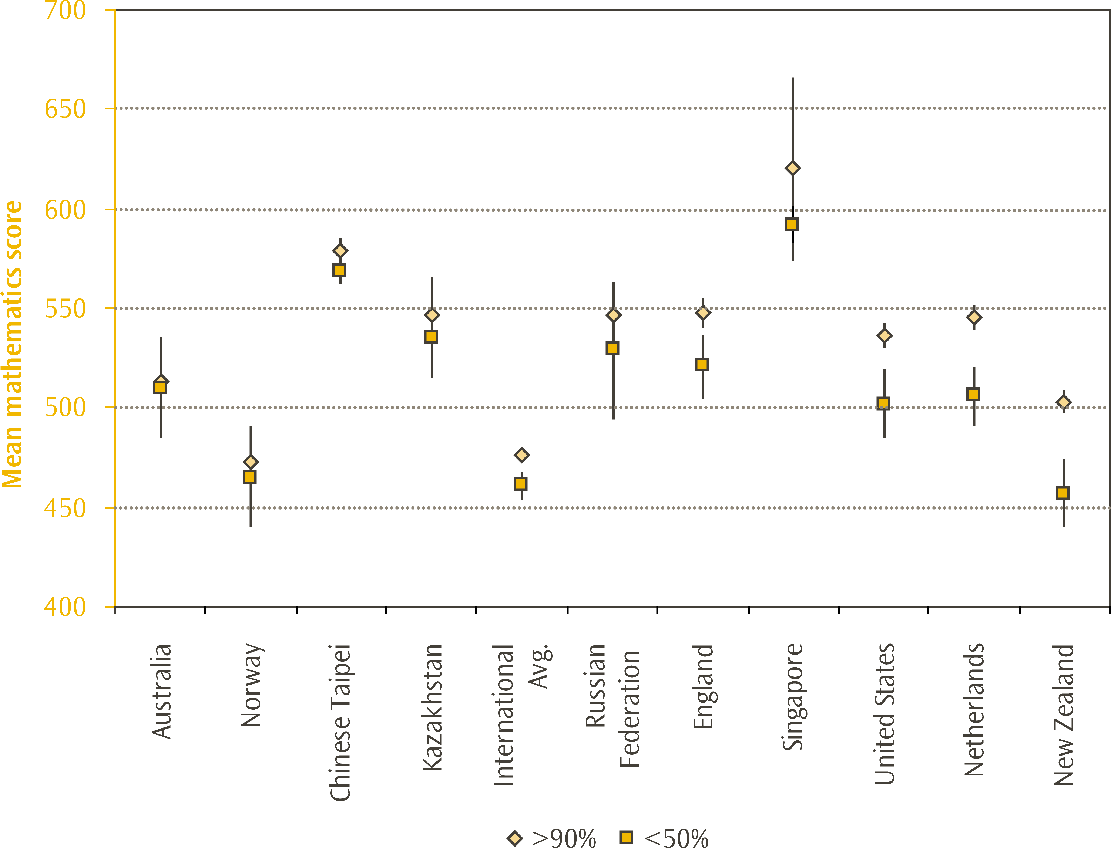
Figure 5: Science achievement of students by principals’ reports on percentages of students having the language of the test as their first language for selected countries in TIMSS 2006/07
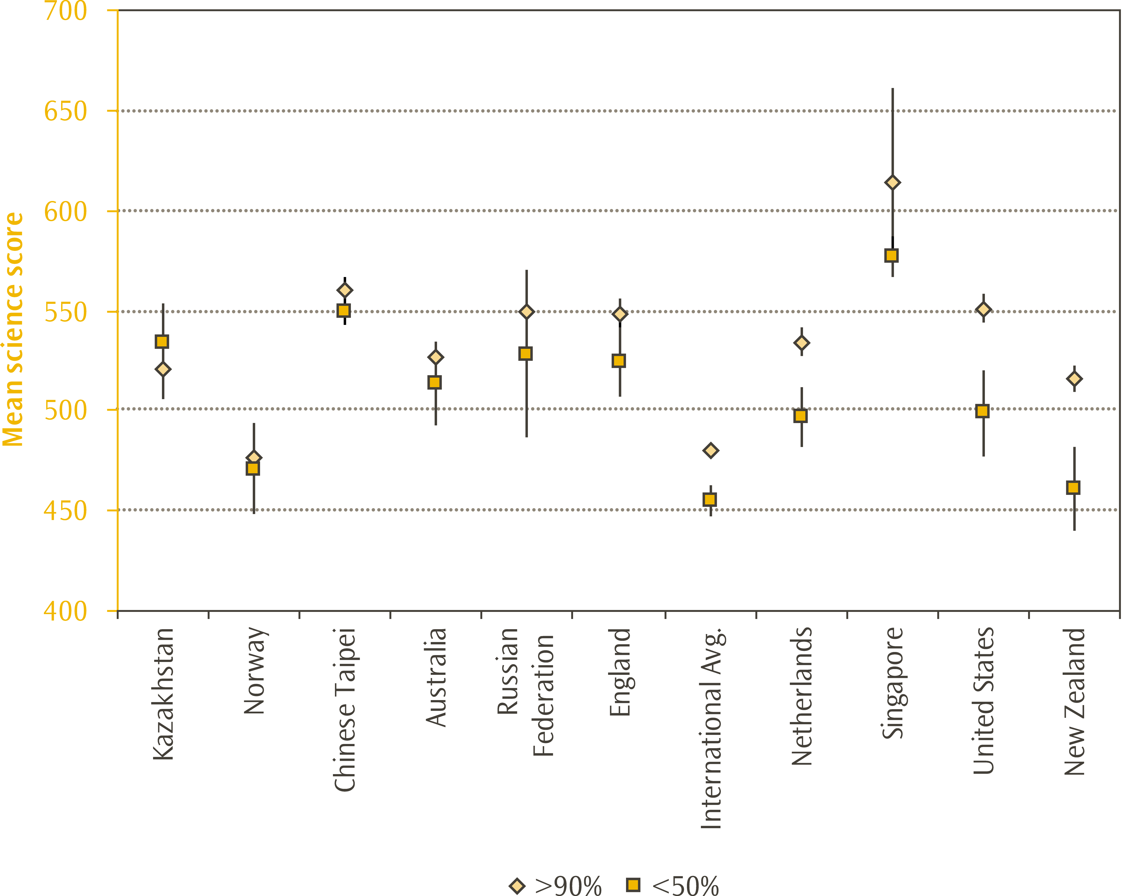
Note: Lines extending from the points represent the 95% confidence interval, e.g. the range within which we are 95 percent confident that the true population value lies.
Data can be found in Tables 37 and 38 in the Appendix.
There were too few students in the ‘less than 50%’ category for Scotland, Hong Kong SAR, and Japan, so no accurate measure of achievement could be displayed for these countries.
Source: Figure 4–Adapted from Exhibit 8.2 Mullis, Martin and Foy, 2008.
Figure 5–Adapted from Exhibit 8.2 Martin, Mullis and Foy, 2008.

School management

The role of the school principal
To assess the role of the school principal and their responsibilities, principals were asked to estimate the percentage of time spent across six school-related activities: administrative duties (e.g. hiring, budgeting, scheduling, meetings); instructional leadership (e.g. developing curriculum, and pedagogy); supervising and evaluating teachers and other staff; public relations and fundraising; teaching; and other activities.
As shown in Table 10, principals in New Zealand spent the majority of their time on administrative duties and instructional leadership (47% and 22% respectively); and considerably less time on teaching; supervising and evaluating staff; public relations and fundraising; and other activities (7%, 11%, 8%, 5% respectively). Principals in Australia reported similar proportions of time for each of the six activities, with the exception of instructional leadership (3 percentage points fewer – although small this figure is statistically significant).
Attending to administrative duties, engaging in instructional leadership, and supervising and evaluating teachers and other staff appear to be the priority for most principals, as these three activities accounted for 72 percent of a principals’ time, on average, internationally. Interestingly, principals in Austria (26%) and Germany (39%) reported spending more than a quarter of their time teaching; an unusually high percent compared to their counterparts in other participating countries.
Of the six activities, principals across all participating countries indicated spending the highest proportion of their time on administrative duties. Principals in New Zealand spent close to half their time on this activity (47%), one of the highest percentages reported, similar to their Norwegian and Australian counterparts (48% and 47% respectively). In contrast, the international average for this activity was around one-third. This finding is also consistent with the findings from PIRLS 2005/06 where the proportion of time spent on administrative duties for New Zealand was also much higher than the international average (Chamberlain, 2007).

Trends in the roles of school principals
The time New Zealand principals spent on administrative duties, instructional leadership, and supervision and evaluation of teachers and other staff has increased since TIMSS 2002/03, while the time spent on public relations and fundraising, as well as teaching, decreased. Time spent on other activities was unchanged.

Variations in principals’ activities across school types
Within New Zealand, there was quite a lot of variation across schools in principal’s estimation of the proportion of time they spent on these roles. In particular, much of the variation seemed to be related to the size of the school, as shown in Table 11.
Consistent with the overall findings, New Zealand principals of schools in all of the size bands spent the largest proportion of their time on administrative duties, with instructional leadership the second largest role. As might be expected, principals of smaller (often rural) schools spent a greater proportion of their time teaching than their counterparts in other schools. Consequently, principals of smaller schools spent a smaller proportion of their time on administrative tasks.
Table 10: Principals’ time* spent on school-related activities for selected countries in TIMSS 2006/07
Country | Average proportion of time
Country | Administrative duties | Instructional leadership | Supervising & evaluating staff | Public relations & fundraising | Teaching | Other
Norway | 48 | 26 | 10 | 3 | 7 | 7
New Zealand | 47 | 22 | 11 | 8 | 7 | 5
Australia | 47 | 19 | 13 | 9 | 6 | 7
Hong Kong SAR | 41 | 24 | 18 | 8 | 4 | 6
England | 39 | 20 | 16 | 9 | 10 | 7
Scotland | 38 | 23 | 13 | 10 | 11 | 6
Singapore | 37 | 21 | 22 | 11 | 2 | 7
United States | 36 | 26 | 23 | 7 | 4 | 5
Chinese Taipei | 32 | 25 | 15 | 12 | 8 | 8
Netherlands | 29 | 28 | 19 | 8 | 5 | 12
Japan | 28 | 23 | 22 | 12 | 8 | 7
Kazakhstan | 21 | 23 | 26 | 11 | 12 | 8
Russian Federation | 21 | 21 | 25 | 12 | 12 | 9
International Avg. | 32 | 21 | 19 | 10 | 11 | 7
Note: * although the information was collected from principals, these averages are calculated across students. They should be interpreted as “for the average student, their principal spent approximately x percentage of their time on y activity”.
Proportions in each row should add to 100%; inconsistencies are due to rounding.
Standard errors are not presented here for ease of reading but can be found in Table 39 in the Appendix.
Source: Adapted from Exhibit 8.5 Mullis, Martin and Foy, 2008.
Table 11: New Zealand Year 5 principals’ time spent on school-related activities across school types in TIMSS 2006/07
Grouping | Average proportion of time
Grouping | Administrative duties | Instructional leadership | Supervising & evaluating staff | Public relations & fundraising | Teaching | Other
Small  (less than 175) | 39 | 19 | 10 | 7 | 20 | 4
Small to Medium  (175 to 399) | 50 | 22 | 10 | 8 | 5 | 5
Med to Large  (400 to 679) | 48 | 23 | 12 | 9 | 3 | 5
Large  (more than 680) | 43 | 22 | 16 | 11 | 4 | 5
New Zealand | 47 | 22 | 11 | 8 | 7 | 5
Note: Although the information was collected from principals, these averages are calculated across students. They should be interpreted as “for the average student, their principal spent approximately x percentage of their time on y activity”.
Proportions in each row should add to 100%; inconsistencies are due to rounding.
Standard errors are not presented here for ease of reading but can be found in Table 40 in the Appendix.

Parental involvement

Do schools encourage home involvement?
In their article Parental Involvement in Children’s Education: Why does it make a difference? Hoover-Dempsey and Sandler (1995) make the observation that “In most circumstances, parental involvement is most characterised as a powerful enabling and enhancing variable in children’s education success, rather than as either a necessary or a sufficient condition in itself for that success. Its absence eliminates opportunities for the enhancement of children’s education; its presence creates those opportunities.” Given the important role that parents play in enriching their child’s education experience, the TIMSS study examined parental involvement in various school activities. Information about parental involvement was collected in two ways in TIMSS 2006/07: the TIMSS National Research Coordinator was asked if their country had a national policy on parental involvement, and furthermore, principals were asked whether their school had asked parents to be involved in various school activities. The specific activities listed were: attend special events (e.g. science fair, concert, sporting events); raise funds for the school; volunteer for school projects, programmes and trips; ensure their child completes his/her homework; and serve on school committees (e.g. select school personnel, review school finances).
Table 12 displays which countries have a national policy on parental involvement (as indicated by the TIMSS National Research Coordinator) and the percentage of students in schools that encourage parental involvement across the five activities examined (according to principals’ reports).
In New Zealand, the National Education Guidelines and National Administrative Guidelines outline parental involvement through school Boards of Trustees. These provisions are governed by section 60A of the Education Act 1989. In 2004 the Ministry of Education also initiated a campaign called ‘Team Up’ which aimed to encourage parents to get behind their child’s learning. The ‘Team Up’ campaign was in operation during testing in 2006.
Along with this encouragement of parental involvement at a national level, principals’ reports also show that New Zealand schools strongly encourage parental involvement. Across each of the five school-related activities examined, at least ninety-four percent of students were in schools where principals’ reported asking parents to be involved.
Most participating countries had a national policy on parental involvement, as demonstrated in Table 13. Although Australia and England did not have such a policy at the national level, the results for schools in these countries show they actively encouraged parental involvement.
The greatest variability across countries was around the percentage of students in schools that asked parents to help raise funds for the school. In New Zealand, Australia, England, Scotland, Ukraine and the United States over 90 percent of students attended such schools, whereas in Japan, Kuwait and Sweden less than five percent of students were in such schools. The international average for this activity was 54 percent. Although compulsory education is free in New Zealand, Australia, England, Scotland, and the United States, schools in these countries have adopted the practice of asking parents to help raise funds as a way to cover costs. For example in New Zealand and Scotland, most schools ask parents for a school donation on an annual basis.
Table 12: Schools’ encouragement of parental involvement for selected countries in TIMSS 2006/07
Country |  | Proportion of students whose schools reported that they ask parents to be involved in the school-related activity
Country | National policy | Attend special events | Raise funds for school | Volunteer for programmes and trips | Ensure child completes homework | Serve on school committees
Scotland | Yes | 100 | 100 | 98 | 100 | 95
Australia | No | 100 | 97 | 98 | 96 | 96
New Zealand | Yes | 100 | 96 | 100 | 94 | 94
United States | Yes | 100 | 94 | 98 | 100 | 89
England | No | 100 | 98 | 93 | 99 | 84
Russian Federation | No | 99 | 67 | 96 | 99 | 91
Singapore | Yes | 99 | 69 | 99 | 99 | 67
Hong Kong SAR | Yes | 94 | 78 | 97 | 95 | 63
Kazakhstan | Yes | 97 | 60 | 83 | 99 | 82
Chinese Taipei | Yes | 95 | 38 | 88 | 99 | 92
Netherlands | Yes | 87 | 33 | 94 | 96 | 90
Norway | Yes | 96 | 10 | 97 | 97 | 89
Japan | Yes | 98 | 2 | 92 | 87 | 23
International Avg. |  | 90 | 54 | 84 | 95 | 71
Note: Standard errors are not presented here for ease of reading but can be found in Table 41 in the Appendix.
Source: Adapted from Exhibit 8.6 Mullis, Martin and Foy, 2008.

Availability of school resources to support learning
Education commentators often point to a lack of resources as affecting the education of students. For example, CBC News (January 30, 2007) reported that a mother pulled her son from the local school system “out of frustration with what she said is a lack of teachers, educational assistants and other resources at the Frontier School Division”. Gamoran, Secada, and Marrett take this further and comment that the impact of professional development on teaching “probably depends in part on the level of resources available for implementation and for diffusion of new ideas and practices” (p. 53). With these kinds of ideas in mind, principals were asked to rate whether their school’s capacity to provide instruction was affected by a shortage or inadequacy of any of 19 resources on a four-point scale: none, a little, some, or a lot. The 19 resources are listed in Table 13.
Of all the resources listed in Table 13, the resource most commonly seen as having an impact on instructional capability by New Zealand principals was a lack of science laboratory equipment and materials. Only 16 percent of students attended schools where their principal did not see this lack as a hindrance to instruction. A lack of computer software for science instruction and computer support staff were the next most common resources to be indicated as hindering instruction.
Table 13: How much principals perceived instructional capability was limited by lack of resources in New Zealand in TIMSS 2006/07
 | Proportion of Year 5 students
Resources | None | A little | Some | A lot
General
Instructional materials (e.g., textbook) | 58 | 31 | 9 | 2
Budget for supplies (e.g., paper, pencils) | 67 | 22 | 7 | 4
School buildings and grounds | 60 | 24 | 14 | 2
Heating/cooling and lighting systems | 73 | 17 | 9 | 1
Instructional space (e.g., classrooms) | 53 | 31 | 12 | 5
Special equipment for disabled students | 67 | 25 | 7 | 1
Teachers | 41 | 33 | 23 | 3
Computer support staff | 25 | 31 | 28 | 16
For mathematics instruction
Computers | 37 | 36 | 22 | 5
Computer software | 32 | 41 | 23 | 5
Calculators | 62 | 28 | 9 | 1
Relevant library materials | 45 | 42 | 12 | 1
Audio-visual resources | 38 | 41 | 16 | 6
For science instruction
Science laboratory equipment and materials | 16 | 26 | 34 | 23
Computers | 30 | 37 | 25 | 8
Computer software | 21 | 38 | 30 | 10
Calculators | 54 | 23 | 16 | 7
Relevant library materials | 39 | 42 | 17 | 2
Audio-visual resources | 35 | 37 | 22 | 6
Note: Standard errors are not presented here for ease of reading but can be found in Table 42 in the Appendix.
Proportions in each row should add to 100%; inconsistencies are due to rounding.

Computers and software
As shown in Table 13, around two-thirds of New Zealand Year 5 students were in schools where their principal reported that a lack of computers hindered the school’s capacity to provide mathematics or science instruction at least a little. A lack of computer software for mathematics instruction was also indicated as a hindrance for around two-thirds of students. A lack of software for science instruction was more of an issue with the principals of nearly 80 percent of students indicating this was a hindrance.
To supplement the questions on computer resources, principals were asked specifically about the number of computers available for educational purposes. On average, there were 23 computers per school available for use by Year 5 students, although this varied across schools.

Teachers and support staff
As shown in Table 13, a lack of teachers was indicated as a hindrance to the school’s capacity to provide instruction for more than half of the students. Three-quarters of students attended schools where the principal perceived that a lack of computer support staff hindered the school’s capacity to provide instruction.
To supplement the questions on teaching and support staff, principals were asked how difficult it was to fill Year 5 teaching vacancies for the 2006 school year. In New Zealand, 44 percent of students were enrolled in schools where the principal reported no teaching positions vacant at this level, in contrast to the international mean of 68 percent.
Approximately 40 percent of New Zealand students attended schools where teaching vacancies were easy to fill, 15 percent of students attended schools where teaching positions were somewhat difficult to fill, and a small minority of students (3%) attended schools where teaching vacancies were very difficult to fill. As might be expected, teaching vacancies at schools in major urban areas were a lot easier to fill than teaching vacancies at schools in smaller urban and rural areas.
Principals were asked if their school used any incentives to recruit or retain Year 5 teachers. In New Zealand, 7 percent of students attended schools where their principals reported using some form of incentive to recruit or retain, compared with the international mean of 12 percent.

Science laboratories
As mentioned earlier, the resource most commonly seen as having an impact on instructional capability was a lack of science laboratory equipment and materials. Principals were also asked specifically if the school had a science laboratory. No definition was given in the question of what was meant by a science laboratory. Eight percent of students in New Zealand attended schools with a science laboratory, compared to the international average of 32 percent.
The average science achievement of students in New Zealand who attended schools with science laboratories was significantly higher than their peers in schools without this resource. Most schools in New Zealand who reported having a science laboratory were composite schools, and as such possibly had access to specialist teaching.
On average internationally, the science achievement of students in schools with science laboratories was higher than those in schools without, although within some countries the difference was not significant (see Table 14). Like all resources, having a science laboratory may not make any difference to achievement unless it is used to enhance the teaching that happens outside the laboratory.

Assistance available during science experiments
Principals were asked if teachers usually have assistance available when students are conducting science experiments. Although this question did not define what was meant by assistance, from the questions surrounding it a principal might be expected to interpret this as the type of assistance supplied by a science teaching expert or laboratory technician. In New Zealand, approximately 12 percent of students were in schools where teaching assistance was available for students conducting science experiments compared with the international average of 27 percent. Over 85 percent of students in Chinese Taipei, Kuwait and Qatar were enrolled in such schools. Among the high-performing countries, Singapore and Hong Kong SAR had around 45 percent of students in schools with teaching assistance available, while the Russian Federation and Japan were much lower with 10 percent and 2 percent respectively of students in such schools.
Table 14: Proportion of students in schools with a science laboratory for selected countries in TIMSS 2006/07
Country | Have science laboratory in school |  |  | Do not have science laboratory in school
Country | % of students | Mean science score |  | % of students | Mean science score
Singapore | 98 | 587 | (4.2) | 2 | ~ | ~
Japan | 98 | 548 | (2.0) | 2 | ~ | ~
Chinese Taipei | 87 | 558 | (2.1) | 13 | 550 | (6.2)
Hong Kong SAR | 25 | 555 | (5.5) | 75 | 553 | (4.4)
United States | 22 | 552 | (6.6) | 78 | 535 | (3.2)
Norway | 18 | 477 | (9.0) | 82 | 476 | (4.0)
Kazakhstan | 14 | 521 | (24.9) | 86 | 535 | (4.6)
Australia | 12 | 541 | (5.0) | 88 | 525 | (3.9)
Scotland | 9 | 527 | (10.6) | 91 | 498 | (2.5)
New Zealand | 8 | 530 | (8.4) | 92 | 502 | (2.8)
Russian Federation | 6 | 540 | (17.0) | 94 | 547 | (4.6)
England | 7 | 559 | (9.3) | 93 | 540 | (3.0)
Netherlands | 0 | ~ | ~ | 100 | 522 | (2.9)
International Avg. | 31 | 491 | (1.9) | 69 | 473 | (1.2)
Note: Standard errors are presented in parentheses.
Tilde (~) indicates insufficient data to report achievement.
Source: Adapted from Exhibit 8.9 Martin, Mullis and Foy, 2008.

Summary measures of availability of school resources
To measure the extent to which shortages or inadequacies of school resources affected schools’ capacity to provide instruction, the TIMSS international researchers created two indices based on principals’ responses to the resources listed in Table 13: the Index of Availability of School Resources for Science Instruction (ASRSI Index) and the Index of Availability of School Resources for Mathematics Instruction (ASRMI Index). The indices each used a portion of the questions, five of the general resources (instructional materials; budget for supplies; school building and grounds; heating/cooling and lighting systems; and instructional space) and five of the subject-specific resources (computers; computer software; calculators; library materials; and audio-visual resources). Students were assigned to one of three levels for each index based on their principals’ average responses. Students assigned to the high level of the index were in schools where the principal indicated that resource shortages of both general and subject-specific resources had little or no impact on instruction. Assignment to the low level indicates that resource shortages of both types had some or a lot of impact on instruction. The medium level includes all other combinations and can be described as resource shortages having a moderate impact on achievement.

Impact of availability of science resources (ASRSI index)
As shown in Table 15, 40 percent of Year 5 students in New Zealand were in schools where principals indicated that resource shortages had minimal impact on science instruction. Fifty-eight percent of students were in schools where resource shortages had a moderate impact on science instruction and two percent of students were in schools where principals indicated that resource shortages had a serious impact on a school’s capacity to provide science instruction. In comparison, fewer students (31%) were in schools internationally, on average, where principals felt that resource shortages had minimal impact on mathematics instruction.
Students in schools where resource shortages made minimal impact on instruction, according to their principals, had similar science achievement to students in schools where principals felt that resource shortages made a moderate impact on instruction. The pattern of little difference in achievement, although not observed across all countries, was observed in many of the high-performing and English-speaking countries. This effect may be confounded by principals’ perceptions or expectations of shortages, or inadequacies of school resources. Principals who expect their students to do better may have a higher expectation regarding level of resources. For example, schools may not have the latest computers.
Table 15: Impact of Availability of School Resources for Science Instruction (ASRSI index) for selected countries in TIMSS 2006/07
Country | Level on the ASRSI Index
Country | High  (no or minimal effect) |  |  | Medium |  |  | Low  (serious effect)
Country | % of students | Mean science  score |  | % of students | Mean science  score |  | % of students | Mean science  score
Singapore | 83 | 586 | (4.6) | 16 | 597 | (9.2) | 1 | ~ | ~
Japan | 53 | 547 | (2.8) | 45 | 548 | (2.4) | 3 | 566 | (12.8)
England | 50 | 547 | (4.6) | 49 | 536 | (4.3) | 1 | ~ | ~
Scotland | 44 | 502 | (4.5) | 53 | 499 | (3.7) | 3 | 510 | (13.2)
Hong Kong SAR | 43 | 556 | (4.8) | 56 | 553 | (4.9) | 1 | ~ | ~
United States | 42 | 550 | (4.2) | 55 | 533 | (3.9) | 3 | 502 | (20.4)
New Zealand | 40 | 501 | (5.1) | 58 | 509 | (3.2) | 2 | ~ | ~
Australia | 39 | 534 | (4.7) | 61 | 522 | (5.4) | 0 | ~ | ~
Chinese Taipei | 36 | 562 | (3.9) | 59 | 555 | (2.5) | 4 | 543 | (9.7)
Russian Federation | 36 | 553 | (8.1) | 61 | 545 | (4.7) | 3 | 493 | (26.8)
Kazakhstan | 33 | 534 | (8.0) | 59 | 532 | (8.5) | 8 | 532 | (10.2)
Norway | 23 | 481 | (5.1) | 74 | 475 | (4.2) | 3 | 452 | (15.5)
Netherlands | 22 | 524 | (5.7) | 75 | 522 | (3.7) | 3 | 500 | (15.2)
International Avg. | 31 | 483 | (2.1) | 59 | 477 | (1.3) | 10 | 442 | (3.4)
Note: Standard errors are presented in parentheses.
Tilde (~) indicates insufficient data to report achievement.
Source: Adapted from Exhibit 8.7 Martin, Mullis and Foy, 2008.
The effect resource shortages had on a school’s capacity to provide science instruction in New Zealand varied across decile groupings, school locations and school sizes.
Table 16 shows that the majority of students attending state schools, regardless of decile, had principals who felt that resource shortages had a moderate impact on the school’s capacity to deliver science instruction. All students attending independent/private schools had principals who reported that resource shortages had minimal impact on the school’s capacity to provide instruction.
In terms of school location and size, students in smaller schools, and schools in minor urban and rural areas, were less likely to have principals who felt resource shortages had minimal impact on the school’s capacity to provide science instruction.
Table 16: Impact of Availability of School Resources for Science Instruction (ASRSI index) across school types for New Zealand Year 5 students in TIMSS 2006/07
 | Proportion of students at each level on the ASRSI Index
 | High  (no or minimal effect) |  | Medium |  | Low  (serious effect)
Decile Groupings
Low (1 to 3) | 39 | (5.9) | 56 | (5.9) | 5 | (3.0)
Medium (4 to 7) | 42 | (5.3) | 56 | (5.1) | 1 | (1.5)
High (8 to 10) | 35 | (5.2) | 64 | (5.4) | 1 | (1.4)
Private schools | 100 | (0.0) | 0 | (0.0) | 0 | (0.0)
School location
Major urban | 44 | (3.6) | 55 | (3.6) | 3 | (1.5)
Minor urban and rural | 27 | (5.9) | 73 | (5.9) | 0 | (0.0)
School size
Small (less than 175) | 29 | (5.9) | 69 | (5.4) | 3 | (2.8)
Small to Medium (175 to 399) | 38 | (5.4) | 60 | (5.9) | 3 | (1.9)
Medium to Large (400 to 679) | 46 | (5.3) | 51 | (5.0) | 3 | (1.9)
Large (more than 680) | 47 | (10.7) | 53 | (10.7) | 0 | (0.0)
Note: Standard errors are presented in parentheses.

Impact of availability of maths resources (ASRMI index)
As shown in Table 17, the majority of Year 5 students in New Zealand (55%) attended schools where principals indicated that resource shortages had minimal impact on mathematics instruction. Forty-four percent of students were in schools where resource shortages had a moderate impact on mathematics instruction and one percent of students were in schools where principals indicated that resource shortages had a serious impact on a school’s capacity to provide mathematics instruction. In comparison, fewer students (36%) were in schools internationally, on average, where principals felt that resource shortages had minimal impact on mathematics instruction.
Students in schools where resource shortages made minimal impact on instruction, according to their principals, had similar mathematics achievement to students in schools where principals felt that resource shortages made a moderate impact on instruction. The pattern of little difference in achievement, although not observed across all countries, was observed in many of the high-performing and English-speaking countries.
Table 17: Impact of Availability of School Resources for Mathematics Instruction (ASRMI index) for selected countries in TIMSS 2006/07
Country | Level on the ASRMI Index
Country | High  (no or minimal effect) |  |  | Medium |  |  | Low  (serious effect)
Country | % of students | Mean maths  score |  | % of students | Mean maths  score |  | % of students | Mean maths  score
Singapore | 84 | 599 | (4.2) | 15 | 605 | (8.3) | 1 | ~ | ~
Scotland | 61 | 499 | (3.5) | 38 | 488 | (3.9) | 1 | ~ | ~
Japan | 58 | 568 | (3.0) | 40 | 567 | (2.9) | 3 | 587 | (16.4)
Hong Kong SAR | 57 | 608 | (4.9) | 43 | 603 | (5.3) | 1 | ~ | ~
Australia | 57 | 523 | (3.1) | 42 | 505 | (8.0) | 1 | ~ | ~
New Zealand | 55 | 493 | (3.3) | 44 | 494 | (4.0) | 1 | ~ | ~
England | 53 | 547 | (4.6) | 46 | 535 | (4.1) | 0 | ~ | ~
United States | 49 | 536 | (4.2) | 48 | 525 | (3.7) | 3 | 481 | (15.2)
Russian Federation | 45 | 550 | (8.0) | 53 | 540 | (6.0) | 2 | ~ | ~
Netherlands | 42 | 538 | (3.4) | 54 | 528 | (3.5) | 4 | 551 | (23.4)
Kazakhstan | 39 | 555 | (8.5) | 57 | 545 | (11.0) | 4 | 557 | (12.5)
Chinese Taipei | 33 | 579 | (3.9) | 63 | 575 | (2.4) | 4 | 559 | (10.3)
Norway | 27 | 483 | (4.7) | 72 | 469 | (3.6) | 1 | ~ | ~
International Avg. | 36 | 480 | (1.7) | 55 | 472 | (0.9) | 9 | 429 | (3.1)
Note: Standard errors are presented in parentheses.
Tilde (~) indicates insufficient data to report achievement.
Source: Adapted from Exhibit 8.7 Mullis, Martin and Foy, 2008.
As with science, the effect resource shortages had on a school’s capacity to provide mathematics instruction in New Zealand varied across decile groupings and school sizes, but in contrast with science, there were no variations when major urban schools were compared to schools in other locations.
Table 18 shows that around half of students attending state schools, regardless of decile, had principals who felt that resource shortages had minimal impact on a school’s capacity to deliver mathematics instruction. In comparison, all students attending independent/private schools had principals who reported that resource shortages had minimal impact on mathematics instruction. It was more commonly reported that resources shortages impacted on instruction at smaller schools than at larger schools as shown in Table 18.
Table 18: Impact of Availability of School Resources for Mathematics Instruction (ASRSI index) across school types for New Zealand Year 5 students in TIMSS 2006/07
 | Proportion of students at each level on the ASRSI Index
 | High  (no or minimal effect) |  | Medium |  | Low  (serious effect)
Decile Groupings
Low (1 to 3) | 56 | (6.3) | 40 | (6.3) | 3 | (2.2)
Medium (4 to 7) | 55 | (4.8) | 43 | (4.6) | 1 | (1.5)
High (8 to 10) | 51 | (5.6) | 49 | (5.6) | 0 | (0.0)
Private schools | 100 | (0.0) | 0 | (0.0) | 0 | (0.0)
School location
Major urban | 56 | (4.0) | 42 | (3.9) | 2 | (1.1)
Minor urban and rural | 51 | (6.1) | 49 | (6.1) | 0 | (0.0)
School size
Small (less than 175) | 51 | (6.2) | 46 | (6.2) | 3 | (2.7)
Small to Medium (175 to 399) | 47 | (5.6) | 53 | (5.6) | 0 | (0.0)
Medium to Large (400 to 679) | 63 | (5.4) | 34 | (4.9) | 3 | (1.9)
Large (more than 680) | 67 | (9.4) | 33 | (9.4) | 0 | (0.0)
Note: Standard errors are presented in parentheses.

School climate
As an environment in which learning is expected to take place, the general climate of the school can enhance or hinder the ability of students to learn. A positive environment, where students and teachers feel safe, valued, and happy, is an environment that can facilitate learning. Time spent in the classroom on behavioural issues, on the other hand, is time not spent on mathematics and science learning.
This section examines student, teacher, and principal perceptions of the climate for learning, teachers’ beliefs on the limitations to science and mathematics learning, and perceptions of school safety and student behaviour. Note that, as mentioned before, percentages reported are the percentages of Year 5 students rather than the percentages of teachers, schools or principals. That is, school context characteristics are described as attributes of students rather than attributes of schools.

Perceptions of climate for learning

Student perceptions of climate for learning
Students in all countries were asked whether they agreed with three statements about their schools: I like being at school, I think that students at my school try to do their best, and I think that teachers at my school want students to do their best. They were given four options: agree a lot, agree a little, disagree a little, and disagree a lot. In addition, New Zealand students were asked whether they agreed with two further statements: I think students at my school care about each other and Students at my school help each other with their school work.
Most New Zealand Year 5 students were positive about their schools and their teachers, with more than 8 out of every 10 students agreeing with statements as shown in Table 19. The statement with the lowest level of agreement was I like being at school with 10 percent disagreeing a little and 6 percent disagreeing a lot – in total 84 percent of students agreed with this statement. The statement with the highest level of agreement is very affirming of New Zealand teachers. Nearly all students, 97 percent, agreed that “I think that teachers at my school want students to do their best”, comprising 91 percent agreeing a lot and 6 percent agreeing a little.
Table 19: New Zealand Year 5 student agreement with statements about their school
Statements about the school | Proportion of students agreeing  (agreeing a little and a lot combined)
I like being at school | 84 | (0.8)
I think that students at my school try to do their best | 92 | (0.4)
I think that teachers at my school want students to do their best | 97 | (0.3)
I think students at my school care about each other | 85 | (0.8)
Students at my school help each other with their school work | 85 | (0.8)
Note: Standard errors are presented in parentheses.
Only one of the five statements showed a significant relationship with achievement: I think that teachers at my school want students to do their best. The three percent of students that disagreed with this statement had much lower achievement than their counterparts who agreed with this statement.
Interestingly, the students who disagreed a little or a lot with the statement I like being at school were predominantly Päkehä/European boys (71% were boys c.f. 50% in the population; 71% were Päkehä/European c.f. 61% in the population). Although girls, Mäori, Pasifika, and Asian students were among those students who disagreed with this statement on liking being at school, there were smaller proportions than might be expected when compared with the population. As mentioned previously, students who disagreed a little or a lot with the statement I think that teachers at my school want students to do their best had lower achievement, on average, than students who agreed with this statement. Although girls, Päkehä/European, Pasifika, and Asian students were among those students who disagreed that teachers want students to do their best, a higher proportion of boys and Mäori students were in this group than might be expected from the population (65% were boys c.f. 50% in the population; 27% were Mäori c.f. 19% in the population).
Compared with students in other English-speaking countries, New Zealand Year 5 students were as positive or more positive about schooling, as shown in Table 20. In comparison to higher-performing countries, the results were mixed. More students in the Russian Federation and Singapore agreed that they liked being at school, compared with New Zealand, but fewer in Hong Kong SAR and Chinese Taipei.
Table 20: Student agreement with the statement “I like being at school” for selected countries in TIMSS 2006/07
Country | Proportion of students agreeing  (agreeing a little and a lot combined)
Kazakhstan | 98 | (0.4)
Russian Federation | 91 | (0.6)
Singapore | 88 | (0.5)
Japan | 86 | (0.8)
Netherlands | 84 | (1.0)
New Zealand | 84 | (0.8)
Norway | 81 | (0.9)
Australia | 80 | (1.2)
England | 76 | (1.0)
United States | 76 | (0.8)
Hong Kong SAR | 75 | (1.0)
Chinese Taipei | 73 | (1.0)
Scotland | 72 | (1.1)
International Avg. | 85
Note: Standard errors are presented in parentheses.

Trends in student perceptions
The first three statements listed in Table 19 were also posed to students in 2002. The proportions of students agreeing with the statement I like being at school where higher in 2002 (87%) than in 2006 (84%), while for the other two statements the proportions were the same. As in 2006, the only statement in 2002 that had a significant relationship with achievement was I think that teachers at my school want students to do their best.

Teacher perceptions of climate for learning
Teachers of Year 5 students were asked how they would characterise eight aspects of life at their school from teachers’ job satisfaction to students’ desire to do well in school as listed in Table 21. They were given five options: very high, high, medium, low, and very low.
Of all the statements listed, teachers were most positive about other teachers in their schools. In particular, most teachers felt that expectations for student achievement were high or very high, with nearly 90 percent of students having teachers who indicated this. Conversely, teachers were not so enthusiastic about parental behaviours, with around half the students having teachers who indicated parental support for student achievement (51%) and parental involvement in school activities (47%) was high or very high. Teachers were also less enthusiastic about students’ regard for school property, with half of the students having teachers who indicated this aspect was high or very high.
Table 21: Extent to which teachers characterised aspects of school climate in New Zealand in TIMSS 2006/07
Statements on aspects of school climate | Proportion of Year 5 students
Statements on aspects of school climate | Very high | High | Medium | Low | Very low
Teachers’ job satisfaction | 17 | 52 | 28 | 2 | <1
Teachers’ understanding of the school’s curricular goals | 22 | 63 | 14 | 1 | <1
Teachers’ degree of success in implementing the school’s curriculum | 17 | 67 | 16 | 1 | 0
Teachers’ expectations for student achievement | 34 | 56 | 10 | <1 | 0
Parental support for student achievement | 15 | 36 | 39 | 9 | 1
Parental involvement in school activities | 13 | 34 | 36 | 13 | 4
Students’ regard for school property | 8 | 42 | 37 | 12 | 1
Students’ desire to do well in school | 11 | 47 | 39 | 2 | 1
Note: Standard errors are not presented here for ease of reading but can be found in Table 43 in the Appendix.
Proportions in each row should add to 100%; inconsistencies are due to rounding.
Comparisons of mathematics and science achievement of students in different categories for each of the statements generally showed higher achievement for those students whose teachers responded high or very high. The exception was the statement on teacher job satisfaction, with those students at each level having similar mathematics and science achievement.
Responses to these questions were summarised into the Index of Teachers’ Perception of School Climate (TPSC). A high level on the index indicates that teachers, on average, selected high or very high when responding to the statements on school climate. That is, the school had a good climate in general. A low level indicates that teachers, on average, selected low or very low when responding to statements on school climate. That is, teachers reported a poor school climate in general. All other teachers were assigned to the medium level of the index indicating some aspects of the school climate were not good.
Based on the TPSC index, 36 percent of New Zealand Year 5 students had mathematics teachers, and 37 percent had science teachers, who reported a good school climate. Most of the remaining students’ mathematics and science teachers respectively reported there were some aspects of school climate that were not good (57%), with a further 6 percent reporting a poor school climate. Note that although school climate was analysed separately for mathematics and science teachers, many New Zealand Year 5 students would have the same teacher for mathematics and science. Consequently, the result was almost the same for mathematics and science teachers.
Scotland, New Zealand, Australia, England, and the United States were at the top of the international tables for good school climate, both for mathematics and science teachers (although the order changed slightly). That is, these English-speaking Western countries had the highest proportion of students whose teachers reported a good school climate (more than one-third of students).
Table 22: Proportion of students whose teachers reported a good school climate (at high level of the TPSC index) for selected countries in TIMSS 2006/07
 | Mathematics teachers |  |  |  | Science teachers
Country | % of students |  |  | Country | % of students
Scotland | 48 | (3.4) |  | Scotland | 47 | (3.3)
United States | 38 | (2.7) |  | New Zealand | 37 | (2.4)
England | 37 | (3.9) |  | Australia | 37 | (3.6)
New Zealand | 36 | (2.3) |  | United States | 36 | (2.7)
Australia | 35 | (3.5) |  | England | 35 | (3.8)
Kazakhstan | 29 | (5.5) |  | Kazakhstan | 29 | (5.5)
Chinese Taipei | 25 | (3.7) |  | Chinese Taipei | 28 | (3.8)
Hong Kong SAR | 22 | (3.8) |  | Hong Kong SAR | 19 | (3.2)
Norway | 18 | (3.1) |  | Norway | 18 | (3.1)
Singapore | 13 | (2.1) |  | Singapore | 13 | (2.3)
Russian Federation | 9 | (2.0) |  | Russian Federation | 9 | (2.0)
Netherlands | 4 | (1.9) |  | Netherlands | 4 | (1.9)
Japan | 4 | (1.5) |  | Japan | 4 | (1.5)
International Avg. | 17 | (0.5) |  | International Avg. | 17 | (0.5)
Note: Standard errors are presented in parentheses.
Source: Adapted from Exhibit 8.12 Mullis, Martin and Foy, 2008 and Exhibit 8.13 Martin, Mullis and Foy.
Consistent with the findings for the individual statements, New Zealand Year 5 students, whose teachers characterised the school climate as good (at the high level on the index), had higher achievement than those whose teachers were not as positive. Figure 6 illustrates this pattern for New Zealand Year 5 students. This pattern was consistent across most countries with very few countries having a pattern of little difference in achievement (Slovenia and Kazakhstan showed this pattern) across the three groups.
Figure 6: Levels of Teachers’ Perceptions of School Climate (TPSC index) by mean achievement for New Zealand Year 5 students in TIMSS 2006/07
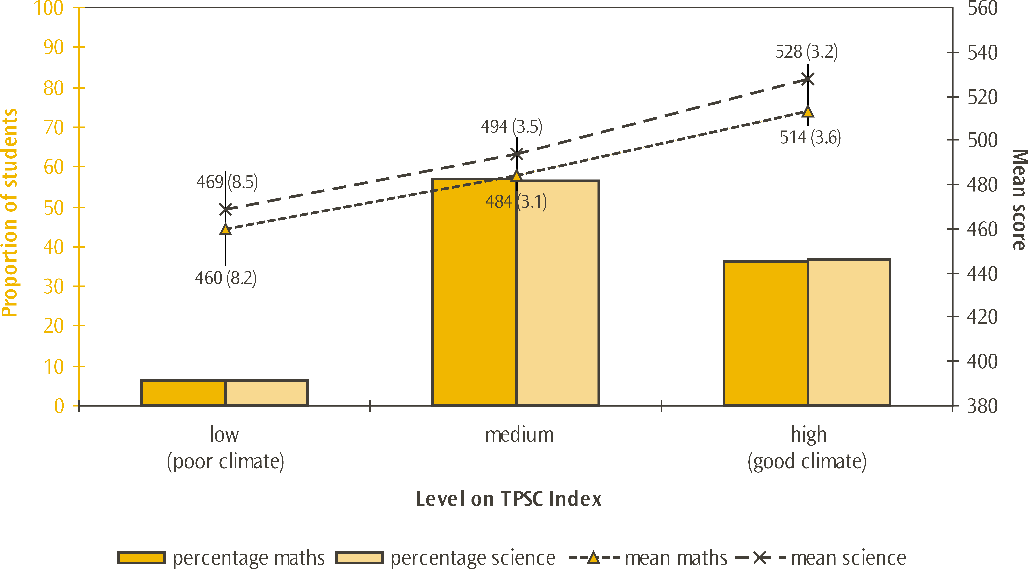
Note: Standard errors are presented in parentheses.
Lines extending from the points represent the 95% confidence interval, e.g. the range within which we are 95 percent confident that the true population value lies.

Trends in teacher perceptions
The questions given to teachers about school climate were first introduced in 2002. Comparisons between the two cycles show no significant change in the proportions of students whose teachers gave positive responses to the individual questions. There is also no significant change in the proportions of students whose teachers characterised the school climate as good since 2002 (at the high level of the TPSC index).
Consistently across the cycles, students whose teachers responded positively to statements about the school climate had higher achievement than those whose teachers were not as positive.

Principal perceptions of climate for learning
Principals of Year 5 students were asked how they would characterise the same eight aspects of life at their school as the teachers, and these are listed in Table 23. They were given the same five options as the teachers: very high, high, medium, low, and very low.
While the percentages were different, the pattern was similar when teachers’ responses and principals’ responses to these questions were compared. The statements where principals were most positive were the four statements relating to teachers with around 90 percent of students having principals who indicated these aspects were high or very high. As for the teachers, aspects relating to parents and students attracted less positive responses from principals. Principals were even less positive than teachers when responding to the statement on parental involvement in school activities with 42 percent of students having principals who characterised this aspect as high or very high (c.f. 47% for teachers’ responses). In contrast, principals were more positive than teachers when responding to the statements on parental support for student achievement (61% high or very high c.f. 51% for teachers) and students’ regard for school property (59% high or very high c.f. 50% for teachers).
Table 23: Extent to which principals characterised aspects of school climate in New Zealand in TIMSS 2006/07
Statements on aspects of school climate | Proportion of Year 5 students
Statements on aspects of school climate | Very high | High | Medium | Low | Very low
Teachers’ job satisfaction | 20 | 66 | 13 | 1 | 0
Teachers’ understanding of the school’s curricular goals | 26 | 65 | 9 | <1 | 0
Teachers’ degree of success in implementing the school’s curriculum | 23 | 68 | 10 | 0 | 0
Teachers’ expectations for student achievement | 34 | 54 | 11 | 1 | 0
Parental support for student achievement | 16 | 46 | 31 | 7 | 1
Parental involvement in school activities | 10 | 31 | 44 | 11 | 3
Students’ regard for school property | 17 | 42 | 35 | 6 | 0
Students’ desire to do well in school | 12 | 62 | 25 | 1 | 0
Note: Standard errors are not presented here for ease of reading but can be found in Table 44 in the Appendix.
Proportions in each row should add to 100%; inconsistencies are due to rounding.
Comparisons of mathematics and science achievement of students in different categories for each of the statements generally showed higher achievement for those students whose principals responded high or very high. As was observed for the teachers’ responses, the exception was the statement on teacher job satisfaction, with those students at the medium level of the statement having similar achievement to those at the high and very high levels. The pattern was the same for both mathematics and science achievement.
Responses to these questions were summarised into the Index of Principals’ Perception of School Climate (PPSC). A high level on the index indicates that principals, on average, selected high or very high when responding to the statements on school climate. That is, the school had a good climate in general. A low level indicates that principals, on average, selected low or very low when responding to statements on school climate. That is, principals reported a poor school climate in general. All other principals were assigned to the medium level of the index.
Based on the PPSC index, 49 percent of students had principals who reported a good school climate, on average. Most of the remaining students’ principals reported there were some aspects of school climate that were not good (47 % medium), with 4 percent reporting a poor school climate.
Principals’ perceptions differ slightly across countries from the teachers’ perceptions discussed earlier (TPSC index). While Australia, New Zealand, Scotland, the United States, and England were up the top of the international tables for good school climate, Chinese Taipei was higher. That is, Chinese Taipei had the highest proportion of students whose principals reported a good school climate, followed by the English-speaking Western countries, with more than 45 percent of students at this level.
Consistent with the findings for the individual statements, New Zealand Year 5 students whose principals characterised the school climate as good had higher achievement than those whose principals were not as positive. Figure 7 illustrates this pattern of achievement for New Zealand Year 5 students. This pattern was consistent across most countries with very few countries having a pattern of little difference in achievement (Chinese Taipei, Slovenia, and Kazakhstan showed this pattern) across the three groups.
Table 24: Proportion of students at each level of Principals’ Perceptions of School Climate (PPSC index) for selected countries in TIMSS 2006/07
 | Proportion of students at each level
Country | High  (good climate) |  | Medium |  | Low  (poor climate)
Chinese Taipei | 64 | (3.7) | 35 | (3.6) | 1 | (0.7)
Australia | 50 | (4.2) | 47 | (3.8) | 2 | (1.2)
New Zealand | 49 | (3.2) | 47 | (3.0) | 4 | (1.2)
Scotland | 48 | (4.8) | 51 | (4.8) | 0 | (0.5)
United States | 48 | (3.0) | 46 | (3.1) | 6 | (1.5)
England | 45 | (4.5) | 47 | (4.6) | 8 | (2.3)
Singapore | 36 | (0.0) | 62 | (0.0) | 2 | (0.0)
Kazakhstan | 29 | (5.4) | 65 | (5.7) | 5 | (2.3)
Hong Kong SAR | 27 | (3.9) | 69 | (4.2) | 5 | (2.0)
Norway | 21 | (3.8) | 78 | (3.9) | 1 | (1.0)
Netherlands | 11 | (2.6) | 84 | (3.1) | 5 | (2.1)
Japan | 10 | (2.6) | 84 | (3.0) | 7 | (1.9)
Russian Federation | 9 | (2.0) | 83 | (3.1) | 8 | (2.5)
International Avg. | 22 | (0.5) | 68 | (0.6) | 10 | (0.4)
Note: Standard errors are presented in parentheses.
Source: Adapted from Exhibit 8.11 Mullis, Martin and Foy, 2008.
Figure 7: Levels of Principals’ Perceptions of School Climate (PPSC index) by mean achievement for New Zealand Year 5 students in TIMSS 2006/07
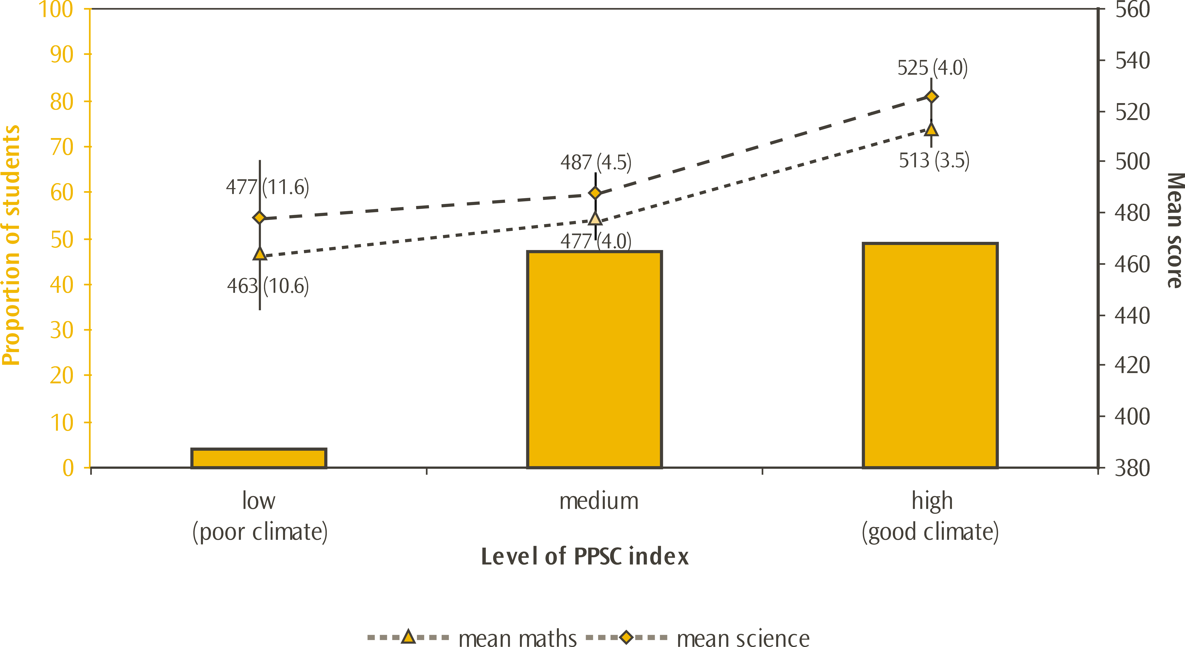
Note: Standard errors are presented in parentheses.
Lines extending from the points represent the 95% confidence interval, e.g. the range within which we are 95 percent confident that the true population value lies.
The achievement results for the low level of the index should be read with caution as there are only 9 schools contributing to this average.

Trends in principal perceptions
The questions given to principals about school climate were first introduced in 2002. Comparisons between the two cycles show no significant change in the proportions of students whose principals gave positive responses to the individual statements. However, there had been a shift within the positive responses for the statement on teachers’ understanding of the school’s curricular goals, with fewer principals responding very high and more responding high (11% fewer students very high and 11% more high). Overall, there has been no significant change in the proportions of students whose principals characterised the school climate as good since 2002 (at the high level of the PPSC index).
Consistently across the cycles, students whose principals responded positively to statements about the school climate had higher achievement than those whose principals were not as positive.

Perceptions of school safety and student behaviours

Student perceptions of school safety and student behaviours
Year 5 students were asked to answer yes or no to the following questions on a series of negative behaviours: Did any of these things happen at school during the last month:
- Something of mine was stolen.
- I was hit or hurt by other students(s) (e.g. shoved, punched, kicked).
- I was made to do things I didn’t want to do by other students.
- I was made fun of or called names.
- I was left out of activities by other students.
Nearly half of all students (44%) reported being hit or hurt by other students in the previous month, while around four in every ten students (42%) reported being made fun of or called names. These were the two most commonly reported negative behaviours. The least commonly reported behaviour, less than one-quarter of students, was being made to do things they didn’t want to. The proportion of students that replied yes to each of these behaviours in 2006 is shown in Table 25.
Table 25: Proportion of students that replied yes to each of these behaviours in New Zealand in TIMSS 2006/07
Statements | Proportion of Year 5 students that replied “yes”
Something of mine was stolen | 39 | (1.0)
I was hit or hurt by other students (e.g. shoved, punched or kicked) | 44 | (1.0)
I was made to do things I didn’t want to do by other students | 24 | (0.9)
I was made fun of or called names | 42 | (1.2)
I was left out of activities by other students | 35 | (0.9)
Note: Standard errors are presented in parentheses.
For each of these behaviours, students who had not experienced them in the previous month had higher achievement, on average, than those who had. The largest difference in achievement was for those students who reported they were made to do things I didn’t want to do by other students – a difference of 41 scale score points for mathematics and 48 scale score points for science.
Responses to these questions were summarised into the Students’ Perception of Being Safe in Schools Index (SPBSS). A high level on the index indicates that students answered no to all five statements. That is, they had no experience of the negative behaviours in the month prior to the TIMSS assessment. A low level indicates that students answered yes to three or more of the questions. That is, children had experienced at least three out of five of the negative behaviours in the month prior to the TIMSS assessment. All other students were assigned to the medium level of the index.
One-quarter of New Zealand Year 5 students reported experiencing none of these negative behaviours in the last month, while one-third reported experiencing at least three of the negative behaviours.
In comparison with students in other countries, a relatively large proportion of New Zealand students (33%) reported experiencing more than half of the negative behaviours in the last month. Only Chinese Taipei had a higher percentage (35%) of students who reported experiencing more than half of these negative behaviours. Across countries, the international average proportion of students who reported experiencing more than half of these negative behaviours was 18 percent, with 26 percent for Australia, 25 percent for England, and 21 percent for Scotland.
As mentioned earlier, one-quarter (25%) of New Zealand Year 5 students reported experiencing none of these negative behaviours in the last month. Only Tunisia had fewer students (23%) who reported experiencing none of these negative behaviours (see Table 26). Across countries, the international average proportion of students who reported experiencing none of these negative behaviours was 42 percent, with 55 percent for Norway, 40 percent for Scotland, 32 percent for England, and 30 percent for Australia.
Table 26: Proportion of students at each level of Students’ Perception of Being Safe in School (SPBSS index) for selected countries in TIMSS 2006/07
Country | Proportion of students at each level
Country | High  (no negative behaviours) |  | Medium |  | Low  (lots of negative behaviours)
Kazakhstan | 80 | (2.3) | 18 | (2.2) | 3 | (0.4)
Norway | 55 | (1.3) | 34 | (0.9) | 12 | (0.8)
Japan | 52 | (1.3) | 34 | (0.9) | 14 | (0.8)
Russian Federation | 51 | (1.3) | 40 | (1.1) | 9 | (0.6)
Netherlands | 48 | (1.4) | 38 | (1.1) | 14 | (0.8)
Scotland | 40 | (1.2) | 39 | (0.9) | 21 | (1.0)
Hong Kong SAR | 37 | (1.3) | 42 | (0.9) | 22 | (1.1)
England | 32 | (1.1) | 43 | (0.9) | 25 | (0.9)
Australia | 30 | (1.2) | 44 | (1.3) | 26 | (1.4)
Singapore | 30 | (0.9) | 45 | (0.7) | 25 | (0.7)
Chinese Taipei | 28 | (1.1) | 38 | (0.9) | 35 | (1.1)
New Zealand | 25 | (0.9) | 42 | (0.9) | 33 | (1.1)
United States | - | - | - | - | - | -
International Avg. | 42 | (0.2) | 40 | (0.2) | 18 | (0.2)
Notes: Standard errors are presented in parentheses.
Dash (-) indicates that comparable data are not available for the United States.
Source: Adapted from Exhibit 8.15 Martin, Mullis and Foy, 2008.
Consistent with the individual questions on safety, students who had experienced none of the negative behaviours in the previous month had higher achievement than those who had experienced some, as illustrated in Figure 8. This pattern was consistent across countries, although for some countries the differences were not significant.
Figure 8: Levels of Students’ Perception of Being Safe in School (SPBSS index) by mean achievement for New Zealand Year 5 students in TIMSS 2006/07
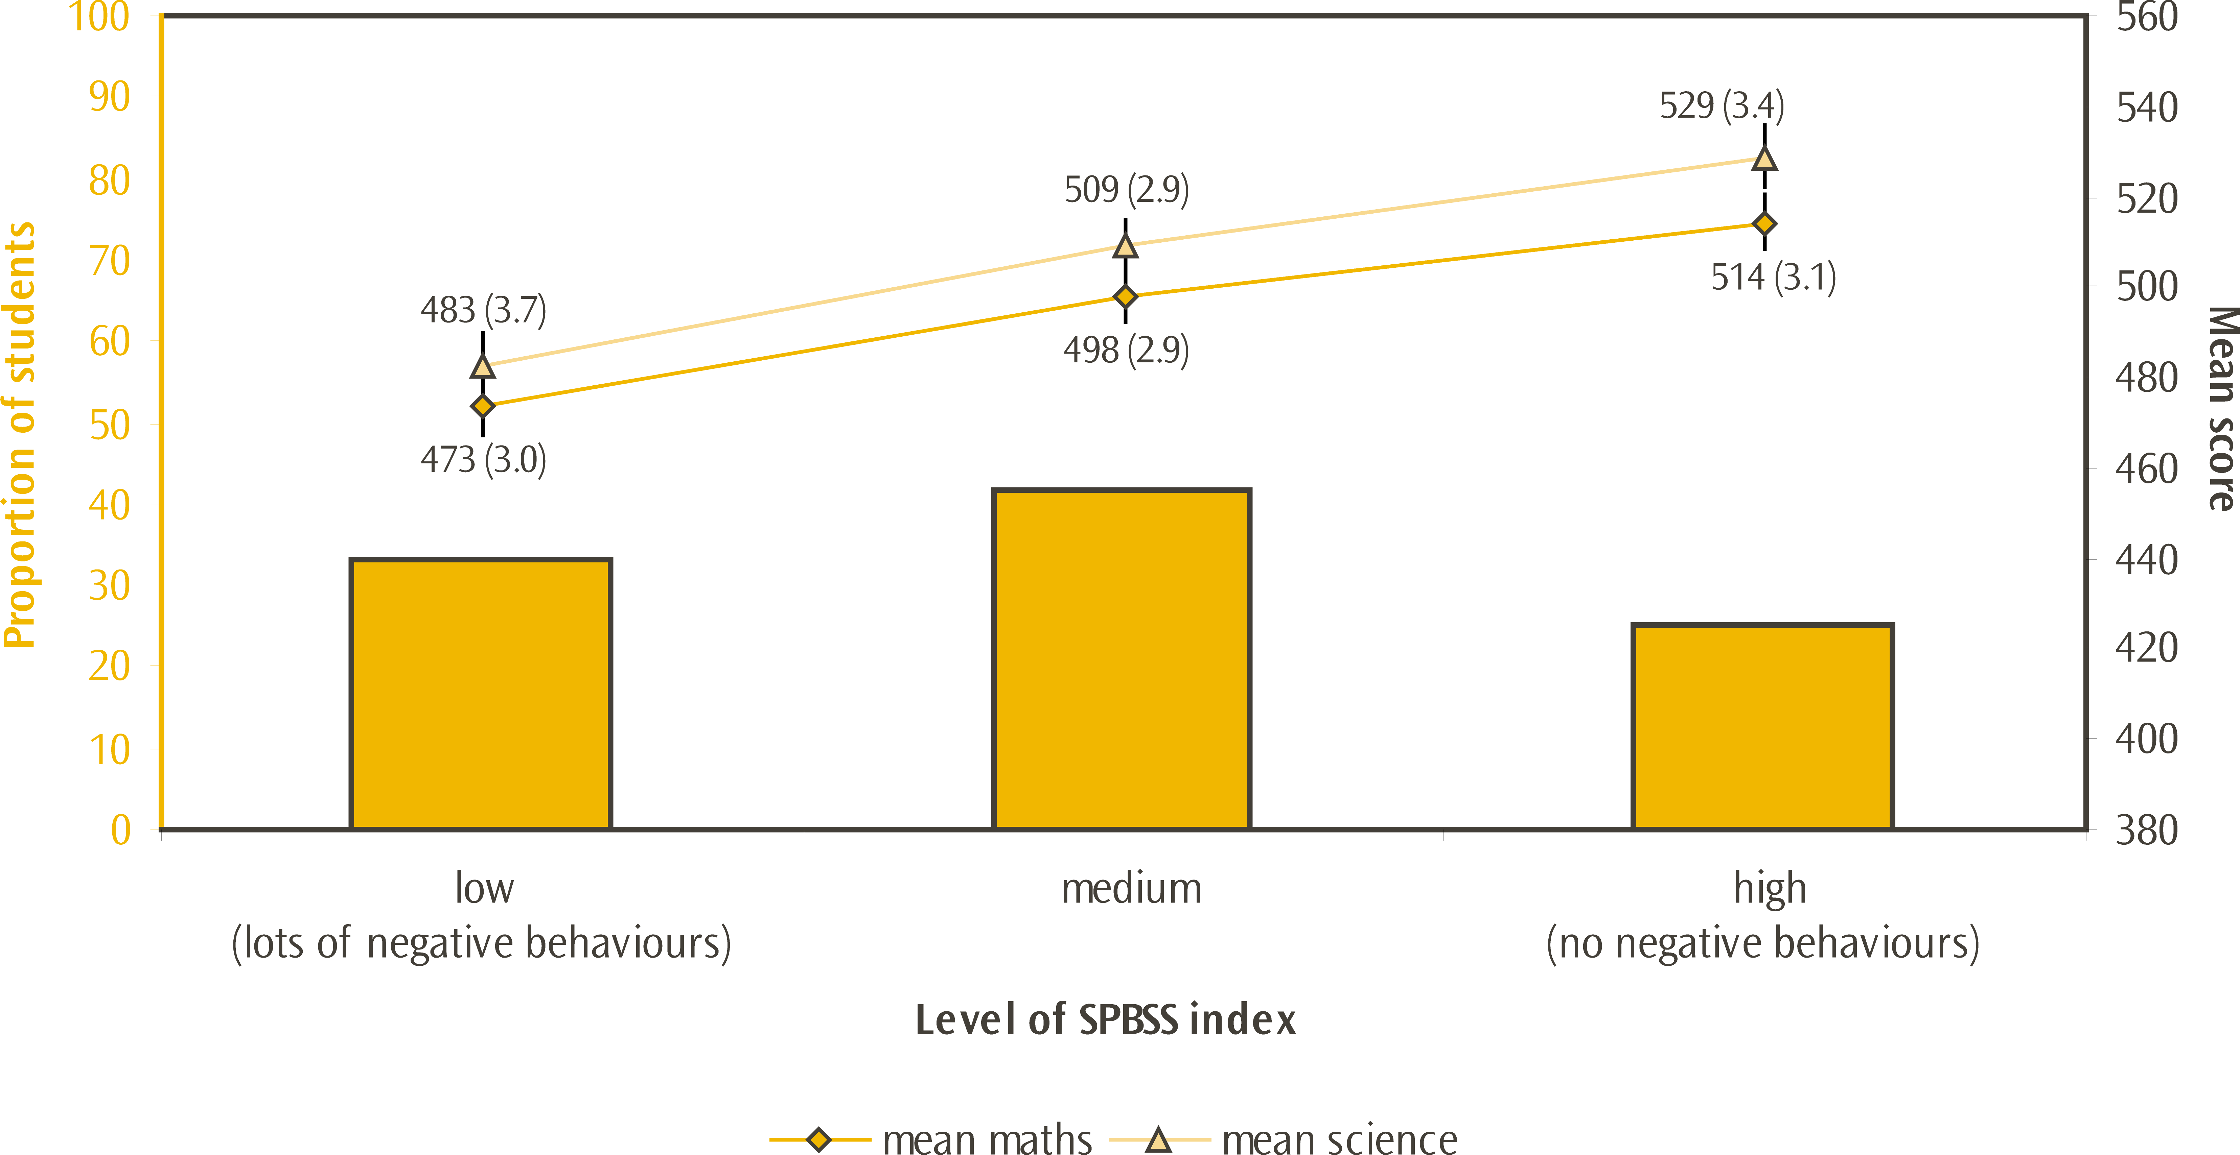
Note: Standard errors are presented in parentheses.
Lines extending from the points represent the 95% confidence interval, e.g. the range within which we are 95 percent confident that the true population value lies.

Trends in student perceptions
The questions given to students about school safety have changed since TIMSS was first implemented in 1994. The only question in 1994 that is still in the 2006 assessment is about having something stolen in the previous month. In 1994, 46 percent of students reported having something stolen compared with the 39 percent in 2006; this represents a significant drop since 1994.
In both 2002 and 2006, students were asked exactly the same questions about school safety. Comparisons between the two cycles show that the reported occurrence of theft has significantly decreased (from 43% to 39%), while the reported level of being left out of activities has significantly increased (from 30% to 35%). There was no significant movement in the other questions. While there have been some movements in the individual questions, there has been no change overall in the proportion of students experiencing none of the negative behaviours since 2002.
Consistently across the cycles, students who had not experienced these negative behaviours had higher achievement than those who had.
While the proportion of students experiencing unsafe behaviours at school was relatively high compared to other countries, and has been over time, as mentioned earlier, most students like being at school.

Teacher perceptions of school safety and student behaviours
Teachers of Year 5 students were asked to indicate the extent to which they agreed or disagreed with three statements on the general levels of safety they experienced at their schools. The statements listed were:
- This school is located in a safe neighbourhood.
- I feel safe at this school.
- This school's security policies and practices are sufficient.
There were four possible response options given: agree a lot, agree, disagree, disagree a lot.
Most students in TIMSS were taught by teachers who agreed their school was a safe place, with 98 percent agreeing or agreeing a lot with the statement I feel safe at school, as shown in Table 27. There was least agreement with the statement this school is located in a safe neighbourhood, with 11 percent of students having teachers who disagreed to some extent.
Table 27: Extent to which teachers agreed with statements on school safety in New Zealand in TIMSS 2006/07
Statements on school safety | Proportion of Year 5 students whose teachers indicated these levels of agreement with the statements
Statements on school safety | Agree a lot |  | Agree |  | Disagree |  | Disagree a lot
This school is located in a safe neighbourhood | 45 | (2.1) | 44 | (2.5) | 10 | (1.4) | 2 | (0.7)
I feel safe at this school | 57 | (2.8) | 41 | (2.8) | 2 | (0.9) | <1 | (0.2)
This school's security policies and practices are sufficient | 43 | (2.7) | 52 | (2.8) | 4 | (1.0) | 1 | (0.5)
Note: Standard errors are presented in parentheses.
Proportions in each row should add to 100%; inconsistencies are due to rounding.
For each of these statements, students whose teachers agreed a lot had higher achievement, on average, than those who agreed to a lesser extent or disagreed.
Responses to these questions were summarised into the Index of Teachers’ Perception of Safety in School (TPSS). A high level on the index indicates that teachers agreed (either agree a lot or agree) with all three statements. That is, they agreed that the school was a safe place. A low level indicates that teachers disagreed (either disagree a lot or disagree) with all three statements. That is, teachers disagreed with statements that the school was a safe place. All other teachers were assigned to the medium level of the index.
Based on the TPSS index, New Zealand teachers’ perception of school safety was more favourable than that of the students, with 86 percent of students having teachers who agreed the school was a safe place. Most of the remaining 14 percent of students’ teachers responded with mixed agreement and disagreement, with less than 1 percent disagreeing that the school was a safe place. Note that although teachers’ perception of safety was analysed separately for mathematics and science teachers, many New Zealand Year 5 students would have the same teacher for mathematics and science. Consequently, the result was the same for mathematics and science teachers.
Among mathematics teachers, the Czech Republic had the greatest proportion of students whose teachers agreed their school was a safe place (97%), and Singapore (which, like New Zealand, was very low with regard to student perceptions) had the second largest (96%). Among science teachers, Singapore and Austria had the greatest proportion of students whose teachers agreed their school was a safe place (96%), and Norway had the next largest (95%). New Zealand, Scotland, Australia, and England were all very similar, with respect to teacher perceptions of safety, but the United States had fewer students whose teachers agreed their school was a safe place.
Table 28: Proportion of students whose teachers agreed their school was safe (at high level of the TPSS index) for selected countries in TIMSS 2006/07
Country | Mathematics teachers |  |  | Country | Science teachers
Country | % of students |  |  | Country | % of students
Singapore | 96 | (1.0) |  | Singapore | 96 | (1.1)
Norway | 95 | (1.7) |  | Norway | 95 | (1.7)
Hong Kong SAR | 88 | (3.2) |  | Hong Kong SAR | 90 | (2.6)
Kazakhstan | 88 | (3.3) |  | Scotland | 89 | (2.5)
Scotland | 87 | (2.6) |  | Kazakhstan | 88 | (3.3)
New Zealand | 86 | (1.8) |  | Australia | 87 | (2.3)
Netherlands | 86 | (2.9) |  | New Zealand | 86 | (1.8)
Australia | 86 | (2.4) |  | Netherlands | 86 | (2.9)
England | 86 | (2.4) |  | England | 86 | (2.4)
Russian Federation | 82 | (3.2) |  | Russian Federation | 82 | (3.2)
United States | 80 | (2.2) |  | Chinese Taipei | 80 | (3.2)
Japan | 66 | (3.5) |  | United States | 78 | (2.5)
Chinese Taipei | 65 | (4.1) |  | Japan | 67 | (3.6)
International Avg. | 80 | (0.5) |  | International Avg. | 80 | (0.5)
Note: Standard errors are presented in parentheses.
Source: Adapted from Exhibit 8.13 Mullis, Martin and Foy, 2008 and Exhibit 8.14 Martin, Mullis and Foy.
Consistent with the individual questions on safety, students whose teachers agreed that the school was a safe place (at the high level on the index) had higher achievement than those whose teachers were not as positive. This pattern was consistent across countries, although for some countries the differences were not significant.
Figure 9: Levels of Teachers’ Perception of Safety in School (TPSS index) by mean achievement for New Zealand Year 5 students in TIMSS 2006/07
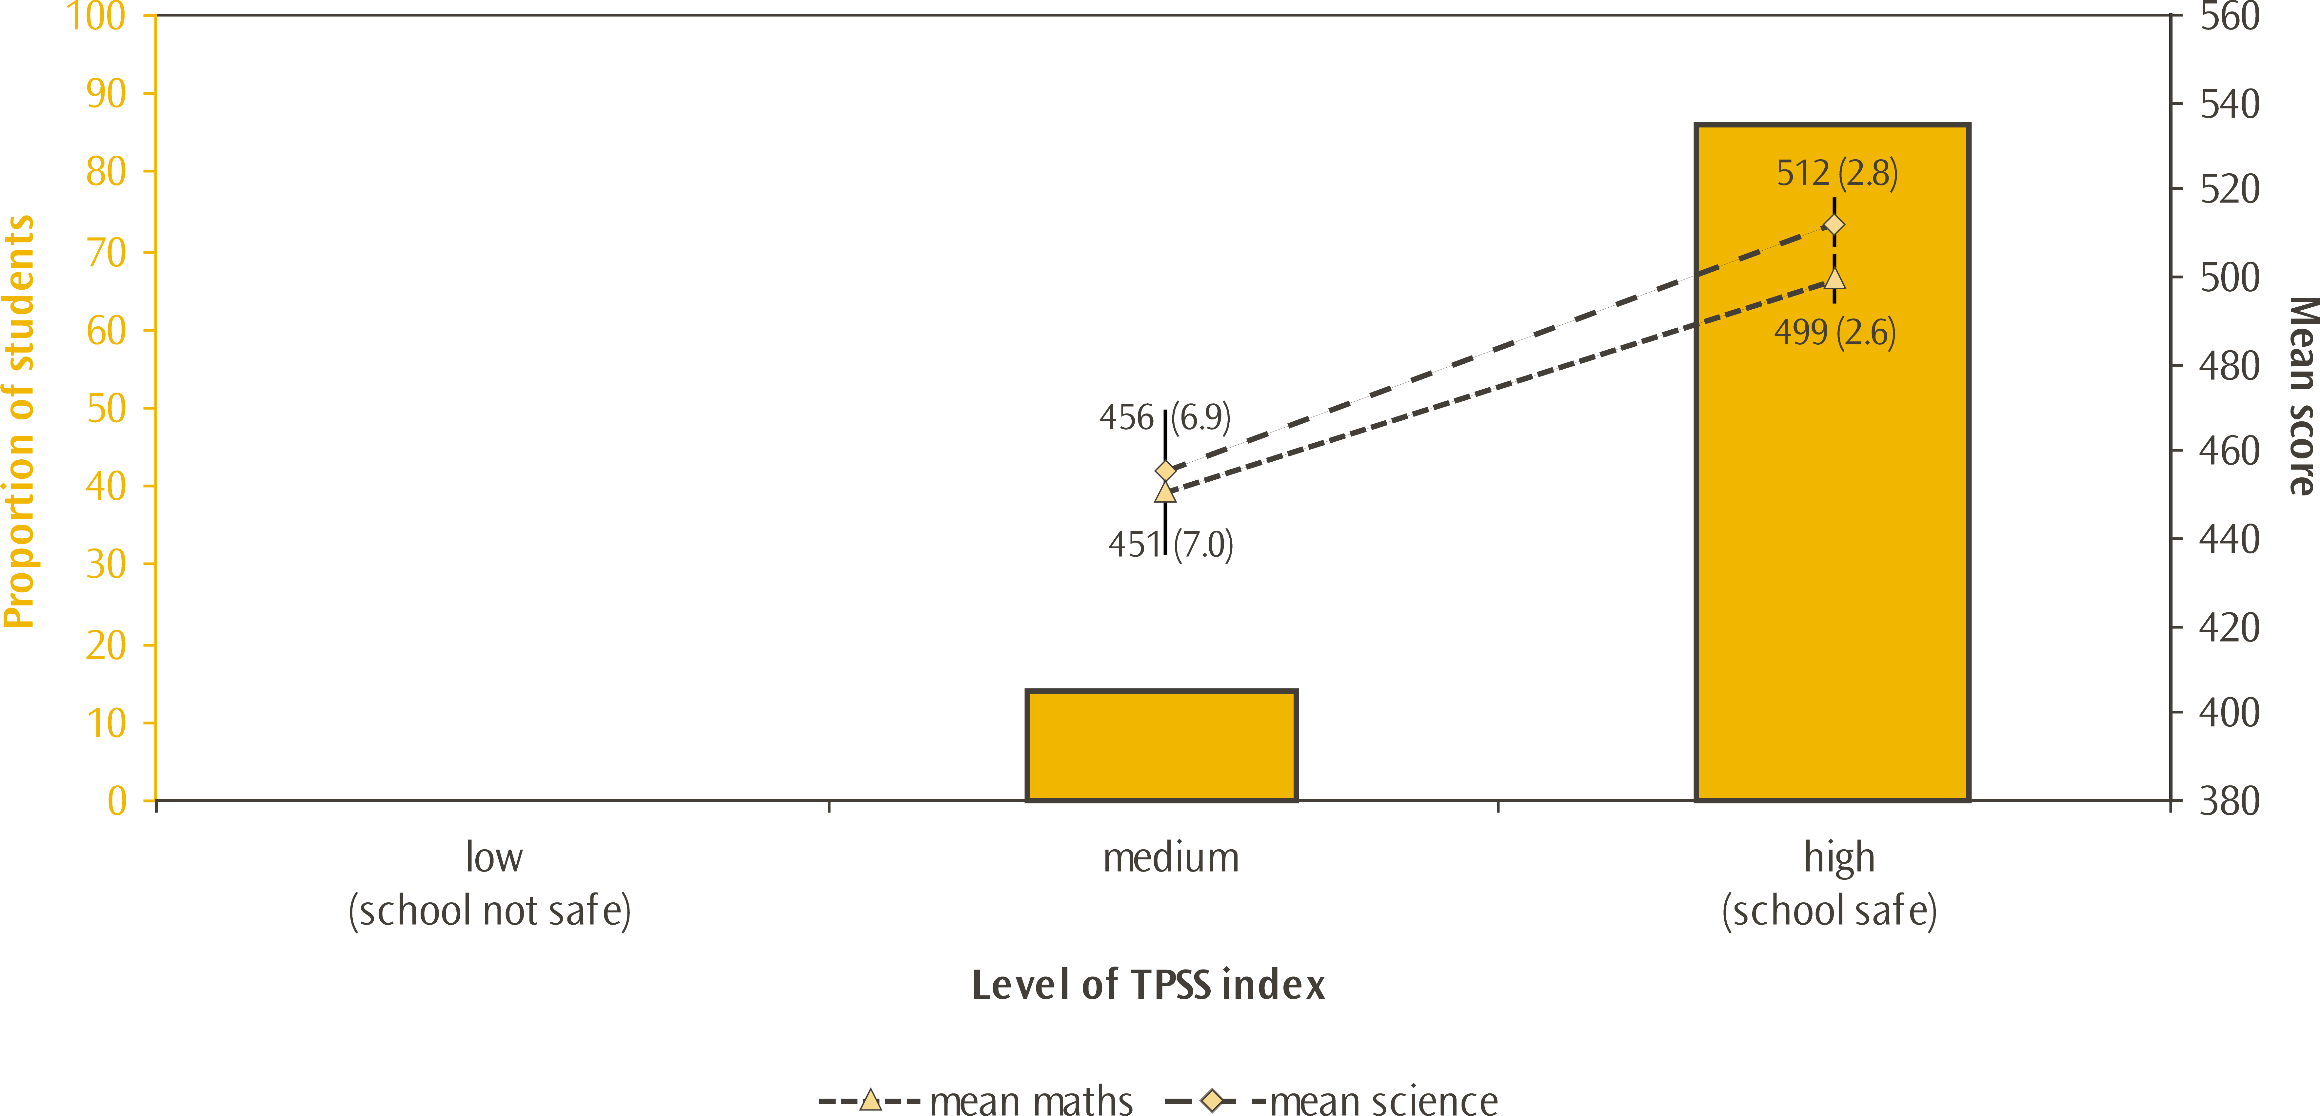
Note: Standard errors are presented in parentheses.
Lines extending from the points represent the 95% confidence interval, e.g. the range within which we are 95 percent confident that the true population value lies.
There were too few students in the low grouping to report achievement for this group.

Trends in teacher perceptions
The questions given to teachers about school safety were first introduced in 2002. Comparisons between the two cycles show no significant change in the proportions of students whose teachers gave positive responses to the individual questions. There is also no significant change in the proportion of students whose teachers agreed that school was a safe place since 2002 (at the high level of the TPSS index).
Consistently across the cycles, students whose teachers agreed that the school was a safe place (at the high level on the index) had higher achievement than those whose teachers were not as positive.

Principal perceptions of school safety and student behaviours
To help foster a healthy learning environment, least disruption to learning is desirable. School principals were asked to report how frequently a series of problem behaviours occurred at their school and the severity of the problem. The behaviours examined were:
- Arriving late at school.
- Absenteeism (i.e., unjustified absences).
- Skipping class.
- Violating dress code.
- Classroom disturbance.
- Cheating.
- Profanity.
- Vandalism.
- Theft.
- Intimidation or verbal abuse of other students.
- Physical injury to other students.
- Intimidation or verbal abuse of teachers or staff.
- Physical injury to teachers or staff.
There were five possible response options given for frequency and three possible response options for the severity of behaviours. These were: never, rarely, monthly, weekly, and daily for frequency of behaviours; and not a problem, minor problem, and serious problem for the severity of behaviours.
Across all the behaviours examined, the majority of Year 5 students attended schools where these behaviours seldom occurred and were perceived by the principal to be minor problems at the most. As shown in Table 29, the most commonly occurring behaviours were arriving late to school, classroom disturbance, and absenteeism. However, for the majority of students, their principals considered these behaviours were at most minor problems (also shown in Table 29). Intimidation or verbal abuse of students was also reported as occurring relatively frequently compared to the other behaviours; this behaviour was the one most commonly considered to be serious, with 10 percent of students at such schools.
Table 29a: Frequency of student behaviours according to principals in New Zealand in TIMSS 2006/07
Behaviours | Proportion of Year 5 students in each category of frequency of behaviours
Behaviours | Never | Rarely | Monthly | Weekly | Daily
Arriving late at school | 1 | 49 | 10 | 24 | 16
Absenteeism | 8 | 52 | 15 | 18 | 7
Skipping class | 74 | 24 | 2 | 0 | 0
Violating dress code | 55 | 32 | 4 | 6 | 2
Classroom disturbance | 4 | 51 | 17 | 20 | 7
Cheating | 22 | 73 | 3 | 1 | <1
Profanity | 18 | 55 | 14 | 11 | 3
Vandalism | 23 | 66 | 9 | 1 | 0
Theft | 18 | 71 | 9 | 2 | 0
Behaviours in relation to other students
Intimidation or verbal abuse | 5 | 55 | 25 | 12 | 2
Physical injury | 12 | 71 | 13 | 3 | 1
Behaviours in relation to teachers of staff
Intimidation or verbal abuse | 43 | 50 | 6 | 1 | 1
Physical injury | 81 | 19 | 0 | 0 | 0
Note: Standard errors are not presented here for ease of reading but can be found in Table 45 in the Appendix.
Proportions in each row should add to 100%; inconsistencies are due to rounding.
Table 29b: Severity of student behaviours according to principals in New Zealand in TIMSS 2006/07
Behaviours | Proportion of Year 5 students in each category of severity of behaviours
Behaviours | Not a problem | Minor problem | Serious problem
Arriving late at school | 42 | 50 | 8
Absenteeism | 50 | 41 | 9
Skipping class | 95 | 5 | 0
Violating dress code | 84 | 15 | 1
Classroom disturbance | 44 | 48 | 8
Cheating | 86 | 13 | <1
Profanity | 63 | 32 | 4
Vandalism | 68 | 30 | 1
Theft | 68 | 31 | 1
Behaviours in relation to other students
Intimidation or verbal abuse | 44 | 46 | 10
Physical injury | 58 | 38 | 4
Behaviours in relation to teachers of staff
Intimidation or verbal abuse | 76 | 22 | 2
Physical injury | 91 | 9 | 1
Note: Standard errors are not presented here for ease of reading but can be found in Table 45 in the Appendix.
Proportions in each row should add to 100%; inconsistencies are due to rounding.
With the exception of cheating and dress code, students attending schools where these behaviours never or rarely happened had higher achievement than those in schools where they happened monthly or more often. Again, with the exception of dress code, students in schools where the behaviours were perceived as not a problem had higher achievement than those where it was a minor or serious problem.
To examine the extent to which lack of attendance affects student learning, TIMSS created an Index of Good Attendance at School (GAS) based on the principal’s responses to three of the questions about student behaviour: arriving late at school; absenteeism (i.e. unjustified absences); and skipping class. A high level on the index indicates that all three behaviours either never occur or were reported not to be a problem. A low level indicates that at least one of the behaviours was reported to be a serious problem. The medium level indicates that problems with student attendance were generally minor.
The majority of Year 5 students in New Zealand (58%) attended schools whose principals indicated that problems with student attendance were generally minor. Thirty-seven percent of students had principals who indicated that student attendance was not a problem, and a small minority of students (5%) attended schools where there were serious problems with student attendance in terms of unjustified absences, arriving late and skipping class according to their principals.
As shown in Table 30, Chinese Taipei had the largest proportion of students in schools where student attendance was not considered a problem. Countries such as the Russian Federation, England, Kazakhstan, and Australia had similar proportions at each level of school attendance ,compared with New Zealand, while the United States had fewer students in schools where student attendance was not considered a problem, and more students in schools where problems with student attendance were minor.
In New Zealand, the mean science and mathematics scores for students in schools where student attendance was not a problem was statistically higher than their counterparts in schools where student attendance was reported to be a problem to some degree (as shown in Figure 10). Likewise, the mean science and mathematics scores for students in schools where there were minor attendance problems were significantly higher than for students in schools with serious attendance problems. This was also the case internationally. This result is perhaps not unexpected, as the less time a student spends being absent, the more instruction time the student gets in the classroom.
Table 30: Proportion of students at each level of Good Attendance at School (GAS index) for selected countries in TIMSS 2006/07
Country | Proportion of students in each level of the GAS index
Country | High  (no problems) |  | Medium  (minor problems) |  | Low  (serious problems)
Chinese Taipei | 77 | (3.9) | 23 | (3.9) | 0 | (0.0)
Netherlands | 66 | (4.1) | 33 | (4.0) | 1 | (0.0)
Singapore | 57 | (0.0) | 42 | (0.0) | 0 | (0.0)
Scotland | 51 | (4.0) | 45 | (4.2) | 4 | (1.8)
Norway | 51 | (4.5) | 48 | (4.5) | 1 | (0.0)
Hong Kong SAR | 50 | (4.5) | 49 | (4.4) | 1 | (0.0)
Japan | 48 | (3.6) | 42 | (3.6) | 10 | (2.1)
Russian Federation | 39 | (3.6) | 58 | (3.0) | 3 | (2.1)
New Zealand | 37 | (3.4) | 58 | (3.5) | 5 | (1.4)
England | 34 | (4.4) | 61 | (4.4) | 4 | (1.8)
Kazakhstan | 34 | (4.4) | 65 | (4.4) | 1 | (0.8)
Australia | 31 | (4.3) | 65 | (4.1) | 4 | (1.4)
United States | 21 | (3.0) | 71 | (3.4) | 8 | (1.8)
International Avg. | 43 | (0.6) | 50 | (0.7) | 7 | (0.3)
Note: Standard errors are presented in parentheses.
Source: Adapted from Exhibit 8.3 Mullis, Martin and Foy, 2008 and Exhibit 8.3 Martin, Mullis and Foy.
Figure 10: Levels of Good Attendance at School (GAS index) by mean achievement for New Zealand Year 5 students in TIMSS 2006/07
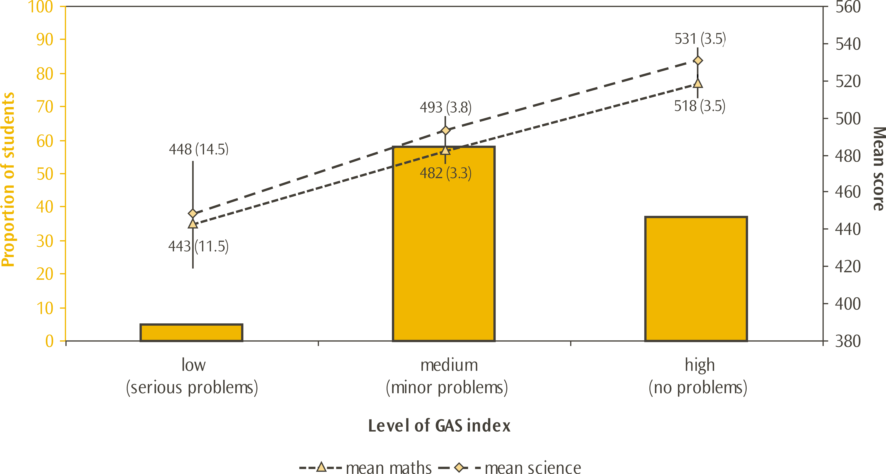
Note: Standard errors are presented in parentheses.
Lines extending from the points represent the 95% confidence interval, e.g. the range within which we are 95 percent confident that the true population value lies.

Trends in principal perceptions
With the exception of incidences of theft, the regularity of negative behaviours has not changed since the 2002/03 cycle. The incidences of theft have become less frequent, with an increase in the proportion of students in schools where the principals report that theft never happens (from 12% to 18%). The severity of behaviours reported has changed in many cases. In the case of thefts and violating dress code, the severity of these issues has decreased, while for absenteeism, arriving late, classroom disturbance, and physical injury of teachers, the severity has increased.
While there have been some changes in the severity of some of the attendance issues over time, the proportion of New Zealand Year 5 students in schools where the principals’ responses were summarised as the school having serious attendance problems has not changed significantly since 2002/03.

Conclusion
This report has examined student, teacher and principal responses to questions on school context, contained in background questionnaires in the TIMSS 2006/07 study. The report explored characteristics of schools, school management, resources, and climate. The relationship between some school context variables and mathematics and science achievements was also examined. Where possible, comparisons with previous cycles were made.
Some of the school characteristics analysed in this report cannot be easily modifed by teachers (such as the socio-economic composition of the school population). While findings for these ‘fixed’ descriptive aspects are both informative and important, the findings around the aspects of school culture and climate have practical implications for practitioners and policy makers.

School characteristics
Socio-economic factors have been widely acknowledged as having a strong influence on student achievement, with findings from TIMSS showing that students who attend high-decile band schools do significantly better, on average, in both mathematics and science than students in low-decile band schools; this is also true for schools with higher proportions of students from affluent home backgrounds. Schools where the majority of students speak English as their home language also have higher levels of student achievement than schools where English is not the first language of the majority of their students. As mentioned in the introduction to this report, research has found that schools can do a lot to mitigate these perceived disadvantages.

Hours of instruction
Changing the number of hours of instruction will not, of itself, change a country’s or a student’s performance from mediocre to great; it is the instruction during these hours that is key to improving performance. Since the previous cycle of TIMSS in 2002/03, New Zealand Year 5 students are spending significantly more class time on mathematics (although significant, this was a relatively small increase) and significantly less on science instruction (this was a comparatively large decrease). While mathematics achievement has not changed significantly since the previous cycle, science achievement has decreased significantly, and this decrease combined with the decrease in hours suggests that this is an area which merits some attention.

School management
Consistent with previous cycles, principals in New Zealand spent, on average, close to half their time on administrative duties; one of the highest proportions reported among participating countries. Principals of larger schools spent more time on administrative duties compared to their counterparts in smaller schools, while principals of small schools spent more time teaching than their counterparts in larger schools. Instructional leadership, arguably the most important task undertaken by principals, was the activity most principals spent the second largest proportion of their time doing. Time spent by principals on activities is an area worth reflecting upon, both at a local and national level.
Parental involvement in schools is actively encouraged by all schools at the Year 5 level. However, many principals and teachers felt that parental involvement was lower than they would like. Given research findings on the value of parental involvement, it is worthwhile that schools continue to encourage this.

School resources
The TIMSS study has provided an opportunity to see where principals perceive resources are lacking, with an emphasis on impact on instructional capability of the school. In general, a lack of science-oriented resources was more of a problem than mathematics-oriented resources, although the principals of nearly half of the students indicated that the lack of mathematics-oriented resources in their school impacted negatively on instruction. In particular, the resource most commonly perceived by New Zealand principals as having a negative impact on instructional capability was a lack of science laboratory equipment and materials.

Perceptions of climate for learning
Students, teachers and principals gave mostly positive responses to statements on the school climate for learning. While students were given different statements from teachers and principals (for example about liking school) they all give a sense that the teachers are dedicated and want their students to do their very best.
Most students like school, but as trends over time show, there is a persistent group of students (bigger in 2006 than in 2002) who are prepared to say that they disagree either a little or a lot with the statement I like being at school. While both boys and girls from all ethnic groupings were in this group, Pākehā/European boys were overrepresented. Also of concern is the small group of students who disagreed either a little or a lot with the statement I think teachers at my school want students to do their best with Māori boys overrepresented.
The results from TIMSS show that achievement in mathematics and science is higher among students in schools reported as having a good school climate. Schools should continue to endeavour to provide a good climate for students.

Perceptions of school safety and student behaviours
New Zealand has rated poorly in international comparisons over the cycles of TIMSS when student perceptions of safety are compared, while rating quite highly with regard to teacher and principal perceptions. Achievement in mathematics and science is higher among students in schools reported as safe. As mentioned earlier, having a good climate in the school is also related to higher achievement.

Final thoughts
While conditions such as safety and climate within a school do not determine achievement, the TIMSS study has shown that these factors are important in providing the conditions where student learning can flourish.
This report has examined only one of the aspects of schooling that can influence achievement. The authors of this report are also working on a report about teaching, due to be released after this report. These two reports, together with those released in December 2008, build a comprehensive picture of mathematics and science at the Year 5 level.
In 2010 and 2011, New Zealand will be participating in the fifth cycle of TIMSS at both the Year 5 and Year 9 levels. This will give New Zealand the opportunity to examine the 2006 Year 5 cohort when they are in Year 9 and to see if improvements have been made at the Year 5 level.

Appendix
Table 32: Standard errors for Table 2 - Mathematics instructional time per year for selected countries in TIMSS 2006/07
Country | Total hours of maths instruction per year | Number |  | Geometric Shapes  and Measures |  | Data Display
Country | Total hours of maths instruction per year | Percent of time per year | Mean scale score | Percent of time per year | Mean scale score | Percent of time per year | Mean scale score
Singapore | (0.8) | (0.7) | (4.3) | (0.6) | (3.6) | (0.5) | (3.2)
England | (2.1) | (0.9) | (3.2) | (0.5) | (2.7) | (0.5) | (2.5)
Scotland | (2.7) | (1.0) | (2.6) | (0.6) | (2.6) | (0.5) | (2.2)
Netherlands | (4.6) | (1.2) | (2.2) | (0.5) | (2.3) | (0.7) | (2.3)
Australia | (5.4) | (1.1) | (3.7) | (0.7) | (3.1) | (0.6) | (3.1)
United States | (3.7) | (1.0) | (2.7) | (0.4) | (2.5) | (0.5) | (2.4)
Hong Kong SAR | (3.4) | (1.0) | (3.8) | (0.7) | (3.1) | (0.5) | (2.7)
New Zealand | (1.8) | (0.8) | (2.7) | (0.4) | (2.3) | (0.3) | (2.6)
Japan | (1.2) | (1.1) | (2.2) | (0.8) | (2.2) | (0.6) | (2.8)
Kazakhstan | (1.8) | - | (6.6) | - | (7.4) | - | (5.8)
Norway | (2.5) | (1.1) | (2.8) | (0.7) | (3.0) | (0.5) | (2.6)
Chinese Taipei | (2.6) | (1.0) | (1.9) | (0.6) | (2.2) | (0.6) | (2.0)
Russian Federation | (1.3) | - | (4.4) | - | (5.1) | - | (4.9)
International Avg. | (0.5) | (0.2) | (0.0) | (0.1) | (0.0) | (0.1) | (0.0)
Note: A dash (-) indicates comparable data are not available.
Source: Adapted from Exhibits 5.2 & 5.3 Mullis, Martin and Foy, 2008.
Table 33: Standard errors for Table 3 - Science instructional time per year for selected countries in TIMSS 2006/07
Country | Total hours of science instruction per year | Life Science |  | Physical Science |  | Earth Science
Country | Total hours of science instruction per year | Percent  of time per year | Mean scale score | Percent  of time per year | Mean scale score | Percent  of time per year | Mean scale score
United States | (2.5) | (0.7) | (2.5) | (0.7) | (2.3) | (0.7) | (2.6)
Japan | (1.2) | (0.8) | (2.0) | (0.9) | (2.3) | (0.7) | (2.7)
Singapore | (0.9) | (0.9) | (4.1) | (0.9) | (3.9) | (0.7) | (3.3)
Chinese Taipei | (1.6) | (1.0) | (2.1) | (1.2) | (2.5) | (0.8) | (1.9)
Hong Kong SAR | (5.2) | (1.3) | (3.5) | (1.0) | (3.5) | (1.1) | (3.2)
England | (1.7) | (0.8) | (2.7) | (1.0) | (2.7) | (0.8) | (2.9)
Kazakhstan | (1.3) | (0.8) | (5.0) | (0.8) | (5.8) | (1.1) | (5.2)
Scotland | (3.1) | (1.5) | (2.2) | (1.7) | (1.9) | (1.7) | (2.5)
Australia | (2.2) | (1.6) | (3.4) | (1.4) | (3.1) | (1.2) | (3.2)
New Zealand | (2.5) | (1.2) | (2.5) | (1.3) | (2.5) | (1.0) | (2.6)
Norway | (1.9) | (1.1) | (2.5) | (0.8) | (2.7) | (1.3) | (2.9)
Russian Federation | (1.1) | (1.2) | (4.1) | (0.7) | (4.6) | (0.8) | (4.3)
Netherlands | (1.5) | (2.1) | (2.2) | (1.0) | (2.3) | (1.5) | (2.5)
International Avg. | (0.5) | (0.2) | (0.0) | (0.2) | (0.0) | (0.2) | (0.0)
Source: Adapted from Exhibits 5.3 & 5.4 Martin, Mullis and Foy, 2008.

Table 34: Data for Figure 1 - Mean achievement scores for New Zealand Year 5 students by decile band* for 1994, 1998, 2002 and 2006
Decile grouping | Mathematics mean achievement score
Decile grouping | 2006 |  | 2002 |  | 1998 |  | 1994
Low (1 to 3) | 443 | (4.5) | 450 | (6.0) | 423 | (9.9) | 420 | (8.5)
Medium (4 to 7) | 492 | (3.7) | 501 | (4.1) | 488 | (7.0) | 487 | (6.3)
High (8 to 10) | 528 | (2.6) | 529 | (4.0) | 513 | (8.2) | 501 | (4.3)
Decile grouping | Science mean achievement score
Decile grouping | 2006 |  | 2002 |  | 1998 |  | 1994
Low (1 to 3) | 451 | (5.4) | 483 | (5.6) | 455 | (11.2) | 448 | (10.9)
Medium (4 to 7) | 505 | (4.1) | 528 | (4.2) | 523 | (6.9) | 528 | (6.3)
High (8 to 10) | 541 | (2.8) | 553 | (3.6) | 544 | (8.0) | 542 | (3.0)
Note: Standard errors are presented in parentheses.
* State and state integrated schools only.
Table 35: Data for Figure 2 - Mathematics achievement of students by principals’ estimates of the level of economic disadvantage in their schools for selected countries in TIMSS 2006/07
Country | Mathematics mean achievement score |  |  |  | Difference
Country | Few disadvantaged students  (0-10%) |  | Many disadvantaged students  (more than 50%) |  | Difference
Kazakhstan | 540 | (9.2) | 588 | (16.2) | -48
Hong Kong SAR | 610 | (5.4) | 588 | (6.3) | 22
Chinese Taipei | 584 | (2.4) | 553 | (12.6) | 31
Russian Federation | 567 | (8.7) | 524 | (12.1) | 43
International Avg. | 490 | (1.7) | 443 | (1.9) | 47
Scotland | 510 | (4.0) | 450 | (6.7) | 60
Australia | 536 | (6.1) | 475 | (11.1) | 61
Netherlands | 544 | (2.7) | 481 | (10.9) | 63
England | 564 | (5.0) | 499 | (4.4) | 65
United States | 569 | (5.9) | 499 | (3.5) | 70
New Zealand | 521 | (2.8) | 437 | (5.1) | 84
Note: Standard errors are presented in parentheses.
Source: Adapted from Exhibit 8.1 Mullis, Martin and Foy, 2008.

Table 36: Data for Figure 3 - Science achievement of students by principals’ estimates of the level of economic disadvantage in their schools for selected countries in TIMSS 2006/07
Country | Science mean achievement score |  |  |  | Difference
Country | Few disadvantaged students  (0-10%) |  | Many disadvantaged students  (more than 50%) |  | Difference
Kazakhstan | 528 | (7.3) | 571 | (12.4) | -43
Hong Kong SAR | 553 | (5.7) | 540 | (6.2) | 13
Chinese Taipei | 565 | (2.6) | 535 | (10.6) | 30
Russian Federation | 567 | (7.4) | 530 | (11.4) | 37
International Avg. | 495 | (1.9) | 445 | (2.0) | 50
Australia | 544 | (4.9) | 486 | (10.5) | 58
Scotland | 517 | (3.2) | 456 | (7.7) | 61
Netherlands | 531 | (3.0) | 468 | (11.3) | 63
England | 564 | (4.7) | 499 | (4.1) | 65
United States | 581 | (6.3) | 504 | (4.0) | 77
New Zealand | 534 | (3.1) | 444 | (5.7) | 90
Note: Standard errors are presented in parentheses.
Source: Adapted from Exhibit 8.1 Martin, Mullis and Foy, 2008.
Table 37: Data for Figure 4 - Mathematics achievement of students by principals’ reports on percentages of students having the language of the test as their first language for selected countries in TIMSS 2006/07
Country | Mathematics mean achievement score |  |  |  | Difference
Country | Many students speak language of test (more than 90%) |  | Few students speak language of test (less than 50%) |  | Difference
Australia | 513 | (3.9) | 510 | (12.5) | 3
Norway | 473 | (3.0) | 465 | (12.8) | 8
Chinese Taipei | 579 | (3.1) | 569 | (3.2) | 10
Kazakhstan | 546 | (9.8) | 535 | (10.3) | 11
International Avg. | 476 | (1.0) | 461 | (3.2) | 15
Russian Federation | 547 | (5.9) | 529 | (17.4) | 18
England | 548 | (3.6) | 521 | (8.0) | 27
Singapore | 620 | (23.2) | 592 | (4.6) | 28
United States | 536 | (3.1) | 502 | (8.7) | 34
Netherlands | 545 | (2.9) | 506 | (7.3) | 39
New Zealand | 503 | (2.7) | 457 | (8.5) | 46
Note: Standard errors are presented in parentheses.
Source: Adapted from Exhibit 8.2 Mullis, Martin and Foy, 2008.

Table 38: Data for Figure 5 - Science achievement of students by principals’ reports on percentages of students having the language of the test as their first language for selected countries in TIMSS 2006/07
Country | Science mean achievement score |  |  |  | Difference
Country | Many students speak language of test (more than 90%) |  | Few students speak language of test (less than 50%) |  | Difference
Kazakhstan | 521 | (7.6) | 534 | (9.9) | -13
Norway | 476 | (3.9) | 471 | (11.3) | 5
Chinese Taipei | 560 | (3.2) | 550 | (3.5) | 10
Australia | 527 | (3.8) | 514 | (10.3) | 13
Russian Federation | 550 | (5.5) | 528 | (21.0) | 22
England | 548 | (3.6) | 524 | (8.5) | 24
International Avg. | 480 | (1.0) | 455 | (3.6) | 25
Netherlands | 534 | (3.3) | 497 | (7.5) | 37
Singapore | 614 | (23.6) | 577 | (5.1) | 37
United States | 551 | (3.3) | 499 | (10.7) | 52
New Zealand | 516 | (3.2) | 461 | (10.3) | 55
Note: Standard errors are presented in parentheses.
Source: Adapted from Exhibit 8.2 Martin, Mullis and Foy, 2008.
Table 39: Standard errors for Table 10 - Principals’ time spent on school-related activities for selected countries in TIMSS 2006/07
Country | Average proportion of time
Country | Administrative duties | Instructional leadership | Supervising & evaluating staff | Public relations & fundraising | Teaching | Other
Norway | (1.3) | (0.8) | (0.5) | (0.4) | (1.0) | (0.8)
New Zealand | (1.1) | (0.7) | (0.5) | (0.4) | (0.5) | (0.6)
Australia | (1.2) | (0.8) | (0.5) | (0.6) | (0.6) | (0.9)
Hong Kong SAR | (1.4) | (1.0) | (0.7) | (0.5) | (0.7) | (0.5)
England | (1.3) | (0.8) | (0.7) | (0.5) | (0.9) | (0.7)
Scotland | (1.5) | (1.1) | (0.7) | (0.5) | (1.1) | (0.8)
Singapore | (0.0) | (0.0) | (0.0) | (0.0) | (0.0) | (0.0)
United States | (1.3) | (1.0) | (0.7) | (0.3) | (0.4) | (0.7)
Chinese Taipei | (1.5) | (0.9) | (0.6) | (0.7) | (0.8) | (0.7)
Netherlands | (1.4) | (1.0) | (0.8) | (0.7) | (1.1) | (0.9)
Japan | (1.0) | (0.9) | (0.8) | (0.6) | (0.7) | (0.6)
Kazakhstan | (0.9) | (0.7) | (1.6) | (0.6) | (0.7) | (0.4)
Russian Federation | (0.7) | (0.6) | (0.7) | (0.4) | (0.6) | (0.5)
International Avg. | (0.2) | (0.1) | (0.1) | (0.1) | (0.1) | (0.1)
Source: Adapted from Exhibit 8.5 Mullis, Martin and Foy, 2008.

Table 40: Standard errors for Table 11 – New Zealand Year 5 principals’ time spent on school-related activities across school types in TIMSS 2006/07
Country | Average proportion of time
Country | Administrative duties | Instructional leadership | Supervising & evaluating staff | Public relations & fundraising | Teaching | Other
Small  (less than 175) | (2.8) | (1.7) | (1.3) | (0.9) | (2.1) | (1.1)
Small to Medium (175 to 399) | (1.5) | (1.2) | (0.7) | (0.6) | (0.7) | (1.0)
Med to Large  (400 to 679) | (2.3) | (1.4) | (0.8) | (0.8) | (0.5) | (1.2)
Large  (more than 680) | (3.5) | (2.4) | (1.6) | (1.4) | (0.9) | (1.5)
New Zealand | (1.1) | (0.7) | (0.5) | (0.4) | (0.5) | (0.6)

Table 41: Standard errors for Table 12 - Schools’ encouragement of parental involvement for selected countries in TIMSS 2006/07
Country | Proportion of students whose schools reported that they ask  parents to be involved in the school-related activity
Country | Attend special events | Raise funds for school | Volunteer for programmes and trips | Ensure child completes homework | Serve on school committees
Scotland | (0.0) | (0.0) | (1.4) | (0.0) | (1.8)
Australia | (0.5) | (1.3) | (1.0) | (1.8) | (1.6)
New Zealand | (0.0) | (1.3) | (0.0) | (1.5) | (1.6)
United States | (0.3) | (1.6) | (0.9) | (0.4) | (2.1)
England | (0.5) | (1.5) | (2.0) | (1.0) | (3.1)
Russian Federation | (0.6) | (3.1) | (1.4) | (0.7) | (2.5)
Singapore | (0.0) | (0.0) | (0.0) | (0.0) | (0.0)
Hong Kong SAR | (2.2) | (3.9) | (1.5) | (1.8) | (4.1)
Kazakhstan | (1.4) | (5.4) | (4.5) | (0.9) | (4.1)
Chinese Taipei | (1.9) | (4.3) | (2.9) | (0.7) | (2.3)
Netherlands | (3.5) | (3.9) | (2.9) | (2.5) | (3.2)
Norway | (1.7) | (2.7) | (1.1) | (1.6) | (2.4)
Japan | (1.2) | (1.3) | (2.3) | (2.7) | (3.6)
International Avg. | (0.4) | (0.6) | (0.5) | (0.3) | (0.5)
Source: Adapted from Exhibit 8.6 Mullis, Martin and Foy, 2008.
Table 42: Standard errors for Table 13 - How much principals perceived instructional capability was limited by lack of resources in New Zealand in TIMSS 2006/07
Resources | Proportion of students
Resources | None | A little | Some | A lot
General
Instructional materials (e.g., textbook) | (3.5) | (3.1) | (2.0) | (1.0)
Budget for supplies (e.g., paper, pencils) | (3.7) | (3.2) | (1.8) | (1.4)
School buildings and grounds | (3.3) | (2.6) | (2.6) | (1.0)
Heating/cooling and lighting systems | (3.1) | (2.7) | (2.0) | (0.8)
Instructional space (e.g., classrooms) | (3.7) | (3.2) | (2.1) | (1.3)
Special equipment for disabled students | (3.5) | (3.1) | (1.8) | (0.8)
Teachers | (3.7) | (3.3) | (3.1) | (1.2)
Computer support staff | (2.8) | (3.1) | (2.8) | (2.8)
For mathematics instruction
Computers | (3.0) | (3.3) | (3.0) | (1.4)
Computer software | (3.1) | (3.3) | (2.9) | (1.3)
Calculators | (3.3) | (3.4) | (1.9) | (0.6)
Relevant library materials | (3.3) | (3.6) | (2.2) | (0.6)
Audio-visual resources | (3.6) | (4.0) | (2.5) | (1.7)
For science instruction
Science laboratory equipment and materials | (2.4) | (3.2) | (3.4) | (3.0)
Computers | (3.1) | (3.2) | (2.9) | (1.8)
Computer software | (2.7) | (3.3) | (3.1) | (2.1)
Calculators | (3.4) | (3.0) | (2.6) | (1.9)
Relevant library materials | (3.4) | (3.5) | (2.7) | (1.0)
Audio-visual resources | (3.1) | (3.2) | (3.3) | (1.6)

Table 43: Standard errors for Table 21 - Extent to which teachers characterised aspects of school climate in New Zealand in TIMSS 2006/07
Aspects of school climate | Proportion of students whose teachers characterised  the aspect on each level of the scale
Aspects of school climate | Very high | High | Medium | Low | Very low
Teachers’ job satisfaction | (2.3) | (2.7) | (2.8) | (0.7) | (0.2)
Teachers’ understanding of the school’s curricular goals | (2.1) | (2.6) | (1.8) | (0.4) | (0.1)
Teachers’ degree of success in implementing the school’s curriculum | (1.7) | (2.2) | (1.8) | (0.4) | (0.0)
Teachers’ expectations for student achievement | (2.6) | (2.5) | (1.6) | (0.2) | (0.0)
Parental support for student achievement | (1.9) | (2.2) | (2.1) | (1.5) | (0.7)
Parental involvement in school activities | (1.8) | (2.3) | (2.5) | (1.8) | (1.1)
Students’ regard for school property | (1.7) | (3.1) | (2.6) | (1.9) | (0.6)
Students’ desire to do well in school | (1.7) | (2.8) | (2.5) | (0.7) | (0.4)

Table 44: Standard errors for Table 23: Extent to which principals characterised aspects of school climate in New Zealand in TIMSS 2006/07
Statements on aspects of school climate | Proportion of Year 5 students
Statements on aspects of school climate | Very high | High | Medium | Low | Very low
Teachers’ job satisfaction | (2.9) | (3.2) | (2.3) | (0.6) | (0.0)
Teachers’ understanding of the school’s curricular goals | (3.2) | (3.3) | (1.7) | (0.4) | (0.0)
Teachers’ degree of success in implementing the school’s curriculum | (3.2) | (3.4) | (2.1) | (0.0) | (0.0)
Teachers’ expectations for student achievement | (3.3) | (3.5) | (2.1) | (0.7) | (0.0)
Parental support for student achievement | (2.6) | (3.4) | (2.8) | (1.5) | (0.4)
Parental involvement in school activities | (2.1) | (3.2) | (3.3) | (2.1) | (1.2)
Students’ regard for school property | (2.6) | (3.2) | (3.2) | (1.7) | (0.0)
Students’ desire to do well in school | (2.3) | (3.2) | (2.7) | (0.6) | (0.0)

Table 45a: Standard errors for Table 29a – Frequency of student behaviours according to principals in New Zealand in TIMSS 2006/07
Behaviours | Proportion of Year 5 students in each category of frequency of behaviours
Behaviours | Never | Rarely | Monthly | Weekly | Daily
Arriving late at school | (0.7) | (3.5) | (2.1) | (2.7) | (2.5)
Absenteeism | (2.0) | (3.5) | (2.5) | (2.5) | (1.4)
Skipping class | (2.8) | (2.8) | (0.8) | (0.0) | (0.0)
Violating dress code | (3.8) | (3.3) | (1.2) | (1.9) | (1.1)
Classroom disturbance | (1.5) | (3.6) | (2.7) | (2.6) | (1.7)
Cheating | (2.9) | (3.1) | (1.2) | (0.7) | (0.5)
Profanity | (2.6) | (3.2) | (2.2) | (2.2) | (1.2)
Vandalism | (3.0) | (2.9) | (2.0) | (0.8) | (0.0)
Theft | (2.4) | (3.0) | (1.8) | (0.9) | (0.0)
Behaviours in relation to other students
Intimidation or verbal abuse | (1.6) | (3.5) | (2.5) | (2.1) | (1.1)
Physical injury | (2.4) | (3.1) | (2.3) | (1.1) | (0.6)
Behaviours in relation to teachers of staff
Intimidation or verbal abuse | (3.4) | (3.7) | (1.6) | (0.6) | (0.6)
Physical injury | (2.8) | (2.8) | (0.0) | (0.0) | (0.0)

Table 45b: Standard errors for Table 29b – Severity of student behaviours according to principals in New Zealand in TIMSS 2006/07
Behaviours | Proportion of Year 5 students in each category of severity of behaviours
Behaviours | Not a problem | Minor problem | Serious problem
Arriving late at school | (3.4) | (3.4) | (1.9)
Absenteeism | (2.9) | (3.1) | (1.8)
Skipping class | (1.7) | (1.7) | (0.0)
Violating dress code | (2.6) | (2.5) | (0.6)
Classroom disturbance | (3.2) | (3.5) | (2.0)
Cheating | (2.3) | (2.3) | (0.5)
Profanity | (3.1) | (3.1) | (1.4)
Vandalism | (3.3) | (3.2) | (0.8)
Theft | (3.0) | (3.0) | (0.8)
Behaviours in relation to other students
Intimidation or verbal abuse | (2.6) | (3.1) | (2.0)
Physical injury | (2.8) | (2.8) | (1.3)
Behaviours in relation to teachers of staff
Intimidation or verbal abuse | (2.9) | (3.1) | (1.0)
Physical injury | (2.2) | (2.1) | (0.7)

References
Caygill, R. (2008). Trends in Year 5 science achievement 1994 to 2006: New Zealand results from three cycles of the Trends in International Mathematics and Science Study (TIMSS). Wellington: Ministry of Education.
Caygill, R., and Kirkham, S.A. (2008). Trends in Year 5 mathematics achievement 1994 to 2006: New Zealand results from three cycles of the Trends in International Mathematics and Science Study (TIMSS). Wellington: Ministry of Education
CBC News (January 30, 2007). Mother pulls son from Leaf Rapids school over lack of resources.
Chamberlain, M. (2007). Reading Literacy in New Zealand: an overview of New Zealand’s results from the Progress in International Reading Literacy Study (PIRLS) 2005/2006. Wellington: Research Division, Ministry of Education.
Gamoran, A., Secada, W.G., & Marrett, C.B. (2006). The organizational context of teaching and learning: changing theoretical perspectives. In M.T. Hallinan (ed.). Handbook of the sociology of education (pp. 37-64). Indiana: Springer.
Hoover-Dempsey, K.V. & Sandler, H.M. (1995). Parental Involvement in Children’s Education: Why Does it Make a Difference? Teachers College Record Vol. 97, No. 2, 310-331.
Hoy, W.K., & Hannum, J.W. (1997). Middle School Climate: An Empirical Assessment of Organizational Health and Student Achievement. Educational Administration Quarterly, Vol. 33, No. 3, 290-311.
Kilpatrick, J., Swafford, J., & Findell, B. (eds). (2001). Adding it up: Helping children learn mathematics. Washington, DC: National Academy Press.
Martin, M.O., Mullis, I.V.S., & Foy, P. (2008). TIMSS 2007 international mathematics report: findings from IEA’s Trends in International Mathematics and Science Study at the fourth and eighth grades. Chestnut Hill, MA: TIMSS & PIRLS International Study Center, Boston College.
Mayer, J.E. (2007). Creating a safe and welcoming school. Educational Practices Series 16. France: Imprimerie Nouvelle Gonnet.
Mullis, I.V.S., Martin, M.O., & Foy, P. (2008). TIMSS 2007 international science report: findings from IEA’s Trends in International Mathematics and Science Study at the fourth and eighth grades. Chestnut Hill, MA: TIMSS & PIRLS International Study Center, Boston College.
Tableman, B. (2004). School climate and learning. Best Practice Briefs 31. Michigan State University.
Valdés, H., Treviño, E., Acevedo, C.G., Castro, M., Carrillo, S., Costilla, R., Bogoya, D., Pardo, C. (2008). Executive summary: Student achievement in Latin America and the Caribbean - Results of the Second Regional Comparative and Explanatory Study (SERCE). Santiago, Chile: Regional Bureau for Education in Latin America and the Caribbean.

Definitions and technical notes
This section gives a brief overview of the technical details and definitions applicable to this report. For a comprehensive description of the technical details pertaining to TIMSS see the TIMSS 2007 Technical Report (Olson, Martin, & Mullis, (Eds.), 2008).

Benchmarks
In order to describe more fully what achievement on the mathematics scale means, the TIMSS international researchers have developed benchmarks. These benchmarks link student performance on the TIMSS mathematics scale to performance on mathematics questions, and describe what students can typically do at set points on the mathematics achievement scale. The international mathematics benchmarks are four points on the mathematics scale: the advanced benchmark (625), the high benchmark (550), the intermediate benchmark (475), and the low benchmark (400). The performance of students reaching each benchmark is described in relation to the types of questions they answered correctly.

Exclusions
Each country was permitted to exclude some students for whom the assessment was not appropriate or was difficult to administer. Countries were required to keep the amount of excluded students as small as possible, with a guideline of 5 percent of the ‘target’ population as the maximum. Any countries that exceeded this value are indicated in the international exhibits. The target population in New Zealand was Year 5 students.
School-level exclusions in New Zealand consisted of very small schools (less than four Year 5 students), special education schools, Rudolf Steiner schools, the Correspondence School, and schools that provide more than 80% of their instruction in te reo Mäori. Within-school exclusions consisted of special education classes, special needs students, students with insufficient instruction in English, and units within schools that provide more than 80% of their instruction in te reo Mäori.
The New Zealand exclusion rate was one of the largest at 5.4 percent and equivalent to Hong Kong SAR and Lithuania. Exclusion rates for most of the other countries were usually kept below the 5 percent maximum, with only the United States and the benchmarking participants exceeding this level.

Mean, medians, and averages
There are three measures of central tendency, but only the mean and the median are used in this report.
The mean of a set of scores is the sum of the scores divided by the number of scores, and is also sometimes referred to as ‘the average’, particularly in the international reports. Note that for TIMSS, as with other large-scale studies, the means for a country are adjusted slightly (in technical terms ‘weighted’) to reflect the total population of Year 5 rather than just the sample.
A median is the middle number when all numbers are put in order.
In earlier cycles of TIMSS, an international mean was reported. However as the number of countries participating changed, this mean shifted so that it was difficult to make comparisons across years. In TIMSS 2006/07 the TIMSS scale average is reported. This is the value to which the scores of each student are scaled (see later note on Scale score points for more details).

Minimum group size for reporting achievement data
In this report, student achievement data is not reported where the group size is less than 30 students or less than 10 schools. While group sizes of 30 to 50 students do have achievement reported in some cases, these are annotated and should be treated with caution as there is a lot of uncertainty in the measurement, as demonstrated by larger standard errors.

Percentile
The percentages of students performing below or above particular points on the scale can be used to describe the range of achievement. The lowest outer limit of achievement reported in ranges is the 5th percentile – the score at which only 5 percent of students achieved a lower score and 95 percent of students achieved a higher score. The highest outer limit is the 95th percentile – the score at which only 5 percent of students achieved a higher score and 95 percent of students a lower score. Therefore, 90 percent of the Year 5 student scores lie between the 5th and 95th percentiles.

Sampling
Schools are sampled in TIMSS with a probability proportional to the number of Year 5 students. In order to improve the precision of sampling, the schools were ordered by decile, level of urbanisation, and size, so that the schools selected better represented the population of schools in New Zealand. Within each school, classes were sampled with equal probability and all Year 5 students within each class were selected.

Scale score points
The design of TIMSS allows for a large number of questions to be used in mathematics and science; each student answers only a portion of these questions. TIMSS employs techniques to enable population estimates of achievement to be produced for each country even though a sample of students responded to differing selections of questions. These techniques result in scaled scores that are on a scale with a mean of 500 and a standard deviation of 100.

Significance tests
In this report, all the comparisons that have been made are tested for statistical significance using the t statistic, with the probability of making an incorrect inference set at 5 percent. To compare the means of two groups of students, the formula to generate the test statistics computed in this report is:
(1)

The calculation of se_{diff} , the standard error of the difference, varies depending on whether the groups were sampled independently or not. If the means for two groups that were sampled independently are being compared, for example, boys’ achievement in 1994 and 2006, then the standard error of the difference is calculated as the square root of the sum of the squared standard errors of each mean:
(2)

For most of the comparisons, this formula was not applicable and so the se_{diff} is computed more accurately by combining variances using custom-written SAS programs. However as a rough estimate, the above formula will give a similar result.
Note that in all calculations, unrounded figures are used in these tests, which may account for some results appearing to be inconsistent.

Standard error
Because of the technical nature of TIMSS, the calculation of statistics such as means and proportions has some uncertainty due to (i) generalising from the sample to the total Year 5 school population, and (ii) inferring each student’s proficiency from their performance on a subset of questions. The standard errors provide a measure of this uncertainty. In general, we can be 95 percent confident that the true population value lies within an interval of 1.96 standard errors either side of the given statistic. This confidence interval is represented in graphs by the lines extending in either direction from the points.

Statistically significant
In order to determine whether a difference between two means is actual, it is usual to undertake tests of significance. These tests take into account the means and the error associated with them. If a result is reported as not being statistically significant then, although the means might be slightly different, we do not have sufficient evidence to infer that they are different. All tests of statistical significance referred to in this report are at the 95 percent confidence level.

Weighting
Due to the use of sampling, weights need to be applied when analysing the TIMSS data. Weighting ensures that any information presented more closely reflects the total population of Year 5 students, rather than just the sample. The TIMSS weighting takes into account school, class, and student level information and the overall sampling weight is a product of the school, class, and student weights.

First published in July 2010 by:
Comparative Education Research Unit
Research Division
Ministry of Education
PO Box 1666
Wellington
New Zealand
Email: research.info@minedu.govt.nz
Fax: 64-4-463-8312
Phone: 64-4-463 8000
© Ministry of Education
All rights reserved.
Enquiries should be made to the publisher.
This report is available from the Education Counts website:
www.educationcounts.govt.nz
ISBN 978-0-478-34276-5
ISBN 978-0-478-34277-2 (web)
RMR-931

The term significant is used throughout this report to refer to statistical significance.
Note that the system is the same for Cantonese, but with different words: 10 is sap, 3 is saam, 13 is sap saam.
See Caygill (2008) and Caygill and Kirkham (2008) for a full explanation of international benchmarks
Responses were coded on a four-point scale: 1=none; 2=a little; 3=some; 4=a lot and averages calculated across the five questions about general resources and five questions about the subject-specific resources. The high level of the index shows that both averages were lower than 2, indicating that resource shortages of both types had little or no impact on instruction. The low level shows that both averages were at least 3, indicating that resource shortages of both types had some or a lot of impact on instruction. The medium level includes all other combinations, indicating that resource shortages of one type had some or a lot of impact on instruction.
Average is computed based on a 5-point scale: 1 = very high; 2 = high; 3 = medium; 4 =low; and 5 = very low. High level indicates average is less than or equal to 2. Medium level indicates that average is greater than 2 and less or equal to 3. Low level indicates average is greater than 3.
Due to rounding this figure (42%) is slightly higher than the sum of the figures that appear in Table 23.
Due to rounding this figure (61%) is slightly lower than the sum of the figures that appear in Table 23.
Average is computed based on a 5-point scale: 1 = very high; 2 = high; 3 = medium; 4 =low; and 5 = very low. High level indicates average is less than or equal to 2. Medium level indicates that average is greater than 2 and less or equal to 3. Low level indicates average is greater than 3.
Note that percentages are of students rather than teachers. Also note that for the purposes of this analysis, mathematics and science teachers have been combined.
See Mullis, Martin, & Foy (2008), Exhibit A.4 for this information.

