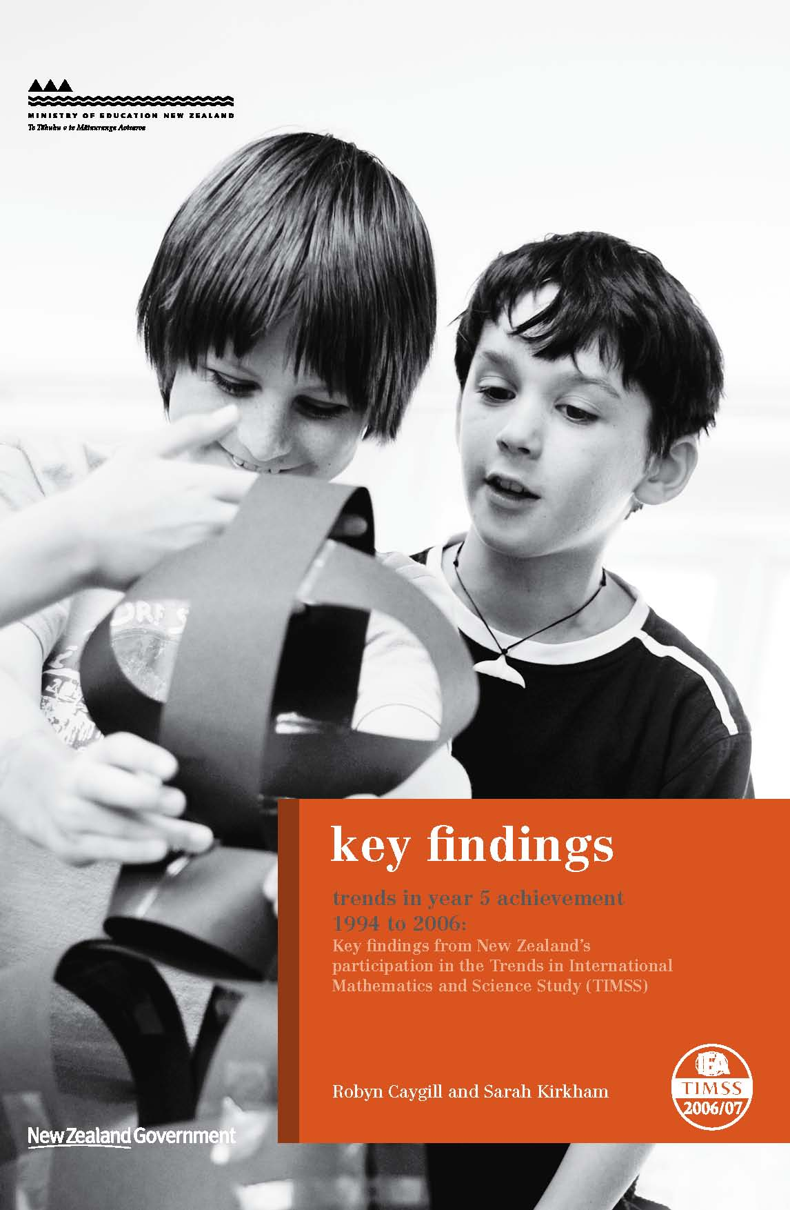
Overview of TIMSS
What is TIMSS?
The Trends in International Mathematics and Science Study (TIMSS) measures trends in mathematics and science achievement at the fourth and eighth grades (Years 5 and 9) as well as monitoring curricular implementation and identifying the most effective instructional practices from around the world.
Conducted on a regular 4-year cycle, TIMSS has assessed mathematics and science in 1994/95, 1998/99, 2002/03, and 2006/07, with planning underway for 2010/11. In TIMSS 2006/07, New Zealand participated at the Year 5 level only. Approximately 425,000 students in 59 countries from all around the world took part in this cycle, 37 of them at the middle primary level (refer countries list towards the end of this summary).
What does TIMSS consist of?
TIMSS consists of assessments of students’ achievements in mathematics and science. Each student was assessed in 2006/07 in two timed sessions of 36 minutes, and answered a combination of mathematics and science questions. The assessment was a pencil-and-paper test containing both multiple-choice and constructed-response questions. Following this, students were given a questionnaire containing questions about themselves, their opinions about mathematics and science, their computer use and time spent on homework.
Principals and teachers were also given questionnaires in order to gain further information about the context in which the mathematics teaching and learning take place. In New Zealand, the assessments and questionnaires were conducted in English.
The TIMSS assessments are organised around two dimensions: a content dimension specifying the domains or subject matter to be assessed within mathematics and science; and a cognitive dimension specifying the domains or thinking processes to be assessed. The content dimensions for mathematics are: number; geometric shapes and measures; and data display; and the content dimensions for science are: life science; physical science; and earth science. For both subjects, the cognitive domains are: knowing, applying, and reasoning. Details of these domains are published in the TIMSS 2007 assessment frameworks (Mullis, Martin, Ruddock, O’Sullivan, Arora, and Erberber, 2005).
How was TIMSS developed?
The TIMSS tests were developed cooperatively with representatives from participating countries. A consortium was responsible for developing procedures and managing the international activities required for the project.
The consortium comprised:
- International Study Centre;
- IEA Secretariat;
- IEA’s Data Processing Centre;
- Statistics Canada;
- Educational Testing Service (ETS).
TIMSS procedures are designed to ensure the reliability, validity, and comparability of the data through standardised procedures, and attention to quality control throughout. Mechanisms, such as field-testing of questions, detailed manuals covering procedures, rigorous training for all involved, and monitoring of implementation, help to maintain the quality of TIMSS.
Why participate in TIMSS?
Although it is often assumed that the international studies are only useful for international benchmarking purposes, the real value of TIMSS lies in its ability to provide a rich picture of mathematics and science achievement within the New Zealand context and over time.
TIMSS (along with other international assessment studies) can provide information about the performance of the New Zealand education system at the national level and in a global context. The information from studies such as TIMSS is used in the development and review of policy frameworks and also to inform and improve teaching practice. Developments arising out of previous cycles of TIMSS include resource materials for schools and teachers along with teacher in-service training programmes.
Mathematics
Trends in mathematics achievement 1994–2006
There has been a significant overall improvement since the first TIMSS cycle in 1994/95. However, New Zealand’s mean mathematics achievement in 2006/07 was not significantly different from TIMSS 2002/03. The proportions of New Zealand students reaching the advanced, high, intermediate, and low benchmarks has not changed significantly since TIMSS 2002/03.
New Zealand mathematics achievement in 2006 in an international context
New Zealand Year 5 students, on average, achieved above the mean mathematics achievement for 12 of the 36 countries that participated in TIMSS 2006/07 at the middle primary level.
New Zealand mathematics performance on content and cognitive domains
Relative to other countries, as well as Year 5 students’ overall performance, New Zealand students were stronger on data display questions and relatively weak on number questions. Students also performed relatively better on questions that involved reasoning compared to knowing or applying.
Teacher reports on hours of mathematics instruction
On average, New Zealand spends less time at the middle primary level teaching mathematics, according to teacher reports, than any of the other English-speaking countries tested. The number of hours New Zealand teachers reported spending on mathematics instruction has changed little since TIMSS 2002/03.
Student attitudes to mathematics
New Zealand middle primary students were generally positive towards mathematics. The proportion has not changed since TIMSS 1994/95. Students who were more positive towards mathematics had, on average, higher achievement than those who were more negative. About half of the New Zealand Year 5 students in TIMSS 2006/07 also expressed a high level of self-confidence in mathematics.
Mathematics achievement and attitudes of girls and boys
There was no difference between mean mathematics achievement of boys and girls in TIMSS 2006/07. Both boys and girls have shown a significant improvement since 1994. About the same proportions of Year 5 girls and boys were very positive about mathematics. However, proportionally more boys than girls in New Zealand expressed a high level of self-confidence in mathematics.
Mathematics achievement and attitudes of students by ethnicity
Both high and low performers were found in all ethnic groupings. Asian and Pākehā/European students demonstrated significantly higher mean mathematics scores than Māori and Pasifika students. Asian students performed significantly higher than Pākehā/European students. Māori students performed significantly higher than Pasifika students. Proportionally more Asian students reported positive attitudes to mathematics and fewer Pākehā/European reported positive attitudes to mathematics. Māori and Pasifika students expressed lower self-confidence in mathematics compared with students in the Pākehā/European, Asian, and Other ethnic groupings.
Mathematics achievement by student’s home background
Students who always or almost always spoke English at home had higher mathematics achievement, on average, than those who sometimes or never spoke English at home. Students who were born in New Zealand had higher mathematics achievement, on average, than those who were not.
Students from higher socio-economic backgrounds, using the proxy measures books in the home, items in the home, household size and mobility, tended to have higher mean mathematics achievement than those from lower socio-economic backgrounds. In addition, the decile of the school they attended, indicative of the level of economic disadvantage in the community in which they live, was positively related to mathematics achievement.
Science
Trends in science achievement 1994–2006
The mean science achievement of New Zealand Year 5 students was about the same in 2006 as in 1994. Although results from 1994, 1998, and 2002, showed a steady increase, this trend did not continue in 2006 when the results returned to the 1994 levels. The range of New Zealand Year 5 science achievement was narrower in 2006 than in 1994, with fewer students demonstrating very high or very low achievement.
New Zealand science achievement in 2006 in an international context
New Zealand Year 5 mean science achievement was significantly higher than 13 of the 36 countries that participated at the middle primary level. A comparison with the other countries that have taken part in TIMSS across all three of the cycles shows that the mean science achievement of New Zealand Year 5 students has moved little in relation to these countries.
New Zealand science performance on content and cognitive domains
Year 5 students demonstrated a relative strength in earth science questions compared to life and physical science. Students also performed relatively better on questions that involved demonstrating knowledge compared to applying knowledge or reasoning.
Teacher reports on hours of science instruction
In 2006, teachers reported significantly fewer hours teaching science to New Zealand Year 5 students, on average, compared with 2002. The number of hours reduced from 66 per year in 2002 to 45 in 2006.
Student attitudes to science
New Zealand Year 5 students generally expressed positive attitudes towards science. Eight out of every ten students indicated that they would like to do more science in school. Those students who reported positive attitudes towards science or were confident in their own science abilities had higher achievement than those who were less positive or confident.
Science achievement and attitudes of girls and boys
There was no significant difference in mean science achievement between New Zealand Year 5 boys and girls. Boys and girls expressed similar attitudes to science, both in terms of enjoyment and motivation, and of self-confidence.
Science achievement and attitudes of students by ethnicity
Both high and low performers were found in all ethnic groupings. Pākehā/European and Asian students had, on average, significantly higher mean science achievement than their Māori and Pasifika counterparts. There was no difference in the average performance of Pākehā/European and Asian students. Māori students had significantly higher mean science achievement than Pasifika students.
More Pākehā/European students and students in the Other ethnic grouping reported high self-confidence in science compared with Asian, Māori, and Pasifika students. Proportionally more students in the Other ethnic grouping reported positive attitudes towards science compared with Pākehā/European, Asian, Māori, and Pasifika students.
Science achievement by student’s home background
Science achievement was higher, on average, among students who regularly spoke English at home. Students who were born in New Zealand had higher science achievement, on average, than those who were not.
Students from higher socio-economic backgrounds, using the proxy measures books in the home, items in the home, household size and mobility, tended to have higher mean science achievement than those from lower socio-economic backgrounds. In addition, the decile of the school they attended, indicative of the level of economic disadvantage in the community in which they live, was positively related to science achievement.
Information
National Reports
The two documents listed below are the beginning of a series of reports about New Zealand’s participation in TIMSS 2006/07 (www.educationcounts.govt.nz/goto/timss). Further analyses will be undertaken including investigation into what is happening in mathematics and science in schools from information collected from teachers and principals; additional reports will be released in 2009.

Trends in Year 5 mathematics achievement 1994 to 2006: New Zealand results from three cycles of the Trends in International Mathematics and Science Study (TIMSS)
Authors: Robyn Caygill and Sarah Kirkham
Trends in Year 5 science achievement 1994 to 2006: New Zealand results from three cycles of the Trends in International Mathematics and Science Study (TIMSS)
Author: Robyn Caygill

These reports describe the mathematics and science achievement of Year 5 students in TIMSS 2006/07. Trends in New Zealand’s achievement over the 12 years from 1994 to 2006 are examined, along with comparisons with other countries. Analyses of achievement by sub-groupings (such as gender and ethnicity) and background information are also presented.
International Reports
International findings for mathematics (Mullis, Martin & Foy, 2008) and science (Martin, Mullis & Foy, 2008) for TIMSS 2006/07 have been published by the IEA and are available from IEA http://www.iea.nl/ and TIMSS & PIRLS study centre http://timss.bc.edu/.
The TIMSS 2007 technical report (Olson, Martin, & Mullis (Eds.), 2008) contains a detailed account of the procedures for scoring, translation of materials, sampling, survey operations, quality assurance, sampling weights, item analysis, scaling, and reporting.
The TIMSS 2007 user guide for the international database (to be published in early 2009) contains information on how to analyse the data.
TIMSS also publishes the TIMSS 2007 encyclopedia: a guide to mathematics and science education around the world (Mullis, Martin, Olson, Berger, Milne, & Stanco (Eds.) 2008) in order to provide a context in which the TIMSS results can be examined. This encyclopaedia contains short reports from each country describing mathematics and science education policies and practices in that country. can be examined. This encyclopaedia contains short reports from each country describing mathematics and science education policies and practices in that country.
List of countries in TIMSS 2006/07 who tested at Year 5 level
Countries participating in TIMSS at the Year 5 level
Algeria |  | England |  | Kuwait |  | Scotland
Armenia |  | Georgia |  | Latvia |  | Singapore
Australia |  | Germany |  | Lithuania |  | Slovak Republic
Austria |  | Hong Kong SAR |  | Morocco |  | Slovenia
Chinese Taipei |  | Hungary |  | Netherlands |  | Sweden
Colombia |  | Iran, Islamic Rep. of |  | New Zealand |  | Tunisia
Czech Republic |  | Italy |  | Norway |  | Ukraine
Denmark |  | Japan |  | Qatar |  | United States
El Salvador |  | Kazakhstan |  | Russian Federation |  | Yemen
Benchmarking participants
Alberta, Canada |  | Dubai, UAE |  | Minnesota, US |  | Quebec, Canada
British Columbia, Canada |  | Massachusetts, US |  | Ontario, Canada

Publishing Info
First published in December 2008 by:
Comparative Education Research Unit
Research Division
Ministry of Education
PO Box 1666
Wellington
New Zealand
Email: research.info@minedu.govt.nz
Fax: 64-4-463 8312
Phone: 64-4-463 8000
© Ministry of Education
All rights reserved.
Enquiries should be made to the publisher.
ISBN 978-0-478-13970-9
ISBN 978-0-478-13971-6 (Web)
RMR-916

Note that this cycle of the study is called TIMSS 1995 internationally as most countries participated in 1995. However southern hemisphere countries conducted the assessment towards the end of 1994 so in New Zealand reports the study is referred to as TIMSS 1994/95. Similarly for the subsequent cycles, the two years in which administrations occurred in participating countries are indicated.
Mongolia were unable to meet sampling criteria so the total number of countries involved in TIMSS 2006/07 at the Year 5 level is usually referred to as 36.
The term ‘significantly’ is used throughout to refer to statistical significance.

