
Resource Teachers of Literacy

Annual Report 2010

Megan Lee

ISSN: 1176-466X
RMR-990

© Ministry of Education, New Zealand — 2011
Research reports are available on the Ministry of Education’s website Education Counts:
www.educationcounts.govt.nz/publications

Acknowledgements
The Ministry of Education Research Division would like to thank all the Resource Teachers of Literacy who completed their annual returns for 2010. The time and effort taken to provide this information is greatly appreciated.

Table of Contents
Acknowledgements i
Table of Contents iii
List of Tables iv
List of Figures iv
Executive Summary 1
Key findings for 2010 1
Section 1: Introduction 3
Background 3
Methodology 3
Response Rates 3
Outline of the report 3
Section 2: Resource Teachers of Literacy support in 2010 5
Students receiving RT:Lit support in 2010 5
Student ethnicity 5
Student ethnicity and gender 6
Overview Form 6
Students referred to Cluster Management Committees in 2010 but not enrolled 7
Individual Forms—Part 2 Forms 8
Type of support provided by RT:Lit in 2010 8
The nature of literacy assistance students received 8
Age of students 9
Prior involvement in Reading Recovery 10
Prior involvement in Reading Recovery 10
Time receiving RT:Lit support 11
Number of months receiving RT:Lit support 11
Number of weeks receiving RT:Lit support 12
Section 3: Student outcomes and final status 13
Student status at last lesson, when support stopped or at the end of the year 13
Student Outcome based on RT:Lit Judgment 15
Discharged Students 16
Student outcome and student final status 17
Student outcome by support type 18
Student outcome and ethnicity 19
Discharged students 20
Student progress over time in RT:Lit support 21
Text readability Level 22 or below 22
Text readability above Level 22 or received Comprehension Tuition 23
Text readability Level 22 or below at entry and above Level 22 or who received Comprehension Tuition at exit 23
Written literacy and oral language assessment tools used 25
Section 4: Regional data 27
Overview of student outcome and status by region 27
Student Outcomes based on RT:Lit judgment 28
Student status at last lesson or at the end of the year, by region 29
Type of support received from RT:Lit 30
Appendix 31

List of Tables
Table 1: Ethnicity profile of Years 1-8 students in 2010 5
Table 2: Ethnicity profile of RT:Lit students in 2010 6
Table 3: RT:Lit Roll 2010 7
Table 4: Type of support provided for students on the 2010 RT:Lit roll 8
Table 5: Nature of the literacy assistance 8
Table 6: Involvement in Reading Recovery 10
Table 7: Reading Recovery outcome 10
Table 8: Number of months in RT:Lit service 11
Table 9: Weeks receiving RT:Lit support (includes students who received both types of support) 12
Table 10: Time in weeks receiving RT:Lit support 12
Table 11: Student outcome and final status 17
Table 12: Text readability level at entry and exit for students assessed below Text Level 22 at entry and above Text Level 22 or who received Comprehension Tuition on exit 24
Table 13: Overview of tools used in RT:Lit for written literacy and oral language 25
Table 14: RT:Lit supported students by Ministry of Education Local Office region 27
Table 15: Student outcomes by Ministry of Education Local Office region at the end of their period of support in 2010 28
Table 16: Final student status by Ministry of Education Local Office region 29
Table 17: Type of support provided for students by Ministry of Education Local Office region 30
Table A 1: Gender of 2010 RT:Lit students 31
Table A 2: Ethnicity of 2010 RT:Lit students 31
Table A 3: Age on entry and exit for discharged 2010 RT:Lit students 31

List of Figures
Figure 1: Student age at entry to RT:Lit support and at exit (when instruction ended or at the end of the year) 9
Figure 2: Student status at last lesson, when support ceased or at the end of the year 14
Figure 3: Student final status—student outcome at last lesson, when support ceased or at the end of the year (all students) 15
Figure 4: Discharged students outcome at last lesson, when support ceased or at the end of the year 16
Figure 5: Student outcome by support type 18
Figure 6: Student outcome and ethnicity (all students) 19
Figure 7: Outcome and ethnicity for discharged students 20
Figure 8: Text readability level at entry and exit for those assessed at Text Level 22 or below 22
Figure 9: Text readability level at entry and exit for those assessed above Level 22 or who received Comprehension Tuition 23

Executive Summary
Resource Teachers of Literacy (RT:Lit) are specialist literacy teachers who support and assist staff and students in Years 1 to 8 who are experiencing difficulties with literacy learning. This report presents data on the students who received support from RT:Lit during 2010.
The purpose of the Resource Teachers of Literacy 2010 Annual Report is to identify the nature of the support RT:Lit provided to students during the year and to report on student outcomes and progress while receiving RT:Lit support.
For the 2010 Annual Report, RT:Lit were asked to complete an overview form and an individual form for each student. The overview form provides a summary of all students on the 2010 RT:Lit roll and the individual forms provide intervention details for each student. From the overview forms, RT:Lit reported 3,995 students on the RT:Lit roll in 2010. Individual forms were received for 3,648 students on the RT:Lit roll who received support in 2010.

Key findings for 2010

Students who received support from Resource Teachers of Literary in 2010
- A total of 3,995 students were on the RT:Lit roll in 2010, compared with 3,857 in 2009. Of the 2010 students, 676 came from incomplete interventions in 2009, 785 from the 2009 waiting list and 2,534 from formal referrals in 2010. A further 656 students who were referred for RT:Lit support in 2010 were still on a waiting list at the end of 2010.
- RT:Lit provided individual forms for 3,648 of the 3,995 students on their roll (similar to the number of forms received for the 2009 year).
- Over half (52%) of the RT:Lit students received direct support (intensive specialised teaching provided by the RT:Lit to individual or small groups of students), and two thirds (67%) received in-direct support (where RT:Lit support classroom teachers in relation to particular students).
- One third of students (33%) received direct instruction only; either individually (21%), in small groups (9%) or both individually and in small-groups (4%). In comparison, 48% of students received indirect support only. Around one fifth of RT:Lit students (19%) received both direct and indirect support. This is generally consistent with results from 2009.
- Consistent with previous years, more boys (68%) than girls (32%) received RT:Lit support in 2010. Also consistent with previous years, half (52%) of all students were New Zealand European, just over one-third (35%) were Māori, 8% were Pasifika and 5% were Asian and other ethnicities.
- The majority (88%) of students on the RT:Lit roll received support for reading literacy (84% received reading processing support and 57% received reading comprehension support). Almost half of students (48%) received written literacy assistance, while 7% of students received support for oral language.
- Nearly one third (32%) of RT:Lit students had previously received Reading Recovery assistance and of these students, almost two fifths (38%) had been successfully discontinued from Reading Recovery.
- The majority of students (62%) began their RT:Lit support when they were aged between seven and nine years.
- On average, students who received direct instruction were supported by RT:Lit for 17 weeks and students who received indirect support were supported for 18 weeks.
Students’ outcomes following Resource Teacher of Literacy support
- Three fifths of all students (59%) supported by RT:Lit in 2010 were discharged by the end of the year. Just over one quarter (28%) of students were due to continue receiving support in 2011. Around 7% of students received incomplete programmes and 3% were referred to alternative support or services. These figures were similar to those in 2009.
- When their support ended or at the end of the year, 29% of students were considered to be ‘at age’, that is, they were reading texts at a level that matched their chronological age and support was no longer required. Just under half of students (47%) were still considered to be ‘at risk’, that is they were reading texts at a level more than a year below their chronological age. The remaining 24% of students were considered to be ‘of concern’ (they were reading texts at a level between 6 months to a year below their chronological age).
- Almost one-third of Māori (29%) and New Zealand European (31%) students were considered to be ‘at age’ when their support ended or at the end of the year. Pasifika students were less likely (24%) than other students to be judged ‘at age’ at the end of their support or the year (compared with 15% in 2009).
- Slightly less than half (40%) of students discharged from the RT:Lit roll were considered ‘at age’ when they were discharged from the roll, 27% were ‘of concern’ and 33% were considered ‘at risk’.
- Around two fifths of Māori (40%) and New Zealand European (43%) students who were discharged in 2010 were ‘at age’ at the end of their support. Pasifika students who were discharged were less likely to be ‘at age’ (33%) than students of other ethnicities (an increase from 25% in 2009).
- A comparison of reading assessment data at entry to and exit from RT:Lit support highlighted a general shift in students’ literacy achievement over the course of RT:Lit support.

Section 1: Introduction

Background
Resource Teachers of Literacy (RT:Lit) are specialist literacy teachers who support and assist staff in schools to meet the needs of Years 1 to 8 students experiencing difficulties with literacy learning. RT:Lit provide reading literacy, written literacy and oral language support. RT:Lit provide this support in two ways, they provide intensive specialised teaching to individual and/or small groups of students (direct support) and support for classroom teachers in relation to particular students (indirect support).
There are 109 RT:Lit positions throughout the country. RT:Lit are based at a host school and work across a number of schools within a cluster. RT:Lit may also work in a cluster with other RT:Lit. RT:Lit have provided data to the Ministry of Education on an annual basis since 2001.
The purpose of the Resource Teachers of Literacy 2010 Annual Report was to identify the nature of the support that RT:Lit provided to students during that year and to report on student outcomes and progress while receiving RT:Lit support.

Methodology
RT:Lit submitted their completed annual returns to the Research Division, Ministry of Education at the end of 2010. They completed two types of forms:
- Overview—Part 1 Cluster Overview Form, this contains information about the number of students on the RT:Lit roll during 2010.
- Individual Form—Part 2 Form, this contains demographic information, intervention details and outcome information. One form was completed for each student on the RT:Lit roll in 2010.

Response Rates
All 109 RT:Lit submitted returns for the 2010 Annual Report. Returns were submitted for 3,648 of the 3,995 students on the 2010 RT:Lit roll.

Outline of the report
The report comprises the following sections:
- Resource Teachers of Literacy support in 2010—outlining the support provided by RT:Lit, demographic and background information for students who received RT:Lit support.
- Student Outcomes—showing progress and outcomes of students who received RT:Lit support.
- Regional Information—provides a regional breakdown on the intervention information, grouped by Ministry of Education local offices.

Section 2: Resource Teachers of Literacy support in 2010
RT:Lit support students in Years 1 to 8 by providing intensive specialised teaching to individual and/or small groups of students and support for classroom teachers in relation to particular students. The following section presents information about the students who received RT:Lit support in 2010.

Students receiving RT:Lit support in 2010
One hundred and nine RT:Lit provided information about 3,648 students they worked with, who were experiencing difficulties with literacy learning in Years 1 to 8 in 2010. These students represent 2% of the total number of students attending schools that RT:Lit worked across. The number of students who received RT:Lit support in 2010 was similar to 2009 (3,708 students), and lower than it was in 2008 (4,258 students ) and 2007 (4,126 students).

Student ethnicity
Table 1 shows the ethnicity of students who received RT:Lit support in 2010 across five ethnic groups: Māori, Pasifika, Asian, New Zealand European/Pākehā and Other Ethnicities. Half of all students (52%) who received RT:Lit support in 2010 were New Zealand European/Pākehā, over one-third (35%) were Māori, 8% were Pasifika, 5% were Asian or other ethnic background. These figures are similar to those recorded in 2009.
Māori students were over-represented in RT:Lit support (compared to the total student population in schools where RT:Lit worked), and Pasifika and Asian students were under-represented.
Table 1: Ethnicity profile of Years 1-8 students in 2010
2010 Years 1 to 8 students | Māori | Pasifika | Asian | NZ European/ Pākehā | Other | Total
All Years 1 to 8 students | 112,274 | 48,243 | 42,921 | 260,351 | 11,326 | 476,961¹
All Years 1 to 8 students | 23.5% | 10.1% | 9.0% | 54.6% | 2.4% | 100.0%
Years 1 to 8 students in schools where RT:Lit worked in 2010 | 49,770 | 23,666 | 17,855 | 114,902 | 5,555 | 211,748
Years 1 to 8 students in schools where RT:Lit worked in 2010 | 23.5% | 11.2% | 8.4% | 54.3% | 2.6% | 100.0%
Years 1 to 8 students who received RT:Lit support in 2010 | 1,263 | 278 | 70 | 1,910 | 114 | 3,648 ²
Years 1 to 8 students who received RT:Lit support in 2010 | 34.6% | 7.6% | 1.9% | 52.4% | 3.1% | 100.0%
¹ Total includes 1,846 students of unknown ethnicity.
² Total includes 13 students without ethnicity information.

Student ethnicity and gender
Table 2 shows the ethnicity and gender of students who received RT:Lit support. Two-thirds (68%) of students were male and one-third were female (32%). Across all ethnicities, there were at least twice as many males in RT:Lit support than females. The proportion of males and females in each ethnic grouping was similar to previous years.
Table 2: Ethnicity profile of RT:Lit students in 2010¹
Ethnicity | Male | Female | Total
Ethnicity | %  (N=2,458) | %  (N=1,149) | %  (N=3,607)
Māori | 66.6 | 33.4 | 34.8
Pasifika | 69.4 | 30.6 | 7.7
Asian | 70.0 | 30.0 | 1.9
New Zealand European/Pākehā | 68.7 | 31.3 | 52.4
Other Ethnicities | 72.6 | 27.4 | 3.1
Total | 68.1 | 31.9 | 100.0
¹ Excludes data from (n=28) students with no gender information and (n=13) students with missing ethnicity information

Overview Form
The Overview Forms (Part 1—Cluster Overview) gather summary information about 2010 RT:Lit roll. These include students who were on the RT:Lit roll at the end of 2009 who had incomplete programmes, students on a waiting list at the end of 2009 and students who were formally referred to the Cluster Management Committee during 2010.
According to the Overview Forms, 3,995 students were on the RT:Lit roll for 2010. Table 3 shows a breakdown of the students on the RT:Lit roll according to the type of referral.
The majority (84%) of students who received an incomplete intervention in 2009 were placed on the RT:Lit roll in 2010. Most (73%) of the students who were on the 2009 waiting list were placed on the 2010 RT:Lit roll. Two thirds (66%) of students who were referred in 2010 were enrolled with RT:Lit.
Table 3: RT:Lit Roll 2010¹
RT:Lit Roll 2010 | N | %
Incomplete intervention in 2009-ongoing tutoring or support (carried over) | 803 | 100.0%
Total not enrolled | 127 | 15.8%
Not enrolled-student left the area | 38 | 4.7%
Not enrolled-student withdrawn for other reason | 89 | 11.1%
Total on 2010 roll following incomplete interventions in 2009 | 676 | 84.2%
2009 Waiting list | 1,074 | 100.0%
Total not enrolled | 289 | 26.9%
Not enrolled-student left the area | 85 | 7.9%
Not enrolled-student withdrawn for other reason | 204 | 19.0%
Total on 2010 roll from 2009 priority waiting list | 785 | 73.1%
2010 Referrals | 3,837 | 100.0%
Total not enrolled | 1,303 | 34.0%
Not enrolled-student still on the waiting list | 656 | 17.1%
Not enrolled-RT:Lit assessment showed student did not require intervention | 248 | 6.5%
Not enrolled-student left the area | 87 | 2.3%
Not enrolled-student withdrawn for other reason | 312 | 8.1%
Total on 2010 roll from 2010 formal referrals | 2,534 | 66.0%
Total students from all sources | 5,714 | 100.0%
Total not enrolled | 1,719 | 30.1%
Not enrolled-student still on the waiting list | 656 | 11.5%
Not enrolled-RT:Lit assessment showed student did not require intervention | 248 | 4.3%
Not enrolled-student left the area | 210 | 3.7%
Not enrolled-student withdrawn for other reason | 605 | 10.6%
Total number of students on RT:Lit roll in 2010 | 3,995 | 69.9%
¹ Based on Overview Forms. Formally referred (minus not enrolled), plus waiting list (minus not enrolled), plus carried over (minus not enrolled) = total number on 2010 roll.

Students referred to Cluster Management Committees in 2010 but not enrolled
Overall, a total of 3,837 students were formally referred by schools to Cluster Management Committees in 2010, and of these 1,303 students were not enrolled. Half the students (50%) who had been referred but not enrolled were still on the RT:Lit waiting list, one-quarter (24%) had been withdrawn for other reasons and 19% were assessed by RT:Lit as not requiring intervention. These figures are also presented in Table 4 below by region.
RT:Lit recorded the ethnicity of the students who were not enrolled in 2010. Just under one-third of non-enrolled students were Māori (32%), almost half (49%) were New Zealand European/Pākehā, and 11% were Pasifika.

Individual Forms—Part 2 Forms
Individual forms were returned for 3,648 students who received support from RT:Lit in 2010. This represents 94% of students estimated to be on the 2010 RT:Lit roll (see Overview Forms).

Type of support provided by RT:Lit in 2010
Over half (52%) of students received direct support and two thirds (67%) received indirect support. Over one-third (33%) received direct instruction only, with one-fifth (21%) receiving individual tuition and 9% small-group tuition. Around half of students (48%) received indirect support only. One fifth (19%) of all students who received RT:Lit support received both indirect and direct support. The proportions of students receiving direct and/or indirect support were similar to those reported in 2009.
Table 4: Type of support provided for students on the 2010 RT:Lit roll¹
 | N | %
Direct support only | 1,211 | 33.4
Individual tuition only | 761 | 21.0
Small-group tuition only | 323 | 8.9
Both individual and small-group tuition | 127 | 3.5
Direct and Indirect support | 689 | 19.0
Individual and indirect | 434 | 12.0
Small-group and indirect | 209 | 5.8
Individual, small group and indirect | 46 | 1.3
Indirect support only | 1,722 | 47.5
Total | 3,622 | 100.0
¹ Excludes data from 26 students with missing information about the type of support they received.

The nature of literacy assistance students received
RT:Lit support students across a range of literacy areas—reading literacy, written literacy and oral language. Table 5 shows the types of literacy assistance students received in 2010. There is a high degree of overlap because students can receive more than one type of support.
Most students (88%) received assistance with reading literacy, with more students receiving support for processing (84%) than comprehension (57%). Nearly half of students supported received written literacy assistance (48%) and 7% received oral language assistance.
Table 5: Nature of the literacy assistance¹
Type of literacy support | N¹ | %
Reading | 3,190 | 87.8
Reading Processing | 3,059 | 84.2
Reading Comprehension | 2,052 | 56.5
Written literacy | 1,738 | 47.8
Oral language | 241 | 6.6
¹ Excludes data for 13 students where nature of support was not specified.

Age of students
RT:Lit provide support to students in Years 1 to 8. The following section presents the distribution of students’ chronological age at entry to RT:Lit support and chronological age at the time of their last lesson, end of support or at the end of the year. Eighty-one per cent of the students had information for chronological age at both entry and exit.
Figure 1 shows the majority of students (62%) began their RT:Lit support aged between 7 and 9 years. Fewer students began younger than 7 years (15%) or after the age of 10 (23%).
Nine per cent of students were younger than 7 years of age when they finished their RT:Lit support or at the end of the year, three fifths (60%) of students were between 7 and 9 years of age, and one-third of students (31%) were 10 years of age or older.
Figure 1: Student age at entry to RT:Lit support and at exit (when instruction ended or at the end of the year)¹
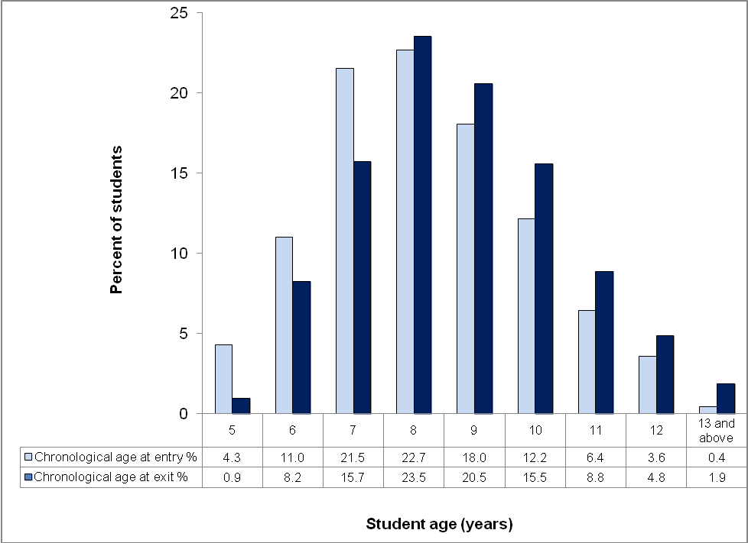
¹ Students who had a recorded chronological age at entry and when support stopped or the end of the year, n=2,954, out of 3,648 (81.0%).

Prior involvement in Reading Recovery
Table 6 shows the proportion of RT:Lit students who had previously received Reading Recovery assistance and Table 7 shows the outcome for these students.
Similar to 2009, one-third (32%) of all RT:Lit students had previously received Reading Recovery assistance. Of these, two-fifths (38%) had been successfully discontinued from the Reading Recovery programme and just under half (46%) had been referred onto other services at the end of their programme (Table 7).
Table 6: Involvement in Reading Recovery
Reading Recovery | N | %
Yes | 1,138 | 31.7
No | 1,761 | 49.0
Don't know | 694 | 19.3
Total | 3,593 | 100.0

Table 7: Reading Recovery outcome
Reading Recovery Outcome | N | %
Successfully discontinued | 434 | 38.1
Referred | 521 | 45.8
Incomplete | 71 | 6.2
Not known | 112 | 9.8
Total | 1,138 | 100.0

Time receiving RT:Lit support
Data were collected on the amount of time each student spent receiving RT:Lit support. This information was recorded in two ways: the start date and end date of the students’ RT:Lit support, and the number of weeks that direct or indirect support was provided.
It should be noted that using the start and end date of the RT:Lit support is a gross measure of time and does not exclude school holidays. The number of weeks in support should exclude school holidays but may include time monitoring the student. Care should be taken when interpreting these findings as neither of these time measures account for the intensity of support ie, the number and length of sessions and whether these are received weekly, fortnightly or monthly.

Number of months receiving RT:Lit support
The number of months students received RT:Lit support was calculated by determining the difference between the start and end date of their RT:Lit support. A total of 2,915 students had both a start and end date for their RT:Lit support (80% of all RT:Lit students).
Students received RT:Lit support over a period of 0 to 45 months. Half (53%) of the students had received up to five months of RT:Lit support in 2010. Around 6% of students had support for a year or more, while a small proportion of students (2%) were recorded as receiving RT:Lit support for 18 months or more.
Table 8: Number of months in RT:Lit service
Number of months in RT:Lit Service | N | %
0-5 months | 1,544 | 53.0%
6-11 months | 1,188 | 40.8%
12-17 months | 120 | 4.1%
18-23 months | 42 | 1.4%
24-29 months | 9 | 0.3%
30 months or more | 12 | 0.4%
Total | 2,915 | 100.0%

Number of weeks receiving RT:Lit support
Students who were supported directly received an average of 17 weeks of RT:Lit instruction. Students who were supported indirectly received an average of 18 weeks of RT:Lit support.
Table 9: Weeks receiving RT:Lit support (includes students who received both types of support)
Direct support | Weeks |  | Indirect support | Weeks
Range | 1-80 |  | Range | 1-140
Mean | 17.3 |  | Mean | 18.2
Median | 16 |  | Median | 17
Mode | 10 |  | Mode | 10
Total | N=1,851 |  | Total | N=2,241
Excludes 49 directly supported students without  data for number of weeks of RT:Lit support. |  |  | Excludes 170 indirectly supported students without data for number of weeks of RT:Lit support.

Table 10 shows that in 2010, students who received direct support were more likely to be supported for 20 weeks or less, than students who received indirect support (75% compared to 59%). Conversely students receiving indirect support were more likely to receive support for over 20 weeks.
Table 10: Time in weeks receiving RT:Lit support¹
Weeks | Direct support only |  | Indirect support only
Weeks | N | % | N | %
0-10 weeks | 341 | 28.9 | 539 | 33.2
11-20 weeks | 545 | 46.1 | 416 | 25.6
21-30 weeks | 198 | 16.8 | 455 | 28.0
31-40 weeks | 78 | 6.6 | 190 | 11.7
41+ weeks | 19 | 1.6 | 25 | 1.5
Total | 1,181 | 100.0 | 1,625 | 100.0
¹ Excludes 30 directly supported and 97 indirectly supported students without data for number of weeks of RT:Lit support

Section 3: Student outcomes and final status
This section presents the status and the outcomes for students at the time of their last lesson of direct instruction, end of indirect support or at the end of the year.
Two types of student outcome data are presented in this section. The first outcome is based on an assessment of the student’s status with regard to RT:Lit support. The second relates to a judgment made by the RT:Lit about the extent to which students could read texts with a readability level that matched their chronological age.

Student status at last lesson, when support stopped or at the end of the year
At the end of the year or at the completion of support RT:Lit provided a final status for each student on their roll in 2010 from the following options:
- Discharged – direct/indirect support was completed and student discharged from RT:Lit roll.
- Further support – the student is likely to require further direct/indirect support next year.
- Incomplete – student received an incomplete intervention:
  - because he/she moved out of the area serviced by the RT:Lit.
  - for some other reason.
- Referred – student requires alternative specialist assistance and was/will be referred on.
- Other – student will be supported by Special Education (SE), Resource Teacher: Learning and Behaviour (RTLB).
Final status data was available for 3,345 of the 3,648 students (92%). Two thirds of the students (59%) were discharged from the RT:Lit roll by the end of 2010. Just under one-third (28%) were thought to require further instruction or support in 2010, 7% received an incomplete intervention (either because they moved or another reason) and 3% were referred elsewhere for specialist assistance.
Figure 2: Student status at last lesson, when support ceased or at the end of the year¹
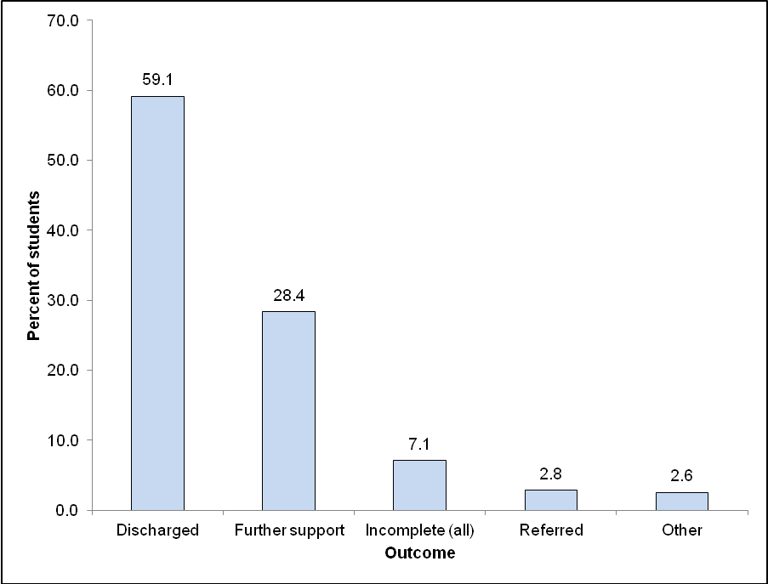
¹ Figure based on 3,345 students with one unique status recorded.

Two thirds (67%) of students receiving only indirect support were discharged from the programme. In comparison, 60% of students who had received direct support only were discharged and 58% of students who had received both forms of support were discharged.

Student Outcome based on RT:Lit Judgment
In 2010, RT:Lit were asked to record whether students could read texts with a readability level that matched their chronological age at the end of their period of support in 2010. This provides one measure of students’ literacy achievement when they stopped RT:Lit support for the year.
RT:Lit were asked to categorise each student into one of the following three options:
- at age— students were reading texts with a readability level that matched their chronological age plus/minus six months, and instruction/support is not longer required.
- of concern— students were reading texts with a readability level between six months to a year less than their chronological age and the student can continue learning in the classroom.
- at risk— students were reading texts with a readability level more than a year below their chronological age.
Just under a third of students (29%) were considered to be ‘at age’, 24% of students were considered to be ‘of concern’ and 47% of students were considered to be ‘at risk’ at the end of their period of RT:Lit support. There were proportionately more students considered ‘at age’ in 2010 than there were in 2009 (24% of students) and proportionately fewer students considered ‘at risk’ in 2010 than in 2009 (55% of students).
Figure 3: Student final status—student outcome at last lesson, when support ceased or at the end of the year (all students)¹
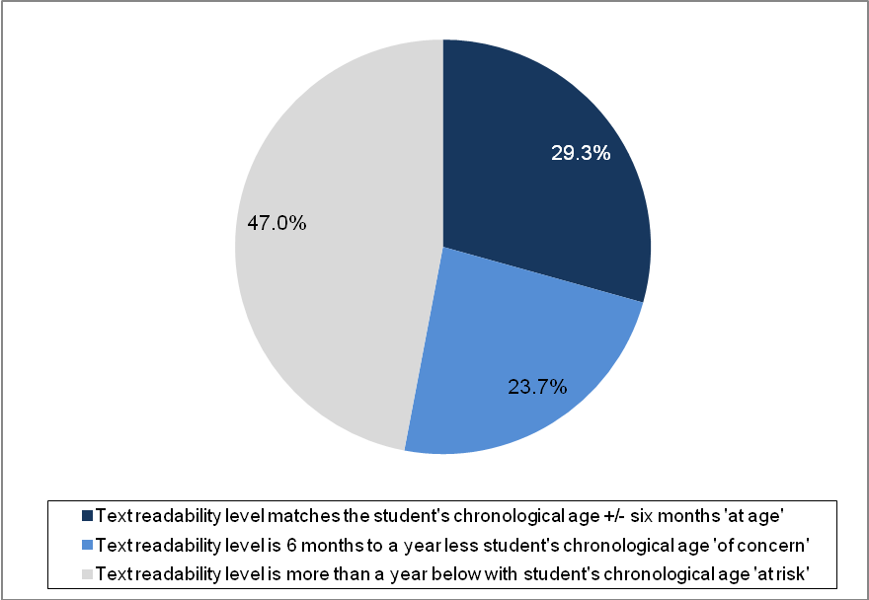
¹ Figure based on 3,110 students with information about their final status.

Discharged Students
According to the RT:Lit judgment, 40% of discharged students were considered to be ‘at age’ and one third (33%) of students who had been discharged were considered to be still be ‘at risk’ in terms of literacy achievement. These results were similar to that found in the previous report for 2009.
Figure 4: Discharged students outcome at last lesson, when support ceased or at the end of the year¹
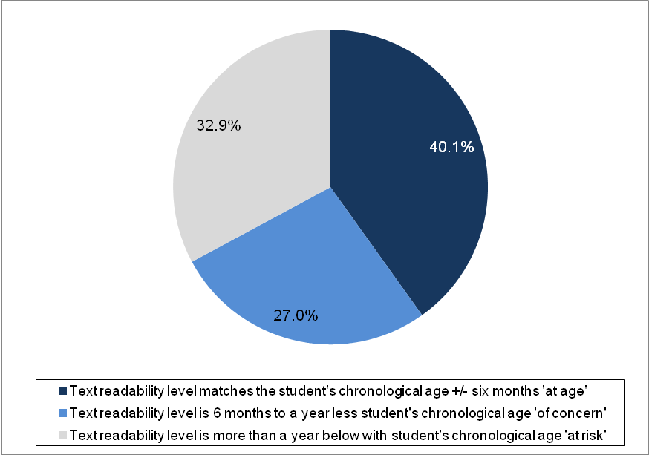
¹ Figure based on 1,847 discharged students that had information about their final status.

Student outcome and student final status
The majority (92%) of students who were judged to be ‘at age’ at the end of their RT:Lit support were discharged. Nearly three-quarters of students (72%) who were ‘of concern’ were discharged along with over two fifths (43%) of those who were judged ‘at risk’ (Table 11).
Around two fifths (38%) of students judged ‘at risk’ at the end of 2010 were identified as needing further support. Students judged ‘at risk’ were more likely than those students who were ‘at age’ or ‘of concern’ to have received an incomplete intervention or to be referred to other specialist assistance.
Table 11: Student outcome and final status
Student outcome (from RT:Lit support) | Readability level matches chronological age expectation -  'at age' |  | Readability level 6-12 months below chronological age -  'of concern' |  | Readability level 12 months or more below chronological age -  'at risk' |  | Total¹
Student outcome (from RT:Lit support) | N | % | N | % | N | %
Discharged | 741 | 91.6 | 495 | 72.4 | 590 | 43.4 | 1,826
Further support | 44 | 5.4 | 144 | 21.1 | 518 | 38.1 | 706
Incomplete (all) | 17 | 2.1 | 19 | 2.8 | 129 | 9.5 | 165
Referred | 4 | 0.5 | 12 | 1.8 | 67 | 4.9 | 83
Other | 3 | 0.4 | 14 | 2.0 | 57 | 4.2 | 74
Total | 809 | 100.0 | 684 | 100.0 | 1,361 | 100.0 | 2,854
¹ Excludes data from 794 students without student outcome or status information.

As with the 2009 data, the information presented in Table 11 suggests there is variation in the criteria RT:Lit use to discharge students from their roll. This could be due to differing interpretation of the terminology or elements of RT:Lit practice, for example some students appear to be discharged when they have reached a certain text readability level while other students may be discharged at the end of the year to be placed back on the RT:Lit roll the following year.

Student outcome by support type
The proportion of students who were considered ‘at age’, ‘of concern’ and ‘at risk’ at their last lesson of RT:Lit support in 2010 was fairly similar across the two types (indirect/direct) of RT:Lit support (Figure 5).
Figure 5: Student outcome by support type
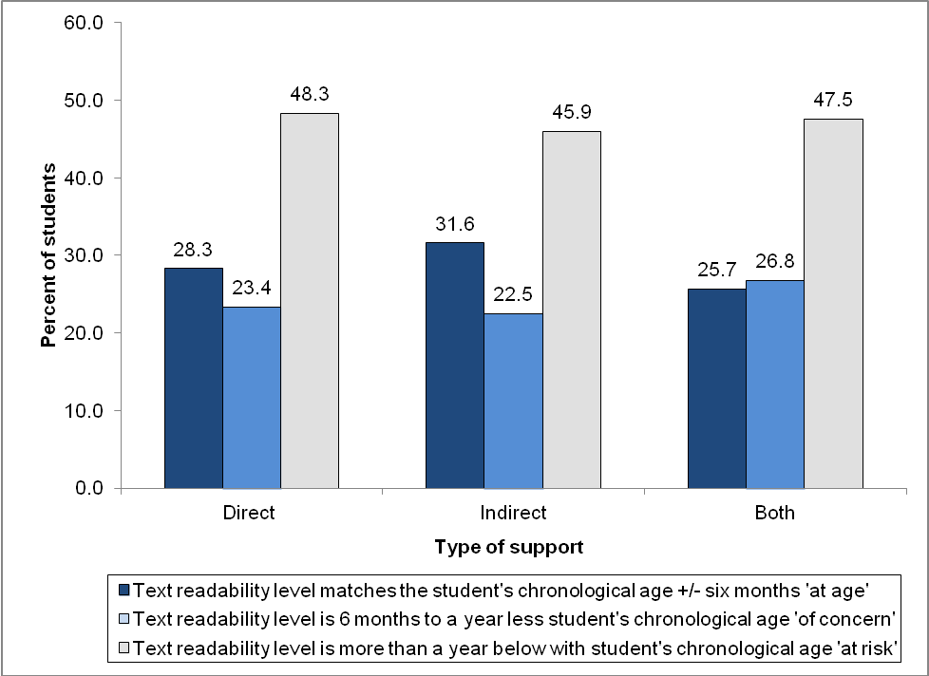

Student outcome and ethnicity
Māori (29%) and New Zealand European/Pākehā (31%) students were more likely to be considered ‘at age’ at the time of their last lesson of RT:Lit support than Pasifika students (24%). Both Māori (52%) and Pasifika (53%) students were more likely to be considered ‘at risk’ than New Zealand European/Pākehā (43%) and ‘other’ ethnicity students (also 43%) were judged ‘at risk’.
Compared with the data from 2009, there was a slight increase in the proportion of Māori and New Zealand European/Pākehā students considered ‘at age; (23% and 26% respectively in 2009) and a notable increase in the proportion of Pasifika students considered ‘at age’ (15% in 2009). The proportion of students considered ‘at risk’ also decreased between 2009 and 2010 for all ethnic groupings (Māori 55%, New Zealand European/Pākehā 53% and Pasifika 62% in 2009).
Figure 6: Student outcome and ethnicity (all students)¹
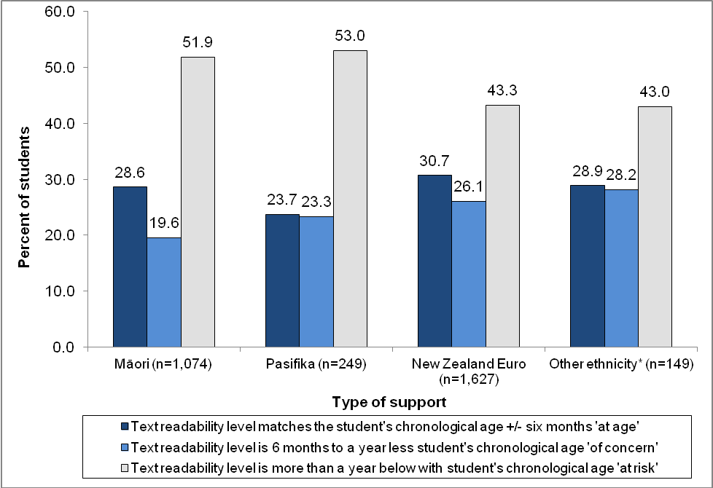
* Other ethnicity includes Asian and Other categories.
¹ Excludes data from 549 students with incomplete student outcome or ethnicity information.

Discharged students
Figure 7 presents outcome data for students who were discharged from RT:Lit support in 2010. Maori and Pasifika students who were discharged were more likely to be ‘at risk’ (37% for both groups) at the end of their support for 2010 than New Zealand European/Pākehā students (28%). New Zealand/Pākehā students (43%) were the most likely to be considered ‘at age’ when they were discharged, compared with 40% of Māori students and 33% of Pasifika students.
Compared with the data from 2009, there was an increase in the proportion of New Zealand European/Pākehā and Pasifika students who were discharged ‘at age (41% and 25% respectively in 2009) and a slight decrease in the proportion of Māori students discharged ‘at age’ (41% in 2009). The proportion of New Zealand European/Pākehā and Pasifika students discharged ‘at risk’ decreased between 2009 and 2010 (32% and 42% respectively in 2009) while the proportion of Māori students discharged ‘at risk’ increased slightly (32% in 2009).
Figure 7: Outcome and ethnicity for discharged students¹
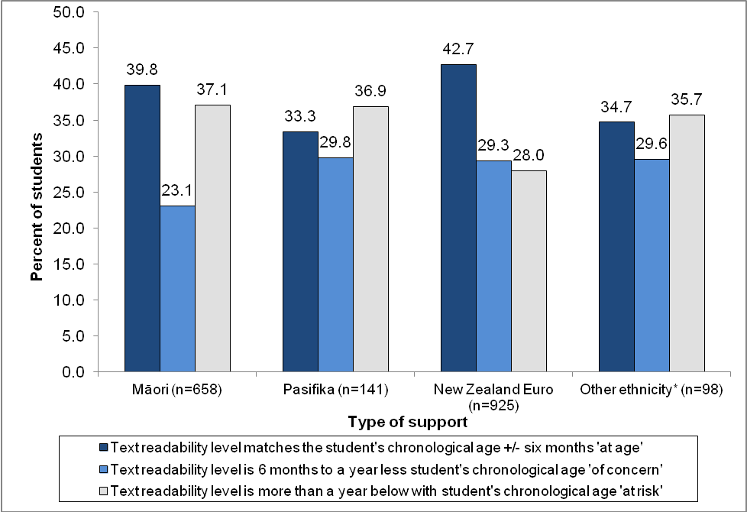
* Other ethnicity includes Asian and Other categories.
¹ Excludes data from 4 students with incomplete ethnicity information.

Student progress over time in RT:Lit support
The following section presents information about student’s reading literacy progress over their period of RT:Lit support. A total of 3,190 students were recorded as having received support from RT:Lit for reading. Complete assessment data on entry and exit from RT:Lit support was available for 2,690 (84%) of these students.
Students’ reading literacy is assessed using different texts depending on the level of texts they were reading upon entry, and whether they receive support for reading comprehension in addition to processing.
A total of 1,712 students (64%) were assessed at an instructional text readability level of 22 or below at entry and exit from RT:Lit support. These students were assessed using the Ready to Read series, the core instructional series that supports reading in the New Zealand Curriculum.
A further 550 students (20%) were assessed using other age-based reading assessment texts at entry to and exit from RT:Lit support as they were either reading above level 22 of the Ready to Read series when they entered the intervention, or received comprehension tuition during the course of their support.
The remaining 428 students (16%) were assessed as below level 22 on the Ready to Read series at entry and above level 22 at exit using other age-based reading assessment texts.
Data for these three groups of students are presented separately.

Text readability Level 22 or below
Figure 8 presents data for the n=1,712 students who were assessed on the Ready to Read series at entry and exit. On entry to RT:Lit support, three-quarters of students (74%) were reading texts at or below Green 3 (Text Level 14 on the Ready to Read series) and 26% were reading above Green 3. In comparison, 69% of these students were reading above Green 3 when they exited RT:Lit support (while just 31% were reading at or below Green 3).
Figure 8: Text readability level at entry and exit for those assessed at Text Level 22 or below¹
¹ Figure based on data from 1,712 students who were assessed using the Ready to Read series at entry and exit from RT:Lit support.

Text readability above Level 22 or received Comprehension Tuition
Figure 9 presents data for the n=550 students who were assessed above Text Level 22 or received comprehension tuition. These students were reading across a range of text readability levels at entry to RT:Lit support. Three quarters (75%) of these students entered RT:Lit support reading texts with a readability level of 9 years or less. In comparison, 32% of these students exited RT:Lit support reading texts with a readability level of 9 years or less.
Figure 9: Text readability level at entry and exit for those assessed above Level 22 or who received Comprehension Tuition¹
¹ Figure based on data from 550 students who were assessed using the Ready to Read series at entry and exit from RT:Lit support.

Text readability Level 22 or below at entry and above Level 22 or who received Comprehension Tuition at exit
Table 12 presents data for the n=428 students assessed at Text Level 22 or below at entry to RT:Lit and above Text Level 22 on exit from RT:Lit support. As these students were assessed on different tools at entry to and exit from RT:Lit support, their data is presented for entry and exit separately. Their assessment data at entry is presented as Text Levels and their assessment data at exit is presented as half yearly age ranges (Table 12).
The two different methods of assessment make it difficult to draw conclusions about this group of students. On entry, students were reading at the higher end of the Ready to Read series, with 63% reading at or above the Turquoise level. When these students exited RT:Lit support, most (72%) were reading books with a text readability level within the range 8.0 to 10.0 years.
Table 12: Text readability level at entry and exit for students assessed below Text Level 22 at entry and above Text Level 22 or who received Comprehension Tuition on exit
Ready-to-read colour | Text Level | Text readability level at entry (Level 22 and below) |  |  | Text readability  (in years) | Text readability age at exit (above Level 22)
Ready-to-read colour | Text Level | N | % |  | Text readability  (in years) | N | %
Magenta | 1 | 2 | 0.5 |  | Under 5 years | 0 | 0.0
Magenta | 2 | 0 | 0.0 |  | 5 years-6 years | 0 | 0.0
Red | 3 | 0 | 0.0 |  | 5.5 years-6.5 years | 0 | 0.0
Red | 4 | 3 | 0.7 |  | 6 years-7 years | 4 | 0.9
Red | 5 | 1 | 0.2 |  | 6.5 years-7.5 years | 1 | 0.2
Yellow | 6 | 3 | 0.7 |  | 7 years-8 years | 18 | 4.2
Yellow | 7 | 7 | 1.6 |  | 7.5 years-8.5 years | 37 | 8.6
Yellow | 8 | 3 | 0.7 |  | 8 years-9 years | 103 | 24.1
Blue | 9 | 7 | 1.6 |  | 8.5 years-9.5 years | 128 | 29.9
Blue | 10 | 6 | 1.4 |  | 9 years-10 years | 77 | 18.0
Blue | 11 | 9 | 2.1 |  | 9.5 years-10.5 years | 25 | 5.8
Green | 12 | 13 | 3.0 |  | 10 years-11 years | 21 | 4.9
Green | 13 | 10 | 2.3 |  | 10.5 years-11.5 years | 4 | 0.9
Green | 14 | 17 | 4.0 |  | 11 years-12 years | 7 | 1.6
Orange | 15 | 34 | 7.9 |  | 11.5 years-12.5 years | 0 | 0.0
Orange | 16 | 43 | 10.0 |  | 12 years-13 years | 1 | 0.2
Turquoise | 17 | 43 | 10.0 |  | 12.5 years-13.5 years | 2 | 0.5
Turquoise | 18 | 25 | 5.8 |  | Total | 428 | 100.0
Purple | 19 | 46 | 10.7
Purple | 20 | 48 | 11.2
Gold | 21 | 53 | 12.4
Gold | 22 | 55 | 12.9
Total |  | 428 | 100.0

Written literacy and oral language assessment tools used
RT:Lit were asked to provide information about the tools they used to assess students written and oral literacy (Table 13). Information about tools used to assess written literacy was available for 1,626 students (94%) who received support with writing and 202 students (84%) who received support with oral language.
The National Writing Exemplars were the most common tool for assessing written literacy (45% of students). Clay Hearing and Recording Sounds in Words; and the Clay Writing Vocabulary task were also frequently used (35% and 31% of students, respectively). The ‘other’ tools used to assess written literacy included Peter’s spelling test (74% of other tools) and Schonell (10% of other tools).
The Record of Oral Language was the most common tool used for assessing oral literacy (68% of students), followed by the Junior Oral Language Screening Tool (21% of students).
Table 13: Overview of tools used in RT:Lit for written literacy and oral language¹
Test type | Student numbers | % of  students
Written Literacy - all | 1,626 | 100.0
Clay Writing Vocab | 500 | 30.8
Clay Hearing and Recording Sounds in Words (HRSW) | 572 | 35.2
asTTle Writing | 199 | 12.2
National Writing Exemplars | 726 | 44.6
Spellwrite Essential lists | 379 | 23.3
Other | 921 | 56.6
Oral Language - all | 202 | 100.0
Record of Oral Language | 137 | 67.8
Junior Oral Language Screening Tool | 29 | 21.2
¹ As more than one written literacy or oral language test could be entered, student numbers for each individual test do not sum to totals.

Section 4: Regional data

Overview of student outcome and status by region
There are 109 RT:Lit positions distributed across New Zealand. To review how students were supported by RT:Lit across the country in 2010, the RT:Lit student population was divided into regions derived from the Ministry of Education local office of the school where the RT:Lit provided support.
Table 14 presents the number of RT:Lit operating in each region, and the number of students they provided support to. Of all students supported by RT:Lit in 2010, the greatest proportion were in the Napier (20%) and Whanganui (12%) local office regions.
Table 14: RT:Lit supported students by Ministry of Education Local Office region
Local Office Area | RT:Lit |  | Students¹ |  | Average students per RT:Lit | All students in schools RT:Lit worked in
Local Office Area | Number | % | Number | % | Average students per RT:Lit | Number | %
Whangarei | 5 | 4.6 | 100 | 2.7 | 20.0 | 6,739 | 3.2
Auckland North | 9 | 8.3 | 174 | 4.8 | 19.3 | 19,560 | 9.2
Auckland South | 18 | 16.5 | 275 | 7.5 | 15.3 | 44,533 | 21.0
Hamilton | 11 | 10.1 | 339 | 9.3 | 30.8 | 16,681 | 7.9
Rotorua | 9 | 8.3 | 240 | 6.6 | 26.7 | 16,245 | 7.7
Napier | 8 | 7.3 | 719 | 19.7 | 89.9 | 13,977 | 6.6
Whanganui | 11 | 10.1 | 422 | 11.6 | 38.4 | 16,340 | 7.7
Wellington | 11 | 10.1 | 314 | 8.6 | 28.5 | 26,214 | 12.4
Nelson | 7 | 6.4 | 226 | 6.2 | 32.3 | 10,596 | 5.0
Christchurch | 11 | 10.1 | 347 | 9.5 | 31.5 | 23,729 | 11.2
Dunedin | 5 | 4.6 | 204 | 5.6 | 40.8 | 10,068 | 4.8
Invercargill | 4 | 3.7 | 287 | 7.9 | 71.8 | 7,066 | 3.3
Total | 109 | 100.0 | 3,647 | 100.0 | 33.5 | 211,748 | 100.0
¹ Does not include data for one student with missing information about the school they attended.

Student Outcomes based on RT:Lit judgment
As described earlier, RT:Lit were asked to record whether students were reading texts with a readability level that matched their chronological age at the end of their period of support in 2010. This provides one measure of students’ literacy achievement when they stopped RT:Lit support for the year.
RT:Lit were asked to categorise each student into one of the following three options:
- at age— students were reading texts with a readability level that matched their chronological age plus/minus six months, and instruction/support is not longer required.
- of concern— students were reading texts with a readability level between six months to a year less than their chronological age and the student can continue learning in the classroom.
- at risk— students were reading texts with a readability level more than a year below their chronological age.
Compared with the overall RT:Lit student population (Figure 3), Table 15 shows that students from schools in the Auckland North (42%) region were more likely than other students to be judged ‘at age’ at the end of their RT:Lit support. Students in the Invercargill (19%) and Whangarei (20%) regions were less likely than other students to be judged ‘at age’. Compared with the data for 2009, the proportion of students considered ’at age’ increased by more than five percentage points in Auckland North (24% in 2009), Auckland South (10% in 2009), Hamilton (20% in 2009), Whanganui (13% in 2009). The proportion of students considered ’at age’ decreased by more than five percentage points in Whangarei (26% in 2009).
Table 15: Student outcomes by Ministry of Education Local Office region at the end of their period of support in 2010¹
Local Office | Text readability level matches chronological age expectation - 'at age' | Text readability level  6-12 months below chronological age expectation - 'of concern' | Readability level 12 months or more below chronological age expectation - 'at risk' | Total students
Local Office | % | % | % | N
Whangarei | 19.8 | 34.9 | 45.3 | 86
Auckland North | 42.1 | 24.1 | 33.8 | 133
Auckland South | 20.8 | 29.6 | 49.6 | 250
Hamilton | 34.8 | 15.0 | 50.2 | 253
Rotorua | 35.5 | 16.4 | 48.1 | 214
Napier | 34.6 | 26.3 | 39.1 | 662
Whanganui | 27.6 | 20.3 | 52.1 | 340
Wellington | 31.4 | 19.9 | 48.8 | 287
Nelson | 30.6 | 33.3 | 36.1 | 183
Christchurch | 23.9 | 25.2 | 50.8 | 305
Dunedin | 22.4 | 17.5 | 60.1 | 143
Invercargill | 19.4 | 25.3 | 55.3 | 253
¹ Excludes 538 students without an outcome status and one student with missing school information.

Although the data in Table 15 suggests that student outcomes from RT:Lit support varies a lot by region, these figures do not take into account students’ performance at entry into RT:Lit support nor do they account for regional variations in RT:Lit practice, size of population or student needs.

Student status at last lesson or at the end of the year, by region
RT:Lit provided an outcome status for each student on their roll from the following options:
- Discharged – direct/indirect support was completed and student discharged from RT:Lit roll.
- Further support – the student is likely to require further direct/indirect support next year.
- Incomplete – student received an incomplete intervention:
  - because he/she moved out of the area serviced by the RT:Lit.
  - for some other reason.
- Referred – student requires alternative specialist assistance and was/will be referred on.
- Other – student will be supported by Special Education, Resource Teacher: Learning and Behaviour (RTLB).
Students were most likely to be discharged from RT:Lit support in the Napier (87%), Rotorua (74%) and Hamilton (74%) regions. Students in schools in the Invercargill (37%) and Wellington (40%) regions were less likely to have been discharged at the end of 2010. Conversely, students in these regions were more likely to require further support (58% in Invercargill and 39% in Wellington).
Compared with the data for 2009, the proportion of discharged students increased by more than five percentage points in Auckland North (45% in 2009), Rotorua (58% in 2009), Napier (71% in 2009), Whanganui (34% in 2009) and Nelson (33% in 2009). The proportion of discharged students decreased by more than five percentage points in Christchurch (67% in 2009) and Dunedin (56% in 2009).
Table 16: Final student status by Ministry of Education Local Office region¹
Local Office | Discharged | Further support | Incomplete (all) | Referred on | Other | Total students
Local Office | % | % | % | % | % | N
Whangarei | 43.7 | 37.9 | 12.6 | 3.4 | 2.3 | 87
Auckland North | 51.9 | 28.2 | 5.1 | 7.1 | 7.7 | 156
Auckland South | 51.0 | 32.0 | 5.1 | 2.8 | 9.1 | 253
Hamilton | 73.8 | 13.9 | 9.6 | 2.8 | 0.0 | 324
Rotorua | 74.4 | 10.0 | 7.6 | 4.3 | 3.8 | 211
Napier | 87.4 | 5.3 | 6.4 | 0.3 | 0.6 | 698
Whanganui | 52.0 | 36.9 | 6.2 | 2.4 | 2.4 | 369
Wellington | 39.5 | 38.8 | 11.3 | 6.2 | 4.1 | 291
Nelson | 45.1 | 44.7 | 2.4 | 7.3 | 0.5 | 206
Christchurch | 45.1 | 37.3 | 10.5 | 3.9 | 3.3 | 306
Dunedin | 47.7 | 46.1 | 4.7 | 0.0 | 1.6 | 193
Invercargill | 37.2 | 57.6 | 4.4 | 0.0 | 0.8 | 250
¹ Excludes 303 students with no outcome information and one student with missing school information.

Type of support received from RT:Lit
The proportion of students receiving each type of support varied a lot across regions. The Rotorua (84%) and Auckland South (71%) regions were more likely than other regions to provide direct support (only) to students. The Napier (71%), Dunedin (70%) and Christchurch (69%) regions were more likely than other regions to provide indirect support (only) to students. The Auckland North and Whangarei regions (both 28%) were slightly more likely than other regions to provide both direct and indirect support to students.
Table 17: Type of support provided for students by Ministry of Education Local Office region¹
Local Office Area | Direct | Indirect | Both | Total students
Local Office Area | % | % | % | N
Whangarei | 33.3 | 38.4 | 28.3 | 95
Auckland North | 48.9 | 23.6 | 27.6 | 174
Auckland South | 71.4 | 4.0 | 24.5 | 273
Hamilton | 55.8 | 23.6 | 20.6 | 335
Rotorua | 84.1 | 7.9 | 7.9 | 239
Napier | 6.6 | 71.0 | 22.5 | 717
Whanganui | 25.6 | 59.1 | 15.3 | 417
Wellington | 43.5 | 40.6 | 16.0 | 313
Nelson | 30.2 | 51.6 | 18.2 | 225
Christchurch | 16.3 | 68.5 | 15.2 | 343
Dunedin | 19.4 | 69.7 | 10.9 | 201
Invercargill | 20.1 | 56.0 | 23.9 | 284
¹ Excludes data from 26 students with missing support information and one student with missing school information

Appendix
The following page presents descriptive data for 2010 RT:Lit students.
Table A 1: Gender of 2010 RT:Lit students
Gender | All |  | Discharged
Gender | N | % | N | %
Girl | 1,153 | 31.9 | 688 | 35.1
Boy | 2,465 | 68.1 | 1,273 | 64.9
Total | 3,618¹ | 100.0 | 1,961² | 100.0
¹ Excludes 30 students without gender data.
² Excludes 17 students without gender data.

Table A 2: Ethnicity of 2010 RT:Lit students¹
Ethnicity | All |  | Discharged
Ethnicity | N | % | N | %
Māori | 1,263 | 34.7 | 710 | 36.0
Pasifika | 278 | 7.6 | 149 | 7.6
Asian | 70 | 1.9 | 48 | 2.4
New Zealand European/Pākehā | 1,910 | 52.5 | 1,007 | 51.0
Other | 114 | 3.1 | 59 | 3.0
Total | 3,635² | 100.0 | 1,973³ | 100.0
¹ Using Statistics New Zealand 1996 hierarchy, students were assigned to one ethnic group by prioritising ethnicity in the following order: Māori, Pasifika, Asian and NZ European.
² Excludes 13 students without ethnicity data.
³ Excludes 5 students without ethnicity data.

Table A 3: Age on entry and exit for discharged 2010 RT:Lit students¹
Age on entry | N | % |  | Age on exit | N | %
5 | 70 | 3.5 |  | 5 | 14 | 0.7
6 | 189 | 9.6 |  | 6 | 140 | 7.1
7 | 437 | 22.1 |  | 7 | 292 | 14.7
8 | 439 | 22.3 |  | 8 | 472 | 23.9
9 | 378 | 19.2 |  | 9 | 421 | 21.3
10 | 251 | 12.7 |  | 10 | 324 | 16.4
11 | 133 | 6.7 |  | 11 | 176 | 8.9
12 | 73 | 3.7 |  | 12 | 102 | 5.2
13 | 3 | 0.2 |  | 13 | 34 | 1.7
Total | 1,973 | 100.0 |  | Total | 1,975 | 100.0
¹ Excludes 5 students with unknown age on entry and 3 students with unknown age at exit.

This information has been provided and reported upon annually since 2001. Prior to 2001, reports were produced on the Resource Teachers of Reading.
Using Statistics New Zealand 1996 hierarchy, students were assigned to one ethnic group by prioritising ethnicity in the following order: Māori, Pasifika, Asian and NZ European.
Each school cluster has a Cluster Management Committee which manages the RT:Lit resource and ensure the provision of an equitable service to the cluster schools.
Please note that the number of students recorded on the Overview Forms is slightly higher than the number of individual student forms returned (3,648).
Reading Recovery is a literacy intervention which provides individual instruction in reading and writing for children who are making slower than expected progress after one year at school.
While it was not intended for the time receiving support to include time where the student was monitored while not on the roll, it is possible some RT:Lit have included this.
There is currently no specified definition for the term ‘discharged’. This term does not necessarily mean that the student has reached a pre-determined or particular level. Students who are discharged may or may not still receive support in the following year depending on individual RT:Lit practice.
It should be noted that Gold (Levels 21/22) is the benchmark for the National Standards in Reading for “after three years at school”. Students assessed above this level should therefore have a text readability levels beyond that expected for eight year old students.
As the age ranges overlap the lower limit of the age range was used to calculate this, it includes those in the 8.5-9.5 year range.
It should be noted that Gold (Levels 21/22) is the benchmark for the National Standards in Reading for “after three years at school”. Students assessed above this level should therefore have a text readability levels beyond that expected for eight year old students. As text readability data has been provided for students below these levels there appears to have been discrepancies around readability level and assessment tools.
As the age ranges overlap, this calculation includes students in the 9.0-10.0 year range but not the 9.5-10.5 year range..

