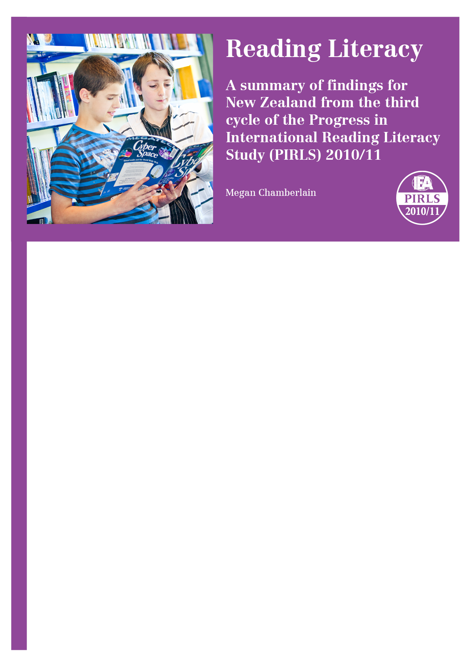
What is PIRLS?
The Progress in International Reading Literacy Study, PIRLS, is an international research study designed to measure trends in reading literacy achievement. It is administered every five years, with the first study in 2001 and the second during 2005 and 2006. The third cycle was conducted during 2010 and 2011, and is hereafter referred to as PIRLS-2010/11. It involved about 300,000 students from 48 countries and nine benchmarking participants. The information in this brochure relates to this most recent cycle undertaken in 2010/11, with some comparisons made with the earlier cycles.

What is the focus of PIRLS?
PIRLS looks at the two main reasons why middle primary students read. They read for literary experience and to acquire and use information. As well as looking at the reasons for reading, the study looks at the processes and skills of reading comprehension. For example, when students read they often need to interpret and integrate ideas in order to understand the underlying message of a story. In other situations they are required to locate a specific piece of information from part of a text to answer a question that they bring to a reading task or to be able to check their understanding of some specifics of a text’s meaning.
As well as comprehensive assessment information, a rich array of contextual background information is collected from students, teachers, parents/caregivers, and school principals. Each country also provided national educational policy information to aid the interpretation of results.

prePIRLS
To meet the needs of the increasing number of developing countries wanting to participate in PIRLS, a less difficult reading comprehension assessment was introduced in 2010/11. This assessment referred to as prePIRLS uses shorter stories and articles, with easier vocabulary and simpler grammar structure.

Which countries took part?
Forty-eight countries from around the world took part in the 2010/11 study. The majority of the countries (42) were in the Northern Hemisphere—Asia, the Caribbean, Europe, North Africa, the Middle East, and North America. These countries administered PIRLS in early 2011. New Zealand along with five other Southern Hemisphere countries—Australia, Botswana, Honduras, Colombia, and Singapore—administered the study in late 2010. The countries taking part in PIRLS and prePIRLS are listed at the end of this brochure.

Which students took part?
Middle primary school is an important transition point in a child’s reading development; most children would have learned to read and are now reading to learn. The study focuses on Grade 4 students around the world, or the fourth year of formal schooling. However, to ensure comparability across countries, the minimum average age of children in a country’s Grade 4 (or equivalent) needed to be at least 9.5 years old. In New Zealand, like England, Malta, and Trinidad and Tobago where students start school at age 5 years, the average age of children in the fourth year of formal schooling is about 9 years. So children in their fifth year of schooling—Year 5 in New Zealand’s case—took part. New Zealand students in PIRLS were on average about 10 years-old.

New feature for 2005/06
Countries that have found the PIRLS assessment too difficult for the majority of their Grade 4 students in previous PIRLS cycles, could administer the assessment to students in Grades 5 or 6.

What did the students have to do in PIRLS?
Each student was given a booklet that contained either two literary (story) texts, two information texts, or one of each. There were five different literary texts and five different information texts so that students did not all have the same material. Each passage (story or information text) was followed by a series of questions that were designed to assess the student’s reading comprehension. Some questions were closed (i.e., students selected an answer from those provided) and some questions were open (i.e., students had to write their own response to the question).

What other information was collected in PIRLS?
Students, parents and caregivers, teachers, and school principals were each asked to complete a questionnaire. Their responses to a range of questions were used to better understand the context of students’ reading achievement. The questionnaires covered topics such as students’ views about reading and school, the availability of educational resources at home, early literacy activities in the home, and teachers’ organisational and instructional practice for teaching reading.

In which language were students assessed?
All countries that took part in PIRLS assessed students according to the language in which they received their instruction. Many countries tested in more than one language because more than one language was used for instruction in their country. In New Zealand schools were given the option of testing students in English or in te reo Māori. When reporting at the national/country level, countries combine the results for the different languages and so does New Zealand. The reading literacy achievement results described relate to all Year 5 New Zealand students.

How did New Zealand Year 5 students fare in the international context?
The results for New Zealand in an international context are reported in PIRLS 2011 International Results in Reading, published in December 2012 and referenced at the end of this summary. The mean reading score (531) for New Zealand Year 5 students was significantly higher than the international PIRLS Scale Centrepoint (500); 32 countries including New Zealand were significantly higher than the PIRLS Scale Centrepoint.
- The New Zealand mean was statistically similar to the means for seven countries, including Australia and four other OECD countries—Austria, Poland, the Slovak Republic, and Slovenia.
- It was significantly lower than the means for 20 countries or education systems, including 14 OECD countries. Five of these jurisdictions with achievement higher than New Zealand assessed in English: Canada, England, Ireland, Northern Ireland, and the United States.
- The New Zealand mean was also significantly higher than the means for 17 countries, including France, Norway, and Spain, and higher than two countries that tested in English—Malta and Trinidad and Tobago.
- The mean reading score for New Zealand in statistical terms did not change from 2001 to 2010/11.
- There were no statistical changes in New Zealand Year 5 students’ achievement in either literary reading or informational reading from 2001 to 2010/11. New Zealand Year 5 students were found to have a significant strength in literary reading compared to their overall reading performance.
- Compared to their overall performance, New Zealand students were generally stronger on questions where they had to use reasoning skills (e.g., interpreting and integrating ideas) and weaker on questions that required them to use text-based skills (e.g., focus on and retrieving explicitly stated information). Because of the features of the different reading texts, the questions assessing the text-based processes were not necessarily less difficult than the questions assessing the reasoning processes.
- Compared with many other countries participating in this study, New Zealand had a relatively large group of students who demonstrated very advanced reading comprehension skills.
- New Zealand also had a slightly bigger group of weaker readers than many of the high-performing countries. These students were likely to have difficulties in locating a specific part of a story, or locating and reproducing information actually stated in a text.
- New Zealand’s Year 5 boys and girls typically achieved above the international means for boys and girls. Although the difference between New Zealand girls and boys, favouring girls, has decreased since 2001, the average difference between them (20 points) remained one of the biggest internationally.
- There was no significant change in the mean reading scores of Year 5 boys and Year 5 girls from 2001 to 2010/11.

How did New Zealand Year 5 sub-populations fare in PIRLS?
The majority of the national results, along with some of the international results, are in the full national report – PIRLS 2010/11 in New Zealand: an overview of findings from the third cycle of the Progress in International Reading Literacy Study (PIRLS), referenced at the end of this brochure.
- There were both high and low-achieving students in all ethnic groupings. However, Pākehā/European (558) and Asian (542) students generally scored at a higher level than Māori (488) and Pasifika (473) students.
- There was no significant change in the mean reading scores for students in any of the four main ethnic groupings from 2001 to 2010/11.
- Pākehā/European girls (570) generally had the highest achievement in PIRLS; they were also more likely to demonstrate they had advanced reading comprehension skills than other Year 5 students.
- The lowest achievement was observed for Pasifika boys (464), and to a lesser extent, Māori boys (478) and Pasifika girls (482); these students tended to be over-represented among students with weaker comprehension skills compared with other groups of Year 5 students.
- Compared to their overall performance, Year 5 girls and boys, and Māori students tended to show stronger performance in their reasoning; Year 5 girls, Pākehā/European, and Māori students tended to be weaker when using text-based skills.
- Year 5 girls in the four main ethnic groupings tended to do significantly better than their respective male counterparts.
- In all ethnic groupings the differences between the mean achievement of girls and boys were greater in literary reading than informational reading.

Did speaking the language of the assessment test at home make a difference?
Students were asked how frequently they spoke at home the language in which they were assessed in PIRLS.
- The average score for those New Zealand students who frequently spoke the language of the PIRLS assessment at home (543) was significantly higher that those students who sometimes or rarely did (499).
- This difference for New Zealand (43) was larger than in most of the countries that assessed in English – for example, Australia (18), England (18), and Ireland (25), but similar to the United States (40).
- This difference for New Zealand had increased markedly from 2005/06 (24) to 2010/11 (43).
- When the home language data was looked at for Year 5 students assessed in English, the difference between the mean reading scores for students in the two home language categories was larger for Pasifika students than students in other ethnic groupings. The difference between means for Pasifika students had also increased from 9 scale score points in 2005/06 to 26 in 2010/11.

Are there things about the home environment that made a difference to students’ reading achievement?
The home has an important role in fostering literacy. There were some important early-literacy activities that parents or caregivers did with their children when they were pre-schoolers that were found to be related to higher reading achievement when children were older and in school. These activities include reading from books to their children, telling stories, singing songs, playing with alphabet toys or word games, and reading labels and signs aloud. A child’s views about reading can also be enhanced through access to home educational resources such as books, and having parents or caregivers who themselves have positive attitudes to reading.

Starting early makes a difference
- According to their parents’ responses, prior to starting school, more than half (55%) of New Zealand Year 5 students often had a high level of engagement in early literacy-related activities compared with less than two-fifths (37%) of students on average internationally.
- Most (92%) New Zealand Year 5 students in 2010/11 had attended an early childhood education (ECE) facility for more than one year before starting school. These tended to be Pākehā/European students (95%) while Pasifika students (79%) were the least likely. On average, the Year 5 students who had not attended an ECE facility, or who had attended for up to and including one year, had lower reading literacy achievement than other Year 5 students.
- Overall attendance at an ECE facility (as measured in PIRLS) was higher in 2010/11 than in either 2005/06 (91%) or 2001 (83%).

Students’ attitudes towards reading
Compared with students in other countries, New Zealand Year 5 students liked reading more; they were mostly motivated, but were much less confident as readers.
- New Zealand’s Asian students tended to like reading more, and be the most confident and motivated readers than students in other ethnic groupings.
- Māori and Pasifika students were less positive about liking reading, Pasifika students the least confident, and Pākehā/European students, the least motivated.

Schools and school climate
The reading achievement of New Zealand Year 5 students was about the same regardless of the urban-rural locality or size of the population centre in which their schools were located. Compared with many other countries, New Zealand principals’ reports indicate that resource shortages or inadequacies had little or no impact on reading instruction in schools. This finding is consistent with previous cycles of PIRLS.
New Zealand’s Year 5 students’ reading achievement was generally lower in schools where proportionately few of the student body had the early literacy skills at school entry than in schools where more of the student body had these skills. These schools also tended to be those with higher proportions of students from lower socio-economic backgrounds. Moreover, there tended to be large differences in achievement between Year 5 students in schools where the student body was drawn from economically disadvantaged communities and those Year 5 students where the student body were drawn from economically advantaged communities, compared to many other countries.
- There was a strong relationship between the international measure of school composition and the decile of New Zealand’s state and state-integrated schools. That is, New Zealand’s deciles 1 and 2 schools and to a lesser extent deciles 3 and 4 schools had the greatest concentration of students from economically disadvantaged backgrounds, while decile 9 and 10 schools had the greatest concentration of students from economically advantaged backgrounds.
- Although there were high-performing and low-performing students across all deciles, Year 5 students in deciles 1 and 2 and to a lesser extent decile 3 and 4 schools tended to have the weakest performance.
- There was no significant change in Year 5 students’ reading achievement for any of the school deciles from 2001 to 2010/11.

School climate
Both international and national research has shown that schools where there is a positive school environment, with few behaviour problems that could potentially impact on the safety of students or teachers, are likely to be better placed for facilitating learning than an environment where students and teachers do not feel safe. School leaders have an important role in promoting a positive school climate, and taking responsibility for improving student outcomes.
- Compared with other countries, New Zealand Year 5 students were more likely to be attending schools where both their principals and teachers endorsed aspects of ‘academic optimism’; they shared a common view of academic success through their understanding of the school’s curricular goals, implementation of the school’s curriculum, and expectations for student achievement.
- New Zealand’s Year 5 students were more likely to have experienced bullying behaviours than many of their international counterparts. This finding is consistent with information reported in 2001 and 2005/06.
- Despite experiencing these negative behaviours, Year 5 students in 2010/11 reported positively that they liked school, with this cohort more positive than either their 2001 or 2005/06 counterparts.

The classroom context and practice
PIRLS gathered a lot of information from teachers and principals in order to understand the actual instructional context in which children are reading. This included information on the amount of time allocated to teaching reading, how classes were organised for reading, the range of activities in reading, and the range of materials used during reading instruction.
- New Zealand primary schools spent, on average, the fourth highest number of hours during the school year—actual and as a proportion of total instructional hours— teaching reading. This amount of time is consistent with the situation in New Zealand in 2001 and 2005/06.
- In 2010, a typical New Zealand teacher of Year 5 students was teaching a class of about 27 students, about the same as in 2005, but one less than in 2001. A class was often a multi-year level or composite class.
- While teachers use a variety of approaches for organising their reading instruction, in New Zealand the single organisational approach reported to be used ‘almost always’ was to arrange Year 5 students into same-ability groups. Teaching reading as a whole-class activity was an approach used often in many countries but relatively infrequently used by New Zealand teachers during reading.
- New Zealand’s Year 5 students were generally less engaged during reading (instruction) than many of their international counterparts. Pākehā/European students were less likely to be engaged than other students in other ethnic groupings.
- The majority of New Zealand teachers reported using a reading series (typically the School Journal) as a basis for their reading programmes, often as a dual approach with children’s books. This finding is consistent with 2001 and 2005/06.

Who conducted PIRLS?
PIRLS is co-ordinated by the International Association for the Evaluation of Educational Achievement (IEA). The Ministry of Education’s Comparative Education Research Unit is responsible for PIRLS in New Zealand

Would you like more information?

National report
The PIRLS national report describes the reading literacy achievement of Year 5 students in both a national and international context. The report provides a snapshot of the findings from the third cycle conducted in 2010/11 along with trend information from the two earlier cycles in 2001 and 2005/06. You will find the New Zealand report on PIRLS on the Ministry of Education’s website www.educationcounts.govt.nz.
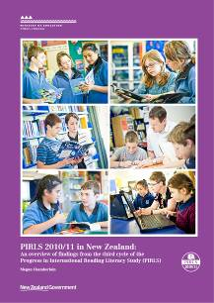
PIRLS 2010/11 in New Zealand: an overview of findings from the third cycle of the Progress in International Reading Literacy Study (PIRLS)
Author: Megan Chamberlain
Published by: Comparative Education Research Unit,
Ministry of Education, 2013.

International reports
The international report and its compendium, an encyclopaedia on reading education, the technical documentation, and the international database with accompanying documentation are available on the PIRLS web site: http://www.timssandpirls.bc.
- PIRLS 2011 International Results in Reading (Authors: I. V. S. Mullis, M. O., Martin, P. Foy, & K. T. Drucker, published by the TIMSS & PIRLS International Study Center and International Association for the Evaluation of Educational Achievement, 2012).
- PIRLS 2011 Encyclopedia Volumes 1 and 2 (Editors: I. V. S. Mullis, M. O., Martin, C A. Minnich, .K. T. Drucker, & M. A Ragan, published by the TIMSS & PIRLS International Study Center, 2012.)
- Methods and Procedures in TIMSS and PIRLS 2011 (Editors: I. V. S. Mullis, & M. O., Martin; http://timssandpirls.bc.edu/methods/index.html)
- PIRLS 2011 User Guide for the International Database (Editors : Editors: P. Foy & K. T. Drucker, published by the TIMSS & PIRLS International Study Center and International Association for the Evaluation of Educational Achievement, 2013).

Countries and education systems participating in PIRLS and prePIRLS in 2010/11
 | PIRLS Grade 4 participants
 | Australia |  | Finland | † | Malta |  | Saudi Arabia
 | Austria | * | France | * † | Morocco | * | Singapore
 | Azerbaijan |  | Georgia | * | Netherlands | * | Slovak Republic
 | Belgium (French) | * | Germany | * | New Zealand | * | Slovenia
* | Bulgaria | * | Hong Kong SAR |  | Northern Ireland |  | Spain
 | Canada | * | Hungary | * | Norway | * | Sweden
 | Chinese Taipei |  | Indonesia |  | Oman |  | Trinidad and Tobago
† | Colombia | * | Iran, Islamic Rep. of |  | Poland |  | United Arab Emirates
 | Croatia |  | Ireland |  | Portugal | * | United States
 | Czech Republic | * | Israel |  | Qatar
 | Denmark | * | Italy | * | Romania
* | England | * | Lithuania | * | Russian Federation
 | PIRLS Grade 6 participants
 | Botswana |  | Honduras |  | Kuwait |  | Morocco
 | PIRLS Benchmarking participants
 | Alberta (Canada) |  | Maltese (Malta) |  | Abu Dhabi (UAE)
 | Ontario (Canada) |  | English/Afrikaans,  Grade 5 (South Africa) |  | Dubai (UAE)
 | Quebec (Canada) |  | Andalusia (Spain) |  | Florida (USA)
 | prePIRLS participants
 | Botswana |  | Colombia |  | South Africa

Notes
† Colombia’s Grade 4 students participated in PIRLS and prePIRLS. Morocco’s Grade 4 and Grade 6 students participated in PIRLS. Malta assessed in English, this being the main language of instruction. Its students were also assessed in Maltese to benchmark their performance against those who were assessed in English.
* These countries and provinces participated in both PIRLS-01 AND PIRLS-2005/06. Kuwait and Israel participated in the two previous cycles; however their data from these cycles are not comparable with 2010/11.
 South Africa took part in prePIRLS. Grade 5 students who receive instruction in English or Afrikaans formed the benchmarking participant group and were assessed as part of PIRLS.

Publishing Info

Comparative Education Research Unit
Research Division
Ministry of Education
PO Box 1666
Wellington 6140
New Zealand
Email: research.info@minedu.govt.nz
Fax: 64-4-463 8312
Phone: 64-4-463 8000
© Crown Copyright
All rights reserved.
Enquiries should be made to the publisher.
July 2013
RMR-1014a

Note that nearly all Year 5 students (98%) were assessed in English.
In 2001, the average of the country means was set to 500 with a standard deviation of 100. The PIRLS achievement scale uses this same point of reference from assessment to assessment.
Because of rounding, some figures may appear to be inconsistent.

