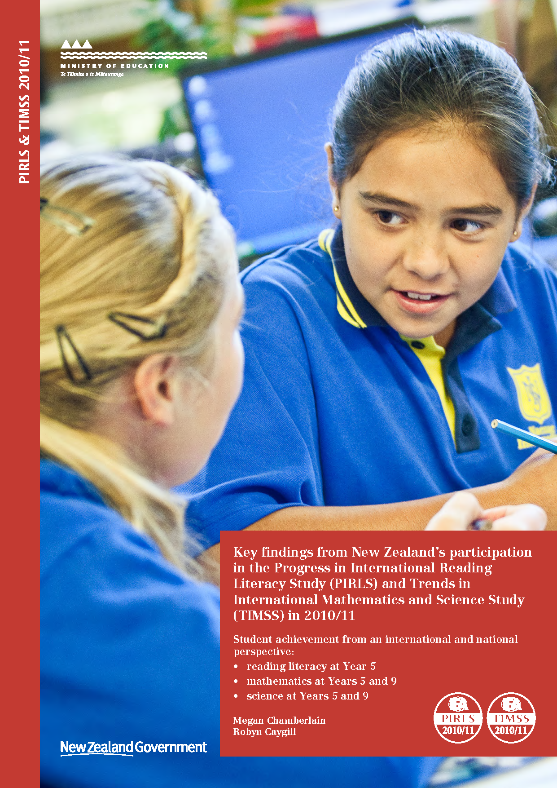

Acknowledgements
The work for PIRLS and TIMSS 2010/11 started in early 2008 beginning with the development phase, followed by the field testing during late 2009 and early 2010, and implementation during late 2010 through to 2011, and has ended with the first phase of international reporting in December 2012. The studies have involved a large number of people working together during different phases of the studies. Without the efforts from these people, the studies would not have been so successful.
However, PIRLS and TIMSS were only made possible because of the efforts of the New Zealand children who took part during 2010 and 2011, as well as the contributions from parents and caregivers, teachers, and school principals. A special thanks is extended to the children and staff of the schools in Christchurch and the West Coast who were involved in these studies during this period.
Megan Chamberlain
(PIRLS National Research Coordinator)
Robyn Caygill
(TIMSS National Research Coordinator)

What are PIRLS and TIMSS

Both PIRLS and TIMSS are international research studies that are designed to measure trends in student achievement. They are coordinated by the International Association for the Evaluation of Educational Achievement (IEA). PIRLS looks at reading literacy achievement of middle primary school students. New Zealand’s Year 5 students take part in PIRLS. It is administered every five years, with the first cycle in 2001, the second in 2005/06, and then the third in 2010/11.
TIMSS looks at the mathematics and science achievement of both middle primary and lower secondary school students. New Zealand’s Year 5 and Year 9 students take part. TIMSS is administered on a regular four-year cycle with the first cycle in 1994/95, and then again in 1998/99, 2002/03, 2006/07, and then the fifth cycle in 2010/11.
TIMSS also provides information on the relative progress of the middle primary school cohort four years later when they are in lower secondary school. For example and although not exactly the same students, the Year 5 student cohort assessed in TIMSS in 2006/07 formed the Year 9 TIMSS cohort in 2010/11.
As well as comprehensive assessment information in three essential learning areas—reading, science, and mathematics—a rich array of contextual background information is collected from students, teachers, parents/caregivers, and school principals. National educational policy information is also provided by each country to aid the interpretation of results.

PIRLS and TIMSS in 2010/11
Both PIRLS and TIMSS were administered in 2010/11. This provided a unique opportunity for many countries participating in both PIRLS and TIMSS at the middle primary level as it had the advantage of one comprehensive assessment in all three learning areas: reading, mathematics, and science. Many countries that took part chose to assess the same middle primary school students in all three areas. New Zealand chose to assess two different groups of students: one group that took part in PIRLS and one group that took part in TIMSS.

What countries took part?
Approximately 60 countries including 28 OECD countries took part in either PIRLS or TIMSS or both during 2010 and 2011. There were countries from Europe, northern and southern Africa, the Americas, the Middle East, the Caribbean, and Asia-Pacific. Southern Hemisphere countries that took part administered PIRLS and TIMSS in late 2010 and Northern Hemisphere countries administered them in early 2011.

Who participated in New Zealand?
PIRLS and TIMSS used a three-tiered approach to sampling in order to be able to describe the achievement of Year 5 and Year 9 students. First, representative samples of schools based on characteristics such as size, decile, location, and at the secondary level, authority and type (single-sex and co-educational), were selected for each study and educational level. Then one or two or in some cases all classes or groups with just Year 5 or Year 9 students were randomly selected from each school. All students in the selected classes or groups took part. Approximately 5,600 Year 5 students from 192 schools took part in PIRLS and 5,300 Year 9 students from 158 schools took part in TIMSS, in November 2010. TIMSS was administered to 5,600 Year 5 students in 180 schools in early October 2011.

What is the focus of PIRLS?
PIRLS looks at the two main reasons why students at the middle primary level read. They are reading for literary experience and to acquire and use information. As well as looking at the reasons for reading, the study looks at the processes and skills of reading comprehension. For example, when students read they often need to interpret and integrate ideas in order to understand the underlying message of a story; in other situations they are required to locate a specific piece of information from part of a text to answer a
question that they bring to a reading task, or to be able to check their understanding of some aspect of the text’s meaning.

What did the students have to do in PIRLS?
Each student was given a booklet that contained either two literary (story) texts, two information texts, or one of each. There were five different literary texts and five different information texts so that students did not all have the same material. Each passage (story or information text) was followed by a series of questions that were designed to assess the student’s reading comprehension. Some questions were closed (i.e., students selected an answer from those provided) and some questions were open (i.e., students had to write their own response to the question with some questions requiring one or two sentences using examples from the texts to explain their answers).

What is the focus of TIMSS?
TIMSS is organised around two aspects: content or subject matter within mathematics and science; and the cognitive or thinking processes involved when answering questions. The mathematics content dimensions are:
- number; geometric shapes and measures; and data display at middle primary level
- number; algebra; geometry (including measurement); and data and chance at the lower secondary level.
The science content dimensions are:
- life science; physical science (aspects of chemistry and physics); and Earth science at the middle primary level
- biology, chemistry, physics, and Earth science at the lower secondary level.
Three cognitive areas were assessed in both mathematics and science and were defined under three broad descriptions, with each encompassing skills and behaviours specific to mathematics or science areas: knowing, applying, and reasoning.

What did the students have to do in TIMSS?
Each student answered sets of mathematics and science questions in a booklet. There were 14 different booklets at each education level. The different booklets meant that more subject-matter could be covered without making the test longer for an individual student. Some questions were closed (i.e., students selected an answer from those provided) and some questions were open (short answers or extended answers with explanations).

In which language were students assessed?
All countries that took part in PIRLS and TIMSS assessed students according to the language in which they received their instruction. Many countries tested in more than one language because more than one language was used for instruction in their country. In TIMSS, New Zealand students were assessed in English and in PIRLS, schools were given the option of testing students in either English or te reo Māori. When reporting at the national/country level, countries combine the results for the different languages and so does New Zealand. The reading literacy achievement results described relate to all Year 5 New Zealand students irrespective of whether their language of instruction is te reo Māori or English or both.

What is the quality of the PIRLS and TIMSS information?
The assessment frameworks, assessments, and contextual questionnaires were developed cooperatively with representatives from all participating countries with input from subject-matter experts. The procedures for developing, implementing, and reporting are designed to ensure the reliability, validity, and comparability of the data through standardised procedures, and attention to quality control throughout. Procedures, such as field-testing of questions, detailed manuals covering procedures, rigorous training for all involved, and quality assurance monitoring during the implementation, ensure good quality information.

Reading literacy

Year 5 students in an international context in 2010/11
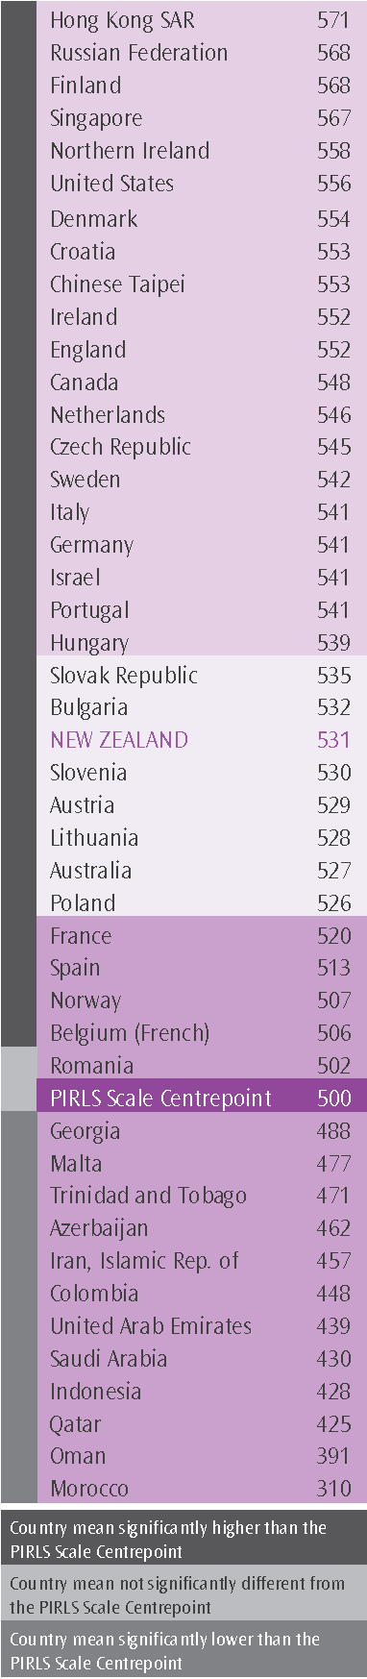
The figure shows the mean reading literacy scores for all the countries in PIRLS. The mean for New Zealand’s Year 5 students was 531 scale score points, and it was significantly higher than the centre value 500 of the PIRLS achievement scale, referred to as the PIRLS Scale Centrepoint (see glossary of terms). The New Zealand reading literacy mean was:
significantly lower than the means for 20 countries, including 14 OECD countries—for example—Finland, United States, England and Northern Ireland, Ireland, and Canada
similar to the means for seven countries, including four OECD countries—for example—the Slovak Republic and Australia
significantly higher than the means for 17 countries, including four OECD countries Belgium (French), France, Norway, and Spain. It was also higher than two countries that tested in English—Malta and Trinidad and Tobago.
The range of scores between New Zealand’s higher performing students and lower performing students was relatively high compared with other countries where English was one of the assessment languages.
Both Year 5 girls (541) and boys (521) achieved on average above the international means for girls (521) and boys (508).
Almost all countries had a significant difference between girls and boys, with girls tending to achieve higher scores than boys. Italy and France are examples where there were no differences between girls’ and boys’ achievement.
- The difference between New Zealand’s girls’ and boys’ mean scores (20) was high when compared with the United States (10) and Canada (12), but about the same as the differences recorded for Finland (21) and England (23).
In many countries, students tended to be either weaker or stronger in one of the two reading purposes in which they were assessed.
- New Zealand Year 5 students showed significantly stronger performance when reading literary texts (e.g., contemporary stories, fables, animal adventure) compared to their overall performance in reading.
Similarly, in many countries students tended to have strengths or weaknesses in the types of comprehension processes and skills that were assessed.
- Year 5 students showed significantly stronger peformance in reasoning (i.e., where they had to interpret, integrate, and evaluate their ideas) and significantly weaker with text-based processes (i.e., where they had to demonstrate their ability to locate and reproduce explicitly-stated pieces of information).

Reading literacy achievement and the PIRLS international benchmarks
There are four international benchmarks on the achievement scale that have been chosen to measure types of comprehension processes and skills learners use when reading the PIRLS texts and answering the assessment questions. Associated with each benchmark are descriptions of these processes and skills.
 |  | Reading for literary purposes | Reading to acquire and use information
 | Advanced International  Benchmark | When reading literary texts, students could: | When reading informational texts, students could:
 | Advanced International  Benchmark | - integrate ideas and evidence across a text to appreciate overall themes;  - interpret story events and character actions to provide reasons, motivations, feelings, and character traits with full text-based support | - distinguish and interpret complex information from different parts of the text, and provide full text-based support;  - integrate information across a text to provide explanations, interpret significance, and sequence activities; and  - evaluate visual and textual features to explain their function.
● | 625
 | High International  Benchmark | When reading literary texts, students could: | When reading informational texts, students could:
 | High International  Benchmark | - locate and distinguish actions and details embedded across the text;  - make inferences to explain relationships between intentions, actions, events, and feelings, and give text-based support;  - interpret and integrate story events and character actions and traits from different parts of the text;  - evaluate the significance of events and actions across the entire story; and  - recognise the use of some language features (e.g., metaphor, tone, imagery). | - locate and distinguish relevant information within a dense text or a complex table;  - make inferences about logical connections to provide explanations and reasons;  - integrate textual and visual information to interpret the relationship between ideas; and  - evaluate content and textual elements to make a generalisation.
○ | 550
 | Intermediate International Benchmark | When reading literary texts, students could: | When reading informational texts, students could:
 | Intermediate International Benchmark | - retrieve and reproduce explicitly stated actions, events and feelings;  - make straightforward inferences about the attributes, feelings, and motivations of the main characters;  - interpret obvious reasons and causes and give simple explanations; and  - begin to recognise language features and style. | - locate and reproduce one or two pieces of information; and  - use subheadings, text boxes, and illustrations to locate parts of the text.
 | 475
 | Low  International  Benchmark | When reading literary texts, students could: | When reading informational texts, students could:
 | Low  International  Benchmark | - locate and retrieve explicitly stated detail. | - locate and reproduce explicitly stated information that was at the beginning of a text.
◉ | 400
 | Did not reach the Low International Benchmark
Source: Mullis, Martin, Foy, & Drucker, 2012.
It is worth remembering that the descriptions shown in the box do not profess to encompass all reading situations 10-year-olds encounter. However, they do reflect the types of PIRLS texts students were asked to read in the assessment, the types of questions they were able to answer successfully, and, for multiple-mark constructed response questions, the quality of their responses.
Figure 1 shows the percentage of New Zealand Year 5 students reaching each benchmark and the cumulative percentages—students who demonstrated the skills and strategies at a given benchmark also demonstrated the skills associated with the lower benchmarks. For example, the 45% of Year 5 students who reached the High International Benchmark demonstrated they had the reading comprehension skills and strategies associated with the Intermediate and Low International Benchmarks.
Figure 1: Percentage of Year 5 students reaching PIRLS international reading benchmarks in 2010/11
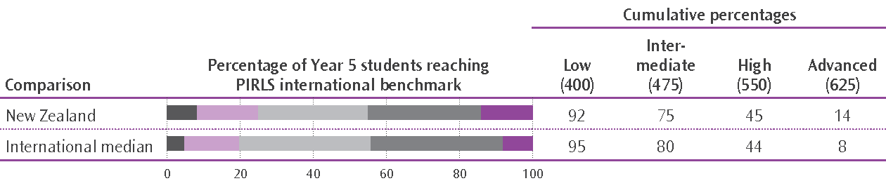
Notes
The darker grey sections on the left-hand-side of the bars represent the percentages of students who did not reach the Low International Benchmark; the mauve represents the students reaching the Low International Benchmark but did not reach the Intermediate International Benchmark, and so on. The darker purple represents the percentage reaching the Advanced International Benchmark.
The standard errors (SE) for New Zealand are not shown in the figure. They are: Low International Benchmark, 0.5%; Intermediate International Benchmark, 0.9%; High International Benchmark 1.1%; and Advanced International Benchmark 0.7%. There are no standard errors for the international medians.
Fourteen percent of Year 5 students reached the Advanced International Benchmark, nearly double the international median of 8%, and the 10th highest proportion internationally. Singapore recorded the largest proportion with 24% of their middle primary students achieving at or above this benchmark.
Some of the countries with significantly higher mean performance overall than New Zealand—for example, Germany (10%), Italy, (10%), and Sweden (9%)—had proportionately fewer of their students reaching this benchmark than New Zealand.
While New Zealand students were well represented among the best readers, they were also a little over-represented among the group of weaker readers. Twenty countries had more than 95% of their students reaching the Low International Benchmark; the percentage for New Zealand was slightly lower at 92%. The 8% of Year 5 students who did not reach this level generally had difficulty even with locating and reproducing explicitly-stated information.

Reading literacy achievement and ethnicity
Across all ethnic groupings there were high-performing and low-performing students, with students from each grouping represented at both the higher and lower benchmarks. Pākehā/European students tended to have higher mean achievement (558) than Māori (488), Pasifika (473), and Asian students (542). Girls in all groupings generally achieved higher reading scores but the differences were greater between Pākehā/European girls and boys (on average, 24 scale score points).

Reading literacy achievement and speaking the test language at home
About one-quarter of Year 5 students reported either only sometimes or never speaking the test language (English or Māori) at home. These students generally had weaker reading comprehension skills (499) than students who always or almost always spoke the test language at home (543). The achievement gap between those who frequently spoke English at home and those who did not was wider for Pasifika students than it was for any other student group.

Students’ views about reading and school
Compared to many of their international counterparts, Year 5 students liked reading (and girls more than boys) but were much less confident with their reading. They were relatively motivated to read, but were a little less engaged with their reading lessons than many of their international counterparts.
Most Year 5 students liked being at school and had a sense of belonging. The majority felt safe at school and liked learning new things. Interestingly just over half of Year 5 students indicated they get bored at school.

Was there any change in Year 5 students’ reading literacy achievement?
Figure 2 shows the mean reading literacy scores for New Zealand Year 5 students for each PIRLS assessment. There was no significant change in the mean reading literacy achievement at Year 5 over the period 2001–2010/11. New Zealand was no exception—England, France, and Italy were examples of systems where there was no significant change over the same period.
A number of countries had significant shifts in their students’ mean achievement. For example Iran (Islamic Republic), the Russian Federation, Hong Kong SAR, and Singapore had significant increases, while the Netherlands and Sweden were examples of countries that had significant decreases.
As well as there being no changes in the mean scores, there were no significant changes in the percentages of New Zealand Year 5 students reaching the PIRLS international reading benchmarks over the period 2001–2010/11.
Figure 2: Trends in New Zealand Year 5 reading literacy achievement,
2001–2010/11
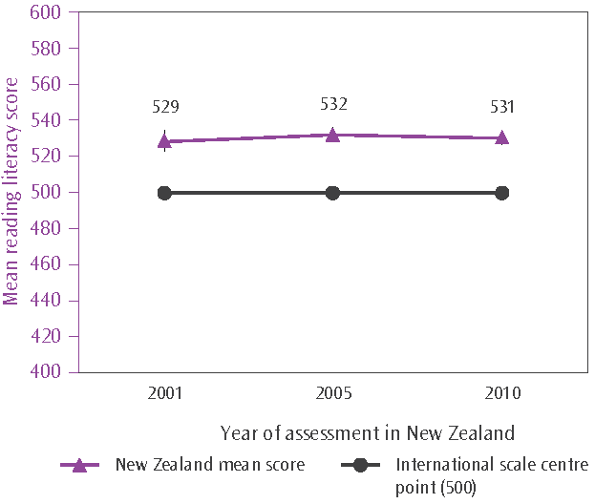
Notes
The New Zealand mean score for each assessment is shown alongside the corresponding data point. The small lines extending from either side of each purple data point represent the confidence interval around the mean (i.e., ±2  standard error).
The standard errors for the 2001, 2005 and 2010 means are: 3.6, 2.0, and 1.9 respectively.
However, because some countries had significant increases in their students’ performance over the 10-year-period and there were some new higher-performing countries joining PIRLS, the international median percentage for each benchmark increased in 2010/11. That is, the countries with improvements have proportionately more of their students reaching the benchmarks, particularly the lower benchmarks, while the new countries have proportionately more of their students reaching a particular benchmark than New Zealand. For example, the international median for the percentage of students that reached the PIRLS Intermediate International Benchmark (or scoring 475 or higher) was 80%; in 2005/06 the median was 76%.
Effectively this means that although New Zealand has had no changes in relation to the actual benchmarks in 2010/11 (i.e., the percentages reaching each benchmark staying the same), the percentage of New Zealand Year 5 students (75%) reaching the Intermediate International Benchmark was lower than the international median. This was not the case in 2005/06, when the percentage of Year 5 students reaching was the same as the median (both 76%).
It was a similar pattern at the High International Benchmark—the percentage of New Zealand Year 5 students reaching this level was the same in both 2005/06 and 2010/11. Compared to the international median of 41% for this benchmark in 2005/06 New Zealand had a higher percentage but in 2010/11, the percentage was about the same as the international median (44%).
Figure 3: Percentage of New Zealand Year 5 students reaching the PIRLS international benchmarks in 2005/06 and 2010/11
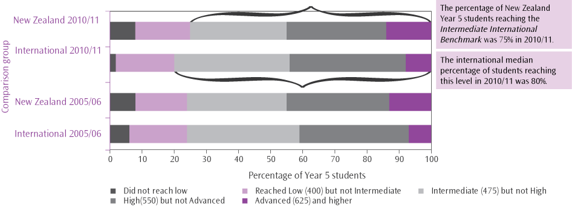

There were no significant changes in the reading achievement for any groups: Māori, Pasifika, Asian, or Pākehā/European students; girls or boys. There was however a small decrease in the difference between girls’ and boys’ mean achievement due to small (non-significant) positive shifts in boys’ reading achievement. In PIRLS this difference in reading has consistently been in favour of girls.
While the percentages of students who regularly spoke the language of the assessment at home and those who either sometimes or never did were about the same in both 2005/06 and 2010/11, the difference between the mean reading achievement of the two groups of students increased markedly from 24 scale score points in 2005/06 to 43 in 2010/11. The biggest increase was observed for Pasifika students (from 9 to 26 scale score points).

Mathematics

Year 5 students in an international context in 2010/11
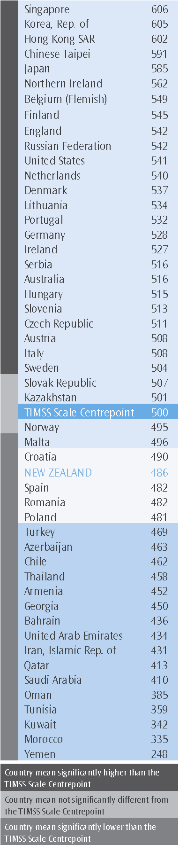
The figure shows the mean mathematics scores at the middle primary level for all the countries in TIMSS. The mean for New Zealand’s Year 5 students was 486 scale score points, and it was significantly lower than the centre value 500 of the middle primary mathematics achievement scale—the TIMSS Scale Centrepoint (see glossary of terms).
The New Zealand Year 5 mathematics mean was:
significantly lower than the means of 29 countries, including 20 OECD countries—for example—Finland, United States, Ireland, and Australia
similar to the means of four countries, including two OECD countries—Spain and Poland
significantly higher than the means of 16 countries, including two OECD countries—Chile and Turkey.
The range of scores between New Zealand’s higher-performing students and lower-performing students was fairly typical when compared with other countries. The Netherlands had the narrowest range and Yemen the widest.
Both Year 5 girls (486) and boys (486) achieved on average just below the international means for girls (490) and boys (491).
Twenty-six countries, including New Zealand, had no significant differences between girls and boys achievement, while 20 had differences that favoured boys. Just four countries had significant differences that favoured girls.
In many countries, students tended to have an area of mathematics that was a strength or a weakness.
- New Zealand’s Year 5 students tended to be a little stronger with questioning on data display (i.e., statistics) compared to their overall performance but a little weaker in both number and geometric shapes and measures.
Similarly, in many countries students tended to have strengths or weaknesses in the types of cognitive behaviours that were assessed.
- Compared to their overall performance, Year 5 students showed significantly stronger peformance in both applying their knowledge and in reasoning, but showed significantly weaker performance when demonstrating their knowledge of mathematical concepts, procedures, and facts.

Mathematics achievement and the middle primary level TIMSS international benchmarks
There are four international benchmarks on the mathematics achievement scale that have been chosen to measure types of cognitive skills and behaviours learners demonstrate when answering the TIMSS assessment questions. Associated with each benchmark are descriptions of these skills and strategies.
 | Advanced international benchmark | Students can apply their understanding and knowledge in a variety of relatively complex situations and explain their reasoning. They can solve a variety of multi-step word problems involving whole numbers including proportions. Students at this level show an increasing understanding of fractions and decimals. Students can apply geometric knowledge of a range of two- and three-dimensional shapes in a variety of situations. They can draw a conclusion from data in a table and justify their conclusion.
● | 625
 | High international benchmark | Students can apply their knowledge and understanding to solve problems. Students can solve word problems involving operations with whole numbers. They can use division in a variety of problem situations. They can use their understanding of place value to solve problems. Students can extend patterns to find a later specified term. Students demonstrate understanding of line symmetry and geometric properties. Students can interpret and use data in tables and graphs to solve problems. They can use information in pictographs and tally charts to complete bar graphs.
○ | 550
 | Intermediate international benchmark | Students can apply basic mathematical knowledge in straightforward situations. Students at this level demonstrate an understanding of whole numbers and some understanding of fractions. Students can visualise three-dimensional shapes from two-dimensional representations. They can interpret bar graphs, pictographs, and tables to solve simple problems.
 | 475
 | Low international benchmark | Students have some basic mathematical knowledge. Students can add and subtract whole numbers. They have some recognition of parallel and perpendicular lines, familiar geometric shapes, and coordinate maps. They can read and complete simple bar graphs and tables.
◉ | 400
 | Did not reach the Low International Benchmark
Source: Mullis, Martin, Foy, & Arora, 2012.
Figure 4 shows the percentage of New Zealand Year 5 students reaching each TIMSS benchmark and the cumulative percentages—students who demonstrated the mathematical skills and behaviours at a given benchmark also demonstrated them at the lower benchmarks. For example, the 58% of Year 5 students who reached the Intermediate International Benchmark demonstrated they had the mathematical skills and behaviours associated with the Low International Benchmark.
Figure 4: Percentage of Year 5 students reaching the TIMSS international mathematics benchmarks in 2010/11
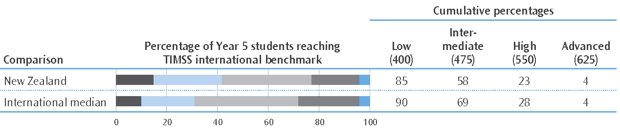
Notes
The darker grey sections on the bars represent the percentages of students who did not reach the Low International Benchmark; the light blue represents the students reaching the Low International Benchmark but did not reach the Intermediate International Benchmark, and so on. The darker blue represents the percentage reaching the Advanced International Benchmark.
The standard errors (SE) for New Zealand are not shown in the figure. They are: Low International Benchmark, 0.5%; Intermediate International Benchmark, 1.1%; High International Benchmark 1.3%; and Advanced International Benchmark 0.8%. There are no standard errors for the international medians.
Just 4% of Year 5 students reached the Advanced International Benchmark (or scored 625 or higher), the same as the international median for that benchmark. Singapore recorded the largest proportion with 43% of their middle primary students achieving at or above this benchmark. Northern Irish and English learners were well-represented at this level with 24% and 18% of their students achieving at or above this benchmark.
Not only did relatively few New Zealand students reach the higher benchmarks, they were also a little over-represented at the lower benchmarks. Fifteen percent of Year 5 students did not reach the Low International Benchmark (i.e., scored 400 or lower); only 17 out of the other 49 countries had more of their students not reaching this level. These students generally had difficulty adding and subtracting whole numbers, recognising parallel and perpendicular lines, recognising some geometric shapes, and completing simple bar graphs and tables.

Mathematics achievement and ethnicity
Across all ethnic groupings there were high-performing and low-performing students, with students from each grouping represented at both the higher and lower benchmarks. Asian students (512) and Pākehā/European students (505) tended to have higher achievement than Māori (443) and Pasifika (444). Asian students also tended to have greater representation at the higher benchmarks while Māori and Pasifika students were over-represented among those not reaching the lowest benchmark. There were no differences in achievement between girls and boys in any ethnic groupings.

Students’ views about mathematics
Compared to many of their international counterparts, Year 5 students were fairly indifferent towards mathematics. They were less confident doing mathematics and they also tended to be less engaged with their mathematics lessons than many of their international counterparts.

Was there any change in Year 5 students’ mathematics achievement?
Figure 5 shows the mean mathematics scores for New Zealand Year 5 students for each TIMSS assessment. After a significant improvement from 1994/95 to 2002/03, the mean achievement at Year 5 has continued to track down so that in 2010/11 Year 5 students were achieving, on average, significantly lower than their Year 5 counterparts were in 2002/03. This change was largely due to significant decreases in performance in both geometric shapes and measures and data display (statistics). Note that TIMSS Year 5 was deferred by one year and was administered in New Zealand in 2011 instead of 2010.
All ethnic groupings and girls and boys are generally achieving better than their respective counterparts in 1994/95. Furthermore, and with two exceptions, there were no significant changes between 2006/07 and 2010/11 for girls or boys, Māori or Pākehā/European students. The two exceptions were for the Asian and Pasifika groupings—Asian students in 2010/11 generally achieved at a significantly lower level compared to their 2006/07 counterparts; and Pasifika students in 2010/11 generally achieved at a significantly higher level compared to their 2006/07 counterparts.
Figure 5: Trends in New Zealand Year 5 mathematics achievement,
1994/95–2010/11
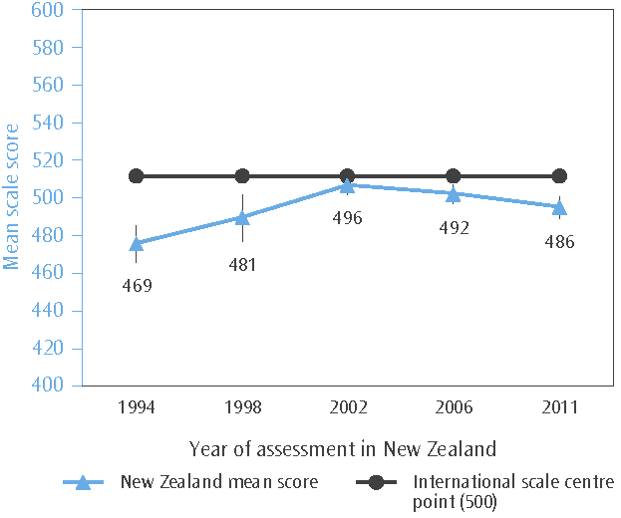
Notes
The New Zealand mean score for each assessment is shown alongside the corresponding data point. The small lines extending from either side of each blue data point represent the confidence interval around the mean (i.e., ±2  standard error).
The standard errors for the means in each assessment (1994, 1998, 2002, 2006, and 2011) are: 4.4, 5.6, 2.1, 2.3, and 2.6.
Figure 6: Mean scores for New Zealand Year 5 students in the TIMSS mathematics domains in 2006/07 and 2010/11
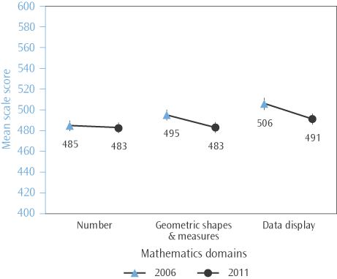
Note
The New Zealand mean score for each assessment is shown alongside the corresponding data point. The lines extending from either side of each data point represent the confidence interval around the mean (i.e., ±2  standard error).
Compared with 2002/03, New Zealand Year 5 students in 2010/11 were less likely to reach any of the international benchmarks. For example, 62% of Year 5 students achieved at or above the Intermediate International Benchmark in 2002/03 compared to 58% in 2010/11.
As noted above there were significant decreases in the means for both geometric shapes and measures (a decrease of 12 scale score points on average) and data display (15 scale score points) from 2006/07 to 2010/11. Figure 6 shows the mean scores for each of the mathematics domains assessed in the two most recent cycles of TIMSS.

Year 9 students in an international context in 2010/11
The figure shows the mean mathematics scores at the lower secondary level for all the countries in TIMSS. The mean for New Zealand’s Year 9 students was 488 scale score points, and it was significantly lower than the centre value 500 of the lower secondary mathematics achievement scale—the TIMSS Scale Centrepoint (see glossary of terms).
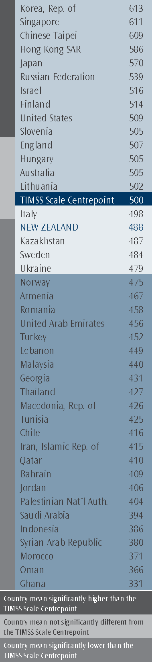
The New Zealand Year 9 mathematics mean was:
significantly lower than the means of 14 countries, including 9 OECD countries—for example—Finland, United States, England, and Australia
similar to the means of four countries, including two OECD countries—Italy and Sweden
significantly higher than the means of 23 countries, including three OECD countries—Norway, Turkey, and Chile.
The range of scores between New Zealand’s higher-performing students and lower-performing students was fairly typical when compared with other countries. Norway had the narrowest range and Turkey, the widest.
Both Year 9 girls (478) and boys (496) achieved on average above the international means for girls (469) and boys (465).
The majority of countries had no significant differences between the average achievement of their girls and boys. However, seven countries including New Zealand had significant differences favouring boys while 13 countries had significant differences that favoured girls.
In many countries, students tended to have an area of mathematics that was a strength or a weakness, which in part reflects curricula expectations at this education level.
- New Zealand’s Year 9 tended to be very strong in data and chance (i.e., statistics and probability) and to a lesser extent number compared to their overall performance. They were very weak in algebra and to a lesser extent geometry.
Similarly, in many countries students tended to have strengths or weaknesses in the types of cognitive behaviours assessed.
- As at Year 5, Year 9 students also showed significantly stronger peformance in both applying their knowledge and reasoning but significantly weaker performance when demonstrating their knowledge of mathematical concepts, procedures, and facts.

Mathematics achievement and the lower secondary level TIMSS international benchmarks
There are four international benchmarks on the lower secondary mathematics achievement scale that have been chosen to measure types of cognitive skills and behaviours students demonstrate when answering the TIMSS assessment questions. Associated with each benchmark are descriptions of these skills and behaviours.
 | Advanced international benchmark | Students can reason with information, draw conclusions, make generalisations, and solve linear equations. Students can solve a variety of fraction, proportion, and percentage problems and justify their conclusions. Students can express generalisations algebraically and model situations. They can solve a variety of problems involving equations, formulas, and functions. Students can reason using geometric figures to solve problems. Students can reason with data from several sources or unfamiliar representations to solve multi-step problems.
● | 625
 | High international benchmark | Students can apply their understanding and knowledge in a variety of relatively complex situations. Students can use information from several sources to solve problems involving different types of numbers and operations. Students can relate fractions, decimals, and percentages to each other. Students at this level show basic procedural knowledge related to algebraic expressions. They can use properties of lines, angles, triangles, rectangles, and rectangular prisms to solve problems. They can analyse data in a variety of graphs.
○ | 550
 | Intermediate international benchmark | Students can apply basic mathematical knowledge in a variety of situations. Students can solve problems involving decimals, fractions, proportions, and percentages. They understand simple algebraic relationships. Students can relate a two-dimensional drawing to a three-dimensional object. They can read, interpret, and construct graphs and tables. They recognise basic concepts of likelihood.
 | 475
 | Low international benchmark | Students have some knowledge of whole numbers and decimals, operations, and basic graphs.
◉ | 400
 | Did not reach the Low International Benchmark
Source: Mullis, Martin, Foy, & Arora, 2012.
Figure 7 shows the percentage of New Zealand Year 9 students reaching each TIMSS benchmark and the cumulative percentages—students who demonstrated the skills and behaviours at a given benchmark also demonstrated those associated with the lower benchmarks. For example, the 24% of Year 9 students who reached the High International Benchmark demonstrated the mathematical skills and behaviours associated with the Intermediate and Low International Benchmarks.
Compared with many countries New Zealand students generally appear to be well-represented at each benchmark, although to some extent this is due to the countries participating at this educational level of TIMSS—some very high-performing systems but relatively more very low-performing countries.
For example, in low-performing countries such as Oman and Ghana no students reached the Advanced International Benchmark (i.e., scored 625 or higher), whereas in two high performing countries—Chinese Taipei (49%) and Singapore (48%)—half the students reached this level. The percentage of students in Australia (9%) and New Zealand (5%) reaching this benchmark was much lower than the high-performing countries, although in the case of Australia, the percentage was three times the international median (3%).
Sixteen percent of New Zealand Year 9 students did not reach the Low International Benchmark; the corresponding percentages for Finland and Australia, for example, were 4% and 11% respectively. Year 9 students not reaching this level had difficulty with the very basics considered appropriate for this educational level: knowledge of whole numbers and decimals, operations, and basic graphs.
Figure 7: Percentage of Year 9 students reaching the TIMSS international mathematics benchmarks in 2010/11
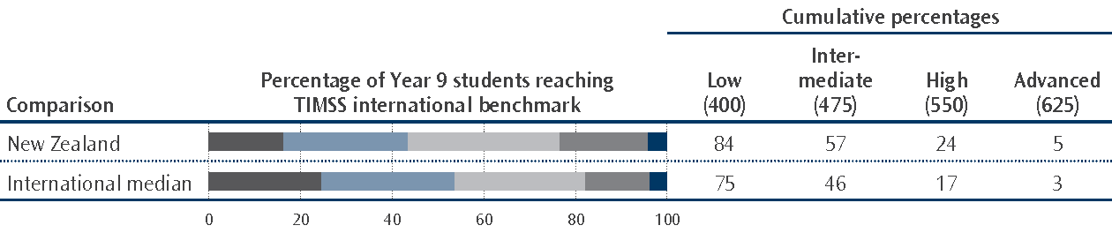
Notes
The darker grey sections on the left-hand side of the bars represent the percentages of students who did not reach the Low International Benchmark; the lighter blue represents the students reaching the Low International Benchmark but did not reach the Intermediate International Benchmark, and so on. The darker blue represents the percentage reaching the Advanced International Benchmark.
The standard errors (SE) for New Zealand are not shown in the figure. They are: Low International Benchmark, 1.6%; Intermediate International Benchmark, 2.8%; High International Benchmark 2.6%; and Advanced International Benchmark 3.0%. There are no standard errors for the international medians.

Mathematics achievement and ethnicity
Across all ethnic groupings there were high-performing and low-performing students, with students from each grouping represented at both the higher and lower benchmarks. Asian students (539) tended to have higher achievement than Pākehā/European (500), Māori (446), and Pasifika (433) students. Asian students were also much more likely to reach the higher benchmarks; nearly one-half achieved at or above the High International Benchmark compared to just over one-quarter of Pākehā/European students. Of those students who did not reach the Low International Benchmark, the highest proportions were Pākehā/European or Māori students, but Māori and Pasifika students were over-represented at this level when compared to their respective proportions in the population.

Mathematics achievement and gender
Year 9 girls’ average performance in 2010/11 was significantly lower than that of Year 9 boys. This is the first time that a significant difference between girls and boys has been observed at this educational level. These differences were found in all mathematics domains assessed in TIMSS. Proportionately more boys than girls also reached each of the international benchmarks. For example, 19% of girls achieved at or above the High International Benchmark compared to 29% of boys.

Students’ views about mathematics
Year 9 students’ views of mathematics—liking mathematics, their confidence learning and doing mathematics, and the value they placed on it as a discipline—were fairly negative compared with the views of many of their international counterparts.

Was there any change in Year 9 students’ mathematics achievement?
Figure 8 shows the mean mathematics scores for New Zealand Year 9 students for each TIMSS assessment. While Year 9 mathematics achievement has remained relatively stable since 1998/99, there are signs that this is changing. (Note that New Zealand did not participate in the Year 9 component of TIMSS in 2006/07.) For example, the significant decrease in girls’ mean achievement from 2002/03 to 2010/11 (from 495 to 478) reported above.
Figure 8: Trends in New Zealand Year 9 mathematics achievement,
1994/95–2010/11
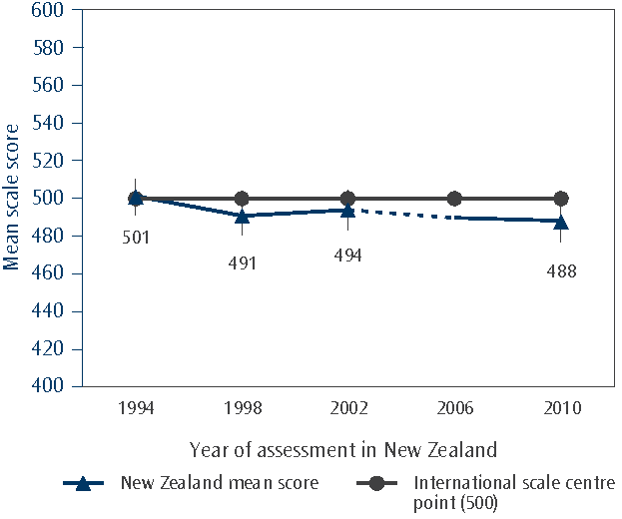
Notes
The New Zealand mean score for each assessment is shown alongside the corresponding data point. The lines extending from either side of each data point represent the confidence interval around the mean (i.e., ±2  standard error).
The standard errors for the means in each assessment (1994, 1998, 2002, and 2010) are: 4.7, 5.2, 5.3, and 5.5.
In addition, proportionately fewer Year 9 students reached both the Low and Intermediate International Benchmarks in 2010/11 than in 2002/03. This was largely due to significantly fewer Pākehā/European students reaching both these two levels. Although not significant, the mathematics achievement of other ethnic groupings is also tracking down. The same pattern was also reflected in the range of scores for Year 9 students (i.e., the difference between the 5th and 95th percentiles), which increased slightly from 260 to 278 over the 8-years from 2002/03 to 2010/11. This was largely due to there being more lower-performing students in 2010/11 than in 2002/03 (i.e., the 25th percentile decreased from 441 to 428; the 5th percentile decreased from 364 to 346).
As noted above there was a significant gender gap favouring boys in 2010/11. Figure 9 shows the mean scores for successive cohorts of girls and boys in Year 9 since the first TIMSS in 1994/95. Interestingly, although not exactly the same students, the Year 9 student cohort assessed in 2010/11 were also part of the Year 5 cohort assessed in TIMSS 2006/07. However, there is no evidence from the performance of Year 5 girls and boys in 2006/07 to suggest there would be a gender difference four years later when they were in Year 9.
Figure 9: Trends in Year 9 mean mathematics achievement 1994/95–2010/11, by gender
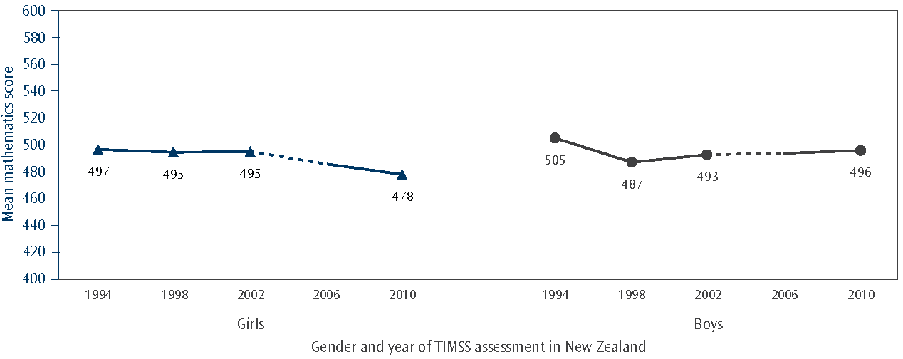
Note
The New Zealand mean score is shown alongside the corresponding data point.

Science

Year 5 students in an international context in 2010/11
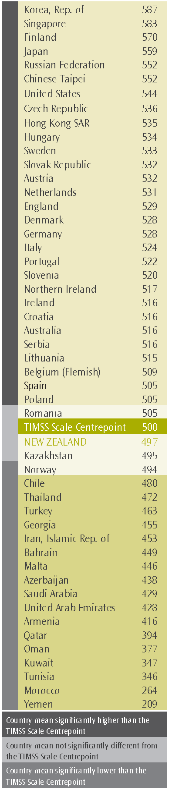
The figure shows the mean science scores at the middle primary level for all the countries in TIMSS. The mean for New Zealand’s Year 5 students was 497 scale score points, and it was not statistically different from the centre value 500 of the middle primary science achievement scale—the TIMSS Scale Centrepoint (see glossary of terms).
The New Zealand Year 5 science mean was:
significantly lower than the means of 29 countries, including 21 OECD countries—for example—Finland, Austria, Portugal, England and Northern Ireland, and Australia
similar to the means of three countries, including one OECD country—Norway
significantly higher than means of 17 countries, including two OECD countries—Chile and Turkey.
The range of scores between New Zealand’s higher-performing students and lower-performing students was about typical when compared with other countries. The Netherlands had the narrowest range and Morocco the widest.
Both Year 5 girls (496) and boys (497) achieved on average above the international means for girls (487) and boys (485).
Twenty-three countries including New Zealand had no significant differences between girls and boys achievement, while 16 had differences that favoured boys and 11 had differences favouring girls.
In many countries, students tended to have an area of science that was a strength or a weakness.
- Compared to their overall performance in science, physical science was a weakness for New Zealand Year 5 students.
Similarly, in many countries students tended to demonstrate a strength or weakness in the types of cognitive behaviours that were assessed.
- There was no area—knowing, applying or reasoning—where Year 5 students demonstrated a strength or weakness.

Science achievement and the middle primary level TIMSS international benchmarks
There are four international benchmarks on the science achievement scale that have been chosen to measure types of cognitive skills and behaviours learners demonstrate when answering the TIMSS assessment questions. Associated with each benchmark are descriptions of these skills and behaviours.
 | Advanced international benchmark | Students apply knowledge and understanding of scientific processes and relationships and show some knowledge of the process of scientific inquiry. Students communicate their understanding of characteristics and life processes of organisms, reproduction and development, ecosystems and organisms' interactions with the environment, and factors relating to human health. They demonstrate understanding of properties of light and relationships among physical properties of materials, apply and communicate their understanding of electricity and energy in practical contexts, and demonstrate an understanding of magnetic and gravitational forces and motion. Students communicate their understanding of the solar system and of Earth’s structure, physical characteristics, resources, processes, cycles, and history. They are beginning to be able to interpret results in the context of a simple experiment, reason and draw conclusions from descriptions and diagrams, and evaluate and support an argument.
● | 625
 | High international  benchmark | Students apply their knowledge and understanding of the sciences to explain phenomena in everyday and abstract contexts. Students demonstrate some understanding of plant and animal structure, life processes, life cycles, and reproduction. They also demonstrate some understanding of ecosystems and organisms' interactions with their environment, including understanding of human responses to outside conditions and activities. Students demonstrate understanding of some properties of matter, electricity and energy, and magnetic and gravitational forces and motion. They show some knowledge of the solar system, and of Earth’s physical characteristics, processes, and resources. Students demonstrate elementary knowledge and skills related to scientific inquiry. They compare, contrast, and make simple inferences, and provide brief descriptive responses combining knowledge of science concepts with information from both everyday and abstract contexts.
○ | 550
 | Intermediate international benchmark | Students have basic knowledge and understanding of practical situations in the sciences. Students recognise some basic information related to characteristics of living things, their reproduction and life cycles, and their interactions with the environment, and show some understanding of human biology and health. They also show some knowledge of properties of matter and light, electricity and energy, and forces and motion. Students know some basic facts about the solar system and show an initial understanding of Earth’s physical characteristics and resources. They are able to interpret information in pictorial diagrams and apply factual knowledge to practical situations.
 | 475
 | Low international benchmark | Students show some elementary knowledge of life, physical, and Earth sciences. Students demonstrate knowledge of some simple facts related to human health, ecosystems, and the behavioural and physical characteristics of animals. They also demonstrate some basic knowledge of energy and the physical properties of matter. Students interpret simple diagrams, complete simple tables, and provide short written responses to questions requiring factual information.
◉ | 400
 | Did not reach the Low International Benchmark
Source: Martin, Mullis, Foy, & Stanco, 2012.
Figure 10 shows the percentage of New Zealand Year 5 students reaching each TIMSS benchmark and the cumulative percentages—students who demonstrated the skills and strategies at a given benchmark also demonstrated the skills associated with the lower benchmarks. For example, the 28% of students reaching the High International Benchmark also showed they had the scientific skills and knowledge associated with the Low and Intermediate International Benchmarks.
Figure 10: Percentage of Year 5 students reaching the TIMSS international science benchmarks
in 2010/11
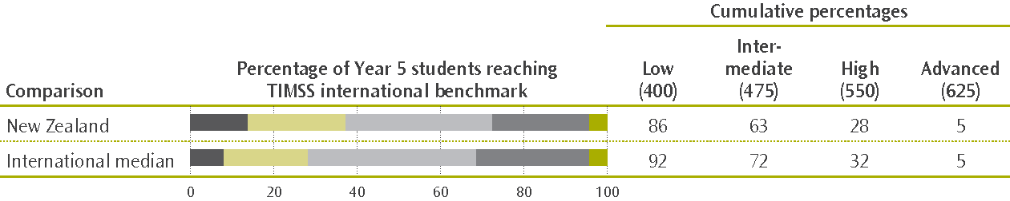
Notes
The darker grey sections on the bars represent the percentages of students who did not reach the Low International Benchmark; the lighter green represents the students reaching the Low International Benchmark but did not reach the Intermediate International Benchmark, and so on. The darker green represents the percentage reaching the Advanced International Benchmark.
The standard errors (SE) for New Zealand are not shown in the figure. They are: Low International Benchmark, 0.9%; Intermediate International Benchmark, 1.3%; High International Benchmark 1.1%; and Advanced International Benchmark 0.5%. There are no standard errors for the international medians.
Compared with many countries New Zealand Year 5 students were reasonably well-represented at the Advanced International Benchmark. However, there was a fairly wide range among countries with approximately 30% of students in Korea and Singapore at this level. Finland too had a relatively high percentage, with 20% reaching this benchmark.
At the other three benchmarks Year 5 students were not well-represented. For example, only 63% of Year 5 students achieved at or above the Intermediate International Benchmark. In half the countries at least 72% of students reached this level, with 90% or more of Finnish, Korean, and Japanese students at this benchmark (i.e., these students had basic knowledge and understanding of practical situations in the sciences).
Fourteen percent of Year 5 students did not reach the Low International Benchmark. The corresponding percentages for Finland and Australia, for example, were 1% and 9% respectively. Year 5 students not reaching this level had little knowledge of the life, physical, and Earth sciences considered appropriate for this educational level. This includes, for example, knowing simple facts related to human health, ecosystems, and the behavioural and physical characteristics of animals, and being able to interpret simple diagrams and complete simple tables.

Science achievement and ethnicity
Pākehā/European (522) tended to have higher achievement than Asian (505), Māori (455), and Pasifika (439) students. Across all ethnic groupings there were high-performing and low-performing students, with students from each grouping represented at both the higher and lower benchmarks. However, few Māori (12%) and Pasifika (9%) students compared with Asian (30%) and Pākehā/European (38%) students were reaching the higher benchmarks. There were no differences between girls’ and boys’ achievement in any ethnic grouping.

Students’ views about science
Compared to many of their international counterparts, Year 5 students’ views about science were fairly indifferent. Furthermore, they were not confident doing science and they also tended to be less engaged with their science lessons than many of their international counterparts.

Was there any change in Year 5 students’ science achievement?
Figure 11 shows the mean science scores for New Zealand Year 5 students for each TIMSS assessment. (Note that TIMSS Year 5 was deferred by one year and was administered in New Zealand in 2011 instead of 2010.) After a significant improvement from 1994/95 to 2002/03, the mean achievement at Year 5 has continued to track down to about the same as in 1994/95.
Continuing the trend observed from 2002/03 to 2006/07, there has been another significant decrease in the average achievement of Year 5 students from 2006/07 to 2010/11. This was largely due to significant decreases in the achievement of girls’ and Asian students. However, Pākehā/European students recorded the biggest decrease since 1994/95, with successive decreases since 1998/99.
Figure 11: New Zealand Year 5 science achievement results, 1994/95–2010/11
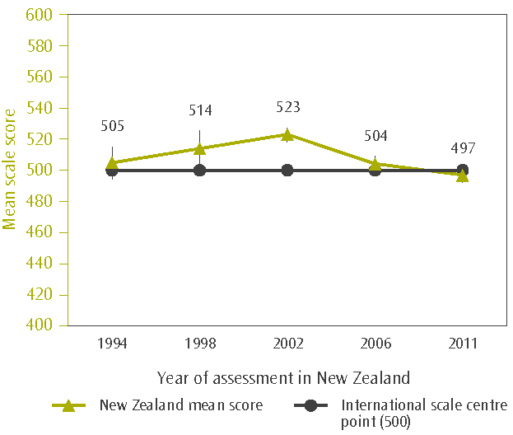
The New Zealand mean score is shown alongside the corresponding data point. The lines extending from either side of each data point represent the confidence interval around the mean (i.e., ±2  standard error).
The standard errors for the means in each assessment (1994, 1998, 2002, 2006, and 2011) are: 5.3, 5.9, 2.3, 2.6, and 2.3.
The aspects of science with the biggest decreases were the life and Earth sciences. These are traditionally areas of relative strength for Year 5 students.
There were no significant changes for Māori or Pasifika students, or for boys from 2006/07 to 2010/11, following these groups’ relatively big decreases between 2002/03 and 2006/07. Figure 12 shows the mean science scores for Year 5 students in each ethnic grouping from 1994/95 to 2010/11.

Figure 12: Trends in Year 5 students’ science achievement by ethnic grouping 1994/95–2010/11
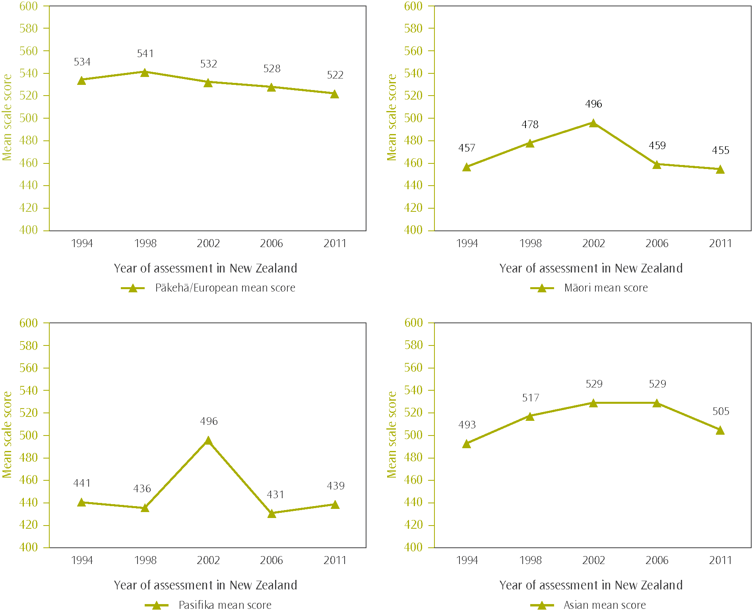

Year 9 students in an international context in 2010/11
The figure shows the mean science scores at the lower secondary level for all the countries in TIMSS. The mean for New Zealand’s Year 9 students was 512 scale score points and it was significantly higher than the centre value 500 of the lower secondary science achievement scale—the TIMSS Scale Centrepoint (see glossary of terms).
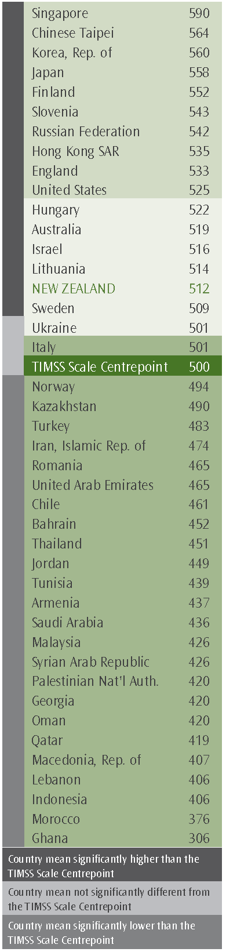
The New Zealand Year 9 science mean was:
significantly lower than the means of 10 countries, including six OECD countries—for example—Finland, Slovenia, and England
similar to the means of 6 countries, including four OECD countries—Hungary, Australia, Israel, and Sweden
significantly higher than the means of 25 countries, including four OECD countries—Italy, Norway, Chile, and Turkey.
The range of scores between New Zealand’s higher-performing students and lower-performing students was fairly typical and about the same as the ranges for England and Australia. Finland had a narrower range than the New Zealand range while the range for Singapore was wider.
Both Year 9 girls (501) and boys (522) achieved on average above the international means for girls (480) and boys (474).
Seventeen countries had no significant differences between girls and boys achievement, while 15 had differences that favoured girls, and 10, including New Zealand, with differences favouring boys.
In many countries, students tended to have an area of science that was a strength or a weakness.
- Earth science was a significant strength for Year 9 students while chemistry was a significant weakness compared to their overall performance in science.
Similarly, in many countries students tended to have a strength or weakness in one or more of the cognitive behaviours assessed.
- Year 9 students tended to be a little weaker applying their scientific knowledge, while reasoning was somewhat of a strength when compared to their overall performance. Knowledge of scientific principles and facts was neither a strength nor a weakness.

Science achievement and the lower secondary level TIMSS international benchmarks
There are four international benchmarks on the science achievement scale that have been chosen to measure types of cognitive skills and behaviours students demonstrate when answering the TIMSS science assessment questions. Associated with each benchmark are descriptions of these skills and strategies.
 | Advanced international benchmark | Students communicate an understanding of complex and abstract concepts in biology, chemistry, physics, and Earth science. Students demonstrate some conceptual knowledge about cells and the characteristics, classification, and life processes of organisms. They communicate an understanding of the complexity of ecosystems and adaptations of organisms, and apply an understanding of life cycles and heredity. Students also communicate an understanding of the structure of matter and physical and chemical properties and changes and apply knowledge of forces, pressure, motion, sound, and light. They reason about electrical circuits and properties of magnets. Students apply knowledge and communicate understanding of the solar system and Earth’s processes, structures, and physical features. They understand basic features of scientific investigation. They also combine information from several sources to solve problems and draw conclusions, and they provide written explanations to communicate scientific knowledge.
● | 625
 | High international  benchmark | Students demonstrate understanding of concepts related to science cycles, systems, and principles. They demonstrate understanding of aspects of human biology, and of the characteristics, classification, and life processes of organisms. Students communicate understanding of processes and relationships in ecosystems. They show an understanding of the classification and compositions of matter and chemical and physical properties and changes. They apply knowledge to situations related to light and sound, and demonstrate basic knowledge of heat and temperature, forces and motion, and electrical circuits and magnets. Students demonstrate an understanding of the solar system and of Earth’s processes, physical features, and resources. They demonstrate some scientific inquiry skills. They also combine and interpret information from various types of diagrams, contour maps, graphs, and tables; select relevant information, analyse, and draw conclusions; and provide short explanations conveying scientific knowledge.
○ | 550
 | Intermediate  international  benchmark | Students recognise and apply their understanding of basic scientific knowledge in various contexts. Students apply knowledge and communicate an understanding of human health, life cycles, adaptation, and heredity, and analyse information about ecosystems. They have some knowledge of chemistry in everyday life and elementary knowledge of properties of solutions and the concept of concentration. They are acquainted with some aspects of force, motion, and energy. They demonstrate an understanding of Earth’s processes and physical features, including the water cycle and atmosphere. Students interpret information from tables, graphs, and pictorial diagrams and draw conclusions. They apply knowledge to practical situations and communicate their understanding through brief descriptive responses.
 | 475
 | Low international benchmark | Students can recognise some basic facts from the life and physical sciences. They have some knowledge of biology, and demonstrate some familiarity with physical phenomena. Students interpret simple pictorial diagrams, complete simple tables, and apply basic knowledge to practical situations.
◉ | 400
 | Did not reach the Low International Benchmark
Source: Martin, Mullis, Foy, & Stanco, 2012.
Figure 13 shows the percentage of New Zealand Year 9 students reaching each TIMSS benchmark and the cumulative percentages—students who demonstrated the scientific skills and knowledge at a given benchmark also demonstrated the skills associated with the lower benchmarks. For example, the 34% of Year 9 students reaching the High International Benchmark also showed they had the scientific skills and knowledge associated with the Low and Intermediate International Benchmarks.
Figure 13: Percentage of Year 9 students reaching the TIMSS international science benchmarks in 2010/11
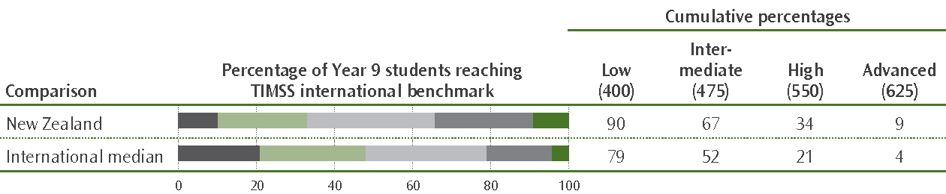
Notes
The darker grey sections on the bars represent the percentages of students who did not reach the Low International Benchmark; the lighter green represents the students reaching the Low International Benchmark but did not reach the Intermediate International Benchmark, and so on. The darker green represents the percentage reaching the Advanced International Benchmark.
The standard errors (SE) for New Zealand are not shown in the figure. They are: Low International Benchmark, 1.2%; Intermediate International Benchmark, 2.2%; High International Benchmark 2.2%; and Advanced International Benchmark 1.0%. There are no standard errors for the international medians.
Compared with many countries, New Zealand Year 9 students were reasonably well-represented at all the international benchmarks. For example, 9% of Year 9 students achieved at or above the Advanced International Benchmark double the international median. However, there was a fairly big range among countries with 40% of students in Singapore at this level, and a group of countries including England and Finland with 10–20%.
Looking at the Intermediate International Benchmark (scoring at least 475) was revealing and highlighted the range in achievement among the 15 OECD countries taking part. Finland recorded the biggest proportion (88%), and Chile (43%) the smallest. New Zealand’s 67% was about the same as that reported for Sweden (68%).
Ten percent of Year 9 students did not reach the Low International Benchmark; the corresponding percentages for Finland and Australia, for example, were 1% and 8% respectively. Year 9 students not reaching this level had difficulty with recognising some basic facts from the life and physical sciences and were not familiar with physical phenomena. They also had problems with interpreting simple pictorial diagrams, completing simple tables, and applying basic knowledge to practical situations.

Science achievement and ethnicity
Pākehā/European (533) and Asian (533) students tended to have higher achievement than Māori (466) and Pasifika (439) students. Across all ethnic groupings there were high-performing and low-performing students, with students from each grouping represented at both the higher and lower benchmarks. However, relatively few Māori students (15%) and even fewer Pasifika students (6%), were reaching the higher benchmarks compared to Asian and Pākehā/European (42% and 43% respectively).

Science achievement and gender
Year 9 girls’ mean performance in 2010/11 was significantly lower than that of Year 9 boys. Differences favouring boys were reflected in all science sub-domains, although the smallest mean difference was observed in biology. Proportionately more boys than girls also reached each of the international benchmarks. Both Pākehā/European and Māori girls generally had significantly lower science achievement than their respective male counterparts. There were no significant differences between girls and boys in either the Asian or Pasifika groupings.

Students’ views about science
Compared to many of their international counterparts in 25 countries that delivered science in an integrated science programme, Year 9 students’ views about science were fairly negative—they were less likely to enjoy science or see the value of science, as well as being less confident studying and doing science. Interestingly, they were relatively engaged during science lessons.

Was there any change in Year 9 students’ science achievement?
Figure 14 shows the mean science scores for New Zealand Year 9 students in each TIMSS assessment since 1994. Despite the apparent tracking down of Year 9 students’ science achievement there was no significant change between 2002/03 and 2010/11, with the achievement returning to about the same as the 1990s. Because New Zealand did not take part in the Year 9 component of TIMSS in 2006/07, it is not possible to look at the different domains of science where achievement may have changed.
Figure 14: New Zealand Year 9 science achievement results, 1994/95–2011
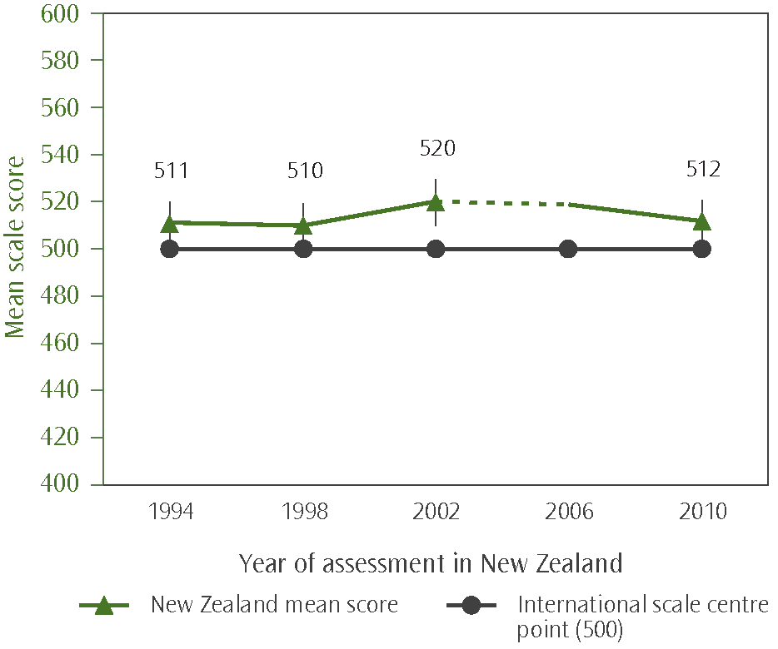
Note: The New Zealand mean score is shown alongside the corresponding data point. The lines extending from either side of each data point represent the confidence interval around the mean (i.e., ±2  standard error).
The standard errors for the means in each assessment (1994, 1998, 2002, and 2010) are: 4.9, 4.9, 5.0, and 4.6.

There were no significant changes in the mean achievement for either Pākehā/European or Asian students, or for Year 9 boys. Although there was no change in the mean for Pākehā/European students there was a slightly wider range of performance in this grouping, with proportionately more scoring higher scores (non-significant) as well as proportionately more scoring lower scores. Both Māori and Pasifika students were generally achieving at a significantly lower level than their 2002/03 counterparts.
While boys’ mean achievement did not change, girls’ mean science achievement decreased significantly from 2002/03 to 2010/11. The decrease from 515 to 501 scale score points was such that girls’ science achievement was significantly lower than that of boys, with the significant ‘gender gap’ on a par with the difference observed in 1994/95. Compared to most countries in that first cycle of TIMSS, New Zealand had one of the biggest gender differences. As Figure 15 shows, the decrease in girls’ achievement was largely due to the decreases of both Pākehā/European and Māori girls’ achievement since 2002/03.
Figure 15: New Zealand Year 9 science achievement results, 1994/95–2010/11
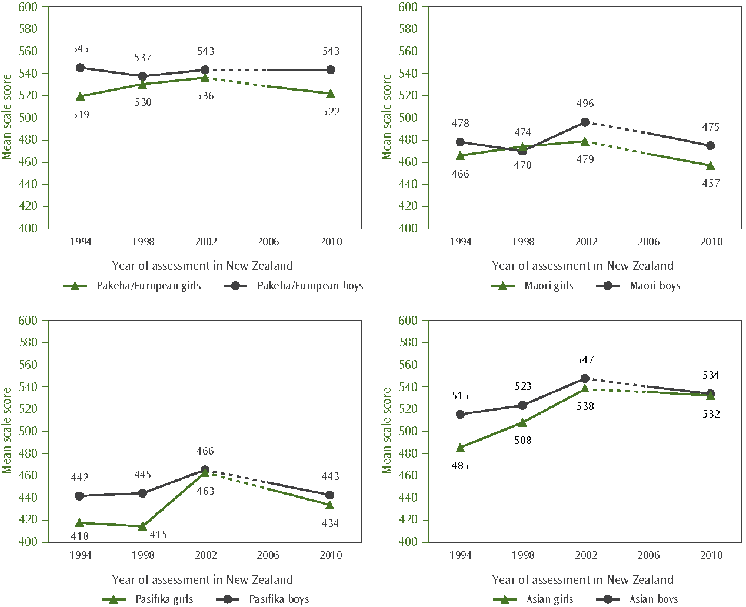

Context for learning—some highlights

To understand the context in which children are learning in school, PIRLS and TIMSS collected information from parents and caregivers, school principals, teachers, and the students in the assessments. The first approach taken to report the results from these studies, internationally and nationally, is a descriptive one where relationships or associations between a set of contextual questions (or statements) and students’ achievement are examined. In many instances the responses to the sets of questions or statements have been summarised into scales, which measure traits (e.g., student motivation) or a situation related positively to achievement. It is important to note that associations do not mean that a set of conditions necessarily cause lower or higher achievement.

Are there things about the home environment that made a difference to students’ achievement?
The home has an important role in fostering learning. Access to educational resources at home—for example—books, parent/caregiver and whānau engagement in children’s learning activities, and their attitudes to learning and to school, all play a role in supporting a child’s confidence and enjoyment in education.

Parents’ views about reading
New Zealand parents and caregivers along with Swedish and Northern Irish parents and caregivers, generally held the most positive views about reading, both as a pleasure activity and the frequency with which they read. Unfortunately, there was no equivalent information on parents’ and caregivers’ views of mathematics or science.

Starting early makes a difference
Compared with parents/caregivers in most other countries, New Zealand parents and caregivers were more likely to report that they often engaged with their child in a variety of literacy-related activities such as reading books, telling stories, singing songs, playing with alphabet or word games, and reading labels and signs aloud prior to them entering primary school. They also reported doing early-numeracy activities such as counting rhymes or singing counting songs, playing with number toys, and playing games involving shapes relatively often.

Early childhood experiences
According to the reports of parents and caregivers most of New Zealand’s Year 5 students in PIRLS had attended an early childhood education facility for more than one year before starting school (92%), with the percentage higher than their Year 5 counterparts in 2001 (83%). On average, the Year 5 students who had not attended or had only up to one year tended to have lower reading achievement than those Year 5 students who had attended longer.

Speaking the language of the test at home
It is widely acknowledged that there are significant benefits of being bilingual or multilingual, with the fostering of these skills essential if young learners are to maintain them into adulthood. However, research findings, including those from previous cycles of PIRLS and TIMSS, have shown that there are sometimes marked gaps in achievement between the learners who do not often speak the language of the assessment at home and those who speak it more often. In New Zealand the two predominant languages of instruction are English and te reo Māori, with the majority of learners in English-medium settings.
There were three sources of information about speaking the language of the assessment at home either English or Māori in PIRLS, or English in TIMSS. For the first, parents and caregivers were asked about their child’s ability to speak the test language before starting school. The second was from the learner’s perspective at the time of PIRLS and TIMSS, and the third was from principals’ perspectives in terms of the composition of their student body. Although comparisons cannot be made from source to source, the resulting information from the three sources is consistent.
In New Zealand, and particularly in reading and science, the difference in achievement between learners who frequently speak the language of the test, mostly English, and those who rarely speak it was relatively large when compared with countries such as Australia, Canada, and England where there were similar proportions of their students who reported rarely speaking the test language at home.

Socio-economic impact
Children’s access to resources at home was examined internationally. Although New Zealand features very positively in terms of the percentage of students in homes with many resources, the difference in achievement between middle primary students from households with many resources and those with fewer resources was wider than in many other countries, including Australia and Canada. While the achievement differences were still very marked at the lower secondary level, they were similar to the differences for Australia and England, and bigger than those observed in Norway and Sweden.

What aspects of the school environment are related to students’ achievement?
Compared to many countries, New Zealand principals did not see shortages in resources to support reading and mathematics as affecting instruction in their schools. However, shortages of science resources, particularly in primary schools, tended to be viewed as being somewhat of an impediment to supporting science instruction. New Zealand learners were also more likely to be attending schools where both their principals and teachers endorsed aspects of ‘academic optimism’, whereby they shared a common view of academic success through their understanding of the school’s curricular goals, implementation of the school’s curriculum, and expectations for student achievement.
Collaboration among teachers was also looked at in both PIRLS and TIMSS; it was viewed as integral to creating a learning environment which focussed on academic success. Because of the different concepts around collegiality and collaboration, in the international context information from teachers on collaboration was sought from the perspective of improving teaching—discussions on how to teach particular topics, planning and preparation of instructional material with colleagues, sharing of teaching experiences, visiting other classrooms, and working together to try out new ideas. The majority of learners in New Zealand and in many other countries were being taught by teachers who worked either collaboratively or very collaboratively. New Zealand middle primary school learners were more likely to have been taught by very collaborative teachers than many of their international counterparts, while Year 5 teachers were more likely to use very collaborative approaches than their Year 9 colleagues. Interestingly, Year 9 science teachers were also more likely than their Year 9 mathematics counterparts to be very collaborative when working with their colleagues. Neither study asked explicitly about collaborative practices between schools.
New Zealand teachers were also generally positive about their schools being a safe place for working (in relation to the location of the school, feeling safe at school, security policies and practices, and students being respectful towards teachers) although teachers in, for example, Northern Ireland, Ireland and Australia were a little more positive than New Zealand teachers.
On a negative note, Year 5 students’ experiences of bullying behaviours were relatively more frequent compared with their counterparts in many other countries during 2010 and 2011. Despite these negative experiences, Year 5 students were generally very positive about their school life and towards learning. Compared to their international counterparts Year 9 students were less likely to have experienced the bullying behaviours, but whereas their primary school counterparts were positive, they tended to be more indifferent towards school.

Socio-economic impact
The economic background of students within schools is an important characteristic to consider when making comparisons across schools. Principals in all countries were asked to provide an estimation of the proportions in their schools from both economically disadvantaged backgrounds and from economically affluent backgrounds. When applying the international measure to the New Zealand context, deciles 1 and 2 schools and to a lesser extent deciles 3 and 4 schools had the greatest concentration of students from economically disadvantaged backgrounds, while decile 9 and 10 schools had the greatest concentration of students from economically advantaged backgrounds.
From an international perspective, the achievement differences between New Zealand primary schools according to their economic composition—the mix of students from economically affluent backgrounds and those from economically disadvantaged backgrounds—were very high compared to many other countries, and in all three learning areas. The differences in achievement were somewhat smaller among New Zealand schools with Year 9 students.
Principals across countries were also asked to estimate the percentage of their intake having early literacy and numeracy skills. While international comparisons were difficult because of the varying school starting ages, what was clear for New Zealand, was that Year 5 student achievement tended to be lower in schools where proportionately few of the intake did not have the pre-requisite skills than in schools where more of the intake had the skills. The student intake of lower decile schools, particularly deciles 1 and 2 schools, was less likely to have early literacy and numeracy skills when beginning primary than higher decile schools, particularly deciles 9 and 10 schools.

What did PIRLS and TIMSS say about the classroom?
Information collected from teachers included their demographic and education background, the number of students in their classes, the time they allocated to teach reading, mathematics and science, how classes were organised for teaching, and their perceptions and beliefs about mathematics and science and teaching in general

Hours of instruction
It is generally difficult to examine the direct effect of instructional time on student achievement because of influencing factors such as the quality of the curriculum and instructional approaches and all the variables that influence them. However, instructional time does provide an indication of the instructional opportunities for student learning. Based on responses from both teachers and school principals, New Zealand schools spent the fourth highest number of hours on average (actual and as a proportion of total instructional hours) during the year on teaching reading (formally and informally). Only the United States, Slovak Republic, and Portugal spent more hours.
At the middle primary level, New Zealand schools also tended to spend a relatively high number of hours (actual and as a proportion of total instructional time) teaching mathematics—168 hours on average in 2010/11 and more on average than the 148 hours in 2006/07. In science the picture was markedly different; New Zealand schools spent relatively few hours teaching science—52 hours per year on average (or 6% of instructional time) compared to 85 hours on average internationally (or 10% of instructional time).
At the lower secondary level, the number of instructional hours per year for mathematics (on average 141 hours) was middle of the range with Sweden recording just 97 hours and Chile, the highest at 193 hours.
For science, the picture is a little more complex at the lower secondary level because in many countries the domains of science are taught as separate subjects—physics, chemistry, and biology (e.g., Finland and Sweden). New Zealand schools, like schools in Australia and England, deliver the science curriculum through a general (integrated) programme. Across countries, there was a very wide variation in the proportion of time allocated to science. The mean proportion of instructional time allocated to Year 9 science (14%) in New Zealand schools was closer to the international mean for countries that delivered an integrated science programme (15%).

Classroom organisation and instructional practices
Educational studies often find it difficult to link student achievement directly to teachers’ instructional practices and activities, although such information can be very insightful. For example, information reported by teachers in PIRLS shows that middle primary school teachers tend to use a variety of organisational approaches when teaching reading. However, in New Zealand the single organisational approach most likely to be used ‘almost always’ by teachers is to arrange Year 5 students into same-ability groups. Teaching reading as a whole-class activity was an approach often used (but not always) by teachers in many countries, including those in Canada, Australia, and Ireland, but virtually never used by New Zealand teachers in reading. There was a similar situation when teaching mathematics at the primary level.
While not quite as marked as in middle primary school, at the lower secondary level New Zealand mathematics teachers also tended to use whole class teaching less often than many of their international counterparts. In science no information was obtained about class organisation approaches.
In the most recent PIRLS and TIMSS there has been an attempt to better understand the factors that interact with teachers’ practice and delivery of the curriculum. One of these is student content engagement (from both teacher and student perspectives). According to information provided by teachers, from an international perspective
New Zealand teachers tended to use ‘engagement’ practices with their Year 5 students less often than many countries including England, Australia, and Canada. However, New Zealand teachers’ reports were similar to reports of teachers in Sweden, Norway, and Finland.

Use of investigations and experiments in science
New Zealand teachers of both Year 5 and Year 9 students give less emphasis to conducting experiments and scientific investigations during science lessons compared to many of their international counterparts. At the middle primary level, this may in fact be related to the small amount of time actually spent on science instruction at the middle primary level. At Year 9, this finding is consistent with similar information reported on in 2002/03.

Use of computers in reading, mathematics, and science
Compared to all other countries, New Zealand stood out as most likely to have computers available for use during science at Year 5. Year 5 students were mostly using them to look up information. They were also used during reading lessons mainly to look up information and for reading online stories and other types of texts.

Confidence of teachers
Relative to many of their international counterparts, teachers of Year 5 students were not confident teaching mathematics and science to their students. In sharp contrast, Year 9 teachers of mathematics and science were relatively confident teaching in their respective disciplines compared to their international counterparts.

Factors impeding instruction
Teachers were asked the extent to which certain factors limited their ability to teach their students. These factors included their students’ lack of pre-requisite knowledge, basic nutrition and not having enough sleep, and having disruptive and uninterested students. Compared to teachers in many other developed and/or OECD countries, New Zealand middle primary teachers were more likely to hold the view that their ability to teach was impeded by their Year 5 students’ lack of pre-requisite knowledge, basic nutrition, and lack of sleep, more so than having disruptive and uninterested students. Year 9 teachers did not view these factors as impediments to quite the same extent as Year 5 teachers.

Comment

This summary has touched on some of the key findings from the latest cycles of PIRLS and TIMSS, with both studies providing snapshots of, and trends in, student achievement. In summing up, at best the achievement in the three learning areas has remained static, with no positive shift in student achievement since the early 2000s. In addition, there are worrying signs of declining performance in middle primary school science and to a lesser extent mathematics.
There are some positive findings. For example, New Zealand schools on the whole provide learning environments that encourage academic success, with school leaders and teachers sharing the same curricular goals and aspirations for their students. On the whole middle primary school learners are positive about school and learning in general.
New Zealand middle primary and lower secondary students exhibited strengths in their ability to reason and to apply their learning. These strengths of New Zealand students have also been highlighted in the Programme for International Student Assessment (PISA), conducted among 15–year–olds. PISA focuses on students’ ability to apply their knowledge and skills in real-life settings and generally New Zealand students achieve very well. Finland also performs very well in PISA. As this report shows Finland is a system that also performs well in ‘curriculum-based’ studies such as TIMSS where its students demonstrate a high level of mathematical and scientific content knowledge, and well-developed cognitive skills and behaviours at both the middle primary and lower secondary levels, and in PIRLS where its students demonstrated highly-developed reading comprehension skills and reasoning abilities at the middle primary level. In addition, in Finland the range of reading scores among students is relatively narrow (an indicator of higher equity), whereas in New Zealand the range is much wider (an indicator of lower equity).
PIRLS and TIMSS have highlighted the fact that there are significant proportions of New Zealand students who at Year 5 have difficulty with locating and retrieving explicitly-stated information from a story or article; adding and subtracting whole numbers and, recognising some geometric shapes; and demonstrating knowledge of simple facts related to human health, ecosystems, and the behavioural and physical characteristics of animals. While the gaps in knowledge and skills for some students will close as they move through school, as TIMSS shows at Year 9 there are still students who have difficulty with the very basics such as knowledge about whole numbers and decimals, and recognising some basic facts from the life and physical sciences considered appropriate internationally for this educational level.
There are challenges for the New Zealand education system—while an individual learner’s socio-economic background need not be a barrier to achieving, there are significant number of schools that are presented with challenges associated with the composition of their student body being from predominately economically disadvantaged backgrounds and their student intake not having the necessary early literacy or numeracy skills, or language skills when beginning school. Students’ self confidence in all three learning areas and the value they place on and engagement with mathematics and science is also of some concern.
Finally, it is recommended that the findings presented here are not viewed in isolation and readers refer to the national reports as they become available and the international publications for more detail.

Why participate in international studies
Although it is often assumed that the international studies are only useful for international benchmarking purposes, the real value of PIRLS and TIMSS lies in its ability to provide a rich picture of reading, mathematics and science achievement within the New Zealand context and over time.
PIRLS and TIMSS (along with other international assessment studies) can provide information about the performance of the New Zealand education system at the national level and in a global context. The information from these studies is used in the development and review of policy frameworks and also to inform and improve teaching practice. Developments arising out of previous cycles of TIMSS for example include resource materials for schools and teachers along with teacher in-service training programmes.

Who conducted PIRLS and TIMSS?
PIRLS and TIMSS are co-ordinated by the International Association for the Evaluation of Educational Achievement (IEA). As with all previous assessment cycles, the International Study Centre at Boston College’s Lynch School of Education in the United States managed the international coordination of both studies in 2010/11. The other key partners involved were: the IEA’s Secretariat (Amsterdam, the Netherlands); the IEA’s Data Processing and Research Centre (Hamburg, Germany); Statistics Canada (Ottawa, Canada); and the Educational Testing Service (at Princeton, New Jersey, United States).
The Ministry of Education’s Comparative Education Research Unit is responsible for all aspects related to PIRLS and TIMSS in New Zealand

Would you like more information?
All international reports are available on http://timssandpirls.bc.edu/

PIRLS international reports
Mullis, I. V. S., Martin, M. O., Foy, P., & Drucker, K. T. (2012). PIRLS 2011 international results in reading. Chestnut Hill, MA: TIMSS & PIRLS International Study Center, Boston College.
Mullis, I. V. S., Martin, M. O., Minnich, C. A., Drucker, K. T., & Ragan, M. A. (Eds.). (2012). PIRLS 2011 encyclopedia: education policy and curriculum in reading (volumes 1 and 2). Chestnut Hill, MA: TIMSS & PIRLS International Study Center, Boston College.

TIMSS international reports
Martin, M. O., Mullis, I. V. S., Foy, P., & Stanco, G. M. (2012). TIMSS 2011 international results in science. Chestnut Hill, MA: TIMSS & PIRLS International Study Center, Boston College.
Mullis, I. V. S., Martin, M. O., Foy, P., & Arora, A. (2012). TIMSS 2011 international results in mathematics. Chestnut Hill, MA: TIMSS & PIRLS International Study Center, Boston College.
Mullis, I. V. S., Martin, M. O., Minnich, C. A., Stanco, G. M., Arora, A., Centurino, V. A. S., & Castle, C .E. (Eds.). (2012). TIMSS 2011 encyclopedia: education policy and curriculum in mathematics and science (volumes 1 and 2). Chestnut Hill, MA: TIMSS & PIRLS International Study Center, Boston College.

International technical report
Martin, M. O., & Mullis, I. V. S. (Eds.). Methods and procedures in TIMSS 2011 and PIRLS 2011. http://timssandpirls.bc.edu/

Glossary of terms used in this summary

Mean
The achievement of students (or percentage with a particular attribute) is summarised for the population or for sub-populations using the statistic referred to as the mean (which is a type of average). The mean is calculated by summing up all the scores (or percentages) and dividing by the total number of students or observations. All the means reported for PIRLS and TIMSS are adjusted (or weighted) so they reflect the total population for which inferences are being made (e.g., Year 5s or Year 9s). The mean scores (or the differences between means) for some sub-populations appear either in parentheses in the text or in the graphics.

International mean
In some instances reference is made to the international mean. This is obtained by summing the mean achievement scores or proportions for each of the participating countries and dividing by the number of countries. For example, the international reading mean for girls is calculated by summing up the mean scores for girls for all countries and then dividing by the number of countries.

Median
The median is another form of the average. It is the value separating the higher half of a sample or population from the lower half. It can be found by arranging all the observations from lowest value to highest value (e.g., the lowest percentage to the highest percentage) and then selecting the middle value.

Range
The range refers to the difference between the highest value and the lowest value of a set of numbers or percentages (e.g., the difference between the highest reading score and the lowest reading score). In PIRLS and TIMSS the range in achievement is often reported by using the
difference between the 5th and 95th percentiles and provides a measure of the spread of achievement. The 5th percentile is the lowest outer limit corresponding to the score at which only 5% of students achieved a lower score and 95% achieved a higher score. The 95th percentile is the highest outer limit corresponding to the score at which only 5% of students achieved a higher score and 95% a lower score. Ninety percent of students’ achievement scores are then between the 5th and 95th percentiles.

Standard Error
A mean or a proportion is usually reported along with its standard error, a measure of how confident we can be with the statistic being reported. In PIRLS and TIMSS the calculation of the standard errors is not straightforward as it reflects the uncertainty due to working from a sample AND the assessment design whereby students were assigned different subsets of items. The standard errors are not shown for all the countries, however in most instances they are reported with the national statistics.

Significantly different
Throughout this report, when a comparison or difference between two statistics is said to be significantly different then this refers to the difference being statistically significantly different. Statistical tests have been undertaken using the difference between two statistics (e.g., two means) and the resulting standard error of the difference to determine whether or not one statistic is different from another. The significance level (or the ‘alpha level’) for making the comparison is set at 0.05—the probability of there not being a difference is 5 percent.
PIRLS Scale Centrepoint
The PIRLS reading achievement scale was established in the first cycle—PIRLS 2001. The average (mean) of the country means of 500 and a standard deviation of 100 was set and remains constant from assessment to assessment. In previous assessment cycles it was referred to as the PIRLS Scale Mean. The new nomenclature refers to the fact that the achievement scale uses the same point of reference–500–from assessment to assessment, and in the case of PIRLS it relates to the original 2001 cycle. If the international mean was used in each cycle (i.e., averaging the country means) then this statistic would change from assessment to assessment as the number and characteristics of participating countries changed. This would result in unreliable estimates of changes in achievement over time. (Also see explanation of the international mean)

TIMSS Scale Centrepoint
The TIMSS achievement scales were first established in 1994/95. As the number of countries joining TIMSS changed, especially from 2002/03 onwards, adjustments had to be made to the scales to bring them in line with the approach taken with PIRLS. It also meant that better reliable trend estimates could be made. Each of the four TIMSS scales also has a mean of 500 and a standard deviation of 100, which remain constant from assessment to assessment. The achievement scales from the assessments in the 1990s have been adjusted too so that trends can be measured across all cycles. In 2006/07, the TIMSS Scale Centrepoint was referred to as the TIMSS International Average or the TIMSS Scale Mean.

OECD countries
There are 34 member countries of the Organisation for Economic Cooperation and Development, the OECD. Twenty-eight OECD countries took part in either PIRLS or TIMSS (see list of participating countries at the back of this report). The OECD countries that did not take part were Estonia, Greece, Iceland, Luxembourg, Mexico, and Switzerland.
The United Kingdom (England, Northern Ireland, Scotland, and Wales) has single membership of the OECD, but Scotland and England each have their own membership of the IEA. England and Northern Ireland data is combined as one OECD country for any comparisons against OECD countries.
Belgium is also an OECD country but the French and Flemish systems of Belgium each have their own membership of the IEA. Belgium (French) took part in PIRLS and Belgium (Flemish) took part in TIMSS. For the purpose of making comparisons with OECD countries each system in each study is counted as an OECD country.

Countries in PIRLS and TIMSS in 2010/11*
 | Country | PIRLS | TIMSS middle primary | TIMSS lower secondary
 | Armenia |  |  | 
 | Australia |  |  | 
 | Austria |  | 
 | Azerbaijan |  | 
 | Bahrain |  |  | 
 | Belgium (Flemish) |  | 
 | Belgium (French) | 
 | Bulgaria | 
 | Canada | 
 | Chile |  |  | 
 | Chinese Taipei |  |  | 
 | Colombia | 
 | Croatia |  | 
 | Czech Republic |  | 
 | Denmark |  | 
 | England |  |  | 
 | Finland |  |  | 
 | France | 
 | Georgia |  |  | 
 | Germany |  | 
 | Ghana |  |  | 
 | Hong Kong SAR |  |  | 
 | Hungary |  |  | 
 | Indonesia |  |  | 
 | Iran, Islamic Rep. of |  |  | 
 | Ireland |  | 
 | Israel |  |   | 
 | Italy |  |  | 
 | Japan |  |  | 
 | Jordan |  |  | 
 | Kazakhstan |  |  | 
 | Korea |  |  | 
 | Kuwait |  | 
 | Lebanon |  |  | 
 | Lithuania |  |  | 
 | Macedonia |  |  | 
 | Malaysia |  |  | 
 | Malta |  | 
 | Morocco |  |  | 
 | Netherlands |  | 
 | New Zealand |  |  | 
 | Northern Ireland |  | 
 | Norway |  |  | 
 | Oman |  |  | 
 | Palestinian Nat'l Auth. |  |  | 
 | Poland |  | 
 | Portugal |  | 
 | Qatar |  |  | 
 | Romania |  |  | 
 | Russian Federation |  |  | 
 | Saudi Arabia |  |  | 
 | Serbia |  | 
 | Singapore |  |  | 
 | Slovak Republic |  | 
 | Slovenia |  |  | 
 | Spain |  | 
 | Sweden |  |  | 
 | Syrian Arab Republic |  |  | 
 | Thailand |  |  | 
 | Trinidad and Tobago | 
 | Tunisia |  |  | 
 | Turkey |  |  | 
 | Ukraine |  |  | 
 | United Arab Emirates |  |  | 
 | United States |  |  | 
 | Yemen |  | 
* Excludes countries which assessed Grade 6 students, benchmarking participants, and prePIRLS participants
 OECD member country
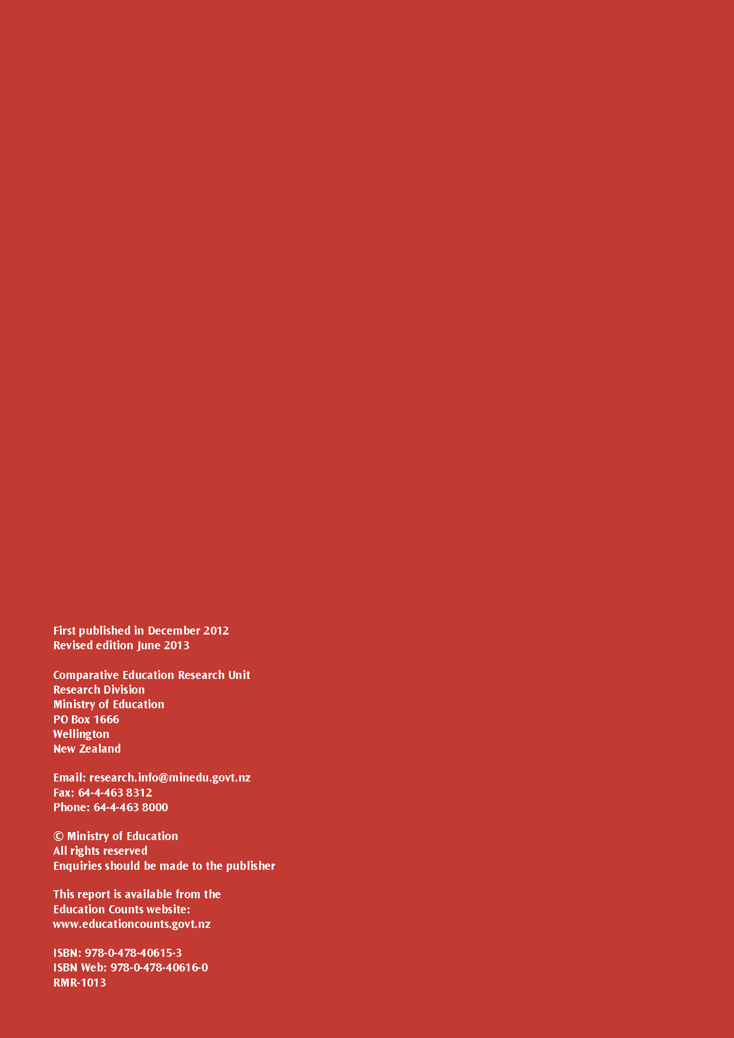

There were some exceptions to this. For example, children with an intellectual disability, less than 1 or 2 years in the language of instruction, a physical disability which would prevent them taking the assessment, or parents who did not wish their child to participate.
Where the curriculum was delivered in classes or schools for 81–100% of the time.
There are no comparable figures for 2001.
The survey for parents/caregivers was administered only to the parents/caregivers of Year 5 students. The response rate to the survey for New Zealand was about 60 percent. Despite the lower response rate, the information is consistent with previous cycles of PIRLS and with PISA (Programme for International Student Assessment).
At the primary level the information was sourced from both parents (highest education, occupation, children’s books) and students (number of books in the home, internet connection, their own bedroom). At Year 9, the information is sourced from just the students.
A comparison of students in ‘schools with more than 25% of the student body from economically affluent homes and 25% or fewer from disadvantaged homes’ with ‘schools with more than 25% of students coming from economically disadvantaged homes and 25% or fewer coming from economically affluent homes’ and ‘schools with neither more affluent nor more disadvantaged students’.
To use engaging practices in ‘most lessons’, teachers had to have used any three of the six practices almost every lesson. These practices were: summarising what was to be learnt from the lesson, relating the lesson to students’ daily lives, using questioning to elicit reasons and explanations, encouraging all students to improve performance, praising for good effort, and bringing interesting materials to class.
The term ‘curriculum-based’ refers to the conceptual model underpinning the IEA studies—the intended, implemented, and attained curriculum where ‘curriculum’ is the major organising concept in considering how educational opportunities are provided to students and the factors that influence how students use these opportunities.

