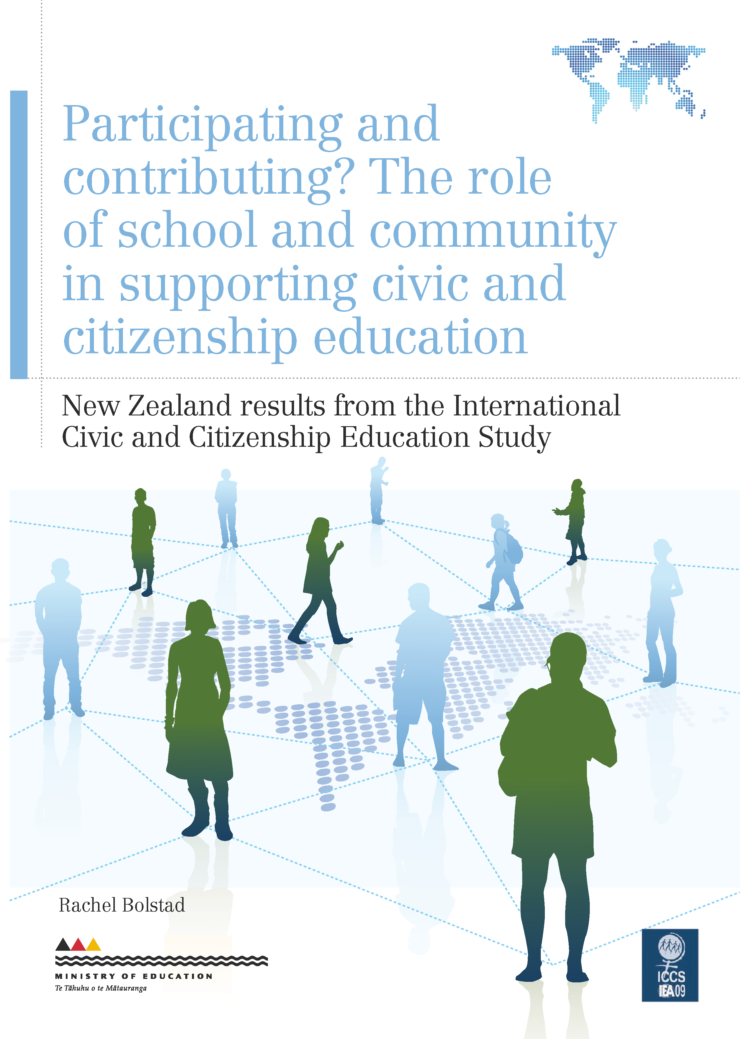
<storyname=ICCSv4_2>
PARTICIPATING AND CONTRIBUTING? THE ROLE OF SCHOOL AND COMMUNITY IN SUPPORTING CIVIC AND CITIZENSHIP EDUCATION
<storyname=ICCSv4_5>

<storyname=ICCSv4_64>
Participating and
contributing? The role
of school and community
in supporting civic and
citizenship education
<storyname=ICCSv4_3>
New Zealand results from the International Civic and Citizenship Education Study
<storyname=ICCSv4_13>
PAGE
<storyname=ICCSv4_14>
<pn>
<storyname=ICCSv4_4>
Rachel Bolstad
<storyname=ICCSv4_1>
PARTICIPATING AND CONTRIBUTING? THE ROLE OF SCHOOL AND COMMUNITY IN SUPPORTING CIVIC AND CITIZENSHIP EDUCATION
<storyname=ICCSv4_25>

<storyname=ICCSv4_11>

Acknowledgements
The International Civic and Citizenship Education Study (ICCS) was a collaborative effort internationally and nationally. Many people were involved in the project and it is not possible to thank them all individually, but it is important to acknowledge key groups of people.
This study was made possible by the cooperation of the schools, teachers and students who took part. Thanks to these participants, we now have a valuable resource about civic and citizenship education in
New Zealand.
Thanks also to the members of the Research Division and other Ministry of Education staff who contributed to the successful planning and implementation of ICCS. In particular, Kate Lang and Sharon Cox were the ICCS National Research Coordinators, Paul Satherley used his expertise to extract the data we requested from the national ICCS database, and Jit Cheung managed interactions between the Ministry of Education and the New Zealand Council for Educational Research (NZCER). Jit and Paul also took care of the reviewing, editing and publishing of this report.
At NZCER, Edith Hodgen and Rachel Dingle managed the flow of data, produced the graphic data summaries and provided quality assurance for the statistical analyses. The report could not have been produced in this form without their acumen and expertise.
Rachel Bolstad,
Senior Researcher,
New Zealand Council for Educational Research

Summary
This report is the fourth in a series based on the International Civic and Citizenship Education Study (ICCS), which was undertaken in New Zealand in 2008. It focuses on the role of the school and the community in civic and citizenship education.
Civic and citizenship education is a topic embedded in the principles, values and key competencies of The New Zealand Curriculum (NZC). Although New Zealand took part in ICCS before NZC was mandated in 2010, the findings are relevant to current civic and citizenship teaching and learning. The participating and contributing key competency and the community and participation for the common good value of NZC are particularly relevant to the findings of this report.
ICCS shows that principals and teachers of Year 9 students see civic and citizenship education as having broad aims. They are likely to select promoting students’ critical and independent thinking as one of the most important aims. In addition, they view the school experience as a whole to be a significant factor in developing students’ civic and citizenship competencies, even though civic and citizenship education has a particular focus in social studies and related subjects.
Principals were asked about student participation in the co-curriculum — those activities undertaken in the school environment, but beyond formal classroom teaching and learning. Students’ co-curricular participation largely comprised sports and cultural activities, with fundraising and engagement with communities on social or environmental issues less common.
Most schools had some form of student representation, with students able to elect peers on school councils or boards of trustees. However, staff and students were likely to have different views on the extent to which student opinion is taken into account. Students were much less likely to think their views were considered on extra-curricular activities and classroom and school rules.
Most students believed they could express a range of opinions in their classrooms, and teachers thought so too. However, teachers were very unlikely to report that most of their Year 9 students suggest class activities, propose topics for discussion or negotiate learning objectives with the teacher.
Year 9 teachers address civic and citizenship education largely through exploring different perspectives on issues. They focus more on social justice issues such as gender equity and care for the environment, and less on civic institutions.
Most Year 9 students (60%) stay informed about political and social issues through watching television, but other ways are much less common. Nearly half of Year 9 students had been involved with collecting money for a social cause, and other types of involvement with social, political, cultural or religious groups were less common. The 2008 general election took place during the period of data collection in New Zealand, and this is likely to have influenced students’ responses to some questions, particularly those relating to political issues.
Civic and citizenship education literature indicates that there is a wide range of ideas about citizenship. Some authors identify at least three quite different views of what a “good” citizen should be: the personally responsible citizen, the participatory citizen or the justice-oriented citizen. The ICCS findings indicate that the practice in New Zealand Year 9 classes aligns most with the personal responsibility and, to a lesser extent, the participatory models of citizenship. ICCS found less evidence that justice-oriented citizenship is a widespread goal of civic and citizenship education in New Zealand schools.

Table of Contents
Summary 3
1. Citizenship competencies and the New Zealand Curriculum 9
2. Schools’ aims for civic and citizenship education 11
3. How civic and citizenship education fits into the school curriculum 15
4. Opportunities for civic and citizenship development in co-curricular activities 17
5. Students’ input into school decision-making 20
6. Civic and citizenship learning in classrooms (all subject areas) 25
7. Civic and citizenship education in Year 9 social studies classrooms 28
8. Civic and citizenship development opportunities in the home and community 32
9. Conclusion 36
References 39
Countries participating in ICCS 40

List of Tables
Table 1: New Zealand teachers’ views of what is important in civic and citizenship education, in relation to other ICCS countries 12
Table 2: Teachers’ reports as to whether their Year 9 students have taken part in these activities in the current school year (teacher survey) 18
Table 3: Areas of disagreement between principals and students from the same schools 23
Table 4: Three kinds of citizen1 37

List of Figures
Figure 1: Schools’ most important aims for civic and citizenship education
(Principal Survey) 11
Figure 2: How civic and citizenship education is offered to Year 9 students
(Principal Survey) 15
Figure 3: Who should have the greatest responsibility for civic and citizenship education at school (Teacher Survey)? 17
Figure 4: Student opportunities to participate in various co-curricular activities in school
(Principal Survey) 20
Figure 5: Teachers’ own civic and citizenship activities (Teacher Survey) 19
Figure 6: Students’ opportunities to elect student representatives (Principal Survey) 21
Figure 7: Students’ opportunities to elect student representatives in relation to other opportunities (Student Survey) 21
Figure 8: Students’ and principals’ views about the degree to which student opinion is taken into account 22
Figure 9: Students’ views about the value and potential of student participation in their schools (Student Survey) 24
Figure 10: What happens during class discussions of social or political issues
(Student Survey)? 26
Figure 11: What do students do in your Year 9 lessons (Teacher Survey)? 27
Figure 12: Activities that occur during Year 9 social studies lessons (Teacher Survey) 28
Figure 13: Resources teachers use to plan civic and citizenship-related topics
(Teacher Survey) 29
Figure 14: Teachers’ confidence to teach civic and citizenship topics (Teacher Survey) 30
Figure 15: Ways civic and citizenship education could be improved (Teacher Survey) 30
Figure 16: Staying informed about political and social issues at home (Student Survey) 32
Figure 17: Students’ involvement in social, political, cultural and religious groups and organisations (Student Survey) 34
Introduction
This is the fourth in a series of reports from the International Civic and Citizenship Education Study (ICCS) undertaken in New Zealand in 2008. This report investigates the role of the school and community in civic and citizenship education. It looks at how Year 9 students experience civic and citizenship education in the school curriculum, and the opportunities students have to develop citizenship competencies through participating and contributing to various aspects of school life. This includes co-curricular activities, which are those undertaken in the school environment but beyond formal classroom teaching and learning. It also includes decision-making about how things happen in their school. The role of home and the community is also discussed.
The first report, published in 2010, is called What do New Zealand students understand about civic knowledge and citizenship? (Lang, 2010). It reports on New Zealand students’ level of civic knowledge relative to other nations that took part in the study.
The second report, published in 2011, is called What do our students think about New Zealand, democracy and freedom? (Satherley, 2011). The focus of this second report is on the views of Year 9 students about New Zealand and its institutions, and about issues of democracy, freedom, equal rights and religion within the context of civic and citizenship education.
The third report, New Zealand students’ intentions towards participation in democratic processes (Hipkins, 2012) focuses on students’ perceptions of responsible adult citizenship and their current interests and abilities with respect to a range of citizenship behaviours and competencies. The students were also asked to look to their futures and say which of a range of social and political activities they will be most likely to participate in when they
are adults.
What is ICCS?
New Zealand is one of 38 countries that took part in ICCS, which is sponsored by the International Association for the Evaluation of Educational Achievement (IEA). ICCS is an international standardised study that looks at the ways in which young people are prepared to undertake their roles as citizens. It measures students’ knowledge and understanding of civic systems and citizenship issues, as well as student attitudes, perceptions and activities relating to civics and citizenship. It also looks at differences among countries in relation to the outcomes of civic and citizenship education and how these differences relate to student, school and community backgrounds.
What can we find out from this study?
Civic knowledge is broadly defined in ICCS as knowledge and understanding of:
›› civic education — the formal institutions and processes of civic life, such as voting in elections
›› citizenship education — how people participate in society, and how citizens interact with and shape their communities and societies.
ICCS measured student perceptions and behaviours relating to civics and citizenship in four domains — value beliefs, attitudes, behavioural intentions, and behaviours. This includes attitudes, views, dispositions and future intentions that relate to participation in civic society, democracy, rights and responsibilities, trust in institutions, and the roles of institutions. An understanding of young people’s civic and citizenship attitudes, views and future intentions would seem to be important for the future working of society. It also provides an important backdrop to measured civic knowledge.
Who took part?
During 2008/09 approximately 140,000 students around 14 years of age and 62,000 teachers in over 5,300 schools from 38 countries around the world participated in ICCS. In New Zealand almost 4,000 Year 9 students, 1,350 teachers and 123 principals from 146 schools took part in the study in November 2008. A representative sample of English-medium New Zealand schools with Year 9 students was selected. The student sample was representative of their Year 9 peers.
Data collection in New Zealand took place close to the 2008 general election, and this is likely to have influenced students’ responses to some questions.
What information was collected?
Each student completed a 40-minute questionnaire about their background and their attitudes, values and behaviours in relation to civics and citizenship. Each student also completed one of seven test booklets in a 45-minute cognitive test. The ICCS assessment framework covered the content domains of civic society and systems, civic principles, civic participation and civic identities.
Teachers answered questions about their perceptions of civic and citizenship education (CCE) in their schools, school organisation and culture, and teaching practices. Principals provided information about their school — characteristics, culture and climate — and the provision of CCE at their school. ICCS also surveyed countries about the structure of their education system, CCE in the curriculum and recent developments in CCE.
Useful resources
The first New Zealand ICCS focus report (Lang, 2010) looked at the key civic knowledge dimension. The second report (Satherley, 2011) focused on students’ views about New Zealand and its institutions, and about issues of democracy, freedom, equal rights and religion within a context of civic and citizenship education. The third report (Hipkins, 2012) focused on students’ perceptions of responsible adult citizenship and their current interests and abilities with respect to a range of citizenship behaviours and competencies.
The ICCS international reports can be accessed from New Zealand’s ICCS webpage at www.educationcounts.govt.nz/goto/iccs. The international database is accessible for public use on the IEA’s data repository at http://rms.iea-dpc.org/.
Technical notes
Statistical significance and standard errors
Because ICCS used scientific statistical sampling methods to obtain a representative sample of the population of Year 9 students, it is possible to calculate the standard errors of the proportions and averages presented in this report. However, we have chosen not to highlight them in the text and graphs in order to focus on overall patterns.
Student, teacher and principal surveys
This report uses ICCS information derived from three separate populations: students, principals and teachers.
Each selected Year 9 student completed a background questionnaire (as well as a civics knowledge test), which sought information on their home and family, their views on political and social issues, and their activities at school, outside of school and in the future. Principals completed a questionnaire about the school environment, the local community, civic and citizenship education at the school, and school size and resources.
A sample of teachers in the selected schools who taught Year 9 students completed a questionnaire which sought information on the teachers’ teaching subjects, age and responsibilities, views and behaviour about teaching approaches, decision-making, school climate, and aims for civic and citizenship education. Those teachers who taught Year 9 social studies went on to answer questions about social studies teaching resources, activities and assessment, and their confidence in teaching social studies topics.
The student sample is representative of New Zealand Year 9 students learning in English medium; the principal sample is representative of English-medium schools where Year 9 students are enrolled; the teacher sample is representative of teachers who teach Year 9 students in English medium. This means we can relate principals’ answers to the students’ answers across schools, but we cannot relate teachers’ answers directly to students’ answers because the selected teachers are not necessarily teachers of the selected students.
Graphs
Graphs in this report show proportions of students along a horizontal axis that has a zero midpoint, which represents a neutral position. Proportions agreeing are to the right of the zero midpoint and proportions disagreeing are to the left. Numerical values less than 5% are not shown on the graphs because the bars are too small.
Graphs and tables identify whether the data come from the student, principal or teacher questionnaires.
In some cases, proportions may not sum to exactly 100% because of rounding.

1. Citizenship competencies and the New Zealand Curriculum
Every English-medium school needs to design a local curriculum based on The New Zealand Curriculum (NZC). The knowledge, skills and dispositions addressed by the ICCS study are in harmony with the principles, values, key competencies and learning areas of NZC, though they are not prescribed in NZC. New Zealand took part in ICCS before NZC was mandated in 2010. The relevant curriculum document in 2008 was Social Studies in the New Zealand Curriculum (Ministry of Education, 1997), the aim of which was “to enable students to participate in a changing society as informed, confident, and responsible citizens”. The ICCS findings are therefore relevant to both the curriculum document of the time and current civic and citizenship teaching and learning. A short discussion in the second report (Satherley, 2011, p. 7) illustrated how the different components of NZC could come together to create a coherent message about what matters for our students as citizens of New Zealand and the world.
This report focuses on the opportunities and contexts for students to experience civic and citizenship education within their schools and communities. It looks at the ways civic and citizenship education is expressed within the formal or intended curriculum. It also considers the extent to which schools provide opportunities for students to develop citizenship competencies through participating in and contributing to co-curricular activities (undertaken in the school environment, but beyond formal classroom teaching and learning) and also decision-making about various aspects of school life. As the ICCS framework notes:
A variety of learning situations can affect civic and citizenship education at schools. These include leadership and management, everyday activities within the school, and the quality of relationships inside the school itself and between the school and the outside community. The students’ daily experience in school is a factor that strongly influences students’ perception of school as a democratic environment. The possibility of establishing and experiencing relationships and behaviours based on openness, mutual respect, and respect for diversity, as well as the possibility of giving and asserting one’s own opinion and points of view, allow students to practice a democratic lifestyle, to begin exercising their own autonomy, and to develop a sense of self-efficacy. (Schulz, Fraillon, Ainley, Losito, & Kerr, 2008, p. 38)
In terms of links to NZC, active participation is reinforced by the participating and contributing key competency, which is about “being actively involved in communities” (Ministry of Education, 2007, p. 13). There is also a strong link to the NZC value of community and participation for the common good (Ministry of Education, 2007, p. 10).
The NZC definition of the key competency participating and contributing highlights the reciprocal nature of the relationship between taking part and developing a sense of belonging and confidence to take part. The NZC vision is for all our young people to be and become: confident (which includes being resourceful, enterprising, resilient); connected (which includes being connected to the land and environment and as members of communities); actively involved (in a range of life contexts, and as contributors to New Zealand’s social, economic, cultural and environmental well-being); and lifelong learners (which includes being informed decision-makers) (Ministry of Education, 2007, p. 8).
Unlike the previous three reports in this series, which only report student data, this report draws on ICCS survey data from students, principals and teachers in order to develop a picture of the contexts and opportunities for civic and citizenship development among our Year 9 students in schools and communities.
The areas discussed in this report are, in order of reporting:
›› schools’ aims for civic and citizenship education
›› how civic and citizenship education fits into the curriculum
›› opportunities for civic and citizenship development in co-curricular activities
›› students’ input into school decision-making
›› civic and citizenship learning in classrooms (all subject areas)
›› civic and citizenship education in Year 9 social studies classrooms
›› civic and citizenship development opportunities in the home and community.

2. Schools’ aims for civic and citizenship education
Teachers and principals were given 10 possible aims for civic and citizenship education and asked to indicate which three were most important for their school. Since there was only one principal survey per school, principals’ responses are reported in terms of the percentages of students whose principals gave each response. However, as multiple teacher responses were received from each school, teacher data are reported as percentages of teachers.
Some variation in teachers’ and principals’ views on the aims of civic and citizenship education may have related to the transition between curriculum documents. Social Studies in the New Zealand Curriculum was the working document in 2008, while The New Zealand Curriculum was published but not yet mandated.
Schools’ intended aims for civic and citizenship education
Figure 1 shows principals’ responses, which can be summarised as follows.
›› The most common aims related to thinking and knowledge development; in particular, promoting students’ critical and independent thinking (representing 75% of students), and promoting knowledge of citizens’ rights and responsibilities (representing 59% of students).
›› Four aims were less common but still popular among principals. Three of these related to students’ participation and contribution in the local community (37%), safeguarding the environment (35%), and school life (33%). The fourth was another knowledge aim, promoting knowledge of social, political and civic institutions (32%). A fifth aim, developing students’ skills and competencies in conflict resolution (17%), was less common.
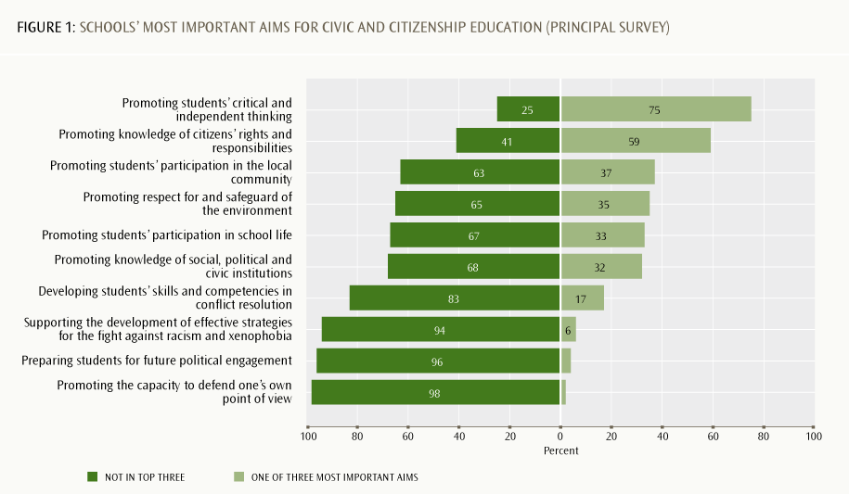
Table 1: New Zealand teachers’ views of what is important in civic and citizenship education, in relation to other ICCS countries
Aim | NZ teachers  % | ICCS average  % | Countries with the 5 highest averages¹  %
Promoting students’ critical and independent thinking | 74 | 52 | Denmark  Sweden  Finland  Liechtenstein  New Zealand | 89  84  81  74  74
Promoting respect for and safeguard of the environment | 50 | 41 | Finland  Chinese Taipei  Malta  Belgium (Flemish)  Slovenia | 61  59  58  58  55
Promoting knowledge of citizens’ rights and responsibilities | 38 | 60 | Thailand  Italy  Russian Federation  Indonesia  Dominican Republic | 78  78  76  75  72
Developing students’ skills and competencies in conflict resolution | 34 | 41 | Colombia  Chinese Taipei  Belgium (Flemish)  Chile  Mexico  Liechtenstein | 73  63  59  58  58  58
Promoting students’ participation in school life | 32 | 19 | Korea, Republic of  Lithuania  Poland  New Zealand  Latvia | 35  35  35  32  29
Promoting students’ participation in the local community | 25 | 16 | Ireland  Poland  Hong Kong SAR  Guatemala  Thailand | 40  38  32  27  27
Promoting knowledge of social, political and civic institutions | 19 | 33 | Indonesia  Thailand  Dominican Republic  Denmark  Estonia | 57  57  54  48  46
Promoting the capacity to defend one’s own point of view | 12 | 20 | Belgium (Flemish)  Austria  Latvia  Bulgaria  Czech Republic | 46  38  38  36  36
Supporting the development of effective strategies for the fight against racism and xenophobia | 11 | 10 | Sweden  Liechtenstein  Spain  England  Cyprus | 31  30  23  23  22
Preparing students for future political participation | 4 | 7 | Liechtenstein  Korea, Republic of  Austria  Denmark  England | 19  16  16  16  16
1. More than 5 may be listed where several countries have the same averages.
Source: Schulz, Ainley, Fraillon, Kerr, & Losito, 2010, pp. 182, 183.
›› Three aims were rarely indicated to be a top priority: supporting the development of effective strategies for the fight against racism and xenophobia (6%), preparing students for future political engagement (4%), and promoting the capacity to defend one’s own point of view (2%).
Teachers’ aims for civic and citizenship education
Teachers were also asked to identify which three of the above aims they considered most important. The response patterns were similar to principals’, although teachers selected “promoting respect for and safeguard the environment” more frequently than “promoting knowledge of citizens’ rights and responsibilities”, though teachers still rated the latter highly.
Table 1 shows New Zealand teachers’ responses in relation to the ICCS average, and the countries with the five highest averages for each item. New Zealand teachers rated the following items above the ICCS average:
›› promoting students’ critical and independent thinking
›› promoting respect for and safeguard of the environment
›› promoting students’ participation in school life
›› promoting students’ participation in the local community
›› supporting the development of effective strategies for the fight against racism and xenophobia.
New Zealand teachers rated the following items below the ICCS average:
›› promoting knowledge of citizens’ rights and responsibilities
›› developing students’ skills and competencies in conflict resolution
›› promoting knowledge of social, political and civic institutions
›› promoting the capacity to defend one’s own point of view
›› preparing students for future political participation.
What can we conclude about schools’ aims?
The teacher and principal data reported above suggest that civic and citizenship education is seen as having broad and general aims in New Zealand schools. New Zealand teachers and principals were both likely to select “promoting students’ critical and independent thinking” as one of the most important aims. Teachers’ responses to this item were well above the ICCS average, although teachers in Denmark, Sweden and Finland were even more likely to select this aim. Some principals and teachers emphasised certain kinds of citizenship values and actions, such as care for the environment and participating in the community.
Apart from the prevalent view about the value of promoting students’ critical and independent thinking, the patterns of responses for principals (Figure 1) and teachers (Table 1) suggest that, overall, there is no strong and consistent view about either which specific kind(s) of citizenship knowledge and competencies New Zealand students should be developing, or what combinations of knowledge and experiences students might need in order to develop them. This may be due to the diffuse nature and structure of civic and citizenship education in New Zealand schools, which is discussed in the next section.
Interestingly, however, most teachers and principals are agreed on what aims are not priorities in civic and citizenship education:
›› supporting the development of effective strategies for the fight against racism and xenophobia
›› preparing students for future political participation
›› promoting the capacity to defend one’s own point of view.

3. How civic and citizenship education fits into the school curriculum
Principals and teachers responded to a series of questions about how civic and citizenship education is offered in the school curriculum, and who they see as primarily responsible for this in their schools.
Civic and citizenship education in the school curriculum
Figure 2 shows how civic and citizenship education is offered to Year 9 students, according to principals.
›› Most students are in schools where principals report that civic and citizenship education occurs as part of their social science subjects (91% of students) and/or is considered to be the result of the school experience as a whole (86%).
›› Less than a third of students are in a school where the principal considers civic and citizenship education to be integrated across all subjects (31%).
›› Twenty percent of students are in a school where the principal considers civic and citizenship education is not part of the school’s curriculum.
›› According to principals, civic and citizenship education is almost never experienced as a separate subject (2%) or is only something extra-curricular (10%).
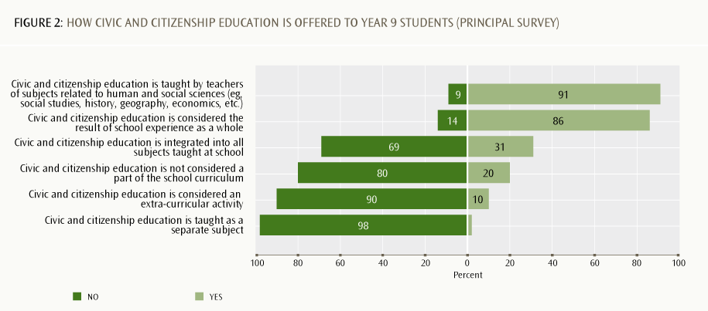

Who should be primarily responsible for civic and citizenship education?
Teachers were asked where they thought the greatest responsibility for civic and citizenship education within the school ought to be located. Teachers generally indicated that responsibility should be shared among all teaching staff, rather than being primarily the responsibility of school leaders or teachers of particular disciplines. As Figure 3 shows:
›› teachers were more likely to think the primary responsibility should lie with teachers of all subjects (38% strongly agreed), rather than with teachers of social studies (29%) or other humanities subjects (20%)
›› teachers were most likely to strongly agree that it should be the responsibility of the school as a whole (53%).
These findings indicate that, although civic and citizenship education has a particular focus in social studies and related subjects, teaching staff and school leaders consider the school experience as a whole to be a significant factor in the development of students’ civic and citizenship competencies. This broad and generalised view is consistent with the broad and generalised aims that staff ascribe to civic and citizenship education in their schools (see previous section).
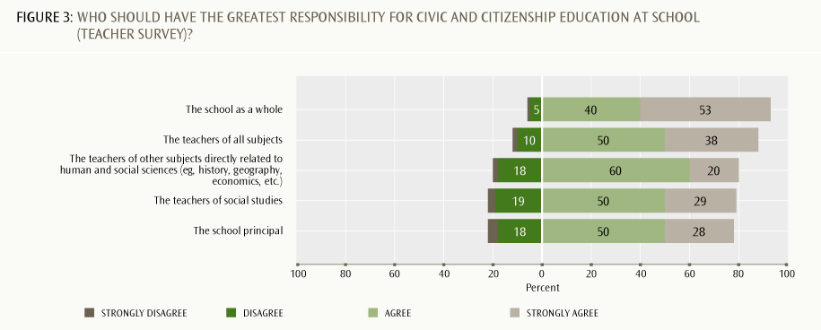

The following two sections look at students’ opportunities to participate in, contribute to and develop civic and citizenship competencies across school life in general. Subsequent sections look at civics and citizenship within classrooms (across all subjects), and within Year 9 social studies classes in particular.

4. Opportunities for civic and citizenship development in co-curricular activities
As the previous sections have shown, New Zealand principals and teachers consider the school experience in its entirety to be an important factor in students’ civic and citizenship education. This section looks at principals’ and teachers’ views on students’ opportunities across school life in general for civic and citizenship development, including co-curricular activities.
Participation in co-curricular activities
Co-curricular activities are those undertaken in the school environment, but beyond formal classroom teaching and learning. Figure 4 shows principals’ reports of how many of their Year 9 students have the opportunity to take part in a range of co-curricular activities. The results can be summarised as follows.
›› All or most Year 9 students were reported to have the opportunity to participate in sports events (97%) and cultural activities (81%).
›› More than half of students are in schools where principals reported that all or most Year 9 students engage in charitable activities such as campaigns to raise people’s awareness (62%) and/or activities related to underprivileged people or groups (54%). Most principals indicated that at least “some” students engaged in each of these activities. It was very unlikely for principals to report that no student or hardly any students did.
›› Less common co-curricular activities for many or most students were those involving an active engagement with the local environment or community. Just over half of students (51%) were at schools where most or all students engaged in multi- and inter-cultural initiatives within the local community, and just under half (46%) were at schools where most or all students undertook activities related to the local environment.
›› Activities such as human rights projects or activities to improve facilities for the local community were much more likely to involve “some” students than “most” or “all” students. In the case of improving facilities for the local community, 21% reported that “none or hardly any” Year 9 students were involved in these activities.
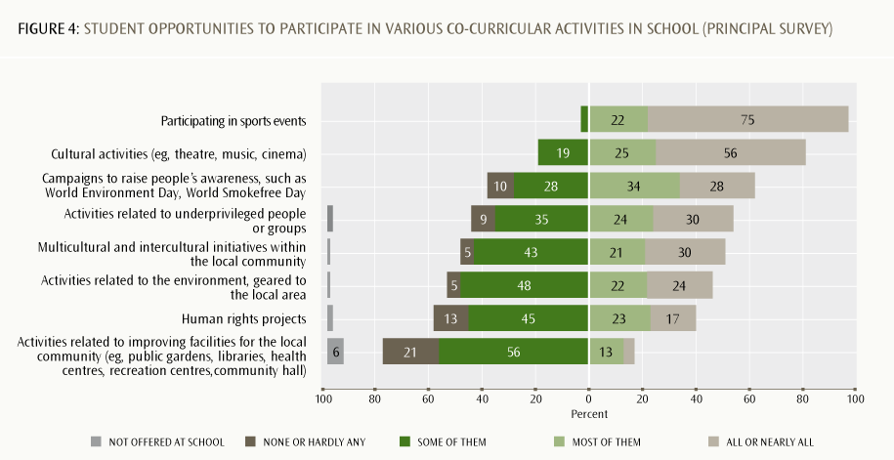
Teachers from a range of curriculum areas were asked whether their class(es) of Year 9 students had actually taken part in any of these activities during the current school year. The patterns are almost identical to the responses given by principals about opportunities to participate. Sports and cultural participation were relatively common, and other kinds of activities were less common (Table 2).
Table 2: Teachers’ reports as to whether their Year 9 students have taken part in these activities in the current school year (teacher survey)
Activity | Percentage of teachers
Participating in sports events | 68
Cultural activities (eg, theatre, music, cinema) | 49
Campaigns to raise people’s awareness, such as World Environment Day, World Smokefree Day | 40
Activities related to the environment, geared to the local area | 36
Activities related to underprivileged people or groups | 32
Multicultural and intercultural activities within the local community | 29
Human rights projects | 20
Activities related to improving facilities for the local community (eg, public gardens, libraries, health centres, recreation centres, community hall) | 17

We analysed teachers’ responses to this question to identify whether there were any differences between teachers who teach Year 9 social studies and those who do not. With two exceptions (participating in sports activities and cultural activities such as theatre and music), Year 9 social studies teachers were more likely than other subject teachers to have participated in these activities with their students within the last 12 months.
The ICCS teacher survey also asked teachers about their own participation in civic and citizenship-related activities within the past 12 months other than those they carry out as part of their school work. As Figure 5 shows:
›› teachers were most likely to have participated in teachers’ associations (75% at least “a few times”) or associations promoting culture/the arts in the local community (59% at least “a few times”)
›› for all the activities listed in Figure 5, teachers were generally more likely to have participated “a few times” than on a regular (eg, at least monthly) basis
›› for 8 of the 11 activities listed, at least half of the teachers said they had “never” participated within the past 12 months.
We analysed the teacher data to see if there were any clear differences according to teachers’ disciplinary area(s). Teachers of language subjects and social science/humanities were somewhat more likely than teachers in the other disciplines to be involved at least “a few times” or more with human rights organisations, political parties, cultural groups promoting the integration of ethnic minorities, associations promoting culture in the local community, and trade unions (although even for these teachers involvement tended to be less than monthly).
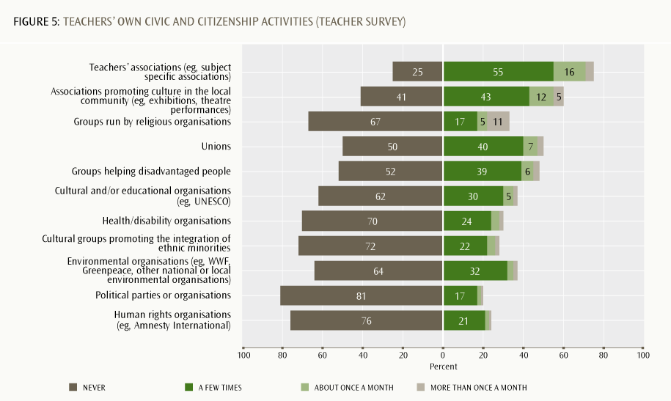
The findings in this section suggest that students’ co-curricular participation and contribution, as reported by principals, largely comprises involvement in sports and cultural activities. While students (and teachers) do sometimes engage in outwardly focused activities, such as fundraising, awareness-raising or engaging with people and groups in the community with specific focuses on social or environmental issues, this occurs less frequently and is also more likely to involve “some” or “a few” students.
Outside school, it appears that most teachers are not frequently engaged in activities with specific groups or organisations to do social justice, charitable or politically oriented work, although most are at least engaged with teachers’ associations and many support local arts or cultural events in the community. This is consistent with findings from the 2009/10 Time Use Survey, which showed that 27% of people aged 12 and over did unpaid work for a non-profit organisation in a four-week reference period (Statistics New Zealand, 2011, pp. 6–7 and Table 11).
Students’ experiences of school as an environment that fosters citizenship development should include not only opportunities to participate, but also opportunities to contribute. The next section looks at students’ opportunities to contribute to decision-making in their schools.

5. Students’ input into school decision-making
The ICCS framework states that “students’ daily experience in school is a factor that strongly influences students’ perception of school as a democratic environment” (Schulz et al, 2008, p. 38). Principals were asked to describe aspects of the decision-making culture of their schools, including the extent to which students are or are not involved in shaping different facets of school life. These could be considered to be part of the tacit or hidden curriculum; that is, the messages that students may pick up about what it means to participate in the democratic process (and who can or cannot participate and contribute) through the ways that power is exercised in the everyday life of school.
Voting for student representatives
Most schools appear to offer Year 9 students the opportunity to elect student representatives to student councils or the school board of trustees. Figure 6 shows that, according to principals, all or most Year 9 students have these voting opportunities. For 16% of students, their principals indicated that students voting for a Year 9 class representative was “not applicable” in their schools, perhaps because student representation does not necessarily include students from every class in these schools, and for 8% of students, voting for student board of trustees representatives was “not applicable” in their schools.
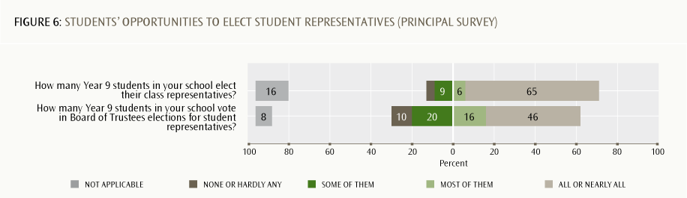

The student survey (Figure 7) shows a similar pattern, with 75% of students reporting they voted for a class or student council representative, although only 46% recalled doing so within the past 12 months. However, it is important to note that:
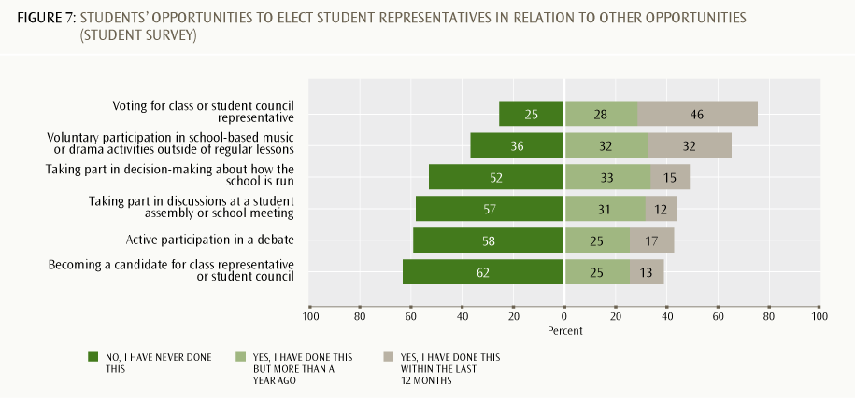

›› more than half the students (62%) said they had never been a candidate for class representative or student council, and only 13% had done so within the past 12 months
›› more than half the students said they had never taken part in discussions at a student assembly or school meeting (57%), nor taken part in decision-making about how their school is run (52%).
The New Zealand figures for the answers to these questions are close to the average for participating countries. The greatest difference was for “taking part in decision-making about how the school is run”, where 48% of New Zealand students reported they had ever done this, compared with the ICCS average of 40% (Schulz et al, 2010, pp. 138–139).
We cross-tabulated New Zealand students’ and principals’ responses to these questions to see whether there was agreement. Interestingly, in schools where principals said “all or nearly all students” elected class representatives, 19% of students said they had never done this, and 27% said they had done so but not in the last 12 months.
Demographic differences in response patterns
Differences were evident in these survey items according to student demographics. For example, female students were more likely than males to say they had taken part in each of the activities listed in Figure 7.
There were also some differences by students’ immigrant status. The three categories used in this research are: student and at least one parent born in New Zealand; student born in New Zealand but both parents born overseas; and student and parents born overseas.
Overseas-born students were more likely than New Zealand-born students to say they had voted for a class representative or had been a candidate for class representative, while students born in New Zealand with overseas-born parents were the most likely to say they had actively participated in a debate.
Even clearer patterns of difference were evident when student data were analysed by ethnicity. Across most items, Pākehā/European students were the most likely to say they had participated, followed by students who identified themselves as Asian (this trend was reversed for three items: “active participation in a debate”, “taking part in school decision-making”, and “being a candidate for class representative”). Māori students were the most likely to say they had never participated, closely followed by Pasifika students (this trend was reversed for one item: “active participation in a debate”).
The difference between Māori and Pākehā/European students’ responses was between 7 and 11 percentage points. The largest difference was for the item “becoming a candidate for class representative or student council”; 41% of Pākehā/European students reported that they had ever done this, compared to 30% of Māori students.
Student input into shaping school life and decision-making
Principals and students were both asked how much students’ opinions are taken into account when decisions are made about various aspects of school life. Figure 8 shows students’ and principals’ respective views about the degree to which students’ opinions are taken into account when decisions are made on a range of issues.
›› Overall, principals tended to think students’ opinions are taken into account more than students believed this to be the case.
›› Both students and principals thought students have the most influence in decisions about extracurricular activities, although students were less likely than their principals to think that student opinions are influential “to a large extent”.
›› Principals tended to say that students’ opinions were influential in decisions about classroom rules, but students were more divided; only 55% of students thought their opinions were taken into account to a large or moderate extent in this respect.
›› The majority of students thought their opinions counted to a small to moderate extent regarding decisions about how classes are taught (74%), teaching and learning materials (68%), and what is taught in classes (65%). Principals were not asked to comment on students’ input into decisions about what is taught and how classes are taught.
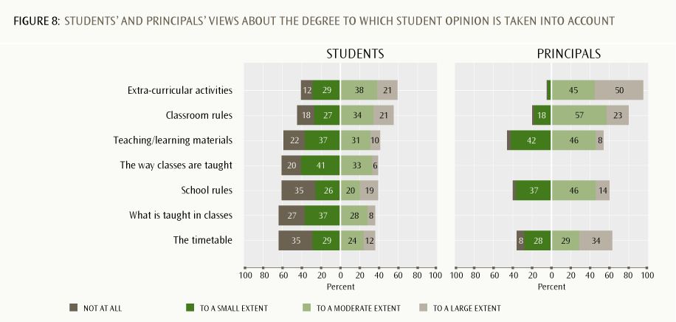

We cross-tabulated principals’ and students’ responses to the questions shown in Figure 8 and found there was a significant amount of disagreement between principals and students within the same schools on some common questions (see Table 3). For example, in schools where the principal said student opinion was influential “to a large extent” when determining the timetable, 65% of students said their opinion was taken into account only “to a small extent” or “not at all”.
Similarly, in schools where principals said student opinion was influential “to a large extent” in terms of input into teaching and learning materials, 60% of students saw their influence as being “to a small extent” or “not at all”.
The reverse pattern was also evident for some items. For example, in schools where principals said student opinion was “not at all” taken into account in shaping extra-curricular activities or classroom rules, 61% of students said their opinion counted to a “large” or “moderate” extent.
This suggests there is a great deal of subjectivity involved in each person’s views about what it means to “take students’ opinions into account”. Even when principals think aspects of school are shaped in ways that take students’ opinions into account, students may not think this is the case. Conversely, when principals think students do not have significant input, students may believe they are influential.
Table 3 also demonstrates consistency of student perceptions across schools, regardless of whether the principal believes student opinions are taken into account or not.
Table 3: Areas of disagreement between principals and students from the same schools
 | Schools where principals said student opinions were taken into account “to a large extent” |  | Schools where principals said student opinions were “not at all” taken into account
 | Percentage of students who claim their opinions count “to a small extent” or “not at all” | Percentage of students who claim their opinions count “to a large extent” or “to a moderate extent” | Percentage of students who claim their opinions are taken into account “to a small extent” or “not at all” | Percentage of students who claim their opinions are taken into account “to a large extent” or “to a moderate extent”
The timetable | 65 | 35 | 66 | 34
Input into teaching and learning  materials | 60 | 40 | 61 | 39
School rules | 50 | 50 | 70 | 30
Extra-curricular activities | 40 | 60 | 39 | 61
Classroom rules | 36 | 64 | 39 | 61

Do students think their input matters?
Students were asked how much they agreed or disagreed with a range of statements about the power of student participation in their schools. Interestingly, although the data reported above suggest that students’ opportunities to participate in decision-making may be somewhat limited, students took a very optimistic view about the value and potential of student participation and input.
›› More than 85% of students agreed or strongly agreed with all of the statements in Figure 9.
›› Almost all agreed with the statement that “lots of positive change can happen in schools when students work together” (only 7% disagreed).
›› Of all the statements listed in Figure 9, students were most likely to strongly agree that all schools should have a student council (36%).
The ICCS international report (Schulz et al, 2010, pp. 136) derives an index of students’ perceptions of the value of participation at school overall. New Zealand’s score on this index, 48, is just below the international average of 50. For comparison, the other English-speaking countries that participated in ICCS, England and Ireland, scored 48 and 51 respectively. Chile and Guatemala had the highest scores internationally (56), while Austria, Korea and Switzerland had the lowest (46).
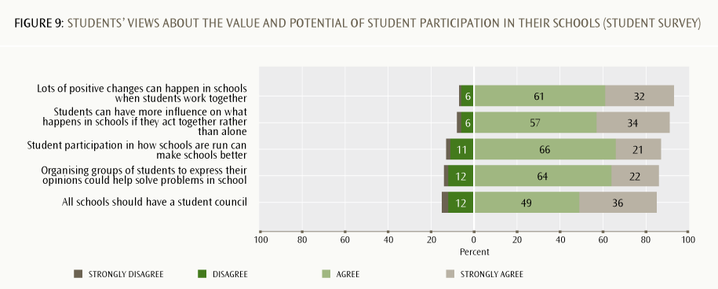

Do students experience their school as a democratic environment?
The overall picture from the data presented in this section shows that students’ input varies across different contexts. A majority of students voted for student representatives, but less than half of students had ever been candidates. A majority believed their views were taken into account at least “to a small extent”, but only small proportions believed their views were taken into account “to a large extent”.
Although most schools do have some form of student representation, and students are able to elect peers to sit on school councils or boards of trustees, the ICCS survey does not provide information about how well these forms of student representation work as a way of supporting student input into the everyday running of school life. This may account in part for why staff and students express differing views about the extent to which student opinion is counted in school decisions. More information is needed to unpack how students’ views and opinions are taken into account. It is possible that, though staff report that their decisions are influenced by their students, this influence is not visible to students themselves.
It is concerning that students’ reports of their participation in various aspects of the co-curriculum tend to vary according to students’ ethnic groupings, with a trend of lower reported participation in particular activities by Māori and Pasifika students, particularly with respect to perceived opportunities for students to act as representatives and/or to contribute directly to discussions and decisions about school life.

6. Civic and citizenship learning in classrooms
(all subject areas)
As discussed in the first section, most students attended schools in which principals reported that Year 9 students experienced civic and citizenship education as part of their subject classes, as well as through the school environment as a whole (see Figure 2). Teachers were more likely to see civic and citizenship as the responsibility of all subject teachers than only teachers of social science/humanities subjects.
The previous sections looked at the extent to which students (and others) have opportunities to engage in participating and contributing to activities across the school, and to decision-making about school matters. This section looks at what students, teachers and principals said about civic and citizenship learning within the context of classroom teaching and learning.
The ICCS teacher survey included teachers from a range of subject areas. This section reports data from students and teachers across subject areas. The section that follows looks specifically at practice within Year 9 social studies classrooms.
Opportunities to hear and express different viewpoints
The ICCS framework suggests that “the possibility of giving and asserting one’s own opinion and points of view” (Schulz et al, 2008, p. 38) is important for students’ citizenship development. Students were asked to comment on how often various things occurred in their classrooms when discussions turned to political or social issues during regular lessons. As Figure 10 shows, students tended to believe their classrooms were places where a range of opinions and perspectives could be expressed.
›› Around half the students thought teachers “often” encouraged students to express their opinions (54%) and make up their own minds (49%), and most said this happened at least “sometimes”.
›› Just over a third of students (34%) said teachers “often” presented several sides of the issues when explaining them in class and allowed students to disagree with them, and that students could express opinions different to those expressed by other students. Just under 80% thought that each of these things happened at least “sometimes”.
›› Two things which more than 30% of students said rarely or never happened were that teachers encouraged students to discuss the issues with people having different opinions (25% “sometimes”, 8% “never”) and students brought up current political events for discussion in class (33% “rarely”, 11% “never”).
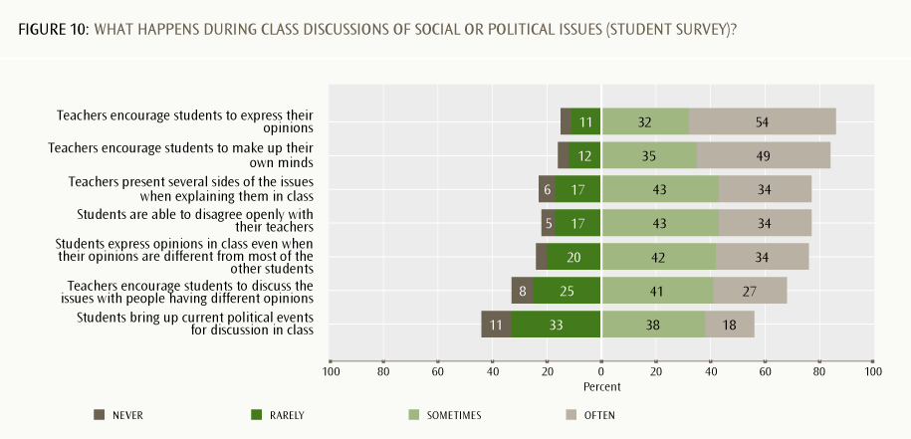

Negotiation of the classroom curriculum
Teachers were asked about various things Year 9 students might do in their class lessons, all of which relate to student input into, feedback about and responsiveness to engaging with the topics and issues discussed in class. Figure 11 can be summarised as follows.
›› Teachers were likely to say that all or most students felt comfortable sharing their views (72%) and knew how to listen to and respect others’ opinions (60%).
›› Teachers were more equivocal about whether students stated their views about school problems or expressed opinions that differed from others. In both cases, teachers were more likely to say “some” students did these things.
›› Few teachers said that all or most students had input into negotiating the classroom curriculum. Teachers were more likely to indicate that only “some” students had input into the choice of learning materials, suggested learning activities, or proposed topics/issues for class discussion.
›› Half of teachers said that none or hardly any students negotiated learning objectives with the teacher.
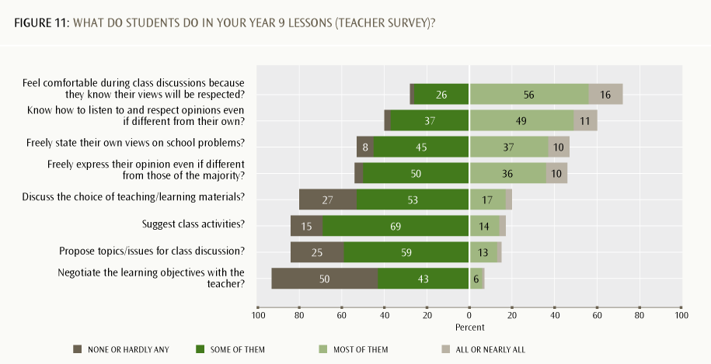

We analysed the data above to see if there were any differences in response between teachers who teach Year 9 social studies and those who do not. Year 9 social studies teachers were slightly more likely to say that at least “some” students proposed topics for discussion, stated their views on school problems, and freely expressed their opinions. The next section provides further insight into teaching and learning practices in Year 9 social studies classrooms.

7. Civic and citizenship education in Year 9
social studies classrooms
This section reports data about civic and citizenship education and teaching and learning practices in Year 9 social studies classes.
Activities undertaken by Year 9 social studies learners
Teachers were asked how often various activities occurred during civic and citizenship education lessons in Year 9 social studies classes. The data in Figure 12 suggest that civic and citizenship education often involves teachers leading and directing discussions and students answering questions or researching and investigating through activities and tasks set by the teacher. For example:
›› teachers reported that they often or very often included discussion of controversial issues (74%) and asked students questions (64%)
›› most teachers (80% or more) said that students “often” or “sometimes” undertook activities involving group or individual research and preparing presentations
›› it was more likely for teachers to “sometimes” rather than “often” have students work on projects that involved gathering information from outside of school or work in groups on different topics
›› it was less common for teachers to “often” or “very often” have students study textbooks (34%) or do drillsheets/worksheets (30%)
›› the most didactic style of teaching was also the least common: 44% of teachers said they “never” lectured while students took notes, although almost as many (43%) indicated this did happen “sometimes”
›› over half the teachers “sometimes” engaged students in role play and simulations, but 26% never used this approach.
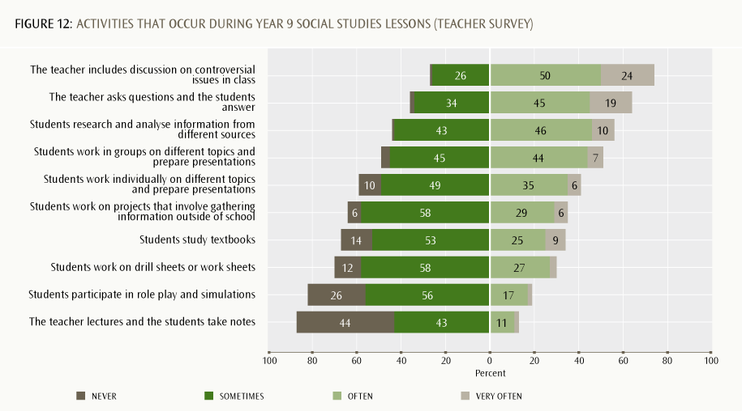
Resources teachers use to plan civic and citizenship topics
Figure 13 shows which resources Year 9 social studies teachers reported using for planning civic and citizenship-related topics. Most teachers developed their own resources or used ICT or media-sourced resources, and a range of other sources/resources were also used. Teachers were generally less likely to use teaching materials published by commercial companies, public institutes or private foundations, although just over half used these at least to a moderate extent.
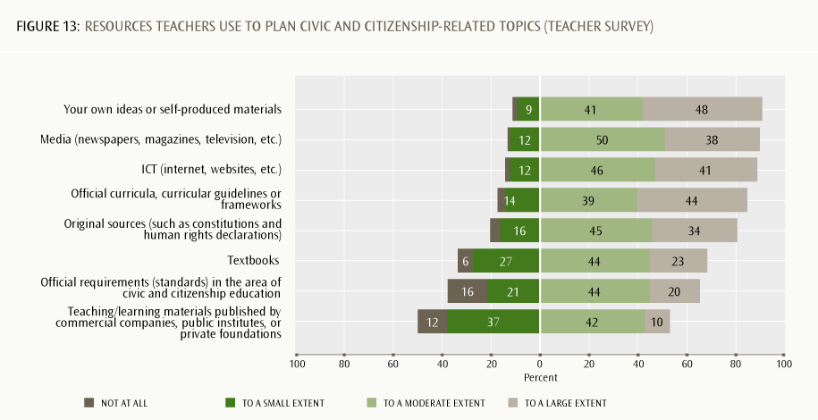

Teachers’ confidence to teach various civic and citizenship topics
Year 9 social studies teachers were asked how confident they felt to teach a variety of civic and citizenship topics. Generally, teachers expressed confidence to teach most of the listed topics.
›› Around half the teachers said they were “very confident” teaching topics linked to equality and diversity issues, environmental issues, and matters related to citizens’ rights and responsibilities (see the top seven items shown in Figure 14).
›› Teachers had moderate levels of confidence teaching topics linked with legal, political and constitutional issues, global/international organisations, and matters linked with media communication, volunteering, and economics and business.
Teachers’ views on how civic and citizenship education could be improved
Teachers of Year 9 social studies were given a list of ways that civic and citizenship education might be improved in their schools and asked to indicate which three things they thought were most important. Figure 15 shows which suggested improvements were most and least commonly indicated by teachers as being the top three most important. Teachers were most likely to suggest better materials and textbooks, additional subject-matter training for teachers, and more cooperation between teachers in different subject areas. It is worth noting that the ICCS survey did not include other possible options, such as giving students more decision-making power in shaping their civic and citizenship learning, or schools forming stronger relationships with various groups in the community.
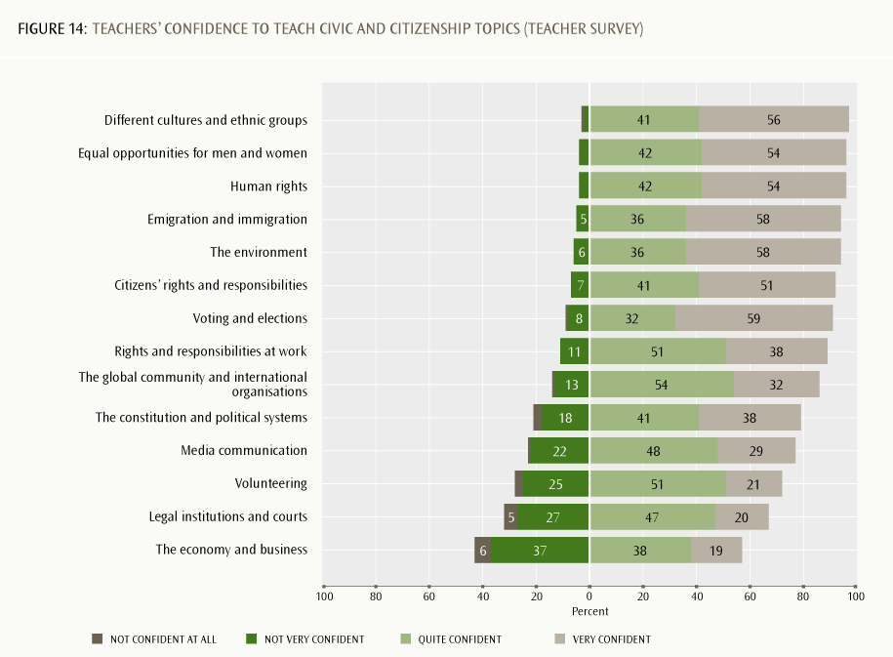

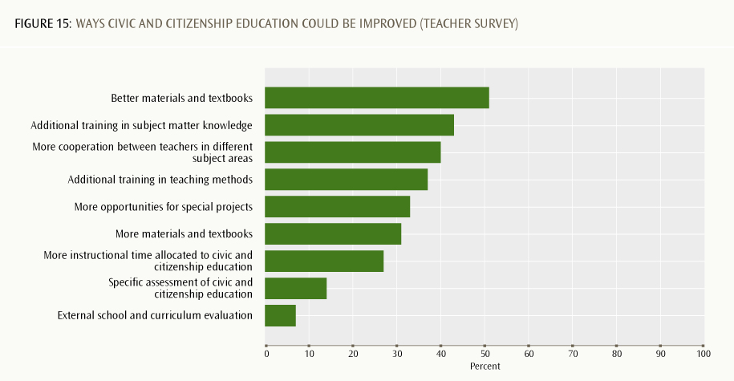

What can we conclude about the nature of civic and citizenship education in Year 9 social studies classrooms?
The findings in this section suggest that Year 9 social studies teachers address civic and citizenship education largely through exploring different perspectives on issues/topics. There appears to be more of a focus on general social justice issues such as gender equality, care for the environment, and rights and responsibilities, and less of a focus on the workings of institutions that support civil society. This section, and the previous one, suggest that both teachers and students see their classes as spaces where different points of view can be discussed and explored, but that teaching and learning are primarily teacher-led, with relatively few opportunities for students to determine the nature and direction of curriculum and learning activities.

8. Civic and citizenship development opportunities in the home and community
This section looks at students’ engagement with political and social issues and activities in the home and community. Readers may also wish to refer to the third report in this series, which reported students’ responses about how interested their caregivers or parents were in political and social issues, and students’ perspectives on their own future civic and citizenship participation (Hipkins, 2012).
Engagement in political and social discussions at home
Students were asked how often they were involved in various activities outside school that would potentially keep them informed and engaged with political or social issues. The 2008 general election, which took place during the ICCS data collection, is likely to have influenced students’ responses to these questions. Figure 16 can be summarised as follows.
›› Sixty percent of students watched television to stay informed about national and international news at least weekly (30% did so daily or almost daily).
›› Students were less likely to frequently engage in other activities listed in Figure 16.
›› A third or more did the following at least weekly: talked with parents/caregivers about what is happening in other countries (39%), participated in a special interest group (35%, though this included a variety of kinds of groups) or read the newspaper to stay informed (33%).
›› Friends and social media appeared not to be important sources of information or discussion regarding news, politics and social issues. Sixty percent never or hardly ever used the internet to keep up with national or international news, and 59% said they never or hardly ever discussed political or social issues with friends.
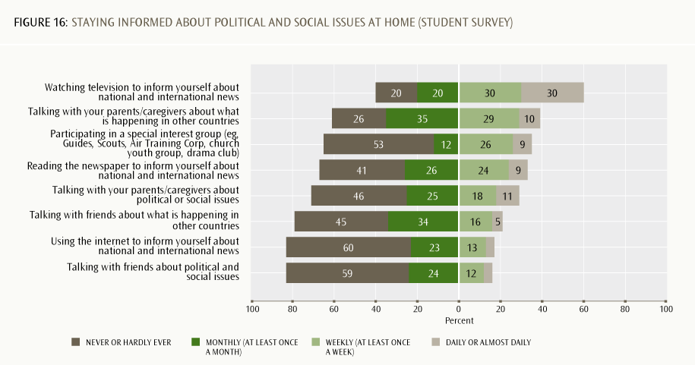

Demographic differences in students’ responses
Differences were evident in students’ responses according to gender, immigrant status and ethnic identification. Gender differences were generally small: females were slightly more likely than males to talk about issues with parents, watch television to stay informed, or participate in a special interest group. Males were slightly more likely than females to use the internet for information.
In terms of immigrant status, students born overseas or whose parents were born overseas reported higher levels of participation across all these activities than New Zealand-born students with at least one New Zealand-born parent. One possible explanation is that their own or their parents’ overseas connections increased their interest in or awareness of issues outside the country.
In terms of students’ ethnic identification, there was a consistent trend for lower rates of participation in these activities among Māori students. However, in four items, Pākehā/European students’ participation rates were equal or very close to those of Māori: both groups tended to report lower levels of frequency for reading newspapers to stay informed, talking with friends about political and social issues or what was happening in other countries, and using the internet to inform themselves about national and international news.
Pasifika students had the highest responses of the four ethnic groupings for watching television to stay informed, talking with friends about issues or what was happening in other countries, and participation in a special interest group. On all other items, Asian students reported the highest frequencies of participation.
Participation and membership in community groups
One survey item asked for further information about students’ involvement in groups, clubs or organisations with particular links to religious, political, or social causes. On the whole, most students were not involved with these kinds of groups. However, Figure 17 shows:
›› just under half had been involved with an organisation collecting money for a social cause (47%), although only 19% within the last 12 months
›› 40% had been involved with a religious group or organisation (23% in the past 12 months)
›› 39% had been involved with a voluntary group doing something to help the community.
Other forms of group or organisational membership were uncommon. Three-quarters or more said they had never been involved with groups based on culture and ethnicity (77%), an environmental organisation (79%), or politically active youth organisations (86–87%). Human rights organisations were the least likely groups for students to be involved with; 93% said they had never done this.
We looked at New Zealand students’ responses in relation to the other ICCS countries. The largest difference between New Zealand students and the ICCS average was students’ involvement in groups of young people campaigning for an issue (Schulz et al, 2010, pp. 132–133). The mean response for New Zealand students (14%) was 15 percentage points below the ICCS average (29%). New Zealand students scored slightly below the ICCS average for the following activities:
›› participation/involvement with an environmental organisation
›› participation/involvement with human rights organisations.
However, New Zealand students scored above the ICCS average for the following activities:
›› an organisation collecting money for a social cause
›› a voluntary group doing something to help the community
›› a cultural organisation based on ethnicity
›› affiliation with a political party or union.
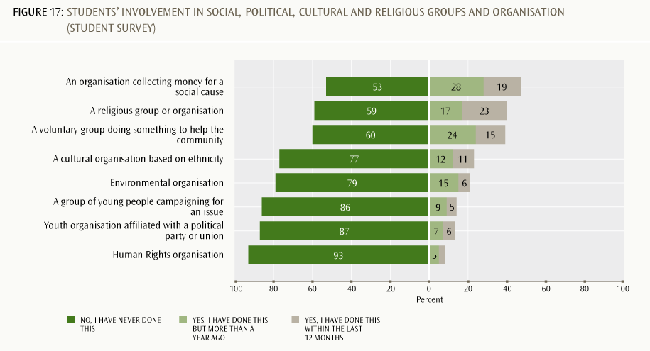

Demographic differences in response patterns
Male students were less likely than females to have participated in most of the groups or organisations listed in Figure 17, apart from three where male and female responses were almost equal: youth political parties, human rights organisations, and groups of young people campaigning for an issue.
In terms of students’ immigrant status, there were no consistent patterns, although students born overseas or whose parents were born overseas had higher rates of involvement with both religious organisations and cultural organisations based on ethnicity.
In terms of students’ ethnic identifications, some patterns were evident. Pasifika students reported higher rates of participation in cultural organisations based on ethnicity, and in religious organisations. Asian students had the second highest involvement in cultural/ethnic organisations, followed by Māori. Pākehā/European students were noticeably less likely to be involved with a cultural/ethnic or religious organisation. In general, Pasifika students tended to report the highest participation in the various groups or organisations, although in most cases the differences between ethnic groups was small.
Summary: Students’ civic interest and participation at home and in the community
The data presented in this section suggest that most New Zealand students are only moderately engaged with social and political issues, and with national and international news. Students born overseas or with parents born overseas are slightly more inclined to be engaged than New Zealand-born students. While many students have been involved in collecting money for social causes, other kinds of involvement with community groups and organisations is less common. As a group, Pasifika students appear to be the most engaged with community groups and organisations. Pākehā/European students were the least likely to be engaged with community groups associated with religion or ethnic/cultural affiliation.

9. Conclusion
The introduction to this report highlighted links to The New Zealand Curriculum’s vision for all our young people to be and become confident, connected, actively involved lifelong learners. The idea that our students should be “actively involved” is reinforced by the participating and contributing key competency, which is about “being actively involved in communities” (Ministry of Education, 2007, p. 13) and links to the NZC value of community and participation for the common good (Ministry of Education, 2007, p. 10). Adding to this, NZC’s identification of “citizenship” as a future-focused principle on which all school curricula should be built gives schools a responsibility to provide a range of opportunities for students to develop civic and citizenship competencies. This report gives some indication of the extent to which New Zealand students actually do, or do not, experience these opportunities. These findings can also be viewed in the context of the earlier curriculum document, which aimed “to enable students to participate in a changing society as informed, confident, and responsible citizens”. This final section looks across the findings to identify implications for education and areas for possible further investigation.
This report indicates that school staff consider students’ citizenship development to be supported both by their classroom learning and by their complete experience of school, and see civic and citizenship education as the responsibility of all teachers. Staff tend to see the main goals of civic and citizenship education in very broad and general terms; for example, as emphasising the development of students’ abilities to think for themselves and as knowledge about citizens’ rights and responsibilities. Beyond this, however, it is somewhat unclear whether there is a consistent view across New Zealand schools about what “civic and citizenship education” ought to involve and what means are effective in developing students’ citizenship competencies. Some staff emphasise various forms of engagement with the local community or participation and contribution to school life as important.
Although the ICCS framework tends not to be concerned with different ways of conceptualising “citizenship”, there is a wide range of meanings of citizenship described in the literature. The example we use in our concluding discussion is taken from Westheimer and Kahne (2004) who describe the personally responsible citizen, the participatory citizen and the justice-oriented citizen (see Table 4).
The findings in this report suggest that, for the most part, school views of civic and citizenship education in New Zealand schools align most closely with the goal of developing “personally responsible citizens” and, to a lesser extent, “participatory citizens”. A larger proportion of teachers than in most other ICCS countries viewed promoting student participation in school life as an important aim of civic education. There is less evidence from this study that developing “justice-oriented” citizens is a widespread goal in New Zealand schools. For example, relatively few staff saw “promoting knowledge of social, political and civic institutions” as a key aim, and such knowledge may be needed in order for students to critically assess social and economic structures to see beyond surface features. However, a majority of teachers (a large proportion compared to other ICCS countries) viewed promoting students’ critical thinking as important for civic education.
The framework of civic and citizenship education developed for ICCS suggests that having opportunities to explore and express one’s own point of view is important. The New Zealand findings suggesting that both teachers and students consider their classrooms to be places where multiple opinions and viewpoints can be comfortably accommodated are positive.
The ICCS framework also suggests that students develop civic and citizenship competencies through being “actively involved” as participating and contributing members of the school community. The New Zealand data provides evidence that there may be some potential to develop students’ opportunities to contribute to decision-making, both in the classroom and at the level of the school. But while students have opportunities to participate in a range of co-curricular activities, these are mainly sporting and cultural activities. Engagement with groups that support social and community causes is less common, and students seem to have few opportunities to contribute to decision-making about how things happen in their schools, other than with respect to extra-curricular activities. Students themselves remain optimistic that they have something to contribute and believe that student input can make a difference.
Table 4: Three kinds of citizen1
 | Personally responsible citizen | Participatory citizen | Justice-oriented citizen
Description | Acts responsibly in his/her community  Works and pays taxes  Obeys laws  Recycles, gives blood  Volunteers to lend a hand in times of crisis | Active member of community organisation and/or improvement efforts  Organises community efforts to care for those in need, promote economic development, or clean up environment  Knows how government agencies work  Knows strategies for accomplishing collective tasks | Critically assesses social, political, and economic structures to see beyond surface causes  Seeks out and addresses areas of injustice  Knows about democratic social movements and how to effect systemic change
Sample actions | Contributes food to a food drive | Helps to organise a food drive | Explores why people are hungry and acts to solve root causes
Core assumptions | To solve social problems and improve society, citizens must have good character; and they must be honest, responsible and law-abiding members of the community | To solve social problems and improve society, citizens must actively participate and take leadership positions within established systems and community structures | To solve social problems and improve society, citizens must question, debate and change established systems and structures when they reproduce patterns of injustice over time
1. Reproduced from Westheimer & Kahne, 2004.

In terms of schools as democratic environments, students are most likely to experience this as a form of representational democracy, where students can be voted to sit on student councils or boards of trustees. However, the ICCS survey data do not provide information about how well these forms of student representation work as a way of supporting student input into the everyday running of school life.
In terms of equity issues, it is concerning that students’ reports of their participation in the co-curriculum tend to show patterns associated with students’ ethnic identifications. For example, there is a trend of lower reported participation in some activities by Māori and Pasifika students, particularly with respect to opportunities for students to act as representatives and/or to contribute directly to discussions and decisions about school life.
Outside school, Year 9 students show relatively modest levels of interest and engagement with social and political issues, even though the 2008 general election took place during ICCS data collection. Non-Pākehā/European students were more likely than Pākehā/European students to be involved with groups or organisations with a cultural, ethnic or religious affiliation, and Pasifika students were the most likely to report involvement in various groups such as these. The data suggest that students who are born in New Zealand to New Zealand-born parents are slightly less likely to be engaged with social, political, and community matters than students born overseas or to overseas-born parents.

References
Hipkins, R. (2012). New Zealand students’ intentions towards participation in democratic processes. Wellington: Ministry of Education.
Lang, K. (2010). What do New Zealand students understand about civic knowledge and citizenship? Results from the International Civic and Citizenship Education Study. Wellington: Ministry of Education.
Ministry of Education. (1997). Social studies in the New Zealand Curriculum. Wellington: Learning Media Limited.
Ministry of Education. (2007). The New Zealand Curriculum. Wellington: Learning Media Limited.
Satherley, P. (2011). What do our students think about New Zealand, democracy and freedom? New Zealand results from the International Civic and Citizenship Education Study. Wellington: Ministry of Education.
Schulz, W., Fraillon, J., Ainley, J., Losito, B., & Kerr, D. (2008). International Civic and Citizenship Education Study: Assessment framework. Amsterdam: International Association for the Evaluation of Educational Achievement.
Schulz, W., Ainley, J., Fraillon, J., Kerr, D., & Losito, B. (2010). ICCS 2009 International Report: Civic knowledge, attitudes, and engagement among lower-secondary school students in 38 countries. Amsterdam: International Association for the Evaluation of Educational Achievement.
Statistics New Zealand. (2011). Time use survey: 2009/10. Wellington: Statistics New Zealand. Retrieved from www.stats.govt.nz/browse_for_stats/people_and_communities/time_use/TimeUseSurvey_HOTP2009-10/Commentary.aspx
Westheimer, J., & Kahne, J. (2004). What kind of citizen? The politics of educating for democracy. American Educational Research Journal, 41 (2), 1-30.

Countries participating in ICCS
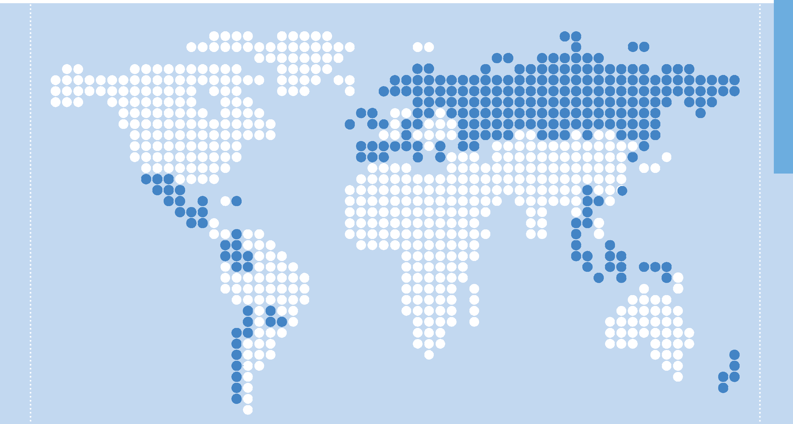

Austria
Belgium/Flemish
Bulgaria
Chile
Chinese Taipei
Colombia
Cyprus
Czech Republic
Denmark
Dominican Republic
England
Estonia
Finland
Greece
Guatemala
Hong Kong Sar
Indonesia
Ireland
Italy
Republic Of Korea
Latvia
Liechtenstein
Lithuania
Luxembourg
Malta
Mexico
The Netherlands
New Zealand
Norway
Paraguay
Poland
Russian Federation
Slovak Republic
Slovenia
Spain
Sweden
Switzerland
Thailand

Source: Schulz et al., 2010.

First published in July 2012 by:
Comparative Education Research Unit
Research Division
Ministry of Education
PO Box 1666
Wellington
New Zealand
Email: research.info@minedu.govt.nz
Fax: 64-4-463 8312
Phone: 64-4-463 8000
© Ministry of Education
All rights reserved.
Enquiries should be made to the publisher.
This report is available from the Education Counts website:
www.educationcounts.govt.nz
ISBN 978-0-478-38666-0
ISBN 978-0-478-38667-7 (web)
RMR-997

The IEA is an independent international consortium that conducts large-scale comparative studies of educational achievement.
The ICCS testing period was mainly 3–21 November 2008, and election day was 8 November 2008. The timing of the data collection was determined by the IEA, not by New Zealand.
The test language was English only.
Some other graphs display a frequency or quantity scale in a similar way.
123 principal responses from 146 participating schools.
1,350 teachers from 146 participating schools.
Teachers were asked to indicate which subject(s) they taught for the majority of hours per week, from the following options: languages, social science/humanities, mathematics, sciences, and other subject areas.
The proportions of 2008’s Year 9 students were: 77% New Zealand born and had parent(s) New Zealand born; 8% New Zealand born but parents born overseas; 15% born overseas. The second and third of these categories are students with an immigrant background.
Students were asked to provide information about the ethnic group(s) they identified with. Students who gave multiple responses to this question were counted in each group. For example, students who identified as Samoan and Chinese were counted in both Pasifika and Asian ethnic groups. The analysis focuses on four main ethnic groupings: Pākehā/European, Māori, Pasifika and Asian. The Other ethnic group is too small for meaningful analysis.
NZC states that “The curriculum encourages students to look to the future by exploring such significant future-focused issues as sustainability, citizenship, enterprise, and globalisation” (Ministry of Education, 2007, p. 9).
Those activities undertaken in the school environment, but beyond formal classroom teaching and learning.

