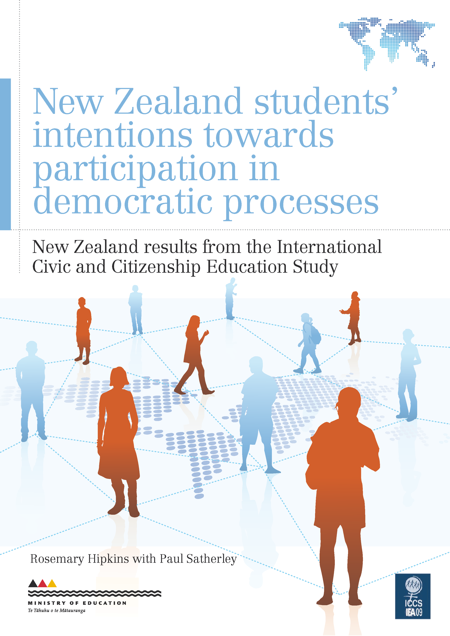

Acknowledgements

The International Civic and Citizenship Education Study (ICCS) was a collaborative effort internationally and nationally. Many people were involved in the project and it is not possible to thank them all individually, but it is important to acknowledge key groups of people.
This study was made possible by the cooperation of the schools, teachers and students who took part. Thanks to these participants we now have a valuable resource about civic and citizenship education in New Zealand.
Thanks also to the many members of the Research Division and other Ministry of Education staff who contributed to the successful planning and implementation of ICCS. In particular, Kate Lang and Sharon Cox were the ICCS National Research Coordinators. Paul Satherley used his expertise to extract the data we requested from the national ICCS database, and Jit Cheung managed interactions between the Ministry of Education and the New Zealand Council for Educational Research (NZCER). Between them Jit and Paul also took care of the reviewing, editing and publishing of this report.
At NZCER, Edith Hodgen and Rachel Dingle managed the flow of data, produced the graphic data summaries and provided quality assurance for the statistical analyses. The report could not have been produced in this form without their acumen and expertise.
Rosemary Hipkins,
Chief Researcher,
New Zealand Council for Educational Research

Summary
This report is the third in a series based on the International Civic and Citizenship Education Study (ICCS), which was undertaken in New Zealand in 2008. It covers students’ perceptions of responsible adult citizenship, their current interests and abilities, and their likely future participation in a range of social and political activities. The data were collected close to the 2008 national election, which is likely to have influenced student views.
Civic and citizenship education is a topic embedded in the principles, values and key competencies of The New Zealand Curriculum (NZC). Although New Zealand took part in ICCS before NZC was mandated in 2010, the findings are relevant to current civic and citizenship teaching and learning. The future focus principle and the participating and contributing key competency of NZC are particularly relevant to the findings of this report.
Citizenship values were strongly held by Year 9 students. We see very high or substantial levels of agreement that good adult citizens:
›› always work hard
›› obey the law
›› vote in every national election
›› take part in activities to protect the environment
›› show respect for government representatives
›› participate in activities to benefit the local community
›› take part in activities that promote human rights
›› learn about the nation’s history
›› follow political issues in the media.
There were much lower levels of support for actions that are overtly political, such as participating in peaceful protests against laws seen as unjust, engaging in political discussions and joining a political party. More knowledgeable students were more likely to agree or strongly agree that working hard and always obeying the law are attributes of good adult citizens.
Greater numbers of students said they were interested in environmental issues than in political or social issues. Girls were more likely to express interest in environmental issues than boys (70% of girls were very or quite interested compared to 56% of boys). Just over half the students said they were interested in national politics and social issues.
Greater proportions of students estimated they have at least some competency in areas associated with traditional school learning activities, such as taking part in discussions and debates, whereas fewer than half estimated they have personal action competencies in areas that require a level of activity (and perhaps initiative) beyond the classroom.
Just over half of Year 9 students had at least modest confidence in their own understanding of political issues, but there were lower levels of confidence that their own views are actually worth hearing.
Coming from households where both parents were interested in political or social issues was associated with having a higher civic knowledge score.
Most students anticipated that they would take part in representative democratic activities such as voting, although more so in national than in local body elections. Eighty-four percent thought they would certainly or probably vote in national elections, compared to 77% for local body elections. Much lower proportions of students anticipated taking part in more participatory democratic activities such as helping a candidate in an election campaign, joining a union or a political party, or standing as a local body candidate.
When students were asked about their anticipated citizenship activities in the near future, we saw much higher levels of support for activities that are generally social in nature compared to those that require overt political participation. For protest actions when they are adults, more than half the students could see themselves taking part in moderate forms of protest, but much lower proportions envisaged undertaking stronger forms of civil disobedience. Boys were more likely than girls to see themselves participating in these more extreme types of protest, such as spray-painting slogans, blocking traffic or occupying buildings.
Māori students were somewhat less likely than other students to think that it is important to vote in every national election, and were also less likely to express an intention to vote in local body elections. Nevertheless, both Māori and Pasifika students were more likely than either Pākehā/European or Asian students to say they might stand as a candidate in a local body election or join a political party.
The New Zealand findings of this report are close to the averages across the countries that participated in ICCS, and are also close to those of the other English-speaking ICCS countries, England and Ireland.

Table of Contents

Summary 3
Introduction 7
1. Citizenship competencies and the New Zealand Curriculum 10
2. Students’ perceptions of the behaviours of a good adult citizen 12
3. Students’ interest in social and political issues 18
4. How students judge their own citizenship competencies 22
5. Students’ estimation of their personal understanding of political issues 25
6. Students’ intentions for personal participation in politics 30
7. Students’ anticipated citizenship activities in the near future 35
8. Students’ views about taking part in protest actions when they are adults 38
9. Are our young people connected and contributing? 41
References 42
Countries participating in ICCS 43

List of Tables
Table 1: Differences in perceptions of adult citizenship behaviours, by ethnicity 14
Table 2: Items that matched perceived importance with likelihood of the students actually doing these things 17
Table 3: Differences in students’ interest in issues, by ethnicity 19
Table 4: Extent of parents’ interest in political and social issues 27
Table 5: Associations between parental interest in political and social issues and students’ knowledge scores 27
Table 6: Extent to which students who expressed a preference for a political party favoured that preference 27

List of Figures
Figure 1: How important are the following behaviours for being a good adult citizen? 11
Figure 2: Relationships between students’ knowledge scores and beliefs about being a good adult citizen 15
Figure 3: How interested are you in the following issues? 17
Figure 4: Associations between knowledge scores and interest in political and social issues 20
Figure 5: How well do you think you would do the following activities? 21
Figure 6: Relationships between students’ self-assessed specific competencies and their knowledge scores 22
Figure 7: How much do you agree or disagree with the following statements about you and politics? 24
Figure 8: Associations between knowledge scores and students’ estimation of their ability to take part in political activities 25
Figure 9: Which of these do you think you will do when you are an adult? 28
Figure 10: Associations between knowledge scores and students’ intentions for personal participation in politics 30
Figure 11: Listed below are different actions that you as a young person could take during the next few years. What do you expect that you will do? 32
Figure 12: Associations between anticipated civic participation and students’ civic knowledge scores 34
Figure 13: There are many different ways how citizens may protest against things they believe are wrong.Would you take part in any of the following forms of protest in the future? 35
Figure 14: Associations between students’ knowledge scores and the sorts of protest actions in which they might take part 37

Introduction
This is the third in a series of reports from the International Civic and Citizenship Education Study (ICCS) undertaken in New Zealand in 2008. This report investigates students’ perceptions of responsible adult citizenship and their current interests and abilities with respect to a range of citizenship behaviours and competencies. The students were also asked to look to their futures and say which of a range of social and political activities they will be most likely to do, or not do, when they are adults.
Students’ overall knowledge scores have been used in this report to check for relationships between what they know and what they think they can do now and might do in the future. As this report will show, these relationships are not straightforward, but they are certainly interesting and thought provoking.
The first report, published in 2010, is called What do New Zealand students understand about civic knowledge and citizenship? (Lang, 2010). It reports on New Zealand students’ level of civic knowledge relative to other countries that took part in the survey.
The second report, published in 2011, is called What do our students think about New Zealand, democracy and freedom? (Satherley, 2011). The focus of the second report is on the views Year 9 students have about New Zealand and its institutions, and about issues of democracy, freedom, equal rights and religion within a context of civic and citizenship education.
Young people also develop an understanding of their roles as citizens through a range of activities and experiences that take place outside the classroom and in contexts beyond the school. The fourth report focuses on the role of the school and community in civic and citizenship education.
What is ICCS?
New Zealand is one of 38 countries that took part in the International Civic and Citizenship Education Study (ICCS) sponsored by the International Association for the Evaluation of Educational Achievement (IEA).
ICCS is an international standardised study that looks at the ways in which young people are prepared to undertake their roles as citizens. ICCS measures students’ knowledge and understanding of civic systems and citizenship issues, as well as student attitudes, perceptions and activities relating to civics and citizenship. It also looks at differences among countries in relation to the outcomes of civic and citizenship education and how these differences relate to student, school and community backgrounds.
What can we find out from this study?
Civic knowledge is broadly defined in ICCS as knowledge and understanding of:
›› civic education — the formal institutions and processes of civic life, such as voting in elections
›› citizenship education — how people participate in society and how citizens interact with and shape their communities and societies.
ICCS measured student perceptions and behaviours relating to civics and citizenship in four domains: value beliefs, attitudes, behavioural intentions, and behaviours. This includes attitudes, views, dispositions and future intentions that relate to participation in civic society, democracy, rights and responsibilities, trust in institutions, and the roles of institutions. An understanding of young people’s civics and citizenship attitudes, views and future intentions would seem to be important for the future working of society. It also provides an important backdrop to measured civic knowledge.
Who took part?
During 2008/09 approximately 140,000 students around 14 years of age and 62,000 teachers in over 5,300 schools from 38 countries around the world participated in ICCS. In New Zealand, almost 4,000 Year 9 students, 1,350 teachers and 123 principals from 146 schools took part in the study between October and December 2008. A representative sample of English-medium New Zealand schools with Year 9 students was selected. The student sample was representative of their Year 9 peers learning in English-medium.
The 2008 general election took place during the period of data collection in New Zealand, and this is likely to have influenced students’ responses to some questions, particularly those relating to voting and elections.
What information was collected?
Each student completed a 40-minute questionnaire about their background and their attitudes, values and behaviours in relation to civics and citizenship. Each student also completed one of seven test booklets in a 45-minute cognitive test. The ICCS assessment framework covers the content domains of civic society and systems, civic principles, civic participation, and civic identities.
Teachers answered questions about their perceptions of civic and citizenship education (CCE) in their schools, school organisation and culture, and teaching practices. Principals provided information about their school — characteristics, culture and climate — and the provision of CCE at their school. ICCS also surveyed countries about the structure of their education system, CCE in the curricula and recent developments in CCE.
Useful resources
The first New Zealand ICCS focus report (Lang, 2010) analysed the key civic knowledge dimension. The second report (Satherley, 2011) focused on student views on democracy and freedom. These reports and also the ICCS international reports published by the IEA can be accessed from New Zealand’s ICCS web page at www.educationcounts.govt.nz/goto/iccs. The international database is also accessible for public use on the ICCS website at http://iccs.acer.edu.au/.
Technical notes
Statistical significance and standard errors
Because ICCS used scientific statistical sampling methods to obtain a representative sample of the population of Year 9 students, it is possible to calculate the standard errors of the proportions and averages presented in this report. However, we have chosen not to highlight them in some of the text and graphs in order to focus on overall patterns.
Graphs
The report contains a number of different graph styles. Graphs similar to Figure 1 show proportions of students along a horizontal axis that has a zero midpoint, which represents a neutral position. Proportions agreeing are to the right of the zero midpoint and proportions disagreeing are to the left. Numerical values less than 5% are not printed on the graphs because the bars are too small.
Graphs similar to Figure 2 have a scale on the horizontal axis that represents the overall civic knowledge score. The round and square dots represent the average civic knowledge score of the students who gave the particular response. An overall pattern of upward slope from left to right within an item indicates that disagreeing is associated with a low knowledge score while agreeing is associated with a high score. Conversely, a downward slope indicates that agreeing is associated with a low knowledge score while disagreeing is associated with a high score.
Every item has four pairs of lines. Each pair relates to one possible response (eg, “very important”). The round dot is the average knowledge score of all the boys who gave that response, and the square dot is the average knowledge score of all the girls who gave that response.
The lines on either side of the dots are error bars. They indicate the interval where we have 95% confidence the true value lies, given that ICCS figures are derived from a sample survey, not full coverage of all Year 9 students. As a general rule of thumb, the longer the error bar the fewer the students who gave that response or the more variable their responses were. If the error bars for a matched pair do not overlap, the difference in knowledge scores between the groups of students who gave that response is statistically significant.
No more than six items are included in these graphs so that they do not become too “busy” to read. Where there were more than six items in a set, we selected those that illustrated all the different patterns we found. A data appendix containing figures for all the items can be located at www.educationcounts.govt.nz/goto/iccs.
In some cases, proportions may not sum to exactly 100% because of rounding.

1. Citizenship competencies and the New Zealand Curriculum
Every English-medium school needs to design a local curriculum based on The New Zealand Curriculum (NZC). The knowledge, skills and dispositions addressed by the ICCS study are in harmony with the principles, values, key competencies and learning areas of NZC, though they are not prescribed in NZC. Although New Zealand took part in ICCS before NZC was mandated in 2010, the findings are relevant to current civic and citizenship teaching and learning. A short discussion in the second report (Satherley, 2011, p. 7) illustrated how the different components of NZC could come together to create a coherent message about what matters for our students as citizens of New Zealand and the world.
This report has a particular focus on whether and how students’ knowledge, skills, attitudes and values come together to enable and empower them to take action when they perceive there are issues to be addressed and they might want to do something to help. ICCS items asked about environmental, social and political issues and actions. This variety provided a broad basis for scoping the actions, behaviours and intentions explored in this report.
The future focus principle of NZC states that “The curriculum encourages students to look to the future by exploring such significant future-focused issues as sustainability, citizenship, enterprise and globalisation” (Ministry of Education, 2007, p. 9). Active participation is implied here and reinforced by the participating and contributing key competency, which is about “being actively involved in communities”. There is also a strong link to the NZC value of community and participation for the common good (Ministry of Education, 2007, pp. 9, 13).
The NZC definition of participating and contributing as a key competency highlights the reciprocal nature of the relationship between taking part and developing a sense of belonging and confidence to take part. The NZC vision is for all our young people to be and become:
›› confident (which includes being resourceful, enterprising, resilient)
›› connected (which includes being connected to the land and environment and as members of communities)
›› actively involved (in a range of life contexts and as contributors to New Zealand’s social, economic cultural and environmental well-being)
›› lifelong learners (which includes being informed decision-makers). (Ministry of Education, 2007, p.8).
Over time, the spread of students’ skill in the participating and contributing key competency can widen. The competencies of students who have successful experiences of taking action are likely to grow stronger. They could as a result become more confident to extend their participation to other areas that are new and challenging for them. Conversely, students who lack confidence and/or interest and decline to participate could progressively become even less confident and less participatory. When carrying out the analysis of the item sets discussed in this report we kept these types of dynamics in mind.
The seven item sets discussed in this report are, in order of reporting:
›› students’ perceptions of the behaviours of a good adult citizen
›› students’ interest in social and political issues
›› how students judge their own citizenship competencies
›› students’ estimation of their personal understanding of political issues
›› students’ intentions for personal participation in politics
›› students’ anticipated citizenship activities in the near future
›› students’ views about taking part in protest actions when they are adults.

2. Students’ perceptions of the behaviours of a good adult citizen
Students were asked to respond to 12 items that describe possible behaviours that might be expected of a good adult citizen. This question probed students’ beliefs about what adults should do as citizens and hence provided some indications of their citizenship values. Figure 1 lists the items and shows the results. Note that responses are ranked according to those items that were judged to be important by the highest to the lowest proportion of students.
Figure 1 shows that overall citizenship values appeared to be strongly held by Year 9 students. Following is a brief summary of the main points.
›› There were very high levels of agreement that good adult citizens always work hard (93% saw this as very or quite important) and obey the law (91%).
›› High numbers of students also believed that good adult citizens should: vote in every national election (84% saw this as very or quite important); take part in activities to protect the environment (80%); show respect for government representatives (79%); and participate in activities to benefit the local community (78%). The timing of the 2008 general election during the ICCS data collection is likely to have influenced students’ responses to this question.
›› A substantial majority of the students also thought that good adult citizens take part in activities that promote human rights (74%), learn about the nation’s history (71%), and follow political issues in the media (69%).
›› There were much lower levels of support for actions that are overtly political, such as participating in peaceful protests against laws seen as unjust (53%) and engaging in political discussions (45%), although still close to half the students did think good adult citizens should do these things.
›› The lowest agreement by far was for the statement that good adult citizens should join a political party (just 26% agreed that this was very or somewhat important).
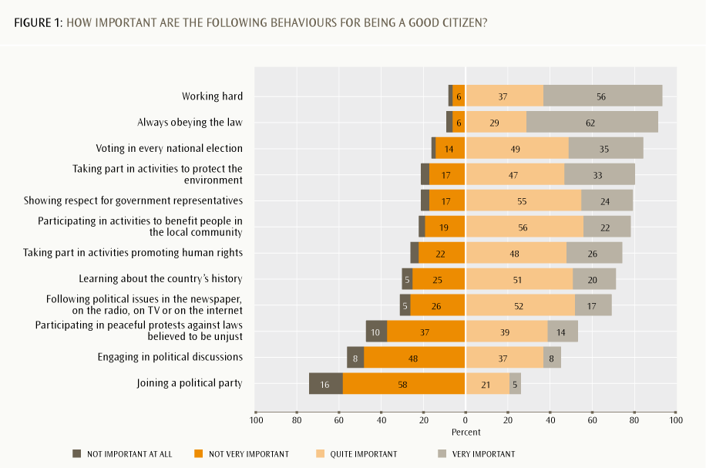
The ICCS 2009 International Report (Schulz, Ainley, Fraillon, Kerr & Losito, 2010, pp. 93-94) derives a scale of students’ perceptions of the importance of conventional citizenship based on six of these items:
›› voting in every national election
›› joining a political party
›› learning about the country’s history
›› following political issues in the newspaper, on the radio, on TV or on the internet
›› showing respect for government representatives
›› engaging in political discussions.
New Zealand’s score on this scale was 48, slightly below the ICCS average of 50. The other English-speaking ICCS countries, England and Ireland, scored 48 and 50, respectively.
Demographic differences in response patterns
Gender differences were found for two of these items. Girls were more likely than boys to think good adult citizens show respect for government representatives and take part in activities to protect the environment.
Analysis by students’ immigrant status revealed a larger number of differences. The categories used in this research are:
›› student and at least one parent born in New Zealand
›› student born in New Zealand but both parents born overseas
›› student was born overseas.
On average, the stronger a student’s overseas connections, the more likely they are to see two particular behaviours as important for being a good adult citizen: showing respect for government representatives and taking part in activities promoting human rights. The proportions seeing these as very or quite important were as follows:
›› showing respect for government representatives (student born overseas, 87%; student born in New Zealand, both parents born overseas, 82%; student and parent(s) born in New Zealand, 77%)
›› taking part in activities promoting human rights (83%; 79%; 73%, respectively).
Finer analysis of the overseas-born students showed that those younger than five years old when they first came to New Zealand had a similar pattern of opinions to those students born in New Zealand whose parents were born overseas.
Compared to New Zealand-born students with New Zealand-born parent(s), somewhat higher proportions of other students thought the following behaviours are very or quite important for good adult citizens: joining a political party; engaging in political discussions; and participating in peaceful protests against laws believed to be unjust. Overseas-born students and New Zealand-born students with parents born overseas were also more likely to see the following as very important: voting in every national election; following political issues in the media; and working hard.
Table 1 shows patterns of differences in views on citizenship behaviour by ethnicity. When analysing ICCS findings by immigrant status and by ethnicity, we need to keep in mind the strongly differing immigrant status composition across ethnic groups. Thus the ethnic patterns may be partly explained by the proportions of overseas-born students in the Pasifika and Asian ethnic groups.
TABLE 1: Differences in perceptions of adult citizenship behaviours, by ethnicity
Behaviour | Percentage Quite Or Very Important
Behaviour | Pākehā/European | Māori | Pasifika | Asian
Voting in every national election | 84 | 77 | 84 | 88
Showing respect for government representatives | 70 | 70 | 77 | 84
Following political issues in the newspaper, on the radio, on TV or on the internet | 69 | 65 | 67 | 75
Participating in peaceful protests against laws believed to be unjust | 49 | 54 | 63 | 60
Joining a political party | 20 | 33 | 44 | 28

The patterns of differences by the combination of ethnicity and immigrant status suggest a lack of interest in some areas of civic participation for Pākehā/European students, and in some cases Māori students. Some of the actions they perhaps take for granted could seem like privileges to an overseas-born student if they came from a less democratic society, or even just a more populous nation where issues of scale and competition might limit opportunities that are more freely available to young people in New Zealand. There are other indications of a possible lack of interest in the following sections of the report.
Patterns of association with students’ knowledge scores
We checked to see if there was a pattern of relationships between students’ responses to the question on the importance of citizenship behaviours and their overall ICCS knowledge scores. Figure 2 shows the results for six of the items in this set. The technical notes on page 8 explain how to read this and other graphs that have the same format.
Because girls performed better than boys on the civic knowledge assessment overall, the predominant pattern of matched responses is for girls to have a somewhat higher knowledge score than boys who gave the same response. For example, in Figure 2 we can clearly see that, on average, of those who thought working hard was quite important, girls had a significantly higher knowledge score than boys.
Responses to working hard and always obeying the law clearly showed the pattern of an upward slope from left to right, indicating that disagreeing is associated with a low knowledge score. Participating in activities that benefit the community and voting in every national election also both trended in this direction, but the association between this belief and the knowledge score was not quite as clear-cut for these items. Taking part in activities to protect the environment, showing respect for government representatives, taking part in activities promoting human rights and learning about the country’s history all followed this same trend.
Patterns for following political issues in the media were more mixed, mainly because students who saw this as quite important had, on average, a higher knowledge score than those who saw it as being very important.
The more knowledgeable students were more likely to think that joining a political party was not important for being a good adult citizen; we see a downward slope from left to right in the bottom panel of Figure 2. Engaging in political discussions and participating in peaceful protests against laws believed to be unjust also followed this pattern, although the differences were not as clear cut as for joining a political party.
Caution is needed when discussing the meaning of these patterns. Knowledge scores show some overall demographic differences. As we have seen, on average, girls had higher knowledge scores than boys. On average, students identifying as Pākehā/European or Asian had higher knowledge scores than Māori or Pasifika students. On average, New Zealand-born students with New Zealand-born parent(s) had higher knowledge scores than overseas-born students; New Zealand-born students with overseas-born parents had the lowest average knowledge score. Because of these differences by demographic variables, it is important to keep in mind that the knowledge associations reported here cannot be separated from these other differences.
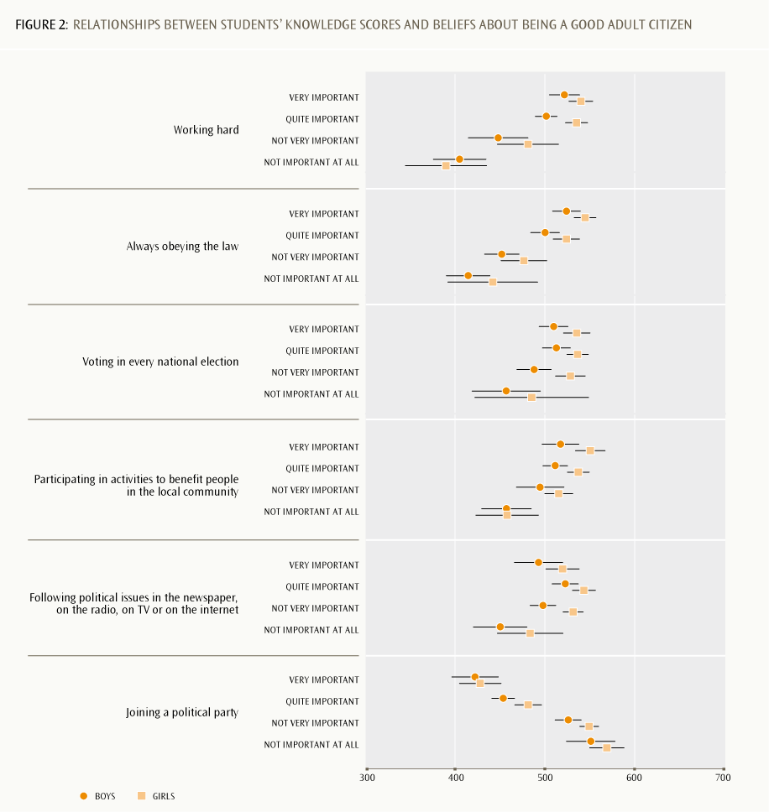
Beginning to build an overall picture of students’ intentions
We opted to begin with this item set as a sort of benchmark of what students see as an ideal of adult participation in civics and citizenship activities. Ideals are value-based, even if those values are tacitly held rather than explicit. In other surveys it has been our experience that when people are asked to identify ideals and then say how often they do these things, a value/practice gap appears (Hipkins, 2010, p. 44). We may not always live up to our ideals, for a wide range of reasons. A small number of items could be matched in this survey, though the wording and scales differed somewhat. Table 2 shows some interesting indications that a value/practice gap is likely to exist for some aspects of students’ citizenship values and actual anticipated practice.
Apart from talking to others and voting, the pattern is for a somewhat smaller proportion of students to think they will do these things compared to the proportion who hold the view that these are indeed things that good adult citizens do. Why might this be? Is it to do with students’ confidence in their own knowledge and skills, their level of interest, how well they are being prepared by school learning experiences, or how much exposure they have to such activities in their home and community lives beyond school? No doubt a combination of these influences is in play, and it is likely to be different for different students. This report cannot address this challenge definitively, but it does provide interesting indications of how some aspects of these dynamics might have underpinned students’ responses.
The next section covers students’ levels of interest in political and social issues. Then the following section covers students’ sense of personal efficacy in relation to taking action as good citizens of a democracy.
TABLE 2: Items that matched perceived importance with likelihood of the students actually doing these things
How important for good adult citizens  (% very or quite important) |  | How likely student will do this  (% certainly or probably will) |  | Difference  (% points)
Voting in every national election | 84 | Vote in national elections | 84 | –
Participating in activities to benefit people in the local community | 78 | Volunteer time to help people in the local community | 60 | –18
Participating in peaceful protests against laws believed to be unjust | 53 | Taking part in a peaceful march or rally | 47 | –6
Engaging in political discussions | 45 | Talk to others about your views on political and social issues | 50 | +5
Joining a political party | 26 | Join a political party | 20 | –6

3. Students’ interest in social and political issues
Students were asked about their current personal interest in social and political issues. Figure 3 shows the items and the responses. The ranking has been determined as in Figure 1, although this item set measures interest rather than importance.
The patterns of responses suggest that a lack of engagement with political and social issues is relatively common among New Zealand students of this age. Being strongly interested is not common for any of the listed issues, with the possible exception of environmental issues. Following is a brief summary of the main points.
›› Greater numbers of students said they were interested in environmental issues than in political or social issues. Girls were more likely to express interest than boys (70% of girls were very or quite interested, compared to 56% of boys).
›› Just over half the students said they were interested in national politics and social issues. Girls were somewhat more likely to say they were interested in the country’s social issues (59%) than were boys (50%). Students were asked this question within two weeks or less of the 2008 general election. Their awareness of social and political issues will have been heightened at this time and may, on average, have increased their interest.
›› Only 40% were interested in local community political issues and just over a third of the students were interested in the politics of other nations, or international politics.
›› Overall, small proportions of students expressed strong interest in the issues asked about except for environmental issues, and even here only 22% of the students said they were very interested.
An ICCS international scale for interest in political and social issues has been derived from students’ answers to this item set, omitting environmental issues (Schulz et al., 2011, pp. 116–118). New Zealand’s score was 50, matching the ICCS average. England’s and Ireland’s scores were 49 and 50, respectively.
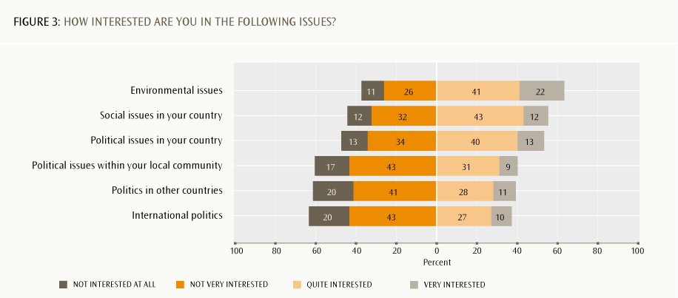
Other demographic differences
There were clear patterns of association between students’ levels of interest and their immigrant status for all except the environmental issues item. There was a clear trend for higher proportions of overseas-born students, followed by New Zealand-born students whose parents were born overseas, followed in turn by New Zealand-born students whose parent(s) were New Zealand-born, to be very or quite interested in political and social issues, as follows:
›› social issues in your country (overseas born, 69%; New Zealand-born, parents born overseas, 62%; New Zealand-born, parent(s) New Zealand-born 55%)
›› international politics (55%, 48%, 33%, respectively)
›› politics of other countries (54%, 47%, 24%, respectively).
The remaining two items followed a slightly different pattern. Similar proportions of overseas-born students and New Zealand-born students with overseas-born parents said they were very or quite interested, but New Zealand-born students had a lower proportion, as follows:
›› political issues in your country (overseas-born, 65%; New Zealand-born, parents born overseas, 66%; New Zealand-born, parent(s) New Zealand-born 49%)
›› political issues within your local community (49%, 51%, 27%, respectively).
Analysis of the overseas-born students by the age they first came to New Zealand shows that those who were younger than five had a similar pattern to New Zealand-born students whose parents were born overseas.
Is it that local students are less interested, or that students who were born elsewhere or who have family members in other parts of the world simply have a “bigger picture” and hence a more international outlook? Either way, the patterns imply challenges for students’ learning about issues that have implications for civics and citizenship.
Table 3 shows the patterns by ethnicity. Again the patterns may be partly explained by the interaction with immigrant status: almost all Māori students are born in New Zealand and have New Zealand-born parents, but Pākehā/European, Pasifika and Asian students have progressively lower proportions.
TABLE 3: Differences in students’ interest in issues, by ethnicity
Type of Issue | Percentage Quite Or Very Interested
Type of Issue | Pākehā/European | Māori | Pasifika | Asian
Environmental issues | 63 | 59 | 67 | 69
Social issues in your country | 53 | 51 | 65 | 67
Political issues in your country | 49 | 51 | 64 | 66
Political issues within your local community | 63 | 59 | 57 | 69
Politics of other countries | 36 | 34 | 46 | 52
International politics | 34 | 34 | 48 | 53

Patterns of association with knowledge scores
Figure 4 (next page) shows how responses to the item set on interest in political and social issues were associated with students’ knowledge scores.
Unlike the item set that probed students’ perceptions of what is important to being a good adult citizen, here we see no clear pattern of association between students’ average knowledge scores and their level of interest in social and political issues. It seems that students with a wide range of knowledge scores have made the same response in each case. Every item is characterised by low levels of responses in the most confident category. Even those students who thought they could do these things were more likely to estimate they could do them fairly well rather than very well. This is similar to the patterns of responses related to how interested they are in social and political issues, as already described.
The international scale for citizenship efficacy (Schulz et al., 2010, pp. 120–121), based on students’ answers to these seven items, shows New Zealand to have a score of 48, slightly less than the ICCS average of 50, and England’s 50 and Ireland’s 49.
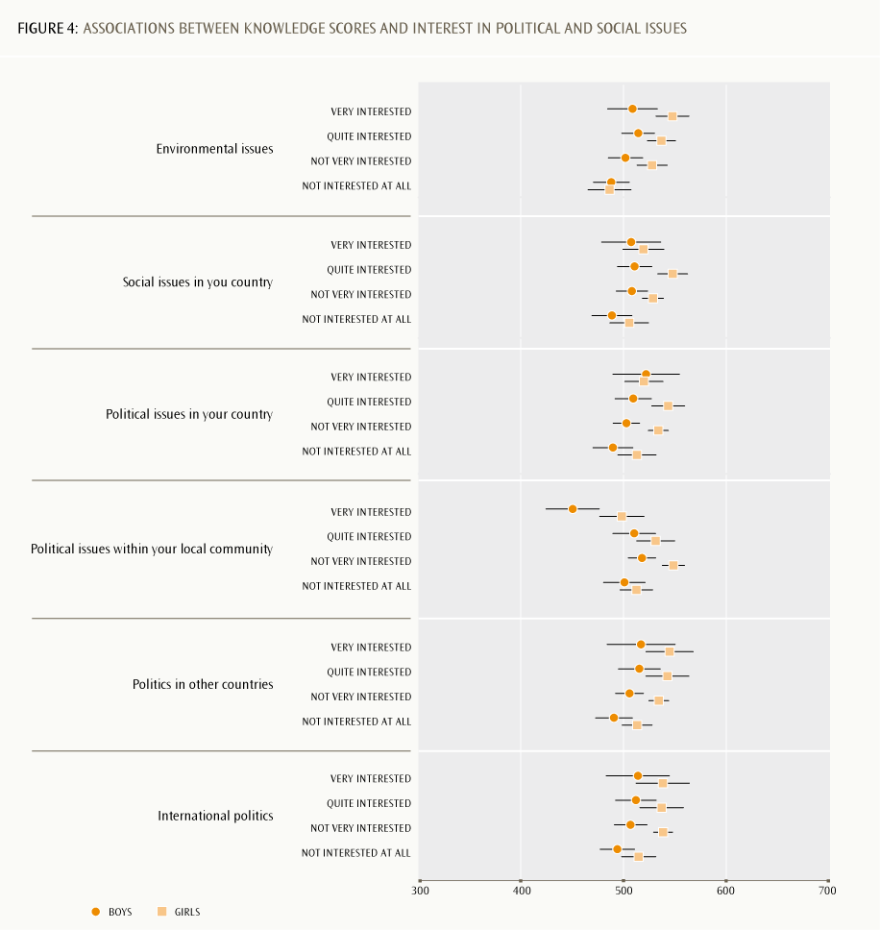
Continuing to build the overall picture
The patterns of relatively low interest — or outright lack of interest — that we found for these six items indicate that this may be at least part of the reason many students do not see themselves as taking part in certain aspects of citizenship when they are adults.
Responses analysed by immigrant status add further evidence to the possibility that New Zealand-born students with New Zealand-born parents have weaker interest in civic and citizenship activities. However, there are no clear indications that a lack of interest is associated with not knowing enough about civic and citizenship issues.
Interest is often linked to a sense that we are already good at something and will experience success when we do it. Two sets of items asked about students’ sense of their current personal efficacy in areas potentially related to civic and citizenship activities. These are considered next.

4. How students judge their own citizenship competencies
Students were asked how well they thought they would do seven described activities. These seven items described action competencies that might be used in common activities likely to be a part of school and everyday life for Year 9 students. Figure 5 shows the results.
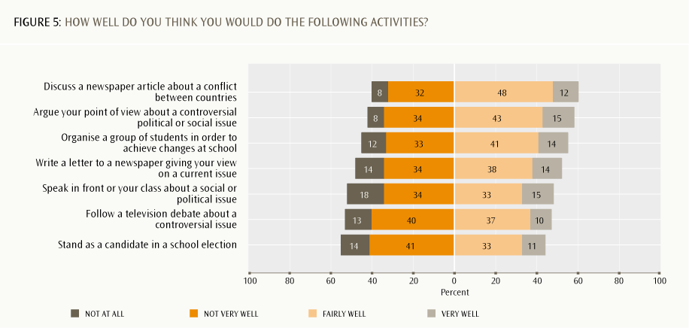
We see a pattern of higher numbers of students estimating they have at least some competency in areas associated with traditional school learning activities, such as taking part in discussions and debates, and fewer than half estimating that they have personal action competencies in areas that require a level of activity (and perhaps initiative) beyond the classroom. Following is a brief summary of the main points.
›› Compared to the other activities listed, more students believed they could do at least quite well in discussing a newspaper article about conflict between nations (60%) or in arguing their point of view about a controversial political or social issue (58%).
›› Just over half the students believed they could do quite well in two activities that required more than talk: moderate activism (ie, organising a group) to achieve changes at school (55%) and writing to a newspaper to express a view on a current issue (52%).
›› Fewer than half thought they would do at least fairly well if required to speak about a political or social issue in front of the class (48%) or follow a television debate about a controversial issue (47%).
›› Even fewer students thought they would do well if standing as a candidate in a school election (44%).
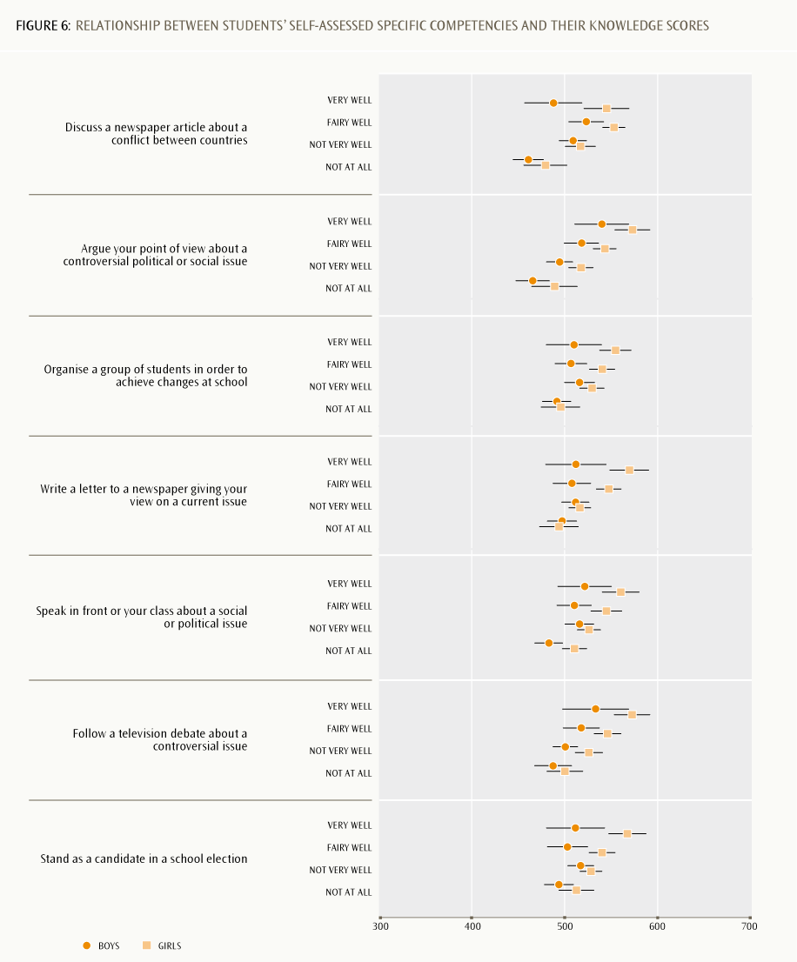
Demographic differences
Response patterns to the two items that required carrying out a specific activity showed gender differences. Overall, girls were more confident of their ability to organise a group of students to achieve changes at school (60%, compared to 48% of boys who thought they would do very or fairly well). Similarly, girls were more likely to think they could write to a newspaper giving their view on a current issue at least fairly well (57%, compared to 46% of boys).
Students of all immigrant statuses and all ethnic groups showed similar patterns of self-assessed competency levels.
Patterns of association with knowledge scores
Figure 6 shows how self-assessed competencies were associated with students’ civic knowledge scores. As with Figure 4, no clear overall pattern is apparent in Figure 6. Perhaps this item set somehow tapped into students’ views of their personal competencies in a way that cued them to think about factors other than what they know about politics or issues. However, for some items, a stronger association exists between a self-assessed competency and the knowledge score of girls than of boys. Writing a letter to a newspaper and standing as a candidate in a school election are examples.
What might lie behind these patterns?
Given the lack of a clear overall association with students’ knowledge scores (or with their immigrant ethnicity status), it could be that the differences in students’ responses were dispositional in nature. Being “ready, willing and able” to take the initiative and do something about an issue of concern requires strategy (knowing what can be done), skills for action (being able to do what you can envisage, and knowing how to go about it), and the necessary confidence and conviction (seeing it as sufficiently important to expend the necessary energy and effort) to see a plan through. All of these things — and more besides — are in addition to traditional content knowledge, which is of course relevant but far from the sole determinant of how competent students feel to take action.
Figure 6 shows that, for some competencies, the association with civic knowledge scores appears stronger for girls than for boys. In these cases we might conclude that the mix of content knowledge and disposition to act differs a little by gender for Year 9 students. So, for example, on average, boys’ self-assessment of how well they would do as a candidate in a school election seems driven largely by disposition rather than by civic knowledge, whereas for girls it may be more of a mix of these two elements.
Many students seem to lack confidence that they would be good at doing a range of activities that could already be available as part of their school learning experiences. Did an element of sensitivity to peer responses influence their thinking at what is an important developmental stage in young people’s lives? These activities would require students to reveal something of themselves to their peers, which points to questions of how self-confident they feel. We next investigate students’ confidence in their grasp of political issues.

5. Students’ estimation of their personal understanding of political issues
Students were asked to say how much they agreed or disagreed with six statements that probed their personal political efficacy; that is, the extent to which they thought they understood issues and that their own views were well informed and therefore worth sharing. Figure 7 shows the results.
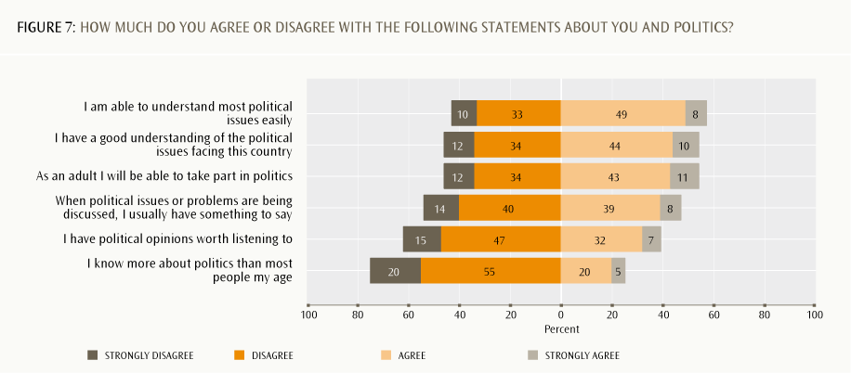
The pattern shows that just over half the students have at least modest confidence in their own understanding of political issues, but there are lower levels of confidence that their own views are actually worth hearing. Following is a brief summary of the main points.
›› Just over half the students agreed or strongly agreed that they can understand most political issues easily (57%), that they have a good understanding of the political issues facing the country (54%) and that they will be able to take part in politics once they are adults (also 54%).
›› Almost half (48%) felt they could make a contribution to a conversation about a political issue or problem.
›› A much lower proportion placed a high value on their own opinions: 39% thought their opinions were worth listening to and just 25% estimated that they knew more about politics than most people of their age.
Students provided these self-assessments of their understanding of political issues close to the 8 November 2008 general election. ICCS data collection took place from about a week before the election day to two weeks afterwards, and this is likely to have affected students’ responses.
Compared to the item sets already discussed, there were even lower levels of strong agreement for these items. Also, there were strong indications that individual students gave the same or a similar response to all six items. If they were confident about their abilities in one area they were likely to be confident in all the other areas as well.
The international scale for internal political efficacy, based on students’ answers to these six items, showed New Zealand’s score of 50 matching the ICCS average (Schulz et al., 2010, pp. 117–119). England’s was 50 and Ireland’s 51.
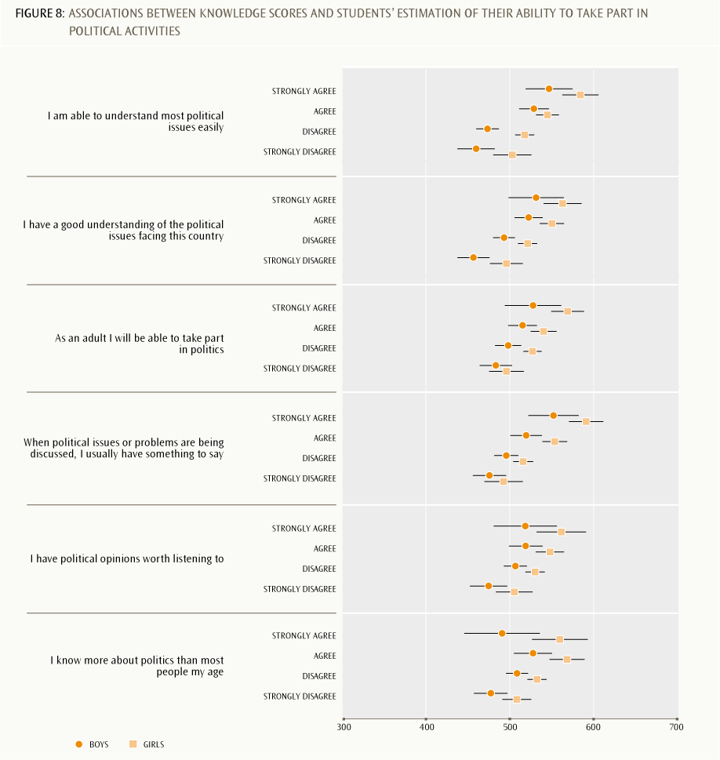
TABLE 4: Extent of parents’ interest in political and social issues
Responses | Mother (percent) | Father (percent)
Very interested | 14 | 20
Quite interested | 55 | 50
Not very interested | 25 | 25
Not at all interested | 5 | 5

TABLE 5: Associations between parental interest in political and social issues and students’ knowledge scores
Parental interest pattern | Percent | Average knowledge score  for this group
Both parents very or quite interested | 60 | 532
One parent very or quite interested | 19 | 524
Neither parent interested | 21 | 497

TABLE 6: Extent to which students who expressed a preference for a political party favoured that preference
Parental interest pattern | Extent to which student favours one party (percent)
Parental interest pattern | A lot | To some extent | A little | Row total
Both parents interested | 38 | 47 | 15 | 100
One parent interested | 34 | 51 | 15 | 100
Neither parent interested | 35 | 43 | 21 | 100

Demographic differences
There was only one pattern of gender difference: boys were more likely to be confident that they know more about politics than other people of their age (30%, compared to 21% of girls). There was also a difference for this item by ethnicity: Asian students were more likely to say this (29%) and Māori students were least likely to think they knew more than other young people (21% of them said this).
As for the item set on students’ current estimations of their competencies, there were no overall patterns of difference by immigrant status, or any other differences by ethnicity.
Patterns of association with knowledge scores
Figure 8 (previous page) shows how personal understanding of political issues was associated with students’ knowledge scores. For all these items, there is a trend for students in the group who are most confident of their ability to take part in a range of political activities to also have a higher average knowledge score.
Compared to the first four items in Figure 8, the pattern is less clear-cut for the final two, which probed the value students attached to their opinions (worth listening to, know more than other young people). Notice that the small group of boys who thought they knew more about politics than most people their age actually had a lower average knowledge score than those boys who were somewhat more modest about their abilities.
The overall picture that is forming in this report is one of moderate levels of interest and self efficacy in areas related to active participation in politics. One question to be explored here is the extent to which this pattern is driven by a lack of familiarity with how such activities play out in real life. Do the adults in students’ lives take an interest in political and social issues? If so, can we see an influence on how the students responded to this survey?
Family interest in political and social issues
One question in the ICCS survey asked students to indicate how interested their parents or caregivers are in political and social issues. Their responses are shown in Table 4.
A somewhat greater proportion of students, and in particular overseas-born and New Zealand-born students with overseas-born parents, perceived that their male parent or caregiver was very interested, but overall these results are very similar. There were no overall differences in these responses by gender.
We also checked to see the extent to which students gave the same response for both parents.
Table 5 shows the results and also the average knowledge score of the students who gave each response. The table shows that coming from households where both parents are interested in political or social issues was associated with having a higher knowledge score. This suggests that one source of students’ civic and citizenship knowledge is the conversations they take part in, or at least overhear, at home.
This is a further example of parental influence on students’ knowledge and opinions: as discussed in sections 2 and 3, parents who were born overseas also appear to influence their children’s views towards stronger interest in social and political issues.
Students’ personal political preferences
One question asked students if they had a preference for one of New Zealand’s political parties in terms of whether they “like it more than others”. Two-thirds (67%) said yes. There was a clear pattern of association between students saying they had a preference and the level of their parents’ interest. Where both parents were interested, 71% of students said they had a preference for one political party. Similarly, 70% of the group who said only one parent was interested also had a personal preference. However, 50% of the group who said neither of their parents was interested also said they liked one party more than the others, so parental interest cannot be the sole influence on these responses.
Those students who had a preference were then asked to indicate how strongly they held their view. The question asked, “How much are you in favour of this party?” and the options provided were “a lot”, “to some extent” or “a little”. Table 6 shows their responses and compares these with their perception that one or both parents were very or quite interested in political and social issues. For these students who expressed a preference, their parents’ interest in political issues appears to have a small association with the strength of their own preference for a political party.
From preferences to action
Expressing a preference for one political party over others does not necessarily indicate an intention to take part in political processes. The next section investigates the types of political activities that students anticipate they will actually take part in when they are older.

6. Students’ intentions for personal participation in politics
This item set described seven political activities in which all adults can potentially participate. Students were asked to say which they thought they were likely to do in their adult lives. Note that this question introduces a likelihood scale. Figure 9 shows the results.
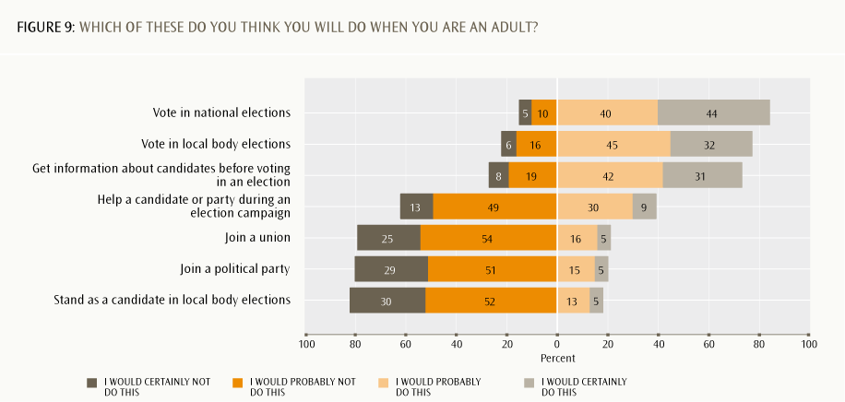
Most students anticipated that they would take part in representative democratic activities such as voting, although more so in national than in local body elections. Eighty-four percent would certainly or probably vote in national elections. This matches the 84% who agree that good adult citizens should vote. Seventy-seven percent thought they would certainly or probably vote in local body elections. The timing of the 2008 general election during the ICCS data collection is likely to have influenced students’ responses to this question.
The international scale of students’ expected electoral participation as an adult was based on the first three items in this set (Schulz et al., 2010, pp. 140, 144).
New Zealand’s score was 49, just below the ICCS average, and compares with England’s 47 and Ireland’s 52. The proportions of students in the three countries who said they would probably or definitely expect to vote in national elections were: New Zealand 84%, England 72% and Ireland 87% (Schulz et al., 2010, p. 145).
Enrolment and turnout rates in the 2008 and 2011 general elections provide some background context for these student intentions. In 2008, 95.3% of eligible voters were enrolled and 79.5% of enrolled electors cast their votes. The figures for the 2011 election showed an enrolment rate of 93.7% and a turnout rate of 73.8%. (Parliamentary Library, 2008, 2011). In 2011 the enrolment rate for 1824-year-olds was much lower than the average across all age groups at 77%. According to the 2008 New Zealand General Social Survey, only 46% of 1524-year-olds said they had voted in the last general election, though many were not eligible to vote on age or other grounds (Ministry of Social Development, 2010, p. 74; Ministry of Justice, 2009, p. 28).
Much lower proportions of students anticipated taking part in more participatory democratic activities such as helping a candidate in an election campaign (39%), joining a union (21%) or a political party (20%), or standing as a local body candidate (18%).
The international scale of students’ expected participation in political activities as an adult based on the remaining four items of this set showed New Zealand’s score at 49, just below the ICCS average (Schulz et al., 2010, pp. 143, 147). England’s score was also 49 and Ireland’s was 50.
Patterns of demographic differences
There were no gender differences for any of the items in this set. There were two differences by immigrant status, and these followed a similar pattern to those reported for students’ levels of interest in political and social issues. Somewhat higher proportions of New Zealand-born students with overseas-born parents, along with overseas-born students, than New Zealand-born students said they would certainly or probably:
›› get information about candidates before voting in an election (overseas-born, 78%; New Zealand-born, parents born overseas, 80%; New Zealand-born, parent(s) New Zealand-born 71%), or
›› help a candidate or party during an election campaign (46%, 44%, 37%, respectively).
As Table 7 shows, there were a greater number of differences by students’ ethnic status. Compared to Pākehā/European and Asian students, Māori and Pasifika students are less likely to report that, when adults, they will vote, but they are more likely to report that they will take the more active roles of joining a union or political party or stand as a candidate. Pasifika students are even more likely than Māori students to take on such roles.
It is likely that some of these actions do not show up as differences by immigrant status because, compared to the item sets reported earlier, responses from Māori students do not match as closely those of Pākehā/European students for this item set though Māori and Pākehā/European students have, overall, similar immigrant status.
Table 7: Differences in anticipated political actions, by ethnicity
Action | Percentage that certainly or probably will do this
Action | Māori | Pākehā/European | Pasifika | Asian
Vote in national elections | 74 | 87 | 80 | 88
Vote in local body elections | 66 | 82 | 71 | 79
Get information about candidates before voting in an election | 60 | 75 | 69 | 80
Help a candidate or party during an election campaign | 41 | 35 | 48 | 41
Join a union | 26 | 18 | 31 | 21
Join a political party | 25 | 17 | 32 | 20
Stand as a candidate in local body elections | 23 | 15 | 31 | 18

Patterns of association with knowledge scores
Figure 10 shows how responses to six of the seven items in this set were associated with students’ knowledge scores. There is no clear pattern for helping a candidate or joining a union. There is a clear pattern of associations between average knowledge scores and students’ intentions to vote in national or local body elections; the higher their knowledge score, the more certain students were that they would take part in voting. The item “get information about candidates before voting in an election” (not shown in Figure 10) also followed this pattern.
Responses to intentions to join a political party or stand as a candidate in local elections show the opposite pattern. Saying they would certainly do this was associated with having a lower knowledge score. Students of different ethnic groups had similar patterns in terms of the relationship between the likelihood of intentions and knowledge score.
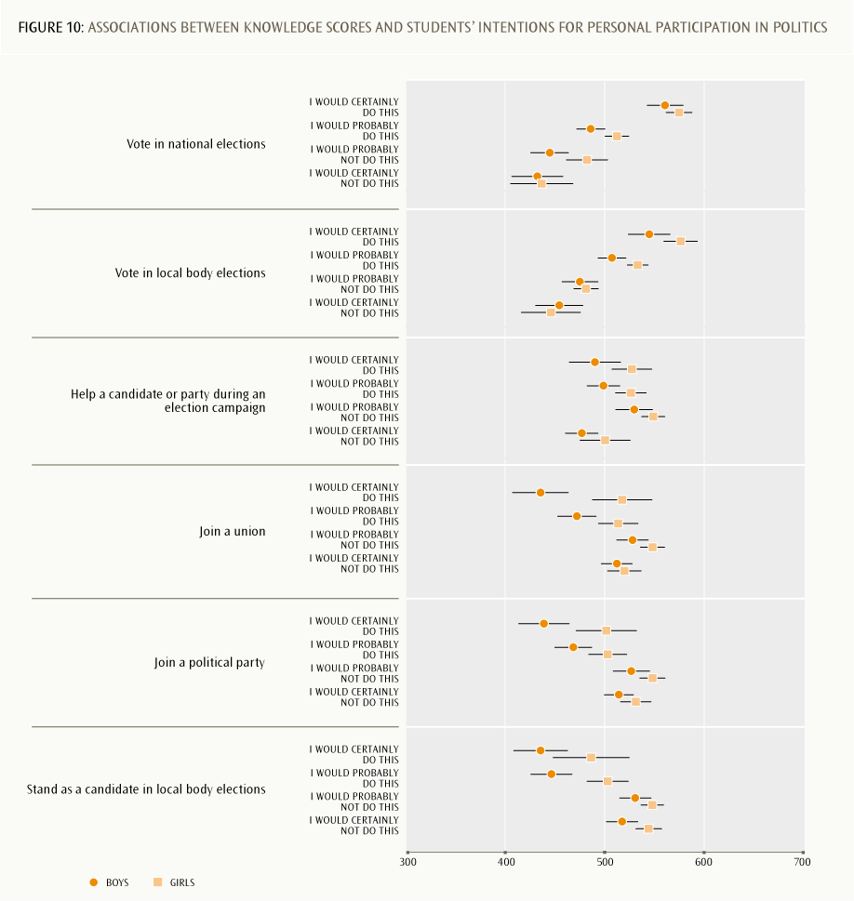
Representative or participatory democratic responsibilities?
The results reported in this section show that most students do intend to exercise their responsibilities and rights with respect to democratic representation. Many of them already have a preference for a political party, especially if one parent has, or both parents have, an interest in politics. However, smaller proportions of students anticipate that they will make a more participatory democratic contribution; for example, by supporting a party or candidate, or actually joining a party or union.
Are there other types of activities in which these young people see themselves personally taking part “during the next few years” — a phrase that potentially includes the rest of their time at school and the immediate post-school years? The next item set investigates this question.

7. Students’ anticipated citizenship activities in the near future
One set of five items described a range of actions that could already be within young people’s grasp and asked how often they thought they might do these things in the next few years. Figure 11 shows the results.
We see much higher levels of support for activities that are generally social in nature compared to those that require overt political participation. Following is a brief summary of the main points.
›› The highest levels of support are for volunteering time to help people in the local community. Sixty percent of the young people thought they would do this. (However, as already discussed, 78% thought that good adult citizens in general would do this.)
›› Exactly half (50%) the students anticipated that they would talk with others about their political and social views. Since these “others” are not specified, this could include relatively private conversations, such as within a peer group or family.
›› A more public declaration of views is something only a minority of these young people see themselves as likely to be doing; 29% said they would certainly or probably write to a newspaper or contribute to an online discussion forum about political and social issues.
›› Even less likely is the prospect of making a commitment to an activist group; just 24% anticipated that they certainly or probably would join an organisation for a political or social cause.
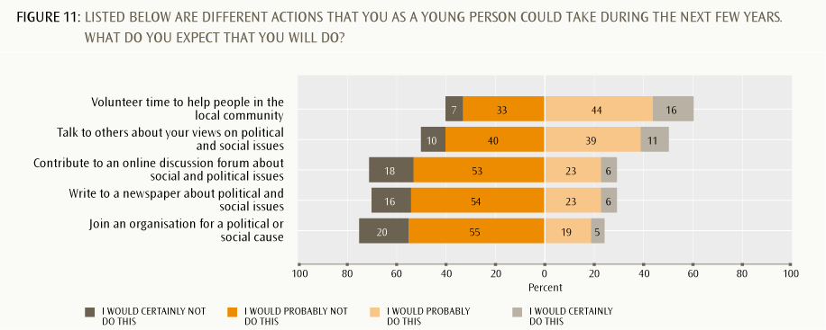
Compared to the 52% who thought they could do at least quite well at writing to a newspaper, just 29% saw this as something they would do in the near future. It would seem that not just estimations of their personal abilities were contributing to this assessment of unlikely future action. Interestingly, when asked to think about taking part at some point in their future life in protests against something they believed to be wrong, 53% could see themselves writing to a newspaper (see next item set). It may be that the lower anticipated levels of action in the close future reflect a lack of urgency or passion about any specific issue that would cause students to consider taking action any time soon.
Demographic differences
There was only one gender difference. More girls (65%) than boys (53%) anticipated that they would actually volunteer time to help people in the local community. There were no gender differences in responses to how important such activities are to being a good adult citizen, so this difference in intended activity levels does not appear to be primarily value-based. The 2009/10 Time Use Survey found parallel results for unpaid work behaviour in a four-week reference period: 72% of all females aged 12 and over reported that they had undertaken unpaid work for other households or organisations, compared with 66% of males aged 12 and over (Statistics New Zealand, 2011, pp. 6, 7, and Table 11).
Compared to New Zealand-born students whose parent(s) were New Zealand-born, greater proportions of New Zealand-born students whose parents were born overseas and overseas-born students said they would certainly or probably:
›› volunteer time to help people in the local community (overseas born, 67%; New Zealand-born, parents born overseas, 70%; New Zealand-born, New Zealand-born parent(s), 57%)
›› write to a newspaper about political and social issues (37%, 38%, 27%, respectively)
›› contribute to an online discussion forum about political and social issues (35%, 36%, 26%)
›› join an organisation for a political or social cause (27%, 32%, 23%).
While these differences could be seen as pointing to greater lack of interest on the part of New Zealand-born students, as we have seen in some earlier item sets, it is likely that this pattern also reflects ethnic differences. Pasifika and Asian students were somewhat more likely than either Pākehā/European or Māori students to say they would volunteer time to help people in the local community or join an organisation for a political or social cause. As footnote 7 states, large proportions of the Pasifika and Asian students had parents born overseas or were born overseas themselves.
Patterns of association with knowledge scores
There was no clear association between students’ future civic action and civic knowledge scores. This is the third of the item sets in this report to show this overall pattern. The others were students’ personal interest in political and social issues (Figure 4) and their estimations of their own competencies to undertake a range of named actions (Figure 6). All these item sets have a strong dispositional element in common: students have to want to be interested and to actively participate. These data patterns seem to be pointing to something other than having a strong knowledge base about civic and citizenship rights, responsibilities and issues as a predictor of likely interest and willingness to contribute to citizenship activities.
However, when we put these data alongside the attitudinal data explored in the second New Zealand ICCS report, a contrasting pattern is revealed. That report describes a pattern of strong positive associations between students’ civic knowledge scores and their beliefs and attitudes about a range of democratic and civic rights issues. (Satherley, 2011). The combination of these two sets of patterns suggests that both of these components matter. Knowledge is clearly associated with democratic attitudes and beliefs, and we also see that for other item sets in this third report. However, competencies to take action make up a wider construct, of which more “academic” knowledge is just one component. “Knowing how” and being confident in one’s abilities to act would appear to be at least as important — if not more so.
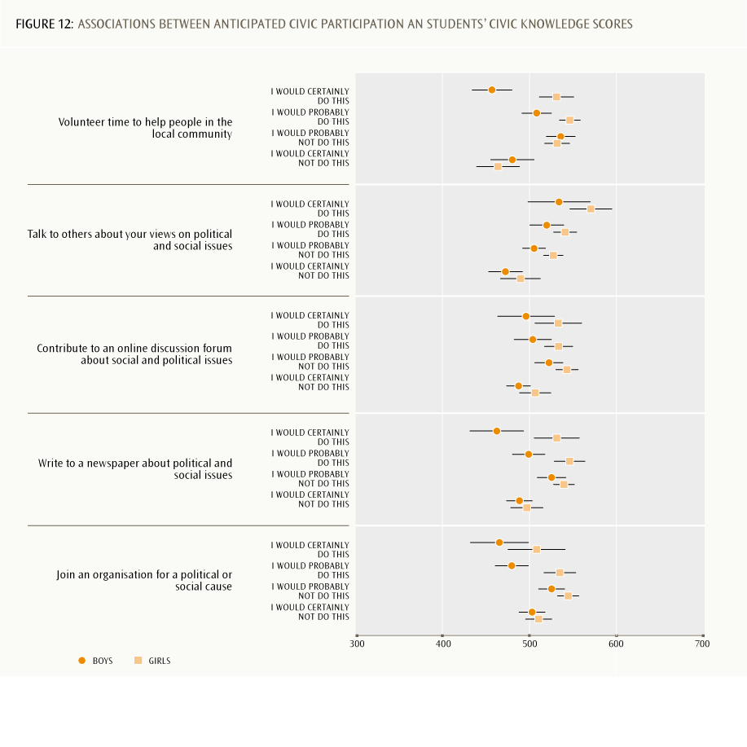
What forms might action take?
Relating these items to the NZC model of key competencies, the responses shown here point to the potential for teachers to help students to strengthen already existing knowledge, skills and dispositions for active citizenship. One way to do this might be to ensure that students have opportunities to develop and take action on their interests in areas that are of personal importance and relevance to them. “Taking action” can cover a wide range of things and circumstances, however. Does the survey give us any insights into the actions students can actually envisage taking when they are adults? The focus of the final item set moves further into the future and turns towards active forms of protest against things that people believe to be wrong.

8. Students’ views about taking part in protest actions when they are adults
The final item set discussed in this report describes a range of possible protest actions, from peaceful, moderate and lawful actions, through to stronger forms of civil disobedience or breaking the law. Students were asked to say how likely it was that they would do each of these things in the future. Figure 13 shows the results.
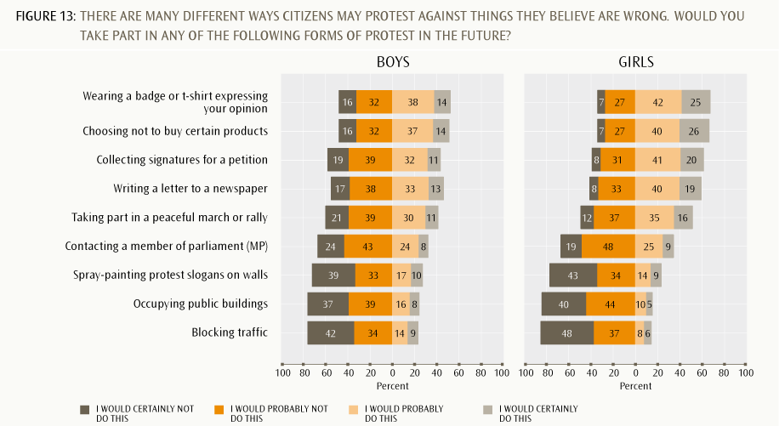
Note that male and female response patterns have been separated out. Unlike the other item sets discussed in this report, there were differences by gender for almost all the items. Girls were more likely to envisage taking part in more lawful and moderate forms of protest. Only a very small proportion of students could see themselves taking part in more confrontational forms of action (the bottom-ranked three items), and these respondents were more likely to be male.
Overall, then, more than half the students could see themselves taking part in the more moderate forms of protest in the future, but there were much lower levels of support for the stronger forms of civil disobedience. Following is a brief summary of the main points.
›› Sixty percent of students envisaged that they would certainly or probably wear a badge or T-shirt that expressed an opinion, or that they would exercise a consumer choice not to buy certain products.
›› Around half the students could see themselves writing a letter to a newspaper (53% certainly or probably) or collecting signatures for a petition (52%).
›› Stepping the level of possible action up a notch, just under half (47%) could envisage taking part in a peaceful march or rally.
›› Just 34% thought they certainly or probably would contact an MP in protest about something they believed to be wrong.
›› Fewer students anticipated that they might spray-paint protest slogans on walls (25%), or block traffic or occupy public buildings (both 19%). Compared to all other items discussed in this report, much higher numbers of students said they would certainly not do these things in the future (between 38% and 45% for the three items).
The ICCS international report derives two scales: one for expected legal protest activities (the first six items) and one for expected illegal protest activities (the remaining three items) (Schulz et al., 2010, pp. 137, 140142). For legal protest activities the scores were: New Zealand, 50; England, 50; Ireland, 51. For illegal protest activities the scores were the same: New Zealand, 50; England, 50; Ireland, 51.
Demographic differences
The only item that did not show a gender difference was contacting an MP. As already outlined, boys were more likely than girls to see themselves taking part in the strongest forms of action (painting slogans, blocking traffic, occupying buildings). Girls were more likely than boys to see themselves making personal statements via their clothing and consumer choices, or taking part in a peaceful march or contributing to a petition, or writing to a newspaper.
There were no clear patterns of difference by immigrant status, but there were several patterns associated with students’ ethnic identifications. Māori and Pasifika students were more likely to say they would certainly or probably take part in:
›› spray-painting protest slogans on walls (Māori, 37%; Pasifika, 34%; Pākehā/European, 21%; Asian, 19%)
›› blocking traffic (Māori, 29%; Pasifika, 25%: Pākehā/European, 17%; Asian, 15%)
›› occupying public buildings (Māori, 26%; Pasifika, 29%; Pākehā/European, 18%; Asian, 20%).
Pākehā/European and Asian students were more likely to say they would take action by choosing not to buy certain products (Māori, 51%; Pasifika, 52%; Pākehā/European, 61%; Asian, 63%). Asian students were less likely to say they would contact a member of Parliament (Māori, 33%; Pasifika, 37%; Pākehā/European, 32%; Asian, 25%).
Patterns of association with knowledge scores
Figure 14 shows how responses to this item set were associated with students’ knowledge scores.
There is a clear pattern of positive association between higher average civic knowledge scores and anticipating taking part in traditional, lawful types of protest activities. There is a negative association for all three more confrontational forms of protest (blocking traffic is not shown here); thinking you might do these things was associated with a lower average civic knowledge score. This pattern is likely to be at least partly related to ethnic differences, but there could be indications of disaffection and disempowerment such that this group of students might see this as a way to have their voices heard. There may also be an element of bravado for some, being offered the opportunity to envisage doing these things without actually having to follow through.
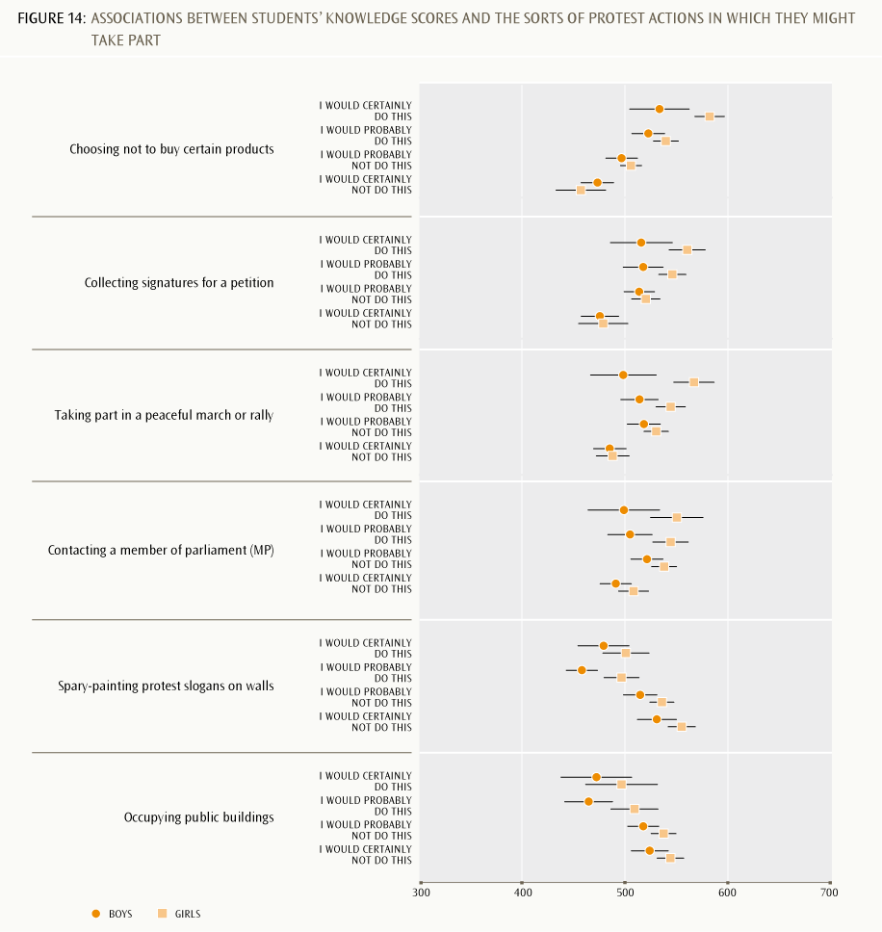

9. Are our young people connected and contributing?
The introduction to this report highlighted links to the NZC vision for all our young people to be and become confident, connected, actively involved lifelong learners. This report gives some indications on where our 14-years-olds are with respect to this ambitious but potentially empowering vision. This final section draws the threads together by looking across all the questions to identify implications for education and areas for further investigation.
This report indicates that most of New Zealand’s young people do have a good sense of what it means to be a responsible and connected citizen. They think it will be important, as an adult, to work hard, show respect for the law and government representatives, vote in national elections (and to a lesser extent in local body elections), and participate in their local communities for both social and environmental good. However, only around half of the responding group expressed an active interest in pursuing issues related to civic and citizenship, or indicated their confidence that they already possess the knowledge and competencies needed to do so. These student views were provided close to the 2008 national election, which is likely to have had an impact on the results. However, these findings imply challenges for meeting the curriculum intent via the education these young people receive at school. The fourth report in the series will look more closely at these challenges.
This report gives some interesting indications of differences between subgroups of students within the overall population. Māori students, for example, were somewhat less likely than other students to think that it is important to vote in every national election, or to express an intention to vote in local body elections. Nevertheless, both they and the Pasifika students were more likely than either Pākehā/European or Asian students to say they might stand as a candidate in a local body election or join a political party.
For the Pasifika students this pattern accords with other indications of a community-minded sense of participation (for example, they were more likely to anticipate volunteering time to help in the local community).
Looking across the various item sets, there is also a sense that New Zealand-born students with New Zealand-born parents are less likely to be actively interested in participation in civic activities, either now or in their adult lives. This seems to indicate a certain lack of interest among these young people, who have always lived in the comparatively settled political and social conditions of New Zealand. However, the pattern could equally reflect the likelihood of more outward-facing connections for students either born overseas or whose parents were born overseas, who are likely to have family and community connections in other parts of the world. Because the majority of Asian students, and more than half the Pasifika students, are either overseas born or born in New Zealand to overseas-born parents, patterns related to ethnicity and to immigrant status do tend to be very closely aligned. This makes exceptions to the overall trends, such as the relatively greater intention of Māori students (who are almost all New Zealand-born) to join a political party, even more noteworthy.
Perhaps of most concern is the small group of young people who could already be expressing a sense of disenfranchisement at age 13 or 14. This group comes most sharply into focus in the item set that discusses possible future protest actions. Those who see themselves taking part in more confrontational and possibly unlawful activities tend to have lower knowledge scores. Could their school education make a positive difference here by supporting these seeming “outsiders” to strengthen their action competencies and increase their civic and citizenship knowledge so that they might envisage other more productive avenues for democratic participation? Again, this is a question taken up by the fourth and final report in this series.

References
Carr, M. (2006). Dimensions of strength for key competencies. Hamilton: University of Waikato. Retrieved from: http://nzcurriculum.tki.org.nz/curriculum_project_archives/references
Hipkins, R. (2010). Reshaping the secondary school curriculum: Building the plane while flying it?: Findings from the NZCER National Survey of Secondary Schools 2009. Wellington: New Zealand Council for Educational Research.
Lang, K. (2010). What do New Zealand students understand about civic knowledge and citizenship?: Results from the International Civic and Citizenship Education Study. Wellington: Ministry of Education.
Ministry of Education. (2007). The New Zealand Curriculum. Wellington: Learning Media.
Ministry of Justice. (2009). New Zealand justice sector civil and democratic outcomes report: June 2009. Wellington: Ministry of Justice.
Ministry of Social Development. (2010). The social report 2010. Wellington: Ministry of Social Development.
Parliamentary Library. (2008). Final results for the 2008 New Zealand general election. Wellington: Parliamentary Library.
Parliamentary Library. (2011). The 2011 general election: Provisional results. Wellington: Parliamentary Library.
Satherley, P. (2011). What do our students think about New Zealand, democracy and freedom?: New Zealand results from the International Civic and Citizenship Education Study. Wellington: Ministry of Education.
Schulz, W., Ainley, J., Fraillon, J., Kerr, D., & Losito, B. (2010). ICCS 2009 international report: Civic knowledge, attitudes and engagement among lower secondary-school students in 38 countries. Amsterdam: International Association for the Evaluation of Educational Achievement.
Statistics New Zealand. (2011). Time use survey: 2009/10. Wellington: Statistics New Zealand. Retrieved from www.stats.govt.nz/browse_for_stats/people_and_communities/time_use/ TimeUseSurvey_HOTP2009-10/Commentary.aspx

Countries participating in ICCS
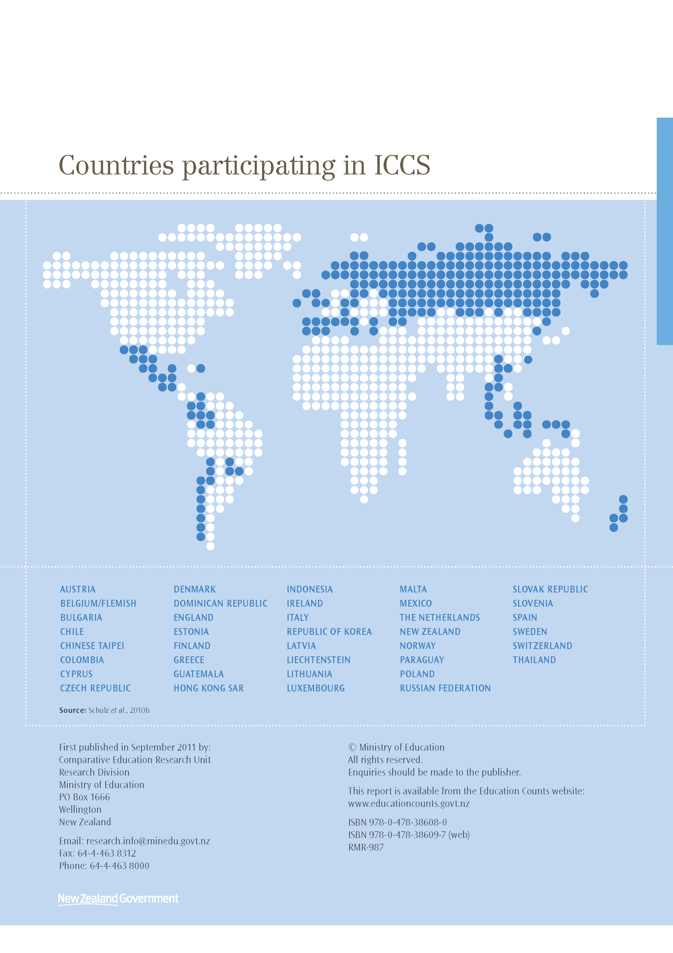

Austria
Belgium/Flemish
Bulgaria
Chile
Chinese Taipei
Colombia
Cyprus
Czech Republic
Denmark
Dominican Republic
England
Estonia
Finland
Greece
Guatemala
Hong Kong Sar
Indonesia
Ireland
Italy
Republic Of Korea
Latvia
Liechtenstein
Lithuania
Luxembourg
Malta
Mexico
The Netherlands
New Zealand
Norway
Paraguay
Poland
Russian Federation
Slovak Republic
Slovenia
Spain
Sweden
Switzerland
Thailand

Source: Schulz et al., 2010.

First published in July 2012 by:
Comparative Education Research Unit
Research Division
Ministry of Education
PO Box 1666
Wellington
New Zealand
Email: research.info@minedu.govt.nz
Fax: 64-4-463 8312
Phone: 64-4-463 8000
© Ministry of Education
All rights reserved.
Enquiries should be made to the publisher.
This report is available from the Education Counts website:
www.educationcounts.govt.nz
ISBN 978-0-478-38645-5
ISBN 978-0-478-38646-2 (web)
RMR-993

The IEA is an independent international consortium that conducts large-scale comparative studies of educational achievement.
The main ICCS testing period was 3-21 November 2008, and election day was 8 November 2008. The timing of the data collection was determined by the IEA, not by New Zealand.
The test language was English only.
For those graphs representing students’ assessment of importance, the proportions reporting quite or very important are to the right of the midpoint. Scales of interest, likelihood etc are displayed similarly.
New Zealand is frequently compared with other English-speaking countries because of similarities in both education systems and cultural background. The scores on this scale range from 44 for the Czech Republic to 58 for Thailand.
The proportions of Year 9 students by immigrant status were: 77% New Zealand-born with parent(s) New Zealand-born; 8% New Zealand-born but parents born overseas; and 15% born overseas. Of students born overseas, 31% were older than 10 years when they first migrated to New Zealand, 45% were aged 5 to 10 years, and 23% were younger than 5.
Almost all Māori students were born in New Zealand with New Zealand-born parents (98%), as were most Pākehā/European students (89%); 50% of Pasifika students were New Zealand-born with New Zealand-born parent(s); 31% were New Zealand-born with overseas-born parents; and 19% were overseas born. The figures for Asian students were: 23%, 22% and 55%, respectively. In addition, overseas-born students of different ethnic groups differed accordingly to the age they first came to New Zealand: 24% of overseas-born Pākehā/European students were younger than 5 when they arrived, compared to 36% of Pasifika students and 16% of Asian students. New Zealand Year 9 students in 2008 identified as Pākehā/European (68%), Māori (22%), Pasifika (14%) and Asian (12%). The percentages sum to more than 100% because of multiple responses by students to different ethnic categories: students may report more than one ethnicity, and every response is counted. The Other ethnicity category was too small to analyse.
Details of how this knowledge measure was derived can be found in Lang, 2010, pp. 1418.
Refer to Lang, 2010, p. 6-13 for more detail and discussion of these differences.
Scores on this scale ranged from Belgium (Flemish), Slovenia and Sweden all at 45 to Thailand at 56.
Scores on this scale ranged from Finland at 46 to the Dominican Republic at 57.
Margaret Carr (2006) introduced this phrase to early discussions about the dispositional nature of the NZC key competencies.
Cronbach’s Alpha is a statistical measure of this. In this case it is high: α = .866 (α = 1.00 would represent 100% correspondence across the items).
The scale scores ranged from the Czech Republic’s 44 to Indonesia’s 56.
Of the students who expressed a preference (n=2,390), most (n=2,373) also responded to this item.
The scores on this scale ranged from 44 for the Czech Republic to 55 for Guatemala.
The 2008 General Social Survey was conducted between April 2008 and March 2009, so the “last general election” may have been either that of 2005 or 2008. Because of the secret ballot, information on differences in turnout rates is not directly available.
The scores on this scale ranged from the Czech Republic at 45 to the Dominican Republic at 57.
The range of score on the scale for expected legal protest activities was Colombia, 55 to Korea, 45. For expected illegal protest activities the range was the Dominican Republic, 55 to Chinese Taipei, 46.
The items omitted in the interests of keeping the figure clear (wearing a badge or T-shirt, writing a letter to a newspaper) also follow this pattern.

