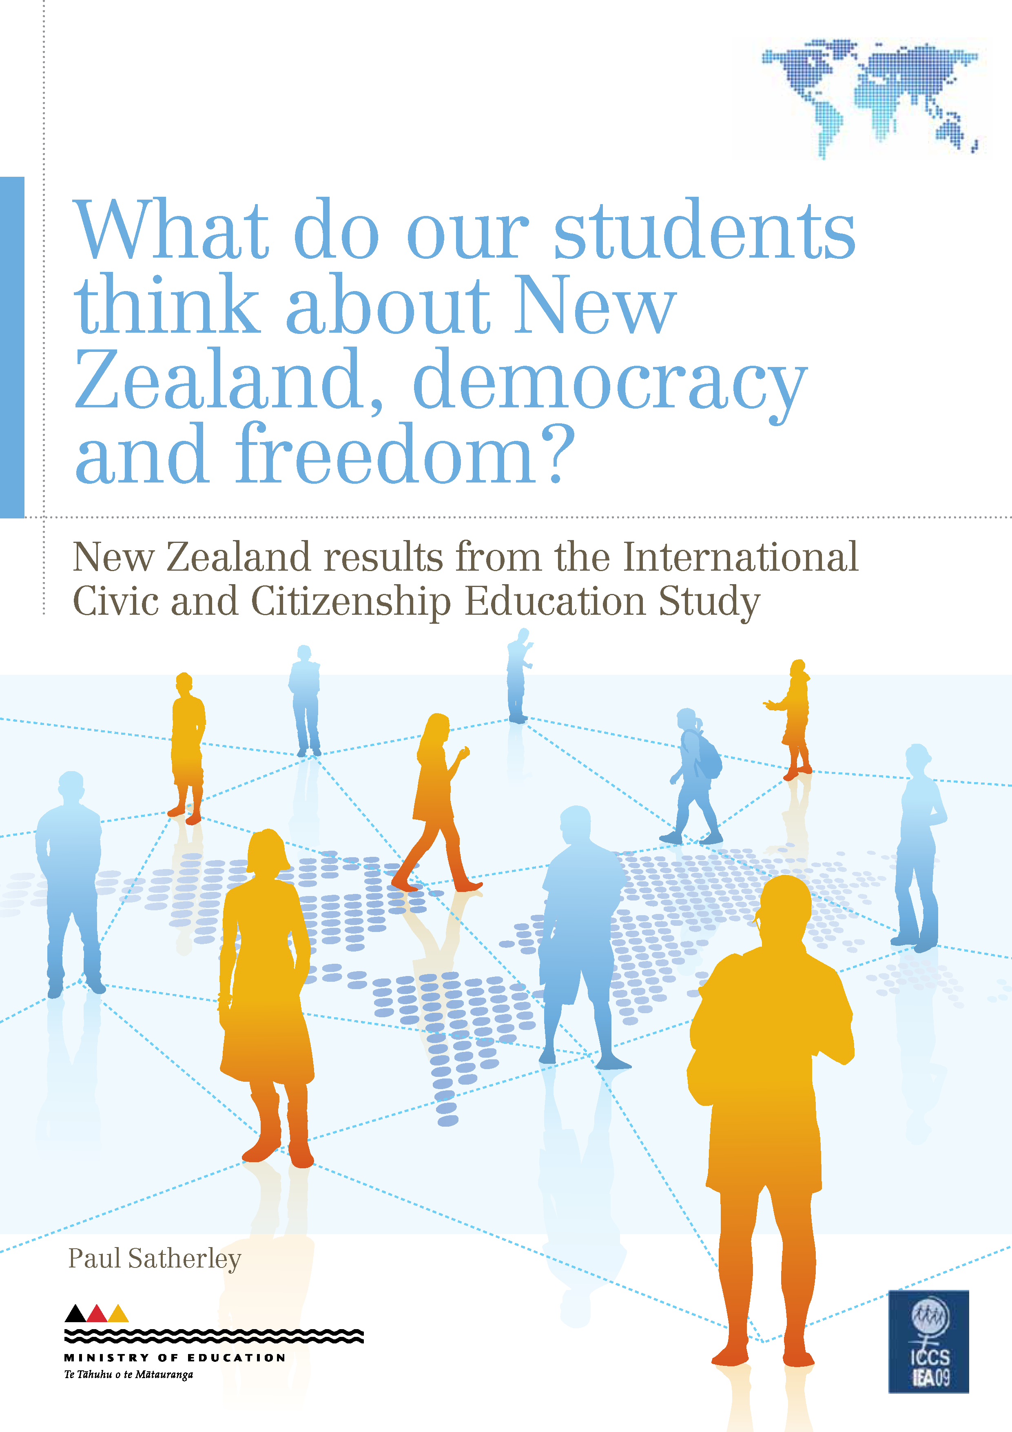

Acknowledgements
ICCS was a collaborative effort, internationally and nationally. Many people were involved in the project and it is not possible to thank them all individually, but we would like to acknowledge a few key groups of people here.
This study was made possible by the cooperation of the schools, teachers and students who took part. Thanks to these participants, we now have a valuable resource about civic and citizenship education in New Zealand.
Thanks also to the many members of the Research Division and other Ministry of Education staff who contributed to the successful planning and implementation of ICCS. In particular, Kate Lang and Sharon Cox were the ICCS national research coordinators.
Finally, thanks to those, especially Rose Hipkins and Edith Hodgen of the New Zealand Council for Educational Research, who contributed to this publication by reviewing, editing and publishing this report.
Paul Satherley
Project Manager
Research Division, Ministry of Education

Summary
This report is the second in a series derived from the International Civic and Citizenship Education Study (ICCS), which was undertaken in New Zealand in 2008. It focuses on the views of Year 9 students on New Zealand and its institutions, and on issues of democracy, freedom, equal rights and religion within the context of civic and citizenship education.
Civic and citizenship education is a topic embedded in the principles, values and key competencies of the New Zealand Curriculum (NZC). ICCS explored dimensions of student civic knowledge and values that link to the NZC key competencies and learning areas. Although New Zealand took part in ICCS before the NZC was mandated in 2010, the findings are relevant to current civics and citizenship teaching and learning.
The results show that a large majority of Year 9 students viewed New Zealand and its key institutions and symbols positively, including having pride in and respect for New Zealand, its political system and its flag. Nearly two-thirds of students agreed or strongly agreed with the personal importance of the Treaty of Waitangi. Although 84% of Year 9 Māori students agreed or strongly agreed that the Treaty of Waitangi is personally important, the percentage was less among Pasifika students (75%), and markedly less among Pākehā/European students (60%) and Asian students (53%).
The armed forces and the police were the New Zealand institutions in which the largest proportion of students had complete trust. Political parties and the media had the largest proportion of students not trusting them at all.
Almost all students agreed or strongly agreed with rights of freedom of expression, respect for social and political rights, free elections, being allowed to protest about laws believed to be unfair, and that political protest should not be violent. Students with greater civic knowledge were more likely to support democratic freedoms.
A large majority of students expressed support for equal rights for men and women, but girls’ support for gender rights was much stronger than boys’.
Year 9 students strongly supported equal rights for different ethnic groups. This includes access to good education, equal opportunities to get good jobs, that schools should teach students to respect members of all ethnic groups, and that members of all ethnic groups should have the same rights and responsibilities. Similar proportions of Pākehā/European and Pasifika students supported equal ethnic group rights. A slightly larger proportion of Asian students than their Pākehā/European and Pasifika peers supported equal ethnic group rights. However, a smaller proportion of Māori students supported equal ethnic group rights.
A large majority of students supported immigrants’ rights to speak their own language, to continue their customs, and to have opportunities for education and voting. The strength of agreement on immigrant rights was strongly associated with students’ own immigrant status: immigrant students supported immigrant rights much more strongly than their non-immigrant peers. Students with greater civic knowledge were more likely to support equal rights for gender, ethnic and immigrant groups.
More than three-quarters of Year 9 students supported religion having a place in the modern world.

Introduction
This report is the second in a series derived from the International Civic and Citizenship Education Study (ICCS) undertaken in New Zealand in 2008. It follows the 2010 report What do New Zealand students understand about civic knowledge and citizenship? (Lang, 2010). The focus here is the views of Year 9 students on New Zealand and its institutions, and on issues of democracy, freedom, equal rights and religion within the context of civic and citizenship education.
Future reports will focus on student behaviours and future intentions in civics and citizenship, and the role of the school and community in civic and citizenship education.

Civic and citizenship education in New Zealand
ICCS data collection took place before the February 2010 implementation of the New Zealand Curriculum (NZC) in English-medium settings. The relevant curriculum document in 2008 was Social Studies in the New Zealand Curriculum (Ministry of Education, 1997), in which civics and citizenship education related particularly to the strands social organisation, and time, continuity and change, and to the processes social decision making and values exploration.
In 21 of the 38 countries that took part in the ICCS study, civic and citizenship education is a compulsory general education subject or course. In New Zealand, the NZC continues to treat civic and citizenship education as a broad-based topic that is embedded in its principles, values and key competencies. Civic and citizenship education is not taught as a separate subject, but is integrated into several curriculum subject areas, with social sciences the key learning area. Social sciences are concerned with how societies work and how people can participate in the world as critical, active, informed and responsible citizens (Ministry of Education, 2007). The next section discusses links between citizenship competencies and the NZC.
Young people also develop an understanding of their roles as citizens through a range of activities and experiences that occur outside the classroom or school. The home and community, as well as national educational and political contexts, influence how students develop civic-related dispositions and competencies.

This report
In ICCS, students were asked to indicate their level of agreement with a wide range of civics and citizenship related statements. The primary focus of this report is on gender analysis to understand what important differences in views there are between Year 9 boys and girls. The report also looks at some differences between the views of students from different ethnic groups as well as groups of different immigrant status − particularly where ethnicity or immigrant status is relevant to the statements − and discusses the associations between different views and students’ civic knowledge.
This report looks first at Year 9 boys’ and girls’ views about New Zealand and some of its key institutions and symbols, including a closer analysis of views about the Treaty of Waitangi. It then covers boys’ and girls’ views on democratic rights, freedoms and citizenship. This leads to an examination of views on gender, and immigrant and ethnic group rights. There is a brief analysis of the students’ views on religion in society, before a concluding section.
For an international comparison of student attitudes and views, readers are referred to chapter 4 of the international ICCS report “Students’ value beliefs and attitudes”, pages 87−114 (Schulz, Ainley, Fraillon, Kerr & Losito, 2010a).

Some technical points

Agreement scale
The ICCS student questionnaire followed common design principles in seeking the level of agreement with a statement on a Likert scale (Strongly agree, Agree, Disagree, Strongly disagree) that does not include a ‘neutral’ midpoint. Much of the analysis compares proportions of students agreeing (either strongly agreeing or agreeing) with those disagreeing (either strongly disagreeing or disagreeing) with the civics and citizenship related statements.

Statistical significance and standard errors
Because ICCS used scientific statistical sampling methods to obtain a representative sample of the population of Year 9 students, it would have been possible to calculate the standard errors of the proportions and averages presented in this report. However, we have chosen not to highlight them in the text and graphs in order to focus on overall patterns.

Graphs
The report contains a number of different graph styles. Graphs similar to Figure 1 show proportions of students along a horizontal axis that has a zero midpoint, which represents a neutral position. Proportions agreeing are to the right of the zero midpoint and proportions disagreeing are to the left. Numerical values less that 5% are suppressed for the sake of space and clarity.
Graphs similar to Figure 2 have a scale on the horizontal axis that represents the overall civic knowledge score. The round dot represents the average civic knowledge score of all the students who gave the particular response. The lines on either side of the dots are error bars. If the error bars of two estimates of an average knowledge score do not overlap, then the difference between them is regarded as statistically significant. An overall pattern of upward slope from left to right indicates that disagreeing is associated with a low knowledge score while agreeing is associated with a high score. Conversely, a downward slope indicates that agreeing is associated with a low knowledge score while disagreeing is associated with a high score.
In some cases, proportions may not sum to exactly 100% because of rounding
.
What is ICCS?
New Zealand is one of 38 countries that took part in the International Civic and Citizenship Education Study (ICCS) sponsored by the International Association for the Evaluation of Educational Achievement (IEA).
ICCS is an international standardised assessment that looks at the ways in which young people are prepared to undertake their roles as citizens. ICCS measures students’ knowledge and understanding of civic systems and citizenship issues, as well as students’ attitudes, perceptions and activities relating to civics and citizenship. It also looks at differences among countries in relation to the outcomes of civic and citizenship education and how these differences relate to student, school and community backgrounds.
What can we find out from this study?
Civic knowledge is broadly defined in ICCS as knowledge and understanding of:
- civic education − the formal institutions and processes of civic life, such as voting in elections
- citizenship education − how people participate in society and how citizens interact with and shape their communities and societies.
ICCS measured student perceptions and behaviours relating to civics and citizenship in four domains: value beliefs, attitudes, behavioural intentions and behaviours. This includes attitudes, views, dispositions and future intentions that relate to participation in civic society, democracy, rights and responsibilities, trust in institutions, and the roles of institutions. An understanding of young people’s civics and citizenship attitudes, views and future intentions seems important for the future working of society. It also provides an important backdrop to measured civic knowledge.
However, it is not always possible to infer students’ values and dispositions from their agreement or disagreement with some statements. For example, either agreeing or disagreeing with “New Zealand shows a lot of respect for the environment.” might be associated with a wide range of values or dispositions about the environment.
Who took part?
During 2008/09 approximately 140,000 students around 14 years of age and 62,000 teachers in over 5,300 schools from 38 countries around the world participated in ICCS. In New Zealand, almost 4,000 Year 9 students, 1,350 teachers and 123 principals from 146 schools took part in the study between October and December 2008. A representative sample of New Zealand schools with Year 9 students was selected. The student sample was representative of their Year 9 peers.
Data collection in New Zealand took place around the time of the 2008 general election, and this may have influenced students’ responses to some questions.
What information was collected?
Each student completed a 40-minute questionnaire about their background and their attitudes, values and behaviours in relation to civics and citizenship. Each student also completed one of seven test booklets in a 45-minute cognitive test. The ICCS assessment framework covers the content domains: civic society and systems, civic principles, civic participation and civic identities.
Teachers answered questions about their perceptions of civic and citizenship education in their schools, school organisation and culture, and teaching practices. Principals provided information about their school (characteristics, culture and climate) and the provision of civic and citizenship education at their school. ICCS also surveyed countries about the structure of their education system, civic and citizenship education in the curricula, and recent developments in civic and citizenship education.
Useful resources
The first New Zealand ICCS focus report (Lang, 2010) focused on the key civic knowledge dimension. The ICCS international reports provide details of international comparative analysis. All of these reports can be accessed from New Zealand’s ICCS webpage at www.educationcounts.govt.nz/goto/iccs.
The international ICCS database is accessible for public use on the IEA’s data repository at
http://rms.iea-dpc.org/.

Links between citizenship competencies and the New Zealand Curriculum
Every school needs to design a local curriculum based on the New Zealand Curriculum (NZC) framework. The knowledge, skills and dispositions addressed by the ICCS study are in harmony with the principles, values, key competencies and learning areas of the NZC, though they are not prescribed in the NZC. This short discussion highlights how the different components of the NZC could come together to create a coherent message about what matters for our students as citizens of New Zealand and the world.
The ICCS survey probed how students see their identity as citizens of their country, and the attitudes they hold towards those who have come from other places. There is a direct link between these items and the NZC vision statement, which says that students’ learning experiences at school should help them to become citizens who are “connected to the land and environment” and who will:
Work to create an Aotearoa New Zealand in which Māori and Pākehā recognise each other as full Treaty partners, and in which all cultures are valued for the contributions they bring. (Ministry of Education, 2007, p. 8)
The NZC principles have been designed to ensure the curriculum is “forward looking and inclusive, and affirms New Zealand’s unique identity”. One NZC principle acknowledges the Treaty principles as providing the “bicultural foundations” of Aotearoa New Zealand. The New Zealand version of ICCS reflected this emphasis by including a New Zealand-specific question asking students about the personal importance of the Treaty of Waitangi.
The future focus principle highlights citizenship as something students should explore as they “look to the future”. Active participation is implied here and is reinforced by the participating and contributing key competency. This action dimension of ICCS will be addressed in the third report in this series, and the fourth report will cover school factors.
Some ICCS items were designed to probe students’ values. There is a strong link between the rights and responsibilities items and the NZC value of equity, through fairness and social justice. Developing a strong sense of the rights of others requires students to “explore with empathy the values of others”. There are also opportunities here for strengthening some dimensions of the key competency relating to others.
The knowledge components of ICCS are most directly located in the Social Science learning area where the overarching aim is for students to “explore how societies work and how they themselves can participate and take action as critical, informed, and responsible citizens”. Producer and consumer rights and responsibilities, and forms of social organisation and leadership, are a focus at Level Four. The study of human rights is an explicit focus at Level Five, as is the study of comparative systems of government.

What do Year 9 students think about New Zealand and its institutions?
The student questionnaire asked about Year 9 students’ agreement or disagreement with the following nine statements about New Zealand.
- I have great respect for New Zealand.
- I am proud to live in New Zealand.
- The New Zealand flag is important to me.
- Generally speaking, New Zealand is a better country to live in than most other countries.
- New Zealand shows a lot of respect for the environment.
- The political system in New Zealand works well.
- The Treaty of Waitangi is important to me.
- I would prefer to live permanently in another country.

Views about New Zealand
A large majority of Year 9 students had a positive view of New Zealand and its key institutions and symbols. Results show that 64–93% of students viewed aspects of New Zealand positively by agreeing or strongly agreeing with the statements about pride in and respect for New Zealand, its political systems, its flag and the Treaty of Waitangi, or by disagreeing or strongly disagreeing with the statement about living permanently in another country.
The patterns in the relative strength of agreement and disagreement differ quite markedly across the range of statements. For example, the statement about the political system working well had a much smaller proportion of students strongly agreeing. Compared to the other statements, agreement here is less emphatic: overall, students were positive about how well New Zealand’s political system works, but they were not as strongly positive as for the other aspects of New Zealand and its institutions included in the study.
The response patterns for preferring to live in another country and being proud to live in New Zealand differ. A larger proportion of students reported that they would prefer to live in another country (27%) than those who are not proud to live in New Zealand (9%). However, almost 80% of those who would prefer to live elsewhere said they are proud to live in New Zealand. This perhaps reflects the wide diversity of reasons people have to want to live overseas, though the two statements, of course, are not necessarily contradictory.
Some statements show moderate gender differences. For example, girls showed marginally stronger agreement than boys with statements referring to pride and respect.
- New Zealand Year 9 students’ views on New Zealand and its institutions, by gender
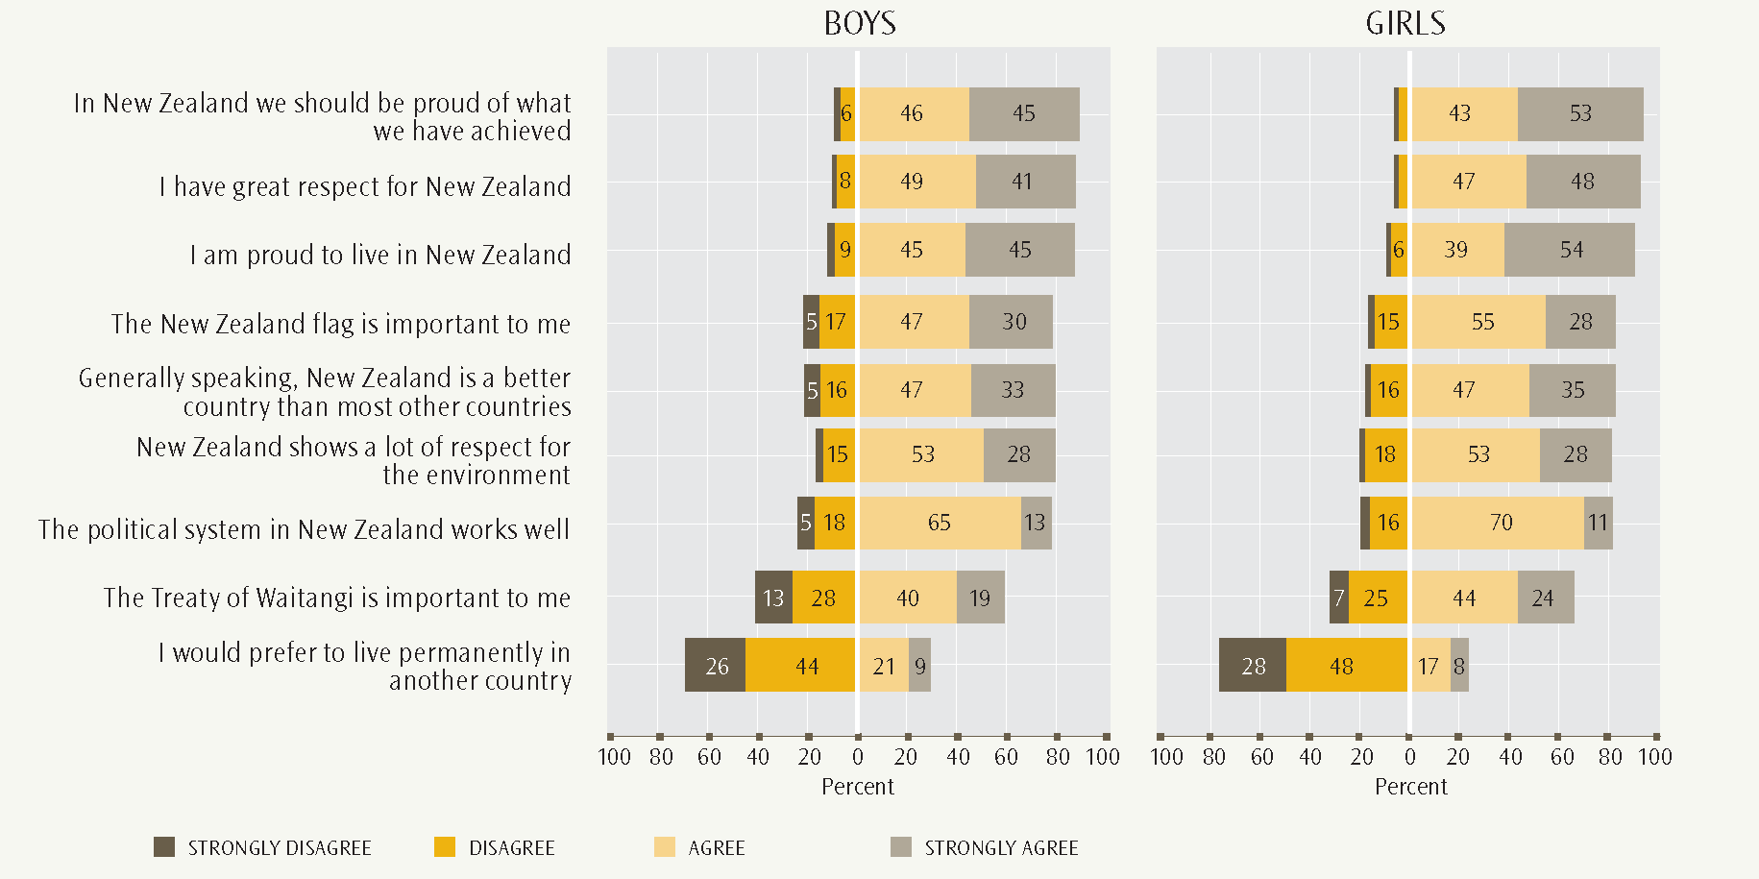
- New Zealand Year 9 students’ views on “The New Zealand flag is important to me” and “In New Zealand we should be proud of what we have achieved”, by civic knowledge score
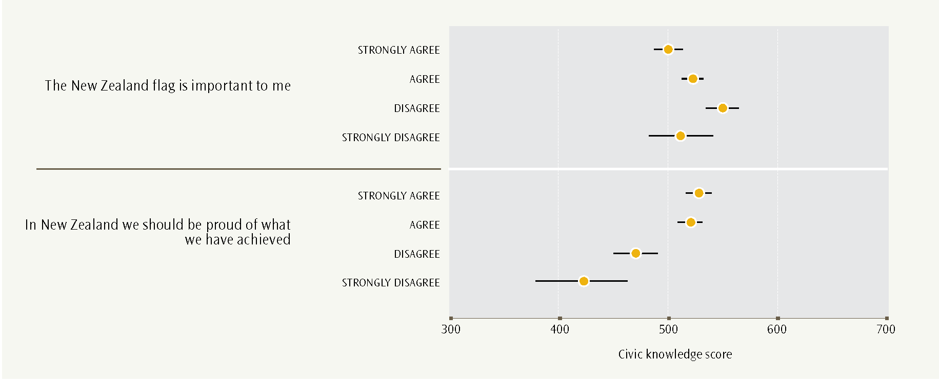
Figure 1 shows the proportions of students agreeing and disagreeing with the statements about New Zealand and its institutions, by gender.
Some statements show moderate differences for students of different immigrant status. Compared to their peers, students born overseas were less likely to strongly agree about the importance of the New Zealand flag. They were much more likely to agree or strongly agree that they would prefer to live in another country, and they were less likely to be proud to live in New Zealand.
For most of the statements about New Zealand, its institutions and symbols, the highest average civic knowledge scores are for the agree and disagree categories, with the strongly agree and strongly disagree categories lower. Moderate rather than strong views are therefore associated with higher civic knowledge. This is consistent with higher civic knowledge being linked to realistic assessments of aspects of New Zealand, its institutions and symbols.
An exception is “In New Zealand we should be proud of what we have achieved”. This may be because students who have a greater civic knowledge are more aware of New Zealand’s achievements. Figure 2 illustrates these associations.

Treaty of Waitangi views
Nearly two-thirds of students (64%) expressed agreement with the statement about the personal importance of the Treaty of Waitangi. This is a little lower than the 70−90% for the other statements about aspects of New Zealand.
The Treaty statement also reveals the strongest overall gender difference. A larger proportion of girls (68% compared to 59% for boys) agreed or strongly agreed that the Treaty is personally important to them, as shown in Figure 1.
Figure 3 shows the differing ethnic patterns for the personal importance of the Treaty of Waitangi. Almost half of Year 9 Māori students strongly agreed that the Treaty of Waitangi is personally important, and altogether 84% either agreed or strongly agreed. This compares with 75% of Pasifika students, 60% of Pākehā/European students and 53% of Asian students who agreed or strongly agreed. While the overall pattern reveals sharp ethnic contrast, the greatest ethnic differences appear for the category strongly agree, highlighting the ethnic differential in strength of agreement.
These findings suggest that the Treaty is more important on average to Māori students because of values and attitudes gained from sources other than the classroom. For example, Māori students may develop a sense of the importance of the Treaty through families, whānau and communities, because Māori, through the Treaty, have the status of signing partners with the Crown.
Figure 4 relates students’ views about the Treaty to their immigrant status. The ICCS categories of immigrant status are:
- student and at least one parent born in New Zealand
- student born in New Zealand, but both parents born overseas
- student and parents born overseas.
Students born in New Zealand were more likely to consider the Treaty of Waitangi personally important. This difference is clearest for the category strongly agree.
A recent Education Review Office (ERO) report provides some empirical evidence from a different perspective. ERO has evaluated how schools were incorporating the eight principles of the NZC into their own schools’ curricula and into the classroom. The evaluation, which covered both primary and secondary schools, found that the Treaty of Waitangi principle was one of the least evident principles in both the schools’ curricula and in classrooms. ERO concluded that schools should develop a more comprehensive view of the implications of the Treaty of Waitangi for school policy and practice, and an understanding of the NZC’s Treaty of Waitangi principle, and promote these principles more effectively in the classroom (Education Review Office, 2011, pp. 19 & 24).
This ERO report reflects current curriculum practice, of course, rather than that of 2008 before the NZC was mandated. However, a 2006 ERO report on the quality of teaching social studies at Years 4 and 8 also found that “many teachers were not fully implementing Social Studies in the New Zealand Curriculum” (Education Review Office, 2006, pp. 1 & 12). In a follow-up report, ERO described examples of good social studies teaching practice, including bicultural perspectives and ongoing study of the Treaty of Waitangi (Education Review Office, 2007, p. 11).
- New Zealand Year 9 students’ views on “The Treaty of Waitangi is important to me”, by ethnicity
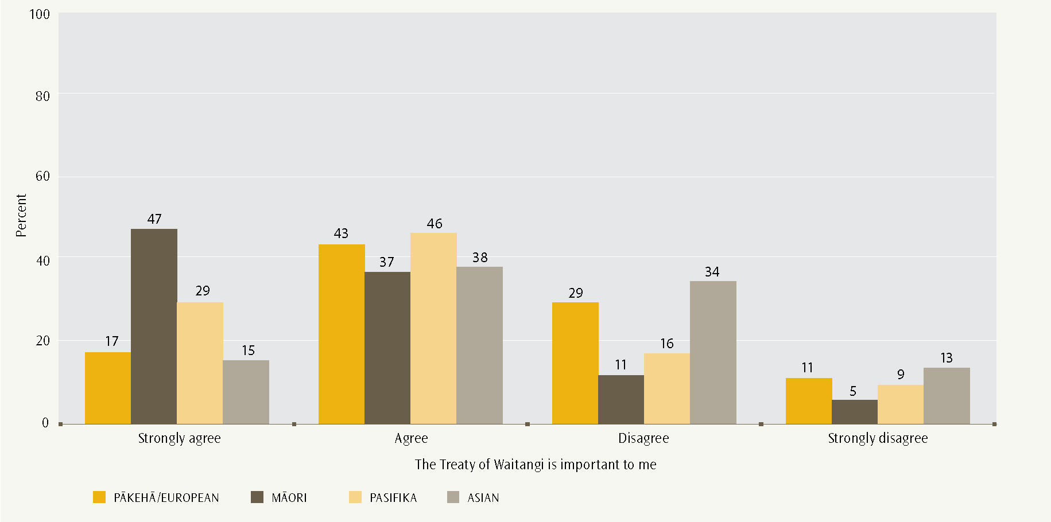
- New Zealand Year 9 students’ views on “The Treaty of Waitangi is important to me”, by immigration status
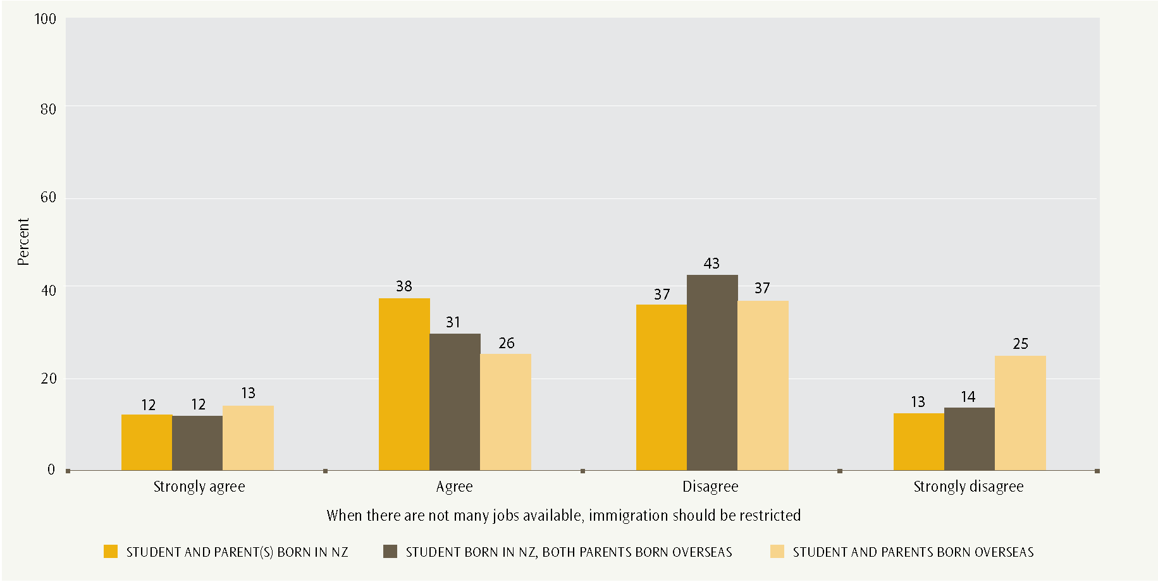
Since 2010, a focus on the Treaty in formal teaching and learning has begun from Years 9 or 10. The NZC states that at Level Five of the Social Sciences learning area “Students will gain knowledge, skills, and experience to … [u]nderstand how the Treaty of Waitangi is responded to differently by people in different times and places” (Ministry of Education, 2007, Appendix).
- New Zealand Year 9 students’ trust in institutions
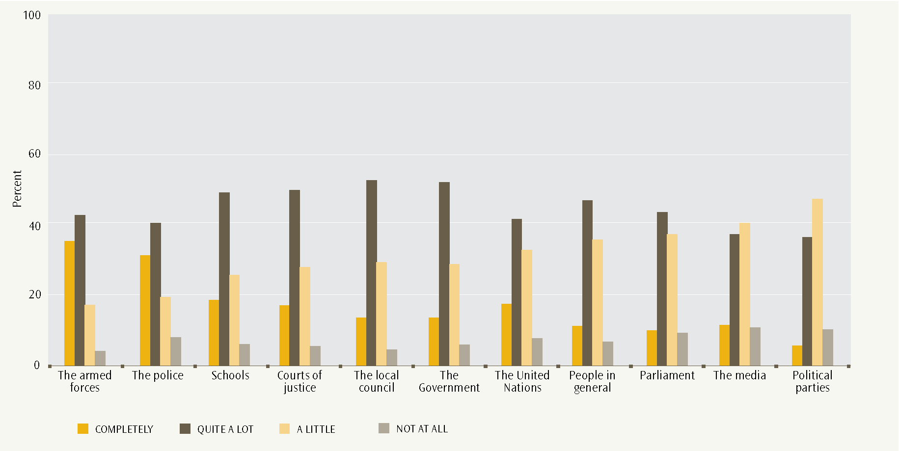
- New Zealand students’ trust in the Government and people in general, by civic knowledge score
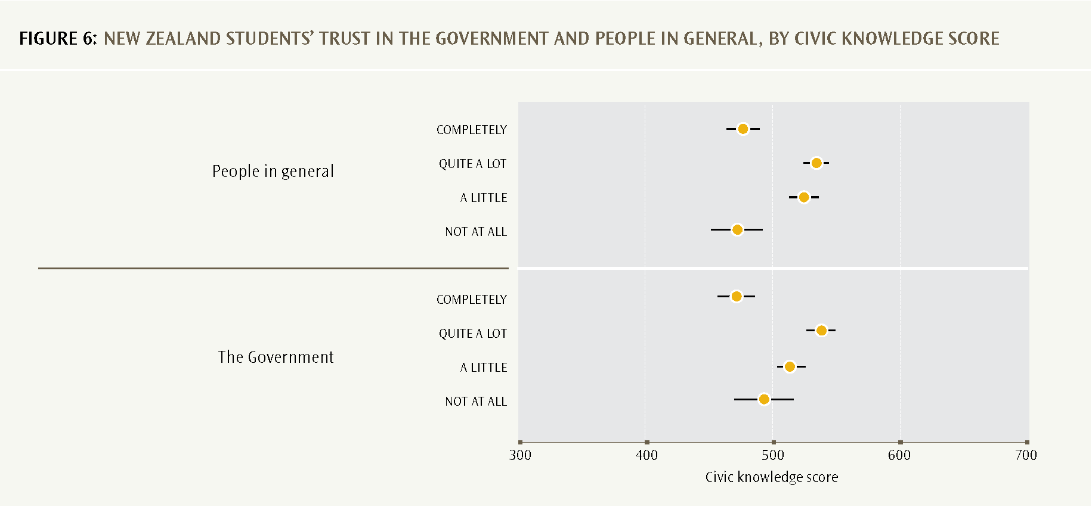

Students’ trust in New Zealand institutions
Figure 5 shows the proportions of Year 9 students who reported different levels of trust in a range of New Zealand institutions and groups. The armed forces and the police were the institutions that the largest proportions of students completely trusted: 35 and 32% of Year 9 students, respectively. Much smaller proportions of students completely trusted the other institutions that were asked about in the study.
Institutions in which two-thirds or more of students expressed at least quite a lot of trust were: the armed forces, police, schools, courts of justice, local councils, and the Government. The groups that between half and two-thirds of students trusted at least quite a lot were: the United Nations, people in general, and Parliament.
Less than half of Year 9 students expressed more than a little trust in media and political parties. Media and political parties also had the greatest proportions of students who had no trust in these institutions (around 10%).
- Proportions of students and adults expressing a comparatively high level of trust in others, ICCS and national social indicator surveys, 2008
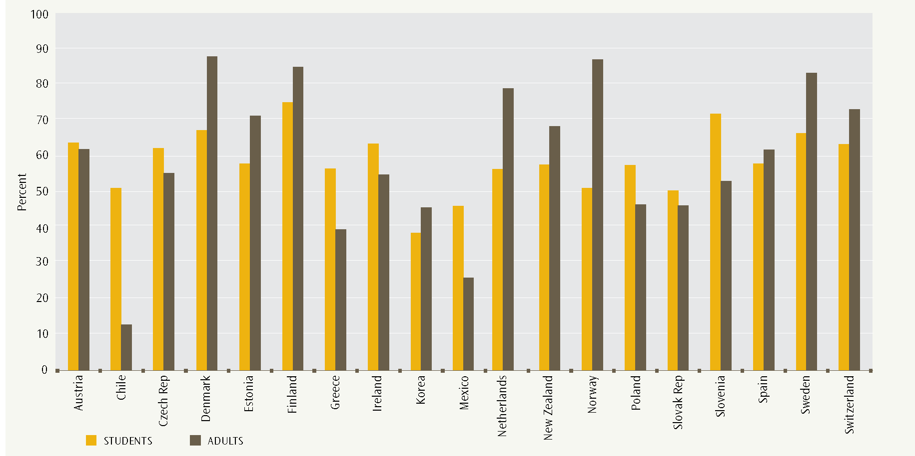
Students’ trust in institutions is related to their civic knowledge score in an interesting way. Higher civic knowledge is associated with moderate, rather than strong, views about trust or distrust in institutions. Figure 6 illustrates this pattern for trust in the Government and trust in people in general. Students with higher civic knowledge scores are likely to have a higher level of knowledge about how societies are organised and when it is appropriate to trust others in specific roles, or in general. An exception was trust in the United Nations, where students with complete trust had higher average civic knowledge.

Students’ and adults’ trust in other people: international comparisons
The ICCS international report derives an index for students’ overall trust in civic institutions (Schulz, Ainley, Fraillon, Kerr & Losito, 2010a, p. 106). New Zealand is very close to the ICCS average.
Students’ and adults’ trust in other people show different relative patterns across countries. The OCED has published comparative figures from 2008 national social indicator surveys for the proportions of adults who have a high level of trust in others (OECD, 2011, pp. 90−91). Figure 7 provides comparative proportions for students and adults in the countries that are included in both ICCS (Schulz et al., 2010a, pp. 108−109) and the OECD report. Some interesting patterns emerge, although there are differences between the questions in the ICCS student questionnaire and in the various national social indicators surveys used.
A larger proportion of New Zealand adults (69%) reported a high level of trust in other people than did New Zealand Year 9 students (58%). This is also the case in several other countries, including Denmark, Estonia, the Netherlands, Norway, Sweden and Switzerland. In Chile, Greece, Mexico, Poland and Slovenia the reverse is true.
We cannot tell from these data whether New Zealand young people become more trusting as they gain a wider range of experiences in social interactions and accessing services, or whether today’s adult cohort are simply more trusting in general than today’s adolescent cohort. Longitudinal data sets would be needed to address this question.
- Figure 8: Proportions of students trusting the national government completely or quite a lot, ICCS 2008 and Corruption Perceptions Index 2009
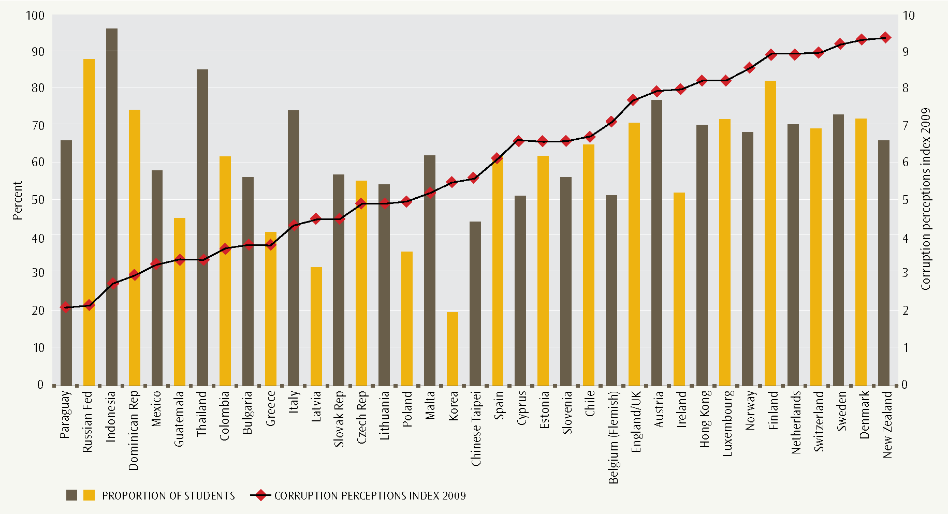
Another interesting international comparative dimension involves comparisons across countries using the Transparency International’s Corruption Perceptions Index. This is a composite index measuring perceived levels of public sector corruption in different countries (Transparency International, 2010, pp. 48−49). The index scores 180 countries on a scale from 0 (highly corrupt) to 10 (very clean). Figure 8 plots the proportion of students who trust the national government, either completely or quite a lot, together with the Corruption Perceptions Index. The 2009 index is used because most countries participated in ICCS in 2009. Countries are arranged in order from most to least corrupt.
New Zealand, which had the highest Corruption Perceptions Index score in 2009, belongs to a group of countries − including Denmark, Sweden, Switzerland, the Netherlands, Finland, Norway, Luxembourg and Hong Kong − where students have moderate to high trust in the national government and that are perceived to have very low levels of public sector corruption.
A different pattern applies for a group of countries − including Paraguay, Russia, Indonesia, the Dominican Republic, Thailand and Italy − that have high levels of student trust in the national government but significant levels of perceived public sector corruption.
Korea stands out for having a low level of student trust in the national government but a moderate level of perceived public sector corruption.

What do Year 9 students think about democracy, freedom and citizenship?
Year 9 students in the ICCS study were asked to rate their level of agreement with the following 12 statements, which cover a wide range of aspects of democracy, freedom and society.
- Everyone should always have the right to express their opinions freely.
- All people should have their social and political rights respected.
- All citizens should have the right to elect their leaders freely.
- Political protest should never be violent.
- People should be able to protest if they believe a law is unfair.
- No company or government should be allowed to own all newspapers in a country.
- Differences in income between poor and rich people should be small.
- When faced with violent threats to national security, the government should have the power to control what appears in the media.
- People should always be free to criticise the government publicly.
- Political leaders should not be allowed to give government jobs to their family members.
- Security agencies should be allowed to check letters, phone calls and emails of anyone suspected of threatening national security.
- The police should have the right to hold people suspected of threatening national security in jail without trial.
- New Zealand Year 9 students’ views on democracy, freedom and citizenship, by gender
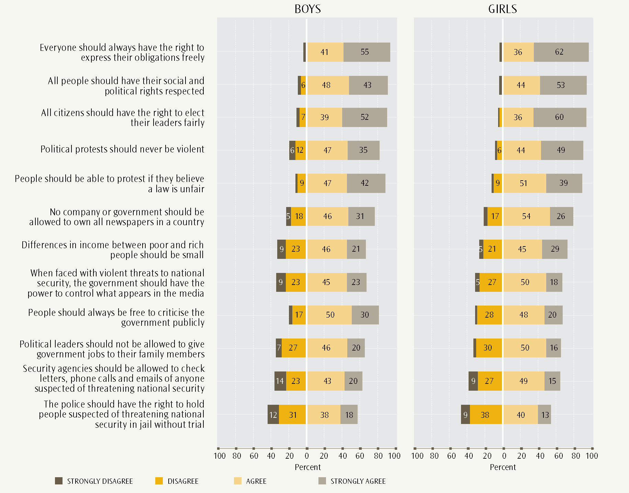
Almost all (close to 90%) students agreed or strongly agreed with: respect of social and political rights; free elections; rights of freedom of expression; political protest being non-violent; and being allowed to protest about laws believed to be unfair.
A second group of statements show smaller proportions of students agreeing or strongly agreeing (60−80%): not allowing single ownership of newspapers; income differences between rich and poor should be small; when faced with threats to security, governments should have the power to control what appears in the media; freedom to publicly criticise the government; not allowing government jobs to be given to family members; security agencies may check the communications of people suspected of threatening security.
Finally, one issue generated evenly divided agreement and disagreement: police should have the right to hold people suspected of threatening national security in jail without trial.
Figure 9 shows the proportions of students − boys and girls − agreeing or disagreeing with the statements. Girls’ agreement is stronger than boys’ on the following: rights to freedom of self-expression; respect for social and political rights; right to free elections; political protest should never be violent; and differences in income between rich and poor should be small. Boys’ agreement is stronger for: being allowed to publicly criticise the government.
The above three groups of statements range from relatively simple to more complex, in the sense that statements in the second and third groups may require trade-offs between different groups’ rights. For example, responses to threats to national security might need to conflict with individual rights. We see a pattern of large proportions of students agreeing with simpler statements and smaller proportions agreeing with more complex statements.
- New Zealand students’ views on “Differences in income between poor and rich people should be small”, “The police should have the right to hold people suspected of threatening national security in jail without trial” and “Everyone should always have the right to express their opinions freely”, by civic knowledge score
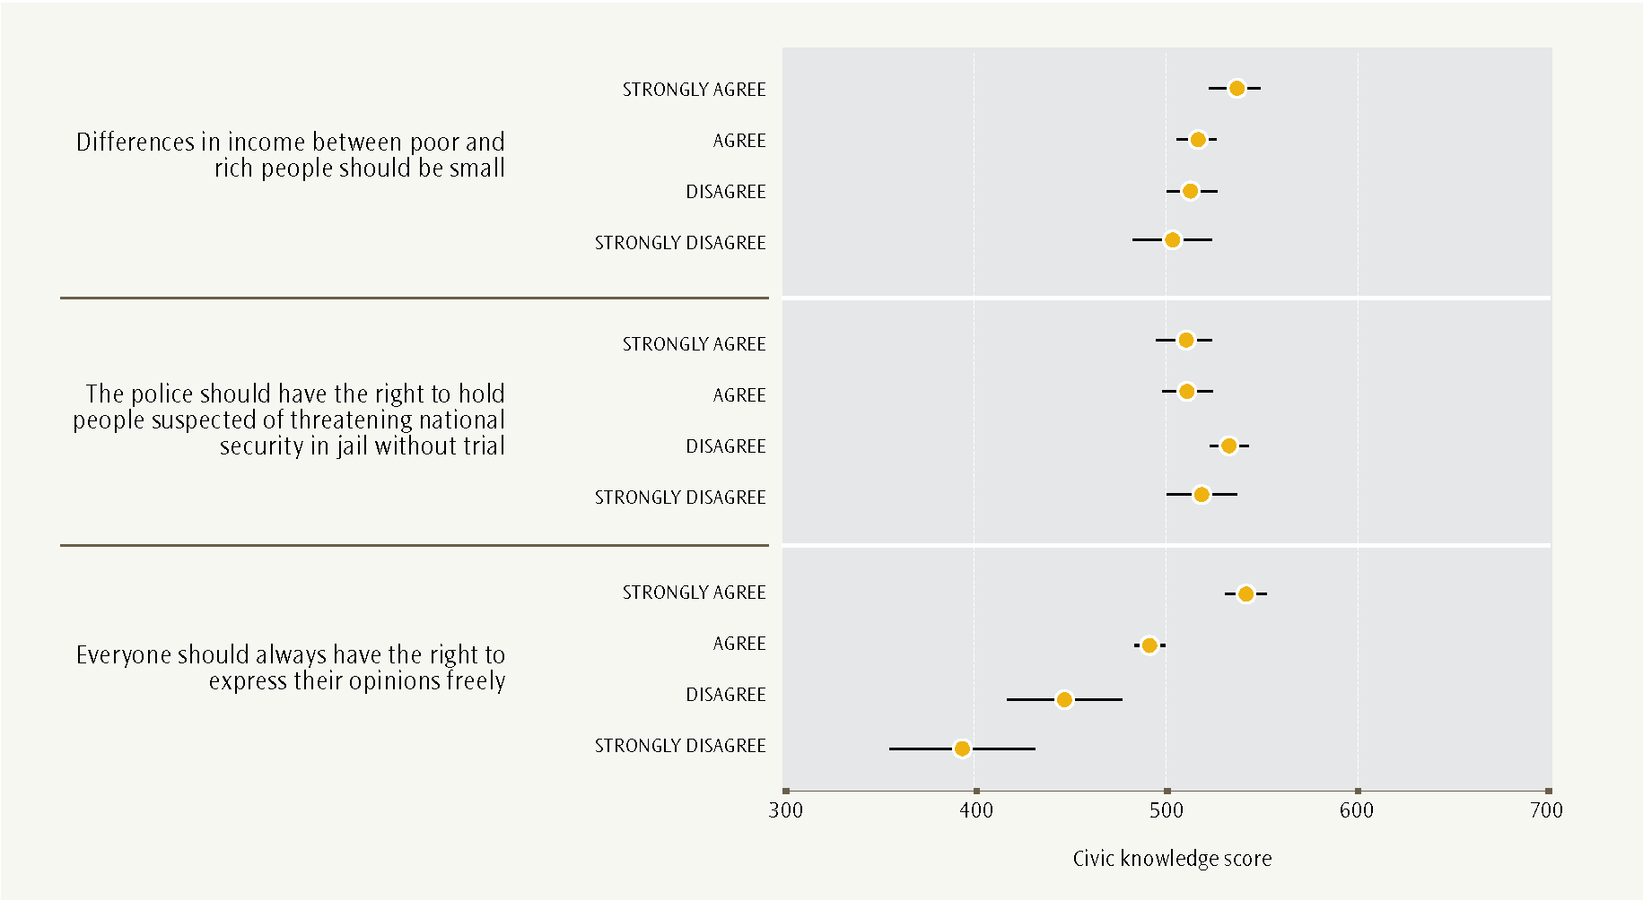
The views expressed about most of the statements on democratic values show strong positive relationships between support for democratic freedoms and civic knowledge, as measured in ICCS. This contrasts with the three statements about responses to threats to national security, which show a less marked relationship between civic knowledge scores and students’ views. This is also the case for the statement “Differences in income between poor and rich people should be small”. Figure 10 illustrates these patterns.
Strong student support for many aspects of democratic freedom, such as the right to free speech, is associated with higher civic knowledge. In contrast, opinions about possible responses to national security concerns and an equitable income distribution are much less strongly associated with civic knowledge. These opinions might be formed more through dispositions or attitudes acquired through family and peer networks or the media rather than through school-based civic education.

What do Year 9 students think about equal rights?
This section covers views of Year 9 students about the rights of men and women, ethnic groups and immigrants. These views are expressed through agreement or disagreement with a range of statements. The approach of the section is to analyse these student views by gender, ethnic group and immigrant status, respectively.
Gender rights
Students were asked about their agreement or disagreement with seven statements about gender rights.
- Men and women should have the same rights in every way.
- Men and women should have equal opportunities to take part in government.
- Men and women should get equal pay when they are doing the same jobs.
- When there are not many jobs available, men should have more right to a job than women.
- Men are better qualified to be political leaders than women.
- Women should stay out of politics.
- Women’s first priority should be raising children.
A very large majority of students supported equal gender rights. Between 82 and 97% of students expressed support for equal rights for men and women in the first six of these seven statements. Figure 11 shows these results.
Girls’ support for gender rights was stronger, on average, than boys’. For girls, the range of support across the statements (agree or strongly agree) was 89−98%, compared with boys’ 73−95%. The comparative strength of girls’ support is especially seen in the proportion of girls who strongly supported gender rights. Across these six attitudinal statements this was between 29 and 17 percentage points greater than the proportion of boys who strongly supported gender rights. The largest gender difference was for “Men are better qualified to be political leaders than women”, where 64% of girls strongly disagreed compared with 35% of boys.
It seems likely that students strongly support rights that apply more directly to their own status − gender in this case.
For these six statements, the stronger the support for gender rights, the higher the average civic knowledge score. This is true for both boys and girls.
The pattern for the statement “Women’s first priority should be raising children” differed from the other six in that students’ views were much more evenly spread. However, girls’ support for equal gender rights − through disagreeing with the statement − was still stronger than boys’. A little more than half (56%) of all students (62% of girls and 49% of boys) disagreed or strongly disagreed. Twenty-nine percent of girls strongly disagreed, compared with 19% of boys. As for the other statements, stronger support for gender rights is associated with higher average civic knowledge scores. Girls’ average scores were higher than boys’ for each support category. These results are illustrated in Figure 12.
- New Zealand Year 9 students’ views on equal gender rights, by gender
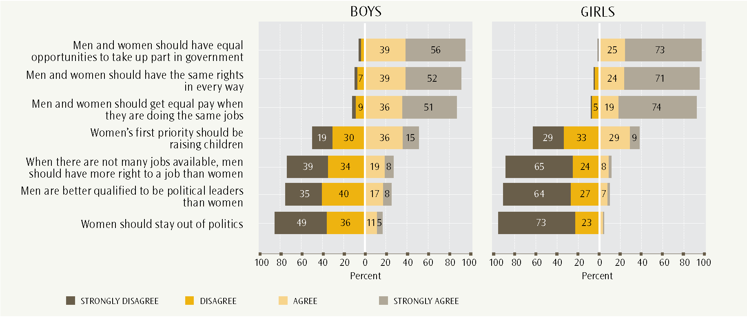
- New Zealand students’ views on “Women’s first priority should be raising children”, by gender and civic knowledge score
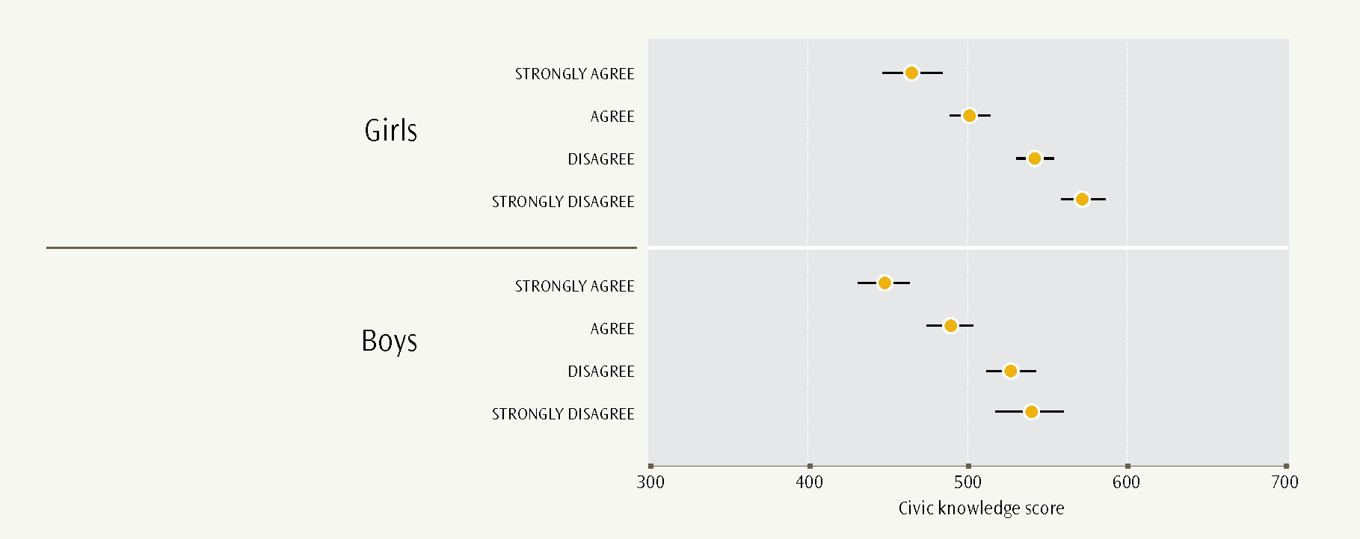
The international ICCS report compares attitudes to gender rights across all of the ICCS participating countries (Schulz et al., 2010a, pp. 97−98). An index measuring overall support for gender rights was derived from students’ responses to all seven gender rights statements. Higher values on the index indicate greater support for gender rights. New Zealand’s average value on the gender rights index was 52 (girls 55 and boys 49). New Zealand was very similar to the ICCS average value of 50 (girls 53 and boys 47). The greatest differences were for Finland and Cyprus, with gender differences of 10 points; the smallest gender difference was for the Dominican Republic, with a difference of 2 points.
Ethnic group rights
Students were asked about their agreement with five statements on ethnic group rights.
- All ethnic groups should have an equal chance to get a good education in New Zealand.
- All ethnic groups should have an equal chance to get good jobs in New Zealand.
- Schools should teach students to respect members of all ethnic groups.
- Members of all ethnic groups should be encouraged to run in election for political office.
- Members of all ethnic groups should have the same rights and responsibilities.
- New Zealand Year 9 students’ views on “All ethnic groups should have an equal chance to get a good education in New Zealand”, by ethnicity
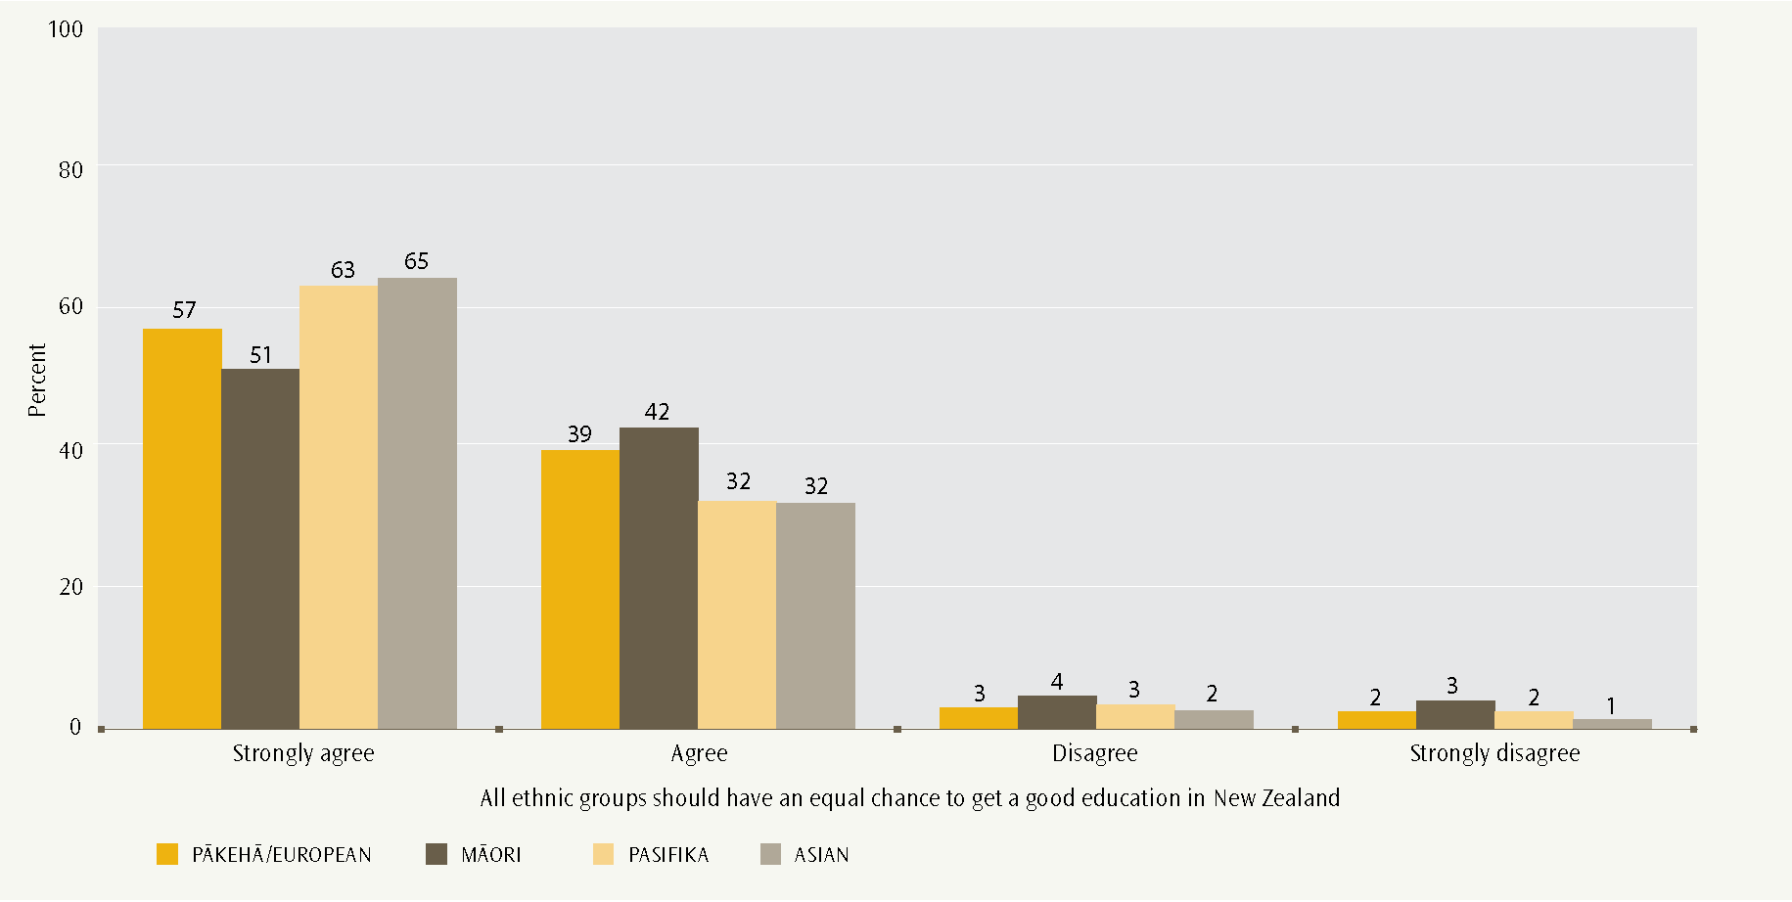
- New Zealand Year 9 students’ views on “All ethnic groups should have an equal chance to get good jobs in New Zealand”, by ethnicity
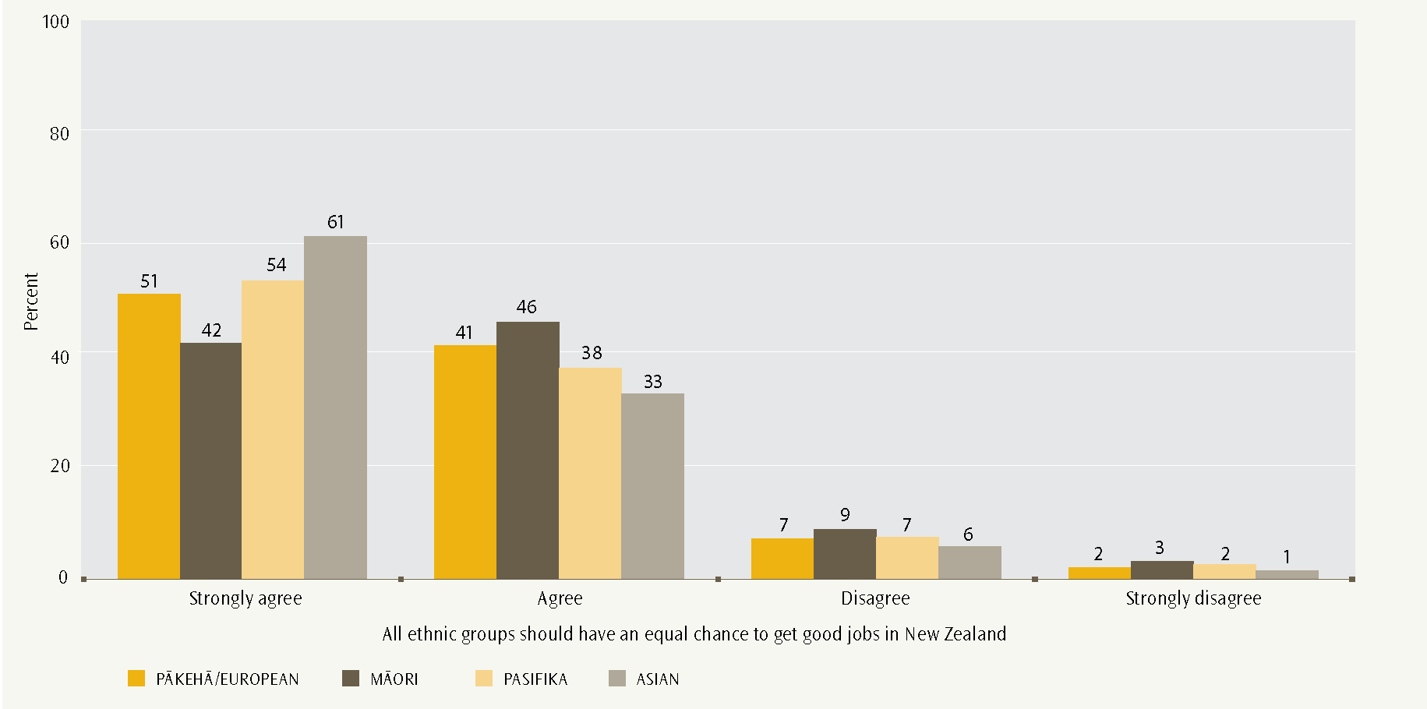
Year 9 students strongly supported equal rights for different ethnic groups. This included access to good education and equal opportunities to get good jobs, where 90−95% of students either agreed or strongly agreed. Close to 90% of students agreed or strongly agreed that schools should teach students to respect members of all ethnic groups, and that members of all ethnic groups should have the same rights and responsibilities.
A slightly smaller proportion of students (about 80%) supported all ethnic groups being encouraged to run in elections for political office (see Figure 16).
- New Zealand Year 9 students’ views on “Schools should teach students to respect members of all ethnic groups”, by ethnicity
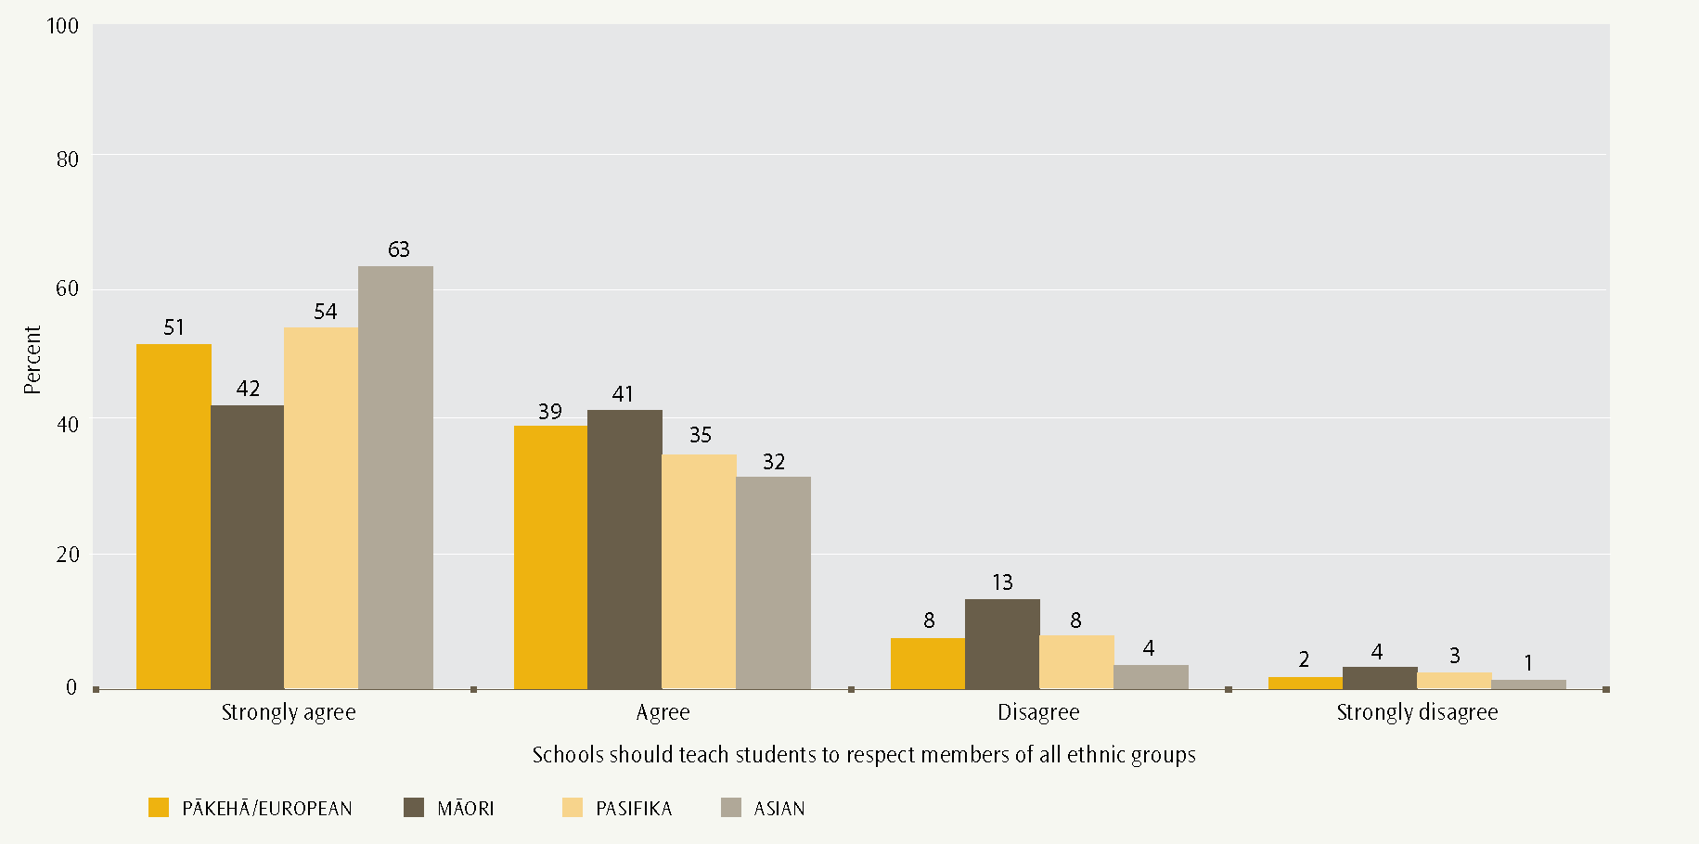
- New Zealand Year 9 students’ views on “Members of all ethnic groups should be encouraged to run in election for political office”, by ethnicity
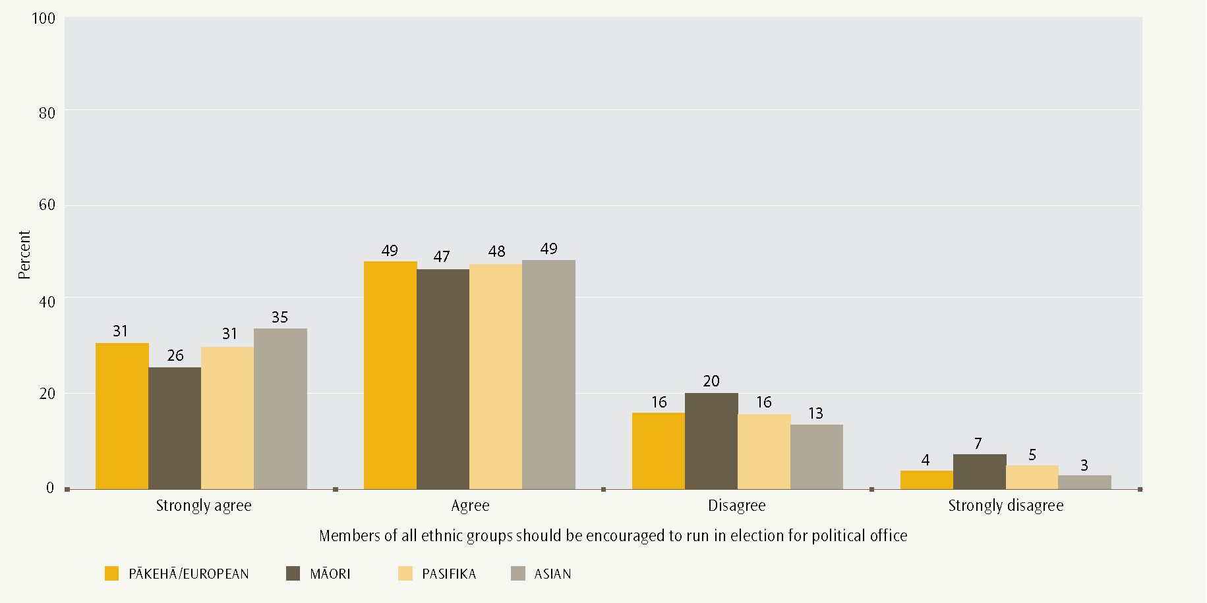
A distinct ethnic pattern appeared in the strength of support of ethnic group rights. Overall, Pasifika and Asian students were a little more likely than Pākehā/European students, and more likely than Māori students, to strongly support the five statements. However, the proportions across ethnic groups of agreeing or strongly agreeing with ethnic group rights are very similar. Figures 13−17 illustrate this analysis.
There is a strong positive relationship between student civic knowledge and support for ethnic group rights. For example, students who strongly agreed with the statement “Members of all ethnic groups should have the same rights and responsibilities” had an average civic knowledge score of 556, compared with those who strongly disagreed, at 409 score points. The figures for Pākehā/European and Māori students are shown in Figure 18. The other ethnic groups followed a similar pattern of higher average civic knowledge score being associated with more support for ethnic group rights.
This is evidence that diverse Year 9 students in 2008 were already valuing “diversity, as found in our different cultures, languages, and heritages” (Ministry of Education, 2007, p. 10), foreshadowing the 2010 implementation of the NZC.
- New Zealand Year 9 students’ views on “Members of all ethnic groups should have the same rights and responsibilities”, by ethnicity
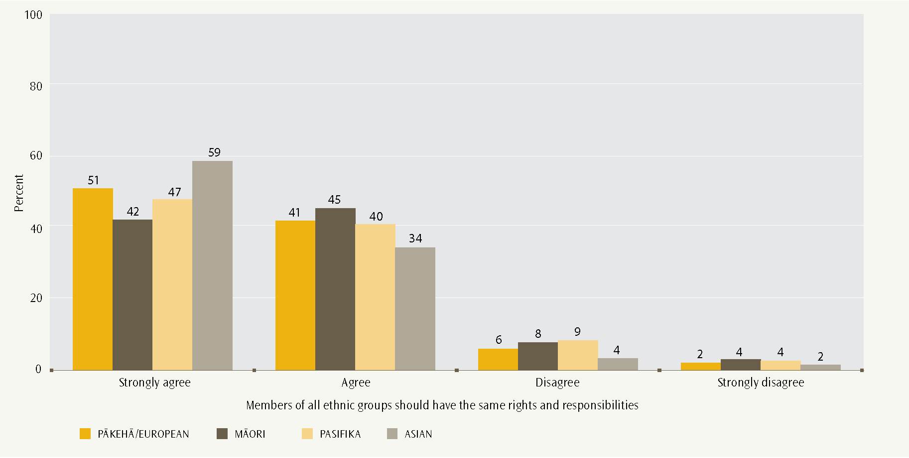
- New Zealand Year 9 students’ views on “Members of ethnic groups should have the same rights and responsibilities”, for Pākehā/European and Māori, by civic knowledge score
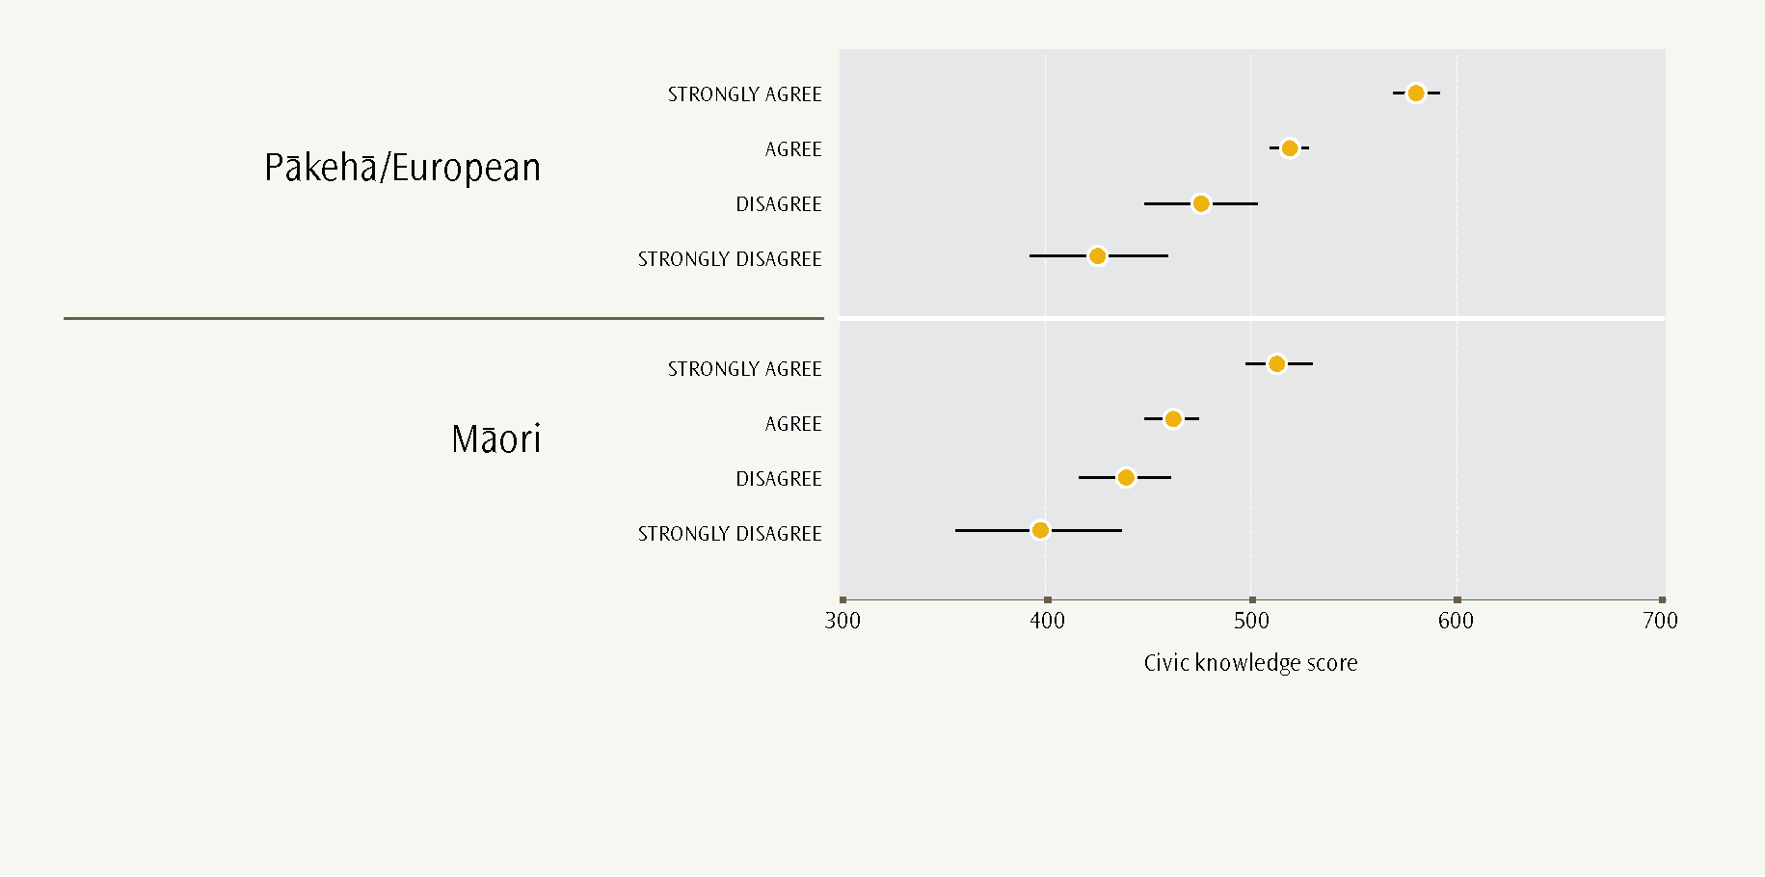
Immigrant rights
Year 9 students were asked about their agreement with six statements on immigrant rights.
- Immigrants should have the opportunity to continue speaking their own language.
- Immigrant children should have the same opportunities for education that other children in the country have.
- Immigrants who live in a country for several years should have the opportunity to vote in elections.
- Immigrants should have the opportunity to continue their own customs and lifestyle.
- Immigrants should have all the same rights that everyone else in the country has.
- When there are not many jobs available, immigration should be restricted.
- New Zealand Year 9 students’ views on “Immigrants should have the opportunity to continue speaking their own language”, by immigrant status
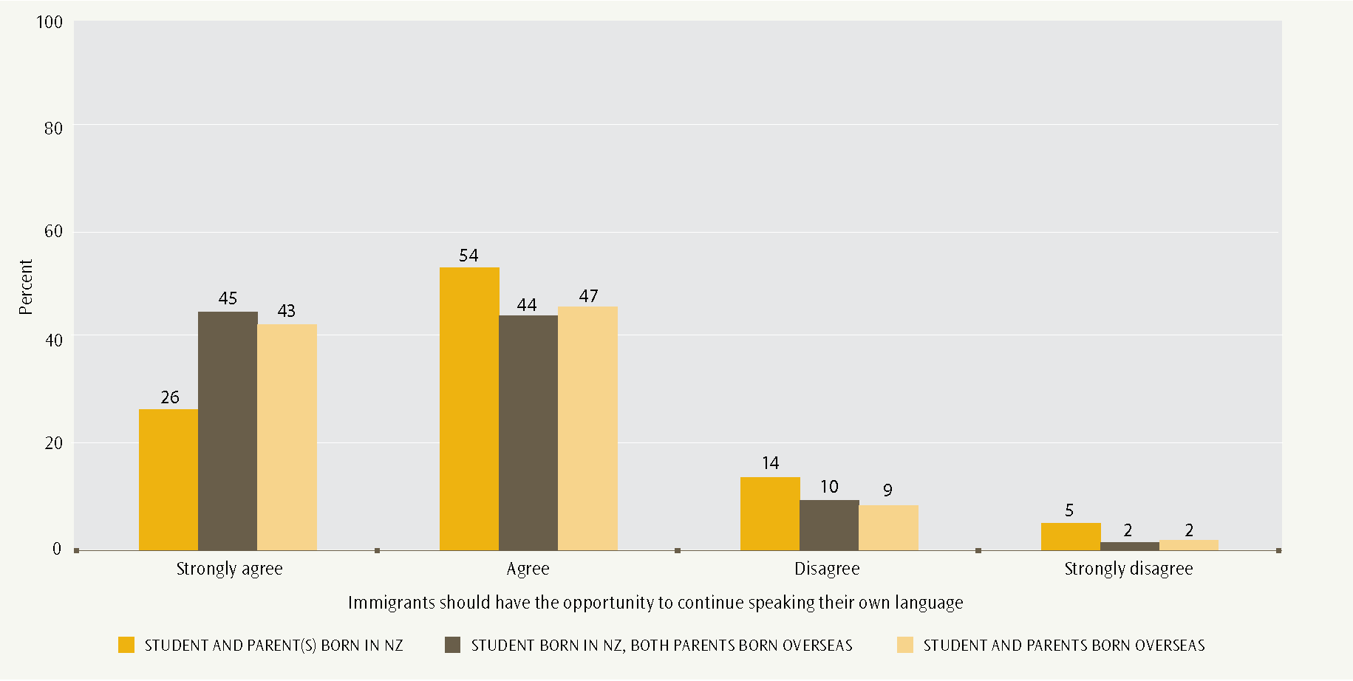
- New Zealand Year 9 students’ views on “Immigrant children should have the same opportunities for education that other children in the country have”, by immigrant status
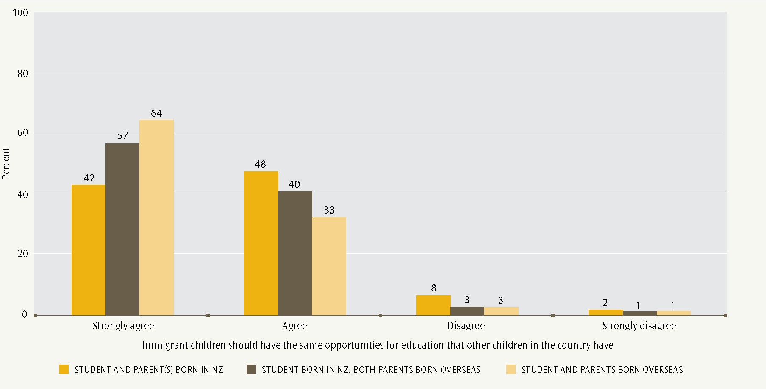
A large majority of students supported immigrant rights. Between 80 and 90% of students agreed or strongly agreed with statements supporting the rights of immigrants to speak their own languages, continue their customs, and have the opportunity for education and to vote.
Figures 19−24 show that the strength of support for immigrant rights was strongly associated with students’ own immigrant status. Students with an immigrant background were more likely to strongly support immigrant rights than students whose parents were born in New Zealand.
- New Zealand Year 9 students’ views on “Immigrants who live in a country for several years should have the opportunity to vote in elections”, by immigrant status
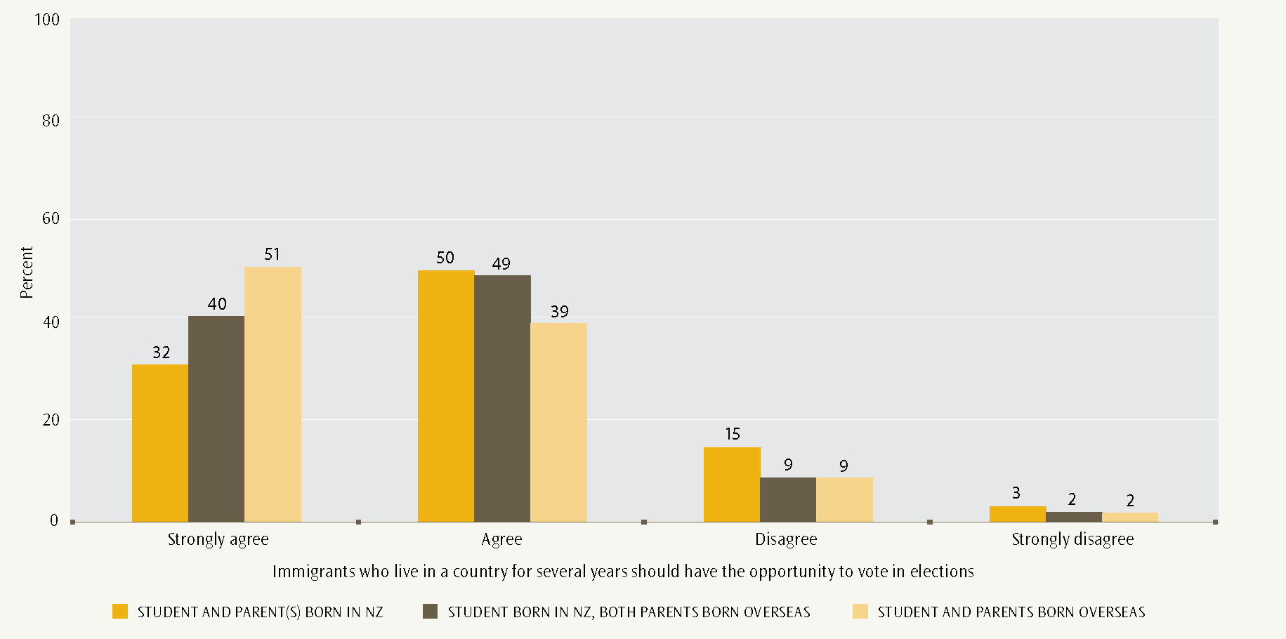
- New Zealand Year 9 students’ views on “Immigrants should have the opportunity to continue their own customs and lifestyle”, by immigrant status
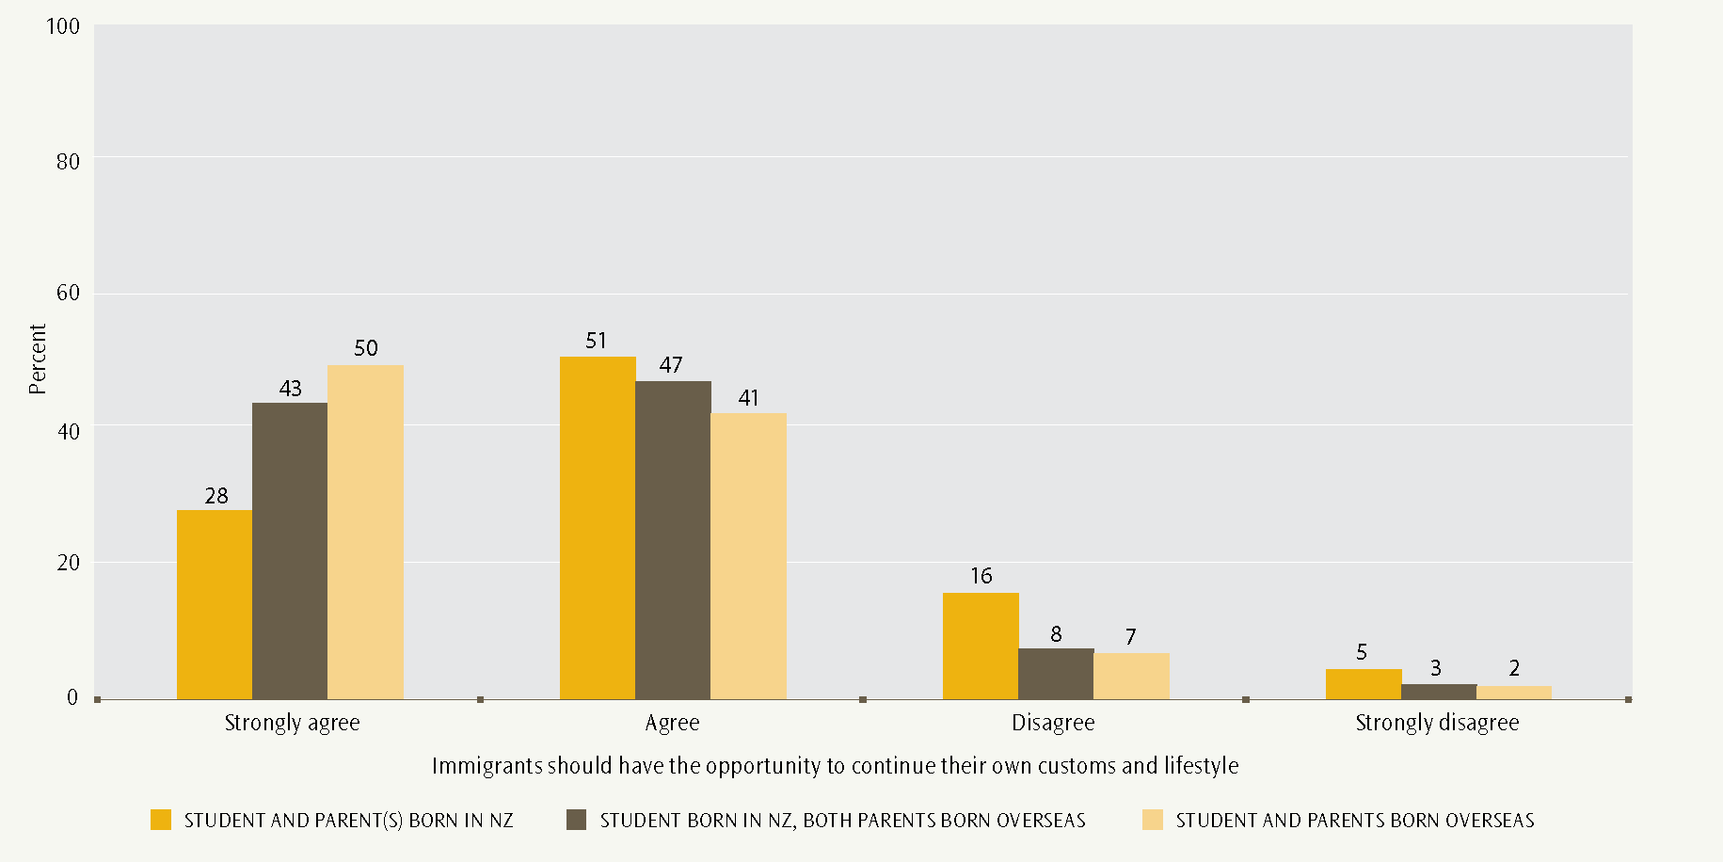
For example, 42% of New Zealand-born students with a parent (or parents) born in New Zealand strongly agreed that immigrant children should have the same opportunities for education as other children. This compares with 57% of New Zealand-born students whose parents were born overseas, and 64% of overseas-born students. We again see a pattern that suggests a student’s support for rights is stronger when those rights relate most directly to the individual − immigrant status in this case.
This pattern differs, however, for views on restricting immigration when jobs are scarce. Views overall for this statement are much more evenly spread compared with the other statements about immigrant rights. Only 52% of all students disagreed or strongly disagreed that immigration should be restricted when jobs are scarce. However, overseas born-students were much less likely to agree with the statement (see Figure 24).
- New Zealand Year 9 students’ views on “Immigrants should have all the same rights that everyone else in the country has”, by immigrant status
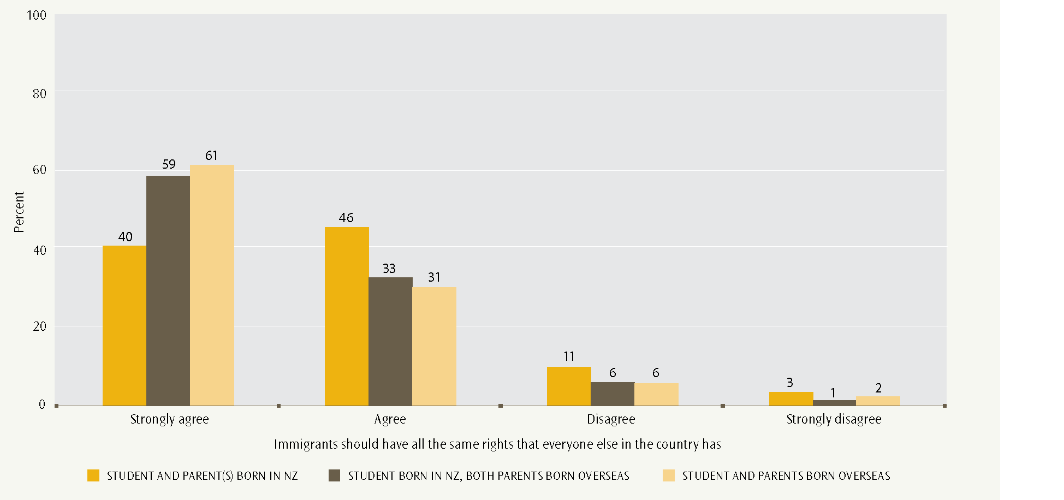
- New Zealand Year 9 students’ views on “When there are not many jobs available, immigration should be restricted”, by immigrant status
Four of the statements about immigrant rights show a strong association between the strength of support for immigrant rights and civic knowledge scores: the greater a student’s civic knowledge, the more likely they are to support immigrant rights (see Figure 25).
In contrast, two statements show a less marked association with civic knowledge scores: about immigrants having the opportunity to continue to speak their own language, and restricting immigration when employment is scarce. Views about immigrants continuing to speak their own language may be more associated with dispositions or attitudes acquired through family, peer networks or the media than with civic knowledge, as measured in ICCS.
- New Zealand Year 9 students’ views on immigrant rights, by civic knowledge score
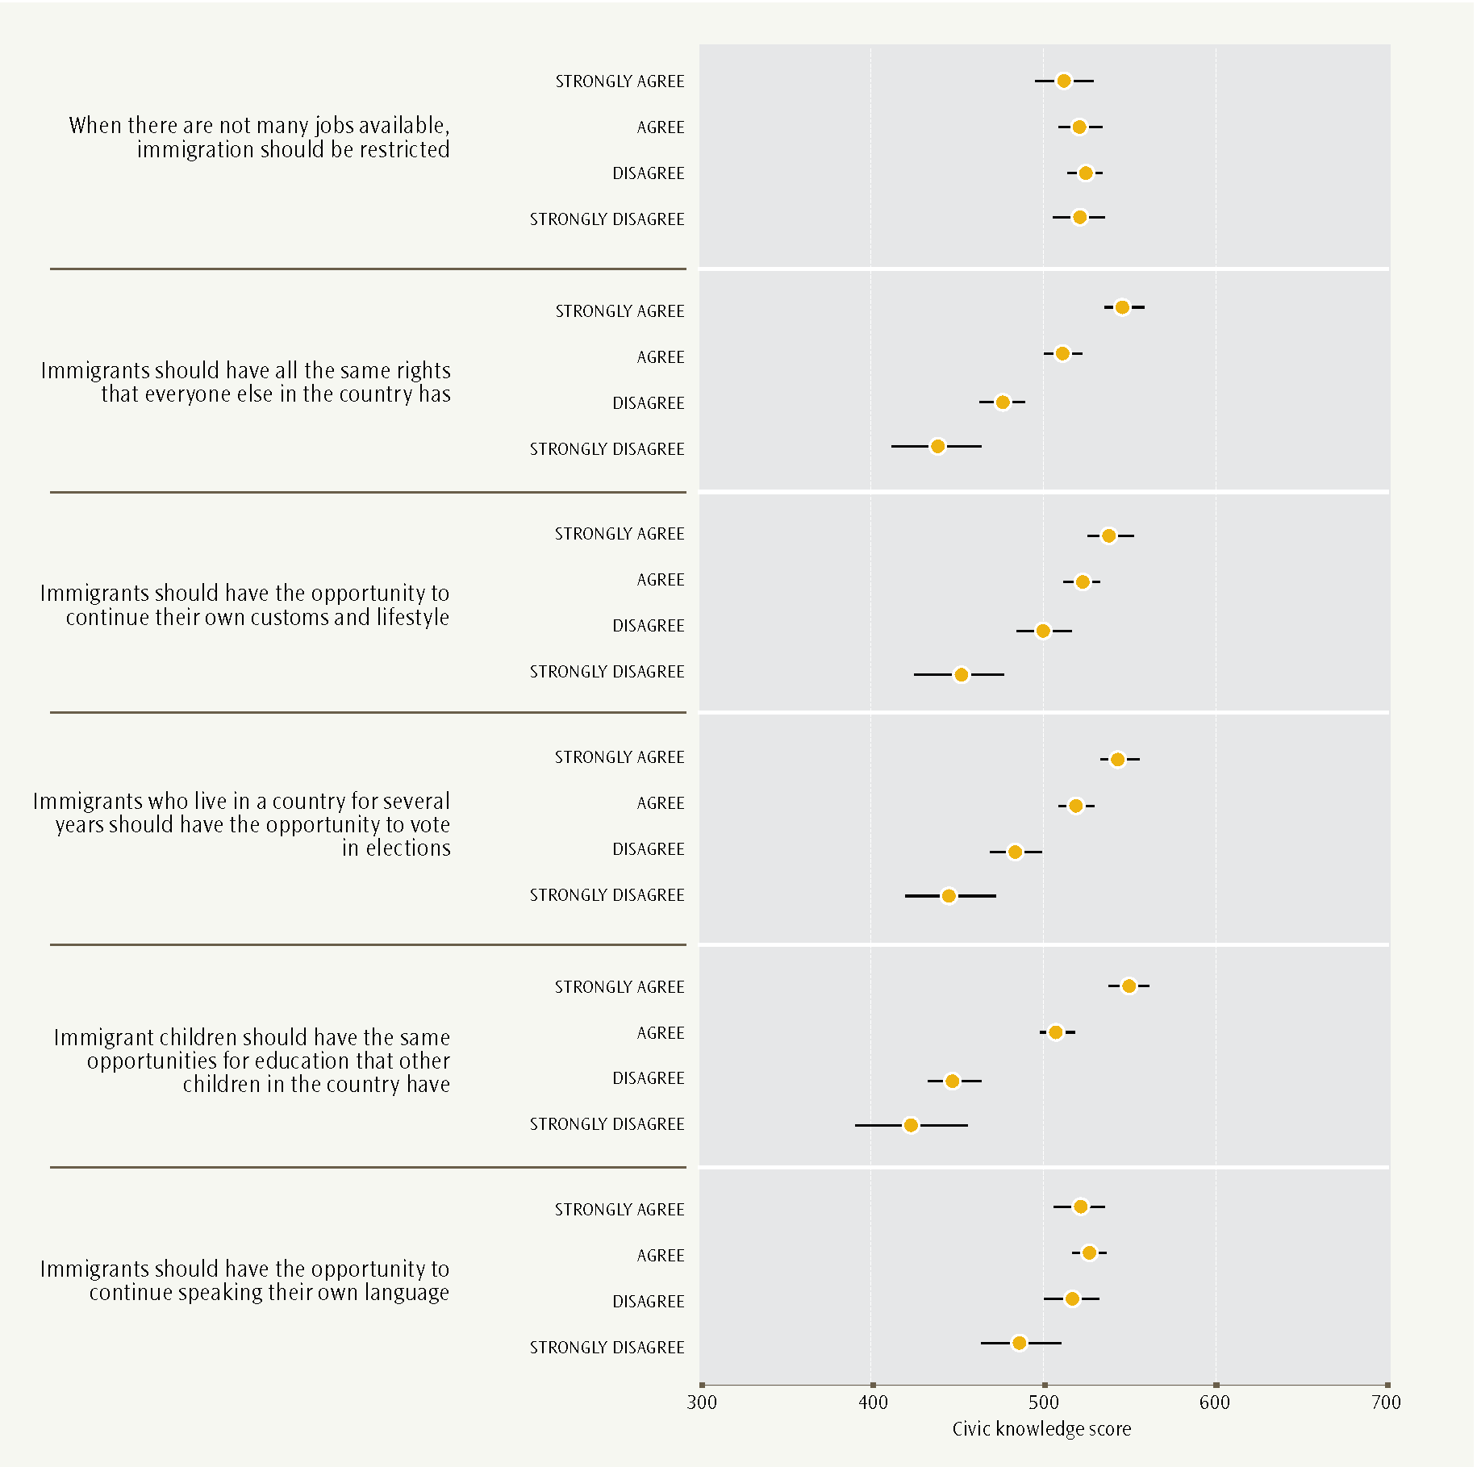
Responses to the statement about restricting immigration when jobs are scarce are less clear-cut from a rights point of view. The statement implies a trade-off between the rights of a country’s current residents to gain employment, and the rights of prospective immigrants. The average civic knowledge scores of students in each category are very similar, and do not appear to be related to their views on this topic.

What do Year 9 students think about religion and society?
Year 9 students were asked about their agreement with six statements on religion and society.
- Religion is more important to me than what is happening in national politics.
- Religion should influence people’s behaviour towards others.
- Religion helps me to decide what is right and what is wrong.
- Rules of life based on religion are more important than civil laws.
- Religious leaders should have more power in society.
- Religion should no longer be relevant in the modern world.
More than three-quarters (78%) of Year 9 students supported religion having a place in the modern world. They disagreed or strongly disagreed with the statement “Religion should no longer be relevant in the modern world”.
About half of Year 9 students agreed or strongly agreed that religion has personal or ethical importance. For example, 51% reported that religion is more important to them than national politics and 48% that religion should influence behaviour towards other people, while 45% agreed that religion helps with deciding about right and wrong.
Much smaller proportions supported rules of life based on religion being more important than civil laws (32%), and that religious leaders should have more power in society (27%).
Girls’ and boys’ patterns of views about religion and society were broadly very similar. Figure 26 shows students’ views about religion and society for Year 9 boys and girls.
- New Zealand Year 9 students’ views on religion and society, by gender
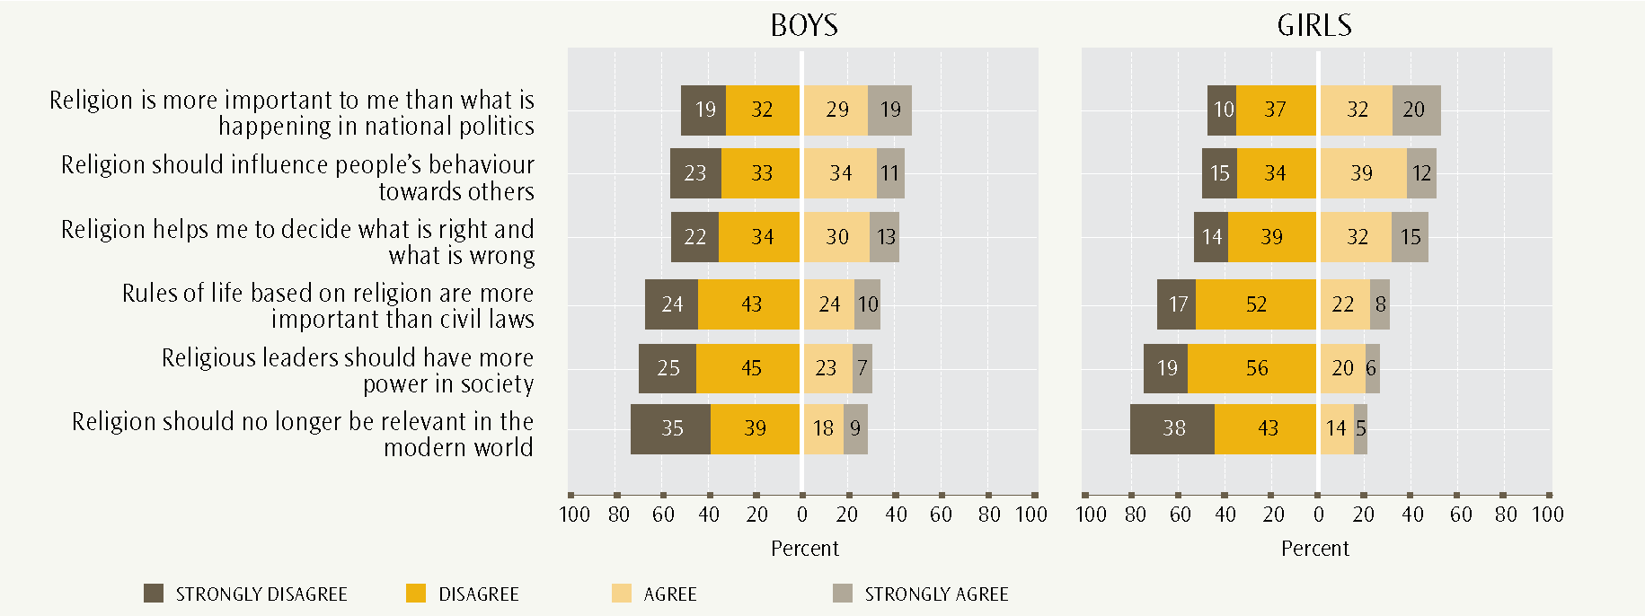
- New Zealand students’ views on “Religion should no longer be relevant in the modern world”, and “Religious leaders should have more power in society” by civic knowledge score
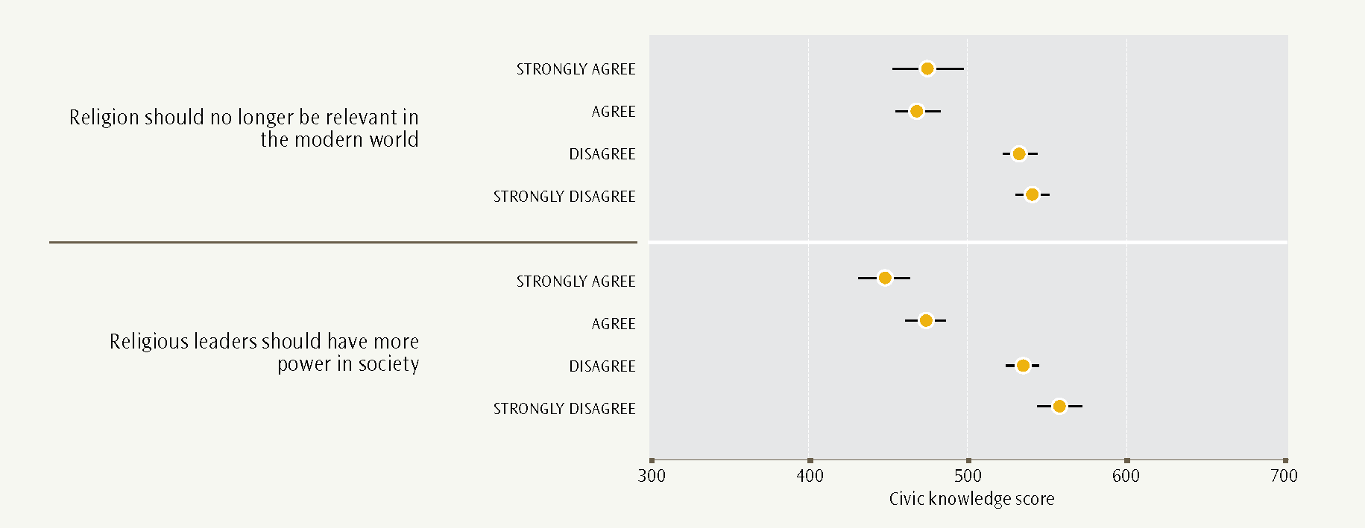
For five of the six statements, a higher civic knowledge score was associated with disagreeing about the importance of religion. These five statements relate to specific aspects of religion: personal, ethical or societal. The strongest of these negative associations with civic knowledge score was for the statement “Religious leaders should have more power in society”. Figure 27 shows that students who strongly disagreed with this statement had the highest average civic knowledge score.
On the other hand, students with higher civic knowledge scores were more likely to see religion as being relevant in the modern world, through disagreeing or strongly disagreeing with the sixth statement. However, these students with higher civic knowledge were less likely to see the relevance of religion in any of the personal, ethical or societal aspects of religion asked about in the ICCS study, particularly that religious leaders should have more power in society (also see Figure 27).

Conclusion
This report has focused on New Zealand Year 9 students’ views, values and perceptions related to New Zealand and its institutions and symbols, and on democratic freedom, equal rights and religion. The report has also discussed relationships between student views and values and civic knowledge, as measured in the ICCS study.
Students with high civic knowledge scores are much more likely to strongly support a range of democratic freedoms, and equal rights for men, women, ethnic and immigrant groups. Further statistical modelling using factor analysis was undertaken to investigate students’ responses to the full set of democratic value statements in relation to their civic knowledge score. This additional analysis found a broad pattern indicating that the greater a student’s civic knowledge, the more likely they are to strongly support democratic values.
Year 9 students are most likely to have moderate opinions on New Zealand and its symbols, and on trust in its institutions. They are somewhat less likely to support specific roles for religion in society or personally. The associations are much weaker between civic knowledge and views on limiting democratic rights in response to concerns about national security, income equity and restricting immigration when jobs are scarce.
What are the implications of these findings, particularly as civics and citizenship are not directly specified as discrete topics or subject areas within the overall framework of the NZC?
A foundation of strong and relevant civic knowledge can help students to develop robust support for democratic values and attitudes. The results of this study show a positive association between civic knowledge and upholding democratic values such as tolerance, respect and human rights for diverse groups. The clear implication is the need to ensure that the school curriculum provides young people with opportunities to gain civics and citizenship knowledge, as well as to understand their own values and why they hold them. Democratic values and civic knowledge may well mutually reinforce each other.
There is a more nuanced relationship between students’ knowledge scores and trust in institutions and individuals. Here we see that the disposition of moderately trusting relationships is associated with higher civic knowledge scores. This may reflect the developmental path of students becoming more discerning and discriminating in their trust relationships with greater civic knowledge and maturity.
In addition to skills, the NZC explains that the key competencies “draw also on knowledge, attitudes and values in ways that lead to action” (Ministry of Education, 2006, p. 12). The relationships among knowledge, attitudes and values are explored in this report. What we have not yet investigated is how both knowledge and attitudinal scores relate to students’ democratic participation, both now and as they envisage taking part in future activities. This will be the subject-matter of the third report in this series.

References
Education Review Office. (2006). The quality of teaching in Years 4 and 8: Social Studies. Wellington: Education Review Office.
Education Review Office. (2007). The teaching of Social Studies: Good practice. Wellington: Education Review Office.
Education Review Office. (2011). Directions for learning: The New Zealand Curriculum principles, and teaching as inquiry. Wellington: Education Review Office.
Lang, K. (2010). What do New Zealand students understand about civic knowledge and citizenship? Results from the International Civic and Citizenship Education Study. Wellington: Ministry of Education.
Ministry of Education. (1997). Social Studies in the New Zealand Curriculum. Wellington: Learning Media Limited.
Ministry of Education. (2007). The New Zealand Curriculum. Wellington: Learning Media Limited.
OECD. (2011). Society at a glance 2011: OECD social indicators. Paris: OECD Publishing.
Schulz, W., Ainley, J., Fraillon, J., Kerr, D. & Losito, B. (2010a). ICCS 2009 international report: Civic knowledge, attitudes and engagement among lower secondary-school students in 38 countries. Amsterdam: International Association for the Evaluation of Educational Achievement (IEA).
Schulz, W., Ainley, J., Fraillon, J., Kerr, D. & Losito, B. (2010b). Initial findings from the IEA International Civic and Citizenship Education Study. Amsterdam: International Association for the Evaluation of Educational Achievement (IEA).
Transparency International. (2010). Transparency International annual report 2009. Berlin: Transparency International Secretariat.
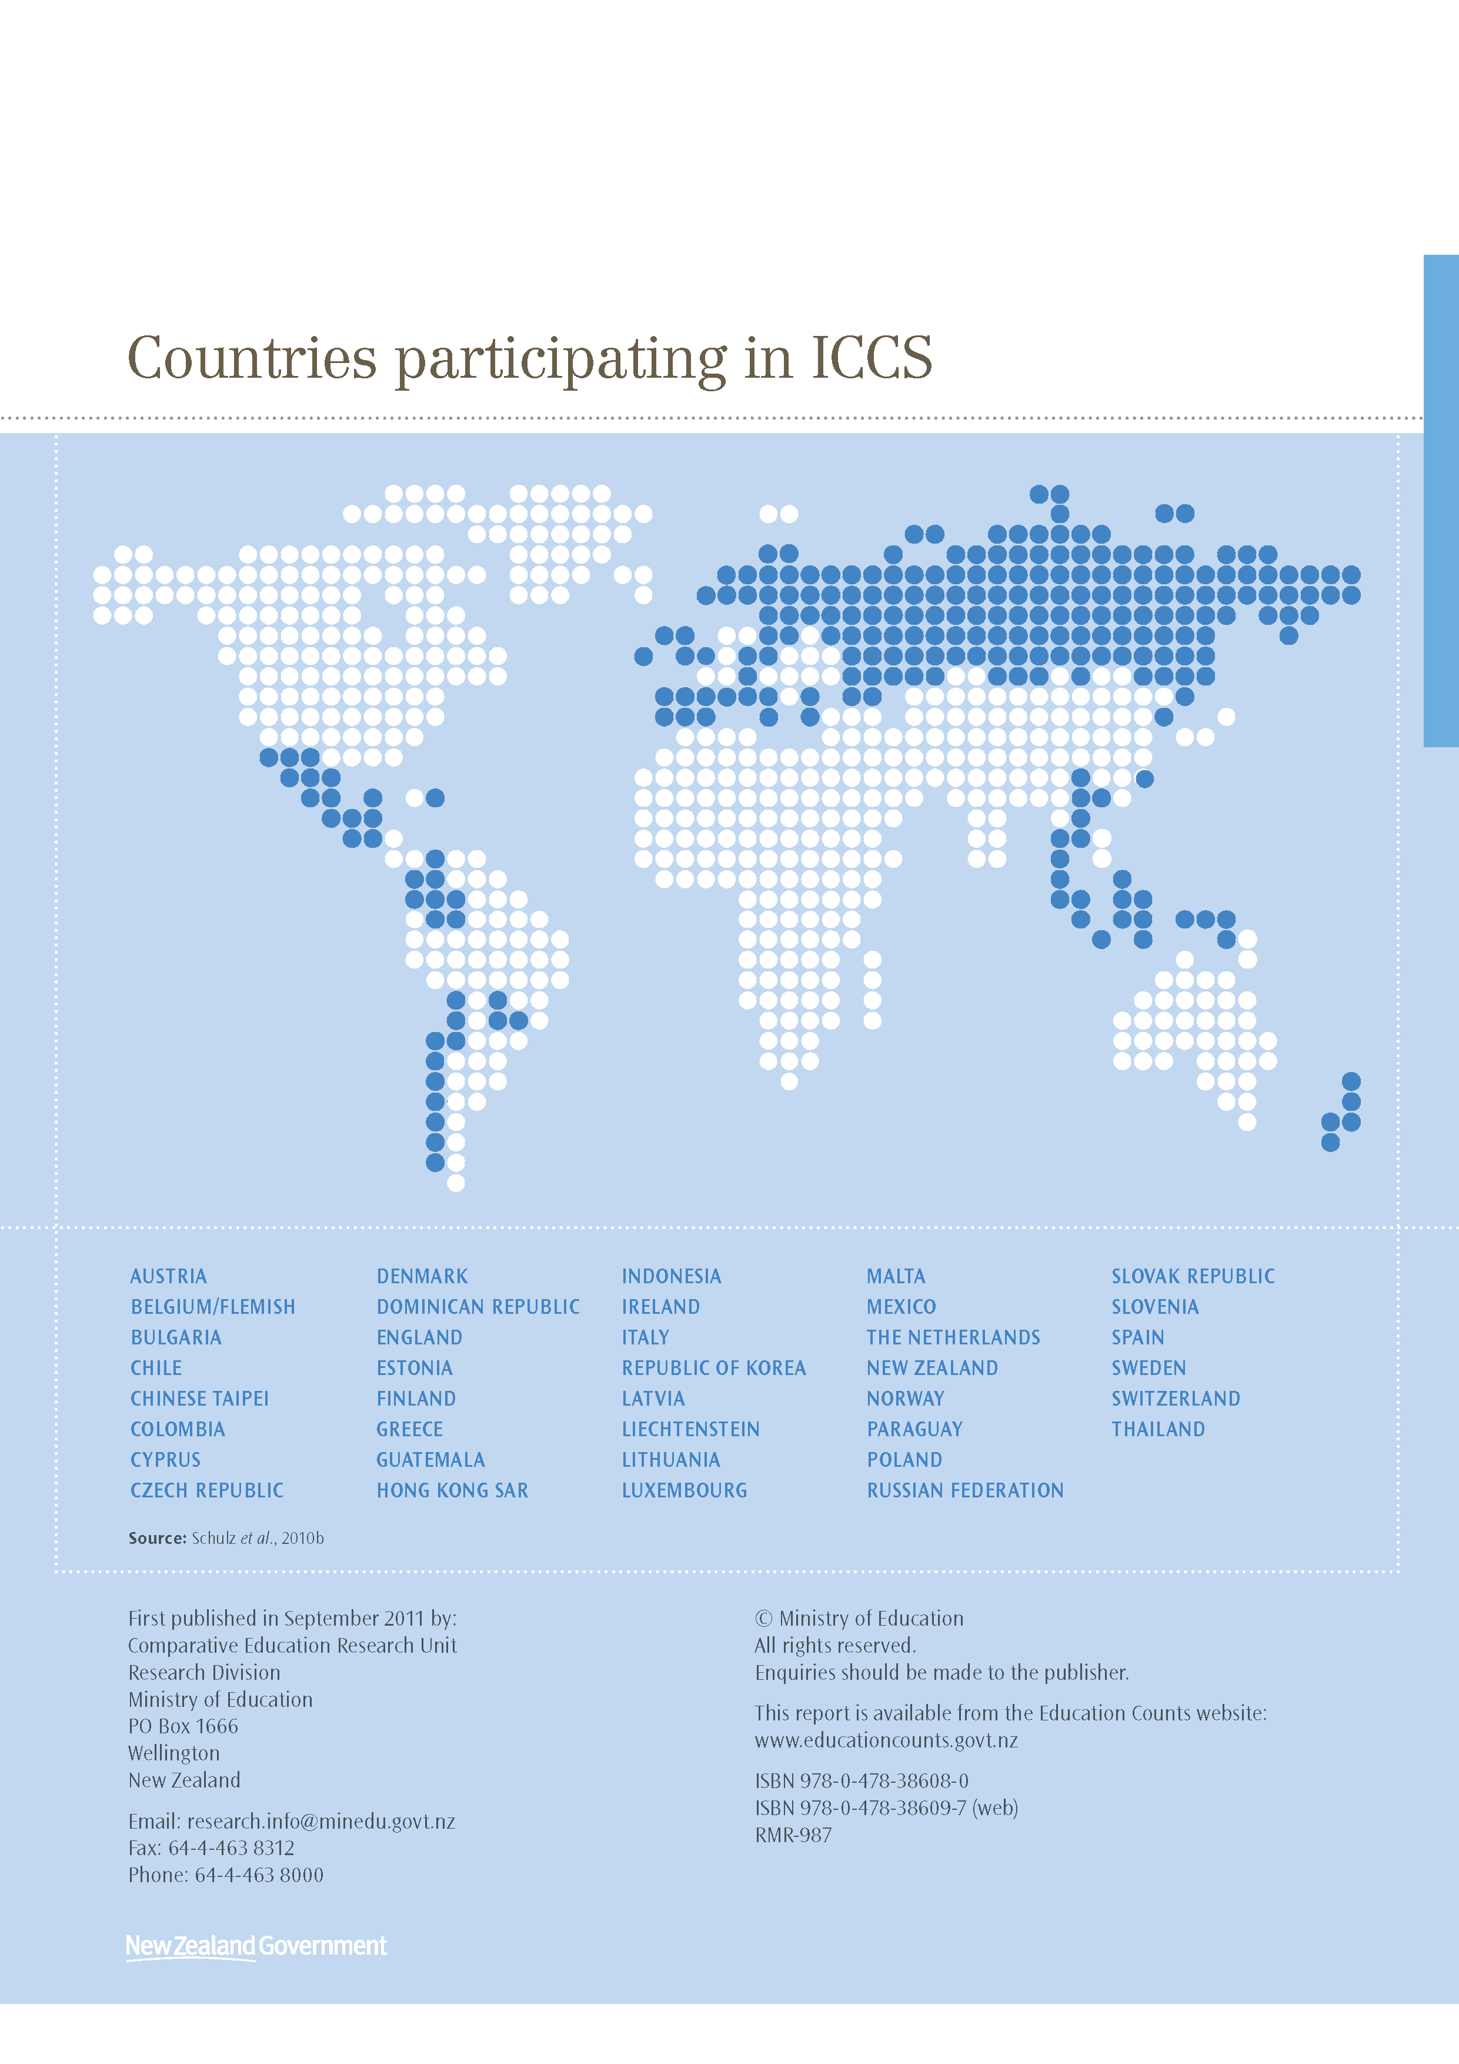

The IEA is an independent international consortium that conducts large-scale comparative studies of educational achievement.
In New Zealand, ICCS was undertaken only in English-medium settings with English as the test language.
The NZC has eight progressive levels, each with its own achievement objectives. Year 9 students are expected to be working towards Level Five.
New Zealand Year 9 students in 2008 identified as: Pākehā/European (68%), Māori (22%), Pasifika (14%) and Asian (12%). The percentages sum to more than 100% because of multiple responses by students to different ethnic categories: students may report more than one ethnicity, and every response is counted. The Other ethnicity category was too small to analyse.
The proportions of 2008’s Year 9 students by immigrant status were: 77% New Zealand born and had parent(s) New Zealand born; 8% New Zealand born but parents born overseas; 15% born overseas.
The proportion of students who reported either trusting people in general completely or quite a lot.
The graph shows the ICCS figure for Flemish Belgium together with the Corruption Perceptions Index score for Belgium as a whole. It also shows the ICCS figure for England with the Corruption Perceptions Index score for the United Kingdom.
The four ethnic categories, Pākēha/European, Māori, Pasifika and Asian, overlap because of double-counting multiple responses.
The categories of immigrant status are: student and parent(s) born in New Zealand; student born in New Zealand but parents born overseas; student born overseas.

