What do New Zealand students understand about civic knowledge and citizenship?

Results from the International Civic and Citizenship Education Study

Kate Lang

Summary
This report focuses on New Zealand Year 9 students’ achievement in civic knowledge in comparison with their peers from other countries.
In this context, civic knowledge includes a wide range of topics from political institutions and concepts, such as human rights, through to topics covering social and community cohesion, diversity, the environment, communications and global society. It is embedded in the New Zealand Curriculum.
The study shows that New Zealand students are generally well prepared for their roles as citizens in the 21st Century compared with many other countries that took part. New Zealand students’ mean civic knowledge score was 517 compared to the international ICCS average of 500 points.
New Zealand students were on a par with countries like England, Norway, Spain, the Russian Federation and the Slovak Republic. Students in 10 countries including Finland, Denmark, the Republic of Korea and Chinese Taipei outperformed our students. New Zealand’s performance was only average compared with other participating OECD countries.
New Zealand had a bigger gap in ICCS civic knowledge scores between high and low achievers compared with other countries in the study. This wide spread of achievement is similar to other international studies in which we take part.
Girls tended to have higher civic knowledge scores than boys in all countries participating in this study. In New Zealand the average difference was 31 score points in favour of girls.
Students identifying with European or Asian ethnic groups generally did better in civic knowledge than Māori or Pasifika students.
Other factors related to higher achievement in civic knowledge in this study included higher levels of parental education and occupation, more books in the home, speaking the test language (English) at home and a non-immigrant background.

Acknowledgements
ICCS was a collaborative effort internationally and nationally. Many people were involved in the project and it is not possible to thank them all individually but we would like to acknowledge a few key groups of people here.
This study was made possible by the cooperation of the schools, teachers and students who took part. Thanks to these participants, we now have a valuable resource about civic and citizenship education in New Zealand.
Thanks also to the many members of the Research Division and other Ministry of Education staff who contributed to the successful planning and implementation of ICCS.
Finally thanks to those who contributed to this publication by reviewing, editing and publishing this report.
Kate Lang
Sharon Cox (2008)
ICCS National Research Coordinators

Overview
New Zealand is one of 38 countries that took part in the International Civic and Citizenship Education Study (ICCS) sponsored by the International Association for the Evaluation of Educational Achievement (IEA) . This first report in a series featuring New Zealand results from the International Civic and Citizenship Education Study (ICCS) focuses on New Zealand Year 9 students’ achievement in civic knowledge in comparison with their peers from other countries. Future reports will focus on student values, attitudes and behaviours in civics and citizenship and the role of the school and community in civic and citizenship education.

What is ICCS?
The International Civic and Citizenship Education Study (ICCS) is an international standardised study that looks at the ways in which young people are prepared to undertake their roles as citizens.
ICCS measures students’ knowledge and understanding of civic systems and citizenship issues, as well as student attitudes, perceptions and activities relating to civics and citizenship. It also looks at differences among countries in relation to the outcomes of civic and citizenship education and how these differences relate to student, school and community backgrounds.

Who took part?
During 2008/09, approximately 140,000 students around 14 years of age and 62,000 teachers in over 5,300 schools from 38 countries around the world participated in ICCS. In New Zealand almost 4,000 Year 9 students, 1,350 teachers and 123 principals from 146 schools took part in the study between October and December 2008. A representative sample of New Zealand schools with Year 9 students was selected. The student sample was representative of their Year 9 peers.
It is worth noting that data collection in New Zealand took place around the time of the 2008 general election, which may have influenced students’ responses to some questions.
This is the first time since 1971 that New Zealand has had an opportunity to know how well our teaching and learning is addressing the important themes around civic and citizenship education.

How does civic and citizenship education fit into the New Zealand curriculum?
Civic and citizenship education is a broad-based topic that is embedded in the principles, values and key competencies of the New Zealand school curriculum. Civic and citizenship education is not taught as a separate subject, but is integrated into several curriculum subject areas, with social sciences being the key learning area. Social sciences are concerned with how societies work and how people can participate in the world as critical, active, informed and responsible citizens (Ministry of Education, 2007). In 21 of the 38 countries that took part in the ICCS study, civic and citizenship education is a compulsory general education subject or course.
Young people also develop understandings about their roles as citizens through a number of activities and experiences that take place outside the classroom or school. The home and community, as well as national educational and political contexts, also influence how students develop civic-related dispositions and competencies.

What information was collected?
Each student completed one of seven test booklets in a 45-minute cognitive test. The rotation of test booklets ensured broad coverage of the content domains of the ICCS assessment framework – civic society and systems, civic principles, civic participation and civic identities. Examples of cognitive test items are provided in the appendix. Students also completed a 40-minute questionnaire about their background and their attitudes, values and behaviours in relation to civics and citizenship.
Teachers answered questions about their perceptions of civic and citizenship education (CCE) in their schools, school organisation and culture, and teaching practices. Principals provided information about their school – characteristics, culture and climate – and the provision of CCE at their school. ICCS also surveyed countries about the structure of their education system, CCE in the curricula and recent developments in CCE.
The ICCS cognitive tests and questionnaires were developed cooperatively with representatives from participating countries. Questions were trialled with a representative sample of students from each country and the results of the field test were used to select and refine the questions for the main study.

What can we find out from this study?
Civic knowledge is broadly defined in ICCS as knowledge and understanding of:
- Civic education – the formal institutions and processes of civic life, such as voting in elections.
- Citizenship education – how do people participate in society and how do citizens interact with, and shape their communities and societies.
The cognitive test material covers a range of key concepts and topics defined in the ICCS assessment framework such as: the roles, rights and responsibilities of citizens; public and political institutions; human rights, freedom and equity; social and community cohesion; decision-making and participation in society; social connectedness; communications; and the environment.
Three-quarters of the civic knowledge questions in the cognitive test required students to use analysis and reasoning and the remaining one-quarter tested students’ knowledge of civics.
ICCS measured student perceptions and behaviours relating to civics and citizenship in four domains – value beliefs, attitudes, behavioural intentions and behaviours. ICCS also explored the learning context for civics and citizenship – schools, classrooms, the community and the home.

How well prepared are our Year 9 students to be future citizens?
New Zealand students are generally well-prepared for their roles as citizens in the 21st Century compared with many other countries participating in ICCS. The mean score for New Zealand in civic knowledge was 517 scale points, which was significantly above the ICCS average of 500 points.
The four top-performing countries were Finland, Denmark, Republic of Korea and Chinese Taipei. New Zealand’s performance in civic knowledge was similar to Belgium (Flemish), Czech Republic England, Estonia, Norway, Slovenia, Slovak Republic, Spain and the Russian Federation. Our mean civic knowledge score was significantly above 16 other countries and significantly below 10 countries.
Australia, Canada and the United States did not take part in ICCS, which reduces the scope for evaluating New Zealand’s performance against English-speaking countries with similar education systems. However, our performance was only average in comparison with other participating OECD countries. New Zealand’s civic knowledge score of 517 was significantly above only five other OECD member countries – Austria, Chile, Greece, Luxembourg and Mexico.
New Zealand had a wide distribution of student civic knowledge scores. The gap between high and low achievers was wider than that of other participating ICCS countries, as shown in Figure 1. In most ICCS countries the gap between the lowest 5 percent and the highest 95 percent of civic knowledge scores was around 300 scale points, whereas for New Zealand it was 360 scale points. England and Bulgaria also had wide score-point distributions, a similar finding to the 2005/06 Progress in International Reading Literacy study (PIRLS) (Chamberlain, 2008).
New Zealand’s wide spread of achievement is also illustrated by our student scores at each end of the scale. For example, our top five percent of students scored 693 points or better in civic knowledge, which was higher than other countries with similar mean scores. At the lower end of the scale, however, the picture was different; five percent of New Zealand students had scores of 333 or below, which was lower than other countries with similar mean scores.
ICCS proficiency levels describe student competencies on a hierarchical scale of knowledge and understanding of civics and citizenship. Each of the three proficiency levels sets out what students can typically do at that level and are anchored at certain score points on the achievement scale. For example, students working at Level 2 have civic knowledge scores between 479 and 562. Appendix 3 of this report provides examples of the types of questions and responses that correspond to the three proficiency levels of the civic knowledge scale.
Figure 2 shows the percentage of students at each proficiency level across countries. More than one-third of New Zealand students (35%) achieved scores that placed them at the highest proficiency level on the ICCS civic knowledge scale (Level 3), compared with 28 percent of students across all of the countries. At the other end of the scale, 14 percent of New Zealand students did not reach Level 1 proficiency which is similar to the ICCS average of 16 percent.
Figure 1: ICCS Civic Knowledge Scores and Distributions
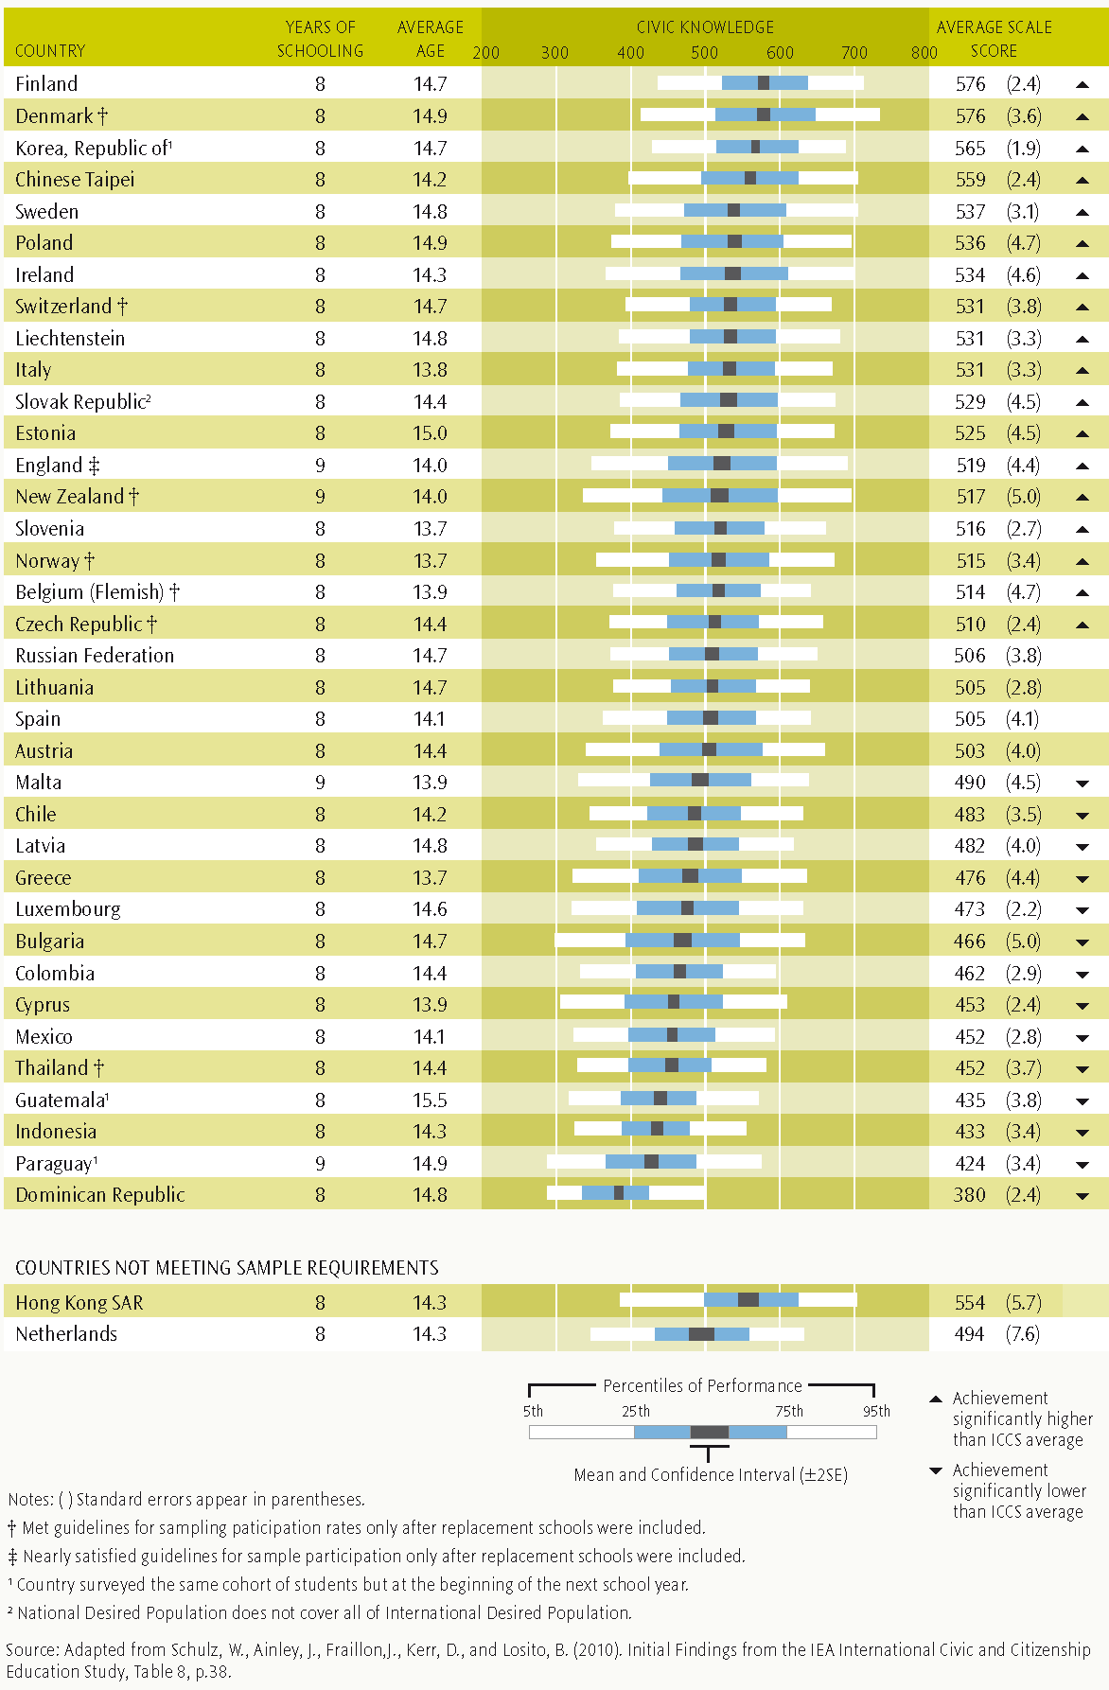
Source: Adapted from Schulz, W., Ainley, J., Fraillon,J., Kerr, D., and Losito, B. (2010). Initial Findings from the IEA International Civic and Citizenship Education Study, Table 8, p.38.
Figure 2: Percentages of students at each proficiency level across countries
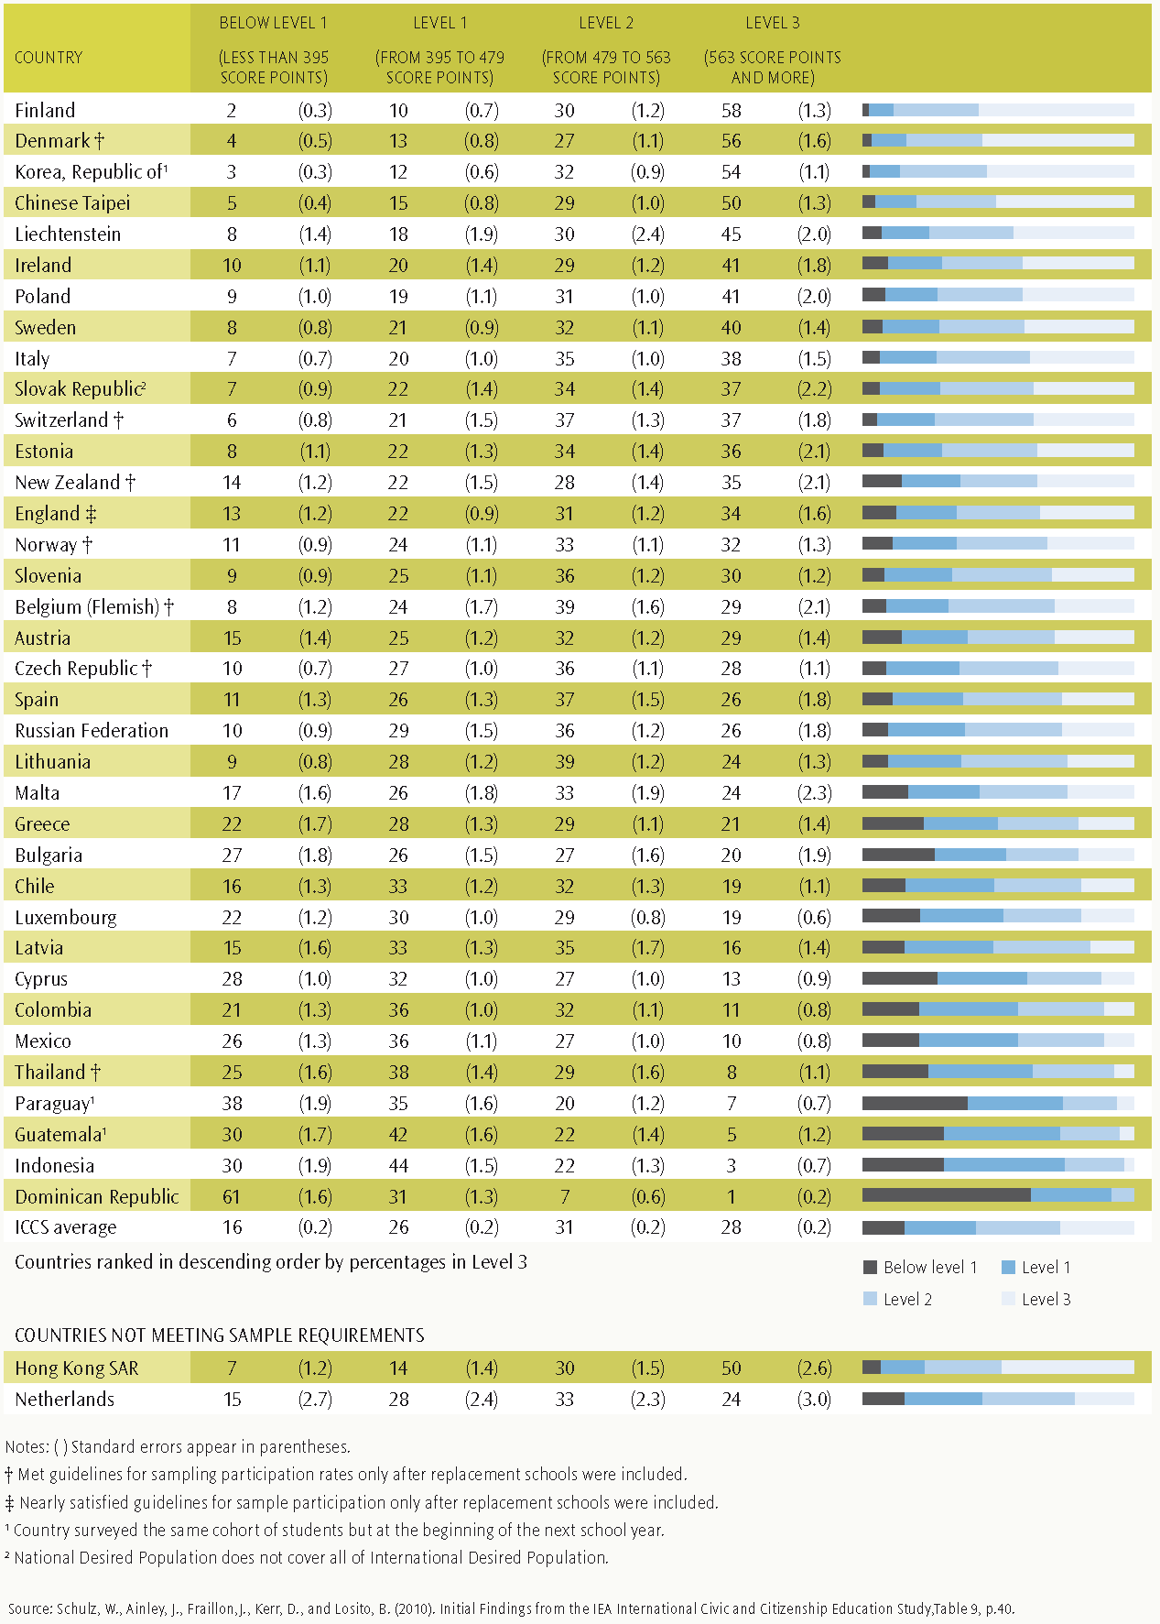
Source: Schulz, W., Ainley, J., Fraillon,J., Kerr, D., and Losito, B. (2010). Initial Findings from the IEA International Civic and Citizenship Education Study,Table 9, p.40.

Civic knowledge by gender and ethnicity

Gender
Girls had higher civic knowledge scores on average than boys across all of the ICCS participating countries and in 31 countries the gender difference was significant. New Zealand girls’ mean score was 532 compared with 501 for boys, a significant difference of 31 score points. Thailand had the biggest score point difference between girls and boys of 48 score points and Guatemala the smallest (2 score points).
Figure 3 shows that 39 percent of New Zealand girls achieved scores at Level 3 of the ICCS civic knowledge proficiency scale compared with only 31 percent of boys. At the other end of the proficiency scale, only 9 percent of girls were below Level 1 compared with 19 percent of boys.
This gender difference may be related in part to the reading skills of New Zealand students – girls do significantly better on average than boys in reading literacy in other international education studies such as PISA and PIRLS.
Figure 3: Percentage of New Zealand Year 9 students at each proficiency level, by gender
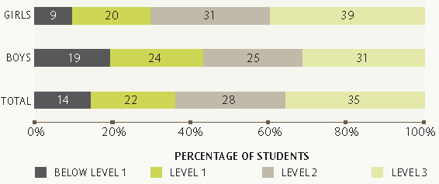

Ethnic Groups
New Zealand students who took part in ICCS were asked to provide information about the ethnic group(s) they identified with. Students who gave multiple responses to this question are counted in each group. For example, students who identify as Samoan and Chinese are counted in both Pasifika and Asian ethnic groups. The following discussion focuses on the four main ethnic groupings: European, Māori, Pasifika and Asian. The Other ethnic group is too small for meaningful analysis.
As Table 1 shows, the mean civic knowledge scores for students identifying as European or Asian were considerably higher than those of students identifying as Māori or Pasifika. Girls generally did better than boys across all of the ethnic groups with Māori having the biggest gender gap of 40 score points. Māori and Pasifika boys’ civic knowledge was particularly weak with average scores of 454 and 433 respectively, well below the ICCS average of 489 for boys.
Table 1: New Zealand Year 9 civic knowledge scores by gender, within ethnic groupings (total responses)
Ethnic group | All students |  | Girls |  | Boys
Ethnic group | Average score | Standard error | Average score | Standard error | Average score | Standard error
European | 541 | (5.0) | 556 | (5.4) | 525 | (6.8)
Māori | 476 | (5.7) | 494 | (7.1) | 454 | (7.3)
Pasifika | 451 | (7.2) | 470 | (8.0) | 433 | (8.3)
Asian | 520 | (9.6) | 538 | (11.2) | 500 | (13.3)
All students | 517 | (5.0) | 532 | (5.9) | 501 | (6.4)
ICCS average | 500 |  | 511 | (0.7) | 489 | (0.7)
Notes: Students who identified with more than one ethnic group are counted in each of those groups.
( ) Standard errors appear in parentheses.
Figure 4 shows the percentage of students at each proficiency level by ethnic grouping. Proportionately few Māori and Pasifika students performed at Level 3 proficiency in civic knowledge. Only 20 percent of Māori students and 13 percent of Pasifika students met Level 3 proficiency compared with 44 percent of European students and 37 percent of Asian students. On the other hand, only 9 percent of European students performed at below Level 1 compared with 15 percent of Asian, 22 percent of Māori and 30 percent of Pasifika students.
Figure 4: Percentage of New Zealand Year 9 students at each proficiency level, by ethnic grouping (total responses)
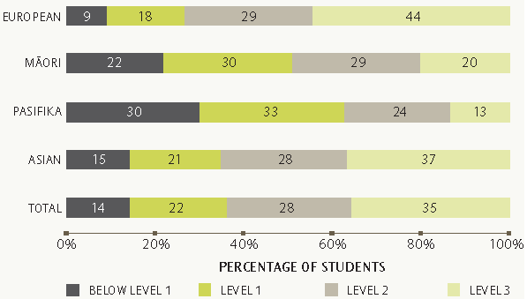
Note: Students who identified with more than one ethnic group are counted in each of those groups.

Family background and civic knowledge

Socio-economic background
Socio-economic background is widely regarded as an important influence on student learning outcomes and separating out the impact of different family background factors on student achievement can be difficult.
ICCS asks students about their home background. Questions about parents’ or caregivers’ occupations, their educational attainment, and home literacy (an estimate of the number of books in their home) are used as a measure of socio-economic background.
Students’ responses to questions about their parents’ occupations were coded using the ISCO-88 classification, transformed into a score on a socio-economic index scale (SEI), then grouped into low, medium or high parental occupational status categories for analysis. Just under half of New Zealand ICCS students (45 percent) were in the medium occupational status group.
Across all ICCS countries, SEI was strongly associated with student civic knowledge. Students classified as high SEI scored 72 points more on average than students classified as low SEI. For New Zealand students, civic knowledge was even more strongly associated with SEI. As Figure 5 shows, the New Zealand score point difference between high and low occupational status categories was 96 scale points on average.
Analyses show that about 11 percent of the differences among student scores were explained by their parents’ occupational status.
Figure 5: New Zealand Year 9 civic knowledge scores by parental occupational status
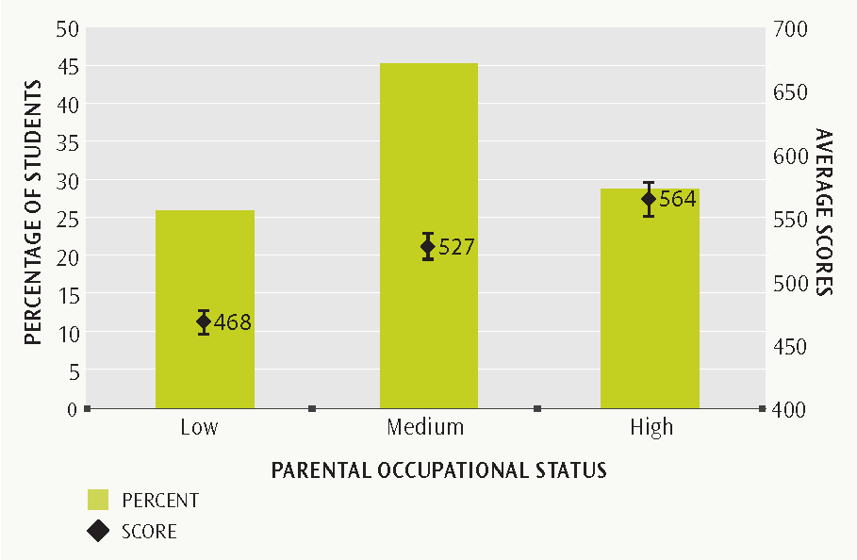
Notes: Each bar represents the highest occupational status of students’ parents/caregivers as reported by students. The data points represent the mean civic knowledge scores for each group of students. The vertical lines extending from the data point show the 95 percent confidence interval around the average (i.e., + or – 2 standard errors).
Table 2 shows that the relationship or association between parental occupational status and civic knowledge for the three English-speaking countries (New Zealand, England and Ireland) that took part in ICCS is stronger than for the overall ICCS average.
Table 2: Students by parental occupational status and civic knowledge, selected countries
Country | Low occupational status |  | Medium occupational status |  | High occupational status |  | Effects of SEI on civic knowledge
Country | Percent of students | Average score | Percent of students | Average score | Percent of students | Average score | Difference in score points for one standard deviation in SEI
New Zealand | 26 (1.0) | 468 (4.9) | 45 (1.1) | 527 (5.3) | 29 (1.1) | 564 (6.9) | 37 (0.8)
England | 29 (1.1) | 477 (5.0) | 44 (1.1) | 524 (4.0) | 27 (1.2) | 576 (7.7) | 42 (1.6)
Ireland | 29 (1.2) | 495 (6.0) | 45 (0.9) | 541 (4.6) | 27 (1.1) | 577 (4.2) | 34 (1.2)
ICCS Average | 36 (0.2) | 471 (0.7) | 40 (0.2) | 507 (0.7) | 23 (0.2) | 543 (1.0) | 29 (0.1)
Notes: Statistically significant (p<0.05) differences in bold.
( ) Standard errors appear in parentheses.
As is often the case in New Zealand, home literacy resources were positively associated with civic knowledge scores. New Zealand students with 500 or more books in their home scored 112 points higher on average than students with ten or fewer books in their home. Another way to visualise this difference is that for every 100 books in the home, a New Zealand student’s score could be expected to increase by around 13 points. This is about the same as the average across all countries in the study (12 points). Around six percent of the differences among student score points both in New Zealand and other ICCS countries were explained by the number of books in the home.
There was a weaker link between parents’ education and student achievement. Just 4 percent of the differences among student scores were explained by the level of education reached by their parents. Another way to visualise this difference is that for each year of parental education, a New Zealand student’s score could be expected to increase by around 12 points, slightly more than the average across all countries in the study (9 points).
New Zealand students reported higher levels of parental education than the ICCS average. Three-quarters of New Zealand students reported that their parents had completed post-secondary level courses or qualifications compared with fewer than half of all students participating in ICCS, although this is not surprising given the wide range of educational systems across the ICCS countries.
Figure 6: New Zealand Year 9 civic knowledge scores by highest level of parental educational attainment
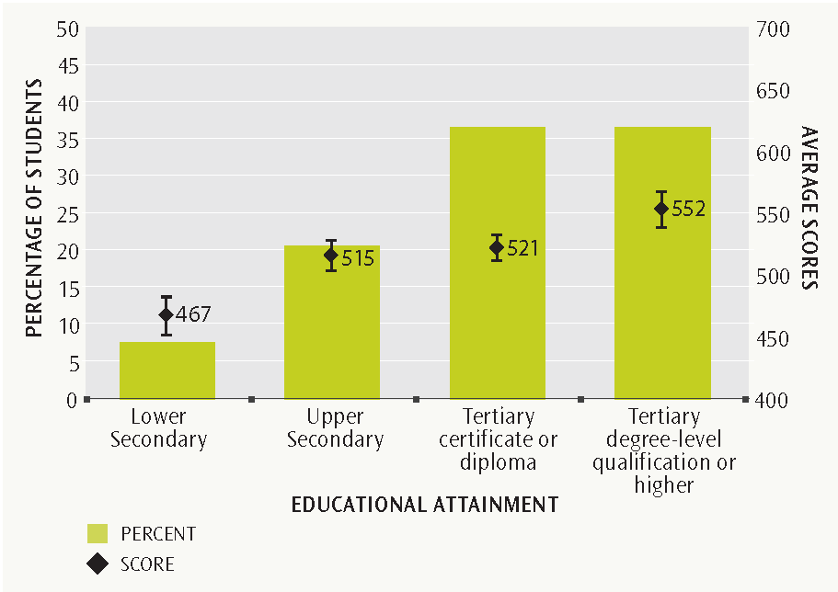
Notes: Each bar represents the highest level of completed education by students’ parents/caregivers as reported by students. The data points represent the mean civic knowledge scores for each group of students. The vertical lines extending from the data point show the 95 percent confidence interval around the average (i.e., + or – 2 standard errors).
Lower secondary educational attainment is defined as completing up to Year 10 with no secondary qualification.

Home language
Language background – that is, the main language spoken in the home - has been associated with student achievement in a number of educational studies. For example, the 2005/06 Progress in International Reading Literacy Study (PIRLS) found that students who never spoke the language used in the PIRLS test at home had lower reading achievement in all countries than those who spoke it at home more frequently (Mullis et al 2007, p.132).
The majority of New Zealand students (91 percent) in the ICCS study reported speaking English at home most or all of the time. Students from English-speaking homes (i.e. the language used in the study) scored 58 points higher on average in civic knowledge than those whose home language was not English. This pattern was similar across the ICCS participating countries with an average of 46 score points difference in favour of students whose home language was the same as the test language.
Few European or Māori students in the study did not speak English at home most or all of the time. More than one-third of Asian students and one-fifth of Pasifika students reported that their home language was not English. Table 3 shows that Pasifika students whose home language was not English scored significantly lower in civic knowledge compared with those who spoke English at home all or most of the time. This finding was also true for Asian students, although the difference was not statistically significant.
Table 3: New Zealand Year 9 civic knowledge scores, by home language (all students, Pasifika and Asian students)
Ethnic group | English (language of the ICCS test) |  |  | Other languages |  |  | Score point difference
Ethnic group | Percent of students | Average score | Standard error | Percent of students | Average score | Standard error | Score point difference
Pasifika students | 80 | 461 | (8.4) | 20 | 412 | (10.8) | 49
Asian students | 63 | 533 | (11.0) | 37 | 497 | (14.1) | 36
All students | 91 | 523 | (5.0) | 9 | 465 | (9.3) | 58
Notes: Students who identified with more than one ethnic group are counted in each of those groups.
Statistically significant (p<0.05) differences in bold.
( ) Standard errors appear in parentheses.

Immigrant status
ICCS uses the term native to refer to students who were born in the country of the assessment and have at least one parent born in the same country. Three-quarters of New Zealand students who participated in ICCS were native students and the remaining quarter were classified for the purposes of this study as having an immigrant background. (i.e., both parents born overseas). Within the immigrant group, two-thirds of the students were also born overseas and one-third was New Zealand-born.
Figure 7 shows that native students had significantly higher achievement scores on average than students with an immigrant background, scoring 19 points more on average than students with parents born overseas. Within the immigrant group, there was no significant difference in civic knowledge scores between students born overseas and those born in New Zealand. However it is interesting to note that New Zealand-born Pasifika and Asian students tended to have higher civic knowledge scores than their overseas-born counterparts.
Home language is likely to be a factor contributing to lower average ICCS achievement among students with an immigrant background. One in three New Zealand immigrant students did not speak English (the language of the ICCS test) at home, and their mean civic knowledge score of 477 points was significantly lower than that of immigrant students who spoke English at home (519 score points).
Figure 7: New Zealand Year 9 civic knowledge scores, by immigrant background
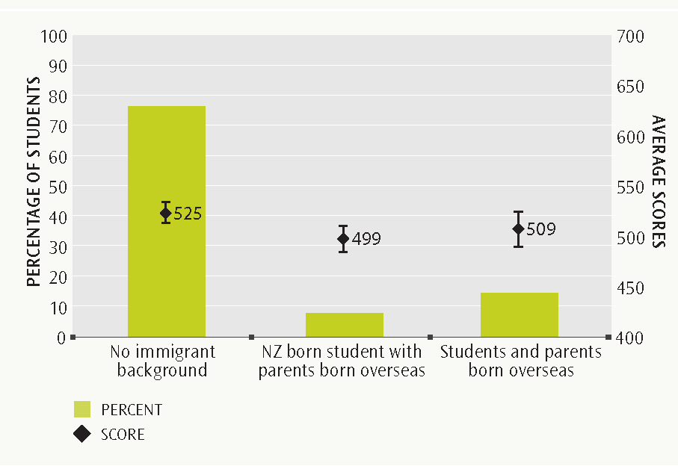
Note: Each bar represents students’ self-reported immigrant background. The data points represent the mean civic knowledge scores for each group of students. The vertical lines extending from the data point show the 95 percent confidence interval around the average (i.e., + or – 2 standard errors).
The 19-point score difference between the mean civic knowledge scores of native students and students with an immigrant background was relatively small in New Zealand compared with the average difference across ICCS countries of 37 points, as illustrated in Figure 8. For example, Switzerland had around the same proportion of immigrant students as New Zealand, but their score point difference was 46.
Figure 8: Civic knowledge scores by immigrant background, selected countries
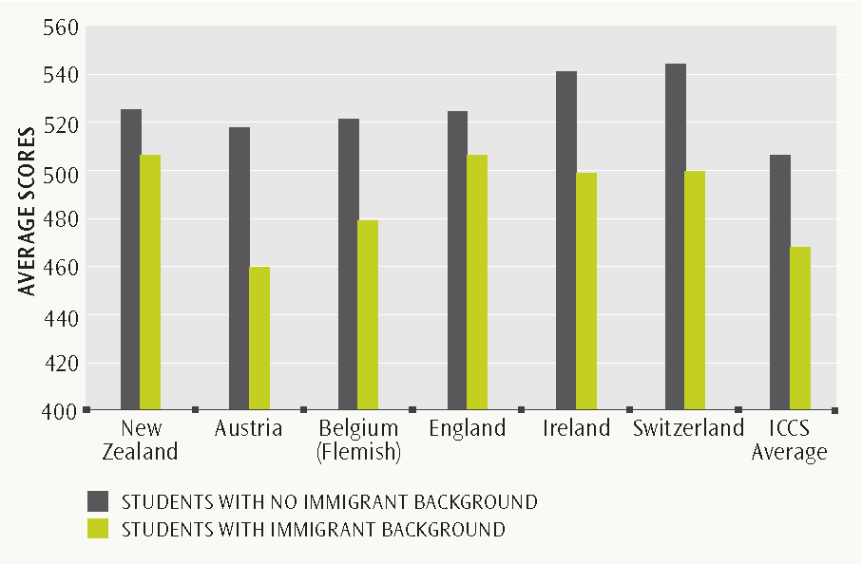
Note: See Appendix 2 for source data.

Final comment
ICCS is a large international study that examines student knowledge and understanding of civics and citizenship in relation to a range of personal, educational, social and cultural factors. This report focuses on New Zealand Year 9 student achievement in civic knowledge. New Zealand students are generally well-prepared to be active citizens with civic knowledge scores significantly above the international average, although our performance was below a number of other OECD countries in the study.
ICCS also investigated student attitudes, values, perceptions and activities related to civic and citizenship. Data from 38 countries has provided a rich source of information about the differences between countries and how these differences relate to student characteristics, school and community contexts, and country characteristics.
We can learn more about civics and citizenship through the ICCS data on student values, attitudes and behaviours, which will be the focus of the second report in this series. The series of New Zealand ICCS reports will provide a broad perspective of how well prepared New Zealand students are to undertake their roles as citizens of the future.
The ICCS international reports can be accessed from New Zealand’s ICCS webpage at www.educationcounts.govt.nz/goto/iccs. The international database will also be accessible for public use (from 2011) on the ICCS website at http://iccs.acer.edu.au/.

Appendices

Appendix 1: An explanation of the ICCS Civic Knowledge Proficiency Levels
Level 3: 563 score points and above
Students working at Level 3 make connections between the processes of social and political organisation and influence, and the legal and institutional mechanisms used to control them. They generate accurate, hypotheses on the benefits, motivations and likely outcomes of institutional policies and citizens' actions. They integrate, justify and evaluate given positions, policies or laws based on the principles that underpin them. Students demonstrate familiarity with broad international economic forces and the strategic nature of active participation.
Students working at Level 3 for example:
- identify likely strategic aims of a program of ethical consumption.
- suggest mechanisms by which open public debate and communication can benefit society.
- suggest related benefits of widespread cognitive intercultural understanding in society.
- justify the separation of powers between the judiciary and the parliament.
- relate the principle of fair and equal governance to laws regarding disclosure of financial donations to political parties.
- evaluate a policy with respect to equality and inclusiveness.
- identify the main feature of free market economies and multinational company ownership.
Level 2: 479 to 562 score points
Students working at Level 2 demonstrate familiarity with the broad concept of representative democracy as a political system. They recognise ways in which institutions and laws can be used to protect and promote a society's values and principles. They recognise the potential role of citizens as voters in a representative democracy, and generalise principles and values from specific examples of policies and laws (including human rights). Students demonstrate understanding of the influence that active citizenship can have beyond the local community. They generalise the role of the individual active citizen to broader civic societies and the world.
Students working at Level 2 for example:
- relate the independence of a statutory authority to maintenance of public trust in decisions made by the authority.
- generalizes the economic risk to developing countries of globalization from a local context.
- identify that informed citizens are better able to make decisions when voting in elections.
- relate the responsibility to vote with the representativeness of a democracy.
- describe the main role of a legislature/parliament.
- define the main role of a constitution.
- relate the responsibility for environmental protection to individual people.
Level 1: 395 to 478 score points
Students working at Level 1 demonstrate familiarity with equality, social cohesion and freedom as principles of democracy. They relate these broad principles to everyday examples of situations in which protection of or challenge to the principles are demonstrated. Students also demonstrate familiarity with fundamental concepts of the individual as an active citizen: they recognise the necessity for individuals to obey the law; they relate individual courses of action to likely outcomes; and they relate personal characteristics to the capacity of an individual to effect civic change.
Students working at Level 1 for example:
- relate freedom of the press to the accuracy of information provided to the public by the media.
- justify voluntary voting in the context of freedom of political expression.
- identify that democratic leaders should be aware of the needs of the people over whom they have authority.
- justifies voluntary voting in the context of freedom of political expression.
- recognise that the UN Universal Declaration of Human Rights is intended to apply to all people.
- generalize about the value of the internet as a communicative tool in civic participation.
- recognise the civic motivation behind an act of ethical consumerism.
Source: Schulz, W., Ainley, J., Fraillon,J., Kerr, D., and Losito, B. (2010). Initial Findings from the IEA International Civic and Citizenship Education Study, Table 5, p.33.

Appendix 2: Additional Table
Table A1: Civic knowledge scores by immigrant background (selected countries)
Country | Students with no immigrant background |  | Students born in country with parent born abroad |  | Students and parents all born overseas |  | Effects of immigrant status (native versus non-native students)
Country | Percent of students | Average score | Percent of students | Average score | Percent of students | Average score | Score point difference | Percent of students
New Zealand | 77 (1.5) | 525 (5.0) | 8 (0.6) | 499 (7.6) | 15 (1.2) | 509 (9.1) | 19 (6.3) | 77 (1.5)
Austria | 81 (1.5) | 516 (4.0) | 13 (1.0) | 464 (6.9) | 7 (0.8) | 451 (9.5) | 57 (6.4) | 81 (1.5)
Belgium (Flemish) | 89 (1.2) | 520 (4.7) | 6 (0.8) | 477 (6.3) | 5 (0.5) | 482 (9.2) | 41 (7.0) | 89 (1.2)
England | 85 (1.9) | 524 (4.0) | 9 (1.3) | 526 (10.4) | 6 (0.9) | 477 (13.8) | 18 (9.7) | 85 (1.9)
Ireland | 88 (1.1) | 541 (4.6) | 1 (0.2) | ^ | 11 (1.1) | 493 (8.0) | 43 (7.7) | 88 (1.1)
Switzerland | 76 (1.7) | 545 (4.1) | 16 (1.4) | 500 (5.7) | 8 (0.7) | 497 (7.8) | 46 (5.7) | 76 (1.7)
ICCS Average | 92 (0.2) | 505 (0.6) | 5 (0.1) | 476 (2.5) | 4 (0.1) | 464 (3.5) | 37 (2.3) | 92 (0.2)
Notes: Statistically significant (p<0.05) differences in bold.
( ) Standard errors appear in parentheses.
^ Number of students too small to report group averages.
Source: Adapted from Schulz, W., Ainley, J., Fraillon,J., Kerr, D., and Losito, B. (2010). Initial Findings from the IEA International Civic and Citizenship Education Study, Table 24, p.77.

Appendix 3: Examples of ICCS cognitive test items
Figure A1: Example of open-ended item at Proficiency Levels 2 & 3 on the ICCS Civic Knowledge Scale, with overall percent correct for New Zealand

CODING GUIDE
Code 2
ICCS Knowledge Scale Proficiency Level 3
- Refers to benefits from two different categories of the five categories listed below.
- better knowledge or understanding of the substance of an issue or situation
- provides solutions to problems OR a forum from which solutions can come
- increase in social harmony, acceptance of difference, or reduction of frustration
- increases people’s confidence or motivation to participate in their society
- represents/enacts the principle of freedom of expression for people
Code 1
ICCS Knowledge Scale Proficiency Level 2
- Refers only to reasons from one of the five listed categories (including responses in which different reasons from the same category are provided).

 | Percent at least 1 point |  | Percent 2 points only
New Zealand | 69 | (1.9) | 25 | (1.5)
ICCS average | 67 | (0.3) | 20 | (0.2)

Figure A2: Example of multi-choice item at Proficiency Level 2 on the ICCS Civic Knowledge Scale, with overall percent correct for New Zealand
✓
 | Percent Correct Response
New Zealand | 50 | (1.4)
ICCS average | 57 | (0.3)
Source: Adapted from Schulz, W., Ainley, J., Fraillon, J., Kerr, D., & Losito, B. (2010). ICCS 2009 International Report: Civic knowledge, attitudes and engagement among lower secondary school students in thirty-eight countries. Amsterdam: IEA.
Figure A3: Example of multi-choice item at Proficiency Level 1 on the ICCS Civic Knowledge Scale, with overall percent correct for New Zealand
✓
 | Percent Correct Response
New Zealand | 82 | (1.4)
ICCS average | 73 | (0.2)
Source: Adapted from Schulz, W., Ainley, J., Fraillon,J., Kerr, D., and Losito, B. (2010). Initial Findings from the IEA International Civic and Citizenship Education Study, Table 7, p.37.

Definitions and technical notes

ICCS cognitive scale scores
The ICCS cognitive scale was derived from 79 test items, and set to a metric with a mean of 500 (the ICCS average score) and a standard deviation of 100 for equally weighted national samples.

Means and averages
The mean of a set of scores is the sum of the scores divided by the number of scores, and is also sometimes referred to as ‘the average’. Note that for ICCS the means are adjusted slightly (in technical terms, ‘weighted’) to reflect the total population of Year 9 rather than just the sample.

Percentile
The lowest reported achievement is for the 5th percentile – the score at which only 5 percent of students achieved a lower score and 95 percent of students achieved a higher score. The highest reported achievement is for the 95th percentile – the score at which only 5 percent of students achieved a higher score and 95 percent of students a lower score; thus 90 percent of student scores lie between the 5th and 95th percentile.

Sampling
Schools were sampled with equal probability of selection. To improve the precision and representativeness of the sample, schools were grouped by size (very large schools with 330 or more Year 9 students and all other schools), decile, type of school (co-ed, single-sex girls and single-sex boys) and state-funded/ private, then sorted by the number of Year 9 students at each school. Within each school, classes were sampled with equal probability and all Year 9 students within each class were selected. The final sample was representative of the New Zealand Year 9 student population.

Statistical significance
It is usual to undertake significance tests to determine whether differences between two averages are actual. These tests take into account the means and the error associated with them. If a difference is not statistically significant then we do not have enough evidence to infer that they are different. All significant differences reported in this publication are at the 95 percent confidence level. Note that it is not possible to test for statistical significance if the two groups being tested are not mutually exclusive (e.g. total response ethnic data, where students who identified with more than one ethnic group are counted in each group).

Standard error
Because of the technical nature of ICCS, the calculation of statistics such as means and proportions has some uncertainty due to (i) generalising from the sample to the total Year 9 school population, and (ii) inferring each student’s proficiency from their performance on a subset of items. The standard errors (usually given in brackets) provide a measure of this uncertainty. In general we can be 95 percent confident that the true population value lies within an interval of 1.96 standard errors either side of the given statistic. The confidence interval is represented in graphs by the lines extending in either direction from the data points.

References
Chamberlain, M (2008). PIRLS 2005/2006 in New Zealand: an overview of national findings from the second cycle of the Progress in International Reading Literacy Study (PIRLS). Wellington: Ministry of Education.
Ministry of Education (2007). The New Zealand Curriculum. Wellington: Learning Media Limited.
Mullis, I.V.S, Martin, M.O., Kennedy, A. M., & Foy, P. (2007). PIRLS 2006 International Report: IEA’s Progress in International Reading Literacy Study in Primary Schools in 40 Countries. Chestnut Hill, MA: TIMSS & PIRLS International Study Center, Boston College.
Schulz, W., Ainley, J., Fraillon, J., Kerr, D., Losito, B. (2010). Initial Findings from the IEA International Civic and Citizenship Education Study. Amsterdam: International Association for the Evaluation of Educational Achievement (IEA).
Schulz, W., Ainley, J., Fraillon, J., Kerr, D., & Losito, B. (2010). ICCS 2009 International Report: Civic knowledge, attitudes and engagement among lower secondary school students in thirty-eight countries. Amsterdam: IEA.

Countries participating in ICCS
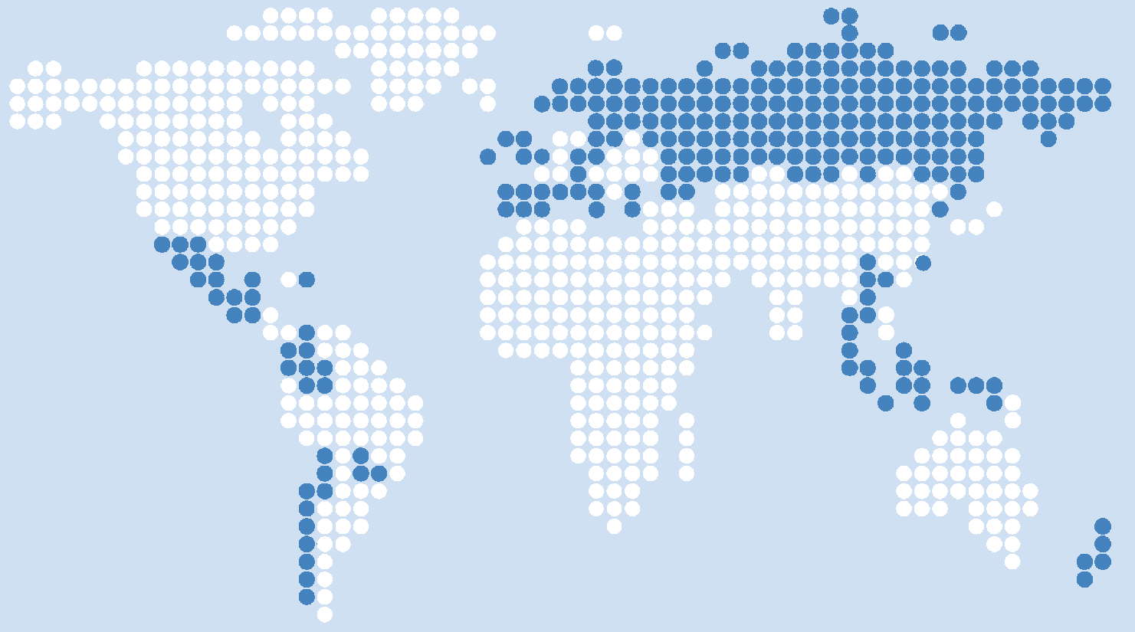

Austria
Belgium/Flemish
Bulgaria
Chile
Chinese Taipei
Colombia
Cyprus
Czech Republic
Denmark
Dominican Republic
England
Estonia
Finland
Greece
Guatemala
Hong Kong Sar
Indonesia
Ireland
Italy Republic Of Korea
Latvia
Liechtenstein
Lithuania
Luxembourg
Malta
Mexico
The Netherlands
New Zealand
Norway
Paraguay
Poland
Russian Federation
Slovak Republic
Slovenia
Spain
Sweden
Switzerland
Thailand

Source: Schulz, Ainley, Fraillon, Kerr and Losito (2010). Initial Findings from the IEA International Civic and Citizenship Education Study.

The IEA is an independent international consortium that conducts large-scale comparative studies of educational achievement.
New Zealand participated in the first IEA study of civic education, which was part of the IEA Six-Subject Survey in 1971. A further IEA Civic Education Study (CIVED) was undertaken in 1999 but New Zealand did not take part.
ICCS data collection took place before the implementation of the revised New Zealand curriculum for English-medium teaching and learning in February 2010. Te Mārautaunga o Aotearoa, the national curriculum for Māori-medium teaching and learning, will be implemented in 2011.
The test language was English only.
This report includes information about students’ backgrounds but does not report on students’ values, attitudes and behaviours. Future reports will focus on these areas as well as teachers’ and principals’ perspectives.
Two countries, Hong Kong SAR and the Netherlands were not included in international comparisons as they did not meet ICCS sampling participation guidelines.
Chile became an OECD member in 2010.
See Appendix 1 for a full description of each proficiency level.
Statistically significant at the 5 percent level (see Definitions section of the Appendix).
Programme for International Student Achievement (PISA) and Progress in International Reading Literacy Study (PIRLS).
Reporting of total response ethnic data is consistent with the Statistics New Zealand standard, but differs from the prioritised classification method used in many Ministry of Education Research Division publications.
International Labour Organisation, 1990.

