
National Standards:
School Sample Monitoring
and Evaluation Project, 2010-2012

Report to the Ministry of Education

Jenny Ward and Gill Thomas
NZ Maths Technology Ltd

ISBN: 978-0-478-40653-5
ISBN: 978-0-478-40654-2 (web)
RMR-1022

© Ministry of Education, New Zealand 2013
Research reports are available on the Ministry of Education’s website Education Counts:
www.educationcounts.govt.nz/publications.

Opinions expressed in this report are those of the authors and do not necessarily coincide with those of the Ministry of Education.

National Standards:
School Sample Monitoring and Evaluation Project, 2010-2012

Report to the Ministry of Education

Jenny Ward and Gill Thomas



Contents
1. Executive Summary 1
2. Methodology 4
2.1 Monitoring and evaluation questions 4
2.2 Sample 6
2.3 Methods and participants 6
3. Making OTJs 12
3.1 Evaluative criteria 12
3.2 Descriptive information 20
4. Moderating OTJs 22
4.1 Evaluative criteria 22
4.2 Descriptive information 28
5. The dependability of OTJs 30
5.1 Evidence from OTJ data 31
5.2 Evidence from the assessment scenarios 36
5.3 Descriptive information 53
6. Reporting to parents 54
6.1 Evaluative criteria 54
6.2 Descriptive information 62
7. Student achievement targets 65
7.1 Evaluative criteria 66
7.2 Descriptive information 71
8. Teacher professional development and levels of understanding among schools about the National Standards 72
8.1 Evaluative criteria 73
8.2 Descriptive information 78
9. Teaching interventions 80
9.1 Evaluative criteria 80
9.2 Descriptive information 86
10. National Standards achievement data 87
10.1 OTJs in reading, writing, and mathematics - 2010 to 2012 88
10.2 2012 OTJs in reading, writing, and mathematics 91
11. Other information 96
11.1 Legal requirements 96
11.2 Support provided 96
11.3 Boards’ and principals’ perspectives 99
Appendices 104
Appendix A: School documentation analysis criteria 104
Appendix B: Criteria for end-of-year report analysis 105
Appendix C: Inter-rater reliability information 106
Appendix D: Online surveys 107

List of tables
Table 1: Monitoring and evaluation questions and statements of intent 5
Table 2: School sample by school decile 6
Table 3: School sample by school type 6
Table 4: School sample by region 6
Table 5: Students for whom OTJs were provided, by year level and gender 8
Table 6: Students for whom OTJs were provided, by year level and ethnicity 8
Table 7: Students for whom OTJs were provided, by year level and school decile 9
Table 8: End-of-year reports 9
Table 9: Monitoring and evaluation question and criteria 12
Table 10: Proportions of teachers using their knowledge of the National Standards in the process of making OTJs,
2010-2012 16
Table 11: Timing of assessment evidence used to inform OTJs 19
Table 12: Proportions of teachers using current achievement evidence to inform OTJ, 2010-2012 19
Table 13: Estimates of average time taken to make one OTJ 20
Table 14: Teachers make OTJs efficiently, 2010-2012 20
Table 15: Number of information sources used by teachers to inform OTJs 20
Table 16: Monitoring and evaluation questions and criteria 22
Table 17: Percentages of teachers that report being involved in moderation discussions 22
Table 18: Proportion of schools using processes and systems to ensure OTJs are consistent, 2010-2012 23
Table 19: Proportion of teachers whose moderation decisions were informed by the National Standards, 2010-2012 25
Table 20: Processes used by schools to select OTJs for moderation 26
Table 21: Proportions of OTJs that were moderated 27
Table 22: Teachers’ estimates of the average time taken to moderate one OTJ 27
Table 23: Moderation processes are efficient and effective, 2010-2012 28
Table 24: Teacher groupings for moderation discussions 28
Table 25: Extent of student achievement information used by teachers to moderate OTJs 29
Table 26: Monitoring and evaluation questions and criterion 30
Table 27: Students’ 2012 reading OTJs disaggregated by their 2011 OTJs. 31
Table 28: Students’ 2012 writing OTJs disaggregated by their 2011 OTJs 31
Table 29: Students’ 2012 mathematics OTJs disaggregated by their 2011 OTJs 31
Table 30: Percentages and numbers of students who were rated in different achievement bands in 2011 and 2012 32
Table 31: Percentages and numbers of students who were rated in different achievement bands in 2010 and 2012 32
Table 32: 2012 reading OTJs with Year 7 and 8 results differentiated by school type 34
Table 33: 2012 writing OTJs with Year 7 and 8 results differentiated by school type 34
Table 34: 2012 mathematics OTJs with Year 7 and 8 results differentiated by school type 35
Table 35: Monitoring and evaluation question and criteria 54
Table 36: Use of National Standards in end-of-year reports 54
Table 37: Clarity of schools’ reports, 2011 and 2012 57
Table 38: Proportions of reports meeting performance criteria, 2010-2012 61
Table 39: Teachers’ perceptions of impact of National Standards reports on families and students 64
Table 40: Monitoring and evaluation question and criteria 65
Table 41: Focus of differentiated National Standards targets 68
Table 42: Proportions of 2012 National Standards targets rated as specific, measurable, challenging, and achievable 69
Table 43: Proportions of schools with National Standards targets meeting performance criteria, 2011 and 2012 70
Table 44: Proportions of National Standards targets meeting performance criteria, 2011 and 2012 70
Table 45: Monitoring and evaluation questions and criteria 72
Table 46: Principals’ and teachers’ understanding of the alignment of National Standards with the
New Zealand Curriculum, 2010 to 2012 76
Table 47: Proportions of schools and teachers meeting performance criteria, 2010-2012 77
Table 48: Monitoring and evaluation questions and criteria 80
Table 49: Proportions of schools meeting performance criterion in 2011 and 2012 81
Table 50: Proportions of teachers meeting performance criterion in 2011 and 2012 84
Table 51: Nature of targeted teaching interventions provided 84
Table 52: Teaching interventions identified by principals 85
Table 53: Monitoring and evaluation question and criteria 87
Table 54: 2010 to 2012 Reading OTJs 88
Table 55: 2010 to 2012 Writing OTJs 89
Table 56: 2010 to 2012 Mathematics OTJs 90
Table 57: Reading OTJs by year level 91
Table 58: Reading OTJs by gender 91
Table 59: Reading OTJs by ethnicity 91
Table 60: Reading OTJs by school decile 92
Table 61: Writing OTJs by year level 92
Table 62: Writing OTJs by gender 92
Table 63: Writing OTJs by ethnicity 93
Table 64: Writing OTJs by school decile 93
Table 65: Mathematics OTJs by year level 93
Table 66: Mathematics OTJs by gender 94
Table 67: Mathematics OTJs by ethnicity 94
Table 68: Mathematics OTJs by school decile 94
Table 69: Principals’ reporting of progress and achievement information to Boards of Trustees 96
Table 70: Principals’ perceptions of the level of support provided by the Ministry of Education 97

List of figures
Figure 1: Anticipated series of effects in schools as a result of the introduction of National Standards 4
Figure 2: Resources identified by teachers as used in the process of making reading OTJs 13
Figure 3: Resources identified by teachers as used in the process of making writing OTJs 14
Figure 4: Resources identified by teachers as used in the process of making mathematics OTJs 15
Figure 5: Teachers’ rating of importance of information from various sources in making reading OTJs 16
Figure 6: Teachers’ rating of importance of information from various sources in making writing OTJs 17
Figure 7: Teachers’ rating of importance of information from various sources in making mathematics OTJs 18
Figure 8: Resources identified by teachers as used in the process of moderating reading OTJs 23
Figure 9: Resources identified by teachers as used in the process of moderating writing OTJs 24
Figure 10: Resources identified by teachers as used in the process of moderating mathematics OTJs 24
Figure 11: Accuracy of teachers’ ratings for the After 2 Years sample rating scenarios in writing 37
Figure 12: Accuracy of teachers’ ratings for the End of Year 4 sample rating scenarios in writing 38
Figure 13: Accuracy of teachers’ ratings for the End of Year 6 sample rating scenarios in writing 38
Figure 14: Accuracy of teachers’ ratings for the End of Year 8 sample rating scenarios in writing 39
Figure 15: Work sample for 2011 scenario positioned ‘above’ the end of year 4 40
Figure 16: Work sample for 2012 scenario positioned ‘above’ the end of year 4 41
Figure 17: Work sample for 2011 scenario positioned ‘at’ the end of year 8 43
Figure 18: Work sample for 2012 scenario positioned ‘at’ the end of year 8 44
Figure 19: Accuracy of teachers’ ratings for the After 2 Years sample rating scenarios in mathematics 45
Figure 20: Accuracy of teachers’ ratings for the End of Year 4 sample rating scenarios in mathematics 46
Figure 21: Accuracy of teachers’ ratings for the End of Year 6 sample rating scenarios in mathematics 46
Figure 22: Accuracy of teachers’ ratings for the End of Year 8 sample rating scenarios in mathematics 47
Figure 23: 2011 scenario positioned ‘below’ the end of year 4 mathematics standard 48
Figure 24: 2012 scenario positioned ‘below’ the end of year 4 mathematics standard 49
Figure 25: Work sample for 2011 scenario positioned ‘below’ the end of year 8 mathematics standard 50
Figure 26: 2012 Scenario positioned ‘below’ the end of year 8 mathematics standard 51
Figure 27: Accuracy of teachers’ ratings for the making writing OTJ scenarios 52
Figure 28: Accuracy of teachers’ ratings for the making mathematics OTJ scenarios 52
Figure 29: Examples of information rated as sufficiently describing student achievement against the
National Standards. 55
Figure 30: Examples of information rated as insufficiently describing student achievement against the
National Standards. 56
Figure 31: Examples of progress reporting in relation to the National Standards. 56
Figure 32: Example of a school’s 2011 and 2012 reports. 57
Figure 33: The clarity of reports that did and did not contain sufficient National Standards achievement information. 58
Figure 34: Example of a report that was rated as containing clear information about student achievement in relation
to the National Standards 58
Figure 35: Example of a report that was rated as containing unclear information about student achievement in relation
to the National Standards 59
Figure 36: Example of a clear report that contained insufficient information about student achievement in relation to
the National Standards 59
Figure 37: Example of an unclear report that contained insufficient information about student achievement in relation
to the National Standards 59
Figure 38: Examples of information about student’s next learning steps in end-of-year reports 60
Figure 39: Examples of information about actions families can take to support student learning in end-of-year reports 61
Figure 40: Examples of reports that described achievement as ‘at’, ‘above’, ‘below’ or ‘well below’ the
National Standards 62
Figure 41: Examples of reports that described achievement using a best fit standard 63
Figure 42: Examples of OTJs presented in diagrams 63
Figure 43: Example of OTJ presented in text 64
Figure 44: Proportions of schools rated as including National Standards achievement targets in school charters, 2011 and 2012. 66
Figure 45: Changes in teachers’ professional knowledge and practice, 2010-2012 74
Figure 46: Teachers collection and use of students’ progress information 75
Figure 47: Principals’, teachers’, and Board of Trustees’ understanding of the purpose of National Standards 75
Figure 48: Principals’ perceptions of staff’s overall level of need for professional development 78
Figure 49: Principals’ perceptions of the extent of the need for professional development at their school 78
Figure 50: Principals’ collation of 2012 OTJs 81
Figure 51: Measures used to systematically track students’ progress in reading from 2011 to 2012 82
Figure 52: Measures used to systematically track students’ progress in writing from 2011 to 2012 83
Figure 53: Measures used to systematically track students’ progress in mathematics from 2011 to 2012 83
Figure 54: Principals’ levels of concern over the unintended consequences of National Standards, 2010 to 2012 99
Figure 55: Extent to which principals perceive low student achievement to be an issue in their own school. 100
Figure 56: Extent to which principals’ perceive low student achievement to be an issue in New Zealand 100

Executive Summary
The National Standards School Sample Monitoring and Evaluation Project describes and evaluates the implementation of National Standards in New Zealand schools. It started in 2010 when the standards were first introduced. This report describes information collected in 2012 and outlines trends observed over the three years of implementation to date.
In 2012 information was collected from a stratified sample of 96 English medium state sector schools with years 1 to 8 students, representative of the population of schools in terms of school type, school decile, and geographic location. Five types of data were collected at two time points. Copies of schools’ 2012 student achievement targets and 2011 analysis of variance reports were collected in the middle of the year. At the end of the year Overall Teacher Judgments (OTJs) in reading, writing, and mathematics were collected for all students, and copies of end-of-year reports to parents, families and whānau were obtained. Online surveys of principals, Boards of Trustees Chairpersons, and teachers were also conducted at the end of the year. The teacher survey contained assessment scenarios that collected information about teachers’ judgments in relation to the National Standards.

Overall Teacher Judgments
The OTJ, as a judgment of each student’s achievement in relation to the National Standards, is central to the implementation of the standards initiative overall. The information OTJs provide is reported to parents, families and whānau and to Boards of Trustees. It is also used by schools to tailor teaching programmes and target students for intervention. For these programmes and interventions to successfully raise student achievement, OTJs need to be dependable.
Evidence suggests that increasing proportions of schools made and moderated OTJs from 2010 to 2012, and that in general, the quality of schools’ processes for making and moderating OTJs improved in this time. The efficiency with which schools made OTJs increased (for example, 39% of teachers made writing OTJs efficiently in 2010 and this increased to 52% in 2012), as did the proportion of teachers that can be considered to be using current assessment evidence to inform OTJs (for example, 37% of teachers used current evidence to make reading OTJs in 2010 and this rose to 72% in 2012). The proportion of schools using formal processes to moderate OTJs also increased over the first three years of the standards implementation (for example, 56% of schools used formal processes to moderate reading OTJs in 2010 and this increased to 62% in 2012).
Three sources of information were examined to investigate the dependability of OTJs: the consistency of students’ OTJs over time, a comparison of the OTJs of Year 7 and 8 students in full primary and intermediate schools, and results from assessment scenarios that collected information about teachers’ judgments in relation to the National Standards. Considered together, this evidence suggests that OTJs lack dependability, which is problematic as students’ OTJs are the basis on which schools tailor teaching support with the ultimate aim of improving achievement. It does need to be noted that these concerns do not mean that all OTJs are inaccurate. While general trends can be identified in the data collected there is no way to ascertain the accuracy of any individual OTJ or to estimate the proportion of accurate OTJs. It is also likely that the inconsistency in teachers’ ratings is a result of the relatively broad nature of the National Standards scale and the current lack of tools available to support National Standards judgments.

Reporting to parents, families, and whānau
Clear reporting to parents, families and whānau is an important part of the National Standards initiative. The intention is that families are well informed about their children’s learning and, therefore, more able to support this in the home.
Findings indicate that schools increasingly reported National Standards information to parents, families, and whānau from 2010 to 2012. The proportion of end-of-year reports that refer directly to the National Standards increased over time (79% in 2010 and 91% in 2012), as did the proportion of reports that sufficiently describe student achievement in relation to the National Standards (60% in 2010 and 73% in 2012). Results suggest that the clarity of reports may be of concern, with less than half (43%) of National Standards reports rated as clear in 2012.

Student achievement targets
OTJs are reported to Boards of Trustees and used to inform annual student achievement targets, which guide decisions about the teaching support individual students receive.
Evidence from the project suggests that increasing proportions of schools included targets in their schools’ charters that addressed student achievement in relation to the National Standards (75% in 2011 and 93% in 2012). The targets were increasingly differentiated to accelerate progress for specific groups of students (57% of National Standards targets were differentiated in 2011 and an average of 64% of targets were differentiated across the three areas in 2012). The level of challenge inherent in schools’ targets may be a cause for concern however, with less than half of schools’ National Standards targets in reading (47%), writing (43%), and mathematics (48%) rated as challenging in 2012.

Schools use of National Standards data
It is intended that schools will use National Standards data to provide both tailored professional development support to teachers and targeted teaching interventions to students, with the ultimate aim of improving student achievement.
Results indicate that increasing proportions of schools collated National Standards achievement data (for example, 76% in mathematics in 2011, increasing to 93% in 2012) and used this to tailor professional development support for teachers (45% in 2010 and 54% in 2012). In turn, teachers indicated that the standards have had an impact on their professional knowledge and practice. In particular, increasing proportions of teachers reported becoming more systematic in their collection of evidence about students’ progress and achievement as a result of the National Standards (63% in 2012) while about half of the teachers surveyed noted they have a better understanding of what students need to be achieving at the level(s) they teach (57% in 2012).
Principals also reported increasingly using National Standards data to inform the provision of tailored teaching interventions for students (an average of 61% across the three areas in 2011 and 89% in 2012). Teaching support was provided in a variety of ways; approximately half of the principals reported that regular classroom teaching programmes were increasingly differentiated to meet students’ learning needs (43% in reading, 48% in writing, 54% in mathematics), with principals noting that support external to the classroom programme was provided both by qualified teachers (72% in reading, 57% in writing, 35% in mathematics) and teacher aides (33% in reading, 20% in writing and mathematics). The quality of these teaching interventions, or the extent to which they were matched with students’ learning needs was unable to be investigated.

National Standards achievement data, 2010 to 2012
There have been small increases in the proportions of students rated ‘at’ or ‘above’ the Reading, Writing and Mathematics Standards over the three years of implementation to date. For example, 72% of students were rated ‘at’ or ‘above’ the Reading Standards in 2010, and this increased to 74% in 2011, and 76% in 2012. Substantial increases in the proportions of students rated ‘at’ or ‘above’ were observed for some demographic sub-groups: Pasifika students and Year 7 students in reading, writing, and mathematics, and students at low decile schools in reading and mathematics. These increases must be interpreted with caution; they represent changes in teachers’ judgments of student achievement over time. Because other evidence raises concerns over the dependability of OTJs, this data cannot necessarily be taken as evidence that student achievement is improving over time.

Methodology
The National Standards School Sample Monitoring and Evaluation Project provides information about the implementation of National Standards and has been operating since 2010 when the standards were first introduced. This report describes information collected in 2012, and outlines trends that have been observed over the three years of implementation to date.

Monitoring and evaluation questions
The study has two purposes:
- To describe the implementation of National Standards within schools
- To monitor and systematically evaluate the effect of National Standards on students, teachers, schools, and parents, families, and whānau.
The descriptive component of the study is focused around twelve open-ended monitoring questions. The evaluative component is focused on the extent to which National Standards are operating as intended, and is based on six statements that describe the intended outcomes of National Standards. Each of these statements has related performance criteria.
Because the effects of National Standards in schools will develop over successive years of implementation, the focus of the study changes over time. Initially, changes in assessment practices were required by the alteration of National Administration Guideline 2A: teachers make overall teacher judgments (OTJs) in relation the National Standards. Following on from this, these judgments are reported to parents, families and whānau, and Boards of Trustees. Collated information can then be used to identify students for teaching intervention. Once these students are identified, teachers’ knowledge is developed as required, and teaching interventions are introduced. The final anticipated effect is a resultant improvement in student achievement. Figure 1 illustrates this series of effects and identifies the expanding focus of the project from 2010 to 2012.
Figure 1: Anticipated series of effects in schools as a result of the introduction of National Standards
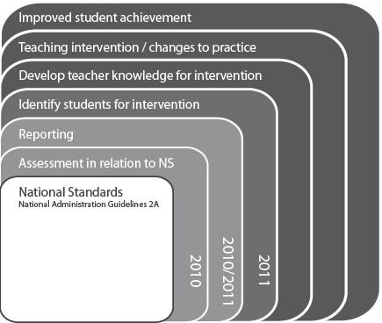
2012
2012
2012
Because the focus of the project has expanded each year, longitudinal information is now available for some effects. For example, information about OTJs has been collected from 2010 to 2012, while two years of information is available about the ways in which schools identify students for intervention.
Table 1 outlines the monitoring and evaluation questions, along with the associated statements of intent. This report is structured around these questions, and Table 1 also shows the chapter in which each of these questions is addressed. The relevant performance criteria are presented at the start of each chapter.
Table 1: Monitoring and evaluation questions and statements of intent
Statements of intent | Monitoring and evaluation questions | Report Chapter
Teachers make defensible, trustworthy judgments against the National Standards. | In what ways do teachers use information from a variety of student assessments to make overall judgments? | Chapter 3
 | What processes are used to moderate OTJs? | Chapter 4
 | How dependable and consistent are teachers’ overall judgments? | Chapter 5
Schools use National Standards assessment information to communicate clearly with parents, families, and whānau about their child’s achievement and progress. | How do schools use information from National Standards to report to and communicate with parents? | Chapter 6
National Standards provides clear information about student achievement for Boards of Trustees that can be used in decision-making and resource allocation processes. | To what extent are National Standards understood as a set of common expectations for student achievement? | Chapter 7
 | In what ways is information from National Standards used by schools to set achievement targets? | Chapter 7
National Standards information is used to identify teachers’ professional development needs. This enables these to be addressed more effectively. | In what ways is information from National Standards used to identify teachers’ professional development needs? | Chapter 8
 | What changes in teachers’ professional knowledge and practice are observed as National Standards are introduced? | Chapter 8
National Standards achievement information is used by teachers and schools to monitor student progress and achievement against the Curriculum. As a result of this, students requiring teaching interventions will be identified, and interventions will be provided. | In what ways is information from National Standards used by schools to describe student achievement and progress? | Chapter 9
 | In what ways is information from National Standards used to provide targeted teaching interventions? | Chapter 9
Student achievement will improve. | What changes in student achievement in reading, writing, and mathematics, as indicated by OTJs, are observed as National Standards are introduced? | Chapter 9

Sample
The project sample consists of 96 schools. A stratified sampling procedure was used to select these schools from the sampling frame, which included all English medium, full primary, contributing, and intermediate state schools. The sample is stratified according to three school characteristics, with three groups within each characteristic:
- School decile: one to three, four to seven, eight to ten.
- School type: full primary, contributing, and intermediate.
- Regions: Auckland, North Island excluding Auckland, and South Island.
Table 2, Table 3, and Table 4 show the demographic characteristics of the 96 schools in the sample, and compare these to national data. The national information was sourced from the Ministry of Education’s administrative data. Note that throughout the report some percentages do not sum to 100 due to rounding error.
Table 2: School sample by school decile
Decile | Sample | National
1 to 3 | 28% | 27%
4 to 7 | 40% | 41%
8 to 10 | 33% | 32%

Table 3: School sample by school type
Years | Sample | National
1 to 8 | 51% | 45%
1 to 6 | 32% | 34%
7 to 8 | 17% | 21%

Table 4: School sample by region
Region | Sample | National
Auckland | 21% | 23%
North Island (excluding Auckland) | 47% | 48%
South Island | 32% | 29%

As shown in Table 2 to Table 4 the sample can be considered representative of the national population of schools in terms of the three stratifying characteristics. The sample composition matches that of the national population within one percent by school decile, within six percent by school type, and within three percent by region. Note that the following subgroups are slightly over or under represented:
- low decile, year 7-8 schools, in the North Island excluding Auckland, under-represented by 2 schools,
- high decile, year 1-8 schools, in the South Island, over-represented by 2 schools.

Methods and participants
Five types of data were collected:
- School documentation, copies of student achievement targets and analysis of variance reports.
- OTJs, collected electronically.
- Copies of students’ end-of-year reports.
- Online surveys of teachers, principals, and Boards of Trustrees Chairpersons.
- Assessment scenarios, collected teachers’ judgments for samples of student work, administered as part of the online survey.
School documentation was collected mid-year. Principals received an email request on 16 July 2012 asking them to forward copies of their school’s 2011 analysis of variance report, and the section of their school’s 2012 charter that included school-wide targets for student achievement in relation to the National Standards. Principals that had not responded by the due date were sent reminder emails and contacted by phone.
All other data was collected at the end of the year. On 12 November 2012 all principals and Boards of Trustees Chairpersons were sent an email request. Board of Trustees Chairpersons were asked to complete an online survey at a web-link that was provided. Principals were asked to:
- Complete an online survey, accessible from a given web-link.
- Arrange for groups of teachers to complete an online survey at a given web-link, ideally at a staff meeting. Instructions specified the survey was to be completed by groups of teachers who work with similar year levels of students, and schools were asked to use their discretion to group teachers. It was suggested the most appropriate grouping would depend on the size of the school, i.e. syndicates or groups of teachers working together in larger schools, and whole staff groupings in smaller schools.
- Provide the OTJs in reading, writing, and mathematics for every student in their school.
- Provide copies of students’ end-of-year reports. Schools were asked to send a copy of the report for the student in each year level whose birthday was closest to 1 January.
It was initially requested that all data be provided by 30 November, and where OTJs would not be ready by this date schools were asked to provide an alternative date. Principals and Boards of Trustees Chairpersons were sent an email reminder five days before the initial closing date, with two email reminders following this on 3 and 13 December. Follow-up phone calls to those schools that had not provided OTJs, or an alternate date for OTJs, began on 4 December. On 13 December schools were advised that the data collection period had been extended to 18 January 2013 as response rates were lower than anticipated. Principals were sent one final email reminder shortly after schools opened for the 2013 school year.

School documentation
Ninety-two schools provided copies of their student achievement targets in relation to the National Standards and their 2011 analysis of variance report. Four researchers with expertise in the National Standards, literacy, numeracy and assessment carried out the analysis. Eight sets of documents were analysed collaboratively to establish consistency of coding, with the remainder of the documents coded independently by one of the researchers.
The performance criteria were developed in 2011 to address the statement of intent from the methodology and align with the Ministry of Education’s requirements and quality indicators for targets in relation to the National Standards. In particular, the School Sample criteria included five of the six SMACAT criteria (specific, measurable, achievable, challenging, and appropriate) used by the Ministry. In accordance with Ministry requirements the criteria also included a focus on the differentiation of targets to accelerate progress and achievement for specific groups of students, and the use of data from analysis of variance reports.
The criteria were revised in 2012 so they were consistent with advice from the Ministry to schools late 2011 and early 2012. Changes were minor but included the addition of new criterion focused on whether National Standards targets were set using baseline data. In addition, two criteria used in 2011 were further differentiated for the 2012 analysis. The 2011 criteria ‘National Standards targets are specific and measurable’ was split into two criteria in 2012: ‘National Standards targets are specific’ and ‘National Standards targets are measurable’. Similarly, the 2011 criteria ‘National Standards targets are challenging and achievable’ was split into two targets focusing on challenge and achievability. Targets from schools’ 2011 charters were re-analysed for these four aspects (specific, measurable, challenging, and achievable) to enable the comparison of 2011 and 2012 results. A copy of the 2012 criteria is included as Appendix A.

Overall teacher judgments (student data)
Seventy-one schools provided OTJs in reading, writing, and mathematics for all students in their school. In total there were 15,329 students for whom at least one OTJ was collected. Tables 5 to 7 provide the demographic data for these students, along with national data for comparison.
Table 5: Students for whom OTJs were provided, by year level and gender
Year level | Student gender
Year level | National (%) |  | Sample (%)
Year level | Male | Female | Male | Female
Year 1 | 6.6 | 6.3 | 4.9 | 4.8
Year 2 | 6.3 | 6.0 | 5.6 | 5.3
Year 3 | 6.1 | 5.8 | 5.6 | 5.4
Year 4 | 6.2 | 5.9 | 5.4 | 5.5
Year 5 | 6.1 | 5.8 | 5.4 | 4.7
Year 6 | 6.0 | 5.8 | 5.5 | 5.4
Year 7 | 7.4 | 6.9 | 8.6 | 9.6
Year 8 | 6.5 | 6.2 | 8.5 | 9.8
All years (%) | 51.2 | 48.8 | 49.6 | 50.4
All years (n) | 243,623 | 232,285 | 7,600 | 7,729

Table 6: Students for whom OTJs were provided, by year level and ethnicity
Year level | Student Ethnicity
Year level | National (%) |  |  |  |  | Sample (%)
Year level | NZE | Māori | Pasifika | Asian | Other | NZE | Māori | Pasifika | Asian | Other
Year 1 | 6.8 | 3.2 | 1.3 | 1.3 | 0.3 | 5.7 | 2 | 1.2 | 1 | 0.2
Year 2 | 6.5 | 3.1 | 1.3 | 1.2 | 0.3 | 6.4 | 2.4 | 1.1 | 1.2 | 0.2
Year 3 | 6.4 | 2.9 | 1.2 | 1.2 | 0.3 | 6.2 | 2.1 | 1.3 | 1.3 | 0.3
Year 4 | 6.5 | 2.9 | 1.2 | 1.2 | 0.3 | 6.4 | 2.1 | 1.1 | 1.4 | 0.2
Year 5 | 6.4 | 2.9 | 1.2 | 1.1 | 0.3 | 5.5 | 2 | 1.1 | 1.2 | 0.3
Year 6 | 6.5 | 2.8 | 1.2 | 1 | 0.3 | 6.2 | 1.9 | 1.1 | 1.3 | 0.3
Year 7 | 7.8 | 3.3 | 1.4 | 1.3 | 0.4 | 11 | 3.5 | 1.6 | 1 | 0.4
Year 8 | 6.9 | 2.9 | 1.3 | 1.2 | 0.4 | 11.3 | 3.3 | 1.6 | 1 | 0.3
All years (%) | 53.7 | 24.1 | 10.2 | 9.4 | 2.7 | 58.6 | 19.3 | 10.2 | 9.6 | 2.3
All years (n) | 255,735 | 114,467 | 48,382 | 44,643 | 12,681 | 10,096 | 3,326 | 1,763 | 1,650 | 398
Table 7: Students for whom OTJs were provided, by year level and school decile
Year level | School decile
Year level | National (%) |  |  | Sample (%)
Year level | Decile 1-3 | Decile 4-7 | Decile 8-10 | Decile 1-3 | Decile 4-7 | Decile 8-10
Year 1 | 3.5 | 4.5 | 5 | 3.3 | 2.6 | 3.8
Year 2 | 3.2 | 4.2 | 4.8 | 3.3 | 2.9 | 4.8
Year 3 | 3.1 | 4.1 | 4.7 | 3 | 3.1 | 4.9
Year 4 | 3.1 | 4.1 | 4.9 | 3 | 3 | 5
Year 5 | 3.1 | 4 | 4.8 | 3 | 2.8 | 4.2
Year 6 | 3.1 | 4 | 4.7 | 3 | 3.2 | 4.7
Year 7 | 3.1 | 5.7 | 5.5 | 2 | 13.1 | 3.1
Year 8 | 2.7 | 5.2 | 4.8 | 2 | 13.1 | 3.2
All years (%) | 25.1 | 35.8 | 39.1 | 22.5 | 43.9 | 33.7
All years (n) | 118,936 | 169,704 | 185,525 | 3447 | 6722 | 5160

Tables 5 to 7 show there are some minor differences between the demographic characteristics of the sample and the national population. For example, Year 7 and 8 students in medium decile schools are slightly over-represented, while Māori students are slightly under-represented. Although these differences are present the sample can be considered to be generally representative of the national population.

End-of-year student reports
65 schools provided copies of students’ end-of-year reports to parents. A total of 395 reports were received. Table 8 shows the year levels of the reports collected.
Table 8: End-of-year reports
Year Level | Number of reports | %
1 | 54 | 14%
2 | 51 | 13%
3 | 54 | 14%
4 | 50 | 13%
5 | 55 | 14%
6 | 53 | 13%
7 | 37 | 9%
8 | 41 | 10%
Total | 395 | 100%

As seen in Table 8 the sample of end-of-year reports has a reasonably even spread across year levels, although reports from Year 7 and 8 students are slightly under-represented.
The criteria for report analysis were the same as those used in 2011 and are included as Appendix B. Two raters coded the 395 reports. Because these two raters had worked together in 2010 and 2011 with a high inter-rater reliability, a small sample of 29 reports was coded independently to ensure the reliability remained high. The consistency between the two raters was 97% and indicates that confidence can be placed in the data coded. Once this consistency was re-established the raters worked independently on the remaining 366 reports.

Online surveys
Online surveys for principals, Board of Trustees Chairpersons, and teachers were developed and administered using Survey Monkey. Copies are included as Appendix D. Analysis involved data collation and the identification of common themes. Those themes identified by 5% or more of participants have been reported. Findings have been compared to results from previous years where possible, and trends are reported.
Sixty-eight principals and 68 Board of Trustees Chairpersons responded to the survey: response rates of 71%.
Forty-seven schools submitted group responses to the teacher survey, a total of 150 responses. While this response rate is lower than 2011 (when 69 schools responded), nearly all teachers from respondent schools contributed to a group response. In the 44 schools that supplied demographic information for the teachers involved in each response, 500 teachers participated, a response rate of 88% based on an estimated 565 teachers in those schools.

Assessment scenarios
The assessment scenarios collected teachers’ judgments in relation to the National Standards for samples of student work, and were administered as part of the online teacher survey. These are included as Appendix D. Each group of teachers completed two scenarios: mathematics and writing. Reading was not included due to the challenge of presenting a work product for reading tasks online.
For each scenario teachers chose a year level standard to focus on: after 2 years, end of year 4, end of year 6, or end of year 8. There were two parts to the scenario at each year level:
- Rating three work or assessment samples as ‘at’, ‘above’, ‘below’, or ‘well below’ the relevant standard. Each writing sample included a description of the writing task, the student’s response, and notes about the writing process used and the students’ level of independence. Each mathematics sample included the problem posed, the student’s response, and teacher’s notes on student’s use of mathematics vocabulary and level of independence as required. The samples were developed by experts to be clearly positioned ‘at’, ‘above’ or ‘below’ a particular standard, and were focused on an aspect of students’ abilities fundamental to the standards. Together the three samples at each year level provided coverage of the breadth of the standard. To ensure the content would be as familiar as possible to teachers, samples were based directly on information in the standards themselves or the National Standards illustrations.
- Making an OTJ on the basis of four pieces of previously rated assessment evidence. The OTJ scenarios provided teachers with a description of four pieces of assessment evidence, each of which already had a rating of ‘at’, ‘above’, or ‘below’ the relevant standard. Teachers were asked to combine the four rated samples to make an OTJ.
The first part of each scenario was designed to collect information about teachers’ ability to rate individual pieces of student work in relation to the National Standards. The second part focused on teachers’ ability to collate several pieces of assessment evidence that had already been rated against the standards to make an OTJ. In addition to these two types of judgements, each scenario also contained qualitative questions that focused on the level of agreement within the group and the basis on which judgments were made.
Teachers were instructed to use any resources they normally use to moderate OTJs as they completed the assessment scenarios. It was suggested that these resources might include National Standards documents and illustrations, the New Zealand Curriculum, relevant curriculum documents such as the Literacy Learning Progressions or the Number Framework, and school-developed documentation.
The extent to which teachers’ judgments were consistent with the positioning of the scenarios as ‘at’, ‘above’ or ‘below’ a particular standard was taken as a measure of the accuracy of teachers’ judgments and therefore the dependability of OTJs.
One hundred and forty-six groups of teachers responded to the mathematics scenarios and 139 group responses to the writing scenarios were received.

Making OTJs
Because the standards encompass the breadth of the New Zealand Curriculum, no single piece of assessment information is sufficient to make an OTJ. Teachers need to “draw on and apply the evidence gathered up to a particular point in time, in order to make an overall judgment about a student’s progress and achievement.” This is a complex process, and central to the National Standards initiative, as it is these assessment decisions that are communicated to parents and Boards of Trustees, and ultimately used as the basis on which schools and teachers identify students for additional teaching support.
This chapter uses evidence from online surveys of teachers and principals to describe and evaluate the way in which teachers make OTJs. Table 9 outlines the monitoring and evaluation question and performance criteria that are the focus of this chapter.
Table 9: Monitoring and evaluation question and criteria
Intended outcome: Teachers make defensible, trustworthy judgments against the National Standards.
Monitoring and  Evaluation Question | Performance criteria | Sources of evidence
In what ways do teachers use information from a variety of student assessments to make overall judgments? | Teachers use their knowledge of the National Standards in the process of making OTJs. | Surveys: teacher and principal
 | OTJs are informed by student achievement information that is relevant and current. | Surveys: teacher and principal
 | Teachers make OTJs efficiently. | Surveys: teacher and principal

Evaluative criteria

Teachers use their knowledge of the National Standards in the process of making OTJs
The online teacher survey asked teachers to identify the resources they used in the process of making OTJs.
Figure 2 shows the 2012 results for reading and is based on the responses of 85 groups of teachers.
Figure 2: Resources identified by teachers as used in the process of making reading OTJs
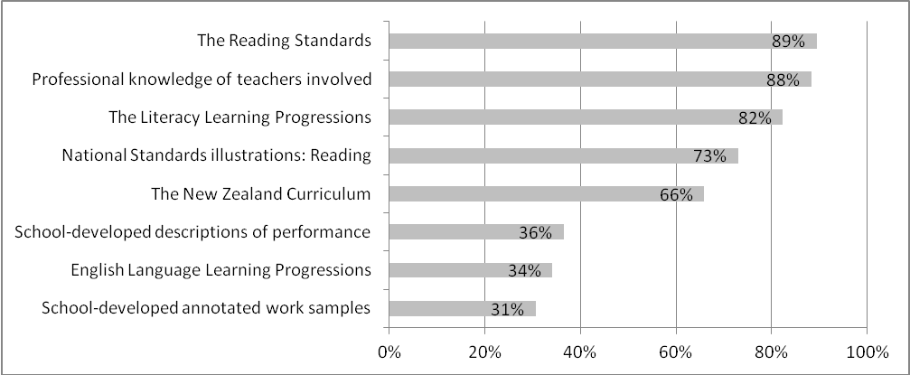
Results indicate that most teachers used the Reading Standards in the process of making reading OTJs, with 89% of teacher groups citing this as used. The National Standards Reading Illustrations were used by approximately three-quarters of teacher groups (73%) with 92% in indcating they had used either or both of these resources. Other resources used by the majority of teacher groups were the Literacy Learning Progressions (82%), and the New Zealand Curriculum (66%). Eighty-eight percent of teacher groups indicated they had used their own professional knowledge in the process of making reading OTJs.
The survey asked teachers to describe the process used to make reading OTJs and 85 groups of teachers did so. Twenty-eight percent of these descriptions involved gathering a range of evidence, with 8% describing some kind of evaluation of this evidence in relation to the National Standards.
Gather the information from a range of assessments and then you discuss the information, look at the criteria - standards - and you discuss with colleagues.
Gather data, recent running records, e-asTTle (if appropriate), teacher observations during lessons, pupils' response to text work. Look across all these aspects to make a judgment against our national standards. Compare results or decisions with a colleague if we are not sure of a decision.
Sixty-four percent of descriptions simply listed the sources of assessment information used to make OTJs.
Teacher observations in guided reading lessons. Probe testing. Reading responses to text. P.A.T. Reading. Arbs. Reading in other curriculum areas. Running records. Self assessments.
Instructional text levels, star, specific classroom observations, 7.5 testing, running records, students’ response to questions.
Figure 3 shows the resources identified by groups of teachers as used in the process of making writing OTJs, based on the responses of 20 groups of teachers.
Figure 3: Resources identified by teachers as used in the process of making writing OTJs
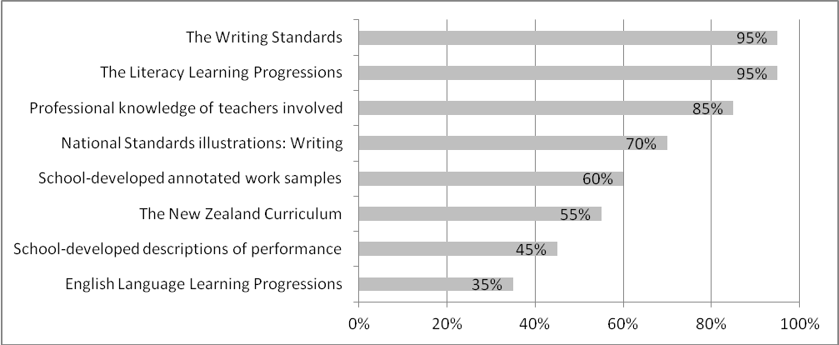
The majority of teacher groups indicated they had used the Writing Standards in the process of making writing OTJs (95%), with 70% indicating they had used the National Standards Writing Illustrations in this process. In total, 95% of teacher groups had used either or both of these National Standards resources. Other resources that were used by the majority of teacher groups include the Literacy Learning Progressions (95%), annotated work samples developed by the school (60%), and the New Zealand Curriculum (55%). Eighty five percent of teacher groups indicated they had used their professional knowledge in the process of making writing OTJs.
Twenty groups of teachers described the process they used to make writing OTJs. Seventy-five percent of these descriptions focused on the gathering together of assessment evidence, with 25% identifying some form of evaluation of this evidence in relation to the National Standards as part of this process.
Observe children, consider bookwork (e.g. do they edit their work? How does this improve it?), teacher conferences, compare to national standards, AsTTle writing.
The main resources are the asTTle rubrics, but I also use exemplars, Nat Standards and Literary Learning progressions. I collect samples of writing throughout the year and annotate them against rubrics I developed for each genre based on the above sources. As the year progresses I can look back on these to develop my OTJ.
Twenty-five pecent of teacher descriptions listed the information sources used to make OTJs instead of describing the process.
Child's writing sample, bookwork, group work, asTTle overall score
Observations, learning conversations, formal assessments, writing samples
Twenty-nine groups of teachers identified the resources they used in the process of making mathematics OTJs. Figure 4 summarises these results;
Figure 4: Resources identified by teachers as used in the process of making mathematics OTJs
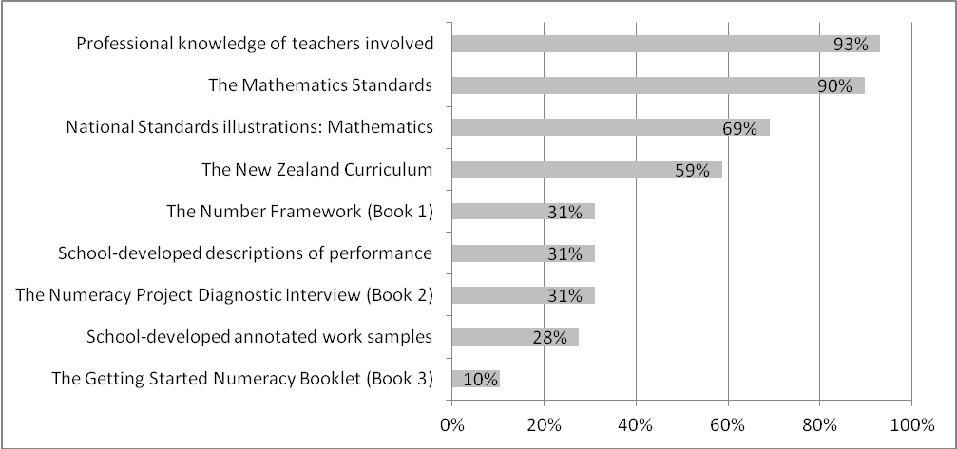
Ninety percent of respondents indicated that they had used the Mathematics Standards in the process of making mathematics OTJs, while 69% indicated they had used the National Standards Mathematics Illustrations in this process. Ninety percent of teacher groups had used either or both of these resources. Results suggest the resource most commonly used to make mathematics OTJs was teachers’ professional knowledge, with 93% of respondents noting this was used.
Twenty-nine groups of teachers described the process they used used to make mathematics OTJs. Thirty-eight percent of these descriptions referred to the gathering of assessment evidence, while 14% described the comparison of evidence collected with the National Standards as part of this process.
We get together all of our data, including observations, and then compare against the standards. We do PAT at the start of the year, so it becomes less important for our later OTJs.
I would check the Standard in the National Standard book - "by the end of" Then I would find information to be able to tell me if the child can, or can not, achieve what is in the standard. I use modelling books, children's workbooks, assessment data to make my OTJ. I also remember it is what the child can do INDEPENDENTLY and MOST OF THE TIME!
Sixty-two percent of the descriptions listed the assessment sources used to inform mathematics OTJs, rather than describing the process of making a mathematics OTJ.
Class obs. PAT, JAM Conversations, mini tests, basic facts.
Teacher observations, e-asTTle, Arbs, Pre and post testing, Mathletics, Students’ feedback
In summary, results suggest that the majority of teacher groups used either the National Standards documents, or the National Standards illustrations in the process of making reading (92%), writing (95%), and mathematics OTJs (90%) in 2012. Table 10 summarises the results for this criterion from 2010 to 2012. Note that there are no results for reading in 2011 as this information was not collected in order to minimise the time taken for teachers to participate.
Table 10: Proportions of teachers using their knowledge of the National Standards in the process of making OTJs, 2010-2012
Performance criterion | Year | Reading | Writing | Mathematics
Teachers use their knowledge of the National Standards in the process of making OTJs. | 2010 | 25% | 38% | 30%
 | 2011 | - | 82% | 86%
 | 2012 | 92% | 95% | 90%

Table 10 shows there has been an increase in the proportion of teachers that are using their knowledge of the National Standards in the process of making OTJs over the three years of implementation to date.

OTJs are informed by student achievement information that is relevant and current
The online survey asked teachers to rate the importance of information from a variety of sources in making OTJs. Groups of teachers rated information sources as minimal, moderate, or high importance for making OTJs, or as used to confirm or disconfirm OTJs. The use of the confirm/disconfirm category is consistent with the process used to make OTJs described in the online professional development modules that accompany the National Standards. These modules describe the process as first making an OTJ on the basis of strategically collected assessment evidence, and secondly comparing this OTJ to results from standardised assessments to confirm or disconfirm the judgment. Figure 5 shows these results for reading and is based on the responses of 85 groups of teachers.
Figure 5: Teachers’ rating of importance of information from various sources in making reading OTJs
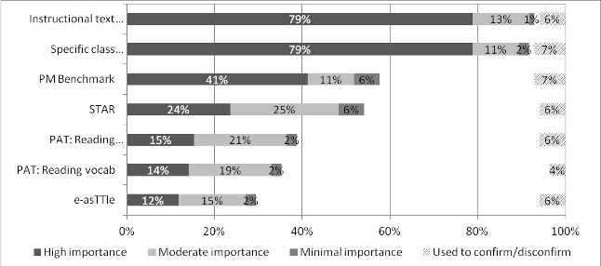
Instructional text levels
Specific class
observations
PM Benchmark
STAR
PAT: Reading
comprehension
PAT: Reading vocab
e-asTTle

Figure 5 indicates teachers regard instructional text levels and specific class observations as the most important sources of information for making reading OTJs. Ninety-two percent of teacher groups rated instructional text levels as of moderate or high importance for making OTJs, and 90% of teacher groups rated specific class observations as moderately or highly important in this regard. The standardised assessments of STAR, PAT, and e-asTTle were regarded as less important overall for making reading OTJs, with up to 50% of teacher groups rating these as of high or moderate importance. Results indicate this is because these assessments are only of relevance at some year levels, with higher proportions of Year 4 to 8 teachers rating all of these standardised assessment information sources as of moderate or high importance than Year 1 to 3 teachers. Teachers were also asked to identify any other sources of information used to make reading OTJs. Eight percent of teacher groups identified Probe as important for this purpose.
All of the sources identified by teachers as important for making OTJs were regarded as relevant to the Reading Standards by a small group of educators with expertise in literacy and the Reading Standards.
In general these results are very similar to those from both 2010 and 2011, although the importance teachers place on the PAT assessments appears to have increased over this period. In 2010 PAT reading comprehension and reading vocabulary tests were rated as moderately or highly important information sources by 20% and 14% of teachers groups respectively, and these figures rose to 36% and 33% in 2012. Figure 6 shows teachers’ ratings of the importance of information from a variety of sources for making writing OTJs and is based on the responses of 20 groups of teachers.
Figure 6: Teachers’ rating of importance of information from various sources in making writing OTJs
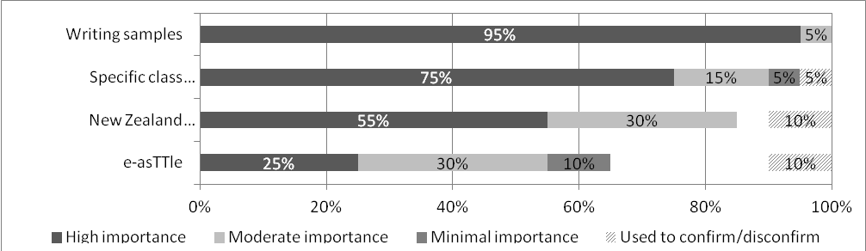
Writing samples
Specific class
observations
New Zealand Curriculum exemplars
e-asTTle

Results suggest that teachers regard writing samples and specific class observations as the most important sources of information for making writing OTJs. One hundred percent and 90% of teacher groups respectively rated these as moderately or highly important sources. Just over half of the teacher groups (55%) regarded the standardised e-asTTle assessment as moderately or highly important for making OTJs; as with reading this lower rating is because e-asTTle is not of relevance for students at all year levels. Higher proportions of Year 4 to 8 teachers rated e-asTTle as of moderate or high importance than Year 1 to 3 teachers.
A small group of experts were asked to rate relevance of information sources to the Writing Standards and agreed that the New Zealand Curriculum exemplars were of less relevance to the Writing Standards than the other assessments listed. Although they contain some features teachers might look for in students’ writing, the English Exemplars are generally students’ second drafts created with varying degrees of teacher support. They are also focused on the English Curriculum and therefore contain little information about the ways in which student use their writing in other areas of the curriculum.
As with reading, these results are very similar to those from 2010 and 2011. The one difference over time is the increasing importance teachers appear to be placing on standardised assessments. In 2010, 34% of teachers rated information from e-asTTle as moderately or highly important for making writing OTJs, and in 2012 this proportion had risen to 55%.
Figure 7 shows teachers’ ratings of the importance of information from a variety of sources in making OTJs in mathematics. The responses of 29 groups of teachers are included.
Figure 7: Teachers’ rating of importance of information from various sources in making mathematics OTJs
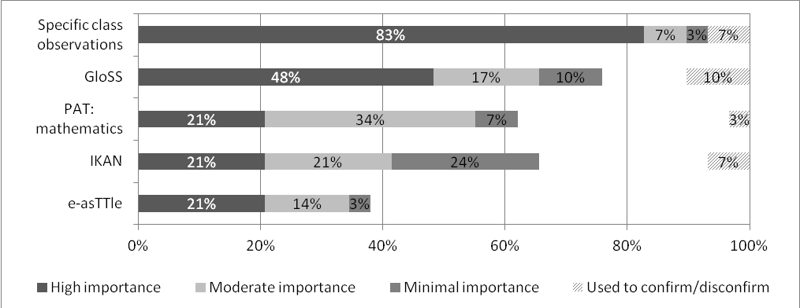
Figure 7 suggests that teachers regard specific class observations as the most important source of student achievement information for making mathematics OTJs. Ninety percent of respondents rated these as moderately or highly important for this purpose. In line with results from reading and writing, information from the standardised assessments (PAT: mathematics and e-asTTle) was regarded as the least important for making OTJs, with 55% and 35% of teacher groups respectively rating these as moderately or very important. These sources were rated more highly by teachers of Year 4 to 8 students than by teachers of Year 1 to 3 students, indicating this lower overall importance rating is attributable to the fact that these assessments are of relevance only at some year levels. Other sources of information that teachers identified as important for making OTJs were modelling books and the Junior Assessment of Mathematics, each identified by 6% of teacher groups.
In terms of the relevance of information from these sources to the standards, expert opinion was that IKAN can be considered to be of less relevance to the Mathematics Standards than the other sources listed. This is because it is focused on students’ knowledge in number while the standards focus on students’ ability to solve mathematical problems.
Two trends are apparent in comparison with results from previous years. The first of these, consistent with results from both reading and writing, is the increasing importance teachers appear to be placing on information from standardised assessments when making OTJs. From 2010 to 2012 the proportion of teachers that rated PAT: Mathematics as moderately or highly important for making OTJs rose from 39% to 55%, while for e-asTTle the comparative increase was from 18% to 35%. The second pattern is an increase in the proportion of teachers regarding information from GloSS as important for making OTJs, accompanied by a decrease in the proportion of teachers that regard IKAN as important in this regard. There was an 18% increase in the proportion of teachers that rated GloSS as moderately or highly important for making mathematics OTJs from 2010 to 2012, and a 10% decrease over this period in the proportion of teachers that rated IKAN in this way.
In summary, results indicate that teachers used assessment information from a range of sources to inform OTJs in 2012, and most of these can be regarded as relevant to the standards. Specific class observations were regarded as important in all three areas, with instructional text levels in reading, writing samples, and results from GloSS assessments in mathematics also being seen as highly important.
In order to evaluate the currency of assessment information used to make OTJs the online survey asked teachers to indicate the length of time from the most and least recent assessments used to inform OTJs. For the purposes of this evaluation, information collected within 12 weeks of the OTJ is considered current on the basis that it is information from the most recent term of the student’s schooling. Table 11 summarises these results.
Table 11: Timing of assessment evidence used to inform OTJs
Learning Area |  | Time from OTJ |  |  |  |  | Number of teachers groups
 |  | 0-2 weeks | 3-4 weeks | 5-12 weeks | 3-6 months | Longer than  6 months | Number of teachers groups
Most recent | Reading | 79% | 16% | 5% | 0% | 0% | 85
Most recent | Writing | 50% | 40% | 10% | 0% | 0% | 20
Most recent | Mathematics | 69% | 24% | 7% | 0% | 0% | 29
Least recent | Reading | 6% | 20% | 46% | 13% | 15% | 85
Least recent | Writing | 5% | 25% | 30% | 25% | 15% | 20
Least recent | Mathematics | 0% | 14% | 45% | 24% | 17% | 29

As shown in Table 11 the majority of teachers can be considered to be using current assessment information to make OTJs. More specifically, the proportions of teacher groups indicating that they used current information to make OTJs was 72% in reading, 60% in writing, and 59% in mathematics. Most teacher groups indicated they had used evidence from within the last four weeks to make OTJs (95% in reading, 90% in writing, and 93% in mathematics). In terms of least recent information used, small proportions of teacher groups indicated they were using evidence collected more than six months from the time of the OTJ (15% in reading and writing, and 17% in mathematics).
Table 12 summarises the results for this criterion for the three years of implementation to date.
Table 12: Proportions of teachers using current achievement evidence to inform OTJ, 2010-2012
Performance criterion | Year | Reading | Writing | Mathematics
OTJs are informed by student achievement information that is relevant and current. | 2010 | 37% | 47% | 37%
 | 2011 | 68% | 61% | 49%
 | 2012 | 72% | 60% | 59%

There has been an increase in the proportion of teachers that can be considered to be using current assessment evidence to inform OTJs. It appears there was a substantial improvement from 2010 to 2011 in relation to this criterion for reading and writing, and that improvements were somewhat smaller between 2011 and 2012 in these areas. In terms of the relevance of student achievement information used to make OTJs, results suggest teachers have placed an increasing importance on information from standardised assessments over the three years of implementation.

Teachers make OTJs efficiently
Survey results suggest that most teachers make OTJs for the students in their class. Respondents reported making an average of 25 reading OTJs, 27 writing OTJs, and 26 mathematics OTJs.
It is difficult to determine the efficiency of the process used to make OTJs as the total time taken depends on the number of OTJs made, the time taken to make one OTJ, and whether OTJs are assigned to individual students, or groups of students. For the purposes of this evaluation an average time of ten minutes or less per OTJ is considered as efficient, as this would require approximately 4 hours per subject area to make OTJs for 25 students, a total of twelve hours over the three areas. Table 13 summarises teachers’ estimates of the time taken to make one OTJ.
Table 13: Estimates of average time taken to make one OTJ
Average time in minutes | Percentage of teacher groups
Average time in minutes | Reading | Writing | Mathematics
5 or less | 18% | 26% | 19%
6 to 10 | 26% | 26% | 41%
11 to 15 | 18% | 11% | 15%
16 to 20 | 9% | 21% | 4%
21 to 30 | 19% | 5% | 7%
31 to 60 | 4% | 5% | 11%
More then 60 | 5% | 5% | 4%
Number of teacher groups | 85 | 20 | 29
As seen in Table 13, 44% of teacher groups can be considered to be making reading OTJs efficiently, 52% to be making writing OTJs efficiently, and 60% to be making mathematics OTJs efficiently. There was reasonable variation in the average amount of time spent to make an OTJ with approximately 5% of teacher groups reporting taking longer than an average of one hour per OTJ in all three areas.
Table 14 shows the proportions of teachers meeting this criterion from 2010 to 2012.
Table 14: Teachers make OTJs efficiently, 2010-2012
Performance criterion | Year | Reading | Writing | Mathematics
Teachers make OTJs efficiently | 2010 | 44% | 39% | 53%
Teachers make OTJs efficiently | 2011 | 39% | 33% | 59%
Teachers make OTJs efficiently | 2012 | 44% | 52% | 60%

There have been small increases in the proportions of teachers that can be considered to be making writing and mathematics OTJs efficiently from 2010 to 2012. Results suggest that teachers may be taking longer to make reading OTJs than they do to make mathematics OTJs with less than half of the respondents making reading OTJs efficiently in all three years.

Descriptive information
The online survey asked respondents to indicate the average number of pieces of assessment evidence used to inform reading, writing, and mathematics OTJs. Table 15 summarises these results.
Table 15: Number of information sources used by teachers to inform OTJs
Learning Area | Percentage of teacher groups |  |  |  |  |  | No. of teacher groups
Learning Area | 1-2  sources | 3-4  sources | 5-6  sources | 7-8  sources | 9-10  sources | >10  sources | No. of teacher groups
Reading | 9% | 47% | 32% | 4% | 2% | 6% | 85
Writing | 10% | 50% | 20% | 20% | 0% | 0% | 20
Mathematics | 3% | 40% | 28% | 17% | 0% | 10% | 29
Most of the teacher groups reported using between three and six pieces of assessment information to make an OTJ (79% of teacher groups in reading, 70% in writing, and 68% in mathematics).
In comparison with results from previous years, smaller proportions of teachers appear to be using large numbers of evidence sources to inform reading and writing OTJs. For example, 27% of teacher groups reported using nine or more pieces of assessment evidence to make a writing OTJ in 2011, and in 2012 this had dropped to 0%. In reading, 16% of teacher groups reported using nine or more pieces of evidence to make an OTJ in 2011, and this proportion had fallen to 8% in 2012. Results in mathematics were different with the proportion of teacher groups indicating they had used nine or more pieces of evidence rising from 7% in 2011 to 10% in 2012.
In terms of the volume of assessment evidence collected, teachers’ survey responses indicate that nearly half believe they collect more evidence of student achievement as a result of National Standards. Forty-four percent of groups surveyed agreed with the statement “We have had to collect more evidence of student progress and achievement [as a result of National Standards]” while 35% disagreed with this statement and 22% were neutral. Principal perceptions seem to support these results with 48% of principals agreeing that teachers at their school have had to collect more evidence of student progress and achievement as a result of the standards, while 21% disagreed and 30% thought their staff was already strong in this area (based on 55 principal responses).
Nearly half of the teacher groups surveyed indicated that they considered students’ previous reading and mathematics OTJs when making end of year OTJs (44% indicated this was the case in reading, and 41% in mathematics). Seventy-five percent of teacher groups noted that they considered students’ previous position when making writing OTJs. Comments indicated that previous results were checked for a variety of purposes. The most commonly cited reason being to check that students were progressing (10% of teacher groups indicated this was the case in reading, 45% in writing, and 13% in mathematics). Previous OTJs were also used as a measure of the consistency of judgments (10% of teacher groups in writing and 6% in mathematics), and used to evaluate teaching effectiveness and inform future directions (10% of teacher groups noted this was the case in writing).
We looked at the previous OTJ from mid-year parent conference and reflected on the progress made from these.
If they [OTJs] are inconsistent then questions need to be asked over whether one teacher has been too harsh/soft.
Looking for improvement or why improvement hasn't happened. What has been put in place?
For professional evaluation of progress and to identify if there is a student / teaching weakness I need to address.
Teachers were invited to comment on making OTJs and 23 groups chose to do so. There were no common themes in these comments, although there was a decline in the number of teachers making generally negative comments about the standards. In 2010 and 2011 approximately one-third of respondents made negative comments about the standards in general (29% and 31% respectively), and this proportion had fallen to 4% in 2012.

Moderating OTJs
Moderation processes are aimed at improving the consistency of OTJs to ensure that assessment decisions are comparable when made by different teachers, and at different times. Clearly, moderation processes have a vital role to play in ensuring the quality of National Standards data. In order to moderate OTJs teachers participate in “professional discussions amongst staff within a school and, where appropriate, across a cluster of schools. Teachers can justify their OTJ in terms of the dependability of the evidence and the process used to determine the OTJ.”
This chapter uses evidence from online surveys of principals and teachers to describe and evaluate the way OTJs were moderated in 2012. Findings are also compared to those from previous years. Table 16 provides the monitoring and evaluation question and performance criteria that are used in this chapter.
Table 16: Monitoring and evaluation questions and criteria
Intended outcome: Teachers make defensible, trustworthy judgments against the National Standards.
Monitoring and  Evaluation Questions | Performance criteria | Sources of evidence
What processes are used to moderate OTJs? | Schools use processes and systems to ensure OTJs are consistent. | Surveys: principal and teacher
What processes are used to moderate OTJs? | Moderation decisions are informed by the National Standards in reading, writing, and mathematics. | Surveys: principal and teacher
What processes are used to moderate OTJs? | Moderation processes are efficient and effective. | Surveys: principal and teacher

Evaluative criteria

Schools use processes and systems to ensure OTJs are consistent
Teachers were asked to identify the nature of the moderation processes they had been involved in. Table 17 summarises these results.
Table 17: Percentages of teachers that report being involved in moderation discussions
Learning Area | Systematic processes and informal discussions | Systematic processes only | Informal discussions only | No moderation | No. of teacher groups
Reading | 51% | 11% | 36% | 2% | 85
Writing | 85% | 0% | 10% | 5% | 20
Mathematics | 48% | 3% | 41% | 7% | 29
Results suggest moderation was more common in writing than in reading or mathematics. Eighty-five percent of teacher groups indicated they had been involved in systematic moderation of writing OTJs, while 62% and 51% indicated this was the case in reading and mathematics respectively. Table 18 compares these results with those from previous years.
Table 18: Proportion of schools using processes and systems to ensure OTJs are consistent, 2010-2012
Performance criteria | Year | Reading | Writing | Mathematics
Schools use processes and systems to ensure OTJs are consistent | 2010 | 56% | 80% | 46%
 | 2011 | 67% | 83% | 90%
 | 2012 | 62% | 85% | 51%

Results suggest that formal moderation processes were more common in writing than in other areas, with more than 80% of teacher groups indicating they were involved in moderating writing OTJs in all three years. In general, there was an increase in the proportions of teacher groups reporting they were involved in the systematic moderation of reading and mathematics OTJs from 2010 to 2011, (an increase of 11% in reading and 44% in mathematics), but no similar increases were observed from 2011 to 2012. Similar proportions of teachers moderated OTJs in 2011 and 2012, with the exception of mathematics where 90% of teacher groups indicated they moderated mathematics OTJs in 2011, and this proportion fell to 51% in 2012. While reasons for the apparent decline in reading and mathematics moderation from 2011 to 2012 are not known, it may be due to teachers becoming more confident in their ability to interpret the standards consistently in these areas.

Moderation decisions are informed by the National Standards in reading, writing, and mathematics
The online survey asked teachers to indicate the resources they had used in the process of moderating OTJs. Figure 8 shows these results for reading and is based on the responses of 85 groups of teachers.
Figure 8: Resources identified by teachers as used in the process of moderating reading OTJs
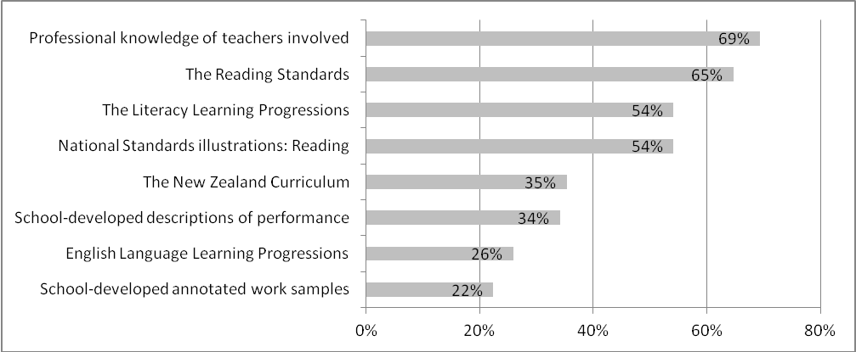
Sixty-five percent of teacher groups indicated that they had used the Reading Standards as a resource when moderating OTJs. A slightly smaller proportion (54%) noted that they had used the National Standards Reading Illustrations in this process, with 69% in total using either or both of these resources. Other resources used by the majority of teachers were the professional knowledge of the teachers involved (noted by 69% of teacher groups), and the Literacy Learning Progressions (54% of teacher groups).
Figure 9 shows the resources teachers noted using in the process of moderating writing OTJs. Responses from 20 groups of teachers are summarised.
Figure 9: Resources identified by teachers as used in the process of moderating writing OTJs
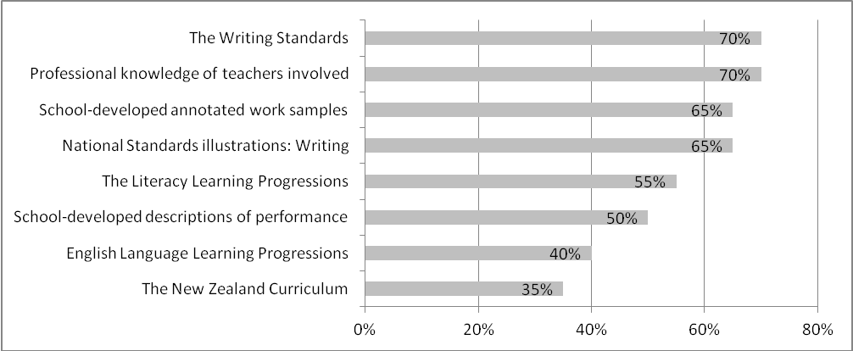
As seen in Figure 9, 70% of teacher groups noted that they had used the Writing Standards to moderate writing OTJs in 2012. A smaller proportion (65%) had used the National Standards Writing Illustrations, with 80% noting they had used at least one of these resources. Most teachers had also used their professional knowledge (70%), and the Literacy Learning Progressions (55%) in this process. The use of school-developed resources was also common in writing, with 65% of teacher groups noting they had used school-developed annotated work samples and 50% indicating they had used school-developed descriptions of performance to moderate writing OTJs.
Figure 10 shows the results for mathematics and is based on the responses of 29 groups of teachers.
Figure 10: Resources identified by teachers as used in the process of moderating mathematics OTJs
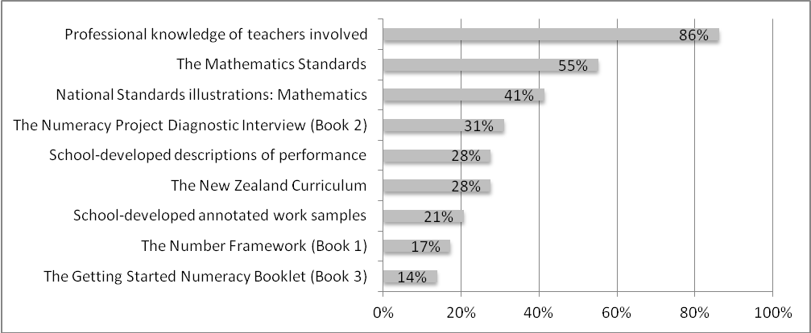
Just over half of the respondents indicated they had used the Mathematics Standards in the process of moderating mathematics OTJs (55%), while just under half indicated they had used the National Standards Mathematics Illustrations in this process (41%). In total, 55% of teacher groups had used either the standards or the illustrations to inform mathematics OTJs. The professional knowledge of teachers involved was the resource most frequently cited as used, with 86% of teacher groups noting this was the case. Up to one-third of teacher groups used Numeracy Project resources such as the Diagnostic Interview (used by 31% of teacher groups), The Number Framework (17% of teacher groups), and the Getting Started Numeracy Booklet (14% of teacher groups) to moderate mathematics OTJs.
The online survey asked teachers to describe the process used to moderate reading, writing, and mathematics OTJs at their school. Eighty-five descriptions were collected in reading, 20 in writing, and 29 in mathematics. Small proportions of these descriptions mentioned the National Standards explicitly. Ten percent of the descriptions in writing and mathematics mentioned the National Standards, while four percent of reading descriptions mentioned these explicitly.
Teacher discussion regarding National standards expectations in relation to specific student work.
Professional teacher discussions, moderation of work samples, review, compare judgements with the National Standards and the Mathematics Curriculum.
Consistent with results from previous years, teachers’ descriptions of the process of moderating OTJs focused on the structure of school-wide discussions. Fifty-one percent of reading descriptions, 65% of writing descriptions, and 34% of mathematics descriptions were of this nature. Small proportions of descriptions also simply listed the sources of assessment evidence used (15% of reading descriptions, 5% of writing descriptions, and 10% of mathematics descriptions).
Make individual judgements first, then meet as year group to discuss and then a staff meeting to compare and contrast year group findings.
Consultation with each other across team and with Year level Teams on either side.
Running records, Probe, teacher observation, collegial discussions.
Approximately one-third of the descriptions of moderating OTJs collected in 2012 explained moderation as an evaluation discussion among teachers, informed by assessment evidence. Twenty-four percent of reading descriptions, 35% of writing descriptions and 31% of mathematics descriptions were of this nature. This is an increase from previous years’ results when 10% to 12% of teacher descriptions were focused on discussion informed by student assessment information.
Each teacher in our team brings data and we have a look and check against the standards. We all have a say in what we think and discuss reasons based on the standards and evidence. This gives us a clearer idea of how each of us makes OTJs and how our assessing can be more aligned and in sync.
Share sample of work and results from testing, discuss, cross group work samples, discussion, coming to an agreed level.
Each teacher had to bring the evidence for a child at a similar level...use our indicators, and justify how they reached the OTJ.
Table 19 shows the proportions of teachers that can be considered to be achieving this criterion in 2010 and 2012. Results were not collected in 2011.
Table 19: Proportion of teachers whose moderation decisions were informed by the National Standards, 2010-2012
Performance criterion | Year | Reading | Writing | Mathematics
Moderation decisions are informed by the National Standards in reading, writing, and mathematics | 2010 | 96% | 98% | 85%
 | 2012 | 69% | 80% | 55%

As shown in Table 19 the proportion of teachers that used the National Standards to inform moderation discussions in reading, writing and mathematics decreased from 2010 to 2012. Reasons for this are unknown but may be related to increased teacher confidence in moderating OTJs.
Results suggest that, in general, teachers used fewer resources to inform moderation decisions in reading, writing, and mathematics as the implementation progressed. Proportions of teacher groups that reported using the resources listed were smaller in 2012 than 2010, in nearly all instances. For example, 80% of teachers indicated they used the New Zealand Curriculum to moderate reading OTJs in 2010, and this proportion fell to 35% in 2012. Similarly, 92% of teachers noted using the Literacy Learning Progression to moderate writing OTJs in 2010, while 35% of teacher groups noted their use in 2012.
While teachers’ use of moderation resources appears to have declined from 2010 to 2012, their understanding of the moderation process seems to have increased. This is suggested by the increase in the proportions of teachers that describe the process of moderation as an evaluation discussion informed by evidence of student achievement. Up to 35% of 2012 respondents described moderation in this way (24% of teacher groups in reading, 35% in writing, and 31% in mathematics), while in 2011 no more than 12% did so (11% of teacher groups in reading, 10% in writing, and 12% in mathematics).

Moderation processes are efficient and effective
Principals were asked to describe the way in which OTJs were selected for moderation in reading, writing and mathematics. Some of these methods can be considered more effective than others. For the purposes of this evaluation, focusing moderation discussion on the OTJs near the boundaries between the levels of the standards is considered effective as it focuses teachers’ attention on the OTJs that are likely to involve the most difficult decisions. Table 20 contains these results and is based on the responses of 65 principals. Note that responses in each area sum to more than 100, as some schools use more than one criterion to select OTJs for moderation.
Table 20: Processes used by schools to select OTJs for moderation
Selection criteria | Reading | Writing | Mathematics
OTJs near the boundaries between the levels of the standards | 41% | 37% | 48%
The OTJs with inconsistent assessment evidence | 22% | 14% | 22%
A random selection of OTJs | 28% | 37% | 24%
All OTJs | 14% | 24% | 17%
Other | 7% | 3% | 4%

As shown in Table 20, nearly half of the principals noted that they used the effective method of selecting the OTJs near the boundaries between the levels of the standards for moderation. Forty-one percent of principals selected reading OTJs this way, while writing and mathematics OTJs were selected in this manner by 37% and 48% respectively. In general, higher proportions of schools were found to have used this effective method in 2012 than in 2011.
If teachers moderate those judgments that are near the boundaries between the levels of the standards, it is reasonable to expect that a minimum of six judgments per class will be moderated. That is, a teacher could be expected to moderate two students to differentiate between students at each boundary (‘above’ and ‘at’, ‘at’ and ‘below’, and ‘below’ and ‘well below’). Assuming class sizes that vary from 15 to 30 students, these six OTJs represent 20-39% of the OTJs, so moderating 20-39% can be considered efficient on this basis. Principals were asked to indicate the proportions of OTJs that were moderated. Sixty-five principals responded and these results are summarised in Table 21.
Table 21: Proportions of OTJs that were moderated
Percentages of OTJs moderated | Percentages of schools
Percentages of OTJs moderated | Reading | Writing | Mathematics
0 | 17% | 8% | 17%
1 to 19 | 25% | 25% | 29%
20 to 39 | 31% | 28% | 26%
40 to 99 | 17% | 22% | 17%
100 | 11% | 18% | 11%

Results suggest a quarter to one-third to of schools moderated a proportion of OTJs that can be considered efficient (31% in reading, 28% in writing, and 26% in mathematics). Moderating a higher proportion than considered efficient was more common in writing, where 40% of schools moderated 40% or more of reading OTJs, and 18% moderated all OTJs. In comparison, 18% of schools moderated 40% or more of their OTJs in reading and mathematics, with 11% moderating all OTJs in these areas. These findings are very similar to those from 2011.
Groups of teachers were asked to estimate the average number of minutes to moderate one OTJ. Table 22 summarises these results. For the purposes of this evaluation up to ten minutes per OTJ is considered efficient as this represents one hour per area (assuming teachers moderate for the six students who are at the boundaries between the levels of the standards for their class), so three hours to moderate reading, writing and mathematics for each class.
Table 22: Teachers’ estimates of the average time taken to moderate one OTJ
Average time in minutes | Percentage of teacher groups
Average time in minutes | Reading | Writing | Mathematics
2 to 5 | 11% | 6% | 28%
6 to 10 | 33% | 31% | 28%
11 to 15 | 22% | 6% | 16%
16 to 20 | 11% | 31% | 4%
21 to 30 | 16% | 13% | 8%
31 to 60 | 3% | 6% | 16%
More then 60 | 4% | 6% | 0%
Number of teacher groups | 79 | 16 | 25

Responses indicate that approximately half of the teachers that moderated reading (44%), writing (37%), and mathematics OTJs (58%) can be considered to be moderating efficiently. These results are very similar to those from 2011 with the exception of writing. In 2011, 13% of teacher groups indicated they spent an average of up to ten minutes moderating writing OTJs, and this increased to 37% in 2012. Approximately one-quarter of teacher groups surveyed indicated they spent longer than an average of 20 minutes moderating reading (23% of teacher groups), writing (25% of teacher groups), and mathematics OTJs (24% of teacher groups).
Table 23 compares 2012 results for these criteria with findings from previous years.
Table 23: Moderation processes are efficient and effective, 2010-2012
Performance criteria | Year | Reading | Writing | Mathematics
Moderation processes are efficient | 2010 | 44% | 39% | 53%
Moderation processes are efficient | 2011 | 49% | 13% | 58%
Moderation processes are efficient | 2012 | 44% | 37% | 56%
Moderation processes are effective | 2010 | 28% | 27% | 33%
Moderation processes are effective | 2011 | 36% | 35% | 30%
Moderation processes are effective | 2012 | 41% | 37% | 48%

In general, the proportion of schools using an effective method to select OTJs for moderation has increased between 2010 and 2012. For example, 28% of schools used an effective method to select reading OTJs for moderation in 2010, and this increased to 41% in 2012. In terms of efficiency there has been no real change over the three years of implementation, with similar proportions of teachers moderating efficiently in 2010 and 2012 in all three areas.

Descriptive information
The online survey asked principals to identify the ways in which teachers were grouped for moderation discussions at their school. Table 24 summarises the responses of 65 principals. Note that some schools grouped teachers in more than one way so columns sum to more than 100%.
Table 24: Teacher groupings for moderation discussions
Grouping | Reading | Writing | Mathematics
All teachers in the school | 34% | 59% | 41%
Small groups of teachers | 64% | 59% | 57%
Other | 5% | 2% | 8%
Approximately two-thirds of the teacher groups surveyed in 2012 indicated that they moderated OTJs in small groups (64% for reading OTJs, 59% for writing OTJs, and 57% for mathematics OTJs). Whole school moderation discussions were used less than small group approaches, with whole school moderation more common in writing (59% of teacher groups) than in reading or mathematics (34% and 41% of teacher groups respectively). Other approaches to moderation noted by teachers included working with other schools, moderation by management staff, or the involvement of professional development facilitators in moderation processes. These findings are all very consistent with 2011 results.
Also consistent with results from 2011, larger schools tended to conduct moderation discussions in small groups. For example, in reading, 75% of schools with more than 150 students conducted small-group moderation discussions, while 35% of schools with less than 150 students on the roll did so.
In their online survey responses teachers indicated the average number of pieces of assessment evidence used for each student in moderation discussions. Table 25 shows these results.
Table 25: Extent of student achievement information used by teachers to moderate OTJs
Number of information sources | Reading | Writing | Mathematics
1 to 2 | 22% | 10% | 3%
3 to 4 | 57% | 50% | 41%
5 to 6 | 13% | 20% | 28%
7 to 8 | 4% | 20% | 17%
9 to 10 | 1% | 0% | 0%
>10 | 1% | 0% | 10%
Number of teacher groups | 85 | 20 | 29
Similar to previous results, nearly all teachers reported using up to six pieces of assessment evidence to moderate OTJs. Ninety-two percent of teacher groups used up to six sources in reading, while in writing and mathematics these proportions were 80% and 72% respectively. Small proportions of teachers appear to be using a large number of evidence sources. For example 2% of teacher groups noted they used nine or more information sources to moderate reading OTJs, while 10% of teacher groups indicated using this number of sources in mathematics.
Thirty-two percent of principals indicated their school had worked with another school to moderate OTJs in at least one of the National Standards areas in 2012. Results suggest that writing OTJs were more commonly the focus of these between school discussions than reading or mathematics OTJs. Thirty percent of principals noted that their staff had worked with another school to moderate writing OTJs, while 7% and 8% respectively noted that this was the case in reading and mathematics. These results are very similar to those from 2011.
Principals were invited to comment on the moderation of OTJs in the online survey and 16 principals chose to do so. There were two common themes in these comments. Ten percent of principals indicated that moderation processes were still being improved in their school, and 5% of principals noted that they were trying to establish some form of between school moderation.
It is an ongoing process and we are continually improving teacher capability. It is a focus in 2013. A goal in the future is to moderate across our cluster of schools.
Teachers tend to mark hard and we will be looking at moderating writing in more detail in 2013.
A decrease in the number of negative comments from principals about the standards in general was observed from 2011 to 2012. Seventeen percent of principals commented negatively about the standards in 2011, and this proportion fell to 3% in 2012.

The dependability of OTJs
The OTJ is central to the National Standards initiative. It is OTJs that are reported to parents and Boards of Trustees, and it is on the basis of OTJs that teaching programmes are tailored, and students identified to receive additional teaching support. For these teaching programmes and interventions to successfully raise student achievement it is vital that OTJs provide a dependable assessment of students’ achievement in relation to the National Standards.
A dependable assessment is defined as one that has both high validity and high reliability. Validity concerns whether assessment results can be used for its intended purpose; the extent to which the assessment measures what it is intended to measure. Reliability concerns the consistency of an assessment; the “extent to which the results from the same assessment can be repeated across time and situations.”
This chapter examines three pieces of evidence to investigate the dependability of OTJs. These three pieces of evidence are the consistency of students’ OTJs over time, a comparison of the OTJs of Year 7 and 8 students in full primary and intermediate schools, and results from the assessment scenarios.
Table 26 outlines the monitoring and evaluation question and performance criterion addressed. Note that when students are described as ‘rated’ this refers to their teachers’ overall judgments of their achievement in relation to the National Standards. For example, where students have been described as “rated ‘at’ ” the standard, this indicates their teacher has given them an OTJ of ‘at’ that standard.
Table 26: Monitoring and evaluation questions and criterion
Intended outcome: Teachers make defensible, trustworthy judgments against the National Standards.
Monitoring and  Evaluation Question | Performance criterion | Sources of evidence
How dependable and consistent are teachers’ overall judgments? | Teachers make dependable OTJs. | OTJ data  Assessment scenarios

Evidence from OTJ data

Consistency of students’ OTJs over time
Examining students’ OTJs over time provides a window on the consistency of teachers’ judgements over time. OTJs were collected in both 2011 and 2012, in at least one area, for a sample of 8,445 students. , Table 28, and Table 29 show the 2012 OTJs for these students in reading, writing, and mathematics respectively, disaggregated by their 2011 OTJs. Note that n denotes the numbers of students rated in each category in 2011, and the proportions in bold represent the students who were rated in the same achievement category in both years.
Table 27: Students’ 2012 reading OTJs disaggregated by their 2011 OTJs
Reading |  | Percentages of students rated in 2011
 |  | Well Below | Below | At | Above
2012 | Well Below | 45.2 | 12.3 | 2.6 | 1.0
2012 | Below | 42.8 | 39.6 | 10.4 | 1.9
2012 | At | 10.5 | 41.5 | 64.1 | 24.0
2012 | Above | 1.5 | 6.6 | 22.9 | 73.1
2012 | n | 600 | 1,422 | 3,325 | 3,098

Table 28: Students’ 2012 writing OTJs disaggregated by their 2011 OTJs
Writing |  | Percentages of students rated in 2011
 |  | Well Below | Below | At | Above
2012 | Well Below | 50.7 | 13.9 | 1.9 | 0.4
2012 | Below | 37.8 | 46.9 | 15.2 | 3.6
2012 | At | 10.8 | 35.3 | 66.2 | 36.0
2012 | Above | 0.7 | 4 | 16.7 | 60.0
2012 | n | 669 | 1,942 | 4,262 | 1,488
Table 29: Students’ 2012 mathematics OTJs disaggregated by their 2011 OTJs
Mathematics |  | Percentages of students rated in 2011
 |  | Well Below | Below | At | Above
2012 | Well Below | 54.8 | 13.5 | 1.7 | 0.3
2012 | Below | 37 | 45.2 | 16.4 | 4.3
2012 | At | 7.7 | 37.0 | 65.0 | 33.5
2012 | Above | 0.5 | 4.3 | 17.0 | 61.9
2012 | n | 595 | 1,872 | 4,070 | 1,796
In all three areas, approximately two-thirds of students rated ‘at’ the National Standards in 2011, were given the same rating in 2012. For example, 64% of students that were rated ‘at’ the relevant reading standard in 2011, were also rated ‘at’ in 2012. Likewise, the majority of students rated ‘above’ in 2011 were also rated ‘above’ in 2012. In reading, 73% of students that were rated ‘above’ the standards in 2011, were rated ‘above’ in 2012. These students appear to be maintaining their position in relation to the National Standards The proportions of students rated ‘at’ the standard in both years were similar in both writing (Table 28) and mathematics (Table 29) to the corresponding proportion in reading. The proportions rated ‘above’ in both years were somewhat lower in writing and mathematics than in reading (around 60% for both).
While students rated ‘at’ or ‘above’ the standards tended to maintain their position from 2011 to 2012, substantial proportions of students rated ‘below’ or ‘well below’ improved their position in this period. Approximately 40% of students rated ‘below’ the standards in 2011 were given an improved rating of ‘at’ or ‘above’ in 2012 (48% in reading, 39% in writing, and 41% in mathematics). Similarly, approximately 50% of students rated ‘well below’ in 2011 received the improved rating of ‘below’, ‘at’, or ‘above’ the standards in 2012 (55% in reading, 49% in writing, and 45% in mathematics).
Given that large proportions of students rated ‘below’ and ‘well below’ in 2011 were rated more highly in 2012, it might be expected that the overall proportions of students meeting the standards would increase substantially in this timeframe. However this was not the case, the actual increases observed were of just a few percentage points. For example, the proportion of students rated ‘at’ or ‘above’ the Reading Standards rose from 74% in 2011 to 76% in 2012, with similar increases in writing and mathematics. These increases are smaller than might be expected because substantial proportions of students declined in their ratings from 2011 to 2012, and the overall net effect of these improvements and declines is small. Table 30 summarises the data for students rated in different achievement categories in 2011 and 2012.
Table 30: Percentages and numbers of students who were rated in different achievement bands in 2011
and 2012
Area | Percentages of students |  |  | Total number tracked in 2011  and 2012
Area | Improved rating  2011 to 2012 | Declined rating  2011 to 2012 | Difference | Total number tracked in 2011  and 2012
Reading | 21 | 17 | 4 | 8,445
Writing | 22 | 19 | 3 | 8,361
Mathematics | 21 | 20 | 1 | 8,333

As Table 30 shows, large proportions of students received a different rating in 2012 than they did in 2011. For example, in reading, 21% of students received an improved rating in 2012 and 17% of students received a poorer rating. This represents a total of 38% of students that have been rated differently in relation to the Reading Standards in 2011 and 2012.
Similar variability was also observed in students’ ratings in relation to the National Standards between 2010 and 2012. Table 31 summarises the data for about 2,500 students judged to be in different achievement categories in relation to the National Standards over two years, from 2010 to 2012.
Table 31: Percentages and numbers of students who were rated in different achievement bands in 2010 and 2012
Area | Percentages of students |  |  | Total number tracked in 2010  and 2012
Area | Improved rating  2010 to 2012 | Declined rating  2010 to 2012 | Difference | Total number tracked in 2010  and 2012
Reading | 22 | 21 | 1 | 2,507
Writing | 24 | 21 | 3 | 2,534
Mathematics | 24 | 16 | 8 | 2,541

In relation to the Reading Standards, 43% of students received different ratings in these two years. Results in writing and mathematics are similar.
While some movement in the data, both positive and negative, would be expected the magnitude of the shifts observed is larger than anticipated. For example, approximately 40% of those students rated ‘below’ the standards in 2011 appeared to improve their position in relation to the reading (48%), writing (39%), and mathematics standards (41%) in 2012. This upward trend is more pronounced for those students rated ‘well below’ in 2011, with about half receiving a higher rating against the reading (55%), writing (49%), and mathematics (45%) standards in 2012. These shifts in the data seem unreasonably large for the first three years of any large-scale sector-wide educational initiative.
There are a range of factors that might account for the patterns seen in this data. Two possible explanations for these fluctuating ratings are that the achievement levels of individual students are relatively unstable over time, or the OTJs lack consistency over time. The extent of the variability observed seems too large to be the result of changes in student achievement alone. The most likely explanation is inconsistency in teachers’ judgments themselves. Some of this inconsistency may be a result of the relatively broad nature of the National Standards scale. Comparing student’s achievement from year to year in this way effectively uses OTJs as a measure of progress. As such, with just one standard for each of eight years of schooling, this leaves scope for the achievement of some students to be underestimated and that of others to be overestimated.
It also needs to be noted that the concerns about consistency raised here do not mean that the OTJs of all or even most students are inaccurate. A proportion of OTJs will accurately represent students’ achievement; however, there is no way to ascertain the size of this proportion or which individual OTJs are accurate. In some ways it is unsurprising that these consistency issues are present, given the recentness of the initiative and the ongoing development of tools to support teachers to make judgments in relation to the National Standards.

OTJs for students at Years 7 and 8
Another source of information about the consistency of teachers’ OTJs comes from examining ratings for students of the same year level, in different types of schools. Tables 32 to 34 show the 2012 OTJs for all students in the sample, with results for students in Years 7 and 8 differentiated by school type. Note that school type “Year 1-8” includes both full primary schools and composite schools with students in years 1 to 15, and the school type “Year 7-8” includes both intermediate schools and secondary schools with students in years 7 to 15. For convenience these categories are referred to in the text as full primary and intermediate schools respectively.
Table 32: 2012 reading OTJs with Year 7 and 8 results differentiated by school type
Year Level | School type | n | Percentages of students rated
Year Level | School type | n | Well Below | Below | At | Above
1 | All | 1,408 | 4.0 | 28.8 | 44.0 | 23.2
2 | All | 1,647 | 5.5 | 15.9 | 37.6 | 40.9
3 | All | 1,651 | 5.1 | 10.8 | 39.2 | 44.8
4 | All | 1,683 | 4.7 | 11.6 | 44.3 | 39.5
5 | All | 1,548 | 6.8 | 15.8 | 43.3 | 34.0
6 | All | 1,665 | 4.5 | 14.5 | 47.2 | 33.8
7 | Year 1-8 | 565 | 5.1 | 15.0 | 44.1 | 35.8
7 | Year 7-8 | 2,224 | 7.6 | 19.6 | 39.2 | 33.6
8 | Year 1-8 | 602 | 3.7 | 14.3 | 42.5 | 39.5
8 | Year 7-8 | 2,202 | 15.6 | 19.0 | 33.8 | 31.6

Table 33: 2012 writing OTJs with Year 7 and 8 results differentiated by school type
Year Level | School type | n | Percentages of students rated
Year Level | School type | n | Well Below | Below | At | Above
1 | All | 1,461 | 2.1 | 17.5 | 66.7 | 13.8
2 | All | 1,663 | 3.7 | 17.9 | 63.8 | 14.6
3 | All | 1,670 | 4.4 | 22.6 | 55.6 | 17.4
4 | All | 1,680 | 6.3 | 20.9 | 51.5 | 21.3
5 | All | 1,547 | 8.0 | 26.9 | 45.1 | 20.1
6 | All | 1,665 | 6.8 | 22.9 | 51.5 | 18.7
7 | Year 1-8 | 563 | 7.5 | 23.3 | 46.9 | 22.4
7 | Year 7-8 | 2,223 | 11.2 | 31.2 | 39.3 | 18.3
8 | Year 1-8 | 600 | 6.8 | 22.5 | 44.0 | 26.7
8 | Year 7-8 | 2,202 | 21.3 | 25.7 | 34.7 | 18.2

Table 34: 2012 mathematics OTJs with Year 7 and 8 results differentiated by school type
Year Level | School type | n | Percentages of students rated
Year Level | School type | n | Well Below | Below | At | Above
1 | All | 1,421 | 1.7 | 9.9 | 68.3 | 20.1
2 | All | 1,657 | 2.8 | 18.2 | 62.2 | 16.8
3 | All | 1,661 | 4.3 | 23.0 | 54.8 | 17.9
4 | All | 1,681 | 5.0 | 16.7 | 51.9 | 26.5
5 | All | 1,545 | 6.9 | 22.8 | 48.7 | 21.6
6 | All | 1,664 | 6.4 | 19.8 | 48.7 | 25.1
7 | Year 1-8 | 562 | 5.9 | 26.5 | 45.6 | 22.1
7 | Year 7-8 | 2,221 | 9.1 | 28.2 | 39.5 | 23.1
8 | Year 1-8 | 601 | 6.2 | 22.5 | 46.1 | 25.3
8 | Year 7-8 | 2,205 | 21.4 | 25.8 | 30.8 | 22.0

The data in Tables 32 to 34 show that, in general, the proportions of students rated ‘at’ or ‘above’ the standards decreases as the year level of students increases. For example, 81% of Year 1 students were rated ‘at’ or ‘above’ the Writing Standard in 2012, while 78% of Year 2 students and 73% of Year 3 students were rated ‘at’ or ‘above’. While this pattern is reasonably consistent from Year 1 to 6, there is a marked difference in teachers’ ratings of Year 7 and 8 students in full primary and intermediate schools. Higher proportions of Year 7 and 8 students in full primary schools were rated as ‘at’ or ‘above’ the standards than Year 7 and 8 students in intermediate schools. For example, in mathematics 68% of Year 7 students in full primary schools were rated ‘at’ or ‘above’ the standards, while 63% of Year 7 students in intermediate schools were rated this way. Similarly, 71% of Year 8 students at full primary schools were rated ‘at’ or ‘above’ the standards in mathematics, compared with 53% of Year 8 students in intermediate schools.
These differences in the OTJs of Year 7 and 8 students at full primary and intermediate schools were observed in all three National Standards areas, and in all three years from 2010 to 2012. One explanation might be that Year 7 and 8 students in full primary schools achieve more highly than Year 7 and 8 students in intermediate schools. However, this is highly unlikely, especially given that there is no substantial difference between the decile distributions of the full primary and intermediate schools in the sample, and that other large-scale studies show no difference in achievement by school type. Another explanation, and a more likely one, is that teachers at intermediate schools and teachers at full primary schools do not judge consistently, with teachers at full primaries and intermediate schools rating differently relative to the standards. A possible reason for this is that full-primary and intermediate teachers’ expectations of Year 7 and 8 students are different. The judgments of teachers at full primary schools may be more likely to be influenced by the earlier achievement and progress of students, whereas the judgments of intermediate teachers may be more likely to be anticipating the demands of secondary schooling.

Evidence from the assessment scenarios
As described in chapter two, the assessment scenarios collected teachers’ judgments in relation to the National Standards for samples of student work, and were administered to groups of teachers as part of the online teacher survey. Each group completed two scenarios: mathematics and writing. Reading was not included due to the challenge of presenting a work product for reading tasks online.
For each scenario teachers chose a year level standard to focus on: after 2 years, end of year 4, end of year 6, or end of year 8. There were two parts to the scenario at each year level:
- Rating three work or assessment samples as ‘at’, ‘above’ or ‘below’, or ‘well below’ the relevant standard. Each writing sample included a description of the writing task, the student’s response, and notes about the writing process used and the students’ level of independence. Each mathematics sample included the problem posed, the student’s response, and teacher’s notes on student’s use of mathematics vocabulary and level of independence as required. The samples were developed by experts to be clearly positioned ‘at’, ‘above’ or ‘below’ a particular standard, and were focused on an aspect of students’ abilities fundamental to the standards. Together the three samples at each year level provided coverage of the breadth of the standard. To ensure the content would be as familiar as possible to teachers, samples were based directly on information in the standards themselves or the National Standards illustrations.

- Making an OTJ on the basis of four pieces of previously rated assessment evidence. The OTJ scenarios provided teachers with a description of four pieces of assessment evidence, each of which already had a rating of ‘at’, ‘above’, or ‘below’ the relevant standard. Teachers were asked to collate the four rated samples to make an OTJ.
The first part of each scenario was designed to collect information about teachers’ ability to rate individual pieces of student work in relation to the National Standards. The second part focused on teachers’ ability to collate several pieces of assessment evidence that had already been rated against the standards to make an OTJ. In addition to these two types of judgements, each scenario also contained qualitative questions that focused on the level of agreement within the group and the basis on which judgments were made.
Teachers were instructed to use any resources they normally use to moderate OTJs as they completed the assessment scenarios. It was suggested that these resources might include National Standards documents and illustrations, the New Zealand Curriculum, relevant curriculum documents such as the Literacy Learning Progressions and the Number Framework, and school-developed documentation.
It is important to note that the assessment scenarios provide one window on the accuracy of teachers’ judgements, but cannot be taken as an absolute measure. The extent to which teachers’ judgments were consistent with the positioning of the scenarios as ‘at’, ‘above’ or ‘below’ a particular standard was taken as a measure of the accuracy of teachers’ judgments and therefore the dependability of OTJs. While the scenarios were designed to imitate the decisions teachers make when they form an OTJ as closely as possible, the tasks are not identical as it is impossible to replicate the breadth and detail of teachers’ knowledge about students in their class.

Sample rating scenarios in writing
The accuracy of teachers’ 2012 ratings for the writing scenarios is shown in Figures 11 to 14. Results are displayed alongside those from 2011, with n indicating the number of groups of teachers that responded to each scenario. An asterisk is used to indicate those scenarios that were positioned ‘above’ the standards; for these scenarios it was not possible for teachers to rate higher. Because none of the scenarios were positioned ‘well below’ the standards there were no scenarios in which it was possible for teachers to rate lower.
While most of the scenarios teachers responded to were the same in 2011 and 2012, some new scenarios were developed for 2012 to replace those that were in the public domain, as they were included in the 2011 report (Ward and Thomas, 2012). The new scenarios were developed to be as similar as possible to the 2011 versions. A description of the writing sample is used to identify scenarios that were the same in both years, while scenarios that differed in 2011 and 2012 are referred to as “sample”.
Figure 11: Accuracy of teachers’ ratings for the After 2 Years sample rating scenarios in writing
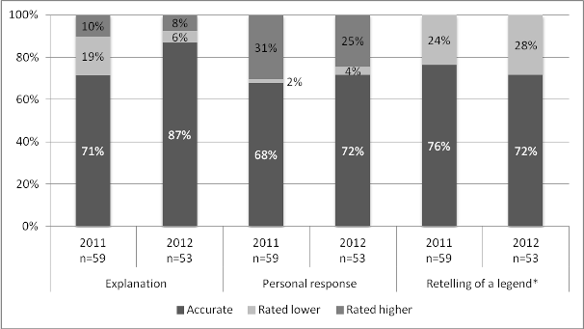
Figure 12: Accuracy of teachers’ ratings for the End of Year 4 sample rating scenarios in writing
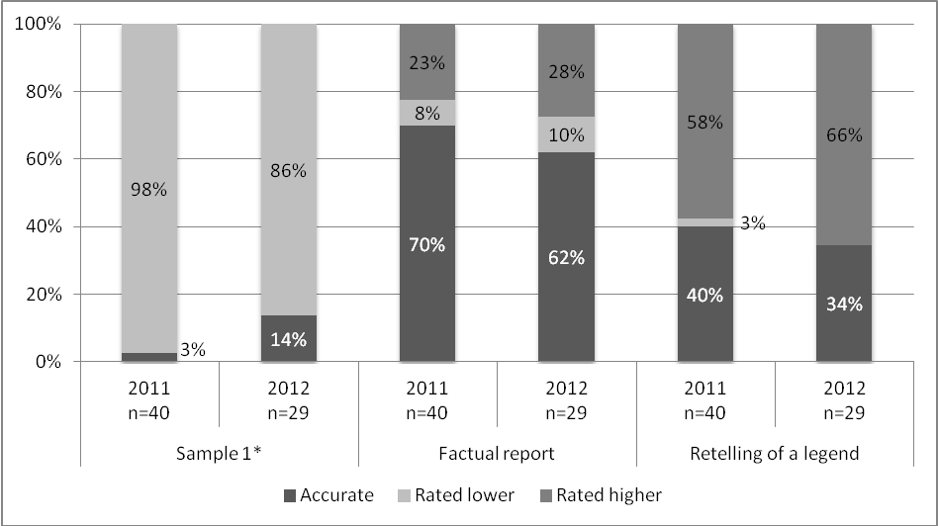
Figure 13: Accuracy of teachers’ ratings for the End of Year 6 sample rating scenarios in writing
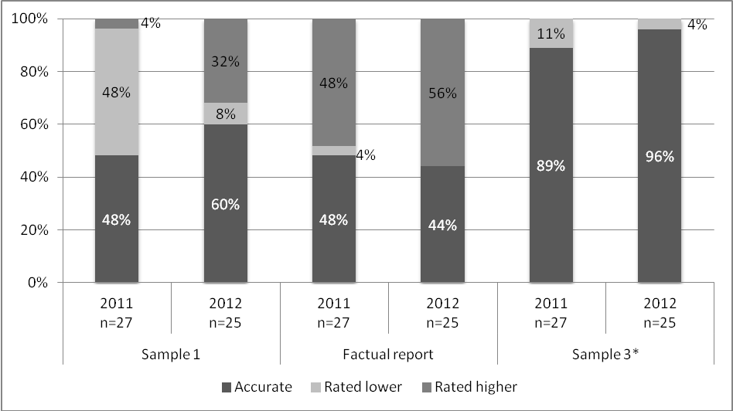
Figure 14: Accuracy of teachers’ ratings for the End of Year 8 sample rating scenarios in writing
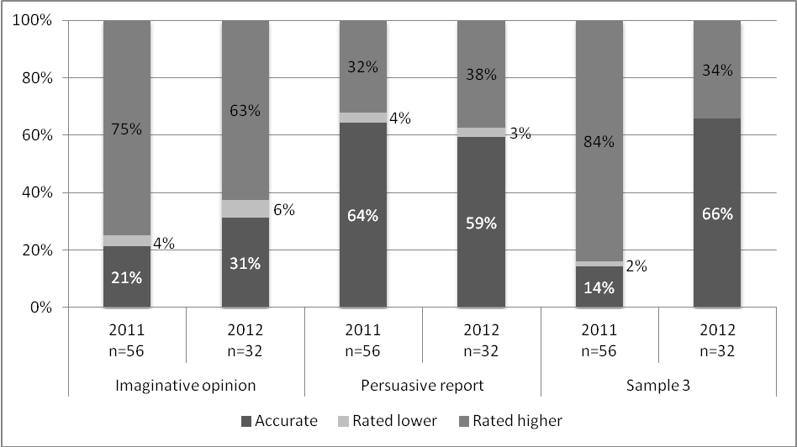
In general, the results from 2012 were similar to those from 2011. Accuracy across the 12 scenarios varied in both years; in 2012 the lowest level of accuracy for a work sample was 14% and the highest was 96%, compared to 3% and 89% respectively in 2011. Over all 12 writing scenarios and 417 ratings in 2012, 61% of teachers’ judgments were accurate. This was an increase from the 2011 overall accuracy of 51%.
Similar to results from 2011, teachers tended to rate writing samples too high rather than too low. For the 310 scenarios where it was possible for groups of teachers to rate either too low or too high (i.e. excluding those scenarios that were positioned ‘above’ the relevant standard), 61% of teachers’ judgments were accurate, 35% were too high and 4% were too low. In 2012 accuracy was lowest against the end of year 4 standard (37%), and greatest against the after 2 years (77%), and end of year 6 (67%) standards; similar to 2011 results. Accuracy in relation to the end of year 8 standard increased from 2011 to 2012 (33% to 52%).
The lowest scoring scenario in both years was Sample 1, positioned to be ‘above’ the end of year 4 writing standard. The writing samples on which this scenario was based were a character description of Fred Dagg in 2011 and an explanation of the water cycle in 2012. Figures 15 and 16 show these samples. The scenarios also outlined that students worked independently to plan and revise these pieces, and that they were planning to publish them on the class blog.
Figure 15: Work sample for 2011 scenario positioned ‘above’ the end of year 4

Figure 16: Work sample for 2012 scenario positioned ‘above’ the end of year 4


The features of these samples that contribute to their positioning at ‘above’ the end of year 4 writing standard include the use of some subject specific vocabulary (for example “real kiwi bloke” in the Fred Dagg sample, and ‘evaporate’ in the water cycle sample) and the independent revision and editing carried out by the student. While accuracy for this scenario increased from 3% in 2011 to 14% in 2012, the majority of teacher groups in both years gave the incorrect rating of ‘at’. While the reasons for this cannot be ascertained, a likely cause for the low accuracy observed is the lack of attention to surface features shown in the samples. This was identified in 2011 as a cause of disagreement among responding teachers, and continued to be an issue in 2012 with 7% of responding teacher groups commenting that the extent of structure required to meet the end of year 4 standard was a point for discussion.
Should there always be paragraphs to be at or above?
We felt first example explained the cycle but lacked punctuation and structure. We expect paragraphs for our year 4's. The second although having no paragraphs did use a variety of specific adjectives, verbs and nouns and varied sentence beginnings. We felt the third did not include enough specific adjectives etc. to meet the 2A or 3B standard.
The Fred Dagg and water cycle samples shown in Figures 15 and 16 were also the basis of scenario 1, positioned ‘below’ the end of year 6 standard. Results for this scenario also differed in 2011 and 2012, with most of the teacher groups that rated inaccurately in 2011 recording a lower than accurate rating of ‘well below’, and most of the teacher groups that rated inaccurately in 2012 recording a higher than accurate rating of ‘at’ or ‘above.’
There was a large difference in the accuracy of teachers’ judgments for sample 3, positioned ‘at’ the end of year 8 standard, in 2011 and 2012. The work samples used as a basis for this scenario were a persuasive opinion about cartoon violence in 2011 and an informative report about the heart in 2012. Figures 17 and 18 show these samples. Note that the scenarios also included students’ reflections on their work, and these described the deliberate use of language for a particular purpose, with an awareness of audience. The student transcript from the 2012 scenario illustrates this:
One of my learning goals is to provide clear information for the reader without going on and on and including unimportant detail. You know, to add impact and affect the reader without boring them. I got heaps of information from the internet and wrote my first version at home. I asked my writing group to listen while I read it aloud and help me decide if I was explaining clearly and if there were parts where there was irrelevant information... Actually I made some changes because of that. Then I read it again and made some more. I decided to add parts like 'The heart is a vital muscle, and without it you'd be in trouble' to emphasise its importance... add impact and to ask the questions - 'you may be wondering...' to make the reader feel more involved with the writing. Actually it was so messy after the changes I wrote it out again 'cause I had trouble reading it. I will type it up.
Figure 17: Work sample for 2011 scenario positioned ‘at’ the end of year 8


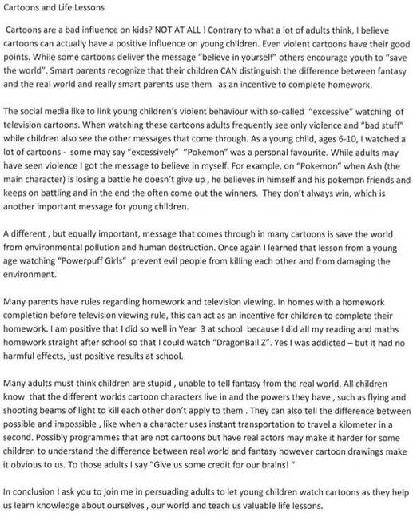
Figure 18: Work sample for 2012 scenario positioned ‘at’ the end of year 8

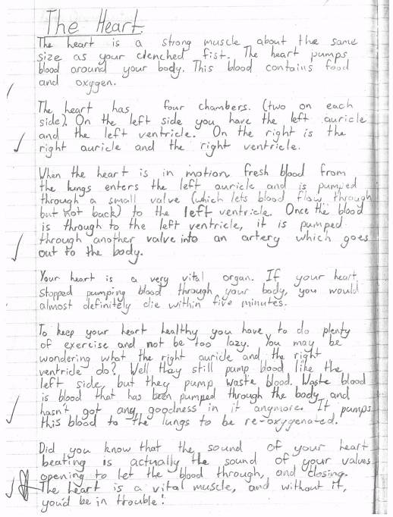
Accuracy for this scenario increased from 14% in 2011 to 66% in 2012, with smaller proportions of teacher groups giving the inaccurate rating of ‘above’ in 2011 (84%) and 2012 (34%). While no clear reasons are evident for this substantial increase in accuracy it is possible that it is due to differences in the samples on which the scenarios were based. In this regard it is interesting to note that these samples were also used in relation to the end of year 6 standard, and results for this were similar across both years. Sample 3 was positioned ‘above’ the end of year 6 standard and rated accurately by 89% and 96% of teachers in 2011 and 2012 respectively. Overall, the majority of teachers accurately rated both samples as ‘above’ the end of year 6 standard, and the heart sample as ‘at’ the end of year 8 standard. In comparison the majority of teachers rated the sample focused on cartoon violence as ‘above’ the end of year 8 standard.

Sample rating scenarios in mathematics
Figures 19 to 22 show the accuracy of teachers’ ratings for the mathematics scenarios in relation to the after 2 years, end of year 4, end of year 6, and end of year 8 standards. As with the results from writing, 2011 results are displayed alongside those from 2012 and n is used to indicate the number of groups of teachers that responded to each scenario. An asterisk indicates those scenarios that were positioned ‘above’ the standards; for these scenarios it was not possible for teachers to rate higher. As in writing, none of the scenarios were positioned ‘well below’ the standards so there were no scenarios in which it was possible for teachers to rate lower.
While most of the mathematics scenarios teachers responded to were the same in both 2011 and 2012, some new scenarios were developed for 2012. These new scenarios were developed to be as similar as possible to the 2011 versions. The name of the relevant strand of mathematics is used to identify scenarios that were the same in both years, while scenarios that differed in 2011 and 2012 are referred to as “sample”.
Figure 19: Accuracy of teachers’ ratings for the After 2 Years sample rating scenarios in mathematics
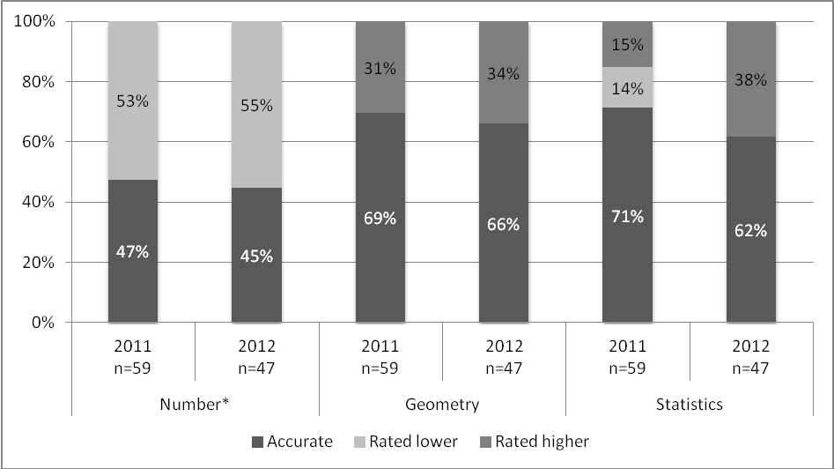
Figure 20: Accuracy of teachers’ ratings for the End of Year 4 sample rating scenarios in mathematics
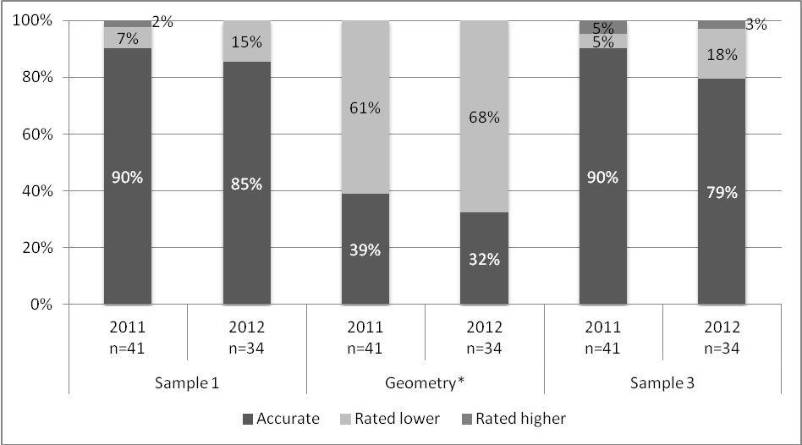
Figure 21: Accuracy of teachers’ ratings for the End of Year 6 sample rating scenarios in mathematics
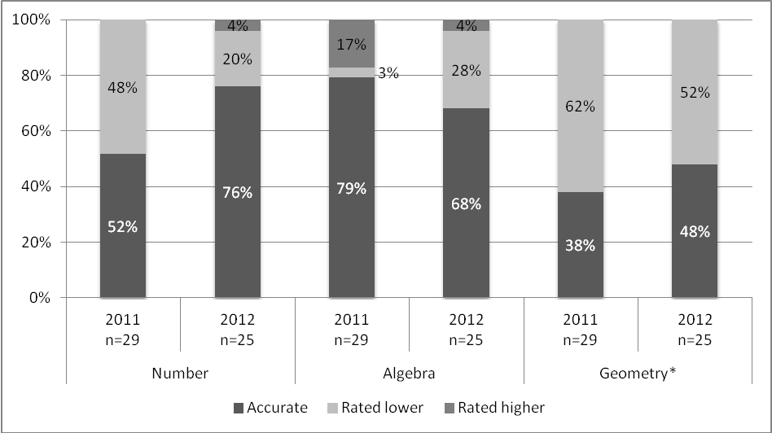
Figure 22: Accuracy of teachers’ ratings for the End of Year 8 sample rating scenarios in mathematics
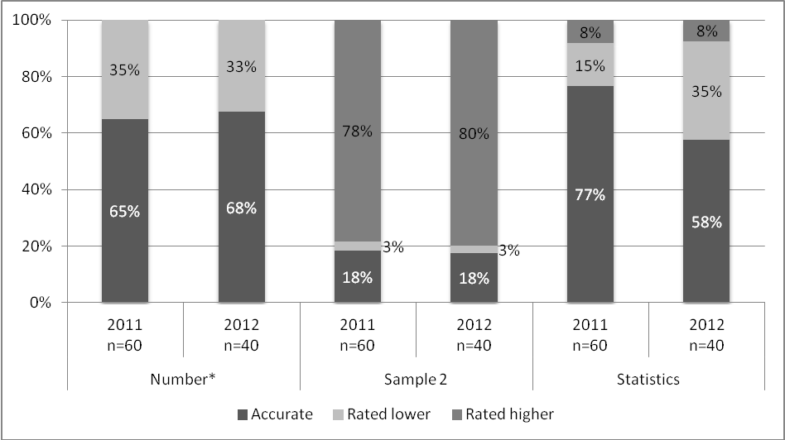
Teachers’ accuracy levels in the mathematics scenarios were very similar in 2011 and 2012. In 2011 the overall accuracy rate was 61% and this decreased slightly in 2012 to an accuracy of 58% across all of the 438 judgments recorded. As in 2011 there was variability in teachers’ accuracy levels across the 12 scenarios. Accuracy ranged from 18% to 90% in 2011, and 18% to 85% in 2012.
Over the three scenarios at each year level, results were most accurate in relation to the end of year 4 standard (73% in 2011 and 66% in 2012) and least accurate in relation to the end of year 8 standard (53% in 2011 and 48% in 2012). In line with results from writing, where teachers’ judgments were not accurate, they tended to rate too high rather than too low. For the 292 judgments where it was possible to rate either too high or too low in 2012 (i.e. with results from those scenarios positioned ‘above’ the standard removed), 62% of judgments were accurate, while 25% were too high and 13% were too low.
One of the most substantial declines in accuracy over the two years was observed for sample 3, positioned ‘below’ the end of year 4 standard. The work samples for this scenario in 2011 and 2012 were both measurement tasks, developed to be as similar as possible. These samples are shown in Figures 23 and 24.
Figure 23: 2011 scenario positioned ‘below’ the end of year 4 mathematics standard

Sample C
Please look at Sam’s recording sheet for the measurement task and decide together the most appropriate rating against the end of year 4 Mathematics standard. Record your answer in the question below.
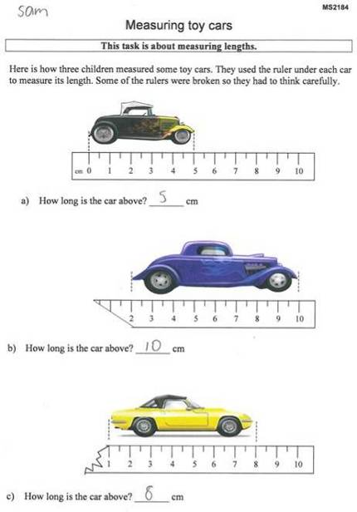
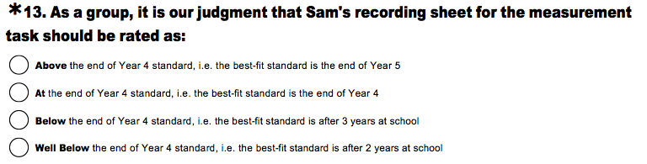
Figure 24: 2012 scenario positioned ‘below’ the end of year 4 mathematics standard

Sample C
Please look at Cam’s recording sheet for the measurement task and decide together the most appropriate rating against the end of year 4 Mathematics standard. Record your answer in the question below.
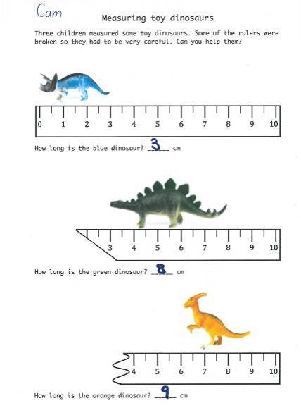
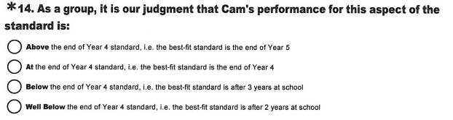
As seen above these samples are equivalent and there is no apparent reason for the accuracy of teachers’ ratings for this scenario to fall from 90% in 2011 to 79% in 2012. In comparison, teachers’ ratings for sample 2, positioned ‘below’ the end of the year 8 standard were very similar. The work samples for this scenario were two algebra tasks, developed to be equivalent. These tasks are illustrated in Figures 25 and 26.
Figure 25: Work sample for 2011 scenario positioned ‘below’ the end of year 8 mathematics standard

Sample B
Please look at Huia’s recording sheet for the patterning task and decide together the most appropriate rating against the end of year 8 Mathematics standard. Record your answer in the question below.
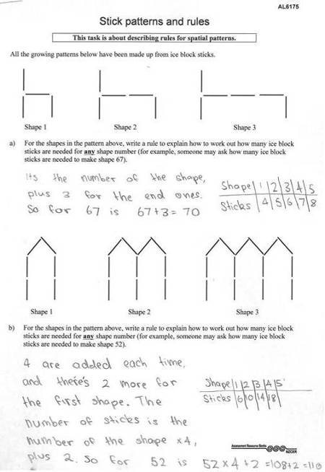
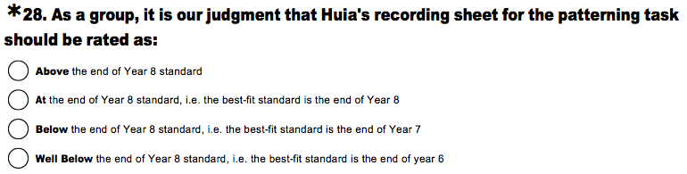
Figure 26: 2012 Scenario positioned ‘below’ the end of year 8 mathematics standard

Sample B
Please look at Kataraina’s recording sheet for the patterning task and decide together the most appropriate rating against the end of year 8 Mathematics standard. Record your answer in the question below.
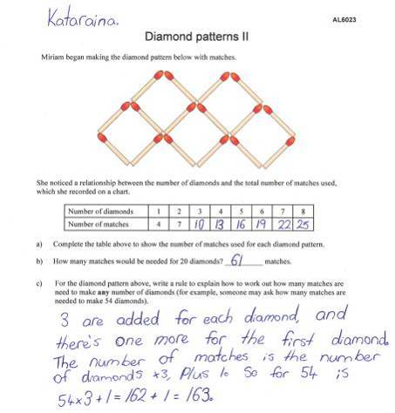

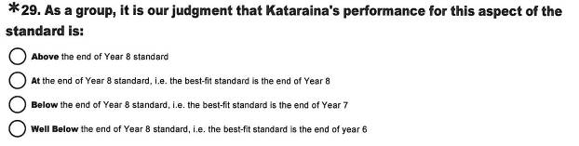
Despite having the highest accuracy for any year level, teachers’ ratings in relation to the end of year 6 standard showed the most variation between 2011 and 2012. Accuracy increased for the number and geometry scenarios (increases of 24% and 10% respectively), and decreased for the algebra scenario (11%). There are no apparent reasons for these variations, given that all of the scenarios were based on the same work samples in both years.

Making OTJ scenarios
The making OTJ scenarios asked teachers to collate four pieces of assessment information that had already been rated in relation to the National Standards, in order to make an OTJ. Figures 27 and 28 show teachers’ levels of accuracy for the writing and mathematics making OTJ scenarios. Results from 2011 are presented alongside those from 2012.
Figure 27: Accuracy of teachers’ ratings for the making writing OTJ scenarios
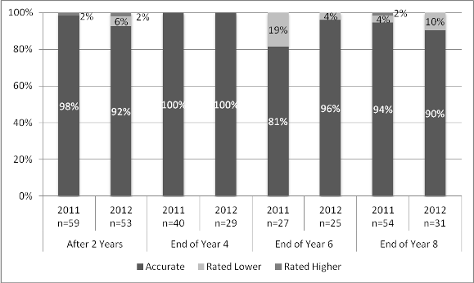
Figure 28: Accuracy of teachers’ ratings for the making mathematics OTJ scenarios
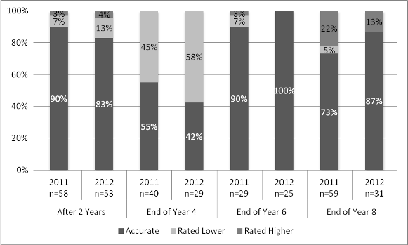
In general, the accuracy of teachers’ ratings in the making OTJ scenarios was similar in 2011 and 2012.
Results indicate that increases in the accuracy of teachers’ ratings for two scenarios was linked to a decreased importance being placed on standardised assessment measures. For example, 19% of teachers’ judgments in relation to the end of year 6 writing standard in 2011 weighted evidence from e-asTTle more heavily than information obtained from samples of students writing. In 2012, this proportion had fallen to 4%. Comments from respondents illustrate this finding.
e-asTTle is a good formal assessment but …. other cross-curricular information places the child AT, rather than BELOW overall.
e-asttle is one shot on one day. Although a reliable method, all has to be made into consideration.
The results from the making mathematics OTJ scenarios positioned at the end of year 6 were similar in this regard with teachers placing less importance on PAT: Mathematics results in 2012 than in 2011.
In summary, results from the making OTJ scenarios indicate that most teachers can collate four pieces of assessment evidence that have previously been rated in relation to the National Standards to make an accurate OTJ. While the sample rating scenarios do not replicate the judgments teachers make on their own students, the results from the scenarios do provide a window on the accuracy and consistency of teachers’ judgments. These findings from the assessment scenarios support evidence from the OTJ data presented earlier in this chapter that raise concerns over the dependability of OTJs.

Descriptive information
The assessment scenarios asked groups of teachers to indicate the level of agreement within the group for both the sample rating, and making OTJ scenarios. Respondents rated agreement as either ready, quickly negotiated, requiring considerable negotiation, or no agreement. The results for 2012 were very similar to those from 2011, with the majority of teacher groups describing agreement as ready or quickly negotiated for all scenarios. For example, the proportions of teacher groups describing agreement as ready or quickly negotiated for the mathematics sample rating scenarios ranged from 83% to 93% in 2011, and 85% to 94% in 2012. These agreement levels were reported for 85% to 95% of the making writing OTJ scenario results in 2011 and 87% to 100% in 2012.
Surveys collected teachers’ and principals’ perceptions of the quality of their school’s OTJs. In line with results from previous years, both groups indicated they were very confident in the accuracy and consistency of their OTJs. Confidence levels reported in 2012 were higher than those reported in 2011 for teachers and principals.
Nearly all groups of teachers described themselves as moderately or very confident in the accuracy of their reading (99%), writing (100%), and mathematics OTJs (97%). Principals were similarly confident of the accuracy of their schools’ reading and mathematics OTJs, with 97% describing themselves as moderately or very confident in this regard. Principal confidence in the accuracy of writing OTJs appears a little lower, with 89% describing themselves as moderately or very confident of this.
Teachers and principals also expressed confidence in the consistency of their schools OTJs. The majority of teacher groups rated themselves as moderately or very confident in the consistency of their reading (95%), writing (95%), and mathematics OTJs (93%). Ninety-five percent of principals described themselves as moderately or very confident in the consistency of their reading and mathematics OTJs, with a slightly smaller proportion (89%) describing themselves this way with regard to the consistency of writing OTJs.

Reporting to parents
Reporting to parents, families and whānau is an important part of the National Standards initiative. Guidelines to schools specify that “Reports should be concise and easily understood, outline a child's progress and achievement, and be free from educational jargon.” The intention is that parents, families and whānau will be well informed about their child’s learning and, therefore, more able to support this in the home.
This chapter uses evidence from an analysis of students’ end-of-year reports and the teacher survey to describe and evaluate the quality of National Standards reports. The monitoring and evaluation question and performance criteria addressed are shown in Table 35.
Table 35: Monitoring and evaluation question and criteria
Intended outcome: Schools use National Standards assessment information to communicate clearly with parents, families, and whānau about their child’s achievement and progress.
Monitoring and  Evaluation Question | Performance criteria | Sources of evidence
How do schools use information from National Standards to report to and communicate with parents? | Parents receive a report that describes their child’s progress and achievement in relation to the National Standards in reading, writing and mathematics. | End-of-year reports  Teacher survey
 | Parents receive a report that is clear. | End-of-year reports  Teacher survey
 | Parents receive a report that identifies their child’s next learning steps, and ways families can help at home. | End-of-year reports  Teacher survey

Evaluative criteria
Reports were categorised into three main groups, dependent on the way National Standards had been used for reporting purposes. Table 36 contains these results for the 395 reports in the sample.
Table 36: Use of National Standards in end-of-year reports
Group | Use of National Standards | No. of reports | % of sample
1 | None: reports do not mention National Standards at all | 35 | 9%
2 | Insufficient: reports refer to National Standards but do not sufficiently describe achievement against the standards | 98 | 25%
3 | Sufficient: reports describe achievement in relation to National Standards | 262 | 66%

In 2012, 9% of the reports analysed made no mention of the National Standards. Of these 35 reports, 15 were judged to have achievement data that would have been sufficient to make an OTJ, while 20 were rated as having insufficient data to make an OTJ.
Over time the proportion of reports that do not mention the National Standards has declined. Twenty-one percent of 2010 reports made no mention of the standards, while in 2011 and 2012 these proportions were 13% and 9% respectively.
Ninety-one percent of the reports in the 2012 sample referred directly to the National Standards. Of these 360 reports, 262 were rated as sufficiently describing students’ achievement in relation to the National Standards (further details below), and 98 were rated as insufficient in this regard. These groups, groups two and three, are the focus of the remainder of this chapter, as it is these which contain information about the way in which National Standards information is communicated to parents, families and whānau in end-of-year reports.

Parents receive a report that describes their child’s progress and achievement in relation to the National Standards in reading, writing and mathematics
In order to be rated as sufficiently describing achievement in relation to the National Standards, an end-of year report needed to include information about the student’s achievement in relation to the standards, and details of something the student could or could not do that was of significance to the standard. In reading, for example, these details included information about the student’s ability to decode text, or their ability to respond, understand and use what they have read in addition to their OTJ. An OTJ and a reading level or age was not considered sufficient. In writing, a report needed to include information about the student’s ability to encode (including planning, revising, or publishing), or use writing for a variety of purposes across the curriculum, in addition to the OTJ. Information about students’ spelling ability and an OTJ was not considered sufficient. In mathematics, a report needed an OTJ and information about the student’s ability in number and other aspects of the mathematics standards such as measurement or geometry. To be rated as sufficiently describing achievement in relation to the National Standards a report needed to fit these criteria for two of the three areas: reading, writing, and mathematics.
Seventy-three percent of the 2012 reports (that made direct reference to the National Standards) were rated as sufficiently describing student achievement in relation to the National Standards. This is an increase on 2010 and 2011 results in which 60% were rated as sufficient. Figure 29 illustrates the content of these reports.
Figure 29: Examples of information rated as sufficiently describing student achievement against the National Standards
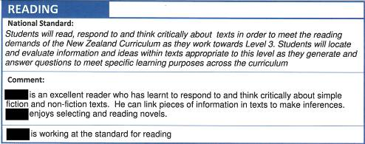
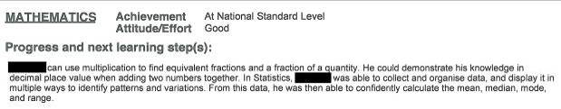
Twenty-seven percent of reports were rated as insufficiently describing student achievement in relation to the National Standards in 2012. Figure 30 provides an example.
Figure 30: Examples of information rated as insufficiently describing student achievement against the National Standards
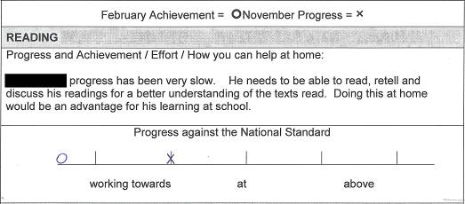
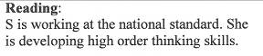
In terms of reporting progress information, nearly 20% of reports described students’ progress in relation to the reading (18%), writing (18%), and mathematics standards (16%). This is an increase from 2011 results in which approximately 10% of reports described students’ progression against the reading (12%), writing (9%), and mathematics standards (9%). Figure 31 provides an example.
Figure 31: Examples of progress reporting in relation to the National Standards.
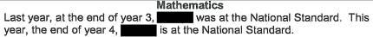
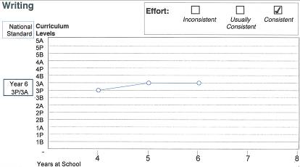

Parents receive a report that is clear.
Reports were rated as either clear or unclear. A clear report was one that was considered easy for parents, families and whānau to understand. To achieve this rating the reading, writing, and mathematics information in the report, including text, tables and graphics, needed to be clear, with no unexplained educational jargon. Forty-three percent of the 2012 reports were rated as clear, and 57% as unclear.
A decrease in the proportion of clear reports was observed from 2011 to 2012. Fifty percent of 2011 reports were rated as clear, while 43% of 2012 reports were rated this way. Forty percent of 2010 reports were rated as clear. To investigate the reasons for this decline the results of 55 schools for which clarity ratings were available in both 2011 and 2012 were analysed. Table 37 shows the clarity of schools’ 2011 reports, disaggregated by the clarity of their reports in 2012. The numbers in bold type show the numbers of schools that have not changed in terms of the clarity of their reports.
Table 37: Clarity of schools’ reports, 2011 and 2012
2011 results | 2012 results
2011 results | Majority of reports  from school rated as clear | Majority of reports from  school rated as unclear
Majority of reports from school rated as clear n= 25 | 17 | 8
Majority of reports from school rated as unclear, n=20 | 5 | 15

The clarity of the reports of 32 schools was unchanged from 2011 to 2012. The reports of five schools had improved in clarity and eight schools had declined. Of these eight schools, six had changed the format of reports from 2011 to 2012 in a way that was judged to reduce the clarity of the information presented. For example, one school replaced a clear statement of students’ achievement in relation to the National Standards with multiple colour-coded tables, and another removed an easily read table and replaced it with a progress graph with unclear scales. The other schools that declined in clarity from 2011 to 2012 had retained the same report format in both years, but one had added multiple assessment results in the comments for each area, and the other had included more jargon in report comments in 2012 than in 2011. Figure 32 illustrates the drop in clarity with the 2011 and 2012 reports from one school. Note that in 2012 there were three of the tables illustrated, one for each of the National Standards areas.
Figure 32: Example of a school’s 2011 and 2012 reports
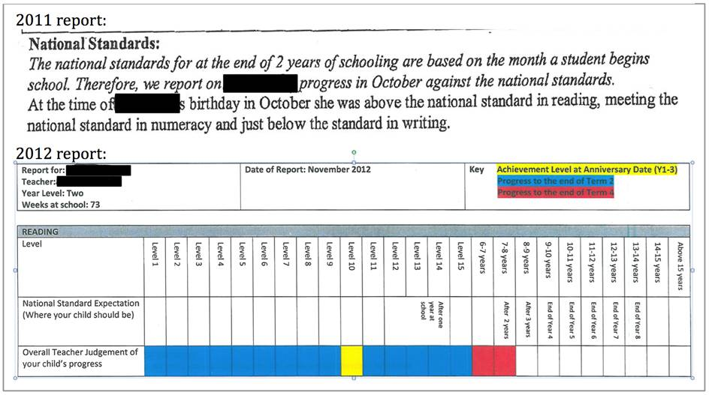
While the proportions of reports rated as clear and sufficiently describing students’ achievement in relation to the standards are of interest, the combination of these characteristics is also relevant. Figure 33 summarises the sufficiency and clarity of the sample of 2012 National Standards reports.
Figure 33: The clarity of reports that did and did not contain sufficient National Standards achievement information

Clear | 5% (18) | 38% (137)
Unclear | 22% (80) | 35% (125)
 | Insufficient National Standards achievement information  (Group 2) | Sufficient National Standards achievement information  (Group 3)

Thirty-eight percent of reports were rated as clear and sufficiently describing students’ achievement in relation to the National Standards. This is similar to 2011 results, when 35% of reports met these two criteria. Figure 34 provides an example.
Figure 34: Example of a report that was rated as containing clear information about student achievement in relation to the National Standards

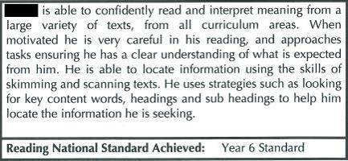
Thirty-five percent of reports were rated as sufficiently describing students’ achievement in relation to the National Standards, but were rated as unclear. These reports contained an OTJ and details of what the student could or could not do that was of significance to the OTJ, but were considered difficult for parents, families and whānau to understand. Features of these reports included the use of technical assessment information and unexplained educational jargon, graphs and tables with complex coding systems, and descriptions of students’ abilities that were difficult to understand. Consistent with the overall decrease in the clarity of reports from 2011 to 2012 described above, the proportion of reports in this category increased from 25% in 2011 to 35% in 2012. Figure 35 provides an example.
Figure 35: Example of a report that was rated as containing unclear information about student achievement in relation to the National Standards

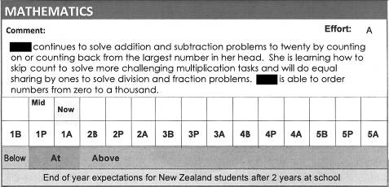
Most of the reports that contained insufficient information in relation to the National Standards were rated as unclear (22% of the reports in total), while a small proportion was rated as clear (5% of the reports in total). Figures 36 and 37 provide examples of these types of reports. Note that the proportions of reports of this nature have been declining over time. Thirty-three percent of reports were rated as insufficient and unclear in 2010 and this declined to 22% in 2012, while 7% were rated as insufficient and clear in 2010 and 5% were rated this way in 2012.
Figure 36: Example of a clear report that contained insufficient information about student achievement in relation to the National Standards
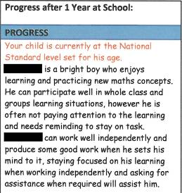
Figure 37: Example of an unclear report that contained insufficient information about student achievement in relation to the National Standards

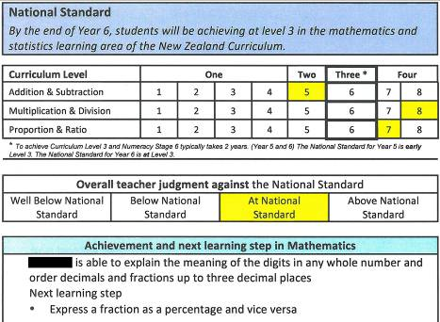

Parents receive a report that identifies their child’s next learning steps, and ways families can help at home
Reports were rated as to whether or not they included students’ next learning steps, and the ways families can support this learning at home. For reports to be rated as containing these elements, they needed to include the relevant information in two of the three areas: reading, writing, and mathematics. Seventy-three percent of reports were found to contain students’ next learning steps, while 53% contained information about the ways families can support learning at home. Note that the quality of this information was not assessed in any way. These elements are illustrated in Figures 38 and 39.
Figure 38: Examples of information about student’s next learning steps in end-of-year reports

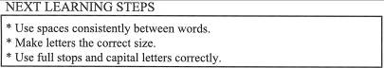

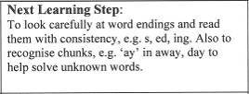
Figure 39: Examples of information about actions families can take to support student learning in end-of-year reports

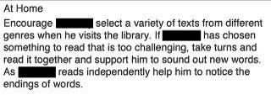

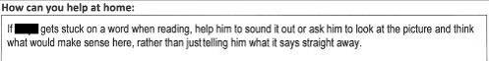
There has been a small increase over time in the proportion of reports that contain information about students’ next learning steps. Seventy percent of 2010 reports contained this information, while 73% of 2012 reports did so. There has been a small decrease in the proportion of reports that describe actions families can take to support their child’s learning. Sixty-one percent of reports contained this information in 2010, while it was included in 53% of 2012 reports.
Table 38 summarises the proportions of reports meeting the National Standards reporting performance criteria from 2010 to 2012.
Table 38: Proportions of reports meeting performance criteria, 2010-2012
Performance criteria |  | Year | Proportion
Parents receive a report that describes their child’s progress and achievement in relation to the National Standards in reading writing, and mathematics. | National Standards referred to directly in reports. | 2010 | 79%
 | National Standards referred to directly in reports. | 2011 | 87%
 | National Standards referred to directly in reports. | 2012 | 91%
 | Achievement in relation to National Standards sufficiently described. | 2010 | 60%
 |  | 2011 | 60%
 |  | 2012 | 73%
Parents receive a report that is clear. |  | 2010 | 40%
 |  | 2011 | 50%
 |  | 2012 | 43%
Parents receive a report that identifies their child’s next learning steps. |  | 2010 | 70%
 |  | 2011 | 68%
 |  | 2012 | 73%
Parents receive a report that identifies ways families can help at home. |  | 2010 | 61%
 |  | 2011 | 55%
 |  | 2012 | 53%

In general, the quality of end-of year reports to parents increased from 2010 to 2012 with higher proportions of reports referring directly to the National Standards, and an increase in the proportion of reports that sufficiently described student achievement in relation to the National Standards over this period. Evidence suggests the clarity of National Standards reports to parents may be an issue, with less than 50% of reports rated as being easily understood by parents, families and whānau in all three years, and an overall decrease in report clarity observed from 2011 to 2012

Descriptive information
Reports used a variety of nationally recognised scales, in addition to the National Standards, to describe students’ progress over time. New Zealand Curriculum levels were used to describe progress in reading (18%), writing (17%), and mathematics (9%), and were usually presented alongside National Standards progress information. Other progress measures in reading included reading ages (11%), reading recovery levels (8%), colour wheel colours (7%), and STAR results (3%). Eleven percent of reports used number framework stages as a measure of progress in mathematics. Small proportions of reports used the PAT assessment scale to describe students’ progress in reading (2%), and mathematics (5%).
Reports described students’ achievement in relation to the National Standards in two ways. Sixty-six percent of reports described students’ achievement in relation to their current year level standard using a scale such as ‘at,’ ‘above,’ ‘below,’ and ‘well below’ (see Figure 40). Eighteen percent of reports identified a best-fit standard, and this information was usually presented graphically (see Figure 41). Fifteen percent of reports used a combination of these two approaches. Schools’ use of the scale and best-fit approaches to describe students’ achievement in National Standards reports has been reasonably consistent from 2010 to 2012.
Figure 40: Examples of reports that described achievement as ‘at’, ‘above’, ‘below’ or ‘well below’ the National Standards

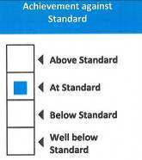

Figure 41: Examples of reports that described achievement using a best fit standard

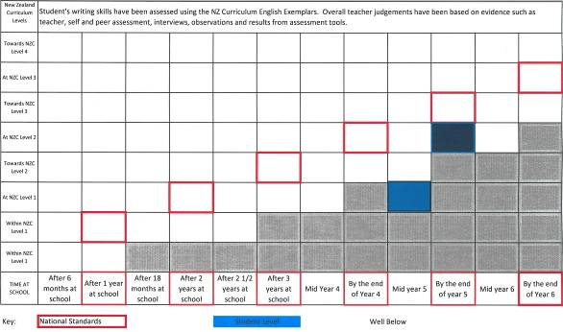

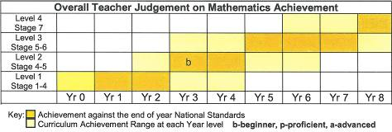
Another distinction in the way that National Standards achievement information was presented is that 58% of reports used diagrams or tables to convey this information (see Figure 42), while 22% presented it in text (see Figure 43). Twenty percent of reports presented National Standards achievement information in both these forms. The form in which National Standards achievement information has been presented in reports has been very consistent over the three years of National Standards implementation, with small fluctuations in these proportions observed.
Figure 42: Examples of OTJs presented in diagrams

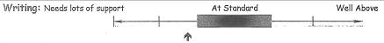

Figure 43: Example of OTJ presented in text

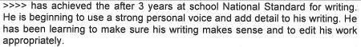
Teachers’ perceptions of the usefulness of progress and achievement information from National Standards for communicating with families and students varied. About half of the teacher groups surveyed rated National Standards information as moderately or very useful for communicating with families (50%) and students (47%). Approximately one-quarter of teacher groups rated this information as not useful for these purposes (21% not useful for communicating with families, 26% not useful for communicating with students).
Teachers were also questioned about the impacts of National Standards reporting on students and families. Tables 39 shows teachers’ agreement levels with three statements about National Standards reporting and is based on the responses of 133 groups of teachers.
Table 39: Teachers’ perceptions of impact of National Standards reports on families and students
Statement | Year | Proportion of teacher groups
Statement | Year | Agree | Neutral | Disagree | Not sure
Families seem more engaged with the reports on their child's progress and achievement. | 2010 | 20% | 33% | 36% | 11%
 | 2011 | 19% | 27% | 50% | 5%
 | 2012 | 25% | 26% | 46% | 4%
Students who are not achieving well appear less positive about their reports than in previous years. | 2010 | 31% | 29% | 24% | 16%
 | 2011 | 51% | 20% | 20% | 9%
 | 2012 | 54% | 29% | 17% | 2%
Students who are achieving well appear more positive about their reports than in previous years. | 2010 | 21% | 36% | 27% | 16%
 | 2011 | 30% | 35% | 27% | 8%
 | 2012 | 32% | 37% | 29% | 2%

A substantial proportion of teachers (46%) did not agree that families are more engaged with their child’s reports as a result of National Standards in 2012, while a smaller proportion perceived them to be more engaged (25%). In general, there has been an increase over time in the proportion of teachers that disagree that families are more engaged with reports (36% in 2010 and 46% in 2012). The majority of teachers (54%) agree that students who are not achieving well appear less positive about their reports than in previous years, while 17% of teachers disagree that this is true. Teachers’ agreement rates in this regard have risen from 31% in 2010 to 54% in 2012. Teachers’ views on whether students achieving well appear more positive about their reports than in previous years are reasonably evenly split between those who agree (32%) and those who disagree (29%). It is interesting to note the proportions of teachers that rated themselves as not sure about these statements steadily fell from 2010 to 2012, as teachers became more experienced with the National Standards.

Student achievement targets
Principals and Boards of Trustees are responsible for prioritising learning needs and allocating resources to improve student achievement. As part of this process Boards of Trustees set annual student achievement targets, which guide decisions about the teaching support individual students receive. Ministry of Education advice to schools emphasises that annual reports, which include student achievement targets, are “an essential part of your school’s continuous process of improvement to raise student achievement for every student, in particular Māori and Pasifika students, and students with special education needs.”
This chapter uses evidence from schools’ student achievement targets and analysis of variance reports, along with information from surveys of principals and Boards of Trustees to describe and evaluate National Standards student achievement targets. The monitoring and evaluation question and performance criteria that are the focus of this chapter are shown in Table 40.
Table 40: Monitoring and evaluation question and criteria
Intended outcome: National Standards provides clear information about student achievement for Boards of Trustees that can be used in decision-making and resource allocation processes.
Monitoring and  Evaluation Question | Performance criteria | Sources of evidence
In what ways is information from National Standards used by schools to set achievement targets? | Targets in the school’s 2012 charter address student achievement in relation to the National Standards. | School documentation: student achievement targets and analysis of variance reports.  Surveys: Principals and Boards of Trustees
 | National Standards achievement targets are informed by baseline data.
 | National Standards achievement targets address the progress rates of all students.
 | All year levels are considered when National Standards targets are set.
 | National Standards achievement targets focus on students who are ‘below’ or ‘well below’ the standards.
 | National Standards achievement targets are differentiated to accelerate progress for specific groups of students.
 | National Standards achievement targets are specific, measurable, challenging, and achievable.

Evaluative criteria

Targets in the school’s 2012 charter address student achievement in relation to the National Standards.
Documentation from 92 schools was analysed. Eighty-six schools had charters that were rated as including student achievement targets in at least one of the National Standards areas. Of these 86 schools, 72 had targets in relation to the Reading Standards, 69 included targets set in relation to the Writing Standards, and 66 had National Standards mathematics targets. Figure 44 illustrates these proportions and provides a comparison to 2011 results.
Figure 44: Proportions of schools rated as including National Standards achievement targets in school charters, 2011 and 2012
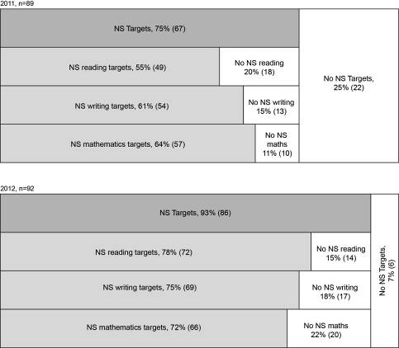

Ninety-three percent of schools included National Standards targets in their 2012 charters. This is an increase from 2011, when 75% of schools had targets that addressed National Standards. In 2012, higher proportions of schools included reading targets in their charters (78%), than included writing (75%) or mathematics targets (72%). This is a reversal of the pattern in the 2011 results where higher proportions of schools included mathematics targets (64%), than included writing (61%) or reading targets (55%), although these differences are small.
In 2012, six schools did not include National Standards targets in their charters. Of these, four had set targets against other measures such as number framework stages, reading levels and PAT stanines. One school had endeavoured to address the National Standards but had targets that conflated these with other assessment measures; for example, their mathematics target specified, “60% of students will be at the National Standard of Stage 3.” One school did not include any reference to the National Standards in their achievement targets.
Those targets that did not address the National Standards (represented by the unshaded regions in Figure 43) were not analysed further, and the discussion that follows in the remainder of this chapter is focused on schools’ National Standards targets. The general nature of schools’ targets in relation to the National Standards is first described, then schools’ National Standards targets in reading, writing, and mathematics are investigated more specifically.

National Standards achievement targets are informed by baseline data.
Ninety-two percent (of the 86 schools that included National Standards targets in their 2012 charter) had used baseline data to inform their National Standards achievement targets. These schools either described 2011 achievement directly alongside 2012 targets, or referred to 2011 achievement levels in accompanying documentation.

National Standards achievement targets address the progress rates of all students.
Thirteen percent of the schools that included targets in relation to the National Standards in their 2012 charters included a focus on the progress rates of all students. This can be considered desirable as it ensures all students are considered in planning and resource allocation. The 2012 results are an increase from the 2011 result in which 6% of schools with National Standards targets included a focus on progress for all students. Examples from 2012 include:
Move all students’ academic levels more than one year forward in the school year.
All of the students who were well below or below the standard in February will make more than one year’s (accelerated) progress in relation to the reading standards. All of the students who were at or above the standard in February will make at least one year’s progress in relation to the reading standards.

All year levels considered when setting National Standards targets.
Eighty-three percent of the 86 schools with National Standards achievement targets had considered students at all year levels when these targets were set. These schools either included all year levels of students in their targets, or targets were set for just those year levels in which students were rated ‘below’ or ‘well below’ the standards. Targeted achievement levels were either the same for all year levels, or differed by year level as appropriate.
For the 33% of children who were not achieving at or above the expected level to be achieving at or above.
By November 2012, 75% of all students will be achieving at or above the standard in writing.
Maths Targets:
After One Year: 90% of students at or above the National Standard.
After Two Years: 90% of students at or above the National Standard.
After Three Years: 90% of students at or above the National Standard.
Year Four: 85% of students at or above the National Standard.
Year Five: 85% of students at or above the National Standard.
Year Six: 80% of students at or above the National Standard.
Year Seven: 80% of students at or above the National Standard.
Year Eight: 70% of students at or above the National Standard.

National Standards achievement targets focus on students who are below or ‘well below’ the standards.
Eighty-three percent (of the 86 schools that included National Standards achievement targets in their 2012 charters) included a focus on the groups of students that were rated ‘below’ or ‘well below’ the National Standards in 2011. Examples include:
Of the 16 (21%) identified as working below the standard, 10 (13%) will be achieving at the standard by the end of the year.”
To reduce the number of students in Year 7 & 8 at both “well below” and “below” the National Standards in Writing by 50%.”
Reading: 85% of students will be achieving at or above the National Standard after two years at school. [Baseline data 2011: 53% of students achieving at or above the After 1 Year standard in November 2011.]
The proportion of schools with National Standards targets that included a focus on students rated ‘below’ and ‘well below’ decreased from 94% in 2011 to 83% in 2012. This decrease is largely attributable to the 18% of schools that included National Standards targets in their charters for the first time in 2012. The National Standards targets of these schools were more often rated as not meeting the performance criteria than targets from other schools.
Fifteen schools included targets in their 2012 charter which were not focused on students ‘below’ and ‘well below’ the standards. These either targeted achievement levels commensurate with current levels, described “positive shifts” without specifying the students whose achievement would be raised, or focused on students rated ‘at’ or ‘above’ the standards in 2011. For example:
National Standards and achievement, to lift achievement in years 2, 4, and 5 by greater than 10%.
For more Year 5 and 6 students who were at the National Standard for maths after 3 years and at the end of 5 years will achieve above the National Standard by the end of year 4 & 6.
The remainder of this chapter focuses on the student achievement targets that were rated as addressing the National Standards in reading, writing and mathematics. That is, those targets represented by the lightly shaded regions in Figure 43: 72 reading targets, 69 writing targets, and 66 mathematics targets. The percentages included in the following sections represent the proportions of these targets that were found to have certain features.

National Standards achievement targets are differentiated to accelerate progress for specific groups of students.
Overall, approximately two-thirds of National Standards targets in reading (65%), writing (64%), and mathematics (62%) were differentiated to accelerate progress for specific groups of students. Table 41 shows the focus of these differentiated targets in each area. Note that percentages are given from the total number of National Standards targets in each area.
Table 41: Focus of differentiated National Standards targets
Sub-groups | Proportion of National Standards targets
Sub-groups | Reading  (n=72) | Writing  (n=69) | Mathematics  (n=66)
Māori students | 28% | 35% | 26%
Pasifika students | 7% | 6% | 6%
Students by year level | 43% | 41% | 48%
Students by gender | 21% | 17% | 12%
Students with special needs | 1% | 1% | 2%
Other students | 4% | 3% | 3%

Approximately a third of National Standards targets in reading (28%), writing (35%), and mathematics (26%) focused on Māori students, while just less than 10% of targets focused on Pasifika students (7% of reading targets, 6% of writing targets, and 6% of mathematics targets). Up to 2% percent of National Standards targets across the three areas focused on students with special needs. Results suggest the focus on these three priority groups was similar in 2011 and 2012. Thirty-three percent of National Standards targets focused on Māori students in 2011, while 9% focused on Pasifika students, and 1% focused on students with special needs.
Nearly half of the 2012 National Standards targets focused on accelerating the progress of specific year levels of students (43% of reading targets, 41% of writing targets, and 48% of mathematics targets), while up to 21% focused on accelerating progress for students of a particular gender. The majority of these targets were focused on boys. In reading for example, 15 schools included targets differentiated by gender and 12 of these were focused on boys, two were focused on both boys and girls, and one was focused on girls only. This focus on boys was also found in 2011 gender-differentiated student achievement targets.

National Standards achievement targets are specific, measurable, challenging, and achievable.
Table 42 shows the proportions of National Standards targets in schools 2012 charters that were rated as specific, measurable, challenging, and achievable.
Table 42: Proportions of 2012 National Standards targets rated as specific, measurable, challenging, and achievable
Performance criteria | Reading | Writing | Mathematics
National Standards achievement targets are specific. | 85% | 86% | 86%
National Standards achievement targets are measurable. | 86% | 87% | 88%
National Standards achievement targets are challenging. | 47% | 43% | 48%
National Standards achievement targets are achievable. | 71% | 72% | 70%

The majority of 2012 National Standards achievement targets were rated as specific and measurable. For example 85% of reading targets were specific, while 86% of writing and mathematics targets were rated this way. In general, those targets that were rated as specific were also rated as measurable. Examples include:
To have all children achieving at or above their expected level with respect to the National Standards.
Move all students who are in the below National Standards group to the at National standards group by the end of the year.
In 2012 the group of Year 2 boys below or well below the National Standard will have made more than one years progress and will be achieving at or above the Reading standard.
Less than half of the 2012 National Standards achievement targets in reading (47%), writing (43%), and mathematics (48%) were considered challenging. To be rated as challenging, targets needed to specify moving at least 50% of the students rated ‘well below’ in 2011 to ‘below’ in 2012, and 80% of the students rated ‘below’ in 2011 to ‘at’ in 2012. Approximately three-quarters of National Standards targets were considered to be achievable (71% of reading targets, 72% of writing targets, and 70% of mathematics targets).
The proportions of National Standards targets rated as meeting all four of these criteria fell slightly from 2011 to 2012. These decreases were generally small; for example, the proportion of National Standards targets rated as specific fell by up to 7%. These declines are attributable to those schools that included National Standards targets in their charters for the first time in 2012.
Tables 43 and 44 show the performance criteria with regard to National Standards targets for which there is information in both 2011 and 2012, and summarises these results.
Table 43: Proportions of schools with National Standards targets meeting performance criteria, 2011 and 2012
Performance criteria | Year | Proportion of schools
Targets in the school’s charter address student achievement in relation to the National Standards. | 2011 | 75%
 | 2012 | 93%
National Standards achievement targets address the progress rates of all students. | 2011 | 6%
 | 2012 | 13%
National Standards achievement targets focus on students who are ‘below’ or ‘well below’ the standards. | 2011 | 94%
 | 2012 | 83%

Table 44: Proportions of National Standards targets meeting performance criteria, 2011 and 2012
Performance criteria | Year | Reading | Writing | Mathematics
National Standards achievement targets are differentiated to accelerate progress for specific groups of students. | 2011 | 57%
 | 2012 | 65% | 64% | 62%
National Standards achievement targets are specific. | 2011 | 92% | 89% | 88%
National Standards achievement targets are specific. | 2012 | 85% | 86% | 86%
National Standards achievement targets are measurable. | 2011 | 92% | 94% | 93%
National Standards achievement targets are measurable. | 2012 | 86% | 87% | 88%
National Standards achievement targets are challenging. | 2011 | 55% | 65% | 53%
National Standards achievement targets are challenging. | 2012 | 47% | 43% | 48%
National Standards achievement targets are achievable. | 2011 | 90% | 81% | 82%
National Standards achievement targets are achievable. | 2012 | 71% | 72% | 70%

In summary, from 2011 to 2012 the proportion of schools that included National Standards targets in their charters increased (from 75% to 93%). While the proportions of schools meeting several of the performance criteria fell over this period, these decreases tended to be small and can be attributed to schools that included National Standards targets in their charters for the first time in 2012. The analysis indicates the level of challenge inherent in student achievement targets may be of concern as less than 50% of National Standards targets were considered to be challenging in 2012.

Descriptive information
Advice from the Ministry of Education indicates that schools should target 100% of students to be ‘at’ or ‘above’ the National Standards in all three areas. Approximately one-third of National Standards reading (35%), writing (30%), and mathematics targets (33%) met this criterion. These targets either specified the groups of students whose achievement would improve, or stated more generally that all students would be rated or ‘at’ or ‘above’ the standards in 2012.
All pupils will be at or above their expected level of achievement in Literacy in relation to the National Standards by the end of the year.
[The] 36% of students who are below will improve by at least two years to be at or above the national standard.
Principals’ views on the usefulness of information from National Standards were obtained through the online survey. The majority of principals regarded information from National Standards as moderately or very useful for setting annual school-wide targets for student achievement (70% of principals) and reporting student progress and achievement to Boards of Trustees (69% of principals). Small proportions of principals (up to 5%) rated National Standards information as not useful for these purposes. Most Board of Trustees Chairpersons (at least 80%) also regarded information from National Standards as moderately or very useful for these purposes.

Teacher professional development and levels of understanding among schools about the National Standards
Data from National Standards provides important information about students’ learning needs which can be used to tailor the professional development teachers receive. Ideally, this professional development will enable teachers to successfully meet students’ learning needs, and achievement will improve. As such, professional development has an important role to play in raising student achievement.
This chapter looks first at teachers’ professional development: how needs are identified and addressed, and what changes have been seen in teachers’ knowledge and work as a result of the National Standards. It then looks more generally at Principals’, Boards’ and teachers’ understandings of the National Standards. The monitoring and evaluation questions and performance criteria addressed are shown in Table 45.
Table 45: Monitoring and evaluation questions and criteria
Intended outcomes | Monitoring and  Evaluation Questions | Performance criteria | Sources of evidence
National Standards information is used to identify teachers’ professional development needs. This enables these to be addressed more effectively. | In what ways is information from National Standards used to identify teachers’ professional development needs? | Schools use National Standards data to identify teachers’ professional development needs. | Surveys: Principal, teacher, and Board of Trustees
 |  | Identified professional development needs are addressed. | Surveys: Principal, teacher, and Board of Trustees
 | What changes in teachers’ professional knowledge and practice are observed as National Standards are introduced? | Teachers have an increased understanding of what students need to be achieving at the level(s) they teach. | Surveys: Principal and teachers
 |  | Teachers have increased knowledge of effective strategies for teaching. | Surveys: Principal and teachers
 |  | Teachers become more systematic in their collection of evidence about students’ progress. | Surveys: Principal and teachers
 |  | Teachers increasingly use evidence of students’ progress to inform their teaching practice. | Surveys: Principal and teachers
National Standards provides clear information about student achievement for Boards of Trustees which can be used in decision making and resource allocation processes. | To what extent are National Standards understood as a set of common expectations for student achievement? | Principals, Boards of Trustees and teachers understand that National Standards provide reference points for student achievement at particular time-points. | Surveys: Principals, Boards of Trustees Chairpersons and teachers
 |  | Principals, Boards of Trustees and teachers understand that National Standards are intended to lift the achievement of those students who are currently not on track to succeed at school.
 |  | Principals, Boards and Trustees and teachers understand that National Standards are aligned to the New Zealand Curriculum.

Evaluative criteria

School use National Standards data to identify teachers’ professional development needs
Fifty-four percent of principals surveyed reported that information from National Standards had been used to identify teachers’ professional development needs in 2102. Those principals that indicated they did not use National Standards information for this purpose were invited to comment, and 31% of respondents chose to do so. There were three common themes in these comments: that principals used other information to determine these needs (8% of respondents), that the focus of their school’s professional development for 2012 was in learning areas other than reading, writing, and mathematics (6% of respondents), and that their school has plans to use National Standards information to identify teachers professional development needs in the future (6% of respondents). These views are illustrated by the following comments received.
PD in 2012 was Writing based and this was determined by earlier writing results that were not based around National Standards.
Already knew what were targeting, this information didn't change that.
Science was focus for PD - science cluster. Will be targeting "explanations" in writing/ science 2013
Have [done this] for 2013 and have also employed an additional teacher for small group literacy/numeracy instruction.
There has been an increase in the proportion of principals using National Standards information to identify teachers’ professional development needs over the three years that National Standards has been implemented. Forty-five percent of principals reported that they used National Standards information to identify these needs in 2010, this to rose to 50% in 2011, and rose again to 54% in 2012.

Identified professional development needs are addressed
Principals were asked to describe the professional development that had been put in place in 2012 to address identified needs. Approximately two-thirds of respondents described the actions they had taken in reading (57%), writing (61%), and mathematics (68%). Results suggest Ministry of Education funded facilitators most often provided teachers’ professional development. Up to one-third of principals indicated Ministry of Education funded facilitation had occurred in reading (21%), writing (28%), and mathematics (29%) in their school in 2012. Note that these proportions include schools that were involved in the Accelerated Literacy Learning project in reading (4%) and writing (7%), or the Accelerated Learning in Mathematics project (11%).
Less than a fifth of principals noted that members of their own staff had led professional development in reading (18%), writing (21%), or mathematics (18%). Smaller proportions of principals indicated that they had engaged private professional development providers (7% in each of reading, writing and mathematics), been involved in the First Chance Literacy programme (7%), or reading recovery (7%).

Teachers have increased knowledge and understanding for teaching
The online survey asked teachers about changes in their work as a result of National Standards. Groups of teachers were asked to indicate their level of agreement with a variety of statements including two that directly reflected the performance criteria related to increasing teachers’ knowledge and understanding for teaching. These statements were “we have a better understanding of what students need to be achieving at the level(s) we teach” and “we have more knowledge of effective strategies for teaching.” Figure 45 shows these results for 2012, alongside information from the previous two years.
Figure 45: Changes in teachers’ professional knowledge and practice, 2010-2012
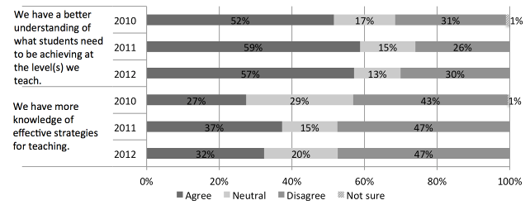
Just under two-thirds of teacher groups indicated that they believe they have a better understanding of what students need to be achieving at the level(s) they teach as a result of National Standards. This result was reasonably consistent over the implementation, rising slightly from 52% in 2010, to 57% in 2012. In comparison, up to one-third of teachers indicated that they believed they did not have a better understanding of what students need to be achieving as a result of National Standards (31% in 2010, 26% in 2011, and 30% in 2012). Principals’ perceptions are in line with teachers’ views. Forty-eight percent of principals in 2012 indicated that they agree teachers at their school have an increased understanding of what students need to be achieving as a result of National Standards, while 7% disagreed, and 45% indicated that teachers at their school already had a sound understanding.
Approximately one-third of teacher groups indicated that they have more knowledge of effective strategies for teaching as a result of National Standards. This proportion was reasonably consistent over the three years of implementation to date (27% in 2010, 37% in 2011, and 32% in 2012). Nearly half of the groups surveyed did not think that they had more knowledge of effective strategies for teaching as a result of the National Standards. Principals’ 2012 perceptions were similar to those of teachers, with 23% agreeing that teachers have an increased knowledge of effective teaching strategies, and 34% disagreeing. Forty-three percent of principals indicated that their teachers were already strong in this area.

Teachers are more systematic in their collection of evidence about students’ progress and increasingly use this to inform their teaching practice
Figure 46 presents evidence from the teachers’ survey about teachers collection and use of student achievement information from 2010 to 2012.
Figure 46: Teachers collection and use of students’ progress information
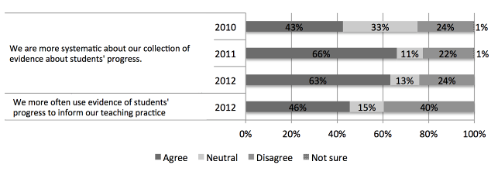
Survey responses suggest that teachers perceive the biggest change to their work as a result of National Standards is that they are now more systematic in collecting evidence of students’ progress. Forty-three percent of teachers agreed that they were more systematic in this regard in 2010, and this proportion rose to 63% in 2012. Approximately a quarter of teachers surveyed (24% in 2010, 22% in 2011, and 24% in 2012) disagreed that they had become more systematic about collecting evidence of student progress as a result of National Standards. Principals’ perceptions are slightly different to those of teachers. Thirty-eight percent of principals surveyed in 2012 indicated that teachers at their school had become more systematic in their collection of evidence of student progress, while 5% disagreed that this was the case. Fifty-seven percent of principals indicated that teachers at their schools had a systematic approach to data collection, prior to the implementation of National Standards.
Results indicate that teachers vary as to whether or not they agree that National Standards has resulted in an increasing use of student achievement information to inform teaching practice. Forty-six percent of teacher groups indicated that this was the case in 2012, while 40% disagreed.

Principals, Boards of Trustees and teachers understand the purpose of National Standards
The online surveys collected information about the understandings principals, teachers, and Board of Trustees Chairpersons have about the purpose of National Standards. Figure 47 shows results from 2012.
Figure 47: Principals’, teachers’, and Board of Trustees’ understanding of the purpose of National Standards
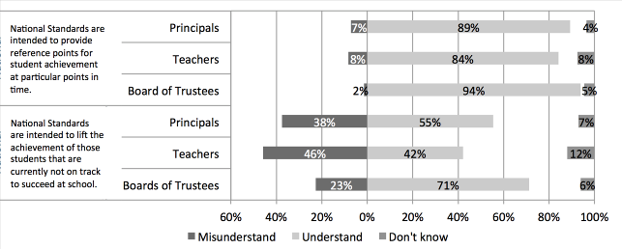
Results indicate that nearly all principals (89%), teachers (84%), and Board of Trustees Chairpersons (94%), understand that National Standards are intended to provide reference points for student achievement at particular points in time. However, the understanding that National Standards are focused on those that students are currently not on track to succeed appears more mixed. Seventy-one percent of Boards of Trustees Chairpersons indicated they understand that National Standards are intended to lift the achievement of those students that are currently not on track to success, compared to 55% of principals and 42% of teachers.

Principals, Boards and Trustees and teachers understand that National Standards are aligned to the New Zealand Curriculum
The online surveys asked principals and teachers to rate a variety of statements about the alignment of the National Standards with the New Zealand Curriculum as true or untrue, in order to ascertain their understanding of this alignment. Table 46 shows these results over the three years in implementation to date.
Table 46: Principals’ and teachers’ understanding of the alignment of National Standards with the New Zealand Curriculum, 2010 to 2012
Alignment | Year | Percentage that understand
Alignment | Year | Principals | Teachers
National Standards are intended to increase students’ access to the breadth of the New Zealand Curriculum. | 2010 | 26% | -
 | 2011 | 24% | 16%
 | 2012 | 30% | 16%
The Reading and Writing Standards do not focus exclusively on the skills and knowledge of classroom English programmes. | 2010 | 61% | -
 | 2011 | 70% | 54%
 | 2012 | 64% | 43%
The Reading and Writing Standards focus on students’ use of literacy skills across all the learning areas and key competencies of the New Zealand Curriculum. | 2010 | 70% | -
 | 2011 | 73% | 78%
 | 2012 | 73% | 66%
The Mathematics Standards are directly aligned to the mathematics and statistics learning area of the New Zealand Curriculum. | 2010 | 45% | -
 | 2011 | 54% | 59%
 | 2012 | 54% | 64%
The Mathematics Standards are not focused on students’ use of mathematical skills across all the learning areas and key competencies of the New Zealand Curriculum. | 2010 | 20% | -
 | 2011 | 38% | 22%
 | 2012 | 14% | 23%

Results indicate that in general, there have been no substantial changes in principals’ and teachers’ levels of understanding about the ways in which the National Standards are aligned with the New Zealand Curriculum from 2010 to 2012.
Overall it appears principals and teachers have a better understanding of the way in which the Reading and Writing Standards align with the New Zealand Curriculum, than the way in which the Mathematics Standards align. For example, 73% of principals understood that the Reading and Writing Standards are focused on students’ use of their literacy skills across all learning areas and key competencies of the New Zealand Curriculum in 2012, while 14% understood that the Mathematics Standards are not focused on students’ use of mathematical skills across the curriculum. While understanding of the alignment with the curriculum is higher for the Reading Standards and Writing Standards than it is for the Mathematics Standards, substantial proportions of teachers and principals do not understand this relationship. For example, 36% of principals in 2012 did not understand that the Reading and Writing Standards do not focus exclusively on classroom English programmes, while 57% of teachers did not understand this.
In general, understanding of the alignment of the Mathematics Standards with the New Zealand Curriculum appears low. For example, 14% of principals understood that the Mathematics Standards are not focused on students’ use of mathematical skills across the curriculum in 2012, while 23% of teachers understood this. Understanding that the Mathematics Standards are directly aligned with the New Zealand Curriculum was higher in comparison although still reasonably low, with 54% of principals and 64% of teachers understanding this is 2012.
Seventy-one percent of Board of Trustees Charipersons indicated that they understood National Standards are aligned to the New Zealand Curriculum in 2012. They were not questioned about their understanding of the details of this alignment.
Table 47 summarises the performance criteria in relation to developing teachers’ knowledge and understandings of National Standards and compares results from 2010 to 2012.
Table 47: Proportions of schools and teachers meeting performance criteria, 2010-2012
Performance criteria | Year
Schools use National Standards data to identify teachers’ professional development needs. | 2010 | 45%
 | 2011 | 50%
 | 2012 | 54%
Identified professional development needs are addressed by schools. | 2012 | 57% in reading  61% in writing  68% in mathematics
Teachers have an increased understanding of what students need to be achieving at the level(s) they teach. | 2010 | 52%
 | 2011 | 59%
 | 2012 | 57%
Teachers have increased knowledge of effective strategies for teaching. | 2010 | 27%
 | 2011 | 37%
 | 2012 | 32%
Teachers become more systematic in their collection of evidence about students’ progress. | 2010 | 43%
 | 2011 | 66%
 | 2012 | 63%

In summary, there is some evidence that principals are using information from National Standards to identify teachers’ professional development needs (54% in 2012), and that these are being addressed (up to 68% in 2012). Results suggest teachers have become increasingly systematic in their collection of evidence about student achievement from 2010 to 2012, with 63% of teacher groups surveyed in 2012 indicating that this was the case. More than half of the teacher groups surveyed indicated they have better understanding of what students need to be achieving at the level(s) they teach (57% in 2012), and approximately one-third of teacher groups noted they have an increased knowledge of effective strategies for teaching as a result of the National Standards (32% in 2012). Overall it appears principals and teachers have a better understanding of the way in which the Reading and Writing Standards align with the New Zealand Curriculum, than the way in which the Mathematics Standards align, with no substantial changes in this regard from 2010 to 2012.

Descriptive information
Principals were asked to indicate their staff’s overall level of need for professional development in reading, writing, and mathematics. Figure 48 shows these results and is based on the responses of 28 principals.
Figure 48: Principals’ perceptions of staff’s overall level of need for professional development
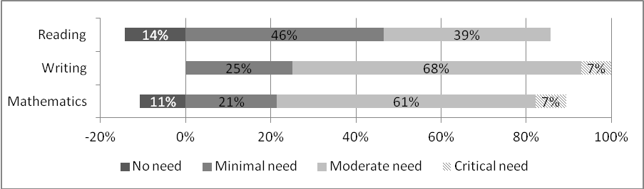
Overall, results suggest principals perceive teachers’ professional development needs to be greater in writing and mathematics than in reading. Sixty percent of principals described needs in reading as non-existent or minimal, while substantially smaller proportions described needs in writing (25%), and mathematics (32%) this way. Seven percent of principals noted there was a critical need for professional development in writing and mathematics, while no principals rated the professional development needs in reading at their school as critical.
Principals were also asked about the extent of the need for professional development in each area in 2012. Figure 49 shows these results and is based on the responses of 28 principals.
Figure 49: Principals’ perceptions of the extent of the need for professional development at their school
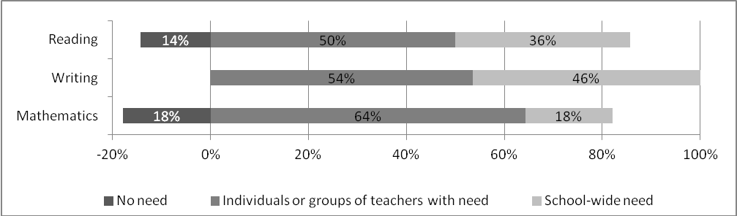
In all three areas, a larger proportion of principals described the professional development needs of their staff as within individuals or groups of teachers, rather than school-wide. For example, 50% of principals described group or individual professional development needs in reading, while 36% described a school-wide need for reading professional development. This difference appears largest in mathematics where 64% of principals described group or individual needs, and 18% described needs as school-wide.
Survey responses indicate that just fewer than two-thirds of principals (59%) and Board of Trustees Chairpersons (62%) regarded information from National Standards as moderately or very useful for identifying teachers’ professional development needs. Smaller proportions rated National Standards information as not useful for identifying professional development needs (20% of principals and 11% of Board of Trustees Chairpersons).
Responses in open comment fields indicate that some Board of Trustees Chairpersons felt they were able to identify teachers professional development needs before the introduction of National Standards, with 15% of comments suggesting this.
We were receiving all the info we required before National Standards.
We did this pre standard with no issues.
Groups of teachers were invited to comment on working with the National Standards, including their effect on their professional knowledge. Thirty-three groups of teachers chose to do so. One of the common themes in these comments was that teachers felt they already had a professional approach, prior to the introduction of National Standards. Seven percent of comments from teacher groups were of this nature.
I don't believe that National Standards have lifted teachers knowledge or performance. Teachers were already aware of the levels that students were working towards.
We feel that teachers, prior to the National Standards, had a professional approach to assessment for learning and were very aware of student needs and capabilities.
As a school we were already using stringent benchmarks and standards to inform parents and to assess student achievement. We were also reflective teachers prior to the implementation of National Standards.
Other common themes identified in teachers’ comments were a concern over the demotivation of students that are consistently rated ‘below’ the standards (5% of respondents), and a note that the intended effects of National Standards may differ from the effect they have had in practice (5% respondents).
…it puts off the students already not achieving who continually get below.
Students that are below care less about their learning than before.
While the National Standards' INTENTION is to raise standards, our previous system worked just as well.
It might be intended to but we do not believe national standards will achieve in lifting students achievement levels. It does not correspond with children's learning.
It is interesting to note that there has been a decrease in the proportion of teachers making generally negative comments about the standards. Thirty-one percent of teacher groups commented negatively when invited to comment on working with National Standards in 2011, and this proportion fell to 14% in 2012.

Teaching interventions
Using National Standards information to inform the provision of teaching interventions is central to the National Standards initiative. For student achievement to improve, quality teaching interventions must be delivered to those students that are currently not meeting the National Standards. Ministry of Education information emphasises that “Timely and targeted interventions will make the difference.”
This chapter uses evidence from surveys of principals, teachers, and Board of Trustees Chairpersons to investigate the ways in which National Standards data was used to inform teaching interventions in 2012. Table 48 shows the monitoring and evaluation questions and performance criteria that are the focus of this chapter.
Table 48: Monitoring and evaluation questions and criteria
Intended outcome: National Standards achievement information is used by teachers and schools to monitor student progress and achievement against the Curriculum. As a result of this, students requiring teaching interventions will be identified, and interventions will be provided.
Monitoring and  Evaluation Questions | Performance criteria | Sources of evidence
In what ways is information from National Standards used by schools to describe student achievement and progress? | Schools collate National Standards achievement data. | Surveys: principal, Board of Trustees chairperson, and teacher.
 | Schools systematically track the progress of individual students against the National Standards.
In what ways is information from National Standards used to provide targeted teaching interventions? | Students rated ‘below’ the standard receive targeted teaching interventions within the classroom programme. | Principal survey
 | Students rated ‘well below’ the standard receive targeted teaching interventions additional to the classroom programme. | Principal survey

Evaluative criteria

Schools collate National Standards achievement data.
The online survey asked principals about the extent to which their school collated 2012 National Standards achievement data. Figure 50 summarises these results for each of the three National Stadards areas.
Figure 50: Principals’ collation of 2012 OTJs
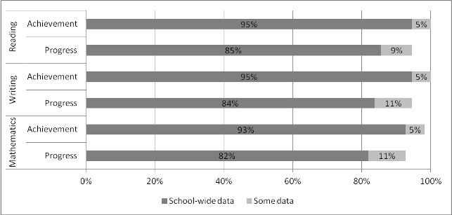
Nearly all principals collated school-wide National Standards data in 2012 to describe student achievement in reading (95%), writing (95%), and mathematics (93%). Principals were invited to describe the ways they had collated data and, and 14% chose to do so. The one common theme in these responses was that they are breaking it down using demographics (5%).
Broken down into gender, year groups, ethnicities and against our target
collation of school wide data, target groups information, year group collation
More than 80% of principals had collated school-wide National Standards data to describe students’ progress in reading (85%), writing (84%) and mathematics (82%). These principals can be considered to be using data effectively as can the small proportions that report collating progress data for some students (9% in reading, 11% in writing and mathematics). Where groups of students have been identified as having similar needs it is a reasonable approach to track their progress in groups.
Table 49 shows the results in relation to this criterion in 2011 and 2012.
Table 49: Proportions of schools meeting performance criterion in 2011 and 2012
Performance criterion | Year | Reading | Writing | Mathematics
Schools collate National Standards achievement data. | 2011 | 78% | 77% | 76%
Schools collate National Standards achievement data. | 2012 | 95% | 95% | 93%

As seen in Table 49 there was an increase in the proportions of principals that reported collating National Standards data to describe student progress and achievement from 2011 to 2012. For example, in reading, 78% of principals collated achievement data in 2011, and this increased to 95% in 2012. Similarly, 78% of principals collated progress data in 2011 and this rose to 94% in 2012. Results were very similar in both writing and mathematics.
Eighty-four percent of principals surveyed in 2012 believed that collated National Standards data provided a useful picture of student achievement in relation to the National Standards. Principals were invited to comment on this and 25% chose to do so. The one common theme in these responses was that National Standards data supplemented other data sources (9% of respondents).
Ongoing data collection and analysis of trends throughout the year had already provided a clear picture of achievement levels. National Standards data confirmed what the staff and BOT already knew.
I anticipate it will give useful information. We collated data of a similar nature prior to National Standards.
Just another view of what we already look at

Schools systematically track the progress of individual students against the National Standards.
Teachers were asked to identify the measures used to systematically track the progress of individual students from the end of 2011 to the end of 2012. Figure 51 shows these results for reading.
Figure 51: Measures used to systematically track students’ progress in reading from 2011 to 2012
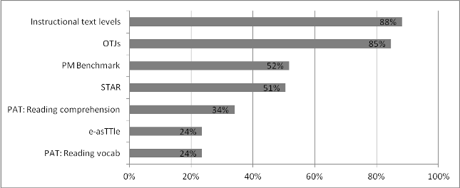
Eighty-five percent of teacher groups reported using OTJs to track the progress of individual students in reading from the end of 2011 to the end of 2012. Instructional text levels were also used by the majority of teacher groups to track students’ progress in reading (88%), and approximately half the teacher groups surveyed reporting using PM Benchmarks (52%) or STAR (51%) for this purpose. Twenty-nine percent of respondents reported using a measure other than those listed, and the one common theme in these responses was the Probe (9% of respondents).
The online survey invited teachers to describe how they used OTJs to track progress in reading and 29% of teacher groups did so. The two common themes in these responses were the use of a student management system to track progress (7% of respondents) and the use of cumulative individual student records such as portfolios or achievement graphs (7% of respondents).
Information is available on e-tap and in learning journals so teachers are informed of students’ progress and next learning steps.
On our student management system, MUSAC. We track data for children to look for progress, or lack thereof.
Twice a year we analyse our OTJ's and make recommendations for 'Next steps' for each student. Graphs are kept and used as comparisons for progress.
Looking at starting individual graphs to track student’s progress from one year to the next. Shows movement and time spent on each level. Also shows children who are below the standard. Visual.
Figure 52 shows the measures used to track the progress of individual students in writing from the end of 2011 to the end of 2012.
Figure 52: Measures used to systematically track students’ progress in writing from 2011 to 2012
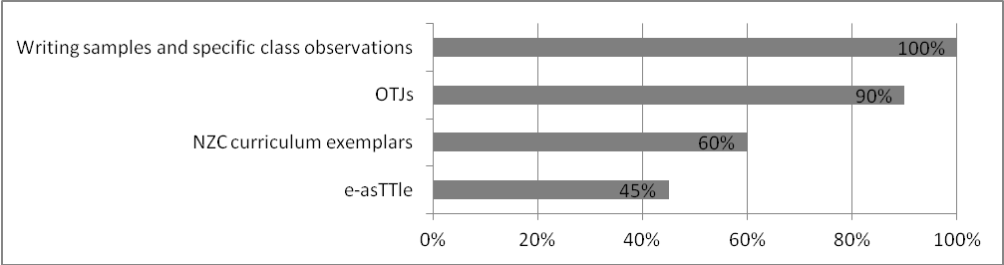
Most teachers (90%) used OTJs to track the progress of individual students in writing from the end of 2011 to the end of 2012. All teacher groups also reported using writing samples and specific class observations.
Forty percent of teachers described the way they used OTJs to track students’ progress in writing. The common themes in these descriptions were the use of a student management system to track students’ progress (15% of respondents) and the use of a cumulative record sheet or portfolio (15% of respondents).
School assessment data base, spreadsheets and comparisons of writing in student profiles
Student Management System, Student Achievement Books, Term by Term Writing Samples
A template for Year 7 and Year 8 students involving formal assessments (Mar.-Nov) as a guide of NS ie. PATs, e-asstle (writing, reading, maths), reading age (star/probe).
Figure 53 shows the measures used to track the progress of individual students in mathematics from the end of 2011 to the end of 2012.
Figure 53: Measures used to systematically track students’ progress in mathematics from 2011 to 2012
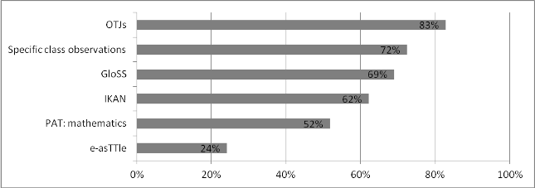
The majority of teacher groups (83%) reported using OTJs to track the progress of individual students in mathematics from the end of 2011 to the end of 2012. Most groups (72%) also reported using specific class observations to track students’ progress, while approximately two-thirds of teacher groups indicated they had used the numeracy assessments of GloSS (69%) and IKAN (62%) to track students’ progress in mathematics. Forty-one percent of respondents indicated they used measures other than those listed above and these included basic facts assessments (14%), JAM (10%), teacher-developed assessments in areas of the curriculum other than number (10%), and NumPA (7%).
Forty-eight percent of respondents described the way they used OTJs to track students’ progress in mathematics from the end of 2011 to the end of 2012. These results were very similar to those for reading and writing with respondents describing the use of their school’s student management system to collate data (7% of respondents). Ten percent of teacher groups also noted that they used data to identify groups of students for targeted support.
We set a school wide target group based on the OTJ results.
[We] have target students that we track closely.
Table 50 summarises results for this criterion in 2011 and 2012.
Table 50: Proportions of teachers meeting performance criterion in 2011 and 2012
Performance criterion | Year | Reading | Writing | Mathematics
Schools systematically track the progress of individual students against the National Standards. | 2011 | 84% | 88% | 86%
 | 2012 | 85% | 90% | 83%

Results indicate that very similar proportions of teachers tracked the progress of individual students in relation to the National Standards in 2011 and 2012. For example, 84% of teachers reported using OTJs to track progress in reading from the end of 2010 to the end of 2011, and 85% reported this to be the case for the following year.

Students rated ‘below’ the standard receive targeted teaching interventions within the classroom programme, and students rated ‘well below’ the standard receive targeted teaching interventions additional to the classroom programme.
Eighty-nine percent of principals noted that they used National Standards data to inform targeted teaching interventions in 2012. This included both targeted instruction within the classroom programme and instruction additional to the classroom programme. Table 51 summarises the nature of interventions provided for students rated ‘below’ and ‘well below’ the standards in reading, writing, and mathematics and is based on the responses of 46 principals.
Table 51: Nature of targeted teaching interventions provided
Area | Students’ rating in relation to National Standards | Teaching interventions
Area | Students’ rating in relation to National Standards | Within the classroom programme | In addition to the classroom programme | No targeted teaching interventions undertaken for these students
Reading | “Below’ | 71% | 60% | 4%
Reading | “Well below’ | 62% | 78% | 2%
Writing | “Below’ | 74% | 41% | 7%
Writing | “Well below’ | 67% | 53% | 4%
Mathematics | “Below’ | 73% | 45% | 5%
Mathematics | “Well below’ | 70% | 45% | 5%

Results suggest that approximately three-quarters of schools provided targeted teaching interventions for students that were rated ‘below’ the standards within the classroom programme (71% in reading, 74% in writing, and 73% in mathematics). Similarly, 78% of schools provided teaching interventions for students that were rated ‘well below’ the reading standards that were in addition to the classroom programme, while smaller proportions of schools provided targeted teaching interventions in writing (53%), and mathematics (45%) that were additional to the classroom programme.
Principals were asked to describe the nature of the teaching interventions put into place at their school, and identify those responsible for their delivery. Table 52 summarises these results in reading, writing and mathematics, both for interventions delivered within the classroom programme, and for those that were additional to it.
Table 52: Teaching interventions identified by principals
Nature of intervention | Percentage of principals
Nature of intervention | Within classroom programme |  |  | Additional to classroom programme
Nature of intervention | Reading | Writing | Mathematics | Reading | Writing | Mathematics
Additional teaching from qualified teacher | 11% | 13% | 11% | 72%^{i} | 57% ^{ii} | 35% ^{iii}
Teacher aide support | 33% | 32% | 28% | 33% | 20% | 20%
Focused in-class support (classroom teacher) | 43% | 48% | 54% | na | na | na
Additional teaching programmes | 0% | 2% | 4% | 15% | 2% | 7%
(i) includes 30% reading recovery
(ii) includes 9% reading recovery and 7% Accelerated Literacy Learning
(iii) includes 17% Accelerated Learning in Mathematics and 7% Mathematics Specialist Teachers
Approximately half of the principals described teaching interventions that occurred within the classroom programme in reading (43%), writing (48%), and mathematics (54%) as focused support from the students’ regular classroom teacher. These principals tended to describe grouping students to enable teachers to meet their needs more effectively, and this included cross grouping arrangements.
Differentiated learning within the classroom through group teaching. [reading]
Grouping the children according to their learning. Cross grouping to help manage the level of ability within a room. [reading]
Students are always grouped in ability groups, so they are targeted through them. [writing]
Needs based teaching that resulted in cross grouping and addition of extra teacher. [maths]
Approximately one-third of principals reported the use of teacher aides to support students within the classroom programme (33% in reading, 32% in writing, and 28% in mathematics). Most of these descriptions focused on teacher aides working directly with students, but small proportions (7% in reading, 4% in writing and mathematics) also described the use of teacher aides to supervise the rest of the class so the classroom teacher was available to teach target groups.
Teacher aides used to target specific needs under teacher direction. [reading]
Class teacher supporting at appropriate levels. Teacher aide providing 1 to 1 support. [writing]
A teacher aide was employed to supervise students so teachers could focus on groups. A teacher aide worked with senior students with special educational needs, supporting them to engage in the class programme. [mathematics]
The most common teaching intervention that was provided in addition to the classroom programme was support from a qualified teacher. Results suggest this varied across the three National Standards areas with 72% of schools noting students were withdrawn from the regular programme to work with a qualified teacher in reading, while this was the case for 57% of schools in writing and 35% in mathematics. Note that these interventions included: reading recovery in reading (30%); reading recovery (9%) and Accelerated Literacy Learning (7%) in writing; and Accelerated Learning in Mathematics (17%) and Mathematics Specialist Teachers (7%) in mathematics.
Employed a trained teacher Yr 3 - 6 area. Yr 1 - 2 Reading assistance programmes and Reading recovery increased. [reading]
Employed experienced teacher to meet needs of underachievers - skill development. [writing]
Teachers - target groups - specific strategies. Experienced teacher to work with targeted students from across classes - specific skills/strategies/knowledge gaps. [mathematics]
Up to one-third of schools reported employing teacher aides to work directly with students who had been withdrawn from the classroom programme in reading (33%), writing (20%), and mathematics (20%). Small proportions of schools (15% in reading, 2% in writing, 7% in mathematics) identified commercial learning programmes including Rainbow Reading and Lexia in reading, Quick-60 in writing, and Coddsbrics and Spring Maths in mathematics.
In summary, evidence suggests that the proportion of schools that collated National Standards data increased from 2011 to 2012 and that most schools tracked the progress of individual students in relation to the National Standards in these years. Results also indicate that most schools used National Standards data to inform targeted teaching interventions in 2012. When considering these results it needs to be remembered that the quality of teaching interventions, and the extent to which these were matched to students’ learning needs was not evaluated.

Descriptive information
The online survey asked principals to identify the tools they used to collate National Standards 2012 achievement data. Sixty-nine percent of principals noted that they used their school’s student management system to collate data, while 51% of principals indicated they used Excel or an alternative spread sheet programme. These results are almost identical to those from 2011.
Principals were invited to comment on using National Standards data to provide targeted teaching interventions and 35% of respondents chose to do so. The one common theme (noted by 15% of principals) was that similar information was available to inform the provision of teaching interventions prior to the introduction of National Standards.
National standards data not required to make these interventions. They provide no new insight, we were already able to identify and support these children prior to national standards and see these as an add on that adds very little value to teaching and learning.
We are able to target our students with other data. We don't need National Standards in order to be able to do this, as this has been the case for years.
The majority of Boards of Trustees Chairpersons (78%), principals (59%), and teachers (49%) regarded information from National Standards as moderately or very useful for identifying students for additional teaching support. In general, teachers regarded National Standards information as less useful for identifying students for additional teaching support than principals or Board of Trustees (29% of teacher groups rated it as not useful while 11% of principals and 6% of Board of Trustees Chairpersons did so).

National Standards achievement data
If National Standards are operating as intended, OTJs will provide a dependable assessment of student achievement, which can be reported to parents and Boards of Trustees. This student achievement information should, in turn, trigger teaching interventions for those students that are not meeting the standards, with a resultant rise in achievement. Given this, the success of the National Standards initiative, can be gauged by the extent to which student achievement increases as the implementation progresses.
This chapter presents OTJ data collected over the three years of implementation to date. Note that for students in years 1 to 3 the tables in this chapter include OTJs in relation to the after 1 year, after 2 years, and after 3 years standards. As a result of schools’ practices, some of these judgments were made at the end of the school year, and some were made during the year on the anniversary of school entry. For students in years 4 to 8, end-of-year OTJs in relation to the relevant year level standard are included. The monitoring and evaluation question and performance criteria addressed are shown in Table 53.
Table 53: Monitoring and evaluation question and criteria
Intended outcome: Student achievement will improve
Monitoring and  Evaluation Question | Performance criteria | Sources of evidence
What changes in student achievement in reading, writing, and mathematics, as indicated by OTJs, are observed as National Standards are introduced? | The proportions of students rated as ‘at’ or ‘above’ the National Standards increase. | National Standards achievement data
 | The proportions of Māori and Pasifika students rated as ‘at’ or ‘above’ the National Standards increase. | National Standards achievement data

It is important to note that it is teachers’ ratings of students’ achievement levels that are presented in this chapter, the teachers’ overall judgement of students performance relative to the National Standards. Because other evidence has raised concerns over the dependability of OTJs (see Chapter 5), it cannot be assumed that teachers’ ratings accurately represent student achievement relative to the standards. Given this, the data must be interpreted with caution.

OTJs in reading, writing, and mathematics - 2010 to 2012
Tables 54 to 56 summarise teachers’ ratings of student achievement in relation to the Reading, Writing, and Mathematics Standards from 2010 to 2012. Note that in all three tables n denotes the numbers of students for whom data is given by year level, school decile, and gender. Students’ OTJs by ethnicity are given as proportions of the number of students with that ethnicity classification, which is slightly larger than n because some students nominate more than one ethnicity.
Table 54: 2010 to 2012 Reading OTJs
Demographic variable |  | Percentages of students rated
 |  | Well below |  |  | Below |  |  | At or above
 |  | 2010 | 2011 | 2012 | 2010 | 2011 | 2012 | 2010 | 2011 | 2012
Year level | 1 | 10 | 5 | 4 | 30 | 29 | 29 | 60 | 66 | 67
Year level | 2 | 6 | 5 | 6 | 20 | 14 | 16 | 74 | 81 | 79
Year level | 3 | 6 | 5 | 5 | 15 | 13 | 11 | 80 | 82 | 84
Year level | 4 | 3 | 5 | 5 | 15 | 13 | 12 | 82 | 82 | 84
Year level | 5 | 6 | 5 | 7 | 17 | 16 | 16 | 77 | 79 | 77
Year level | 6 | 8 | 5 | 5 | 17 | 16 | 15 | 75 | 80 | 81
Year level | 7 | 12 | 13 | 7 | 23 | 23 | 19 | 65 | 64 | 74
Year level | 8 | 10 | 14 | 13 | 22 | 21 | 18 | 68 | 66 | 69
Ethnicity | Asian | 6 | 6 | 5 | 15 | 16 | 13 | 79 | 78 | 82
Ethnicity | European | 6 | 5 | 5 | 16 | 15 | 14 | 79 | 80 | 81
Ethnicity | Māori | 11 | 13 | 10 | 28 | 26 | 24 | 61 | 61 | 67
Ethnicity | Pasifika | 20 | 16 | 11 | 30 | 26 | 25 | 50 | 59 | 63
Ethnicity | Other | 6 | 10 | 8 | 20 | 23 | 20 | 75 | 67 | 72
School decile | 1-3 | 15 | 13 | 12 | 30 | 24 | 24 | 55 | 63 | 65
School decile | 4-7 | 8 | 10 | 8 | 20 | 20 | 18 | 72 | 70 | 74
School decile | 8-10 | 3 | 3 | 3 | 13 | 13 | 10 | 85 | 85 | 87
Gender | Male | 10 | 10 | 9 | 22 | 21 | 20 | 69 | 69 | 72
Gender | Female | 6 | 6 | 5 | 18 | 16 | 14 | 76 | 79 | 81
All |  | 8.0 | 8.0 | 6.9 | 19.7 | 18.3 | 16.8 | 72.3 | 73.7 | 76.3
n |  | 534 | 1,295 | 1,055 | 1,315 | 2,940 | 2,552 | 4,834 | 11,869 | 11,587
Table 55: 2010 to 2012 Writing OTJs
Demographic variable |  | Percentages of students rated
 |  | Well below |  |  | Below |  |  |  | At or above
 |  | 2010 | 2011 | 2012 |  | 2010 | 2011 | 2012 | 2010 | 2011 | 2012
Year level | 1 | 8 | 2 | 2 |  | 13 | 22 | 18 | 79 | 76 | 81
Year level | 2 | 3 | 3 | 4 |  | 22 | 17 | 18 | 76 | 80 | 78
Year level | 3 | 6 | 4 | 4 |  | 22 | 25 | 23 | 72 | 71 | 73
Year level | 4 | 3 | 7 | 6 |  | 19 | 20 | 21 | 78 | 73 | 73
Year level | 5 | 10 | 8 | 8 |  | 25 | 29 | 27 | 66 | 64 | 65
Year level | 6 | 13 | 8 | 7 |  | 26 | 25 | 23 | 61 | 68 | 70
Year level | 7 | 17 | 16 | 10 |  | 36 | 32 | 30 | 47 | 52 | 60
Year level | 8 | 12 | 16 | 18 |  | 37 | 30 | 25 | 52 | 54 | 57
Ethnicity | Asian | 7 | 6 | 5 |  | 19 | 20 | 17 | 74 | 74 | 78
Ethnicity | European | 9 | 6 | 7 |  | 23 | 23 | 21 | 68 | 71 | 72
Ethnicity | Māori | 11 | 14 | 12 |  | 34 | 33 | 30 | 55 | 52 | 58
Ethnicity | Pasifika | 14 | 16 | 13 |  | 39 | 32 | 30 | 48 | 53 | 57
Ethnicity | Other | 9 | 13 | 9 |  | 28 | 30 | 28 | 63 | 58 | 63
School decile | 1-3 | 12 | 13 | 13 |  | 36 | 32 | 30 | 52 | 55 | 57
School decile | 4-7 | 12 | 12 | 10 |  | 28 | 28 | 24 | 60 | 60 | 66
School decile | 8-10 | 5 | 4 | 4 |  | 18 | 19 | 19 | 77 | 78 | 78
Gender | Male | 13 | 12 | 11 |  | 30 | 31 | 28 | 57 | 57 | 61
Gender | Female | 6 | 6 | 6 |  | 24 | 21 | 19 | 71 | 72 | 75
All |  | 9.8 | 9.2 | 8.6 |  | 26.4 | 25.8 | 23.6 | 63.8 | 65.0 | 67.8
n |  | 656 | 1,468 | 1,308 |  | 1,769 | 4,113 | 3,605 | 4,278 | 10,348 | 10,361
Table 56: 2010 to 2012 Mathematics OTJs
Demographic variables |  | Percentages of students rated
 |  | Well below |  |  | Below |  |  | At or above
 |  | 2010 | 2011 | 2012 | 2010 | 2011 | 2012 | 2010 | 2011 | 2012
Year level | 1 | 7 | 1 | 2 | 9 | 14 | 10 | 84 | 84 | 88
Year level | 2 | 4 | 4 | 3 | 22 | 18 | 18 | 75 | 78 | 79
Year level | 3 | 4 | 4 | 4 | 33 | 27 | 23 | 63 | 70 | 73
Year level | 4 | 5 | 5 | 5 | 20 | 20 | 17 | 76 | 75 | 78
Year level | 5 | 8 | 7 | 7 | 21 | 26 | 23 | 71 | 67 | 70
Year level | 6 | 8 | 6 | 6 | 25 | 23 | 20 | 67 | 71 | 74
Year level | 7 | 12 | 15 | 8 | 38 | 32 | 28 | 51 | 53 | 64
Year level | 8 | 12 | 14 | 18 | 33 | 31 | 25 | 56 | 56 | 57
Ethnicity | Asian | 5 | 4 | 3 | 13 | 16 | 15 | 82 | 81 | 83
Ethnicity | European | 7 | 6 | 6 | 24 | 23 | 19 | 70 | 72 | 75
Ethnicity | Māori | 10 | 13 | 12 | 34 | 33 | 28 | 56 | 54 | 61
Ethnicity | Pasifika | 15 | 15 | 11 | 39 | 32 | 30 | 46 | 53 | 59
Ethnicity | Other | 6 | 10 | 9 | 26 | 26 | 25 | 69 | 65 | 66
School decile | 1-3 | 12 | 12 | 12 | 37 | 31 | 28 | 52 | 57 | 61
School decile | 4-7 | 9 | 11 | 9 | 29 | 28 | 24 | 63 | 62 | 67
School decile | 8-10 | 5 | 3 | 3 | 16 | 17 | 14 | 80 | 80 | 83
Gender | Male | 9 | 9 | 9 | 26 | 24 | 22 | 65 | 67 | 69
Gender | Female | 7 | 7 | 7 | 26 | 26 | 21 | 66 | 67 | 72
All |  | 7.9 | 8.2 | 7.8 | 26.2 | 25.0 | 21.5 | 65.9 | 66.8 | 70.8
n |  | 535 | 1,310 | 1,183 | 1,769 | 3,977 | 3,266 | 4,445 | 10,628 | 10,769
Over the three years since the introduction of National Standards there have been small increases in the proportions of students rated ‘at’ or ‘above’ the standards in all three areas. The proportions of students rated as ‘at’ or ‘above’ the Reading Standards rose from 72% in 2010, to 74% in 2011, to 76% in 2012. Similar increases were seen in students’ ratings in relation to the Writing Standards (64% in 2010, 65% in 2011, 68% in 2012) and the Mathematics Standards (66% in 2010, 67% in 2011, 71% in 2012).
There have been substantial increases in the proportions of students rated ‘at’ or ‘above’ the standards from 2010 to 2012 for several demographic sub-groups of students. These include Pasifika students and Year 7 students in reading writing, and mathematics, and students at low decile schools in reading and mathematics. For example the proportions of Pasifika students rated as ‘at’ or ‘above’ the Reading Standards increased from 50% in 2010, to 59% in 2011, to 63% in 2012. Similarly, the proportion of students at low decile schools rated ‘at’ or ‘above’ the Mathematics Standards rose from 52% in 2010, to 57% in 2011, to 61% in 2012.
While these increases in the proportions of some groups of students rated as ‘at’ or ‘above’ the standards are substantial, it must be remembered that the data reflect patterns in teachers’ ratings of students’ achievement. Given that other evidence suggests these ratings may not be dependable (see Chapter 5) the data cannot be taken as evidence that student achievement is improving over time.

2012 OTJs in reading, writing, and mathematics
Students’ OTJs were collected for a sample of 15,329 students in 2012. In general, these data are very similar to those collected in both 2010 and 2011.

2012 Reading OTJs
Tables 57 to 60 show the 2012 reading OTJs of all students in the sample by year level, gender, ethnicity and school decile.
Table 57: Reading OTJs by year level
Year Level | n | Percentages of students rated
Year Level | n | Well Below | Below | At | Above
1 | 1,408 | 4 | 28.8 | 44.0 | 23.2
2 | 1,647 | 5.5 | 15.9 | 37.6 | 40.9
3 | 1,651 | 5.1 | 10.8 | 39.2 | 44.8
4 | 1,683 | 4.7 | 11.6 | 44.3 | 39.5
5 | 1,548 | 6.8 | 15.8 | 43.3 | 34
6 | 1,665 | 4.5 | 14.5 | 47.2 | 33.8
7 | 2,788 | 7 | 18.7 | 40.2 | 34.1
8 | 2,804 | 13.1 | 18 | 35.7 | 33.3

Table 58: Reading OTJs by gender
Gender | n | Percentages of students rated
Gender | n | Well Below | Below | At | Above
Male | 7,533 | 8.7 | 19.5 | 40.7 | 31.1
Female | 7,661 | 5.2 | 14.1 | 41.1 | 39.6

Table 59: Reading OTJs by ethnicity
Ethnicity | n | Percentages of ethnic classifications rated
Ethnicity | n | Well Below | Below | At | Above
Asian | 1,646 | 5.1 | 13 | 40.6 | 41.3
NZ European | 9,988 | 5.1 | 13.5 | 40.8 | 40.5
NZ Māori | 3,291 | 9.7 | 23.8 | 43.9 | 22.6
Pasifika | 1,745 | 11.4 | 25.2 | 39.7 | 23.7
Other | 395 | 7.8 | 20 | 41.5 | 30.6

Table 60: Reading OTJs by school decile
Decile band | n | Percentages of students rated
Decile band | n | Well Below | Below | At | Above
1-3 | 3,432 | 11.7 | 23.7 | 43.7 | 20.8
4-7 | 6,678 | 7.6 | 18.4 | 41.3 | 32.8
8-10 | 5,084 | 2.9 | 10 | 38.4 | 48.7

Greater proportions of female students (81%) were rated ‘at’ or ‘above’ the Reading Standards than male students (72%). In terms of ethnicity, similar proportions of Asian and European students were rated ‘at’ or ‘above’ the standards (82% and 81% respectively), with smaller proportions of Māori students (67%), and Pasifika students (63%) rated this way. Students at high decile schools had the highest proportion rated ‘at’ or ‘above’ the standards (87%), followed by students at medium decile schools (74%), then students at low decile schools (65%).

2012 Writing OTJs
Tables 61 to 64 present students’ 2012 writing OTJs. Summaries are provided by year level, gender, ethnity and school decile.
Table 61: Writing OTJs by year level
Year Level | n | Percentages of students rated
Year Level | n | Well Below | Below | At | Above
1 | 1,461 | 2.1 | 17.5 | 66.7 | 13.8
2 | 1,663 | 3.7 | 17.9 | 63.8 | 14.6
3 | 1,670 | 4.4 | 22.6 | 55.6 | 17.4
4 | 1,680 | 6.3 | 20.9 | 51.5 | 21.3
5 | 1,547 | 8 | 26.9 | 45.1 | 20.1
6 | 1,665 | 6.8 | 22.9 | 51.5 | 18.7
7 | 2,786 | 10.4 | 29.6 | 40.8 | 19.1
8 | 2,802 | 18.2 | 25.1 | 36.7 | 20

Table 62: Writing OTJs by gender
Gender | n | Percentages of students rated
Gender | n | Well Below | Below | At | Above
Male | 7,569 | 11 | 28.3 | 47.4 | 13.3
Female | 7,705 | 6.1 | 19 | 51.5 | 23.4

Table 63: Writing OTJs by ethnicity
Ethnicity | n | Percentages of ethnic classifications rated
Ethnicity | n | Well Below | Below | At | Above
Asian | 1,647 | 5 | 17.1 | 51 | 26.9
NZ European | 10,063 | 6.9 | 21.1 | 51.7 | 20.4
NZ Māori | 3,309 | 12 | 30.2 | 47 | 10.8
Pasifika | 1,756 | 12.6 | 30 | 44 | 13.4
Other | 396 | 8.8 | 27.8 | 48.5 | 14.9

Table 64: Writing OTJs by school decile
Decile band | n | Percentages of students rated
Decile band | n | Well Below | Below | At | Above
1-3 | 3,431 | 13.1 | 29.7 | 46.6 | 10.6
4-7 | 6,688 | 9.8 | 24.4 | 46 | 19.8
8-10 | 5,155 | 3.9 | 18.5 | 55.9 | 21.7

In general, the proportions of students rated ‘at’ or ‘above’ the standards were greater at earlier year levels than at later ones. Larger proportions of female students (75%) were rated ‘at’ or ‘above’ the standards than male students (61%), and larger proportions of students at high decile schools were rated ‘at’ or ‘above’ the standards (78%) than students at medium (66%) or low decile (57%) schools. In terms of ethnicity, larger proportions of Asian students (78%) were rated ‘at’ or ‘above’ the standards than European students (72%), while Māori and Pasifika students had similar proportions of students rated ‘at’ or ‘above‘ the standards (58% and 57% respectively).

2012 Mathematics OTJs
Tables 65 to 68 show students’ 2012 mathematics OTJs. As in reading and writing, summaries are provided by year level, gender, ethnicity, and school decile.
Table 65: Mathematics OTJs by year level
Year Level | n | Percentages of students rated
Year Level | n | Well Below | Below | At | Above
1 | 1,421 | 1.7 | 9.9 | 68.3 | 20.1
2 | 1,657 | 2.8 | 18.2 | 62.2 | 16.8
3 | 1,661 | 4.3 | 23 | 54.8 | 17.9
4 | 1,681 | 5 | 16.7 | 51.9 | 26.5
5 | 1,545 | 6.9 | 22.8 | 48.7 | 21.6
6 | 1,664 | 6.4 | 19.8 | 48.7 | 25.1
7 | 2,783 | 8.4 | 27.9 | 40.7 | 22.9
8 | 2,806 | 18.1 | 25.1 | 34.1 | 22.7

Table 66: Mathematics OTJs by gender
Gender | n | Percentages of students rated
Gender | n | Well Below | Below | At | Above
Male | 7,542 | 8.9 | 21.8 | 46.5 | 22.8
Female | 7,676 | 6.6 | 21.2 | 51.3 | 21

Table 67: Mathematics OTJs by ethnicity
Ethnicity | n | Percentages of ethnic classifications rated
Ethnicity | n | Well Below | Below | At | Above
Asian | 1,647 | 3 | 14.5 | 47.2 | 35.3
NZ European | 9,998 | 6.4 | 18.9 | 50.5 | 24.2
NZ Māori | 3,302 | 11.5 | 27.8 | 48.1 | 12.6
Pasifika | 1,760 | 10.5 | 30.2 | 48.4 | 10.9
Other | 397 | 9.1 | 24.9 | 46.3 | 19.6

Table 68: Mathematics OTJs by school decile
Decile band | n | Percentages of students rated
Decile band | n | Well Below | Below | At | Above
1-3 | 3,439 | 11.6 | 27.5 | 48.9 | 11.9
4-7 | 6,693 | 9.4 | 24 | 45.4 | 21.2
8-10 | 5,086 | 3 | 14.1 | 53.5 | 29.5

In general, the proportions of students rated ‘at’ or ‘above’ the standards were greater at earlier year levels than at later ones. For example, 88% of students were rated ‘at’ or ‘above’ the after one year standard, while 57% of student were rated ‘at’ or ‘above’ the end of year 8 standard. Larger proportions of female students (72%) were rated ‘at’ or ‘above’ than male students (69%), and larger proportions of students at high decile schools (83%), were rated ‘at’ or ‘above’ than students at medium (67%), or low decile schools (61%). With regard to ethnicity, higher proportions of Asian students (83%) were rated ‘at’ or ‘above’ the standards than European students (75%), Māori students (61%) or Pasifika students (59%).

Comment on students’ 2012 OTJs in reading, writing, and mathematics
In general the student data collected in 2012 are very consistent with data collected in 2010 and 2011. This consistency is expected, as any systematic effects are likely to be constant over time, and all three datasets are large enough for random errors to cancel.
As with data from previous years, the 2012 OTJs data reflect the demographic patterns that would be expected given other evidence about student achievement in New Zealand. The achievement of students at high decile schools is rated more highly than the achievement of students at medium decile schools, which is in turn rated more highly the achievement of students at low decile schools. The achievement of female students tends to be rated more highly than the achievement of male students, particularly in reading and writing. With regard to ethnicity, the achievement of Asian and European students is rated more highly than the achievement of either Māori or Pasifika students. While the overall trend is for smaller proportions of students to be rated ‘at’ or ‘above’ the standards as students’ year level increases, the results in writing and mathematics are more consistent in this regard than those in reading (Tables 57, 61, and 65 contain these comparisons).
Information presented in Chapter 5 raises concerns about the dependability of OTJs. Students’ OTJs show considerable variability over time, a substantial component of which may reflect inconsistency in the OTJs themselves. As discussed in Chapter 5, the concerns about consistency do not mean that the OTJs of all or even most students are inaccurate. A proportion of OTJs will accurately represent students’ achievement; however, there is no way to ascertain the size of this proportion or which individual OTJs are accurate. It is also likely that some of the inconsistency in teachers’ ratings is a result of the relatively broad nature of the National Standards scale.
Given the concerns over the consistency of OTJs, the 2012 OTJ data must be interpreted with caution. It also needs to be noted that there is a possibility that there is some form of systematic bias is in teachers’ ratings. For example, if teachers are making OTJs by comparing the achievement of students in their class, then teachers at low decile schools might tend to judge students more generously than teachers at high decile schools. Any systematic biases such as this will remain in aggregated data.

Other information
This chapter presents information about the proportions of schools meeting their legal obligation with respect to the National Standards from 2010 to 2012, and principals’ perceptions of the support provided by the Ministry of Education. Principals’ and Boards of Trustees’ perspectives on the National Standards and their possible unintended consequences are also described.

Legal requirements
Evidence from surveys of principals suggests that 83% of schools met the legal requirement to assess students’ achievement in relation to the National Standards in 2010. This proportion rose over the three initial years of implementation, to 96% in 2011, and 100% in 2012.
Eighty-two percent of principals indicated that their school had included National Standards student achievement targets in their 2011 charter for at least one National Standards area. These schools were meeting the requirement to “include targets for student achievement in relation to the National Standards in their 2011 charters.” The proportion of schools meeting this requirement rose to 89% in 2012.
Table 69 summarises information collected in 2012 about the proportions of schools reporting National Standards progress and achievement information to their Board of Trustees.
Table 69: Principals’ reporting of progress and achievement information to Boards of Trustees
Information | Reported in 2012 | Planned for 2013 | No plan for this yet
Reading achievement reported | 95% | 5% | 0%
Reading progress reported | 81% | 19% | 0%
Writing achievement reported | 91% | 7% | 2%
Writing progress reported | 75% | 21% | 4%
Mathematics achievement reported | 91% | 9% | 0%
Mathematics progress reported | 74% | 25% | 2%

Seventy-two percent of schools reported progress and achievement information in all three National Standards areas in 2012 and are meeting the legal requirement outlined in NAG 2A which requires schools to “use National Standards to report school-level data in the board’s [2012] annual report on National Standards” and specifies that this needs to include “how students are progressing against the standards as well as how well they are achieving.” Evidence suggests that 95% of schools plan to meet this requirement in 2013.

Support provided
Principals were asked to indicate how well supported by the Ministry of Education they felt in a variety of areas. This included support through advisors, published material, online information and resources. Results from 2012 are shown in Table 70 along with results from the previous two years.
Table 70: Principals’ perceptions of the level of support provided by the Ministry of Education
Focus of support | Year | Unsupported | Minimally supported | Moderately supported | Well supported
Making OTJs | 2010 | 21% | 51% | 20% | 9%
Making OTJs | 2011 | 15% | 38% | 39% | 8%
Making OTJs | 2012 | 16% | 44% | 39% | 2%
Moderating OTJs | 2010 | 35% | 42% | 17% | 6%
Moderating OTJs | 2011 | 22% | 42% | 31% | 5%
Moderating OTJs | 2012 | 26% | 44% | 28% | 2%
Reporting to families/whānau | 2010 | 13% | 49% | 21% | 17%
Reporting to families/whānau | 2011 | 12% | 28% | 49% | 11%
Reporting to families/whānau | 2012 | 14% | 35% | 42% | 9%
Reporting to students | 2010 | 21% | 56% | 14% | 9%
Reporting to students | 2011 | 15% | 43% | 38% | 4%
Reporting to students | 2012 | 19% | 40% | 37% | 4%
Setting student achievement targets relative to National Standards | 2010 | 30% | 42% | 20% | 9%
 | 2011 | 10% | 43% | 42% | 5%
 | 2012 | 12% | 44% | 37% | 7%
Reporting National Standards achievement to the Board | 2010 | 27% | 49% | 18% | 6%
Reporting National Standards achievement to the Board | 2011 | 10% | 43% | 41% | 7%
Reporting National Standards achievement to the Board | 2012 | 14% | 44% | 37% | 5%
Reporting National Standards achievement to the Ministry | 2010 | 31% | 49% | 14% | 6%
Reporting National Standards achievement to the Ministry | 2011 | 15% | 46% | 35% | 4%
Reporting National Standards achievement to the Ministry | 2012 | 11% | 44% | 39% | 7%
Using information from National Standards to identify students for targeted teaching interventions | 2010 | 28% | 47% | 16% | 10%
 | 2011 | 16% | 51% | 28% | 4%
 | 2012 | 12% | 49% | 33% | 5%
Using information from National Standards to identify teachers' professional development needs | 2010 | 34% | 44% | 14% | 9%
 | 2011 | 23% | 45% | 30% | 3%
 | 2012 | 16% | 56% | 23% | 5%

In general, the numbers of principals reporting feeling moderately or well supported increased from 2010 to 2012 The largest increases in support were in reporting National Standards achievement to the Ministry (from 20% in 2010 to 46% in 2012) and reporting National Standards achievement to the Board (from 24% in 2010 to 42% in 2012). There have been commensurate decreases in proportions of principals describing themselves as unsupported by the Ministry of Education. For example, the proportion of principals that described themselves as unsupported to make OTJs fell from 21% in 2010 to 16% in 2010, while the proportion describing themselves as unsupported to moderate OTJs fell from 35% to 26% in this time.
While principals reported that they felt better supported by the Ministry of Education in 2012 than they did in 2010, the majority of principals still rated themselves as unsupported or minimally supported in most of the areas listed above. For example, most principals described themselves as unsupported or minimally supported to make (60%) and moderate OTJs (70%) in 2012. Overall, principals described themselves as most supported to report to families and whānau, with 51% describing themselves as moderately or well supported in this area in 2012.
Principals reported receiving support to implement the National Standards from a variety of sources in 2012. These included Ministry of Education contracted PLD providers (32%) and private consultants (26%). Nine percent of principals indicated they had received support from other sources and these included working with a Student Achievement Advisor as part of the Student Achievement Function, collaboration with other schools in a learning and change network cluster, and assistance from Resource Teachers of Learning and Behaviour. Fifty-one percent of principals noted that they had not received any support to implement the National Standards in 2012.
Principals were invited to comment about the implementation of National Standards or the support received in 2012 and 26% chose to do so. The nature of these comments varied widely, although 37% of respondents commented negatively about the implementation or the support available. No positive comments were noted.
There appears to have been little or no MOE support at a local level. Advisors seem very difficult to access, especially if the schools data is fairly good.
There is a lot of information on line but little resource to deliver with staff and difficult to access in a user friendly way.
As with PD in general the Ministry’s support systems are hopeless.
Find individual PD hard to find and believe this is essential to teachers.
Board of Trustees Chairpersons were also asked to identify the training and support received by the Board to assist them to implement the National Standards in 2012. The majority of respondents (79%) noted that they had read material from the New Zealand School Trustees Association (NZSTA), while smaller proportions had worked with Ministry of Education Board of Trustees training providers (29%) or participated in webinars (21%). Six percent of Board of Trustees Chairpersons noted that the Board had received support from the school’s principal, while 6% also indicated they had received no support to implement the standards in 2012.

Boards’ and principals’ perspectives
Principals were questioned about their level of concern over four possible unintended consequences of National Standards. Figure 54 summarises these results from 2010 to 2012.
Figure 54: Principals’ levels of concern over the unintended consequences of National Standards, 2010 to 2012
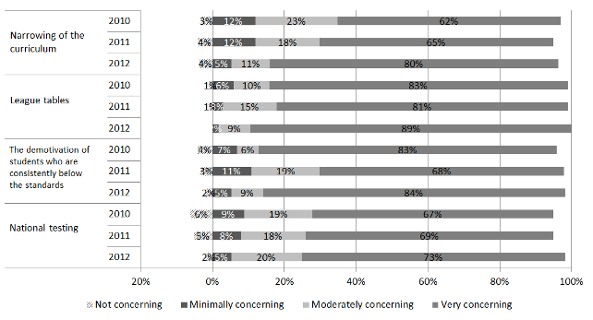
Evidence suggests that there is a high level of concern among principals about the unintended consequences of National Standards. More than 90% of principals described themselves as moderately or very concerned about each of the four unintended consequences in 2012. Results also indicate that levels of concern among principals have grown over time, with higher proportions of principals describing themselves as ‘very concerned’ in 2012 than in 2010, for all of the four consequences listed above. In particular, concern over the narrowing of the curriculum has grown, with 62% of principals describing themselves as very concerned in 2010, and 80% describing themselves this way in 2012.
In 2012 principals were also questioned about how likely they thought each of these consequences were. In general, principals regarded each of these consequences as likely, as well as concerning. Results indicate that principals believe the most likely unintended consequence is league tables, with 89% of principals rating this very likely, although substantial proportions of principals rated each of the unintended consequences as very likely. Sixty-six percent of principals rated the narrowing of the curriculum as very likely, 61% rated the demotivation of students consistently below the standards as very likely, and 55% rated national testing as very likely. Small proportions of principals rated each of the unintended consequences as unlikely or very unlikely. Seven percent of principals rated narrowing of the curriculum and demotivation of students that are consistently below the standards as unlikely or very unlikely, while 5% rated national testing this way. No principals rated league tables as unlikely or very unilkely.
In 2012 Board of Trustees Chairpersons were also asked to rate their level of concern over each of the four unintended consequences of National Standards listed above. In general Boards appeared to be substantially less concerned about all four issues than principals, which is consistent with 2011 results. To illustrate, the proportions of principals rating each of the unintended consequences as very concerning in 2012 ranged from 73% (for national testing) to 89% (for league tables), while for Boards the proportions rating each of the issues as very concerning ranged from 30% (for national testing) to 58% (for league tables).
Board of Trustees Chairpersons also rated each of the unintended consequences as less likely than principals in 2012. For example the proportions of principals rating each of the unintended consequences as very likely ranged from likely ranged from 55% (for national testing) to 89% (for league tables), while for Boards it ranged from 26% (for national testing) to 61% (for league tables).
Principals were questioned about the extent to which they thought low achievement was currently an issue, both within their own school and within NZ more generally. Figures 55 and 56 present results collected from 2010 to 2012.
Figure 55: Extent to which principals’ perceive low student achievement to be an issue in New Zealand
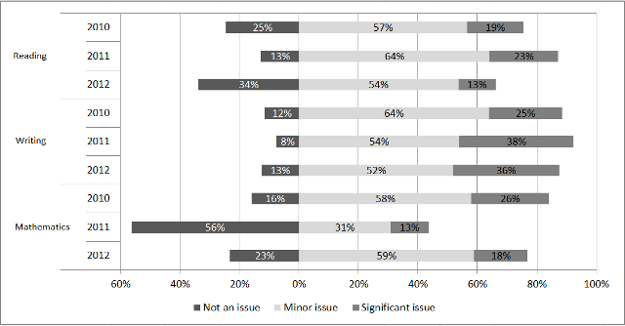
Figure 56: Extent to which principals perceive low student achievement to be an issue in their own school.
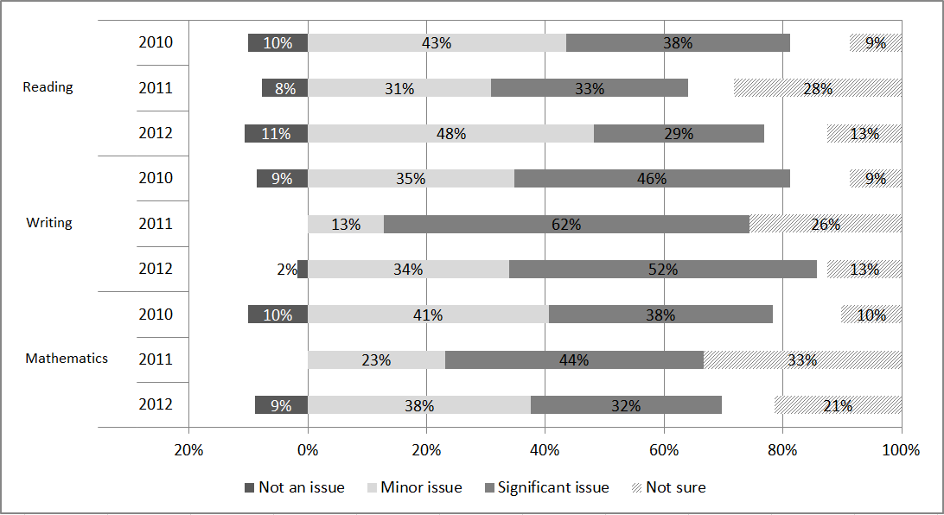
Note that no principals indicated they were ‘not’ sure’ whether low student achievement was as issue in their school, in any area, or in any year.
Principals perceived low student achievement to be a more significant issue in New Zealand overall than in their own school. This was the case in all three National Standards areas and over all three years of the implementation to date. For example, 13% of principals indicated they thought low student achievement in reading was a significant issue in their own school in 2012, while 29% indicated they thought it was a significant issue in New Zealand generally. 2011 results in mathematics were the most extreme example of this pattern, with 67% of principals indicating they thought low student achievement was an issue nationally, and 44% describing it as an issue in their school.
In nearly all areas there were small decreases in the extent to which principals’ perceived low achievement to be an issue from 2010 to 2012, both in their own school and in New Zealand. For example, 19% of principals perceived low student achievement in reading to be a significant issue in their own school in 2010, and this fell to 13% in 2012. Similarly, 38% of principals rated low student achievement in reading as a significant issue in New Zealand and this fell to 29% in 2012.
Principals were invited to comment on the National Standards in general, and 19% of respondents chose to do so. These comments were very wide-ranging, with 14% of respondents commenting negatively on some aspect of the standards and 2% commenting positively. Examples of negative comments include:
After two years of trialling NS and working to understand them we still have no faith that they support and improve students’ learning. As a school we really object to labelling our students, particularly new entrants, We comply with NS expectations but it is a ‘tick the box' only and we have no whole school buy in.
They are time consuming and of dubious value.
To bench-mark our NZ Curriculum was a logical next step. However the implementation of National Standards in its present form is counter productive in supporting the breadth and richness of the NZC. Schools that have a high level of integrity around their data even when it's not ideal run the risk of being severely 'punished' with a reduction of enrolments.
In comparison, 58% of principals that responded commented negatively about the National Standards in general in 2011, while 4% commented positively.
Nearly all Board of Trustees Chairpersons surveyed (99%) indicated that they had received reports about students’ progress and achievement relative to the National Standards in 2012. Most also indicated that they believed the reports received by the board provided a useful picture of student achievement in relation to the National Standards in reading (94%), writing (94%), and mathematics (92%) in 2012. They also believed that they provided a useful picture of student progress from the end of 2011 to the end of 2012 (89% in all three areas).
Board of Trustees Chairpersons were invited to comment on the progress and achievement reports their Board had received, and 36% of respondents chose to do so. There were three common themes in these comments: a general description of the information received (6% of respondents), a preference for measures other than National Standards to describe students’ progress and achievement (6% of respondents), and expressions of confidence in the capability of the staff and management at their school (5% of respondents). These themes are illustrated below.
The reports provided evidence of the ages, ethnicity and gender of where our students were in regards to the National Standards.
Our principal showed us a breakdown of student achievement across all year levels at mid term, which was broken into cohorts to display gender and ethnicity, and target groups that needed additional support.
Other than meeting our NAG obligations the nat stds did not give us the kind of detailed information/data that the other reports from the management team provide.
We already had perfectly adequate reporting on student achievement before being forced to adopt so called National Standards. The OTJ used in their assessment means that this is in fact an unquantifiable measure in our view.
Extremely well implemented by School management and ongoing updated.
The reporting model used by Management at our School is always up to the minute, a working document and very easy to understand for all BOT members
Boards of Trustees appear to be very confident that schools are effectively implementing National Standards, with 95% of Board of Trustees Chairpersons describing themselves as moderately or very confident in this regard.
When questioned about whether they had used the National Standards progress and achievement information they had received in 2012, 58% of Boards indicated they had taken some action, 23% noted they are planning to take some action, while 20% had nothing planned at the time they responded to the survey. These results are very similar to those from 2011. The survey also asked Board of Trustees Chairpersons to describe any actions that had been taken or were planned as a result of receiving National Standards progress and achievement information, and 78% of respondents did so. Actions identified included planning for teaching interventions (30% of respondents), identifying groups of students for targeted teaching interventions (24% of respondents), making plans for teachers’ professional development (12% of respondents), and allocating budgets (6% of respondents). The following comments illustrate these themes.
Encouraged the Principal to put targeted teaching in place for some students that need it. We've also engaged some external providers of professional development.
It has helped us see groups of students that the staff have identified as needing extra support. Because we are a smaller school we have used targeted teacher aide hours to provide extra support alongside focussed teaching strategies in the relevant areas.
Learners identified as lower than expected on the standards have been targeted for additional support, and through this these cohorts have made significant advances over the past year.
It has enabled us to identify the correct groups of students that need to be targeted for extra help
Some targets for 2013 will be based on National Standards data for 2012.
We will use the data to set targets for 2013, and make decisions around where/what emphasis we need to put into each curriculum area. The data will also help us budget for next year particularly with teacher professional development.
Board of Trustees Chairpersons were invited to comment on the National Standards and 42% chose to do so. Themes were very wide-ranging, with 15% of respondents commenting negatively on some aspect of the National Standards and 3% commenting positively. The negative comments received are illustrated below.
I think our teaching staff and Principal are managing the implementation absolutely as well as can be expected of any school, given the hurried implementation, the lack of consultation with the profession, the lack of professional development available for teachers, the fact that the MoE has been sprinting to try and catch up with the policy roll out, and the general messiness and lack of clarity of the roll out.
Yes, we are doing what we are told to, but the situation is hopelessly wrong for us. Implementing them certainly doesn't mean we agree with them.
In comparison, 21% of Boards’ comments about the National Standards were generally negative in 2011, while 5% were generally positive.
Six percent of respondents expressed confidence in the capability and commitment of the staff at their school.
The Board of Trustees at [XXX] School believe that the management and teachers have done a magnificent task to implement the National Standards without any exemplars to follow. They continually ask questions of themselves as to whether they are doing their duties to the best of students' benefit.
Our teachers have developed an excellent report format that makes it very clear to the parents where their child sits in relation to the national standards which includes how their child has progressed over the last year. Development of this report template took a huge amount of their time.
Our staff work very hard to implement these initiatives and to report to the Board.

As outlined in the compliance rubric which is included in the National Standards Guidance Pack used by Ministry of Education staff when responding to school charters.
Strengthening Targets: Resource for Boards, October 2011; Annual Reports: Guidance for Reporting on Student Progress and Achievement, October 2011; Annual Reporting e-Update: March 2012.
National data obtained from www.educationcounts.govt.nz/
Excluding full-fee paying students
n denotes the total numbers of ethnic classifications. These are larger than the total numbers of students because some students are classified as more than one ethnicity.
See Appendix C for full inter-rater reliability statistics.
Not all respondents answered the demographic questions that specified the number of teachers involved in compiling the response.
This is an estimate based on school roll numbers, assuming an average class size of 25 students.
http://assessment.tki.org.nz/Overall-teacher-judgment/Making-an-overall-teacher-judgment, retrieved 4 March 2013.
See www.nzmaths.co.nz/ns-modules
National Standards Fact sheet 5: Moderation. Accessed from http://nzcurriculum.tki.org.nz/National-Standards/Key-information/Fact-sheets/Moderation, 7 March 2013.
Based on average time taken to moderate one OTJ.
Selecting students near the boundaries between the levels of the standards for moderation.
National Standards Fact sheet 7: Overall Teacher Judgment. Retrieved from http://nzcurriculum.tki.org.nz/National-Standards/Key-information/Fact-sheets/Overall-teacher-judgment
http://assessment.tki.org.nz/Glossary
Comparative proportions ‘at’ or ‘above’ in 2011 and 2012 given as proportions of the total sample of students in 2011 and 2012. Tables 54-56 provide more information.
See for example: Crooks, T., Smith, J., & Flockton, L. (2010). Mathematics Assessment Results 2009, National Education Monitoring Project (Report No. 52). Wellington: Ministry of Education Crooks, T., Smith, J., & Flockton, L. (2009). Reading and Speaking Assessment Results 2008, National Education Monitoring Project (Report No. 49). Wellington: Ministry of Education Crooks, T., Flockton, L., & White, J. (2007). Writing Assessment Results 2006, National Education Monitoring Project (Report No. 41). Wellington: Ministry of Education
No scenarios were positioned ‘well below’ the standard.
Ward, J., & Thomas, G., (2012). National Standards: School Sample Monitoring and Evaluation Project, 2011, Report to the Ministry of Education. Retrieved from http://www.educationcounts.govt.nz/publications/schooling/111080
http://nzcurriculum.tki.org.nz/National-Standards/Key-information/Fact-sheets/Reporting-in-plain-language
A best-fit approach identifies the standard that is the best descriptor of students’ achievement. For example, a Year 6 student that is performing poorly may be described as ‘at’ the end of year 5 standard.
www.minedu.govt.nz/Boards/SchoolPlanningAndReporting/QuestionsAndAnswers.aspx
Criteria developed for the National Standards: School Sample Monitoring and Evaluation Project. See section 2.3.1 for details.
Information related to this criterion was collected by school in 2011, and by National Standards area in 2012.
Strengthening Targets: Resources for Boards, October 2011 version available from www.minedu.govt.nz/Boards/SchoolPlanningAndReporting/Planning/StrengtheningTargets.aspx
http://nzcurriculum.tki.org.nz/National-Standards/Key-information/Questions-and-answers.
Where students were identified with more than one ethnicity, results were included for all of the ethnicities specified.
Where students were identified with more than one ethnicity, results were included for all of the ethnicities specified.
Where students were identified with more than one ethnicity, results were included for all of the ethnicities specified.
See for example, the Achievement Information Kits that summarise NZ student achievement information in reading, writing, and mathematics. These were published by the Ministry of Education in 2006, and are available from www.educationcounts.govt.nz/topics/research/6858/6578.
Note that the OTJs of year 7 and 8 students show some variability by school type and this is described in section 5.1.2.
http://nzcurriculum.tki.org.nz/National-Standards/Key-information/Information-for-schools/National-Standards- launch-pack/Timeline.
National Administration Guideline 2A, accessed from www.minedu.govt.nz/NZEducation/EducationPolicies/Schools/PolicyAndStrategy/ PlanningReportingRelevantLegislationNEGSAndNAGS/TheNationalAdministrationGuidelinesNAGs.aspx#NAG2A

