Appendices

Appendix A: School documentation analysis criteria
Criteria
Includes targets in relation to the National Standards in Reading
National Standards reading targets specific
National Standards reading targets measurable
National Standards reading targets challenging
National Standards reading targets achievable
Sub-group targets in reading focus on Māori students
Sub-group targets in reading focus on Pasifika students
Sub-group targets in reading focus on students with special needs
Sub-group targets in reading focus on students by year level
Sub-group targets in reading focus on students by gender
Sub-group targets in reading focus on other students
Includes targets in relation to the National Standards in Writing
National Standards writing targets specific
National Standards writing targets measurable
National Standards writing targets challenging
National Standards writing targets achievable
National Standards writing targets specify 100% of students to be rated ‘at’ or ‘above’
Sub-group targets in writing focus on Māori students
Sub-group targets in writing focus on Pasifika students
Sub-group targets in writing focus on students with special needs
Sub-group targets in writing focus on students by year level
Sub-group targets in writing focus on students by gender
Sub-group targets in writing focus on other students
Includes targets in relation to the National Standards in Mathematics
National Standards mathematics targets specific
National Standards mathematics targets measurable
National Standards mathematics targets challenging
National Standards mathematics targets achievable
National Standards mathematics targets specify 100% of students to be rated ‘at’ or ‘above’
Sub-group targets in mathematics focus on Māori students
Sub-group targets in mathematics focus on Pasifika students
Sub-group targets in mathematics focus on students with special needs
Sub-group targets in mathematics focus on students by year level
Sub-group targets in mathematics focus on students by gender
Sub-group targets in mathematics focus on other students
National Standards targets have been set taking students of all year levels into consideration
National Standards targets set using baseline data
National Standards targets focus on students who are below or well below the relevant standard
National Standards targets include a focus on progress for ALL students

All criteria were dichotomous and reports were rated as containing or not containing each feature.

Appendix B: Criteria for end-of-year report analysis
Criteria | Code | Description
Use of NS | 1 | Report explicitly mentions NS
Use of NS | 2A | Report doesn’t mention NS, but includes other achievement data, which is sufficient to make an OTJ. No further analysis required.
Use of NS | 2B | Report doesn’t mention NS, but includes other achievement data which is insufficient to make an OTJ. No further analysis required.
Use of NS | 2C | Report doesn’t mention NS and has no other achievement data. No further analysis required.

Only those reports in category one above, that is those reports that explicitly mention the National Standards, were analysed in further detail. The further criteria applied were:
Criteria
Achievement in relation to NS is sufficient
Progress over time is shown on a nationally recognised scale.
If yes, which scale(s)?
Progress time points
Clarity
Next learning steps included in at least 2 learning areas
Descriptions of actions families can take to support student learning
Achievement in relation to NS is described using best fit
Achievement in relation to NS is described using a scale
Achievement in relation to NS is shown using diagram / table
Achievement in relation to NS is shown using words

With the exception of the criteria used to describe the way student progress is reported, the criteria are dichotomous and reports were rated as containing or not containing each feature.

Appendix C: Inter-rater reliability information
Criteria | Spearman correlation | Agreement rate
Use of NS | - | 1.00
Achievement in relation to NS is sufficient | 1.00 | 1.00
Clarity | 0.85 | 0.94
Next steps / learning goals | 0.85 | 0.94
Descriptions of families' actions | 0.92 | 0.96
Achievement in relation to NS is described using best fit | 1.00 | 1.00
Achievement in relation to NS is described using a scale | 1.00 | 1.00
Achievement in relation to NS shown using diagram/table | 1.00 | 1.00
Achievement in relation to NS shown using words | 0.93 | 0.98

Note that these statistics are based on the independent coding of 50 reports. Where Spearman’s rho is not provided, it could not be calculated because one or both of the raters showed no variability. For these criteria the agreement rate was used as a measure of reliability

Appendix D: Online surveys
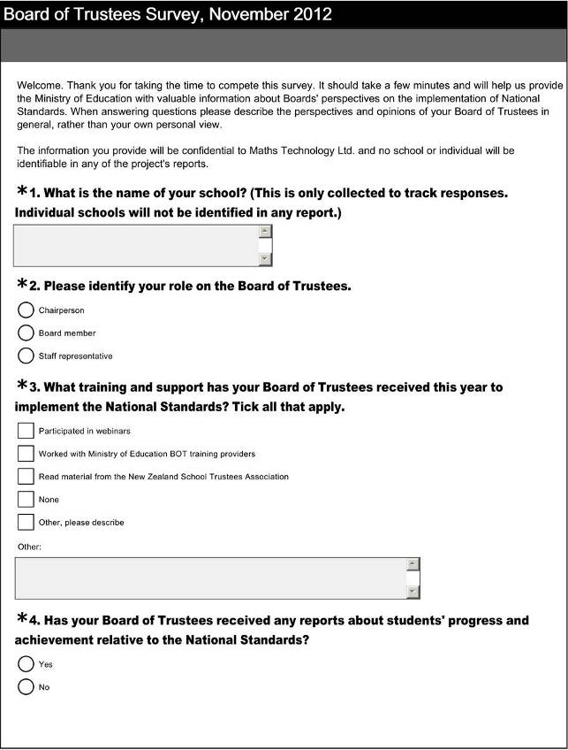
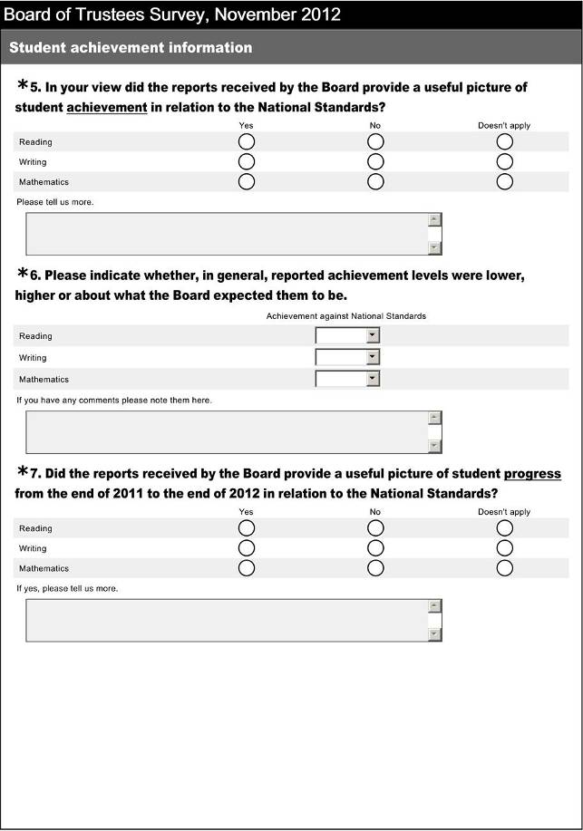

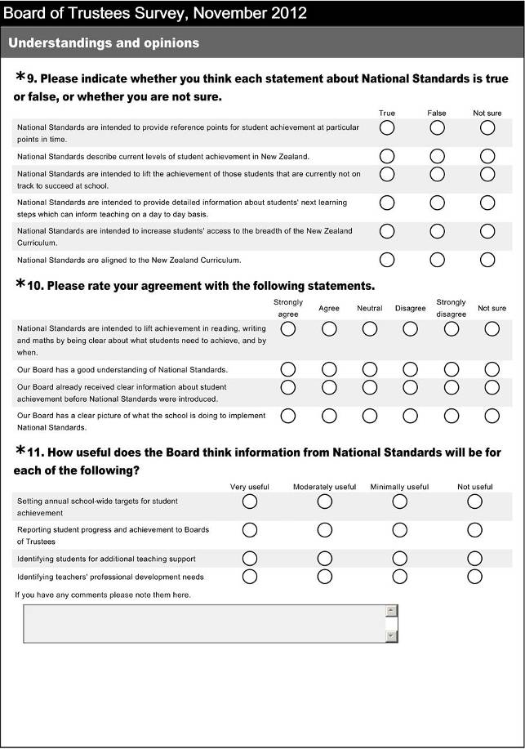
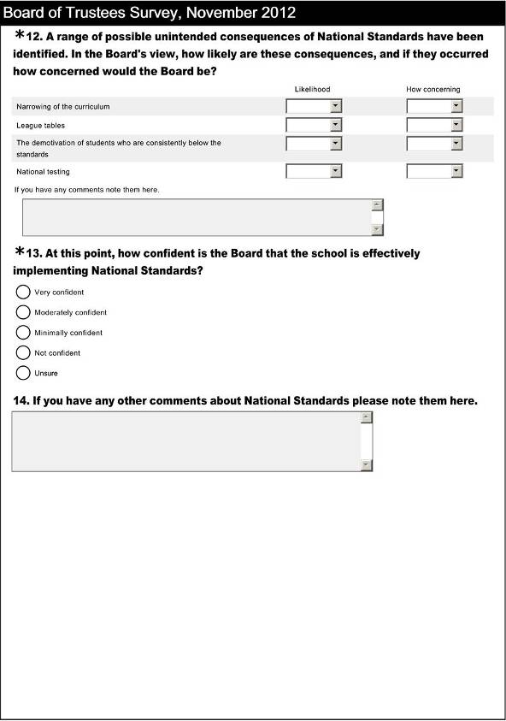
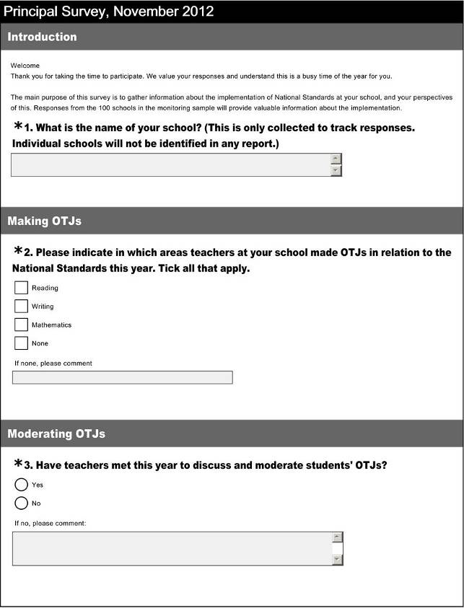
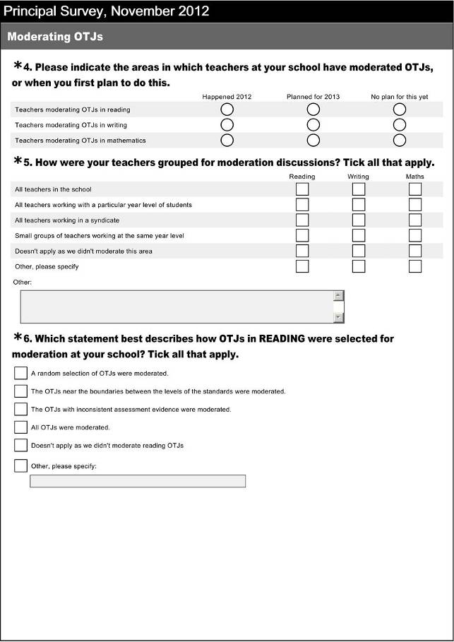
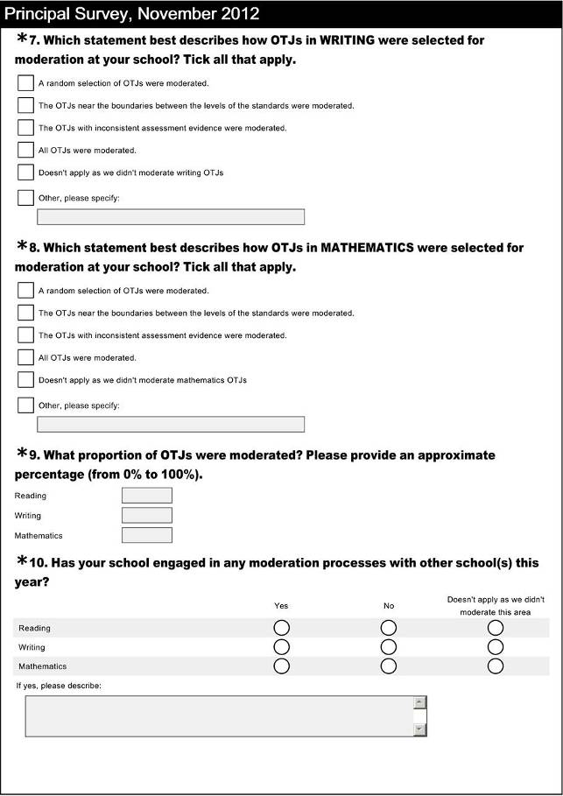
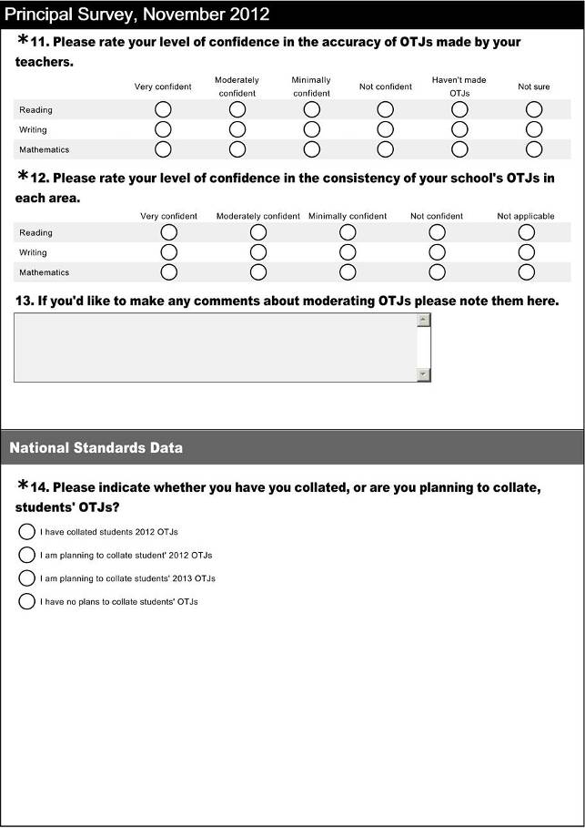
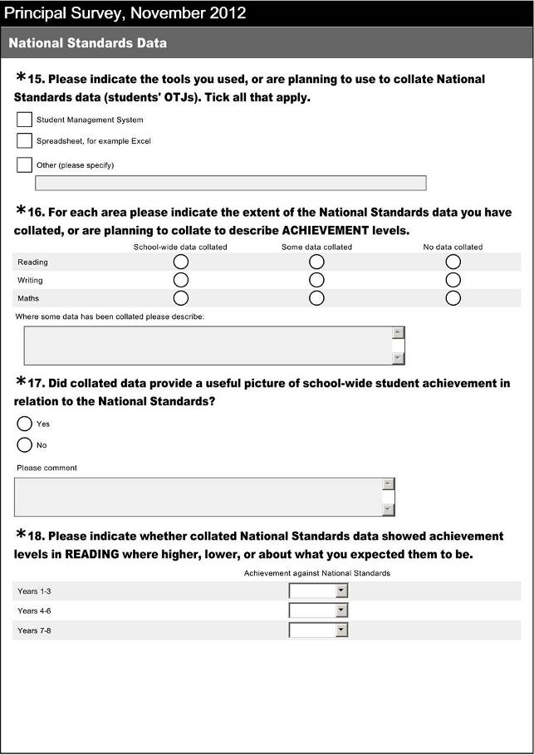
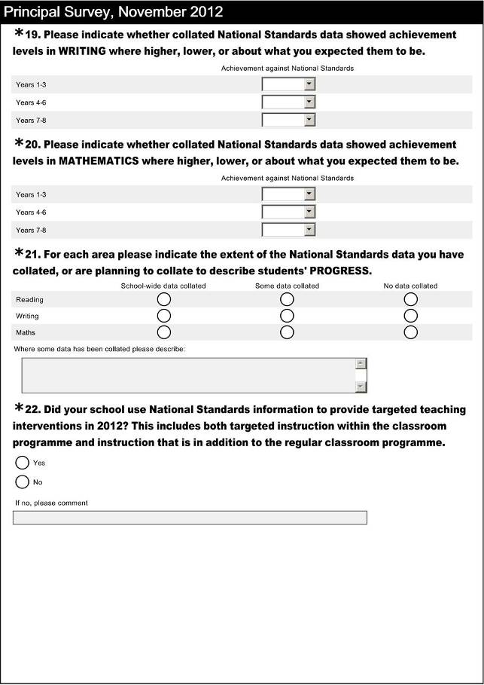
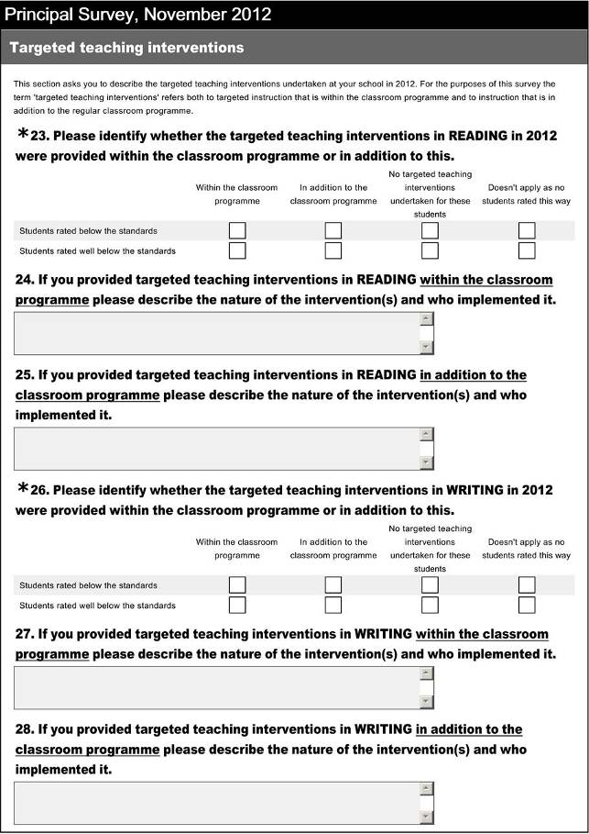
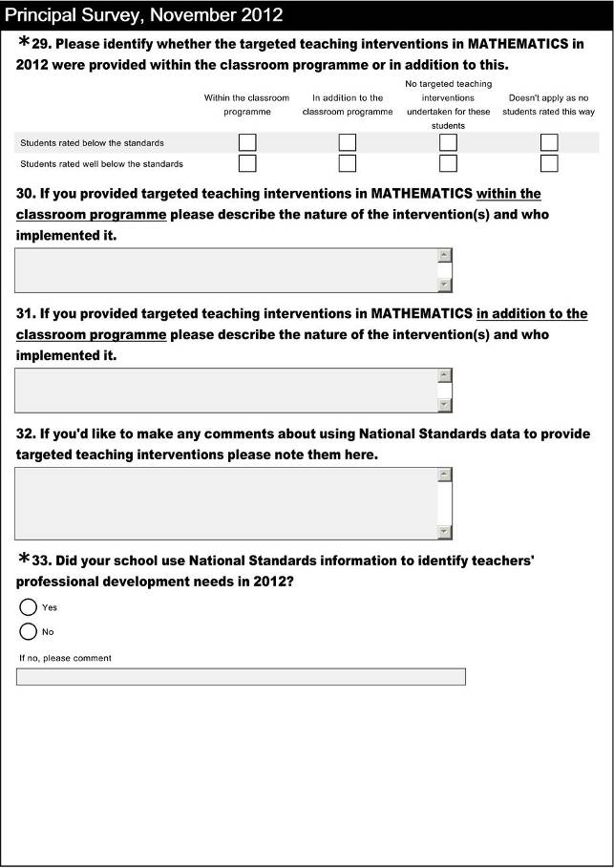
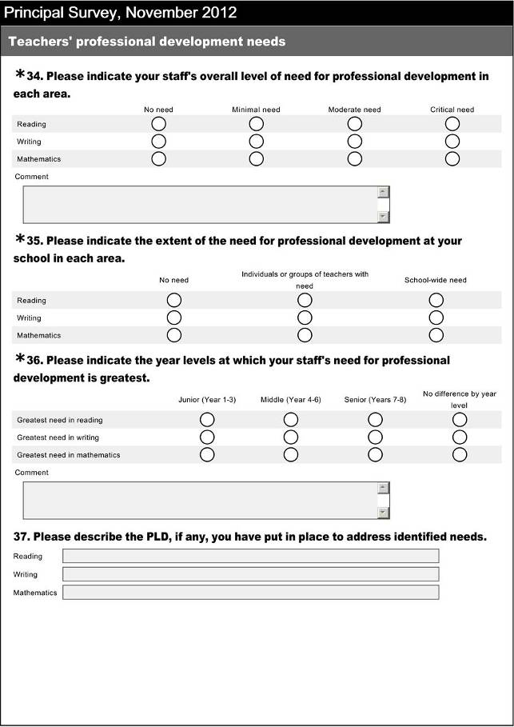
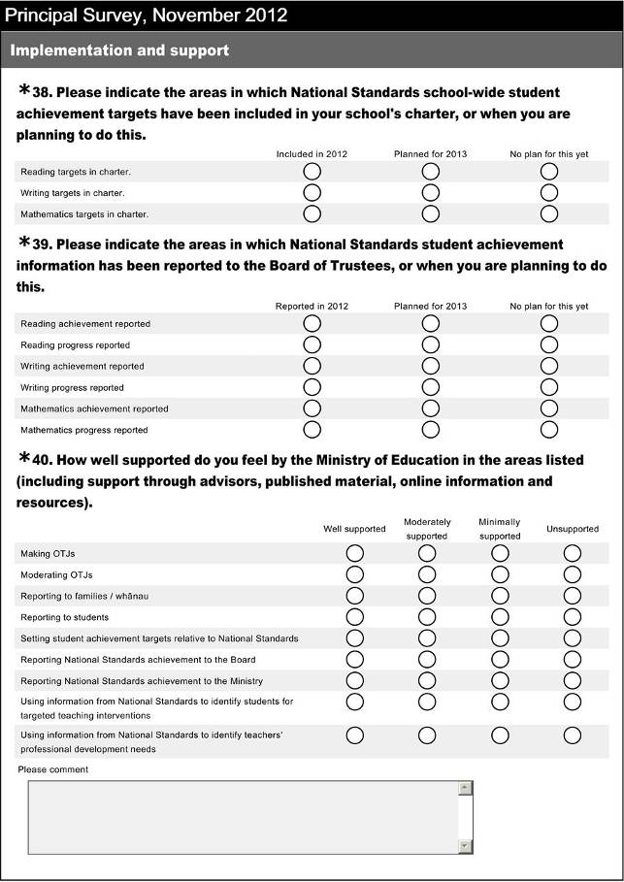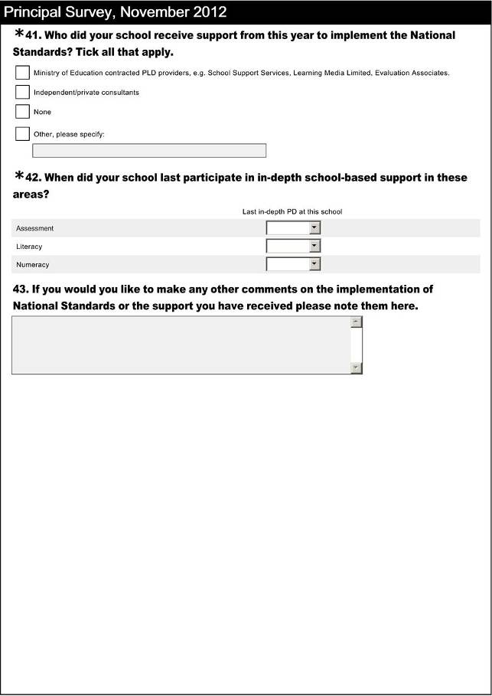
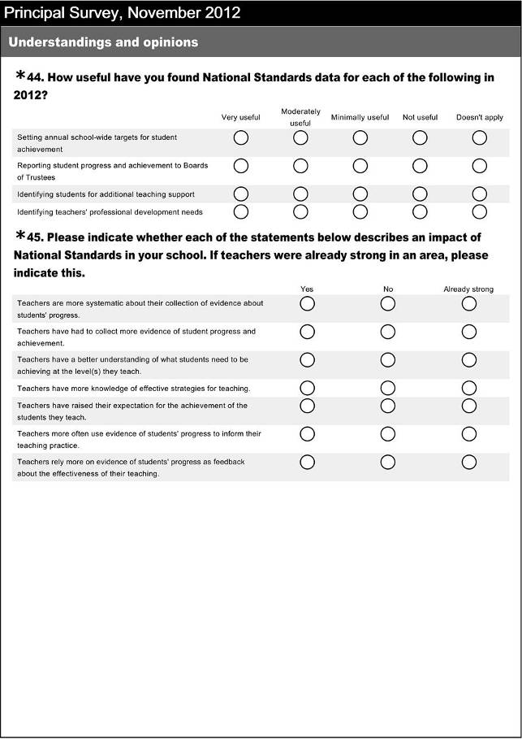

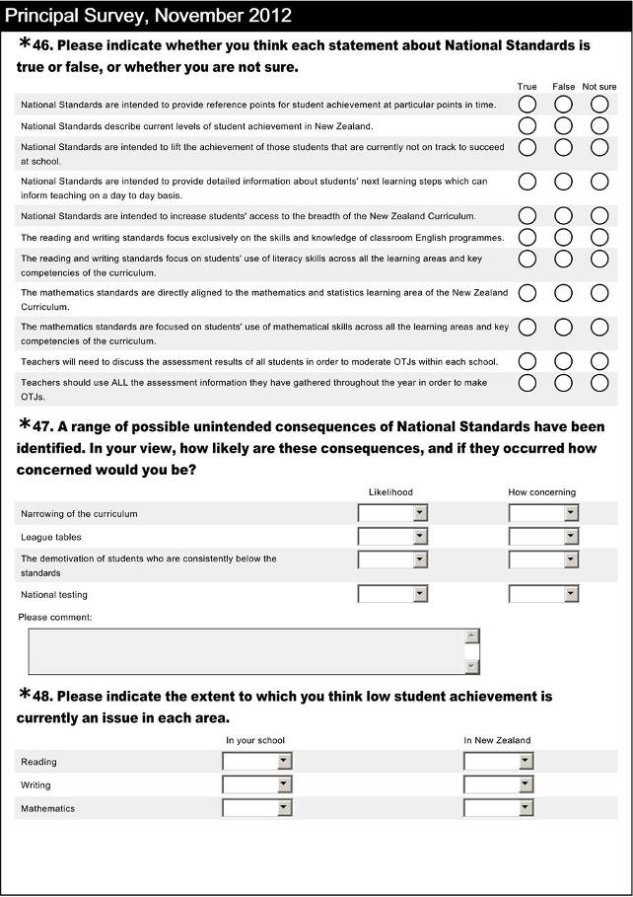

Skip logic was employed in the teacher survey. Respondents chose to focus on standards at particular year levels or answer questions in relation to reading, writing, or mathematics wherever question numbering is not consecutive.
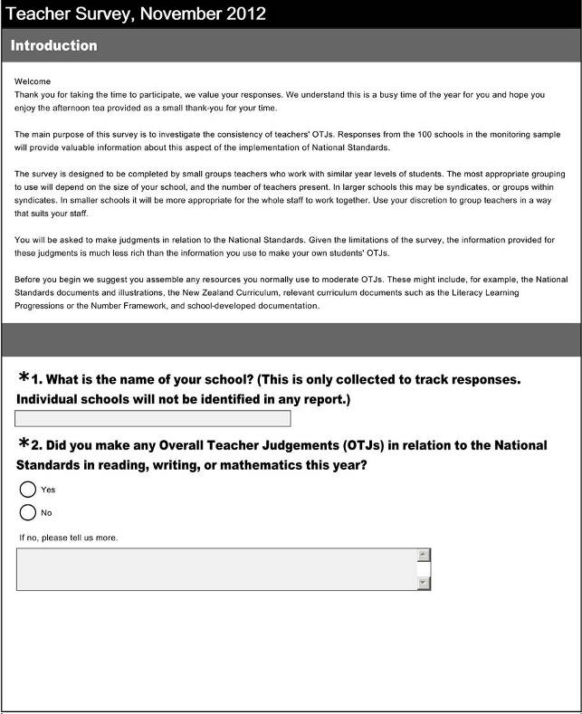
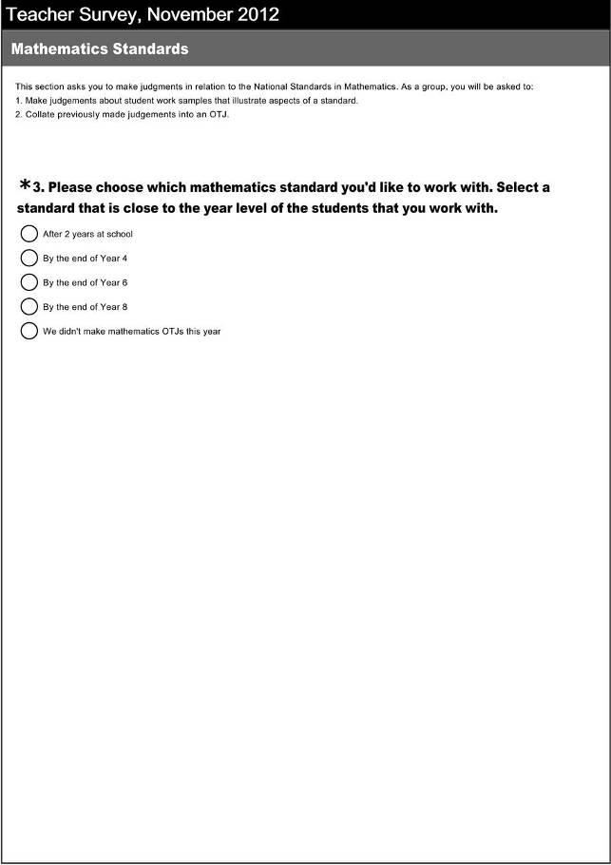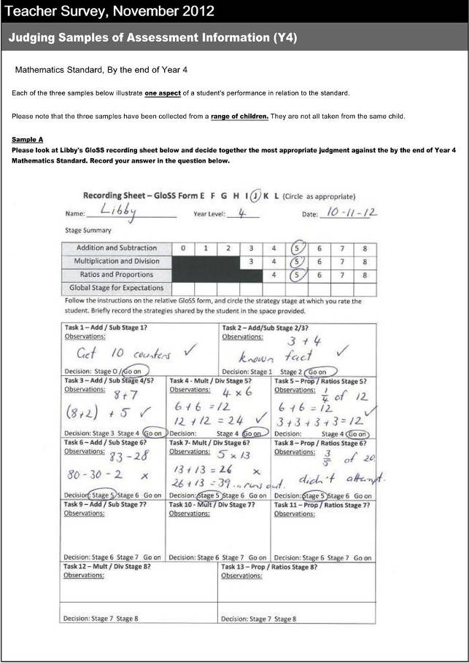


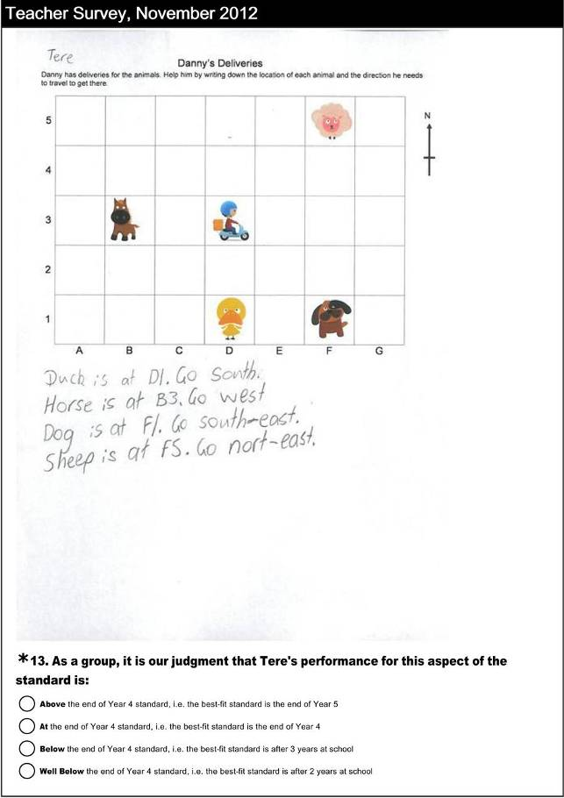
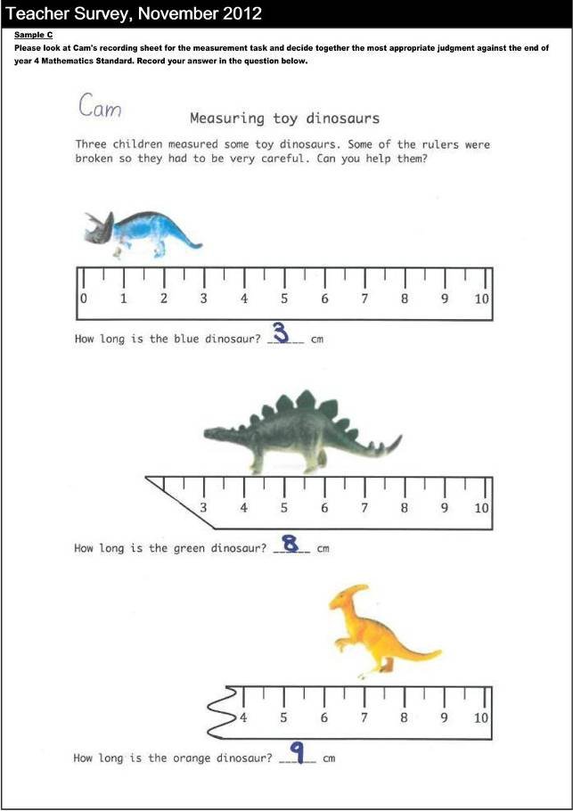
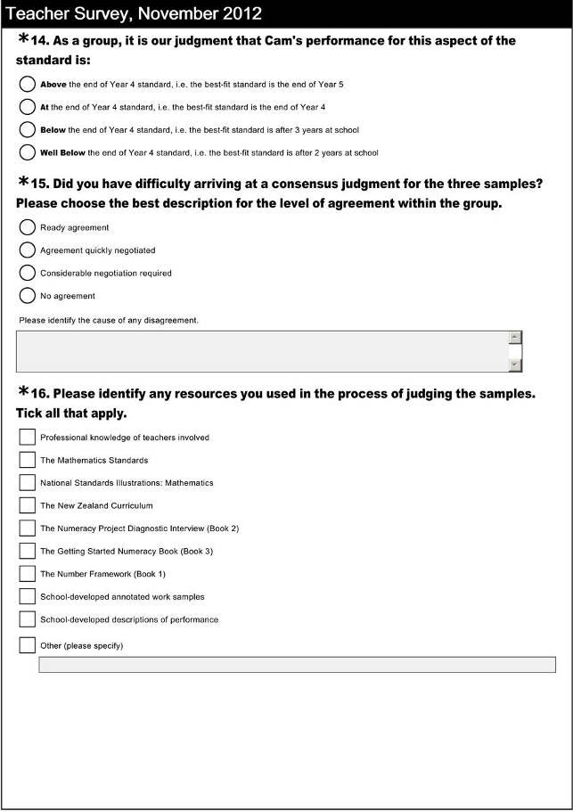
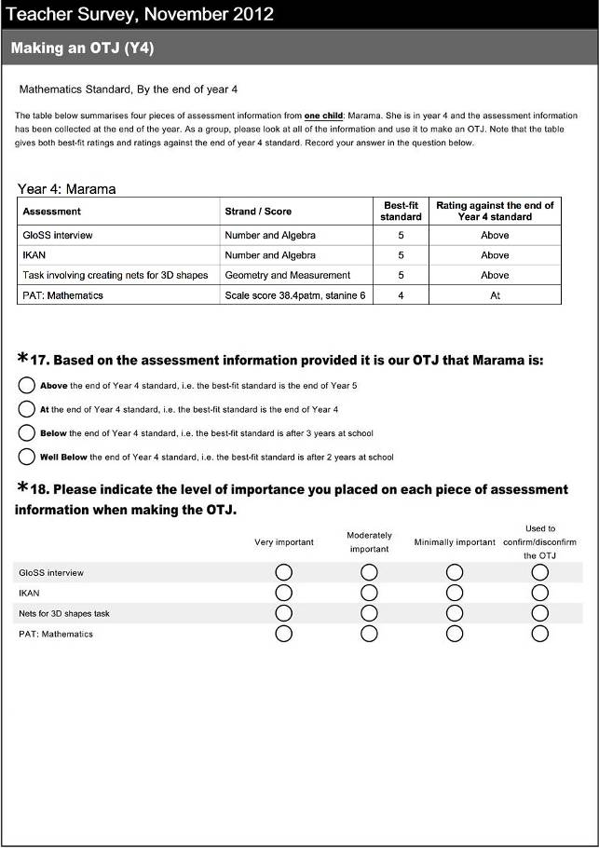

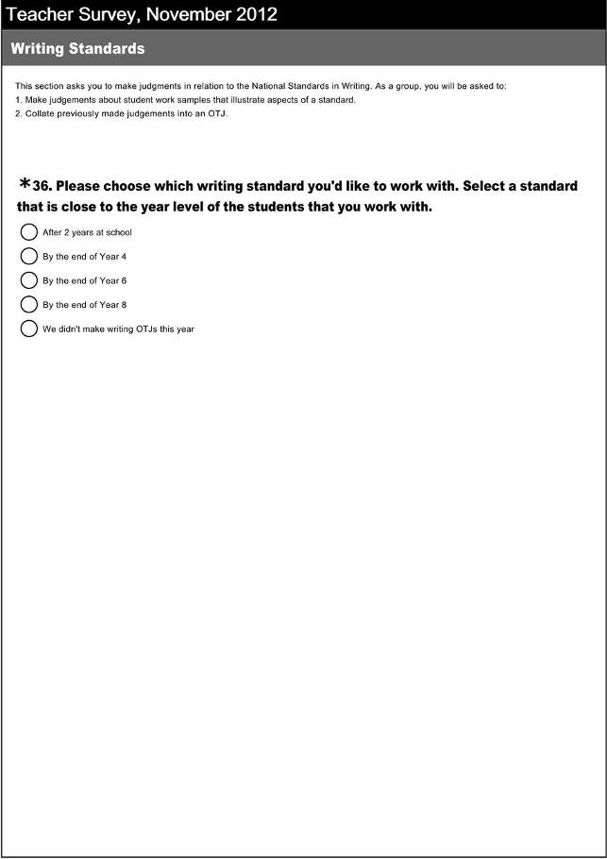
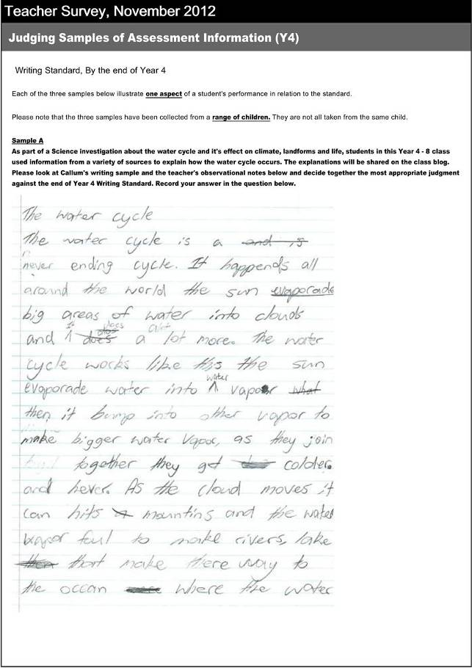
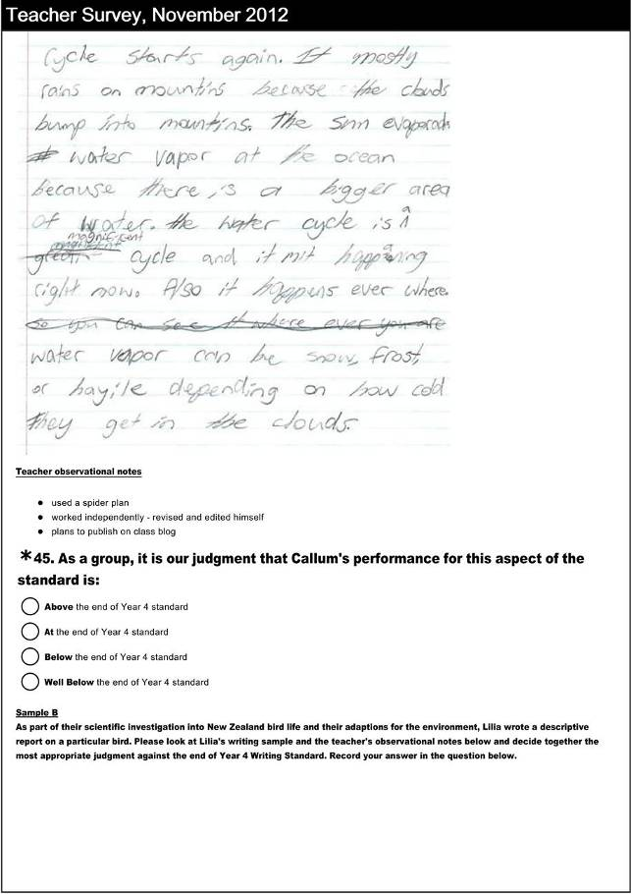
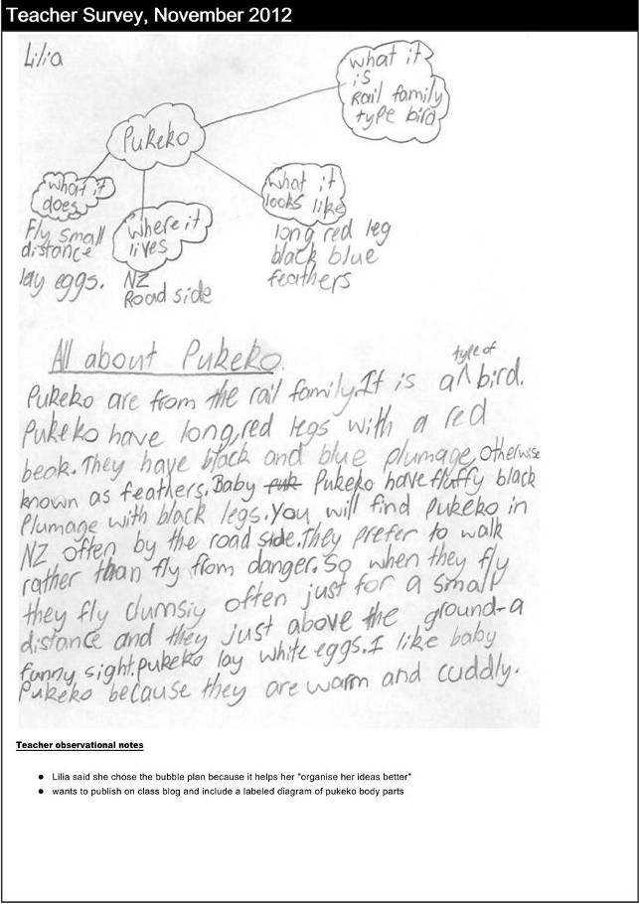

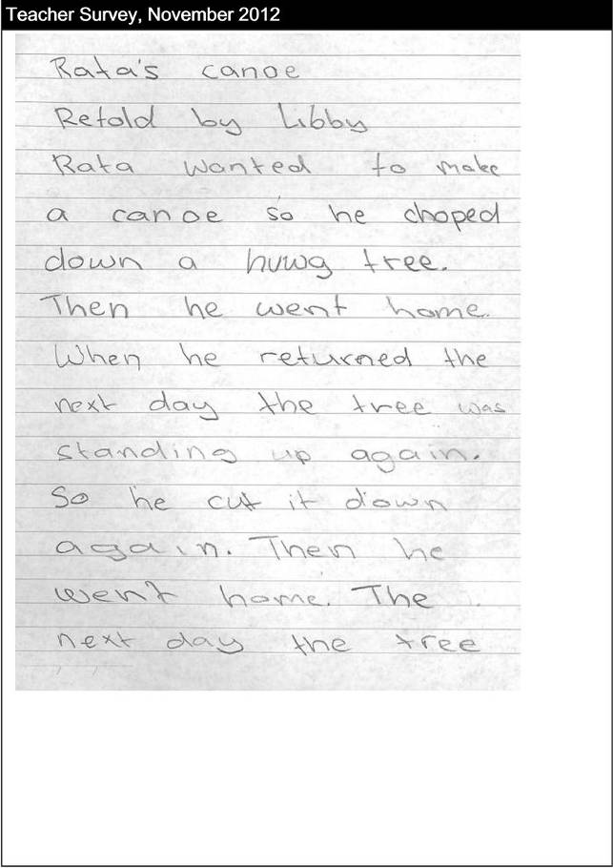
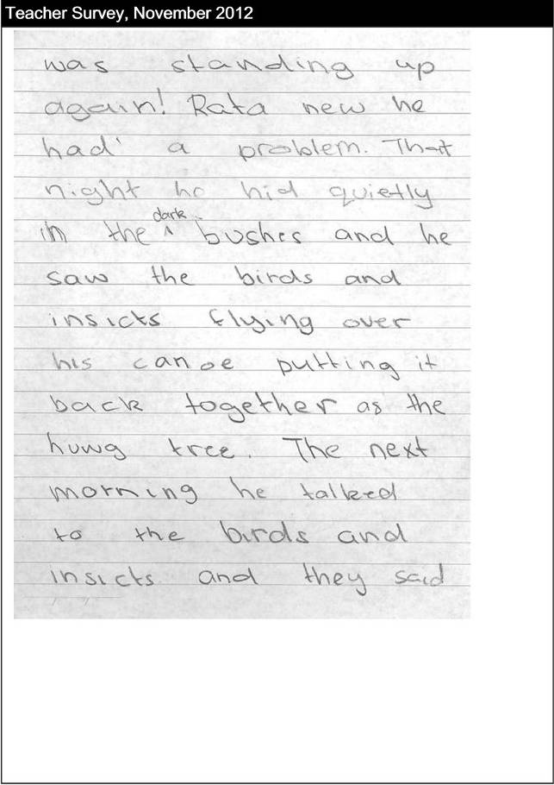
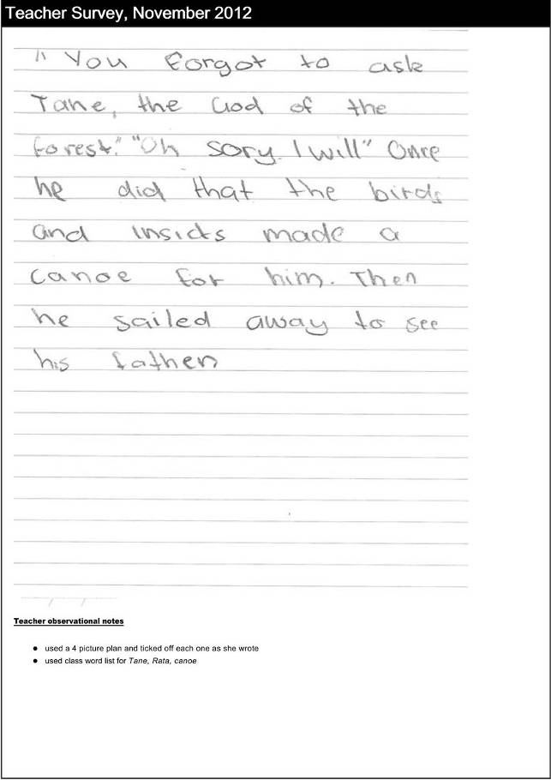
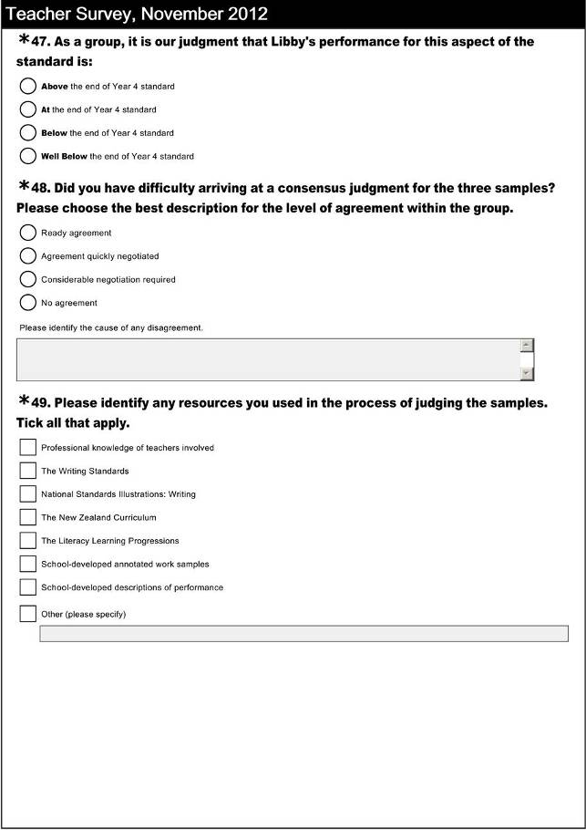
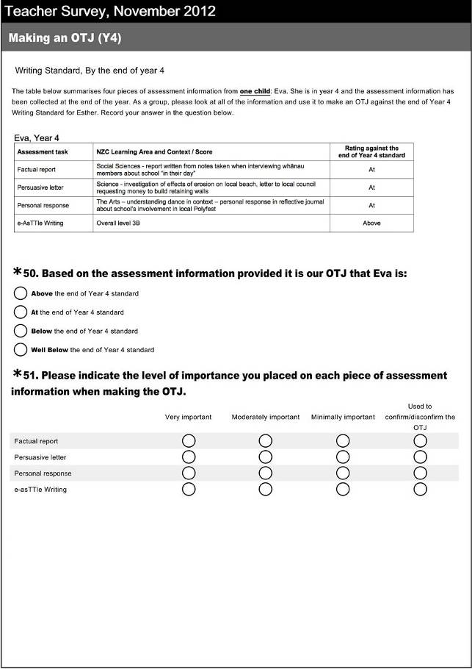

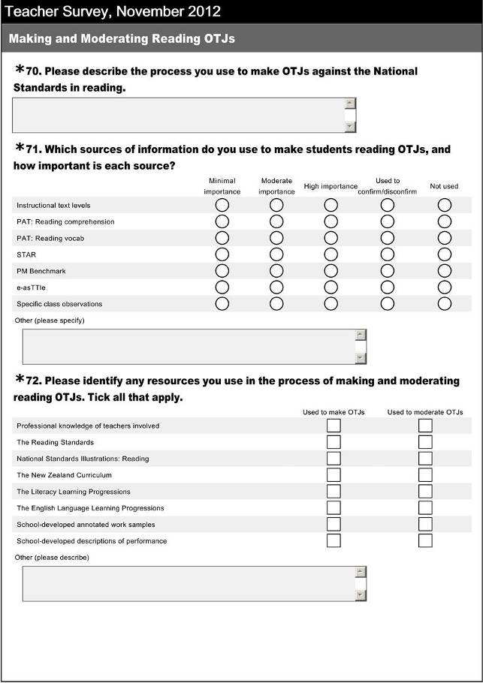
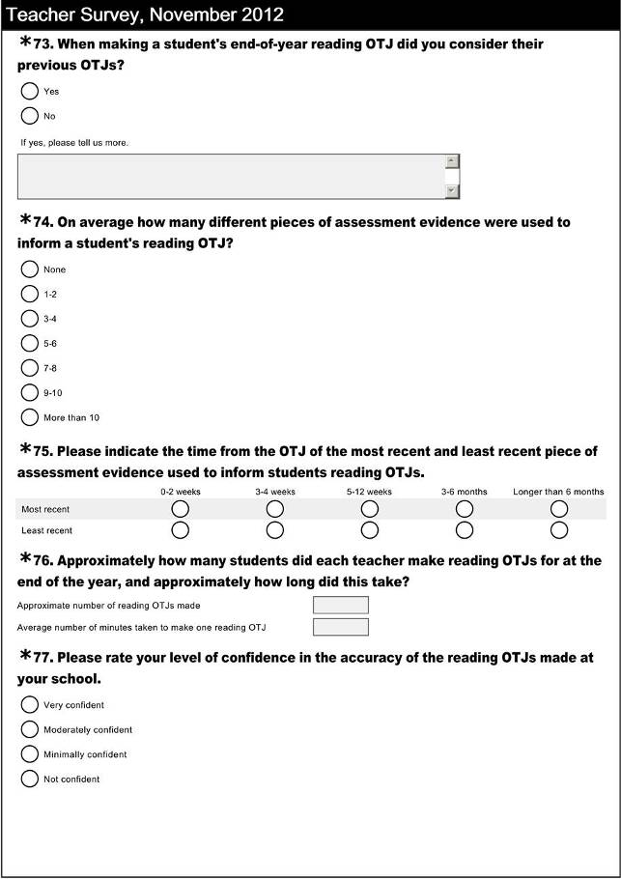
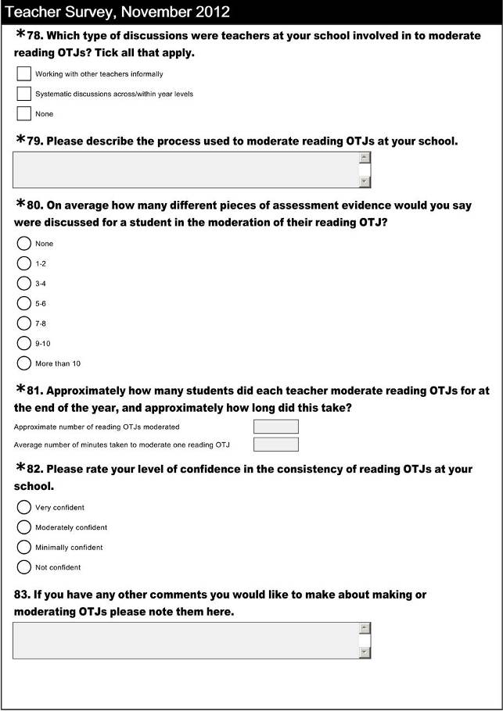
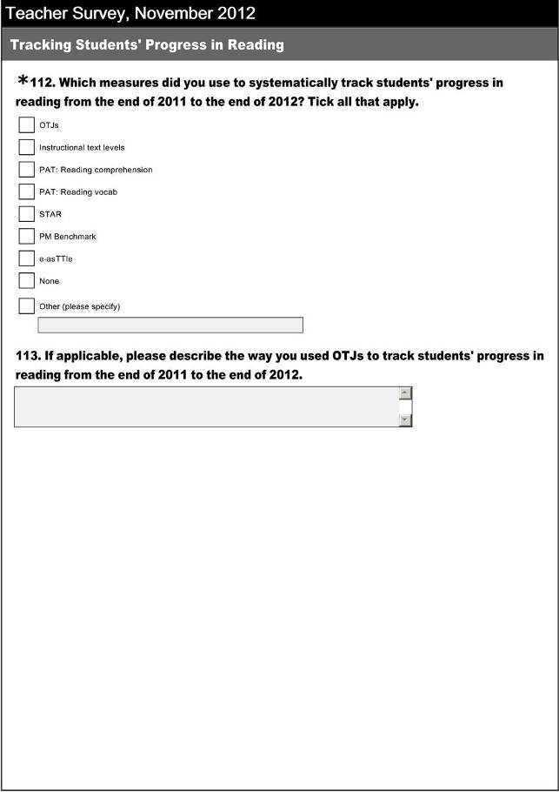
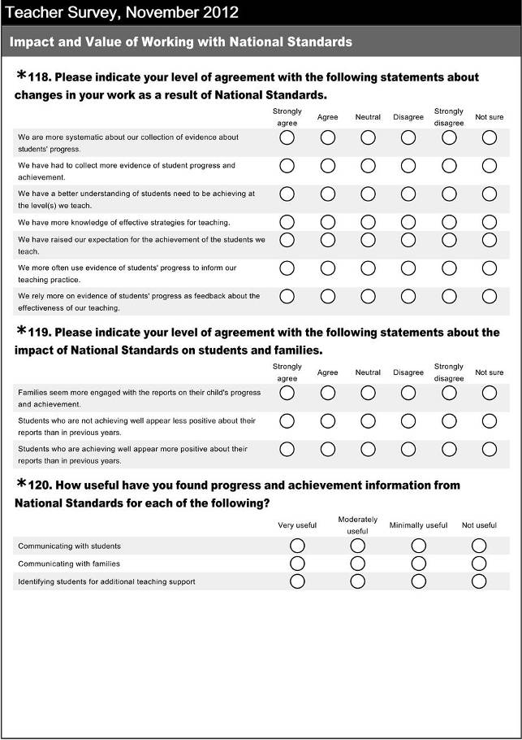
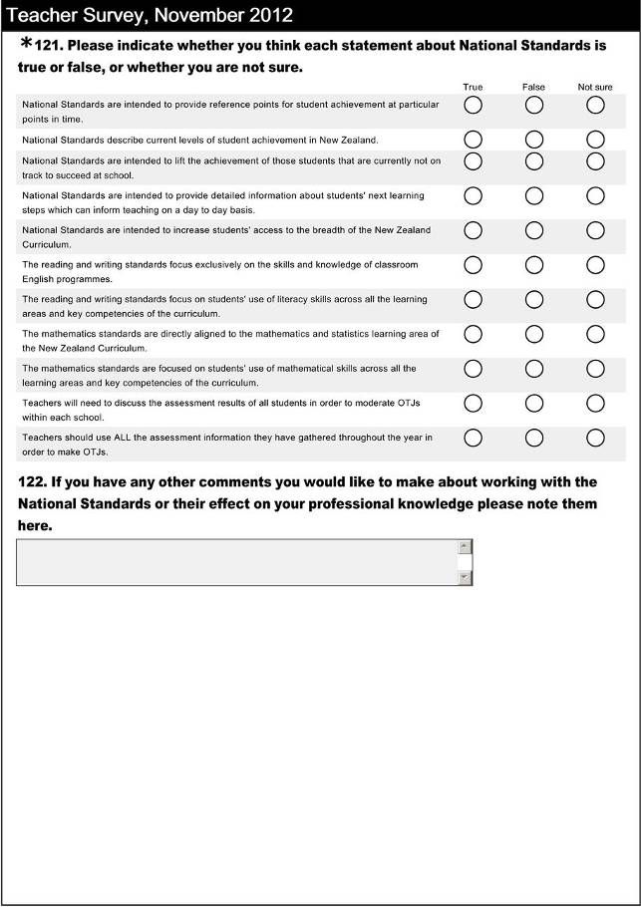
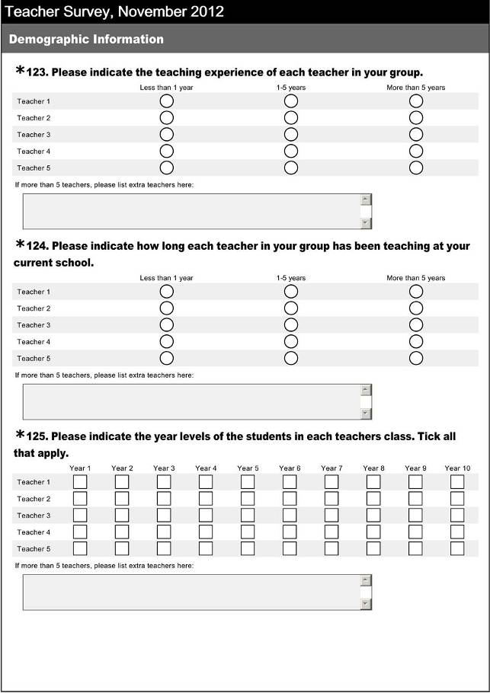

To be rated as challenging reading, writing and mathematics targets need to specify moving at least 50% of students rated ‘well below’ in 2012 to a rating of ‘below’ in 2013, and at least 80% of students rated ‘below’ in 2012 to a rating of ‘at” in 2013.
Information about where the student sits in relation to NS and details of something of significance to OTJ in terms of what they can/can’t do. (Not necessarily narrative, doesn’t need to identify which specific standard – assume they have used the appropriate one.) Something of significance to OTJ may include: - Reading : Something about ability to decode and how they respond, understand, and use what they have read. Reading level/age not enough on it’s own. - Writing : Something about ability to encode (including planning, revising and publishing) and ability to use writing for a variety of purposes across the curriculum. Information about spelling not enough on it’s own. - Mathematics: something about numeracy strategy, ability to solve problems, other aspects of mathematics curriculum. Information about knowledge (eg basic facts) not enough on its own.
NS, curriculum levels, e-Asttle, STAR, PAT, reading colours, reading recovery levels, reading chronological ages, numeracy stages
Mid 2010, end 2010, mid 2011, end 2011, mid 2012, end 2012.
Information about reading, writing, mathematics is easy to understand: text, tables, and graphs. No unexplained jargon, concise.

