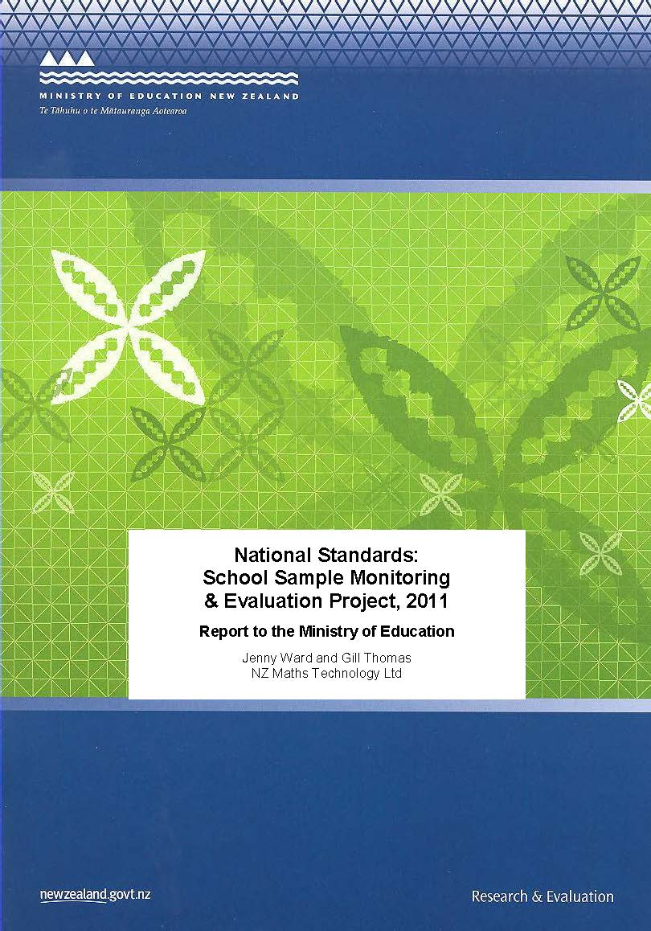

ISBN: 978-0-478-38664-6
ISBN: 978-0-478-38665-3 (web)
RMR-996

© Ministry of Education, New Zealand 2012
Research reports are available on the Ministry of Education’s website Education Counts:
www.educationcounts.govt.nz/publications.

Opinions expressed in this report are those of the authors and do not necessarily coincide with those of the Ministry of Education.

National Standards:
School Sample Monitoring and Evaluation Project, 2011

Report to the Ministry of Education

Jenny Ward and Gill Thomas



Contents
1. Executive Summary 1
2. Methodology 5
2.1 Monitoring and evaluation questions 5
2.2 Sample 8
2.3 Methods and participants 9
3. Making OTJs 15
3.1 Evaluative criteria 15
3.2 Descriptive information 21
4. Moderating OTJs 25
4.1 Evaluative criteria 25
4.2 Descriptive information 28
5. The Dependability of OTJs 31
Evaluative criteria 33
5.1 Sample rating scenarios 33
5.2 Making OTJ scenarios 44
5.3 Descriptive information 49
6. National Standards Achievement Data 53
6.1 Reading OTJs 53
6.2 Writing OTJs 54
6.3 Mathematics OTJs 56
6.4 Comment on reading, writing, and mathematics OTJs 57
6.5 Student data 2010 and 2011 57
7. Reporting to parents 61
7.1 Evaluative criteria 61
7.2 Descriptive information 66
8. Student achievement targets 69
8.1 Evaluative criteria 69
8.2 Descriptive information 72
9. Identifying students for intervention 73
9.1 Evaluative criteria 74
9.2 Descriptive information 79
10. Other Information 81
10.1 Charter requirements 81
10.2 Principals’ understandings and perspectives 81
10.3 Board perspectives 87
Appendices 93
Appendix A: Project methodology 93
Appendix B: Principal interview schedule 94
Appendix C: School documentation analysis criteria 95
Appendix D: Criteria for end-of-year report analysis 96
Appendix E: Inter-rater reliability information 98
Appendix F: Online surveys 99
Appendix G: Differences between 2011 and 2010 student achievement data 136

List of Tables

Table 1: Monitoring and evaluation questions and criteria – OTJs 6
Table 2: Monitoring and evaluation questions and criteria – reporting to parents 6
Table 3: Monitoring and evaluation questions and criteria – student achievement targets 7
Table 4: Monitoring and evaluation questions and criteria – identifying students for intervention 7
Table 5: School sample by school decile 8
Table 6: School sample by school type 8
Table 7: School sample by region 8
Table 8: Students for whom OTJs were provided, by year level and gender 11
Table 9: Students for whom OTJs were provided, by year level and ethnicity 11
Table 10: Students for whom OTJs were provided, by year level and school decile 12
Table 11: End-of-year reports 12
Table 12: Monitoring and evaluation questions and criteria – making OTJs 15
Table 13: Timing of assessment evidence used to inform OTJs 20
Table 14: Estimates of average time taken to make one OTJ 21
Table 15: Number of information sources used by teachers to inform OTJs 21
Table 16: Monitoring and evaluation questions and criteria – moderating OTJs 25
Table 17: Percentages of teachers that report being involved in moderation discussions 25
Table 18: Processes used by schools to select OTJs for moderation 27
Table 19: Proportions of OTJs that were moderated 27
Table 20: Teachers’ estimates of the average time taken to moderate one OTJ 28
Table 21: Teacher groupings for moderation discussions 28
Table 22: Extent of student achievement information used by teachers to moderate OTJs 29
Table 23: Monitoring and evaluation questions and criteria - dependability of OTJs 32
Table 24: Reading OTJs by year level 53
Table 25: Reading OTJs by gender 53
Table 26: Reading OTJs by ethnicity 53
Table 27: Reading OTJs by school decile 54
Table 28: Writing OTJs by year level 54
Table 29: Writing OTJs by gender 54
Table 30: Writing OTJs by ethnicity 55
Table 31: Writing OTJs by school decile 55
Table 32: Mathematics OTJs by year level 56
Table 33: Mathematics OTJs by gender 56
Table 34: Mathematics OTJs by ethnicity 56
Table 35: Mathematics OTJs by school decile 56
Table 36: Students’ 2011 reading OTJs disaggregated by their 2010 OTJs 58
Table 37: Students’ 2011 writing OTJs disaggregated by their 2010 OTJs 58
Table 38: Students’ 2011 mathematics OTJs disaggregated by their 2010 OTJs 58
Table 39: Overall movement in students’ ratings 2010 to 2011 59
Table 40: Monitoring and evaluation questions and criteria, reporting to parents 61
Table 41: Use of National Standards in end-of-year reports 61
Table 42: Monitoring and evaluation questions and criteria, student achievement targets 69
Table 43: Number of schools with targets differentiated to accelerate progress for sub-groups of students rated below or ‘well below’ the National Standards in 2010 71
Table 44: Monitoring and evaluation questions and criteria, identifying students for intervention 73
Table 45: Teaching interventions identified by principals 78
Table 46: Themes in principals’ comments on National Standards 86

List of Figures

Figure 1: Anticipated series of effects in schools as a result of the introduction of National Standards 5
Figure 2: Resources used by teachers to rate work and assessment samples in relation to the National Standards in Writing 15
Figure 3: Resources used by teachers to rate work and assessment samples in relation to the National Standards in Mathematics 16
Figure 4: Teachers’ rating of the importance of information from various sources in making reading OTJs 18
Figure 5: Teachers’ rating of the importance of information from various sources in making writing OTJs 19
Figure 6: Teachers’’ rating of the importance of information from various sources in making mathematics OTJs 19
Figure 7: Accuracy of teachers’ ratings for the sample rating scenarios in writing 33
Figure 8: Work sample from scenario positioned ‘above’ the end of year 6 35
Figure 9: Work sample for scenario positioned ‘above’ the end of year 4 36
Figure 10: Accuracy of teachers’ ratings for the sample rating scenarios in mathematics 37
Figure 11: Assessment scenario, number,’at’ the end of year 4 standard 39
Figure 12: Assessment scenario, measurement, ‘below’ the end of year 4 40
Figure 13: Assessment scenario, algebra, ‘below’ the end of year 8 standard 42
Figure 14: Accuracy of teachers’ writing OTJs 44
Figure 15: Making writing OTJ scenario, ‘at’ the end of year 4 45
Figure 16: Making writing OTJ scenario, ‘above’ the end of year 6 45
Figure 17: Accuracy of teachers’ mathematics OTJs 46
Figure 18: Making mathematics OTJ scenario, ‘at’ the after 2 years standard 47
Figure 19: Making mathematics OTJ scenario, ‘above’ end of year 4 48
Figure 20: Teachers’ rating of agreement levels within the group for the writing scenarios 49
Figure 21 Teachers’ rating of agreement levels within the group when making judgments in the mathematics scenarios 50
Figure 22: Example of information rated as sufficiently describing student achievement against the National Standards 62
Figure 23: Example of information rated as insufficiently describing student achievement against the National Standards. 62
Figure 24: The clarity of reports that did and did not contain National Standards achievement information 63
Figure 25: Example of a report that was rated as containing clear information about the student’s achievement in relation to the National Standards 63
Figure 26: Example of a report that was rated as containing unclear information about the student’s achievement in relation to the National Standards 64
Figure 27: Example of a clear report that was rated as containing insufficient information about the student’s achievement in relation to the National Standards 64
Figure 28: Examples of unclear reports that were rated as containing insufficient information about the student’s achievement in relation to the National Standards 65
Figure 29: Example of a report describing student progress in relation to the National Standards 65
Figure 30: Examples from end-of-year reports of students’ next learning steps 66
Figure 31: Examples from end-of-year reports of actions families can take to support student learning 66
Figure 32: Examples of reports that described student achievement using a scale such as ‘at’ / ‘above’ / below / well below 66
Figure 33: Examples of reports that described student achievement using a best fit standard 66
Figure 34: Examples of OTJs presented in diagrams or tables 67
Figure 35: Examples of OTJs presented in text 67
Figure 36: Proportions of schools rated as including National Standards student achievement targets in school charters 70
Figure 37: Principals’ collation of 2011 OTJs 74
Figure 38: Principals’ perceptions of the achievement levels in collated OTJ data 75
Figure 39: Measures used to systematically track students’ progress in reading 76
Figure 40: Measures used to systematically track students’ progress in writing 77
Figure 41: Measures used to systematically track students’ progress in mathematics 77
Figure 42: Principals’ understandings of National Standards 82
Figure 43: Principals’ perceptions of the level of support provided by the Ministry of Education 83
Figure 44: Principals’ level of concern over the unintended consequences of National Standards 84
Figure 45: Board of Trustees understanding of school actions 87
Figure 46: Board of Trustees rating of NS achievement information against expectations 88
Figure 47: Boards’ perspectives on the usefulness of student achievement information from National Standards 89
Figure 48: Boards’ level of concern over the unintended consequences of National Standards 90

1. Executive Summary
The National Standards School Sample Monitoring and Evaluation Project is a three-year study that describes and evaluates the implementation of National Standards in schools. This report contains information collected in 2011, which was both the second year of implementation and the second year of the project.
Information was collected from a stratified sample of 100 schools, representative of the population of schools in terms of school decile, school type and geographic region. Six main types of data were collected at two time points. In the middle of the year principal interviews were conducted and copies of schools’ student achievement targets and analysis of variance reports were collected. At the end of the year, OTJs were collected for all students, and copies of students’ end-of-year reports were obtained. Online surveys of teachers, principals, and Boards of Trustees Chairpersons were also conducted and information about teachers’ judgments in relation to the National Standards was collected using assessment scenarios.
Analysis focused on describing and evaluating the extent to which National Standards was operating as intended, and was based around specific monitoring and evaluation questions and performance criteria.

Overall Teacher Judgments
- Teachers used a range of information sources to make OTJs in reading, writing and mathematics. Most of the information sources identified by teachers as important in making OTJs were considered to be relevant to the National Standards.
- The sources of assessment information rated as most important by teachers included specific class observations in reading, writing, and mathematics, instructional text levels in reading, the collection of samples in writing, and GloSS and IKAN assessment results in mathematics.
- In an increase from 2010 results, approximately two-thirds of teachers can be considered to have used current assessment evidence to inform reading (68%) and writing (61%) OTJs, while just under half (49%) used current evidence to make mathematics OTJs. The remainder used evidence than was more than 12 weeks old.
- Approximately one-third of teachers took up to ten minutes to make one reading (39%) or writing (33%) OTJ, while just less than two-thirds (59%) were making mathematics OTJs in this time. This was considered to be efficient.
- Teachers and principals reported high confidence levels in both the accuracy and consistency of their school’s OTJs.
A variety of processes were used to moderate OTJs.
- Most schools used school wide moderation processes in writing (83%) and mathematics (90%), while about two-thirds of schools (67%) moderated reading OTJs. This is an increase from 2010, especially in mathematics, and results suggest schools tended to carry out formal moderation in writing in 2010, and extend this to mathematics in 2011.
- Approximately a third of schools used an efficient method of selecting OTJs for moderation by focusing on the judgments near the boundaries between the levels of the standards in reading (36%), writing (35%) and mathematics (30%).
- Thirty-six percent of principals indicated they had engaged in moderation practices with other schools. Writing was the area of focus for most between-school moderation.
The study collected information about teachers’ ability to rate individual pieces of student work in relation to the National Standards, and to collate several pieces of assessment evidence that had already been rated against the standards to make an OTJ. Student OTJ data was also used to provide information about the dependability of teachers’ OTJs.
- There was considerable variability in the accuracy of teachers’ ratings against the National Standards for individual work or assessment samples. In writing, accuracy ranged from 3% to 89% over the samples, while accuracy in mathematics ranged from 18% to 90%. This is a cause for concern as it is these individual judgements that are the basis of OTJs.
- Most teachers were able to collate four pieces of assessment evidence, each of which had been previously rated by experts, against the standards to make an accurate OTJ.
- Large positive shifts were observed for those students rated ‘below’ or ‘well below’ the standards in 2010. For example, approximately 60% of students rated ‘well below’ in 2010 received an improved rating in 2011. Given evidence from the assessment scenarios, and the magnitude of the changes observed, it is most likely the shifts in the data are attributable to teacher inconsistency in making OTJs.
- Aggregated reading, writing, and mathematics OTJs for 16,111 students were consistent with results from 2010. Demographic patterns in these data were in line with other evidence of student achievement in New Zealand, due to the large sample size that tends to cancel out random error in individual OTJs.

Reporting to parents
- Evidence suggests that nearly 90% of parents received an end-of-year report for their child that referred directly to the National Standards. Sixty percent of these reports were rated as sufficiently describing the child’s achievement in relation to the National Standards.
- Approximately 10% of reports that referred directly to the National Standards described children’s progress over time in relation to the reading (12%), writing (9%) and mathematics standards (9%).
- Fifty percent of the reports that described achievement in relation to the National Standards were rated as clear, that is, able to be easily understood by parents, families, and whānau.
- Sixty-eight percent of the National Standards reports identified the child’s next learning steps, while 55% included ways families can support learning at home.

Student achievement targets
- Seventy-five percent of schools included targets in their 2011 charter that addressed student achievement in relation to the National Standards.
- In terms of the nature of the students targeted, 94% of schools with National Standards targets focused on students who were below or well below the standards, while 6% included progress goals for all students.
- Fifty-seven percent of schools with National Standards achievement targets differentiated these to accelerate progress for specific groups of students. Thirty-three percent of schools included a focus on Māori students and 9% included a focus on Pasifika students. Other groups of students differentiated in National Standards targets included students with special needs (1%), boys (16%), and girls (1%).
- Most of the targets that addressed student achievement against the National Standards in reading (92%), writing (89%) and mathematics (88%) were specific and measurable.
- Of the targets that addressed the National Standards, approximately two-thirds addressed students at all year levels (59% reading, 67% writing, 60% mathematics), while over half were considered appropriate, i.e. both challenging and achievable (55% reading, 65% writing, 53% mathematics).

Identifying students for intervention
- Approximately three-quarters of principals collated school-wide National Standards data to describe student achievement in reading (78%), writing (77%), and mathematics (76%). In terms of using National Standards data to describe progress, around two-thirds had collated school-wide progress data (66% reading, 65% writing, 65% mathematics), and approximately 15% had collated progress data for some students (12% reading, 15% writing, 15% mathematics).
- About 85% of teachers reported tracking student progress in relation to the National Standards in reading (84%), writing (88%), and mathematics (86%) from the end of 2010 to the end of 2011 using OTJs.
- Just under two-thirds of principals indicated that they had used National Standards data to identify students for additional teaching support in reading (63%), writing (58%), and mathematics (63%). The interventions listed by principals included the provision of additional qualified teaching support, teacher aides, focused in-class teacher support, and the provision of additional learning programmes.

Perspectives of principals and Boards of Trustees
- Principals’ levels of understanding about the nature and intended consequences of National Standards had generally improved from the end of 2010 to the end of 2011.
- In general, principals felt more supported by the Ministry of Education in 2011 than in 2010, although more than half still described themselves as minimally supported or unsupported in nearly all aspects.
- Principals’ views over the usefulness of National Standards data were varied. Comments indicated both principals and Boards of Trustees felt they were already using data purposefully before the introduction of National Standards.
- Principals remain concerned over the unintended consequences of National Standards. Boards of Trustees share their concerns.
- Most Boards of Trustees feel they have a good understanding of the National Standards and what their school is doing to implement them. Most Boards are also confident their school is effectively implementing the standards.

2. Methodology
The National Standards School Sample Monitoring and Evaluation Project is a three-year study focused on the implementation of National Standards in schools. This report contains information collected in 2011, which was both the second year of the standards’ implementation and the second year of the project.

2.1 Monitoring and evaluation questions
The study has two purposes:
To describe the implementation of National Standards within schools
To monitor and systematically evaluate the effect of National Standards on students, teachers, schools, and parents, families, and whānau.
The descriptive component of the study is focused around thirteen open-ended monitoring questions. The evaluative component is focused on the extent to which National Standards are operating as intended, and is based on seven statements that describe the intended outcomes of National Standards. Each of these statements has related performance criteria.
Because the effects of National Standards in schools will develop over successive years of implementation, the focus of the study changes over time. Initially, changes in assessment practices are required by the alteration of National Administration Guideline 2A: teachers make overall teacher judgments (OTJs) in relation the National Standards. Following on from this, these judgments are reported to parents, families and whānau, and Boards of Trustees. Collated information can then be used to identify students for teaching intervention. Once these students are identified, teachers’ knowledge is developed as required, and teaching interventions are introduced. The final anticipated effect is a resultant improvement in student achievement. Figure 1 illustrates this series of effects and identifies the expanding focus of the project in 2010 and 2011.
Figure 1: Anticipated series of effects in schools as a result of the introduction of National Standards
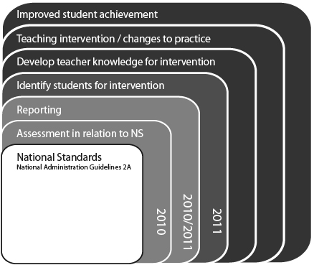
The project had four areas of focus in 2011:
- OTJs
- Reporting to parents
- Reporting to the Board of Trustees through student achievement targets
- Identifying students for intervention
The project’s methodology, which includes the monitoring and evaluation questions for all three years of the study, and the data sources that will be used, is included as Appendix A. The specific questions addressed in 2011, the statements of intent, and the related performance criteria are shown in Table 1 to Table 4.
Table 1: Monitoring and evaluation questions and criteria – OTJs
Intended outcome: Teachers make defensible, trustworthy judgments against the National Standards.
Monitoring and  Evaluation Questions | Performance criteria
In what ways do teachers use information from a variety of student assessments to make overall judgments? | Teachers use their knowledge of the National Standards in the process of making OTJs.
 | OTJs are informed by student achievement information that is relevant and current.
 | Teachers make OTJs efficiently.
What processes are used to moderate OTJs? | Schools use processes and systems to ensure OTJs are consistent.
What processes are used to moderate OTJs? | Moderation decisions are informed by the NS in reading, writing, and mathematics.
What processes are used to moderate OTJs? | Moderation processes are efficient and effective.
How dependable and consistent are teachers’ overall judgments? | Teachers make dependable OTJs.

Table 2: Monitoring and evaluation questions and criteria – reporting to parents
Intended outcome: Schools use National Standards assessment information to communicate clearly with parents, families, and whānau about their child’s achievement and progress
Monitoring and  Evaluation Questions | Performance criteria
How do schools use information from National Standards to report to and communicate with parents? | Parents receive a report that describes their child’s progress and achievement in relation to the NS in reading, writing and mathematics.
 | Parents receive a report that is clear.
 | Parents receive a report that identifies their child’s next learning steps, and ways families can help at home.

Table 3: Monitoring and evaluation questions and criteria – student achievement targets
Intended outcome: National Standards provides clear information about student achievement for Boards of Trustees which can be used in decision making and resource allocation processes.
Monitoring and  Evaluation Questions | Performance criteria
In what ways is information from National Standards used by schools to set achievement targets? | Targets in the school’s 2011 charter address student achievement in relation to the NS.
 | NS achievement targets focus on students who are below or ‘well below’ the standards.
 | NS achievement targets are differentiated to accelerate progress for specific groups of students.
 | NS achievement targets address the progress rates of all students.
 | NS achievement targets are specific and measurable.
 | NS achievement targets are appropriate (challenging and achievable).
 | NS achievement targets address students at all year levels.

Table 4: Monitoring and evaluation questions and criteria – identifying students for intervention
Intended outcome: National Standards achievement information is used by teachers and schools to monitor student progress and achievement against the Curriculum. This enables students requiring teaching interventions to be identified.
Monitoring and  Evaluation Questions | Performance criteria
In what ways is information from National Standards used by schools to describe student achievement and progress? | Schools collate National Standards achievement data.
 | Collated achievement data provides a clear picture of school-wide student achievement in relation to the NS.
 | Schools systematically track the progress of individual students against the National Standards.
In what ways is information from National Standards used to identify students requiring targeted teaching interventions? | Schools use National Standards data to identify students below the standard as requiring targeted teaching interventions within the classroom programme, and students rated at ‘well below’ the standard as requiring futher support in addition to this.

2.2 Sample
The project sample consists of 100 schools. A stratified sampling procedure was used to select these schools from the sampling frame, which included all-English medium, full primary, contributing, and intermediate state schools. The sample is stratified according to three school characteristics, with three groups within each characteristic:
- School decile: one to three, four to seven, eight to ten.
- School type: full primary, contributing, and intermediate.
- Regions: Auckland, North Island excluding Auckland, and South Island.
Table 5, Table 6, and Table 7 show the demographic characteristics of the 100 schools in the sample, and compare these to national data. The national information was sourced from the Ministry of Education’s administrative data.
Table 5: School sample by school decile
Decile | Sample | National
1 to 3 | 28% | 27%
4 to 7 | 39% | 41%
8 to 10 | 33% | 32%

Table 6: School sample by school type
Years | Sample | National
1 to 8 | 50% | 45%
1 to 6 | 33% | 34%
7 to 8 | 17% | 21%

Table 7: School sample by region
Region | Sample | National
Auckland | 20% | 23%
North Island (excluding Auckland) | 49% | 48%
South Island | 31% | 29%

As shown in Table 5 to Table 7 the sample can be considered representative of the national population of schools in terms of the three stratifying characteristics. The sample composition matches that of the national population within two percent by school decile, within five percent by school type, and within three percent by region. Note that the following demographic subgroups are slightly under-represented in the sample:
- Low decile, year 1-6 schools in Auckland, under-represented by two schools.
- High decile, year 7-8 schools in Auckland, under-represented by two schools.
- Low decile, year 7-8 schools in the North Island excluding Auckland, under-represented by two schools.

2.3 Methods and participants
Six main types of data were collected at two time points.
- Mid-year data collection
  - principal interviews, conducted by phone,
  - school documentation, copies of student achievement targets and analysis of variance reports.
End-of-year data collection
  - OTJs, collected electronically,
  - copies of students’ end-of-year reports,
  - online surveys of teachers, principals, and Boards of Trustees Chairpersons,
  - assessment scenarios, collected teachers’ judgments for samples of student work and administered as part of the online teacher survey.
Mid-year data collection commenced on 2 August. All principals in the sample were sent an email asking them to make an appointment for the phone interview using an online scheduler or an 0800 phone number. Appointments were available during the two-week period from Monday 8 August to Friday 19 August and were 30 minutes long, with interviews expected to take approximately 15 minutes. Principals were also asked to forward copies of their school’s 2010 analysis of variance report, and the section of their school’s 2011 charter that included school-wide targets for student achievement in relation to the National Standards. Principals who had not responded were sent reminder emails or phoned. Seventy-six of the interviews were conducted during the scheduled period, and the remainder were carried out by 2 September. Four of the 104 schools in the 2010 sample withdrew during the interview process.
During the mid-year interview all principals advised when students’ OTJs and end-of-year reports would become available, and nominated a convenient date in term 4 for the researchers to make contact regarding the collection of this data. The format in which OTJs were to be provided was also discussed, in order to facilitate end-of-year data collection.
The end-of-year data collection began on 26 October. From this date schools were sent reminders as agreed during the interview. On Monday 14 November all principals and Boards of Trustees Chairpersons were sent an email request. Board of Trustees Chairpersons were asked to complete an online survey at a web-link that was provided. Principals were asked to:
- Complete an online survey, accessible from a web-link that was provided.
- Arrange for groups of teachers to complete an online survey at a given web-link, ideally at a staff meeting. Instructions specified the survey was to be completed by small groups of teachers who work with similar year levels of students, and schools were asked to use their discretion to group teachers suitably for their staff. It was suggested the most appropriate grouping would be dependent on the size of the school, i.e. syndicates or groups of teachers within syndicates working together in larger schools, and whole staff groupings in smaller schools.
- Provide the OTJs in reading, writing, and mathematics for every student in their school.
- Provide electronic or hard copies of students’ end-of-year reports. Schools were asked to send a copy of the report for the student in each year level whose birthday was closest to 1 January.
It was requested that surveys be completed by 2 December, and that OTJs and copies of student reports be provided at the date agreed during the mid-year interview.
Principals and Boards of Trustees Chairpersons were each sent three email reminders: five days before the survey closing date (28 November), the working day which followed the survey’s closing date (5 December), and a fortnight after the initial closing date (16 December).
Participation funding was offered for the mid- and end-of-year data collection to maximise response rates.

2.3.1 Principal interviews
The interview focused on the status of 2010 OTJs, the timing and nature of 2011 OTJs, the Ministry of Education’s response to the school’s student achievement targets, and the facilitation of end-of-year data collection. The interview schedule is included as Appendix B. The interview response rate was 100%.
Responses were recorded and analysis included data collation and the identification of common themes. Themes identified by 5% or more of participants have been reported.

2.3.2 School documentation
Eighty-nine schools provided copies of their student achievement targets in relation to the National Standards and their 2010 analysis of variance report. Analysis of the reports was carried out collaboratively, by three researchers with expertise in the National Standards, literacy, numeracy and assessment.
The performance criteria were developed to address the statement of intent from the methodology and align with the Ministry of Education’s requirements and quality indicators for targets in relation to the National Standards. In particular, the School Sample criteria included five of the six SMACAT criteria (specific, measurable, achievable, challenging, and appropriate) used by the Ministry. In accordance with Ministry requirements the criteria also included a focus on the differentiation of targets to accelerate progress and achievement for specific groups of students, and the use of data from analysis of variance reports. A copy of these criteria is included as Appendix C.

2.3.3 Overall Teacher Judgments (student data)
Seventy-five schools provided data for all students in their school in the form of OTJs in reading, writing, and mathematics. In total there were 16,111 students for whom at least one OTJ was collected. Table 8 to Table 10 provide the demographic data for these students with a comparison to national data.
Table 8: Students for whom OTJs were provided, by year level and gender
Year level | Student gender
Year level | National (%) |  | Sample (%)
Year level | Male | Female | Male | Female
Year 1 | 6.4 | 6.2 | 4.8 | 4.5
Year 2 | 6.2 | 5.9 | 5.6 | 5.4
Year 3 | 6.2 | 6.0 | 5.9 | 5.5
Year 4 | 6.1 | 5.8 | 5.3 | 5.2
Year 5 | 6.1 | 5.9 | 5.7 | 5.4
Year 6 | 6.2 | 5.9 | 4.9 | 5.6
Year 7 | 7.5 | 7.1 | 9.0 | 9.7
Year 8 | 6.4 | 6.0 | 8.5 | 9.1
All years (%) | 51.2 | 48.8 | 49.7 | 50.3
All years (n) | 243,569 | 232,228 | 8,010 | 8,101

Table 9: Students for whom OTJs were provided, by year level and ethnicity
Year level | Student Ethnicity
Year level | National* (%) |  |  |  |  | Sample (%)
Year level | NZE | Māori | Pasifika | Asian | Other | NZE | Māori | Pasifika | Asian | Other
Year 1 | 6.6 | 3.2 | 1.3 | 1.2 | 0.3 | 5.3 | 2.1 | 1.2 | 0.9 | 0.1
Year 2 | 6.5 | 3.0 | 1.2 | 1.2 | 0.3 | 6.5 | 2.0 | 1.2 | 1.2 | 0.3
Year 3 | 6.6 | 2.9 | 1.3 | 1.2 | 0.3 | 6.7 | 2.1 | 1.2 | 1.4 | 0.2
Year 4 | 6.5 | 2.9 | 1.3 | 1.1 | 0.3 | 5.8 | 2.0 | 1.3 | 1.1 | 0.3
Year 5 | 6.6 | 2.9 | 1.3 | 1.0 | 0.3 | 6.5 | 2.0 | 1.1 | 1.1 | 0.4
Year 6 | 6.7 | 2.9 | 1.2 | 1.1 | 0.3 | 6.0 | 1.9 | 0.9 | 1.3 | 0.3
Year 7 | 8.1 | 3.4 | 1.5 | 1.3 | 0.4 | 10.8 | 3.7 | 2.2 | 1.2 | 0.5
Year 8 | 6.8 | 2.8 | 1.2 | 1.1 | 0.3 | 10.2 | 3.5 | 2.1 | 1.0 | 0.5
All years (%) | 54.3 | 23.9 | 10.2 | 9.2 | 2.4 | 57.8 | 19.3 | 11.2 | 9.1 | 2.5
All years (n) | 257,566 | 113,358 | 48,466 | 43,554 | 11,269 | 10,344 | 3,459 | 2,012 | 1,630 | 444
* Excluding full-fee-paying students

Table 10: Students for whom OTJs were provided, by year level and school decile
Year level | School decile
Year level | National (%) |  |  | Sample (%)
Year level | Decile 1-3 | Decile 4-7 | Decile 8-10 | Decile 1-3 | Decile 4-7 | Decile 8-10
Year 1 | 3.4 | 4.3 | 4.9 | 3.3 | 2.7 | 3.3
Year 2 | 3.2 | 4.2 | 4.7 | 2.9 | 3.2 | 4.8
Year 3 | 3.2 | 4.1 | 4.8 | 3.2 | 3.0 | 5.2
Year 4 | 3.2 | 4.1 | 4.7 | 3.0 | 2.9 | 4.5
Year 5 | 3.2 | 4.1 | 4.7 | 2.9 | 3.2 | 5.0
Year 6 | 3.2 | 4.2 | 4.8 | 2.7 | 3.1 | 4.7
Year 7 | 3.2 | 5.8 | 5.6 | 3.6 | 11.7 | 3.4
Year 8 | 2.7 | 5.0 | 4.7 | 3.4 | 10.9 | 3.3
All years (%) | 25.3 | 35.9 | 38.8 | 25.0 | 40.8 | 34.2
All years (n) | 119,960 | 169,988 | 184,122 | 4,021 | 6,579 | 5,511

Table 8 to Table 10 show there are some minor differences between the demographic characteristics of the sample and the national population. For example, year 7 and 8 students and medium-decile schools are slightly over-represented, while Māori students are slightly under-represented. Although these differences are present, the sample can be considered as generally representative of the National population.

2.3.4 End-of-year student reports
Seventy-nine schools provided copies of students’ end-of-year reports. Table 11 summarises the year levels of the reports that were provided.
Table 11: End-of-year reports
Year Level | Number of reports | %
1 | 65 | 13
2 | 64 | 13
3 | 61 | 13
4 | 62 | 13
5 | 67 | 14
6 | 64 | 13
7 | 51 | 11
8 | 51 | 11
Total | 485 | 100

As shown in Table 11 the sample of end-of-year reports has a reasonably even spread over year levels 1-8.
The criteria for report analysis were amended from those used in 2010 to include the reporting of progress information. These criteria are included as Appendix D. Two raters coded the 485 reports. Because these two raters had worked together in 2010 with a high inter-rater reliability, a small sample of 10 reports was coded independently to ensure the reliability remained high. The consistency between the two raters was 95% and indicates that confidence can be placed in the data coded. Once this consistency was re-established the raters worked independently on the remaining 475 reports.

2.3.5 Online surveys
Online surveys for principals, Board of Trustees Chairpersons, and teachers were developed and administered using Survey Monkey. Copies are included as Appendix F. Analysis involved data collation and the identification of common themes. Those themes identified by 5% or more of participants have been reported. Findings have been compared to 2010 results where possible, and differences of 20% or greater between the two years’ results are noted.
Seventy-eight principals and 73 Board of Trustees Chairpersons responded to the survey.
Sixty-nine schools submitted group responses to the teacher survey, a total of 197 responses. In the 66 schools that supplied demographic information for the teachers involved in each response, 737 teachers participated, a response rate of 91% based on an estimated 809 teachers in those schools.

2.3.6 Assessment scenarios
The assessment scenarios collected teachers’ judgments in relation to the National Standards for samples of student work, and were administered as part of the online teacher survey. These are included as Appendix F. Each group of teachers completed two scenarios: mathematics and writing. Reading was not a focus due to the challenge of presenting a work product for reading tasks online.
For each scenario teachers chose a year level standard to focus on: after 2 years, end of year 4, end of year 6, or end of year 8. There were two parts to the scenario at each year level:
- Rating three work or assessment samples as ‘at’, ‘above’ or ‘below’ the relevant standard.
  - Each writing sample included a description of the writing task, the student’s response, and notes about the writing process used and the students’ level of independence. Each mathematics sample included the problem posed, the student’s response, and teachers notes on students’ use of mathematics vocabulary and level of independence as required.
  - The samples were developed by experts to be clearly positioned ‘at’, ‘above’ or ‘below’ a particular standard, and were focused on an aspect of students’ abilities fundamental to the standards. Together the three samples at each year level provided coverage of the breadth of the whole standard.
  - To ensure the content would be as familiar as possible to teachers, samples were based directly on existing information actually in the standards themselves or in the National Standards illustrations.
- Making an OTJ on the basis of four pieces of assessment evidence that had been previously rated by experts. The OTJ scenarios provided teachers with a description of four pieces of assessment evidence, each of which already had a rating of ‘at’, ‘above’, or ‘below’ the relevant standard. Teachers were asked to collate the four rated samples to make an OTJ.
The first part of each scenario was designed to collect information about teachers’ ability to rate individual pieces of student work in relation to the National Standards. The second part focused on teachers’ ability to collate several pieces of assessment evidence that had already been rated against the standards to make an OTJ. In addition to these two types of judgements, each scenario also contained qualitative questions that focused on the level of agreement within the group and the basis on which judgments were made.
Teachers were instructed to use any resources they normally use to moderate OTJs as they completed the assessment scenarios. It was suggested that these resources might include National Standards documents and illustrations, the New Zealand Curriculum, relevant curriculum documents such as the Literacy Learning Progressions or the Number Framework, and school-developed documentation.
The extent to which teachers’ judgments were consistent with the positioning of the scenarios as ‘at’, ‘above’ or ‘below’ a particular standard was taken as a measure of the accuracy of teachers’ judgments and therefore the dependability of OTJs.
One hundred and eighty nine groups of teachers responded to the mathematics scenarios and 182 group responses to the writing scenarios were received.
Note that throughout the report some percentages do not sum to 100 due to rounding error.

3. Making OTJs
In order to make an OTJ, teachers need to gather and evaluate assessment evidence and use it to make an informed decision about the student performance in relation to the relevant National Standard. This process is central to the implementation of National Standards, as the resultant information is used to report to parents, families and whānau and the Board of Trustees, develop student achievement targets, and identify students for teaching intervention.
This chapter investigates evidence from the teachers’ survey and assessment scenarios in order to describe and evaluate the ways in which teachers make judgments against the National Standards. Table 12 shows the monitoring and evaluation question and performance criteria that are addressed.
Table 12: Monitoring and evaluation questions and criteria – making OTJs
Intended outcome: Teachers make defensible, trustworthy judgments against the National Standards.
Monitoring and Evaluation Questions | Performance criteria | Sources of evidence
In what ways do teachers use information from a variety of student assessments to make overall judgments? | Teachers use their knowledge of the National Standards in the process of making OTJs. | Assessment scenarios
 | OTJs are informed by student achievement information that is relevant and current. | Teacher survey
 | Teachers make OTJs efficiently. | Teacher survey

3.1 Evaluative criteria

3.1.1 Teachers use their knowledge of the National Standards in the process of making OTJs
The assessment scenarios in writing and mathematics asked teachers to identify the resources used in the process of rating students’ work and assessment samples against the National Standards. Figure 2 shows these results for writing and is based on the responses of 182 groups of teachers.
Figure 2: Resources used by teachers to rate work and assessment samples in relation to the National Standards in Writing
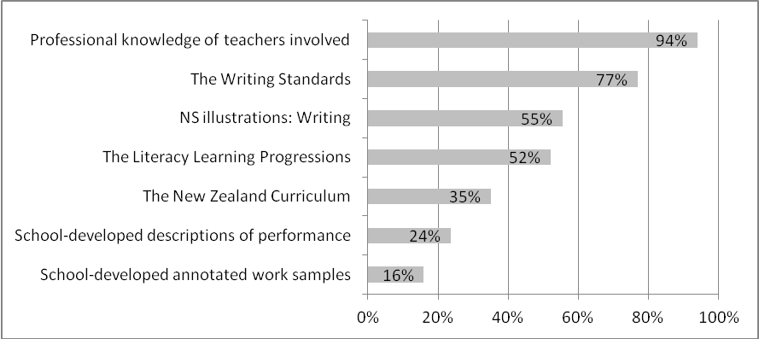
Results indicate that National Standards documentation was used by the majority of teachers in rating the samples, with 77% of teacher groups identifying that they used the National Standards Writing statements and 55% identifying the use of National Standards Writing illustrations. The professional knowledge of the teachers involved appears to be the resource most widely used, with 94% of teacher groups identifying this as used in the process. Small proportions of teachers noted that they had used school-developed descriptions of performance (24%), or annotated work samples (16%).
Forty-one groups of teachers described the process they used to make writing OTJs as part of the online survey. Twenty-nine percent of these comments described a process which included evaluating assessment information against the National Standards.
Gather 2-3 pieces of evidence. Read over Exemplars. Moderate at staff meetings. Look at National Standards.
First we do a writing sample using a different genre each time. We then moderate in a syndicate and then across the school. We then look at their sample, their book work (independent and teacher guided) and compare these to exemplars, National Standards and LLP's and Jill Eggleton to make an OTJ.
The remaining 71% of descriptions provided by groups of teachers did not mention the National Standards in their description of the process of making writing OTJs. These tended to describe the school-wide process or list the assessments used.
Gather various work samples, conference with learners, e-asttle writing assessments, peer moderation, team moderation.
Taken from draft writing books, writing samples, spelling reviews and learning conversations with the pupils.
Figure 3 summarises the resources used in the process of rating students’ work and assessment samples against the National Standards in Mathematics and is based on the responses of 189 teacher groups.
Figure 3: Resources used by teachers to rate work and assessment samples in relation to the National Standards in Mathematics
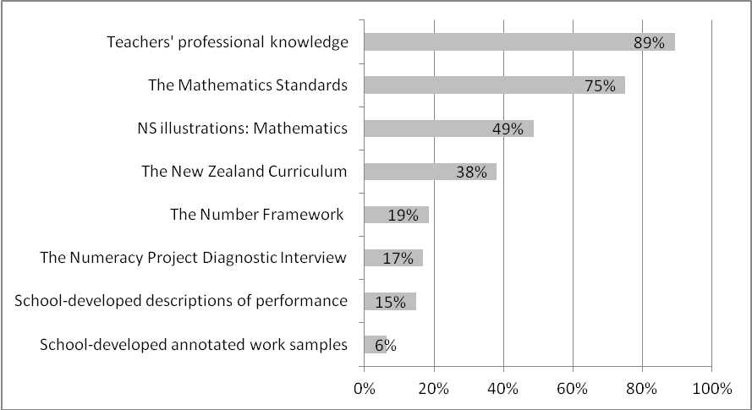
The results for mathematics are very similar to the results for writing, with the majority of teachers using National Standards documentation to rate students’ work and assessment samples. Seventy-five percent of teacher groups used the National Standards statements in this process, while the National Standards Mathematics illustrations were used by 49% of teacher groups. The most widely used resource was the teachers’ professional knowledge, with 89% of teacher groups noting that this was used.
Forty-two teacher groups provided descriptions of the process they used to make mathematics OTJs as part of the online survey. Twenty-one percent of these responses made mention of National Standards documentation in their description.
Using the Maths Standards document and the illustrations poster, along with prof knowledge we rate the child against their age using data from numeracy testing alongside data collected about the other strands. Greater weight is given to the numeracy strand as we spend the most time on that strand in Juniors.
Use a variety of assessment tools depending on the topic and age of the students - IKAN, GloSS, e-asTTle, AWS testing, PATs, observational charts, observations. Compare results to NS documents and whole-school assessment rubrics. Discuss and moderate results with staff, particularly if the student is close to reaching the standard or if the results have discrepancies. Make the OTJ.
Descriptions of the process of making OTJs that did not refer to using National Standards documentation (79%) tended to list the various assessments used or describe school-wide processes.
Collecting anecdotal evidence, group observations, various formative and summative assessment and standardised tests. Students’ bookwork. Moderating books.
Discussion of data at teacher meetings and syndicate level. Results of class tests in relation to other data.
In terms of teachers’ reflections on their own knowledge, the majority of teachers felt they had a better understanding of what students need to be achieving as a result of their work with National Standards. Fifty-nine percent of teacher groups agreed with the statement “We have a better understanding of what students need to be achieving at the levels we teach”, while 26% disagreed, and 15% were neutral in this regard. Forty-two percent of teacher groups also felt they had raised their expectations for the achievement of the students they teach as a result of working with the National Standards, while 38% felt they had not raised their expectations, and 19% were neutral.
In summary, evidence suggests that approximately three-quarters of teacher groups used the National Standards in writing (77%) and mathematics (75%) in the process of making OTJs. Results indicate that around half of the teacher groups used the National Standards illustrations in this process (55% writing, 49% mathematics).

3.1.2 OTJs are informed by student achievement information that is relevant and current.
The online survey asked teachers to rate the importance of a variety of information sources for making reading OTJs. Teachers were asked to classify each information source as of high, moderate, or low importance to the OTJ, or as used to confirm/disconfirm their OTJ. The use of the confirm/disconfirm category reflects the process for making OTJs described in the online professional development modules that accompany National Standards. The modules describe the process of making an OTJ as first using strategically collected evidence to make an OTJ, and then, secondly, comparing this OTJ to results from standardised assessments in order to conform or disconfirm the judgment. Figure 4 shows these results, based on the responses of 96 teachers.
Figure 4: Teachers’ rating of the importance of information from various sources in making reading OTJs
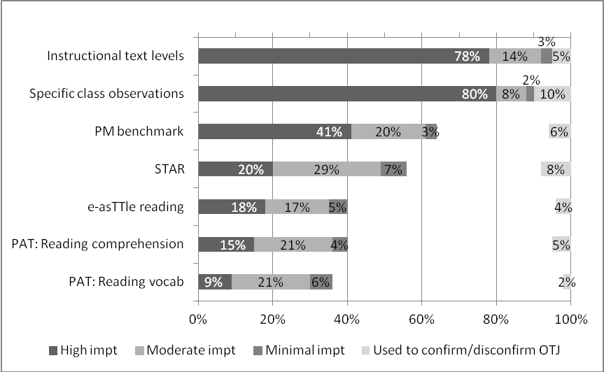
Evidence suggests that teachers regarded instructional text levels and specific class observations as the most important sources of information about student achievement, with all teachers noting these were used in making reading OTJs. Ninety-two percent of teacher groups rated instructional text levels as of moderate to high importance in making reading OTJs, and 88% rated specific class observations in this way. Teachers appear to regard the standardised assessments of e-AsTTle and PAT as the least important information sources, with each noted as being used by up to 40% of teacher groups. More specifically, 35% of teacher groups rated information from e-asTTle as moderately or very important in making reading OTJs, while 36% rated PAT: Reading comprehension, and 30% rated PAT: Reading vocab in this way. This may be because these assessments are only useful at particular year levels, rather than all year levels.
In addition to the assessments listed in Figure 4, teachers were also asked to identify any other important information sources important in making reading OTJs. Nine percent of teacher groups listed Probe as important in this regard.
It is interesting to note that small proportions of teachers indicated that they used standardised assessment information to confirm or disconfirm OTJs. This approach is promoted in the National Standards professional development material for teachers, however only 4% of teacher groups used e-asTTle to confirm or disconfirm reading OTJs, while PAT: Reading comprehension, PAT: Reading vocabulary, and STAR were each used by 5%, 2%, and 8% of teacher groups respectively.
In order to determine the relevance to the National Standards of the information sources identified by teachers as informing students’ OTJs a small group with expertise in literacy and the Reading Standards were consulted. Expert opinion was that all of the information sources listed could be considered to be relevant to the Reading Standards.
Forty-one groups of teachers rated the importance of information from various sources in making writing OTJs. These results are shown in Figure 5.
Figure 5: Teachers’ rating of the importance of information from various sources in making writing OTJs
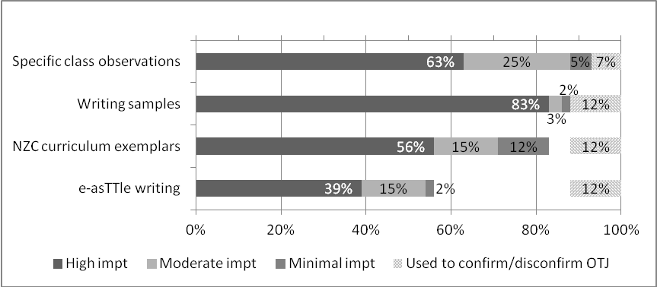
Results suggest teachers regard specific class observations and writing samples as the most important information sources for making writing OTJs. All teachers indicated they used these sources, with 88% and 86% of teacher groups respectively rating them as moderately or very important for making writing OTJs.
e-asTTle was the information source rated as important least often, with 54% of teacher groups rating it as moderately or very important in making writing OTJs. This is an increase from 2010 results, where 34% of teacher groups rated e-asTTle as being of moderate to high importance in making OTJs. In line with results from reading, small proportions of the teacher groups said they used this standardised assessment to confirm or disconfirm OTJs.
In order to determine the relevance of the information sources that teachers had used to inform OTJs a small group with expertise in literacy and the Writing Standards were consulted. Expert opinion was that NZC curriculum exemplars are of less relevance to the Writing Standards than the other assessments listed. While these suggest some evidence that teachers might look for as they observe student’s writing, in many cases the English Exemplars are students’ second drafts created with varying degrees of teachers support. They are also focused on the English Curriculum and therefore do not provide opportunities for students to demonstrate how they use writing in other areas of the curriculum.
Figure 6 shows teachers’ rating of the importance of various information sources in making mathematics OTJs. Results are based on the responses of 43 teachers.
Figure 6: Teachers’’ rating of the importance of information from various sources in making mathematics OTJs
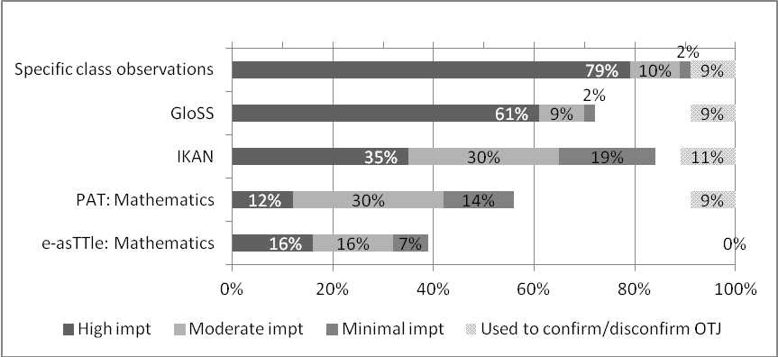
Evidence suggests teachers regard specific class observations as the most important information source for making mathematics OTJs. All teachers noted they used this source, and 89% of teacher groups rated it as moderately to very important in making mathematics OTJs. The numeracy assessments of GloSS and IKAN were also rated highly, with 70% and 65% of teacher groups respectively rating them as of moderate to high importance. It is of interest that the GloSS assessment was rated as more important for making mathematics OTJs in 2011 than 2010, with an increase from 47% to 70% over this time.
The standardised assessments of PAT: Mathematics and e-asTTle: Mathematics were rated as of moderate to high importance in making mathematics OTJs by 42% and 32% of teacher groups respectively. This indicates they were of less importance to teachers than non-standardised sources. Consistent with results in reading and writing, small proportions of teachers used standardised assessments to confirm or disconfirm OTJs. Nine percent of teacher groups indicated they used PAT: Mathematics in this way. Other sources of information identified by teachers as important in making mathematics OTJs were NumPA and teacher-developed tests for areas of mathematics other than number, each identified by 7% of respondents.
While evidence suggests teachers are using a range of information sources to make mathematics OTJs, some of these sources provide information that is of greater relevance to the Mathematics Standards than others. In order to determine the relevance of the information sources listed to the Mathematics Standards a small group with expertise in mathematics and the Mathematics Standards was consulted. Expert opinion was that IKAN, which provides information about students’ knowledge in number, is of less relevance to the standards than the other assessments listed. This is because the standards focus on students’ ability to “use their knowledge to think mathematically when solving problems” rather than recalling items of number knowledge.
In summary, evidence suggests teachers used a range of information sources to make OTJs in reading, writing and mathematics. Most of the information sources teachers reported using were regarded by experts as relevant to the National Standards. Specific class observations were rated as one of the most important sources for making OTJs in all three areas. In addition, instructional reading levels, writing samples, and the GloSS assessment in mathematics were also rated highly. Results indicate a minority of teachers used information from standardised assessments to confirm or disconfirm OTJs as advocated by the National Standards teacher professional development material.
To provide a measure of the currency of assessment information used to make OTJs, the online survey asked teachers to indicate the time from the OTJ of the most recent and least recent assessment evidence used. Table 13 summarises these results. For the purposes of this evaluation, assessment evidence collected within 12 weeks of the OTJ is considered current on the basis that it is information from the most recent term of the students’ schooling.
Table 13: Timing of assessment evidence used to inform OTJs
Learning Area |  | Time from OTJ |  |  |  |  | Number of teachers groups
 |  | 0-2 weeks | 3-4 weeks | 5-12 weeks | 3-6 months | Longer than  6 months | Number of teachers groups
Most recent | Reading | 81% | 14% | 4% | 0 | 1% | 96
Most recent | Writing | 51% | 24% | 20% | 0 | 5% | 41
Most recent | Mathematics | 74% | 19% | 5% | 0 | 2% | 43
Least recent | Reading | 4% | 23% | 41% | 16% | 17% | 96
Least recent | Writing | 2% | 20% | 39% | 10% | 29% | 41
Least recent | Mathematics | 0% | 19% | 30% | 30% | 21% | 43
Sixty-eight percent of respondents can be considered as using current assessment information to inform reading OTJs. This is an increase from 2010 where 37% were found to be using current reading information. In writing, 61% of teacher groups indicated current assessment information was being used, while in mathematics 49% of teacher groups indicated this. Most teachers used some evidence from within the last 4 weeks to inform students’ OTJs, (95% in reading, 75% in writing, and 93% in mathematics). In terms of the least recent evidence source, some teachers were found to be using information that was collected more than six months from the date of the OTJ (17% in reading, 29% in writing, and 21% in mathematics).

3.1.3 Teachers make OTJs efficiently
Evidence suggests most teachers make OTJs for the students in their class. Respondents reported making an average of 25 reading OTJs, 23 writing OTJs, and 24 mathematics OTJs.
It is difficult to determine the efficiency of the process used to make OTJs as the total time taken depends on number of OTJs made, the time taken to make one OTJ, and whether OTJs are assigned to individual students, or groups of students. For the purposes of this evaluation an average time of ten minutes or less per OTJ is considered as efficient, as this would require approximately 4 hours per subject area to make OTJs for 25 students, a total of twelve hours over the three areas. Table 14 summarises teachers’ estimates of the time taken to make one OTJ.
Table 14: Estimates of average time taken to make one OTJ
Average time in minutes | Percentage of teacher groups
Average time in minutes | Reading | Writing | Mathematics
5 or less | 22% | 10% | 32%
6 to 10 | 17% | 23% | 27%
11 to 15 | 26% | 20% | 10%
16 to 20 | 6% | 15% | 7%
21 to 30 | 20% | 23% | 15%
31 to 60 | 7% | 8% | 10%
More then 60 | 2% | 3% | 0%
Number of teacher groups | 88 | 40 | 41

These results indicate that 39% of respondents made reading OTJs in less than ten minutes, while 33% made writing OTJs and 59% made mathematics OTJs in this time. These teachers can be considered as making OTJs efficiently.

3.2 Descriptive information
Teachers were asked to estimate, on average, the numbers of pieces of assessment evidence that were used to inform a student’s OTJ in each area. Table 15 summarises these results.
Table 15: Number of information sources used by teachers to inform OTJs
Learning Area | Percentage of teacher groups |  |  |  |  |  | No. of teacher groups
Learning Area | 1-2  sources | 3-4  sources | 5-6  sources | 7-8  sources | 9-10  sources | >10  sources | No. of teacher groups
Reading | 4% | 41% | 34% | 5% | 3% | 13% | 96
Writing | 2% | 34% | 34% | 2% | 5% | 22% | 41
Mathematics | 5% | 23% | 44% | 21% | 5% | 2% | 43

As seen in Table 15 most teachers are using between three and six information sources to inform OTJs (75% of teacher groups in reading, 68% in writing, and 67% in mathematics). Up to five percent of teacher groups used just one or two sources in each area. Evidence suggests teachers used more sources of evidence in writing, with 27% of teacher groups using nine or more sources, than in reading and mathematics, where 16% and 7% of respondents used nine or more sources respectively.
Teachers were asked whether they considered student’s previous OTJs when making their current end-of-year OTJ in each area. Just over half of the respondents reported doing so (51% for reading OTJs, 63% for writing, and 58% for mathematics). There were two common themes in comments associated with this response. The first of these was that the student’s previous OTJ was considered in order to reflect on progress made to date (15% of respondents made this comment in regard to reading OTJs, 20% in regard to writing OTJs, and 11% in regard to mathematics OTJs).
Good to see progress and reflect on previous levels
To check that the progress is appropriate considering they’re past OTJs. To pick up children that may not be making acceptable progress.
It is important to see progress over time, to identify factors that might be affecting any unexpected large jumps forwards or backwards.
The second common theme in these responses concerned ensuring consistency of OTJs across the school (7% of teacher groups commented this was the case in writing, and 6% made this comment in mathematics).
Needed to ensure consistency across the 2 years - checked back over previous evidence if uncertain.
To further confirm that as a whole, our school is tracking and assessing consistently and that there is no discrepancies between junior/senior levelling.
In survey responses, 66% of teacher groups indicated they believe they are more systematic in their collection of evidence of student progress as a result of the introduction of National Standards. This is an increase from the 2010 result in which 43% of teacher groups indicated they believed they were more systematic. In 2011, 22% of teacher groups disagreed that they had become more systematic in their collection of assessment information, while 11% were neutral in this regard and 1% of respondents were unsure.
In terms of the volume of assessment evidence collected, 57% of teacher groups indicated they had collected more evidence of student progress and achievement as a result of the introduction of National Standards. Again this is an increase on the 2010 result in which 33% felt they were collecting more achievement evidence. In 2011, 30% of teacher groups indicated they had not collected more evidence, 12% were neutral in this regard and 1% were unsure.
Teachers were invited to comment on working with the National Standards and 72 groups of teachers chose to do so. Comments were wide-ranging and generally negative. Thirty-one percent of respondents commented on negative aspects of the standards, while 2% commented positively. Four percent of respondents made comments that were neither clearly positive nor clearly negative in nature. Responses contained three common themes. These were that the implementation of National Standards is a time consuming task for teachers (6% of respondents), that the National Standards set unrealistically high expectations for students’ achievement (7% of respondents), and a concern over the demotivation of students who are consistently rated as below the standard (6% of respondents).
National Standards have taken teachers time and focus away from our core job of teaching students.
National Standards have not been responsible for our children's progress. Everything that takes place in our schools have been done for years, National Standards have not helped in our children's success. They have just repeated the same process with more work and the results remain the same!!!
I feel the National Standards are set too high and they are an unrealistic goal for over 50% of the students. Students who are below the standard get very discouraged. I also feel disheartened.
The National Standards are unrealistic and set too high for the students.
Students have made excellent progress but will never meet the standard. It's disheartening for kids to see that they are below even though they have made progress. The visual diagrams of standards catch students’ interest rather than the comments.

4. Moderating OTJs
Making an OTJ requires teachers to draw together assessment information from a variety of sources. In order to ensure the consistency of judgments between teachers, “schools need to establish a moderation process within their assessment programme. The process needs to consider how teachers interpret National Standards as well as how they make their judgments from the assessment information they have gathered”.
This chapter uses evidence from principal and teacher surveys to investigate the processes used by schools to moderate OTJs in reading, writing, and mathematics. Table 16 shows the monitoring question and performance criteria that are addressed.
Table 16: Monitoring and evaluation questions and criteria – moderating OTJs
Intended outcome: Teachers make defensible, trustworthy judgments against the National Standards.
Monitoring and  Evaluation Questions | Performance criteria | Sources of evidence
What processes are used to moderate OTJs? | Schools use processes and systems to ensure OTJs are consistent. | Surveys: principal and teacher
What processes are used to moderate OTJs? | Moderation decisions are informed by the NS in reading, writing, and mathematics. | Surveys: principal and teacher
What processes are used to moderate OTJs? | Moderation processes are efficient and effective. | Surveys: principal and teacher

4.1 Evaluative criteria

4.1.1 Schools use processes and systems to ensure OTJs are consistent.
Teachers were asked to identify the nature of the moderation processes they had been involved in. Table 17 summarises these results.
Table 17: Percentages of teachers that report being involved in moderation discussions
Learning Area | School-wide processes and informal discussions | Systematic processes only | Informal discussions only | No  moderation | No. of teacher groups
Reading | 59% | 7% | 29% | 4% | 96
Writing | 78% | 5% | 15% | 2% | 41
Mathematics | 74% | 16% | 2% | 7% | 43

Evidence suggests most schools used school-wide systems and processes to moderate OTJs in writing (83%) and mathematics (90%), with school-wide moderation processes less common in reading (67%). In line with this finding, informal moderation discussions appear to have been most common in reading. Twenty-nine percent of teacher groups indicated they had participated in informal moderation discussions only in reading, with smaller proportions indicating this was the case in writing (15%) and mathematics (2%).
Information about moderation from 2010 results indicates that writing was an area of focus for most schools in terms of formal moderation practices. Eighty percent of teacher groups indicated they were involved in formal moderation processes in writing in 2010, while 56% and 46% respectively were involved in the formal moderation of reading and mathematics OTJs. These results suggest many schools carried out formal moderation of writing OTJs in 2010, and extended this to mathematics OTJs in 2011.

4.1.2 Moderation decisions are informed by the National Standards in reading, writing, and mathematics
In order to investigate the extent to which the National Standards informed moderation decisions, teachers were asked to describe the process they used to moderate OTJs in reading, writing, and mathematics. Ninety-six responses were received in reading, while 41 and 43 responses respectively were collected in writing and mathematics. Teachers’ responses tended to focus on organisational structure of discussions across the school, rather than the content of moderation discussions.
Small proportions of responses made direct mention of the National Standards in their description of the processes used to moderate OTJs. Eleven percent of descriptions in reading mentioned the National Standards, while in writing and mathematics 10% and 12% of respondents mentioned the National Standards respectively.
Discussed in syndicate areas and looked at samples from students at different levels, compared them to the [reading] standards and literacy progressions.
Took in 3 student’s samples and all achievement information (high, middle, low). Discussed and debated against the [writing] standards and progressions.
We all brought different exemplar levels of knowledge, strategies and strands to syndicate meetings then whole school meeting. We then compared them to the National Standards [in mathematics].
The descriptions of the processes used to moderate OTJs that did not refer to the National Standards tended to describe the school-wide process of moderation or the sources of student achievement data that were used.
We have had k-lit cluster discussions, within school discussions, team solutions working with each teacher across the school, working on consistency within school. [reading]
Asttle, STAR, Probe and Benchmarks.
Single pieces of work are moderated in the group to ensure that our marking is equal across the board. Literacy meetings across the department. Meetings with local school to share moderation standards. Year level moderations meetings. [writing]
Moderation occurred within syndicates, the lead teacher sat across the moderation of most syndicates to ensure consistence. Our next step is to do more cross syndicate moderation. [mathematics]
Sharing of Gloss test and Ikan.

4.1.3 Moderation processes are efficient and effective
Principals were asked to describe the way in which OTJs were selected for moderation in reading, writing and mathematics. Some of these methods can be considered more efficient than others. For the purposes of this evaluation, focusing moderation discussion on the OTJs near the boundaries between the levels of the standards is considered effective as it focuses teachers’ attention on the OTJs that are likely to involve the most difficult decisions. Table 18 contains these results and is based on the responses of 74 principals. Note that responses in each area sum to more than 100, as some schools use more than one criterion to select OTJs for moderation.
Table 18: Processes used by schools to select OTJs for moderation
Selection criteria | Reading | Writing | Mathematics
OTJs near the boundaries between the levels of the standards | 36% | 35% | 30%
The OTJs with inconsistent assessment evidence | 33% | 22% | 23%
A random selection of OTJs | 33% | 32% | 34%
All OTJs | 13% | 23% | 16%
Other | 7% | 7% | 13%

Results indicate that approximately a third of schools used the efficient method of selecting OTJs near the boundaries between the levels of the standards as a focus for moderation. Thirty-six percent of schools used this method in reading, while 35% and 30% respectively used this method in writing and mathematics.
If teachers moderate those judgments that are near the boundaries between the levels of the standards, it is reasonable to expect that a minimum of six judgments per class will be moderated. That is, a teacher could be expected to moderate two students to differentiate between students at each boundary (‘above’ and ‘at’, ‘at’ and ‘well below’, and below and ‘well below’). Assuming class sizes that vary from 15 to 30 students, these six OTJs represent 20-39% of the OTJs as an efficient proportion to moderate. Principals were asked to indicate the proportions of OTJs that were moderated. Seventy-four principals responded and these results are summarised in Table 19.
Table 19: Proportions of OTJs that were moderated
Percentages of OTJs moderated | Percentages of schools
Percentages of OTJs moderated | Reading | Writing | Mathematics
0 | 24% | 7% | 27%
1 to 19 | 26% | 24% | 23%
20 to 39 | 24% | 27% | 22%
40 to 99 | 15% | 20% | 15%
100 | 11% | 22% | 14%

Results suggest around a quarter of schools moderated a proportion of OTJs that can be considered efficient in reading (24%), writing (27%), and mathematics (22%). In general, schools tended to rate a greater proportion of writing OTJs than was considered efficient, and a smaller proportion of reading and mathematics OTJs than was considered efficient. For example, 42% of schools moderated more writing OTJs than was considered efficient, and 31% of schools moderated less. In contrast, 26% of schools moderated more reading OTJs than was considered efficient and 50% of schools moderated less.
Teachers were asked to estimate the average number of minutes taken to moderate one OTJ. Table 20 summarises these results. For the purposes of this evaluation up to ten minutes per OTJ is considered efficient as this is one hour per area (assuming they moderate for the 6 students who are at the boundaries between the levels of the standards for their class) so three hours to moderate reading, writing and mathematics for their class.
Table 20: Teachers’ estimates of the average time taken to moderate one OTJ
Average time in minutes | Percentage of teacher groups
Average time in minutes | Reading | Writing | Mathematics
2 to 5 | 24% | 3% | 33%
6 to 10 | 25% | 10% | 25%
11 to 15 | 20% | 21% | 10%
16 to 20 | 8% | 18% | 8%
21 to 30 | 20% | 21% | 15%
31 to 60 | 1% | 21% | 10%
More then 60 | 1% | 8% | 0%
Number of tchr groups | 75 | 39 | 40

Survey responses indicate approximately half of the teachers who moderated reading OTJs (49%) and mathematics OTJs (58%) can be considered to be moderating efficiently, taking up to ten minutes per OTJ. Efficiency rates were lower in writing, where 13% of teacher groups spent up to ten minutes per OTJ. This writing efficiency rate appears to be lower than in 2010, when 39% of teacher groups estimated spending up to ten minutes to moderate an OTJ. Among the least efficient were those teachers who spent more than 20 minutes per OTJ in moderation. This is half of the teachers who moderated writing OTJs (50%), with smaller proportions of teachers taking longer than 20 minutes to moderate reading (22%) and mathematics OTJs (25%).

4.2 Descriptive information
Principals were asked to identify how teachers within the school were grouped for moderation discussions in reading, writing, and mathematics. Table 21 displays these results. Note that columns sum to more than 100% as some schools group teachers in more than one way.
Table 21: Teacher groupings for moderation discussions
Grouping | Reading | Writing | Mathematics
All teachers in the school | 36% | 56% | 38%
Small groups of teachers | 67% | 69% | 69%
Other | 8% | 8% | 8%

Just over two-thirds of schools held discussions in small groups to moderate reading (67%), writing (69%), and mathematics OTJs (69%). Approximately half of the schools held whole-school moderation discussions in writing (56%), while whole-school discussions were less common in reading (36%) and mathematics (38%). Other groupings of teachers described by schools included meetings with other schools and moderation by management staff.
As might be expected a whole-school approach to moderation was more common in small schools, while a small group approach was more common in large schools. For example, in writing 75% of schools with less than 150 students conducted moderation discussions with all teachers in the school, while 46% of these schools conducted discussions in small groups. In contrast, 46% of schools with more than 150 students carried out whole-school writing moderation discussions, while 88% of these schools conducted discussions in small groups. Note that some schools combined whole-school and small group approaches.
Teachers were asked to estimate the average number of different pieces of assessment evidence that were discussed for a student in the moderation of their reading, writing and mathematics OTJs. Table 22 displays these results.
Table 22: Extent of student achievement information used by teachers to moderate OTJs
Number of information sources | Reading | Writing | Mathematics
1 to 2 | 11% | 28% | 7%
3 to 4 | 58% | 40% | 41%
5 to 6 | 24% | 23% | 44%
7 to 8 | 2% | 0% | 2%
9 to 10 | 1% | 0% | 2%
>10 | 3% | 10% | 2%
Number of teacher groups | 91 | 40 | 41

Nearly all groups of teachers report using up to six pieces of evidence to moderate student’s reading (93%), writing (91%), and mathematics OTJs (92%). Small proportions of teachers are consulting a larger number of sources, with up to 10% of teacher groups using more than 10 sources of evidence for this purpose over the three areas.
Just over one-third of principals indicated they had engaged in moderation practices with other schools in at least one area (36%). Small proportions of schools had moderated in two (4%) or three areas (7%). The area of focus for most between-school moderation discussions was writing. Results indicate that 32% of schools worked with other schools to moderate writing OTJs, while smaller proportions conducted between-schools moderation in reading (10%) and mathematics (12%).
Principals were invited to comment on the moderation of OTJs and 33 principals chose to do so. Overall, 17% of respondents commented negatively while four percent of principals made positive comments. Twenty-two precent of respndents made comments that were neither clearly negative nor clearly positive. The two common themes in these comments were the time-consuming nature of moderation processes (8% of respondents) and a concern over the nationwide consistency of OTJs (5% of respondents).
We have spent a lot of time discussing the standards instead of looking at students' individual achievement and next learning steps. This has added to an already busy job load.
The teachers found this very time consuming. There was lots of professional discussion around this at all levels.
My biggest problem is how do we get consistency across all of NZ. There is a school not far from ours that accepts a lower standard than we do and I am not prepared to compromise what I (and my school) interpret to be the Year 6 standard, for example.
We are confident in the level of consistency within our own school but we have no idea as to how our judgments compare on a national level.

5. The Dependability of OTJs
The OTJ, as a judgment of each student’s achievement against the National Standards, is central to the successful implementation of the standards initiative overall. The information OTJs provide is used to tailor teaching programmes and target students for intervention. For these programmes and interventions to successfully raise achievement, OTJs need to be dependable. A dependable assessment is defined as one that has both high validity and high reliability. Validity concerns whether assessment results can be used for a particular purpose, the extent to which results can be interpreted in a particular way because the assessment measures what it is intended to measure. Reliability concerns the consistency of an assessment, the “extent to which the results from the same assessment can be repeated across time and situations.”
This chapter provides information about the dependability of OTJs, collected through the use of assessment scenarios. As described in chapter two, the assessment scenarios collected teachers’ judgments in relation to the National Standards for samples of student work, and were administered to groups of teachers as part of the online teacher survey. Each group completed two scenarios: mathematics and writing. Reading was not a focus due to the challenge of presenting a work product for reading tasks online.
For each scenario teachers chose a year level standard to focus on: after 2 years, end of year 4, end of year 6, or end of year 8. There were two parts to the scenario at each year level:
- Rating three work or assessment samples as ‘at’, ‘above’ or ‘below’ the relevant standard. Each writing sample included a description of the writing task, the student’s response, and notes about the writing process used and the students’ level of independence. Each mathematics sample included the problem posed, the student’s response, and teachers notes on students’ use of mathematics vocabulary and level of independence as required. The samples were developed by experts to be clearly positioned ‘at’, ‘above’ or ‘below’ a particular standard, and were focused on an aspect of students’ abilities fundamental to the standards. Together the three samples at each year level provided coverage of the breadth of the standard. To ensure the content would be as familiar as possible to teachers, samples were based directly on information in the standards themselves or the National Standards illustrations.
- Making an OTJ on the basis of four pieces of previously rated assessment evidence. The OTJ scenarios provided teachers with a description of four pieces of assessment evidence, each of which already had a rating of ‘at’, ‘above’, or ‘below’ the relevant standard. Teachers were asked to collate the four rated samples to make an OTJ.
The first part of each scenario was designed to collect information about teachers’ ability to rate individual pieces of student work in relation to the National Standards. The second part focused on teachers’ ability to collate several pieces of assessment evidence that had already been rated against the standards to make an OTJ. In addition to these two types of judgements, each scenario also contained qualitative questions that focused on the level of agreement within the group and the basis on which judgments were made.
Teachers were instructed to use any resources they normally use to moderate OTJs as they completed the assessment scenarios. It was suggested that these resources might include National Standards documents and illustrations, the New Zealand Curriculum, relevant curriculum documents such as the Literacy Learning Progressions and the Number Framework, and school-developed documentation.
The extent to which teachers’ judgments were consistent with the positioning of the scenarios as ‘at’, ‘above’ or ‘below’ a particular standard was taken as a measure of the accuracy of teachers’ judgments and therefore the dependability of OTJs.
Table 23 shows the monitoring and evaluation question and the performance criteria used in this chapter.
Table 23: Monitoring and evaluation questions and criteria - dependability of OTJs
Intended outcome: Teachers make defensible, trustworthy judgments against the National Standards.
Monitoring and  Evaluation Questions | Performance criteria | Sources of evidence
How dependable and consistent are teachers’ overall judgments? | Teachers make dependable OTJs. | Assessment scenarios

Evaluative criteria

5.1 Sample rating scenarios

5.1.1 Sample rating scenarios in writing
Teachers chose to work at one of four levels: after 2 years, end of year 4, end of year 6, or end of year 8. They rated three separate writing samples against the Writing Standards for the selected year level. The accuracy of teachers’ ratings for the 12 sample rating scenarios is shown in Figure 7. Note that the number of groups of teachers rating the three scenarios at each year level is specified as n.
Figure 7: Accuracy of teachers’ ratings for the sample rating scenarios in writing
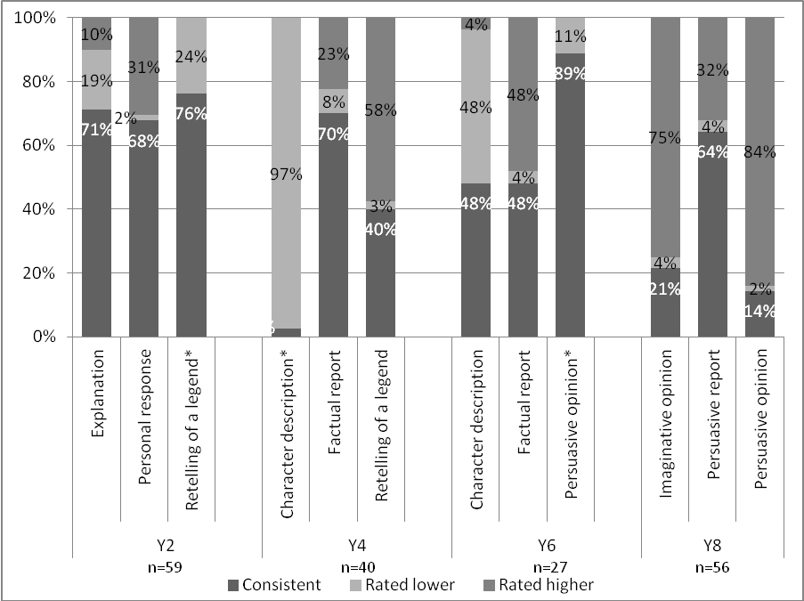
*indicates teachers were unable to rate higher, as scenario rating was above the relevant standard.
As seen in Figure 7 there was considerable variability in the accuracy of teachers’ ratings for the sample rating scenarios in writing. Accuracy ranged from 3% (for a character description rated against the end of year 4 standard) to 89% (for a persuasive opinion rated against the end of year 6 standard). By year level, accuracy was greatest against the after 2 years (72%) and end of year 6 (62%) standards, while the ratings against the end of year 4 (38%) and end of year 8 (33%) standards were least accurate. Over all 546 ratings, 51% of teachers’ judgments were accurate.
The scenario that resulted in the greatest accuracy was a persuasive opinion focused on the benefits of watching cartoons. This scenario was ‘above’ the end of year 6 standard, a rating that was made by 89% of teacher groups. The work sample from this scenario is illustrated in Figure 8. Note that teachers were also provided with the following student transcript:
“One of my learning goals is to add more impact and effect the reader by using strong words so I asked my writing group to listen while I read it aloud and help me change some of the words. I had adults but I really like “the social media” it sounds more important and means the newspaper and that. I decided to change watching to viewing because that’s more stronger…I decided to type it out at the very end as I’m not a neat writer and it makes it easier to read.”
Figure 8: Work sample from scenario positioned ‘above’ the end of year 6

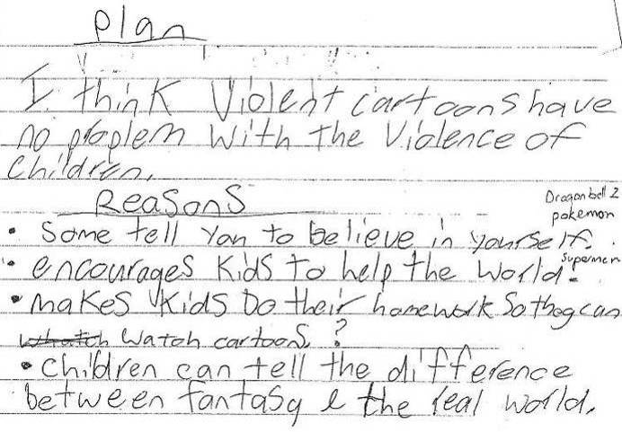
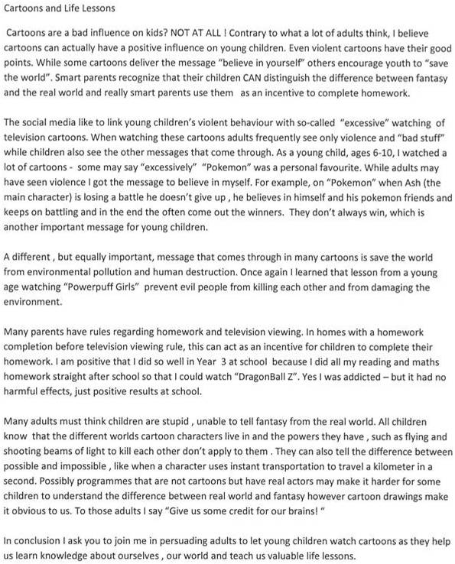
The least accurate rating was a character description of Fred Dagg that was ‘above’ the end of year 4 standard, a rating made by 3% of respondents. Ninety-seven percent of teacher groups gave the lower rating of ‘at’. The work sample for this scenario is illustrated in Figure 9. The scenario also outlined that the student worked independently, and plans to publish and include the sample on the class blog.
Figure 9: Work sample for scenario positioned ‘above’ the end of year 4

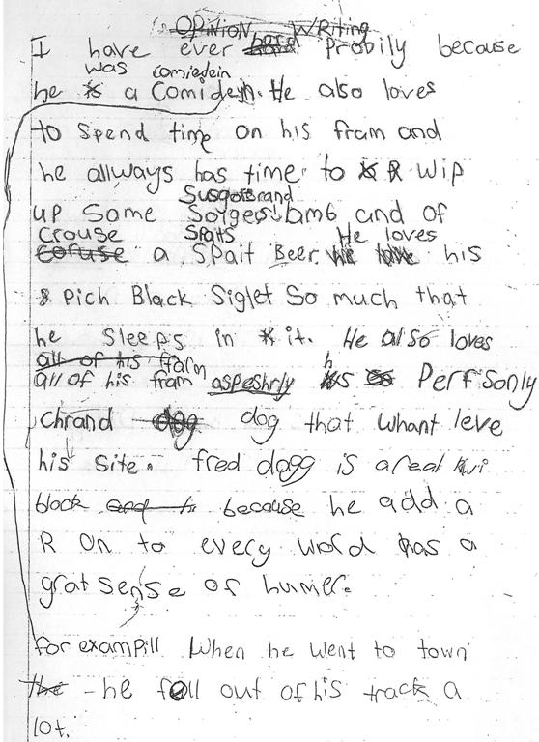

The features of this scenario which contribute to its positioning of ‘above’ the end of year 4 writing standard include the use of more advanced descriptive language than expected at this level, the inclusion of some subject specific vocabulary (for example, “real kiwi bloke”), and the independent revision and editing carried out by the student. While the reasons for almost all teachers giving this a lower rating cannot be ascertained, teachers’ comments indicated the lack of attention to surface features in this piece of writing was a point of discussion. In addition, teachers reported low levels of agreement within the group for this scenario, which is described more fully in section 5.3.1.
The other two sample rating scenarios with the lowest accuracy were those for the end of year 8 standard. In both these scenarios, teacher groups rated higher than the position of the scenario. The samples involved were an imaginative opinion about life 100 years from now (developed as ‘below’ and rated as ‘at’ by 75% of teacher groups) and the persuasive opinion about watching cartoons (developed as ‘at’ and rated as ‘above’ by 84% of teacher groups). These examples are indicative of the general trend in which those teachers that gave inaccurate judgments in writing tended to rate higher than required, rather than lower. Excluding the scenarios where it was not possible to rate too high as the scenario was positioned above the standard (420 judgments), 50% were of teacher judgments were accurate, while 42% were too high and 8% were too low. It is of note that this trend is dominant at year 8 (where 64% of ratings were too high and 3% were too low) and year 4 (40% too high and 5% too low). The trend was less pronounced at year 2 (20% too high and 10% too low) while at year 6, equal proportions of teachers rated too high and too low (26%).

5.1.2 Sample rating scenarios in mathematics
Teachers were asked to rate three scenarios based on samples of students’ work or assessment information in relation to the National Standards in Mathematics. Teachers selected a standard to work with, choosing from the After two Years, end of year 4, end of year 6, or end of year 8 standards. Figure 10 shows the accuracy of teachers’ ratings for each scenario. Note that n provides the numbers of teacher groups that responded to each of the three scenarios within each level.
Figure 10: Accuracy of teachers’ ratings for the sample rating scenarios in mathematics
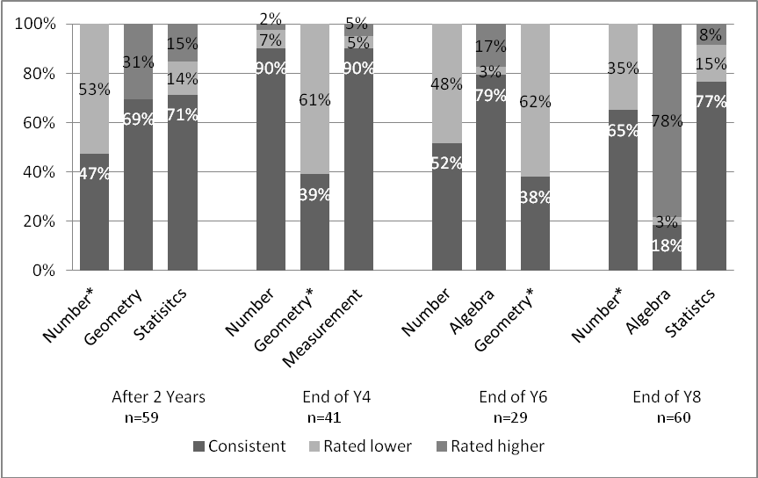
*indicates teachers were unable to rate higher, as scenario rating was above the relevant standard.
Figure 10 indicates that the accuracy of teachers’ judgments in mathematics was variable. Accuracy over the 12 scenarios ranged from 18% (end of year 8 algebra sample) to 90% (end of year 4 number and measurement samples). Over the three scenarios at each level, teachers’ judgments in relation to the end of year 4 standard were most accurate (73%) while those against the end of year 6 (56%) and end of year 8 standard (53%) were least accurate. Teachers’ judgements against the after 2 years standard were 63% accurate. Over all of the 12 scenarios and four standards (567 ratings in total), teachers’ ratings were 61% accurate.
The two mathematics scenarios rated with the greatest accuracy involved a recording sheet from a GloSS assessment interview, and a sample of student work from a measurement task involving a broken ruler. Both scenarios involved groups of teachers rating against the end of year 4 standard, and resulted in 90% accuracy. Figure 11 and Figure 12 illustrate these scenarios.
Figure 11: Assessment scenario, number,’at’ the end of year 4 standard
Sample A
Please look at Emma’s GloSS recording sheet and decide together the most appropriate rating against the end of year 4 Mathematics standard. Record your answer in the question below.
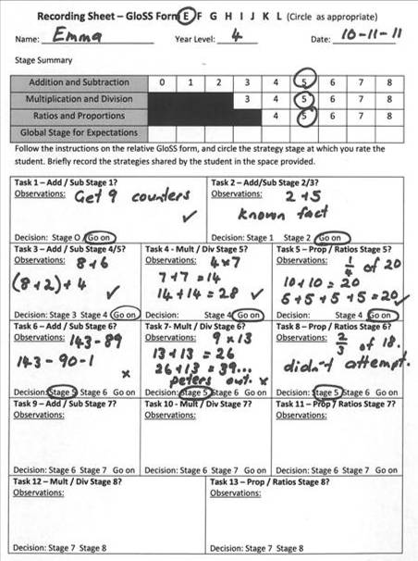

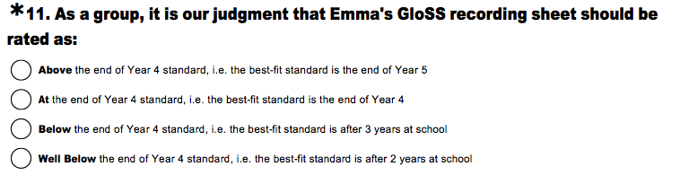
Figure 12: Assessment scenario, measurement, ‘below’ the end of year 4
Sample C
Please look at Sam’s recording sheet for the measurement task and decide together the most appropriate rating against the end of year 4 Mathematics standard. Record your answer in the question below.

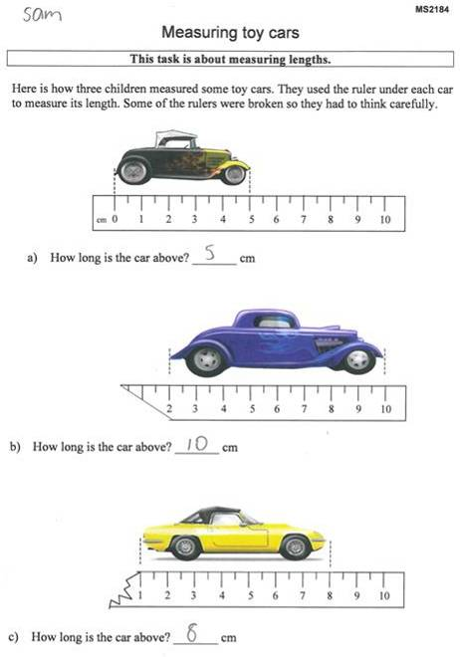
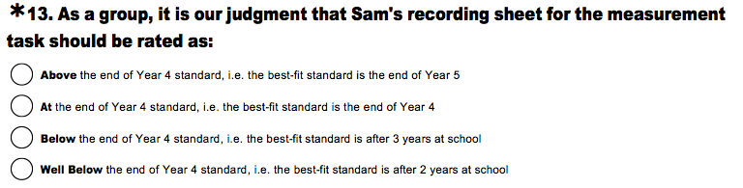
Two other scenarios were rated accurately by over three-quarters of respondents. The first of these focused on an algebra sample involving the description of a general rule from a tiling pattern. Seventy-nine percent of teacher groups accurately rated this ‘at’ the end of year 6 standard. The second scenario with high accuracy used a statistics sample, and involved predicting the outcome of a two-dice probability task. This scenario was accurately judged by 77% of teacher groups to be ‘at’ the end of year 8 standard.
The scenario that resulted in the lowest accuracy involved an algebra task that involved describing a general rule for a matchstick pattern. This is illustrated in Figure 13.
Figure 13: Assessment scenario, algebra, ‘below’ the end of year 8 standard

Sample B
Please look at Huia’s recording sheet for the patterning task and decide together the most appropriate rating against the end of year 8 Mathematics standard. Record your answer in the question below.
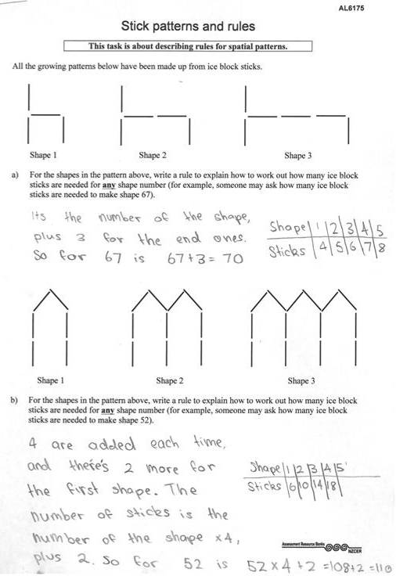
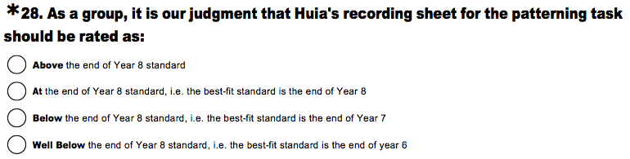
This matchstick task was positioned ‘below’ the end of year 8 standard, as it did not include an equation that expressed the pattern’s rule, which is explicitly stated in the standard. Eighteen percent of teacher groups rated this accurately, while most groups of teachers (75%) judged it as ‘at’ the end of year 8 standard. Two other tasks in which teachers achieved a low accuracy were focused on geometry. The first of these involved a student successfully describing locations with co-ordinates and giving directions using compass points, and was accurately rated ‘above’ the end of year 4 standard by 39% of teacher groups. The second involved accurate isometric drawings from 4 viewpoints and was accurately rated ‘above’ the end of year 6 standard by 38% of teacher groups. The majority of respondents rated both these geometry scenarios as ‘at’ the relevant standard (62% in Year 6 and 61% in Year 4).
In general, teachers’ ratings in the mathematics scenarios tended to be too high rather than too low. Over the 378 ratings where it was possible to rate both higher and lower than accurate (i.e. excluding those scenarios that were positioned above the standard), 67% of teachers’ judgments were accurate while 23% were too high and 10% were too low. The tendency to rate too high was greatest at year 8 (43% too high and 9% too low) and year 2 (23% too high and 7% too low). In years 4 and 6 this trend was reversed (4% higher and 6% lower at year 4, 9% higher and 26% lower at year 6).

5.1.3 Concluding comment
Findings indicate there is considerable variability in the accuracy of teachers’ ratings against the National Standards for individual work or assessment samples. In writing, accuracy ranged from 3% to 89%, while accuracy in mathematics ranged from 18% to 90%. This finding is a cause for concern as it is these individual judgments that are synthesised to form OTJs. Given this concern, the dependability of the OTJ is also called into question.

5.2 Making OTJ scenarios

5.2.1 Making writing OTJ scenarios
In addition to rating individual writing samples in relation to the Writing Standards, teachers were also asked to synthesise four pieces of already rated assessment information to make an OTJ. These results are shown in Figure 14.
Figure 14: Accuracy of teachers’ writing OTJs
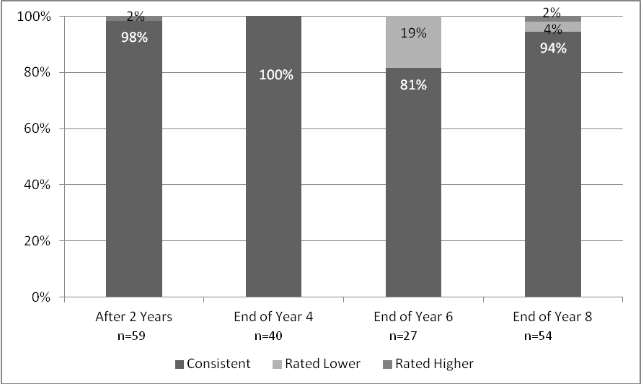
As seen in Figure 14, teachers’ accuracy in making OTJs ranged from 81% (against the end of year 6 standard) to 100% (against the end of year 4 standard). Overall, 95% of teacher groups were able to synthesise four pieces of assessment evidence to make an accurate writing OTJ. Four percent of teachers’ OTJs were positioned too low, while 1% were positioned too high.
Teachers’ OTJs were most accurate for the end of year 4 scenario, with 100% of teacher groups giving the accurate rating of ‘at’ the standard. This scenario is illustrated in Figure 15.
Figure 15: Making writing OTJ scenario, ‘at’ the end of year 4
Writing Standard, By the end of Year 4
The table below summarises four pieces of assessment information from one child: Esther. She is in year 4 and the assessment information has been collected at the end of the year. As a group, please look at all of the information and use it to make an OTJ against the end of year 4 writing standard for Esther. Record your answer in the question below.

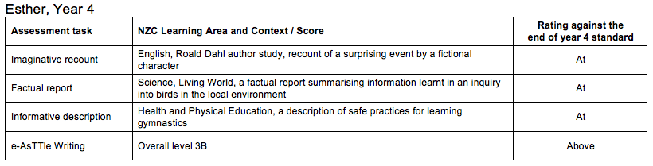

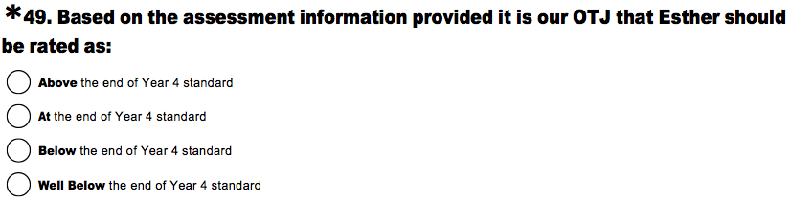
In contrast, the scenario that resulted in the least accurate OTJs was against the end of year 6 standard. Figure 16 shows this scenario.
Figure 16: Making writing OTJ scenario, ‘above’ the end of year 6
Writing Standard, By the end of Year 6
The table below summarises four pieces of assessment information from one child: Piripi. He is in year 6 and the assessment information has been collected at the end of the year. As a group, please look at all of the information and use it to make an OTJ against the end of year 6 writing standard for Piripi. Record your answer in the question below.

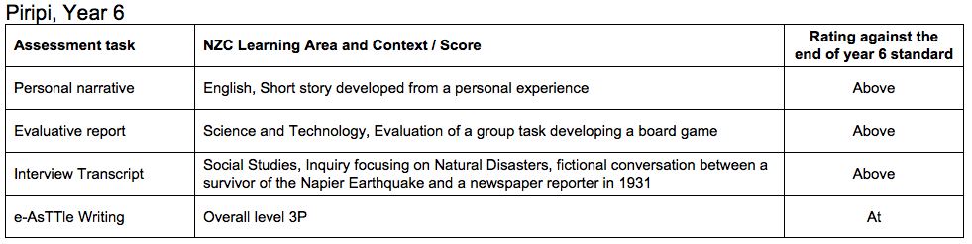
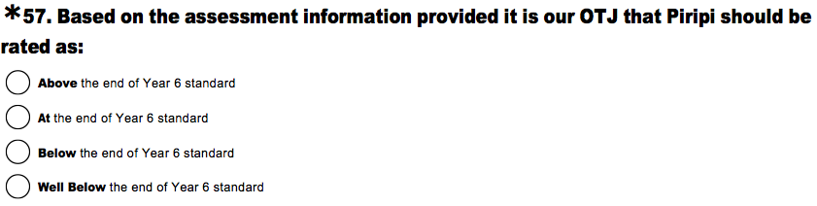
Eighty-one percent of teacher groups accurately rated this scenario as ‘above’ the end of year 6, while 19% of teacher groups rated Piripi as ‘at’. It appears these teachers have weighted the standardised e-asTTle assessment more heavily than the other assessment tasks listed. The scenario at the end of year 8 also involved evidence from e-asTTle. The four samples listed were explanatory notes, a persuasive letter, and an evaluatory report all rated as ‘at’ the end of year standard and an e-asTTle assessment with a rating of ‘below’ the standard. It is interesting to note that 94% of teacher groups gave an accurate OTJ of ‘at’ the standard, while just 4% of teacher groups gave weight to the e-asTTle assessment and rated the student as below.

5.2.2 Making mathematics OTJ scenarios
The making mathematics OTJ scenarios similarly asked teachers to synthesise four pieces of already rated assessment information to make an OTJ. Figure 17 shows these results.
Figure 17: Accuracy of teachers’ mathematics OTJs
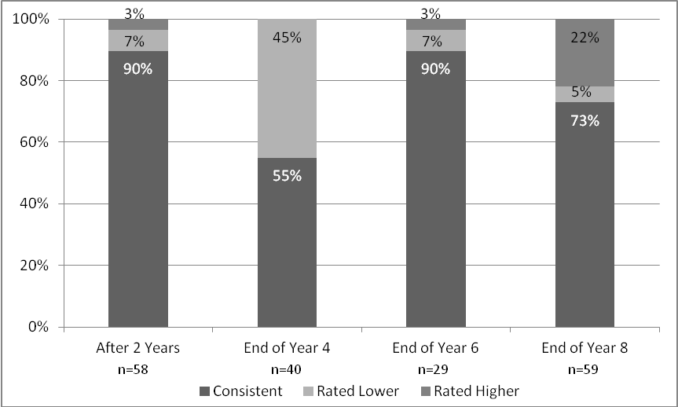
Figure 17 indicates a range in the accuracy of teachers’ mathematics OTJs for the scenarios. This accuracy ranged from 55% against the end of 4 standard to 90% against the after 2 years and end of year 6 standards. Over all four standards, 77% of teacher judgements were accurate, while 15% were positioned too low and 9% were positioned too high. Figure 18 illustrates one of the scenarios that resulted in the greatest accuracy.
Figure 18: Making mathematics OTJ scenario, ‘at’ the after 2 years standard
Mathematics Standard, After 2 years at school
The table below summarises four pieces of assessment information from one child: Henri. He has just turned seven and has been at school for 2 years. As a group, please look at all of the information and use it to make an OTJ. Note that the table gives both best fit ratings and ratings against the after 2 years at school standard. Record your answer in the question below.

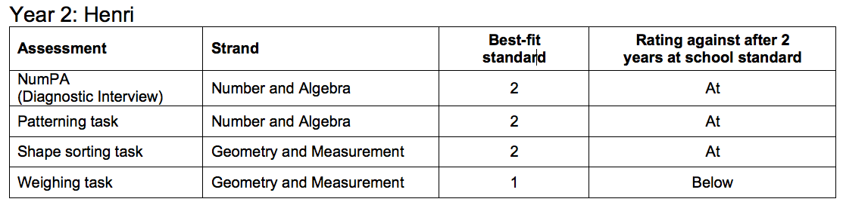

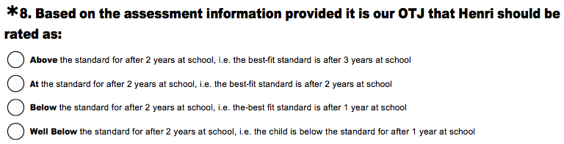
The scenario illustrated in the above figure was positioned ‘at’ the after 2 years standard, and 90% of teacher responses were consistent with this. The four pieces of evidence for the end of year 6 scenario which also resulted in a high accuracy were a GloSS interview, a measurement of volume task and a multivariate data task which were all rated as ‘at’ the standard and a PAT: Mathematics results rated ‘above’ the standard. Ninety percent of teacher groups accurately rated this scenario ‘at’ the end of year 6 standard on the basis of these four pieces of assessment information.
Teachers’ OTJs for the scenario focused on the end of year 4 standard were least accurate (55%). This scenario is illustrated in Figure 19.
Figure 19: Making mathematics OTJ scenario, ‘above’ end of year 4
Mathematics Standard, By the end of Year 4
The table below summarises four pieces of assessment information from one child: Moana. She is in year 4 and the assessment information has been collected at the end of the year. As a group, please look at all of the information and use it to make an OTJ. Note that the table gives both best-fit ratings and ratings against the end of year 4 standard. Record your answer in the question below.

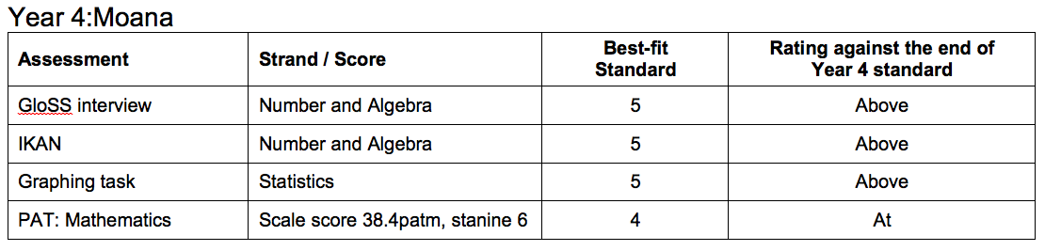
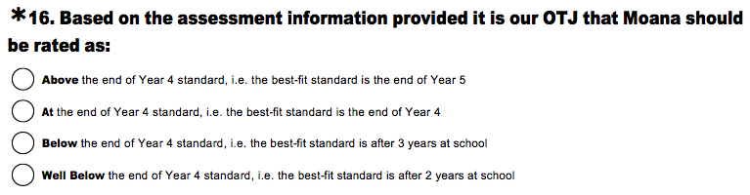
It is of interest that 45% of teacher groups rated lower than the scenario’s position of ‘above’ and rated Moana ‘at’ the standard. These teachers appear to have weighted the information from the standardised PAT assessment more heavily than the other information provided. In comparison, results from the teachers’ Year 8 OTJ scenario indicate that 22% of teacher groups weighted a conversion between measurement units task more highly than information from a GloSS interview, an e-asTTle assessment, and a net matching task.

5.2.3 Concluding comment
Evidence suggests most teachers are able to make an accurate OTJ on the basis of four previously rated pieces of assessment evidence. In writing overall accuracy was 95%, while in mathematics 77% of scenario OTJs were accurate. This is of interest as it indicates teachers are able to accurately synthesise a variety of assessment information, a skill that is crucial to making accurate OTJs. It needs to be noted however, that the results from the sample rating scenarios call into question the dependability of the judgments that are being combined, and therefore the overall dependability of teachers’ OTJs.

5.3 Descriptive information

5.3.1 Writing scenarios
Teachers were asked to rate the levels of agreement within the group for the sample rating and making OTJ scenarios. This information is summarised in Figure 20.
Figure 20: Teachers’ rating of agreement levels within the group for the writing scenarios
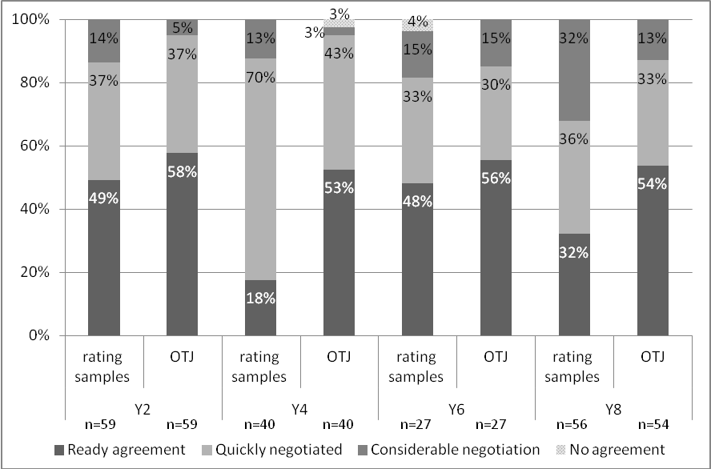
In general, most groups of teachers reported high levels of agreement over the sample rating scenarios with 68-88% of teacher groups describing this as ready or quickly negotiated. Agreement over the OTJ scenarios was also high, and reasonably consistent across year levels; with over 86% of teacher groups describing this as ready or quickly negotiated at all levels. Small proportions of respondents (up to 4%) identified there was no agreement within the group. At every year level teachers reported greater levels of agreement for the making OTJ scenarios than for the sample rating scenarios. For example, against the after 2 years standard 95% of teacher groups described agreement for the OTJ scenarios as ready or quickly negotiated, while 86% of teacher groups described agreement over the sample rating scenarios in this way.
Although reported agreement levels are generally high it is interesting to note the scenarios for which agreement levels were lowest. The lowest reported agreement occurred for the end of year 4 scenarios, and this included the scenario for which there was the lowest accuracy. This scenario involved a character description of Fred Dagg (Figure 9); 98% of teacher groups rated this scenario as ‘at’ when it was actually positioned ‘above’. Comments left by teachers describing the cause of disagreement for these scenarios identified the relative weighting that should be given to surface and deeper features of a students’ writing as a point of debate. Note that 11 groups of teachers made comments describing the causes of disagreement for these scenarios, and five of these included the relative weighting of surface and deeper features.
Difficult to balance surface v deeper features.
Discussion was mainly about separating deeper features from surface features.
The other scenarios in which teachers reported lower levels of agreement than in general, were focused on the end of year 8 writing standard. Fourteen teacher groups identified the causes of disagreement for these scenarios, and five teacher groups noted the difficulty of rating students as ‘above’ the end of year 8 standard as an area of uncertainty.
There is no criteria for Above Year 8 Standard, therefore we are reluctant to assign that result, though we consider this a very strong piece.
Don't feel confident marking above level as we have no indicators to guide us.
These comments, and the low levels of teacher agreement reported for this scenario, provide some rationale for the difference between the positioning of the scenario as ‘above’, and the rating of ‘at’ provided by 84% of teacher groups.
Across all the scenarios 63 teacher groups described the sources of disagreement within the group. Other themes identified in these comments included a need for more information about the student (11 comments), and the need to clarify the standards requirements in order to make a judgment (5 comments).
Not adequate information to make an accurate judgement.
We felt that these samples were difficult to make an informed OTJ due to lack of WALTS and lack of prior knowledge of the students' ability and engagement with the task.
Reference to the Standards document was vital in order to make a judgement.

5.3.2 Mathematics scenarios
The assessment scenarios asked teachers to rate the level of agreement within the group when making judgments in relation to the National Standards. Figure 21 summarises these result.
Figure 21 Teachers’ rating of agreement levels within the group when making judgments in the mathematics scenarios
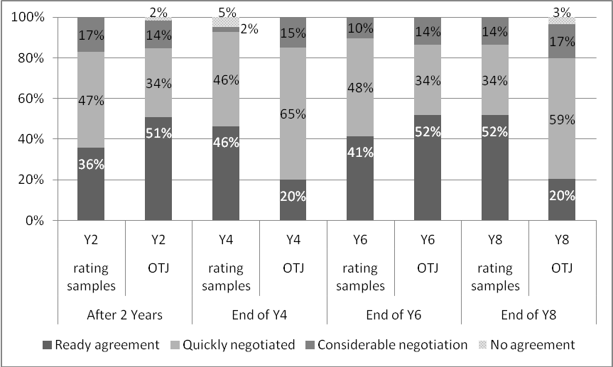
Teachers reported reasonably high levels of agreement within the group when making judgments against the Mathematics Standards in the assessment scenarios. Most groups of teachers (83-93%) reported ready or quickly negotiated agreement when rating the samples, with similar agreement levels reported when making OTJs (80-86%). Small proportions of respondents (up to 5%) reported no agreement within the group.
Teachers were asked to identify the cause of any disagreement within the group when rating samples and making OTJs and 55 chose to do so. The three common themes in these comments were the need to clarify their own understanding of National Standards requirements (16 comments), the need to know further background information about the students concerned (10 comments), and the relative weighting that should be given to standardised assessments when making OTJs (4 comments).
Difficulty deciding between ‘at’ and above standard as we are not sure what ABOVE looks like compared to AT.
Different interpretations of the standard. We had to check with the document.
As professionals we felt that not enough information could be supplied through the samples, i.e. there needs to be more than one reference point per child. However these assessments are valuable tools TOWARDS forming OTJ's. Conversations and observations are vital in forming OTJ's.
Difficult to make an assessment based on a lack of the anecdotal information.
The place of a PAT test. Was it minimally important or used to confirm.

5.3.3 School perceptions
Teachers and principals were asked to rate their level of confidence in the accuracy and consistency of their school’s OTJs. Teachers’ responses indicate they are very confident in this regard. Nearly all teacher groups rated themselves as moderately or very confident in the accuracy of their reading (98%), writing (93%), and mathematics OTJs (95%). Principals appear to share this confidence with over 80% identifying themselves as moderately or very confident in the accuracy of their school’s OTJs in reading (93%), writing (82%), and mathematics (90%).
Teachers also appear confident about the consistency of OTJs at their school, with nearly all teacher groups rating themselves as moderately to very confident in the consistency of their reading (94%), writing (88%), and mathematics OTJs (93%). Principals appear slightly less assured of the consistency of OTJs than teachers, with just over-three quarters rating themselves as moderately or very confident in the consistency of reading (88%), writing (77%) and mathematics OTJs (87%) at their school.

6. National Standards Achievement Data
OTJs in reading, writing, and mathematics were collected for 16,111 students in the 2011 sample, and as described in chapter two, can be considered representative of the National population. These data provide useful information about broad patterns of student achievement because random error at the level of individual data tends to be cancelled out by aggregation
Note that for students in years 1 to 3 the tables in this chapter include OTJs in relation to the after 1 year, after 2 years, and after 3 years standards. As a result of schools’ practices, some of these judgments were made at the end of the school year, and some were made during 2011, on the anniversary of school entry. For students in years 4 to 8, end-of-year OTJs in relation to the relevant year level standard are included.

6.1 Reading OTJs
Table 24 to Table 27 provide the reading OTJs for all students in the sample by year level, gender, ethnicity, and school decile.
Table 24: Reading OTJs by year level
Year Level | n | Percentages of students rated
Year Level | n | Well Below | Below | At | Above
1 | 1472 | 5 | 29 | 38 | 28
2 | 1735 | 5 | 14 | 35 | 46
3 | 1827 | 5 | 13 | 38 | 44
4 | 1691 | 5 | 13 | 42 | 40
5 | 1790 | 5 | 16 | 42 | 37
6 | 1688 | 5 | 16 | 40 | 40
7 | 2979 | 13 | 23 | 33 | 31
8 | 2837 | 14 | 21 | 35 | 31

Table 25: Reading OTJs by gender
Gender | n | Percentages of students rated
Gender | n | Well Below | Below | At | Above
Male | 7961 | 10 | 21 | 37 | 32
Female | 8048 | 6 | 16 | 38 | 41

Table 26: Reading OTJs by ethnicity
Ethnicity | n | Percentages of ethnic categorisations rated
Ethnicity | n | Well Below | Below | At | Above
Asian | 1614 | 6 | 16 | 33 | 45
NZ European | 10283 | 5 | 15 | 38 | 42
NZ Māori | 3430 | 13 | 26 | 38 | 23
Pasifika | 2004 | 16 | 26 | 34 | 25
Other | 442 | 10 | 23 | 40 | 27

Table 27: Reading OTJs by school decile
Decile band | n | Percentages of students rated
Decile band | n | Well Below | Below | At | Above
1-3 | 4011 | 13 | 24 | 37 | 26
4-7 | 6531 | 10 | 20 | 38 | 32
8-10 | 5467 | 3 | 13 | 36 | 49

In general, greater proportions of female students (79%) were rated as ‘at’ or ‘above’ the Reading Standards than male students (69%), while in terms of ethnicity New Zealand European students had the highest proportion rated as ‘at’ or ‘above’ the Reading Standards (80%), followed by Asian students (78%), Māori students (61%), and Pasifika students (59%). Higher proportions of students at high decile schools (85%) were rated as ‘at’ or ‘above’ the Reading Standards than students at medium (70%) or low decile schools (63%).

6.2 Writing OTJs
Collated writing OTJs for the 16,111 students in the sample are given in Table 28 to Table 31. Summaries are provided by year level, gender, ethnicity, and school decile.
Table 28: Writing OTJs by year level
Year Level | n | Percentages of students rated
Year Level | n | Well Below | Below | At | Above
1 | 1472 | 2 | 22 | 61 | 15
2 | 1722 | 3 | 17 | 62 | 18
3 | 1801 | 4 | 25 | 52 | 19
4 | 1645 | 7 | 20 | 54 | 19
5 | 1749 | 8 | 29 | 45 | 19
6 | 1648 | 8 | 25 | 50 | 18
7 | 2998 | 16 | 32 | 35 | 17
8 | 2805 | 16 | 30 | 36 | 18

Table 29: Writing OTJs by gender
Gender | n | Percentages of students rated
Gender | n | Well Below | Below | At | Above
Male | 7864 | 12 | 31 | 44 | 13
Female | 7976 | 6 | 21 | 50 | 22

Table 30: Writing OTJs by ethnicity
Ethnicity | n | Percentages of ethnic categorisations rated
Ethnicity | n | Well Below | Below | At | Above
Asian | 1610 | 6 | 20 | 50 | 24
NZ European | 10126 | 6 | 23 | 50 | 21
NZ Māori | 3410 | 14 | 33 | 42 | 10
Pasifika | 1989 | 16 | 32 | 41 | 12
Other | 432 | 13 | 30 | 48 | 10

Table 31: Writing OTJs by school decile
Decile band | n | Percentages of students rated
Decile band | n | Well Below | Below | At | Above
1-3 | 3994 | 13 | 32 | 43 | 12
4-7 | 6394 | 12 | 28 | 43 | 17
8-10 | 5452 | 4 | 19 | 55 | 23

In general, the proportions of students rated as ‘at’ the Writing Standards decreases as the year level of the students increases. For example, 61% of students are rated ‘at’ the after 1 year standard, while 36% were given this rating at the end of year 8. Note that the proportions of students rated as ‘above’ the standard remains reasonably consistent across the year levels, ranging from 15-19%. In terms of gender, ethnicity, and decile the student data for writing show the same general trends as the student data for reading. Female students (72% rated ‘at’ or ‘above’) were rated more highly than male students (57%) and Asian students (74%) were rated more highly than New Zealand European, (71%) Pasifika (53%), and Māori students (52%). Higher proportions of students in high decile schools (78%) were rated as ‘at’ or ‘above’ the Reading Standards than students in medium (60%), or low decile schools (55%).

6.3 Mathematics OTJs
The mathematics OTJs for all students in the sample are provided in Table 32 to Table 35. As in reading and writing, summaries are provided by year level, gender, ethnicity, and school decile.
Table 32: Mathematics OTJs by year level
Year Level | n | Percentages of students rated
Year Level | n | Well Below | Below | At | Above
1 | 1474 | 1 | 14 | 59 | 25
2 | 1720 | 4 | 18 | 59 | 19
3 | 1798 | 4 | 27 | 52 | 18
4 | 1645 | 5 | 20 | 51 | 24
5 | 1733 | 7 | 26 | 44 | 23
6 | 1629 | 6 | 23 | 45 | 26
7 | 2988 | 15 | 32 | 34 | 19
8 | 2831 | 14 | 31 | 34 | 22

Table 33: Mathematics OTJs by gender
Gender | n | Percentages of students rated
Gender | n | Well Below | Below | At | Above
Male | 7846 | 9 | 24 | 43 | 24
Female | 7972 | 7 | 26 | 47 | 20

Table 34: Mathematics OTJs by ethnicity
Ethnicity | n | Percentages of ethnic categorisations rated
Ethnicity | n | Well Below | Below | At | Above
Asian | 1599 | 4 | 16 | 46 | 35
NZ European | 10115 | 6 | 23 | 47 | 25
NZ Māori | 3405 | 13 | 33 | 42 | 12
Pasifika | 1995 | 15 | 32 | 42 | 11
Other | 436 | 10 | 26 | 50 | 15

Table 35: Mathematics OTJs by school decile
Decile band | n | Percentages of students rated
Decile band | n | Well Below | Below | At | Above
1-3 | 3996 | 12 | 31 | 42 | 15
4-7 | 6383 | 11 | 28 | 43 | 19
8-10 | 5439 | 3 | 17 | 50 | 30

In general, the patterns of student achievement in relation to the Mathematics Standards display the same trends as the data for the Reading and Writing Standards. The one exception is by gender, where the same proportion of male and female students were rated as ‘at’ or ‘above’ the Mathematics Standards (67%). As in writing, the mathematics results show decreasing proportions of students rated ‘at’ the standard as year level increases (59% ‘at’ Year 1 and 34% ‘at’ Year 8) and there is a reasonably consistent proportion (18-26%) of students rated ‘above’ the standards in years 1 to 8. Higher proportions of Asian students (81%) were rated as ‘at’ or ‘above’ the Mathematics Standards than New Zealand European (72%), Māori (54%), or Pasifika students (53%). Higher proportions of students at high decile schools (80%) were rated as ‘at’ or ‘above’ the standard than students at medium (62%) or low decile schools (57%).

6.4 Comment on reading, writing, and mathematics OTJs
In general, the 2011 student data reflect the demographic patterns that would be expected, given other evidence about student achievement in New Zealand. In terms of achievement, students in high decile schools are rated more highly than students in medium decile schools, who in turn are rated more highly than students in low decile schools. In general, the achievement of Asian students is rated more highly than that of NZ European students, which in turn is rated more highly than the achievement of Māori and Pasifika students.
While the general trend is for smaller proportions of students to be rated as ‘at’ or ‘above’ the standards as year level increases, there is also a notable jump in this pattern after year 6. For example, in reading 80% of year 6 students were rated ‘at’ or ‘above’ the standards while 64% of year 7 students received these ratings. While the reasons for the jump in ratings at the intermediate level are not clear, several factors may contribute. It may be, for example, that a ceiling effect is operating at the top end of the standards. Alternatively, it may be that the patterns are attributable to teachers of year 7 and 8 students judging more harshly than teachers of students in years 1 to 6. Another explanation might be that the end of year 7 and 8 standards themselves may be more difficult than those at other year levels.
Although the aggregated data are consistent with other evidence about student achievement across the country, it must be noted that two significant sources of error remain. The first of these is the possibility that teachers’ judgments against the National Standards lack validity. Evidence from the assessment scenarios, presented in the previous chapter, suggests this may be the case. The second possible source of error is systematic error, or bias. If, for example, there is any tendency for teachers to form OTJs by comparing a student to others in the same class or school, then teachers at low decile schools will tend to judge students more generously than teachers at high decile schools. Systematic error such as this will remain in aggregated data, at least in any comparison of high and low decile schools.

6.5 Student data 2010 and 2011
Comparisons of the aggregated OTJ data from 2010 and 2011 provide information that can be used to make inferences about the reliability, or consistency, of teachers’ judgments in 2010 and 2011. This section first considers the differences between the two datasets, and then looks at evidence from a sample of students for whom OTJs were collected in both 2010 and 2011.
The overall patterns in the 2011 student achievement data were very consistent with that collected in 2010. Overall, from 2010 to 2011 there was a small upward shift in teachers’ ratings, with 2% more students rated as ‘at’ or ‘above’ the reading standards in 2011 than 2010, and 1% more rated as ‘at’ or ‘above’ the writing and mathematics standards. Tables of differences between the two datasets are provided in Appendix G. The consistency between these two datasets is expected, given that any systematic effects present will remain unchanged from 2010 to 2011, and both datasets are large enough for random errors to cancel.
For 4,342 students, OTJs were collected in both 2010 and 2011 for at least one of reading, writing or mathematics. This made it possible to compare the OTJs for these students across the two years. Table 36 to Table 38 show the students’ 2011 OTJs in reading, writing, and mathematics, disaggregated by their 2010 OTJs. Note that n provides the number of students rated in each category in 2010, and the numbers in bold font represent the proportions that have remained in the same category between 2010 and 2011.
Table 36: Students’ 2011 reading OTJs disaggregated by their 2010 OTJs
Reading |  | 2010
 |  | Well Below | Below | At | Above
2011 | Well Below | 41 | 16 | 2 | 0
2011 | Below | 36 | 41 | 12 | 1
2011 | At | 17 | 36 | 60 | 21
2011 | Above | 6 | 7 | 27 | 77
2011 | n | 297 | 782 | 1596 | 1541

Table 37: Students’ 2011 writing OTJs disaggregated by their 2010 OTJs
Writing |  | 2010
 |  | Well Below | Below | At | Above
2011 | Well Below | 39 | 15 | 2 | 0
2011 | Below | 36 | 47 | 18 | 3
2011 | At | 22 | 34 | 66 | 38
2011 | Above | 3 | 5 | 15 | 59
2011 | n | 357 | 1007 | 2080 | 807

Table 38: Students’ 2011 mathematics OTJs disaggregated by their 2010 OTJs
Mathematics |  | 2010
 |  | Well Below | Below | At | Above
2011 | Well Below | 45 | 14 | 2 | 0
2011 | Below | 32 | 46 | 16 | 2
2011 | At | 20 | 36 | 63 | 30
2011 | Above | 4 | 4 | 20 | 68
2011 | n | 286 | 1,054 | 2,012 | 904

The majority of students that were rated ‘at’ or ‘above’ the standards in 2010 were given the same rating in 2011. For example, 60% of students who were rated ‘at’ the relevant reading standard in 2010 were also given this rating in 2011, while 77% of those rated ‘above’ in reading in 2010 were rated ‘above’ the following year. These students appear to be maintaining their achievement relative to the National Standards over the two years and the results for writing (Table 37) and mathematics (Table 38) show the same trend.
Of those students who were rated ‘below’ the reading standard in 2010, 41% appear to have maintained their position, being given the same rating in 2011. Forty-three percent of these students appear to have improved their achievement relative to the National Standards, as they were given a rating of ‘at’ or ‘above’ the following year. Of those students rated ‘well below’ in reading in 2010, 45% were given the same rating in 2011, while 59% appear to have improved their position, being given a rating of ‘well below’, ‘at’ or ‘above’ in 2011. The results in writing and mathematics are very similar to those in reading.
While the general trend is for students rated at or above to maintain their position over the two years, and students rated below or well below to improve their position, the net overall movement within the data is minimal. Table 39 shows these data.
Table 39: Overall movement in students’ ratings 2010 to 2011
Area | Percentages of students
Area | Improved rating  2010 to 2011 | Declined rating  2010 to 2011 | Net movement
Reading | 22 | 16 | 6
Writing | 22 | 21 | 1
Mathematics | 23 | 19 | 4

Although the net overall movement was minimal there were large positive and negative shifts in the data. For example, in reading 22% of students appear to have improved their achievement relative to the standards, and sixteen percent appear to have declined, leaving a small overall positive shift of six percent. In all three areas the groups of students who improved their ratings (larger proportions of the smaller groups of students rated below or well below), were almost balanced out by groups of students whose ratings declined (smaller proportions of the larger groups of students rated at or above).
While some movement in the data, both positive and negative, would be expected the magnitude of the shifts observed is larger than anticipated. For example, approximately 40% of those students rated ‘below’ the standards in 2010 appeared to improve their position in relation to the reading (43%), writing (39%), and mathematics standards (40%) in 2011. This upward trend is more pronounced for those students rated ‘well below’ in 2010, with more than half receiving a higher rating against the reading (59%), writing (61%), and mathematics (56%) standards in 2011. While the broad nature of the standards, with just eight achievement levels, may have contributed to the size of shifts being overestimated in some instances, these shifts in the data seem unreasonably large for the first two years of any large-scale sector-wide educational initiative.
Given the large shifts observed in the data, two possibilities exist. It is theoretically possible that the improved ratings against the National Standards from 2010 to 2011 represent an actual shift in student abilities, although the magnitude of the apparent shifts both up and down renders this possibility most unlikely. More probably, teachers have been inconsistent in making judgments against the standards from 2010 to 2011. Given the dependability concerns raised in Chapter 5, and the unreasonable magnitude of the change suggested by the shifts in the data, the second option is the more likely reason for the changes in students’ ratings between the two years. This being the case, the student achievement data cast further doubt over the reliability, and therefore the dependability, of teachers’ OTJs.

7. Reporting to parents
Clear reporting to parents, families and whānau is an important part of National Standards. Schools have been advised that “Reports should be concise and easily understood, outline a child's progress and achievement, and be free from educational jargon.” The importance of providing information about students’ next learning steps and ways family can support this learning at home is also emphasised in Ministry of Education guidelines to schools.
This chapter reports on an analysis of copies of students’ end-of-year reports (2011). Table 40 outlines the monitoring and evaluation question and performance criteria that are addressed.
Table 40: Monitoring and evaluation questions and criteria, reporting to parents
Intended outcome: Schools use National Standards assessment information to communicate clearly with families about their child’s achievement and progress.
Monitoring and  Evaluation Questions | Performance criteria | Sources of evidence
How do schools use information from National Standards to report to and communicate with parents? | Parents receive a report that describes their child’s progress and achievement in relation to the NS in reading, writing and mathematics. | End-of-year reports
 | Parents receive a report that is clear. | End-of-year reports
 | Parents receive a report that identifies their child’s next learning steps, and ways families can help at home. | End-of-year reports

7.1 Evaluative criteria
Reports were categorised into three main groups, dependent on the way they used National Standards for reporting purposes. Table 41 summarises these results for the sample of 485 reports.
Table 41: Use of National Standards in end-of-year reports
Group | Use of National Standards | No. of reports | % of sample
1 | None: reports do not mention National Standards at all | 63 | 13%
2 | Insufficient: reports refer to National Standards but do not sufficiently describe achievement against the standards | 171 | 35%
3 | Sufficient: reports describe achievement in relation to National Standards | 251 | 52%

Thirteen percent of the reports made no direct mention of the National Standards. Of the 63 reports that did not mention the National Standards, 7 were judged to include achievement data that would have been sufficient to make an OTJ, while 42 were rated as having insufficient information to make an OTJ, and 14 contained no achievement data at all. In 2010 a larger proportion of reports were rated as Group 1 (21)%, and slightly smaller proportions of reports were rated as groups 2 (31%) and 3 (48%).
Eighty-seven percent of the reports referred directly to the National Standards. Of these 422 reports, 251 were rated as sufficiently describing students’ achievement in relation to the National Standards (further details below), while 171 were rated as insufficient in this regard. It is these reports, groups two and three, which are the focus of the remainder of this chapter. The reports that did not refer directly to the National Standards were not analysed further as they contained no information about the ways in which schools communicate National Standards information to parents, families, and whānau.

7.1.1 Parents receive a report that describes their child’s progress and achievement in relation to the NS
In order to be rated as sufficiently describing achievement in relation to the National Standards, an end-of year report needed to include information about the student’s achievement in relation to the standards, and details of something the student could or could not do that was of significance to the standard. In reading, for example, these details included information about the student’s ability to decode text, or their ability to respond, understand and use what they have read in addition to their OTJ. An OTJ and a reading level or age was not considered sufficient. In writing, a report needed to include information about the student’s ability to encode (including planning, revising, or publishing), or use writing for a variety of purposes across the curriculum, in addition to the OTJ. Information about students’ spelling ability and an OTJ was not considered sufficient. In mathematics, a report needed an OTJ and information about the student’s ability in number and other aspects of the mathematics standards such as measurement or geometry. To be rated as sufficiently describing achievement in relation to the National Standards a report needed to fit these criteria for two of the three areas: reading, writing, and mathematics.
Sixty percent of the reports (that made direct reference to the National Standards) were rated as sufficiently describing student achievement in relation to the National Standards. Figure 22 illustrates the content of these reports. This is the same percentage of reports as from 2010.
Figure 22: Example of information rated as sufficiently describing student achievement against the National Standards
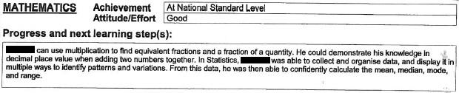
Forty percent of the reports were rated as insufficiently describing students’ achievement in relation to the National Standards. Figure 23 provides an example.
Figure 23: Example of information rated as insufficiently describing student achievement against the National Standards
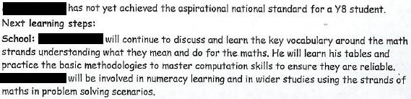

7.1.2 Parents receive a report that is clear
Reports were rated as either clear or unclear. A clear report was one that was considered easy for parents, families and whānau to understand. To achieve this rating the reading, writing, and mathematics information in the report, including text, tables and graphics, needed to be clear, with no unexplained educational jargon. Fifty percent of the reports were rated as clear, and 50% were rated as unclear. This is an increase of 10% from 2010 results in which 40% of the reports that referred directly to the National Standards were rated as clear.
While the proportions of reports rated as clear and sufficiently describing achievement in relation to National Standards are of interest in themselves, the combination of these characteristics is also informative. Figure 24 summarises this information.
Figure 24: The clarity of reports that did and did not contain National Standards achievement information

Clear | 15% (64) | 35% (146)
Unclear | 25% (107) | 25% (105)
 | Insufficient NS achievement information  (Group 2) | Sufficient NS achievement information  (Group 3)

In a repeat of the 2010 result, 35% of reports were rated as clear and sufficiently describing student achievement in relation to the National Standards. Figure 25 provides an example of this type of report.
Figure 25: Example of a report that was rated as containing clear information about the student’s achievement in relation to the National Standards
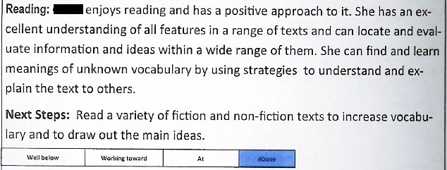
Twenty-five percent of reports were rated as sufficiently describing student achievement against the National Standards, but were unclear. This is very similar to the 2010 result of 26%. These reports contained an OTJ and a comment of significance to the OTJ but were considered difficult for parents, families and whānau to understand. They included the use of technical assessment information and language, graphs and tables that were difficult to interpret, and unclear descriptions of student abilities. Figure 26 provides an example of this type of report.
Figure 26: Example of a report that was rated as containing unclear information about the student’s achievement in relation to the National Standards
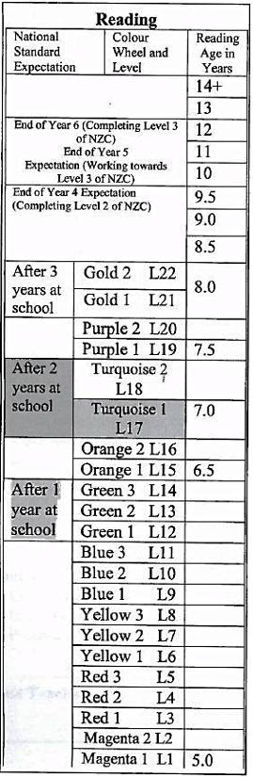
The total proportion of reports rated as insufficiently describing student achievement in relation to the National Standards was 40%, the same as in 2010. In 2011 this proportion included 15% that were rated as clear and 25% that were rated as unclear, while in 2010 a larger proportion were rated as unclear (33%) while a small proportion were rated as clear (7%). Examples of these reports are provided in Figure 27 and Figure 28.
Figure 27: Example of a clear report that was rated as containing insufficient information about the student’s achievement in relation to the National Standards
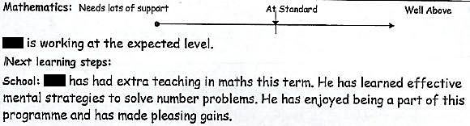
Figure 28: Examples of unclear reports that were rated as containing insufficient information about the student’s achievement in relation to the National Standards
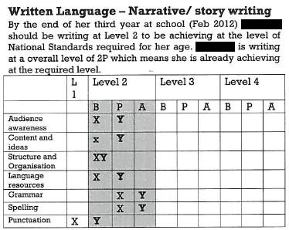

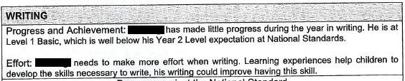
A small proportion of the reports that mentioned the National Standards directly, described student progress against the Reading (12%), Writing (9%), and Mathematics Standards (9%). Figure 29 illustrates these reports.
Figure 29: Example of a report describing student progress in relation to the National Standards
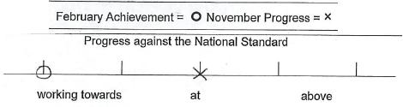
A further 11% of reports described student progress against a nationally recognised scale, other than the National Standards. These scales included New Zealand curriculum levels in reading (20 reports), writing (50 reports), and mathematics (39 reports). In reading, reading recovery levels (39 reports), chronological reading ages (37 reports), and the colourwheel (20 reports) were used to report progress. In writing, progress was described using e-asTTle (8 reports), while in mathematics, the Number Framework was used (51 reports).

7.1.3 Parents receive a report that identifies their child’s next learning steps, the actions the school will take to support learning, and ways families can help at home
Reports were rated as to whether or not they included students’ next learning steps, and the ways families can support this learning at home. For reports to be rated as containing these elements, they needed to include the relevant information in two of the three areas: reading, writing, and mathematics. Sixty-eight percent of reports were found to include students’ next learning steps, and 55% included family actions. Figures 30 and 31 provide examples. Note that the quality of the information provided was not assessed. These results are similar to those from 2010 where 70% of reports included next learning steps and 61% included family actions.
Figure 30: Examples from end-of-year reports of students’ next learning steps
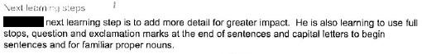
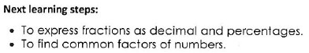
Figure 31: Examples from end-of-year reports of actions families can take to support student learning


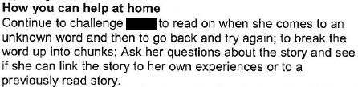

7.2 Descriptive information
Two ways were used to present student achievement information in reports. Seventy-three percent of reports used a scale to describe achievement in relation to the student’s current year level standard using terms such as ‘at’, ‘above’, ‘below’ or ‘well below’. Twenty-five percent of schools described a best fit standard for the student, irrespective of their current year level. For example, a Year 5 student that was ‘above’ the standard was referred to as achieving ‘at’ the end of year 6 standard. Three percent of reports used neither of these approaches, as they contained no OTJ. The two approaches are illustrated in Figure 32 and Figure 33. These results are similar to those from 2010 where 73% of reports used a rating scale and 28% used a best fit approach.
Figure 32: Examples of reports that described student achievement using a scale such as ‘at’ / ‘above’ / below / well below

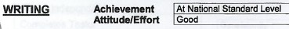
Figure 33: Examples of reports that described student achievement using a best fit standard

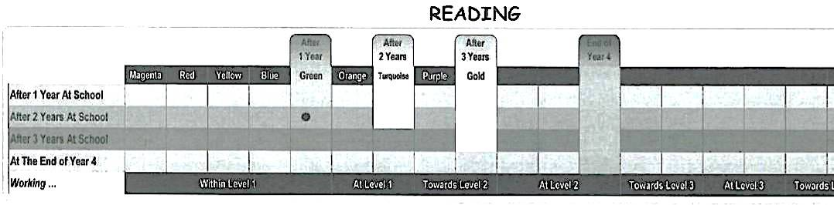

Sixty-six percent of reports presented student achievement in relation to the National Standards in a diagram or table, while 21% of reports used narrative text. These approaches are illustrated in Figure 34 and Figure 35. Results from 2011 are consistent with those from 2010. In 2010, 63% of reports presented student achievement information in a diagram or table, 20% presented it in text form, and 17% combined both these approaches.
Figure 34: Examples of OTJs presented in diagrams or tables
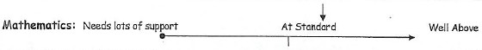

Figure 35: Examples of OTJs presented in text
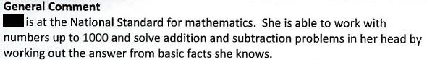

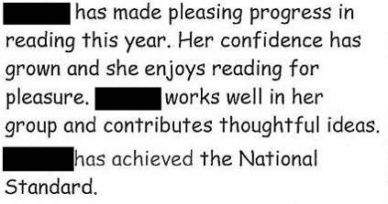

Reports from five of the 79 schools who contributed to the sample used different reporting formats at different year levels of the school. For each of the five schools there was coherence between the different formats used.
During the mid-year interview, principals were asked when teachers at their school were making OTJs for students in years 1 to 3, and when these were reported to parents. Seventy-five schools had made OTJs for these students, and of these 56% were making these as part of their regular reporting cycle and 44% were making them on or close to the anniversary of the student’s entry to school. Of the 33 schools that were making these OTJs on the anniversary of school-entry, 20 schools were reporting these to families around the time they were made, and 13 were reporting them as part of their school’s regular reporting cycle.
Eighty-two percent of principals identified that their school was making mid-year OTJs for students in years 4 to 6 in 2011. Of these 82 schools, 51 were making OTJs that were a judgment of current achievement, 22 were making judgments that were a prediction of end of year achievement, and 7 schools were combining these approaches. Two principals noted that both these approaches were being used inconsistently across their school, as there were differences between teachers in this regard.

8. Student achievement targets
Boards of Trustees play a key role in school governance. As part of this role Boards are responsible for setting student achievement targets and using these to allocate resources equitably. Because student achievement targets help determine the support received by individual students, quality targets help enable the appropriate allocation of resources.
This chapter investigates the quality of student achievement targets using evidence from an analysis of school documentation. Table 42 contains the monitoring and evaluation question and performance criteria addressed.
Table 42: Monitoring and evaluation questions and criteria, student achievement targets
Intended outcome: National Standards provides clear information about student achievement for Boards of Trustees which can be used in decision making and resource allocation processes.
Monitoring and  Evaluation Questions | Performance criteria | Sources of evidence
In what ways is information from National Standards used by schools to set achievement targets? | Targets in the school’s 2011 charter address student achievement in relation to the NS. | School documentation: student achievement targets and analysis of variance reports  Principal interviews
 | NS achievement targets focus on students who are below or ‘well below’ the standards.
 | NS achievement targets are differentiated to accelerate progress for specific groups of students.
 | NS achievement targets address the progress rates of all students.
 | NS achievement targets are specific and measurable.
 | NS achievement targets are appropriate (challenging and achievable).
 | NS achievement targets address students at all year levels.

8.1 Evaluative criteria

8.1.1 Targets in the school’s 2011 charter address student achievement in relation to the NS
The student achievement targets and analysis of variance reports of 89 schools were analysed. Seventy-five percent of these schools (67 schools) had charters that were rated as including student achievement targets in at least one of the National Standards areas. Of those 67 schools, 49 had targets in relation to the Reading Standards, 54 included targets against the Writing Standards, and 57 addressed the Mathematics Standards in their targets. Figure 36 illustrates these proportions.
Figure 36: Proportions of schools rated as including National Standards student achievement targets in school charters
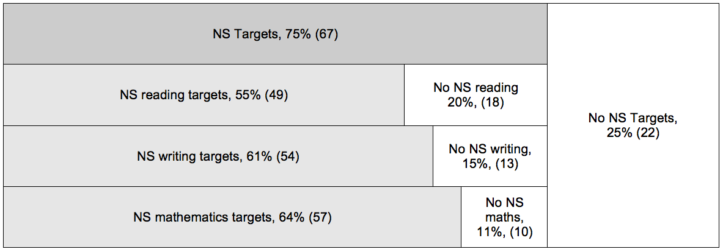
Twenty-five percent of schools had charters that were rated as not including student achievement targets in relation to the National Standards in reading, writing, or mathematics. Of these 22 schools, nine schools made no reference to the National Standards in their targets, and four schools did not include targets at all but had more general objectives, such as “embed the use of National Standards at years 7 and 8.” Nine schools had endeavoured to address the National Standards but had targets that conflated these with other assessment measures. Examples included “To raise individual PAT math test results so that 80% of Y3-8 achieve at national standard levels by the end of the year” and “It is intended that within the year that Year 8 students will achieve at or above the national norm by the end of the year, i.e. achieve at National Standard.”
The information in the remainder of this chapter focuses first on the general nature of schools’ targets in relation to the National Standards, and then looks specifically at the reading, writing, and mathematics targets that addressed each of the National Standards. Those targets that did not address National Standards (represented by the unshaded regions in Figure 36) were not analysed further.

8.1.2 NS achievement targets focus on students who are below or ‘well below’ the standards
Of the 67 schools that included student achievement targets in relation to the National Standards, 63 included a focus on students who were rated as ‘below’ or ‘well below’ the National Standards in 2010. Examples include:
We will target the 34 children, 27%, who did not meet the mathematics standards in November 2010… We aim to increase the overall total of children achieving at or above to 85% of our school students.
Move all students who are in the below national standards group to the at standards group by the end of the school year.
Four schools included targets not focused on students rated as below or ‘well below’ the standards in 2010. Three of these were schools with targeted 2011 achievement levels which were commensurate with 2010 levels, and one school specified a “15% positive shift of students’ achievement of National Standards” but did not specify the students whose ratings against the Standards would be raised to achieve this shift.

8.1.3 NS achievement targets are differentiated to accelerate progress for specific groups of students
Thirty-eight of the 67 schools with student achievement targets in relation to the National Standards included differentiation to accelerate progress for specific groups of students. Nearly all of the schools with differentiated targets focused on students who were rated ‘below’ or ‘well below’ the National Standards (37 schools). Table 43 indicates the student sub-groups that were the focus of these differentiated targets.
Table 43: Number of schools with targets differentiated to accelerate progress for sub-groups of students rated below or ‘well below’ the National Standards in 2010
Student sub-group | Number of schools
Māori students | 22
Pasifika students | 6
Male students | 11
Female students | 1
Students with special needs | 1
Identified cohort students | 7

The majority of schools with differentiated targets included a focus on Māori students (22 of the 38 schools), while approximately one-third focused on male students (11 of the 38 schools). A small number of schools (6) focused on Pasifika students or identified a particular cohort of students, for example one school targeted the 12 year 6 students that were ‘well below’ the reading and writing standards to make at least one year’s progress in each of these areas (7 schools).
One school included National Standards targets that were differentiated to accelerate progress for students rated “above” or “well above” the Reading and Writing Standards in 2010.

8.1.4 NS achievement targets address the progress rates of all students
Four of the 67 schools had targets in relation to the National Standards which included a focus on the progress of all students. An example is provided below:
All students who were below or well below the standard in February will make more than one year’s (accelerated) progress in relation to the writing standards. All of the students who were at or above the standard in February will make at least one year’s progress in relation to the writing standards.
Specifying progress rates for all students can be considered desirable as it ensures all students are considered in planning and resource allocation. The remainder of this chapter focuses on the student achievement targets that were rated as addressing the National Standards in reading, writing and mathematics. That is, those targets represented by the lightly shaded regions in Figure 36: 49 reading targets, 54 writing targets, and 57 mathematics targets. The percentages included in the following sections represent the proportions of these targets that were found to have certain features.

8.1.5 NS targets specific and measurable.
Most National Standards student achievement targets in reading (92%), writing (89%), and mathematics (88%) were rated as specific and measurable. Examples of these include:
To have 80% of students achieving at or above the National Standards in Mathematics by the end of 2011.
90% of Year 5 students will be reading at and above the National Standard by the end of the 2011 school year.
Reduce the percentage of students performing below the National Standard [in Mathematics] by 50% after the 2nd and 3rd year at schools, and at the end of year 4,5 and 7.
Those targets that did not meet this criterion did not specify either the standard that was being targeted, or the proportions of students that were expected to achieve that standard. For example:
Increase the number of students achieving at or above the National Standard, yrs. 1-8 for reading.
To raise the rate of progress for all students deemed at risk of not achieving at the level of the National Standards in writing.

8.1.6 NS targets appropriate (challenging and achievable)
National Standards targets were rated as appropriate if they were considered to be both challenging and achievable in relation to baseline achievement data. Half to two-thirds of the National Standards student achievement targets in reading (55%), writing (65%), and mathematics (53%) were rated as appropriate. These examples include targeting a shift from 62% of year 4 to 6 students ‘at’ or ‘above’ the Reading Standards in 2010 to over 80% in year 2011, and raising the achievement of the 28% of students rated as below the Writing Standards in 2010 to ‘at’ or ‘above’ in 2011.
Twenty-two reading targets, 19 writing targets, and 27 mathematics targets were rated as not appropriate. Of these targets, approximately half were not considered challenging as they targeted lower levels of achievement in 2011 than in 2010, or aimed to increase achievement levels by less than 5%. Up to one-third of these targets were not specific and measurable and so contained no defined level of challenge. Small numbers of these targets were not considered achievable as they required significantly accelerated progress from the majority of students. For a few schools, documentation did not include baseline data and for these schools the appropriateness of National Standards targets could not be determined.

8.1.7 NS targets address students at all year levels
Approximately two-thirds of National Standards targets in reading (59%), writing (67%) and mathematics (60%) addressed the achievement of students at all year levels. These targets tended to be consistent across all year levels of the school, although some specified different achievement levels to be attained at different year levels. Examples of both these approaches are given below:
In relation to National Standards [reading] achieving at or above: Target across the school 92%.
All students from Year 1 to Year 6 not meeting the National Standards in Reading from 2010 “will be at the expected standard” by Term 4 2011.
Year 1: At least maintain the current levels of achievement for at and above students. To shift the 4 students who are Below to At. Year 2: At least maintain the current levels of achievement for at and above students. To shift the 7 students who are Below to At. Year 3: At least maintain the current levels of achievement for at and above students. To shift the 7 students who are Below to At... [Reading targets in same format for all year levels, 1-8].

8.2 Descriptive information
Information about the Ministry of Education’s response to schools’ 2011 charters (which included student achievement targets) was collected in the mid-year principal interviews. Eighty-nine principals were able to provide information about the Ministry response, and of these, 66 schools’ charters had been accepted as meeting legislative requirements, 20 schools had been advised their charter was non-compliant and 3 schools had received a letter of receipt but no notification of acceptance or otherwise at the time of the interview (August 2011).
Fifty-five of the 66 schools (83%) that had their charters accepted by the Ministry of Education as meeting legal requirements were rated by this study as having targets that addressed the National Standards. Eleven schools (17%) had their charters accepted but were rated by this study as not including achievement targets in relation to the National Standards.
Principals’ perceptions of the usefulness of National Standards achievement data for setting targets were obtained in the online survey. Of the 62 respondents, 64% rated National Standards data as very or moderately useful for setting student achievement targets, while 23% rated it as minimally useful, and 13% rated it as not useful in this regard.

9. Identifying students for intervention
Information about National Standards emphasises the importance of targeted teaching interventions in raising student achievement. Early identification of students who are not making expected progress will allow these students to be supported appropriately with a resultant increase in achievement rates. “Timely and targeted interventions will make the difference.”
This chapter uses evidence from principal and teacher surveys to describe the ways in which schools use National Standards information to monitor student progress and achievement, and identify students for targeted teaching interventions. The monitoring and evaluation question and performance criteria addressed are shown in Table 44.
Table 44: Monitoring and evaluation questions and criteria, identifying students for intervention
Intended outcome: National Standards achievement information is used by teachers and schools to monitor student progress and achievement against the Curriculum. This enables students requiring teaching interventions to be identified.
Monitoring and  Evaluation Questions | Performance criteria | Sources of evidence
In what ways is information from National Standards used by schools to describe student achievement and progress? | Schools collate National Standards achievement data. | Surveys: principal and teacher groups
 | Collated achievement data provides a clear picture of school-wide student achievement in relation to the NS. | Surveys: principal and teacher groups
 | Schools systematically track the progress of individual students against the National Standards. | Surveys: principal and teacher groups
In what ways is information from National Standards used to identify students requiring targeted teaching interventions? | Schools use National Standards data to identify students below the standard as requiring targeted teaching interventions within the classroom programme, and students rated at ‘well below’ the standard as requiring further support in addition to this. | Surveys: principal

9.1 Evaluative criteria

9.1.1 Schools collate National Standards achievement data.
Principals were questioned about the extent to which they had collated students’ 2011 OTJs. Figure 37 summarises these results.
Figure 37: Principals’ collation of 2011 OTJs
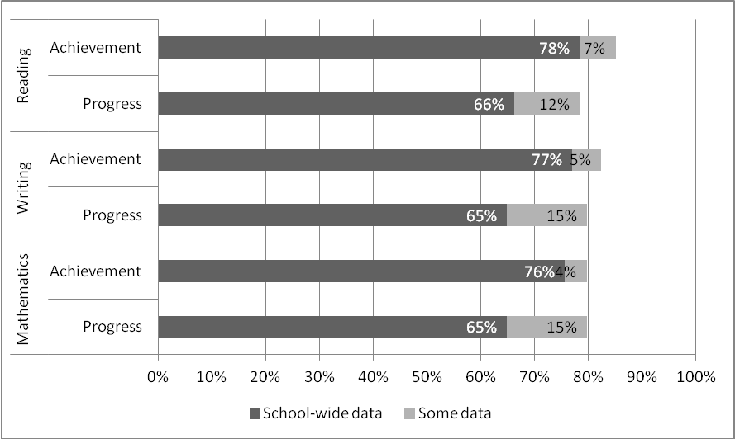
Approximately three-quarters of principals collated school-wide National Standards data to describe student achievement in reading (78%), writing (77%), and mathematics (76%). These principals can be considered as using the data effectively, as this collation will assist in the process of identifying groups of students who are not achieving as expected.
In terms of using National Standards data to describe progress, around two-thirds of principals had collated school-wide progress data in reading (66%), writing (65%), and mathematics (65%). These principals can be considered to be using the data effectively, as can the smaller proportions of principals that had collated progress data for some students (12% reading, 15% writing, 15% mathematics). Where groups of students have been identified as having similar needs, and are receiving similar teaching support, it is a reasonable approach to track these students in groups.

9.1.2 Collated achievement data provides a clear picture of school-wide student achievement in relation to the NS.
To date, it is not possible to ascertain whether collated data shows a clear picture of student achievement, as schools are not required to report school-level data against the National Standards until the release of Boards’ reports to their communities in 2012. This being the case, information was gathered on principals’ perceptions of collated data.
Principals were asked to indicate whether the collated data for their school showed achievement levels to be about what they expected them to be, or higher or lower than this. These results are shown in Figure 38.
Figure 38: Principals’ perceptions of the achievement levels in collated OTJ data
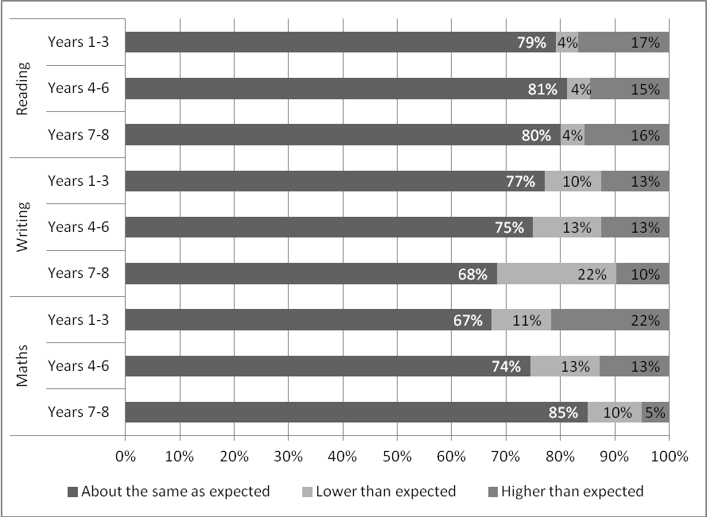
Most principals found achievement levels in collated data were similar to their expectations. Results indicate that principals found results in reading to be most in line with their expectations (79-81% as expected), while those in mathematics were least in line with expectations (67-85% as expected).
Where collated reading data was not in line with principals’ expectations, it tended to indicate higher achievement levels than principals expected. For example, at years 1-3 17% of principals noted achievement levels in reading were higher than they expected, while 4% indicated they were lower. In mathematics this pattern was inconsistent across year levels with more principals finding achievement levels at year 1-3 higher than they expected (22%) rather than lower (11%), while at years 7-8 achievement tended to be lower than expected (10%) rather than higher (5%).
In terms of progress, the majority of principals (65% in reading, 62% in writing, and 63% in mathematics) reported that collated National Standards progress data showed ‘most’ of their students had progressed approximately one year standard. Of the remaining students, responses suggested that principals’ perceptions were that around half had progressed more than one year level standard, and half had progressed less than this. These patterns were very consistent across all three areas, and very similar to teachers’ perceptions of patterns of progress in National Standards data.
When questioned abut the usefulness of National Standards data for identifying students for additional teaching support, 55% of principals rated it as moderately or very useful, 26% rated it as minimally useful, and 20% rated it as not useful. Thirty-three principals chose to comment on the usefulness of National Standards data. Comments were varied and three common themes were identified. These were that schools were already using data before the introduction of National Standards (23% of respondents), that schools were complying with data requirements because they were required to (6%), and that data sources other than National Standards were perceived as more reliable sources of information (5%).
Data gathered prior to National Standards was and is more reliable. We already used this data…and will continue to do so. We report on NS because we have to, but don't really use this data for much else.
It needs to be noted that these things were happening anyway…assessment is not new, and data has always been collected and used to assess needs, BoT, individual and school wide. We are mandated to use the standards as a guide but no new behaviours as such have been employed, just different rubrics / illustrations etc plus far more discussion
We are giving them minimal emphasis only because we have been forced to by the MoE. We currently have very effective demonstrated processes in place for raising student achievement and see no reason to change to something less defined. We will obey the law and that is all.
The data we want is better obtained through other more reliable tools such as PAT, e- AsTTle, GLOSS etc However we are required to make our student achievement targets using national standards. Problem for us is where is the reliability and validity in the NS as a measure? It’s not, but we are being quite pragmatic about it!

9.1.3 Schools systematically track the progress of individual students against the National Standards
The groups of teachers were asked identify the measures they used to systematically track students’ progress in reading from the end of 2010 to the end of 2011. Figure 39 shows these results.
Figure 39: Measures used to systematically track students’ progress in reading
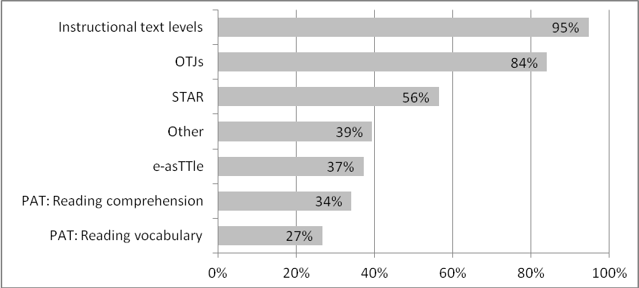
Eighty-four percent of teacher groups reported that they tracked student achievement against the National Standards from the end of 2010 to the end of 2011 using students’ OTJs. Most teacher groups also used instructional text levels for this purpose (95%) while STAR was used by just over half the groups in the sample (56%). Least used were the standardised assessments e-asTTle (37%), and PAT (34 % reading comprehension and 27% reading vocabulary). Other measures groups of teachers identified using for this purpose were varied; common themes included the PROBE reading assessment (11%) and the observation survey, also known as the 6 Year Net (6%).
Figure 40 shows the measures teachers used to track students’ progress in writing from the end of 2010 to the end of 2011.
Figure 40: Measures used to systematically track students’ progress in writing
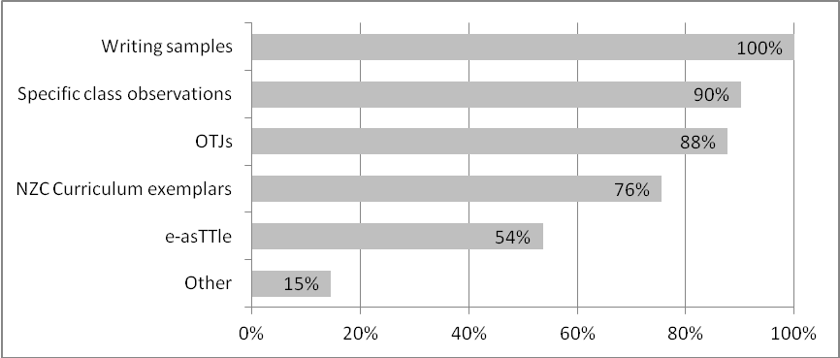
Most groups of teachers (88%) noted that they used students’ OTJs to track progress in writing over the 2011 school year. Over three-quarters of teacher groups also reported using writing samples (100%) and specific class observations (90%) to track progress, while the standardised of e-asTTle assessment was used by just over half of respondents (54%). Other measures identified by schools as used for this purpose included school-developed writing rubrics (7%), and the literacy learning progressions (5%).
Figure 41 shows the measures teachers used to track students’ progress against the Mathematics Standards in 2011.
Figure 41: Measures used to systematically track students’ progress in mathematics
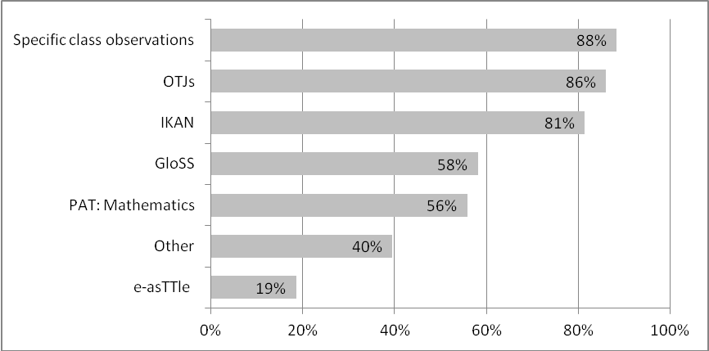
Evidence suggests most groups of teachers (86%) used OTJs to track student progress in relation to the Mathematics Standards. Over eighty percent of teacher groups also reported using specific class observations (88%) and the IKAN assessment (81%) for this purpose. Smaller proportions of teacher groups reported using the standardised assessments of PAT: Mathematics (56%) and e-asTTle (19%). Other measures teacher groups identified using included the NumPA interview (19%), school-developed tests of basic facts (7%), snap shots assessment of strategy (5%) and teacher developed assessments in strands of the curriculum other than number and algebra.
In summary, evidence suggests most teacher groups tracked student achievement from the end of 2010 to the end of 2011 using OTJs (84% reading, 88% writing, 86% mathematics). Other measures used by the majority of teacher groups included instructional text levels in reading (95%), the collection of writing samples (100%), specific class observations in writing (90%) and mathematics (88%), and the IKAN assessment in mathematics (81%).

9.1.4 Schools use National Standards data to identify students below the standard as requiring targeted teaching interventions within the classroom programme, and students rated at ‘well below’ the standard as requiring further support in addition to this
Principals were asked whether their school had used National Standards data to identify students for additional teaching support in reading, writing, and mathematics. Responses indicate 63% of schools had used this data to identify students for further support in reading and mathematics, while 58% had done so for writing.
Principals described the students targeted and the nature of the programme(s) provided in reading (37 principals), writing (35 principals), and mathematics (37 principals). Four main types of intervention were identified and these results are summarised in Table 45.
Table 45: Teaching interventions identified by principals
Intervention | Percentage of principals
Intervention | Reading | Writing | Mathematics
Additional teaching from qualified teacher | 25%* | 5% | 17%**
Teacher aide support | 12% | 8% | 8%
Focused in-class support (classroom teacher) | 5% | 4% | 12%
Additional teaching programmes | 18% | 6% | 5%
* includes 10% reading recovery.
** includes 6% cross-grouping of students
The reading intervention most commonly identified was the provision of additional qualified teaching support (25%). This included support from reading recovery teachers, reading support teachers, resource teachers of literacy, and resource teachers of learning and behaviour. The provision of additional reading programmes was also identified (18%). These included Lexia Reading online, Rainbow Reading, and Toe by Toe.
We identified cohorts of students and have worked with RTLB to devise reading programmes to support the students.
We run a very effective multi lit programme and Lexia Reading - we also do target teaching with the teacher most experienced in this area - 2 reading recovery teachers for 6 year olds.
RTlit rainbow reading and toxic reading programmes / TAsupport / Board funded teacher for small groups.
In writing, teacher-aide support was most commonly identified (8%), while in mathematics, focused in-class support (12%), and additional support form a qualified teacher (11%) were mentioned. Additional teaching programmes identified included Lexia, Steps Spelling, and Word Power in writing, while in mathematics Coddbrics, Bump It, and Spring into Maths were referred to.
Classroom support [in writing] provided by extra teacher, teachers aides and RTLit referrals
Below and well below students [in writing] are discussed at the beginning of each term at staff meeting and the teacher targets specific learning areas. These are reviewed each term.
Teacher aide support with CODDSBRICS programme
Pupils needing support [in mathematics] were given 1 to 1 Teacher Aide support, and some small group and in class support. Areas worked on were identified by the classroom teacher.
In terms of the students identified for this support, just under a third of principals (30%) mentioned that students rated as below or ‘well below’ the standards in reading, writing, or mathematics were targeted. A small proportion of principals (8%) also noted the identification of year levels of students for additional support in these areas.
Those who are more than one year below the standard. Specialised programmes with teacher aides
Small group of five or six students who are identified as well below withdrawn from classes.
2011 Year 2-3 students. Classroom support provided by extra teacher, teachers aides and RTLit referrals.
In summary just under two-thirds of schools used National Standards data to identify students for additional teaching support in reading (63%), writing (58%), and mathematics (63%). Small proportions of schools identified focused in class support as an intervention in reading (5%), writing (4%), and mathematics (12%). Other interventions noted were the provision of additional qualified teaching support, the use of teacher aides, and the provision of additional teaching programmes. Students identified as targeted included those rated below or ‘well below’ the standards (30%) and those in particular year levels (8%).

9.2 Descriptive information
Evidence suggests principals used a variety of tools to collate students’ 2011 OTJs. Just over two-thirds of principals noted they used spreadsheets for this purpose (69%) while over half reported using the school’s student management system (52%). Some principals reported using more than one tool.
Teachers were asked to describe the way they used OTJs to track students’ progress in reading against the National Standards from the end of 2010 to the end of 2011. Seventy-nine groups of teachers made comments and the nature of these comments was varied. Just under a third of these comments (32%) described or listed the data sources used to track achievement, while just under a quarter of responses (22%) described where tracking information was stored. Storage options described included using tracking sheets to store students’ data over time (9%), and the use of student management systems (8%) and individual profiles (5%).
Individual teacher Inquiry Plans, running records, observations of students’ reading behaviours.
Running records, benchmarks, reading graphs, observations, anecdotal notes.
Tracking book Reading overview sheet for the year with running record results and comments.
Place on etap register and student profiles - compared data in term 1 and term 3.
Twenty-three percent of teacher groups described the ways in which tracking data was used. The uses identified included the identification of target groups of students (10%) and grouping students for instruction (13%). Eight percent of teacher groups also commented on the importance of in-class monitoring to inform tracking.
At least monthly running records, which take into account what the reading sounds like and comprehension and regular movement through the colour wheel. As a team we introduced target children for reading - these children were those who were at risk of not meeting the standard earlier in the year and we monitored these children’s progress on a weekly basis.
They were used as a starting point, to form groups, to issue reading material.
Cross checked the various information, but daily observation against specific learning goals was the most important.
Teachers were asked to describe the way they used OTJs to track students’ progress in writing against the National Standards and thirty-six groups of teachers chose to do so. One-third of the respondents described or listed data sources used for tracking, and a similar proportion (34%) described the way tracking data is collated and stored. These storage mechanisms included the use of a portfolio of student writing samples over time (17%), the school’s student management system (11%), and use of a spreadsheet (6%).
Looked at assessment data, sample books, previous report
Class performance, asTTle writing and OTJ.
Samples of work with annecdoted information kept
Record OTJ's on Kamar and personal teacher assessment tracking records use e-asTTle goal setting for each learner and conference with them
Gathered data on a spreadsheet or in a table across various portfolio samples and activities.
Forty-two percent of responses described the uses made of data tracking progress in writing. These included to inform teaching (17%) to group students (11%), to set individual learning goals (8%), and to identify students for targeted teaching (6%).
Informed teaching and grouping across classes. Across syndicates as a team looking at March data and compared that to June, Sept and now November data for that cohort across Writing, Reading and Numeracy
OTJ form the basis of our planning, identification of students of concern, allocation of resources/ staffing and money, Professional devel. needs. OTJ are revisited throughout the year to ensure we are meeting the needs of our students.
Keep data and use this for learners to set individual learning goals for their writing. Monitor and check throughout the year. Share successes with learners.
Thirty-seven groups of teachers described the way they tracked students’ progress against the National Standards in Mathematics from the end of 2010 to end of 2011. Nearly two-thirds of these comments (65%) focused on the ways data was collated and stored. These respondents identified use of the school’s student management system (30%), class tracking sheets (11%), individual tracking sheets (11%), progress graphs in students’ end-of-year reports (8%) and NumPA tracking sheets (5%) as important in this process.
Assessment data is recorded in MUSAC reports are then generated and given to lead teacher to discuss. They are also discussed at syndicate level.
Used class lists to record and compare data throughout the whole year
Recorded in Classroom Manager and in reports to parents.
Just over a third of respondents (35%) identified staff that made use of the data. These included groups of teachers (30%) and curriculum leaders (5%). Fourteen percent of teacher groups noted that mathematics progress data was used to inform teaching and group students for instruction.
Every term children who are at risk are discussed at a staff meeting.
Centralised school wide data system, teacher planning and assessment tracking, maths curriculum team (tracking regularly)
Initially testing was used to inform teaching and grouping.

10. Other Information

10.1 Charter requirements
During the mid-year interview principals were questioned about the status of OTJs in their school for 2010 and 2011. Eighty-three of the 100 principals interviewed indicated that their school had made OTJs in 2010, while 17 indicated they had not. In terms of 2011 OTJs, 96 principals indicated these would be made, with most of these making OTJs for all students (92 schools) but a small number making OTJs at some year levels only (2 schools) or in some areas only (1 school).
The survey asked principals when they included, or planned for the inclusion of, National Standards student achievement targets in their school’s charter. Eighty-two percent of principals indicated that they had included National Standards targets in their school’s 2011 charter for at least one of the National Standards areas. These schools are meeting Ministry requirements to “include targets for student achievement in relation to the National Standards in their 2011 charters.” A further 11% of schools planned to meet this requirement in 2012, with 7% of schools having no plans to include National Standards student achievement targets in their school charters.
Principals were also asked whether they had reported, or when they planned to report, National Standards information in the Board’s annual report. Sixty-four percent of principals had reported both achievement and progress information in at least one of the National Standards areas to their Board in 2011, and a further 24% had plans to do this for at least one area in 2012. This 88% of schools will be compliant with NAG 2A which requires schools to “use National Standards to report school-level data in the board’s [2012] annual report on National Standards” and specifies that this needs to include “how students are progressing against the standards as well as how well they are achieving.” Eight percent of schools were planning to report achievement data in at least one area in 2012, but had no plans to report progress data, while 4% of schools had no plans to report either achievement or progress information. This is largely similar to the 2010 results.

10.2 Principals’ understandings and perspectives
Principals were asked to respond to a series of statements to determine the extent to which they understand the nature and intended consequences of National Standards. Results are shown in Figure 42 alongside results from the end of 2010. Note that the statements shown in the figure are abbreviations of the statements used in the survey. The full text for these survey items is included in Appendix F.
Figure 42: Principals’ understandings of National Standards
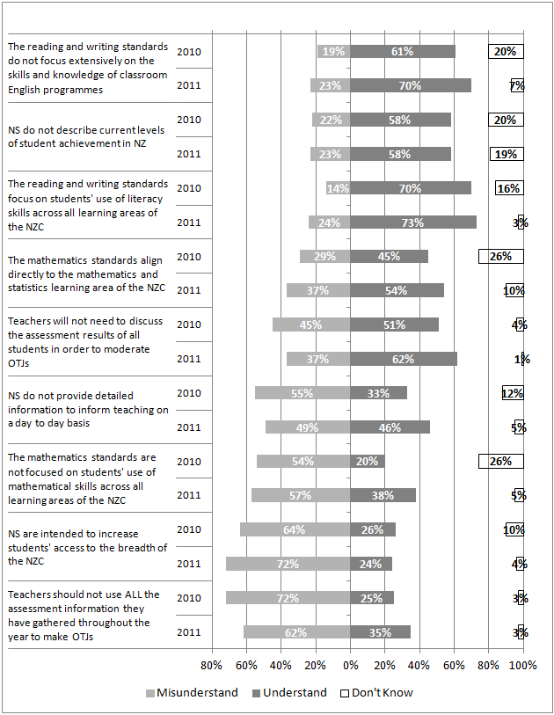
NS do not provide detailed information to inform teaching on a day to day basis
The mathematics standards are not focused on students' use of mathematical skills across all learning areas of the NZC
NS are intended to increase students' access to the breadth of the NZC
Teachers should not use ALL the assessment information they have gathered throughout the year to make OTJs
In general, principals’ understandings of the National Standards appear to have increased from the end of 2010 to the end of 2011. The largest shift was in the proportion of principals that understand the mathematics standards are not focused on students’ use of mathematical skills across all learning areas of the New Zealand Curriculum. Twenty percent of principals in 2010 and 38% in 2011 understood this. There were also increases of greater than 10% in the proportions of principals that understand National Staandards do not provide detailed information to inform teaching on a day to day basis (from 33% to 46%), and teachers do not need to discuss the assessment results of all students in order to moderate OTJs (from 51% to 62%). The proportion of principals that understand the intent of National Standards is to increase students’ access to the breadth of the New Zealand Curriculum remains low (26% in 2010 and 24% in 2011), and the proportion that misunderstand this increased by 8% (from 64% to 72%). There was also an increase in the proportion of principals that misunderstand the reading and writing standards focus on students’ use of literacy skills across all learning areas of the New Zealand Curriculum (from 14% to 24%).
The survey asked principals to rate how well supported they felt by the Ministry of Education in a number of areas. Figure 43 summarises the responses of 74 principals.
Figure 43: Principals’ perceptions of the level of support provided by the Ministry of Education
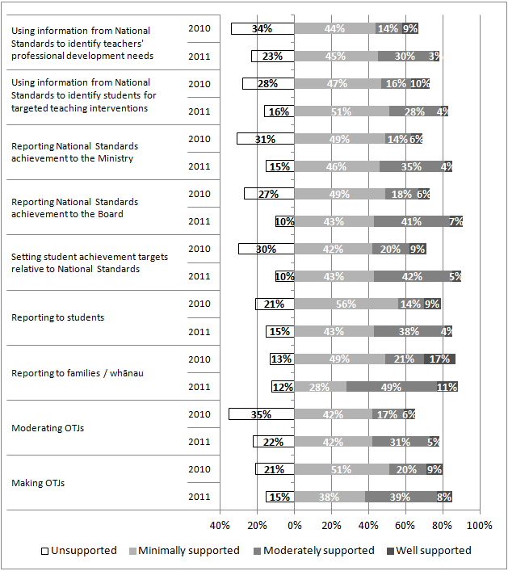
In general, principals felt more supported by the Ministry of Education in 2011 than in 2010. For example, 24% of principals described themselves as moderately or well supported to report National Standards achievement to the Board in 2010 and this proportion increased to 48% in 2011. Principals also reported feeling more supported to report to families and whānau (increased from 38% to 60% moderately or very supported) and the Ministry of Education (increased from 20% to 39%). Despite these increases more than half of the principals described themselves as minimally supported or unsupported for eight of the nine areas listed in 2011. Principals feel most supported to report to families, with 60% rating themselves as moderately or very supported in this area.
Seventy-three percent of principals indicated their school had received support to implement the National Standards in 2011. This included those who had received support from Ministry of Education contracted PLD providers (45%), those who had received support from independent providers (15%) and those who specified receiving support from others (14%). Other support listed by principals included working with another school or cluster of schools, and general collegial support from professional networks. Twenty-seven percent of principals reported their school received no support to implement the National Standards in 2011.
Twenty-six principals chose to comment on the implementation of National Standards or the support they had received. Themes in these comments were wide ranging, with one theme identified by more than 5% of respondents. Nine principals (12% of respondents) commented on the need for more professional development support funded by the Ministry of Education.
Need more!! Particularly at the teacher level, so that they have all the necessary knowledge and pedagogy to shift, and our leaders have the skill to support ongoing progress.
It is unfortunate that Team Solution facilitators are no longer providing support as they have done a great job in this school. If schools have to pay for this type of PD, there will be lip service only paid to OTJ's.
We try and get onto contracts to support literacy and numeracy but it is very competitive so we work as a cluster with the [local] Principals association picking up and sharing through our clusters.
Principals were asked to rate their level of concern over the unintended consequences of National Standards. Figure 44 summarises these results and compares them to those from the end of 2010.
Figure 44: Principals’ level of concern over the unintended consequences of National Standards
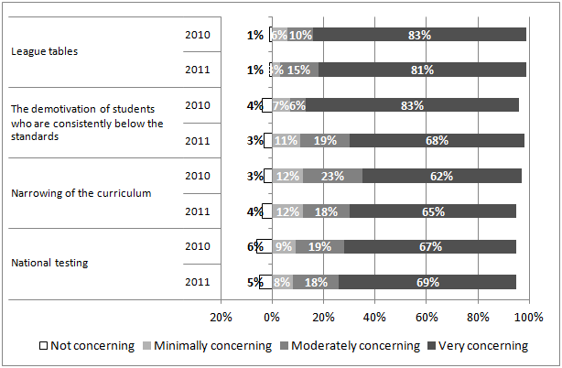
Results suggest principals remain concerned over the unintended consequences of National Standards, with League Tables remaining the issue of most concern. Over 60% of principals rated all of the four issues listed as very concerning and their comments reflect these concerns:
A national test is the only way to ensure consistency across schools but then we'll end up with a system similar to those which are already failing overseas. League tables would be my biggest concern and will inevitably not be able to show progress in a school correctly.
My greatest concern is the narrowing of the curriculum. Schools are focusing all their resources on NS in Literacy and Numeracy. NS are aimed at ensuring students can access the curriculum but the implementation has been counter-productive as schools are now only concerned with Reading, Writing and Maths.
Still worried about league tables widening the achievement gap, whereby parents of able students move their children to schools higher up the league table, and successful teachers only wanting to teach in schools that are perceived to be successful.
Note that the question asked principals to rate their level of concern, but did not address the likelihood of these possible consequences occuring.
At the conclusion of the mid-year interview principals were asked if they would like to make any comments about the National Standards and 90 principals chose to do so. Fifity-eight percent of these comments were generally negative in regard to the National Standards, while 4% were positive, and 38% were neither positive nor negative. The following comments illustrate this.
I still fail to see how they [NS] are going to raise student achivement. Measuring doesn't make a blind bit of difference. Before NS I knew the kids who weren't achieving and I was working with those kids and families already. If teachers could see the benefit to kids in raising student achievement they would support NS whole heartedly - like they did with the numeracy project - but that isn't happening. If that isn't happening then it's a job for ero - don't make all schools do NS for the benefit of the few who aren't effective already.
I think they're a good thing. The moderation and professional discussions around it has been great - good PD and helped teachers get to know their kids better. I'm pleased with the way things have gone.
There has been a lot of hoo-ha about them. We see them as a small part of a big-picture. They are a tool for teachers to help evaluate where students are at and where they are going. There's very little new about them and I wonder why there's been such a stink about them. We're not overly worried and we're also not overly celebrating them. We haven't changed much at all.
Themes in responses were wide ranging, and those identified by more than 5% of respondents are outlined in Table 46.
Table 46: Themes in principals’ comments on National Standards
Theme | Number of principals
Labelling students as below/well below is detrimental to them and their families | 19
The variation in OTJs between schools is a concern | 18
Our school is complying because it's a legal requirement | 14
The NS have been poorly implemented | 13
League tables are a concern | 12
NS won't raise student achievement | 11
We are doing what we can to make the standards work usefully for our school | 11
I don't like NS | 8
The students at our school have very low standards of achievement on entry | 6
NS have generated productive professional discussions on teaching | 6
Our school had benchmarks for student achievement prior to NS | 6
Some students will never achieve the NS | 5
I am concerned the NS are effectively narrowing the curriculum | 5
The reading standard for students after one year of instruction is too high | 5
Our school doesn’t need NS to know which students are not achieving | 5
It is important that progress data is taken into account | 5
I am in favour of the NS | 5
It has taken a lot of time/work to implement NS at out school | 5

Seven themes were identified by over 10% of respondents. These themes are illustrated in the following principals’ comments:
Below judgments also create angst in family and students …a kid who is promoted 5 reading levels in 6 months still gets a below judgement and feels like a failure.
We here err on a harsh judgement … we never gild the lily… but what happens when our data is compared to other schools? This is my huge concern, and it's a big problem nationally. Other concern is kids don't progress at the same rate … it's not right to label a kid as a failure at 6 years old.
We do it because we have to; we're not overly enthusiastic about it.
It was bought in way too quickly … no support for teachers. Teachers are muddled and fuddled. Over time I think they'll can them…- but we'll see what happens after 10 years. Teachers know where their kids are already … don't need NS to tell us that.
But the reporting part of it is going to be damaging for us… our data is never going to look good, we've got over 50% transience every year … the newspaper won't look at our progress data which is actually great.
They're still not going to make any difference to achievement… data won’t make any difference …the $ should have been spent resourcing remedial programmes.
It's been great in terms of making us look at where we're at. There's lots of things we don't agree with, but it's there…so let's use it to help us see where we can focus on. We've got to make it useful for us.

10.3 Board perspectives
The Board of Trustees survey asked respondents to rate their level of confidence that the school is effectively implementing National Standards. Most Board Chairpersons rated themselves as very confident in this regard (68%), while 25% rated themselves as moderately confident. Small proportions of respondents rated themselves as minimally confident (5%) or unsure (2%).
Figure 45 shows survey respondents’ level of agreement with three statements.
Figure 45: Board of Trustees understanding of school actions
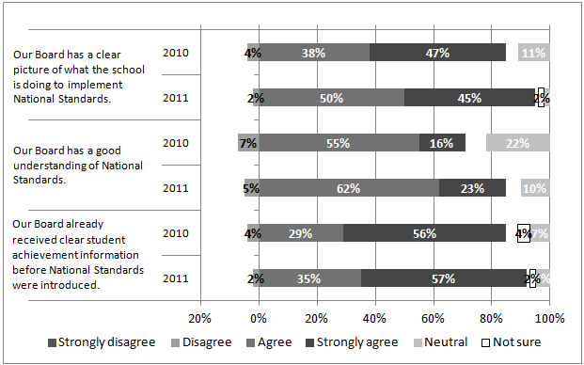
In general, most Boards feel they have a good understanding of National Standards and what the school is doing to implement them. Results indicate respondents felt more positive in this regard in 2011 than 2010. Fourteen percent more Board of Trustees Chairpersons agreed their Board has a good understanding of National Standards (85% compared to 71%), and 10% more agreed the Board has a clear picture of school implementation actions (95% compared to 85%). Most 2011 respondents (92%) felt they already received clear information about student achievement before the introduction of National Standards, an increase from the 2010 result (85%).
Most respondents (92%) indicated their Board of Trustees had received reports on students’ progress and achievement relative to National Standards. Of those who had received reports, almost all (98%) also indicated the information they received provided a clear picture of student achievement in all three areas, with a small proportion (2%) rating these reports as unclear. Sixteen respondents chose to comment on the achievement reports they had received and these tended to comment on report content.
Each area of all curriculum have given reports during the year. Total assessment data given and variance report against our targets. Broken down from school to gender and reported on Māori, Pasifika and special needs or at risk.
We had several breakdowns including by year, gender, and ethnicity.
Respondents to the Board of Trustees survey were asked whether National Standards achievement levels in their school were lower than expected, higher than expected, about the same as expected, or whether they didn’t understand the results. Figure 46 shows these results.
Figure 46: Board of Trustees rating of NS achievement information against expectations
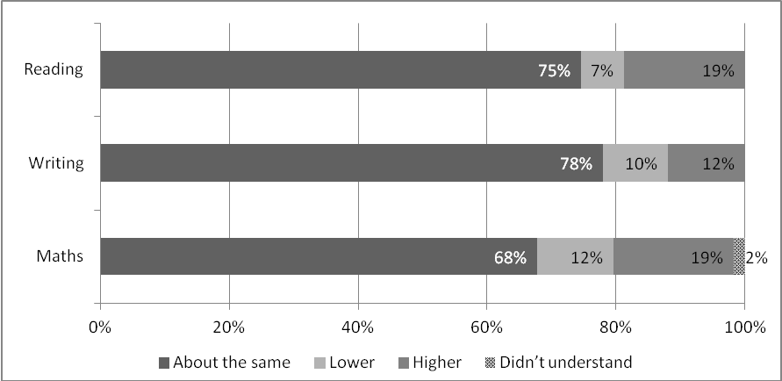
About thee-quarters of respondents indicated that the National Standards achievement information they had received showed achievement levels in reading (75%), and writing (78%) were about what they expected. Sixty-eight percent noted mathematics achievement levels were as expected. Where achievement levels were not congruent with expectations, most Boards felt levels were higher than expected rather than lower. This difference was greatest in reading (19% higher than expected and 7% lower), and smallest in writing (12% higher than expected and 10% lower). Comments were focused around the levels of achievement being in line with expectations.
We expected our results to be good which is what they were as we set them higher then the nat standards.
We expected the achievement to be lower than it had been in the past when measured against national standards and that was the case.
Targets were approx. what we thought they would be. We have made excellent progress from data gathered at start of year especially our seven group who had low entry levels.
Overall the complete result did confirm where we believe our school is positioned.
Over 90% of respondents indicated they had received reports of student progress in relation to the National Standards in reading (92%), writing (90%), and mathematics (93%) from the end of 2010 to the end of 2011. Around 10% of respondents (8% in reading, 10% in writing and 10% in mathematics) indicated they had not received progress reports, but comments indicated most of these Boards (8%) were expecting to receive these in due course.
Progress was reported to the middle of the year. We expect further progress to be reported at our next meeting. Data has not yet been finalised.
Only from the end of 2010 to middle of 2011. We are giving the teachers more time before we see and analyse the end of year result.
Results to year end not collated yet.
Most of those who had received this information believed it provided a clear picture of student progress in reading (95%), writing (93%), and mathematics (95%).
Just over half (54%) of the respondents to the Board of Trustees survey indicated they had taken some action as a result of receiving information about student progress and achievement in relation to the National Standards. Twenty percent of respondents indicated they are planning to take some action, while 26% have nothing planned at this stage. Forty-eight respondents left comments describing these actions (either taken or planned). Common actions noted were using the information to inform planning processes (23%), identify students for targeted teaching support (16%), and identify areas for teacher professional development support (11%). Eight percent of respondents also noted the actions listed were undertaken before the introduction of National Standards.
We discuss and encourage planning to lift the lower performers. This is not different to earlier reporting, as National Standards have not provided a better tool to assess student achievements. It will improve standardisation across schools I am sure.
Action plans have been designed to lift underachieving students. We have used the information in updating our 3yr strategic plan and annual plan
…Target groups (mainly in the senior school) have been identified and targeted small group teaching is a focus for these students next year to move them up the expected levels. BoT is actively working with staff to plan and implement PD focus and to support the staff in the implementation of planned initiatives.
Looking where to target learning and staff this was done before national standards were introduced anyway.
Respondents to the Board of Trustees survey were asked to rate the level of usefulness of information from National Standards for a variety of purposes. Figure 47 summarises these results.
Figure 47: Boards’ perspectives on the usefulness of student achievement information from National Standards
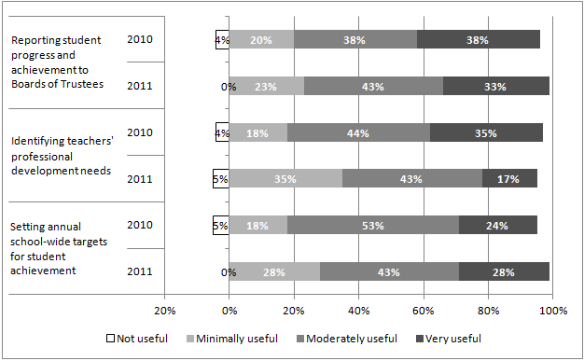
In general, most Boards regarded information from National Standards as useful. The majority of respondents rated this information as moderately to very useful for reporting student progress and achievement to Boards of Trustees (76%), identifying teachers professional development needs (60%), and setting school-wide achievement targets (71%). In comparison with results from 2010 there has been a decrease in the perceived value of this information for identifying teachers’ professional development needs. Fewer respondents rated it as very useful for this purpose in 2011 (17%), while more respondents rated it as minimally useful (35%). Twenty-three respondents chose to leave comments about the usefulness of information from National Standards. The one common theme in these responses was that these actions were already being taken before the introduction of National Standards (21% of respondents).
We had stringent and thorough measuring and reporting in place prior to national standards so they have had little impact on changing our approach how we use our results.
As we already received clear information about student achievement before National Standards were introduced we don't see any advantage to us as a Board.
We have been doing these before nat standards came along, and as already stated we set our goals higher then the nat standards average.
Ninety-six percent of respondents to the Board of Trustees survey indicated they had received training and support to implement the National Standards. Three main sources of support were cited. Eighty-six percent of respondents indicated they had read material from the New Zealand School Trustees Association, 43% identified they had worked with Ministry of Education Board of Trustees training providers, and 30% noted they had participated in webinars. Fourteen percent of respondents also noted they had received advice and information from the school principal and senior staff.
Respondents to the Board of Trustees survey were asked to rate their level of concern over possible unintended consequences of National Standards. Figure 48 shows these results.
Figure 48: Boards’ level of concern over the unintended consequences of National Standards
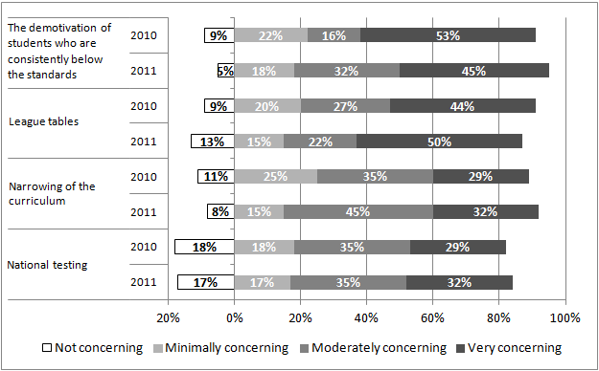
Results indicate that Boards are concerned about the unintended consequences of National Standards. Around three-quarters of respondents rated themselves as moderately or very concerned about the four issues listed. Boards appeared to be more concerned about student demotivation and the narrowing of the curriculum in 2011 than in 2010. Eight percent more respondents rated themselves as moderately or very concerned about student demotivation in 2011 than in 2010, while 13% more rated themselves this way in regard to narrowing of the curriculum. In general, the level of concern about these possible consequences is lower among Boards than it is among principals. For example, over all four possible consequences 83% - 96% of principals rated themselves as moderately to very concerned, while 67% - 77% of Board of Trustees Chairpersons rated themselves in this way.
Twenty-four respondents chose to comment on the National Standards in general. The three common themes in these comments were a lack of support for National Standards (7%), positive support for National Standards (5%), and the view that the implementation of National Standards was poor (5%).
Our compliance with National Standards should not be read as support of it.
National standards do not add to our understandings - conversely they add considerable burden for very little gain, especially during a rushed implementation.
[Our] School is a small school in a rural area. National Standards can promote the school into a good position on league tables because of the small class sizes and the attention teachers can give individual students to help raise them to National Standard. This suits our school, which we are currently trying to 'recruit' more students into.

Appendices

Appendix A: Project methodology
 | Monitoring and evaluation questions | Intentions | Data sources
Antecedents | - To what extent are the National Standards understood as a set of common expectations for student achievement?  - What processes are employed by schools to maintain consistent application of the National Standards? | - National Standards provides clear information about student achievement for Boards of Trustees, which can be, used in decision making and resource allocation processes. | Online survey: principals and BOT representatives  Principal interviews  Schools’ achievement targets and analysis of variance reports
Transactions | - In what ways do teachers use information from a variety of student assessments to make overall judgments?  - What processes are used to moderate OTJs?  - How dependable and consistent are teachers’ overall judgments? | - Teachers make defensible, trustworthy judgments against the National Standards. | Student achievement data  Online assessment scenarios  Online surveys: teachers and principals  Principal interviews
Outcomes | - What changes in student achievement in reading, writing and mathematics are observed as National Standards are introduced?  - What changes in teachers’ professional knowledge and practice are observed as National Standards are introduced?  - In what ways is information from National Standards used by schools to set achievement targets?  - In what ways is information from National Standards used by schools to describe student achievement and progress?  - In what ways is information from National Standards used to provide targeted teaching interventions?  - In what ways is information from National Standards used to identify teachers’ professional development needs?  - How do schools use information from National Standards to report to and communicate with parents?  - To what extent do parents understand, value, and use National Standards information about their child? | - National Standards achievement information is used by teachers and schools to monitor student progress and achievement against the Curriculum.  - As a result of using National Standards to monitor achievement and progress some students will be provided with targeted teaching interventions.  - Student achievement will improve.  - Schools use National Standards assessment information to communicate clearly with families about their child’s achievement and progress.  - National Standards information is used to identify teachers’ professional development needs. This enables these to be addressed more effectively. | Student achievement:  OTJs  Teachers: online surveys  Schools:  achievement targets  analysis of variance reports  online surveys: principals  individual interviews: principals  end-of-year reports  Whānau:  online survey: parents  end-of-year reports

Appendix B: Principal interview schedule

Questions to schools who provided OTJ data in 2010
- To supply OTJs to us last year you uploaded them to the database / entered them directly into the database / provided us with a spreadsheet. Would it be convenient for you to do the same this year?
Questions to schools who did not provide OTJ data in 2010
- Did your teachers make OTJs in reading, writing and mathematics in 2010? If yes, did you use a rating scale (at, above, below, well below) a best fit judgment, or some other method?
- Will your teachers make OTJs in reading, writing and mathematics at the end of this year? If yes, what is the most convenient way for you to provide this data to us?
Questions to all schools in the sample
- Did your teachers make OTJs mid-2011 for year 4-6 students? If yes, was this a prediction of end-of-year achievement, or a current state judgment?
- Are you planning to make end-of-year OTJs in 2011? If yes, will you use a rating scale (at, above, below, well below) a best fit judgment, or some other method?
- When are the OTJs for students in years 1-3 being made? If OTJs for students in years 1-3 are made on anniversary to school entry, when are these reported to parents?
- When do you think your school will be in a position to provide OTJs and copies of students’ reports at the end of the year? When would it be suitable for us to send an email reminder?
- Is there another person in your school you’d like us to copy into that reminder?
- Last year we had a disappointing response rate to the teachers’ survey. Do you have any suggestions for how we could improve this?
- Did you get a response from the Ministry of Education when you submitted your student achievement targets for 2011 (as part of your charter)? If yes, what was the nature of the response from the Ministry to your student achievement targets?
- Are there any other comments you’d like to make about the National Standards?

Appendix C: School documentation analysis criteria
Criteria | Code | Desc.
Includes targets in relation to the National Standards in Reading | 0 | No
 | 1 | Yes
National Standards reading targets address students at all year levels | 0 | No
 | 1 | Yes
National Standards reading targets specific and measurable | 0 | No
National Standards reading targets specific and measurable | 1 | Yes
National Standards reading targets appropriate (challenging and achievable) | 0 | No
 | 1 | Yes
Includes targets in relation to the National Standards in Writing | 0 | No
 | 1 | Yes
National Standards writing targets address students at all year levels | 0 | No
 | 1 | Yes
National Standards writing targets specific and measurable | 0 | No
National Standards writing targets specific and measurable | 1 | Yes
National Standards writing targets appropriate (challenging and achievable) | 0 | No
 | 1 | Yes
Includes targets in relation to the National Standards in Mathematics | 0 | No
 | 1 | Yes
National Standards mathematics targets address students at all year levels | 0 | No
 | 1 | Yes
National Standards mathematics targets specific and measurable | 0 | No
 | 1 | Yes
National Standards mathematics targets appropriate (challenging and achievable) | 0 | No
 | 1 | Yes
National Standards targets focus on students who are below or well below the relevant standard | 0 | No
 | 1 | Yes
National Standards targets include a focus on progress for ALL students | 0 | No
 | 1 | Yes
National Standards targets include a focus on sub-groups of students | 0 | No
 | 1 | Yes
Sub-group targets focus on students who are below or well below the NS | 0 | No
 | 1 | Yes
Below or well below sub-group targets focus on Māori students | 0 | No
 | 1 | Yes
Below or well below sub-group targets focus on Pasifika students | 0 | No
 | 1 | Yes
Below or well below sub-group targets focus on students with special needs | 0 | No
 | 1 | Yes
Below or well below sub-group targets focus on students by gender | 0 | No
 | 1 | Yes
Below or well below sub-group targets focus on other students | 0 | No
 | 1 | Yes
Sub-group targets focus on students who are at or above the National Standards | 0 | No
 | 1 | Yes

Appendix D: Criteria for end-of-year report analysis
Criteria | Code | Description
Use of NS | 1 | Report explicitly mentions NS
Use of NS | 2A | Report doesn’t mention NS, but includes other achievement data, which is sufficient to make an OTJ. No further analysis required.
Use of NS | 2B | Report doesn’t mention NS, but includes other achievement data which is insufficient to make an OTJ. No further analysis required.
Use of NS | 2C | Report doesn’t mention NS and has no other achievement data. No further analysis required.

Only those reports in category one above, that is those reports that explicitly mention the National Standards, were analysed in further detail. The further criteria applied were:
Criteria | Code | Description
Achievement in relation to NS is sufficient | 0 | No
Achievement in relation to NS is sufficient | 1 | Yes
Progress over time is shown on a scale. (Can be diagrams or words, naming of skills learnt not enough.) | 0 | No
 | 1 | Yes
If yes, which scale(s)? | Name of scale
If yes, Mid 2011 to end 2011 or end 2010 to end 1011? | 0 | Mid-end 2011
If yes, Mid 2011 to end 2011 or end 2010 to end 1011? | 1 | End10 - end11
Clarity | 0 | No
Clarity | 1 | Yes
Next learning steps included in at least 2 learning areas | 0 | No
Next learning steps included in at least 2 learning areas | 1 | Yes
School actions to support student learning described in at least 2 learning areas. (Must be explicit that it’s the school that going to do them). | 0 | No
 | 1 | Yes
Descriptions of actions families can take to support student learning | 0 | No
 | 1 | Yes
Achievement in relation to NS is described using best fit | 0 | No
Achievement in relation to NS is described using best fit | 1 | Yes

Criteria | Code | Description
Achievement in relation to NS is described using a scale | 0 | No
Achievement in relation to NS is described using a scale | 1 | Yes
Achievement in relation to NS is shown using diagram / table | 0 | No
Achievement in relation to NS is shown using diagram / table | 1 | Yes
Achievement in relation to NS is shown using words | 0 | No
Achievement in relation to NS is shown using words | 1 | Yes
Similar format to other reports from the same school | 0 | No
Similar format to other reports from the same school | 1 | Yes
Coherence between different formats from the same school (assumed coherent if similar format) | 0 | No
 | 1 | Yes

Appendix E: Inter-rater reliability information
Criteria | Spearman correlation | Agreement rate
Use of NS | - | 1.00
Achievement in relation to NS is sufficient | 1.00 | 1.00
Clarity | 0.85 | 0.94
Next steps / learning goals | 0.85 | 0.94
Descriptions of school actions | 1.00 | 1.00
Descriptions of families' actions | 0.92 | 0.96
Achievement in relation to NS is described using best fit | 1.00 | 1.00
Achievement in relation to NS is described using a scale | 1.00 | 1.00
Achievement in relation to NS shown using diagram/table | 1.00 | 1.00
Achievement in relation to NS shown using words | 0.93 | 0.98
Similar format among year levels | - | 1.00
Coherence among year levels | - | 0.84

Note that these statistics are based on the independent coding of 50 reports. Where Spearman’s rho is not provided, it could not be calculated because one or both of the raters showed no variability. For these criteria the agreement rate was used as a measure of reliability.

Appendix F: Online surveys
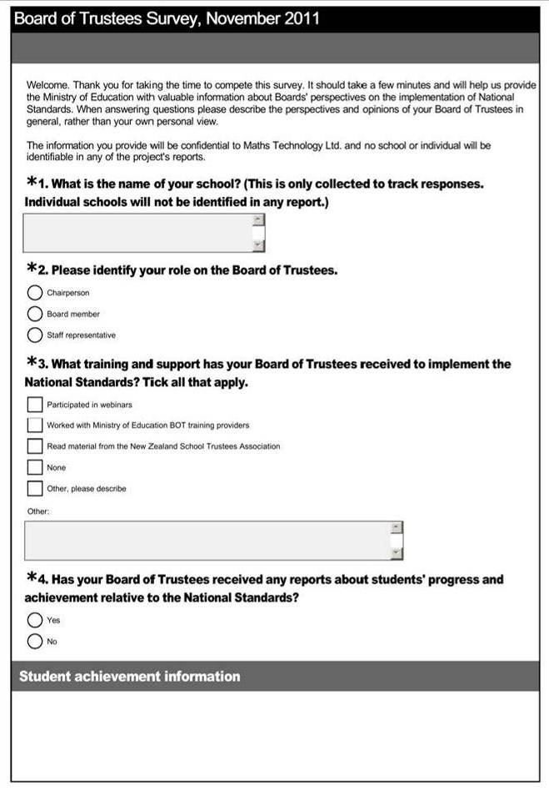

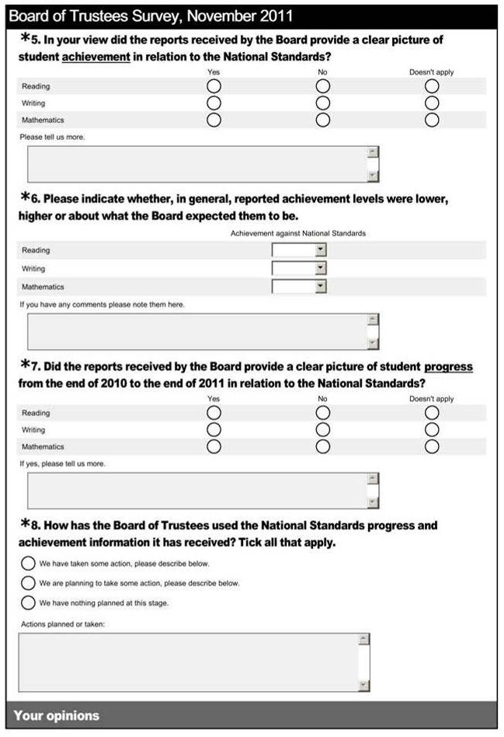

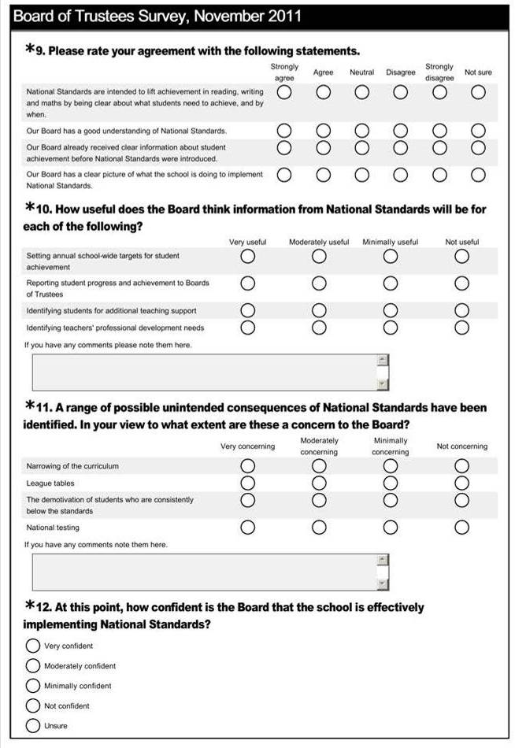



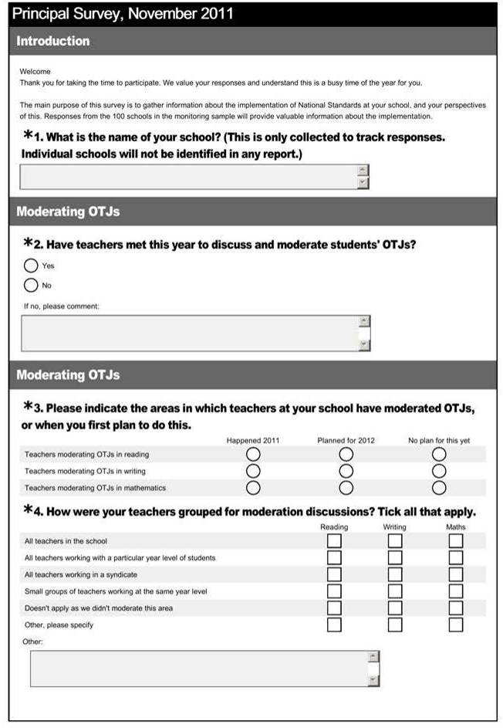

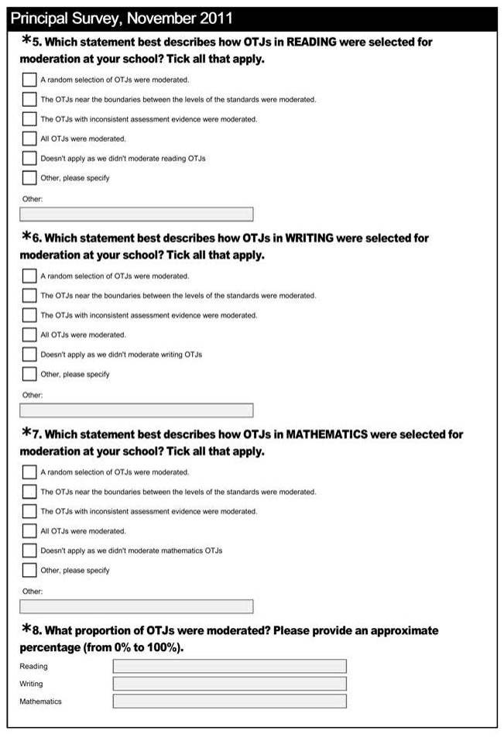

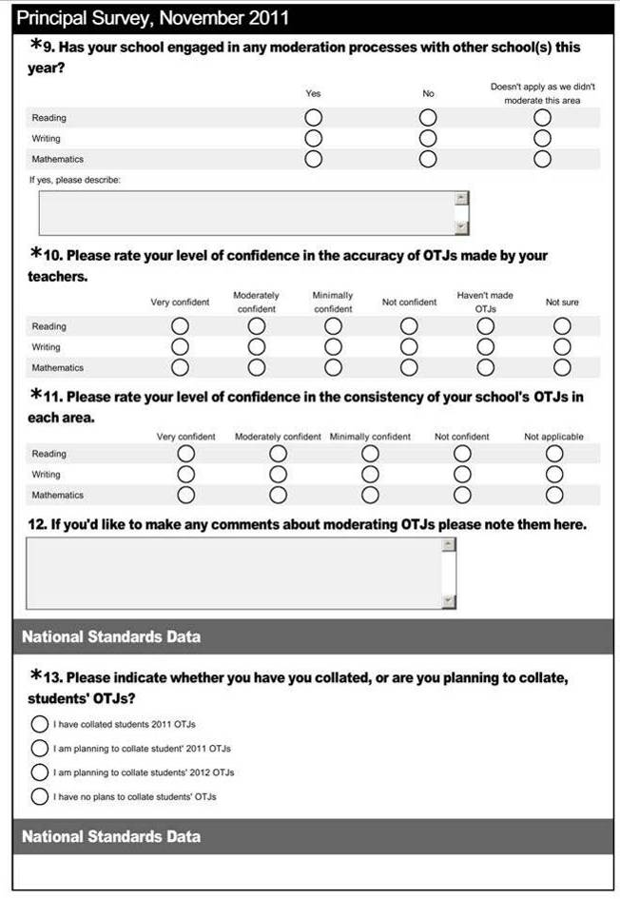

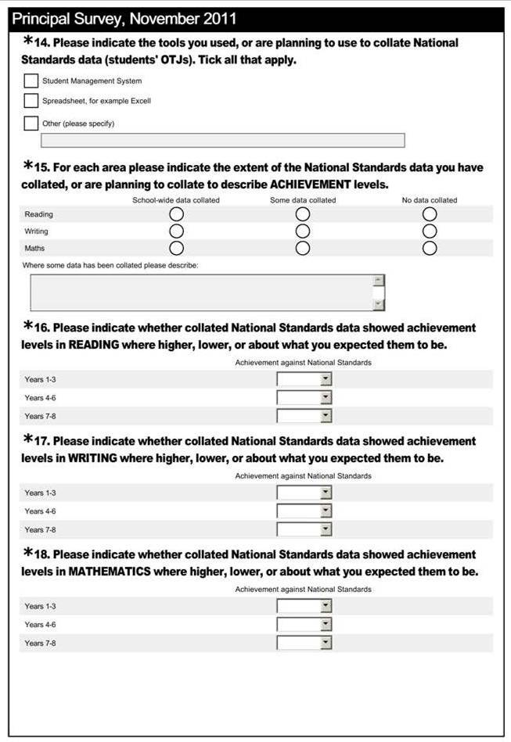

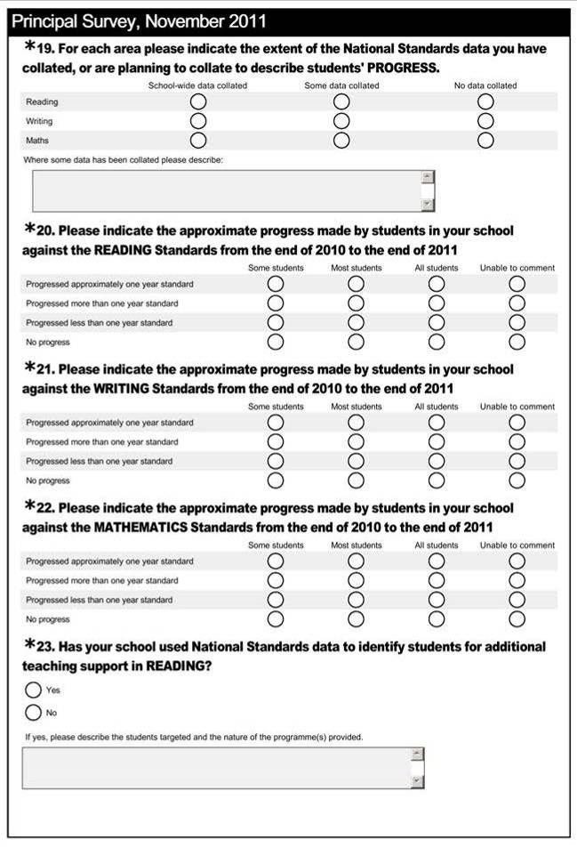

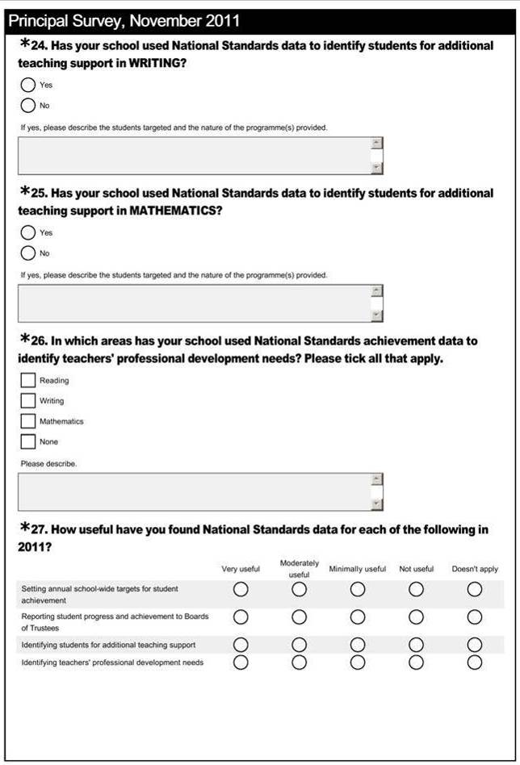

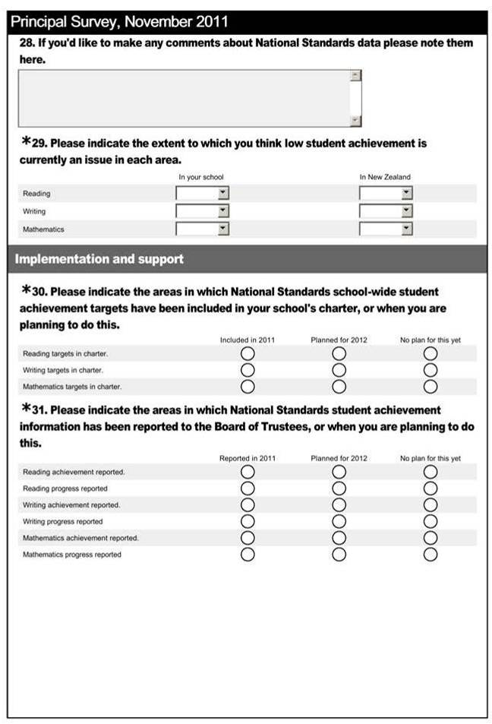

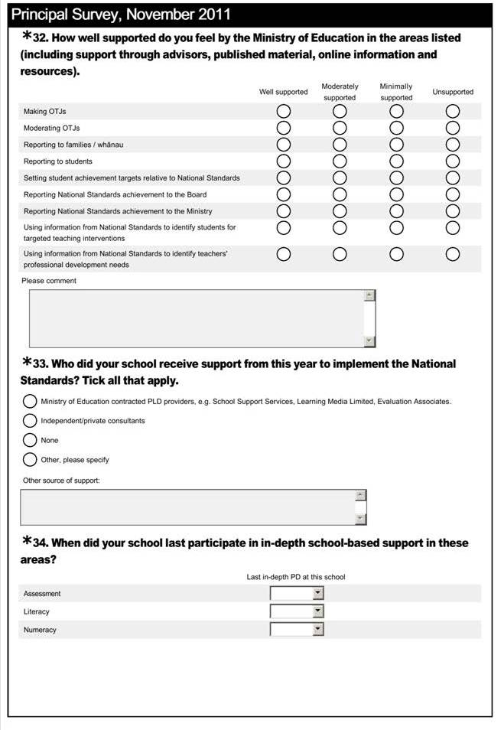

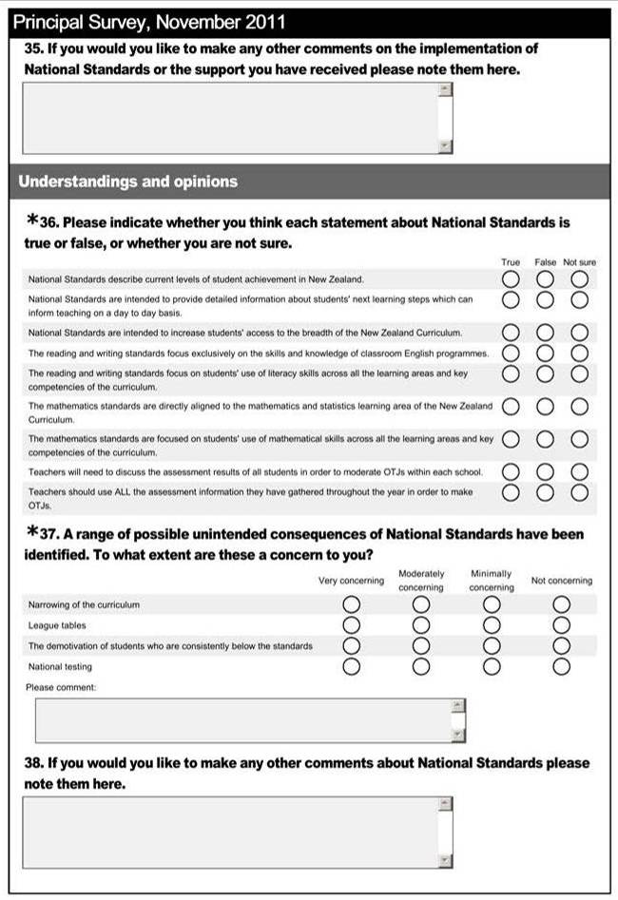
Skip logic was emplyed in the teacher survey wherever question numbering is not consecutive. Respondents chose to focus on standards at particular year levels or answer questions in relation to reading, writing, or mathematics.
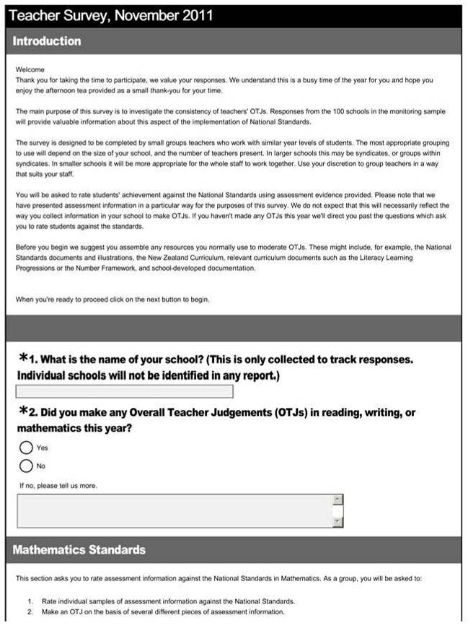

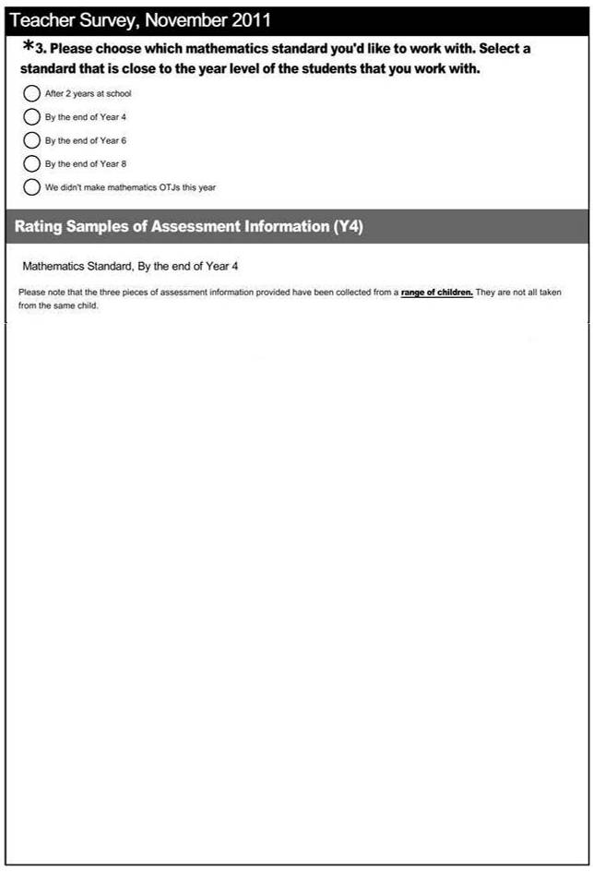
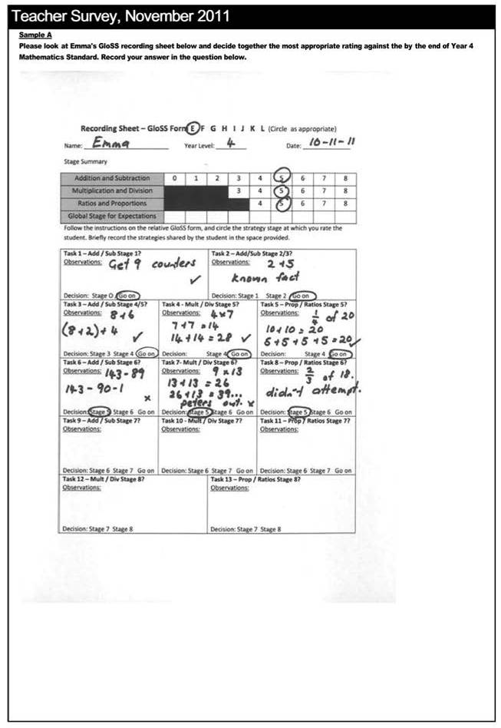
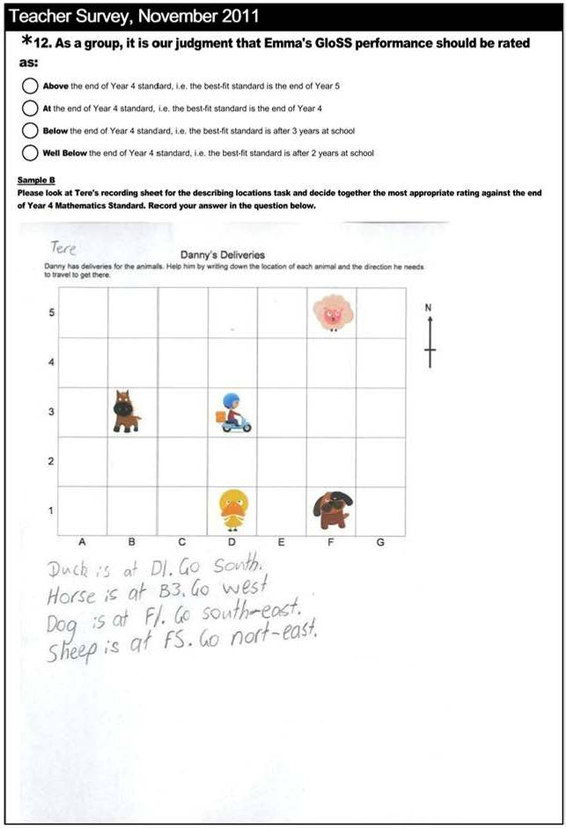

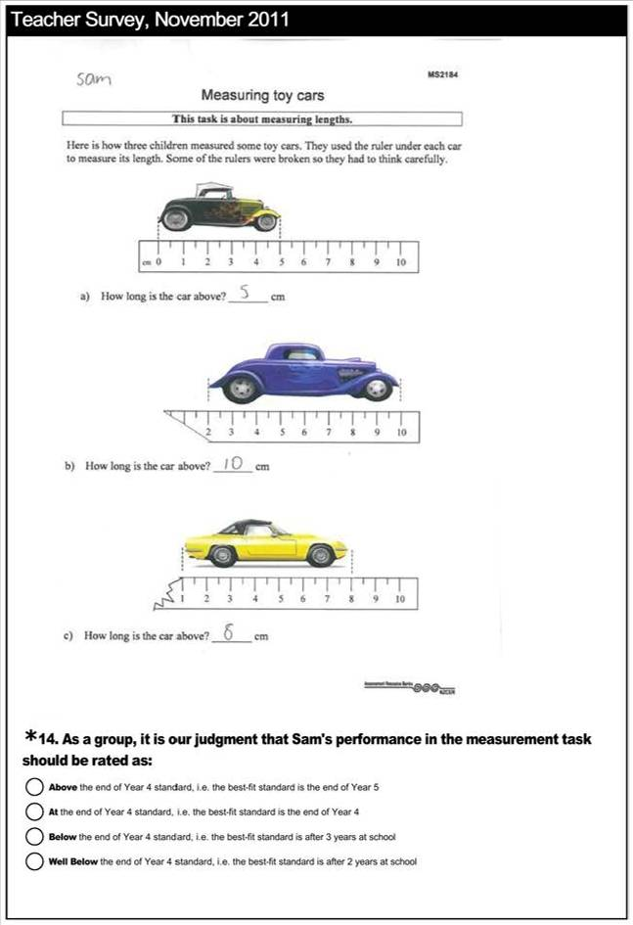
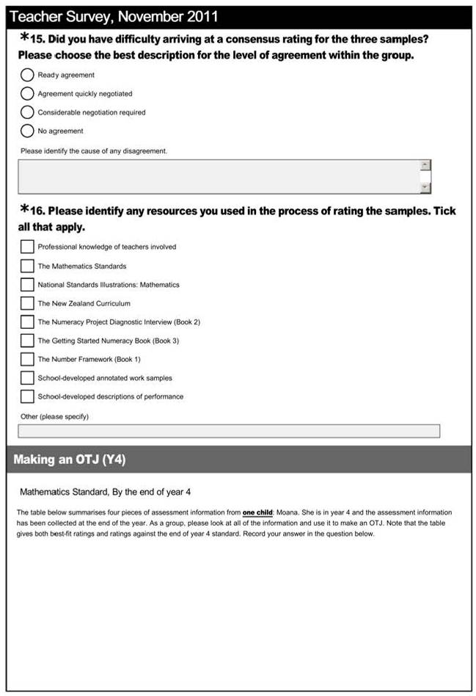

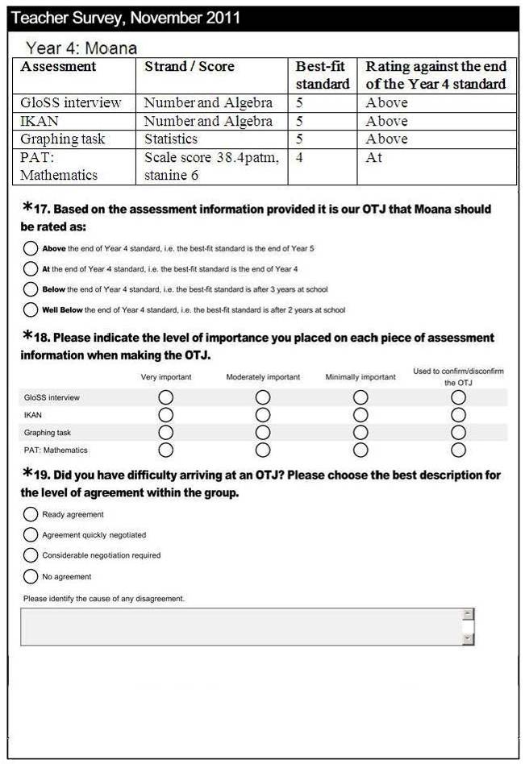

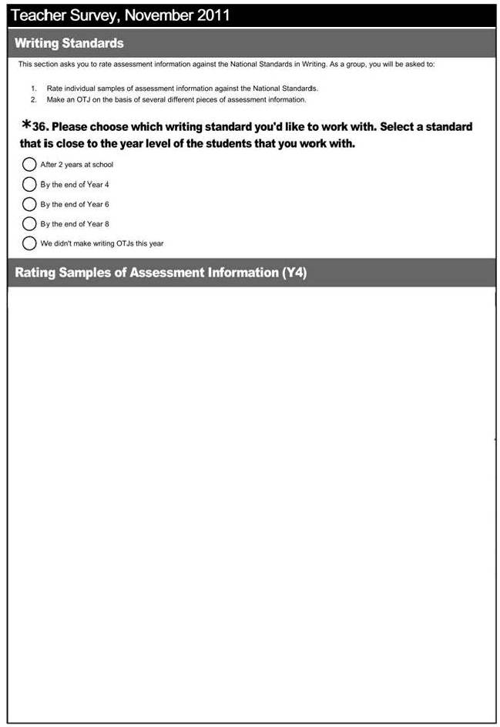

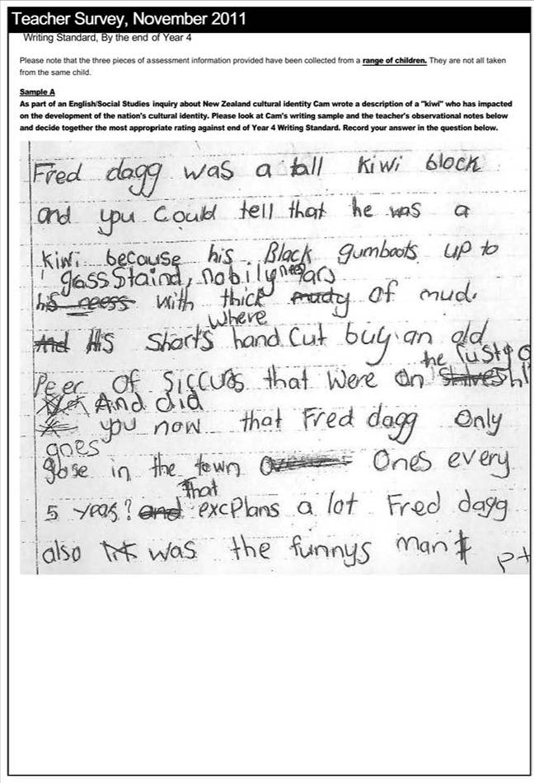
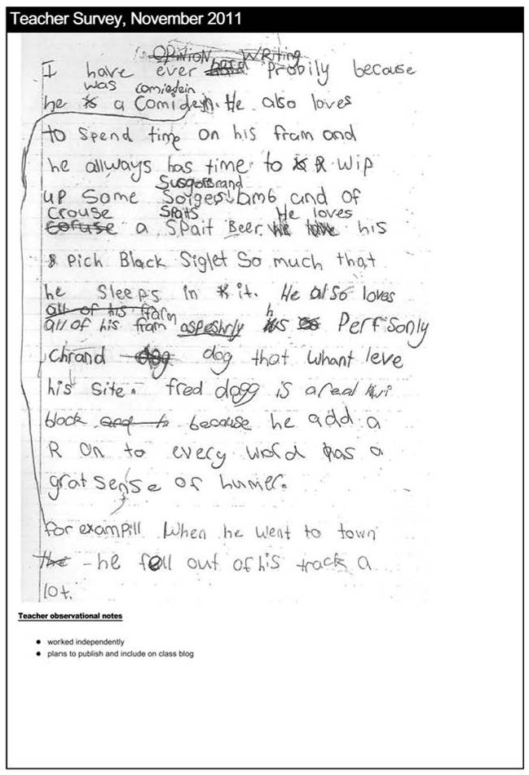

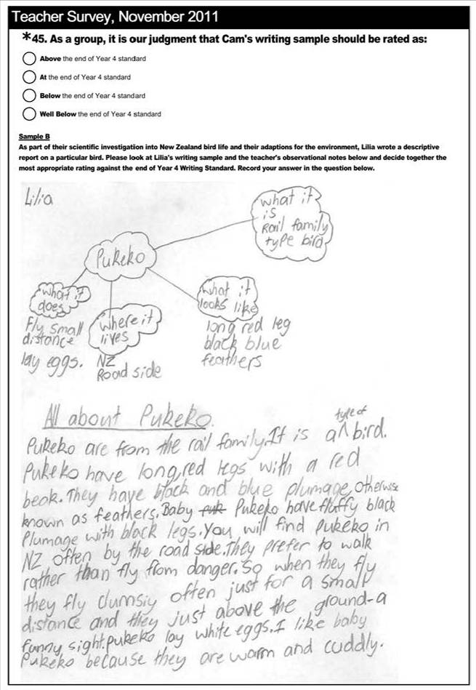

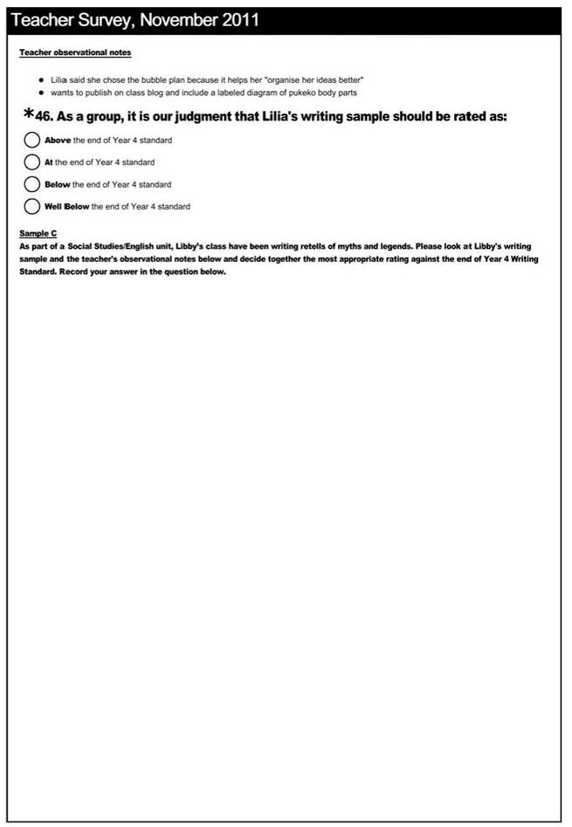




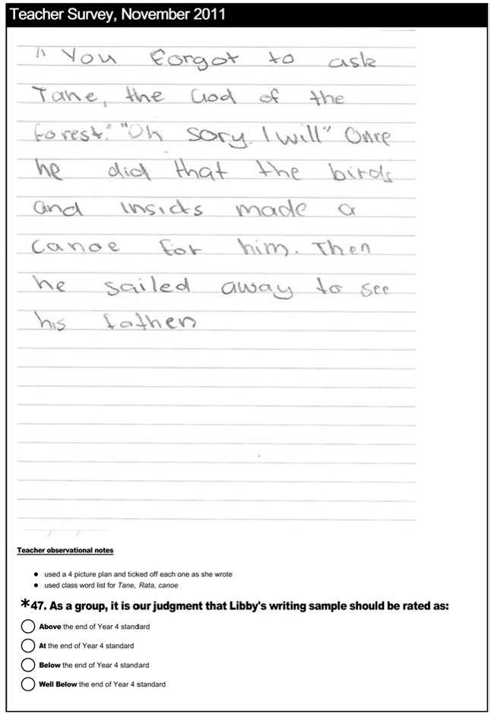

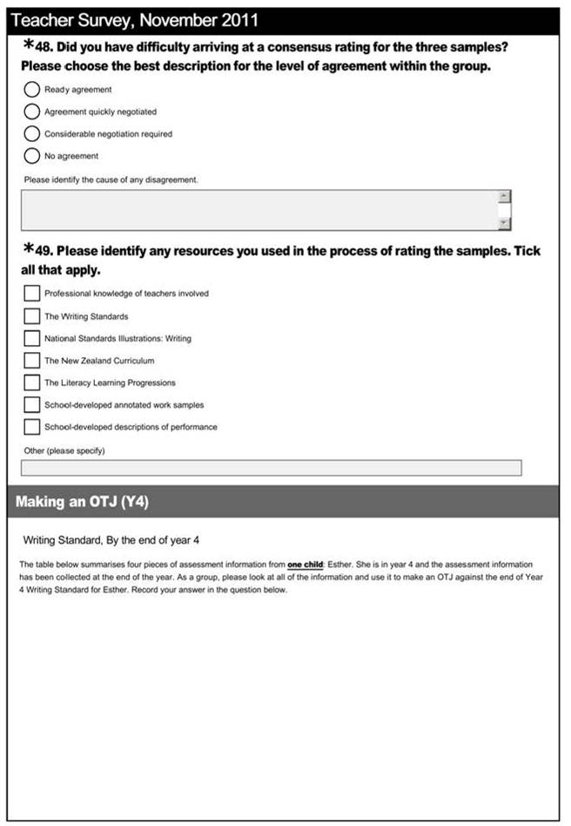
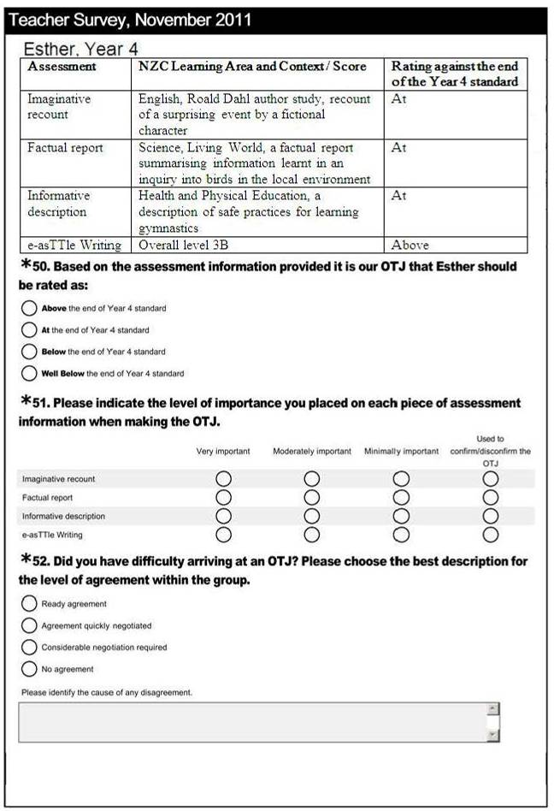
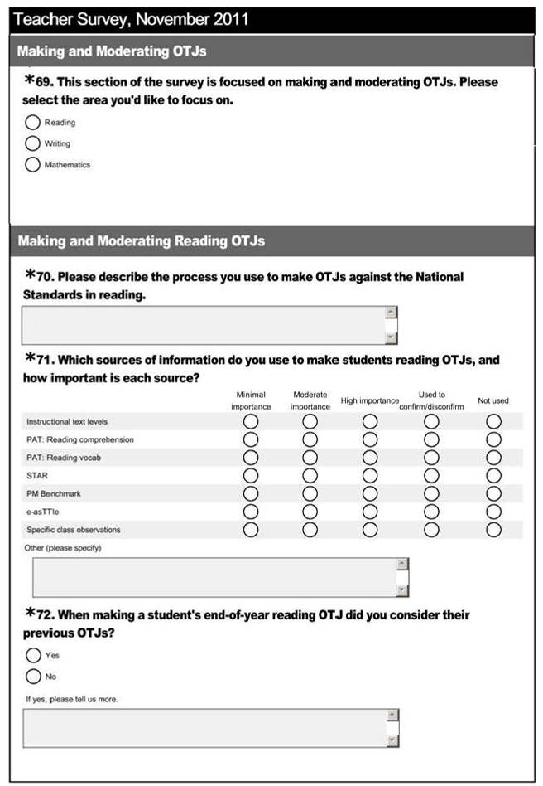
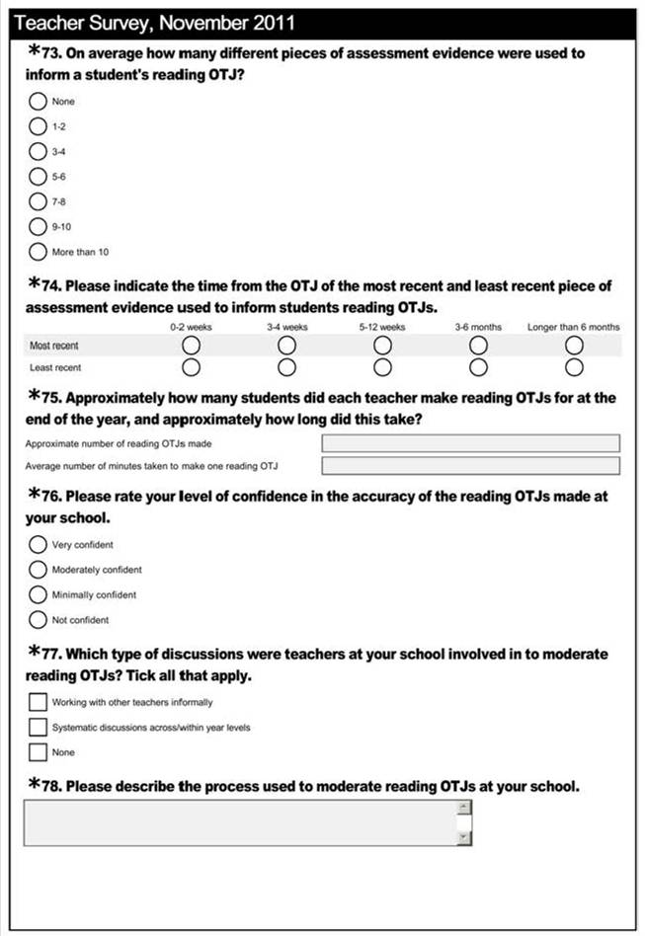
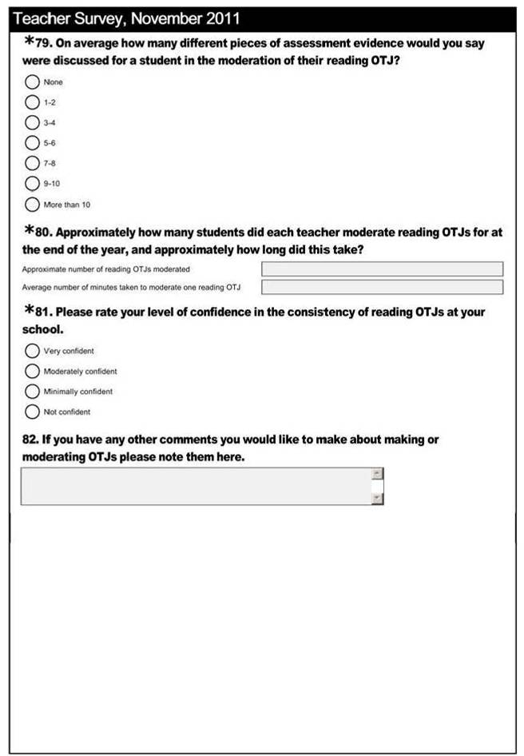

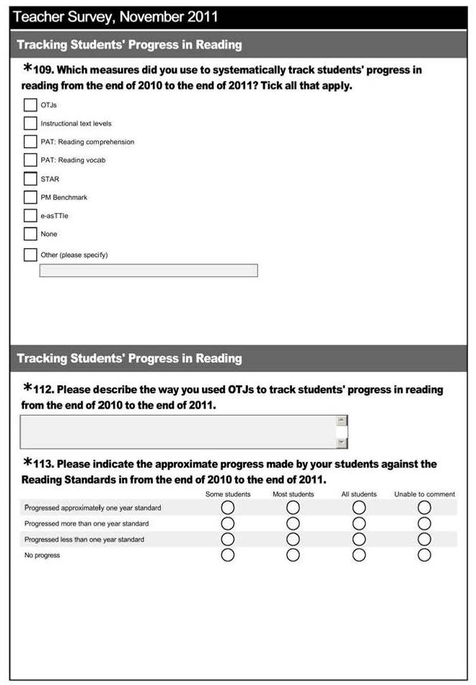

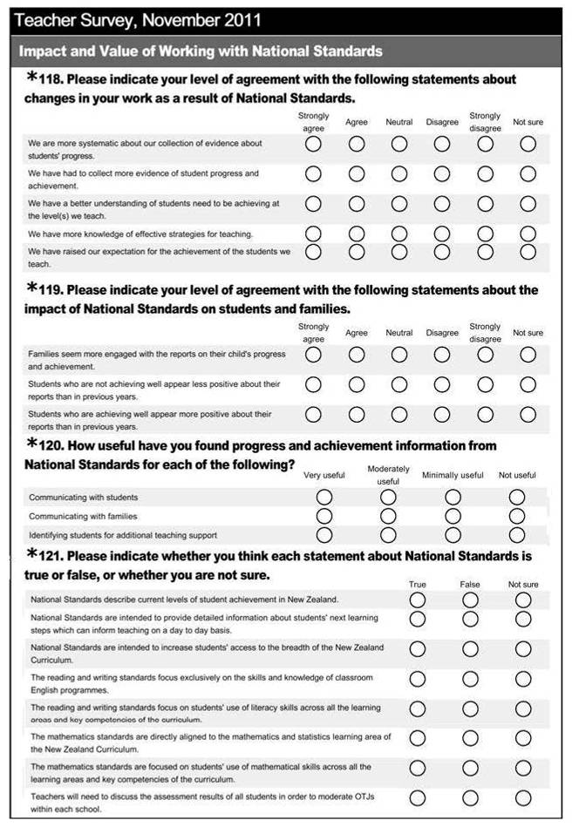
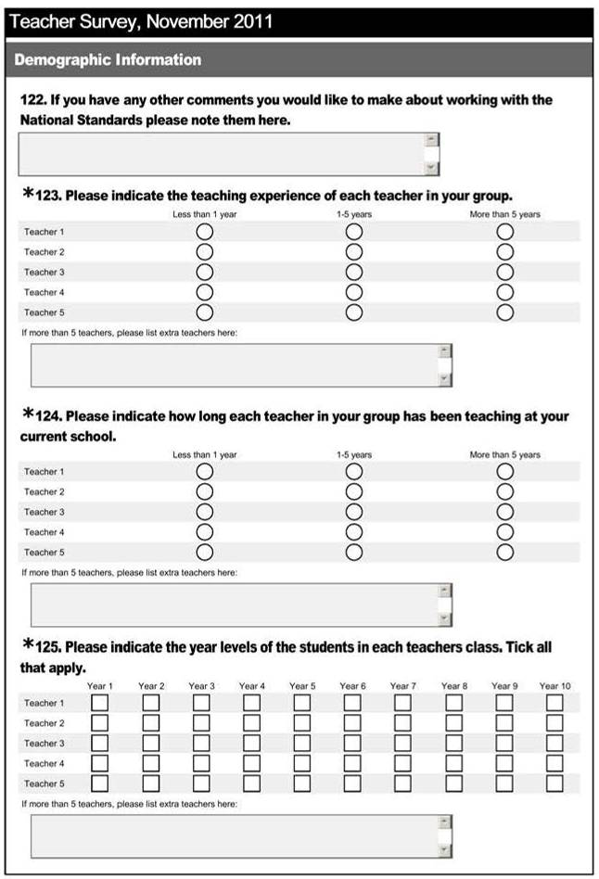

Appendix G: Differences between 2011 and 2010 student achievement data

Reading OTJs, 2011 less 2010
Year Level | n | Percentages of students rated
Year Level | n | Well Below | Below | At | Above
1 | 855 | -5 | -1 | 1 | 5
2 | 1136 | -1 | -6 | -5 | 12
3 | 1214 | -1 | -2 | 0 | 2
4 | 815 | 2 | -2 | 0 | 0
5 | 942 | -1 | -1 | 0 | 2
6 | 834 | -3 | -1 | -1 | 6
7 | 1851 | 1 | 0 | 4 | -5
8 | 1704 | 4 | -1 | -2 | 0

Gender | n | Percentages of students rated
Gender | n | Well Below | Below | At | Above
Male | 4747 | 0 | -1 | 0 | 0
Female | 4579 | 0 | -2 | -1 | 4

Ethnicity | n | Percentages of students rated
Ethnicity | n | Well Below | Below | At | Above
Asian | 776 | 0 | 1 | -6 | 5
NZ European | 6344 | -1 | -1 | 0 | 1
NZ Māori | 2135 | 2 | -2 | -4 | 4
Pasifika | 1276 | -4 | -4 | 3 | 6
Other | -121 | 4 | 3 | 3 | -11

Decile band | n | Percentages of students rated
Decile band | n | Well Below | Below | At | Above
1 to 3 | 2576 | -2 | -6 | -9 | 17
4 to 7 | 3360 | 2 | 0 | 4 | -6
8 to 10 | 3390 | 0 | 0 | -1 | 1

Writing OTJs, 2011 less 2010
Year Level | N | Percentages of students rated
Year Level | N | Well Below | Below | At | Above
1 | 856 | -6 | 9 | 0 | -3
2 | 1109 | 0 | -5 | 3 | 1
3 | 1180 | -2 | 3 | -2 | 1
4 | 770 | 4 | 1 | 0 | -5
5 | 903 | -2 | 4 | 2 | -4
6 | 792 | -5 | -1 | 5 | 2
7 | 1870 | -1 | -4 | 1 | 4
8 | 1672 | 4 | -7 | 0 | 2

Gender | n | Percentages of students rated
Gender | n | Well Below | Below | At | Above
Male | 4636 | -1 | 1 | 1 | -1
Female | 4501 | 0 | -3 | 1 | 0

Ethnicity | n | Percentages of students rated
Ethnicity | n | Well Below | Below | At | Above
Asian | 763 | -1 | 1 | 2 | -2
NZ European | 6175 | -3 | 0 | 2 | 1
NZ Māori | 2116 | 3 | -1 | -3 | 0
Pasifika | 1261 | 2 | -7 | 4 | 1
Other | -134 | 4 | 2 | 3 | -8

Decile band | n | Percentages of students rated
Decile band | n | Well Below | Below | At | Above
1 to 3 | 2559 | 1 | -4 | -5 | 8
4 to 7 | 3225 | 0 | 0 | 1 | -1
8 to 10 | 3353 | -1 | 1 | 5 | -4

Mathematics OTJs, 2011 less 2010
Year Level | n | Percentages of student rated
Year Level | n | Well Below | Below | At | Above
1 | 859 | -6 | 5 | -10 | 10
2 | 1107 | 0 | -4 | 2 | 1
3 | 1175 | 0 | -6 | 2 | 5
4 | 767 | 0 | 0 | 4 | -5
5 | 891 | -1 | 5 | -1 | -3
6 | 753 | -2 | -2 | 4 | 0
7 | 1830 | 3 | -6 | 4 | -2
8 | 1702 | 2 | -2 | 0 | 0

Gender | n | Percentages of student rated
Gender | n | Well Below | Below | At | Above
Male | 4599 | 0 | -2 | 2 | 0
Female | 4470 | 0 | 0 | 1 | 0

Ethnicity | n | Percentages of student rated
Ethnicity | n | Well Below | Below | At | Above
Asian | 753 | -1 | 3 | 3 | -4
NZ European | 6123 | -1 | -1 | 1 | 1
NZ Māori | 2113 | 3 | -1 | -4 | 2
Pasifika | 1268 | 0 | -7 | 5 | 2
Other | -140 | 4 | 0 | 3 | -7

Decile band | n | Percentages of student rated
Decile band | n | Well Below | Below | At | Above
1 to 3 | 2565 | 0 | -6 | -5 | 10
4 to 7 | 3181 | 2 | -1 | 1 | -2
8 to 10 | 3323 | -2 | 1 | 6 | -6

As outlined in the compliance rubric which is included in the National Standards Guidance Pack used by Ministry of Education staff when responding to school charters.
National data obtained from www.educationcounts.govt.nz/.
See Appendix E for full inter-rater reliabiilty statistics.
Not all respondents answered the demographic questions that specified the number of teachers involved in compiling the response.
Estimated from school roll numbers, assuming an average class size of 25 students.
See www.nzmaths.co.nz/ns-modules/.
Available from www.nzmaths.co.nz/illustrations/.
The New Zealand Curriculum Mathematics Standards for Years 1-8. p.10. Ministry of Education, 2010.
Available from www.nzmaths.co.nz/illustrations/.
National Standards Fact sheet 5: Moderation. Retrieved from http://nzcurriculum.tki.org.nz/National-Standards/Key-information/Fact-sheets/Moderation.
National Standards Fact sheet 7: Overall Teacher Judgment. Retrieved from http://nzcurriculum.tki.org.nz/National-Standards/Key-information/Fact-sheets/Overall-teacher-judgment
http://assessment.tki.org.nz/Glossary
Note that the demographic charactersitics of the groups of teachers rating at each year level were similar, with comparable teaching experience and length of employment at their current school.
Note that the demographic charactersitics of the groups of teachers rating at each year level were similar, with comparable teaching experience and length of employment at their current school.
Where students were identified with more than one ethnicity, results were included for all of the ethnicities specified.
Where students were identified with more than one ethnicity, results were included for all of the ethnicities specified.
Where students were identified with more than one ethnicity, results were included for all of the ethnicities specified.
See for example, the Achievement Information Kits that summarise NZ student achievement information in reading, writing, and mathematics. These were published by the Ministry of Education in 2006, and are available from www.educationcounts.govt.nz/topics/research/6858/6578.
Patterns were, therefore, also unchanged in relation to comparative student achievement data available from the Ministry of Education. For details see National Standards: School Sample Monitoring and Evaluation Project 2010, pp. 27-31, available from www.educationcounts.govt.nz/publications/schooling/national-standards-school-sample-monitoring-and-evaluation-project-2010.
National Standards Fact sheet 11: Reporting in plain language. Retrieved from http://nzcurriculum.tki.org.nz/National-Standards/Key-information/Fact-sheets/Reporting-in-plain-language.
Legislative requirements for targets contained in section 61 of the Education Act 1989.
http://nzcurriculum.tki.org.nz/National-Standards/Key-information/Questions-and-answers.
National Administration Guideline 2A.
http://nzcurriculum.tki.org.nz/National-Standards/Key-information/Information-for-schools/National-Standards-launch-pack/Timeline.
National Administration Guideline 2A, accessed from www.minedu.govt.nz/NZEducation/EducationPolicies/Schools/PolicyAndStrategy/ PlanningReportingRelevantLegislationNEGSAndNAGS/TheNationalAdministrationGuidelinesNAGs.aspx#NAG2A
Information about where the student sits in relation to NS and details of something of significance to OTJ in terms of what they can/can’t do. (Not necessarily narrative, doesn’t need to identify which specific standard – assume they have used the appropriate one.) Something of significance to OTJ may include: - Reading : Something about ability to decode and how they respond, understand, and use what they have read. Reading level/age not enough on it’s own. - Writing : Something about ability to encode (including planning, revising and publishing) and ability to use writing for a variety of purposes across the curriculum. Information about spelling not enough on it’s own. - Mathematics: something about numeracy strategy, ability to solve problems, other aspects of mathematics curriculum. Information about knowledge (eg basic facts) not enough on its own.
NS, curriculum levels, e-Asttle, STAR, PAT, reading colours, reading recovery levels, reading chronological ages, numeracy stages, school specific scale.
Information about reading, writing, mathematics is easy to understand: text, tables, and graphs. No unexplained jargon, concise.

