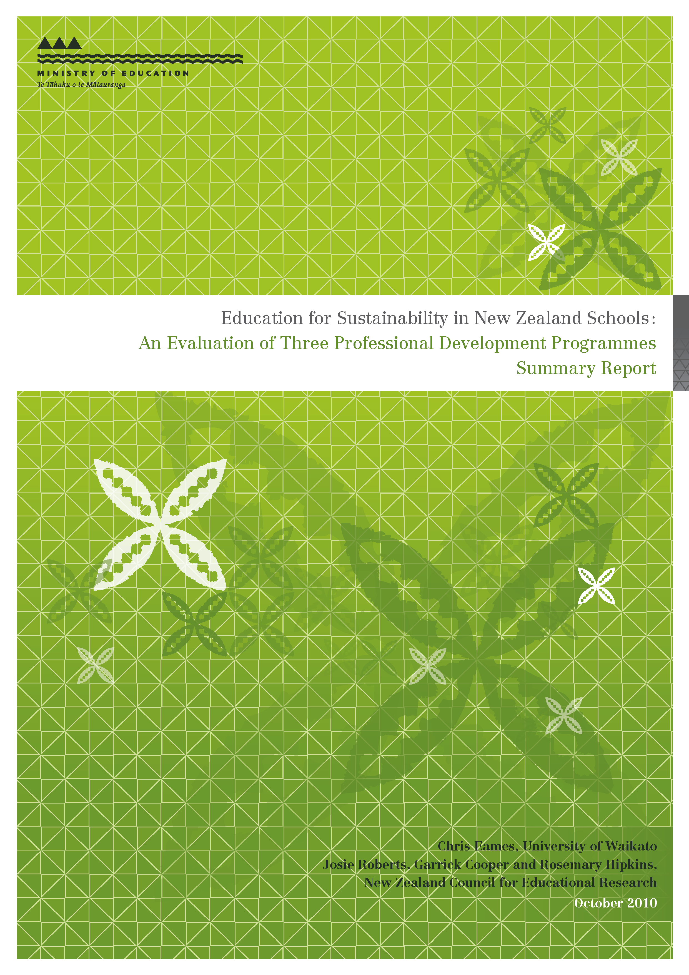

Executive Summary
This evaluation of three Education for Sustainability (EfS) professional development programmes — Enviroschools Programme, the National EfS Team and Mātauranga Taiao — was conducted between 2007 and 2009. The Enviroschools Programme is a joint local–central government initiative focusing on community partnerships, sustainable school practices and student leadership/engagement. The National EfS Team is a School Support Services advisory group focusing on teacher pedagogy, curriculum development and student achievement/engagement. Mātauranga Taiao is a Māori-medium education professional development programme for kaiako and Resource Teachers in Māori, which focuses on co-constructing mātauranga taiao. The evaluation examined the intentions, processes and outcomes of each initiative against an analytic framework that drew on international and national conceptions of EfS.
Findings showed that each initiative was achieving: greater inclusion of sustainability content and more integrative teaching across the curriculum; the development of facilitative teaching styles that were empowering students to become strongly engaged in their learning and to think critically about issues; and the development of sustainable practices in schools and their communities. Challenges remain for: fostering EfS in large primary and secondary schools; building a strong local knowledge base in EfS; and developing a coherent education strategy for New Zealand EfS to help students learn for a sustainable future.

Introduction
This Summary Report summarises an evaluation of three Education for Sustainability (EfS) professional development programmes being funded by the Ministry of Education: the Enviroschools Programme, the National EfS (NEfS) Team and Mātauranga Taiao. It is supported by a more extensive Overview Report on the evaluation of these three initiatives and an individual report on each initiative.
The Enviroschools Programme began in Hamilton in the late 1990s as a local government initiative and now involves approximately 20 percent of all New Zealand schools. The programme delivers EfS support in schools through a local and regional structure funded by local government, and a national office funded currently by the Ministry of Education.
The NEfS Team grew out of a professional development programme for Environmental Education in the late 1990s. The team constitutes a group of advisers and two co-coordinators who are located within six New Zealand universities and employed through School Support Services.
Mātauranga Taiao began in 2007, and developed from a recognised need for targeted professional development in EfS in Māori-medium education. A national coordinator and two regional coordinators provide professional development for kaiako and Resource Teachers of Māori to enable them to foster EfS in Māori immersion programmes and kura.
EfS is an educational approach that integrates environmental, social, cultural, political and economic concerns, in addressing how to create a sustainable future. The international literature recommends that EfS be guided by systems thinking, transformational learning, whole-school approaches, participatory action taking and cultural inclusiveness. These principles are recognised in Agenda 21 (UNCED, 1992) and the Decade of Education for Sustainable Development (UNESCO, 2009).
The New Zealand Government has signalled that education for sustainable development is critically important to protect and enhance our environment, which in turn is fundamentally linked to our social and economic wellbeing. The New Zealand Curriculum (NZC), (Ministry of Education, 2007) provides a stronger message and greater potential for inclusion of EfS in schools than the previous curriculum. It presents sustainability as a future-focus theme, includes principles, values and visions for sustainability and encourages schools to engage in their own curriculum design.

Methodology
The evaluation focused on the individual and joint contributions of the three initiatives to EfS guided by three evaluation questions:
- What are the key messages, goals and intended outcomes of school-based EfS and how does each initiative align with these?
- How effective are the three initiatives in “operationalising” EfS key messages and achieving EfS goals in schools?
- What are the future directions for school-based EfS in relation to current and potential goals?
We interviewed a range of programme staff in each initiative during 2007, and carried out interviews and case studies within schools and kura during 2008. Questionnaires were also completed by Enviroschools facilitators and national EfS advisers, and by EfS lead teachers in schools that had received support from these two initiatives.
Findings were analysed using a framework based on four central ideas derived from national and international conceptions of EfS and the initiatives’ objectives, namely transformational learning, systems thinking, cultural interfaces and professional development. This enabled us to balance an outcomes-based evaluation with a more ecological systems approach that highlights the importance of visions, values, principles and processes as well as the interconnectedness of whole systems.
First we present the main findings for each initiative and then outline the joint contribution of the three initiatives to EfS outcomes.

Findings from each initiative
The next two tables outline the aims, achievements and challenges for the Enviroschools and NEfS programmes and the third table offers a more narrative summary for Mātauranga Taiao.

Table 1: Summary of findings for the Enviroschools Programme
Aim | Achievements | Challenges
Change towards sustainable practices. | Achieving school change and some transfer to students’ homes. | Constraints to change from regulatory authorities.
Empowering teachers and learners. | Evidence of development of facilitative teaching styles. | Lack of initial teacher education in EfS pedagogy reported.
Development of student critical thinking and reflection. | Teachers report student development in these areas. | Need to enhance teacher pedagogical content knowledge in EfS to further develop this.
Promote school-community links. | Highly developed in some schools, but not others. | Links dependent somewhat on the nature of the school’s community.
Foster integration of EfS across the curriculum. | Evidence that this is developing and that EfS is providing a vehicle for cross-curricular delivery. | Exemplars needed to scaffold teachers lacking EfS or sustainability knowledge background.
Recognise Māori perspectives and the Treaty of Waitangi. | Partnership with Te Mauri Tau providing excellent resources and facilitator training. Some evidence of outcomes for Māori students. | Demand for resources and training currently outstripping supply.
Distributed leadership that focuses effort at local level. | Evidence of some development of sustainable practices and networking through and between communities. | Maintaining a consistent approach through the distributed leadership. Time required to support this.
Support for changing practice. | Evidence of good environmental outcomes in schools and communities, which may in time lead to systemic educational change. | Evidence of long-term educational change requires long-term study.

Table 2: Summary of findings for the NEfS Programme
Aim | Achievements | Challenges
Foster EfS professional learning communities (PLCs). | Increased teacher collaboration. PLCs established within and between some schools. | Building ongoing whole-school PLCs, particularly in large primary and secondary schools.
Support teachers’ action-based exploration of EfS. | Teachers learnt “how to” provide EfS learning opportunities. | Working with teachers’ (tacit) learning theories that contrast with EfS pedagogy.
Transformational approach informed by ecological change principles, constructivist educational theory and intentions of NZC. | Evidence of more facilitative teaching for co-constructed and authentic learning. | Extending approaches throughout school system, including secondary sector and policy arenas.
Work with Ministry of Education frameworks and a range of others to support whole-school shifts. | Teachers supported to make cross-curricular and school-community connections. | Resourcing to “deeply” link EfS to NZC.
EfS as context and content for curriculum development and integration. | Increased sustainability content. Some whole-school curriculum development. | Integrating learning areas for complex systems thinking, especially in secondary schools.
Shift environmental education to wider sustainability focus. | Teachers enhanced their (holistic) sustainability knowledge. | Deepening “economic”, “Māori”, and “scientific” knowledge. Keeping abreast of opportunities.
Innovative action competent students who act sustainably. | Students developed wide range of related indicators. Some evidence of increased achievement in core learning areas. | Extending EfS opportunities to all students. Developing appropriate strategies for assessing student outcomes.
Schooling models sustainable behaviour and design. | Sustainable practices developed as learning opportunities and transferred to students’ wider lives. | Gaining leadership support to embed practices and extend to “redesign”.

Table 3: Summary of findings for Mātauranga Taiao
Key points
Mātauranga Taiao is embedded in, and draws explicitly from, Māori epistemologies.
This includes the interdependability between the physical environment, people and ātua Māori, the puna (wellsprings) of knowledge being situated in local communities, and the integral relationship between narrative and the wellbeing of the physical environment.
The backbone of the Mātauranga Taiao programme was a series of five national noho grounded in different locations with onsite and distance support over a two-year period.
Mātauranga Taiao’s process of co-constructing mātauranga taiao with the students, and supporting these 25 kaiako and Resource Teachers Māori to co-construct knowledge with their kura students and communities, strengthened over time.
Students most appreciated site visits, guest speakers, working collaboratively and developing their critical thinking skills. They found the inquiry, experiential and co-operative learning activities the most useful.
The programme enabled students to build a community of mātauranga taiao educators who shared practices beyond noho and made connections with knowledgeable others in their rohe.
Students made links between mātauranga taiao and the Marautanga o Aotearoa. The students were shown how to meet the outcomes of different learning areas, including hauora and pūtaiao, by focusing on the kaupapa of mātauranga taiao. In doing so they strongly centred mātauranga Māori in their kura curriculum.
The programme contributed to a change towards a taiao focus across kura with a growing commitment to the kaupapa from kaiako and whānau.
The students developed a number of teaching programmes, including exploring the narratives of the people/land and making their kura more sustainable. They also shared support material over the two years, including unit plans.
This standalone initiative is important for consolidating Māori conceptions of, and approaches to, mātauranga taiao. It has the potential to offer challenges to EfS professional development in English-medium schools, which will in turn have benefits for Māori students throughout New Zealand, and to become a significant influence on national conceptions of EfS.

The contributions of the three initiatives to EfS
The three initiatives together contribute governmental, community and indigenous approaches to EfS delivery which address current priorities for the Ministry of Education (Ministry of Education, 2009):
- The Enviroschools Programme focuses on learning communities that draw on — and develop — the leadership of students and community members, and it foregrounds community partnerships, sustainable school practices and student engagement/leadership. The Enviroschools Programme draws on educational knowledge from the community sector, including Māori knowledge.
- NEfS focuses primarily on teacher professional development and teacher learning communities, and it foregrounds teacher pedagogy, curriculum development and student engagement/achievement. NEfS draws on educational knowledge from the academic and government sector.
- Mātauranga Taiao focuses on teacher professional development and teacher learning communities in kura kaupapa Māori, and it foregrounds co-constructing mātauranga taiao. Mātauranga Taiao draws on situated knowledge from local contexts and is developing knowledge, resources and facilitator capacity simultaneously.
We find that, together, the initiatives have contributed to the following outcomes. Here we also identify a number of gaps that suggest opportunities for the ongoing development of EfS:
- Policy – the three initiatives have worked together to develop a strategy for EfS and have provided leadership in assisting policy development at government levels. A key gap appears to be the lack of a systems approach to cross-government strategy for development of EfS to better support the work of these initiatives.
- Curriculum – these initiatives are impacting on the inclusion of environmental and sustainability content that connects a range of learning areas with each other and the “front end” of the New Zealand Curriculum. A key gap appears to be in the availability of specific resources such as exemplars that show teachers how they could integrate EfS into their curriculum, particularly for secondary schools.
- Pedagogy – these initiatives are impacting on the development of more facilitative teaching styles, and providing learning opportunities that are authentic, action-oriented, inquiry-based or cross-cultural. A key gap was said to be initial teacher education to foster these teaching approaches in EfS.
- Assessment – these initiatives are beginning to develop ideas around assessment in EfS. A key gap is that understanding of assessment in EfS is not strong amongst teachers or the initiative professional developers partly because of the challenges in developing appropriate and useful measures of student outcomes in this field.
- Professional development – these initiatives provide valued professional development both within and outside the school, and at individual, collective and whole-school levels. They also foster interschool and school community networks for sharing of knowledge and skills.
- School operations – these initiatives are improving the sustainability of school operational practices, and the practices are becoming embedded when supported by the whole school and its community. A key gap appears to be a lack of support or coherent planning by regulatory authorities to assist schools to become more sustainable.
- Community interactions – these initiatives are impacting on the development of stronger school-community interactions for EfS. These are being influenced by the nature of the school communities.
- Evaluation – these initiatives together are developing strategies for evaluating change in collective educational and environmental outcomes in schools and communities. A challenge is to establish evaluation processes to monitor long-term outcomes of emerging sustainability innovations.
- This evaluation has reported a range of student outcomes being achieved by the three EfS initiatives. These include:
- development of critical thinking and personal reflection about sustainability
- consideration of multiple knowledges and perspectives in addressing sustainability issues
- strong engagement in learning and active involvement in locally-relevant, authentic learning opportunities
- planning and taking action to promote sustainability in their schools and communities
- transfer of learning at school to take actions at home on sustainability issues.

Conclusions and recommendations
This evaluation concludes that the three EfS programmes are contributing to bring about educational change that is leading to learning outcomes that are required for a sustainable future. The professional development support is encouraging more transformative learning styles, greater student engagement and stronger school–community interactions. However, while there is some evidence of very good progress in these areas, this is not pervasive within or across all schools, and several challenges remain in order to realise national and international intentions for EfS.
Challenge: Although there are some good examples of EfS in secondary schools, it is an ongoing challenge to support EfS development and integration into secondary curriculum and teaching practices.
- Possible next steps:
- Short term: Support the development of secondary-specific resources to build teachers’ understandings of EfS across and within secondary subject/discipline areas.
- Long term: Ensure that future developments across all the systems components of secondary education (policy, curriculum, pedagogy, assessment/qualification, school operations and community interactions) are aligned to support EfS.
Challenge: The three programmes (NEfS, Enviroschools and Mātauranga Taiao) are developing and adding t o the New Zealand knowledge base for EfS, at the same time as they are delivering professional learning in the area.
- Possible next steps:
- Recognise that developing the knowledge base while simultaneously delivering professional learning requires sufficient time and support, as well as the right combinations of people and knowledge.
- Provide strong linking opportunities between the professional developers and the growing knowledge bases through regular and ongoing professional development opportunities for the facilitators and advisers.
- Foster and encourage the development of EfS in initial teacher education programmes, so that beginning teachers are well prepared to deliver EfS in their classrooms.
Challenge: The national and global significance of “sustainability” is rapidly evolving and developing across all sectors (including financial, governmental, legislatory and community and social sectors). EfS needs to stay connected with these emerging developments.
- Possible next steps:
- Develop a coherent, systems-based government strategy which identifies sustainability, including EfS, as a driver for policy making across all sectors.
- Develop stronger synergies between central and local government for development of EfS that encourages consistent policy making and effective programme development.
- Foster and encourage research into long-term outcomes of EfS in schools in creating sustainable behaviour change to inform the development of enhanced EfS delivery.

References
Ministry of Education, (2007). The New Zealand Curriculum.
Ministry of Education. (2009). Statement of Intent 2008–2013. Retrieved 25 April 2009, from www.minedu.govt.nz/theministry/publicationsandresources/statementofintent/soi2008/strategic_direction.aspx#ministry_of_education_priority_outcomes.
UNCED. (1992). Agenda 21. Retrieved 10 July 2007, from www.unesco.org/education/English/chapter/chapter.shtml.
UNESCO. (2009). Education for Sustainable Development. Retrieved 30 April 2009, from http://portal.unesco.org/education/en/ev.php-URL_ID=23280&URL_DO=DO_TOPIC&URL_ SECTION=201.html.

