
A report to the Ministry of Education

Evaluation of Teacher Professional Development Languages (TPDL) in Years 7-10 and the Impact on Language Learning Opportunities and Outcomes for Students
AUT - Sharon Harvey, Clare Conway, Heather Richards & Annelies Roskvist

Published by:
Curriculum Teaching and Learning – Design
Schooling Division
Ministry of Education
P O Box 1666
Wellington 6140
New Zealand

Fax: 64-4-463-8051
Phone: 64-4-463-8000
© Crown Copyright
All rights reserved
Enquiries should be made to the publisher.

April 2010
ISBN: 978-0-478-34220-8
This report is available from the Education Counts website: http://www.educationcounts.govt.nz

Acknowledgements

Firstly we would like to thank the Ministry of Education for commissioning this research. We have been able to work closely with Margaret Hardiman (Senior Advisor, Languages) in the Ministry for the duration of the project and this has been a positive and productive relationship.
Secondly, we are very grateful to our seven case study participants who were generous with their time and information and who all remained in the study throughout the period of research. We thoroughly enjoyed our time in their language classes and were impressed with the hard work and dedication they bring to language teaching. We also very much appreciated the time and effort survey respondents put into responding to our surveys and particularly those who remained in the study for all three surveys.
At AUT University, several people, apart from the researchers have been integrally involved in the project. Frank Smedley has worked closely with us on the design of the surveys and this has been very much appreciated. In addition, Afshana Ali has acted as research administrator throughout the project. Her attention to detail has been assiduous and we are very grateful to her for the support and dedication she has shown over the last year.
Finally we would like to sincerely thank our academic reviewers, Emeritus Professor Mike Byram (University of Durham, UK) and Associate Professor David Crabbe (Victoria University, Wellington) for their close reading and helpful suggestions.

Dr Sharon Harvey
Clare Conway
Heather Richards
Annelies Roskvist

Acronyms

AUT Auckland University of Technology
CPT1 Chinese Proficiency Test 1
DELE Diploma de Español como Lengua Extranjera
HOD Head of Department
ILT Intercultural language teaching
iCLT Intercultural Communicative Language Teaching
LIA Language Immersion Award
LL Learning Languages
LLS Learning Language Series
LIPIS Languages in Primary, Intermediate and Secondary Schools
PD Professional Development
PPP Presentation, practice and production model
NCEA National Certificate of Educational Achievement
NZALT New Zealand Association of Language Teachers
RFP Request for Proposal
SPSS Statistical Package for the Social Sciences
SLA Second language acquisition
TKI Te Kete Ipurangi – The Online Learning Centre
TPDL Teacher Professional Development Languages
TL Teaching Language
WTC Willingness to communicate

Table of Contents

Acknowledgements iii
Acronyms iv
Table of Contents v
List of Tables viii
List of Figures ix
Chapter One Introduction 1
1.0 Introduction 1
1.1 Background to TPDL 2
Chapter Two Design of study 4
2.0 Introduction 4
2.1 Design of study 4
2.2 Instruments 5
2.3 Participants and response rates 6
2.4 Ethical issues 6
2.5 Research analysis 8
2.6 Limitations and clarifications 8
Chapter Three Impact of the TPDL programme Years 7-10 on the development of teachers’ proficiency in the teaching language (TL) 10
3.0 Introduction 10
3.1 Background 10
3.2 Length of study and exam achievement 12
3.3 Teacher perception of TL proficiency 13
3.4 Motivation to learn TL 15
3.5 Teacher knowledge of TL compared with student knowledge of TL 17
3.6 Confidence and use of TL language 18
3.6.1 Confidence in using the TL in the classroom 18
3.6.2 Teacher participation in the TL community 19
3.7 Effectiveness of the language study course 21
3.7.1 Useful aspects of the language study course 22
3.7.2 Teacher suggestions for improvements to language study course 23
3.8 Conclusion 23
Chapter Four Impact of TPDL Years 7-10 on the teachers’ second language teaching knowledge 26
4.0 Introduction 26
4.1 Participants’ teaching background 26
4.2 Understanding how students learn an additional language 27
4.2.1 Observed language input 32
4.2.2 Observed teacher provision for language output 34
4.3 Understanding how to teach an additional language 35
4.3.1 Teacher perceptions 35
4.3.2 Observed effectiveness of teaching 39
4.4 Factors that foster teachers gaining second language teaching knowledge 42
4.5 Factors that hinder teachers gaining second language teaching knowledge 45
4.6 Conclusion 48
Chapter Five Impact of TPDL Years 7-10 on the teachers’ knowledge of the learning languages area of The New Zealand curriculum (2007) and specific curriculum guidelines 50
5.0 Introduction 50
5.1 Teacher knowledge of the learning languages area 50
5.2 Teacher knowledge of specific language guidelines 52
5.3 Language and cultural knowledge 53
5.4 Factors that hinder or foster teachers’ knowledge of the learning languages area of the curriculum and specific language guidelines 58
5.5 Conclusion 59
Chapter Six The perceived impact of TPDL on student learning and outcomes 61
6.0 Introduction 61
6.1 Perceived impacts of TPDL on student learning 62
6.2 Perceived student use of the TL 63
6.2.1 Perceptions of students’ ability to understand and use familiar expressions and engage in interactive tasks 64
6.2.2 Perceived opportunities for TL output and levels of student engagement (evidenced in classroom observations) 67
6.2.3 Perceptions of other student learning outcomes and experiences 69
6.2.4 Perceived impact of TPDL on students’ learning: Cultural Knowledge strand 73
6.3 Perceived impact of TPDL on student achievement 74
6.3.1 Assessment of student progress in learning languages and what accounts for these practices 76
6.4 Perceived impact of TPDL learning on student motivation 80
6.4.1 Student motivation and student contact with TL and culture 81
6.5 Conclusion 83
Chapter Seven Sustainability and replicability of the TPDL programme Years 7-10 85
7.0 Introduction 85
7.1 Sustainability 85
7.1.1 Characteristics of the current TPDL course 85
7.1.2 Continuing development 97
7.1.3 Future teacher and learner cohorts 101
7.1.4 TPDL course staff and structures 103
7.2 Replicability 104
7.3 Conclusion 105
Chapter Eight Conclusion 108
8.0 Introduction 108
8.1 Teachers’ development in language proficiency 108
8.2 Teachers’ development of second language teaching knowledge 109
8.3 Teachers’ development of knowledge of the curriculum and specific language curriculum guidelines 111
8.4 Learning opportunities and outcomes for students 112
8.5 Programme sustainability and replication 113
8.6 Issues to be considered further 114
8.7 Recommendations for TPDL (in its current form) 116
8.7.1 Language study 116
8.7.2 Second language teaching methodology paper 116
8.7.3 Enhancing the teaching of the Cultural Knowledge strand and improving outcomes 116
8.7.4 In-school and online support provided by programme facilitators 117
8.7.5 Other 117
8.8 Further research 118
References 119

List of Tables

Table 1: Teacher perceptions of change in language proficiency level 15
Table 2: Teacher participation in the TL community 20
Table 3: Useful aspects of the language study course programme 22
Table 4: Suggestions for improvement to language study course 23
Table 5: [Ellis] Principles (Ministry of Education, 2007c). 29
Table 6: Teacher application of Ellis principles in observations 1 and 3 31
Table 7: Teacher perception of most beneficial factors for language teaching knowledge 42
Table 8: Factors that made it difficult for teachers to develop language learning and teaching 46
Table 9: Main aims of last lesson taught 55
Table 10: Examples of opportunities for student TL output observed by researchers. 68
Table 11: Language learning strategies used by students across three observations 69
Table 12: Examples of students in case study classes developing Key Competencies 71
Table 13: Case study teachers’ perceptions of changes in their students’ responses 72
Table 14: Teachers’ examples of the impact of the programme on their students’ achievement 76
Table 15: How case study participants are assessing and reporting on progress of learners 79
Table 16: Opportunities provided by TPDL teachers for their students to participate with the TL community 82
Table 17: Means of support provided by schools 93
Table 18: Recommendations to incoming TPDL participants (Survey 3, n=23) 96
Table 19: Type of intended professional development 98
Table 20: Ways schools could best support continuing language teaching development 99
Table 21: Recommendations to teachers interested in TPDL course (Survey 3) 102

List of Figures

Figure 1: Number of teachers on TPDL programme and their teaching language (Thomson, 2008b and Thomson, 2009) 11
Figure 2: Teachers and type of language study course 11
Figure 3: Perceived language proficiency level (Survey 1 and Survey 3) 14
Figure 4: Teacher motivation to learn TL 16
Figure 5: Teacher perceptions of their TL knowledge compared with their students’ TL knowledge 17
Figure 6: Teacher confidence in using the TL in the classroom 18
Figure 7: Extent to which participants feel their language study course is effective 21
Figure 8: Length of time teaching TL (n= 34) 27
Figure 9: Extent of teacher understanding of how students learn an additional language 28
Figure 10: Extent of understanding of how to teach an additional language 36
Figure 11: Expected impact of the TPDL programme on teaching practice (Survey 1) 37
Figure 12: Perceived impact of the TPDL programme on teaching practice (Survey 3) 37
Figure 13: Teacher perception of effectiveness at teaching the TL 39
Figure 14: Perceived helpfulness of TPDL tutor feedback and discussion 43
Figure 15: Teacher perceptions of extent of knowledge of Learning Languages area of curriculum 51
Figure 16: Extent of teacher knowledge of specific language guidelines 53
Figure 17: Teachers’ perceptions of impact of teachers' TPDL learning on student learning 63
Figure 18: Teachers’ perception of students’ ability to understand and use familiar expressions and everyday vocabulary 65
Figure 19: Extent to which the majority of students in teachers’ classes can interact in a supported way using the TL 66
Figure 20: Teachers’ perceptions of recognition by most students of organisation of target culture 73
Figure 21: Teachers’ perceptions of the impact of TPDL learning on student achievement 75
Figure 22: Means by which teachers assess students’ progress formally (Survey 2) (Note: Teachers responded to more than one category) 77
Figure 23: Teachers’ perceptions of the extent of student motivation to learn TL 80
Figure 24: Teachers’ perceptions of the impact of TPDL programme on students' motivation 81
Figure 25: Teachers’ perceptions of students’ willingness to communicate 81
Figure 26: Use of TPDL recommended websites by survey three respondents (n=25) 87
Figure 27: Further investigations into student language learning 88
Figure 28: Teachers’ level of contact with other course participants 90
Figure 29: TPDL workload 91
Figure 30: Average time spent per week preparing language teaching resources 91
Figure 31: Extent teachers feel their school is supportive of TPDL study 92
Figure 32: Extent of teachers’ formal communication with school staff about TPDL 94
Figure 33: Extent of teachers’ informal communication with school staff about TPDL 95
Figure 34: Other teachers in the school interested in doing TPDL in future 101

Chapter One Introduction

1.0 Introduction
Like governments in similar jurisdictions, the New Zealand government is increasingly responding to pressures to internationalise and interculturalise the education system so that young New Zealanders finish their schooling able to meet the multifarious challenges of thriving in a multicultural, globalised economic and social world. To this end, the Ministry of Education has identified Learning Languages as a new learning area in The New Zealand Curriculum (2007) (Ministry of Education, 2007a). The New Zealand initiative is in line with the Common European Framework goal to foster plurilingualism and pluriculturalism (Kohonen, 2006) and concomitant Australian moves to integrate intercultural competencies into language learning (see, for example, the Tasmanian Department of Education website,
http//www.education.tas.gov.au/school/educators/resources/lote/cultural/icll).
The emphasis on extending and improving the quality of provision of language learning in New Zealand schools relies on the growing language and intercultural proficiencies of language teachers and their ability to effectively teach additional languages to New Zealand students. Language teachers in New Zealand schools span a number of levels of proficiency themselves in the teaching languages (TL), ranging from beginner to native speaker level. In a context of rapidly growing student numbers in some languages (Education Counts, 2007, p.1) and more schools offering a greater range of language learning opportunities, more, and more proficient teachers are needed to teach languages. Consequently, in order to meet demand many new language teachers are having to learn languages alongside of or just a step ahead of their students. A recent ERO report considering schools’ readiness for the full implementation of the new national curriculum in 2010 noted:
The majority of secondary schools and a growing number of primary schools were already offering students opportunities for learning a second or subsequent language. The most commonly stated challenges in both primary and secondary schools were finding and/or retaining suitably qualified staff and building the capability and confidence of staff in teaching a language (ERO, 2009).

One way the Ministry of Education has responded to the challenge of building greater capacity in language teaching is to commission a professional development course. The programme is known as Teacher Professional Development in Languages (TPDL). The AUT research team were contracted by the Ministry of Education to provide research and evaluation services to determine the effectiveness of this professional development programme. The effectiveness of TPDL was to be evaluated in terms of:
- teachers’ development in language fluency
- teachers’ second language teaching knowledge
- teachers’ knowledge of the Learning Languages strand of The New Zealand Curriculum (2007) and of their specific language curriculum guidelines
- student learning and outcomes
- the sustainability and replicability of the TPDL programme
Concomitantly, the Ministry requested evidence about the programme’s contribution to Effective Teaching in order to inform the design of future initiatives and decisions around resourcing and long term planning for learning languages.
The duration of this project was to be from February 2008 to March 2009. However, the contract was not signed until 2 May 2008 and will now run until June 2009. The final budgeted total was $67,066.90 (inclusive of GST) (Ministry of Education, 2007b).

1.1 Background to TPDL
The TPDL programme began as a two year pilot delivered through one contractor in 2005 – UniServices, and two contractors in 2006 (UniServices was one of these). The programme was implemented fully from March 2007. Since 2007 there has been one contractor for the programme and this is UniServices, University of Auckland. In 2006 and 2007, the programme was offered to teachers of additional languages in Years 7- 8. In 2008, this was extended to teachers of additional languages in Years 9 - 10. In 2007, places were offered to forty applicants and in 2008 fifty eight applicants joined the TPDL programme.
The current target participants for TPDL are language teachers of French, Spanish, German, Japanese and Chinese who want to improve their teaching language proficiency, increase their knowledge of the languages curriculum and increase their understanding of second language teaching methodology.
The course offers three distinct components,
- Language proficiency improvement for those that need it through a course of a minimum of forty learning hours. These courses can be taken locally or by distance learning and teachers have enrolled as students at a number of institutions throughout the country in order to meet the course requirement. Where appropriate courses have not been available, customised courses have been organised for participants.
- A second language acquisition methodology paper (EDPROFST360) delivered at different locations throughout the country by University of Auckland academic staff. In addition to learning about second language acquisition methodology, this paper also requires teachers to examine The New Zealand Curriculum (2007) (Ministry of Education, 2007a) and specifically the Learning Languages strand as well as the specific language guidelines for their teaching language. The paper includes four observations of language lessons (one per term) followed by a ninety minute discussion with TPDL facilitators based on evidence collected during the observation.
- Four two hour language group meetings which integrate language and theory and offer practice for teachers to sit international language examinations (University of Auckland, 2007).
In 2008, meetings for the course were held in Auckland, Rotorua/Hamilton, Wellington and Timaru.
This report is divided into eight chapters. The second chapter outlines the design of the study; it discusses the ethical issues and describes the approach to data analysis. The limitations of the study as well as an explanation of terms are also presented in this chapter.
Chapters three to seven discuss the findings of the study. Each of the chapters addresses a key research theme as originally identified in the Request for Proposal (RFP). In Chapter three, we examine teacher participation in the language courses and the improvement in proficiency they have experienced over this time. Chapter four focuses on the learning teachers have experienced while studying the University of Auckland paper EDPROFST360, focusing particularly on their understanding of second language teaching methodology. Chapter five also considers teacher learning in EDPROFST360 but focuses on improvements and changes to teacher understanding and teachers’ ability to work with the Learning Languages strand of The New Zealand Curriculum (2007) (Ministry of Education, 2007a) and specific language curriculum guidelines. Chapter six considers the outcomes for students as a result of teacher participation in TPDL and chapter seven examines the ways in which TPDL establishes sustainable teacher development and the possible replicability of the course. Chapter eight draws together conclusions and recommendations. Appendices include the research contract, ethical approval documentation and the research tools.

Chapter Two Design of study

2.0 Introduction
The design for the research is a mixed methods approach which balances a broad brush picture of the gains and issues for teachers and students with some ‘up-close’ examinations of what happened in classrooms when language teachers undertook TPDL.
The research questions were as follows:
- What is the impact of the TPDL programme Years 7 -10 on the development of teachers’ fluency in the teaching language?
- What is the impact of the TPDL programme Years 7 -10 on teacher second language teaching knowledge?
- What is the impact of the TPDL programme Years 7 - 10 on teachers’ knowledge of the Learning Languages strand of The New Zealand Curriculum (2007) and specific curriculum guidelines?
- What is the impact of the TPDL programme Years 7 -10 on student learning and outcomes?
- How sustainable and replicable is the TPDL programme Years 7 -10?
As noted in the previous chapter, the concept of effective teaching will be addressed throughout the report.

2.1 Design of study

The study was divided into three phases coinciding roughly with the beginning, middle and completion of the TPDL course. The aim was to gauge the effects of TPDL on practices through the year. Unfortunately the late signing of the contract meant that teachers had already started TPDL by the time the first phase of research was underway. Each phase involved the deployment of three research instruments: a survey, a case study observation and a case study interview.
Phase one: Between April and early June 2008.
Phase two: Between July and September 2008.
Phase three: November 2008.

2.2 Instruments

Data was gathered in the following ways:
- Three questionnaires were administered to all 2008 participants on the TPDL programme – one in late April/May, one in July and one in November (see Appendix Four, p.147). The questionnaires examined changing teacher language proficiency, practices, perceptions of the course and perceptions of outcomes for students in the 2008 TPDL cohort. They were constructed using the detailed questions in the RFP (Ministry of Education, 2007b) as a guideline as well as issues arising from key second language acquisition literature. These issues were: motivation, language input and output, language pedagogy, knowledge of language and knowledge of culture (Ellis, 2005a & 2005b; Erlam, 2005; Gibbs & Holt, 2003; Crozet & Liddicoat, 1997; Dornyei & Czizer, 1998; Harmer, 2002; Byram, 2007) The first survey collected baseline and biographical data while the second and third surveys included issues arising from the emerging case study data as well. Each questionnaire was assigned a code and was tracked through the code rather than through individual teachers’ names. While this did not provide anonymity for respondents (the research team could, if required, identify individual responses) it did increase the level of participant confidentiality.
- Seven case study participants were recruited through the initial surveys and were interviewed and observed in their teaching three times over the course of the year. The interview questions were semi-structured, and generated from the survey framework, essentially interrogating the key research questions in more depth. The interviews enabled the researchers to probe teacher understandings in order to gather their feelings, views and attitudes towards their professional development (Kervin, Vialle, Herrington & Okely, 2006). Handwritten interview notes were taken.
- Tolich and Davidson (1999) suggest observation guides can be drawn up from a range of sources. The researchers developed the observation prompts from key literature (including: Krashen, 1981; Erlam, 2005; Gibbs & Holt, 2003; Ellis, 1993; Crozet & Liddicoat, 1997) and TPDL documents (e.g. milestone reports). Data was recorded through note taking. Because the presence of a researcher in the room with teacher and students may in itself be intrusive (Labov, 1972) the team did not digitally record teaching sessions as this may have introduced further distractions.
- TPDL milestone reports were another source of data. They were analysed and integrated into the writing of this evaluation. The milestone reports were all written by Wendy Thompson, Project Director of TPDL as feedback on the course to the Ministry of Education. There were nine milestone reports available for 2007 and 2008.

2.3 Participants and response rates
The participants were Years 7-10 language teachers who were enrolled in the 2008 TPDL programme. We asked all of them to respond to the surveys (n=58) and to volunteer for the case studies. There were 34 responses to the first survey out of a possible 58. There were 29 responses for the second survey and 25 for the third. Some questions had invalid responses and so total answers did not always tally with total response numbers. The researchers have only reported valid responses. The team provided a book voucher as a small incentive for teachers who completed all three surveys.
Case study participants were purposively selected from volunteers to provide as wide a mix as possible in terms of the following variables:
- geographical area
- type of school (i.e. intermediate, full-primary, district high, secondary)
- decile rating
- varying school communities (rural, small town, large city)
- level of students (Years 5 – 10)
- languages taught (Chinese, French, German, Japanese, Spanish)
- types of language learning opportunities for TPDL participants (e.g. polytechnic, distance, community provider)
- level of teaching experience (we have two case study participants who are first year teachers)
As mentioned previously, all seven case study participants participated in the whole study. The research team would like to acknowledge the teachers who were willing to participate. The case study teachers in particular were generous with their time and information.

2.4 Ethical issues
In this section we outline some of the specific issues that arose in relation to ethical review for this project. Firstly, in relation to consent, all case study participants individually volunteered their participation through the initial survey and their individual consent for participation in the case studies was obtained through them (rather than through their schools). Principals were asked for research access to schools for the case study research only after teachers had volunteered to participate. All survey participants responded voluntarily and this was reflected in the decreasing number of responses: 34 participants for the first survey, 29 for the second and 25 for the third.
As part of the ethical approval process the research team were required to consider the relevance of the Treaty of Waitangi to the research. The research team noted that some teachers who took part in the case study research or those filling out the surveys could be Māori. The team explained that all participants would be given adequate time to consider the invitation to participate and that Māori may want to discuss their involvement with whanau. In the event no participants identified themselves as Māori.
Further, it was envisaged that the results of the research could be of interest to Te Reo teachers working in Kura Kaupapa Māori and mainstream classes with children acquiring Māori as a second language. The research might also be of interest to educators designing professional development for teachers of Te Reo. Because this research was carried out for the Ministry of Education the research team will discuss with them ways of sharing findings with Te Reo programmes and other relevant stakeholders.
In regard to issues of a conflict of interest, the researchers judged that they were unlikely to have any existing relationships with the 2008 TPDL cohort. The only perceived coercive influence might be that the research was funded by the Ministry of Education who were also sponsoring the TPDL. The researchers were therefore careful in the documentation and their interactions with teachers to point out their independence from Ministry and the fact that Ministry would not know who participated and who did not. Ministry have not had access to any raw data.
The research team felt that the ethical risks to participants were minimal. However, we acknowledged that the case study participants may have felt uncomfortable being interviewed and observed especially if they were new to language teaching, and if they felt self conscious about teaching and speaking the teaching language. Some teachers may have felt uncomfortable about being observed if they did not have a well-behaved or engaged class. The researchers therefore explained to case study teachers that their particular data would form part of a much larger picture and the Ministry would be interested in this rather than any specific detail relating to individual teachers. The team also reiterated the privacy and confidentiality protections designed into the research, which have safeguarded individual identity. Furthermore the researchers explained that they themselves were language teachers and language teacher educators who were used to observing teachers with different levels of experience and proficiency in the teaching language. Finally, teachers were able to withdraw from the research with no adverse consequences for their TPDL or any future professional development in which they chose to take part in. While there was a decline in respondent rate for the surveys, the seven case study teachers remained in the study throughout.

2.5 Research analysis
The research team analysed data in the following ways,
- The surveys were quantitative and qualitative in design although the first survey, ascertaining base line data, was predominantly quantitative. Because of the relatively low numbers, quantitative data was simply compiled on Excel spreadsheets and transferred into graphs. Qualitative survey data was entered into digital files and manually coded for significant themes related to the key research questions.
- The interview and observation data was recorded in note form and transferred into electronic transcripts by the researchers. Data was analysed in terms of the key research themes. Further sub themes were identified on an ongoing basis. Analysis was gradual, incremental and initially tentative so that premature explanation and conclusions were avoided (Tolich & Davidson, 1999). Non identifying quotes from the interview data were extracted to highlight issues or findings and enrich the final research narrative.
- Data from the 21 observations was analysed through mapping key components of observed teaching on to a grid. The grid called for responses to key components of effective language teaching: language input and output, focus on the form of the TL, instruction related to culture, student motivation, and learning strategies (see Appendix Four). The grid was a way of systematising the interpretation of the observational analysis and it enabled comparison between each of the three observations in a particular case study. Furthermore, the researchers kept a running record of the lesson, including direct quotes where possible.
- Milestone reports from the TPDL programme were available from the Ministry of Education. These were coded for themes and data incorporated where relevant.

2.6 Limitations and clarifications
The research has several limitations. The first is associated with the signing of the contract which occurred on 2 May, 2008. By this time TPDL participants had already embarked on their course. For those who were studying their teaching language (TL) for just one semester, that component was already half way through. The other components of TPDL were year long and so teachers had only experienced one weekend session of EDPROFST360 and one observation by the TPDL facilitator when they first met the researchers. Understanding that the validity of the research depended on reaching teachers before too much of the TPDL had passed, the research team secured initial ethical approval for the project prior to the contract being signed and the first survey was sent out in late April. Nevertheless, because of the time taken to identify and secure the participation of case study participants the first round of case study interviews and observations did not occur until May.
Another limitation of the study is the relatively low representation of Asian languages. Of the initial 34 responses only eleven teachers taught an Asian language. Few of these offered to participate in the case studies and in the event, the team were only able to secure one teacher of an Asian language for the case studies.
Among other things, the Ministry of Education wanted to find out through this evaluation, the outcomes for students learning languages in Years 7-10 as a result of their teachers undertaking TPDL. While Chapter six does address issues that we have been able to assemble through teacher perceptions and milestone data, the research was not designed to ascertain student outcomes through primary data collection. Data on student progression for language students in these years is not easily available on a national level and schools themselves have variable (and generally minimal) approaches to assessing achievement and reporting progression in learning languages. Moreover it was not within the scope of this research to seek ethical approval to engage students themselves as research participants. This would be possible however in a further study.
Finally, because of the discrepancy in respondent numbers to the three surveys, the researchers have generally only compared the stable cohort (core) of teachers who responded to all three surveys. Where this is of interest we have also included information from the full survey one cohort. Survey two data has only been included where the results were particularly pertinent to the question being discussed.
An explanatory note is warranted concerning the major assessment teachers undertook for TPDL. The milestone reports for the 2007 cohort referred to an ‘action research project’. Later milestone reports, however, referred to the assignment as an ‘inquiry learning project’. The researchers have used the term ‘action research project’ throughout this report. TPDL participants also referred to the project as the ‘action research project’.
Finally, in an effort to ensure that confidentiality of participants was preserved, especially that of case study participants, we have mostly had to leave out references to particular languages and countries. Had we included references to languages, and particularly Asian languages, participants would have been easily identifiable. As language teachers ourselves we regret this because including more detail about the actual utterances used and related contextual information would have provided more ‘colour’ and specificity to the report.

Chapter Three Impact of the TPDL programme Years 7-10 on the development of teachers’ proficiency in the teaching language (TL)

Teachers are ‘busy and often overworked’. In order to sustain their involvement, they need a catalyst or ‘urgency’. The learning experience needs to be meaningful, practical and relevant to their classroom with their particular students (Stoll, Fink & Earl, 2003, p. 85).

3.0 Introduction
Studying the TL is a core component of TPDL for teachers who do not have advanced proficiency. This has many benefits both in developing participants’ language knowledge as well as providing further insights into the challenges of being a language learner. For the language study component of the TPDL, teachers study their TL at an appropriate level from a local institution or from an extramural provider, in order to improve their language proficiency and prepare for an internationally recognised language examination (Thomson, 2008d).
In this chapter we consider the progress teachers made in developing their TL proficiency. We give the background of the participants, including their teaching TL and type of language study undertaken. We note the length of study and participation in internationally recognised examinations. Also considered is the teachers’ proficiency in the TL, their motivation to learn the TL, the teachers’ knowledge compared with their students’ knowledge of the TL and teacher confidence in using the TL in the classroom and in the community. The effectiveness of the language study component of TPDL including teacher suggestions for improvements is also presented.

3.1 Background
The cohort of TPDL participants who began in 2008 consisted of 58 teachers, 50 of whom completed the programme (see Figure 1). The majority were teaching European languages (21 French, 21 Spanish and five German) with five teaching Chinese and four teaching Japanese (Thomson, 2008b). Most of these 58 teachers were also studying the language concurrently.
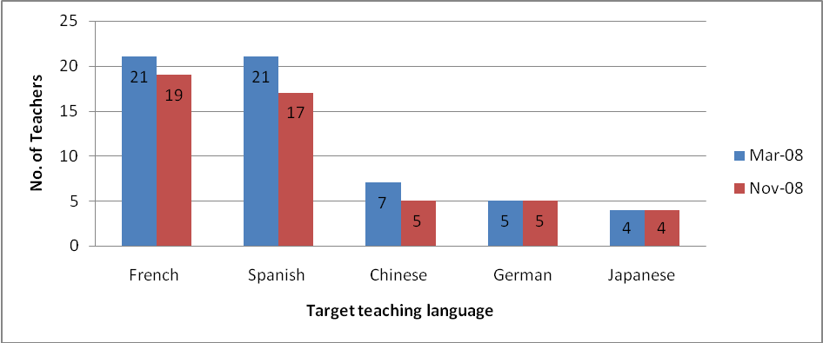Figure 1: Number of teachers on TPDL programme and their teaching language (Thomson, 2008b and Thomson, 2009)
The TPDL participants undertook their language study courses in a range of settings (see Figure 2). Half (11 of 22) of the survey one core respondents were studying the language through a credit bearing course (e.g. through a university, polytechnic or high school), while seven were studying in local community classes and four others were engaged in independent language study. Survey three showed that three participants had made changes during the year; two to independent study and one to a local community class. One of the reasons that some of these changes occurred was that programme directors made new arrangements to ‘accommodate individual preferences and circumstances’ (Thomson, 2008e, p. 2).
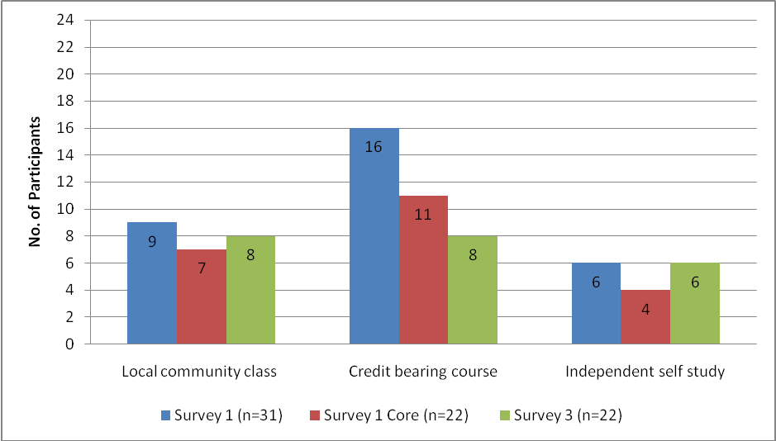 Figure 2: Teachers and type of language study course

3.2 Length of study and exam achievement
Becoming proficient in another language takes time. Learning language is a long process, and it can be a challenge to sustain the learning, so motivation may fluctuate over the time. The fact that the TPDL teachers committed to learn and teach the language concurrently may have been the powerful ‘catalyst’ needed (Stoll et al., 2003) to help them to pursue their language study in addition to their already demanding workload.
In survey one respondents indicated that their time in language study varied. However all of them devoted a minimum of two hours a week, and over half spent more than two hours a week studying language. Thomson (2008e) reports that nearly half the TPDL teachers studied at UNITEC (an Auckland polytechnic), and feedback on attendance results indicated that they missed very few classes over the semester. In addition, UNITEC’s customised distance programmes worked well, particularly the French programme which had an increased number of teachers wanting to take part in the course (Thomson, 2008e).
Data from the 25 respondents in survey three indicates that just under half (11) studied their TL for one to two terms, another 11 studied for three to four terms, while two did no language study. So just under half the respondents continued their language study into semester two. While Milestone Report Eight suggests that 90% of the teachers who had studied in semester one would continue in semester two (Thomson, 2008e, Appendix 16), the researchers’ data indicates that a second semester of TL study had not eventuated for all of them. Case study interviews revealed that one teacher would have liked to continue her language study for a second semester, but was unaware that TPDL would pay for her to continue.
Language study was not considered necessary for two of the survey three respondents, as they were either native speaker level or advanced TL speakers. However, other participants found the language study course valuable not just because of the language learning. For example, when asked what was most useful in their language study, four of the 20 respondents mentioned aspects other than acquiring the language. Two said they benefited from being a learner, and two said they gained good teaching ideas from taking part in the language classes.
According to the most recent milestone report (Milestone Report Nine), the TPDL programme provides support and encouragement for teachers to sit an internationally recognised language examination. Twenty two of the 50 teachers who completed TPDL in 2008 sat a relevant language examination, including one who sat Level 1 NCEA in the TL (Thomson, 2009). Nineteen teachers passed their examination, with three still awaiting results (Thomson, 2009). The remaining teachers did not sit an examination either because they already had a degree in the language, were not confident or ready yet, or there was no examination available at an appropriate level (Thomson, 2009). However, there is continuing development in the area of language examinations, and as further suitable examinations became available, the TPDL directors facilitated the teachers’ enrolment. For example, one teacher of Chinese sat and passed the new Chinese Proficiency Test 1 (CPT1) which was being trialled in the Auckland area. The introduction of this Chinese examination and the new A1 Spanish Diploma de Español como Lengua Extranjera, (DELE) offered more teachers the opportunity to set language proficiency goals and work towards achieving them. As noted by Thomson (2008e), language examinations can have a motivating effect on language teachers.

3.3 Teacher perception of TL proficiency
A further way of obtaining insights into teachers’ proficiency in the TL is to investigate their perceptions of their gains in the TL. A comparison of data from surveys one and three indicated some progress. Survey one, administered shortly after the start of the TPDL course, asked respondents to categorise their proficiency level in their TL on a five point Likert scale from beginner to bilingual. The results (see Figure 3) revealed that the majority (20 of the 25 respondents) described themselves as being at ‘intermediate’ level or below at the beginning of the course. Only five of the core 25 respondents described themselves as highly proficient, at ‘advanced’ or ‘bilingual’ level. Results from survey three, administered at the end of the course, showed the advanced level had remained constant and there had been movement at the lower levels, with the clearest upward movement being from elementary to intermediate level. By the end of the course, eight of the 24 respondents described themselves as ‘intermediate’ level, compared with just three at the start of the course. Half (12 of the 24 core respondents) perceived themselves at beginner or elementary level.
While teacher perceptions of their language level are not an objective measure of TL proficiency, they do indicate that teachers themselves feel they improved in their language skills. This sense of achievement can only be good for their confidence in using the TL in the classroom.
However, the fact that half the survey respondents indicated they were still at elementary level or below raises the question of whether they have sufficient knowledge of the subject (i.e. the TL) to meet the Ministry of Education’s Statement of Intent regarding effective teaching: ‘Effective teaching focuses on maximising learning outcomes for all learners in every situation. Effective teaching requires knowledge of subject and teaching practice. The heart of effective teaching is where these three areas of influence intersect’ (Ministry of Education, 2007b, p.3). In this particular programme, and at this particular stage of the Ministry of Education’s intent to upskill generalist teachers, it is not possible for all language teachers to have considerable subject knowledge. However, language learning is an ongoing ‘dynamic, developmental process’ (Crabbe, 2005, p. 6) and teachers at the lower levels of TL proficiency need to be encouraged to continue learning the TL until they do have considerable knowledge so they can be fully effective.
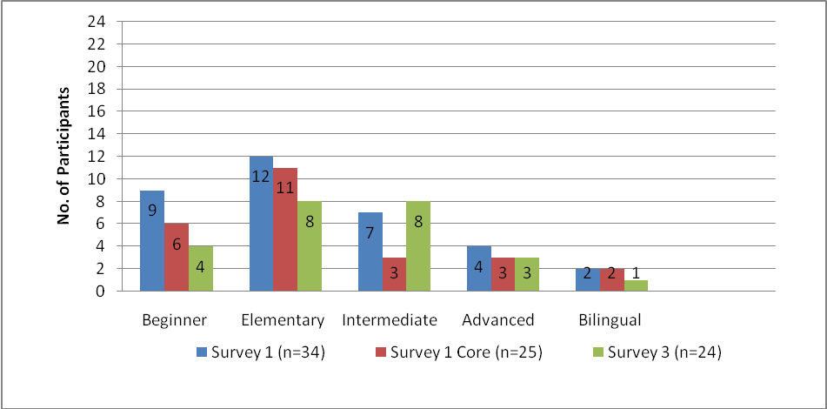
Figure 3: Perceived language proficiency level (Survey 1 and Survey 3)
The case study data gathered from surveys one, two and three across the year reveals further insights into the type, timing and amount of change in language proficiency teachers perceived (see Table 1 below). Of the teachers who perceived no change in their language proficiency level, none of them sat an exam and studied the language only for one term or not at all. The teacher who noted a decrease in proficiency had one term of study, and sat and passed the examination. Although orally fluent, through the language study course, the teacher became more aware of the need to develop the written area of her language. Of the three teachers who noticed increases in their proficiency, two sat examinations, one learned the language for three terms and one for four terms. The teacher who studied for the full two semesters and sat an international exam indicated she had made a steady increase in her level of language proficiency throughout the year. As could be expected, the length of study and the preparation for an exam resulted in the greatest perception of change. Sitting an external exam appears to have made a difference to teachers’ perception of proficiency. One reason could be that passing the exam gave the teachers a new measure of confidence. Another reason could be that the exam provided external motivation for the teachers, thus increasing their perception of proficiency.

Teacher | Language learning background and perceptions of proficiency level throughout the course.
Teacher 1  Small increase | Teacher 1 had learned the TL for one year in a community night class before coming on TPDL. At the beginning of the course she assessed herself as a beginner TL speaker. By the end of TPDL she felt she had moved half a level up, and was calling herself a beginner/elementary user. This teacher studied the TL for one term. She did not sit an internationally recognised exam.
Teacher 2  Increase | Teacher 2 studied the TL while at high school. Over the course of TPDL she reported an increase in her level of TL proficiency, from elementary to intermediate. She completed three terms of language study and passed an international language examination.
Teacher 3  Steady increase | Teacher 3 had studied the TL at both high school and night school. During TPDL she completed four terms of language study, and saw herself as steadily increasing in her language proficiency, from beginner level in survey one, to elementary in survey two and intermediate in survey three. She successfully passed an international language examination.
Teacher 4  No change | Teacher 4 had learned the TL at high school for five years and classified her language proficiency at an elementary level. She completed one term of language study and remained constant in her perception of her level. She did not sit an international language examination.
Teacher 5  No change | Teacher 5 had learned the TL at night school, and perceived herself as having an elementary level of proficiency at the beginning of the course. Half way through TPDL she reclassified herself downwards to ‘beginner’, but by the end of the course felt she was again elementary. She completed two terms of language study and did not sit an international examination.
Teacher 6  No change | Teacher 6 had learned the TL in a variety of settings: high school, tertiary study, personal independent study and in-country experience. She did not attend language study and remained constant in her perception of her language proficiency as being ‘advanced’. Observations of her teaching indicated that she was an advanced, fluent TL speaker. She did not sit an international language examination.
Teacher 7  Decrease | Teacher 7 had learned the TL from living in the country for several years. At the beginning of the TPDL programme, she classified herself as ‘bilingual.’ However, in the second and third survey, she had reclassified herself to an intermediate level. Observations of her teaching indicated that she was an advanced, fluent TL speaker. The reasons for her reclassification are not clear, but they may reflect a lack of confidence in her written skills which she had never formally studied. This teacher completed one term of language study and passed the internationally recognised exam.
Table 1: Teacher perceptions of change in language proficiency level

3.4 Motivation to learn TL
Motivation is an important factor in language learning as it is seen as responsible for ‘… why people do something, how long they are willing to sustain the activity and how hard they are going to pursue it’ (Dornyei, 2000, p. 8). Motivation is not constant and data from surveys one, two and three shows the fluctuations among participants over the year. At the start of the TPDL course, survey one revealed that all of the respondents except one were motivated or very motivated to learn the TL (see Figure 4).
By survey two, eight of the 24 core group were no longer studying the TL. A number of reasons were given for stopping: time pressure (personal and/or work commitments); no available course at the next level; course not meeting their needs; had already fulfilled the TPDL requirements; being at a very high level of TL proficiency and so there was no need for any further instruction. Of the 16 teachers who responded to the question about their level of motivation to learn the TL, all except one were motivated or very motivated to learn.
Data from survey three revealed that three quarters (17 of the 22 respondents) were still motivated to learn the language, but the number who felt ‘very motivated’ had dropped from 10 teachers to six teachers. This may reflect teachers’ ‘end of year’ feeling with a degree of tiredness, or the fact that they had already completed the TPDL requirements. It is worth noting that when teachers were asked in survey three about their intentions for further TL study, 21 of the 24 respondents planned to continue to study their TL in 2009, either through a local community class, a credit bearing course or independent self-study. Three teachers had no plans to continue: two because of the cost, and one because she was already bilingual.
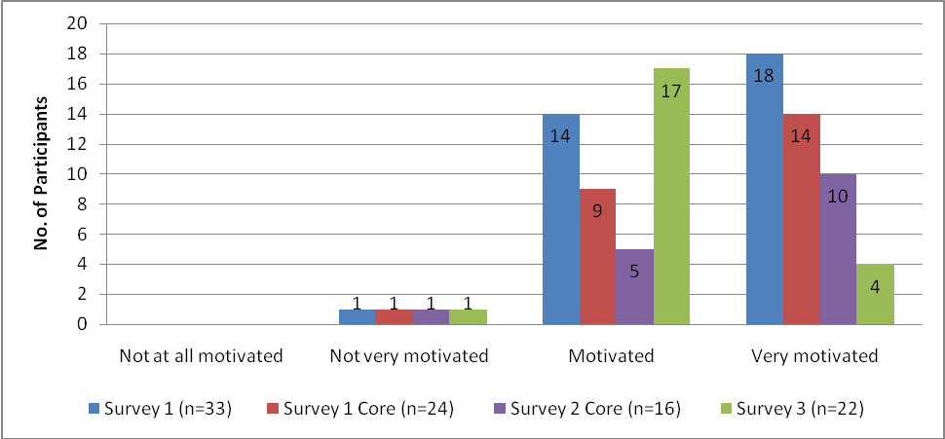
Figure 4: Teacher motivation to learn TL
One factor which may help to sustain motivation for some teachers is the Ministry of Education Language Immersion Award (LIA). There is considerable interest in the LIA with 19 of the 23 survey three respondents stating they are, or may be, interested in the award to travel and study their TL abroad. All but one of the seven case study teachers were interested in applying or had applied for the LIA. However, comments from those who expressed interest but had not yet applied, indicated concerns such as family commitments and the ‘monster time’ required to complete the application. The one teacher who was not interested was a beginner in the TL, and wanted to wait until she was more competent so that she could fully benefit from the cultural experience. Five of the 50 TPDL teachers (three French, one German, one Japanese) received an LIA award in 2008 (Thomson, 2009) and will be undertaking their immersion experience in 2009. Further evidence of the benefits of this award will be reported on in Evaluation of the Language and Culture Immersion Experiences for Teachers Programmes: Their impact on teachers and their contribution to effective second language learning (Harvey, Roskvist, Corder & Stacey, 2009).

3.5 Teacher knowledge of TL compared with student knowledge of TL
At the beginning of the TPDL course 17 of the core 25 survey participants described themselves at beginner or elementary level in their knowledge of the TL. In most cases, these teachers were teaching the TL to students who were also beginners. It was important to find out whether the teachers’ knowledge of the TL continued to be at least equal to, but preferably greater than, the students’ knowledge throughout the course. From the beginning, all but one respondent felt they had ‘a bit more’ or ‘considerably more’ knowledge of the TL than their students (see Figure 5). This was to be expected, as all but two respondents had had some previous TL instruction. Of the remaining two, one had experienced living in the target culture and had undertaken self-study in the TL, and the other one, although not familiar with the TL, had previously learned other languages. Survey three data indicated that there had been movement for three respondents who now indicated they had considerably more knowledge than their students.
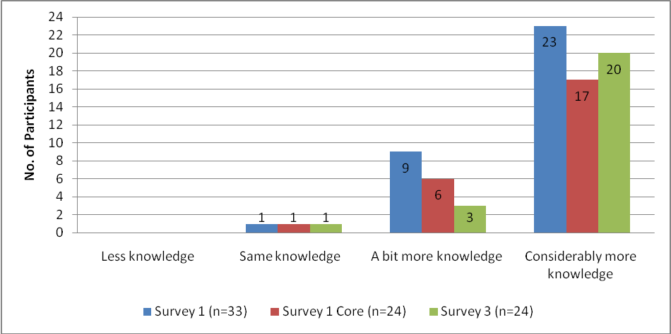
Figure 5: Teacher perceptions of their TL knowledge compared with their students’ TL knowledge
As mentioned before, knowledge of subject is one of the requisites for effective teaching (see section 3.3) and it is desirable for teachers to have more knowledge than their students. There is the potential for students (through independent study or prior language knowledge) to be at a more advanced level than the teacher. However, the core survey respondents indicated this was not the case in their classes. On the TPDL programme, nearly all teachers had more knowledge, although some had only a little more. Where teachers had only a little more knowledge than their learners, it is possible that language teaching could be seen as less effective. However, it is reported (Scott and Butler, 2007) that when teachers and their students are learning the language at the same time, they empower one another as language learners; together they take risks, increase their knowledge and support each other in learning.

3.6 Confidence and use of TL language
The development of teachers’ TL proficiency can be investigated through an enquiry into teacher confidence in using the TL with their learners in the classroom. A further means of investigation is to consider the teachers’ opportunities for TL use when participating in the TL community either directly or indirectly.

3.6.1 Confidence in using the TL in the classroom
Participants were asked about their level of confidence in using the TL with their learners at the beginning and at the end of the TPDL programme. There was an increase in teachers’ level of confidence with the majority (22 of 24 respondents) indicating they were ‘confident’ or ‘very confident’ in using the TL with the students, compared with 17 teachers at the start of the course (see Figure 6).
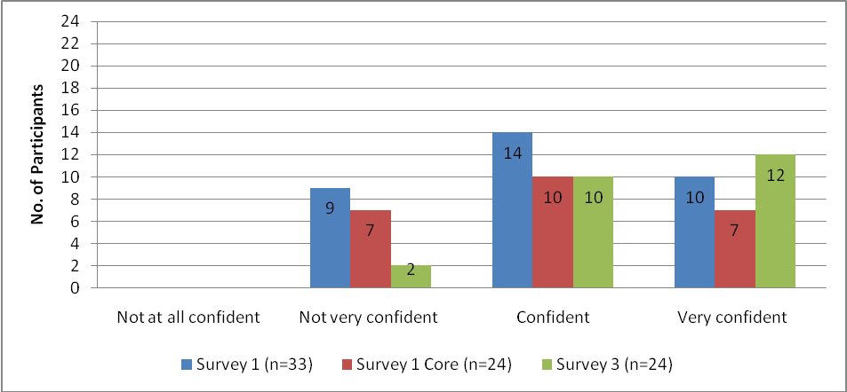
Figure 6: Teacher confidence in using the TL in the classroom
Overall, the surveys indicated the majority of the teachers were feeling confident about their use of the TL with their students. They were not only feeling more confident, but were also using the TL more in class. The TPDL course facilitators gathered evidence across four visits on the amount and purpose of teacher use of the TL and at each visit, the expected standard was raised (Thomson, 2009, Appendix 13). According to milestone report nine, the majority of teachers (43 of the 47) observed in visit four, were either meeting or exceeding the progress standards for teacher TL use in the classroom (Thomson, 2009, Appendix 27). The researchers in their final observations of case study teachers noted varying degrees of teacher TL input which is reported on in 4.2.1.

3.6.2 Teacher participation in the TL community
Participating in the TL community is an integral part of language learning. A study of more than 1700 highly motivated foreign language learners found that interethnic contact influenced learner attitudes to TL in a positive way, assisted the development of the learners’ language competence, increased their motivation and reduced their anxiety when using the TL (Kormos & Csizér, 2007). The study also identified two main types of intercultural contact; direct and indirect. Direct contact includes visit to TL country, contact with non native or native speakers of the TL, internet chat and email or mail. Indirect includes contact with a teacher who has had experience in TL country and interaction with television, the internet, books and magazines. Both kinds of contact were found to build positive attitudes to language learning (Kormos & Csizér, 2007). It is therefore important for TPDL participants, as learners of the TL themselves, to have contact with their TL community.
In survey one, respondents were asked if they had opportunities for participation in the TL community. Over half the respondents indicated they had none. However, the researchers believed that participants may have had a narrow concept of ‘TL community’. Therefore, in survey two, a more detailed question was asked, categorising contact with the TL community according to types of intercultural contact situations, ‘direct’ and ‘indirect’ (Kormos & Csizér, 2007).
The data from survey two showed that more than two thirds of the teachers were engaging indirectly with the TL community through the internet, DVDs and books. In addition, some were reading magazines and watching television in the TL. Similarly, direct contact was mentioned by 20 of the 28 teachers (71%) who indicated they had direct spoken contact in New Zealand with TL expert users. Eight of the 28 teachers indicated they participated in the TL community through visiting the TL country. A small number of teachers had direct written contact through email and conventional mail in the TL. The results from survey three indicated that this engagement with the TL community remained constant for the rest of the course.
Data gathered from the case studies provides further elaboration on the participation in the TL community, both direct and indirect (see Table 2).

Teacher | Type of participation in TL community
Teacher 1 | Direct  Limited participation in TL community. Not confident to explore TL community. Has practised language in TL restaurant.  Indirect  Reads TL books and uses the internet. Watches TV.
Teacher 2 | Direct  Full participation. Speaks to other TL colleagues, relatives, and practises in TL country.  Indirect  Watches TL television, movies and DVDs and reads books.
Teacher 3 | Direct  Limited participation in TL community. Not aware of any opportunities to practise speaking TL and not confident to go the wider TL community. Practises with one class member in TL Study class.  Indirect  Watches movies and DVDs, reads books and magazines and uses the internet.
Teacher 4 | Direct  Limited participation in TL community. Writing emails in TL.  Indirect  Reads books and magazines. Uses the internet. Downloads daily TL news programme on to iPod. Watches movies and DVDs.
Teacher 5 | Direct  Limited participation. Sometimes speaks TL to colleague in school. Doesn’t go into the wider TL community.  Indirect  Reads TL magazines, books and uses the internet.
Teacher 6 | Direct  Some participation in TL community. Member of TL community group; weekly meetings with TL speaking friends.  Indirect  Reads TL books, uses the internet and watches TL movies.
Teacher 7 | Direct  Full direct participation with TL community. Member of TL community group. Weekly meetings with TL speakers. Speaks to TL colleagues and language assistants.  Indirect  Uses TL internet, books, DVDs, magazines and writes letters.
Table 2: Teacher participation in the TL community
Table 2 shows combined data gathered from interviews two and three with case study teachers. The researchers noted there was a range of direct participation, from limited practices of speaking with or writing to other TL users, through to full, regular oral and written contact with the TL community. Researchers also noted a slight increase in the variety of indirect contact during the year. For example, one teacher who mentioned using the internet and reading books earlier in the course indicated she was also watching movies and reading magazines in the TL by the end of the course. By the end of the course, all had established some indirect contact with the TL community. It is difficult to ascertain the extent to which the increased participation in the TL community was a result of TPDL. However, increased motivation and participation appears to correspond with studying the language and working with other colleagues interested in the same language and culture.

3.7 Effectiveness of the language study course
As well as gathering data on the teachers’ developing language proficiency, motivation and confidence in use of the TL, the researchers sought to understand the extent to which the teachers believed their language study course was effective (see Figure 7).
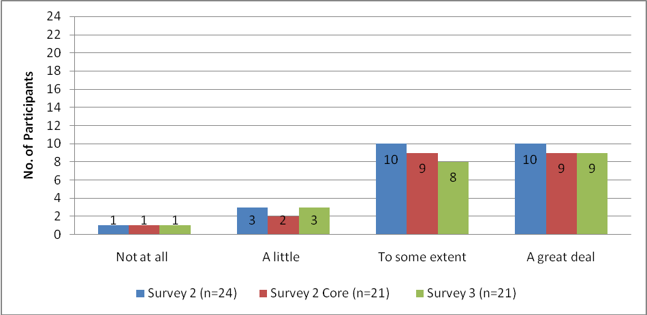
Figure 7: Extent to which participants feel their language study course is effective
Figure seven shows that teachers’ perceptions of language study effectiveness remained constant. The majority (17 of 21) indicated at the end of the TPDL programme that their language study course was effective ‘to some extent’ or ‘a great deal.’ However, there were still four respondents who believed the language study they undertook was only ‘a little effective’ or ‘not effective at all’. All five of the seven case study teachers who undertook language study were positive about their language study courses. However, two were disappointed, but commented that it was no fault of the TPDL programme directors, as there were no suitable classes in the area.
As noted by Thomson (2008e), there were occasions where teachers chose to go to particular community classes against the Project Director’s advice. These classes proved unsatisfactory for three teachers. In addition, one teacher found the customised distance programme did not suit her learning style because of a slow start and difficulties communicating with the tutor. The TPDL course directors went to considerable lengths to organise alternative tuition. However, difficulties in finding suitable tutors in convenient locations broke the continuity of language learning, which may have accounted for the lack of effectiveness recorded by some survey respondents.

3.7.1 Useful aspects of the language study course
Surveys two and three asked qualitative questions requiring participants to reflect on useful aspects of their language study course at the end of each semester of learning. A number of categories emerged as being important in fostering language study. The teachers appreciated the opportunities to use the TL and to communicate with other participants or the class teacher when they were studying the language. Teachers noted the usefulness of the language content they were taught. Receiving language teacher feedback on the accuracy of their language use encouraged them as language learners. In survey two, some participants indicated they found studying and preparing for an exam motivating.
The answers from the survey three qualitative question on useful aspects of the language study course are summarised below (Table 3) and are in ranked order of mention. One area that did not emerge in survey three was the motivation arising from examination preparation. By the time survey three was administered, teachers had completed their internationally recognised language exam and so the motivating aspect of this seems to have become less important.
Useful aspects (x number of participant comments) | Sample teacher comments
Opportunities to practise (x 12) | Opportunity for conversation practice;  conversation with my tutor most useful;  opportunity to speak with my language instructor regularly.
Language course content (x6) | Hearing correct pronunciation and grammar;  vocabulary development;  formulaic expressions.
Class teacher feedback on language (x5) | Immediate feedback;  the help from tutor;  having an instructor available to clarify information such as verb tenses;  regular feedback and feed-forward.
Table 3: Useful aspects of the language study course programme

3.7.2 Teacher suggestions for improvements to language study course
As well as understanding the benefits teachers received from their language study course, it is important to consider teacher suggestions for improvements. Suggestions for ways to improve the course were gathered in surveys two and three. Not all respondents made comments. However eight teachers said they were happy with the course and did not make any suggestions for improvement. All other suggestions are reported below in Table 4 in ranked order (the same comment made by the one teacher in the two surveys is indicated only once).

Improvements | Sample teacher comments
More practice (x6) | More conversational time. Maybe a bit more oral interaction. More face-to-face oral practice.
Delivery (x5) | Method of teaching was dull - more variety and reduce the amount of theoretical analysis. Slow down. Didn’t suit my learning style.
More grammar (x4) | More structure of the language and how things fit together. More emphasis on grammar.
Other (x1 comment each unless otherwise stated) | Need local area class (x 2).  A course at the appropriate level (x 2) – too wide a range of speaking level.  Better technical support for distance classes e.g. video cam.  Clearer assessment guidelines.  Less homework.  More written work in the course.  Supply of DVDs for language lessons.  More feedback on language use.  Face-to-face university credit-bearing course in the TL that fits around full-time work..
Table 4: Suggestions for improvement to language study course
While there were many positive aspects of the language study component of the TPDL, there were still areas where the language courses were not fully meeting the needs of the teachers. This is an area that may be difficult to address as not all the language courses are able to be influenced by the TPDL directors. This is further elaborated in chapter eight when considering sustainability of the TPDL programme.

3.8 Conclusion
Teacher proficiency in the TL is a key determinant in the quality of student language learning (Gibbs & Holt, 2003). The languages learning component of the TPDL programme had a positive impact on the TL proficiency of most teachers. By the end of the programme, most teachers perceived they had increased their level of TL proficiency and at the time of writing this report, nearly all of those who sat internationally recognised examinations had received confirmation of passing. The data showed that by the end of the course there was a decrease in those describing themselves at lower levels, and an increase in those perceiving themselves at intermediate level. Amongst the case study teachers, those who perceived positive change had studied the language for more than two terms and sat an examination. Those who perceived no change had not sat an exam and had studied the language for the minimum time required, or not at all. Along with this perception of increased level of proficiency came a gain in confidence in using the TL in the classroom. As well, all the teachers indicated at the end of the course they had more knowledge of the TL than their students. TL use was also reported on by the TPDL directors who confirmed that the majority of teachers were at the expected or an accelerated level of TL use in the classroom. Outside the classroom, teachers were engaged in a range of direct and indirect forms of participation in the TL community. Motivation to study the TL was sustained over the course. Although after semester one some participants had stopped learning, by the end of the TPDL programme more than three quarters of survey respondents intended to continue to study in 2009. Similar numbers expressed possible interest in the LIA as a means of developing their TL fluency and understanding more about the culture. Some TPDL participants had already been awarded LIA for 2009.
The language study component of the TPDL programme was considered by the majority of respondents to be effective to some extent or a great deal. The main way the language study course fostered TL proficiency was the opportunity provided for teachers to communicate in the TL in the language class. In addition, teachers appreciated the accurate language input they received and the feedback on their own TL accuracy. While the majority of teachers were satisfied with their language study courses, some respondents felt their course was only ‘a little effective’ or ‘not effective at all’. Teachers thought language study courses could be improved by including more oral interaction, more engaging teaching methods and more focus on the structure of the TL. At this stage it would appear that some of these improvements are not within the immediate control of the TPDL directors who were very aware and pro-active in trying to meet the language needs of the teachers.
Although participants had made progress in their TL learning, around half of survey three respondents perceived themselves to be at Elementary or lower in their TL proficiency. Another eight participants were at Intermediate level. The Ministry of Education Statement of Intent, 2006-2011 notes that knowledge of subject is one of the three conditions for effective teaching to occur (Ministry of Education, 2007b). With half of the core survey participants having relatively low levels of TL proficiency, it is difficult for student language learning to be maximised.
Recommendations and implications for the TPDL programme
- It is desirable for teachers who are teaching the TL to be at an intermediate level of TL proficiency or above. Therefore, teachers who are below an intermediate level of TL proficiency should be encouraged to study the TL during and beyond the course, and to sit exams to reach intermediate level.
- Sitting an external language exam is desirable for those teachers who are not bilingual as sitting an exam was found to increase teacher perceptions of TL proficiency.
- The Language Immersion Awards are motivating for many of the TPDL participants and should be strongly promoted on the programme.
- Language study classes need to be of a high standard and to meet the needs of the TPDL teachers, so there is continuity of learning.
- Teachers’ prior interests and experiences in relation to the target language community need to be acknowledged and harnessed during the TPDL course. These can be explicitly built upon to encourage participants to seek out opportunities to engage directly and indirectly with target language communities.

Chapter Four Impact of TPDL Years 7-10 on the teachers’ second language teaching knowledge

I’ve chosen to present my own provisional specifications in the form of ‘principles.’ I do not expect that … all language teachers will agree with them. I hope, though, that they will provide a basis for argument and reflection (Ellis, 2005b, p. 210).

4.0 Introduction
It is important for those teaching an additional language to have a sound knowledge of how students learn language and in turn, ways to effectively teach a language. Language teachers need a framework from which to develop their teaching skills and the Ellis principles of language teaching (2005b) drawn from Second Language Acquisition (SLA) research provide the theoretical foundation of the TPDL programme. This chapter considers the impact of the TPDL programme on teachers’ second language teaching knowledge. Two aspects of second language teaching knowledge are considered: understanding how students learn an additional language, and understanding how teachers teach an additional language.

4.1 Participants’ teaching background
In considering respondents’ teaching background it is necessary to consider general teaching experience, prior instruction in language teaching and length of time in teaching the TL. The cohort of teachers involved in the research on the TPDL programme was relatively experienced in general teaching, with twenty one of the thirty four respondents to survey one having been teaching for seven or more years, and sixteen of those for more than ten years. Five respondents were undertaking the course with only one to three years of general teaching experience. With regard to prior knowledge of language teaching, more than two thirds of the teachers had attended short courses or seminars on teaching language with nearly one third having no previous language teaching instruction. The length of time TPDL participants had been teaching the TL varied from no previous language teaching through to more than ten years’ experience. Figure 8 shows nearly one third of participants were in their first year of TL teaching, one third were not new to teaching the TL and just over one third could be viewed as experienced language teachers.

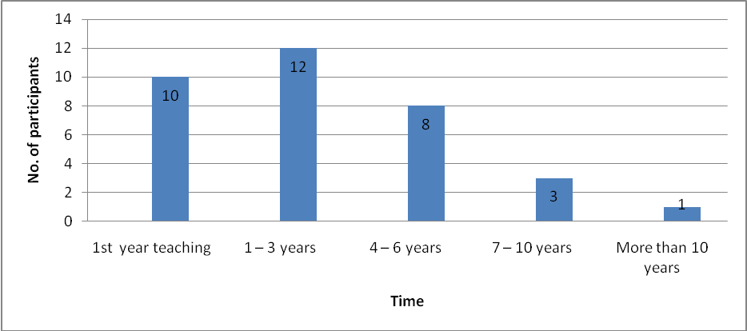
Figure 8: Length of time teaching TL (n= 34)
Thus, the survey respondents brought to the TPDL programme a range of general teaching experience, a variety of previous instruction in language teaching and varying lengths of time teaching the TL.

4.2 Understanding how students learn an additional language
For teachers to be able to teach another language effectively, it is important for them to understand key aspects of how students learn an additional language. An integral part of the TPDL programme involved looking at the principles of SLA. Given that nearly two thirds of survey one respondents had had some prior language teaching instruction, it is not surprising that at the start of the TPDL programme, all of the core respondents, with the exception of one, indicated that they had between ‘a little’ and ‘good’ understanding of how students learn a second language (see Figure 9).
In survey three, teachers reported a considerable increase in their understanding of how students learn an additional language with 22 indicating they had a ‘good’ understanding and three saying they had ‘expert’ understanding. One teacher commented in her final interview that her understanding had increased ‘out of sight’. Understanding more about how students learn language helped this teacher to make lessons more meaningful for the learners. ‘I didn’t realise just how shallow my teaching was last year…. This year has been purposeful. The kids remember a lot more because it’s more meaningful to them’.

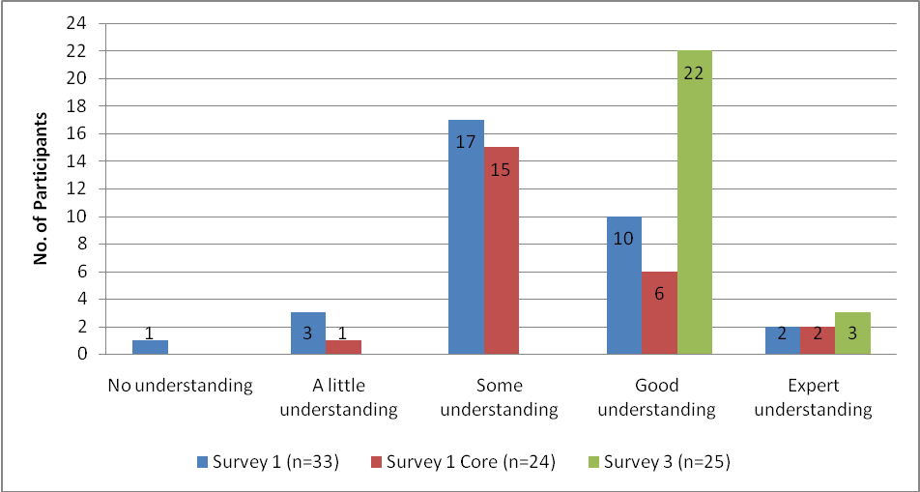
Figure 9: Extent of teacher understanding of how students learn an additional language
Early on, the programme introduced the Ellis principles (2005b) as a framework for increasing teachers’ knowledge of how students learn another language (see Table 5). The researchers noted in the surveys and case study interviews there was constant mention about ‘the Ellis principles’ and how understanding these was helping them know more about their learners. One teacher, in response to the question about what things were helping her improve her knowledge, replied, ‘Mr Ellis’s principles. It’s so logical – why haven’t they used them before!’. The teacher then went on to list the principles and commented how students needed to work out patterns and have opportunities for output. Other teachers referred to single principles, especially the formulaic expressions principle, which were helping them understand an important aspect of how students learn another language and which they said they were using in their teaching. Teacher application of the Ellis principles was confirmed by the researchers in observations of case study teachers (see Table 6). Of the seven case study teachers, six teachers were all observed making positive changes between observations one and three. Three had a stronger focus on meaning, two teachers had a stronger focus on form, one teacher created more opportunities for interaction and another teacher was providing freer opportunities for interaction. One teacher who was not able to be observed three times made no change between observation one and two.

- Instruction needs to ensure that learners develop both a rich repertoire of formulaic expressions and a rule-based competence
- Instruction needs to ensure that learners focus predominantly on meaning
- Instruction needs to ensure that learners also focus on form
- Instruction needs to be predominantly directed at developing implicit knowledge of the L2 while not neglecting explicit knowledge.
- Instruction needs to take into account the learner’s “built-in syllabus”.
- Successful instructed language learning requires extensive L2 input.
- Successful instructed language learning also requires extensive L2 output.
- The opportunity to interact in the L2 is central to developing L2 proficiency.
- Instruction needs to take account of individual differences in learners
- In assessing learners’ L2 proficiency, it is important to examine free as well as controlled production.
Table 5: [Ellis] Principles (Ministry of Education, 2007c).

Teacher | Observation 1: Main principles observed/not observed | Observation 3: Main principles observed/not observed
Teacher 1 | Input - T provided high level of input TL through use of TL for formulaic expressions, classroom management and instructions and social aims.  Interaction - T set up interactive task in TL (card game) which students played for 45 minutes, using TL formulaic expressions.  Output - T provided some opportunities to use the TL orally  Meaning - Focus on meaning  Form - No focus on form observed.  Assessing production - T assessed the practice by asking for student feedback on activity. | Input - T provided high level of input TL through use of formulaic expressions, classroom management and instructions and social aims.  Interaction - T set up interactive bingo game in TL to revise numbers. T set up interactive controlled practice of new key vocabulary related to insects and revision of formulaic expressions for “is it a (butterfly)?”  Output - T provided some opportunities to use the TL orally.  Meaning - Focus on meaning.  Form - Some focus on form (pronunciation, gender).
Teacher 2 | Input - T provided high level of input TL through use of TL for formulaic expressions, classroom management and instructions and social interactions.  Interaction - T set up opportunities for group interaction but students did this in English.  Output - T provided some opportunities to use the TL orally. Response to roll call, T set up controlled practice of known TL through play reading and sentence ordering.  Meaning - Focus on meaning.  Form - Vocabulary and pronunciation. | Input - T provided high level of input TL through use of TL for formulaic expressions, classroom management, instruction and social interactions/informal chat.  Interaction - no pair/group oral interaction in TL.  Output - T provided opportunities to use the TL orally and in written form. Students observed using formulaic expressions.  Meaning - Considerable focus on meaning.  Form - Focusing on form: grammar, vocabulary, pronunciation.
Teacher 3 | Input - T provided high level of TL input through use of TL for formulaic expressions, classroom management and instructions and social aims.  Interaction - no pair/group oral interaction in TL.  Output - T focused on introducing new language and providing controlled practice through translation and sentence writing. T provided some opportunities to use the TL orally.  Meaning - Focus on meaning.  Form - Verb endings, singular/plural, pronunciation. | Input - T provided high level of TL input through listening to text, reading text as well as extensive use of teacher TL for classroom management, instructions, social goals. Teacher had noticeably adjusted her level of language to take into account the learners’ increased knowledge of TL.  Interaction - provided opportunities for students to interact in TL in groups.  Output - T provided many opportunities for output, oral and written.  Meaning - strong focus on meaning through students’ categorisation of vocabulary.  Form - T provided some opportunities for focus on form.
Teacher 4 | Input - Some input of TL through teacher use of TL in instructions and for classroom management. Eclectic mix of activities: new language (numbers), songs, months.  Interaction - T set up short controlled practice with opportunity for students to interact through a mingle activity using the TL to revise formulaic language.  Output - T provided some opportunities for students to use the TL orally.  Meaning - Some focus on meaning.  Form - Pronunciation and some translation to highlight structures. | Input - T provided TL input through use of video. - Limited T use of TL for classroom management and instruction (T mainly spoke English).  Interaction - T provided opportunity for interactive, freer practice of new language and previously learned formulaic expressions through student preparation and delivery of skits.  Output - T provided some opportunities for students to use the TL orally and in writing.  Meaning - Some focus on meaning.  Form - Word endings.
Teacher 5 | Input - T provided TL input using DVD and also TL to manage class, give instructions; teacher reverts to English when students don’t understand.  Interaction - T Set up related practice activity for groups (asking about birthdates). Free use of TL language in role play where students access all known language was on a topic of students’ choice.  Output - T provided opportunities for students to use the TL orally - choral songs, repetition of vocabulary and formulaic expressions after DVD model and after teacher. Role play and group activity. Written output: copying from board.  Meaning- Some focus on meaning.  Form - No focus on form. | Input - T uses more TL for classroom management and instructions with the input initially in TL, but teacher reverts to English if students don’t understand. Input (song) from video. Teacher models dialogue (ordering in a cafe).  Interaction - Interactive free language practice: ordering in café.  Output - Many opportunities for oral TL use.  Meaning - Some focus on meaning.  Form - Pronunciation, gender, plurals, apostrophe, prepositions.
Teacher 6 | Input - T provided effective input through use of TL for instructions and managing class.  Interaction - T set up controlled practice through interactive mingle task asking about family tree members.  Output - T set up opportunities for output of TL through singing, noughts and crosses, vocabulary exercise, sentence writing.  Meaning - T set up opportunity to negotiate meaning.  Form – grammar (prepositions).  Assessing production - T assessed the practice by asking for student feedback on activity. | Input - T uses TL for instructions. More use of English in this lesson than previously (disciplines in TL and then English).  Interaction - T provided opportunity for pair reading of dialogue.  Output - T set up opportunity for output of TL through singing and writing.  Meaning - Focus on meaning of vocabulary.  Form - Pronunciation, gender of words.
Teacher 7 | Input - T provides some input of TL but using code switching (phrases mixing TL and English).  Interaction - Students work in pairs in question and answer exercise asking and answering about the time.  Output - T provides opportunities for chorus responses, individual students to ask questions and paired exercises.  Meaning - T made considerable effort through use of flashcards, wall charts and worksheets to convey meaning.  Form - Some focus on form through attention to writing system in TL and sentence order. | Input - Short video from LLS. T provides some input of TL but using code switching (phrases mixing TL and English). T introduces vocabulary items and question forms.  Interaction - Students work in pairs in question and answer exercise discussing animals and which animals students like.  Output - T provides opportunities for chorus responses and repetition. Written cross word to fill in with new TL vocabulary items. Paired exercise for questions and answers.  Meaning - Excellent flashcards, video, teacher explanation, good recycling so plenty of opportunity for students to understand meaning.  Form - Not too much attention to form. More teaching individual items or chunks of language.
Table 6: Teacher application of Ellis principles in observations 1 and 3

4.2.1 Observed language input
This section reports further on teacher provision of language input and language output. The teacher can provide language input for the students by using the TL during the lesson to manage the classroom, manage social aims and as a medium of instruction. As well, the teacher can provide input from other sources of TL such as songs, DVDs, classroom displays, written texts, and through opportunities for students to listen to each other.

Language input from teacher TL use
As noted in Milestone Report Five there was a ‘very low level use of the TL amongst most teachers’ at the start of the TPDL course (Thomson, 2008b). However, three months later when the researchers carried out their first observations of case study teachers, all of the observed teachers were able to utilise some TL to give instructions, maintain discipline, give encouragement and group students.
Two fluent case study teachers used the TL 70-80% of the teacher talk time to manage the class, and also as the medium of instruction (e.g. to explain the lesson for the day, to elicit ideas from students). The less proficient teachers still made some use of the TL to manage the class. In all the observed classes, teachers used basic classroom language to greet students, to take the roll, to give instructions such as, ‘stand up’, ‘take your books out’, ‘shut the door’, ‘look at this’, and ‘say it all together’. One teacher was observed using some inaccurate grammar and pidgin TL along with English for some of these instructions. In Years 7-8 where students remained with the same teacher for a range of subjects, some teachers explicitly wove the TL into aspects of normal classroom routine for example, requiring dates and times to be written in the TL. As well, all teachers were able to give encouraging feedback to learners, for example, ‘yes’, ‘well done’, ‘that’s good’ in the TL.
Thomson (2009) states that during visit four, the majority of the TPDL cohort (43 of the 47 teachers observed) were meeting or exceeding the expected progress standards (which were raised for each observation) in teacher use of the TL. The researchers noted in their final observations that the TL input from case study teachers had generally been maintained, although there were occasions where teachers were using English to manage the class when the researchers felt they were capable of using the TL. There was one occasion where the teacher was using more English than she had in the first observation. It is interesting to note that the TPDL programme and the teachers’ language study course had finished for most of the teachers by the time the researchers’ final observations were undertaken. This may have had some influence on the amount of TL and English that was used in the final observations.
Richness of language input
The researchers noted throughout the observations that there was a range in the depth and breadth of language the teachers used with the students. Case study teachers with an advanced level of proficiency and previous contact with the target culture, gave their learners rich exposure to the TL (natural pace, frequent repetition, well graded language, long utterances, complex sentences, interesting cultural anecdotes and explanations). In one case, the teacher had the linguistic fluency and awareness to noticeably increase the level of her TL input, taking into account the time students had been learning the TL. In contrast, teachers with lower levels of proficiency provided more limited language exposure. They had less facility to extend and elaborate in the TL when delivering the lesson, and were less able to respond spontaneously to the classroom situation.
Another form of rich language input that some teachers were able to provide was through using a language assistant (a fluent native speaker of the TL). This facility was available to approximately one third of the respondents. Two of the case study teachers indicated they had access to language assistants, one on a regular basis, and the other only very occasionally. Both these teachers were the most fluent speakers of the case study teachers. The first teacher indicated through interview that the language assistant regularly engaged in intensive conversation and games with students. One researcher observed the second teacher using a language assistant in the lesson to monitor and engage with students in the TL during the lesson.

Language input from other TL resources
Table 6 records the oral input teachers provided for their learners. As well, researchers noted case study teachers provided TL input through a range of other resources. There were extensive displays of student work in the TL, posters of the country, maps and wall charts (e.g. of grammar rules), as well as key vocabulary and laminated formulaic expressions. All of the case study teachers were observed using commercially prepared audio materials such as songs, CDs and DVDs which provided students with further exposure to authentic TL. One teacher provided opportunities for her learners to use the internet to search for TL material in order to write a newsletter while another used an internet based translation software (Language Tools) to find a TL phrase and encouraged students to find TL vocabulary items they wanted to use in a speaking activity.
To conclude, teachers were providing students with a wide range of input in the TL. They used the TL to give instructions, manage the class and on some occasions were able to use the TL as a medium of instruction. As well, teachers provided further opportunities for TL input through a range of other written, aural and visual resources.

4.2.2 Observed teacher provision for language output
Providing opportunities for student oral language output is a significant part of the TPDL programme. Student oral TL output can be described as single word, short phrases, formulaic expressions or extended utterances in the TL. Oral TL output can be promoted in two main ways, through teacher-student interaction and student-student interaction. As well, teachers can provide other opportunities for language output through individual and whole class tasks, including singing songs, reading aloud and repeating after the teacher or CD/DVD/tape. Further language output can be in written form with students recording TL in books, completing worksheets or other written tasks.

Teacher-student interaction in TL
The researchers observed that case study teachers frequently asked students questions, either in the TL or in English. Some questions elicited one word TL responses, for example, saying ‘here’ to answer the roll. Other questions elicited short phrase responses in the TL (e.g. ‘4th June’) or formulaic expressions (e.g. ‘sorry I’m late’). There was little observed emphasis on teachers asking questions that encouraged students to produce extended utterances in teacher-student interactions.

Student-student interaction in TL
The TPDL director noted in the base-line data gathered at the beginning of the course that not many teachers were planning opportunities for students to interact using the TL (Thomson, 2008b). Three months later, in the first observation of the case study teachers, the researchers noted teachers did provide opportunities for language output through student-student interaction. For example, there were bingo games practising numbers, and card games that students played using formulaic expressions such as ‘don’t cheat’, ‘it’s my turn’, ‘who’s next?’. In other observed classes, teachers set up mingle activities for students where they circulated in the classroom using formulaic language to ask others about names and family members. In the final observation of case study teachers, further activities were observed where students worked in pairs or groups, for example, to run a quiz in the TL about insects. Some teachers were observed organising role-plays for students to use new language or to combine new language with previously learned language. In a few cases interactive tasks were organised for students to talk about the language (e.g. group correction of previously written TL sentences, and group preparation of a newsletter in the TL) rather than in the language.

Other output opportunities
Case study teachers were also observed providing other opportunities for student TL output. In most classes, teachers asked students to sing songs, either accompanying commercially produced CDs or singing previously learned songs from memory or with the aid of song-sheets. Some teachers asked students to read aloud from text books, stories or prepared dialogues. Teachers also provided opportunities for written TL output through sentence writing and written gap-fill exercises.
To conclude, by the end of the course, case study teachers had been observed providing a wide range of opportunities for student TL output. Teachers demonstrated that they were aware of the need for TL output and also they had an understanding of the ways to encourage it. The effectiveness of these opportunities for student TL output is discussed in 4.3.2.

4.3 Understanding how to teach an additional language
The teachers had clearly gained an understanding of how students learn a language by the end of the course. As observed by the researchers and reported in Table 6 (p. 32) the teachers were applying their knowledge of the Ellis principles in their lesson planning and lesson organisation and had demonstrated some positive change by the end of the course. It is also interesting to consider teachers’ perceptions of their understanding of how to teach the TL. Following this, the researchers’ observations of teacher effectiveness are discussed.

4.3.1 Teacher perceptions
This section examines how much teachers said they understood about how to teach an additional language. It also considers the teachers’ perceptions of how much the TPDL programme had impacted on their classroom practice and looks at how effective the teachers felt they were at teaching.

Teacher perceptions of their understanding of how to teach
Early on in the course teachers were asked the extent to which they understood how to teach an additional language. Figure 10 illustrates the findings. Three quarters (18) of the core respondents to survey one said they had ‘some understanding’ of how to teach an additional language, with five indicating they had ‘good understanding’. Survey three revealed that by the end of the course, 20 indicated they had ‘good understanding’, and two described themselves as ‘expert’. So overall, there were changes in teacher perceptions of their level of understanding of how to teach an additional language.

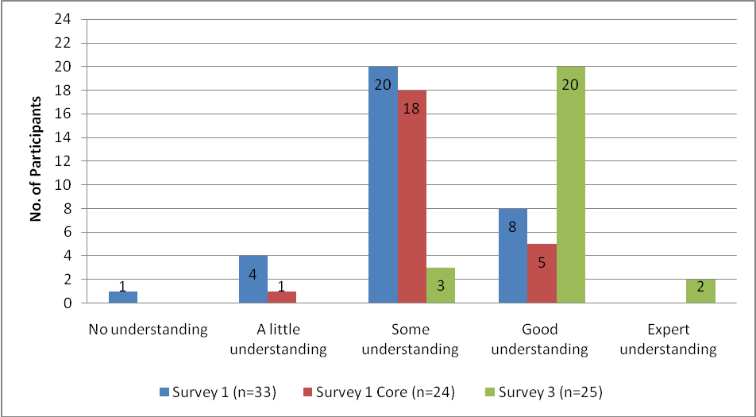
Figure 10: Extent of understanding of how to teach an additional language

Teacher perceptions of the impact of the TPDL programme on classroom practice
Teachers can gain knowledge of how to teach an additional language from many different aspects of the TPDL programme: from the language study component, from the EDPROFST360 paper and from observation feedback by TPDL facilitators. Early on in the course, participants were asked to what extent they thought the TPDL programme would impact on their classroom practice. Figure 11 shows three quarters (18) of the core respondents believed the course would have ‘considerable’ impact on their teaching practice. To ascertain the extent of the impact, teachers were asked a similar question in survey three. Figure 12 shows that at the end of the course, approximately half (12 of the 23 respondents) said the course had changed their classroom practice ‘considerably’. While others noted some change, and all the change was reported as positive.
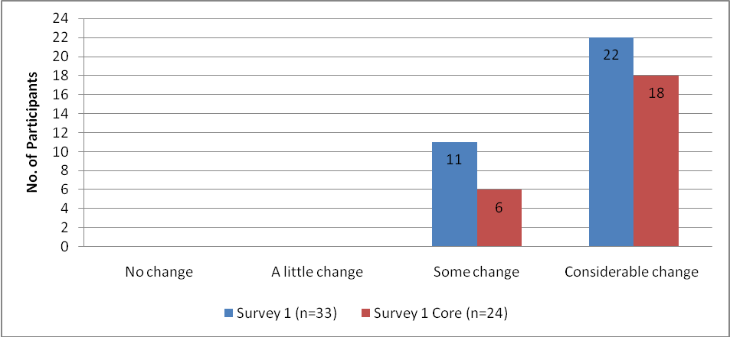
Figure 11: Expected impact of the TPDL programme on teaching practice (Survey 1)
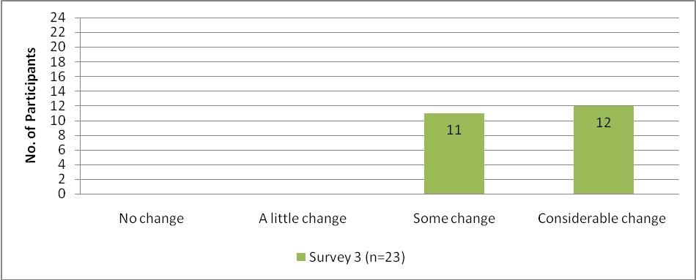Figure 12: Perceived impact of the TPDL programme on teaching practice (Survey 3)
It appears that some respondents expected a greater degree of change in their teaching practice than they perceived had actually occurred. One way to account for this difference is that teachers may have become more realistic about the complex skills required to teach an additional language. In addition, they may have become aware of the length of time needed to learn about and implement these skills.

Survey respondents were also asked to indicate how they expected the TPDL programme would change their practice. At the beginning of the TPDL programme, the respondents anticipated that the main impact would be an improvement in their knowledge of the TL. However, subsequent surveys showed a shift in their perceptions. Teachers focused increasingly on their developing classroom skills. When asked for details on how the TPDL programme had impacted on their classroom practice, teachers gave positive responses. Sometimes there were general comments about improved understanding of how to teach a language. Other respondents were more specific. Teachers indicated there was now more oral interaction in their classrooms (nine comments), they used the TL more confidently in their classes (four comments) they had a greater repertoire of teaching strategies (three comments) and two teachers commented their lessons were more student centred. Other teachers mentioned having greater insights into the curriculum.
The impact of the programme on classroom practice was explored in more depth through the case study interviews. Case study teachers reported the TPDL programme was impacting on their classroom practice in several ways: increased use of TL, change in classroom dynamics, and confidence and skills in how to teach a language.
Case study teachers said they were focusing more on using the TL in class and were planning more for TL output. This resonates with Ellis’ recommendation to maximise use of the TL inside the classroom, using it as both ‘the medium and the object of instruction’ (2005a, p. 39). Increased TL use by case study teachers was also a result of the visits by TPDL language facilitators who rated teachers on aspects of TL production in their classes. These visits, especially the initial ones, prompted teachers to utilise as much TL in the classroom as they were able to. One teacher spoke of ‘using the TL as much as possible for classroom management and within the lesson’ while another said she was trying ‘to cut out my own English’.
Further changes described by case study teachers included changes in classroom dynamics with one teacher commenting on a ‘shift in power to the students’ and another saying, ‘it’s made a difference not being an expert’. One teacher also talked of ‘giving students more ownership’ and ‘trying not to underestimate their knowledge’.
The most frequently mentioned areas of impact were confidence and skills in how to teach a language, linking in tightly to the Ellis principles and the importance of using formulaic expressions. Interactive student–centred, task-based activities also became more of a focus for teachers in their planning of lessons. As well, teachers commented on learning styles, developing learner independence and using resources. One case study teacher commented on the change in her teaching style ‘…finally I’m letting go of the ‘direct teaching’ by providing more student directed activities’. In the final interview, although very positive about the course, one teacher in her first year of language teaching recognised that she needed more time to implement aspects of the course.

Teacher perceptions of effectiveness at language teaching
In terms of teacher perception of their own effectiveness at teaching the TL, there was considerable positive movement in how the teachers viewed their teaching effectiveness throughout the course. At the beginning, nearly half of the respondents described themselves as ‘effective in teaching in some areas’ and half described themselves as ‘generally effective’ (Figure 13). There was a noticeable shift in the second survey, and survey three showed that more than three quarters (19) of the core group saw themselves as ‘generally effective’ or ‘highly effective’ by the end of the course. This positive movement may reflect the teachers’ developing confidence as they applied their new learning in the classroom context.
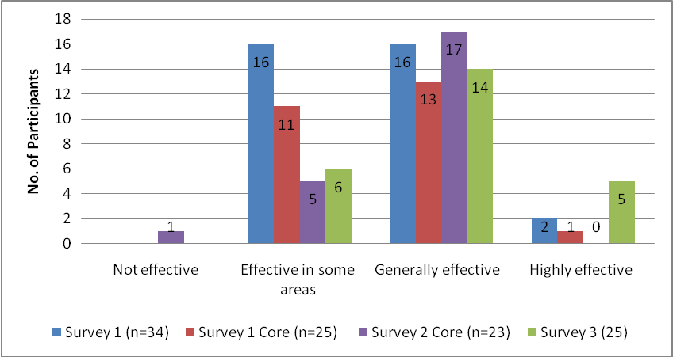
Figure 13: Teacher perception of effectiveness at teaching the TL

4.3.2 Observed effectiveness of teaching
One of the main aims of the TPDL programme is for teachers to encourage student TL interaction, one of the key Ellis principles (see Table 5). The TPDL facilitators observed the teachers in the classroom throughout the course and reported that the majority were meeting the expected or accelerated standards in providing opportunities for students to interact in the TL (Thomson, 2009). The researchers also saw some successful instances where teachers set up lessons so that students were fully engaged in extended interaction in the TL. For example, one class played a game in TL in small groups with a supporting list of formulaic expressions to refer to, which enabled them to use the TL throughout the game.
As well as observing successful examples of teachers providing opportunities for learners to interact in the TL, it is also important to note that the researchers saw other situations where the teacher’s intention for learners to produce the TL was not always fully realised. This was not because the students did not have the necessary TL, but because the teacher did not deliver the activities effectively. As well as being founded on the Ellis principles, successful lessons require systematic delivery which depends on the scaffolding of activities, clear and staged instructions and the monitoring of students. Scaffolding, monitoring and instructions are general principles of good teaching which become particularly important in the language teaching classroom where subject knowledge (the TL) is also the language of instruction.

Scaffolding
In several cases, teachers gave sufficient language input but then asked the learners to engage in tasks without sufficient scaffolding. On some occasions, the case study teachers did not provide sufficient opportunities for students to practise the language before being asked to complete a detailed task. For example in one lesson, learners had TL input on I am Polish, I am a New Zealander, but because the teacher did not provide opportunities for students to become familiar with the new words and phrases, the students quickly fell back on using English when they started the activity.

Instructions
In a number of cases the researchers noted there could have been more effective student output of the TL if the teacher had provided clearly staged delivery of instructions. In one observed lesson the task was for students to order food in a café. The students were organised into groups and given worksheets with listed food items. The teacher modelled the activity and then set students off in pairs. However many of the students did not complete the task effectively as the teacher’s instructions were not clear. Many students did not fully engage in the task because they were not aware they had to take the role of the waiter and the customer. Consequently they did not get the desired amount of TL practice.

Monitoring
As well as giving carefully staged instructions it is important that teachers monitor students once the task has begun. Some students need extra support in starting activities, which if they understand from the beginning, will ensure they keep up with the group and successfully complete their task. The researchers noted in several case study classes there was very successful monitoring. Even in very lively classrooms where students went off task, the teacher quickly brought them back to focus through constant, vigilant circulation. However, in other classes there was insufficient monitoring. In one case the teacher concentrated on one small group of focused learners. This resulted in not all students attempting the task, and some of those that started not continuing. Instead they became disruptive, but were ignored by the teacher. In another class, disruption also arose through lack of monitoring resulting in the teacher cutting short the activity and admonishing the whole class. In both cases, a proportion of the class had no useful language practice.
It is clear from Milestone Report Six that teachers on the course were exposed to models for effectively setting up activities. Instructions to facilitators of the first group meeting regarding presenting workshop activities to the TPDL participants were: ‘In the way you present/demonstrate the following activities, please model how you would expect them to do so with their classes (i.e. using TL for instruction, management and social interaction)’ (Thomson, 2008c, Appendix 9). However, many teachers need more opportunities to analyse the complexities of scaffolding, giving instructions and monitoring. This would assist teachers in providing the best opportunities for students to have the maximum TL output.
In addition, teachers who are less fluent in the TL need more useful TL instructional language (e.g. Here is…, listen to me, say these words, what do you say, talk to your neighbour, who do you talk to? etc). Increased teacher facility in using the TL provides students with more useful TL input and reinforces student TL learning. One case study teacher wanted to use more TL. However, she mentioned the unreliability of online translation facilities for classroom management instructions. As a beginner learner of the language she needed somewhere she could quickly go to obtain reliable translations for the instructions she wanted to use with her class.
To summarise, a lack of clear scaffolding prior to students working on a task, a lack of clear staged instructions in setting up interactive tasks, and lack of careful monitoring of students during tasks resulted in minimal student TL output in some observed classes.
Three areas where TPDL could focus more on these necessary skills are in language group meetings, the facilitator feedback and observation form, and in the planning template. In the language groups, the facilitator could not only introduce the activity and relate it to the Ellis principles, but also analyse and unpack the staging and techniques used for delivery. Another way would be to include a section on teacher delivery on the newly introduced planning template. Milestone Report Eight notes the effectiveness of this planning template and indicates TPDL is considering extending and improving the template (Thomson, 2008e). There is an opportunity here to focus teachers on their use of TL in the management of activities. A third way to ensure this is addressed is to include on the facilitator observation form ‘Evidence of ‘principles and strategies’, how teachers scaffold, give instructions and monitor ensuring maximum student output. Milestone Report Eight notes in the minutes of the TPDL team meeting term three that this form is in the process of revision and re-ordering of points for implementation in 2009 (Thomson, 2008e).

4.4 Factors that foster teachers gaining second language teaching knowledge
The researchers have identified from survey and case study data the following factors that teachers suggest foster their gains in knowledge of how to teach an additional language (Table 7).
Factors that foster second language teaching knowledge(x number of participant comments) | Sample teacher comments
In class observation and feedback (x7) | - Mentoring from my observation tutor.  - Observation tutoring particularly helpful – prompted reflection about effectiveness of different teaching strategies.  - Feedback about my specific situation helped improve my teaching.  - The classroom visits were positive and gave a specific time to reflect on my teaching of TL.
Theory (x7) | - Ellis principles.  - The pedagogy with tutor.  - Learning the theory of effective language learning.
Practical ideas (x6) | - Activities gave me some good ideas to use in class.  - Worksheets useful.  - Getting ideas of what to do with my students.  - Sessions on activities for vocabulary were of immediate help.
Being a language learner (x4) | - Meeting with and sharing language learning experiences with other teachers.  - Being a learner.  - Interacting with other beginner learners.  - Reminding myself of language instructions.
Tutor support (x3) | - Support and encouragement from all tutors.
Studying the curriculum (x3) | - It’s given me a good understanding of the curriculum.
Action research (x3) | - Action research.
Discussion (x2) | - Invaluable discussion with colleagues.  - Meeting some awesome practitioners who have been only too willing to share their professional knowledge about how they teach the TL.
Table 7: Teacher perception of most beneficial factors for language teaching knowledge
(Note: Combined data from survey 3, question 6 (What did you find most useful in your language study course? n=20) and question 82 (What aspects helped your language learning and language teaching the most? n=24). There was no duplication of respondent answers between the questions. Where respondents made comments on more than one aspect, all comments have been categorised and included.)
The qualitative feedback indicates that having a balance of theory (academic readings) and practice was seen as useful by participants. While some respondents noted the theory as the most helpful, others focused on the benefits of the practical experience such as classroom practice, observation and practical ideas for teaching. Teachers, like students, have different learning styles and the balance of theory and practice on TPDL seemed to suit teachers’ different learning styles. While teachers identified the above factors as useful in their development of second language teaching knowledge, it is important to keep in mind that these factors may not necessarily change their teaching practice, particularly in regards to promoting immediate improved outcomes for diverse learners (Timperly, Wilson, Barrar & Fung, 2007).

In-class observation, feedback and support
Support from TPDL facilitators was a significant factor that helped teachers gain more understanding of how to teach a language. Observation feedback and discussion with the facilitators and tutors was increasingly valued by most participants throughout the course (see Figure 14).
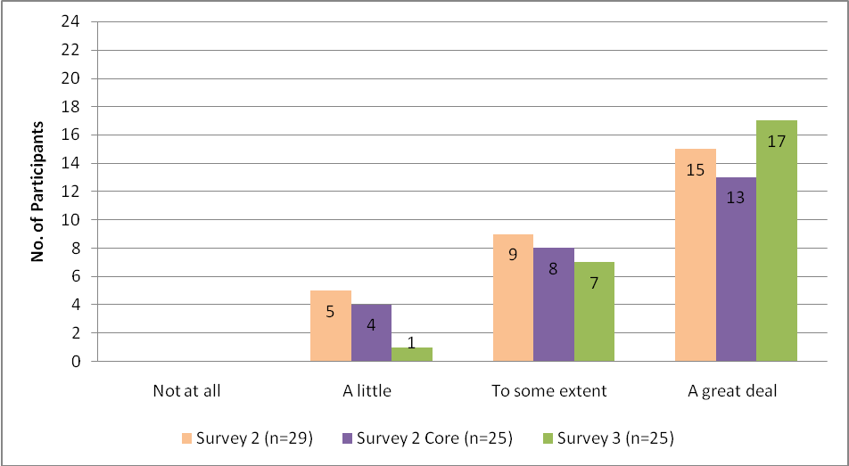Figure 14: Perceived helpfulness of TPDL tutor feedback and discussion
Survey and case study interviews showed that tutors were both challenging and supportive. One participant commented early on in the programme, ‘…I’m not sure what they want me to do – they want me to let go, but I’m too experienced to throw out the bath water and the baby’. Another case study teacher enthused, ‘… [TPDL facilitator] is wonderful - I’m on cloud nine after she has been’! The influence of facilitator support was linked with the powerful experience of being observed and receiving feedback on teaching. The feedback and discussion on teaching provided an opportunity for teachers to reflect deeply on their particular teaching context. One participant noted a direct link with an improvement in her own teaching, ‘Feedback in my specific situation helped improve my teaching’. The comprehensive form used by the TPDL facilitators for giving feedback clearly focused on language input, language output and teacher providing opportunities for student interaction (Thomson, 2008e, Appendix 10). Using this form contributed to consistent, constructive feedback to TPDL participants.

Experiential learning: being a language learner, discussing and gaining practical ideas
It is useful to note the link the teachers made between learning a language and understanding how to teach a language. Having to consider language learning from the language learner’s point of view rather than their usual position as teacher was seen as valuable. Participants noted how useful it was in their language classes to receive feedback on accuracy of language and to have the opportunities to use the TL with their classmates. As well they appreciated opportunities to get ideas, worksheets, other resources, and cultural information from the language learning classes that they could then apply to their own immediate teaching situation. The opportunity of being a language learner was available to the majority of TPDL participants. However, those bilingual and fluent speakers of the TL who were not required to study the TL missed out on the language learner experience.
One particular factor noted earlier on in the course was the usefulness of teachers working together with other colleagues in language group meetings. During the four language group meetings participants experienced being a language learner in a supportive environment. They had opportunities to try out language learning activities with follow up discussion and reflection time as well as examination of the underlying principles. As well, the language group meetings provided opportunities for the teachers to discuss what they were doing in the classroom and to exchange resources and ideas. From the discussion and reflection, teachers took these ideas back to the classrooms and put them into practice with their own learners.

Ellis principles
The Ellis principles (Ministry of Education, 2007c) were mentioned in response to several questions in the research study. Their usefulness was noted early on in the course, when the participants were introduced to the ten provisional principles for language learning and teaching (see Table 5, p. 26). Both the survey respondents and case study teachers frequently reported how useful these principles were in helping them plan and evaluate their lessons from the beginning of TPDL. One case study teacher, who had previously taught the TL for one year using the Ministry of Education Learning Language Series (LLS) text, commented:
When doing my lesson plan, I’m keeping in mind the principles and thinking of where I have, in my lesson, the input, the output, the formulaic expressions, the meaningful context. And I try to get a mix of listening, speaking, reading and viewing. This is the biggest change. Instead of just following the [Ministry of Education resource], I’m looking critically at the lesson plan and thinking how can I incorporate whatever the lesson is light on.
Mid-course another teacher said ‘…I’ve done a lot with the Ellis principles. I review and revisit the principles. I use them to plan my lesson. I ask myself, what do I start with first?’ At the end of the course, three of the case study teachers noted how useful the Ellis principles were in guiding their teaching and helping them increase their knowledge of how to teach a second language.
Studying the new curriculum was also identified as a useful factor in helping teachers develop their language teaching. It provided teachers with broad goals for teaching, through statements of student achievement objectives and expected language and cultural knowledge. The usefulness of studying the curriculum is further reported on in Chapter Five.

Action research
Other aspects that helped teachers learn how to teach an additional language were reading about methodology and exploring the theory of language teaching. Readings around areas of interest led teachers to choose action research projects related to their own students and contexts. Teachers particularly mentioned how much they learned through undertaking the action research project. Milestone Report Nine Appendix 14 provides a list of course participants’ inquiry learning topics (Thomson, 2009). One teacher, for example, looked at whether three short lessons a week were more effective than one long lesson. Another looked at how many words students could learn within a set time period. This application of theory to practice confirms Lightbown ‘… it is only when [newly trained teachers] have tried out some of the pedagogical applications suggested by SLA research that they will understand what it really means for their own teaching context’ (2000, p. 453).

4.5 Factors that hinder teachers gaining second language teaching knowledge
As well as considering what factors foster gains in knowledge of how to teach an additional language, survey respondents were asked to identify aspects of the programme that made it difficult for them to develop language learning and teaching skills. This question was also explored in the case study interviews.
Table 8 shows the survey three (n=20) participants’ responses to the question on factors in the programme that hindered their gain in second language teaching knowledge. Before discussing these factors, it is important to mention that nine teachers commented that there was nothing in the programme made it difficult for them. One teacher said, ‘If anything, it pushed me to extend myself’. However, other teachers mentioned factors that did make it difficult for them to develop their teaching. The lack of time and aspects of the observation visits were the main areas of identified difficulty. Other aspects teachers commented on were resources, pedagogy and TPDL lecturer availability.
Factors that hinder (x number of participant comments) | Sample teacher comments
None (x9) | - Nothing. If anything, it pushed me to extend myself.
Workload /lack of time (x6) | - Time spent travelling.  - I felt a long way behind everyone else, which was quite demotivating.  - Nothing. However this was on top of a demanding teaching/administration workload and I found the year exhausting.  - One of the things the course does not take into consideration is that most of the course participants have a lot of other subjects to deal with and they have just not got the time or energy to devote solely to the course.  - School focus was literacy and numeracy ahead of language.
Observation visits and expectations (timetabling)  (x3) | - The visits for observations were not realistic. The expectations didn’t fit with the timetable of the class learning, didn’t respect the makeup of the class.  - The fact that it expected students to communicate very early in the course before they had time to acquire much vocab. With only two hours a week I found the students forgot a lot in between lessons and I felt the progress was very slow.  - Stressful observations, given other teaching commitments.
Too much pedagogy (x2) | - Too much emphasis on pedagogy (not enough for language learning).  - Some weekend pedagogy sessions became boring – could be shortened.
Lack of resources for Asian languages (x1) | - Few resources - only one other person doing my TL and she was a native speaker.
Assignments (x1) | - (No explanation).
Availability of lecturer (x1) | - I was very frustrated when I was not able to reach (tutor) when I was doing my research.
Table 8: Factors that made it difficult for teachers to develop language learning and teaching

Time/workload
Not unexpectedly, many teachers mentioned time and workload as a real problem for them. Full-time teachers found they had a lack of personal time. They reported working long hours each week to keep up. They were studying the language at night time, and the pedagogy in block courses which included some Saturdays. For some the course required them to travel quite long distances to attend sessions. As well, they were being regularly observed, and felt they wanted to prepare lively, interactive lessons with appropriate, engaging resources for their learners to demonstrate their new learning. Finding, adapting and preparing resources was time-consuming. One teacher commented, ‘… Saturday is my laminating day.’
The school timetable was also another factor that was limiting some teachers’ ability to implement their new learning. In the Years 7-8 classes, there were prioritising issues. In several cases the teachers were aware they were consciously prioritising the TL at the expense of other subjects while they were on the course in order to try out language teaching activities and to complete the TPDL requirements. In other instances, teachers were finding it difficult because of the demand of other curriculum subjects and the strong school focus on literacy and numeracy, science and IT. It was often difficult to schedule enough time for language teaching. One case study teacher commented, ‘Finding 45 minutes to maintain TL teaching each week is hard as it’s the first thing to get bumped off , to meet the requirements for literacy, numeracy and inquiry learning.’ This is confirmed in Milestone Report Nine with the comment that language learning was not given a regular time throughout the year and students were disadvantaged because of it. Thomson states, ‘Every one of the In-School Facilitators is able to cite cases of being greeted by the teacher at Visit 4 with a comment such as ‘we haven’t had a lot of … TL since your last visit’’ (2009, p. 19). This was also confirmed by one researcher whose case study teacher was available for the final interview but could not offer a class for observation because she was no longer teaching TL to the class.

Facilitation visits and expectations
Teachers of Years 7-8 also commented on the facilitator visits in connection with their acquisition of language teaching knowledge and skills. One teacher reported that observations were stressful. Two others made comments about the somewhat unrealistic expectations of TPDL observation visits. One felt that her students were expected to communicate before they had sufficient knowledge of vocabulary. Another teacher commented that what she had to do in the facilitator visits did not fit in with her class learning.

Other factors
Of the other comments from survey respondents, two need mentioning: the lack of TPDL resources for Asian languages, and the lack of guidance with the action research project. One teacher commented that teachers of languages other than Asian languages seemed to get ‘heaps of resources.’ The resources were sometimes translated from one European language into her Asian TL, but a further complication was that when she got the translated resources, they were not at the right level for her learners. Two case study teachers said that although they benefited from completing the action research project, they had difficulties understanding the scope and standard of what was expected. Most teachers at this level would not have adequate grounding in defining a research question, in research methods (and specifically action research), nor on consent procedures for working with students, nor did TPDL appear to offer these skills.

4.6 Conclusion
The majority of the teachers in the study were experienced general classroom teachers, and two thirds had had some prior instruction in how to teach a language. The impact of TPDL on the teachers’ second language teaching knowledge is considered in two main areas: understanding SLA and understanding how to teach an additional language. The research data indicates that teachers perceived they gained in knowledge about how students learn an additional language. The researchers’ observations of case study participants support these findings. Teachers demonstrated knowledge of the Ellis principle of providing input. Mostly, case study teachers used the TL to deliver some or all of their lessons and manage their classes. Those teachers who were more proficient in the TL were provided richer language input than those who were less proficient. Teachers also exposed students to TL through a range of other resources. As well as providing TL input, case study teachers demonstrated knowledge of other Ellis principles by providing opportunities for TL output and opportunities for students’ TL interaction.
With reference to teachers’ knowledge about how to teach an additional language, the teachers perceived they had gained knowledge about how to do this and that they had increased their level of effectiveness in teaching. Case study observations revealed that teachers had made positive changes in their implementation of the Ellis principles by the end of the course. However, in some observed cases application of the Ellis principles did not result in maximum student TL output and TL interaction because of insufficient scaffolding, clear instructions and monitoring.
Many aspects of the TPDL programme fostered teachers’ gaining knowledge of how to teach a language. The key contributing components were a balance of practice and theory. Practical aspects included in-class observations and feedback, practical ideas, facilitator support and discussion. In addition, being a language learner helped teachers gain knowledge of learning and teaching. Theoretical aspects mentioned particularly were the Ellis principles and the academic theory component of the action research project. As well as positive comments about the impact of the programme on teachers’ second language teaching knowledge, there were some factors that hindered gains in knowledge. Time was a pressure for some TPDL participants. Moreover, in Years 7-8, participants sometimes felt they were prioritising language teaching time at the expense of other areas of the curriculum. In two cases, teachers noted that the expectations of observation visits were difficult to meet.
In spite of the factors that some participants perceived as hindering their learning, overall the majority saw the impact of the programme on their teaching as being very positive. The TPDL programme enabled the participants to gain second language teaching knowledge through offering a theoretical framework and a wide range of practical experiences.
Recommendations and implications for the TPDL programme
- Teachers gain insights into pedagogy through being language learners themselves, so providing opportunities for advanced or bilingual language teachers to briefly study a new language could be considered.
- TPDL needs to focus on three general principles of effective lesson delivery (scaffolding, instructions and monitoring) and highlight their importance for the language teaching. This could be achieved and modelled in language group meetings, the facilitator feedback and observation form, and in the planning template.

Chapter Five Impact of TPDL Years 7-10 on the teachers’ knowledge of the learning languages area of The New Zealand curriculum (2007) and specific curriculum guidelines

If connections are made between the curriculum, and pupils’ daily lives… pupils are more likely to see the relevance for them (Stoll et al., 2003).

5.0 Introduction
For teachers of additional languages it is important that they understand the central place of communicative competence in the generic framework for teaching and learning languages in English medium schools (Ministry of Education, 2007c), as well as the other key factors that contribute to the framework. These are cultural knowledge (of native and diasporic TL communities and societies) and intercultural competence (the ability to communicate and socially engage effectively with people from languages and cultures different from one’s own). Teachers also need to be able to interpret and work within the individual specific language guidelines. This chapter analyses the impact of TPDL on teachers’ knowledge of the Learning Languages area of the curriculum, their knowledge of the specific curriculum guidelines and their understanding of language communicative competence and cultural knowledge.

5.1 Teacher knowledge of the learning languages area
The New Zealand Curriculum (2007) (Ministry of Education, 2007a) was introduced to the TPDL participants early on day one of the EDPROFST360 course and Thomson (2009) reports that at this stage there seemed to be a low level of teacher experience with this document. Three quarters of the primary teachers stated that ‘they did not use it, had not seen it, or were confused by the curriculum and the Learning Languages Series’ (Thomson, 2009, p. 16). The researchers investigated teacher knowledge of the Learning Languages (LL) area of The New Zealand Curriculum (2007) through surveying respondents’ perceptions about their knowledge, and through further questions in interviews with case study teachers. In observations researchers also considered aspects of the framework that were being implemented. A comparison of survey one and survey three data shows a notable increase in teachers’ perceptions of their understanding of LL (see Figure 15).
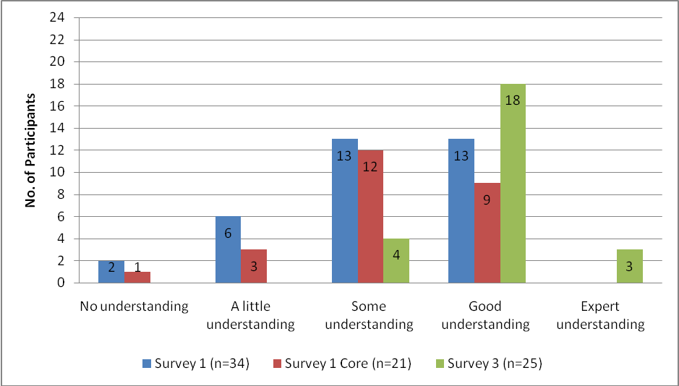
Figure 15: Teacher perceptions of extent of knowledge of Learning Languages area of curriculum
The first survey gathered data around the time participants started the EDPROFST360 course. The data (see Figure 15) showed that four of the 21 core respondents said they had ‘no’ or ‘a little’ understanding of the LL area of The New Zealand Curriculum (2007). Twenty one indicated ‘some’ understanding or ‘good’ understanding. In the case study interviews, when asked about how they thought the TPDL programme would impact on their classroom practice, one teacher specifically mentioned ‘the curriculum’. Other teachers referred to the curriculum in different ways, for example, it will ‘change the focus of pedagogy to a more student-centred approach’ or it will provide ‘better teaching strategies to make learning more meaningful’. One case study teacher commented that it was taking a while to understand all the new curriculum terminology. Between the first and third survey there was a definite shift in teachers’ perceptions of their understanding of the LL area of The New Zealand Curriculum (2007). Data from survey three indicated just four people reported they had ‘some understanding’, 18 had a ‘good understanding’ and three teachers considered themselves ‘expert’.
When survey respondents were asked mid course about the effect of TPDL on their classroom practice, there was a mention about the curriculum. Several respondents made comments about their developing knowledge of the new curriculum, for example, ‘I can see that learning achievement is incorporated into the programme. The progression of learning is highlighted … that is, where to next?’ Case study teachers also made a range of comments and a theme that emerged was the breadth of the new curriculum document. Some case study teachers initially saw this as worrying because they did not know exactly what to teach. However, others saw it positively as they felt that it gave them more scope in their classroom teaching. Several teachers mentioned the links they were making between the old and new curriculum and their developing confidence. One teacher reported, ‘I used to wonder what was going on with the curriculum. Now I can talk the talk’. Another comment indicated the teacher was making links with TL learning beyond the scope of the TPDL programme, ‘I’ve learned curriculum knowledge and made connections to Year 11’. At the end of the course, five case study teachers said they were working well with the LL area, while two teachers felt they needed more support as the curriculum was not sufficiently detailed. Chapters five and seven give examples of where teachers are implementing key aspects of the curriculum.
TPDL assessment results confirmed that teachers had gained new knowledge of the LL area of The New Zealand Curriculum (2007). According to Milestone Report Nine, the TPDL teachers focus on the LL area of the curriculum through the EDPROFTST360 paper (Thomson, 2009). Thomson (2009) also indicates that teachers’ knowledge of the LL area was assessed through a comprehensive test of their understanding of The New Zealand Curriculum (2007) as well as their ability to align a unit from the Language Learning Series (LLS) to the Ellis principles. Teachers were provided with pre-test practice and given feedback and feed-forward on their results. Milestone Report Nine reports that all participants passed the final curriculum test which was open-book and held in class (Thomson, 2009). Milestone Report Nine also reports that by the end of the course teachers understood the difference between the curriculum document and the LLS (Thomson, 2009).

5.2 Teacher knowledge of specific language guidelines
As well as being asked about their knowledge of the LL area of The New Zealand Curriculum (2007), teachers were also asked through surveys and interviews about their knowledge of the curriculum guidelines in their specific language. It is important to note that at the time the research was being conducted new guidelines were in a revision phase and had not been published. It was not clear when researchers surveyed and interviewed teachers whether they were discussing the old guidelines or the new ones which some may have seen. The likelihood, however, is that teachers were working with the unrevised guidelines.
The increase in teachers’ perceptions of their knowledge of the specific language guidelines was similar to their increase in knowledge of the new curriculum (see Figure 16). To begin with, five respondents indicated they had a ‘good understanding’, but by survey three 15 said they had ‘good’ and two said they had ‘expert understanding’.
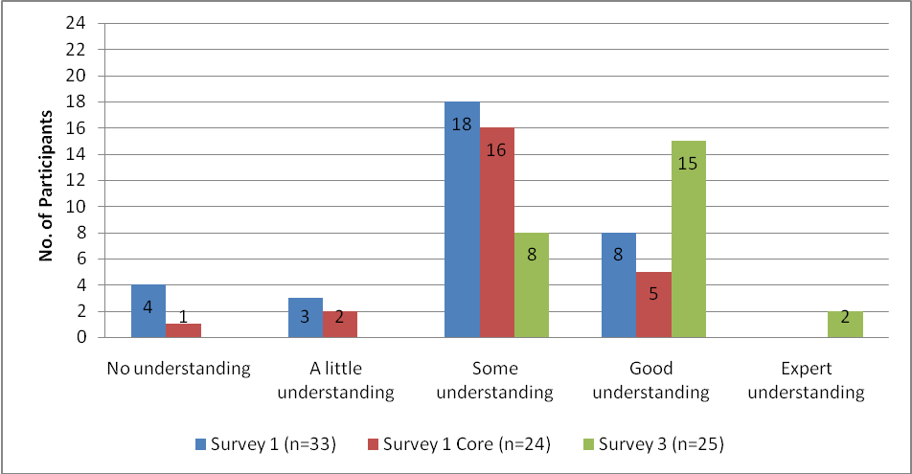Figure 16: Extent of teacher knowledge of specific language guidelines
Some case study teachers throughout the course commented on the specific language guidelines. One teacher indicated that she was now aware that specific guidelines for her TL existed. Two people commented on the links they were making between the TL guidelines and the LL area of the curriculum, and as one of them said, ‘…the new curriculum document is quite open, like an umbrella. So now I use my TL guidelines to fill in the gaps’. The final interview question on what use teachers made of the specific TL guidelines drew a range of responses. One teacher said they used them because they had many practical examples within a context. Another teacher said of the guidelines, ‘they are easy to navigate, they are precise and I use them for assessments’. The answers from the five other case study teachers indicated the guidelines were useful but they did not give examples of how they used them.

5.3 Language and cultural knowledge
The Knowledge Awareness section of the LL area of the curriculum has Communicative Competence at its core and states ‘In learning languages students learn to communicate in an additional language … and explore different world views in relation to their own’ (Ministry of Education, 2007c). Communicative Competence is supported by two components: Interacting Making Meaning and Knowledge Awareness. Knowledge Awareness comprises two further strands, Language Knowledge and Cultural Knowledge, both of which have equal weighting in the framework (Ministry of Education, 2007c). In addition, the framework elaborates on how the language knowledge and cultural knowledge areas are structured (Ministry of Education, 2007c). Cultural Knowledge at levels one to four (the levels of students in Years 5- 10) involves students firstly recognising and then describing the organisation of the target culture. It also involves students making links between the target culture and their own, and then comparing and contrasting cultural practices (Ministry of Education 2007c).
Crozet & Liddicoat, (1997) observe that culture needs to be explicitly taught in the language learning classroom. Byram, Gribkova & Starkey suggest that cultural teaching should not just be ‘the transmission of information about the foreign country’ but rather it should be ‘more concerned with the human relationships and identities of speakers in the target culture context’ (2002, p. 10). Students should be encouraged to make a comparative analysis with their own culture and to reflect on the differences in order to come to a deeper awareness of their own cultural boundaries, reactions and understandings (Byram et al., 2002; Crozet & Liddicoat, 1997). Language teaching therefore needs to integrate an intercultural dimension so speakers are able to not only acquire a linguistic competence but also an intercultural competence enabling a shared understanding and an ability to interact with other intercultural speakers (Byram et al., 2002).
Opportunities provided by teachers for learners to develop Cultural Knowledge
With respect to the Language Knowledge strand in the Generic Framework (Ministry of Education, 2007c), there is some evidence that TPDL teachers were helping students develop their knowledge of the TL to meet communication achievement objectives (see chapter seven). However, this is not so clear cut for the Cultural Knowledge strand. The findings from surveys, interviews and observations indicated that teachers were developing students’ cultural knowledge and intercultural skills in fairly limited ways. In survey one, only one of the 33 respondents said she made a specific link between language and culture, mentioning that she hoped TPDL would provide a structure for exploring the language and culture. In survey two and three, when asked about the TPDL programme impact on their classroom practice, no respondents mentioned knowledge of culture. Thomson (2009) in Milestone Report Nine noted that some teachers who were new to learning the language were initially worried about the Cultural Knowledge strand of the curriculum. In the first interview, two case study teachers mentioned using DVDs and the internet to introduce cultural aspects into the lesson. However, although these materials were observed being used, a more explicit connection could have been made to help students to recognise the organisation of the target culture and to make connections with their own culture(s). As Stoll et al. (2003) note, for students to see the relevance of language learning they need to make connections with their own lives.
After interview one, the researchers became aware of the lack of focus by teachers on developing students’ cultural knowledge. This was therefore explored in interviews two and three through questioning teachers about the main aims of the last lesson they had taught. As can be seen in Table 9, the teachers’ responses were predominantly related to language and communication.
Teacher | Interview 2 |  | Interview 3
 | Language/  communication aims | Cultural aims | Language/  communication aims | Cultural aims
Teacher 1 | - Students to take ownership of own learning.  - Learn and practise new vocabulary.  - Develop student confidence in communicating in TL. |  | - Extended teaching practice.  - Review of formulaic expressions.  - Revision of parts of the body.
Teacher 2 |  | - Cultural knowledge  – deepen students’ understanding of TL people & countries.  – looking for similarities and differences in TL film. | - Focus on form (perfect tense).  - Teaching grammar more explicitly.  - Group work to pair work to individual.
Teacher 3 | - Revision.  - Preparation for summative test.  - Reading for comprehension.  - pronunciation and listening. |  | - Students to be introduced to new vocabulary by need (not list).  - Students to have shared their words with group and done task in TL. | - Students to recognise difference between NZ and TL climate and seasons.
Teacher 4 | - Practise formulaic phrases.  - Revise colours.  - Practise clothes vocab through listening and writing. |  | - New formulaic language.  - Revise greetings.  - Grammar: word endings.  - Vocabulary: names of countries; I am v. I’m from. | - Students to be aware of difference between nationality (I’m from NZ) and cultural identity (I’m Samoan).
Teacher 5 | - Introduce new vocabulary.  - Move kids along in relation to TL. |  | - Learners to communicate in TL (food likes and dislikes).
Teacher 6 | - Learn adjectival phrases.  - Learn vocabulary for school subjects.  - Asking and answering questions.  - To help their oral production. |  | - To introduce and get students to learn weather phrases.
Teacher 7 |  | - Students to experience the cultural aspects of welcoming people and TL etiquette around food. | - Vocabulary: animals, colours.  - Grammar revision: I like.
Table 9: Main aims of last lesson taught
Data from interview two revealed that while five teachers had language aims, only two teachers had explicit cultural aims for their last lesson. It is interesting to note that teachers’ aims at this stage of the course were either linguistic/communicative or cultural, that is language and culture were being taught discretely. Findings from interview three indicated that five teachers had linguistic/communicative aims only, while two teachers had both linguistic/communicative and cultural aims. Over the 14 interviews there were only four mentions by teachers of having cultural aims in their lessons.
In the four instances where case study teachers had cultural aims, they were diverse. One teacher wanted her high school students to watch a TL film and look for differences and similarities with students in New Zealand and the target culture. Another teacher planned for her students to understand the special rules around mealtime and sharing food. One teacher wanted her students to be able to recognise the difference between seasons in the TL country and NZ. The fourth teacher introduced appropriate TL structures for students to talk about themselves so that they could become aware of the difference between nationality and cultural identity. These four teachers showed a developing awareness of the importance of including cultural aims in their lessons. However, there were still three case study teachers who, by the end of the course, had made no mention about having cultural aims in their lessons. They may have had an intention to include aspects of culture, but this was not made explicit to the researchers in interview.
Although there were no stated cultural aims for many of the observed lessons, aspects of cultural teaching were however, recorded by researchers. For example, one teacher was observed linking TL fairy stories and English fairy stories before students read the story in the TL and then acted the parts, having noticed the different sounds animals make in different cultures. In addition, there was visual support with a map of the TL country to locate where the story took place. In another observed lesson, a different case study teacher made incidental references about the target culture so that her students made links with their own culture. For example, the teacher drew the students’ attention to the use of the same concept (‘cauliflower ears’) in both languages to describe large ears. The teacher then contextualised this vocabulary through reference to the All Blacks and the current rugby relationships between the two countries.
In some classes opportunities for full exploitation of the ‘teaching moment’ in terms of cultural and particularly intercultural knowledge were lost. For example, in one class, students learned vocabulary for a wide range of school subjects studied in the TL culture but the teacher did not take this further by asking students to compare and contrast the subjects studied in the two different countries. In another observed class, the teacher provided a task for students to learn clothes vocabulary. Students had to draw a washing line of clothes and name the items of the clothing in the TL. However, there was no mention of the practice of drying clothes (strung up between apartment blocks) in the TL country and possible reasons for these differences. Visual illustrations of clothes drying in the TL country could have helped learners to recognise the links and differences between cultures through understanding more about accommodation and lifestyles in urban areas.
There was only one instance of a teacher providing opportunities for students to develop intercultural competence. This teacher introduced aspects of teenage life in two cultures (TL and New Zealand) through a discussion comparing teenager curfews and parental rules when socialising. Thus there was a greater critical focus on human relationships and identities of speakers. Milestone Report Nine notes two examples where TPDL participants explored the link between cultural and communicative aspects of teaching in their action research projects. One teacher organised language learning through cultural themes and the other developed an intercultural unit for her TL class Thomson (2009).
Factors influencing teacher provision of opportunities for learners to develop cultural knowledge
Several factors may influence teacher provision of opportunities to develop students’ Cultural Knowledge: the qualities and skills teachers bring to the course, the presentation of Cultural Knowledge in the Generic Framework (Ministry of Education, 2007c) and the TPDL course content. The qualities and skills that teachers brought to the TPDL course contributed to their ability to focus on culture in their lessons. In observed case studies where lessons involved culture and language, researchers found one or more of the following factors: high teacher proficiency in the TL, previous teacher experience in the target culture or strong teacher appreciation of the target culture. Harnessing and developing teachers’ language background and experience and attitudes to the target culture will help to foster their ability to develop their learners’ cultural understanding and intercultural competence. Personal experience and an enthusiasm and deep appreciation of the target culture were factors that enabled some teachers to understand and incorporate the cultural knowledge strand into their teaching. As noted by the researchers and Thomson (2009), teachers who had visited or lived in the target culture or had had some motivational catalyst were able to considerably enrich lessons for students. They provided opportunities for them to make links with their own lives, and in one notable case (Thomson, 2009), raise students’ awareness of their own culture and surroundings. Another key to improving the development of teachers’ cultural knowledge lies in the way culture is presented in the Generic Framework (Ministry of Education, 2007c). As mentioned above, the document includes both Language and Cultural Knowledge. The elaboration of Cultural Knowledge however is not supported with principles in the same way as the Language Knowledge strand is. The lack of a clear supporting framework may make it difficult for teachers and teacher educators to interpret the cultural knowledge intent. Milestone Report Nine revealed the TPDL directors had an awareness of the need for a greater intercultural dimension to language teaching (Thomson, 2009). A focus in the framework (which we understand is presently being developed) could facilitate educators firmly embedding cultural knowledge, including intercultural competence, into the TPDL course content. Teachers then could be expected to engage with a set of intercultural competency principles in the same way that they embraced those presented by Ellis (2005b).

5.4 Factors that hinder or foster teachers’ knowledge of the learning languages area of the curriculum and specific language guidelines
Several factors emerged that foster or hinder teachers’ knowledge of the curriculum and their understanding of the language-specific guidelines. The focus and time spent on the curriculum in the TPDL programme on the EDPROFST360 was seen as useful for all but one of the case study teachers. One teacher mentioned that the clear explanations and tutor expectations helped her understanding. So also did the curriculum discussions on the course and the links made with what teachers were doing in their classrooms. One case study teacher said that ‘pulling apart’ the new curriculum document to understand it more fully was very helpful, while several teachers found the comparison of the old curriculum with the new valuable as well. A comment from a survey two respondent summed up many teachers’ learning, ‘…though I still have some queries about the new curriculum … and the future NCEA External Assessments, I am now clear about how the new is different from the old’.
Another factor that helped foster understanding of the curriculum was the test within the EDPROFST360 paper. This test focused on teachers demonstrating knowledge of how to practically align teaching materials with the LL area of The New Zealand Curriculum (2007). The test did not assess the cultural knowledge strand, but as noted in Milestone Report Nine, the intention is to do so in 2009 (Thomson, 2009). Initially, engaging with the curriculum was challenging for some case study teachers. One teacher commented early on that it was taking her a while to understand all the new terminology. Another teacher said the new curriculum was difficult to interpret and she was unsure about what she had to teach. Two teachers commented on the pressure they felt with the forthcoming curriculum test. However, once they had sat and passed the test and seen the practical application, its value was confirmed, and teachers had very positive comments, ‘I’ve got my head around the new curriculum … it was a good test to see if we could apply it.’ This deep processing required for teachers to be able to apply the curriculum principles, along with the pre-test practice and the final test requirements helped the teachers to gain a strong understanding of the curriculum document.
Survey respondents also mentioned they gained further understanding of the curriculum through professional development set up within their own schools and personal reading they did around the topic. One case study teacher found the curriculum easy to work with from the beginning and was able to integrate TL guidelines into the key concepts of The New Zealand Curriculum (2007) document before she attended the TPDL course. She therefore felt that a lot of the TPDL time spent on the curriculum was ‘a waste of time’ and that teachers should already be familiar with the framework. However, overall the case study teachers felt positive about their developing knowledge of the curriculum as a result of the TPDL course.

5.5 Conclusion
Indications are that the teachers perceived they made considerable gains in their knowledge of the LL area of The New Zealand Curriculum (2007) and in their understanding of the language-specific guidelines. Analysis and discussion, readings, the curriculum test, and prior cultural experience, were all factors that fostered new and improved understandings of the curriculum. With reference to introducing aspects of culture into their classes, there was a range of findings. Some of the case study teachers were observed introducing aspects of culture, while others missed opportunities to make the target culture relevant to learners’ lives. Teachers were able to apply aspects of language knowledge from the curriculum, but were less successful in applying aspects of the cultural knowledge strand. Respondents did not indicate any significant factors hindering their learning of the curriculum. However the researchers note the lack in teacher development of the learners’ cultural knowledge as outlined in the Cultural Knowledge strand of the curriculum. As Byram et al. comment, ‘Being exposed to the target culture is an absolute must for any learner/teacher’ (2002, p. 10). There needs to be a greater focus in the TPDL programme on Cultural Knowledge and a clearer exploration of culture and intercultural competence for TPDL participants, both theoretical and applied. Milestone Report Nine notes the intention for TPDL directors to include questions on cultural knowledge in the EDPROFST360 curriculum test, suggesting there may be a much greater focus on this area in future TPDL courses (Thomson, 2009). Assessing participants’ ability to incorporate an intercultural dimension into their teaching will help to ensure that teachers have integrated linguistic, communicative and cultural aims in their lessons.
Recommendations and implications for the TPDL programme
- The following components of the EDPROFST360 paper were useful in developing teachers’ knowledge of the curriculum and should continue to be a key part of the TPDL programme:
  - Close analysis of the new curriculum, and comparison with the old curriculum.
  - The practical application of the curriculum to classroom learning.
  - The formative and summative test aligning the curriculum with classroom learning.
  - Multiple opportunities over time to study the curriculum.
- The TPDL programme would benefit from the following:
  - Including a component which enables participants to reflectively and critically engage with their own cultural identity and to plan how they might teach intercultural competence in their language classes.
  - The inclusion of a set of principles within the Generic Framework to help teachers interpret and apply the Cultural Knowledge strand of the curriculum, for example through incorporating intercultural aims into lesson planning.

Chapter Six The perceived impact of TPDL on student learning and outcomes

Opportunities for teachers to engage in professional learning and development can have a substantial impact on student learning (Timperley, Wilson, Barrar & Fung, 2007, p. xxv).

6.0 Introduction
A key focus of the TPDL research is evaluating ‘the effectiveness of the programme in improving learning opportunities and outcomes for students of languages’ in Years 7-10 (Ministry of Education, 2007b, p. 4). Chapter five reports on TPDL participants’ increase in their knowledge of teaching pedagogy and effective classroom practice. As Alton-Lee suggests, ‘quality teaching (is) identified as the key system influence on high quality outcomes for diverse students’ (2003, p.89). This chapter analyses the impact of TPDL on students’ language learning, experiences and outcomes. It is important to note that the design of the study has not enabled the researchers to collect data on individual student academic achievement and learning; and that findings are limited to teachers’ perceptions both through the case studies and surveys, as well as milestone report data.
The term ‘outcomes’ encompasses more than academic achievement outcomes. It also includes social outcomes such as an enhanced sense of personal identity, improved self-esteem, and more positive attitudes towards learning as well as improvement in interactions with both fellow students and with teachers (Timperley et al., 2007; Guskey, 2002; Thomson, 2008a and 2009). Outcomes can also include increased student engagement, development of learner independence and acquisition of language learning strategies. The latter is of significance since the vision articulated in the LL area includes (alongside learning to communicate in an additional language and exploring different world views) development of students’ ‘capacity to learn further languages’ (Ministry of Education, 2007a, p. 24).
The following sections report on the impact of TPDL on student learning, achievement in learning languages and on student motivation. They describe teachers’ views on what they believe the majority of their students know and can do in the language, and how they are assessing and reporting progress made by their students. Pertinent at this point is an awareness of the distinction between learning and achievement. Some teachers in the study appeared to lack an awareness of this distinction. Poskitt and Taylor argue that the nuanced difference between the two is important.
In simple terms, learning is the process or experience of gaining knowledge or skill. It can be likened to the journey towards a destination…. By contrast, achievement refers more to the successful completion of something (especially by means of exertion, skill, practice or perseverance). It can be likened to arrival at a destination (2008, p. 14).
Moreover, any discussion of student output should be considered in the light of the classroom context; the primary and intermediate school context (Years 1-8) is significantly different to that of the secondary context (Years 9-13). One key difference is the amount of time dedicated to language teaching and learning; although there are variations across schools, researchers noted primary and intermediate schools generally timetabling one period weekly of 45 minutes (and this could be for one, two or more terms), while secondary schools timetabled three periods of 50 minutes per week or thereabouts for the year. The length of time students have studied the TL is another significant contextual factor. The LL area has eight levels of achievement with students who have no prior knowledge of the language, beginning at Level 1. ‘Curriculum level 1 is the entry level, regardless of school year’ (Ministry of Education, 2007c). Students learning languages at primary and intermediate schools are likely to be at Level 1 as could be those students in Year 9 who are learning the language for the first time. Obviously the proficiency descriptor for students at Levels 1-2 and corresponding expectations of language knowledge and cultural knowledge will be considerably lower than expectations of students who have studied the TL for several years and who are at Levels 3-4 or higher. These differences have implications for teachers and students. Students with more learning time over the year are likely to make better progress and realise higher levels of achievement than those who are taught for just one period a week for two terms.

6.1 Perceived impacts of TPDL on student learning
Initially in this section, teachers’ perceptions of overall student learning are discussed and then this is followed by comment on teachers’ perceptions of their students’ learning of specific skills and knowledge. Survey data showed that teachers’ expectations of students’ learning were higher towards the beginning of the TPDL programme than at the end of the year when TPDL was completed. As shown in Figure 17, in comparing the responses of teachers who responded to both the first and final surveys, the majority of teachers (21 of 24 respondents) in the first survey believed that their TPDL learning would have ‘considerable’ or ‘high’ impact on the majority of students’ learning. However, the final survey revealed that only 14 of 24 respondents saw their learning as having ‘considerable’ or ‘high’ impact. Corresponding with this decrease was an increase in the number of teachers who thought the programme would have only ‘some’ impact on their students’ learning.
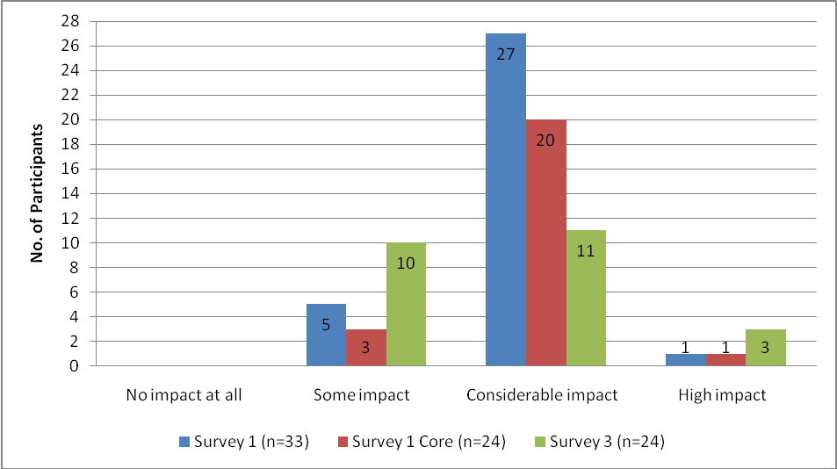Figure 17: Teachers’ perceptions of impact of teachers' TPDL learning on student learning

There are a number of possible reasons for this difference between initial high expectations and lower perceptions at the end of the course. As indicated in Chapter four, initially survey respondents when asked to indicate how they expected the programme to change their practice, anticipated that the main impact would be increased TL proficiency. Subsequent surveys showed a shift in teachers’ perceptions with an increasing focus on the pedagogical aspects of the classroom and their developing classroom skills (see 4.2.1). However, although teachers in the survey reported less optimism about the effects of TPDL on overall student learning, other sources indicated a more positive picture. Milestone reports, in particular the observations by the TPDL facilitators, and the case study observations undertaken by the researchers, suggested improved student outcomes across several areas. The following sections describe these in more detail.

6.2 Perceived student use of the TL
TPDL’s stated aim is to develop teacher language proficiency and second language teaching capabilities in order to improve student language learning outcomes in Years 7-10 (Thomson, 2009, p. 1). The facilitator visits had a strong focus on teacher and student use of the TL. This data is ‘discussed with teachers in learning conversations focused on maximising student learning and outcomes’ (Thomson, 2009, p. 5). Facilitators who observed lessons in the fifty TPDL teachers’ classrooms recorded their observations using three progress standards which are considered critical components of effective language teaching and learning: TL input, student (oral), TL output and meaningful (oral) communication (Thomson, 2009, p. 14). As noted in Chapter four, the expected and accelerated progress standards under each of the three categories is raised for each visit. Of particular relevance to this chapter is student TL usage; almost 20% of classes in visit four demonstrated accelerated progress in student TL usage while 70% of classes in visits three and four showed expected progress (Thomson, 2009, Appendix 26). Similarly, the final milestone report on 2007 (Milestone Report Four) reports that in 30 of 31 classes (Years 7-8), student utterances in the TL had qualitatively and quantitatively improved through the year (Thomson, 2008a, p. 10).

6.2.1 Perceptions of students’ ability to understand and use familiar expressions and engage in interactive tasks
Survey questions asked about teachers’ perceptions of their students’ abilities to use common expressions and everyday language and engage in interactive tasks, to make connections between their own language and the TL and to recognise that the TL is organised in particular ways. Most survey respondents answered questions about levels one and two, with only six teachers in survey one and four teachers in survey three responding to those questions relevant to levels three and four. Several of those teachers also answered the questions related to levels one and two indicating they taught across all four levels.
One of Ellis’ principles for effective instructional practice is that teachers need to ensure that learners develop ‘a rich repertoire of formulaic expressions’ (2005a, p. 33) since these play a key role in language acquisition particularly at the early stages. In looking at the core group of teachers who answered both survey one and the final survey, the number of teachers who perceived that their students’ ability to understand and use familiar expressions and everyday vocabulary to a ‘considerable’ extent increased from one teacher (out of 23 respondents) in the first survey to almost a third of teachers (seven of 22 respondents) in the final survey. There was a corresponding decrease in the number of teachers who thought their students could understand and use familiar expressions and everyday vocabulary ‘a little’, that is 10 of 23 respondents in survey one to four of 22 respondents in survey three. The number of teachers, who believed the majority of their students could understand and use familiar expressions and everyday vocabulary to ‘some extent’, remained the same.
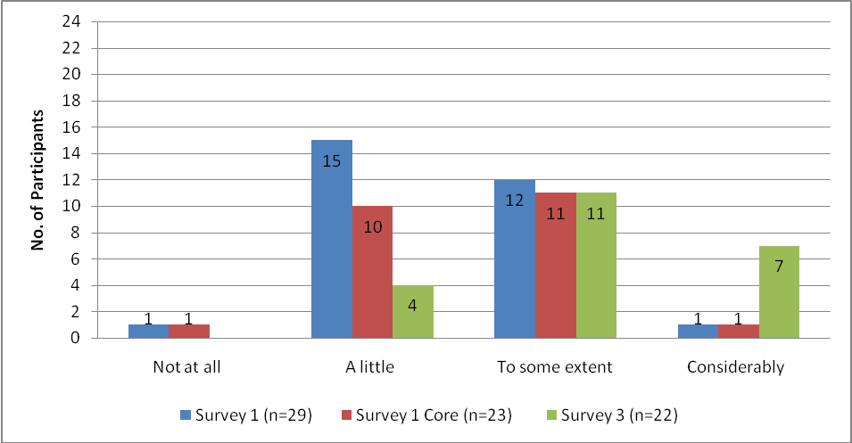
Figure 18: Teachers’ perception of students’ ability to understand and use familiar expressions and everyday vocabulary
In early case study observations, researchers noted the use of formulaic language by students mostly in predictable situations such as roll call and greetings. In some instances students were able to use formulaic language effectively in freer practice when well supported (e.g. with reference to cue cards). A number of classrooms also displayed formulaic chunks in the TL on large cards and posters so that students could refer to them and students were observed doing this. By the final observation, researchers noted some students using formulaic language both more often and more confidently in predictable situations such as if they were late, and in free language use for example, creating a role play.
Resonating with the above are milestone reports for 2006, 2007 and 2008 which reported increases in student TL production over the respective academic years. Milestone Report Nine (for 2008) reports baseline data (obtained in visit one) showing that in the majority of classes, either no formulaic language was heard or it was restricted to greetings. By visit four, in all but five out of 47 classes (i.e. 90%) student utterances demonstrated ‘substantial improvement in quality and sophistication’ and in almost 20% of classes, student TL use dominated and showed ‘a rich repertoire of formulaic expressions’ (Thomson, 2009, p. 12).
Alongside the increase in the use of familiar expressions and everyday vocabulary, survey findings (the core group of teachers who answered both survey one and survey three) demonstrated that the proportion of teachers who perceived the majority of their students as able to interact in a simple way in supported situations to ‘a little’ extent decreased from more than a third (nine of 23 respondents) in the first survey to four of 22 respondents in the final survey. Correspondingly the number of teachers who viewed their students as being able to interact in a simple way to ‘some’ or a ‘considerable’ extent showed a small increase over the three surveys from just under half (13 of 23 respondents) of teachers to more than four fifths (18 of 22 respondents) in the final survey.
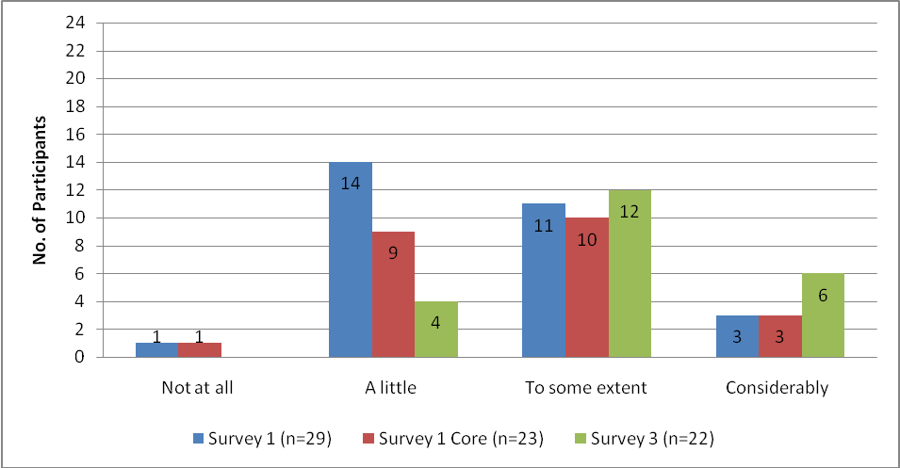
Figure 19: Extent to which the majority of students in teachers’ classes can interact in a supported way using the TL
This critical role of interaction is recognised in the new curriculum:
Interaction in a new language, whether face to face or technologically facilitated, introduces (students) to new ways of thinking about, questioning, and interpreting the world and their place in it. Through such interaction, students acquire knowledge, skills, and attitudes that equip them for living in a world of diverse peoples, languages, and cultures (Ministry of Education, 2007a, p.24).
But as Ellis points out, ‘creating the right kind of interaction for acquisition constitutes a major challenge for teachers’ (2005a, p. 41). As noted in Chapter four, case study observations showed teachers setting up group activities with varying degrees of success. This resonates with the baseline data obtained from the first visit to teachers’ classrooms by TPDL facilitators. Observations ‘showed no group or pair work and no opportunities for meaningful interaction in two thirds of classes’ (Thomson, 2009, p. 12). By visit four, facilitators reported that in 80% of classes, students were using the TL to negotiate meaning and in 37% of these classes, there was evidence of students taking ownership of interactions (Thomson, 2009, p. 2). Further data provided in the final milestone report for 2008 shows that close to 50% (n=24) of teachers visited were at the ‘expected’ level as regards providing opportunities for student interaction and 30% at the ‘accelerated’ level (Thomson, 2009, Appendix 26). In the final survey, most teacher respondents (75% of 24 respondents) indicated that the majority of their learners were able to complete TL interactive tasks set up in the classroom while 21% (five of 24 respondents) of teachers believed the majority of their students could do this ‘to some extent’. Case study observations showed some excellent examples of student interaction but unrealised opportunities were also noted. As stated in Chapter four, there is a need for increased scaffolding, clear and staged instructions and monitoring of activities in order to maximise the potential of interactions for effective practice.

6.2.2 Perceived opportunities for TL output and levels of student engagement (evidenced in classroom observations)
In the case study observations researchers recorded a variety of opportunities for output and levels of student engagement. Examples were seen of case study teachers encouraging TL output from restricted practice activities to extended TL interactions, with the former appearing to be more prevalent. The extent of student TL output and level of engagement observed by the researchers in a selection of activities is indicated in Table 9. High levels of student engagement were observed in restricted TL practice activities such as songs and acting out a play (script in TL provided) and in freer language activities, specifically games. However researchers also noted that in some free practice activities, teachers’ intentions for students’ TL output were not always fully maximised (see also 4.2.2). It is useful to briefly comment on the value of ‘games’; these are activities with a strong language focus where the TL is used purposefully and authentically. Reasons for their success in engaging students and providing opportunities for authentic language use include the competitive element, the rules or structure of the game which are familiar because students may have played similar games in their own languages as well as the opportunity to use repeated formulaic expressions in realistic contexts, for example, ‘it’s your turn’.
Class level | Activity observed | Extent of student TL output | Level of student engagement
Levels 5 -8 | Information gap  (groups) | Semi-restricted language practice: use of formulaic language to share likes and dislikes (food) for about 10 minutes. | Students totally engaged while teacher working with their group. Some other groups also engaged but about 40% of class off task at some point (needed more scaffolding in order to undertake the activity).
Levels 5 -8 | Songs  (whole class) | Restricted language practice: repetition with actions in some cases; 15 minutes of extended language practice. | High level of engagement; all students observed to be on-task.
Levels 5 -8 | Role play  (groups) | Free language practice: use of formulaic language for five minutes in groups using known and new formulaic language and then presentation of role play to class. | Most groups engaged and on-task but several were not able to produce the new phrase, relying instead on limited number of known phrases (needed opportunity to listen and repeat/choral repetition to build fluency).
Levels 5 -8 | Card game  (groups) | Free language use: use of formulaic language for extended period ( 20 minutes). Students provided with phrase cards as support. | High level of engagement by all students; students were forced to use the TL phrases to play the game.
Levels 5 -8 | Dialogue writing  (pairs) | Free language use based on a dialogue students had listened to earlier. | Some pairs used TL effectively in their dialogues while other pairs had difficulty and did not seem to have sufficient TL to undertake the task. Some off-task behaviour noted (needed more scaffolding).
Levels 5 -8 | Crossword  (individually) | Restricted language practice: students work individually to complete the crossword using familiar vocabulary; students could also access words from wall charts. | Some students highly engaged; others unsure what to do (needed further instructions in order to complete the task).
Level 9 | Writing article for newsletter in TL (groups) | Free language use: students access all known vocabulary and grammar as well as TL sources on internet and in books to write the article in TL (topic of their choice). Engaged for 35 minutes. | High level of engagement. Some groups wrote in TL while others wrote in English and then translated into TL. Teacher worked individually with groups and used TL almost exclusively. Students talked with teacher about TL in English.
Level 9 | Vocabulary building  (individually) | Restricted language practice; students needed to find vocabulary related to current topic and record; gave teacher one word answers. | Students on task and generally engaged but limited output; no reason to communicate or negotiate meaning.
Level 9 | Ordering sentences on cards making up a story; then read aloud (pairs) | Restricted language practice for 15 minutes. | Students highly engaged and on-task reading TL sentences aloud.
Level 9 | Acting out a play  (groups) | Restricted language practice for 20 minutes.  Opportunity to focus on pronunciation and fluency. | High level of engagement.
Table 10: Examples of opportunities for student TL output observed by researchers

6.2.3 Perceptions of other student learning outcomes and experiences
The impact of TPDL can also be seen in teachers’ perceptions of other student learning (other than language learning) that occurred as well as the impact on student learning experiences. The researchers noted that in some case study classes, teachers were encouraging the enhancement of learner independence and a culture of mutual learning and support. In one class for example, students were working in groups playing different language games. Once they had mastered the game, they then taught the rest of the class their game in the TL. In another class, learners led class activities in the TL (e.g. calling out colours for a game of colour snap). Students were also observed working in groups and undertaking mutual error correction on their group poster. At the end of one of the classes, students gave class and individual feedback on how well they had been able to do the tasks, with teacher input in the form of suggestions as to how students could improve their learning.
An analysis of impacts on student learning should also include the acquisition and use of language learning strategies since, as discussed in the introduction to this chapter, language learning strategies enhance acquisition and, being transferable, will have a positive effect on the acquisition of further languages. Chamot defines learning strategies as ‘the thoughts and actions that individuals use to accomplish a learning goal’ (2004, p. 1). As Table 11 shows, the most frequently used strategies observed by the researchers were recording new vocabulary in exercise books, and using other sources of TL information (e.g. wall charts, text books, sheets in exercise books and dictionaries).
Strategies observed | Instances across three observations
Recording new vocabulary in exercise books. | 14
Using other sources of TL information e.g. wall charts, text books, sheets in exercise books. | 9
Using dictionaries (including picture dictionaries), and internet translation software such as Language Tools (via Interactive Whiteboard) to find TL words. | 9
Reflecting on learning e.g. discussing how much TL was used and what they needed to know to play the game. | 3
Listening to teacher explain the purpose of activities. | 2
Guessing words using context. | 2
Learning vocabulary using laminated word cards. | 1
Using pictures to help remember words. | 1
Table 11: Language learning strategies used by students across three observations
Teachers were observed explicitly teaching strategies, for example encouraging learners to find vocabulary in dictionaries or on the internet, and teaching vocabulary learning strategies. In interview three, teachers also mentioned teaching students to use mnemonics and associations to learn vocabulary, making links between the shape of characters (for Chinese or Japanese) and meaning, discussions with students of ways to learn and the purpose of activities, looking for patterns, making links across other school subjects and looking for common words in English and the TL.
Finally, a further and very important outcome is the development by students of the Key Competencies (Ministry of Education, 2007a). Key Competencies are defined as ‘the capabilities people have, and need to develop, to live and learn today and in the future’ (Ministry of Education, 2007a, p.12). Teachers are expected to ensure that the Key Competencies, viewed as the ‘key to learning’ in every learning area, develop alongside language and intercultural skills. According to Crabbe, second language learning has a ‘unique contribution to make to the development of the generic key competencies’ (2005, p. 9). One Key Competency of particular significance to language learning and the development of intercultural competence is Managing Self. Involving far more than just organising oneself, this Key Competency is linked with the concept of identity. As students ‘move between, and respond to, different languages and different cultural practices, they are challenged to consider their own identities and assumptions’ (Ministry of Education, 2007a, p.24). Additionally this Key Competency involves students having the opportunity to enhance their sense of personal identity, ‘seeing themselves as capable learners’, as being able to undertake self-assessment, set learning goals, make plans and know how to act independently (Ministry of Education, 2007a, p.16).
The table below provides examples from case study observations where students applied Key Competencies. As can be seen in regards to Managing Self, although students were observed taking some responsibility for managing their learning, there was little evidence of developing intercultural competence.

Key Competencies | Examples of activities where students were observed developing the Key Competencies | Year
Thinking | - Answering questions relating to causes of differences between NZ and TL country’s climate.  - Asking questions about the language and culture.  - Making connections between own and target culture.  - Thinking about structure of the TL and making own corrections.  - Guessing meaning of new phrases and words. | 9  7
Using language, symbols, & texts | - Reading texts and identification of words related to different seasons.  - Using language orally and in written form.  - Use of ICT to access information. | 9  7  8 and 9
Managing self | - Working to time limits to complete activities.  - Finding opportunities to learn by locating vocabulary in dictionaries and internet resources.  - Able to work effectively in groups.  - Organising own written work. | 9  9 and 7  7, 8, 9  7,8. 9
Relating to others | - Group work: listening to each other contributions.  - Encouraging each other to present.  - Playing game co-operatively. | 9 and 7  7  7, 8, 9
Participating & contributing | - Building up class knowledge of climate and creating a group poster of the four seasons.  - Allocating parts and reading a play aloud in groups.  - Presenting a role play to the class.  - Producing (in groups) articles for a Class Newsletter (for parents) in TL on topics of their choice. | 9  7, 8  9
Table 12: Examples of students in case study classes developing Key Competencies
In terms of the perceived impact on student language learning experiences, case study teachers reported changes in students’ responses to their teaching. Final interviews with case study participants revealed that five of the seven teachers had noticed very positive changes in the students’ responses. As shown in Table 12, these changes were related to their students being more positive, confident, motivated and engaged. The remaining two teachers recognised their own teaching had changed (e.g. they reported more recycling of language and more focus on oral production) but had not noticed a change in students’ responses. One teacher, as noted in chapter four, is a first year teacher who admitted difficulty in noticing changes. She noted, ‘I can’t really compare because this is my first year. Some of the class are really interested and others aren’t but this is the same in other subjects’.

Case study teachers’ perceptions of changes in students’ responses (Interview three)
Increased student TL output (x 5)

- Greater uptake in speaking TL.
- More use of language outside the classroom – they see the practical applications of the language.
- Increased TL usage but need more time to practise.
- More independent learning, for example, one student found an idiomatic phrase for ‘you’re crazy’ and tries to use it in various situations.
- Use of the TL has grown exponentially especially with this particular topic of food.
Increased engagement /enjoyment (x4)

- Students can see the teacher is enjoying teaching so will buy in if they notice you have fun and are enjoying teaching.
- More engaged compared to the beginning of the year.
- Students are always very enthusiastic and have responded well.
- Students always pleased and eager for more.
Increased confidence (x2)

- Increased confidence to give it a go, especially the boys.
- Students not scared to speak.
No noticeable change (x2)

- Don’t think the students would notice any difference.
Table 13: Case study teachers’ perceptions of changes in their students’ responses
Earlier interview responses from case study teachers included changes such as students having more fun in their language learning, more student involvement with the language, greater use of formulaic expressions, students being more motivated and becoming more independent as language learners. One teacher, for example, reported that students were getting TL books out of the library while another talked of students not wanting to give up their TL lessons for other timetable subjects.
As discussed in chapter four, all case study teachers remarked on positive changes in their language teaching. In terms of teachers’ perception of their own effectiveness at teaching the TL, a considerable increase was reported (see 4.2.1) over the period of the programme. That this has impacted on student learning is indicated in the comment by one teacher who noted increases in student engagement, student output and motivation:
It has completely changed the way I teach my language class ... I am also using task based activities as much as possible which has really engaged the students. Finally, I am letting go of the ‘direct teaching’ in class by providing more student directed activities which has shown an increase in student production of the TL instead of me talking all the time. This programme has changed my whole approach which has made the experience exciting for me and my students.

6.2.4 Perceived impact of TPDL on students’ learning: Cultural Knowledge strand
As discussed in chapter five, making connections between students’ own cultures and the target culture is a new component in The New Zealand Curriculum (2007). The Cultural Knowledge strand talks of students learning about culture and the interrelationship between culture and language.
They grow in confidence as they learn to recognise different elements of the belief systems of speakers of the target language. They become increasingly aware of the ways in which these systems are expressed through language and cultural practices. As they compare and contrast different beliefs and cultural practices, including their own, they understand more about themselves and become more understanding of others (Ministry of Education, 2007c).
It appears from observations and interviews that for many teachers this is proving to be a challenging shift. In terms of students’ ability to recognise that the target culture is organised in particular ways, survey one showed almost half of teacher respondents (12 of 23 core respondents) perceived that the students in their classes had ‘no’ or ‘a little’ recognition that the target culture is organised in particular ways. However, there was an increase from survey one to the final survey, with almost three quarters of teachers (15 of 21) in the final survey viewing their students as having this recognition to ‘some extent’ or to a ‘considerable extent’ and a corresponding decrease to six respondents perceiving the majority of their students having ‘no’ or ‘a little’ recognition.
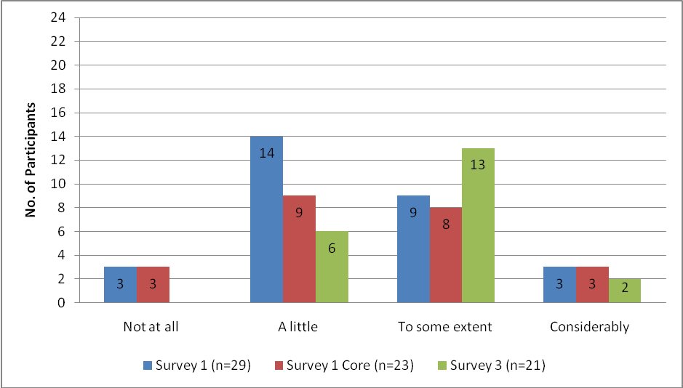
Figure 20: Teachers’ perceptions of recognition by most students of organisation of target culture
Similarly, the proportion of teachers, whose students were able to make connections with the target culture to ‘some extent’ and ‘considerably’ increased. In the observations of case study teachers, researchers noted teachers making connections such as linking the use of waiata to tell stories and songs in the TL and inviting native speakers to the classroom. The statement from one teacher reported in an interview is an example of linking cultural knowledge with language teaching:
When we were doing modal verbs, I used the context of youth culture i.e. what you are allowed to do and not do in (country) as a teenager e.g. you can go clubbing as a 16 year old in (country) but you have to be home by 12.00. We made comparisons with NZ… so activities revolved around how you would say that in TL.
However, although researchers observed some effective opportunities for students to make links between their own cultures and the target culture, case study observations also noted missed opportunities for students to make explicit connections. One such example was when students watched a video which showed TL speakers greeting each other. Discussion of what is appropriate in greeting people in the TL culture accompanied by comparisons with students’ known cultures would have maximised the opportunity for making cross-cultural links.
Overall, students did not appear to be getting many opportunities to make cultural connections. This may be for two reasons: firstly because as noted previously, teachers do not yet seem to have a robust understanding of the new curriculum as regards the emphasis on cultural knowledge and the movement to intercultural competence. Moreover, TPDL in 2008 did not appear to have much of a focus on this other than its inclusion in the Evidence of Principles and Strategies form used by facilitators when observing the classes (Thomson, 2009, Appendix 15). In Milestone Report Nine, Thomson (2009, p. 16) mentioned cultural knowledge but it is not obvious that ‘making connections’ or ‘intercultural competence’ were integrated into the programme. Secondly, it is important that teachers themselves are interculturally competent. As Byram points out, ‘Language teaching with an intercultural competence dimension presupposes that teachers themselves will have acquired intercultural communicative competence to a reasonable level’ (2008, p. 83). A stronger focus on this competency in TPDL and accompanied by opportunities to participate in immersion experiences would be beneficial to improving opportunities and outcomes for students.

6.3 Perceived impact of TPDL on student achievement
The perceived impact of TPDL participants’ learning on student achievement is a difficult area to comment on given the data available (limited to teachers’ perceptions). In terms of the perceived impact of TPDL on student achievement, there is a decrease between teachers’ expectations in the first survey and their perceptions in the final survey. When comparing responses for the core 23 teachers who answered both survey one and the final survey, around three quarters (18 of 23 teacher respondents) believed their TPDL learning would have ‘considerable’ or ‘high’ impact on student achievement. The final survey showed a decrease with almost half of the teachers in the third survey (12 of 23 respondents) seeing the TPDL learning as having ‘considerable’ or ‘high’ impact and close to half indicating only ‘some’ impact.
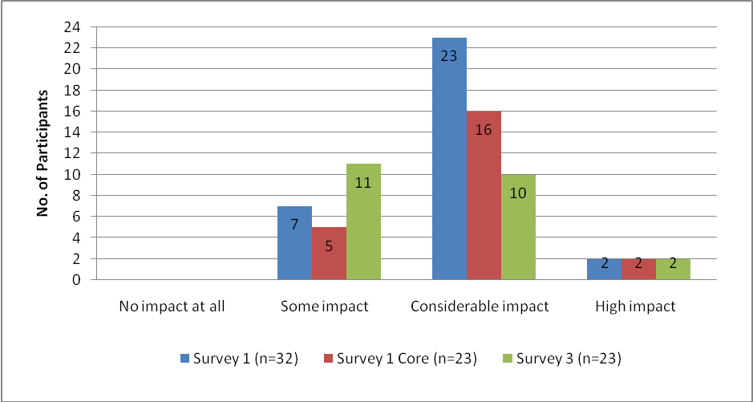
Figure 21: Teachers’ perceptions of the impact of TPDL learning on student achievement
The final survey also asked teachers for examples of the impact of the programme on their students’ achievement. Twenty two teachers responded and of these, the majority (18) listed increased student use of the TL and/or increased TL output quality. Table 14 summarises their responses. Note that some teachers recorded several examples.

Impact | Number of teachers who listed the impact | Teachers’ comments on how the programme impacted on student achievement
Increased use of TL by students /  increased quality of TL output | 18 | - Students are greeting and chatting in L2 in the playground.  - Students show interest in extending their L2 knowledge for their own day to day use.  - Increased fluency and knowledge of TL (formulaic expressions).  - Greater use of formulaic expressions has helped the more diffident to communicate orally.  - They have moved from single words to formulaic chunks to full sentences and multi-clause sentences.  - More language heard in class formally and informally.  - Students are able to write letters about themselves and their families.  - Increased willingness to use the TL.  - Increased use of task-based learning. Suits boys particularly.  - Communicative skills have improved with more task-based learning.  - Due to students knowing exactly what and why they are doing things, they produce better results.
Students’ enjoyment,  enthusiasm and  motivation | 8 | - Students are asking for extension activities.  - Higher achieving students are more motivated to learn.  - Insistence on use of TL is self-perpetuating motivationally.  - Retention appears to be much higher in this group for 2009.
Confidence | 2 | - More confident and enthusiastic about speaking.
Recall | 1 | - Students are recalling more language.
Table 14: Teachers’ examples of the impact of the programme on their students’ achievement

6.3.1 Assessment of student progress in learning languages and what accounts for these practices
Hattie and Timperley argue that the importance of assessment to successful learning and teaching cannot be underestimated:
Effective teaching not only involves imparting information and understandings to students (or providing constructive tasks, environments, and learning) but also involves assessing and evaluating students’ understanding of this information, so that the next teaching act can be matched to the present understanding of the students. (2007, p. 88).
In this section, types of assessment and means of reporting are discussed. It should be noted that there is variability across primary, intermediate and secondary schools as regards recording achievement in the TL. This varies from no requirement to the regular recording of achievement. This is perhaps not surprising given the different school contexts as well as individual school requirements.
Survey data shows that both formal and informal assessments of students are undertaken by teachers. The surveys indicated that formal assessment of students’ progress was achieved through a variety of means: speaking tests were used most frequently followed closely by listening, vocabulary and writing tests. Grammar tests were the least used means of assessing students’ progress. From the interviews with case study teachers, it appears the tests were generally written by the teachers and based on classroom learning.
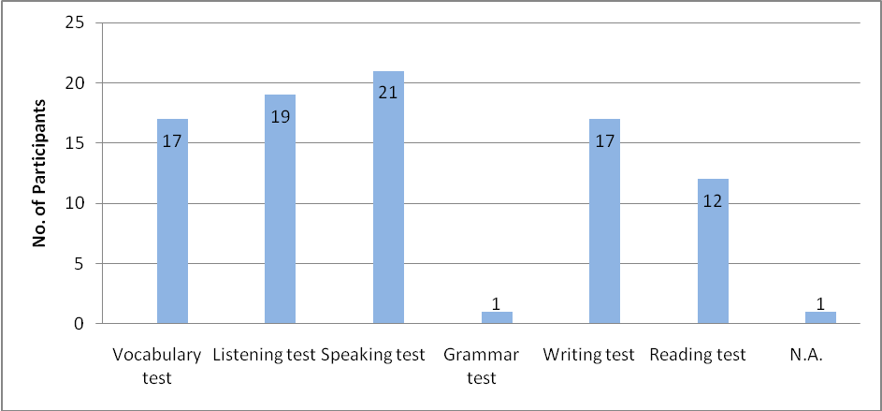
Figure 22: Means by which teachers assess students’ progress formally (Survey 2) (Note: Teachers responded to more than one category)
Interview data showed teachers of classes at levels one and two used more informal assessment, for example ‘through conversation as I monitor the class and through checking of exercise books’. In the observations of case study teachers, all demonstrated considerable use of informal feedback given in the TL to individuals and to groups/class as a whole. As indicated in Table 15, case study teachers had a range of responses when asked about their assessment practices, from no formal assessment (only informal oral assessments during the lesson) through to one-to-one conferencing with students (Year 7) and regular formative assessments with summative unit tests set by the department (Year 9). In one class, students were asked to self-assess at the end of the unit (Year 7). Another teacher gave an end of year exam assessing listening, reading and writing as well as assessing oral language where students used digital voice recorders (Year 9).

Milestone Report Nine reported evidence of an ‘increased awareness of the importance of formative assessment’ (Thomson, 2009, p. 17). Of the 21 responses to the post-test survey (undertaken as part of EDPROFST360), all teachers undertook some kind of student assessment but this was largely of oral production with less than a quarter undertaking some kind of written test. The data showed evidence of a shift in formative assessment with about 75% in the post-test survey reporting monitoring individual students as they worked in pairs/groups (as opposed to teachers asking individual students for an answer to a question they posed (Thomson, 2009, p. 18). Given the importance of assessment as (along with quality teaching) ‘at the heart of increased student engagement, learning and achievement’ (Poskitt & Taylor, 2008, p. 10), TPDL could benefit from an enhanced focus in this area.
A majority of teachers (22 of 27 respondents in the second survey and 15 of 23 respondents in the final survey) recorded the results of formal tests twice a term. Although three of 27 teacher respondents in the second survey were not keeping any records of formal testing, this had decreased to just one teacher by the time of the final survey. This is reflected in Milestone Report Nine which reports anecdotally that Years 9-10 teachers have a greater awareness of the importance of diagnostic testing while Years 7-8 teachers have increased awareness of ‘the importance of reporting on student achievement in the TL and the inclusion of TL language work in students’ portfolios’ (Thomson, 2009, p. 17).
For 14 of 24 teacher respondents in the final survey the results were made known to parents and 10 teachers submitted test results to the Head of Department (HOD) or Principal. No teacher reported submitting results of formal tests to the following year TL class teacher which potentially has implications for student transition to higher class levels. Table 15 shows how case study teachers were assessing students’ progress and also indicates how the progress was reported. Teachers of students at Years 5-8 tended to have no requirement to report student progress while teachers of students in Years 9-10 upwards had more formal means of reporting progress. The table indicates a range of reporting methods, from no formal record, through to regular recording in either mark book or electronic database. One teacher kept a duplicate copy receipt book and after one-to-one conferencing with a student she gave them a copy of her comments. Two Years 7-8 teachers took advantage of school portfolios to include results of TL tests and or school work. In some cases assessment records went into school reports. One HOD used results in a Board of Trustees report and several teachers commented on the use of assessment records to inform further planning. One teacher intended for her students to take a record of their learning to their language class the following year.

Year | How students’ progress is being assessed by case study teachers  (From interview two) | Method of reporting progress by case study teachers  (From interview three)
Years  5 -8 | No formal assessment (x2).  Informal oral assessment – Assessing as teacher monitors the class (x2).  Checks students’ books and gives feedback (x2).  Other:  - 1:1 conferencing on a weekly basis (School policy) where the language is assessed.  - Prepares pre-tests for new units of work.  - Self assessment by students at the end of units.  In Action Research project, teacher noted students’ questions and answers using formulaic language and gave individualised feedback. | - No formal requirement to report at the school (x2).  - Has recorded comments (positive for all children).  - Plans to report informally at end of year learners’ ‘fete’ and students may receive a certificate at the end of the year.  - Parents may get feedback at the 3-way conferencing.  - End of year report will have comments on what students can do in the TL.  - Comments in intermediate general school report for able TL learners only  - Next year, teacher plans to report on all students in the school report.  - School prize for TL student.  - Results of assessment (e.g. asking students for colours at the weekly 1:1 conferencing) written in duplicate receipt book and gives a copy to students to show them what they know.  - Database to track raw data from pre- and post-tests.  - Portfolio of all school work including language learning (x2).  - Written TL samples included in student portfolios for Secondary school.  - Would like to extend her Action Research project so that she can give feedback to parents on student output.
Year  9 | Assesses all four skills with this level.  Gives unit tests and mini-orals, with students using digital voice recorders saving files on the computer.  The end of year exam assesses listening, reading and writing.  Formative tests all the time (e.g. vocabulary tests).  Summative unit tests (departmental tests). | - Exam results in form of grades are entered on school database and reported in school report. Includes detailed suggestions to parents on ways they can support their children in language learning.  - Records students’ progress in electronic mark book and uses this to give feedback and feed-forward to students.  - Reports to parents both in Progress Report and in end of year report with grades and comments.  - Also reports to HOD who writes reports for School Board.  - Reports at Parent/teacher interviews with Year 10 students and makes recommendations regarding students continuing with TL study.
Table 15: How case study participants are assessing and reporting on progress of learners

6.4 Perceived impact of TPDL learning on student motivation
As discussed in chapter three, motivation is known to have considerable impact on second language acquisition (Dornyei, 2000). In this section, teachers’ perceptions of the impact of TPDL on student motivation is explored first through the eyes of the TPDL teachers and then in light of researchers’ observations of case study teachers and interviews with them. Survey respondents perceived that nearly all of their students were ‘motivated’ or ‘very motivated’ to learn the TL.
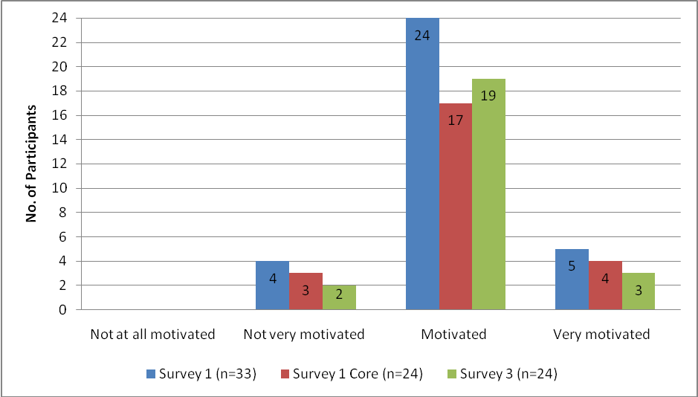
Figure 23: Teachers’ perceptions of the extent of student motivation to learn TL
A level of student motivation was also confirmed by the researchers’ observations and interviews. Observations revealed varied examples of students being enthusiastic and engaged in a number of activities, requesting more class time on TL learning, and asking questions about the language and culture.
Two thirds of teachers (limited to the core group who answered both the first and final surveys) in the first survey (17 of 24 respondents) expected that their learning would have ‘considerable’ or ‘high’ impact on the majority of students’ motivation while six respondents believed it would have ‘some’ impact (see Figure 24). In contrast, in the second and final surveys, this was reversed. About one third of teachers in the final survey (nine of 24 respondents) indicated ‘considerable’ or ‘high’ impact and almost two thirds (15 of 24 respondents) viewed the programme as having ‘some’ impact on their students’ motivation. This downward trend resonates with those findings discussed earlier in the chapter where teachers’ initial expectations exceeded what they perceived as actually occurring at the time of the second and final surveys. Interestingly when a cross tabulation was done, there was a positive relationship between teachers’ level of motivation to learn the TL and their perceptions of their students’ motivation to learn the language.
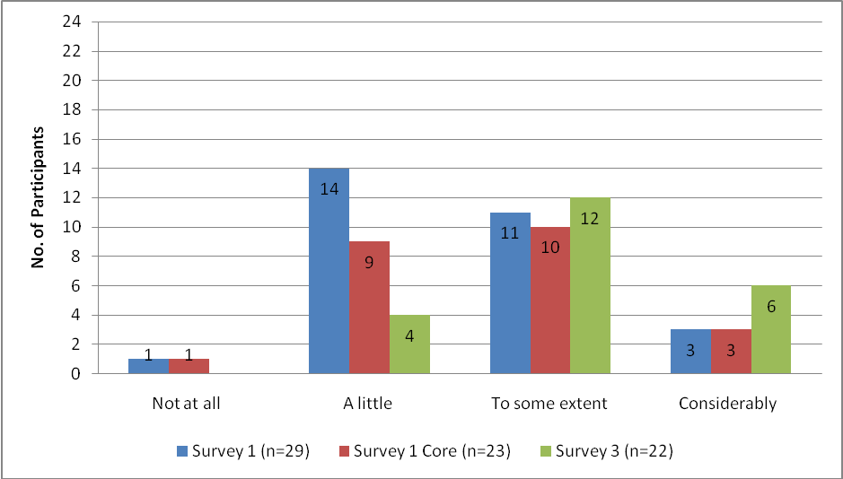
Figure 24: Teachers’ perceptions of the impact of TPDL programme on students' motivation

6.4.1 Student motivation and student contact with TL and culture
A more recently researched extension to motivation is ‘willingness to communicate’ (WTC) which also plays a significant role in second language use and hence acquisition. Dörnyei argues that generating a willingness to communicate is ‘a central, if not the most central objective of modern L2 pedagogy’ (2001, p. 51). Figure 25 reveals that the majority of teachers (21 of 24 respondents) who responded to the final survey perceived that the majority of their students were ‘willing’ or ‘very willing’ to communicate in the TL. Researchers’ observations also showed that students were willing to communicate i.e. to use the TL with each other and with their teachers.
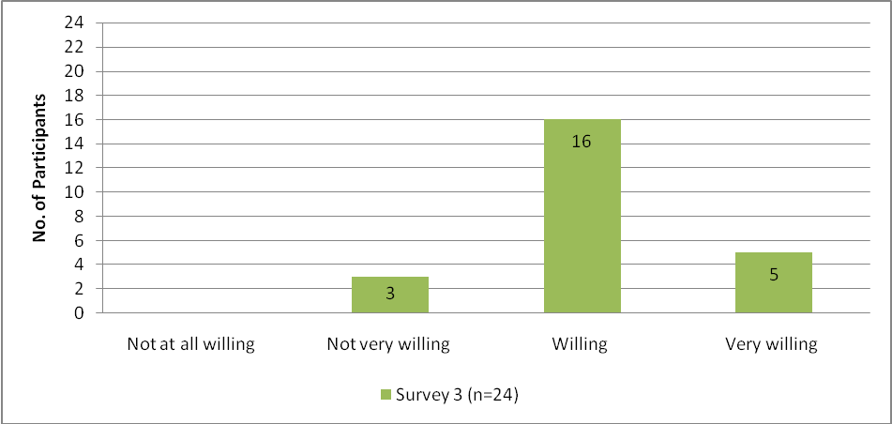
Figure 25: Teachers’ perceptions of students’ willingness to communicate
Motivation and willingness to communicate can be enhanced through contact with the TL and culture (Csizér & Kormos, 2008). It is unclear if the TPDL programme explicitly explores how student motivation can be enhanced, however given its importance in language learning, the programme could well benefit from a heightened focus on motivation and WTC. Survey data, observations and interviews with teachers indicated that their students have considerably more opportunities for a number of indirect TL cultural contacts mainly in the form of the internet, books, movies/DVDs and magazines than opportunities for direct contact with the TL community. In terms of direct spoken contact, less than half of the teachers surveyed (24 respondents), reported opportunities for their students to have direct contact with TL expert users such as visitors from TL countries while very few respondents reported direct written TL contact. The final survey also indicated that 66% of teachers’ classes had no access to a native speaker language assistant.
Indirect TL contact | Number of opportunities
Internet | 18
Books | 14
Movies/DVDs | 14
Magazines | 13
TV | 4
Direct spoken TL contact
In NZ with TL expert users | 11
Visit to TL country | 5
Direct written TL contact
Email | 2
Chat rooms in TL | 0
Post | 0
Table 16: Opportunities provided by TPDL teachers for their students to participate with the TL community
Classroom observations of the seven case study participants showed mainly indirect opportunities for students to have TL contact. Use of the Ministry-provided LLS, which provides multi-media materials designed for teachers and students who are new to language learning at Years 7 and 8 (Levels one and two achievement objectives in the curriculum) such as Sí! An Introduction to Spanish, were noted in a number of observations with teachers commenting on the usefulness of the accompanying videos, CDs and print materials. In regards to the Oui! An Introduction to French (DVD), one teacher commented ‘it does the things that I can’t do - it provides a springboard for further learning… also brings in cultural learning… it’s powerful’.
Other indirect opportunities observed included the use of songs in the TL from the Hello World website (Hello World, 2009) which provides TL games, activities and songs. One case study teacher reported in an interview that she used the internet to obtain authentic texts such as weather reports in the TL about the TL country, as well as international soccer results which were of interest to her class. She also took her students to TL films. Her students were observed accessing the internet themselves to locate information on the TL country’s results in the Olympic Games. However in general, case study observations showed limited opportunities for students to participate directly with the TL community. As noted in chapter four, two case study teachers had access to native speaker language assistants. Interestingly both teachers were the most fluent of the case study teachers. Increased direct participation has the potential to augment the quality of language learning opportunities and experiences for students and to further increase their motivation to interact in meaningful ways. This is an area TPDL could usefully make a contribution through for example, promoting the application process for language assistants, and raising teacher awareness of the benefits of technology-facilitated communication.

6.5 Conclusion
TPDL has resulted in changed teaching practices which in turn appear to have led to enhanced language learning opportunities and outcomes for students. Although some survey findings demonstrated there were decreases between teachers’ initial optimistic expectations of the impact of TPDL on the students’ learning, achievement and motivation and their perceptions of what they believed occurred by the end of the teaching year, other survey results indicated positive findings. These included teachers’ perceptions of increases in their students’ abilities to understand and use familiar expressions, to interact in supported situations, to complete interactive tasks and to recognise that the TL and culture are organised in particular ways. Positive outcomes for students were recorded from classroom observations and interviews by the researchers and from milestone reports. Gains other than those directly related to language acquisition as listed above, included some development of learner independence, some development of Key Competencies and a modest acquisition of language learning strategies. Most case study participants noted positive changes in their students’ responses to their teaching with the students being more positive, confident, motivated and engaged.
Most opportunities to participate with the TL community were of an indirect nature through the internet, DVDs, books and magazines. Few opportunities for direct contact were noted. However teachers perceived their students to be willing to communicate in the TL where opportunities arose.
In terms of assessment practices, findings revealed differences in the amount and type of assessment undertaken. Both formal and informal assessments of students were administered by teachers with teachers of students at Levels one and two undertaking more informal assessment. Formal assessment of students’ progress was achieved mainly through speaking tests followed closely by listening and vocabulary tests. Recording of students’ progress and achievement also showed considerable variation. For some teachers it was not a school requirement while others regularly recorded results of tests or took advantage of school portfolios to include results of TL tests and/or work. Despite teachers in the survey perceiving the impact of TPDL on student achievement was less than they had originally expected, they also indicated that their students had achieved in their language learning in several ways with an increase in the amount and quality of TL output being the most widely reported achievement. Overall, the research provides evidence that the TPDL programme has impacted positively on student language learning opportunities and outcomes.
Recommendations and implications for the TPDL programme
- Given the importance attributed to motivation and willingness to communicate in TL use and acquisition, TPDL could benefit from an enhanced focus on these.
- Contact with the TL and culture can result in increased motivation and willingness to communicate. Greater access to direct authentic interaction opportunities through language assistants, the use of technology, and as an outcome of LIAs for teachers through school to school links (with immersion country schools) would likely lead to increased student motivation, widely recognised as integral to successful second language acquisition.
- Given the recognised importance of the role of assessment in learning and in achievement, its focus in TPDL should be re-assessed so that student learning and motivation can be maximised.

Chapter Seven Sustainability and replicability of the TPDL programme Years 7-10

If teacher engagement with new ideas and practices is to be more than a brief encounter, there are issues of sustainability to be considered (Timperley et al., 2007, p. 218).

7.0 Introduction
Because of the urgent need to upskill teachers in teaching languages the Ministry of Education is interested in whether TPDL is sustainable in its current form and whether or not it can be replicated. This is discussed below in terms of the sustainability of learning for participants, the programme itself and how a version of TPDL might be replicated.

7.1 Sustainability
The purpose of professional development is for participants to be able to transfer their learning experience into their work situation. However, moving from the relatively short encounter of the course (one academic year), to long term impact can be a challenge. Once the professional development support is withdrawn, the effects of the course may diminish, and so for professional learning experiences to be sustainable, conditions need to be established both during the course as well as afterwards (Timperley et al., 2007). This section considers the sustainability of the existing TPDL course in terms of its professional development, and the sustainability of the ongoing learning for graduating participants and their students. It also considers the continuing cohorts of teachers and students wanting to teach and learn languages, and the sustainability of the TPDL course infrastructure.

7.1.1 Characteristics of the current TPDL course
A sustainable, successful teacher professional development course that encourages participants to change their practice needs to have a number of key components: a foundation of deep principled knowledge, the development of inquiry skills and a link to a school environment supportive of participants (Timperley et al., 2007). In addition, teachers can be encouraged to sustain their new learning by belonging to a knowledge community (Craig, 2007).

Foundation of principled knowledge
For participants to undergo and sustain profound change in professional development, courses need to be underpinned by a principled knowledge base. Teachers not only have to understand these principles but also know how they relate to their individual teaching situation and practice (Timperly et al., 2007). TPDL is founded on a knowledge base that follows the principles of The New Zealand Curriculum (2007) which makes explicit statements about what is deemed important in education. It is an outcomes-focused curriculum with eight key principles that form a foundation for all decisions made in schools, putting students at the centre of teaching and learning (Ministry of Education, 2007a). The Language Learning area of the curriculum is informed by the work of Byram (1995), Kramsch (1993), Scarino (2000) and Ellis (2005a), and the TPDL programme has a particular focus on Ellis’s principles of instructed language learning.
The Ellis principles are part of the framework of the pedagogy component and the in-school component of the TPDL programme. In the pedagogy component, the EDPROFST360 paper, the paper content is aligned with the Ellis principles. The paper outline shows that the ten principles are introduced to the TPDL participants on the first day of the EDPROFST360 course and participants work with these principles throughout the seven subsequent course days (Faculty of Education, 2008a). Instructions in the summary to the group facilitators stress, ‘Your goal is that the teachers understand the principles which underpin the tasks and that they are able to adapt ideas rather than run off and immediately use these specific activities’ (Thomson, 2008c). Knowledge of theory is assessed through the curriculum test which examines teachers’ ability to relate the Ellis principles to units of work. In addition, all the EDPROFST360 paper content is supported by relevant academic readings in the field of language teaching and learning.
The EDPROFST360 paper also provides opportunities for teachers to develop deep principled knowledge through online support. Two websites are recommended: the Languages in Primary, Intermediate and Secondary Schools (LIPIS) website (www.teamsolutions.ac.nz/lipi/) and the Ministry of Education Te Kete Ipurangi (TKI) website. Teachers can access the TPDL core reading list, as well as extra, academic, language teaching readings to inform their practice and to help them with their classroom investigations in the action research project. Figure 26 indicates that of the 25 respondents to survey three, 19 had used the LIPIS website during the course and 22 had used TKI leaving three respondents who had not accessed either website. More than three quarters of the respondents made use of the websites, with TKI used more frequently than LIPIS.
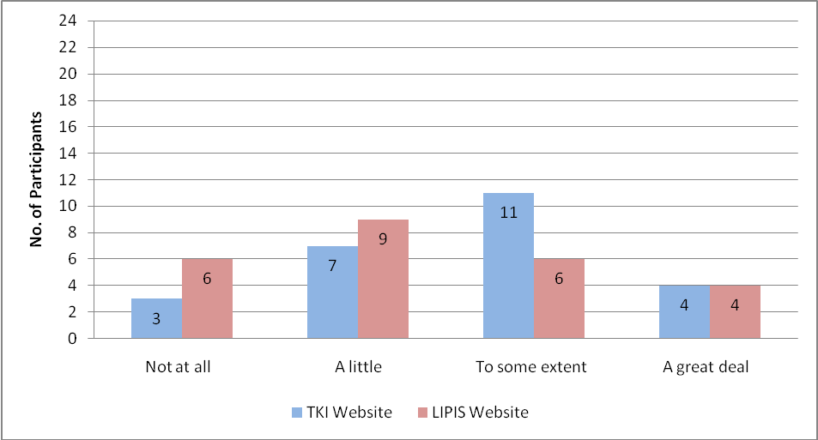
Figure 26: Use of TPDL recommended websites by survey three respondents (n=25)
The second component of the TPDL programme, in-school support, is also based on and provides further opportunities for teachers to develop deep principled knowledge. TPDL course facilitators observe the teachers in the language teaching classroom and note evidence of the Ellis principles that teachers are implementing, using the Evidence of Principles and Strategies form (Thomson, 2009, Appendix 15). Follow up facilitator feedback considers the principles and strategies used by the classroom teacher, and the lesson is discussed so that participants can continue to develop their knowledge and practice.
In the first interview with case study teachers, four of the seven teachers mentioned that knowledge of the Ellis principles helped them improve their understanding of how students learn an additional language. Comments from participants in surveys and in case study interviews confirm the efficacy of working from the Ellis principles. In survey two, which was conducted at a time when the respondents were focusing on the Ellis principles in the EDPROFST360 paper, 23 of the 29 respondents, when asked about the impact of the TPDL on their classroom practice, responded mentioning aspects of Ellis’s principles, for example, ‘I’m changing to more task-based student centred activities and have increased knowledge of the theoretical underpinnings of my teaching practice’. Researchers’ observations of case studies also noted teachers implementing key areas covered in the course (see Table 10, p.69). Thus, teachers demonstrated an awareness of second language acquisition theory.
As noted earlier, however, there seems to be a gap in the teaching of Cultural Knowledge in TPDL. Byram (1995) and Kramsch (1993) are quoted on the generic framework (Ministry of Education, 2007c). There is further reference to the intercultural dimension on the Evidence of Principles and Strategies form (Thomson, 2008b, Appendix 10) and intention to add a Byram reference to the EDPROFTS360 Course Outline reading list (Faculty of Education, 2008b). However, the teaching of intercultural competence was not included in the Course Outline Content Overview (Faculty of Education, 2008b). Thus teachers’ knowledge of how to approach the teaching of culture was limited. As yet there are no clearly outlined principles in the area of intercultural competence available to teachers through the Ministry of Education. The researchers understand that a set of principles for Intercultural Communicative Language Teaching (iCLT) are being drafted (Newton, Yates, Shearn, Nowitzki, Dickie & Winiata, 2008). Once a set of iCLT principles is adopted, it will provide a significant extended foundation of knowledge for TPDL and a more comprehensive platform for discussion in facilitator observation, feedback and in-school support.
Development of inquiry skills
A key means of fostering inquiry skills was through the action research project. Assessment two, worth 80% of the EDPROFST360 paper, required teachers to critically reflect on a set of readings, plan and implement a teaching intervention relevant to their own context, and collect evidence of student learning gains (Faculty of Education, 2008b). Teachers then shared their findings through presentations towards the end of the course. All seven case study teachers mentioned that the action research project helped them understand how students learn an additional language. One teacher said that sharing the findings with other teachers was beneficial and she intended to implement another teacher’s findings in her own classroom context. The action research project was a platform for teachers to deeply process information and problem-solve. For some, it also provided the possibility for maintaining an inquiry approach to their teaching and learning once the course had ended. Half of the 24 survey three respondents indicated they would be likely to do a further investigation (e.g. similar to their action research project) into their students’ language learning the following year (see Figure 27).
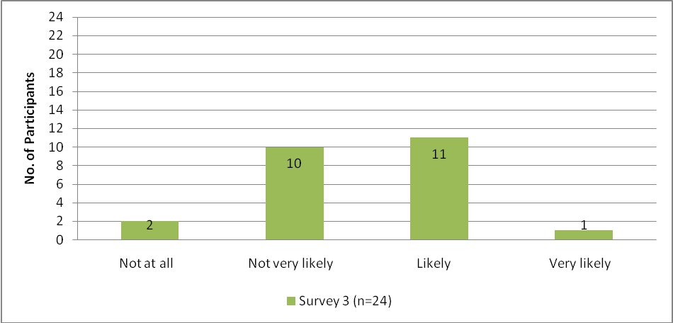
Figure 27: Further investigations into student language learning
Establishment of a knowledge community
Further ways of ensuring that engagement with new ideas is more than a ‘brief encounter’ is to consider what happens when a participant leaves a professional development course. There are three possible pathways regarding participants’ new learning. Their knowledge may decline, it may be maintained, or ideally their new understanding may continue to develop and increase. One way for learning to be consolidated and extended is for teachers to become part of a knowledge community that has a life beyond the course. Although the form of the community need not be prescribed, there does need to be an impetus to prompt its start. The community needs to respond to the members’ interests, needs and context.
The TPDL programme provided the impetus for developing teachers’ knowledge. The philosophy underpinning the course encouraged a culture of group learning through continued interaction in the EDPROFST360 days. This involved discussion and exchanges of ideas, as well as a formalised presentation of the action research projects. When the TPDL teachers first met together in workshops they were required to interact using the TL, and to participate in pair and group learning activities, with follow-up discussion on linking practice and theory (Thomson, 2008d). One case study teacher in the first interview was very positive about the TPDL programme intensive days. ‘I can interact with peers, with experts and with a full range of people. It’s neat. You can become isolated [in your school]. On the course, others want to know and discuss new things’.
In survey one participants were asked about the level of contact they desired with other TPDL participants outside the EDPROFST360 days (see Figure 28). The majority (24 of 25) of the core survey one respondents said they would like to meet each other at least once a term. Survey two data indicated that 19 of the 24 core respondents were in contact at least once a term, four of them monthly. Six of them had weekly contact, which may have been because of a need for peer academic support as respondents were nearing the end of the EDPROFST360 input and moving towards presenting their action research projects. The participants on the programme were taking opportunities to gain support and work together outside the course days. By the end of the course, 20 of the 25 survey three respondents indicated they were still in contact with other participants at least once a term, and seven of them were in contact monthly. Having contact with participants outside the course schedule and working collaboratively on the course through group learning and interaction helped teachers to develop their knowledge. As one case study teacher commented, ‘You can do more when teachers work together’.

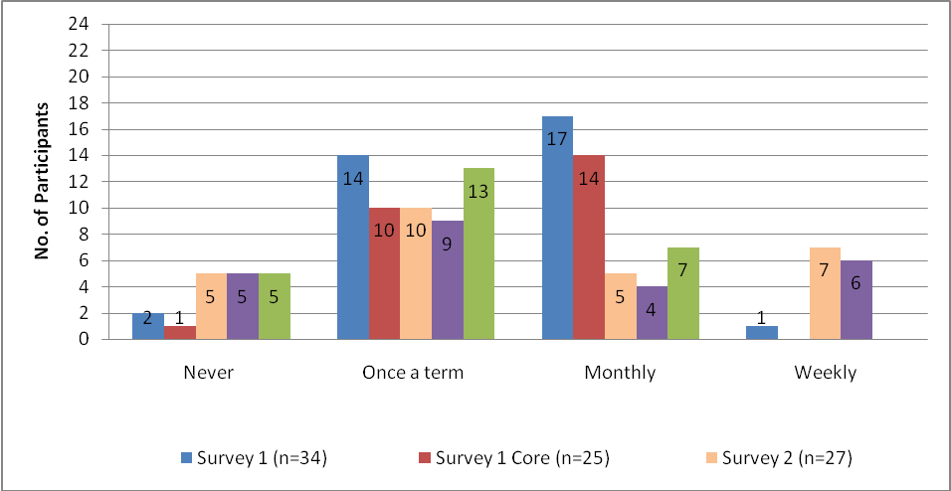
Figure 28: Teachers’ level of contact with other course participants
School support
Support by participants’ schools is also an important feature of teacher success in professional development. The leaders and staff within the school, as well as other interested members in the surrounding environment, need to provide encouragement to teachers at the start of the course and take an interest throughout. This is important to ensure that the long term impact of the course becomes ‘more than a brief encounter’ (Timperley et al., 2007, p. 218).
Before considering the ways schools can offer support, the considerable increase in workload that teachers encounter when they enrol in the TPDL course needs to be recognised. Although the majority of teachers (18 of 25 respondents) found the course workload heavy, they indicated it was manageable (see Figure 29). It is interesting to note that the five teachers who commented that the workload was easily managed all reported having strong support and encouragement from their schools. Of the two teachers who found the workload too heavy, one indicated she had support from her school ‘to some extent’, while the other was ‘fully’ supported but it indicated it was her first time teaching a language.
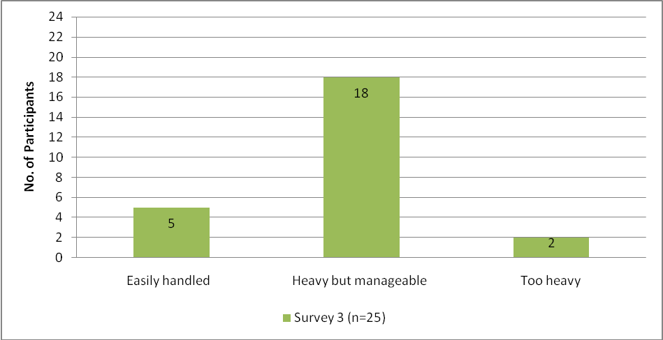
Figure 29: TPDL workload
As well as taking part in all the components of the TPDL course, teachers undertook considerable preparation of resources to support their new language teaching classroom practice (see Figure 30). Ten of the 25 survey three respondents reported spending more than three hours on average per week on language teaching resource preparation (e.g. cards for language games, posters etc). This is in addition to lesson preparation for their language class.

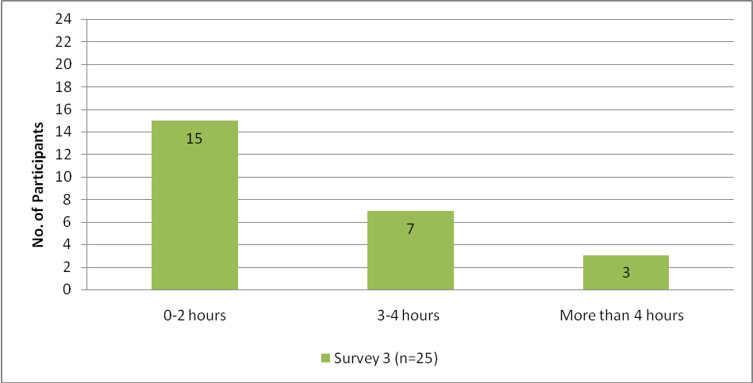
Figure 30: Average time spent per week preparing language teaching resources
Given the increased course workload described above, it is important that schools support their teachers while they undertake the course so they can maximise and implement their new learning in the classroom. In response to a question about school support of teachers’ study on the TPDL programme, survey respondents indicated that the support they received from the school remained constant until the end of the course (see Figure 31). More than three quarters of respondents in both surveys two and three felt that their school was either ‘mostly’ or ‘fully’ supportive, while the remainder felt their school was supportive to ‘some extent.’
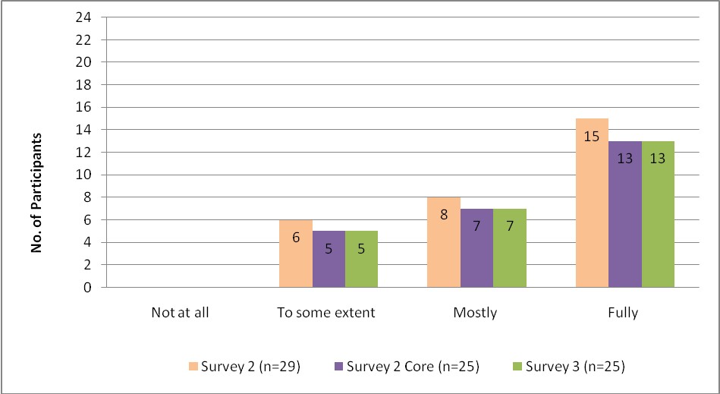
Figure 31: Extent teachers feel their school is supportive of TPDL study
Data from case studies and surveys indicated schools were supportive of teachers in three main ways: general encouragement and guidance, release from teaching for professional development, and financial support (see Table 17). General encouragement and guidance included one school having an open door policy from senior staff to support the TPDL teacher when she felt pressure from course and classroom commitments. One teacher found it very affirming that the HOD in her school was interested in implementing aspects of her action research project. Another school offered their facilities to host the TPDL group presentation of the action research projects. Some schools released participants from teaching so they could meet with the TPDL facilitator within school time to have feedback on their observations. However, others did not receive this support and had to discuss their lessons at lunch time or after school. Other teachers mentioned schools supported them financially through travel allowances and the purchase of language teaching and learning resources.

Means of school support (x number of participant comments) | Sample teacher comments
Interest, encouragement, guidance and permission for teachers to do the course ( x 16) | - My HOD gave me advice at any stage of my classwork and research project.  - Encouraged within my department (but no obvious school encouragement).  - They gave me time to do the course.  - The school created a class for me to teach the TL.  - [The school] asked to see feedback on my teaching.  - The Principal came and watched the [action research] presentations.  - Letting me do the course for Appraisal.  - Management read my research document.  - Showed interest in my work.  - Allowed me to participate in all aspects of the PD without question.  - School had an open door policy for help at any time.  - Time to visit other teachers of languages to see how they use technology.  - I’ve been given an extra unit to coordinate the languages programme next year.  - HOD interested in implementing findings from action research project.
Release from teaching (x 17) | - Put a reliever in place so I could attend PD days.  - Covered my class while I was on the course.  - Covered my class when I sat the TL exam.  - Release time for interviews after the observations.  - School has been fantastic. Nothing too much trouble. Release time readily available for TPDL visits.  - Payment of relievers – have always had a ‘yes’ answer to any request I have made regarding the course.
Financial support ( x 4) | - Blown away when HOD paid for the text and all photocopying.  - Paid for the mileage.  - Money available for resources.  - They approved my course enrolment and paid.
Table 17: Means of support provided by schools
(Note: Combined data from survey three (n=25) and interviews two and three. There was no duplication of respondent answers between the questions).
Some teachers were supported as required by the contract but there was no extra support provided outside the commitment of the contract. One teacher felt the school did not sustain languages adequately as there were other areas in the school curriculum which were seen as more important. One teacher said she did not think her school knew very much about the programme at all. A high school teacher reported excellent support from her department, but less from the school which favoured more generalised PD programmes for the benefit of all staff.
A further way schools were perceived to show interest in the TPDL teachers’ learning was to provide opportunities for teachers to talk to colleagues formally. Eleven of the 25 core survey two respondents indicated that they did not formally report aspects of the TPDL programme to the school. However, 14 said they formally communicated with staff either ‘a little’ or ‘to some extent’. Survey three data gathered at the end of the course indicated that there had been a slight decrease, with 11 now formally reporting to the school community either ‘a little’ or ‘to some extent.’ Examples of such formal reporting included a language prize presented at assembly, a student display of TL learning, and a demonstration of students interacting in the TL at school assembly. One case study teacher mentioned how the positive feedback from other language teaching staff on her students’ performance at assembly was encouraging. Two of the case study teachers indicated that they shared the findings of their action research reports with management, either through providing the written report or through management attendance at presentations.
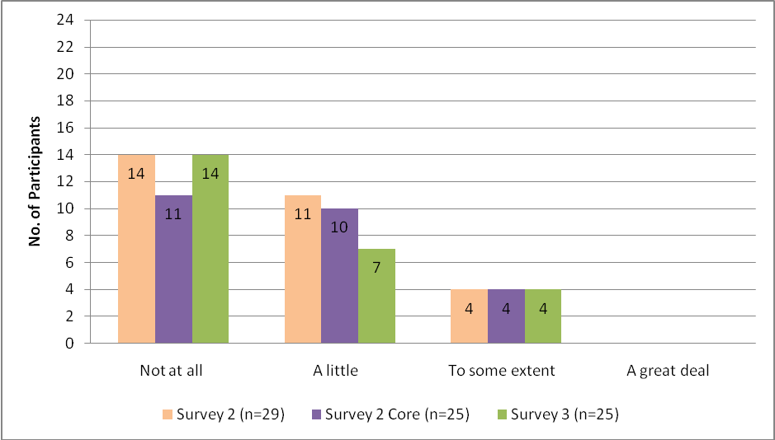
Figure 32: Extent of teachers’ formal communication with school staff about TPDL
While some teachers did not formally report to the school community about the TPDL course, there was considerable informal communication (see Figure 33). In survey two, the majority (23 of 25 the core respondents) indicated they talked informally to staff (e.g. in break time) in their schools about the TPDL programme. However by survey three, there had been a slight decrease in this with five indicating they were not talking informally at all about the course. Teachers who indicated they were talking informally to staff did so in a number of ways. One case study teacher talked to her HOD Years 7 and 8 about the implementation of languages for 2010, and to other colleagues about aspects of the course. One case study teacher reported that other teachers in the school asked her about the TPDL programme and showed interest in enrolling.
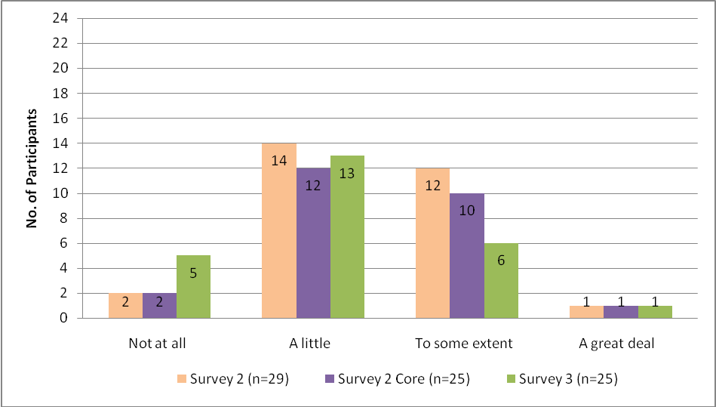
Figure 33: Extent of teachers’ informal communication with school staff about TPDL
When TPDL participants were asked a question in the final survey about what they would recommend to incoming TPDL participants, the role of the school and support was not mentioned in their responses. Rather, they focused on suggestions for practical ways to handle the workload and learning on the course (see Table 18).

Recommendations  (x number of participant comments) | Sample teacher comments
Action research project (x9) | - Don’t choose a research question that’s too complex.  - Keep action research project simple and narrowly focused Think about action learning project early on. Make sure it’s relevant to future practice.  - Begin the research well ahead of the due date.
Time  (x8) | - Don’t study anything else apart from the selected language; it’s demanding of your time.  - It’s good provided you’re motivated and can organise your time.  - I’d recommend it with reservations because it could lead to over commitment of time and energy.  - A study leave entitlement could help avoid a work overload.  - Stay on top of the readings.  - Do language exams in the first half of the year as the second half is often over-crowded especially as the research deadline looms.
Networking  (x5) | - Take every opportunity to network with other participants.  - Interact with many teachers from other schools.  - Go to Auckland for the PD sessions – bigger and more positive group.  - It’s enjoyable to meet other teachers and discuss ideas.  - Excellent networking.
Resources  (x5) | - Use TKI and LIPIS – there are great resources and ideas.  - Collect as many resources as are made available.  - Collect and share resources.  - Get help with making resources.
Other | - Ensure they have a few people taking the same language.  - Take advantage of tutor’s knowledge and expertise.
Table 18: Recommendations to incoming TPDL participants (Survey 3, n=23)
The table shows the importance of participants being able to manage their time from the start of the course. This is reflected in comments about managing time in general (e.g. around reading and language study) and also managing the action research project with early identification of a clear, narrowly focused topic relevant to the classroom. In addition, teachers commented about the benefits of networking with other language teachers, and collecting and sharing resources. As one survey respondent summed up,
Take a very deep breath. It’s not the walk in the park we were led to believe when the pamphlet was put under our nose. But the personnel are lovely… Go on the course because it’s so necessary to form good practice and because it’s enjoyable.
Language courses
For the TPDL programme to be fully sustainable quality language courses for TPDL participants are essential. To cater for all TPDL participants, the language study component provided flexible language learning opportunities. Teachers could complete their language study through a tertiary provider, community classes, and/or a distance course. There was a strong commitment from the TPDL directors to secure and maintain effective language study for teachers. For the majority of the teachers on the 2008 TPDL programme this was successful. However, there are a number of points to consider for ongoing sustainability: class availability, quality courses and timing of TPDL and the language study course.
All five teaching languages need to be available in all regions of the country as required by TPDL participants. Courses should be convenient and at an appropriate level. They need to be effective face to face classes in tertiary or community institutions, or effective distance classes. As discussed in chapter three, there was a range of effectiveness of distance, customised programmes. Those organised by UNITEC were received well by participants to the extent that numbers of teachers wishing to do the French distance programme increased. Analysis of this model could identify features to be used to continue to develop other distance programmes in other languages to an equally high standard.
A third factor desirable for sustainability arose from one teacher’s comment about the timing of the language study course. At the end of the TPDL course she reported that although she had a level of proficiency in the TL, gained in high school, she felt intensive study of the language before beginning to teach it would have benefited her. She felt that having to teach the language before she had begun her language study course made the task more challenging than it needed to be. It would be useful to consider the possibility of offering an intensive language study courses run in the school holidays for those who were lacking in confidence at the start of teaching their language classes.

7.1.2 Continuing development
Once a professional development course is completed, teachers need to have a knowledge community which supports them in their continuing development. As Craig notes ‘… knowledge communities sustain [teachers] by providing instruction and opportunities for growth. The efficacy of individuals, along with the power of small groups to inspire and influence change, becomes readily apparent to others’ (2007, p. 621). Table 19 shows how teachers intended to gain support for their continuing development once the course finished. Thirteen respondents said they would be likely to have regular meetings inside/outside school with language teaching colleagues. Other teachers indicated their intentions to engage in further teacher professional development through professional development days, membership of language associations, conference attendance and presentations. Six of the 25 respondents indicated they were likely to undertake a higher language teaching qualification in the future. This represents a strong commitment by teachers to their own ongoing learning.
Type of intended professional development | Number of participant responses
Professional development days (schools, Ministry, NZALT) | 18
Conference attendance | 15
Membership of recognised language association (e.g. NZALT, Alliance Française) | 14
Regular meetings inside/outside school with language teaching colleagues | 13
Formal language teaching qualification (e.g. Graduate Diploma/Masters) | 6
Conference presentations | 2
Table 19: Type of intended professional development
(Note: Participants ticked more than one answer)
Ongoing school support for language teacher development

Teachers were asked how schools could best support them beyond the course. Table 20 indicates the key areas of school support teachers considered important for sustaining their language teaching development. Table 20 indicates teachers would particularly like support through funding and time for further study of language pedagogy, conference attendance and enrolment in further language classes. Other areas that emerge are valuing language teaching in the school and providing assured language classes so teachers can continue to develop their language teaching skills. As well, teachers would like schools to provide resources for language teaching, including access to computers so teachers can supplement their lessons with PowerPoint and internet resources.

Ways schools could best support continuing language teaching development (x number of participant comments) | Sample teacher comments
Further pedagogy study  (x8) | - Support more tertiary study in language teaching pedagogy.  - Allow me to continue with my study.  - Time to attend courses.  - Continue to pay for courses and allow me time to do so where needed.  - Provide relievers so I can attend PD days.
Conference attendance  (x5) | - Support to go to conference.  - Let me go to conferences.  - Continue to help pay cost/time to go to conferences.
Funding for language courses and/or language exam fees (x4) | - Pay for language courses and exam fees as well as required text.  - Continue paying the fees for UNITEC TL class.
Assured future TL class  (x3) | - Let the language classes run even with small numbers.  - Let me teach a TL class!  - Offer TL at Year 8 as well as Year 7.
Value the TL  (x2) | - Value the TL more in terms of timetabling.  - Allow students to take two languages at one level, for example, Māori and TL.
Resources  (x2) | - Give me time to develop resources.  - Give me a budget for resources.
Access to technology in language classroom (x2) | - Fund the laptop when delivering TL in the classroom - PowerPoint, internet resources.  - An improved classroom environment with access to computers.
Other  (x 1) | - Time to see effective language teaching programmes in other schools.  - Support application for immersion award.
Table 20: Ways schools could best support continuing language teaching development

Ongoing language development for teachers
Ongoing TL development beyond the course is important for many teachers 50% of the survey participants described themselves as elementary or beginner level language learners at the end of the TPDL course (see Figure 3). As noted in chapter three the length of study and the preparation for an exam resulted in the greatest perception of change in TL level proficiency. Where possible, teachers need to be encouraged and supported to obtain further qualifications in the TL through formal study in a community, tertiary or online distance course. Actively participating in the TL community is a further way for teachers to continue developing their language knowledge and fluency. While teachers had established a level of indirect contact with TL community by the end of the course, direct participation was more limited (see chapter three). Teachers need to be encouraged and supported to engage with TL speakers. Increased access to TL language assistants in schools could also help less proficient teachers to sustain and develop their language knowledge. A further means of teachers increasing their language and cultural knowledge is through the LIA (see Section 3.4).
Ongoing language development for Years 7-10 learners
Another aspect of sustaining the TPDL programme is effective ongoing language development for Years 7-10 language learners. For teachers to remain motivated and sustained while on the programme, it is necessary for them to feel that languages are important and supported by their school. They need to have confidence that what they are doing is valued. One way is for them to know their learners have continued opportunities to learn the language. Years 7-10 students who have learned the TL for one semester, or in many cases for one year, have developed some ability to communicate in the TL. Sustaining this knowledge is important. The research data from interview three revealed a range of continuity of language learning for students. In one high school, virtually all students would progress to the next level in the TL. In another high school, the case study teachers indicated that about half the class would choose to continue with the same TL and classes would be available for them. Some teachers of Year 8 students who were going into Year 9 at high school were concerned about this transition. Three teachers expressed concern that their students who had studied the TL for one year would expect a higher level of TL at high school and might not get it. Ideally, primary and secondary teachers need to build relationships to facilitate the transition. One teacher liaised with the local high school and although the high school teacher was not anticipating any problems with the students having prior knowledge, the current teacher felt it could be a problem and students might be demotivated. Another case study teacher was considering devising a system of passports so that students could take records of their Year 8 learning with them to their high school TL class the following year, thus making the transition smoother. Teachers of Years 7 indicated that there would be no continuity of TL learning for some students while others would be in a class where they were learning a different TL.

7.1.3 Future teacher and learner cohorts
For the programme to be sustainable there needs to be a continuing cohort of teachers wanting to become language teachers. There also needs to be a continuing interest amongst students in learning an additional language and schools fully supporting the Ministry’s intention to offer languages to all Years 7-10 students by 2010.
Future teacher cohort
As a way to gauge the level of interest amongst teachers for future TPDL courses, the researchers asked the 2008 course participants to indicate if there were other teachers in their school who would be interested in doing TPDL in the future (see Figure 34).
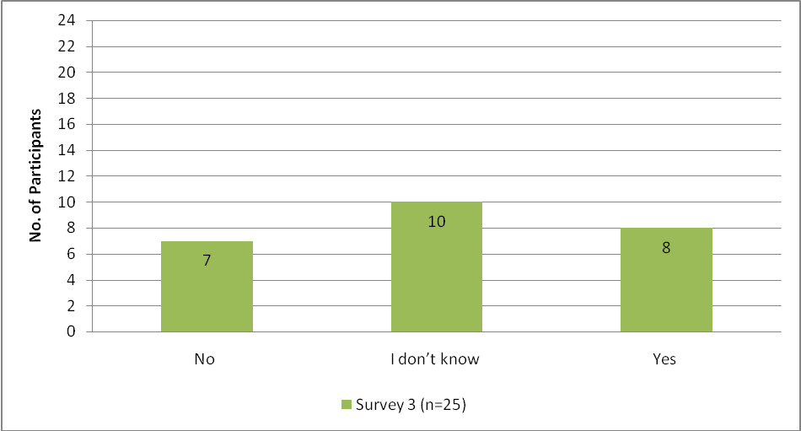
Figure 34: Other teachers in the school interested in doing TPDL in future
Of the 25 survey three respondents, 17 said either there was no interest or they didn’t know if teachers in their school were interested in doing TPDL. Eight said there was interest, and one survey respondent commented:
There are three teachers from our school who have applied for the programme. I’ve told them the workload is not too onerous, it’s very interesting, the theory of the pedagogy paper will help them learn about how kids learn in general, they will meet some really interesting people on the course and see how other teachers teach.
Participants talking informally about the TPDL programme to staff throughout the year may have had an impact on other teachers’ interest in the course. One case study teacher noted that although no teachers in her school were interested in doing TPDL for one of the five languages offered, they could be interested if the programme was for Te Reo. According to the Ministry of Education a Te Reo Māori professional development programme is in fact available but is not well known.
Recommendations from current TPDL participants are a very powerful form of advertising and promotion. Researchers noted a significant number of recommendations about the TPDL programme as indicated in Table 21.

Sample positive comments about TPDL 2008
- It’s changed my teaching dramatically. It opened doors for me. I have even more fun teaching TL now (and I always enjoyed it).
- I would highly recommend the course.
- Positive recommendation: observations very useful.
- Do it. It’s worth it to be able to teach correctly.
- It’s the best PD I’ve ever had.
- The theory of the pedagogy paper helps learn about how kids learn in general.
- Tutor approachable, positive, upbeat, supportive and encouraging, passionate and professional – simply a superlative teaching professional.
Table 21: Recommendations to teachers interested in TPDL course (Survey 3)

Future language teachers can be encouraged to join the TPDL course through current participants talking formally and informally about the course in schools and at language cluster meetings. It would appear that a continuing cohort of teachers is likely for 2009.
Future learner cohort
To encourage students to be interested in learning an additional language in schools, the profile of languages needs to continue to be raised so that the wider school community sees it as favourable. At Years 7-8, schools are being asked to prioritise a range of subjects of which Learning Languages is just one. As indicated by Thomson in Milestone Report Nine (Thomson, 2009) and by the researchers in chapter five, teachers found it a challenge to schedule regular language teaching throughout the year. Learning languages needs to be seen as advantageous for students and schools need to make a strong commitment to language teaching to avoid the risk of the teaching and learning of languages in Years 7-8, in particular, being diminished. In addition, successful language learning at Years 7-8 provides students with more options at high school and can thus increase the cohort of interested learners. The researchers noted that in the 2008 TPDL cohort, teachers were predominantly teaching French and Spanish. To get a better spread of languages, Asian languages need to be especially promoted throughout the country amongst staff, students and the wider school community

7.1.4 TPDL course staff and structures
For the sustainability of the TPDL programme it is important to consider the TPDL staffing both current and future. As well, course sustainability relies on a sound infrastructure and effective systems.
TPDL programme staff
Survey respondents’ feedback on the 2008 TPDL teaching team was noticeably very positive with participants commenting on the staff availability, professionalism and expertise. This is a strength of the TPDL programme. The programme directors ensured information was made available to the staff. They were also quick to discuss and resolve issues as they arose, for example finding an appropriate language study course for Waikato teachers once a problem was revealed (Thomson, 2008e). Staff vigilance and understanding of course participants’ developing learning was significant and evidenced in the milestone reports throughout the course. Milestone Report Eight demonstrates continuing online professional debate amongst the teaching team, about course participants’ progress (Thomson, 2008e, Appendix 13). The TPDL 2008 teaching staff were regularly informed throughout the course and appeared to be a strong team. If the programme remains in its current form, the course directors need to ensure there are sufficient numbers of qualified staff inducted into the programme so that staffing continues to be effective.
TPDL infrastructure
TPDL appears to have a sound infrastructure and effective systems. Project directors kept the Ministry informed, kept the team members informed and maintained close contact with participants throughout with detailed communications. Milestone Reports Eight and Nine for the Ministry of Education (Thomson 2008e, Thomson 2009) provided evidence of effective basic organisational systems. The comprehensive appendices to these reports showed there was effective liaison between all team members within and outside Auckland through minutes kept of meetings (Thomson, 2008e, Appendix 12). In addition, there were samples of staff email contact with the 2008 cohort. The infrastructure allowed for direct participant-initiated communication with teaching staff and sample feedback from teachers showing they liaised intensely with the teaching staff (Thomson, 2008e Appendix 9). The TPDL directors had well organised schedules and clear plans for promoting the programme. For example, Appendix 11, Milestone Report Eight details how the project directors in June, called for in-school facilitators to help with promotional work through publicising the course at conference. They also indicated plans to speak to principals about the course for the following year, and organise seminars on TPDL for secondary school teachers as well as update the TPDL brochure.
There is a question however as to whether the current highly detailed reporting and close contractual relationship with the Ministry of Education is the most sustainable way for TPDL (or a version of it) to continue into the future. While the current model may have been an effective way to run a pilot it is doubtful that this structure could continue indefinitely. It must be considerably more expensive to run than equivalent teacher qualifications and professional development programmes embedded in recognised qualifications in universities. The reporting is detailed and presumably time consuming for both the producers (TPDL directors) and consumers (Ministry officials) of the milestone reports, although they are a valuable source of data. Arguably, a more sustainable organisation of TPDL could be to gather its strengths into a full university (preferably postgraduate) qualification to be delivered through universities in appropriate centres.

7.2 Replicability
Given the relative success of TPDL, its ability to be replicated is an area that requires careful consideration. This is particularly so given the large numbers of teachers that need to be trained in order for most schools to offer Learning Languages to students from Years 7-10 from 2010. Importantly, replicability in the TPDL context can be interpreted to mean either the expansion of the TPDL programme to provide other languages (e.g. Te Reo) or duplication of the programme by other providers in other areas of the country. Metz, Blowie & Blasé (2007) provide a framework when considering key factors required for a programme to be replicated. Stakeholders and adopters need to consider core components of the programme (core intervention and core implementation) as well as adaptable and discretionary components.
Core components
Core intervention components are essential and indispensable components to obtaining the desired outcomes for a programme (Metz et al., 2007). TPDL outcomes are drawn from The New Zealand Curriculum (2007) (Ministry of Education, 2007a). If similar outcomes are sought in replicable programmes, adopters need to share similar beliefs about language learning and teaching. For example, they need to support the idea that it is possible to learn and teach the same language concurrently and ensure participants have access to a language study component to develop their TL fluency. Also, second language acquisition theory needs to be provided at a tertiary level embodying principles relating to developing both communicative competence and intercultural competence. Adopters also need to support participants through ongoing observation and feedback on their language teaching development throughout the course. These areas are essential and at present on the TPDL programme they inter-relate and are taught within one programme in one academic year.
Core implementation components are the essential or indispensable components for implementing the practice (Metz et al., 2007). They include financial resources, staff, administrative structures and classroom teaching opportunities. Any replicated course needs to be fully resourced financially so that staff is able to teach and observe participants regularly throughout their professional development. Participants need access to resources such as texts, curriculum documents and to appropriate language teaching practice opportunities throughout the course. Financial support is essential for fees and to adequately cover the necessary release days for teachers. Suitably qualified teaching staff with a range of language backgrounds needs to be selected and inducted into the programme, and mentored where necessary to ensure consistency of delivery across the programme. There should to be systems for documenting and reporting (where necessary) on the programme to stakeholders, with regular review and monitoring. There also needs to be appropriate administrative staff familiar with the programme and provider environment. Both teaching and administrative staff require supporting infrastructure such as internet access enabling communication with programme participants and effective liaison.
Adaptable and discretionary components
Programmes that have a level of flexibility are easier to replicate than others because adopters can adapt the programme to meet the unique needs of the target participant group (Metz et al., 2007). The TPDL programme currently has an element of flexibility. Although the theoretical teaching and learning component is tightly linked to classroom practice, the language study component is offered in a more flexible mode. Adopters could consider whether the components remain inter-related or if they could be successfully taught discretely. If adopters decide to deliver components discretely, it is important to ensure that the participants gain a comprehensive picture of learning and teaching so that the benefits of the components relating and reinforcing each other are not lost. This would involve considerable continuity and liaison among teaching staff. While learning a language should be compulsory for all course participants, as it is beneficial for both linguistic purposes and for developing languageteaching knowledge, there is room for further flexibility around the language study component to meet participants’ needs. Potentially, some participants could study the TL adjacent to the course (e.g. in summer school). Others who have some TL knowledge could study the language at the start of the course, while other bilingual and more proficient TL teachers could study an additional language at their discretion throughout the course to gain the benefits of understanding the learning process.
As noted previously, a number of these factors could inform the development of a comprehensive and appropriate (possibly postgraduate_ qualification for Years 7-10 language teachers.

7.3 Conclusion
TPDL is currently meeting the important conditions recommended for sustainability of teacher development. The professional development programme is founded on principled knowledge and theory. It provides opportunities for participants to develop inquiry skills and to become part of a knowledge community. The programme has multiple approaches throughout the course to make this knowledge manifest for the teachers. It encourages participants to develop their inquiry skills related to their classroom practice through comprehensive assessment involving classroom intervention and critical reflection. Participants are encouraged to interact and collaborate from the start of the course, thus providing an opportunity for them to establish a knowledge community. For sustainability the TPDL programme participants need to have access to quality language courses at appropriate levels. The participant school’s involvement can help sustain teacher development. Schools are able to contribute to supporting teachers in a variety of practical ways while teachers are on the course. Once the teachers have finished the course, the school philosophy will be essential to maintain a culture of support and teacher development. As well, for sustainability there needs to be an ongoing cohort of teachers; approximately one third of the current cohort indicated there was interest from teachers in their school in future TPDL programmes.
In addition to supporting teachers’ ongoing professional development, it is important that schools also continue to promote language teaching and learning in Years 7-10 so that teachers feel their language teaching work is a valued component of the curriculum. There are challenges in sustaining language learning for students. The profile of learning an additional language needs to continue to be raised and seen as advantageous not only by schools and students but also by the wider community. Although five languages are offered at present the numbers of teachers and students are not evenly spread. Asian languages are poorly represented. Another challenge is the transition of students in Years 7-8 and consideration needs to be given to making this effective so a continuity of language teachers and students is assured.
A final factor to consider for sustainability is the staffing, infrastructure and systems. A strength of the programme was the positive team of programme directors and facilitators who were able to effectively respond to the participants and continually engage in professional debate. The infrastructure allowed for communication between the programme and the Ministry, and also within the programme amongst the team and the project directors.
Adopters considering replicating the programme need to consider core components and components which are adaptable and discretionary. Core components of the course include: language study, SLA theory involving communicative and intercultural competence, observations of practical teaching, and opportunities for teachers to have discussion and feedback on their learning. At present these components are interrelated. However, it may be possible for some components to be taught discretely, for example the language study component could be offered in a more flexible mode. In addition, the course needs to be fully resourced financially and there needs to be suitably qualified teaching staff with consistent delivery across all aspects of the programme.

Recommendations and implications for the TPDL programme
- TPDL project directors need to incorporate a set of principles for intercultural communicative language teaching into the programme.
- School principals need to consider realistic, practical ways they can support their teachers who are on the TPDL programme, especially at the start of the TPDL programme.
- TPDL needs to ensure that there are fully effective language classes. They could recommend the effective UNITEC model to other distance providers.
- It could be useful to consider the possibility of offering intensive language study courses run in the school holidays (particularly over the summer break).
- Ongoing TL development beyond the course is important for those teachers who described themselves as elementary or beginner level language learners at the end of the TPDL course
- Where possible, teachers need to be encouraged and supported to obtain further qualifications in the TL through formal study in a community, tertiary or online distance course.
- Actively participating in the TL community is a further way for teachers to continue developing their language knowledge and fluency.
- Increased access to TL language assistants in schools could also help less fluent teachers to sustain and develop their language knowledge.
- Schools and TPDL should encourage teachers to develop their language and cultural knowledge through the LIA.
- Teachers need to feel their work is a valuable part of the curriculum, so schools need to promote language learning for Years 7 – 10 and ensure there is continuity in student learning.
- Asian languages need to be especially promoted throughout the country and amongst staff, students and the wider school community.
- It may be possible to consider delivering an expanded version of TPDL as a stand-alone qualification in several New Zealand universities.

Chapter Eight Conclusion

8.0 Introduction
This chapter provides a summary of key findings as regards the effectiveness of TPDL in the following areas: teachers’ development in language proficiency; second language teaching knowledge; knowledge of the curriculum and specific language curriculum guidelines; student learning and outcomes; and programme sustainability and possible replication. The summary is followed by a consideration of issues raised by the research. In addition, there are recommendations for programme design which would maximise the effectiveness of future professional learning in Learning Languages for teachers of Years 7-10 students.

8.1 Teachers’ development in language proficiency
The teachers on TPDL were, in the main, teachers of European languages, female and from North Island urban schools. Although many of the survey respondents were experienced teachers, the majority had three or fewer years experience in teaching the TL. There were some expert TL users in TPDL, but most teachers perceived themselves to be at intermediate level or below at the beginning of the course. By the end of the course, there was a decrease in teachers describing themselves at lower levels, and an increase in those perceiving themselves at intermediate level or higher.
Sitting and passing an internationally recognised language examination provided evidence of TL proficiency and proved to be motivating for teachers. In total, 54 TPDL teachers from 2005 - 2008 have sat 79 internationally recognized language proficiency examinations with 100% success rate. For case study teachers, sitting an examination and engaging in three to four terms of language study resulted in the greatest perception of change in language proficiency.
As regards teachers’ language learning, most teachers surveyed initially planned to study the language for two semesters and the programme provided for this, but only half of those who had studied in the first semester continued. One reason was that not all teachers were aware that costs for a second semester of language study would be met by TPDL. Teachers who continued their language learning throughout the year generally maintained their motivation, though a little less so than at the beginning. This may have been due to heavier work commitments as the year progressed. The decrease in motivation (from ‘highly motivated’ to ‘motivated’) contrasts with teachers’ reporting that they maintained high levels of participation over the year with TL communities. They did this mainly through indirect experiences (internet, DVDs, films and books) but also through direct contact (with expert users of the language). The decrease also is at variance with many teachers’ plans to continue language study the following year and interest in the Ministry funded LIAs. The reported decrease in motivation also varies with survey findings which revealed that teachers perceived that their confidence in using the TL with the students had increased over the year with the majority indicating they were ‘confident’ or ‘very confident’ at the end of the course. A longer term investigation could usefully provide information as to the extent to which motivation is maintained beyond the course.
Language study courses were seen as effective by most teachers but some teachers believed their course was only a little effective or not effective at all. Teachers were generally positive about the benefits of language study courses which included not only TL acquisition but also gaining insights into teaching and into the challenges of being a language learner. However there is a need for consistently high quality language study courses to provide for the needs of all language teachers. Some teachers believed they needed to have some TL proficiency and language learning experience before they began teaching their own students and TPDL could consider how this could be achieved. There is also a need for teachers’ TL proficiency to develop beyond TPDL since as Gibbs and Holt (2003) argue, teachers’ level of TL proficiency is one of the crucial factors in successful language learning.

8.2 Teachers’ development of second language teaching knowledge

The impact of TPDL on teacher knowledge of how students learn an additional language and on knowledge of language teaching methodology was considerable for most teachers in the study. By the end of 2008, the majority of teachers indicated achieving a good understanding of how students learn a second language, a considerable movement from the initial survey. The Ellis principles (Ministry of Education, 2007c) provided a valuable framework for helping teachers understand second language acquisition and effective language teaching and learning with teachers regularly mentioning these principles in the three surveys over the year. The principles were perceived as helping with both confidence and approaches to language teaching. Observations and interviews with case study teachers supported this. Teachers were observed applying the principles in their practice and in the interviews, frequent reference was made to them as useful to ‘hang on to’ and as a guide for their teaching.
One of the Ellis principles for successful language acquisition is extensive TL input. Teachers were observed providing TL input for a range of classroom purposes although the amount and quality varied. The teachers with greater TL proficiency and previous contact with the TL culture understandably provided students with richer exposure to the TL (e.g. in terms of length of utterances, grading of language, pace) compared to teachers with lower levels of proficiency (less able to extend and elaborate in the TL during lesson delivery). Oral TL input was also provided through other sources such as multi-media resources, the internet and expert TL users.
TPDL places considerable emphasis on student oral TL output. In particular, facilitators’ in-school visits included a strong focus on encouraging teachers to provide opportunities for sustained student TL output and on using the language ‘as a tool for communication’ (Thomson, 2009, Appendix 15). Teachers were thus well aware of the need for opportunities for student TL output and a range of ways to provide these was observed. The output varied from single word through to extended utterances and was mainly student to teacher and student to student but there were also opportunities for some students to engage with TL community members such as language assistants. TPDL facilitators reported the majority of teachers were meeting the expected or accelerated standards as regards providing opportunities for students to interact. However, researchers’ observations revealed that these opportunities were not always fully realised, for a number of reasons related to lack of teachers’ classroom skills in appropriate scaffolding, instructions and monitoring.
Teachers’ reported understanding of how to teach an additional language increased noticeably with more than three quarters of teachers surveyed at the end of the course viewing themselves as generally or highly effective. However the teachers’ perceptions of the impact of TPDL on classroom practice at the end of TPDL was less than anticipated earlier in the programme. This was possibly because of teachers’ new and growing awareness of the complexity of skills involved in successful language teaching as well as the time needed to develop these. Factors that fostered teachers’ increased knowledge of language teaching methodology included a balance of theory and practice, the Ellis principles which provided a clear language teaching framework, study of the curriculum and the action research project.
Consistent, constructive feedback from facilitators during the in-school visits was viewed as valuable and because of the spacing of visits, gave teachers time to reflect on their own context and implement new learning. Support from EDPROFST360 tutors as well as from peers was also noted by teachers as a further factor that fostered learning. The language group meetings with colleagues for example gave opportunities for teachers to try out language activities, exchange resources and ideas and practise their TL. These two features of the course, engaging ‘… external expertise’ and ‘… providing opportunities to interact in a community of professionals’ align with teacher professional best practice as identified in Timperly et al. (2007, p. xxvi).
Also mentioned by teachers was their experience of being language learners themselves. They felt they gained valuable ideas on how to teach as well as what it was like to be a language learner. Those who were expert users of the TL already did not need to enrol in classes. The researchers felt however that the teachers would have gained insights into their students’ situation if they had had the chance to be a language learner again (in a language other than their TL).
Almost half of the teacher respondents indicated that there were no factors that made it difficult for them to gain maximum knowledge of language teaching methodology. Of the teachers who indicated there were reasons, a key factor that emerged was the overall teaching workload and a consequent lack of time. Also, a few teachers thought that facilitator feedback was not realistic given the limited amount of TL timetabled teaching time (especially Years 7 and 8), and timetable demands of other curricula subjects. Two other factors that made it difficult for some teachers to gain knowledge of language teaching methodology was a lack of resources for teachers of Asian languages and an inadequate understanding of the scope of the action research project.

8.3 Teachers’ development of knowledge of the curriculum and specific language curriculum guidelines

Three areas of teacher curriculum knowledge were investigated: teachers’ perceptions of their understanding of the Learning Languages area of The New Zealand Curriculum (2007) (Ministry of Education, 2007a), their knowledge of the TL specific guidelines, and their implementation of the cultural knowledge strand. Teachers reported a low level of knowledge with the Learning Languages area of the curriculum near the beginning of TPDL however there was a notable increase in teachers’ perceptions of the extent of their knowledge by the end of the course. The curriculum tests administered as part of EDPROFST360 were viewed by teachers as useful and helped to increase confidence. As regards the language specific guidelines, most teachers indicated a level of comfort with these and commented positively on them. It is of concern however that some teachers were unaware of their existence at the beginning of the course and so were unable until later in the year to access these. It was also not clear which version of the guidelines teachers had been using.
The Cultural Knowledge strand is an important component in the new curriculum. Its focus on the interrelationship between culture and language, making connections between known and TL cultures and the inclusion of intercultural competence presented a challenge for many language teachers, particularly those new to language teaching. The extent to which teachers were integrating cultural knowledge into their programmes was variable. Researcher observations showed that lesson aims focused mainly on language and communication. Where teachers did have cultural aims in their lessons, there was a range of ways culture was addressed. Interestingly, teacher skill in developing cultural knowledge for students did not seem to be attributable to one specific factor such as facility in the TL, but rather was due to a range of factors. Our research indicates that teachers need more explicit instruction on how to teach the Cultural Knowledge strand. In particular, given the government’s expectation of the development of interculturally competent students, this area needs to be given attention in TPDL. TPDL directors are aware of the need to foreground the cultural knowledge strand and have already instigated changes for 2009 (Thomson, 2009, Appendix 15). The research team questions whether this can be managed within the current 15 point EDPROFST360 paper and suggest expanding the current paper to 30 points to accommodate the requirements of the cultural strand.

8.4 Learning opportunities and outcomes for students
The research indicates improved language learning outcomes and language learning experiences for students as perceived by teachers, TPDL facilitators and researchers. These included improvements in students’ abilities to understand and use familiar expressions and to engage in interactive tasks, to recognise that the TL and culture are organised in particular ways and in students’ ability to make connections with the target culture. Gains other than those directly related to language acquisition included development of Key Competencies (including learner independence) and the acquisition of language learning strategies which enhance the capacity to learn further languages. Five of the case study participants noted positive changes in many of their students’ responses to their teaching with the students being more positive, confident, motivated and engaged. Students were also observed with high levels of engagement in a number of TL activities. These tended to be restricted practice type activities and games that included clear linguistic aims. Teachers in the surveys perceived their students to have maintained high levels of motivation and willingness to communicate. Students had opportunities for contact with the TL community but this was mainly indirect contact in the form of the internet, books and DVDs. Opportunities exist for the enhancement of meaningful and authentic student TL interaction for example, through language assistants and technology mediated communication.
Understanding of the impact of TPDL on student achievement was limited to teachers’ perceptions since no individual student academic achievement data was able to be accessed. Teachers’ initial expectations of the impact of TPDL on achievement, student learning and motivation decreased during the course. This decrease paralleled the decline in teachers’ initial optimism of the impact of TPDL on classroom practice during the year. Given that teachers viewed their students as having made progress and shown improvement in a number of sub skill areas, this anomaly is difficult to explain. Further research could shed light on whether this situation continued over the following year or, as teachers embedded the new learning, they rather viewed the macro impact of TPDL more positively.
Assessment of student learning was mainly informal at Years 5-8, with some formal assessment occurring in Years 9-10. Students’ speaking was assessed more frequently than other skills. The recording of students’ progress showed considerable variation from no reporting, because in some cases the school did not require this (Years 5-8 classes), to assessment of the four skills through unit tests and end of year exams (a Year 9 class). An enhanced focus on assessment in TPDL, recognising its important role in learning and achievement, would help to maximise outcomes for students.

8.5 Programme sustainability and replication
If professional learning is to be more than just a brief undertaking for teachers, it needs to be sustainable. In analysing sustainability, several aspects were examined: the sustainability of the TPDL course, of the learning for teachers and of the learning for the students. This section also considers aspects of replicability.
Key factors identified for successful and sustainable professional development that change teachers’ practice are: a strong foundation of deep principled knowledge; opportunity for participants to develop inquiry skills; a supportive school environment for participants and membership of a knowledge community or community of practice ref. In terms of a strong foundation of knowledge, teachers are able to gain this in a number of ways including through EDPROFST360, access to Ministry of Education (and other) websites and through relevant core readings. TPDL is founded on a strong knowledge base linked to the principles of The New Zealand Curriculum (2007) (Ministry of Education, 2007a) as well as a strong focus on the Ellis principles of instructed language learning and more recently, on the work of Byram (1995) and Scarino (2000). The In-School support component with facilitator observations followed by feedback and discussion is a further means to attaining language teaching knowledge and one which teachers noted as valuable. In terms of the potential to develop inquiry skills, this was achieved mainly through the action research project which involved reading, classroom intervention and sharing findings. TPDL provided an impetus for teachers to become part of a knowledge community through the provision of interaction opportunities during the course especially at the language group meetings. Finally the TPDL programme itself requires continuity of staff, course infrastructure and systems if it is to continue to successfully prepare teachers for high quality TL teaching.
The research raised issues for the ongoing sustainability of learning for teachers and concomitantly, students. If the goal of effective teaching in languages is to be widely realised, teachers’ knowledge of their subject area, that is TL proficiency and cultural knowledge (including intercultural competence) needs to be developed on an ongoing basis. Teachers need continuing access to language classes at the appropriate level and these classes need to be convenient and of high quality. Certainly the use of customised distance programmes, regarded positively by some teacher participants, makes a contribution to TPDL’s sustainability. In addition, enhanced participation by teachers with TL communities has the potential to result in increased interaction and hence TL acquisition, as well as a better understanding of the TL culture(s). The availability of further ongoing professional development, not necessarily only through tertiary education organisations but also through schools, can facilitate further learning for teachers in these areas.
In order for students to continue their language learning while at school a range of factors need to be in place: students need to have access to their language of learning from primary through to secondary school; classes need to be at the appropriate proficiency levels for students at different stages of their study and language teachers need TL proficiency levels higher than their students. With the Ministry of Education’s expectation that all schools with students in Years 7-10 should be working towards offering students the opportunity to learn an additional language, there needs to be an increasing pool of teachers wanting to become language teachers and the TL proficiency of many current language teachers needs to increase. Additionally, increasing the profile and status of language learning should be promoted in the school and wider community to make the learning of languages more desirable for students.
Schools’ philosophies and commitment are essential for the maintenance and promotion of language learning in Years 7-10. Teachers in the surveys noted schools providing encouragement and guidance as well as more practical assistance such as release from teaching and financial assistance but the amount of support varied from school to school. Such school support was considered important by teachers because of the increased workload while on the course.
In discussing the issue of replicability, two aspects are considered: expanding TPDL to include other languages and the duplication of the programme by other providers in other parts of the country. The use of a framework incorporating core intervention and core implementation components (Metz, Blowie & Blasé, 2007) is helpful. Core intervention components considered essential to meeting the desired outcomes include adopters having similar beliefs about language teaching and learning as well as being able to provide the three key elements on the programme. Core implementation components include sufficient financial resources, suitable staff and administrative structures and classroom teaching opportunities. In addition to the components listed above, effective replicable programmes need to be flexible and capable of being customised to meet the needs of the target participant group. One possibility may be to move an expanded version of TPDL into a full academic qualification, perhaps a postgraduate diploma, available through a number of universities in New Zealand. Another would be to offer such a qualification by distance from one university. As noted previously this might be difficult to achieve under current institutional arrangements as the Ministry of Education is unable to recommend directly to tertiary institutions the programmes they should offer.
Finally, TPDL makes a valuable contribution to effective teaching as defined by the Ministry in the Statement of Intent, 2006-2011 (Ministry of Education, 2007b). The research has demonstrated that TPDL has resulted in improvements in the areas listed above. However the research has also highlighted some issues and areas requiring improvement and/or further investigation and these are listed in the following sections.

8.6 Issues to be considered further
A number of points for further consideration have arisen in the course of this research. Firstly, the proficiency level of teachers does seem to impact on student learning and so every effort needs to be made to provide ways for teachers to improve their TL proficiency. This includes access to quality language learning classes, immersion opportunities and access to the TL and community in other ways (directly and indirectly). Secondly, it is important that language teachers are taught the specific skills of language teaching. One particular area that seems to require attention is that of careful scaffolding of languages learning. A greater focus on the practical delivery of effective language teaching needs to be integrated into TPDL.
In addition, the effective integration of culture and language teaching is not explicitly addressed through TPDL. This is reflected in teacher practice which tends to be patchy. Students need to be provided with robust opportunities to learn more about the target culture and to become interculturally competent.
The area of assessment of student achievement in language learning also needs to be addressed within TPDL. Until there is systematic assessment (both formative and summative) of student learning it will be very difficult to know whether students are making much progress or not. In addition, the reporting of achievement across the country should be given careful consideration.
The time that professional development programmes like TPDL take in teacher energy needs to be factored into further developments. For Years 5-8 teachers especially, the burden is considerable as teachers have a number of other subjects to teach and the amount of time for each cohort of students is minimal. If TPDL or something similar were to be modularised (i.e. not everything had to be done in the same academic year) teachers could take the programme over several years.
While many schools were supportive of TPDL participants, others were more variable. It would be helpful if principals were visited by TPDL coordinators or facilitators, or Ministry of Education personnel to apprise them of what the school could and should provide to TPDL participants.
In discussions with Years 5-7 teachers researchers learned of their apprehension over what students could expect at high school in relation to language learning opportunities, including the range of languages taught and the proficiency level of the teacher. A greater understanding of language learning experiences and opportunities over time for students would be valuable.
Finally the low number of teachers of Asian languages on the TPDL programme, particularly in light of the Government’s International Education Agenda 2007–2012 in which Asia and the Pacific Rim have a particular focus, is of concern.
The heavy reporting load of the TPDL directors as evidenced in the milestone reports does not appear to be a sustainable feature of the programme. If the current contract is to be continued, it may be time to move to a high trust model where educator professionalism is taken as a given.

8.7 Recommendations for TPDL (in its current form)

8.7.1 Language study
Information on the language learning opportunities for teachers needs to clearly state that fees for second term courses are paid for and this information should be more widely disseminated.
All language study courses that teachers undertake ought to be monitored for quality and accessibility i.e. there is a need for consistently good language study courses to provide for the needs of all language teachers.
There is a need for intensive language learning opportunities or opportunities for teachers new to the TL to undertake initial language study before they begin teaching.
Expert users of the TL should be encouraged to undertake language study (i.e. of another language) since being in the role of a language learner can help teachers gain insights into both learning and teaching.
Consideration should be given to funding teachers for on-going TL learning beyond TPDL until those of Years 7-8 reach an acceptable minimum level of proficiency (Intermediate).

8.7.2 Second language teaching methodology paper
A strong focus on language teaching skills should be included in the EDPROFST 360 sessions and perhaps at language group meetings. Teachers need to develop skills in scaffolding, giving clear and staged instructions and monitoring activities should be integrated into the programme. These delivery skills should be modelled and incorporated into the lesson observation template and in the planning template.
Clear instructions and expectations as to the scope of the action research project need to be provided. Many teachers do not have the research methodology and design skills to undertake even small research projects.
There is a need for a heightened focus on assessment as this is seen to have a key role in learning and achievement, so that student learning and achievement can be maximised.

8.7.3 Enhancing the teaching of the Cultural Knowledge strand and improving outcomes
A need exists for considerable further exploration and development on the TPDL programme of the Cultural Knowledge strand of the curriculum and intercultural competence so that teachers can provide opportunities for learners to develop these. Consideration should be given to the addition of another paper or expanding the current one to 30 points to accommodate the requirements of the cultural strand.
A set of principles on the Cultural Knowledge strand and intercultural competence could usefully be integrated into the programme. The language acquisition methodology component in the EDPROFST360 paper and classroom observations by facilitators have had some success in improving student language learning opportunities and outcomes. A similar set of principles integrated into the programme and underpinned by in-class observations could prove equally effective in developing teacher knowledge and expertise in the cultural knowledge strand and intercultural competence. We understand that these are near completion.
TPDL directors should consider what attributes teachers bring to TPDL as a starting point for developing the ability to teach intercultural competence for example, experience in the target culture.

8.7.4 In-school and online support provided by programme facilitators
There is a need for greater awareness on the part of some facilitators as to the amount of weekly time students in primary and intermediate schools spend on learning the TL and a more realistic understanding of what can be achieved in that time.

8.7.5 Other
TPDL could promote opportunities for students to access TL speakers and communities in order to provide for meaningful and authentic interaction. Some of these opportunities are listed below:
- Access to language assistants. The Foreign Language Assistantship programme is administered by ILANZ on behalf of the New Zealand Ministry of Education and provides native speaker language assistants from France, Germany and Spain to New Zealand schools. Further publicity about the scheme and its benefits could result in more schools or groups of schools collaborating and hosting language assistants.
- Use of technologically facilitated communication. Chat rooms, email and the use of virtual learning environments /immersive virtual worlds enable students to have direct contact with TL speakers. TPDL could take a greater role in encouraging such interaction by including practical sessions on how to teach this way.
- School to school relationships created through links between immersion award participants and schools in immersion countries. The Language Immersion Awards (LIA) for teachers provide important opportunities for teachers to develop their TL proficiency, their cultural knowledge and intercultural competence. They could also provide more opportunities to make ongoing links with TL speakers in the immersion countries. TPDL could usefully play a role in promoting this.
- Promotion of opportunities for students and teachers to have an ‘immersion experience’ within New Zealand by linking with TL communities here. For example, teachers learning Chinese could stay for a weekend with a Chinese speaking family.
For consideration by the Ministry of Education
The issue of transition for languages students (particularly from Year 8 TL classes to Year 9 classes) would benefit from consideration by the Ministry of Education so that the continuity and efficacy of language learning for students is assured. Closer links with neighbouring schools and the use of portfolios (along the lines of the European Language Portfolio), so teachers have information as to what students have previously achieved, are two areas that could be explored.

8.8 Further research
Further research is needed in order to evaluate the long term impacts of TPDL on teacher language teaching practices. It is recommended that a further survey to 2008 TPDL participants and a follow up with 2008 case study teachers be carried out in a year.
The area of student achievement in Years 7 -10 needs to be investigated in more depth with student participants. This could include the tracking of long term student language learning experiences (including proficiency of teachers, different languages encountered and studied and achievement attained).
Further evidence is also needed on the teaching of Asian languages as the TPDL evaluation raised some issues as regards native and non-native speaking teachers and a paucity of resources. Additional case studies would provide in-depth data that would be of assistance to the Ministry of Education in making decisions about long term planning for Asian languages.
Intercultural communicative language teaching (iCLT) is a new focus in the curriculum. Evidence of the impact of TPDL on student experiences, learning and achievement in this area, through case studies and a survey would yield useful data on the efficacy of TPDL teaching of this.
Another useful area of research would be how transition arrangements for students are managed in other countries. In the first instance this could take the form of a literature review.

References
Alton-Lee, A. (2003). Quality teaching for diverse students in schooling: Best evidence synthesis. Wellington, NZ: New Zealand Ministry of Education. Retrieved October 11, 2008, from
http://www.educationcounts.govt.nz/publications/series/2515/5959
Byram, M. (2008). From foreign language education to education for intercultural citizenship: Essays and reflections. Clevedon: Multilingual Matters.
Byram, , M., Gribkova, B., & Starkey, H. (2002). Developing the intercultural dimension in language teaching: A practical introduction for teachers. The Council of Europe. Retrieved April 29, 2009 from http://lrc.cornell.edu/director/intercultural.pdf
Byram, M. (2007). How do I teach the intercultural dimension if I have never left my country? Culture and Literature, Special Edition, 8-11.
Byram, M. (1995). Intercultural Competence and Mobility in Multinational Contexts: a European View. In M.L. Tickoo (Ed.), Language and Culture in Multilingual Societies (pp. 21-36). Singapore: SEAMO Regional Language Centre.
Chamot, A. (2004). Issues in language learning strategy research and teaching. Electronic Journal of Foreign Language Teaching. 1 (1), 14-26. Retrieved October 10, 2008 from
http://e-flt.nus.edu.sg/v1n12004/chamot.htm#Chamot,%20A.U.%20(2001)
Crabbe, D. (2005). The essence of learning second languages in the New Zealand school context. The New Zealand Curriculum Online. Retrieved June 30, 2009 from http://nzcurriculum.tki.org.nz/Curriculum-project-archives/Consultation-and-feedback/Reports-and-analyses
Csizér, K. & Kormos, J. (2008). The relationship of intercultural contact and language learning motivation among Hungarian students of English and German. Journal of Multilingual and Multicultural Development, 29(1), 30-48.
Craig, C. (2007). Illuminating qualities of knowledge communities in a portfolio-making context. Teachers and Teaching: Theory and Practice, 13(6), 617- 636.
Crozet C. & Liddicoat, A. (1997). The challenge of intercultural language teaching: Engaging with culture in the classroom. In J. Lo Bianco, A. Liddicoat & C. Crozet (Eds.), Striving for the third place: Intercultural competence through language education (pp. 113-115). Melbourne: Language Australia.
Dörnyei, Z. (2000). Teaching and researching motivation. Harlow, UK: Pearson.
Dörnyei, Z. (2001). New themes and approaches in L2 motivation research. Annual Review of Applied Linguistics, 21, 43-59.
Dörnyei, Z. & Czizér, K. (1998). Ten commandments for motivating language learners: results of an empirical study. Language Teaching Research, 2 (3), 203-229.
Education Counts (2007). Subject enrolments as at 1 July 2007. Retrieved 10 January, 2008, from
http://www.educationcounts.govt.nz/statistics/schooling/july_school_roll_returns/subject_enrolment/subject_enrolments_as_at_1_july_2007
Education Review Office. (2009). Readiness to implement the New Zealand Curriculum. Wellington: Education Review Office. Retrieved June 30, 2009, from http://ero.govt.nz/ero/publishing.nsf/Content/readiness-nz-curric-jan09
Ellis, R. (1993). The structural syllabus and second language acquisition. TESOL Quarterly, 27(1), 91-113.
Ellis, R. (2005a). Instructed second language acquisition: A literature review. New Zealand: Ministry of Education. Retrieved November 20, 2007, from http://educationcounts.edcentre.govt.nz/publications/schooling/instructed_second_language_acquisition
Ellis, R. (2005b). Principles of instructed language learning. System 33(2), 209-224.
Erlam, R. (2005). Maximising instructional effectiveness in the language classroom. The New Zealand Language Teacher, 31, 38 - 40.
Faculty of Education (2008a). Course outline EDPROFST360 Auckland. Auckland: University of Auckland. Retrieved October 20, 2008, from http://www.education.auckland.ac.nz/uoa/fms/default/education/lipis/docs/templates/EDPROFST360_akl.doc
Faculty of Education (2008b). EDPROFST360 prescription. Auckland: University of Auckland. Retrieved October 20, 2008, from http://www.education.auckland.ac.nz/uoa/fms/default/education/lipis/docs/templates/EDPROFST360_regions.doc
Gibbs, R. & Holt, R. (2003). The teaching of international languages in New Zealand schools in Years 7 and 8: An evaluation study. Report to the Ministry of Education. Auckland: Auckland University of Technology.
Guskey, T. (2002). Professional development and teacher change. Teachers and Teaching: Theory and Practice, 8(4), 381-391.
Harmer, J. (2002). The practice of English language teaching. Harlow, England: Longman.
Harvey, S., Roskvist, A., Corder, D., & Stacey, K. (2009) [forthcoming] Evaluation of the Language and Culture Immersion Experiences for Teachers Programmes: Their impact on teachers and their contribution to effective second language learning. Report to the Ministry of Education. Auckland: Auckland University of Technology.
Hattie, J. & Timperley, H. (2007). The power of feedback. Review of Educational Research, 77(1), 81-112. Retrieved October 13, 2008, from http://ft.csa.com.ezproxy.aut.ac.nz/ids70/resolver.php?sessid=kemhh1b9juci2k3i59ki07fru1&server=csaweb116v.csa.com&check=a2df6738a59bcbc5f80b244f3022109f&db=sageduc-set-c&key=0034-6543%2F10.3102_00346543077001081&mode=pdf
Hello-World. (2009). Total immersion, serious fun! with Hello-World. Retrieved on 20 February, 2009, from http://www.hello-world.com/
Kervin, L., Vialle, W., Herrington, J. & Okely, T. (2006). Research for Educators. Canada: Thomson Learning Nelson.
Kohonen, V. (2006). Towards transformative foreign language teacher education: The subject teacher as a professional social actor. Unpublished draft paper.
Kormos, J. & Csizér, K. (2007). An interview study of intercultural-contact and its role in language learning in a foreign language environment. System, 35(2), 241-258.
Kramsch, C. (1993). Language study as border study: Experiencing difference. European Journal of Education, 28(3), 349-358.
Krashen, S. (1981). Second language acquisition and second language learning. Oxford, England: Pergamon.
Labov, W. (1972). Sociolinguistic patterns. Philadelphia, PA: University of Pennsylvania Press.
Lightbown, P. (2000). Anniversary article: Classroom SLA research and second language teaching. Applied Linguistics, 21(4), 431-462.
Metz, A., Bowie, L. & Blasé, K. (2007). Seven activities for enhancing the replicability of evidence-based practice. Research-to-Results: Child Trends. October 2007-30. Retrieved October 16, 2008, from http://www.childtrends.org/files/child_trends-2007_10_01_RB_Replicability.pdf
Ministry of Education. (2007a). The New Zealand Curriculum (2007). Wellington: Learning Media.
Ministry of Education. (2007b). Evaluation of Teacher Professional Development Languages (TPDL) in Years 7-10 and the impact on language learning opportunities and outcomes for students. Request for Proposals. Wellington: New Zealand Ministry of Education.
Ministry of Education. (2007c). The generic framework for teaching and learning languages in English-medium schools. Wellington: Learning Media.
Ministry of Education. (n.d). Statement of intent 2007 – 2012. Wellington: Ministry of Education. Retrieved October 24, 2008, from http://www.minedu.govt.nz/theMinistry/PublicationsAndResources/StatementOfIntent/SOI2007.aspx
Newton, J., Yates, E., Shearn, S., Nowitzki, W., Dickie, J. & Winiata, N.. (2008). Intercultural language learning: Implications for effective teaching [Draft report]. Wellington: New Zealand Ministry of Education.
Poskitt, J. & Taylor, K. (2008). National education findings of assess to learn (AtoL) report. Wellington: Ministry of Education. Retrieved on October 10, 2008, from http://www.educationcounts.govt.nz/publications/schooling/27968/27984/7
Scarino, A. (2000). The Neglected Goals of Language Learning. Babel, 3 (34), 4 - 11.
Scott, A. & Butler, P. (2007). “My teacher is learning like us”: Teachers and students as language learners. The New Zealand Language Teacher. 33, 11-16.
Stoll, L., Fink, D. & Earl, L. (2003). It’s about learning (and It’s about time): What’s in it for schools? London: Routledge.
Timperley, H., Wilson, A., Barrar, H. & Fung, I. (2007). Teacher professional learning and development: Best evidence synthesis iteration. Wellington, New Zealand: Ministry of Education. Retrieved October 10, 2008, from http://educationcounts.edcentre.govt.nz/goto/BES
Thomson, W. (2009). Teacher professional development languages Years 7-8: Milestone 9. The University of Auckland, Auckland: Auckland Uniservices Ltd.
Thomson, W. (2008a). Teacher professional development languages Years 7-8: Milestone 4. The University of Auckland, Auckland: Auckland UniServices Ltd.
Thomson, W. (2008b). Teacher professional development languages Years 7-8: Milestone 5. The University of Auckland, Auckland: Auckland UniServices Ltd.
Thomson, W. (2008c). Teacher professional development languages Years 7-8: Milestone 6. The University of Auckland, Auckland: Auckland UniServices Ltd.
Thomson, W. (2008d). Teacher professional development languages Years 7-8: Milestone 7. The University of Auckland, Auckland: Auckland Uniservices Ltd.
Thomson, W. (2008e). Teacher professional development languages Years 7-8: Milestone 8. The University of Auckland, Auckland: Auckland Uniservices Ltd.
Thomson, W. (2007). Teacher professional development languages Years 7-8: Milestone 3. The University of Auckland, Auckland: Auckland UniServices Ltd.
Tolich, M. & Davidson, C. (1999). Starting fieldwork: An introduction to qualitative research in New Zealand. Auckland: Oxford University Press.
University of Auckland. (2007). Professional development programme for Year 7-8 teachers in learning languages 2007: Chinese, French, German, Japanese or Spanish [pamphlet]. Auckland: University of Auckland.



The Ministry of Education defines effective teaching (Ministry of Education, n.d) as, Effective teaching focuses on maximising learning outcomes for all learners in every situation. Effective teaching requires knowledge of subject and teaching practice. The heart of effective teaching is where these three areas of influence intersect.

