Resource Teachers: Learning and Behaviour –
An Evaluation of Cluster Management
September 2009

Foreword
The whakataukī of the Educational Review Office (ERO) demonstrates the importance we place on the educational achievement of our children and young people:
Ko te Tamaiti te Pūtake o te Kaupapa
The Child – the Heart of the Matter

In our daily work we have the privilege of going into early childhood services and schools, giving us a current picture of what is happening throughout the country. We collate and analyse this information so that it can be used to benefit the education sector and, therefore, the children in our education system. ERO’s reports contribute sound information for work undertaken to support the Government’s policies.

This report, Resource Teachers: Learning and Behaviour – An Evaluation of Cluster Management, follows ERO’s previous reviews of resource teacher services: Evaluation of the Resource Teacher: Learning and Behaviour Service, and its companion publication, Examples of Good Practice (both in 2004); Evaluation of the Resource Teacher: Literacy Service (2004) and Examples of Good Practice (2006); and An Evaluation of the Resource Teachers: Māori Service (2008).

Successful delivery in education relies on many people and organisations across the community working together for the benefit of children and young people. We trust the information in ERO’s evaluations will help them in their task.

Graham Stoop
Chief Review Officer

September 2009

Overview 1
Recommendations 3
Introduction 4
ERO’s evaluation framework 5
Findings 7
A: Cluster governance and management 8
B: Specific aspects of cluster practices 36
Conclusion 44
Recommendations 45
Appendix 1: Methodology 46
Appendix 2: RTLB clusters 47
Appendix 3: RTLB cluster sample characteristics 49
Appendix 4: Synthesis Rubric 50
Appendix 5: Glossary of terms 51

Overview
Resource Teachers: Learning and Behaviour (RTLB) work as itinerant teachers in clusters of schools. The RTLB service is governed and managed in these clusters. The Government allocates approximately $73 million per annum to fund the RTLB service to support students with learning and behaviour difficulties, and to build teacher capability in working with diverse groups of students.
The Education Review Office (ERO) previously reviewed the RTLB service in 2004. The Ministry of Education responded to the 2004 evaluation by developing a policy document and guidelines Resource Teachers: Learning and Behaviour (RTLB) Policy and Toolkit (2007) to replace the previous RTLB Guidelines 2001. The intent of this document was to guide schools in their management of the resource and to improve accountability. Three national positions were also established: a national RTLB coordinator, a professional practice advisor and an RTLB advisor.
ERO’s 2009 evaluation focused on the effectiveness of the current governance and management model and the impact of the Policy and Toolkit. Evidence was gathered from reviews of 40 RTLB clusters, representing 20 percent of the 199 RTLB clusters throughout New Zealand. The data was gathered during Term 1, 2009.
Despite increased guidance and support from the Ministry of Education, the wide variability of governance and management practice ERO reported in 2004 remains evident. The findings in this evaluation closely mirror those of ERO’s 2004 evaluation of the RTLB service. A lack of strong external and internal accountabilities for the use of funding and management of RTLB remains an issue in a large proportion of clusters.
ERO found that just under half (18) of the 40 clusters were well governed and managed. Cluster effectiveness was found to be strongly influenced by leadership, especially from convenors or managers, and cluster principals’ active support and involvement. In those that were led effectively, the purpose and nature of the service was clearly understood and the work of RTLB was well managed, monitored and evaluated.
Just over half (22) of the RTLB clusters were not well governed or managed. Self review was limited or non-existent, and clusters were not identifying needs or priorities. In many of these clusters RTLB were not getting their employment entitlements, particularly in relation to professional supervision and performance management. Aspects of referral and intervention practices were inconsistent with RTLB policy, and the lack of monitoring systems at management level meant such inconsistencies were not being identified or addressed.
Considerable variation in how clusters managed the Learning Support Funding (LSF) and Year 11 to 13 funding means that the Ministry of Education cannot be assured these funds are allocated and used in accordance with RTLB policy. A total of $969,000 of LSF across all RTLB clusters was reported to the Ministry of Education as under-spent in 2007 and $476,000 in 2008. The widespread lack of accountability and use of these funds is of concern.
Across the 40 clusters in this evaluation, ERO found evidence of Ministry staff giving advice or making decisions that were inconsistent with the stated RTLB policy. This was particularly in relation to decisions about employment practices and RTLB training. The involvement of Group Special Education (GSE) staff and the quality and nature of the partnership between RTLB clusters and GSE varied considerably among clusters.
At the time of this evaluation there were 199 clusters of varying size managing 799 RTLB. This evaluation of 40 of the clusters demonstrates that the current model for governing and managing the RTLB service does not ensure all students referred to the RTLB service are well served.
This report highlights good practice found in clusters that were well governed and managed, and identifies steps for improvement that could be used in the short term to address identified issues. However, it raises the question as to whether a larger economy of scale would better serve schools, teachers and students. It is ERO’s view that the existing governance and management model should be reviewed to ensure a more cohesive and consistent approach to the service that RTLB provide for schools.
Such a review would provide an opportunity to rationalise the management and deployment of available resources to improve support for students and teachers. A seamless approach to such provision should be based on a robust analysis of needs across schools that identifies priorities, and determines the nature and timing of interventions based on sound evidence.
A more cohesive use of resources could be achieved by:
- improving coordination of schools’ access to the full range of appropriate special education personnel support;
- making better use of the specialist knowledge and skills of RTLB and other specialists;
- providing relevant professional development to build RTLB capability;
- ensuring appropriate and timely professional supervision for RTLB;
- minimising opportunities for the capture of RTLB by individual schools; and
- recognising the needs of students and teachers in secondary schools and resourcing these appropriately.

Recommendations
ERO recommends that in the short term the Ministry of Education and RTLB clusters use the findings of this evaluation to address identified issues to improve the governance and management of clusters.
ERO recommends that in the medium term the Ministry of Education initiates a review of the current RTLB cluster model to determine the best approach to governing and managing the RTLB service in the context of the wider special education provision.

Introduction
This evaluation focuses on governance and management practices in 40 Resource Teachers: Learning and Behaviour (RTLB) clusters, representing 20 percent of all clusters. It is a follow-up to ERO’s 2004 evaluation of the RTLB service.
The RTLB service was established in 1999 as part of the Special Education 2000 policy. RTLB provide itinerant specialist support to students and their teachers, in order to improve the educational outcomes for Years 1 to 10 students with moderate learning or behaviour difficulties. RTLB work with, and are employed to work in a cluster of schools. A cluster is a designated geographical grouping of schools that determines its own governance and management structure within the RTLB policy framework and manages the cluster service.
At the time of this evaluation there were 779 RTLB positions in 199 clusters of schools. The Government allocates approximately $73 million per annum to fund the service. This funding includes Learning Support Funding, Year 11 to 13 funding and operational funding for RTLB salaries, management, administration, establishment and travel costs. Up to 50 RTLB Māori provide support for students in Māori medium education. This evaluation did not focus specifically on the work of RTLB Māori.
In its 2004 evaluation ERO made recommendations about increasing the:
- quality and consistency of the RTLB service;
- effectiveness of the RTLB service; and
- effectiveness of the RTLB service for Māori students.
The Ministry of Education responded to ERO’s 2004 evaluation by implementing several strategies to improve the service. Three national positions were established: a national RTLB coordinator, a professional practice advisor and an RTLB advisor.
During 2005 and 2006, the Ministry developed a policy document Resource Teachers: Learning and Behaviour (RTLB) Policy and Toolkit (2007) to replace the RTLB Guidelines 2001 on 30 March 2007. This document provides the RTLB policy which all clusters must follow. RTLB and personnel involved in cluster governance and management are expected to use the Policy and Toolkit to bring about continuous improvement to the service.
According to the Policy and Toolkit, Resource Teachers: Learning and Behaviour are part of a continuum of support that includes the Ministry of Education’s Special Education (GSE) staff, Learning Support Teachers (LST) and other resource teachers. GSE, LST and RTLB are expected to work together so all students needing support can receive it.

The RTLB model involves RTLB working through an intervention sequence, with the teacher(s) and others involved, for each student referred. RTLB policy clearly states what RTLB should not provide:
An RTLB should not:

- teach a particular subject or course
- act as a remedial tutor of students with special needs
- work as a teacher-aide or reliever
- take responsibility for a special class or unit
- carry out routine school duties
- provide a counselling, social work, or truancy service
- assume management responsibility for crisis/traumatic incidents
- make formal diagnoses of disabilities (eg ADHD, dyslexia), or
- report on a teacher’s professional abilities or management skills.
ERO’s focus for this evaluation is the governance and management of RTLB clusters, particularly in relation to the impact that Ministry strategies such as the Policy and Toolkit and increased support for RTLB clusters have on improving practice.

ERO’s evaluation framework
ERO gathered and analysed information from clusters in response to the following evaluation questions:

- To what extent does governance and management of RTLB clusters ensure:
- students with learning or behaviour needs receive appropriate support to achieve to their potential; and
- teachers build capability in working with/teaching diverse groups of students?
- What processes and practices contribute to the effectiveness of the RTLB service?
- What processes and practices could be further developed to improve the effectiveness of the RTLB service?
- How well do RTLB clusters manage the transition of students in and out of schools to ensure continuity of learning and behaviour support for students?

The Ministry’s Policy and Toolkit includes a set of indicators for an effective RTLB cluster. These indicators provided a useful framework for analysing the findings from each cluster review.

An effective RTLB cluster will be able to show evidence that it:
- operates in accordance with RTLB policy;
- focuses on positive outcomes for all students;
- is able to demonstrate the outcomes of RTLB interventions;
- has clear referral processes that ensure equitable access for all students with learning or behaviour difficulties;
- has RTLB who work collaboratively with GSE to provide a seamless continuum of flexible service for students with learning or behaviour difficulties;
- has quality systems for RTLB appointment and performance management, including professional supervision and appraisal;
- has a robust planning and reporting cycle incorporating self review;
- encourages continuing professional learning to improve practice and ensures a diverse RTLB skill base;
- values collegial support and provides mentoring when needed;
- maintains professional, trusting, respectful relationships at all levels;
- communicates with clarity and openness;
- has a cluster operational document of policies and procedures;
- has strong professional leadership in governance and management and the active participation of cluster principals, who have a shared understanding of the RTLB role; and
- has transparent processes for the allocation of funding on a needs basis in accordance with Ministry of Education and cluster policy.

Findings
This section includes ERO’s findings about the extent to which clusters are well governed and managed. The 14 characteristics of effectiveness, as set out in the previous section, were grouped into seven areas as follows:
- operating according to requirements;
- self review, planning and reporting;
- access to the service;
- personnel management and support;
- relationships;
- communication; and
- leadership and involvement.
For each of the seven areas the report identifies the RTLB policy requirements, sets out what ERO found and includes, where relevant, comments from RTLB and cluster personnel, along with an example of good practice from one of the 40 clusters in this evaluation. ERO’s judgement about the effectiveness of clusters is followed by next steps for improvement.
This section also includes ERO’s findings in relation to other aspects of RTLB cluster practice. These include:
- managing transitions;
- RTLB in secondary schools;
- support for Māori students;
- use of Learning Support Funding and Year 11 to 13 Funding; and
- the impact of the Policy and Toolkit.

A: Cluster governance and management

A1: Operating according to requirements

What is expected?
RTLB clusters are expected to operate in accordance with Ministry of Education RTLB policy as set out in the Resource Teachers: Learning and Behaviour (RTLB) Policy and Toolkit (2007). The policy sets direction in relation to: Resource Teachers: Learning and Behaviour, trustees, RTLB qualification, governance, Memorandum of Agreement, operational document, cluster resourcing, secondary schools, working collaboratively, evidence-based practice, intervention goals, and cluster planning and reporting.
Ministry of Education, 2007, Resource Teachers: Learning and Behaviour (RTLB) Policy and Toolkit (2007) p.12

What did ERO find?
The management group is responsive rather than directive. The RTLB know what the direction is.
(Comment from GSE representative on management committee)
Figure 1 shows that 18 of the 40 clusters were operating in accordance with RTLB policy. In the remaining 22 clusters, ERO found aspects of practice that were not aligned to policy, or instances where requirements were not being met. There was considerable variation in: cluster management structures; the membership of management committees and referral committees; the regularity of meetings; and in the roles and responsibilities of various groups, for example, management committees and referral committees. However, these factors were not found to be major determinants of how well the clusters were governed and managed.

Figure 1: Operating according to requirements

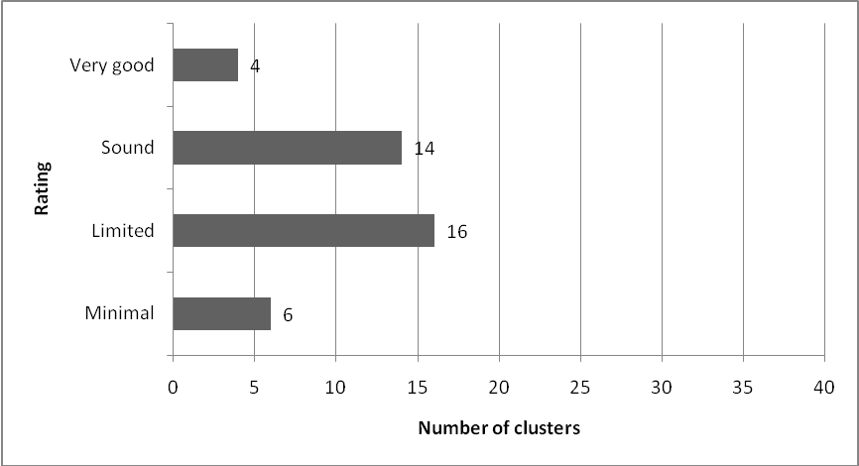

In the clusters that were operating in accordance with RTLB policy, a comprehensive operational framework of documented policies and procedures underpinned effective governance and management practices. These were customised to the cluster and closely aligned to the Policy and Toolkit. Cluster convenors or managers provided strong leadership, and management committees were active in supporting convenors and RTLB. Committees met at least once a term with good representation from cluster school principals and RTLB. Ways of working together promoted a strong sense of cluster identity and contributed to cluster-wide consistency of practice. Regular monitoring was underpinned by a collective understanding of roles and responsibilities in the cluster. A culture of trust and respect prevailed.
Just over a third of clusters had operational documents that were up to date and aligned to the Policy and Toolkit. Some distributed this documentation to all schools in the cluster. Operational documents were under review or needing review in 16 of the clusters, while seven clusters did not have an operational framework to guide practice. Some of these clusters worked directly from the Policy and Toolkit, without customising policies and procedures to their specific context. Others had policies to guide practice, but these were incomplete. In a few clusters, RTLB had developed policies and procedures to guide their practice as a response to the lack of operational documentation at management level.
Every cluster is required to have a Memorandum of Agreement (MoA) that describes the roles and responsibilities of the schools in the cluster and the relationship between the cluster and the Ministry of Education. Not all clusters had a signed MoA in place. (A fifth of the clusters were awaiting the return of a signed copy from the Ministry, and a similar number were in the process of getting the MoA signed by schools.) This situation raises questions about the purpose and value of these agreements.
The management of cluster funds varied. In seven clusters, funds were well managed, and processes for allocation, with clear lines of accountability, were known to all. In the four clusters where funds were poorly managed and allocated, issues related to budget information not being shared and a lack of transparency about the use of funding, in particular of the Learning Support Fund (LSF) and Year 11 to 13 funding. Monitoring and accountability for the use of funding were areas of weakness in many of the clusters.
In a few clusters, particularly those with one RTLB, there was a tendency for RTLB to take, or have delegated to them, responsibility for management activities such as policy development, annual reporting and setting up and implementing referral processes. This added to RTLB workloads and affected access to their services.

ERO’s judgement
The RTLB policy requirements set out in the Resource Teachers: Learning and Behaviour (RTLB) Policy and Toolkit (2007) are not fully adhered to in just over half the clusters in this evaluation.
It is concerning that there are no consequences for not following policy and that there are no effective monitoring or accountability mechanisms in place for ensuring requirements are being met in all clusters. ERO found instances where Ministry of Education personnel had approved or condoned practices that were contrary to RTLB policy. Poor governance and management practices often impacted negatively on the service’s quality, in particular the management of the RTLB, whose work is critical in supporting students and teachers to achieve desired outcomes.

Next steps for improvement
The governance and management issues related to RTLB clusters not operating according to policy requirements need to be addressed. This should include:
- clarifying the rationale for the MoAs and establishing a process to ensure they are current and that all parties have a signed copy;
- implementing more effective systems to monitor how well clusters are meeting policy requirements;
- providing easily accessible support for clusters regarding the development of operational documents;
- providing ongoing professional development for cluster convenors, specific to their role; and
- providing opportunities to share good governance and management practice across clusters.
Example of good practice in an RTLB cluster that is operating according to requirements
Cluster A
This cluster consists of 10 schools, with four RTLB. It has two employer school boards, one primary and one secondary. Traditionally, the principal of the
fund-holder school has been the cluster convenor. Teacher surveys in 2007 and 2008 showed a high level of satisfaction with the RTLB service in this cluster.

This cluster has clear, well-established structures for governance and management. The operational document includes policies and procedures that are tailored to the particular character and needs of the cluster, and these effectively guide cluster operations effectively. A protocol with GSE is in place, and the partnership is working well. Policies are reviewed to align them with the Policy and Toolkit.

Governance is the responsibility of a group that includes all the principals in the cluster. This group meets twice a year with the GSE service manager and one RTLB representative. The management committee comprises four principals representing the range of school types in the cluster, with the convenor, a GSE representative, and all the RTLB. This group meets once a term.

The strong, committed leadership of the convenor is a key factor in the effective governance and management of the cluster. The convenor takes a proactive approach to her role, and ensures that cluster schools are kept well informed about RTLB and management matters through regular communication channels. A strong sense of unity and ownership of the service is evident among cluster principals.

The convenor is supported by the management committee whose minutes and reports demonstrate clear, methodical operating procedures and systems. Members of the management group articulate cluster strengths, needs and priorities. RTLB report to this group, providing useful and full updates on progress with their work goals. The management committee supports and advises employer principals about their responsibilities in regard to RTLB. Management documents show clear tracking of administration and travel grants. The Learning Support Fund (LSF) is used primarily to employ two cluster teacher aides, who are deployed across the cluster by RTLB. A small portion of the LSF is contestable.

The intake and review committee is a separate group consisting of the convenor, principal representatives, RTLB and the GSE service manager. The principals take part in intake and review processes on a rostered basis, which enables all of them to increase their understanding and knowledge of RTLB work.

Overall, the high level of collegiality and involvement of cluster principals at management, governance and referral levels is a strength of the cluster. Principals are well informed about initiatives and interventions across the cluster, and are committed to contributing to a service that helps students achieve to their potential.

A2: Self review, planning and reporting

What is expected?
RTLB clusters are expected to have a continuing and regular annual planning,
self-review and reporting cycle that leads to improvement. Every cluster must plan annually to meet the needs of the target students; ensure every RTLB keeps a record of work undertaken with students and the outcomes; collate the records of individual RTLB into a cluster record; and report annually on the work of RTLB and the outcomes of students, to all schools in the cluster and in a prescribed format to the Ministry of Education.
Ministry of Education, 2007, Resource Teacher: Learning and Behaviour (RTLB) Policy and Toolkit (2007) p.15

What did ERO find?
Figure 2 shows that self review, planning and reporting was not a strong feature of governance and management practice across the clusters. Seven clusters had processes that supported ongoing cluster planning, self review and reporting, although only two of these had robust processes in place.

Figure 2: Self review, planning and reporting

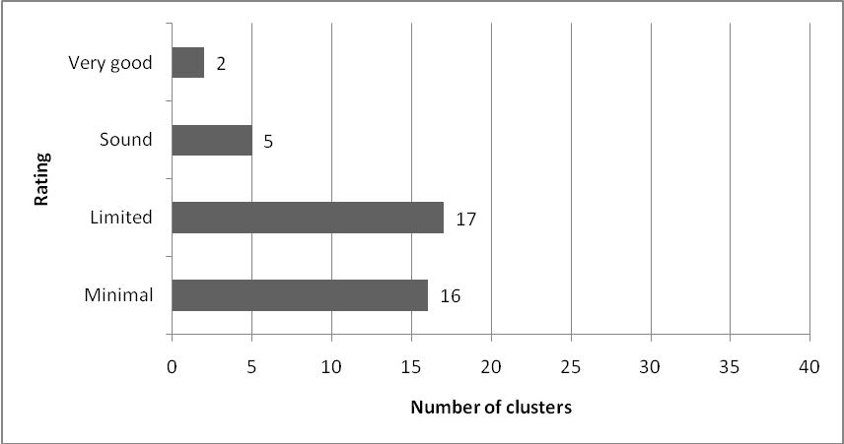

In seven clusters, an analysis of cluster needs informed strategic or annual planning. Clusters used a range of information to determine short and long-term goals. Data included cluster survey results (with data from a range of users of the service including teachers, Special Education Needs Coordinators (SENCO) and principals), analysis of referral patterns, outcome data from RTLB interventions, and student achievement data. Cluster priorities were identified and used to set direction for long-term planning. They also provided a structure for cluster reporting additional to Ministry of Education reporting requirements.
We are responsive to feedback. We survey schools, principals and teachers and RTLB act on this information to plan and modify what they do. We are keen for the service to be responsive.
(Comment from member of management committee)

In four of the seven clusters, self review was particularly strong, planned and focused on improvement. Data was gathered from a range of sources, analysed, and findings used to review policies and practices, and measure progress against strategic goals. Clusters were responsive to emerging trends and patterns and gave priority to identified needs in planning.
Most (33) clusters did not have a good understanding of self review and planning and reporting as it pertains to the RTLB service. Where plans existed, these were often developed by RTLB and consequently focused on their work. Many clusters had undertaken no analysis of needs based on information gathered as part of self review. Some had plans that were very task-oriented without a good understanding of the potential of self review to improve the cluster’s operation and effectiveness. Many clusters had no agreed approach to self review and no processes to seek systematic and regular feedback from schools. Management committees and convenors did not see or understand the value of self review to the cluster. These clusters had no way of knowing the extent to which practice and policy were aligned.
We have in the past talked as a cluster about being proactive. I suggested many years ago that we develop a cluster-wide strategic plan for our RTLB based on data from our engagement with students and schools in our area. This was done at least once. But I am not sure whether it has happened since.
(Comment from cluster personnel questionnaire)
In some clusters RTLB were highly reflective, but there was no formal approach at management level to use and build on this understanding of practice. Many principals commented that they were too busy in their own schools and did not have time for RTLB cluster self-review activities. Self review was not seen as relevant or useful in many clusters.
Most of the 40 clusters had completed the required annual reporting to the Ministry of Education. In clusters where this complemented other reporting, it was based on data from RTLB reports to management committees. In other clusters, reporting was undertaken as a compliance activity with little bearing or relevance to actual planning, practice and outcomes.
ERO had concerns about the accuracy and quality of data gathered and reported in many clusters. For example, some clusters reported that goals for individual students were in progress when in fact all students were removed from the RTLB roll at the end of the year. There were also inconsistencies in how RTLB gathered and analysed data. In many clusters there was no analysis of data at cluster level, with data being gathered for Ministry reporting and not used for any other purpose. There was a general tendency towards descriptive and generalised reporting, rather than relating it to outcomes. ERO also found variation in whether or not schools received reports on the outcomes of RTLB work. Many convenors and/or management committees did not realise they were required to report to schools in the cluster.
In about half the clusters, RTLB kept good records of their work and were able to provide evidence of the progress and effectiveness of their interventions. In six of these clusters RTLB records clearly showed all phases of the intervention and evidence of collation and analysis of the information. This was reported to the management committee and used to inform cluster-wide planning. RTLB record-keeping was hugely variable in six of the clusters because of a lack of cluster-wide expectations and systems. Inconsistencies in record-keeping made it more difficult for clusters to analyse data and produce useful, valid information about the service’s impact.

ERO’s judgement
Annual planning, self review and reporting were the weakest aspects of cluster governance and management practice, despite being required under RTLB policy. ERO’s 2004 evaluation identified a similar concern. The lack of systematic self review limits the extent to which clusters can plan and respond to identified priorities and meet students’ learning and behaviour needs. Issues related to the Ministry’s reporting requirements, particularly about accuracy and the quality of the data, limit the usefulness and relevance of what is reported.

Next steps for improvement
The rationale for reporting, and the nature and use of data gathered, should be reviewed to ensure reporting is useful for the cluster and used by the Ministry to improve the RTLB service. This should include the Ministry:
- using information gathered to provide targeted support to individual clusters;
- supporting cluster convenors and management committees to increase their understanding of the value of self review as it applies to the RTLB service; and
- assisting clusters to implement a robust cycle of planning and reporting based on sound evidence gathered as part of regular self review.

Example of good practice in an RTLB cluster that effectively implements self review, planning and reporting

Cluster B
This cluster has five RTLBs working across 10 schools, including one secondary school. The cluster has established a continuous planning/self review/reporting cycle that is geared to ongoing improvement.

A system for regular review of cluster operations includes seeking and acting on feedback from personnel in the cluster. Emerging trends and patterns are shared, discussed and responded to. The self-review process is planned and underpinned by a range of good quality qualitative and quantitative data.

Strategic planning includes the cluster’s vision, mission, goal development and actions to be taken. The plan identifies long and short-term goals that are firmly based on analysis of cluster needs. The cluster uses information on the achievement of students to set its targets and cluster priorities. A major focus for 2009 is on the transition of students. There has been much discussion around this theme to gain clarity about the cluster’s strengths and weaknesses. Five critical transition points have been identified, and planning has involved developing appropriate strategies at each point for students’ smooth transition to their new learning environments.

The cluster has also identified the need for behaviour management support for beginning teachers. Building the capability of these teachers has become a goal and in support of this goal, RTLB have undertaken professional development to raise their own knowledge of effective practices about managing classroom behaviour. RTLB have conducted school behaviour surveys, reported to management on the findings, facilitated staff meetings and developed a booklet for teachers. Although it is too early to evaluate fully the impact of these strategies, actions taken so far demonstrate a positive response.

Analysis of referral patterns shows that boys and Māori students are disproportionately represented. RTLB have scheduled professional development in Māori pedagogy, in order to improve their own understanding before implementing cluster-wide initiatives.

RTLB keep sound and substantial records of intervention sequences. Of particular note are their case closure records, which contain pre and post-intervention data as well as recommendations for teachers and students.

The cluster has reliable reporting systems. The management committee receives comprehensive and informative reports from RTLB, and reports regularly to cluster schools on management business, trends and patterns in the data, and the impact of RTLB interventions on student achievement. RTLB also send out newsletters to schools, reporting on interventions and outcomes.

A3: Access to the service

What is expected?
Each cluster is expected to have policies and procedures to ensure equitable access to the RTLB service. These should include transparent intake procedures that ensure equitable and timely responses. All cluster schools should have access to the cluster’s operational procedures, including cluster referral processes. Clusters should operate a separate referral and review committee which should comprise GSE and representatives of the cluster’s RTLB and principals.
Ministry of Education, 2007, Resource Teacher: Learning and Behaviour (RTLB) Policy and Toolkit (2007) pp.15 and 19

What did ERO find?
Figure 3 shows that about half of the clusters had sound to very good processes to ensure equitable access to the RTLB service. It is of concern that there were issues with access to the service in just under half of the clusters.

Figure 3: Access to the service

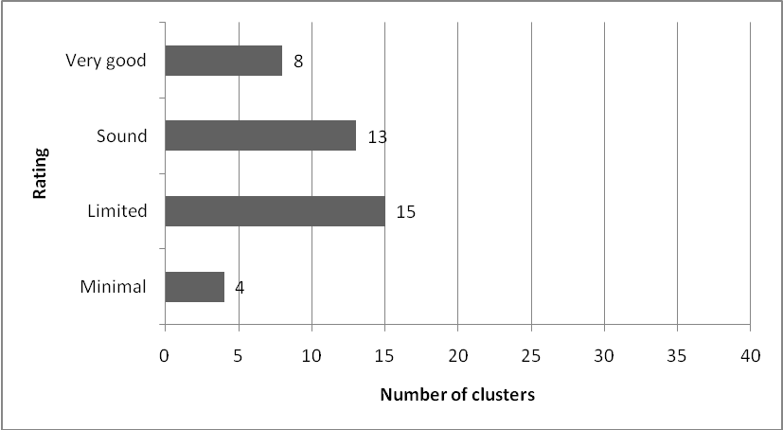

ERO found different practices associated with access that worked well in cluster contexts, including varied:
- numbers of RTLB and schools in the cluster;
- types of schools served by the cluster; and
- ways of working in clusters.

Common features of good practice included:
- referral committees with good representation of RTLB, management and GSE;
- sufficient data from schools to make informed decisions;
- open or rotational involvement of cluster school principals;
- good communication of referral processes and timely decisions;
- referral processes being well understood with easy access to forms;
- clear criteria for acceptance onto the RTLB roll;
- filtering or pre-referral discussions with school personnel to ensure appropriate referrals; and
- minimal delays between students being accepted on the roll and commencement of interventions.
In some clusters there was ongoing review and refinement of referral processes, with an increasing emphasis on getting good information from schools and ensuring other options had been explored by the school before referring to the RTLB service.
Issues associated with access to the RTLB service included poor communication about the outcomes of referral processes and a lack of transparency about how decisions were made. In addition to this were misunderstandings about the RTLB role, with some schools wanting a ‘quick fix’ approach.
In a few clusters, schools expected the RTLB to withdraw students, or wanted the cluster to fund a teacher aide without RTLB involvement. Where an individual RTLB worked only in one or two schools and took all referrals for them, there was limited use of RTLB’s knowledge and skill base. In one cluster, some of the RTLB were unit-based rather than itinerant which placed limitations on the access schools had to the full range of RTLB expertise in the cluster.
Discontinuation practices impacted negatively on access in some clusters. In many, cases were discontinued after 30 weeks and in others closure was routine at the end of the year. School personnel expressed dissatisfaction where teachers or Special Education Needs Co0rdinators (SENCO) had to re-refer students. RTLB and cluster personnel spoke of the increasing number of students being re-referred. However, most clusters did not have data about how many re-referrals were occurring. In a few clusters, there were instances where students remained on the RTLB roll for two years or more.
At least a third of our roll is made up of re-referrals. Some children are coming to our notice over and over again.
(Comment from member of management committee)
An issue of professional safety regarding access to the service emerged in two clusters, each with one RTLB. In these clusters the RTLB made referral decisions on their own. Four clusters in this study had one RTLB and while two of these clusters had recently established committees with responsibility for referral decisions, the other two had no formal means for making such decisions. This is not in line with RTLB policy.

ERO’s judgement
The management of access to the RTLB service was highly variable. In some clusters, students and teachers did not have equitable access to RTLB and referral processes were not well known or transparent. The success of the service was largely determined by the extent to which students who required support and met pre-determined criteria were responded to in an appropriate and timely manner. Misunderstandings and misconceptions about the RTLB role compounded the situation and limited access to the service.

Next steps for improvement
Consideration needs to be given to establishing a shared understanding of the RTLB’s role and of the nature of their work. This should include:
- ensuring RTLB training is relevant to their work, particularly as it shifts to being more focused on systemic interventions;
- clarifying the nature of the intervention model in terms of who RTLB work with, and the length and focus of such interventions; and
- more rigorous monitoring of RTLB interventions to ensure these are undertaken within agreed parameters.
Clusters also need to ensure all schools have access to the RTLB skill base by having transparent allocation and deployment processes as part of the referral system.

Example of good practice in an RTLB cluster with good access to the service

Cluster C
Cluster C consists of 14 diverse schools, including six rural and one secondary school. Three RTLB work in the cluster, and of these two are in training. Access to RTLB service is very good. The RTLB are well known and have built very good relationships with schools and families.

The management committee, which includes the three RTLB, takes responsibility for the cluster’s intake and review functions. The fortnightly management meetings allow time for prioritising referrals according to needs-based criteria. RTLB caseloads are decided through collaborative decision making.

The referral process is well understood by teachers and principals, and is regarded as equitable. A flyer is distributed to schools to explain the RTLB role, referral procedure and services offered. Discussions with SENCO and special needs committees in schools enable RTLB to assist and advise key personnel when a referral is being considered. These student-focused discussions increase schools’ awareness of the RTLB role and the priority given to building teacher capability (“The teacher is the first client” – RTLB). Further benefits include the greater efficiency brought about by filtering or redirecting of referrals, and schools’ sense of involvement in the RTLB service.

RTLB place strong emphasis on accepting referrals without making judgements about those in schools making the referral. This ‘no blame’ approach aims to foster a high level of professional trust and to minimise perceived barriers to accessing the service. GSE are well represented at management and intake meetings, and RTLB actively promote collegial relationships with other support agencies in the community.

All schools in the cluster, including the college, access the service for both learning and behaviour needs. Previously, the priority was behaviour, but a local initiative, supported by RTLB, led to the introduction of social workers in schools. This contributed to greater flexibility and more attention to cluster-wide learning.

RTLB are central to the allocation of LSF funding. The main uses of this resource are employment of teacher aides and provision of teacher release time.

A4: Personnel management and support

What is expected?
The employer school board, through the principal has responsibility for the employment of RTLB. The board is responsible for all employment matters: appointment, induction and performance management, including appraisal, professional development and supervision. Ministry of Education, 2007, Resource Teachers: Learning and Behaviour (RTLB) Policy and Toolkit (2007) pp.12 and 18

What did ERO find?
As shown in Figure 4, just under half the clusters were adequately managing personnel and providing support for RTLB. Fifteen clusters had limited personnel management practices, and in eight ERO identified several concerns.

Figure 4: Personnel management and support

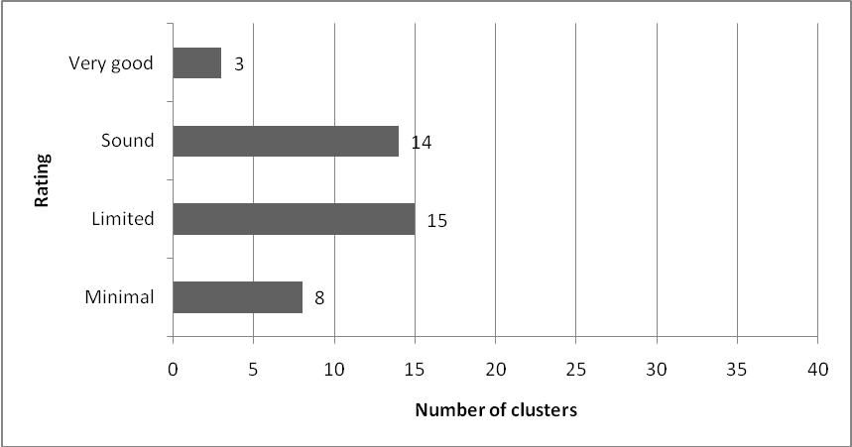
In the clusters where personnel management and support was very good, policies and procedures guided consistent practice for RTLB appointment, induction and appraisal. In one cluster, the management committee worked closely with the employer school to ensure appointments and the appraisal process reflected cluster needs and priorities.
There was considerable variation in the number and role of the employer schools. Twenty-two clusters had one employer school, while one cluster had as many as six employer schools. Figure 5 shows the spread of employer schools across the clusters in this evaluation.

Figure 5: Number of employer schools per cluster

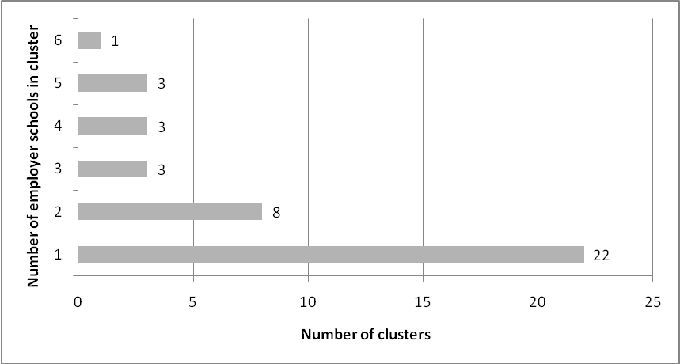
The Policy and Toolkit states that clusters should be working towards reducing the number of employer schools to one. Most of the clusters with more than one employer school were not doing this. ERO found no relationship between the number of employer schools and the effectiveness of governance and management. In fact in the clusters that were well governed and managed, the number of employer schools ranged from one to five. In these clusters, good practice was based on the extent to which employer schools knew about and were supported in fulfilling their responsibilities. It was the culture and leadership in the cluster that made the difference.
ERO analysed the education review reports of the employer schools in RTLB clusters that were not well governed and managed to examine the relationship between performance in the cluster and the performance of the employer schools. In most cases there was no clear link between employer school performance and cluster performance. The majority of these schools are on a regular review cycle. Many had areas of good performance in their personnel management and in aspects of leadership, and school planning and reporting. It would seem that good practice in employer schools is not being applied to the cluster context.
Most clusters had good appointment processes, with half stating they based recent appointments on identified needs or priorities. In some clusters, employer schools took responsibility for appointments and in others it was a collaborative approach involving the management committee and employer school. There were small fields of suitable applicants in a few clusters. Induction practices varied and formalised induction processes were evident in only a quarter of the clusters. Where induction was planned, it was usually undertaken by an RTLB.
ERO identified several issues regarding employment practices that were not aligned to RTLB policy. Policy states that “RTLB are full-time, permanent itinerant teachers.” ERO found evidence of RTLB job-sharing in three clusters, working in relieving positions in three clusters, working in fixed-term contracts in four clusters and working part-time (not job sharing) in two clusters. At least four clusters had non-itinerant RTLB, with several more having RTLB who were supposedly itinerant, but based and working solely in one school. This was particularly so in secondary schools. Although RTLB policy is quite clear in this regard, cluster practices varied considerably. ERO found evidence of Ministry of Education staff giving advice or making decisions related to employment practices that were inconsistent with policy.
Most clusters employed RTLB who were trained or in training, and most offered support for RTLB in training by reducing their caseload and giving a time allowance for study. There were benefits in having RTLB in training. These included trainee RTLB upskilling their colleagues and sharing current research. Nine RTLB were not qualified and were working in six clusters. Of these nine, three had started but not completed training, three had no intention of completing training, one was in a job-share position, and two were in long-term relieving positions. In two clusters, two RTLB had had their training deferred and in another one RTLB had an exemption. ERO found inconsistencies in whether or not RTLB in relieving positions could undertake training. In one cluster, a relieving RTLB was funding the training herself and in another the RTLB in a long-term relieving position had been told that she was not able to access the training. In some clusters Ministry of Education staff made decisions, or gave advice, regarding training that were inconsistent with RTLB policy.
Some clusters made good use of the diverse skill base in their RTLB teams. In five clusters a lead RTLB/team leader or coordinator(s) had been appointed to undertake various tasks including liaising with the management committee, representing RTLB on the management and/or referral committee, reporting to management and overseeing and monitoring workloads, appraisal processes and professional development activities. This lead role worked well in most of these clusters. However, it had a negative impact when the role was used by lead RTLB or team leaders to dominate decision-making. This sometimes contributed to relationship difficulties.
In most clusters, professional development for RTLB was funded through budget provision. In a third, professional development focused on a mix of cluster and individual RTLB priorities. However, much of the professional development was not linked to appraisal goals or cluster needs and priorities. In some clusters, RTLB participated in professional development programmes and activities being undertaken by staff in employer schools, for example in relation to current curriculum initiatives. In other clusters, RTLB were expected to undertake professional development not related to their role or learning and development needs. For some RTLB, the only professional development undertaken and funded by the cluster was attendance at an annual conference. RTLB commented on the lack of relevant professional development post training. The impact of the investment in professional development for RTLB was unclear in most clusters.
In 28 clusters, RTLBs were appraised annually. The quality of this appraisal varied greatly, with only half of these clusters implementing a comprehensive appraisal process likely to lead to improved practice. In these clusters, appraisal was based on RTLB professional standards, personal and professional goals and cluster priorities or objectives. Appraisal of RTLB was not carried out in four of the clusters; in a further eight, it varied among employer schools; and in a few clusters some RTLB were appraised while others were not because of variable employer school practices. Some RTLB expressed their frustration about the lack of accountability systems for addressing their concerns about the performance of their colleagues.
I have not been informed of the appraisal process for the RTLB in our area. There has been no contact from the fund-holder school to gain feedback for the purpose of appraisal.
(Comment from Cluster personnel questionnaire)

In one cluster with two employer schools, the two RTLB (each employed by a different school board) had different employment conditions and two different job descriptions. In 2008 the appraisal for one RTLB was well done while the other was poor and no formal appraisal of either RTLB was undertaken prior to 2008. In many clusters appraisal had limited impact on practice.
Access to, and uptake of, professional supervision by RTLB was variable, often due to misunderstanding of its purpose and value. In 16 clusters RTLB had good access to supervision in individual, peer and group contexts. These clusters budgeted for supervision and there were no issues for them in accessing appropriate supervision. In 10 clusters, supervision was budgeted for, but not always accessed. This was because of factors such as the high cost of supervision; RTLB not seeing it as useful; or it being accessed on a needs-only basis. In four clusters, RTLB had difficulty finding suitable people to provide supervision.
GSE played a key role in supervision in some clusters, but not in others. In four clusters, access to supervision was not equitable, with RTLB receiving paid supervision and others having to fund it themselves or being unable to access it. Two clusters had just made budget provision for supervision in 2009, and in four there was no provision or access to supervision. Three of the four clusters with no professional supervision had only one RTLB. This is concerning, given that these RTLB work on their own and do not have the same access to collegial support as RTLB in larger clusters.
RTLB should not be placed in sole positions. To have the support of colleagues and the ability to have interaction on a daily basis with others is essential. To be part of a cluster of RTLB would be just so good!
(Comment from RTLB questionnaire)

ERO’s judgement
Personnel management is important in supporting and improving RTLB practice. This evaluation has found that not all RTLB were getting their employment entitlements, particularly as these pertained to appraisal, professional development and professional supervision. Discrepancies related to RTLB employment were found between, and sometimes within, clusters. Advice from, and decisions by, Ministry of Education staff were sometimes inconsistent with policy.
Practices in just over half the clusters were not fully in accordance with RTLB policy requirements. In some clusters variable personnel management practices contributed to inconsistencies in the RTLB role and the quality of the service. This variation affected the effectiveness of clusters in improving outcomes for students and support for teachers.

Next steps for improvement
Variations in how well employer schools carry out their responsibilities, as employers of RTLB need to be addressed urgently. This should include closer monitoring of employer schools to ensure RTLB get their entitlements as employees in relation to appraisal, professional development and supervision.

Example of good practice in an RTLB cluster that provides effective personnel management and professional support

Cluster D
Cluster D comprises 16 urban schools, including three secondary schools. Six itinerant RTLB work in these schools. There are three employer boards, and although the Ministry of Education expects clusters to reduce to one employer school, this cluster has no intention of doing so. Responsibility for personnel matters has been delegated to the principals of the employer schools. The management committee provides advice and support to employer schools to ensure that they fulfil their responsibilities.

Five of the RTLB are permanent and full time. A newly appointed sixth RTLB is a long-term reliever for a year. Appointment procedures are formally documented, and in this cluster they are carried out by the management committee in association with the employer school principal. The overarching consideration is to employ suitable RTLB who complement the existing skill base. A documented induction programme is in place, and the relieving RTLB found that it was well managed, useful and beneficial.

With the exception of the long-term reliever, all the RTLB have completed training. Professional development is budgeted for, and RTLB access appropriate learning opportunities to further develop their skills and knowledge as well as to support cluster initiatives. Currently, support for students with dyslexia is a cluster priority, and all the RTLB have identified this as a professional development focus.

School personnel, including senior managers and SENCOs, work to ensure the deployment of RTLB is equitable and transparent. Records and reports on student outcomes across the cluster confirm schools’ perceptions that staffing is used effectively to meet identified needs. RTLB are assigned to work in any of the schools according to their caseload, their strengths and the specific needs of the school.

The three RTLB who have a secondary background work mainly, but not exclusively, in the three secondary schools. These RTLB have high credibility in the schools, and provide valued service. The secondary schools have access to the full range of experience and skills in the RTLB team, not only to those with a secondary background.

The cluster has a contract with a registered psychologist to provide professional supervision. Workplace support is also available in the form of an industrial chaplain based in the convenor’s school. Funding is allocated for two individual sessions for each RTLB per term, and two per year with the whole team. The RTLB share a strong collegial philosophy, and they meet regularly as a team to discuss pertinent issues and support each other.

All the RTLB are appraised annually using RTLB professional standards and key performance indicators. This is the responsibility of the employer school principal. The process follows a three-year cycle: principal appraisal, peer appraisal, and external appraisal. Appraisal policies and procedures are followed consistently by the three employer school principals.

A5: Relationships

What is expected?
In effective RTLB clusters professional, trusting and respectful relationships are maintained at all levels.
Ministry of Education, 2007, Resource Teachers: Learning and Behaviour (RTLB) Policy and Toolkit (2007) p.19

What did ERO find?
As shown in Figure 6, in well over half of the clusters, good quality relationships enhanced the way cluster management personnel and RTLB worked with each other and personnel in cluster schools to achieve positive outcomes for students and teachers. However, in just over a third of the clusters, relationship issues had a negative impact on the effectiveness of the service.

Figure 6: Relationships

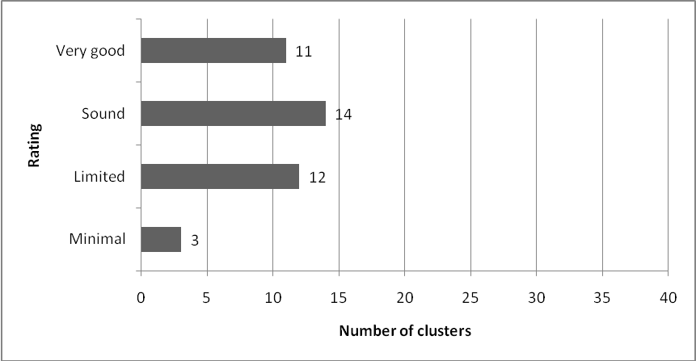
Relationships in clusters were one factor that contributed to success. In clusters where relationships were professional and respectful, a climate of trust prevailed and RTLB worked collaboratively with each other, management committee members, school principals, teachers and students. Relationships were cultivated through regular visits by RTLB to schools, ‘road shows’ about the service, RTLB’s participation in whole school professional development, and meetings between RTLB and SENCOs and other school personnel. A fifth of the clusters had a liaison system whereby RTLB were allocated one or more schools in the cluster. This practice was well received and valued by schools in these clusters. The liaison role provided opportunities for RTLB to keep in regular contact with school personnel. RTLB were visible and accessible.
In the few clusters where relationships were not working well, issues related to:
- lack of trust and some misunderstanding between RTLB and school personnel;
- tensions in the RTLB team;
- lack of flexibility or unwillingness to work in different ways;
- inequitable workloads; and
- limited involvement by principals in the management of the cluster.
In well governed and managed clusters, the development of relationships with organisations and agencies beyond the cluster was an important factor. Good relationships existed among clusters and regular meetings provided opportunities for sharing information, particularly about students transitioning between schools. The potential for relationship issues was mitigated by establishing good systems and processes.
The Ministry of Education expects that RTLB and GSE staff work in partnership to provide a seamless service to schools. All clusters should have a signed protocol with GSE showing how RTLB and GSE work together. ERO found that half the clusters had a current, signed protocol with GSE. In six clusters the protocol was being negotiated and in two it had expired. Eleven clusters did not have a signed protocol with GSE. In one cluster a protocol document was unsigned and no-one knew about its status. In some areas GSE developed the protocol and it covered more than one RTLB cluster. In others the approach was more collaborative and tailored to one particular cluster.
Our GSE liaison person attends all our review and intake meetings. She provides advice and guidance as needed or acts as a conduit to other GSE personnel who can help us. Her personal qualities ensure the relationship is very professional. Decisions are made collaboratively with respect shown for people’s differing areas of expertise.
(Comment from an RTLB questionnaire)
Where a partnership approach existed, RTLB and GSE staff worked collaboratively, co-working and sharing information to best respond to the needs of individual students.
Issues that hampered relationships between RTLB clusters and GSE included:
- staff turnover;
There is a lack of personnel available to support more students with more severe needs and we find we are trying to help schools manage until appropriate support can be accessed. When schools beg for support we ring and discuss with an available expert to keep us safe until they come on board.
(Comment from an RTLB questionnaire)

- a lack of GSE input in the referral process;
- blurring of the RTLB role due to GSE staff expecting RTLB to work with high needs students; and
- clusters having to work with more than one GSE district.
Relationships were also constrained by the limited GSE resource in some areas.
The nature and quality of relationships with organisations and agencies beyond the cluster (and beyond GSE) varied between clusters. In some clusters, regular meetings and sharing of information between different agencies enhanced relationships. RTLB had a good knowledge of, and access to, local services. In other clusters, relationships with other agencies were more sporadic.

ERO’s judgement
The quality and nature of the relationships in and beyond RTLB clusters were a positive feature in many clusters. The personal qualities of the people (cluster convenors, RTLB, management committee members, school principals, teachers and staff in other agencies such as GSE) influenced ways of working to bring about positive outcomes for students and teachers. Where relationship issues existed, they were sometimes quite deeply embedded in the cluster culture and not easily addressed without external intervention. Poor relationships had a negative impact on the quality of the service, RTLB professionalism and the perceptions of their work in the wider community.

Next steps for improvement
The Ministry needs to implement a more proactive and responsive approach to identifying and managing relationship issues in clusters. Where relationship concerns are identified or known about, constructive interventions would help give clusters the support they need to resolve issues.
The Ministry has a lead role in ensuring protocols between RTLB clusters and GSE are signed and that the approach to develop them is a shared and useful process.
Example of good practice in an RTLB cluster with positive relationships

Cluster E
This cluster consists of 10 primary and intermediate schools, of which five are rural. Two RTLB work in these schools, with one employer school.

Relationships throughout this cluster are positive and mutually respectful. This is partly attributable to clear definition and sound understanding of roles and responsibilities. The convenor and management committee are key leaders in the fostering of strong collegial relationships across the cluster. They are actively involved in supporting RTLB and the level of discussion at committee meetings is high, showing good understanding of cluster issues and current interventions. The management committee is supportive of the convenor and share management responsibilities equitably. Professional, trusting relationships are evident at all levels.

The management committee has a thoughtful, considered approach to appointing new RTLB. Highest priority is given to recruiting someone with ‘passion’ and an ability to work collaboratively. Those involved in or connected with the current RTLB, respect them for the professional and personal qualities that they bring to the work. The relationship with GSE is also positive. The GSE representative on the management committee has fulfilled this role for three years. She recognises and affirms the importance of regular interface and collaboration, and her input is similarly valued.

RTLB have extensive, useful networks in the community, with other agencies and clusters. RTLBs appreciate and maintain their connections with the regional RTLB association.

Comprehensive systems for communication in and beyond the cluster underpin the maintenance of positive relationships. RTLB keep in regular contact with schools and sit on management groups for other education services such as Supplementary Learning Support.

A6: Communication

What is expected?
Effective RTLB clusters communicate with clarity and openness.
Ministry of Education, 2007, Resource Teachers: Learning and Behaviour (RTLB) Policy and Toolkit (2007) p.19

What did ERO find?
As shown in Figure 7, good communication was a positive feature in over half the clusters. These clusters had a good balance between formal, informal and incidental means of communicating. Poor communication in 16 clusters resulted from a reliance on informal ways of sharing information and relationship issues influencing the ability of RTLB and cluster personnel to focus on their work.

Figure 7: Communication

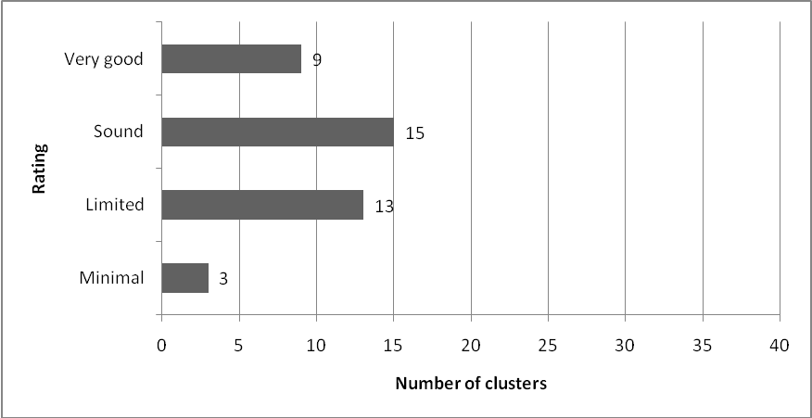

In clusters where communication was very good:
All RTLB visit schools as a group and meet staff and management teams to clarify their roles and responsibilities.
(Comment from a cluster principal)
- regular emails and newsletters kept everyone informed;
- management committee minutes were widely circulated;
- RTLB made regular visits to schools in a liaison role;
- informative cluster websites made information and forms easily accessible;
- RTLB facilitated SENCO and other meetings at cluster level;
- clusters had established systems for two-way communication between schools and RTLB; and
- it was effective and transparent at all levels.

Effective communication contributed to high levels of engagement and involvement in cluster governance and management. School personnel knew what was happening and had opportunities to have a say about the management of the cluster.
In the few clusters where communication was poor, relationship issues dominated and there was a lack of shared understanding about roles and responsibilities at all levels of the cluster. Communication issues had a negative impact on the ability of these clusters to provide a good quality service.

ERO’s judgement
Effective communication ensured that all involved were well informed about, and able to contribute to, the work of the cluster. It increased the transparency of cluster policies and practices and improved access to the service. Where communication was poor, it often resulted in lack of participation and interest from schools in the cluster, unrealistic expectations or under-utilisation of the service.

Next steps for improvement
The Ministry should provide opportunities for clusters to share good communication practices. The development of communication strategies could help clusters to think and work more strategically in sharing information with schools in the cluster and between clusters.
Example of good practice in an RTLB cluster with effective communication

Cluster F
This cluster comprises 19 diverse schools, including three rural and three secondary schools. Nine RTLB work across the cluster, which has five employer schools.

Good communication is vital for the effective operation of the RTLB service, especially for maintaining a sense of ownership and unity across a large cluster with a wide range of school types, multiple employer schools, and an urban-rural mix.

Well-established systems and pathways for communication are based on positive interpersonal relationships. These are characterised by high levels of trust and a strong sense of collaboration. Links between SENCOs, principals, teachers and RTLB are strong throughout the cluster, and communication flows freely between them through both formal and informal channels. For example, RTLB meet at least once a week with the SENCOs in the schools where they are working, and pass meeting minutes to the principals. When a referral is not accepted, RTLB go to the school and discuss the reasons with the referrer.

One of the strengths of the cluster is the RTLB’s practice of taking the time to sit down with teachers to develop a workable intervention plan and to maintain regular contact thereafter. This collaborative approach creates a shared understanding and clarity about what is important and how learning and behaviour concerns can best be addressed. Professional conversations between RTLB and teachers enable both parties to freely express their views, opinions and ideas. RTLB come into these discussions with an open mind and a willingness to share and learn. RTLB frequently attend school staff meetings, to keep up to date with changes and curriculum developments.

RTLB hold a regular team ‘forum’, which is an opportunity to report on professional development, share current research, and hear from representatives from other agencies. A communication loop back to schools enables teachers to benefit from relevant forum material.

Alongside the effective oral communication practices are documented systems for sharing information and reporting progress. The RTLB produce resources that are tailored to the local context, including a handbook that is distributed across the cluster. This is reviewed every year, and contains clear information about the cluster, contacts, management structures, meeting dates, the RTLB model, guidelines for referral, types of intervention, request forms, and LSF policy and procedures. Anyone reading the handbook can learn exactly what schools can expect from RTLB and what RTLB expect from schools.

A7: Leadership and involvement

What is expected?
Effective RTLB clusters have strong professional leadership in governance and management and the active participation of cluster principals who have a shared understanding of the RTLB role.
Ministry of Education, 2007, Resource Teachers: Learning and Behaviour (RTLB) Policy and Toolkit (2007) p.19

What did ERO find?
As Figure 8 shows, leadership of clusters and the involvement of principals was not a strong feature of RTLB clusters. Just under half the clusters had good leadership and a good level of involvement of cluster principals.

Figure 8: Leadership and involvement

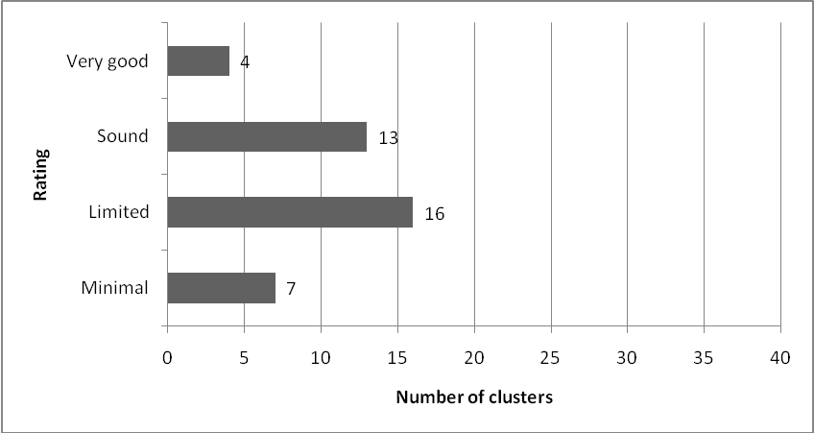
In the majority of clusters, the convenor was principal of one of the employer schools, which was also sometimes the fund-holder school. In the clusters where leadership was strong, convenors were often the professional leaders who were committed to, practised advocacy for, and had the ability to engage all principals in cluster matters. In one cluster, for example, a succession plan had been developed and another cluster principal worked alongside the convenor and could step into that role if needed. Some clusters formalised this role by designating or electing a co-convenor. A rotational or roster system for principal involvement on the management committee or on the referral committee contributed to increasing participation in cluster management and decision making.
In some clusters, weak professional leadership and poor governance and management practices meant RTLB took the initiative and largely managed themselves. They got on with running the service in spite of issues. Their professionalism carried the service and buffered any inadequacies in governance and management practices or systems.
In a few clusters, the convenor had been in that role for some time and in others new principals found themselves in the role by default. In others, the convenor role was undertaken by a senior manager from a cluster school. In three clusters, the convenor was a paid manager of the cluster. The effectiveness of having managers in paid positions varied.
New convenors in several clusters were coming to terms with their role and how to bring about required changes. In one, the convenor was well supported by the board chairperson, who was knowledgeable about and committed to the cluster. ERO identified the potential of these clusters to move forward with committed leadership from these new convenors.
The involvement and participation of principals in cluster management varied across the clusters. It was good or strong in about half. In clusters with a high level of involvement by principals, this was attributed to the leadership of the cluster, good relationships at all levels, and a shared sense of cluster and of the RTLB role. In a fifth of clusters, the only principals involved were those on the management committee. In others, while involvement was not high, good communication and reporting systems meant principals (and, in some clusters, their boards) were well informed about RTLB’s work and were kept up to date with recent developments.

ERO’s judgement
Leadership was a key factor in the governance and management of RTLB clusters. Good leadership strongly influenced how well clusters were managed and the extent to which school principals were actively involved. Poor leadership contributed to management issues and concerns identified in this report.

Next steps for improvement
Increasing opportunities for ongoing training and support for convenors and employer school principals could enhance leadership capability in clusters.

Example of good practice in an RTLB cluster with strong leadership

Cluster G
This is an urban cluster, consisting of 16 schools, two of which are secondary. There are eight RTLB, with five employer schools. The current convenor provides strong professional leadership. He is visionary and decisive, and supported in his role by the lead RTLB. Collectively they fulfil the responsibilities outlined in the Policy and Toolkit.

There is clear evidence of proactive leadership by the convenor, leading to improved governance and management practices that align with the Policy and Toolkit. Succession planning and induction include the establishment of two co-convenor positions. Care has been taken to ensure that the incoming convenors have a clear understanding of their role.

The convenor has led changes to the way the cluster is managed, primarily to strengthen the cluster as a whole unit instead of operating as disparate groups. Increased transparency and consistency have brought about greater participation from cluster principals, more equitable access to the RTLB service, and ultimately more positive outcomes for students. Changes are being managed effectively and strategically.

One of the objectives in the 2008–2012 plan is to develop effective communication protocols to ‘engage stakeholders in the process’. Actions include outlining cluster-wide expectations and introducing the liaison RTLB role. Flow charts identify who is responsible for consultation and communication. Cluster principals support the RTLB service and have a sound understanding of the RTLB role itself and of their own responsibilities. They have opportunities to contribute to decisions about planning and policy, and feel listened to. Reports presented by the convenor at monthly principals’ meetings ensure that they are kept up to date with developments. The annual meeting of cluster principals is well attended.

The establishment of a lead RTLB position has formalised leadership roles in the RTLB team. The current leader supports the convenor, and is well respected and supported. He provides professional leadership as well as taking responsibility for some day-to-day management tasks.

B: Specific aspects of cluster practices
This section reports ERO’s findings relating to specific aspects of RTLB cluster practice, including:
- managing transitions;
- RTLB in secondary schools;
- support for Māori students;
- use of Learning Support and Year 11 to 13 funding; and
- the impact of the Policy and Toolkit.

B1: Managing transitions

What is expected?
According to the Policy and Toolkit, clusters should develop protocols to manage transitions for students when they begin school, move between schools, or between support services.
Ministry of Education, 2007, Resource Teachers: Learning and Behaviour (RTLB) Policy and Toolkit (2007) p.90

What did ERO find?
As with other findings in this evaluation, practices related to transition were hugely variable. In most clusters they were informal and reliant on RTLB’s professionalism, their concern for students, and the quality of their relationships with teachers and SENCO in schools.

Examples of how transitions were managed well in clusters included:
- Year 8 students who were making the transition to secondary school remained on the RTLB roll to ensure they were well supported.
- A concern about a cohort of students moving from primary to intermediate school developed into an initiative whereby all schools could refer any student they had concerns about as they moved to the larger intermediate school.
- Transition plans were developed for students who had been on the RTLB roll and were moving between classes or schools.
- Children enrolling at school for the first time were supported by RTLB in liaison with GSE.
- A review in the cluster of transition practices identified key transition points for students. It improved the coordination of agencies around transition and the support for all students moving into or between schools.
Transitions were easier to manage when students were moving to one intermediate or one secondary school within a cluster. Relationships were developed and processes agreed on how information was shared and how RTLB worked with school personnel to ensure a smooth transition between schools. Some clusters discontinued students on an RTLB roll at the end of the year, which had a negative impact on continuity for students, particularly when they were moving between schools or clusters.
Practices for the transition of students with learning or behaviour difficulties when they started school were variable. Where there was good liaison with GSE, information was shared and this led to a well-managed start to school for students. Some clusters identified issues related to students starting school, particularly with students involved in early intervention programmes starting school without RTLB knowing about their need for support.
For many clusters, the most difficult aspect of transition related to transient students. Some clusters were vague about how information was to be shared between clusters. There were also inconsistencies between clusters regarding communication about students who moved across districts and had been or were still on the roll of their previous RTLB cluster.
Where transitions were poorly managed, this was often due to a lack of communication about students’ involvement with an RTLB.
A few clusters adopted a hands-off approach to transition, in the belief that this gave students a ‘fresh start’.

ERO’s judgement
In most clusters, practices associated with the transition of students on an RTLB’s roll were largely informal and reliant on RTLB’s relationships with school personnel in cluster schools, with GSE, or in other clusters.

Next steps for improvement
Clusters should consider formalising transition practices to ensure smooth transitions that best meet students’ needs. This should include:
- developing protocols for students moving between clusters; and
- implementing a more proactive and consistent approach, that involves GSE staff and RTLB, for students who are starting school.

B2: RTLB in secondary schools

What is expected?
According to the Policy and Toolkit, clusters with secondary schools need to acknowledge their different and complex structures and provide support accordingly.
Ministry of Education, 2007, Resource Teacher: Learning and Behaviour (RTLB) Policy and Toolkit (2007) p.12

What did ERO find?
Of the 40 clusters in this evaluation, two were made up of only secondary schools and 30 included a mix of primary and secondary schools. The two secondary clusters operated quite differently from each other and had contrasting opinions about the effectiveness of the approach. In one there was strong support for secondary dedicated clusters, while members of the other could see the benefits of a primary and secondary mix.
In just over half of the 30 clusters, with a mix of primary and secondary schools, school personnel were satisfied with the service they received from the RTLB.
The RTLB service in secondary schools worked well when RTLB gave priority to working with staff and developing trusting relationships. RTLB understood the secondary system and the implications for working with students who had multiple teachers. They worked well alongside specialist teachers. RTLB credibility, and management and teachers in secondary schools understanding the RTLB’s role were key factors. In one cluster forms had been developed specifically for referrals for secondary students and teachers. In other clusters, RTLB took part in regular pastoral care and special needs committees so they knew what was happening and could respond to needs as appropriate in the secondary school.
RTLB in secondary schools are more isolated but they do other things outside their job description that minimise their isolation.
(Cluster personnel)
Where ERO found dissatisfaction with the service, issues related to:
- the quality, credibility and teachers’ perceptions of RTLB;
- some secondary schools wanting to have and manage the resource themselves;
- perceptions that the intervention model did not fit in secondary schools; and
- the limitations of accessing only one RTLB, who worked solely in a school.
Some secondary school personnel said they preferred to have RTLB based at their school so they could have access as needed. The RTLB were seen to be part of the school and viewed as a resource in their school rather than a service for a cluster of schools. Others preferred the RTLB to have a secondary teaching background. RTLB in a few clusters were sometimes involved in classroom teaching and withdrawing individual students. A lack of monitoring by the management committee allowed such situations to continue unchallenged.
The secondary school is dissatisfied because the RTLB don’t understand secondary teaching. They say “give us the money and we will use it ourselves”.
(Cluster convenor)

In a few clusters, RTLB were involved in, and had some of their time specifically allocated to, school-based professional development programmes such as Te Kōtahitanga. Clusters did not have information to determine the effectiveness of this involvement and not all management committees knew of RTLB’s involvement in such programmes.

ERO’s judgement
ERO did not identify any particular cluster model that worked best for secondary schools. The RTLB service works well in secondary schools where management and RTLB understand the factors that need to be considered in a secondary school environment. An approach is needed, that takes account of the specialised nature of teaching in secondary schools and the fact that students have multiple teachers.

Next steps for improvement
Further investigation is needed into how the RTLB service fits with secondary school practices to ensure it provides appropriate support for students with moderate learning and behaviour needs. Such an investigation should focus on strengthening ways RTLB can build teacher capability in a secondary school environment and the best ways to work at a systemic level.
Clusters need to develop ways to more closely monitor the impact of RTLB involvement in professional development programmes such as Te Kōtahitanga.

B3: Support for Māori students

What is expected?
As part of their annual review, clusters must consider the needs of Māori students, especially those in Māori-medium settings.

All RTLB may take referrals for Māori students. In some clusters one or more positions may be designated RTLB Māori, to focus specifically on Māori students.
Ministry of Education, 2007, Resource Teachers: Learning and Behaviour (RTLB) Policy and Toolkit (2007) p.17

What did ERO find?
We’ve never considered looking at what is happening for our Māori students. Now with the Policy and Toolkit we are looking at how we can be more culturally sensitive. Most of my roll is Māori.
(RTLB)

The extent to which the clusters considered the needs of Māori students was variable. This was not a strong feature of most clusters. A quarter had collected data about the number of Māori students on RTLB rolls, but there was little analysis or use of this data to identify the effectiveness of interventions for Māori students or to determine cluster priorities. Just under half had not given any particular consideration to the needs of Māori students.
In a fifth of the clusters, where data had been gathered and analysed, strategies or goals were included in the annual planning process. These included a focus on improving RTLB practice in working with Māori students and their whānau, by seeking relevant professional development.

ERO’s judgement
The limited analysis of information about the needs of Māori students by RTLB clusters means priority is not being given to ensuring the service responds to these students. Although most clusters provide the Ministry of Education with data in their annual reporting, many do not analyse or use it. This is not acceptable, given the current focus on supporting all Māori students to achieve success.

Next steps for improvement
As part of a wider strategic focus on supporting Māori learners to achieve success, RTLB clusters should actively demonstrate the difference the service is making for Māori students, whether in mainstream or immersion settings.
While this evaluation did not specifically focus on the work of RTLB Māori, in a quarter of clusters access to RTLB Māori was found to be an issue, particularly in those with high numbers of Māori students in mainstream schools.

B4: Use of the Learning Support and Year 11 to 13 Funds

What is expected?
RTLB clusters receive Learning Support Funding (LSF) to support students who have learning or behaviour difficulties and to support the work of RTLB. They also receive Year 11 to 13 Funding which is based on the Years 11 to 13 roll and deciles of cluster schools. This funding is provided to clusters rather than direct to schools to encourage creative and flexible use of the amalgamated sum.
Ministry of Education, 2007, Resource Teachers: Learning and Behaviour (RTLB) Policy and Toolkit (2007) pp. 62-63

What did ERO find?
ERO found wide variation in the use of both these funds, including in how these funds were allocated, used and accounted for. Some clusters had very detailed policies and procedures for allocation and accountability of the LSF. The LSF was allocated according to needs linked directly to RTLB interventions with students and teachers. Schools had to apply for the LSF, and decisions were made by the management or referral committee, or by RTLB. Many clusters distributed the funding to pay for teacher aide hours for students on the RTLB roll. Such allocation was either needs-based or pro-rata, with schools receiving their portion of the funding to pay for teacher aide hours. Very few clusters had reporting processes to account for LSF use. In one the LSF was divided between the RTLB to use as they saw fit. In another it was used to employ two teacher aides to work in schools across the cluster. A few clusters had recently reviewed their policy for LSF use, tightening the criteria for allocation and being more specific about reporting.
Allocating the LSF has been an evolutionary process. It used to be pro-rata with a central reserve. Now it is totally in the hands of RTLB. They allocate and monitor the fund and it is needs based. They report to the management committee. Students have to be on the RTLB roll and funding is used to support plans and interventions.
(Cluster convenor)
Most of the money goes into teacher aide resources. I think we have a positive role providing this resource. Schools are lucky.
(RTLB)

In some clusters, the use of Year 11 to 13 funding was accessed or allocated on a needs basis and the management committees received reports from schools about its use. In most clusters, where there were schools with students in Years 11 to 13, the funding was allocated on a pro-rata basis with no expectations for reporting on its use. The cluster was simply a means to distribute this fund with no criteria or accountability for its use. In one cluster the Year 11 to 13 funds remained in the fund-holder school’s bank account as the secondary schools did not ‘seek’ this money.

ERO’s judgement
ERO found considerable variation in how clusters allocated and used the LSF and Year 11 to 13 funding. The Ministry of Education cannot be assured these funds are being allocated and used in accordance with RTLB policy. The widespread lack of accountability is of concern.

Next steps for improvement
Clusters should be held accountable for allocation and use of both the LSF and the Year 11 to 13 funds. More systematic monitoring and improved accountability are needed to ensure this funding is used to support students and the work of RTLB.

B5: Policy and Toolkit

What is expected?
The Ministry of Education Resource Teachers: Learning and Behaviour (RTLB) Policy and Toolkit 2007 was collaboratively developed in response to ERO’s evaluation of the RTLB service in 2004. It includes both policy and guidance for the governance and management of RTLB and the work of RTLB.
Ministry of Education, 2007, Resource Teachers: Learning and Behaviour (RTLB) Policy and Toolkit (2007) p.1

What did ERO find?
Although the RTLB policy requirements in the Policy and Toolkit are listed as things that must be done, there is no monitoring of the extent to which clusters are doing them and no consequences for clusters that do not do so. This lack of monitoring and accountability contributes to the wide variation in practice.
Although the Policy and Toolkit has been positively received in many clusters, its impact varies considerably. On a positive note, it has provided a stimulus for some clusters to review policies and procedures and to better align policy and practice. It has helped clarify expectations and guide the development or review of operational documents. Many RTLB commented on the usefulness of the Policy and Toolkit in guiding their work.
The RTLB have become more professional in the last three years. There is more accountability between schools and RTLB.
(Cluster personnel)

The Policy and Toolkit has been used to identify shortcomings or confirm existing good practice in some clusters. Others have used it as a compliance checklist and ERO’s review has prompted convenors, management committees and RTLB to take a closer look at the document. A few clusters were working directly from the Policy and Toolkit and others had used it to develop a cluster-specific operational document of policies and procedures to guide practice.
A few clusters viewed the Policy and Toolkit as another level of bureaucracy and did not use it or see it as relevant. Others were working from policy documents that were developed prior to the Policy and Toolkit, and saw no reason to review or update policy frameworks. Some convenors and members of management committees noted they would like to see more ‘must dos’ in the RTLB policy. In a few clusters the Policy and Toolkit caused friction and tensions as there were different interpretations about what different requirements meant in practice.

ERO’s judgement
The Policy and Toolkit provides a very useful framework for effective cluster governance and management. It also gives RTLB a basis for their work and what they can expect from their employer school. The wide variability in awareness and use of the Policy and Toolkit is of concern given that it includes the policy that RTLB clusters must adhere to. While some clusters found it to be a very useful document, others totally overlooked it or deliberately did not use it. As noted earlier in this report, just over half the clusters were not operating according to RTLB policy requirements. ERO identified issues related to accountability for meeting requirements and a lack of communication about expectations regarding use of the Policy and Toolkit.

Next steps for improvement
The status of the Policy and Toolkit and expectations associated with its use need to be made clearer.

Conclusion
This evaluation investigated how well RTLB clusters are governed and managed to support students with learning or behaviour difficulties so they can achieve to their potential, and to help teachers build their capability in teaching diverse groups of students. This report highlights good practice found in clusters that were well governed and managed and identifies steps for improvement that could be used in the short term to address identified issues.
Despite improvements that could be made within the current cluster model, the variability found in governance, management and delivery of the RTLB service nationally indicates a need for review of the model to ensure a more cohesive and consistent approach. Such a review should be considered in the context of wider special education provision and alignment of services available to schools, teachers and students.
An underpinning factor is the way in which RTLB clusters, and the governance and management of these clusters, have been developed as a ‘layer’ in the self-governing and managing model of schooling in New Zealand. A key issue is that this ‘layer’ does not have the same accountabilities and support as do individual schools. ERO’s finding that just over half the clusters were not operating in accordance with aspects of RTLB policy highlights this.
Although the findings indicate that the effectiveness of clusters was related less to the cluster, model, structure or size of the cluster and more to the commitment, involvement and collaboration among people, the question about what is needed to improve the service delivery model remains.
The geographical grouping of some RTLB were found to work very well because they were discrete entities, with boundaries aligned with other initiatives such as professional development clusters or the local principals’ association. Some clusters were also well aligned with district offices for GSE and other agencies. Others were not a logical fit with activities in a district or area, which meant more difficulties in communicating and coordinating and made working relationships more difficult to establish. In reviewing the cluster model, consideration needs to be given to creating boundaries that make use of existing activities and align logically with regional offices and agencies. Maximising the benefits of a larger economy of scale could work to increase alignment between agencies and use regional strengths.
It is timely that the RTLB service delivery model is reviewed to achieve better alignment and use of resources. Structures, programmes and interventions need to be complementary and informed by evidence of what works.

Recommendations
ERO recommends that in the short term the Ministry of Education and RTLB clusters use the findings of this evaluation to address identified issues to improve the governance and management of clusters.
ERO recommends that in the medium term the Ministry of Education initiates a review of the current RTLB cluster model to determine the best approach to governing and managing the RTLB service in the context of the wider special education provision.

Appendix 1: Methodology

Selection of clusters
The 40 clusters in the evaluation included 12 that were randomly selected from those in the previous investigation. A further 28 were selected to complete a sample that reflected the national profile of RTLB characteristics. See Appendices 2 and 3 for details about this sample.
During the RTLB cluster reviews, ERO gathered and considered information from a variety of sources: interviews with cluster governance and management personnel; interviews with RTLB; interviews with relevant school personnel; and RTLB governance and management policy and procedural documentation.

Questionnaires
Two online questionnaires were developed to obtain information from RTLB and cluster personnel outside the selected sample of 40 clusters. These questionnaires were available on ERO’s website in Term 1, 2009. The response to them was very poor; 35 RTLB (just under five percent) completed one of the questionnaires and 26 cluster personnel completed the other. The lack of response to the questionnaires meant this data was of limited use in this evaluation as the numbers were too small to undertake any meaningful analysis. Some of the responses were used as quotes to support the broader findings.

Review team
A team of six review officers was involved in developing the evaluation framework and tools and undertook the evaluation in Term 1, 2009.

Analysis
Review officers completed a synthesis sheet for each cluster visited. A rubric based on the Policy and Toolkit and indicators was used to assist with synthesis of findings. This information, together with responses to the online questionnaires, was collated and analysed.

Appendix 2: RTLB clusters
The 40 RTLB clusters selected were:

Cluster name | Number of RTLB | Number of schools in cluster
Aranui* | 6 | 11
Auckland Central | 12 | 23
Birkenhead | 4 | 10
Blenheim, Picton and Kaikoura | 5 | 24
Bombay | 1 | 7
Bream Bay | 1 | 5
Burnside | 4 | 10
Christchurch East | 2 | 6
Colenso | 3 | 8
Dunedin Secondary* | 4 | 11
Glenbervie | 3 | 7
Grey | 3 | 14
Hastings East* | 5 | 15
Henderson* | 8 | 20
Hillcrest | 6 | 16
Hokianga* | 1 | 5
Invercargill | 10 | 27
Kaikohe | 5 | 18
Lower Hutt Northern* | 3 | 10
Masterton Secondary | 2 | 6
Morrinsville | 2 | 7
Mt Roskill* | 8 | 16
Nelson* | 4 | 11
Opotiki | 2 | 10
Otara North | 3 | 4
Otorohanga/Kawhia* | 2 | 14
Palmerston North A* | 2 | 10
Papakura South | 3 | 7
Peninsula (Auckland) | 3 | 10
Pokeno | 1 | 7
Rotorua West | 6 | 12
South Wairarapa | 3 | 14
Tauranga Peninsula* | 9 | 19
Te Kuiti | 2 | 13
Te Puke | 4 | 12
Timaru/Waimate | 6 | 28
Upper Hutt* | 7 | 19
Waimea | 4 | 11
Wanganui Primary | 7 | 35
Wellington North West | 4 | 12

*Cluster was included in ERO’s 2004 evaluation.

Appendix 3: RTLB cluster sample characteristics
- Total number of RTLB: 778
- Total number of RTLB clusters: 199
- Total number of RTLB clusters in sample: 40 (20 percent of all RTLB clusters)

Feature | Total number of RTLB clusters | Percent of RTLB clusters | 20 percent of population | Number of RTLB clusters in sample | Percent of sample
1 RTLB  2 RTLB  3 RTLB  4 RTLB  5 RTLB  6 RTLB  7 RTLB  8 RTLB  9 RTLB  10-11 RTLB  12-13 RTLB  14+ RTLB | 20  41  50  32  13  18  9  3  5  5  2  1 | 10.1%  20.6%  25.1%  16.1%  6.5%  9%  4.5%  1.5%  2.5%  2.5%  1%  0.5% | 4  8  10  6  3  4  2  1  1  1  1  1 | 4  7  8  7  3  4  2  2  1  1  1  0 | 10%  17.5%  20%  17.5%  7.5%  10%  5%  5%  2.5%  2.5%  2.5%  0%
 | 199 | 100% | 42 | 40 | 100%

 | 1 | 2 | 3 | 4
Operates according to requirements | Cluster not operating in accordance with RTLB policy.  Cluster processes for the allocation of funding not clear or easy to track.  Operational document of policies and procedures is not up to date or complete. | Cluster operates according to some RTLB policy (not in all areas of governance and management).  Processes for allocation of funding exist but not easy to track/follow.  Operational document is incomplete in some aspects or out of date. | Cluster operates in accordance with most RTLB policy.  Cluster has transparent processes for the allocation of funding on a needs basis in accordance with Ministry of Education and cluster policy.  Operational document is complete and current. | Cluster has an operational document of policies and procedures that is clear and effectively guides operations.  Cluster operates in accordance with all RTLB policy. Funding allocation processes are well known to all involved and fully adhered to.
Self review,  planning and reporting.  Focus on outcomes | Cluster planning and reporting is limited or non-existent.  Very limited or no self review.  Minimal or no evidence of outcomes of RTLB interventions. | Cluster planning and reporting undertaken in a superficial way.  Some evidence of outcomes of RTLB interventions. | Cluster has a planning and reporting cycle incorporating evidence-based self review.  Cluster focuses on positive outcomes for all students.  Cluster is able to demonstrate the outcomes of RTLB interventions. | Cluster has a robust planning and reporting cycle that is informed by evidence-based self review and leads to innovative and informed practice.  Cluster focuses on positive outcomes for all students.  Cluster is able to demonstrate the outcomes of RTLB interventions in order to measure the effectiveness of service over time.
Access to service | Not clear whether referrals are managed to ensure equitable access for all students with learning or behavioural difficulties. Evidence of inequitable access. | Referral processes exist but not always adhered to.  Some evidence of issues re access to service. | Cluster has referral processes that are followed to ensure equitable access for all students with learning or behavioural difficulties. | Referral processes are known, understood, followed and easy to access. Principals affirm and endorse the high standard of practice applied to the referral process.
Personnel management and professional support | Systems for appointment and performance management, including professional supervision and appraisal are out of date and do not guide/reflect practice.  Minimal opportunities for RTLB to undertake professional learning.  Minimal collegial support and mentoring. | Systems for RTLB appointment and performance management, including professional supervision and appraisal are not fully developed.  Some support and encouragement for professional learning.  Collegial support and mentoring evident but not cluster wide or formalised. | Cluster has sound systems for RTLB appointment and performance management, including professional supervision and appraisal.  Cluster encourages continuing professional learning to improve practice and ensure a diverse RTLB skill base to meet students’ individual needs.  Cluster values collegial support and provides mentoring when needed. | Cluster has high quality systems for appointment and performance management, including professional supervision and appraisal.  Cluster actively seeks continuing professional learning based on current research to improve practice and ensure a diverse skill base to meet students’ individual needs.  Cluster values collegial support and provides mentoring. RTLBs actively seek feedback about their practice.
Relationships | Poor relationships at all levels.  RTLB and cluster schools do not work collaboratively with GSE or other agencies. | Relationships exist but not always professional, trusting and respectful.  Ad hoc approach to collaboration with GSE and other agencies. | Professional, trusting and respectful relationships generally evident.  Work underway to develop protocols with GSE and work collaboratively with other agencies. | Cluster actively promotes professional, trusting and respectful relationships at all levels.  Cluster has RTLB that work proactively with GSE and other agencies to provide a seamless continuum of flexible service for students with learning or behavioural difficulties.
Communication | Poor communication in the cluster. | Communication issues evident at some levels of the cluster. | Generally good communication but could improve clarity and openness. | Cluster communicates regularly, with clarity and openness. Communications are timely.
Leadership and involvement | Lack of leadership in the cluster. Minimal involvement of cluster principals. Limited understanding of RTLB role. | Leadership in some aspects of cluster governance and management.  Not a high level of participation from cluster principals.  Some shared understanding of RTLB role. | Cluster has good professional leadership in governance and management and the involvement of cluster principals who have a shared understanding of the RTLB role. | Cluster has strong professional leadership in governance and management and the active participation of cluster principals who have a shared understanding of the RTLB role. The employing board is knowledgeable and well informed.
Appendix 4: Synthesis Rubric

Appendix 5: Glossary of terms

Term | Explanation
Cluster | A designated geographical grouping of schools that determines its own governance and management structure within the RTLB policy framework and manages the cluster service.
Convenor | The cluster principal who is responsible for ensuring the management fulfils its roles and for communicating with cluster schools about RTLB matters.
Employer school | A school that is responsible for appointing, managing the performance of, and providing supervision for, the RTLB it employs.
Fund-holder school | The school that receives and manages funding for the whole cluster.
GSE | Group Special Education (GSE) is the part of the Ministry of Education that focuses on services for children and young people with special education needs.
Induction | Training for newly appointed personnel.
Intervention | Action taken or strategies adopted to address an identified learning or behaviour difficulty.
Itinerant | Mobile among cluster schools, not based at one school.
Job description | There is a national template available. Clusters may add to this but may not delete items. www.tki.org.nz/governance/rtlb.
LSF | The Learning Support Fund is allocated according to cluster policy, to support students with learning or behaviour difficulties and to support the work of RTLB. It should be accessed by schools on a needs basis. It can be used for a range of purposes.
Management committee | This committee is responsible for managing the cluster’s RTLB service. It should comprise employer school principals, fund-holder school principal, representatives of other cluster schools, representatives of the cluster’s RTLB, Māori and Pacific representation, and a principal as convenor.
Memorandum of Agreement (MoA) | Every cluster school is required to have signed an agreement with the Ministry, which describes their roles and responsibilities, and the relationship between the cluster and the Ministry.
Operational document | Every cluster is required to have an operational document with contextually appropriate policies and procedures that align with RTLB policy.
Performance management | Employer principals are responsible for managing the performance of RTLB on their staff. They should implement a robust appraisal process, with reference to agreed cluster priorities. They should also have an annually negotiated performance agreement for each RTLB.
Planning and reporting cycle | Every cluster should have a continuing and regular annual planning, self review and reporting cycle that leads to ongoing improvement in student outcomes.
Policy and Toolkit | The Ministry of Education’s 2007 publication to guide RTLB clusters’ policy and practice. It replaced the 2001 document.
Professional development | RTLB should have regular opportunities to engage in professional learning that is tailored to their role and cluster needs. It needs to be funded at cluster level through the RTLB administration grant.
Professional standards | These describe the expected standard of performance for RTLB. While they are not part of the collective agreement, they may be used as a basis for appraisal.
Referral and review committee | (Known as ‘intake and review’ in some clusters.) A subcommittee comprising GSE and representatives of the cluster RTLBs and principals. The committee is responsible for receiving referrals or requests for assistance, allocating referred students to appropriate RTLBs and monitoring progress towards goals.
RTLB | Resource Teachers: Learning and Behaviour. The key role of these teachers is to assist cluster schools to meet the needs of students with learning and/or behaviour difficulties.
RTLB: Māori | RTLB whose priority is to work in Māori medium settings.
Self review | Internal evaluation of effectiveness. It takes a variety of forms, both formal and informal, including data analysis, surveys, reflection and feedback. These tools are used to measure impacts and progress against targets and goals.
SENCO | Special Education Needs Coordinator . A senior teacher with specific responsibility for students with special learning needs in his or her school.
SLS | Supplementary Learning Support, provided by Learning Support Teachers in schools.
Supervision | Professional supervision of RTLB is based on the following approach from the National Supervision Framework, Ministry of Education (2005):  Formal supervision is a structured, safe and reciprocal relationship for reflecting upon practice. The process supports, challenges and inspires us to deliver a responsive and effective service for clients. Formal supervision is based on our collective strengths and an intention to achieve professional, personal and service objectives in the interests of our clients. Supervision acknowledges different views of knowledge and ways of knowing, including those of Māori and other cultures.
TKI | Te Kete Ipurangi, the website for the RTLB Policy and Toolkit, as well as resources and templates.
Transition | Students’ movement between different education settings, eg from ECE to school, primary to intermediate, Year 8 to Year 9, school to school, support service to support service.
Year 11-13 funding | This is used to provide learning and/or behaviour support for students who are beyond the Year 10 level covered by RTLB. It should be accessed on a needs basis, and schools are accountable for its use.

See Appendix 1 for characteristics of the 40 RTLB clusters.
Ministry of Education, 2007, Resource Teachers: Learning and Behaviour (RTLB) Policy and Toolkit (2007). The relevant page numbers are included.
See glossary, Appendix 5.
See glossary, Appendix 5.
Ministry of Education, 2007, Resource Teachers: Learning and Behaviour (RTLB) Policy and Toolkit (2007). p.12
RTLB policy states that every RTLB must attain the RTLB qualification within three years of appointment.
Note ERO did not include a focus on the work of RTLB Māori in this evaluation.
See Appendix 4.

