Indicators Live:

Education At
A Glance 2009:

Results for New Zealand

Report:

Indicators Live: Education at a Glance 2009, Results for New Zealand

Authors:
Strategy and System Performance Group

Published by:
Education Information and Analysis
Strategy and System Performance
MINISTRY OF EDUCATION

© Crown Copyright
All rights reserved.
All enquiries should be made to the publisher.

This report is available from the Ministry of Education website:

http://www.educationcounts.govt.nz/publications

September 2009

ISBN (Web) 978-0-478-34184-3
TABLE OF CONTENTS

1. INTRODUCTION 1
2. WHAT DO WE SPEND ON EDUCATION? 3
2.1 Annual expenditure on educational institutions per student, for all services 3
2.2 Expenditure on educational institutions as a percentage of GDP, by level of education 5
2.3 Expenditure on educational institutions as percentage of GDP per capita 6
2.4 Total public expenditure on education 6
2.5 Distribution of government spending on tertiary education in 2006 for selected OECD countries 8
3. WHAT DO TERTIARY STUDENTS PAY? 9
3.1 Estimated annual average tuition fees charged by tertiary-type A educational institutions for national students (academic year 2006/07) 9
3.2 Relative proportions of public and private expenditure on educational institutions, as a percentage, for tertiary education (2000, 2006) 10
4. HOW DOES OUR PARTICIPATION COMPARE? 11
4.1 All levels of education 11
4.1.1 Enrolment rates, by age 11
4.1.2 Transition characteristics from age 15 to 20, by level of education (2007) 12
4.1.3 Education expectancy (2007) 13
4.2 Participation in tertiary education 14
4.2.1 Expected years in tertiary education (2007) 14
4.2.2 Entry rates to tertiary education and age distribution of new entrants (2007) 16
5. HOW DOES OUR ACHIEVEMENT COMPARE? 18
5.1 The profile of 15 year-old top performers in science 18
5.2 Graduation rates in tertiary education (2007). 20
6. HOW DO RETURNS TO EDUCATION IN NEW ZEALAND COMPARE? 21
6.1 Employment 21
6.1.1 Proportion of the youth population is not in education and unemployed (2007) 21
6.1.2 Impact of education on the likelihood of employment 22
6.2 Earnings/benefits of education 25
6.2.1 Private and public returns from tertiary education 25
6.2.2 Social outcomes from attaining higher education qualifications 27
7. HOW EDUCATED ARE WE? 30
7.1 Educational attainment: adult population 30
7.2 Annual average growth in 25 to 64 year-old population with tertiary qualifications between 1998 and 2006 33
REFERENCES 36

LIST OF FIGURES

Figure 1. Per student annual expenditure to educational institutions for selected OECD countries (2006) 4
Figure 2. Expenditure on educational institutions as percentage of GDP by levels of education for selected OECD countries (2006) 5
Figure 3. Per student annual expenditure to educational institutions in relation to GDP per capita for selected OECD countries (2006) 6
Figure 4. Public expenditure on education as a percentage of total public expenditure for selected countries (2006) 7
Figure 5. Public expenditure on education as a percentage of GDP for selected countries by levels of education (2006) 8
Figure 6. Distribution of government spending on tertiary education in 2006 for selected OECD countries 9
Figure 7: Annual average domestic tuition fees charged by tertiary institutions for selected OECD countries 2006 10
Figure 8: Proportions of public and private expenditure on tertiary education institutions in 2006 11
Figure 9. Enrolment rates by age for selected countries (2007) 12
Figure 10. Enrolment rates in secondary education for 15 to 20 year-olds (2007) 12
Figure 11: Percentage of young males and females in education (2007) 13
Figure 12: Expected years in education for 15-29 year-olds (2005-2007) 14
Figure 13: Expected years in tertiary type B education (2007) 15
Figure 14: Expected years in tertiary type A education (2007) 15
Figure 15. Enrolment rates in tertiary education for 16 to 20 year-olds (2007) 16
Figure 16: Entry rates to tertiary-type A programmes (2007) 17
Figure 17: Entry rates for advanced research programmes 17
Figure 18: Age distribution of new entrants to tertiary-type A programmes 18
Figure 19. Mean score and percentage of top performers on the science scale in PISA 2006 for selected countries 19
Figure 20: Graduation rates from tertiary-type A programmes for selected countries (2007) 21
Figure 21: Percentage of the cohort population not in education and unemployed by age group 2007 22
Figure 22: Employment rate by gender and tertiary education level 2007 23
Figure 23: Employment rate by level of qualification and year 24
Figure 24: Unemployment rate by level of qualification and year: New Zealand 24
Figure 25: Unemployment rate by level of qualification and year: OECD average 25
Figure 26: Private and public net present value for upper secondary non-tertiary education level (2005) 26
Figure 27: Private and public net present value for tertiary education level (2005) 27
Figure 28: Estimated percentage of individuals expressing political interest by level of education and age 28
Figure 29: Estimated percentage of individuals expressing political interest by level of education and income levels 29
Figure 30: Estimated percentage of individuals expressing interpersonal trust by level of education and age 29
Figure 31: Estimated percentage of individuals expressing interpersonal trust by level of education and income level 30
Figure 32. The percentage of the 25-64 year-old population with tertiary education as a highest attainment in 2007 31
Figure 33. Composition of the 25-64 year-old population in New Zealand by highest level of educational attainment from 2003 to 2007 32
Figure 34. Proportion of New Zealand’s 25-64 year-old population by highest level of educational attainment in 2007 compared with OECD average 32
Figure 35. Distribution of the 25-64 year-old population by highest level of education attained (2007) 33
Figure 36. Annual average growth rate in the 25-64 year-old population in tertiary education between 1998 and 2006 34
Figure 37. Annual average growth rate in the 25-64 year-old population in upper secondary and post-secondary non-tertiary education between 1998 and 2006 34
Figure 38. Annual average growth rate in the 25-64 year-old population below upper secondary education between 1998 and 2006 35

1. INTRODUCTION

Education at a Glance 2009 is published against a backdrop of a worldwide global recession. This gives added prominence to the recurring themes of the growing demand for education and the expected strains on public funding.

The OECD continues to emphasise the returns to education, both public and private. This year it explores, as it has done in earlier years, new measures of public and private returns to education. As in previous years, it plots the steady growth in international education, noting that this growth has been accompanied by increased interest in comparisons between education systems.

Governments and taxpayers make very substantial investments in education. In New Zealand, the government spends more than NZ$10 billion on education. Students and employers also pay large amounts. This investment is justified by the expectation that education makes a positive contribution to our society and to our economy – in other words, that investment is expected to yield a return. The government expects that a better educated population will have higher skills and will improve productivity and innovation in the economy. Research has shown that countries with higher average levels of education have better health outcomes and lower crime rates. For individuals, higher education qualifications offer a path to better careers with higher earnings. For firms, employees with higher qualifications are likely to have higher skills and hence offer greater returns.

All governments are paying increasing attention to international comparisons as they search for effective policies that enhance individuals’ social and economic prospects and seek to meet rising demands. The indicators published annually in Education at a Glance are intended to help governments, people working in education and the public to see their education system in the light of the performance of comparable countries.

International comparisons are especially important for a small country like New Zealand which is not as wealthy as some other OECD countries. We have a small open economy and are highly reliant on land-based resources. Therefore, we rely to an unusual extent on innovation to make the most of our resource base. This puts education in a key role since all the international evidence suggests that an innovative economy and improvements in productivity depend on a more highly skilled workforce.

.
1: SOME KEY TERMS AND DEFINITIONS

Coverage of data:
Data for most of the indicators relates to the OECD countries’ 2006/07 academic year (described as 2007) and their 2006 financial year. Due to the different timing of our academic and financial years, New Zealand’s data is out-of-phase and relates to our 2006/07 financial year and 2007 academic year. Where the period of data differs for some or all countries this is noted in Education at a Glance. The results presented in Education at a Glance, and this report, predate a number of developments in educational participation and financing in New Zealand and should be interpreted in this light.

ISCED levels:
The International Standard Classification of Education (ISCED) levels are:
ISCED 0 - Pre-primary education; includes only children aged 3 years and above.
ISCED 1 - Primary education; in the New Zealand education system this translates into years 1 to 6.
ISCED 2 - Lower secondary education; this translates into years 7 to 10 in New Zealand.
ISCED 3 - Upper secondary education; for New Zealand this covers years 11 to 15 in the school system, plus lower level programmes in the tertiary sector, such as level 1 to 3 certificates.
ISCED 4 - Post secondary non-tertiary education; this corresponds most closely with advanced level 4 certificate programmes in the New Zealand system.
ISCED 5a - Programmes are largely theory-based and are intended to provide sufficient qualifications for gaining entry into advanced research programmes and professions with high skill requirements. Programmes at this level of education are sometimes described as tertiary type-A programmes. For New Zealand, this level covers degree (Bachelor and Masters) studies and post-graduate certificates and diplomas.
ISCED 5b - Programmes focus on practical, technical or occupational skills for direct entry into the labour market. Programmes at this level of education are sometimes described as tertiary type-B programmes. This level covers diploma programmes in New Zealand.
ISCED 6 - Tertiary programmes at this level are devoted to advanced studies and original research. They lead to the award of an advanced research qualification. In the New Zealand education system this translates into doctoral and equivalent studies.

Purchasing Power Parity (PPP): This concept is used to produce currency conversion rates that equalise the purchasing power of different currencies. PPP exchange rates are used in preference to market exchange rates, which are affected by many factors that have little to do with the current relative purchasing power in different OECD countries. In other words, PPP eliminates the differences in price levels between countries.
The PPP index used by OECD in Education at a Glance is known as known as PPP for GDP (Gross Domestic Product). It provides a basis for measuring the cost of devoting resources to education rather than alternative uses. It does not necessarily provide a basis for assessing the relative quantities of educational inputs that OECD countries devote to education.

The indicators presented in Education at a Glance are in many cases the product of annual data collections from the member countries. That data does not usually change dramatically from year to year, so change in the resulting indicators is limited accordingly. What becomes of interest then is not only the level of an indicator, but also the direction and significance of change over one or more years. For many indicators, comparisons with a reference year such as 2000 are presented and, in some cases, annual time series over the past decade.

In this report, we present the results for selected indicators for New Zealand in Education at a Glance 2009. The coverage of our results is not comprehensive, but is intended to cover indicators that from past experience have attracted the most interest in New Zealand or are otherwise seen as most worthy of discussion. We note changes over the past few years for some of these indicators and draw comparisons with other OECD countries. In some cases, comparisons are based on countries seen to have the most comparable education systems, such as Australia, and in some cases with countries whose performance sets a benchmark for comparison and emulation.

Amongst some of the changes in this year’s edition are analyses of the impact of on some indicators of international students, of special interest to New Zealand on account of its high proportion of such students. The background to the adjustments to indicators is described more fully in a companion to this report “Indicators Unplugged: Measuring Education without International Students

2. WHAT DO WE SPEND ON EDUCATION?
Expenditure on education is an investment that boosts productivity, facilitates economic growth, reduces inequality among social groups and contributes to the personal and social development of individuals. Education is a sector of the economy where all governments intervene to promote access to educational opportunities.

Education at a Glance provides a range of indicators on education expenditure. In this report we focus on key expenditure indicators that measure the investment in education in New Zealand.

Expenditure measures in Education at a Glance are commonly limited to educational institutions on the basis that most resources used in the education process, such as government funding of institutions and student fees, are channelled through the institutions providing the educational services. Indicators should be interpreted with this limitation in mind. Three indicators focusing on total expenditure are analysed and presented below, each providing an insight into how our investment in education compares internationally.

At a per-student level, New Zealand’s expenditure levels, measured in US dollars purchasing power parity (PPP) terms, are below average, reflecting our below average national income. In 2006, New Zealand’s GDP per capita was 15% below the OECD country average. This does not necessarily mean that the quantity of education resources per student is lower, as the PPP index does not specifically account for the cost of education services in each country.

On the other hand, expressed as a percentage of GDP, our education expenditure consistently ranks very high and is comfortably above the OECD average. This is partly explained by the demographic structure of our population and the proportion in the main education age groups, along with our relatively high proportion of international students.

Finally a measure is presented that avoids the interpretation difficulties of PPP rates, relative wealth and student numbers – expenditure per student as a proportion of GDP per capita. This measure is best placed to address the question of whether our expenditure is what might be expected. This shows that although New Zealand’s position is above average at some education levels (pre-primary, post-secondary non-tertiary and tertiary type-B (diploma) level), it is below average overall.

2.1 Annual expenditure on educational institutions per student, for all services
This indicator provides an assessment of the investment in each student. Expenditure on educational institutions per student is largely influenced by teachers’ salaries, pension systems, instructional and teaching hours, the cost of teaching materials and facilities, programme orientation (e.g. general or vocational) and, at some levels of study, the degree to which governments wish to share costs with users. Policies to attract new teachers or to reduce average class size or staffing patterns have also contributed to changes in the expenditure on educational institutions per student over time.

As represented by the simple average of all OECD countries, OECD countries spend US$7,840 annually per student from primary through tertiary education levels. This amounts to US$6,437 per primary student, US$8,006 per secondary student and US$12,336 per tertiary student. On average, all OCED countries spend nearly twice as much per student at the tertiary level than at the primary level. However, these simple average figures mask a broad range of expenditure patterns across countries.
In 2006, New Zealand’s per student annual expenditure on educational institutions was US$6,222; US$1,618 less than the OECD average. Figure 1 presents per student annual expenditures for New Zealand, Australia, the United Kingdom, Ireland, the United States and the OECD average for 2006. Relative to the countries with which we usually compare ourselves, New Zealand has the lowest annual expenditure on educational institutions per student at all levels (see Figure 1).

Figure 1. Per student annual expenditure to educational institutions for selected OECD countries (2006)
Source: OECD, Education at a Glance, Table B1.1a

Per student expenditure varies substantially across levels of education. At the pre-primary level, New Zealand’s expenditure per student is very close to the OECD average of US$5,260. Note that figures are for 2006 (2006/07 in the case of New Zealand) and pre-date the introduction of significant funding particularly in early childhood education in New Zealand in 2006/07. Several OECD countries spend between US$7,000 and US$9,000 annually at this level, including Iceland, Italy, the United Kingdom, and the United States. However, OECD countries have different rules for the commencement of compulsory education and a number do not achieve full enrolment (defined by OECD as enrolment rates exceeding 90%) until age 6. New Zealand’s pre-primary education sector, which comprises only ages 3 and 4, covers a shorter period than some countries making comparisons difficult for this education level.

At the primary level, New Zealand spent US$4,952 per student in 2006 compared to the OECD average of US$6,437. Our expenditure at secondary level is more than US$1000 higher than at the primary level, though almost US$2,000 less per student than the OECD average. The OECD average is pulled upwards by countries such as Luxemburg, Switzerland, Austria and the United States that spend between US$10,000 and US$18,000 annually on students in secondary educational institutions.

2.2 Expenditure on educational institutions as a percentage of GDP, by level of education
Expenditure on educational institutions as a percentage of GDP shows the proportion of national resources devoted to education. This includes government subsidies plus tuition fees and other contributions from students, households and other private entities to education.

In 2006, New Zealand ranked seventh highest in terms of expenditure on educational institutions as a percentage of GDP, behind Iceland, the United States, Korea, Denmark, Canada and Sweden. Figure 4 shows expenditure on educational institutions as a percentage of GDP for New Zealand, Australia, Ireland, the United Kingdom, the United States and the OECD average.

Figure 2. Expenditure on educational institutions as percentage of GDP by levels of education for selected OECD countries (2006)
Source: OECD, Education at a Glance, Table B2.2

New Zealand’s expenditure on educational institutions for all levels of education as a percentage of GDP is substantially higher than Australia’s, which is closer to the OECD average. Across the OECD, expenditure on educational institutions as a percentage of GDP varies substantially by levels of study. For example, in 2006 for pre-primary education, levels varied from 0.1 percent (Australia) to 0.9 percent (Iceland and Israel) and the OECD average was 0.5 percent. This substantial variation reflects countries’ differing starting age for compulsory education. New Zealand’s expenditure on pre primary education was 0.3 percent of GDP, below the OECD average, but reflecting its relatively early school starting age.

On average, OECD countries spent 3.7 percent of their GDP on primary, secondary and post secondary non-tertiary educational institutions in 2006. With an expenditure of 4.3 percent of GDP, New Zealand ranks third highest (behind Iceland and Denmark) in spending on these levels of education.

In New Zealand and across the OECD, about one quarter of education spending is made at the tertiary level. New Zealand’s expenditure of 1.5 percent of GDP is slightly above the OECD average of 1.4 percent. It should be noted that some countries with higher tertiary education expenditure, such as Canada, Japan, Korea and the United States also have the highest average tuition fees. The level of fees paid by tertiary students in New Zealand and other countries is discussed later in this paper.

2.3 Expenditure on educational institutions as percentage of GDP per capita
This indicator measures spending per student taking into account a country’s relative wealth.

Results for different education level spending in selected countries are presented in Figure 3. It is apparent that taking the wealth of a country into account changes New Zealand’s position among its peers. Using this measure at pre-primary level, New Zealand’s expenditure of 19 percent is above the OECD average of 18 percent, (see Figure 1); as is its expenditure at post-secondary non-tertiary education level (21 percent compared to OECD average of 15 percent). It should be noted, though, that many countries are unable to isolate expenditure for the latter level of education.

Figure 3. Per student annual expenditure to educational institutions in relation to GDP per capita for selected OECD countries (2006)
Source: OECD (2009), Education at a Glance, Table B1.4

At primary, secondary and tertiary education levels, spending per student in New Zealand is below the OECD average. However, the gap is narrowed when related to GDP per capita. Expenditure on educational institutions per student as a proportion of GDP per capita is 18, 23 and 35 percent for primary, secondary and tertiary education respectively. These compare with OECD averages of 20, 25 and 40 percent respectively. Across all levels of education from primary to tertiary, New Zealand’s expenditure per student as a proportion of GDP per capita is 23 percent; 3 percentage points below the OECD average.

2.4 Total public expenditure on education
Public expenditure on education as a percentage of total public expenditure provides a measure of the value placed on education relative to other public areas of investment, such as health care, social security, defence and security. It can also reflect the demographic composition of a country.

The preceding measures of expenditure adopt a national perspective, but focus on resourcing provided to educational institutions. Public expenditure covers expenditure by government only, but includes student support payments such as loans, allowances and scholarships. In the case of student loans, these are measured as the cash outlay rather than the economic or accounting cost to the government.

On average, OECD countries allocated 13.3 percent of total public expenditure to education in 2006. The share of educational expenditure varied from 10 percent in Germany to 22 percent in Mexico. For the same period, New Zealand’s share of public expenditure devoted to education was 18.9 percent. This places us third in the OECD, behind Mexico and the Slovak Republic.
shows education expenditure as a percentage of total public expenditure for selected countries, including New Zealand, and the OECD average.

Figure 4. Public expenditure on education as a percentage of total public expenditure for selected countries (2006)
Sources: OECD (2009), Education at a Glance, Table B4.1

The proportion of public expenditure devoted to education at the different levels of education also varies widely among OECD countries. In 2006, OECD countries allocated between 6.3 percent (Germany) and 15.1 percent (Mexico) of total public expenditure to primary, secondary and postsecondary non-tertiary education; between 1.6 percent (Italy) and 5.1 percent (New Zealand and Norway) was allocated to tertiary education (OECD, 2009).

In 2006, New Zealand ranked second in the proportion of total public expenditure allocated to primary, secondary and post secondary non-tertiary education, and second (narrowly behind Norway) in the proportion allocated to tertiary education.

New Zealand’s relatively high proportion of public expenditure on education reflects its relatively low level of total public expenditure. Education at a Glance reports that only Slovak Republic, Mexico and Korea have lower levels of public expenditure in relation to GDP. According to the OECD, the countries with relatively low rates of public spending nevertheless place high priority on education. For example, the shares of public spending allocated to education in Mexico and the Slovak Republic are the highest in OECD, yet their total public spending accounts for a relatively small proportion of GDP. This also applies for New Zealand.

In 2006 New Zealand’s public expenditure on education as a proportion of GDP was sixth in the OECD at 6.0 percent, compared to the average of 5.3 percent. Figure 5 illustrates the share of public expenditure as a percentage of GDP for a selection of countries, including New Zealand, and the OECD average.

Figure 5. Public expenditure on education as a percentage of GDP for selected countries by levels of education (2006)
Source: OECD (2009), Education at a Glance, Table B4.1

2.5 Distribution of government spending on tertiary education in 2006 for selected OECD countries
On average, OECD countries spend 19 percent of their public budgets on tertiary education through subsidies to students and other private entities. In 2006, subsidies to students accounted for 42 percent of government spending on tertiary education in New Zealand, the highest of all OECD countries.

It should be noted that a proportion of New Zealand’s financial aid to students - tuition fees financed via student loan borrowing - is paid, in practice, directly to institutions, although it is officially classified as a subsidy to students. Only about 23 percent of public funding is actually paid directly to students.

One way of understanding the split between funding for institutions and student support funding in New Zealand is to compare New Zealand with some of the OECD countries where no tuition fees are charged. In Denmark, for example (where no tuition fees are charged), 71 percent of public expenditure goes directly to tertiary institutions and 29 percent to students; in Sweden, the split is 74 percent and 26 percent respectively. These ratios are broadly comparable to the 77:23 split that occurs in New Zealand, if we reclassify the fees borrowed via the loan scheme as funding provided to institutions. shows the distribution of government spending on tertiary education in 2006 for selected OECD countries along with the OECD average.

Figure 6. Distribution of government spending on tertiary education in 2006 for selected OECD countries

Note: Financial aid to students includes the following categories: grants/scholarships; public student loans; family or child allowances contingent on student status; public subsidies in cash or in kind, specifically for housing, transportation, medical expenses, books and supplies, and social, recreational and other purposes; and interest-related subsidies for private loans.
Source: OECD (2009), Education at a Glance, Table B5.4

3. WHAT DO TERTIARY STUDENTS PAY?
As students move from the compulsory years of schooling into tertiary education, differences emerge between in the ways in which education is funded. Tuition fees are common, though by no means universal. Different methods of student support apply - universal and targeted, grants and loans. There is considerable interest in how different funding mechanisms are reflected in education participation and attainment. The following indicators highlight how New Zealand compares in its funding, participation and attainment in the tertiary education.

3.1 Estimated annual average tuition fees charged by tertiary-type A educational institutions for national students (academic year 2006/07)
The OECD compiles the average tuition fee charged to tertiary students across the OECD. The average domestic fee is calculated on an equivalent full-time basis and is adjusted using purchasing power parities (PPP) to enable a comparison to be made with the tuition fees charged in other countries.

Large differences were observed among OECD countries in the average tuition fees charged by institutions for tertiary type-A programmes in 2006, with New Zealand tuition fees being significantly lower than those charged in the United States, Australia and Japan. No tuition fees were charged for degree level qualifications by public institutions in seven OECD countries

New Zealand tertiary education institutions charged an average annual fee of US$2,765 for tertiary type-A programmes. This was 31 percent lower than the Australian average fee (US`$4,035). However, if we account for the respective national income levels of the two countries, we find that the average New Zealand fee as a proportion of GDP per capita was only 9 percent lower than that of Australia. .

At the tertiary-type B level, New Zealand average fees were more in line with those charged in the United States and Japan (see Figure 7), but 23 percent lower than those charged in Australia. However, when related to GDP per capita, New Zealand average tertiary type-B were 2 percent above the fees charged for similar programmes in Australia. As with tertiary-type A study, there were several OECD countries that did not charge tuition fees at the tertiary-type B level (e.g. Ireland).

Figure 7: Annual average domestic tuition fees charged by tertiary institutions for selected OECD countries 2006
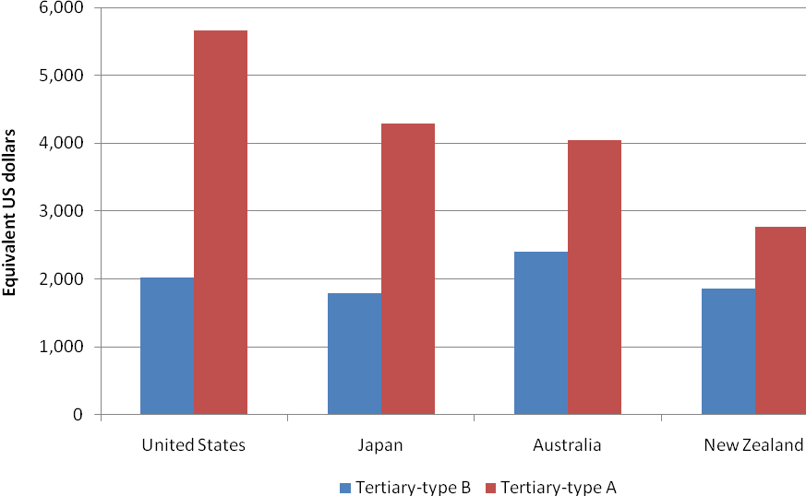
Notes:
1. This figure expresses annual average tuition fees per student in equivalent US dollars converted using purchasing power parities.
2. Amounts of tuition fees should be interpreted with caution as they result from the weighted average of the main tertiary-type A and tertiary-type B programmes and do not cover all institutions
Source: OECD (2009), Education at a Glance, Tables B5.1.a, B5.1b (web only)

3.2 Relative proportions of public and private expenditure on educational institutions, as a percentage, for tertiary education (2000, 2006)
Expenditure on tertiary education institutions comes from a variety of sources. The OECD measures how much of this expenditure is allocated from public sources, such as government grants, and how much is sourced privately, such as tuition fees from students and grants from private business.
Figure 8 illustrates the proportion of public and private expenditure on tertiary education institutions in 2006. In New Zealand, private expenditure accounted for 37 percent of total expenditure on tertiary education institutions in 2006. In Australia, the contribution from private sources is higher than New Zealand at 52 percent. Private expenditure in the OECD ranges from a low of three percent in Norway to a high of 66 percent in the United States, and averages 27 percent.

Figure 8: Proportions of public and private expenditure on tertiary education institutions in 2006
Source: OECD (2009), Education at a Glance, Table B3.2b

Expenditure from private sources also includes tuition fees paid by international students. If we look at the balance between the fees paid just by domestic students and subsidies paid by government, the student share of the full cost is around 30 percent. Of that 30 percent, much is paid by way of the compulsory fee entitlement in the Student Loan Scheme and hence, has a government subsidy. Allowing for that effect, and given that the cost to the government of lending under the Student Loan Scheme in 2006/07, the year analysed, was 41.15 cents in each dollar borrowed, the actual share of full cost borne by students reduces to around 21 percent.

4. HOW DOES OUR PARTICIPATION COMPARE?
Enrolment rates complement information about the educational attainment of the population. They provide an indication of the extent to which human capital is being maintained and extended. In the following indicators we explore New Zealanders’ participation at various levels of education.

4.1 All levels of education

4.1.1 Enrolment rates, by age
For pre-primary years (ages 3 and 4), participation in New Zealand is relatively high and during the years 5-14 participation is close to 100 percent, in line with almost all other OECD countries. Differences emerge beyond compulsory schooling age.

At ages 15-19 only Luxembourg, the United Kingdom, Mexico and Turkey have lower proportions of the population enrolled in education. However, this pattern is reversed in subsequent age groups and New Zealand’s enrolments rates for age groups 20-29, 30-39 and over 40 are all comfortably above the OECD average. Figure 9 shows the enrolment rates by age groups as a proportion of total population of these groups for selected OECD countries in 2007. Although the enrolment rate of 15-19 year-olds in New Zealand has increased slightly since 2000, it is still less than the OECD average. By contrast, the rate for 20-29 year-olds has increased faster than the OECD average over that time.

Figure 9. Enrolment rates by age for selected countries (2007)
Source: OECD (2009), Education at a Glance, Table C1.1

4.1.2 Transition characteristics from age 15 to 20, by level of education (2007)
When enrolments of 15-20 year-olds are explored more deeply, year by year, different patterns of education participation emerge. Figure 10 shows the enrolment rates in secondary education by single age groups for 15 to 20 year-olds. Enrolment in secondary education drops rapidly from age 16, and overall enrolment is well below the OECD average at ages 17, 18 and 19 years.

Figure 10. Enrolment rates in secondary education for 15 to 20 year-olds (2007)

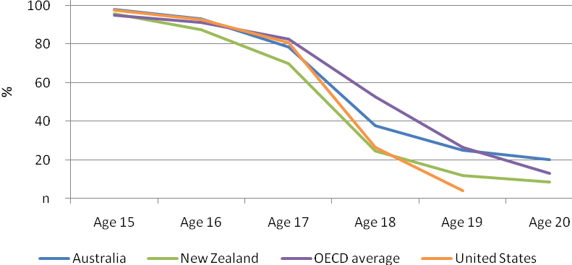
Source: OECD (2009), Education at a Glance, Table C1.3

Indicator C3 in Education at a Glance, which measures the success of students in moving from education to work, provides further insight into youth engagement in education. Indicator C3 reports that 73% of 15 to 19 year-old New Zealanders were engaged in education in 2007. This is less than Australia (80%), the United States (85%) and the OECD on average (84%), but higher than the United Kingdom (62%).
New Zealand’s relatively low level of enrolment in education in this indicator reflects its low unemployment levels in 2007. Whereas, compared to their OECD counterparts, 10.7% fewer New Zealand 15-19 year-olds were enrolled in education, 8.6% more were in employment in 2007. (The impact of education on employment is explored further in 6.1.2.)
At older age groups the proportions of the population participating in education in New Zealand are more favourable. For instance, the proportion of 20 to 24 year olds is similar to other countries, while the proportion of 25 to 29 year olds is higher than most other countries. Generally, females are more likely to be in education than males, as illustrated in Figure 11. However, in New Zealand and also Australia, a higher percentage of 20-24 year-old males than females were in education in 2007.

Figure 11: Percentage of young males and females in education (2007)
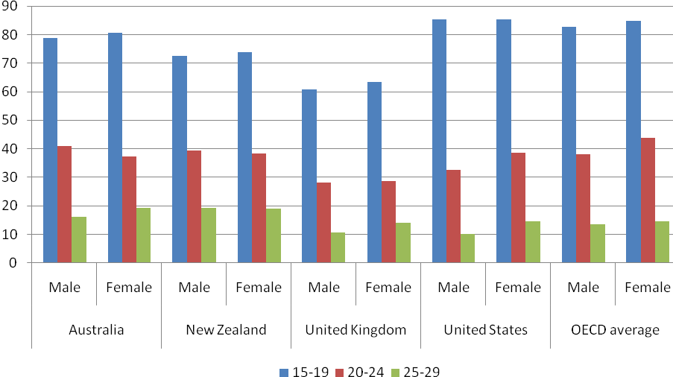
Source: OECD (2009), Education at a Glance, Table C3.2b and C3.2c (web only)

4.1.3 Education expectancy (2007)
This measure estimates the number of years a person in each country can expect to be enrolled in education, given current enrolment patterns. It is computed as the total of the probabilities of being enrolled in education at each specific year of age. This measure has some limits for New Zealand, in particular:
- in the past it has not distinguished full-time from part-time study
- its measurement of education expectancy at ages 40 and over is not robust - that age group makes up a significant portion of New Zealand’s tertiary education participants
- it includes both international and domestic students
However, this year full-time and part-time participation is distinguished and, while the impact of international students has not yet been measured, this should be possible for future years.

Figure 12 shows that a young person aged 15 in New Zealand can expect to spend 6.8 years in additional education. This figure has remained relatively constant over the last three years and is similar to other countries in the OECD. New Zealanders enjoy slightly fewer years of full-time education, but considerably more part-time years. If measured on a full-time equivalent basis, it is likely that New Zealand’s result would be close to average. Adjusting for international students would reduce New Zealand’s result somewhat.

Figure 12: Expected years in education for 15-29 year-olds (2005-2007)
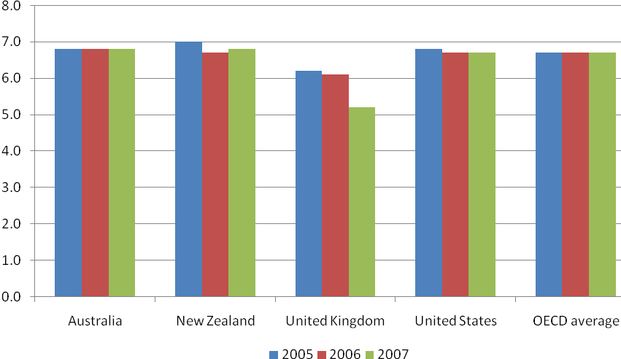
Source: OECD (2009), Education at a Glance, Table C3.1b (web only)

4.2 Participation in tertiary education
Tertiary participation is particularly important for developing and maintaining a highly qualified workforce. It has also been shown to be a key factor in better labour market outcomes.

4.2.1 Expected years in tertiary education (2007)
Results for education expectancy at the tertiary level in New Zealand mirror the results for all levels of education combined. New Zealanders enjoy slightly fewer full-time years of tertiary education, but considerably more part-time years.
At tertiary-type B level, New Zealand has a relatively high number of expected years of tertiary study overall; higher than countries such as Australia and the United Kingdom, although full-time study years are only at the OECD average (see Figure 15). Expected years participating in tertiary-type A programmes are slightly above average overall, although below average for full-time study (see Figure 14).
Figure 13: Expected years in tertiary type B education (2007)
Source: OECD (2009), Education at a Glance, Table C1.8 (web only)
Figure 14: Expected years in tertiary type A education (2007)
Source: OECD (2009), Education at a Glance, Table C1.8 (web only)
Figure 15 shows the enrolment rates for 16 to 20 year-olds in tertiary education. For 19 and 20 year olds, rates are very similar to those of Australia and above the OECD average. For both countries, this can be largely attributed to the impact of international students.

Figure 15. Enrolment rates in tertiary education for 16 to 20 year-olds (2007)
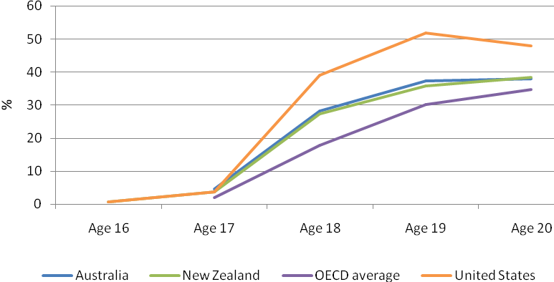
Source: OECD (2009), Education at a Glance 2009, Table C1.3

4.2.2 Entry rates to tertiary education and age distribution of new entrants (2007)
The net entry rate is the number of first-time entrants to tertiary education in an age group divided by the total population in that age group. The overall entry rate is the sum of net entry rates for all age groups. The result provides a proxy for the probability of a person entering tertiary education within their lifetime. Although these conditions are somewhat simplistic, it provides a measure for international comparison albeit with limitations. Rates are calculated in Education at a Glance for tertiary-type B, tertiary-type A and advanced research programmes. The age distribution at which people are likely to enter tertiary-type A study is also provided.

The relatively large number of older aged New Zealanders entering tertiary education for the first time tends to inflate the net entry rate, as there is more than one generation entering at the same time. Rates are also inflated by the high proportion of international students in the New Zealand system. Education at a Glance includes rates adjusted to exclude international students.

In tertiary-type B, New Zealand has a fairly high entry rate of 48, compared with an average of 15 across the OECD. The New Zealand rate for females is 54 and males is 42. After adjusting for international students, the rate for New Zealand is 41. New Zealand’s high rate reflects the high numbers of adult students entering this level of tertiary education for the first time.

New Zealand’s overall entry rate for tertiary-type A is presented in Figure 17. It is lower than Australia’s and higher than the OECD average. Once adjusted for international students, it is similar to that of Australia and the United States. For males, the New Zealand rate is considerably lower than Australia’s while it is higher for females, and similar to Australia and the United States.

Figure 16: Entry rates to tertiary-type A programmes (2007)
Source: OECD (2009), Education at a Glance, Table A2.4

New Zealand entry rates for advanced research programmes are lower than Australia’s and the OECD average (see Figure 18). After adjusting for international students, the difference between New Zealand and Australia is even greater. Rates are fairly similar for males and females.
Figure 17: Entry rates for advanced research programmes
Source: OECD (2009), Education at a Glance, Table A2.4

New Zealand has a very wide age distribution for first time entry to tertiary-type A compared with other similar OECD countries. Figure 19 shows the age distribution of new entrants to tertiary-type A programmes. Fifty percent of New Zealand first-time entrants enter study by the age of 21, compared to the OECD average of just over 20. However, the 80th percentile for New Zealand is over 30, compared with 25 for the United Kingdom and the OECD average.

Figure 18: Age distribution of new entrants to tertiary-type A programmes
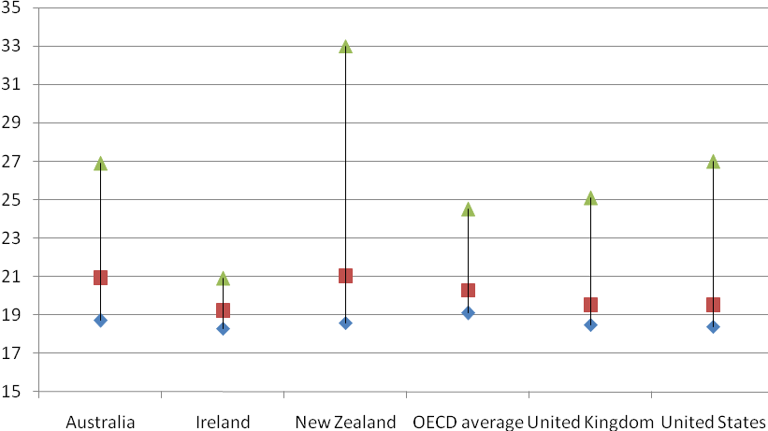
Note: Middle box indicates 50th percentile and top and bottom indicate the 80th and 20th percentiles respectively.
Source: OECD (2009), Education at a Glance, Table A2.4

5. HOW DOES OUR ACHIEVEMENT COMPARE?
Education at a Glance traditionally draws on data from OECD’s triennial Programme for International Assessment (PISA) to provide new insights into the determinants of education performance. This year some further results are presented from the PISA 2006 survey.

5.1 The profile of 15 year-old top performers in science
High-level skills are critical for the creation of new knowledge, technologies and innovation and emerge as an important contributor to economic growth and social development. Data from PISA provides information on the characteristics of top performing students in science. New Zealand features prominently in these results as we have one of the largest proportions of top performing students in science.

The PISA science assessment is scored on a scale which has an OECD mean of 500 and a standard deviation of 100. This scale can be divided into bands reflecting the types of tasks students attaining a particular score can typically do. Top achieving students are defined as those who achieved at levels 5 or 6. These students attained a score of at least 633 score points on the PISA science scale.

In New Zealand, 18 percent of students reached levels 5 or 6 on the science scale. The proportion of top achieving students is only exceeded by Finland (21 percent), and it is significantly above the OECD average of nine percent. New Zealand is also among the best performing countries for both reading and mathematics.

Figure 16 shows the percentage of top performers on the science scale in PISA 2006.

Figure 19. Mean score and percentage of top performers on the science scale in PISA 2006 for selected countries
Note: Not all PISA participating countries are shown in the above figure.
Source: OECD (2009), Education at a Glance, Table A4.1a

Across all OECD countries, an average of four percent of students are top performers in all three assessment areas. In New Zealand this proportion is 8.9 percent, a proportion similar to Finland (9.5 percent).

Unlike most OECD countries, New Zealand girls are as likely to be among the top performers in science as New Zealand boys.

Top performing students tend to come from a relatively advantaged socio-economic background (as measured by PISA). However, as noted in Education at a Glance, this is not an insurmountable barrier; about one quarter of New Zealand top performing science students come from a socio-economic background lower than the national average. This proportion is similar to the OECD average.

In New Zealand, immigrant students are as likely to be top performers as students born in New Zealand to New Zealand-born parents. This is unlike many other OECD countries where immigrant students are less likely to be among the top performers in science.

Students’ attitudes and motivations tend to be related to their performance. If a country can successfully convey scientific knowledge and competencies and engage students in science-related issues and foster students’ career aspirations in science then that country is better placed to have a talent pool able to take up a career in science. Thus, fostering interest and motivation in science seems to be an important policy goal in its own right.

The indices of attitude and motivation used in PISA are relative measures. This means that we need to compare top performing students at levels 5 and 6 in science relative to another group. In the analyses in Education at a Glance, top performers are compared on these indices relative to performers at level 4 (hereto referred to as strong performers) on the PISA science scale.

Top performers in science report enjoying learning science more than strong performers do. For New Zealand, the difference in science learning enjoyment between top and strong performers is the same as the average difference for OECD countries. Similarly, the difference between New Zealand top performers and strong performers on their reported motivation to learn science because of their belief it will help in the future is the same as the average difference for OECD countries. However, the difference between top performers and strong performers on the extent to which they engage in science-related activities is larger for New Zealand than it is in many other OECD countries.

New Zealand’s top performers receive about half an hour per week more in regular school lessons on science than New Zealand strong performers. This difference is the same as the OECD average. However, New Zealand’s top performers overall receive more instruction time per week than their top performing counterparts in other OECD countries.

Across the OECD, top performers agree that the subjects they study, their teachers and the subjects available to them in school provide them with the basic knowledge and skills for a science-related career. In New Zealand (along with their counterparts in Australia, the Netherlands, Switzerland and the United Kingdom), top performers, when compared to strong performers, are more likely to agree with this statement than in other OECD countries.

In summary, the difference between New Zealand’s top performers and strong performers on most of the measures regarding attitude and motivation is comparable to the average difference for OECD countries. For some measures (science-related activities, and the provision of knowledge and skills towards a science-related career, in particular), the difference between New Zealand’s top performers relative to strong performers is greater than for their OECD counterparts.

5.2 Graduation rates in tertiary education (2007).
The graduation rate is the percentage of the population completing a qualification for the first time. As with the entry rate, it is computed by summing graduation percentages for each age group. Graduation rates are calculated in Education at a Glance for tertiary-type B, tertiary-type A and advanced research programmes.

As with entry rates, this indicator tends to overestimate for countries with a higher proportion of international students and older students. Education at a Glance includes rates adjusted to exclude international students. Figure 20 illustrates the graduation rates from tertiary-type A programmes for New Zealand and selected OECD countries.

New Zealand’s overall graduation rate for tertiary-type A is slightly lower than Australia’s and higher than the OECD average. Adjusting for international students reduces the rates for both Australia and New Zealand. Rates for females are higher than the rates for males.

Figure 20: Graduation rates from tertiary-type A programmes for selected countries (2007)

Source: OECD (2009), Education at a Glance, Table A3.1

In tertiary-type B, New Zealand has a fairly high graduation rate of 20.4 percent, compared the OECD average of 9.4 percent. The New Zealand rate for females is 23.9 percent and males is 16.7 percent. After adjusting for international students, the rate for New Zealand is 16.6 percent. This high rate reflects the large numbers of adult students in New Zealand completing qualifications at this level for the first time.

New Zealand’s graduation rate for advanced research programmes is 1.3 percent. This is slightly above the OECD average of 1.5 and lower than Australia’s of 1.9. Excluding international students reduces New Zealand’s rate considerably to 0.8 percent, due the high proportion of international students at this level.

6. HOW DO RETURNS TO EDUCATION IN NEW ZEALAND COMPARE?
Various indicators in Education at a Glance seek to measure the benefits, both private and public, from higher levels of education (and the costs to individuals of lower levels of education). These costs and benefits can take the form of different earning and employment prospects.

6.1 Employment

6.1.1 Proportion of the youth population is not in education and unemployed (2007)
Young people are the principal source of new skills in the labour market and those with low skills are often penalised (OECD 2009). Therefore, it is important that young people are engaging in education or are in employment. This OECD indicator examines the proportion of people aged 15-19 years, 20-24 years and 25-29 years who are not in education and are unemployed.

The percentage of the younger population that is not in education and unemployed in New Zealand in 2007 was lower than in Australia, and lower than the OECD average in each of the three age cohorts. Figure 21 presents the percentage of each cohort not in education and unemployed in 2007 for selected countries. The graph shows that about 2.6 percent of people aged 15-19 years were not in education and unemployed; likewise were 3.2 percent of the 20-24 year olds, and 2.5 percent of the 25-29 year olds. In Australia, 3.3 percent of 15 to 19 year olds were not in education and unemployed, as were 3.3 percent of 20-24 year olds and 3 percent of 25-29 year olds. Across the OECD an average of 2.8 percent of 15-19 year olds, 6.6 percent of 20-24 year olds and 5.9 percent of 25-29 year olds were not in education and unemployed.

Figure 21: Percentage of the cohort population not in education and unemployed by age group 2007
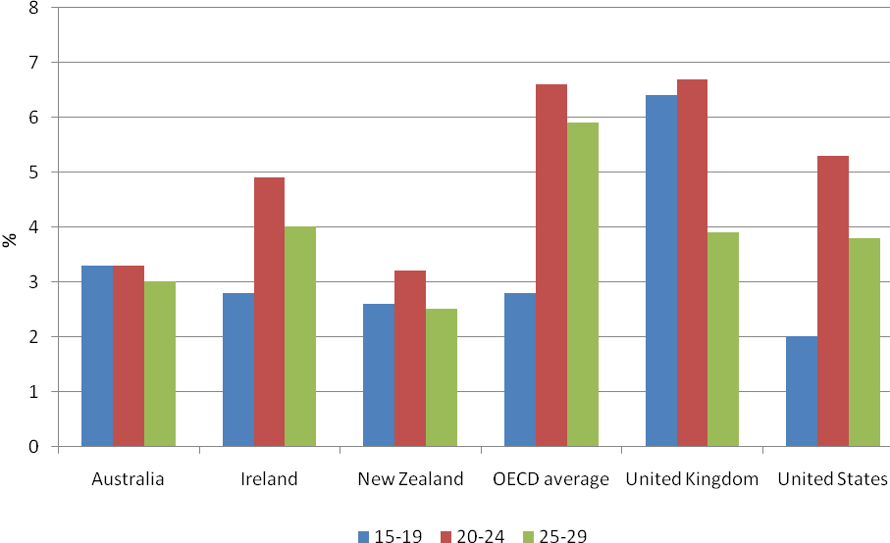
Source: OECD (2009), Education at a Glance, Table C3.3

This positive result for New Zealand partly reflects the historically low unemployment levels being experienced in 2007. Since then, there has been a marked rise in youth unemployment in New Zealand as the country has moved into recession.

6.1.2 Impact of education on the likelihood of employment
With its very low unemployment, New Zealand has enjoyed reasonable results on the OECD’s employment indicators. However, as much of the recent growth in employment in New Zealand has been among those with low or no qualifications, the level of qualifications held is a less powerful predictor of employment in this country than in some others. This particular employment indicator examines the employment rate of the population aged 25 to 64 years, by level of education qualification. Because women have a lower level of engagement with the labour market, the analysis examines the employment rate for men and women separately.

In New Zealand, the association of higher employment rate with higher education qualifications is not as strong as exhibited by Australia, or by the OECD average. Figure 22 contains the unemployment rates by gender and tertiary education level in 2007 for selected countries. In New Zealand, men with a lower secondary qualification have an employment rate of 78 percent. This compares with an employment rate of 92 percent for men with an upper secondary qualification, 92 percent for post-secondary non tertiary qualification and 91 percent for both tertiary type B and tertiary-type A qualifications. The associated figures for New Zealand women are 60 percent, 76 percent, 75 percent, 77 percent and 79 percent, respectively.

For both genders, there is only a small or little difference in the rate of employment between upper secondary to tertiary-type A qualifications, especially for men. In other countries, there is a clearer positive association between the employment rate and level of educational qualification. For example, the chances of employment for males are four percentage points higher for tertiary-type A in Australia, compared with upper secondary (twelve percentage points for women). This compares with a figure of six percentage points for men in the OECD on average (13 percentage points for women).

Figure 22: Employment rate by gender and tertiary education level 2007
Source: OECD (2009), Education at a Glance, Table A6.1.a

Although there is not much difference in the likelihood of employment between upper secondary and tertiary level qualifications, 2007 was at a time of historically low unemployment. Trend data suggests that one of the main advantages of higher education qualifications, especially in New Zealand, is that they insulate people from the impact of the economic cycle.

Figure 23 shows the employment rate at various levels of education in 1997, 2002 and 2007. The economy in New Zealand was relatively weaker in 1997 than in 2007. Figure 23 shows that in New Zealand, people with below upper secondary or upper secondary post-secondary non-tertiary education exhibited rises in their employment rate between 1997 and 2007. For example, in 1997, the employment rate for people with below upper secondary qualifications was 64 percent. By 2007, the employment rate for this group had risen to 71 percent. This compares with people with a tertiary education, where their employment rate remained relatively stable at around 82 and 84 percent in 1997 and 2007, respectively. The difference in employment rates is minimised during times of strong economic growth, but in times of weaker economic performance it is those with lower education qualifications that are affected the most, in terms of a lower chance of employment.

A similar pattern is exhibited in Australia, although the average result in OECD countries does not illustrate the same gains in employment rates for those with lower education qualifications between 1997 and 2007.

Figure 23: Employment rate by level of qualification and year
Source: OECD (2009), Education at a Glance, Table A6.2a

The trend in unemployment rates over the past decade and its association with levels of education is even more striking. In New Zealand unemployment has fallen most for those with the least education (below upper secondary level) as shown in Figure 24. Across the OECD, unemployment levels have varied over time, but those with higher qualifications (tertiary education) have maintained a relatively constant margin over the least qualified in terms of reduced unemployment (refer to Figure 25).

Figure 24: Unemployment rate by level of qualification and year: New Zealand
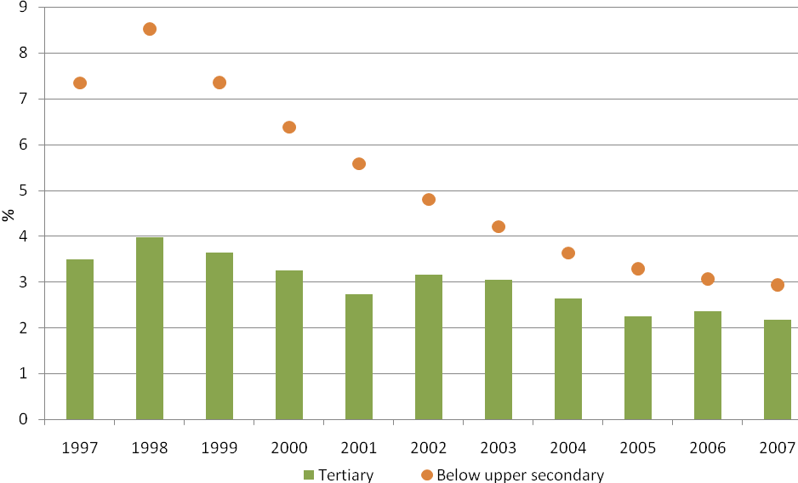
Source: OECD (2009), Education at a Glance, Tables A6.4a

Figure 25: Unemployment rate by level of qualification and year: OECD average
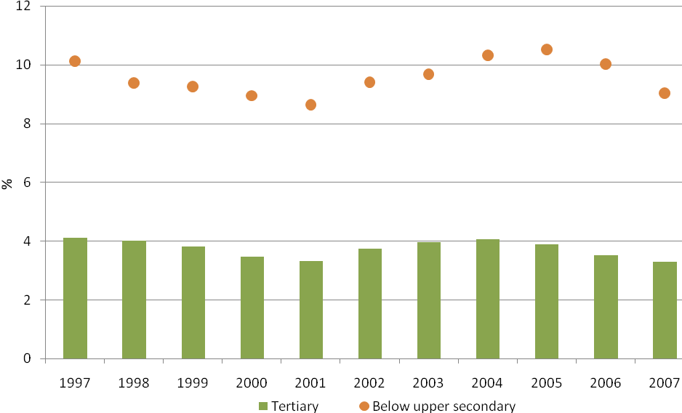
Source: OECD (2009), Education at a Glance, Tables A6.4a

6.2 Earnings/benefits of education

6.2.1 Private and public returns from tertiary education
Since 2007, the OECD has been calculating rates of return on tertiary education. This entails estimating the costs to government and to an individual student of undertaking a tertiary qualification, compared to the benefits in the form of additional tax receipts for the government and extra earnings for the individual over the expected life of a graduate.

This is a complex calculation that depends on the quality of the data used by the OECD analysts to make the necessary estimates, and on them making a number of assumptions. The calculation is narrowly focussed on economic returns – it makes no provision for the non-financial benefits, to individuals and to society, which research shows come from investing in tertiary education.

Despite these limitations, this rate of return analysis is useful as a contribution to our understanding of the value we get from our investments in tertiary education.
The OECD analysis looks at:
- differences in the returns for men and women
- the returns for degree-level study, as opposed to post-secondary non-tertiary study and completion of secondary school
- the private net present value – that is, the benefits that individuals get from their investment in tertiary education, and
- the public net present value – that is, the benefits to the government.
The methodology used by the OECD generates the net present value (NPV) of attaining higher levels of education. An NPV is generated by discounting future cash flows against the costs of attaining higher levels of education. This provides us with a figure to compare returns from alternative education investments. The analysis includes costs such as the foregone income from studying a qualification when deriving the NPV.

The OECD uses a five percent discount rate for future cash flows, equivalent to potential interest earnings in relatively low-risk government bonds. The OECD then uses purchasing power parities to covert the various national currencies into US dollars for comparison

The OECD NPV calculations assume that the person is single and childless, and that the foregone earnings from engaging in education are set at the minimum wage in each country.

A positive NPV indicates that the financial returns from attaining the next level of education will provide a greater return than investing in government bonds. A negative NPV indicates the individual would achieve a higher return if they invested in government bonds rather than education.

First, looking at the private returns from an individual attaining an upper secondary non-tertiary level qualification, Figure 26 and Figure 27 show that there is a positive net present value for attaining this level of education in New Zealand. The NPV for men is around US$31,000 and around US$11,500 for women. The large discrepancy between men and women is mostly a result of a loss of transfer payments for women as they move to this higher level of education. The NPV in Australia, and the OECD average, are higher for both men and women than in New Zealand. For example, the NPV for men in Australia is around US$49,500 and for women US$25,800. This result reflects New Zealand’s lower than average income levels, but also the fairly compressed wage differentials in its labour market.

Figure 26: Private and public net present value for upper secondary non-tertiary education level (2005)
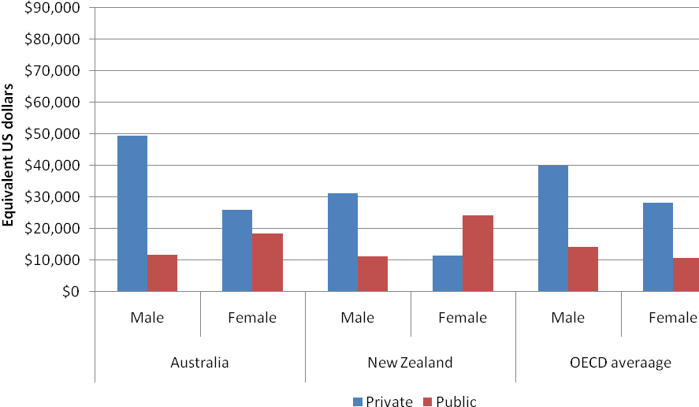
Source: OECD (2009), Education at a Glance, Tables A8.1-A8.4

There are also positive public NPVs from attaining an upper secondary non tertiary qualification. The NPV in New Zealand is around US$11,200 for men and around US$24,100 for women. The result for men is slightly below that of Australia (around US$11,750) and the OECD average (around US$14,050). However, the public NPV for women in New Zealand (around US$24,100) is higher than in Australia (around US$18,430) and the OECD average (around US$10,560). The reason for this higher return in New Zealand relates to the reduction in transfer payments to women as a result of them attaining this level of qualification.

Figure 27: Private and public net present value for tertiary education level (2005)
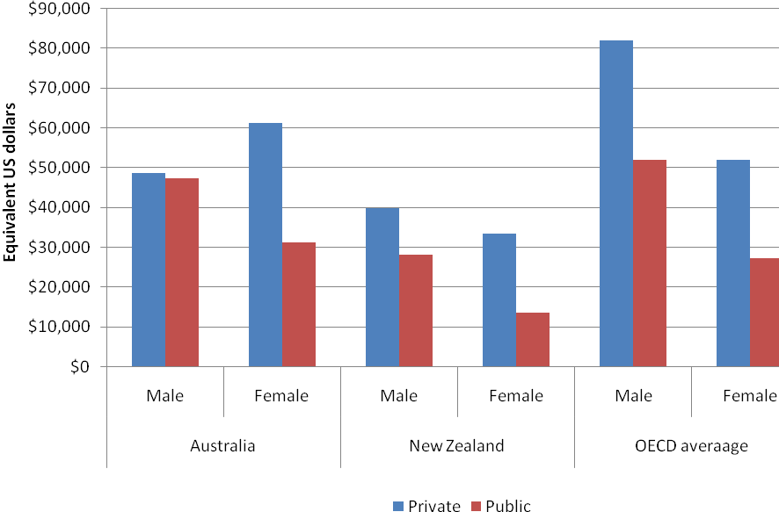
Source: OECD (2009), Education at a Glance, Tables A8.1-A8.4

Overall, the OECD statistics suggest that there are positive financial returns to both individuals and the public from people attaining upper secondary non-tertiary qualifications.

For New Zealanders who attain a tertiary qualification, the OECD calculation also shows a positive NPV. The private NPV for attaining this level of education is around US$40,000 for men and around US$33,570 for women. Although positive, the private NPVs for both men and women in New Zealand are below that of Australia and the OECD average.

The public NPV for people attaining a tertiary education is positive for both men and women in New Zealand. The public NPV is around US$28,200 for men and around US$13,700 for women. These public NPVs are lower than in Australia and the OECD average for both men and women.

6.2.2 Social outcomes from attaining higher education qualifications
In addition to the positive financial returns gained from attaining higher levels of education, better social outcomes (OECD 2009) can also be associated with them. The OECD has used survey information to measure the association between levels of education and social outcomes. For New Zealand two social outcomes are measured: interest in politics and the level of interpersonal trust.

To generate estimates of association between education and social outcomes, the OECD uses statistical modelling to control for other factors that may influence participation, such as age and income. This isolates the impact of education on these social outcomes.

The New Zealand data in this indicator is sourced from the 2004 International Social Survey Programme. For most other OECD countries, the estimates are derived from the European Social Survey (2004 and 2006) or the Adult Literacy and Lifeskills Survey (2003).

The measure presented in Figure 28 and Figure 29 is the predicted percentage of people who are at least ‘fairly interested’ in politics. Because interest in politics increases with age, the predicted percentages at age 30, 45 and 60 years are presented for different levels of education, while holding income constant at the country average. The results show that the likelihood of interest in politics in New Zealand increases as the level of education rises at each of the three ages displayed in Figure 28.

The marginal effect, that is, how much interest in politics rises as the level of education increases, is lower in New Zealand compared with the average OECD increase. However, as can be seen in Figure 28, the OECD average is much lower at each age, being derived from an overall much lower base.

Figure 28: Estimated percentage of individuals expressing political interest by level of education and age
Note: NZ data refers to 2004. The OECD country average is for 21 countries
Source: OECD (2009), Education at a Glance, Table A9.6

A similar trend is also observed at different levels of income when holding other factors, such as age, constant. This shows a greater interest in politics as education qualifications increase in each income group.

Figure 29: Estimated percentage of individuals expressing political interest by level of education and income levels
Note: NZ data refers to 2004. The OECD country average is for 21 countries
Source: OECD (2009) ,Education at a Glance ,Table A9.7

The association between higher levels of education and interpersonal trust are illustrated in Figure 30 and Figure 31. This shows the predicted percentage of the population who believe that, at the very least, most people do not try to take advantage of others. The results show that a higher level of education is associated with higher levels of interpersonal trust. Figure 30 shows the estimated percentages of interpersonal trust in people at three representative ages in varying educational categories.

Figure 30: Estimated percentage of individuals expressing interpersonal trust by level of education and age

Note: NZ data refers to 2004. The OECD country average is for 21 countries
Source: OECD (2009), Education at a Glance, Table A9.7

In New Zealand, the marginal effect from attaining higher qualifications is less than that indicated by the OECD average. However, once again, the OECD average is derived from a much lower base than the New Zealand data.

Similar results are reported for those people at different levels of income (see Figure 31). Overall, higher education is associated with a greater level of interpersonal trust.

Figure 31: Estimated percentage of individuals expressing interpersonal trust by level of education and income level
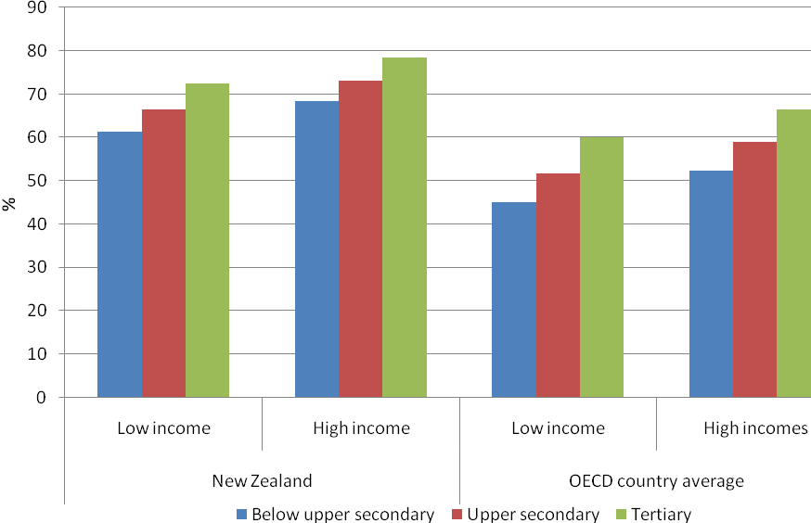
Note: NZ data refers to 2004. The OECD country average is for 21 countries
Source: OECD (2009), Education at a Glance, Table A9.7

The OECD findings of positive social outcomes being associated with higher levels of education complements the findings of the New Zealand Census-Mortality Study, which found that higher levels of education were associated with lower mortality rates. The findings also complement the results from a social measurement tool developed by the Ministry of Social Development, the Economic Living Standards Index (ELSI), which consolidates large amounts of information about different aspects of economic wellbeing into a single score. The effects of education on the ELSI index clearly illustrate its association with improved living standards.

7. HOW EDUCATED ARE WE?

7.1 Educational attainment: adult population
Education plays a key role in providing individuals with the knowledge, skills and competencies needed to participate effectively in society and its economy (OECD, 2009). This indicator measures the educational attainment of the adult population as captured through formal educational qualifications. As such, this indicator provides a proxy for the knowledge and skills available to national economies and societies. It is assumed that the higher the proportion of adult population with tertiary qualifications, the richer the country is in terms of its human capital.

This is an established indicator in Education at a Glance and, from year to year, the changes in educational attainment of such a wide adult population group are mostly due to the changes in the educational attainment of younger cohorts. Nevertheless, the longitudinal history in this indicator tells an interesting story.

The proportion of adult population with tertiary qualifications in New Zealand has increased rapidly since 2004, compared to a steady increase for the United States, the United Kingdom, Ireland and the OECD average. Figure 32 shows the proportion of adult population with tertiary qualification in selected countries and the OECD average in 2007.

Figure 32. The percentage of the 25-64 year-old population with tertiary education as a highest attainment in 2007
Source: OECD (2009), Education at Glance, Table A1.1a

In 2007, the proportion of adult population with tertiary qualifications in New Zealand increased from 39 percent in 2006 to 41 percent, which is far above the OECD average of 27 percent. In 2007, only two OECD countries had a higher percentage of the adult population with tertiary education than New Zealand, namely Canada and Japan.

The percentage of adults with upper secondary education as their highest level of education has substantially decreased since 2003. This is a consequence of the proportion of adults with tertiary qualifications increasing over the same period. Figure 33 shows the composition of New Zealand’s adult population aged 25 to 64 years since 2003 by highest level of educational attainment.

Figure 33. Composition of the 25-64 year-old population in New Zealand by highest level of educational attainment from 2003 to 2007
Source: OECD (2009), Education at Glance, Table A1.4

New Zealand compares favourably with the OECD average: New Zealand has a lower percentage of the adult population with below upper secondary education (21 percent) compared with the OECD average of 31 percent; and over 40 percent of the New Zealand adult population has attained a tertiary qualification. Figure 34 shows how New Zealand compares to the OECD average on this indicator.

Figure 34. Proportion of New Zealand’s 25-64 year-old population by highest level of educational attainment in 2007 compared with OECD average
Source: OECD (2009), Education at Glance, Table A1.1a.

Figure 35 compares educational attainment of the New Zealand adult population with that of selected OECD countries in 2007. The United Kingdom stands out among the five countries, with a majority of adults having attained an upper secondary education qualification (54 percent); the proportion of its population with tertiary education qualifications is not as high as in New Zealand. Australia and Ireland have similar distributions, with approximately a third of their population in each of the three qualification categories.

While the attainment of the population cannot change rapidly, New Zealand has a high level of migration internationally, both inward and outward. This can impact on both the level of qualifications and the skills of the population.

Figure 35. Distribution of the 25-64 year-old population by highest level of education attained (2007)
Source: OECD (2009), Education at Glance 2009, Table A1.4

7.2 Annual average growth in 25 to 64 year-old population with tertiary qualifications between 1998 and 2006
This is a new indicator, introduced for the first time in Education at a Glance 2009. The annual average growth rate of the adult population with tertiary education was positive for all OECD countries between 1998 and 2006. New Zealand’s growth rate of 5.1 percent is well above the OECD average of 4.5 percent per year. New Zealand compares favourably with Australia, where the average growth in the adult population with tertiary education has been 4.5 percent per year, and performed better on this indicator than the United Kingdom (3.7 percent) and the United States (3 percent). On the other hand, the New Zealand population with tertiary education did not grow as fast as that in Ireland, where the adult population with tertiary education experienced a growth rate of 7.7 percent per year (see Figure 36).

From 1998 to 2006, New Zealand has, on average, experienced a 0.4 percent annual decrease in the adult population with upper secondary education, reflecting a rise in tertiary qualifications over that period. This compares to an OECD average annual increase of 1.9 percent. Apart from New Zealand, the only countries that also experienced a drop were Poland, Iceland, Denmark and Germany. In the remaining OECD countries, the adult population with upper secondary education grew. Figure 37 shows that the United States and the United Kingdom had a growth rate of below one percent.
Figure 36. Annual average growth rate in the 25-64 year-old population in tertiary education between 1998 and 2006
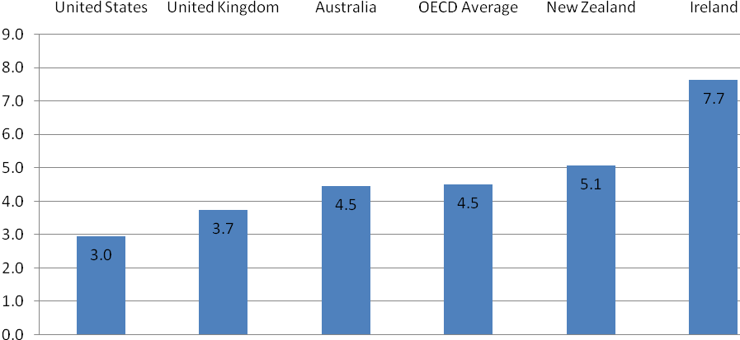
Source: OECD (2009), Education at Glance, Table A1.5

Figure 37. Annual average growth rate in the 25-64 year-old population in upper secondary and post-secondary non-tertiary education between 1998 and 2006
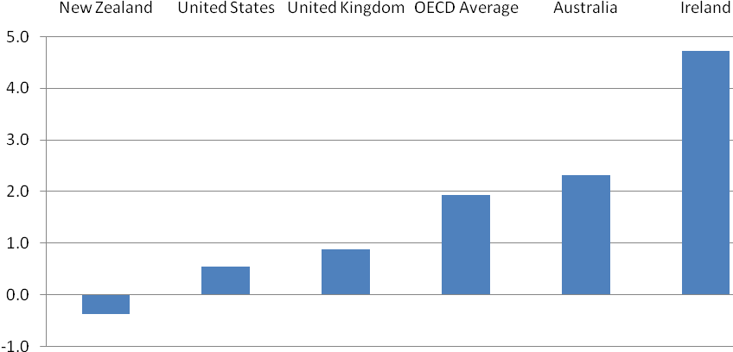
Source: OECD (2009), Education at Glance, Table A1.5

On average, New Zealand’s adult population with less than upper secondary education also declined during the period from 1998 to 2006 by a rate of 2.0 percent per year, which is comparable to the OECD average (refer to Figure 38). For New Zealand such a decrease was offset by the growth in adult population with tertiary qualification.

Figure 38. Annual average growth rate in the 25-64 year-old population below upper secondary education between 1998 and 2006
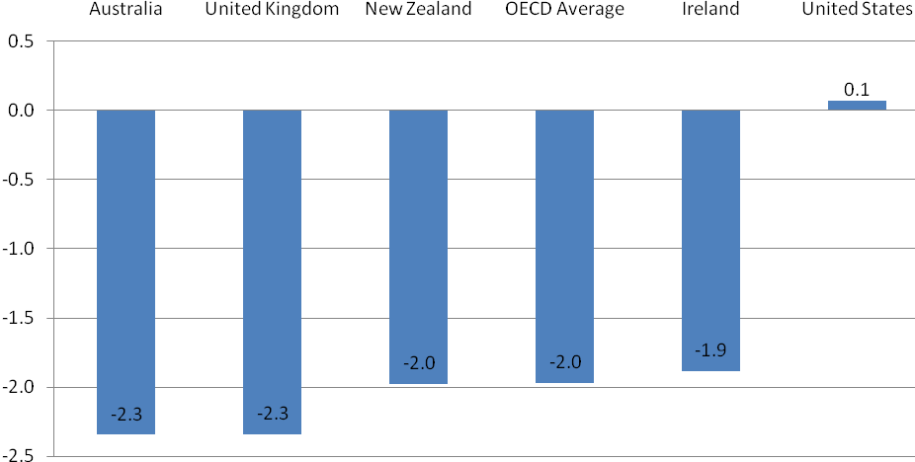
Source: OECD (2009), Education at Glance, Table A1.5

REFERENCES

OECD (2009), Education at a Glance 2009: OECD Indicators, Organization for Economic Co-operation and Development, Paris

OECD (2008), Education at a Glance 2009: OECD Indicators, Organization for Economic Co-operation and Development, Paris

OECD (2007), Education at a Glance 2009: OECD Indicators, Organization for Economic Co-operation and Development, Paris

OECD (2006), Education at a Glance 2009: OECD Indicators, Organization for Economic Co-operation and Development, Paris

New Zealand’s expenditure is measured over the 2006/07 financial year.
See Box 1 for definition of tertiary-type A and tertiary-type B education programmes.
Note that the OECD definition of tertiary education institutions includes tertiary providers and government agencies.
Note that this includes lower level certificate courses in the New Zealand tertiary system that are considered equivalent to upper secondary education in the ISCED classification.
C3 is sourced from labour force surveys and complements C1 which measures participation from administrative enrolment data.
This represents an increase on last year’s published figure of 65.6%, but due to data revisions really represents a decline from 78% in 2005 and 73.9% in 2006.
The OECD definition of transfer payments includes housing benefits and social assistance related to earnings levels.
This is ISCED levels 3 and 4 – upper secondary and post secondary non-tertiary education.
See Atkinson, J New Zealand Census-Mortality Study WebTable, Department of Public Health, Wellington School of Medicine and Health Sciences, University of Otago.
See Ministry of Social Development (2006) New Zealand living standards 2004.
Education at a Glance analyses the age group 25-64 and sub-groups within it.
Upper secondary describes the ISCED 3 level of education. In New Zealand terms it includes lower level certificate programmes that take place beyond the schooling system.

