

Schools Analysis Unit

National School Roll Projections

2011 Update

Executive Summary

The 2011 National School Roll Projections were completed in August 2011 and, overall, have been increased slightly compared to the previous projections.

The ministry has produced three variants of projections – low, medium and high – to provide risk assessments around projected rolls. The medium projection is traditionally used for financial forecasting and other planning purposes.

Under this scenario, total school rolls are projected to increase from 755,700 in 2012 a peak of an estimated 810,600 full-time equivalent students in 2024. This increase is attributed to relatively large birth cohorts entering primary schooling together with higher retention rates in upper secondary schooling.

Primary school rolls are expected to increase steadily from 2012 as the recent high births and relatively high expected birth rates from 2007 to 2010 start to impact on primary schools.

This trend impacts on primary school rolls which are expected to peak in 2019 with 517,200 students expected to attend New Zealand primary schools that year.

Secondary school rolls were 0.4% lower than previous projections for 2010 (a difference of 1,000) and continue to decline slightly until the impacts of the high birth cohort enter secondary schooling in 2019.

Recent high birth cohorts will move into secondary schooling leading to a large increase in secondary school rolls from 2020. This growth is expected to peak in 2024 at an estimated 302,700 full-time equivalent students.

The Ministry of Education will continue to monitor closely the number of school enrolments and the drivers behind these (births, migration and retention) and consider the impact on future planning and financial forecasting.
Introduction

This report describes the latest projections of the number of full-time equivalent students enrolled in New Zealand schools. The projections are used to assess demand for resources in the schooling sector and, as part of the Government’s five-year budget process, to support expenditure forecasts of teachers’ salaries, schools’ operational grants and student allowances. The forecast rolls presented here are snapshots based as at 1 July for primary year-levels and 1 March for secondary year-levels.

These projections include actual school rolls up to July 2011 for primary year-levels and March 2011 for secondary year-levels. Assumptions regarding progression/retention rates, births and migration have been revised since the previous projections.

This report is divided into three sections:

- Results of the latest school roll projections;

- Projections under low, medium and high fertility assumptions; and

- Projections for special school students and home schooling students.

1. School Roll Projections

The forecast results presented here are based on a series of three roll projections: low, medium and high. While the medium projection is what the ministry has traditionally used for financial forecasting and planning purposes, consideration should be given to the possibility of high and low projections eventuating. The medium projection is based on the ministry’s best estimates for what will happen to progression/retention rates, fertility and migration levels in future years. For example, it is assumed that retention rates will be high in the next few years due to the current financial conditions. There is also the possibility that migration could be lower than predicted by Statistics New Zealand (SNZ). These kinds of assumptions are taken into account when producing the medium projection. The low and high projections are produced by setting the progression/retention rates, fertility and migration assumptions to lower or higher levels, respectively (see Section 2 for further discussion about fertility and migration assumptions).

The projected rolls, as presented below, consist of regular students in Year 1 to Year 15 within the New Zealand schooling system. This includes adult students, but excludes foreign fee paying students (FFPs) and students receiving scholarships from the New Zealand Agency for International Development (NZAID). Special school and home schooled students are projected separately and will be discussed in Section 3.

Primary School Roll Projections

In 2011, primary enrolments were around 472,700 - approximately 700 or 0.2% fewer than in 2010. The rolls are expected to increase from 2012 onwards and peak at 517,200 in 2019 (Table 1). Note that the high Year 7 rolls observed in Table 1 are due to measurement issues and not to do with an unusually large cohort.

The single most important driver in the primary forecast is the number of children born in a given year and their entrance into the school system five years later. Since 2004, there has been a gradual increase in the number of births. Birth rates were particularly high since 2007 there have been five consecutive years of high birth cohorts that will begin entering primary schooling from 2012. This increase is expected to boost primary rolls from 2012 and impact on secondary rolls in later years. In addition, if births remain at current levels for the next few years this will further increase projected primary enrolments from 2017 onwards.

The impact of migrants on primary enrolments is expected low and expected to remain so. The level of primary school-age migrants has declined steadily since its peak in 2003 and this trend is expected to be low for the next few years.

Figure 1 shows projected primary rolls under the three sets of scenarios (low, medium and high).

Breakdown of the Primary School Roll Projections (Medium Variant)
Projection Year | Year 1 | Year 2 | Year 3 | Year 4 | Year 5 | Year 6 | Year 7 | Year 8 | Total
2011* | 59,582 | 57,344 | 57,618 | 56,685 | 56,785 | 57,595 | 68,946 | 58,144 | 472,699
2012 | 62,505 | 59,213 | 57,352 | 57,818 | 56,932 | 56,387 | 67,839 | 60,008 | 478,055
2013 | 64,709 | 62,113 | 59,218 | 57,551 | 58,069 | 56,532 | 66,413 | 59,045 | 483,651
2014 | 63,693 | 64,300 | 62,113 | 59,421 | 57,801 | 57,659 | 66,590 | 57,810 | 489,387
2015 | 64,615 | 63,292 | 64,296 | 62,321 | 59,676 | 57,394 | 67,910 | 57,960 | 497,463
2016 | 63,185 | 64,206 | 63,289 | 64,506 | 62,583 | 59,253 | 67,601 | 59,110 | 503,733
2017 | 62,840 | 62,787 | 64,202 | 63,498 | 64,774 | 62,134 | 69,781 | 58,839 | 508,855
2018 | 62,529 | 62,445 | 62,786 | 64,413 | 63,762 | 64,306 | 73,171 | 60,738 | 514,150
2019 | 62,268 | 62,137 | 62,445 | 62,994 | 64,680 | 63,303 | 75,728 | 63,681 | 517,236
2020 | 62,077 | 61,878 | 62,137 | 62,652 | 63,258 | 64,213 | 74,554 | 65,900 | 516,668
2021 | 61,957 | 61,689 | 61,878 | 62,344 | 62,915 | 62,803 | 75,617 | 64,875 | 514,078
2022 | 61,897 | 61,570 | 61,690 | 62,085 | 62,606 | 62,463 | 73,960 | 65,805 | 512,074
2023 | 61,897 | 61,510 | 61,570 | 61,896 | 62,346 | 62,156 | 73,561 | 64,365 | 509,301
2024 | 61,897 | 61,510 | 61,511 | 61,776 | 62,157 | 61,899 | 73,201 | 64,017 | 507,968
2025 | 61,917 | 61,510 | 61,511 | 61,717 | 62,037 | 61,711 | 72,898 | 63,704 | 507,005
2026 | 61,947 | 61,530 | 61,511 | 61,717 | 61,977 | 61,593 | 72,677 | 63,441 | 506,393
2027 | 61,977 | 61,560 | 61,531 | 61,717 | 61,977 | 61,533 | 72,538 | 63,250 | 506,082
2028 | 62,017 | 61,589 | 61,560 | 61,737 | 61,977 | 61,533 | 72,468 | 63,128 | 506,010
2029 | 62,067 | 61,629 | 61,590 | 61,766 | 61,997 | 61,533 | 72,468 | 63,068 | 506,119
2030 | 62,128 | 61,679 | 61,630 | 61,796 | 62,027 | 61,553 | 72,468 | 63,068 | 506,348
* Actual July roll in 2011.

Figure 1. Primary School Roll Projection Scenarios
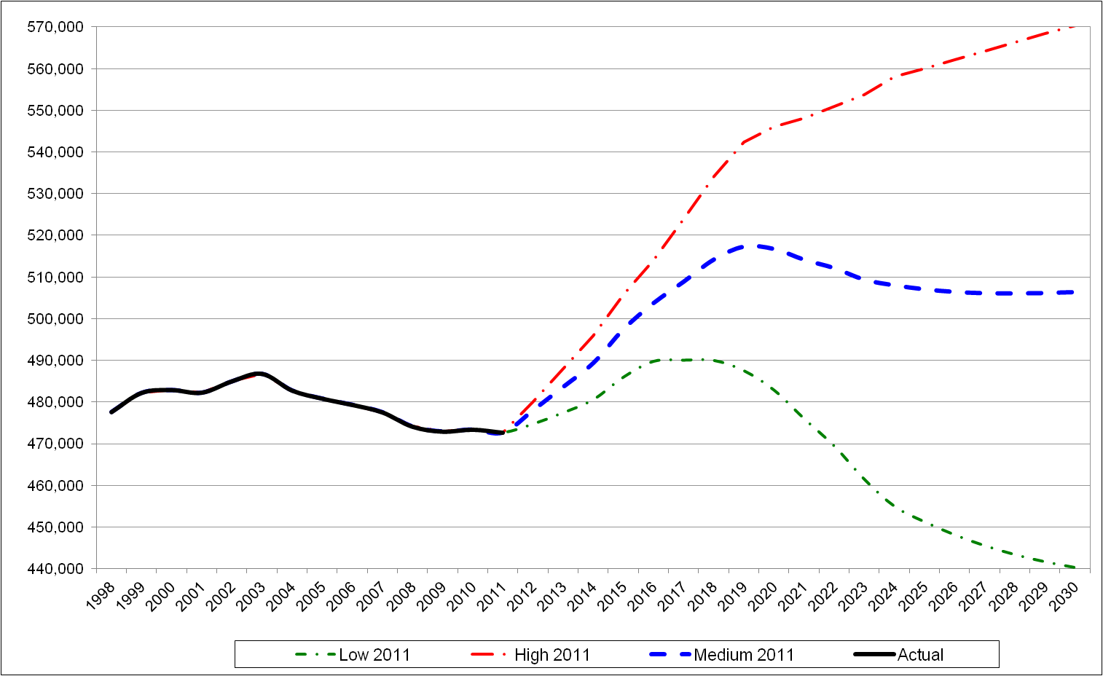
Secondary School Roll Projections

Breakdown of the Secondary School Roll Projections (Medium Variant)
Projection Year | Year 9 | Year 10 | Year 11 | Year 12 | Year 13 | Year 14 | Year 15 | Total
2011* | 59,145 | 58,683 | 60,597 | 54,884 | 45,649 | 729 | 396 | 280,083
2012 | 57,961 | 59,175 | 58,687 | 54,462 | 46,038 | 1,135 | 207 | 277,665
2013 | 59,817 | 57,994 | 59,176 | 52,770 | 45,670 | 1,147 | 323 | 276,896
2014 | 58,858 | 59,846 | 58,001 | 53,204 | 44,282 | 1,136 | 326 | 275,653
2015 | 57,632 | 58,889 | 59,845 | 52,154 | 44,640 | 1,103 | 323 | 274,586
2016 | 57,779 | 57,667 | 58,893 | 53,808 | 43,762 | 1,112 | 314 | 273,333
2017 | 58,924 | 57,813 | 57,681 | 52,955 | 45,153 | 1,090 | 316 | 273,932
2018 | 58,654 | 58,955 | 57,823 | 51,884 | 44,438 | 1,125 | 310 | 273,189
2019 | 60,544 | 58,685 | 58,961 | 52,001 | 43,565 | 1,107 | 320 | 275,184
2020 | 63,471 | 60,571 | 58,691 | 53,023 | 43,647 | 1,087 | 315 | 280,804
2021 | 65,676 | 63,489 | 60,569 | 52,777 | 44,507 | 1,088 | 309 | 288,416
2022 | 64,656 | 65,688 | 63,470 | 54,460 | 44,294 | 1,110 | 310 | 293,987
2023 | 65,582 | 64,670 | 65,654 | 57,042 | 45,709 | 1,104 | 316 | 300,077
2024 | 64,150 | 65,595 | 64,639 | 58,982 | 47,848 | 1,140 | 314 | 302,667
2025 | 63,804 | 64,167 | 65,562 | 58,070 | 49,447 | 1,193 | 325 | 302,567
2026 | 63,493 | 63,822 | 64,142 | 58,904 | 48,677 | 1,232 | 339 | 300,608
2027 | 63,231 | 63,511 | 63,798 | 57,637 | 49,389 | 1,212 | 350 | 299,129
2028 | 63,041 | 63,250 | 63,489 | 57,329 | 48,336 | 1,231 | 345 | 297,021
2029 | 62,920 | 63,060 | 63,230 | 57,054 | 48,077 | 1,204 | 350 | 295,896
2030 | 62,860 | 62,940 | 63,041 | 56,823 | 47,848 | 1,198 | 343 | 295,052
* Actual March roll in 2011.

In 2011, secondary enrolments were around 280,000 - approximately 1000 or 0.4% less than in 2010. Secondary rolls are expected to continue to decline until 2018. Larger increases start around 2020 due to higher birth rates from 2004 – 2011. Secondary rolls are projected to peak in 2024, with around 302,700 full-time equivalent students expected (Table 2).

The secondary school roll projections are affected by actual and projected births as well as retention levels at upper secondary schools. The recent roll growth in the secondary cohort is mainly due to the increase in retention rates at the senior levels. This is due to the current economic environment. It is expected that the retention rates in senior year levels will remain high in the future while the country recovers from the recession. The forecast assumes they will remain close to current levels, but in the past they have dropped slightly when the labour market improves.

The impact of migrants on secondary enrolments has declined since its peak in 2003 and has been fairly consistent since 2005, with an average net gain of 1600 students per year for the last 5 years. This trend is expected to be maintained for the next few years.

Figure 2 shows projected secondary rolls under the three sets of scenarios (low, medium and high).

Figure 2. Secondary School Roll Projection Scenarios
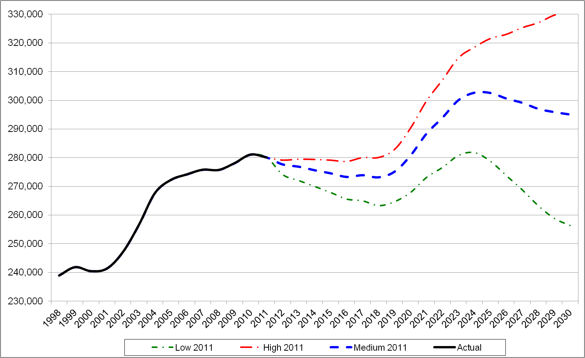
2. Fertility Scenarios

Given the rapid rise in births in recent years, it is important to assess the sensitivity of projections relating to fertility assumptions.

SNZ produces nine series of birth projections, based on different sets of assumptions regarding fertility, migration and mortality. Series 2, 5 and 8 of these projections have been adopted as a basis for the low, medium and high scenarios for the ministry’s 2011 National School Roll Projections. Series 5 is considered by SNZ as the most likely long-term scenario and is based on medium fertility, medium mortality and medium migration assumptions. Series 2 and 8 use the same assumptions except that Series 2 assumes low fertility, mortality and migration while Series 8 assumes high.

As stated previously, the ministry’s low, medium and high projections are produced by varying progression/retention rates, fertility and migration assumptions. In order to isolate the impact of fertility from other factors it is useful to consider the ministry’s medium projection and apply different fertility scenarios whilst holding all other factors constant. Figure 3 shows the resulting projections when Series 2, 5 and 8 are applied from 2012 onwards and compares them with the ministry’s medium projection. (Note that Series 2 of the birth projections assumes low fertility, medium mortality and medium migration).

Figure 3 shows that the fertility assumption has a crucial impact on projected rolls in later years. Under the high fertility (Series 8) scenario we would expect total rolls to increase to around 867,200 in 2030. Under the medium fertility (Series 5) scenario we would expect total rolls to peak at just over 810,600 in 2024. It is interesting to note that even under the low fertility (Series 2) scenario, we would still expect total rolls to peak at a higher level (784,600 in 2021) than the previous peak of 754,500 in 2010. This is due to the effect of the actual high births of the last few years flowing through the school system.

Figure 3. Total School Rolls: Low, Medium and High Fertility Projections
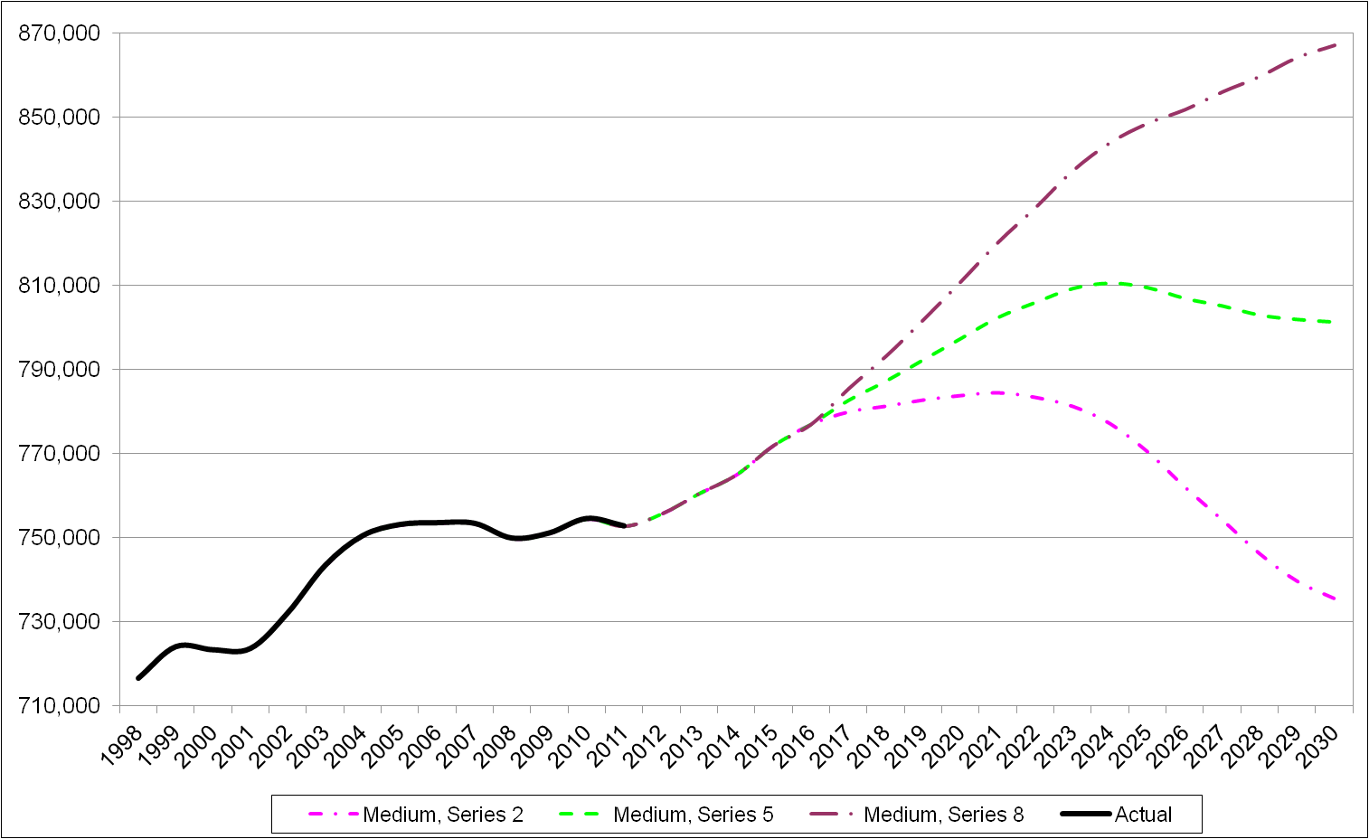
3. Special Schools and Home Schooled Students

Special school enrolments and home schooled students are modelled separately from the National School Roll Projections and are not included in the discussions above. Projected special school enrolments are expected to increase from 3,700 in July 2011 to 4,000 in July 2030 (Table 3). The number of home schooled students is also expected to grow, from 6,500 in July 2011 to 6,900 in July 2030.

Projections for Special Schools and Home Schooling Students
 | Special School Students |  |  | Home Schooling Students
Projection Year | Primary | Secondary | Total | Primary | Secondary | Total
2007* | 1,669 | 1,798 | 3,467 | 4,189 | 2,284 | 6,473
2008* | 1,677 | 1,843 | 3,520 | 4,208 | 2,292 | 6,500
2009* | 1,665 | 1,927 | 3,592 | 4,319 | 2,465 | 6,784
2010* | 1,710 | 1,929 | 3,639 | 4,276 | 2,479 | 6,755
2011 | 1,821 | 1,907 | 3,728 | 3,998 | 2,451 | 6,449
2012 | 1,827 | 1,914 | 3,741 | 4,013 | 2,460 | 6,473
2013 | 1,839 | 1,926 | 3,764 | 4,038 | 2,475 | 6,513
2014 | 1,850 | 1,937 | 3,787 | 4,061 | 2,489 | 6,550
2015 | 1,866 | 1,954 | 3,821 | 4,096 | 2,511 | 6,607
2016 | 1,878 | 1,967 | 3,845 | 4,121 | 2,526 | 6,648
2017 | 1,892 | 1,981 | 3,873 | 4,151 | 2,545 | 6,695
2018 | 1,903 | 1,993 | 3,896 | 4,173 | 2,558 | 6,731
2019 | 1,915 | 2,006 | 3,921 | 4,200 | 2,575 | 6,775
2020 | 1,928 | 2,019 | 3,946 | 4,230 | 2,593 | 6,823
2021 | 1,940 | 2,031 | 3,971 | 4,260 | 2,612 | 6,872
2022 | 1,948 | 2,040 | 3,989 | 4,281 | 2,625 | 6,906
2023 | 1,956 | 2,049 | 4,005 | 4,301 | 2,637 | 6,937
2024 | 1,960 | 2,052 | 4,012 | 4,308 | 2,641 | 6,949
2025 | 1,957 | 2,049 | 4,006 | 4,302 | 2,637 | 6,940
2026 | 1,951 | 2,043 | 3,994 | 4,288 | 2,629 | 6,917
2027 | 1,946 | 2,038 | 3,984 | 4,279 | 2,623 | 6,902
2028 | 1,941 | 2,033 | 3,974 | 4,267 | 2,616 | 6,883
2029 | 1,939 | 2,030 | 3,969 | 4,261 | 2,612 | 6,874
2030 | 1,937 | 2,029 | 3,966 | 4,258 | 2,610 | 6,868
* Actual July rolls.

Conclusion

Total school rolls are projected to increase from 755,700 in 2012 a peak of an estimated 810,600 full-time equivalent students in 2024. This increase is attributed to relatively large birth cohorts entering primary schooling together with higher retention rates in upper secondary schooling. The number of recent births remains the most significant driver of school rolls in short and long-term. Entry of consecutive cohorts into the schooling system will essentially determine the trend in school rolls in the coming years. Slight growth in total school rolls is expected in the short-term. The Ministry will continue to closely monitor the number of school enrolments and the determinants of these enrolments (births, economic conduction, migration and retention).

Projected rolls do not include foreign fee-paying students and students attending special schools.
Note that special and home-schooled students are modelled separately and are not included in the roll projections discussed in Sections 1 and 2 of this report.

