
Early Effects of Free
Early Childhood Education

Report to the Ministry of Education

N. Froese
MartinJenkins

ISBN 978-0-478-13910-5
Web Copy ISBN 978-0-478-13911-2
RMR-907

© Ministry of Education, New Zealand — 2008
Research reports are available on the Ministry of Education’s website Education Counts:
www.educationcounts.govt.nz/publications.

Opinions expressed in this report are those of the authors and do not necessarily coincide with those of the Ministry of Education

Early Effects of Free
Early Childhood Education

Final Report
Natalie Froese

Preface
This report has been prepared for the Ministry of Education by Natalie Froese from Martin, Jenkins & Associates Limited (MartinJenkins).
MartinJenkins is a New Zealand based consulting firm providing strategic management support to clients in the public, private and not-for-profit sectors.
Our over-riding goal is to build the management capability of the organisations we work with. We do this by providing strategic advice and practical support for implementation in the areas of:
- organisational strategy, design and change
- public policy and issues management
- evaluation and research
- financial and economic analysis
- human resource management.
MartinJenkins was established in 1993, and is privately owned and directed by Doug Martin, Kevin Jenkins, Michael Mills and Nick Davis.

Contents
Executive Summary 1
1. Introduction 5
1.1. Free ECE 5
1.2. Early effects study 7
1.3. Scope 7
1.4. Methodology 8
2. Findings 11
2.1. Implementation – “first effects” of Free ECE on services 11
2.2. Practices & policies – early effects of Free ECE on services 16
2.3. Enrolment and participation 30
2.4. Costs & revenues 36
3. Summary and observations 45
Appendix 1: Interview schedule for services as part of the Free ECE project 49
Appendix 2: Free ECE follow up survey 59
Appendix 3: Code categories 69

Tables
Table 1: ECE funding paid to services as a GST incl rate per child per hour, 1 July 2007 6
Table 2: Phases of the research 8
Table 3: Category of service 9
Table 4: Non-response analysis (Follow up, Phase 3, Feb-Mar 2008) 10
Table 5: Understanding of Free ECE (Survey, Feb-Mar 2008) 13
Table 6: Steps (Interviews, Oct-Nov 2007) 14
Table 7: Different situations of services (Interviews, Oct-Nov 2007) 18
Table 8: Feedback on budgeting (Interviews, Oct-Nov 2007) 21
Table 9: Operational changes (Interviews, Oct-Nov 2007 and survey, Feb-Mar 2008) 23
Table 10: Time required for administrative tasks (Survey, Feb-Mar 2008) 25
Table 11: Changes in time required (Survey, Feb-Mar 2008) 26
Table 12: Total enrolment hours (Survey, Feb-Mar 2008) 32
Table 13: Attendance patterns (Survey, Feb-Mar 2008, n=51)) 35
Table 14: Attested hours (Interviews, Oct-Nov 2007) 41
Table 15: Perceived financial position (Survey, Feb-Mar 2008, n=50) 42

Figures
Figure 1: Implementation burden (Interviews, Oct-Nov 2007) 15
Figure 2: Operational changes, (Survey, Feb-Mar 2008, n=51) 22
Figure 3: Changes to fee structure (Survey, Feb-Mar 2008) 28
Figure 4: Changes in enrolment since Free ECE (Survey, Feb-Mar 2008, n=51) 33
Figure 5: Patterns of enrolment response (Interviews, Oct-Nov 2007) 36
Figure 6: Resulting costs and revenues 36
Figure 7: Administrative time costs per week (Survey, Feb-Mar 2008, n=51) 39
Figure 8: Estimated direct financial cost for weekly administration of Free ECE
(Survey, Feb-Mar 2008, n=50) 39
Figure 9: Time and cost association (Survey, Feb-Mar 2008) 40

Executive Summary

Free ECE
Free ECE is an education policy aimed at increasing participation in teacher-led services and eligible kōhanga reo by reducing the cost barrier to families. Free ECE also gives parents more choice about work and study which supports the Choices for Living, Caring and Working plan, and contributes to the government goal of Families, Young and Old. Under this policy, government funds up to 6 hours per day and up to 20 hours of Free ECE per week for 3 and 4 year old children (and some five-year olds) who attend teacher-led early childhood services. Funding is provided for up to 20 hours per week to encourage intensive participation in quality ECE.

Early effects study
The focus of this study is on the early effects of Free ECE on participating services’ practices, policies, costs and revenues. The primary purpose of the study is to provide the Ministry with information on the early implementation of Free ECE which could lead to fine tuning of the operational policy settings, including the rules by which Free ECE operates. It is expected that the study will also inform the wider evaluation of the ECE strategic plan, including Free ECE. Key questions include:
- What are the early effects of Free ECE on participating services’ practices, policies, costs and revenues?
- Whether, how and why services have changed practices and/or policies as a result of implementing Free ECE.
- What changes in practices and/or policies do services expect or plan to make in the future, and why?
- Whether, how and why revenue and costs have changed for services as a result of implementing Free ECE.
- How enrolment patterns have changed in individual services since the implementation of Free ECE.

Methodology
The study included four phases, as described in the Table (next page).
Phases | Primary research activity | Research period
Phase one | Project Inception phase including 8 key informant interviews with selected members of the Free ECE Sector Advisory Group | September 2007
Phase two | Qualitative research with 60 services to understand current state of play and build a rich description of the nature of change | September - November 2007
Phase three | A follow up email survey with the same services interviewed as part of phase two | February - March 2008
Phase four | Analysis and reporting of the information gathered from above activities | March- April 2008

The findings drawn from the 60 services interviewed for phase 2, and 52 services surveyed for phase 3 are only representative of those participating. The information has been drawn from a diverse group in order to cover as many situations as possible, so that future policy development is informed about the various ways in which services have reacted to Free ECE. The findings therefore represent a broad spectrum of early effects of Free ECE, but are neither exhaustive nor representative. However, they have resulted from an in-depth understanding of services’ contexts and experiences, which provides a much richer set of data than would be possible through other methods. Where possible, we have complemented findings from interviews with tables or graphs from the follow-up survey. Often professional judgement was required to interpret responses in such a way that different situations described in interviews could be aggregated or grouped together. Findings cannot be generalised to regions, types of services, or the sector in general.

Key findings

Implementation
Services participating in the study wanted to offer Free ECE, but often had some concerns about the implementation of it in their service. These concerns were generally financial in nature. In particular, some services needed (and continue to need) assistance in understanding how to budget and use Optional Charges.
The time and money invested by services to implement Free ECE varied by service, and were affected by both the number of implementation steps they undertook, and features of the service (such as size and stability of the roll, number and engagement of parents). When implementation was stressful it was often due to uncertainty about the financial impacts of Free ECE on the service.

Changes to practices & policies
Services most commonly made changes in regards to:
- Financial management and budgeting (e.g. recalculating budgets, forecasting). This was the most significant change for many services, and could generate stress for some services that were uncomfortable with new and uncertain financial impacts.
- Fees and charges (e.g. adjusting fee schedules, introducing optional charges). Adjusting fees and charges was a complex process for most services. Because the nature of the fee structures are complicated (a range of different rates, discounts, etc.) the net effect of changing the structure on families was often ambiguous (costs may have increased for those with one two-year-old attending mornings, but decreased for those with 2 children attending all day). Overall, a few services increased fees, a few decreased fees, and the rest made no changes or made a mix of changes. Nearly half of services we spoke to also introduced an optional charge.
- Administration (including scheduling, invoicing, etc). Most administrative changes occurred during implementation and included issuing and collecting attestation forms and scheduling children. Services estimated significantly higher administrative burden shortly after implementation of Free ECE than when we followed up in March 2008. By that time, estimated ongoing costs of administering Free ECE were clustered around two hours per week. By this time, the administrative burden had significantly reduced overall. Most services reported moderate administrative time, and either no direct financial cost or under $100 per week.
- Operations (hours, staffing or services provided). Fewer services reported changes to their hours of operation or staffing. Those that did more often reported extended opening hours and improved teacher to child ratios.

Enrolment and participation
Overall, nearly half of services said that they believed their enrolment (total hours for all children) had increased since the introduction Free ECE. For those whose enrolment stayed the same rather than increasing, this was often because the service was already full.
Some new patterns in enrolment have been observed when looking across what services told us about their individual changes in enrolment. These include: more three and four year old children attending, and longer days or more days per week of attendance.

Revenue and financial position
Revenue streams for services include fees and charges, MOE funding (bulk funding, Free ECE funding for attested hours, and other funding) and other subsidies such as Childcare Assistance through Work and Income.
Overall, there was a clear tendency for services to believe that parents were attesting all their hours with their service. This results in a larger concentration of services’ revenues coming from MOE. In general, there was also a tendency for fewer families in a service to use the Childcare Subsidy.
By March 2008, half of services said they were somewhat or much better off financially after Free ECE. About 40% said that there was little or no change to their financial position, and just over 10% said they were somewhat or much worse off financially.

- Introduction

Free ECE
Free ECE is an education policy aimed at increasing participation in teacher-led services and eligible kōhanga reo by reducing the cost barrier to families. Free ECE also gives parents more choice about work and study which supports the Choices for Living, Caring and Working plan, and contributes to the government goal of Families, Young and Old. Under this policy, government funds up to 6 hours per day and up to 20 hours of Free ECE per week for 3 and 4 year old children (and some five-year olds) who attend teacher-led early childhood services. Funding is provided for up to 20 hours per week to encourage intensive participation in quality ECE.
Free ECE was introduced for teacher-led early childhood education (ECE) services and some kōhanga reo from 1 July 2007. Some of the key features of Free ECE are:
- Free ECE is available to any three or four year old who is enrolled in an ECE service that is offering Free ECE.
- All teacher-led ECE services, and some kōhanga reo, are eligible to provide Free ECE. Eligible services can choose whether to provide Free ECE. If they choose to provide it, they must not limit it to certain children, days or times.
- Children can receive Free ECE from more than one service.
- In general, eligibility for Free ECE funding begins on the child’s third birthday and ends on the child’s fifth birthday.
- Free ECE is available for up to six hours per child per day, and up to a maximum of 20 hours per child per week. The ECE subsidy remains in place for non-Free hours.
- Families whose children receive Free ECE may also receive the Childcare Subsidy to help them pay for ECE that is not covered by Free ECE, but it cannot be applied to Free hours.
- Services must not charge fees for the hours that they provide Free ECE, but may set fees for hours outside of Free ECE and can ask for donations.
- Services may also request from parents another type of voluntary payment called ‘optional charges’. These cover services not required by regulation or that could be provided by parents if they choose to do so (e.g. sunblock). Once agreed, parents must pay optional charges.
- Free ECE funding is based directly on children’s participation. Free ECE will be paid on the existing funding payment dates, which are the first working day of March, July and November.
- For the first 12 months (through June 2008) services are able to receive advance funding when they commence offering Free ECE, based on their predictions of hours of Free ECE provided over a week. A ‘wash up’ adjustment is made at the end of the funding period where services have under or over predicted their hours of provision.
- Free ECE funding rates are based on 100 percent of the average hourly cost of ECE provision to the regulated standard, as recorded by services in their 2006 operating cost surveys.
There are 15 different Free ECE funding rates, reflecting the existing ECE funding subsidy rate structure, as outlined in the following table:
Table 1: ECE funding paid to services as a GST incl rate per child per hour, 1 July 2007
 | Current ECE funding subsidy rate (age 2 and over) | Free ECE
All-day teacher-led centre-based services
100% registered teachers | $6.41 | $10.89
80-99% registered teachers | $5.70 | $10.13
50-79% registered teachers | $4.62 | $8.91
25-49% registered teachers | $3.86 | $8.08
0-24% registered teachers | $3.43 | $7.61
Sessional teacher-led centre-based services
100% registered teachers | $5.36 | $6.53
80-99% registered teachers | $4.53 | $5.85
50-79% registered teachers | $3.83 | $5.09
25-49% registered teachers | $3.38 | $4.57
0-24% registered teachers | $3.09 | $4.28
Protected rate (former Quality Rate) | $3.26 | $4.41
Teacher-led home-based early childhood services
Quality | $3.99 | $8.45
Standard | $3.52 | $7.98
Eligible Te Kōhanga Reo (except those recognised as teacher-led for funding)
Quality | $3.94 | $7.64
Standard | $3.47 | $7.19
http://www.minedu.govt.nz
In services offering Free ECE, parents may elect to access the Childcare Subsidy in place of Free ECE or to cover remaining costs of ECE. The Childcare Subsidy is a non-taxable payment available for low-and-middle income families to ensure that affordability of childcare is not a barrier for families to take up, and retain employment, education or training. Parents and caregivers in work, education or training (or where the child has a disability) can claim up to 50 hours per week in Childcare Subsidy; parents not participating in those activities can claim up to nine hours a week. Parents apply for assistance directly from the Ministry of Social Development, and payments are redirected to the childcare provider. Childcare Subsidy is available for children aged 0-5, subject to household income limits. Free ECE and Childcare Subsidy cannot be paid for the same hours.

Early effects study
The focus of this study is on the early effects of Free ECE on participating services’ practices, policies, costs and revenues. The primary purpose of the study is to provide the Ministry with information on the early implementation of Free ECE which could lead to fine tuning of the operational policy settings, including the rules by which Free ECE operates. It is expected that the study will also inform the wider evaluation of the ECE strategic plan, including Free ECE. Key questions include:
- What are the early effects of Free ECE on participating services’ practices, policies, costs and revenues?
- Whether, how and why services have changed practices and/or policies as a result of implementing Free ECE.
- What changes in practices and/or policies do services expect or plan to make in the future, and why?
- Whether, how and why revenue and costs have changed for services as a result of implementing Free ECE.
- How enrolment patterns have changed in individual services since the implementation of Free ECE.

Scope
This study focuses on changes made by services in response to Free ECE. Specifically, changes services have made to their policies, procedures or operations, and what implications there have been on the costs and revenues.
The focus is on early effects on services. Other information, such as early effects on families, children, communities or the sector is out of scope for this project, although information presented here would serve to inform a wider discussion.
Four kōhanga reo were intended to be part of this study, however could not be scheduled within the available timeframe.

Interpretation of results
The findings drawn from the 60 services interviewed for phase 2, and 52 services surveyed for phase 3 are only representative of those participating. The information has been drawn from a diverse group in order to cover as many situations as possible, so that future policy development is informed about the various ways in which services have reacted to Free ECE. The findings therefore represent a broad spectrum of early effects of Free ECE, but are neither exhaustive nor representative. However, they have resulted from an in-depth understanding of services’ contexts and experiences, which provides a much richer set of data than would be possible through other methods. Where possible, we have also complemented findings from interviews with tables or graphs from the follow-up survey. Often professional judgement was required to interpret responses in such a way that different situations described in interviews could be aggregated or grouped together. Findings cannot be generalised to regions, types of services, or the sector in general.

Methodology
The study included four phases, as described below in Table 2:
Table 2: Phases of the research
Phases | Primary research activity | Research period
Phase one | Project Inception phase including 8 key informant interviews with selected members of the Free ECE Sector Advisory Group | September 2007
Phase two | Qualitative research with 60 services to understand current state of play and build a rich description of the nature of change | September - November 2007
Phase three | A follow up email survey with the same services interviewed as part of phase two | February - March 2008
Phase four | Analysis and reporting of the information gathered from above activities | March- April 2008

Phase 1
Key informants were identified by the Ministry, from the Free ECE Sector Advisory Group and included people with insight into: homebased care, sessional and all-day ECE services, kindergartens, and private services. These participants helped us to understand the perspectives of these services, and helped to identify issues and concerns that we should explore as part of this work. Key informants were interviewed by telephone and helped to inform the design of phase 2.

Phase 2
Phase 2 involved in-person visits to 60 services, during which we conducted individual or group semi-structured interviews. Services were selected using MOE databases, with a primary goal of diversity rather than representation. Fifteen services were selected in each of four regions: Auckland, Wellington, Rotorua and Nelson. At the time of selection, two of these regions were “higher uptake” areas (Nelson and Wellington) while South Auckland and Rotorua were “lower uptake” areas. Where selected services were not available to participate, we selected a replacement service with similar attributes (e.g. replaced sessional kindergartens with sessional kindergartens). In smaller centres, this was not always possible, but overall the mix of services matches the planned methodology. A description of participating services (as categorised by MOE databases) is provided below in Table 3:
Table 3: Category of service
Category | Service type | Completed
Location | Urban | 55
 | Rural (<5000 people) | 5
Ownership | Community | 38
 | Private | 22
Service type | Education & Care | 41
 | Kindergarten | 11
 | Homebased | 8
Sessional | All day | 45
 | Mixed | 6
 | Sessional | 9
Funding band | 0-24% | 3
 | 25-49% | 8
 | 50-79% | 16
 | 80-99% | 10
 | 100% | 15
 | Standard | 2
 | Quality | 6

The service mix was designed to represent a diverse group and good mix of different types of services, rather than to reflect a national profile of services.
Services were contacted by telephone using the named contact in the MOE databases, but were encouraged to help us select the best person or group of people to participate in the study. For example, kindergartens may select someone from the service as well as their association to participate. Fieldwork was undertaken primarily in October 2007 with a few taking place in early November 2007. Researchers recorded responses to the questions posed in the interview guide, and collaborated on summarising findings.
Quotations provided in this summary are from researchers notes and are used to illustrate the type of feedback provided by services; they may differ from verbatim recordings. Where necessary details have been omitted or masked to preserve anonymity. The interview schedule is included in Appendix 1.

Phase 3
In Phase 3 a web-based survey was sent to all 60 services who had participated in Phase 2, and a hard-copy option (fax or post) was also made available. The survey was launched 14 February 2008 and follow up by email or telephone was made each week until 17 March 2008. During telephone follow up, services had the option to provide their responses over the telephone. The survey and response codes are included in Appendix 2 and Appendix 3.
In total, 52 services took part in the survey follow up, although 2 services did not complete the entire survey during the 4 weeks of available time. We conducted a non-response analysis and note that during telephone follow-up a few services mentioned that they were reluctant to participate due to staff changes. When existing staff were not involved in the earlier phase of the research, or had no knowledge of the service before implementing Free ECE, they were more likely to tell us that they were not sure if they would complete the survey. When analysing the profile of those who did not respond to the survey, the most notable characteristic was those in the lower funding band (based on the MOE database provided at project inception, see Table 4). It is possible that staff turnover or general staff pressure may have made them more reluctant to spend time on the survey.
Table 4: Non-response analysis (Follow up, Phase 3, Feb-Mar 2008)
Type of Service | Ownership | Sessional | Funding Band | District
Education & Care Service | Community | AD* | 50-79% RT** | Auckland S
Education & Care Service | Community | M | 50-79% RT | Auckland S
Education & Care Service | Community | AD | 80-99% RT | Nelson
Education & Care Service | Community | AD | 50-79% RT | Nelson
Education & Care Service | Private | AD | 50-79% RT | Rotorua
Education & Care Service | Private | AD | 50-79% RT | Nelson
Education & Care Service | Private | AD | 50-79% RT | Nelson
Education & Care Service | Private | AD | 50-79% RT | Nelson
*AD=All Day M=Mixed S=Sessional ** Registered Teachers

- Findings
Findings have been oriented to inform a discussion about the early effects of Free ECE on participating services’ practices, policies, costs and revenues, including examining how and why services have responded to Free ECE as they did. We have organised the summary as follows:
- Implementation – in this section we describe the processes and effects that are unique to services’ implementation of Free ECE. This includes how services first engaged with Free ECE, how they decided to implement it, and what was required to do so. This section is largely informed by phase 2 (covering the time period from July to November) whereas the sections that follow are also informed by phase 3.
- Policies and practices – in this section we detail the types of policy, procedural and operational changes services made over the first 9 months of Free ECE (from July to March) and the implications they had for services. We pay particular attention to budgeting, administration and setting of fees and charges. Note that fees and charges are a main revenue stream, and are revisited in the section on costs and revenues.
- Enrolment and participation – in this section we describe what changes there have been in children’s participation and the perceived reasons for changes, again covering the first 9 months of Free ECE.
- Revenues and costs – in this section we discuss Free ECE’s effects on the main funding streams. We also discuss the types of ongoing costs that services told us were due to Free ECE, and how these have changed as services moved from implementation to business as usual.
- Implications for operational policy – finally, we highlight lessons learned from this study that can be used to aid in fine tuning Free ECE, and may help to inform the design and delivery of initiatives across the sector.

Implementation – “first effects” of Free ECE on services

Deciding whether and how to offer Free ECE
The vast majority of services decided to provide Free ECE to benefit parents. In fact, parents were often consulted as part of a service’s decision making process about Free ECE or during the process of implementation. However, the single most significant factor determining whether services chose to offer Free ECE was the funding rate and resulting implications for the financial sustainability of the service. Many services used a “fiscal neutrality” approach to deciding whether or not to implement Free ECE – they would offer it if they believed they could achieve a relatively unchanged net financial position. For a few services who said that Free ECE rates were more than what they had previously been charging, the decision to implement was easy. Other services made a series of assumptions about costs and revenues, and felt reasonably comfortable with their financial projections of the impact of offering Free ECE. Some services could not come to what they believed was an accurate forecast of their revenue stream following implementation, and for these services the decision to offer Free ECE was not made with confidence. One service explained “we did heaps of budgeting only to find out that in the end we had no idea and had to take a leap of faith”.
Financial concerns included:
- how would it work out financially overall
- whether and how to implement optional charges – e.g. how many families would pay it, needing to justify it to parents, having to explain to parents that they were “not free”, anticipating how new parents would react, and the fact that some felt that optional charges “did not work” for their service
- loss of control and diversity of revenue sources due to greater concentration of MOE funding (as opposed to fees)
- less certainty of income when services were unsure of how parents would react to Free ECE.
By March 2008, some services remained concerned about how they were budgeting for payments and washups from MOE, and a few had questions about parts of Free ECE that directly affect their revenue – such as funding rates, how to administer optional charges, and how to properly claim for Free ECE funding. However, the majority of services felt that they were the same or better off financially after 9 months of Free ECE (financial impacts are discussed in more detail below).
For other services, a primary concern was their ability to understand the details of Free ECE and how to manage the technical administration requirements. Some of the services appeared to have been operating by keeping more of a “big picture” view in mind, and were struggling to absorb the ‘attention to detail’ for record-keeping required by Free ECE.
Some kindergartens had particular concerns about how Free ECE changed the nature of their service. Depending on the kindergarten, Free ECE could have acted as a catalyst to: change the financial relationship with the association (e.g. shift to/from centralised finance), change hours of operation, and move to more of a “business” or “daycare” model. Other kindergartens made fewer changes.
Nine months following implementation, 7 of the 10 services surveyed rated their understanding of various aspects of Free ECE as “Good” or “Excellent”. However, some services continued to struggle with budgeting for Free ECE (in particular the payments, washups and cashflow) and how to use Optional Charges. Table 5 provides details.
Table 5: Understanding of Free ECE (Survey, Feb-Mar 2008)
Thinking about what different staff need to know about Free ECE, how would you rate your service's understanding of Free ECE?
 | Excellent |  | Good |  | Needs improvement |  | Not Sure |  | Total
Understanding of why Free ECE was introduced | 27 | 53% | 20 | 39% | 3 | 6% | 1 | 2% | 51
Understanding of the Free ECE funding rates | 13 | 25% | 27 | 53% | 7 | 14% | 4 | 8% | 51
Understanding of how to budget for Free ECE payments and washups | 7 | 14% | 21 | 43% | 16 | 33% | 5 | 10% | 49
Understanding of how to use Optional Charges | 10 | 20% | 23 | 46% | 11 | 22% | 6 | 12% | 50
Understanding of the Free ECE daily and hourly maximums | 24 | 48% | 22 | 44% | 3 | 6% | 1 | 2% | 50
Understanding of the Free ECE reporting requirements | 16 | 31% | 23 | 45% | 8 | 16% | 4 | 8% | 51

Process of implementation
Many services found implementation to be the most significant time investment in Free ECE. Because all the services we interviewed had decided to offer Free ECE, the implementation process for them actually began with choosing whether Free ECE could work for them, then moving to decide how they could make it work for them.
Table 6 describes the process of implementation that services went through:
Table 6: Steps (Interviews, Oct-Nov 2007)
Steps | Examples of actions taken
Reviewing how the service operates (an optional step) | - reorganising their operations or method of service. An example of an operational change was moving from sessional to all-day services. An example of changing the method of service was when some kindergartens started operating more like child care centres, charging fees and accepting younger children (if they had not already been doing so)  - changing their financial approach. An example was a service calculating costs per hour of providing service and then orienting fees and other policies to cover those costs
Budgeting | - increased monitoring of the budget (re-budgeting and closely tracking the budget)
Updating materials | - updating their enrolment forms  - updating fees, schedules, sessions, brochures or other promotional materials
Communicating with parents | - consultation with parents  - distribution of Free ECE materials in advance of implementation  - surveying parents in the early stages to get a view on a) whether they supported Free ECE (with whatever changes it may have entailed) and b) how many hours they would want to use and/or attest at the service  - calculating the best financial situation for individual families and advising them on how to combine Free ECE and Work and Income’s Childcare Subsidy
Scheduling children & waiting lists | - rescheduling to give more hours to children in their care (when there was capacity and increased demand)  - more managing of spaces due to increases in demand for Free ECE and expansion of waiting lists
Updating systems and recordkeeping | - setting up spreadsheets, new software or internal systems for keeping track of Free ECE children  - collecting and recording attestation forms

Challenges of implementation
Late in 2007, services were quite “clustered” in terms of how easy or difficult the implementation process was for them. A significant proportion – probably just more than 1/3 – believed that implementation had been relatively straightforward. These services used words like “very easy” “easy, once you could get your head around it” or “not that big of a deal” to describe the process.
The remaining 2/3 of services found the process of implementation to be more challenging. Among these services, about half sat in the middle – they could think of many things that made implementation difficult, but could also identify helpful things, or felt that the challenges of implementation had largely been overcome. The rest felt quite strongly that implementation had been very difficult. They told us “it has been a nightmare”, “I’ve aged years” or “it’s been months of heartache and sleepless nights”.
Some of the factors that seemed to be associated with how much work and stress key staff experienced during implementation are described in the grid (Figure 1) below.
Figure 1: Implementation burden (Interviews, Oct-Nov 2007)
High Stress
Services did not necessarily find a lot of paperwork related to Free ECE, but used this as a catalyst to rethink operations (e.g. some kindergartens).  Difficulty understanding and budgeting. Uncomfortable with change and lack of certainty.  Philosophical questions: are we seen as educators or becoming babysitters? What is best for child development?  Might have had lower business capacity, or (in contrast) been very detail-oriented and frustrated by the uncertainties and imprecision of Free ECE. | Found it all very stressful, and found the work overwhelming. Contacting a high number of parents, chasing forms and defending optional charges could add to stress.  May not have had dedicated administrative staff, and were shouldering teaching as well as Free ECE implementation.  Services may have been undergoing other changes as well.  Service may have had fluctuating rolls or a flexible nature making budgeting difficult and requiring a lot of scheduling time to fit in children. Some services meticulously checked and double-checked records against computer systems.
Low admin/paperwork burden | High admin/paperwork burden
Found it very easy, simply attached the attestation form to their enrolment form. Often used software and did not question it (little double-checking).  Having a small roll, regular contact with parents, and parent’s general agreement and support helped. Having limited scope for scheduling changes helped as well.  Having an association or umbrella organisation often helped. Sometimes it was obvious Free ECE would work well and be welcomed. | Found it very time consuming but had dedicated staff to devote to it, lowering stress.
Low Stress

Factors affecting implementation
During interviews, we were able to discuss the implementation of Free ECE in detail. These conversations provided specific examples of how internal and external factors affected the successful delivery of Free ECE.
Things that made it easier to implement Free ECE included:
- dedicated administrative staff, adequate time to prepare and well-developed systems (such as software)
- having a stable roll, a small roll, and/or close relationships with families
- having relatively few changes to explain, notably no fee increases or optional charges “all we did was add another column in our spreadsheet…”
- attendance at MOE training workshops and information (many services found this helpful)
- established management practices that were working well.
Things that tended to make it difficult or costly for services included:
- not having what services considered “adequate information” sooner – this included things like the timing of the services’ receipt of final Free ECE rates, “last minute” changes to optional charges or other features, not having their questions answered at the MOE workshops and receiving inconsistent information from MOE
- dealing with parents when “Free ECE” was not going to be “free”. This included a wide range of issues such as optional charges, the 6 hour daily maximum, lack of available spaces, and the fact that some parents were counting on Free ECE hours in addition to free kindergarten or the free 9-hour Childcare Subsidy from Work and Income
- changing rolls (children entering and leaving) or flexible scheduling requiring weekly changes to attestation forms; several services could not understand why the specific days of attested hours mattered. “Free started the second week of school holiday. So children were attending childcare plus kindergarten [and had done attestation forms prior to roll out], you had to amend the forms for the holidays as they are not in kindergarten. Now they get Free ECE and WINZ. Then holidays end and you amend again as they go back to kindergarten. By that time WINZ is overpaying you…”
- the amount of work required to budget and set fees and/or optional charges depended to some extent on the type of fee structure that existed prior to Free ECE. If services used an hourly rate or operated sessionally (i.e. never breaching the 6 hours per day or 20 hours per week limit) before implementing Free ECE, changes were more straightforward than if they had a complex fee structure, sliding scales, discounts, long day rates, etc
- several services mentioned that the media had been unhelpful by publishing negative stories and “too much” or misleading information
- several services felt that the rates were too low, private services’ costs were not truly reflected in the MOE survey of costs, sessional rates were too far below day rates, and that services should have been consulted prior to implementation rather than after.

Practices & policies – early effects of Free ECE on services

Overview
During interviews we asked specifically about several different kinds of changes in practices or policies (what we are broadly calling operational changes) including: financial management, marketing, enrolment, opening hours or staffing, fees and charges, and services. In some cases, services had made changes that were a clear and direct response to Free ECE – the most notable of these included introducing optional charges, changing fees or moving from sessional to all-day hours. Much of the time, however, services were reluctant to say that changes were a direct response to Free ECE, or a response to Free ECE alone. In this section we discuss how and why services might have made changes in each of the following broad categories:
- business practice (primarily financial management) and budgeting
- operations (hours, staffing or services provided)
- administration (including scheduling, invoicing, etc)
- fees and charges
- future plans.

Types of services and budgeting philosophy
In this section we describe the main types of services that participated in the research. Following this, we describe different budgeting philosophies. The combination of the type of service and their approach to budgeting were important factors in how Free ECE affected them.

Education and Care Centres
Centres comprised 41 of the sites participating in the study, with about 1/3 privately owned and 2/3 community-based centres. There were several features typical of their business practices:
Private centres were not uniform. Some tended to feel that Free ECE concentrated revenues from MOE, and therefore reduced business autonomy and “tied their hands” in terms of how they met costs. They were accustomed to charging fees in order to cover the full costs of running the service and to assume responsibility for their viability. At the same time, private centres were not necessarily “profit-maximising”; quite a few centres adjusted rates and hours based on community needs and what they believed was best for children. Changes were sometimes made in order to maintain their revenues rather than significantly improving them. Others had been struggling financially and welcomed Free ECE. Some private centres also tended to speculate about what incentives government was trying to put in place with Free ECE, they asked “was it intended to help increase the supply of child spaces?”.
Community based centres also varied in their circumstances depending on the communities they served. Most had boards which contributed to the governance and decision-making around Free ECE and included parent representatives and staff members. The services we interviewed were a diverse group with different perspectives that depended on, for example, whether they were:
Table 7: Different situations of services (Interviews, Oct-Nov 2007)
Well integrated, complementary services with kindergarten (e.g. caring for the same children) | “Competing” with kindergartens for children’s attendance (e.g. families tend to choose one type of service)
Struggling to fill their rolls | Consistently full and/or had waiting lists
Serving working parents or providing all-day services | Sessional and reaching more families who work less (e.g. one partner at home)
Serving a specific ethnic or socio-economic group (very low income, new immigrants, wealthier working parents, young families, etc) | Serving a real mix of different types of families
Seeing stable rolls and a consistent set of families with ongoing relationships | Seeing a transient roll and always meeting new parents and children

All of these features affected services’ decision-making about whether and how to implement Free ECE and the consequent impact on costs and revenues.
In addition, there were some types of services that showed similarities in their business models.

Kindergartens
Kindergartens are unique in that they are part of regional associations that offer support, direction, and in some cases centralised finance. In the kindergartens we spoke to, most decisions about policy and procedural changes were made by the association, although usually teachers were consulted and often responsible for tracking enrolments and attested hours. To the extent that finances were centralised, associations were also able to provide feedback on costs, revenues and financial impacts of Free ECE.
Some decided to charge fees for unattested hours. Particularly in cases where kindergartens did not charge prior to Free ECE, the introduction often led to a significant shift in how they were run, including a significant investment to rework their materials, operating systems, accounting, etc. In addition, these kindergartens had the most work to do in communicating and negotiating with parents.
Where kindergartens had been non-charging prior to Free ECE and remained non-charging, there were relatively few changes to their policies and processes.
Regardless of fee charges, where Kindergarten associations had decided to move to centralised finance with Free ECE, the individual kindergartens and the kindergarten committees needed to adjust the budgets set by the association, and in submitting fees they did collect to the association for redistribution. Many now have more certainty in their budget. Depending on the budgets provided by the association, they may or may not have reduced fundraising and donations. “We fundraise for fun things, not for the power bill”.

Homebased Care Networks
Homebased Care (HBC) Networks that we visited tended to report that Free ECE had been awkward for them. Typically catering to younger children, HBC places a high value on flexibility of services, taking children full time during school holidays and allowing changes to days and times on a frequent basis. In addition, HBC tends to be integrated with kindergarten sessions for children of that age. With the advent of Free ECE, some of the HBC networks found that children were less likely to attend both HBC and kindergarten or that the nature of the hours-sharing had changed. HBC networks found the paperwork associated with the flexibility they offered parents to be time consuming to manage.

Services under an association or umbrella organisation
Any one of the types of services described above could sit under an association or be part of an umbrella organisation. When associations or umbrella organisations supported services financially, the service managers were less involved in the financial business decisions. They sometimes told us that their job was to attend to occupancy, rather than all aspects of finance. We included interviews with umbrella organisations (Barnardos, Kidicorp) in order to include the perspectives of these significant “managers” of services as well as those of staff from the individual services.

Budgeting philosophy
A specific and important feature of a service’s business model is how they approach and manage their budget. Services (private or community based) with an accounting philosophy tended to have set budgets based on a series of assumptions about Free ECE take-up. They had a comprehensive understanding of their various costs and sources of revenue, and tracked key components on a regular basis. Certain features of the business, such as software, stable enrolment, simple fee structures, and limited variations in hours of attendance made this philosophy more practical to apply. While some services were managed in this way before Free ECE, those that found Free ECE rates were lower than their existing fees sometimes began to track revenues more closely. These services were dependent upon optional charges or other means of making up lost revenue, which sometimes resulted in a more careful and rigorous approach to their financial management.
Some services adopted a very micro-based accounting approach, for example, tracking revenue and expenses on a daily basis. These services often became overwhelmed and found all the possible combinations of costs and revenues to be unmanageable. They believed that it was pointless (if not impossible) to make assumptions about total enrolments and rates because of the number of unpredictable factors affecting these. These services therefore “gave up” and operated under a more intuitive financial philosophy. Examples of the kinds of factors that affect a service’s budget include:
- the exact number and ages of children in attendance each hour (as that will determine if a subsidy is provided and the rate)
- whether or not parents attest hours or pay fees (sometimes fees and Free ECE rates would be different amounts)
- whether parents would be eligible for and take up the Work and Income Childcare Subsidy (which is a different rate and may or may not be accompanied by fees)
- the number of qualified teachers on the floor each hour (e.g. gaining or losing staff, teacher illness etc) which affects ratios, rates and reliever costs
- whether new parents coming on board agree to pay the Optional Charge (or other optional payments like donations) or not
- whether children move to kindergarten as they get older or not
- changes to community supply, demand and prevailing fees
- supply and cost of qualified teachers and teachers in training
- other factors (e.g. food costs).
Other services (private or community based) employed a more intuitive financial philosophy. These services were uncertain about what financial position they were in, particularly after implementing Free ECE. Therefore, they operated on a “general sense” of how well things were going. They often pursued fiscal neutrality, meaning that they worked out in general what fees would result in “staying the same” after the introduction of Free ECE. The aim was to keep their total support per child (from MOE, Work and Income and parents) the same and, therefore, as long as the rolls followed the same trends they did not see a need to do extensive financial analysis.
This approach was not necessarily less rigorous, but operated using a set of “higher level” assumptions – for example they might have assumed enrolment and costs would all stay the same. Features such as operating at capacity, having various sources of revenue all aligned to a similar rate, and having a bit of a financial “buffer” allowed some services take this approach.

Initial and later feedback on budgeting
It was clear from both interviews and the subsequent survey that the majority of changes to budget management occurred during the implementation phase of Free ECE. Table 8 summarises how services adjusted their budget management practices:
Table 8: Feedback on budgeting (Interviews, Oct-Nov 2007)
Changes to management of budgets | Implications for services
Some kindergartens moved to centralised finance (associations may cross-subsidise kindergartens or simply “channel” funds) | This shift could have been complex for associations, who may have redistributed (or merely channelled) funds and/or assumed administrative tasks. Services may have benefited from less administration or guaranteed (often more generous) budgets from associations. Where equalised, services may have lost some control of their own revenues.
Some services invested in an accountant or software | Formalised processes for a few services who took a new approach to managing the budget.
Some services reacted to more / less money | Some knew that Free ECE rates were higher than their fees, so they did not worry too much about the budget. Others who suspected they might be worse off delayed significant purchases and watched the budget more closely. A few services that moved from donations to fees adopted new invoicing practices.
Some services reacted to less certainty about the budget

When following up with services in March 2008, about 4 in 10 said that they changed how they managed the budget during the implementation phase. Only 1 in 10 said they had subsequently made changes, and about 2 in 10 said they would probably continue to make changes in the future (see Figure 2, next page).
Changes to management of budgets was the most common policy or practice change overall reported by services (see Figure 2, next page). This is consistent with a common finding from interviewers that Free ECE’s likely effects on services’ finances was a key factor determining whether or not they offer Free ECE, and what other changes to policies or practices they needed to make Free ECE work. Notwithstanding changes in budget management being common, some services continued to find financial management difficult. Difficulties arose from:
- an inability to forecast costs and revenues to services’ satisfaction (discussed above); in particular, services’ concern about the stability of optional charge revenue. Even after 9 months of Free ECE, about 20% of those surveyed were not sure how to use optional charges, and small number of services reported that not all parents paid optional charges. While opting-out is consistent with the intent of optional charges, it did increase uncertainty about this source of revenue for services, the majority of whom told us that their optional charge was essential for their financial viability.
- a lack of understanding of how to best budget for MOE payments and washups (30% of those surveyed were still unsure about this)
- Confusion regarding the overlap between Free ECE and the Work and Income Childcare Subsidy.

Other operational changes
When we followed up with services in March 2008, we asked services to report on when they made operational changes, and which changes were under consideration for the future. Budgeting remained common, as were service enhancements (e.g. improved teaching ratios, longer hours and more services. In addition, some services planned to expand the number of spaces in the future – Figure 2 provides details. Note that services could report more than one change (many did) and could also report the same type of change more than once (e.g. made changes when implementing Free ECE, and planned to make future changes as well).
Figure 2: Operational changes, (Survey, Feb-Mar 2008, n=51)
During interviews we discussed a range of operational changes that services had made or were considering at the time. We focused discussions around the reasons for such changes, including whether or not Free ECE was a reason and what implications such changes had for the services concerned (see Table 9).
Table 9: Operational changes (Interviews, Oct-Nov 2007 and survey, Feb-Mar 2008)
Operating hours Some services changed from sessional to all-day. In some cases this was only a 15 minute change. A few more suggested they may do so in the future. Others extended their existing hours. | Moving to all-day services increases the Free ECE rate; however, there may be additional investments required (kitchens, nap rooms, etc) to comply with license requirements. Several sessional services questioned why their rate was so much lower, and whether Free ECE was trying to “force” all day services. Others said that to make Free ECE work for them, they had to extend their hours.  Some services who extended their hours were reluctant to say that it was due to Free ECE. Rather, they said that there had been an increasing trend of working parents and/or community demand for longer hours. However, Free ECE may have supported this change or provided the impetus to make the change.  By March 2008, 7 of 51 services said that they had moved from sessional to all-day (note that these are survey responses; many services were already offering all-day services). 1 or 2 other services adjusted their hours (longer or shorter).
Staffing Some services increased teachers’ rates of pay, or were actively recruiting more teachers. | Several issues with regard to teacher supply and remuneration were raised. These included: how long teachers wanted to work, stress levels, numbers of children in the service (more children for shorter periods of time took more time and energy), pay parity or collective agreements, a general shortage of qualified teachers, services’ “point of difference” (such as generous non-contact hours) that they could offer teachers. Services may have adjusted the ratio temporarily to deal with staff shortages, to deal with Free ECE issues “off the floor”.  By March 2008, 18 of 51 services said that they had improved the teacher:child ratio (more teachers per child), whereas 2 reported that they now had fewer teachers per child.
Services provided Very few services had changed the services they provided either way at this early stage. | A few services made minor adjustments – asking parents to bring morning tea, cutting back on art supplies, or adding fun events like free raffles, etc. Most were waiting to see how the financial situation looked after a longer period of time. By March 2008, 8 of 51 said that they now provide more services (meals, trips, supplies) while 3 said they now provide less.

Administration
The effect of Free ECE on administrative time and practice was a significant area of investigation for this work for two reasons. First, it was a significant concern for many of the services who participated in the study. Second, it was an area directly affected by implementation of Free ECE.
As mentioned earlier, administration of Free ECE generally involves two main aspects:
- communications: informing parents and completing attestation forms (particularly at implementation, but also for “new” parents on an ongoing basis)
- recordkeeping: keeping track of attendance, fees and charges (for some services this involved taking into account Free ECE as well as the Childcare Subsidy administered by Work and Income).
Initially, communicating with parents required a significant time commitment. Services explained Free ECE to parents, but also used that time to: explain or work out “new” costs for parents, try to accommodate parent’s desired ECE hours, and collect the attestation forms. By March 2008, these types of activities were ranked as among the least time consuming, even though most services said that they now took more time than before Free ECE (see Tables 10 and 11).
The amount of time that recordkeeping required depended on the individual service. During interviews, some services told us that recordkeeping was simple. For example, “we added a column to our spreadsheet”. More often, however, services invested additional time in recordkeeping. Often, this time was related to:
- attendance: services now have to ensure that attendance records and attestation forms (and funding forms) match. Some services not only reconciled these items, but double-checked that attendance forms had been entered correctly into software systems to ensure they claimed for the correct MOE payments. This task could be complicated by changing rolls, school holidays, administering several services (e.g. several homebased caregivers), having administrators located off-site, and the type of systems (computer, paper) in place. Checking attendance records was ranked in the survey as the most time consuming aspect of administration, along with updating attestation forms when a child’s attendance changed
- fees and charges: at a minimum, services needed to calculate fees and charges for parents taking into account free hours. This sometimes extended to helping parents determine how to best make use of Free ECE and the Childcare Subsidy and to addressing issues of overpayment from Work and Income when parents moved from Childcare Subsidy to Free ECE. Invoicing and collecting payments from parents was ranked “in the middle” of time consuming administration activities. About half of services said that since offering Free ECE this activity now took longer. Others said that it took the same amount of time and a few services said it now took less time, probably due to introduction of better systems. During interviews, some services said that either they had stopped charging parents anything, or had never really spent much time “chasing” outstanding accounts.
With regard to the Childcare Subsidy, there were two time consuming-aspects. First, some services assumed parents’ responsibility for liaising with Work and Income and reconciling Free ECE hours with subsidised hours. These services may have helped parents work out which was the better option for them financially, or called Work and Income to check that parents had cancelled the Subsidy when moving them over to Free ECE. Services said that when they had a good working relationship with a Childcare Coordinator at Work and Income, this process went well. However, when parents moved from the Childcare Subsidy to Free ECE there could be delays and a few services struggled with cashflow and overpayments. “Interface between us and Free and WINZ is terrible, we are 8.5 weeks behind. The subsidy is granted but it takes 8 weeks at WINZ to change the payment to me.” These situations were quite specific to individual services and Work and Income offices. Overall, liaising with Work and Income about the Childcare Subsidy was ranked as one of the least time consuming activities. It was least likely to be reported as “more time consuming” since the introduction of Free ECE, and most likely to be reported as “less time consuming” (as fewer children took up the Childcare Subsidy). That said, for a small number of services, often homebased care services, the interface between Free ECE and Childcare Subsidy remained a burden. Tables 10 and 11 summarise this information.
Table 10: Time required for administrative tasks (Survey, Feb-Mar 2008)
How time consuming are the following aspects of administering Free ECE? | Very time consuming  (rank=4) | Somewhat time consuming  (rank=3) | Not very time consuming  (rank=2) | Minimal  (rank=1) | Not sure | Average Time Rank
Updating attestation forms (n=51) | 22% | 49% | 14% | 16% | 0% | 2.8
Checking attendance records against Free ECE forms or software (n=50) | 26% | 36% | 22% | 12% | 4% | 2.8
Collecting attestation forms (n=51) | 14% | 41% | 25% | 20% | 0% | 2.5
Invoicing parents/collecting arrears (n=47) | 13% | 40% | 34% | 13% | 0% | 2.5
Completing the MOE Funding Claim Form (RS7) (n=50) | 20% | 26% | 28% | 18% | 8% | 2.5
Informing parents about Free ECE (n=51) | 10% | 37% | 24% | 29% | 0% | 2.3
Informing parents about the optional charge (n=31)* | 6% | 39% | 35% | 19% | 0% | 2.3
Reconciling Free ECE with the Work and Income Childcare Subsidy (n=46) | 17% | 24% | 28% | 26% | 4% | 2.3
*The low response rate to this question is due to many services selecting “not applicable” because they did not use an optional charge. A few services who did not report offering an optional charge still answered this question. We permitted these responses, as they still may have needed to explain what an optional charge was to parents who had questions. Other n values also reflect the total responses less “not applicables”.

The most common request put forward by services to reduce administration time was for Free ECE to not be tied to specific days of the week; that is, to avoid making changes to attestation forms (and corresponding Free ECE records) when a child’s attendance changes in terms of days of the week but not total hours (e.g. moving from a Tuesday to a Wednesday).
Table 11: Changes in time required (Survey, Feb-Mar 2008)
Compared to BEFORE offering Free ECE, how much time does it take for the following tasks? | Much more time | A little more time | About the same amount of time | A little less time | Much less time | Not sure / NA
Signing up new families / children | 22% | 43% | 33% | 2% | 0% | 0%
Scheduling children | 6% | 35% | 47% | 4% | 0% | 8%
Liaising with Work and Income about the Childcare Subsidy | 6% | 31% | 37% | 8% | 8% | 10%
Invoicing parents and collecting arrears | 16% | 32% | 40% | 2% | 4% | 6%
Other administration | 24% | 42% | 32% | 2% | 0% | 0%
n=51

Fees and charges

Fee structures
Fee structures were heterogeneous before Free ECE. Services used one or a combination of charging methods including hourly rates, sessional rates, daily rates, weekly rates, “package” rates (e.g. pick 3 mornings, 5 short days, 3 long days, any 5 morning or afternoon sessions) and term rates. In addition, these could be a series of discounts or sliding scales based on age of child, how many hours were attended per day or per week, whether siblings attended, or whether parents paid in advance, were staff members or had special circumstances. Some services had additional charges for outings, meals, etc, whereas others did not. These complexities and changes to fee structures as a result of Free ECE made it difficult to make before and after comparisons.
Some services operated in a business-like manner and did not struggle with bad debts, whereas a few services appeared to treat fees much like donations in that they did not necessarily expect parents to pay – and many did not. Because of this, each service approached fees and optional charges in a different way.
Our initial analysis from interviews with services a few months after Free ECE implementation focused on explicit fee changes (independent from other changes to discounts, optional charges etc) that were linked to Free ECE. In summary:
- quite a few services (approx. ¼) made no changes to their fees. This seemed to be especially common when Free ECE rates were close to their existing fees
- some services (near 1/10) increased their fees (including several kindergartens who moved from donations to fees). In a few cases this allowed unattested hours to “cross-subsidise” attested hours, where as in other cases it seemed to be more opportunistic
- some services (near 1/10) decreased their fees. [There was some ambiguity here -for example, when a service told us “We used to charge $90 per week, now with Free ECE we charge $45 per week”. In this case, “effective hourly rate” was probably unchanged for parents. A few services seemed confused about the correct processes or terminology. They said that they “cut the fees” rather than describing the change as an unchanged fee for unattested hours plus a (lower) optional charge for other hours. Others reduced unattested hours fees because the Free ECE rates (sometimes in conjunction with optional charges) could “subsidise” other children]
- quite a few services (near ¼) made a mix of changes – for example, they moved from sessional to hourly rates or restructured their “package” rates. These could either have resulted in general increases or decreases on average, or could have affected different families in different ways: “our afternoons are now a bit cheaper, mornings are a bit more expensive”. Some of the cross-subsidisation mentioned above may have been occurring in these cases, but would depend on the enrolment, ages of children, etc
- a few services changed their fees (generally increasing them) but said that it had nothing to do with Free ECE – it was driven by other factors such as covering rising costs or the increase had been planned prior to Free ECE even being introduced. Sometimes these services did change their fees alongside Free ECE so that parents could analyse all the changes together.
- a few services also made changes to other aspects of fees, such as a range of discounts, sliding scales, etc.
Services who adjusted fees often did so for a number of reasons, and many changed the way they charged fees (e.g. daily to hourly). Many did this with the objective of maintaining the same revenue overall – although some services did take the opportunity to increase margins.
By March 2008, 9 months after implementation, similar patterns emerged. About a third of services said that fees were higher (regardless of the child’s age group they serviced) than prior to Free ECE, about half said they were the same, and a small number (about 1 in 10) reported lower fees. Figure 3 provides details:
Figure 3: Changes to fee structure (Survey, Feb-Mar 2008)
The main implications for services reconsidering their fees were that some of them needed a new strategy for covering costs, and perhaps a guiding philosophy about how that should be done – for example, some were committed to seeing no family being made worse off, others were committed to keeping Free ECE being “free” so made up shortfalls in funding for Free ECE hours elsewhere (adjusting fees, discounts, etc).
Experiences with explaining fee changes to parents ranged from minimal effort (simply publishing new rates) to confrontation (justifying their fees and explaining why Free ECE was not “free” for them) to advisory (calculating the best combination of Free ECE, Childcare Subsidy, etc for parents: “Other challenges were trying to get parents to understand the 6 hour max and the 20 hour maximum, and interface with WINZ if they are more than 6 hrs per day. We have sessional and all day children, so we work out for them the best attendance for them to minimise cost. “

Optional charges
Shortly after implementation, we asked each service whether or not they had introduced optional charges. About half of all services said they had, and this remained consistent over time. Over 40% of those surveyed in March 2008 reported using an optional charge.
- Most services discussed their optional charge in a straightforward manner, but a few services seemed to misunderstand optional charges – referring to them as fees or donations, but describing them like an optional charge. As indicated above, by March 2008 some services remain confused about optional charges.
- A few services struggled to tell us what the optional charge was for, but most identified items like meals, higher than minimum required ratios, etc. Montessori services tended to cite the special character of their programme as what the optional charge was for, which may not align to Free ECE funding rules. In some cases, the stated reason for the optional charge was viewed as unimportant – what services cared about was the fact that they needed the optional charge to remain viable.
- Many of the services who did use optional charges considered them very important for their financial viability – several said they could not offer Free ECE without them, and if parents did not pay them (particularly new parents, who were not experiencing the cost reduction of Free ECE) they would need to re-evaluate their budgets/fee structure. When surveyed, over 70% of services said that the optional charge was “essential to being able to offer Free ECE”. A few services considered them more like “a bonus”.
- Services told us that parents’ reactions to optional charges ranged from being thrilled that they were so much lower than fees to confusion about charging rules around Free ECE, to being angry and upset that Free ECE was not free. There was little apparent pattern to what services told us about parent reactions (e.g. not necessarily related to family incomes).
- Optional charges, like fees, took a variety of forms – charges by the hour, session, day, week or term. They ranged from less than 50 cents per hour to $3 per hour.
- A number of services were very concerned about whether “new” parents would have different attitudes and expectations towards payment of optional charges. This concern, in some instances, was due to an informal ‘social contract’ that was formed when services and their existing parents collaborated on optional charges at implementation. By March 2008, most services reported that most or all parents paid the optional charge, although small numbers reported that some parents had chosen not to pay. When it came to “new” parents, results indicated that while some new parents did not expect to have to pay anything for 20 hours of ECE, most came to understand why the optional charge was in place and decided to pay it.

Donations, grants and fundraising
Depending on the type of service, services may have engaged in fundraising or applying for community grants prior to Free ECE; some kindergartens were entirely donation-based. As mentioned elsewhere, some kindergartens introduced fees at the same time as implementing Free ECE and may or may not have continued to ask for donations or fundraise. In addition, the significance of these revenue sources varied by individual services.
A few services who asked for donations or fundraised said that if they did continue, they would be less reliant on these forms of revenue following introduction of Free ECE, or indicated they could be used more strategically in future rather than out of necessity – for example fundraising less often for larger items, or fundraising for fun extras.
Services who used community grants typically indicated that they would continue to apply for these. A few thought Free ECE might make this more difficult, but others did not agree or had not thought about any potential impact.

Future Changes
During interviews held shortly after services implemented Free ECE, few said that they had firm plans to make further changes to policies or practices. Several were considering expanding their size or hours, for example, but said that undertaking these changes depended on many things. A few services said that they were “trialling” Free ECE and would monitor the situation as it evolved.
- When we followed up in March 2008, similar patterns emerged. As illustrated above in Figure 2, the most common future change related to improved management of the budget. Other planned changes included:
- providing more services (e.g. meals, trips, supplies) – 6 services
- cutting back on services (e.g. meals, trips, supplies) – 1 service
- improving the teacher:child ratio meaning more teachers per child – 6 services
- reducing the teacher:child ratio meaning fewer teachers per child – 1 service
- moving from sessional to all-day – 3 services
- opening for a longer time (more hours per day) – 5 services
- opening for a shorter time (fewer hours per day) – 1 service
- becoming licensed for more child spaces overall – 4 services
- becoming licensed for fewer child spaces overall – 2 services
- increased minimum enrolment requirements (days per week or hours per day) – 5 services.
Most often, services said they were planning to make these changes in the next six months. We did not ask services to identify reasons for the changes during the follow-up survey, because during the interview phase it was clear that most operating decisions were highly influenced by a range of considerations that were specific to services’ staff, parents and communities.

Enrolment and participation

Context
During the implementation phase, offering Free ECE meant that services had to change their enrolment procedures. At a minimum this involved adjusting forms to meet Free ECE requirements (e.g. “not attending another service”, adding “true and correct” clause to the signature) and completing attestation forms. Services that were more flexible, in particular homebased care networks, were more likely to find that changes to attendance generated additional paperwork.
Aside from the impact on administration, it was not clear initially how Free ECE might affect children’s enrolment. Free ECE could potentially affect incentives for both services and parents. The intersection of parents’ demand for ECE and services’ ability to provide spaces determines enrolment patterns. Services told us there are a number of reasons for their enrolment at any given time:
- The ECE sector is inherently dynamic; children will move through the “under 2” category to the “over 2” category, and move through Free ECE eligibility and eventually go to school. The child’s age, stage of development and personal needs will also likely change during this time. For some families, this is a large driver of participation in ECE.
- In addition, there are family dynamics – the number of children in a family, school attendance, and parent responsibilities that affect an individual child’s participation in ECE.
- Families and children have personal relationships with their caregivers. In some cases, this is a very significant factor to participation, and results in quite inelastic response to policy or fee changes.
- Other families use ECE as their primary means of childcare. If they choose to work or must work, they have limited flexibility and, therefore, finding care that meets their specific needs is paramount. For example, these families may need full time child care and not accept part time child care.
- Many services we spoke to were operating at full capacity. When full, new children can only be admitted when a child leaves – and that child’s space must meet the new family’s need (e.g. full time/part time space). Furthermore, if there is an “internal waiting list”, additional spaces that open up when a child leaves may be used by existing families who want to expand their child’s existing hours. Consequently, this may not open up any space to children from new families.
- Similarly, when spaces open up, they may not match waiting families’ needs. For example some services told us that afternoons were difficult to fill because pre-school children tend to take naps in the afternoon.
- Overall availability of early childhood services in a community will affect parents’ choice and ability to access ECE.
In this section, we use the terms enrolment and participation somewhat interchangeably. However, enrolment generally refers to how much an individual child would attend (or the policies that govern how much a child can or must attend, such as minimum days requirements). Participation generally refers to the aggregation of enrolment; a larger picture of how many and how much children are attending in general.

Changes in participation

Overview
Overall, nearly half of services said that they believed their enrolment (total hours for all children) had increased since the introduction Free ECE. For those whose enrolment stayed the same rather than increasing, this was often because the service was already full.
Some new patterns in enrolment have been observed when looking across what services told us about their enrolment. These include: more three and four year old children, and longer days or more days per week of attendance.

Average enrolment hours
During the interview stage in late 2007, most services could tell us whether they thought their total average enrolment hours had changed overall, and whether Free ECE affected that change. A possible effect of Free ECE is having more parents demand ECE and therefore services enrolling more children or providing more hours of care. When services thought about their total overall enrolment patterns:
- about half of the services said that Free ECE caused no change in their total enrolment hours (a few said they had an increase, but felt it was definitely not due to Free ECE). These represented a mix of services – but slightly more kindergartens and community based services rather than private services said that they had no change.
- of the remaining half, most said they had an increase in total average enrolment hours – several mentioned only a slight increase. These increases were slightly more likely to be reported by private services and less likely to be kindergartens. A few services said they experienced decreases in participation or that they did not really know.
By March 2008, the follow-up survey showed a similar overall pattern: nearly half said they stayed the same, whereas nearly half said they had an increase in total enrolment hours (see Table 12, next page).
- Kindergartens were less likely to report increases in enrolment, while Education and Care centres were less likely to say that they had space available (either having increased enrolment or staying full).
- Private services were more likely to have increased, whereas community services were more likely to have stayed the same (with space or full).
Table 12: Total enrolment hours (Survey, Feb-Mar 2008)
 | Percentage | Number
Increased | 41% | 21
Decreased | 8% | 4
Stayed the same (with space available) | 18% | 9
Stayed the same (full) | 31% | 16
Not sure | 2% | 1

New children being enrolled
Most services saw little change in the trends of participation of new children (who had not attended their service before), although some did see new children and families join their service – partly due to Free ECE but also for other reasons like being new to the area. Many services tended to be operating at high occupancy, so total enrolment hours after Free ECE stayed the same or increased as existing children used more hours. A few services indicated their service had probably become less accessible to new families after implementing Free ECE, and some worried about whether 2 year olds were being “squeezed out of the market”, particularly for homebased care which tends to focus on younger children. To help understand whether this was happening, in March 2008 we asked more specifically about participation of children of different ages.
Figure 4: Changes in enrolment since Free ECE (Survey, Feb-Mar 2008, n=51)
As shown in Figure 4, it appears that while more 3 and 4 year olds were attending, services did not necessarily report corresponding decreases in the number of younger children attending. However, it does imply that the mix of children might now be older. This could be due to 2 year olds turning 3 and attending more hours, and 3 and 4 year olds staying on longer (rather than moving to Kindergarten) for example.
When we conducted interviews, services said that it had been difficult to get into their service for quite some time, so Free ECE made little difference to accessibility, although it might have increased the waiting list. Also, sometimes services had some spaces available (often part time afternoons) but parents did not want those places (they either wanted mornings or all day care). Where services saw families withdraw (due to Free ECE making other options more affordable or for other reasons) new families had a chance to access the service.
A few services began encouraging more regular or structured attendance. This often resulted from increased parent demand for Free hours, because it was easier for services to manage fewer children, or as part of a larger policy made by an umbrella organisation. However, part of the drive for this was that simpler enrolment made it easier to manage Free ECE. If more hours were now required by a service, fewer families overall would be accepted by the service, and new families might find it more difficult to enrol.
Some services that had spare capacity prior to the introduction of Free ECE told us that they saw their rolls increase following the introduction of Free ECE. This occurred more often in lower socioeconomic areas, as would be expected because Free ECE can help to remove a financial barrier to ECE. However, not all lower socioeconomic areas saw increases in enrolment, and a few services continued to struggle to fill their rolls. These services told us that there were several community issues affecting their enrolment – low family incomes, reluctance to engage with Work and Income, apathy, transience, etc.
Some services had children with special needs enrolled. They raised a number of issues around providing special needs care, such as the waiting time for an assessment, availability of GSE, etc but reported no changes in terms of access or services as a result of Free ECE. They described special needs children as being as entitled as anyone else.

Hours of participation
Many services undertook consultation with families in order to increase hours of their existing children if they were attending fewer than 20 hours per week. For services offering sessional or part time ECE, many saw increases; for example: “Often they would go from 3 or 4 to 5 mornings a week”; “Children used to go to kindy at 4, now they are staying on”.
Some services could clearly identify that families were responding to Free ECE and increasing use. Others, however, were reluctant to attribute changes in participation to Free ECE. They either described any changes to enrolment as part of the normal movement of children (as they got older, stopped napping, etc) or they pointed out there were trends toward longer days or more sessions per week for other reasons (eg. parents working more and a social attitude supporting ECE).
Other services saw little or no increase in hours for existing families – either because they had limited capacity to offer more hours, children were already attending 20 hour sessions (e.g. 5 mornings per week) or because the children were attending full time (up to 50 hours per week).
The follow-up survey in March confirmed the patterns that had already emerged during the interview phase. In general, children often attended more hours per day and more days per week, and about half of the services noticed a tendency for children to be more likely to attend only one service. Table 13 provides details:
Table 13: Attendance patterns (Survey, Feb-Mar 2008, n=51))
Three and four year olds are now attending… | True for many of our children | True for some of our children | True for 1 or 2 of our children | No / not sure / not applicable
MORE hours in a day | 24% | 33% | 10% | 33%
FEWER hours in a day | 0% | 10% | 8% | 82%
MORE days per week | 22% | 27% | 10% | 41%
FEWER days per week | 2% | 14% | 10% | 75%
only ONE service | 39% | 16% | 6% | 39%

Reduced participation
There were a few different scenarios under which children might now access less ECE.
A few services said that some children reduced participation in kindergarten after Free ECE. Many of these children were attending more than one service (ie. often combining homebased or centre care with lower-cost kindergarten) before Free ECE, and were now able to afford to use just one type of care. A few homebased services worried that these children were missing out on the larger group experience without kindergarten. However, in terms of total ECE exposure (of any type), these children’s hours seemed to remain about the same. Alternately, homebased services who were “paired” with kindergartens that extended their hours may have seen reductions in the hours that children attended homebased care.
Some “new” families who were accessing ECE for the first time, particularly if they were prompted to do so by the Free ECE programme, wanted to access at least 20 hours of care immediately. Services explained to parents that was “not how it works”. Rather, families usually had to access whatever space was available, then “build up their hours” as additional spaces opened up. With existing families using more hours, some services’ rolls became more stable, reducing the spaces that were opening up for new families.
A few services also reported that families reduced their use of care, in order to make it “totally free”. The most common example was moving from four 6 hour sessions per week (24 hours) to three 6 hour sessions (18 hours).
Figure 5 below illustrates the different types of scenarios services described:
Figure 5: Patterns of enrolment response (Interviews, Oct-Nov 2007)
Longer Hours
Longer days or more sessions used by existing children, “squeezing out” other children.  Influenced by community capacity and waiting lists, parent demand for certain times or all day care | Longer days or more sessions used by existing children, combined with some children leaving, allowing new children in  Influenced by community capacity and choice. For example in one community Montessori offered Free ECE, making it more affordable – some families moved there, opening up spaces in other centres.
Fewer children attending | More children attending
A few services saw children drop from 24 hours to 18 hours. Some were using “free” kindergarten and using 9 hours from Childcare Subsidy for a total of 29 hours, now they dropped to 18 or 20 (this could potentially free up spaces for more children).
Influenced by parents’ want or need to avoid costs, and a lack of a work “driver” (this could open up spaces, or in a low-demand community result in fewer children attending)
Shorter hours

Was this expected?
Most services said that changes to enrolments were broadly what they had expected. A few said that they did not know what to expect – that they had made no assumptions about what parents would do, or that there were too many competing influences to know how parents would react overall. A few others said that they expected more take-up of the available spaces (often in the afternoons) than had actually happened.

Costs & revenues
How services decided to implement Free ECE, and whether offering Free ECE changed their enrolment and participation, affected costs and revenues. The figure below illustrates how Free ECE affects costs and revenues. Note that, at each step, other factors besides ECE also influence decisions and outcomes for services.
Figure 6: Resulting costs and revenues

During interviews, we derived in-depth and service-specific descriptions of the community, family and service needs and capacity. We then discussed implementation activities and what costs services’ estimated were associated with this stage, and what costs they thought might be ongoing. At the time of the interviews, some of the impacts of changes to policy or practice remained unknown (for example, whether the roll would increase or decrease, or “new parents” would pay optional charges). Therefore, during the follow up survey we asked services to take a second look at ongoing costs and their overall resulting financial position.

Summary of implementation cost estimates
During implementation, the most significant cost to services was associated with manager/staff time. Many services (about half) found it difficult to quantify costs precisely and refused to be “pinned down” to making an estimate of how much time they had invested in start up. This was frequently due to:
- not keeping track properly “I could give you a number but it would not be the right number”
- not accounting for opportunity costs “I am the owner, I absorb those costs”
- not being able to distinguish Free ECE startup time from other things (new service, new staff, Kiwisaver, GST, etc) that were contributing to a busy time.
Of those who did make an estimate, most reported under one week of “full time equivalent” time, although some felt it was longer.
Examples of the types of things services told us about the implementation costs include:
“90% of it is beating it out with the committee and figuring it out how it can work for us (10% is hard costs)”
“The biggest cost is initial set up – maybe budget one month to get ready”
Much of the additional implementation time seemed to be unpaid – staff working longer hours or managers, owners and licensees spending unpaid time on implementation issues. Several services noted that time costs also reflected other opportunity costs. They said things like “it’s not only that we are spending time on this, it’s that we are not spending that time on other things”.
Few services could provide an estimate of the direct financial costs of implementing Free ECE (overall most services told us that “time costs” outweighed direct costs). When services did estimate financial costs of implementing Free ECE, it was often because they were upset about the costs of implementation, so they tended to report “higher” costs. Many services said the direct costs (such as adding a page to their newsletter or printing a new enrolment form) were inconsequential – often these items were printed as needed anyway. Other costs, such as refreshments for a parents evening or postage for letters were not recorded. When these types of costs were estimated, it was usually not more than a couple of hundred dollars, and often less.
Services not in a main centre had higher costs of travel to MOE workshops, which usually added another hundred dollars or so to their cost estimate. If services engaged an accountant or purchased software, their direct costs were higher – usually $1,000 or more.
Because of the very small number of services (only 25% of services at most) who calculated what they believed to be the financial costs of implementation, we have insufficient evidence to draw conclusions about a typical cost of implementation.

Estimates of ongoing costs of administering Free ECE
During the interviews, services had difficulty estimating what the ongoing costs of administering Free ECE might be. Changes to ongoing costs were difficult to isolate when they were small, or when a number of changes had taken place for a variety of reasons besides Free ECE (staff and teacher pay rises were the most common example). While most services talked about ongoing costs in general terms, more than half provided some specific information. These services were not necessarily able to accurately estimate total ongoing costs, or even give a ballpark figure – they might have remembered a hard cost like software licensing but not have been able to estimate additional administrative time, for example. In addition, it appeared that some services found this information to be “sensitive” – for example if they had to reveal wage rates of staff members. Therefore, we present some examples of the types of ongoing costs that services told us about:
- teaching – services rarely attributed changes in teaching costs to Free, but sometimes noted that they changed for other reasons (e.g. collective agreements, market conditions etc). A few services adjusted non-contact time, which may or may not have added to costs, depending if ratios were such that it could be “absorbed” into teachers’ regular hours; a few had higher ratios (1:10 rather than 1:8)
- administration and management – many services were able to describe administrative costs in more detail. Note that these time costs were sometimes paid staff hours, and sometimes unpaid time put in by staff, management or owners:
  - about 1/5 said that administrative time was unchanged or minimally higher; in a few instances certain people we interviewed had less administration (but it was generally absorbed by someone else)
  - about half of services estimated that administration took “more time”. Of these, 2/3 provided an actual estimate of the additional time. Services estimated between an additional half hour to 30 hours per week. The most common responses were up to 10 hours per week. Because the number of services is small, there is no discernable pattern to these responses. For example the highest estimate of 30 hours per week: “three quarters of my day”, was reported by a service that made few changes to policies and described the implementation as relatively easy
  - technology costs – several services invested in new or upgraded software to support Free ECE. Sometimes Free ECE was the impetus for this purchase, whereas other times they had been thinking about purchasing software for some time. Where purchases or upgrades were needed, there were some ongoing costs, mainly for licensing. These ranged from a one-off cost to several hundred dollars per month.
When following up in March 2008, questions focused on ongoing administrative costs, as these were the most significant and most related to Free ECE. By this time, the administrative burden had significantly reduced overall. Most services reported moderate administrative time, and either no direct financial cost or under $100 per week. Figures 7 and 8, below, provide more detail on these estimates.
Figure 7: Administrative time costs per week (Survey, Feb-Mar 2008, n=51)
Notes: “No time” refers to services who said that either administration was undertaken by another office (such as an association) or who said that it took “essentially” no time to administer Free ECE. About half of services report up to 1.5 hours per week of administrative time, with fewer than 10% reporting 4 hours or more.
Figure 8: Estimated direct financial cost for weekly administration of Free ECE (Survey, Feb-Mar 2008, n=50)

By March 2008, 70% of services surveyed estimated the cost of administering Free ECE to be $100 per week or less. About ¼ said there had been no direct financial cost for their service. Interestingly, there was only a loose association between time spent on additional administration and extra administration cost. While the highest estimated costs did correspond to the highest reported number of hours spent on administering Free ECE (arrow in top right corner) there remain to be some services who do not appear to cost their time – they report several hours of administration, but at no direct cost (arrow in bottom right corner of Figure 9):
Figure 9: Time and cost association (Survey, Feb-Mar 2008)

Summary of effects of Free ECE on revenue streams
Most services could not provide actual revenue details at the time of interviews (which were held prior to wash-up payments). However, a few could provide projections that they believed were accurate, and some had a general sense of what had changed. Thinking in terms of revenue streams was novel for many services, as they were used to focusing on only one aspect of revenue at a time – for example their fees or their enrolments.

Ministry funding and cashflow
Overall, most services felt that their funding from MOE had increased. A few provided specific details such as “MOE funding has gone from 1/3 of revenue to 50%” but most did not. Several issues were raised that affect MOE funding:
- many services wanted to hire more teachers and increase their funding band – although a few mentioned that the costs of hiring qualified teachers would “eat up” the additional funding so they would not really be ahead financially
- a few services had or were considering moving to an all-day service, due to the higher rates compared to sessional
- many services were anticipating the “results” of their RS7, which is the MOE ECE funding form. Quite a few mentioned that they had been conservative in their approach to claims for advance funding, and when services volunteered information about the wash-up, they tended to believe their estimates were accurate or that they had provided more attested hours than they had estimated in the RS7.
The main determinant of the level of Free ECE funding is the number of attested hours that services claim. We asked services about where parents were attesting their hours. In some cases, services were not sure whether parents were splitting hours with another service or not (for example if they used 18 hours with one service, it was not obvious if they were attesting the other two hours elsewhere). A few services were also concerned that there is no reconciliation process for ensuring that children only attend 20 hours in total across services.
Overall, however, there was a clear tendency for services to believe that parents were attesting all their hours with them, as shown in Table 14.
Table 14: Attested hours (Interviews, Oct-Nov 2007)
Attested hours
100% (or “all”) attest all hours with us | Most common response (almost half)
~ 90% attest all hours with us (a few split hours or use W&I) | Many services (about 1/5)
A majority attest all hours with us (some split hours or use W&I) | Many services (about1/5)
Some, few or none attest all hours with us (many split hours or use W&I) | Some services (about 1/6)

The concentration of MOE funding (forming a larger proportion of services’ budgets) had mixed feedback from services:
- positive aspects – guaranteed income; some felt it was easier to calculate and budget; reduced the size of late fees or bad debts; if all your costs are covered you do not need to invoice any more.
- negative aspects – reduced control or autonomy over income stream; the impact of holdbacks and wash-ups on cashflow management is more significant in terms of larger dollar values; lack the regular cashflow from parents’ fees; being more vulnerable to policy changes or incentives. Some services feared that Free ECE rates would not keep pace with increased future costs.

Work and Income Childcare Subsidy
Many services saw children move from the Childcare Subsidy to Free ECE. When children attended more than 20 hours per week and their parents were working, they would sometimes “top up” the Free ECE with subsidised hours under the Childcare Subsidy. When parents were not working, they chose between Free ECE (up to 20 hours) or 9 hours of Childcare Subsidy. In some cases, children stayed on Childcare Subsidy rather than use Free ECE, because the optional charges were greater than the out-of-pocket costs of left by the Childcare Subsidy. Several issues about the Free ECE and Childcare Subsidy interface were discussed, including:
- some services assumed parents’ responsibility for working out which programme would work best for them financially, applying for the subsidy, and notifying Work and Income if there were changes.
- when a single child used both Free ECE and the subsidy, there was potential for overpayment and delays. Services described overcoming this by developing a close working relationship with Work and Income. When overpayments or delays did occur, services sometimes indicated this caused emotional and financial stress due to cashflow problems and confusion.

Financial viability
At the time of our interviews, most services had formed an opinion about the net impact of Free ECE on their overall financial position (if not specific costs and revenue streams). As mentioned earlier, most services that decided to offer Free ECE did so following a financial analysis that resulted in the decision to offer it; therefore, there is selection bias towards those services most likely to benefit financially.
- Around 1/4 of services said they did not know whether or not they were better off – that it was too soon to tell and that a number of factors were coming into play and would continue to do so (e.g. whether or not parents would continue to pay optional charges)
- About 1/3 said that they were better off or expected to be better off
- About 1/4 said they expected to be neutral
- About 1/10 said they were worse off or very vulnerable financially. A few worried about their survival.
For services where Free ECE rates were similar to the services’ pre-Free ECE fees, there was little issue: “the only change is where the funds are coming from”.
By March 2008, fewer services were unsure of their financial position, and more services were feeling better off. As shown in Table 15, about half felt “somewhat” or “much” better off, while about 1/3 were the same or “a little” better or worse off. About 1/10 said they were “somewhat” or “much” worse off.
Table 15: Perceived financial position (Survey, Feb-Mar 2008, n=50)
Overall, do you feel that your service is financially better off because of the decision to offer Free ECE?
Much better off | 8 | 16%
Somewhat better off | 17 | 34%
A little better off / About the same / A little worse off | 18 | 36%
Somewhat worse off | 4 | 8%
Much worse off | 2 | 4%
Not sure | 1 | 2%

Community-owned services were more likely to say that they felt financially better off than privately owned services. Among types of services, kindergartens tended to report feeling better off, while homebased care services were more likely to report feeling worse off.
Services had clear ideas about why they felt better or worse off as a result of offering Free ECE. Their feedback, provided via the survey which followed at least one full funding round, is summarised below. Reasons for feeling financially better off included:
Improved rates / payments (n=15)
- “Because of the structure of our sessions, we can provide more teaching staff, lower costs for parents, and greatly increasing the number of hours we are open”
- “The funding per hour for Free ECE is more than what we were charging per hour in fees”.
Increased demand / roll is full or higher (n=8)
- “It has increased rolls from 58% to 92% in 6 months.”
- “We are able to have children attend who may not necessarily have attended previously due to worry of fee payment. This is the first question parents ask ‘are you offering 20 hours free?’ We are able to offer the Free ECE to parents who have limited incomes.”
The reasons that services said they were feeling financially worse off included:
Poor cashflow and increased finance costs (n=3)
- “We are paying interest on an overdraft because the advance only covers 75% of the fees we used to get on a regular weekly basis.”
- “The financial drag with the wash up, the long wait for WINZ Subsidies … taking so much longer because of the time taken to process the 20 Free ones.”
- “Much more finance [is] required to carry on operation of Centre.”
Revenues not keeping up to costs (n=3)
- “We have predominantly three and four year olds we are unable to recover the actual costs of operating… there is no capacity to recover this shortfall in fees.”
- “The fees charged are less than we would normally have charged and as the children tend to stay longer, the staff hours have increased therefore increasing wages. Fees do not cover this increase in wages.”
- “Our income from parents has reduced. The free subsidy does not make up for the loss of fees.”
More admin costs (n=3)
- “…the new computer and system to manage the complexity, lots more staff time.”
- “Increase of administration hours and remuneration.”
- “Increased administration costs that have been absorbed by the organisation.”
Reduction in roll (n=2)
- “The decrease in income for us can vary depending on the roll. If this means that we are down it is only by a small margin we carry it, so that our parents benefit.”
- “Parents are choosing to take the full 20 hours at day care centre (because of our current structure of hours available). Therefore there has been a drop in rolls … due to the Free ECE.”
It is important to recognise that these self-evaluations of the impact of Free ECE on finances are independent of overall financial performance. That is, services who are still doing well financially may objectively state that their costs of administering Free ECE are uncompensated and therefore they are worse off than if they did not administer it. Similarly, services who feel better off as a result of Free ECE may still be struggling financially for other reasons.

- Summary and observations
The purpose of this project was primarily to describe how services had responded to Free ECE, in particular with regard to their policies and practices, and how Free ECE had affected their enrolments, costs and revenues. By selecting a diverse group of services, this project has been able to describe a range of responses and effects:

Policies and practices
The most common changes to policies and practices were in relation to financial management and budgeting, and communicating with parents. With regard to financial management, services tended to undertake activities such as increased planning, more stringent budgeting or monitoring, and investment in software to help administer Free ECE. Other operational changes tended to be “improvements” such as more teachers per child, more supplies or events, or opening longer. However, a few services did make restrictions in order to cut back (e.g. delaying large purchases) or to make Free ECE easier to administer (e.g. minimum attendance policies). Changes that services were considering for the future tended to mirror the changes that have already been made to date.

Enrolment
Enrolment patterns varied among services, but a significant number reported that on average, their total enrolment hours stayed the same, or had increased since Free ECE. Often, this increase was most seen in 3&4 year olds. While some services expressed concern about availability of ECE for younger children, this research did not indicate a strong “squeezing out” effect. There did appear to be some unique patterns, with kindergartens less likely to report increases in enrolment. Homebased care services were also unique, but small sample sizes did not allow us to investigate patterns or correlations for them.

Costs and revenues
The range of services’ estimates of costs related to Free ECE was wide. Most discussion focused on the upfront costs of implementation, and the vast majority of these costs were time costs. The most time consuming activities appeared to be planning, re budgeting and communicating with parents. However, for some services “enrolling” children in Free ECE was also time consuming.
The amount of time required was very dependent upon the individual service, but most estimates of implementation time were in the vicinity of up to 1 week of FTE time. By the time Free ECE had been offered for about 9 months, about half of services reported administration time of up to 1.5 hours per week, with about one in ten reporting 4 hours or longer per week. Most reported a direct financial cost of up to $100 per week.
With respect to revenue streams, MOE funds make up a larger proportion of total revenue than prior to Free ECE. This greater concentration of MOE funding has pros and cons for different services; some appreciate the reliability of funds, whereas others are apprehensive about being so dependent on one type of revenue which may be subject to policy change. In general, funding from Childcare Subsidy and fees are smaller proportions of revenue than before.
Shortly following implementation, about 1/3 of services said they expected to be financially better off. By March 2008, about half said that they were “somewhat” or “much” better off financially. Another third were financially neutral or only a “little” better or worse off. This finding is not surprising, given that most services to take up Free ECE first would be the ones who expect to benefit.

Observations
During the course of this work, we have identified factors that appear to have affected services’ experiences in delivering Free ECE, and may be useful for considering how to implement changes in Free ECE policy or other policies in the sector. These are observations only, and the ideas should be tested within the broader ECE evidence base.

Business capacity and philosophy
We have described how different services have been accustomed to taking different approaches to running their service and in particular managing their budgets. Some services are very detail-oriented whereas others take a higher-level view, basing financial decisions on a series of assumptions. The business philosophy and capacity can be very influenced by the individual personalities and approaches of staff – particularly in the case of small services or owner/operator services.
In addition, we observed that the following features affected services’ success in delivering Free ECE:
- change management capabilities – the amount of support that services required depend on their capability to manage change in general. For example, while discussing Free ECE, several services mentioned the need to adapt to other changes – from meeting teacher qualification goals to offering KiwiSaver. Change management ability can be quite independent from their ability to manage effectively overall, but is linked to how they manage overall - particularly their approach to financial management, staffing, communication with parents, etc
- reaction to uncertainty – similarly, the likelihood of Free ECE take-up and the ability to adapt to a new policy is closely linked to how a service reacts to uncertainty. This is somewhat related to their management style (e.g. how they budget and what assumptions they make about revenue streams) but may be even more related to their structure and existing financial health (e.g. whether they are part of an association or group, whether they are profitable, etc)
- if this small but diverse group of services may serve as a microcosm for the sector, then this would emphasise the diversity of the sector and perhaps the need for many services to develop financial and managerial capacity, or invest in technology or other resources in order to meet the business needs of ECE services.

Community relationships
There are two interesting aspects of relationship management that were noticed during this project:
- first, some services were still adapting to becoming “delivery agents” of Free ECE. It appeared to us that Free ECE may have changed public perceptions of the service and/or ECE, and relationships with parents. Parents and communities may not have had subsidisation of ECE on the top of their minds in the past. Now, however, some services were engaged in discussion, debate, planning and even joint decision-making with communities and parents. Parents are now more likely to ask questions about operating costs and funding subsidies. The private operations of some services now have a more public face, and as such services may feel that the government should have provided financial support (e.g. a grant) to cover the implementation of Free ECE on behalf of the government, and
- another interesting dynamic was the relative bargaining power of parents and services, depending on the supply and demand for spaces, and the flexibility (or lack of flexibility) of management. Whereas in some cases services could define operations that suited them, in others parents’ preferences and response was a very important determining factor on how they operated.

Working collaboratively
Services were keen to have their say and be involved in this project, and some mentioned that they wished they could have been more involved sooner. Services (particularly those who noted operational difficulties) felt especially well-positioned to be involved in testing or critiquing forms and highly specific scenarios. At the same time, services who are in unique situations or are under various types of pressure (resources, finance, capacity) need an appropriate type of contact (e.g. meetings outside operating hours) to be able to participate.

Specific suggestions and feedback from services
It is also important to note that while this project was ongoing, specific suggestions for improvements to operational policy (e.g. changing format or explanations on the attestation form) were passed on to the Ministry of Education, and they have been responsive to services’ feedback.

Appendix 1: Interview schedule for services as part of the Free ECE project
Name of service:

Address, phone number:

Names of participants: (1)
(2)
(3)
Consent to record information, and provide details
No need to view if service is not named

Email contact for follow up survey:

Background Information
- Can you give me a brief introduction to how your service operates?
- Can we go through some of the specific details?
About your service… | Total | Under 2 | Over 2 (3-4 yrs, 5+)
# of child spaces
# of enrolments
Operating hours
# of children with special educational needs
Language service provided? | No / Yes, ____________________
Are you part of an association? | No / Yes, _____________________
Do you receive assistance with financial recordkeeping from them? | No / Assistance only / Centralised finance
Please let us know the Full-Time-Equivalent (FTE) staff you have (ie – 2 people working half days each will be 1 FTE).
# of teachers (if you are centre-based)
# of educators (if home-based)
# of qualified kaiako at the kohanga
# of volunteers
# of other staff

- If you provide centre-based services, what funding band applies to you?
100% registered teachers
80-99% registered teachers
50-79% registered teachers
25-49% registered teachers
0-24% registered teachers

If you provide home-based or kohanga services, what is your network size (or what funding rate do you receive)?
Quality
Standard
- What motivated your service to consider offering Free ECE?
- What were the factors you considered?
- What were concerns you had?

Enrolment and participation
The rest of the interview will focus on the impact Free ECE has had on your service. When we talk about it, I want you to think about all the features of Free ECE, such as: How many hours it covers per day (6) and per week (20), the rate that it pays, the types of children who are covered, and the recordkeeping requirements.
- Since you registered to offer Free ECE in your service, have there been any changes to your enrolment numbers?
- How many new children enrolled? What could be the reasons for this? What type of children are they? (age, etc.)
- How many children have withdrawn? What could be the reasons for this? What type of children are they? (age, etc.)
- What about participation?
- Changes in # of hours?
- Changes in # of days?
(Probe: were these changes made by parents using ECE? Were they changes your service had to make due to ECE?)
- Overall, have your average weekly enrolment hours...
- Increased? Decreased? Stayed the same?
- Did children who were getting the Childcare Assistance subsidy from Work and Income move to Free ECE? Why or why not?
- Where there any changes in enrolment or participation for children with special educational needs? Why?
- Were these changes expected or anticipated by your service?
- How do they affect your service?
- Of the total number “Free ECE eligible” children that are enrolled at your service, about how many have…
Attested all their Free ECE hours to your service?
Split their Free ECE hours with your service and another?
Chosen not to attest their Free ECE hours with you?
- Was this expected? How does it affect your service?
- What do you anticipate that parents of your younger children will do when they become eligible for Free ECE?

Policies and practices
- Since your decision to offer Free ECE, what practical changes have you to the way in which you operate your service?
Can you tell me a bit about the areas in which these changes have occurred? (Probe whether the changes were due to Free ECE or not). Where possible, I would like you to compare what you changed with your operations prior to implementing Free ECE.
- Management of operational budgets
  - Staff roles in relation to budgeting (more staff for administration, different arrangements etc.)
  - Centralised versus locally managed
  - Systems to manage budgets
  - Others___________________
- Marketing
  - Different marketing focus (enhanced focus on marketing to gain increased share of parents with Free ECE hours)
  - New information/forms
  - Others___________________
- Enrolment policies
  - Minimum number of hours enrolled per day or per week
  - Change in ages of children enrolled
  - Casual enrolments
  - Management of waiting lists
  - Others___________________
- Enrolment procedures
  - Making changes to the enrolment form
  - Ensuring parents complete attestation forms
  - Asking for optional charges
  - Others___________________
- Record keeping
- Staffing choices
  - Changed teachers/educator/qualified kaiako’s child ratio (how?)
  - More/fewer teacher aides
  - More administrative staff / coordinators
  - Others___________________
- Use teachers/educator/qualified kaiako’s time
  - Use of any non-contact time? (explaining Free ECE, enrolment, administration, professional development time etc.)
  - What they do in teaching time
  - Others___________________
- Operating hours
  - Sessional versus all day
  - Number of hours per day
  - Others___________________
- Fees and charging policies
  - Fees for under 2s and over 2s; same rate or different rate?
  - Fees for “non-Free ECE” children or hours?
  - Optional charges – what does it include and what happens if parents don’t pay?
  - Capping hours?
  - Changes to discounts for multiple children, full-weeks, etc.
  - Donations
  - Others___________________
- Expectations about parent involvement (*)
  - More or less volunteer input
  - Changes in how much volunteering services want or need
  - Changes in how much parents are willing to volunteer
  - Others___________________
- Services provided
  - More or fewer resources available for meals, trips, supplies, etc.
  - Others __________________
- How easy or difficult has it been for you to make the changes necessary to deliver Free ECE in your service?
- What has helped to make it easy?
- What has contributed to the difficulties?
- Have the changes you made been sufficient? Do you have plans for making additional changes in the coming 12 months? What would these be and why?

Revenues
What has been the impact on Revenue Streams? How has this affected your service?
- Overall, do you feel financially better off with Free ECE? Why? What have you used the extra funds to do?
- How have revenues changed….
- From Childcare Assistance? (*)
  - Have the number of CCA hours increased or decreased?
- From ECE Subsidy?
- From Free ECE (how did the advance work?)
- From other MOE payments like Equity funding?
- How have fees, charges and donations changed for parents?
- Fees under 2s
- Fees over 2s
- Optional charges
- Discounts or group pricing
- Donations
- What impact have these changes had on the number of hours for these groups (are there now more/fewer under 2s? higher/lower revenues from optional charges?)
- Have you seen or do you expect any change in the contribution from the local community now that you have implemented Free ECE? Specifically in relation to:
- Fund raising activities
- Community grants
- Volunteer time (why has this changed?) (*)
- Are there any other sources of revenue for your service? Please explain what they are and how have changed.
- How is Free ECE impacting on your cashflow? What is the impact of receiving money from the Ministry as an advance then “square-up” rather than through parent fees or other sources?
If you have not already done so, let’s summarize these:
Features | How much did they change? |  | Main reasons they changed? | Effects on enrolment and revenues?
Features | Before | After | Main reasons they changed? | Effects on enrolment and revenues?
Fees – under 2
Fees – over 2 non-Free
Optional Charges:
-
-
-
Discounts
Donations
# of CCA payments
Other government funding (specify)
Community funding (fundraising, grants)
Volunteer time
Other things

Costs
- Overall, do you feel like your costs (both dollars and time costs) have changed since Free ECE? How?
- Dollars / Time
- I’d like to go through a list of costs, and talk about which have changed, and how Free ECE might have affected why they changed.
- Teaching or educating costs
  - More or fewer teachers/educator/qualified kaiako
  - Change to rate of pay
  - More time spent teaching (e.g., due to extended hours)
  - More time spent on non-teaching duties
- Administrative costs
  - More time spent on administration overall
  - New staff to handle administration
    - Has this freed up other staff?
  - Printing/mailing costs
- Capital expenditure
  - Investment in new IT
If you have not already done so, let’s summarize these:
Features …Did these change? | How much did they change? |  | Main reasons they changed? | One-off cost or ongoing cost? What impact? (small? large?)
Features …Did these change? | Before | After | Main reasons they changed? | One-off cost or ongoing cost? What impact? (small? large?)
Teachers/educator/qualified kaiako
Teaching hours
Rate of pay
Non-contact hours
Rate of pay
Total change in costs
Administrative costs
More administrative hours
Rate of pay
Total staff costs
Printing costs (specify, brochure, new invoices, etc.) ____________________

Capital expenditure
IT systems
Software
Budgeting systems
Other costs
____________________
____________________
- To sum up, what would you say the impact of implementing Free ECE has had for your service?
- Have you benefited or are you no better off?
- What has the impact been on parents?
- How do you expect this to change in the future for your service?
- Do you think parent participation in ECE will change over time due to Free ECE?

Appendix 2: Free ECE follow up survey
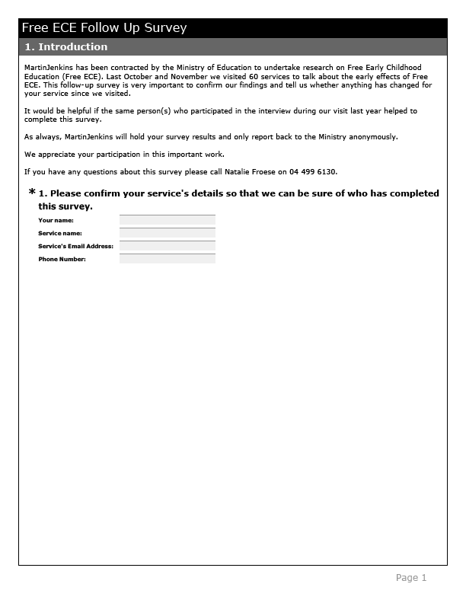
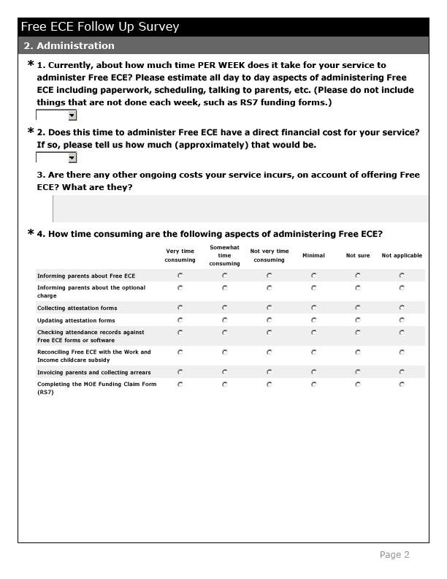
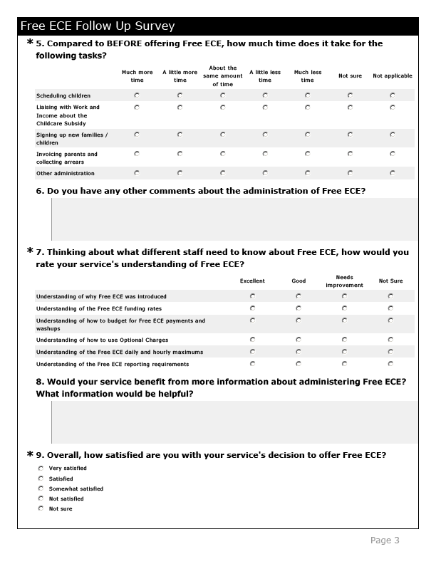
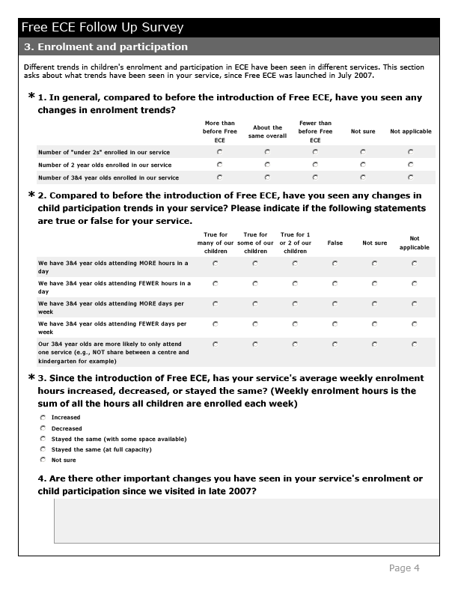
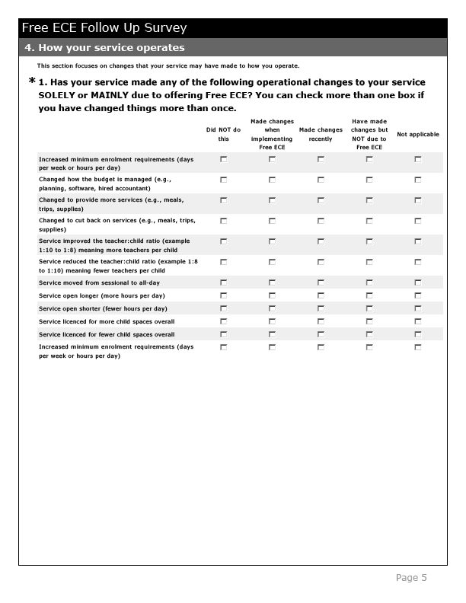
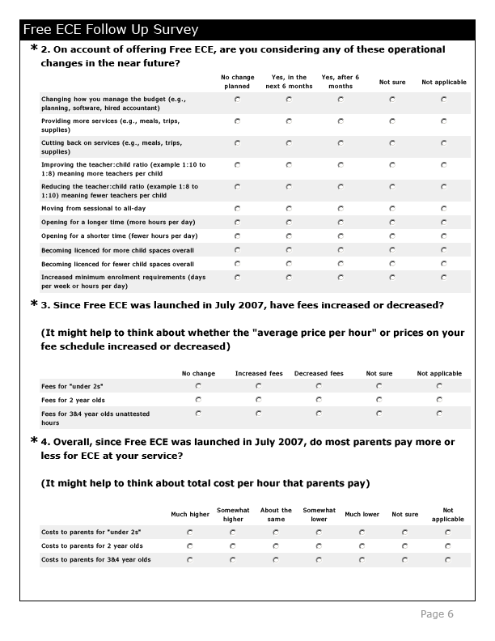
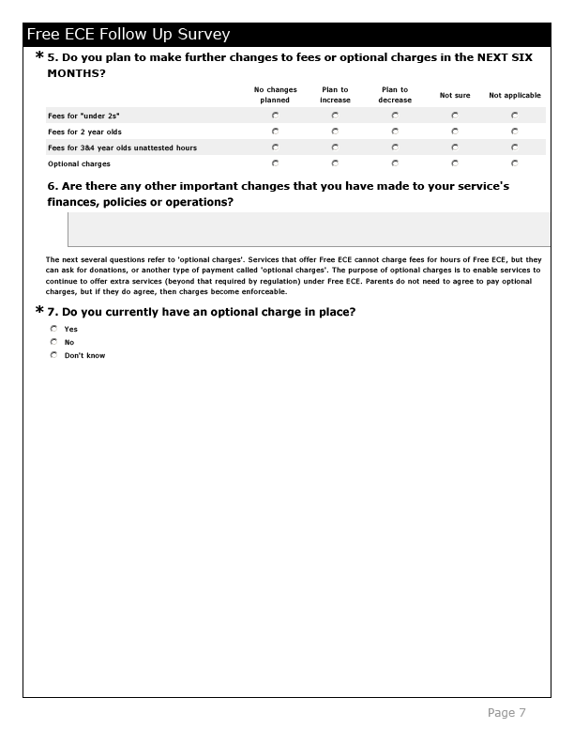
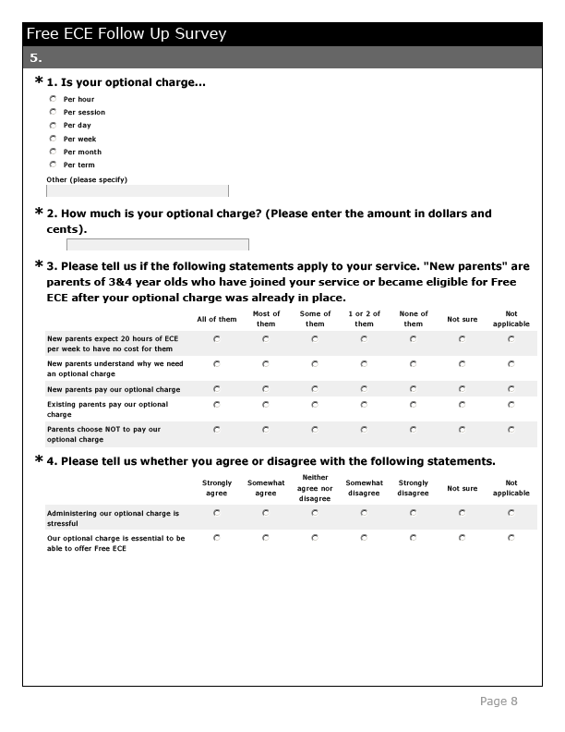
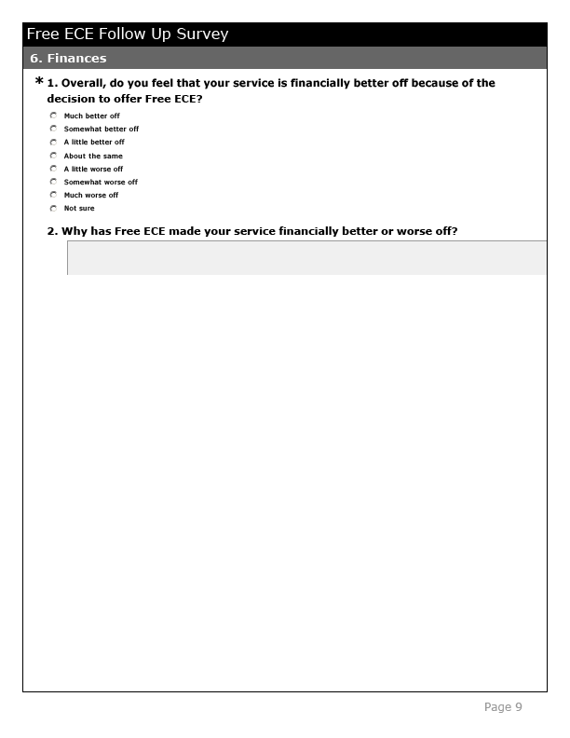
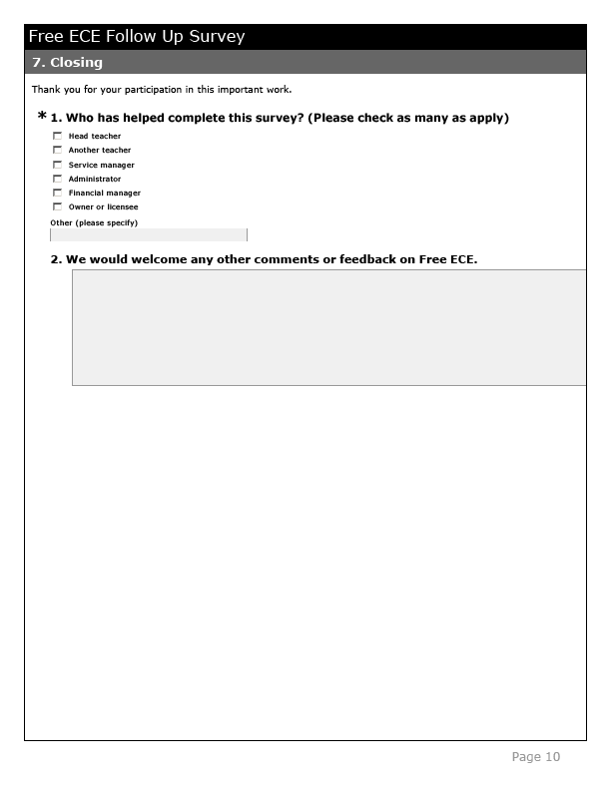

Appendix 3: Code categories

Question 2-1 administration
- Essentially no time at all
- No time for our service (association or umbrella organisation does it)
- About 30 minutes or less
- 30 minutes to 1 hour
- 1.5 hours
- 2 hours
- 2.5 hours
- 3 hours
- 3.5 hours
- 4 hours
- 4 to 6 hours
- 6 to 8 hours
- More than 8 hours
- Not sure

Question 2-2 direct cost
- No direct financial cost
- Up to $50 per week on average
- $50 to $100 per week on average
- $100 to $150 per week on average
- $150 to $200 per week on average
- More than $200 per week on average
- Not sure
- Not applicable

Request for Proposal, MOE
Information is drawn from the RFP “Early Effects of Free Early Childhood Education (ECE)”, Ministry of Education, July 2007.
A teacher-led service is one where one or more ECE qualified and registered teachers are responsible for the overall programme in the service. A qualified teacher would usually have a Diploma of Teaching in ECE or an equivalent qualification.
Request for Proposal, MOE
Many services said that Free ECE has been excellent for children and families.
Note that 2 surveys were incomplete; sample size varies throughout the report depending to the number of responses to each question.
It appears this was more common for homebased care networks.
Note that for other services concentrated MOE was not a concern but a positive feature of Free ECE. See the section on costs and revenues for details.
There were no clear patterns between types of services or ownership of services and their understanding of various elements.
When the total is less than 52, it is because some respondents have elected to not answer a question. One respondent answered only the first few questions, so effectively there is a possible total of 51 respondents for most of the survey.
Free ECE rates were initially released in December 2006 and increased to reflect cost increases in Budget 2007.
In this context visits by evaluators to study the early effects of Free ECE was considered a consultation.
Throughout this section, figures refer to the total number of services participating in the interview phase, unless citing survey results.
Note that we have analysed “private kindergartens” along with private childcare centres.
Note that some kindergartens had been charging fees prior to Free ECE.
A few services said they did not enforce fees at all – so essentially all charges were optional.
We note that this approach does not imply that these services took any more or less care with the required attendance, documentation and attestation forms.
Many, but not all of those who planned to make changes in the future also reported making changes already.
We investigated those 13 services who administered an optional charge and “strongly agreed” that it was essential to them. These services did appear more likely to have full compliance than the 8 services who “agreed” or were indifferent to the optional charge, although within each group there was a range of responses.
Services spoke about a “contact person”, this is likely to have been the Childcare Coordinator.
A small number of services identified that it might be important to set rates high enough so that parents attested hours with them (e.g. they were not the “cheaper” service).
Services only commented on fees for age groups that they accepted (under 2s, 2 year olds, 3 and 4 year olds). In general, services tended to report the same pattern for each age – that is, fees “across the board” tended to move in the same direction, although a few cases of potential cross-subsidisation did exist. Note that a confounding factor is the general tendency for costs and fees to increase over time.
A few services mentioned that parents with English as a second language may have difficulty understanding aspects of Free ECE: “ ‘Attestation’ does not translate well”; this may also apply to ideas like optional charges.
Note that observed patterns are based on very few services in each category and should be interpreted in light of this study only.
Services found it difficult to speculate about whether or not children may also be new to ECE (not having attended any ECE before).
Of the 24 services who said they had more 3&4 year olds, only 4 also said that they had fewer younger children.
Some services reported benefits to children due to longer hours of care, whereas a few others said that children were now in care too long.
Quotations have been paraphrased to preserve confidentiality. Source: Survey, Feb-Mar 2008.
Sample sizes may be too limited to pick up these types of issues, particularly when not investigated directly throughout the research.

