APPENDIX A:

Sample Friendship Map
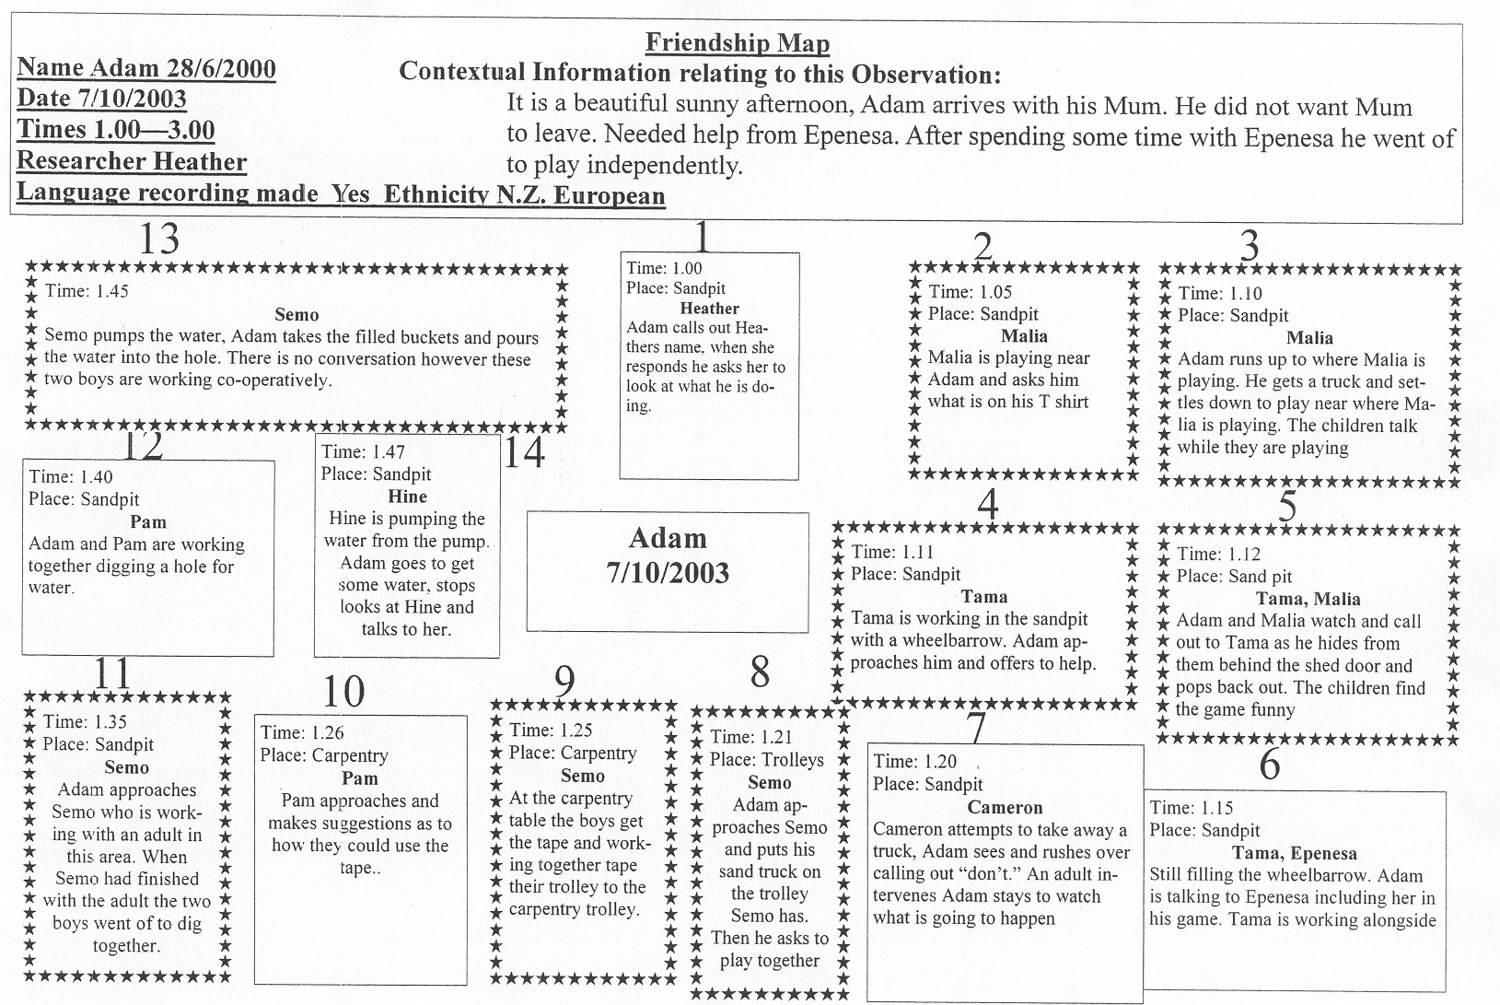
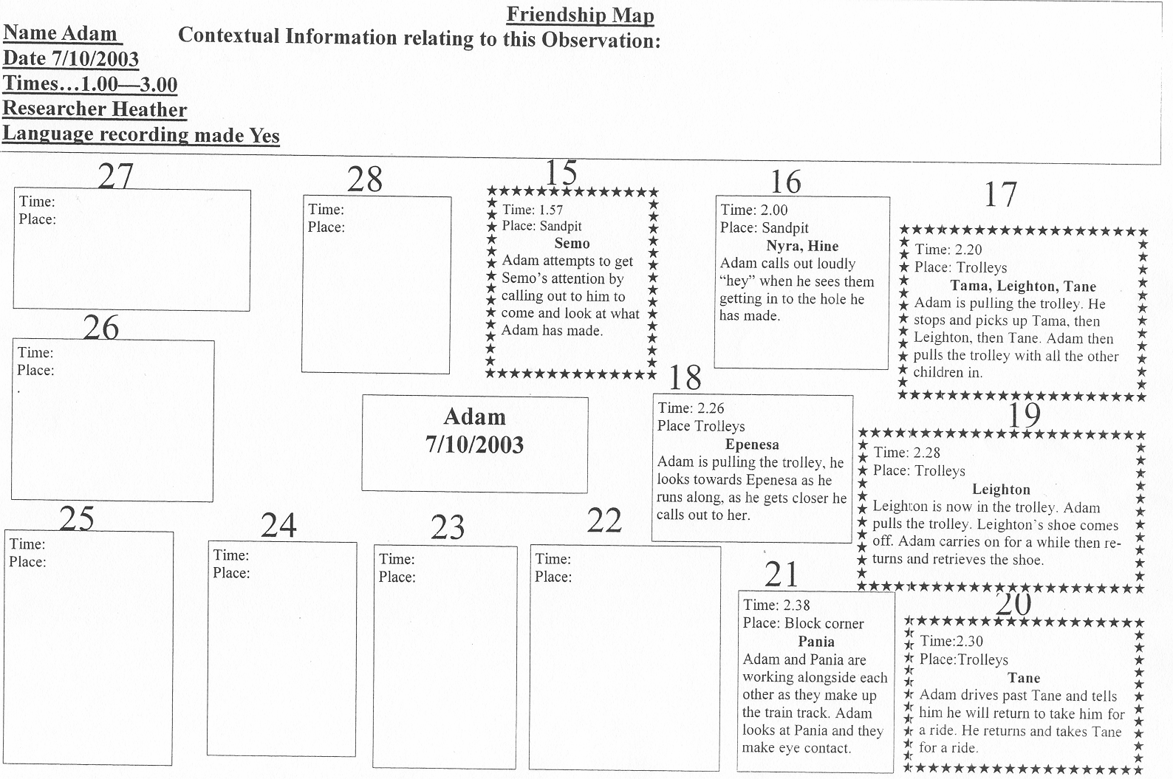

APPENDIX B:

Sample of Teaching – Learning Story

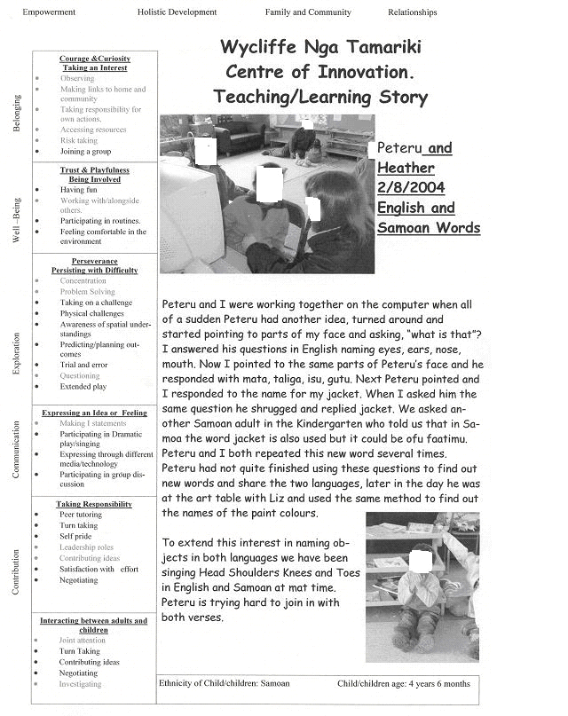

APPENDIX C:

Sample of Video Transcript
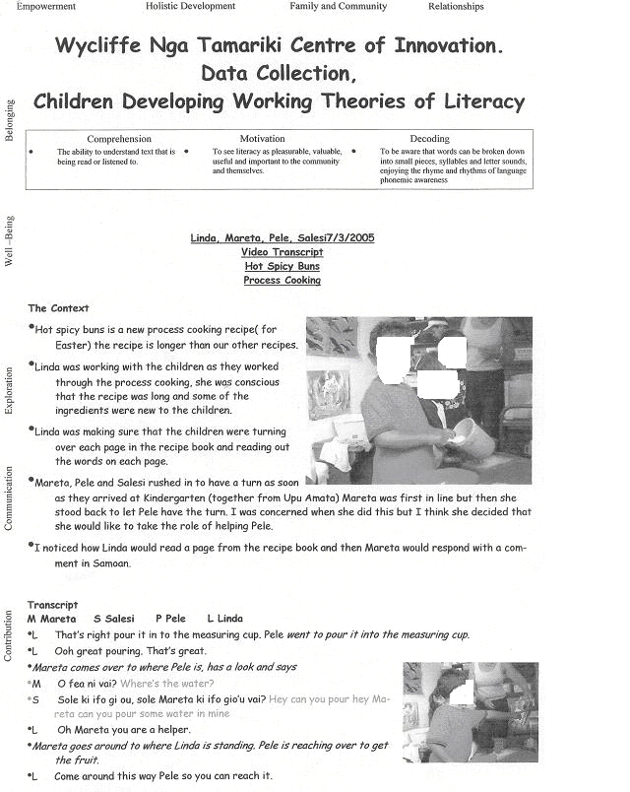

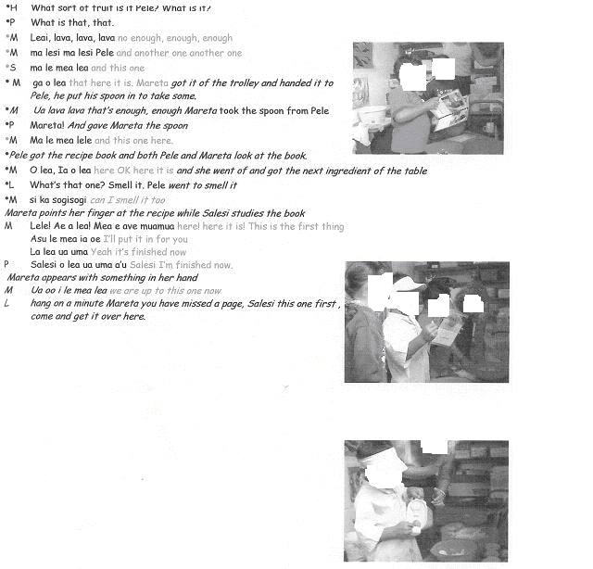
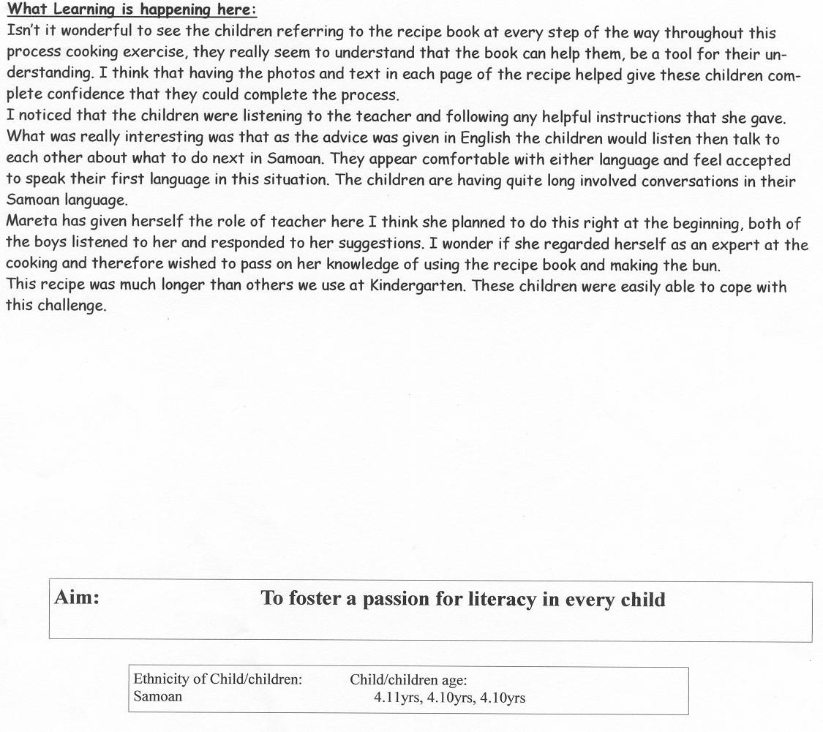

APPENDIX D:

Schedule of Dissemination Activities
Articles and/or Talks undertaken by WNT about the COI project from June 2003 to December 2005.

20th August 2003: Samoan Assembly of God Church, Napier
Titled: Celebration Fono

13th September 2003: N.Z.K.I. meeting, Wellington
Titled: Intercultural Research

24th September 2003: 8th Early Childhood Convention, Palmerston North, in conjunction with Cherreen Exeter MOE
Titled: Blending cultures.

23rd September 2003: 8th Early Childhood Convention, Palmerston North, presentation facilitated by Anne Meade and in conjunction with other COI’s
Titled: Promoting an Intercultural Environment

29th November 2003: Early Childhood Research Symposium
Titled: WNT Centre of Innovation

November2003: NKA Primary Teachers and Principals Evening,
Titled: Wycliffe Nga Tamariki Centre of Innovation

March 2004: Hawkes Bay Network Meeting Ruawharo
Titled: Wycliffe Nga Tamariki Centre of Innovation

18th March 2004: Kindergarten Senior Teachers Hui, Wellington, short presentation by Eileen Woodhead
Contents: COI project

10th May 2004: New Zealand Education Gazette Tukutuku Korero, article contributed to by Wycliffe Nga Tamariki Kindergarten and Upu Amata
Titled: More than Neighbours

28th May 2004: New Zealand Childcare Association Conference, Queenstown
Titled: Building a Relationship with a Samoan Community

May 2004: Electronic newsletter to wider community

18th & 19th August 2004: Network meeting Wanganui and Hawera, presentation by Teacher Researcher and Research Associate
Titled: Wycliffe Nga Tamariki Kindergarten Centre of Innovation

September 2004: Electronic newsletter to wider community.

December 2004: Article in Early Education Journal, Written by Liz Schimanski
Titled: Reflections on being a teacher in a Centre of Innovation

22nd November 2004: Presentation to Centre of Innovation Hui, Wellington
Titled: Extending the WNT Community of Learners

23rd November 2004: EC Research Symposium, Wellington, presented by teacher researchers and research associates
Titled: Learning about Children’s Friendships.

13th November 2005: Mini Conference, Palmerston North, presented by Teacher researcher and research associate
Titled: The Dance of Friendships

November 2005: Electronic Newsletter to wider community

December 2004, Findings of 1st action research cycle published, hard copy distributed and electronic copy MOE web site.
Title: The Dance of Friendships

24th June 2005 N. Z. Kindergarten Inc Conference, Wellington
Title: Working along other services

Poster Presentation European Early Childhood Research Association Conference, Dublin
Title: Teachers Researching Young Children’s Working Theories

3rd September 2005: EIT Research Symposium, Taradale
Title: Enhancing Teachers Reflective Practice

28th September 2005: Ulimasao Conference, Apia Samoa presented by Teacher Researcher and Research Associate
Titled: Supporting Bilingual Development within a Community of Learners

12th October 2005: Book Launch with community, Napier.
Titled: Catching the Waves

15th November 2005: Heretaunga Kindergarten Teachers Staff Meeting
Titled: Wycliffe Nga Tamariki Kindergarten

December 2005: Electronic newsletter to wider community.

December 2005: Article in Early Education Folio, collaborative writing between teacher researchers and research associates.
Titled: Teachers Researching Young Children’s working theories

