Monitoring the recovery

Post-compulsory education in greater Christchurch

This report forms part of a series called Supporting the tertiary education system.
Author
Roger Smyth, Senior Manager, Tertiary Sector Performance Analysis
Email: roger.smyth@minedu.govt.nz
Telephone: 04-463 8633
Fax: 04-463 8713
Acknowledgements
The author gratefully acknowledges comments provided by Jason Dowse (Canterbury Earthquake Recovery Authority), Nick Montague (Ministry of Business, Innovation and Employment), Graeme Finn, Sergei Koudrin and Paul Pearson (Tertiary Education Commission), Rob Burrough, Trevor McIntyre, Mieke Wensvoort (Ministry of Education) and members of Youth Futures Canterbury.
All views expressed in this report, and any remaining errors or omissions, remain the responsibility of the author.
Published by
Tertiary Sector Performance Analysis
Tertiary, International and System Performance
MINISTRY OF EDUCATION
© Crown Copyright
This work is licensed under the Creative Commons Attribution 3.0 New Zealand licence.
You are free to copy, distribute and adapt the work, as long as you attribute the work to the copyright holder and abide by the other licence terms. To view a copy of this licence, visit www.creativecommons.org/licenses/
by/3.0/nz/.
This report is available from the Ministry of Education’s Education Counts website: www.educationcounts.govt.nz.
October 2013
ISBN (web) 978-0-478-42205-4
Monitoring the recovery
1 Introduction, context and summary of findings 1
2 Entering work 5
2.1 Young people not in employment, education or training 5
2.2 Young people on an unemployment benefit 6
2.3 The youth population fell… 8
2.4 The proportion of young people in work fell… 8
3 Leaving school 10
3.1 School leaver destinations… 10
3.2 School achievement… 14
4 Entering tertiary education 16
4.1 Tertiary enrolments were down in 2011… 17
4.2 Enrolments in 2012 show encouraging signs of recovery… 19
4.3 Industry training… 19
4.4 Secondary tertiary programmes … 21
5 Completing tertiary qualifications 22
5.1 Qualification completions fell in 2011… 23
5.2 The effect on the completion of higher-level qualifications was less… 24
5.3 The fields graduates in greater Christchurch specialise in… 25
5.4 How well do the institutions perform… 26
5.5 Achievement in secondary/tertiary programmes… 27
6 Performance of greater Christchurch tertiary education institutions 29
6.1 Financial performance – leading up to 2011… 30
6.2 The institutions’ financial situation in 2011… 32
6.3 Non-financial performance… 35
Appendix A Data sources 37

Figures
1.1  1.2  1.3  1.4  2.1  2.2  2.3  2.4  2.5  3.1  3.2  3.3  4.1  4.2  4.3  4.4  5.1  5.2  5.3 | Percentage of people aged 15 to 24 years not in employment, education, or training (June quarter) in greater Christchurch and New Zealand 6  Canterbury unemployment benefit recipients aged 18 to 24 years 7  Net migration of people aged 15 to 24 years in greater Christchurch and New Zealand 8  Percentage of people aged 15 to 24 years in employment, education or training in greater Christchurch and New Zealand 9  Tertiary study destinations in the first year after leaving secondary school in greater Christchurch 11  Proportion of greater Christchurch school leavers who undertake no further education or training in New Zealand 12  Proportion of greater Christchurch school leavers who undertake no further education or training in New Zealand by ethnic group and highest school qualification 13  NCEA achievement levels by school leavers in greater Christchurch 14  Percentage of Māori and Pasifika school leavers who leave with NCEA level 2 or higher in greater Christchurch and New Zealand 15  Enrolments in formal tertiary education in providers in greater Christchurch 17  Enrolments in formal tertiary education by first-year students in Christchurch Polytechnic and the University of Canterbury 18  Number of industry trainees in greater Christchurch 20  Qualification completions at greater Christchurch tertiary education institutions 23  Proportion of completions at greater Christchurch tertiary education institutions at higher qualification levels 24  Field of study of graduates at bachelors degree and above from greater Christchurch tertiary education institutions 26  Course completion rates at greater Christchurch tertiary education institutions 27  Operating surplus (deficit) as a percentage of total revenue for greater Christchurch tertiary education institutions 30  Capital expenditure, capital expenditure as a percentage of depreciation, operating cash surplus and liquid assets of greater Christchurch tertiary education institutions 31  Financial performance of greater Christchurch tertiary education institutions 33
Tables
3.1  4.1  4.2  4.3  5.1  5.2 | Participation in secondary-tertiary programmes in greater Christchurch 21  Student achievement in, and outcomes of, trades academy study in 2011 at the Canterbury Tertiary College 27  Student achievement in, and outcomes of, Gateway programmes in 2011 in greater Christchurch 28  Youth Guarantee student achievement in 2011 in greater Christchurch 28  Earthquake-related receipts and expenses recorded in the 2010 and 2011 annual reports of Lincoln University, the University of Canterbury and Christchurch Polytechnic Institute of Technology. 34  Non-financial performance of tertiary education institutions in greater Christchurch 35

Introduction, context and summary of findings
The context
The sequence of earthquakes that hit Canterbury in 2010 and 2011 caused great disruption for the education system. The lives of people working in the education system – students and teachers – were enormously disrupted, with many people needing to live in make-shift accommodation, some injured and many affected personally by the deaths that occurred. The experience of the earthquakes, followed by dislocation, uncertainty and the disruption to the community caused great stress.
Education organisations, important contributors to the social fabric of any community, were severely disrupted. All schools experienced damage and several had to share their sites with other schools. Tertiary education organisations lost buildings and had to make do in make-shift facilities while they waited for insurance payouts and for building and land assessments.
The private tertiary education sector – much of it based in the central business district – was especially severely affected. Around 40 percent of all those who died in the 22 February 2011 earthquake were staff or students at one tertiary education provider, Kings Education, destroyed when the CTV building collapsed. Many of the central business district providers faced the loss of their headquarters.
Schools and tertiary education organisations lost revenue as international students left or stayed away and as tertiary students stayed out of Christchurch or deferred their education. Some families left the region or shifted from the more badly damaged areas within greater Christchurch, causing rolls to fall.
Tertiary education institutions face a gap between the cost of repairs and rebuilding and insurance cover. This, coupled with uncertain enrolments and the loss of international students, is putting a large financial strain on institutions.
Two years after the February 2011 earthquake, the post-compulsory education system in greater Christchurch shows encouraging signs of recovery. This report looks at trends in the system as it moves to recovery.
This report focuses on the post-compulsory education system. Post-compulsory education means education for those who are aged 16 years or older who are attending school or a tertiary education provider.
It looks at the system in Waimakariri and Selwyn Districts and Christchurch City, the three local authorities that cover the greater Christchurch urban area. In this report, we refer to this area as greater Christchurch.
The importance of the post-compulsory education system
The education system has a crucial role in the recovery of greater Christchurch. It is the post-compulsory education system that will provide many of the skills and knowledge needed for the development of the region as its economy adapts to changes precipitated by the earthquakes.
It is through the post-compulsory education system that much of the new knowledge and the intellectual capital needed to fuel the development of new products and services will come. These products and services will provide the basis for the longer term prosperity of greater Christchurch and the Canterbury region and hence, will also benefit New Zealand’s economy and society.
In the short- to medium-term, the people of greater Christchurch are also counting on schools and tertiary institutions to provide many of the skills needed for the physical rebuild of the city.
As well as its role in building human capital for the recovery of the region, the post-compulsory education system is essential to the well-being of the community; a thriving city needs a vibrant post-compulsory sector both to provide opportunities for learning and because post-compulsory education delivers social and cultural benefits to students as well as to the society.
These factors mean that it is important we take a systematic view of how the post-compulsory education system in greater Christchurch recovers.
The government response
The government took immediate steps in response to the earthquake sequence to support learners in greater Christchurch and to support the post-compulsory education system. Government:
- put in place the Recovery Strategy and developed a recovery programme specifically addressing education
- modified tertiary funding and tertiary student support arrangements to enable students to continue their studies at other institutions
- managed diplomatic relationships and provided support for the parents of international students
- maintained funding levels in schools in 2011 and in tertiary institutions in 2011 and 2012
- created a new scholarship scheme for greater Christchurch school leavers to help them enter tertiary education, and
- allocated $42 million in Budget 2011 to support training in trades that would help the recovery, while also encouraging polytechnics to reprioritise their work to provide extra trades training places to help ensure the availability of the skills needed for the rebuild
- created initiatives to encourage young Māori and Pasifika to enter trades training.
Education New Zealand allocated an extra $5 million to help the recovery of international education in greater Christchurch.
The government launched the Education Renewal/Recovery Programme for greater Christchurch in May 2012. As part of that programme, it has agreed to allocate additional capital funding to the three tertiary education institutions based in greater Christchurch, subject to satisfactory business cases.
That recovery programme forms part of an interconnected set of recovery and renewal plans – notably the labour market recovery programme and the economic recovery programme which all contribute to the overarching Recovery Strategy.
This report series
This report is the first in a series that will track trends in the post-compulsory education system in greater Christchurch over the next three years. This first report provides a baseline view of the sector, looking at what happened in 2011 and giving first information on how the system is recovering.
The monitoring framework
We know relatively little about the consequences of natural disasters for education systems. While there are accounts of the effects of and recovery from natural disasters in other countries, the particular circumstances of each mean that it is hard to identify common elements. However, the international evidence suggests that once the initial major disruption is over, other factors (such as economic change) start to cloud the effects of the disaster (Beaven & Pearson, 2012). So it is necessary to select monitoring measures carefully and to refer to the broader context of the within which the recovery occurs.
This report series will look at five aspects of the system:
- The transition from education to work
- Leaving school
- The movement into tertiary education
- Qualification achievement in tertiary education
- The state of the tertiary education institutions.
Within each of these areas, we look at a number of indicators that give a view of performance and progress.
SUMMARY OF FINDINGS
Young people in work and education…
- The youth population in Christchurch fell in 2011, following the earthquakes, with some leaving the city and fewer people entering greater Christchurch for tertiary education.
- Historically, employment outcomes for young people in greater Christchurch have been better than in the rest of New Zealand. But in the wake of the earthquakes, the proportion of young people who are not in employment, education or training (NEET) rose.
- Unemployment among young people spiked in 2011 but has since come back to more normal levels.
Leaving school …
- School leaver achievement levels in greater Christchurch were higher in 2011 than in previous years, despite the disruption to the schooling network caused by the earthquakes. However, there are wide differences between schools in achievement levels.
- Six years after leaving school, a quarter of those who leave with no qualifications have not undertaken any further formal education or training.
Participation in tertiary education …
- Tertiary education enrolments went down in greater Christchurch in 2011 in response to the earthquakes.
- 12 percent among domestic students, compared with 7% nationally
- By an estimated 30% among international students
- Among domestic students, the fall was greater among first year students and among those from outside Christchurch.
- In 2012, the domestic enrolment numbers went up slightly on 2011, with polytechnic enrolments strong. But international enrolments went down again.
The performance of the tertiary education institutions …
- The three tertiary education institutions – which are responsible for 80 percent of the tertiary education delivery in greater Christchurch – face financial challenges as they embark on their repair and renewal programmes. The government has asked all three to prepare business cases that may lead to capital injections by the Crown.

Entering work
We monitor people entering work because…
The post-compulsory education system in greater Christchurch has an important role in supporting the recovery from the 2010 and 2011 earthquakes. The system needs to help develop the skills of the youth population to support the rebuild, while also supporting the longer-term economic recovery through up-skilling the population of the Canterbury region.
For young people in post-earthquake Christchurch, skills and qualifications have become more important as the industries that have traditionally provided work for young people with lower qualifications (like tourism and retail) have contracted.
The system needs to strive to maintain connections with young people until they have gained qualifications that are likely to increase their chances of sustainable employment.
In this section, we look at the proportion of young people who are not in employment, education or training (NEET), at youth unemployment and at the engagement of young people with employment.
The baseline position – what the data shows…
- Historically, greater Christchurch has seen lower levels of young people not in employment, education, or training (NEET) than is typical for New Zealand as a whole.
- NEET levels rose following the earthquakes. In 2012, greater Christchurch matched the rest of New Zealand.
- The proportion of young people in work fell. The number of unemployment benefit recipients aged 18 to 24 years spiked mid-2011 although, since then, the number has fallen.
- The population aged 15 to 24 years fell significantly following the earthquakes.
Looking forward…
Employment prospects for young people are improving as the rebuild gains momentum. Young people have greater opportunities to train for jobs in the rebuild as a result of action by government, firms involved in the rebuild and tertiary education organisations.
The government has developed an economic development plan for greater Christchurch intended to strengthen the position of firms in industries where greater Christchurch has a comparative advantage.

Young people not in employment, education or training
The proportion of people aged 15 to 24 years who are not in employment, education, or training (NEET) in greater Christchurch has risen since the earthquakes.
Historically, the proportion of young people who are NEET has been lower in Christchurch than in New Zealand as a whole. However, in 2012, the NEET rate in greater Christchurch rose while it fell in the country as a whole in response to a slowly strengthening youth labour market.
Figure 2.1
Percentage of people aged 15 to 24 years not in employment, education, or training (June quarter) in greater Christchurch and New Zealand
Source: Statistics New Zealand, Household Labour Force Survey.
Note: Household Labour Force Survey data is subject to sampling errors
Figure 2.1 also shows the effects of the recession of 2009 – when NEET rates in New Zealand moved to a new equilibrium level, in common with similar measures in other countries.
The Household Labour Force Survey for the September 2012 quarter shows the upward trend in the NEET rate continuing in greater Christchurch. Although greater Christchurch had a lower NEET rate in September 2012 than the rest of New Zealand, there was a significant pick-up between September 2011 and September 2012 – from 7.5 percent to 10.7 percent. Over the same period, the NEET rate for the rest of New Zealand rose, but to a lesser extent.

Young people on an unemployment benefit
The number of unemployment benefit recipients aged 18 to 24 years in Canterbury spiked in 2011 but then fell. The number rose to 16 percent of the national total in June 2011, with the number having risen by more than 25 percent on the previous year. From June 2011, the number fell. Between June 2011 and June 2012, the number of unemployment benefit recipients in Canterbury fell by 48 percent to stand at 10 percent of the national figure.
Figure 2.2
Canterbury unemployment benefit recipients aged 18 to 24 years
- Canterbury region compared to New Zealand
- Quarterly trend in unemployment benefit recipients aged 15 to 24 years in the Canterbury region
Source: Ministry of Social Development, Quarterly regional labour market updates.
Note: The data in this figure is for the Canterbury region, not simply greater Christchurch. The data relates only to those aged 18-24 years.

The youth population fell…
One of the factors influencing the changing rates is the movement of the population. Statistics New Zealand reports that the population aged 15 to 24 years in greater Christchurch fell by 1.6 percent between June 2010 and June 2011 and by a further 0.8 percent between June 2011 and June 2012. Statistics New Zealand estimates that the number of people aged 15 to 24 years in greater Christchurch fell by around 1,650 between June 2010 and June 2012.
Part of the fall in population can be attributed to off-shore emigration. While migration saw a net loss of people aged 15 to 24 years from greater Christchurch between 2010 and 2012, this was only around 45 percent of the youth population loss in that period. The other main reason for the drop was internal migration – people moving from greater Christchurch to other parts of New Zealand.
Figure 2.3
Net migration of people aged 15 to 24 years in greater Christchurch and New Zealand
Source: Statistics New Zealand, Permanent and long-term migration statistics (June years).

The proportion of young people in work fell…
If we look at young people in employment between June 2011 and June 2012, we see a fall in the proportion of young people in employment, education or training in greater Christchurch, while nationally there was a small increase.
Figure 2.4
Percentage of people aged 15 to 24 years in employment, education or training in greater Christchurch and New Zealand
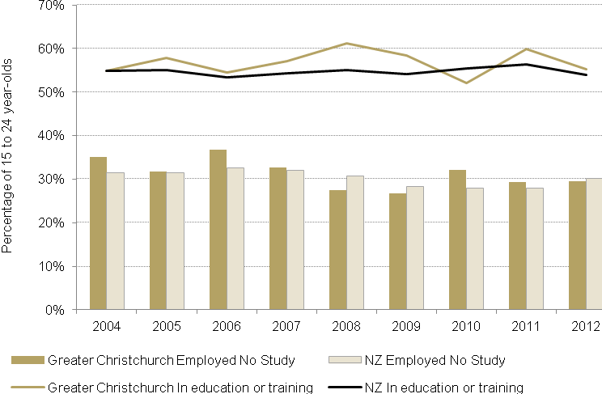
Source: Statistics New Zealand, Household Labour Force Survey (June quarters).
Note: Household Labour Force Survey data is subject to sampling errors.
Figure 2.4 also shows the effects of the recession of 2009, with the number in employment falling from its high in 2006 to a low in 2009.
Looking at the September quarters, we see the proportion of young people in employment in greater Christchurch dropped further between June 2011 and September 2011 but returned to pre-earthquake levels in 2012. The proportion in education or training was stable in 2012.

Leaving school
We monitor people leaving school because….
Systems are most vulnerable at points of transition. One critical transition point for the young is leaving school.
So we monitor what happens to young people in their first few years after leaving school and we look at trends in school leavers’ achievement.
The baseline position – what the data shows…
- Those who left school in greater Christchurch in 2010 were less likely to go into further education or training than in earlier years.
- Those who left with low school qualifications were much less likely to access further education or training.
- There were significant differences between schools in greater Christchurch in the proportion of low-qualification leavers who transferred to further education or training.
- School-leaver achievement levels in Christchurch are greater than the national level. NCEA results appear not to have been affected by the earthquakes.
Looking forward…
The development of new secondary/tertiary programmes – such as Youth Guarantee – and the availability of vocational pathways that help young people find more meaningful ways through the education system should ensure that more young people stay longer in the education system and make a smoother transition to work.
Reorganisation of the school network in greater Christchurch offers opportunities to lift school leaver achievement.

School leaver destinations…
Those who left school in greater Christchurch in 2010 were less likely than school leavers in previous years to go into tertiary education in New Zealand in the following year.
Figure 3.5, for instance shows that of those who left school with level 3 or higher qualification in 2010, 64 percent enrolled in a degree in 2011, against 68 percent in the previous three years, while the proportion entering any level of tertiary education dropped from 63 percent to 58 percent.
These measures vary greatly by school. Overall, 64 percent of the 2010 NCEA level 3 leavers went into a degree in 2011, while in one-third of the 37 secondary schools, the proportion was less than 50 percent. In 2010, 58 percent of all greater Christchurch school leavers entered some form of tertiary education or training in 2011, while in a quarter of the schools, the proportion was below 50 percent.
Figure 3.5
Tertiary study destinations in the first year after leaving secondary school in greater Christchurch
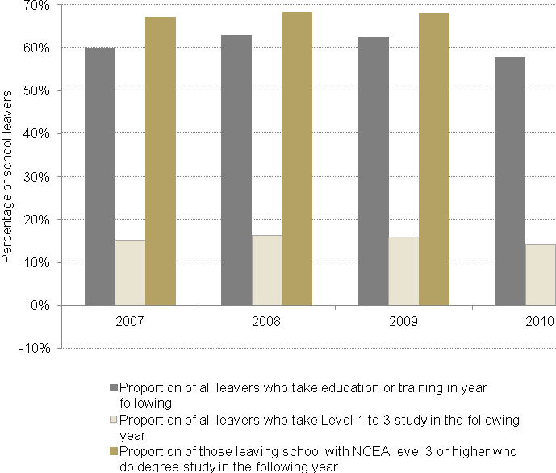
Source: Ministry of Education, transitions data.
Note: Level 1 to 3 post-school qualifications match the level of qualifications taught in the senior secondary school system. Some are vocational qualifications. Others are designed to prepare learners for higher levels of study. Refer to www.nzqa.govt.nz for formal definitions of qualification levels.
One of the problems is that the propensity to take up further education is related to the level of school achievement – in greater Christchurch, as well as through the rest of New Zealand. Of those who left school in greater Christchurch in 2010 with qualifications below NCEA level 2, only 37 percent entered some form of tertiary education in 2011. This suggests that those who have the greatest need for further education or training are the least likely to access it.
When we take a longer term view, we see similar patterns. Looking at school leavers from schools in greater Christchurch, we see that 14 percent have taken no further education or training six years after leaving school, compared with 17 percent nationally. Figure 3.6 shows the post-school education destinations of greater Christchurch school leavers over the six years following leaving school, split by their highest level in NCEA.
Figure 3.6
Proportion of greater Christchurch school leavers who undertake no further education or training in New Zealand
Source: Ministry of Education, transitions data and school leaver data.
Note: This figure aggregates data from the school leaving years 2004 to 2010. The transitions data has no information on destinations if the student does not enter tertiary education. Those who do not enter tertiary education could be in work, overseas, on a benefit or disengaged from work.
As we would expect, Figure 3.6 shows that many people delay starting further education or training, with the proportion not entering further study falling from around 35 percent in the first year out of school to 14 percent in the sixth. The proportions are higher for:
- Māori (22 percent in the sixth year) and Pasifika (30 percent)
- those from decile 1 to 4 secondary schools (25 percent)
- those with low or no qualifications (27 percent).
The data by ethnic group and highest school qualification is set out in Figure 3.7.
Figure 3.7
Proportion of greater Christchurch school leavers who undertake no further education or training in New Zealand by ethnic group and highest school qualification
Source: Ministry of Education, transitions data and school leaver data.
Note: Note this aggregates school leaving years from 2004 to 2010. For people who do not enter tertiary there is no information on their destinations after leaving school.
Among those who leave school with a level 3 qualification, there are only slight differences in participation in tertiary education between ethnic groups. School leavers with a level 1 qualification or less show marked differences in participation. Asian and Pasifika students with low school leaving qualifications have the lowest propensity to go to tertiary education.

School achievement…
School leaver achievement in greater Christchurch is better than national norms and has not dropped in the aftermath of the earthquakes. The percentage of 2011 leavers who had low or no qualifications fell in 2011 faster in greater Christchurch than it did nationally. The proportion of people leaving school in greater Christchurch with NCEA level 2 or a higher qualification has been rising and is also better than the national rate. The achievement in Christchurch, and nation-wide, are still short of the government’s target that 85 percent of all New Zealanders leave school with a level 2 qualification by age 18 years.
Figure 3.8
NCEA achievement levels by school leavers in greater Christchurch
- Percentage of school leavers who leave with low or no school qualifications
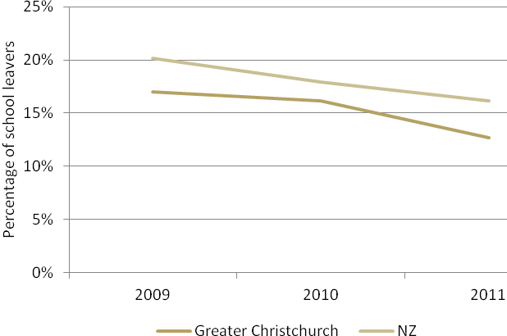
- Percentage of school leavers with NCEA level 2 or higher and level 3 or higher
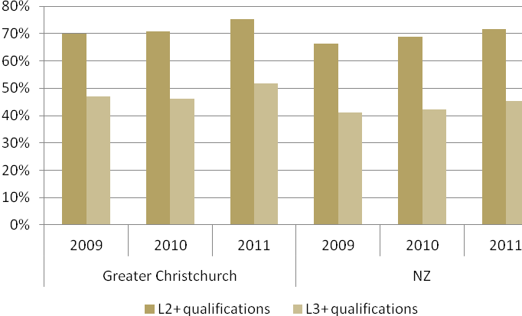
Source: Ministry of Education, school leaver data.
In part, the strong school leaver achievement in 2011 in greater Christchurch will have resulted from more people staying on at school during 2011, as well as from the efforts put in by schools to support learning in difficult circumstances.
There is wide variation among secondary schools in school leaver achievement. In 2010, the range among greater Christchurch secondary schools was 26 percent to 96 percent, with 11 schools above the government’s target of 85 percent and five schools below 50 percent.
There are differences by ethnic group. While school leaver achievement by Māori and Pasifika in greater Christchurch has improved in recent years, the level of achievement is lower than the whole group of school leavers in greater Christchurch. The level of achievement of Māori in greater Christchurch is higher than for Māori across the rest of New Zealand but the reverse is true for Pasifika. Figure 3.9 illustrates the trends by looking at the proportions that leave school with NCEA level 2 or higher.
Figure 3.9
Percentage of Māori and Pasifika school leavers who leave with NCEA level 2 or higher in greater Christchurch and New Zealand
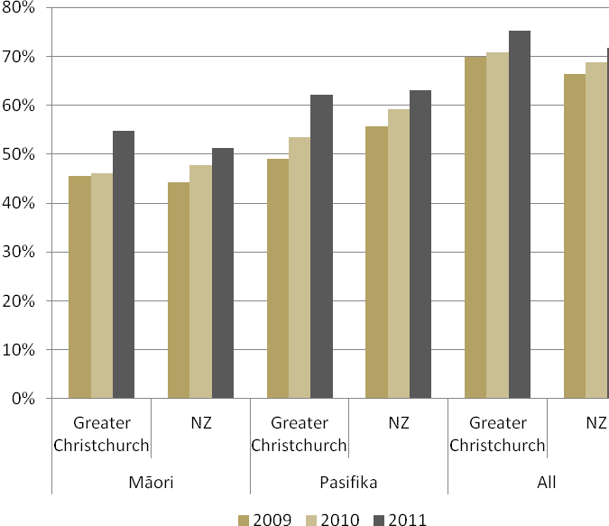
Source: Ministry of Education, school leaver data.
Figure 3.5 reinforces the earlier observation about the large improvements in the proportion of school leavers gaining NCEA level 2 in greater Christchurch, despite the disruptions in senior secondary schooling in the wake of the earthquakes in 2011. This improvement is seen among Māori and Pasifika as well as in the whole school population.

Entering tertiary education
We monitor tertiary education provision in Christchurch because…
Greater Christchurch has a large tertiary education sector. There are three tertiary education institutions that have their headquarters in the area, but 10 other tertiary education institutions also have a presence in Christchurch. There are also many private training establishments.
The tertiary education system helps provide the skills and knowledge needed for the development of the region as its economy adapts to changes precipitated by the earthquakes.
We need new knowledge to fuel the development of the area.
In the short- to medium-term, we are also counting on our schools and tertiary education institutions to contribute to the skills needed for the physical rebuild of the city.
People develop the skills we need through participating in tertiary education. At the same time, tertiary education organisations rely on student numbers to maintain their income and to enable them to maintain their intellectual capital – which is the source of much of the innovation needed by the economy and the society. Post-compulsory education is a critical part of the Economic Recovery Programme for greater Christchurch.
In this section, we look at participation in tertiary education – including industry training. We look at the change that occurred between 2010 and 2011 and give a first view of the 2012 enrolments.
The baseline position – what the data shows…
- Tertiary enrolments fell in greater Christchurch in 2011 in response to disruption caused by the earthquakes.
- In greater Christchurch, enrolments fell in terms of equivalent full-time student units by around 11 percent for domestic students and by 15 percent for international students.
- The fall was most pronounced among first-year students, students from outside the region and students in shorter, lower-level qualifications.
- Industry trainee numbers fell nationally in 2011 as a consequence of changes in operational policy, but the fall in greater Christchurch was more pronounced.
Looking forward…
There were larger intakes of domestic students in greater Christchurch in 2012 than in 2011, leading to a small increase in domestic enrolments in formal tertiary education in greater Christchurch. Much of the strength in the enrolments in 2012 derived from the polytechnics where enrolments were up by 14 percent on 2011, largely in response to the perceived need for skills in the local labour market. Cohort effects meant that enrolments remained below pre-earthquake levels at the University of Canterbury, although there appears to have been a recovery to close to historical levels of intakes.
Formal enrolments of international students in greater Christchurch fell further in 2012, by 17 percent, on top of the large fall that occurred in 2011.
Reforms to industry training announced in early 2013 are intended to lift the performance of the industry training system. The Apprenticeship Reboot scheme, developed as part of the transition to the new industry training system, provides incentives for young people to enter trades training in demand areas – such as construction.
But employers will need to increase the volume of in-work training they undertake to respond to the demands of the rebuild.

Tertiary enrolments were down in 2011…
Enrolments in formal tertiary education fell between 2010 and 2011 throughout New Zealand, but the extent of the fall in greater Christchurch was larger. While the number of people enrolled in formal tertiary education in New Zealand dropped by around 7 percent, in greater Christchurch, the fall was 12 percent.
If we look at the trend between 2010 and 2011 in equivalent full-time student (EFTS) units – which gives a better index of the effects of the fall on institutional revenue – we see that the fall in domestic EFTS in greater Christchurch was just short of 11 percent with the drop in international EFTS at around 15 percent.
However, those falls were averages across the system; some providers were hit much harder, especially private training establishments, many of which were located in the central city and focused on the international student market.
Figure 4.10
Enrolments in formal tertiary education in providers in greater Christchurch
Source: Ministry of Education.
Notes: Data relates to students enrolled at any time during the year with a tertiary education provider at a campus in greater Christchurch in formal qualifications of greater than 0.03 EFTS (more than one week's duration). Data excludes all non-formal learning and on-job industry training and those private training establishments which did not receive government tuition subsidies.
While tertiary enrolments in greater Christchurch have historically been around 10 percent of the national total, this fell to 8.7 percent in 2011. Not all of the reduction is due to the earthquakes of 2010 and 2011: the proportion had begun to fall in 2010.
The number of Māori enrolled in greater Christchurch fell by 12 percent in 2011, while the number of Pasifika students dropped by nearly 16 percent. This followed falls in Māori and Pasifika enrolments in Christchurch in 2010 also. Māori enrolments in formal tertiary education in greater Christchurch represented 3.7 percent of the national figure in 2011, compared to a high of 4.8 percent in 2005.
The fall in enrolments in greater Christchurch was most pronounced among international students and new students
The fall in enrolments in Christchurch was more pronounced among international students. International student numbers fell by 17 percent in formal tertiary education providers that receive government funding. The fall was much higher among private providers who focus exclusively on international students. Over the whole system in greater Christchurch, the drop in international students was estimated to be more than 30 percent between 2010 and 2011.
Enrolments by students aged 25 years and over fell by 17 percent. Enrolments by students aged 20 years and under dropped by 11 percent – partly reflecting the reduction of the size of this age cohort as the birth bubble moves through the population, adding to earthquake effects. There was a smaller fall in enrolments by 20 to 24 year-olds. This distribution reflects the fact that institutions in greater Christchurch reported significant falls among first-year students in response to the earthquakes, but reasonably good retention among existing students. While there was a fall in first-year students in all eight New Zealand universities in 2011, the falls at Lincoln University and the University of Canterbury were both more than 25 percent, significantly higher than other universities.
Figure 4.11 below shows the number of first-year students at Christchurch Polytechnic Institute of Technology and the University of Canterbury over 2008 through to 2011, plus the percentage of first-year students whose last high school was in greater Christchurch.
Figure 4.11
Enrolments in formal tertiary education by first-year students in Christchurch Polytechnic and the University of Canterbury
Figure 4.11 shows that the number of first-year students fell in 2010, and then dropped again sharply in 2011, as prospective students withheld their enrolments. The steep increase in the proportion of first-year students who had come from schools in greater Christchurch suggests that the fall in first-year enrolments was disproportionately among those from outside Christchurch.
While institutions outside greater Christchurch welcomed transfers from Canterbury providers, our analysis shows relatively few 2010 students moved to providers in other areas of the country. In fact, there was a lower level of transfer to other regions from Canterbury providers during 2011 than from institutions elsewhere in New Zealand.

Enrolments in 2012 show encouraging signs of recovery…
The 2012 enrolment data suggests that the domestic student intake in greater Christchurch is in line with intakes in earlier years: the number of domestic equivalent full-time students enrolled in campuses in greater Christchurch was up around 1 percent on 2011. While 2011 was – as noted above – a low year for enrolments, the data suggests that new student intakes were similar to the years before the earthquakes. This suggests a faster recovery of enrolments than many people had predicted.
In the polytechnics, where there are many qualifications of one-year duration, domestic enrolments in 2012 were around 13 percent up on 2011. Wānanga saw a 7 percent rise on 2011, while in private training establishments, there was a 6 percent drop .
Domestic enrolments at the universities were around 2 percent below a year earlier. Given that most university students study multi-year qualifications and that most of the reduction in 2011 was among new students, the data suggests that there was some recovery in the intakes of first-year students in 2012.
The greater Christchurch share of national domestic enrolments in 2012 is slightly up on the share from a year earlier.
Where the reduction in enrolments has accelerated is among international students. In equivalent full-time student terms, we have seen a reduction of around 17 percent between 2011 and 2012. About 80 percent of the reduction was in the private training establishments..

Industry training…
Industry training has a key role in the recovery in Canterbury. Most of the occupations needed for the rebuild of Christchurch city, and for the repairs to buildings, are covered by industry training. Estimates by government agencies, and the Canterbury Development Corporation, of the rebuild workforce needs, suggest that an additional 10,000 – 17,000 construction workers will be needed by the recovery at its peak. Also, the tail of activity past peak demand is expected to create additional work for the next 20 years. There will be a flow-on demand need for extra workers in industries like accommodation, hospitality, retail, support services etc). Modelling suggests this might add up to 15,000 other workers.
In many cases – such as building and plumbing – certification through industry training is a prerequisite for working independently. The industry training system is designed for people in work, with much of the training delivered in the workplace. Because of disruption to work and because the recovery was still in its early stages many employers were reluctant to take on trainees during 2011. While the Tertiary Education Commission arranged for polytechnics to fill some of the gap, and alternative pathways were put in place, the industry training data still shows a significant drop in trainees between 2010 and 2011 in greater Christchurch.
The drop in trainees also reflected policy changes in the industry training system that began to take effect from mid-2010. These changes – designed to focus the system on those likely to succeed in gaining qualifications – removed inactive and unsuccessful trainees from the system.
This meant that between 2010 and 2011, the number of trainees dropped by 27 percent nationally. The drop in greater Christchurch was greater at 35 percent.
Figure 4.12
Number of industry trainees in greater Christchurch
Source: Tertiary Education Commission.
Notes: The data includes industry trainees and modern apprenticeships on training agreements in greater Christchurch. It covers all industry training organisations.
While Figure 4.12 shows a downward trend in industry trainee numbers, some of the decline reflects the delays in the start of the rebuild – and the requirement that trainees have jobs before the start of their training agreements. However, some of the reduction was taken up by higher enrolments in pre-trades courses at polytechnics. The government allocated extra funding to trades training nationally to lift the contribution of the education system to the rebuild.
Employers will have to increase the amount of in-work training they are prepared to support to reverse the declining trend in the number of trainees – which will require a change in the approach In some workplaces.

Secondary tertiary programmes …
The government has introduced a range of secondary-tertiary programmes to cater for young people for whom traditional school-based education is not working and who would otherwise be at risk of not achieving a qualification at level 2.
There are three types of programmes that enable senior secondary students to undertake tertiary study, while retaining a link to their school. The table below sets out the numbers undertaking study in greater Christchurch in 2011 at a trades academy, in the Gateway programme and at a tertiary provider in a Secondary-Tertiary Alignment Resource (STAR) programme.
Table 4.1
Participation in secondary-tertiary programmes in greater Christchurch
 | 2011
Trades academies | 101
Gateway | 616
Secondary-Tertiary Alignment Resource (STAR) | 1,011
Source: Ministry of Education and the Tertiary Education Commission.
The government created an additional trades academy in Christchurch in 2012 and expanded the number of places available in the existing academy. In 2012, there were 306 young people studying at the Canterbury Tertiary College, a trades academy led by Christchurch Polytechnic Institute of Technology, and involving three other polytechnics. At the new academy, the National Trade Academy, there were 68 people studying in 2012.
The Youth Guarantee programme aims to increase the educational achievement of 16 and 17 year-olds not currently engaged in education, and to improve transitions between school, tertiary education and work. It provides fees-free tertiary education opportunities at levels 1 to 3 on the New Zealand Qualifications Framework, including foundation-level vocational and generic skills that will assist learners in pursuing higher-level education, training or work. Youth Guarantee aims to ensure all young people achieve a minimum of NCEA level 2.
In 2010, the Canterbury region had 186 equivalent full-time student units in Youth Guarantee, 12 percent of the national total. While the number of equivalent full-time student units rose to 252 in 2011, the share of the national Youth Guarantee total dropped to 10 percent.

Completing tertiary qualifications
We monitor the stock of qualifications and the rate at which students complete their tertiary education qualifications because…
Educational qualifications are a good proxy for skills, especially among young people. The tertiary education system in greater Christchurch is one of the main sources of graduates among the population. The recovery, and renewal of the economy and society in the region, will be influenced by the effectiveness of the system in producing graduates – as well as the extent to which those graduates remain to contribute their skills to the local labour market.
So, it is important to monitor the contribution of the system to the stock of qualifications in the population. We do this by focusing on the qualifications produced by the three large institutions that have their headquarters in greater Christchurch.
We also look at course and qualification completion rates – which are broad measures of the efficiency of the institutions in producing graduates.
The baseline position – what the data shows…
- There was a fall in the number of qualification completions in greater Christchurch in 2011. The fall was most pronounced in shorter and lower level qualifications, with the number of higher-level qualification completions relatively less affected.
- The tertiary institutions in greater Christchurch have good completion rates.
- At higher qualification levels, there has been a trend towards more completions in fields such as agriculture, engineering, health, science and education, with fewer completions in commerce and society and culture.
- The Canterbury Tertiary College – the trades academy hosted by Christchurch Polytechnic Institute of Technology – reported excellent results in 2011, despite the disruption caused by the earthquakes.
Looking forward …
We expect that the smaller intakes in the two greater Christchurch universities in 2011 will lead to a reduction in qualification completions at degree level from 2013. We expect a lesser effect on completions of degrees in science, engineering and related fields, as these fields experienced lower falls in intake in 2011.
Industry training intakes fell in 2011 in greater Christchurch as firms involved in construction waited for the rebuild momentum to build and for the work to pick up. This may lead to a dip in industry training completions in the short term. However, with the rebuild now under way and a reformed industry training system, completion of industry training qualifications should pick up over the next three years.
The government focus on secondary tertiary programmes has increased the number of places in trades academies and fees-free Youth Guarantee training in greater Christchurch. This growth is expected to lead to an increase in the numbers gaining better preparation for further study or training.

Qualification completions fell in 2011…
Qualification completions at the three tertiary education institutions based in greater Christchurch increased between 2008 and 2010 by nearly 10 percent. However, between 2010 and 2011, the number fell 7 percent. Nationally, the increase was 13 percent between 2008 and 2010, with a further increase of 2 percent between 2010 and 2011. As a consequence, the three institutions’ share of the national total fell in 2011 from more than 6 percent to around 5.5 percent.
Figure 5.13 Qualification completions at greater Christchurch tertiary education institutions
- Qualifications completed at Lincoln University, Christchurch Polytechnic Institute of Technology and the University of Canterbury
- Annual change in the number of qualifications completed
Source: Ministry of Education.
Note: The Lincoln University completions in 2011 have been adjusted to exclude completions at the Telford campus.
The greatest fall occurred at Christchurch Polytechnic Institute of Technology (CPIT) (9 percent). The extent of the drop at CPIT is likely a consequence of the fact that compared with the universities, polytechnics have a higher proportion of their enrolments in shorter qualifications of one year or less. Therefore, a higher proportion of CPIT’s students would normally complete during or at the end of their first year. As much of the enrolment reduction in 2011 in response to the earthquakes was among first-year students, CPIT experienced the reduction in completions immediately. It was noted in the previous section that the enrolment drops at the two universities was disproportionately focused on first-year students in multi-year qualifications – and hence, the immediate impact on completion numbers was less, but they may experience lower completion numbers over the next two years.

The effect on the completion of higher-level qualifications was less…
While completion of qualifications is important, the greatest human capital growth comes from higher-level qualifications. People with higher-level qualifications tend to have greater skills and this is reflected in their earnings. The government’s better public services programme has a target for lifting the proportion of the population with qualifications at level 4 and above.
The proportion of completions at higher levels was not significantly affected by the 2011 earthquakes – largely because many of the students were well advanced towards completion of their qualifications by the start of 2011. In fact, the proportion of degree graduates rose slightly, as degree students expecting to complete in 2011 would be unlikely to not pursue their studies in 2011, whereas the reduction in completions was most evident in shorter, lower-level qualifications.
In the three tertiary education institutions, the proportion of completions by Māori and Pasifika at higher levels dropped in 2011.
Figure 5.14
Proportion of completions at greater Christchurch tertiary education institutions at higher qualification levels
Source: Ministry of Education.

The fields graduates in greater Christchurch specialise in…
One of the most important contributions the tertiary education system can make to the recovery in greater Christchurch is to provide skills needed for growth and development. One important way of monitoring that contribution is to look at the fields of study graduates specialise in – especially in advanced trades, technical and professional qualifications.
The areas we intend to focus on are:
- pre-trades qualifications – programmes that prepare people to move into industry training
- vocational qualifications at level 4 and at diploma level – particularly those in areas that help prepare people for work in the rebuild, and
- degree and higher qualifications – that provide high-skilled people who can be available to work in the firms that will provide the base for the recovery of the economy in greater Christchurch.
There are two important limitations in the data in this analysis.
We cannot accurately work out which graduates are Christchurch-based when they studied at a Christchurch campus with a provider that has their headquarters elsewhere. This is a significant limitation as there are three polytechnics based in other South Island centres with a Christchurch presence. The Southern Institute of Technology has a campus in Christchurch where they teach some of the important trades needed for the rebuild of greater Christchurch, while Tai Poutini Polytechnic and Aoraki Polytechnic each have a Christchurch presence. For simplicity’s sake, we report here only on the graduates of the University of Canterbury, Lincoln University and CPIT who provide the great majority of graduates.
Secondly, many graduates – especially those who take higher-level qualifications – leave Christchurch for other centres soon after graduating. There is evidence that the exit of graduates at higher qualification levels from Christchurch is only partly offset by graduates coming in from other centres. Therefore, this analysis overstates the number of new graduates available to the greater Christchurch labour market.
About half of the level 1 to 3 qualifications completed at CPIT each year are in areas that prepare people for entry into trades training. Since 2008, the number of vocational qualifications completed at level 4 and at diploma level has remained at 1,100 to 1,200 a year. Of these, around 29 percent are in the building/construction-related fields. Between 2009 and 2011, the number of people completing such qualifications has ranged between 430 and 480 per year.
The field with the largest number of degree and postgraduate qualification completions is management and commerce. However, over the period from 2008 to 2011, there has been a trend towards science-related fields (such as natural and physical sciences, agriculture and engineering), with a corresponding reduction in the number of graduates who have studied management and commerce and society and culture. The trend is illustrated in Figure 5.15.
Figure 5.15
Field of study of graduates at bachelors degree and above from greater Christchurch tertiary education institutions
Source: Ministry of Education.

How well do the institutions perform…
Course completion rates are an indicator of the efficiency of a provider’s academic programme. In 2011, the completion rates at CPIT were 85 percent over all levels of study, compared with a median for all polytechnics of 79 percent. The University of Canterbury’s course completion rate was 88 percent, against the median for all universities of 86 percent. With the absorption of Telford Rural Polytechnic into Lincoln University in 2011, Lincoln has become a ‘dual sector’ institution. Lincoln’s course completion rate in 2011 was 82 percent, lower than the median for universities of 86 percent. However, in earlier years, Lincoln’s course completion rate was above the rate for all universities.
Figure 5.16 looks at trends in course completion rates.
Figure 5.16
Course completion rates at greater Christchurch tertiary education institutions
Source: Ministry of Education.
Notes: No result is shown for Lincoln for 2011 as we were unable to separate the results for the Telford campus from those of the Lincoln campus.

Achievement in secondary/tertiary programmes…
The tables below set out the results in 2011 of those studying at the Canterbury Tertiary College, the trades academy located at CPIT, and those undertaking Gateway programmes while at secondary school in greater Christchurch.
Table 5.2
Student achievement in, and outcomes of, trades academy study in 2011 at the Canterbury Tertiary College
Achievement | Proportion of students
Completed NCEA level 1 | 30%
Completed NCEA level 2 | 53%
Completed NCEA level 3 | 23%
Outcomes
Continued study with Canterbury Tertiary College | 27%
Full-time tertiary study | 20%
Study at school full-time | 8%
Employed with an industry training agreement | 21%
Others in employment | 11%
Source: Christchurch Polytechnic Institute of Technology.
Note: Fifteen percent of students completed NCEA level 1 and 2 and 11 percent completed NCEA level 2 and 3
Table 5.3
Student achievement in, and outcomes of, Gateway programmes in 2011 in greater Christchurch
Credits attained | Proportion of students
No credits | 59%
5 or fewer credits | 14%
6 to 10 credits | 13%
11 to 20 credits | 11%
21 or more credits | 4%
Outcomes
Further study, including return to school | 70%
Employment | 25%
Source: Tertiary Education Commission.
The results of the Canterbury Tertiary College trades academy in 2011 were very high, with 80 percent of all trainees completing one or more NCEA qualifications and with 87 percent having a positive destination in the following year. That level of student performance may reflect the fact that some students came from secondary schools that experienced serious disruption in the 2011 earthquakes. In some cases, arrangements were made for students to do a higher proportion of their time at the trades academy, and some students became full-time trades academy students.
The performance of students in Youth Guarantee programmes in greater Christchurch in 2010 and 2011 is set out in the table below.
Table 5.4
Youth Guarantee student achievement in 2011 in greater Christchurch
Provider | Number of learners | Successful completion of courses | Successful completion of qualifications
Christchurch Polytechnic Institute of Technology | 173 | 69% | 44%
Academy Group | 55 | 39% | 32%
Seymour College | 30 | 97% | 93%
Avonmore Tertiary Institute | 23 | 74% | 72%
Greater Christchurch | 285 | 66% | 48%
All New Zealand | 3,597 | 65% | 54%
Source: Tertiary Education Commission.
The 285 Christchurch Youth Guarantee students had achievement broadly in line with the national norm.

Performance of greater Christchurch tertiary education institutions
We monitor the financial health of three Christchurch institutions and their speed of recovery
There are 13 public tertiary education institutions in greater Christchurch – four universities, eight polytechnics and one wānanga. All but three of them have their headquarters in other regions, with branch campuses in Christchurch.
The three institutions that have their headquarters in greater Christchurch – Christchurch Polytechnic Institute of Technology, the University of Canterbury and Lincoln University – were responsible for 79.5 percent of the delivery of formal tertiary education in greater Christchurch. They produce most of the graduates and they employ the great majority of the staff involved in tertiary education in greater Christchurch. The two universities are responsible for much of the research produced in the tertiary sector in greater Christchurch.
In 2010, their combined equity was $1,091 million, and their revenue was $482 million overall. Collectively, they employed 3,350 full-time equivalent staff.
The health of those three institutions and their speed of recovery is an important part of the rebuilding of the tertiary education network in greater Christchurch.

we look at the following indicators of institutional financial HEALTH:
  - operating surplus before abnormal items as a percentage of total revenue
  - net cash flow – cash receipts from operations as a percentage of cash payments from operations
  - working capital ratio – current assets as a percentage of current liabilities
  - abnormal items – such as insurance receipts
  - capital expenditure.

we also monitor their core business performance through:
  - achievement of the institutions’ investment plan targets for domestic students
  - the proportion of international students.

for the two universities, we look at:
  - research intensity – the ratio of research revenue to tuition revenue
  - external research income per full-time equivalent academic staff member.
The baseline position – what the data shows…
In 2011, the institutions managed their core teaching and research activities in line with earlier financial performance trends. Where their annual reports show the effects of the enormous disruption caused by the earthquakes is in the one-off impacts. Each institution reported some preliminary insurance receipts and some earthquake-related expenditure, while the University of Canterbury’s deficit was significantly impacted by a write-down in the value of its assets.
Where tertiary education institutions in greater Christchurch did not meet their enrolments and funding targets in 2011 and 2012, the Government agreed not to recover the resulting overfunding. Two of the institutions fell below their funding targets in 2011 as a consequence of earthquake-related drops in enrolments and hence benefitted from this dispensation.
Looking forward…
As the institutions develop their plans for the renewal of their facilities, they will face very significant capital expenditure commitments. This will place a great deal of pressure on the institutions’ cash flows and on their financial performance. The government has agreed to provide financial support for the intuitions to enable them to meet these challenges and to help them position themselves for the new environment they face. The institutions are working through the preparation of business cases that will lead to the government’s decisions on how much to devote and for what purposes.

Financial performance – leading up to 2011…
In the years leading up to the earthquakes of 2010 and 2011, the University of Canterbury and Christchurch Polytechnic both had strong financial performance. Each institution reported an operating surplus in excess of the Tertiary Education Commission’s benchmark for prudential operation – 3 percent of revenue. Lincoln University has reported an operating deficit in nine of the years since 1997, including in the years 2008 to 2010. Lincoln had an operating cash surplus, meaning that its immediate viability was not in question. However, the continued operating deficits mean that the institution was not earning enough to keep investing in its ongoing development.
Figure 6.17 looks at the reported operating surplus of the three institutions as a percentage of their total operating revenue and compares that with the Tertiary Education Commission’s benchmark of 3 percent.
Figure 6.17
Operating surplus (deficit) as a percentage of total revenue for greater Christchurch tertiary education institutions
Source: Tertiary Education Commission and annual reports f the institutions. Note: The data in this graph relates to ordinary operations only and excludes all one-off expenses and revenue
One important aspect of financial performance is the ability of an institution to reinvest to maintain its assets. That is especially important for tertiary education institutions which need to maintain their equipment and facilities and keep up with changing technology if they are going to offer high quality teaching and research.
Figure 6.18 graphs for each of the tertiary education institutions their capital expenditure, their operating cash surplus and the extent of their liquid assets.
Figure 6.18
Capital expenditure, capital expenditure as a percentage of depreciation, operating cash surplus and liquid assets of greater Christchurch tertiary education institutions
(a) Lincoln University
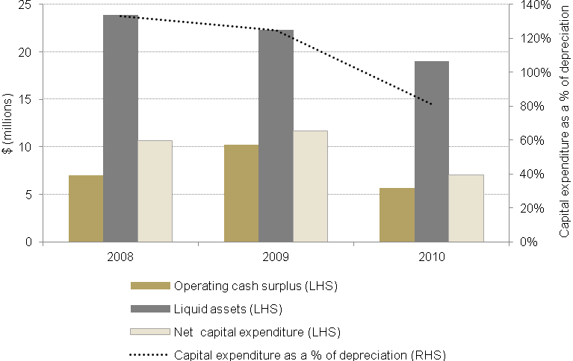
(b) University of Canterbury
(c) Christchurch Polytechnic Institute of Technology
Source: Tertiary Education Commission.
The large increase in liquid assests at the University of Canterbury in 2009 relates to the university having issued bonds which raised $50 million.
As noted above, Lincoln has run an operating deficit for much of the last 15 years. Yet, it has managed an operating cash surplus in most years and has reasonable levels of liquid assets, indicating that it has managed to avoid immediate problems of solvency. However, Lincoln didn’t generate the cashflow necessary to finance its level of capital expenditure and so had to reduce its level of cash reserves to finance its investment in its facilities. Capital expenditure exceeded the provision for the depreciation of assets in two of the three years shown in Figure 6.18.
Christchurch Polytechnic Institute of Technology (CPIT) had healthy cash surpluses in 2009 and 2010 and relatively low capital expenditure, meaning it was accumulating cash reserves when the earthquakes struck.

The institutions’ financial situation in 2011…
If we focus on the core teaching and research activities of the three institutions in 2011, we see that their performance in 2011 was not dissimilar to their performance in 2010.
While Lincoln continued to operate at a deficit, the extent of the deficit was less in 2011.
Performance at the other two institutions deteriorated but remained positive. At the University of Canterbury, while revenue fell, so did costs, and this meant the university maintained an operating surplus. CPIT faced the earthquakes from a strong financial position and returned a good surplus, well above the level for prudent operation. The three institutions managed to maintain reasonable cash flows from operations.
Figure 6.19 reproduces some of the data from Figure 6.17 and Figure 6.18 and extends it to 2011.
Figure 6.19
Financial performance of greater Christchurch tertiary education institutions
- Operating surplus or deficit as a percentage of total revenue
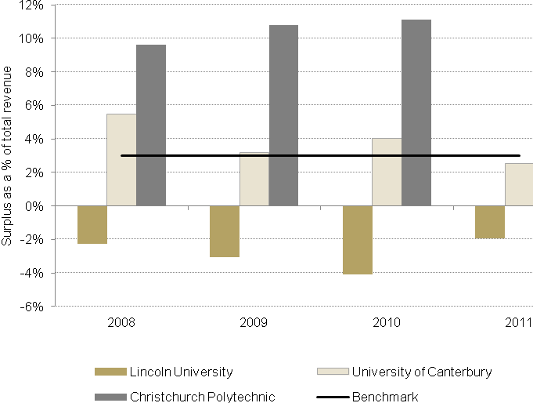
Note, the University of Canterbury’s surplus figure for 2011 was restated to accommodate a prior period accounting error following the publication of the annual repiort for 2011. The figure used in the 2011 annual report saw a surplus of 3.3%, whereas the 2012 annual report dat states the 2011 figure was 2.5% of operating revenue. This graph uses the corrected figure of 2.5%.
- Earnings before depreciation and unusual items
Source: Tertiary Education Commission and the annual reports of the three tertiary education institutions.
Note: The data excludes revenue from insurance payouts, costs of earthquake repairs and the effects of impairments of the value of buildings on the statement of financial performance.

Looking at the normal operations of the institutions – their teaching and research – does not tell the whole story. On top of the operating performance shown above, the institutions received revenue from insurance payouts but then wrote down the value of their capital assets to reflect the damage they had experienced.
Insurance payouts received in 2011 were just initial payouts, from business continuity insurance and for immediate recovery work and temporary repairs. The full revenue from insurance payouts will take several years to flow through. Revaluations of assets during 2011 were done differently in each of the institutions, so the final effects of revaluation are not recorded in the latest accounts.
The table below sets out the insurance payouts from the 2010 and 2011 earthquakes, the direct costs of repairs paid out in 2010 and 2011 and the write-down of building values, as shown in the annual accounts for the 2010 and 2011 years.
Table 6.5
Earthquake-related receipts and expenses recorded in the 2010 and 2011 annual reports of Lincoln University, the University of Canterbury and Christchurch Polytechnic Institute of Technology.
 | Insurance receipts  $(000) |  | Extra costs incurred  $(000) |  | Impairment of buildings due to earthquakes, recognised in  the 2011 accounts $(000)
 | 2011 | 2010 | 2011 | 2010 | 2011 | 2010
Lincoln University | 3,204 | 1,067 | 1,727 | 807 | 6,855 | 9,491
University of Canterbury | 56,646 | 2,917 | 22,453 | 2,033 | 83,402 | 26,465
Christchurch Polytechnic Institute of Technology | 2,623 | - | 3,125 | - | 2,588 | -
Source: Tertiary Education Commission and annual reports of Lincoln University, CPIT and University of Canterbury.
Note: The figures in this table are those reported in the institutions’ annual reports for 2010 and 2011. The revaluation of buildings, leading to the impairment of buildings was not done on the same basis over the three institutions. Insurance receipts and earthquake-related expenses do not represent the final value.
The differences between tertiary education institutions shown in Table 6.5 reflect a number of decisions relating to the timing of the assessments made of the condition of the buildings, insurance payouts, and so on. Also, the figures in Table 6.5 should not be seen as representing the ‘final’ position of the institutions.
Each institution faces very high costs of building and facility works required – most of which could not be started in 2011 or 2012. As the major repairs, rebuilding and renewal work is only now starting, the earthquakes had a relatively low impact on the institutions’ cash flow in 2011 and 2012. However, the insurance payout is not expected to cover the costs of the renewal and repair work.
The effect is that there will be very heavy demands on each institution’s cash flow in the next few years as they seek to renew their facilities and adapt to meet changed conditions. The government agreed in late 2012 to invite the institutions to submit business cases that may lead to capital injections to help them meet the costs of renewal and take the opportunity to reposition themselves to meet new challenges.

Non-financial performance…
Table 6.6 shows the performance of the three institutions on two measures:
- The ratio of domestic enrolments in line to the investment plan targets agreed with the Tertiary Education Commission – a measure of the extent to which the institution has managed its enrolments.
- The proportion of international students in their enrolments – a measure of the extent of internationalisation of the institution.
For the two universities we also show two research measures:
- External research revenue per full-time equivalent staff member – a measure of the value placed on the institution’s research by businesses and research funders.
- The ratio of research revenue to teaching revenue – a measure of ‘research intensity’, the extent to which the institution devotes its resources to research.
Table 6.6
Non-financial performance of tertiary education institutions in greater Christchurch
 | Measure | 2009 | 2010 | 2011
Lincoln University | Percentage of plan funding achieved | 101% | 100% | 98%
Lincoln University | Percentage of international students | 26% | 25% | 19%
Lincoln University | External research income/FTE | $97,550 | $106,160 | $118,537
Lincoln University | Research revenue to teaching revenue | 84% | 84% | 73%
University of Canterbury | Percentage of plan funding achieved | 104% | 105% | 94%
University of Canterbury | Percentage of international students | 11% | 9.3% | 7.0%
University of Canterbury | External research income/FTE | $49,808 | $34,676 | $37,346
University of Canterbury | Research revenue to teaching revenue | 26% | 24% | 27%
Christchurch Polytechnic Institute of Technology | Percentage of plan funding achieved | 100% | 96% | 87%
Christchurch Polytechnic Institute of Technology | Percentage of international students | 10% | 12% | 10%
All tertiary education institutions | Percentage of plan funding achieved | 102% | 102% | 98%
All tertiary education institutions | Percentage of international students | 11% | 11% | 12%
All universities | Percentage of plan funding achieved | 103% | 103% | 99%
All universities | External research income/FTE | $61,918 | $60,675 | $61,712
All universities | Research revenue to teaching revenue | 39% | 38% | 38%
Source: Tertiary Education Commission.
Notes: (a) Lincoln data for 2011 incorporates Telford data, following the Telford/Lincoln merger on 1 January 2011. This affects the Lincoln measures in all but the external research income per full-time equivalent staff indicator. The staffing data used in the denominator of that measure excludes Telford staff. (b) The percentage of international students has been calculated using equivalent full-time student units.
Over 2009 to 2013, institutions have had to achieve at least 97 percent of their agreed investment plan funding target to avoid a recovery of over-funding and they are expected to keep their funded enrolments below 103 percent of the target. Over the whole system, institutions achieved fewer places than expected in their investment plans in 2011, following two years with small average over-enrolments. The falls in 2011 at the University of Canterbury and CPIT were very significant. Lincoln University would also have fallen under the 97 percent threshold were it not for the incorporation of enrolments from Telford Rural Polytechnic, following the merger in 2011.
Recognising the difficulties faced by the Christchurch institutions, the government agreed not to apply funding recoveries to these institutions for their 2011 and 2012 enrolments.
While international students contribute valuable revenue, international enrolments can be volatile and expose the institution to risks. Lincoln University has a very high proportion of international students. This has helped support Lincoln over a 15-year period that has been difficult financially, but the continuing fall in international student numbers in 2011 and 2012 following the earthquakes has been damaging for Lincoln. The proportion of international students at the University of Canterbury was lower than the university average in 2011.
All three institutions saw international students fall as a proportion of the total following the 2011 earthquakes, as enrolments by international students dropped faster than domestic enrolments. However, in Lincoln’s case, the incorporation of the Telford Rural Polytechnic led to an influx of domestic students which reduced the percentage of international students on Lincoln’s roll.
Lincoln had the highest focus of all universities on research and the highest research earnings per full-time equivalent staff member. However, with the absorption by Lincoln of Telford in 2011, the ratio of research revenue to teaching revenue fell. In Canterbury’s case, the ratio of research revenue to teaching revenue rose in 2011 for two reasons: research revenue went up 11 percent between 2010 and 2011 and, at the same time, teaching revenue fell because the number of students dropped.

- Data sources
The data used in this report came from:

Christchurch Polytechnic Institute of Technology
- Annual reports
- CTC achievement report

Lincoln University
- Annual reports

Ministry of Education
- Transitions data
- School leaver statistics
- Tertiary education enrolment and completion statistics

Ministry of Social Development
- Regional labour market updates

Statistics New Zealand
- Household Labour Force Survey
- Permanent and long-term migration statistics

Tertiary Education Commission
- Industry training statistics
- Targeted training statistics
- Youth Guarantee statistics
- Tertiary education institution financial monitoring statistics

University of Canterbury
- Annual reports

This was down from 41%-42% in the previous three years.
Note that this target is not solely focused on school leaver achievement. It is expected that some people will gain a level 2 qualification by accumulating credits gained in school and in tertiary education.
The birth bubble refers to the population bulge of New Zealanders, those born in 1989 through to 1991, which largely completed its move from school to tertiary education in 2011.
Lincoln was excluded from this analysis because of the Lincoln University/Telford Rural Polytechnic merger on 1 January 2012. It was not possible to readily separate the Telford campus students from the Lincoln campus students and it was not meaningful to construct this measure for enrolments in Balclutha.
This analysis looks only at the University of Canterbury, Christchurch Polytechnic Institute of technology and Lincoln University.
The University of Canterbury, however, has changed some accounting policies. If we were to apply those standards to the accounts for 2009 and 2010, the surpluses in each of those years would have been small and well under the 3 percent benchmark.
Government funding for domestic enrolments was maintained at levels agreed in the institutions’ investment plans, despite the fall in enrolments following the 2011 earthquake. This is despite normal practice being to recover funding when enrolments do not meet targets. However, the tuition fee income fell. In Canterbury’s case, government funding for tuition went up by 7 percent. This was offset by a drop in fee income of 12 percent. Overall, tuition revenue was down 2 percent.

