CoREs and effect

This report forms part of a series called Research and knowledge creation.
Authors
Warren Smart, Principal Research Analyst

Roger Smyth, Manager
Tertiary Sector Performance Analysis, Ministry of Education

Shaun Hendy, Professor of Computational Physics, Victoria University of Wellington, Deputy Director, MacDiarmid Institute for Advanced Materials and Nanotechnology and Industry, and Outreach Fellow, Industrial Research Ltd

Catriona Sissons, Victoria University of Wellington and MacDiarmid Institute for Advanced Materials and Nanotechnology

Corresponding author
Warren Smart
Email: warren.smart@minedu.govt.nz
Telephone: 04-463-8035
Fax: 04-463-8713
Acknowledgements
The authors gratefully acknowledge the assistance of the directors and managers of the seven CoREs reported on in this paper, who supplied data and who commented on drafts. The authors also acknowledge the work of Virginia Nicholson and Carl Neumayr of the MacDiarmid Institute for Advanced Materials and Nanotechnology for assistance in the bibliometric analysis in the report.

The authors also gratefully acknowledge comments provided by reviewers at the Ministry of Business, Innovation and Employment, the Tertiary Education Commission and Universities New Zealand. The authors also gratefully acknowledge Alison Lipski, who proof-read this report.
All views expressed in this report, and any remaining errors or omissions, remain the responsibility of the authors.
Published by
Tertiary Sector Performance Analysis
Tertiary, International and System Performance
MINISTRY OF EDUCATION
© Crown Copyright
This work is licensed under the Creative Commons Attribution 3.0 New Zealand licence.
You are free to copy, distribute and adapt the work, as long as you attribute the work to the copyright holder and abide by the other licence terms. To view a copy of this licence, visit www.creativecommons.org/licenses/
by/3.0/nz/.
This report is available from the Ministry of Education’s Education Counts website: www.educationcounts.govt.nz.
February 2013
ISBN (web) 978-0-478-38650-9
CoREs and effect
Summary 1
1 Introduction 2
1.1 Background 2
1.2 Measuring the effects of the research funding changes 3
2 Background 4
2.1 What are Centres of Research Excellence? 4
2.2 Why were the Centres of Research Excellence established? 4
2.3 What are the objectives of the Centres of Research Excellence fund? 5
2.4 How were the Centres of Research Excellence selected? 5
2.5 The Centres of Research Excellence 6
2.6 Government funding of Centres of Research Excellence 6
3 Data and method 9
3.1 Scope of analysis 9
3.2 Strategic impact 9
3.3 Research networks and collaboration 9
3.4 Research quality 10
3.5 Academic impact of research 11
3.6 Knowledge transfer 12
4 The Allan Wilson Centre 13
4.1 Introduction 13
4.2 Strategic impacts 14
4.3 Research networks and collaboration 14
4.4 Research quality and impact 15
4.5 Knowledge transfer 17
5 The Bio-Protection Research Centre 19
5.1 Introduction 19
5.2 Strategic impacts 20
5.3 Research networks and collaboration 20
5.4 Research quality and academic impact 21
5.5 Knowledge transfer 23
6 The MacDiarmid Institute 26
6.1 Introduction 26
6.2 Strategic impacts 27
6.3 Research networks and collaboration 27
6.4 Research quality and academic impact 28
6.5 Knowledge transfer 30
7 The Maurice Wilkins Centre 32
7.1 Introduction 32
7.2 Strategic impacts 33
7.3 Research networks and collaboration 33
7.4 Research quality 34
7.5 Knowledge transfer 36
8 Gravida: National Centre for Growth and Development 38
8.1 Introduction 38
8.2 Strategic impacts 39
8.3 Research networks and collaboration 39
8.4 Research quality and academic impact 40
8.5 Knowledge transfer 42
9 Ngā Pae o te Māramatanga 44
9.1 Introduction 44
9.2 Strategic impacts 45
9.3 Research networks and collaboration 46
9.4 Research quality 46
9.5 Knowledge transfer 48
10 The Riddet Institute 52
10.1 Introduction 52
10.2 Strategic impacts 53
10.3 Research networks and collaboration 53
10.4 Research quality and impact 54
10.5 Knowledge transfer 56
11 Conclusion 59
References 61

Figures
1  2  3  4  5  6  7  8  9  10  11  12  13  14  15  16  17  18  19  20  21  22  23  24 | Research networks and collaboration at the Allan Wilson Centre 15  Allan Wilson Centre journal publications 16  Research training at the Allan Wilson Centre 17  Research networks and collaboration at the Bio-Protection Research Centre 21  The Bio-Protection Research Centre journal publications 22  Sources of external research income for the Bio-Protection Research Centre 23  Research training at the Bio-Protection Research Centre 23  Research networks and collaboration at the MacDiarmid Institute 28  MacDiarmid Institute journal publications 29  Research training at the MacDiarmid Institute 30  Research networking and collaboration at the Maurice Wilkins Centre 34  Maurice Wilkins Centre journal publications 35  Research training at the Maurice Wilkins Centre 37  Research networks and collaboration at Gravida 40  Gravida journal publications 41  Research training at Gravida 43  Research networks and collaboration at Ngā Pae o te Māramatanga 46  Ngā Pae o te Māramatanga research publications 47  Participation and completions of PhDs by Māori 49  Capability-building activities at Ngā Pae o te Māramatanga 50  Research networks and collaboration at the Riddet Institute 54  Riddet Institute journal publications 55  Sources of external research income for the Riddet Institute 56  Enrolments of postgraduate students affiliated with the Riddet Institute by level 57

Tables
1  2  3  4  5  6  7  8  9  10 | Government appropriation for Centres of Research Excellence – $millions 7  Total funding for Centres of Research Excellence 2008-2011 – $millions 8  Australian Research Council journal ranking tiers 2010 11  Allan Wilson Centre journal publications by tier 16  Bio-Protection Research Centre journal publications by tier 22  MacDiarmid Institute journal publications by tier 29  Maurice Wilkins Centre journal publications by tier 35  Gravida journal publications by tier 41  Ngā Pae o te Māramatanga journal publications 47  Riddet Institute journal publications by tier 55

Summary
The government set up Centres of Research Excellence (CoREs) in the New Zealand university system in 2002 and 2003 as one of the mechanisms for lifting the research performance of New Zealand’s universities. The CoREs were designed to reduce the problems of a widely distributed university system in a small country. The CoREs were focused on areas of excellence in research. They were designed to build networks to connect high-performing researchers in the university system – and hence to create critical mass in chosen fields of research, despite the widely scattered capability.
This paper is an evaluative analysis of the performance of seven of the eight CoREs that have received government funding since 2002:
The Maurice Wilkins Centre for Molecular Biodiscovery – based at the University of Auckland
The MacDiarmid Institute for Advanced Materials and Nanotechnology – based at Victoria University of Wellington
Gravida: National Centre for Growth and Development – based at the University of Auckland
The Allan Wilson Centre – based at Massey University
The Riddet Institute – based at Massey University
The Bio-Protection Research Centre – based at Lincoln University
Ngā Pae o te Māramatanga – based at the University of Auckland
Key FINDINGS
Our study finds evidence that:
- the work of the CoREs has had wide-ranging impacts on New Zealand’s society and economy
- the nature of the impact varies between CoREs, and ranges from commercialisation of the results of CoRE research, to public health initiatives, improved biosecurity, better management of New Zealand’s natural environment, and social change
- the quantity and quality of research outputs in each CoRE have increased, evidenced by improvements in bibliometric measures
- collaboration between researchers has increased, as evidenced by growth in co-authorship networks
- public outreach programmes that go beyond those normally undertaken by universities have lifted the profile of and interest in science among young people and have influenced national debates.

.

Introduction

Background
Throughout the developed world, governments have sought to improve their innovation systems as a means of enhancing economic performance. As part of this trend, successive governments in New Zealand have looked for ways to get better value from the work of the country’s research organisations. This has resulted in change in the way research, science and technology funding has been allocated over the last two decades. More recently, the government has introduced structural reform in Crown research institutes and in the government’s research agencies.
The tertiary education system – and the universities in particular – represents a large and critically important part of the innovation system. The universities are responsible for most of New Zealand’s fundamental research, produce the majority of indexed research publications and account for a third of all research expenditure in New Zealand (Statistics New Zealand 2011). University staff comprise a large proportion of New Zealand’s research workforce. Universities are also the organisations responsible for nearly all research training in New Zealand; through their postgraduate qualifications, they train those who are going to enter the research and development workforce, while research training develops valuable skills to those who aim to work in business or government – instilling high-level critical thinking skills and the capacity to absorb innovation.
Over the period 1999 to 2004, the government made a number of structural changes to the funding of research in the tertiary education sector in an effort to lift research performance. These changes culminated in the introduction of two complementary funding streams for research in tertiary education organisations.
The Performance-Based Research Fund (PBRF) allocates funding on the basis of three measures of the excellence of an organisation’s research. Any tertiary education organisation that has degree-awarding status may compete for PBRF funding. The PBRF provides funding in recognition of high-quality research, irrespective of the field of research. The PBRF is complemented by funding for a small number of Centres of Research Excellence (CoREs), selected on the basis of a track record of excellent research in areas of national importance. Each CoRE is hosted by a university but involves a network of research organisations. Each has its own focus and mode of operation. Funding was allocated to CoREs because they were seen as an important means of encouraging collaboration between researchers and of creating critical mass in research in important fields, where there was an expectation that research knowledge could and should be disseminated and used to influence the economy and society.
The goal of the PBRF was to lift the average quality of research in the sector by providing incentives for all tertiary education organisations to encourage staff to improve research performance across all fields. Funding for the CoREs, by contrast, was targeted to a few areas of high performance in a few universities.
The PBRF and CoREs share a focus on rewarding the quality of research in tertiary education organisations. Given the role of the universities in research training and the importance of research in underpinning degree-level teaching, the government sees both these two funding mechanisms as supporting teaching in universities – and especially postgraduate teaching.
The government’s CoREs fund distributed around $260 million in operating funding and $50 million in capital funding between 2001/2 and 2011/12.

Measuring the effects of the research funding changes
University research performance in New Zealand has improved over the last decade. Analyses by Smart and Weusten (2007) and Smart (2009) show that much of this lift is attributable to changes in university research funding. But because the PBRF was agreed on at around the same time as the first CoREs were selected, it is difficult to separate the impact of the CoREs on overall research performance from the impact of the PBRF.
Further, the data and information on the CoREs’ performance have been difficult to access and interpret, because the CoREs were given only broad reporting requirements that gave each CoRE considerable freedom to determine its approach to reporting. As a consequence, the CoREs have each developed different reporting approaches. As a result, there has been no previous published systematic study of data on the CoREs’ performance, despite the level of the government’s investment in them. By contrast, the PBRF is driven by standard and centrally collected performance data. So most analyses of university research performance since 2004 have focused on the PBRF data.
This report is the first published evaluative analysis of the CoREs. It examines their performance on a number of complementary measures of research performance, looking at their key strategic impacts, publication quality, academic impact and trends in collaboration. It compares the performance of the CoREs and the performance of universities in other countries working in similar fields. It also describes some of the knowledge and technology transfer activities of the CoREs. In this way, the analysis in this report addresses each of the government’s goals for the CoREs and asks whether and to what extent those goals have been met.

Background

What are Centres of Research Excellence?
Centres of Research Excellence (CoREs) are defined as:
…inter-institutional research networks, with researchers working together on commonly agreed work programmes. CoREs focus on the development of human capital, so they undertake outreach activities (for example, within the wider education system). CoREs make a contribution to national development and focus on the impact of their research.
Each CoRE is hosted by a university and comprises a number of partner organisations which can include other universities, Crown research institutes and wānanga. Most CoREs have close working connections within their wider community of interest.
www.tec.govt.nz/Funding/Fund-finder/CoREs/

Why were the Centres of Research Excellence established?
The concept of Centres of Research Excellence was developed following a 2001 review of the tertiary education system by the Tertiary Education Advisory Commission (TEAC). The Commission believed that:
…there was a need for greater concentration of research effort, as well as improved linkages between tertiary providers, industry, other research users and the wider community.
(TEAC 2001, p.103)
The TEAC report led the government to identify three main problems with the research funding at that time.
First, the main research funding mechanism in the government’s tertiary education funding at the time (the ‘research top-ups’) allocated funding to institutions based on the number of domestic enrolments at the bachelors level or higher. This had the effect of spreading research funding broadly, and on the basis of an institution’s ability to recruit students, rather than on account of its research activities. In many cases, institutions were attracting research funding on the basis of enrolments in areas where they had high levels of teaching but low research output, while university departments with good research performance but lower enrolments were not generating much research funding.
Second, the top-ups system was seen as not encouraging inter-institutional collaboration. International evidence suggests that research is most likely to be successful if there is a critical mass of researchers who can collaborate on projects, pool their capability and perspectives and share some of the capital resources required for research. New Zealand’s widely dispersed population and small tertiary education system make it hard to create critical mass. While some funds, such as the Marsden Fund, did encourage collaboration between university researchers, the collaboration was for a defined programme of research and for a defined period.
Third, the research top-ups did nothing to target research funding to areas important to New Zealand’s future development.
While the PBRF was designed to address the first of those problems, it didn’t do anything to deal with the second or the third. The CoREs were designed to address all three of those problems and hence to complement the PBRF.

What are the objectives of the Centres of Research Excellence fund?
When it set up funding for the CoREs, the government set out three principal aims. It sought to create clusters or networks of high-performing researchers who would undertake research that would be:
- strategically focused and linked to New Zealand’s future economic and societal needs
- of excellent quality
- transferable.
The government was aware that the Australian government had funded a group of 67 Cooperative Research Centres, and the Canadian government had created Networks of Centres of Excellence. Those two governments had provided extra funding to seed the centres and to get the research collaboration working. Early evaluations suggested that the Australian and Canadian approaches had succeeded in encouraging greater collaboration and in concentrating research expertise and resources. And this had led to a lift in research quality.
The CoREs were seen as creating similar advantages for New Zealand. They were to be focused on areas with a track record of research excellence. They were designed to capitalise on that research excellence by creating incentives for collaboration and networking – thus building greater critical mass. And they were intended to strengthen the transfer of the knowledge created – that is, to get better dissemination of research findings.

How were the Centres of Research Excellence selected?
The CoREs were selected through a competitive bidding process. Tertiary education institutions were invited to submit proposals for the creation of centres. A panel of experts/peer reviewers assessed the proposals against a set of criteria designed to meet the government’s goals for the CoREs’ funding.
The selection criteria were designed to ensure that each CoRE would meet the characteristics agreed by the government and described above. But each proposal had elements that were specific to the focus of the CoRE – that reflected the fields of research and the institutions concerned. Some aspects of the proposals – for instance, their plans for knowledge transfer – differed substantially.
There have been three selection rounds for the CoREs. Five CoREs were selected in 2002, with another two chosen in a second round in 2003. These seven CoREs were allocated funding for six years. There was a mid-term review after three years, with funding for the remaining three years to be confirmed on the basis of an assessment of performance to date.
Towards the end of the six-year period, a new expert panel was convened to assess new CoRE proposals and to determine if the seven existing CoREs would have their funding renewed for a second six-year period. As a result of that assessment, six of the seven CoREs were given an extra six years’ funding and the Riddet Institute became the eighth CoRE, while the New Zealand Institute of Mathematics and its Applications did not have its funding renewed.
At the mid-point of each of the six-year funding cycles, the CoREs have been required to undertake a self-assessment to inform a mid-term review. These reviews have had the potential to influence the funding allocated during the last three years of the cycle, although neither mid-term review led to any change in funding of any of the CoREs.

The Centres of Research Excellence
The eight CoREs that received government funding between 2002 and 2012 cover research in areas such as public health, biosecurity, food science, ecology, and researcher capability development, as well as biomedical science and nanotechnology. The eight CoREs are:
The Maurice Wilkins Centre for Molecular Biodiscovery
The MacDiarmid Institute for Advanced Materials and Nanotechnology
Gravida: National Centre for Growth and Development
The Allan Wilson Centre
The Riddet Institute
The Bio-Protection Research Centre
Ngā Pae o te Māramatanga
The New Zealand Institute of Mathematics and its Applications (NZIMA)
Because NZIMA didn’t have its funding extended following the review at the end of the first funding cycle, we have excluded it from the analysis in this paper. A more detailed description of the activities and focus of each of the seven CoREs we analyse in this study is provided later in this report.

Government funding of Centres of Research Excellence
Government funding of the CoREs comprises a mix of operating and capital contributions. Between 2001/02 and 2011/12, around $257 million was allocated to the CoREs in operating funding and around $51 million in capital funding (see Table 1). The operating funding is ongoing in each year, while the capital funding is discretionary.
Each CoRE is funded for a period of six years. The government allocated extra funding for the second round of funding in 2008/09. The withdrawal of funding for the New Zealand Institute of Mathematics and its Applications reflects the gradual reduction in their funding following their non-selection in the second round.

Table 1
Government appropriation for Centres of Research Excellence – $millions
Year | Type of funding
 | Operating | Capital | Total
2001/02 | $1.2 | $5.0 | $6.2
2002/03 | $14.4 | $25.9 | $40.4
2003/04 | $19.7 |  | $19.7
2004/05 | $21.1 |  | $21.1
2005/06 | $21.3 |  | $21.3
2006/07 | $21.4 |  | $21.4
2007/08 | $23.2 | $20.0 | $43.2
2008/09 | $34.0 |  | $34.0
2009/10 | $33.9 |  | $33.9
2010/11 | $33.3 |  | $33.3
2011/12 | $33.7 |  | $33.7
Total | $257.2 | $50.9 | $308.1
Note: The funding is exclusive of GST.

The government allocated around $250 million in 2011/12 through the PBRF, compared with around $34 million to the CoREs. Between 2001/02 and 2011/12, around $2 billion was allocated to tertiary institutions through the research top-ups and the PBRF. So in 2011/12 the CoREs represented about 12 percent of the government’s tertiary education research funding allocation, while they were about 13 percent of all Vote Tertiary Education research funding between 2001/2 and 2011/12. This gives a sense of the scale of government funding allocated via the CoREs.
There is an expectation by the government that the CoREs would use their government funding as a base and then generate additional funding – through industry-funded research contracts and through the government’s contestable science and innovation funds (such as funding allocated by the Health Research Council and the former Foundation for Research, Science and Technology).

A number of different operating models are used within the CoREs; some CoREs compete directly for additional research monies – from government science funds and industry – whereas others provide funding and support to their membership to align with funding won in the name of their home institution. Funding raised in these ways represents the majority of the revenue of the CoREs. However, differences in operating models and in attribution and accounting practices mean that it is difficult to get an entirely consistent view of the extent of this funding.

Table 2 sets out an indicative estimate made by the Association of CoREs (aCoRE) of the range of research contract funding won by the CoREs in total over the period 2008 to 2011.

Table 2
Total funding for Centres of Research Excellence 2008-2011 – $millions
CoRE funding (TEC)
- CoRE operational funding¹ | 126
- CoRE capital funding | 20
Total | 146
Other funding
- Other NZ government funding direct to CoREs | 8
- NZ non-government funding direct to CoREs | 7
- Overseas funding direct to CoREs | 1
- NZ government funding indirectly attracted by CoREs² | 223
- NZ non-government funding indirectly attracted by CoREs² | 15
- Overseas funding indirectly attracted by CoREs² | 54
Total Other funding | 308
Source: Association of CoREs
Notes:
1 This excludes the New Zealand Institute of Mathematics and its Applications.
2 Approximate funding won by CoRE investigators through their employing organisations.
3 The data in this table was not collected on a consistent basis – it reflects differences in the accounting approaches between the CoREs and of their host universities, plus differences between the CoREs in the treatment of relationships of CoRE investigators to their host university department. As such, the data should be seen as indicative only.

Table 2 suggests that the base CoRE funding is only a small part of the actual revenue generated by the CoREs.
Because the CoREs have different areas of focus, they will have different potential sources of revenue. These differences in focus are visible in the data on two CoREs that disclose their revenue in a disaggregated way – the Bio-Protection Research Centre and the Riddet Institute. Both are successful in raising revenue from industry and from government’s contestable science and innovation funds. But the balance between these sources differs between the two CoREs. The Riddet Institute has a clear focus on the food industry, so most of its funding comes from that source. Biosecurity and pest management, major foci for the Bio-Protection Research Centre, have a significant public good dimension and this is reflected in the high levels of funding to that CoRE from government sources.
Between 2003 and 2010, the Bio-Protection Research Centre raised almost $5 million from business and around $34 million from the Government’s strategic research funds funded via Vote Science and Innovation. In comparison, in 2011 alone, the Riddet Institute raised around $3.4 million from research contracts with industry and $0.9 million from government strategic research funds.
And in 2011, Maurice Wilkins Centre investigators were working on eight multi-year research contracts funded by Vote Science and Innovation, worth a total of around $38 million.

Data and method

Scope of analysis
This report examines the performance of seven of the eight Centres of Research Excellence (CoREs) across five areas: strategic impact, research networks and collaboration, research quality, the academic impact of research, and knowledge transfer (including human capital development). As the reporting of the CoREs evolves, we expect to be able to report performance on a more regular basis.
We focus on the performance of the CoREs between 2002 and 2010.

Strategic impact
This section describes some of the most important impacts of the research of the CoRE. The CoREs were selected because of their research excellence and their strategic importance for New Zealand. So we look at some of the contributions each CoRE has made to the wider New Zealand society and economy, beyond the production of research papers and beyond the education role of the CoREs. The focus of this section is on the ways in which each CoRE’s research has been used in society and in business and how New Zealand’s society and economy have been influenced by that research.

Research networks and collaboration
Using the publication lists compiled for the principal investigators in each CoRE, we constructed co-author network diagrams for each year. Co-author relationships between pairs of authors are revealed by noting instances when the two authors appear in the author list of the same publication in a given year. By representing authors as nodes and connecting co-authors by lines, we can draw co-authorship network diagrams. These diagrams provide an indication of the degree of collaboration occurring in the CoRE between principal investigators and may show changes over time in collaboration as the CoRE develops.
It is to be expected that principal investigators will co-author articles with people who are not principal investigators: in some instances these co-authors will not be associated with the CoRE, while in other cases they may be affiliated with the CoRE in other ways. We have retained all co-authors in the network diagram, whether principal investigators or not, as we recognise that collaboration can be mediated by individuals who are not principal investigators (eg co-supervised research students or postdoctoral fellows, or associate investigators of the CoRE).
For each CoRE, we have constructed co-authorship diagrams to illustrate trends in collaboration between researchers. In this report, we have reproduced the co-authorship diagrams covering joint publications for a period of two years at the start of their funding (2003/04 for most CoREs) and a second for the period 2009/10. This allows us to depict the early- and late-stage collaboration networks that have arisen within each CoRE.
Examples of these network diagrams and how to interpret them are presented below.

Year a Year b

In year a, the principal investigators (represented by blue dots) are not collaborating with each other. However, in year b, two of the principal investigators are directly linked to each other through a co-authored paper, while two others are indirectly linked through co-authorship.

Research quality
To rate the quality of the peer-reviewed journal publications from the CoREs, we have assigned each publication a rating reflecting the quality of the journal in which it was published. We used the journal quality ranking list produced by the Australian Research Council (ARC) as part of the Australian university research quality assessment system – Excellence in Research for Australia (ERA).
The ARC used a comprehensive consultation process to determine the journal rankings, with several discipline representative bodies helping in their compilation. Therefore, these rankings reflect a consensus among Australian experts/researchers. But, by their nature, they have an element of subjectivity and they were determined with publication by Australian authors in mind. Therefore, publications in New Zealand-based journals may receive a lower ranking than if a similar exercise were to be carried out in New Zealand.
Over 20,000 journals were ranked by the ARC into four tiers. The definitions of each of the four tiers are presented in Table 3. The ARC applied a ‘not ranked’ category to new journals. Also, a number of journals that published articles by CoRE researchers did not appear on the list. This may be because Australian authors did not publish in these journals and so they were not ranked by the ARC, or because the journals had only recently been created. We have allocated these journals to the not ranked category.
Table 3
Australian Research Council journal ranking tiers 2010
Tier | Definition
A* | Typically an A* journal would be one of the best in its field or subfield in which to publish and would typically cover the entire field/subfield. Virtually all papers these journals publish will be of a very high quality. These are journals where most of the work is important (it will really shape the field) and where researchers boast about getting accepted. Acceptance rates would typically be low and the editorial board would be dominated by field leaders, including many from top institutions.
A | The majority of papers in a tier A journal will be of very high quality. Publishing in an A journal would enhance the author’s standing, showing they have real engagement with the global research community and that they have something to say about problems of some significance. Typical signs of an A journal are fairly low acceptance rates and an editorial board that includes a reasonable fraction of well-known researchers from top institutions.
B | Tier B includes journals with a solid, though not outstanding, reputation. Generally, in a tier B journal one would expect only a few papers of very high quality. They are often important outlets for the work of PhD students and early-career researchers. Typical examples would be regional journals with high acceptance rates, and editorial boards that have few leading researchers from top international institutions.
C | Tier C includes quality, peer-reviewed journals that do not meet the criteria of the higher tiers.
Not ranked | The journal was not ranked by the Australian Research Council.
Adapted from www.arc.gov.au/era/tiers_ranking.htm

Academic impact of research
This analysis looked at articles published by researchers designated as principal investigators at each of the CoREs. We used the Thomson Reuters Web of Science to examine the number of citations per publication for each of the CoREs and compared that with the same measure for the publications in a similar field produced by a top-ranked institution in Australia.
For each of the six CoREs with a focus on science, lists of investigators were used to compile lists of publications by each year using author searches of the Science Citation Index Expanded and the Conference Proceedings Citation Index – Science databases in the Thomson Reuters Web of Science. The searches were restricted to articles, proceedings articles, notes and letters. For each CoRE, impact factors (IF) for each year from 2005 to 2011 (since 2006 for Gravida and 2010 for the Riddet Institute) were computed using the citations to publications as recorded in the Web of Science according to the formula:
$\text{IF}(\text{Year})=\frac{C(\text{Year},\left\{P(\text{Year}−1),P(\text{Year}−2)\right\})}{N(\left\{P(\text{Year}−1)\right\})+N(\left\{P(\text{Year}−2)\right\})}$

where P(Year) is the list of publications in a given Year, N({P}) is the number of publications in the set {P} and C(Year,{P}) is the number of citations received by publications in the set {P} in a given Year. This is essentially the same measure of impact as that commonly used by journals (commonly known as journal impact factors or JIFs).
Because there are different rates of citation in different subject disciplines, the multi-disciplinary nature of some of the CoREs in this analysis means that the impact factors need to be treated with an element of caution. In particular, it is not valid to compare the performance of the CoREs against each other. Rather, in this measure, we compare each CoRE against a leading benchmark institution.
As it proved difficult to locate an institution that had an inter-disciplinary mix that was comparable with that of the Maurice Wilkins Centre, that CoRE was excluded from this part of the analysis.
Nga Pāe o te Māramatanga (NPM) operates across a range of disciplines, with a particular focus on the emerging field of indigenous studies. The impact factor analysis described above is not applicable to the social sciences (as opposed to health or natural sciences) because of differences in publication conventions between the natural sciences and the social sciences. So we have not used this approach for NPM.
To select benchmark institutions, we chose to use the results of the recent Excellence in Research for Australia (ERA) initiative. Each CoRE in the study was asked to nominate the fields of research most relevant to their research from the Australian and New Zealand Standard Research Classifications. The top-ranked Australian university based on the aggregate ERA scores in each CoRE’s nominated fields of research was then chosen as the corresponding benchmark institution. In some cases where the subject coverage of the CoRE journal publications was not covered adequately by the benchmark institution, another benchmark was added to cover those areas. This procedure led to the following choices of benchmark institutions:
- The Allan Wilson Centre: University of Queensland and Stony Brook University (an American university)
- The Bio-Protection Research Centre: University of Adelaide
- The MacDiarmid Institute: University of Queensland
- Gravida: University of Queensland and University of Adelaide
- The Riddet Institute: University of Queensland, University of Adelaide and University of New South Wales.
Although this means we are comparing a CoRE’s performance with the entire research output in the selected subject areas of an Australian university, the research performance of that university was assessed as being of world class and hence provides a useful benchmark.
A list of publications with authors from each of the benchmark institutions was then compiled by searching for all publications from these institutions that fell in the top eight most frequent Web of Science subject area classifications for the corresponding CoRE publication lists. Where multiple benchmark institutions were used (for Gravida and Riddet), an aggregated impact factor was computed from a weighted sum of impact factors for different subject areas at the different benchmark institutions. The weights in this sum were chosen to match the aggregate distribution of Web of Science subject areas that made up each particular CoRE’s publication list. This procedure produced a representative list of publications from the benchmark institution(s) that overlapped substantially in subject classification with the corresponding list from each CoRE. The impact factor of this representative list was then computed using the formula above.

Knowledge transfer
This analysis describes some of the ways in which the CoREs in this study have gone about their activities. This includes how many postgraduate research students are supported by the CoREs and also their commercialisation and outreach activities.

The Allan Wilson Centre


Introduction
The Allan Wilson Centre creates and uses leading genomic and biomathematical methods to understand evolutionary processes and the history of humans, plants and animals in New Zealand and the Pacific region. The Allan Wilson Centre has six partner institutions, with the host institution being Massey University.
The vision of the Allan Wilson Centre is to improve the health and wellbeing of New Zealand’s peoples and environment by:
- developing the next generation of national and international leaders in evolutionary, biomathematical and genomic sciences
- working to secure the future of New Zealand’s biological heritage through active engagement and partnerships with resource management agencies and research collaborations
- actively engaging with and creating partnerships between the scientific community and Māori communities
- inspiring the public with new knowledge of the history of New Zealand’s peoples, plants and animals
- promoting public interest in the ways in which science improves management of the natural environment.

The strategic goals of the Allan Wilson Centre are to:
- maintain international standards of research excellence in evolutionary biology
- translate research results into practical outcomes for New Zealand and New Zealanders
- contribute to our national identity through the stories we tell about the origins and histories of our people, animals and plants
- grow the people and systems of the Allan Wilson Centre to sustain an efficient, effective and transparent organisation that is greater than the sum of its parts.

Partner institutions
Massey University (host)  University of Canterbury  The University of Auckland |  |  |  |  |  | University of Otago  Victoria University of Wellington  Plant and Food Research
Government funding $millions 2002-2010
 | 2002 | 2003 | 2004 | 2005 | 2006 |  | 2007 | 2008 | 2009 | 2010 | Total
Operating | $1.0 | $2.0 | $2.1 | $2.1 | $2.1 |  | $2.1 | $2.6 | $3.0 | $3.0 | $20.0
Capital | $5.4 |  |  |  |  |  |  | $1.4 |  |  | $6.8
Total | $6.4 | $2.0 | $2.1 | $2.1 | $2.1 |  | $2.1 | $4.0 | $3.0 | $3.0 | $26.8
Note: The funding is exclusive of GST.
Source: Ministry of Education and Tertiary Education Commission

Strategic impacts
The Allan Wilson Centre has implemented nine strategic initiatives. These are aimed at research of the highest quality that has a national profile, can demonstrate wide benefit, and incorporates knowledge transfer activities. The research should also demonstrate practical benefits ranging from the development of new technologies to improved management and conservation status for a range of New Zealand’s endangered biota.
One of those initiatives, Building a shared future: Uawanui sustainability project, works collaboratively with all land-use communities to develop a practical vision to achieve long-term economic, environmental, cultural and social sustainability across the entire Uawa/Tolaga Bay catchment and coast. In addition to the strategic focus, the project also involves identifying and supporting the implementation of early specific work areas ‘on the ground’ that are aligned with supporting a prosperous community in a healthy environment.

Another of the initiatives, Water quality and public health: disease ecology and pathogen evolution, has developed epidemiological models to enable researchers to investigate the evolution and transmission of disease in the New Zealand environment. The theme of this strategic initiative, ‘One Health’, recognises that the health of humans, animals and ecosystems is inextricably linked, and so need to be considered collectively. This programme is creating an evolutionary framework to understand economically important diseases including Campylobacter, Salmonella, Cryptosporidium and Giardia and has already led to improved public health and conservation management in New Zealand.
The other Allan Wilson Centre strategic initiatives include:
- development of new technologies for estimating biodiversity directly from soil samples
- development of new genetically based tools which are of international value in management of New Zealand’s rarest bird species as well as supporting the Department of Conservation’s efforts to maximise genetic diversity in future generations
- sequencing the tuatara genome
- development of new and better software to understand evolutionary relationships among populations.

Research networks and collaboration
The co-author networks for the Allan Wilson Centre’s principal investigators from 2003/04 and 2009/10 are compared in Figure 1. The comparison illustrates a large increase in collaboration between investigators over this period. In 2003/04, five separate groupings are evident but by 2009/10, all but one of the principal investigators can be connected by co-authorship. This is very strong evidence for Centre-wide collaboration among Centre investigators.
Figure 1
Research networks and collaboration at the Allan Wilson Centre
2003/04 | 2009/10
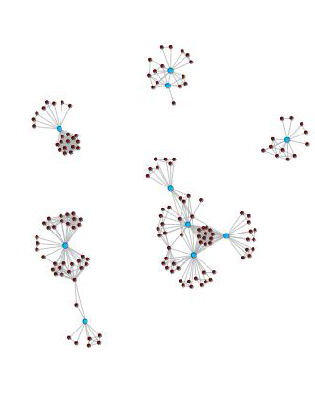 | 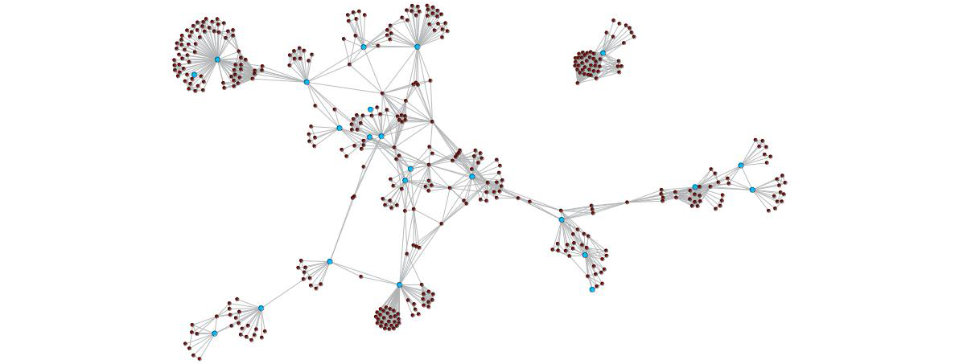
Note: The blue dots (nodes) represent principal investigators at the CoRE. The brown dots represent co-authors of publications that are not principal investigators. The grey lines link each co-author.

Research quality and impact
The number of journal articles produced by researchers from the Allan Wilson Centre increased strongly from 2004 before peaking in 2008 (see Table 4 and Figure 2). The number of publications reduced in 2009, and then increased strongly in 2010. The fluctuation in publication numbers was indicative of a change in Centre leadership and the departure of two experienced investigators. It also occurred at the start of the second round of CoREs funding, which brought a refocused strategic direction for the Centre.
Overall, between 2002 and 2010, 28 percent of ERA-ranked journal publications were in A* journals, 35 percent in A journals, 20 percent in B journals and 17 percent in C journals. The highest proportion of articles published in A*-ranked or A-ranked journals was achieved in 2008 (73 percent).
The Allan Wilson Centre’s impact factor has remained comparable with that of the University of Queensland, the leading institution in the ERA in the Centre’s field of research, and Stony Brook University, a benchmark institution nominated by the Centre (see Figure 2). In 2006, it had the highest impact factor of the three institutions, although from 2008 to 2011 the Centre’s impact factor was less than that of the other two.
Overall, these measures provide evidence of the international competitiveness of the Allan Wilson Centre’s research activities.

Table 4
Allan Wilson Centre journal publications by tier
Year | Number of publications |  |  |  |  |  |  | Distribution of publications  (ERA ranked only)
 | A* | A | B | C | Not ranked | Total |  | A* | A | B | C | Total
2002 | 10 | 10 | 9 | 6 | 0 | 35 |  | 29% | 29% | 26% | 17% | 100%
2003 | 15 | 8 | 8 | 5 | 3 | 39 |  | 42% | 22% | 22% | 14% | 100%
2004 | 11 | 13 | 5 | 10 | 2 | 41 |  | 28% | 33% | 13% | 26% | 100%
2005 | 21 | 17 | 11 | 9 | 5 | 63 |  | 36% | 29% | 19% | 16% | 100%
2006 | 23 | 26 | 18 | 12 | 0 | 79 |  | 29% | 33% | 23% | 15% | 100%
2007 | 30 | 44 | 18 | 20 | 4 | 116 |  | 27% | 39% | 16% | 18% | 100%
2008 | 40 | 54 | 20 | 14 | 3 | 131 |  | 31% | 42% | 16% | 11% | 100%
2009 | 12 | 22 | 17 | 21 | 5 | 77 |  | 17% | 31% | 24% | 29% | 100%
2010 | 20 | 32 | 26 | 14 | 7 | 99 |  | 22% | 35% | 28% | 15% | 100%
Total | 182 | 226 | 132 | 111 | 29 | 680 |  | 28% | 35% | 20% | 17% | 100%
Note: Due to rounding, the percentages may not add to 100%.
Figure 2
Allan Wilson Centre journal publications
Total publications | Publications by tier
Distribution of publications by tier  (ERA ranked only) | Impact factor of the Allan Wilson Centre publications compared with those of the University of Queensland and Stony Brook

Knowledge transfer

Research training
In the area of research training, 136 students started their research qualification between 2002 and 2010 at the Allan Wilson Centre (see Figure 3). In 2010, 14 students started a PhD and nine started study in other research qualifications. During the period 2002 to 2010, 85 students completed their research training at the Allan Wilson Centre. In 2010, 13 students completed their PhDs, while eight completed other types of research degrees.
Figure 3
Research training at the Allan Wilson Centre
Postgraduate research students starting study affiliated with the Allan Wilson Centre by level | Postgraduate research completions through the Allan Wilson Centre by level

Creating critical mass in research in ecology and evolution
The Allan Wilson Centre is a network of over 100 researchers at six institutions studying New Zealand’s biodiversity and researching human and environmental health. Between 2002 and 2011, Allan Wilson researchers were awarded nationally competitive and prestigious research grants, including 22 Marsden grants, four James Cook Fellowships, and two Rutherford Discovery Fellowships, totalling $22 million.

Graduates who have studied for their doctorates through the Allan Wilson Centre have gone on to postdoctoral positions in Copenhagen, Oslo, Brussels, Vienna, Warwick, Stanford and Yale and on to work nationally and internationally in universities, museums, and public and private companies.

The Centre has employed 67 postdoctoral fellows since 2002.

The Allan Wilson Centre Student Internship Programme commenced in 2011, building on the Summer Scholarship programme implemented in 2002. The internship programme provides a contestable fund delivering research training to postgraduate students while contributing to building network-wide expertise and knowledge.

From mathematics to biology: applications important to New Zealand
New genomic technologies are providing enormous quantities of new genetic data, beyond the capacity of traditional analytic methodologies. Bio-mathematicians from the Allan Wilson Centre are working to develop new and better software for the visualisation and analysis of genetic data.

This work underpins knowledge of the genetic architecture of the species involved, from sheep and tuatara to insects and bacteria. One example of the relevance to New Zealand is work on improving the understanding of the genetic structure of economically important fisheries. Another line of research, undertaken in consultation with Ngatiwai and Ngati Manuhiri, uses the latest genomic techniques and novel mathematics to produce software for unearthing previously undetected species present in an ecosystem. That work is of practical concern to both the Department of Conservation and the Auckland City Council.

Understanding New Zealand’s natural history
Allan Wilson Centre scientists work on conservation genetics of New Zealand’s most iconic species. Centre researchers work with the Department of Conservation (DoC) to improve understanding of New Zealand’s unique biodiversity and translate this understanding into improved management decision-making. For example, the Centre develops new tools which are currently informing DoC’s management of New Zealand’s rarest bird species, maximising genetic diversity for future generations and enhancing their long-term survival prospects.
Centre researchers work on several elements of New Zealand’s biota. The work the Allan Wilson Centre does on the tuatara, for example, extends from elucidating its genome to translocation programmes and projecting the long-term effects of climate change on its unusual sex-determination system. The Centre’s work on kiwi has involved understanding the provenance of feathers in Māori cloaks, and researching the genetic consequences of past conservation efforts (which may compromise their ability to resist novel disease).

Focused knowledge transfer to iwi
The Allan Wilson Centre undertakes active engagement with iwi throughout New Zealand over taonga species. An example is the Centre’s work in Uawa/Tolaga Bay, a project that integrates science and the humanities to create a bicultural, intergenerational sustainable project of benefit to all.

Focused knowledge transfer to other stakeholder groups
The Allan Wilson Centre uses a range of mechanisms to bring its work to New Zealanders. Since August 2011, over 4,000 New Zealanders have attended the Centre’s nationwide lecture series. An example is the visit to New Zealand in February 2012 of Professor Chris Stringer, bestselling author and research leader in human origins at the Natural History Museum of London to speak on: ‘Human Evolution: Neanderthals and Ancient Pathways from Africa to Britain’.

The Allan Wilson Centre was a Principal Sponsor of the Transit of Venus Project and Forum The subject of the Forum was ‘Science as the foundation for the future of New Zealand’. The forum was attended by 280 delegates from business, science, education, community, and iwi.
Two projects that grew from the Transit of Venus Project are:
- Pest-free New Zealand
- Te Awaroa – an project to reinvigorate New Zealand’s rivers and waterways by reinstating riparian strips using New Zealand’s indigenous flora.

The Bio-Protection Research Centre


Introduction
The Bio-Protection Research Centre focuses on finding new, sustainable, low or nil pesticide solutions to protect New Zealand’s plant-based, productive ecosystems from plant pests, pathogens and weeds. The research is organised into interlinking themes: biosecurity, sustainable bioprotection, and plant bioprotection systems biology. Each theme incorporates aspects of mātauranga Māori.
The Bio-Protection Research Centre comprises four partner institutes: Lincoln University, Massey University, Plant and Food Research, and AgResearch; and seven collaborating institutions: the University of Auckland, Auckland University of Technology, the University of Canterbury, the University of Otago, Landcare Research, Scion and the Plant Industry division of Australia’s Commonwealth Scientific Industrial Research Organisation (CSIRO). It is hosted by Lincoln University.

The Bio-Protection Research Centre contributes to national bioprotection science outcomes by:

- conducting strategically important plant-based research on pest, disease and weed management systems in productive ecosystems, aligned with the goals and objectives of relevant government and industry science strategies
- using information obtained from research to support bioprotection decision-making and policy development
- supporting the best bioprotection scientists in New Zealand
- producing next-generation scientists in bioprotection and linking bioprotection science with secondary and tertiary education
- contributing to national and international science, enabling skills and knowledge to be sourced and shared
- working with end-users to ensure timely and effective uptake of research findings.

Partner institutions
Lincoln University (host)  Massey University |  |  |  |  | Plant and Food Research  AgResearch Ltd
Government funding $millions 2003-2010
 | 2003 | 2004 | 2005 | 2006 |  | 2007 | 2008 | 2009 | 2010 | Total
Operating | $2.8 | $2.9 | $2.9 | $2.9 |  | $3.0 | $3.0 | $3.4 | $3.7 | $24.7
Capital | $5.7 |  |  |  |  |  | $1.1 |  |  | $6.8
Total | $8.5 | $2.9 | $2.9 | $2.9 |  | $3.0 | $4.1 | $3.4 | $3.7 | $31.5
Note: The funding is exclusive of GST.
Source: Ministry of Education and Tertiary Education Commission

Strategic impacts

New tools for biosecurity
The Bio-Protection Research Centre has developed new tools to assist with the identification of high-risk pests crossing New Zealand’s borders.

Since 2003, researchers from the Centre have been working on DNA barcoding as a technique for distinguishing exotic species from their commonly intercepted egg and larval life stages, leading to the development of a barcoding tool for the identification of two of New Zealand’s highest-risk pest groups, fruit flies and tussock moths. This tool is now routinely used by the Ministry of Primary Industries, allowing them to make more rapid and effective biosecurity decisions. Important spin-offs from this work include the discovery of a new tussock moth forestry pest species and the identification of horticultural pest species.

Bio-Protection Research Centre scientists are now working with a number of international agencies to develop further applications of this technology. The Centre is also using new technologies and capabilities such as bioinformatics. The number of Centre projects over the last two years that have included a component of next generation sequencing has increased markedly.

Commercialisation of research findings
Scientists from the Centre have worked with industry partners to develop and successfully commercialise several products for the control of diseases of economically important crops. These include:

Sentinel® – for use against grey mould in grapes, a disease estimated to cost New Zealand vineyards more than $30 million a year
Tenet® – for control of white rot in onions. Economic and environmental benefits estimated at $15 million a year
Lettucemate™ – provides protection against Sclerotinia disease in lettuce seedlings.
ArborGuard™ – reduces pesticide inputs in pinetree nurseries and increases survival and vigour of seedlings, benefitting plantation owners by an estimated $2 million a year.

Molecular biology of grass endophytes
Basic molecular biology research on fungal endophytes of pasture grasses has continued to unravel the mechanisms of cellular interactions between these mutualistic organisms and their hosts. These fungi are the cause of severe animal disorders, but are also responsible for anti-feedant effects against important pasture insect pests. The research has explained the cellular mechanisms that differentiate between symbiotic and pathogenic relationships in this economically important fungus/plant interaction.

Research networks and collaboration
The co-author networks for the Bio-Protection Research Centre’s principal investigators from 2003/04 and 2009/10 are compared in Figure 4. The comparison suggests increased levels of collaboration between principal investigators over this period. In 2003/04, there was a single cluster of collaboration evident, but by 2009/10 there were several collaborative clusters. This is evidence for ongoing collaboration among Centre principal investigators, although several distinct clusters are evident.
Figure 4
Research networks and collaboration at the Bio-Protection Research Centre
2003/04 | 2009/10
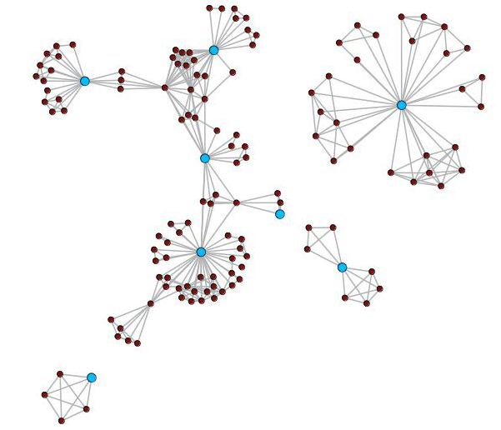 | 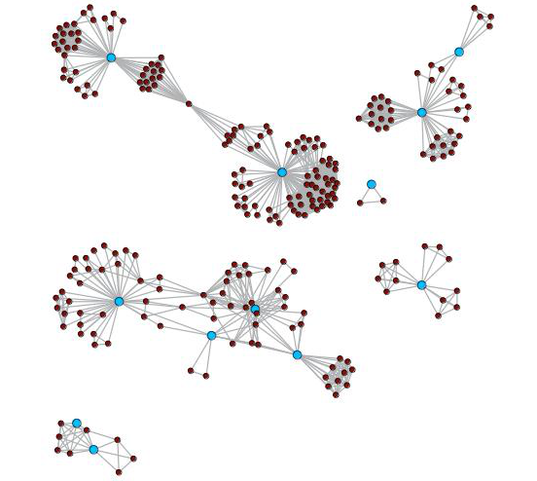
Note: The blue dots (nodes) represent principal investigators at the CoRE. The brown dots represent co-authors of publications that are not principal investigators. The grey lines link each co-author.

Research quality and academic impact
The number of journal articles produced at the Bio-Protection Research Centre increased steadily between 2003 and 2006, before dropping in 2007 (see Table 5 and Figure 5). Since then, the level of output has increased significantly, with the highest level of output reported in the last year of the analysis, 2010.
Overall, between 2003 and 2010, 12 percent of ERA-ranked journal publications were in A* journals, 30 percent in A journals, 41 percent in B journals and 17 percent in C journals. The highest proportion of articles published in A*-ranked or A-ranked journals was achieved in 2009 (52 percent).
The proportion of articles published in A* or A journals is lower than in some of the other CoREs. This reflects the nature of bioprotection science, and the ranking of appropriate journals in this field.
The Centre’s impact factor remained comparable with that of the University of Adelaide over the period of study, and showed strong growth towards the end of the period (see Figure 5). The University of Adelaide was the top ERA-ranked university in the Centre’s field of research. This represents very strong evidence of the international quality of the Centre’s research programme.

Table 5
Bio-Protection Research Centre journal publications by tier
Year | Number of publications |  |  |  |  |  |  | Distribution of publications  (ERA ranked only)
 | A* | A | B | C | Not ranked | Total |  | A* | A | B | C | Total
2003 | 1 | 2 | 7 | 2 | 3 | 15 |  | 8% | 17% | 58% | 17% | 100%
2004 | 3 | 6 | 6 | 3 | 0 | 18 |  | 17% | 33% | 33% | 17% | 100%
2005 | 3 | 3 | 16 | 4 | 3 | 29 |  | 12% | 12% | 62% | 15% | 100%
2006 | 0 | 14 | 22 | 7 | 2 | 45 |  | 0% | 33% | 51% | 16% | 100%
2007 | 1 | 6 | 12 | 7 | 3 | 29 |  | 4% | 23% | 46% | 27% | 100%
2008 | 7 | 26 | 26 | 7 | 12 | 78 |  | 11% | 39% | 39% | 11% | 100%
2009 | 16 | 18 | 20 | 11 | 11 | 76 |  | 25% | 28% | 31% | 17% | 100%
2010 | 7 | 23 | 26 | 15 | 10 | 81 |  | 10% | 32% | 37% | 21% | 100%
Total | 38 | 98 | 135 | 56 | 44 | 371 |  | 12% | 30% | 41% | 17% | 100%
Note: Due to rounding, the percentages may not add to 100%.

Figure 5
The Bio-Protection Research Centre journal publications
Total publications | Publications by tier
Distribution of publications by tier  (ERA ranked only) | Impact factor of Bio-Protection Research Centre publications compared with those of the University of Adelaide

Knowledge transfer

Working with industry and with government
The Bio-Protection Research Centre has attracted considerable research funding from Vote Science and Innovation and also from industry (see Figure 6). In 2003, 64 percent of income for the Bio-Protection Research Centre was from non-Tertiary Education Commission (TEC) sources. In 2010, this was 62 percent. In terms of the sources of non-TEC income, $5.3 million was attracted from non-TEC government sources in 2010 and $0.9 million from industry. This compares with $3.7 million from non-TEC sources and $0.4 million from industry in 2003.
Figure 6
Sources of external research income for the Bio-Protection Research Centre

Research training
The Bio-Protection Research Centre had 54 students studying towards their doctoral degree in 2010 (see Figure 7). This compares with 36 doctoral students in 2003, the Centre’s first year as a CoRE. In 2010, 10 students completed their doctoral degree at the Bio-Protection Research Centre, the greatest number since establishment.
Figure 7
Research training at the Bio-Protection Research Centre
PhD enrolments affiliated with the Bio-Protection Research Centre | PhD completions through the Bio-Protection Research Centre
Of the PhD graduates at the Bio-Protection Research Centre up to and including 2010, 75 percent were employed as researchers in New Zealand, with the remaining 25 percent being employed as researchers overseas.
The number of postdoctoral research fellows at the Centre has increased over time. In 2010, there were 22.3 full-time equivalent postdoctoral fellows, compared with 12.7 in 2003.

Creating a critical mass of researchers in bioprotection
The Bio-Protection Research Centre has created a network of leading researchers in bioprotection across all relevant New Zealand institutions and many international organisations.
In 2009, the Centre hosted a workshop to coincide with the international peer review of the Centre’s research. The review panel included international science leaders in molecular biology, plant pathology, weed science and entomology. The workshop highlighted recent and current research, drawing 120 researchers from all of the Centre’s partner and collaborating institutions, along with representatives from funding agencies, stakeholders, business partners and end-users.
In 2011, the 1st Bio-Protection Symposium (Managing pests: the future of biocontrol) and associated workshop attracted 145 researchers, students, industry representatives and regional council staff. This also generated a high-profile published review, co-authored by world leaders in research on microbes for biocontrol of insect pests, plant diseases and weeds.

Community education through collaborative research projects
Greening Waipara is a Bio-Protection Research Centre project exploring the impact of a shift away from conventional crop production systems towards systems incorporating ecological engineering techniques in vineyards. The project promotes Māori cultural knowledge of the native species planted and encourages the ethic of kaitiakitanga. By the end of 2009, 52 properties had joined the project and seven community sites established. Support for the participating properties is provided by a ‘biodiversity ambassador’, who provides advice and helps coordinate planting days. The project is unique in that native plant and animal restoration is being undertaken in a working agricultural landscape. The concept has generated significant interest from other winegrowing regions within New Zealand and overseas.

Some of the vineyard properties participating in the Greening Waipara project have also created biodiversity trails leading visitors from the winery through areas of native plantings interspersed within the vineyard. Specially made artificial refuges have been placed among the plantings to provide native fauna and other beneficial invertebrates with protective shelter until the plantings are established. As part of these trails, a series of educational quizzes has been developed for children to complete as they walk the trail.

Promotion of bioprotection science to secondary schools
Educating the next generation of young New Zealanders about the value of native biodiversity is important, and doing so in a working agricultural context adds many new dimensions to the learning experience, helping to bridge the chasm between conventional farming systems and conservation.
The Centre participated in the LENScience initiative, providing web/satellite-TV-based learning on topics of agro-ecology and on-farm biodiversity. This information was of particular relevance to senior science/ecology students, and was transmitted to 100 schools and 1,000 students, in each of two years.
Outreach programmes involving the Centre’s Māori Bio-protection Theme have included: a ‘Māori in Science Day’ for high school students, co-sponsoring of ‘Navigate-08’, the South Island’s first Māori-specific careers event, and numerous school visits, which have focused on Māori success in education, tertiary study options, and science as a viable career. Centre staff working in this Theme have also been involved with Te Oranga Pounamu’s career wānanga.

The MacDiarmid Institute


Introduction
The MacDiarmid Institute for Advanced Materials and Nanotechnology was selected for funding in the first CoREs selection round in 2002, and its funding was renewed in the 2008 selection round. The Institute is named after Alan MacDiarmid, the New Zealand-born chemist awarded the Nobel Prize in Chemistry in 2000 for his co-discovery of plastics that can conduct electricity.
The Institute is a national partnership between Victoria University of Wellington (the host), the University of Canterbury, the University of Otago, Massey University, the University of Auckland (from 2012), Industrial Research Ltd and GNS Science. The Institute has principal investigators at all its partner institutions.
The Institute’s multi-disciplinary research programmes focus on developing and applying new techniques in physics, chemistry and engineering to create new technologies and novel materials through the manipulation of atoms and molecules. Its research has found applications in electronics, energy, value-added foods, healthcare and fashion. The MacDiarmid Institute seeks to commercialise its research by collaborating directly with industry and by spinning out companies through its partner organisations. The Institute aims to expose its graduate students to a wide range of scientific techniques and methodologies, as well as developing their business and communication skills.
In our citation impact analysis, we compare the MacDiarmid Institute’s research publications with the University of Queensland, a Group of Eight university that ranks first among Australian universities on aggregate in the MacDiarmid Institute’s field of research classifications in the 2010 ERA assessment.
Partner institutions
Victoria University of Wellington (host)  University of Canterbury  Massey University  The University of Auckland |  |  |  |  |  | University of Otago  Industrial Research Limited  Institute of Geological and Nuclear Sciences
Government funding $millions 2002-2010
 | 2002 | 2003 | 2004 | 2005 | 2006 |  | 2007 | 2008 | 2009 | 2010 | Total
Operating | $1.9 | $3.9 | $4.0 | $4.1 | $4.1 |  | $4.1 | $5.3 | $6.6 | $6.6 | $40.7
Capital | $9.8 |  |  |  |  |  |  | $9.8 |  |  | $19.6
Total | $11.7 | $3.9 | $4.0 | $4.1 | $4.1 |  | $4.1 | $15.1 | $6.6 | $6.6 | $60.3
Note: The funding is exclusive of GST.
Source: Ministry of Education and Tertiary Education Commission

Strategic impacts
The MacDiarmid Institute contributes to New Zealand economically and socially, through its research, the commercialisation of its findings, its outreach activities and the training of entrepreneurial graduate students who have the ability to communicate well.
Examples of the impact of the Institute’s work include:
Creating internationally important science and technology
Gas storage and catalysis are two important components of modern chemical processing. MacDiarmid Institute scientists at Massey University have devised a new method for maintaining the structural integrity of materials – called metal organic frameworks – that has the potential to change the way gas is stored and catalysed.
MacDiarmid scientists working on nuclear magnetic resonance (NMR) at Victoria University of Wellington were responsible for the development of Rheo-NMR and multidimensional diffusion NMR, two techniques now widely used for investigating complex materials – such as cheese, porous oil-laden rocks and polymer systems.
MacDiarmid scientists at the University of Canterbury have developed innovative approaches to surface modification and patterning which have become a standard method for control of nanoscale films of surfaces. These innovative methods are now being applied to new sensor design and in the development of molecular electronics.
Exploration of the behaviour of single molecule magnets by MacDiarmid scientists at the University of Otago has created a base for investigation of how to develop high temperature switching.
Leading high-value manufacturing innovations
Magritek Limited (NMR Instruments), a spin-off company established by MacDiarmid founder Professor Sir Paul Callaghan, makes portable magnetic resonance imaging devices. Magritek won the 2011 New Zealand Innovators Awards in the Health and Sciences category.
Another MacDiarmid spin-out, Anzode Inc, was founded to commercialise Sir Paul’s nickel-zinc battery technology, and won a Bayer Innovators Award in 2010.
MacDiarmid scientists are working on the use of gold and silver nanoparticles as colourants for wool and other fibres, for high-value fashion fabrics, carpet and functional textiles.
MacDiarmid scientists were instrumental in creating HTS-110, a high temperature superconductor company which has been responsible for world-leading approaches to the manufacture of high temperature superconductor wire used in high-quality magnets.

Research networks and collaboration
The co-author networks for the Institute’s principal investigators from 2003/04 and 2009/10 are compared in Figure 8. It is evident that collaboration among Institute investigators has increased considerably. In 2009/10, all but two of the Institute’s 40 principal investigators can be connected by co-authorship, which is a substantial increase from 2003/04. This is strong evidence of Institute-wide collaboration.
Figure 8
Research networks and collaboration at the MacDiarmid Institute
2003/04 | 2009/10
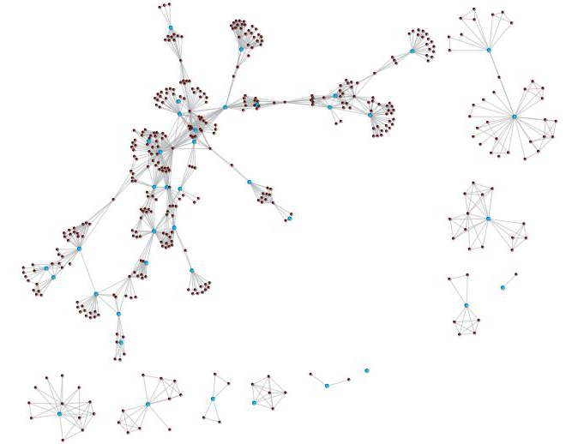 | 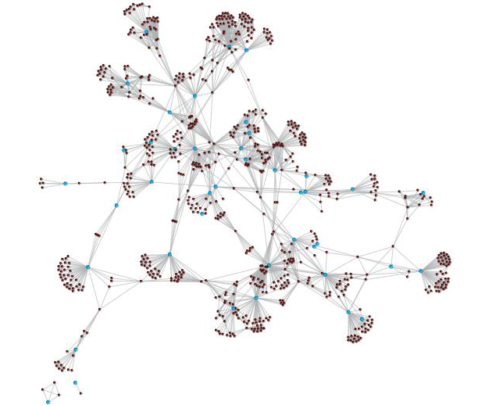
Note: The blue dots (nodes) represent principal investigators at the CoRE. The brown dots represent co-authors of publications that are not principal investigators. The grey lines link each co-author.

Research quality and academic impact
The ranking of the peer-reviewed journal publications of the MacDiarmid Institute is presented in Table 6. More than 1,300 journal articles have been published by researchers from the MacDiarmid Institute since its creation in 2002.
The number of publications increased between 2002 and 2006, reflecting the lag in the time it takes for the research to be published following the creation of the CoRE. The number of journal articles dropped slightly in 2007, before increasing again to reach 196 in 2010 – slightly below the greatest volume of peer-reviewed journal publications for the MacDiarmid Institute in a calendar year (2009).
Overall, of those journal articles that were ERA ranked between 2002 and 2010, 22 percent were in A* journals overall, 38 percent in A journals, 28 percent in B journals and 12 percent in C journals. The highest proportion of articles in A* or A tier journals (71 percent) was achieved in 2010, the last year in this analysis.
The MacDiarmid Institute’s citation impact is comparable with that of the University of Queensland, the top ERA-ranked institution in this field, throughout the period of study (see Figure 9). It is also noteworthy that the Institute’s impact factor has shown a sustained increase over the time period studied, something that is consistent with the increase in proportion of A and A* journals. This growth in citation impact has taken place at the same time as an increase in the volume of publications each year, suggesting that quality has not been sacrificed for quantity.
Overall, these measures provide strong evidence of the international competitiveness of the MacDiarmid Institute’s research programme and indicate a lift in performance since the Institute was founded.
Table 6
MacDiarmid Institute journal publications by tier
Year | Number of publications |  |  |  |  |  |  | Distribution of publications  (ERA ranked only)
 | A* | A | B | C | Not ranked | Total |  | A* | A | B | C | Total
2002 | 5 | 12 | 20 | 15 | 3 | 55 |  | 10% | 23% | 38% | 29% | 100%
2003 | 13 | 41 | 34 | 11 | 5 | 104 |  | 13% | 41% | 34% | 11% | 100%
2004 | 14 | 36 | 47 | 9 | 2 | 108 |  | 13% | 34% | 44% | 8% | 100%
2005 | 36 | 56 | 38 | 20 | 6 | 156 |  | 24% | 37% | 25% | 13% | 100%
2006 | 44 | 64 | 45 | 17 | 3 | 173 |  | 26% | 38% | 26% | 10% | 100%
2007 | 35 | 61 | 36 | 15 | 7 | 154 |  | 24% | 41% | 24% | 10% | 100%
2008 | 32 | 57 | 49 | 22 | 5 | 165 |  | 20% | 36% | 31% | 14% | 100%
2009 | 45 | 70 | 40 | 31 | 12 | 198 |  | 24% | 38% | 22% | 17% | 100%
2010 | 56 | 75 | 45 | 9 | 11 | 196 |  | 30% | 41% | 24% | 5% | 100%
Total | 280 | 472 | 354 | 149 | 54 | 1,309 |  | 22% | 38% | 28% | 12% | 100%
Note: Due to rounding, the percentages may not add to 100%.
Figure 9
MacDiarmid Institute journal publications
Total journal publications | Journal publications by tier
Distribution of journal publications by tier  (ERA ranked only) | Impact factor of the MacDiarmid Institute publications compared with those of the University of Queensland

Knowledge transfer
The knowledge transfer roles of the MacDiarmid Institute can be grouped under:
• Education of physical scientists
• Commercialisation of research findings
• Educating the public about the benefits of science and technology.

Research training – educating the next generation of physical scientists
The MacDiarmid Institute is the only CoRE in the physical sciences in New Zealand and consequently places emphasis on postgraduate and postdoctoral training in this area. Between 2002 and 2010, 222 postgraduate students started a PhD and 52 started a masters degree at the MacDiarmid Institute (see Figure 10). Over that time, 60 of the students starting a PhD and six of the students doing a masters thesis were supported by a MacDiarmid Institute scholarship.
Figure 10
Research training at the MacDiarmid Institute
Postgraduate research students starting with affiliation to the MacDiarmid Institute by level | Postgraduate research students completing degrees through the MacDiarmid Institute by level

In 2009, there were also 45 postdoctoral fellows studying and working in the Institute. Twelve of the postdoctoral fellows were funded by MacDiarmid Institute fellowships.
The MacDiarmid Institute Emerging Scientists Association (MESA) has provided workshops, seminars and practical resources for students and postdoctoral fellows to enhance their skills, knowledge and ideas in areas including entrepreneurship and commercialisation of science, communication, and technical expertise. During 2011/12, MESA ran and organised over 20 workshops and seminars.
Outreach programmes have been successful in encouraging Māori and Pasifika students into science and technology degrees. The Discovery Awards is an annual programme where Māori and Pasifika high school students are embedded in MacDiarmid Institute research groups for two weeks and undertake a short research project. Survey results show that this programme significantly increases the students’ desire to study science or technology at university.

Commercialisation of research findings
The Institute aims to support New Zealand’s productivity and to contribute to economic growth through the commercialisation of its research. Companies formed to commercialise MacDiarmid research findings are Magritek Ltd (founded in 2004), Anzode Inc (founded in 2004), Nano Cluster Devices (2003-2008), Boutiq (founded in 2011) and Synthodics (founded in 2012). Institute researchers also work with a number of New Zealand technology companies, such as Izon, a company which makes portable devices for counting viruses and nanoparticles. Other companies that the Institute works with include Aeroqual, a company that makes gas sensors for air quality monitoring, Fonterra, and Fisher and Paykel Healthcare.
Between 2002 and 2009, researchers at the MacDiarmid Institute filed 92 patents.
New Zealand Trade and Enterprise also use the Institute’s reputation to advertise New Zealand in overseas markets as a leading centre for science and technology.
Educating the public about the benefits of science and technology
The MacDiarmid Institute’s science communication activities have had a significant impact on the national dialogue. New Zealand’s science and economic policy has been influenced by Wool to Weta, the book by the Institute’s founding director, Sir Paul Callaghan, which describes how science and technology can influence the New Zealand economy. The companion television series, Beyond the Farm and Theme Park, was shown on TVNZ7 in 2007.
The Institute has helped make several television documentaries, for example, Super Plastics Man and Venus: A Quest. It sponsored one of its alumni, Dr John Watt, inaugural winner of the Prime Minister’s Emerging Scientist Prize, to present TVNZ7’s science show Ever Wondered?

The Maurice Wilkins Centre


Introduction
The Maurice Wilkins Centre for Molecular Biodiscovery was one of the groups selected for funding in the first CoREs selection round in 2002 and its funding was renewed in the 2008 round. It is named for Maurice Wilkins, the New Zealand-born physicist who won the Nobel Prize in 1962 for his work, with Francis Crick and James Watson, in the discovery of the structure of DNA.
The Maurice Wilkins Centre targets major human diseases, with a focus on cancer, diabetes and infectious disease. The Centre aims to develop drugs and vaccines, tools for early diagnosis and prevention of disease, and new models of disease.
The Centre is a multidisciplinary network that brings together medical doctors, biologists, chemists and computer scientists. It comprises 118 investigators throughout the country, and over 140 early-career affiliated researchers. It links researchers from six universities, three Crown research institutes and two private research institutes.
The Centre’s goals include to deliver health and economic benefits through biomedical research and to train New Zealand’s future leaders in biomedical science. The Centre’s expertise covers a wide range of fundamental sciences including: structural biology, molecular biology, cell biology, immunology, proteomics, organic and medicinal chemistry, bioinformatics, bioengineering and advanced mathematical modelling.

Partner institutions
The University of Auckland (host)  University of Otago  University of Canterbury  University of Waikato  Victoria University of Wellington  Massey University |  |  |  |  |  | Malaghan Institute for Medical Research  Industrial Research Limited  Plant and Food Research Limited  AgResearch Limited
Government funding $millions 2002-2010
 | 2002 | 2003 | 2004 | 2005 | 2006 |  | 2007 | 2008 | 2009 | 2010 | Total
Operating | $1.3 | $2.6 | $2.7 | $2.8 | $2.8 |  | $2.8 | $3.4 | $4.0 | $4.0 | $26.4
Capital | $4.3 |  |  |  |  |  |  | $2.7 |  |  | $7.0
Total | $5.6 | $2.6 | $2.7 | $2.8 | $2.8 |  | $2.8 | $6.1 | $4.0 | $4.0 | $33.4
Note: The funding is exclusive of GST.
Source: Ministry of Education and Tertiary Education Commission

As noted in the previous section, we did not include the Maurice Wilkins Centre in the citations analysis because it proved difficult to allocate a benchmark institution.

Strategic impacts
The Maurice Wilkins Centre contributes to the New Zealand economy and society by improving health outcomes and providing direct economic gains.
Between 2004 and 2011, Maurice Wilkins Centre researchers were listed on more than 55 patents granted, each of which has the potential to result in significant commercial benefit.
In 2011, Maurice Wilkins Centre researchers licensed five new cancer drugs to international pharmaceutical companies to be taken to clinical trials in patients. An example is PR610, an anticancer “stealth” drug. The first clinical trial, a phase I/II study, will be conducted at Auckland City Hospital, Waikato Hospital and sites in the United States. PR610 belongs to a new class of hypoxia-activated pro-drugs for the treatment of cancer.
The Centre’s principal investigators have founded a number of spin-out companies, including ProActa Inc, Pathway Therapeutics Ltd and Symansis Ltd, with the support of New Zealand-based investors as well as international partners.
Centre investigators have established partnerships with international non-profit organisations to increase the uptake of their research and expertise. These organisations include the Global Alliance for TB Drug Development, the TB Structural Genomics Consortium, the Drugs for Neglected Disease Initiative and the Physiome Project. For instance: in 2012, a compound designed by Maurice Wilkins Centre investigators, which shows promise against treatment-resistant tuberculosis, was selected for clinical trial by the Global Alliance for TB, the world’s leading organisation for targeting TB.

Research networks and collaboration
The co-author networks for the Centre’s principal investigators from 2003/04 and 2009/10 are compared in Figure 11. The comparison illustrates the increase in collaboration between principal investigators over this period. In 2003/04, three separate groupings are evident, with evidence of collaboration between only four of the five principal investigators. By 2009/10, all principal investigators can be connected by co-authorship. It is noteworthy that this cohesiveness and high degree of collaboration have occurred despite the multi-disciplinary nature of the Centre.
Figure 11
Research networking and collaboration at the Maurice Wilkins Centre
2003/04 | 2009/10
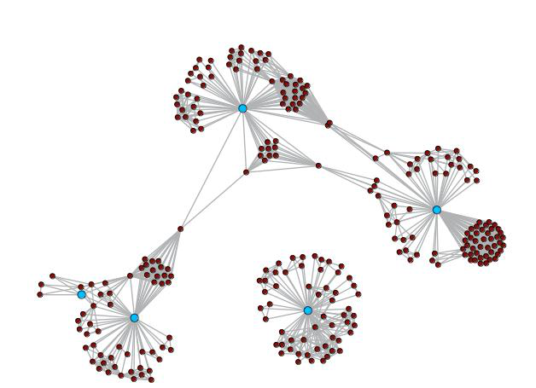 | 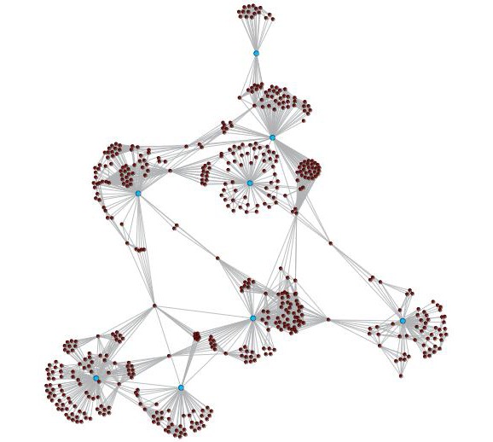
Note: The blue dots (nodes) represent principal investigators at the CoRE. The brown dots represent co-authors of publications that are not principal investigators. The grey lines link each co-author.

Research quality
The rating of peer-reviewed journal publications by researchers at the Maurice Wilkins Centre is presented in Table 7. This shows that the volume of journal publications increased between 2003 and 2008 as the CoRE developed over time. The flattening of growth in the number of journal publications since 2008 suggests that research output at the CoRE has now stabilised.
The majority of journal publications authored by researchers at the Maurice Wilkins Centre were published in journals that were rated as being of very high quality in the Excellence in Research Assessment rankings. Of those journal articles that were ranked, 31 percent of journal publications between 2003 and 2010 were in A* journals, 34 percent in A journals, 20 percent in B journals and 14 percent in C journals.
Discounting the results in 2003, when the level of publication output was low the proportion of articles published in tier A* or A journals exhibited a growing trend over time, with the highest proportion (74 percent) achieved in 2010, the last year in this analysis.
Table 7
Maurice Wilkins Centre journal publications by tier
Year | Number of publications |  |  |  |  |  |  | Distribution of publications  (ERA ranked only)
 | A* | A | B | C | Not ranked | Total |  | A* | A | B | C | Total
2003 | 13 | 11 | 7 | 2 | 1 | 34 |  | 39% | 33% | 21% | 6% | 100%
2004 | 15 | 13 | 13 | 8 | 5 | 54 |  | 31% | 27% | 27% | 16% | 100%
2005 | 14 | 16 | 8 | 11 | 6 | 55 |  | 29% | 33% | 16% | 22% | 100%
2006 | 25 | 15 | 10 | 13 | 6 | 69 |  | 40% | 24% | 16% | 21% | 100%
2007 | 17 | 31 | 21 | 7 | 1 | 77 |  | 22% | 41% | 28% | 9% | 100%
2008 | 18 | 29 | 17 | 18 | 0 | 82 |  | 22% | 35% | 21% | 22% | 100%
2009 | 27 | 31 | 18 | 4 | 1 | 81 |  | 34% | 39% | 23% | 5% | 100%
2010 | 31 | 26 | 10 | 10 | 0 | 77 |  | 40% | 34% | 13% | 13% | 100%
Total | 160 | 172 | 104 | 73 | 20 | 529 |  | 31% | 34% | 20% | 14% | 100%
Note: Due to rounding, the percentages may not add to 100%.

Figure 12
Maurice Wilkins Centre journal publications
Total journal publications | Journal publications by tier
Distribution of journal publications by tier
(ERA ranked only)

Knowledge transfer
The Maurice Wilkins Centre’s knowledge transfer roles can be grouped under:
- Translation of research findings
- Research training
- Public engagement – promotion of science to the public and to young people
- Promotion and dissemination of research in the science community.

Translation of research findings
As noted in the strategic impacts section of this report, Maurice Wilkins Centre scientists were responsible for 55 patents between 2004 and 2011 alone and in 2011 licensed five cancer drugs to pharmaceutical companies.
Spin-out companies founded by Maurice Wilkins Centre researchers and involved in drug development have moved the centre of their operations to the United States to undertake late-stage clinical trials. Despite this shift offshore, financial benefits have flowed back to New Zealand from these companies through contract research and through shareholdings held by the New Zealand founders and investors. For example, Pathway Therapeutics has generated more than $10 million of overseas investment in its research programme in New Zealand.
Centre investigators also support innovation in the wider biotechnology and drug development sectors by providing established companies with expertise and facilities for research. In 2010, these included New Zealand companies and major multinational companies, including Merck & Co Ltd and Novartis International AG.

Research training
Because the CoREs are hosted by universities and funded through the government’s allocation for tertiary education, they all have a focus on postgraduate training. The number of postgraduate research students that have received financial support from the Maurice Wilkins Centre through scholarships, working expenses, travel funds or provision of research equipment has increased significantly over time (see Figure 13). In 2002, six postgraduate research students were supported by the Maurice Wilkins Centre. By 2010, this number had increased to 147, 90 percent being PhD students.
In 2010, a total of 31 students completed their research degrees with support from the Maurice Wilkins Centre. Twenty-five of these completions were at the PhD level. The number of completions has been rising over time, reflecting the increased number of postgraduate students who were doing their research with support from the Centre.

Figure 13
Research training at the Maurice Wilkins Centre
Postgraduate research students supported by the Maurice Wilkins Centre by level | Postgraduate research students completing degrees with support from the Maurice Wilkins Centre by level

In 2011, the Centre paid or contributed to the salaries of 11 postdoctoral research fellows.
The Centre hosts an annual event for early-career scientists to extend their vision beyond their immediate research groups and improve their awareness of scientific and career opportunities. The Centre has also initiated a programme for early-career scientists to acquire new technical skills at international workshops and leading laboratories overseas.

Public engagement – promotion of science to the public and to young people
The Maurice Wilkins Centre actively engages with the public by sharing news of its research and successes and providing commentary on topical scientific issues. It communicates with New Zealanders through the news media, public lectures and presentations, and visits by school students.
Maurice Wilkins Centre investigators support initiatives aimed at promoting science to young people – including the New Zealand Science Hub, the Liggins Education Network for Science, and science open days. The Centre supports secondary school science teachers by providing opportunities for them to attend scientific conferences and supporting teacher research fellowships.

Promotion and dissemination of research in the science community
Maurice Wilkins Centre research is disseminated through publications and presentations to academic and industrial audiences. The Centre also sponsors or hosts workshops, symposia and conferences across a wide range of disciplines related to biomedical science. In its Annual Symposia, the Centre brings together experts to address issues of national importance, such as the threat posed to New Zealand by ‘superbugs’.
Events such as these enable wider dissemination of current research at the Maurice Wilkins Centre as well as promotion of the Centre’s capabilities, but they also serve an important national role in focusing a broad community on issues of major importance to New Zealand.

Gravida: National Centre for Growth and Development

Introduction
Gravida: National Centre for Growth and Development was selected as a CoRE in 2003, during the second selection round, with its funding being renewed in the 2008 round. Gravida is a collaborative network with seven partner institutions, spanning the developmental, biomedical, animal and population sciences. Its research findings are applied in the clinical, agricultural, public policy and education sectors.
Gravida’s scientists seek to address the question: what makes the best start for a healthy life?
Their research into growth and development seeks a better understanding of the biology of the early-life period, and of its impact on life-long human health and livestock performance. Research to date demonstrates that environmental influences before, during and shortly after pregnancy can subtly alter an individual’s development in ways that affect life-long health and potentially the health of the next generation. These changes can appear in humans as increased risk of developing conditions such as obesity, type 2 diabetes, and heart disease later in life – conditions that are of growing concern in New Zealand today. In farm animals, the same changes may have downstream effects on health and production characteristics.
The unifying theme for these investigations is the concept of developmental plasticity – the idea that a developing organism responds to environmental cues by altering its developmental characteristics at the molecular level. In some cases, these responses may lead to poor health outcomes in later life, or to poorer production characteristics in livestock.
In our citation impact analysis, we compare Gravida’s research publications with the University of Queensland and the University of Adelaide, both Group of Eight universities. The University of Queensland was the highest-performing Australian university in the Excellence in Research Australia assessment on average across the subject areas nominated by Gravida. However, because there was a lack of articles from the University of Queensland in the subject areas of agriculture, we selected journal articles from the top-performing Australian university in these areas, the University of Adelaide, to use in a subject-area weighted calculation of the overall benchmark for Gravida.
Partner institutions
The University of Auckland (host)  Massey University  University of Canterbury  University of Otago |  |  |  |  | AgResearch Ltd  Landcorp Farming Ltd  The Liggins Institute
Government funding $millions 2003-2010
 | 2003 | 2004 | 2005 | 2006 |  | 2007 | 2008 | 2009 | 2010 | Total
Operating | $3.6 | $3.9 | $4.2 | $4.2 |  | $4.3 | $5.7 | $7.3 | $7.2 | $40.3
Capital | $5.2 |  |  |  |  |  | $3.3 |  |  | $8.5
Total | $8.8 | $3.9 | $4.2 | $4.2 |  | $4.3 | $9.0 | $7.3 | $7.2 | $48.8
Note: The funding is exclusive of GST.
Source: Ministry of Education and Tertiary Education Commission

Strategic impacts
Gravida has been responsible for significant discoveries that impact on the lives of people in New Zealand and overseas. Important discoveries include:
Women who eat a high-fat diet during pregnancy have children who are fatter before puberty, and who also tend to start puberty at an earlier age. Importantly, this effect is transmitted to subsequent generations.
Moderate exercise during pregnancy may have a positive effect on the babies of overweight mothers. This provides an important intervention for overweight and obese women in New Zealand and overseas, who are more likely to give birth to larger babies, who in turn are more likely to develop obesity and diabetes in later life.
Poor maternal nutrition around the time of conception in sheep leads to preterm birth, findings that now also have been reported in several human populations. The importance of the pre- and peri-conceptional period for a healthy pregnancy outcome has been introduced into the pregnancy guidelines of many developed countries, including New Zealand.
Infants born prematurely or after a prolonged gestation are at greater risk of developing obesity and diabetes later in life. Pre-term and post-term infants make up 7 to 9 percent of all live births in New Zealand.
Twin conception results in a different developmental profile from that in singletons, resulting in altered postnatal phenotype including increased adult adiposity. Together with European collaborators, Gravida scientists have shown that this is regulated by modification of genes.
Children born following in vitro fertilisation (IVF) are different – phenotypically, hormonally and biochemically.
Components of fertility treatment that have long-term effects on the growth and well-being of IVF children. In New Zealand, IVF children make up 2-4 percent of all live births.
Feeding ewes at reduced levels in early pregnancy produces daughters with increased milk production; this is reflected in faster growth rates of the next generation lambs, demonstrating the long-term effects on animal productivity.
Understanding the breeding age and dietary needs of pregnant ewes could help farmers increase ewe productivity, through earlier breeding (at eight months rather than the traditional 18 months) and better targeted feeding regimens to increase lamb numbers and produce healthier, heavier lambs.

Research networks and collaboration
The co-author networks for Gravidas’s principal investigators from 2004/05 and 2009/10 are compared in Figure 14. There is a high degree of collaboration evident right from the start of the Centre, reflecting its origins in the Liggins Institute. Collaboration among the principal investigators has continued to be strong, as demonstrated by the growth of collaboration within Gravida’s core even as the size of the Centre’s investigator cohort has grown. This is strong evidence for Centre-wide collaboration.
Figure 14
Research networks and collaboration at Gravida
2004/05 | 2009/10
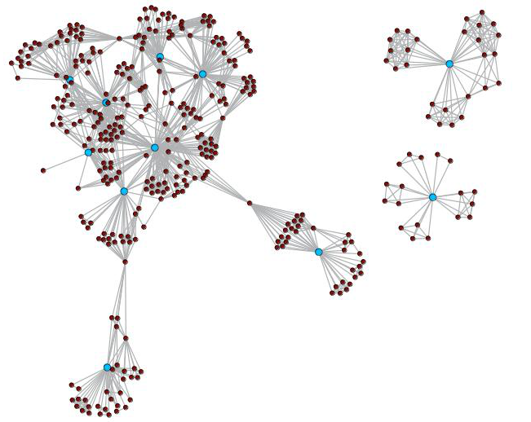 | 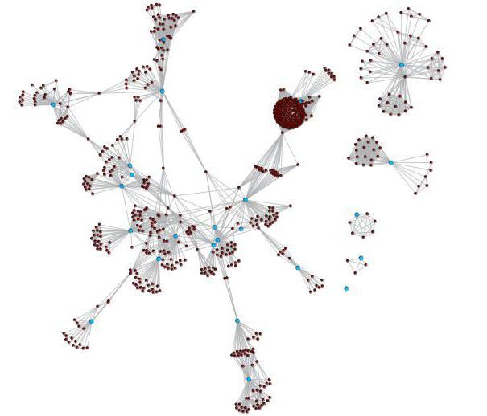
Note: The blue dots (nodes) represent principal investigators at the CoRE. The brown dots represent co-authors of publications that are not principal investigators. The grey lines link each co-author. The large brown dot in the 2009-10 diagram represents a large cluster of authors.

Research quality and academic impact
The ranking of peer-reviewed journal articles published by Gravida investigators is presented in Table 8. The largest number of journal articles (179) was published in the 2009 calendar year. A large proportion of Gravida funding is dedicated to three-year projects. Therefore, publication trends show peaks and troughs that reflect the end of funding periods.There was a noticeable rise in the number of articles published in A-ranked journals from 2008 onwards.
Overall, between 2003 and 2010, 21 percent of ERA-ranked journal publications were in A* journals, 38 percent in A journals, 29 percent in B journals and 12 percent in C journals. The highest proportion of articles published in A*-ranked or A-ranked journals was achieved in 2008 (72 percent).
The impact factor of Gravida researchers exceeds that of the combined Australian benchmark institutions (the University of Queensland and the University of Adelaide) over the time period studied (see Figure 15). We note that the impact factor of the Centre has declined somewhat over time, something that may be related to the increase in the number of publications in A journals relative to A* journals over time. However, the fall in the average impact factor may reflect the growth in Gravida’s agricultural science publications (which have lower rates of citation than other subject areas at Gravida). Nonetheless Gravida researchers have maintained high output of high impact papers despite an increase in the number of Gravida scientific papers indexed by the Web of Science.
Table 8
Gravida journal publications by tier
Year | Number of publications |  |  |  |  |  |  | Distribution of publications  (ERA ranked only)
 | A* | A | B | C | Not ranked | Total |  | A* | A | B | C | Total
2003 | 17 | 37 | 22 | 9 | 0 | 85 |  | 20% | 44% | 26% | 11% | 100%
2004 | 24 | 40 | 34 | 19 | 3 | 120 |  | 21% | 34% | 29% | 16% | 100%
2005 | 32 | 46 | 48 | 15 | 4 | 145 |  | 23% | 33% | 34% | 11% | 100%
2006 | 29 | 44 | 41 | 22 | 7 | 143 |  | 21% | 32% | 30% | 16% | 100%
2007 | 33 | 42 | 59 | 17 | 6 | 157 |  | 22% | 28% | 39% | 11% | 100%
2008 | 35 | 72 | 29 | 13 | 7 | 156 |  | 23% | 48% | 19% | 9% | 100%
2009 | 30 | 64 | 49 | 16 | 20 | 179 |  | 19% | 40% | 31% | 10% | 100%
2010 | 30 | 72 | 37 | 16 | 14 | 169 |  | 19% | 46% | 24% | 10% | 100%
Total | 230 | 417 | 319 | 127 | 61 | 1,093 |  | 21% | 38% | 29% | 12% | 100%
Note: Due to rounding, the percentages may not add to 100%.

Figure 15
Gravida journal publications
Total journal publications | Journal publications by tier
Distribution of journal publications by tier  (ERA ranked only) | Impact factor of Gravida journal publications compared with those of the University of Queensland and University of Adelaide

Knowledge transfer
The knowledge transfer roles of Gravida can be grouped under:
- Promotion of and advocacy for research findings among policy makers and in the relevant professions
- Research training
- Promotion of science to secondary school students.

Promotion of research findings among policy makers and professionals
The Centre focuses on how the early-life environment affects longer-term health – of both people and production animals. The research conducted in the Centre finds that changes in early-life conditions can bring important benefits. The Centre promotes these findings to health professionals and government agencies – such as the Ministry of Health – as a means of informing public health policy and practice. Among the approaches used by the Centre is econometric modelling of the costs of a poor start to life.
Gravida scientists contribute to Ministry of Health working groups, such as the one on National Maternity Standards, national health policy groups such as the NZ Growth Hormone Committee and the Health Research Council of New Zealand Biomedical Science Committee.
The new longitudinal study Growing up in New Zealand, led by Gravida, has the potential to provide insight into the health and wellbeing of New Zealanders over coming decades.
The Centre has begun a new initiative to promote findings with relevance to agricultural productivity to rural professionals through farmlet-based educational programmes.

Research training
The Centre, like all of the CoREs, has a focus on postgraduate training. The number of students enrolled in and completing PhDs that were affiliated with Gravida is presented in Figure 16. In 2010, there were 41 students enrolled in PhDs at Gravida; this compares with seven in 2003, the first year of operation of the Centre. Many of these students receive scholarships from the Centre, which funds between eight and 15 full stipends per year. In 2010, the number of students completing a PhD at Gravida was five, compared with three in 2006. The growing number of completions reflects the growth in enrolments in earlier years.

Figure 16
Research training at Gravida
Total number of PhD students affiliated with Gravida | Completions of PhDs through Gravida

Until recently, postgraduate funding was largely tied to three-year research projects, which has led to the pooling of graduations around the end of the three-year funding cycle.
Other training initiatives include postdoctoral students chairing sessions at the Centre’s annual symposium, or Short Term Funding support.
Early- to mid-career researchers are also provided with opportunities for leadership development to ensure long-term sustainability of the Centre’s Executive team.

Promotion of science to secondary school students
Gravida is a key contributor to the award-winning LENScience school/science-community partnership initiative.
The programme constitutes an important channel through which the Centre aims to build scientific literacy and community-based health awareness. LENScience provides hands-on, interactive web/satellite-TV-based learning experiences and school-based learning modules incorporating current Gravida research such as the effect of diet and lifestyle on life-long health. More than 200 schools across New Zealand have participated in the programmes reaching over 40,000 students. These students have been exposed to active researchers and to the excitement of leading-edge scientific investigation. As well as building scientific literacy, LENScience plays a role in encouraging young people to take up further study in science. Other training opportunities of both younger and older students are currently being explored, as is outreach to the broader community, including ethnic groups.

Ngā Pae o te Māramatanga


Introduction
As New Zealand’s Indigenous Centre of Research Excellence, Ngā Pae o Te Māramatanga’s (NPM’s) vision is to realise the creative potential of Māori peoples to bring about positive change and transformation, contributing to national development and benefit.
The mission of NPM is to conduct excellent research relevant to Māori communities and to commission research focused on three research priorities:
- Optimising Māori economic performance
- Fostering Te Pā Harakeke: healthy and prosperous families of mana
- Enhancing Māori distinctiveness.
In addition to research, NPM:
- contributes significantly to increasing the number of Māori people succeeding in tertiary education and research training
- builds research and scientifically literate cultures within Māori communities through knowledge-sharing activities
- leads developments on indigenous approaches to knowledge creation
- maintains a significant international profile in the field of indigenous development research.
NPM assists the government in meeting Treaty obligations and responds to equity issues.
NPM has 16 partner institutions and is hosted by the University of Auckland.
Partner institutions
The University of Auckland acting through Te Wānanga o Waipapa (host)  The Auckland War Memorial Museum  Lincoln University  Manaaki Whenua Landcare Research  Te Papa Tongarewa  Te Tapuae o Rēhua  Te Tauihu o Ngā Wānanga  Te Whare Wānanga o Awanuiārangi | Te Wānanga o Aotearoa  Auckland University of Technology  University of Otago acting through the Eru Pomare Health Research Centre  University of Canterbury  Victoria University of Wellington  Waikato Raupatu Lands Trust  University of Waikato
Government funding $millions 2002-2010
 | 2002 | 2003 | 2004 | 2005 | 2006 | 2007 | 2008 | 2009 | 2010 | Total
Operating | $1.6 | $3.3 | $3.4 | $3.5 | $3.5 | $3.5 | $4.4 | $5.3 | $5.3 | $34.1
Capital | $0.4
Total | $2.0 | $3.3 | $3.4 | $3.5 | $3.5 | $3.5 | $4.4 | $5.3 | $5.3 | $34.5
Note: The funding is exclusive of GST.
Source: Ministry of Education and Tertiary Education Commission
Analysis of the citations of research papers works best in the natural sciences, medicine and related fields. In other disciplines, where the research publication conventions are different, this sort of analysis is less robust. The wide spread of disciplines covered by NPM and the focus on indigenous studies mean that a citations analysis of NPM’s research work would not be meaningful or appropriate.
In developing its research network, NPM has had to take account of these factors:
- Indigenous Development is multi-disciplinary, so research outputs appear in a diverse range of journals and conferences.
- Indigenous Development is a new discipline and hence mechanisms for measuring academic merit and productivity are still in development. For example, there are few reputable academic journals dedicated to this field.
- When NPM was created, the research resources in New Zealand needed for investigations in indigenous development were spread across many organisations, so the first task of NPM was to marshall and organise resources and to create an environment for Māori-relevant research. Measurement of performance was not as well developed in this field as in other research fields.
- In the period 2002 to 2010, NPM focused on addressing disparities in Māori participation and success in tertiary education and research training. The early target of ‘500 Māori PhDs’ was important for NPM at that stage in its evolution.

Strategic impacts
In the years 2002 to 2010, NPM sought ‘the transformation of New Zealand society such that Māori participate fully in all aspects of society and the economy’. To achieve this, NPM has organised and developed a research network by marshalling the resources of the tertiary education sector, the museum sector and other organisations – including Crown research institutes, iwi organisations/trusts and community and private research agencies – to build an effective research network according to the prescription of a CoRE as ‘an inter-institutional network of collaborating researchers working on an agreed plan’.
During this period, NPM funded a range of research drawn from the experiences, circumstances and priorities facing Māori communities. Examples of NPM research include:
In education, the research project Te Kotahitanga focused on enhancing the relationships between Māori students and their teachers in compulsory education. The resulting increase in the success of Māori students has led to its adoption and implementation by the Ministry of Education.
In health, NPM research has focused on health disparities between Māori and non-Māori. A recent NPM project highlighted inequalities in child health faced by Māori in New Zealand and quantified the cost of the current situation to New Zealand.
In engineering, Māori needs for affordable quality housing led to research that has developed a novel building product with good thermal and earthquake performance.
In the environmental sciences, research on water quality in the Ahuriri estuary, using Māori approaches, led to the recovery of the economic resources of shellfish and flounder. The project also makes the estuary safe for other human activities. This collaborative project involved local authorities and the local Māori community, and involved Māori students from the local secondary school in science that had direct relevance to their own lives.

Research networks and collaboration
NPM has focused on collaboration at the institutional level rather than the researcher level. This reflects the social science base of much of NPM’s work; in social sciences there is generally less emphasis on co-authorship/team approaches to research. Thus the use of article co-authorship as an indicator of the collaboration is not as meaningful an indicator of NPM’s collaboration as it is in the CoREs that focus on natural sciences or health. Nonetheless, it is interesting to note that a co-author analysis of NPM’s publication list shows an increase in collaboration between researchers between 2004 and 2010 (see Figure 17 below). The diagram illustrates the increase in both collaboration and scale of research over the period. While not as significant as that of the other CoREs, this increase in collaboration is evident despite the fact that the number of researchers supported by NPM has also increased.
Figure 17
Research networks and collaboration at Ngā Pae o te Māramatanga
2004 | 2010
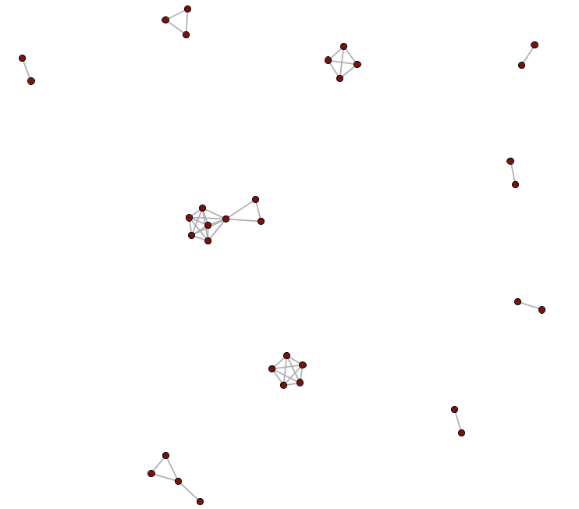 | 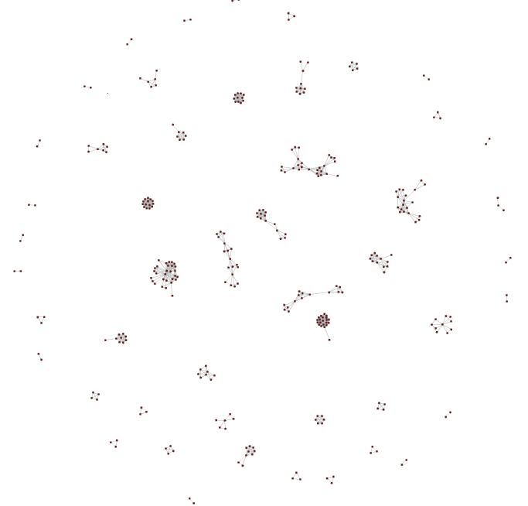
Note: The brown dots represent authors and the grey lines link each co-author.

Research quality
The number of journal articles produced by researchers affiliated with NPM has increased significantly over time (see Table 9). In 2004, just nine articles were produced, compared with 114 in 2010. Overall, of those articles that were ERA ranked, 3 percent of journal articles were published in A*-ranked journals between 2002 and 2010, 6 percent in A-ranked journals, 60 percent in B-ranked journals and 31 percent in C-ranked journals.
These results reflect the emerging nature of indigenous research. Two of the key journals that publish work by NPM researchers, MAI Review and AlterNative, are new journals in this new research field. They were rated B and C, respectively, by the Australian Research Council. So although the proportion of A*-ranked and A-ranked journal articles is low, this does not reflect on the quality of NPM’s research. Also, in the social sciences, journal articles are not always the main avenue for the publication of research. Figure 18 also presents the distribution of research publications by type for NPM in 2010. Journal articles were just 30 percent of all publications, with conference papers being the main means of research dissemination.
Table 9
Ngā Pae o te Māramatanga journal publications
Year | Number of publications |  |  |  |  |  |  | Distribution of publications  (ERA ranked only)
 | A* | A | B | C | Not ranked | Total |  | A* | A | B | C | Total
2002 | 0 | 0 | 0 | 1 | 1 | 2 |  | 0% | 0% | 0% | 100% | 100%
2003 | 0 | 0 | 0 | 0 | 1 | 1 |  |  |  |  |  | n/a
2004 | 0 | 0 | 1 | 5 | 3 | 9 |  | 0% | 0% | 17% | 83% | 100%
2005 | 2 | 2 | 3 | 8 | 26 | 41 |  | 13% | 13% | 20% | 53% | 100%
2006 | 4 | 2 | 26 | 15 | 14 | 61 |  | 9% | 4% | 55% | 32% | 100%
2007 | 1 | 5 | 45 | 25 | 8 | 84 |  | 1% | 7% | 59% | 33% | 100%
2008 | 0 | 2 | 55 | 24 | 5 | 86 |  | 0% | 2% | 68% | 30% | 100%
2009 | 2 | 6 | 60 | 21 | 10 | 99 |  | 2% | 7% | 67% | 24% | 100%
2010 | 4 | 8 | 61 | 29 | 12 | 114 |  | 4% | 8% | 60% | 28% | 100%
Total | 13 | 25 | 251 | 128 | 80 | 497 |  | 3% | 6% | 60% | 31% | 100%
Note: Due to rounding, the percentages may not add to 100%.

Figure 18
Ngā Pae o te Māramatanga research publications
Total journal publications | Journal publications by tier
Distribution of journal publications by tier  (ERA ranked only) | All types of publications in 2010 by type

Knowledge transfer

Research training
A key focus of NPM is supporting new Māori researchers and building research capability in the field of indigenous development. To assess the impact of NPM on the development of researcher capability among Māori, we examine long-term trends in Māori participation and completion in doctoral study. Ngā Pae o te Māramatanga was established in 2002. We expect that statistics would begin to show the effects of the work of NPM within three years of that time.
Figure 19 shows the number of enrolments in doctorates for Māori students between 1994 and 2010. The data shows that enrolments have been rising over time, but since 2006 there has been a surge in enrolments. This is reflected in participation rates, with the participation rate for Māori in doctoral study increasing from 0.07 percent in 2006 to reach 0.10 percent in 2010. A comparison with the participation rate for all domestic doctoral students and for Europeans shows that this increase is over and above the observed trend for the population as a whole. The timing of this increase suggests that the existence and work of NPM have contributed to the increase in research training by Māori.
Note that not all of the additional Māori doctoral students have had a direct connection with NPM. However, raising the awareness of the benefits of and the opportunities for doctoral studies among Māori has been a major goal of NPM.
The number of completions of doctoral degrees by Māori students has also increased over time. The lag period between initial enrolment suggests that the increase in completion shown in 2010 should be continued in future years.
Figure 19
Participation and completions of PhDs by Māori
Māori students enrolled in doctoral study in New Zealand tertiary institutions | Participation rates in doctoral study in New Zealand tertiary institutions by selected groups (domestic students)
Māori completing a doctorate in New Zealand tertiary institutions

Some of the capability-building activities used by NPM to boost Māori scholarship are presented in Figure 20. The main activities have been to support attendance at conferences for doctoral students, while also providing support in developing the writing skills required at the doctoral level. In terms of direct financial support for students, 57 grants were provided to doctoral students in 2010 to encourage knowledge sharing, academic presentation and dissemination of findings. Fifty-four percent of grants in 2010 supported conference attendance.

Figure 20
Capability-building activities at Ngā Pae o te Māramatanga
Number of Capability Building Programme awards/events by type
Number of knowledge sharing grants by type

Building indigenous development as a field of research
Ngā Pae o te Māramatanga has worked to build indigenous development as a legitimate field of research. The two peer-reviewed journals created by NPM, AlterNative and MAI Review, have provided scholars affiliated with the CoRE – and researchers in indigenous development and scholarship throughout the world – with opportunities to publish their work. These journals are relatively new but have gained C and B ratings, respectively, in the Australian Research Council’s journal rankings.

NPM has also created an online portal, Te Pūkenga Tukutuku, that enables scholars to connect and share as a directory of indigenous research capability. This also allows community and private connection with indigenous scholars in particular research areas.

This work and the other research work of the CoRE have created new perspectives for scholars, researchers and students.

NPM’s media centre creates opportunities to share information between scholars through the world. It is used for teaching and research and as a repository of many researchers’ work for future generations.

The NPM grants and awards programme supports research training and dissemination, with more than 100 awards being made in 2010. This included about 60 awards in the Knowledge Sharing Award programme.

The CoRE has built a national network for Māori doctoral students. Te Kupenga o MAI supports the development of Māori and Indigenous postgraduate students across 10 sites. At least 400 Māori students have participated each year in the programme: 442 Māori students attended writing retreats and writing skills workshops and 687 attended doctoral student conferences.

The Riddet Institute


Introduction
The Riddet Institute carries out fundamental research that will underpin the next generation of innovative foods. It conducts discovery-based scientific research into the structure and behaviour of complex food systems and how these interact with the consumer to influence health, wellness and the quality of life. The Institute became a Centre of Research Excellence in 2008.
The Institute’s vision is to be a premier centre for research and scholarship that underpins the development of innovative foods promoting health and wellness.
The Institute’s strategies revolve around four goals:
1 World-leading capability in food and health research in five key areas:
- Food materials science
- Nutritional/digestive biochemistry and physiology
- Novel and emerging process technologies
- Food structure – nutrition interface
- Modelling and engineering.

2. Training tomorrow’s leaders
Development of highly qualified personnel for the food industry, the research and education sector and government, through advanced training of doctoral and postdoctoral scholars.

3. Strong linkages to the food industry
The Riddet Institute aims to support and develop the food industry through: a good understanding of the needs of the New Zealand food industry; conducting world-class relevant science; transferring knowledge; and providing leadership.

4. National leadership in food innovation
As an integrator for its partners, the Riddet Institute aims to fulfil an important leadership role in the transformation of the New Zealand food industry to a world-leading, technology-enabled industry for the 21st century.

The Riddet Institute has five partner institutions and is hosted by Massey University.

Partner institutions
Massey University (host)  The University of Auckland  University of Otago | AgResearch Ltd  Plant and Food Research
Government funding $millions 2008-2010
 | 2008 | 2009 | 2010 | Total
Operating | $3.1 | $3.1 | $3.1 | $9.4
Capital | $1.6 |  |  | $1.6
Total | $4.7 | $3.1 | $3.1 | $11.0

Note: The funding is exclusive of GST.
Source: Ministry of Education and Tertiary Education Commission

Strategic impacts
The Riddet Institute is focused on one of the industries where New Zealand has international leadership and on which the New Zealand economy depends and where there is unrealised potential for innovation.
Riddet Institute scientists maintain direct connections with the country’s large food companies. The Institute’s main vehicle for interaction with the New Zealand food industry is the Riddet Foodlink™ network, which has more than 100 member companies. Riddet uses this group to share ideas on research directions. Riddet Foodlink™ members have access to information on research publications, invitations to summit meetings and access to industry workshop programmes.
Through its connections to industry, the Riddet Institute ensures that knowledge generated from its fundamental science programmes directly benefits the industries it serves, and thus the New Zealand economy.
Riddet research has led to the development of patented technologies for application in the food industry such as: omega-3 encapsulation technology now licensed to Croda (UK); a meat meat hydrolysate technology developed for Meat Biologics now licensed to ANZCO; BioLysine™, ProBioLife™ technology for shelf-stable delivery of probiotics to be licensed to Goodman Fielder. The latter was selected in 2011 by the Institute of Food Technologists in the United States for its innovation showcase and won the NZIFST Food Industry Award for Excellence in Innovation.

Research networks and collaboration
The co-author network for the Riddet Institute’s principal investigators from 2009/10 is shown in Figure 21. The network reveals the existence of two large collaborative clusters of principal investigators. As the newest Centre of Research Excellence, the Institute does not yet exhibit a fully connected collaborative network; however, there is certainly evidence for collaboration among its principal investigators.
Figure 21
Research networks and collaboration at the Riddet Institute
2009/10
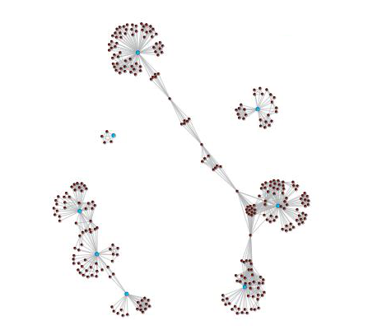
Note: The blue dots (nodes) represent principal investigators at the CoRE. The brown dots represent co-authors of publications that are not principal investigators. The grey lines link each co-author.

Research quality and impact
Since the Riddet Institute became a CoRE in 2008, its research output has increased significantly. Output almost tripled between 2008 and 2010 (see Table 10 and Figure 22). Overall, between 2008 and 2010, 15 percent of ERA-ranked journal publications were published in A* journals, 43 percent in A-ranked journals, 28 percent in B-ranked journals and 15 percent in C-ranked journals. The highest proportion of A*-ranked and A-ranked journal publications (61 percent) was achieved in 2010, the last year of this analysis.
Figure 22 shows that the Institute’s impact factor is ahead of the aggregate Australian benchmark (an aggregation of the University of Queensland, the University of Adelaide and the University of New South Wales, which were the leading Australian universities in the Riddet Institute’s fields of research).
Table 10
Riddet Institute journal publications by tier
Year | Number of publications |  |  |  |  |  |  | Distribution of publications  ERA ranked only)
 | A* | A | B | C | Not ranked | Total |  | A* | A | B | C | Total
2008 | 5 | 15 | 10 | 7 | 3 | 40 |  | 14% | 41% | 27% | 19% | 100%
2009 | 16 | 33 | 25 | 16 | 8 | 98 |  | 18% | 37% | 28% | 18% | 100%
2010 | 15 | 54 | 31 | 12 | 6 | 118 |  | 13% | 48% | 28% | 11% | 100%
Total | 36 | 102 | 66 | 35 | 17 | 256 |  | 15% | 43% | 28% | 15% | 100%
Note: Due to rounding, the percentages may not add to 100%.

Figure 22
Riddet Institute journal publications
Total publications | Publications by tier
Distribution of publications by tier  (ERA ranked only) | Impact factor of Riddet Institute publications compared with those of the University of Queensland, University of Adelaide and University of New South Wales
Note: The impact factor data includes the impact of work that was undertaken before the Institute received Centre of Research Excellence funding.

Knowledge transfer

Working with industry and government
In 2008, just under 50 percent of total income for the Riddet Institute was sourced outside of the Tertiary Education Commission operational funding. By 2011, this had increased to 61 percent. The sources of external research contract income for the Riddet Institute are presented in Figure 23. Although the Riddet Institute attracts significant funding from Vote Science and Innovation contestable funds, an even greater amount is sourced from industry based in New Zealand and overseas. In 2011, $3.4 million in research income was sourced from industry, compared with $1.8 million in 2008.
Figure 23
Sources of external research income for the Riddet Institute

The Riddet Institute aims to act as a catalyst to industry investment in research. It has been instrumental in setting up a major programme of research with Fonterra and ZESPRI under the Primary Growth Partnership initiative, with planned research expenditure of $70 million over seven years. The Institute was also chosen by ZESPRI in 2008 to manage its health and nutrition research platform worth $1.5 million per year.

Research training
As was shown by the research publication indicator, the impact of becoming a CoRE on postgraduate research training is clear for the Riddet Institute (see Figure 24). The number of students affiliated with the Riddet Institute has increased significantly from 30 in 2008 to just under 60 in 2010. Fifty of the 60 students at the Institute in 2010 were studying towards a doctoral degree. An important outcome of the development of these students is their ability to find influential roles in research and industry. The destinations of Riddet Institute graduates include: Fonterra, the Baker Institute, Nestle, PepsiCo, Goodman Fielder and the University of Reading.
Figure 24
Enrolments of postgraduate students affiliated with the Riddet Institute by level

Creating critical mass in research on food science and technology
Over the last four years the Institute has grown capability and capacity to build a critical mass of researchers in food science and nutrition, attracting more than 50 postgraduate students and young scientists in a multi-disciplinary and cross-institutional environment that allows access to a wide pool of equipment, facilities and science expertise. This represents a major increase in New Zealand’s research capability in this area.

The Institute has built research relationships with overseas universities and research institutes that have a focus on food science, including: Wageningen UR, Netherlands, the University of California Davis, the University of Guelph, the Korea Food Research Institute, the Bragg Institute and Cornell University. The Riddet Institute is also a member of two European Union ‘COST’ Actions, one of only a few non-EU members in these collaborative networks. The Institute is working in collaboration with Wageningen UR and other research partners to develop a significant new research programme to address global requirements in protein nutrition (PROTEOS).

The standing of the Riddet Institute in global science was evident in its hosting of an international symposium on dietary protein quality at the invitation of the Food and Agriculture Organization of the United Nations and the organisation of a subsequent Expert Consultation process.

Building links between science, industry and government
The Riddet Institute provides leadership in the agrifood sector in New Zealand. It holds annual agrifood summit meetings for industry and government leaders so that the issues around food research, education and technology transfer can be debated. One outcome of these summits has been the publication of A Call to Arms – a contribution to a New Zealand agrifood strategy, which advocates for increased industry connectivity.

The Riddet Institute maintains close ties with New Zealand government agencies, especially the Ministry of Business, Innovation and Employment and New Zealand Trade and Enterprise. The Institute has assisted with New Zealand government initiatives to develop international science linkages, such as the MSI-led Focal Point Programme to South Korea and a joint New Zealand-India science and technology initiative on agriculture and food research.

To promote a message of achieving prosperity in New Zealand through agrifood innovation, the institute published a book (Floreat Scientia 2011) celebrating some of New Zealand’s most influential agrifood innovation successes.

Conclusion
New Zealand has a small but widely distributed population and a small university system. These features make it hard to develop the sort of critical mass of capability that is needed to underpin excellence in research. The government created the CoREs as a means of building networks of excellent researchers in fields of strategic importance for New Zealand. The CoREs were to be focused on areas with a track record of research excellence. They were designed to capitalise on that research excellence by creating incentives for collaboration and networking, thus building greater critical mass. And they were intended to strengthen the transfer of the knowledge created – that is, to get better dissemination of research findings.
Little comparable data is available on the performance of the CoREs, so there have been no earlier, systematic analyses of their performance. This study has looked at the performance of seven CoREs on five dimensions that relate to the government’s goals for the CoREs:
- The strategic impact of the research produced by the CoREs
- Trends in the quality of their research publications
- Trends in the impact of their research publications
- The extent to which they have improved researcher collaboration and networking
- Indicators of their success in transferring or translating knowledge.
The study shows that:
- the CoREs have shown lifts in research quality, with a good proportion of their publications falling into the highest-quality research classifications
- they managed to maintain or lift the number of publications in the top two research classifications
- the CoREs compared favourably with the top Australian universities in their fields of research, as demonstrated by the bibliometric impact analysis
- all CoREs have been successful in lifting research collaboration
- those CoREs that have a focus on commercialisation of their research have good records in winning research contract funding from business, in patenting, and in the creation of spin-out companies to develop the intellectual property created for market
- those with a focus on public good research have been successful in influencing public health, biosafety, environmental management and national debates in their areas of work
- all have extensive postgraduate education programmes and a number of initiatives designed to promote their science among young people and the public.
To that extent, the CoREs studied in this paper have contributed towards the objectives of the policy in that they have maintained or lifted research quality, at a level comparable with the best Australian universities, improved the extent of collaboration between researchers – in most cases, across a wide geographical area – and had success in translating or transferring their research findings.
We also see opportunities for extending the analysis of CoREs by looking at the tracking of graduates from the CoREs’ postgraduate education programmes via the Employment Outcomes of Tertiary Education dataset.

References
Cinlar, N & J Dowse (2008) Staffing and performance trends in research subject areas. Tertiary Education Commission: Wellington.
Smart, W (2008a) Trends in measured research quality: An analysis of PBRF Quality Evaluation results, Ministry of Education: Wellington.
Smart, W (2008b) Research par excellence: The factors associated with higher research quality in New Zealand tertiary education organisations, Ministry of Education: Wellington.

Smart, W (2009) Making an impact, Ministry of Education: Wellington.

Smart, W (2011) Do people with doctoral degrees get jobs in New Zealand post study?
Ministry of Education: Wellington.

Smart, W & M Weusten (2007) (Ex)Citing research: A bibliometric analysis of New Zealand university research 1981-2005, Ministry of Education: Wellington.
Smart, W & R Smyth (2008) Monitoring research: A synthesis of Ministry of Education analyses of tertiary education research 2004-2008, Ministry of Education: Wellington.

Smyth, R (2008) How the PBRF has shifted research funding, Ministry of Education: Wellington.

TEAC (2001) Shaping the funding framework, Fourth report of the Tertiary Education Advisory Commission, Tertiary Education Advisory Commission: Wellington.
TEC (2007) Performance-Based Research Fund: Evaluating research excellence. The 2006 assessment, Tertiary Education Commission: Wellington.

There are non-university partners in CoREs, but each CoRE is hosted by a university and the majority of the researchers work in universities.
The Foundation for Research, Science and Technology was merged with the Ministry of Research, Science and Technology in 2011 to form the Ministry of Science and Innovation. In 2012, the Ministry of Science and Innovation was absorbed into the Ministry of Business, Innovation and Employment. Also in 2012, the Government announced the creation of the Advanced Technical Institute, a new Crown agent, responsible for helping firms in manufacturing and services to improve their growth through technological innovation and its commercialisation.
Data from Thomson Reuters shows that university researchers were responsible for 69 percent of indexed research papers with New Zealand authors between 2005 and 2009.
Whereas the Crown research institutes account for a quarter.
In 1999, the government moved to identify a research funding component within the tuition subsidies. This change, implemented from 2000, created ‘research top-ups’ attached to subsidies for tuition at degree level and higher. In the late 1990s, the government had also discussed the idea of linking a component of research funding to research performance.
Refer to TEC (2007) for an account of the workings of the PBRF.
Section 162 of the Education Act 1989 states that university ‘...research and teaching are closely interdependent and most of their teaching is done by people who are active in advancing knowledge’ and that universities ‘...meet international standards of research...’.
Refer for instance to TEC (2007), Smart (2009), Smart (2008a), Smart (2008b), Smyth (2008), Smart and Smyth (2008) and Cinlar and Dowse (2008).
The material in this section is taken from the case put to the Cabinet for the funding of the CoREs.
The selection framework for the 2006/7 round can be found at: www.tec.govt.nz/Funding/Fund-finder/CoREs/Funding-round/.
See the funding determination for Centres of Research Excellence at www.tec.govt.nz/Resource-Centre/Ministerial-determinations/.
We did not look at the New Zealand Institute of Mathematics and its Applications, as funding for this CoRE was phased out in 2011. The Riddet Institute was funded from 2008. Given that this centre existed without CoRE status from before that time, we look at the performance of that CoRE from 2005.
The ARC has decided to cease using the journal list in the next ERA round.
Subject to the restrictions on article types given above.
The Australian Group of Eight universities are large research-intensive metropolitan universities. The eight universities are: the Australian National University, the University of Queensland, the University of Sydney, the University of New South Wales, the University of Melbourne, Monash University, the University of Adelaide, and The University of Western Australia.
Until 2012, Gravida was known as the National Research Centre for Growth and Development (NRCGD).
See www.alternative.ac.nz and www.review.mai.ac.nz.
See http://scholar.mai.ac.nz.
See Smart (2011) for an illustration of how we might use this dataset to look at the educational outcomes of the CoREs.

