
Going abroad

What do we know about people going overseas after tertiary study?

This report forms part of a series called Outcomes of tertiary education.

Authors
Roger Smyth, Manager, Tertiary Sector Performance Analysis, Ministry of Education
Email: roger.smyth@minedu.govt.nz
Telephone: 04-463 8633
Fax: 04-463 8713

Deborah Spackman, Statistical Analyst, Statistics New Zealand
Email: deborah.spackman@stats.govt.nz
Telephone: 04-931 4960
Fax: 04-931 4030
Acknowledgements
The authors gratefully acknowledge comments provided by Tas Papadopoulos, Statistics New Zealand, Estelle Le Lievre, Inland Revenue, Morag McConville and Warren Smart, Ministry of Education, and other colleagues at the Ministry of Education, Inland Revenue and Statistics New Zealand. The authors also gratefully acknowledge the assistance provided by Nick Chen and Jamie Hyatt, who provided support in data extraction and interpretation. The authors also thank Alison Lipski, who proof-read this report.
All views expressed in this report, and any remaining errors or omissions, remain the responsibility of the authors.
Published by
Tertiary Sector Performance Analysis
Tertiary, International and System Performance
MINISTRY OF EDUCATION

This work is licensed under the Creative Commons by Attribution 3.0 New Zealand licence. In essence, you are free to copy, distribute and adapt the work, as long as you attribute the work to the copyright holder and abide by the other licence terms. To view a copy of this licence, visit: www.creativecommons.org/licenses/by/3.0/nz.
This report is available from the Ministry of Education’s Education Counts website:
www.educationcounts.govt.nz
January 2012
ISBN (web) 978-0-478-38639-4
Going abroad
1 Introduction 3
2 Context 5
2.1 New Zealanders abroad – the overseas experience 5
2.2 Trends in migration by young New Zealanders 6
2.3 Tertiary education, student loans and travelling overseas 8
3 The loan scheme, the data and the scope of this study 9
3.1 The loan scheme and going overseas 9
3.2 The dataset 10
3.3 The scope of this report 11
4 Who was overseas in 2010? 12
4.1 Scope 12
4.2 How many were overseas? 12
4.3 Higher-level qualifications 16
4.4 Is there a relationship between loan size and going overseas? 18
4.5 How much do those overseas owe? 23
4.6 What can we conclude about those overseas in April 2010? 24
5 Those who left study in 2004 – Who went overseas? 25
5.1 Scope 25
5.2 How many were overseas? 25
5.3 How much do those overseas owe? 26
5.4 Who has returned? 29
5.5 What can we conclude about 2004 leavers? 37
6 Who returned to New Zealand between 2007 AND 2010? 38
6.1 Scope 38
6.2 Who returned to New Zealand? 38
6.3 Loan size 42
6.4 Duration away 44
6.5 Who went away for three years or less? 45
6.6 What can we conclude about the people who returned? 48
7 Conclusion 49
Appendix A data tables 51
References 59

Figures
1  2  3  4  5  6  7  8  9  10  11  12  13  14  16  17  18  19  20  21  22  23  24  25  26  27  28  29  30  31  32  33  34 | Emigration and net migration for New Zealanders aged 18 to 30, 1979 to 2009 6  Emigration by New Zealanders aged 18 to 30 and unemployment rates in New Zealand, 1990 to 2009 7  Student Loan Scheme borrowers who left study between 1999 and 2008: proportions of those with non-resident borrower status at 1 April 2010, by demographic characteristics – sex, ethnicity, citizenship status, age 13  Student Loan Scheme borrowers who left study between 1999 and 2008: proportions of those with non-resident borrower status at 1 April 2010, by study characteristics – provider-type, completion status, level of study 15  Student Loan Scheme borrowers who left study between 1999 and 2008: proportions of those who studied at bachelors level or higher and who had non-resident borrower status at 1 April 2010, by field of study and completion status 16  Distribution of size of loans on leaving study, by whether New Zealand-based or non-resident 19  Median size of loan on leaving study, by level of study and completion status and by whether New Zealand based or non-resident 20  Median size of loan on leaving study, by field of study and by whether New Zealand-based or non-resident 21  Median size of loan on leaving study, by gender and ethnic group and by whether New Zealand-based or non-resident 22  Median size of loan on leaving study, by citizenship status and by whether New Zealand-based or non-resident 23  People who left study in 2004 25  Student Loan Scheme borrowers who left study in 2004 and still had a positive balance at some point between 31 March 2007 and 31 March 2010: proportion of those with non-resident borrower status from 10 April 2007, by study characteristics – level of study and completion status 26  Leaving balance and balance at 31 March 2010 for Student Loan Scheme borrowers who left study in 2004: non-resident borrowers from 10 April 2007, compared with those who were New Zealand-based 27  Non-resident Student Loan Scheme borrowers who left study in 2004 and were away from 10 April 2007: leaving balance for those with NRB status compared with those that were New Zealand-based, and the percentage of leavers with NRB status, by demographic characteristics – age group in 2010 27  Leaving loan balances for borrowers who left study in 2004: New Zealand-based borrowers compared with overseas-based borrowers who were away from 10 April 2007, by qualification level and completion status 29  Distribution of months that people left New Zealand and then returned – for people whose final year of study was 2004, who had non-resident borrower status after leaving study but had returned by 31 March 2010 31  Distribution of months that people left New Zealand – for people whose final year of study was 2004 and who had non-resident borrower status on 31 March 2010 32  Student Loan Scheme borrowers who left study in 2004: percentage of each demographic characteristic with non-resident borrower status, by demographic characteristics – sex, ethnicity, age group 33  Student Loan Scheme borrowers who left study in 2004: percentage of each demographic characteristic with non-resident borrower status who returned to New Zealand by 31 March 2010, by demographic characteristics - sex, ethnicity, age group 34  Student Loan Scheme borrowers who left study in 2004: percentage of each study characteristic with non-resident borrower status, by study characteristics – provider type, level of study, completion status 34  Student Loan Scheme borrowers who left study in 2004: percentage of each study characteristic with non-resident borrower status who returned to New Zealand by 31 March 2010, by study characteristics – provider type, level of study, completion status 35  Student Loan Scheme borrowers who left study in 2004: percentage of each study characteristic with non-resident borrower status, by study characteristics – level of study, completion status 36  Student Loan Scheme borrowers who left study in 2004: median loan balance, by NRB status 36  Student Loan Scheme borrowers: percentage of all borrowers of a particular demographic with non-resident borrower status on or after 10 April 2007, by who had returned by 31 March 2010 and who was still away, by demographic characteristics – sex, ethnicity, age group, citizenship 39  Student Loan Scheme borrowers: percentage of those with non-resident borrower status on or after 10 April 2007, who had returned by 31 March 2010, by demographic characteristics - sex, ethnicity, age group, citizenship 40  Student Loan Scheme borrowers: percentage of a particular demographic with non-resident borrower status on or after 10 April 2007, who had returned by 31 March 2010 and who was still away, by study characteristics - provider, level, completion status 41  Student Loan Scheme borrowers: percentage of those with non-resident borrower status on or after 10 April 2007, who had returned by 31 March 2010, by study characteristics – provider, level, completion status 41  Student Loan Scheme borrowers: percentage of those with non-resident borrower status on or after 10 April 2007, who had returned by 31 March 2010, by study characteristics – level of study, completion status 42  Median leaving balance and balance at 31 March 2010 for Student Loan Scheme borrowers who returned to New Zealand between 10 April 2007 and 31 March 2010, compared with non-resident borrowers who were still away and those that were New Zealand-based 43  Median leaving balance and balance at 31 March 2010 for Student Loan Scheme borrowers who returned to New Zealand between 10 April 2007 and 31 March 2010, compared with non-resident borrowers who were still away and those that were New Zealand-based, by study characteristics – level of study and completion status 44  Student Loan Scheme borrowers who returned between 10 April 2007 and 31 March 2010: percentage of a particular demographic who were away for less than three years and more than three years, by demographic characteristics – sex, ethnicity, age group, citizenship 46  Student Loan Scheme borrowers who returned between 10 April 2007 and 31 March 2010: percentage of a particular demographic who were away for less than three years and more than three years, by study characteristics – level of study and completion status 47  Student Loan Scheme borrowers who returned between 10 April 2007 and 31 March 2010: percentage of a particular demographic who were away for less than three years and more than three years, by study characteristics – field of study and completion status 48

Tables
1  2  3  4  5 | Borrowers with non-resident borrower status on 1 April 2010 who had studied at higher levels, by citizenship status, completion status and field of study 17  Length of time away for people who left New Zealand and then returned – for people whose final year of study was 2004, who had a status of NRB after leaving study but had returned by 31 March 2010 31  Length of time away for people who left New Zealand – for people whose final year of study was 2004 and who had non-resident borrower status on 31 March 2010 32  People who left study after 1999, categorised by NRB status 38  Student loan borrowers who returned to New Zealand between 10 April 2007 and 31 December 2009: year students left New Zealand and the year they returned 45

Summary
This report looks at people who used the Student Loan Scheme while undertaking tertiary study, and then went overseas.
It profiles those overseas and looks at the characteristics of those who return to New Zealand and of those who stay away; and it examines progress in repaying loans by those stay away and those who return.
kEY FINDINGS
who goes overseas
About 19 percent of all account holders who had used the Student Loan Scheme and had left study in 1999 or later were recorded as overseas on our census date. This represented 61,800 people.
Those who are overseas are disproportionately people aged between 25 and 34 who have studied at higher levels, often at a university, and have been successful in their studies.

Who returns
The characteristics of the people who returned from overseas are similar to the characteristics of those who stay away – in other words, it’s hard to predict who will stay away simply by looking at the demographic or study characteristics of borrowers.
While people with degree level and higher qualifications are more likely to be overseas, they do not seem to be more likely to stay overseas.
Of the people who had left study in 1999 or later and who were overseas on or after 10 April 2007, 26 percent had returned to New Zealand by 31 March 2010. Almost 70 percent of people who returned had been away for three years or less.

Repaying loans
Those overseas are likely to have left study with slightly larger loans than people who remain in New Zealand.
The people who had gone overseas and are still away had made less progress on repaying their student loans.
Those who go overseas and then return make substantial progress on their loan repayments – particularly those who completed their qualification – mostly because they then repay through tax deductions but also because they are more likely to have higher level qualifications which lead to higher earnings.
Those who stay away make little or no progress in repaying their loans. The majority owe more than when they left study. Of those who stay away, the median loan balance had fallen only among those who had successfully completed a higher level qualification.

The most important messages to take from the findings in this report are:
- At any point in time, a high proportion of borrowers will be overseas-based. Many of them match the characteristics we think of as associated with the New Zealand tradition of the overseas experience, or OE – they tend to be reasonably young and have completed a tertiary qualification.
- Of those who were found to have returned, most did so after a reasonably short period – three years or less. But a large proportion had been away for longer than three years and was still based overseas at the end of our data series.
- And there were few distinctive characteristics of those who returned that mark them out from those who stay away.
- Those who go overseas tend to have left study with slightly larger loans than those who remain in New Zealand.
- While those overseas have poor repayment records overall, those who return make good progress in repaying loans. Those who return repay at a slightly faster rate than those who never went overseas, in part because they are more likely to have higher qualifications that lead to higher earnings.
- More than half of those who stay overseas for an extended period see their loan balances rise, not decrease, over time, as interest and penalties outweigh any repayments.

Introduction

Why we need information on people going overseas
Like other small countries – especially those close to large and prosperous neighbours and with few barriers to the movement of labour – New Zealand loses some of its educated population to other countries. We have a tradition of young people going overseas, mostly for a short spell of ‘overseas experience’, or OE. People who spend time working in other countries can bring back fresh perspectives and ideas to use in their careers and this can benefit our country. But if people stay away for extended periods, there is a relatively lower probability of their returning and contributing to our economy. For this reason, we need good information on the extent to which our educated young people leave New Zealand and the length of their time away.
A second reason why we wish to measure the extent of departures from New Zealand by young educated people relates to the Student Loan Scheme and its operation. The loan scheme applies different rules to overseas-based and New Zealand-based borrowers, with interest being charged only to those based overseas. Therefore, in its role as collector of loan repayments, Inland Revenue needs accurate information on which borrowers are overseas.
Further, the student loan repayment behaviour of overseas-based and New Zealand-based borrowers is different. Borrowers in New Zealand repay through the tax system, have a high level of compliance and generally move to full repayment quickly. By contrast, overseas borrowers have relatively lower compliance, with much of the overdue payments attributable to overseas-based borrowers (Ministry of Education, 2009). A consequence of this is that the value of the loan scheme asset is critically dependent on accurate data on the number of borrowers overseas and an understanding of patterns of departures and returns.

What information is there on borrowers going overseas?
Inland Revenue needs accurate information on overseas borrowers to manage the loan scheme. So, during 2007, the government legislated for a match between Customs data on border movements and Inland Revenue’s records of student loan borrowers. Over time, the matched Customs/Inland Revenue data will give us an insight into the dynamics of borrowers’ overseas travel, allow us to monitor the extent to which New Zealand is losing young graduates to other countries and help us to lift the understanding of the loan scheme.
Under the agreement between Inland Revenue and Customs, the border movements of all those who cross the border and who have a loan balance of $20 or more are recorded. Some data from this matching is held in the integrated dataset on student loans and allowances, a confidentialised dataset managed by Statistics New Zealand for the Ministry of Education, the Ministry of Social Development and Inland Revenue. At this stage, the only data available in the dataset relates to the residency status of borrowers between 10 April 2007 and 1 April 2010. There is also some data on border movements for earlier years that came from a limited retrospective matching of data between Customs and Inland Revenue.
Over time, we will get fuller, longitudinal data on border movements by people with loans. This will enable us to explore and answer questions such as:
- What are the characteristics of those who go overseas following study?
- How long do they typically spend overseas before returning?
- What is the probability of a person returning to New Zealand after a period abroad of (for instance) three years?
This present report is the first attempt to use the new data match analytically. Because of the limited availability of data, it confines itself to three analyses:
- the characteristics of the people who were recorded as being non-resident (ie overseas-based) Student Loan Scheme borrowers on 10 April 2010
- the characteristics of those who left study in 2004 and were assessed as being non-resident borrowers at some point in the period 10 April 2007 to 31 March 2010 and the characteristics of those from this group who returned to New Zealand
- the characteristics of the borrowers who returned from overseas and became New Zealand-based during the period 10 April 2007 to 31 March 2010 – and what we know about their duration overseas.

Context

New Zealanders abroad – the overseas experience
The ‘overseas experience’, or OE, is a New Zealand tradition. Many young New Zealanders take an OE soon after completing tertiary study. Some will return after a period of three years or less, having had some time in the workforce in another country and having acquired skills and experience beyond what would have been available to them in the New Zealand labour force. Some will stay much longer overseas and some won’t ever return to the New Zealand labour market.
In their study of Census data from nine countries, Bryant and Law (2004) note that about 14 percent of all New Zealand-born people were living abroad, with three-quarters of that group in Australia. While Bryant and Law report that the proportion of New Zealand-born people living overseas is lower than the corresponding proportion for Ireland, it is higher than that of Australia, Canada, Korea, Italy, the Netherlands, the United Kingdom and the United States.
In a similar analysis of Census data for the OECD, Dumont and Lemaitre (2005) identify New Zealand, Ireland and Luxembourg as the three countries (of the 27 analysed) with the highest proportion of their birth population living abroad – by their estimates, above 20 percent in all three cases. Dumont and Lemaitre also analyse the extent to which emigrants are ‘highly skilled’, as indicated by whether they hold a tertiary educational qualification. New Zealand ranks second (to Ireland) on that scale, with more than 15 percent of its tertiary-qualified birth population living abroad.
These findings need, of course, to be put into context. As indicated by Glass and Choy (2001), New Zealand experiences a ‘brain exchange’: while we lose highly qualified people through emigration, New Zealand is a popular destination for highly skilled migrants from other countries. Bryant and Law (2004) also look at the ‘reverse diaspora’ and conclude that “the contribution [to New Zealand] of the overseas-born population [has been] underestimated”. Looking at the tertiary qualified, Dumont and Lemaitre (2005) find that highly skilled emigration from New Zealand is balanced by highly skilled immigration. In addition, Statistics New Zealand migration data shows that, over the last decade, more than a quarter of all emigrants classified themselves as having a high-skilled occupation, but they were matched by a similar number of immigrants in those same occupational groups.
While that may be so, evidence from the Adult Literacy and Life Skills (ALL) survey suggests that a numerical balance between immigrants and emigrants with degrees does not guarantee an ‘even’ exchange of skills; degree-qualified immigrants were much more likely to have low literacy and/or numeracy than New Zealand-born degree holders – in large part because the ALL assessment was conducted in English (Smyth and Lane, 2009). One consequence is that many immigrants who hold degrees but who are educated in a language other than English hold jobs in New Zealand that don’t reflect their education, at least in the five or so years following their immigration.
As a result, there remains a risk that the New Zealand labour market may lose access to skills as a result of migration, so it remains important to monitor trends in the emigration of those New Zealanders with tertiary qualifications – not because there is anything wrong with people taking an overseas experience but because those who stay away for an extended period are more likely to be lost to our economy and society.

Trends in migration by young New Zealanders
Statistics New Zealand’s migration data gives trends in arrivals from people intending to stay in New Zealand for 12 months or more and departures of those intending to stay away for 12 months or more. The series includes New Zealanders departing for extended periods and returning home, as well as citizens of other countries leaving New Zealand after an extended stay or migrating to New Zealand. Given that the majority of long-term departures are by New Zealand citizens, the Statistics New Zealand emigration data gives a good sense of the extent to which New Zealanders are taking an overseas experience.
Figure 1
Emigration and net migration for New Zealanders aged 18 to 30, 1979 to 2009
Source: Statistics New Zealand, Permanent and Long-term Migrant Data, September quarters.
Figure 1 shows reasonably steady emigration from New Zealand by young people, but with a rough balance between the number of people departing from and those entering New Zealand since the early 1990s. On average, roughly 28,000 people aged between 18 and 30 have left New Zealand per year over the past 20 years, many of them to Australia and the United Kingdom. Over the last 10 years, these two destinations together represented between 62 percent and 75 percent of all departures by 18 to 30 year olds.
While there is a steady outflow of young people, the net migration line shows the influence of both immigration by young foreign nationals and also the return of young New Zealanders following an overseas experience of more than 12 months. Statistics New Zealand data shows that there were more departures than arrivals among those aged 18 to 25 years in six of the last 10 years, while net migration among the 26 to 30 year age group was positive in every year.
The years 2002 and 2003 saw especially strong inwards migration by young people. The extent of the shift over that period was probably the result of two causes. First, it may have represented greater return from overseas by young New Zealanders in the wake of the September 11 2001 terrorist attacks in the United States. Second, it may also show the influence of a surge in the number of international students that occurred around that time. The other year with very strong inward migration was 2009, probably a consequence of the severity of the recession in many other developed countries – especially the United Kingdom.
The data from 2009 suggests that one of the influences on permanent or long-term migration may be the business cycle. Even if young people are travelling in search of an overseas experience – rather than to build a career – it would usually be thought that they are more likely to travel when jobs are either harder to get in New Zealand or else more plentiful in the destination countries. Figure 2 shows similar migration data as Figure 1 but with the New Zealand unemployment rate overlaid.
Figure 2
Emigration by New Zealanders aged 18 to 30 and unemployment rates in New Zealand, 1990 to 2009
Source: Statistics New Zealand, Household Labour Force Survey and Permanent and Long-term Migration Data.
Figure 2 shows little obvious relationship between unemployment in New Zealand and the number of young people going overseas; the fall in unemployment following the recession of 1991 signalled a rise in departures and there was a similar response to falling unemployment between 1998 and 2002. Data on unemployment in Australia, the UK and the Organisation for Economic Co-operation and Development (OECD) also appears to show that the availability of work in popular destinations seemed to have little influence on the rate of departure until the downturn of 2009. Even when one lags the unemployment rate, there is no evidence of a statistical relationship between the business cycle and travel. This raises questions about whether young people’s primary reasons for overseas travel are work-related, and other questions about their reasons for overseas travel – but that is beyond the scope of this study.

Tertiary education, student loans and travelling overseas
One of the reasons we are especially interested in the patterns of overseas travel by young New Zealanders is that many young New Zealanders who take an overseas experience have undertaken tertiary education and so have acquired skills at the expense of New Zealand taxpayers. Many of those people will not have repaid their student loans when they left the country. While borrowers are in New Zealand, their repayments are mostly made through deductions by their employer from their earnings, so they can be passive in dealing with their loans. However, when they move overseas, borrowers need to begin to manage their loan repayments actively. This change means that many of those with loans who are overseas don’t meet their repayment obligations and this impacts on the valuation (and hence the cost to the Government) of the scheme.
The fact that there are many highly educated young people overseas also implies that we might be losing some of the skills we need in our labour market. And if people with higher qualifications leave New Zealand and stay away for an extended period, it raises questions about the benefits to New Zealand of the Government’s funding of tertiary education. Inevitably, New Zealand, like all countries, will lose some people with higher education – the problem is to quantify the extent of long-term/permanent loss.
For these reasons, it is important to get a good understanding of the patterns of overseas travel among those who undertake tertiary education.
Earlier analysis of the migration of Student Loan Scheme borrowers by Inland Revenue and the Ministry of Education also shows the relatively short-term nature of young people’s overseas experience. The Student Loan Scheme annual report for 2004 states:
A study of the time spent away from New Zealand by those with Student Loan Scheme debt confirms that the majority do return to New Zealand. Of the borrowers who left the country in 1996, nearly two-thirds had returned to New Zealand by June 2004. … Around two-thirds of all those borrowers still overseas have been away from New Zealand for less than four years and hence a significant majority of them are expected to return to New Zealand. Those who remain out of New Zealand for more than five years have a low propensity to return, however.
That analysis, however, relied on borrowers’ own declarations that they were overseas. It is now known that there was significant under-reporting of overseas status under the self-declaration system.
New information, available from a match of data on border crossings and data on student loans, has improved our understanding of who goes overseas, the educational achievement of those who go overseas and the length of their stay. This data – described in Chapter 3 – provides the base for the analyses in Chapters 4, 5 and 6 of this report.

The loan scheme, the data and the scope of this study

The loan scheme and going overseas
The Student Loan Scheme has always had different arrangements for those who leave New Zealand before repaying their loans. People resident in New Zealand repay through the tax system and have the benefit of targeting provisions in the scheme – and in particular, their repayment obligations are lower (or zero) if their incomes are low. These benefits are not available to those based overseas, for two reasons.
- Firstly, one of the main goals of the Government’s tertiary education funding is to lift the skill level of the resident population. A more skilled population leads to a more productive economy as well as to benefits for the individuals who have acquired those skills. The Government reasoned that the New Zealand taxpayer should not be incurring the cost of a targeted benefit for a person who isn’t contributing the skills acquired in their tertiary education to the New Zealand society and economy.
- Secondly, it wouldn’t be possible for New Zealand’s Inland Revenue Department to administer those provisions for people overseas as they don’t have a direct relationship with those people and have no knowledge of their incomes.
People who leave New Zealand before repaying their loans are required to report to Inland Revenue that they are overseas. However, many people go overseas without telling Inland Revenue and, until relatively recently, Inland Revenue had no effective way of policing that rule. This meant there was a significant undercount of those actually overseas. For instance, over the period 2003 to 2005, between 6.0 and 6.3 percent of borrowers declared that they were overseas (Ministry of Education et al, 2004). The evidence suggests that non-compliance with that requirement was increasing over time. When it first obtained matched data, Inland Revenue reported that an “…historic data match has identified approximately 38,000 borrowers who had not notified Inland Revenue of their departure…” (Ministry of Education, 2007). In 2009, using data from the Customs/Inland Revenue data match, the annual report of the Student Loan Scheme reported that about 82,000 people with loan balances of $20 or more – or 15 percent of the total – were overseas-based. This report shows that about 19 percent of those with loan accounts on 10 April 2010 who left after 1999 had been classified by Inland Revenue as non-resident borrowers. This suggests that the numbers reporting themselves as going overseas may have been less than half the true numbers.

The shift to interest-free loans
In 2005/06, the Government moved to make the Student Loan Scheme interest-free for those who stay in New Zealand, with interest still to be charged if a borrower is assessed as being overseas-based.
Under the new policy, a loan holder is considered to be non-resident if they are out of New Zealand for 184 days or more – about six months. And if the borrower returns to New Zealand, they wouldn’t be reclassified as New Zealand-based until they have remained in New Zealand for 183 days or more.

Matching data on border crossings
The shift to interest-free loans was thought to create a greater incentive for non-compliance with the requirement that borrowers declare their departure from New Zealand to Inland Revenue. As a result, the Government legislated to allow a match between Customs data on border movements with Inland Revenue data on loans. This match enables Inland Revenue to track each borrower’s departures from and arrivals in New Zealand, enabling them to work out if a borrower has non-resident borrower status (and hence a liability for interest) at any point in time.
Inland Revenue supplies this data to Statistics New Zealand for inclusion in the Integrated Dataset on Student Loans and Allowances, a confidentialised, longitudinal database that is used for modelling and valuing the Student Loan Scheme and for research and analysis. That dataset provides the basis for the analysis in this report.
Because the integrated dataset contains each borrower’s educational history, as well as borrowing and repayment data, we can focus on the non-resident borrowers and look at their demographic and study characteristics.

The dataset
The integrated dataset on student loans and allowances is an analytical dataset managed by Statistics New Zealand that matches data from the Ministry of Education (on tertiary education enrolments and completions), from the Ministry of Social Development (on borrowing and on allowances received) and from Inland Revenue (on loan balances and incomes). Inland Revenue data on borrowers’ residency status is now included in the dataset.
The linking of data on public tertiary education institutions was backdated to 1997 when the dataset was created, but linked data covering the whole sector dates from 1999.

How is the data used to establish whether a borrower is New Zealand-based?
A borrower is assigned non-resident borrower (NRB) status by Inland Revenue if the data shows that he/she has been overseas for 183 days or more. Someone who has left for overseas may not be given the NRB status until he/she has passed the 183-day mark, at which time the NRB status is assigned with effect from the date of the border crossing.
There are also people with NRB status who are physically present in New Zealand, either as part of a short stay back home or during the first 183 days of their return, while they wait for reclassification as New Zealand-based. These people are deemed to be overseas for student loan purposes, and in this study. Once someone has been back for 184 days, they are then classified as New Zealand-based from the date of their actual return.

The accuracy of the data
Inland Revenue supplements border movement data with information from self-declaration and with information from other sources. This means that NRB status is informed by the latest data available to Inland Revenue.

The retrospective data match
As well as determining which borrowers crossed the border following the introduction of interest-free loans on 1 April 2006, Inland Revenue and Customs did a limited match of historical data on border crossings by Student Loan Scheme borrowers. This match sought to identify the last known departure date for those identified as overseas. However, it was a limited data match restricted to those with balances in April 2007 of $2,000 or more, those not already known to be overseas (usually through self-reporting), those who were known to be bankrupt, those who had PAYE tax payments in March 2006 or those who were known to have borrowed in the 2006 academic year.

The scope of this report
The Customs/Inland Revenue data match is comprehensive only for the period April 2007 to April 2010 so we do not have a long enough time series to undertake a really comprehensive analysis at this time. In the future, this dataset will enable us to make detailed analyses of movements by borrowers across the border, and will enable us to answer questions such as:
- What are the characteristics of those who go overseas following study?
- How long do they typically spend overseas before returning?
- What is the probability of a person returning to New Zealand after a period abroad of, say, five years and how does that compare with the probability of return within three years?
With the data match covering only three years, this first report drawn from the data on borrowers going overseas confines itself to three main questions:
- Chapter 4: How many people were recorded as being overseas-based Student Loan Scheme borrowers on 10 April 2010? What does that represent as a proportion of all those who have student loans? How do their characteristics compare with the whole population of borrowers? How large are their loans and how does that compare with New Zealand-based borrowers?
- Chapter 5: What are the demographic and study-related characteristics of those who left study in 2004 and were assessed as being overseas-based at some point in the period 10 April 2007 to 31 March 2010? How do their characteristics compare with the others who finished study in 2004? How soon after leaving study did this group depart? How many had returned by April 2010? Of those who had been away and returned, how long had they been away?
- Chapter 6: What are the characteristics of the borrowers who had left study at some stage after 1999 and then had returned from overseas and became New Zealand-based during the period 10 April 2007 to 31 March 2010? What are their demographic and study characteristics? What do we know about their duration overseas?
In the future, we will be able to use regression and other statistical techniques to determine in a more robust way which factors are associated with going overseas and estimating the probabilities that certain types of people will stay away for an extended period.
Given the preliminary nature of this study and the relatively short time series available in the dataset, we have not conducted tests for statistical significance and we have not controlled for all variables in our analysis.

Who was overseas in 2010?

Scope
In this section, we look at how many people were recorded as being non-resident Student Loan Scheme borrowers on 10 April 2010, both in total and as a proportion of all those who have student loans. We compare the profile of those who were assessed as being overseas-based on 10 April 2010 with all those with loans. We also look at the size of the loans of those overseas, compared with those who are resident in New Zealand.
In this chapter, we focus on those who studied at some point in 1999 or later. We don’t look at earlier groups of borrowers because the complete linking of data in the integrated dataset – the source of the data used in this report – occurs only from 1999. So we don’t have complete data on those who left study in earlier years.
The data in this chapter looks at the residency status of borrowers at a single point in time. Obviously, some of the people with non-resident borrower status in this group will have been overseas for some time, others will have been overseas for a short time only, and a few will have already returned to New Zealand by the date of the data match but have yet to spend the 183 consecutive days in New Zealand needed to be classified as a New Zealand-based borrower. Conversely, there will be people classified as New Zealand-based on 10 April 2010 who were actually overseas, some within the first 183 days of their overseas experience.

How many were overseas?
About 321,800 people had used the Student Loan Scheme at some stage after 1999, had left study by the end of 2008 and had a loan of $20 or more on 31 March 2010. Of those people, about 61,800, or 19 percent, had been assessed as having non-resident borrower status on 10 April 2010 – that is, they had been assessed by Inland Revenue as being overseas on 10 April 2010 and having been so for 184 days or more. The 61,800 includes people who had been overseas for several years, as well as those who had recently left the country. And, of course, some of those who had left study between 1999 and 2008 had spent some time overseas following study and had returned before 10 April 2010; they, of course, are not counted in this analysis.
Table 1 in Appendix A sets out the characteristics of the 61,800 overseas-based borrowers. Figure 3 below compares some of the demographic characteristics of that group with the characteristics of the 321,800 people in the population we are looking at, while Figure 4 gives the relative distribution of their study characteristics. Essentially, those overseas on 10 April 2010 were disproportionately:
- male – 21 percent of male borrowers had non-resident borrower (NRB) status, against 18 percent of female borrowers
- of Asian ethnicity but less likely to be Māori or Pasifika – among borrowers of Asian ethnicity, 30 percent had NRB status, compared with 14 percent of Māori and 16 percent of Pasifika
- New Zealand permanent residents, as opposed to New Zealand citizens – of those who were New Zealand permanent residents, 25 percent had NRB status, against 19 percent of the whole group and 18 percent of New Zealand citizens
- aged between 25 and 34 years old – 24 percent of those aged between 25 and 34 had been assigned NRB status, against 19 percent of the whole sample.
Figure 3
Student Loan Scheme borrowers who left study between 1999 and 2008: proportions of those with non-resident borrower status at 1 April 2010, by demographic characteristics – sex, ethnicity, citizenship status, age
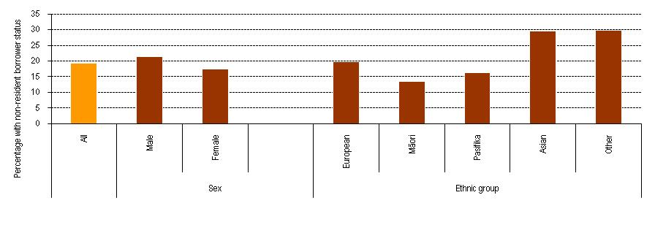
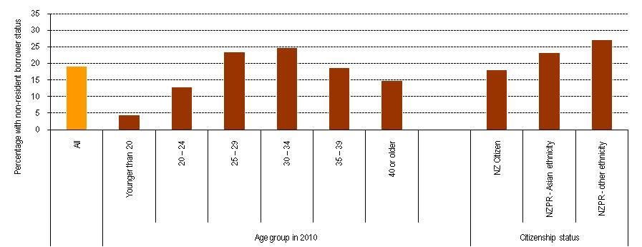
Source: Statistics New Zealand, Integrated Dataset on Student Loans and Allowances.
Note: Refer to Appendix A for more detailed data. Those with unknown citizenship status are ignored in the citizenship graph.
Figure 3 gives rise to two observations. First, it is sometimes asserted that some people acquire permanent resident status as a means of getting the advantages of a New Zealand tertiary education at lower cost, but with a view to then leaving New Zealand. It has been suggested that this is especially the case in relation to permanent residents of Asian ethnicity. The data behind Figure 3 confirms that permanent residents are more likely to be overseas, but it suggests that the incidence of going overseas is higher among permanent residents with other ethnicities. Given that 30 percent of all people of Asian ethnicity were shown as overseas and that 23 percent of permanent resident Asians were overseas, it follows that the incidence of travelling overseas was higher among New Zealand citizens of Asian ethnicity than among permanent residents of Asian ethnicity.
The second observation relates to the age distribution of those overseas. Given that nearly everyone aged 36 or younger would have had the chance to use the loan scheme throughout their studies, our main focus is on those aged 35 or under – they represent the ‘more typical’ loan scheme user. The number overseas on 1 April 2010 was highest in the 25 to 29 age group, where there were 21,300 borrowers with non-resident borrower status, compared with 16,100 in the 30 to 34 year age group.
Figure 3 shows that the proportion of borrowers overseas reduces after the age of 35. The proportion overseas is higher in the 30 to 34 age group than in the 25 to 29 group because more of the New Zealand-based borrowers aged 30+ will have repaid in full, while those overseas for an extended period are unlikely to have done so – thus, those overseas are a larger proportion of the whole. But given that the number of borrowers overseas is lower in the 30 to 34 year age group, we may also be observing signs of New Zealanders returning to New Zealand as they get older.
In Figure 4, we look at the study characteristics of those overseas on 1 April 2010. Those with non-resident borrower status were disproportionately:
- more likely to have studied at a university – 26 percent of those who had studied at a university had NRB status, against 17 percent at a polytechnic, 11 percent at a wānanga and 15 percent at a private training establishment
- more likely to have studied at bachelors degree level or higher – 25 percent of those who studied at bachelors level or higher were NRB, compared with 19 percent of the whole sample
- more likely to have been successful at completing a qualification, especially at bachelors level or higher – 22 percent of all those who were successful in completing and 27 percent of those who were successful at bachelors level or higher had NRB status, against 17 percent of all those who were unsuccessful.
Figure 4
Student Loan Scheme borrowers who left study between 1999 and 2008: proportions of those with non-resident borrower status at 1 April 2010, by study characteristics – provider-type, completion status, level of study
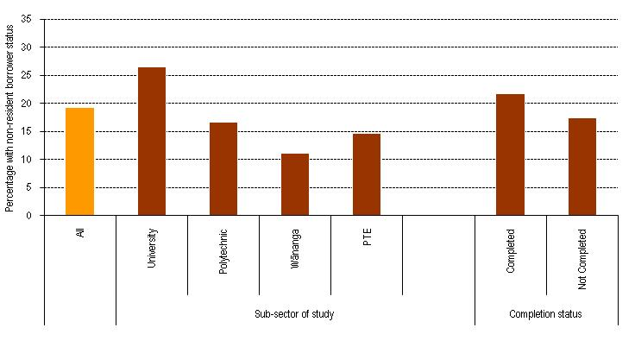
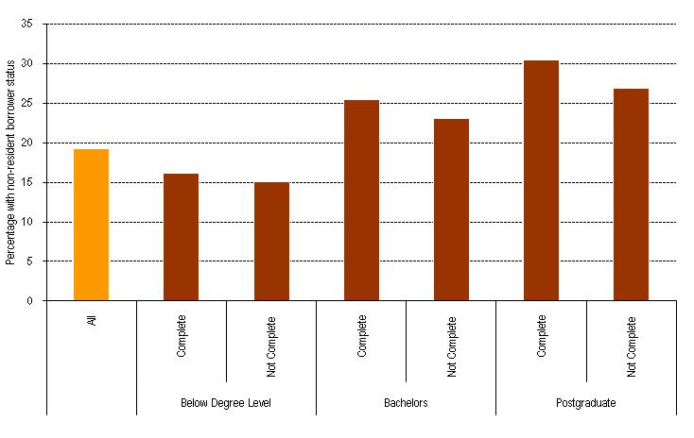
Source: Statistics New Zealand, Integrated Dataset on Student Loans and Allowances.
Note: Refer to Appendix A for more detailed data.
The high incidence of NRB status among those who studied at universities reflects the fact those overseas are more likely to have undertaken bachelors level qualifications or higher.
The data suggests that we need to look more closely at those with non-resident borrower status who studied at higher qualification levels.

Higher-level qualifications
The data shows that around 25 percent of those who had studied at bachelors level or higher and left study between 1999 and 2008 and who still had a student loan – about 29,800 people – were overseas on 10 April 2010. And of those 29,800, around 19,100 had successfully completed a qualification.
Given the importance to our economy of people with higher qualifications and given the costs to the system of educating those people, we take a closer look in this section at the characteristics of the people who had studied at higher levels and who had been classified as non-resident.

Field of study
There are significant differences between the fields of study for the qualifications taken by those with non-resident borrower status. Figure 5 below shows the proportions of those who studied at bachelors level or higher and who had non-resident borrower status on 10 April 2010 according to the field of study of the qualification taken.
Figure 5
Student Loan Scheme borrowers who left study between 1999 and 2008: proportions of those who studied at bachelors level or higher and who had non-resident borrower status at 1 April 2010, by field of study and completion status

5a – Qualification completed
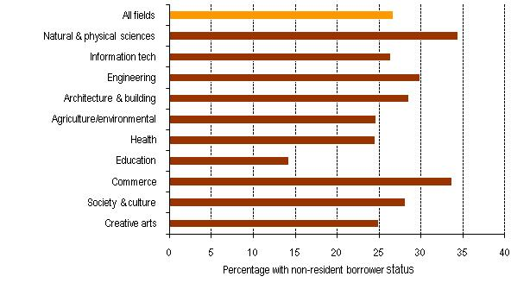
5b – Qualification incomplete
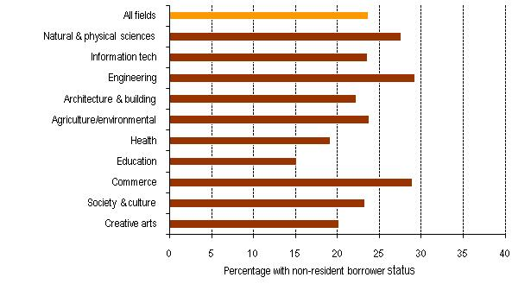

Source: Statistics New Zealand Integrated Dataset on Student Loans and Allowances. Interpretation: Ministry of Education.
Note: Refer to Appendix A for more detailed data. Those with unknown field of study are ignored.
Those who studied education – a vocational field of study with good employment prospects in New Zealand – had a very low proportion overseas. Health – another vocational field with ready employment for new graduates – had a moderately low proportion overseas. High levels of NRB status are found among commerce and engineering – two fields where there are usually thought to be good employment prospects overseas. There was a high proportion of graduates in science overseas also, possibly reflecting a perceived shortage of opportunities for science graduates in New Zealand.

Citizenship status
Given the finding – illustrated in Figure 3 above – that people with permanent resident status are more likely than New Zealand citizens to go overseas after study, it is useful to focus on the citizenship status of borrowers overseas who had studied at higher levels. Table 1 below looks at the completion status, field of study and citizenship status of those with NRB status who had studied at higher levels. This looks only at those fields of study where there were significant numbers – greater than 100 – overseas with permanent resident status.
Table 1
Borrowers with non-resident borrower status on 1 April 2010 who had studied at higher levels, by citizenship status, completion status and field of study
 |  | Percentage with NRB status
 | Number of NZPR borrowers with NRB status |  | All | NZ citizens | NZPRs
Completion status
Complete | 855 |  | 26.6 | 25.0 | 32.6
Not complete | 633 |  | 23.7 | 21.8 | 31.0
Field of study
Natural and physical sciences | 156 |  | 31.3 | 28.5 | 36.1
Health | 159 |  | 22.9 | 21.4 | 34.6
Management and commerce | 510 |  | 31.7 | 29.4 | 34.1
Society and culture | 270 |  | 25.7 | 24.8 | 33.2
Source: Statistics New Zealand, Integrated Dataset on Student Loans and Allowances.
Note: Refer to Appendix A for more detailed data. Only fields of study in which there were greater than 100 New Zealand permanent resident (NZPR) borrowers with NRB status are reported. Those with unknown citizenship status are ignored.
New Zealand permanent residents are more likely to have been overseas on 10 April 2010 in eight of the 11 broad fields of study analysed, including all those fields that attract large numbers of international students.
In part, the higher incidence of non-resident borrower status among those who studied while New Zealand permanent residents reflects the fact that those people are, by definition, entitled to live and work in another country. A permanent resident is likely to have family and/or other connections with his/her home country.
The data available to us now isn’t of long enough duration to enable us to look into the question of whether people use New Zealand permanent resident status as a means of gaining a New Zealand education at lower cost without any intention of returning to work in New Zealand. Over time, however, we expect to be able to gain greater insight into this issue.

Is there a relationship between loan size and going overseas?
Another area where there is something of an imbalance between those overseas and all leavers is in the size of loan balance. It has sometimes been claimed that loans ‘encourage’ people to leave New Zealand. In this section, we look at those overseas on 10 April 2010 and relate that to the size of their loans at the point when they left study.
Of course, when we focus on borrowers’ residency at a fixed point in time, we need to recall that some of those with NRB status may well have spent some time in New Zealand, while those who are New Zealand-based will have been overseas – perhaps for an extended period – before returning to New Zealand. But the NRB borrowers will also include a group of people who have been out of New Zealand for an extended period and who don’t expect to return in the medium term. Conversely, the New Zealand-based borrowers will include a large number who have had continuous residence and employment in New Zealand. We can’t draw definitive conclusions about the relationship between loan size and travel overseas from the data available to us now, but this section seeks to do a first-level investigation of the relationship.
The median loan balance on leaving study of those who had NRB status on 1 April 2010 was $16,900, compared with $12,500 for those who were New Zealand-based on that date. This means that those who had NRB status on 10 April 2010 left study with loans that were about a third higher than those who were New Zealand-based.
Another way of looking at the difference in leaving loan balance is to note that 30 percent of those with NRB status on 10 April 2010 had left study with modest sized loans – $10,000 or less. But the corresponding figure for those who were New Zealand-based on 10 April 2010 was 41 percent. When we look at those with large loans, we see that 9 percent of the NRB group left study with loans of $45,000 or more, compared with 6 percent of those who were in New Zealand on 10 April 2010. In other words, relatively fewer NRB borrowers left study with small loans and relatively more NRB borrowers left with large loans.
Figure 6
Distribution of size of loans on leaving study, by whether New Zealand-based or non-resident
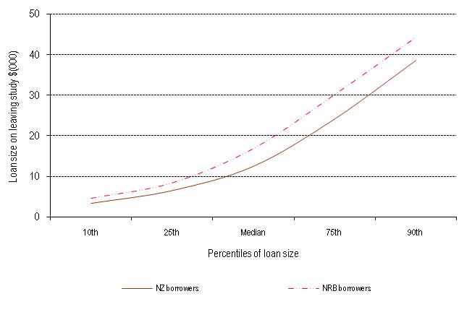
Source: Statistics New Zealand Integrated Dataset on Student Loans and Allowances. Interpretation: Ministry of Education.
Note: Refer to Appendix A for more detailed data.
The term ‘percentile’ refers to the ‘rank’ or position of a value. The 25th percentile is the point that divides the lowest 25% of the values from the rest, while the 90th percentile divides the distribution into the bottom 90% and the top 10%.
An earlier Ministry of Education statistical study (Smart, 2006) explored the relationship between loan balance and going overseas. That study found that size of loan had a very small but statistically significant relationship to whether a person went overseas following study. So in the remainder of this chapter, we look at differences between NRB and New Zealand-based borrowers in the size of the loan at the point when the borrower left study.

Level of study and tertiary education provider
To some extent, the imbalance in the size of loans on leaving study reflects the distribution of borrowers overseas. Those who had studied at bachelors degree level or higher – who are over-represented among those overseas – are known to have higher loan balances (Ministry of Education, 2009; Griffen, Scott and Smyth, 2005). So it is important to take account of level of study when we look at how the size of loan is related to the likelihood of a borrower having NRB status.
Figure 7
Median size of loan on leaving study, by level of study and completion status and by whether New Zealand based or non-resident
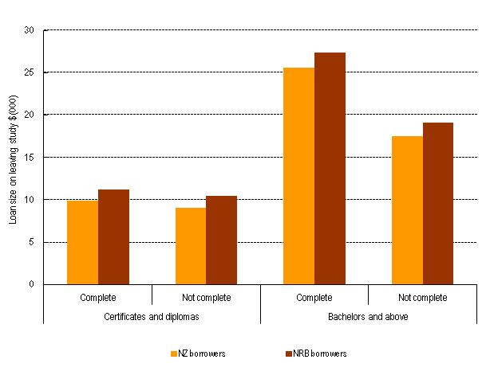
Source: Statistics New Zealand Integrated Dataset on Student Loans and Allowances. Interpretation: Ministry of Education.
Note: Refer to Appendix A for more detailed data.
While those with NRB status left study with larger loans, the differences are lower in each of the four categories than the 35 percent margin between the loans of the NRB group and the New Zealand-resident group, referred to earlier. For those who studied at bachelors degree level or higher (and who thus make up the majority of those overseas), the leaving loans of the NRB group were 7 percent higher among those who completed and 9 percent higher among those who didn’t complete a qualification. The corresponding figures for certificate and diploma leavers were 13 percent and 15 percent.
The differences by level of qualification are mirrored when we look at the type of tertiary education provider the borrowers studied at. Those who take higher qualifications are most likely to do so at a university. Because there is a higher incidence of NRB borrowers who went to universities and because students leave universities with higher loans, it is important to take account of the type of provider when we look at loan size of NRB borrowers.

Field of study
There are differences in leaving loan size between fields of study, particularly at bachelors degree level and higher. Across all fields of study except one, those with non-resident borrower status on 10 April 2010 left study with larger loans. The exception was those who studied information technology at bachelors degree level or higher.
Figure 8
Median size of loan on leaving study, by field of study and by whether New Zealand-based or non-resident

8a – Certificates and diplomas
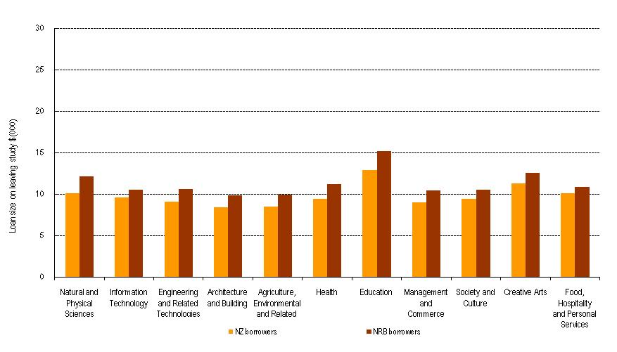
8b – Bachelors and above
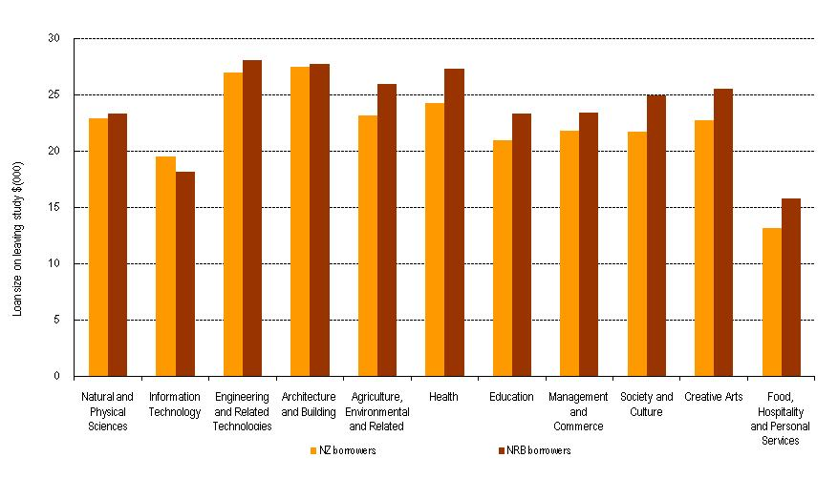
Source: Statistics New Zealand Integrated Dataset on Student Loans and Allowances. Interpretation: Ministry of Education.
Note: Refer to Appendix A for more detailed data.
On average, the margin between the leaving loans of those who go overseas and those who don’t was higher among people who studied at lower qualification levels. One reason for the relatively high margin between those who do and don’t go overseas with health qualifications may be that people with longer health qualifications (such as medicine) that have higher fees may be more inclined to go overseas than those who take shorter qualifications (such as nursing). .

Demographic characteristics
Figure 9 below shows the differences in leaving loan size between New Zealand-based and overseas-based borrowers by demographic factors.
Figure 9
Median size of loan on leaving study, by gender and ethnic group and by whether New Zealand-based or non-resident
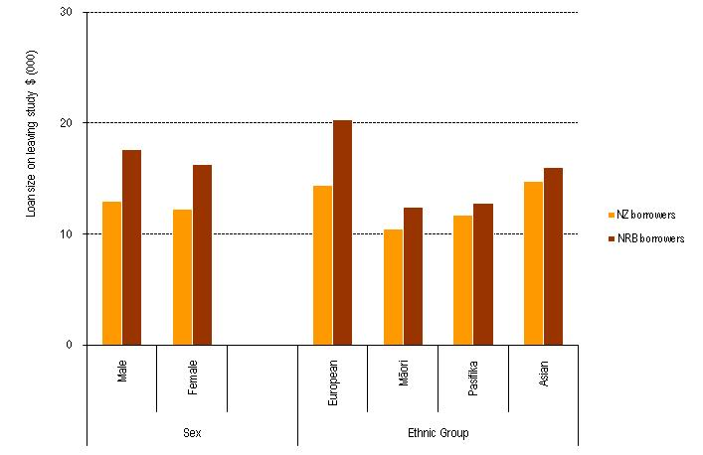
Source: Statistics New Zealand Integrated Dataset on Student Loans and Allowances. Interpretation: Ministry of Education.
The margin in median leaving loan balance between those with NRB status and those in New Zealand on 10 April 2010 is largest for those of the European ethnic group (40 percent) and for males (36 percent), while it is least for Asians (9 percent).
The margins also differ by age group, with the age groups in which there is the highest incidence of NRB status – the 25 to 29 year group and the 30 to 34 year age group – having high margins (20 percent and 23 percent respectively). There is also a high margin for those aged 35 to 39 (31 percent). However, the difference is smaller in other age groups.

Citizenship status
The margin in loan size between those based overseas on 10 April 2010 and those in New Zealand was most pronounced for New Zealand citizens, at 38 percent. The corresponding figure for permanent residents of Asian ethnicity was only 12 percent.
Figure 10
Median size of loan on leaving study, by citizenship status and by whether New Zealand-based or non-resident
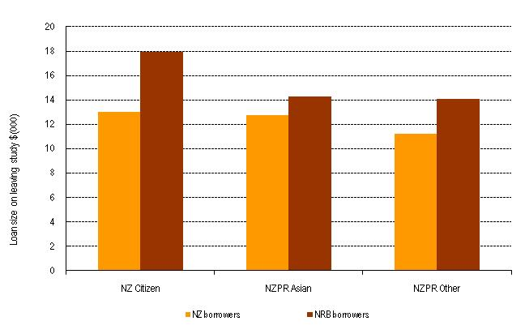
Source: Statistics New Zealand Integrated Dataset on Student Loans and Allowances. Interpretation: Ministry of Education.
Note: Those with unknown citizenship status are ignored.

Is there a relationship between loan size and going overseas?
The best way to look at the relationship between loan size and going overseas is to look at loan balance at the point at which each borrower leaves study. Clearly, those overseas left study with larger loans. But the extent of the difference is reduced when we control for the level of study. This is consistent with the findings of Smart (2006), who found there is a statistically significant relationship but the relationship between loan size and going overseas is relatively small. To estimate the strength of the relationship is beyond the scope of this study, but would involve controlling for a large number of study-related and demographic variables, as well as having information about the year of leaving New Zealand.

How much do those overseas owe?
The group of borrowers overseas on 10 April 2010 will include people who have been overseas ever since leaving study, while the group of New Zealand-based borrowers will include some who hadn’t ever been overseas. The first of those subgroups contains a relatively high proportion of non-compliant borrowers who don’t meet their repayment obligation, so this depresses the repayment rates of the NRB group, while the second subgroup acts to increase the repayment rate of the New Zealand-based borrowers. So all other things being equal, we would expect those overseas on any date to have larger loans than those in New Zealand on that date.
The data shows that those overseas have significantly higher loan balances than those in New Zealand. The 2010 annual report on the loan scheme states that the median loan held by those based overseas at 30 June 2010 was $17,901, as opposed to $10,657 for those in New Zealand (Ministry of Education, 2010).
One factor is that those overseas left study with larger loans. But the more important reasons relate to what happens after the borrower leaves New Zealand. One reason is that those in New Zealand have recently had the benefit of no interest on their loans. It is also relatively easy for people working in New Zealand to make repayments as, in most cases, their repayments are deducted from their earnings by their employers. Many of those overseas are travelling or in lower-paid jobs and are not in a position to make repayments, especially as they are not usually in regular contact with Inland Revenue. Many of those overseas have the benefit of a repayment holiday for part of their time after leaving study and so they accrue loan interest, often without any offsetting repayments.
And there is also lower compliance with repayment obligations among those overseas. This means that many of those overseas fall into default and have overdue repayments. Of all borrowers overseas in April 2010, nearly 34,500 NRB borrowers had overdue repayments on 30 June 2010, amounting to 40 percent of those overseas, whereas 12 percent of borrowers in New Zealand had overdue repayments (Ministry of Education, 2010). And the average overdue amount held by borrowers overseas was more than double the average for borrowers in New Zealand.
These figures mean that overseas-based borrowers have a disproportionate impact on the value of the loan scheme. It is for this reason that the Government announced a range of measures in 2010 aimed at addressing the problems caused by overseas-based borrowers.

What can we conclude about those overseas in April 2010?
Those who are overseas are disproportionately people aged between 25 and 34 who have studied at higher levels, often at a university, and have been successful in their studies. Within that group is the traditional OE group – young people who leave in the first five years following graduation, to gain experience of other countries. Those overseas are likely to have left study with larger loans than people who remain in New Zealand, but the margin is less pronounced when we control for the level of study.
Those who follow the traditional OE pattern will usually return within a reasonably short time and hence the benefits of their taxpayer-funded education won’t be lost to New Zealand. But many will stay away longer, meaning that their contribution to New Zealand’s development is lost and that they are more likely to default on their student loan repayment obligations.
So the most important questions to address are: How long do most people spend away? What are the demographic and study characteristics of those who stay away longer? How well do those overseas repay their loans? The next two chapters in this report address those questions within the limits of the data we currently have.

Those who left study in 2004 – Who went overseas?

Scope
In this section we look at the demographic and study-related characteristics of people whose last year of study was 2004, and compare them with those who are overseas with those who are New Zealand-based. It also allows us to look at who from this leaving cohort has gone overseas and returned.
People who left study in 2004 are a useful group for us to study. In 2004, 62.5 percent of all students and 76.7 percent of full-time students accessed the Student Loan Scheme (Ministry of Education, 2010). Much of this cohort still had a positive student loan balance at the time the Customs/Inland Revenue data match started in April 2007. Those borrowers had been out of study for two years before the data match started, so only a small proportion of them would have had the opportunity to have completed their OE before the data match started – meaning that, over time, we will get a comprehensive view of their travel patterns.

How many were overseas?
Around 47,000 people left study in 2004, having used the Student Loan Scheme at some stage during their study. Of these, 42,200 had a positive balance on 31 March 2005. Of those, 5,100 people repaid their loan by 31 March 2007, so would not have been included in the Customs match or assessed for overseas status by Inland Revenue. This analysis therefore concentrates on the 37,100 people who had a positive loan balance at some time from 31 March 2007 to 31 March 2010, the bottom two boxes in Figure 11 below.
Figure 11
People who left study in 2004
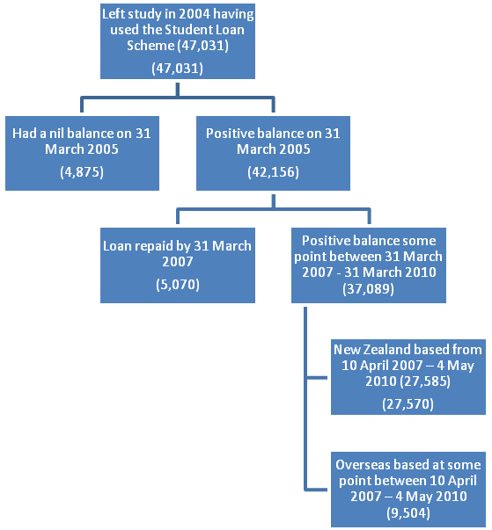
Of the 37,100 people with a positive balance, 26 percent were assessed by Inland Revenue as being overseas between 10 April 2007 and 31 March 2010, having been away for 184 days or more. This group of 9,500 people does not represent the full set of people that have spent time overseas from this leaving cohort. People may have left after study and returned by 10 April 2007, or may have repaid their student loan before going overseas.
The 2004 leavers with NRB status had similar demographic and study characteristics as the group described in Chapter 4. However, the 2004 leavers who had NRB status were more likely to have completed higher-level qualifications than the broader group of leavers discussed in Chapter 4. Of the 2004 leavers, 30 percent of those who were successful in completing and 38 percent of those who were successful at bachelors level or higher had a status of NRB, compared with 22 percent of all those who were not successful.
Figure 12
Student Loan Scheme borrowers who left study in 2004 and still had a positive balance at some point between 31 March 2007 and 31 March 2010: proportion of those with non-resident borrower status from 10 April 2007, by study characteristics – level of study and completion status
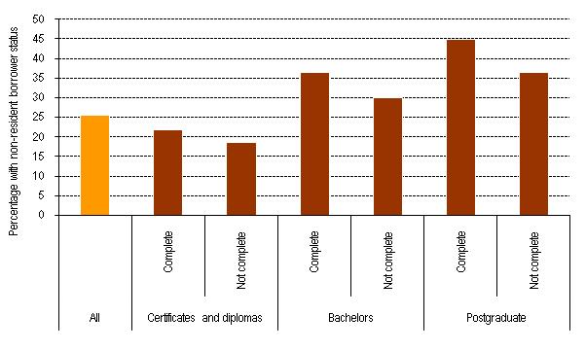
Source: Statistics New Zealand, Integrated Dataset on Student Loans and Allowances.

How much do those overseas owe?
For 2004 leavers, the median leaving loan balance for those with NRB status is higher than those who remained in New Zealand, with those overseas leaving study with a median balance of $17,600, compared with $10,800 for New Zealand-based borrowers, similar to the margin between the borrowers overseas and the New Zealand-based borrowers identified in section 4.5. Those overseas also made less progress on repaying their loans, paying back around 12 percent of their loans, compared with 47 percent for those in New Zealand.
The New Zealand-based 2004 leaving cohort has had the advantage of the interest-free student loan policy since 2006. Those overseas, on the other hand, accrued interest on their loans in 2005 and also for the period they had NRB status after April 2006. And, as mentioned in section 4.5, they may have been on a repayment holiday from April 2007, meaning no repayments were required. Over 55 percent of 2004 leavers with NRB status between April 2007 and March 2010 had a larger balance on 31 March 2010 than they did on 31 March 2005 after leaving study, compared with 21 percent of those without NRB status.
Figure 13
Leaving balance and balance at 31 March 2010 for Student Loan Scheme borrowers who left study in 2004: non-resident borrowers from 10 April 2007, compared with those who were New Zealand-based
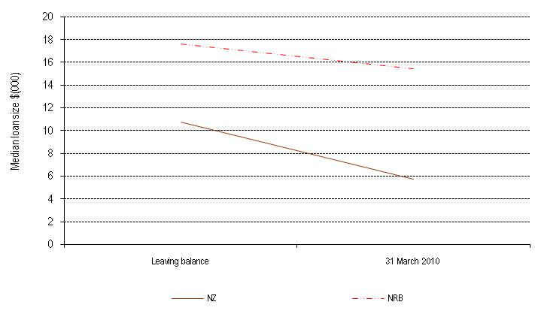Source: Statistics New Zealand, Integrated Dataset on Student Loans and Allowances.

Figure 14 below shows that, in general, the median leaving loan balance for 2004 leavers is lower among those aged over 35, as is the proportion of people with a status of NRB.
Figure 14
Non-resident Student Loan Scheme borrowers who left study in 2004 and were away from 10 April 2007: leaving balance for those with NRB status compared with those that were New Zealand-based, and the percentage of leavers with NRB status, by demographic characteristics – age group in 2010
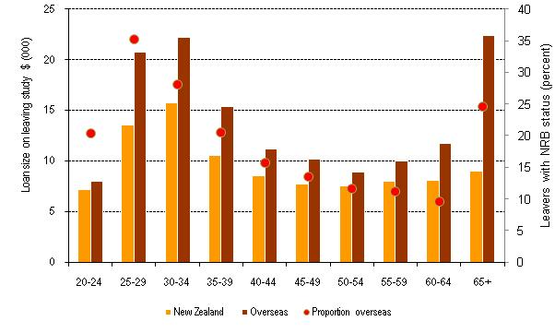
Source: Statistics New Zealand, Integrated Dataset on Student Loans and Allowances.
However, younger age groups are also more likely to have studied, and completed a qualification, at bachelors level or higher, meaning they are more likely to have larger loans. These younger age groups are also more ‘typical’ OE candidates. So it should not be assumed that it is larger loans that drive people overseas. It may instead be that the people who are more likely to go overseas are also more likely to have larger loans.
As with all leavers profiled in Chapter 4, the 2004 leavers who were overseas had bigger loans on leaving study than those who stayed in New Zealand. Almost half (47 percent) of the people with loans who remained in New Zealand had a balance on leaving study of less than $10,000, while 19 percent had loans greater than $25,000. But only 28 percent of the loans of those with NRB status at some stage were less than $10,000, while 34 percent had loans larger than $25,000.
Figure 15
Range of leaving loan balance for borrowers who left study in 2004: New Zealand-based borrowers compared with overseas-based borrowers who were away from 10 April 2007
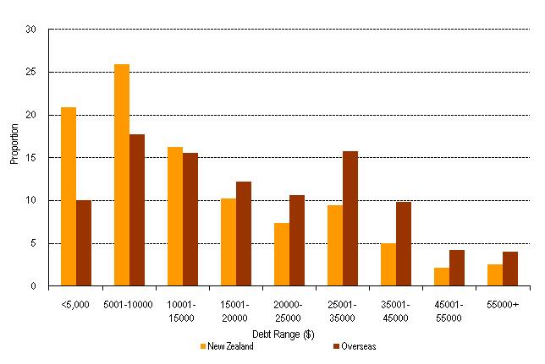
Source: Statistics New Zealand, Integrated Dataset on Student Loans and Allowances.
However, this may have more to do with the characteristics of the people who have gone overseas, rather than the amount of student loan. Males have a higher median loan amount and are more likely to go overseas. Completion status and level of study also play a part. A greater proportion of those who remained in New Zealand had incomplete lower-level qualifications, which are more likely to have a loan amount of less than $10,000, while borrowers overseas included a higher proportion of people with completed qualifications at bachelors and postgraduate level. Higher levels of study are associated with bigger loans, in large part because higher-level qualifications are likely to take longer to complete.
Figure 16
Leaving loan balances for borrowers who left study in 2004: New Zealand-based borrowers compared with overseas-based borrowers who were away from 10 April 2007, by qualification level and completion status
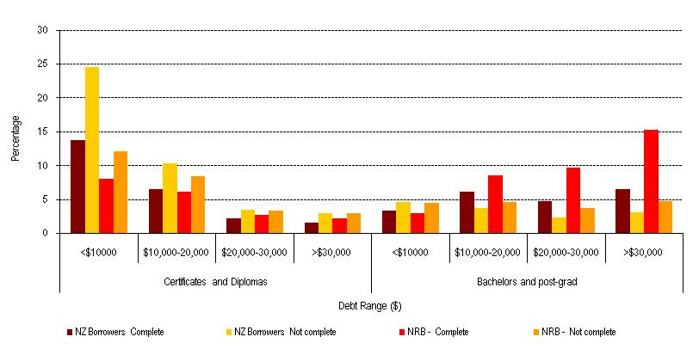
Source: Statistics New Zealand, Integrated Dataset on Student Loans and Allowances.
As mentioned in Smart (2006), larger debt levels may be overstated for those with NRB status as “borrowers with smaller student loan leaving balances may have repaid their loans before going overseas and would not be required to declare their residency status to Inland Revenue” (page 5). Furthermore, the ‘persons of interest’ list used for the Customs data match only included borrowers with a loan of more than $20 at the time of the match. This may result in overseas borrowers with small balances not being matched by Customs.

Who has returned?
One subgroup of particular interest is those who left study in 2004, went overseas and then returned by 31 March 2010. Looking at this subgroup gives an idea of the characteristics of people whose stay overseas is relatively short, and it enables us to get an idea of the proportion of those who take an OE who return to New Zealand within six years of leaving study.
Some NRB status information exists before the data match in 2007. However it is known to be an undercount of the number overseas because, before the data match, people were expected to declare themselves as non-resident on leaving New Zealand. Despite this, it is still useful to include these people in any analysis of 2004 leavers when looking at who was overseas, and who had returned by 31 March 2010.

Assumptions
Due to the undercount, Inland Revenue assigned some people an imputed departure date of 1 April 2007. For the purposes of this analysis, we have imputed time away from New Zealand for the 2004 leavers who were away from New Zealand when the data match started, using income in some instances. Where possible, the NRB status start date has been used. But where it is not possible, the last Customs departure date is sought. If we were unable to find a departure date, we assumed a borrower was overseas in previous, adjacent tax years where their income is less than $1,000. The basis of this assumption is that someone living in New Zealand is likely either to have earnings or to receive a benefit of more than $1,000 in a tax year. We use that to impute a leaving date. This is a reasonable proxy for the NRB status start date.

It is assumed that as 2004 is the cohort’s last year of study, they are all resident in New Zealand in that year. In reality, a person may have studied earlier in the year and left part-way through the year. There is also a handful of people with an NRB start date before 2004. It is possible to be overseas-based and study extramurally, and also possible to return to New Zealand, do a course and return overseas in a shorter length of time than is necessary to be considered New Zealand-based. Time overseas before leaving study has been discounted, so where the NRB start date or Customs departure date is before 2004 it was changed to 1 January 2004.

When did people leave New Zealand?
By 31 March 2010, 9,900 (27 percent) of the 37,100 2004 leavers had been non-resident borrowers at some stage after 2004. Of these, 7,100 people (72 percent) were still overseas on 31 March 2010. Their characteristics and student loan balances can be compared with those of the 2,800 people who went overseas but returned and the 27,200 people who have not been classified as NRB since their leaving year in 2004.

As can be seen in Figures 17 and 18 below, there is a marked seasonal pattern to when people leave New Zealand to go overseas. Most departures take place in the first half of the year, with fewer leaving in September and October. Particularly for those who are still overseas, there is also a wave of students who left in late 2004 and early 2005, likely shortly after completing study. There is also a very seasonal pattern to when people returned to New Zealand, shown in Figure 17. Spikes can be seen at the end of the year, particularly in December.
It is interesting that the distribution of leaving dates for those who had returned to New Zealand by 31 March 2010 (Figure 17) is similar to that of those who were still away (Figure 18). Half of the 2004 leavers with NRB status at some point left before August 2006.
Figure 17
Distribution of months that people left New Zealand and then returned – for people whose final year of study was 2004, who had non-resident borrower status after leaving study but had returned by 31 March 2010
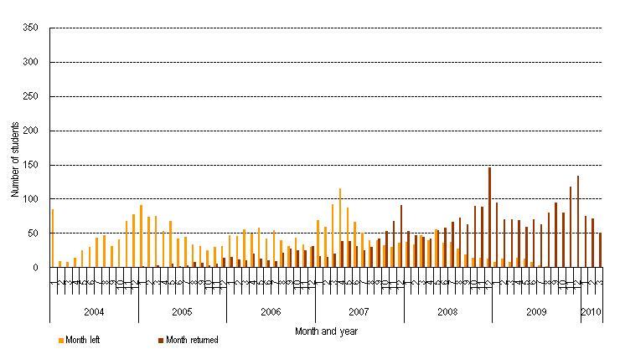
Source: Statistics New Zealand, Integrated Dataset on Student Loans and Allowances.
We can see in Table 2 below that the median time away for 2004 leavers who had returned by April 2010 was 18 to 24 months, while around 24 percent were away for more than three years.
Table 2
Length of time away for people who left New Zealand and then returned – for people whose final year of study was 2004, who had a status of NRB after leaving study but had returned by 31 March 2010
Time away | Count
Less than 12 months | 519
12-18 months | 504
18-24 months | 459
24-30 months | 354
30-36 months | 285
More than 36 months | 669
Total | 2,793
Source: Statistics New Zealand, Integrated Dataset on Student Loans and Allowances.
Note: All counts are randomly rounded to base 3. This may result in a total not agreeing with the sum of the individual items shown in the table.
Figure 18 shows that around 9 percent of borrrowers who left study in 2004 had a status of NRB by the start of 2007, and were still overseas on 31 March 2010. This represents over 55 percent of all those from this cohort with a status of NRB on 31 March 2010.
Figure 18
Distribution of months that people left New Zealand – for people whose final year of study was 2004 and who had non-resident borrower status on 31 March 2010
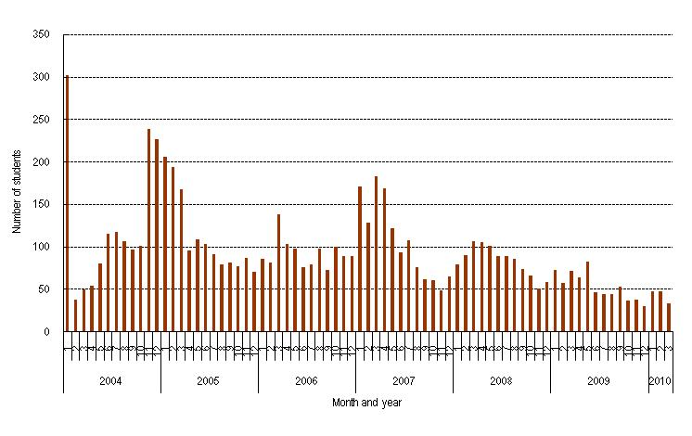
Source: Statistics New Zealand, Integrated Dataset on Student Loans and Allowances.
We can see in Table 3 below that the median length of time away for those who are still away is more than 36 months, much longer than for those who had returned.
Table 3
Length of time away for people who left New Zealand – for people whose final year of study was 2004 and who had non-resident borrower status on 31 March 2010
Time away | Count
Less than 12 months | 573
12-18 months | 381
18-24 months | 546
24-30 months | 450
30-36 months | 627
More than 36 months | 4,488
Total | 7,065
Source: Statistics New Zealand, Integrated Dataset on Student Loans and Allowances.
Note: All counts are randomly rounded to base 3. This may result in a total not agreeing with the sum of the individual items shown in the table.

Who left New Zealand?
Of people who left study in 2004 and had a status of NRB:
- males were slightly more likely than females to go overseas and still be overseas on 31 March 2010
- those of Asian ethnicity were more likely to go overseas and still be there by 31 March 2010, while those of European ethnicity were the most likely to have returned and those of Māori and Pasifika ethnicity were less likely to have had a status of NRB
- those aged 25 to 34 were more likely to go overseas but were also more likely to have returned by 31 March 2010.
Figure 19
Student Loan Scheme borrowers who left study in 2004: percentage of each demographic characteristic with non-resident borrower status, by demographic characteristics – sex, ethnicity, age group
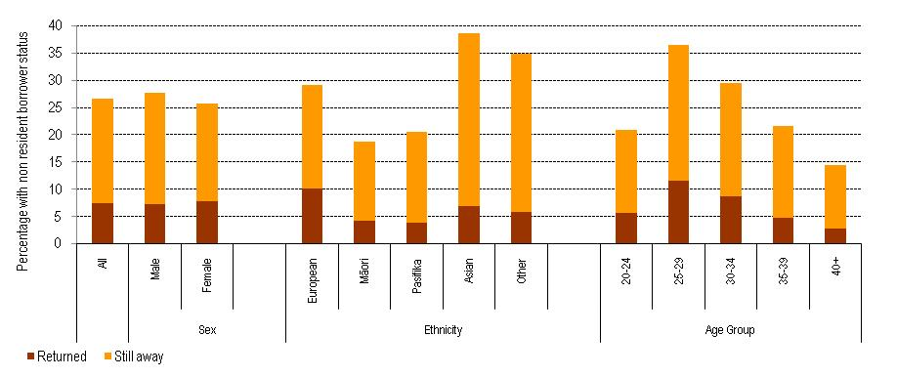
Source: Statistics New Zealand, Integrated Dataset on Student Loans and Allowances.
Figure 20
Student Loan Scheme borrowers who left study in 2004: percentage of each demographic characteristic with non-resident borrower status who returned to New Zealand by 31 March 2010, by demographic characteristics - sex, ethnicity, age group
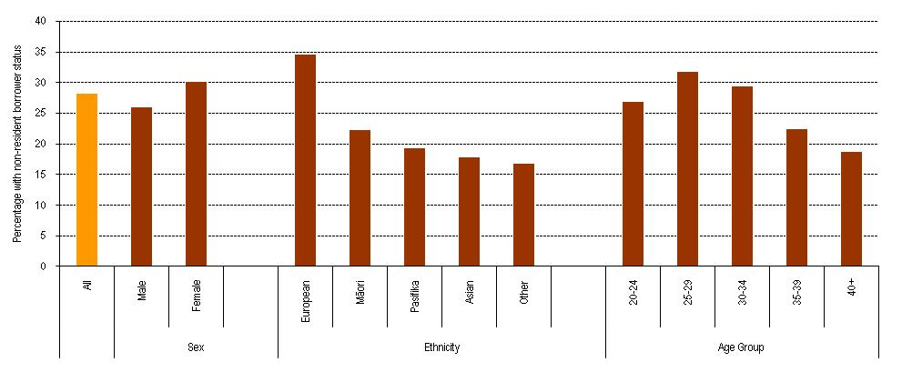
Source: Statistics New Zealand, Integrated Dataset on Student Loans and Allowances.
Figures 21 and 22 show the study characteristics of 2004 leavers who have had a status of NRB, and the likelihood that they had returned to New Zealand by 31 March 2010. Although people who studied at university, studied at bachelors level or above, and completed their qualification were more likely to go overseas, they were also more likely to have returned. As noted in section 4.3, people with higher qualifications are important to the economy. So, it is interesting to note that those who completed higher qualifications are no less likely to return to New Zealand.
Figure 21
Student Loan Scheme borrowers who left study in 2004: percentage of each study characteristic with non-resident borrower status, by study characteristics – provider type, level of study, completion status
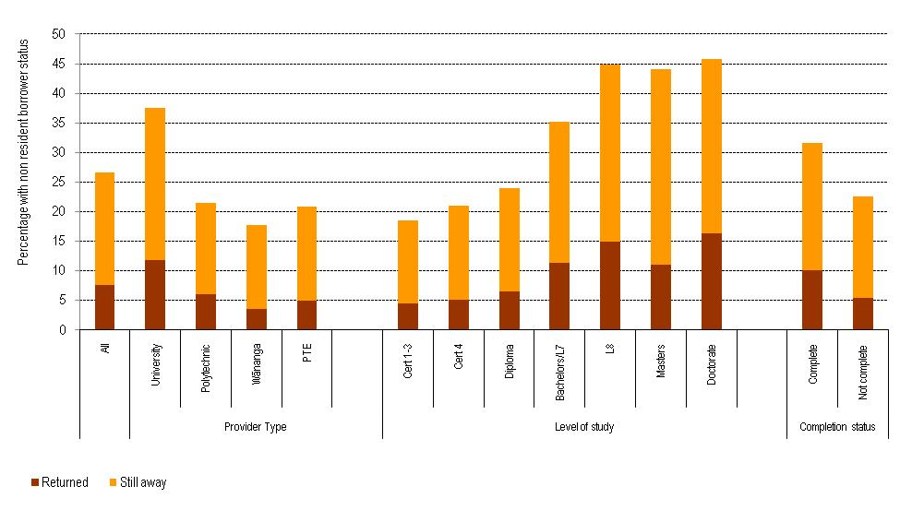
Source: Statistics New Zealand, Integrated Dataset on Student Loans and Allowances.

Figure 22
Student Loan Scheme borrowers who left study in 2004: percentage of each study characteristic with non-resident borrower status who returned to New Zealand by 31 March 2010, by study characteristics – provider type, level of study, completion status
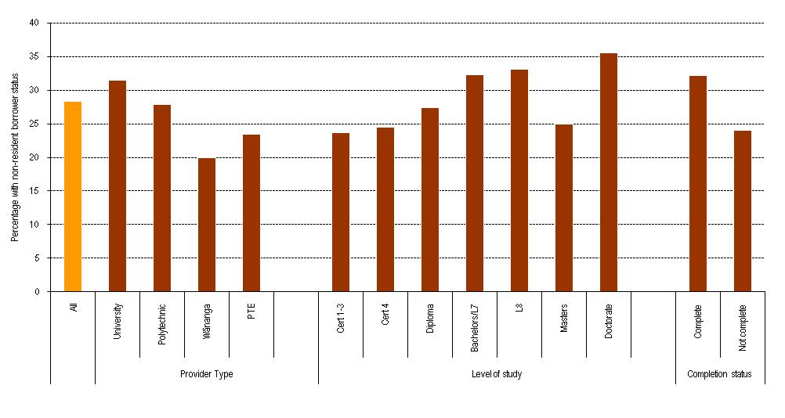
Source: Statistics New Zealand, Integrated Dataset on Student Loans and Allowances
As found in section 4.3, a further breakdown of level of study by completion status shows that people who completed a higher qualification were more likely to have a status of NRB than their counterparts who did not complete their qualification. People who studied at degree level or higher were also more likely to go overseas than those who studied below degree level, regardless of completion status.
However, it is important to note that people who completed their qualification were also more likely to have returned to New Zealand by 31 March 2010 than those who had not, as were people who studied at degree level or higher.
Figure 23
Student Loan Scheme borrowers who left study in 2004: percentage of each study characteristic with non-resident borrower status, by study characteristics – level of study, completion status
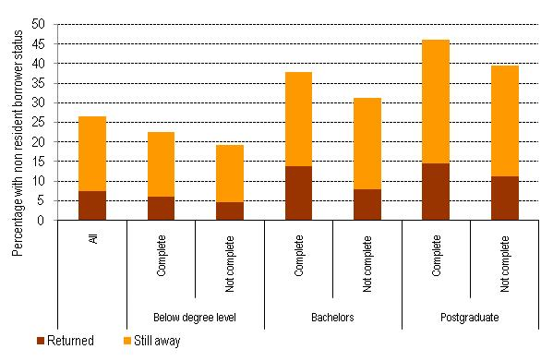
Source: Statistics New Zealand, Integrated Dataset on Student Loans and Allowances.
Those who had non-resident borrower status at some stage had larger loans on leaving study compared with those who had never had that status. There was a large drop in loan size five years after leaving study for the New Zealand-based people and among those who returned – showing the effects of interest-free loans and the relative ease of making repayments through the New Zealand tax system. The rate of repayment for those who returned was actually faster than the rate of repayment of those who never went overseas, probably because the returners were more likely to have completed higher-level qualifications and so were more likely to have higher earnings once they returned to New Zealand. Interestingly, there was a small drop in the median loan size for people who were still overseas, despite the fact that these people were accruing interest, many of them were in default and incurring penalties and many were taking advantage of a repayment holiday. But many of those still away had a larger loan balance on 31 March 2010 than they did on leaving study.
Figure 24
Student Loan Scheme borrowers who left study in 2004: median loan balance, by NRB status
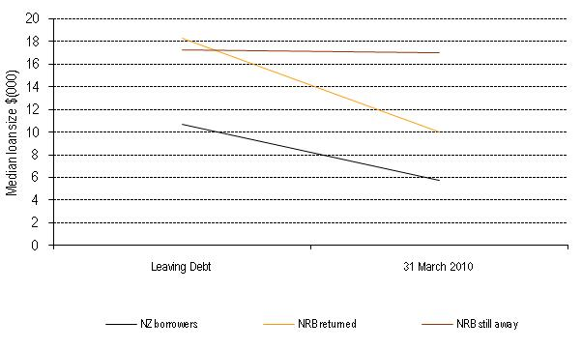
Source: Statistics New Zealand, Integrated Dataset on Student Loans and Allowances.

What can we conclude about 2004 leavers?
Those who went overseas from the 2004 leaving cohort had similar study, demographic and loan characteristics to those overseas among all borrowers. While people with degree level and higher qualifications are more likely to have a status of NRB, they do not seem to be more likely to stay overseas. A longer time series is needed for this cohort before we can look at who is more likely to stay away for extended periods.
The benefits of the 2006 policy giving interest-free loans for New Zealand-based students can be clearly seen for the 2004 leaving cohort. The people who had gone overseas and were still away on 31 March 2010 had made less progress on repaying their student loans; in fact, many owe more than when they left study. While people who have a status of NRB appear to have a higher student loan, this may be because those who are more likely to go overseas have a higher loan, rather than higher debt ‘driving’ people offshore.

Who returned to New Zealand between 2007 AND 2010?

Scope
The aim of this section is to take a closer look at the people who have returned to New Zealand between 10 April 2007 and 31 March 2010, having had non-resident borrower status. This group includes people who may have been away for some time, as well as people who have had a shorter period overseas. In comparing the demographic and study characteristics of the different groups, we can start to form some idea of the types of borrowers who have been away and returned, and of the people who have returned after being away for only a short period of time.

Who returned to New Zealand?
Around 379,500 people used the Student Loan Scheme and left study between 1999 and 2008 and still had a balance sometime between 31 March 2007 and 31 March 2010. These people can be divided into the following four categories:
Table 4
People who left study after 1999, categorised by NRB status
Category | Explanation | Count | Percentage
Never NRB | Have never had a status of NRB | 287,100 | 75.6
NRB – returned by 10 April 2007 | Had a status of NRB but had returned to New Zealand before 10 April 2007 | 11,499 | 3.0
NRB – returned | Had a status of NRB but returned to New Zealand between 10 April 2007 and 31 March 2010 | 21,294 | 5.6
NRB – still away | Had a status of NRB and were still NRB on 31 March 2010 | 59,649 | 15.7
Total |  | 379,542
Source: Statistics New Zealand, Integrated Dataset on Student Loans and Allowances.
Note: All counts are randomly rounded to base 3. This may result in a total not agreeing with the sum of the individual items shown in the table.
The analysis in this section will focus on the 21,300 people who have returned to New Zealand between 10 April 2007 and 31 March 2010. This group makes up 6 percent of the 379,500 people who have left study having used the Student Loan Scheme. They can be compared with the 287,100 people who have never had a status of non-resident borrower, and the 59,600 people who were still away at 31 March 2010.
The characteristics of the people who returned to New Zealand are a function of the characteristics of the people who left. Because of this, those who returned will be profiled by comparing them with the people who were still away on 31 March 2010. The 21,300 people who returned represent 26 percent of those with NRB status on or after 10 April 2007.
In Figure 25 we look at the characteristics of those who had a status of NRB on or after 10 April 2007. Figure 26 then shows the proportion of the people who were NRB and had returned by 31 March 2010. Of the people who had a status of NRB on or after 10 April 2007, those who returned between 10 April 2007 and 31 March 2010 were:
- slightly more likely to be female – 27 percent of females returned compared with 25 percent of males. As can be seen in Figure 25, males were more likely to be overseas
- more likely to be of European ethnicity than Māori, Pasifika or Asian ethnicity – 32 percent of borrowers of European ethnicity returned to New Zealand during this period, compared with 21 percent of Māori, 19 percent of Pasifika and 19 percent of those of Asian ethnicity. Those of Asian ethnicity were more likely to have a status of NRB
- more likely to be aged between 25 and 34 years, and less likely to be aged 40 years or over – 29 percent of borrowers aged between 25 and 34 years had returned, compared with 27 percent of those under 25 and 18 percent of those aged 40 years or over
- more likely to be a New Zealand citizen and less likely to be a New Zealand permanent resident – 28 percent of New Zealand citizens had returned, compared with 22 percent of Asian permanent residents and 18 percent of other permanent residents.

Figure 25
Student Loan Scheme borrowers: percentage of all borrowers of a particular demographic with non-resident borrower status on or after 10 April 2007, by who had returned by 31 March 2010 and who was still away, by demographic characteristics – sex, ethnicity, age group, citizenship
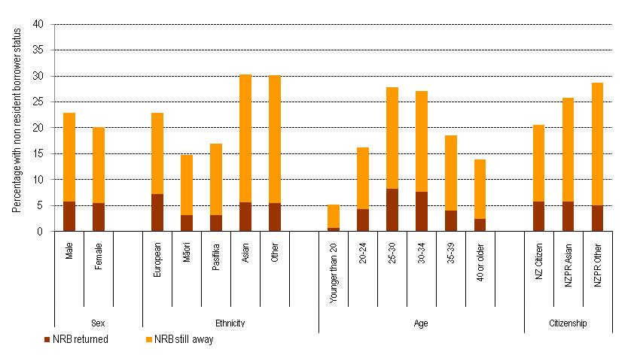
Source: Statistics New Zealand, Integrated Dataset on Student Loans and Allowances.

Figure 26
Student Loan Scheme borrowers: percentage of those with non-resident borrower status on or after 10 April 2007, who had returned by 31 March 2010, by demographic characteristics - sex, ethnicity, age group, citizenship
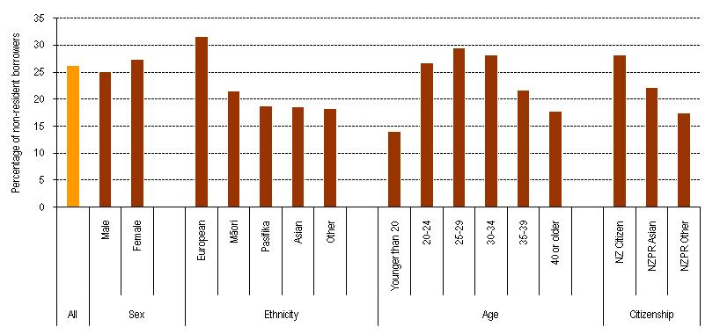
Source: Statistics New Zealand, Integrated Dataset on Student Loans and Allowances.

Of the people who had a status of NRB on or after 10 April 2007, those who returned between 10 April 2007 and 31 March 2010 were:
- more likely to have studied at a university or polytechnic and less likely to have studied at a wānanga – 28 percent of non-resident borrowers who studied at a university returned to New Zealand during this period, compared with 26 percent of those at a polytechnic, 24 percent at a PTE and 20 percent at a wānanga. People who studied at a university were more likely to have a status of NRB, as seen in Figure 27 below
- more likely to have studied at honours/postgraduate certificate/diploma or bachelors level and less likely to have studied at doctorate or masters level – 30 percent of those with NRB who studied at honours/postgraduate certificate/diploma level and 29 percent who studied at bachelors level returned, compared with 23 percent of those who studied at masters and doctorate levels
- more likely to have completed their qualifications – 29 percent of those with NRB who had completed their qualification had returned, compared with 24 percent of those who did not.
Figure 27
Student Loan Scheme borrowers: percentage of a particular demographic with non-resident borrower status on or after 10 April 2007, who had returned by 31 March 2010 and who was still away, by study characteristics - provider, level, completion status
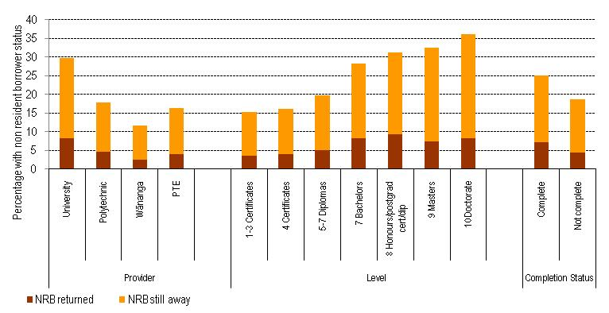
Source: Statistics New Zealand, Integrated Dataset on Student Loans and Allowances.

Figure 28
Student Loan Scheme borrowers: percentage of those with non-resident borrower status on or after 10 April 2007, who had returned by 31 March 2010, by study characteristics – provider, level, completion status
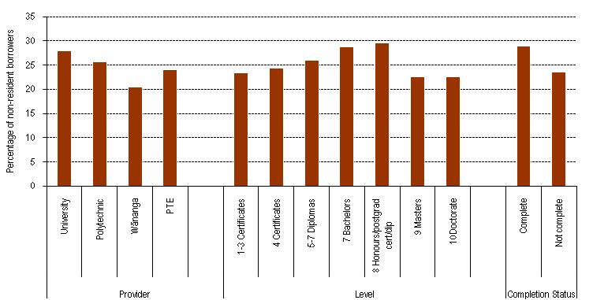
Source: Statistics New Zealand, Integrated Dataset on Student Loans and Allowances.

The demographic and study characteristic results suggest that, in some cases, if a group has a low propensity to go overseas, the people from that group who do go overseas are more likely to stay away, for example, people of Māori and Pasifika ethnicity, and those aged 35 years and over.

Level of study by completion status
While there is some difference in who is more likely to have returned between those who completed and those who did not, there is no clear pattern across level of study. As we can see in Figure 29 below, for every level except doctorates, a higher proportion of those who had NRB status and had completed their qualification returned to New Zealand than those who did not complete.
Figure 29
Student Loan Scheme borrowers: percentage of those with non-resident borrower status on or after 10 April 2007, who had returned by 31 March 2010, by study characteristics – level of study, completion status
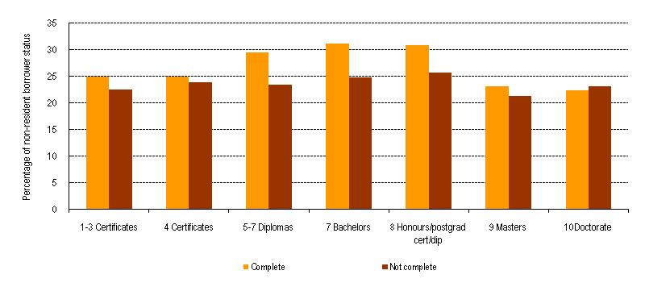
Source: Statistics New Zealand, Integrated Dataset on Student Loans and Allowances.

Loan size
As found in sections 4.4 and 5.4, those with a status of NRB had a higher median leaving loan than those who were New Zealand-based. The loan balances of people who returned between 10 April 2007 and 31 March 2010 started off similar to those who were still away, but behaved more like those who stayed in New Zealand, with a comparable decrease in median loan size compared with their leaving balances.
New Zealand-based borrowers had a median leaving debt of $10,510, which dropped to $6,960 (34 percent) by 31 March 2010, while those who had a status of NRB and returned had a median leaving loan of $17,660, which dropped to $10,960 (33 percent). However, those with NRB status who had not returned had a median leaving loan of $16,540 and this had increased by 5 percent to $17,280.
It is not possible in this study to determine if the people who have returned have made more payments towards their student loan while overseas, or if the faster rate of repayment is due to their return to New Zealand, or a combination of the two. Some may also have been eligible for the late payment amnesty, where Inland Revenue reversed late payment penalties for some non-resident borrowers. One reason there may be an increase in loan size compared with the decrease for those who returned is that while both groups were away at some point from 10 April 2007, those who returned to New Zealand would make repayments through the PAYE system if they were employed, and be able to take advantage of the interest-free policy.
Figure 30
Median leaving balance and balance at 31 March 2010 for Student Loan Scheme borrowers who returned to New Zealand between 10 April 2007 and 31 March 2010, compared with non-resident borrowers who were still away and those that were New Zealand-based
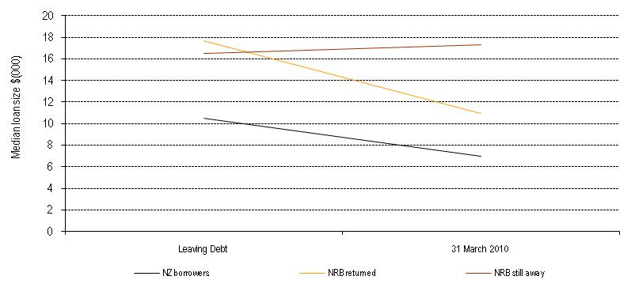
Source: Statistics New Zealand, Integrated Dataset on Student Loans and Allowances.
The difference in repayments can also be seen when we look at these three groups broken down by level and completion status, as seen in Figure 31 below. At the aggregate level, people who studied at any level and with either completion status make progress on repaying their student loan if they were New Zealand-based or if they returned from overseas.
On average, those who returned tend to repay at a faster rate than those who never went overseas, possibly because they are more likely to have the higher-level qualifications that lead to higher earnings. However, most of those who returned still owed more on 31 March than people who had never had NRB status.
The majority of the people who were still NRB owed more on 31 March 2010 than they owed when they left study – because of the effects of interest, repayment holidays and, in many cases, non-compliance and consequent penalties. Of those still based overseas, only those who studied above degree level and completed their qualification had decreased their median loan amount.
It is not possible to analyse all of the reasons for this difference. When we have a longer time series we will be able to form a better idea about whether this is a result of the length of time that people are away, or if they are defaulting on their payments, or if demographic or study characteristics are having effects.
Figure 31
Median leaving balance and balance at 31 March 2010 for Student Loan Scheme borrowers who returned to New Zealand between 10 April 2007 and 31 March 2010, compared with non-resident borrowers who were still away and those that were New Zealand-based, by study characteristics – level of study and completion status
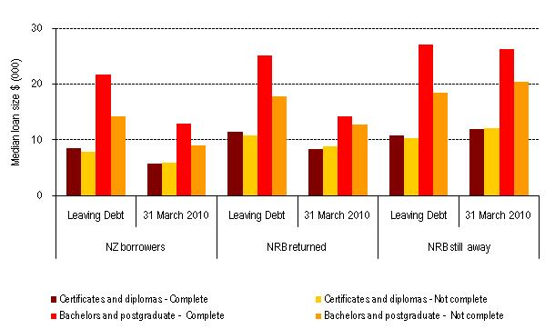
Source: Statistics New Zealand, Integrated Dataset on Student Loans and Allowances.

Duration away
It would be useful to know how long people who have had NRB status were away from New Zealand. While it will be some years before the time series of quality information is long enough to do a complete analysis of duration away, we can look at the distribution of when people left compared with when they returned for those who returned between 10 April 2007 and 31 December 2009.
In Table 7 below we can see that, of the people who returned in 2009, 44 percent left from 2008 onwards, and were therefore overseas for a reasonably short time.
Table 5
Student loan borrowers who returned to New Zealand between 10 April 2007 and 31 December 2009: year students left New Zealand and the year they returned
 | Year returned to New Zealand
Year left New Zealand | 2007 | 2008 | 2009
1999-2006 | 2,604 | 3,375 | 2,733
2007 | 1,239 | 2,856 | 2,133
2008 | . | 597 | 3,189
2009 | . | . | 666
2010 | . | . | .
Source: Statistics New Zealand, Integrated Dataset on Student Loans and Allowances.
Note: This analysis excludes people whose departure date cannot be accurately determined. This means that the number of returners will not agree with the numbers in Table 4 above. All counts are randomly rounded to base 3. This may result in a total not agreeing with the sum of the individual items shown in the table. Note that counts are skewed towards later years as the numbers borrowing are larger in later years.

Who went away for three years or less?
As we have a reliable NRB status end date for the people who have returned between 10 April 2007 and 31 March 2010, we can look at the duration away for this group. It is again possible to look at the demographic and study characteristics of these people, and we look to see who is more likely to stay away for more than three years. For this section, the 2,200 people with an imputed leaving date of 1 April 2007 have been excluded as this date is known to be incorrect, so we do not know how long they have been away.
Overall, 69 percent of the people who returned over this period were away for less than three years. This does not mean that 69 percent of the people who go overseas and have a status of NRB are likely to return before three years is up. Rather it means that, of those who returned over this period, more than two-thirds went for only a short period of time.
As can be seen in Figure 32 below, there is little variation in who is likely to stay for more than three years across sex and ethnicity. However, there is considerable variation across age groups, with 97 percent of those aged less than 25 years who returned having a status of NRB for less than three years. This fits the idea of a typical OE, where a young person goes overseas for a couple of years but returns to New Zealand after this period. This age group is less likely to leave in the first place and reasonably likely to return. Those aged 25 to 34 years are similar to the overall population but only 52 percent of those aged 30 to 34, and 47 percent of those aged 35 to 39 years who returned were away for less than three years.
There is also some variation across citizenship, with 88 percent of Asian New Zealand permanent residents and 78 percent of other New Zealand permanent residents who returned doing so after being away for less than three years. This is greater than the 69 percent of New Zealand citizens who returned. We have seen that New Zealand permanent residents are more likely to go overseas and less likely to return, but the majority of those who had returned did so after a short period.
Figure 32
Student Loan Scheme borrowers who returned between 10 April 2007 and 31 March 2010: percentage of a particular demographic who were away for less than three years and more than three years, by demographic characteristics – sex, ethnicity, age group, citizenship
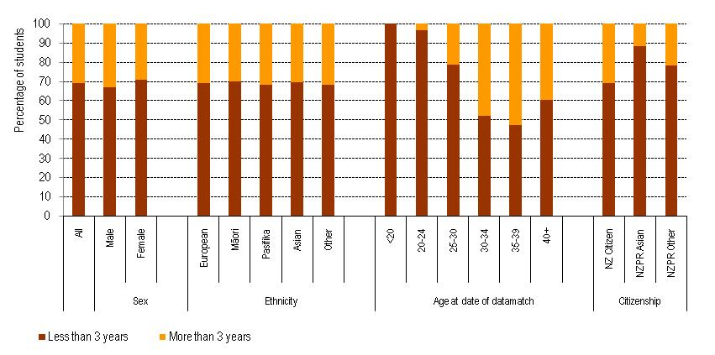
The proportion of the people who returned who were away for three years or less was fairly constant across provider types, ranging from 67 percent for universities to 75 percent for wānanga. This is somewhat surprising because level of study and completion status make a difference to the propensity to go overseas, and differences in level of study are often apparent in provider type.
The higher the level of study, the larger the proportion of people who returned who were away for longer than three years, as shown in Figure 33 below. Generally speaking, people who did not complete their qualifications were more likely to have been away for longer than three years across most levels.
The pattern among those who studied at doctorate level reflects the career path of those who aspire to research or academic careers. It is common for those who gain a PhD to work as a post-doctoral fellow in the first few years following graduation and, in many cases, this post-doctoral work is completed overseas, but often as a stepping stone to a research or academic post in New Zealand. This is likely to be the reason for the larger proportion of doctoral graduates who returned after being away for more than three years.
The high proportion of those with incomplete doctorates and those with masters degrees who come back after an extended period may also be an indication of people who have finished their postgraduate studies at universities overseas.

Figure 33
Student Loan Scheme borrowers who returned between 10 April 2007 and 31 March 2010: percentage of a particular demographic who were away for less than three years and more than three years, by study characteristics – level of study and completion status
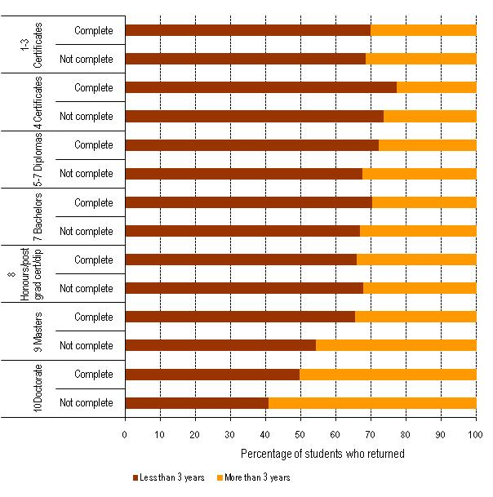
There is surprisingly little variation in the proportion of people who returned who were away for less than three years when we look at field of study, with perhaps the exception of Information Technology, which had proportionally more people who returned after more than three years. Figures 5a and 5b in Chapter 4 found considerable difference in the proportion of those who studied at bachelors level or higher and who had non-resident borrower status for different fields of study. It is interesting that, despite this, the field studied does not seem to influence the length of time these people who had returned were away.
Figure 34
Student Loan Scheme borrowers who returned between 10 April 2007 and 31 March 2010: percentage of a particular demographic who were away for less than three years and more than three years, by study characteristics – field of study and completion status
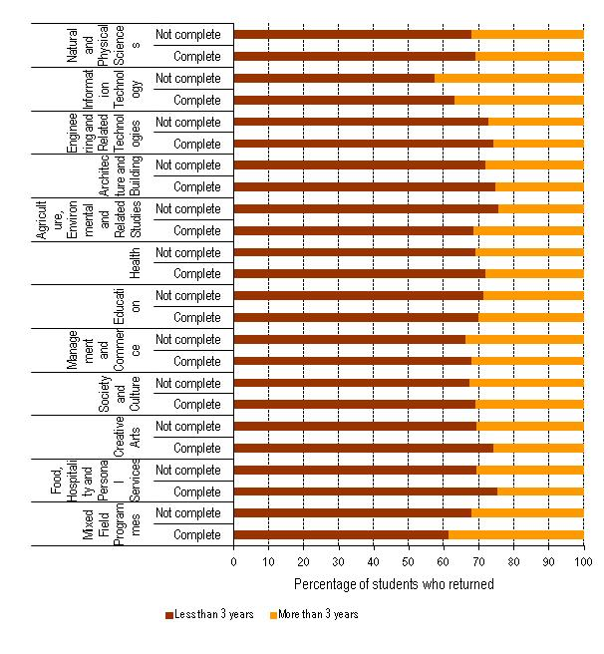

What can we conclude about the people who returned?
Overall, of the people who had a status of NRB on or after 10 April 2007, 26 percent had returned to New Zealand by 31 March 2010. What is particularly interesting is that there does not seem to be bias in the pattern of return; generally speaking, the characteristics of the people more likely to go overseas are reflected in the characteristics of those who returned. Those who return make substantial progress on their repayments compared with those who are still away, particularly those who completed their qualification. We also found that almost 70 percent of people who returned had been away for three years or less.

With this information, we start to build up a profile of the people who have been overseas and have returned to New Zealand. As the time series grows, we can get a better idea of the time people spend overseas.

Conclusion

The context
The ‘overseas experience’, or OE, is a New Zealand tradition, especially among the young and among those who complete tertiary study. There are benefits to our country from people spending some time working in other countries. But if people stay away for extended periods, there is a relatively lower probability of their returning and contributing to our economy the skills they have acquired in their education. So we need good information on the characteristics of the educated young New Zealanders who go overseas, the extent to which they leave New Zealand, the length of their time away and the likelihood of losing people permanently.
Another reason for analysing trends in overseas departures by young educated people is to improve the management of the loan scheme. The Student Loan Scheme is a major area of government cost and an important government financial asset. The loan scheme – and, in particular, meeting the costs of deterioration in the value of the asset – is one of the major components of tertiary education expenditure. The major causes of the loss of value are low repayment rates and the extent of non-compliance with repayment expectations. Those overseas tend to be poor repayers and many overseas-based borrowers don’t comply with their repayment obligations. So we need better information on which borrowers are overseas if we are to target initiatives designed to improve repayment rates by those overseas.

This report
This report uses data from the matching of information on border crossings with data on student loans to look at:
- the characteristics of loan scheme borrowers who were based overseas on 10 April 2010
- those who left study in 2004 and were overseas-based at some point in the period 10 April 2007 to 31 March 2010, and at who from this group returned to New Zealand
- the characteristics of those who returned from overseas and became New Zealand-based during the period 10 April 2007 to 31 March 2010 – and what we know about their duration overseas.

Key findings
The most important messages to take from the findings in this report are:
- At any point in time, a high proportion of borrowers will be overseas-based. Many of them match the characteristics we think of as associated with the New Zealand tradition of OE – they tend to be reasonably young and have completed a tertiary qualification.
- Of those who were found to have returned, most did so after a reasonably short period – three years or less. But a large proportion had been away for longer than three years and was still based overseas at the end of our data series.
- And there were few distinctive characteristics of the returners that mark them out from those who stay away.
- Those who go away have slightly larger loans than those who remain in New Zealand. While those overseas have poor repayment records overall, those who return make good progress in repaying loans. On average, those who stay overseas for an extended period see their loan balances rise, not decrease, over time.

Future research and analysis in this area
To get a good idea of patterns of overseas travel by graduates will take time. People can travel overseas immediately following study or after a delay while they earn money for travel or build a career. A number of those overseas return quickly – within three years – but others stay away for a good many years. And it appears that those who stay away for six years or more have a high probability of staying away for many years, or forever.
This means that we need a long time series if we are going to explore these questions more deeply – we need the time series to mature, so we can look at those who left study after the data match started and track their departures from and returns to New Zealand over six years or more. For us to do this, three or more new cohorts of Inland Revenue/Customs data match records to be added to our dataset.
So over the next few years we expect to be able to enlarge on and deepen this baseline analysis.
Quantitative studies of borrower behaviour will only ever tell us part of the story, however – it is essential to scope an issue and to identify areas of interest. The kind of analysis set out in this paper and envisaged for this series ultimately needs to be complemented by qualitative work to establish the range of motivations behind the behaviour mapped by analysis of the administrative data.

- data tables

Table 1
Student Loan Scheme borrowers who left study between 1999 and 2008: proportions of those with non-resident borrower status at 10 April 2010, by selected borrower categories
 | All borrowers | NRB on 10 April 2010 | Percent with NRB status
Total | 321,765 | 61,827 | 19
Sex
Male | 138,981 | 29,772 | 21
Female | 182,784 | 32,058 | 18
Ethnic group
European | 158,976 | 31,326 | 20
Māori | 73,038 | 9,891 | 14
Pasifika | 28,734 | 4,641 | 16
Asian | 34,527 | 10,215 | 30
Other | 12,798 | 3,807 | 30
Unknown | 13,689 | 1,950 | 14
Age group in 2010
Younger than 20 | 3,162 | 141 | 4
20-24 | 55,041 | 7,020 | 13
25-29 | 91,005 | 21,291 | 23
30-34 | 64,947 | 16,065 | 25
35-39 | 36,579 | 6,822 | 19
40 or older | 71,028 | 10,488 | 15
Citizenship status
New Zealand citizen | 269,538 | 48,717 | 18
New Zealand permanent resident – Asian | 4,506 | 1,047 | 23
New Zealand permanent resident – other | 5,919 | 1,608 | 27
Subsector of study
University | 111,063 | 29,430 | 26
Polytechnic | 103,701 | 17,286 | 17
Wānanga | 17,001 | 1,887 | 11
Private training establishment | 90,000 | 13,224 | 15
Completion status
Completed qualification | 136,491 | 29,562 | 22
Did not complete qualification | 185,271 | 32,265 | 17
Level of study and completion status
Certificates and diplomas – complete | 64,707 | 10,446 | 16
Certificates and diplomas – not complete | 109,497 | 16,578 | 15
Bachelors – complete | 54,216 | 13,794 | 25
Bachelors – not complete | 38,583 | 8,919 | 23
Postgraduate – complete | 17,298 | 5,256 | 30
Postgraduate – not complete | 6,660 | 1,794 | 27

Table 2
Student Loan Scheme borrowers who left study between 1999 and 2008: proportions of those who studied at bachelors level or higher and who had non-resident borrower status at 10 April 2010, by field of study and completion status
Field of study | Completion status | All borrowers | NRB on 10 April 2010 | Percent of NRB who returned
Natural and physical sciences | complete | 5,928 | 2,040 | 34
Natural and physical sciences | not complete | 4,767 | 1,314 | 28
Information technology | complete | 1,584 | 417 | 26
Information technology | not complete | 1,842 | 435 | 24
Engineering and related technologies | complete | 3,072 | 918 | 30
Engineering and related technologies | not complete | 1,140 | 333 | 29
Architecture and building | complete | 1,137 | 324 | 28
Architecture and building | not complete | 459 | 102 | 22
Agriculture, environmental and related studies | complete | 816 | 201 | 25
Agriculture, environmental and related studies | not complete | 543 | 129 | 24
Health | complete | 9,414 | 2,307 | 25
Health | not complete | 3,915 | 750 | 19
Education | complete | 12,453 | 1,773 | 14
Education | not complete | 4,110 | 621 | 15
Management and commerce | complete | 12,540 | 4,227 | 34
Management and commerce | not complete | 9,459 | 2,736 | 29
Society and culture | complete | 13,665 | 3,843 | 28
Society and culture | not complete | 13,203 | 3,072 | 23
Creative arts | complete | 7,110 | 1,770 | 25
Creative arts | not complete | 3,447 | 696 | 20
All fields | complete | 52,467 | 19,050 | 27
All fields | not complete | 34,536 | 10,713 | 24

Table 3
Distribution of size of loans on leaving study and at 31 March 2010, by whether New Zealand-based or non-resident at 10 April 2010
Percentile of loan size | NZ-based borrowers |  | Non-resident borrowers
Percentile of loan size | Leaving debt ($) | Debt at 31 March 2010 ($) | Leaving debt ($) | Debt at 31 March 2010 ($)
10th | 3,410 | 1,650 | 4,620 | 4,290
25th | 6,560 | 4,490 | 8,430 | 8,820
Median | 12,530 | 9,700 | 16,870 | 18,280
75th | 24,170 | 19,890 | 30,150 | 34,050
90th | 38,580 | 33,800 | 44,230 | 52,660

Table 4
Median size of loan on leaving study and at 31 March 2010, by selected borrower categories and whether New Zealand-based or non-resident at 10 April 2010
 | All borrowers |  |  | NZ-based borrowers |  |  |  | Non-resident borrowers
 | Leaving debt ($) |  | Debt at 31 March 2010 ($) | Leaving debt ($) |  | Debt at 31 March 2010 ($) |  | Leaving debt ($) | Debt at 31 March 2010 ($)
Sex
Male | 13,800 |  | 11,360 | 12,940 |  | 9,920 |  | 17,600 | 19,320
Female | 12,910 |  | 10,620 | 12,280 |  | 9,550 |  | 16,280 | 17,430
Ethnic group
European | 15,500 |  | 11,840 | 14,440 |  | 10,470 |  | 20,270 | 20,100
Māori | 10,670 |  | 9,470 | 10,440 |  | 8,810 |  | 12,420 | 14,400
Pasifika | 11,860 |  | 10,540 | 11,700 |  | 9,770 |  | 12,750 | 15,870
Asian | 15,100 |  | 13,830 | 14,770 |  | 11,710 |  | 16,030 | 20,040
Age group in 2010
Younger than 20 | 6,570 | 6,220 |  |  | 6,600 |  | 6,210 | 6,170 | 6,440
20-24 | 10,350 | 8,910 |  |  | 10,120 |  | 8,550 | 11,800 | 12,080
25-29 | 16,680 | 13,390 |  |  | 15,990 |  | 11,900 | 19,200 | 18,780
30-34 | 18,800 | 14,970 |  |  | 17,770 |  | 12,700 | 21,860 | 24,600
35-39 | 13,650 | 10,920 |  |  | 12,960 |  | 9,540 | 16,940 | 20,160
40 or older | 9,500 | 8,170 |  |  | 9,220 |  | 7,480 | 11,000 | 14,320
Citizenship
New Zealand citizen | 13,730 |  | 11,150 | 13,000 |  | 10,000 |  | 17,950 | 18,630
New Zealand permanent resident – Asian | 13,040 |  | 12,530 | 12,720 |  | 11,320 |  | 14,250 | 15,540
New Zealand permanent resident – other | 11,870 |  | 11,030 | 11,250 |  | 9,560 |  | 14,070 | 16,520
Provider type
University | 22,010 |  | 17,480 | 21,510 |  | 15,350 |  | 23,480 | 24,560
Polytechnic | 10,180 |  | 8,270 | 9,910 |  | 7,500 |  | 11,600 | 13,290
Wānanga | 9,690 |  | 8,550 | 9,580 |  | 8,180 |  | 10,680 | 12,270
Private training establishment | 10,500 |  | 9,450 | 10,170 |  | 8,640 |  | 12,680 | 14,960
Level of study and completion status
Certificates and diplomas – complete | 10,130 |  | 8,380 | 9,930 |  | 7,730 |  | 11,190 | 12,610
Certificates and diplomas – not complete | 9,270 |  | 8,120 | 9,040 |  | 7,560 |  | 10,440 | 12,620
Bachelors and postgraduate – complete | 26,050 |  | 20,600 | 25,570 |  | 18,410 |  | 27,390 | 27,480
Bachelors and postgraduate – not complete | 17,830 |  | 15,030 | 17,480 |  | 13,270 |  | 19,060 | 21,470

Table 5
Student Loan Scheme borrowers who left study in 2004 and had a positive balance at some stage between 31 March 2007 and 31 March 2010: proportion of those with non-resident borrower status at any time between 10 April 2007 and 10 April 2010, by selected borrower categories
 | All borrowers | NRB | Percent with NRB status
Total | 37,089 | 9,504 | 26
Sex
Male | 16,263 | 4,350 | 27
Female | 20,829 | 5,154 | 25
Ethnic group
European | 19,341 | 5,394 | 28
Māori | 8,370 | 1,521 | 18
Pasifika | 3,315 | 657 | 20
Asian | 3,471 | 1,302 | 38
Other | 1,395 | 474 | 34
Unknown | 1,191 | 156 | 13
Age group in 2010
20-24 | 3,129 | 636 | 20
25-29 | 12,753 | 4,491 | 35
30-34 | 7,752 | 2,184 | 28
35-39 | 4,599 | 948 | 21
40 or older | 8,853 | 1,251 | 14
Citizenship status
New Zealand citizen | 31,728 | 7,860 | 25
New Zealand permanent resident – Asian | 162 | 78 | 49
New Zealand permanent resident – other | 459 | 231 | 50
Subsector of study
University | 12,882 | 4,632 | 36
Polytechnic | 12,054 | 2,496 | 21
Wānanga | 2,607 | 444 | 17
Private training establishment | 9,543 | 1,932 | 20
Completion status
Completed qualification | 16,512 | 5,025 | 30
Did not complete qualification | 20,580 | 4,482 | 22
Level of study and completion status
Certificates and diplomas – complete | 7,911 | 1,731 | 22
Certificates and diplomas – not complete | 12,957 | 2,412 | 19
Bachelors – complete | 6,531 | 2,373 | 36
Bachelors – not complete | 4,503 | 1,353 | 30
Postgraduate – complete | 2,046 | 915 | 45
Postgraduate – not complete | 630 | 231 | 36

Table 6
Student Loan Scheme borrowers who left study in 2004 and had a positive balance at some stage between 31 March 2007 and 31 March 2010: percentage of each demographic characteristic with non-resident borrower status by who had returned and who was still away on 31 March 2010, by selected categories
 | All borrowers | NZ-based | NRB – returned by 31 March 2010 |  | NRB – still away on 31 March 2010
 | All borrowers | NZ-based | Count | Proportion of total | Count | Proportion of total
Total | 37,089 | 27,231 | 2,793 | 8 | 7,065 | 19
Sex
Male | 16,263 | 11,766 | 1,173 | 7 | 3,321 | 20
Female | 20,829 | 15,465 | 1,620 | 8 | 3,741 | 18
Ethnic group
European | 19,341 | 13,713 | 1,950 | 10 | 3,678 | 19
Māori | 8,370 | 6,801 | 351 | 4 | 1,218 | 15
Pasifika | 3,315 | 2,637 | 132 | 4 | 549 | 16
Asian | 3,471 | 2,130 | 240 | 7 | 1,101 | 32
Other | 1,395 | 909 | 81 | 6 | 405 | 29
Unknown | 1,191 | 1,032 | 42 | 4 | 117 | 10
Age group in 2010
20-24 | 3,129 | 2,475 | 177 | 6 | 480 | 15
25-29 | 12,753 | 8,112 | 1,479 | 12 | 3,165 | 25
30-34 | 7,752 | 5,466 | 678 | 9 | 1,614 | 21
35-39 | 4,599 | 3,609 | 222 | 5 | 768 | 17
40 or older | 8,853 | 7,572 | 240 | 3 | 1,038 | 12
Citizenship status
New Zealand citizen | 31,728 | 23,556 | 2,505 | 8 | 5,667 | 18
New Zealand permanent resident – Asian | 162 | 81 | 15 | 9 | 69 | 42
New Zealand permanent resident – other | 459 | 225 | 27 | 6 | 207 | 45
Subsector of study
University | 12,882 | 8,055 | 1,518 | 12 | 3,309 | 26
Polytechnic | 12,054 | 9,462 | 720 | 6 | 1,872 | 16
Wānanga | 2,607 | 2,148 | 93 | 4 | 369 | 14
Private training establishment | 9,543 | 7,563 | 465 | 5 | 1,518 | 16
Completion status
Completed qualification | 16,512 | 11,301 | 1,677 | 10 | 3,531 | 21
Did not complete qualification | 20,580 | 15,927 | 1,119 | 5 | 3,534 | 17
Level of study and completion status
Certificates and diplomas – complete | 7,911 | 6,129 | 480 | 6 | 1,302 | 16
Certificates and diplomas – not complete | 12,957 | 10,458 | 594 | 5 | 1,908 | 15
Bachelors – complete | 6,531 | 4,056 | 900 | 14 | 1,575 | 24
Bachelors – not complete | 4,503 | 3,099 | 354 | 8 | 1,050 | 23
Postgraduate – complete | 2,046 | 1,101 | 297 | 14 | 651 | 32
Postgraduate – not complete | 630 | 381 | 72 | 11 | 177 | 28
Table 7
Student Loan Scheme borrowers who left between 1999 and 2008: number who never had non-resident borrower status, number with NRB status who had returned between 10 April 2007 and 31 March 2010, and number still away, by selected characteristics
 | All borrowers | Never NRB | NRB – returned between 10 April 2007 and 31 March 2010 | NRB – still away on 31 March 2010
Total | 379,542 | 287,103 | 21,291 | 59,649
Sex
Male | 166,518 | 123,360 | 9,603 | 28,557
Female | 213,024 | 163,740 | 11,691 | 31,089
Ethnic group
European | 192,867 | 140,808 | 14,010 | 30,195
Māori | 82,575 | 69,024 | 2,604 | 9,528
Pasifika | 32,328 | 26,301 | 1,026 | 4,428
Asian | 40,335 | 27,255 | 2,286 | 9,954
Other | 14,967 | 10,053 | 828 | 3,684
Unknown | 16,467 | 13,665 | 540 | 1,860
Age group in 2010
Younger than 20 | 3,243 | 3,075 | 24 | 144
20-24 | 60,810 | 50,862 | 2,643 | 7,215
25-29 | 107,052 | 74,934 | 8,808 | 20,958
30-34 | 77,145 | 50,424 | 5,892 | 14,982
35-39 | 43,341 | 33,297 | 1,743 | 6,267
40 or older | 87,945 | 74,508 | 2,187 | 10,083
Citizenship status
New Zealand citizen | 318,165 | 242,526 | 18,471 | 46,908
New Zealand permanent resident – Asian | 5,121 | 3,759 | 294 | 1,026
New Zealand permanent resident – other | 6,717 | 4,695 | 339 | 1,590
Subsector of study
University | 133,350 | 87,663 | 11,091 | 28,593
Polytechnic | 125,130 | 99,600 | 5,733 | 16,569
Wānanga | 19,641 | 17,025 | 471 | 1,827
Private training establishment | 101,421 | 82,815 | 3,996 | 12,657
Completion status
Completed qualification | 163,266 | 116,748 | 11,814 | 28,941
Did not complete qualification | 216,279 | 170,352 | 9,480 | 30,708
Level of study and completion status
Certificates and diplomas – complete | 76,809 | 61,323 | 3,621 | 10,056
Certificates and diplomas – not complete | 127,962 | 104,616 | 4,725 | 15,753
Bachelors – complete | 64,656 | 42,051 | 6,150 | 13,596
Bachelors – not complete | 45,174 | 32,292 | 2,814 | 8,541
Postgraduate – complete | 21,489 | 13,191 | 2,001 | 5,226
Postgraduate – not complete | 8,238 | 5,580 | 543 | 1,710
Table 8
Student Loan Scheme borrowers who returned between 10 April 2007 and 31 March 2010: number who were away for less than three years and number who were away for more than three years
 | NRB – returned between 10 April 2007 and 31 March 2010
 | Count | Away for less than 3 years | Away for more than 3 years
Total | 21,291 | 13,197 | 5,910
Sex
Male | 9,603 | 5,751 | 2,835
Female | 11,691 | 7,446 | 3,075
Ethnic group
European | 14,010 | 8,769 | 3,894
Māori | 2,604 | 1,614 | 684
Pasifika | 1,026 | 600 | 279
Asian | 2,286 | 1,422 | 615
Other | 828 | 513 | 240
Unknown | 540 | 273 | 198
Age group in 2010
Younger than 20 | 24 | 24 | ..
20-24 | 2,643 | 2,280 | 81
25-29 | 8,808 | 6,156 | 1,647
30-34 | 5,892 | 2,820 | 2,589
35-39 | 1,743 | 756 | 837
40 or older | 2,187 | 1167 | 762
Citizenship status
NZ citizen | 18,471 | 11,481 | 5,133
NZ permanent resident – Asian | 294 | 222 | 30
NZ permanent resident – other | 339 | 237 | 63
Subsector of study
University | 11,091 | 6,810 | 3,318
Polytechnic | 5,733 | 3,603 | 1,494
Wānanga | 471 | 303 | 105
Private training establishment | 3,996 | 2,481 | 996
Completion status
Completed qualification | 11,814 | 7,545 | 3,240
Did not complete qualification | 9,480 | 5,649 | 2,667
Level of study and completion status
Certificates and diplomas – complete | 3,621 | 2,325 | 891
Certificates and diplomas – not complete | 4,725 | 2,853 | 1,263
Bachelors – complete | 6,150 | 3,972 | 1,677
Bachelors – not complete | 2,814 | 1,683 | 840
Postgraduate – complete | 2,001 | 1,221 | 660
Postgraduate – not complete | 543 | 303 | 180

Note: People who have an imputed leaving date of 1 April 2007 are included in the count but not in the number of people who were away for less than or more than three years.

References
Bryant J and D Law (2004) New Zealand’s diaspora and overseas-born population New Zealand Treasury, Wellington
Dumont J-C and G Lemaitre (2005), Counting immigrants and expatriates in OECD countries: a new perspective, Organisation for Economic Co-operation and Development, Paris
Glass H and W-K Choy (2001) Brain drain or brain exchange? New Zealand Treasury, Wellington
Griffen F, D Scott and R Smyth (2005) Living with a student loan: a profile of student loan debt and repayment, post-study income and going overseas Ministry of Education, Wellington
Ministry of Education, Inland Revenue and Ministry of Social Development (2004) Student Loan Scheme Annual Report 2004. Ministry of Education, Wellington
Ministry of Education (2005) Student loans among Māori students, Ministry of Education, Wellington
Ministry of Education (2007) Student Loan Scheme Annual Report 2007. Ministry of Education, Wellington
Ministry of Education (2009) Student Loan Scheme Annual Report 2009. Ministry of Education, Wellington
Ministry of Education (2010) Student Loan Scheme Annual Report 2010. Ministry of Education, Wellington
Smart W (2006) Do student loans drive people overseas – what is the evidence? Ministry of Education, Wellington
Smart W (2011) Post doc – do people with doctoral degrees get jobs in New Zealand post study? Ministry of Education, Wellington
Smyth R and J Hyatt (2005) Who doesn’t pay back – the characteristics of borrowers who make no progress in reducing their student loans Ministry of Education, Wellington

Smyth R and C Lane (2009) Skills and education: how well do educational qualifications measure skills? Ministry of Education, Wellington

10 April 2010.
Other countries with similar circumstances include Ireland and Luxembourg.
Refer to Ministry of Education (2009), Student Loan Scheme Annual Report 2009, pp 31-34 and pp 42-43 for an account of the differences in repayment characteristics for those resident in New Zealand and those based in New Zealand.
This means that all individual identifying data is removed from this dataset.
All three are small countries with relatively few barriers to the movement of labour to neighbouring larger and prosperous countries.
Using data on the occupation of permanent or long-term migrants by major occupation code for the September quarter 2000 to 2009 and considering the four major categories: Legislators, Administrators and Managers; Professionals; Technicians and Associate Professionals; and Trades Workers.
Between 1992 and 2008, the proportion of long-term departures from New Zealand by people who are New Zealand citizens has varied from a low of 66 percent to a high of 80 percent – with an overall average over the period of 73 percent. The proportion of departures to Australia and the United Kingdom is even higher when we look at the emigration of New Zealand citizens of all ages – ranging from 75 percent to 83 percent over the last 10 years. Emigrants also include a majority who are New Zealand-born – around 60 percent in most years.
Statistics New Zealand data shows that, in most years, something between a fifth and a quarter of permanent or long-term arrivals are by New Zealand-born.
The effect of international students on net migration should neutralise over time – because arrivals by new students should roughly be balanced by departures by completing students. What made the period 2002 to 2004 unusual was that the scale of enrolments by international students moved to a new level around that time.
By ‘lagging’ the unemployment rate, we mean looking for a relationship between unemployment in a given year and migration patterns, say, two years later.
The linking occurs for those in public tertiary education institutions from 1997 on. The extension of the integration to private training establishments was from 1999.
Refer also to section 3.2 of this report. People in this group could be physically present in New Zealand on 10 April either as part of a holiday back home or because they have yet to qualify for reclassification as New Zealand-based – which requires them to remain in New Zealand for 184 days. All such people are deemed to be overseas for student loan purposes, and in this study.
The loan scheme started in January 1992. A person aged 18 on 1 April 1992 would have been 36 years old on 1 April 2010.
Of $20 or more.
Health includes fields like medicine, dentistry and nursing, but also lower-level qualifications aimed at training people for roles that support health professionals.
In one of the statistical models in that study, Smart used as a proxy for being overseas ‘having zero income’ as a means of mitigating distortions resulting from low compliance with the requirement on those overseas to declare their residency status to Inland Revenue. So while Smart’s work predates the Customs/Inland Revenue data match, his conclusions are considered broadly valid.
In 2007, the Government introduced changes that allow those overseas to suspend repayments on their loans for up to three years. This is called the ‘repayment holiday’ system. While on a repayment holiday, a borrower incurs interest on their loan.
Refer also to section 4.2 of this report, where 19 percent were away. The higher percentage in this section reflects the fact that some will have been away and returned. Also, those who left study in 2004 and who took an OE were probably most likely to start their OE by 2010. People in this group could be physically present in New Zealand but have yet to qualify for reclassification as New Zealand-based – which requires them to remain in New Zealand for 184 days. All such people are deemed to be overseas for student loan purposes, and in this study.
Inland Revenue’s primary objective for determining NRB status is to work out who qualifies for the student loan interest write-off. This meant that where Inland Revenue could not establish a definite leaving date but knew someone had been overseas for at least 183 days, they assigned a status of NRB start date of 1 April 2007. This imputation was known to be inaccurate in some cases but was all that was needed for Inland Revenue to apply the policy correctly.
Of course, it is not fail-safe. For example, someone may leave New Zealand part-way through a year having received more than $1,000 in income during that tax year. Their NRB status would not be picked up until the following year, so their duration away would be understated. Also, some people may be in New Zealand, but not participating in the labour market or receiving a benefit because of caring responsibilities.
Includes around 400 borrowers who had been overseas and returned by 10 April 2007.
They may have been overseas before 2004 and returned. Only the most recent NRB period is analysed.
It should be noted that the spike seen during January 2004 is artificially high, caused by the imputation method described above, which assigned that date to a group of people whose NRB status began before 2004. There is also a smaller, artificial spike in April 2007, caused by the records with a start date imputed by Inland Revenue to be 1 April 2007, where some of these people had actually left New Zealand earlier.
Of the 47,031 who left study in 2004 having used the Student Loan Scheme.
This is a slight undercount, as someone who repays before returning would probably not be captured as they would no longer be on the match list.
These dates are used because the 1999 extension of the Statistics New Zealand integrated dataset meant that private training establishments are included from then. The latest leaving cohort available is 2008. Note that some of these people will have studied in 2007 and 2008. Some people may also have returned to New Zealand to study.
Note that this total is different from that in Chapter 4 for two reasons – firstly, this total includes people with a balance on 31 March 2007 rather than 31 March 2010. Secondly, this population excludes people who were non-resident borrowers before 1999, while Chapter 4 included everyone who left study after 1999.
We do not look at the 11,499 people who had a status of NRB but had returned to New Zealand before 10 April 2007 because, before April 2007, overseas status was determined by the ‘325 day rule’ – a borrower had to be overseas for a minimum of 325 days in a 12-month period and have a permanent place of abode not in New Zealand to be considered overseas-based. Also, before April 2007 overseas status was largely determined by borrower self-declaration and hence is an undercount.
Data is only available until 31 March 2010. As it only relates to the first quarter of the year, 2010 is excluded.
There are 450 people who had NRB status and then returned to study in New Zealand; this is 2 percent of the returners. There are also people who had NRB status while studying, presumably studying extramurally or on an exchange.
Because the data match was first done in April 2007, there is no clear data on leaving date for people who left before then. Inland Revenue used a number of approaches to impute a leaving date but these are not exact. The effect is that the 2007 departure figures are overstated by around 3,300 people known to have left earlier but with no known departure date. Around a third of these cases have been overwritten using a proxy, where if they have a total income or benefit of less than $1,000 in previous, adjacent years they are assumed to be overseas and given a start date of 31 March of that year. Where a proxy cannot be used, the start date has been left as 1 April 2007, causing the 2007 leaving year figures to be inflated. There are approximately 2,200 of these records.
Refer also to Smart (2011).

