
E-Learning Provision and Participation

Trends, Patterns and Highlights

This report forms part of a series called Learners in tertiary education.
Other topics covered by the series are access, pathways, support, participation, retention and qualification completions.
Author
Peter Guiney, Analyst
Email: peter.guiney@minedu.govt.nz
Telephone: 04-463-7557
Fax: 04-463-8713
Acknowledgements
The author gratefully acknowledges comments provided by David Earle, Ralf Engler, Bill Anderson, Nyk Huntington and Olga Gladkikh. The author also gratefully acknowledges the assistance provided by Roger Smyth. The author also gratefully acknowledges Roger Smyth, who proof-read this report.
All views expressed in this report, and any remaining errors or omissions, remain the responsibility of the author.
Published by
Tertiary Sector Performance Analysis and Reporting
Strategy and System Performance
MINISTRY OF EDUCATION
© Crown Copyright
This work is licensed under the Creative Commons Attribution 3.0 New Zealand licence.
You are free to copy, distribute and adapt the work, as long as you attribute the work to the copyright holder and abide by the other licence terms. To view a copy of this licence, visit http://creativecommons.org/licenses/by/3.0/nz/.
This report is available from the Ministry of Education’s Education Counts website:
www.educationcounts.govt.nz
May 2011
ISBN (web) 978-0-478-36771-3
E-Learning Provision and Participation
1 Introduction 5
2 E-Learning Provision 8
2.1 System Level Provision 8
2.2 Bachelors Degree and Certificate Level Provision 9
2.3 Sub-Sector Provision 10
3 E-Learning Participation in Bachelors Degree Courses 16
3.1 Age 16
3.2 Ethnicity 18
3.3 Gender 19
4 E-Learning Participation in Certificate Level Courses 21
4.1 Age 21
4.2 Ethnicity 22
4.3 Gender 24
5 E-Learning Participation in Extramural and Part-Time by Field of Study 25
5.1 Exploring Web-Based E-Learning 25
5.2 Exploring field of study differences 25
6 Conclusions 28
6.1 E-Learning 28
6.2 Provision 28
6.3 Participation 29
References 30

Figures
1  2  3  4  5  6  7  8  9  10  11  12  13  14  15  16  17  18  19  20 | Proportion of the Total Course EFTS for the No Access and E-Learning Categories 8  Proportion of the E-Learning EFTS by e-Learning Category 9  Proportion of E-Learning in Bachelors Degree and Certificate Level Courses 9  Proportion of Bachelors Degree and Certificate Level E-Learning EFTS by e-Learning Category 10  Proportion of E-Learning in University and Polytechnic Bachelors Degree Courses 11  Proportion of E-Learning in University and Polytechnic Certificate Level Courses 11  Proportion of University and Polytechnic Bachelors Degree E-Learning EFTS by e-Learning Category 12  Proportion of University and Polytechnic Certificate Level E-Learning EFTS by e-Learning Category 13  Proportions of University and Polytechnic Degree Level EFTS in the No Access and Web-Based Categories 14  Proportions of University and Polytechnic Certificate Level EFTS in the No Access and Web-Based Categories 14  Proportion of E-Learning EFTS for 18-19 and the 40+ age groups in Bachelors Degree Courses 16  Proportion of the 18-19 and 40+age groups Bachelors Degree E-Learning EFTS by e-Learning Category 16  Proportion of E-Learning EFTS for Māori, Pasifika and Europeans in Bachelors Degree Courses 17  Proportion of Europeans, Māori and Pasifika Bachelors Degree E-Learning EFTS by e-Learning Category 18  Proportion of E-Learning EFTS for Females and Males in Bachelors Degree Courses 19  Proportion of E-Learning EFTS for the 18-19 year old and 40+ age groups in Certificate Level Courses 20  Proportion of the 18-19 year old and 40+ age groups Certificate E-Learning EFTS by e-Learning Category 21  Proportion of E-Learning EFTS for Māori, Pasifika and Europeans in Certificate Level Courses 21  Proportion of Europeans, Māori and Pasifika Certificate E-Learning EFTS by e-Learning Category 22  Proportion of E-Learning EFTS for Females and Males in Certificate Level Courses 23
Tables
1  2  3 | Intramural, Extramural, Full-Time and Part-Time Web-Based Participation for the 40+, European and Māori Learner Groups 2008 24  E-Learning Degree Provision by Field of Study 25  E-Learning Certificate Provision by Field of Study 25

Summary
the report’s main findings are:
Across the whole system e-learning represented less than half of all provision. However the proportion of e-learning rose between 2004 and 2008. In 2008, 48 percent of all provision had an e-learning component.
E-learning is widely available at higher qualification levels, but much less so at lower levels. For bachelors degrees, there was growth in e-learning provision over the period 2004-2008 but for certificates, e-learning availability declined.
E-Learning was more widely available in some parts of the sector than others. For example polytechnics had the majority of their bachelors degree provision in No Access. But in universities most of their degree level provision had an e-learning component.
If we look at the type of e-learning provision Web-Supported was the largest category at both degree and certificate level. Web-Based was the smallest category in degree level provision and at certificate level.
The 18-19 year old age group had a higher participation rate in e-learning than other age groups.
Pasifika had higher e-learning participation at both degree and certificate level than Māori and Europeans. Māori had the lowest e-learning participation.
Males had higher e-learning participation than females in bachelors degrees. But, in certificates, females had higher e-learning participation than males.

Introduction
This report looks at trends, patterns and highlights in e-learning in the tertiary sector over the time period 2004 to 2008. For the purposes of this report e-learning is defined as: ‘Learning that is enabled or supported with the use of Information Communication Technologies (ICT).’ These ICTs include the internet, video and audio conferencing, and interactive whiteboards.
This is an important area of research and analysis for two reasons. Firstly increasing numbers of people and households are using ICT. For example, according to the 2009 World Internet survey of 30 countries, the number of New Zealand households with a broadband connection is 83 percent, up from 69 percent in the 2007 survey. The survey also shows that people in New Zealand are increasingly using the internet for obtaining information rather than for entertainment. A recent Statistics New Zealand survey shows a similar degree of broadband penetration and growth. In addition there has been rapid growth in the uptake of mobile devices in New Zealand.
Secondly the Government has committed to providing 97 percent of New Zealand schools with access to ultra-fast broadband within the next six years. To support this commitment, the Ministry of Education has created an ultra-fast broadband programme. New initiatives arising from this programme include a significant upgrade to school ICT networks. Over 500 schools have had their ICT networks upgraded and it is planned by the end of 2011 to have a third of all eligible schools’ networks upgraded. The other major initiative is trial provision to schools of high-speed access to a range of resources and services. It is likely that these (and other similar ultra-fast broadband initiatives) will produce significant numbers of school leavers used to ICT supported learning and expecting a similar environment when they enter the tertiary system.
The report’s focus will be on addressing the following questions:
- How much of total provision is e-learning? How has this changed over time?
- What is the rate of growth in e-learning compared to non e-learning? What are the differences?
- What is the rate of growth in the e-learning categories? What are the differences?
- Which sub-sector is offering the most and least e-learning? Do the rates of growth in each sub-sector match the overall levels and if not, where are the differences?
- Of degree and certificate level qualifications which has the most and least e-learning and what are the rates of growth? What are the similarities and differences between these and the overall rates of provision?
- What are the differences in participation in e-learning between and among the report’s learner groups?
- Has there been increased demand for e-learning amongst the younger age groups?
- We also will attempt to assess whether or not it is students or providers who are important in determining e-learning provision and participation.

Data on e-learning in tertiary education
The Single Data Return (SDR) is the main collection of statistical data from Tertiary Education Organisations (TEOs). In 2004 a field was introduced – called the Internet field – that provides data on TEO engagement with e-learning. This is a course level variable that is split into categories based on the course’s differing requirements for student access and participation.
The face-to-face or traditional delivery category is referred to in the Internet field as No Access. The e-learning categories are referred to in the Internet field as the Web-Supported, Web-Enhanced and Web-Based categories. They are defined below:
- No Access: Where no part of the course is accessible online.
- Web-Supported: where a course provides students access to limited online materials and resources. Access is optional, as online participation is likely to be a minor component of study.
- Web-Enhanced: where a course expects students to access online materials and resources. Access is expected, as online participation is likely to make a major contribution to study.
- Web-Based: where a course requires students to access the accompanying online materials and resources. Access is required, as online participation is required.
For the purposes of this report, the Web-Supported, Web-Enhanced and Web-Based categories were combined to form a single category – the e-learning category. The aggregation of these three categories to create the e-learning category was done because of the limitations associated with the field. For example courses change to incorporate greater involvement in e-learning but this is sometimes not picked up by the SDR.
In addition there may also be differences between and within TEOs in their interpretation of the different categories and how courses are mapped to these categories. For example, it is hard to establish clear boundaries between the Web-Supported and Web-Enhanced categories. This difficulty means that the data related to the categories of e-learning in the report must be treated with some caution.

E-Learning Publication Series
The report focuses on provision and participation. One of the key reasons for establishing the Internet field was to enable the comparison of outcomes between students learning online and those studying via traditional delivery. It is intended to address this in the next publication in this series by focusing on student achievement.

Analytical Approach
The report’s analysis uses course data. For each course, we look at the Equivalent Full Time Student (EFTS) factor which is a measure of the ‘size’ of a course. This has been aggregated at a system, course and sub-sector level. We also use this measure to quantify student participation in e-learning. This is because EFTS is a standardised measure of volume, so it is a more accurate indicator of provision and student participation than course or enrolment numbers.
The analysis in the report will look at the following variables:
- Study-related variables: Course levels and sub-sector (Chapter 2 below); extramural and intramural attendance, full-time and part-time study and field of study (Chapter 5 below).
- Demographic variables: Age, ethnicity and gender (Chapters 3 and 4 below).

E-Learning Provision
This chapter looks at e-learning provision, that is the amount of learning being provided that has an e-learning component. The chapter is split into three sections which examine this provision at a system, course and sub-sector level. The two course levels we examine are bachelors degree and Level 1-4 certificates. These course levels were selected because they represent the largest groups and because they allow us to look at differences in e-learning provision between higher and lower levels of study. The distribution of e-learning provision in post-graduate courses is similar to that in bachelors provision while the patterns in diploma level study is broadly similar to the patterns in certificates.

System Level Provision
Figure 1
Proportion of the Total Course EFTS for the No Access and E-Learning Categories
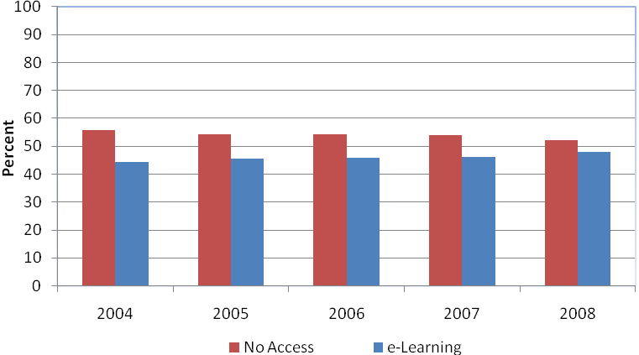
At a system level the e-learning category increased its share over the time period. But the majority of provision over the time period was still in the No Access category.

Figure 2
Proportion of the E-Learning EFTS by e-Learning Category
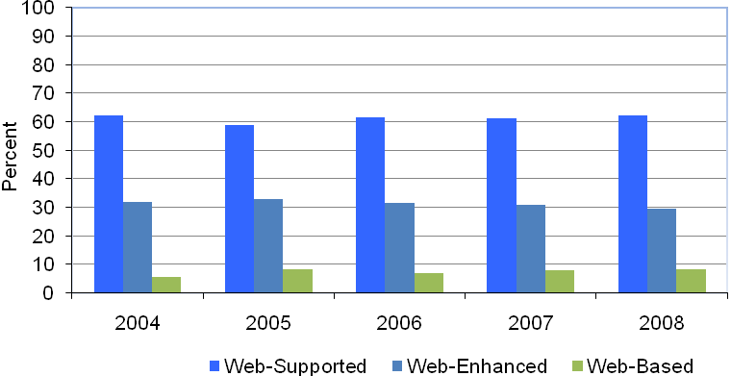
The largest of the e-learning categories was Web-Supported but it had no growth over the time period. Web-Enhanced was the next largest category and was the only one to experience a decline in its growth. While Web-Based was the smallest category, it increased its share of the overall total.

Bachelors Degree and Certificate Level Provision
Figure 3
Proportion of E-Learning in Bachelors Degree and Certificate Level Courses
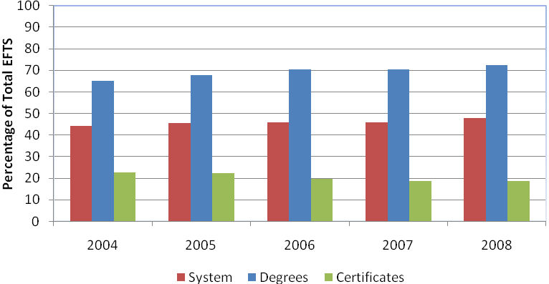
Figure 3 shows that bachelors degree and certificates courses present different pictures of e-learning provision. Across the whole system, provision in the e-learning category was almost 50 percent of the total by 2008, but in degree level courses nearly three quarters of provision was in the e-learning category. But in certificate level courses, provision in the e-learning category accounted for only about 20 percent of the total. For bachelors degree courses, the e-learning category increased its share of provision over the time period. But for certificate level courses the e-learning category’s share of provision decreased over the time period.
This suggests that course level is a factor associated with e-learning category provision. This association between level of study and e-learning provision was also evident at other levels. This apparent bias could be because of the correlation between ICT and literacy skills. Those with higher literacy skills use ICT more than those with lower literacy skills who use it less.
Figure 4 below splits the total e-learning EFTS into e-learning categories. For certificates, the percentages are a percentage of about 20 percent of all certificates EFTS and for degrees the percentages are a percentage of about 70 percent of all degree EFTS.
Figure 4
Proportion of Bachelors Degree and Certificate Level E-Learning EFTS by e-Learning Category
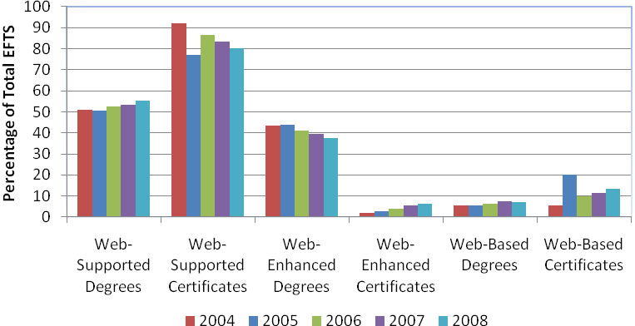
At both certificate and bachelors degree level, most e-learning was done through the Web-Supported category. For certificates, there was a decline in Web-Supported while that category had a modest increase at bachelors degree level. But the major difference was in the Web-Enhanced category. At certificate level this was the smallest category. In contrast for bachelors degree Web-Enhanced was a much larger component of provision. Web-Based was a minority of provision at both certificate and degree level but it was larger and had stronger growth at certificate level.

Sub-Sector Provision
The final part of this chapter examines provision from a sub-sector perspective. We look at trends in universities and polytechnics. Wānanga and private training establishments were not included as it was not possible from existing data to construct a comparable time series with universities and polytechnics. However some brief comments on their e-learning provision based on the available data is provided in the Conclusions section of the report.
Figure 5
Proportion of E-Learning in University and Polytechnic Bachelors Degree Courses
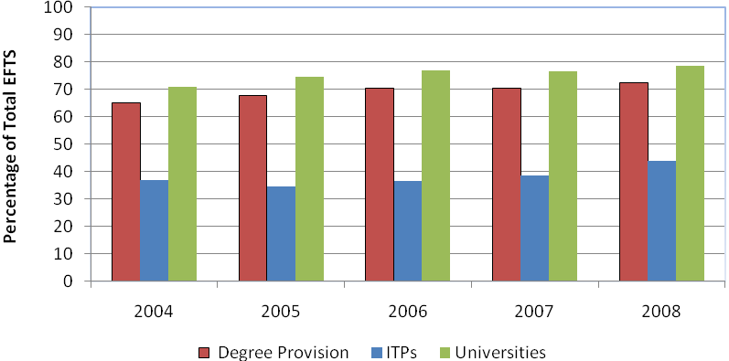

Figure 6
Proportion of E-Learning in University and Polytechnic Certificate Level Courses
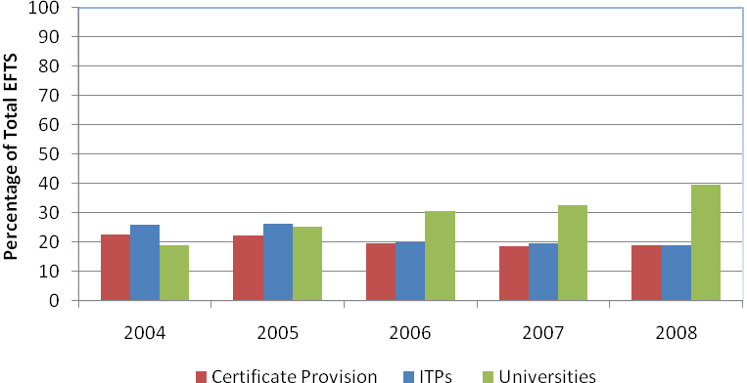
Figures 5 and 6 show e-learning provision differs by type of institution. At degree level for example, the universities had a majority of their bachelors degree provision in the e-learning category. But the polytechnics only had a minority of their degree provision in the e-learning category and this was noticeably less than the overall degree provision. However the polytechnics proportion of degree level provision in the e-learning category increased over the time period.
At certificate level, the e-learning category was a minority of provision for both universities and polytechnics. But universities had more e-learning provision than polytechnics and they had a large increase in their e-learning category (over 20 percentage points). In contrast, at the polytechnics, there was a modest decrease in their e-learning category provision.
These institutional differences reflect the fact that e-learning is more prevalent at degree level study and less so at certificate level. Degree level study is universities’ core provision. Universities may be using the capability and infrastructure built up to support degree level e-learning to apply it to other course levels. In contrast, polytechnics’ core provision is in certificate and diploma level study. As a result, they may not have built up their capability and infrastructure to support e-learning to the same extent as universities. This may be why polytechnics tend to offer less e-learning than universities at the same level.
Figures 7 and 8 split the e-learning provision for degrees and certificates at universities and polytechnics. For certificates at universities the percentages are a share of about 40 percent of all their certificates provision in 2008 (but of about 20 percent in 2004). For degrees the percentages are a percentage of 70 percent of all their degree provision in 2004 (but almost 80 percent in 2008). For polytechnics, the shares represent a percentage of just over 25 percent of their certificate EFTS in 2004 and almost 20 percent in 2008. For degrees in polytechnics the shares represent a percentage of about 40 percent of all their degree EFTS in 2004 and 45 percent in 2008.
Figure 7
Proportion of University and Polytechnic Bachelors Degree E-Learning EFTS by e-Learning Category
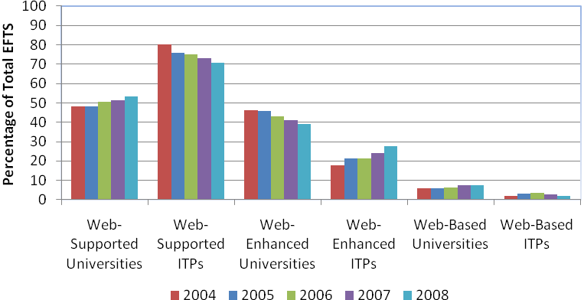

Figure 8
Proportion of University and Polytechnic Certificate Level E-Learning EFTS by e-Learning Category
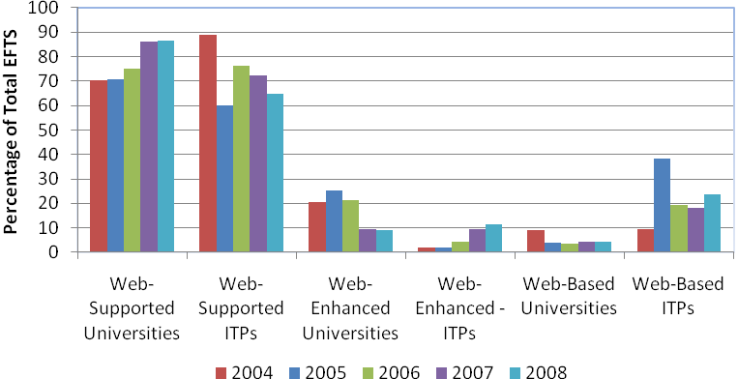
Figures 7 and 8 suggest that there are differences between universities and polytechnics not only in the extent of e-learning provision, but also how this is delivered. In universities, Web-Supported was the largest e-learning category in bachelors degrees. While it was much larger at polytechnics, Web-Supported provision declined as more polytechnic degree provision shifted to Web-Enhanced. Web-Based was the smallest category at degree level. For universities at degree level, Web-Based was larger and had stronger growth than at polytechnics.
At certificate level, Web-Supported - the lowest level of ICT support for learning - was much larger for both universities and polytechnics than at degree level. The Web-Enhanced category was larger for polytechnics by 2008. Web-Based was much larger at polytechnics (and larger than Web-Enhanced) and had strong growth while at universities, it declined over the time period and was the smallest category.
It is evident in the data presented that the most likely explanation for the spike in Web-Based provision at certificate level in 2005 was that some polytechnics re-defined large numbers of their courses to Web-Based. If the increase had been due to external factors such as government funding priorities we would likely have seen a different and less dramatic growth pattern.
Figure 9
Proportions of University and Polytechnic Degree Level EFTS in the No Access and Web-Based Categories
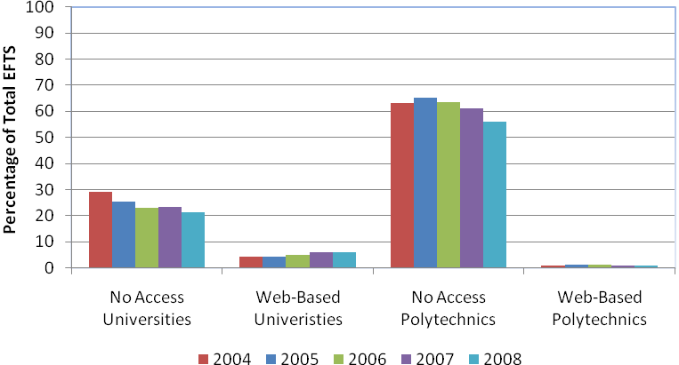
Figure 10
Proportions of University and Polytechnic Certificate Level EFTS in the No Access and Web-Based Categories
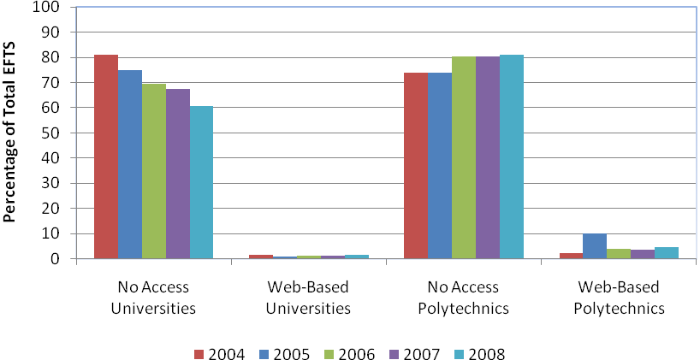
Because there is some uncertainty among providers as to the boundary between Web-Supported and Web-Enhanced delivery, it is useful to compare the trends in No Access delivery to trends in Web-Based provision.
Figures 9 and 10 contrast No Access and Web-Based provision at universities and polytechnics. No Access was the largest component of certificate level provision at both universities and polytechnics. But it was larger at polytechnics based on an increase in its provision over the time period while universities had a large decline. Polytechnic Web-Based provision was both larger and had stronger growth over the time period than universities.
No Access was also the largest component of degree level provision at polytechnics. It was a much smaller component of university provision where both Web-Supported and Web-Enhanced were larger. Both polytechnics and universities had a decline in No Access provision at degree level over the time period. Web-Based provision presents a different picture at degree level. At universities it was larger and had stronger growth over the time period than polytechnics.

E-Learning Participation in Bachelors Degree Courses
Chapters 3 and 4 look at participation in e-learning courses by age, ethnicity and gender. We illustrate the trends by focussing on 18-19 year olds, the 40+ age group, European, Māori and Pasifika and females and males in bachelors degree and certificate level courses. The main focus of these chapters is exploring the questions of the extent to which provision and student preference influence e-learning participation. This will be done by examining the learner groups to see if they were choosing to participate in e-learning at higher (or lower) levels than the extent of provision of e-learning.
There are varying explanations for student participation in e-learning courses. As shown in Chapter 2 there were institutional differences in the extent of e-learning provision. This means that students studying at particular institutions were more (or less) likely to have opportunities to participate in e-learning. Field of study is also a factor, with some fields having more and some less e-learning provision – which we look at in Chapter 5 below. This shows that students choosing particular fields of study were more (or less) likely to have opportunities to participate in e-learning.
But there are student factors as well. One of these is whether or not they had access to technologies that would allow them to participate in e-learning. The other explanation for e-learning (or No Access) participation is student preference or choice. Given that students are being compared on their participation in the same course offerings and that this includes all institutions and fields of study we would expect to see differences in preferences of different student groups to be reflected in the e-learning participation patterns.

Age
In examining how e-learning is distributed by the age of the students we look at the 18-19 and 40+ age groups. It is often assumed that younger people (sometimes referred to as ‘digital natives’) are more likely to use ICT than older people (sometimes referred to as ‘digital immigrants’). This analysis looks at whether or not there were clear differences in e-learning participation between these age groups which may indicate preferences for traditional delivery methods or e-learning.

Figure 11
Proportion of E-Learning EFTS for 18-19 and the 40+ age groups in Bachelors Degree Courses
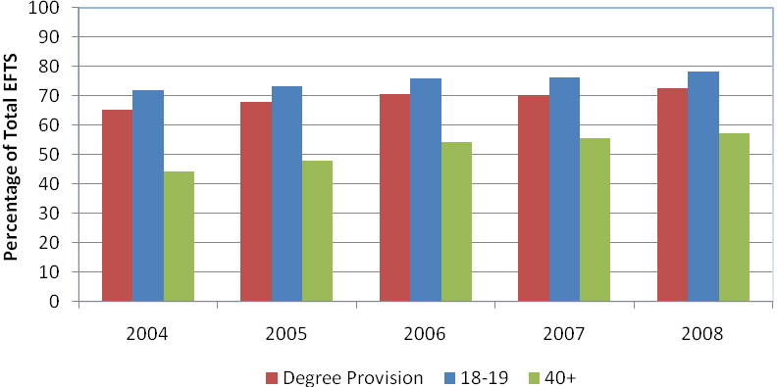
The 18-19 year olds participated in e-learning at bachelors degree level at a higher rate than the 40+ age group and also the overall degree level e-learning provision. This may be an indication that student preference was a factor in 18-19 year olds participation in courses with an e-learning component. While the participation in e-learning by students aged 40+ represented a small majority in 2008 this was much lower than the extent of e-learning provision at degree level. This may indicate that student preference was a factor in the 40+ age group participation in No Access courses.
Figure 12
Proportion of the 18-19 and 40+age groups Bachelors Degree E-Learning EFTS by e-Learning Category
Figure 12 splits the total e-learning EFTS at degree level into e-learning categories for the 18-19 and 40+ age groups. It does not include the No Access courses. For 18-19 year olds the proportion of the e-learning categories is a percentage of 70 percent of all degree EFTS (in 2004 but almost 80 percent in 2008). For the 40+ age group the proportions in each category represent a percentage of about 45 percent of all their degree EFTS in 2004 and about 60 percent in 2008.
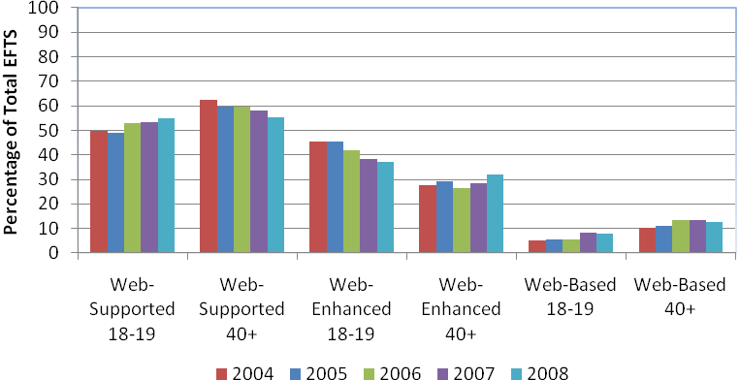
The 18-19 year olds had higher participation in Web-Enhanced at degree level. The 40+ age group had a higher proportion of its degree level participation than the 18-19 year olds in Web-Supported.
While Figure 9 shows lower participation by 40+ students in e-learning, the distribution of e-learning from students in that age group among the e-learning categories shows interesting patterns. The 40+ age group participation in Web-Based courses was higher than the extent of Web-Based provision at this level (refer to Figure 4). This suggests that a sub-group of the 40+ age group chose to enrol in courses using Web-Based delivery methods. This may reflect the need of some in that age-group to balance study and their work or family commitments and chose these particular courses for their study because of the flexibility they provide. This will be explored in more detail in Chapter 5 which examines Web-Based participation in intramural, extramural, full-time and part-time study.

Ethnicity
This second part of the chapter examines e-learning participation in degree level courses from an ethnicity perspective. Māori and Pasifika were selected as they are priority groups in the latest Tertiary Education Strategy. Europeans, as the largest group, were also selected as a reference group.
Figure 13
Proportion of E-Learning EFTS for Māori, Pasifika and Europeans in Bachelors Degree Courses
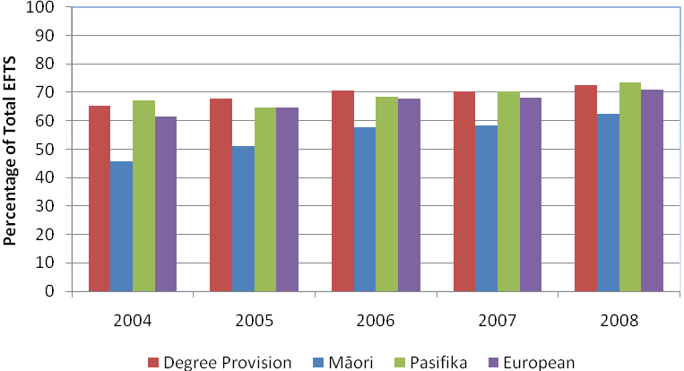
None of the ethnic groups showed a clear preference for e-learning at degree level. Pasifika and Europeans e-learning participation roughly equalled the level of degree provision. But Māori e-learning participation was much lower than both the other ethnic groups and provision. This may indicate that courses that attract larger numbers of Māori may have a lower incidence of e-learning. Alternatively it could be that more Māori have a preference for courses with traditional delivery.
Figure 14 splits the total e-learning EFTS at degree level for European, Māori and Pasifika. It does not include the EFTS in No Access courses. For Europeans the proportions in each e-learning category are a percentage of about 60 percent of all their degree EFTS (in 2004 but about 70 percent in 2008). For Māori the shares of each category represent a percentage of about 45 percent of all their degree EFTS in 2004 and about 60 percent in 2008. For Pasifika the shares represent a percentage of almost 70 percent of all their degree EFTS in 2004 and almost 75 percent in 2008.
Figure 14
Proportion of Europeans, Māori and Pasifika Bachelors Degree E-Learning EFTS by e-Learning Category
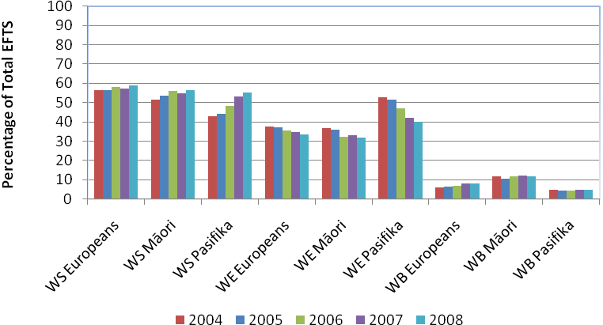
For all the ethnic groups Web-Supported (WS in Figure 14) was the main vehicle for e-learning participation over the time period and all had growth in it. This was largest for Pasifika. Web-Enhanced for Māori and Europeans was noticeably smaller than Web-Supported throughout the time period, but among Pasifika, this category attracted a significant share of enrolments.
Comparing these shares with the extent of provision across the system suggests that preference was a factor in Māori participation in Web-Based (WB in Figure 12) over Web-Enhanced courses. For Māori this may indicate the existence of a sub-group who are unable to access traditional forms of participation. This will be explored in more detail in Chapter 5 which examines their e-learning participation in intramural, extramural, full-time and part-time study.

Gender
The final part of this chapter examines e-learning from a gender perspective.
Figure 15
Proportion of E-Learning EFTS for Females and Males in Bachelors Degree Courses
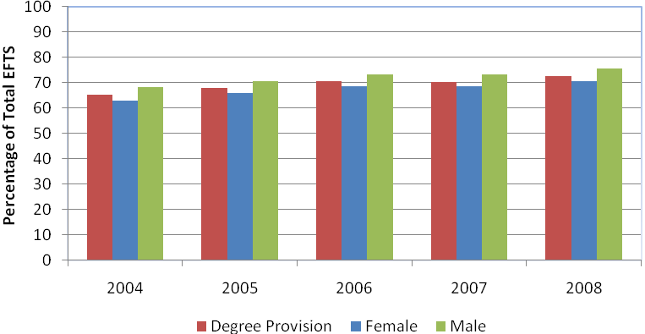
Males had higher e-learning participation than females at degree level and this was higher than overall degree level provision. But females had stronger growth in e-learning. These gender differences may be due to differences in field of study preference between males and females. This will be explored in more detail in Chapter 5 which examines e-learning provision through field of study.

E-Learning Participation in Certificate Level Courses
This chapter examines participation in certificate level courses using the same learner groups as Chapter 3. Certificate level courses for the purposes of this report include all those at levels 1-4.

Age
Figure 16
Proportion of E-Learning EFTS for the 18-19 year old and 40+ age groups in Certificate Level Courses
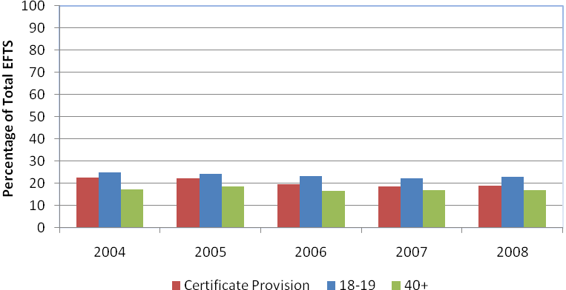
Only a minority of certificate level participation was in courses with an e-learning component. This applied to both age groups studied. However 18-19 year olds had higher participation in certificate level e-learning courses than the extent of provision of e-learning at this level while the 40+ age group had less participation. This may indicate that at certificate level 18-19 year olds had a slightly stronger preference for participation in e-learning courses while the older age group may have a preference for participation in courses with traditional delivery approaches. Similar patterns were observed for these age groups at degree level study.
Figure 17 splits the total e-learning EFTS at certificate level for the 18-19 and 40+ age groups into the e-learning categories. For 18-19 year olds the e-learning share is a percentage of about 25 percent of their certificate EFTS. For the 40+ age group, the share represents a percentage of about 16 to 18 percent of their certificate EFTS.

Figure 17
Proportion of the 18-19 year old and 40+ age groups Certificate E-Learning EFTS by e-Learning Category
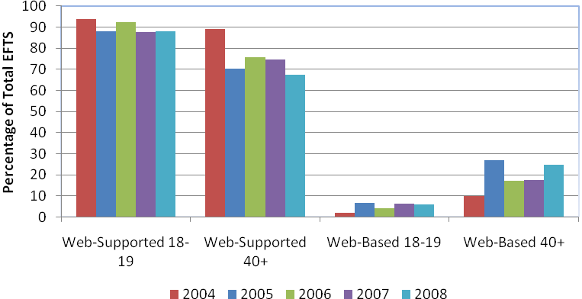
Web-Supported was the largest category for both age groups reflecting the fact that this category represented the biggest share of certificate level e-learning provision (refer to Figure 4). For the 40+ age group their Web-Based participation was much larger and had stronger growth than the extent of Web-Based certificate level provision. This aligns with the finding at degree level where this age group had relatively high participation in Web-Based courses. This will be explored in more detail in Chapter 5.

Ethnicity
Figure 18
Proportion of E-Learning EFTS for Māori, Pasifika and Europeans in Certificate Level Courses
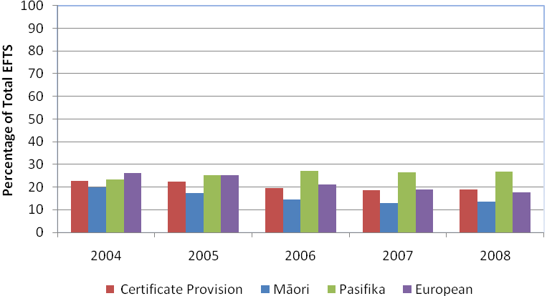
All the ethnic groups had e-learning as a minority of their participation at certificate level. Pasifika had higher participation in the e-learning category at certificate level than the extent of e-learning provision at this level. Pasifika also were the only group to have growth in e-learning participation. Europeans had the largest decline in their e-learning participation. Māori had lower e-learning participation in certificates than other ethnic groups and these findings reflect the pattern of participation in e-learning at degree level. This may indicate that at certificate level also, Pasifika may have a preference for e-learning and Māori for traditional delivery methods.
Figure 19 splits the total e-learning EFTS at certificate level for European, Māori and Pasifika. For Europeans the shares in each e-learning category are percentages of about 25 percent of their certificate EFTS (in 2004 but about 18 percent in 2008). For Māori the shares represent a percentage of about 20 percent of their certificate EFTS in 2004 and about 15 percent in 2008. For Pasifika the shares represent a percentage of about 23 percent of their certificate EFTS in 2004 and about 27 percent in 2008.
Figure 19
Proportion of Europeans, Māori and Pasifika Certificate E-Learning EFTS by e-Learning Category
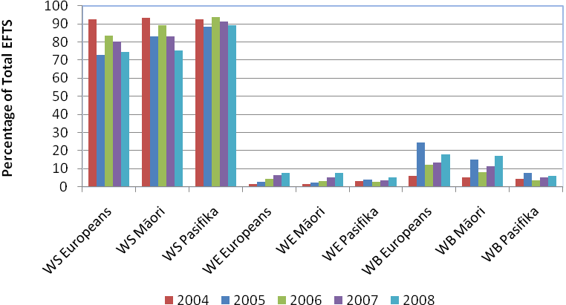
Web-Supported (WS in Figure 19) was the dominant category for e-learning participation at certificate level for all ethnic groups. For Māori and European, participation in Web-Supported courses was lower than the level of provision across the system but it was higher for Pasifika.
For Māori and European participation in Web-Based (WB in Figure 19) courses was larger than the extent of provision across the system whilst for Pasifika it was much lower. For Māori this aligns with the finding at degree level. This will be explored in more detail in Chapter 5.

Gender
Figure 20
Proportion of E-Learning EFTS for Females and Males in Certificate Level Courses
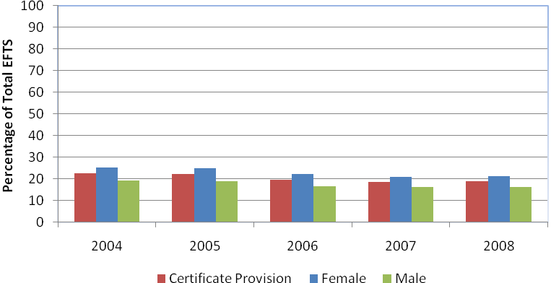
Females had higher participation in e-learning than the extent of e-learning provision at certificate level. This is in contrast to degree level study. As with degree level study, these gender differences in participation may be due to differences in e-learning provision in different fields of study. This will be explored in more detail in Chapter 5 which examines e-learning provision by field of study.

E-Learning Participation in Extramural and Part-Time by Field of Study
This chapter looks at some of the other factors that may be influencing e-learning participation – mode of study and field of study. Chapters 3 and 4 showed higher Web-Based e-learning participation among Māori and older students despite relatively lower e-learning participation overall. Examining factors such as mode and field of study may help us to understand if there were sub-groups whose preferences influenced these participation patterns. It will also help determine if some fields of study had greater levels of e-learning participation.

Exploring Web-Based E-Learning
Table 1 looks at the 40+ age group and Māori Web-Based participation by study mode. The data in Table 1 is from 2008 only and does not control for course level. The percentage of participation in courses with Web-Based e-learning is derived by dividing the total Web-Based EFTS by the total e-learning EFTS.
Table 1
Intramural, Extramural, Full-Time and Part-Time Web-Based Participation for the 40+, European and Māori Learner Groups 2008
Learner Groups | Intramural | Extramural | Full-Time | Part-Time
40+ | 6.9% | 38.9% | 10.3% | 26.7%
Māori | 7.9% | 34.9% | 12.0% | 19.5%
All | 6.8% | 30.1% | 14.9% | 18.9%

Table 1 shows that and students were more likely to be in Web-Based courses if they had extramural as their study mode. This is particularly the case for Māori and for older students. The older students were also more likely to be in Web-Based courses if they were studying part-time.

One likely explanation for these differences are that those sub-groups among Māori and among older students who may be unable to access tertiary education through traditional means (for example because of work or family commitments) are utilising the additional flexibility provided by Web-Based e-learning to access, and participate in tertiary education.

Exploring field of study differences
Chapters 3 and 4 also suggested that there was higher e-learning participation among males in bachelors degree and females in certificates. We speculated that this could be due to differences within fields of study. Tables 2 and 3 look at field of study e-learning provision in bachelors degrees and certificates. The percentages used in the tables for each field of study are an average of the total provision over the time period. This is compared to the average of the bachelors degrees and certificates provision over the time period.
Table 2 looks at bachelors degree e-learning provision by field of study.

Table 2
E-Learning Degree Provision by Field of Study
Field of Study | E-Learning Provision | Overall Degree Provision
All | 58.81% | 69.29%
Agriculture, Environments and Related Studies | 69.35% | 69.29%
Architecture and Building | 46.84% | 69.29%
Creative Arts | 40.35% | 69.29%
Education | 54.63% | 69.29%
Engineering and Related Technologies | 37.97% | 69.29%
Food, Hospitality and Personal Services | 56.00% | 69.29%
Health | 52.22% | 69.29%
Information Technology | 75.29% | 69.29%
Management and Commerce | 84.48% | 69.29%
Mixed Field Programmes | 24.84% | 69.29%
Natural and Physical Sciences | 88.49% | 69.29%
Society and Culture | 75.27% | 69.29%

Table 3
E-Learning Certificate Provision by Field of Study
Field of Study | E-Learning Provision | Overall Certificate Provision
All | 19.99% | 20.43%
Agriculture, Environment and Related Studies | 11.72% | 20.43%
Architecture and Building | 11.14% | 20.43%
Creative Arts | 18.69% | 20.43%
Education | 27.02% | 20.43%
Engineering and Related Technologies | 11.69% | 20.43%
Food, Hospitality and Personal Services | 17.07% | 20.43%
Health | 11.78% | 20.43%
Information Technology | 26.38% | 20.43%
Management and Commerce | 33.71% | 20.43%
Mixed Field Programmes | 31.03% | 20.43%
Natural and Physical Sciences | 27.96% | 20.43%
Society and Culture | 11.68% | 20.43%

There were differences among the fields of study in provision as shown in Tables 2 and 3. At degree level, Information Technology, Management and Commerce, Natural and Physical Sciences and Society and Culture had more e-learning provision than the field of study average and overall provision. This is important because Management and Commerce, Natural and Physical Sciences and Society and Culture are large fields in terms of student enrolments.

In contrast some of the more applied fields e.g. Engineering and Related Technologies, Architecture and Building, Health, Creative Arts and Education had less e-learning provision than the field of study average and overall provision.

At certificate level, Health, Engineering and Related Technologies and Architecture and Building had less provision than the field of study average and overall provision. Information Technology, Management and Commerce and Natural and Physical Sciences had more provision than the field of study average and overall provision. Similar patterns were observed at degree level.

But Education which had less provision at degree level had more than the field of study average and overall provision at certificate level. In contrast Society and Culture which had more provision at degree level had less than the field of study average and overall provision at certificate level.

Tables 2 and 3 may indicate that field of study is an additional factor in e-learning provision regardless of level or institution. For example Education, had much less e-learning provision at degree level than would be expected if institutions and course level were the determining factors. Management and Commerce which has a large presence outside of universities also had much more e-learning provision at both degree and certificate level than would be expected if institutions and course level were the determining factors. The one common theme among the fields with low e-learning provision is the fact that they all have a large practical component within them which does not lend itself easily to e-learning. This may be why there are differences in e-learning provision between the fields.

Conclusions

E-Learning
ICT use in New Zealand is growing at a rapid rate as evidenced by recent surveys. This is not only occurring in households but also in the workplace and increasingly, in education, particularly through the Government’s Ultra Fast Broadband programme. ICT use in education has particular value for two reasons. Firstly, information is an important component in all teaching and learning and ICT can increase access to information. Secondly it provides additional flexibility which helps learners access tertiary study regardless of their personal circumstances or geographical location. Using ICT means there does not have to be a critical mass of learners present to support a physical campus. The increasing use of ICT in delivering education information is evidenced by this report. Looking at extramural and part time study shows that some of the learner groups analysed in this report appear to be using e-learning (through Web-Based courses) as an alternative means to access and participate in tertiary education.

Provision
Over the period 2004-2008, the majority of provision in the New Zealand tertiary system had No Access to e-learning. But over that time period, the proportion of provision in the e-learning category increased. If we look at those courses that had an e-learning component, we find that the Web-Supported category was larger than the Web-Enhanced and Web-Based categories. While Web-Based was the smallest category at degree level its share of e-learning provision increased over the time period.
There was a strong association between course level and e-learning provision. Most bachelors degree level courses were in the e-learning category and this share increased over the time period. But in certificate level qualifications, most provision had no e-learning access and this share increased over the time period.
While we didn’t look at postgraduate courses in this report, the data shows that they too had a large majority in the e-learning category and that the proportion that had access to e-learning grew over the time period. The majority of provision for diplomas (Levels 5-7) had No Access but the proportion that had access to e-learning grew over the time period. The predominance of e-learning in higher level courses perhaps reflects evidence that the use of ICT is correlated to literacy skills – those with lower literacy use ICT less while those with higher literacy skills use it more (Lane 2010).
Institution type was associated with e-learning category provision. When we control for course level, we find that university courses were more likely to be in the e-learning category than polytechnic courses. For instance, at bachelors degree level, universities had most of their courses in the e-learning category, while in polytechnics, most of these courses had no e-learning access. However both had growth in their e-learning category provision.
These institutional differences may be due to the predominance of university provision being at higher levels, meaning that they have developed greater capability and infrastructure to offer courses through e-learning and then are more likely to apply that at all levels. Institution type was also associated with how courses were delivered. For example at bachelors degree level, the universities had a greater share of their e-learning provision than polytechnics in the Web-Supported and Web-Based categories
The available data indicates that at Private Training Establishments (PTEs) and wānanga, the majority of provision at bachelors degree and certificate level was in the No Access category and the proportion that had access to e-learning declined over the time period. The majority of PTE and wānanga e-learning provision was in the Web-Supported category. The exception was wānanga at bachelors degree level where they had most of their e-learning provision in the Web-Based category.

Participation
The association between course level and e-learning is also evident in patterns of participation – largely, (but not entirely) because there was relatively less e-learning category provision at lower levels. At bachelors degree level, the extent of participation in e-learning by the 18-19 year olds and males was noticeably higher than the rate of provision. At certificate level, this was also true for the 18-19 year olds as well as Pasifika and females. But participation in e-learning courses was noticeably lower for Māori and the 40+ age group than the rate of provision.
For all groups studied, Web-Supported was the main vehicle for e-learning participation, especially at certificate level. However there were some interesting preferences and patterns in participation.
Age was a factor associated with e-learning participation. When we control for course level, we find that 18-19 year olds had higher participation in e-learning than the 40+ age group. This may indicate that young people may have greater preference than older people for e-learning courses.
But there were some interesting observations. In particular, while Web-Based e-learning had the lowest share of provision among the e-learning categories, the 40+ age group had noticeably more Web-Based participation than the younger age group. The analysis in Chapter 5 suggests that this may be due to the existence of a sub-group of older people who chose Web-Based e-learning because work or family commitments precluded their involvement in any traditional delivery teaching. It is also likely driven by an increase in Web-Based extramural provision as institutions offering this type of provision transition from paper-based to ICT enabled delivery.
There are differences between ethnic groups in e-learning participation. When we control for course level, we find that Māori had lower e-learning participation rates than the other ethnic groups. While Māori had low e-learning participation overall, they had higher participation than other groups in Web-Based e-learning. The analysis in Chapter 5 suggests there may be a sub-group of Māori who take Web-Based e-learning because they were unable to undertake traditional forms of participation.
Males had slightly higher e-learning participation in bachelors degree than females. But at certificate level, women had higher e-learning participation than men. These gender differences could be the result of differences in e-learning in some fields of study. For example at degree level Education and Health which are fields traditionally dominated by women had less e-learning provision than overall provision. At certificate level Engineering and Related Technologies and Architecture and Building which are fields traditionally dominated by men had less e-learning provision than overall provision.

References
Bell A., Billot, J., Crothers, C., Gibson, A., Goodwin, I., Sherman, K., Smith, N., Smith, P., (2010), The Internet in New Zealand: 2007-2009, Auckland University of Technology, Auckland
Lane, C., (2010), Adult literacy and numeracy in New Zealand – key factors, Ministry of Education. Wellington
Ministry of Education, (2009), What is e-Learning, Ministry of Education, Wellington
Ministry of Education, (2010), Ultra-fast Broadband in Schools, Ministry of Education, Wellington
Ministry of Education (2010), 2010 Single Data Return: A Manual for Tertiary Education Organisations and Student Management System Developers, Ministry of Education, Wellington
Ministry of Education, Tertiary Education Commission (TEC), (2010), Sector Feedback on Proposed 2011 SDR Changes, Ministry of Education and TEC, Wellington
Statistics New Zealand, (2009), Internet Service Provider Survey, Statistics New Zealand, Wellington

1 Refer to http://www.minedu.govt.nz/NZEducation/EducationPolicies/TertiaryEducation/ELearning/WhatIsELearning.aspx for more details on tertiary e-learning
Bell, A, et al (2010), The Internet in New Zealand: 2007-2009
Internet Service Provider Survey: June 2009, Department of Statistics
Bell, A, et al (2010), The Internet in New Zealand: 2007-2009
Ministry of Education, (2010), Ultra-fast Broadband in Schools
These are taken from the 2010 SDR Manual
Ministry of Education and Tertiary Education Commission (2010), Sector Feedback on Proposed 2011 SDR changes
1.0 EFTS represents a full-time full-year load for a student. The EFTS factor of a course is a number between 0 and 1 that gives the proportion of a full-time full-year load represented by that course. A course with an EFTS factor of 0.25 requires a quarter of a full-time full-year load.
Lane, C., (2010), Adult literacy and numeracy in New Zealand – Key factors, Ministry of Education, Wellington
Bell A., Billot, J., Crothers, C., Gibson, A., Goodwin, I., Sherman, K., Smith, N., Smith, P., (2010), The Internet in New Zealand: 2007-2009, Auckland University of Technology, Auckland; Department of Statistics, (2009), Internet Service Provider Survey, Department of Statistics, Wellington

