
PB4L School-wide Evaluation:
Preliminary findings

Report to the Ministry of Education

Sally Boyd, Rachel Dingle, and Nicole Herdina
New Zealand Council for Educational Research

ISBN: 978-0-478-43921-2 (print)
ISBN: 978-0-478-43922-9 (web)
RMR-1047
© Ministry of Education, New Zealand 2014
Research reports are available on the Ministry of Education’s website Education Counts:
www.educationcounts.govt.nz/publications.

Opinions expressed in this report are those of the authors and do not necessarily coincide with those of the Ministry of Education.

PB4L School-wide Evaluation: Preliminary findings
Sally Boyd, Rachel Dingle, and Nicole Herdina

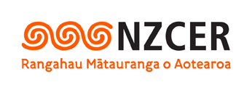

New Zealand Council for Educational Research
P O Box 3237
Wellington
New Zealand

© Ministry of Education, 2014

Acknowledgements
The authors would like to thank the many people who made the writing of this report possible. Our particular thanks go to the staff and students at PB4L School-Wide schools who completed surveys and responded to our requests for school data and documents. Our thanks also go to the School-Wide Practitioners and other Ministry of Education stakeholders who contributed their views and experiences to inform the scoping phase of the evaluation and provided the material used in this report. We would also like to thank our New Zealand Council for Educational Research (NZCER) colleagues who reviewed and formatted this report.

Table of contents
1. Executive summary 1
2. Introduction 9
Introduction to School-Wide 9
Background to the evaluation 11
Introduction 11
Scoping period 12
Principles underpinning the evaluation approach 12
SW theory of change 12
SW-specific evaluation questions 14
Evaluation methodology 14
Evaluation phases, timelines, and reporting 15
Evaluation questions and related data-collection strategies 15
Ethics and informed consent 17
Response rates 17
Who responded to the surveys? 19
Survey data analysis and interpreting survey data 20
Limitations of the evaluation design and data-collection strategies 25
What is the focus of this report? 25
3. SW implementation and support 26
Brief summary of chapter findings 26
Implementing SW 28
Support for SW 28
Getting started with SW 29
School teams 31
School systems for acknowledging and addressing behaviour 33
Data reporting 33
Professional learning and resources for staff to support SW 35
Longer term sustainability 39
Challenges to maintaining SW, as identified by schools 39
Coaches’ views on the SW support model 40
The impact of support on rate of SW implementation 41
Support from cluster groups 42
Support for schools from the SW workforce 43
Providing support to schools 43
Aspects of SW that may need further support 46
Focusing on priority learners 46
Connections between behaviour and learning 49
SW in secondary schools 50
4. Exploring evidence of short-term shifts 55
Brief summary of chapter findings 55
Evidence for short-term shifts 56
Are changes happening for students? 57
Active student involvement in SW 66
Changes for school culture and systems 67
Are changes happening for teachers and in classrooms? 70
Changes in the involvement of parents and whānau in SW 73
The extent of shifts in schools 74
5. Enablers and barriers 75
Enablers and barriers 75
School enablers 75
School barriers 76
SW support and system enablers 77
System barriers 77
6. The journey so far 78
Changes to school practice and student outcomes 81
Managing whole-school change 81
Enabling continuous improvement at all levels of the system 82
References 85

Tables
Table 1: School characteristics by SW cohort year 11
Table 2: Data-collection methods used to explore the evaluation questions 17
Table 3: Data-collection response rates 18
Table 4: Mean total ODR rates by length of time in SW 60
Table 5: Mean physical aggression ODR rates by length of time in SW 60
Table 6: Ratio of physical aggression ODR to total ODR by time in SW 61

Figures
Figure 1: Core elements of the SW Tier 1 framework* 10
Figure 2: SW Theory of change 13
Figure 3: SW evaluation questions 14
Figure 4: Coach views on support for SW (2010/11, n = 89; 2012/13, n = 102) 28
Figure 5: Curriculum leader views on support for SW (2010/11, n = 74; 2012/13, n = 107) 29
Figure 6: Coach views on starting to implement SW (2010/11, n = 89; 2012/13, n = 102) 30
Figure 7: Coach views on the SW team (2010/11, n = 89; 2012/13, n = 102) 31
Figure 8: Curriculum leader views on SW team support (2010/11, n = 74; 2012/13, n = 107) 32
Figure 9: 2010/11 coach views on school systems to support behaviour (n = 89) 33
Figure 10: 2010/11 coach views on using data (n = 89) 34
Figure 11: 2010/11 coach views on sharing data (n = 89) 34
Figure 12: 2010/11 coach views on the support provided to staff (n = 89) 35
Figure 13: 2010/11 curriculum leader views on their access to support (n = 74) 35
Figure 14: Coach views on the extent SW is embedded (2010/11, n = 89; 2012/13, n = 102) 36
Figure 15: Coach views on SW philosophy and features (2010/11, n = 89; 2012/13, n = 102) 38
Figure 16: Coach views on the 2013 SW support model (All cohorts, n = 191) 40
Figure 17: 2010/11 coach views on SW’s contribution to changes to student knowledge/competencies
(n = 89) 57
Figure 18: 2010/11 coach views on SW’s contribution to changes to key behaviour outcomes (n = 89) 58
Figure 19: Stand-down rates for 2010/11 SW (n = 188) and comparison schools (n = 278) 62
Figure 20: Suspension rates for 2010/11 SW (n = 187) and comparison schools (n = 274) 63
Figure 21: Exclusion rates for 2010/11 SW (n = 183) and comparison schools (n = 264) 63
Figure 22: Expulsion rates for 2010/11 SW (n = 67) and comparison schools (n = 87) 64
Figure 23: 2010/11 coach views on student leadership opportunities (n = 89) 66
Figure 24: 2010/11 coach views on SW’s contribution to changes to school culture and processes (n = 89) 68
Figure 25: 2010/11 coach views on SW’s contribution to use of school data (n = 89) 69
Figure 26: 2010/11 curriculum leader views on SW’s contribution to confidence in managing behaviour
(n = 74) 70
Figure 27: 2010/11 curriculum leaders’ views on SW’s contribution to approaches to behaviour
expectations (n = 74) 71
Figure 28: 2010/11 curriculum leader views on SW’s contribution to behaviour management strategies
(n = 74) 72
Figure 29: 2010/11 coach views on SW’s contribution to changes to connections with parents and whānau
(n = 89) 73

Appendices
Appendix 1: PB4L evaluation principles 87
Appendix 2: Example of information sheet 88
Appendix 3: Wellbeing@School aspect map 90
Appendix 4: Wellbeing@School demographics 91
Appendix 5: Wellbeing@School outcome data and boxplots 92
Appendix 6: Wellbeing@School primary data 95
Appendix 7: Wellbeing@School secondary and intermediate data 99

1. Executive summary
This report summarises the initial findings from phase 1 of an evaluation of Tier 1 of Positive Behaviour for Learning (PB4L) School-Wide (SW). It describes the extent of implementation of SW in schools, identifies short-term shifts for schools that joined the initiative in 2010 or 2011, and discusses enablers and barriers to implementation. It outlines some big-picture trends that can then be further explored in the final 2015 report.
Introduction to PB4L SW
SW is one component of the PB4L programme of work. SW is the New Zealand version of a proven international initiative called Positive Behavioral Interventions and Supports. SW offers primary, intermediate, and secondary schools a way of building a consistent and positive school-wide climate to support learning. It is a framework of key elements which schools implement in ways that suit their context. It aims to engage the whole school community in adapting school structures, practices, and philosophies related to behaviour, and in developing systems that everyone can use in a consistent way. Each school forms a team to implement SW in a way that is collaborative, data-driven, and problem-solving. School staff are offered a package of SW training and support which includes training days, cluster meetings with local schools, and access to regionally-based SW Practitioners who work with schools to support them to implement SW.
SW has three tiers. During Tier 1 schools put in place a core set of behaviour support systems and practices designed to be used consistently by all to encourage positive behaviour. Once the core elements of Tier 1 are in place schools can move to Tier 2 (developing targeted interventions for small groups of vulnerable students) and Tier 3 (developing specialised interventions for individuals who need additional support). SW began in New Zealand in 2010. Each year around 100 schools join the initiative.
Introduction to this evaluation
The New Zealand Council for Educational Research (NZCER) evaluation is a mixed-method study with a focus on process and outcomes. The evaluation focuses on Tier 1 of SW and runs from 2013 to 2015. The evaluation questions this report explores are:
- What short-term shifts is SW supporting towards SW outcomes for students and schools?
- Are core SW practices being implemented as intended?
- What factors enable or hinder the shifts in schools?
- What does effective support for SW schools look like in a New Zealand context?
Phase 1 of the evaluation mostly took place in Terms 3–4, 2013, and involved the 408 schools that joined Tier 1 of SW from 2010–13. We collected data on short-term shifts, and barriers and enablers from 89 schools that joined SW in 2010/11. Baseline data and information about the initial implementation of SW was collected from 102 schools that joined in 2012/13. Data from the following existing and new sources are included in this report.
Schools and Ministry of Education personnel
- Surveys from 191 school coaches and 181 English and mathematics curriculum leaders in SW schools
- School-Wide Evaluation Tool (SET) data from 169 SW schools (SET documents the extent to which seven essential features of SW are in place in a school and consistently understood and used)
- SW values and behaviour expectations documents from 92 SW schools
- Surveys from 13 SW Practitioners, and interviews with seven Ministry of Education SW national and regional practice leaders and managers.

Student data
- National data on stand-down, suspension, expulsion, and exclusion rates (SSEE) from SW and non-SW schools
- Office Discipline Referral (ODR) data from 87 SW schools
- Wellbeing@School student surveys from 71 SW schools and 10,883 students compared with data from a national reference group.
What short-term shifts is SW supporting?
At the beginning of the evaluation, we developed a “theory of change” for how SW processes and practices could lead to the expected outcomes, and the factors that could have a bearing on these changes. This theory of change underpins our evaluation work. To explore if schools are following the expected pattern we used a number of sources of data to map the actual pattern of implementation and outcomes changes onto the theory-of-change diagram.
The blue shading on the diagrams below indicates that 60% or more of school coaches or curriculum leaders agreed that a practice was in place, or reported a shift in practices or outcomes. We also used data from national and regional Ministry of Education staff to inform some sections.
Yellow shading indicates less than 60% agreement or reports of shifts. As expected, staff at schools that joined SW in 2010 or 2011 reported more practices in place and a number of short-term changes, so the blue shading is much more evident. Staff from the 2012/13 schools that had only been part of SW for a year or less reported fewer core practices in place or shifts, so the yellow shading dominates.
These maps are included below to give the reader a visual impression of the pattern of change for schools.

KEY
Core SW processes
60% or more of school coaches or curriculum leaders report processes in place
Less than 60% report processes in place

Short-term changes
60% or more report shifts in practice
Less than 60% report shifts in practice
60% or more shift (from longer-term outcomes)

Faded text = practices not explored in surveys
Notes
Each statement has been colour-coded from responses to core questions, or clusters of questions, in the school coach or curriculum leader survey
Most information comes from the coach survey. Where information comes from the curriculum leader survey this is indicated by (Curric)

The colour codes in the national and regional practice sections are summarised from information collected via interviews and the SWP survey
CORE SW ACTIVITIES & PROCESSES IMPLEMENTED WITH FIDELITY
Student
- Students have an active role in developing shared values and expectations (have agency)

School and staff
- School staff have an active role in developed shared values & expectations (SET A) (Curric)
- Values & expectations are modelled and taught (SET B) (Curric)
- The principal and senior leadership team actively support SW
- School staff are ready to implement a new initiative (80% buy in) (Curric)
- School selects SW team leader and coach with needed authority and capabilities
- School develops a SW team that identifies priorities, develops and implements action plans, and reports data (SET F)
- Consistent systems for recognition of shared values & expectations and addressing behaviour incidents are developed (SET C/D)
- School develops staff capacity to manage data system for collecting and reporting SW data (SET E)
- School develops effective system for collecting and reporting SW data to stakeholders (SET E)
- Schools use SW framework in ways that align with the context of their school community and the needs of Māori and Pasifika learners, and students with special needs
- Schools use SW framework in ways that align with the NZ education system (e.g., NZC & leadership models that value relationships and Manaakitanga, pono, ako, and awhinatanga)

Parent, whānau & community
- School works effectively with community (including Māori and Pasifika community) to develop shared values and expectations

National & regional
- Effective school coaching and PLD networks set up in regions
- SW Practitioners (SWP) (regional specialists) are recruited, trained & have the capabilities needed to work with school teams
- National structure provides guidance and feedback from data to regions (networks exist but are not formalised)
SHORT-TERM CHANGES EXPECTED (1–2 years)
Student outcomes and shifts in processes
- Some decreases in challenging behaviour incidents & SSEE
- Some increases in positive behaviours (e.g., attendance, engagement, social wellbeing
- Students offered active leadership role in promoting and celebrating school values (roles less likely to include active participation in decision-making)
- Students have access to effective learning experiences and staff modelling related to shared school values

School outcomes and shifts in processes
Teachers and classrooms
- Shift from a punishment to a learning view of behaviour management (Curric)
- Increased confidence to manage behaviour (Curric – near 60%)
- Increased capability to actively model and incorporate values & behaviour expectations (in ways that relate to priority groups: Māori students, Pasifika students, students with special needs) (Curric – near 60%)
- More time teaching (less time managing behaviour) (Curric)

Leadership, culture & systems
- School culture is more welcoming, inclusive, & consultative (Curric and coach)
- School leaders maintain involvement with SW and model learning and systems orientation towards behaviour
- Increased use of consistent school approaches (School system for approaches to recognition of values & behaviours and addressing incidents is used by most staff and is relevant for target groups (Māori learners, Pasifika learners, students with special needs)
- School PLD processes support all staff to understand shared values and work to align their behaviours and practices (Curric)
- Effective team-based problem-solving processes are in place
- School uses SMS/data system proactively to report at different levels (school structures, classroom, all students, at risk groups)
- Staff are able to use data for meaningful decision making (e.g., to identify target groups or areas of practice) (Less so for Curric)
- School has fitted SW within their culture and community context and has worked to align approach to learning and other initiatives and programmes with SW

Parent, whānau & community outcomes and shifts in processes
- School has established effective processes for seeking input from parents & whānau and reporting developments
- School has started to make connections with groups in wider community to support SW (e.g., Sports Clubs)
National & regional outcomes and shifts in processes
- Regional SWP teams have a mix of needed expertise and a team-based approach that enables the team to effectively support schools
- School cluster processes support schools to share expertise
- Processes developed for defining roles and sharing expertise between SWP and other MoE professionals (networks exist but are not formalised
- Data collection and feedback loops are used to improve support to schools (use of regional data and national systems data) (loops exist but are not formalised)
- SWP teams make connections with other agencies & sector groups

Theory-of-change map for 2010/11 SW schools

Theory-of-change map for 2012/13 SW schools

KEY
Core SW processes
60% or more of school coaches or curriculum leaders report processes in place
Less than 60% report processes in place

Short-term changes
60% or more report shifts in practice
Less than 60% report shifts in practice

Faded text = practices not explored in surveys
Notes
Each statement has been colour-coded from responses to core questions, or clusters of questions, in the school coach or curriculum leader survey
Most information comes from the coach survey. Where information comes from the curriculum leader survey this is indicated by (Curric)

The colour codes in the national and regional practice sections are summarised from information collected via interviews and the SWP survey

CORE SW ACTIVITIES & PROCESSES IMPLEMENTED WITH FIDELITY
Student
- Students have an active role in developing shared values and expectations (have agency)

School and staff
- School staff have an active role in developed shared values & expectations (SET A) (Curric)
- Values & expectations are modelled and taught (SET B) (Curric)
- The principal and senior leadership team actively support SW
- School staff are ready to implement a new initiative (80% buy in) (Curric)
- School selects SW team leader and coach with needed authority and capabilities
- School develops a SW team that identifies priorities, develops and implements action plans, and reports data (SET F)
- Consistent systems for recognition of shared values & expectations and addressing behaviour incidents are developed (SET C/D)
- School develops staff capacity to manage data system for collecting and reporting SW data (SET E)
- School develops effective system for collecting and reporting SW data to stakeholders (SET E)
- Schools use SW framework in ways that align with the context of their school community and the needs of Māori and Pasifika learners, and students with special needs
- Schools use SW framework in ways that align with the NZ education system (e.g., NZC & leadership models that value relationships and Manaakitanga, pono, ako, and awhinatanga)

Parent, whānau & community
- School works effectively with community (including Māori and Pasifika community) to develop shared values and expectations

National & regional
- Effective school coaching and PLD networks set up in regions
- SW Practitioners (SWP) (regional specialists) are recruited, trained & have the capabilities needed to work with school teams
- National structure provides guidance and feedback from data to regions (networks exist but are not formalised)

SHORT-TERM CHANGES EXPECTED (1-2 years)
Student outcomes and shifts in processes
- Some decreases in challenging behaviour incidents & SSEE
- Some increase in positive behaviours (e.g., attendance, engagement, social wellbeing)
- Students offered active leadership role in promoting and celebrating school values (roles less likely to include active participation in decision-making)
- Students have access to effective learning experiences and staff modelling related to shared school values

School outcomes and shifts in processes
Teachers and classrooms
- Shift from a punishment to a learning view of behaviour management (Curric)
- Increased confidence to manage behaviour (Curric)
- Increased capability to actively model and incorporate values & behaviour expectations (in ways that relate to priority groups: Māori students, Pasifika students, students with special needs) (Curric)
- More time teaching (less time managing behaviour) (Curric)

Leadership, culture & systems
- School leaders maintain involvement with SW and model learning and systems orientation towards behaviour
- Increased use of consistent school approaches (School system for approaches to recognition of values & behaviours and addressing incidents is used by most staff and is relevant for target groups (Māori learners, Pasifika learner, students with special needs)
- School PLD processes support all staff to understand shared values and work to align their behaviours and practices (Curric)
- Effective team-based problem-solving processes in place
- School uses SMS/data system proactively to report at different levels (school structures, classroom, all students, at risk groups)
- Staff are able to use data for meaningful decision making (e.g., to identify target groups or areas of practice)
- School has fitted SW within their culture and community context and has worked to align approach to learning and other initiatives and programmes with SW

Parent, whānau & community outcomes and shifts in processes
- School has established effective processes for seeking input from parents & whānau and reporting developments
- School has started to make connections with groups in wider community to support SW (e.g., Sports Clubs)
National & regional outcomes and shifts in processes
- Regional SWP teams have a mix of needed expertise and a team-based approach that enables the team to effectively support schools
- School cluster processes support schools to share expertise
- Processes developed for defining roles and sharing expertise between SWP and other MoE professionals (networks exist but are not formalised)
- Data collection and feedback loops are used to improve support to schools (use of regional data and national systems data) (loops exist but are not formalised)
- SWP teams make connections with other agencies & sector groups

The overall picture which emerges from different sets of data is that SW is an initiative that is valued by many schools. The majority of coaches and curriculum leaders from 2010-11 schools thought SW was supporting a wide range of positive changes for their school, and for students and teachers. Coaches tended to describe these shifts as a major change, and curriculum leaders, a minor change. Secondary/intermediate coaches tended to report more change to student behaviour, and primary coaches, to school culture and systems. As expected, coaches from 2012/13 schools reported fewer changes or said it was too early to tell.
Changes for schools
The main messages from school surveys are that SW is improving school cultures and supporting increased consistency in approaches to behaviour. The majority of school coaches and curriculum leaders reported that SW had contributed to:
- a more respectful and inclusive school culture (84% of coaches and 62% of curriculum leaders) or school safety (80% of coaches and 64% of curriculum leaders)
- school systems and processes which supported consistency, e.g., most reported that SW had improved the effectiveness of school approaches to addressing behaviour incidents (83% of coaches and 64% of curriculum leaders).
The majority of coaches also reported that SW had assisted in improving school systems for collecting and reporting behaviour data.
Changes for students
One of the largest positive changes reported by school staff was a decrease in behaviour referrals for major incidents (73% of primary and 76% of secondary/intermediate coaches). Around four-fifths of coaches and two-thirds or more of curriculum leaders also reported that SW was supporting shifts in student outcomes such as:
- positive changes in student awareness of behaviour expectations and consequences, valuing of the way staff acknowledge positive behaviour, and student ability to self-reflect and manage their behaviour
- increases in on-task behaviour and engagement in class.
Changes in student outcomes were more evident in reports from school staff than in student data. About 68% of secondary/intermediate coaches and 45–55% of primary coaches reported that SW was having an impact on the SSEE rates at their school. The SSEE and ODR we collected mostly showed a general downward trend particularly in expulsion rates. For a number of reasons these patterns need to be interpreted with caution. In part this reflects the variable quality of these data and the difficulties of collecting full datasets. A further year of data collection may result in more definitive patterns.
We collected Wellbeing@School student survey data from schools that joined SW in 2012/13, to provide a baseline for future monitoring. These data are included in appendices 4 to 7. Students from 2012/13 SW schools mostly showed a similar pattern to the Wellbeing@School national reference data and there were no real differences between 2012 and 2013 schools. This is the pattern we would expect given that these schools have recently joined SW. Patterns are more likely to be evident after 3 to 5 years.
Changes for teachers
The 2010/11 curriculum leaders who responded to the survey were in leadership roles in their schools. Therefore we would expect that many would be confident managing student behaviour. Most reported this was the case. However, around half or more of these curriculum leaders reported that SW had increased their confidence in managing behaviour in (59%) and outside (57%) the classroom.
Over three-quarters of 2010/11 curriculum leaders agreed that SW had supported them to see that new behaviours could be taught and thought that SW had made a difference to their approaches to behaviour.
Only relatively small proportions of 2010/11 curriculum leaders did not support their school’s approach to SW (11%) or did not think SW had supported any changes to their approaches to behaviour (15%).
Changes for parents and whānau
Making connections with parents and whānau is an area of practice where coaches reported fewer changes. However, their responses indicate that SW is encouraging some schools to work more collaboratively.

Is SW being implemented as intended?
As expected, schools that have been part of SW for longer have more of the key features in place. Data from SET and school coaches and curriculum leaders showed similar findings. Staff from schools that joined SW in 2012/13 were more likely to report it was too soon to tell or reported less agreement that key features were in place, compared to 2010/11 schools.
Sustainability and continued support
Support for an initiative is an important aspect of sustainability. Most school coaches (81%) and curriculum leaders (77%) from 2010/11 schools thought staff supported SW. They thought SW focused on areas important to their school and was flexible enough to fit with their school culture. Most staff from 2012/13 schools also showed support for the initiative.
Most 2010/11 coaches thought that SW was now embedded in the way their schools worked. Half thought they had the structures and processes in place to keep developing Tier 1 in the longer term. However, more than half wanted continued contact with SW Practitioners, and one-third, other schools. 2010/11 schools had many of the features in place which are suggested in the literature as supporting sustainability.
What does effective support look like?
Current support models and levels appeared to be effective for many schools that had been part of SW since 2010/11, as well as newer schools that joined in 2012/13. The majority of school coaches agreed they had access to:
- effective professional learning about SW, and useful tools and resources they could adapt
- effective support and communications from SW Practitioners and one-on-one sessions if needed
- useful ideas from cluster sessions and connections that assisted in developing approaches.
We found a relationship between coaches’ reports of effective support from SW Practitioners and faster rates of SW implementation as measured by SET. Working with the same SW Practitioner over time was related to reports of better outcomes, yet many schools had changes of SW Practitioner. Recognising this, national and regional Ministry of Education staff surveys and interviews showed that they considered SW could benefit from a clearer workforce model which retained skilled SW Practitioners and built capacity. They also identified the need to find ways to maintain some form of support for existing SW schools as new schools came on board, and to better align training approaches with good practice professional learning and development (PLD) approaches and existing New Zealand-based knowledge about effective PLD and pedagogy.
A shift to regional delivery was assisting regions and SW Practitioners to offer support that was tailored to the schools in their area. However this shift also created concerns about “drift” between regions and a need for stronger networks to assess fidelity of training and support processes, support the moderation of these processes, and share good practice.
What factors enable or hinder change? Possible areas to build practice
A different journey for some schools
SW is faster to implement in deciles 5–8 schools than lower decile schools. However, although deciles 1–2 schools took longer to implement SW, coaches in these schools reported using more consultative approaches with staff and greater shifts in student outcomes. They also were more likely to consider that SW was embedded in their school. This, with other data included in this report, suggests that the extent to which schools work collaboratively with staff is a key enabler that can support later consistency of practice.
Other enablers included having an effective school team that included the principal and Māori representation, prioritising staff training and learning related to SW, and having effective systems for recording and reporting data.
The data from all sources suggest that the SW implementation journey is more complex for secondary and large intermediate schools, and that SW is less embedded in these schools. There is a wider gap between SW and existing practices in secondary and intermediate schools compared with primary schools. However, a number of secondary and intermediate schools have effectively implemented SW and have reported shifts in practice and student outcomes. This suggests models of good practice exist and could be shared.

Building systems for continuous improvement
The majority of schools and Ministry of Education staff reported SW is supporting consistency of practice and positive changes to school practices, systems, and outcomes. SW appears to be assisting schools to develop a problem-solving culture, in their own school and with others in their SW cluster group. It appears to be helping regional Ministry of Education staff to build localised problem-solving teams that assist schools to work through any challenges with implementing SW. Structures that enable SW stakeholders to problem-solve in relation to system-level issues are less well-embedded. Putting in place systems that build practice in relation to some of the key challenges experienced by schools and Ministry of Education staff is likely to support positive outcomes to be more consistently reported across more schools.
We identified a number of areas in which existing knowledge in the system could be drawn on to strengthen practice for schools. These include building a stronger focus on:
- system-wide and local ways to support schools with data reporting and use
- support models specifically tailored to secondary and large intermediate schools
- models that show schools effective ways of working collaboratively with students and parents and whānau
- approaches to supporting teachers to teach and model behaviour expectations
- how the perspectives and needs of priority learners might be considered within SW.
Limitations of the data
A relatively low number of schools responded to a request for ODR data, and the ODR and SSEE data were of variable quality. As a consequence we have placed more emphasis on self-reporting from school staff to draw initial conclusions about the extent of implementation of SW and SW’s influence on short-term outcomes. To ensure our initial overall findings are robust, we used a combination of strategies to look for patterns in the data. These included data triangulation (looking at data from different sources to see if it tells a similar story) and mapping changes for 2010/11 and 2012/13 schools to see if they are following an expected pattern.

2. Introduction

Introduction to School-Wide
School-Wide (SW) is one component of the Positive Behaviour for Learning (PB4L) initiative. PB4L is a key strategy to improve the education sector’s capability to focus on student wellbeing and positive behaviour, through evidence-based initiatives with sound foundations in social and cognitive learning theory.
SW was initially developed in the United States where it is known as Positive Behavioral Interventions and Supports. The initiative is also used by schools in Australia. In partnership with the school sector, SW was selected for implementation in New Zealand following the Taumata Whanonga behaviour summit in 2009. SW started in New Zealand in 2010. SW is funded by the Ministry of Education and through the Prime Minister’s Youth Mental Health project.
SW offers primary, intermediate, and secondary schools a way of building a consistent and positive school-wide climate to support learning. It is a framework of core elements rather than a set “programme”, which means schools implement it in ways that suit their context. Each school forms a team who develop and implement the core elements by working in a collaborative and problem-solving way. The SW implementation process aims to engage the whole school community in adapting school structures, practices, and philosophies that relate to behaviour and in developing systems that are used consistently by all.
SW offers a range of supports for schools which include national training days run by SW Practitioners. SW Practitioners also visit schools to offer support and facilitate local school cluster meetings where schools meet to support each other. In 2013 there were three North Island regions (Northern, Central North, and Central South) and one South Island region (Southern).
SW Practitioners also oversee the administration of the School-Wide Evaluation Tool (SET). SET documents the extent to which seven essential features of SW are in place in a school and consistently understood and used. SET is completed at least annually by each school with the involvement of the SW team and a sample of staff and students.
SW has three tiers which school teams build sequentially. This evaluation only focuses on Tier 1. During Tier 1 a school puts in place a core set of behaviour support systems and practices designed to encourage positive behaviour. These are called “universals” as they are aimed at all staff and students. Prior research shows that universal practices are effective for about 80% of students. The seven core elements of the SW framework and related practices are shown in Figure 1 below.
Figure 1: Core elements of the SW Tier 1 framework*
- The principal provides support and promotes participation and ownership. The principal works to get at least 80% buy-in from staff before joining SW. A representative team which includes a school coach and team leader, and parent and community members, is formed to lead consultation, decision making, and implementation.
- A common purpose and approach to discipline is developed in collaboration with the school community.
- A set of three to five whole-school positive behaviour expectations, and a matrix which defines what these behaviours look like in different settings, are collaboratively developed and agreed on with staff, students, parents, and whānau.
- Behaviour expectations are actively taught and staff and students promote these behaviours to their peers.
- Positive behaviour is reinforced by systems such as positive teacher attention, praise, and rewards.
- Consistent consequences are developed to discourage unwanted behaviour. Behaviour incidents are classified as minor (addressed by all staff) and major (addressed by senior staff). Behaviour incidents are addressed consistently and fairly and documented through an Office Discipline Referral (ODR) process.
- Schools develop data-based decision-making systems to enable staff to identify and address problem behaviour and contexts. Data are shared with the school community and used to evaluate the effectiveness of SW.
* Adapted from Ministry of Education .
The Ministry of Education provides $10,000 per school per year for training and support for the first 2 years of SW Tier 1. Schools are expected to allocate some release time to key staff to take on team roles.
Schools are expected to take between 3 and 5 years to implement the three tiers of SW. Once the core elements of Tier 1 are in place (as judged by consistent high scores on SET), schools can move to Tier 2 (developing targeted interventions for small groups of vulnerable students) and Tier 3 (developing specialised interventions for individuals who need additional support).
It is important to note that each cohort of SW schools has been slightly different. In 2010 interested schools were invited to join SW. Since then targets have been developed. The current priority for SW is low-decile secondary schools. In addition, the training and support model has evolved each year. Table 1 below shows the characteristics of the schools in the 2010–13 SW cohorts.
Table 1: School characteristics by SW cohort year
SW cohort | 2010 (N = 86) |  | 2011 (N = 114) |  | 2012 (N = 89) |  | 2013 (N = 119)
Characteristics | - N | % | - N | % | - N | % | - N | %
Decile band
1–2 | 37 | 43 | 46 | 40 | 30 | 34 | 39 | 33
3–8 | 49 | 57 | 67 | 59 | 57 | 64 | 71 | 60
9–10 | 0 | 0 | 1 | 1 | 2 | 2 | 9 | 8
Region
Central North | 26 | 30 | 34 | 30 | 19 | 21 | 32 | 27
Central South | 20 | 23 | 20 | 18 | 19 | 21 | 26 | 22
Northern | 20 | 23 | 36 | 32 | 33 | 37 | 30 | 25
Southern | 20 | 23 | 24 | 21 | 18 | 20 | 31 | 26
Type
Full primary | 19 | 22 | 28 | 25 | 23 | 26 | 24 | 20
Contributing | 17 | 20 | 33 | 29 | 23 | 26 | 28 | 24
Intermediate | 24 | 28 | 8 | 7 | 17 | 19 | 7 | 6
Composite | 7 | 8 | 2 | 2 | 2 | 2 | 5 | 4
Secondary | 18 | 21 | 41 | 36 | 24 | 27 | 55 | 46
Kura kaupapa Māori | 1 | 1 | 1 | 1 | 0 | 0 | 0 | 0
Special | 0 | 0 | 1 | 1 | 0 | 0 | 0 | 0

At the end of 2013, 408 schools were active in SW: 86 from the 2010 cohort, 114 from 2011, 89 from 2012, and 119 from 2013. The evaluation is focused on Tier 1 and the schools that joined from 2010 to 2013.

Background to the evaluation

Introduction
This evaluation is a component of a larger evaluation that covers three PB4L initiatives. The evaluation is designed to provide the Ministry of Education and the sector stakeholders with a fuller understanding of:
- how three of the key PB4L initiatives: SW, Incredible Years: Teachers, and the Intensive Wraparound Service, are being implemented in New Zealand, including synergies between the initiatives
- how well they are achieving short-term outcomes (the gains made for students and their families and whānau, teachers, and schools) and how sustainable any gains made are (whether these initiatives are on track to achieve medium- and long-term outcomes). The evaluation pays particular attention to gains for priority learner groups: Māori, Pasifika, students with special education needs, and students from low socio-economic backgrounds
- the aspects of delivery and setting which may be contributing to:
  - how well the initiatives are working at both the national, setting, and individual levels
  - any differences in patterns of gains.
The overall evaluation is designed to provide information and understanding that can be used by the Ministry of Education and the education sector to decide if any aspects of these initiatives need strengthening or changing, in order to achieve their medium- and long-term outcomes.

Scoping period
The first stage of the evaluation involved a scoping period. During this period we:
- developed a good grasp of the three initiatives through reading key documents and reports and interviewing key Ministry of Education staff, practitioners, and sector stakeholders
- held two joint hui with Ministry of Education staff and key sector stakeholders to develop and check the theory of change for each of the three initiatives and the evaluation principles and approach
- developed a final evaluation plan for the three initiatives including SW.

Principles underpinning the evaluation approach
During the scoping period we were able to work with key stakeholders to refine a set of evaluation principles for the PB4L evaluation. These principles reflect the strengths-based approach of PB4L as well as ways of working which incorporate the views of multiple stakeholders. The principles are outlined in Appendix 1.

SW theory of change
One of the key components of the scoping period was the development of a theory of change for SW. Theories of change are similar to programme logic models. However logic models tend to be descriptive, whereas theory-of-change models are more explanatory and predictive. Logic models show, usually in a sequential and graphical form, aspects of a programme including implementation activities and processes, outputs, and short, medium, or longer-term outcomes. A theory of change is more focused on specifying the underlying assumed, hypothesised, or tested causal linkages . Exploring the extent to which an initiative follows the expected theory of change then becomes one way of inferring causality.
A theory of change is particularly appropriate for initiatives such as SW which have a clearly defined set of core practices and principles that have been shown to result in similar outcomes across different types of schools and countries.
The theory of change developed for SW is shown in Figure 2. This theory defines core SW practices and the expected short-term changes and medium- to longer term outcomes, based on the literature and stakeholder knowledge. It was used to guide the selection of data sources and the development of evaluation instruments.

PB4L principles and ways of working
Evidence-based & researched strengths-based programmes or systematic approaches whose ‘delivery’ is consistent with its ‘messages’ (content)
Emphasis on proactive action and building teacher and school agency (confidence in taking responsibility for shaping the environment promoting positive behaviour rather than seeing behaviour management as largely reactive and limited to consequences)
Emphasis on ongoing data/evidence based inquiry cycles
Emphasis on importance of relationships and sharing of knowledge, and co-construction
National teams leading and supporting local delivery through formative quality assurance, information and data sharing and knowledge-building partnership, rather than line management
Figure 2: SW Theory of change

Sector alignments:
Key Government policy and targets and focus on priority learners, Ka Hikitia, Pasifika Education plan, Success for all, NZ Curriculum (NZC) pedagogies, other Youth Mental Health initiatives)
Other MoE initiatives (e.g., Suspension reduction, Restorative practices, Te Kotahitanga)
National support for school SMS
Regional delivery model supports both local practice and national consistency
Changes in reporting requirements for schools/ MoE (Planning & reporting; Reporting on priority learners)
Extent of alignment between SW & existing school cultures & practices:
already defined values, behaviour expectations, & consistent approaches
alignment between SW & other school PLD priorities
staff’s existing views on behaviour (punishment or learning focused)
classroom resources available that promote shared values & behaviour expectations
existing capability of Student Management System (SMS)
existing consultative relationship with students
existing consultative relationship & processes with parents, whānau & wider community
school’s existing collaborative inhouse
coaching PLD structure & processes
readiness to share practice & work in cluster

CORE SW ACTIVITIES & PROCESSES IMPLEMENTED WITH FIDELITY
Student
Students have an active role in developing shared values and expectations (have agency)

School and staff
School staff have an active role in developed shared values & expectations (SET A)
Values & expectations are modelled and taught (SET B)
The principal and senior leadership team actively support SW
School staff are ready to implement a new initiative (80% buy in; not too many other PLD priorities)
School selects SW team leader and coach with needed authority and capabilities
School develops a SW team that identifies priorities from SET, develops and implements action plans, and reports data (SET F)
Consistent systems for recognition of shared values & expectations and addressing behaviour incidents are developed (SET C/D)
School develops staff capacity to manage data system for collecting and reporting SW data (SET E)
School develops effective system for collecting and reporting SW data to stakeholders (SET E)
Schools use SW framework in ways that align with the context of their school community and the needs of Māori and Pasifika learners, and students with special needs
Schools use SW framework in ways that align with the NZ education system (e.g., NZC & leadership models that value relationships and Manaakitanga, pono, ako, and awhinatanga)

Parent, whānau & community
School works effectively with community (including Māori and Pasifika community) to develop shared values and expectations

National & regional
Effective school coaching and PLD networks set up in regions
SW Practitioners (SWP) (regional specialists) are recruited, trained & have the capabilities needed to work with school teams
National structure provides guidance and feedback from data to regions
SHORT-TERM CHANGES EXPECTED (1-2 years)
Student outcomes and shifts in processes
Some decreases in challenging behaviour incidents & SSEE
Some increase in positive behaviours (e.g., attendance, engagement, social wellbeing)
Students offered active leadership role in promoting and celebrating school values
Students have access to effective learning experiences and staff modelling related to shared school values
School outcomes and shifts in processes
Teachers and classrooms
Shift from a punishment to a learning view of behaviour management
Increased confidence to manage behaviour
Increased capability to actively model and incorporate values & behaviour expectations (in ways that relate to priority groups: Māori students, Pasifika students, students with special needs)
More time teaching (less time managing behaviour/ODR)
Leadership, culture & systems
School leaders maintain involvement with SW and model learning and systems orientation towards behaviour
Increased use of consistent school approaches (School system for approaches to recognition of values & behaviours and addressing incidents is used by most staff and is relevant for target groups (Māori learners, Pasifika learner, students with special needs)
School PLD processes support all staff to understand shared values and work to align their behaviours and practices
Effective team-based problem-solving processes in place
School uses SMS/data system proactively to report at different levels (school structures, classroom, all students, at risk groups)
Staff are able to use data for meaningful decision making (e.g., to identify target groups or areas of practice)
School has fitted SW within their culture and community context and has worked to align approach to learning and other initiatives and programmes with SW
Parent, whānau & community outcomes and shifts in processes
School has established effective processes for seeking input from parents & whānau and reporting developments
School has started to make connections with groups in wider community to support SW (e.g., Sports Clubs)
National & regional outcomes and shifts in processes
Regional SWP teams have a mix of needed expertise and a team-based approach that enables the team to effectively support schools
School cluster processes support schools to share expertise
Processes developed for defining roles and sharing expertise between SWP and other MoE professionals
Data collection and feedback loops are used to improve support to schools (use of regional data and national systems data)
SWP teams make connections with other agencies & sector groups

MEDIUM to LONGER TERM OUTCOMES (3-5+ years)
Student outcomes
Improved behaviour and learning (fewer challenging incidents & SSEE, increased engagement, attendance, and achievement, smoother transitions to and from school)
Increased wellbeing and ability to self-manage
Increased skills & capability in promoting social wellbeing of peers and community
School outcomes
Teachers and classrooms
Teachers skilled at proactively managing behaviour and modelling and teaching effective behaviour strategies
More inclusive classroom culture and stronger relationships
Increased focus on learning (less time managing behaviour)
Increased job satisfaction (higher staff attendance & retention)
Leadership, culture & systems
School culture is more welcoming, inclusive, & consultative
All staff actively promote consistent approach to shared values
Effective staff relationships and team-based problem-solving culture is embedded and maintained in longer-term
Staff have ongoing access to effective PLD and opportunities to build expertise and practice
Data systems are used for early targeting of individuals and student groups (Tier 2 & 3)
Range of effective approaches and support available for target individuals and student groups (Tier 2 & 3)
SW fully integrated in business as usual at school (aligned with learning approaches, systems and other initiatives and aspects of practice)
Lower demand for external professional support
Parent, whānau & community outcomes
Parents/whānau more involved in school decision-making and have increased learning orientation towards behaviour
Wider community supports SW
National & regional outcomes
Nationally consistent PLD systems for SW schools
Increased capacity of SWP and other external professionals to work in collaborative teams with schools
Effective network of sharing between schools is maintained and builds knowledge and practice (coaching network)
Increased inter-agency alignment
Shift in education services (less need for reactive services)

SW-specific evaluation questions
The SW evaluation has an emphasis on outcome and process evaluation. The outcome evaluation aims to provide information about the short-term changes expected (over 1 to 2 years) of the programme, as shown in the fourth column in Figure 2. These changes should allow the achievement of the medium- to longer term outcomes (column 5 in Figure 2). Outcomes are broadly defined as gains or shifts along the desired path experienced by schools as defined in the SW theory of change.
The process evaluation dimension aims to provide information about the implementation process and quality, and factors that may enable or hinder gains and positive shifts towards the short-term outcomes of SW. The process dimension of the evaluation also aims to provide illustrations of effective SW practice in New Zealand, particularly as experienced by Māori and Pasifika students, students with special education needs, and those from low socio-economic backgrounds. These illustrations will come from Phase 2 of the SW evaluation, which includes case studies of schools.
The SW evaluation questions are set out in Figure 3 below.
Figure 3: SW evaluation questions
Outcomes-focused question
Question 1: What short-term shifts is SW supporting towards SW outcomes for students and schools?
- For students (e.g., decrease in challenging behaviour and increases in positive behaviour)
- For teachers and classrooms (e.g., increased teacher confidence in managing behaviour)
- For school leadership, culture, and systems (e.g., increased consistency of practice in promoting positive behaviour expectations and addressing incidents; ability to use data for decision making)
For parents and whānau (e.g., increased involvement in school decision making related to SW)
Process-focused questions
Question 2: Are core SW practices being implemented as intended?
Question 3: What factors enable or hinder the shifts in schools (identified from question 1)?
Question 4: What does effective practice in SW schools look like in a New Zealand context (in particular, as experienced by Māori and Pasifika students, and students with special education needs)?
- Question 5: What does effective support for SW schools look like in a New Zealand context?

Evaluation methodology
The SW evaluation is designed as a mixed-method study which utilises both quantitative and qualitative data, and connects existing school data with new evaluation data.
The design of the PB4L evaluation draws on the utilisation-focused approach developed by Michael Patton . This approach is based on the idea that every step of evaluation decision making should be guided by a deliberate attempt to maximise the use of findings by intended users, as users are more likely to make effective use of findings if they have a sense of ownership over the process. Patton suggests evaluators should, for example, seek to identify, recruit, and work with intended users throughout all phases of the evaluation. This utilisation-focused approach has a close match with the PB4L principles of partnership, collaboration, and transparency, and the processes the New Zealand Council for Educational Research (NZCER) set up to work with stakeholders in the scoping phase.
The evaluation has a knowledge-building focus. We used information-sharing loops during the scoping phase. We are also using these loops to develop data-collection processes and to discuss emerging findings and insights with the Ministry of Education and SW personnel. This emphasis is to ensure that evaluation findings are communicated in ways that are likely to support their use.
To this end, the SW evaluation team has developed a working relationship with the SW practice manager and the national practice group. We will work with this group to ensure that summaries of data and insights from this report will be shared with SW Practitioners and schools in ways that support them to use the findings to inform their practice. In addition, to support knowledge building in schools, each school that uses the Wellbeing@School student survey as part of the evaluation data-collection process has automatic access to individual school reports which can be used to track change and support data-driven decision making.

Evaluation phases, timelines, and reporting
The SW evaluation is designed in three main phases. Phase 1 took place in Terms 3–4 of 2013. The main aim of this phase was to collect data about short-term shifts and barriers and enablers for schools that joined SW in 2010 and 2011, and baseline and implementation data for schools that joined in 2012 and 2013.
Phase 2 of the SW evaluation involves a set of case studies of SW schools that have experienced significant changes in practice as shown by the phase 1 data. The case studies are planned for Term 2, 2014, and a short case-study report will be completed in September 2014. Phase 3 involves a second round of data collection similar to that undertaken in phase 1. Using the data collected from phase 1, a reduced set of key information will be collected in Term 3, 2014, to provide further information on short-term shifts and barriers and enablers for schools. Analyses of the phase 2 and 3 data will be incorporated into a final report in March 2015.
This report summarises initial data and findings from the first data collection round in 2013.

Evaluation questions and related data-collection strategies
A number of different sources of data were used to answer the evaluation questions.

Existing data
The existing data includes:
- past and current stand-down, suspension, exclusion, expulsion (SSEE) data from SW and non-SW schools. Data from 2009 to 2012 was used in this report.
- past and current SET data. SET is an international tool designed to measure the extent and fidelity of SW implementation. It is completed annually by all SW schools. Data from 2010–12 schools was used in this report.
- Ministry of Education roll return data, which includes information on school type, size, decile, and proportion of Māori and Pasifika enrolment
- findings from the 2013 NZCER National Survey of primary and intermediate schools (Wylie & Bonne, 2014). We included some questions about SW in this survey to inform this evaluation.
We also planned to use attendance data from SW schools. However, on further discussion with the Ministry of Education we decided the data schools give the Ministry of Education was not suitable for the evaluation, as it was a snapshot of a short period of time.

New data
All schools that joined SW in 2012 and 2013 were invited to use the Wellbeing@School student survey. Students from two year levels completed the survey; that is, Years 5 and 6 students from contributing schools, Years 7 and 8 students from full primary and intermediate schools, and Years 9 and 10 students from secondary schools. These year levels were selected as they are key years in terms of student behaviour.
The Wellbeing@School student survey provides data on student perceptions of some core SW practices and the extent to which students experienced behaviours such as physical aggression and bullying at school. Students from contributing and full primary schools completed the Primary survey form. Students from composite, intermediate, and secondary schools completed the Intermediate/Secondary form.
All schools that joined SW in 2010 to 2013 were invited to take part in the following data-collection activities.
- An online survey of school coaches. The coach was selected as the main contact person in schools as they are likely to have a big-picture overview of all aspects of SW practice and outcomes, given their role on the school SW team and in liaising between school leaders, SW Practitioners, and staff at their own and other schools at cluster meetings.
- An online survey of mathematics and English curriculum leaders. We sent a survey to these staff because they are likely to have an overview of school systems and could provide an independent view about how they and other teachers from two key learning areas are experiencing SW.
- Office Discipline Referral (ODR) data. Schools were asked to fill in a form to show their total ODR count and a physical aggression (or nearest behaviour) count for 4 weeks in June. We requested the data from 2009 to 2013 but we expected that many 2012 and 2013 schools might not yet have systems in place to collect this information.
- Documents showing the three to five positive values/behaviour expectations developed by schools. We also requested the matrix which outlines what these behaviours look like in different settings.
SW practice leaders and regional practitioners were invited to take part in:
- an online survey for the 23 SW Practitioners from four regions
- individual interviews with national and regional SW managers and practice leaders.
Questions in the school staff and SW Practitioner surveys were designed to explore the evaluation questions. We used the theory of change to define the areas of focus. To develop questions we drew on a number of sources including practitioner knowledge of SW, the areas of focus in existing SW evaluation tools, and the themes noted in international research.
The school staff surveys included a focus on two of the areas prior SET analyses suggested were harder for schools to implement: responding to behaviour problems, and teaching behavioural expectations . We adapted some questions from an existing SW instrument, the Benchmarks of Quality survey, to give us more information about these areas of practice. We also included a focus on the extent of student agency and the connections between approaches to behaviour and learning, as these were themes highlighted in an Australian study as warranting more exploration .
The surveys also included a focus on practices shown to be related to sustainability as measured by the Schoolwide Universal Behavior Support Sustainability Index (SUBSIST) Checklist for School Teams .
Table 2 shows how the data-collection methods map to the evaluation questions. For each question, more than one source of information has been used to inform the findings.
Table 2: Data-collection methods used to explore the evaluation questions
Evaluation question |  |  | Data-collection method
Evaluation question | Surveys |  |  |  |  |  | School data and documents |  |  | Interviews
Evaluation question | Students (Wellbeing @School) | School (coach & curriculum leaders) |  | Regional SW Practitioners | SET | SSEE |  | ODR | School behaviour expectations | National/regional managers & practice leaders
1) What short-term shifts is SW supporting towards SW outcomes for students and schools? | √  (baseline only) | √ |  | √ |  | √ |  | √ |  | √
2) Are core SW practices being implemented as intended? |  | √ |  | √ | √ |  |  |  | √ | √
3) What factors enable or hinder the shifts in schools? |  | √ |  | √ | √ |  |  |  |  | √
4) What does effective practice in SW schools look like in a New Zealand context?
5) What does effective support for SW schools look like in a New Zealand context? |  | √ |  | √ | √ |  |  |  |  | √

Ethics and informed consent
Prior to collecting data for the SW evaluation, an ethics application for the study was approved by the NZCER ethics committee. NZCER ethical requirements stipulate that participation is voluntary and that participants are fully informed about the study. A number of different systems were put in place to protect the rights of participants. These included sending all adult participants information letters about each data-collection aspect they were involved in, and posting information on a webpage. An example of an information sheet is in Appendix 2.

Response rates
Table 3 provides an overview of the data collected during Phase 1.
Table 3: Data-collection response rates
Data-collection method | Data collected | Overall response
Wellbeing@School  student survey | 10,883 students from 71 SW schools  - 29 schools from the 2012 SW cohort and 42 from the 2013 cohort  - 1,531 students completed the Primary survey  - 9,352 students completed the Intermediate/Secondary survey | (71/208 schools)  34%
School coach survey | 191 surveys from individual schools (238 in total)  - 89 surveys from 2010/11 SW cohorts  - 102 from 2012/13 SW cohorts  - 102 from primary schools  - 89 from intermediate/secondary/composite schools | 47%  (191/408 schools)
School curriculum leader survey (up to two English or mathematics leaders per school) | 181 surveys (94 English and 87 Mathematics from 124 schools in total)  - 74 surveys from 53 schools in the 2010/11 cohorts  - 107 surveys from 71 schools in the 2012/13 cohorts  - 74 surveys from primary/contributing school curriculum leaders  - 107 surveys from intermediate/secondary/composite schools | 30% school response rate  NA* Individual response rate
SW Practitioner survey | 13 surveys | 57%  (13/23)
National and regional interviews | 7 interviews | NA
SSEE data (from the Ministry of Education national database) | Data from the 2009–12 national data set for:  - 289 SW schools active in 2013 (used to inform comparison group selection)  We used data for the analysis of SSEE rates from:  - 200 SW schools from the 2010/11 cohorts  - 289 non-SW comparison schools | NA
SET data (from schools) | 289 schools in total submitted 2010–2012 SET data to the Ministry of Education. 169 schools granted permission to use their SET data in our analysis. This included:  - 123 schools from the 2010/11 cohorts  - 46 schools from the 2012 cohort | 58%  (169/289 schools)
ODR data (from schools) | 87 schools in total  - 50 from 2010/11 SW cohorts  - 37 from 2012/13 SW cohorts | 21%  (87/408 schools)
Values and behaviour expectations documentation (from schools) | 92 schools in total  - 50 from 2010/11 SW cohorts  - 42 from 2012/13 SW cohorts | 23%  (92/408 schools)
*The number of total possible respondents is not known.
Collecting data from and about schools posed some challenges. We did not have access to direct contact details for the school coaches who were our main point of contact at schools, or curriculum leaders. Therefore we sent generic emails and letters to schools and relied on SW Practitioners to send email requests to school coaches. This took longer than expected and we lengthened the timeframes to maximise response rates. As much as possible we tried to make use of existing data on student outcomes. We also collected some new data. Much of the data relating to student outcomes was incomplete and required substantial cleaning. Thus some of the lower response rates reflect the difficulties of contacting people and collecting data in school settings where staff have many completing priorities. These challenges also highlight some of the tensions in sourcing implementation and outcome data within the current system.

Who responded to the surveys?

Who responded to the school staff surveys?
We received 238 responses to the school coach survey from 191 individual schools. As we received multiple surveys from some schools, we selected one survey from each school for the final dataset. We selected the respondent who was the most likely to have a role only as a school coach (e.g., some respondents noted they were the team leader as well as coach). Respondents’ schools were broadly representative of the full cohort of SW schools. There were some slight variations in terms of school decile, and slightly more than the expected proportion of responses from 2010/11 schools were from primary coaches (e.g., 58% of the 2010/11 returns were from primary coaches. Primary schools comprised 48% of all 2010/11 SW schools). The response rate by region varied between 37% and 66%. We did not do any analysis by region as there were not enough schools by cohort to make this robust. In addition school type varies by region (e.g., there are fewer lower decile schools in the southern region). This would have impacted on the analysis.
The demographic questions in the school coach survey showed that most people who responded to the survey were SW coaches (90%). We sent the survey to the coach but also suggested that they could complete it with team members. Therefore, some team leaders and principals also responded to the survey, and some staff held multiple leadership roles.
Prior to becoming a coach, more than half (56%) of respondents were in a senior or middle leadership position at their school and around one quarter (26%) were senior or classroom teachers. Most had been working at their school for at least 2 years. Around two-thirds were female, and three-quarters were aged 30–59. Most identified as New Zealand European (68%), and some as Māori (13%), Pasifika (4%), or Asian (1%). These age, gender, and ethnicity data suggest that school coaches are broadly representative of the teaching workforce. Approximately 17% did not respond to the demographic questions.
The demographic questions in the curriculum leader survey showed that the majority (77%) were senior or middle leaders. A small number (6%) were senior or classroom teachers. Many (61%), and significantly more of the English leaders, were on the PB4L SW team at their school. Most curriculum leaders had been working at their school for at least 2 years. Around four-fifths were female, and three-quarters were aged 30–59. Most identified as New Zealand European (65%), and some as Māori (7%), Pasifika (5%), Asian (1%), or other (11%). These age, gender, and ethnicity data suggest that the curriculum leaders are broadly representative of the teaching workforce. Approximately 15% did not respond to the demographic questions.

Who responded to the SW Practitioner survey?
The demographic questions in the SW Practitioner survey showed that SW Practitioners from all four Ministry of Education regions responded to the survey. Of the 13 people who responded, the majority were females (8/13) aged 40 or more (9/13). Prior to becoming a SW Practitioner:
- Eight had 5 or more years’ experience facilitating group training or cluster sessions
- Ten had 5 or more years’ experience supporting school staff to address behaviour challenges
- Eight had 5 or more years as a teacher or in a position of responsibility at a school.

Survey data analysis and interpreting survey data
The data from different cohorts of SW schools are used in different ways. Schools that joined SW in 2010 or 2011 have been part of the initiative for 2 to 3 years at the time of the first data-collection round. Therefore their data is the main focus of this report. Most of the text, tables, and figures report data from 2010 and 2011 SW schools. We used these data to explore the extent to which the features of SW were evident in schools, and the extent to which schools were noting short-term shifts.
Schools that joined SW in 2013 were new to the initiative and were in the process of training. Those that joined in 2012 were in the first full year of implementing SW. Therefore data were collected from these schools in order to provide information on schools’ initial experiences of implementing SW with the current model of practice, and a baseline for later comparison. Data from these schools are used to explore expected patterns of change but not short-term shifts.
We used a number of different approaches to assess the extent of SW contribution to the changes reported here. These approaches will be expanded upon in the final report, and include:
- using the theory of change as a basis to document differences between the 2010/11 and 2012/13 cohort to ascertain if the expected pattern of change over time was occurring (see theory-of-change maps in the final chapter)
- data triangulation (that is, looking at what the qualitative and quantitative data from different stakeholders and sources told us about key aspects of SW practice and outcomes)
- comparing trends from comparison schools and those shown in the latest SW indicator report to patterns observed in the data in this report.
In combination, these different approaches are enabling us to build a robust picture of the contribution of SW to changes in school practice.

Analysis of school staff survey data
There were two main types of questions included in the school coach and curriculum leader surveys: fixed-choice questions in the form of Likert-type scales (e.g., agreement or impact scales) or yes or no responses; and open-ended responses which were coded into categories.
The data from the fixed-choice questions were captured using SAS software. For ease of viewing, much of the data are presented in graphs. In figures and text the numbers who responded are indicated as a proportion of the total number of respondents replying to each survey. In some cases (mostly because of non-response or rounding), percentages do not always total to 100.
Some survey questions in the school staff surveys had relatively high levels of non-response and levels of non-response varied between questions. Non-response rates were higher for the questions at the end of the survey. Non-response data are reported in graphs and tables.
For the coach and curriculum leader surveys we compared the 2010/11 cohort to the 2012/13 cohort. We also compared responses from secondary and intermediate schools with primary and contributing schools between the 2010/11 and 2012/13 schools. We grouped intermediate and secondary schools together as they had some features in common, such as large rolls. Their data also showed a similar pattern. We also looked for differences between schools of different deciles and size. In analysing by decile, we grouped schools into five categories, and then collapsed these groups for reporting purposes where trends were similar or if there were too few schools in a group to do a meaningful analysis. For example, we compared deciles 1–2 to deciles 3–8 schools. There are very few deciles 9–10 schools in SW so we tended to group these schools with other schools or not include them in the commentary.
As primary schools tend to be smaller than secondary, we categorised primary schools as small if they had a student roll of 200 or less, and large if their roll was more than 200. A small secondary or intermediate school had a roll of 400 or less, and a large school, more than 400.
For the curriculum leader surveys we compared responses between: English and mathematics leaders, the 2010/11 and 2012/13 cohorts, and primary and intermediate/secondary school respondents. The lower overall school response rate to the curriculum leader survey (124 schools), combined with the fact that significantly more of the English leaders were also members of the PB4L SW team means that we need to be cautious in interpreting these data. Being a central member of the school team may influence teachers’ views as they are likely to have more knowledge of SW implementation and outcomes at their school.
Mostly curriculum leaders replied to survey questions in similar ways to coaches. They showed similar overall levels of agreement and change but tended to agree with statements or report changes as minor. Coaches tended to strongly agree with statements and report changes as major. Given that the overall pattern was similar, rather than reporting curriculum leader data separately we have used their responses to supplement the data collected from school coaches. Where curriculum leader data patterns were of note or different to coaches we have commented on this in the text. When we are exploring changes for teachers we focus on the data from curriculum leaders.
To enable similarities and differences between groups of school staff to be identified, frequency tables were produced for all data. Chi-square statistics from contingency tables were used to test for statistically significant differences between groups. For ease of reading, statistical differences are indicated in the text with terms such as significantly more/fewer, significantly more likely, or significantly less likely, or significantly less agreement. We only reported statistically significant differences where the p-value was equal to or less than 0.05. This indicates that there is a 95 percent probability that the differences observed were not a chance association.
In some cases relationships were not statistically significant but a pattern seemed evident. These relationships are indicated in the text with the phrase tended to.

Analysis of Wellbeing@School student data
The primary aim of using the Wellbeing@School student survey in the phase 1 evaluation is to provide a baseline dataset to track possible changes at the school level in student perceptions of school practice, and student behaviour, over the course of the evaluation, and to provide a foundation to track longer term change (3–5 years) in SW schools. There is also a gain for individual schools, since the Wellbeing@School data should be useful in their SW work. Wellbeing@School explores students’ perceptions of five aspects of school life (for more information, see the aspect map in Appendix 3). Three aspects most clearly align with SW practice, namely:
- school-wide climate and practices: the extent to which a safe and caring climate is modelled through school-wide culture and practices
- teaching and learning: the extent to which a safe and caring climate is modelled through teacher behaviours and expectations, and within the classroom learning programme
- aggressive student culture: the extent to which aggressive and bullying behaviours occur at school.
We used the national reference group data from the national Wellbeing@School trial which occurred in September and October of 2011 to compare with data from SW schools to see how similar SW schools were to the national picture, and therefore whether we could also use this information as a baseline. We also analysed the Wellbeing@School student data in relation to SW cohort (that is, 2012 and 2013). Demographic information and these baseline pictures are reported in Appendices 4–7.
Prior Wellbeing@School analysis from the national trial shows different patterns between Years 5/6, Years 7/8, and Years 9/10 students. Analysis of the data from the 71 SW 2012 and 2013 schools showed that intermediate students who completed the Wellbeing@School Intermediate/Secondary survey form were more similar in their perceptions to Years 9/10 students. Therefore we have included intermediate students with Years 9/10 students in the item reports in appendix 7. These data are presented as baseline information, as 2012 and 2013 schools have only just joined SW, therefore we are not expecting to see any real differences between cohorts or in comparison with the national reference group.
The questions in the Wellbeing@School student survey are all in the form of Likert-type scales (e.g., agreement or frequency scales). For the purpose of comparison with the national reference data, students’ raw scores are changed into a measurement scale. These data are presented in boxplots. Information about how to interpret boxplots is contained in Appendix 5. Given the year level differences noted we have reported some examples of summary boxplots by year level.
Students’ raw scores have also been converted into percentages. These are shown in item reports in the appendices.

Analysis of SW Practitioner survey and interview data
Because of the small number of SW Practitioners and national and regional interviewees, a qualitative approach was used to analyse the SW Practitioner survey and interview data. A frequency table of the survey data was produced and this was analysed alongside open-ended responses which were coded into themes. The notes taken during telephone and face-to-face interviews were considered in relation to themes relating to the main evaluation questions.

Analysis of school data and documents
We collected SSEE, SET, and ODR from SW schools. We used three approaches to explore these data:
- Within SW school analysis—SSEE and ODR data were compared to the SW schools’ patterns prior to joining SW and since joining SW to look for shifts over time. SET data from the first 2 years of SW implementation were analysed to explore factors relating to the rate of implementation.
- Between SW school analysis—Patterns for 2010/11 SW schools were documented. For some data they were compared to 2012/13 schools.
- National analysis—SSEE data from cohorts of SW schools were compared to national trends.

Analysis of SET data
We used SET data in a number of ways. We had complete SET data for 121 schools from the 2010/11 cohorts. We split the 2010/11 SW schools into groups depending on their rate of change in the average SET score in the first years they were in SW. We used the rate of change to divide schools into three groups which each contained large enough numbers to analyse. These were:
- fast rate = 40% or more improvement in the average SET score (43 schools)
- medium rate = 25% to 39% improvement in the average SET score (45 schools)
- low, no, or negative rate = up to 25% change in average SET score (33 schools).
We used these data to explore if schools that had a faster rate of initial implementation were different from other schools, and the factors that might impact on implementation rates.
We also used a recent 80% score on SET as one of the criteria to categorise schools as high- or low-outcome schools. Although SET measures the extent of implementation of SW rather than outcomes, we included it in this outcomes analysis as we would expect that schools with high scores on SET would be implementing the key features of SW, which should lead to improved outcomes. Key questions from the coach survey were used as measures of changes to outcomes. We were able to compare SET and coach data from 63 of the 2010/11 schools. We used this analysis to explore differences between schools and to identify barriers and enablers to change.
We also looked for correlations between SET data and SSEE data as described below.

Analysis of SSEE data

SSEE patterns over time for SW and a comparison group
We obtained the national stand-downs, suspensions, exclusions, and expulsions (SSEE) dataset for 2009–12 for all schools from the Ministry of Education. We used these data to compare patterns of change over time in SSEE rates for SW schools and to look for similarities or differences to the pattern for non-SW schools. We selected a comparison group of non-SW schools with characteristics similar to the 2010–13 SW schools. To select this group we used data on school decile, type (primary, intermediate, composite, secondary), and region. It is difficult to select a comparison group with a strong match to all three characteristics. In addition, there was some missing data in the dataset. Therefore data from the comparison group should be viewed as indicative only.
SSEE data from the Ministry of Education is calculated as an age-standardised rate per 1,000 students. For comparison purposes with other data sources we converted this into a rate per 100 students. We looked at patterns for schools that had been in SW for longer (2010 and 2011 schools). We looked for changes in rates over time and differences in rates between SW and comparison schools.
We looked at the SSEE data in two ways—by calendar and programme year. Programme year shows the length of time in SW. For example, a school that joined SW in 2010 had been part of SW for three programme years. The baseline year was 2009 for these schools. A school that joined SW in 2011 had been part of SW for two programme years and the baseline year was 2010. We looked at patterns of change for schools that had been in SW after one, two, and three programme years. For non-SW schools we used the 2009 data as a baseline year, and 2010 as year 1 and so on.
We also used this analysis to look for changes in rates over time and differences in rates between SW and comparison schools. We found that the calendar- and programme-year data produced graphs that were almost identical so we have only included the calendar-year data in this report.

Correlations between SET and SSEE rates
For SW schools, we looked at SET data to see if high scores on SET (implementation of the key features of SW) were associated with differences in SSEE data.
We analysed the data by the length of time schools had been in SW, rather than calendar year. For each programme year we calculated the individual correlation between each of the eight SET component scores and the four SSEE age-standardised rates per 1,000 students. Due to schools not having SSEE incidents to report, particularly expulsions, or because low numbers are suppressed by the Ministry of Education to protect student privacy, the maximum number of schools we were able to compare was 133.

Analysis of school ODR data
We asked school coaches to fill in a form to show their total ODR count and a physical aggression (or nearest behaviour) count for 4 weeks in June. The data from 2009 to 2013 was requested if available. We received ODR data from 87 schools, although the data was not complete for all schools. This is to be expected as schools are developing these systems. For data that was comparable across schools we divided the total ODR count and the physical aggression count by the school’s roll each year to calculate a per student rate per school, we then looked for change in mean rates over time.
We also looked at the ratio of physical aggression to total ODR incidences to see if the level of major incidences were changing over time in relation to the total ODR rate.
A number of schools noted that their ODR data were very variable as they were sorting out how to record data or had changed the way they categorised behaviours. Some schools recorded only major incidents, others recorded all minor and major incidents. Some had data for the full number of years requested (2009 to 2013). Others returned data from the one or two most recent years. This variability means we need to be very cautious in interpreting any data patterns. This variability, combined with the low response rate, also suggests that it is difficult for schools to access these data.

Analysis of school values and behaviour expectations documentation
We received copies of school PB4L SW values and/or behaviour expectations matrices from 92 schools. Some schools sent one document and others both. We coded these documents against a number of different factors.
Our main focus was exploring the extent to which the documents made connections between approaches to behaviour and learning. We used a key competencies framing to look for specific and generic statements about learning, such as:
- managing self: goal setting/reflection (e.g., I reflect on my learning/I plan next steps)
- managing self: being motivated/organised (e.g., I manage my learning effectively)
- relating to others: peer learning (e.g., I give good feedback to others, I help others to learn)
- thinking: (e.g., I am a critical thinker/problem-solver; I ask good questions)
- using language, symbols, and texts: (e.g., I use information effectively to communicate)
- high expectations/striving for excellence (e.g., I try to do my best all the time)
- other generic statements about learning or achievement (e.g., I am a good learner).
We noticed that school documents varied as to the visibility of priority learners, so we developed codes to categorise whether they contained an explicit connection to each of the three priority learner groups. For Māori learners we looked for values such as whanaungatanga, manaakitanga, or ako, or reference to tikanga or ways of working. We looked for reference to Pasifika values in a Pasifika language. For students with special education needs we looked for explicit reference to respect for difference, diversity, and inclusion beyond simply including others.
We initially planned to compare these factors to school coach views about the extent of implementation of SW and change to student outcomes. However we did not have enough documents for this analysis.

Limitations of the evaluation design and data-collection strategies
A relatively low number of schools responded to our request for ODR data and the data we received varied between schools. We also noted variability in the national SSEE dataset (which is reliant on material from schools). Owing to the variable quality of the “hard” data we have access to, we have placed more emphasis on self-reporting of change from school staff to draw initial conclusions about the extent of implementation of SW and short-term outcomes. To ensure these initial statements are robust we used a combination of strategies to look for patterns in the data. These included data triangulation (looking at data from different sources to see if they tell a similar story) and mapping the pattern of change for 2010/11 and 2012/13 schools against the theory of change.
There was a relatively high non-response rate to some of the questions in the school coach and curriculum leader surveys, particularly questions at the end of the surveys. One impact of high non-response rates is that the percentages noted in the text are likely to be under-reported. For example, a question for which the majority of respondents agreed or strongly agreed might be reported as 75% agreement. Of the remainder, 15% could be missing data. Given the overall positive trend it is likely that many of the non-respondents might have also agreed with this question. Because of the level of missing data we selected a 60% cut-off point for the summary map against the theory of change rather than the 80% standard which is often used for SW. Non-response data has been included in figures and tables.

What is the focus of this report?
This report outlines the Phase 1 findings from the SW evaluation. The main focus of this report is exploring the extent to which the features of SW have been implemented in schools that have been part of the initiative since 2010 and 2011 and whether short-term shifts in student, teacher, and school outcomes are evident in these schools. The aim of this report to start to identify and describe some big-picture patterns and trends that can then by further explored in the final report. Baseline data collected from students using the Wellbeing@School survey is also presented.
This report includes information on evaluation questions 1, 2, 3, and 5, and is structured around these questions:
- Chapter 3 outlines Phase 1 findings about the implementation of SW and the SW model of support for schools.
- Chapter 4 outlines Phase 1 findings about short-term shifts.
- Chapter 5 discusses enablers and barriers to change.
- Chapter 6 summarises progress against the SW theory of change and discusses key shifts and areas to build practice.

3. SW implementation and support

Brief summary of chapter findings
Focus of this chapter
- Evaluation question 2: Are core SW practices being implemented as intended?
- Evaluation question 5: What does effective support for SW schools look like in a New Zealand context?
Implementing SW
Coaches from schools that had been in SW since 2010/11 reported that many of the key features of the initiative were in place such as:
- an actively involved principal
- an effective problem-solving SW school team
- behaviour expectations and consequences that are well-known by students and staff
- an easy and consistently used system for acknowledging and rewarding positive behaviour
- clarity around minor and major behaviour incidents
- an easy and consistently used system for reporting, and processes for using school data to improve school systems and practices.
Data from curriculum leaders and SET gave a similar picture.
Practices that were less embedded in schools that began SW in 2010/11 included:
- processes for including students, parents, and whānau as key partners in SW
- processes for considering SW in relation to priority learners and exploring outcomes for these groups
- processes for teaching behaviour expectations
- reporting of data summaries to staff, students, parents, and whānau
- a process for inducting new staff or relievers into SW practices.
Sustainability and continued support
Support for an initiative influences sustainability. Most school coaches and curriculum leaders across all cohorts considered staff showed support for SW. They thought SW focused on areas that were important to their school, and was flexible enough to fit with their school culture.
Most coaches whose schools started SW in 2010/11 considered SW was embedded in the way their school worked. Half reported they had all the structures and processes they needed to keep developing Tier 1 in the longer term. More than half also wanted continued contact with SW Practitioners, and one-third, contact with other SW schools. Overall, 2010/11 schools had in place many of the features which are suggested in the literature as supporting sustainability.
Staff from schools that joined SW in 2012/13 also mostly showed strong support for the initiative. As is to be expected, they reported it was too soon to tell or agreed less that key features were in place compared to staff from 2010/11 schools.

A different journey for some schools
SW is faster to implement in deciles 5–8 schools than in lower decile schools. However, although deciles 1–2 schools took longer to implement SW, coaches in these schools also reported greater shifts in student outcomes, and higher use of consultative approaches with staff. Deciles 1–2 schools also reported SW was more embedded at their school and greater shifts in a wider range of student outcomes.
Although like primary schools, secondary and intermediate schools reported shifts in practice and student outcomes, SW was less embedded in secondary and intermediate schools. The SW journey was more complex for these schools. They had a wider gap between existing practices and SW, and were less likely to work collaboratively with their community, have practices that supported consistency, and data systems that enabled them to use data to make changes to school systems or practices. The findings suggest that secondary and intermediate schools could benefit from a tailored support model that reflects the complexities of managing a whole-school cultural shift in a large school.
The SW support model
The models and levels of support offered to schools in 2013 appeared to be well regarded by the majority of schools that had been part of SW since 2010/11, as well as newer schools that joined in 2012/13. The majority of school coaches agreed they had access to:
- effective professional development about SW, and access to useful tools and resources they could adapt
- effective support and communications from SW Practitioners and one-on-one sessions if needed
- useful ideas from cluster sessions and connections that assisted in developing approaches.
A perception of effective support from SW Practitioners was related to faster SW implementation. Working with the same practitioner over time was related to reports of better outcomes. Many schools had changes of practitioner. Recognising this, national and regional Ministry of Education staff considered SW could benefit from a clearer workforce model which retained skilled staff, built capacity, and had different roles to acknowledge different skill sets.
They also suggested there was a need to: address concerns about maintaining support levels as new schools came on board; better align training approaches with what is known in New Zealand about good practice professional learning approaches; and develop stronger systems to support practitioners to share good practice between regions and decide on what constitutes fidelity of practice so that this can be maintained across regions.

Implementing SW
This chapter combines different sources of data to explore the extent to which schools have implemented the key features of SW, and how the SW support model might enable this implementation. These data include: information from the school coach, English and mathematics curriculum leader, and SW Practitioner surveys; SET data; and information from interviews with national and regional Ministry of Education staff who are involved in leading and delivering SW. For general questions about support for SW, and the initial activities involved in SW, such as setting up SW school teams, the data from both school cohorts is displayed. We then refer to data from the 2010/11 cohort to show how staff perceived the features of SW that are likely to take longer to set up.

Support for SW
Do you have any other comments to make about PB4L-SW?
Our involvement in PB4L-SW has been extremely exciting, and has resulted in some very dynamic changes to the culture of our school. While it has always been a good, positive culture it has become more focussed with everyone in the whole community knowing exactly what the school values/rules are and how they apply to everyday life. Any new staff who come on board are expected to fit in and embrace our way as well. We hope to continue to grow and develop over the years. (coach survey)
Support by school leaders, staff, and students is important to the success of an initiative and is a factor that is related to sustained SW implementation . Almost all the coaches whose school had been part of SW since 2010 or 2011, and who responded to this question, thought SW was supported by staff, students, parents, and whānau. Coaches of the 2010/11 cohort were twice as likely to strongly agree that SW was supported by staff than coaches of the newer 2012/13 cohort. This may suggest that, as staff develop more understanding of SW, support for the initiative grows. For many of the 2010/11 schools this support appears to be maintained over time (see Figure 4).
Figure 4: Coach views on support for SW (2010/11, n = 89; 2012/13, n = 102)
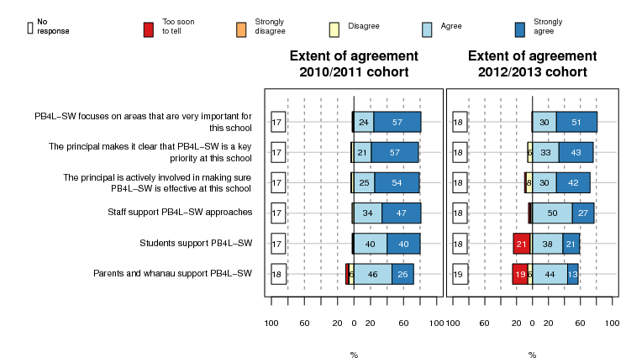

Most English and mathematics curriculum leaders also thought SW was supported at their school, with almost four-fifths agreeing or strongly agreeing that they and the colleagues in their department supported SW (see Figure 5). Again, levels of strong agreement are higher for the 2010/11 cohorts.
Some curriculum leaders disagreed that SW was supported at their school. However, these numbers were relatively small (11% of 2010/11 and 3% of 2012/13 curriculum leaders).
Figure 5: Curriculum leader views on support for SW (2010/11, n = 74; 2012/13, n = 107)
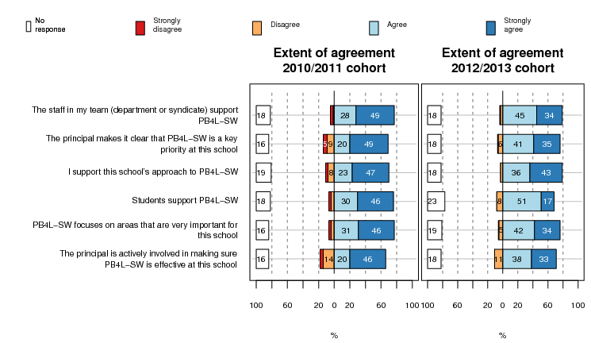

Data from other sources also show that SW is well supported in the school sector. The 2013 NZCER national survey of principals showed that, of the 24 principals who were at SW schools, the majority considered SW was very useful (50%) or useful (38%) in supporting them to develop approaches to student wellbeing and behaviour . These ratings were higher than those given to a number of other Ministry of Education initiatives.

Getting started with SW
Alignment of a new initiative with existing practice is a factor that supports uptake. Figure 6 shows that most 2010/11 coaches thought that SW was well aligned with existing practice.
Buy-in from at least 80% of staff is needed before schools can start SW, and SW emphasises ways of working that involve the whole school community in the journey. Figure 6 shows that most (78%) coaches from 2010/11 schools reported that staff were actively involved in the decision to join SW, and a shared view was developed with staff about what the school wanted to achieve from SW (89%). Curriculum leaders reported a similar pattern. This suggests that most 2010/11 schools had processes in place for working collaboratively with staff. At many schools students were also involved in decisions with most coaches reported that students were key partners in contributing to the development of values (76%) or behaviour expectations (75%). Parents and whānau were less involved. About half of 2010/11 schools consulted parent and whānau about joining SW (53%) or saw them as key partners in developing SW approaches (45%).
Most (80%) coaches from 2012/13 schools also reported that staff were actively involved in the decision to join SW. They showed a different pattern from 2010/11 coaches in relation to other questions. They tended to be less likely to strongly agree with some statements or report that it was too early to tell. Some of these differences were statistically significant. This is likely to be because these schools are still in the early stages of SW. Further rounds of data collection will be able to confirm if this is the case.
Figure 6: Coach views on starting to implement SW (2010/11, n = 89; 2012/13, n = 102)
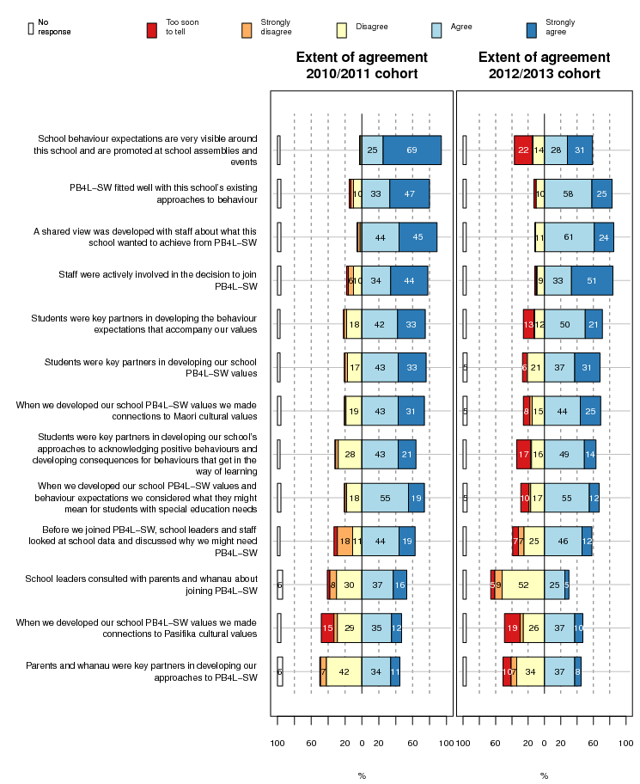

We looked for differences by school type for the 2010/11 cohorts. Coaches from deciles 1–2 schools were more likely to strongly agree that their school worked collaboratively with staff than coaches from deciles 3–10 schools. Coaches from small schools were more likely than their colleagues at large schools to report that their school regularly sought parent and whānau input into approaches to behaviour.

School teams
An effective SW school team is related to sustained implementation . Only three schools did not have a SW team. As shown in Figure 7 below most coaches from both cohorts of SW were positive about their team’s working and skill mix. They were slightly less positive about the SW team’s connections with other school teams to ensure alignment across the school.
Figure 7: Coach views on the SW team (2010/11, n = 89; 2012/13, n = 102)
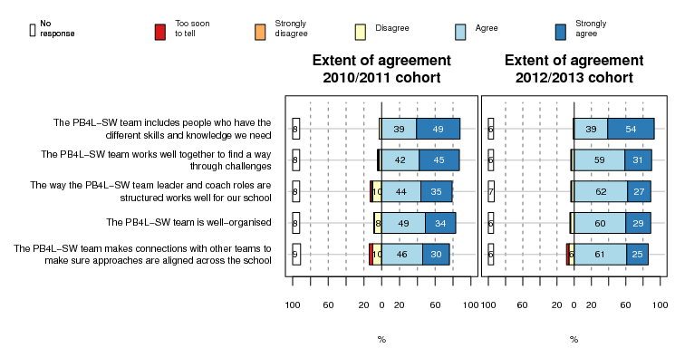

Teams varied in how often they met in 2013. Over half of teams meet frequently (18% every 1–2 weeks and 37% every 3–4 weeks). Of the rest, 20% met every 5–6 weeks, and 16% met once a term or once or twice a year.
Eighty percent or more of the SW teams included a SW coach, SW team leader, and the principal or another senior leader. Between 40 and 70 percent of teams also included: teachers with pastoral responsibility for students; a Special Education Needs Co-ordinator (SENCO) or staff who worked with students with special education needs; staff, whānau, or community members who could represent the interests of Māori students; and a board of trustees member. Fewer teams included parents and whānau (37%), or staff, whānau, or community members who could represent the interests of Pasifika students (15%).

Student involvement on SW teams
A few 2010/11 schools had student representatives on the SW team (15%) or processes at team meetings to hear the input of student representatives (27%) (see Figure 10, presented later). These proportions were slightly higher for 2012/13 schools (21% and 34% respectively). This may suggest that a focus on involving students is becoming more common practice in SW schools. In general, coaches and curriculum leaders showed lower levels of agreement about most of the survey statements that related to input in decision making by students compared with other aspects of practice.

Curriculum leader views on SW teams and support
Curriculum leaders were generally positive about their school’s SW team and their access to support, resources, and professional learning relating to SW (see Figure 8). Curriculum leaders from 2010/11 schools expressed more agreement with these items than 2012/13 leaders, suggesting that the SW team at their school was effective in building and maintaining relationships and support over time. As you would expect from schools that had recently joined SW, more 2012/13 curriculum leaders reported that it was too soon to tell if these processes would be put in place.
Like coaches, the curriculum leaders from 2010/11 schools were less likely to report that the SW team made connections with other school teams (76% of coaches and 66% of curriculum leaders).
Figure 8: Curriculum leader views on SW team support (2010/11, n = 74; 2012/13, n = 107)
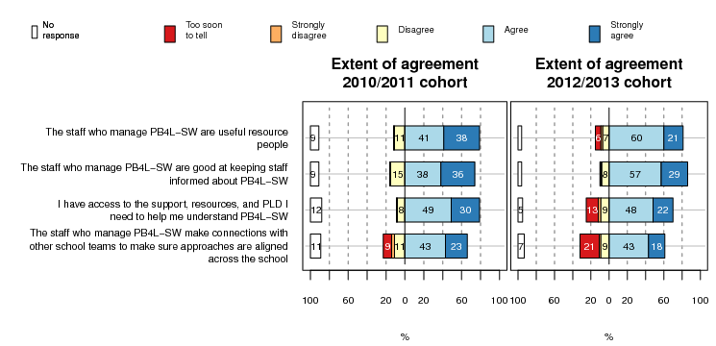

School systems for acknowledging and addressing behaviour
We will now focus on the material from 2010/11 schools to explore how coaches and curriculum leaders perceived some aspects of SW that are likely to take longer to implement and therefore are more likely to be in place in the schools that joined SW in 2010 and 2011.
SW prioritises consistency of approach and the use of data to support that. To enable that, schools need to have or develop good systems to track behaviour data. Most 2010/11 coaches considered their school had developed easy-to-use systems for reporting acknowledgements or rewards (83%) and behaviour incidents (84%) (see Figure 9). Most also reported having access to technical support if needed (78%). They were somewhat less sure that all school staff had a similar approach to using these systems (70%), or had the same understanding of which incidents were minor and which were major, and therefore needed to be referred on (74%).
Figure 9: 2010/11 coach views on school systems to support behaviour (n = 89)
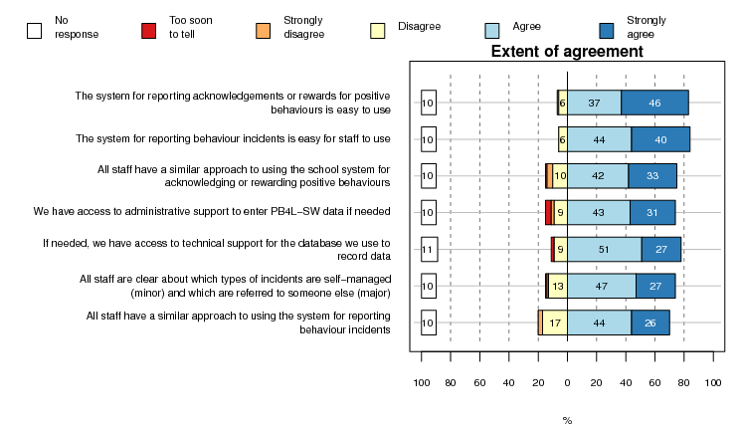

Data reporting
Figure 10 suggests that most (72%) school teams frequently reviewed student data. At least a third reviewed data every 4 weeks (the frequency suggested by SW). Around one-fifth of schools did not appear to be frequently reviewing data. A similar proportion were not using data or feedback about how SW was working for Māori students, and somewhat more in relation to how SW was working for Pasifika students, and students with special education needs. For some schools, this could be because there are too few of students in each group to meaningfully collate data. This is indicated by the “Too soon to tell” option on the graph which also functions as a “Not applicable” option. Overall coaches’ responses suggest that processes that make use of feedback and data from priority learners might not be strongly embedded in some schools.
Coaches from large primary schools were the most likely to report that they used data to make changes to school systems, and coaches from large secondary/intermediate schools the least likely (see Figure 25, presented in the next chapter). This suggests that some schools are finding it easier than others to use data to inform actions.
Figure 10: 2010/11 coach views on using data (n = 89)
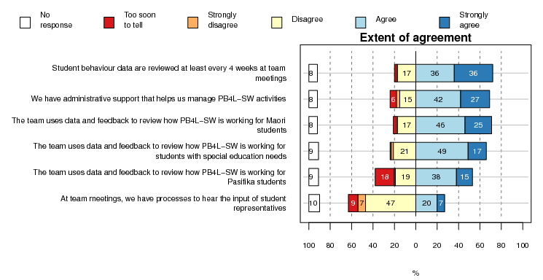
Figure 11 below shows that most schools tended to provide teachers with access to data (72%) or regularly report data to staff (59%). As is to be expected, SW teams tended to review data more often than it was reported to staff. Schools were less likely to regularly report behaviour data to students (32%) and parents and whānau (37%).
Figure 11: 2010/11 coach views on sharing data (n = 89)
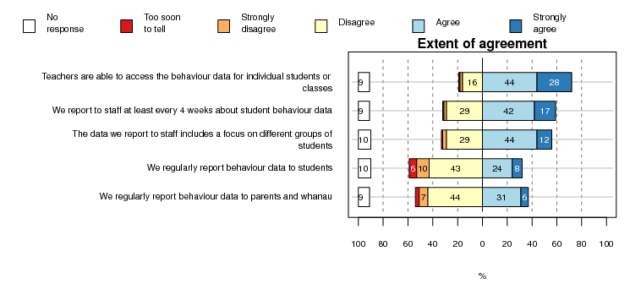
Curriculum leaders at 2010/11 schools had different views from school coaches about their access to data. Although they considered SW was improving their access to data, they also tended to be more likely to disagree with statements about their ability to use behaviour data in comparison with other survey questions. For example, 30% disagreed or strongly disagreed that behaviour data is reported to staff in a way that is useful.

Professional learning and resources for staff to support SW
Most 2010/11 schools had developed a variety of resources and supports for staff to assist them to implement core SW practices (see Figure 12). Most common were: resources that support staff to acknowledge and promote positive behaviour (86%), materials that assist teachers to teach behaviour expectations (81%); and training on processes to report behaviour incidents (83%). Less common processes included inducting new staff and relievers (64%), and regular PLD sessions for staff (69%).
Figure 12: 2010/11 coach views on the support provided to staff (n = 89)
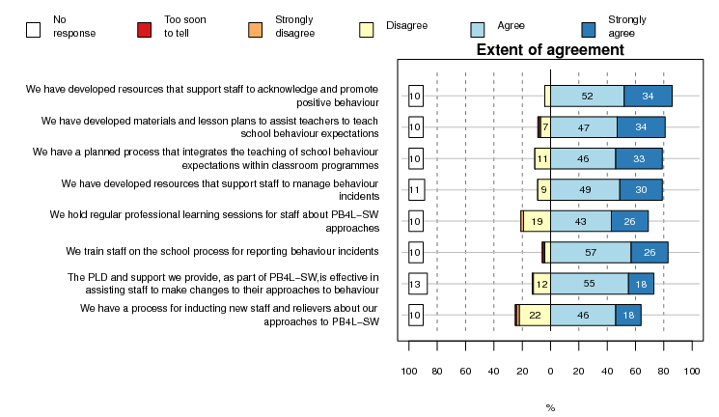
Similarly, curriculum leaders gave generally positive responses about their access to teaching resources and PLD, suggesting their school was providing them with the support they needed to integrate core SW approaches into their practice (see Figure 13).
Figure 13: 2010/11 curriculum leader views on their access to support (n = 74)
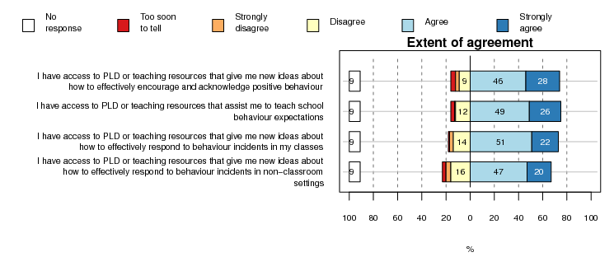
Sustainability and continued support
We asked school coaches and curriculum leaders a number of summary questions about SW, and here report the answers from both the 2010/11 and 2012/13 cohorts. Figure 14 below shows the responses of school coaches.
The responses of coaches from 2010/11 schools suggest that SW was becoming part of the fabric of their school. Most thought that: staff had a good understanding of the features of SW (77%); SW worked well for most students (83%) and for students from the different priority learner groups; and SW was improving their school culture (81%) and was embedded in the way their school worked (76%). The responses of coaches from 2012/13 schools suggested that, as expected, SW was less embedded. This can be seen by the number (23%) who selected the “too soon to tell” option.
Figure 14: Coach views on the extent SW is embedded (2010/11, n = 89; 2012/13, n = 102)
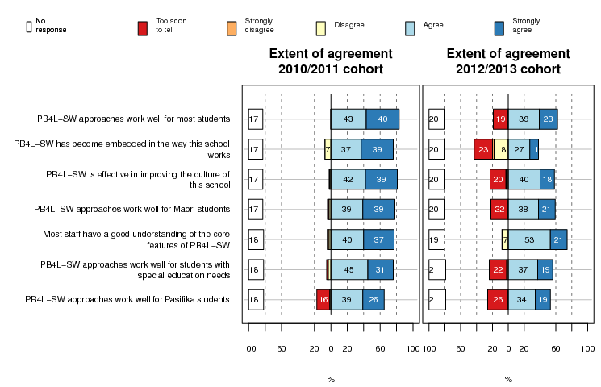
Significantly more 2010/11 coaches from deciles 1–2 schools than deciles 3–10 schools strongly agreed that SW was embedded at their school.
2010/11 curriculum leaders responded to these questions in a similar way to coaches. For many of the questions in the survey, curriculum leaders tended to select the “agree” rather than “strongly agree” option. For the questions in Figure 14 above there was very little difference between the numbers of coaches and curriculum leaders who strongly agreed with each statement. One exception was that slightly more curriculum leaders (36%) than coaches (26%) strongly agreed with the statement about SW approaches working well for Pasifika students. Overall this suggests that different staff members have relatively consistent views about the effectiveness of SW and how embedded it is in school practice.

Core features of SW
We also asked coaches and curriculum leaders a range of questions about core features of SW and aspects of the philosophy about behaviour that underpins the initiative as well as possible tensions (see Figure 15 below).
Responses to these questions indicate that most of the staff from 2010/11 schools who responded had adopted the SW philosophy that positive behaviour can be taught and learnt. Most 2010/11 coaches agreed or strongly agreed with questions about SW philosophy such as: SW supports staff to see that new behaviours can be taught (80%); this school makes clear connections between approaches to behaviour developed through SW and learning (73%); and SW encourages useful dialogue about behaviour between staff and students (82%).
Most also agreed or strongly agreed with the statements about core features, suggesting that many considered these to be in place at their school. Examples included: we regularly check how we are progressing with SW (74%); and the behaviour consequences and acknowledgement/rewards systems are used effectively by staff to encourage positive behaviour (75%).
Overall 2010/11 curriculum leaders showed a similar pattern to coaches in how they responded to these questions. They tended to be more likely to agree rather than strongly agree with a few statements such as: the behaviour consequences and acknowledgement systems are used effectively by staff to encourage positive behaviour (29% of curriculum leaders and 36% of coaches strongly agreed), and SW supports staff to see that new behaviours can be taught (24% of curriculum leaders and 34% of coaches strongly agreed). Slightly more curriculum leaders (42%) than coaches (31%) strongly agreed that timelines for making changes relating to SW were realistic. The overall similarity between curriculum leaders and coaches shows that these different groups of staff had relatively consistent and positive views about the core features and philosophy of SW and the extent to which these features had been adopted at their school.
Again, as you would expect for those who had more recently joined SW, 2012/13 coaches and curriculum leaders tended to show less agreement with these statements or indicate that it was too early to tell.
In terms of tensions that might impact on SW, around half of coaches indicated that PB4L was one of a number of competing priorities at the school. Around one quarter reported that some staff were not supportive of SW. These tensions tended to be reported more by 2012/13 coaches. This may suggest that over time schools find ways to resolve these concerns.
Figure 15: Coach views on SW philosophy and features (2010/11, n = 89; 2012/13, n = 102)
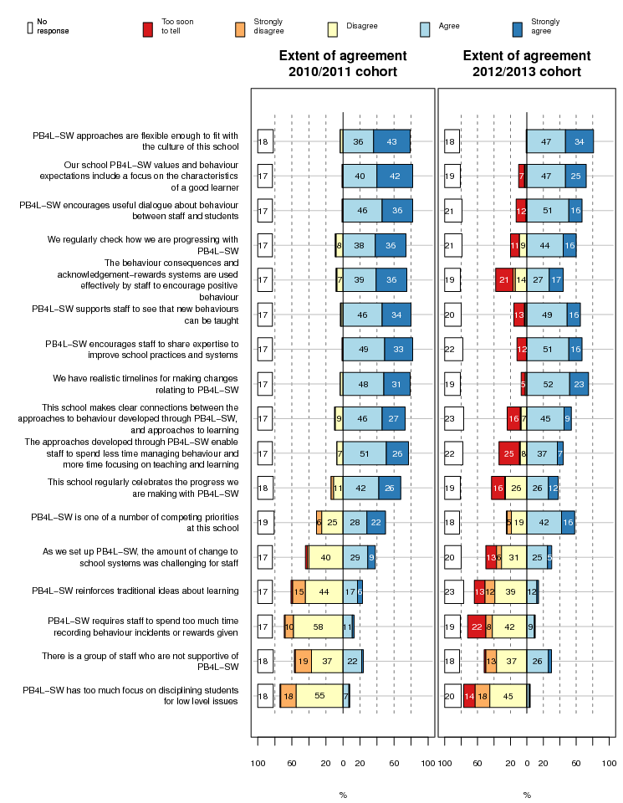

Longer term sustainability
Many of the 2010/11 schools had many of the features that McIntosh et al. suggest support sustainability, such as a well-organised school team, data being regularly reviewed at team meetings, the use of data for problem solving and decision making, school leaders who prioritised SW, a belief by staff that SW focused on important priorities, access to external expertise, and connections to other schools. Some features which are related to sustainability appeared to be less embedded. These included regular reporting of data to staff and celebration of progress with SW.
When asked about longer term sustainability, 52% of 2010/11 coaches thought they had the structures and processes in place to keep developing Tier 1 of SW. Around 53% wanted continued contact with SW Practitioners, and 39%, other schools.

Challenges to maintaining SW, as identified by schools
Although most 2010/11 coaches and curriculum leaders supported SW, some reported aspects of SW that did not work so well for their school or groups of students or staff (in response to an open-ended question). Some aspects were reported by both coaches and curriculum leaders. The most common were:
- building shared expectations and beliefs and resistance to change (7% of coaches and 9% of curriculum leaders)
- inconsistent use of systems by staff (8% of coaches and 9% of curriculum leaders)
- managing challenging students (e.g., the 5–7% of students who require Tier 2 or 3 approaches) (6% of coaches and 14% of curriculum leaders).
In addition, school coaches commented on the:
- time-intensive nature of SW (e.g., the workload for the team or coach) (10%)
- need for more focus on ways of teaching behaviour expectations (8%)
- need for better data collection or recording systems (6%).
Are there any aspects of PB4L-SW that don’t work so well at your school or for particular groups of students or staff?
Hard for a small-staffed school to put in SO much TIME with collating and data analysis. It feels that the coach, lead teacher and principal are having to continue to lead, inspire other staff members. (coach survey)

Need to get all staff on board, remove the inconsistencies so that all staff respond in the same manner and that we are positive rather than punitive when there are infractions that occur. (curriculum leader survey)

Dealing with students with more extreme behavioural issues is still a challenge. We are looking forward to Tier 2 to resolve some of these issues. (coach survey)

Coaches’ views on the SW support model
SW offers a support model to schools which includes national training days, visits to schools by SW Practitioners, access to SW conferences, and access to local cluster meetings where schools meet to support each other. The Ministry of Education provides a $10,000 participation grant per school per year for training and support for the first two years of SW.
The mix of different external supports that constituted the SW support and training model appeared to be meeting the needs of many schools. Most (78%) coaches from both cohorts agreed that, in 2013, the way SW support and resources were organised was effective for their school (see Figure 16).
Figure 16: Coach views on the 2013 SW support model (All cohorts, n = 191)
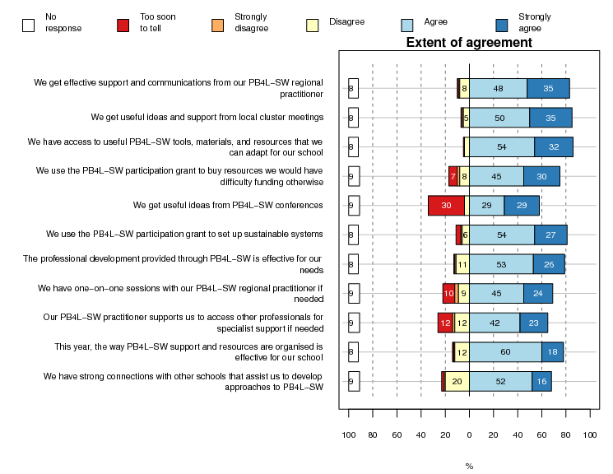
Coaches from 2010/11 and 2012/13 schools responded in very similar ways to these questions, suggesting that the 2013 support model was effective for schools that had been in SW for a number of years as well as those which had recently joined. The majority of coaches from all cohorts agreed they got effective support and communications from their SW Practitioner (83%) and that they had adequate access to useful tools, resources, and materials (86%) and effective professional development (79%) to support SW. Secondary/intermediate school coaches tended to show less agreement on these questions compared with primary school coaches, but these differences were not statistically significant.
In terms of internal support provided by their school, about half (48%) of all coaches considered they did not have enough time allocated to their role.

The impact of support on rate of SW implementation
The School-Wide Evaluation Tool (SET) is completed annually by schools. This tool gives an indication of the extent to which schools have implemented the key features of SW. A feature is considered to be implemented if there is 80% agreement on a number of items about this feature. Schools also get an overall score which summarises their overall level of implementation.
We used the SET data from 2010/11 schools to see if there were any differences between schools that had a fast or slow rate of implementing SW. We split the 2010/11 schools into groups depending on their rate of change in average SET scores between the first 2 years they were part of SW. We categorised these rates as:
- fast rate = 40% or more improvement in the average SET score (43 schools)
- medium rate = 25% to 39% improvement in the average SET score (45 schools)
- low, no, or negative rate = up to 25% change in average SET score (33 schools).
We looked to see if there were any differences between schools by their rate of implementation to see if those which were faster to implement SW were different from other schools.

Differences between schools
There were only a few differences between these groups which appeared to impact on the rate of implementation. Significantly more of the fast-implementing schools were deciles 5–8 (45% of deciles 5–8 and 31% of deciles 1–4). The low- or medium-implementation-rate schools were more likely to be deciles 1–4. This suggests that higher decile schools found it easier to implement SW. Owing to low numbers deciles 9–10 schools are not included in this analysis.
However, significantly more 2010/11 coaches from deciles 1–2 schools agreed that SW was embedded in their school (86% of deciles 1–2 and 68% of deciles 5–8). Deciles 1–2 schools also reported greater changes to some student outcomes. This suggests that lower decile schools are taking longer to implement SW, but it may ultimately result in more changes to student outcomes and school practices. This may well be because these schools are more in need of SW.
Another difference was that significantly more coaches from fast-implementing schools strongly agreed that they got effective support and communications from their SW Practitioner (50% of fast and 21% of medium/low). They also tended to be more likely to strongly agree that they were able to have one-on-one sessions with their SW Practitioner if needed (33% of fast and 18% of medium/low). There were also some variation in implementation rates by the region in which schools were located.

Stability of relationships and change
The analysis summarised above suggested that perceptions of effective support relationships assisted schools to implement SW. Therefore we took a closer look at the other questions in the coach survey about the connections between schools and SW Practitioners and school clusters. We looked at the data from all 2010/11 schools. Many schools had changes in the SW Practitioner with whom they worked. Only 26% of coaches reported their practitioner had stayed the same over their time in SW (16% for 2010/11 schools; 35% for 2012/13 schools). Of the rest, 31% had one change, 23% had two or three changes, and 2% had four or more changes in SW Practitioner. The other schools did not respond to this question. School coaches tended to report more stability in their school teams (50% had the same coach, team leader, and principal over their time in SW) and clusters (56% were still in the same cluster).
Overall, coaches were more likely to strongly agree that many of the features of SW were in place or report major changes to outcomes if their SW Practitioner had stayed the same, or if they had a stable SW school team. A number of these differences were statistically significant, for example, twice as many coaches at schools who had worked with the same SW Practitioner strongly agreed that referrals for major behaviour incidents were decreasing over time (86% same practitioner, 40% one change in practitioner, 37% two or more changes in practitioner). Similar proportions reported that SW had supported a major positive change in this outcome although these figures were not statistically significant (79% same practitioner, 40% one change in practitioner, 40% two or more changes in practitioner).
These data suggest that effective relationships with SW Practitioners is one key aspect of the support model which assists schools to make progress with implementing SW in ways that support improved outcomes.

Support from cluster groups
The SW support model sets up regional clusters to encourage schools to work together to problem solve and build practice. All of the 2010/11 coaches who responded to a question about cluster groups reported they had attended some meetings, and over two-thirds had attended all of their cluster’s meetings in 2013. Similarly, most (85%) of the 2012/13 coaches had attended all cluster meetings. Most noted they gained a range of benefits from these meetings. Only two had not attended any cluster meetings or reported they gained no benefit from meetings. The most common benefits (selected by 70% or more across all cohorts) included:
- information about the evidence base of SW
- ideas about how to promote and acknowledge positive behaviour
- ideas about how to manage behaviour incidents
- ideas about how to set up effective school systems for reporting behaviour data
- ideas about ways of changing school systems or settings to encourage positive behaviour
- having a safe place to have conversations about data and school practice.
Least commonly indicated benefits related to aspects of SW that this report suggests are less common practice in schools. This included ideas for seeking student input into SW or strategies for working with parents and whānau. This suggests that a focus on these areas in cluster meetings might assist schools to build a stronger focus on working collaboratively with students, parents, and whānau.

Support for schools from the SW workforce
This section of the report draws on information from the SW Practitioner survey and interviews with national and regional Ministry of Education staff involved with SW.

Providing support to schools
Regular access by school staff to external expertise is related to sustained SW implementation , 2013). Therefore an effective support workforce with the requisite knowledge is a core component of SW. Support to SW schools is currently provided by SW Practitioners employed by regional Ministry of Education offices. The SW Practitioners work in regional teams. Their role varies depending on their level of experience but usually includes running Tier 1 school training days, facilitating school cluster sessions, and visiting schools to provide one-on-one mentoring and problem-solving support, and to assist in administering tools such as SET.
The demographic questions in the SW Practitioner survey gave some indication that those who responded were likely to have a range of competencies and knowledge sets they could draw on in their role, such as prior experience: facilitating group training, supporting school staff to address challenging behaviour, and working as a school staff member.
The SW Practitioner survey had a focus on the extent to which SW Practitioners thought they had the training, capabilities, and access to information and resources they needed to fulfil their role. In terms of their professional practice, all 13 practitioners who responded to the survey agreed they felt confident in their role and received the training they needed for their various roles in working with schools. They also agreed with statements about whether they were part of a community of practice in their region which worked together to discuss challenges and problem solve.
In terms of access to resources, most SW Practitioners agreed or strongly agreed with survey statements about their access to knowledge and tools that they could share with schools, such as information about: the international effectiveness of SW, evidence-based approaches to behaviour, and New Zealand examples of practice.
The feedback from schools summarised in the SW indicator report suggests that Tier 1 training was meeting the needs of school staff . However, many SW Practitioners and other Ministry of Education staff involved with SW thought that SW training approaches needed to be reviewed to better align them with what is known in New Zealand about effective PLD and pedagogy. One commonly suggested improvement was less focus on sharing information via PowerPoint presentations, and more focus on interactive sessions that supported schools to develop plans to suit their context. Other suggestions included developing a New Zealand clearing house of online resources and videos for schools to use to run their own training sessions, and making stronger connection with New Zealand-based practice, such as the knowledge built through Te Kotahitanga.

Problem solving when things don’t go as planned
Use of core SW processes, such as data-driven approaches and problem-solving models (e.g., Team-Initiated Problem-Solving (TIPS)), appeared to be giving SW Practitioners a structure that assisted them to facilitate school teams to work through dilemmas or solve problems. SW Practitioners reported using a number of different strategies to work more actively with schools that were having difficulty implementing aspects of SW or were losing momentum. The strategies SW Practitioners described in some of the open-ended survey questions included:
- attending school team meetings to support the coach or team leader to air concerns, and to support the school team to problem solve
- supporting the school to revisit their action plan and set small, achievable goals
- using evidence from SW tools, such as SET or the Team Implementation Checklist, to focus on whether the seven essential features of SW were in place, and reflect on solutions
- supporting school teams to re-engage with staff (e.g., by assisting in running school professional development sessions)
- maintaining regular contact with the principal and/or re-engaging them with training
- supporting schools to review the structure of their team to make sure they had the right mix of people on the team
- regular contact and positive feedback
- offering strategies or new ideas (e.g., through organising visits to other SW schools).
Many of these strategies required face-to-face support. A number of SW Practitioners and other Ministry of Education staff considered the support needs of schools had been underestimated. This was particularly the case for schools that were finding it hard to implement SW (such as large secondary schools), as well as schools that had been in SW for a number of years. Staff from some regions noted they had struggled to support schools in 2013 owing to staff turnover or staff funding caps. Others were concerned about how they would provide the same level of support once more schools started SW in 2014.

Developing regional approaches to supporting schools
One aspect of SW that was supporting SW Practitioners in their role was the regionalised model of SW delivery which started in 2013. SW Practitioners and other regional Ministry of Education staff interviewed felt this structure better enabled them to tailor support to localised needs. Some of the benefits included the ability to:
- recruit people to complement the skill set of the regional team or who had credibility in local schools (e.g., some regions had employed Māori SW Practitioners to work with schools with high Māori rolls or experienced school coaches who had credibility in the sector)
- run regional booster or forums tailored to emerging school needs, or regroup clusters in ways that better suited schools
- develop regional data-driven approaches to identifying and working with local schools that were experiencing implementation barriers (e.g., one region had developed a spreadsheet to look at the SW data from the schools in their region that were finding aspects of SW hard to implement, to identify areas of concern for which they could provide additional support)
- quickly allocate personnel and other resources to suit immediate needs (e.g., more experienced SW Practitioners could be assigned to mentor and support newer practitioners)
- work with local Māori and Pasifika advisors to support schools
- make links with local iwi to develop local protocols for working with schools
- work in a joined-up way with other Ministry staff such as Senior Advisors or Student Achievement Function (SAF) practitioners to problem-solve around the needs of individual schools.
Some of the challenges of regionalisation included:
- a perception of “drift” between regions and different views about what constitutes fidelity of SW training and support
- a lower frequency of communications from national level and loss of some of the systems for networking, sharing, and building good practice in SW at a national level
- difficulties in collecting regional data that could be used nationally
- lack of time to do induction and training of new SW Practitioners in regions (some considered this would be better managed nationally)
- different management structures and reporting lines between regions.
A national practice group and lead SW Practitioner roles had been formalised in late 2013 which many Ministry of Education staff considered could help to address some of these challenges. Most felt there was a need for a stronger system that supported continuous improvement by enabling regions to work together to assess the “fidelity” of their practice, and identify and share good practice between regions. Some considered some form of inter-region moderation system could be developed by current staff, others suggested there was a need to work with critical friends and make stronger links with international expertise. The need for a stronger national research focus in SW that could be achieved by forging connections with universities was also mentioned, as was the need to make stronger connections between SW and existing good practice in New Zealand such as the knowledge built through initiatives such as Te Kotahitanga.

Planning a service delivery model
A common theme in the interviews with Ministry of Education staff was that SW had been implemented quickly and new cohorts of schools added before practices had been embedded. Many considered they were now going through a similar process of “building the plane while flying it” in terms of developing a model of delivery for Tier 2 and 3. Most considered there was not enough resourcing at a national level to spend the time needed to pilot approaches and map out what this model might look like. Some thought there was a need to more closely examine international blueprints for Tier 1-3 delivery, and consider what these might mean for New Zealand. There was also a need to further explore how SW fitted with the work of other Ministry of Education staff to ensure that schools received a coherent package of support.

Recruiting and retaining a SW Practitioner workforce
The current SW Practitioner workforce model was in a state of review at the time data was being collected for this evaluation, and it was unclear how this model would develop in the future or who would be providing support to schools. Various suggestions were on the table such as current SW Practitioners, or people such as Resource Teachers of Learning and Behaviour (RTLB) or experienced school coaches who could be seconded to work with other schools.
Since 2010 there has been a relatively high turnover of SW Practitioners in some regions or unfilled vacancies (some regions had lost positions through funding caps). New cohorts of schools being added to SW each year compounded this situation. This was resulting in SW Practitioners having workloads higher than the recommended 20 schools. These changes are a concern for SW given that stability of SW Practitioner over time is linked with faster implementation and perceptions of improved outcomes by school coaches.
Interviewees suggested there were a number of factors that needed addressing in the current model to ensure that it enabled regions to recruit and retain SW Practitioners and build capability. These included that the pay structure and contract nature of the role did not adequately recognise the skill set required of SW Practitioners, or provide job security or opportunities for career progression. These factors were contributing to difficulties in recruiting and retaining SW Practitioners. Other factors interviewees and survey respondents suggested could be addressed included a need for:
- a national induction and/or formalised accreditation process for SW Practitioners (e.g., a number suggested SW would benefit from a similar accreditation model as the Incredible Years Teachers programme)
- a planned structure for Tier 1-3 that outlined how the workforce would be structured, the different skill sets required for Tier 1-3, and which allowed for specialist positions
- more recognition or resources for SW Practitioners who worked with schools in isolated regions which required substantial travel time
- more structures to support the ongoing development of SW Practitioners in their role such as a formalised PLD structure and ongoing supervision.
Most SW Practitioners and other Ministry of Education interviewees were strongly supportive of SW and considered that SW was achieving good outcomes. They also thought these outcomes could be made more consistent across schools with an improved workforce model. This new model needed to address the above tensions, provide adequate support to schools, build capability, and provide a clear blueprint for how the different tiers of SW would be delivered.
Are there any key changes that could be made to the way your role is structured or supported that would assist you to do your job more effectively?
Frequent PLD opportunities, increase staff capacity, salary parity with other roles of the same level of work (SAF), leadership pathway progression in role, adequate supervision, National Technical Assistance Team to support practitioners, integrated behaviour service with PB4L-SW, links with universities to do NZ research and links with Māori academics - Te Kotahitanga [to] be more culturally responsive (SW Practitioner survey)

Aspects of SW that may need further support
In this section of the report we look at three aspects of practice that were identified in the scoping phase of the evaluation as warranting additional consideration. These are:
- how SW incorporates a focus on priority learners
- the relationship between SW approaches to behaviour and existing school approaches to learning
- the fit between SW and secondary school practice.
We analysed the data from the school and SW Practitioner surveys and interviews with SW Practitioners to explore what they could tell us about these areas. We found that, in line with the SW focus on problem solving, Ministry of Education staff were actively working to build practice at a national, regional, and local school level in relation to these aspects of practice.

Focusing on priority learners
The SW theory of change identifies alignment with other Ministry of Education and other sector initiatives and targets as one factor that is likely to influence SW implementation. One important Ministry of Education goal is improving outcomes for priority learners. The SW evaluation questions and data gathering tools include a focus on approaches and outcomes for three groups of priority learners: Māori students; Pasifika students; and students with special education needs. We asked questions about how schools and SW Practitioners incorporated a focus on these three groups within SW processes. The aim of these questions was to explore how well priority learners were included and supported through SW.
Overall, most school coaches and curriculum leaders considered that SW worked well for all three groups of priority learners (see figure 14 presented earlier). However, school coaches and curriculum leaders showed more disagreement that practices which related to priority learners were in place in comparison with many other survey questions. This suggests there is considerable variability between schools.
Schools seemed to have more processes for ensuring Māori students and community perspectives were included in SW and exploring outcomes for Māori learners than they did for the other two groups of priority learners. A focus on learners with special education needs was also more visible in schools than a focus on Pasifika learners. This may reflect that Pasifika students tend to be clustered in some schools, with other schools having few Pasifika students.
A summary of responses to all the questions related to priority learners in the 2010/11 coaches and curriculum leader survey is presented below. Information from an analysis of school behaviour expectations documents is also included. Further analyses (such as by percent of Māori or Pasifika enrolment) can be undertaken in the final report.

Māori learners and communities
Most (79%) coaches agreed or strongly agreed that PB4L-SW approaches work well for Māori students. A focus on Māori learners was visible in core SW processes as shown below.
- Forming a SW team and working in a consultative way: Nearly half (45%) of coaches reported having staff, parents or community members who could represent the interests of Māori students on the SW team and 49% agreed or strongly agreed that they regularly sought Māori community input to improve approaches to behaviour.
- Developing behaviour expectations: Most (74%) coaches agreed or strongly agreed that their school made connections to Māori cultural values when their SW values were developed. More than one-third of the behaviour expectations documentation we reviewed made an explicit connection to Māori values or ways of working (34% for 2010/2011 cohort; 45% for 2012/2013 cohort). This increase could be a reflection of the stronger Ministry focus on priority learners.
- Teaching behaviour expectations: The majority (66%) of coaches agreed or strongly agreed that all staff were skilled at making space for Māori students to share their cultural perspectives and attitudes when talking about behaviour. The majority (74%) of curriculum leaders agreed or strongly agreed with a similar statement about their own practice.
- Analysing data to suggest priorities: Most (71%) coaches agreed or strongly agreed that the SW team use data and feedback to review how well SW was working for Māori students.

Students with special education needs
Most (76%) coaches agreed or strongly agreed that PB4L-SW approaches work well for students with special education needs. A focus on students with special education needs was visible in core SW processes as shown below.
- Forming a SW team and working in a consultative way: Just over half (53%) of coaches report having a SENCO or staff who could represent the interests of students with special education needs on the SW team and 68% agreed or strongly agreed that they regularly sought input from staff who are responsible for special education needs provision to improve their approaches to behaviour.
- Developing behaviour expectations: Most (74%) coaches agreed or strongly agreed that their school considered what their SW values might mean for students with special education needs when these values were developed. About one-quarter of the behaviour expectations documents we reviewed included explicit statements about inclusion or respecting diversity and difference (26% of the 2010/11 cohort and 29% of the 2012/13 cohort).
- Teaching behaviour expectations: The majority (70%) of coaches agreed or strongly agreed that all staff are skilled at making space for students with special education needs to share their perspectives when talking about behaviour. The majority (74%) of curriculum leaders agreed or strongly agreed to a similar statement about their practice.
- Analysing data to suggest priorities: Two-thirds (66%) of coaches agreed or strongly agreed that the SW team use data and feedback to review how well SW was working for students with special education needs.

Pasifika students and communities
Most (65%) of coaches agreed or strongly agreed that PB4L-SW approaches work well for Pasifika students. A number commented that this question was not applicable to their school (16%). Schools varied as to how much this priority group were visible in core SW processes.
- Forming a SW team and working in a consultative way: A small group of schools (15%) reported having staff, parents or community members who could represent the interests of Pasifika students on the SW team. More (30%) agreed or strongly agreed that they regularly sought Pasifika community input to improve approaches to behaviour.
- Developing behaviour expectations: About half (47%) of the coaches agreed or strongly agreed that their school made connections to Pasifika cultural values when their SW values were developed. About 15% noted this question was not applicable to their school. None of the behaviour expectations documentation we reviewed made a clearly identifiable connection to Pasifika values or ways of working in a Pasifika language. In part this may reflect the many different Pasifika cultures in schools and therefore the difficulties inherent in prioritising a value from one culture. Many schools included a focus on respect, and some, a focus on service. These values are described as core Pasifika values.
- Teaching behaviour expectations: About half (54%) of coaches agreed or strongly agreed that all staff are skilled at making space for Pasifika students to share their cultural perspectives and attitudes when talking about behaviour. More (74%) curriculum leaders agreed or strongly agreed to a similar statement about their practice.
- Analysing data to suggest priorities: About half (53%) of coaches agreed or strongly agreed that the SW team use data and feedback to review how well PB4L-SW was working for Pasifika students. A number (18%) noted this question was not applicable to their school.

Ministry of Education staff views about focusing on priority learners
Similar to the data from schools, SW Practitioners reported differences between schools in the extent to which they had processes in place to work collaboratively with priority learners and their communities, and use data about priority learners to improve practices.
There was a general consensus from Ministry of Education staff that the SW family, whānau, and community training module for schools provided models of effective practice for working collaboratively. SW Practitioners were less clear about the fit between SW practices and school support for students with special education needs (e.g., Are connections made between students’ Individual Education Plan (IEP) goals and SW expectations?).
Respondents to the SW Practitioner survey showed lower levels of agreement with statements that related to priority learners compared with the other aspects of practice explored in the survey. They included whether they had access to examples of how SW could be implemented in ways that valued Māori or Pasifika world views or took into account students with special education needs, or that their region had made connections with local iwi to talk about SW.
National and regional staff provided a variety of examples of how they were actively working to strengthen their own, and schools’, focus on supporting priority learners. At a national level they were working on processes to support schools to focus on inclusive practices alongside the implementation of SW. At a regional level they were working to build stronger connections with a range of people who could assist them to build practice, such as local iwi. Ministry of Education staff also provided a wide range of suggestions about future possibilities.
Overall the information from schools and Ministry of Education staff suggests that both are building ways to include and support priority learners within SW. These data also suggest that regions and schools could benefit from further sharing of effective models of practice.

Are there any changes that could be made to PB4L-SW to better suit priority learners?
Include Te Kotahitanga strategies and pedagogy into the classroom management practices
SW Practitioners to model tikanga Maori
Incorporate models and research from Māori; e.g., Durie, Meyer, MacFarlane
Team with Building on Success to work alongside schools to enhance and strengthen what we do for Māori
Work with Ministry IMER team to develop iwi links per region for community involvement (SW Practitioner survey)
Work with Pasifika team to include Pasifika models in training—Fale fono etc. and establish regional links to Pasifika community (SW Practitioner survey)

Connections between behaviour and learning
We included a focus on the extent to which school staff perceived there was a clear connection between SW’s focus on behaviour and school approaches to learning as a lack of obvious connections was an area of tension noted in an Australian evaluation .
Most 2010/11 coaches and curriculum leaders agreed or strongly agreed that their SW values included a focus on the characteristics of a good learner (83% of coaches and 76% of curriculum leaders) and that their school made a clear connection between SW approaches to behaviour and approaches to learning (81% of coaches and 64% of curriculum leaders). The lower level of agreement by curriculum leaders suggests some were less clear about these connections than coaches.
To further explore this connection we asked schools to send us their values and behaviour expectations documentation. We developed a framework based on the key competencies to analyse these documents for connections to learning behaviours. We found that most (86%) of the 92 school values and behaviour expectations documents we reviewed made some form of connection to learning behaviours. Most common (62%) was a generic connection (e.g., I am a good learner). Around one-third made explicit connections to more specific learning behaviours through statements about:
- high expectations or striving for excellence (e.g., I try to do my best all the time)
- managing self: Goal setting/reflection (e.g., I reflect on my learning/I plan next steps)
- managing self: Being motivated/organised (e.g., I manage my time well)
- thinking: (e.g., I am a critical thinker/problem solver; I ask good questions).
Less common were statements connected to the dimension of relating to others that is connected to peer learning (e.g., I give good feedback to others), or the competency using language, symbols, and texts.
This information suggests that many SW schools in New Zealand have made a connection between the behaviours they are promoting through SW and key learning behaviours. For some this connection was stronger than others. Some schools provided very clear examples of what learning behaviours might look like—others provided more generic descriptions.
It is likely that the implementation of the revised NZC over 2007–10 influenced these connections as this prompted many schools to review their values and develop clear ideas of what core learning values looked like. It appears that this prior work has been incorporated into SW.

SW in secondary schools
Interviews and surveys with Ministry of Education staff suggested that secondary and large intermediate schools experienced a number of challenges implementing SW compared with primary or contributing schools. Prior analyses of SET data also suggest that secondary schools are slower to move to Tier 2 .
The data in Chapter 4 on changes in schools show that while secondary schools and large intermediates were experiencing gains with SW, coaches from 2010/11 schools reported fewer shifts in some outcomes and fewer changes to practice than did 2010/11 primary and contributing school coaches.
We looked at these data to see what they could tell us about the aspects of SW implementation that might be more complex for secondary and intermediate schools to implement and therefore might benefit from further support. Our main focus was the data from the 2010/11 school coach survey. We compared the data from 37 secondary/intermediate school coaches to that of 52 primary school coaches. We also looked at information from the curriculum leader survey from 2010/11 schools, and surveys and interviews with SW Practitioners and other national and regional Ministry of Education staff involved in SW.

School coach perspectives
Data from the school coach survey suggests that the SW implementation journey is more complex for secondary and large intermediate schools. Fewer secondary/intermediate coaches strongly agreed that SW was embedded in the way their school worked (27% of secondary/intermediate coaches and 48% of primary coaches) and significantly fewer reported that staff, students, or parents and whānau supported SW.
Overall, significantly fewer secondary/intermediate school coaches agreed that many of the core features of SW were in place compared to their primary colleagues. They were also less likely to report shifts in practice in relation to some of these features. A similar pattern was evident in responses from curriculum leaders. There were six main areas of difference between secondary/intermediate and primary schools.

The fit between SW and existing approaches
The school coach survey findings suggest that, prior to SW, secondary/intermediate schools had different ways of working compared with primary schools. Secondary/intermediate coaches’ views about whether SW fitted well with existing approaches to behaviour were polarised. A relatively large proportion (54%) strongly agreed, but 19% disagreed. Primary school coaches showed a more consistent pattern of agreement (42% strongly agreed, 40% agreed, and 10% disagreed or strongly disagreed). Secondary/intermediate coaches were also less likely to strongly agree that SW approaches were flexible enough to fit with the culture of their school (32% of secondary/intermediate coaches and 50% of primary coaches). Taken together, this suggests that SW required bigger shifts in thinking and practice for secondary/intermediate school staff.

School size
One key difference between secondary/intermediate and primary school contexts is the size of the school. This has implications for school teams that are attempting to work collaboratively to create a whole-school shift in culture, as there are many more students and staff to work with. We looked to see if there were any differences between the views of coaches at small and large secondary/intermediate schools. In general, coaches at large secondary/intermediate schools were less likely to agree with statements. More disagreed that the professional development provided through SW was effective for their needs (28% of large and 0% of small). Fewer also strongly agreed that staff supported SW (20% of large and 58% of small). Coaches at large secondary/intermediate schools also reported fewer major positive shifts in school systems related to SW such approaches to addressing behaviour incidents (24% of large and 67% of small). Fewer changes to schools’ ability to report and use data were also reported. For example, 28% of coaches at large secondary/intermediate schools reported SW had supported a major positive change in the effectiveness of processes for reporting behaviour data to staff. The figure for small secondary/intermediate schools was 50%.

Leading the whole community in a SW journey
As they started SW, secondary/intermediate coaches reported less overall agreement that their school had processes in place for working collaboratively with all the key members of the school community (staff, students, parents, and whānau). Significantly fewer secondary/intermediate coaches agreed or strongly agreed that their school held regular professional learning sessions for staff about SW (59% of secondary/intermediate coaches and 75% of primary coaches). Significantly fewer also strongly agreed that their school regularly sought staff input to improve approaches to behaviour (19% of secondary/intermediate coaches and 48% of primary coaches).
Secondary/intermediate coaches were also less likely to agree or strongly agree that parents and whānau were key partners in developing approaches to SW (27% of secondary/intermediate coaches and 58% of primary coaches), and that students were key partners in the development of school PB4L values and behaviour expectations (65% of secondary/intermediate coaches and 81% of primary coaches). However, significantly more secondary/intermediate coaches agreed or strongly agreed they had processes in place to enable student input into team meetings (38% of secondary/intermediate coaches and 19% of primary coaches).
Active involvement by the school principal is a key feature of SW and a known contributing factor in the success of school change initiatives. Secondary/intermediate coaches tended to be less likely to strongly agree that the principal was actively involved in SW (43% of secondary/intermediate coaches and 62% of primary coaches).

Teaching behaviour expectations
Significantly fewer secondary/intermediate coaches strongly agreed that their school had a planned process to integrate the teaching of school behaviour expectations within the classroom programme (22% of secondary/intermediate coaches and 40% of primary coaches). This is one aspect of SW that SET data shows is harder for schools in general to implement . Other data from the open-ended questions in the survey and from SW Practitioners supports the view that this was an aspect of SW that secondary schools found harder to put in place.

Developing consistent practices for reinforcing positive behaviour and addressing incidents
Significantly fewer secondary/intermediate coaches strongly agreed with statements about consistency of approaches across the school such as: all staff make sure they frequently praise student and acknowledge positive behaviour (19% of secondary/intermediate coaches and 48% of primary coaches); and all staff use similar approaches to managing behaviour incidents across classroom and non-classroom settings (10% of secondary/intermediate coaches and 42% of primary coaches). They also tended to express less agreement with statements such as: all staff are clear about which types of incidents are self-managed (minor) and which are referred to someone else (major); and all staff have a similar approach to using the system for reporting behaviour incidents. There are a number of factors that may influence consistency in secondary/intermediate schools. One factor is the larger rolls of secondary/intermediate schools which results in coaches having larger numbers of staff to work with. This, in combination with having fewer processes for working collaboratively with the whole school community, and less focus on ongoing staff PLD, as discussed above, may be factors that influence consistency of practice later on.

Developing effective data-reporting processes
Secondary/intermediate and primary schools had different approaches to data. Secondary/ intermediate schools were significantly more likely to use a student data management system such as KAMAR or MUSAC to manage SW data. Primary schools tended to use Excel or other databases.
There did not appear to be large differences in views about data-recording systems between secondary/intermediate and primary school coaches. There were differences in views about how data were reported and used. Secondary/intermediate coaches tended to express a wider range of views about whether school databases gave them the reports they needed. Many (43%) strongly agreed that this was the case, however, 22% also disagreed. The figures for primary schools were 37% and 10% respectively. This suggests that many schools had found workable solutions to managing and using data whilst others (mostly secondary) had yet to do the same.
Secondary/intermediate coaches tended to report less sharing of data and significantly fewer agreed that data were used to make improvements to school systems. Reflecting this, curriculum leaders at secondary schools were less likely to agree with statements about data being reported in ways they could use. We asked schools whether they collected data about the “the big five”. That is, they recorded “what, where, when, who, and why” information about behaviour incidents. About four-fifths of schools reported collecting this information. Secondary/intermediate schools were significantly less likely to discuss “who” and “why” data with their school team. This is likely to reflect larger rolls sizes as well as possible challenges with reporting.
Looked at together these findings suggest that data reporting and use is more complex in secondary/intermediate school settings and is likely to be one factor that is getting in the way of schools using data to problem solve and make improvements.

Summary of school coach perspectives
Overall these data suggest that shifts in practice in secondary schools are likely to involve longer time frames and more support to develop processes that engage the whole school community, support the teaching of behaviour expectations and consistency of practice, and enable schools to make effective use of data.
There were no significant differences between secondary/intermediate and primary school coaches’ views about the current level and type of external support they received from SW Practitioners and through cluster groups. It appears that their support needs relate more to models of practice they could use in their school.
How could PB4L-SW be improved?
More strategies on how it could work within big multicultural high schools. (coach survey)

The information presented above suggests that SW is more complex to implement in secondary and intermediate school settings. However, it is important to note that a number of secondary and intermediate schools have effectively implemented SW and many secondary and intermediate school coaches were also reporting positive shifts in practice and student outcomes. These shifts are summarised in Chapter 4.

Ministry of Education staff views on SW in secondary/intermediate schools
Reflecting the findings from schools summarised above, SW Practitioners and other regional Ministry staff were finding that secondary schools could take much longer to implement SW. Some regions were also having difficulty recruiting the targeted number of secondary schools. On the whole the complexities in the secondary sector and for some large intermediate schools identified by SW Practitioners and other regional Ministry staff were similar to those identified by schools. They also commented on:
- the size of the school and therefore number of staff that coaches needed to work with
- competing priorities (some schools were involved in many initiatives. This could result in the principal devolving leadership of SW to less senior staff. Some school coaches or team leaders had other key school management or pastoral roles to fulfil.)
- the management structures in some secondary schools that did not enable connections between the different leadership teams
- difficulties with managing data within existing data-management systems
- an existing school behaviour management approach which did not align well with SW and therefore resulted in difficulties getting all staff on board with new approaches
- a high turnover of school staff in general, and in the school SW team.
In general regional Ministry of Education staff considered more acknowledgement was needed of the complexities of the secondary environment and the time it might take for the whole-school cultural shift that SW requires. SW Practitioners and other regional Ministry of Education staff were already working to provide additional support to secondary schools that suited the nature and geographical location of the schools in their area. Some were setting up secondary clusters to support schools to jointly problem solve common challenges. Others were running booster sessions on areas of identified need, such as how to make the most of student data management systems such as KAMAR.
On an individual school level, SW Practitioners were finding that some secondary schools required more face-to-face support. This support could be important for isolated schools whose staff found it hard to get to cluster meetings due to long travel times. SW Practitioners and other regional Ministry staff noted that, in 2013, they were just able to provide the face-to-face support they felt schools needed, but were concerned they would not be able to provide a similar level of support in 2014, as additional schools joined SW.
Although regions and SW Practitioners were using problem-solving approaches to support the secondary schools in their region, there was a general consensus that these schools would benefit from a formalised support model that was tailored to their needs. This is consistent with the picture from schools. Some of the aspects of this model identified by SW Practitioners and other regional Ministry of Education staff included more:
- IT support (e.g., more local and national systems-level support for schools to use student data management systems to collect and report SW data, or free access to the SW Information System (SWIS))
- support structures or funding that acknowledge the complexities and longer time frames that might be necessary in secondary contexts (e.g., FTE allocated for school coaches or team leaders in schools where they work with a large number of staff)
- tailored group support (e.g., specific training, such as forums or booster sessions about concerns specific to secondary schools, such as working with data systems, or seconding school staff onto SW regional teams to work with schools)
- tailored individual support (e.g., extra time for SW Practitioners to work with individual schools to support their school team)
- formalised demonstration schools that other schools could visit to gain ideas
- ideas about processes that keep the principal and senior school leaders connected with the SW team, enable SW activities to be communicated to different teams across the school, and ensure successes are celebrated
- support for teachers with lessons plans and behaviour management
- support to involve and consult students
- focus on coherence in the wider system and making links with other Ministry of Education initiatives and the Education Review Office.

4. Exploring evidence of short-term shifts

Brief summary of chapter findings
Focus of this chapter
This chapter primarily uses data from 2010/11 SW schools to explore question 1: What short-term shifts is SW supporting towards SW outcomes for students, teachers, schools, parents, and whānau?
Shifts in practice and outcomes
Coaches and curriculum leaders from 2010/11 schools thought SW was supporting a wide range of positive changes to student, teacher, and school outcomes. Coaches tended to report these shifts as a major change, and curriculum leaders, a minor change.
Although secondary/intermediate school coaches reported that SW was less embedded at their schools, they also tended to report more change to student behaviour outcomes than primary school coaches. This is likely to be related to the fact that secondary/intermediate schools have a greater number of major behaviour incidents (e.g., as shown by their higher SSEE rates) and therefore have more opportunity for change in these rates. Primary coaches reported more changes to school culture and systems. Coaches from deciles 1–2 schools reported greater shifts in student outcomes than coaches from deciles 3–10 schools.
Changes for students
Around four-fifths of 2010/11 coaches and two-thirds or more of curriculum leaders reported that SW was supporting shifts in student outcomes, such as:
- positive changes in student awareness of behaviour expectations and consequences, valuing of the way staff acknowledge positive behaviour, and ability to self-reflect and manage their behaviour
- increases in on-task behaviour and engagement in class.
Another key positive change reported by 2010/11 coaches was a decrease in behaviour referrals (73% of primary and 76% of secondary/intermediate). Just over two-thirds of secondary/ intermediate, and 45–55% of primary school coaches, reported that SW was supporting a decrease in the different SSEE rates at their school.
We compared school reports of a decrease with the national SSEE and the ODR data we collected from schools. This comparison showed a general downward trend in these data and in particular in expulsion rates. For a number of reasons these patterns need to be interpreted with caution. One reason is that we had a small amount of ODR data.
The extent to which changes to SSEE rates can be attributed to SW is unclear given that the national SSEE data also showed similar patterns. We also looked at SET data to see if schools that had high scores (i.e., had fully implemented SW) were more likely to have decreased SSEE rates. We found that high SET scores were not clearly correlated with decreases in SSEE rates. This suggests that more exploration is warranted of how SSEE decisions are made in schools to ensure that these decisions are aligned with SW practice.
These changes in SSEE and ODR data, however, represent a positive trend. A further year of data collection may result in more definitive patterns.
Changes for schools
Many coaches and curriculum leaders reported that SW had contributed to:
- a more respectful and inclusive school culture (84% of coaches and 62% of curriculum leaders) or school safety (80% of coaches and 64% of curriculum leaders)
- school systems and processes which supported consistency of practice in regard to behaviour, e.g., most reported SW had improved the effectiveness of school approaches to addressing behaviour incidents (83% of coaches and 64% of curriculum leaders).
Many coaches also reported that SW had supported improvement to school systems for collecting and using data.
Changes for teachers
The 2010/11 curriculum leaders who responded to the survey were in leadership roles in their schools. Therefore we would expect that many would be confident managing student behaviour. Most reported this was the case. However, around half or more of these curriculum leaders reported that SW had increased their confidence in managing behaviour in (59%) and outside (57%) the classroom
Over three-quarters of 2010/11 curriculum leaders agreed that SW had supported them to see that new behaviours could be taught and thought that SW had made a difference to their approaches to behaviour. Examples of commonly reported changes included: knowing and modelling school behaviour expectations, and involving students in deciding what behaviours like respect looked like. A relatively small group (around 15%) noted that SW had made no difference to their approaches to behaviour. Some areas of possible additional support for teachers are identified.
Changes for parents and whānau
Making connections with parents and whānau in relation to behaviour practices is an aspect for which fewer coaches reported changes to school practice. However, their responses indicate that SW is encouraging some schools to work more collaboratively with parents and whānau, suggesting that these schools are developing models that could be shared.

Evidence for short-term shifts
This chapter uses different sets of data to explore the extent to which SW is supporting shifts towards SW outcomes for students, teachers, schools, parents, and whānau. These data include:
- information from the 2010/11 school coach and curriculum leader surveys
- ODR rates collected from schools
- SSEE data
- national SET data from schools.
Much of the data from the school surveys are presented in figures. These figures include two strip graphs. One shows the extent to which school coaches or curriculum leaders agree that each practice is in place. This is included to give the reader a sense of how embedded this practice is in schools. To explore how SW might be contributing to shifts in schools we asked about the extent to which SW had supported change to each practice, and whether this was a major or minor change. Responses to this question are shown on the right-hand graph.
The reporting in this chapter mostly concentrates on the extent to which SW had contributed to change. For changes to student and school outcomes we have mostly presented the coach data. For changes to teacher outcomes we have focused on the curriculum leader data.
We have interpreted reports of either a major or minor positive change as an indication of a shift in student, teacher, or school outcomes. Across most questions, more coaches reported that these shifts were a major change. Curriculum leaders had more qualified views. They showed similar overall patterns in terms of which school, teacher, or student outcomes they thought had changed, but tended to describe shifts as a minor change. More also reported that SW had no impact in relation to a number of practices. One or two reported negative shifts in relation to some practices. These differences in views are likely to reflect the different position of these staff members. School coaches have more invested in SW and therefore are more likely to report change. Curriculum leaders have less of a vested interest in SW. However, the overall picture shows that curriculum leader views were more similar than different to coach views.

Are changes happening for students?
Please describe the three main things that have changed at your school as a result of PB4L-SW.
Numbers of incidents have decreased. No children outside principal’s office/less detentions (coach survey)
Less behaviour problems. Students taking responsibility. Students acting as role models for others by showing positive behaviour. (curriculum leader survey)

Coaches and curriculum leaders from 2010/11 schools reported that SW was supporting positive change to a wide range of student outcomes as summarised below.

Changes to student knowledge and competencies
Three of the largest impacts of SW reported by coaches were that SW had supported a major or minor positive change in students’ awareness of behaviour expectations (83%), the value students placed on positive behaviour acknowledgements (83%), and students’ knowledge of school behaviour consequences (80%) (see Figure 17). These are three of the core foci of SW.
Coaches considered SW had also supported a change in students’ competencies, such as their ability to reflect on and self-manage their behaviour (80%) or resolve conflicts (80%), and was resulting in learners who were on-task and more engaged (81%). These changes tended to be described as minor rather than major, and coaches showed less agreement that they were embedded in their school. This suggests that SW is having an impact on these competencies, but they are harder to change in a short time frame.
Figure 17: 2010/11 coach views on SW’s contribution to changes to student knowledge/competencies (n = 89)
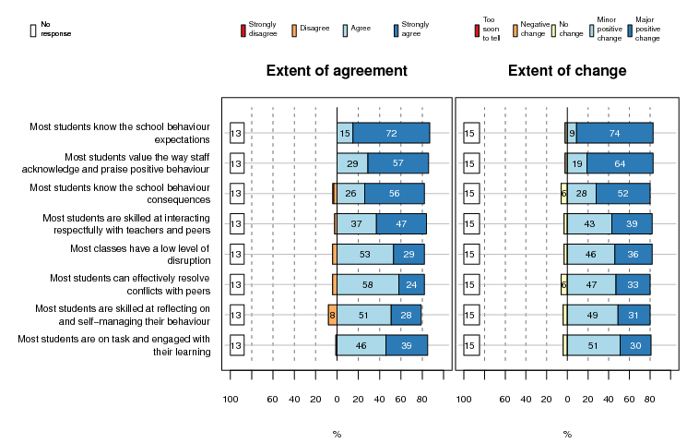
Curriculum leaders showed a similar pattern to coaches in terms of the aspects of student knowledge and competencies in which they considered SW had supported change. For example, 74% thought SW had supported a major or minor positive change in students’ awareness of behaviour expectations and 70% on the value students placed on positive behaviour acknowledgements. Curriculum leaders tended to describe these changes as minor rather than major. A few also reported no change.
Views on the extent of change varied depending on school type. Significantly more coaches from deciles 1–2 schools and primary schools reported major changes to students’ knowledge about expectations and some student competencies, for example:
- 48% of primary and 8% of secondary/intermediate coaches reported a major positive shift in students’ ability to reflect on and self-manage their behaviour
- 44% of primary and 16% of secondary/intermediate coaches reported a major positive shift in students’ ability to resolve conflicts with peers.

Changes to student attendance and key behaviour outcomes
Coaches reported SW had supported shifts in all the key student behaviour and attendance outcomes included in the survey (see Figure 18). The largest positive change was a decrease in referrals for major incidents, such as physical assaults, which was reported by 73% of primary and 76% of secondary/intermediate school coaches. Of these, 42% of primary, and 38% of secondary/intermediate school coaches, reported that this was a major change. Reducing the number of major behaviour referrals is a core focus of SW and these data suggest that SW has created change in this area.
Coaches reported fewer major changes in the questions about SSEE rates and attendance, which suggests change in these outcomes are harder to achieve.
Figure 18: 2010/11 coach views on SW’s contribution to changes to key behaviour outcomes (n = 89)
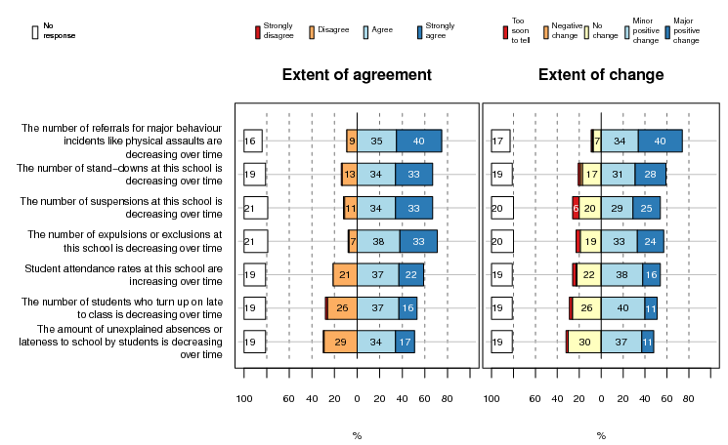

For most student outcomes, there was a group of 7–30% of coaches who reported no change. For example, 17–20% of coaches reported there had been no change to each of the questions about SSEE rates. This could be because their schools already have lower SSEE rates. Further analysis of the connection between SW and SSEE rates is provided later in this chapter.
With the exception of behaviour referrals, for all the outcomes included in Figure 18 above, secondary/intermediate school coaches tended to report more overall change than primary school coaches (by around 10–15%). One of these differences was statistically significant—improvements in lateness to class (68% of secondary/intermediate and 48% of primary reported a major or minor change).
The fact that more secondary/intermediate school coaches tended to more report change in relation to student behaviour incidents is not surprising given that these are more pertinent to these schools as they have higher SSEE rates than primary schools. Thus although there are more challenges in implementing SW in secondary/intermediate schools, as described in the previous chapter, coaches from these schools are still reporting positive gains.
Coaches from deciles 1–2 schools also reported more overall change to these outcomes than coaches from deciles 3–10 schools. Again a contributing factor to this pattern is that low-decile schools are likely to have higher initial SSEE rates. However, these data also suggest that low-decile schools are seeing more positive changes to student behaviour that are attributed to SW.
Curriculum leaders were not asked this question.

School data key behaviour outcomes: ODRs
We asked schools to send us an annual snapshot of ODR data as we wanted to see if this showed the expected pattern of decreases over time. We asked school coaches to fill in a form to show their total ODR count and a physical aggression (or nearest behaviour) count for 4 weeks in June, for each year from 2009 to 2013. We received ODR data from 87 schools. To provide data comparable across schools we divided these data counts by roll size to give an average rate per school. We then looked for change in mean rates over time by the length of time schools had been in SW (i.e., 2010 schools had been in SW for 4 years at the time the data was collected, and 2011 schools, 3 years).
A number of schools noted that their rates were very variable as they were sorting out how to record data, or had changed how they reported major and minor incidents. Only a few had data for the full number of years requested (2009 to 2013). This resulted in a small number of schools in the baseline year. Most schools provided data from 1 or 2 years, and so each programme year includes a different mix of schools. Therefore these data should be read with caution.
Table 4 shows the mean total ODR rate per school from the baseline year to 4th year in SW. For 2010/11 schools these data show a pattern of increases in the first year of SW. This is likely to reflect the fact that schools are developing their data gathering and reporting systems and decided which behaviours to refer. Following this increase, the data show a downward trend which is consistent with the changes reported by coaches. By the 4th year the overall ODR rate is similar to the baseline. It is important to note that the baseline year only included a small number of schools.
We included the data from 2012/13 schools to see if they were starting to show a similar pattern. These data suggest that these schools are different from 2010/11 schools. They had a higher baseline ODR rate. Like 2010/11 schools they showed an increase in ODR reporting in the first year of SW. Following this these schools showed a bigger decrease in the ODR rate in the second year of SW.
Table 4: Mean total ODR rates by length of time in SW
Total ODR rate per 100 students
 | 2010/11 cohort |  | 2012/13 cohort
 | n | Rate | n | Rate
Base year | 14 | 10.51 | 16 | 18.48
1st year | 22 | 13.84 | 27 | 25.80
2nd year | 41 | 12.70 | 18 | 16.24
3rd year | 48 | 12.73 | . | .
4th year | 16 | 10.95 | . | .

Table 5 shows the mean physical aggression rate by time in SW. For 2010/11 schools these data show no clear pattern over time. For 2012/13 schools the data show a short-term increase. This may represent a normal fluctuation.
Table 5: Mean physical aggression ODR rates by length of time in SW
Physical aggression rate per 100 students
 | 2010/11 cohort |  | 2012/13 cohort
 | n | Rate | n | Rate
Base year | 14 | 1.84 | 16 | 1.57
1st year | 22 | 1.42 | 28 | 3.15
2nd year | 41 | 2.50 | 18 | 4.84
3rd year | 48 | 2.19 | . | .
4th year | 16 | 2.49 | . | .

Table 6 shows the ratio of physical aggression referrals compared to the overall ODR rate. We included this analysis to see if rates of physical aggression referrals decreased in relation to the overall rate. This tests whether schools are experiencing lower levels of physical aggression referrals in relation to other types of behaviour. This analysis shows no clear patterns, which suggests that referrals for physical aggression are increasing or decreasing in similar ways to other behaviours.
Table 6: Ratio of physical aggression ODR to total ODR by time in SW
Ratio of physical aggressions to total ODRs
 | 2010/11 cohort |  | 2012/13 cohort
 | n | Rate | n | Rate
Base year | 11 | 0.24 | 15 | 0.02
1st year | 21 | 0.25 | 27 | 0.05
2nd year | 40 | 0.33 | 17 | 0.27
3rd year | 47 | 0.31 | . | .
4th year | 16 | 0.28 | . | .

The data on overall changes to ODR rates fit with school staff’s perceptions of changes over time. The data on physical aggression rates shows a different pattern. This may suggest that, as schools are developing improved systems for recording and reporting behaviour incidents, this is resulting in more reporting of incidents. However, the actual number of incidents may not have changed or could be decreasing.
The overall ODR rate shows a possible start of a downward trend. Further rounds of data collection would be necessary to see if these patterns continue over time or are reflecting usual fluctuations between years.
The variability in the data returned by schools, combined with the low response rate, supports other information presented in this report, which suggests that some schools have difficulty assessing or tailoring data reports.

National data on key behaviour outcomes
SSEE data also provides a measure of behaviour incidents in schools. We looked at these datasets to see if SW schools were showing any changes over time. For 2010/11 SW schools we looked at the rates from 2009–2012 for each of the four aspects of SSEE (stand-downs, suspensions, exclusions, and expulsions). We took 2009 as a baseline year (the year before 2010 schools started SW).
We also compared the data from 2010/11 SW schools to a comparison group of non-SW schools. Owing to the relatively small number of secondary schools in New Zealand it is difficult to select a comparison group with a strong match to all school characteristics. Therefore data from this comparison group should be viewed as indicative only. The fact that these two groups of schools are not the same is shown by their different starting points. Figures 19–22 below show that in 2009 (the baseline year) the SW schools had higher rates for all four aspects of SSEE than the comparison-group schools.
As SW schools started from a different place than non-SW schools this suggests they have different approaches to managing behaviour incidents and are likely to have different patterns of change.

Stand-downs
Figure 19 shows the stand-down rates for SW and the comparison schools. This figure shows a small increase in stand-down rates for SW schools over time. However this could represent a normal fluctuation of the data. Comparison schools show a small decrease in stand-downs over time. The gap between SW and comparison schools appears to be increasing over time.
Figure 19: Stand-down rates for 2010/11 SW (n = 188) and comparison schools (n = 278)
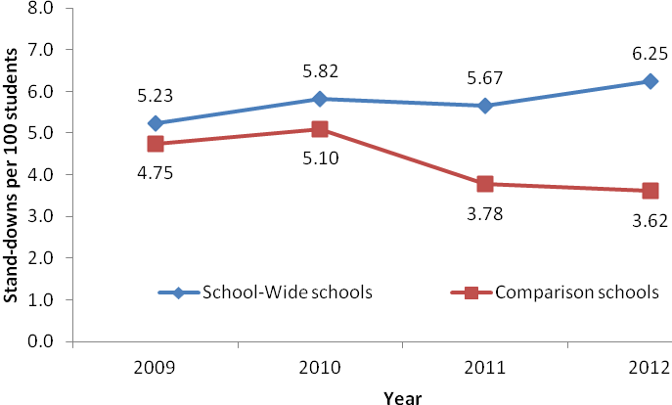

These data show a different pattern from that which is reported in the September 2013 PB4L-SW indicator report (Ministry of Education, 2013), which showed improvements in stand-down rates over 2009 to 2011 for the 2010 SW schools in comparison with a matched group of schools. There are a number of possible reasons for these differences. The analysis presented here is for 188 schools from two SW cohorts (2010 and 2011) and it covers a longer time period. The 2011 schools may have a different pattern from the 2010 schools. There were also differences in how the comparison groups were selected.

Suspensions
Figure 20 shows suspension rates for SW and comparison schools. These data show a slight increase for SW schools and then the start of a downward trend. A similar downward trend is shown by the comparison group. The gap between SW and comparison schools increased slightly over 2009 to 2011 and is starting to close again in 2012.
Figure 20: Suspension rates for 2010/11 SW (n = 187) and comparison schools (n = 274)
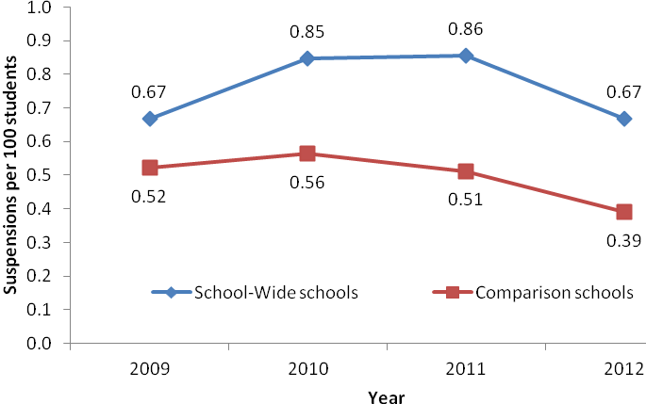

Exclusions
Figure 21 shows exclusion rates for SW and comparison schools. These data show a slight increase for SW and comparison schools in 2011 followed by a decrease in 2012. The gap between SW and comparison schools is staying relatively constant over time.
Figure 21: Exclusion rates for 2010/11 SW (n = 183) and comparison schools (n = 264)
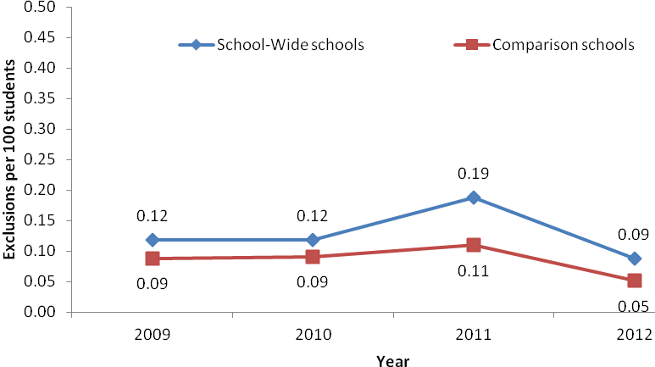

Expulsions
Figure 22 shows expulsion rates for SW and comparison schools. These data show an increase in 2010 for SW schools followed by a sharp decrease to a zero rate for 2011 and 2012. The comparison group show a more even pattern and they also reached a zero rate by 2012. It is important to note that these rates are very small, therefore one expulsion in a school can make a large difference to the data. However these data may suggest that SW is having an influence on school decisions to expel students.
Figure 22: Expulsion rates for 2010/11 SW (n = 67) and comparison schools (n = 87)
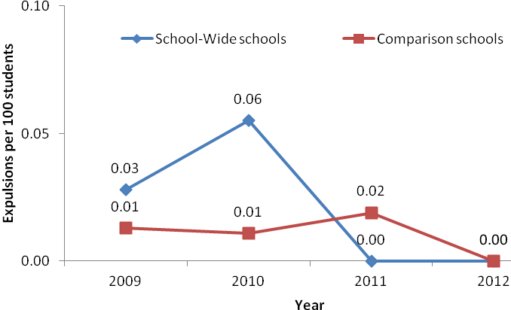

Summary of SSEE data
Overall, for SW schools the data on SSEE rates in Figures 19–22 appear to show a slight increase in stand-downs (the least serious consequence out of the four SSEE actions) and a downward trend in the three other rates. SW schools appear to have more movement in their rates than comparison schools, which suggests they have more variability in behaviour incidents between years than the comparison schools. These data tentatively suggest that SW schools are working to offer students consequences such as stand-downs that result in them staying at school. However, the comparison schools show a similar pattern. These schools may be involved in other Ministry of Education initiatives to lower SSEE rates.
Lowering SSEE rates, and particularly expulsion rates, is an important outcome for SW as SSEE experiences are linked to early school leaving and poorer long-term education and health outcomes for youth. These SSEE data show the possible start of a positive trend, which is supported by the data from the coach survey. Further monitoring of SSEE data over time is likely to give a more complete picture.
As shown above, the relationship between SW and SSEE rates is not straightforward. This finding has been noted internationally. An Australian study found a decrease in the length of suspensions but no overall decrease in suspension rates in the schools that were part of the Australian version of SW .

The relationship between SET and SSEE
To further explore the connection between SW and SSEE rates we looked at SET data to see if it showed a relationship to SSEE data. SET measures the extent of SW implementation but not outcomes. However, you would expect that, over time, as SW becomes more embedded in a school, high scores on SET would be associated with improved outcomes for students, such as lower rates of each of the four aspects of SSEE.
We looked for correlations between the seven SET components and the average SET score and each component of SSEE. We looked at these data by the length of time schools had been part of SW (i.e., year one was 2010 for schools that joined in 2010, and 2011 for 2011 schools). The maximum number of schools we were able to compare was 133.
The data from the first year that schools joined SW showed a few small but statistically significant correlations between higher SET scores and higher suspension rates. Like the ODR data reported above, this may suggest that in the first year of SW, as schools sorted out their behaviour consequences systems, some may have relied more on suspension as a consequence for unwanted behaviour. The second and third year data showed no clear patterns. We need to be cautious about interpreting these data as both the SET and SSEE datasets are incomplete.
Some regional Ministry of Education staff commented during interviews that they had noticed that a few schools with consistently high scores on SET also had very high rates of SSEE. They suggested there might be a lack of alignment between SW practice in these schools and processes for making SSEE decisions. The board of trustees has a key role in reviewing decisions about SSEE. Data from coaches show that less than half (44%) of SW teams included a representative from the board of trustees. This suggests that exploring further ways to actively connect SSEE decisions with SW practice might result in a stronger relationship between SW and improved SSEE outcomes.
Other data presented in the PB4L-SW indicator report (Ministry of Education, 2013) suggest that SW is having a positive impact on retention rates and NCEA level 1 achievement rates. Over time further monitoring of patterns for existing and new cohorts of SW schools will give more surety about the extent to which these patterns can be attributed to SW.

Active student involvement in SW
One of the short-term changes expected in SW schools is that students will be offered leadership roles in promoting and celebrating positive behaviour. We were interested in the extent to which SW supports changes to student leadership opportunities as this is an aspect of practice an Australian study suggested warranted more exploration .
Figure 23 shows that SW appears to be supporting change in student leadership roles at some schools. Over half of the coaches considered that being part of SW had prompted positive change to the leadership roles available to students, such as designing new ways of promoting school values (52%) or demonstrating these values to their peers (73%). However, there is considerable variability between schools, with more than one-quarter reporting no change to most of these practices.
Figure 23: 2010/11 coach views on student leadership opportunities (n = 89)
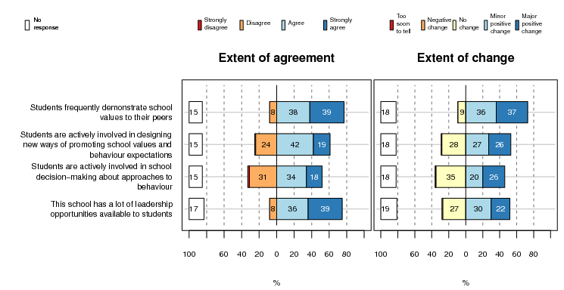

Primary and secondary coaches expressed similar views about whether SW had supported change in the leadership roles offered to students.

Changes for school culture and systems
Survey responses suggest that SW is having an impact on whole-school culture, systems, and data-collection processes. In an open-ended question we asked coaches and curriculum leaders what were the three main things that had changed at their school as a result of SW. They mentioned many different aspects of practice. One theme that stood out was improved consistency. Changes relating to consistency that were mentioned by 15% or more of 2010/11 coaches or curriculum leaders were:
- a more consistent approach to behaviour (37% of coaches and 23% of curriculum leaders)
- more shared awareness of common school values and behaviour expectations (25% of coaches and 26% of curriculum leaders)
- the development of a more positive approach to behaviour including praising or rewards (20% of coaches and 19% of curriculum leaders)
- the establishment or clarification of school-wide values and clear behaviour expectations (18% of coaches and 4% of curriculum leaders)
- more use or analysis of data (17% of coaches and 5% of curriculum leaders).
Coaches tended to focus more on changes to school systems and processes. When considering changes, curriculum leaders tended to comment more on changes to school culture, including:
- improvements in student behaviour (18% of coaches and 30% of curriculum leaders)
- improved school culture and relationships (16% of coaches and 22% of curriculum leaders).
Please describe the three main things that have changed at your school as a result of PB4L-SW.
Consistency—in the way we teach social skills, the way we report issues/problems, the way we reinforce positive values. (coach survey)

Expectations of behaviour embedded into everyday conversations. Collection of worthwhile behaviour data and how it can be used leading to next steps. Whole staff awareness of the programme and common language for behaviour. (coach survey)

Students overall are more engaged in their learning, more respectful and .... positive! Staff spend less time focused on behaviour management in the classroom and more time on teaching and learning. Behaviour expectations and processes are much more consistently applied school-wide. (curriculum leader survey)

Changes to school culture and processes
The majority of coaches and curriculum leaders thought SW had resulted in improved effectiveness in addressing behaviour incidents (83% of coaches and 64% of curriculum leaders) (see coaches’ views in Figure 24). Coaches and curriculum leaders also reported that SW had contributed to a more respectful and inclusive school culture (84% of coaches and 62% of curriculum leaders) and school safety (80% of coaches and 64% of curriculum leaders). These were some of the larger changes reported by coaches and curriculum leaders suggesting that SW was having an impact on school processes which were contributing to cultural changes.
Figure 24: 2010/11 coach views on SW’s contribution to changes to school culture and processes
(n = 89)
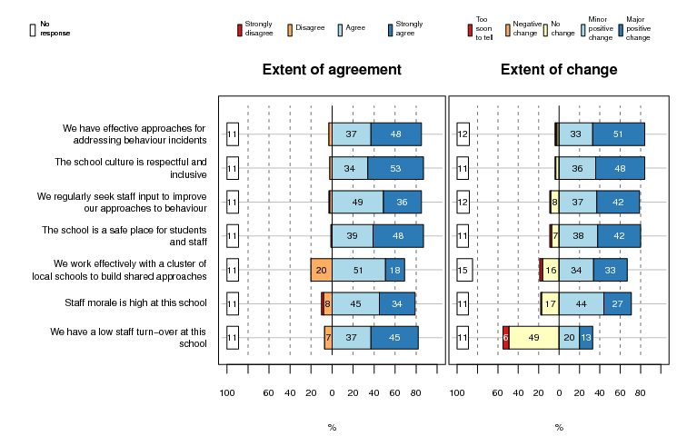

Reflecting the general pattern shown in coach and curriculum leader responses, more coaches tended to describe change as major, and curriculum leaders as minor. For example, 42% of curriculum leaders reported that SW had contributed to major improvements in school safety, and 22% of curriculum leaders thought the same.
Figure 24 also shows that 2010/11 coaches also thought SW had supported positive changes to school processes for collaborating with staff and local schools. Again reflecting the pattern noted above, 42% of coaches reported that SW had contributed to a major change in how their school sought staff input to improve approaches to behaviour. About one-quarter (26%) of curriculum leaders thought the same. A number (22%) reported no change in this aspect of practice.
Coaches and curriculum leaders reported less change in relation to staff morale or turnover. These aspects of school life are noted in the SW theory of change as possible longer term outcomes of SW. These data support this.

Changes to school data reporting and use
Most 2010/11 coaches considered SW had supported them to improve systems for data collection, reporting, and use. Around 70% to 80% reported major or minor changes to each aspect in Figure 25 below, suggesting that although there are challenges in reporting and using data SW is supporting schools to use student behaviour data to make improvements.
Figure 25: 2010/11 coach views on SW’s contribution to use of school data (n = 89)
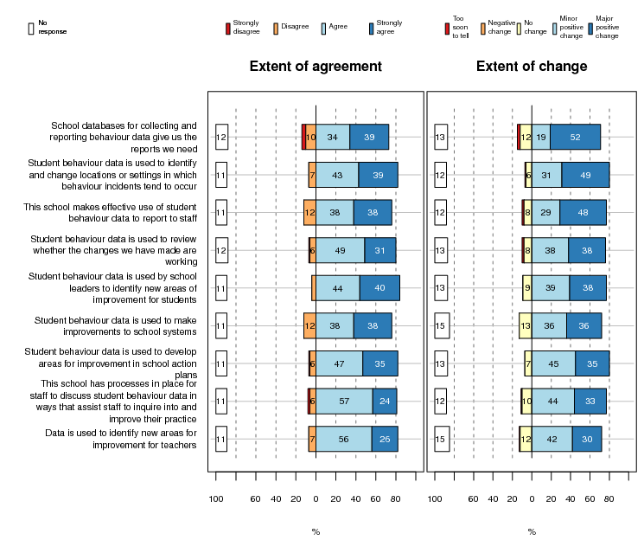
Around one-third to a half of school coaches described each change as major. School coaches reported greater change in the aspects of SW that schools focus on first, such as developing reporting systems, using data to make changes to locations or setting in which behaviour incidents occur, and reporting data to staff. They reported fewer major changes to practices that might be more complex, such as using data to make changes to school systems or to support staff to inquire into their practice.
Curriculum leaders were less likely than coaches to report shifts in terms of school data use (around 50–55% reported similar changes to coaches, and around one-quarter to one-third reported these changes were major). Like school coaches, they reported more changes to the aspects of SW that schools are likely to focus on first.
We asked curriculum leaders if SW had supported schools to report behaviour data to staff in ways that are useful. This was the data practice that curriculum leaders reported the most change in, with nearly one-third (32%) noting there had been a major change at their school. Reflecting their pattern of responding to other questions, around one-fifth also thought there had been no change to all the questions about data use. Although curriculum leaders present a more qualified view of change at their school, their, and coach responses, suggest that SW is supporting schools to use data to make improvements. As commented on in the chapter about implementation of SW, these findings also suggest that there is room for further changes in this aspect of practice.

Are changes happening for teachers and in classrooms?
To explore whether SW was supporting changes to teacher beliefs, practice, or confidence we asked curriculum leaders a number of questions about their practice. Overall, three-quarters of the 2010/11 curriculum leaders reported that SW had made a difference to their approaches to behaviour and agreed that SW had supported them to see that new behaviours could be taught. About 15% thought that SW had made no difference to their approaches to student behaviour.
Data from the 2013 NZCER primary and intermediate school National Survey show a similar pattern. Of the 104 teachers who were in SW schools, most noted that SW had improved their practice or thinking. A similar proportion of these teachers (14%) noted that SW had little or no impact on their practice.

Confidence in managing behaviour
The curriculum leaders who responded to the survey were in leadership roles in their schools. Therefore we would expect that many would be confident managing student behaviour. Most reported this was the case. However, around half or more of the 2010/11 curriculum leaders also reported that SW had increased their confidence in managing behaviour in (59%) or outside (57%) the classroom (see Figure 26).
Figure 26: 2010/11 curriculum leader views on SW’s contribution to confidence in managing behaviour (n = 74)
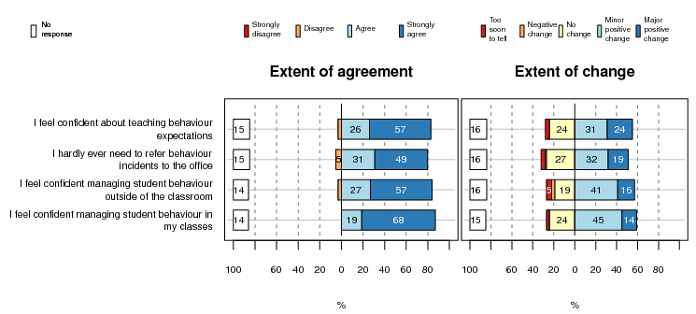

Some of these questions we also asked coaches. They reported a similar pattern of shifts but more major changes than curriculum leaders.

Strategies for promoting behaviour expectations and managing behaviour
The majority of 2010/11 curriculum leaders agreed that they engaged in a range of practices that supported them to promote student behaviour expectations (see Figure 27). SW had supported a major or minor change for half or more on many core SW practices, such as:
- knowing school behaviour expectations (65% reported a major or minor change)
- displaying school behaviour expectations in their classroom (62% reported a major or minor change)
- linking classroom expectations to school-wide expectations (57% reported a major or minor change)
- using a range of strategies to show students what behaviours like respect look like (53% reported a major or minor change)
- actively reminding students about behaviour expectations whether they are in my classes or not (53% reported a major or minor change)
- involving students in deciding what behaviours like respect look like (50% reported a major or minor change).
Figure 27: 2010/11 curriculum leaders’ views on SW’s contribution to approaches to behaviour expectations (n = 74)
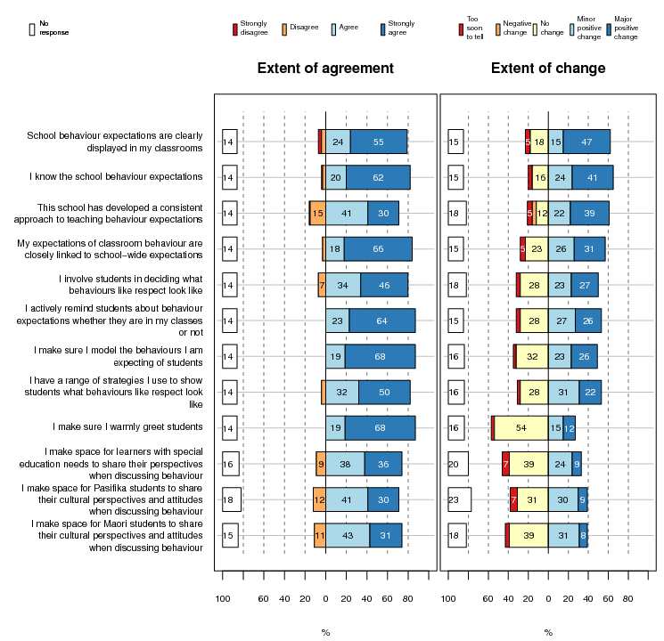

As shown in Figure 27 above most curriculum leaders reported that SW had contributed to changes in the way they approached behaviour expectations. However, the number who reported no change to each practice was also relatively high and varied from 16% to 54%. For some practices this is likely to be because they are already well embedded, as all who responded agreed they engaged in this practice. Examples include: I make sure I warmly greet students, and I make sure I model the behaviours I am expecting of students.
Other practices appeared to be less embedded and also were less likely to change. Most of these practices were about making space for the different groups of priority learners to share their perspectives when discussing behaviour. As discussed in Chapter 3 on implementation of SW, these are some practices for which more models or support could be beneficial for schools.
The curriculum leader survey also included a focus on the different strategies teachers use to manage behaviour. These are shown below in Figure 28. Again SW had supported a major or minor change for around half of the 2010/11 curriculum leaders on a number of practices including:
- I make sure I remind students of their choices before I give behaviour consequences or use the office referral process (58% reported a major or minor change)
- I make sure I acknowledge students’ positive behaviours more than I discuss behaviour concerns (55% reported a major or minor change)
- I involve individual students in problem-solving discussions (54% reported a major or minor change).
Figure 28: 2010/11 curriculum leader views on SW’s contribution to behaviour management strategies (n = 74)
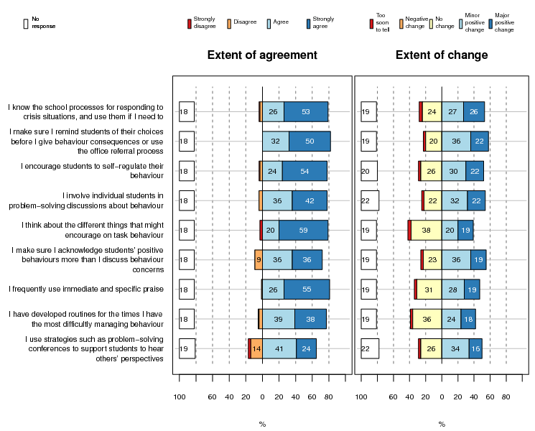
Curriculum leaders tended to report most shifts as minor, and the number who reported no change to each practice was also relatively high (varying from 20% to 38%.) Like the approaches to behaviour expectations discussed above, for some practices this is likely to be because they are already well embedded. Other practices were less well embedded and could be areas that might require further support for some staff. One example is a core SW practice: “I make sure I acknowledge students’ positive behaviours more than I discuss behaviour concerns.” Although over half reported positive change to this practice, for 36% this was a minor change, and 23% reported no change. Other examples of practices that may benefit from more support include: I have developed routines for the times I have the most difficulty managing behaviour, and I use strategies such as problem-solving conferences to support students to hear others’ perspectives.

Changes in the involvement of parents and whānau in SW
Coaches and curriculum leaders showed low levels of agreement on most survey statements that related to parent and whānau involvement in SW. These included questions about consulting parents and whānau about joining SW, involving parents and whānau as key partners in developing approaches to SW, and reporting to parents and whānau. Coaches also reported lower levels of agreement that parents and whānau supported SW compared with how they perceived support by students and staff. Similarly, coaches reported fewer shifts in practice in relation to working with parents and whānau (see Figure 29). For example, only 32% reported that SW had supported a positive change in the extent to which they regularly sought parent and whānau involvement to improve approaches to behaviour. These data suggest that developing ways to actively involve parents and whānau in approaches to behaviour is an area for which schools could benefit from more support. The figure below shows that SW was supporting some schools to make changes to the way they sought input from parent and whānau groups. These schools could be developing approaches that could be shared more widely with others.
Figure 29: 2010/11 coach views on SW’s contribution to changes to connections with parents and whānau (n = 89)
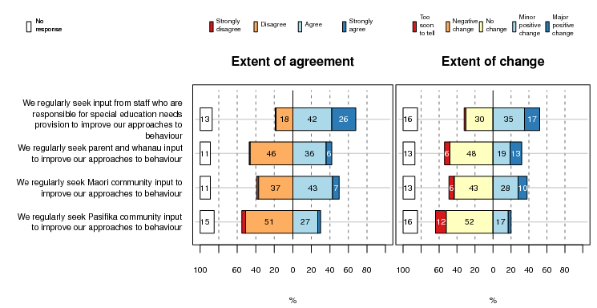

The extent of shifts in schools
We initially planned to use the ODR, SSEE, and SET data to identify if there were groups of high- and low-outcome schools among the 2010/11 cohort which we could compare to survey data about implementation and outcomes to explore patterns. The incompleteness of the datasets meant that we had to develop a different approach. Instead, we used a mix of implementation and outcome questions as criteria to create groups of high- and low-outcome schools.
We included a combination of the average SET scores and four key implementation and outcome questions from the coach survey to place the 89 schools for which we had data in a high-, medium-, or low-outcome group. We included implementation questions as part of the criteria given the assumption that effective implementation of SW should lead to improved outcomes.
The high-outcome group of 22 schools had four to five of the following in place:
- a recent average SET score of 80% or more
- the coach strongly agreed that SW has become embedded in the way their school worked
- the coach reported a major positive change in school culture
- the coach reported a major positive decrease in the amount of behaviour referrals
- the coach reported a major positive decrease in the level of disruption in classes.
Schools were placed in the middle group (29 schools) if they had two to three of these features, and a low group (38 schools) if they had one or no features.
We looked to see if there were any differences between these three groups in terms of school characteristics. Schools in the high-outcome group tended to be primary schools, and those in the low-outcome group, large secondary or intermediate schools. However, these differences were not statistically significant.
We compared the three groups’ responses to key questions in the coach survey to look for similarities and differences. In general coaches from the high-outcome schools were more likely to strongly agree with many of the implementation questions in the survey. They reported having more effective SW teams, staff support for SW, and consistency of practice. They also reported a greater number of major shifts in practice and outcomes at their school. Interestingly, most, but not all, of the schools in the high-outcome group had a recent SET score of 80%, suggesting that the relationship between SET scores and outcomes is not straightforward.
This analysis supports other data presented in this report which shows that schools vary as to how successfully they are able to implement SW in a way that results in positive change in school culture and outcomes. It confirms other data which suggests that secondary/intermediate schools face more challenges implementing SW. However, this is not the case for all schools, as the high- shift group also contained a number of secondary/intermediate schools.
This analysis is also used to inform the discussion on barriers and enablers presented in the next chapter.

Wellbeing@School data: Providing a baseline to explore students’ views
Wellbeing@School student survey data was collected from the 2012/13 SW schools to provide a baseline to use to look for future short-term shifts. Because this is baseline data it is not reported in this chapter as the 2012/13 schools have not been part of SW for long enough to look for short-term shifts. A summary of demographic details from the students and schools that responded, summary boxplots, and item reports from the Primary and Intermediate/Secondary survey are included in Appendices 4–7.

5. Enablers and barriers

Enablers and barriers
The focus of this chapter is the third evaluation question: What factors enable or hinder the shifts in schools? The main enablers identified as supporting schools to implement SW, and the barriers, are summarised below.
We used a number of different sources of data to inform this chapter. One was the analysis of high-, medium-, and low-outcome schools reported in Chapter 4. There were some differences in how the high-outcome schools worked compared with the medium- or low-outcome schools that stood out, allowing us to identify enabling factors and barriers to the implementation of SW and its impact. In most cases these factors were very similar to those already identified as enablers or barriers in the previous chapters. For example, the analysis of secondary/intermediate school experiences in comparison with primary schools provided some information on enablers and barriers. We have also included data from interviews and surveys with Ministry of Education staff about systems-level enablers and barriers.
It is important to note that some school contextual factors can be either an enabler or barrier. For example, being located in a large school was helpful in a primary setting as this was related to better processes for managing data that appeared to lead to more use of data. Being located in a large school in a secondary/intermediate setting was related to more difficulty in using data and in achieving consistency across the school.

School enablers
Examples of enablers from survey questions about how schools build staff ownership of SW
As one staff member asked when it was announced we were having a PB4L team meeting: “Aren't we all on that team?” In regular staff meetings the staff is always involved in making decisions about implementation of PB4L strategies both covering non-classroom and classroom settings. Staff or teams have developed their own lesson plans and have shared ideas at meetings. All staff meetings focus on staff making decisions on where to next for PB4L. (coach survey)
School-wide planning, PB4L alive and discussed at staff meetings, school-wide review and analysis of behaviour trends. (curriculum leader survey)

School type
Primary schools found SW easier to implement. Location in a large rather than small primary school was an enabler in terms of data use. Higher decile schools were faster to implement SW but deciles 1–2 schools were more likely to report that SW was embedded at their school and to report more changes to practice and outcomes.

School processes and systems
SW was more embedded and more change was reported in schools where staff supported the philosophy of SW, and considered the initiative was well aligned with existing practice and flexible enough to fit with their school culture. Other enablers included if a school:
- had an effective SW team which stayed the same over time. This team had the people with the needed skills who were able to work through challenges. Key people included the principal and staff, whānau, or community members who could represent the interests of Māori students. Effective teams were well organised, had administrative support, and made connections with other teams in the school
- used consultative processes as they joined SW to encourage staff buy-in and ownership
- made connections between approaches to behaviour and learning
- offered staff a range of supports to work towards consistency of practice, such as teaching resources, frequent training on school systems, and frequent professional learning opportunities, and had a planned process to integrate the teaching of behaviour expectations within classroom programmes
- used the SWIS to manage data (although many schools also used other data-management systems effectively as well)
- frequently reported data summaries to all members of their school community (staff, students, and parents and whānau)
- used data to make changes to school systems and practices
- had realistic timelines for change and regularly checked and celebrated progress with SW.

Support models
SW was more embedded and coaches reported more change in schools that had:
- a SW Practitioner who stayed the same over time
- effective communication and support from SW Practitioners and access to one-on-one sessions if needed
- access to effective training and cluster meetings where schools worked together to build approaches.

School barriers
Examples of barriers identified in survey questions
Being consistent with recording the data, consistent teaching of the lessons. (coach survey)
Poor access to data. Less involvement by staff members and student group—has begun to drop off. (curriculum leader survey)

School type
SW was less embedded in secondary or intermediate schools, and in particular, large schools.

School processes and systems
School processes and systems barriers included:
- less emphasis on staff consultation, involvement, and professional learning in relation to SW
- less emphasis on working collaboratively (e.g., processes that include the perspectives of students, parents and whānau, and priority learners in the SW journey)
- less emphasis on developing planned approaches to teaching behaviour expectations and difficulties achieving consistency across the school
- challenges with reporting and using data (for example, some secondary schools had difficulty using existing student management systems to manage data. However, other schools reported using these systems effectively)
- less emphasis on reporting to staff, students, parents, and whānau
- unclear connections between SW practices and decisions about stand-downs, suspensions, exclusions, and expulsions
- high workloads for school coaches and team members
- difficulty managing more challenging students.

SW support and system enablers
Data from Ministry of Education staff, and questions in the coach survey about SW support and training approaches, have been used to explore the system enablers and barriers described below. Aspects of the system which appeared to be supporting schools to embed SW included:
- an effective training, support, and cluster model which is well regarded by schools
- the regional delivery model when it enabled Ministry of Education staff to tailor approaches to suit local school needs
- a focus on using problem-solving approaches to support schools
- the formation of regional SW teams with a mix of skills and the ability to access support and network with other Ministry of Education professionals.

System barriers
System-level factors which appeared to be acting against building a stronger support system for schools included:
- turnover of SW Practitioners and unfilled vacancies which create high workloads and therefore less time to support struggling schools
- a changing SW workforce model that did not clearly address ways to build capacity in the workforce (e.g., a need for formalised processes for SW Practitioner induction, training, supervision, and ongoing PLD)
- perceptions of drift or difference in practice between regions and concerns about fidelity of the SW support model
- difficulties with access to regional and/or national data to review and build practice.

6. The journey so far
Do you have any other comments to make about PB4L-SW?
I think some of us were sceptical about PB4L at the start as we felt that we already used restorative practice and were unconvinced that it would be any different. It has been. I think the big change is that the buy-in is now school wide; and that because the values were chosen and developed largely by the students (though with teacher input), the students also have much greater ownership of our college and the behaviours we all are expected to use and value. There has been a huge positive improvement in behaviour overall and it is a much happier place to work, teach and learn. (curriculum leader survey)

The intent of this report is to provide some initial analysis of patterns of shifts for the schools that have been working with SW since 2010/11 and baseline material for schools that joined in 2012/13. This information is intended to suggest trends that can be further explored in the final report. Key findings are reported in the executive summary. In this section, we give an overall picture of how that first cohort, and the 2012/13 cohort, are making progress in their SW journey. Mapping the extent to which an initiative is following an expected pattern of implementation and change is one way of evaluating whether an initiative is supporting improved outcomes.
Figures 30 and 31 below use the SW theory of change to compare the extent to which 2010/11 and 2012/13 SW schools reported having key SW activities and processes in place and were reporting changes to practices and outcomes.
- Blue shading indicates that 60% or more of school coaches or curriculum leaders agreed that a practice was in place or reported a shift in practices or outcomes. National and regional changes are based on a summary of Ministry of Education staff views.
- Yellow shading indicates less than 60% agreement or reports of shifts.
A 60 percent cut-off was selected as this represents a majority view. A key which explains how the map was developed is located on the right-hand side of each figure.
Only the short-term changes identified in the theory of change are included in these figures. As expected, staff from schools that had been part of SW for longer (the 2010/11 cohorts) reported more practices in place and a number of short-term changes (i.e., a pattern of blue shading is much more evident). As expected for schools that have only been part of SW for a year or less, the 2012/13 SW schools reported fewer core practices in place or shifts (i.e., a pattern of yellow shading is much more evident).
This map suggests that the implementation of SW is mostly functioning as intended in schools and is starting to result in shifts in practice and outcomes for schools that have been in the initiative since 2010/11.
Figure 30 Theory-of-change map for 2010/11 SW schools

KEY
Core SW processes
60% or more of school coaches or curriculum leaders report processes in place
Less than 60% report processes in place

Short-term changes
60% or more report shifts in practice
Less than 60% report shifts in practice
60% or more shift (from longer-term outcomes)

Faded text = practices not explored in surveys
Notes
Each statement has been colour-coded from responses to core questions, or clusters of questions, in the school coach or curriculum leader survey
Most information comes from the coach survey. Where information comes from the curriculum leader survey this is indicated by (Curric)
The colour codes in the national and regional practice sections are summarised from information collected via interviews and the SWP survey
CORE SW ACTIVITIES & PROCESSES IMPLEMENTED WITH FIDELITY
Student
- Students have an active role in developing shared values and expectations (have agency)

School and staff
- School staff have an active role in developed shared values & expectations (SET A) (Curric)
- Values & expectations are modelled and taught (SET B) (Curric)
- The principal and senior leadership team actively support SW
- School staff are ready to implement a new initiative (80% buy in) (Curric)
- School selects SW team leader and coach with needed authority and capabilities
- School develops a SW team that identifies priorities, develops and implements action plans, and reports data (SET F)
- Consistent systems for recognition of shared values & expectations and addressing behaviour incidents are developed (SET C/D)
- School develops staff capacity to manage data system for collecting and reporting SW data (SET E)
- School develops effective system for collecting and reporting SW data to stakeholders (SET E)
- Schools use SW framework in ways that align with the context of their school community and the needs of Māori and Pasifika learners, and students with special needs
- Schools use SW framework in ways that align with the NZ education system (e.g., NZC & leadership models that value relationships and Manaakitanga, pono, ako, and awhinatanga)

Parent, whānau & community
- School works effectively with community (including Māori and Pasifika community) to develop shared values and expectations

National & regional
- Effective school coaching and PLD networks set up in regions
- SW Practitioners (SWP) (regional specialists) are recruited, trained & have the capabilities needed to work with school teams
- National structure provides guidance and feedback from data to regions (networks exist but are not formalised)
SHORT-TERM CHANGES EXPECTED (1-2 years)
Student outcomes and shifts in processes
- Some decreases in challenging behaviour incidents & SSEE
- Some increase in positive behaviours (e.g., attendance, engagement, social wellbeing
- Students offered active leadership role in promoting and celebrating school values (roles less likely to include active participation in decision-making)
- Students have access to effective learning experiences and staff modelling related to shared school values

School outcomes and shifts in processes
Teachers and classrooms
- Shift from a punishment to a learning view of behaviour management (Curric)
- Increased confidence to manage behaviour (Curric – near 60%)
- Increased capability to actively model and incorporate values & behaviour expectations (in ways that relate to priority groups: Māori students, Pasifika students, students with special needs) (Curric – near 60%)
- More time teaching (less time managing behaviour) (Curric)

Leadership, culture & systems
- School culture is more welcoming, inclusive, & consultative (Curric and coach)
- School leaders maintain involvement with SW and model learning and systems orientation towards behaviour
- Increased use of consistent school approaches (School system for approaches to recognition of values & behaviours and addressing incidents is used by most staff and is relevant for target groups (Māori learners, Pasifika learner, students with special needs)
- School PLD processes support all staff to understand shared values and work to align their behaviours and practices (Curric)
- Effective team-based problem-solving processes in place
- School uses SMS/data system proactively to report at different levels (school structures, classroom, all students, at risk groups)
- Staff are able to use data for meaningful decision making (e.g., to identify target groups or areas of practice) (Less so for Curric)
- School has fitted SW within their culture and community context and has worked to align approach to learning and other initiatives and programmes with SW

Parent, whānau & community outcomes and shifts in processes
- School has established effective processes for seeking input from parents & whānau and reporting developments
- School has started to make connections with groups in wider community to support SW (e.g., Sports Clubs)
National & regional outcomes and shifts in processes
- Regional SWP teams have a mix of needed expertise and a team-based approach that enables the team to effectively support schools
- School cluster processes support schools to share expertise
- Processes developed for defining roles and sharing expertise between SWP and other MoE professionals (networks exist but are not formalised
- Data collection and feedback loops are used to improve support to schools (use of regional data and national systems data) (loops exist but are not formalised)
- SWP teams make connections with other agencies & sector groups
Figure 31 Theory-of-change map for 2012/13 SW schools

KEY
Core SW processes
60% or more of school coaches or curriculum leaders report processes in place
Less than 60% report processes in place

Short-term changes
60% or more report shifts in practice
Less than 60% report shifts in practice

Faded text = practices not explored in surveys
Notes
Each statement has been colour-coded from responses to core questions, or clusters of questions, in the school coach or curriculum leader survey
Most information comes from the coach survey. Where information comes from the curriculum leader survey this is indicated by (Curric)
The colour codes in the national and regional practice sections are summarised from information collected via interviews and the SWP survey
CORE SW ACTIVITIES & PROCESSES IMPLEMENTED WITH FIDELITY
Student
- Students have an active role in developing shared values and expectations (have agency)

School and staff
- School staff have an active role in developed shared values & expectations (SET A) (Curric)
- Values & expectations are modelled and taught (SET B) (Curric)
- The principal and senior leadership team actively support SW
- School staff are ready to implement a new initiative (80% buy in) (Curric)
- School selects SW team leader and coach with needed authority and capabilities
- School develops a SW team that identifies priorities, develops and implements action plans, and reports data (SET F)
- Consistent systems for recognition of shared values & expectations and addressing behaviour incidents are developed (SET C/D)
- School develops staff capacity to manage data system for collecting and reporting SW data (SET E)
- School develops effective system for collecting and reporting SW data to stakeholders (SET E)
- Schools use SW framework in ways that align with the context of their school community and the needs of Māori and Pasifika learners, and students with special needs
- Schools use SW framework in ways that align with the NZ education system (e.g., NZC & leadership models that value relationships and Manaakitanga, pono, ako, and awhinatanga)

Parent, whānau & community
- School works effectively with community (including Māori and Pasifika community) to develop shared values and expectations

National & regional
- Effective school coaching and PLD networks set up in regions
- SW Practitioners (SWP) (regional specialists) are recruited, trained & have the capabilities needed to work with school teams
- National structure provides guidance and feedback from data to regions (networks exist but are not formalised)
SHORT-TERM CHANGES EXPECTED (1-2 years)
Student outcomes and shifts in processes
- Some decreases in challenging behaviour incidents & SSEE
- Some increase in positive behaviours (e.g., attendance, engagement, social wellbeing)
- Students offered active leadership role in promoting and celebrating school values (roles less likely to include active participation in decision-making)
- Students have access to effective learning experiences and staff modelling related to shared school values

School outcomes and shifts in processes
Teachers and classrooms
- Shift from a punishment to a learning view of behaviour management (Curric)
- Increased confidence to manage behaviour (Curric)
- Increased capability to actively model and incorporate values & behaviour expectations (in ways that relate to priority groups: Māori students, Pasifika students, students with special needs) (Curric)
- More time teaching (less time managing behaviour) (Curric)

Leadership, culture & systems
- School leaders maintain involvement with SW and model learning and systems orientation towards behaviour
- Increased use of consistent school approaches (School system for approaches to recognition of values & behaviours and addressing incidents is used by most staff and is relevant for target groups (Māori learners, Pasifika learner, students with special needs)
- School PLD processes support all staff to understand shared values and work to align their behaviours and practices (Curric)
- Effective team-based problem-solving processes in place
- School uses SMS/data system proactively to report at different levels (school structures, classroom, all students, at risk groups)
- Staff are able to use data for meaningful decision making (e.g., to identify target groups or areas of practice)
- School has fitted SW within their culture and community context and has worked to align approach to learning and other initiatives and programmes with SW

Parent, whānau & community outcomes and shifts in processes
- School has established effective processes for seeking input from parents & whānau and reporting developments
- School has started to make connections with groups in wider community to support SW (e.g., Sports Clubs)
National & regional outcomes and shifts in processes
- Regional SWP teams have a mix of needed expertise and a team-based approach that enables the team to effectively support schools
- School cluster processes support schools to share expertise
- Processes developed for defining roles and sharing expertise between SWP and other MoE professionals (networks exist but are not formalised)
- Data collection and feedback loops are used to improve support to schools (use of regional data and national systems data) (loops exist but are not formalised)
- SWP teams make connections with other agencies & sector groups

Changes to school practice and student outcomes
The main themes that stood out from school and Ministry of Education staff reports were that SW was supporting improvements in school culture and consistency of practice in approaches to behaviour. Staff at most of the schools that had been part of SW since 2010/11 considered that SW was supporting a wide range of changes to their school. Key changes are shown in the above diagram and include:
- a more respectful, inclusive, and positive culture
- fewer major behaviour incidents
- an improved classroom environment and student engagement, with teachers spending less time managing behaviour
- the development of an effective SW team which uses data to improve school practice
- the building of collaborative ways of working with staff and students to improve school practice.
There were some 2010/11 schools that reported that SW was less embedded in their school. More secondary and intermediate schools were in this group.
SW is faster to implement in deciles 5–8 schools than in lower decile schools. However, although deciles 1–2 schools took longer to implement SW, coaches in these schools also reported using more consultative approaches with staff, greater shifts in student outcomes, and were more likely to consider that SW was embedded in their school. This, and other data, suggests that the extent to which schools work collaboratively with staff is a key enabler.
The 2013 support model appeared to be effective in providing most 2010/11 schools with the support they needed to build or maintain SW, and 2012/13 schools the support they needed to implement SW. Ongoing relationships with SW Practitioners were an important component of this support. Strong relationships were related to reports of faster implementation and improved outcomes.

Managing whole-school change
The initial findings in this report suggest that for the majority of schools SW is balancing what Fullan calls the “too tight/too loose” dichotomy. That is, processes for change cannot be too tight (e.g., mandated reforms which do not create ownership) nor too loose (bottom-up change where educators are left to shape an initiative to their own design). Questions about fidelity between regions, and the difficulties some schools (particularly large secondary and intermediate schools) appear to be having in implementing SW suggest that some schools, and Ministry of Education staff who support schools, are experiencing SW as “too loose”. Fullan suggests one way of finding a balance between these two positions is by creating a continuous improvement culture which values innovation while also having measures of accountability. SW has built systems to create this culture at a local school and regional level. This system seems less formalised at a national level or between regions. The need for these sorts of systems is supported by the Organisation for Economic Co-operation and Development (OECD) and Wylie . Both suggest that New Zealand could benefit from having more structures that enable networking in ways that support best practice to become common practice.
Realistic time frames for change are vital to the success of an initiative. Internationally many reforms follow the pattern of a short burst of activity followed by a return to previous practice . One key reason for this is an underestimation of the length of time that is necessary for change to become embedded in school practice. Timperley, Wilson, Barrar, and Fung note that in most circumstances an extended time frame of 2 to 5 years is needed. In a secondary school context, where the challenges are more complex, some literature suggests that 5 to 7 years may be required . The theory-of-change map shows that a number of short-term changes are evident for 2010/11 SW schools. The initial suggested time frame for these changes was 1 to 2 years. However, at the time of data collection these schools had been part of Tier 1 of SW for 2 or 3 full years. This suggests that a time frame of 1 to 4 years is more realistic. This time frame is in line with views of school staff, with half of the 2010/11 coaches reporting they had the structures they need to keep progressing with Tier 1. Many wanted some form of continued support. These data suggests that a re-think of time frames and related support may be needed, particularly for some secondary and intermediate schools.

Enabling continuous improvement at all levels of the system
The findings in this report suggest SW is supporting many positive shifts in practice and outcomes. They also suggest sharing existing models of good practice, and working at a school and system level to strengthen the resources and support offered to schools, is likely to result in more consistent outcomes for a wider range of schools.
One area that stood out is the model of support offered to secondary and intermediate schools. Initial findings from this evaluation, and from the PB4L-SW indicator report , suggest that SW can support positive outcomes in the secondary sector. The data presented in this report on SW implementation show more variation across secondary and intermediate schools than primary schools. There is less international research about the efficiency of approaches such as SW in secondary settings. This provides New Zealand with an opportunity to build understandings about what a support structure tailored to a secondary practice might look like and to provide resources to support schools with known areas of difficulty (such as using data to improve practice, and approaches to teaching behaviour expectations in a secondary context).
Data systems and reporting was another area of complexity at different levels of the system. The findings suggest that New Zealand needs a more coherent system to ensure the same data are used at local, regional, and system level to better support the system to self-improve. The ability to access and use data is a key prerequisite of a data-driven initiative such as SW.
The SW model offers schools and SW Practitioners processes for problem solving and developing practice (i.e., continuous improvement). Using these processes, Ministry of Education staff in the four regions are attempting to provide support to meet the needs of schools that are struggling with aspects of SW. A more formalised model of support and resourcing for these schools may result in better outcomes.
The initial findings also suggest a number of other areas that could be strengthened. At a school level, these include sharing effective processes and models for:
- working collaboratively with staff, students, parents, and whānau
- supporting teachers to teach behaviour expectations
- considering the world views and needs of priority learners within SW practice
- aligning SW with SSEE decision-making processes in schools.
The data collected suggests that some schools have developed these processes, therefore this knowledge already exists in the system to be harnessed and shared more widely.
At a national level, activities that the data suggest might result in improved outcomes include:
- promoting lower turnover of SW Practitioners and a workforce model that builds capacity (such as formalised induction, accreditation, and supervision, a clearer role structure based on expertise, or formalised PLD processes)
- formalised pathways for moderating and building practice between regions. This could help build consensus about what variations are acceptable within SW ideas of fidelity; enable regional variation to suit school needs; support the sharing of good practice; support Ministry of Education staff from different initiatives to work together; and build practice through drawing on international expertise or support from New Zealand-based critical friends.
The initial findings from phase 1 of the evaluation of SW suggest that most of these school and system challenges could be addressed by building on the successes, knowledge, and expertise already developed through SW. Addressing these challenges, and further embedding a problem-solving culture throughout all levels of the system is likely to result in a more consistent pattern of outcomes across schools.

References

Fullan, M. (2007). The new meaning of educational change (4th ed.). New York: Teachers College Press.
McIntosh, K., MacKay, L., Hume, A., Doolittle, J., Vincent, C., Horner, R., et al. (2010). Development and initial validation of a measure to assess factors related to sustainability of school-wide positive behavior support. Journal of Positive Behavior Interventions, 13(4), 208–218.
McIntosh, K., Mercer, S., Hume, A., Frank, J., Turri, M., & Mathews, S. (2013). Factors related to sustained implementation of schoolwide positive behavior support. Exceptional Children, 79(3), 293–311.
Ministry of Education. (2007). The New Zealand curriculum. Wellington: Learning Media.
Ministry of Education. (2012). Positive Behaviour for Learning School-Wide implementation guide 2012. Wellington: Ministry of Education.
Ministry of Education. (2013). Positive Behaviour for Learning (PB4L) School-Wide indicator report (September 2013 draft). Unpublished report
Mooney, M., Dobia, B., Barker, K., Power, A., & Watson, K. (2008). Positive behaviour for learning: Investigating the transfer of a United States system into the NSW Department of Education and Training Western Sydney Region schools. Penrith, NSW: University of Western Sydney.
Nusche, D., Laveault, D., MacBeath, J., & Santiago, P. (2012). OECD reviews of evaluation and assessment in education: New Zealand 2011. Paris: OECD Publishing.
Patton, M. (2002). Qualitative evaluation and research methods (3rd ed.). Thousand Oaks, CA: Sage.
Patton, M. (2008). Utilization-focused evaluation (4th ed.). Thousand Oaks, CA: Sage.
Patton, M. (2012). Essentials of utilization-focused evaluation. Los Angeles: Sage.
Russell, V. (2003). Messages from MYRAD: Improving the middle years of schooling. A research and development monograph. Victoria: IARTV.
Thomson, P. (2010). Whole school change: A review of the literature. Newcastle upon Tyne, UK: Arts Council England.
Timperley, H., Wilson, A., Barrar, H., & Fung, I. (2007). Teacher professional learning and development: Best evidence synthesis iteration (BES). Wellington: Ministry of Education.
Wylie, C. (2012). Vital connections. Wellington: NZCER Press.
Wylie, C., & Bonne, L. (2014). Primary and intermediate schools in 2013: Main findings from the NZCER national survey. Wellington: NZCER.

- PB4L evaluation principles
Ways of working
The evaluation team will work in ways that …
- align with the principles and kaupapa that underpin PB4L
- value partnerships and transparency
- focus on wellbeing and inclusion of students
- are underpinned by strengths-based approaches
- are underpinned by evidence-based approaches
- emphasise reflective practice
- prioritise team problem solving and data-based inquiry cycles
Ways of working that value different world views, perspectives, and needs
- Māori world views are explicit within the theory of change, question formation, evaluation methodology, fieldwork, analysis, and reporting
Upholding culturally inclusive evaluation principles of:
Aroha
- Uphold participants’ wellbeing and protect them from any potential harm that could result from their participation in the project (from differing expectations or understandings about project purpose, data management and use, to confidentiality), by ensuring all project communication is clear, consistent, and easily understood by participants
Mana tangata
- uphold the integrity and autonomy of participants by interacting in culturally appropriate ways
- acknowledge the validity of diverse participant world views
- participants can freely chose to participate
- participants are able to ask questions and receive timely responses about the evaluation generally throughout its life cycle

- Pasifika world views are explicit within the theory of change, question formation, evaluation methodology, analysis, and reporting
- Perspectives of students with special needs are incorporated
- Use and enhance existing data collection as much as possible, and keep data collection efficient and focused
- Student and whānau and family needs come before the evaluation needs
- Respect the sensitivity of people and data (e.g., students and whānau in the Intensive Wraparound Service)

Learning and knowledge building orientation in the New Zealand context
The evaluation aims to …
- identify models and case studies of effective PB4L practice that can be used by schools, early childhood education services, and PB4L practitioners
- identify enablers and barriers (critical success factors) that support positive outcomes for Māori learners
- identify enablers and barriers (critical success factors) that support positive outcomes for Pasifika learners
- identify enablers and barriers (critical success factors) that support inclusive practice and positive outcomes for students with special education needs
- identify enablers and barriers (critical success factors) that support positive outcomes for students from low socio-economic backgrounds
- support the strengthening of data-driven decision making
- provide useful information that can feed inquiry loops for all evaluation participants.
- Example of information sheet

PB4L School-Wide evaluation information sheet
For school principals and PB4L School-Wide coaches
August 2013
Why have I received this information sheet?
You have been sent this information sheet because your school is part of PB4L School-Wide. NZCER is seeking your support as partners in an evaluation of PB4L School-Wide. The purpose of this information sheet is to provide you with a brief overview of the different activities in the evaluation, and how you or your school might be involved. You do not have to do anything now. We will be contacting you soon with more information about each activity as it occurs.
Introduction to the evaluation of PB4L School-Wide
The Ministry of Education has contracted NZCER to evaluate PB4L School-Wide (and a number of other PB4L initiatives). This evaluation will occur over 2013 to 2015. The main purpose of the evaluation is to provide the Ministry of Education, schools and other interested groups with a sound understanding of:
- Outcomes: how PB4L School-Wide is working in New Zealand; and how well the initiative is meeting short and medium-term goals
- Process: the different factors that may be contributing to how well the initiative is working at the school, regional, and national level
The evaluation will provide models of effective practice and material for Ministry staff and schools to decide if there are aspects of PB4L School-Wide and its co-ordination that could be strengthened or changed, and if so, how best this might be done.
For more information see the website: http://www.nzcer.org.nz/research/pb4l-eval
What evaluation activities involve schools?
This evaluation involves a number of different activities. The main activities that involve schools are shown below.
Online surveys for staff at all PB4L School-Wide schools  Who are the surveys for? The PB4L coach and the leaders of the English and Mathematics curriculum  What is the main focus of the surveys? To hear staff’s perspectives about the short-term outcomes of PB4L School-Wide, and the factors that influence how well PB4L School-Wide is working in your school  Timeframes: Mid Term 3, 2013 and 2014  Who will we contact first? The PB4L School-Wide coach | Collection of key school data and documents  What data and documents will we collect? Some Office Discipline Referral (ODR) data and an outline of the values/behaviour expectations and behaviour consequences that your school is focusing on as part of PB4L  Timeframes: Mid Term 3, 2013 and 2014  Who will we contact first? The PB4L School-Wide coach
Wellbeing@School surveys for students  Who are the surveys for? A sample of students at the schools that joined PB4L School-Wide in 2012 and 2013  What is the main focus of the surveys? To collect data about students’ view on school climate, student behaviour, and key school practices  Timeframe: Early Term 3, 2013 and 2014  Will schools be able to access this data? Schools will be able to access personalised online reports  Who will we contact first? The principal | Case studies of 7 PB4L School-Wide schools  Who will be involved? Schools which have shown substantial positive changes in student outcome data  What is the main focus of the case studies? To explore what effective PB4L School-Wide practice looks like in a range of New Zealand schools  Timeframe: Term 3, 2014  Who will we contact first? The principal
What other activities are part of the evaluation?
From the Ministry of Education national office, we will be collecting some existing data about School-Wide schools, e.g., student stand-down, suspension, exclusion, expulsion (SSEE) and attendance data, and data from the School-Wide Evaluation Tool (SET).
The main purpose for collecting this data is to see what it can tell us about the short-term outcomes of PB4L School-Wide and whether these are influenced by the implementation of core School-Wide practices.
We will also be conducting surveys and interviews with PB4L School-Wide practitioners and School-Wide practice managers and policy leaders to hear their perspectives about effective support for schools.
How will the findings from the evaluation be shared and reported?
The findings from the evaluation will be written up in reports for the Ministry of Education and discussed with key national education groups.
One principle of the evaluation is that findings should be useful to the different groups that are involved and contribute to decision-making that improves practice. We will be sending summaries of reports and key findings to schools and PB4L School-Wide practitioners. The first report will be a summary of the national data analysis which will be available later in 2013.
Ethics and confidentiality
Participation in the evaluation is voluntary, but we strongly encourage you to take part. It is very important that the education sector has good information about how PB4L School-Wide works in a New Zealand context. This information will assist schools and the Ministry to make future decisions.
It is very important that the school data and documents that are collected as part of this evaluation are kept secure. A number of steps will be taken to protect the confidentiality of this data:
- Data will be housed on a secure password protected server.
- Only members of the NZCER project team will have authorised access to the data.
- Any reports, including reporting on Wellbeing@School Student Surveys, will include aggregated data only. Individual schools will not be named or identified in any way in reports or discussions. (There is one exception to this, to support the sharing of practice in the sector, we plan to publish the school case studies. With each case study school’s permission the school will be named, but not school leaders, teachers, or students.)
What happens next?
We really appreciate this opportunity to work with you. We will be contacting you with more information about each activity as it occurs. You may also receive emails and information about the evaluation from your local PB4L School-Wide practitioner.
NZCER contacts
A team of people are working on this evaluation at NZCER. Please contact the people below if you have any queries.
Sally Boyd Project leader DDI 04 802 1466 sally.boyd@nzcer.org.nz
Rachel Dingle Senior statistician DDI 04 802 1389 rachel.dingle@nzcer.org.nz
Jess Mazengarb Project and data officer DDI 04 802 1625 jess.mazengarb@nzcer.org.nz

- Wellbeing@School aspect map
Main aspect: School-wide climate and practices
This aspect explores students’ perceptions of whether a safe and caring climate is modelled through school-wide culture and practices.
Sub-aspect | This sub-aspect explores the extent to which …
1. Caring and collaborative school | … students perceive the school to be a caring place that models values such as caring (aroha), respect, and hospitality (manaakitanga), and collaboration with students.
2. Safe school | … students perceive the school to be a safe place with consistent approaches to behaviour.
3. Respect for culture | … students perceive the school acknowledges and affirms their different cultures and backgrounds.
Main aspect: Teaching and learning
This aspect explores students’ perceptions of whether a safe and caring climate is modelled through teacher behaviours and expectations, and within the classroom learning programme.
4. Caring teaching | ... students perceive teachers have high expectations for all students, and model and promote respectful interactions and prosocial behaviours (e.g., caring, helping, showing empathy).
5. Caring learning | … students perceive the learning programme provides experiences that are likely to enhance their social and emotional competencies (e.g., how to engage in social problem solving).
Main aspect: Community partnerships
This aspect explores students’ perceptions of whether a safe and caring climate is modelled through connections with parents and whānau, and whether they consider the wider community to be caring.
6. Home–school partnerships | … students perceive that school practices model a sense of community with parents and whānau, and that they have access to social support outside school.
Main aspect: Prosocial student culture and strategies
This aspect explores students’ perceptions of the extent to which they and their peers engage in prosocial behaviours and use prosocial strategies.
7. Prosocial student culture | … students perceive themselves and their peers to be engaging in prosocial behaviours (e.g., caring, helping, showing empathy).
8. Students’ social strategies | … students know and use social problem-solving strategies (e.g., managing their emotions, seeking help).
Main aspect: Aggressive student culture
This aspect explores students’ perceptions of the extent to which aggressive and bullying behaviours occur at school.
9. Aggressive student culture | … students experience aggressive and bullying behaviours.

- Wellbeing@School demographics

Primary survey | 2012 SW cohort | 2013 SW cohort
Number of schools | 7 full primary  9 contributing | 3 full primary  10 contributing
Number of students | 830 students | 701 students
Gender | 50% Male  50% Female | 47% Male  52% Female
Ethnicity | 60% New Zealand European  30% Māori  15% Pasifika  7% Asian  14% Other | 49% New Zealand European  35% Māori  23% Pasifika  4% Asian  20% Other
Intermediate/Secondary survey | 2012 SW cohort | 2013 SW cohort
Number of schools | 6 Intermediate  1 Composite  6 Secondary | 3 Intermediate  4 Composite  22 Secondary
Number of students | 2,764 students | 6,588 students
Gender | 47% Male  53% Female | 48% Male  52% Female
Ethnicity | 62% New Zealand European  25% Māori  14% Pasifika  10% Asian  15% Other | 67% New Zealand European  23% Māori  8% Pasifika  11% Asian  14% Other

- Wellbeing@School outcome data and boxplots

Wellbeing@School data
This appendix presents the baseline Wellbeing@School student data from schools that joined SW in 2012 and 2013. It is important to note that 2012 schools had only been part of SW for 1 year at the time students completed the survey, and 2013 schools had just joined SW. Therefore we would not expect to see statistically significant differences between 2012 and 2013 schools or differences between SW schools and the 2011 national reference data. The primary aim of collecting this data was to provide a baseline dataset to track possible changes in student perceptions of school practice and behaviour over the course of the evaluation, and to provide a foundation to track longer term change (over 3–5 years) in SW schools.
We compared 2012/13 SW schools to the data from a national Wellbeing@School trial which occurred in late 2011. We also compared the Wellbeing@School student data in relation to their SW cohort (that is, 2012 and 2013) and in terms of student gender. Prior Wellbeing@School analysis from the national trial shows different patterns between Years 5/6, Years 7/8 and Years 9/10 students. Data from SW schools also showed different patterns for Years 7 and 8 students. Therefore we looked at the data from each year level separately.
Wellbeing@School explores student perceptions of five aspects or dimensions of school life (for more information, see the aspect map in Appendix 3). Summary boxplots that show the five main aspects of Wellbeing@School are presented below. There are three aspects which are more clearly aligned with SW practice, namely: school-wide climate and practices, teaching and learning, and aggressive student culture.
The data from schools shows, as expected, SW students mostly responded to the surveys in similar ways to students in the national reference group. There were no obvious differences between 2012 and 2013 SW schools. Students at SW schools tended to report slightly lower scores on the school-wide climate and practices and student culture and strategies aspects and slightly higher levels of aggressive behaviours than students in the national reference group. (Note that the aggressive scale is reversed. A higher scale score indicates more frequent reports of aggressive behaviour).
Aspect boxplots from Year 8 and Year 9 students are presented below to illustrate these patterns. Year 9s are the most similar to the national reference group and Year 8s the least similar (this probably reflects the fact that there is more variability in the Year 8 data as these students could be in the last year of primary or intermediate school, or a junior in a Years 7–13 school.)
The information below is a quick guide to interpreting the boxplots.

A quick guide to boxplots for the Wellbeing@School survey
- In the Wellbeing@School survey, raw scores (student responses to questions) are converted to locations on a measurement scale.
- Once located on the scale, the distribution of scale scores for a group of students can be compared with the distribution of scores for another group (e.g., Years 9/10 student responses can be compared to the national trial data. The national reference data is shown as the shaded boxplot behind each coloured plot in the figures following).
- The score are evenly divided into four groups called quartiles.
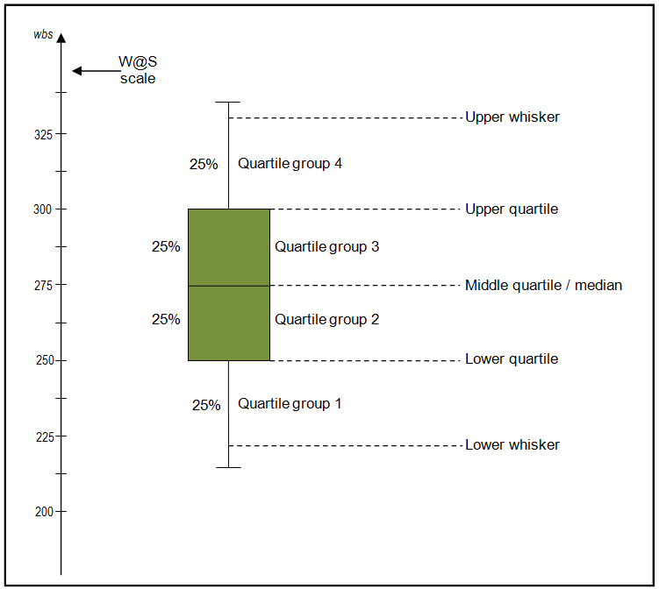
Boxplots include a:
- Median (the mid-point of the data shown by the line that divides the box into two parts): half the scores are greater than or equal to this value and half are less.
- Upper quartile (the box above the mid-point line): 75% of scores fall below the upper quartile.
- Lower quartile (the box below the mid-point line): 25% of scores fall below the lower quartile.
- Whiskers (the vertical lines above and below the box): The upper and lower whiskers represent the top 25% and lower 25% of scores.

Different boxplot shapes and positions give information
about the data.
- If the boxplot is comparatively short: This suggests that overall students have a high level of agreement with each other.
- If the boxplot is comparatively tall: This suggests students hold quite different opinions about this aspect.
- If one boxplot is much higher or lower than another: This could suggest a difference between groups. For example, if a boxplot is more than one quartile higher or lower than another boxplot this is likely to indicate a statistically significant difference.
- If a boxplot is much higher or lower than the national reference group boxplot: This suggests an area of difference.
- If the four sections of the boxplot are uneven in size: This shows that many students have similar views at certain parts of the scale, but in other parts of the scale students are more variable in their views. A long whisker means that student views are varied in the upper or lower quartile. A short whisker means views are more similar.
Wellbeing@School aspect boxplot for Year 8 students

Wellbeing@School aspect boxplot for Year 9 students

- Wellbeing@School primary data

The 2012 data includes 830 students, and the 2013 data, 701 students.
Aspect 1—School-wide climate and practices
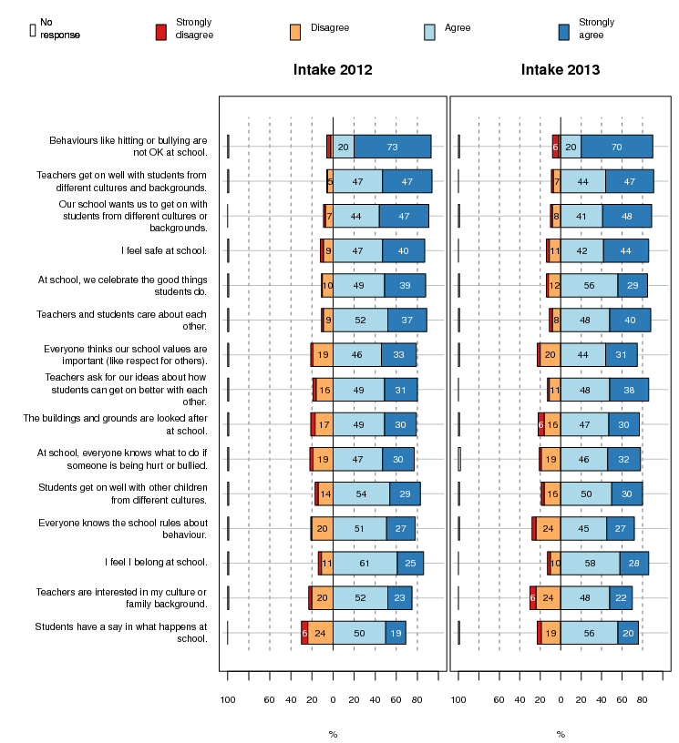

Aspect 2—Teaching and learning
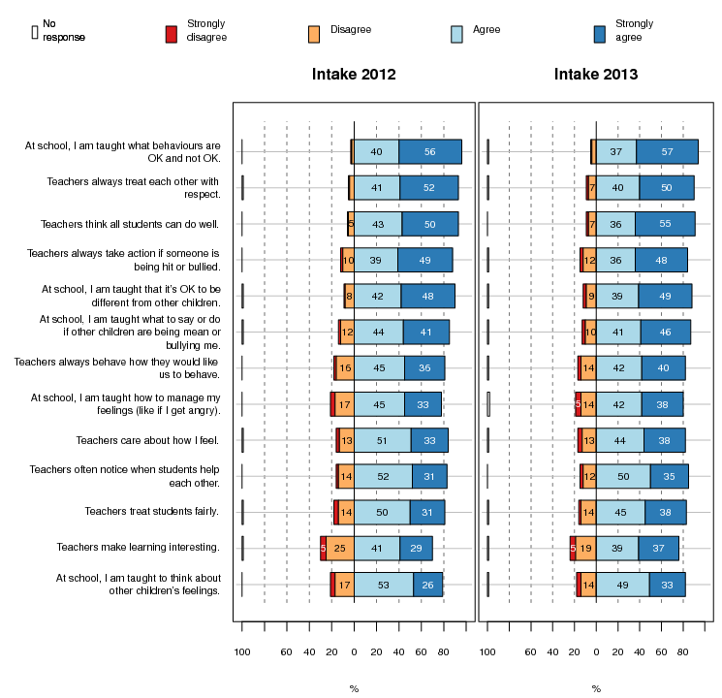

Aspect 3—Community partnerships
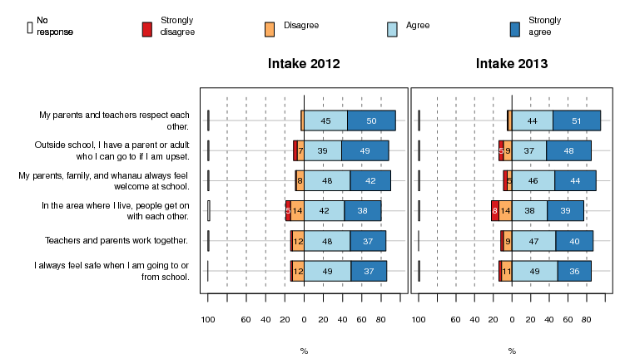

Aspect 4—Prosocial student culture and strategies
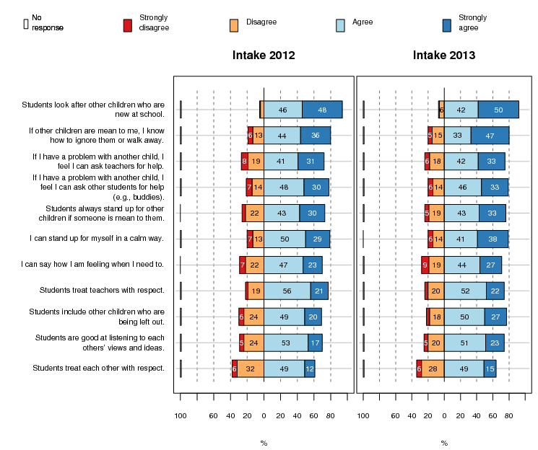

Aspect 5—Aggressive student culture
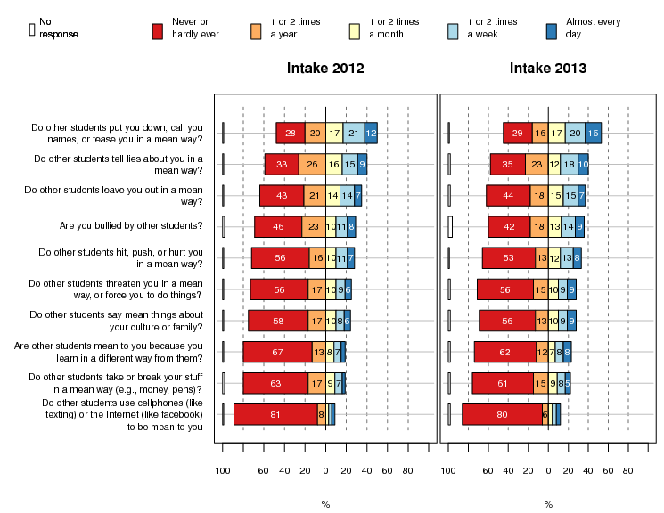

- Wellbeing@School secondary and intermediate data
The 2012 data includes 2,764 students, and the 2013 data, 6,588 students.

Aspect 1—School-wide climate and practices
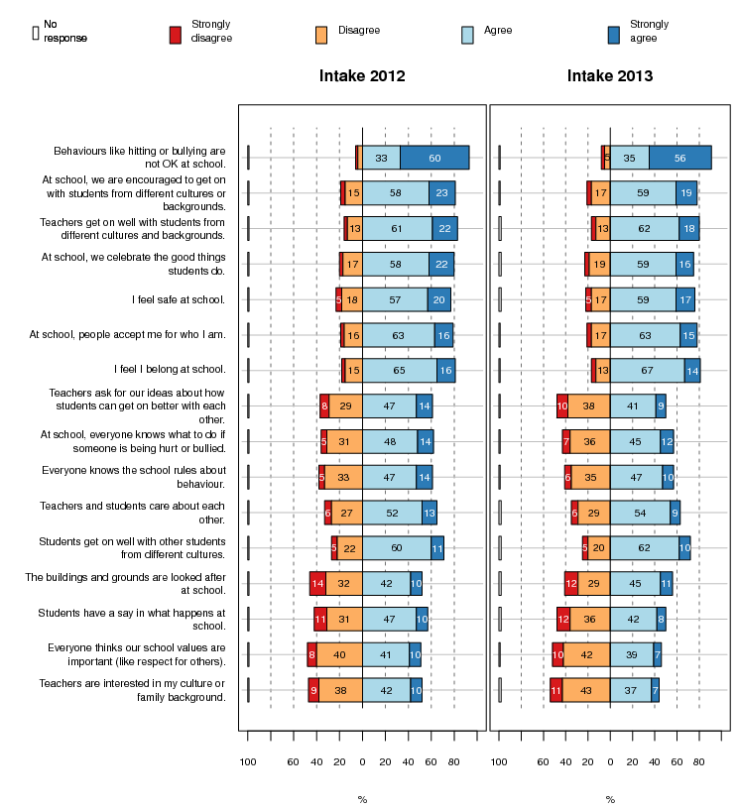

Aspect 2—Teaching and learning
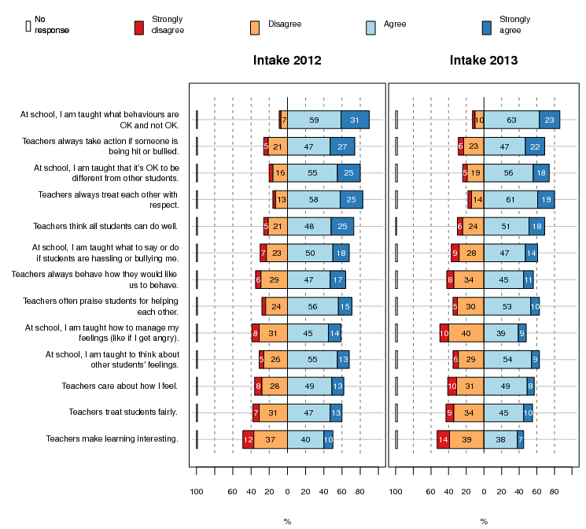

Aspect 3—Community partnerships
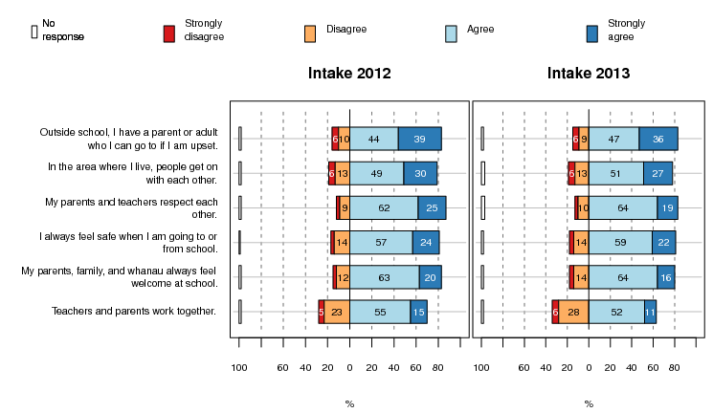
Aspect 4—Prosocial student culture and strategies
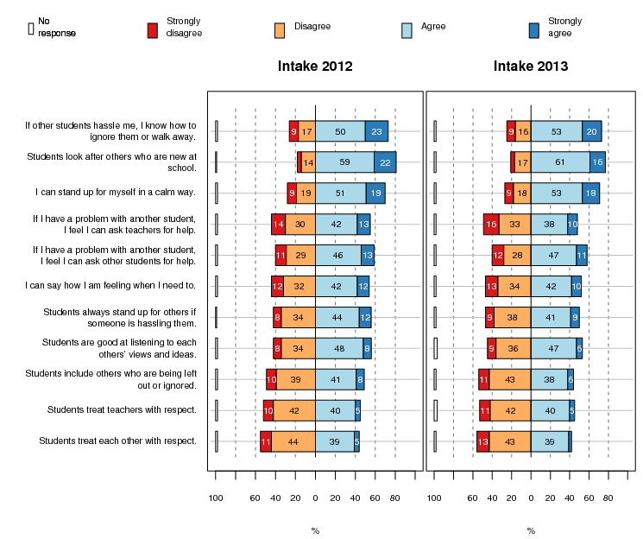
Aspect 5—Aggressive student culture
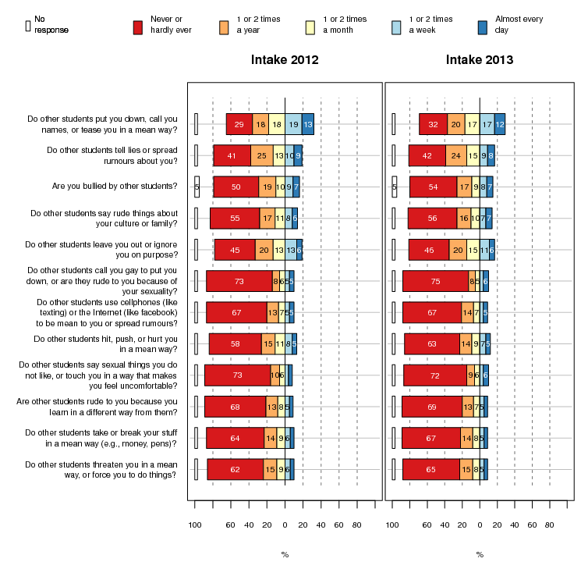

Available from http://www.pbis.org/evaluation/evaluation_tools.aspx
http://www.wellbeingatschool.org.nz/
Available from http://www.pbis.org/evaluation/evaluation_tools.aspx
Small primary schools had a student roll of 200 or less. Large primary had a roll of more than 200. A small secondary or intermediate school had a roll of 400 or less, and a large school, more than 400.
Scoping interviews suggested that these differences could be related to differing approaches in 2010 to how SET was completed between the four regions rather than differences between schools. The different regions also have different decile patterns. For these reasons this information is not included.
http://www.minedu.govt.nz/~/media/MinEdu/Files/Boards/EffectiveGovernance/SupportingPasifikaSuccess.pdf
As expected, coaches and curriculum leaders from 2012/13 schools reported fewer changes in student outcomes or that it was too soon to tell. Mostly, these data are not reported in this chapter.
We also did this analysis by programme year (i.e., 2009 data acted as the baseline for 2010 SW schools, and 2010 data, the baseline for 2010 SW schools). This analysis mostly showed a very similar pattern to the calendar year analysis. Therefore we have reported the calendar year analysis only for comparability with the comparison group and the PB4L-SW indicator report (Ministry of Education, 2013).
The PB4L-SW indicator report reported data only from the SW cohort which joined the initiative in 2010. Therefore the dataset in the indicator report included a smaller number of schools (86). The analysis also covered a shorter time period (2009 to 2011).
The correlations were of the magnitude of 0.21 to 0.26 with p-values ranging from 0.03 to 0.006.
A 60% cut off was selected to compensate for the amount of missing data to later questions in the survey.

