Appendix C: Further information on the Child Disability Allowance
Child Disability Allowance application form
Slide 1

Slide 2
Words related to physical disabilities appearing on the application form
The following information expands on results of the analysis of words that appeared in 24,000 Child Disability Allowance (CDA) application forms, further to the overview given in Section 1.3.
In the free fields of the 24,000 CDA applications forms analysed, the 215 most commonly used words (omitting words such as ‘and’ and ‘of’) included only 29 that appear to relate to possible physical disability. These words (with the number of forms on which they are mentioned in brackets) included: palsy (846), palsey (52), spastic (167), hemiplegia (132), diplegia (56), talipes (122), hydrocephalus (117), muscular (115), dystrophy (92), arthritis (72), juvenile (probably chronic juvenile arthritis) (66), dysplasia (70), hip (81), physical (63), deformity (62), leg (56), gross (probably as in gross motor) (63), physical (63), spinal (54), dyspraxia (328), club (251), motor (249), spina (210), spinal (54), and bifida (194).
In addition, it is reasonable to expect that a fair proportion of premature babies go on to develop a disability with a physical component. The following words relate to children who were born prematurely: prematurity (153) and premature (59). ‘Multiple’, which was mentioned 139 times, may relate to multiple disabilities, where a physical component could well be inferred.
Four further potentially relevant terms concerned cleft lip and palate, which may be related to physical difficulties with communication and feeding. Related terms were mentioned as follows: cleft (271), lip (114), palate (204) and feeding (77).
If we only look at the applications containing a medical term that suggests physical disability, the number of children and young people affected appears to be somewhere between 1,000 and 2,600. A more precise estimate within this range depends on a best guess of whether some children and young people had several of the terms on one application form. Thus muscular (115) and dystrophy (92) probably referred to a maximum of 115 children and young people with a possible physical disability, rather than to over 200.

Appendix D: Further data on children and young people with a disability due to an accident
Education-based rehabilitation: Summary of issues highlighted in the serious injury satisfaction survey
The serious injury satisfaction survey is a face-to-face interview carried out by an independent research firm on an annual basis which provides seriously injured claimants and their support people with an opportunity to indicate their degree of satisfaction with the Accident Compensation Corporation (ACC) in terms of:
- the application process
- the information provided
- the services received.
This year the survey included questions relating to education-based rehabilitation for the first time. The respondents were 23 main support people of school-age children, and the key findings are summarise below.
Type of class
- Twelve children were in regular classes.
- Nine children were in a specialised unit.
- Two children were in a setting classified as ‘other’ (no further details provided).
Assessments
Injury-related needs
- Sixteen respondents agreed that the assessment accurately identified their child’s injury-related needs.
- Four respondents disagreed with the above statement.
- No information was provided for the remaining three respondents.
Personal care needs during the school day
- Twelve respondents agreed that the assessment accurately identified their child’s personal care needs during the school day.
- Six respondents disagreed with the above statement.
- No information was provided for the remaining five respondents.
Outside organisations
- There were some concerns in relation to assessments being completed by outside organisations who were not familiar with the children concerned.
Education-based rehabilitation
Teacher aides
- Seventeen respondents agreed that the teacher aide service was the most appropriate way to meet their child’s injury-related needs.
- Four respondents disagreed with the above statement and felt that more specialised care, information and flexibility were required.
- Two respondents were unsure.
Problems experienced
- Eight respondents had experienced problems with education-based rehabilitation services, including lack of or delays in assessments being undertaken, insufficient support for their children during the school day, or ineligibility for special funding.
- Fifteen respondents had not experienced any problems.
Suggested improvements
- The areas where improvements were suggested included:
- improved communication and co-ordination between the parties concerned
- an improved assessment process
- additional teacher aide hours
- additional equipment (e.g. computer)
- more flexible criteria for education-based rehabilitation.
- Eight respondents were unsure or did not have any suggestions.
Cause of accident, by age at accident, for children and young people with physical disabilities
Further to the overview given in Section 1.5, the following data (abstracted in July 2002) expand on ACC database information concerning the causes of accidents that resulted in a physical disability, and the age at which these accidents occurred.
Table D1: Causes of accidents resulting in disability, by age
Cause of accident | Age at accident (years)
Cause of accident | 0–5 | 6–10 | 11–17 | Total
Medical treatment | 118 | 12 | 3 | 133
Other or unclear cause | 75 | 16 | 9 | 100
Other loss balance / personal control | 45 | 20 | 13 | 78
Collision with / knocked over by object | 25 | 21 | 5 | 51
Other loss of control of vehicle | 18 | 8 | 14 | 40
Struck by person/animal | 21 | 6 | 2 | 29
Loss of hold | 13 | 1 | 1 | 15
Tripping or stumbling | 10 | 3 | 2 | 15
Slipping, skidding on foot | 5 | 5 | 4 | 14
Fire | 9 | 2 | 1 | 12
Swerving / evasive action | 5 | 2 | 1 | 8
Boiling (violent and inadvertent) | 6 |  |  | 6
Other collapse/overturning/inundation | 1 | 2 | 3 | 6
Pushed or pulled | 3 | 2 | 1 | 6
Driving into hole/object/animal/etc | 3 | 1 |  | 4
Criminal act | 2 | 1 |  | 3
Flooding/overflow/escape of liquid | 3 |  |  | 3
Object coming loose / goods shifting | 2 |  | 1 | 3
Skid | 1 | 1 | 1 | 3
(Blank) |  | 1 | 3 | 4
Explosion/blasting/implosion | 1 | 1 |  | 2
Exposure to elements | 1 | 1 |  | 2
Lifting/carrying/strain | 1 |  | 1 | 2
Other or unclear fire or explosion | 1 |  | 1 | 2
Recoil/ejection | 2 |  |  | 2
Struck by hand-held tool/implement | 1 | 1 |  | 2
Work property or characteristics |  | 2 |  | 2
Bursting/breakage/distortion | 1 |  |  | 1
Electrical shock/short circuit |  | 1 |  | 1
Inadvertent machine/vehicle movement | 1 |  |  | 1
Loss of consciousness / sleep / giddy | 1 |  |  | 1
Lurching / jerks in vehicles, etc | 1 |  |  | 1
Mechanical malfunction | 1 |  |  | 1
Misjudgement of support | 1 |  |  | 1
Puncture | 1 |  |  | 1
Shooting |  |  | 1 | 1
Something giving way underfoot | 1 |  |  | 1
Total | 380 | 110 | 67 | 557

Appendix E: Number of ORRS-funded students per 1,000 population in each territorial local authority, 2000
The following data were used to generate the figures on ORRS funding per 1,000 population that are reported in Section 1.6.
Table E1: Rate of ORRS-funded students, by territorial local authority
Territorial local authority (TLA) | Total ORRS per 1,000 | Male ORRS per 1,000 | Female ORRS per 1,000
Far North District | 5.23 | 6.04 | 4.37
Whangarei District | 10.08 | 11 | 9.12
Kaipara District | 5.45 | 7.22 | 3.57
Rodney District | 5.40 | 6.13 | 4.63
North Shore City | 7.33 | 8.56 | 6.04
Waitakere City | 15.56 | 18.34 | 12.65
Auckland City | 11.48 | 13.58 | 9.27
Manukau City | 7.15 | 8.15 | 6.11
Papakura District | 11.27 | 13.87 | 8.51
Franklin District | 7.86 | 10.50 | 5.04
Thames–Coromandel District | 5.08 | 6.45 | 3.64
Hauraki District | 11.74 | 12.84 | 11.27
Waikato District | 3.95 | 4.86 | 2.96
Matamata–Piako District | 7.62 | 7.76 | 7.49
Hamilton City | 14.81 | 17.39 | 12.17
Waipa District | 4.38 | 5.61 | 3.09
Otorohanga District | 11.94 | 12.85 | 10.96
South Waikato District | 10.76 | 11.81 | 9.65
Waitomo District | 6.59 | 10.50 | 2.63
Taupo District | 8.25 | 9.43 | 7.05
Western Bay of Plenty District | 6.91 | 7.82 | 5.93
Tauranga District | 9.35 | 11.24 | 7.36
Rotorua District | 10.42 | 12.69 | 8.02
Whakatane District | 10.77 | 11.65 | 9.85
Kawerau District | 7.84 | 10.13 | 5.43
Opotiki District | 5.04 | 6.50 | 3.49
Gisborne District | 9.43 | 10.03 | 8.81
Wairoa District | 7.96 | 11.40 | 4.42
Hastings District | 7.67 | 8.40 | 6.90
Napier City | 11.42 | 13.95 | 8.824
Central Hawke’s Bay District | 5.29 | 5.58 | 4.94
New Plymouth District | 10.32 | 11.98 | 8.57
Stratford District | 12.45 | 16.19 | 8.62
South Taranaki District | 5.98 | 7.59 | 4.18
Ruapehu District | 14.87 | 12.28 | 17.84
Wanganui District | 10.87 | 12.67 | 8.96
Rangitikei District | 4.28 | 6.01 | 2.39
Manawatu District | 4.87 | 6.29 | 3.32
Palmerston North City | 11.99 | 14.29 | 9.73
Tararua District | 6.58 | 4.49 | 8.88
Horowhenua District | 7.88 | 10.11 | 5.56
Kapiti Coast District | 6.45 | 8.47 | 4.42
Porirua City | 9.25 | 13.22 | 4.98
Upper Hutt City | 8.15 | 9.35 | 6.82
Lower Hutt City | 8.51 | 9.68 | 7.27
Wellington City | 10.24 | 12.15 | 8.32
Masterton District | 14.16 | 14.97 | 13.31
Carterton District | 4.78 | 4.03 | 5.64
South Wairarapa District | 4.03 | 5.57 | 2.36
Tasman District | 11.90 | 10.73 | 13.13
Nelson City | 10.06 | 12.49 | 7.50
Marlborough District | 6.48 | 6.66 | 6.29
Kaikoura District | 7.58 | 9.34 | 5.60
Buller District | 4.43 | 6.41 | 2.11
Grey District | 3.99 | 5.82 | 2.18
Westland District | 4.50 | 5.06 | 3.90
Hurunui District | 2.39 | 3.77 | 0.96
Waimakariri District | 6.26 | 8.19 | 4.23
Christchurch City | 13.13 | 15.94 | 10.22
Banks Peninsula District | 3.71 | 4.32 | 3.04
Selwyn District | 3.44 | 3.86 | 2.98
Ashburton District | 9.09 | 10.89 | 7.09
Timaru District | 8.55 | 11.59 | 5.34
Mackenzie District | 7.00 | 7.93 | 5.74
Waimate District | 4.15 | 5.08 | 3.00
Chatham Islands District | 14.49 | 10.75 | 15.87
Waitaki District | 10.74 | 14.59 | 6.42
Central Otago District | 4.36 | 4.82 | 3.81
Queenstown-Lakes District | 4.77 | 4.37 | 5.16
Dunedin City | 9.71 | 12.61 | 6.78
Clutha District | 7.03 | 9.46 | 4.17
Southland District | 3.44 | 3.21 | 3.71
Gore District | 4.41 | 6.35 | 2.28
Invercargill City | 13.66 | 16.80 | 10.44
Area outside TLA | 4,060.61 | 5,444.44 | 2,000
Total NZ by TLA/area unit | 9.61 | 11.38055 | 7.750068

Appendix F: Students with moderate physical disabilities application form
The application form for students with moderate physical disabilities is available at www.minedu.govt.nz/index.cfm?layout=document&documentid=12279&data=l
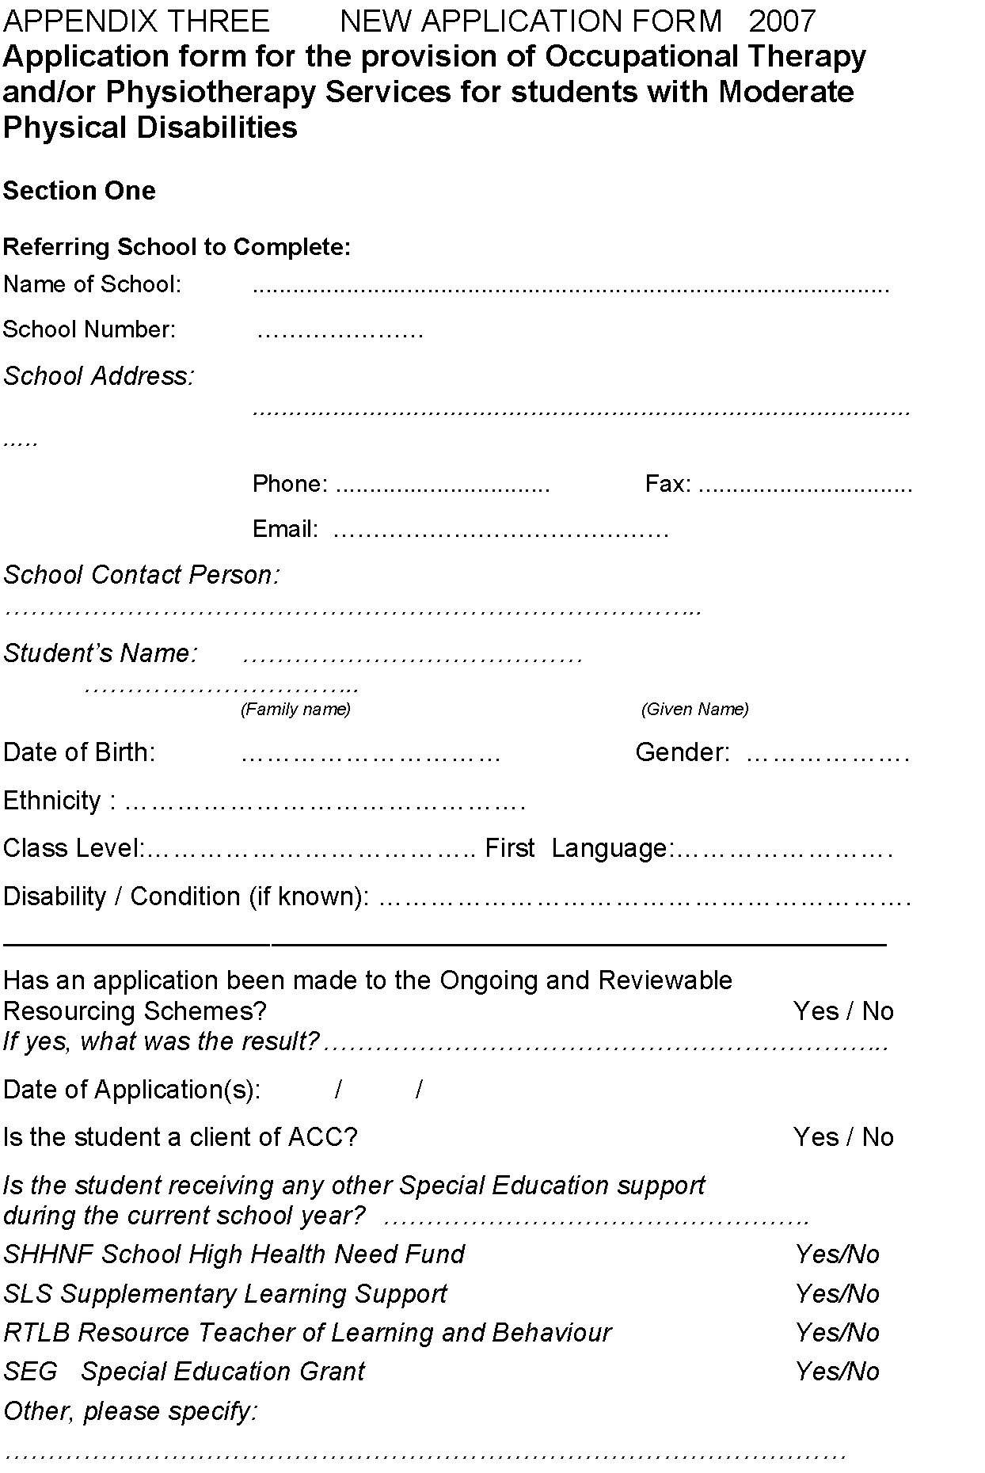
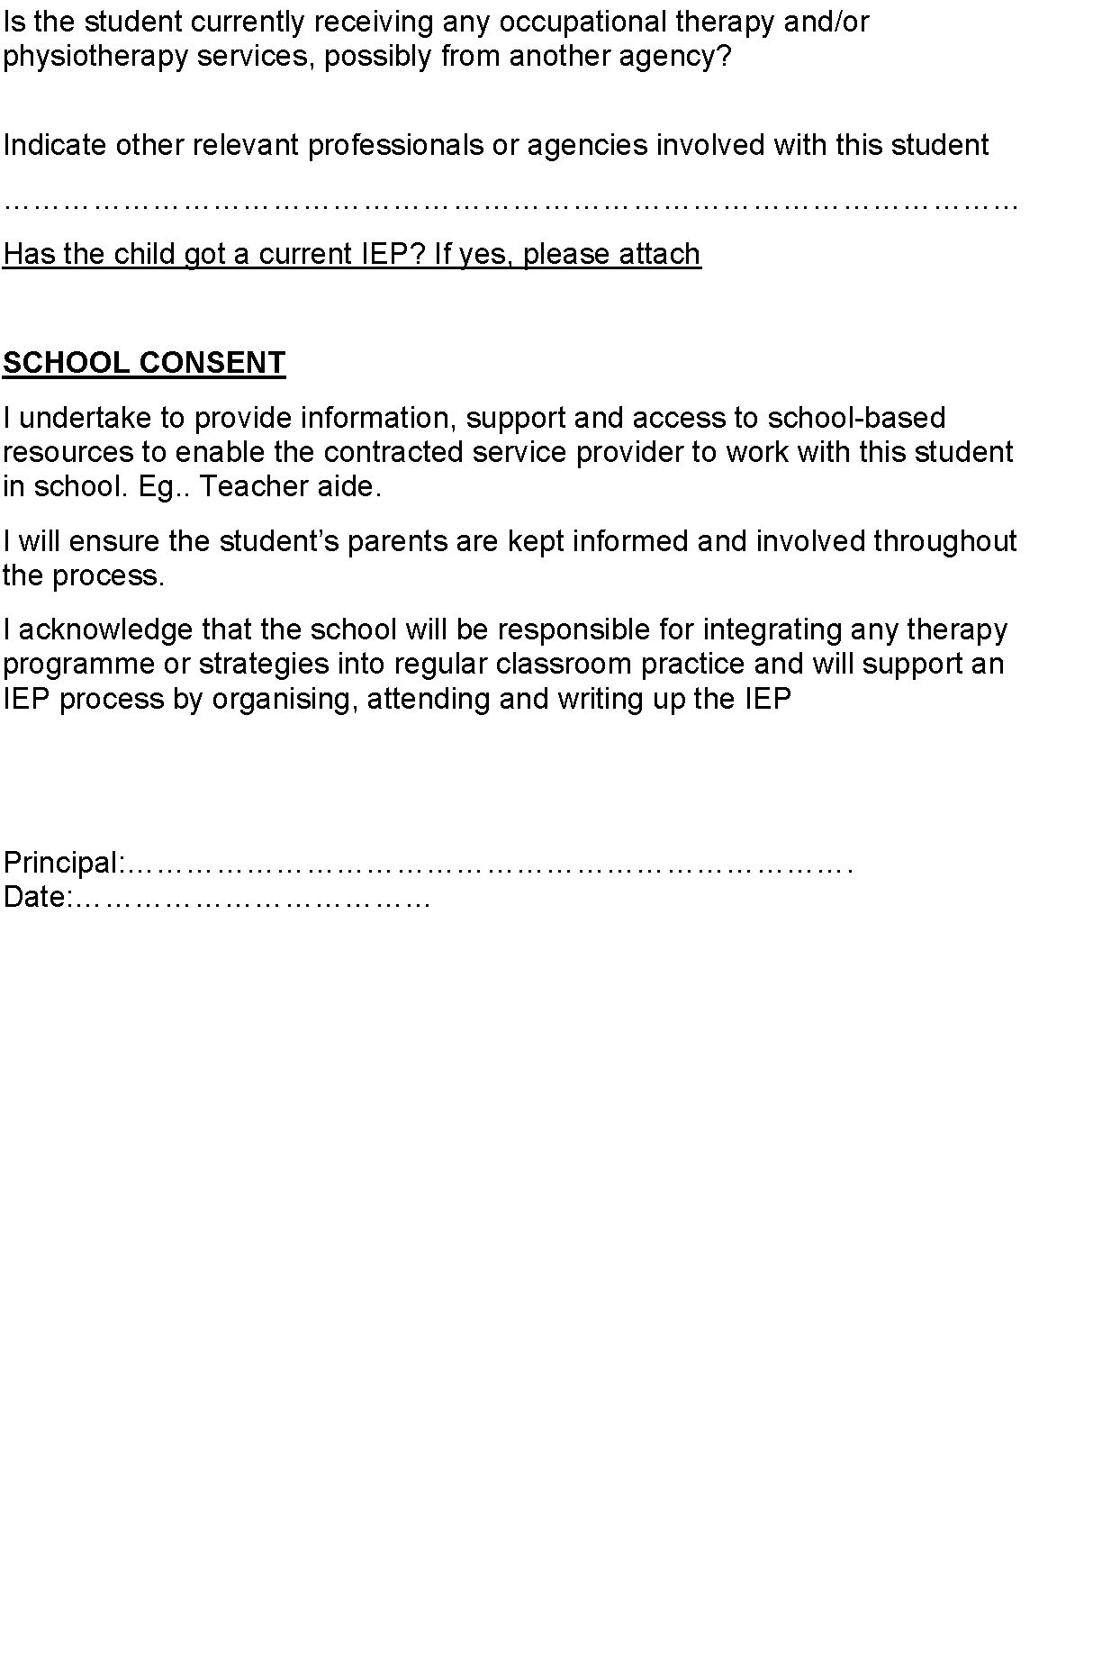
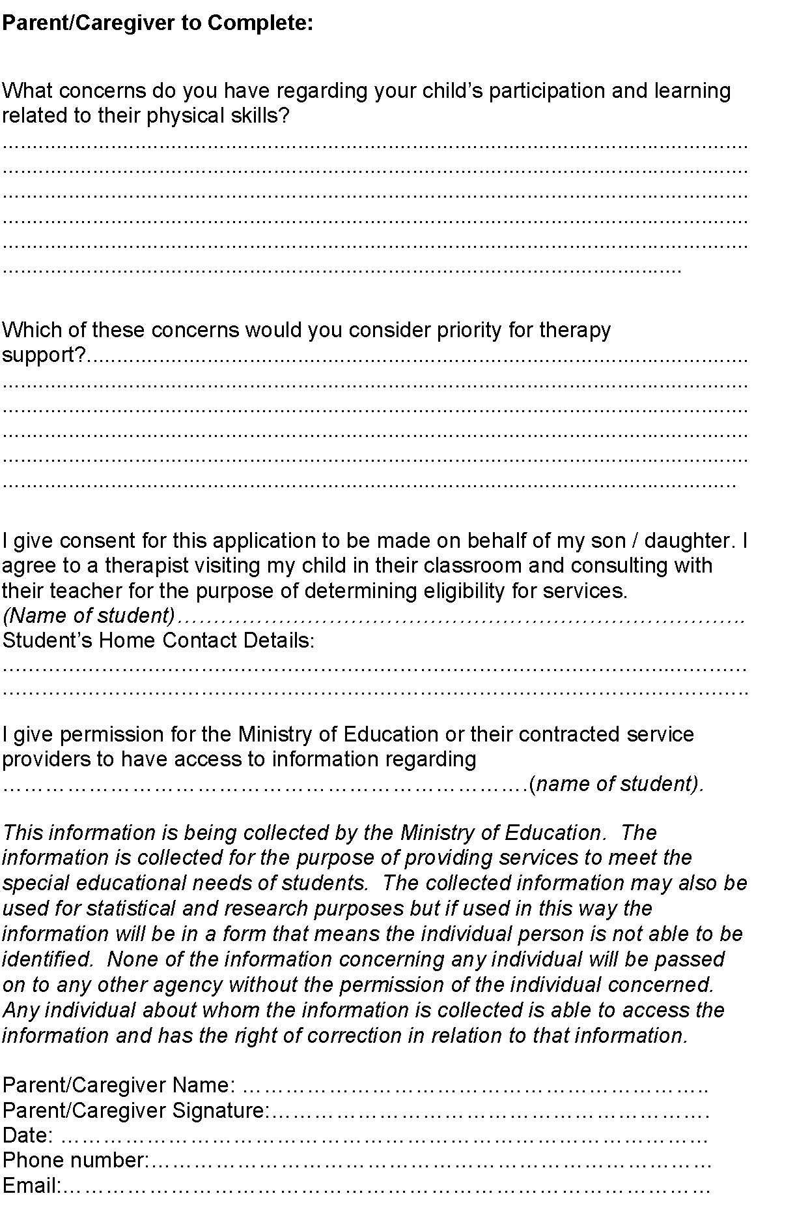
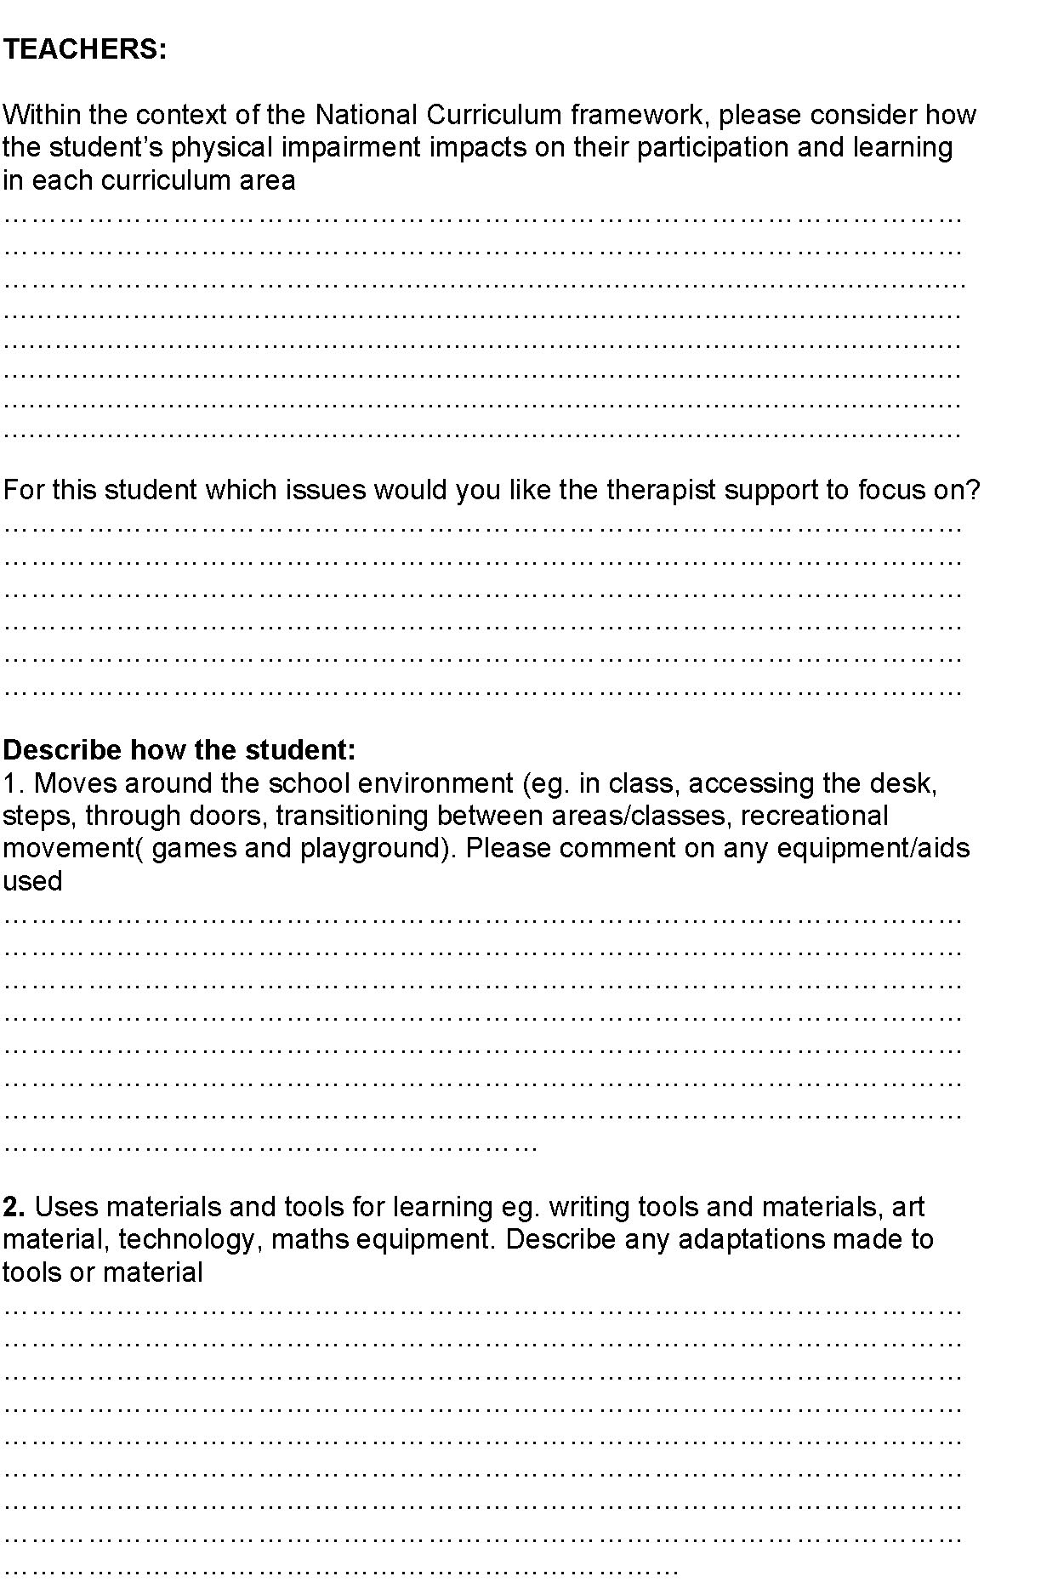
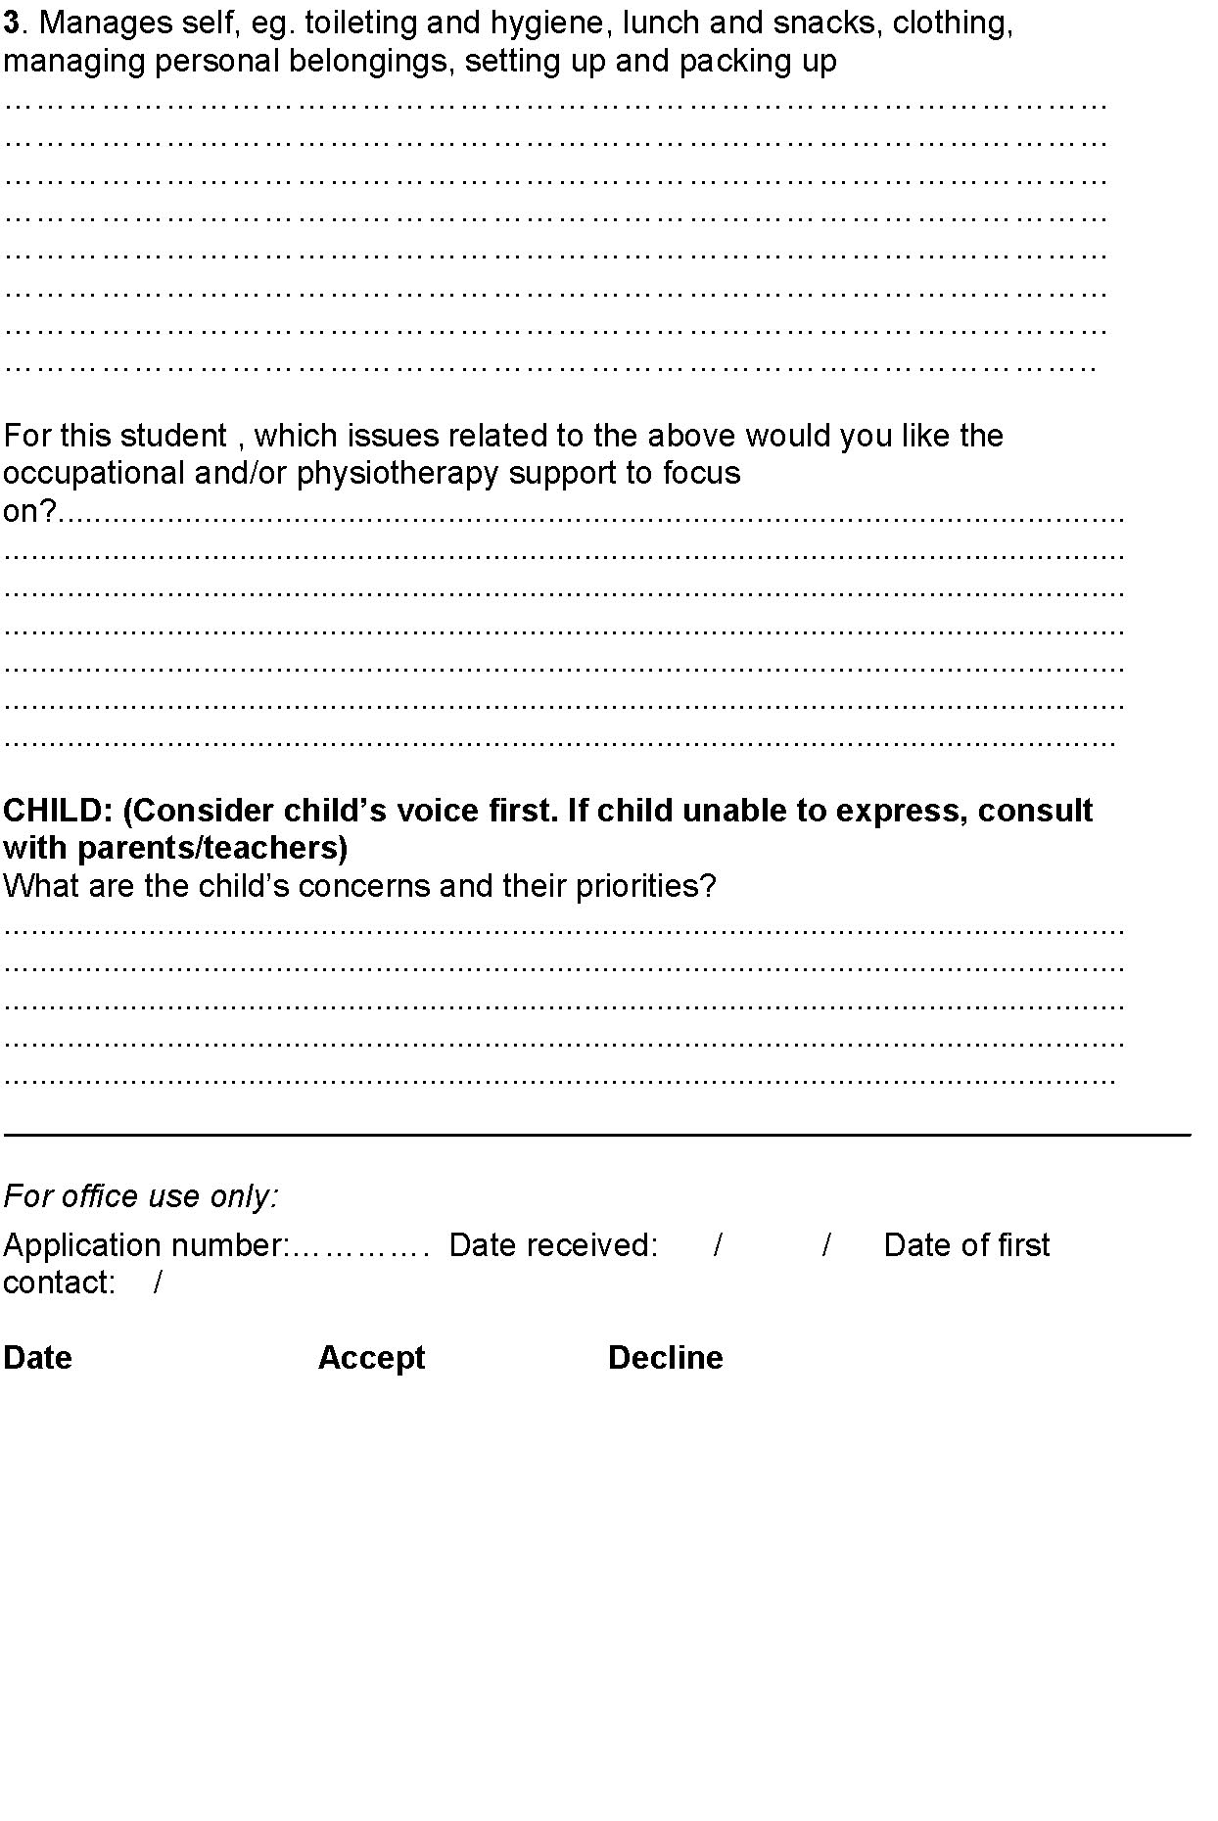

Appendix G: Questionnaire used in survey of schools
Cover letter 1
24 June 2003  «Name»  «Title»  «Organisation»  «Address_1»  «Address_2»  «Address_3» | National Office | Group Special Education  45-47 Pipitea Street  Thorndon  P O Box 1666  Wellington  New Zealand | Phone: 0-4-463 8000  Direct: 04 463 8260  Fax: 04 463 8254  www.minedu.govt.nz
Dear «Title»
Research on resourcing for students with physical disabilities
I am writing to ask you to complete the enclosed questionnaire from Dr Phillipa Clark of the University of Auckland. It is part of a research project that has been commissioned by the Ministry of Education, through the Advisory Reference Group for Students with Physical Disabilities. The Reference Group’s brief includes promoting and supporting robust research into effective integrated teaching, learning and therapy practices so that children and young people with physical disabilities successfully overcome barriers to learning and develop their potential to participate effectively in life.
Dr Clark’s research project is designed to obtain and synthesise the available information on the distribution of resources/funding streams for children and young people with physical disabilities, and the quantum of resourcing on a national/regional basis. The questionnaire mainly deals with the provision of therapy services to enrolled students in your school. It is closely linked to another research project contracted by the Reference Group to the Donald Beasley Institute at Dunedin on case studies of integrated effective service provision for children and young people with physical disabilities. Both projects build on an earlier scoping report commissioned by the Reference Group and published in April last year (www.educationcounts.govt.nz/publications/special_education/15734).
I strongly encourage you complete the questionnaire – it will provide important information that will be a foundation for the Ministry to make well-informed decisions about future resourcing for students with physical disabilities.
If you have any questions about the research project, please contact Dr Clark (p.clark@auckland.ac.nz), Melissa Weenink of the Ministry’s Research Division (melissa.weenink@minedu.govt.nz), or myself (joanna.curzon@minedu.govt.nz).
Kind regards

Joanna Curzon
Senior Adviser, Group Special Education
Cover letter 2
24 June 2003  «Name»  «Title»  «Organisation»  «Address_1»  «Address_2»  «Address_3» | National Office | Group Special Education  45-47 Pipitea Street  Thorndon  P O Box 1666  Wellington  New Zealand | Phone: 0-4-463 8000  Direct: 04 463 8260  Fax: 04 463 8254  www.minedu.govt.nz

Dear «Title»
Research on resourcing for students with physical disabilities
I am writing to ask you to complete the enclosed questionnaire from Dr Phillipa Clark of the University of Auckland. It is part of a research project that has been commissioned by the Ministry of Education through the Advisory Reference Group for Students with Physical Disabilities. The Reference Group’s brief includes promoting and supporting robust research into effective integrated teaching, learning and therapy practices so that children and young people with physical disabilities successfully overcome barriers to learning and develop their potential to participate effectively in life.
Schools and units like yours, which are receiving additional resourcing support for students with physical disabilities (the so-called Three Year Package), agreed to participate in research and evaluation of effective therapy practice as a condition of receiving this additional support.
Dr Clark’s research project is designed to obtain and synthesise the available information on the distribution of resources/funding streams for children and young people with physical disabilities, and the quantum of resourcing on a national/regional basis. It is closely linked to another research project contracted by the Reference Group to the Donald Beasley Institute at Dunedin on case studies of integrated effective service provision for children and young people with physical disabilities. Both projects build on an earlier scoping report commissioned by the Reference Group and published in April last year (www.educationcounts.govt.nz/publications/special_education/15734).
I strongly encourage you complete the questionnaire – it will provide important information that will be a foundation for the Ministry to make well-informed decisions about future resourcing for students with physical disabilities.
If you have any questions about the research project, please contact Dr Clark (p.clark@auckland.ac.nz), Melissa Weenink of the Ministry’s Research Division (melissa.weenink@minedu.govt.nz), or myself (joanna.curzon@minedu.govt.nz).
Kind regards
Joanna Curzon
Senior Adviser, Group Special Education

Appendix H: Summary of case study sites and students
Schools with therapy provision on site
Table H1: Self-contained school

SCHOOL
Type and level | Self-contained special school; year 1−
Decile | 1

FOCUS STUDENT: Simon
Age / year at school | 18 years / year 14
Disability | Cerebral palsy (spastic diplegia), epilepsy, learning disability; uses wheelchair
Funding stream and level | ORRS very high need
Supports (at school) | Specialist teacher, teacher aide, special education assistant, PT, OT, SLT, music teacher.  Cost of these services = $11,500 plus teacher component.
Supports (itinerant)
Transport | Taxi funded by Ministry of Education

FOCUS STUDENT: Selena
Age / year at school | 12.8 years / year 9
Disability | Physical and learning disability, scoliosis; uses wheelchair
Funding stream and level | ORRS, very high needs
Supports (at school) | Specialist teacher, teacher aide, special education assistant, PT, OT, SLT, music teacher.  Cost of these services = $11,500 plus teacher component.
Supports (itinerant) | –
Transport | –

Table H2: Secondary school with an attached unit

SCHOOL
Type and level | Secondary school with attached unit – unit has transitional funding; years 913
Decile | 6

FOCUS STUDENT: Heather
Age / year at school | 14 years / year 10
Disability | Cerebral palsy, learning needs; uses wheelchair, learning to use power chair
Funding stream and level | ORRS, high needs
Supports (at school) | Teacher aide, physiotherapy 2 x week (swimming at the public pool, and PT in the unit), OT support approx. 2 x week for writing and positioning, independent living, independent mobility
Supports (itinerant)
Transport | Taxi funded by Ministry of Education
Other | Combined programme in regular classes and unit, adapted curriculum, home-care support

FOCUS STUDENT: Harry
Age / year at school | 16 years / year 12
Disability | Spinal bifida; uses wheelchair independently
Funding stream and level | ORRS, high needs
Supports (at school) | Teacher aide in study lines, OT and PT 3 x week, primarily in the unit
Supports (itinerant) | –
Transport | Taxi funded by Ministry of Education
Other | Education is in regular classroom, and regular curriculum

Table H3: Primary school with an attached unit (urban)

SCHOOL
Type and level | Primary school with attached unit − unit has transitional funding.  Years 1−8; 22 students on unit roll; unit staffing = 3 full-time teachers, 2.5 therapy positions, 22 full- or part-time teacher aides
Decile | 2

FOCUS STUDENT: Penny
Age / year at school | 11 years / year 7
Disability | Spastic cerebral palsy, visual impairment, autism spectrum disorder; uses wheelchair independently
Funding stream and level | ORRS, funded as an ‘over’
Supports (at school) | I hour per day integrated therapy in the unit
Supports (itinerant) | –
Transport | Private
Other | In regular class; home-care support

FOCUS STUDENT: Paul
Age / year at school | 8 years / year 4
Disability | Cerebral palsy, visual impairment, serious illness
Funding stream and level | ORRS, very high needs
Supports (at school) | Teacher aide support − 30 hours
Supports (itinerant)
Transport | Taxi funded by Ministry of Education
Other | In unit full-time; private SLT paid for by parents

Table H4: Intermediate school with attached unit

SCHOOL
Type and level | Intermediate with attached unit.  Years 7 & 8; 31 students on unit roll (some in regular classes); unit has transitional funding; staffing = 3 teachers, 1.5 OT positions, part-time SLT, 1 full-time PT, one therapy assistant, several teacher aides and special ed. assistants.
Decile | 3

FOCUS STUDENT: Isobel
Age / year at school | 12 years / year 8
Disability | Hemiplegia, seizures
Funding stream and level | ORRS, high needs
Supports (at school) | SLT:  - 1 hour individual per week  - 3 group oral-motor sessions per week.  OT:  - 45 mins per week 1:1  - community integration group 1 hour per week (with 7 others) for 2 terms  PT:  - 1 hour per week 1:1 per week  - hydrotherapy 1 x per week.  Counselling from teaching staff; RDA 1x per week; special ed. assistant and teacher aide support in class (aide shared between 4 students).  Total cost = $10,250.
Supports (itinerant) | –
Transport | Taxi funded by Ministry of Education
Other | In unit full-time except for reading (in regular class); reads 2 years above chronological age

FOCUS STUDENT: Ian
Age / year at school | 11 years old / year 7
Disability | Cerebral palsy (spastic diplegia)
Funding stream and level | ORRS, high needs
Supports (at school) | Full-time teacher aide (shared with 3 other children); therapies provided mostly in school hours.  PT:  - 3 x weekly (individual)  - 3 x weekly stretches  - daily walking.  OT:  - monitoring assistive technology  - assessing and prescribing  Total cost of aide and therapy = $10,200
Supports (itinerant) | –
Transport | Taxi funded by Ministry of Education
Other | In regular class, academically very able;  currently has weekly post-operative PT (health)
Schools with itinerant therapy provision
Table H5: Health-provided Child Development Service in a rural area
SCHOOL
Type and level | Rural college; years 713
Decile | 6

FOCUS STUDENT: Ricky
Age / year at school | 11 years / year 7
Disability | Low tone, unstable gait, poor motor and visual-perceptual development, post-accident skin grafts, behavioural and social challenges
Funding stream | Health funding for in-school OT
Supports (at school) | Post-accident ACC-funded teacher aide time of 12.5 hrs/week, now withdrawn
Supports (itinerant) | OT once every 3 weeks; RTLB consults with teacher; RDA in school time
Transport | Private
Other | Recent PT at home (result of parental advocacy)

SCHOOL
Type and level | Rural primary; years 1−6
Decile | 7

FOCUS STUDENT: Rose
Age / year at school | 6 years / year 2
Disability | Sensory integration and motor-planning problems; speech problems; ASD
Funding stream | No funding; turned down twice for ORRS high needs
Supports (at school) | Full-time teacher aide paid for by family ($3,500 per term); Health-funded OT
Supports (itinerant) | RTLB consults with teacher by telephone as needed
Transport | School bus − put on bus then met at school by mother
Other | At-home learning support from independent organisation (paid for by family)

Table H6: Health-provided Child Development Service in an urban area
SCHOOL
Type and level | Local urban primary school; years 1−8
Decile | 5

FOCUS STUDENT: Caitlin
Age / year at school | 8 / year 4
Disability | Cerebral palsy (spastic diplegia), visual perception and memory problems;  receives Botox treatment
Funding stream and level | ORRS, medical high needs (following parental advocacy after being turned down for ORRS)
Supports (at school) | Teacher aide − 5 hrs per week for daily stretching and learning support; PT − 1 due to shortage of therapists; special needs teacher − 1.5 hrs for remedial maths in a group, additional time for writing a remedial reading programme, setting up social opportunities in playground
Supports (itinerant) | –
Transport

SCHOOL
Type and level | Local urban primary school; years 1−6
Decile | 8

FOCUS STUDENT: Christopher
Age / year at school | 7 years / year 3
Disability | Cerebral palsy (spastic diplegia); receives Botox treatment
Funding stream and level | Recently approved for moderate contract for joint therapy; turned down 3 x for ORRS
Supports (at school) | Teacher aide for 1:1 reading 40 mins per week; RTLB consults with teacher for maths adaptation
Supports (itinerant) | 1 hour every 2 weeks for joint OT/PT
Transport | Private

Table H7: GSE service providing itinerant services

SCHOOL
Type and level | Rural area school; years 1−13
Decile | 5

FOCUS STUDENT: Ashley
Age / year at school | 16 years / year 10 for a second year
Disability | Cerebral palsy, learning disability; uses a wheelchair and K-walker
Funding stream and level | ORRS, very high needs; $12,583
Supports (at school) | Correspondence school maths; CCS funding for support with eating at lunchtime; RDA in school time
Supports (GSE itinerant) | PT  OT  SLT  Vision support – 6 x per year
Transport | School bus (no hoist)
Other | Home-care support

FOCUS STUDENT: Alan
Age / year at school | 10 years / year 6
Disability | Cerebral palsy, fine motor control problems
Funding stream and level | ORRS, high needs; $8,300
Supports (at school) | Teacher aide – 18 hours per week class support and community mobility support;  0.1 special education needs teacher for:  - 1:1 reading support (daily)  - stretching  - programme assessment and planning.  Special music – 1:1
Supports (GSE itinerant) | PT  OT  SLT  Vision support – once a fortnight
Transport | School bus

Table H8: GSE service providing itinerant services

SCHOOL
Type and level | Local rural primary; years 1−8
Decile | 10

FOCUS STUDENT: Laura
Age / year at school | 12 years / year 8
Disability | Cerebral palsy affecting all parts of her body; uses a wheelchair
Funding stream and level | ORRS high needs; $6,760
Supports (at school) | Teacher aide − mornings only; school tops up from SEG to get this much;  0.1/0.2 teacher (principal) does specialist programming to support learning
Supports (GSE itinerant) | OT 2 x per term; PT 2 x per term
Transport

SCHOOL | Rural primary
Type and level | Local rural primary; years 1−8
Decile | 2

FOCUS STUDENT: Leah
Age / year at school | 8 years; year 4
Disability | Athetoid cerebral palsy; uses a wheelchair and Hart Walker
Funding stream and level | ORRS high needs; $10,584
Supports (at school) | Teacher aide − full-time, shared by 2 people
Supports (GSE itinerant) | OT  PT  SLT: very small amount  0.1/0.2 special education needs teacher (used flexibly by own class teacher)
Transport | Taxi funded by Ministry of Education
Notes to tables: ORRS = Ongoing and Reviewable Resourcing Schemes; PT = physiotherapy; OT = occupational therapy; SLT = speech-language therapy; GSE = Ministry of Education, Special Education; SEG = Special Education Grant; RTLB = Resource Teachers: Learning and Behaviour: ASD = Autism Spectrum Disorder; RDA = Riding for the Disabled Association

Appendix I: Brief for schools
Integrated Effective Service Provision for Children and Young People with Physical Disabilities: Case Studies
Information Brief For Potential Case Study Sites (Schools)
Background to the project
This project is part of a larger research programme commissioned and funded by the Ministry of Education, and overseen by the Ministry’s Reference Group on Physical Disabilities. The aim of this larger programme is to gather understandings which will contribute to improving policy and service provision for students with physical disabilities, their families and whānau.
The present study emerges out of recommendations from the research programme’s scoping study. The scoping study suggested that it would be valuable to explore the different ways in which support teams work to provide education and support for children and young people with physical disabilities. In particular it suggested that the project should look at support teams which are using best practice (usually referred to as ‘integrated effective practice’). The main components of effective integrated practice are described below. It is hoped that this focus will provide some useful information about the various ways in which teams can work best to support students with physical disabilities and their families. In addition, the project could identify some of the barriers encountered by teams in their attempts to provide integrated effective practice. The project is centred particularly on the experiences of children and their families, and on the impact of various services and supports on children’s and families’ daily lives.
What will the project involve?
The project aims to describe and explore integrated effective service provision in practice in schools and related settings for students with physical disabilities. Nine case studies will be undertaken across a range of school and other settings (e.g. home; health; education; private therapy; welfare; ACC-supported settings). The project will try to cover the following range of school settings: inclusive, where students are included and taught in the regular classroom alongside their age peers; special school; special unit; high/low decile; urban/rural; primary/ secondary/ intermediate/ area school. If you agree to participate, a researcher will spend one week in your school observing two students with physical disabilities for two days each, as they move through the school day.
Observations of focus children. Observations will take place in the child’s classroom(s), and will focus on all aspects of their school day, including their interactions with teachers and other adults, and with children. The researcher will also observe the students outside school hours at home and in other community settings.
Interviews with the support team. The work of the support team will be observed as it impacts on the child’s daily life. The remaining day and some evenings will be used to informally interview team members, including the child’s teacher(s), other school-based support staff and the school principal. The child and their parents will also be interviewed, as will two recent school leavers with physical disabilities who have attended your school.
A proposal for the study has been approved by the University of Otago Human Ethics Committee. The results from this project will be written into a research report for the Ministry of Education, and may be used in conference presentations, teacher professional development, and written publications in teacher-focused and academic publications. In any of these forms of dissemination, confidentiality and anonymity will prevail. Your school, and the children, parents, teachers and support staff who participate in the study, will not be identified. However, it is important for you to understand that some staff in the Research Division of the Ministry of Education and members of the Ministry of Education’s Reference Group on Physical Disabilities will know the research sites, and may therefore be able to identify some case studies. Adult participants in the project will be informed of this point.
What is integrated effective practice?
The Scoping Project on Integrated Effective Service Provision for Children and Young People with Physical Disabilities (McDonald, Caswell & Penman, 2002), reviewed the international literature in this area, and the researchers also asked students, parents, and support team members to describe what they considered effective integrated practice to look like.
The Scoping Project provides an extensive and detailed discussion about integrated effective practice, and stresses that any discussion must take into account the uniqueness of New Zealand’s population and context. In summary, it concluded that integrated effective practice is indicated and achieved when:
- the wishes of families are respected and trusting relationships are built over time
- there is effective inter-agency collaboration
- there is raised awareness of disability issues within schools and the wider community
- teams collaborate effectively in the planning and implementation of individualised programmes
- client-centred meaningful goals are developed and functional skills are learnt in natural settings
- service providers are willing to consider new ideas, pay respect to alternative forms of intervention and assist families in making informed decisions
- there is recognition that staffing concerns about workload, training and ongoing supervision need to be addressed
- policy, funding and resource allocation support the diverse needs of children and young people with physical disabilities.
The literature review also suggested some ways that effective practice could be identified. The Scoping Report suggested that in New Zealand, practices could be said to be working in integrated, effective ways if there is:
- extensive family involvement
- learning and achievement by the student
- acceptance, inclusion and friendship with peers
- the availability of supports to adapt the curriculum
- a focus in education and other areas on quality of life which recognises the multiple ways in which quality of life can be determined
- a commitment to accountability and a means for ensuring accountability.
People interviewed for the Scoping Project said that an integrated effective model of service provision would mean that students with physical disabilities would:
- have opportunities to develop relationships with peers which are supported by sensitive arrangements for the provision of necessary therapies
- be happy
- receive support that is practically oriented and directed towards the improvement of their physical skills
- have equitable access to and choice between good-quality services
- access services that respond to their individual needs.
Further enquiries
If you have any questions about the project please feel free to contact:
Dr Jude MacArthur
Senior Researcher
Donald Beasley Institute
(03) 479 2162.

Appendix J: Brief for Child Development Teams
Integrated Effective Service Provision for Children and Young People with Physical Disabilities: Case Studies
Information Brief For Potential Case Study Sites (Child Development Teams)
Background to the project
This project is part of a larger research programme commissioned and funded by the Ministry of Education, and overseen by the Ministry’s Reference Group on Physical Disabilities. The aim of this larger programme is to gather understandings which will contribute to improving policy and service provision for students with physical disabilities, their families and whānau.
The present study emerges out of recommendations from the research programme’s scoping study. The scoping study suggested that it would be valuable to explore the different ways in which support teams work to provide education and support for children and young people with physical disabilities. In particular it suggested that the project should look at support teams which are using best practice (usually referred to as ‘integrated effective practice’). The main components of effective integrated practice are described below. It is hoped that this focus will provide some useful information about the various ways in which teams can work best to support students with physical disabilities and their families. In addition the project could identify some of the barriers encountered by teams in their attempts to provide integrated effective practice. The project is centred particularly on the experiences of children and their families, and on the impact of various services and supports on children’s and families’ daily lives.
What will the project involve?
The project aims to describe and explore integrated effective service provision in practice in schools and related settings for students with physical disabilities. Nine case studies will be undertaken across a range of school and other settings (e.g. home; health; education; private therapy; welfare; ACC-supported settings). The project will try to cover the following range of school settings: inclusive, where students are included and taught in the regular classroom alongside their age peers; special school; special unit; high/low decile; urban/rural; primary/ secondary/ intermediate/ area school. If your Child Development team agrees to participate, a researcher will spend one week with your team and, in particular, with two focus students who receive the services of your team.
Observations of focus children Observations will take place in the child’s school and classroom(s), and will focus on all aspects of their school day, including their interactions with teachers and other adults, and with children. The researcher will also observe the students outside school hours at home and in other community settings.
Interviews with the support team. The work of the support team will be observed as it impacts on the child’s daily life. The remaining day and some evenings will be used to informally interview team members, including the child’s teacher(s), other school-based support staff and the school principal. The child and their parents/whānau will also be interviewed, as will two recent school leavers with physical disabilities who have recently left school and received support from your Child Development team .
A proposal for the study has been approved by the University of Otago Human Ethics Committee. The results from this project will be written into a research report for the Ministry of Education, and may be used in conference presentations, teacher and therapist professional development, and written publications in teacher-focused and therapist-focused and academic publications. In any of these forms of dissemination, confidentiality and anonymity will prevail. Your team, and the children, parents, teachers and support staff who participate in the study, will not be identified. However, it is important for you to understand that some staff in the Research Division of the Ministry of Education and members of the Ministry of Education’s Reference Group on Physical Disabilities will know the research sites, and may therefore be able to identify some case studies. Adult participants in the project will be informed of this point.
What is integrated effective practice?
The Scoping Project on Integrated Effective Service Provision for Children and Young People with Physical Disabilities (McDonald, Caswell & Penman, 2002), reviewed the international literature in this area, and the researchers also asked students, parents, and support team members to describe what they considered effective integrated practice to look like.
The Scoping Project provides an extensive and detailed discussion about integrated effective practice, and stresses that any discussion must take into account the uniqueness of New Zealand’s population and context. In summary, it concluded that integrated effective practice is indicated and achieved when:
- the wishes of families are respected and trusting relationships are built over time
- there is effective inter-agency collaboration
- there is raised awareness of disability issues within schools and the wider community
- teams collaborate effectively in the planning and implementation of individualised programmes
- client-centred meaningful goals are developed and functional skills are learnt in natural settings
- service providers are willing to consider new ideas, pay respect to alternative forms of intervention and assist families in making informed decisions
- there is recognition that staffing concerns about workload, training and ongoing supervision need to be addressed
- policy, funding and resource allocation support the diverse needs of children and young people with physical disabilities.
The literature review also suggested some ways that effective practice could be identified. The Scoping Report suggested that in New Zealand, practices could be said to be working in integrated, effective ways if there is:
- extensive family involvement
- learning and achievement by the student
- acceptance, inclusion and friendship with peers
- the availability of supports to adapt the curriculum
- a focus in education and other areas on quality of life which recognises the multiple ways in which quality of life can be determined
- a commitment to accountability and a means for ensuring accountability.
People interviewed for the Scoping Project said that an integrated effective model of service provision would mean that students with physical disabilities would:
- have opportunities to develop relationships with peers which are supported by sensitive arrangements for the provision of necessary therapies
- be happy
- receive support that is practically oriented and directed towards the improvement of their physical skills
- have equitable access to and choice between good-quality services
- access services that respond to their individual needs.
Further enquiries
If you have any questions about the project please feel free to contact:
Dr Jude MacArthur
Senior Researcher
Donald Beasley Institute
(03) 479 2162
jude.macarthur@stonebow.otago.ac.nz

Appendix K: Information sheets and consent forms
Integrated Effective Service Provision for Children and Young People with Physical Disabilities: Case Studies
Information Sheet For Parents/Caregivers/Whānau Of Children/Youth With Disabilities
This project is part of a larger research programme commissioned and funded by the Ministry of Education, and overseen by the Ministry’s Reference Group on Physical Disabilities. The aim of this larger programme is to gather information which will help to improve policy, services and supports for students with physical disabilities, their families and whānau.
What is the aim of the project?
The overall purpose of the case studies is to gather information which will contribute to improving service provision for students with physical disabilities, their families and whānau and inform both policy development and decisions about resourcing. The study will look at the various ways in which support team members in schools, at home and in the community (e.g. teachers, therapists, teacher aides, counsellors and others) can best work together to support students with physical disabilities and their families. The project also hopes to identify some of the barriers faced by these teams as they work to provide effective and integrated practice, and to comment on the overall impact of resourcing for students on the student and their family. Nine schools will participate in the study around New Zealand, covering a range of settings (inclusive; special school; special unit; high/low decile; urban/rural; primary/secondary).
What type of participants are being sought?
Participants in each school will be two children with physical disabilities. I may also talk with friends of the children with disabilities at school. Other participants include parents/caregivers of the two children with physical disabilities; and members of the educational support team, including the principal, class teacher, teacher aide, therapists, and any other support staff working as part of the team both within and outside the school.
What will participants be asked to do?
If you agree to participate, you and your child will be asked to sign a consent form which shows that you understand the study and wish to participate. I will spend one week in your child’s school. observing him or her and one other student who has a physical disability. I would like to find out as much as I can about your child’s daily life, at school, home and in the community, and how members of your child’s educational support team fit into and support your child's day. To do this I will observe and talk with your child for two days, moving with them as they go through an ordinary day. At school I will observe in the classroom and in the school grounds, looking at all aspects of their school day, including their interactions with teachers and other adults, and with children. I may at times talk with adults if I need clarification about what is happening. I may also talk to your child’s friends, providing they and their parents agree to take part in the project. A letter describing the project will be sent to all families in the school so that everyone knows why I am there. I would like to see what your child’s life is like outside school hours, by coming home with them after school and/or going with them to other places such as clubs, sports groups, or friends’ homes.
I will be talking with adults who support your child’s education and general development, including the school principal; your child’s teacher(s); therapists; teacher aide; and any other adults who provide support through either education, health or ACC funding. These discussions will focus on the type of support provided to your child; the resourcing your child receives; the impact of that resourcing; your child’s educational and other goals; planning for your child’s education; the various ways in which team members work together to support you and your child; and the kinds of links and relationships the team has with you, your child and the rest of your family. I will look at some of the resourcing, planning and teaching documents used to support your child’s education, including his/her IEP.
I will interview both you and your child at home. In the interviews I will be asking you about your child’s life at school, at home and in the community, and how the support team works to support your child's education and development, and your family life.
Can participants change their mind and withdraw from the project?
You or your child may withdraw from participation in the project at any time and without any disadvantage to yourself or your child of any kind.
What data or information will be collected and what use will be made of it?
The data I collect will include observations and interview transcripts. As I observe your child’s day at school and elsewhere, I will write down notes to describe what he/she is doing, their interactions with others (adults and children), and their comments in relation to any questions I might ask them about what they are doing. I may at times record my observations on a tape recorder, however I will go somewhere private to do this.
I will be using an open-questioning approach in my interviews with children and adults in the project. This means that it is not possible to say exactly what questions will be asked in the interview beforehand. Some questions will come up as we talk. Consequently, although the Ethics Committee is aware of the general areas we will cover in the interview, the Committee has not been able to review the precise questions to be used. In the event that the line of questioning does develop in such a way that you or your child feels hesitant or uncomfortable you are reminded of your right to decline to answer any particular question(s) and also that you or your child may withdraw from the project at any stage without any disadvantage to yourself of any kind.
The results from this project will be written into a report for the Ministry of Education. They may also be used in conference presentations and teacher training, and be published in written material for teachers, other professionals and researchers to learn from. Any data included will in no way be linked to any specific participant. Some staff in the Research Division of the Ministry of Education, and members of the Ministry of Education’s Reference Group on Physical Disabilities will know which schools have participated in the project, however this information will remain confidential to these groups. All of my observations and any interviews will be confidential to myself and to the other researchers on the team (Dr Trevor McDonald, Ms Pat Caswell, Ms Carolyn Simmons Carlsson and Teina Boasa-Dean . I will send you a summary of the study’s results, and you are most welcome to request a copy of the results of the project from me should you wish.
The data from the study (observation notes and interview transcripts) will be securely stored so that only those mentioned below will be able to gain access to it. At the end of the project any personal information will be destroyed immediately except that, as required by the University’s research policy, any raw data on which the results of the project depend will be kept in secure storage for five years, after which time it will be destroyed.
What if participants have any questions?
If you have any questions about the project, either now or in the future, please feel free to contact either:
Researcher’s name and telephone or Dr Jude MacArthur
Donald Beasley Institute
PO Box 6189
Dunedin
Telephone Number: (03) 479 8080
This project has been reviewed and approved by the Ethics Committee
of the University of Otago


Information Sheet For Parents/Caregivers Of Friends Of Focus Child
Integrated Effective Service Provision for Children and Young People with Physical Disabilities: Case Studies
This project is part of a larger research programme commissioned and funded by the Ministry of Education, and overseen by the Ministry’s Reference Group on Physical Disabilities. The aim of this larger programme is to gather information which will help to improve policy, services and supports for students with physical disabilities, their families and whānau.
What is the aim of the project?
The overall purpose of the case studies is to gather information which will contribute to improving service provision for students with physical disabilities, their families and whānau and inform both policy development and decisions about resourcing. The study will look at the various ways in which support team members in schools, at home and in the community (e.g. teachers, therapists, teacher aides, counsellors and others) can best work together to support students with physical disabilities and their families. The project also hopes to identify some of the barriers faced by these teams as they work to provide effective and integrated practice, and to comment on the overall impact of resourcing for students on the student and their family. Nine schools will participate in the study around New Zealand, covering a range of settings (inclusive; special school; special unit; high/low decile; urban/rural; primary/secondary).
What type of participants are being sought?
Participants in each school will be two children with physical disabilities. I may also talk with friends of the children with disabilities at school. Other participants include parents/caregivers of the two children with physical disabilities; and members of the educational support team, including the principal, class teacher, teacher aide, therapists, and any other support staff working as part of the team both within and outside the school. I have given you this information sheet because your child is a friend of x [one of the children participating in the project]. If it is all right with you I would like to talk with your child about the things he/she and x like to do together at school and outside of school.
What will participants be asked to do?
If you and your child agree to participate, you and your child will be asked to sign a consent form which shows that you understand the study and wish to participate. I will come to your home to talk with your child. In the interview I will be asking your child about their friendship with x, and about the things that he/she and x like to do at school. I am also interested in finding out what your child thinks about life at school both for themselves and for x.
Can participants change their mind and withdraw from the project?
Your child may withdraw from participation in the project at any time and without any disadvantage to yourself or your child of any kind.
What data or information will be collected and what use will be made of it?
I will tape the interview with your child so the data I collect from your child will include interview transcripts. I will be using an open-questioning approach in my interviews with children and adults in the project. This means that it is not possible to say exactly what questions will be asked in the interview beforehand. Some questions will come up as we talk. Consequently, although the Ethics Committee is aware of the general areas we will cover in the interview, the Committee has not been able to review the precise questions to be used. In the event that the line of questioning does develop in such a way that your child feels hesitant or uncomfortable they will be reminded of their right to decline to answer any particular question(s) and also that they may withdraw from the project at any stage without any disadvantage of any kind.
The results from this project will be written into a report for the Ministry of Education. They may also be used in conference presentations and teacher training, and be published in written material for teachers, other professionals and researchers to learn from. Any data included will in no way be linked to any specific participant. Some staff in the Research Division of the Ministry of Education, and members of the Ministry of Education’s Reference Group on Physical Disabilities, will know which schools have participated in the project, however this information will remain confidential to these groups. All of my observations and any interviews will be confidential to myself and to the other researchers on the team (Dr Trevor McDonald, Ms Pat Caswell, Ms Carolyn Simmons Carlsson and Teina Boasa-Dean . I will send you a summary of the study’s results, and you are most welcome to request a copy of the results of the project from me should you wish.
The data from the study (observation notes and interview transcripts) will be securely stored so that only those mentioned below will be able to gain access to it. At the end of the project any personal information will be destroyed immediately except that, as required by the University’s research policy, any raw data on which the results of the project depend will be kept in secure storage for five years, after which time it will be destroyed.
What if participants have any questions?
If you have any questions about the project, either now or in the future, please feel free to contact either:
[Researcher’s name and telephone] or Dr Jude MacArthur
Donald Beasley Institute
PO Box 6189
Dunedin
Telephone Number:
(03) 479 8080
This project has been reviewed and approved by the Ethics Committee
of the University of Otago
CONSENT FORM FOR PARENTS/CAREGIVERS/ YOUNG ADULTS WHO HAVE LEFT SCHOOL
Integrated Effective Service Provision for Children and Young People with Physical Disabilities: Case Studies
I have read the Information Sheet concerning this project and understand what it is about. All my questions have been answered to my satisfaction. I understand that I am free to request further information at any stage.
I know that:
My participation (and my child’s participation) in the project is entirely voluntary;
- I/We are free to withdraw from the project at any time without any disadvantage;
- The data [audio-tapes and notes] will be destroyed at the conclusion of the project but any raw data on which the results of the project depend will be retained in secure storage for five years, after which it will be destroyed;
- This project involves an open-questioning technique where the precise nature of the questions which will be asked have not been determined in advance. Instead questioning will depend on the way in which the interview develops and that in the event that the line of questioning develops in such a way that I feel hesitant or uncomfortable I may decline to answer any particular question(s) and/or may withdraw from the project without any disadvantage of any kind.
- The results of the project may be published but our anonymity will be preserved.
I AGREE TO TAKE PART IN THIS PROJECT.
(I HAVE SPOKEN WITH MY CHILD ABOUT THE PROJECT AND S/HE AND I AGREE S/HE CAN TAKE PART)
........................................................................... …………..……… (Signature /signature of Parent) (Date)

I/WE DO NOT WANT TO PARTICIPATE IN THIS PROJECT
.................................................................... …………………..
(Signature/signature of Parent) (Date)
This project has been reviewed and approved by the Ethics Committee
of the University of Otago

INFORMATION FOR CHILDREN/YOUTH IN THE STUDY
Note: The language in these appendices is appropriate to primary-age children. The language was adapted for older youth participating in the project, and for young adults who had left school. The format of these appendices was also adapted to meet the needs of participants who used alternative forms of communication.

The ‘Help at School’ Project
Children’s Information Sheet (Primary)
Dear …………………………………………….
I would like you to read this information sheet to help you decide whether you would like to take part in a study I am doing.
What It’s About
I am doing a study about what children think about the help they get from adults at school and outside of school (at home and in other places like music or cubs or sport). My report is going to be about how some of the adults who work at school (like your principal, your teacher, your physio, or OT) and in other places can really help kids with physical disabilities to have a good life. I’m interested in what you think, and in what happens for you at school.
Who I Want To Talk To
I am going to be spending two days with you. That’s a long time, and I hope we can have some fun and that you don’t get sick of me! I will visit you at home, and then I will go with you to school. I will spend the day with you at school and come back home with you after school. I want to see what your day is like and what you do in an ordinary day. I will talk to you about some of the things that happen at school. I will ask you to tell me about some of the things that are happening and for your opinion about things. I will also be talking to your Mum and Dad, your teacher(s) and the other adults who help you (such as your physio, OT, teacher aide, etc.). I want to know what they think about the help you get from all these people as well.
What You Would Have To Do
You and your Mum or Dad (or a caregiver) will sign a special form, called a Consent Form, which tells me you understand about the study and you want to be in it. Then I will talk to you about school, about the things you like to do at school, or don’t like! I will talk to you a little bit when I come to school, like I might ask you to tell me about things you are doing. But I would really like to come and talk with you at home if that’s OK. If you want Mum or Dad to be there when we talk that’s fine, you can choose. When I am at school I will be around for most of the day. I want to see what your day is like. I would like to write down some of the things I see you doing, and I might write down some of the things you tell me as well. Sometimes I might talk to your friends, that is if they want to talk to me.
You Can Change Your Mind
Even if you sign the form, you can change your mind later if you don’t want to be in the study anymore and if you don’t want to talk to me sometimes (you might have other things you want to do), or if you just want me to go away, that’s all OK.
If you have any worries after our talks you can come and talk to me. I will keep everything private but if I’m not sure about something you’ve told me I might want to talk to your Mum or Dad or someone at school but I will check that’s OK with you first.
How I Will Do The Study
When I am at home and school with you I will be writing things down. I will be writing down what is happening in class − what you are doing, and who with, what the adults are doing. When we are talking I will write things down too. I will also write down notes in my book about what I see you and your friends doing at playtime and lunchtime.
When I talk to you at home I may put a tape on so that I can remember what you have said for my report. But at anytime you can tell me to turn it off and I will. The tape and the copy of your words from the tape will only be seen by me, and four of my workmates who are talking with other kids a bit like you and I are. When I have written the report the tape will be wiped clean. The copy of the words will be kept locked up at my office in Dunedin for five years and then it will be shredded.
When I write my report I might write about some of the things you have talked about but I won’t use your name, or the name of the school so people won’t know they are your words.
If You Want To Know More About The Study
If you, or Mum or Dad (or your caregivers), want to know more about the study you can ask me or my boss, Jude. Our names are written here with our phone numbers.
Researcher Jude MacArthur
Phone (03) 479 80808
Thank you for reading this Information Sheet.
This project has been reviewed and approved by the Ethics Committee
of the University of Otago.

The ‘Help and Support at School’ Project
Children’s Information Sheet (Secondary)
Dear……………………………
I would like you to read this information sheet to help you decide whether you would like to take part in a study I am doing.

What It’s About
I am doing a study about what children and young people think about the help and support they get from adults at school and outside of school (at home and in other places like music, clubs or sports). My report is going to be about how some of the adults who work at school (like your principal, your teacher, and others such as therapists) and in other places can help children and young people with physical disabilities to have a good life. I’m interested in what you think, and in what happens for you at school.

Who I Want To Talk To
If you agree to be in my study, I will be spending two days with you. I will visit you at home, and then I will go with you to school. I will spend the day with you at school and come back home with you after school. I want to see what your day is like and what you do in an ordinary day. I will talk to you about some of the things that happen at school and I will ask you to tell me about some of the things that are happening and for your opinion about things. I will also be talking to your parents, your teacher(s) and the other adults who help you (such as your physio, OT, teacher aide, etc.). I want to know what they think about the help you get from all these people as well.

What You Would Have To Do
You and your parents will sign a special form called a Consent Form, which tells me you understand about the study and you want to be in it. After that I will make a time to talk to you about school. I will also talk to you a little bit when I come to school. For example, I might ask you to tell me about things you are doing. I would also like to come and talk with you at home for a bit longer, if that’s OK. If you want your parents to be there when we talk that’s fine, you can choose.
When I am at school I will be around for most of the day so I can see what your day is like. I would like to write down some of the things I see you doing, and I might write down some of the things you tell me as well. Sometimes I might talk to your friends, that is if they want to talk to me.

You Can Change Your Mind
Even if you sign the form, you can change your mind later if you don’t want to be in the study anymore or if you don’t want to talk to me sometimes (you might have other things you want to do), or if you just want me to go away, that’s all OK.
If you have any worries after our talks you can come and talk to me. I will keep everything private but if I’m not sure about something you’ve told me I might want to talk to your parents or someone at school but I will check that’s OK with you first.

How I Will Do The Study
When I am at home and school with you I will be writing things down. I will be writing down what is happening in class − what you are doing, and who with, what the adults are doing. When we are talking I will write things down too. I will also write down notes in my book about what I see you and your friends doing at break times.
When I talk to you at home I may put a tape on so that I can remember what you have said for my report. But at any time you can tell me to turn it off and I will. The tape and the copy of your words from the tape will only be seen by me, and four of my workmates who are talking with other young people like you and I are. When I have written the report the tape will be wiped clean. The copy of the words will be kept locked up at my office in Dunedin for five years and then it will be shredded.
When I write my report I might write about some of the things you have talked about but I won’t use your name, or the name of the school. No one will know that they are your words.

If You Want To Know More About The Study
If you, or your parents, want to know more about the study you can ask me. My name is written below with my phone number.
Researcher Jude MacArthur
Phone (03) 4798080
Thank you for reading this Information Sheet.
This project has been reviewed and approved by the Ethics Committee
of the University of Otago.

INFORMATION SHEET FOR FRIENDS
The ‘Help at School’ Project
Friends’ Information Sheet
Dear …………………………………………….
I would like you to read this information sheet to help you decide whether you would like to take part in a study I am doing.

What It’s About
I am doing a study about what children think about the help they get from adults at school and outside of school (at home and in other places like music or cubs or sport). My report is going to be about how some of the adults who work at school (like your principal, your teacher, and other adults like the physio, or OT who help X) can really help kids with physical disabilities like X to have a good life. I’m interested in what you and X do together at school, in what you think about school yourself, and in what you think school is like for X.

Who I Want To Talk To
I am going to be spending two days at school. I will be talking to X and to some adults at school about the help X and other kids get at school. I would like to talk to you about some of the things that happen at school. I will ask you to tell me about some of the things that are happening and for your opinion about things.

What You Would Have To Do
You and your Mum or Dad (or a caregiver) will sign a special form, called a Consent Form, which tells me you understand about the study and you want to be in it. Then I will talk to you about school, about the things you like to do at school, or don’t like! I will talk to you about the things you do with X at school and at home. I might also talk to you a little bit when I am at school, like I might ask you to tell me about things you are doing. But I would really like to come and talk with you at home if that’s OK. If you want Mum or Dad to be there when we talk that’s fine, you can choose.

You Can Change Your Mind
Even if you sign the form, you can change your mind later if you don’t want to be in the study anymore and if you don’t want to talk to me sometimes (you might have other things you want to do), or if you just want me to go away, that’s all OK.
If you have any worries after our talks you can come and talk to me. I will keep everything private but if I’m not sure about something you’ve told me I might want to talk to your Mum or Dad or someone at school but I will check that’s OK with you first.

How I Will Do The Study
When I talk to you at home I may put a tape on so that I can remember what you have said for my report. But at anytime you can tell me to turn it off and I will. The tape and the copy of your words from the tape will only be seen by me, and four of my workmates who are talking with other kids a bit like you and I are. When I have written the report the tape will be wiped clean. The copy of the words will be kept locked up at my office in Dunedin for five years and then it will be shredded.
When I write my report I might write about some of the things you have talked about but I won’t use your name, or the name of the school so people won’t know they are your words.

If You Want To Know More About The Study
If you, or Mum or Dad (or your caregivers), want to know more about the study you can ask me or my boss, Jude. Our names are written here with our phone numbers.
Researcher (name)
Phone (phone)
My Boss Jude MacArthur 03 479 8080
Thank you for reading this Information Sheet.
This project has been reviewed and approved by the Ethics Committee
of the University of Otago.

INFORMATION SHEET FOR YOUNG ADULTS WHO HAVE LEFT SCHOOL
Integrated Effective Service Provision for Children and Young People with Physical Disabilities: Case Studies
This project is part of a larger research programme commissioned and funded by the Ministry of Education, and overseen by the Ministry’s Reference Group on Physical Disabilities. The aim of this larger programme is to gather information which will help to improve policy, services and supports for students with physical disabilities, their families and whānau.
What is the aim of the project?
The overall purpose of the case studies is to gather information which will contribute to improving service provision for students with physical disabilities, their families and whānau and inform both policy development and decisions about resourcing. The study will look at the various ways in which support team members in schools, at home and in the community (e.g. teachers, therapists, teacher aides, counsellors and others) can best work together to support students with physical disabilities and their families. The project also hopes to identify some of the barriers faced by these teams as they work to provide effective and integrated practice, and to comment on the overall impact of resourcing for students on the student and their family. Nine schools will participate in the study around New Zealand, covering a range of settings (inclusive; special school; special unit; high/low decile; urban/rural; primary/secondary).
What type of participants are being sought?
Participants in each school will be two children with physical disabilities. I may also talk with friends of the children with disabilities at school. Other participants include parents/caregivers of the two children with physical disabilities; and members of the educational support team, including the principal, class teacher, teacher aide, therapists, and any other support staff working as part of the team both within and outside the school. I have given you this information sheet because you are an ex-pupil of the school. I would like to talk with you about your experience at school.
What will participants be asked to do?
If you agree to participate, you will be asked to sign a consent form which shows that you understand the study and wish to participate. I will talk with you at a time and place that suits you. I am particularly interested in how school has helped you in your transition to adult life, and in what you are doing now and/or would like to be doing now as a young adult.
Can participants change their mind and withdraw from the project?
You may withdraw from participation in the project at any time and without any disadvantage of any kind.
What data or information will be collected and what use will be made of it?
I will tape the interview with you so the data I collect from you will include interview transcripts. I will be using an open-questioning approach in my interviews with children and adults in the project. This means that it is not possible to say exactly what questions will be asked in the interview beforehand. Some questions will come up as we talk. Consequently, although the Ethics Committee is aware of the general areas we will cover in the interview, the Committee has not been able to review the precise questions to be used. In the event that the line of questioning does develop in such a way that you feel hesitant or uncomfortable you will be reminded of your right to decline to answer any particular question(s) and to withdraw from the project at any stage without any disadvantage of any kind.
The results from this project will be written into a report for the Ministry of Education. They may also be used in conference presentations and teacher training, and be published in written material for teachers, other professionals and researchers to learn from. Any data included will in no way be linked to any specific participant. Some staff in the Research Division of the Ministry of Education, and members of the Ministry of Education’s Reference Group on Physical Disabilities, will know which schools have participated in the project, however this information will remain confidential to these groups. Any interviews will be confidential to myself and to the other researchers on the team (Dr Trevor McDonald, Ms Pat Caswell, Ms Carolyn Simmons Carlsson and Teina Boasa-Dean). I will send you a summary of the study’s results, and you are most welcome to request a copy of the results of the project from me should you wish.
The data from the study (observation notes and interview transcripts) will be securely stored so that only those mentioned below will be able to gain access to it. At the end of the project any personal information will be destroyed immediately except that, as required by the University’s research policy, any raw data on which the results of the project depend will be kept in secure storage for five years, after which time it will be destroyed.
What if participants have any questions?
If you have any questions about the project, either now or in the future, please feel free to contact either:
Researcher’s name and telephone or Dr Jude MacArthur
Donald Beasley Institute
PO Box 6189
Dunedin
Telephone Number: (03) 479 8080
This project has been reviewed and approved by the Ethics Committee
of the University of Otago

CONSENT FORM FOR CHILDREN
I have read the information sheet about the ‘Help at School’ project and I understand it.
I know that………..
I don’t have to be in the project unless I want to be.
Later on I can change my mind if I don’t want to be in the project anymore.
I don’t have to answer any of the questions if I don’t want to.
I can tell (researcher) I have had enough watching and I want him/her to go.
I can change my mind and go and play or ask for the tape to be turned off anytime I want.
If I ever have any questions I can ask [researcher name] about them or get Mum or Dad or my carer to phone [researcher’s] boss, Jude, to ask her.
No bad things will happen to me if I change my mind about anything to do with the project.
I would like to be part of the project.
…………………………………………My signature
…………………………………. The date
I don’t want to be part of the project
…………………………………………My signature
…………………………………The date
INFORMATION FOR SUPPORT TEAM MEMBERS IN THE STUDY
Integrated Effective Service Provision for Children and Young People with Physical Disabilities: Case Studies
This project is part of a larger research programme commissioned and funded by the Ministry of Education, and overseen by the Ministry’s Reference Group on Physical Disabilities. The aim of this larger programme is to gather information which will help to improve policy, services and supports for students with physical disabilities, their families and whānau.
What is the aim of the project?
The overall purpose of the case studies is to gather information which will contribute to improving service provision for students with physical disabilities, their families and whānau and inform both policy development and decisions about resourcing. The study will look at the various ways in which support team members in schools, at home and in the community (e.g. teachers, therapists, teacher aides, counsellors and others) can achieve effective integrated practice in the support of students with physical disabilities and their families/whānau. The project also hopes to identify some of the barriers faced by these teams as they work to achieve effective integrated practice, and to comment on the overall impact of resourcing for students on the student and their family. Nine schools will participate in the study around New Zealand, covering a range of settings (inclusive; special school; special unit; high/low decile; urban/rural; primary/secondary).
What type of participants are being sought?
Participants in each school will be two focus children with physical disabilities. I may also talk with friends of the children with disabilities at school. Other participants include parents/caregivers of the two children with physical disabilities; and all members of the educational support team, including the principal, class teacher, teacher aide, therapists, educational psychologist, counsellor, and any other support staff working as part of the team both within and outside the school.
What will participants be asked to do?
If you agree to participate, you will be asked to sign a consent form which shows that you understand the study and wish to participate. I will spend one week in your school observing the focus children for a period of two days each. I would like to find out as much as I can about the children’s daily lives, at school, home and in the community, and how members of the support team support the child’s learning and development as they move through their day. To do this I will observe and talk with the children, moving with them as they go through an ordinary day. At school I will observe in the classroom and in the school grounds, looking at all aspects of their school day, including their interactions with teachers and other adults, and with children. I may at times talk with adults if I need clarification about what is happening. I may also talk to the focus child’s friends. A letter describing the project will be sent to all families in the school so that everyone knows why I am there. I will also observe the focus child’s life outside school hours, by accompanying them home after school and/or by going with them to other places such as clubs, sports groups, or friends’ homes.
I will be talking with adults who support the focus child’s education and general development, including the school principal; teacher(s); therapists; teacher aide; and any other adults who provide support through either education, health or ACC funding. These discussions will focus on the type of support provided to the child; the resourcing the child receives; the impact of that resourcing; the child’s educational and other goals; planning for the child’s education; the various ways in which team members work together to support the child and their family; the team’s philosophy and general approach to providing support; and the kinds of links and relationships the team has with the child and their family. I will also look at some of the resourcing, planning and teaching documents used to support the child’s education, including his/her IEP. I will interview support team members individually about some of these issues outside school hours and at a time and place that suits them.
Can participants change their mind and withdraw from the project?
You may withdraw from participation in the project at any time and without any disadvantage to yourself of any kind.
What data or information will be collected and what use will be made of it?
The data I collect will include observations and interview transcripts. As I observe the child’s day at school and elsewhere, I will write down notes to describe what he/she is doing, their interactions with others (adults and children), and their comments in relation to any questions I might ask them or adults about what they are doing. I may at times record my observations on a tape recorder, however I will go somewhere private to do this. I will be using an open-questioning approach in my interviews with children and adults in the project. This means that it is not possible to say exactly what questions will be asked in the interview beforehand. Some questions will come up as we talk. Consequently, although the Ethics Committee is aware of the general areas we will cover in the interview, the Committee has not been able to review the precise questions to be used. In the event that the line of questioning does develop in such a way that you or your child feels hesitant or uncomfortable you are reminded of your right to decline to answer any particular question(s) and also that you or your child may withdraw from the project at any stage without any disadvantage to yourself of any kind.
The results from this project will be written into a report for the Ministry of Education. They may also be used in conference presentations and teacher training, and be published in written material for teachers, other professionals and researchers to learn from. Any data included will in no way be linked to any specific participant. Some staff in the Research Division of the Ministry of Education, and members of the Ministry of Education's Reference Group on Physical Disabilities will know which schools have participated in the project, however this information will remain confidential to these groups. All of my observations and any interviews will be confidential to myself and to the other researchers on the team (Dr Trevor McDonald, Ms Pat Caswell, Ms Carolyn Simmons Carlsson and Teina Boasa-Dean). I will send you a summary of the study’s results, and you are most welcome to request a copy of the results of the project from me should you wish.
The data from the study (observation notes and interview transcripts) will be securely stored so that only those mentioned below will be able to gain access to it. At the end of the project any personal information will be destroyed immediately except that, as required by the University’s research policy, any raw data on which the results of the project depend will be kept in secure storage for five years, after which time it will be destroyed.
What if participants have any questions?
If you have any questions about the project, either now or in the future, please feel free to contact either:
Researcher’s name and telephone or Dr Jude MacArthur
Donald Beasley Institute
PO Box 6189
Dunedin
Telephone Number: (03) 479 8080

This project has been reviewed and approved by the Ethics Committee
of the University of Otago.
CONSENT FORM FOR SUPPORT TEAM MEMBERS
Integrated Effective Service Provision for Children and Young People with Physical Disabilities: Case Studies
I have read the Information Sheet concerning this project and understand what it is about. All my questions have been answered to my satisfaction. I understand that I am free to request further information at any stage.
I know that:
- My participation in the project is entirely voluntary;
- I am free to withdraw from the project at any time without any disadvantage;
- The data [audio-tapes and notes] will be destroyed at the conclusion of the project but any raw data on which the results of the project depend will be retained in secure storage for five years, after which it will be destroyed;
- This project involves an open-questioning technique where the precise nature of the questions which will be asked have not been determined in advance. Instead questioning will depend on the way in which the interview develops and that in the event that the line of questioning develops in such a way that I feel hesitant or uncomfortable I may decline to answer any particular question(s) and/or may withdraw from the project without any disadvantage of any kind.
- The results of the project may be published but my anonymity will be preserved.
I AGREE TO TAKE PART IN THIS PROJECT.
........................................................................... …………..……… (Signature ) (Date)
I DO NOT WANT TO PARTICIPATE IN THIS PROJECT
.................................................................... …………………..
(Signature) (Date)
This project has been reviewed and approved by the Ethics Committee
of the University of Otago.

Appendix L: Interview guides
Integrated Effective Service Provision for Children and Young People with Physical Disabilities: Case Studies
Interview Guides
Checklist
Interview for each focus child:
Parents/Caregivers Of Children With Physical Disabilities
Focus Children
Friends Of Focus Children
Young Adults Who Have Left School
Therapists
Class Teacher (Primary) Or Special Needs Co-Ordinator / Hod Special Needs (Secondary – The Person With Whom The Student Has The Closest Relationship)
Teacher Aides
Principal
Questionnaire On Funding
INTERVIEW GUIDE FOR PARENTS/CAREGIVERS OF CHILDREN WITH PHYSICAL DISABILITIES
(If two parents are interviewed, interview them together)
Integrated Effective Service Provision for Children and Young People with Physical Disabilities: Case Studies
Thank you for your interest in this study. As you know I and a team of other researchers are undertaking a project for the Ministry of Education. You will be familiar with the project from reading the Information sheet. I want to talk with you about your child’s life at school, at home and in the community, and about the ways in which the support team works to support your child and your family. (X denotes the child/youth’s name)
Background
Tell me about X. His/her age, your family and their place in it, what they are like as a person, a little bit about their disability − type, impact, etiology.
Describe their everyday life for me. What does a typical day look like? How happy are you with the way X’s daily life looks at the moment? What are the best aspects of their life? The areas where you would like to see change?
School experiences
Tell me about their school experience − history to date. What do they say about school? What do they like/dislike? Interests at school? Academic progress? Progress in other areas? Friendships and relationships? What are the good things about his/her school experience? What things would you like to see changed?
Leisure time
How would you describe their out-of-school time? Leisure and recreation activities? Locations (home, community, friends’ homes)? Friendships and relationships? Segregated or community based?
Resourcing
Tell me what level of resourcing your child receives currently. Through what stream? How is the resourcing used? How happy are you with the level of resourcing? What areas are well supported by resourcing? Are there any areas of shortfall? Where would you like to see additional or different resourcing?
What for you are the reasons for X receiving these services? i.e. why do they have physio/OT/SLT etc.?
Who makes the decisions about what services X receives? What is your involvement in that process?
How do you feel about the balance between therapy time and learning time? How well do the two work together?
The support team
Who is involved in your child’s support team?
How would you describe the work of the various people in the team? of the team itself?
How would you describe the way in which the team works? (e.g. integrated? piecemeal?)
How would you describe the team’s role in and contribution to your child’s life? (at school? at home? in the community?); what about their role in and contribution to the family’s life?
What is your role in the team? How happy are you with that role/level of involvement?
What do you value most about the team?
Where would you like to see changes made?
The future
How well do you think X’s education is preparing him/her for life as an adult? To do the things they want to do when they are an adult?
As you look ahead, what would you really like to see X doing when they leave school? What sort of life? Any concerns? nightmares? about what might happen in the future?
Do you see your child being supported in ways which make it likely that the goals you have for them will be met?
INTERVIEW GUIDE FOR FOCUS CHILDREN
Integrated Effective Service Provision for Children and Young People with Physical Disabilities: Case Studies
I want to talk to you for a few minutes about school, and after school, and the adults who help you and your family. I am writing a report for the Ministry of Education. The Ministry is like the big boss of all the schools in New Zealand. People in the Ministry would really like to make sure that kids with physical disabilities have a good time at school, and at home. They want to make sure that the adults who help you at school and in other places really do make life better for you and for your family, and that they help you to learn lots of important things. They have asked me and some of my workmates to go to schools and talk to kids like you and their Mums and Dads and teachers and therapists about what happens at school and after school.
I will write a report for the Ministry of Education about what school is like for kids with physical disabilities, and what adults can do to make school and home life even better. They will use the report to make good changes at school so that you and other kids like you can learn a lot and have a life which is the best it can be.
Are you happy to tell me a bit about what school is like for you?
Requesting consent
It is your choice to talk with me about school and adults at school. If you don’t want to talk to me, that’s fine, you can tell me and we will stop now.
Are you happy to tell me a bit about school? If yes, then:
If, when we are talking, you want to stop talking or go that’s ok. If you don’t want to answer any of the questions that’s OK too. When we are talking I will put the tape on so that I can remember what everyone said for my report. But at anytime you can tell me to turn it off and I will. I won’t tell anyone else what you have said unless you tell me that it’s OK to tell someone else. I might want to talk to Mum and Dad or (teacher or child with disability’s teacher aide) about some of the things you say but I will always ask you first. Also, you can tell me if there is anything you don’t want me to tell them.
I will be writing a report (like homework) about the things we talk about but I won’t use your real name or the name of the school, so no-one will know that you said it. When I have finished writing my report I will clean the tape and take off the things you said. Is it OK if I use the tape recorder? If I ask you a question and you don’t want to answer it, that’s OK, you can just tell me that. If I ask you a question and you're not sure about how to answer it, it’s OK to say ‘I don't know’ or ‘I'm not sure’. If you want me to turn off the tape while you are talking, that’s OK too.
Sign the consent form (this part should be negotiated with the family in the case of primary school children and children/youth who use alternative communication)
If you are happy about all these things we will sign this special form (consent form). This tells me that you know what we are going to be talking about and you are happy with that.
Do you have any questions you want to ask me? Sign the consent form.
Interview
Family
Tell me about your family. Have you got brothers and sisters at this school?
School history
Have you always gone to this school? Tell me about your other schools.
Current school
What is this school like?
What kind of things do you like doing at school?
What are you learning about just now?
What do you like best about school? What do you look forward to?
Are there things you don’t like about school? Tell me about them.
Tell me about the things you like to do at playtime. Are you always able to do the things you like doing? Are there things you don’t like to do at playtime or lunchtime?
Friends
Who do you usually get around with at playtime and lunchtime?
Who would you say were your best friends?
Tell me about the things you like to do with your friends (at school and after school).
Do your friends ever help/support you at school?
Next school (for children about to transition)
What school are you going to next?
Are you looking forward to going to that school?
What are you looking forward to?
(If concerns are mentioned…) Can you tell me about your worries/concerns?
Are any of your friends going there? Brothers or sisters?
Adults on the support team
Who are the adults who help/support you at school?
Can you tell me about them and about what each of them does? (Ensure the range of adults who provide support are covered.)
Tell me first of all why you have a physio/OT/SLT?
What do they do with you?
What do the ‘good’ ones do / what are they like? / how did they support/help you?
What do the ‘not so good’ ones do/ what were they like? / how do they support you?
Where do you have therapy? Do you have it in or out of school time? What do you think about having therapy at school?
Do therapists work with your teacher or is therapy provided out of the classroom?
After school
What about after school? Who are the adults that help you there? Can you tell me about them and about what each of them does? (Check during this discussion about adult behaviour which is approved or disapproved of).
What would the best school in the world look like?
What do you want to do/be when you leave school?
Post school (for secondary students only)
How do you think school will help you to do what you want to do when you leave school?
INTERVIEW GUIDE FOR FRIENDS OF FOCUS CHILDREN
(Interview children at their home − let them choose whether to be interviewed alone or with parents)
Integrated Effective Service Provision for Children and Young People with Physical Disabilities: Case Studies
I want to talk to you for a few minutes about school. I am writing a report for the Ministry of Education. The Ministry is like the big boss of all the schools in New Zealand. People in the Ministry would really like to make sure that kids with physical disabilities like your friend X have a good time at school, and at home. They want to make sure that the adults who help kids like X at school and in other places really do make life better for them. They have asked me and some of my workmates to go to schools and talk to kids like you and teachers and other adults who help at school about what happens at school and after school. I would like to talk with you about what you think school is like – both for yourself and for X. I’m also interested in hearing about the things you and X like to do together at school and after school.
I will write a report for the Ministry of Education about what school is like for kids with physical disabilities, and what adults can do to make school and home life even better. You might have some good ideas too about what would make school the best place it can be for X. The Ministry will listen to what people in my study say, and they will use the report to make good changes at school. Are you happy to tell me a bit about what school is like for you and for X?
Requesting consent
It is your choice to talk with me about school and adults at school. If you don’t want to talk to me, that’s fine, you can tell me and we will stop now.
Are you happy to tell me a bit about school? If yes, then:
If, when we are talking, you want to stop talking or go that’s ok. If you don’t want to answer any of the questions that’s ok too. When we are talking I will put the tape on so that I can remember what everyone said for my report. But at any time you can tell me to turn it off and I will. I won’t tell anyone else what you have said unless you tell me that it’s OK to tell someone else. I might want to talk to Mum and Dad or (teacher or child with disability’s teacher aide) about some of the things you say but I will always ask you first. Also, you can tell me if there is anything you don't want me to tell them.
I will be writing a report (like homework) about the things we talk about but I won’t use your real name or the name of the school, so no-one will know that you said it. When I have finished writing my report I will clean the tape and take off the things you said. Is it OK if I use the tape recorder? If I ask you a question and you don’t want to answer it, that’s OK, you can just tell me that. If I ask you a question and you’re not sure about how to answer it, it’s OK to say ‘I don’t know’ or ‘I’m not sure’. If you want me to turn off the tape while you are talking, that’s OK too.
If you are happy about all these things we will sign this special form (consent form). This tells me that you know what we are going to be talking about and you are happy with that.
Do you have any questions you want to ask me? Sign the consent form.
Interview
Friendship
How do you know X?
How long have you known him/her?
What things do you like doing together at school?
Do you ever play together after school or do other things together out of school? How easy is it to get together outside of school? What sorts of things do you like to do together?
School experiences
How would you describe your usual day at school? What are the best things about school? Worst things?
Does X’s day at school look like yours? Similarities? Differences? What do you think are X’s favourite things about school? The things he/she dislikes about school?
Adult support for X
I’m interested in what you think about the adults who support/help X at school. What sorts of things do you see adults doing with X?
What do you think about the way other adults at school help X?
What do you think are the reasons for X having help from adults like the PT/OT/SLT?
INTERVIEW GUIDE FOR YOUNG ADULTS WHO HAVE LEFT SCHOOL
Integrated Effective Service Provision for Children and Young People with Physical Disabilities: Case Studies
Tell me about yourself. Tell me about your family, your friends.
Tell me about the schools you have been to. What were they like?
What were the best things about school?
The worst things?
What did you dream of doing when you left school?
What are you doing now?
What do you do/where do you work?
What is the relationship to your aspirations?
What is your memory of the adults who supported you through school? Who were they?
What sorts of things did they do with you?
When you look back at your school days, do any of these people who supported you stand out for you as being very special? What did these ‘good’ ones do/what were they like? how did they support/help you?
What did the ‘not so good’ ones do / what were they like?
Can you tell me what therapists did with you? Where was the therapy provided? Was it provided in or out of school time?
Did therapists work with your teacher or was therapy provided out of the classroom?
How well did these people work together for you?
What about the other adults who supported you outside of school? Did they work with the adults at school? Did they know what the others were doing with you at school?

The present and future
How well have your teachers and others (therapists etc.) helped you to be an adult and to do the things you want to do as an adult? What were the most helpful things? Where were the gaps?
If you could give advice to adults who work in schools supporting students with disabilities like yourself, what would it be? Advice for teachers/therapists? principals? teacher aides/others?

INTERVIEW GUIDES FOR SUPPORT TEAM MEMBERS
THERAPISTS (PT, OT, SLT)
TEACHERS (class teacher in primary schools, and special needs co-ordinator / HoD special needs in secondary schools)
PRINCIPALS
QUESTIONNAIRE ON FUNDING
This questionnaire should be given to one person in the school to complete.
INTERVIEW GUIDE FOR THERAPISTS
Integrated Effective Service Provision for Children and Young People with Physical Disabilities: Case Studies
Education, therapy and service provision
Who do you work with in order to support X’s education (i.e. people on the team). What are their roles? Relationships to each other?
How many children do you provide support/services for?
How many schools and community settings do you provide this support in?
In general, how often would you see most of your students?
Can you describe the range of children (in terms of needs / complexity of disability)?
In general, how well do you feel able to support these students?
Areas where you feel support works well for the students?
Areas where you would like to see some changes?
General questions relating to the team
How would you describe the approach to education and service provision used with X and with others? (e.g. is the team student-based or do you use a whole-school approach?)
What are the things that make your team work well? (If others tried to do what you do, what would they need to do that?)
Who is the leader of the team? What does it mean to be the leader? What are the leader’s roles and responsibilities?
How is the team linked to the school? (e.g. through the principal, DP, AP, class teacher?)
What are the key principles underlying the support team’s approach to service provision, and the key components of the support team’s approach to service provision (e.g focus on inclusive education; clear and complementary roles and responsibilities; regular team meetings; co-ordinated visits) ?
Does the team have a shared framework ? (i.e. shared vision of the future, common goals and understandings, an evolving framework based on reflection and change). How do you ensure that there is a shared framework? Do you have opportunities to discuss and renegotiate the framework?
What areas would you describe as having general team agreement? What about areas where there is disagreement? What happens when there is disagreement?
What are the specific attributes of your team’s practice that have made a difference? (e.g. professional development; regular meetings; being part of a learning community).
How do you and the team stay up to date?
Have you ever changed the way you work as a team / the approach that you use?
Do you ever draw on outside support? If so, give examples.
How do you know that what you are doing is working for the children and young people with physical disabilities whom you support?
How happy are you with the overall team approach?
How well does your work relate to the other services and supports X receives?
Do you ever have a chance to reflect on, review and revise the overall services provided for X. If so, how is this done?
Any areas for improvement?
Questions relating to the individual’s own role and approach
Roles and responsibilities
Tell me first of all about your role as a (physio/occupational/SL) therapist. How would you describe what you do?
What specific responsibilities do you have on the team? to X?
How would you describe your personal philosophy in providing support to X?
What do you try to achieve − as a therapist? − as a team member?
Accessing the curriculum
Tell me what you do with X to support her/his access to the curriculum.
Tell me how the support you provide supports her/his access to the curriculum.
To what extent do you think X benefits from the supports and resources he/she receives? (i.e. in relation to meeting their learning goals and accessing the curriculum?). Any areas where change is needed?
How well do you think X’s learning goals and overall needs are met by the curriculum. I would like you to think about X’s overall development as a child/young person, their academic, social (friendship) and future needs (including their needs to move into adulthood and to have a good adult life).
In what ways do you see X’s education benefiting him/her in the longer term?
Therapy and education
How much time is X engaged in work directly related to the curriculum, versus time in therapy? What is your impression about the balance achieved between the two?
Where is therapy usually provided? How happy are you with this arrangement? Would you want to make any changes in this area?
Role of teacher aide and 0.1/0.2 teacher
How much teacher aide support does X receive?
How is this teacher aide support used for X?
How well does this work for X? for you as (therapist)? for the classroom as a whole?
Who makes decisions about the TA’s roles and responsibilities in the classroom and elsewhere? What is your role in that process?
How is the 0.1/0.2 teacher position used to support X?
How happy are you with the way this position is used? Would you want to make any changes to this? If so, what kinds of changes?
Effective integrated practice
What to you are the components of effective integrated practice for children with physical disabilities? Tell me why you think these things are important.
(Show the components from the scoping project) (insert)
How in your view is the therapy and service provision you are involved in related to the principles and components of effective integrated practice?
What are the barriers to achieving effective integrated practice for your team?
INTERVIEW GUIDE FOR CLASS TEACHER (Primary)
SPECIAL NEEDS CO-ORDINATOR/HoD SPECIAL NEEDS (Secondary)
Own role and responsibilities
How would you describe your role as X’s teacher? How would you describe what you do?
What specific responsibilities do you have on the team? to X?
How would you describe your personal philosophy in providing support to X?
What do you try to achieve − as a teacher? as a team member?
Accessing the curriculum
Tell me what you do with X to support her/his access to the curriculum.
How are learning goals identified for X?
Once learning goals are determined for X who makes the decisions about the supports that are needed for X to meet those goals? How are these decisions made?
Tell me how the support you provide supports her/his access to the curriculum.
To what extent do you think the various supports provided to X support him/her to access the curriculum? Any areas where change is needed?
How well do you think X’s learning goals and overall needs are met by the curriculum? I would like you to think about X’s overall development as a child/young person, their academic, social (friendship) and future needs (including their needs to move into adulthood and to have a good adult life).
In what ways do you see X’s education benefiting him/her in the longer term?
To what extent do you think X benefits from the supports and resources he/she receives? (i.e. in relation to meeting their learning goals and accessing the curriculum?).
The role of other teachers in the school (secondary only)
How would you describe the role of other subject teachers in the school in relation to X’s education?
How would you describe your role with these teachers?
How well do other teachers in the school support X’s education? What needs do these other teachers and classrooms have in order to support X well?
Therapy and education
How much time is X engaged in work directly related to the curriculum, versus time in therapy? What is your impression about the balance achieved between the two?
Where is therapy usually provided? How happy are you with this arrangement? Would you want to make any changes in this area?
Role of teacher aide and 0.1/0.2 teacher
How much teacher aide support does X receive?
How is this teacher aide support used for X?
How well does this work for X? for you as teacher? for the classroom as a whole?
Who makes decisions about the TA’s roles and responsibilities in the classroom and elsewhere? What is your role in that process?
How is the 0.1/0.2 teacher position used to support X?
How happy are you with the way this position is used? Would you want to make any changes to this? If so, what kinds of changes?
Effective integrated practice
What to you are the components of effective integrated practice for children with physical disabilities? Tell me why you think these things are important.
(Show the components from the scoping project)
How in your view is the education, therapy and service provision you are involved in related to the principles and components of effective integrated practice?
What are the barriers to achieving effective integrated practice for your team?
INTERVIEW GUIDE FOR TEACHER AIDES
Roles and responsibilities
How much time do you have to support X at school?
Tell me first of all about your role as a TA. How would you describe what you do?
Who makes decisions about your role and responsibilities in the classroom and elsewhere? What is your role in that process?
What specific responsibilities do you have to X? and on the team as a whole?
How happy are you with your role? How well does your role support X? How well does it support the classroom as a whole?
How would you describe your personal philosophy in providing support to X?
What do you try to achieve − as a TA? as a team member?
Accessing the curriculum
Tell me what you do with X to support her/his access to the curriculum.
Tell me how the support you provide supports her/his access to the curriculum.
To what extent do you think X benefits from the supports and resources he/she receives? (i.e. in relation to meeting their learning goals and accessing the curriculum?). Any areas where change is needed?
How well do you think X’s learning goals and overall needs are met by the curriculum? I would like you to think about X’s overall development as a child/young person, their academic, social (friendship) and future needs (including their needs to move into adulthood and to have a good adult life).
Therapy and education
How much time is X engaged in work directly related to the curriculum, versus time in therapy? What is your impression about the balance achieved between the two?
Where is therapy usually provided? How happy are you with this arrangement? Would you want to make any changes in this area?
Who do you work most closely with? Who provides you with support in your work with X? What training have you had, including access to professional development?
Effective integrated practice
What to you are the components of effective integrated practice for children with physical disabilities? Tell me why you think these things are important.
(Show the components from the scoping project)
How in your view is the therapy and service provision you are involved in related to the principles and components of effective integrated practice?
What are the barriers to achieving effective integrated practice for your team?
INTERVIEW GUIDE FOR PRINCIPALS
School’s role
Tell me first of all how you see the school’s role in supporting and teaching students with physical disabilities. What is your school’s underlying philosophy in this area? Could you give me a copy of your school’s Special Needs Policy? How was this policy developed and when was it last reviewed?
What to you are the most important outcomes for students with physical disabilities who attend your school? (academic, social, physical, transition)? What would you like to see students achieve by the time they leave your school?
How well do the supports and resources your school receives for students with physical disabilities help them to access the curriculum?
Have you identified any gaps in the area of supports and resources? What are these? What solutions would you suggest for bridging these gaps?
Principal’s own role
Could you describe the role that you play in supporting students with physical disabilities in your school? Are you involved in the support team? If so, how would you describe your involvement?
How well do you think the support team in your school works to support students with physical disabilities? Are there any areas you have questions about or which you would like to see changed? If so tell me about those.
Effective integrated practice
What to you are the components of effective integrated practice for children with physical disabilities? Tell me why you think these things are important.
(Show the components from the scoping project)
How in your view is the therapy and service provision you are involved in related to the principles and components of effective integrated practice?
What are the barriers to achieving effective integrated practice for your team?

Integrated Effective Service Provision for Children and Young People with Physical Disabilities: Case Studies
QUESTIONNAIRE ON FUNDING
We will discuss the following questions together in the interview. It would be very helpful if you could look over these questions beforehand, and think about (and record where possible) any relevant information and responses.
School______________________________________________
Name of Focus Student_________________________________
Year at school________________________________________
Year of class they attend_________________________________
Age________________
Focus Students and funding/resourcing
What services is X receiving (including education, ACC, health provided services)? (If known record the level of funding, funding streams and the level of support provided)

What is the actual cost of these services ? (if known)

Explain why X is receiving these services. What is the rationale for provision, and what is the process involved in making decisions and choices about service provision? How are X and his/her family involved in this process?

On what basis are decisions made about the allocation of funding resources to services and supports (e.g. are decisions based on supports needed to access the curriculum? the amount of money available? the child’s needs? family preferences? teacher preferences?)

Who contributes to these decisions; and how are the decisions made (e.g. a team approach? individual decision? parent/child involvement)?

Have you ever had to make any trade-offs in relation to resource use (e.g. so that needs can be met as best as possible within the available resourcing)?

What is the impact of X’s resourcing (funding) on child and family outcomes?

How well does X’s resourcing (including funding, provision of and access to services) meet his/her identified and perceived needs?

Impact of resourcing on effective integrated practice
What is the impact of X’s resourcing (funding) on the team’s ability to provide effective integrated practice?

Do you think that the resources and associated services/supports for X result in integrated effective practice as described in the scoping report (attached)?
(i) How would you describe X’s strengths and needs?

(ii) How happy are you with the type and level of service provision? To what extent are the needs of X met within available resources/ service provision?

If they are not well met, then answer the next 2 questions
(iii) Ideally, what services/supports would you like to see X receive in relation to their strengths/needs/IEP goals? Why would you choose to have these supports?

(iv) If there are perceived areas of funding shortfall, where are these?

What services/supports would you describe as critically important for X both now and in the future?

Are there any areas where X needs additional support? What are these and why do you think they are needed?

In general (i.e. not specifically relating to ‘X’), how do you feel about the level of resourcing and support available to the students you work with? What areas would you describe as being well resourced/supported, under- or unresourced? Where would you like to see some different or additional support and why would you want to see these?

Source: ACC

