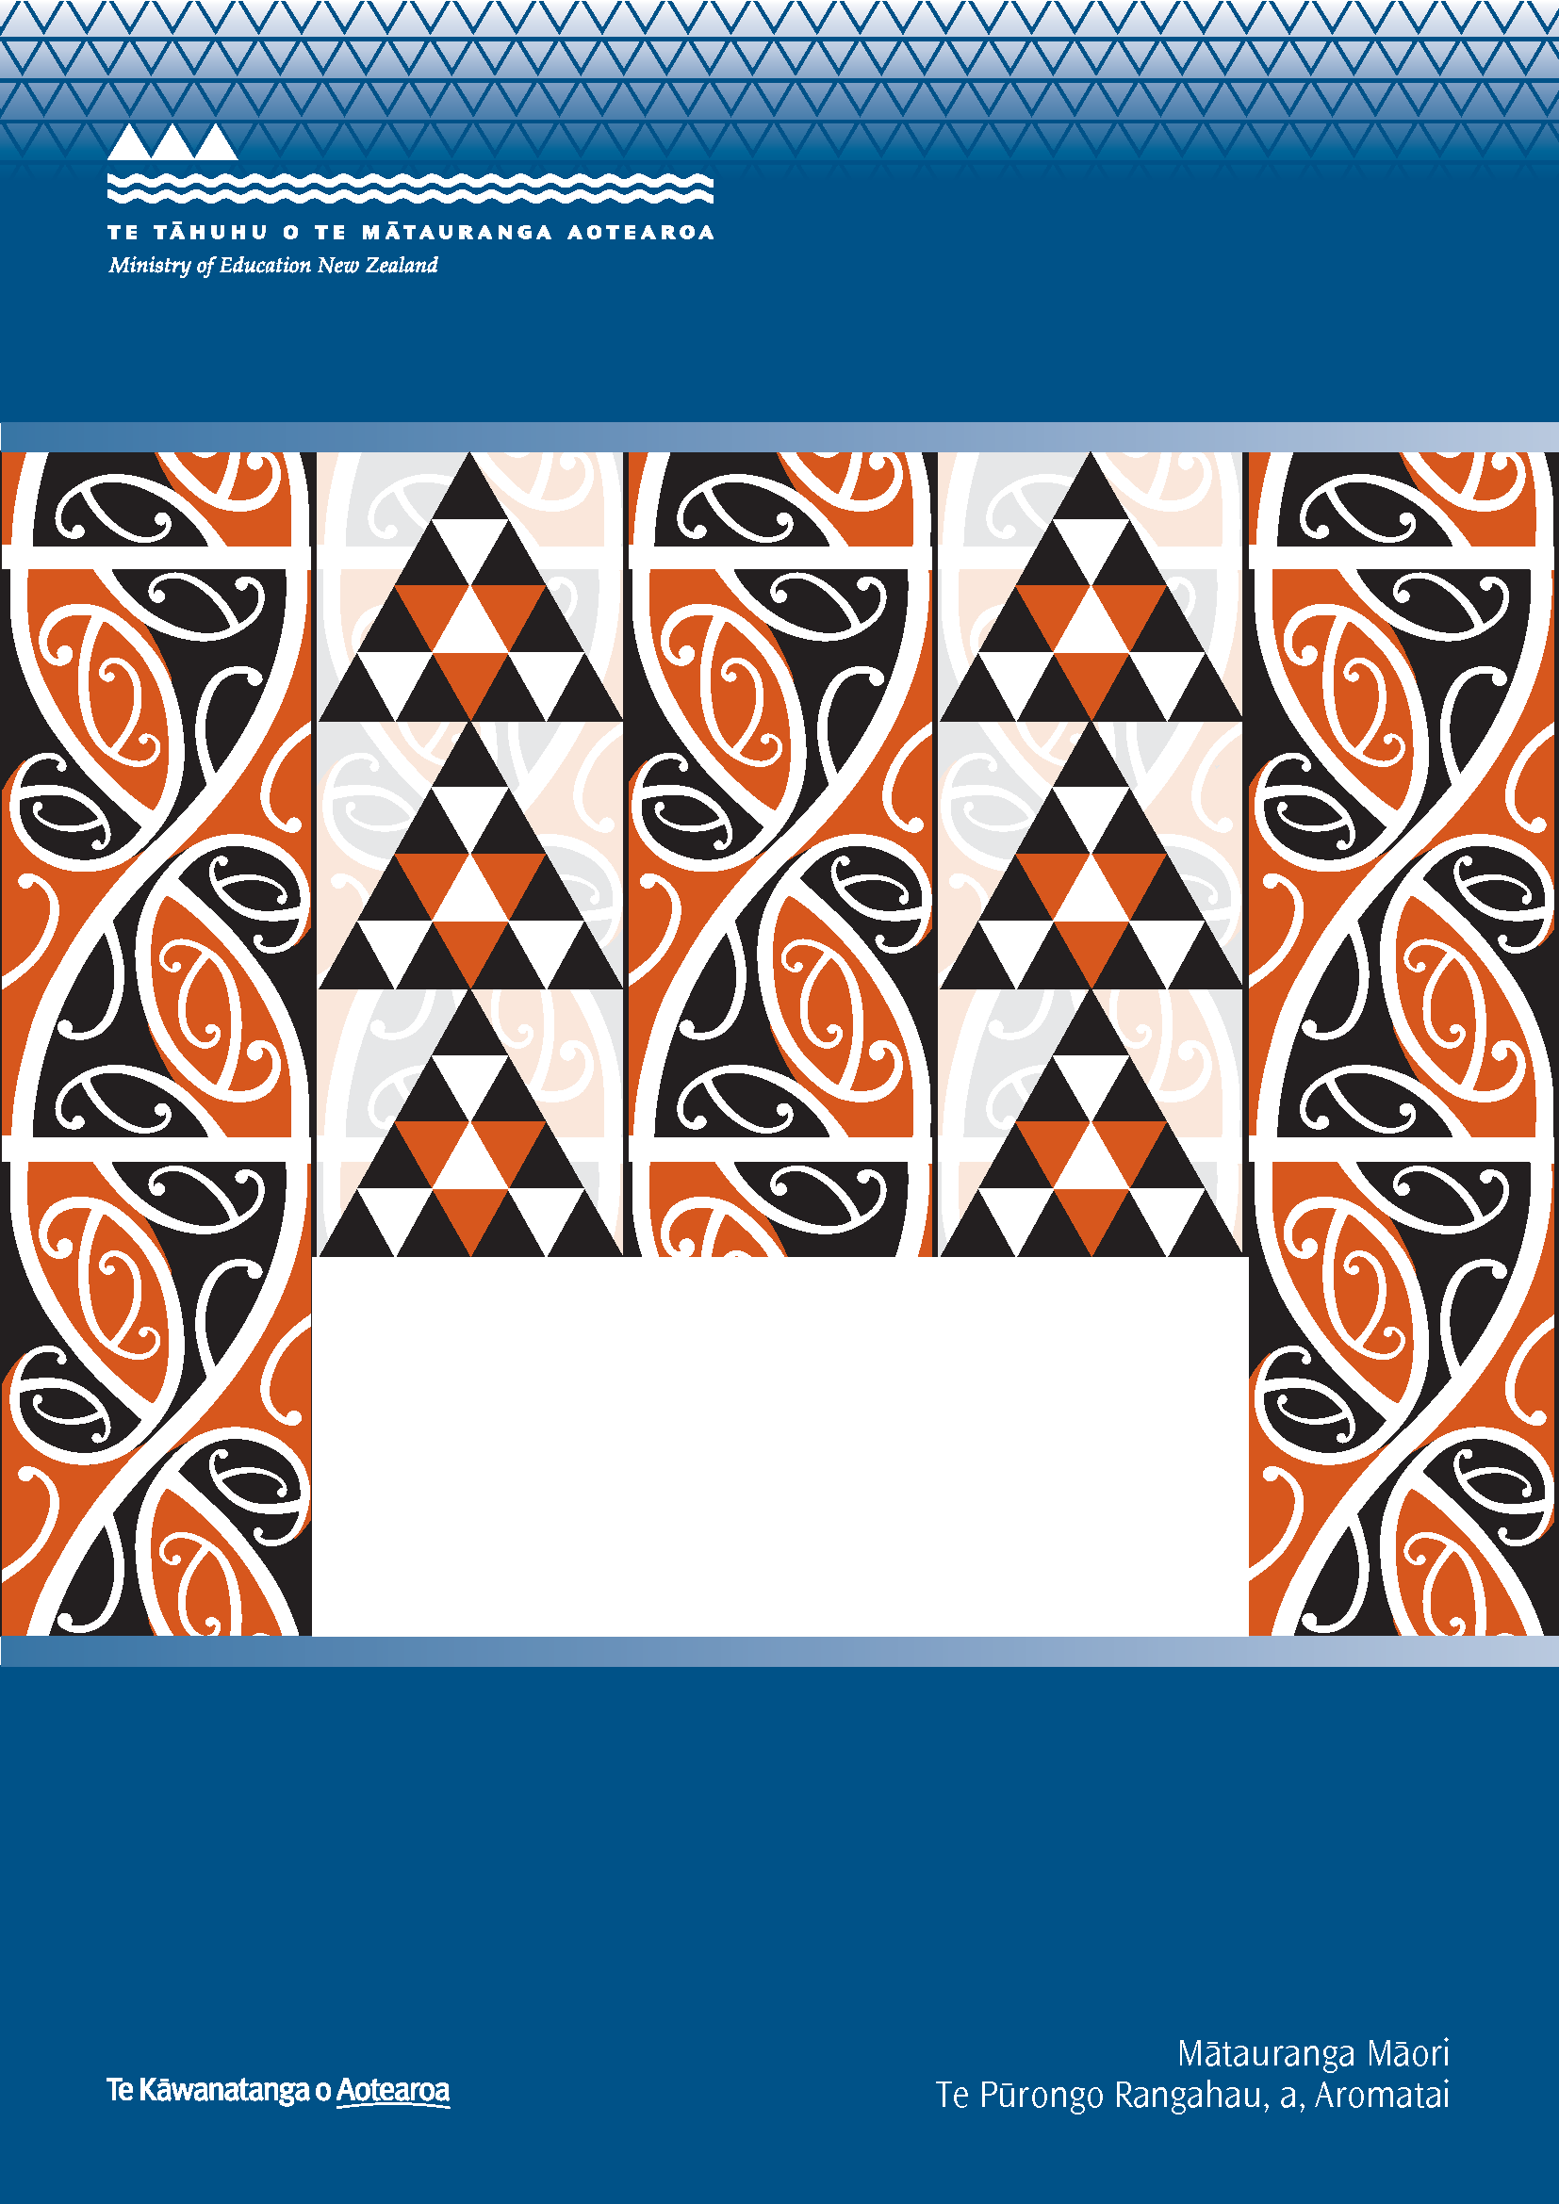
Ngā Whanaketanga
Rumaki Māori
Analysis of feedback from
Readiness Workshops

Report to the Ministry of Education

Kāhui Tautoko Consulting Ltd

ISBN: 978-0-478-36795-9
ISBN: 978-0-478-36796-6 (web)
RMR-982
© Ministry of Education, New Zealand — 2011
Research reports are available on the Ministry of Education’s website Education Counts:
www.educationcounts.govt.nz/publications.

Opinions expressed in this report are those of the authors and do not necessarily coincide with those of the Ministry of Education

He Whakamārama
The kōwhaiwhai design on the cover is featured in Te Wāhanga, a meeting room in the Ministry of Education’s Head Office dedicated to te ao Māori. The kōwhaiwhai symbolises the journey from one generation to the other. The continuous line indicates the passage of time. The pattern in red depicts the generations of today and the black represents those who have passed on. The triangle is a symbol regularly used in tukutuku, raranga and tāniko designs to depict strength and determination. The cover, then, is symbolic of the challenge that education has offered and continues to offer those who have passed on and those of today.
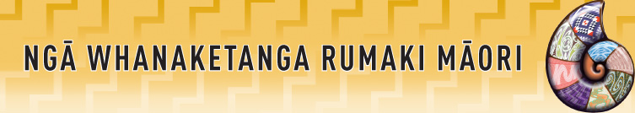

NGĀ WHANAKETANGA RUMAKI MĀORI
Analysis of Feedback from Readiness Workshops

Report to the Ministry of Education

Contents
Executive Summary 1
High level of confidence for Ngā Whanaketanga Rumaki Māori 1
Challenges with Implementing Ngā Whanaketanga Rumaki Māori 2
Further Support Required 2
Other Comments 2
1. Introduction 3
Background to Ngā Whanaketanga Rumaki Māori 3
Methodology 3
2. Feedback Analysis 5
Responses by Region 5
Responses by Role 6
Confidence in Implementing Ngā Whanaketanga Rumaki Māori 8
Challenges in Implementing Ngā Whanaketanga Rumaki Māori 12
Further Support Required 14
Other Comments 16
3. Conclusions 17
Respondent Findings 17
Response Findings 17
High level of confidence for Ngā Whanaketanga Rumaki Māori 17
Challenges with Implementing Ngā Whanaketanga Rumaki Māori 18
Further Support Required 19
Other Comments 20
4. Concluding Remarks 21
5. Appendix 1: Survey Form 23

List of Tables
Table 1: Responses by region 5
Table 2: Responses by role 6
Table 3: Responses by region and role 7
Table 4: Confidence in implementing Ngā Whanaketanga Rumaki Māori 8
Table 5: Confidence by role 9

List of Figures
Figure 1: Responses by role 6
Figure 2: Confidence in implementing Ngā Whanaketanga Rumaki Māori 8
Figure 3: Confidence by role 9

Executive Summary
From 2011, Māori medium schools that use Te Marautanga o Aotearoa will implement Ngā Whanaketanga Rumaki Māori, Māori medium national standards, for students in years 1 to 8. They describe the pāngarau and te reo skills and knowledge students need to learn at different stages of their schooling. Ngā Whanaketanga Rumaki Māori aims to help Māori communities localise the curriculum and together shape Māori medium education, while also meeting the Government’s goals of improved achievement and accountability of schools to parents through plain language reporting.
Over the period March to April 2011, the Ministry of Education (hereafter referred to as ‘the Ministry’) held a series of Ngā Whanaketanga Rumaki Māori Readiness Workshops with the Māori medium sector in 16 regions throughout the country. At these Readiness Workshops feedback was sought from the sector on their confidence towards implementing Ngā Whanaketanga Rumaki Māori, any challenges that existed and what further support was required.
The Ministry sought feedback from participants through a hard copy survey form handed out and collected at the Readiness Workshops.
Across the 16 regions a total of 348 people attended the Readiness Workshops. Of those who attended, a total of one hundred and ninety eight (198) hard copy survey responses were collected. A total of 51 (25.8%) responses were received either fully or partly in te reo Māori and 147 (74.2%) responses received in English. Reflecting those who attended, the majority of responses (115 or 58.4%) were received from school leaders (teaching staff or senior management). Over a quarter (56 or 28.4%) of the responses were received from Board of Trustees members and 20 (10.2%) responses were received from In-Service Teacher Educators (ISTE) which provides a good range of perspectives.

High level of confidence for Ngā Whanaketanga Rumaki Māori
Overall the level of confidence in implementing Ngā Whanaketanga Rumaki Māori is relatively high. Across the country 62% of respondents were either ‘Confident’ (54%) or ‘Very confident’ (8%) with implementing Ngā Whanaketanga Rumaki Māori. Just over 30% of respondents were ‘Not very confident’ and 8% were ‘Not at all confident’.
Of those who were ‘Very confident’ or ‘Confident’ they indicated that there was strong support from whānau, staff and kura leadership towards implementing Ngā Whanaketanga Rumaki Māori. There was clear alignment between Te Marautanga o Aotearoa and Ngā Whanaketanga Rumaki Māori and there was confidence as a result of receiving valuable professional development and support in understanding Ngā Whanaketanga Rumaki Māori and how to implement it within Māori medium settings.
Of those who indicated that they were ‘Not very confident’ or ‘Not at all confident’ some stated that there was a lack of professional development opportunities made available to assist staff and kura to effectively implement Ngā Whanaketanga Rumaki Māori. There was a lack of knowledge or understanding around Ngā Whanaketanga Rumaki Māori as some had only just begun to become familiar with them and that more time was needed to be able to gain a clear understanding of the expectations around Ngā Whanaketanga Rumaki Māori and then be able to effectively implement it.

Challenges with Implementing Ngā Whanaketanga Rumaki Māori
While there was a high level of confidence, there were a number of responses highlighting challenges to being able to effectively implement Ngā Whanaketanga Rumaki Māori. Key themes to emerge from the responses included challenges around building the understanding and buy-in from whānau and the community around Ngā Whanaketanga Rumaki Māori, that more support (including professional development) would need to be made available and prioritised to kura and whānau, and that given the changes and expectations around Te Marautanga o Aotearoa some were struggling with the implementation timeframes for Ngā Whanaketanga Rumaki Māori.
There were also comments relating to Māori language provision within English medium settings. Challenges existed in gaining support for Te Marautanga o Aotearoa and Ngā Whanaketanga Rumaki Māori from senior leadership, the Boards of Trustees and the wider school community. A small number of responses stated there was a perceived lack of consistency and alignment across the school in implementing different curriculums (New Zealand Curriculum and Te Marautanga o Aotearoa) and standards (Ngā Whanaketanga Rumaki Māori and National Standards) as well as duplication of reporting requirements.

Further Support Required
The most prominent response related to the need for more ongoing professional development around Ngā Whanaketanga Rumaki Māori. Other supports needed included upskilling in te reo Māori proficiency, a longer timeframe for implementation of Ngā Whanaketanga Rumaki Māori as well as providing additional tools and resources such as best practice guidelines in plain language reporting, templates, exemplars, Frequently Asked Questions, CD-Roms, case studies and online tools.
Responses also suggested other supports that were required including enabling networking opportunities with other kura who are implementing Ngā Whanaketanga Rumaki Māori which could be facilitated through workshops, facilitated discussions, cluster groups, peer support, mentoring and inter-kura visits. More support was required from In-Service Teacher Educators and Facilitators as well as strong buy-in and support from whānau, senior leadership and Boards of Trustees.

Other Comments
Overall respondents acknowledged the supportive role that the Readiness Workshop Facilitators had played in developing understanding around Ngā Whanaketanga Rumaki Māori and indicated strong support and willingness for the implementation of Ngā Whanaketanga Rumaki Māori. Many were supportive of the progressions approach as part of Ngā Whanaketanga Rumaki Māori which was considered suited to Māori medium settings and Ngā Whanaketanga Rumaki Māori was seen as a great opportunity to increase achievement for learners, to collaborate more effectively with whānau as well as ensuring an evidence based approach.

1. Introduction

Background to Ngā Whanaketanga Rumaki Māori
Ngā Whanaketanga Rumaki Māori have been developed by Māori medium leaders in te reo and pāngarau (mathematics). They describe the kōrero (oral language), pānui (reading), tuhituhi (writing) and pāngarau (mathematics) skills and knowledge that students need to learn in all learning areas across Te Marautanga o Aotearoa, at different points of their year 1 to 8 schooling.
Ngā Whanaketanga Rumaki Māori aims to help Māori communities localise the curriculum and together shape Māori medium education, while also meeting the Government’s goals of improved achievement and accountability of schools to parents through plain language reporting.
Over the period March to April 2011, the Ministry held a series of Ngā Whanaketanga Rumaki Māori Readiness Workshops with the Māori medium sector across 16 regions throughout the country. The workshops comprised school leaders including teachers or senior management, Board of Trustees members, In-Service Teacher Educators and whānau in kura and Māori medium settings. The purpose of the Readiness Workshops was to provide key information to attendees to ensure they are well prepared and have a clear understanding of what they are required to do when implementing Ngā Whanaketanga Rumaki Māori. At these Workshops feedback was sought from the participants on their confidence towards implementing Ngā Whanaketanga Rumaki Māori, any challenges that existed and what further support was required.
The Ministry sought feedback from participants through a hard copy survey form handed out and collected through the Readiness Workshops. (See Appendix 1 for survey form).
The Ministry has commissioned Kāhui Tautoko Consulting Ltd (KTCL) to collate and analyse the feedback from the sector gathered through the surveys and provide a report on the findings.

Methodology
The Ngā Whanaketanga Rumaki Māori Readiness Workshops were facilitated by contractors and/or Ministry of Education staff. During the workshops participants were given the opportunity to complete a hard copy survey that would help to inform the ongoing implementation of Ngā Whanaketanga Rumaki Māori. Three of the eight survey questions related specifically to the evaluation of the Readiness Workshops and have not been included in the analysis of this report. Attendance sheets were completed and hard copy survey forms collected by the workshop facilitators which were given to the Project Manager, Te Reo Māori, Schooling Group.
In total, 348 people attended the workshops and 198 feedback forms were received.
The hard copy survey forms were provided to KTCL to analyse and provide a written report of the findings back to the Ministry of Education. The survey forms were inputted into a database in preparation for the analysis. KTCL used the online Surveymonkey tool to create a database. Feedback from the surveys were entered into the database by two KTCL staff proficient in te reo Māori.
Of the surveys received 51 were received in te reo Māori, either in part or fully, and 147 were received in English. The surveys provided in te reo Māori were translated into English by a Senior Consultant fluent in te reo Māori.
Once all surveys were loaded into the database the Senior Consultant analysed the feedback against the respective questions. The analysis was undertaken in English but where direct quotes in te reo Māori have been added, both the Māori and translated versions are provided. The quantitative data was analysed using Surveymonkey. A thematic analysis approach was used for the qualitative data drawing on key themes to emerge from the feedback against each related question. Each theme is quantified by the number of times it is repeated or supported by statements made against each individual question. Conclusions were then formulated from the overall findings.
The draft analysis and report was peer reviewed by staff of the Ministry of Education prior to being finalised.

2. Feedback Analysis

Responses by Region
Across the 16 regions a total of 348 people attended the Readiness Workshops. Of those who attended a total of one hundred and ninety eight (198) hard copy survey responses were collected. Analysis of the respondents reveals the following:
Table 1: Responses by region
Region | Survey Response Percent | Survey Response Count | Percentage of Attendees who Submitted Survey | Attendance Percent | Attendance at Workshops
Kaitaia | 1.5% | 3 | 60.0% | 1.4% | 5
Kaikohe | 0.0% | 0 | 00.0% | 4.3% | 15
Whangarei | 2.5% | 5 | 100.0% | 1.4% | 5
Auckland West | 3.0% | 6 | 37.5% | 4.6% | 16
Auckland South | 2.5% | 5 | 33.3% | 4.3% | 15
Hamilton | 18.7% | 37 | 64.9% | 16.4% | 57
Rotorua | 18.7% | 37 | 105.7%¹ | 10.1% | 35
Whakatane | 9.1% | 18 | 66.7% | 7.8% | 27
Gisborne/Wairoa | 4.0% | 8 | 19.5% | 11.8% | 41
Napier | 11.1% | 22 | 78.6% | 7.8% | 28
Palmerston North | 5.1% | 10 | 50.0% | 5.7% | 20
Taranaki | 3.5% | 7 | 42.2% | 4.9% | 17
Whanganui | 2.0% | 4 | 66.7% | 1.7% | 6
Wellington | 10.2% | 20 | 64.5% | 8.9% | 31
Nelson | 6.1% | 12 | 52.2% | 6.6% | 23
Invercargill | 2.0% | 4 | 57.1% | 2.0% | 7
TOTAL | 100% | 198 | 56.9% | 100% | 348
¹ This anomaly appears as a result of some attendees not completing the attendance registration form.
Table 1 shows that the majority of survey forms were collected from Hamilton and Rotorua (37 respectively) followed by Napier (22), Wellington (20) and Whakatane (18). These regions also had the highest levels of attendance at the Readiness Workshops: Hamilton (57); Rotorua (35); Wellington (31 and Napier (28). Of note there were a high number (41) of attendees at the Gisborne/Wairoa Readiness Workshops relative to the number of survey responses collected (8). This means that only 19.5% of people who attended the Readiness Workshops in the Gisborne/Wairoa areas submitted a survey response.

Responses by Role
Figure 1 and Table 2 shows the majority (58.4%) of the 198 responses received were from school leaders which included teaching staff or senior management (Principals or Deputy Principals). Over a quarter (28.4%) of the responses received were from Board of Trustees members as well as 20 responses from In-Service Teacher Educators (ISTE) which provides a good range of perspectives. Only a small number of whānau responses have been collected, however a number of Board of Trustee members also indicated that they were whānau representatives.
Figure 1: Responses by role
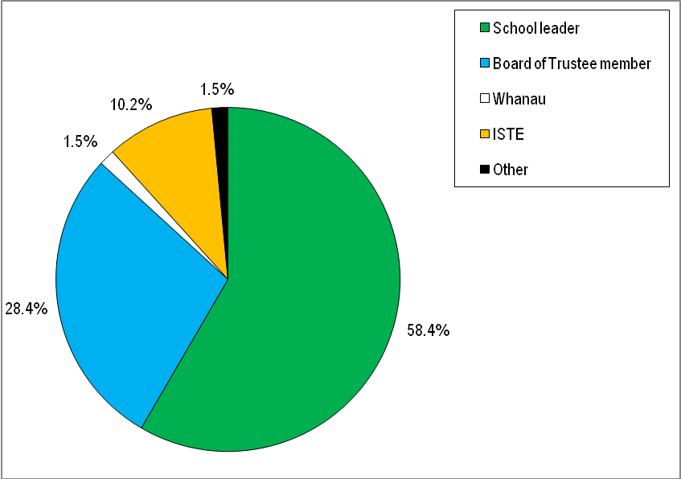
Whānau

Table 2: Responses by role
In what role are you attending this workshop?
Role | Response Percent | Response Count
School leader | 58.4% | 115
Board of Trustees member | 28.4% | 56
Whānau | 1.5% | 3
ISTE | 10.2% | 20
Other (please specify) | 1.5% | 3
answered question |  | 197
skipped question |  | 1

The following table provides a breakdown of the responses by region and the role of respondents.
Table 3: Responses by region and role
In what role are you attending this workshop?
Region | School leader | Board of Trustees member | Whānau | ISTE | Other (please specify) | Response Percent | Response Count
Kaitaia | 2 | 0 | 0 | 0 | 1 | 1.5% | 3
Whangarei | 3 | 0 | 0 | 1 | 1 | 2.5% | 5
Auckland West | 6 | 0 | 0 | 0 | 0 | 3.0% | 6
Auckland South | 2 | 3 | 0 | 0 | 0 | 2.5% | 5
Hamilton | 17 | 17 | 1 | 2 | 0 | 18.8% | 37
Rotorua | 29 | 7 | 0 | 1 | 0 | 18.8% | 37
Whakatane | 9 | 8 | 0 | 0 | 0 | 8.6% | 17
Gisborne/Wairoa | 2 | 4 | 2 | 0 | 0 | 4.1% | 8
Napier | 12 | 5 | 0 | 5 | 0 | 11.2% | 22
Palmerston North | 9 | 0 | 0 | 1 | 0 | 5.1% | 10
Taranaki | 4 | 1 | 0 | 1 | 1 | 3.6% | 7
Whanganui | 2 | 1 | 0 | 1 | 0 | 2.0% | 4
Wellington | 11 | 5 | 0 | 4 | 0 | 10.2% | 20
Nelson | 5 | 3 | 0 | 4 | 0 | 6.1% | 12
Invercargill | 2 | 2 | 0 | 0 | 0 | 2.0% | 4
answered question |  |  |  |  |  |  | 197
skipped question |  |  |  |  |  |  | 1
Note: Responses were received from 15 of the 16 workshops.

Confidence in Implementing Ngā Whanaketanga Rumaki Māori
Participants were asked “How confident are you about implementing Ngā Whanaketanga Rumaki Māori?” See Figure 2 and Table 4. Overall there were 181 responses to this question, with 17 not providing a response. Across the country 62% of respondents were either ‘Confident’ (54%) or ‘Very confident’ (8%) with implementing Ngā Whanaketanga Rumaki Māori. Just over 30% of respondents were ‘Not very confident’ and 8% were ‘Not at all confident’.
Figure 2: Confidence in implementing Ngā Whanaketanga Rumaki Māori
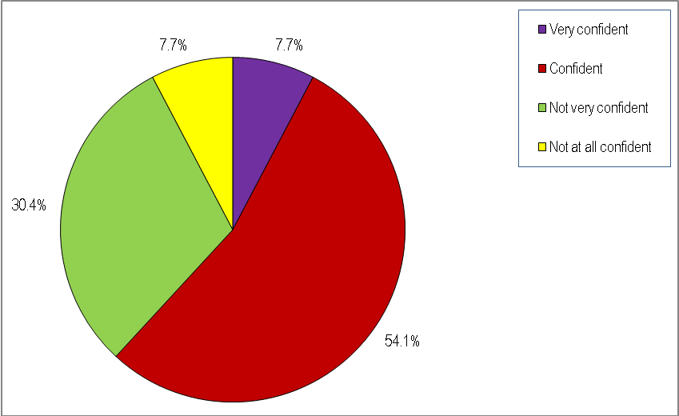

Table 4: Confidence in implementing Ngā Whanaketanga Rumaki Māori
How confident are you about implementing Ngā Whanaketanga Rumaki Māori?
Confidence level | Response Percent | Response Count
Very confident | 7.7% | 14
Confident | 54.1% | 98
Not very confident | 30.4% | 55
Not at all confident | 7.7% | 14
answered question |  | 181
skipped question |  | 17

In analysing the level of confidence by region the results show the overall levels of confidence are consistent with the national levels with the majority of responses throughout most regions indicating that they were either very confident or confident in implementing Ngā Whanaketanga Rumaki Māori.
Figure 3: Confidence by role
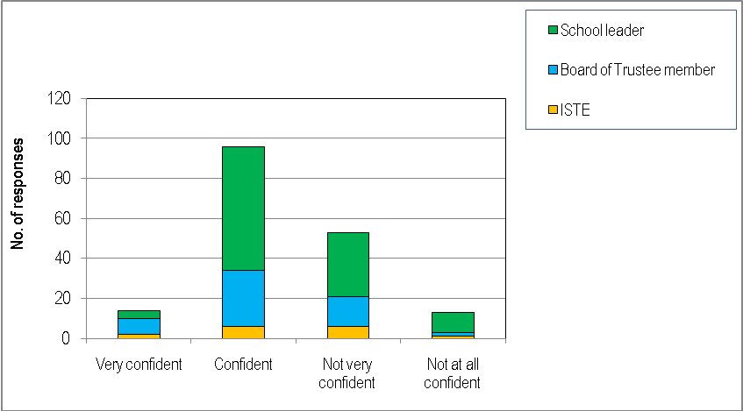

In analysing the level of confidence by role (see Figure 3 and Table 5) 57% (62) of school leaders stated that they were ‘Confident’ in implementing Ngā Whanaketanga Rumaki Māori and 30% (32) stated that they were ‘Not very confident’. For Board of Trustees members, 53% (28) stated that they were ‘Confident’ and 28% (15) stated that they were ‘Not very confident’. For In-Service Teacher Educators 40% (6) stated that they were ‘Confident’ and 40% (6) stated that they were ‘Not very confident’.
Table 5: Confidence by role
How confident are you about implementing Ngā Whanaketanga Rumaki Māori?
Confidence level | Very confident | Confident | Not very confident | Not at all confident | Response Count
School leader | 4 (3.7%) | 62 (57.4%) | 32 (29.6%) | 10 (9.3%) | 108
Board of Trustees member | 8 (15.1%) | 28 (52.8%) | 15 (28.3%) | 2 (3.8%) | 53
ISTE | 2 (13.3%) | 6 (40.0%) | 6 (40.0%) | 1 (6.7%) | 15
TOTAL | 14 | 96 | 53 | 13 | 176
Note: Responses from ‘whānau’ (3) and ‘Other’ (2) respondents have been deleted from this table and calculations do not consider their responses.
The survey asked respondents to explain their response. A total of 155 responses were collected from respondents explaining their level of confidence. Of the 108 responses who indicated that they were ‘Very confident’ or ‘Confident’, 85 (79%) respondents made a response explaining their level of confidence. From the 85 responses that were either ‘Very Confident’ or ‘Confident’, key themes to emerge from responses included:
- Strong support from whānau, staff and kura leadership (18) – there was strong support and willingness amongst whānau, staff, principals and Boards of Trustees towards implementing Ngā Whanaketanga Rumaki Māori;
- Professional development and support (17) – respondents indicated that they were confident as a result of receiving valuable professional development and support in understanding Ngā Whanaketanga Rumaki Māori and how to implement it within Māori medium settings;
- Alignment between Te Marautanga o Aotearoa and Ngā Whanaketanga Rumaki Māori (15) – many responses indicated that they could see a clear alignment between Te Marautanga o Aotearoa and Ngā Whanaketanga Rumaki Māori;
- Implementation of Ngā Whanaketanga Rumaki Māori (11) – a number of respondents stated that they were confident as they had already started the implementation process for Ngā Whanaketanga Rumaki Māori; some respondents indicated that they had been involved in the development of Ngā Whanaketanga Rumaki Māori from the early stages;
- Clear guidelines and expectations (11) – respondents stated that the Ngā Whanaketanga Rumaki Māori resources and documents gave clear guidance and direction around the expectations required to implement Ngā Whanaketanga Rumaki Māori; some considered that more time was needed to digest all of the information but they were still confident that Ngā Whanaketanga Rumaki Māori would be implemented successfully; and
- Informative workshops (4) – four responses specifically stated that the Readiness Workshops were very informative and had provided some clear guidance around Ngā Whanaketanga Rumaki Māori and the implementation process.
Some of the comments received from respondents who indicated that they were either ‘Very confident’ or ‘Confident’ include:
“We have excellent support and communication between BOT Principal / Rumaki unit. I do not foresee any issues or concerns with implementation.”
“I understand the obligations and requirements to have this kaupapa implemented by the end of 2011.”
“Some areas we have had lots of time to experiment and implement / others still a little in the dark (but getting there).”
“This hui was very informative. It was great that we were allowed to question and have open discussion. The facilitators were also very knowledgeable and explained everything clearly.”
“I te tirohanga tuatahi i raru, ēngari te haerenga mai ki tenei hui kua āhua pai haere taku whai mōhiotanga.” [At first I was concerned, however as a result of coming here to this Workshop my level of understanding has increased].
Of the 69 responses who indicated that they were ‘Not very confident’ or ‘Not at all confident’, 68 (99%) respondents provided an explanation of their level of confidence. Key themes to emerge from responses included:
- Lack of knowledge or understanding around Ngā Whanaketanga Rumaki Māori (15) – some responses indicated that the lack of confidence stemmed from not knowing too much about Ngā Whanaketanga Rumaki Māori; some (9) stated that they had just started becoming familiar with Ngā Whanaketanga Rumaki Māori and that they would become more confident as their understanding and familiarity with Ngā Whanaketanga Rumaki Māori increased;
- Lack of professional development and support (13) – a number of responses indicated that there had been a lack of professional development opportunities made available to assist staff and kura to effectively implement Ngā Whanaketanga Rumaki Māori; six responses also stated that further support and explanation was required around certain aspects of Ngā Whanaketanga Rumaki Māori;
- More time required (9) – some respondents felt that more time was needed to be able to gain a clear understanding of the expectations around Ngā Whanaketanga Rumaki Māori and then be able to effectively implement it;
- Lack of alignment between Te Marautanga o Aotearoa and Ngā Whanaketanga Rumaki Māori (4) – a small number of responses felt that there was a lack of alignment between Te Marautanga o Aotearoa and Ngā Whanaketanga Rumaki Māori;
- Staff turnover (3) – a small number of responses indicated that due to staff turnover there was a lack of capacity within the short term to effectively implement Ngā Whanaketanga Rumaki Māori; and
- Competence in te reo Māori (3) – three responses indicated that their lack of competence in te reo Māori was a barrier to them being able to effectively implement Ngā Whanaketanga Rumaki Māori and that further professional development in te reo Māori would be required.
Some of the comments received from respondents who indicated that they were either ‘Not very confident’ or ‘Not at all confident’ include:
“Staff have had no training re: using, understanding and implementing Ngā Whanaketanga. PD roll out is too slow.”
“Lack of information - the emails informing of the date/time of the hui did not come to schools. The year is passing and nothing has happened to support teachers in implementing Ngā Whanaketanga Rumaki Māori.”
“He ihu hupe tau hou ki tenei kaupapa [I am still new to this subject matter]. Looking forward to further engagements.”
“E ako ana tonu au e pā ana ki te Marautanga ahakoa he pai ki a au te āhuatanga o Ngā Whanaketanga Rumaki Māori heoi pai ake enei progressions i nga year standards.” [I am still learning about the Marautanga however I do like the aspects of Ngā Whanaketanga Rumaki Māori, the progressions are better than the year standards].
“Not sure how to connect the whanaketanga to the Marautanga.”
“Not quite where I want to be in terms of my sound knowledge of the Ngā Whanaketanga Rumaki Māori. Ma te wa.” [In time]

Challenges in Implementing Ngā Whanaketanga Rumaki Māori
Participants were asked “What are the biggest challenges for you in implementing Ngā Whanaketanga Rumaki Māori?” Overall there were 191 responses to this question, with 7 not providing a response. Key themes to emerge from the responses included:
- Need for whānau understanding and buy-in (37) – a significant number of responses identified that building the understanding and buy-in from whānau and the community was critical, yet it would take time and effort that needed to be considered as part of the implementation of Ngā Whanaketanga Rumaki Māori; engaging whānau and ‘getting whānau on board’ can be challenging at times; Ngā Whanaketanga Rumaki Māori required a mind-shift in the roles that kura and whānau play in education and learning, which could be a slow but necessary process;
- Lack of/Need for professional development (22) - a number of respondents stated that in order to realise the objectives of Ngā Whanaketanga Rumaki Māori more support (including professional development) would need to be made available to kaimahi, senior leadership, Boards of Trustees and importantly, whānau; professional development was required to increase teacher understanding and application of Ngā Whanaketanga Rumaki Māori; there was a lack of investment or prioritisation from senior management in Ngā Whanaketanga Rumaki Māori professional development;
- Timelines for implementation (21) – the timelines for implementation for Ngā Whanaketanga Rumaki Māori were seen by some as a challenge. Given the changes and expectations around Te Marautanga o Aotearoa some were struggling with the implementation timeframes for Ngā Whanaketanga Rumaki Māori;
- Lack of tools for assessment and reporting (19) – key challenges included the lack of available tools and/or templates for assessment and reporting in Ngā Whanaketanga Rumaki Māori; a lack of time and resources inhibited the ability of kaimahi to develop assessment and reporting tools from scratch; without a set of comprehensive assessment and reporting tools, a lack of consistency and application would ensue;
- Rumaki within English medium settings (17) – a number of comments were received from school leaders that provide Māori language provision within English medium settings. Comments included that challenges existed in gaining support for Te Marautanga o Aotearoa and Ngā Whanaketanga Rumaki Māori from senior leadership, the Board of Trustees and the wider school community; a lack of consistency and alignment across the school in implementing different curriculums (NZ Curriculum and Te Marautanga o Aotearoa) and standards (Ngā Whanaketanga Rumaki Māori and National Standards); duplication of reporting and the lack of capacity to meet reporting requirements;
- Implementation of Te Marautanga o Aotearoa (15) – a number of responses stated that kura are still in the process of developing and implementing Te Marautanga o Aotearoa including the development of profiles and marau-a-kura, therefore Ngā Whanaketanga Rumaki Māori would naturally follow after these processes were complete; a small number of responses (3) found that there was a lack of alignment between Te Marautanga o Aotearoa and Ngā Whanaketanga Rumaki Māori;
- Te Reo Māori proficiency (14) – a lack of proficiency in te reo Māori was a barrier in terms of understanding Ngā Whanaketanga Rumaki Māori (including kupu hou or new words) as well as being able to effectively implement them; there was also a lack of professional development for te reo Māori and second language acquisition;
- Lack of capacity (14) – a number of responses indicated that there was a lack of time and human resources to effectively implement Ngā Whanaketanga Rumaki Māori; small kura with only a minimum number of staff found it quite challenging to meet both teaching and administrative requirements; there were many priorities and requirements for action across the schooling sector but very few resources (particularly human resource) to implement and action it all; and
- Clarity around progressions and targets (9) – comments included that there was a lack of understanding and clarity around progressions and targets, how they were set and how they were assessed; challenge of ensuring consistency in the application of Ngā Whanaketanga Rumaki Māori; lack of tools or guidelines around assessment or the application of Ngā Whanaketanga Rumaki Māori; the need for goals and targets to be flexible to the differences and realities of each community.
Some of the comments received from those who responded to the question: “What the biggest challenges were in implementing Ngā Whanaketanga Rumaki Māori?” include:
“How will I report to whānau is there a template or model that we can use or do we compose our own?”
“To not rush our kaiako. Like our tamariki it's called progressions towards the kaupapa, nērā!”
“Getting schools to a stage with Te Marautanga o Aotearoa so that they can engage in Ngā Whanaketanga Rumaki Māori indepth.”
“Varying perspectives and judgments in relation to the content of Ngā Whanaketanga Rumaki Māori.”
“Taking whānau along the progressions. Positioning bilingual education within Te Marautanga o Aotearoa. Measurement of progress.”
“Understanding at whānau level to change styles of learning and "old school" rules and regulations.”
“Continued non-involvement from our own whānau. We as teaching staff need to step up to the challenge.”
“Language capability and capacity of our staff, tamariki and parents. Lack of professional development.”
“Availability of appropriate assessment tools that are nationally recognised.”
“Working within a school that runs both NZC & Te Marautanga o Aotearoa.”
“Aligning appropriate learning targets for all learners. Support for teachers to ensure that they do not feel isolated in dealing with implementation issues. Plain language reporting making sure our report truly reflects the Ngā Whanaketanga Rumaki Māori. Working out exactly where we are at present and making changes.”

Further Support Required
Participants were asked “What further support do you think you need to implement Ngā Whanaketanga Rumaki Māori?” Overall there were 149 responses to this question. Key themes to emerge from the responses included:
- Professional development (25) – the largest number of responses related to the need for more professional development particularly for teachers but including principals and Boards of Trustees. Comments also included the need for funded professional development days across a number of areas including unpacking Ngā Whanaketanga Rumaki Māori, alignment between Te Marautanga o Aotearoa and Ngā Whanaketanga Rumaki Māori, moderation and assessment practice and leadership;
- Networking with other kura (23) – there was a strong level of interest from respondents in networking with other kura who are implementing Ngā Whanaketanga Rumaki Māori which could be facilitated through workshops, facilitated discussions, cluster groups, peer support, mentoring and inter-kura visits.
- Supplementary resources and tools (14) – additional tools and resources were needed to support teachers and kura in implementing Ngā Whanaketanga Rumaki Māori. Responses included the need for tools around implementing Ngā Whanaketanga Rumaki Māori such as best practice guidelines in plain language reporting, templates, exemplars, FAQ’s, CD-Roms, case studies and online tools;
- More time (13) – responses suggested that more time was required so that whānau and school leadership could consider and develop the best approach towards implementing Ngā Whanaketanga Rumaki Māori. This included completing the design and implementation of Te Marautanga o Aotearoa and ensuring strong alignment with Ngā Whanaketanga Rumaki Māori;
- Additional workshops (13) – there were a number of responses suggesting that additional workshops be provided as they have been valuable in building understanding and confidence; kanohi ki te kanohi (face to face) approaches were considered to be most preferable;
- More support from ISTE’s and Facilitators (8) – comments were received stating that more support was required from In-Service Teacher Educators such as the Resource Teachers of Māori and Kaitakawaenga for Pāngarau and Reo. Support in the ongoing monitoring of progress was also required from ISTE’s and facilitators.
- School leadership (7) – more leadership was required from principals and Board of Trustee’s in supporting the implementation of Ngā Whanaketanga Rumaki Māori, particularly rumaki settings within English medium schools; Boards of Trustees also need further support and professional development in gaining a better understanding of Ngā Whanaketanga Rumaki Māori and how to incorporate it within the overall strategic planning processes;
- Upskilling in te reo Māori proficiency (6) – responses suggested that targeted professional development in te reo Māori proficiency and second language learning acquisition was needed so that teachers could effectively implement Ngā Whanaketanga Rumaki Māori;
- Whānau input (6) – a small number of responses highlighted the need for stronger whānau engagement and support in implementing Ngā Whanaketanga Rumaki Māori;
- Additional support with moderation and reporting (5) – more guidance and support for moderation and assessment practices relating to Ngā Whanaketanga Rumaki Māori were identified on a number of occasions. Clearer guidance needs to be provided to ensure that teachers are confident in assessment and moderation practices for various aspects of Ngā Whanaketanga Rumaki Māori; and
- No additional support required (3) – a small number of responses indicated that no additional support was required for their kura to successfully implement Ngā Whanaketanga Rumaki Māori.
Some of the comments received from those who responded to the question: “What further support do you think you need to implement Ngā Whanaketanga Rumaki Māori?” include:
“I think with the networking today everything will fall into place. Tena te Tumanako [that is the hope].”
“Kaiako need assistance in developing and moderating overall teacher judgements.”
“To hui with whānau from kura to explain what the Marau is all about and how Ngā Whanaketanga relates to the Marau. To have someone to do a workshop for staff who will implement Ngā Whanaketanga.”
“Couple more sessions on how to overlay Ngā Whanaketanga and National standards and having community and board support.”
“Ko te karanga he hui ma te katoa, kia marama te katoa [I am calling for hui involving all so that everyone understands and is knowledgeable].”
“Clarify target setting in relation to Ngā Whanaketanga Rumaki Māori. Developing appropriate reporting systems.”
“Visits to other kura or hui with kura and to see how they have implemented.”
“More workshops / seminars staggered throughout the year to see how each school is going on challenges / implementation / success.”
“More support for our kaiako/ Tumuaki / BOT on how to/ where to set targets for our rumaki reo tamariki. Tautoko in reo/pāngarau expectation levels for tamariki. Are there templates/guides/support available online anywhere?”
“Moderating and making sound overall school judgments that reflect a common understanding of student achievement.”
“Kia haere tonu ngā mahi o ngā Kaitakawaenga Pāngarau ki roto i ngā kura kia hapai ai te kaupapa [Continue the work of the Kaitakawaenga Pāngarau in schools to ensure the achievement of the kaupapa].”
“Regular hui with my colleagues to compare / discuss progress, problems and discoveries etc.”

Other Comments
Participants were also asked “Are there any further comments that you would like to make about Ngā Whanaketanga Rumaki Māori?” Overall there were 109 responses to this question. Key themes to emerge from the responses, not already covered in previous questions, included:
- Acknowledgment of work done and facilitators (20) – comments received acknowledged the supportive role that Readiness Workshop Facilitators had played in developing understanding around Ngā Whanaketanga Rumaki Māori; strong support and willingness for the implementation of Ngā Whanaketanga Rumaki Māori;
- Ngā Whanaketanga Rumaki Māori a great opportunity (11) - many comments saw that Ngā Whanaketanga Rumaki Māori was a great opportunity to increase achievement for learners, to collaborate more effectively with whānau and to ensure an evidence based approach; and
- Support for progressions (7) – several comments were supportive of the progressions approach as part of Ngā Whanaketanga Rumaki Māori as opposed to rigidly defined targets or standards; philosophically many agreed that this approach was better suited to Māori medium settings.
Some of the comments received from those who responded to the question: “Are there any further comments that you would like to make about Ngā Whanaketanga Rumaki Māori?” include:
“Really support the notion of progression. Actually quite excited about meeting this challenge of implementing Ngā Whanaketanga. This workshop inspired me to get cracking.”
“He rawe te mohio kua timata tatou ki te aromatawai i te reo ō ā tātou tamariki ki te roanga ō ā rātou noho ki te reo rumaki [It is awesome to know that we have started assessing the language progression of our children throughout their time in the Māori language setting].”
“Ae! ka tika [Yes! This is the right way]. The way it gives opportunities to whānau, hapū and gives the mana back to the whānau.”
“If quality teaching and learning is happening in classrooms and reflect whainga outlined in Te Marautanga o Aotearoa, assessing against Ngā Whanaketanga Rumaki Māori should be a smooth process.”
“I like the philosophical thinking of progressions not a mark in the sand.”
“Kia u to matou kura ki te Marautanga o Te Aho Matua, na mātou i hangai to matou ake marau ēngari kua kitea ētahi korero pai hei akiaki i a mātou ki te hanga to mātou aromatawai [We adhere to Te Aho Matua, we developed our own curriculum but I have seen some great information that will support us in developing our assessment.”

3. Conclusions

Respondent Findings
Across the 16 regions where Ngā Whanaketanga Rumaki Māori Readiness Workshops took place, a total of 348 people attended the Workshops. Of those who attended a total of one hundred and ninety eight (198) hard copy survey responses were collected.
The responses analysed by region show that the majority of survey forms were collected from Hamilton and Rotorua (37 respectively) followed by Napier (22), Wellington (20) and Whakatane (18). These regions also had the highest levels of attendance at the Readiness Workshops: Hamilton (57); Rotorua (35); Wellington (31) and Napier (28). Of note there were a high number (41) of attendees at the Gisborne/Wairoa Readiness Workshops relative to the number of survey responses collected (8).
The majority (58.4%) of the 198 responses received were from school leaders which included teaching staff or senior management (Principals or Deputy Principals). Over a quarter (28.4%) of the responses received were from Board of Trustees members as well as 20 (10.2%) responses from In-Service Teacher Educators (ISTE) which provides a good range of perspectives. Only a small number of whānau responses have been collected, however a number of Board of Trustees members also indicated that they were whānau representatives.

Response Findings

High level of confidence for Ngā Whanaketanga Rumaki Māori
Overall the level of confidence in implementing Ngā Whanaketanga Rumaki Māori is relatively high. Across the country 62% of respondents were either ‘Confident’ (54%) or ‘Very confident’ (8%) with implementing Ngā Whanaketanga Rumaki Māori. Just over 30% of respondents were ‘Not very confident’ and 8% were ‘Not at all confident’.
In analysing the level of confidence by region the results show the overall levels of confidence are consistent across the different regions with the majority of responses indicating that they were either very confident or confident in implementing Ngā Whanaketanga Rumaki Māori.
In analysing the level of confidence by role of submitter, 57% (62) of school leaders stated that they were ‘Confident’ in implementing Ngā Whanaketanga Rumaki Māori and 30% (32) stated that they were ‘Not very confident’. For Board of Trustees members, 53% (28) stated that they were ‘Confident’ and 28% (15) stated that they were ‘Not very confident’. For In-Service Teacher Educators 40% (6) stated that that they were ‘Confident’ and 40% (6) stated that they were ‘Not very confident’.
Explanations given by respondents who were ‘Very confident’ or ‘Confident’ included:
- Strong support from whānau, staff and kura leadership towards implementing Ngā Whanaketanga Rumaki Māori;
- Confident as a result of receiving valuable professional development and support in understanding Ngā Whanaketanga Rumaki Māori and how to implement it within Māori medium settings;
- Clear alignment between Te Marautanga o Aotearoa and Ngā Whanaketanga Rumaki Māori;
- Had already started the implementation process for Ngā Whanaketanga Rumaki Māori or had been involved in the development of Ngā Whanaketanga Rumaki Māori from the early stages;
- The Ngā Whanaketanga Rumaki Māori resources and documents gave clear guidance and direction around the expectations required to implement Ngā Whanaketanga Rumaki Māori; and
- The Readiness Workshops were very informative and had provided some clear guidance around Ngā Whanaketanga Rumaki Māori and the implementation process.
Explanations given by respondents who were ‘Not very confident’ or ‘Not at all confident’ included:
- Lack of knowledge or understanding around Ngā Whanaketanga Rumaki Māori as respondents had only just begun to become familiar with Ngā Whanaketanga Rumaki Māori;
- Lack of professional development opportunities made available to assist staff and kura to effectively implement Ngā Whanaketanga Rumaki Māori
- More time was needed to be able to gain a clear understanding of the expectations around Ngā Whanaketanga Rumaki Māori and then be able to effectively implement Ngā Whanaketanga Rumaki Māori;
- Lack of alignment between Te Marautanga o Aotearoa and Ngā Whanaketanga Rumaki Māori;
- Due to staff turnover there was a lack of capacity within the short term to effectively implement Ngā Whanaketanga Rumaki Māori; and
- Lack of competence in te reo Māori was a barrier to teachers and whānau being able to effectively implement Ngā Whanaketanga Rumaki Māori and that further professional development in te reo Māori would be required.

Challenges with Implementing Ngā Whanaketanga Rumaki Māori
While there was a high level of confidence, there were a number of responses highlighting challenges to being able to effectively implement Ngā Whanaketanga Rumaki Māori. Key themes to emerge from the responses included:
- Building the understanding and buy-in from whānau and the community was critical, yet it would take time and effort that needed to be considered as part of the implementation of Ngā Whanaketanga Rumaki Māori;
- In order to realise the objectives of Ngā Whanaketanga Rumaki Māori more support (including professional development) would need to be made available and prioritised to kaimahi, senior leadership, Board of Trustee and importantly, whānau;
- The timelines for implementation for Ngā Whanaketanga Rumaki Māori were seen by some as a challenge. Given the changes and expectations around Te Marautanga o Aotearoa some were struggling with the implementation timeframes for Ngā Whanaketanga Rumaki Māori;
- Lack of available tools and/or templates for assessment and reporting in Ngā Whanaketanga Rumaki Māori;
- Māori language provision within English medium settings - challenges existed in gaining support for Te Marautanga o Aotearoa and Ngā Whanaketanga Rumaki Māori from senior leadership, the Board of Trustees and the wider school community; a lack of consistency and alignment across the school in implementing different curriculums (NZ Curriculum and Te Marautanga o Aotearoa) and standards (Ngā Whanaketanga Rumaki Māori and National Standards); duplication of reporting and the lack of capacity to meet reporting requirements;
- Kura are still in the process of developing and implementing Te Marautanga o Aotearoa including the development of graduate profiles and marau-a-kura, therefore Ngā Whanaketanga Rumaki Māori would naturally follow after these processes were complete;
- Lack of proficiency in te reo Māori was a barrier in terms of understanding the Ngā Whanaketanga Rumaki Māori (including kupu hou or new words) as well as being able to effectively implement them;
- Lack of time and human resources to effectively implement Ngā Whanaketanga Rumaki Māori, especially for small kura with only a minimum number of staff responsible for meeting both teaching and administrative requirements; and
- A lack of understanding and clarity around progressions and targets, how they were set and how they were assessed; challenge of ensuring consistency in the application of Ngā Whanaketanga Rumaki Māori as well as the need for goals and targets to be flexible to the differences and realities of each community.

Further Support Required
The most prominent response related to the need for more ongoing professional development around Ngā Whanaketanga Rumaki Māori. Other supports needed included upskilling in te reo Māori proficiency, a longer timeframe for implementation of Ngā Whanaketanga Rumaki Māori as well as providing additional tools and resources such as best practice guidelines in plain language reporting, templates, exemplars, FAQ’s, CD-Roms, case studies and online tools.
Responses of other supports required included:
- More support required from In-Service Teacher Educators and Facilitators;
- Networking with other kura who are implementing Ngā Whanaketanga Rumaki Māori which could be facilitated through workshops, facilitated discussions, cluster groups, peer support, mentoring and inter-kura visits;
- Additional workshops to be provided as they have been valuable in building understanding and confidence;
- More leadership required from principals and Boards of Trustees in supporting the implementation of Ngā Whanaketanga Rumaki Māori, particularly rumaki settings within English medium schools;
- More guidance and support for moderation and assessment practices relating to Ngā Whanaketanga Rumaki Māori; and
- Stronger whānau engagement and support in implementing Ngā Whanaketanga Rumaki Māori.

Other Comments
A number of other comments were also received from respondents. Key themes to emerge from the responses, not already covered in previous questions, included:
- Acknowledging the supportive role that Readiness Workshop Facilitators had played in developing understanding around Ngā Whanaketanga Rumaki Māori;
- Strong support and willingness for the implementation of Ngā Whanaketanga Rumaki Māori;
- Ngā Whanaketanga Rumaki Māori was a great opportunity to increase achievement for learners, to collaborate more effectively with whānau and to ensure an evidence based approach; and
- Supportive of the progressions approach as part of Ngā Whanaketanga Rumaki Māori as opposed to rigidly defined targets or standards; philosophically many agreed that this approach was better suited to Māori medium settings.

4. Concluding Remarks
Kāhui Tautoko Consulting Limited makes the following concluding remarks to the Ministry of Education:
- That there were 198 survey responses collected as part of the Ngā Whanaketanga Rumaki Māori Readiness Workshops – 51 of which were submitted either fully or partly in te reo Māori and 147 in English;
- That a majority of survey responses indicate a high level of confidence in implementing Ngā Whanaketanga Rumaki Māori;
- That a significant number of respondents stated that more time was needed to build understanding around Ngā Whanaketanga Rumaki Māori and to engage, inform and get buy-in from whānau;
- That respondents identified the need for more professional development opportunities including Ngā Whanaketanga Rumaki Māori requirements, moderation and assessment and te reo Māori proficiency;
- That a number of respondents suggested that additional tools and resources that support Ngā Whanaketanga Rumaki Māori be provided such as reporting templates, best practice guidelines and online tools.
- That there were variable perspectives with regards to the perceived alignment (or lack of) between Te Marautanga o Aotearoa and Ngā Whanaketanga Rumaki Māori; and
- That a number of respondents have stated their commitment and excitement about using Ngā Whanaketanga Rumaki Māori to lift the achievement of learners within Māori medium education.

5. Appendix 1: Survey Form

NGĀ WHANAKETANGA RUMAKI MĀORI
FEEDBACK FROM READINESS WORKSHOPS
Region: ________________ Date: ___________2011
Ngā mihi ki a koutou kātoa.
The Ministry of Education would like to thank you for your continued support of Ngā Whanaketanga Rumaki Māori. The readiness workshops are designed to provide you with information to support you to implement Ngā Whanaketanga in 2011 and beyond. We would appreciate your feedback to ensure the workshops are as useful as possible. We would also like to gather your thoughts about implementing Ngā Whanaketanga Rumaki Māori. The information collected will be used by the Ministry of Education to support you to implement Ngā Whanaketanga.
Please complete this feedback form and return it to the facilitation team at the end of the workshop.
In what role are you attending this workshop? (Tick one box)
School leader ◻ Board of trustee member ◻
ISTE ◻ Whānau ◻
Other (please state role) __________________
How confident are you about implementing Ngā Whanaketanga Rumaki Māori? (Tick one box)
Very confident ◻ Confident ◻ Not very confident ◻ Not at all confident ◻
Please explain:

What are the biggest challenges for you in implementing Ngā Whanaketanga Rumaki Māori?

What further support do you think you need to implement Ngā Whanaketanga Rumaki Māori?

Are there any other comments you would like to make about Ngā Whanaketanga Rumaki Māori?

What aspects of the workshop did you find most useful?

What aspects of the workshop did you not find useful?

Why?

To assist us with future workshops what suggestions would you make to improve the workshop?

THANK YOU VERY MUCH FOR YOUR FEEDBACK

Planned Ngā Whanaketanga Rumaki Māori Readiness Workshops for Christchurch were postponed as a result of the February 2011 earthquake. Decisions are being made around the format and timing of Ngā Whanaketanga Rumaki Māori Readiness Workshops for Christchurch.

