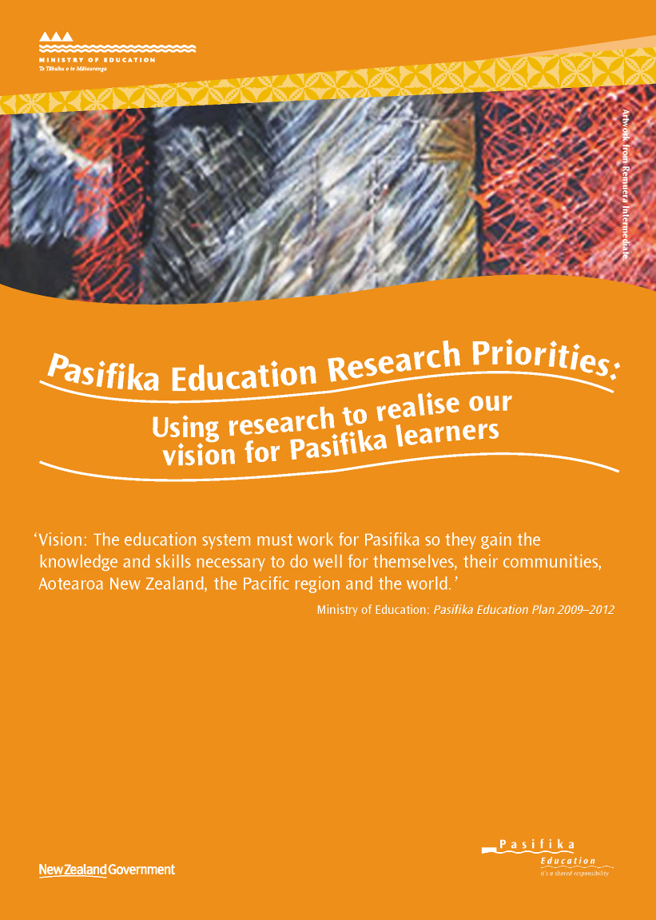
Kia orana, Fakaalofa lahi atu, Mālō e lelei, Talofa lava, Ia orana, Talofa ni, Ni sa bula vinaka, Halo ola keta, Greetings
Welcome to all readers of this document. It is our collective hope that it will serve as an important catalyst for helping to improve outcomes for all Pasifika learners.
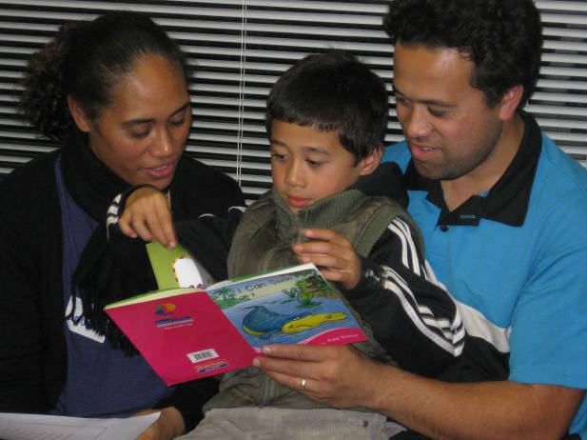
Vitaliano Roache aged 5 in between his mother, Luisa Roache, and father, Tommy Roache, during a Reading Together Workshop held at St Joseph’s School, Otahuhu, Auckland.

Published by:
Research & Evaluation Team
Research Division
Ministry of Education
PO Box 1666
Wellington 6140
New Zealand
© Crown Copyright
All rights reserved.
Enquiries should be made to the publisher.
March 2012
ISBN: 978-0-478-38643-1
ISBN Web: 978-0-478-38644-8
RMR-0991

Contact information:
Email: research.info@minedu.govt.nz
Fax: 04 463 8312 Phone 04 463 8000
This document is available from the Education Counts website:
www.educationcounts.govt.nz

Introduction
This document sets out current priorities (as at March 2012) for Pasifika research in education in Aotearoa New Zealand.
We need more high quality research to improve the education system so it works for all Pasifika learners. This is the vision of the Pasifika Education Plan 2009–2012 and the rationale for this document.
The research priorities in this document reflect key areas within the Pasifika Education Plan 2009–2012 and Working Group members’ discussions with a wide range of Pasifika groups and individuals.
This document will be useful if you are:
- a researcher doing, or wanting to do, research in Pasifika education
- a tertiary teacher guiding your students to choose research topics
- a tertiary student or teacher researcher looking for a Pasifika research topic as part of your course of study.
As the research priorities are intended to result in findings on what works well for Pasifika learners, this document will also be of interest to:
- policy-makers using evidence to develop policy affecting Pasifika education
- leaders of educational institutions using evidence in decision-making
- teachers using evidence to improve their practice
- parents and other members of Pasifika communities.
‘Pasifika is a collective term used to refer to people of Pacific heritage or ancestry who have migrated or been born here in Aotearoa New Zealand.’
‘Pasifika people have multiple world views with diverse cultural identities and may be monolingual, bilingual or multilingual.’
(Pasifika Education Plan 2008–2012, Ministry of Education, Wellington, 2008).

Overview
The aim of this document is to support the vision for Pasifika learners of the Pasifika Education Plan 2009–12. To do this, we need a collaborative, coordinated approach to gathering quality research knowledge.
This is essential if we are to better inform policy, decision-making and practice for improved Pasifika presence, engagement and achievement in education.
Along with setting out research priorities this document:
- highlights the need for well considered research processes, such as relationship building and dissemination
- outlines a number of mechanisms, activities and processes important for achieving the aim of this document
- provides details on where to locate further Pasifika education publications
- explains why this document was developed (the rationale) — Appendix 1, p.15
- lists members of the Working Group and outlines the principles that underpin the document — Appendix 2, pp.16–17
- indicates the people or groups who provided feedback during consultation on what research priorities to include in the document — Appendix 3, p.18.
For researchers and policy-makers in particular, but also all interested readers, the present document should be read alongside the report Teu Le Va — Relationships across research and policy in Pasifika education: A collective approach to knowledge generation & policy development for action towards Pasifika education success (Airini, Anae, Mila-Schaaf, et al, 2010).
‘The strategic intent of the approach [in the Teu Le Va report] is Pasifika success in New Zealand’s education system. [It] recognises the critical role of research-informed policy that comes from a sound, comprehensive, relevant and developing Pasifika education research base.’
The Teu Le Va report ‘offers a philosophical and methodological base for the translation of research into policy for better Pasifika education outcomes. … Essentially, [this] involves identifying and understanding the va or ‘spaces’ between different stakeholders in Pasifika education research and development. Developing, cultivating and maintaining relationships consistent with the principles and understandings that underpin the widely shared Pasifika concept of va and to teu le va is advocated. This will strengthen opportunities for knowledge transfer across these spaces.’
‘Teu Le Va emphasises working together and sharing power. It affirms the importance of relationships and creates a new va’a for researchers and policy-makers [and others] to work together. It supports Pasifika-led knowledge creation and the importance of Pasifika leadership in research and policy. It signals a move away from a focus on failure, ‘the tail’ of underachievement, and deficit, to a focus on potential and on everyone in the education system taking responsibility for optimising education outcomes for and with Pasifika learners.’
From Teu Le Va — Relationships across research and policy in Pasifika education (pp.1–5)
The Pasifika Education Research Guidelines (Anae et al, 2001) are also recommended for researchers and other interested readers.
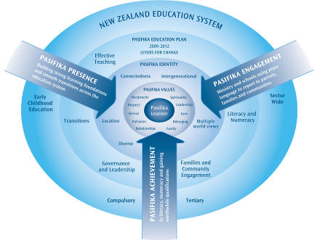
Research Priorities
The Compass for Pasifika Success in the Pasifika Education Plan 2009–2012 identifies five key areas (levers for change) that we need to know more about if we are to provide an effective education system for all Pasifika learners.
As shown in the Compass diagram opposite, these areas are:
- Literacy and numeracy
- Families and community engagement
- Governance and leadership
- Transitions
- Effective Teaching [and Learning].
‘Pasifika people have multiple world views and diverse cultural identities. They are able to operate and negotiate successfully through spiritual, social, political, cultural and economic worlds. Success in education requires harnessing Pasifika diversity within an enabling education system that works for young people, their families and communities. This requires the education system, leadership and curricula to start with the Pasifika learner at the centre, drawing on strong cultures, identities and languages.’
(Pasifika Education Plan 2009–2012, Ministry of Education, p.3)
These areas have been used to group priority research questions within this document.
The research priorities apply across all sectors of education:
- early childhood education
- the schooling sector
- tertiary education
- special education.
Keeping Research Priorities Current
The priorities will be reviewed as information needs are met and new topics emerge and as further feedback comes to hand.
A new Pasifika Education Plan, due for release in 2012, and findings of a review of Pasifika education research literature over the last 10 years, may also lead to changes to the priorities as listed in the present document.
Revised versions of this document will be posted online at www.educationcounts.govt.nz as the need arises.
Using the Priorities to Develop Your Research Projects
The following pages (pp. 8–10) provide priority questions for education research within each of the five key areas. There are also indicative topics for research under each broad priority question.
The questions and topics, developed after discussions with a range of Pasifika groups and individuals, are provided to help achieve a focused overall approach to research. They are not intended to suggest the specific research questions that you as an individual researcher or member of a research team might wish to ask or how you will carry out your particular research project.
To develop your research questions and methodology based on the priorities identified in this document, as researchers you will need to consider the importance of such factors as:
- Pasifika values — for example, spirituality, reciprocity, respect, belonging (see Compass diagram on the previous page)
- diversity amongst Pasifika communities — for example, diverse Pacific cultures, languages, and worldviews, and intergenerational factors such as length of time lived in New Zealand
- regional differences among Pasifika communities in Aotearoa New Zealand
- gender differences
- the availability of data on outcomes for Pasifika learners
- the impact on Pasifika learners’ education of other social influences — socio-economic status, health and well-being, housing.
Other important considerations in developing individual projects include: Who will be most likely to take an interest in the findings? How might the findings be used to improve outcomes for Pasifika learners? How and when will the findings be conveyed to intended audiences? How can these audiences be supported or encouraged to make best use of the findings?
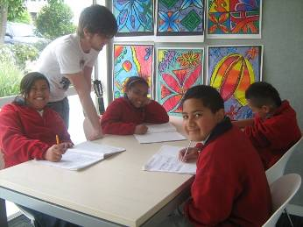
Dave Johnston, teacher aide with Pasifika students at St Therese School, Mt Roskill, Auckland.
“A collaborative approach is important for raising literacy achievement,” says Brenda Mauger, Principal at St Therese School.

Illustration: Developing an Individual Research Project Relating to the Priorities
As an example, you might choose to investigate aspects of the Key Area ‘Effective Teaching and Learning’ (see p.10).
The priority questions listed under this key area are:
- How prepared are teachers to effectively teach Pasifika learners?
- What knowledge, skills and qualities do teachers need to effectively teach Pasifika learners?
To help address one or both of these broad questions you might choose the indicative topic for research that highlights the importance of looking at ‘Pasifika pedagogies and culturally responsive teaching for Pasifika’.
But to refine the broad question(s) and topic so that they can be turned into a fully-developed project, as researchers you will need to consider further questions to focus your investigation. For instance, you might want to consider such questions as:
- How are Pasifika pedagogies and culturally responsive teaching defined/understood?
- What do they mean in practice?
- In what ways do they differ from what is understood to be effective teaching and learning for diverse students generally?
You may then decide to focus, for example, on culturally responsive teaching for Samoan learners, or for Pasifika boys, or to explore the issue in different regions, and from a range of different perspectives (teachers, teacher educators, principals, families, students, community and church leaders). You may also wish to explore these questions within a certain subject area, such as mathematics or social studies.
Key Areas with Current Priority Research Questions and Indicative Topics for Research
The priority research questions and indicative research topics listed reflect the feedback received from all those consulted as well as the outcome of discussions within the Working Group.
Literacy and Numeracy
Priority questions
How can literacy and language development (oral language, and reading and writing) be well supported for Pasifika learners in Pacific languages and/or English?
What are the issues for Pasifika learners in relation to the range of literacies (eg, information, financial, subject-specific literacy) required in contemporary society?
What knowledge and skills do teachers need for Pasifika learners to succeed in mathematics?
Topics for research
- Early language development
- The relationship between fluency in a Pacific language and educational outcomes, including longitudinal impact of learning through Pacific languages
- Bilingualism, and immersion education
- Information literacy
- Financial literacy
- Early numeracy development
- Quality mathematics teaching for Pasifika learners
Families and Community Engagement
Priority questions
How can relationships between Pasifika families and communities, and schools and early childhood education centres be well supported?
How can we better understand Special Education from the perspectives of Pasifika families?
Topics for research
- The impact of recent educational policies or initiatives on relationships between Pasifika families/communities and schools and early childhood centres
- Sharing of information between early childhood education centres or schools and Pasifika families
- Pasifika families’ engagement with secondary schools
- The nature and extent of teacher–family engagement regarding learner progress and achievement
- Pasifika families’ access to and use of early intervention and other Special Education services

Governance and Leadership
Priority questions
What aspects of governance and leadership contribute to an organisational and educational culture (eg, in an early childhood education centre, school, or tertiary institution) that ensures success for Pasifika learners?
How are Pasifika learners and communities prepared to exercise their rights within our democracy? What are the implications of a rights-based approach to education for our Pasifika learners and communities?
Topics for research
- Civics and citizenship
- Organisational culture
- Board of trustees representation — capacity and capability
- Early childhood education centres — sustainability, governance and management
- Revival and maintenance of Pacific languages

Transitions
Priority questions
What are the key determinants of successful transitions throughout the learning pathway for Pasifika learners?
Topics for research
- Into, through and out of secondary schooling
- Transition to school, particularly issues around languages and literacy
- Adult transitions in the workplace
- Impact of mentoring on educational success, particularly at transition points
- Transitions for Pasifika learners with special educational needs

Effective Teaching and Learning
Priority questions
How prepared are teachers to effectively teach Pasifika learners?
What knowledge, skills and qualities do teachers need to effectively teach Pasifika learners?
Topics for research
- Teacher education preparation for teaching Pasifika learners
- Pasifika pedagogies and culturally responsive teaching for Pasifika
- Second language teaching and learning for Pasifika learners
- Effective teaching at senior secondary level
- Innovative teaching and learning for Pasifika learners
- Identifying and addressing the needs of Pasifika gifted and talented learners
- Quality early childhood education provision for Pasifika children
Achieving the Aim of this Document
Achieving the aim of this document — to gather quality research knowledge that will inform policy, decision-making and practice for improved Pasifika presence, engagement and achievement in education — requires collaboration and coordination and is the collective responsibility of researchers, funders and other users of research.
More specifically, various mechanisms, activities or approaches are needed to support the process of gathering quality information, through research projects that address priority questions.
Some key mechanisms, activities or approaches are listed below. The list will be added to or revised once other groups and individuals have had the opportunity to further the work of developing a sound research knowledge base on Pasifika education.
Promoting the Research Priorities Document as a Basis for Action
- Researchers with an interest in Pasifika education will need to purposefully publicise this document, facilitate discussion about ongoing research priorities, and take opportunities to coordinate and/or collaborate on research activities. Taking these actions will help develop a deeper, more coherent body of Pasifika education research knowledge in key areas than is currently available.
- This research priorities document will be referenced in information about applying for the Ministry of Education’s Study Award in Pasifika Education Research. Further information on this annually funded award is available on the Education Counts website.
- Members of the Working Group for this document (for details see Appendix 2) will take up opportunities to lead presentations or discussions about the research priorities work at relevant fono and conferences, for example, at Pasifika Advisory Group fono convened by the Ministry of Education, the annual New Zealand Association for Research in Education (NZARE) conference, and at meetings of Building Research Capability in the Social Sciences (BRCSS).
- The research priorities document will be featured in an upcoming edition of Talanoa Ako: Pacific Education Talk, a publication produced and disseminated by the Pasifika Education team within the Ministry of Education.
Undertaking Individual Studies
- University supervisors of PhD or Masters level students intending to undertake Pasifika education research are encouraged to ensure that their students take into account current research priorities as listed in this document when planning their research, especially if they have a particular interest in maximising the potential of their studies to contribute to improved outcomes for all Pasifika learners.
- The Ministry of Education will either commission or undertake three projects in 2012 relating to the research priorities listed in this document.

Making Better Use of Existing Data and Evidence
- The Ministry of Education will do more analysis of data concerning Pasifika learners from national and international studies of student achievement.
- Both researchers and funders of research should investigate the potential of large-scale cross-sector studies with Pasifika cohorts — eg, Growing Up in New Zealand, Youth 2012, Pacific Island Families Study — to either complement or strengthen their own findings or provide a wider context for their particular study.
- Researchers and/or policy-makers should initiate conversations with each other to discuss current and upcoming policy information needs, with a view to exploring and making further use of existing data and evidence; similarly, such discussions are valuable when either planning new research or early in the policy-development process.
Doing Good Research
- To build a sound research knowledge base that can be used by policy-makers and practitioners for improved outcomes for all Pasifika learners, individual research projects should:
- be informed by the Ministry of Education Pasifika Education Research Guidelines (Anae et al, 2001) and the Teu Le Va — Relationships across research and policy in Pasifika education report (Airini et al, 2010)
- be focused on clear research questions, be well-planned, use rigorous and appropriate research methodologies, and be ethically and culturally sound
- use and build on existing Pasifika knowledges and other relevant educational knowledge/research findings
- take into account from the outset the likely usefulness and appropriateness of the research for policy, decision-making and practice
- have clear, built-in processes for dissemination of findings to a range of audiences, from policy-makers to community members
- emphasise respectful, collaborative relationships between researchers, between researchers and policy- or decision-makers, and between researchers and all those involved in the research project.
Building Capacity and Capability
- When commissioning or undertaking Pasifika education research funders and researchers should consider the composition of the research team. This is important both to ensure that Pasifika researchers have the opportunity to lead projects and that new or emerging Pasifika researchers have the opportunity to work as part of an experienced team and receive appropriate mentoring and support.
Improving Dissemination and Use of Research Findings
- The Ministry of Education will scope the possibility of a web-based register of Pasifika education research projects. Development of such a register would complement the existing Ako Aotearoa register of tertiary education research and the New Zealand Council for Educational Research’s theses database. Both of these can be searched to find Pasifika research projects.
- Researchers should consult/seek advice so that they can take into account from the outset the likely usefulness and appropriateness of the research for policy, decision-making and practice.
- Researchers should ensure that they have clear processes in place for effective dissemination of findings to a range of audiences, from policy-makers to community members.

How to Find Out More About the Research Priorities Work
For further information, please contact a member of the Working Group (see p.16) or the:
Research and Evaluation Team
Research Division
Ministry of Education
P O Box 1666
Thorndon
Wellington 6140
Phone: 04 463 8299
Email: research.info@minedu.govt.nz
Selected References
Airini, Anae, M., Mila-Schaaf, K. with Coxon, E., Mara, D. and Sanga, K. (2010). Teu Le Va — Relationships across research and policy in Pasifika education: A collective approach to knowledge generation & policy development for action towards Pasifika education success. Auckland UniServices Ltd for the Ministry of Education, Wellington.
Anae, M., Coxon, E., Mara, D., Wendt-Samu, T., Finau, C. (2001). Pasifika Education Research Guidelines, Auckland UniServices Ltd for the Ministry of Education, Wellington.
Coxon, E., Anae, M., Mara, D., Wendt-Samu, T. (2002). Literature Review on Pacific Education Issues, Auckland UniServices Ltd for the Ministry of Education, Wellington.
Ministry of Education. (2011). Pasifika Education Plan Monitoring Report: 2009, Ministry of Education, Wellington, New Zealand.
Ministry of Education. (2009). Pasifika Education Plan 2009–2012, Ministry of Education, Wellington, New Zealand.
Further Publications
More Pasifika education publications can be found on the following websites.
Ministry of Education websites
- The Ministry’s Education Counts site includes links to Pasifika research and statistics information in other parts of Education Counts; it also contains links to relevant material on other websites.
www.educationcounts.govt.nz/topics/pasifika_education
- Also, for accessing Pasifika information on the Ministry’s external website the address is
www.minedu.govt.nz/NZEducation/EducationPolicies/PasifikaEducation.aspx

Other sites for locating Pasifika education publications
These include:
- New Zealand Educational Theses Database. This database is funded by the Ministry of Education, through the Iterative Best Evidence Synthesis (BES) Programme. The database lists over 10,000 theses.
http://library.nzcer.org.nz/nzetbasic.php
- Ako Aotearoa National Register of Research and Implementation Projects. The Ako Aotearoa Research Register is a comprehensive source of information on recent tertiary education research and implementation projects, currently being conducted in New Zealand (2006 onwards).
http://akoaotearoa.ac.nz/research-register
- University of Auckland site for Pasifika education research. This site contains research work conducted by Pasifika staff and colleagues and postgraduate students; the research has a focus on Pasifika learners in schools and on their families and communities.
www.education.auckland.ac.nz/uoa/pacific-education-research
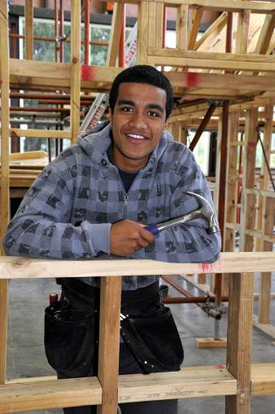
Construction is a passion for Jono Hala’ufia, a Youth Guarantee student at the Manukau Institute of Technology.
Appendix 1: Rationale
This section provides a brief explanation of why this document was developed.
There are many highly achieving Pasifika young people in Aotearoa New Zealand. In recent years monitoring data show that Pasifika learners are making good progress in many aspects of education, from early childhood education through to tertiary level.
But at the same time, there continue to be disproportionate numbers of Pasifika learners who are underachieving compared to non-Pasifika learners, and who leave formal education without the level of knowledge and skills that will help ensure optimal life outcomes.
This means that there must now be a sense of urgency for Aotearoa New Zealand’s education system to do better for Pasifika learners and their families and communities.
While we are starting to get a picture of how to improve the education system to ensure that it caters well for all Pasifika learners, we need more high quality research knowledge to support this.
The rationale for the development of these research priorities is therefore to encourage the production of research-based evidence in key areas which can be used more directly and effectively in policy and practice for improved educational outcomes for all Pasifika learners.

Appendix 2: The Working Group — Members and Working Principles
This document was developed by a Working Group established in February 2011 by the Pasifika Education and Research and Evaluation teams within the Ministry of Education. The impetus for a Working Group to draw up a plan for Pasifika education research in Aotearoa New Zealand came from a set of recommended action points in the Ministry-commissioned report, Teu Le Va — Relationships across research and policy in Pasifika education: a collective approach to knowledge generation & policy development for action towards Pasifika education success (Airini, Anae, et al, 2010). This report in turn arose from a symposium held in Wellington in late 2007 to discuss how to develop stronger links between research and policy for improved Pasifika education outcomes.
Working Group members were included on the basis of their: involvement in the development of the Teu Le Va report; Pasifika research expertise; knowledge of and involvement in Pacific communities; role in key teams within and beyond the Ministries of Education and Pacific Island Affairs in relation to the research priorities work; insights as a Pasifika learner, teacher, parent and community member.
Members of the Working Group
Amosa Fa’afoi, School of Māori, Social and Cultural Studies, University of Canterbury
Dr Diane Mara, Faculty of Education, University of Auckland
Dr Eve Coxon, Faculty of Education, University of Auckland
Ezra Schuster, Special Education, Ministry of Education
Fuapepe Rimoni, Te Kura Māori, Faculty of Education, Victoria University of Wellington
Heleen Visser, Research Division, Ministry of Education
Ivan Tava, Senior Advisor Pasifika, Careers New Zealand
Jo MacDonald, Research Division, Ministry of Education
Dr Lana Perese, Ministry of Pacific Island Affairs
Dr Lesieli MacIntyre, School of Educational Studies, Massey University
Dr Lesieli Tongati’o, Pule Ma’ata Pasifika, Ministry of Education, Wellington
Dr Lynne Whitney, Research Division, Ministry of Education
Dr Melani Anae, Centre for Pacific Studies, University of Auckland
Tagaloatele Peggy Fairbairn-Dunlop, Professor of Pacific Studies, Institute of Public Policy, Auckland University of Technology
Shelley Kennedy, Research Division, Ministry of Education
Principles
An outline of the principles that both guided the Working Group’s development of this document and provide the framework for ongoing work on the research priorities are given below.
For the purposes of this document, the Working Group agreed that the research priorities would be:
- framed within the Ministry of Education’s current Pasifika Education Plan 2009–2012
- developed through a process of consultation
- guided by the principles within Teu Le Va — Relationships across research and policy in Pasifika Education which emphasise the fostering of respectful, collaborative relationships between researchers, between researchers and policy-makers, and between researchers and all those involved in any given research project (students, teachers, parents, families, community representatives, policy-makers) in the building of a sound knowledge-base for Pasifika education.
The Working Group also agreed that:
- producing research to inform policy, decision-making and practice is the collective responsibility of researchers, funders and the users of research (eg, policy makers)
- the sense of urgency to do better for all Pasifika learners has vital implications for how we establish research priorities and work together to build a comprehensive body of sound research knowledge
- identifying and building on successes — where things are going well for Pasifika learners — is a key focus for Pasifika education research projects
- while the main focus for research priorities within the context of this document is education, it is essential within any education research endeavour to be mindful of social factors outside of education and to be aware of relevant work being carried out by other government departments (eg, health, social welfare, justice, housing) and related organisations.
Appendix 3: Consultation
The current priority research questions listed in this document reflect the feedback received from all those consulted (see below) as well as the outcome of discussions within the Working Group.
Working Group members consulted with a wide range of groups and individuals with a key part to play in Pasifika education and research during June–December 2011. Those consulted included the Pasifika Advisory Group convened by the Ministry of Education, university researchers and students, teachers, parents and community members, and officials in government departments. The purpose of the consultation was to tell people about the research priorities work, and gain their views, along with reasons, on what should be key research priorities for Pasifika education.
The consultation involved:
- Feedback from participants at the Pasifika Advisory Group meeting, June 2011, following a presentation on the research priorities by Working Group members
- Roundtable discussion at the Pacific Circle Consortium conference (13 participants, and a further participant followed up by email)
- Roundtable discussion at the University of Auckland Pacific Reference Group (15 participants, including academic and general staff representatives and representatives from Auckland University Pacific Islands Students Association)
- Email correspondence from member of FAGASA (Fa’aläpotopotoga mo le A’oa’oina o le Gagana Sämoa i Aotearoa / Association for the Teaching of Samoan in Aotearoa)
- National academic consultation by KAREN (Kiwi Advanced Research and Education Network) Access grid (41 participants plus feedback by email from Pacific Bilingual Coalition)
- Discussions about research priorities within the Ministry of Education (with participants from each of the Best Evidence Synthesis team, Schooling Policy, Special Education, Pasifika unit fono with regional coordinators, Research Division)
- Contributions from attendees at a New Zealand School Trustees Association workshop
- Responses received via Ministry of Pacific Island Affairs networks — including emails from staff at Learning Media and Whitireia Community Polytechnic
- Discussion with Pasifika students at Auckland University (17 students)
- Discussion with Pasifika students studying Early Childhood Education at the University of Auckland (17 students)
- Contributions from a Pasifika Branch meeting (5 participants)
- Contributions from the Tangiianui Pacifika Branch, Hawkes Bay (6 participants)
- Feedback gathered via Careers New Zealand networks
- Feedback following presentation at the New Zealand Association for Research in Education (NZARE) Annual Conference, December 2011 (20 participants).

This was the Working Group established to prepare this document. Details of the Working Group are given in Appendix 2 (p.16).
Being carried out by a team from the Jessie Hetherington Centre for Educational Research, Victoria University of Wellington. The review will be published in the second half of 2012.
As might be expected, there is likely to be overlap between questions and topics listed under each of the key research areas.
www.educationcounts.govt.nz/topics/research/16721.
Ministry of Education. (2011). Pasifika Education Plan Monitoring Report: 2009, Ministry of Education, Wellington, New Zealand.
This two-day symposium — Is Your Research Making a Difference to Pasifika Education? — was co-hosted by the Pasifika Caucus of the New Zealand Association of Research in Education (NZARE) and the Ministry of Education. Further details about the symposium can be found in the Teu le Va report.
The draft research priorities document has also been discussed in a number of forums, and the Working Group welcomes feedback and contributions from the wider sector to ensure this document is revised over time to keep it relevant and current.
The Pasifika Advisory Group is a partnership between Pasifika communities and the Ministry of Education. Membership is spread across the country and represents a variety of skills, backgrounds and experiences across all education and community sectors. The group meets twice a year to discuss issues in relation to Pasifika education.

