
Monitoring and Evaluating
Curriculum Implementation
Final Evaluation Report on the Implementation
of The New Zealand Curriculum 2008-2009

Report to the Ministry of Education

Dr Claire Sinnema
The University of Auckland

ISBN: 978-0-478-36741-6
ISBN: 978-0-478-36742-3 (web)
RMR-964

© Ministry of Education, New Zealand 2011
Research reports are available on the Ministry of Education’s website Education Counts:
www.educationcounts.govt.nz/publications.

Opinions expressed in this report are those of the authors and do not necessarily coincide with those of the Ministry of Education.

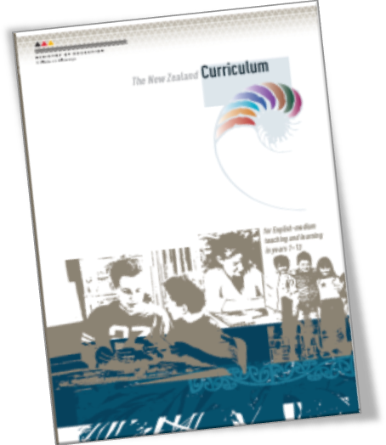

Monitoring and Evaluating

Curriculum Implementation

Final Evaluation Report on the Implementation of
The New Zealand Curriculum 2008–2009

Prepared by
Dr Claire Sinnema
Auckland UniServices Ltd Faculty of Education
(A wholly owned company of The University of Auckland
The University of Auckland)

Acknowledgements
This evaluation was initiated and funded by the Ministry of Education. Ministry advisers, researchers and data analysts made valuable contributions to the evaluation process, as did many educators throughout New Zealand.
The involvement of teachers and principals from schools across the country was critical to this evaluation. Their willingness to share their experience of curriculum implementation is much appreciated. In particular, those in schools who coordinated survey responses or contributed to focus group sessions are appreciated.
Four colleagues from the Faculty of Education at the University of Auckland deserve special mention for their assistance at various stages of the evaluation. Associate Professor Graeme Aitken provided invaluable advice about research design and Dr Fiona Ell was involved in online survey data analysis. Jung Son from the Faculty of Education set-up, and monitored the online survey. The work of Pauline Jaggs in focus group sessions and research assistance throughout was invaluable.

Table of Contents
Executive Summary 1
Overview of methodology 1
Framework for the evaluation 2
Summary of findings 2
Receptivity 2
Understanding and practice 3
Support 4
Explaining the implementation progress 5
Recommendations 7
Recommendation 1: Focus on deepening educators’ understandings about curriculum elements and their relationship to each other 7
Recommendation 2: Strengthen the quality of support for curriculum implementation 8
Recommendation 3: Create conditions that enable and promote effective curriculum implementation 8
Recommendation 4: Promote sustained inquiry into curriculum implementation 9
Methodology 11
Research questions 11
Sub-questions 11
The theoretical framework 12
Support encounters 12
Receptivity 12
Understanding 12
Practice 12
Samples and data sources 13
Sample representativeness 14
Instruments 16
Paper surveys 16
Web survey 2009 16
Web survey 2008 17
Focus groups 18
Analysis 18
Paper survey 2008–2009 18
Qualitative analysis 20
The curriculum context: Features of The New Zealand Curriculum 20
Findings: Introduction 23
Findings: Receptivity to The New Zealand Curriculum 25
To what extent do schools and teachers feel confident about, or challenged by, the implementation of The New Zealand Curriculum? 25
Regard and confidence 25
Findings: The New Zealand Curriculum Understanding and Practice 31
What progress is being made in schools’ practice and understanding of The New Zealand Curriculum? 31
Overview of progress in curriculum practices 32
Are the key competencies becoming more evident in teaching and learning? 34
Are Teaching as Inquiry, Values, student agency and parent involvement becoming more evident in teaching and learning? 36
Values 37
Teaching as Inquiry 40
Teaching as Inquiry/Inquiry Learning confusion 40
Student agency 41
Parent involvement 43
Overall understanding of curriculum change 45
Assimilation: Seeking the familiar in the unfamiliar 46
Group comparisons 47
School type comparison: Primary/secondary 47
Roles comparison: Teachers/principals 47
School decile comparison 48
School curriculum design and review 49
Curriculum principles in practice 50
High expectations 51
Learning to learn 51
Day-to-day practice: Change to classroom practice and reporting 52
Planning documentation 53
Approaches/activities used in teaching and learning 53
Resources used 53
Content/topics/themes 54
Students’ role 54
Reporting approach/content 54
Findings: Support for Implementing The New Zealand Curriculum 55
What help have educators had to learn about The New Zealand Curriculum? 55
How do educators describe the quality of the support they have had to learn about The New Zealand Curriculum? 59
How have the materials, resources and programmes supported schools and teachers to make changes? 61
Barriers 63
Supportive educational contexts 65
Leadership 65
Competing demands 66
School structures and systems 67
Findings: Relationships between Support, Receptivity and Practice 69
What explains curriculum implementation progress? 69
What predicts practice? 69
What predicts confidence? 70
What predicts regard? 70
Conclusions 73
Recommendations 76
Recommendation 1: Focus on deepening educators’ understandings about curriculum elements and their relationship to each other 76
Recommendation 2: Strengthen the quality of support for curriculum implementation 77
Recommendation 3: Create conditions that enable and promote effective curriculum implementation 77
Recommendation 4: Promote sustained inquiry into curriculum implementation 78
Appendices 79
Appendix 1: Paper Survey Instrument - The New Zealand Curriculum: Snapshot Survey 2009 80
Appendix 2: Factor Analysis Support and Receptivity Items Time 1 82
Appendix 3: Factor Analysis Support and Receptivity Items Time 2 83
Appendix 4: Factor Analysis Practice Items Time 2 84
Appendix 5: Effect sizes (Cohen's d) for factors 2008–2009 86
Appendix 6: Difficulty ratings for practice items 2009 87
References 89

List of Figures
Figure 1: Regression summary: Predictors in curriculum implementation 5
Figure 2: SERUP Framework 12
Figure 3: Overview of data sources and samples 13
Figure 4: Comparison of survey achieved samples and teacher population by school type 14
Figure 5: Comparison of survey achieved samples and teacher population by region 15
Figure 6: Comparison of survey achieved samples and teacher population by decile 15
Figure 7: Theory of curriculum implementation 16
Figure 8: Receptivity to the NZC: Regard and confidence 2008–2009 25
Figure 9: Percentage responses to regard items 26
Figure 10: NZC regard and confidence: Primary and secondary comparisons 2008–2009 26
Figure 11: Difficulty ratings for NZC practices 28
Figure 12: NZC practices: 2008–2009 comparison 33
Figure 13: Key competencies evident in practice: 2008–2009 34
Figure 14: Values, Teaching as Inquiry, student agency and parent involvement evident in practice: 2008–2009 36
Figure 15: Values items: Comparison of 'Very Strongly Evident in my Practice' responses 38
Figure 16: Percentage of respondents reporting Teaching as Inquiry practices being ‘Very Strongly Evident’ in their practice: Comparison 2008—2009 40
Figure 17: Student agency items: 2009 frequencies 42
Figure 18: Partnership items: Comparison of 'Very Strongly Evident in my Practice' responses 43
Figure 19: Parent/Whanau/Community frequency of participation: Informing, Consulting and Collaborating 44
Figure 20: Ratings degree of change in NZC 45
Figure 21: Ratings of shifts required by NZC 45
Figure 22: NZC practices 2009: Primary/secondary comparison 47
Figure 23: NZC practices 2009: Teachers/principals comparison 48
Figure 24: NZC practices: Low decile/mid decile comparison 49
Figure 25: Review of curriculum elements: 2008–2009 49
Figure 26: Most emphasised curriculum principles as indicated by principals 50
Figure 27: Moderate or substantial changes to practice 53
Figure 28: Support encounters: 2008–2009 56
Figure 29: Frequency of encounters with internal supports 57
Figure 30: Frequency of encounters with Te Marautanga o Aotearoa and Best Evidence Syntheses 57
Figure 31: Frequency of encounters with external supports 58
Figure 32: Views of the quantity of support provision: 2008–2009 59
Figure 33: Support quality: 2008–2009 59
Figure 34: Support quality items: Mean response 60
Figure 35: Support quality items: Percentage of respondents at positive and negative end of continua 60
Figure 36: NZC practices 2009: Low support quality/high support quality comparison 62
Figure 37: NZC changes to practice: Low support quality/high support quality comparison 62
Figure 38: NZC regard and confidence: Low support quality/high support quality comparison 62
Figure 39: Mean scores for teacher ratings on barriers to NZC implementation: 2008–2009 comparison 64
Figure 40: Percentage of respondents rating barriers to NZC implementation as ‘Moderate’, ‘Difficult’ and ‘Extremely serious’: 2009 65
Figure 41: Regression summary: Practice as dependent variable 69
Figure 42: Regression summary: Confidence as dependent variable 70
Figure 43: Regression summary: Regard as dependent variable 71
Figure 44: Regression summary: Predictors in curriculum implementation 71
Figure 45: NZC practices: 2008–2009 comparison 73

List of Tables
Table 1: Overview of MECI participants 1
Table 2: NZC practices: 2008–2009 comparison Error! Bookmark not defined.
Table 3: Practice factors 31
Table 4: NZC practices: 2008–2009 comparison 33
Table 5: Percentage of respondents reporting practices as ‘Very Strongly Evident’ in their practice 35
Table 6: Percentage of respondents reporting practices being ‘Very Strongly Evident’ in their practice: 2008-2009 comparison 37
Table 7: NZC practices 2009: Primary/secondary comparison 47
Table 8: NZC practices, regard and confidence 2009: Teachers/principals comparison 48
Table 9: NZC practices: Respondents’ school decile comparison 49
Table 10: Items included in support factors 55
Table 11: Practices, regard and confidence 2009: Low quality support/high quality support comparison 63

Executive Summary
In November 2007, a revised national curriculum was launched in New Zealand. The New Zealand Curriculum (NZC) (Ministry of Education, 2007) replaced the previous series of curriculum statements developed during the 1990s which were the focus of a curriculum stock-take between 2000 and 2002. It was developed through a lengthy and inclusive development process that involved participants from a wide range of stakeholder groups. This report summarises a national evaluation of the implementation of that curriculum undertaken by researchers at the Faculty of Education at the University of Auckland for the Ministry of Education. The project, called MECI (Monitoring and Evaluating Curriculum Implementation) sought to establish a national picture of implementation progress in English-medium state and state-integrated schools in the first two years following the curriculum’s launch.

Overview of methodology
The main research questions focused on gaining a national picture of implementation progress:
Research Question 1: What progress was made in the first two years of implementation of The New Zealand Curriculum?
Research Question 2: What factors explain the degree of progress in implementing The New Zealand Curriculum?
To address these questions a mixed-methods approach was taken, in which data were gathered through four surveys of educators in random stratified samples of schools (see Table 1), complemented by a series of 26 focus groups involving 247 participants from across a range of school types and roles.
Table 1: Overview of MECI participants
 | Number of participating schools | Number of respondents
Web 2008 (Aug) | 230 | 579
Paper 2008 (Oct/Nov) | 221 | 2578
Web 2009 (Nov) | 345 | 604
Paper 2009 (Oct/Nov) | 176 | 1800

In August 2008 there were 579 respondents to a web survey from 230 (19%) of the 1210 schools invited to participate. The 579 respondents represented 13% of the teachers in the participating schools. In October 2008 an additional sample of schools were invited to respond to a paper survey in an effort to increase the response rate. There were 2578 responses during October and November to the 2008 paper survey from teachers and principals in 221 (37%) of the 593 schools invited to participate. The 2578 respondents represented 41% of the teachers in the participating schools. In October and November 2009, the second administration of both paper and web surveys took place. There were 604 responses from educators in 345 (29%) of the 1191 schools invited to take part in the 2009 web survey. The 604 responses represented 8% of the teachers in the participating schools. The 2009 paper survey was identical to the first paper survey, with the addition of two support encounter items and one support quality item. It was sent to the principals of the same 593 schools who were sent the paper survey in 2008, with a request for them to again extend the invitation to all teachers in their school. Responses were received from 1800 educators in 176 schools. The 1800 responses represented 36% of teachers in the participating schools.

Framework for the evaluation
Support — the kinds of support educators encountered (including people within and beyond their schools, publications and web) and how valuable they perceived those supports to be.
Receptivity — the extent to which educators value the curriculum, their confidence in implementing it in their own context, and the degree to which they perceive implementation to be feasible.
Understanding — how educators understand a range of key elements of the new curriculum (including Teaching as Inquiry, values, principles, key competencies, the vision, and the learning areas) and their views about the extent of shift required or offered under the new curriculum.
Practice — the extent to which practices that reflect the intentions of the new curriculum are becoming evident in both leaders’ and teachers’ practices.

Summary of findings

Receptivity
To what extent do schools and teachers feel confident about, or challenged by, the implementation of The New Zealand Curriculum?
The New Zealand Curriculum is well regarded by educators across the system. They generally view it positively and consider it to be a high quality document that is an improvement on the previous curriculum. The mean rating on the 0–5 scale for regard (incorporating items about how flexible, practical and improved the curriculum is) was 3.3 in 2008 and 3.4 in 2009. In 2009, more than three quarters (77%) of respondents rated at the positive end of a 6-point continuum asking if they view the curriculum to be worse or better than the previous one. Comments from educators in a range of contexts also indicated that there is widespread approval of the direction set out in The New Zealand Curriculum, and in most cases enthusiasm and eagerness to implement it well. Educators particularly value the curriculum for its flexibility, its relevance to 21st century learners, and its potential to support high quality teaching and learning for students.
However, the ratings for confidence (which incorporated respondents’ views of how complicated they view The New Zealand Curriculum to be, how reasonable they consider the workload, and how easy and confidently they view implementation) were not as high as the ratings for regard. The mean rating on the 0–5 scale for confidence was 2.7 in 2008 and 2.8 in 2009.
Low levels of confidence were also indicated in the difficulty ratings for key New Zealand Curriculum practices included in the surveys. Many key aspects of the curriculum continue to be considered difficult to implement. Across 23 practice items, an average of 48% of respondents indicated those practices to be difficult or very difficult, rather than easy or very easy. Additionally, the mean ratings for difficulty did not shift significantly between 2008 and 2009.
There were also marked differences between primary and secondary respondents in relation to regard and confidence. While the overall pattern of higher regard than confidence ratings stands for both groups, secondary respondents rated both of these lower than primary respondents.
In summary, implementing key practices related to The New Zealand Curriculum continues to be difficult. The New Zealand Curriculum is cherished but is challenging.

Understanding and practice
What progress is being made in schools and by leaders in implementing school-wide curriculum design?
There has been widespread engagement with the curriculum since its launch in 2007 and progress in reviewing curriculum elements necessary for designing a local school curriculum. The majority of principals reported having reviewed all elements, including values (88%), principles (80%), key competencies (89%), pedagogy (71%) and the individual learning areas (77%). There remain however, between 10% and 20% of schools who have not yet reviewed those elements.
There is evidence of a strong understanding of the school-based curriculum design implications of The New Zealand Curriculum. Respondents typically both recognise and value the opportunity to design a curriculum that meets the needs of their own students and addresses both national and local community aspirations for learning.
What progress is being made by schools and leaders in implementing the purposes and key understandings of The New Zealand Curriculum?
Despite progress in educators’ familiarity with The New Zealand Curriculum (99% have encountered the document at least once, and 68% six or more times), there have not been notable shifts in teaching and learning practices. Many have begun thinking about and considering how practices could shift to more strongly reflect The New Zealand Curriculum, but fewer have actually applied those practices. Responses indicated that key curriculum aspects, including competencies, values, Teaching as Inquiry, partnerships and student agency are generally not yet strongly evident or consistently embedded in practice. About a third of respondents view the curriculum overall to be more the same, than different to the previous curriculum (30%). About one-third of respondents also tend to view The New Zealand Curriculum as requiring few shifts (35%).
Comparisons were made between 2008 and 2009 responses to questions about how evident key curriculum aspects are in educators’ practices. While there were pockets of significant progress in particular schools, the general pattern was of only slight shift, surface-level change, or for just discrete aspects of The New Zealand Curriculum to have been addressed. The mean ratings for each of these aspects did increase slightly between 2008 and 2009, but Cohen’s d effect size calculations signal that the magnitude of the shift was very small, as shown in Table 2.
Table 2: NZC practices: 2008–2009 comparison
 | 2008 |  |  | 2009 |  |  | Effect size (Cohen's d)
 | mean | n | SD | mean | n | SD | Effect size (Cohen's d)
Key Competencies (Situated intra/inter-personal) | 2.11 | 2487 | 0.618 | 2.20 | 1752 | 0.564 | .16
Key Competencies (Disciplinary) | 2.11 | 2519 | 0.533 | 2.17 | 1761 | 0.505 | .11
Key Competencies (Pedagogical) | 1.52 | 2481 | 0.669 | 1.60 | 1750 | 0.643 | .13
Values Factor | 1.83 | 2509 | 0.621 | 1.86 | 1756 | 0.610 | .05
Teaching as Inquiry | 1.98 | 2507 | 0.542 | 2.01 | 1757 | 0.519 | .07
Student agency | 1.40 | 2480 | 0.719 | 1.44 | 1751 | 0.709 | .05
Parent Involvement | 1.26 | 2441 | 0.749 | 1.29 | 1730 | 0.705 | .05

In addition, it is apparent that the understanding and interpretations of key curriculum aspects continue to be an implementation issue. While the curriculum promotes school-based curriculum design, there are many requisite aspects which are misunderstood, or understood in less depth or with less complexity than the curriculum requires. Understanding issues, in which practitioner interpretations differ from curriculum intentions, include for example:
- Confusion between Teaching as Inquiry (when teachers inquire into: what is most important; what strategies or approaches are most likely to work; and the impact of teaching on students) and Inquiry learning (one approach teachers might use, but don’t have to, in which students learn about learning, investigation and research as they explore topics of interest).
- A superficial view of values in the curriculum (focused on inculcating the national curriculum and school values) rather than the deeper three way values education process signalled in The New Zealand Curriculum (education about values, and in valuing skills alongside encouraging affiliation to key public values).
- The tendency to emphasise familiar aspects when faced with unfamiliar curriculum ideas as seen in the data about partnerships for teaching and learning. There is a tendency to emphasise the educators’ role in informing more so than consulting parents/communities, and even less emphasis on collaborating on teaching and learning matters.
- The tendency to emphasise the more familiar idea of skills (from the previous curriculum) when explaining understandings about key competencies, despite key competencies requiring much more nuanced and complex interpretations about how knowledge, attitudes, skills and values are integrated.

Support
To what extent are the materials, resources and programmes supporting schools and teachers to make the changes needed?

Quantity
In both 2008 and 2009, there was a trend for far greater engagement with internal supports (both colleagues and resources) than with external supports (advisors, consultants, facilitators or colleagues from other schools). Supports in a sustained way (encountering the support six or more times since 2008), was 68% for The New Zealand Curriculum document, 62% for colleagues within their school, 29% for other Ministry of Education publications, and 22% for The New Zealand Curriculum website. For external supports (those not consistently available within a school) the percentage who had encountered them in a sustained way were 14% for colleagues at other schools, 14% for advisors, 7% for facilitators and 4% for private consultants.
A large proportion of teachers, principals and leadership team members reported not engaging with Te Marautanga o Aotearoa at all during 2009. Teachers in particular had engaged less with Te Marautanga o Aotearoa than others. Just over one quarter of principals (27%) and one third of leadership team members (33%) had referred to Te Marautanga more than three times, but only 7% of teachers reported the same level of engagement.
Slightly more than half (51%) of the teacher respondents reported engaging with a Best Evidence Synthesis at least once to support their implementation of The New Zealand Curriculum. Slightly more than half of the principal respondents (51%) and other leadership team members (58%) had used a Best Evidence Synthesis more than three times.
Educators’ responses about the quantity of support provision (rated on a miserly–generous continuum) showed that in 2009 more educators (56%) continue to view the quantity of support provision on the miserly, rather than generous end of the continuum. Views about insufficient provision of support were also emphasised in focus group and web survey comments.

Quality
Respondents were asked to rate support quality on 6-point Semantic Differential scales which had a negative anchor at one end, and a positive anchor at the other. Ratings were collapsed to indicate the percentage of respondents who viewed support quality at the negative end of the scale, or the positive end (productive, relevant, stimulating and challenging) of the scale. In 2009 the aspect of support quality with the greatest proportion of respondents at the positive end of the continuum was ‘relevance’ (70%) indicating that support tends to be considered relevant to the task of curriculum implementation. The aspects with the greatest proportion of respondents at the negative end were on the items with ‘tedious’ (43%) and ‘waste of time’ (39%) as the negative anchors. These findings indicate that approximately one third of respondents in 2009 (and close to half in the case of tedious-stimulating) continue to view their experience of support as more low than high quality.
What alternative or further supports do schools and teachers feel they need to effectively implement The New Zealand Curriculum?
The most significant barrier to implementation reported by respondents in 2009 was lack of time for planning and implementation. More than two thirds of respondents (67%) indicated this to be a moderate, difficult or extremely serious barrier. Other notable barriers to implementation (rated as moderate, difficult or extremely serious) included lack of expertise availability (43%), lack of face-to-face support (44%) and lack of professional learning community support (37%).

Explaining the implementation progress
What explanations are there for where more or less significant change is occurring?
To inform the question about what explains the degree of progress in curriculum implementation, a series of stepwise linear regressions were carried out, examining the relationship between the support, receptivity and practice variables. When the findings from the series of linear regressions (detailed more fully from p. 78) are considered together, a picture emerges of important influences on key aspects of implementation (see Figure 1).
Figure 1: Regression summary: Predictors in curriculum implementation
Support Quality
(24%)
Regard (46%)
Confidence
(16%)
Practice
Support Quality (1%)
Support Quantity: Internal (6%)
Support Encounters: Internal (2%)
When practice was taken as the dependent variable, confidence (β = 0.199) accounted for 16%, and internal support quantity (β = 0.199) for a further 6% of the combined 22% variance in practice. This shows an important relationship between educators’ views of the complexity, workload and difficulty involved in implementation and their response in terms of classroom practice. When confidence was taken as the dependent variable, regard (β = 0.582) accounted for 46% of the variance in confidence, and support quality (β = 0.105) accounted for the additional percentage in the total 47% of the variance predicting confidence. The factors for support quantity, both internal and external, were not shown in the model as predictors of confidence. When regard was taken as the dependent variable, support quality (β = 0.404) accounted for 24% of the variance in regard, and internal support encounters (β = 0.203) accounted for the additional 2% in the total 26% of the variance predicting regard.
This suggests that support (both quantity and quality), unsurprising, does not have a direct and certain relationship with shifts in practices that reflect The New Zealand Curriculum. Rather, high quality support functions to improve the regard that educators have for the curriculum, in ways that increase their confidence, which in turn contributes to their ability to give effect to the curriculum in their practice. It is important to note, that variables in the relationship between support quality and practice were beyond the scope of this research.
Confidence was shown to be a key variable in explaining limited progress, and variable implementation of the curriculum. Educators were no more confident about giving effect to the curriculum in 2009 than they were the year before, despite there being a programme of support for implementation in place. The reasons for the lack of confidence were diverse, relating to teachers’ own curriculum, assessment and content knowledge and also to contextual barriers.
What about understanding?
Interpretations and understandings about curriculum also explain the limited degree of progress overall. The role of teachers’ theories, understandings, knowledge and beliefs as key influences on their practice is widely recognised. Understanding the curriculum as more similar to than different from the previous curriculum, for example, is not conducive to change in practice. New information, such as that embedded in a new curriculum, does not simply supplant existing knowledge and practice (Spillane, Reiser, & Reimer, 2002). Well-intentioned practitioners are likely to be influenced by expectations embedded in their existing schema, and to over-assimilate reform ideas as similar to their existing ideas. The limited shifts in curriculum related practices found here signals a need for more opportunities for theory engagement in relation to the curriculum as a whole and its elements. Educators’ existing beliefs need to be cued (in relation to the new understandings) and examined in relation to the new learning. Giving effect to real change in response to the curriculum requires confidence, and confidence requires (amongst other things) deep understandings about the distinctions between the old and the new.

Recommendations
The findings from this evaluation indicate that some, albeit limited, progress has been made in schools across the county in implementing the NZC. There remain many aspects in which there has been limited implementation. There is significant scope to strengthen the extent to which students’ experience teaching and learning in ways consistent with the aspirations set out in the curriculum.
The NZC “is a clear statement of what we deem important in education” (Ministry of Education, 2007, p. 4). The findings from this evaluation give rise to four key recommendations to support important educational aspirations being achieved. Across the system there is a need to:
- focus on deepening educators’ understandings about curriculum elements and their relationship to each other
- strengthen the quality of support for curriculum implementation
- create conditions that enable and promote effective curriculum implementation
- promote sustained inquiry into curriculum implementation.
For each of the recommendations there are implications for various groups including teachers, school leaders, support providers and policy makers. Key implications are introduced here, but the suggestions are not exhaustive.

Recommendation 1: Focus on deepening educators’ understandings about curriculum elements and their relationship to each other
The New Zealand Curriculum emphasises aspirations for the curriculum serving ambitious and future focused goals for students and education generally. Goals for education include building an education system for the 21st century and securing New Zealand’s place in the global knowledge society of the future. Goals for students include that they experience the most effective, powerful and engaging teaching possible and are prepared for complexity, change and diversity in information, technology, work and social conditions. The New Zealand Curriculum vision for students is for lifelong learners who are confident and creative, connected, and actively involved. Realising these goals, and this vision, requires educators to have deep understandings both about the discrete curriculum elements (such as values, learning areas, Teaching as Inquiry, and key competencies), and the implications of those elements when considered in combination.
Findings from this evaluation signal that teachers and principals have begun to grapple with the meaning of each of the curriculum elements, but in most cases have not had the opportunity to develop deep understandings. As is common in the implementation of curriculum policy initiatives, there has been a tendency in the first two years since the launch of The New Zealand Curriculum to emphasise surface aspects, and to focus more on familiar than unfamiliar ideas.
Focusing on deepening understandings about curriculum suggests, for teachers, the need to be open to identifying curriculum aspects that are most unfamiliar, and also contemplating greater depth in curriculum aspects initially considered familiar. It requires attention to curriculum elements not only as discrete parts, but also to the curriculum as whole in which learning areas, values, pedagogy, and key competencies (for example) interact. To address this recommendation, school leaders will need to focus their leadership on moving beyond curriculum familiarity or compliance, towards curriculum depth. A focus on depth requires quite different expectations, resourcing and professional learning to a focus on curriculum compliance.

Recommendation 2: Strengthen the quality of support for curriculum implementation
High quality support is important for two key reasons. Firstly, in this evaluation a relationship was found between the quality of support educators reported and the extent to which they hold the curriculum in high regard and have the confidence necessary (though not sufficient) to ultimately shift their practice in ways that reflect its aspirations. Support providers have an important role to play in working with practitioners to recognise the value, relevance and importance of the curriculum overall, and of more specific aspects of the curriculum. Secondly, educators are unlikely to arrive at new and deeper understandings of curriculum (found in this evaluation to be a gap) on their own. High quality support has a critical role to play in engaging practitioners’ theories of action (including cueing their existing understandings) in order to deepen their understandings of the curriculum.
There are implications here, both for those who resource and plan curriculum implementation support, and for those who provide it. School leaders, for example, need to ensure support for their teachers that is not just about the New Zealand Curriculum, but that is likely to be effective in helping teachers deepen their understandings and shift their practice. That, for most, will require opportunities for theory engagement—to rigorously inquire into existing beliefs about curriculum, teaching and learning, in light of what is set out in the new curriculum and to respond.
For those with a role in policy, a key implication is around the provision of support that goes beyond just informing educators about the curriculum, or communicating ideas. Rather it requires high quality support provision that engages them in examining the congruence between their own theories of practice, and the theories that underpin key curriculum elements. The need to strengthen capabilities for high quality support provision relates to support from both within and beyond schools.

Recommendation 3: Create conditions that enable and promote effective curriculum implementation
Curriculum implementation does not occur in a bubble. Teaching and learning at the classroom level is nested within, and influenced by, the school, community and national educational context. The practices deemed important in the New Zealand Curriculum can be either enabled or constrained by the conditions in place in each of those contexts. Contextual factors were raised by many participants in this evaluation as barriers to their implementation efforts.
Just as the curriculum seeks to prepare students for lives that are profoundly different from the past, so too the curriculum requires a profound response. Implementation that goes beyond substituting language and altering paperwork, to profoundly changing and improving students’ experience of teaching and learning, requires particular conditions. Teachers and leaders could consider, for example, how their schools’ goals, resources, routines, and systems enable each of the curriculum elements. To what extent do these support each of the learning areas, the key competencies, effective pedagogy or values for example? Less tangible elements of the context, such as attitudes, values and expectations, also function as enabling or constraining conditions on curriculum implementation, and require consideration.
At the system level, attention to policy alignment is key in considering how conditions enable and promote implementation. As practitioners in school grapple with multiple policies and programme initiatives, the coherence between these is critical. There is a need to examine the extent to which requirements beyond the curriculum, for planning and reporting or performance management for example, align with the direction set out in the New Zealand Curriculum.

Recommendation 4: Promote sustained inquiry into curriculum implementation
It is clear from the evaluation of curriculum progress between 2008 and 2009, that implementation of a curriculum as ambitious as The New Zealand Curriculum is not a one or two year endeavour. Implementation will require sustained inquiry over time at both school and system levels. The curriculum focus on continuing design and review, and the Teaching as Inquiry model support the notion of sustained inquiry in schools. This inquiry should also be paralleled with system level inquiry, in order for the priorities, needs and strengths in relation to implementation to be effectively responded to.

Methodology
Data for this evaluation were gathered through a range of methods, including web-based and paper surveys at two time points each, and from a series of key informants (focus groups and email interviews). A mixed methods approach (Greene, Benjamin, & Goodyear, 2001) was used in response to the scope of the evaluation, the complexity of curriculum implementation processes, and the desire to both describe and explain implementation progress. The surveys included both quantitative and qualitative items, and the key informant sessions focused on the qualitative questions. The various methods were integrated and interacted (Caracelli & Greene, 1997) using a fully mixed concurrent dominant status design based on Leech and Onwuegubuzie’s typology of mixed methods design (2007). For example, the design of the first web survey was informed by early focus groups and email interviews. Similarly, guiding questions for subsequent focus groups were informed by findings from the surveys, and survey data were used as prompts for rich descriptions and examples in some focus groups.
A utilisation-focused evaluation (Patton, 1997) approach was used, in which all phases of the evaluation, from design through to reporting, focused on the intended use of the evaluation findings by the intended users. Users, including policy makers at the Ministry of Education, and also a range of others (teacher educators, school leaders, curriculum advisory groups, and school support providers) have been involved in the development of the research instruments and informed of interim findings during the evaluation process. The Program Evaluation Standards (The Joint Committee on Standards for Educational Evaluation, 2007) for feasibility, propriety, accuracy, and utility, were incorporated throughout the evaluation.

Research questions
The main research questions focused on gaining a national picture of implementation progress:
Research Question 1: What progress was made in the first two years of implementation of The New Zealand Curriculum?
Research Question 2: What factors explain the degree of progress in implementing The New Zealand Curriculum?

Sub-questions
Sub-questions include the following, and are referred to explicitly in the findings section of this report:
- To what extent do schools and teachers feel confident about, or challenged by, the implementation of The New Zealand Curriculum?
- What progress is being made in schools and by leaders in implementing school-wide curriculum design?
- What progress is being made by schools and leaders in implementing the purposes and key understandings of The New Zealand Curriculum?
- How have the materials, resources and programmes supported schools and teachers to make changes?
- What alternative or further supports do schools and teachers feel they need to effectively implement The New Zealand Curriculum?

The theoretical framework
The evaluation was guided by a theoretical framework which comprised four elements—support encounters, receptivity, understanding and practice (SERUP) as shown in Figure 2.
Figure 2: SERUP Framework
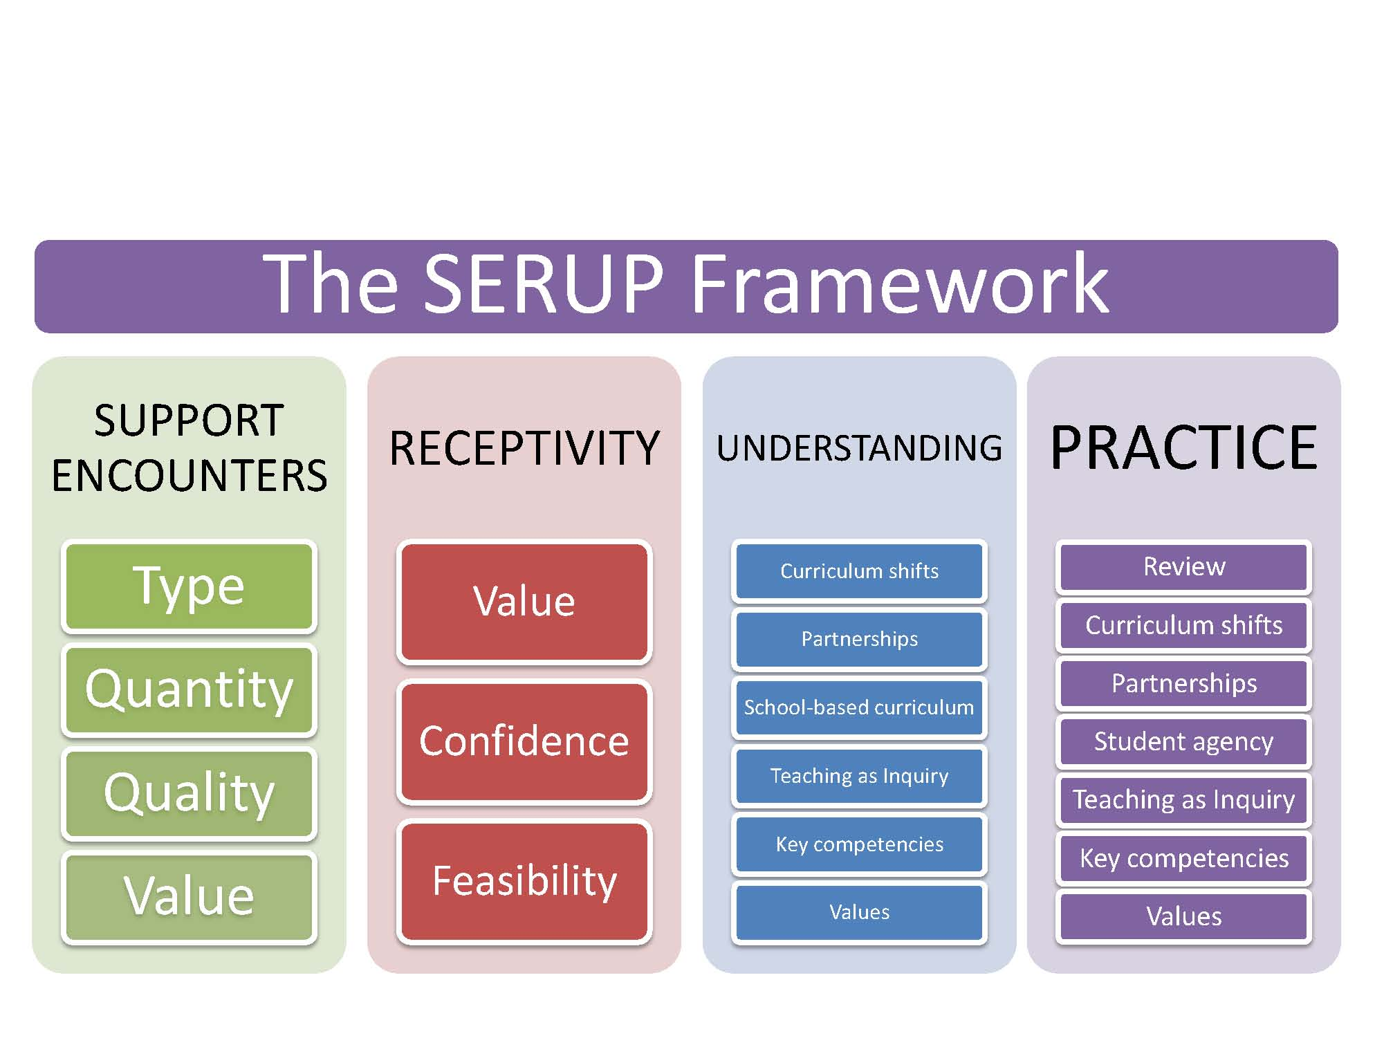

Support encounters
Data were gathered on the extent to which educators had encountered various kinds of support (including people within and beyond their schools, print publications and online material) and how valuable and high quality they perceived those supports to be.

Receptivity
Data were gathered about the extent to which educators value the curriculum, their confidence in implementing it in their own context, and the degree to which they perceive implementation to be feasible.

Understanding
Attention was also given to how educators understand key elements of the new curriculum. The New Zealand Curriculum has, for instance, significantly greater emphasis on effective pedagogy, Teaching as Inquiry and the development of key competencies. It also affords schools substantially more flexibility through its emphasis on locally designed curricula and sets out principles and values that are to be reflected in teaching and learning programmes. Evaluation tools asked practitioners to report not only how much, and what they were implementing in relation to these aspects, but also examined curriculum understandings underlying those reports. Of key interest was the extent to which those understandings aligned with curriculum intentions as expressed by experts who had been closely involved in designing the curriculum.

Practice
An overriding rationale for the curriculum change related to the pursuit of improved teaching and learning. It was critical, therefore, to also gather data on teaching practices in response to the new curriculum. Of particular interest was the extent to which practices that reflect the intentions of the new curriculum were becoming evident in both leaders’ and teachers’ practice. Practice items were not designed to measure adherence to the use of particular strategies, sequences, materials, or to duration stipulations for particular practices as is often the case in evaluations concerned with “fidelity of implementation’ (O'Donnell, 2008). Rather, they were designed to measure the nature of practices teachers are emphasising in their work with students. They were about more generic practices deemed to be indicators of curriculum intentions being realised.

Samples and data sources
More than 5000 educators have taken part in the series of evaluation activities between the beginning of 2008 and the end of 2009 as summarised in Figure 3.
Figure 3: Overview of data sources and samples
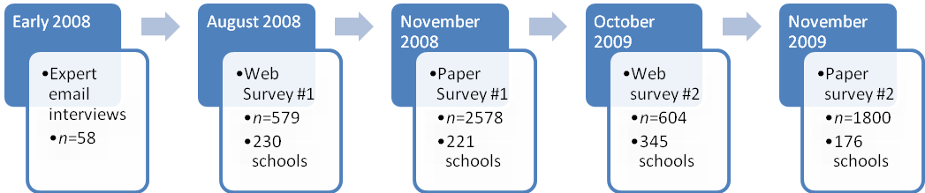
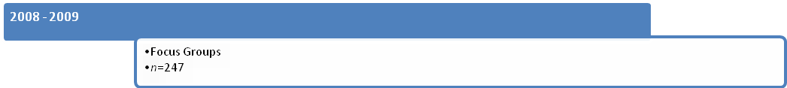
During the early months of 2008, focus groups and email interviews with curriculum experts were held to inform the design of the evaluation. Ministry of Education officials helped to identify the curriculum experts who were mostly members of curriculum advisory and writing groups. Fifty-eight experts responded to the questions about critical understandings, shifts required by the new curriculum and potential misunderstandings. Their responses were used to clarify key areas of focus for the evaluation.
In August 2008, a comprehensive web survey was carried out. Principals from a stratified random sample of 1210 schools were sent an email invitation to take part in the web survey, and to forward the invitation to all of their teachers. There were 579 respondents to that survey from 230 (19%) of the 1210 schools invited to participate. The 579 respondents represented 13% of the teachers in the participating schools. The original evaluation design was to carry out three web surveys. The low response rate, however, prompted a decision to design two additional paper surveys (to be administered towards the end of 2008 and 2009) and to administer just one further web survey (towards the end of 2009).
In October 2008, principals from a stratified random sample of 593 schools (no schools from the web survey sample were included) were sent an invitation by mail inviting them, and all of their teachers, to complete the enclosed paper surveys. These were a short two-sided single page survey of 84 curriculum implementation items and five demographic items. In the following month there were 2578 responses to the survey from teachers and principals in 221 (37%) of the 593 schools invited to participate. The 2578 respondents to the 2008 paper survey represented 41% of the teachers in the participating schools.
In October 2009, the second administration of both paper and web surveys took place. The second web survey focused on open-ended understanding items, and duplicated the series of receptivity items from the paper survey. Email invitations were sent to principals in 1191 schools (the same sample as those invited in 2008 with those who requested not to be invited again excluded). Once again, principals were requested to forward the email invitation to all teachers in their school. There were 604 responses from educators in 345 (29%) of the invited schools. The 604 responses to the 2009 web survey represented 8% of the teachers in the participating schools.
The 2009 paper survey was identical to the first paper survey, with the addition of two support encounter items and one support quality item. It was sent to the principals of the same 593 schools with a request for them to again extend the invitation to all teachers in their school. In the following month, responses were received from 1800 educators from 176 schools. The 1800 responses represented 36% of teachers in the participating schools.
The surveys were complemented by a series of 26 focus groups involving 247 participants from across a range of school types and roles.

Sample representativeness
The random samples for invited schools for both web and paper surveys were based on a stratified-sampling frame constructed around units of school type, region, and decile. The achieved samples (actual respondents) for each of the surveys were compared to the total population of teachers (for English-medium state and state-integrated schools) and these comparisons are presented below.

School type
The respondents to all surveys were similar to the teacher population in terms of the school types they work in (composite, primary, secondary and special). The participating teachers and those in the population of English-medium schools were similar for both of the paper surveys, but slightly less similar for the web surveys as shown in Figure 4.
Figure 4: Comparison of survey achieved samples and teacher population by school type
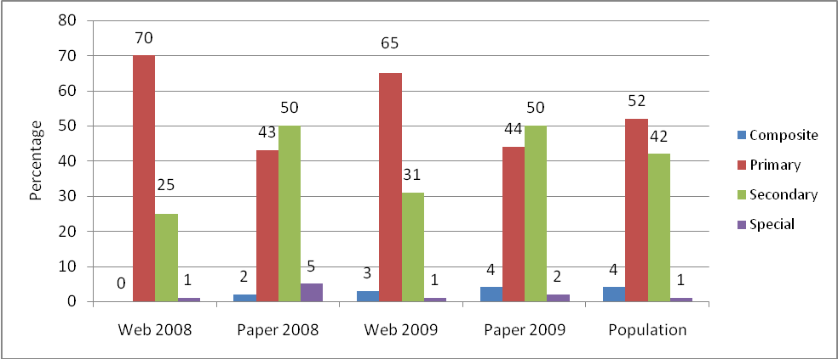

School Region
Similarly, the proportion of respondents from each of the six regions (organised in this way to match the regional delivery of school support services) for all of the surveys, closely matched the regions of the total population of teachers.
Figure 5: Comparison of survey achieved samples and teacher population by region
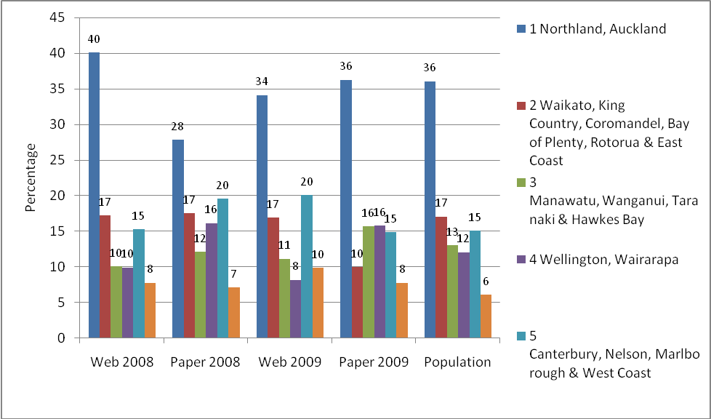

School Decile
The socio-economic status-based decile rating for schools was also a consideration in the sampling frame. For all surveys a slightly higher proportion of teachers from mid (4–7) and high (8–10) decile schools responded relative to the proportion of teachers in mid and high decile schools in the population. The proportion of teachers in low (1–3) decile schools was, therefore, slightly lower than in the achieved sample than in the population. The match was closest in the 2009 paper survey.
Figure 6: Comparison of survey achieved samples and teacher population by decile
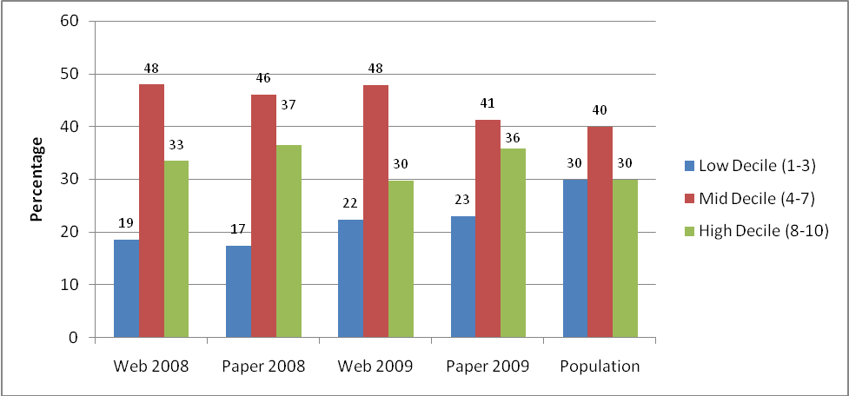

Instruments

Paper surveys
The paper survey was designed to capture key aspects from the theoretical framework in a short easy to complete format on two sides of one A4 sheet (see Appendix 1). It repeated some items from the first web survey for the purposes of comparison, and re-framed other aspects of the framework, with an emphasis on items relating to practice. The survey instrument was identical at both time points (with the exception of two additional items in 2009), and provided the key source of comparison in relation to the question of progress over the first two years of implementation.
The paper survey asked respondents to indicate: demographic information (school type, school region, school level, socio-economic status rating); the frequency various implementation supports (including people, web and print) had been encountered (8 items on a 4-point Likert scale); the quality of implementation support (4 items on a 6-point Semantic Differential scale); their general views of the curriculum and of the degree of change required (2 items on a 6-point Semantic Differential scale); extent to which a range of key curriculum-related practices were evident in practice (22 items on a 4-point Likert scale); and the extent to which they had made change to a range of day-to-day practices (7 items on a 6-point Likert scale).
The 6-point change scale drew on a number of sources including Hall and Hord’s (2006) Concerns-Based Adoption Model. They identified, verified, and operationally defined eight different levels of use of a new innovation. These levels are used to determine the extent and quality of change being implemented in classrooms (Hall & Hord, 1987, 2006; Hall & Loucks, 1975, 1977, 1981). They range from non-use, through orientation, preparation, mechanical, routine, refinement, integration, and finally to renewal (a stage whereby the use of an innovation in re-evaluated and modifications/improvements are sought). The change scale also drew on a model of change developed through studies on intentional change in relation to addictive behaviours (J. O. Prochaska & DiClemente, 1983; J. O. Prochaska, DiClemente, & Norcross, 1992). The model, described by Prochaska and others as ‘transtheoretical’, outlines six stages of intention change—pre contemplation, contemplation, preparation, action, maintenance and termination. The model, which has been tested widely in studies about individuals and addictive behaviours, has also been found to hold for organisations (J. M. Prochaska, 2000) and has been used in education settings (Evers, Prochaska, Van Marter, Johnson, & Prochaska, 2007). It was adapted for the purposes of this evaluation to outline a theory of curriculum implementation (see Figure 7).
Figure 7: Theory of curriculum implementation
Pre-contemplation
Contemplation: Reject
Contemplation:
Endorse
Planning
Initial Action
Maintaining/ Refining Action

Web survey 2009
The second web survey (administered in 2009) repeated some items from the first web survey and the first paper survey for the purposes of mode comparison, and re-framed other aspects of the framework, with an emphasis on items relating to understanding. It asked respondents to indicate: demographic information; the extent to which a lack of various supports were considered to be barriers to curriculum implementation (9 items on a 6-point Likert scale); and their receptiveness to, and views of, the curriculum (10 items on a 6-point Semantic Differential scale). Respondents were also asked to indicate which of the curriculum principles (Treaty of Waitangi, Cultural diversity, Inclusion, Learning to learn, Community engagement, Coherence, Future focus) are emphasised most and least in the school’s curriculum, and to give examples of those principles in practice. The 2009 web survey also included four open-ended understanding items and a space for general comment. The open-ended understanding items were designed to elicit examples from practice that indicate key understandings respondents bring to curriculum elements. The open-ended items used projective device questions in which respondents completed unfinished sentences:
- The best example I have seen of teaching for key competencies is....
- Teaching as Inquiry in the NZC requires teachers to....
- Values in the NZC requires teachers to....
- Key competencies in the NZC requires teachers to....
- The most significant change in practice in my school or class in response to the NZC is....

Web survey 2008
The first web survey, administered in 2008, was developed for teachers, and slightly revised to ensure the school leaders’ version was relevant to the role of principal.
It included sections for:
- indicating frequency of engagement with various supports—print, people and web
- rating the value/quality of curriculum implementation supports—print, people and web
- space for open-ended responses/views about implementation support
- rating barriers to curriculum implementation (in terms of support provision)
- suggesting priorities for implementation support
- rating views about the NZC
- rating confidence for implementing the NZC and its various elements
- rating barriers to curriculum implementation (in terms of own capacity)
- indicating the accuracy of statements about key aspects of the curriculum, and space for comment
- indicating the extent of change in unit planning for the learning areas
- indicating the extent/nature of discussion about the NZC
- indicating the response to key competencies (in planning, discussions with staff/students)
- indicating the nature of implementation goals
- indicating the extent to which coherence across sectors is a focus
- indicating the nature of provision of Te Reo Maori me ona Tikanga
- indicating the focus, if any, of school review
- indicating the extent of Teaching as Inquiry practices
- open-ended responses to questions asking respondents to explain various key aspects of the curriculum.
Feedback from key stakeholders (in particular the Ministry of Education) and from pilot respondents was used to refine the survey instrument during the design phase.

Focus groups
In addition to the surveys, 26 focus groups were held (with selective sampling) exploring the views of 247 teachers, teacher educators and principals. Email interviews (using convenience sampling) were also used (James, 2007) as a means for gathering rich qualitative data from participants in remote locations.
In the first year of the research, the focus group interviews were based around a broad semi-structured schedule that prompted discussion about the quantity and quality of support encountered, views of the curriculum, and understandings about key shifts required. Focus group composition in the first year was typically based around subject area interests. They were selected not on the basis of being representative of the wider population, but on the basis that they would have contributions to make related to the implementation of the curriculum. The emphasis in the second year of the research shifted to focus on key themes emerging from the 2008 survey data. For example, themes of primary/secondary differences, principal/teacher differences, and issues in understanding and implementing partnerships, and the Teaching as Inquiry elements of the curriculum were foci for the interviews, and influenced the composition of the groups. In these focus groups, findings from survey data were used as prompts for discussion. As well as being a useful stimulus for discussion, focus group participants’ reactions to survey findings provided an insight into possible explanations and examples underlying quantitative data. The number of participants in each focus group varied, but was typically between five and eight enabling a range of ideas and perspectives to be raised. An invitation to respond to questions in an email interview was also extended (via an Education Gazette advertisement) and 12 educators who were unable to attend focus groups in person participated in that way.

Analysis

Paper survey 2008–2009
Quantitative analysis of categorical and rating scale items in the survey (using SPSS) was carried out. Analyses included factor analysis, Multivariate Analysis Of Variance (MANOVA), effect-size calculations and stepwise linear regression. Focus group, email interview and open-ended survey items were coded qualitatively (using Excel and NVivo) and frequency counts were calculated for selected items.

Factor analysis
Factor analysis was used to uncover the dimensions of the support and receptivity items, and practice items. This involved an exploratory factor analysis using maximum likelihood extraction method, followed by oblimin rotation. A 5-factor solution for the support and receptivity items (excluding one item—miserly-generous) and a 9-factor solution for the practice items were selected since those factor structures matched between the Time 1 and Time 2 data. This enabled comparisons to be made across the two time points. The factors, as outlined in the pattern matrices in Appendix 2, Appendix 3 and Appendix 4 were:
Support quantity: internal is a 4-item factor (α=0.73), measuring the quantity of encounters with support available within schools including own colleagues. The Ministry of Education provided publications and website material and the curriculum document.
Support quantity: external is a 4-item factor (α=0.66), measuring the quantity of encounters with support sourced externally to the school including state-funded advisors, private consultants, facilitators from other initiatives and colleagues from other schools.
Support quality is a 4-item factor (α=0.93), measuring respondents’ views of how productive, relevant, stimulating and sound the quality of support provision was that they experienced.
Regard is a 3-item factor (α=0.80), measuring the extent to which respondents view the curriculum positively in terms of being flexible and practical and better than the previous curriculum.
Confidence is a 4-item factor (α=0.73), measuring the extent to which respondents feel confident about implementing the curriculum (confidence and ease of implementation) and consider it to be feasible (reasonable workload and uncomplicated).
Key competency: pedagogical is a 2-item factor (α=0.72), measuring the integration of key competencies across learning areas and fostering of students’ dispositions to recognise when and how to use key competencies.
Key competency: disciplinary is a 4-item factor (α=0.61), measuring competencies relating to thinking and use of language, symbols and texts and the application of knowledge to meaningful real-world contexts.
Key competency: situated inter-/intra-personal is a 3-item factor (α=0.79), measuring educators’ focus on competencies of relating to others, managing self and participating and contributing.
Values is a 4-item factor (α=0.80), measuring the emphasis on teaching that encourages curriculum values, develops values exploration skills and knowledge about the nature of values, and attends simultaneously to knowledge, attitudes and values during learning.
Student agency is a 2-item factor (α=0.71), measuring the emphasis on enabling students to participate in decisions about what and how they learn and how they are assessed.
Parent involvement is a 3-item factor (α=0.80), measuring the emphasis on parents and community members being consulted on teaching and learning matters, and taking part in teaching and learning both at home and at school.
Teaching as Inquiry is a 5-item factor (α=0.75), measuring the extent to which an inquiry-oriented approach is taken—being responsive to evidence about students’ needs, abilities and response to teaching; drawing on both colleagues’ experience and published research to inform changes to practice; and collecting and analysing data about student response to teaching.
Change to classroom practice is a 5-item factor (α=0.91), measuring the degree of change to planning, approaches/activities, resources, content/topics/themes and the role of students in class.
Change to reporting is a 2-item factor (α=0.94), measuring the degree of change to the content and manner of reporting to parents.
A single-factor solution across all of the practice items was also extracted, to identify if a single practice factor would be suitable for use in subsequent linear regression (23 items [excluding those rated on the change scale], α=0.92).

Comparisons between groups
A MANOVA test was conducted to look for between-subjects effects of a range of groups—2008 and 2009 respondents, those from different school levels (primary and secondary), those from schools of differing deciles (low, mid and high deciles), between those with different roles in schools (teachers and principals) and between those reporting experience of low and high quality support. For these multivariate analyses the regard and confidence factors were included as dependent variables alongside all of the practice factors since it was deemed important to establish between group differences on all these variables. Regard and confidence were subsequently treated as independent variables in other analyses described later.
Effect sizes (Cohen’s d) were calculated for group mean differences on all of the factors (where those differences were found to be statistically significant) to determine the magnitude of the difference. Effect size calculations were considered useful for considering the relative magnitude across, for instance, each of the factors relating to practice, and to determine relative progress across multiple curriculum aspects.

Regression
A series of stepwise linear regressions were carried out in order to describe the relationship between one predicted (dependent) variable and a selection of predictor variables (independent). In the first instance a single practice factor was treated as the dependent variable, and all of the support and receptivity factors were included as independent variables. The strongest predictor from each analysis (which was confidence in the first regression treating practice as the dependent variable) was then treated as the dependent variable in the subsequent analysis.

Qualitative analysis

Thematic analyses
Focus groups were recorded, transcribed and entered into NVivo. The development of categories for the qualitative analysis occurred both inductively and deductively. The SERUP framework provided the basis for deductive categories, or confirmatory thematic (a priori) analysis. These categories included, for example, support encounters (positive, negative, quantity, quality, source); receptivity (positive, negative, value, feasibility, confidence); understanding and practice (all curriculum elements). There was also attention to exploratory (a posterior) analysis. This inductive coding allowed additional themes to be noted, and previously coded data were cross-checked as additional categories emerged. Web survey comments were also coded, mainly inductively, and frequency counts calculated for each category.

The curriculum context: Features of The New Zealand Curriculum
There are several important characteristics of the NZC that had implications for evaluating its implementation:
- The New Zealand Curriculum provides direction and guidance for teaching and learning for every curriculum area in New Zealand’s state and state-integrated schools.
- Schools’ local curricular are required to provide teaching and learning programmes that are based on The New Zealand Curriculum learning area statements, underpinned by its principles, and that address the stated values, key competencies, and achievement objectives.
- The New Zealand Curriculum emphasises flexibility and school autonomy. Rather than a prescription, it focuses on school-based curriculum design—the requirement for schools to design local curricular that are responsive to the needs of their particular students and communities.
- The New Zealand Curriculum, unlike its predecessor, has substantial emphasis on pedagogy—it signals not only the direction for teaching and learning in terms of what outcomes students should achieve, but also guidance for teaching and learning processes that signals how students and other stakeholders should experience teaching and learning.
- The New Zealand Curriculum is one of two curriculum documents that comprise the national curriculum: The New Zealand Curriculum (English-medium) and Te Marautanga o Aotearoa (Māori-medium). Te Marautanga o Aotearoa is the partner document of NZC. It has been developed for Māori medium settings levels 1 and 2, however, all New Zealand schools can utilise this document in their respective schools. It is not a translation of NZC and was developed based on Māori philosophies and principles.

Findings: Introduction
Findings are reported in the following section in relation, firstly, to receptivity. Findings in relation to practices and understandings are then reported together. The reason for this is that it became apparent that how educators understand curriculum aspects needs to be considered alongside findings from self-reports of implementation. This section is followed by findings in relation to support, and finally in relation to explanations for curriculum implementation progress.
The following sections summarise the findings from the 2-year project and supplement the detailed report about the 2008 data reported in May 2009 to the Ministry of Education. The findings in this report refer mainly to data from the 2008 and 2009 paper surveys unless specific reference is made to a web survey.

Findings: Receptivity to The New Zealand Curriculum

To what extent do schools and teachers feel confident about, or challenged by, the implementation of The New Zealand Curriculum?
Respondents were asked about how well they regard the curriculum, in terms of its flexibility, practicality and the extent to which they view it to be better, rather than worse, than the previous curriculum. They were also asked about their confidence in implementing The New Zealand Curriculum in terms of how complicated they view it to be, how reasonable they consider the workload, and how easy and confidently they view implementation.

Regard and confidence
The difference in ratings for curriculum regard between 2008 and 2009 was statistically significant, but small, but the ratings were high in both years: 3.3 on the 0-5 scale in 2008 and 3.4 in 2009.
Figure 8: Receptivity to the NZC: Regard and confidence 2008–2009
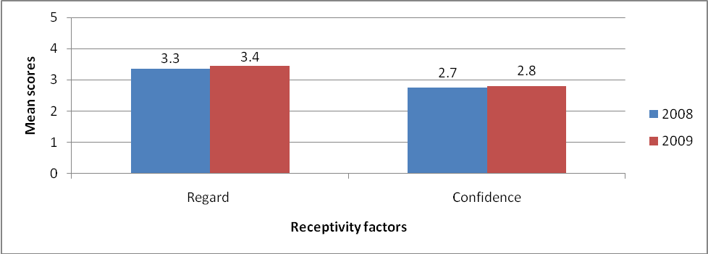
The positive views about the curriculum being practical, flexible and an improvement on its predecessor are also indicated by the percentage of participants responding at the positive end of the Semantic Differential scales (positive and negative anchors at the end of a 6-point scale) for each of the items shown in Figure 9. In 2009 (as in 2008) the vast majority of respondents positioned their response at the positive end of the scale for each of the regard items; better-worse (77%), practical—impractical (79%) and flexible—restrictive (88%).
Figure 9: Percentage responses to regard items
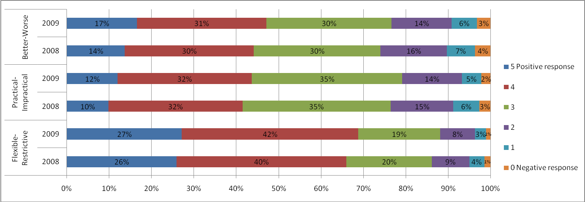
The ratings by primary respondents for both regard and confidence were not statistically significantly higher in 2009 than 2008. The ratings by secondary respondents were statistically significantly higher in 2009 than in 2008 but, as shown in Figure 10, the difference was only small. The initial positive response had been maintained.
Figure 10: NZC regard and confidence: Primary and secondary comparisons 2008–2009
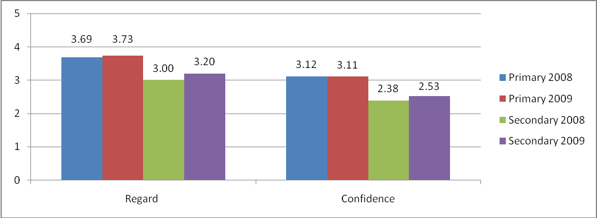
The overall positive response to the curriculum in the paper surveys was also evident in comments made by teachers and principals in the web surveys and across all focus groups:
I love it—as a teacher, parent and Board of Trustees member I can only see huge advantages for students, schools and the future of New Zealand. (W09)
I think the New Zealand Curriculum …is the answer, is the way forward for the 21st Century. It is. I mean I agree with it wholeheartedly. (FG Secondary teacher)
The most predominant theme in positive comments about the curriculum relates to its flexibility and the school-based curriculum design aspect. There remains a distinct tone of excitement and sense of possibility in the responses of most teachers and principals:
I am looking forward to the new curriculum being implemented in our school. I think that it is an exciting change that allows for flexibility [and] cohesion amongst different curriculum areas. (W09)
It just simplifies things and gives you more flexibility to take it in a direction that will suit your class. (FG Primary teacher)
The freedom that the NZC allows to develop a curriculum for our own 'clients' is one of the wow factors of it. (W09)
Many respondents were pleased at the pedagogical emphasis in the new curriculum, with its focus on approaches that are likely to support students in their learning and achievement:
Very exciting that schools can design their local curriculum and there is a move to a more constructivist approach and a real look at how children learn best. (W09)
Very excited. The NZC means that there has to be a shift in a lot of teaching practice—a shift that is going to benefit our students. (W09)
Others noted the relevance of the curriculum in preparing students for the future:
I think just from my own looking through, it’s more child-centred now and it’s all about creating children, for a world out there that we don’t even know what it’s going to be like, well that’s how I see it. (FG Primary teacher)
Those who expressed a less-than-positive view of the curriculum often referred to the lack of certainty about the place of knowledge in the new curriculum, which indicates a misunderstanding about reduced importance of knowledge:
Process seems fine however I do worry about content general knowledge acquired, as I feel there will be gaps in their learning. (W09)
Width of science curriculum has been increased but without extra time depth of knowledge and/or thinking may be sacrificed. (W09)
There are important elements that were part of the old one, knowledge and skills that we need to plan for and deliver. (FG Primary teacher)
Some also indicated uncertainty due to the reduced prescription, and increased professional autonomy in The New Zealand Curriculum:
It’s a lot broader than what it was, although I personally prefer it quite prescriptive, I’m sort of being told what to teach. (FG Secondary teacher)
It sort of destabilises people ... we don’t know what we’re going to be doing, we hear that say year 11 we’re going to not teach micro-organisms and ... we’re going to put something else there, but what’s going to go there? At the moment there’s a big question mark, so it’s specifics, and I think teachers like to deal with nuts and bolts and certainly in Science, you know exactly, you know, down to the lesson, what you’re going to be doing. When I looked at this curriculum, and thought yeah great, aspirational statements and things – but it’s how to get from A to B and to the day-to-day running and that is quite scary and especially when you have to build all the assessments and the pathways as well. (FG Secondary Science Teacher)
Others expressed more general frustration about change generally:
Please don't keep reinventing the wheel for the sake of it! (W09)
The lower ratings for ‘confidence’ than ‘regard’ shown in Figure 8, were also evident in the more mixed responses during focus groups from educators about their belief in their own ability to give effect to The New Zealand Curriculum. Some expressed high levels of confidence:
I’m really enjoying the challenge of putting together documentation specific to the needs and interests of children in our school. I am part of the special projects for developing curriculum and as a DP and driver of curriculum at [school name], this gives me a formal forum in which I can be supported and be supportive of other leaders in the sharing of best practice, leading learning and managing school-wide change. Through this Special Project, the development of a professional learning community of senior managers provides me with a forum for shared facilitation around the development of our school curriculum based on the NZC. We’re going well and will have our school-based curriculum in place for the start of 2010. (Primary Deputy Principal)
I think that the amount of professional development and exposure that enough teachers have had is meaning people can now talk about these things from a new level of understanding; everyone together understanding the schools are working pretty hard to make sure that people know the document. (Secondary teacher)
It should not be a hard task to implement. As previously stated, the Curriculum is the MoE catching up with us and allowing us to teach best. (Web09)
We are at an exciting time in our history with education. I am so motivated and enlightened with the pathway put forward with the NZC and feel confident and passionate about the change that is happening. (Web09)
Ratings on the practice difficulty scale (a scale comprising 23 items in which 0 represents very difficult, 1–difficult, 2–easy, 3–very easy) indicate that despite pockets of confidence, there remains an overall pattern of practices not yet being considered easy (see Figure 11).
Figure 11: Difficulty ratings for NZC practices
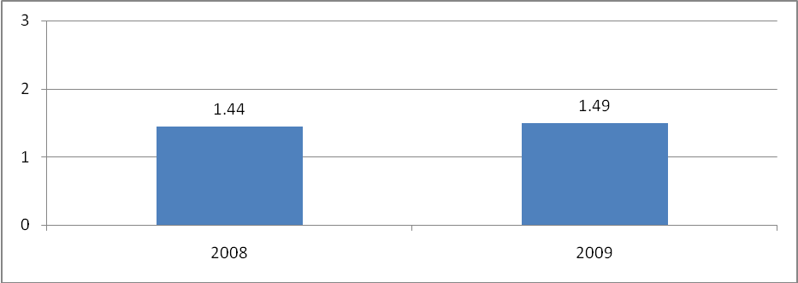
Difficulty ratings for items about practices considered important for implementation of The New Zealand Curriculum (2009 paper survey), indicate that a significant proportion of teachers continue to find all of these practices difficult or very difficult, rather than easy or very easy (see Appendix 6). These findings indicate that there remains significant work to be done on developing educators’ confidence and capability in giving effect to key curriculum intentions. Some explained their lack of confidence as being due to shortcomings in their own curriculum and content knowledge:
It’s teacher knowledge I think, you know, because we’re going deeper and trying to do things. You know, deeper understandings is named like that specifically because that’s exactly what we want to do, instead of once over lightly. You know, we’ve found our own knowledge shortcomings. (Primary teacher)
We realise we actually don’t know how to do some of the things we would like to teach the children. (FG Art teacher)
Many recognised the importance of confidence in an implementation effort that requires teachers to take risks, and to shift practice:
Because if you’ve got that confidence with the kids, not everything you do in the classroom has to work. Whereas, if you’re unsure, you’re only going to do things that are safe. So you can take a risk can’t you? (FG Secondary teacher)

Findings: The New Zealand Curriculum Understanding and Practice

What progress is being made in schools’ practice and understanding of The New Zealand Curriculum?
Findings about the progress that has been made in implementing The New Zealand Curriculum are reported, mainly, against nine aspects of practice (or factors). The aspects of practice and the survey items that were included in each are outlined in Table 3. These nine aspects of practice are organised in this way since a factor analysis of both the 2008 and 2009 paper survey data revealed these items to hang together in a common factor structure when the 26 items were analysed.
Table 2: Practice factors
Practice factors | Items included in the factor
Key competencies: pedagogical | Integrating key competencies and learning areas  Foster students’ own disposition to recognise when and how to use the key competencies
Key competencies: disciplinary | Thinking key competency  Using language symbols and text key competency  Students do things with knowledge in meaningful real-world contexts
Key competencies: situated inter-/intra-personal | Relating to others key competency  Managing self key competency  Participating and contributing key competency
Values | Encouraging students to hold the values listed in the NZC  Developing students' skills for exploring values  Drawing out knowledge, attitudes and values during learning experiences  Teaching and learning about the nature of values
Student agency | Students participate in decisions about what and how they learn  Students participate in decisions about how they are assessed
Partnerships | Parents/community members are consulted about teaching and learning; their views/opinions are sought, taken seriously and responded to  Parents/community members often take part in teaching and learning at home  Parents/community members often take part in teaching and learning at school, as key participants in the programme  Teaching and learning about the nature of values
Teaching as Inquiry | I engage with evidence about students' needs and abilities to prioritise next steps for learning  I draw on the experience of colleagues to inform possible changes to my teaching  I read and use published research to inform possible changes to my teaching practice  I modify teaching practices as a result of what I have learned about student response to my teaching  I systematically collect data and analyse it to understand students' response to my teaching
Change to classroom practice | Planning documentation  Teaching/learning approaches/activities used  Resources used for teaching and learning  Content/topics/themes of teaching and learning  Role students take in class
Change to reporting | Way parents are reported to  Content of reports to parents
Responses to items included in the first seven of the factors on the table above were on a 4-point scale:
0 – Not evident; it is NOT something I consider to be an important aspect of my practice
1 – Evident at times but NOT something that I feel I must always do
2 – Strongly evident; it is important to me that I do this often
3 – Very strongly evident; it really matters to me that I do this consistently
This scale signals how evident curriculum practices are both in terms of how frequently they are done and also the commitment educators have to them.
Responses to items included in the last two factors on the table above (both about change) were on a 6-point scale:
0 – Have not considered
1 – Considered, decided not to change
2 – Intend to make changes
3 – Made slight changes
4 – Made moderate changes
5 – Made substantial changes
This scale, and the items rated on it, varies distinctly from the other practice scales, since it relies on self-reports of change generally, and not necessarily in relation to items deemed to reflect The New Zealand Curriculum. For this reason, findings from these are treated much more cautiously than those from the main practice factors.

Overview of progress in curriculum practices
There were only very small shifts in the extent to which educators reported curriculum elements being evident in practice between 2008 and 2009. Those reporting key curriculum elements as “very strongly evident” in their practice shifted, on average (across 23 items) 1% over the year, from 22% to 23%. The means for all types of practice changed little (see Figure 12). For the key competency factors and Teaching as Inquiry factor, the shifts, albeit small, were statistically significant. For values, student agency and parent involvement, there was no statistically significant change between 2008 and 2009—the degree to which these aspects were evident was maintained, but not improved.
Figure 12: NZC practices: 2008–2009 comparison
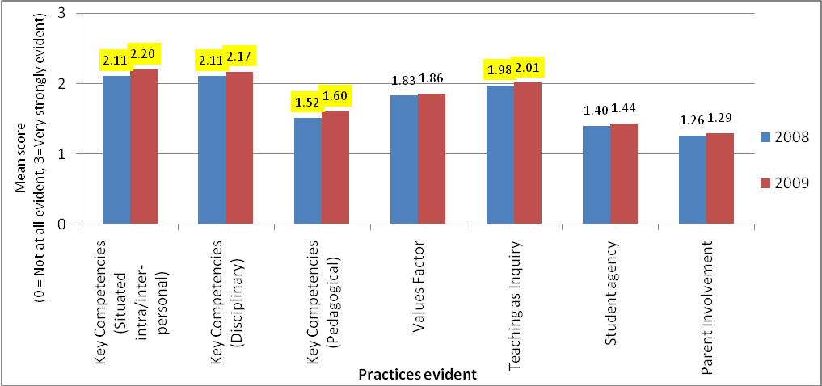
More importantly the effect sizes, indicating the magnitude of any shift between the two time points, were very small (Cohen’s d effect sizes of less than .2 for the key competency factors and less than .1 for all of the other factors, see Table 4 and Appendix 5).
Table 4: NZC practices: 2008–2009 comparison
 | 2008 |  |  | 2009 |  |  | Effect size (Cohen's d)
 | mean | n | SD | mean | n | SD | Effect size (Cohen's d)
Key Competencies (Situated intra/inter-personal) | 2.11 | 2487 | 0.618 | 2.20 | 1752 | 0.564 | .16
Key Competencies (Disciplinary) | 2.11 | 2519 | 0.533 | 2.17 | 1761 | 0.505 | .11
Key Competencies (Pedagogical) | 1.52 | 2481 | 0.669 | 1.60 | 1750 | 0.643 | .13
Values Factor | 1.83 | 2509 | 0.621 | 1.86 | 1756 | 0.610 | .05
Teaching as Inquiry | 1.98 | 2507 | 0.542 | 2.01 | 1757 | 0.519 | .07
Student agency | 1.40 | 2480 | 0.719 | 1.44 | 1751 | 0.709 | .05
Parent Involvement | 1.26 | 2441 | 0.749 | 1.29 | 1730 | 0.705 | .05

The interpretation of these findings as positive, neutral, or negative, depends largely on the expectations held for implementation. A central focus of the research question for this evaluation was on progress. This implies that regardless of the starting points of educators, over time, increasing evidence of curriculum-related practices could be anticipated. It is acknowledged that implementation is an ongoing endeavour, that substantial change takes many years, and that 2008—2009 was an early phase of implementation of The New Zealand Curriculum. But even so, the data from this study indicates limited progress in terms of practice, despite the positive findings about educators’ regard for the curriculum. In addition, the data used in the 2008—2009 comparisons were collected 16 months and 4 months prior to the new curriculum becoming mandatory. This was during a period of intensive attention to support for curriculum implementation, making the limited progress a concern.
It is argued here, that evidence of progress would have been indicated by:
- at least small, and ideally moderate, rather than very small effect sizes comparing the magnitude of difference between 2008 and 2009 on each type of practice
- statistically significant shifts in a positive direction for all rather than just some of the practice factors
- the overall percentage difference of those rating curriculum elements as very strongly evident in their practice increasing by more than one percent between 2008 and 2009.
An alternative view might be that the relatively high starting points for some practice elements are sufficient, and that maintaining, rather than improving, levels of curriculum-related practice are acceptable during the early phases of implementation.

Are the key competencies becoming more evident in teaching and learning?
There were statistically significant differences for all three of the key competency-related factors, in the desired direction, between 2008 and 2009. The magnitude of the differences, though, is only very small. The effect size (Cohen’s d) for the disciplinary element of key competencies was 0.11 for the situated intra-/inter-personal 0.15 and 0.13 for the pedagogical element.
Figure 13: Key competencies evident in practice: 2008–2009
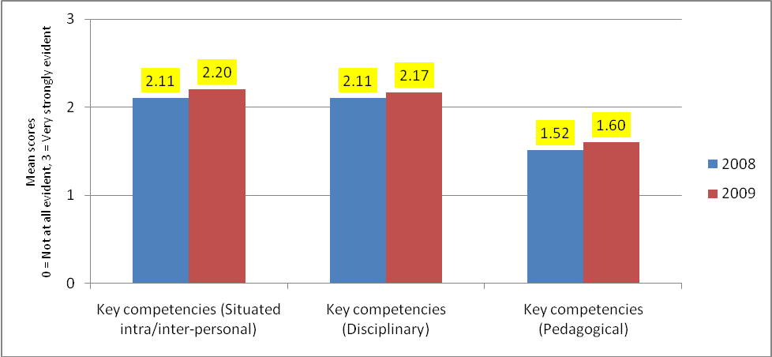
Another means of considering the shift between 2008 and 2009 is to compare the percentage of respondents who reported each individual practice item as being very strongly evident in their practice (since these practices being strongly evident in practice is consistent with the direction set out in The New Zealand Curriculum).
Table 5 shows that there was only a small percentage increase over the one year timeframe on all items, and for the vast majority of respondents, key curriculum practices are not yet strongly or consistently evident in their practice.
Table 3: Percentage of respondents reporting practices as ‘Very Strongly Evident’ in their practice
Practice factor | Practice items | 2008  % | 2009  % | Difference  %
Key competency: Disciplinary | Developing student competency in thinking | 26 | 30 | 4
Key competency: Disciplinary | Developing student competency in using language symbols and text | 34 | 37 | 3
Key competency: Disciplinary | Students do things with knowledge in meaningful real-world contexts | 30 | 31 | 1
Key competency: Disciplinary | Integrating key competencies and learning areas | 19 | 24 | 4
Key competency: Situated inter-/intra-personal | Developing student competency in relating to others | 33 | 36 | 3
Key competency: Situated inter-/intra-personal | Developing student competency in managing self | 36 | 39 | 4
Key competency: Situated inter-/intra-personal | Developing student competency in participating and contributing | 26 | 28 | 2
Key competency: Pedagogical | Foster students’ own disposition to recognise when and how to use the key competencies and be willing to do so | 11 | 11 | 0
Key competency: Pedagogical | Students participate with staff in discussions about the key competencies | 8 | 8 | 1

Explanations for the limited shift were highlighted in the range of responses to the web survey item that asked respondents to complete the phrase ‘Key competencies in the NZC requires teachers to...’. Some responses demonstrated insight into the complexity and challenge involved in implementing key competencies, but most gave only a surface-level response.
Examples of deeper responses included the following:
We’ve been talking about dispositions forever in various ways, you know, getting kids into a space where they are willing to learn and to be lifelong learners....but the trick is not in identifying that, but how you get that disposition, how you encourage that in them. (FG Primary teacher)
I like the recognition as learners being lifelong and have found this is affecting my outlook on seeing my time with the student as a short phase but I now look to see what learning tools they have rather than necessarily what knowledge they have. (W09)
[P]lan and teach using rich contexts that provide opportunities for students to display KCs within that teaching/learning dynamic. (W09)
The teaching of the key competencies involves equipping the learner with the knowledge to identify, apply and reflect on each of the competencies in a range of contexts. Although there needs to be much rich and challenging dialogue with learners about what the competencies are and how they are essential tools for life, they do not ‘stand alone’, but should ideally be embedded seamlessly across all learning contexts. (W09)
Encourage independent learning focus and stamina in their students so that they develop their thinking, language depth and use, self motivation, inter-relationships, tolerance and involvement in their ongoing learning. (W09)
Typically there were more surface responses including suggestions of a compliance nature relating to documentation, such as “format units to make sure they [key competencies] are included”.
In focus groups there was evidence of increasing recognition in 2009 that key competencies differ in important ways to essential skills. There was typically a great deal of discussion, though, between participants about how key competencies might look in relation to other curriculum elements, including the learning areas. While there was more talk about the differences between key competencies and essential skills, it remained difficult to elicit examples about how key competencies had changed practice and changed the nature of students’ learning experiences.

Are Teaching as Inquiry, Values, student agency and parent involvement becoming more evident in teaching and learning?
There were statistically significant differences for the Teaching as Inquiry factor between 2008 and 2009, but not for the values, student agency, or parent involvement factors. Effect size calculations (Cohen’s d) for each of these factors, however, show that the magnitude of the differences between 2008 and 2009 are tiny—Teaching as Inquiry (0.06), Values (0.05), Student agency (0.05), Parent involvement (0.05).
Figure 14: Values, Teaching as Inquiry, student agency and parent involvement evident in practice: 2008–2009
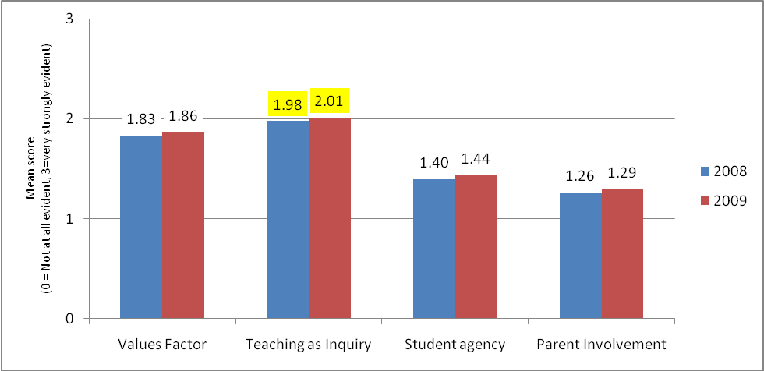
Comparisons between the 2008 and 2009 percentages of respondents who reported each individual practice item as being strongly evident in their practice are another signal of the limited shift. For several items there was no increase in the percentage reporting practices strongly evident, at most the increase was 2%, and for two items there was a 1% decrease (see Table 6).
Table 4: Percentage of respondents reporting practices being ‘Very Strongly Evident’ in their practice: 2008-2009 comparison
 | Practice items | 2008  % | 2009  % | Difference  %
Values | Encouraging students to hold the values listed in the NZC | 28 | 30 | 2
Values | Developing students' skills for exploring values | 15 | 15 | 0
Values | Drawing out knowledge and attitudes and values during learning experiences | 20 | 22 | 2
Values | Teaching and learning about the nature of values | 18 | 17 | -1
Teaching as Inquiry | I engage with evidence about students' needs and abilities to prioritise next steps for learning | 33 | 34 | 2
Teaching as Inquiry | I draw on the experience of colleagues to inform possible changes to my teaching | 31 | 33 | 2
Teaching as Inquiry | I read and use published research to inform possible changes to my teaching practice | 16 | 17 | 1
Teaching as Inquiry | I modify teaching practices as a result of what I have learned about student response to my teaching | 34 | 35 | 1
Teaching as Inquiry | I systematically collect data and analyse it to understand students' response to my teaching | 22 | 23 | 0
Student agency | Students participate in decisions about what and how they learn | 14 | 14 | 0
Student agency | Students participate in decisions about how they are assessed | 7 | 7 | 0
Parent involvement | Parents/community members are consulted about teaching and learning; their views/opinions are sought, taken seriously and responded to | 10 | 9 | -1
Parent involvement | Parents/community members often take part in teaching and learning at home | 11 | 11 | 0
Parent involvement | Parents/community members often take part in teaching and learning at school, as key participants in the programme | 6 | 5 | 0

Values
The emphasis in the approach to addressing values in the curriculum remains on defining and then modelling/‌encouraging particular sets of values—schools’ own values aligned to the values stated in The New Zealand Curriculum. While almost one third of respondents said that they consistently or often encourage students to hold The New Zealand Curriculum values, there is still less attention, as shown in Figure 15, to the more difficult aspects. Only a small proportion of respondents report integrating values into learning experiences across the curriculum (22%), learning about the nature of values (17%), and developing skills for exploring values (15%).
Figure 15: Values items: Comparison of 'Very Strongly Evident in my Practice' responses
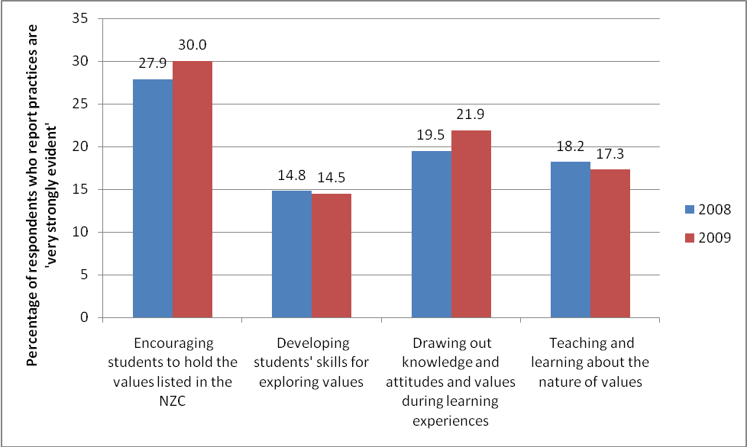
The emphasis on schools aligning to, and students holding, ‘particular’ (NZC) values is also evident in the following comments:
[Values in the NZC require teachers to...] be cognizant of the values that are espoused by the school community and act in ways that reflect these. (Web09)
One of the things that I think that we have got very close to understanding, it’s about getting that habit changed for us is the alignment of our school values and the values that are espoused in that New Zealand Curriculum document. I think we’re quite a long way along the track there. Not every teacher will be able to tell you how they align, but at a strategic level, we certainly understand them and it’s gradually filtering down through the school. (FG Secondary)
[T]hat’s the only thing that I could think of that I would classify as having some form of being embedded, the school values and a close alignment to the New Zealand Curriculum values and how that’s reflected in restorative practices and respectful systems um throughout the school. It’s embedded as a system; it’s not embedded as a culture. So the system is there, but it’s not, it doesn’t happen naturally [laughs]. It has to be forced. (FG Secondary AP)
These findings suggest that the three-way values education process signalled in The New Zealand Curriculum (education about values, and in valuing skills alongside encouraging affiliation to key public values) is not yet well understood.
Those who are integrating values across the curriculum explain the potential for embedding values throughout the learning areas and throughout the day:
The kids know them and you can go back to them any time of the day at any stage and in any subject, it’s not just a set time for values or whatever: in the playground, before school, after school, whenever, you can. (Web09)
For many, the role of values in the curriculum has been not so much about teaching and learning, but about behaviour management:
Most of us run our behaviour management through using the values as the basis for behaviour management. (FG Primary)
[When]kids slip up or make a mistake or do something wrong …they’re pretty good at telling you which one of the values they broke … their understanding of their values and what’s required of each one and. So it’s easy to do them [values] because that’s what you want the kids to have and that’s just a natural thing. You want the kids to show respect, you want the kids to be responsible and you want the kids to show kindness. (FG Primary)
As the quote above shows, comments typically emphasised teachers’ role in encouraging affiliation to particular values, without attention to the other two aspects of the three-way values education process.
In many focus groups, the multicultural dimension of values was raised, and often as a challenge rather than as a rich resource for values in the curriculum:
Values is very difficult. I mean we’ve got over 50 different nationalities at our school so they have got a different sense of the values. (FG Secondary teacher)
The cultural thing you bring up is really interesting too because one of our challenges, because we’ve got quite a large Polynesian community, is the differing values. One of the ones that we had looked at was pride, that for our Palagi parents, they would like their children to be proud of what they do and they feel that if you have pride in yourself then that motivates you to keep going or it becomes an end to a goal and it’s something really positive. But for many of our Pacific Island parents, especially the Tongan ones, they felt that pride is almost a sin, that it was, that humility was the value that they wanted to be taught and that they felt that if you were prideful then you wouldn’t be respectful or humble. So that’s been a challenge for us. (FG Primary)

Teaching as Inquiry
Five items related specifically to the Teaching as Inquiry model in The New Zealand Curriculum and were designed to address aspects of the focusing, teaching and learning inquiries.
Figure 16: Percentage of respondents reporting Teaching as Inquiry practices being ‘Very Strongly Evident’ in their practice: Comparison 2008—2009
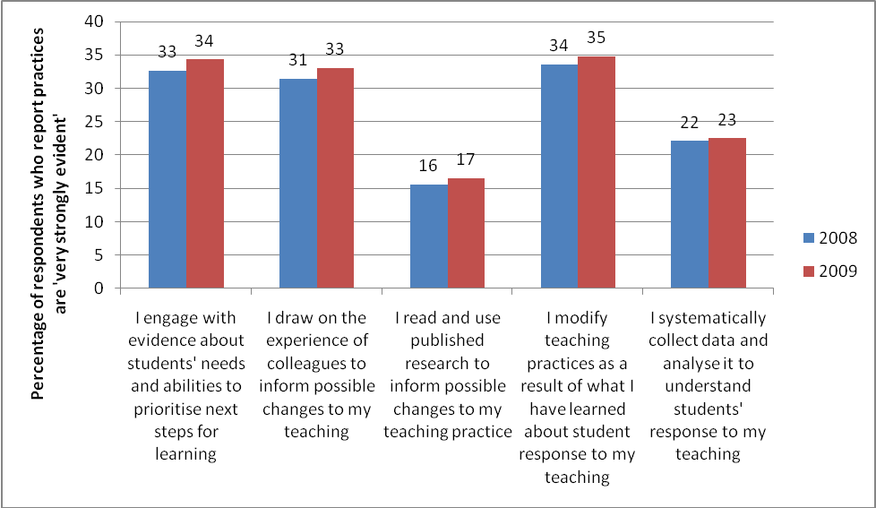
The three inquiries are used to structure a summary of the Teaching as Inquiry item findings below:
- Focusing inquiry: One third report strong emphasis in their practice on prioritising next learning steps for learning based on evidence about students’ need and abilities.
- Teaching inquiry: The practice of reading and using published research to inform teaching was strongly evident in half as many respondents’ practice as attention to colleagues’ experience in both 2008 and 2009.
- Learning inquiry: While more than a third of educators report modifying their practice as a result of learning about students’ response to their teaching, less than a quarter report that systematically collecting data for that purpose is strongly evident in their practice.

Teaching as Inquiry/Inquiry Learning confusion
There was a great deal of variation in participants’ understandings about the model of Teaching as Inquiry in The New Zealand Curriculum. Comments from many (in the 2009 web survey) about what Teaching as Inquiry requires indicate some depth of understanding, through reference to formative assessment, focusing inquiry, attention to evidence, data and research, inquiring teachers, and being improvement focused:
...use formative assessment, both formal and informal, to inform them about student achievement then use this data to make decisions about student needs and finally consult colleagues, research and other sources to find innovative approaches to meet student needs.
...understanding where the students are with their learning, what the best way forward is for those students and reflecting on how it went and implications for future practice.
...Reflect on their practice in order to get better outcomes for their students. Requires de-privatisation of the classroom and requires honest, frequent high quality feedback related to specific goals from mentors and colleagues. It also requires a level of comfort with uncertainty as one learns and adjusts practice and brings on board new beliefs about their learners and themselves as teachers.
...Make decisions about their teaching practice based on data and information and reflect, make changes and move forward—it is all about raising student achievement.
...adopt a big paradigm shift and position themselves as researchers or problem solvers. Their findings should provoke new perspectives and encourage alternatives in looking for ways to improve student achievement.
...integrate formative practice, data analysis, action research—to inquire into the efficacy of their teaching practice.
...Use data to inform their programme, update programmes based on the needs and gaps they see, and be reflective on own teaching, ensuring that we learn from our "mistakes" or less successful strategies and programmes and making changes.
There is still, though, a significant degree of confusion between the notion of Teaching as Inquiry as described in The New Zealand Curriculum, and Inquiry learning approaches. Thirty-three percent of the 513 comments in the web survey revealed this confusion as indicated by the suggestions about the implications of Teaching as Inquiry in the following examples:

Student-question driven
Encourage student to ask questions and seek the answers themselves.
[teach] specific thinking tools and questioning strategies.

Student independence
Scaffold knowledge building around a 'topic' and then allow students to explore questions of interest to them with as much guidance as they need or don't need for their age and ability. This new 'independent' learning is then shared with others or results in some further 'action'.

Teachers’ facilitation role
Teaching as Inquiry requires teachers to give up the 'centre stage' and become more of a facilitator in the classroom.

Emphasis on students’ skills
Ensure children have the skills to find information.
Guide children through a process to get, sort and use information.

Reduced emphasis on knowledge
Be more process driven rather than knowledge based.

Project/Integrated learning approach
More jargon for old thematic/integrated learning approaches

Student agency
While more educators reported involving students in decisions about what and how they learn, than about how they are assessed, a large proportion still only allow this at times or not at all, as shown in Figure 17.
Figure 17: Student agency items: 2009 frequencies
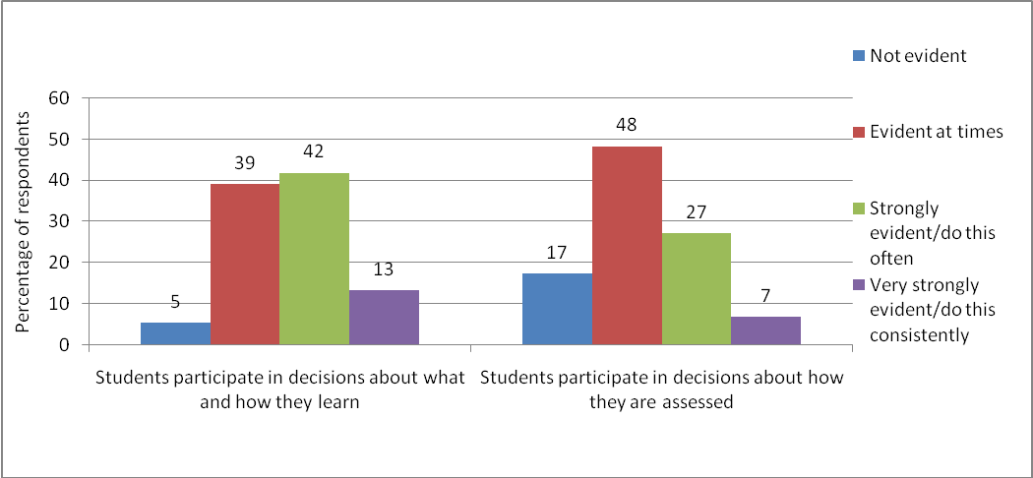
Developing and enhancing student agency in decision making is seen as a big step, or even a risk, for many teachers:
We’ve got a huge change in our thinking to come forward to, you know, that – because for so long we’ve told them what to do and what to think and suddenly we are having to change the way we approach things and for some of us, we’re further down the track than others. (FG Secondary AP)
Even those that would like to give it a go, they themselves are not comfortable with feeling, “Well I don’t really know where this is going.” And the students need to have a little bit of safety as well. I mean it would be something that you could trial on a small scale and over time you then build it as people get more confident and feel safer with the outcome that you can get from it as well. (FG Primary)
Many also raised a concern about students and parents not having an expectation that teachers will share a decision-making role with students:
And so it’s actually educating the students and the parents as well that there is a change in the way and how we approach the learning process. (FG Secondary)
In some cultures, if the teacher wants the student to actually work, and have agency, the parents and the students think the teacher’s opting out and doesn’t have the knowledge base. So they see that as poor teaching because um good teaching is you spoon-feed the child and the child regurgitates it at the end of the year. (FG Secondary)
Some signal that such agency and decision-making roles are possible for certain phases in the learning, and for certain (more capable) learners:
One teacher just told me recently that … they have total freedom about how they present their assessment, they can do anything. They can do a blog, a diary, a PowerPoint....You’d probably find there’s a lot of that going on for individual assignments within classes. I definitely think those that are able, they’re given the choice.
A common response related to the barrier of assessment and qualification systems to the idea of student agency:
You could, if it wasn’t for the tyranny of the moderation, you could do different things. But it’s so much trouble if you upset the moderators that it’s better just to go with the tried and true, and so that would cut out student choice really. (FG Secondary)

Parent involvement
Only a very small proportion of respondents (11%) reported that involving parents/community members in teaching and learning is “Very strongly evident” in their practice (see Figure 18). When focus group participants were asked to explain their interpretation of taking part in teaching and learning at home, they typically described parents’ role in ensuring homework is completed, and not necessarily taking part in the substantive aspects of home learning. The lowest rated of these three items was parents/community members often taking part in teaching and learning at school, as key participants in the programme. This implies parents going beyond the traditional parent-help model of involvement, to making meaningful contributions and having their expertise utilised, but was described as difficult by most focus group participants, and (like for all of these items) especially those from secondary contexts.
Figure 18: Partnership items: Comparison of 'Very Strongly Evident in my Practice' responses
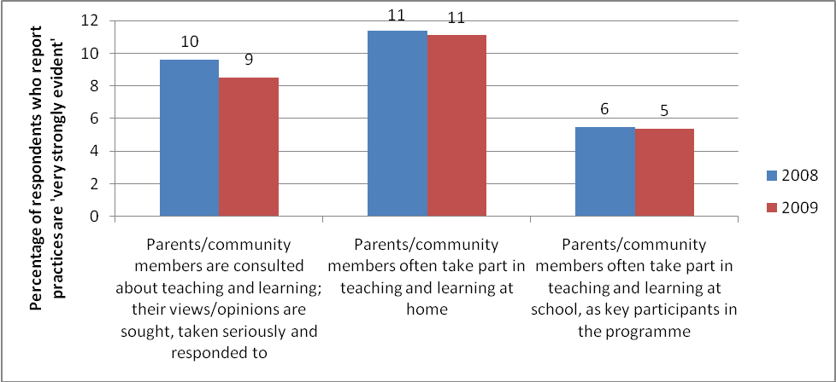
In a similar set of items, respondents were asked to indicate the frequency with which parents/community members are informed about, consulted about or collaborate in teaching and learning matters. The same pattern, in terms of frequency of participation emerged in the 2009 data as was evident in the 2008 data. More respondents reported “always” or “often” informing than consulting with parents about teaching and learning, and more reported “always” or “often” consulting than collaborating.
Figure 19: Parent/Whanau/Community frequency of participation: Informing, Consulting and Collaborating
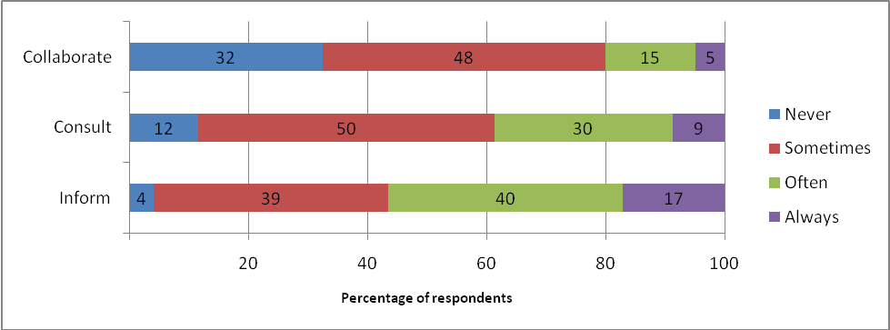
Focus group participants often signalled an awareness of the need to grapple with ways to engage parents and whanau:
A lot of the work that we’ve been talking about with trying to implement ideas from the new curriculum has been about how do you engage with your community, how you have learning opportunities that are about the community in which kids live and how do you form relationships with local businesses or pathways for kids in, between school and outside of school? (FG Secondary)
Those who described efforts at partnering with parents and communities on teaching and learning matters gave examples of community members’ expertise, and community/wider education initiatives being used:
We need to look to the outside area and community environment, I think of it as going back to what I sort of said before and how we’re bringing in problems around the area, like we’ve just done a planting with the Enviro School. (FG Primary)
Using resources that we have in our community that are relevant to our children and our children’s needs or learning needs and using experts in the community, things like that. And also involving parents, getting families more involved, if we can – you know, like Science expo. (FG Primary)
These efforts do, though, often present schools with challenges:
We tried a few different things but nothing that I’ve found to be totally sustainable. I think that things like Gateway programmes where kids are actually going out and working in communities and then coming back to school for learning and assessment to support that work out in the community, that’s really successful. But oh my god those are labour intensive and it takes a lot for a teacher or an individual in a school to connect those organisations. (FG Secondary)
I think the other thing in terms of difficulty is that we talk about students going out into the community to work or to have learning experiences, but that in itself is posing a lot of problems, administrative problems, not necessarily just from a timetable point of view but from a safety point of view. I mean I’ve just come back from a camp of 150 kids and the RAMS that we had to go through to do that was just ridiculous and every time you take a trip out, I took the girls out yesterday on a guided education programme, you know, every time you’re doing all these things there are barriers that you’re putting in the way. You know, we’ve got the Gateway programme going but, you know, you’ve got the competing balance between being in a class and bums on seats as well as going out and having the experience. So there’s all the, those sorts of things that are making things hard, to get kids out of school into you know real life. (FG Secondary)
Partnerships across school sectors were also raised by participants as an area with potential for improvement:
I would like for there to be more interaction between the two, but there isn’t, and it’s not up to me. (FG English Secondary)
But we’re finding it quite difficult here with the intermediate school to try and have a seamless programme and to actually break the barriers as well. (FG Science Secondary)

Overall understanding of curriculum change
In the 2008 web survey respondents were asked “If someone asked you 'what is the most significant change in practice required by this curriculum?' what would you say?”. Thirty-four per cent of respondents either indicated “do not know”, or did not respond. It was clear from the quantitative data a year later that educators grasp of the magnitude of change and shift required by The New Zealand Curriculum was still variable. Respondents were asked, for example, to rate on Semantic Differential scales to indicate if they understand the curriculum to be more the same or different to the previous one. The 6-point categorical responses were transformed to collate responses from the lower 3-scale points, and the higher 3-scale points as shown in Figure 20.
Figure 20: Ratings degree of change in NZC
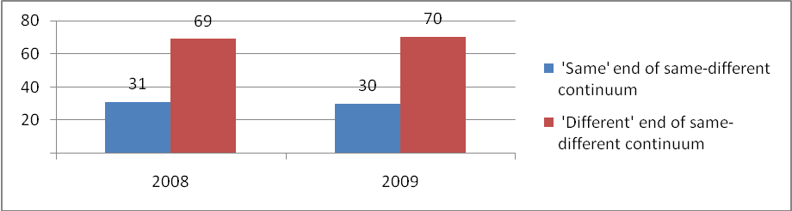
They were also asked to indicate (also on a 6-point Semantic Differential scale) whether the NZC requires few shifts or major shifts.
Figure 21: Ratings of shifts required by NZC
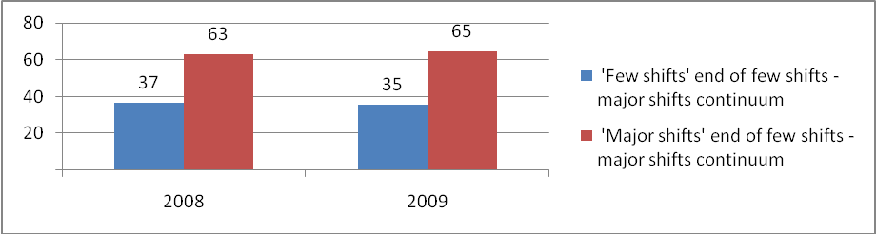
The trend overall was for respondents to recognise The New Zealand Curriculum as quite different and requiring major shifts. In 2009 a substantial proportion (around one third of respondents), however, continued to view The New Zealand Curriculum as more the same as the previous curriculum and as requiring fewer, rather than major, shifts. It may be an apparent positive finding that at least a majority recognise the call in the curriculum for a profound response to improving teaching and learning. The finding is less positive, though, when the proportion of teachers who view the curriculum as being more the same, and requiring relatively few shifts is translated into the number of students whom they teach–many thousands of students.

Assimilation: Seeking the familiar in the unfamiliar
For many, there has been a tendency to assimilate their understanding about the new curriculum into their understanding of the old one or to seek the familiar in the unfamiliar. This is often expressed as an “I already do that” kind of response when asked about new curriculum aspects:
There were not major changes as the new NZC was similar to the old, so most things just needed tweaking. (W09)
We’ve looked at the key competencies with all the units that we’re implementing and sort of identified how they fit with what we’re doing. (W09)
I think a lot of it was just the same,...For us I don’t think it’ll make all that much difference, it just seems like a lot of, kind of new-looking things coming out are things we’re already doing, just a matter of some sort of paper trail to follow. (FG Secondary)
It’s basically stuff you’ve been teaching them anyway. You know, it’s just now when we’re writing it down. (W09)
I don’t think I had to really change much in terms of how I teach them and what I’ve always taught them anyway, but I feel now all I’m really doing is making a note of it, to be honest. (W09)
Often, participants who take this view emphasise the technical and compliance-driven aspects of curriculum implementation—adjusting just the paperwork and planning documentation:
At this stage, it seems to be more of a change in paperwork rather than a change in teaching practice. (W09)
Well I’ve just found that with the curriculum, which I think is very exciting, that staff have been quite resistant to moving into a different place. What staff want – but I’m generalising – is really just an extra line that they can draw in their scheme, you know, an extra column that they can then tick. (FG Secondary Deputy Principal)
While the assimilation tendency has been unconscious for many, others have quite purposefully sought (in their work with others) to emphasise the alignment between existing practices and The New Zealand Curriculum, rather than opportunities for change and improvement:
I think that teachers, classroom teachers, give themselves a wee bit of a hard time. When I say to them, “Okay, let’s look at this particular key competency, ‘Relating to others’, how have you implemented that in your classroom to date?” – after I’ve observed them. And well, they’ll…”We were talking at the beginning of the lesson to each other, just greeting each other, okay, that’s relating to others.” “We were working in groups part of the time – that’s relating to others.” You know, and when we go through it like that, the teacher will sit back and go, “Okay, right, so it’s not so bad, I’m actually doing it, I’m actually doing the key competency of ‘Relating to others’”.
This approach is not, however, likely to deepen understandings about how to strengthen key competencies in teaching and learning (Cowie & Hipkins, 2009).

Group comparisons
A MANOVA test was used for the 2009 paper survey data to examine whether there were significant differences between respondent groups (their school’s decile, their role, the primary/secondary school levels).

School type comparison: Primary/secondary
There were statistically significant differences between primary and secondary respondents on all of the practice factors shown in Figure 22. The magnitude of the difference between the two groups is calculated as an effect size, and shown in Table 7. The difference is a moderate one for most of the factors (d = ≥ 0.4) but is large for the parent involvement factor (d = 0.93).
Figure 22: NZC practices 2009: Primary/secondary comparison
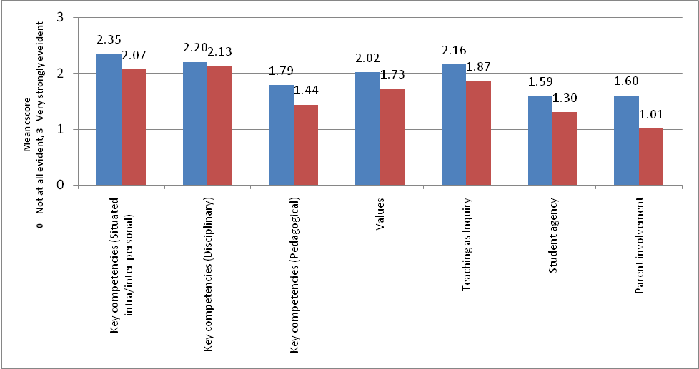
Table 5: NZC practices 2009: Primary/secondary comparison
Variable | Primary |  |  | Secondary |  |  | Effect size  (Cohen's d)
 | M | N | SD | M | N | SD
Key competencies (Situated intra-/inter-personal) | 2.35 | 763 | .501 | 2.07 | 875 | .584 | 0.50
Key competencies (Disciplinary) | 2.20 | 767 | .490 | 2.13 | 879 | .521 | 0.13
Key competencies (Pedagogical) | 1.79 | 761 | .603 | 1.44 | 875 | .632 | 0.57
Values | 2.02 | 763 | .539 | 1.73 | 878 | .634 | 0.50
Teaching as Inquiry | 2.16 | 765 | .480 | 1.87 | 876 | .512 | 0.59
Student agency | 1.59 | 762 | .663 | 1.30 | 875 | .709 | 0.42
Parent involvement | 1.60 | 757 | .611 | 1.01 | 860 | .664 | 0.93

Roles comparison: Teachers/principals
There were statistically significant differences between the response of principals and teachers on all of the practice factors shown in Figure 23. The magnitude of the difference between the two groups is calculated as an effect size, and shown in Table 8.
The difference is small for key competencies (disciplinary), (d = 0.20) and moderate for all of the other practice factors (d = ≥0.4).
Figure 23: NZC practices 2009: Teachers/principals comparison
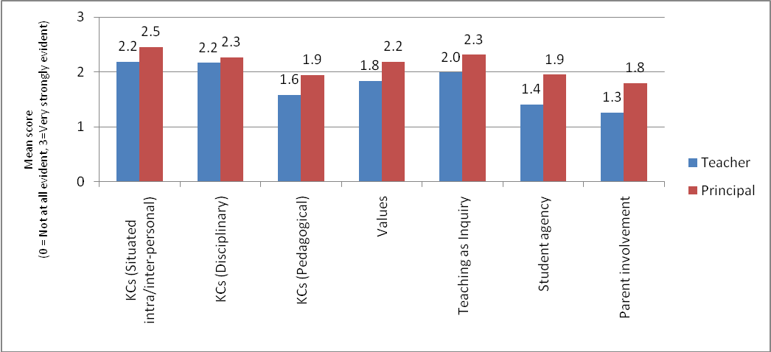
Table 6: NZC practices, regard and confidence 2009: Teachers/principals comparison
Variable | Teachers |  |  | Principals |  |  | Effect Size  (Cohen's d)
 | M | N | SD | M | N | SD
Key competencies (Situated intra-/inter-personal) | 2.18 | 1622 | .561 | 2.46 | 70 | .557 | -0.49
Key competencies (Disciplinary) | 2.16 | 1631 | .504 | 2.26 | 70 | .548 | -0.20
Key competencies (Pedagogical) | 1.58 | 1622 | .631 | 1.94 | 69 | .720 | -0.57
Values | 1.84 | 1626 | .609 | 2.19 | 70 | .591 | -0.57
Teaching as Inquiry | 1.99 | 1628 | .515 | 2.31 | 70 | .474 | -0.62
Student agency | 1.41 | 1623 | .700 | 1.95 | 69 | .743 | -0.77
Parent involvement | 1.26 | 1602 | .697 | 1.80 | 70 | .686 | -0.77

School decile comparison
Differences between 2009 respondents working in low, mid and high decile schools were not marked. The only statistically significant differences were on the Teaching as Inquiry factor and the Student agency factor (with respondents from low and decile schools rating slightly higher than respondents from both mid and high decile schools). The magnitude of the differences on these factors (see Table 9) was small.
Figure 24: NZC practices: Low decile/mid decile comparison
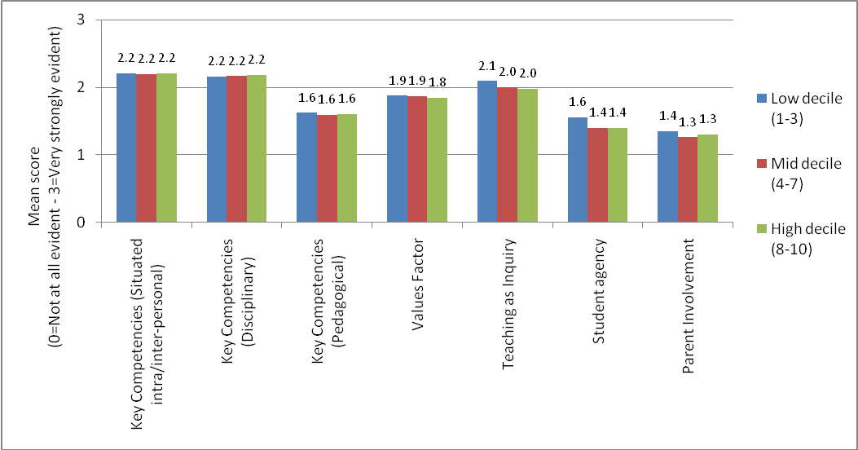
Table 7: NZC practices: Respondents’ school decile comparison
 | Respondents’ Decile Effect Size Comparisons
 | Low decile - Mid decile | Mid decile - High decile | Low decile - High decile
Teaching as Inquiry | 0.19 | 0.03 | 0.22
Student agency | 0.23 | 0.00 | 0.22

School curriculum design and review
A key feature of The New Zealand Curriculum is its emphasis on school-based curriculum, and the process of design and review. At the end of 2008 the majority of principals had reported having reviewed the “front-end” aspects of the curriculum – values, principles, key competencies, and fewer reported having reviewed pedagogy or the “back-end” of individual learning areas. One year later, more principals reported having reviewed all elements, and the pattern is much the same (with greater attention to the front than the back end).
Figure 25: Review of curriculum elements: 2008–2009
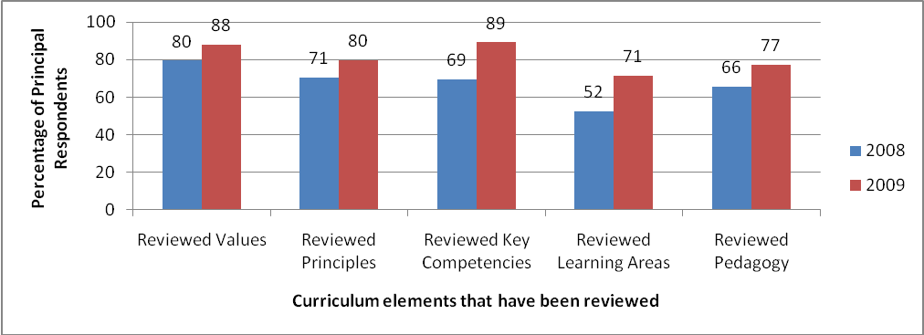
While the shift between 2008 and 2009 indicates some progress, there remain 10-20% of schools who have not yet reviewed values, principles or key competencies in their school’s curriculum, 23% that have not reviewed pedagogy, and 29% that have not reviewed the individual learning areas in light of The New Zealand Curriculum. Many of those who carried out thorough reviews speak positively about the process and outcomes:
Implementing NZC has given us the opportunity to think clearly about what we are teaching and the purpose of the learning. We have redirected our thinking around subject-based teaching to global or overarching themes. Inquiry will form part of the teaching and learning platform but will not be the only way in which we deliver our curriculum. The NZC in our school will be a work in progress as we begin to implement it in 2010. Reflection and review will always be an integral part of ensuring we are meeting the needs of all of our students. (Web09)
We’ve identified areas that we need to work on and we can tailor how we deliver the curriculum to meet those needs and that’s – that’s the freedom of the new curriculum, you know, that we can take advantage of and get a lot out of. (FG Primary)

Curriculum principles in practice
The New Zealand Curriculum requires schools to implement a curriculum for their students that is “underpinned by and consistent with the principles”. Respondents to the web survey were asked to indicate the principles that are most and least emphasised in their school’s curriculum.
Figure 26: Most emphasised curriculum principles as indicated by principals
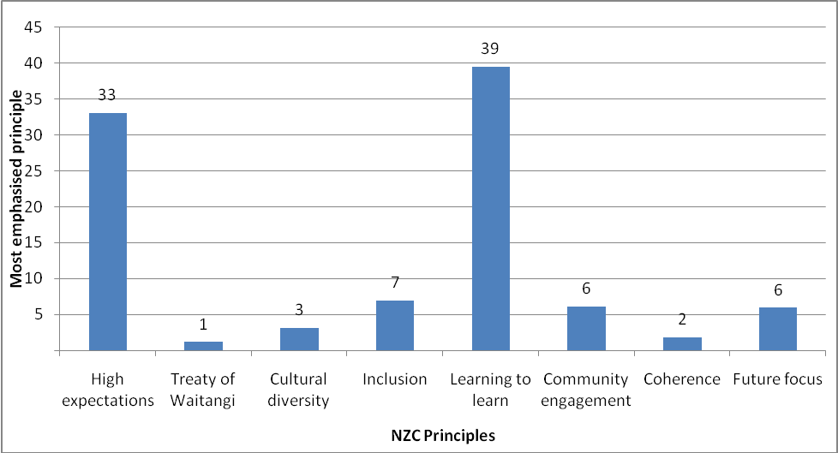
The findings indicate a pattern of emphasis on the learning to learn, and high expectations principles, with significantly fewer schools indicating that most emphasis is on inclusion, community engagement, future focus, cultural diversity, coherence or the Treaty of Waitangi. To find out more about how educators are interpreting these principles, respondents to the 2009 web survey were asked to give an example of their most emphasised curriculum principle in action. A selection of examples for the two most predominant principles is outlined below.

High expectations
Many of the examples about high expectations in practice related to the provision of support, and the establishment of particular support roles for focusing on student achievement:
All Yr 11 students are supported one-to-one where required so that they are able to achieve NCEA L1 Literacy & Numeracy Credits.
The teacher who spends time in advising students on how they can improve the quality of their work from an A grade standard to an M or E and then facilitating those students to achieve those improvements.
Role of an academic dean has been introduced—students are tracked and they seek to achieve.
High expectations from all students, teachers. Striving to continually to improve. Have introduced colleagues going into classes to observe and discuss changes to their practice.
Others emphasised the shared nature of expectations, between various stakeholders:
Conversations with parents, students and teachers emphasise the high expectations we have for all students. We stress X is here and together we want to move to here...
Data was mentioned by many as being critical to the principle of high expectations:
Continual analysis of data to address weak areas, making example of good practise of children at assemblies and staff meetings. Staff visiting other good practitioners in other schools, good PD.
Others gave examples in which high expectations are incorporated into specific goal and target-setting activities:
Our school code of conduct is "To Achieve Personal Excellence we...". We use rubrics, set targets etc.
Reports to individual students which emphasise the need for goal setting and the personal benefits of striving to achieve.
Each student will make progress. Teachers can make a difference. Specific achievement targets and data gathering for each learning area each year.

Learning to learn
Many respondents talked about learning to learn being promoted through the development of planning structures based around the key competencies:
In our school we have a Key Competency focus that runs through the school each term as a classroom/school focus.
Others emphasised the use of inquiry learning approaches as a means of giving effect to the learning to learn principle:
Using inquiry learning — teaching children the skills they need to investigate a question they have and want to answer.

Considerable emphasis on student led enquiry and students taking charge of their own learning.
Inquiry learning — teaching children to question and to wonder.
Assessment was raised by many as a key example of learning to learn happening:

Assessment for learning, self review, reflective practice.
Emphasis on explicitly unpacking the key competencies using AFL practice so students learn more about themselves at learners.

Student led conferences.
Some examples signalled the use of metacognitive strategies:
Children writing a reflective journal on their learning and identifying what they need to do next.
For others, the use of authentic learning contexts and the real application of learning were the strongest examples of the learning to learn principle in action:
Students carrying out a market of produce made, costed and sold by them as an authentic experience.
Hands-on direct experience learning.
School and community garden competition is involving children in sharing ideas and resources with community members, businesses, etc.
Most recently children and myself working on solving a school wide problem – head lice. We developed a website around teaching children how to deal with it. Children learning from adults, children teaching children and all working together using a range of ICTs to create a child friendly website.
Teacher modelling of being a learner was mentioned by several respondents:
Teachers and learners alike need to model life-long learners. Teachers doing critical inquiry with student learning.

Day-to-day practice: Change to classroom practice and reporting
Respondents were asked to indicate on a 6-point scale, the extent of change to various aspects of day to day practice (0, have not considered – 5, made substantial changes). Figure 27 indicates the percentage of respondents in 2008 and 2009 who reported making moderate or substantial changes to their practice.
There was an increase between 2008 and 2009 in the percentage of educators reporting moderate/substantial change. More than half of the respondents indicated (in 2009) that they had made moderate or substantial changes to their planning or to the approaches and activities used. Between one third and one half of respondents indicated moderate or substantial changes to the remaining aspects of practice. There are still many respondents (between 40% and 68%) who have not yet made moderate or substantial change on these aspects of teaching and learning.
Figure 27: Moderate or substantial changes to practice
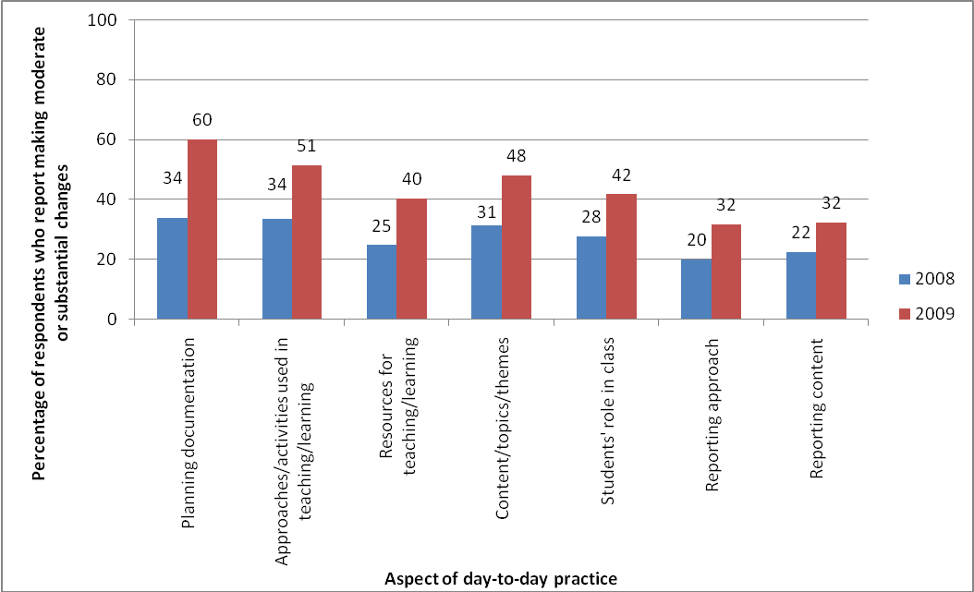
Reports of change, however, require cautious interpretation since they do not necessarily indicate changes that are in line with the direction of The New Zealand Curriculum. The following responses to a question on the 2009 web survey, which asked for examples of the most significant change in practice, give an insight into the nature of some of this change.

Planning documentation
Reworking of old units and creation of new units to better match the key competencies etc of The New Zealand Curriculum.
Matching the assessments to the new levels, rewriting the scheme and course outlines so we are teaching processes rather than facts.

Approaches/activities used in teaching and learning
I have increased the amount of "hands-on" investigative work, and reduced the written exercise component.
I use more group work and enquiry-based learning. I focus less on the content and more on the understanding and trust that this will get the students through their exams (hopefully!!).
Differentiated learning and assessment including more self and peer assessment as a powerful form of formative assessment.

Resources used
Importance of local knowledge and use of community facilities — back to the teachable moments – using experiences that are happening around.

Content/topics/themes
To respond more to the learning needs of students rather than take units and lessons from a book.
Ensuring that all learning experiences are set in a real life context — clearer understanding of why we are doing this.

Students’ role
Children engaging with students, teachers and parents to discuss what they are learning and how they see themselves as learners.

Reporting approach/content
Looking at our portfolios and considering what we put in them — how can we implement the NZ curriculum and report to our parents more effectively on student achievement?
The change in reporting to parents and the board to be more inclusive of the features of our vision for the school.

Findings: Support for Implementing The New Zealand Curriculum

What help have educators had to learn about The New Zealand Curriculum?
Findings about the support that educators have had to implement The New Zealand Curriculum are reported, mainly, against three aspects (or factors) of support – internal support encounters, external support encounters and support quality. Internal support encounters are those that are available (typically) at any time within each school. External support encounters are those that require special arrangements to be in order to access the support. These aspects are organised in this way since a factor analysis of both the 2008 and 2009 paper survey data revealed these items to hang together in a common factor structure when all of the individual items were analysed.
Table 8: Items included in support factors
Support factors | Items included in the factor
Support encounters: internal | Colleagues from own school  Ministry of Education publications  NZC website  NZC document
Support encounters: external | Advisors  Private consultants  Facilitators from other initiatives  Colleagues from other schools
Support quality | Waste of time – Productive  Irrelevant – Relevant  Tedious – Stimulating  Flawed – Sound

Responses to the support encounter items were on a 4-point scale (0–3) to indicate the number of times each support type had been encountered since the launch of the NZC:
0 – Not at all
1 – 1–2 times
2 – 3–5 times
3 – 6+times
Responses to the support quality items were on a 6-point Semantic Differential scale, with the negative scale point scoring 0 and the most positive scale point scoring 5.
In both 2008 and 2009, there was a trend for far greater engagement with supports that are available internally (both colleagues and resources) than with external support (advisors, consultants, facilitators or colleagues from other schools). The mean for external support encounters was close to the “1–2 times” scale point while the mean for internal support encounters was close to the “3–5 times” scale point.
Figure 28: Support encounters: 2008–2009
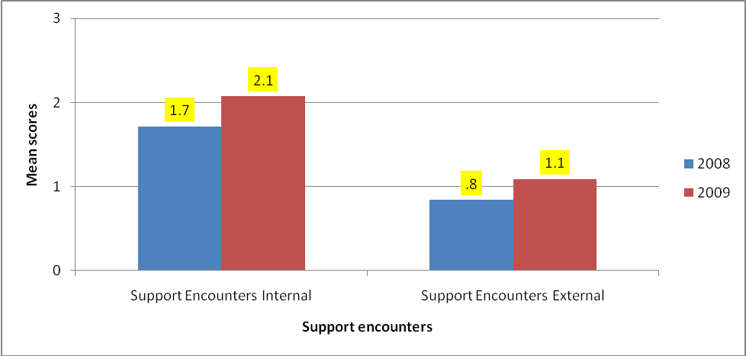
The emphasis on internally available support is highlighted in the following scenario described by a Primary school team leader. She describes a whole school teacher-only day approach to dealing with the “front end” of the document, followed by staff meetings focused on other aspects (in this case learning areas), led by school-based staff who have looked to The New Zealand Curriculum website as a resource.
Participant: So we’ve had two teacher-only days about the curriculum; one last year and one this year, and they’ve been really focused on unpacking the new curriculum and looking at it from the point of view of our school. So what we wanted to do was set up a document that was the NZC curriculum as [our school] sees it... So we [the curriculum team and the associate principal] set up what we’re going to do and what direction we’re going to take it in and we’ve done it over a variety of sessions. So we’ve done for instance at staff meetings, we’ve done one learning area a staff meeting. So at the beginning of the staff meeting we set out which learning area we’re talking about, how we see that learning area in our classrooms, how we all know that we’re teaching it effectively. The values and visions and things we’ve really left for the teacher-only days because they’re a little bit longer to do.
Interviewer: So where has your professional development come from, to enable you to do that?
Participant: Nowhere really. That’s been a self-taught scenario. So I tend to read articles on the NZC website.
A typical pattern was for schools to work on the “front-end” of the document initially, and many are now beginning to consider the learning areas:
We’ve done the values and unpacked the first part, but we’re doing the learning areas, the curriculum areas next year. Coming up, that’s going to be our big goal. It’s been really good, a good discussion and working and getting things together and the values especially, that took quite a bit of community involvement, all those sorts of things. So yes, I think that we’re feeling quite supported with the new document.
A secondary teacher gave a similar example of internal/school-based support for implementation:
We have professional development every week on a Wednesday morning before school. So the kids start an hour late, which is pretty common in secondary schools these days and we’ve had time during that time to look at the new curriculum this year. They’ve done a lot. (FG Secondary)
The frequency of encounters with the various internal supports is outlined in Figure 29. This shows an increase between 2008 and 2009 in those engaging in a more sustained way (6+ times) with each of these support types.
Figure 29: Frequency of encounters with internal supports
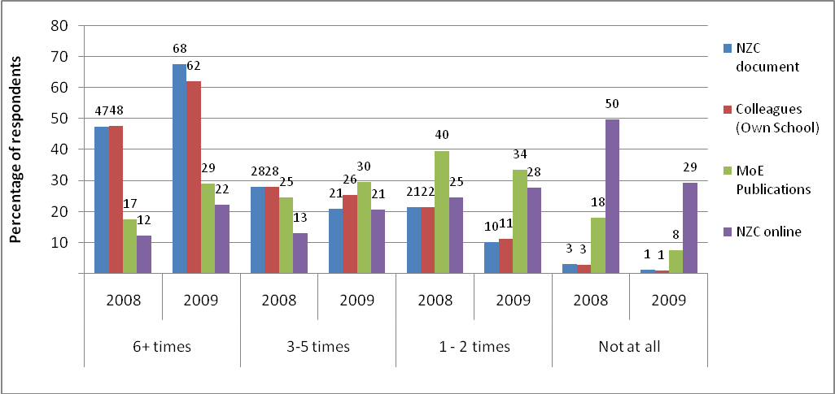
Figure 30: Frequency of encounters with Te Marautanga o Aotearoa and Best Evidence Syntheses
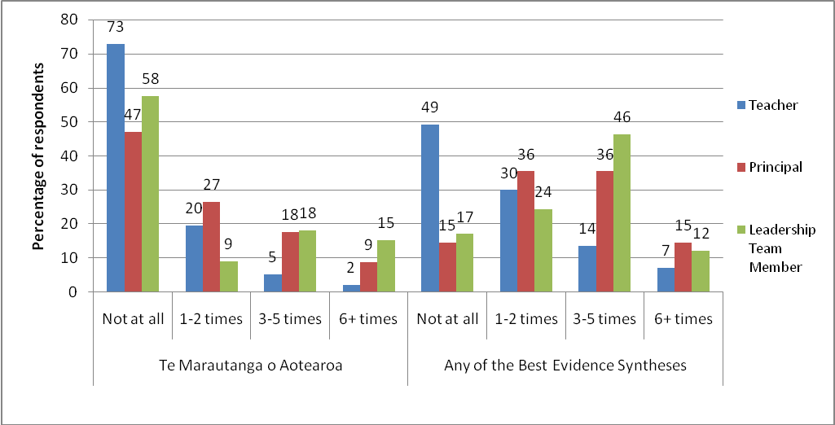
Focus group participants in the first year of the evaluation also reported two additional types of document that were providing support for curriculum implementation: the Best Evidence Synthesis series, and Te Marautanga o Aotearoa. For this reason, items about these were included in the 2009 paper survey. These items were analysed by role (see Figure 30) to indicate the extent to which teachers, principals and other leadership team members had engaged with these documents.
A large proportion of teachers, principals and leadership team members reported not engaging with Te Marautanga o Aotearoa at all. Teachers in particular had engaged less with Te Marautanga than others. Just over a quarter of principals (27%) and a third of leadership team members (33%) had referred to Te Marautanga more than three times, but only 7% of teachers reported the same level of engagement.
Slightly more than half (51%) of the teacher respondents reported engaging with a Best Evidence Synthesis at least once to support their implementation of The New Zealand Curriculum. Slightly more than half of the principal respondents (51%) and other leadership team members (58%) used a Best Evidence Synthesis three or more times.
Comparison of the frequency of encounters with internal supports (see Figure 29) and external supports (see Figure 31) shows that educators are far more likely to have had more frequent encounters with internal than external supports for curriculum implementation.
Figure 31: Frequency of encounters with external supports
Advisors
Colleagues
(Other Schools)
Facilitators
(Other initiatives)
Private
Consultants
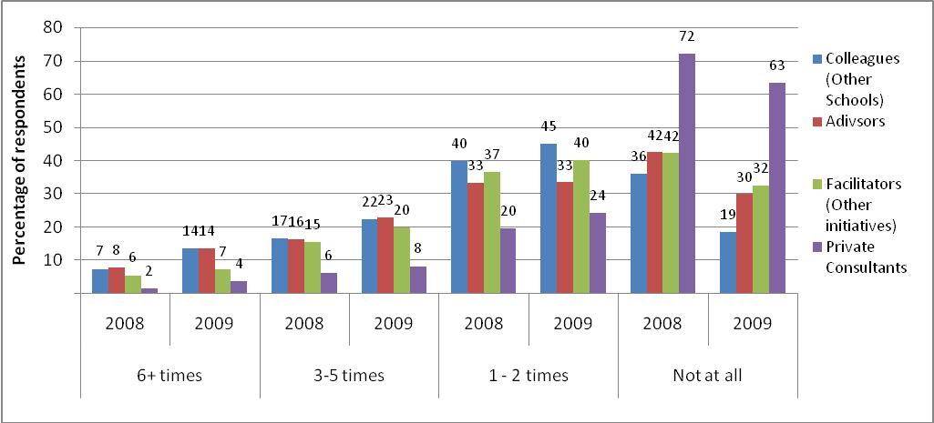

Opportunities to access sustained support (6+ times) with advisors was also raised as a point of frustration in participants’ comments:
When the government decides to slash Team Solutions people who are the experts, then where does it leave us who are out here in the school with this document in front of us, going, “How do I implement this?” (Secondary teacher)
I think having more support for Gisborne in general would be extremely beneficial to schools. We share ideas across schools but still require training/support/strategies from the 'experts'. We recently had ERO and they questioned some of our decisions and where we were up to and it became apparent that we weren't where we thought we were up to! How do we know if we don't have external input? (Web09)
In 2009 more educators (56%) continued to view the quantity of support provision on the miserly, rather than the generous, end of the continuum (see Figure 32).
Figure 32: Views of the quantity of support provision: 2008–2009
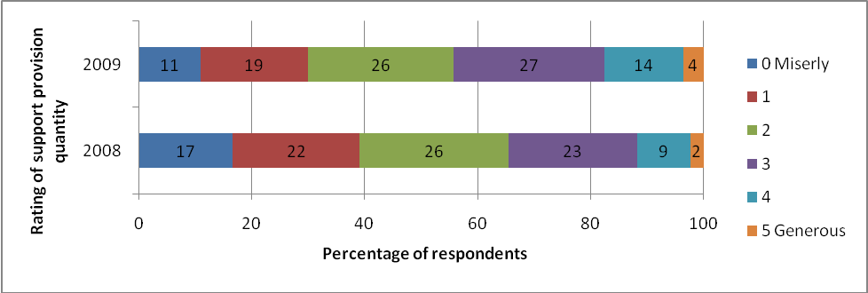

How do educators describe the quality of the support they have had to learn about The New Zealand Curriculum?
Support quality was rated slightly higher in 2009 than it was in 2008.
Figure 33: Support quality: 2008–2009
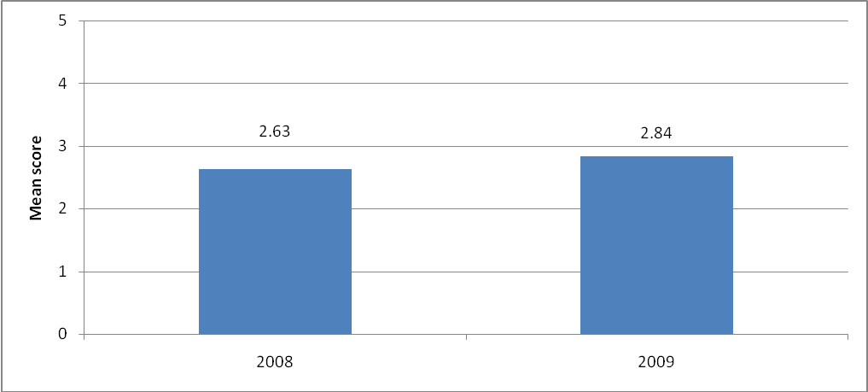
The overall support quality findings (see Figure 33) reflect responses to all support quality items (see Figure 34), including those about how productive, relevant, stimulating and sound support has been.
Figure 34: Support quality items: Mean response
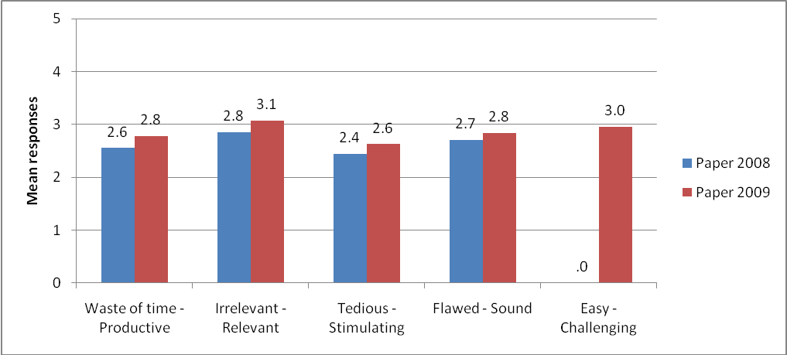
The ratings for support quality items were on 6-point Semantic Differential scales which had a negative anchor at one end, and a positive anchor at the other. Respondents indicated at one of the six scale points to indicate their view. Ratings were collapsed to indicate the percentage of respondents who viewed support quality at the negative end of the scale, or the positive end (productive, relevant, stimulating and challenging) of the scale.
Figure 35: Support quality items: Percentage of respondents at positive and negative end of continua
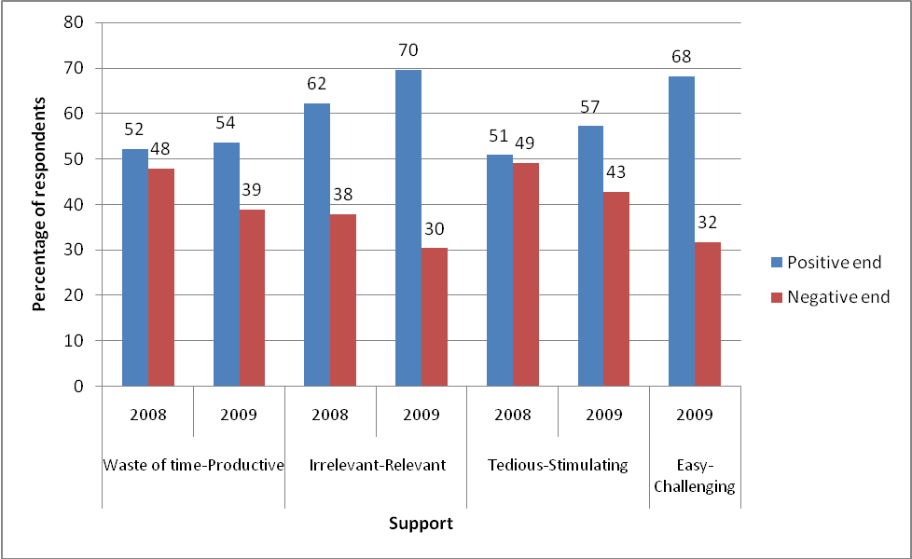
In 2009 the aspect of support quality with the greatest proportion of respondents at the positive end of the continuum was relevance (70%) indicating that support tends to be considered relevant to the task of curriculum implementation. The aspects with the greatest proportion of respondents at the negative end were on the items with tedious (43%) and waste of time (39%) as the negative anchors. These findings indicate that approximately one third of respondents in 2009 (and close to half in the case of tedious-stimulating) continue to view their experience of support as more low than high quality.
Comments about high quality support were often made about individuals within schools and nationally esteemed experts whose expertise has been valued by those working in schools:
I think it’s excellent. The people who are leading it at our school, she’s an AP, and that’s her focus, and um I think she’s been tremendous. Also we’ve been bringing our reporting in with the standards, or the possible standards, prior to the knowing them, so she’s been doing a lot of work with that as well... I feel very confident that she knows what she’s doing.
Criticism related to the quality of externally available resource material:
I think a website is a good idea, because of course you can access that at any time. Perhaps what they need to do is have something that says – be more discriminatory about what they’re putting on it. I was going to say have something that’s sort of from a panel, so you have a panel of experts, so you might have, I don’t know, [academic researcher named] and she runs all the discussion about the key competencies. So I think it needs to be something that says, ‘these are the experts in their field and this is the kind of guidance that you can have.’ ‘These are [the people], if you want to ask questions, then you ask questions.’ I just feel like what happens is they get a potpourri of stuff and they just stick it all on there and some of it seems to be of varying quality.
And also to the theoretical rather than the applied nature of resource material:
There’s a lot of documents out there about the key competencies and why they’re necessary and what we should have and how they’re gonna contribute to our kids’ learning, but there’s very little advice on how you actually put them into the curriculum yourself.
Many comments referred to individual nationally esteemed experts whose expertise has been valued by those working in schools.

How have the materials, resources and programmes supported schools and teachers to make changes?
Responses to support quality items were used to group respondents as reporting low, mid or high quality support for curriculum implementation. A very clear pattern emerged when the responses by those groups to all other factors were compared. Those who reported higher support quality also reported higher ratings for practice (see Figure 36), change (see Figure 37), regard and confidence (see Figure 38) and those differences are all statistically significant.
There were marked differences in all factors (relating to support, receptivity and practice) between those indicating high and low quality supports. In all cases, the effect size calculations showed the difference between low and high quality support groups to be moderate or large (see Table 11).
The Key competencies (pedagogical) (d = 0.88), Parent involvement (d = 0.80), Teaching as Inquiry (d = 0.79), Student agency (d = 0.77), Key competencies (situated intra-/inter-personal) (d = 0.70), Values (d = 0.69) and Key competencies (disciplinary) (d = 0.40) factors all had large or moderate effect sizes. There was a moderate difference between the groups on extent of change to reporting (d = 0.75). There were large effect sizes for the differences between groups on extent of change to classroom practice (d = 0.87), regard (d = 1.55), and confidence (d = 1.29).
Figure 36: NZC practices 2009: Low support quality/high support quality comparison
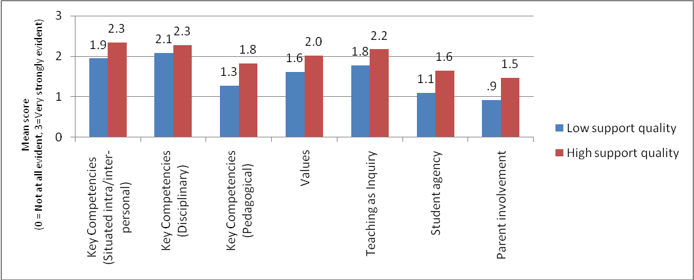
Figure 37: NZC changes to practice: Low support quality/high support quality comparison
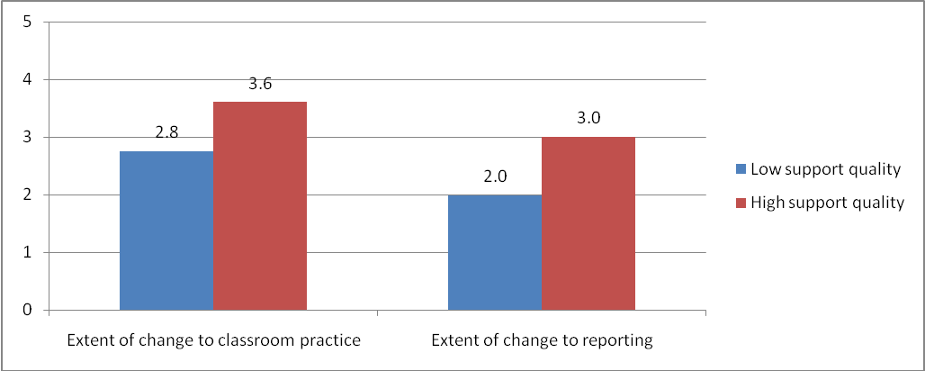
Of all the factors considered, the differences in ratings between those indicating high and low quality support were greatest for regard (d = 1.55 )and confidence (d = 1.29 ) which both had very large effect sizes.
Figure 38: NZC regard and confidence: Low support quality/high support quality comparison
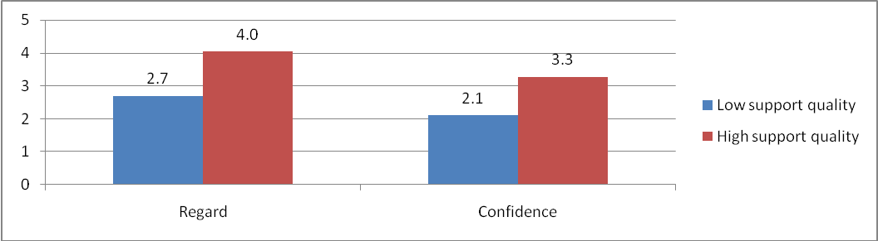
Table 9: Practices, regard and confidence 2009: Low quality support/high quality support comparison
Variable | Support Quality Low |  |  | Support Quality High |  |  | Cohen's d Effect Size
 | M | N | SD | M | N | SD
Key competencies (Situated intra-/inter-personal) | 1.9459 | 228 | .67723 | 2.3380 | 532 | .50154 | 0.70
Key competencies (Disciplinary) | 2.0801 | 229 | .53634 | 2.2757 | 535 | .47498 | 0.40
Key competencies (Pedagogical) | 1.2712 | 228 | .69483 | 1.8248 | 530 | .59841 | 0.88
Values | 1.6100 | 228 | .68087 | 2.0238 | 535 | .56801 | 0.69
Teaching as Inquiry | 1.7769 | 229 | .56955 | 2.1725 | 533 | .47143 | 0.79
Student agency | 1.1004 | 229 | .71540 | 1.6474 | 529 | .70308 | 0.77
Parent involvement | .9230 | 223 | .71881 | 1.4696 | 526 | .66985 | 0.80
Extent of change to classroom practice | 2.7607 | 228 | 1.13101 | 3.6067 | 542 | .89833 | 0.87
Extant of change to reporting | 1.9842 | 221 | 1.33177 | 3.0038 | 533 | 1.38092 | 0.75
Regard | 2.7012 | 222 | 1.15146 | 4.0390 | 543 | .71608 | 1.55
Confidence | 2.1031 | 223 | 1.07327 | 3.2716 | 541 | .82668 | 1.29

Barriers
Respondents to the web surveys were asked to indicate on a 0–5 scale the extent of potential barriers (0, not a barrier – 5, an extremely serious barrier) to curriculum implementation. Lack of time, expertise availability, and high quality support were rated by teachers as the most serious barriers. For nearly all items (except web-based support) the barrier rating became less serious in 2009 than it was rated in 2008 (the “high quality support for implementation” item was included in 2009, but not in 2008) as shown in Figure 39. Information about the curriculum is considered the least likely to be a barrier, with a notable improvement between 2008 and 2009.
Figure 39: Mean scores for teacher ratings on barriers to NZC implementation: 2008–2009 comparison
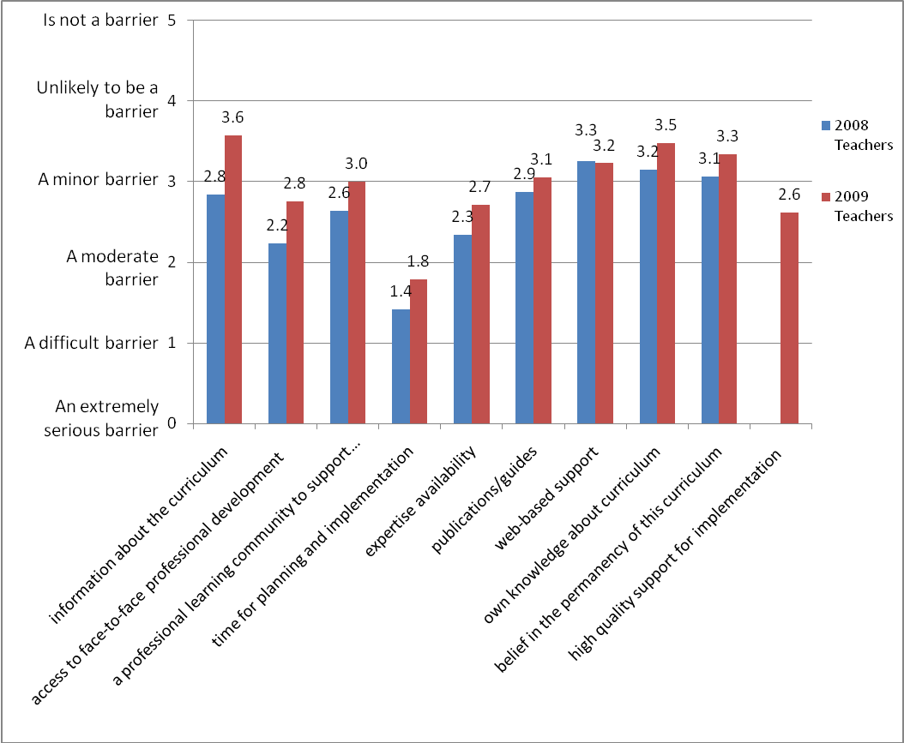
While the improvement in the mean scores for barriers between 2008 and 2009 is clearly positive, there remains a perception by a significant proportion, that lack of various supports are preventing curriculum implementation efforts. More than two thirds (67%) of respondents to the 2009 web survey indicated that lack of time for planning and implementation is still a notable barrier (moderate, difficult or extremely serious), 43% for lack of expertise, 44% a lack of face-to-face support and 37% lack of a professional learning community.
Figure 40: Percentage of respondents rating barriers to NZC implementation as ‘Moderate’, ‘Difficult’ and ‘Extremely serious’: 2009
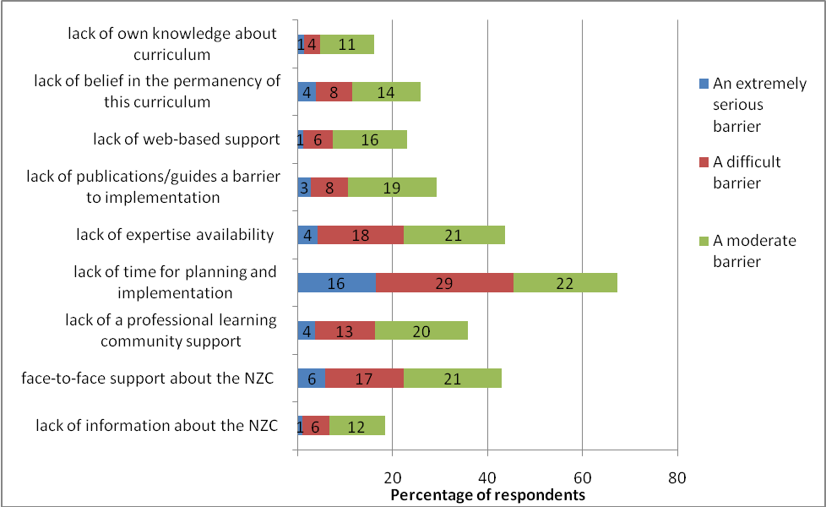

Supportive educational contexts
Three other important considerations were raised repeatedly in focus group sessions as participants talked about what had enabled or constrained their capacity to implement the curriculum—leadership, competing demands and school structures and systems.

Leadership
The importance of school leadership, and in particular, leaders’ capability to lead others’ curriculum learning, was raised by many:
Any change takes time and many people take a lot of time to change. It is frustrating to hear about some of the approaches schools are taking which amount to nothing more than clip-on activities. Sadly a lack of intellectual grunt is missing at the management level of many schools. (W09)
That’s my biggest thing with being, leading professional development is trying to inspire teachers to recognise that they are presenting a model of the ultimate learner. You know, they’ve got their own subject area about which they are incredibly passionate and they’re a great learner and that, but being a teacher is about trying to um inspire people to want to learn anything. And in order to do that, you have to be the best learner you can be yourself and model that for the kids, show them how you learn. (FG Secondary AP)
Many leaders acknowledged that their own understandings may not yet be deep enough to support others in the best way:
Well I was thinking, I think if there were examples of relating to others and how it’s been explicitly taught, people might actually be able to identify or not identify with it much easier. I mean I’d like to—I was just about to ask you, what is an example then of explicitly using the key competency of relating to others? Because I myself, I’m sitting here going, off the top of my head, I’m not sure if I can think of something. (FG Secondary AP)
It’s not just me but it’s all of us in a way isn’t it? [that need more information]. I mean I would class myself as a member of staff who actually has a pretty good grip of what is actually in the book, in having spent a lot of time dealing with it, but there are a lot of staff who haven’t got to that stage and to help them, I need to have the tools to help them as well. (FG Secondary AP)

Competing demands
Throughout this evaluation, competing demands of assessment/qualifications and curriculum have been raised by secondary participants as a barrier to implementation.
I was just going to ignore all that thing [the curriculum] and just go with what’s asked for in the achievement standards, then that’s what I’m going to teach and so they pass and that’s it. (FG Secondary)
We are completely governed—although we shouldn’t be but we are, by assessment. (Secondary teacher)
I actually think there is a conflict between the new curriculum and assessment full stop, because one is confining, and that’s the assessment, and the curriculum is trying to open new horizons and let us run with it. And as long as you require a national examination system for senior school, you’re going to put the brakes on that. It’s just the nature of it. (Secondary Deputy Principal)
The introduction of National Standards to the primary sector led many participants to express serious concerns about what they perceived to be competing demands of The New Zealand Curriculum and National Standards. This was raised in all of the focus groups held immediately prior to and at the time of the announcement of the National Standards policy, and by 10% of the respondents to the 2009 web survey who chose to make a comment in a “general comments” section of the survey. They describe reduced confidence, commitment and momentum in curriculum implementation as consequences of the perceived conflict:
There are mixed messages out there at the moment in relation to policy direction. This is causing unrest and uncertainty! (W09)
Keep the National Standards out of the equation and let the schools develop their curriculum in line with the essence of NZC. It is the best thing that has happened in Education for a long time, don't allow it to be dumbed down by schools worrying about the possibility of league tables and being judged by very narrow criteria. (W09)
It will be interesting to see how the largely unprescriptive curriculum works alongside a largely prescriptive national standards measurement of achievement particularly for students who have Special learning needs at primary school level. (W09)
It’s a great curriculum and one to be proud of. I just hope those ill-informed and flawed National Standards don't dilute it and cause our enlightened 21st century education system to revert to a 19th century model!!!!! (W09)

School structures and systems
In several focus groups, discussion turned to the organisational structures and systems that may need re-considering in light of the possibilities presented by The New Zealand Curriculum:
The structures within schools and people who have been doing the same things year on year and you’ve got all those textbooks and you’ve got four hours of work or you’ve got whatever you’ve got traditionally, that’s quite hard to turn all of that on its head.
For many the timetable, in secondary schools in particular, is viewed as a constraint to curriculum implementation:
I also think the timetable structure is a huge constraint. You have a group of students for an hour and you just get started and then they’ve got to drop and go to something which is completely different. And I think that helps stop the continuity of actually being able to work with them to work out what it is that as you say they can choose to do that. (FG Secondary)
They are always feeling that they are under time pressure at secondary school. Um your students taking eight—eight subjects, perhaps up to ten in the junior school; different hour every day doing something different, I think that that doesn’t allow them to develop things either. And doesn’t allow them to become really engaged in a lot of it. Some of the classes get to the point where they’re lining up to try and get out of the room at ten to ten to go to the next class at ten o’clock and you say to them, “What’s so good next period that you want to rush out of here,” and they look at you as if to say, “Well that’s not the point, we just know we’ve got to move on.” You know they’re not actually um going to the next subject because they really want to go there, or they’ve really hated what they’ve just had, it’s just this treadmill. It’s a treadmill day, and I think that’s one of the biggest constraints in secondary school, is the fact that they don’t get time. (FG Secondary)

Findings: Relationships between Support, Receptivity and Practice

What explains curriculum implementation progress?
To inform the question about what explains the degree of progress in curriculum implementation, a series of stepwise linear regressions were carried out, examining the relationship between the support, receptivity and practice variables. Regression is used to test the effects of independent (predictor) variables on a single dependent (criterion) variable. For the purposes of these regressions the multiple practice variables (as reported in the group comparisons section) were substituted for a single practice scale (α= 0.92) that incorporated all 23 practice items, and was the dependent variable in the first regression.

What predicts practice?
When practice was taken as the dependent variable, confidence (β = 0. 134), support quantity: internal (β = 0. 119), support quantity: external (β = 0. 105), support quality (β = 0. 051), and regard (β = 0. 053), collectively accounted for 26% of the variance in practice. Using a 2-factor model (since the effects of regard, support quantity: external and support quality were so small), confidence (β = 0.199) accounted for 16%, and internal support quantity (β = 0. 199) for a further 6% of the combined 22% variance in practice (see Figure 41).
Figure 41: Regression summary: Practice as dependent variable
Confidence
(16%)
Practice
Support Quantity: Internal (6%)
Teachers’ accounts of shifting their practice also referred to the role of confidence, and in particular to the relationship between curriculum language and confidence:
I think confidence is often related to language. I can remember the first time we saw the pedagogy [section] in a staff meeting...it was a word that people weren’t familiar with and comfortable with using. And I think that within the document itself, as new ideas are introduced, becomes necessary for teachers to change the language that they’re using for discussion and that’s a part of the confidence too. When you can use the evidence and you can speak the speak, it helps you with the confidence in terms of delivering that particular part of the curriculum. (DP Secondary focus group)
Many teachers, particularly those from the secondary sector whose programmes were previously determined largely by prescriptive syllabi, explained the impact of reduced prescription (the automatic consequence of the new curriculum’s increased flexibility) on teacher confidence:
It sort of destabilises. People don’t feel confident that they know exactly what they’re going to be doing, and I think that’s the issue...we don’t know what we’re going to be doing. We heard that year 11 were going to not teach micro-organisms and we’re going to put something else there, but what’s going to go there? At the moment there’s a big question mark, so it’s specifics. I think teachers like to deal with nuts and bolts and certainly in Science [to know] exactly, down to the lesson, what you’re going to be doing. I looked at this curriculum and thought, yeah great aspirational statements and things, but it’s how to get from A to B and to the day-to-day running that is quite scary. (Secondary Science focus group)

What predicts confidence?
Given that confidence was, of the variables considered here, the most predictive of practice; it was deemed appropriate to treat the confidence factor as the dependent variable in the next linear regression to examine predictors of confidence. When confidence was taken as the dependent variable, regard (β = 0. 582) accounted for 46% of the variance in confidence, and support quality (β = 0. 105) accounted for the additional percentage in the total 47% of the variance predicting confidence (see Figure 42). The factors for support quantity, both internal and external, were not shown in the model as predictors of confidence.
Figure 42: Regression summary: Confidence as dependent variable
Regard (46%)
Confidence
Support Quality (1%)
The relationship between regard and confidence was also evident in the qualitative data as can be seen in the following comment that progresses from praise for the curriculum itself, to confidence in making change:
We are at an exciting time in our history with education. I am so motivated and enlightened with the pathway put forward with the New Zealand Curriculum and feel confident and passionate about the change that is happening. (Web09)

What predicts regard?
Given that regard was, of the variables considered here, the most predictive of practice; it was deemed appropriate to treat regard as the dependent variable in the next linear regression to explain what predicts regard. When regard was taken as the dependent variable, support quality (β = 0.404) accounted for 24% of the variance in regard, and internal support encounters (β = 0.203) accounted for the additional 2% in the total 26% of the variance predicting regard (see Figure 43).
Figure 43: Regression summary: Regard as dependent variable
Support Quality (24%)
Regard
Support Encounters: Internal (2%)
When the findings from the series of linear regressions are considered together, a picture emerges of important influences on key aspects of implementation. Findings from all of the regression analyses are summarised in Figure 44.
Figure 44: Regression summary: Predictors in curriculum implementation
Support Quality (24%)
Regard (46%)
Confidence
(16%)
Practice
Support Quality (1%)
Support Quantity: Internal (6%)
Support Encounters: Internal (2%)
This suggests that support (both quantity and quality), unsurprisingly, does not have a direct and certain relationship with shifts in practices that reflect The New Zealand Curriculum. Rather, high quality support functions to improve the regard educators have for the curriculum, in ways that increase their confidence, which in turn contributes to their ability to give effect to the curriculum in their practice. It also shows the importance of regard—educators’ recognition of, and commitment to, the policy they are responsible for implementing strongly predicts the extent to which that policy is ultimately enacted. It is important to note, that other potentially influential variables in the relationship between support quality and practice were beyond the scope of this research. The high ratings for regard of The New Zealand Curriculum indicated by participants in this research are positive and key to successful implementation, but educators need more than just high regard in order to give effect to the curriculum as it was intended. Deep understanding of the nature of the curriculum, how it differs from the previous one, and the kinds of approaches and strategies likely to support its implementation are required. Opportunities to strengthen these understandings and to inquire into practices intended to reflect the aspirations of the new curriculum mediate educators’ regard for the new curriculum, and the teaching and learning that students ultimately experience.

Conclusions
The New Zealand Curriculum is well regarded by educators across the system. They generally view it positively and consider it to be a high quality document that is an improvement on the previous curriculum. There is wide spread approval of the direction set out in The New Zealand Curriculum, and in most cases enthusiasm and eagerness to implement it well. Educators particularly value the curriculum for its flexibility, its relevance to 21st century learners, and its potential to support high quality teaching and learning for students. There has been widespread engagement with the curriculum since its launch in 2007 and progress in reviewing curriculum elements necessary for designing a local school curriculum. The majority of principals reported having reviewed all elements, including values, principles, key competencies, pedagogy and learning areas. There is evidence of a strong understanding of the school-based curriculum design implications of The New Zealand Curriculum. Respondents typically both recognise and value the opportunity to design a curriculum that meets the needs of their own students and addresses both national and local community aspirations for learning. In addition, the quality of support for implementation was rated more highly in 2008 than in 2009, and perceived barriers to implementation, in nearly all cases, reduced over that year.
This evaluation has shown, however, that there was not significant progress in implementing many key aspects of New Zealand’s revised national curriculum between 2008 and 2009 (see Figure 45), despite educators having high regard for the curriculum at both time points.
Figure 45: NZC practices: 2008–2009 comparison
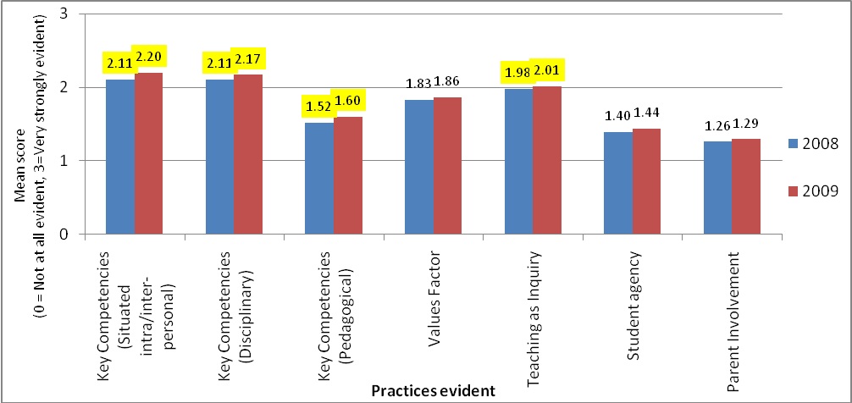
Practitioners were not resistant to implementing the curriculum, or critical of its content or requirements. They also did not, however, change their practices in ways that reflect key elements of the new curriculum. This was the case for all respondents, but more so for teachers than leaders and more so for secondary than primary respondents. The curriculum, while designed as an inclusive one for both primary and secondary suggests, for example, a move toward greater student agency in learning, including student involvement in decisions about teaching, learning and assessment. Student agency was, alongside Parent involvement, one of the lowest rated practice variables. Secondary teachers often reported contextual barriers that made realising aspirations for student agency challenging. This response echoes the findings of Rudduck and Fielding (2006) who also found student voice to be challenging for teachers and suggest that there is a risk of surface compliance given the current popularity of student voice.
The limited progress finding is not unique to this curriculum implementation effort. Research on curriculum implementation over the decades suggests that the intentions of curriculum designers often fail to be realised when practitioners in educational contexts attempt to implement them. The conclusions of much of the research over decades of curriculum developments have more often than not, been reports of failure. In 1948, for example, Mackenzie and Lawler writing on curriculum change and improvement noted that “although philosophy has been changed and new objectives have been enumerated, and even a course of study developed, classroom practices have been modified but little” (p. 273). In the 1970s, Goodlad’s and Klein’s (1974) investigations showed that curriculum innovations were not finding their way into classrooms and Fullan and Pomfret (1977) described widespread variation in whether or not innovations were being implemented. Limited impact of curriculum reform efforts have also been noted by van den Akker and Verloop (1994) and many others more recently including Fullan (2008) and Levin (2008). Levin describes how little impact a curriculum change can have on teaching practice and suggests that limited adoption is more likely where the significance of the curriculum change is more significant. There is, it would seem, substantial variance in the extent to which curricular that are designed for students, are actually experienced by students (D. Cohen, Raudenbush, & Ball, 2003).
Confidence was shown to be a key variable in explaining the limited progress and variance referred to above. In the descriptive data, for instance, the overall mean for confidence was significantly lower than for regard. There were also no statistically significant differences between the 2008 and 2009 ratings for confidence. Educators were no more confident about giving effect to the curriculum in 2009 than they were the year before, despite there being a programme of support for implementation in place. The reasons for the lack of confidence were diverse, relating to teachers’ own curriculum, assessment and content knowledge and also to contextual barriers. In secondary contexts for instance, the lack of alignment between assessment systems and the requirements of the curriculum were a key concern. Confidence was also the highest predictor of practice in the regression analyses demonstrating an important connection between educators’ views of the complexity, workload and difficulty involved in implementation and their response in terms of classroom practice.
Giving effect to real change in response to the curriculum requires confidence, and confidence requires deep understandings about the distinctions between the new and the old curriculum elements. This is particularly so when new elements are easily perceived as being more similar to old elements than is actually the case. It was clear from the responses that, similar to those in Roehrig, Kruse and Kern’s study (2007), “implementation of the curriculum was strongly influenced by the teachers’ beliefs about teaching and learning, and the presence of a supportive network at their school sites” (p. 883). It was clear that efforts to implement The New Zealand Curriculum were also affected in ways unhelpful to the task by the sense-making processes at play (Spillane et al., 2002). Prior knowledge at times prevented new ways of conceiving curriculum practice. Quite different interpretations were made by those in different groups to key curriculum elements, and the tendency to assimilate new ideas with existing ones were strongly evident. One example of this was in relation to the model of effective pedagogy outlined in The New Zealand Curriculum—‘Teaching as Inquiry’ (Aitken & Sinnema, 2008; Ministry of Education, 2007). Prior knowledge of other kinds of inquiry led many educators to assume that Teaching as Inquiry is the same as inquiry learning, which it is not. As two secondary teachers noted (in web survey comments), “It seems like it is promoting learning by inquiry as the major method of instruction” and "‘projects’ have been renamed”. The curriculum’s promotion of Teaching as Inquiry could not, in fact, be more different to inquiry learning or projects. But to realise the distinction requires educators to read and understand much more than the heading. Recognition of the extent to which educators were “making the unfamiliar, familiar”, led to a specific focus group session about Teaching as Inquiry. In that session, participants were asked to describe what was familiar to them about this new curriculum aspect. It emerged that they associate the notion of Teaching as Inquiry not only with students’ inquiry learning/projects, but also with action learning, reflective practice, research projects, formative assessment and metacognition. Each of these has characteristics that are related to Teaching as Inquiry, but importantly they are also quite different in significant ways.
In this evaluation, there was no evidence of widespread understanding of the extent to which The New Zealand Curriculum calls for change and improvement. Even those who did recognise that call, and who had high regard for the curriculum’s shift; were not always able to effect change in their classrooms to any meaningful extent.
The role of teachers’ theories, understandings, knowledge and beliefs as key influences on their practice is widely recognised. New information, such as that embedded in a new curriculum, does not simply supplant existing knowledge and practice (Spillane et al., 2002). The generalised and automatic nature of schemata means that we rely on “surface or superficial similarities between new knowledge about something and our existing scripts for that something” (Spillane, 2004, p. 78). Well-intentioned practitioners are likely to be influenced by expectations embedded in their existing schema, and to over-assimilate reform ideas as similar to their existing ideas. As Fullan describes, this is not a new phenomenon, but is a challenging one:
Early study of implementation revealed a great deal of superficial or non-use of purported adopted innovations. One might think that this was a symptom of the beginning phases of working to improve implementation, but these problems persist to today, and they relate to the perennial difficulty of people changing both their behaviours (skills, competencies) and their beliefs (knowledge, understanding). (Fullan, 2008)
Change is also described by Robinson, Hohepa & Lloyd (2008) as a process that requires theory engagement. Theories of action are powerful, they say, because they explain teachers’ actions and act as filters through which change messages are interpreted. High quality support that attends to what is known about sense-making in policy implementation, and to the need for theory engagement, will be key to continued implementation efforts.
Like other studies (Niesche & Jorgensen, 2010), substantial differences were found between the views of principals (and other non-teaching school leaders) and teachers in their reports about the implementation process. Given the press for school principals to work as instructional leaders with a focus on the core business of teaching and learning (Robinson et al., 2008), higher principal regard and confidence is a positive finding. It also signals that conditions are being created in which authority and knowledge for reform have begun to shift from external actors to the practitioners in schools—a key component of taking a reform to scale (Coburn, 2003). This shift to internal conditions for reform was also evident in the greater reliance reported in this study on internal (own colleagues for example) than external (private consultants, external facilitators and advisors) support providers. This brings with it, though, important implications in terms of the need to focus on building capacity for high quality support within schools. The differences between the views of principals and teachers is also problematic in another respect. It indicates a lack of a shared understanding about the nature of curriculum and the extent to which schools are progressing with curriculum-related practices.
The limited progress on all of the practice variables examined here signal the need for more sustained inquiry into curriculum, particularly given that the curriculum is a broad and encompassing one. Differences between the 2008 and 2009 means for practices (there was one year between administrations) were only statistically significant for three of the four practice variables, and even then, the magnitude of those difference was very small. While there were instances of teachers making meaningful changes to their practice, many were, as Bjork (2009), also reported unsettled by the disruptions to existing practice. They were “grounded by time-honoured methods, curriculum outlines, and culturally constructed conceptions of how to teach a particular subject...[and] often felt as if a secure foundation had been pulled out from underneath them” (p. 33).
Despite the limited progress in practice identified in this evaluation, the findings in relation to receptivity (and particularly the wide-spread high regard for the curriculum) suggest that practitioners across the system are well-poised to continue their efforts to give effect to The New Zealand Curriculum.

Recommendations
Findings from this evaluation suggest that continued efforts, across the system, to support curriculum implementation, should:
- focus on deepening educators’ understandings about curriculum elements and their relationship to each other
- strengthen the quality of support for curriculum implementation
- create conditions that enable and promote effective curriculum implementation
- promote sustained inquiry into curriculum implementation.
For each of the recommendations there are implications for various groups including teachers, school leaders, support providers and policy makers. Key implications are introduced here, but the suggestions are not exhaustive.

Recommendation 1: Focus on deepening educators’ understandings about curriculum elements and their relationship to each other
The New Zealand Curriculum emphasises aspirations for the curriculum serving ambitious and future focused goals for students and education generally. Goals for education include building an education system for the 21st century and securing New Zealand’s place in the global knowledge society of the future. Goals for students include that they experience the most effective, powerful and engaging teaching possible and are prepared for complexity, change and diversity in information, technology, work and social conditions. The New Zealand Curriculum vision for students is for lifelong learners who are confident and creative, connected, and actively involved. Realising these goals, and this vision, requires educators to have deep understandings both about the discrete curriculum elements (such as Values, Learning Areas, ‘Teaching as Inquiry’, and Key Competencies), and the implications of those elements when considered in combination.
Findings from this evaluation signal that teachers and principals have begun to contemplate implications of each of the curriculum elements, but in most cases have not had the opportunity to develop deep understandings. As is common in the implementation of curriculum policy initiatives, there has been a tendency in the first two years since the launch of The New Zealand Curriculum to emphasise surface aspects, and to focus more on familiar than unfamiliar ideas.
Focusing on deepening understandings about curriculum suggests, for teachers, the need to be open to identifying curriculum aspects that are most unfamiliar, and also contemplating greater depth in curriculum aspects initially considered familiar. It requires attention to curriculum elements not only as discrete parts, but also to the curriculum as whole in which learning areas, values, pedagogy and key competencies (for example) interact. To address this recommendation, school leaders will need to focus their leadership on moving beyond curriculum familiarity or compliance, towards curriculum depth. A focus on depth requires quite different expectations, resourcing and professional learning to a focus on curriculum compliance.

Recommendation 2: Strengthen the quality of support for curriculum implementation
High quality support is important for two key reasons. Firstly, in this evaluation a relationship was found between the quality of support educators reported and the extent to which they hold the curriculum in high regard and have the confidence necessary (though not sufficient) to ultimately shift their practice in ways that reflect its aspirations. Support providers have an important role to play in working with practitioners to recognise the value, relevance and importance of the curriculum overall, and of more specific aspects of the curriculum. Secondly, educators are unlikely to arrive at new and deeper understandings of curriculum (found in this evaluation to be a gap) on their own. High quality support has a critical role to play in engaging practitioners’ theories of action (including cueing their existing understandings) in order to deepen their understandings of the curriculum.
There are implications here both for those who resource and plan curriculum implementation support, and for those who provide it. School leaders, for example, need to ensure support for their teachers that is not just about The New Zealand Curriculum, but that is likely to be effective in helping teachers deepen their understandings and shift their practice. That, for most, will require opportunities for theory engagement—to rigorously inquire into existing beliefs about curriculum, teaching and learning, in light of what is set out in the new curriculum and to respond.
For those with a role in policy, a key implication is around the provision of support that goes beyond just informing educators about the curriculum, or communicating ideas. Rather it requires high quality support provision that engages them in examining the congruence between their own theories of practice, and the theories that underpin key curriculum elements. The need to strengthen capabilities for high quality support provision relates to support from both within and beyond schools.

Recommendation 3: Create conditions that enable and promote effective curriculum implementation
Curriculum implementation does not occur in a bubble. Teaching and learning at the classroom level is nested within, and influenced by, the school, community and national educational context. The practices deemed important in The New Zealand Curriculum can be either enabled or constrained by the conditions in place in each of those contexts. Contextual factors were raised by many participants in this evaluation as barriers to their implementation efforts.
Just as the curriculum seeks to prepare students for lives that are profoundly different from the past, so too the curriculum requires a profound response. Implementation that goes beyond substituting language and altering paperwork, to profoundly changing and improving students’ experience of teaching and learning, requires particular conditions. Teachers and leaders could consider, for example, how their school’s goals, resources, routines, and systems enable each of the curriculum elements. To what extent do those support each of the learning areas, the key competencies, effective pedagogy or values for example? Less tangible elements of the context, such as attitudes, values and expectations, also function as enabling or constraining conditions on curriculum implementation, and require consideration.
At the system level attention to policy alignment is critical in considering how conditions enable and promote implementation. As practitioners in school grapple with multiple policies and programme initiatives, the coherence between these is critical. There is a need to examine the extent to which requirements beyond the curriculum, for planning and reporting or performance management for example, align with the direction set out in The New Zealand Curriculum.

Recommendation 4: Promote sustained inquiry into curriculum implementation
It is clear from the evaluation of curriculum progress between 2008 and 2009, that implementation of a curriculum as ambitious and aspirational as The New Zealand Curriculum is not a one or two year endeavour. Implementation will require sustained inquiry over time at both school and system levels. The curriculum focus on continuing design and review, and the Teaching as Inquiry model support the notion of sustained inquiry in schools. That inquiry should also be paralleled with system level inquiry, in order for the priorities, needs and strengths in relation to implementation to be effectively responded to.

Appendices

Appendix 1: Paper Survey Instrument

THE NEW ZEALAND CURRICULUM: SNAPSHOT SURVEY 2009
I have read and understood the information describing the aims and content of the following questionnaire.  I am aged 16 years or older. I agree to take part in this research under the terms indicated in the information supplied.  Please indicate your agreement to participate here: □ |  |  |  |  |  |  |  |  |  |  |  |  |  |  |  |  |  |  | Please mark boxes with  to indicate your responses
RESPONDENT INFORMATION
Region:  □ 1 – Northland, Auckland  □ 2 – Waikato, King Country, Coromandel, Bay of Plenty, Rotorua, East Coast  □ 3 – Manawatu, Wanganui, Taranaki, Hawkes Bay  □ 4 – Wellington, Wairarapa  □ 5 – Nelson, Marlborough, West Coast, Canterbury  □ 6 –Otago, Southland |  | School Decile:  □ Low (1-3)  □ Mid (4-7)  □ High (8-10) |  |  |  |  | School Type:  □ Primary (including  full primary and  intermediate)  □ Secondary  □ Composite  □ Special |  |  |  |  |  | Role/s:  □ Classroom teacher  □ Syndicate/team/  department leader  □ Principal  □ AP or DP (non-  teaching)  □ AP or DP (teaching) |  |  |  | Learning Area/s Taught:  □ All  □ English  □ Health and Physical Well-being  □ Learning Languages  □ Mathematics and Statistics  □ Science  □ Social Sciences  □ Technology  □ The Arts □ n/a
Did you complete the 2008 Snapshot Survey?
□ Yes
□ No
What is the name of your school? |  |  |  |  |  |  |  |  |  |  |  |  |  |  |  | What suburb is your school in?
SUPPORT
How often have you been able to talk with/read/use the following curriculum implementation supports during 2008 AND 2009?
 | Not at all |  | 1-2 times |  | 3-5 times |  |  | 6+  times |  |  |  |  |  |  |  |  |  | Not at all |  | 1-2 times | 3-5 times | 6+  times
Advisors (school support services) |  |  |  |  |  |  |  |  |  |  | Ministry of Education publications
Private consultants |  |  |  |  |  |  |  |  |  |  | ‘The NZC Online’ website
Facilitators from other initiatives |  |  |  |  |  |  |  |  |  |  | ‘The New Zealand Curriculum’ document
Colleagues from own school |  |  |  |  |  |  |  |  |  |  | ‘Te Marautanga o Aotearoa’ document
Colleagues from other schools |  |  |  |  |  |  |  |  |  |  | Any of the Best Evidence Syntheses
How do you view the support that has been provided to implement the NZC? (Indicate on the continua below)
Miserly |  |  |  | □ |  | □ |  |  | □ | □ |  | □ |  | □ | Generous
Waste-of-time |  |  |  | □ |  | □ |  |  | □ | □ |  | □ |  | □ | Productive
Irrelevant |  |  |  | □ |  | □ |  |  | □ | □ |  | □ |  | □ | Relevant
Tedious |  |  |  | □ |  | □ |  |  | □ | □ |  | □ |  | □ | Stimulating
Flawed |  |  |  | □ |  | □ |  |  | □ | □ |  | □ |  | □ | Sound
Easy |  |  |  | □ |  | □ |  |  | □ | □ |  | □ |  | □ | Challenging
RECEPTIVITY
How do you view the New Zealand Curriculum (indicate on the continua below)
Restrictive |  |  |  | □ |  | □ |  |  | □ | □ |  | □ |  | □ | Flexible
Uncomplicated |  |  |  | □ |  | □ |  |  | □ | □ |  | □ |  | □ | Complicated
Impractical |  |  |  | □ |  | □ |  |  | □ | □ |  | □ |  | □ | Practical
Unreasonable workload |  |  |  | □ |  | □ |  |  | □ | □ |  | □ |  | □ | Reasonable workload
More work (than previous curriculum) |  |  |  | □ |  | □ |  |  | □ | □ |  | □ |  | □ | Less work (than previous curriculum)
Worse (than previous curriculum) |  |  |  | □ |  | □ |  |  | □ | □ |  | □ |  | □ | Better (than previous curriculum)
Difficult to implement |  |  |  | □ |  | □ |  |  | □ | □ |  | □ |  | □ | Easy to implement
Substantially the same (as previous curriculum) |  |  |  | □ |  | □ |  |  | □ | □ |  | □ |  | □ | Substantially different (from previous curriculum)
Requires few shifts in practice |  |  |  | □ |  | □ |  |  | □ | □ |  | □ |  | □ | Requires major shifts in practice
Not at all confident about implementing the NZC |  |  |  | □ |  | □ |  |  | □ | □ |  | □ |  | □ | Very confident about implementing the NZC

PRACTICE (continued)
Has your school curriculum been reviewed in relation to: | Yes | No/  Not yet | How often are parents/community members involved in decisions about curriculum, teaching and learning at your school in the following ways? |  |  |  |  |  |  |  |  | Never |  |  | Some-times |  | Often |  |  | Always
Values | □ | □ | Parents/community members are informed about teaching and learning thorough, open, clear communications about learning programme |  |  |  |  |  |  |  |  | □ |  |  | □ |  | □ |  |  | □
Principles | □ | □ | Parents/community members are consulted about teaching and learning; their views and opinions are sought, taken seriously and responded to |  |  |  |  |  |  |  |  | □ |  |  | □ |  | □ |  |  | □
Key Competencies | □ | □
Learning areas | □ | □ | Parents/community members collaborate in designing the teaching/learning programme by sharing in decision-making |  |  |  |  |  |  |  |  | □ |  |  | □ |  | □ |  |  | □
Pedagogy | □ | □
Have you made changes to any of the following in response to the new curriculum? |  |  |  | Have not considered |  | Considered, decided not to change |  | Intend to make changes |  |  | Made slight changes |  |  | Made moderate changes |  |  |  |  | Made substantial changes
Planning documentation |  |  |  | □ |  | □ |  | □ |  |  | □ |  |  | □ |  |  |  |  | □
Teaching and learning approaches/activities used |  |  |  | □ |  | □ |  | □ |  |  | □ |  |  | □ |  |  |  |  | □
Resources used for teaching and learning |  |  |  | □ |  | □ |  | □ |  |  | □ |  |  | □ |  |  |  |  | □
The content/topics/themes of teaching and learning |  |  |  | □ |  | □ |  | □ |  |  | □ |  |  | □ |  |  |  |  | □
The role students take in class |  |  |  | □ |  | □ |  | □ |  |  | □ |  |  | □ |  |  |  |  | □
The way in which you report to parents |  |  |  | □ |  | □ |  | □ |  |  | □ |  |  | □ |  |  |  |  | □
The content of reports to parents |  |  |  | □ |  | □ |  | □ |  |  | □ |  |  | □ |  |  |  |  | □
PRACTICE (continued) |  |  |  |  | To what extent are the following evident in your practice? |  |  |  |  |  |  |  | How difficult do you find the following  to implement?
To what extent are the following evident in your practice,  and how difficult you think they are to implement? |  |  |  |  | Not evident; it is NOT something I consider to be an important aspect of my practice |  | Evident at times but NOT something that I feel I must always do |  | Strongly evident; it is important to me that I do this often | Very strongly evident; it really matters to me that I do this consistently. |  |  | Very difficult |  |  | Difficult |  | Easy |  |  | Very Easy
Developing student competency in Thinking |  |  |  |  | □ |  | □ |  | □ | □ |  |  | □ |  |  | □ |  | □ |  |  | □
Having students do things with knowledge in meaningful real-world contexts |  |  |  |  | □ |  | □ |  | □ | □ |  |  | □ |  |  | □ |  | □ |  |  | □
Encouraging students to hold the values listed in the NZC |  |  |  |  | □ |  | □ |  | □ | □ |  |  | □ |  |  | □ |  | □ |  |  | □
I engage with evidence about students’ needs and abilities to prioritise next steps for learning |  |  |  |  | □ |  | □ |  | □ | □ |  |  | □ |  |  | □ |  | □ |  |  | □
Integrating the key competencies and the learning areas together |  |  |  |  | □ |  | □ |  | □ | □ |  |  | □ |  |  | □ |  | □ |  |  | □
Developing student competency in Using Language, Symbols, and Text |  |  |  |  | □ |  | □ |  | □ | □ |  |  | □ |  |  | □ |  | □ |  |  | □
I systematically collect data and analyse it to understand students’ response to my teaching |  |  |  |  | □ |  | □ |  | □ | □ |  |  | □ |  |  | □ |  | □ |  |  | □
Students participate in decisions about what and how they learn |  |  |  |  | □ |  | □ |  | □ | □ |  |  | □ |  |  | □ |  | □ |  |  | □
Developing students skills for exploring values |  |  |  |  | □ |  | □ |  | □ | □ |  |  | □ |  |  | □ |  | □ |  |  | □
I modify teaching practices as a result of what I have learned about student response to my teaching |  |  |  |  | □ |  | □ |  | □ | □ |  |  | □ |  |  | □ |  | □ |  |  | □
Developing student competency in Managing Self |  |  |  |  | □ |  | □ |  | □ | □ |  |  | □ |  |  | □ |  | □ |  |  | □
Students participate in decisions about how they are assessed |  |  |  |  | □ |  | □ |  | □ | □ |  |  | □ |  |  | □ |  | □ |  |  | □
Drawing out knowledge and attitudes and values during learning experiences |  |  |  |  | □ |  | □ |  | □ | □ |  |  | □ |  |  | □ |  | □ |  |  | □
Teaching and learning about the nature of values |  |  |  |  | □ |  | □ |  | □ | □ |  |  | □ |  |  | □ |  | □ |  |  | □
Developing student competency in Relating to Others |  |  |  |  | □ |  | □ |  | □ | □ |  |  | □ |  |  | □ |  | □ |  |  | □
Foster students own disposition to recognise when and how to use the key competencies and be willing to do so |  |  |  |  | □ |  | □ |  | □ | □ |  |  | □ |  |  | □ |  | □ |  |  | □
I draw on the experience of colleagues to inform possible changes to my teaching practice |  |  |  |  | □ |  | □ |  | □ | □ |  |  | □ |  |  | □ |  | □ |  |  | □
Students participate with staff in discussions about the key competencies |  |  |  |  | □ |  | □ |  | □ | □ |  |  | □ |  |  | □ |  | □ |  |  | □
I read and use published research to inform possible changes to my teaching practice |  |  |  |  | □ |  | □ |  | □ | □ |  |  | □ |  |  | □ |  | □ |  |  | □
Parents/community members are consulted about teaching and learning; their views and opinions are sought, taken seriously and responded to |  |  |  |  | □ |  | □ |  | □ | □ |  |  | □ |  |  | □ |  | □ |  |  | □
Developing student competency in Participating and Contributing |  |  |  |  | □ |  | □ |  | □ | □ |  |  | □ |  |  | □ |  | □ |  |  | □
Parents/community members often take part in teaching and learning at school, as key participants in the programme |  |  |  |  | □ |  | □ |  | □ | □ |  |  | □ |  |  | □ |  | □ |  |  | □
Parents/community members often take-part in teaching and learning at home |  |  |  |  | □ |  | □ |  | □ | □ |  |  | □ |  |  | □ |  | □ |  |  | □

Appendix 2: Factor Analysis Support and Receptivity Items Time 1
Support and Receptivity Items Pattern Matrix Time 1 (2008)
 | Factor
 | 1 | 2 | 3 | 4 | 5
Support Quantity: External
Advisors | .089 | -.083 | .027 | -.059 | .463
Private Consultants | -.051 | .079 | .034 | .006 | .443
Facilitators other initiatives | .067 | -.026 | .107 | -.005 | .441
Support Quantity: Internal
Colleagues Other | .005 | -.040 | .335 | -.019 | .372
Colleagues Own | .012 | .023 | .451 | .066 | .181
MoE publications | -.004 | -.029 | .630 | -.032 | .123
NZC Online | .014 | -.016 | .542 | .016 | .044
NZC document | .049 | .091 | .648 | -.097 | -.097
Support Quality
Miserly - Generous | .665 | .223 | -.081 | .196 | .225
Waste of time - Productive | .894 | .046 | -.004 | .075 | .069
Irrelevant - Relevant | .940 | -.079 | .035 | -.071 | -.093
Tedious - Stimulating | .809 | -.050 | .057 | -.137 | .013
Flawed - Sound | .806 | .008 | .063 | -.098 | -.056
Confidence
Complicated - Uncomplicated | -.062 | .438 | -.007 | -.019 | -.008
Unreasonable workload - Reasonable workload | .100 | .526 | -.060 | -.197 | .116
Difficult to implement - Easy to implement | .094 | .779 | -.019 | -.039 | .017
Not confident at all - Very confident | .129 | .645 | .261 | .057 | -.110
Regard
Restrictive - Flexible | .065 | .121 | .089 | -.563 | .056
Impractical - Practical | .150 | .462 | -.026 | -.380 | .090
Worse - Better | .120 | .395 | .039 | -.424 | .078

Appendix 3: Factor Analysis Support and Receptivity Items Time 2
Support and Receptivity Items Pattern Matrix Time 2 (2009)
 | Factor
 | 1 | 2 | 3 | 4 | 5
Support Quantity: External
Advisors | .107 | -.024 | .049 | .524 | .008
Private Consultants | -.037 | -.014 | .000 | .553 | -.003
Facilitators other initiatives | .013 | .040 | -.042 | .678 | .006
Colleagues Other | -.028 | -.041 | .180 | .416 | -.097
Support Quantity: Internal
Colleagues’ Own | .031 | .042 | .604 | .030 | .083
MoE publications | .024 | -.007 | .507 | .174 | -.036
NZC Online | .048 | .032 | .424 | .147 | .022
NZC document | -.008 | -.002 | .718 | -.127 | -.110
Support Quality
Miserly - Generous | .648 | .168 | .000 | .104 | .124
Waste of time - Productive | .921 | -.005 | .032 | -.051 | .031
Irrelevant - Relevant | .931 | -.078 | .020 | -.052 | -.032
Tedious - Stimulating | .763 | -.038 | .003 | .044 | -.081
Flawed - Sound | .798 | -.019 | .002 | -.017 | -.079
Confidence
Complicated - Uncomplicated | -.036 | .474 | .040 | -.047 | .020
Unreasonable workload - Reasonable workload | .101 | .396 | -.068 | .073 | -.304
Difficult to implement - Easy to implement | .074 | .735 | -.041 | .076 | -.070
Not confident at all - Very confident | .095 | .477 | .112 | .003 | -.188
Regard
Restrictive - Flexible | .020 | -.048 | .068 | .008 | -.694
Impractical - Practical | .107 | .290 | .012 | .013 | -.554
Worse - Better | .055 | .195 | -.034 | .075 | -.649

Appendix 4: Factor Analysis Practice Items Time 2
Practice Items Pattern Matrix Time 1 (2008)
 | Factor
New factor name | FP8 | FP1 |  | FP7 |  | FP9 |  | FP4 |  | FP6 |  | FP5 |  | FP2 |  | FP3
Classroom change
Changes to Planning documentation | .018 | .086 |  | .736 |  | -.054 |  | .075 |  | -.064 |  | .047 |  | -.002 |  | .011
Changes to Teaching/learning approaches/activities used | -.072 | .001 |  | .953 |  | .004 |  | .002 |  | .011 |  | -.024 |  | -.003 |  | -.013
Changes to Resources used for teaching and learning | .010 | -.063 |  | .852 |  | .032 |  | -.054 |  | .008 |  | -.028 |  | -.017 |  | .022
Changes to Content/topics/themes of teaching and learning | .031 | -.001 |  | .826 |  | .004 |  | -.002 |  | -.001 |  | .006 |  | -.007 |  | -.032
Changes to Role students take in class | .127 | -.033 |  | .728 |  | .037 |  | -.025 |  | .073 |  | -.011 |  | .019 |  | -.021
Reporting change
Changes to the way parents are reported to | .950 | -.033 |  | .029 |  | .006 |  | .023 |  | -.011 |  | -.016 |  | .016 |  | .012
Changes to the content of reports to parents | .938 | .019 |  | .012 |  | .011 |  | .009 |  | -.016 |  | .000 |  | -.035 |  | -.021
Key Competency: Disciplinary
Developing student competency in Thinking | -.005 | .157 |  | -.001 |  | .078 |  | -.096 |  | .157 |  | .048 |  | .353 |  | .092
Developing student competency in Using language symbols and text | -.013 | .145 |  | .030 |  | .078 |  | -.039 |  | -.081 |  | .214 |  | .289 |  | .127
Students do things with knowledge in meaningful real-world contexts | -.006 | .118 |  | .020 |  | -.001 |  | -.065 |  | .209 |  | .052 |  | .377 |  | -.030
Integrating Key Competencies and Learning Areas | .062 | .124 |  | .099 |  | -.097 |  | -.032 |  | .011 |  | .034 |  | .371 |  | .231
Key Competency: Situated intra/inter-personal
Developing student competency in ‘Relating to others’ | .025 | .620 |  | .047 |  | -.060 |  | -.209 |  | .004 |  | -.020 |  | .022 |  | -.014
Developing student competency in ‘Managing self’ | .021 | .596 |  | .021 |  | .010 |  | .056 |  | .100 |  | .103 |  | .110 |  | .051
Developing student competency in ‘Participating and contributing’ | .009 | .590 |  | .013 |  | -.167 |  | -.014 |  | .023 |  | .011 |  | .070 |  | .039
Key Competency: Pedagogical
Foster students own disposition to recognise when and how to use the key competencies and be willing to do so | .031 | .137 |  | .016 |  | -.049 |  | -.215 |  | .109 |  | -.028 |  | .071 |  | .465
Students participate with staff in discussions about the key competencies | .111 | -.042 |  | -.028 |  | -.230 |  | -.068 |  | .145 |  | -.007 |  | .052 |  | .465
Values
Encouraging students to hold the values listed in the NZC | .037 | .099 |  | .050 |  | -.087 |  | -.236 |  | -.024 |  | -.033 |  | .444 |  | .019
Developing students' skills for exploring values | .012 | -.048 |  | .029 |  | -.078 |  | -.589 |  | .148 |  | .008 |  | .127 |  | .023
Drawing out knowledge and attitudes and values during learning experiences | -.020 | .234 |  | .000 |  | -.006 |  | -.494 |  | .060 |  | .115 |  | -.057 |  | .047
Teaching and learning about the nature of values | .019 | -.007 |  | .023 |  | -.044 |  | -.796 |  | -.048 |  | .037 |  | .017 |  | .039
Teaching as Inquiry
I engage with evidence about students' needs and abilities to prioritise next steps for learning | .088 | .040 |  | -.021 |  | -.146 |  | -.018 |  | .034 |  | .334 |  | .372 |  | -.076
I draw on the experience of colleagues to inform possible changes to my teaching | .024 | .147 |  | .028 |  | -.106 |  | -.103 |  | -.012 |  | .376 |  | -.056 |  | .003
I read and use published research to inform possible changes to my teaching practice | -.015 | .030 |  | .089 |  | -.105 |  | .016 |  | .050 |  | .390 |  | -.017 |  | .245
I modify teaching practices as a result of what I have learned about student response to my teaching | .070 | .109 |  | -.035 |  | .080 |  | -.116 |  | .116 |  | .590 |  | -.008 |  | -.025
I systematically collect data and analyse it to understand students' response to my teaching | -.023 | -.093 |  | .065 |  | -.135 |  | -.005 |  | .067 |  | .565 |  | .142 |  | .010
Student agency
Students participate in decisions about what and how they learn | .012 | .066 |  | .044 |  | -.093 |  | .005 |  | .684 |  | .063 |  | .049 |  | -.037
Students participate in decisions about how they are assessed | .051 | -.016 |  | .033 |  | -.031 |  | -.094 |  | .537 |  | .040 |  | -.081 |  | .261
Parent involvement
Parents/community members are consulted about teaching and learning; their views/opinions are sought, taken seriously and responded to | .037 | .028 |  | .017 |  | -.617 |  | .013 |  | .065 |  | .114 |  | -.011 |  | .091
Parents/community members often take part in teaching and learning at home | .004 | .114 |  | .009 |  | -.679 |  | -.020 |  | -.023 |  | .018 |  | .029 |  | -.026
Parents/community members often take part in teaching and learning at school, as key participants in the programme | .018 | -.048 |  | .005 |  | -.810 |  | -.065 |  | .058 |  | -.037 |  | -.033 |  | .028

Appendix 5: Effect sizes (Cohen's d) for factors 2008–2009
Variable | 2008 |  |  | 2009 |  |  | Effect Size (Cohen's d)
 | M | N | SD | M | N | SD
Key competencies: Disciplinary | 2.11 | 2519 | .533 | 2.17 | 1761 | .505 | -0.11
Key competencies: Situated inter/intra-personal | 2.11 | 2487 | .618 | 2.20 | 1752 | .564 | -0.15
Key competencies: Pedagogical | 1.52 | 2481 | .669 | 1.60 | 1750 | .643 | -0.13
Values factor | 1.83 | 2509 | .621 | 1.86 | 1756 | .610 | -0.05
Teaching as Inquiry | 1.98 | 2507 | .542 | 2.01 | 1757 | .519 | -0.06
Student agency | 1.40 | 2480 | .719 | 1.44 | 1751 | .709 | -0.05
Parent involvement | 1.26 | 2441 | .749 | 1.29 | 1730 | .705 | -0.05
Extent of change to classroom practice | 2.63 | 2534 | 1.209 | 3.25 | 1766 | 1.015 | -0.55
Extent of change to reporting | 2.07 | 2475 | 1.488 | 2.62 | 1722 | 1.440 | -0.37
Support encounters Internal | 1.71 | 2538 | .715 | 2.07 | 1773 | .650 | -0.52
Support encounters external | .84 | 2482 | .672 | 1.09 | 1738 | .710 | -0.36
Support quality | 2.63 | 2333 | 1.186 | 2.84 | 1701 | 1.117 | -0.18
Regard | 3.3457 | 2499 | 1.02222 | 3.4474 | 1757 | .98075 | -0.10
Confidence | 2.7443 | 2500 | .96852 | 2.7978 | 1758 | .94288 | -0.06

Appendix 6: Difficulty ratings for practice items 2009
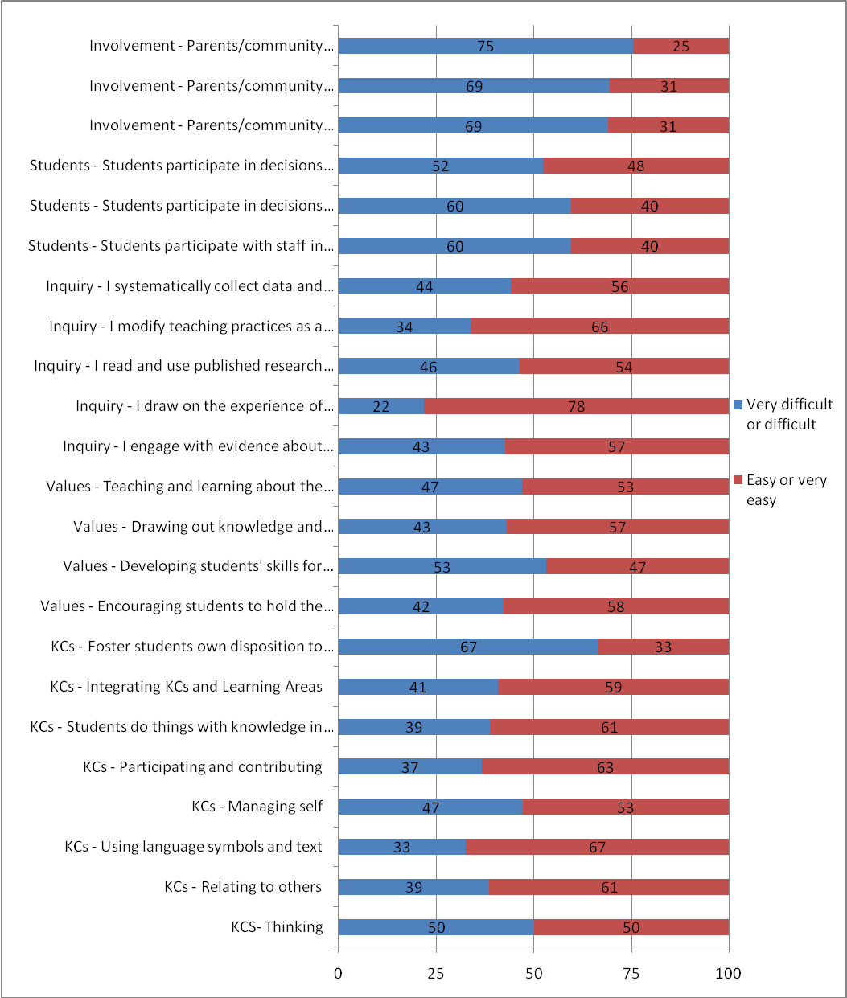

References
Aitken, G., & Sinnema, C. (2008). Effective pedagogy in Social Studies / Tikanga ā Iwi: Best Evidence Synthesis Iteration. Wellington: Ministry of Education.
Bjork, C. (2009). Local implementation of Japan's integrated studies reform: A preliminary analysis of efforts to decentralise the curriculum. Comparative Education, 45(1), 23-44.
Caracelli, V. J., & Greene, J. C. (1997). Crafting mixed-method evaluation designs. In J. C. Greene, V. J. Caracelli & (Eds.), Advances in mixed-method evaluation: The challenges and benefits of integrating diverse paradigms, new directions for evaluation. San Francisco, CA: Jossey-Bass.
Coburn, C. E. (2003). Rethinking scale: Moving beyond numbers to deep and lasting change. Educational Researcher, 32(6), 3-12.
Cohen, D., Raudenbush, S., & Ball, D. (2003). Resources, instruction, and research. Educational Evaluation and Policy Analysis, 25(2), 119-142.
Cohen, J. (1988). Statistical power analysis for the behavioral sciences (2nd ed.). New York: Academic Press.
Cowie, B., & Hipkins, R. (2009). Curriculum implementation exploratory studies: Final report [Electronic Version]. Retrieved September 6, 2010 from http://www.educationcounts.govt.nz/publications/curriculum/57760/1.
Evers, K. E., Prochaska, J. O., Van Marter, D. F., Johnson, J. L., & Prochaska, J. M. (2007). Transtheoretical-based bullying prevention effectiveness trials in middle schools and high schools. Educational Research, 49(4), 397-414.
Fullan, M. (Ed.). (2008). Curriculum implementation and sustainability. Los Angeles: Sage.
Fullan, M., & Pomfret, A. (1977). Research on curriculum and instruction implementation. Review of Educational Research, 47(2), 335-397.
Goodlad, J. I., & Klein, M. F. (1974). Looking behind the classroom door; a useful guide to observing schools in action: Worthington, Ohio, C. A. Jones Pub. Co., 1974.
Greene, J. C., Benjamin, L., & Goodyear, L. (2001). The merits of mixing methods in evaluation. Evaluation, 7(1), 25-44.
Hall, G. E., & Hord, S. M. (1987). Change in schools: Facilitating the process. Albany, NY: State University of New York Press.
Hall, G. E., & Hord, S. M. (2006). Implementing change: Patterns, principles, and potholes. Boston: Pearson/Allyn & Bacon.
Hall, G. E., & Loucks, F. F. (1975). Levels of use of the innovation. Journal of Teacher Education, 26(1), 52-56.
Hall, G. E., & Loucks, F. F. (1977). A developmental model for determining whether the treatment is actually implemented. American Educational Research Journal, 14(3), 263-276.
Hall, G. E., & Loucks, F. F. (1981, April). The concept of Innovation configurations: An approach to addressing program adaptation. Research on concerns-based adoption. Paper presented at the Annual Meeting of the American Educational Research Association, CA.
James, N. (2007). The use of email interviewing as a qualitative method of inquiry in educational research. British Educational Research Journal, 33(6), 963-976.
Leech, N. L., & Onwuegubuzie, A. J. (2007). A typology of mixed methods research. Quality and Quantity, 43(2), 265-275.
Levin, B. (Ed.). (2008). Curriculum policy and the politics of what should be learned in schools. Los Angeles: Sage.
Mackenzie, G. N., & Lawler, M. R. (1948). Chapter V: Curriculum: Change and improvement. Review of Educational Research, 18(3), 273-281.
Ministry of Education. (2007). The New Zealand Curriculum Wellington: Learning Media.
Niesche, R., & Jorgensen, R. (2010). Curriculum reform in remote areas: The need for productive leadership. Journal of Educational Administration, 48(1), 102-117.
O'Donnell, C. L. (2008). Defining, conceptualizing, and measuring fidelity of implementation and its relationship to outcomes in K-12 curriculum intervention research. Review of Educational Research, 78(1), 33-84.
Patton, M. C. (1997). Utilization-focused evaluation: The new century text (3 ed.). Thousand Oaks, Calif: Sage Publications.
Prochaska, J. M. (2000). A transtheoretical model for assessing organizational change: A study of family service agencies' movement to time-limited therapy. Families in Society, 81(1), 76-84.
Prochaska, J. O., & DiClemente, C. C. (1983). Stages and processes of self-change in smoking: Toward an integrative model of change. Journal of Consulting and Clinical Psychology, 5, 390-395.
Prochaska, J. O., DiClemente, C. C., & Norcross, J. C. (1992). In search of how people change: Applications to addictive behaviors. American Psychologist, 47(9), 1102-1114.
Robinson, V., Hohepa, M., & Lloyd, C. (2008). School leadership and student outcomes: Identifying what works and why. Best Evidence Synthesis Iteration [BES]. Wellington: Ministry of Education.
Roehrig, G. H., Kruse, R. A., & Kern, A. (2007). Teacher and school characteristics and their influence on curriculum implementation. Journal of Research in Science Teaching, 44(7), 883-907.
Rudduck, J., & Fielding, M. (2006). Student voice and the perils of popularity. Educational Review, 58(2), 219-231.
Spillane, J. (2004). Standards deviation: How schools misunderstand education policy. Cambridge, Massachusetts: Harvard University Press.
Spillane, J., Reiser, B. J., & Reimer, T. (2002). Policy implementation and cognition: Reframing and refocusing implementation research. Review of Educational Research, 72(3), 387-431.
The Joint Committee on Standards for Educational Evaluation. (2007, June). Program evaluation standards (October 2007, Draft 3). from http://www.wmich.edu/evalctr/jc/
van den Akker, J., & Verloop, N. (1994). Evaluation approaches and results in curriculum research and development in The Netherlands. Studies In Educational Evaluation, 20(4), 421-436.

Including Primary, Intermediate, Full-primary, Contributing, Secondary, Composite and Special
Including Principals; Deputy, Assistant and Associate Principals; and Classroom teachers
Standardised mean effect sizes (such as Cohen's d) indicate the mean difference between two variables expressed in standard deviation units. A score of 0 represents no change. An effect-size of d=1.0 indicates an increase of one standard deviation. While interpretations of effect sizes are dependent on the measurement context, Cohen (1988) offered the following guide: .8 = large, .5 = moderate and .2 = small.
Regression is used to test the effects of independent (predictor) variables on a single dependent (criterion) variable. For the purposes of these regressions the multiple practice variables (as reported in the group comparisons section) were substituted for a single practice scale (α = 0.92) that incorporated all 23 practice items, and was the dependent variable in the first regression.
A school's decile indicates the extent to which it draws its students from low socio-economic communities. Decile 1 schools are the 10% of schools with the highest proportion of students from low socio-economic communities. Decile 10 schools are the 10% of schools with the lowest proportion of these students.
Yellow highlights are used on figures in this section to signal that the difference between the 2008 and the 2009 mean was statistically significant.
Unstandardised Beta Coefficients

