
Monitoring Teacher Supply
Survey of staffing in New Zealand schools
at the beginning of the 2012 school year
Megan Lee
Ministry of Education
Monitoring Teacher Supply
Survey of staffing in New Zealand schools
at the beginning of the 2013 school year

Ministry of Education

First published in 2013 by the:

Research Division
Ministry of Education
PO Box 1666
Wellington
New Zealand

ISSN – 1176-6352

RMR-1027

© Ministry of Education, New Zealand — 2013

Research reports are available on the Ministry of Education’s website Education Counts:
www.educationcounts.govt.nz/publications.

Acknowledgements
The Research Division, Ministry of Education would like to thank all the principals of the schools who responded to this survey. Your continuing support is much appreciated.

Contents
Summary 1
Introduction 3
Background 3
Method and response rates 3
Points to note 4
The staffing situation in New Zealand schools at the start of the 2013 school year 5
Entitlement staffing vacancies 5
How many vacancies were there on the first day of school in 2013? 5
How many schools had vacancies on the first day of school in 2013? 5
Were vacancies more likely to be present in certain types of schools? 5
Re-advertised vacancies 7
What proportion of vacancies had been re-advertised? 7
What proportion of entitlement positions were re-advertised? 7
Geographical location of schools with vacancies and re-advertised vacancies 8
Immersion/bilingual teacher vacancies in primary schools 9
Māori language and subject vacancies in secondary schools 9
Teacher Appointments 11
Primary schools 11
Secondary schools 12
Sources of Teacher Supply in 2013 14
Overseas-trained teachers 14
Beginning teachers 15
Availability of Relief Teachers Proficient in Te Reo Māori 17
Conclusion 18
Appendix 19

List of tables
Table 1: Response rates 3
Table 2: Number of responding schools and their FTTE entitlement positions (2005-2013) 3
Table 3: Vacancies (FTTE) at the beginning of the school year (2006-2013) 6
Table 4: Re-advertised vacancies (FTTE) at the beginning of the school year (2006-2013) 7
Table 5: Geographical location (by Ministry of Education local office areas) of school with vacancies and re-advertised vacancies 2011 to 2013 8
Table 6: Secondary school subject vacancies 10
Table 7: The number of relatively new overseas-trained teachers at the start of Term 1 (2009-2013) 15
Table 8: First year beginning teachers in New Zealand schools at the start of Term 1 (2009-2013) 16
Table 9: First and second year beginning teachers in NZ schools (2011-2013) 17

List of figures
Figure 1: Percentage of vacant entitlement positions (FTTE) at the beginning of the school year (1997-2013) 6
Figure 2: New Zealand trained applicants applying for permanent positions in primary schools between July-Januarya 12
Figure 3: Secondary schools advertising for a teacher in 8 subject areas in the six months prior to the survey 13
Figure 4: New Zealand trained applicants applying for subject positions at secondary schools between July and January 14
Figure 5: Level of difficulty finding relief teachers proficient in Te Reo Māori 18

List of appendix tables
Appendix Table 1: Proportion of vacant entitlement positions, by school characteristics 19
Appendix Table 2: Proportion of re-advertised positions, by school characteristics 20
Appendix Table 3: Proportion of advertised positions in primary schools in which an appointment was made 20
Appendix Table 4: Proportion of advertised positions in secondary schools in which an appointment was made 20
Appendix Table 5: Characteristics of schools employing relatively new overseas-trained teachers 21
Appendix Table 6: Characteristics of schools with first year beginning teachers 22
Appendix Table 7: Characteristics of schools with first and second year beginning teachers 23

Summary
The annual Survey of Staffing provides the Ministry of Education with a snapshot of the number of entitlement staffing vacancies at the start of Term 1. The survey also collects information about the number of overseas-trained and beginning teachers employed by schools. In 2013, the survey was completed by 91% of all state and state-integrated schools (92% of primary schools and 86% of secondary schools).

Vacancies in state and state-integrated schools
There were 220.5 Full-Time Teacher Equivalent (FTTE) vacancies in state and state-integrated schools at the start of the 2013 school year. These vacancies represented 0.5% of all FTTE entitlement positions in state and state-integrated schools (0.5% in primary schools and 0.6% in secondary schools). Over the last eight years, the overall vacancy rate has varied between 0.9% and 0.4%.
As a proportion of entitlement positions, and consistent with previous years, vacancies were higher in schools in rural areas, schools with the highest proportion of Māori students on their roll (relative to other schools) and low decile schools (deciles 1–3).

Vacancies for Māori medium/bilingual teachers in primary schools
In primary schools, there were 16 FTTE vacancies for Māori medium/bilingual teachers. These vacancies represented 0.5% of all FTTE entitlement positions in schools that offer Māori medium education (slightly higher than 0.4% in 2012 and higher than 0.2% in 2011).

Vacancies for Pasifika Medium/bilingual teachers in primary schools
At the start of Term 1 2013, there were no reported vacancies for Samoan, Tongan or Cook Islands bilingual teachers — representing a decrease compared to 0.4% in 2012 and 0.2% in 2011 of all FTTE entitlement positions in primary schools that offer Pasifika medium education.

Subject vacancies in secondary schools
Vacancies in secondary schools were most likely to be for mathematics & statistics (15% of vacancies), followed by vacancies for Māori language teachers (Te Reo Māori and Māori medium/bilingual, 13%), technology subjects (13%) and science subjects (12%). Comparison with past years shows that English, Māori language, mathematics & statistics, and science subjects typically have the largest vacancy rates. A higher demand for teachers would be expected in the core subjects offered in secondary schools. Vacancies in technology subjects fluctuate more markedly, with the rate in 2013 (13%) being a marked increase on the rate in 2012 (5.2%).

Re-advertised vacancies
In 2013, 22% of vacancies in primary schools and 41% of vacancies in secondary schools at the beginning of Term 1 had been re-advertised. There is anecdotal evidence that schools may choose to re-advertise vacancies to broaden their pool of applicants so care is required when considering these results. Re-advertised vacancies represented just 0.1% of all FTTE entitlement positions in primary schools and 0.2% of entitlement positions in secondary schools. The proportion of re-advertised vacancies in primary and secondary schools has fluctuated over the last eight years, but in 2013 were half what they were in 2006.

Relief teachers for positions that require proficiency in Te Reo Māori
Overall, 62% of principals (with positions that require teachers to be proficient in Te Reo Māori) reported finding it ‘very difficult’ to find relief teachers for positions that require proficiency in Te Reo Māori (60% of such primary schools and 65% of such secondary schools). Twenty-nine per cent of principals (31% of such primary schools and 26% of such secondary schools) reported finding it ‘somewhat difficult’ to source relief teachers for these positions.

New Zealand-trained applicants
Over the past three years, there has been an increase in the number of New Zealand trained teachers applying for permanent positions in primary schools. Seventy-three per cent of primary schools had nine or more applicants for permanent Scale A classroom teacher position in 2013, compared to 70% of primary schools in 2012 and 59% in 2011.
In secondary schools, the number of New Zealand trained applicants for positions has stayed relatively stable over the last three years. In 2013, schools were less likely to receive a high number of applications (nine or more) for Te Reo Māori, physics and technology positions compared to other subjects — a trend that has been consistent over the last three years.
While the proportion of schools receiving no New Zealand trained applicants increased for Te Reo Māori, health & physical education, chemistry, physics and technology compared to 2012, it is important to keep in mind the actual numbers involved in such cases are quite small. For example, in 2013 seven secondary schools reported receiving no applicants for Te Reo Māori positions, representing 13% of all secondary schools advertising a Te Reo Māori position.

Overseas-trained teachers
The number of relatively new overseas teachers employed in state and state-integrated schools has declined over the last four years. Relatively new overseas-trained teachers in 2013 represented 0.4% of all teachers in primary schools (down from 1.0% in 2009 but the same proportion as in 2012) and 0.6% of all teachers in secondary schools (down from 1.7% in 2009 and 0.8% in 2012).

Beginning teachers
Over the last five years, the percentage of first year beginning teachers (as a proportion of all teachers) has fluctuated. Overall, in 2013, first year beginning teachers made up 4.2% of all teachers (higher than the 3.6% in 2012 and 2011). First year beginning teachers comprised 4.9% of teachers in the primary sector (up from 3.8% in 2012) and 3.2% of teachers in the secondary sector (down slightly from 3.3% in 2012).

Introduction

Background
The aim of the annual Survey of Staffing is to provide a snapshot of the staffing situation in state and state-integrated schools at the beginning of the school year. The Survey of Staffing is one source of information the Ministry of Education uses to monitor teacher supply and demand. The Research Division has carried out the Survey of Staffing since 1997.

Method and response rates
Principals of primary and secondary schools were asked to complete the Survey of Staffing on the first day of school for 2013. Principals completed the survey either online or on a paper copy that was posted back to the Research Division. Response rates for the 2013 survey are presented in Table 1. Responses were received from 91% of all state and state-integrated schools (92% of primary schools and 86% of secondary schools). The 2013 response rate was lower than that of 2012 when 94% of all schools responded – 94% of primary schools and 95% of secondary schools.

Table 1: Response rates
 | Primarya | Secondaryb | Total
Number of schools surveyed | 1,985 | 441 | 2,426
Number of schools that responded | 1,834 | 381 | 2,215
Percentage of schools that responded | 92% | 86% | 91%
a Primary includes full primary, contributing, intermediate and special schools.
b Secondary includes composite (year 1-15) and secondary (both years 7–15 & 9–15) schools.
Table 2 presents the number of schools that responded to the Survey of Staffing between 2005 and 2013, and the entitlement positions in those schools, expressed as full-time teacher equivalents (FTTEs). The number of entitlement positions is formula driven and derived from school rolls, which vary from year to year.

Table 2: Number of responding schools and their FTTE entitlement positions (2005-2013)
 | Primary
 | 2005 | 2006 | 2007 | 2008 | 2009 | 2010 | 2011 | 2012 | 2013
Number of schools that responded | 1,919 | 1,898 | 1,955 | 1,924 | 1,959 | 1,946 | 1,837 | 1,888 | 1,834
Entitlement positionsª in schools that responded to the survey (FTTE) | 21,710 | 22,360 | 23,216 | 22,848 | 25,179 | 25,250 | 23,700 | 24,638 | 24,189
 | Secondary
 | 2005 | 2006 | 2007 | 2008 | 2009 | 2010 | 2011 | 2012 | 2013
Number of schools that responded | 382 | 382 | 384 | 393 | 388 | 402 | 381 | 417 | 381
Entitlement positions in schools that responded to the survey (FTTE) | 17,641 | 18,154 | 18,209 | 18,479 | 18,064 | 18,583 | 17,965 | 19,195 | 17,441
 | Total
 | 2005 | 2006 | 2007 | 2008 | 2009 | 2010 | 2011 | 2012 | 2013
Number of schools that responded | 2,301 | 2,280 | 2,339 | 2,317 | 2,347 | 2,348 | 2,218 | 2,305 | 2,215
Entitlement positions in schools that responded to the survey (FTTE) | 39,351 | 40,514 | 41,425 | 41,327 | 43,243 | 43,833 | 41,665 | 43,832 | 41,630
a Entitlement positions for the 2013 school year are based on provisional data for those schools that responded. The provisional figures are confirmed after the annual March 1 roll return data are compiled.

Points to note
- This report provides a snapshot of the staffing situation in New Zealand state and state-integrated schools at the start of the 2013 school year. It does not account for population trends that might impact on future teacher demand (eg, fluctuations in the number of births) nor does it account for other factors that can impact on teacher supply (such as characteristics of the teaching population, or the number of students studying for a qualification). This report should not be used in isolation to predict future staffing situations.
- This report is just one source of information the Ministry collects to monitor teacher supply and demand. Other sources of information include monitoring advertisements in the Education Gazette and information from the March roll returns, and analysing population trends and teacher loss rates.
- The survey does not address the staffing situation in the early childhood education sector.
- Schools were asked to indicate whether they had any entitlement staffing vacancies. Some schools may have had vacancies at the beginning of Term 1 above their current staffing entitlement but it is beyond the scope of the survey to collect information on these vacancies.
- To enable comparisons to be made with data collected from the Survey of Staffing conducted in previous years, data from special schools are included with the data from primary schools and data from composite schools are included with the data from secondary schools.
- Throughout the report, vacancies and re-advertised vacancies are analysed as a proportion of all entitlement positions. Entitlement positions for the 2013 year are based on provisional data for the schools that responded. The entitlement figures are obtained from the Resourcing Division of the Ministry of Education and are confirmed after the annual March 1 roll return data are compiled.

The staffing situation in New Zealand schools at the start of the 2013 school year

Entitlement staffing vacancies
Entitlement staffing refers to the number of full-time (or full-time equivalent) teachers that a school is entitled to given the number of students on their roll and their education needs.
In this survey the term ‘entitlement staffing vacancy’ is defined as any position which was not filled by a permanent teacher, or by a long-term relief teacher whose tenure was more than 10 consecutive weeks, at the beginning of the new school year.

How many vacancies were there on the first day of school in 2013?
Schools that responded to the survey had a total of 220.5 full-time teacher equivalent (FTTE) vacancies at the start of Term 1 2013 (Table 3). These vacancies represented 0.5% of all FTTE entitlement positions. The proportion of vacant positions in 2013 was slightly higher than last year (0.4% in 2012) and the same as that recorded in 2011 (0.5%).
Vacant entitlement positions in primary schools were 0.5% (119.4 FTTE) of entitlement positions (slightly higher than the 0.4% in 2012 and 2011). The percentage of vacant entitlement positions in secondary schools was 0.6% (101.0 FTTE). This was slightly higher than 0.5% in 2012 and the same as 2011.
The proportion of vacant positions over the last four years (2010–2013) remains lower than vacancies recorded in the four years prior (2006–2009). This drop in teacher vacancies may reflect the tightening of the New Zealand and global labour market or a change in the supply of teachers applying for teaching positions.
Figure 1 depicts a longer term trend, presenting the percentage of vacant entitlement positions (FTTE) at the beginning of the school year over a 17 year period (1997–2013). This shows, in very general terms, a period of decline in the proportion of vacancies from the late 1990s, with secondary schools, in general, having larger proportions of vacancies at the beginning of the school year than primary schools.

How many schools had vacancies on the first day of school in 2013?
The 220.5 FTTE vacancies reported in the 2013 survey were spread across 8.9% (n=198) of schools (Table 3). This is an increase in the percentage of schools with vacancies compared to 2012 and 2011 (7.4% and 7.8% respectively), but lower than the percentage of schools with vacancies in any year during the 2006–2009 period. Refer to Table 3 for further details.

Were vacancies more likely to be present in certain types of schools?
As a proportion of entitlement positions, vacancies were greatest in:
- schools in rural areas (population <1,000)
- schools with the highest proportion of Māori students on their roll (relative to other schools)
- low decile schools (deciles 1–3).
This pattern is consistent with previous years (see Appendix Table 1).

Table 3: Vacancies (FTTE) at the beginning of the school year (2006–2013)
 | Primary
 | 2006 | 2007 | 2008 | 2009 | 2010 | 2011 | 2012 | 2013
Vacancies (FTTE)
- number of vacancies (FTTE) | 188.3 | 173.0 | 170.6 | 180.7 | 114.2 | 90.3 | 92.3 | 119.4
- percentage of vacant entitlement positions (%) | 0.8 | 0.7 | 0.7 | 0.7 | 0.5 | 0.4 | 0.4 | 0.5
Schools with vacancies
- number | 186 | 167 | 162 | 166 | 116 | 96 | 92 | 121
- percentage of responding schools (%) | 9.8 | 8.5 | 8.4 | 8.5 | 6.0 | 5.2 | 4.9 | 6.6
 | Secondary
 | 2006 | 2007 | 2008 | 2009 | 2010 | 2011 | 2012 | 2013
Vacancies (FTTE)
- number of vacancies (FTTE) | 180.9 | 189.9 | 201.0 | 148.9 | 71.4 | 103.5 | 92.4 | 101.0
- percentage of vacant entitlement positions (%) | 1.0 | 1.0 | 1.1 | 0.8 | 0.4 | 0.6 | 0.5 | 0.6
Schools with vacancies
- number | 120 | 135 | 129 | 106 | 65 | 76 | 79 | 77
- percentage of responding schools (%) | 31.4 | 35.2 | 32.8 | 27.3 | 16.2 | 19.9 | 19.0 | 20.2
 | All schools
 | 2006 | 2007 | 2008 | 2009 | 2010 | 2011 | 2012 | 2013
Vacancies (FTTE)
- number of vacancies (FTTE) | 369.2 | 362.9 | 371.6 | 329.5 | 185.6 | 193.8 | 184.7 | 220.5
- percentage of vacant entitlement positions (%) | 0.9 | 0.9 | 0.9 | 0.8 | 0.4 | 0.5 | 0.4 | 0.5
Schools with vacancies
- number | 306 | 302 | 291 | 272 | 181 | 172 | 171 | 198
- percentage of responding schools (%) | 13.4 | 12.9 | 12.6 | 11.6 | 7.7 | 7.8 | 7.4 | 8.9

Figure 1: Percentage of vacant entitlement positions (FTTE) at the beginning of the school year (1997–2013)
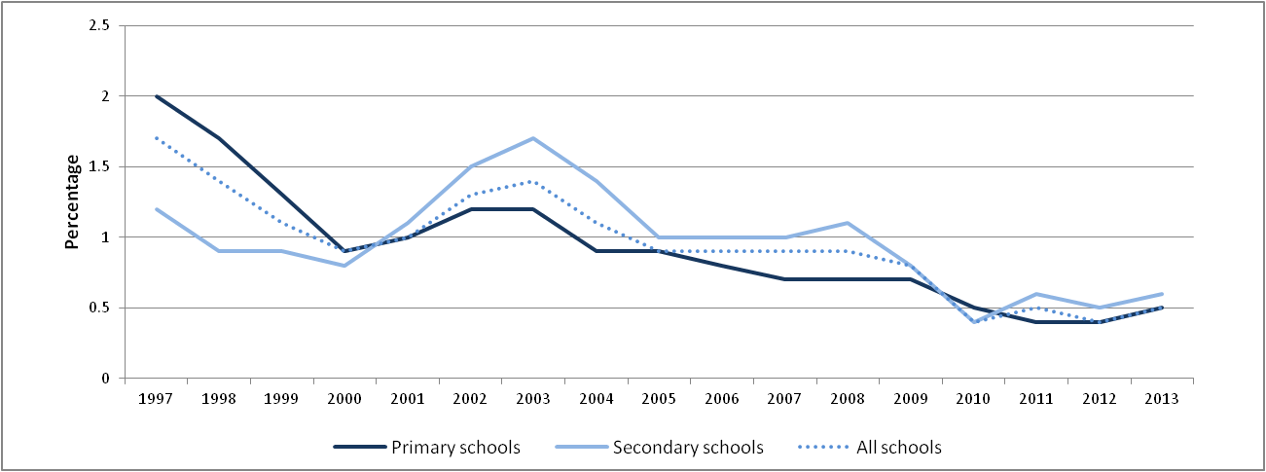

Re-advertised vacancies
Re-advertised vacancies are defined as any position which has been advertised nationally more than once with no appointment being made after the first time advertised. The proportion of re-advertised vacancies has been used as a proxy in this report to indicate positions that are ‘hard-to-staff’, however, there is anecdotal evidence that schools may choose to re-advertise vacancies in order to broaden the pool of applicants. The following results should be interpreted with this in mind.

What proportion of vacancies had been re-advertised?
At the start of Term 1 2013, 22% of vacancies in primary schools and 41% of vacancies in secondary schools had been re-advertised. Re-advertised vacancies in primary schools were lower in 2013 than in 2012 (31%) but similar to the proportion recorded in 2011 (24%). Re-advertised vacancies in secondary schools were higher in 2013 than 2012 (36%) but lower than the proportion recorded in 2011 (51%).

What proportion of entitlement positions were re-advertised?
As shown in Table 4, 1.3% of primary schools and 10% of secondary schools had re-advertised vacancies at the start of 2013. Re-advertised vacancies represented just 0.1% of all FTTE entitlement positions in primary schools and 0.2% of entitlement positions in secondary schools – the same proportions as in 2012.

Table 4: Re-advertised vacancies (FTTE) at the beginning of the school year (2006–2013)
 | Primary
 | 2006 | 2007 | 2008 | 2009 | 2010 | 2011 | 2012 | 2013
Re-advertised positions (FTTE)
- number | 41.5 | 47.3 | 69.7 | 73.4 | 34.9 | 21.6 | 28.8 | 26.7
- percentage of entitlement positions (%) | 0.2 | 0.2 | 0.3 | 0.3 | 0.1 | 0.1 | 0.1 | 0.1
Schools with re-advertised positions
- number | 42 | 46 | 72 | 69 | 37 | 24 | 28 | 24
- percentage of responding schools (%) | 2.2 | 2.4 | 3.7 | 3.5 | 1.9 | 1.3 | 1.5 | 1.3
 | Secondary
 | 2006 | 2007 | 2008 | 2009 | 2010 | 2011 | 2012 | 2013
Re-advertised positions (FTTE)
- number | 74.2 | 100.6 | 120.2 | 67.4 | 26.1 | 53.2 | 33.4 | 41.4
- percentage of entitlement positions (%) | 0.4 | 0.6 | 0.7 | 0.4 | 0.1 | 0.3 | 0.2 | 0.2
Schools with re-advertised positions
- number | 61 | 81 | 82 | 54 | 24 | 42 | 29 | 38
- percentage of responding schools (%) | 16.0 | 21.1 | 20.9 | 13.9 | 6.0 | 11.0 | 7.0 | 10.0
 | All schools
 | 2006 | 2007 | 2008 | 2009 | 2010 | 2011 | 2012 | 2013
Re-advertised positions (FTTE)
- number | 115.7 | 147.9 | 190.0 | 140.8 | 61.0 | 74.8 | 62.2 | 68.1
- percentage of entitlement positions (%) | 0.3 | 0.4 | 0.5 | 0.3 | 0.1 | 0.2 | 0.1 | 0.2
Schools with re-advertised positions
- number | 103 | 127 | 154 | 123 | 61 | 66 | 57 | 62
- percentage of responding schools (%) | 4.5 | 5.4 | 6.6 | 5.2 | 2.6 | 3.0 | 2.5 | 2.8

Showing a similar patter to the data on entitlement staffing vacancies, re-advertised vacancies, as a proportion of all entitlement positions, were greatest in:
- schools in rural areas (population < 1,000)
- schools with the highest proportion of Māori students on their roll (relative to other schools)
- low decile schools (deciles 1–3).
Appendix Table 2 has further details.

Geographical location of schools with vacancies and re-advertised vacancies
Vacancies and re-advertised vacancies for the period 2011–2013 are shown in Table 5 for each of the Ministry of Education local office areas.
There was little change overall in the proportion of entitlement vacancies between 2011 and 2013. Consistent with data from previous years, the Whangarei area had the highest proportion of vacant entitlement positions (1.2%). The most marked increases in the proportion of entitlement vacancies were in:
- Whangarei area — increased to 1.2% (0.9% in 2011 and 0.7% in 2012)
- Whanganui area — increased to 0.8% (0.4% in 2011 and 2012)
- Invercargill area — increased to 1.0% (0.2% in 2011, 0.6% in 2012)
- Rotorua area — increased to 0.6% (0.5% in 2011 and 0.2% in 2012).
Minor changes in the proportion of re-advertised positions were recorded across most areas. Of note:
- re-advertised positions in the Whangarei area increased from 0.1% in 2012 to 0.4% in 2013
- in Nelson, re-advertised positions increased from 0.2% in 2012 to 0.5% in 2013, (making it the area with the highest proportion of re-advertised positions)
- re-advertised positions decreased from 0.6% in 2012 to 0.2% in the Invercargill area.

Table 5: Geographical location (by Ministry of Education local office areas) of school with vacancies and re-advertised vacancies 2011 to 2013
Ministry of Education local office areas | Vacancies (FTTE) |  |  |  |  |  | Re-advertised vacancies (FTTE)
Ministry of Education local office areas | 2011 |  | 2012 |  | 2013 |  | 2011 |  | 2012 |  | 2013
Ministry of Education local office areas | N | % a | N | %a | N | % a | N | % a | N | % a | N | % a
Whangarei | 16.1 | 0.9 | 11.7 | 0.7 | 22.1 | 1.2 | 7.0 | 0.4 | 1.6 | 0.1 | 7.7 | 0.4
Auckland North | 15.5 | 0.3 | 14.8 | 0.3 | 16.3 | 0.4 | 3.0 | 0.1 | 3.6 | 0.1 | 4.0 | 0.1
Auckland South | 39.3 | 0.4 | 35.8 | 0.4 | 29.9 | 0.3 | 16.5 | 0.2 | 14.5 | 0.2 | 11.0 | 0.1
Hamilton | 21.6 | 0.6 | 20.9 | 0.5 | 21.5 | 0.6 | 9.9 | 0.3 | 6.3 | 0.2 | 6.0 | 0.2
Rotorua | 17.5 | 0.5 | 7.7 | 0.2 | 18.5 | 0.6 | 6.2 | 0.2 | 4.3 | 0.1 | 3.4 | 0.1
Whanganui | 12.2 | 0.4 | 12.2 | 0.4 | 25.1 | 0.8 | 3.0 | 0.1 | 4.0 | 0.1 | 4.4 | 0.1
Napier | 11.2 | 0.5 | 8.4 | 0.4 | 10.0 | 0.5 | 6.5 | 0.3 | 2.0 | 0.1 | 1.0 | 0.0
Wellington | 22.3 | 0.5 | 21.9 | 0.5 | 33.7 | 0.7 | 8.6 | 0.2 | 8.8 | 0.2 | 10.0 | 0.2
Nelson | 8.5 | 0.5 | 10.7 | 0.6 | 12.0 | 0.7 | 2.0 | 0.1 | 4.0 | 0.2 | 8.0 | 0.5
Christchurch | 22.5 | 0.5 | 25.7 | 0.5 | 16.6 | 0.3 | 9.9 | 0.2 | 6.1 | 0.1 | 8.6 | 0.2
Dunedin | 4.7 | 0.3 | 8.7 | 0.5 | 5.2 | 0.3 | 1.2 | 0.1 | 1.0 | 0.1 | 2.0 | 0.1
Invercargill | 2.4 | 0.2 | 6.3 | 0.6 | 9.6 | 1.0 | 1.0 | 0.1 | 6.0 | 0.6 | 2.0 | 0.2
Total | 193.8 | 0.5 | 184.7 | 0.4 | 220.5 | 0.5 | 74.8 | 0.2 | 62.2 | 0.1 | 68.1 | 0.2
ª Percentage of provisional entitlement positions (FTTE) in schools that responded to the survey.

Immersion/bilingual teacher vacancies in primary schools
Principals of primary schools with vacancies at the start of the year were asked if any of these positions were for Māori medium/bilingual teachers, or Samoan, Tongan or Cook Islands bilingual teachers.
Māori Medium/bilingual: At the start of Term 1 2013, there were 16 FTTE vacancies for Māori medium/bilingual teachers. These vacancies represent 0.5% of all FTTE entitlement positions in primary schools that offer Māori medium education. This figure is slightly higher than the 0.4% in 2012 and higher than the 2011 figure (0.2%). These vacancies were in full immersion and bilingual schools as well as in schools that offer immersion and bilingual classes.
Pasifika Medium/bilingual: At the start of Term 1 2013, there were no reported vacancies for Samoan, Tongan or Cook Islands bilingual teachers — representing a decrease compared to 0.4% in 2012 and 0.2% in 2011 of all FTTE entitlement positions in primary schools that offer Pasifika medium education.

Māori language and subject vacancies in secondary schools
Table 6 presents vacancies in secondary schools by subject area for 2009–2013. Mathematics & statistics vacancies made up the greatest proportion of all vacancies in secondary schools (14.2 FTTE vacancies, representing 15.4% of all vacancies in secondary schools — a decrease compared to 19.1% in 2012). Given the high number of mathematics & statistics teachers in New Zealand secondary schools it is not surprising that the greatest proportion of vacancies is in this subject area.
Vacancies for Māori language positions (Te Reo Māori and Māori medium/bilingual) were at 13.5% (12.4 FTTE) in 2013 (up from 12.9% in 2012), making up the second highest proportion of vacancies. The next highest vacancies were in technology subjects, which increased from 5.2% in 2012 to 13.3% (12.2 FTTE) in 2013, and science subjects at 11.7% (10.7 FTTE), down from 14.8% in 2012.

Table 6: Secondary school subject vacancies
Subjects | 2009 |  | 2010 |  | 2011 |  | 2012 |  | 2013
Subjects | N | % | N | % | N | % | N | % | N | %
English | 26.1 | 17.5 | 14.8 | 20.7 | 10.4 | 10.0 | 10.3 | 11.1 | 9.6 | 10.5
Māori (Total) | 18.2 | 12.2 | 5.8 | 8.1 | 14.0 | 13.5 | 11.9 | 12.9 | 12.4 | 13.5
Māori (Te Reo) | 12.2 | 8.2 | 2.8 | 3.9 | 7.5 | 7.3 | 7.6 | 8.2 | 9.4 | 10.2
Māori medium / bilingual | 6.0 | 4.0 | 3.0 | 4.2 | 6.5 | 6.3 | 4.3 | 4.7 | 3.0 | 3.3
Mathematics & statistics | 15.2 | 10.2 | 9.2 | 12.9 | 17.5 | 16.9 | 17.6 | 19.1 | 14.2 | 15.4
Sciences (Total) | 17.3 | 11.6 | 6.7 | 9.3 | 10.5 | 10.1 | 13.7 | 14.8 | 10.7 | 11.7
General science | 12.3 | 8.3 | 4.1 | 5.7 | 4.8 | 4.7 | 6.7 | 7.2 | 4.7 | 5.2
Biology | 2.0 | 1.3 | 2.6 | 3.6 | 0.0 | 0.0 | 2.0 | 2.2 | 0.0 | 0.0
Physics | 2.0 | 1.3 | 0.0 | 0.0 | 3.5 | 3.4 | 1.0 | 1.1 | 4.0 | 4.3
Chemistry | 1.0 | 0.7 | 0.0 | 0.0 | 2.2 | 2.1 | 4.0 | 4.3 | 2.0 | 2.2
Technology (Total) | 21.4 | 14.4 | 9.8 | 13.7 | 10.9 | 10.5 | 4.8 | 5.2 | 12.2 | 13.3
Graphics | - | - | 1.2 | 1.7 | 1.9 | 1.8 | 0.1 | 0.1 | - | -
Resistant materials | - | - | 3.5 | 4.9 | 3.5 | 3.4 | 3.3 | 3.6 | - | -
Electronics | - | - | 0.0 | 0.0 | 0.0 | 0.0 | 0.1 | 0.1 | - | -
Food technology | - | - | 2.6 | 3.6 | 2.5 | 2.4 | 0.8 | 0.9 | - | -
Textiles | - | - | 1.1 | 1.5 | 0.0 | 0.0 | 0.0 | 0.0 | 1.2 | 1.3
Design | - | - | 0.0 | 0.0 | 1.0 | 1.0 | 0.0 | 0.0 | - | -
Bio and chemical related technology | - | - | 0.0 | 0.0 | 1.0 | 1.0 | 0.0 | 0.0 | - | -
Programming and computer science | - | - | 0.2 | 0.3 | 1.0 | 1.0 | 0.2 | 0.2 | - | -
Digital information | - | - | 0.2 | 0.3 | 0.0 | 0.0 | 0.3 | 0.3 | 2.4 | 2.6
Digital infrastructure | - | - | 0.0 | 0.0 | 0.0 | 0.0 | 0.0 | 0.0 | - | -
Digital media | - | - | 1.0 | 1.4 | 0.0 | 0.0 | 0.0 | 0.0 | - | -
Other technology |  |  |  |  |  |  |  |  | 8.6 | 9.3
Health & physical education | 9.3 | 6.2 | 1.4 | 2.0 | 6.4 | 6.2 | 2.8 | 3.0 | 4.5 | 4.9
Food & nutrition | 5.0 | 3.4 | 2.2 | 3.1 | 0.6 | 0.6 | 1.0 | 1.1 | 2.5 | 2.7
Social studies | 6.3 | 4.2 | 5.5 | 7.7 | 6.4 | 6.2 | 8.1 | 8.8 | 1.2 | 1.3
Drama |  |  | 0.9 | 1.3 | 0.2 | 0.2 | 0.8 | 0.9 | 1.8 | 2.0
Art | 2.7 | 1.8 | 3.1 | 4.3 | 3.5 | 3.4 | 1.0 | 1.1 | 2.8 | 3.0
Commerce | 2.0 | 1.3 | 2.1 | 2.9 | 2.0 | 1.9 | 1.0 | 1.1 | 1.0 | 1.1
Music | 1.6 | 1.1 | 1.9 | 2.7 | 1.3 | 1.3 | 2.0 | 2.2 | 3.0 | 3.3
Other / Non-subject specific | 22.9 | 15.3 | 7.2 | 10.1 | 18.9 | 18.3 | 16.4 | 17.7 | 16.0 | 17.4
Total | 148.9 | 100.0 | 71.4 | 100.0 | 103.5 | 100.0 | 92.4 | 100.0 | 91.9ª | 100.0
ª This total is less than the total of FTTE vacancies specified in Table 3 due to a small number of schools not specifying the subject area of their vacancies.
.

Teacher Appointments
Principals were asked whether they had advertised for a permanent classroom teacher in the six months prior to the survey, and if so, how many New Zealand-trained teachers applied for the position. Primary school principals answered this question in relation to permanent Scale A classroom teachers and secondary school principals answered this question in relation to English, Te Reo Māori, mathematics & statistics, chemistry, physics, general science, health and physical education, and technology positions only. If schools had advertised for more than one position in the last six months, they answered this question in relation to the most recent position advertised.

Primary schools
Forty-three per cent of primary principals indicated they had advertised for a permanent Scale A classroom teacher in the past six months — a similar proportion to that of 2011 and 2012. As shown in Figure 2, the number of New Zealand trained teachers applying for permanent positions has been increasing over the past three years. In 2013, 73% of cases had nine or more New Zealand-trained applicants, compared to 70% of cases in 2012, and 59% of cases in 2011. In 2010, principals reported that 48% of advertised positions received applications from nine or more New Zealand-trained teachers.
Consistent with data from previous years, appointments were made for the majority (96%) of these advertised positions (see Appendix Table 3).

Figure 2: New Zealand trained applicants applying for permanent positions in primary schools between
July–Januaryª
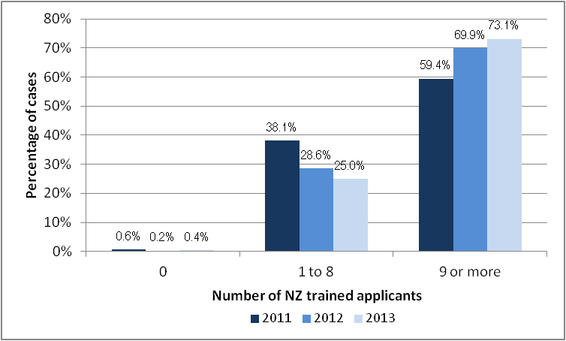
^{b}
ª Percentages do not add up to 100% as a small proportion of principals indicated they were unsure about the number of New Zealand trained applicants or did not specify the number (1.5% in 2013, 1.3% in 2012 and 1.9% in 2011)
^{b} Due to a formatting error, the 2011 figure for zero number of applicants was incorrectly reported as 6% instead of 0.6% in the monitoring report for last year (2012). This has now been corrected.

Secondary schools
Figure 3 shows the proportion of secondary schools that had advertised for a permanent position in each of the subjects listed in the six months prior to the survey. Consistent with general trends identified over the past three years, advertised positions in the six months prior to the 2013 survey were most likely to be in English and mathematics & statistics and least likely to be in chemistry and physics. A higher demand for teachers in mathematics & statistics and English would be expected as these are core subjects offered in all secondary schools.

Figure 3: Secondary schools advertising for a teacher in 8 subject areas in the six months prior to the survey
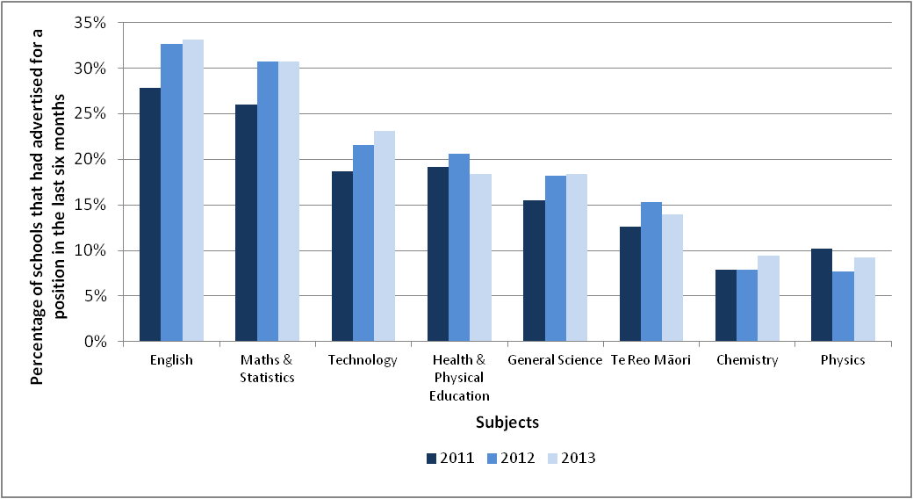
Figure 4 presents the number of New Zealand trained teachers that applied for permanent positions in key subject areas. The numbers of New Zealand trained applicants for positions has stayed relatively stable over the last three years.
Schools were less likely to receive a high number of applications (9 or more) from New Zealand trained teachers for Te Reo Māori, physics and technology positions compared to other subjects – a trend that has been consistent over the last three years. Despite this, a greater proportion of schools received 9 or more applications for their physics vacancies in 2013 compared with 2012 (even though they do not receive a high number of applications overall).
The proportion of schools receiving 9 or more New Zealand trained applicants also increased for mathematics & statistics and general science in 2013 compared to 2012.
While the proportion of schools receiving no New Zealand trained applicants increased in 2013 compared to 2012 for Te Reo Māori, health & physical education, chemistry, physics and technology the actual numbers involved in such cases are quite small.

Figure 4: New Zealand trained applicants applying for subject positions at secondary schools between July and January
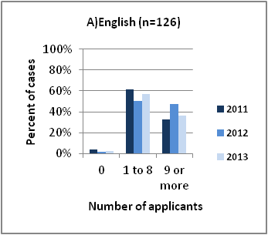 | 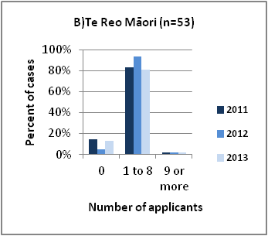 | 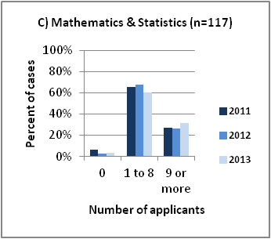
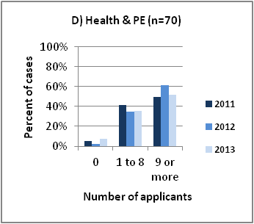 | 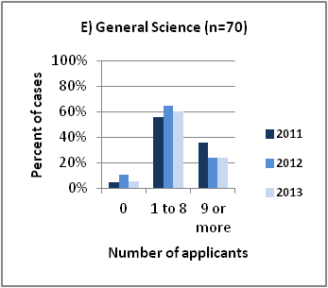 | 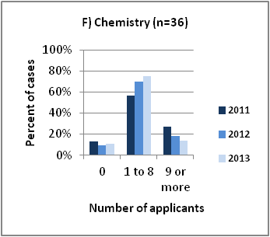
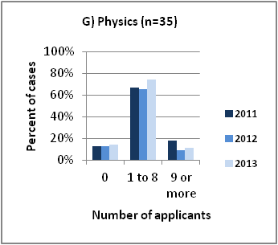 | 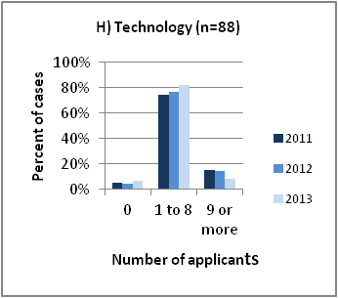

As in 2012, Te Reo Māori and chemistry positions were less likely to be filled by a successful candidate in 2013 than other subject positions (see Appendix Table 4). Also as in 2012, the majority (more than 90%) of advertised positions in English, mathematics & statistics, health and physical education, general science, and technology were filled with a successful candidate. In 2013, too, 91% of physics positions were filled — a marked change from the 77% of positions in 2012.

Sources of Teacher Supply in 2013
The supply of teachers for New Zealand schools is dependent on a number of sources, the most significant being the movement of part-time or fixed term teachers into permanent positions Two additional sources of supply are the recruitment of first year (beginning) teachers and of overseas-trained teachers. Ongoing monitoring of the supply and demand for teachers in New Zealand indicates that beginning and overseas-trained teachers may find it more difficult now to secure a teaching position.

Overseas-trained teachers
Principals were asked to indicate the number of relatively new overseas-trained teachers employed by their school. For this survey, a ‘relatively new overseas-trained teacher’ was defined as an overseas trained teacher who taught for the first time in New Zealand in either 2012 or 2013.
As shown in Table 7, the number of relatively new overseas teachers employed in state and state-integrated schools has declined over the last four years. Relatively new overseas-trained teachers in 2013 represented 0.4% of all teachers in primary schools (down from 1.0% in 2009 but the same proportion as in 2012) and 0.6% of all teachers in secondary schools (down from 1.7% in 2009 and 0.8% in 2012).

Table 7: The number of relatively new overseas-trained teachers at the start of Term 1 (2009-2013)
 | 2009 |  | 2010 |  | 2011 |  | 2012 |  | 2013
 | Number | % of all  teachers ª | Number | % of all  teachers ª | Number | % of all  teachers ª | Number | % of all  teachers ª | Number | % of all  teachers ª
Primary | 317 | 1.0 | 248 | 0.8 | 187 | 0.7 | 123 | 0.4 | 104 | 0.4
Secondary | 376 | 1.7 | 289 | 1.4 | 235 | 1.1 | 164 | 0.8 | 113 | 0.6
Total | 693 | 1.3 | 537 | 1.1 | 422 | 0.9 | 287 | 0.6 | 217 | 0.5
ª ‘Percentage of all teachers’ is based on the headcount of teachers on the payroll during the second pay period of February 2013

In 2013, two-thirds (n=149, 69%) of overseas teachers were employed by schools in main urban areas. Two-thirds (n=154, 71%) of overseas teachers were employed in schools with a lower proportion of Māori students (schools with less than 18.7% Māori students) and three-quarters of overseas teachers (n=170, 78%) were employed in decile 4 to 10 schools.
When analysed as a proportion of all teachers, overseas-trained teachers were spread relatively evenly between different localities and deciles, but were slightly more likely to be in schools in secondary urban areas (populations between 10,000 and 30,000), and slightly less likely to be in schools with the highest proportion of Māori students (see Appendix Table 5).

Beginning teachers
Principals were asked whether their school had any first year beginning teachers on their staff in 2013, and if so, to indicate the number that were eligible, and those who were not eligible, for the Beginning Teacher Time Allowance (BTTA).
In 2013, there were 1,929 first year beginning teachers employed in New Zealand schools at the start of the school year. These teachers represented 4.2% of all teachers at responding schools (higher than the 3.6% in 2012 and 2011). First year beginning teachers comprised 3.2% of teachers in the secondary sector (down slightly from 3.3% in 2012) and 4.9% of teachers in the primary sector (up from 3.8% in 2012). As with previous years, the majority (n=1,603, 83%) of first year beginning teachers were eligible for the Beginning Teacher Time Allowance, a decrease on the 92% eligible in 2012. Over the five year period shown in Table 8, the number of first year beginning teachers has fluctuated in numbers and as a percentage of all teachers.

Table 8: First year beginning teachers in New Zealand schools at the start of Term 1 (2009-2013)
 | 2009 |  | 2010 |  | 2011 |  | 2012 |  | 2013
 | Number | % of all  teachers ª | Number | % of all  teachers ª | Number | % of all  teachers ª | Number | % of all  teachers ª | Number | % of all  teachers ª
Total number of first year beginning teachers (headcount)
Total | 2,029 | 3.8 | 1,720 | 3.4 | 1,766 | 3.6 | 1,794 | 3.6 | 1,929 | 4.2
Primary | 1,308 | 4.2 | 1,064 | 3.6 | 970 | 3.5 | 1,079 | 3.8 | 1,308 | 4.9
Secondary | 721 | 3.2 | 656 | 3.1 | 796 | 3.9 | 715 | 3.3 | 621 | 3.2
First year beginning teachers eligible for the Beginning Teacher Time Allowance
Total | 1,973 | 3.7 | 1,658 | 3.3 | 1,605 | 3.3 | 1,646 | 3.3 | 1,603 | 3.5
Primary | 1,280 | 4.1 | 1,027 | 3.5 | 906 | 3.2 | 997 | 3.5 | 1,061 | 4.0
Secondary | 693 | 3.1 | 631 | 3.0 | 699 | 3.4 | 649 | 3.0 | 542 | 2.8
First year beginning teachers not eligible for the Beginning Teacher Time Allowance
Total | 56 | 0.1 | 62 | 0.1 | 161 | 0.3 | 148 | 0.3 | 326 |  | 0.7
Primary | 28 | 0.1 | 37 | 0.1 | 64 | 0.2 | 82 | 0.3 | 247 |  | 0.9
Secondary | 28 | 0.1 | 25 | 0.1 | 97 | 0.5 | 66 | 0.3 | 79 |  | 0.4
ª ‘Percentage of all teachers’ is based on the headcount of teachers at responding schools on the second payroll in February 2013.

In 2013, 71% (n=1,372) of first year beginning teachers were employed by schools in main urban areas. Just over half (n=1,058, 55%) of first year beginning teachers were employed by schools with a low (less that 18.7%) proportion of Māori students, and three-quarters (n=1,385, 72%) were employed in decile 4 to 10 schools.
When analysed as a proportion of all teachers in state and state-integrated schools, first year beginning teachers in 2013 were more likely to be employed in lower (1–3) decile schools, and schools with a high proportion (38% to 100%) of Māori students (see Appendix Table 6).
In addition to collecting information about first year beginning teachers, principals were also asked to indicate the number of second year beginning teachers on their staff in 2013.
Consistent with previous years, secondary schools (86%) were more likely than primary schools (58%) to have employed at least one first or second year beginning teacher in 2013. First and second year beginning teachers comprised 6.5% of the teaching population in secondary schools and 9.3% of the teaching population in primary schools.

Table 9: First and second year beginning teachers in NZ schools (2011-2013)
 | Total schools with beginning teachers |  |  |  |  |  | Total (1st and 2nd yr) beginning teachers
 | 2011 |  | 2012 |  | 2013 |  | 2011 |  | 2012 |  | 2013
 | N | % of all schools | N | % of all schools | N | % of all schools | N | % of all teachers ª | N | % of all teachers ª | N | % of all teachers ª
Total number of beginning teachers (headcount)
Total | 1,292 | 58.3 | 1,369 | 59.6 | 1,382 | 62.7 | 3,464 | 7.2 | 3,567 | 7.1 | 3,719 | 8.1
Primary | 976 | 53.1 | 1,019 | 54.0 | 1,063 | 58.1 | 1,984 | 7.1 | 2,102 | 7.4 | 2,471 | 9.3
Secondary | 316 | 82.9 | 350 | 85.0 | 319 | 85.5 | 1,480 | 7.2 | 1,465 | 6.7 | 1,248 | 6.5
Beginning teachers eligible for the Beginning Teacher Time Allowance
Total | 1,253 | 56.5 | 1,332 | 58.0 | 1,339 | 60.8 | 3,156 | 6.5 | 3,286 | 6.5 | 3,203 | 7.0
Primary | 941 | 51.2 | 987 | 52.3 | 1,028 | 56.2 | 1,850 | 6.6 | 1,930 | 6.8 | 2,074 | 7.8
Secondary | 312 | 81.9 | 345 | 83.7 | 311 | 83.4 | 1,306 | 6.4 | 1,356 | 6.2 | 1,129 | 5.9
Beginning teachers not eligible for the Beginning Teacher Time Allowance
Total | 150 | 6.8 | 147 | 6.4 | 161 | 7.3 | 308 | 0.6 | 281 | 0.6 | 516 | 1.1
Primary | 95 | 5.2 | 105 | 5.6 | 118 | 6.4 | 134 | 0.5 | 172 | 0.6 | 397 | 1.5
Secondary | 55 | 14.4 | 42 | 10.2 | 43 | 11.5 | 174 | 0.9 | 109 | 0.5 | 119 | 0.6
ª ‘Percentage of all teachers’ is based on the headcount of teachers on the payroll during the second pay period in February 2013

As in 2012, first and second year beginning teachers comprised a larger proportion of the teaching population in rural schools, schools with the highest proportion of Māori students on the roll and lower decile schools (see Appendix Table 7).

Availability of Relief Teachers Proficient in
Te Reo Māori
Principals were asked how easy or difficult it is to find relief teachers for positions that require proficiency in Te Reo Māori. This question was added in 2011 in response to anecdotal reports from schools that finding qualified relief teachers proficient in Te Reo Māori is difficult.
In 2013, 16% of primary schools, and 61% of secondary schools had positions that require teachers to be proficient in Te Reo Māori. As shown in Figure 5, about two-thirds of principals from these schools (60% from primary and 65% from secondary schools) find it very difficult, and about a quarter of principals (31% from primary and 26% from secondary schools) find it somewhat difficult to source relief teachers for these positions. These figures are similar to those of 2012.

Figure 5: Level of difficulty finding relief teachers proficient in Te Reo Māori
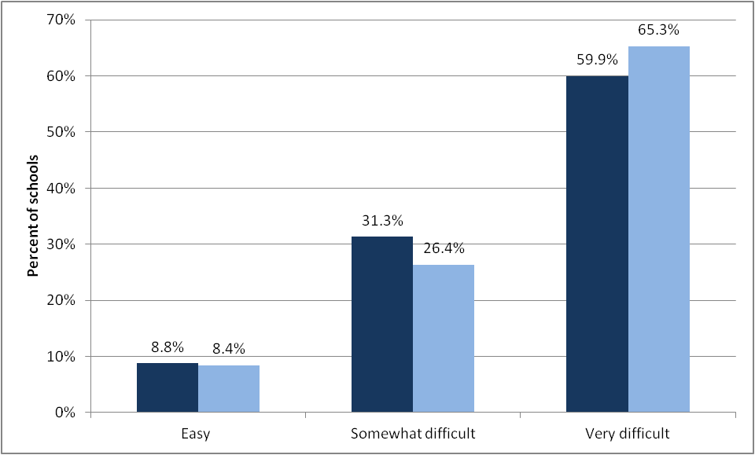

Conclusion
Compared to 2012, there was a marked decline in the response rate from secondary schools and a slight decline in the response rate from primary schools; however, overall, 91% of state and state integrated schools contributed to the 2013 survey.
At 0.5% of all FTTE entitlement positions, the proportion of vacancies at the beginning of the school year in 2013 are within the trend shown over the previous three years of between 0.5% and 0.4%. However, looking over a longer period, there has been a decline in the proportion of vacancies since the late 1900s. Secondary schools, in general, have larger proportions of vacancies than primary schools.
This year’s results also show a continuing shift in the supply of teachers applying for, and being appointed to positions. Over the last few years, we have seen more New Zealand-trained teachers applying for positions and fewer relatively new overseas teachers being employed. In 2013, there was also an increase in the number of first year beginning teachers being appointed in primary schools.
In relation to secondary school subject vacancies, the 2013 results generally show a continuation of the trends seen in previous years, with the highest subject vacancy rates in secondary schools being for teachers of English, mathematics & statistics, science, and Te Reo Māori subjects. In 2013, technology subjects also had relatively higher vacancy rates compared with the previous year. However, it is worth noting that the proportion of entitlement vacancies in any of the subject areas was not greater than 15.4% (or 14.2 FTTE positions).

Appendix

Appendix Table 1: Proportion of vacant entitlement positions, by school characteristics
 | Vacant entitlement positions (FTTE)
 | 2011 |  | 2012 |  | 2013
 | N | % ª | N | % ª | N | % ª
All schools | 193.8 | 0.5 | 184.7 | 0.4 | 191 | 0.5
Locality
Main Urban (population > 30,000) | 97.8 | 0.3 | 116.8 | 0.4 | 131.1 | 0.4
Secondary Urban (10,000 to 30,000) | 10.0 | 0.3 | 13.2 | 0.4 | 20.8 | 0.7
Minor Urban (1,000 to 9,999) | 36.3 | 0.7 | 28.0 | 0.5 | 19.2 | 0.4
Rural (< 1,000) | 49.8 | 1.4 | 26.7 | 0.7 | 49.4 | 1.3
Māori Roll (quartiles)
0% to 10.1% | 41.1 | 0.3 | 42.9 | 0.3 | 53.3 | 0.4
10.2% to 18.6% | 42.5 | 0.4 | 35.5 | 0.3 | 40.6 | 0.3
18.7% to 37.9% | 43.3 | 0.4 | 47.3 | 0.4 | 52.4 | 0.5
38% to 100% | 66.9 | 0.9 | 59.0 | 0.8 | 74.1 | 1.0
Socio-economic indicator
Deciles 1–3 | 80.3 | 0.7 | 77.3 | 0.7 | 83.7 | 0.8
Deciles 4–7 | 71.9 | 0.4 | 64.7 | 0.4 | 78.8 | 0.5
Deciles 8–10 | 41.6 | 0.3 | 42.8 | 0.3 | 58.0 | 0.4
ª ‘Percentage of schools that responded to the survey

Appendix Table 2: Proportion of re-advertised positions, by school characteristics
School Characteristics | Re-advertised vacant entitlement positions (FTTE)
School Characteristics | 2011 |  | 2012 |  | 2013
School Characteristics | N | % ª | N | % ª | N | % ª
All schools | 74.8 | 0.2 | 62.2 | 0.1 | 68.14 | 0.2
Locality
Main Urban (population > 30,000) | 26.2 | 0.1 | 37.4 | 0.1 | 42.04 | 0.1
Secondary Urban (10,000 to 30,000) | 3.6 | 0.1 | 6.8 | 0.2 | 5.0 | 0.2
Minor Urban (1,000 to 9,999) | 21.3 | 0.4 | 11.0 | 0.2 | 4.4 | 0.1
Rural (< 1,000) | 23.7 | 0.7 | 7.0 | 0.2 | 16.7 | 0.4
Māori Roll (quartiles)
0% to 10.1% | 14.6 | 0.1 | 9.0 | 0.1 | 20.64 | 0.2
10.2% to 18.6% | 16.5 | 0.1 | 16.0 | 0.1 | 14.0 | 0.1
18.7% to 37.9% | 11.7 | 0.1 | 11.0 | 0.1 | 12.0 | 0.1
38% to 100% | 32.0 | 0.4 | 26.2 | 0.3 | 21.5 | 0.3
Socio-economic indicator
Deciles 1–3 | 36.0 | 0.3 | 31.7 | 0.3 | 27.1 | 0.3
Deciles 4–7 | 25.2 | 0.2 | 21.7 | 0.1 | 25.04 | 0.2
Deciles 8–10 | 13.6 | 0.1 | 8.8 | 0.1 | 16.0 | 0.1
ª ‘Percentage of entitlement positions in schools that responded to the survey

Appendix Table 3: Proportion of advertised positions in primary schools in which an appointment was made
 | 2011 | 2012 | 2013
Advertised a position | 43.0% | 43.6% | 42.8%
Made an appointment | 95.0% | 97.3% | 96.1%

Appendix Table 4: Proportion of advertised positions in secondary schools in which an appointment was made
Year | English | Te Reo Māori | Maths & Statistics | Health & Physical Education | General Science | Chemistry | Physics | Technology
2011 | 91.4% | 79.5% | 89.5% | 94.4% | 91.5% | 96.4% | 83.3% | 89.7%
2012 | 97.0% | 86.7% | 91.1% | 98.8% | 92.8% | 81.3% | 76.7% | 94.3%
2013 | 96.0% | 82.7% | 93.0% | 95.6% | 94.0% | 84.2% | 90.9% | 91.9%

Appendix Table 5: Characteristics of schools employing relatively new overseas-trained teachers
School Characteristics | 2011 |  | 2012 |  | 2013
School Characteristics | Number  (headcount) | % of all  teachers ª | Number  (headcount) | % of all  teachers ª | Number  (headcount) | % of all  teachers ª
All schools | 422 | 0.9 | 287 | 0.6 | 217 | 0.5
Primary schools | 187 | 0.7 | 123 | 0.4 | 104 | 0.4
Secondary schools | 235 | 1.1 | 164 | 0.8 | 113 | 0.6
Locality
Main Urban (population > 30,000) | 316 | 0.9 | 198 | 0.6 | 149 | 0.5
Secondary Urban (10,000 to 30,000) | 28 | 0.8 | 22 | 0.6 | 26 | 0.8
Minor Urban (1,000 to 9,999) | 44 | 0.7 | 36 | 0.6 | 21 | 0.4
Rural (< 1,000) | 34 | 0.8 | 31 | 0.7 | 21 | 0.5
Māori Roll (quartiles)
0% to 10.1% | 140 | 1.0 | 102 | 0.7 | 90 | 0.6
10.2% to 18.6% | 105 | 0.8 | 89 | 0.6 | 64 | 0.5
18.7% to 37.9% | 91 | 0.7 | 49 | 0.4 | 39 | 0.4
38% to 100% | 85 | 1.0 | 47 | 0.6 | 24 | 0.3
Socio-economic indicator
Deciles 1–3 | 132 | 1.1 | 78 | 0.6 | 47 | 0.4
Deciles 4–7 | 138 | 0.7 | 102 | 0.5 | 92 | 0.5
Deciles 8–10 | 151 | 0.9 | 107 | 0.6 | 78 | 0.5
ª ‘Percentage of all teachers’ is based on the headcount of teachers on the payroll during the second pay period of February 2013

Appendix Table 6: Characteristics of schools with first year beginning teachers
School Characteristics | Schools with first year  beginning teachers |  |  | First year beginning teachers
School Characteristics | Number | % of all  schools |  | Number  (headcount) | % of all  teachers ª
All schools | 955 | 43.3 |  | 1929 | 4.2
Primary | 703 | 38.4 |  | 1308 | 4.9
Secondary | 252 | 67.6 |  | 621 | 3.2
Locality
Main Urban (population > 30,000) | 630 |  | 54.0 | 1372 | 4.2
Secondary Urban (10,000 to 30,000) | 74 |  | 49.7 | 130 | 3.8
Minor Urban (1,000 to 9,999) | 115 |  | 44.6 | 241 | 4.6
Rural (< 1,000) | 136 |  | 21.6 | 186 | 4.3
Māori Roll (quartiles)
0% to 10.1% | 260 |  | 47.0 | 554 | 4.0
10.2% to 18.6% | 247 |  | 44.7 | 504 | 3.8
18.7% to 37.9% | 256 |  | 46.5 | 487 | 4.4
38% to 100% | 192 |  | 35.2 | 384 | 5.1
Socio-economic indicator
Deciles 1–3 | 277 |  | 42.4 | 544 | 4.9
Deciles 4–7 | 377 |  | 42.2 | 735 | 4.0
Deciles 8–10 | 301 |  | 45.9 | 650 | 4.0
ª ‘Percentage of all teachers’ is based on the headcount of teachers on the payroll during the second pay period of February 2013

Appendix Table 7: Characteristics of schools with first and second year beginning teachers
School Characteristics | Schools with first and second year beginning teachers |  | First and second year beginning teachers
School Characteristics | Number | % of all  schools | Number  (headcount) | % of all  teachers ª
All schools | 1382 | 62.7 | 3,719 | 8.1
Primary | 1063 | 58.1 | 2,471 | 9.3
Secondary | 319 | 85.5 | 1,248 | 6.5
Locality
Main Urban (population > 30,000) | 870 | 74.6 | 2606 | 8.0
Secondary Urban (10,000 to 30,000) | 110 | 73.8 | 279 | 8.2
Minor Urban (1,000 to 9,999) | 166 | 64.3 | 445 | 8.4
Rural (< 1,000) | 236 | 37.5 | 389 | 9.1
Māori Roll (quartiles)
0% to 10.1% | 362 | 65.5 | 1078 | 7.7
10.2% to 18.6% | 372 | 67.3 | 1027 | 7.8
18.7% to 37.9% | 345 | 62.6 | 898 | 8.1
38% to 100% | 303 | 55.5 | 716 | 9.4
Socio-economic indicator
Deciles 1–3 | 396 | 60.6 | 1010 | 9.1
Deciles 4–7 | 566 | 63.4 | 1449 | 7.9
Deciles 8–10 | 420 | 64.0 | 1260 | 7.7
ª ‘Percentage of all teachers’ is based on the headcount of teachers on the payroll during the second pay period of February 2013

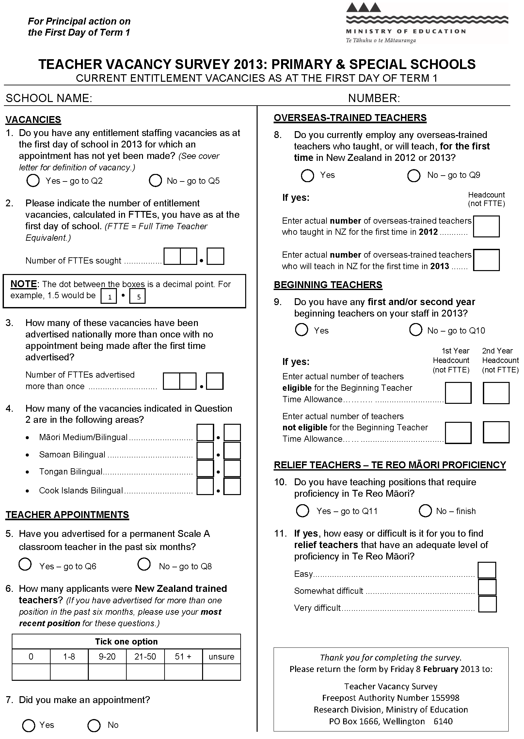
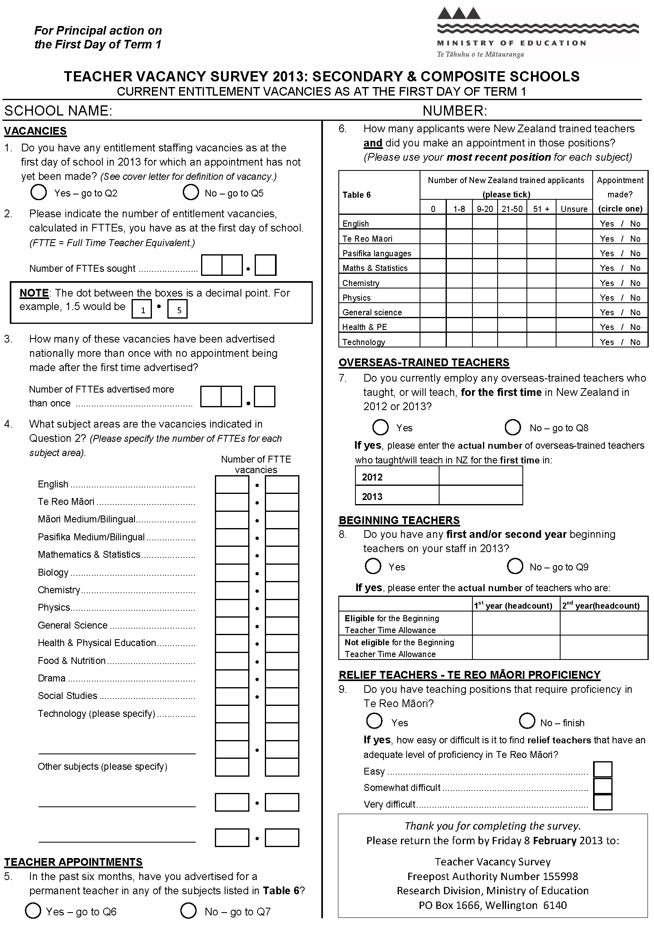

For the purposes of this survey, first year beginning teachers were either in permanent or fixed-term positions of more than 10 consecutive weeks. To be eligible for the Beginning Teacher Time Allowance beginning teachers must be provisionally registered and be employed at least 0.5 FTTE.
Other sources of information include monitoring advertisements in the Education Gazette and information from the Ministry of Education’s March roll returns, and analysing population trends and teacher loss rates.
Five schools indicated they would not be completing the survey due to workload issues caused by Novopay.
These analyses are managed by the Education Information and Analysis Division of the Ministry of Education.
Refer to Table 2 for the number of entitlement positions in the responding schools.
This ongoing monitoring is overseen by the Education Information and Analysis team in the Ministry of Education.
As these figures are based on a headcount of overseas teachers working in schools, they are influenced by the number of schools that respond to the survey and do not provide any information about whether these teachers were working full or part-time. These figures should be taken as an indication of the number of overseas-trained teachers employed in primary and secondary schools only.
The Beginning Teacher Time Allowance (BTTA) is available to state and state integrated school boards employing first and second year beginning teachers. The beginning teacher must be provisionally registered, appointed to a position for at least 10 weeks, be at least 0.5 FTTE, and be paid out of teacher salaries. Full-time teachers receive 0.2 FTTE time allowance and part-time teachers receive 0.1 FTTE in their first year. The allowance (0.1 FTTE) is also available for full-time second year beginning teachers.
For the purposes of this survey, teachers are defined as those in permanent and fixed term positions of more than 10 consecutive weeks (either full-time or part-time).

