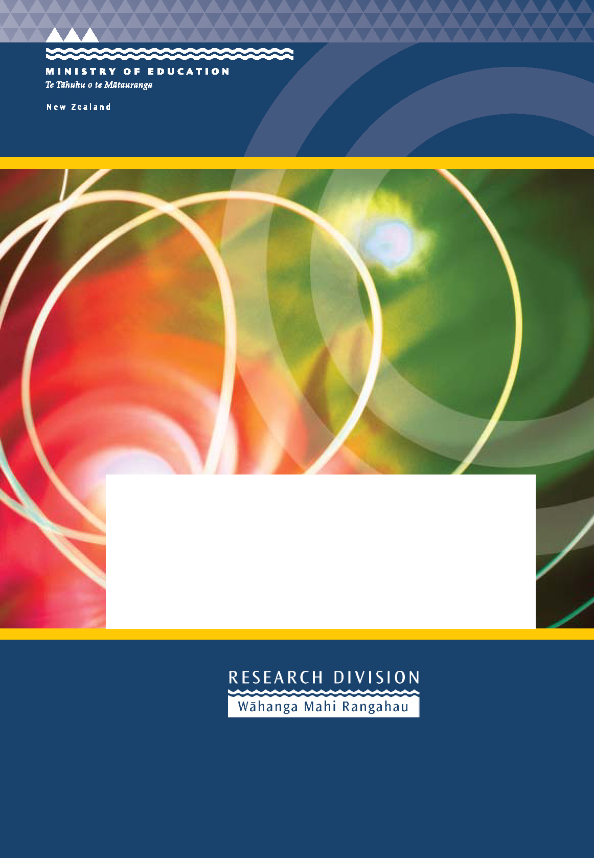

Monitoring Teacher Supply

survey of staffing in new Zealand schools at the Beginning of the 2005 school year
Research Division
Ministry of Education

First Published in 2005 by the:
Research Division
Ministry of Education
PO Box 1666
Wellington
New Zealand
Copyright © Ministry of Education
All Rights Reserved. Enquiries should be made to the publisher.
ISSN – 1176-6352



Monitoring Teacher Supply

Technology Courses:

Survey of Staffing in New Zealand

Schools at the Beginning of the 2005
School Year

PREPARED BY:
Research Division
Ministry of Education
June 2005

CONTENTS

EXECUTIVE SUMMARY 1
MONITORING TEACHER SUPPLY 3
Introduction 3
Method and Response Rates 4
Points to Note 5
THE STAFFING SITUATION IN NEW ZEALAND SCHOOLS AT THE START
OF THE 2005 SCHOOL YEAR 7
Entitlement Staffing Vacancies 7
Re-advertised Vacancies 9
Characteristics of Schools where Vacancies and Re-advertised Vacancies were Concentrated 11
The Geographic Location of Schools with Vacancies and Re-advertised Positions 13
Subject Vacancies in Secondary Schools 15
MEASURES TAKEN BY SCHOOLS TO COVER VACANT POSITIONS 17
SOURCES OF TEACHER SUPPLY IN 2005 19
Overseas Teachers 19
Beginning Teachers 22
CONCLUSION 25
APPENDICES 27

ACKNOWLEDGEMENT
The researchers would like to thank the principals of schools who responded so promptly to this survey. Their continuing support is much appreciated.

EXECUTIVE SUMMARY
Since 1997 the Research Division of the Ministry of Education has undertaken a Teacher Vacancy Survey of all state and state integrated schools at the beginning of each school year to monitor the staffing situation in New Zealand schools. This one-page survey provides the Ministry with a snapshot of the number of entitlement staffing vacancies and re-advertised vacancies in schools at the start of Term 1, how these vacancies are being covered and, in the case of secondary schools, in what subject areas pressure points are occurring. While school vacancies are also monitored through the March and July roll returns and through the advertisements in the Education Gazette this survey provides the Ministry with valuable vacancy information early in the school year.
The 2005 survey was completed by 89 percent of all schools (91% of primary schools and 80% of secondary schools). This is a lower response rate than was achieved for the 2004 survey which was completed by 95 percent of all schools.
The 2005 results show that while vacancies in primary schools remained at a similar level as in 2004, in secondary schools vacancies continued to decline. Thirty-one percent of secondary schools had vacancies at the beginning of the school year compared with 39 percent at the same time in 2004. The vacancies within these schools represented 1.0 percent of all entitlement positions in secondary schools, down from 1.4 percent in 2004.
The number of re-advertised positions is considered to be an indication of “hard-to-staff” positions. Compared with 2004, in 2005 more primary and fewer secondary schools appeared to be having difficulty in filling their vacancies. In 2005, 2.9 percent of all primary schools had re-advertised positions (compared with 1.8% in 2004) and 16 percent of all secondary schools had re-advertised positions (compared with 23% in 2004). In 2005, 29 percent of all vacancies and 0.3 percent of all entitlement positions in primary schools were re-advertised (compared with 21% of all vacancies and 0.2% of all entitlement positions in 2004). In secondary schools, 47 percent of all vacancies and 0.5 percent of all entitlement positions were re-advertised in 2005 (compared with 51% of all vacancies and 0.7 percent of all entitlement positions in 2004).
Further results from the survey in 2005 indicated that:
- The Invercargill Ministry of Education local office area recorded the highest proportion of both vacancies and re-advertised positions. In 2005, 2.8 percent of entitlement positions in that office area were vacant, and 1.7 percent had been re-advertised (compared with 1.3% vacancies and 0.5% re-advertised in 2004 respectively).
- The proportion of vacancies and re-advertised vacancies were greater in schools with larger concentrations of Māori students and in schools in lower socio-economic areas (deciles 1-3 schools).
- A smaller proportion of lower decile schools (deciles 1-3) reported experiencing vacancies in 2005 (15.5%) than was the case in 2004 (17.5%). A similar proportion of lower decile schools reported re-advertised vacancies in 2005 as in 2004.
- The use of trained relief staff (employed for 10 school weeks or less) was the most common measure used to cover vacancies in both primary (62.1% of all primary vacancies were covered in this way) and secondary (51.5%) schools. This measure was used to a greater extent in primary schools and to a relatively lesser extent by secondary schools in 2005 than in 2004.
- The subject areas most sought after in secondary schools were technology (15.5% of all entitlement vacancies), mathematics (13.9%), English (9.2%), Māori (8.1%) and sciences (7.5%).
- There were 1,116 overseas teachers (who had taught for the first time in New Zealand in 2003, 2004, or 2005) teaching here at the beginning of 2005. Nearly three-quarters (74.4%) of these teachers were teaching in secondary schools.
- In 2005, the total number of first year beginning teachers decreased slightly in both primary and secondary schools when compared with the previous year.
- As found in previous surveys, beginning teachers were more likely to be teaching in lower decile schools (deciles 1-3) and in schools with larger concentrations of Mäori students.
- The highest proportions of beginning teachers were employed in the Invercargill (6.2%); Wellington (5.7%), Auckland South (5.5%), and Wanganui (5.4%) local office areas.
The 2005 data suggest that secondary schools are facing less difficulty in staffing their schools than they did in 2004. However, secondary student numbers are still expected to continue to grow in the short term. This implies that the demand for secondary teachers will continue to remain high over the next couple of years. Since 1996, the Ministry of Education has introduced a range of initiatives to increase the supply of teachers. These initiatives include scholarships, loan support, allowances for priority subject areas, retraining for former secondary teachers, returning to teaching allowances, national relocation grants to encourage teachers to take up hard to staff positions, conversion courses to assist primary teachers with degree qualifications to teach in secondary schools, and international relocation grants. The Ministry of Education will continue to closely monitor the teacher supply situation in New Zealand and the outcomes of the initiatives it has in place to increase the supply of secondary teachers.

MONITORING TEACHER SUPPLY

Introduction
New Zealand primary school rolls peaked in 2003, and are expected to continue to decline over the next few years. Secondary school rolls have seen considerable growth in recent years, but are expected to flatten-off in 2007 and decline from 2008. This means that the demand for secondary teachers will remain high in the short-term and steady thereafter.
Since 1996, the Ministry of Education has introduced a number of initiatives aimed at increasing the supply of teachers in all New Zealand schools. Initially, these initiatives focussed mainly on increasing the number of primary school teachers. However, in more recent years the initiatives have been focussed on getting more teachers into secondary schools to match the increasing demand for secondary teachers.
Some of the initiatives already in place include the following.
- Secondary Subject Trainee Allowances for biology, chemistry, English, computing, te reo Māori, mathematics, physics and technology, worth up to $10,000;
- Loan support for teachers of te reo Māori, physics and mathematics in their second to fourth years of teaching;
- Free retraining for former secondary teachers;
- Returning to teaching allowances;
- Rural scholarships worth $10,000 each;
- Conversion courses to assist existing primary teachers with degree qualifications to teach in secondary schools;
- National relocation grants for teachers to move to teaching jobs in other parts of New Zealand;
- International relocation grants of NZ$5,000 to encourage New Zealand teachers living overseas to return and take a teaching position in New Zealand;
- International relocation grants of NZ$4,000 to encourage overseas trained teachers to come to New Zealand to teach.
In September 2004, the government announced a new range of TeachNZ scholarships for potential secondary and Māori Medium teachers. These scholarships replaced the previous scholarships for Māori and Pasifika. Under these new scholarships, students can have their fees paid while they complete a degree qualification and a secondary teaching qualification. They may be eligible for an allowance of $10,000 if they include certain papers in their degree programme and complete the training to become teachers of targeted subjects.
The TeachNZ Unit of the Ministry of Education has contracted four recruitment agencies to actively encourage New Zealand secondary teachers working in the United Kingdom to return home to teach. If they recruit these teachers, or suitably qualified overseas trained teachers, then they are able to reduce their charges to the school by $1,000 and claim that subsidy back from the Ministry.
The Ministry monitors the teacher supply situation in New Zealand schools closely. One of the ways in which it does this is to undertake a survey of all schools at the beginning of the school year. The Teacher Vacancy Survey has been undertaken since 1997 and provides a snapshot of the staffing situation in schools at the start of Term 1.

Method and Response Rates
As in previous years, information on the staffing situation in schools was sought from principals, who were asked to complete a brief, one-page survey outlining the situation in their schools at the beginning of Term 1. In 2005, both primary and secondary schools were asked to complete the survey as at 31 January 2005.
The overall format of the survey has remained largely unchanged since 1997. The 2005 survey asks each principal to provide information on:
- the number of entitlement vacancies and re-advertised vacancies in their school at the beginning of the school year;
- how any vacancy was being covered; and
- the numbers of first year beginning teachers and overseas teachers who are teaching in New Zealand for the first time.
In addition secondary school principals were asked to indicate:
- the subject areas in which any vacancies occurred; and
- the number of positions where an appointment has been made but the appointee was unable to start at the beginning of Term 1.
Schools were then asked to fax the completed forms to the Research Division of the Ministry of Education. The 2005 survey was completed by 89 percent of all schools (91% of all primary and special schools and 80% of all secondary and composite schools).
Completed surveys were received from 1,919 primary and special schools, and 382 secondary and composite schools. One hundred and ninety primary and special schools and ninety-six secondary and composite schools did not return their surveys.
Table 1: Response Rates
 | Primary ª | Secondary ^{b} | Total
Number of schools surveyed | 2,109 | 478 | 2,587
Number of schools that responded | 1,919 | 382 | 2,301
% of schools that responded | 91.0% | 79.9% | 88.9%
Number of schools that didn't respond | 190 | 96 | 286
a Primary includes full primary, contributing, intermediate and special schools.
b Secondary includes composite, secondary (both years 7-15 & years 9-14) and Kura Teina.

Points to Note
- To enable comparisons to be made with data collected from the Teacher Vacancy Surveys conducted in previous years, data from special schools are included with the data from primary schools and data from composite schools are included with the data from secondary schools.
- Schools were asked to indicate whether they had any entitlement staffing vacancies. It is acknowledged that some schools may have had vacancies at the beginning of Term 1 above their current staffing entitlement but it was beyond the scope of the survey in its present format to collect information on these vacancies.
- An entitlement staffing vacancy was defined as any position which was not filled by a permanent teacher or a long-term reliever whose tenure was more than 10 consecutive weeks.
- A re-advertised vacancy was defined as any position which had been advertised nationally more than once with no appointment being made after the first time advertised.
- While the survey asked for information on the vacancies within schools, some of the responding schools indicating they were fully staffed at the beginning of the school year took the opportunity to comment on the difficulties they had encountered securing their new teachers. It is acknowledged that the data collected from the Teacher Vacancy Survey have limitations and that the survey results do not reflect the time and effort put in by schools to ensure they were fully staffed at the beginning of Term 1.
Table 2 provides details of the numbers of schools responding to the vacancy surveys since 1998 and for those schools, the total number of provisional entitlement positions, expressed as full-time teacher equivalents (FTTEs). It can be seen that the total number of provisional entitlement positions varies from year to year. Some of this fluctuation will be due to variations in the number of schools that responded to the survey. Other possible influences on the number of provisional entitlements include policy changes which create additional teaching positions; the formation of new schools; school mergers, closures and re-designations.
Table 2: Number of responding schools and the provisional entitlement positions (FTTEs) within these schools (1998 – 2005)
 | Primary
 | 1998 | 1999 | 2000 | 2001 | 2002 | 2003 | 2004 | 2005
Number of schools which responded | 2,266 | 2,237 | 2,213 | 2,185 | 2,183 | 2,121 | 2,026 | 1,919
Entitlement positions within these schools (FTTE) | 21,764 | 22,361 | 22,399 | 22,733 | 22,846 | 22,789 | 22,923 | 21,710
 | Secondary
 | 1998 | 1999 | 2000 | 2001 | 2002 | 2003 | 2004 | 2005
Number of schools which responded | 380 | 381 | 394 | 398 | 394 | 385 | 379 | 382
Entitlement positions within these schools (FTTE) | 14,976 | 15,242 | 15,574 | 15,763 | 15,499 | 15,948 | 16,082 | 17,641
 | Total
 | 1998 | 1999 | 2000 | 2001 | 2002 | 2003 | 2004 | 2005
Number of schools which responded | 2,646 | 2,618 | 2,607 | 2,583 | 2,577 | 2,506 | 2,405 | 2,301
Entitlement positions within these schools (FTTE) | 36,740 | 37,603 | 37,973 | 38,496 | 38,345 | 38,737 | 39,005 | 39,351

THE STAFFING SITUATION IN NEW ZEALAND SCHOOLS AT THE START OF THE 2005 SCHOOL YEAR
The monitoring of teacher vacancies and re-advertised vacancies provides a useful source of information about the supply of and demand for teachers. While it is expected that most schools will on occasion experience a staffing vacancy, it is re-advertised vacancies (or ‘hard to staff’ positions) in particular, that provide a measure of the difficulty experienced by schools in recruiting teachers.

Entitlement Staffing Vacancies
In this survey the term ‘entitlement staffing vacancy’ is defined as any position which is not filled by a permanent teacher or by a long-term reliever with tenure of more than 10 consecutive weeks [as at the beginning of the new school year]. Information on positions such as Reading Recovery and Operations Grant-funded teachers are not included in this analysis.
How many schools had vacancies as at 31 January 2005?
As in previous years, a small proportion of all schools (13.2%) had vacant entitlement positions at the beginning of 2005 (see Table 3). While this overall percentage has remained the same as in 2004, the pattern of change is slightly different by school type. The proportion of secondary schools with entitlement vacancies decreased from 38.8 percent in 2004 to just under one third (31.4%) of secondary schools in 2005. By contrast, the proportion of primary schools with entitlement vacancies increased slightly from 8.4 percent to 9.6 percent. It is important to note that there were approximately five times more primary schools than secondary schools that responded to the 2005 survey.
How many vacancies were there as at 31 January 2005?
In 2005, the total number of Full-Time Teacher Equivalent (FTTE) vacancies across all schools was 362.8. This represented just less than one percent (0.9%) of all FTTE entitlement positions in those schools (i.e. nearly one in every hundred entitlement positions was vacant as at 31 January 2005). This represented a decrease of 0.2 percent in the proportion of vacancies to entitlement positions from the 2004 survey (which in turn decreased by 0.3% from 2003).
Similar to 2004, the proportion of vacancies to entitlement positions in the primary sector in 2005 was 0.9 percent. On the other hand, in the secondary sector the proportion of vacancies to entitlement positions decreased from 1.4 percent to 1.0 percent. As stated earlier, the overall response rate was lower than in 2004. However, it is beyond the scope of this study to establish to what extent the lower response rate of secondary schools in 2005 affected the proportion of entitlement positions reported as vacant.
Table 3: Vacancies (FTTE) as at the beginning of the school year (1998 – 2005)
 | Primary
 | 1998 | 1999 | 2000 | 2001 | 2002 | 2003 | 2004 | 2005
Vacancies (FTTE)
- number of vacancies (FTTE) | 365.3 | 286.1 | 208.0 | 221.6 | 272.1 | 275.2 | 197.0 | 189.1
- proportion of all entitlement positions (%) | 1.7 | 1.3 | 0.9 | 1.0 | 1.2 | 1.2 | 0.9 | 0.9
Schools with vacancies
- number | 311 | 245 | 189 | 215 | 245 | 236 | 171 | 184
- proportion of all schools (%) | 13.7 | 11.0 | 8.5 | 9.8 | 11.2 | 11.1 | 8.4 | 9.6
Schools with at least one FTTE vacancy
- number | 272 | 206 | 159 | 157 | 191 | 188 | 142 | 146
- proportion of all schools (%) | 12.0 | 9.2 | 7.2 | 7.2 | 8.7 | 8.9 | 7.0 | 7.6
 | Secondary
 | 1998 | 1999 | 2000 | 2001 | 2002 | 2003 | 2004 | 2005
Vacancies (FTTE)
- number of vacancies (FTTE) | 132.5 | 132.4 | 124.7 | 170.7 | 237.9 | 266.1 | 227.3 | 173.7
- proportion of all entitlement positions (%) | 0.9 | 0.9 | 0.8 | 1.1 | 1.5 | 1.7 | 1.4 | 1.0
Schools with vacancies
- number | 97 | 101 | 106 | 130 | 148 | 166 | 147 | 120
- proportion of all schools (%) | 25.5 | 26.5 | 26.9 | 32.7 | 37.6 | 43.1 | 38.8 | 31.4
Schools with at least one FTTE vacancy
- number | 84 | 86 | 90 | 116 | 135 | 149 | 128 | 103
- proportion of all schools (%) | 22.1 | 22.6 | 22.8 | 29.1 | 34.3 | 38.7 | 33.8 | 27.0
 | All Schools
 | 1998 | 1999 | 2000 | 2001 | 2002 | 2003 | 2004 | 2005
Vacancies (FTTE)
- number of vacancies (FTTE) | 497.8 | 418.5 | 332.7 | 392.3 | 510.1 | 541.3 | 424.3 | 362.8
- proportion of all entitlement positions (%) | 1.4 | 1.1 | 0.9 | 1.0 | 1.3 | 1.4 | 1.1 | 0.9
Schools with vacancies
- number | 408 | 346 | 295 | 345 | 393 | 402 | 318 | 304
- proportion of all schools (%) | 15.4 | 13.2 | 11.3 | 13.4 | 15.3 | 16.0 | 13.2 | 13.2
Schools with at least one FTTE vacancy
- number | 356 | 292 | 249 | 273 | 326 | 337 | 270 | 249
- proportion of all schools (%) | 13.5 | 11.2 | 9.6 | 10.6 | 12.7 | 13.4 | 11.2 | 10.8

Re-advertised Vacancies
Similar to previous surveys, the 2005 survey continued to define a ‘re-advertised position’ as any position which had been advertised nationally more than once with no appointment being made after the first time advertised. As stated earlier, these positions are considered to be an indication of positions being ‘hard to staff’.

Table 4: Re-advertised vacancies (FTTE) at the beginning of the school year (1998 – 2005)
 | Primary
 | 1998 | 1999 | 2000 | 2001 | 2002 | 2003 | 2004 | 2005
Re-advertised positions (FTTE)
- number | 63.8 | 60.9 | 32.0 | 36.6 | 54.7 | 66.6 | 40.4 | 55.2
- proportion of all entitlement positions (%) | 0.3 | 0.3 | 0.1 | 0.2 | 0.2 | 0.3 | 0.2 | 0.3
Schools with re-advertised positions
- number | 58 | 56 | 28 | 35 | 57 | 59 | 37 | 55
- proportion of all schools (%) | 2.6 | 2.5 | 1.3 | 1.6 | 2.6 | 2.8 | 1.8 | 2.9
 | Secondary
 | 1998 | 1999 | 2000 | 2001 | 2002 | 2003 | 2004 | 2005
Re-advertised positions (FTTE)
- number | 47.9 | 37.4 | 46.5 | 59.1 | 101.9 | 143.6 | 116.0 | 82.0
- proportion of all entitlement positions (%) | 0.3 | 0.2 | 0.3 | 0.4 | 0.7 | 0.9 | 0.7 | 0.5
Schools with re-advertised positions
- number | 38 | 33 | 42 | 59 | 79 | 104 | 87 | 63
- proportion of all schools (%) | 10.0 | 8.7 | 10.7 | 14.8 | 20.1 | 27.0 | 23.0 | 16.5
 | All Schools
 | 1998 | 1999 | 2000 | 2001 | 2002 | 2003 | 2004 | 2005
Re-advertised positions (FTTE)
- number | 111.7 | 98.3 | 78.5 | 95.8 | 156.6 | 210.2 | 156.4 | 137.2
- proportion of all entitlement positions (%) | 0.3 | 0.3 | 0.2 | 0.2 | 0.4 | 0.5 | 0.4 | 0.3
Schools with re-advertised positions
- number | 96 | 89 | 70 | 94 | 136 | 163 | 124 | 118
- proportion of all schools (%) | 3.6 | 3.4 | 2.7 | 3.6 | 5.3 | 6.5 | 5.2 | 5.1
What proportion of schools had re-advertised vacancies?
Of those schools that responded to the survey in 2005, just over one in twenty (5.1%) had re-advertised positions. This represented almost the same proportion of schools with re-advertised vacancies as in 2004 (5.2%). The proportion of primary schools with re-advertised vacancies increased from 1.8 percent in 2004 to 2.9 percent in 2005 while the proportion of secondary schools with re-advertised vacancies decreased from 23.0 percent in 2004 to 16.5 percent in 2005.
What proportion of vacancies had been re-advertised?
Table 4 indicates that in 2005, 0.3 percent of all entitlement positions were vacancies that had been re-advertised. This represented a decrease of 0.1 percent from 2004. The proportion of all entitlement positions that was re-advertised increased in primary schools from 0.2 percent in 2004 to 0.3 percent in 2005 and decreased in secondary schools from 0.7 percent in 2004 to 0.5 percent in 2005.
What proportion of all vacancies was re-advertised by school type?
In 2005, there was a total of 362.8 FTTE vacancies across all schools. Of these, 189.1 FTTE vacancies were in primary schools and the remaining 173.7 FTTE vacancies were in secondary schools.
Thirty eight percent (i.e. nearly four of every ten) of these teaching vacancies were re-advertised in 2005. This was a slight increase compared with 2004, where re-advertised vacancies (156.4 FTTE) represented over a third (36.9%) of all teaching vacancies.
In 2005, 29.2 percent of all primary school vacancies were re-advertised in 2005. This represented an increase of 8.7 percent from 2004 when 20.5 percent of vacancies were re-advertised.
On the other hand, 47.2 percent of secondary school vacancies were re-advertised in 2005. This was a slight decrease from 2004 where 51.0 percent of secondary school vacancies had been re-advertised.
As in 2004, schools were asked whether they had any entitlement staffing positions where an appointment had been made but where the appointee was unable to start work at the beginning of Term 1.
At the beginning of 2005, nine primary schools (with a total of 3.7 FTTE vacancies), and nineteen secondary schools (with a total of 20.1 FTTE vacancies) had made appointments but the teachers were unable to start teaching at the beginning of the 2005 school year.

Characteristics of Schools where Vacancies and Re-advertised Vacancies were Concentrated
Table 5 provides a breakdown of the schools that had vacancies and re-advertised vacancies at the beginning of the 2005 school year by locality, decile and concentration of Mäori students. In previous years, the proportion of vacancies and re-advertised positions were greatest in schools with a higher proportion of Mäori students on their roll and in low decile schools (deciles 1-3). Data for 2005 in Table 5 shows a similar pattern.
As a proportion of their total staffing entitlement, vacancies were highest in rural localities (with a population less than one thousand), and in secondary urban localities (with a population of between ten and thirty thousand people). On the other hand, vacancies and re-advertised positions were relatively lower in schools in main urban (with a population of over thirty thousand) or in minor urban areas (with a population of between ten thousand and thirty thousand).
In 2005, the proportion of vacancies to entitlement positions remained a similar level in rural localities to that experienced in 2004 (1.8%). However, the proportion decreased in secondary urban localities (from 1.7% in 2004 to 1.6% in 2005), minor urban localities (from 1.7% in 2004 to 1.1% in 2005) and main urban areas (from 0.9% in 2004 to 0.7% in 2005). The proportion of re-advertised positions increased in secondary urban localities (from 0.5% in 2004 to 0.8% in 2005), and in rural areas (from 0.3% in 2004 to 0.8% in 2005).
Similar to previous years, the proportion of vacancies and re-advertised positions to total staffing entitlement was highest in the schools with a greater concentration of Mäori students. The proportion of vacancies remained at the 2004 level in schools with the highest concentration of Mäori students at 1.6 percent of all entitlement positions. The proportion of re-advertised positions in these schools increased slightly from 0.5 percent in 2004, to 0.7 percent in 2005. In schools with low concentrations of Mäori students the proportion of vacancies (0.6%) and re-advertised positions (0.2%) to all staffing entitlement also remained constant from 2004 to 2005.
In 2005, there was again a clear pattern evident by school decile, as in previous years. The proportion of vacancies and re-advertised positions to staffing entitlement was highest in low decile schools (deciles 1-3) and lowest in high decile schools (deciles 8-10). However, the proportion of vacancies decreased slightly in both low decile (from 1.7% in 2004 to 1.4% in 2005) and in mid-decile schools (deciles 4-7) (from 1.1% in 2004 to 0.9% in 2005). Both the proportion of vacancies and re-advertised positions in high decile schools remained constant at 0.6 percent and 0.2 percent respectively from 2004 to 2005. The proportion of re-advertised vacancies to entitlement positions decreased slightly in low decile schools (from 0.7% in 2004 to 0.6% in 2005), and in mid-decile schools (from 0.4% in 2004 to 0.3% in 2005).
Table 5: Distribution of vacancies and of re-advertised positions in 2005, by school characteristics a
 | Vacancies |  |  |  | Re-advertised positions
School Characteristics | Schools |  | Positions (FTTE) |  | Schools |  | Positions (FTTE)
School Characteristics | N | % | N | % | N | % | N | %
All schools | 304 | 13.2 | 362.8 | 0.9 | 118 | 5.1 | 137.2 | 0.3
Locality
Main Urban (population > 30,000) | 159 | 13.3 | 191.1 | 0.7 | 51 | 4.3 | 62.6 | 0.2
Secondary Urban (10,000 to 30,000) | 29 | 20.1 | 46.2 | 1.6 | 15 | 10.4 | 21.8 | 0.8
Minor Urban (1,000 to 9,999) | 44 | 16.5 | 53.3 | 1.1 | 21 | 7.9 | 22.0 | 0.5
Rural (< 1,000) | 72 | 10.4 | 72.2 | 1.8 | 31 | 4.5 | 30.8 | 0.8
Māori Roll (quartiles)^{b}
0% to <8.3% | 55 | 10.8 | 61.6 | 0.6 | 20 | 3.9 | 22.0 | 0.2
8.3% to <17.2% | 82 | 14.5 | 89.4 | 0.8 | 27 | 4.8 | 27.0 | 0.2
17.2% to <34.3% | 71 | 12.6 | 81.0 | 0.8 | 23 | 4.1 | 25.6 | 0.3
34.3% to 100% | 83 | 14.7 | 113.4 | 1.6 | 40 | 7.1 | 49.9 | 0.7
Socio-economic indicator
Deciles 1–3 | 107 | 15.5 | 153.1 | 1.4 | 51 | 7.4 | 66.3 | 0.6
Deciles 4–7 | 130 | 14.1 | 138.9 | 0.9 | 44 | 4.8 | 45.6 | 0.3
Deciles 8–10 | 67 | 9.8 | 70.9 | 0.6 | 23 | 3.4 | 25.3 | 0.2
a Note that percentages in the first and third columns of figures in this table are based on the total number of schools and percentages in the second and fourth columns are based on the total number of provisional entitlement positions in each category.
b Mäori roll information was unavailable for thirteen schools which indicated a total of 17.3 FTTE vacancies or for eight schools with a total of 12.7 FTTE vacancies which had been re-advertised.

The Geographic Location of Schools with Vacancies and Re-advertised Positions
In order to determine whether schools in particular regions of New Zealand experience more or less difficulty in employing staff than those in other regions, the geographical location of schools with vacancies and re-advertised in 2005 was compared. Vacancies were calculated for each Ministry of Education Local Office area. Table 6 provides details of regional vacancies and re-advertised positions for 2004 and 2005.
In 2005, the proportion of vacancies in any one Ministry of Education local office area ranged from 0.7 percent to 2.8 percent of all entitlement positions in that office (compared with a range of 0.7% to 1.7% in 2004). The proportion of re-advertised positions ranged from 0.2 percent to 1.7 percent in 2005 (compared with a range of 0.1% to 0.6% in 2004).
In 2005, the Invercargill local office recorded both the highest proportion of vacancies (2.8% of all entitlement positions) and re-advertised positions (1.7%), well above the national average of 0.9 percent and 0.3 percent respectively. This was an increase of 1.5% in the proportion of vacancies and of 1.2 percent in the proportion of re-advertised positions in that office since 2004.
The other local offices that experienced an increase in vacancies in 2005 compared to 2004, as a proportion of entitlement positions were Whangarei (an increase of 0.2%), Hamilton and Dunedin (both with an increase of 0.1%). Those that experienced a decrease were Napier (down by 0.7%); Auckland North (0.5%); Wellington (0.3%); Auckland South and Wanganui (both with a decrease of 0.2%); and Rotorua and Christchurch (both 0.1%). The proportion of vacancies in the Nelson office remained the same as in 2004 (at 1.4%).
Table 6: Regional distribution (according to Ministry of Education Local Offices) of vacancies and of re-advertised positions 2004 and 2005
Ministry of Education Local Offices | Vacancies (FTTE) |  |  |  | Re-advertised vacancies (FTTE)
Ministry of Education Local Offices | 2004 |  | 2005 |  | 2004 |  | 2005
Ministry of Education Local Offices | N | %a | N | %a | N | %a | N | %a
Whangarei | 15.4 | 0.9 | 18.5 | 1.1 | 5.5 | 0.3 | 9.6 | 0.6
Auckland North | 50.8 | 1.2 | 27.3 | 0.7 | 25.6 | 0.6 | 8.0 | 0.2
Auckland South | 75.0 | 0.9 | 53.6 | 0.7 | 33.7 | 0.4 | 19.5 | 0.2
Hamilton | 37.0 | 1.1 | 43.7 | 1.2 | 8.8 | 0.3 | 15.8 | 0.4
Rotorua | 38.5 | 1.3 | 37.0 | 1.2 | 14.0 | 0.5 | 12.6 | 0.4
Wanganui | 30.8 | 1.0 | 27.3 | 0.8 | 11.2 | 0.4 | 10.0 | 0.3
Napier | 39.7 | 1.7 | 22.1 | 1.0 | 10.8 | 0.5 | 9.2 | 0.4
Wellington | 55.1 | 1.3 | 44.0 | 1.0 | 23.5 | 0.6 | 11.6 | 0.3
Nelson | 23.2 | 1.4 | 22.3 | 1.4 | 6.0 | 0.4 | 3.1 | 0.2
Christchurch | 33.6 | 0.7 | 26.2 | 0.6 | 9.5 | 0.2 | 12.0 | 0.3
Dunedin | 11.7 | 0.7 | 15.2 | 0.8 | 2.3 | 0.1 | 10.0 | 0.6
Invercargill | 13.5 | 1.3 | 25.7 | 2.8 | 5.5 | 0.5 | 15.8 | 1.7
Total | 424.3 | 1.1 | 362.8 | 0.9 | 156.4 | 0.4 | 137.2 | 0.3
a Percentage of entitlement positions (FTTE) within schools that responded to the survey.

Subject Vacancies in Secondary Schools
As in previous surveys, the 2005 survey also sought information from secondary schools about the subject areas in which vacancies occurred, to establish whether there was a concentration of vacancies in particular subject areas.
Overall, at the beginning of 2005, there was a total of 173.7 (FTTE) vacancies representing 0.9 percent of all entitlement positions in secondary schools. This was 53.6 fewer FTTE vacancies than at the beginning of 2004 (where there was a total 227.3 FTTE vacancies representing 1.4% of all entitlement positions).
No subject area information was provided for a total of 38.5 FTTE vacancies in 2005 (nearly twice the number of vacancies that were unspecified in 2004). The pattern of vacancies by subject area was also different than at the beginning of 2004. The highest proportion of vacancies occurred in English and sciences in 2004 while in technology and mathematics positions in 2005.
At the beginning of 2005, there were 26.9 FTTE vacancies in technology subjects representing 15.5 percent of all vacancies in secondary schools. This was an increase of 2.7 percent from 2004. For mathematics, there were 24.2 FTTE vacancies representing 13.9 percent of all vacancies in secondary schools, an increase of 4.2 percent from 2004.
Vacancies in English decreased from 40.1 FTTE vacancies in 2004 (17.6% of all secondary vacancies) to 16.0 FTTE vacancies in 2005 (9.2% of all secondary vacancies). There were also decreases in the proportions of vacancies in sciences from 14.0 percent (31.9 FTTE) in 2004 to 7.5 percent in 2005 (13.1 FTTE); in Mäori from 9.0 percent in 2004 to 8.1 percent in 2005 (14.1 FTTE) and in physical education from 6.5 percent in 2004 to 5.1 percent (8.9 FTTE) in 2005.
Table 7: Subject areas in which there were vacancies in secondary schools at the beginning of the 2004 and 2005 school years
Subject areas | Number of  FTTE vacancies in 2004 | Percentage of total FTTE vacancies in 2004 (%) | Number of  FTTE vacancies in 2005 | Percentage of total FTTE vacancies in 2005 (%)
Technology | 29.0 | 12.8 | 26.9 | 15.5
Mathematics | 22.1 | 9.7 | 24.2 | 13.9
English | 40.1 | 17.6 | 16.0 | 9.2
Māori | 20.5 | 9.0 | 14.1 | 8.1
Sciences | 31.9 | 14.0 | 13.1 | 7.5
Physical education ª | 14.7 | 6.5 | 8.9 | 5.1
Social Sciences (includes social studies) | 5.5 | 2.4 | 6.4 | 3.7
Art | 2.4 | 1.1 | 6.3 | 3.6
Guidance & counselling | 6.6 | 2.9 | 4.7 | 2.7
Music | 6.2 | 2.7 | 4.3 | 2.5
Commerce (includes accounting & economics) | 2.5 | 1.2 | 4.4 | 2.5
Languages | 4.5 | 2.0 | 2.8 | 1.6
Management ^{c} | 23.2 | 10.2 | - | -
Other (not more than 3 FTTEs in any one area) ^{b} | 1.2 | 0.5 | 3.1 | 1.8
Subject area not specified | 16.9 | 7.4 | 38.5 | 22.2
Total | 227.3 | 100.0 | 173.7 | 100.0
a Physical Education includes Health.
b In 2005, subjects in the ‘other’ category included performance, librarianship and drama.
c In 2004, schools were asked to include management explicitly as a subject option, but not in 2005. In 2005 these have been included under “subject area not specified” category. This represented four FTTE positions or 2.3 percent of total vacancies in secondary schools.

MEASURES TAKEN BY SCHOOLS TO COVER VACANT POSITIONS
Schools were asked to provide details of any interim measures they had in place to cover vacancies at the time they were surveyed. Several options for covering vacancies were outlined on the survey form and additional measures could also be described.
Tables 8 and 9 indicate that the use of trained relief staff (employed for 10 school weeks or less) continues to be the most common measure used to cover vacancies in both primary and secondary schools. The use of trained relief staff increased in primary schools (by 9.1% from 53.0% in 2004 to 62.1% in 2005) and decreased in secondary schools (by 3.5% from 55.0% in 2004 to 51.5% in 2005).
Secondary schools increased in their use of departing staff to cover vacancies (from 9.8% in 2004 to 14.6% in 2005) and class reorganisation (from 6.3% in 2004 to 7.9% in 2005). On the other hand they decreased their use of management teachers (from 6.6% in 2004 to 3.2% in 2005), use of staff with limited authority to teach (from 9.7% in 2004 and 7.8% in 2005) and other measures for covering vacancies (from 5.3% in 2004 to 2.0% in 2005).
Primary schools increased their use of management teachers to cover vacant positions (from 10.4% in 2004 to 13.7% in 2005). They decreased their use of departing staff (from 5.1% in 2004 to 4.5% in 2005), class reorganisation (from 5.0% in 2004 to 2.6% in 2005), and other measures to cover vacancies (from 8.2% in 2004 to 5.1/% in 2005). Use of staff with limited authority remained at a similar level (at 2.1% in 2004 and at 2.2 % in 2005).
Table 8: Measures taken in primary schools to cover vacancies in 2002 – 2005
 | 2002 |  | 2003 |  | 2004 |  | 2005
 | Number of FTTE vacancies covered | Percent of all vacancies % | Number of FTTE vacancies covered | Percent of all vacancies  % | Number of FTTE vacancies covered | Percent of all vacancies  % | Number of FTTE vacancies covered | Percent of all vacancies%
Management teachers (DP/AP) | 21.5 | 7.9 | 28.8 | 10.5 | 20.5 | 10.4 | 25.9 | 13.7
Departing staff | 27.9 | 10.3 | 17.8 | 6.5 | 10.0 | 5.1 | 8.5 | 4.5
Trained relief staff (employed for 10 school weeks or less) | 164.2 | 60.3 | 144.9 | 52.7 | 104.5 | 53.0 | 117.5 | 62.1
Limited authority to teach | 9.1 | 3.3 | 10.3 | 3.7 | 4.2 | 2.1 | 4.2 | 2.2
Class reorganisation | 13.3 | 4.9 | 19.9 | 7.2 | 9.9 | 5.0 | 5.0 | 2.6
Other measures a | 17.5 | 6.4 | 39.8 | 14.5 | 16.2 | 8.2 | 9.7 | 5.1
Not specified | 18.6 | 6.8 | 13.7 | 5.0 | 31.7 | 16.1 | 18.3 | 9.7
Total FTTE vacancies | 272.1 | 100.0 | 275.2 | 100.0 | 197.0 | 100.0 | 189.1 | 100.0
a “Other measures” included cover provided other forms of relief teacher and the reallocation of staff.
Table 9: Measures taken in secondary schools to cover vacancies from 2002 – 2005
 | 2002 |  | 2003 |  | 2004 |  | 2005
 | Number of FTTE vacancies covered | Percent of all vacancies  % | Number of FTTE vacancies covered | Percent of all vacancies  % | Number of FTTE vacancies covered | Percent of all vacancies % | Number of FTTE vacancies covered | Percent of all vacancies  %
Management teachers (DP/AP) | 17.5 | 7.4 | 20.6 | 7.8 | 14.9 | 6.6 | 5.5 | 3.2
Departing staff | 41.3 | 17.4 | 42.9 | 16.1 | 22.3 | 9.8 | 25.4 | 14.6
Trained relief staff (employed for 10 school weeks or less) | 137.3 | 57.7 | 139.3 | 52.3 | 125.1 | 55.0 | 89.4 | 51.5
Limited authority to teach | 12.1 | 5.1 | 21.0 | 7.9 | 22.0 | 9.7 | 13.5 | 7.8
Class reorganisation | 9.4 | 4.0 | 18.2 | 6.8 | 14.4 | 6.3 | 13.8 | 7.9
Other measuresa | 9.3 | 3.9 | 18.6 | 7.0 | 12.0 | 5.3 | 3.4 | 2.0
Not specified | 11.0 | 4.6 | 5.5 | 2.1 | 16.6 | 7.3 | 22.5 | 13.0
Total FTTE vacancies | 237.9 | 100.0 | 266.1 | 100.0 | 227.3 | 100.0 | 173.7 | 100.0
a In 2005, ‘Other measures’ included reallocating existing staff, other forms of relief and students being taught by correspondence.

SOURCES OF TEACHER SUPPLY IN 2005
The supply of teachers for New Zealand schools is dependent on a number of sources. The recruitment of first year (beginning) teachers is one of these sources. Another source is the recruitment of teachers from overseas. Over recent years, when demand for teachers has been particularly high, overseas teachers have been encouraged to apply for positions in New Zealand. As in previous years, the Teacher Vacancy Survey for 2005 asked questions about these two sources of teacher supply: the recruitment of overseas teachers and of beginning teachers.

Overseas Teachers
The survey form asked principals whether their school employed any overseas teachers, and, if so, to indicate the actual number of teachers and the year in which they first began teaching in New Zealand. For the 2005 survey, an ‘overseas teacher’ was defined as an overseas trained teacher who taught for the first time in New Zealand in either 2003, 2004 or 2005.
There were 52 fewer overseas teachers in New Zealand schools at the beginning of 2005 (1,168 in 2004 and 1,116 in 2005) compared to the same time in 2004, although the total was still higher than in 2003 (897).
In 2005, there was an increase in the number of overseas teachers in primary schools (286 in 2005 compared to 279 in 2004), but a decrease in secondary schools (830 in 2005 compared to 889 in 2004). The proportion of overseas teachers who were teaching for the first time at a New Zealand school (at the beginning of the school year) decreased from 36 percent in 2004 to 32 percent in 2005.
Table 10: The year in which overseas teachers (teaching at schools in 2005) began teaching in New Zealand
As at 31 January 2005 | Primary  (headcount) | Secondary (headcount) | Total  (headcount)
Overseas teachers who began in 2003 | 110 | 234 | 344
Overseas teachers who began in 2004 | 84 | 331 | 415
Overseas teachers who began in (at the beginning of) 2005 | 92 | 265 | 357
TOTAL | 286 | 830 | 1,116

Equivalent data from the 2004 Teacher Vacancy Survey are detailed in Appendix Table A2.
Table 11 provides details of the 772 overseas teachers that began teaching in New Zealand in either 2004 or 2005. These teachers are considered ‘relatively new’ to teaching in New Zealand and in 2005 represented 1.7 percent of all primary and secondary teachers. Although this was a slight decrease in the proportion of ‘relatively new’ overseas teachers from 2004 (2.0%), this percentage was slightly higher than in 2003 (1.3%).
The number of secondary schools and primary schools employing ‘relatively new’ overseas teachers decreased slightly in 2005 in comparison with 2004. The proportion of secondary schools employing these teachers dropped from 58.8 percent in 2004 to 56.0 percent in 2005. In primary schools, the decrease was from 7.1 percent to 6.5 percent in 2005.

Table 11 also indicates that, as in 2004, in terms of where overseas teachers were employed as a proportion of all teachers in New Zealand, they were slightly more likely to be in schools with a lower proportion of Mäori students. They were least likely to be teaching in schools in rural areas. The decile of the school was not a factor related to where an overseas teacher was employed at the beginning of 2005.
Equivalent data from the 2004 Teacher Vacancy Survey are detailed in Appendix Table A1.
Just under half (47%) of ‘relatively new’ overseas teachers who began teaching in New Zealand for the first time in either 2004 or 2005 (N=772) were teaching in the Auckland North and Auckland South local office areas. As a proportion of the overall teaching force, these teachers accounted for 2.9 percent of teachers in the Auckland South area and 2.1 percent of teachers in Auckland North area. The Whangarei (2.2%), Wellington and Nelson (1.6%); Christchurch and Dunedin (1.0%) areas had the next highest proportion of ‘relatively new’ overseas teachers as a proportion of all teachers in their areas.
Table 11: Characteristics of schools in which ‘relatively new’ overseas teachers were employed
in 2005
 | Schools |  | Overseas Teachers
 | Number | % of all  schools | Number  (headcount) | % of all  teachers a
Total | 338 | 14.7 | 772 | 1.7
Primary | 124 | 6.5 | 176 | 0.7
Secondary | 214 | 56.0 | 596 | 3.0
Locality
Main Urban (population > 30,000) | 222 | 18.5 | 553 | 1.7
Secondary Urban (10,000 to 30,000) | 27 | 18.8 | 56 | 1.7
Minor Urban (1,000 to 9,999) | 56 | 21.1 | 108 | 1.9
Rural (< 1,000) | 33 | 4.8 | 55 | 1.1
Māori Roll (quartiles) b
0% to 8.2% | 84 | 16.5 | 222 | 1.9
8.3% to 17.1% | 107 | 18.9 | 241 | 1.8
17.2% to 34.2% | 80 | 14.2 | 177 | 1.5
34.3% to 100% | 60 | 10.6 | 123 | 1.5
Socio-economic indicator
Deciles 1–3 | 92 | 13.3 | 212 | 1.7
Deciles 4–7 | 143 | 15.5 | 320 | 1.7
Deciles 8–10 | 103 | 15.1 | 240 | 1.7
a ‘Percentage of all teachers’ is based on a headcount of all teachers on the payroll during pay period 1324.
b No Mäori roll information was available for seven schools that employed nine overseas teachers.

Beginning Teachers
In addition to the questions regarding overseas teachers, the survey also asked about the first year beginning teachers within schools. Principals were asked to indicate the number of beginning teachers in their school who were eligible for the Beginning Teacher Time Allowance and those who were not eligible for the allowance.
In 2005, there were 2,308 first year beginning teachers employed in New Zealand schools, 1,288 in primary and 1,020 in secondary schools. As can be seen in Table 12, 2,200 teachers were eligible for the Beginning Teacher Time Allowance. The remaining 108 first year teachers were not eligible for the allowance (for example, because they did not meet the specified eligibility criteria).
The number of both primary and secondary teachers that were eligible for the Beginning Teacher Time Allowance remained the same in 2005 as in 2004 (N=2,200). Fifty-eight of the beginning teachers were also from overseas; the majority of this group (N=35) were teaching in secondary schools.
Table 13 provides details of the characteristics of the schools in which beginning teachers were employed in 2005. Slightly more beginning teachers entered the secondary sector (5.1%) than the primary sector (4.9%) – that is, as a proportion of all teachers in each of the sectors.
Similar to 2004, the large majority (79.6%) of all secondary schools in 2005 employed at least one beginning teacher. Also, similar to 2004, as a proportion of all teachers, beginning teachers were slightly more likely to be teaching in lower decile schools (15.4%).
Results of the 2004 survey are shown in Appendix Table A3 to enable comparisons to be made.
In 2005, the highest proportions of beginning teachers were employed in the Invercargill (6.2%); Wellington (5.7%), Auckland South (5.5%), and Wanganui (5.4%) local office areas.
Similar to previous years, as a proportion of all teachers, beginning teachers were more likely to be teaching in schools with larger concentrations of Mäori students and in main urban areas (population greater than 30,000).
The final question on the survey form sent to primary schools aimed to find out if any school principals were also beginning teachers. Primary principals were asked to indicate whether they were either a Year 1 or a Year 2 beginning teacher. In 2005, nine principals reported that they were beginning teachers (two were Year 1 beginning teachers and seven were Year 2 beginning teachers). Most of these teachers were teaching in schools with a total roll of less than fifty students.
Equivalent data from the 2004 Teacher Vacancy Survey are detailed in Appendix Table A3.
Table 12: First year beginning teachers in New Zealand schools on day one of the new school year (1998 – 2005)
Number of (headcount) | 1998 | 1999 | 2000 | 2001 | 2002 | 2003 | 2004 | 2005
Total beginning teachers
Total | - | - | - | - | 2,454 | 2,524 | 2,348 | 2,308
Primary | - | - | - | - | 1,563 | 1,556 | 1,319 | 1,288
Secondary | - | - | - | - | 891 | 968 | 1,029 | 1,020
Beginning teachers eligible for the Beginning Teacher Time Allowance
Total | 2,102 | 2,055 | 2,215 | 2,190 | 2,253 | 2,364 | 2,200 | 2,200
Primary | 1,450 | 1,315 | 1,400 | 1,457 | 1,411 | 1,441 | 1,211 | 1,215
Secondary | 652 | 740 | 815 | 733 | 842 | 923 | 989 | 985
Beginning teachers not eligible for the Beginning Teacher Time Allowance
Total | - | - | - | - | 201 | 160 | 148 | 108
Primary | - | - | - | - | 152 | 115 | 108 | 73
Secondary | - | - | - | - | 49 | 45 | 40 | 35
Beginning overseas teachers
Total | 192 | 69 | 34 | 41 | 39 | 57 | 81 | 58
Primary | 154 | 36 | 17 | 17 | 11 | 13 | 10 | 23
Secondary | 38 | 33 | 17 | 24 | 28 | 44 | 71 | 35
Total beginning teachers, excluding those from overseas
Total | 1,910 | 1,986 | 2,181 | 2,149 | 2,415 | 2,467 | 2,267 | 2,250
Primary | 1,296 | 1,279 | 1,383 | 1,440 | 1,552 | 1,543 | 1,309 | 1,265
Secondary | 614 | 707 | 798 | 709 | 863 | 924 | 958 | 985

Table 13: Characteristics of schools in which beginning teachers were employed in 2005
 | Schools |  | Beginning Teachers
 | Number | % of all  schools | Number  (headcount) | % of all  teachers a
Total | 1,055 | 45.8 | 2,308 | 5.0
Primary | 751 | 39.1 | 1,288 | 4.9
Secondary | 304 | 79.6 | 1,020 | 5.1
Locality
Main Urban (population > 30,000) | 679 | 56.7 | 1,635 | 5.1
Secondary Urban (10,000 to 30,000) | 75 | 52.1 | 157 | 4.7
Minor Urban (1,000 to 9,999) | 133 | 50.0 | 278 | 4.9
Rural (< 1,000) | 168 | 24.2 | 238 | 4.9
Māori Roll (quartiles) b
0% to 8.2% | 239 | 46.9 | 543 | 4.5
8.3% to 17.1% | 277 | 49.0 | 651 | 5.0
17.2% to 34.2% | 264 | 46.9 | 612 | 5.2
34.3% to 100% | 239 | 42.3 | 424 | 5.1
Socio-economic indicator c
Deciles 1–3 | 310 | 44.9 | 669 | 5.4
Deciles 4–7 | 443 | 47.9 | 948 | 5.0
Deciles 8–10 | 301 | 44.0 | 690 | 4.8
a To obtain the ‘Percentage of all teachers’, the number of beginning teachers was expressed as a proportion of the headcount of all teachers on the payroll during pay period 1324.
b No Mäori roll information was available for thirty six schools that employed seventy eight first year beginning teachers.
c No decile information was available for one school that employed one first year beginning teacher.

CONCLUSION
The Teacher Vacancy Survey has been undertaken by the Research Division of the Ministry of Education each year since 1997. This one-page survey, which schools complete at the beginning of the school year and return by fax, provides the Ministry with a snapshot of the number of vacancies and re-advertised vacancies in schools at the start of Term 1, how these vacancies are being covered and, in the case of secondary schools only, in what subject areas pressure points are occurring. While school vacancies are also monitored through the March 1 roll returns and through the advertisements in the Education Gazette, the Teacher Vacancy Survey provides the Ministry with valuable vacancy information early in the school year. The 2005 survey was completed by 89 percent of all schools.
Although, the overall number of entitlement positions was greater at the beginning of 2005 than at the beginning of 2004, there were fewer entitlement positions in primary schools but more entitlement positions in secondary schools. As in 2004, vacancies and re-advertised positions, as a proportion of all entitlement positions dropped in 2005. This provides an indication that schools were experiencing less difficulty in filling positions at the beginning of 2005.
The roll growth seen over recent years continues to move from primary schools into secondary schools. It is expected that the demand for teachers in secondary schools will remain high and reach a plateau in 2007. It is therefore interesting to note that in 2005, the number of secondary school vacancies, as a proportion of all entitlement positions, has continued to decrease since 2003 (from 1.7% in 2003 to 1.0% in 2005). The proportion of secondary schools with vacancies followed a similar pattern since 2003 (from 43.1% in 2003 to 31.4% in 2005).
Since 2003, the number of re-advertised positions, an indication of ‘hard to staff’ positions, has decreased. Across all school types, the proportion of all entitlement positions that were re-advertised declined slightly by 0.1 percent (from 0.4% in 2004 to 0.3% in 2005). Re-advertised vacancies in 2005 represented 0.3 percent of all entitlement positions in primary schools (a slight increase from 0.2 percent in 2004). On the other hand, re-advertised vacancies in secondary schools continued to decline from 2003 (from 0.9% in 2003 to 0.5% in 2005).
In terms of covering their vacancies, both primary (62.1%) and secondary (51.5%) schools were more likely to use trained relief staff who were employed for 10 weeks or less as the main means of covering vacancies in 2005, as in previous years. In addition, primary schools continued to increase their use of management teachers (13.7% in 2005 compared with 10.4% in 2004). They were, however, less likely to use departing staff (4.5%) or class reorganisation (2.6%) than in 2004. Over the same period, secondary schools increased their use of departing staff (from 9.8% of all vacancies in 2004 to 14.6% in 2005) and class reorganisation (from 6.3% in 2005 to 8.0% in 2005) and decreased their use of management teachers (from 6.5% in 2004 to 3.2% in 2005) and teachers with limited authority to teach (from 9.7% in 2004 to 7.8% in 2005).
As in previous years, vacancies and re-advertised vacancies were greater in schools that had larger concentrations of Mäori students and in deciles 1-3 schools. In 2005, a smaller proportion of lower decile schools (deciles 1-3) reported experiencing vacancies (17.5% in 2004 and 15.5% in 2005). In contrast, there was a slight increase in the proportion of lower decile schools reporting re-advertised positions (from 7.3% in 2004 to 7.4% in 2005). In addition, deciles 1-3 schools also reported decreases in the proportion of vacancies of all entitlement positions (from 1.7% in 2004 to 1.4% in 2005) and re-advertised vacancies (from 0.7% in 2004 to 0.6% in 2005).
The Invercargill local office area recorded the highest proportion of vacancies (2.8% of all entitlement positions) and re-advertised positions in 2005 (1.7%). Other local office areas with above the national average of 0.9 percent of vacancies to entitlement positions were Nelson (1.4%), Hamilton and Rotorua (both 1.2%), Whangarei (1.1%), Napier and Wellington (both 1%). In addition to Invercargill, other local offices with above the national average of 0.3 percent of all entitlement positions being re-advertised were the Whangarei and Dunedin offices (both 0.6%), and the Hamilton, Rotorua, Napier and Dunedin offices, each with 0.4 percent.
In 2005, the subject areas most sought after in secondary schools were technology (15.5% of all FTTE vacancies), mathematics (13.9%), English (9.2%), Mäori (8.1%) and sciences (7.5%).
Although vacancies and re-advertised vacancies continued to decrease in 2005, the demand for teachers in our secondary schools is expected to remain high for the next couple of years as secondary rolls continue to grow. It is expected that secondary roll growth will plateau in 2007.
Teacher supply is a priority for the Ministry of Education and over recent years the government has introduced a number of initiatives designed to increase the supply of teachers. The Ministry will continue to closely monitor the teacher supply situation and the initiatives it has in place, especially in light of the wider context in which other countries are also experiencing shortages of secondary school teachers.

APPENDICES
Table A1: Characteristics of schools in which ‘relatively new’ overseas teachers were employed in 2004
 | Schools |  | Overseas Teachers
 | Number | % of all  schools | Number  (headcount) | % of all  teachers a
Total | 366 | 15.2 | 872 | 2.0
Primary | 143 | 7.1 | 200 | 0.8
Secondary | 223 | 58.8 | 672 | 3.7
Locality
Main Urban (population > 30,000) | 255 | 20.7 | 661 | 2.2
Secondary Urban (10,000 to 30,000) | 32 | 20.3 | 67 | 2.0
Minor Urban (1,000 to 9,999) | 51 | 18.7 | 93 | 1.8
Rural (< 1,000) | 28 | 3.8 | 51 | 1.1
Māori Roll (quartiles) b
0% to 8.7% | 105 | 18.0 | 277 | 2.2
8.8% to 17.6% | 105 | 18.3 | 231 | 1.9
17.7% to 35.2% | 95 | 16.3 | 228 | 2.0
35.3% to 100% | 55 | 9.6 | 126 | 1.7
Socio-economic indicator ^{c}
Deciles 1–3 | 105 | 14.8 | 269 | 2.3
Deciles 4–7 | 143 | 14.9 | 335 | 1.9
Deciles 8–10 | 117 | 16.0 | 263 | 1.8
a ‘Percentage of all teachers’ is based on a headcount of all teachers on the payroll during pay period 824
b No Mäori roll information was available for six schools that employed ten overseas teachers.
c No decile information was available for one school that employed five overseas teachers who began teaching in New Zealand in either 2003 or 2004.

Table A2: The year in which overseas teachers (teaching at schools in 2004) began teaching in New Zealand
As at January 2004 | Primary  (headcount) | Secondary (headcount) | Total  (headcount)
Overseas teachers who began in 2002 | 79 | 217 | 296
Overseas teachers who began in 2003 | 127 | 323 | 450
Overseas teachers who began in (at the beginning of) 2004 | 73 | 349 | 422
Total | 279 | 889 | 1,168

Table A3: Characteristics of schools in which beginning teachers were employed in 2004
 | Schools |  | Beginning Teachers
 | Number | % of all  schools | Number  (headcount) | % of all  teachers a
Total | 1,102 | 45.8 | 2,348 | 5.4
Primary | 802 | 39.6 | 1,319 | 5.3
Secondary | 300 | 79.2 | 1,029 | 5.6
Locality
Main Urban (population > 30,000) | 692 | 56.1 | 1,672 | 5.5
Secondary Urban (10,000 to 30,000) | 88 | 55.7 | 176 | 5.4
Minor Urban (1,000 to 9,999) | 151 | 55.3 | 273 | 5.3
Rural (< 1,000) | 171 | 23.1 | 227 | 5.0
Māori Roll (quartiles) b
0% to 8.7% | 272 | 46.7 | 565 | 4.5
8.8% to 17.6% | 289 | 50.3 | 659 | 5.5
17.7% to 35.2% | 287 | 49.2 | 646 | 5.8
35.3% to 100% | 234 | 40.7 | 421 | 5.7
Socio-economic indicator c
Deciles 1–3 | 351 | 49.4 | 733 | 6.4
Deciles 4–7 | 431 | 44.8 | 927 | 5.2
Deciles 8–10 | 319 | 43.8 | 681 | 4.8
a To obtain the ‘Percentage of all teachers’, the number of beginning teachers was expressed as a proportion of the headcount of all teachers on the payroll during pay period 824.
b No Mäori roll information was available for twenty schools that employed fifty-seven first year beginning teachers.
c No decile information was available for one school that employed seven first year beginning teachers.

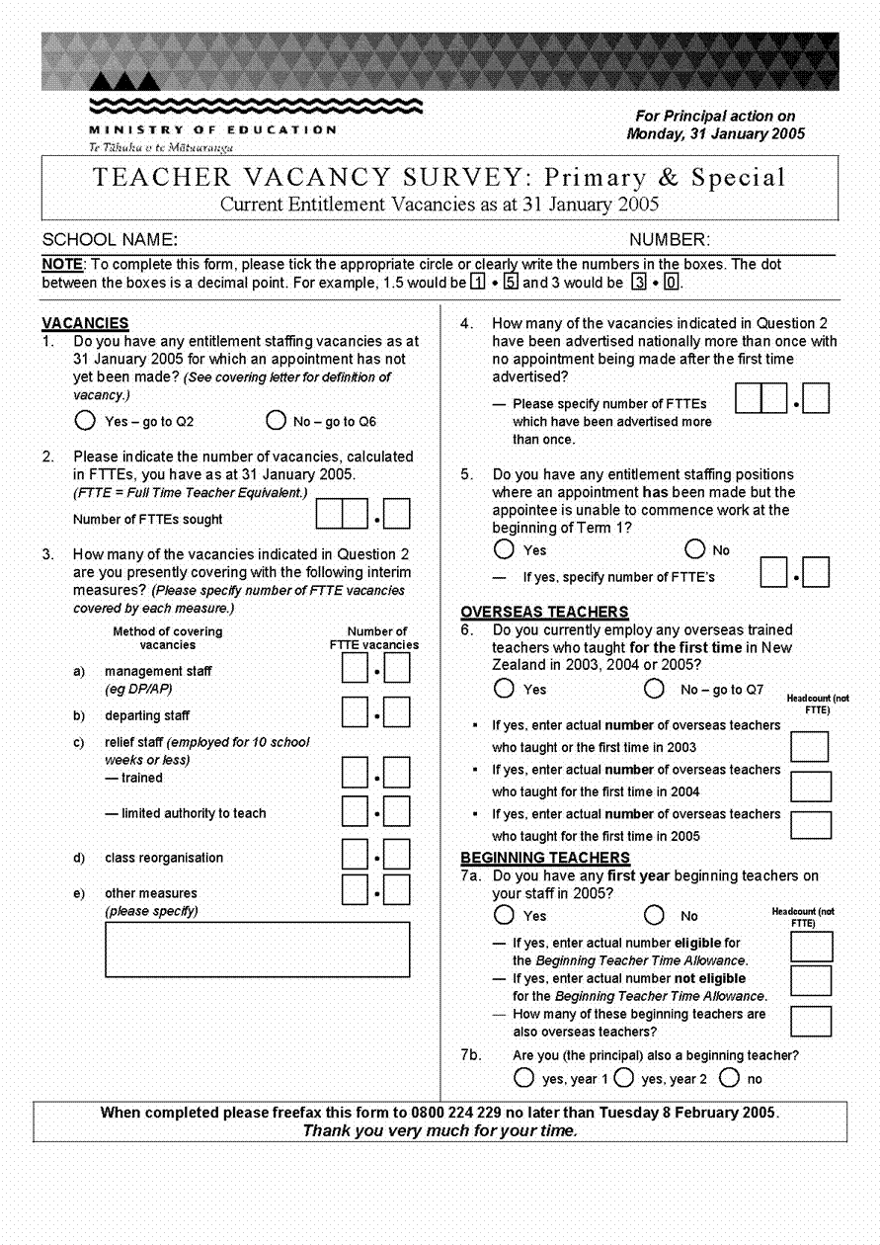

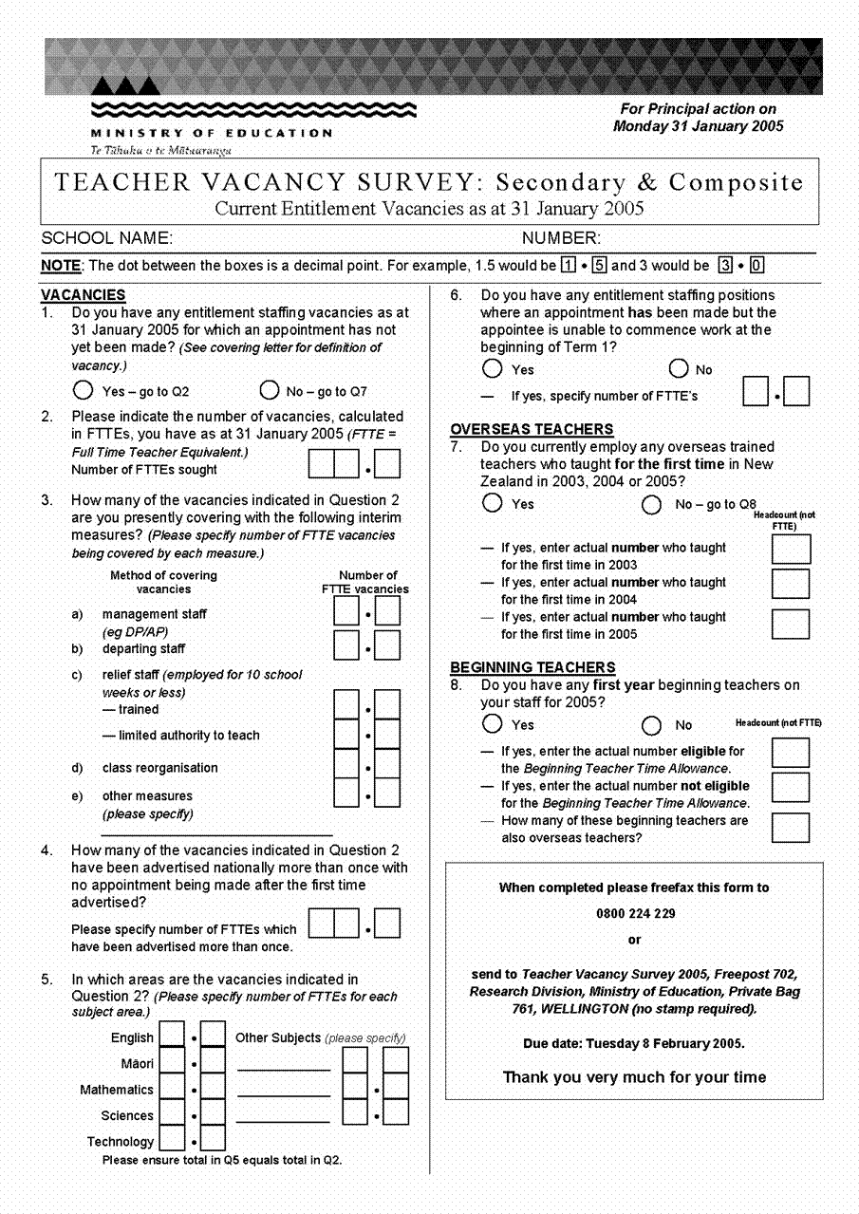

It is acknowledged that some schools may have vacancies at the beginning of Term 1 above their current staffing entitlement but it was beyond the scope of the survey in its present format to collect information on these vacancies.
These returns are managed by the Data Management and Analysis Division of the Ministry of Education.
More information on these initiatives can be obtained from the TeachNZ website on www.teachnz.govt.nz
Entitlement positions’ for the 2005 school year are based on provisional data for those schools that responded (190 primary schools and 96 secondary schools did not return completed survey forms in 2005). The entitlement figures are confirmed after the annual March 1 roll return data are compiled based on the confirmed March 1 school rolls.
Full–time teacher equivalents.
Vacancies which have been advertised nationally more than once with no appointment being made after the first time they were advertised.
It should be noted that fewer schools responded to the Teacher Vacancy Survey in 2005 than in previous years. Completed surveys were not received from 190 primary schools and 96 secondary schools in 2005 therefore the number of overseas teachers employed at the start of the 2005 school year may be slightly higher than reported here.
‘Relatively new’ overseas teachers are defined as those overseas teachers who began teaching in New Zealand for the first time in either 2004 or 2005.
The Beginning Teacher Time Allowance is available to school boards employing New Zealand or overseas trained year one teachers within their first 12 months of teaching. A beginning teacher appointed to a full-time position is entitled to 0.2 FTTE time allowance for advice and guidance for their first year, provided they meet the specified eligibility criteria. Under the Secondary Teachers’ Collective Agreement 2004-2007, second-year beginning teachers in secondary schools who are employed full-time receive 0.1 FTTE time for advice and guidance purpose during their second year.
Completed surveys were not received from 190 primary schools and 96 secondary schools. The number of beginning teachers employed at the start of the current school year may therefore be higher than this number.
Prior to 2002 information was only sought on first year beginning teachers who were eligible for the Beginning Teacher Time Allowance.
‘Relatively new’ overseas teachers are defined as those overseas teachers who began teaching in New Zealand for the first time in either 2003 or 2004.

