
Evaluation of student facing
web-based services:
Any Questions (Nielsen/NetRatings)

Report to the Ministry of Education

Nielsen/NetRatings

ISBN 978-0-478-13733-0
Web Copy ISBN 978-0-478-13734-7
RMR-858

© Ministry of Education, New Zealand — 2007
Research reports are also available on the Ministry’s website: www.minedu.govt.nz/goto/2107 and on Education Counts: www.educationcounts.edcentre.govt.nz/research/index.html

Opinions expressed in this report are those of the authors and do not necessarily coincide with those of the Ministry of Education



AnyQuestions Final Service Evaluation



Table of Contents
Abstract 1
AnyQuestions Service Evaluation: Key Conclusions 3
Opportunities for greater levels of learning 3
Background & Objectives 5
Introduction And Objectives 5
Research Approach 6
Findings And Observations 11
Quality of service provision 13
Satisfaction 13
Operational Characteristics 15
Service Reach 18
Quality Of Service Provision – Key Learnings 23
Immediate Learning For Young People 27
Immediate learning for young people – Key Learnings 31
Alignment And Transfer Of Learning 33
Alignment And Transfer Of Learning – Key Learnings 37
Learning For Teachers And Other Adults 39
Teachers And Librarians 39
Other Adults – Parents And Guardians 43
Learning For Teachers And Other Adults – Key Learnings 47
Appendix A: Additional Sample Composition Analysis 49
Ministry of Education Database Additions 49

Abstract
This document is the final service report developed by Nielsen/‌NetRatings relating to the AnyQuestions website and will be complemented by two similar reports relating to an evaluation of the Studyit website and Wicked website.

It is a culmination of findings delivered through two phases of research activity relating specifically to the AnyQuestions website – preliminary analysis of existing research materials and the conduct of quantitative research among the site’s current user base. Alongside this evaluation is one conducted by CORE Education, making use of a differing research methodology and analysis techniques to enhance the depth and breadth of the evaluation.

This report delivers an evaluation of the extent to which AnyQuestions impacts student learning as well as its impact on teachers, librarians and parents. It is supported by two additional documents, the first which summarises the findings from the phase 1 analysis of existing materials, including conduct of an Expert Usability Review of the existing website and other similar online learning sites globally; and the second provides a summary of responses to the quantitative research (phase 2) in chart and table format.

On completion of an evaluation of the Studyit and Wicked websites, an holistic piece of analysis and reporting will be delivered to determine how web-based services (in general) are currently aligning and integrating with children and young people’s overall learning experiences and outcomes.

AnyQuestions Service Evaluation: Key Conclusions
The AnyQuestions site provides New Zealand students (and educators) with a unique learning service that is largely appreciated among the current user base. It complements the important role that search engines now play in supporting students’ school-related research, helping to equip them with the confidence and expertise to use such tools safely and effectively on their own. The nature of the online reference service is also consistent with the method by which an increasing number of young New Zealanders feel comfortable for their communication, ie, instant messaging. The anonymity and text-based communication associated with this function is often appealing to those less likely to ask for help in a face to face situation and those who feel less confident in their level of knowledge or their ability to interact socially.

It appears that these important benefits of AnyQuestions may be being missed by a key group of students most likely to find value in the nature of the service – those without easy access to the Internet either at school, home and/‌or after school care, without strong support for school-related activities, who are faring less well in their education achievements and potentially less confident socially. The current student user base of the service reveals greater than average levels of Internet access and predominantly feel confident and competent in their schooling abilities – a trait reinforced by teachers and librarians who feel that the site is the most likely to attract those students who are actively engaged in their own learning and study processes. Educators do believe, however, that issues of accessibility form the greatest barriers to uptake of AnyQuestions among students, as opposed to student apathy, irrelevance, duplication with other services or poor quality assistance provided.

This does, however, pose a question as to the most effective way to attain a balance between helping students move toward greater self sufficiency (the current site users) while providing more support for struggling students with lower motivation and in some cases, those with limited access to the resources provided.

This leads to a further finding relating to educators’ (and parents’) promotion of tools and resources to assist students in their school work. While search engines are felt to play an important role, on the whole, offline resources are those commonly promoted and those with the highest perceived value. This may be due, in part, to the differing levels of Internet access across students, creating a barrier to widespread recommendation; but could also be a ramification of a lack of awareness of the true value of many online resources and the breadth of these resources available to students. Regardless, a realisation of the full advantage of the online medium will likely not occur among New Zealand students until these perceptions change among teachers, librarians and parents/‌carers. They are strong sources of awareness and recommendation for students.

Opportunities for greater levels of learning
In addition to the issues of service reach discussed above, the site appears to be missing its full potential in supporting the development of information literacy to the user base. While the site is starting to encourage students down the thinking path, it is at a low level on the continuum but it is highly encouraging to note that students who are lead further down the thinking continuum are more likely to be satisfied with the experience.
The barriers to this delivery are two-fold:
- There is evidence of a disconnect between students’ expectations of the site and what it will deliver, and the objective of the site and that reinforced to operators; and
- There is also evidence (from CORE’s transcript analysis) that operators may, in many instances, find it difficult to teach students the required skills due to the simple nature of information requests received. There would be value in ensuring operators are ‘armed’ with all the training and support materials they need to guide sometimes reluctant students through the journey.

While great, both barriers can be overcome over time. The most important short term refinement is the correct positioning and communication of the service through all marketing, promotions and communication on the site itself, in its content and from the operators. In part this may rely on an education campaign about the service, which must extend to educators. Close to three quarters of educators currently believe the site is a study/‌assignment help desk. Another immediate-term development relates to training for operators, to allow them to effectively support information literacy learning – among those open to learning and those who are not.

As noted above, those students learning information literacy skills are leaving the site more satisfied, while the majority appear to return to the site simply for ‘answers’ which has resulted in a fairly ‘muted’ satisfaction among most students. It is believed that further equipping students to conduct searches and understand their home work and assignment questions will facilitate greater self sufficiency, improved efficiency and effectiveness in their school work and in turn, greater perceived usefulness and value of the AnyQuestions service. The present ‘average’ levels of satisfaction are warning signs of the need for some refinement to the site’s service.

It is interesting to note, however, the increasing level of repeat visitation achieved by the site and the finding that more frequent users are more satisfied. Despite this correlation, we do heed warning in linking service success with measures of long term repeat visitation. In fact, a successful experience with the service may actually be one which, in a few visits, takes the student from a low level of information literacy through to higher levels such as ‘organising and making sense’. This can be tracked and monitored through transcript analysis and capture of previous interaction on Any Questions could potentially become part of the operator’s dialogue, in order to measure students’ progress over time.

Overall, the potential of AnyQuestions is great, due to its unique alignment with the means by which an increasing number of students are now initiating their research for school (ie via search engines). AnyQuestions is positioned well to play a key role in introducing students to more effective search techniques and methods of verifying the reliability of information found. Going forward, it will be vital to the service’s success, to engage students in processes to develop research and information handling skills of their own. This goes hand in hand with the training of the operators to ensure they have strategies to achieve this engagement and teaching. To support this teaching, the site could also employ more accurate education, marketing and general communications campaigns relating to the intent and process of the service, aimed at students, parents and educators. This will ensure students’ expectations are met and that they arrive to the site with an open mind as to the learning journey through which they will be taken.

Background & Objectives

Introduction And Objectives
Information and Communications Technologies (ICTs) are increasingly being used in educational contexts globally and in New Zealand. The Ministry of Education considers these tools to be critical in their overall mission to raise achievement and reduce disparity amongst students.

The Ministry of Education operates and funds (either fully, or in-part) three web-based learning services targeted directly at students: AnyQuestions, WickED and Studyit. These resources take advantage of the unique ability of the online medium to allow for active interactions and encourage students in a new way to take responsibility for their own learning and educational progression.

The Ministry of Education, commissioned a thorough evaluation of all three services, with a view to achieving two main objectives:

- Understanding, more fully, the impact of each service on users, teachers, schools, and the service providers themselves.
- Determining how web-based services (in general) are currently aligning and integrating with children and young peoples’ overall learning experiences and outcomes.

This report focuses on an evaluation of the performance of AnyQuestions, as a site designed to be a learning space through which students can interact with librarians to assist their search for information related to educational activities. Specifically, this report summarises the final results culminating from an online survey among end users of the website, launched from AnyQuestions.co.nz, complemented by a summary of findings from up-front, preparatory research and analysis relating to the site.

Background
AnyQuestions is a joint service trial between the Ministry of Education, the National Library and public libraries of New Zealand with support from commercial sponsors Sun Microsystems Ltd and Telecom NZ Ltd. Its aim is to develop a reference service for access by New Zealand students via the online medium. The online service provides students with searchable study resources available for reading online and/or for download, as well as employing a variety of online communications tools (forums, co-browsing and email) which provide access to additional support from librarians.

One of the key goals of AnyQuestions.co.nz is to encourage the development of information literacy skills in students. The following quotes, taken from ‘Student Learning in the Information Landscape’ June 2005, a report published by Education Review Office, provides excellent context for the role of information literacy in a ‘wired’ environment, and helps to set the stage for the role of AnyQuestions.co.nz in the lives of young New Zealanders:
“With the huge increases in the volume of information and students’ use of the internet, it has become crucial that students learn how to evaluate the authority, accuracy, objectivity, currency and coverage of the information they get from a wide range of sources.”

“Information literacy is a process of acquiring the skills, attitudes and values for effectively navigating and using the information landscape, including the internet. Information literacy needs to be taught explicitly throughout students’ schooling and across the curriculum to ensure they learn to apply it, as a matter of course, in all their encounters with information. It is about giving students the skills to “engage with information as the basis for developing a sophisticated understanding of the world and their place in it” and for becoming informed, fully-contributing citizens.”

“Students also need to develop positive attitudes to reading to function effectively in the information landscape. Students who choose to read independently for information, pleasure and personal development are engaging with the information landscape and building foundations for becoming independent, life-long readers and learners.”

“It is the task of the school to provide students with rich learning opportunities for exploring and using the information landscape with confidence and skill.”

Research Approach
The evaluation was conducted by two complementary research suppliers – Nielsen/NetRatings, a specialist provider of information and research services to evaluate online communications and provide recommendations to help improve users’ online experience and improve the overall effectiveness of the website or online application; and CORE Education, a not-for-profit educational research and development organisation which researches, applies, supports and disseminates new learning technologies. CORE's misssion is to push the boundaries of educational possibilities in New Zealand and the Asia-Pacific region through the effective use of e-learning strategies and tools.

To create the most efficient and effective evaluation process, the two suppliers undertook complementary research and analysis activities, developing a coordinated research approach that drew on the strengths of each supplier and balanced the available project budget with the information objectives to be fulfilled.

These activities are summarised in the table below, indicating concurrent activity across both Nielsen/‌NetRatings and CORE Education, as well as stand-alone activity.

 | Nielsen/NetRatings | CORE Education
1.  Concurrent up-front activity | Preparatory Analysis -  - Analysis of site usage data  - Student feedback  - Librarian (operator) feedback  - Expert review of usability practice of Any Questions  - Expert review of similar online reference services  globally  - Telephone interviews with technicians | Preparatory Analysis – Analysis of 380 transcripts of conversations between librarian and students using the Any Questions online reference service
2.  Stand-alone primary research activity A. | Conduct of an online survey among a random sample of visitors to the Any Questions website  The findings from the survey helped to guide the design of CORE’s next research activity:
3.  Stand-alone primary research activity B. |  | In school interviews  6 schools selected based on the site data, representing primary, intermediate and secondary schools in main centres of NZ  Interviews conducted among:  - school principal  - at least one teacher (who had encouraged student use of Any Questions)  - a group of up to 6 students (some of whom had accessed Any Questions in the past)
4.  Stand-alone primary research activity C. |  | Operator Interviews  Four interviews were conducted among the librarians working on the online reference service; they were completed by email questionnaire and phone interviews
5.  Concurrent research activity D. | Holistic analysis of all stages of research, culminating in a final service report evaluating Any Questions | Holistic analysis of all stages of research, culminating in a final service report evaluating Any Questions

This document evaluates the Any Questions service based on the activities conducted by Nielsen/NetRatings. CORE Education’s evaluation can be found in a separate document.

Nielsen/NetRatings conducted the evaluation in two key phases:

Phase I - Preparatory Analysis
- Desk research of existing documents,
- interviews with the website’s technical managers,
- analysis of site measurement statistics,
- Expert Review of the AnyQuestions.co.nz Site,
- Expert Review of similar sites around the globe, and
- Safety audit of the AnyQuestions.co.nz site.

Phase II – In depth Analysis of End Users’ attitudes toward the service
- Online Survey of site visitors

In order to measure the impact of AnyQuestions on students’ learning experience and evaluate the extent to which the service currently meets the website objectives, Nielsen/‌NetRatings conducted an online survey among a sample of website users. The main aim of the research conducted was to gain a comprehensive understanding of users’ reactions to the AnyQuestions website and to ascertain the degree to which the site meets users’ expectations and requirements in terms of content, functionality, usability and overall look & feel, and the degree to which the site facilitates the Ministry of Education’s core learning competencies – Thinking, Making Meaning, Relating to Others, Managing Self, Participating and Contributing. Additionally, understanding the extent to which AnyQuestions integrates with students’ overall suite of educational activities, both online and offline is a key aim of the evaluation.

A site intercept survey methodology was used to capture a representative sample of site users, including students, teachers, parents, librarians and any other users of the service. In addition to the site intercept component of the survey, an email list was provided by the Ministry to enable a survey invitation to be sent to previous website users.

The survey data was collected between 15 March and 17 May 2006 with a total sample size of n=293. The average completion time was 9.2 minutes and an overall completion rate of approximately 4% was achieved. The site intercept survey invitation can be seen overleaf.

Survey Invitation
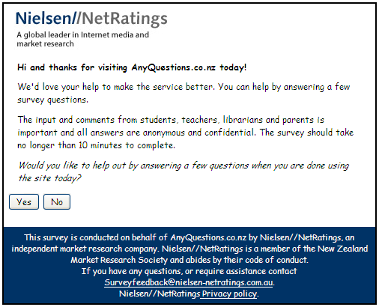

Sample Composition
The majority of AnyQuestions site users are students (66%), while the remaining ‘Adult’ users constitute just over one-third of visitation (34%). Of students, over half are within the site’s primary target age bracket, 10-15 years (51%), a further 10% are between 16 and 19 years of age and only 5% were under 10 years of age.

While these breakdowns of the user audience provide a true indication of visitor representation, please note that students under 14 years of age were asked to gain parental/‌guardian permission before completing the online survey. As this would likely serve as a barrier to completion for some children, particularly of a younger age, it is likely that 10 – 14 year olds actually make up more than 51% of the student audience and that potentially more than 5% are under 10 years of age.

In terms of site usage, more females than males visit the AnyQuestions site (75% females vs. 25% males), and this phenomenon is observed across the various student age brackets. It should, however, be noted that an increased site participation rate amongst males is observed as their age increases (14% of visitors aged 5-9 years are male, 24% aged 10-15 years and 30% aged 16-19). There is also some anecdotal evidence that females are more likely to participate in surveys than are males – meaning that the site user base may be less skewed toward females than indicated by the survey. Further analysis of first names (as captured for the online reference service) would shed more light on gender representation for the online reference service.

Those students using the AnyQuestions site are significantly more likely to have home Internet access than the general New Zealand population (94% of AnyQuestions student users have Internet access at home compared to 67% of all New Zealanders aged 10 years and over).
For purposes of additional analysis, the Ministry provided Nielsen/‌NetRatings with school-related data for attachment to the data collected, allowing for the inclusion of information such as:
- Formal School Name
- School deciles
- Region (rural vs. urban)
- Gender status of school (e.g. single sex)
- Isolation measure

The analysis conducted using the additional data provided by the Ministry of Education is appended to this document (Appendix A).

Findings And Observations
The findings and observations derived from this research and explored in this report cover four specific areas:
- Quality of service provision
- Immediate learning for young people
- Alignment and transfer of learning
- Learning for teachers and other adults

Each ‘section’ of the findings and observations explores one of the four key areas outlined above and is intended to provide insight into how the usage patterns, behaviours and perceptions of site visitors interacts with the key goals for the AnyQuestions service and, more generally, those of the Ministry of Education (as outlined in the Introduction and Objective section of this report).

Where possible, this report has incorporated findings, knowledge and general commentary based on Nielsen/‌NetRatings’ expertise in the field of Internet and technology. Particularly, learnings from market reports and non-confidential research concerning youth have been incorporated in some instances to supplement the primary research findings of the AnyQuestions evaluation.

Quality of service provision
In measuring the quality of service provision, key indicators included for benchmarking the service provided by AnyQuestions include students’ perceptions and satisfaction regarding specific elements of the service as well as an overall satisfaction measure of AnyQuestions – the specific elements include; the “knowledge and capabilities” of facilitators, perceptions and satisfaction with the technological platform and operational characteristics. The satisfaction measures also include extrinsic aspects such as the service’s hours of operation and staffing. Further consideration is given to the reach of the service to students who are diverse by geographical location, ethnicity, language, social status, scholastic ability, access to technology, and age. Further aspects related to the geographical reach and participation in the AnyQuestions service is provided in Appendix A as additional analysis conducted from data provided by the Ministry and attached to respondent data (particularly with regard to specific schools).

Satisfaction
Satisfaction is measured on a three point “happiness” scale where respondents indicate if they are “happy”, “unhappy” or “neither” with a particular aspect of the service. Overall, almost one in six students (58%) indicated that they were satisfied with AnyQuestions overall and 64% indicated that they are satisfied specifically with the ‘Ask a Librarian’ component of the site. In Nielsen/‌NetRatings’ experience, these levels of satisfaction can be considered moderate, however it should be noted that when surveying young adults and children, it is widely believed within the research industry that younger individuals tend to be less inclined to rate the “top score” and this should be considered when evaluating the measures throughout this report. While satisfaction can be considered moderate, the level of dissatisfaction is clearly low across the various elements measured, though around one in ten ‘unhappy’ users is a performance measure to be tracked and improved upon.

Satisfaction with AnyQuestions
Base: Students, n=157
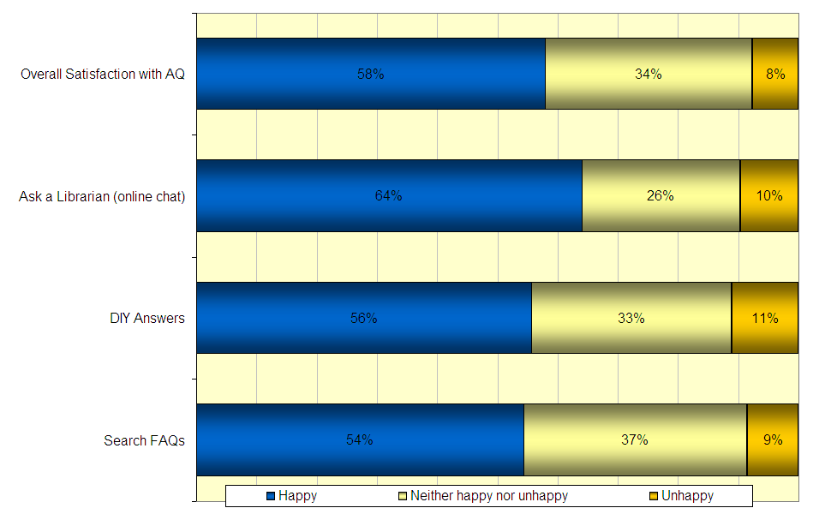

In overall satisfaction, male students report a higher level of satisfaction (74% Happy) than female students (53% Happy). Female students tend to display higher levels of neutrality with 40% neither happy nor unhappy compared to only 18% of males. The reason behind this gender difference observed is difficult to definitively isolate, however, it can be hypothesised that due to the consistency of higher male satisfaction across the various site aspects, that females may hold higher expectations from this type of educational service which appears to be meeting expectations as opposed to exceeding them.

When the overall measures from specific areas of the site are investigated, consistently moderate scores are observed. Over half of student visitors to the ‘FAQs’ were satisfied with that section (54%) and 56% of those using DIY Answers were happy with their experience using that area of site content.

Satisfaction with sections of AnyQuestions
Base: Students, n=157
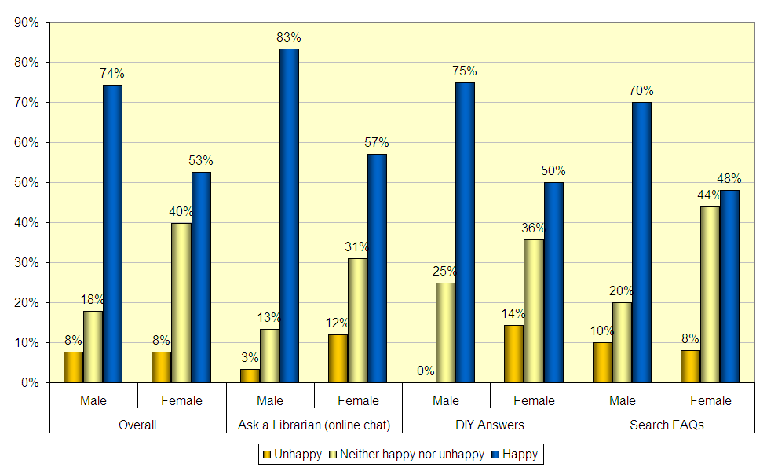

The frequency with which users access the service appeared to display a relationship with the level of overall satisfaction observed. Infrequent users and first time users reported the lowest level of satisfaction (the extent to which they are “Happy”) with the service. Less than two-fifths of first time users were satisfied with AnyQuestions (39%), and only 45% of those visiting less frequently than monthly reported being happy with the service overall. This finding reiterates the possibility that expectations are impacting satisfaction with the service. Infrequent users may be less likely to have fully determined what they expect from the site and could therefore be less willing to state that their expectations have been exceeded (to state that they are “Happy”). This notion is supported by the high levels of “neutral” responses observed amongst first-time and infrequent users (46% first time, 48% less frequently than monthly). Those using AnyQuestions weekly were most satisfied (88%) and those using it more frequently than once a week were also highly satisfied (77%). Overall satisfaction levels, across the range of visitation frequencies, are displayed in the figure below. This finding indicates that communications aimed at driving the frequency of uptake of the service should help to clearly define expectations of potential users with the goal to increasing satisfaction amongst those who infrequently use the service.

Overall Satisfaction by frequency of AnyQuestions usage
Base: Students, n=157
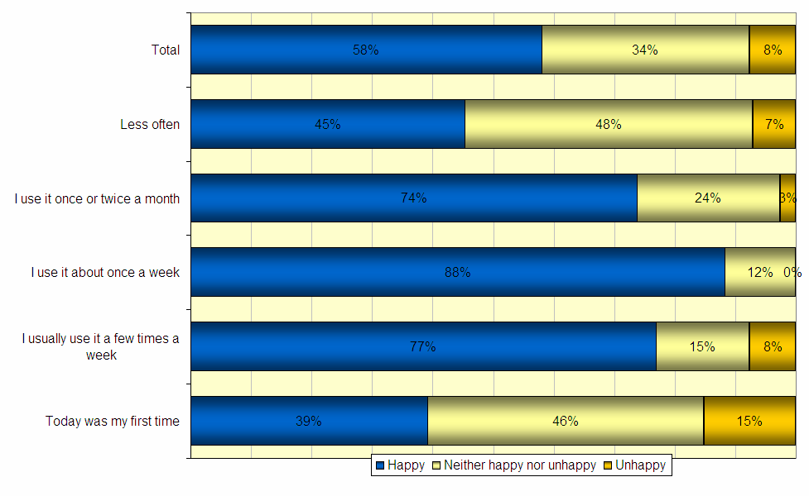

It is also interesting to note that more recent users of the AnyQuestions service are more satisfied than the earlier adopters. Users up-taking within the past 1-6 months reported 78% overall satisfaction compared to 56% of those who report having first used AnyQuestions more than one year ago. This may reflect slight operational and technical changes to AnyQuestions over-time, with the early adopters allowing their earlier experiences to affect their perception of the offering. Alternatively, these results may be explained by the successful transfer of information literacy skills to a large set of the earlier adopters – for example, many students who visited AnyQuestions for the first time more than one year ago may have successfully acquired sufficient information search skills to be self sufficient in seeking the information they require without a visit to the AnyQuestions site. Students that did not successfully acquire these skills after having first visited more than a year ago are those that continue to use AnyQuestions and are less satisfied with their experiences. It also seems plausible that some students who are skilled, continue to use the site as they develop an attachment to it or get successful outcomes from it in terms of quality support and answers.

This presents a paradox for the Ministry, in that the successful transfer of the desired skills could reasonably result in the cessation of site usage, however it does present the opportunity to concentrate efforts on those students who remain and require additional assistance to become more self sufficient when seeking information. Capture of previous interactions on Any Questions could potentially become part of the operator’s dialogue, in order to measure students’ progress over time via transcript analysis.

Operational Characteristics
The most popular “section” of AnyQuestions used by student visitors was the online reference service, where students interact with librarians in real-time. The majority of site usage was driven by the ‘ask a librarian’ service with around three-quarters of visitors using this section of the site compared to approximately one-quarter of students using the ‘FAQ’ section and one-quarter the ‘DIY Answers’ section. This aligns with the analysis of website traffic which found the DIY Answers section of the site to account for 23% of page impressions during 2005 and 32.3% of visitors aged 8-17 years reported using DIY Answers through the opt-in site survey – 67% of whom found it useful.

Cross-content usage is apparent, with 37% of FAQ users also having used DIY Answers and over one-fifth (22%) of those who had used the online reference service had also used DIY Answers and 16% had used FAQs.

Males displayed a slightly higher propensity to use the ‘ask a librarian’ service (77% males vs. 73% females), while females were slightly more inclined to have used the ‘DIY Answers’ section of the site (25% females vs. 23% males). This finding may be a ramification of female students’ lower levels of satisfaction with the online reference service which in turn leads them to do it themselves via DIY Answers, but the gender differences are negligible.

Of those that had not used the reference service (‘ask a librarian’), over one-third did not realise this function was available (34%) while others had their needs satisfied through the FAQ section, allowing students to self-manage and take a self-sufficient approach to their research. Over half of student visitors to the ‘FAQs’ were satisfied with that section (54%) and 56% of those using DIY Answers were happy with their experience using that component of the site.

The point was raised in the up front analysis that, potentially, the prominence of the link to the online reference service could be improved, as it is located low on the page and initially out of view on many screen settings. This has since been rectified but the link would benefit from more emphasis, based on the finding that 8% of all student site visitors were unaware of the function. Focused marketing and specific promotion of this core function of the AnyQuestions site may also drive awareness of the online reference service among both existing users and prospects. Successful methods of building site awareness are discussed later in this report.

Users of the online reference service were, to a great extent, satisfied with the resource. Almost four in five users were happy with the extent to which the librarians were “friendly and helpful” (78%), and 63% were satisfied with the facility’s ease of use. This is testament to the dedication, training and effort put into the service by the operators and service managers and is consistent with the Phase 1 review which found that the service provided clear and simple instructions and steps to log in and speak with an operator. The service functionality and presentation is also consistent with the way that an increasing number of young New Zealanders are communicating with peers – using instant messaging services.

The 37% either indifferent or unhappy with the reference service ease of use also supports the Phase 1 findings that the service reliability can suffer due to technical issues, and some users may have frustrating experiences if they fail to reach an operator, or similarly, if they are forced to wait in the queue to be ‘spoken to’ for a significant period of time. Indicative conversion rates for the site (based on a measure of the rate of visitors to the site who move on to participate in “live chat”) sit at 18% and reveal a slight downward trend. Demand for the reference service far outstripped the ability of the site to answer queries during the first year of operation (2005), with a total of 16,258 visitors joining the queue and only 8,507 sessions actually taking place.

Satisfaction with the processes involved in ‘asking a librarian’
Base: Students who used the online reference service, n=116
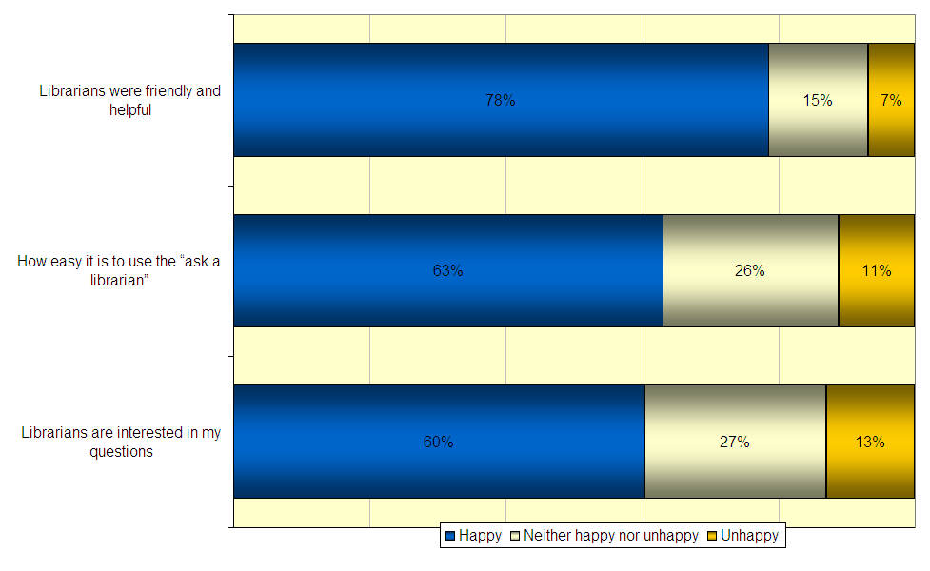

While the students are satisfied with the friendliness and helpfulness of the operators, there appears to be a lack of understanding amongst students regarding a key goal of the site - to develop information literacy skills (rather than to simply provide answers). This perception emerged some time ago through a survey conducted among operators, through which comments were made relating to students’ expectations of being provided with direct access to answers to their queries, rather than wishing to be provided with instruction on conducting their own searches. If a student site visitor expects simply to be given answers rather than be taken through the information search process (to develop their information literacy), they may not feel that the librarians have been ‘helpful’.

Students were, however, moderately satisfied with the final result of their librarian interaction - just under three-fifths were satisfied with ultimately being provided with the answer (59%) and 57% satisfied with being provided with the appropriate website links. These findings do highlight that students appear to perceive the service as an ‘answer’ service, rather than for learning and research assistance, and this should be a communication goal of the site, and operators, going forward.

While the overall outcome is satisfactory for the student users, the “ask a librarian” process itself seems to deliver somewhat less satisfaction. Again it is likely that these results are largely driven from the perceptions that AnyQuestions is an answer service and ignorance amongst student users that the site’s goal is to assist in the development of their information literacy. Less than half of students that had used the online reference service were satisfied with the quality of search and study advice received (47%) and the assistance provided by librarians to assist in establishing the information sought (45%). More alarming, however, is the low level of satisfaction with librarians’ explanations as to why site links provided might be helpful (39% ‘happy’ with the extent to which “librarians explain why the sites they take me to are helpful/good”).

The low level of satisfaction with the explanation received may indicate that operators are not proactively explaining to students the reasons for the approach used in seeking the information requested, and this may be compounded by the seemingly high level of student ignorance surrounding the service as an information literacy development tool. The possibility that operators are not proactively explaining to students the overall purpose of the process is also highlighted by the low level of student satisfaction with explanations surrounding how the information could be self-sufficiently sought on a subsequent occasion (again only 39% were ‘happy’ with the extent to which “Librarians explain how I can find information for myself next time”).

It is difficult to isolate the exact driving factor behind these perceptions, but indications lean toward two drivers: students are not prepared to receive this type of counsel when asking a question of the operator (especially if they expect that they will just be given the answer); librarians are merely providing answers to students without explanation surrounding the search process. The latter may be tied to findings from CORE’s transcript analysis which found that many questions issued to the operators are quite straightforward and not of sufficient depth to enable a thorough information search “lesson” (ie, simple/‌closed questions). This supports both the idea that students are not expecting to learn search skills and that operators may, in many instances, find it difficult to teach them the required skills due to the simple nature of information requests received.

There is a difficult balance to be achieved here on the part of the operators, in supporting longer term self sufficiency through encouraging engagement in the process among student users, while at the same time delivering ‘answers to questions’ to meet students’ expectations of the service. The requirements are two-fold: providing operators with sufficient and relevant training and resources to achieve engagement among students and support information literacy learning, even among students who appear averse to this type of learning; and more accurate communication and marketing of the service to students, educators and parents to ensure that it is positioned in the right way to meet expectations.

Service Reach
Two thirds of all site visitors are students and within the group, over half are within the site’s primary target age bracket, 10-15 years (51%). One third of all site visitors come from this target group.

In addition there is some usage from older students though minimal use among the secondary target – year 4 and 5 students, as highlighted in the figure below. Please note, however, that the need for students under 14 years to gain parental/‌guardian permission before completing the online survey would likely serve as a barrier to completion for some children, particularly of a younger age.

AnyQuestions usage by year at school
Base: Students, n=157

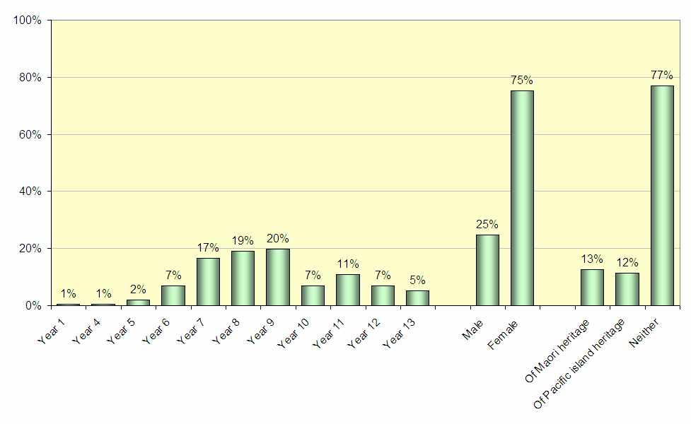

The AnyQuestions service is mostly attracting English speakers (83%) while only 3% of users speak Maori (despite 13% being of Maori heritage). The site appears to be mostly reaching students who feel confident about their academic performance with 86% reporting to either feel they are “doing really well in most things [at school]” or “doing well in most things [at school]”. Only 14% report difficulty at school. In interpreting these results it should be considered that reported performance may differ to actual performance, however, it remains that students who believe they are doing well are more likely to be users of the service as they are likely to be more motivated to learn and take a pro- active approach to their learning.

Student self evaluation of academic performance
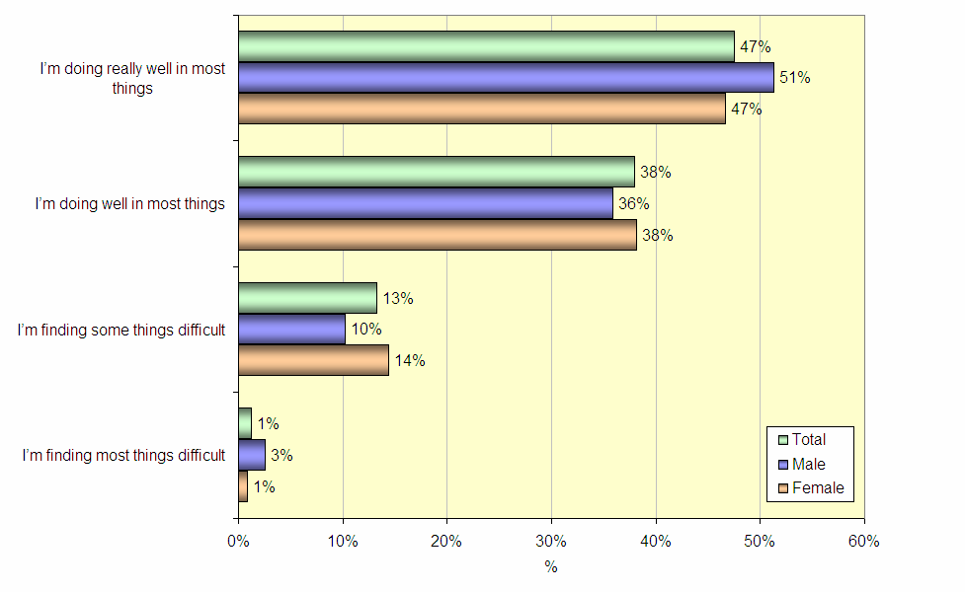
Base: Students, n=157

Access to the site from home seems to be the most common place from which students have “ever” accessed AnyQuestions, particularly on weekdays. Overall, classroom usage during school time was the second most likely place of access, however, it should be noted that classroom access was reported at a significantly higher level for females than males (36% females vs. 18% males). Boys were more likely to report access from the library during school lunchtime than girls (23% males vs. 6% females); perhaps social contributors come into play here, with boys feeling it is less ‘cool’ to be seen using such a site ‘in public’.

The figures also reveal a user base with slightly greater access to the Internet at home than the general youth population in New Zealand (70.2% among the AnyQuestions students vs 65% among New Zealand households with children aged 6-17 years).

Students were also asked to identify the location from which they most often access AnyQuestions. Home, as an AnyQuestions access point, dominated with more than two-thirds (70%) of students claiming it is the place from where they use AnyQuestions most often. This was followed by the school library (9%), computer room at school (8%), and a classroom at school (6%). Analysis of website traffic by time of day during Phase 1 indicated increasing usage of AnyQuestions during the school day (in the later part of 2005) while the peak usage time remained with the after school period between 3pm and 5pm (correlating with largely home-based access). Interestingly, those using the site on a Saturday were the most likely to spend longer periods of time on the site, consuming more web pages, probably based on the additional time afforded to users on the weekend.

Students using AnyQuestions also reveal higher levels of broadband access (at home and other locations) than the general population. More than half of students accessing the site most often from home do so over a broadband connection (55% compared with the average 19.8% of all New Zealand households), broadband access from various locations is reported in the figure below. The large level of reported home access to the AnyQuestions service is interesting to note considering that New Zealand levels of broadband access amongst Internet users (individuals aged 10 years and over) is quite low at 33%, based on international standards. Penetration of home Internet access in New Zealand has historically been on par and in some cases ahead of other key global markets, including the US and Australia. However, penetration of broadband has not followed a similar trend and with just 19.8% of household connections being at faster than dial-up speed, the rate of broadband penetration at home in New Zealand is less than half of the rate of the US and Australia.

Place and Speed of Internet Access
Base: Students, n=157
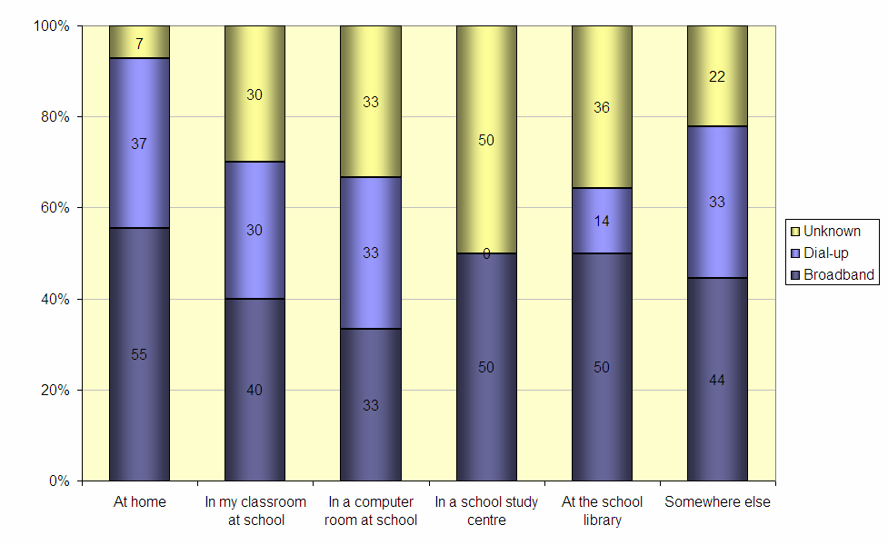

Broadband users were more likely than dial-up users to visit the FAQ and DIY Answers sections. One quarter of visitors on a broadband connection had used the DIY Answers section (25%) compared to 21% of dial-up users, while 28% of those on broadband used the Search FAQ section compared to only 19% of those on a dial-up connection. Interestingly, connection speed had no impact of the use of the online reference service, consistently the most popular area of the site despite the speed of access. This reveals the perceived value of the service across a range of students, even those willing to overcome the barriers of speed, and potentially reliability, which are heightened when accessing the service using a dial up connection.

However, while connection speed did not impact students’ use of the online reference service it did have a slight impact on satisfaction with the service. Two-thirds of broadband users were happy with the ‘ask a librarian’ section (66%) compared to 59% of dial-up users. This is consistent with the Phase 1 findings relating to the service’s technical reliability which is likely to have a greater impact on a dial up users’ experience than for those on broadband. This in turn has ramifications for users’ ultimate satisfaction with the service.

The AnyQuestions service was reported to be used quite infrequently with just over half of students reporting to visit the site monthly or less frequently (51%) with males reporting slightly less frequent usage than females (56% monthly or less regularly for males vs. 49% for females). This may be indicative of a greater propensity for female students to develop an ongoing and more frequent relationship with online educational resources such as AnyQuestions but as noted earlier in the report, long term repeat visitation should perhaps not be used as a measure of site success.

In terms of marketing efforts aimed at promoting awareness of the AnyQuestions service, awareness was largely generated through Stickers/Bookmarks circulated throughout schools and also to a large extent through word-of-mouth from teachers. Overall, one quarter of students first became aware of AnyQuestions through a sticker or bookmark (25%) and just under one quarter from their teacher (24%). It should be noted that while the level of awareness generated through promotions (stickers/bookmarks) and word of mouth (teachers) was at similarly high levels, initial awareness levels differed amongst male and female students. Male students tended to recall first becoming aware of AnyQuestions through the sticker or bookmark (28% male vs. 24% females) while females students were more likely to recall first becoming aware through their teacher (28% females vs. 10% males). Males display greater message resonance when the communication is conducted via promotional material while for females it is greater when through their teacher, which is a consideration in future marketing efforts, including those to help position the service outside simply the provision of answers.

Method of initial discovery of AnyQuestions
Base: Students, n=157
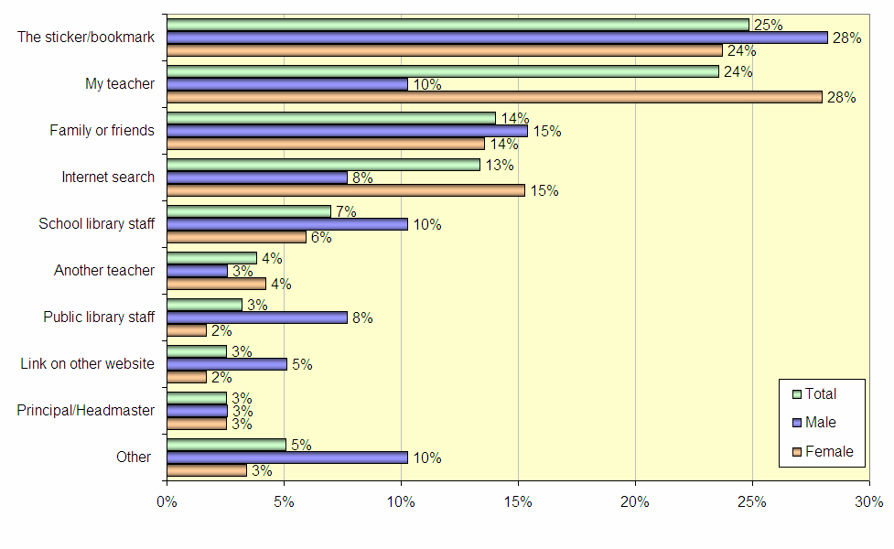

Quality Of Service Provision – Key Learnings
Student satisfaction with aspects of AnyQuestions is generally moderate to high, with moderate satisfaction with the service overall. This satisfaction can be taken as an indirect measure of the effectiveness of the site in transferring information search skills, as it is hypothesised that the moderate levels of “happiness” coupled with high levels of neutral ratings indicates a lack of understanding on the students’ behalf that the purpose of AnyQuestions is to assist in the development of information literacy, particularly surrounding the ability to search for that information effectively using online resources.

It is recommended that efforts directed at more clearly explaining this purpose to students (and to teachers as they are one of the key mechanisms through which students first discover AnyQuestions) may align their expectations more closely to what is delivered when using the site. Ultimately, successful communication efforts spreading this message should be expected to yield greater satisfaction from student users of the service as they will be more consciously aware of what defines a successful interaction (i.e. A successful interaction could be considered one in which either the student acquires new information search skills, or one that is self sufficient and results in acquiring the information sought). This raises the paradoxical issue that many students who do successfully acquire the skills AnyQuestions is intended to transfer, cease to use the service while those who do not, continue to use AnyQuestions simply as an answer service.

In fact, the site statistics indicate a decline in the number of unique visitors to the site month on month since launch in February/March 2005 but an increase in repeat visitation rates. On average, each month of 2005 saw just under one in every three site visitors (29.6%) being a repeat user of the service. A successful experience with the service may actually be one which, in a few visits, takes the student from a low level of information literacy through to higher levels such as ‘organising and making sense’. This can be tracked and monitored through transcript analysis and in this case, high levels of repeat visitation would not necessarily be a measure of success for the site.

Broad satisfaction with the various site sections is strong across the ‘online reference service’, ‘FAQs’, and ‘DIY Answers’. Male students are slightly more satisfied than female students overall. The online reference service received the highest satisfaction mark overall, with two-thirds of students reporting that they are ‘happy’ with the facility, though further analysis reveals that those with a broadband connection display greater satisfaction than those on dial up.

More frequent interactions with AnyQuestions seem to result in higher levels of satisfaction with the service. This may suggest that students require frequent usage of the site in order to more easily comprehend the offering and become comfortable in understanding that it is genuinely fulfilling an educational need. It should be noted that any measure of satisfaction is captured within the context of expectation, that is, as students become more experienced using and interacting with AnyQuestions, their expectations change (along with their satisfaction). This experience (measured by frequency of use) couples with the idea that the more the site is used by an individual student, the greater that student’s propensity becomes to understand the site offering – a service dedicated to developing information literacy rather than as a website that merely provides answers. As noted earlier in this Section of the report, getting this message across can come from equipping operators with more relevant training and resources and more accurately marketing and communicating the service as one which supports information literacy, rather than simple providing answers.
There is also evidence that the site has improved over time as users introduced to the site in the last six months are slightly more satisfied than users introduced to the site earlier in its development lifetime. This is an interesting finding, suggesting that while the expectation benchmark is changing as users increase their experience levels, improvements to the operational/function/technical platform, and even in operator experience and expertise, are assisting to drive a greater level of overall satisfaction. On-going improvements to the technology behind the site, and other developments such as expansion of the DIY Answers and FAQs database are seemingly providing a positive contribution to overall site experience while the attrition of students successfully acquiring information search skills is likely to be placing downward pressure on satisfaction results from “long time” users.

Operational Characteristics
The majority of site usage was driven by the ‘ask a librarian’ service with around three-quarters of visitors using this section of the site compared to approximately one-quarter of students using the ‘FAQ’ section and one-quarter the ‘DIY Answers’ section. Additional marketing to students of these “secondary” areas of the site may help to alleviate pressure on the online reference service, from both a technical and human resourcing perspective. This form of targeted purpose marketing could help promote the notion that AnyQuestions is a service to help students become (more) self-sufficient in their study/information search activities, i.e. teaching students to manage themselves. Recent improvements and expansion of the FAQ database should assist in helping to deliver a positive experience for users of this section and future developments could see this content better integrated into the online reference service to stimulate usage for those waiting in the queue, perhaps using ‘pop up’ style messages or other prominent communication. Clear communication of the intention of this integration would be key to users’ uptake though.

While promotion of the idea that AnyQuestions can help information literacy is an important goal moving forward, when students were asked to evaluate different aspects of the online reference service, they report to be less ‘happy’ overall with aspects relating to being taken through the information literacy process than being provided with the answers directly. There appears to be a portion of users who are simply seeking a ‘quick fix’ solution to their problem, and are unlikely to actively seek long-term benefits or ask to be taken through the process of developing information literacy skills. This highlights the importance of seeking creative methods to encourage student users to use the ‘FAQs’ or ‘DIY Answers’ components of the site, and make the intent of the online reference service clearer. As noted in the Expert Review during Phase 1, the service is communicated and positioned as ‘helping you find the answers you need for your school work’. To improve satisfaction and set expectations this positioning statement should be refined to communicate the information literacy learning component of the service. Also as mentioned in the initial report, the FAQ search provides few search tips or pointers and as such, does little to contribute to improving users’ information literacy.

Service Reach
The service is predominantly used by a selection of students with higher than average levels of access to technology in the home and at school (Internet connection and broadband connection) and likely those with good access to support networks such as parents and teachers proving beneficial to students’ education performance. Usage of AnyQuestions seems to be primarily driven by students who feel they are doing well in their studies, hence, it is a great offering for those already motivated and pro-active in their own learning.

Interestingly, students’ perceptions of their academic performance corresponded with changes in satisfaction with the reference service. Three-quarters of students who felt they were doing well at school were happy with the ‘ask a librarian’ section compared to 64% of the sample overall.

While it should be acknowledged that reported academic performance and actual academic performance may differ, it remains that students who believe they are performing well academically are using the site to a greater extent (and are more happy with the site sections) than students who feel they are performing poorly. If this “perceived academic performance” in any way indicates actual performance, then the development of information literacy is being conducted amongst academically stronger students. Within the limitations of the data available for capture (reported performance rather than actual), it does suggest that more active targeting may be required to reach those students who are less actively engaged in their educational development or who are not performing well. These students show a lower level of access to support channels for assisting this development and lower access to technology such as personal computers and the Internet, which has quickly become a key mechanism for information distribution and children’s learning, in general.

This represents a great challenge for individual educators, the service providers, the Ministry of Education, and indeed, the government as a whole. As the online medium becomes increasingly important as a learning and development tool for New Zealand youth and adults, accessibility, confidence and competence in the medium becomes increasingly important. If these three attributes do not proliferate to all groups within the population there is real risk that development will be at an exponential rate among those with greater levels of access and confidence, leaving behind those without.

Immediate Learning For Young People
The Immediate Learning for Young People section explores the various learning methods that are occurring through the use of AnyQuestions (and the manner in which the learning occurs), by asking students to reflect on what they had learned during their experience on the site. Included in the lines of questioning were questions relating to AnyQuestions.co.nz’s specific objective of improving student learning around information literacy, and also the learning that might lie beyond that core goal.

Students are turning to the site for support across a wide range of subject areas, but predominantly in Social Studies (46%) and Science (40%). It is interesting to note that for particular subject areas, gender differences were observed. Boys reported to be more likely to use AnyQuestions for support in Science (49% males vs. 37% female) and Maths (21% males vs. 10% females), whereas girls are more likely to have used AnyQuestions for English (31% females vs. 21% males). Gender-related course selections would drive this finding.

In terms of the capacity in which AnyQuestions is corresponding to the educational lives of students, the site is predominantly used to source answers to homework questions or assignments (73%). Male students are more likely to report using the site as a search resource (54%), and are also more likely to be investigating the site for more ‘speculative’ reasons (“I was just curious to see what it was all about”).

Reasons for visiting AnyQuestions
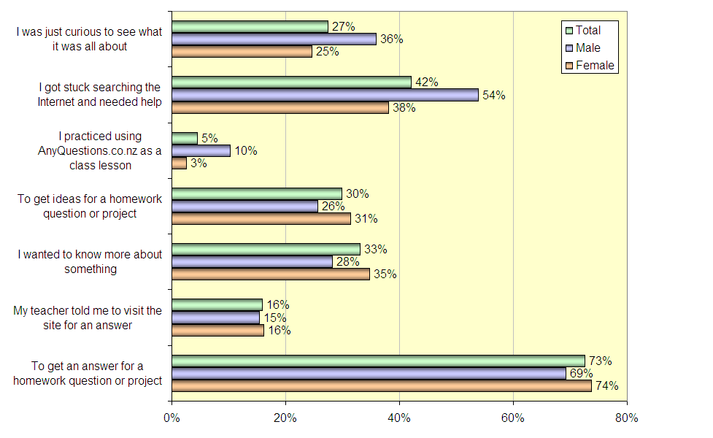
Base: Students, n=157

Students most commonly perceived ‘query resolutions’ as the primary learning outcome from the site while information literacy skills, such as learning to search for information independently, were less commonly cited. Clearly, most students are focused on finding answers to specific questions, rather than on developing information literacy skills, in their interactions with librarians on the site, though there was around one in five who improved their search capabilities.

Disappointing were the 19% who felt they did not learn anything. Interestingly, this group was most likely to use the ‘ask a librarian’ section of the site and not surprisingly displayed an extremely low level of satisfaction with that section of those that felt they had learned nothing, only 12% were ‘Happy’ with the ‘ask a librarian’ service compared to 64% overall. This finding reiterates the notion that the successful transfer of information literacy skills results in higher levels of satisfaction with the service. Alternatively, it may also suggest that some of these users had a poor experience because of the technical difficulties mentioned earlier, which should be refined going forward.

Just under one-third of 5-9 year olds learned how to better understand their homework questions (29%), compared to 16% of 10-15 year olds and only 13% of 16-19 year olds. It is interesting to note that the relationship of ‘learning how to better understand homework questions’ and age is inverse. It may have been expected that older students would be more likely to acquire this skill through AnyQuestions, however, these older students may already possess adequate homework dissection skills through experience at school. Younger students almost certainly would have had less exposure to the types of schoolwork that require significant effort to identify the elements of the question asked. While it is possible that these skills are organically acquired by students through experience, it may also indicate that schools are proactively educating their students about understanding the question asked.

Perceived Outcome of AnyQuestions Usage
Base: Students, n=157
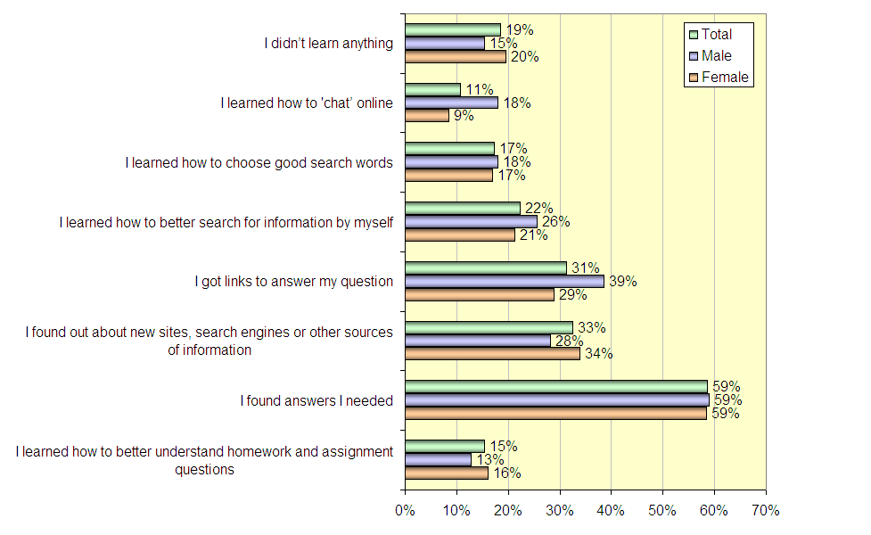

Overall, students were satisfied with their stated learning outcomes as a result of using the site, with 57% reporting to be happy and only 7% reporting to be unhappy with what they had learned using AnyQuestions. It is important to note that those students learning or improving their information literacy skills via their site interactions were happier with the overall outcome of their visit than those who simply found answers to their questions – 88% of those that learned to better search for information themselves were happy overall compared to 71% of those that just received an answer and only 14% of those that report to have learned nothing.

A positive outcome of the site experience can be seen in the chart below, revealing high proportions of students learning how to search more effectively on their own, using online resources, including improved understanding of what was being asked of them in homework and assignment questions.

Perceived Outcome of AnyQuestions Usage
Base: Students, n=157
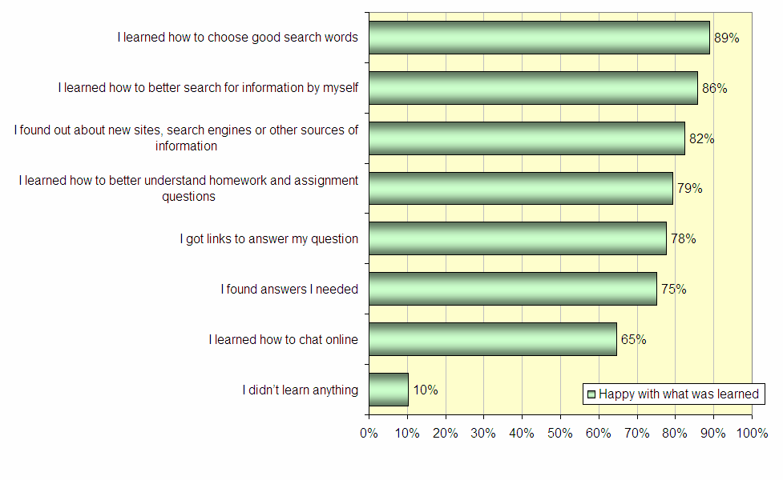
Immediate Learning For Young People – Key Learnings
Visits to AnyQuestions are primarily driven by the need to resolve specific needs/objectives, generally perceived by students to be finding specific answers to questions. While the development of information literacy skills is not the primary driver of visitation amongst students, it is still a key factor in the top few reasons for visitation. It is also interesting to note that few students reported having visited AnyQuestions actively as part of a school lesson, this may be an opportunity for students to be introduced to the service by teachers in a ‘hands-on’ and interactive environment during a lesson that includes Internet usage. This may enable the concept of developing literacy skills through the website to be more fully appreciated and for the site’s purpose to be more clearly communicated.

For those students who do reveal the development of information literacy skills as a learning outcome of the site, their satisfaction with what they have learned on the site tends to be higher than for students where the visit resulted only in the provision of answers to their questions. Furthermore, students who reported having developed information literacy skills also reported developing more skills overall from using the site, as seen in the table below, ie, those only finding the answers they needed are far less likely than others to learn search techniques, learn about search resources or to better understand home work questions.

Immediate learning for young people – Key Learnings
Visits to AnyQuestions are primarily driven by the need to resolve specific needs/objectives, generally perceived by students to be finding specific answers to questions. While the development of information literacy skills is not the primary driver of visitation amongst students, it is still a key factor in the top few reasons for visitation. It is also interesting to note that few students reported having visited AnyQuestions actively as part of a school lesson, this may be an opportunity for students to be introduced to the service by teachers in a ‘hands-on’ and interactive environment during a lesson that includes Internet usage. This may enable the concept of developing literacy skills through the website to be more fully appreciated and for the site’s purpose to be more clearly communicated.

For those students who do reveal the development of information literacy skills as a learning outcome of the site, their satisfaction with what they have learned on the site tends to be higher than for students where the visit resulted only in the provision of answers to their questions. Furthermore, students who reported having developed information literacy skills also reported developing more skills overall from using the site, as seen in the table below, ie, those only finding the answers they needed are far less likely than others to learn search techniques, learn about search resources or to better understand home work questions.
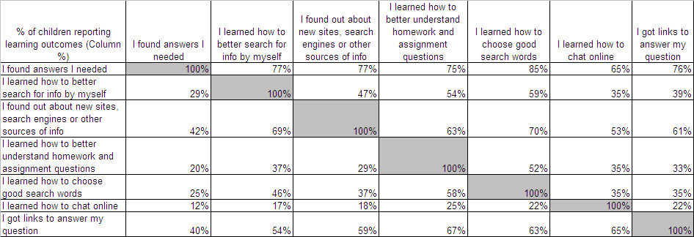

Alignment And Transfer Of Learning
AnyQuestions is part of a broader network of learning contexts and learning goals in students and young people’s lives. More specifically, AnyQuestions.co.nz links to students’ experience of public and school libraries and other information environments, and therefore student learning around information literacy. As such, the service must aim to ultimately align with and support learners’ wider educational endeavours. In this section this alignment is explored, as is the impact of the Internet as a resource used by students in their learning endeavours and information literacy more generally.

In examining the role of the online medium in the educational lives of students, it is important to note that one quarter of students’ average weekly Internet usage is at school, and one third of their home Internet use is for school work. This strongly indicates that a large proportion of student Internet usage is for educational purposes, reinforced by the Phase 1 finding that ‘homework’ is the most popular online activity for the target group (8-17 year olds). Males report spending more time online in total, but the proportion of online time allocated between school and home is very similar across males and females, as is depicted in the figure below:
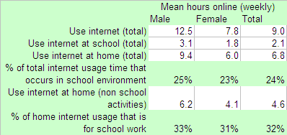

Not only are students spending relatively large amounts of time using the Internet, they are displaying fairly sophisticated usage. Students report using search engines more than any other online resource to find information for school work (94%), compared to approximately half of online Australian adults who use search engines as the most common means of finding out about websites (51%). This ‘all encompassing’ search facility far exceeds the use of dedicated online resources such as subject or school-specific websites.

Online educational resources used
Base: Students, n=157
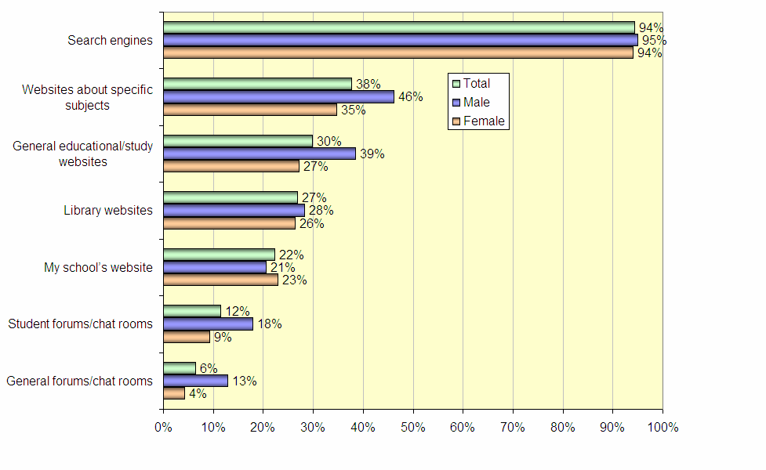
Additionally, students’ perceptions of search engines as an important resource for school related activities far exceeded perceived importance of the other online resources used. Search engines were also most commonly rated by students as the favourite type of website to use for educational purposes.

Perceived Importance of Online Resources Used
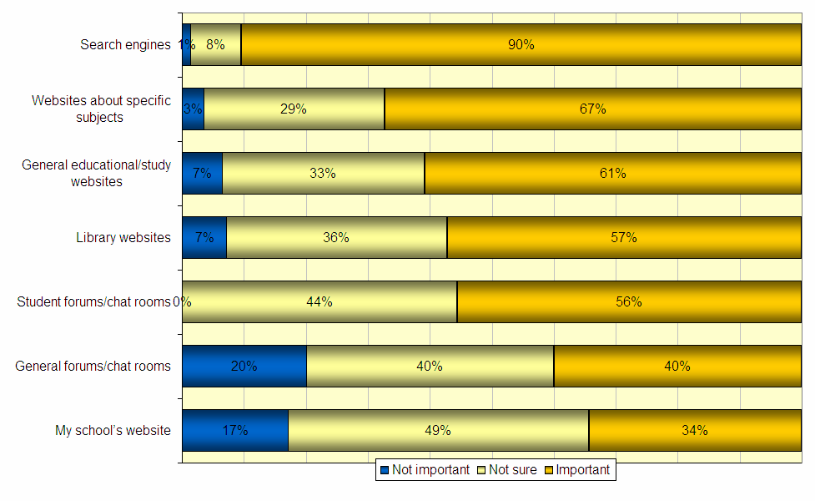
Base: Students, n=157

This outstanding preference and perceived value of search engines reinforces the need to ensure New Zealand students are equipped to make use of these tools in an efficient, effective and safe manner, in both a supervised and unsupervised environment, but also indicates the degree of confidence and success they already have in this research resource.
Favourite types of educational website
Base: Students, n=157
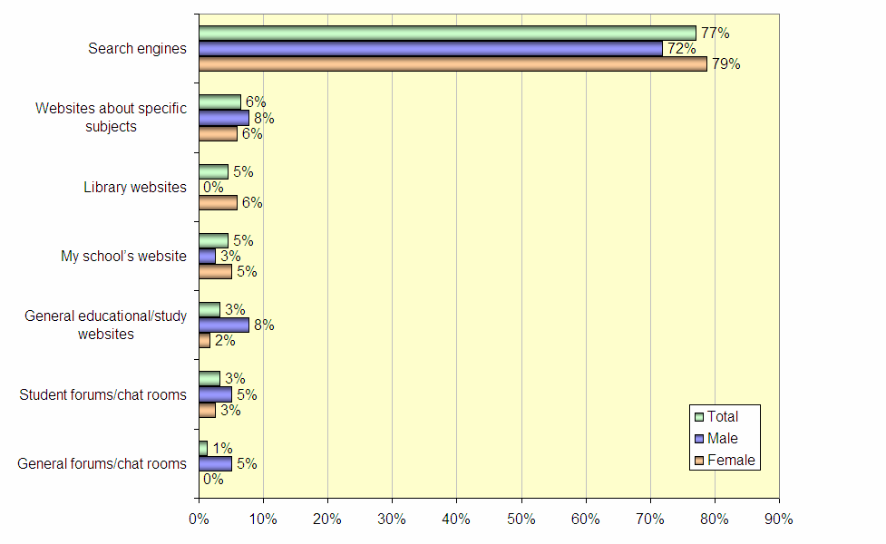

Just over one third of students felt that AnyQuestions was more useful than other websites that they use for school, and overall more than half find the site to be at least as useful as other sites. The broad collection of websites mentioned by students for educational purposes included:

Range of websites used for school
Multi-subject  bbc.co.uk  schoolsonline.co.nz  DOC  learning media  NZQA  librarychristchurch.org.nz  Commonwealthgames2006.com |  |  | Online Communities  kidzworld  Kiwi Conservsation Club  www.answerbag.com  letus.org  icq.com hahaha2.zoomshare.com  kidscom.com
School Websites  tbc.school.nz  Massey University Library  University of Waikato  Summerland Primary  Tainui School  cobham.schoolzone.nz | Subject Sites  Shakespeare Notes  chem4kids.com  primarygames.com  nz maths  sciencebuddies.com  funbrain.com  mathworld.com  studyit.org |  | Online Encycolpaedia / Reference  Wikipedia  Encarta  dictionary.com  thesaurus.com  www.factmonster.com  Cia World Factbook  TKI-epic  www.govt.nz
Paid Resources  Brainpop  Britannica |  |  | Study Cheats  www.123helpme.com

While AnyQuestions is considered an important resource amongst the range of online learning sources available, libraries and family are widely drawn upon offline resources for school-related activities. Overall, 71% of students have consulted a school library, 62% a public library and 62% have sought assistance from their family. It is interesting to note that while little gender differences were observed in library usage, males were more likely to seek advice from family than females (76% males vs. 57% females).

Public libraries were considered by students to be the most important resource for finding information for school work (80% rated public libraries as “important”), which highlights the importance of providing prominent links to the library websites from the AnyQuestions site (currently somewhat hidden within ‘Hotlinks’ in the secondary menu). Following public libraries, help from family was considered the second most important resource (71%), and school libraries were perceived to be the third most important resource with two thirds of students rating them as an important offline resource (66%). These findings still reinforce search engines’ appeal and perceived value, above and beyond the range of offline resources used, but they also reveals students’ balanced approach in determining their most useful sources of information, and that people haven’t altogether dropped off the radar.

When investigating the frequency with which all resources (online and offline) were utilised, family assistance was most often used with almost nine out of ten students drawing upon family help weekly or more regularly (89%), and highlighting another means by which the site could be further promoted to stimulate use – building awareness of the service and its benefits among parents to ensure strong recommendation to their children.

Search engines were also frequently drawn upon as a resource with 88% of students using one weekly or more regularly and school libraries occupied the third place for frequency of resource use (67% used the school library weekly or more regularly). While public libraries were considered quite important as learning resources, they were used less frequently than other resources, with 45% reporting to use them weekly or more regularly.

Alignment And Transfer Of Learning – Key Learnings
Students are spending over an hour a day (on average) on the Internet, with one quarter of this time being spent from school. A further third of their time spent at home on the Internet is also for school related purposes. As an online based tool, AnyQuestions is clearly well placed to help support students’ learning as a service perceived to be important amongst the range of educational resources available.

As another key online learning tool, search engines are seen as important and are considered to be a ‘favourite’ type of website, used as school resource by more students overall than any other resource. Search engines are consulted just slightly less frequently than family for help with schoolwork.

It is important to consider that the frequency of consultation of online resources is likely to be impacted to some degree by access to the Internet. While access among the user base is high, comparative to the general population, there are still more barriers to using online resources relative to the ease of access to advice/‌assistance from family, in many cases.

The dominance of search engines as an important and frequently used resource makes AnyQuestions’ role in helping students expand their searching techniques even more critical. It is vital that students better understand how to evaluate the authenticity and appropriateness of content ultimately found via an online search as well as develop the range of techniques used to find and manage that information. AnyQuestions is positioned well to play a key role in introducing to students more effective search techniques and methods of verifying the reliability of information found.

Learning For Teachers And Other Adults
As a component of evaluating the impact of AnyQuestions on learning outcomes, research was also conducted amongst adult users. This element of the evaluation aims to provide some insight into the impact of AnyQuestions on school and teacher practices. It is explored how AnyQuestions is positioned as a learning environment to students by teachers and schools. It should be noted when reading and interpreting results that due to a much lower level of site usage from the adult segments, the sample sizes captured through the site intercept survey are substantially lower than those attained for students. The findings of this section should be taken as indicative only, rather than as statistically robust measures. The sample sizes are as follows; n=33 teachers/librarians and n=44 parents/guardians/other adults).

Teachers And Librarians
With regards to the use of the Internet as an educational resource, teachers/librarians spend on average just over 3 hours per week using the Internet for school-related activities for students (including preparation for classes as well as in-class work) though 60% report using the Internet in this capacity for 3 hours or less each week.

Considering the range of both online and offline resources available, teachers and librarians are more likely to recommend offline resources to students for educational purposes (four of the top five recommended resources are offline). Despite this likelihood, search engines are the most commonly recommended resource, with 94% of teachers/librarians directing students to these to assist in the search for information (providing an indication as to search engines’ popularity as a school resource among students). After search engines, the most recommended resources included books (91%), school libraries (82%) and public libraries (79%).

Recommended resources for students
Base: Teachers/librarians n=33
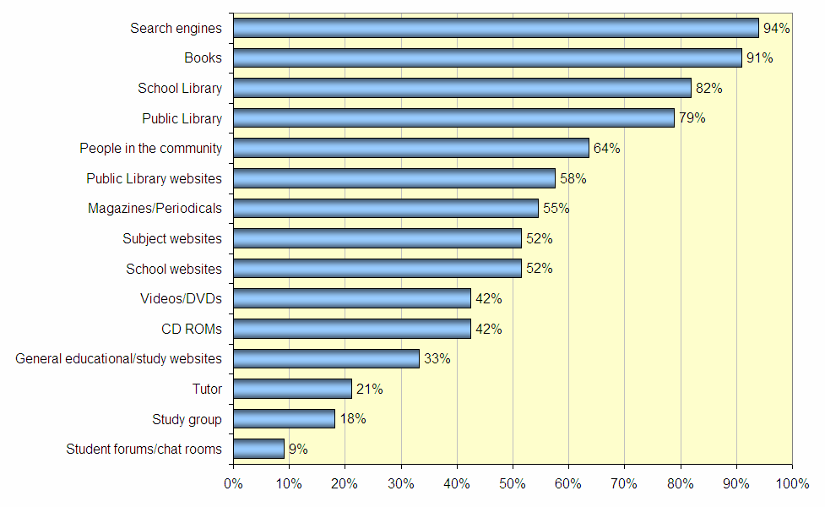

This recommendation of largely offline resources likely stems from the perceived value of these resources among teachers and librarians. They feel that offline resources are more important for helping students to locate quality information for schoolwork, with books, public libraries and school libraries the top three “most important” resources identified by teachers/librarians (88% identified books as either very or somewhat important, 88% for public libraries on the same measure and 85% from school libraries). Despite being recommended more than any other resource, search engines came in equal third with 85% feeling they were very or somewhat important in helping students locate quality information.

Among teachers and librarians, awareness of the AnyQuestions service is primarily driven from promotional activity (39% first became aware of AnyQuestions through these marketing efforts) and also word of mouth from other educators (24% heard about it from a teacher and 18% from a librarian). Strategically, the way in which teachers become aware of the service is important to note, especially considering that a large proportion of student users discovered the site from their teacher or librarian. This finding suggests that promotional activity directed toward educators can be an effective means of stimulating usage not only amongst this group but also amongst students.

Teachers’ and librarians’ length of experience with the service is generally quite recent. Almost half have been using the site for less than one month (49%) and 70% for six months or less. While the majority of teachers/librarians were recent users, those who had been using AnyQuestions for longer periods of time were more satisfied overall with the site’s performance, following the trends seen among student users. Just over half of the teachers/librarians who had been using the site for less than one month (57%) reported being either Happy or Very Happy overall while 83% of those who have been using the site for more than one year were either Happy or Very Happy. Overall, two thirds were satisfied with the site, reiterating that the majority of teacher/librarian users were more recently introduced to AnyQuestions.

When asked if AnyQuestions was recommended to students, the majority of teachers and librarians said that they did actively recommend the service (73%). This finding can be reinforced through some of the open ended responses captured:

“I think you are all doing an amazing job. When I tell people about the AnyQuestions website they are all blown away that such [a] thing exists.”

When teachers/librarians are recommending the service to students, it is chiefly positioned as a “study/assignment help desk” (71%) and as a “service for improving students’ overall information literacy” (50%). This may relate to the way in which the service is positioned through its marketing efforts to teachers and librarians. If it was more overtly positioned as a service for the improvement of students’ information literacy, this may further increase their perceived relevance of the service. Additionally, it would help to ensure that teachers and librarians provide more accurate communication and positioning of the service and its purpose, to their students.

Teachers/librarians’ perceived barriers to student uptake of the service largely related to accessibility rather than student apathy. Over half of teachers/librarians (52%) believed that a lack of access to computers and the Internet at school is a key barrier to students’ uptake and use of the service. In the same vein, just under half (49%) believed that a key barrier was the limited access to these computer and Internet facilities outside of school. While, earlier in this report it was noted that a high level of home Internet access existed among student visitors, it is imperative that it be understood that this measure is amongst the current users – not those who do not currently use the site. In some respects, lack of Internet access as a barrier can be interpreted positively – barriers to use are not a lack of relevance of the service nor are they a display of student apathy, rather, non-usage is perceived to be driven by a lack of technological access.

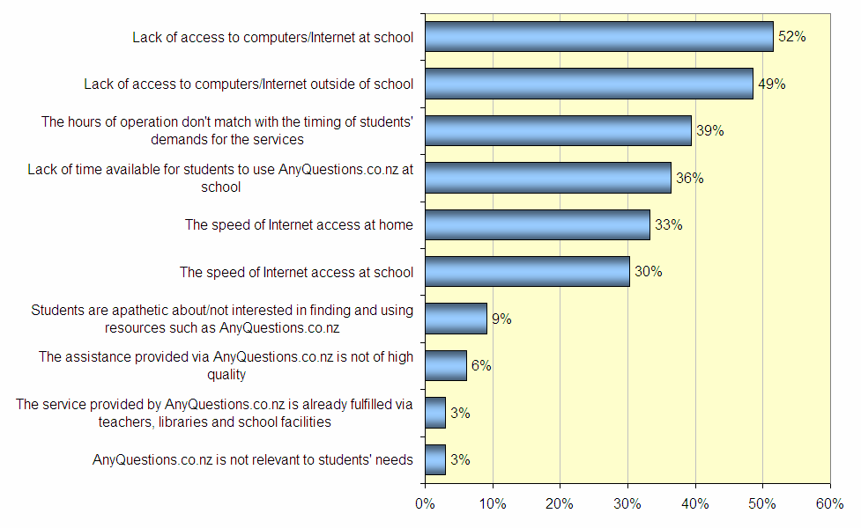

In a similar vein to the perceived barriers to use identified by teachers/librarians, they were also asked to identify the ‘types’ of student they believe currently use the service. Many continued the theme that usage is largely constituted of students who have access:

“Ones that have access to computers and then access to the internet.”

“Those who know about it, who are organised and who have ready access to a computer terminal with internet access.”

While others suggested that the current usage is attributable to those students who are actively engaged in their own learning and study processes, consistent with the high proportion of student users found to be faring well at school:

“Independent students who are positive in their approach to the Inquiry process.”

“Students that are interested in getting their work finished and genuinely need help.”

“Those with teacher prompting/guidance or those confident/literate/interested enough to use a website independently.”

With the active engagement of students an important concept in driving uptake amongst students of services such as AnyQuestions, this highlights the importance of the role that teachers and librarians play in shaping this proactive behaviour. Just under one third of teachers/librarians had used AnyQuestions with students in school (30%) and a further one in five had directed students to the site to use independently (21%). While active use of the service with students was moderate, the teachers/librarians noted particular areas in which the service is performing well - as highlighted below:

“Supporting the Information Literacy modelling process”

“Encouraging students and drawing out their communication skills”

“[Providing] good quality information [while still encouraging] students to think for themselves”

“This is an awesome site for helping students.”

“Just being available.”

“[The site is good] for helping the students find the right information.”

While the perception is that AnyQuestions is teaching important skills to students and providing good support in improving information literacy, several areas of potential improvement were also identified:

“Maybe need more librarians on the service so the students don't have to wait so long.”

“[The site] needs to be available during school hours.”

“Fewer drop offs due to technical issues.”

“It doesn't work, if it can't meet needs then stop wasting money on it.”

“Software [not] coping with heavy load at peak periods.”

“A great service although still needing some further development to make it easier to use and more stable - essential that funding be made available to keep this service going.”

“Wanted to use for an immediate answer. Now I know about it I will use as it is intended.”

Other Adults – Parents And Guardians
According to Nielsen/NetRatings’ NetWatch in Q1 2005, New Zealand parents (66.5%) are more likely to be regular Internet users (defined as having used the internet in the last 4 weeks) than the overall adult population (61.3%). Single parents are less likely to be Internet users and just 44.2% of single parents have access to the internet at home, compared with 67.3% of parents (overall) and 63% of all New Zealanders aged 18+.

Parents and guardians (and other adults) using AnyQuestions spend an average of 2.6 hours per week using the Internet either for or with their children for school-related activities. This Internet usage is coupled with recommendations of specific resources, both online and offline. Similar to the teachers and librarians, parents are most commonly recommending search engines (82%) as the online resource of choice to help students locate quality information for school-related activities. Books and Libraries are the next most recommended information sources (Books 71%, school library 64%, public library 61%).

Parents follow a similar pattern to teachers and librarians in their perception that offline resources play a more important role in students’ learning, possibly a result of their personal social and learning experiences. Almost nine in ten parents (87%) believed that books were either very or somewhat important for students’ learning experiences, 86% for public libraries and 82% for school libraries. Search engines were also perceived as important (and the most important online resource) with 76% of parents nominating this resource as important. Nielsen/‌NetRatings’ eGeneration Study among parents of 6-17 year olds found that parents’ confidence in the online medium was extremely high and played an important role in their child’s development. It was perceived as a great ‘all rounder’ being ranked second only to books as an education vehicle and second only to free to air television for children’s entertainment. It does however, warrant further investigation among both parents and teachers/‌librarians as to the drivers behind their perceptions toward offline resources as being more valuable than the host of online resources now available.
Parents primarily became aware of AnyQuestions via word of mouth, notably from teachers, while 18% first heard about the service through marketing material. The clear majority of parent users were visiting AnyQuestions for the first time (57%) and only 2% had been using the site for more than one year. In another similar trend to teachers and librarians, parents’ experience appears to impact the level of satisfaction enjoyed with the site overall. Just over two-fifths of parents (44%) visiting the site for the first time report being either happy or very happy with their overall experience compared to 80% of those that have been using the site for 6-12 months.

Tenure of AnyQuestions usage
Base: Parents, Guardians and other adults n=44

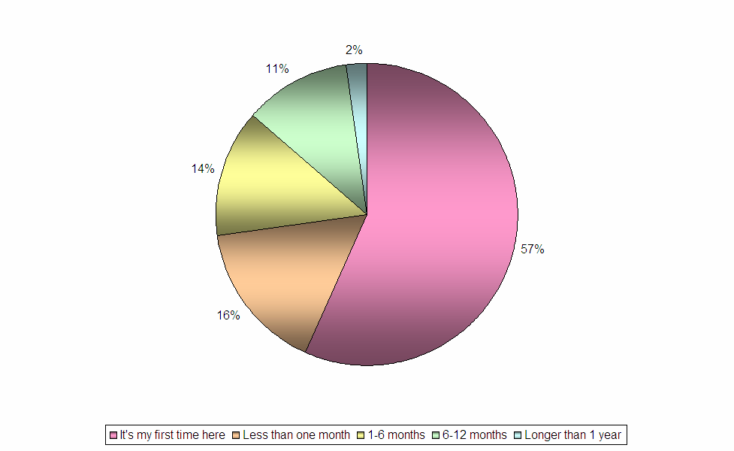

Parents perceived the role of AnyQuestions in a similar way to that observed amongst teachers/librarians. Four-fifths of parents (80%) see AnyQuestions as a study or assignment help desk and 55% as a service for improving students’ online search skills, again emphasising the need for more accurate positioning of the service through refined marketing and communication. It is also interesting to note that approximately half of parents had actively used the site with the student(s) in their care.

Parental perception of AnyQuestions’ purpose
Base: Parents, Guardians and other adults n=44
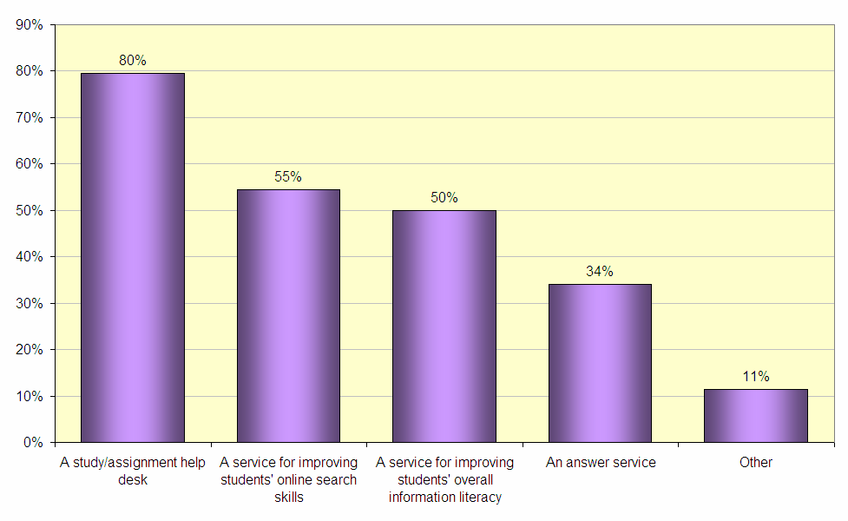

Parents were asked to provide open ended responses to the areas in which they felt AnyQuestions was performing well. These areas included:

“Easy to follow and quick replies” “Good response time - knowledgeable librarians.”

“Responsive, friendly, helpful.”

“[the site teaches] study skills and [gives] help with questions.”

”I felt the way in which my child was guided through websites when she was really stuck before talking to AnyQuestions was brilliant, as she was feeling really confused.”

“Directs students to the appropriate web site to answer their questions.”

”I am very pleased that this service is available for my students and am very happy with the information it provides them with.”

“You offer great service that I know is safe for my students to use even unsupervised. Thanks.”

Parents were also asked to provide open ended responses to the areas in which they felt AnyQuestions could improve. These areas included:

“[The site should provide] a better explanation of what it is.”

“[Instead of] giving answers they give you options to questions or they tell you to go on other sites.” – This parent likely did not understand the process whereby the online librarian was trying to teach research skills.

“Availability can be variable though high use times.”

“[The site] didn't get back with an answer and when it did a week later the homework was already into teacher, too slow in answering back.”

“We often don't get onto the computer until after tea due to after school activities as 6pm is the site’s end time we often miss out.”

“The hours of service are somewhat limited. Maybe being able to leave a question with you and you answering later and emailing the answer to us later? 6pm is just way [too] early [to close].”

“Help Desk you can phone.”

“My daughter says that sometimes the connection finishes by itself.”

“My older son uses the site every night but I have been unable to get in to it on my computer and my work computer – blocked.”

“[More] current events, technology.”

“Maybe have more information on New Zealand's events.”

“The hours of service are somewhat limited. Maybe being able to leave a question with you and you answering later and emailing the answer to us later? 6pm is just way too early [to close].”

“Help Desk you can phone.”

“My daughter says that sometimes the connection finishes by itself.”

Learning For Teachers And Other Adults – Key Learnings
Search engines are recommended by all adults to students for use as resources for school work, but fewer are recommending specific websites to students. This may suggest a lack of awareness on behalf of adults around the specific online resources available and could provide AnyQuestions with the opportunity to become the gateway for adults, to the online resources available.

In Nielsen/‌NetRatings’ research experience it has often been identified that Internet usage overwhelmingly tends to be undertaken alone rather than as a group activity, however a key difference in this instance is that approximately half of parents and adults are using the site in conjunction with their children/students, while teachers/librarians are slightly more likely to be directing children to the site to participate in the experience on their own. In an educational context, it is possible that accompanied Internet usage could be beneficial to students, if the adult is proactively passing on effective information literacy skills. Alternatively, the site’s safety standards and practices could be further highlighted to parents to provide confidence in allowing independent student use. This is particularly important where online ‘chat’ functions are available on sites, functions which parents have probably been warned to be wary of.

The accompanied usage reported by parents may be contributing the slightly higher proportion of parents/guardians and other adults being aware of the goal of the site to increase information literacy (through teaching searching skills), as these adults will have participated in the process with their students.

In a similar vein to the satisfaction trends observed amongst students, more experience with the site seems to lead to higher levels of satisfaction among adults. This phenomenon may be an indication that adults need the additional contact with the site in order to fully understand its purpose and the role it can play in students’ learning and information literacy acquisition.

Teachers primarily position the site to students as a study help desk, and feel that the students taking the most advantage of the site are those who are actively engaged in their own learning. Parents/guardians and other adults also, to a large degree, perceive the site to be a study help desk. The name of the service clearly suggests the provision of help (and answers), so these impressions are certainly understandable. Considering the large role that adults, particularly teachers, play in generating initial awareness of the service, they should be considered an important resource in the promotion and positioning of the service to students. Parents present an opportunity through which to further promote the site to students based on the high proportion of students seeking study and home work assistance from family.

Nielsen/‌NetRatings would recommend (where possible) that teachers/librarians and parents form part of AnyQuestions’ marketing and education activities to either promote or more clearly position the service to students in an effort to boost the levels of satisfaction and student information literacy learning. This is especially important when it is considered that both adult segments show some indications that the intent of the site (being to teach information literacy) is not clearly apparent. Communication and education relating to the true purpose of the site should be undertaken to reinforce the site’s core goal, targeting the teachers and parents who in turn will inform their students.
The inclusion of the various types of adults as targets for marketing communication activities may include the provision of support materials and resources to help these adults pass on an accurate portrayal of the service to students and even assist students to more effectively use the site.

Appendix A: Additional Sample Composition Analysis

Ministry of Education Database Additions
Please note: The following composition analysis is provided based on additional data provided from the Ministry of Education. The outputs within this appendix refer to student participants based on the school which they reported to attend compared to the national metrics derived from the Ministry’s data. Due to participant text entry errors, the sample data is available only for 138 student participants.

School gender definition captured in sample

 | Sample | National
Co-ed | 76% | 95%
Single Sex (Girls) | 19% | 2%
Single Sex (Boys) | 5% | 3%

Deciles – Simple vs. National

 | Decile
 | Sample | National
Average | 7.098 | 5.488
1-3 | 12% | 30%
4-6 | 25% | 30%
7-10 | 63% | 40%

Isolation Index – Sample vs. National

 | Iscolation Index
 | Sample | National
Average | 0.559 | 1.007
0.0 – 0.5 | 67% | 43%
0.51 – 1.0 | 14% | 17%
1.01 + | 19% | 40%

School Authority
School Authority | Sample | National
State | 80% | 83%
State: Integrated | 14% | 13%
Private: Fully Registered | 6% | 4%
Private: Provisionally Registered | - | 0.2%
Other: Vote Education | - | 0.04%

School Type captured in sample

Region of school captured in sample

Urban – Sample vs. National
Urban | Sample | National
Main Urban | 83% | 54%
Minor Urban | 6% | 11%
Rural | 7% | 29%
Secondary Urban | 5% | 6%
District/City captured in sample

The completion rate refers to the proportion of invited participants who accepted the invitation to participate and fully completed the survey.
Note: The term “users” is utilised here and throughout this report, as well as the term “visitors”, when describing respondents. This is done as the responses captured from participants in the research are intended to be reflective of site users generally and the findings extrapolated to that population.
Nielsen/‌NetRatings New Zealand eGeneration Report 2005-2006
Nielsen/‌NetRatings NetWatch, Quarter 4, 2005
Nielsen/‌NetRatings New Zealand eGeneration Report 2005-2006
Note – the service is available from 1pm-6pm which cuts into some of the school day.
Note: This comment is extracted verbatim from a response to the question “In what areas do you feel that the AnyQuestions.co.nz service needs improvement or development?”
Outside the scope of NetRatings’ study but could be complemented by insights derived by CORE’s analysis and evaluation

